(this outline -
- skeletal outline(page1),
- then full outline(page2-88),
- then short/summary outline version(page89-106)

Skeletal outline:
- Introduction
  - Juries
- Privileges
  - Element 1: communication made
  - Element 2: in confidence
  - Element 3: Between lawyer and Client
    - Attorney client privilege in corporate setting
  - Element 4: in the provision of legal services
  - Waiver of Attorney Client Privilege
    - Scope of Waiver
    - Crime Fraud Exception
- Trial Structure and Judicial Role
- Relevance
  - Probative value and prejudice
  - Conditional relevance
- Character Evidence
  - Character in issue
  - Character in Criminal Cases
  - Methods of Proving Character
  - Other uses of specific conduct and habit evidence
  - Habit Evidence
  - Sexual Assault and Molestation
- Other forbidden inferences
  - Subsequent remedial measures
  - Offers and Negotiations
  - Offers to pay medical expenses
  - Plea deals
  - Liability insurance
- Trial mechanics
- Competence
  - Personal Knowledge
- Impeachment
  - Character for truthfulness
  - Impeachment by prior conviction
  - Prior inconsistent statements
  - Bias
  - Incapacity
  - Specific Contradiction
- Rehabilitation
- Hearsay
  - Non Hearsay
  - Statements
  - Confrontation clause and hearsay
  - Statements that are “not hearsay” Rule 801(d)(1) and (2)
    - Rule 801(d)(1) declarant is required to be available to testify at trial
      - Prior inconsistent statement
      - Statement of identification
      - Prior consistent statement
    - Rule 801(d)(2) - Statements of party opponents (doesnt matter if declarant is available?)
- Exceptions to Hearsay
  - 803 Exceptions - doesn't matter if declarant is available to testify
    - Spontaneous Statements
      - Present sense impression
      - Excited utterance
      - Then existing mental state
    - Recorded Statements
      - Injury reports
      - Recorded recollection
      - Business records
      - Public records
  - 804 exception - declarant must be unavailable
    - Criteria for being unavailable
    - Former testimony
    - Dying declaration
    - Statements against interest
    - Forfeiture by wrongdoing
    - Residual exception
    - Machine generate proof
  - Hearsay and due process
- Authentication
  - Digital evidence
  - Best Evidence Rule
- Opinions and Experts
  - Lay opinion
  - Expert Opinion
    - Daubert revolution
    - Social science evidence

(full outline)
EVIDENCE
- Introduction

Evidence = sources used to establish that some fact in the case, or some statement about the fact is true or false (examples of evidence: testimony, documents, other physical evidence)

Rules of Evidence = procedural rules, they restrict what can be introduced at trial, limited in scope and most rules only apply to trial part of legal process (big exception = privilege rules)

General things that are important to think about:
- What facts are you using the evidence to prove?
- Understand the legal strategy - Why are these facts important? How does the evidence prove those facts?
- Strategy and underlying law - How do the facts and evidence support legal elements you are trying to prove?
- Evidence law requires you rationally state your legal theory - if you can’t articulate theory you don't know what you are using the evidence to prove

Rule 101. Scope; Definitions
- Scope. These rules apply in proceedings in United States courts. The specific courts and proceedings to which the rules apply, along with exceptions, are set out in Rule 1101.

Rule 1101. Applicability of the Rules
- Apply to US district courts
- Rules apply in
  - Civil cases
  - Criminal cases and proceedings

Rule 102. Purpose - These rules should be construed so as to administer every proceedings fairly, eliminate unjustifiable expense and delay, and promote the development of evidence law, to the end of ascertaining the truth and securing a just determination.
- Simplified: 3 values = accuracy, fairness, efficiency

- Juries:

Rule 606. Juror’s Competency as a Witness
- At the trial. A juror may not testify as a witness before the other jurors at trial. If a juror is called to testify, the court must give a party an opportunity to object outside the jury’s presence.
- During an Inquiry into the Validity of a Verdict or indictment.
- Prohibited Testimony or Other Evidence. During an Inquiry into the validity of a
(summary version) juror cant testify about statement or incident that occurred in jury deliberations; the effect of anything on jurors’ votes, jurors mental processes concerning verdict. Court cant receive evidence of juror’s statement on these matters
- Generally cannot testify about things happening inside jury room but can testify about things brought in from outside the juror room (extraneous information)

Voir dire / bias …? ( i have a lot of notes about this from first day of class)

Warger v. Shauers:
RULE: as to matters other than mental operations and emotional reactions, substantial authority refuses to allow a juror to disclose irregularities which occur in the jury room, but allows his testimony as to irregularities occurring outside and allows outsiders to testify as to occurrences both inside and out (from advisory committee note on rule)
Facts: the trial was about truck driver who had hit motorcyclist and caused injuries, during jury selection jurors were asked, “there is a reason you would not be able to be fair and impartial”, juror whipple says “no,” whipple tells other juror that her daughter had hit someone in an accident and if she had been sued it would have ruined her life, warger (motorcyclist) moves for new trial seeking to introduce this evidence
Issue: Does 606(b) barr evidence of the affidavit of juror about something spoken about during deliberations?
Holding and reasoning: This is barred by 606(b), juror Affidavit was inadmissible,

Federal approach = cannot allow evidence of things said during deliberations even if it shows juror misconduct during jury selection (voir dire) unless it was shown an extraneous matter had influenced the jury, cannot impeach the verdict of the jury by attacking the deliberation unless with extraneous evidence (rule above)

Iowa approach (i dont think we need to know this) = objective jury misconduct may be testified to in California, Florida, Iowa, Kansas, Nebraska, New Jersey, North Dakota, Ohio, Tennessee, and Washington

Objective evidence = thoughts, feelings, mental process
Subjective evidence = statements, actions, anything that is not mental or emotional state

Pena Rodriguez v. Colorado
RULE: If a juror makes a clear statement showing reliance on racial bias or animus to convict a defendant, an exception to the no-impeachment rule allows jurors to testify about jury deliberations to determine whether racial bias deprived the defendant of an impartial jury.. (allows expcetion to normal 606b rule about not testifying to things in jury room - this rule only applies to criminal cases)
Facts: man sexually assaulted 2 women at trial he introduce evidence of alibi witness, one juror said another juror expressed anti hispanic bias, Pena submitted affidavit with number of bias statements trying overturn his verdict
Issue: is there a constitutional exception to the anti impeachment rule?
Holding and Reasoning: there is an exception. The court must determine if juror HC (racist cop) statement’s alone were enough, or if persuasive other jurors and if that would be enough, because HC was law enforcement other juror’s likely would have listened to him and he would have had influence on other jurors,
^come back to this case, maybe re read case***

- PRIVILEGE
Privilege rules are rules of discovery

Rule 501 - Privilege in General - The common law - as interpreted by United States courts in the light of reason and experience - governs a claim of privilege unless any of the following provides otherwise:
- The United States Constitution;
- A federal statute; or
- Rules prescribed by the Supreme Court
But in a civil case, state law governs privilege regarding a claim or defense for which state law supplies the rule of decision

Scope of Privilege:
- Privilege extends through client’s lifetime and continues after death
- Privilege belongs to client not lawyer
- Privilege may be claimed by the client of their representative/lawyer

Swindler v. Berlin
Rule - Attorney/Client privilege survives the death of the client.
Facts - Attorney met with his client, Foster, because of investigations into Foster regarding some firings that happened when Foster was deputy white house counsel. Shortly after the meeting Foster killed himself and independent counsel wants the notes from the meeting.
Issue - does the attorney client privilege survive after death?
Holding and Reasoning - Yes the privilege survives after death. This encourages communication because clients knows privilege continues after death and necessary to encourage “full and frank” discussion. Need to foster trust between attorney and client and we want strong privilege protection. 5th amendment only protects you from revealing incriminating information, but does not protect you from embarrassing information you don't want to be revealed after death.

US v. Jicarilla Apache Nation
Rule - Fiduciary exception to ACP occurs when a private person acting as a trustee is seeking legal advice on the trust’s management for the benefit of the beneficiary, making that communication discoverable
Facts - The Apache Nation claims that the government mismanaged their lands, and seeks to find out what legal advice the government received about this land management. Apache Nation claims a fiduciary exception to the attorney-client privilege permits discovery of the advice.
Issue - Is the fiduciary duty exemption applicable to the US government in this case?
Holding and Reasoning - The fiduciary duty exception does not apply here and US had privilege regarding advice they got about. There are 2 reasons for the fiduciary duty exception (1) Beneficiaries are the real clients of the attorney and not the trustee because it is their money, (2) The fiduciary duty to furnish trust related information outweighs the privilege. Here the tribe is not necessarily the real client because the US does have interest and the attorneys were paid by the government not from the trust so its not like the tribe was paying for the legal advice out of their trust. Court says here the government is not a normal private trustee, their relationship is not defined by common law and is defined by different statutes. US has different obligations than private trustees.

Attorney Client Privilege Elements:
- A communication made
- In confidence
- Between lawyer and client
- In the course of provision of legal services
- Burden of proving privilege applies is on person asserting privilege

- Element 1: A Communication Made:

Communication = An utterance intended by the speaker to relate some information to a listener. The communication must be created for the benefit of the attorney, if the communication is prepared for other purposes than seeking advice from a lawyer then it is not protected (more than mere transfer of pre-prepared information).

Information v. Communication
The privilege protects against revealing the statements that a person makes privately to his or her lawyer. It does not protect against revealing the information the client knows, whether or not the client may have communicated that information in privileged conversations. (ex: you cant ask “ did you tell your attorney you ran the light?”, but you can ask “did you run the light?”)

Information = facts gathered by client, fees paid to retain attorney for tax matter, no immunity from disclosure of facts or information external to communications

Communication = conversation between client and her attorney about these facts, communications with attorney about tax matter, immunity from disclosure of content of communication

US v. Kendrick
Rule - Observable facts about physical appearance or demeanor are not communications (Testimony concerning client’s condition is admissible, attorney can testify about client’s condition and nature of interaction.)
Facts - Attorney testified that client “seemed sane” and said defendant “was responsive, readily supplied facts and names of people involved.”
Issue - Can an attorney testify to a client's condition when they were speaking?
Holding and Reasoning - Attorney can testify to a client's condition. Privilege only protects the substance of any confidential communications. Attorney is only testifying to objectively observable particularities of the client's demeanor and attitude. These observable facts about kendrick - demeanor and attitude and are not communications - not things he intended to communicate to lawyer

Tornay v. US
Rule - Fee information is generally not protected by privilege. / Payment is not “communication”.
Facts - Attorney testified as to “what, when, and how” the client paid the attorney.
Issue - Is payment information privileged?
Holding and Reasoning - Fee information is generally not privileged and payment of fees is only incidental to the attorney-client relationship and does not usually involve disclosure of confidential communication. Payment is not intended to communicate anything. The purpose of the privilege is to give client’s incentive to communicate and not to immunize clients against government investigation.

- Element 2: In Confidence

In confidence = an utterance intended to be confidential - conversations are confidential so long as the attorney and client take reasonable steps to exclude third parties
- If the communication is not intended for your attorney, it is not covered by ACP, (like if it was ultimately intended for a third party or intended only for you)

Third party rule = if a third party is present conversation is not privileged (exceptions for interpreters, secretaries etc)

US v. Gann
Rule - the burden of ensuring the privilege applies rests with person asserting it who must take reasonable steps to ensure that third parties are excluded
Facts - Police were in process of searching house of def who was felon, Gann called attorney from house in presence of number of police officers, gov wanted to introduce evidence which was testimony of officer who overheard Gann saying to his lawyer “ex con in possession i guess,” gov wanted to introduce this in order to show Gann was aware he had guns in the house
Issue - was this phone conversation with his lawyer privileged? / did officers have a duty to leave the room?
Holding and Reasoning - conversation is not privileged because Gann did not take reasonable steps to ensure there were no third parties present / listening

US v. Evans
Rule - A third party attorney that is present during a consultation must be acting in their capacity as an attorney in order to not destroy privilege (cannot be acting in capacity as friend).
Facts - Evans was being targeted in a federal corruption investigation. His friend, Holden, found out and took him to 3 different attorneys to talk about situation, seek legal advice, and decide which attorney to go with. One of the attorneys was Koch. Evan, Holden, and Koch were present during conversation
Issue - Is the conversation between Evans and Koch privileged?
Holding and Reasoning - No the conversation is not privilege because Holden was determined to be present as a friend and not attorney. Koch said that Holden said he was present not as Evan’s attorney, but as personal friend. AC privilege will not shield from disclosure statements made by a client to his or her attorney in the presence of a third party who is not an agent of either the client or attorney. Evans did not carry burden to proving Holden’s presence was necessary to accomplish the objective of the consultation.

US v. Lawless
Rule - When information is transmitted to an attorney with the intent that the information will be transmitted to a third party (in this case IRS) that information is not confidential.
Facts - Financial info that client provided to attorney was used to prepare tax returns, Financial info was ultimately intended for IRS
Issue - are the financial documents for tax returns confidential?
Holding and Reasoning - not confidential. The tax preparer attorney here is seen as a “conduit” for the client. Under the conduit model, activities that anticipate disclosure of information to someone other than the attorney are not confidential.

Smithkline Beecham v. Apotex
Rule - in order for the communication to be privileged, the information must be provided to the attorney so that they can sift and asses its legal implications
Facts - client gave attorney design information in order for attorney to asses patentability
Issue - is this information confidential?
Holding and reasoning - Yes it is confidential because the client provided info in order for the attorney to asses patentably and sift info to prepare patent application. Court implies that in the patent preparation process it is one in which the client and counsel confer about what to do in a way that tax preparation process does not. The attorney must “assess” and “sift” the information. (this kind of bleeds into legal services elements because preparing a patent application is viewed as more “legal” than tax preparation).

- Element 3: Between Attorney and Client

- When does the relationship begin?
  - The relationship begins when the client seeks legal services from the attorney
  - Privilege extends to to consultations before formal relationship is established
  - Client does not need to have made payment to attorney
- Who counts as an attorney? / Who else other than an attorney is covered under the privilege?
  - The privilege covers the attorney and those agents employed by the lawyer to assist in the provision of legal services (support staff, interpreters, accounts)
- What happens when someone misrepresents themselves as an attorney?
  - Anyone that a client reasonably believes is an attorney counts as one for the privilege

US v. Kovel
Rule - So long as the non lawyer is working in an agency relationship at direction of lawyer (and rendering legal services) that communication is privileged
Facts - Attorney was helping client with taxes, tax issue was complex so he asked account to help, gov began investigation into client and wanted accountant to testify as to communications between him and the client
Issue - are the communications between account and client privileged?
Holding and Reasoning - Yes in this situation they are privileged. The account was working on behalf of the attorney. The judge compared the account to an interpreter in this case and an interpreter would have privilege. Judge says support staff that work for the attorney and the communications to them are covered under the privilege. It was important in this case the client went to the attorney first and then the account second. (if client went to accountant first then it may not have been covered)

US v. McPartlin
Rule - conversations with co defendant's lawyers are covered by the privilege when mounting a joint defense.
Facts - Ingram paid McPartlin and other money in order to secure hauling contract with district. Benton, vp of Ingram corporation, kept appointment calendars and kept notes with substance of conversations. Ingram lawyer interviewed McPartlin because he wanted to challenge the truth of Benton’s dairy entries. At trial Ingram tried into introduce evidence of conversations with McPartlin but McPartlin's attorney objected on ground of privilege.
Issue - is conversation with a co defendant's lawyer privileged?
Holding and Reasoning - McPartlin was entitled to the protection of the attorney client privilege because his statements were made in confidence to an attorney for a co defendant for a common purpose related to both defenses. Common defense rule protects pooling of information for any defense purpose common to the participating defendants. Attorney for each co-defendant represents both for purposes of joint defense.

Pasteris v. Robillard (do we need to know this case?)

- Attorney Client Privilege in the Corporate Setting:

Upjohn v. US
Rule - A communication is protected if it is a (1) Communication made by employees to corporate counsel (2) At the direction of corporate superiors (3) For the purpose of obtaining legal advice (4) Regarding matters within the employees duties (5) Employees knew the purpose of communications (upjohn test)
Facts - Gov was investigating Upjohn corporation for violating foreign corruption act. Thomas, general counsel of Upjohn, sent out a questionnaire and interviewed various employees. Government sought answers from questionnaires and notes from interviews. Thomas says information is privileged.
Issue - are communications between attorney representing corporation and the employees privileged?
Holding and Reasoning - Yes the communications are privileged. Privilege exists to protect not only the giving of professional advice to those who can act on it but also the giving of information to the lawyer to enable him to give sound and informed advice. The attorney needs the information whether they are senior officials or mid level employees. Communications concerned matters within the scope of the employees corporate duties and the employees themselves were sufficiently aware they were being questioned so the corporation could obtain legal advice. The court created the upjohn model.

Upjohn Test: Applies in the corporate setting to identify the scope of the privileged client who can assert the privilege. If an employee provides information to the corporations attorney under the upjohn rule, only the corporation and not the employee who can assert the privilege.
- You need to show 5 elements to show the attorney client privilege between corporate employees and attorney…
- Communication made by employees to corporate counsel
- At the direction of corporate superiors
- For the purpose of obtaining legal advice
- Regarding matters within the employees duties
- Employees knew the purpose of communications

Upjohn Warnings: Telling the employee that they are not the client under Upjohn and the corporation is, and only company gets privilege.

Work Product Doctrine:
- Core work product = sort of material in which the attorney engages in legal analysis
- The work product doctrine prevents discovery of core work product when prepared by a lawyer in anticipation of litigation
- protects the attorney’s labors, not the client's confidences
- Work product protection can be overcome by some showing of “substantial need” for the information
- Example: information given by client and transcribed by attorney is not work product, but research and analysis that is attorney’s ordinary creative work is protected

US v. Ruehle
Rule - If a corporation gives Upjohn warning the information the employee gives to counsel is not covered under attorney client privilege.
Facts - Broadcom corp hired a law firm to know if their stock option scheme was legal, the Law firm interviewed ruehle who was the company’s chief financial officer. The attorneys claimed they gave ruehle upjohn warning - telling him they were acting as representatives of broadcom, specifically the audit committee and therefore the privilege rested only with the company. The evidence the Gov sought were the incriminating statements made Ruehle to the law firm during interview.
Issue - was the information that Ruehle revealed to the law firm privileged?
Holding and Reasoning - No the information was not privileged. The interests of employees may diverge from and conflict with those of corporations and the employee has right not to speak with lawyer and has right to obtain separate counsel. Ruehle did not do this so when company/law firm did not assert the AC privilege on his behalf he was out of luck. He knew information would be communicated to third parties and therefore was not confidential.

- Element 4: In the Provision of Legal Services

Legal Services = those activities that are characteristic of a lawyer, such as sifting facts and evidence and providing legal advice. Where a lawyer is simply acting as a conduit between the client and third party, they are likely not providing legal services (ex: delivering goods, acting as accountant, or acting as an investigator are not primarily legal services)

Hughes v. Meade
Rule - Delivering goods on behalf of a client is not “providing a legal service” required for attorney client privilege
Facts - A guy stole a typewriter. The guy goes to Hughes, a lawyer, and asks him to return the typewriter. Hughes is called as a witness and asked who asked him to return the typewriter.
Issue - Is the client’s identity privileged when all the lawyer did was deliver goods?
Holding and Reasoning - No the client’s identity is not privileged. Delivering a typewriter is not providing a legal service and does not fall within the professional scope of lawyers. (this also bleeds into element 1 because this was not a communication, also generally client’s identity is not privileged unless it is exceptional circumstances when client’s identity communicates something)

US v. Davis
Rule - Preparing tax returns is not the kind of legal service that is protected by attorney client privilege.
Facts - Davis appealing judgment that required him to hand over documents relating to the tax liability of his client.
Issue - when an attorney is acting as accountant and doing someone’s tax returns are the documents privileged?
Holding and Reasoning - The documents are not privileged. Preparing tax returns is not legal service. If an account had been doing this service there would not question that this information would not be privileged just because the guy doing the taxes happens to be a lawyer does not make the information privileged.

Wartell v. Purdue University
Rule - An attorney working as an investigator is not providing a legal service. (an attorney investigating in preparation for litigation can have protection of attorney client privilege, but must be sifting information from investigation with an eye to the law)
Facts - Wartell, a professor, made a complaint against the president of Purdue. Purdue hires and independent investigator, but the investigator was really a lawyer that Purdue retained. The attorney never told Wartell that he was on retainer for Purdue. At the end of investigation the lawyer sends a report to trustees. Wartell wants a copy but investigator/ lawyer says it is protected by attorney client privilege.
Issue - Does lawyer working in investigation capacity get attorney client privilege?
Holding and Reasoning - No there is not attorney client privilege here. When he complied his report he was basically working as a private eye and not attorney. The investigation was not in preparation litigation.

Luv n’ Care v. Williams Intellectual Property
Rule - Patent agent client privilege is narrower than attorney client privilege and requires that communication is “necessary for the preparation or prosecution of patent applications” / Communications which are not “reasonably necessary and incident to the preparation and prosecution of patent proceedings are not protected”
Facts - Lun N Care entered into litigation with Laurain about who had infringed on who’s patent. The Luv N Care filed a separate lawsuit against WIP. They sought documents from WIP relating to its work with Laurain. WIP claims those documents are privileged.
Issue - what is the scope of the patent privilege?
Holding and Reasoning - there is previous case that found “preparation and prosecution of patent application for other constitutes the practice of law.” however scope of patent privilege is narrower relative to the more board attorney client privilege. Communication must be “necessary for the preparation or prosecution of patent applications.”

- Waiver of the Attorney Client Privilege:

Rule 502 - Attorney Client Privilege and Work Product; Limitation on Waiver
The following provisions apply to disclosure of a communication or information covered by the attorney client privilege or work product doctrine
- Disclosure made in a federal proceeding or to a federal office or agency; scope of waiver. When disclosure is made in federal proceeding and waives attorney client privilege, the waiver extends to an undisclosed communication or information in a federal or state proceeding only if:
    - The waiver is intentional
    - The disclosed and undisclosed communication or information contain the same subject matter
    - They ought in fairness be considered together
- Inadvertent disclosure. Disclosure does not operate as a waiver in a proceeding if:
    - The disclosure was inadvertent
    - The holder of the privilege or protection took reasonable steps to prevent disclosure
    - The holder promptly took reasonable steps to rectify the error
- requires the producing party to follow up on any obvious indications that a protected communication or information has been produced inadvertently

Inadvertent waiver can be determined based on the following factors, with courts taking different positions depending on how forgiving they are
- Reasonableness of the precautions taken
- Time taken to rectify the error
- Scope of discovery
- Extent of disclosure
- Overriding issue of fairness

3 main questions surrounding waiver:
- Who can waive the attorney client privilege? - The privilege may be waived by the client or their representative
- When is the privilege waived? - Conduct incompatible with preserving the privilege waives the privilege
- How broad is the waiver? - If the client or representative is compelled to disclose the communication, they can preserve the privilege by objecting

US v. Bernard
Rule - Conduct inconsistent with confidentiality waives attorney client privilege. Disclosing communication between attorney and client is “conduct inconsistent with confidentiality.”
Facts - Bernand, the defendant, made an illegal loan to Mr Treat. Bernard told Mr Treat that his lawyer, Mr Nally, had told him that the loans were legal. The evidence the government sought was Mr Nally’s testimony as to the content of the conversations with Bernard.
Issue - Did Bernard waive attorney client privilege?
Holding and Reasoning - Yes Bernard waived the attorney client privilege because disclosing the communications between attorney and client is “conduct was inconsistent with confidentiality.”

Tasby v. US
Rule - Attorney client privilege is waived when client attacks his attorney’s competence in giving legal advice.
Facts - Tasby argued he had ineffective assistance of counsel in prosecution for kidnapping. He said counsel had coerced him into taking the stand. Tasby then attempted to stop his attorney from testifying.
Issue - Did Tasby waive the privilege?
Holding and Reasoning - The court held he waived privilege when he “attacked his attorney’s competence in giving legal advice, since such an attack puts in issue that advice and ascribes a course of action to his attorney that raises the specter of ineffectiveness or incompetence.” The only way for an attorney to rebut ineffective assistance of counsel or malpractice claim is to disclose conversations they had with client.

Hollins v. Powell
Rule - Failure to assert privilege at trial waives any privilege which may have existed due to compulsion
Facts - Hollins was one of a group of plaintiffs who brought a civil rights action against the city and powell, who is the mayor, for firing him in violation of constitutional rights. Hollins wants to depose city attorney. City objected on grounds of privilege but court compel city attorney to testify in deposition. During deposition city attorney answers questions about communications between him and his clien but he objected and asserted privilege. At trial mayor testifies as to communications between him and attorney but city attorney does not object.
Issue - was the attorney client privilege preserved?
Holding and Reasoning - No the privilege was not preserved after the mayor testified at trial. After the deposition the attorney client privilege was preserved because the attorney objected to testifying and asserted privilege. But when the mayor / attorney did not object at trial and the mayor testified they waived the privilege.

- Scope of the Waiver:

In Re Von Bulow
Rule - Non litigation exception = do not have disclose rest of conversations or conversations on same subject because disclosure was made outside litigation context. (miller said other courts dont follow this).
Facts - Von Bulow was convicted of murdering his wife. Then he was acquitted on appeal. This appeals attorney wrote a book about the case and von bulow consented to this. Then von bulow’s step children sue him. In this civil case the step kids try to compel disclosure of conversations between von bulow and his attorney. There were 2 types of statements at issues: those eventually disclosed in the book and those not disclosed in the book.
Issue - did Von Bulow waive privilege for communications not disclosed in the book.
Holding and Reasoning - The court uses narrow scope of waiver and finds that says “there is no reason to broaden the waiver beyond those matters actually revealed.” This court does not use either fairness or subject matter doctrine. The court’s rationale is that the book / disclosures were made outside the litigation context and Von Bulow and attorney did not know there would be future litigation.

Fairness doctrine = if you disclose part of a conversation then you waive privilege as to the rest of the conversation.
- This is the default rule for trial related practice (from video lecture)

Subject Matter Doctrine = once communications are disclosed you waives privilege with regard to parts of other communications on same subject matter
- Intentional disclosure normally waives privilege as to other communications on same subject matter (from video lecture)

- Crime Fraud Exception:

Crime Fraud Exception = when the client seeks an attorney’s advice on how to commit a future crime or fraud the communications are not privileged.
- Exception does not apply to prior criminal acts
- Client’s intention controls - exception applies when client seeks advice about committing future crime, doesn't matter if attorney knows but if client knows the advice is to be applied to future wrongdoing

US v. Zolin
Rule - Attorney client privilege protection only applies to prior criminal acts, the protection does not apply to current or future wrongdoing.
Facts - federal gov sought tax returns of L Ron Hubbard in connection with a criminal investigation. The government wants 2 tapes recordings that were filed under seal in a different proceeding. The government argued the tapes were not privileged because they fell under crime fraud exception.
Issue - Can the court listen to the tapes to determine whether the crime fraud exception applies?
Holding and Reasoning - The decision to engage in “in camera” review of the tapes was within the sound discretion of the court. The court needs to know if the lawyer gave advice about tax evasion. The only way to know if the tapes are admissible is by listening to them to know what is discussed. (in CA there is a rule that you cannot prove crime fraud exception by the revealing the communications you must find another way, this makes it so much harder to prove)

- TRIAL STRUCTURE AND JUDICIAL ROLE

Admissibility = an item is admitted into evidence if the court or other tribunal makes it part of the official record
- Judges (not juries) consider questions of admissibility

Excludability = to exclude evidence, an attorney must object to the introduction of evidence by making an oral motion to exclude it.

Rule 103. Rulings on Evidence
- Preserving a claim of error - party may claim error in a ruling to admit or exclude evidence only if the error affects a substantial right
  - If the ruling admits evidence, a party, on the record:
    - Timely objects or moves to strike; and (When evidence is introduced if opponent does not object she loses ability to exclude at trial)
    - States the specific round, unless it was apparent from the context; or (Stating specific ground makes it easier for judges to determine admissibility under 104)
  - If the ruling excludes evidence, a party informs the court of its substance by an offer of proof, unless the substance was apparent from the context
- Not needing to renew an objection or offer of proof. Once the court rules definitively on the record — either before or at trial — a party need not renew an objection or offer of proof to preserve a claim of error for appeal.
- Court’s statements about the ruling; directing an offer of proof
- Preventing the jury from hearing inadmissible evidence
- Taking notice of plain error - a court may take notice of a plain error affecting a substantial right, even if the claim of error was not properly preserved.
*do we need to know b-e?*

Harmless error standard = does not affect a substantial right (did not affect the outcome of the trial)

Affecting a substantial right = evidence introduced changed or influenced jury’s verdict on an important issue (or evidence not introduced would have changed jury’s verdict on an important issue), appellant must prove 2 things
- Trial judge had no evidentiary basis for their ruling
- The error affected the outcome of the case

Plain error standard = court will only overturn the lower court decision if there was a miscarriage of justice (very difficult to get court to overturn when using this standard)

Abuse of discretion standard = appellate court will only overturn the lower court decision if there was a miscarriage of justice

Bandera v. City of Quincy
Rule - Under rule 103 you must object to evidence in a timely manner and state the specific ground on which you object for the harmless error standard to apply, if you do not then the plain error standard will apply on appeal.
Facts - plaintiff claims she was a victim of sexual harassment by someone at police department. Plaintiff claims the police department knew the officer was employee misconduct but negligently failed to hire him. Plaintiff called witness and she was a police officer who was sexually harassed. She testified to how she felt about her own sexual harassment but she also testified to what she thought the psychological impact of sexual harassmetn would be on bandera. This was inappropriate testimony but did the defendant properly object to it?
Issue - did the opponent properly object under rule 103?
Holding and Reasoning - No they did not properly object because they did not state on what ground they were objecting (what rule it was violating), opponent had previously objected to the testimony but on a different ground/ for a different reason and it had been overruled, they re objected to the testimony but on a different ground/ under a different rule but they did not say this, because they did not properly object the court will use the plain error standard because they did not state the specific ground

Rule 104. Preliminary Questions
- In General. The court must decide any preliminary question about whether a witness is qualified, a privilege exists, or evidence is admissible. In so deciding, the court is not bound by evidence rules, except those on privilege.

Preliminary question of fact = whether a fact essential to the admissibility of an item of evidence exists
- Court must decide preliminary issue of fact and when doing so are not bound by rules of evidence
- How this plays out in court is (1) proponent seeks to introduce evidence (2) opponent seeks to exclude it then (3) judge must rule on admissibility under 104(a)
- Preponderance of the evidence is the standard of proof the judge should use when determining a preliminary issue of fact / ruling on admissibility
- If a party loses on the ruling of admissibility, after the trial ends they can appeal under 103
*what is the different between preliminary issue of fact and ruling on admissibility?*

This applies to 4 broad issues that judges face
- Witness qualification
- The existence of privilege
- Rules of relevance and character evidence
- Hearsay rules in article 8

- RELEVANCE

Rule 402. General Admissibility of Relevant Evidence
Relevant evidence is admissible unless any of the following provides otherwise:
- US constitution
- Federal statute
- These rules; or
- Other rules prescribed by the Supreme Court
Irrelevant evidence is not admissible

Rule 401. Test for Relevant Evidence
Evidence is relevant if:
- It has any tendency to make a fact more or less probable than it would be without the evidence; and
- relation between some item of evidence and some fact, and the relation is that the evidence makes the fact more or less probable (this is part of logical connection between the evidence and the fact), fact is part of and supports and element of a claim (is material)
- Nature of this relationship depends on the existence of the connection between the evidence and the fact and not its strength or weight
- The fact is of consequence in determining the action
- Of consequence = fact is material, the fact must be one that helps prove the claim or defense in the case at hand
- Determining the action = ….?

Notes on rule 402:
- In order to assess relevance you have to know legal and factual issues in the case
- Rule 401 asks you to show how the evidence you want to introduce ot facts in the case more or less likely to have occurred
- Rule 401 is low standard and very easy to satisfy

Relevance is about constructing unbroken chains of logical inference
- So long as there is no missing link between the fact and the claim, the evidence is relevant
- The longer the chain between the inference, fact, and legal claim, the weaker the inference

Four questions to ask when determining the relevance and probative weight of a piece of evidence
- What was the evidence sought to be admitted?
- What fact did it make more or less likely?
- How was that fact material or of consequence?
- How did that fact determine the action or prove a claim/element?

Knapp v. State (logical relevance)
Rule - the weight of the evidence does not matter, only its connection to the fact of consequence in determining the action (must distinguish between low probative value and relevance)
Facts - Knapp shot the sheriff but he claimed it was in self defense. He testified that he heard the sheriff clubbed an old man to death. Prosecution then sought to admit testimony of doctor who testified that the old man died of senility and alcoholism.
Issue - is the doctors testimony relevant ?
Holding and Reasoning - evidence is relevant. the evidence (testimony of doc) is material because it goes to disprove knapp’s claim. Court says there is a chain of inference which is: doc testimony → old man did not die because of clubbing by sheriff → someone is lying about hearing that sheriff killed him → hearing that sheriff killed someone is memorable → unlikely that def would hear this and not remember who told him → no one told the def that sheriff killed someone → def lied about hearing this.

US v. Dominguez (logical relevance)
Rule – Evidence can be relevant even if it is weak evidence that does not prove guilt
Facts - Customs officer was convicted of robbing, kidnapping and killing victim who was carrying 700,000 into US, victim killed by gunshot. Gov wanted to introduce evidence that Dominguez owned a gun, and asked for help replacing barrel; the repairman noticed an attempt to remove the barrel.
Issue - is the evidence that he owned a gun and asked for help replacing the barrel relevant?
Holding and Reasoning - the evidence is relevant and therefore admissible. The evidence is material/ of consequence because if dominguez tried to replace barrel to conceal crime than he must have shot and killed the victim with a guilty mind

State v. Larson (logical relevance)
Rule - Relevant evidence means evidence having any tendency to make the existence of any fact that is of consequence to the determination of the action more probable or less probable than it would be without the evidence
Facts - Larson was charged with negligent endangerment of a child. Larson was drinking heavily at party, and he borrowed a high spirited horse and decided to give a 5 year old child a ride on the back of the horse, the horse reared and fell back and crushed the child , killing her. Prosecution wanted to introduce evidence that Laron’s blood alcohol level would have prevented him from driving a car. Larson claims that this was irrelevant because government would have to prove that riding a horse is like driving a car.
Holding and Reasoning - Evidence is relevant. Judge disagreed with Larson’s argument. Judge thought blood alcohol in comparison to driving would help the jury to estimate how drunk he was when he was on the horse. The evidence is material because it shows how clouded his judgment was. It “determined the action” because it demonstrated Larson acted negligently in allowing the child to ride the horse with him.

- Probative Value and Prejudice:

Rule 403. Excluding Relevant Evidence for Prejudice, Confusion, Waste of Time, or Other Reasons
The court may exclude relevant evidence if its probative value is substantially outweighed by a danger of one or more of the following:
- unfair prejudice,
- Principle way item of evidence can be unfair or unjust is by short circuiting the fact finder;s ability to respond rationally to the evidence and instead appealing to knee jerk reactions and prejudice or overly emotional reactions
- confusing the issues, misleading the jury, undue delay, wasting time, or
- Undermines accuracy and undermines efficiency
- needlessly presenting cumulative evidence.

Evidence is excluded only if probative danger substantially outweighs probative value

Probative value = how much rational weight to give an item of evidence
- Weight we give evidence depends upon judges and juries common sense - upon reason/ logic/ experience
- Probative value is also dependent in part on the range of other options for proving that fact (like both parties just stipulating to a fact rather than bringing in the evidence)
- Also:
  - Rational and narrative persuasiveness
  - Necessary to satisfy fact-finder’s expectations about the types of evidence she will see or hear at trial
- Trial judge determines the weight of probative value and probative danger, and how substantial is hte difference in value

US v. Noriega (confusing issues)
Rule - rule 403
Facts - Noriega was convicted for drug trafficking. US gov was arguing he had unexplained wealth. Noriega wants to introduce evidence about how much money US gov paid him and what operations/ activities he did in exchange for that payment. Trial court said he could introduce how much the US gov paid him but not about duties he performed.
Issue - Does probative value outweigh probative danger?
Holding and Reasoning: court holds that trial court did not abuse discretion when it determined that the probative value of the proffered material was outweighed substantially by the confusion of issues its admission would have caused. Allowing noriega to introduce the evidence of details of activities he performed in exchange for compensation by US gov would confuse issues - it would shift focus from drug trafficking to geo political intrigue. There is also little probative value in him disclosing his activities, may make his stated amount more credibility but only a slight chance.

US v. Flitcraft (presenting cumulative evidence / confusing issues)
Rule - A district court’s ruling under Rule 403 will not be distubed except for an abuse of discretion
Facts - Flitcraft was convicted of failing to file tax return and and filing false withholding exemptions certificates. Flitcradt wants to introduce cases and articles he read that convinced him his wages were not income. He relied on these documents when he thought he owed no tax. Trial judge did not allow the introduction of the evidence but allowed him to testify orally about them. Flitcraft thinks his testimony would have been more reliable if he had been able to introduce the documents.
Issue - can flitcraft introduce documents?
Holding and Reasoning - This court finds no abuse of discretion by trial court. Introduction of the documents would have been cumulative because Flitcraft testified to the documents and their contents so the introduction of the documents would have little further proactive value. In addition, documents presented danger of confusing the jury by suggesting the law about income taxes is unsettled.

Abernathy v. Superior Hardwoods
Rule - 403
Facts - Abernathy drove a flatbed truck loaded with logs to a sawmill owned by Superior Hardwoods. Abernathy was taking off chains that were securings but before he could stow them into the cab of the truck a forklift began unloading the logs and one fell off and hit Abernathy in the back and he sued. Superior Hardwood made a video years later of how logs are usually unloaded they wanted to use the sound of the video to show the jury that Abernathy should have heard the sound of the forklift coming and therefore he is contributorily negligent. Trial court allowed the video but without sound
Holding and Reasoning - This court does not believe there was an abuse of discretion with the sounds. The microphone was not placed where Abernathy was standing, the volume in the court with the video may not be same volume as Abernathy would hear the forklift at. It basically is not a replication of what he would have heard so it had very little probative value. This could come just in cross examination with the video but it is better for efficiency to just not admit the sound of the video.

US v. McRae
Rule – Relevant evidence is inherently prejudicial, only excluded under 403 when unfair prejudice substantially outweighs the probative value.
Facts - McRae shot and killed his wife. His only defense was that it was an accident and not malicious. During the trial photogrpahs of the scene were introduced (of wife’s dead body, you can see her head and exit and entry wounds and how here head was broken from the shot). McRae argues that these photos should have been excluded under 403 for being prejudicial.
Issue - should these photographs have been excluded under 403?
Holding and Reasoning - No the photographs should not have been excluded. They were important to establishing elements of the offense such as the position of her body and McRae’s defense that this was an accident. The photos were material and of consequence - because prosecution claimed defendant shot the victim intentionally, photos determine the action because it was highly proactive of required state of mind, photos are admissible because probative danger is not undue, does not substantially outweigh probative value. The pictures were prejudicial but still admissible because tendency of the pics to induce emotional reaction does not substantially outweigh the rationally probative value of the photos showing McRae did not shoot accidentally

US v. Mehanna
Rule – Relevant evidence is inherently prejudicial, only excluded under 403 when unfair prejudice substantially outweighs the probative value.
Facts - Mehanna was charged with translation of propaganda produced by terrorist organizations, which he posted on a website, he was also charged with material support to terrorists. Gov introduced pictures, videos and printed materials, some of these depicted violent scenarios like beheadings,
Issue - was the introduction of this evidence unfairly prejudicial?
Holding and Reasoning - not unfairly prejudicial. Some emotion in a case like this is normal. The fact this evidence was offered to prove = defendant harbored anti american animus which caused him to support terrorists, motive and intent. Evidence was material or of consequence = showed his motive and intent, evidence determined the action = helping to prove the mental state element of the offense. These images and video have narrative value, evidence is relevant and admissible because emotional impact directly related to type of crime (terrorism)

Rule 105. Limiting Evidence That Is Not Admissible Against Other Parties or for Other Purposes
If the court admits evidence that is admissible against a party or for a purpose - but not against another party or for another purpose - the court, on timely request, must restrict the evidence to its property scope and instruct the jury accordingly.
- Evidence that might otherwise be excluded because it violates one of the rules of evidence can nonetheless be admitted so long as it satisfied one of the other rules and the court includes a limiting instruction
- This rule can be taken into account for unfair prejudice under 403

Old Chief v. US (rule 105 and 403)
Rule - in very rare exceptional circumstances, rule 105 may be insufficient to avoid the relevant probative danger, and so the trial court should permit stipulations, or exclude the evidence (The proper test is to balance the degrees of probative value and unfair prejudice for the evidence in question and for alternative, relevant evidence.)
Facts - someone fired a gun during a disturbance, soon after Old Chief was arrested, prosecution brought 3 charges, assault with dangerous weapon, using firearm in relation to crime of violence, and felon in possession of firearm, for felon in possession prosecution has to prove he had been convicted of earlier felony, his previous felony was assault causing serious bodily injury, Old Chief offered to stipulate that he is felon in order to not introduce the title of his prior conviction because the assault charge is similar to the dangerous weapon charge and there is worry that an inference about their similarity will be unfairly prejudicial
Issue - May relevant evidence be excluded when its risk of unfair prejudice substantially outweighs its probative value, in view of the availability of alternative evidence on the same point?
Holding and Reasoning - Yes. Relevant evidence may be excluded when its risk of unfair prejudice substantially outweighs its probative value judged in the context of the availability of alternative evidence on the same point. Although the prosecution is entitled to prove its case by the evidence of its own choice, this rule has no application where the evidence is not essential in providing a continuous story of its case against the defendant. The proper test is to balance the degrees of probative value and unfair prejudice for the evidence in question and for alternative, relevant evidence. The alternative evidence may be admitted if it carries the same or greater probative value, but lower risk of unfair prejudice than the evidence in question.

- Conditional Relevance:

Rule 104(b) Relevance That Depends on a Fact.
When the relevance of evidence depends on whether a fact exists, proof must be introduced sufficient to support a finding that the fact does exist. The court may admit the proposed evidence on the condition that the proof be introduced later.
- Introduction of one item will depend upon the proponents ability to introduce later proof of another item (depends on the answer to a “preliminary question” of fact)
- Evidence item 1 is only relevant on the condition that evidence item 2 is relevant as well
- Example = there is homicide case and prosecution wants to introduce evidence that the police found a bloody machete in the defendant’s garage, the relevance of this item depends (or is conditioned) on another fact – that the victim was killed with a machete (as opposed to shot or poisoned)
- 104(b) tells us we can admit the evidence of the machete if there is proof sufficient to support finding that vic was killed with large knife – this means 2 things
- Evidence of defendant having machete can be introduced before evidence about how vic was killed with large knife if they promise to produce this evidence later - (if it is never proved judge will just tell jury to ignore the machete evidence)
- Risk of letting the jury hear the evidence is lower, so the burden of proof under 104(b) for showing the preliminary fact is lower than under 104(a) - sufficiency standard is lower than preponderance of the evidence (only admissible evidence can be considered to establish preliminary facts under rule 104(b))
- Conditional relevance is question for jury - we leave it to the jury to decide whether the underlying context has been proven adequately to support the consideration of the conditionally relevant information - example - if jury decides that not enough proof the vic was killed with a knife then it will not pay attention to the fact that defendant had machete in his garage and it will be of no interest to juror (other preliminary fact questions like relevance are usually for judge)

State v. McNeely (conditional relevance)
Rule - The conditionally relevant evidence is admissible if the proponent produces sufficient evidence for a reasonable juror to believe the preliminary fact exists.
Facts - McNeely was in prison and he was charged with killing another person in prison. A fellow inmate named Thompson testified against McNeely at trial. He testified that he spoke with a person who said his name of McNeely and that this person told him he had choked and killed the victim. But during the trial Thompson could not identify McNeely. McNeely argues his testimony should not be admitted because it was conditionally relevant on the fact that the person making the statements to Thompson was in fact McNeely and prosecution could not prove this.
Issue - was there sufficient evidence to show person who made statements to Thompson was McNeely?
Holding and Reasoning - The court thinks that a reasonable juror could find that defendant was the person with whom Thompson has spoken in jail. Court thinks there was sufficient evidence to prove person was McNeely, the person claimed he was McNeely and the reason Thompson could not identify him in court was because he gained 25 pounds and shaved his mustache - so changing appearance and other conversations were enough to believe that person was McNeely

Steps for Rule 104(b):
- Ask yourself what is the preliminary fact that needs to be proved to make evidence in question admissible
- If that preliminary fact is not proved would the evidence still be relevant?
- If yes - ues 104(a) - judges rules on admissibility
- If no - ues 104(b) and ask if the proponent produced sufficient evidence for a reasonable juror to believe the preliminary fact exists

- CHARACTER EVIDENCE:

Rule 404. Character Evidence; Crimes or Other Acts
- Character Evidence.
- Prohibited Uses. Evidence of a person’s character or character trait is not admissible to prove that on a particular occasion the person acted in accordance with the character or trait.

Central danger = jury with make a problematic inference, they will treat someone who generally acts a certain way as acting that way on a particular occasion or punish them for acting that way in the past - propensity inference may lead to wrong conclusion, propensity inference would almost always be supported by evidence that carries significant risk of unfair prejudice

Features of Rule 404 worth emphasizing:
- General presumption that character evidence is inadmissible
- Applies different to civil and criminal cases
- Special rules for character witnesses
- Works in conjunction with rule 405

Exceptions to general presumption that character evidence is inadmissible:
- 404(a)(2)(A) - Character of criminal defendant in criminal case (more detail below)
- 404(a)(2)(B) and (C) - Character of crime victims in criminal case
- 404(a)(3) - Character of witness in any case (using rules 607, 608, 609)

Different uses of someone’s “character”:
- Credibility purpose
  - They are lying / impeachment purpose
- Character is an element of a charge, claim, or defense
- There is evidence of prior bad act used for some non character purpose
- Character is used for propensity purposes

People v. Zackowitz
Rule – Evidence that has no relevance other than to demonstrate a criminal defendant’s propensity to commit a crime is inadmissible to prove the defendant’s guilt.
Facts - Defendant and his wife were walking home, on the way Coppola was with a group who sexually harasses Zachowitz’s wife and wife told Zachowitz. He runs home and grabs a gun and goes back. During the scuffle Zachowitz shoots and kills Coppola. Defendant is claiming self defense and that Coppola had a wrench. Prosecution wants to introduce evidence that Zachowitz has 3 pistols at home. Zackowitz objects to the evidence. (evidence is being introduced to show that Zackowitz owns a lot of guns so is the violent gun slinging type - inference is that he is prone to violence)
Holding and Reasoning - Court holds that this is character evidence and should not be admitted. Court says this evidence has 3 major problems. (1) misuse - jury may convict defendant for acts other than those charged (2) unfair prejudice - unfair to adjudicate the current allegations based on the defendant’s past conduct (3) unfair surprise - defendant forced to defend himself against sweeping attacks on character, trial becomes about defending himself against something other than the charged crime. Court wants to stop the jury from making illicit inference that just because he owns guns he is violence guy in general

- Character in Issue:
With character in issue the point is not to prove that because the party is a certain type of character they acted in a certain way on a particular occasion, the only point is to show they are a certain type of character period.

Cases in which character may be in issue as an element of the law
- Affirmative defense of truth in a defamation cases
- The negligent hiring of subordinate under a respondeat superior theory
- The character of a parent in a child custody case; and
- The status of the defendant in juvenile case
- As an element of an entrapment defense in a criminal case

Cleghorn v. New York Central (character in issue - civil case)
Rule – Character evidence is admissible if the evidence goes to the ultimate issue of a charge, claim, or defense.
Facts - there was a railroad accident caused by the signal operator wrongly signaling that the track was safe to travel on. Plaintiff offered evidence that the signal operator was a drunkard and had been found drunk on prior occasions, claimed the purpose of the evidence was to show he was drunk at the time of the incident and that he was a drunkard and this was known by the company and they knew and knew he was unfit to be a signal operator but did not fire him.
Holding and Reasoning - The evidence of him being drunkard is admissible. The evidence is not about propensity because it is not about what the signal operator would do based on prior conduct. The evidence is used to show the company was negligent in continuing to employ the signal operator - they knew about his prior conduct and did nothing.

Berryhill v. Berryhill (character in issue - civil case)
Rule - if the character or reputation becomes a matter in issue in a civil suit, evidence with reference to such party’s reputation or character is admissible
Facts - this is a child custody case. The question is about which parent is fit to take care of the child. Petitioner asks the spouse whether he had killed anyone.
Holding and Reasoning - evidence is admissible. In a child custody proceeding character is obviously in issue. Thus the question here would be relevant as an attempt to show a specific act of bad character bearing on the “fitness” of the respondent.

Larons v. Klapprodt (character in issue - civil case)
Rule - character evidence allowed for affirmative defense of truth in defamation case
Facts - This is a slander case. Larson called Klapprodt a drunk and promiscuous. Plaintiff seeks to introduce evidence that Klapprodt has a bad reputation.
Holding and Reasoning - admissible. Since damage to reputation was at least part of Klapprodt’s claim, evidence of his reputation or past misdeeds was admissible both in establishing truth, and in mitigating damages. Klapprodt’s defense depended on him not having bad character, so character was an element of the lawsuit

Character in Issue in criminal cases comes up primarily through entrapment defense - for a valid entrapment defense there are 2 related elements:
- Showing government agent induced the person to commit the crime
- Person’s lack of predisposition to engage in criminal conduct absent inducement
  - Criminal disposition = propensity, so show they would not have committed the crime without the government inducing them to commit the crime,

United States v. Baez (character in issue - criminal case)
Rule - Evidence of predisposition to commit crime is allowed to rebut entrapment defense.
Facts - Baez was convicted of being felon illegally in possession of a gun. Baez said he was going to raise entrapment defense, to rebut this defense gov sought to introduce to show predisposition to commit this evidence by introducing Baez’s statements, conduct, and prior convictions for weapons possession. Baez challenges this evidence
Holding and Reasoning - admissible. “If a defendant presents credible evidence of government inducement, then the prosecution must show predisposition beyond reasonable doubt.” evidence of predisposition is allowed to rebut entrapment defense.

- Character in a Criminal Cases:

Rule 404(a)(2) Exceptions for a Defendant of Victim in a Criminal Case. The following exceptions apply in a criminal case:
- A defendant may offer evidence of the defendant’s pertinent trait, and if the evidence is admitted, the prosecutor may offer evidence to rebut it;
- Places admissibility of character evidence - the defendant must be the first to introduce character evidence (must be first to “open the door”) by either introducing defendant’s good character or victim’s bad character - Once defendant opens door prosecutor can rebut - but prosecution is limited to rebutting the same trait
- Subject to limitations in rule 412, a defendant may offer evidence of an alleged victim’s pertinent trait, and if the evidence is admitted is admitted, the prosecutor may:
(ii) offer evidence to rebut it; and
(iii) offer evidence of the defendant’s same trait; and
- in a homicide case, the prosecutor may offer evidence of the alleged victim’s trait of peacefulness to rebut evidence that the victim was the first aggressor.

Rule 404(a)(3) Exceptions for a Witness. Evidence of a witness’s character may be admitted under rule 607, 608, 609.

Notes on 404(2)
- Usually character evidence is introduced through witness testifying defendant or vic has good/bad character
- For (C) even if defendant does not introduce character evidence, prosecution may rebut with evidence of victim’s peaceful

- Methods of Proving Character:

Rule 405. Methods of Proving Character
- By Reputation or Opinion. When evidence of a person’s character or character trait is admissible, it may be proved by testimony about a person's reputation or by testimony in the form of opinion. On cross-examination of the character witness, the court may allow an inquiry into relevant specific instances of the person’s conduct.
- Someone, including defendant himself, can testify that in their opinion defendant has a trait
- Someone can testify defendant has a reputation for having the trait
- proponent introducing evidence of a prior incident of the def acting in conformity with the trait is prohibited - Evidence of specific instances can only be introduced on cross examination of character witness
- Example: a criminal defendant’s witness says that in her opinion the defendant is a peaceful person, then the prosecution can ask, “were you aware that 12 years ago child protective services interviewed the defendant in connection with assaulting her daughter?” but prosecution cannot introduce independent evidence to support the question but must have a reasonable good faith belief that person did specific act in the question, and then must be satisfied with witness’s answers even if prosecutor knows she is lying, then criminal defendant cannot introduce evidence to rehabilitate herself but she can only have the witness reassert her opinion that she is a peaceful person, prosecution can also rebut by offering her own witness using opinion and reputation evidence
- By Specific Instances of Conduct. When a person’s character or character trait is an essential element of a charge, claim, or defense, the character or trait may also be proved by relevant specific instances of the person's conduct.
- Use 405(b) when character is in issue and there are no restrictions on manner of proof that apply in criminal context

Michelson v. United States
Rule - according to rule 405(a) prosecution can ask a character witness about specific acts on cross examination
Facts - Michelson was convicted of bribing a federal agent. He admitted he passed money but said it was because of agent’s threats, demands, and solicitation. Defendant calls witness who testifies that he had good reputation and honest reputation. Then prosecution asks witness, “did you hear the that defendant was arrested for receiving stolen good?” and witness said no. Defendant challenges right of prosecution to cross examine character witness
Issue - does prosecution have right to cross examine character witness?
Holding and Reasoning - Court holds that this was proper cross examination of the character witness. According to rule 405 prosecution can ask questions about specific instances on cross examination. Court discusses how it is a hazard for a defendant to bring in a character witness because now that witness is open for cross examination - can test sufficiency of knowledge by asking what stories were circulating concerning events

Questions in book
Page 275: 4.2, 4.3, 4.4, (talked about in class on 09/06)

Government of Virgin Islands v. Roldan
Rule - according to rule 405(a) prosecution can ask a character witness about specific acts on cross examination
Facts - Roldan was convicted of first degree murder, nephew’s wife was called as a witness for government, on cross examination Roland counsel asked if he was a “lonely and unsociable fellow,” then on re direct prosecution asked if she had heard that he had previously been convicted of murder.
Issue - could prosecution ask about Roland’s prior bad act?
Holding and Reasoning - prosecution could ask the specific act question because Roland “opened the door” to character evidence when his counsel asked if he was a lonely and unsociable fellow

United States v. Krapp
Rule - Prosecution can only cross examine by asking specific act question if they have a good faith belief defendant did the act in the question
Facts - Krapp convicted of making false records with intent to defraud US. Krapp presented character witness who testified Krapp was honest and trustworthy. Prosecution asked if witness knew Krapp’s husband omitted cash income on their tax return. Defendant objected to this question because that tax return had never been filed and prosecution knew this and prosecution needed good faith belief Krapp knew tax return was false, and judge asked jury to disregard the question. Krapp argues there should have been mistrial because of the question.
Holding and Reasoning - Mistrial is not necessary. Even though question was improper it was not so offensive to warrant mistrial, questions was only asked once and subject matter never brought up again, plenty of other evidence for jury to base their conviction

United States v. Setien
Rule - Defendant cannot establish good character through prior good acts/ specific acts
Facts - Setien was convicted of conspiracy to import cocaine. Setien had witness that Setien had turned down offers to make easy money helping him distribute cocaine and told witness that his acts were bad for society. Trial judge excluded this testimony and Setien argues it should not have been excluded.
Holding and Reasoning - Trial court was correct to exclude. This testimony was an attempt to portray good character through the use of prior “good acts” which is prohibited, you can only establish good character through opinion/ reputation testimony not specific acts

United States v. Ford
Rule - Defendant cannot establish good character through prior good acts/ specific acts
Facts - Ford was convicted of wire fraud. Ford took the stand at trial and sought to testify about he had cooperated with FBI investigation about identity theft. Trial court did not allow this testimony.
Holding and Reasoning - Court holds it was proper to exclude testimony. Rule 405 limits form character evidence can take. Allows testimony about opinion/ reputation and only allows testimony of specific instances of defendants character if it is an element of the charge, Ford’s law abidingness is not an essential element of the fraud charge nor defense to it
Questions gone over in class
4.7 (on 09/06)

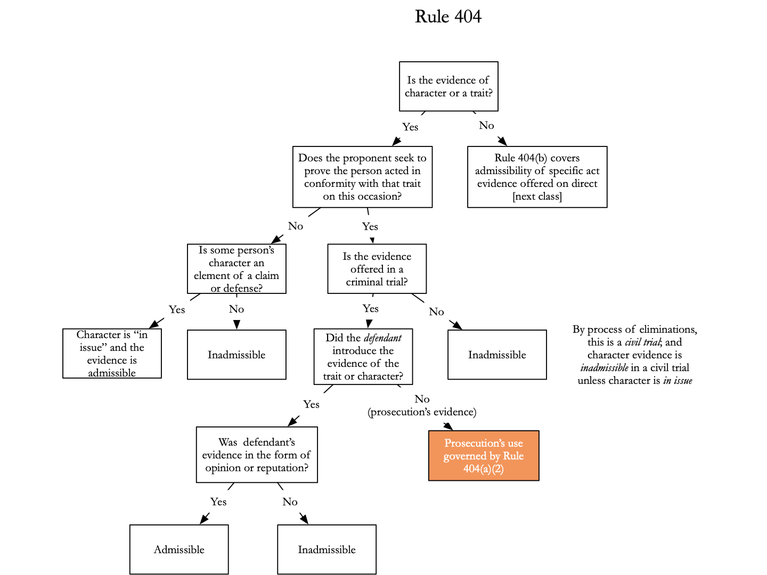
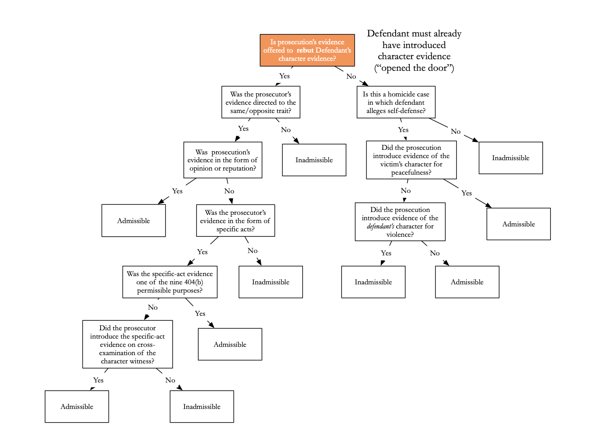

- Other Uses of Specific Conduct and Habit Evidence:

Rule 404(b) Crimes, Wrongs, and Other Acts
- Prohibited Uses. Evidence of a crime, wrong, or other act is not admissible to prove a person’s character in order to show that on a particular occasion the person acted in accordance with the character.
- Permitted Uses; Notice in a Criminal Case. This evidence may be admissible for another purpose, such as proving motive, opportunity, intent, preparation, plan, knowledge, identity, absence of mistake, or lack of accident.
*do we need to know 404(b)(3)?*

Notes on 404(b)(2):
- Cannot make inference, general trait → specific act, or specific act → general trait, but you can make the inference specific act → specific act under 404(b)(2)
- 404(b)(2) provides non exhaustive list of uses that do not make the inference from general trait to particular act
- Evidence is admissible for other purpose, to prove intent, motive … etc - (mimickop)
Motive (Boyd)
Intent (Beechum)
Mistake (absence of mistake, lack of accident)
Identity (Dossey)
Common plan (Lewis)
Knowledge (Crocker)
Opportunity (DeJohn)
Preparation
- Trick is to identify permissible purpose under 404(b)(2) then ask for limiting instruction under 105 to tell jury to ignore impermissible purpose
- Also you still have to do a 403 balancing test

Things to remember in general - character evidence two uses:
- Proponent wishes to introduce evidence of defendant’s prior specific acts
  - Non character use = inference from specific act to specific act via MIMICKOP
  - Character use = inference from general trait to specific act

United States v. Beechum (intent)
Rule -Where extrinsic offense evidence is relevant to a 404(b)(2) issue, it may be admissible if (1) the evidence is relevant to an issue other than the defendant’s character propensity and (2) the evidence possesses probative value that is not substantially outweighed by its undue prejudice and meets the other requirements of Rule 403
Facts - Beecham was convicted of unlawfully possessing a silver dollar that he knew to be stolen from the mail. Government sought to introduce evidence of 2 credit cards found in beecham’s wallet, the cards had been mailed 10 months prior to 2 different addresses on his route
Issue - was it proper to admit the credit cards as evidence?
Holding and Reasoning - It was proper to admit evidence of 2 stolen credit cards. The evidence was offered to prove intent, that he intended to steal card 1 and 2, but also coin, the specific act introduced by government was that he intended to steal card 1 (he kept it in his wallet for 10 months so it was clear he intended to take it), so inference is that he intended to take the coin (not accident that it was in his possession)

US v. Boyd (motive)
Rule -
Facts - Boyd charged with marijuana trafficking. Government wants to introduce evidence that Boyd personally used marijuana and cocaine. Government said reasons for introducing evidence to show he participated in the marijuana trafficking to support his own personal drug use.
Holding and Reasoning - the evidence was properly admitted, evidence was admitted to show motive for marijuana trafficking not to show he bad character. Court weighs probative value and danger under 403 and says probative danger does not outweigh value and there is not really prejudicial danger because conduct of personal drug use is not more sensational or disturbing than the crimes with which he was charged

US v. DeJohn (opportunity)
Rule -
Facts - DeJohn was convicted of uttering and publishing US treasury checks, YMCA security testified he had detained defendant when he found him behind the reception desk in the past, chicago police officer testified that when he was searching DeJohn on an unrelated charge he found check on him and defendant told officer that he got the checks form behind the reception desk
Issue - was it proper to admit testimony of ymca security guard and officer?
Holding and Reasoning - yes it was proper to admit testimony. The evidence shows defendant had access to the reception desk to steal the treasury checks, opportunity was a material issue. (incorrect inference: DeJohn stole checks from desk in the past → he is bad person/thief → he stole checks in this case, correct inference: he stole check from desk in the past → he has opportunity to access desk → he accessed desk in this case)

Lewis v. US (plant and intent)
Rule
Facts - Defendant is convicted of burglary. He argues court erred in admitting into evidence testimony that defendant had participated in the burglary of a garage store earlier on the evening of the post office burgarly
Holding and Reasoning - evidence of testimony about participation in earlier burglary is admissible. Evidence fits into 404(b)(2), it establishes plan and intent, items that were taken during garage burglary were used in post office burglary

US v. Crocker (knowledge)
Rule
Facts - defendant convicted of conspiracy to commit bank theft, he drove friend to bank, defendant trying to say that fact that he knowingly participated was crucial element and gov could not clearly established without prior arrest evidence (Crocker had been arrested before with co conspirtor while in car with counterfeit checks)
Issue - was it abuse of discretion to admit evidence of prior arrest with same friend for same crime (with counterfeit checks)
Holding and Reasoning - not abuse of discretion to introduce evidence of friends prior arrest for counterfeit check. fact that defendant had been arrested before with same guy was highly probative of his knowledge that friend’s checks and his trips to the banks were for illicit purpose, he could not say he thought he was merely driving his friend to the bank

US v. Dossey (identity)
Rule
Facts - appellant convicted of armed bank robbery, bank teller testified that robber had blond hair and wore blue shirt and had pink glasses, other woman testified that appellant told her she robbed a bank in arkansas and wore blonde wig with pink glasses, woman and appellant robbed bank together and appellant wore same costume
Issue - was the testimony of woman who had robbed bank with her admissible?
Holding and Reasoning - testimonial evidence was relevant to prove identification, modus operandi and disguise can prove identity, substantial probative value and was not outweighed by possibility of unfair prejudice, these marks of identify are sufficiently unique to mark out this person, It has to be a unique identifier - so it matters that this person had specific wig and glasses, only the cases where she wore the same disguise are admissible

US v. Wright
Rule
Facts - defendant charged with distributing cocaine, 3 plain clothes officers bought crack from man on street, they took photos of the man, officers said man was wright, they then taped his phone and recorded conversation where he was telling a woman that he was a drug dealer
Issue - was evidence of taped phone calls admissible?
Holding and Reasoning - this evidence is not admissible, gov argued that phone called was used to establish intent and identity, but there was not issue was intent in the case, the phone call does not help with identity because it only shows that Wright is a drug dealer not that he was the man in the photos, this would be using an impermissible inference of because he is a drug dealer he is more likely than the average person to have committed this crime, use of evidence of other crimes to establish a propensity to commit the type of crime charged is the use of such evidence that 404b forbids, because he sells drugs he sold drugs on this occaison is impermissible inference

US v. Davis
Rule
Facts - Davis arrested with cocaine in backseat, gov used prior conviction of possession, gov argued evidence of prior conviction was to establish knowledge that substance was cocaine and gov on appeal argues it was for intent
Issue - was evidence of prior conviction admissible?
Holding and Reasoning - The evidence of prior conviction is not admissible. Government did not show possession charge is relevant to knowledge in this case because they did not show that the cocaine in the past and in this case looked the same, it may have been a complete different form of cocaine (powder v. crystals), government also cannot use past possession charge to show that he had intent to distribute in this instance

US v. Ekiyor
Rule
Facts - defendant convicted of intent to distribute cocaine, he was found with key to a suitcase with his name on it full of cocaine at airport, def wants to introduce evidence that baggage carriers smuggle drugs sometimes
Issue - can defendant introduce evidence of baggage handlers smuggling?
Holding and Reasoning - this evidence is reverse 404b evidence, acts by third party is inadmissible if it is offered only to support a propensity inference - that is to suggest that it is more likely that the third party conducted himself on another occasion in accordance with the character evidence of the “other act” (third party has done it before so they did it in this instance), this evidence would just show propensity of an entire class (baggage handlers) to engage in smuggling activity,

Huddleston v. US (knowledge / standard of proof)
Rule - Standard for proving prior act is sufficiency of evidence (same of 104(b) conditional relevance) not preponderance of the evidence.
Facts - Huddleston was convicted of selling stolen goods and possessing stolen property, Huddleston said that all appliances he sold were provided to him form Leroy Wesby and that he did not know they were stolen. Government sought to introduce similar act evidence - he had sold a bunch of memorex tapes at a low price and they were also stolen,
Issue - did prosecution need to prove by preponderance of the evidence that
Holding and Reasoning - Prosecution does not need to prove this by a preponderance of the evidence, trial judge only needs to decide whether jury could reasonably find it to be true, jury could find it reasonably to be true that items in prior act had been stolen because of quantity and price

Problems from book:
Page 305 - 306 - 4.9, 4.10 (class 09/13)

- Habit Evidence:

Rule 406. Habit; Routine Practice
Evidence of a person's habit or an organization’s routine practice may be admitted to prove that on a particular occasion the person or organization acted in accordance with the habit or routine practice. The court may admit this evidence regardless of whether it is corroborated or whether there was an eyewitness.

Habit = regular response to a repeated specific situation
- To prove someone has a habit, proponent must show at the very least that person acts in the same way over and over against on lots of occasions in response to specific stimulus
- No stimulus no habit
- There is regular repeated test (emphasis that habit is regularly repeated) and semi automatic test (emphasis habit being non volitional) -
- Habit evidence should not say anything good or bad about the person, if it is something that would prove good character it may not be habit evidence (ex: rabbi testifies defendant observes sabbath and doesn't go out on saturdays)

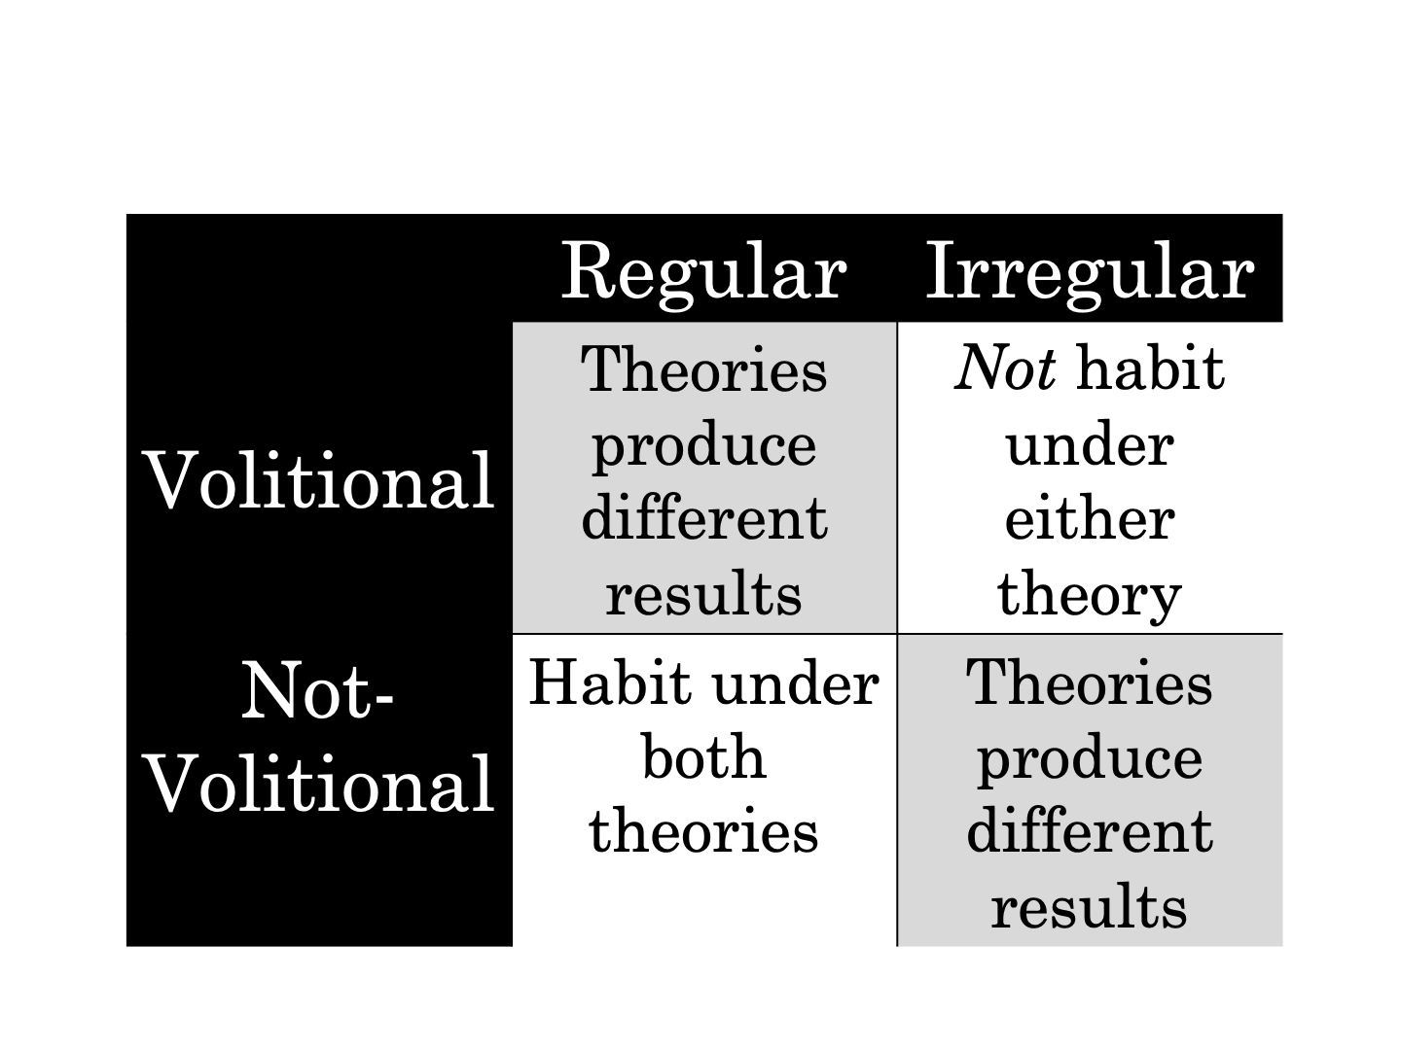
Examples:
- Guy has rabbi testify that he observes sabbath and never goes out on saturdays - court said this is not allowed a habit evidence - probably applying semi automatic test and says this action is volitional
- Guy is pilot and everytime he gets into a plane he demands to fly the plan. Court allows this has habit evidence - court probably apply regularly repeated test because this action is not really non volitional

Kornberg v. US
Rule
Facts - Kornberg underwent surgery to improve hearing, but nerve got damaged and he got partial hearing loss, he claims he was not given sufficient information about risks of surgery. Doctor introduces habit evidence that he informs patients of risks before every surgery,
Issue - was there plain error in admitting the evidence of doctor’s habits about informing patients
Holding and Reasoning - there was no error. Doc said he did 40 surgeries, court is applying regularly repeated test, because this habit probably would be considered volitional but they emphasize it was something he did regularly so they allow it as habit evidence

Ortiz v. City of New York — this case is confusing to me i don't really understand what we are supposed to get from it
Rule -
Facts - Plaintiff argues he was not drunk on day of incident and that police wrongfully assaulted and seized him. Defendant police officers assert that plaintiff was combative and drunk on day of incident. Defendants want to introduce medical records (records say that he was drunk, combative, and violent) for day of the incident, defendants also want to introduce medical records for 3 earlier dates when plaintiff was admitted to the hospital to be treated for intoxication, they want to prove he has chronic alcohol abuse. They argue it is admissible as habit evidence.
Holding and Reasoning - Court only allows medical records for the day of incident and not prior dates. Other circuits are split on whether prior dates of intoxication can be introduced to prove person was drunk on other occasion. This court does not want to allow it.

Questions from book
Page 311 - 4.11 (class 09/13)

- Sexual Assault and Molestation:

Rule 412. Sex Offense Cases: The Victims’s Sexual Behavior or Predisposition
- Prohibited Uses. The following evidence is not admissible in a civil or criminal proceeding involved alleged sexual misconduct:
- Evidence offered to prove that a victim engaged in other sexual behavior; or
- Evidence offered to prove a victim’s sexual predisposition
- Rule 402a2 allows defendant to open the door by introducing evidence of his own character or vic character - but 412 is a type of character trait that is off the table
- Rule 412a - bans the use for purposes of introducing vic past sex conduct, other sexual behavior or her predisposition to engage in sex activity, it also excludes behavior that a fact finder might infer and willingness to engage in sexual activity such as prior offers to engage in sexual intercourse
- ACN says it extends to sexual fantasty and way vic dresses and lifestyle if used to suggest sexual character
- Exceptions:
- Criminal Cases
- Evidence of specific instances of a victim’s sexual behavior, if offered to prove that someone other than the defendant was the source of semen, injury, or other physical evidence;
- This exception applies “where the prosecution has directly of indirectly asserted that the physical evidence originated with the accused”
- defendant can rebut with evidence that victim had sex with someone else
- Evidence of specific instances of a victim’s sexual behavior
- Admissible pursuant to this exception might be evidence of prior instances of sexual activities between the alleged victim and the accused, as well as statements in which the alleged victim expressed an intent to engage in sexual intercourse with the accused, or voiced sexual fantasies involving the specific accused
- Evidence whose exclusion would violate the defendant’s constitutional rights.
- Example; due process right and confrontation clause
- Civil Cases. In a civil case, the court may admit evidence offered to prove a victim’s sexual behavior or sexual predisposition if its probative value substantially outweighs the danger or harm to any victim and of unfair prejudice to any party. The court may admit evidence of the victim's reputation only if the victim has placed in it controversy.
- This test for admitting evidence offered to prove sexual behavior or sexual propensity in civil cases differs in three respects from the general rule governing admissibility set forth in Rule 403
  - First, it reverses the usual procedure spelled out in Rule 403 by shifting the burden to the proponent to demonstrate admissibility rather than making the opponent justify exclusion of the evidence
  - Second, the standard expressed in subdivision (b)(2) is more stringent than in the original rule; it raises the threshold for admission by requiring that the probative value of the evidence substantially outweigh the specified dangers
  - Finally, the Rule 412 test puts “harm to the victim” on the scale in addition to prejudice to the parties

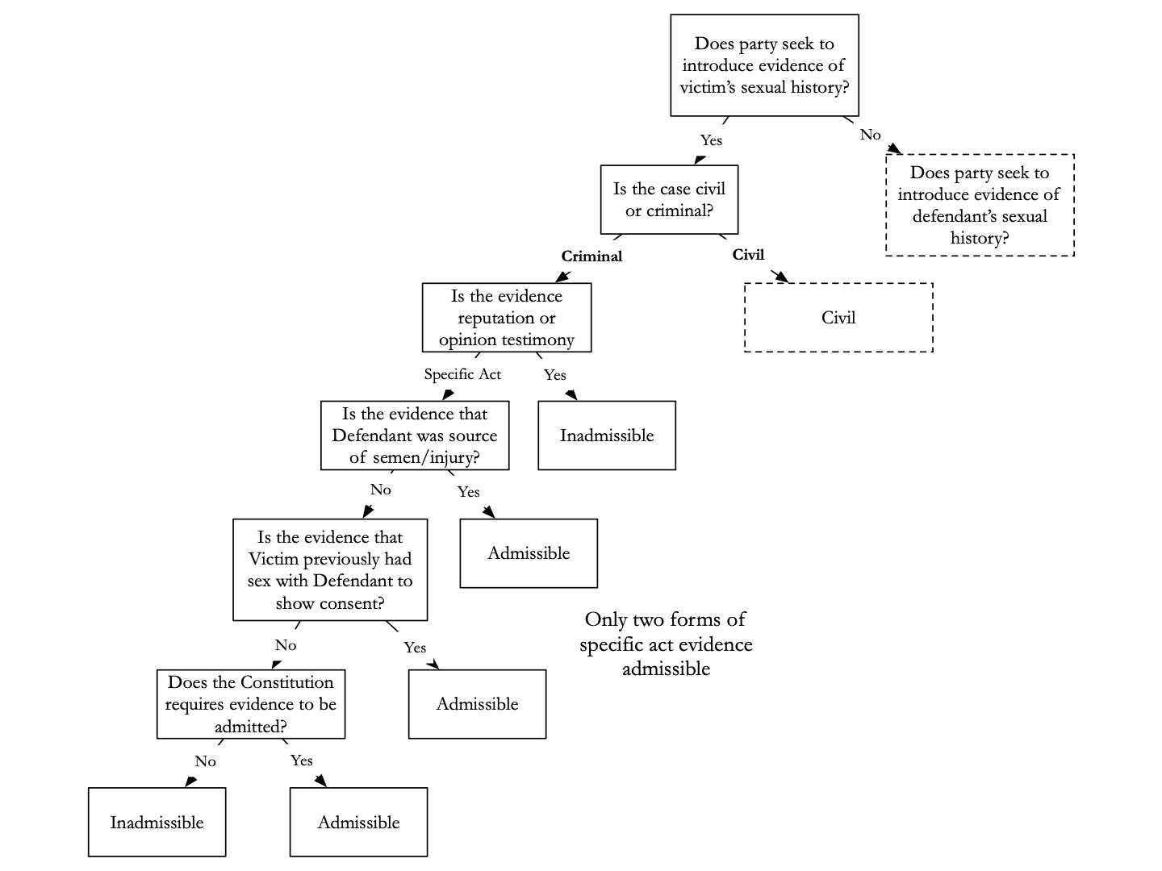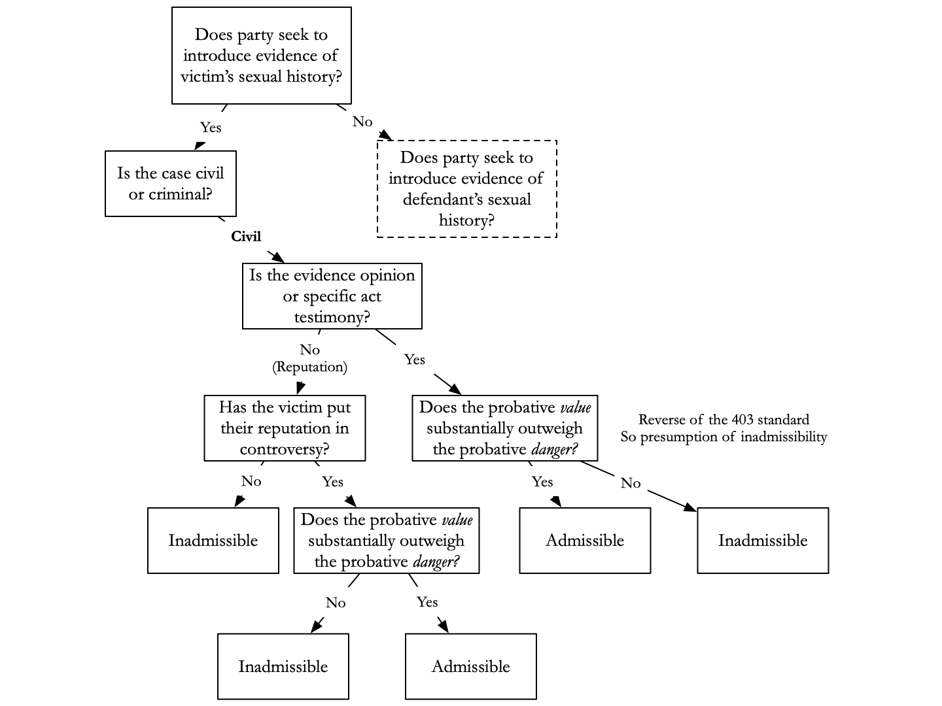

Graham v. State (is this the old law?)
Facts - The defendant wants to introduce evidence that the victim was unchaste, he wants to bring in evidence that she was the first aggressor and she made sexual advances to defendant and when he rejected him, she attacked him and defendant was just defending himself
Holding and Reasoning - judge allows in this evidence he thinks the victim's character is relevant to whether the man’s story is credible.

Olden v. Kentucky (sexual assault and confrontation clause)
Rule - A defendant charged with sexual assault is permitted, within reasonable limits that avoid undue prejudice to the complainant, to cross-examine the complainant about a motive to lie about the alleged assault.
Facts - A black man is accused of raping a white woman. Victim says she is raped by two men Olden and Harris, Olden said that the victim lied about being raped. The victim was married but at the time of the inciden she was living with another man who was black. Olden said the victim lied about being raped to protect her relationship with Russel, the black man who she was living with, because he would be suspicious when he saw her exit the car with another man.
Issue - Can the defendant introduce evidence of the victim’s relationship with Russel?
Holding and Reasoning - The court of appeals does not allow this under rule 403, because the court thinks it would be unfairly prejudicial if the jury heard about her inter racial extramarital relationship. The supreme court reverses and holds that the relationship with Russel is vital to explain why the victim had a motive to lie and supreme court held that the state could not prevent the defendant from confronting a witness about her reason to lie, the defendants case rested on her reason to lie about the rape,

US v. Willis (criminal case) (412(b)(2)(A) exception)
Rule - exception to 412 applies when prosecution has directly or indirectly asserted the physical evidence originated with the accused
Facts - Willis charged with sexual abuse, he admits to the sexual conduct but says it was consensual. Earlier that evening Victim was babysitting. Willis wants to introduce evidence the victim had sex with her boyfriend while babysitting earlier in the evening. He wants to introduce sexual assault examination that shows semen from both Willis and victims boyfriend.
Issue - can the defendant introduce evidence that victim had another sexual encounter on the same evening when prosecution is did not seek to prove charges by showing physical evidence originated exclusively with him?
Holding and Reasoning - Willis cannot introduce the evidence of the sexual assault exam. This is not a case where the government sought to prove the charges against Willis by showing that physical evidence originated exclusively with him. Willi admits he had sex with her so evidence she had sex with someone else earlier does not make it more or less probable that she consented to Willis.

US v. Thompson (constitutional exception to 412)
Rule - The defendant generally may not introduce evidence of the victim’s pre-indictment and post-indictment sexual behavior.
Facts - Defendant has been charged with sex trafficking of two victims. The Defendant is trying to introduce evidence concerning the victims’s sexual behavior, including prostitution prior to and subsequent to the time period at issue. Defendant claims it would violate his constitution rights (due process and confrontation clause) to exclude the evidence.
Issue - can the defendant bring in evidence of past prostitution of the victims?
Holding and Reasoning - The court holds this evidence is clearly the type of evidence that should be inadmissible under 412(a). Court also holds that this should not come in under the exceptions of 412(b)(1)(C) because it does not violate the confrontation clause. Confrontation clause guarantees the right to cross examine government witnesses but the court retains latitude insofar as the confrontation clause is concerned. The court can impose reasonable limits on cross examination based on concerns of things like harassment, prejudice, confusion of the issue, the witness’s safety etc. here a reasonable limit would be to prohibit defendant from cross examining sex trafficking victims about acts of prostitution that are unrelated to the charges in the indictment. Even if 412(a) did not prohibit this, it still would be prohibited because it has little impeachment value and bringing in the evidence would not be about truth of victim’s testimony

Polo-Calderon v. Corporacion Puertorriquena (civil case)
Rule - 412(2) reverse 403 balancing for civil cases. In civil cases involving alleged sexual misconduct, evidence of the victim’s sexual behavior or sexual predisposition is inadmissible if the defendant has not established that the probative value of the evidence substantially outweighs its prejudicial effect.
Facts - Plaintiff sues company he works for and his supervisor for sexual harassment. Defendants want to introduce evidence of the plaintiff’s dating history and the fact that he is gay.
Holding and Reasoning - court applied a reverse 403 balancing, so probative value of the evidence has to outweigh the probative danger. In this case the value does not outweigh the danger. Court also states that the fact that he may have welcomed sexual advances from his workplace in no way pertains to his sexual harassment claim against defendant.

Rule 413. Similar crimes in Sexual- assault cases
- Permitted uses. In a criminal case in which a defendant is accused of a sexual assault, the court may admit evidence that the defendant committed any other sexual assault. The evidence may be considered on any matter to which it is relevant.
- If def accused of sexual assault prior sexual assaults are admissible
- Sexual assault include most forms of offensive sexual touching - defendant does not need to be accused of a crime for it to count
- Does not include lude conversation, emails or texts

Rule 414. Similar Crimes on Child-Molestation Cases
- Permitted Uses. In a criminal case in which a defendant is accused of child molestation, the court may admit evidence that the defendant committed any other child molestation. The evidence may be considered on any matter to which it is relevant
- Under age 14

Rule 415. Similar Acts in Civil Cases Involving Sexual Assault or Child Molestation
- Permitted Uses. In a civil case involving a claim for relief based on a party’s alleged sexual assault or child molestation, the court may admit evidence that the party committed any other sexual assault or child molestation. The evidence may be considered as provided in Rules 413 and 414.
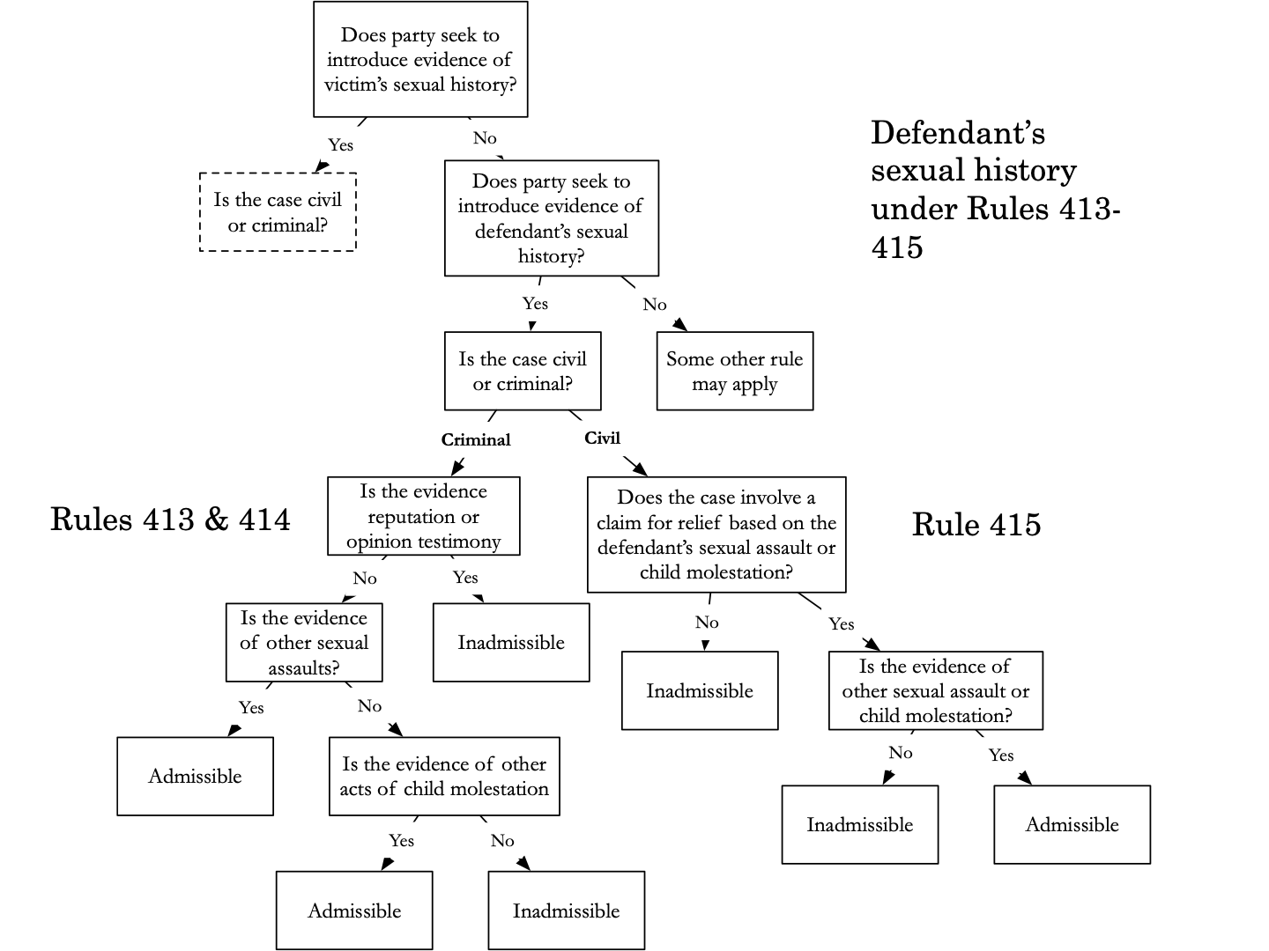
US v. LeCompte
Rule - when determining if prior offense can be introduced under 414, court must still do a 403 balancing test. (probative danger cannot outweigh probative value)
Facts - defendant is charged with sexual assault of his niece by marriage, prosecution wants to introduce evidence of a prior uncharged sexual offense against a previous niece by marriage.
Issue - does probative value of prior offense outweigh probative danger in this case?
Holding and Reasoning - this court thinks the probative danger (of the unfair prejudice the prior offense would give him) does not outweigh the probative value. The court points to fact that prior offense and current offense are substantially similar and differences were small, and that 8 year lapse between two offenses is not significant

US v. Majeroni (rule 414)
Rule -
Facts - defendant charged with possession of child porn. Prosecution wants to introduce a prior charge of possession of child porn in 2001 through Rule 414 (current case is in 2013). Defendant argues too much time has passed for charge to have proactive value, danger outweighs value,
Issue - is a prior charge of a similar offense from 12 years ago probative?
Holding and Reasoning - District court disagreed and found similarity between crimes was of significant probative value and the jury would weigh the passage of time in considering the evidence of the prior conviction. Court also states rule 414 does not contain a time limit

US v. Cunningham
Rule - “propensity” evidence and “motive” evidence need not overlap
Holding and Reasoning - Rule 414 was added to make evidence of prior acts of child molestation expressly admissible without regard to 404(b). A person’s motive to commit the crime with which he is charged is revealed by his past commission of the same crime. Court draws analogy to “firebug” a person who like to set fire because they like to watch fire, their past commission of an arson crime is motive for another arson case.

- OTHER FORBIDDEN INFERENCES:

- 407 - 411 → these rules have similar structure, there is permitted purpose then prohibited purpose
- For each rule you have to identify evidence covered by rule then determine whether the evidence is offered for the prohibited purpose of the permitted one

  - Subsequent remedial measures
Rule 407. Subsequent Remedial Measures
When measures are taken that would have made an earlier injury or harm less likely to occur, evidence of the subsequent measures is not admissible to prove:
- Negligence
- Culpable conduct
- A defect in a product or its design
- A need for a warning or instruction
But the court may admit this evidence for another purpose, such as impeachment or–if disputed–proving ownership, control, or the feasibility, or precautionary measures.
- Block inference that making safety improvement after injury shows a party was cupable by not taking action sooner
- Permissible purpose listed are other types of issue that might be in contention at trial, example of proving ownership = if person denies they were owner evidence of subsequent remedial measure can show they made those changes because they had title or control (control is same)

Clausen v. Storage Tank Development Corp. (control exception to rule 407)
Rule - Rule 407 allows evidence of subsequent remedial measures when offered to prove control.
Facts - plaintiff slipped and fell and injured his back while working as pile driver at a job site at a fuel terminal facility. He slipped on some ramp. Storage Tank is arguing that evidence of them replacing the ramp in 1992 (3 years after plaintiff fell) should not have been allowed.
Holding and Reasoning - There was no plain error by allowing evidence of Storage Tank replacing the ramp. The parties agreed that who controlled the ramp was a material issue in the case (either Storage Tank had control over this ramp or another company Gourdreau). Storage Tank had asserted that Gourdeau had control of the ramp. Storage Tank tried to argue this evidence was not probative because its was 3 years later and that jury probably misused the evidence and used considered the evidence for liability/fault. But this court did not find the argument successful because trial court gave limiting instruction to only use evidence for control.

Diehl v. Blaw-Knox (rule 407)
Rule - Rule 407 does not exclude subsequent remedial measures taken by a non party
Facts - Plaintiff worked from a construction company called IA. While working they were using a road widener manufactured by Blaw. When they were reversing the road widener plaintiff was behind it and did not know ti was backing up and it hit him. After the accident IA mechanic made adjustments to the road widener like putting on beeping noise so people could hear it backing up. Plaintiff wanted to introduce the mechanic work as evidence
Issue - can IA’s subsequent remedial measures be introduced?
Holding and Reasoning - Plaintiff can introduce this evidence because subsequent remedial measure was taken by IA, who is not a party. Blaw is the defendant party in this case not IA so the measures taken by IA can be introduced.

  - Compromise Offers and Negotiations
Rule 408. Compromise Offers and Negotiations
- Prohibited Uses. Evidence of the following is not admissible—on behalf of any party—either to prove or disprove the validity or amount of a disputed claim or to impeach by a prior inconsistent statement or contradiction:
- Furnishing, promising, or offering—or accepting, promising to accept, or offering to accept—a valuable consideration in compromising or attempting to compromise the claim; and
- Conduct or a statement made during compromise negotiations about the claim—except when offered in a criminal case and when the negotiations related to a claim by a public office in the exercise of its regulatory investigative, or enforcement authority
- Exceptions. The court may admit this evidence for another purpose, such as proving a witness’s bias or prejudice, negating a contention of undue delay, or proving an effort to obstruct a criminal investigation or prosecution.
- Precludes party from introducing evidence that a party engages in civil settlement offers, purpose is to encourage settlement of disputes without fear of offer later being used against them if settlement process breaks down
- Applies to communication / conduct of parties during negotiation process not only offer amount
- For this rule to apply there must dispute over liability or amount to be paid - also this rule applies to offers to compromise and not admissions of guilt (if the party admitted guilt it could still come in?)
- Cannot use this communication in settlement agreement to attack witnesses credibility (prior inconsistent statement or contradicting something they said during testimony, but still can come in for bias)

US v. Davis (rule 408)
Rule - Rule 408 excludes evidence of settlement offers and negotiations when the evidence is “offered to prove liability for, invalidity of, or amount of a claim” / expectation if person is trying to “buy off a witness”
Facts - Davis was national treasurer of frat. He was charged with stealing from the frat. At trial Davis’s successor, Hammock, gave testimony about a conversation they had. Hammock asked Davis why he wrote 29,000$ of fraternity checks out to cash and that the money was missing. Davis responded we can split the 29,000 and make this situation go away. Hammock said there was actually 100,000 missing and Davis said he could pay and Hammock said if he wanted to negotiate he had to talk to legal counsel.
Issue - was this conversation admissible under 408?
Holding and Reasoning - Court holds this conversation was not admissible under 408. There can be no doubt Davis offered to compromise a disputed claim. Gov introduced the convo to prove Davis’s guilt which is prohibited or in words of 408 “liability.” there is an expectation if person is trying to “buy off a witness” but court here does not think Davis was trying to bribe Hammock (? but to me it really seemed that is what he was trying to do lol)

Ramada Development Co. v. Rauch (rule 408)
Rule - A report can represent collection of statement in an effort to compromise and therefore be inadmissible under 408, and rule does not indicate that there must be a pre-trial understanding or agreement between parties regarding the nature of the report
Facts - Rauch signed contract with Ramada Development to build motel. Rauch occupied motel but refused to make further payments and Rauch sued for balance due under the contract. Rauch sought to introduce a report that confirmed majority of alleged defects but district court ruled it inadmissible because report was tool used in an unsuccessful attempt to settle.
Issue - was the report intended to be part of the negotiations toward compromise?
Holding and Reasoning - The report fits squarely within rule 408 and it was correct for district court to rule it inadmissible. Report was commissioned by Ramada to prepare a report that would function as a basis of settlement negotiations regarding the alleged defects. Report represents collection of statements made in the court of an effort to compromise

Carney v. American University (rule 408)
Rule - Rule 408 is inapplicable when the claim is based upon some wrong that was committed in the course of settlement discussions, e.g. breach of contract or unfair labor practice)
Facts - Carney (plaintiff), who was African American, was the director of student services at The American University (American) (defendant). Carney was named acting dean of students. Carney applied for the permanent dean position, but was not selected. Carney returned to her role as director of student services. American eliminated Carney’s position two years later during a period of downsizing. Carney sent a letter to American stating that she intended to sue for discrimination. American responded to Carney’s discrimination claim with a settlement letter indicating that Carney might be entitled to an additional three months’ severance pay under American’s personnel policies. However, American did not give Carney the additional three months’ severance pay. Carney brought suit against American in the United States District Court for the District of Columbia, claiming, in addition to discrimination, that American’s failure to give her the additional three months’ severance pay was in retaliation for her lawsuit. Carney sought to introduce the letter from American to prove her retaliation claim, but the district court excluded the letter under Federal Rule of Evidence (FRE) 408.
Holding and Reasoning - this court disagrees with district court and holds it is not inadmissible under 408. Although settlement letters are inadmissible to prove liability or amount, they are admissible “when evidence is offered for another purpose.” in particular to be used to establish and independent violation (here, retaliation) which is unrelated to the underlying claim which was subject of correspondence letters.

PRL USA Holdings v. United States Polo Associations (rule 408)
Rule - using evidence for estoppel by acquiescence is “another purpose” under the exception of rule 408
Facts - PRL (polo ralph lauren) sued USPA because they were using a logo similar to theirs. At trial def offered testimony that during settlement negotiations PRL gave USPA consent to use a version of the double horsemen logo and implied it was not offensive. They were trying to prove affirmative defensive of estoppel by acquiescence. PRL objected under rule 408.
Holding and Reasoning - testimony allowed. This falls under exception. Evidence of settlement negotiation cannot be used to prove liability but the exception is that they can be used for another purpose. Using it for estoppel by acquiescence is another purpose and therefore allowed.

  - Offers to pay medical expenses
Rule 409. Offers to Pay Medical and Similar Expenses
Evidence of furnishing, promising to pay, or offering to pay medical, hospital, or similar expenses resulting from an injury is not admissible to prove liability for the injury.
- Prohibited purpose to show person giving medical assistance is liable but permissible to show other conduct or statement unrelated to payment (such as discussions why person paid)

- Plea deals
Rule 410. Pleas, Plea Discussions, and Related Statements
- Prohibited uses. In a civil or criminal case, evidence of the following is not admissible against the defendant who made the plea or participated in the plea discussions:
- A guilty plea
- A nolo contendere plea
- A statement made during a proceeding on either of those pleas under federal Rule of Criminal Procedure 11 or a comparable state procedure; or
- A statement made during plea discussion with an attorney for the prosecuting authority if the discussions did not result in a guilty plea or they resulted in a later-withdrawn guilty plea.
- Exceptions. The court may admit a statement described in rule 410(a):
- In any proceeding in which another statement made during the same plea or plea discussions has been introduced, if in fairness the statements ought to be considered together; or
- In a criminal proceeding for perjury or false statement, if the defendant made the statement under oath, on the record, and with counsel present.
Notes on rule 410:
- Evidence impermissible against defendant or from negotiations over pleas that do not result in guilty conviction; permissible for clarification or perjury proceeding (criminal settlement equivalent of 408)
- Negotiations must have fallen apart in one of three way (1) no plea is entered, (2) plea is entered but later withdrawn, (3) def enters plea of no contest (call nolo contendere)
- As with rule 408 the rule applies only to negotiations not to admissions so the contents of a criminal defendants uncontested admissions made during the plea process and finalized during a guilty plea that is not withdraw are admissible at trial

US v. Mezzanatto
- Makes rule 410 largely irrelevant, common condition of entering plea negotiations is to waive protections of rule 410 and is it very common for defendant to do so
- ???? do i need more than this for this case

US v. Mergen
- Similar to Mezzanatto defendant signed waiver of rights under 410

- Liability Insurance
Rule 411. Liability Insurance
Evidence that a person was or was not insured against liability is not admissible to prove whether the person acted negligently or otherwise wrongfully. But the court may admit this evidence for another purpose such as proving a witness’s bias or prejudice or proving agency, ownership, control.
- Because someone has insurance doesn't mean they are engaged in risky behavior

Charter v. Chleborad (411)
Rule - evidence of existence of insurance is not admissible to show negligence but is admissible for another purpose like showing bias
Facts - claim for medical malpractice. Plaintiff was hit by truck, accident cause injuries to legs, he was sent to hospital and defendant performed surgery, as result of complications plaintff transfered to another hospital where both legs were amputated, dr. lichtor testified for plaintiff about cause of complications was def negligence, def than offered testimony of mr. alder about dr. lichtor not having a reputation for telling truth, but it later came out in plaintiffs motion for new trial that mr alder was employed by same liability carrier who represents defendant
Holding and Reasoning - in this case the fact that defendant’s insurer employed Mr. Alder was clearly admissible to show possible bias of that witness. Plaintiff’s claim rested for the most part on credibility of that witness. The insurance here was used to prove bias not liability so it is admissible

Higgins v. Hicks Co. (411)
Rule - evidence of liability insurance may be admitted if relevant to an issue in the case or to prove bias or prejudice of witness
Facts - there was construction on highway and there was motorcycle accident. Guy in crash suing Hicks Co who was under contract with south dakota and claim hicks co and south dakota were negligent in opening both eastbound lanes with warning signs about construction. They wanted to introduce evidence that south dakota had insurance to eliminate bias of the jurors as taxpayers of the state of south dakota.
Holding and Reasoning - court holds admitting evidence of insurance to eliminate bias of jurors as taxpayers in state is not allowed under exception of 411. They hold this is not relevant to the issue

Practice questions in class 9/20

- TRIAL MECHANICS

Rule 611. Mode and Order of Examining Witnesses and Presenting Evidence
- Control by the court; purposes. The court should exercise reasonable control over the mode and order of examining witnesses and presenting evidence so as to:
- Make those procedures effective for determining the truth;
- Avoid wasting time; and
- Protect witness from harassment or undue embarrassment
- ultimate authority over mode and order rests with judge
- Scope of cross-examination. Cross examination should not go beyond the subject matter of the direct examination and matters affecting the witness’s credibility. The court may allow inquiry into additional matter as if on direct examination
- 611(b) limits scope of matters that can be inquired into on cross - cross should not go into matters that go beyond subject matter of direct (subject matter of direct limits scope of cross) - calling a witness and only asking them narrow questions on direct also limits other side on their cross
- ^ but courts do no interpret this limitation strictly - they allow cross to explore inferences and implications (especially credibility)
- Leading questions. Leading questions should not be used on direct examination except as necessary to develop the witness’s testimony. Ordinarily, the court should allow leading questions:
- On cross-examination; and
- When a party calls a hostile witness, an adverse party, or witness identified with an adverse party.
- 611(c) gives judges discretion to allow leading questions on direct

Leading question = one that suggests to the witness the answer desired by the questioner

Hostile witness = it is some who is evading questions and is uncooperative in answer non leading direct examine questions or is interfering with elicitation of testimony, need not be angry witness

Stone v. Peacock (rule 611a)
Rule - judge can make modification the traditional process whereby the parties can call all witnesses in any order they choose, by ordering a plaintiff to take the stand himself first before any other witness to get the chronology or basic facts out in complex case, but defendant prevented from cross examining him
Facts - stone lost jury verdict in his suit against officers claiming they terminated his employment in retaliation for his speaking out about improper use of public property funds, district court required stone to testify first for chronology, stone counsel protested to the reordering of witnesses
Holding and reasoning - 611(a) gives court reasonable control over the order and presentation of evidence,

Elgabri v. Lekas (rule 611a/ 611c)
Rule - Plaintiff required to use defendants on case-in-chief only to introduce evidence he could not obtain from other sources / plaintiff doesnt have unfettered right to call defendant during his case in chief
Facts - plaintiff called defendant to the stand as part of his case in chief. Court limited the plaintiff’s examination of the witness to only subject matter that could not be obtained in another way
Holding and Reasoning - plaintiff does not have unrestrained right to call defendants during their case in chief. It was within court’s discretion to place this limit on plaintiff under rule 611. Plaintiff was able to cross examine other defendant during their presentation and only objecting to the order of presentation so this was not abuse of discretion. Just because 611(c) says you can use leading questions for adverse parties on direct examination does not mean you have unrestrained right to to call defendants during your case in chief if you are plaintiff
US v. Wilford (rule 611a ?)
Rule - decision whether to allow a party to present evidence in surrebuttal is committed to the sound discretion of the trial court
Facts - Wilford and 2 co defendants were convicted of extorting drivers at a waste treatment cedar rapids construction site, Gov had witness, who was an investigator, testify to observations taking place at other construction site to show similarities of what happened to both sites
Holding and Reasoning - no abuse of discretion in not allowing evidence in defendant’s surrebuttal. Even though a party is normally entitled to impeach the credibility of an opponent’s key witness, in this case the investigator was not a key government witness and his evidence regarding similiarity of pittsburg and desmoins incident was merely cumulative so not unfairly prejudicial to not allow defendants to present evidence in surrebuttal.

US v. Carter (611b and scope of subject matter on cross)
Rule - Rule 611(b) limits cross-examination to subject matter of direct examination, it also grants trial court discretion to permit inquiry into additional matters as if on direct examination.
Facts - Carter charged with robbery. Gov did not call Riggins during its case in chief, defendant called Riggins as part of his defense and on cross gov went beyond scope of defendant’s direct examination of Riggins. It exceed scope on 3 subjects (1) def told riggins he committed robberies, (2) riggins remembering what clothes def was wearing day of robbery, (3) recognition of clothes discarded following first robbery were similiar to clothes def owned
Holding and reasoning - not abuse of discretion to let cross examination go beyond scope of direction examination. in light of probative value of evidence trial judge did not abuse his discretion by allowing gov to exceed scope of Riggins direct examination

US v. Nabors (leading questions and child witness)
Rule - Leading questions permitted under exception that applies to “the child witness or the adult with communication problems.”
Facts - Defs are 2 brothers convicted of robbery, In trial, 12 year old nephew was witness, he testified about how he saw them in the basement after the robbery talking about all the money they got, During direct examination prosecutor asked nephew what the brothers said when they saw him, nephew said “they said, ‘tray is here’” but prosecutor asked, “tray, have you told me before what they said?” because he wanted nephew to say exactly what brothers said which was ”oh shit tray is here”, At the time the def objected to questioning but trial court permitted questions
Holding and Reasoning - Leading questions ordinarily not permitted on direct there is exception for “child or adult with communication problems” In this case the prosecution did not suggest the language used but did press for a repetition of words previously used, Tray’s hesitation of using bad word was understandable, And wording of statement was important because it indicated some alarm at being discovered thus it was proper for the prosecutor to attempt to elicit precise language

v. City of Chicago
Rule - people who work with defendant usually would be seen as an “adverse” witness to the plaintiff
Facts - Chicago police officer, Kusar, entered plaintiffs home an shot and killed dog because dog allegedly lunged at officer, Plaintiff sues, trial court refused to permit counsel for plaintiffs to use leading questions furing direct examination of other officers that work with Kusar
Holding and Reasoning - this was an error but not reversible error. Officers should have been regarded as adverse and therefore should have been subject to leading questions on direct. (They were employees of defendant city of chicago, they worked with Kusar and were present at time of incident). But error is not reversible because there was not clear showing of prejudice. Defendants also called officers as witnesses, so on cross plaintiff could use leading questions against them so they still had this opportunity. Also officers were cooperative when they were questioned on direct.

Rule 106. Remainder of or Related Writings or Recorded Statements.
If a party introduces all or part of a writing or recorded statement, an adverse party may require the introduction, at that time, of any other part–or any other writing or recorded statement–that in fairness ought to be considered at the same time.
- Known as rule of completeness - party can require more of writing or recording to give context
- Limited to only documents or recordings

- COMPETENCE

Rule 601. Competency to Testify in General
Every person is competent to be a witness unless these rules provide otherwise. But in a civil case, state law governs the witness’s competency regarding a claim or defense for which state law supplies rule of decision.
- 3 categories often charged incompetent = children, people with mental illnesses, and addicts - However, such individuals are not always excluded, the only question is whether they can effectively communicate what they perceived
- Other than that people are generally seen as competent (even if they have been convicted as perjurer), unless another rule excludes them like no personal knowledge, etc

Rosen v. US
Rule - jury functions as a lie detector “leaving credit and weight of testimony to be determined by the jury, rather than by the judge rejecting witnesses as incompetent”
Facts - Rosen, Broder, and Wagner charged with conspiracy to steal check from US post. Government calls Border, who has already plead guilty. Defendants claim Border is incompetent to testify because he has forgery conviction and this shows he is a fabricator and liar.
Holding and Reasoning - court holds him competent. Court rejects idea that is is supposed to determine credibility through competence rule. Instead court establishes that credibility should be judged by jury

US v. Lightly
Rule - for witness to be competent all that is required is personal knowledge; capacity to recall; and ability to understand duty to tell the truth
Facts - McKinley was stabbed in his prison cell. Lightly and McDuffie were investigated but only Lightly was charged because McDuffie was deemed criminally insane. Lightly claimed he was only breaking up the fight between McKinley and McDuffie and that McDuffie was the one who stabbed McKinley. Lightly was going to have Mcduffie testify but the court ruled him incompetent because he was subject to hallucinations.
Issue - was it proper for court to categorically rule out a witness with mental issues?
Holding and reasoning - this was an error not to have McDuffie testify. No categorical exclusion of people with mental issues as per se incompetent. All that is required is personal knowledge; capacity to recall; and ability to understand duty to tell the truth and this applies to persons considered to be insane to the same extent that it applies to other persons. Improper for court to disqualify mcduffie becaus his doc said he remembered what happened, he understood oath, and could communicate what happened.

  - Personal Knowledge:
Rule 602. Need for Personal Knowledge
A witness may testify to a matter only if evidence is introduced sufficient to support a finding that the witness has personal knowledge of the matter. Evidence to prove personal knowledge may consist of the witness’s own testimony. This rule does not apply to a witness’s expert testimony under Rule 703.
- Personal knowledge = first hand knowledge acquired by direct perception through one of 5 senses (Personally perceived what she claims to have perceived - seen, heard, smelled, tasted, touched)
- Raises question of condition relevance (rule 104b) - witness claim is only relevant on condition she did or could have perceived it - requires same standard of sufficiency of evidence
- Rule requires proponent to introduce foundation evidence under sufficiency standard contained in 104b to establish she could perceive what she claims to have seen/heard/touched etc

US v. Hickley (rule 602)
Rule - testimony should not be excluded for lack of personal knowledge unless no reasonable juror could believe that the witness had the ability and opportunity to perceive the event that he testified about.
Facts - hickey charged with conspiracy to distribute cocaine. There was mistrial then he retried and found guilty. Ventimiglia was a cocaine addict and a witness for prosecution. Hickey is appealing arguing that court should not have allowed Ventimiglia's testimony because there is lack of evidence to substantiate finds that he had personal knowledge of events upon which to base his testimony.
Holding and Reasoning - not abuse of discretion to allow testimony of Ventimiglia. Despite fact that Ventimiglia's testimony may have been unbelievable to some and in spite of the possibility that his perceptions was sometimes impaired, a reasonable juror could believe that he perceived the course of events. So long as reasonable juror could believe that he perceived what he claims to have seen then it is up to cross examiner to ruin his credibility / make jury not believe him. Threshold to satisfy personal knowledge requirement is low doesn't matter that he is cocaine addict.

Rule 603. Oath or Affirmation to Testify Truthfully
Before testifying, a witness must give an oath or affirmation to testify truthfully. It must be in a form designed to impress that duty on the witness’s conscience.
- oath or affirmation need not take any particular form so long as it establish the witnesses connection to truth telling

- IMPEACHMENT

Point of live witness testimony is to assess the credibility of witnesses and their: perception, memory, sincerity, and narration
- Perception = ability to see or hear events described in their testimony, questions often reveal if witness opportunity and ability to see events
- Memory = memories are fragile and accuracy diminishes over time, in addition to to subjective factors like witness’s confidence in accuracy of memory effect credibility
- Narration and accuracy = person’s ability to describe the things perceived can influence credibility, things like words choice, using generalities, language barriers, and consistency can effect how convincing a witness appears
- Sincerity = even a witness who had an opportunity to observe a recent event clearly who had confidence in her memory and is able to clearly related wha they perceive may nevertheless not be telling the truth, there are many reasons a witness may not be sincere, like they are not truthful person or have bias

Impeachment = effort to prove witness is not telling the truth, usually an attack on one or more qualities mentioned above (perception, memory, narration and accuracy, sincerity)

Structure for assessing credibility:
- One party attacks / impeaches witness’s credibility
- Other party can “rehabilitate” the witness
(cannot rehabilitate / support credibility of a witness if they have not been impeached, under 607 a party can impeach their own witness)

There are limits on extrinsic evidence to impeach a witness
- Intrinsic evidence = evidence abstained through questioning of the witness on the stand in the current proceeding, comes from the witness themself, witness’s own answers to questions when given on witness stand
- Extrinsic evidence = anything other than evidence given by the witness on the stand. Like documents, testimony of a different witness, video, audio etc

Modes of Impeachment:
- Character for truthfulness → shows witness is a liar or has a reputation for dishonesty
- Inconsistency → shows witness has changed her story over time
- Bias → shows that the witness has motive to slant testimony
- Incapacity → shows witness lacked ability to perceive what she claims
- Specific contradiction → shows testimony is demonstrably false

  - Character for Truthfulness
Impeaching a witness by questioning their character for honesty is governed by 3 rules
- Rule 404(a) character evidence - sets aside character for honesty as special type of character evidence that is admissible
- Rule 609 - governs use of the criminal convictions used to impeach
- Rule 608 - governs all other witness character evidence

Rule 608. A Witness’s Character for truthfulness or Untruthfulness
- Reputation or Opinion Evidence. A witness’s credibility may be attacked or supported by testimony about the witness’s reputation for having a character for truthfulness, or by testimony in the form of an opinion about that character. But evidence of truthful character is admissible only after the witness’s character for truthfulness has been attacked.
- Specific Instances of Conduct. Except for a criminal conviction under Rule 609, extrinsic evidence is not admissible to prove specific instances of a witness’s conduct in order to attack or support the witness’s character for truthfulness. But the court may, on cross examination, allow them to be inquired into if they are probative of the character of truthfulness or untruthfulness of:
- The witness; or
- Another witness whose character the witness being cross examined has testified about

Character witness = witness with personal knowledge who testifies about another witness’s character for truthfulness, 608(a) - basically using a character witness,

Rule 608 limits:
- On direct examination proponent can only introduction reputation or opinion testimony
- A party can only introduce specific act evidence to prove honesty or dishonesty on cross examination of a witness
- On cross examination if the proponent wants to elicit specific act evidence they can only do this with intrinsic evidence - no extrinsic evidence of specific acts and cross examiner must take the answer that the witness gives and cannot rebut (even if they know the witness is lying, similar to rule 405)

US v. Lollar (608(a))
Rule - A witness may testify about whether he would believe the defendant under oath if the defendant has been called to testify.
Facts - lollar was convicted for interstate transportation of stolen property, lollar testified at trial, gov recalled one of its witnesses and asked if he would believe lollar under oath, witness said no, lollar objected to this question but it was overruled, appellant now argues that it was error to allow witness to offer his opinion to appellant’s veracity
Issue - did trial court abuse discretion when it recalled witness to ask if they would believe the defendant under oath?
Holding and Reasoning - court did not abuse discretion. Once Lollar testied, he put his own credibility in issue because anyone can impeach any witness for character for untruthfulness. After Lollar testified the government was free to offer evidence bearing on the defendants believability as a witness. Rule 608(a) states that witnesses may be asked directly to state their opinion of the principle witness’s character for truthfulness

Glaze v. Childs (608(b))
Rule -
Facts - Glaze was prisoner, Childs was a guard, Glaze sued arguing Childs violated his constitutional rights by failing to protect him from a violent attack, Glaze’s cellmate testified that he warned Childs about the attack, Childs testified he was not warned, jury returned for Childs, Glaze now argues he should have been able to cross examine Childs about a certain incident where Childs gave an inmate a cigarette which was against policy,
Issue - did court properly decline this inquiry under 608(b)?
Holding and Reasoning - yes court properly decline this inquiry under 608(b). This evidence is a specific act but it does not show deceit or fraud, no one is saying Childs lied about passing the cigarette only that he violated the policy by doing so, so it is not probative of character for truthfulness - Not substantive character under 404(b); no lying or deception, so not credibility character evidence, so inadmissible to prove dishonesty -

US v. Rosa
Rule - You cannot ask specific act questions about conduct that does not bear on truthfulness or untruthfulness.
Facts - Rosa, kostrick, and romano were charged with cocaine trafficking, rosa plead guilty and testified for the government, Kostrick and Romano argue that district court improperly prohibited their cross-examination of Rosa regarding certain prior criminal conduct (bribery)
Holding and Reasoning - trial court did not abuse discretion when they did not allow questioning about the bribery that he had not been convicted of because this is not probative of character for truthfulness. Judge did permit questioning on cross about his conspiratorial oath of loyalty to his crime family to the extent that it bore on truthfulness. Similarly, the trial judge correctly allowed cross examination concerning fraudulent insurance claims Rosa had filed since fraud is one of the offenses that bears on a witness’s credibility. Only subject that judge prohibited on cross was Rosa’s alleged involvement in a bribe of a public official. Bribery is not the kind of conduct which bears on truthfulness.

US v. White
Rule - Extrinsic specific act evidence of dishonesty inadmissible; only permissible on cross of Northcutt
Facts - White appealing conviction, Northcutt was the government’s star witness, White wanted to introduce evidence from Northcutt’s prior attorney that Northcutt had previously offered to fabricate testimony in exchange for government leniency
Holding and Reasoning - White can only elicit evidence of Northcutt;s credibility through cross examination of Northcutt and not through an extrinsic source (like Northcutt’s prior attorney). Rule 404(b) prohibits use of extrinsic act evidence to should he had proclivity to lie - specific instances of misconduct of a witness for the purpose of attacking credibility cannot be proved by extrinsic evidence

US v. Aponte
Rule - specific instances of the conduct of a witness, for the purpose of attacking or supporting the witness’ credibility may not be proved by extrinsic evidence
Facts - Aponte's appeals conviction of conspiracy to rob post office and aiding and abetting armed robbery, Quiles offered false descriptions of robbers in a document
Issue - can you offer documents to show a witness’s capacity for deception?
Holding and Reasoning - documents were offered to show Quiles capacity for deception, however the statements were excludable as extrinsic evidence of the character and conduct of Quiles

- Impeachment by Prior Convictions:
Rule 609. Impeachment by Evidence of a Criminal Conviction
- In General. The following rules apply to attacking a witness’s character for truthfulness by evidence of a criminal conviction:
- For a crime that, in the convicting jurisdiction, was punishable by death or by imprisonment for more than one year, the evidence (this is a felony):
- Must be admitted, subject to Rule 403, in a civil case or in a criminal case in which the witness is not a defendant; and
- Must be admitted in a criminal case in which the witness is a defendant, if the probative value of the evidence outweighs its prejudicial effect to that defendant; and
- So if the conviction was for felony then there are 2 different balancing tests depending on whether this is criminal or civil case, criminal = modified 403, civil = normal 403)
- For any crime regardless of the punishment, the evidence must be admitted if the court can readily determine that establishing the elements of the crime required proving–or the witness’s admitting–a dishonest act or false statement. (this is Crimne falsi)
- Limit on the evidence after 10 years. The subdivision (b) applies if more than 10 years have passed since the witness’s conviction or release from confinement for it, whichever is later. Evidence of the conviction is admissible only if:
- Its proabtive value, supported by specific facts and circumstances, substantially outweigh its prejudicial effect; and
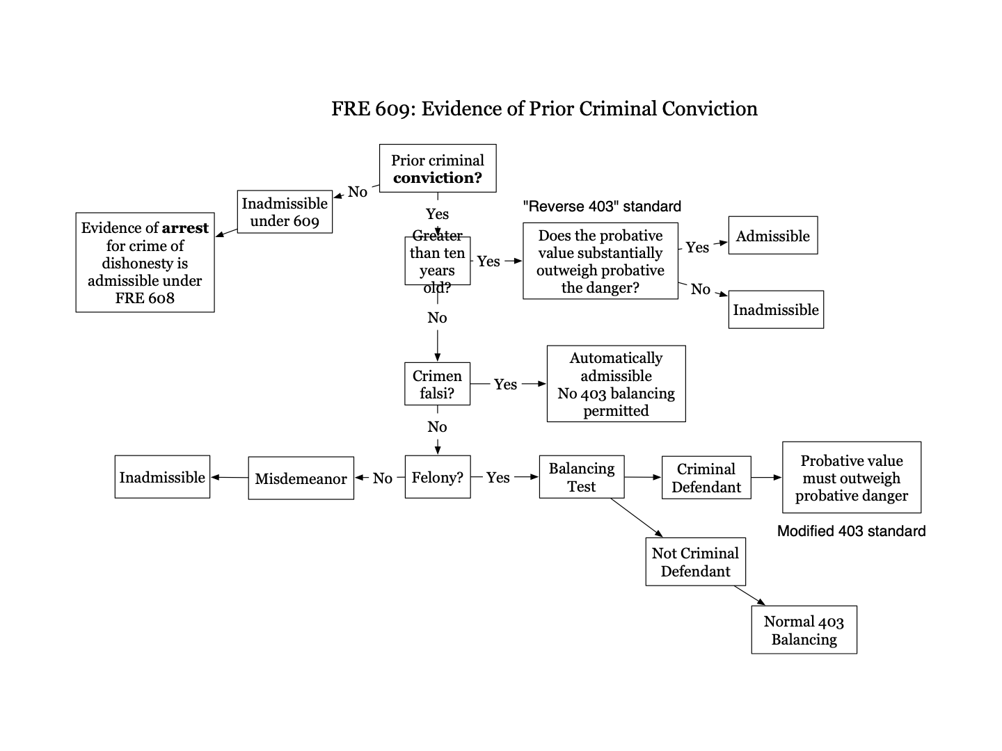

US v. Wong
Rule - General balancing test of 403 is not applicable to crimen falsi conviction under 609(a)(2) / prior convictions involving dishonesty (crimen falsi) are not within the discretion of the court to admit or not admit - they are admissible
Facts - Wong argues it was error for judge not to do 403 balancing with crimen falsi conviction
Issue - do you need to do 403 balancing with crimen falsi?
Holding and Reasoning - no error, not appropriate to do a 403 balancing with crimen falsi, it is admissible

US v. Estrada
Rule - Impeachment of a witness with evidence of a prior conviction under Federal Rule of Evidence 609(a)(1) may include questioning about the statutory name of the offense of which the witness was convicted.
Facts - Estrada charged with narcotics trafficking. Gov called some cooperating witnesses, defendant wanted to impeach the witnesses with prior convictions. Trial court said for a conviction that goes to credibility teh defense counsel could inquire into the nature of the conviction but if it is “simply a felony” the defense counsel could ask only about the fact and date of conviction without naming the offense.
Issue - can impeachment by prior criminal conviction under 609(a)(1) include the name of the offense?
Holding and Reasoning - yes, you can ask questions about the name of offense. 609(a)(1) allows prior felony conviction to be admitted after being subject to 403 balancing. Crimes that do not fall under Rule 609(a)(2) (crimen falsi), but nevertheless have high probative value for determining a witness’s credibility include theft, escape, violent crimes involving premeditation, and crimes involving an evasion of responsibility or abuse of trust (this is from quimbee so I dont know accurate this list it). Crimes that likely have little probative value for determining credibility include crimes involving impulsive violence and crimes involving public morality.
*notes from class on this case**** = on final if we are assessing probative value / danger of a felony Justice Sotomayer tells us in this case we can look at it like non violent v. violent, non violent felony likely will have more probative value, also look into how much planning went into it

*there are some questions on the powerpoint

US v. Amaechi
Rule = shoplifting in itself is not a crime of dishonesty; crimes that are not felonies (have punishment of less than one year imprisonment) are inadmissible for impeachment purposes.
Facts - Amaechi was convicted of narcotics trafficking based on evidence he had taken a delivery of a suitcase containing heroin. Gov witness was Doreen who had taken the suitcase to Amaechi. Amaechi argues court erred in excluding evidence of Doreen’s prior shoplifting conviction.
Issue - can a misdemeanor shoplifting conviction admissible for impeachment by prior conviction?
Holding and reasoning - inadmissible. Rule 609 allows evidence of a witness’s prior conviction for impeachment if, the punishment could have exceed one year (here it could not) or if the crimen involves and element of deceit (crimen falsi). Doreen only got sentence of supervision not prison. Court also says that shoplifting is not a crime that involves deceit and is not a crime of dishonesty under 609.

US v. Sanders
Rule - Prior convictions are generally inadmissible in cases where the current offense is the same or similar to the prior conviction. (609(a)(1) crimes).
Facts - Sanders was charged with assault with a dangerous weapon and possession of contraband shank. Sanders testified and claimed self defense. Prosecution sought to introduce evidence of Sander’s prior convictions of assault and possession of contraband shank under 609.
Holding and Reasoning - Sander’s prior convictions are inadmissible. Prosecution may inquire about defendant witness prior felony convictions to impeach, but prior convictions are generally inadmissible in cases where the current offense is the same or similar to the prior conviction. The probative danger outweighs the probative value because the prior conviction is so similar the jury is more likely to draw impermissible inference that because he committed the crime before he committed it in this instance. Also the crime here is not really about truthfulness assault, (violent crime), does not bear heavily on character for truthfulness or likelihood to commit perjury.

US v. Oaxaca (this case has opposite outcome as Sanders…?)
Rule - a crime is not per se inadmissible if it is identical to that for which the defendant is on trial.
Facts - Oaxaca charged with armed bank robbery. Oaxaca took the stand and then prosecution impeached him with his prior convictions of burglary and bank robbery. Oaxaca argues that because of the nature of the prior convictions (their similarity with current crime) the probative danger and prejudicial effect outweighs the probative value.
Issue - is an identical crime per se inadmissible?
Holding and Reasoning - court finds no abuse of discretion in admitting prior convictions. The convictions were for crimes that reflected adversely on the defendant’s honesty and integrity so they were relevant to Oaxaca’s credibility. This judge thinks crimes of theft are more indicative of credibility than crimes of violence.

US v. Hernandez
Rule - even if there is a similarity between current charge and prior conviction, the conviction may be admissible if credibility of the witness is important
Facts - Hernandez convicted of conspiracy to kidnap and kidnapping. He argues district court erred in admitting evidence of his prior criminal conviction for the possession of cocaine and marijuanna, he argues the convictions are related because current kidnapping was to get ransom to pay back a drug deal, he argues crimes are too similar and therefore prejudicial
Holding and Reasoning - this court finds there was no abuse of discretion on the part of the district court. District court admitted evidence because of its value in assessing the credibility of the defendant and court knew of the similarity of the two crimes. The similarity is a factor the court knew it had to take into account but it determined credibility of the defendant witness was important in this case.

Luce v. US (preserving claim of error)
Rule - to obtain a review of a claim of error of improper impeachment conviction, the defendant must have testified at trial.
Facts - Luce charged with crimes related to possession of cocaine. He filed a motion in limine to attempt to exclude evidence of prior drug possession conviction if he decided to testify. District court denied the motion and found the prior drug possession conviction fell within the category of admissible previous crimes under 609(a)(1), possibly because of this ruling Luce did not testify. He was convicted and now appeals.
Issue - does a defendant need to testify at trial to preserve his right to review the trial court’s motion to exclude the use of evidence of his prior conviction?
Holding and reasoning - yes to obtain a review of a claim of improper impeachment by prior conviction under rule 609(a)(1), a defendant must have testified at trial. Any harm that results from a district court;s in limine ruling of whether the prior conviction is admissible would be purely speculative if the defendant never actually testifies because the nature and scope of the defendant’s testimony would have an effect on the court’s ruling. Because he did not testify and convictions were not used against him, he is not entitled to review.

Ohler v. US
Rule - introducing evidence constitutes waiver of objection to its introduction / a defendant who preemptively introduces evidence of a prior conviction on direct examination may not claim on appeal that the trial court’s decision to admit the evidence was error.
Facts - Ohler was charged with importing and possessing marijuanna with intent to distribute. Prosecution filed motion seeking to introduce evidence of defendant’s prior conviction and district court granted the motion so if defendant decided to testify the prosecution could introduce the prior conviction. Defendant testified and during direction examination Ohler preemptively admitted the prior conviction. Ohler was convicted and now appeals district court grant of prosecution's motion to admit prior conviction.
Issue - if a defendant preemptively introduces evidence of prior conviction on direct examination claim on appeal that trial court decision to admit the prior conviction was an error?
Holding and Reasoning - no, if the defendant preemptively introduces evidence of prior conviction on direct examination they cannot claim it was error to admit the conviction on appeal. A general rule if the defendant introduces the evidence they waive their right to to argue it should not have been admitted. Also even thought the court granted the motion we do not know for sure if the prosecution would have introduced the evidence so the harm is speculative.

- Prior Inconsistent Statements
Notes on prior inconsistent statements;
- Prior inconsistent statement may be used for 2 purposes: impeach witness’s credibility or to prove that the prior statement is the true one (the second substantive use is covered by 801(d)(1)(A) - hearsay rule)
- The impeachment use if covered by 613 - does not require that either first or second statement is true - just about showing that both cannot be true therefore one must be false
- Any prior inconsistent statement is allowed to impeach - It need not be given under oath, at a prior hearing, etc. Any statement will do, as long as it is inconsistent
- How inconsistent must the prior statement be? - Need not directly contradict prior testimony, just as long as the prior statement conveys a significantly different picture of events than the current testimony, not inconsistent just because it is less thorough

Rule 613. Witness’s Prior Statement
- Showing or Disclosing the Statement During Examination. When examining a witness about the witness’s prior statement, a party need not show it or disclose its contents to the witness. But the party must, on request, show it or disclose its contents to an adverse party’s attorney.
- If prior inconsistent statement is memorialized in some document or recording the proponent need not disclose the contents before impeaching witness, but if opposing counsel contests then proponent must disclose to opposing counsel's attorney
- Extrinsic Evidence of a Prior Inconsistent Statement. Extrinsic evidence of a witness’s prior inconsistent statement is admissible only if the witness is given an opportunity to explain or deny the statement and an adverse party is given an opportunity to examine the witness about it, or if justice so requires.

US v. Lebel
Rule - Non identification (or identification) is non-verbal conduct intended as an assertion; Rule 613(b) does not prescribe precise timing for permitting witness to explain or deny past inconsistent statements.
Facts - Lebel convicted of conspiring to import heroin. Laws was testifying for the government and could identify all conspirators except Lebel, but then he identified him the next day. Lebel tried to elicit this lack of identification when examining a DEA agent. Judge did not allow introduction of non identification until Laws had the opportunity to explain the statement. Lebel argues this is not a statement and therefore not within 613 and argues if it is under 613 then Laws does not need to be confronted with the statement immediately.
Holding and Reasoning - Court says the non identification is a statement - “statement includes nonverbal conduct of a personal, if it intended by him as an assertion.” Court agrees with his argument that Laws did not need to be confronted with the statement immediately. Rule 613 does not specify and particular order of calling witnesses and so defense should have been able to introduce the evidence during the examination of the DEA agent. (but this was harmless error so court will not order new trial)

US v. Truman
Rule - a failure to member is inconsistent with a prior statement from memory and failure to remember allows impeachment from prior inconsistent statement. / where a witness who testifies under oath and is subject to cross examination in a prior state court proceeding explicitly refuses to answer the question at the current trial, the refusal to answer is inconsistent with his prior testimony.
Facts - Truman’s building burned down. The son was arrested but at the state court proceeding the son testified that the father hold him to burn the building down. These charges were dismissed. Now there is a federal trial. Prosecution asks the son if the father told him to burn the building down but this time the son refuses to answer. The prosecution reads out his testimony from the state court trial.
Holding and Reasoning - This evidence is admissible to impeach the witness for credibility. (most of the reasoning is about issues with hearsay rule which I wont talk about here)

US v. Ince ***REWATCH CLASS FOR THIS CASE TO GET PROPER RULE ****
Rule - When deciding whether to permit the prosecution to impeach its own witness with otherwise inadmissible hearsay evidence containing an alleged confession by the defendant, a trial court must determine whether the evidence is more probative than prejudicial.Must do 403 balancing when deciding whether to admit evidence for impeachment that is hearsay / cannot, in bad faith, attempt to introduce impeachment evidence knowing it most likely going to be used by jury for impermissible substantive purposes
Facts - Ince was charged with assault with dangerous weapon (shooting at some trucks), on the same night Neumann was questioned by police and she told police that Ince confessed to her that he shot the trucks, at trial gov called Neumann as a witness but Neumann testified she could not recall the events of that night, then gov called the police officer that Neumann spoke with in order to impeach Neumann and officer talks about how Neuman said that Ince confessed to her, but at this trial there was a deadlocked jury and then mistrial, there was a second trial where prosecution did this whole rigamaroll again and called Neumann again and again she did not recall, again called police officer from the night
Holding and Reasoning - the court finds that the testimony of the officer is inadmissible. The prosecution can impeach its own witness but there are limits. Prosecution cannot use impeachment as a way to admit hearsay evidence. (Morlang issue). When determining whether the prosecution’s witness’s testimony is inadmissible, the trial court must apply 403 balancing test to determine whether the evidence is more prejudicial than probative. Here because the evidence being used to impeach was a confession it was very prejudicial, many jurors do not understand impeachment v. substantive use so they are likely to use this evidence for the wrong conclusion. The probative value was also minimal and prejudice high so it should not have been admitted.

Morlang Issue:
- About credibility uses v. substantive uses
- a bad faith attempt to introduce impeachment evidence for substantive purposes (this happened in Ince)
- From powerpoint: prosecution knows witness cannot remember X → prosecution calls witness to testify about X → witness testifies she cannot remember X → prosecution impeaches with prior statement → does prosecution have another way to get evidence admitted? → if no then it is inadmissible attempt to impeach, if yes it is admissible

US v. Webster
Rule - impeachment by prior inconsistent statement may not be permitted where employed as a mere subterfuge to get before the jury evidence not otherwise admissible (morlang)
Facts – Webster was convicted of aiding and abetting. Gov called the bank robber, King, to the stand and he gave testimony that exculpated Webster. Then gov introduced evidence of prior inconsistent statements that inculpated Webster and said the introduction of these statements were for impeachment purposes. Webster argues these statements were inadmissible because you cannot introduce evidence for impeachment when it is otherwise inadmissible hearsay.
Holding and Reasoning – Usually impeachment by prior inconsistent statement is impermissible if used to get otherwise inadmissible evidence before the jury. Using evidence in this way places hearsay evidence as substantive evidence against defendant. But The court holds that here the prior inconsistent statements that inculpate Webster, that were being used to impeach King are admissible. There was no bad faith on the side of the prosecution because they did not know what King was going to say before he took the stand (unlike Ince where the prosecution knew Neumann was not going to remember). Prosecution had offered to question the witness privately/ not in front of the jury first but defendant said no. So here it was ok to admit the testimony (that is hearsay) because it was not done in bad faith. (so it is more about if it was done on purpose / bad faith)

People v. Freeman
Rule
Facts – Freeman was convicted of serving as a getaway driver in robbery that Foster was a gunman. Duckwoth’s daughter is Foster’s girlfriend, Duckworth went to her daughters house that morning and Then Duckworth told an officer that she heard her daughter say “hello freeman.” then at trial when Duckworth was questioned about this statement she made to the officer but she said she didn’t remember saying this. Then prosecution has officer testify about the statement Duckworth made to him. Freeman argues officer’s testimony was inadmissible hearsay.
Holding and Reasoning – the court holds that the officer’s statement was not hearsay because it was not used to prove the truth of the matter asserted (the substantive purpose) and that the statement was being used for its impeachment purpose and therefore is admissible because it is a prior inconsistent statement. It is admissible for impeachment as prior inconsistent statement, does not matter that it would be inadmissible under the hearsay rule.

Questions 7.8, 7.9, 7.10 on page 419 of casebook

- Bias
Bias = motive to slant testimony/ lie, or has a stake in the litigation — ex: relationship with one of the parties, an employee of one of the parties, witness particularly likes or fears one of the parties, witness gets money if one side wins, etc
- Bias is always relevant and may be proved with specific instances of conduct and extrinsic evidence
- But it is subject to 401 and 403 balancing
- After witness is impeached for bias, he can be rehabilitated

US v. Abel
Rule – evidence that is sufficiently probative of a witness’s possible bias for or against a party warrants its admission into evidence
Facts – Abel was charged for bank robbery, Ehle was an accomplice and pleaded guilty and became witness for prosecution against Abel. Ehle implicated Abel in crime, then Able brings witness, Mills who says Ehle told him that he intended to lie to get better prison sentence. Ehle then comes back to testify and says that he, abel, and mills are part of a gang that is require to commit perjury for each other, this statement was meant to impeach Mills testimony.
Issue – was evidence of gang probative of possible bias?
Holding and Reasoning – yes the evidence was probative of Mills bias. Because mills was part of a gang that requires you to commit perjury it gives rise to inference that Mills may be perjuring himself in court. Impact of bias upon a witness’s credibility requires that such evidence be admitted. (Miller said - court could have taken out inflammatory part of the evidence like the name of the gang or type of gang (it was white supremist gang) but this would take away probative force)

- Incapacity
Incapacity general rule = A witness can always be impeached by showing that his capacity to observe, remember, or narrate events correctly has been impaired. / lacked the opportunity or capacity to perceive what she claimed to have perceived or lacked mental capacity to perceive or recall events

There are different kinds of things to show capacity has been impaired:
Sensory defect
Mental defect
Drugs and alcohol

US v. Sasso (recheck rule for this one)
Rule - Evidence for incapacity must indicate that witness suffered problems of perceptions (like they were delusion, paranoid, or had other memory problems) or it is inadmissible (otherwise it just doesnt have probative value / relevance)
Facts - Sasso and Armienti were convicted of trafficking illegal firearms. Armienti’s former girlfriend, Kramer, testified. Sasso wanted to introduce evidence that Kramer had been taking antidepressants. Kramer had been in a car accident where the other person died, so she saw a psychiatrist and took mood stabilizers because of this. District court did not allow this evidence in.
Holding and Reasoning – This court sees no abuse of discretion in not admitting those facts. Fact that her depression was relatively recent and as a result of the accident does not suggest that condition has any probative value, no indication that the car accident put her in a delusional state or that any medications prescribed would have affected her ability to perceive events, and no evidence that Kramer was on antidepressants during the time she was involved with Armienti. Court talked about a previous case where they allowed this type of evidence in, but in that case there was evidence of delusional and paranoid behavior and there is no indication of that here with Kramer.

Henderson v. Detella (re check rule)
Rule – If proponent uses evidence of drugs use to impeach, it must have connection to capacity to perceive at time of offense and not just generally impeach character (because they are drug user)
Facts – Henderson shot and killed Leaonard, then shot Chavez but Chavez survived. At trial Chavez testified and identified Henderson as the shooter. On cross examination Henderson asked if Chavez used speed and Chavez said no. Then Henderson brought a witness, Jones, who testified that he had seen Chavez use speed many times. Judge did not allow this testimony in/ barred this line of questioning.
Holding and Reasoning - Judge did not abuse discretion in not allowing this line of questioning. Whether Chavez had been using speed at the time of the offense it would have been proper line of questioning. But with Jones questioning we do not know when those occasions were in reference to the murder/ shooting. It is thus not clear that testimony was proactive of Chavez ability to recognize and identify the individual who committed the offense. Without connection to cognitive ability at time of offense the evidence only impeaches her character which is improper.

- Specific Contradiction
There is not a specific rule that governs impeachment by contradiction, but 403 rule of relevance and collateral matter rule govern admissibility

Both intrinsic and extrinsic evidence is allowed to contradict a witness - includes another witness who contradicts the testimony, documents, or recordings (but limits on extrinsic, below)

Collateral Matter Rule = limit on admissibility of extrinsic evidence offered to impeach by contradiction
- You cannot introduce extrinsic evidence to impeach a witness on a collateral matter
- A matter is collateral if it has no importance to the case except for its tendency to impeach a testifying witness by showing there were wrong about a fact
- If you seek to introduce extrinsic evidence to show that a witness was wrong about something unimportant to the case, the judge will likely not allow the extrinsic evidence
- You can only introduce extrinsic evidence to impeach on a material contradiction / impeach on collateral matter only through intrinsic evidence

Example: I was exiting the movie theater when I witnessed the assault. I saw the movie Good Will Hunting. Then the party tries to impeach by contradiction by showing the witness actually saw Titanic. This is a collateral matter because what movie they saw is not of consequence to the claim or defense. But something like who punched who first is material (not collateral).

Simmons v. Pinkerton Inc
Rule – if impeachment is about collateral matter you can only impeach through intrinsic evidence
Facts – Simmons hired Pinkerton Inc to provide security for warehouse. Warehouse burns down and fire marshall determined it was caused by the Pinkerton security guard. Simmons sues Pinkerton inc. Before trial Hayne (pinkerton guard) agreed to take a polygraph but then never took the test. Hayne told investigator that he took the test and passed. At trial Simmons calls Hayne and asked if lied about the polygraph and Hayne admitted he lied.
Issue – Is this line of questioning admissible?
Holding and Reasoning – This questioning is admissible. This is a collateral issue so Simmons would not be able to impeach about this contradiction (the lie about the polygraph) through extrinsic evidence, but here they impeached through intrinsic evidence –they just asked Haynes directly so it was ok. evidence of polygraph test is specific instance of lying; and so admissible so long as in the form of intrinsic evidence on cross. (miller says this case is weird because court ends up deciding the issue under 608 specific act rule and not specific contradiction rule)

US v. Copelin
Rule – if impeachment is about collateral matter you can only impeach through intrinsic evidence
Facts – Copelin was charged with distribution of cocaine. Copelin claimed another person was actual seller. Copelin testifies and on cross Copelin was asked if he had seen the other man selling the cocaine and he said he did not see drugs change hands, then he was asked if he had ever seen drugs in this life and he said he had only seen drugs on TV. Then to impeach Copelin prosecution sought to introduce evidence that Copelin had tested positive multiple times so he must have seen it outside TV. trial court allowed this evidence
Holding and Reasoning – This was a valid impeachment of Coplein’s testimony. No collateral matter rule issue because it was through intrinsic evidence, intrinsic evidence is permissible to show witness had used and so could recognize cocaine. (couldnt have used test result document because that would have been extrinsic evidence). (not sure if this is important but = This is evidence of a prior bad act, under rule 608 you cannot use the prior to show defendant acted in conformity with the prior but you can use for another purpose like impeachment here. Here the judge should have given limiting instruction that purpose was to impeach the witness which trial judge is did not do so there was reversible error.)

Question 7.12 page 433 of casebook discussed in class 9/27

- REHABILITATION

Rehabilitation = opposite of impeachment, suggest that testimony is worthy of belief

For every method of impeachment there is a method of rehabilitation

Impeachment = witness should not be believed because … | Rehabilitation = witness should be believed because …
Dishonesty | Honesty
Inconsistency: witness changed their story | Consistency: witness did not change their story
Bias: witness had motive to slant testimony | Disinterest: no motive to slant
Incapacity: witness lacks the ability to perceive or recall subject of testimony | Capacity: witness had the ability to perceive or recall subject of testimony
Specific Contradiction: part of what witness said is demonstrably untrue | Specific Corroboration: part of witness said is demonstrably true

Notes on Rehabilitation:
- No bolstering = lawyer may not offer evidence supporting his witness’s credibility, unless that credibility has first been attacked by the other side
- Rule 608 and 609 count as sort that justify rehabilitation for honesty
- Party can use 608 techniques to rehabilitate witness character honesty (only opinion / reputation on direct, specific acts on cross) **i got this from video but i dont really get what this means**
- Impeaching for bias or incapacity is not attack on honesty so cannot rehabilitate with honesty
- Impeachment with prior inconsistent statement it is not clear if this is about character for honesty
- Same rules apply on method of proof to rehabilitation and impeachment

US v. Lindeman
Rule – If a witness has been impeached for bias, the other side can rehabilitate the witness by showing they do not have an interest in the outcome of the case
Facts – Lindemann was charged with fraud in connection with a conspiracy to have his horse killed for purpose of collecting insurance money. Burns testified that Lindemann paid him to kill the horse. On cross examination Lindemann suggested that Burn was biased because he would not have received a plea deal without testifying against Lindemann. On redirect Burns said that he testified that he killed horses for many people and cooperated with gov on prosecution on those cases and 90% of people he told gov about pleaded guilty. Lindemann argues this testimony on redirect is inadmissible and it was bolstering.
Holding and Reasoning – The court holds this is not bolstering because Burns was impeached for bias by Lindemann. If the witness is impeached for bias then he may be rehabilitate by showing his disinterest. They showed his disinterest in outcome of the case by showing this case against Lindemann was not important to his plea deal, Burns had given 30 other names in exchange for the plea deal, this one case against Lindemann was not important for the deal and if Lindemann had not been convicted he still would have gotten the plea deal, Lindemann was not the big fish. Lindemann’s argument was the prosecution bolstered him by rehabilitating character for honesty when his character for honesty had not been impeached. But because he was impeached and rehabilitated for bias, Lindemann’s argument that 608 limitation is an issue is incorrect.

Following cases are important together…

Beard v. Mitchell (in this case prior inconsistent statement did consistent attack on character for truthfulness)
Rule – Impeachment for prior inconsistent statement may be an attack on character for honesty and therefore support rehabilitate for honesty
Facts – at trial judge permitted Kororas to testify that defendant Mitchell had a reputation for truthfulness. Plaintiff argues this was an impermissible use of reputation evidence under 608(a) and the rule does not permit the admission of this type of evidence to counter impeachment by prior inconsistent statements (plaintiff concedes they did impeach witness but through prior inconsistent statements).
Issue – can you rehabilitate with character for truthfulness when witness was impeached for prior inconsistent statements?
Holding and Reasoning – yes, 608(a)(2) provides “evidence of truthful character is admissible only after the character of the witness for truthfulness has been attacked by opinion or reputation evidence or otherwise.” the use of prior inconsistent statements may constitute an attack on truthfulness.

US v. Danehy
Rule – Vigorous cross examination does not open the door for rehabilitation. / Simply contradicting trial testimony/ pointing out discrepancies between defendant's testimony and other witness’s testimony does not go to character.
Facts – Danehy claiming he should have been able to introduce evidence of his reputation for truthfulness because he credibility had been attacked.
Holding and Reasoning – he cannot introduce reputation for truthfulness because character had not been attacked. Here the “attack” was vigorous cross examination and the pointing out by the prosecutor of discrepancies between the defendant’s testimony and that of other witnesses. This does not call into question the reputation of the defendant for truthfulness. The mere fact that a witness was contradicted by other evidence in a case does not constitute an attack upon his reputation for truth. Danehy was trying to bolster.

US v. Drury (similar to danehy)
Rule
Facts – Drury argues he should have been able to introduce evidence of truthful character because government attached his credibility at trial. He does not argue government presented any opinion or reputation evidence about his character but he argues his character was “otherwise” attacked. He offers scattered questions asked by prosecutor during cross like, “are you telling us that you told an arresting officer that you wanted to make a statement and he wouldn’t let you?” and “are you saying that he hushed you up?” and “is that what you want us to believe?”
Issue – were these scattered questions an attack on character?
Holding and Reasoning – cannot introduce evidence of character for truthfulness. Government counsel pointing out inconsistencies in testimony and arguing that the accused testimony is not credible does not constitute an attack on the accused’s reputation for truthfulness within the meaning of rule 608.

US v. Murray (Miller said this case is very similar to Drury and Danehy but its allowed here problem because it is gov doing and not defendant)
Rule – An extended and vigorous cross examination of witness that exposes various illegal activites and sordid activities does open the door for defendant’s character for honesty and allows party to introduce character for truthfulness evidence to rehabilitate
Facts – Among witnesses against Murray was Brown, a police informant. After Murray cross examined Brown the government called Lt. Goshert to testify about Brown’s reliability. Murray says this was improper because Brown’s character for truthfulness had not been attacked.
Holding and Reasoning – Court holds the testimony about Brown’s reliability is admissible. It it true Murray did not offer opinion or reputation evidence to impeach Brown, but Murrya’s counsel performed an extended and vigorous cross examination of Brown that exposed Brown’s various illegal and sordid activities. (they asked about = heavy drug use, acquaintances with drug dealers, tax free compensation for work as informant, convictions for drug possession and theft, unlawful carrying of unlicensed firearm). In view of questioning, the opinion or reputation testimony given by Goshert fell within language of 608(a)(2) permitting introduction of such evidence to support a witness’ credibility when his character for truthfulness has been “otherwise” attacked.

Questions 7.13, 7.14 - page 441 - class 9/27

**WHEN REVIEWING OUTLINE COME BACK AND WATCH REVIEW CLASS (09/29) AND LOOK AT REVIEW POWERPOINT***

- HEARSAY
Hearsay = an out of court statement that is offered to prove the truth of the matter asserted
Declarant = person who made the out of court statements
Witness testimony = witness speaking at the proceeding, they are under oath and recounting perceptions from memory
Hearsay statements = declarant speaking, writing, recording, out of court or at another proceeding, the statements are not under oath, not something a witness is recounting from memory; or not something the witness perceived

4 worries of hearsay:
- Ambiguity
- Insincerity
- Incorrect memory
- Inaccurate perception
Live witness testimony gets rid of worries because witness is under oath, you can see demeanor, you can get larger context os statement, and you can cross examine

Rule 801. Definitions that Apply to This Article; Exclusions from Hearsay (same as definitions above)
- Statement. “Statement” means a person's oral assertion, written assertion, or nonverbal conduct, if the person intended it as an assertion.
- Must make an assertion about the world that can be true or false
- There is a whole section on this part below
- Declarant. “Declarant” means the person who made the statement.
- Hearsay. “Hearsay” means a statement that:
- The declarant does not make while testifying at the current trial or hearing; and
- A party offers in evidence to prove the truth of the matter asserted in the statement.
- Need to work out what fact is the statement asserting and whether that the fact the proponent is trying to prove
Rule 801 continues below …

Rule 802. The rule against hearsay.
Hearsay is not admissible unless any of the following provide otherwise:
- Federal statute
- These rules
- Other rules prescribed by supreme court

Trial of Sir Walter Raleigh (old law / dont know if we need to know this case)
Facts – SWR (sir walter raleigh) was charged with treason in connection with an alleged conspiracy to kill the king. Prosecution alleged co conspirator was Lord Cobham, who had already confessed to conspiracy and implicated SWR. Prosecution read Cobham confession at SWR trial and this was only evidence against SWR. SWR argues that Cobham confessed and implicated him only to save his own life. SWR sought to cross examine Cobham, and argued the confession was unreliable hearsay.
Holding and Reasoning – Court held that the co conspirator does not need to testify at the defendant’s trial. Court was concerned Cobham would be pressured by SWR to retract confession.
*check this case on other outlines**

Leake v. Hagert (miller says “a straightforward hearsay case”)
Rule – Hearsay rule “prohibits use of person’s assertion, as equivalent to testimony of the fact asserted, unless the assertor is brought to testify in court on the stand, where he may be probed and cross examined as to the grounds of his assertion and his qualifications to make it”
Facts – Charlotte Hagert hit the back of Leake’s tractor with her car, Leaker sues her for negligent driving, she counterclaims he was also negligent because he did not have proper lighting on the back of his tractor. Gross conduct investigation of the accident. Gross testified that Leake’s son told him that the tractor light had been broken for some time. Three other witness also testified that the light had been broken for some time.
Holding and Reasoning – Gross’s testimony was hearsay because it contain a out of court statement offered to prove the truth of the matter asserted. Declarant was the son who did not make the statement while testifying at trial.

- Non Hearsay Uses for Out of Court Statements
Non Hearsay = statements or conduct that are not offered to prove the truth of the matter asserted
- Example of when not offered to prove matter assert - for impeachment purposes (talked about previously), or for identify purposes,

3 core non hearsay statements:
- Declarant’s state of mind – statement offered to show declarant’s state of mind like knowledge and intent
- What declarant believes, circumstantial evidence of was in declarant’s mind at the time,
- Could be a lack of sanity statement, if declarant says, “i am a dolphin” or somethin crazy, this statement is not offered to prove the truth of the matter asserted because declarant is obviously not a dolphin, the statement is circumstantial evidence to prove she insane
- Direct evidence of mental state would be words like: think, know, remember, feel
- Listener’s state of mind – a statement offered to show that the listener knew or didn’t know of something (not offered to show the truth of the thing known or not known)
- Think of Knapp case - someone told the defendant that the sheriff had beat an someone to death, this out of court statement was admissible to prove Knapp’s mental state to prove he had necessary fear for for self defense, the effect of the statement mattered and not whether the statement was true
- Sometimes used to show someone had notice - if employee tells employer “supervisor is harassing me” this can be admissible to show employer had notice of wrongdoing
- Verbal act – a statement which gives rise to legal consequences is not hearsay when offered to show those legal consequences, like words of an offer for a contract, or words of defamation, or threats
- This could also be commands like “shut the door”

Lyons Partnership v. Morris Costumes Inc
Rule – A statement that is not offered to prove the matter asserted is not hearsay
Facts – Barney copyright owner is suing costume guy who is selling dragon costume that looks like Barney. At trial a school principle testified that when she wore the costume at school, all the school children chanted Barney, some parents also testiifed that when they rented the dragon costume the children thought it was barney, the district court did not allow this testimony and said it was hearsay
Issue – was this testimony inadmissible hearsay?
Holding and Reasoning – Court holds this was non hearsay and is therefore admissible. Lyons did not offer the children’s statement to prove the truth of the matter asserted but rather to prove that the children expressed a belief that the costume was Barney, this was offered as proof of children’s reactions and not hearsay

US v. Feliz (offered to prove effect on listener)
Rule – A statement that is offered to prove the effect on the listener and not to prove the truth of the matter asserted is not hearsay
Facts – Feliz was arrested and convicted based on 2 written confessions, Feliz moved to suppress confessions and said he was induced to make confessions because police said if he did not write the confessions they would deport his mother, the mother is the one who testified that the police made these statements
Holding and Reasoning – The police officer’s statements were not hearsay because Feliz did not attempt to introduce the officer’s threats for the truth of the matter asserted, the testimony was offered to show the effect of the words spoken on the listener (feliz),

Campbell v. BSC (effect on listener)
Rule – If statement is used to demonstrate had knowledge or notice of something it is not hearsay
Facts – BSC makes permanent implantation devices and uses a material called polypropylene, on the material safety data sheet (the msds) for polypropylene there is a warning about using the material in permanent explanations devices. BSC objects to the introduction of the MSDS warning as hearsay
Holding and Reasoning – the MSDS warning is not hearsay because it is not offered to prove the truth of the matter asserted, Campbell introduced the warning to demonstrate the BSC had notification of the manufacturers concerns about the safety of BSC’s product for permanent implantation and to address BSC’s knowledge of potential safety concerns in its final product

Direct v. Circumstantial evidence for mental states:
- Direct evidence would be statement with “i think,” “i believe,” “i feel” etc
- Circumstantial evidence would be statement that doesn't use ^ those words
- Example: child saying “its barney” is circumstantial evidence that they think it is Barney, child saying “i think it is Barney” is direct evidence
- If the statement falls into the direct evidence category then it is being offered to prove the truth of the matter asserted and it would be excluded by rule 801, but there is another rule for this that will come up below

Questions 3.2, 3.3 on page 64

US v. Jefferson
Rule – document offered to prove defendant had notice of hearing date is not hearsay
Facts / Holding – The district court properly admitted letter and two mailgrams into evidence to show that Jefferson had been sent notice of the hearing he failed to attend. These were not offered to prove the truth of the matter asserted but only to show Jefferson had been sent notice of the hearings.

US v. Saavedra
Rule – Statement used to prove misrepresentation element of a crime is not a “statement offered to prove the truth of the matter asserted” under hearsay
Facts – Saavedra convicted of conspiracy to commit wire fraud. Jail inmate would call someone and pose as law enforcement and ask victim to “verify” their credit card number and then call western union and order a money order using the stolen card number, Saavedra would then be the person to go pick up the money order. Victims testified that they received calls from a man who identified himself as law enforcement. Saavedra argues this testimony was hearsay.
Issue – was victim testimony hearsay?
Holding and Reasoning – The victim’s testimony was not hearsay, it was not offered to prove the truth of the matter asserted (i.e. that the man really was law enforcement), instead it was offered to prove that credit card numbers were fraudulently obtained. It was offered to prove the misrepresentation element of fraud.

Hanson v. Johnson (verbal act)
Rule – Out-of-court statements not offered to prove the truth of the matter asserted, but whose words themselves affect the legal rights of the parties are admissible.
Facts – Hanson leased farm to Schrik but retained right to ⅖ of the corn grown on the farm, Schrik mortgaged his share of the crops to the bank, bank sold Schrik’s property and part of sale was corn, bought by Johnson. Hanson sued for his portion of the corn, Hanson introduced that Schrik told his corn in question was his, he said that Schrik specifically said “here is your corn for the year,”
Holding and Reasoning – These out of court statements are not offered to prove the truth of the matter asserted, the statements itself affects the legal rights of the parties but the statement is a verbal act. The statement establish the corn as Hanson’s property, therefore is a verbal act and so is admissible.

Creaghe v. Iowa Home Mutual Casualty
Rule – verbal act not hearsay
Facts – There was a car accident between Creaghe and Osborn. Craeghe got judgment against Osborn and sues Osborn’s insurance company for the money. At trial an insurance agent testifies that before the accident Osborn told him to cancel his policy. Creaghe argues this testimony is hearsay.
Holding and Reasoning – The hearsay rule does not prohibit relevant testimony about what contracting parties said about an oral agreement. The issue is not whether the statement is true ( for truth of matter assert) but the issue is whether the statement was made.

- Statements - Rule 801(a)
801(a) rewritten = “Statement” means a person's oral assertion, written assertion, or nonverbal conduct, if the person intended it as an assertion.

Issues that come up with “statements”
- Silence = Silence generally does not count as statement
- Conduct Intended as Assertion = conduct is nonverbal but nonetheless may be intended as an assertion and this conduct is capable of being hearsay
  - Example = someone asks you, “who hit you?” and you point to someone, you pointing is equivalent of assertion, “this person is the one who hit me”
  - The conduct must be intended to communicate some fact
- Implied Assertions = Sometimes there is non verbal conduct or a verbal conduct that asserts something that the “declarant” did not intend to assert, but there is an assertion that is implied - and this is not hearsay because it does not fall within the definition of “statement” because the assertion was not intended (this is a new rule, under old common law rule / declarant model this was hearsay)
  - Only matters intended to be directly communicated by the statements are part of the statement itself; other inferences, even ones directly implied by the statement, are not part of the statement
- Non humans do not make statements = something from animal, machine, sign is not hearsay

US v. Zenni (implied assertions)
Rule – An implied assertion / nonassertive verbal conduct does not constitute a “statement” under the hearsay rule
Facts – Defendant charged with illegal betting activities, gov had warrant to search defendants house and government agents answered defendant’s phone and listened to people place bets. Prosecution sought to introduce evidence of people placing bets on the phone to show callers thought the house was used for betting. Defendant argued these statements made on the phone calls were hearsay.
Issue – were phone calls hearsay?
Holding and Reasoning – Not hearsay. Court holds this is non assertive verbal conduct because the people on the phone did not state/assert “i think this is a betting house.” Non assertive verbal conduct is not subject to the hearsay rule because it is not a “statement” because speaker did not intend it to be an assertion of the matter trying to be proven. Generally, if an individual bases an action on a certain belief, that belief is trustworthy because the individual has based his or her actions on the correctness of the belief. In this case, the phone calls were offered by the prosecution as being relevant to an implied assertion that Humphrey’s house was where people are able to place bets. The calls are not direct assertions, but rather constitute nonassertive verbal conduct reflecting a belief the individuals held about the house.

Hearsay within Hearsay / Multiple Hearsay = one hearsay statement includes another hearsay statement, example: John testifies that Jill told him that she overheard Jane saying that she saw a blue car running a red light
- Rule 805 tells us that each level of hearsay must fit within its own exception to be admissible

Questions in book - 3.13, 3.14, 3.15 page 73

- Confrontation Clause and Hearsay
6th amendment contains confrontation clause = “in all criminal prosecutions, the accused shall enjoy the right to be confronted with the witnesses against him”

Does not apply in 3 major categories
- Hearsay in civil cases
- Hearsay introduced against prosecution in criminal case
- Hearsay declarations from someone who winds up testifying in open court and is subject to cross examination

Testimonial Statements = statements given to government agent whether law enforcement or substitute as part of interrogation or functional equivalent during investigation
- confrontation clause only applies to testimonial statements
- Statements given not during investigation or not to government agent are not testimonial
- Certain statements to law enforcement delegates such as medical officials under a duty to report domestic violence or child abuse could as testimonial if circumstances suggest delegate was interrogating the person as part of criminal prosecution
- Clearest class of non testimonial are statements where primary purpose of state is to report on going emergency

2 exceptions to confrontation clause:
- Dying declarations - Rule 804(2)
- Statements of witnesses that the defendant wrongfully and intentionally prevented from testifying - Rule 804(6)

Crawford v. Washington (testimonial)
Rule – Where testimonial statements are at issue criminal defendant must have opportunity to confront witness
Facts – Saliva Crawford told her husband that Lee tried to rape her, Crawford confronts Lee and ends up killing him, at trial Crawford is claimign self defense, Silvia is claiming marital privilege and does not testify at trial, the prosecution sought to introduce statements sivilia made by playing video of her interrogation (this is hearsay but was allowed in on an exception that we will learn about soon), Crawford objects to wife’s video statement on confrontation clause grounds
Issue – Did allowing pre recorded statement (and no taking stand) violate confrontation clause?
Holding and Reasoning – Court holds this is a violation of the confrontation clause, Scalia held that confrontation clause applies in a criminal trial to exclude testimonial hearsay statements introduced by prosecution from a declarant who is unavailable to testify, The rational is that the 6th amendment creates and independent and important right for criminal def to cross examine their accusers in a criminal trial, Accuser just means any witness that would give testimony for the state

Ohio v. Clark (non testimonial)
Rule – primary purpose test = statements are testimonial when the circumstances objectively indicate that there is no such ongoing emergency, and that the primary purpose of the interrogation is to establish or prove past event potentially relevant to a later criminal prosecution / non testimonal = statements made under circumstance objectively indicating primary purpose of interrogation is to enable police assistance to meet on going emergency
Facts – Mothers boyfriend was watching kids, and when kid was at school a teacher noticed bruises, she asked kid who did this and kid said “dee, dee” - state wanted to introduce these statements, child did not need to testify because of some statute about child abuse victims
Holding and Reasoning – court held questioning by the teacher was to determine whether the child was being abused and whether that abuse was on going, and this falls into the emergency exception and there is non testimonial. In child abuse cases duration of the emergency can vary considerable depending on the nature of
the emergency. Court also adds purpose of interrogation must by investigatory, the teacher’s questioning was to protect the child by ending the threat of abuse and purpose was not to gather evidence for a trial

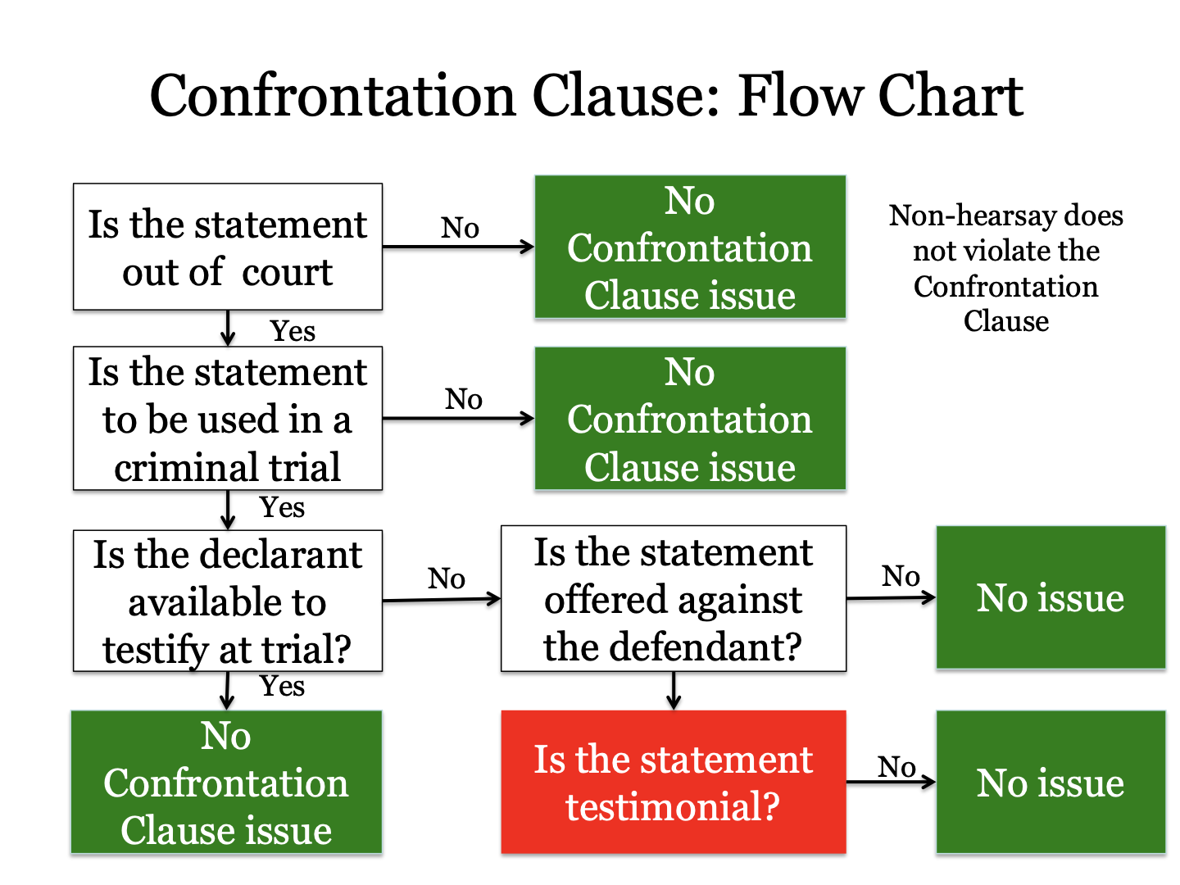
Davis v. Washington(case talked about within Crawford)
- Non testimonial statements
- Statements made to 911 operator about an on going emergency, but then switch happens and it is no longer on going emergency, so statements go from nontestimonial to testimonial

Hammon v. Indiana (case talked about within Crawford)
- Testimonial statements
- Domestic violence case, police arrive at house and separate husband and wife, statements made by wife to police are testimonial because there is not an ongoing emergency

Questions 3.19, 3.20 -page 91 on 10/11

  - Statements that are “not hearsay” - Rule 801(d)(1) and (2)
There are 3 broad categories of “exceptions” but not all are called exceptions:
- Statements that do not fit the definition of hearsay–so they just aren’t hearsay–these are non hearsay and were already discussed above
- Statements that do fit definition of hearsay but FRE allows but for some reasons labels them “not hearsay” instead of putting them in exceptions
- 29 exceptions - Statements that do fit the definition of hearsay so presumptively excluded but then can be allowed if they fit an exception

Miller created hearsay map–to group the exceptions we learned into manageable categories
1st group → require declarant to be available to testify at trial
- Rule 801(d)(1)(A) = prior inconsistent statements by witness
- Rule 801(d)(1)(C) = prior identification statement by witness
- Rule 801(d)(1)(B) = prior consistent statement by witness
2nd group → requires declarant to be unavailable at trial
3rd group → declarant’s availability to testify is immaterial
- Rule 801(d)(2) = opposing party statements

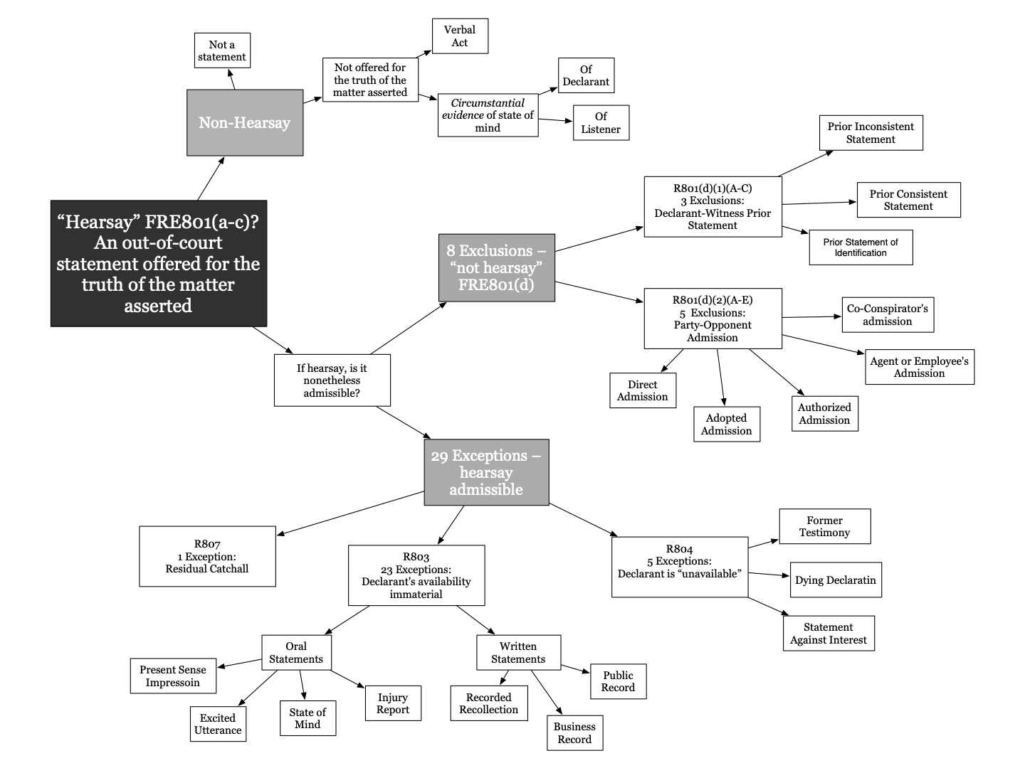

    - Rule 801(d)(1) - declarant must be available to testify
Rule 801 (d) (1) A Declarant-Witness’s Prior Statement. The declarant testifies and is subject to cross examination about a prior statement, and the statement:
- declarant required to be available to testify as witness and declarant must have actually testified before the out of court statement is admissible
- Is inconsistent with the declarant’s testimony and was given under penalty of perjury at a trial, hearing, or other proceeding, and the statement:
- “Other proceeding” could be grand jury even though witnesses do not get cross examined at grand jury hearings
Notes on 801(d)(1)
- We have seen prior inconsistent statement before for the impeachment purpose, but here it is being offered for the substantive purpose → to prove the truth of the matter asserted
- 801(d)(1) allows an out of court statement that is offered to prove the truth of the matter asserted if 3 conditions are met
- Declarant has testified as a witness at current trial – 801(d)(1)
- The prior statement is inconsistent with the current testimony– 801(d)(1)(A)
- The out of court statement was also given under oath – 801(d)(1)(A)

Albert v. McKay (shows when a prior inconsistent statement is being used for impeachment v. substantive purpose - applies old common law rule)
Rule – Statement introduced for impeachment purpose cannot be used for substantive purpose by jury. (here other part so 801(d)(1)(A) are met except the part that statement was made at prior hearing)
Facts – Albert was killed when he was working on a machine and his clothes got caught in it and he was crushed. Albert’s wife sued the employer. Employer argues and brings many witnesses, including man named Elener, to testify that machine was already running when Albert began working on it. Albert’s wife brings witness to impeach Elener, this impeach witness says that Elener told him that the machinery had not been running when Albert began working on it. This was the only evidence that contradicted the fact that machinery was already running. Jury found for Albert’s wife and Employer appeals arguing there is no evidence that shows the machine was not running.
Holding and Reasoning – The court reverses judgement and says the evidence was used for an incorrect purpose. When a witness is impeached by proof of prior inconsistent statements, the effect is merely to discredit him as a witness and the prior statemetn is incompetent for any other purpose and they do not constitute evidence of the truth of the facts stated. In the absence of any conflict the jury had no right to find a verdict based upon the theory the machine had already been running. (miller adds this statement cannot be used for the substantive purpose of proving the truth stated because the prior inconsistent statement was not said at a hearing it was just said to another employee)

Miller notes - the trick is to be able to spot when statement is used for credibility/ impeachment v. substantive use

The declarant testifies and is subject to cross examination about a prior statement, and the statement:
Rule 801(d)(1)(C) = Identifies a person as someone the declarant perceiver earlier.
- Note: 801(d)(1)(C) does not have requirement of prior statement being made at hearing like (A) does

Example: A victim of domestic abuse may have told a police officer that abuser is her partner. Then she recants and refuses to identify him at trial. The prosecutor can then use the earlier statement of identity for impeachment purpose or substantive purpose of identifying him as the person who assaulted the partner

US v. Owens
Rule – Memory loss does not indicate unavailability under 801(d)(1)
Facts – Foster was attacked by Owens. After the attack Foster was in the hospital and an FBI agent came to question him. The first visit Foster does not remember who attacked him. After a couple weeks the FBI agent comes back and Foster remembers and tells him Ownes is the one who attacked him and he points out Owens from an photo lineup. Then at trial Foster testifies that he cannot remember seeing the attacker. Foster remembers the FBI agent visiting him but does not remember any other visitors.
Issue – is Foster’s prior identification admissible?
Holding and Reasoning – Foster’s identification is admissible. Memory loss does not indicate unavailability regarding 801(d)(1). Court looks at definition in 801(d)(1)(C) - “not hearsay is a prior statement of identification of a person made after perceiving the person, if the declarant testifies at trial or hearing and is subject to cross examination concerning the statement.” Foster is subject to cross so its admissible - also no confrontation clause issue because he is subject to cross at trial

Questions - 3.22, 3.24, 3.25 page 98 - on 10/13

The declarant testifies and is subject to cross examination about a prior statement, and the statement:
Rule 801(d)(1)(B) Is consistent with the declarant’s testimony and is offered
    - To rebut an express or implied charge that the declarant recently fabricated it or acted from a recent improper influence or motive in so testifying; or
    - To rehabilitate the declarant’s credibility as a witness when attacked on another ground
- Note: 801(d)(1)(B) the prior statement does not need to be under oath or at a hearing, Miller also says these have little probative value

Limits on Prior Consistent Statements
- Witness must be impeached before the statement is admissible
- The impeachment must take form of an express or implied charge that declarant recently fabricated their testimony or acted with recent improper influence or motive when testifying

Tome v. US
Rule – Under Federal Rule of Evidence 801(d), a consistent, out-of-court statement made by a witness is admissible to rebut a charge of a fabrication or improper motive, but only if made before the motive to fabricate arose.
Facts – Tome was charged with sexual abuse of his daughter. At trial he argued his wife lied about the abuse so the child would not be returned to her father. At trial the daughter testified but she could only give one or two word answers and generally was not very forthcoming with her answers. Prosecution introduced 6 other witnesses to support daughter’s testimony, the witnesses described statements the daughter made to them before trial.
Issue – were the out of the court statements made by the daughter admissible under 801(d)(1)(B)?
Holding and Reasoning – witnesses testimony about statements by daughter to other 6 witnesses are inadmissible. Testimony of 6 other witnesses is consistent with declarant (daughter’s) testimony and it was offered to rebut an implied charge that declarant acted from improper influence (mother wanting custody). So it fits (B) so far, but court goes into the timing of the statements. All the statements the daughter made were at the end of the summer just when the mother was supposed to return the daughter to her father because they had joint custody. The court thought the timing of this was important and the court thinks there is a further temporal condition that should be met - the prior consistent statement should have been made before the motive arose.

Questions 7.15 - page 453 on 10/13

Flow chart for 801(d)(1)(A), (B), and (C)
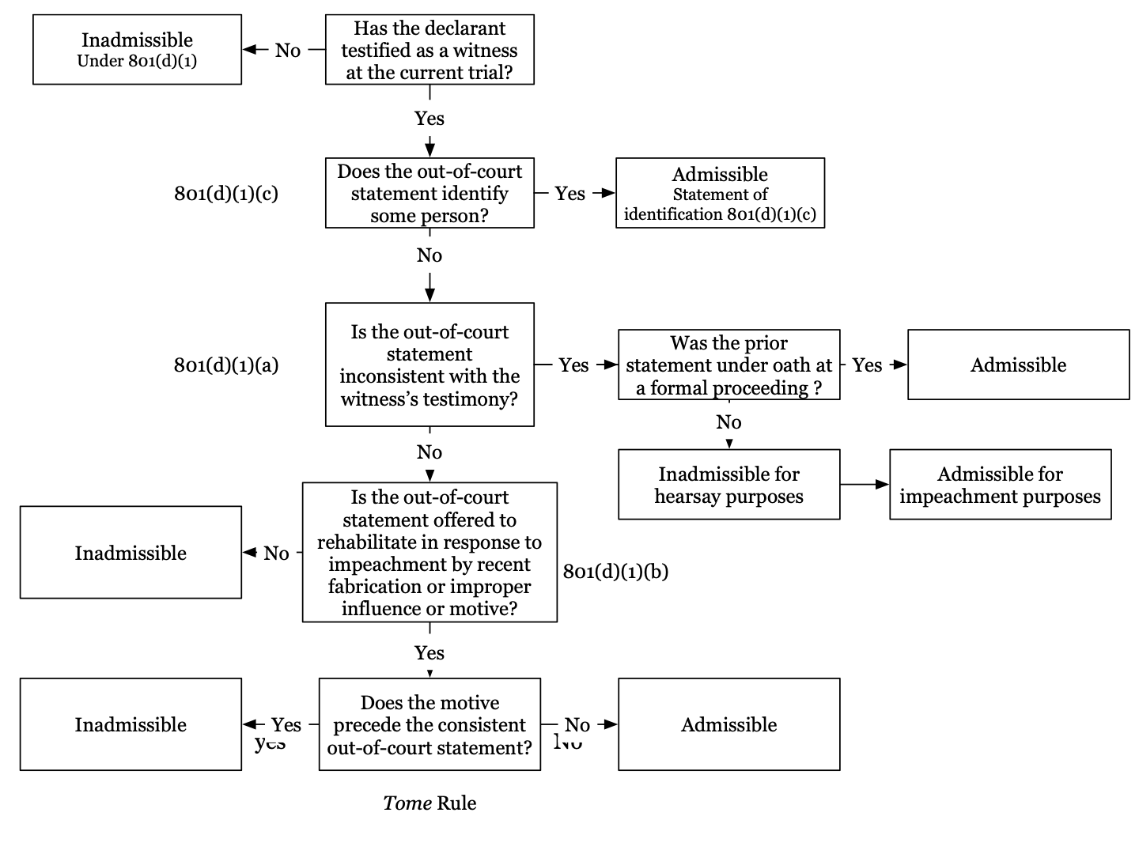

- Statements of Party Opponents - Rule 801(d)(2)

Rule 801. (d) (2) An Opposing Party’s Statement. The statement is offered against an opposing party and:
- Was made by the party in an individual or representative capacity;
- party themself makes the statement (B-E is when statement is “fairly attributable”)
- Is one the party manifested that it adopted or believed to be true
- Party does not make the statement but through actions endorses the statement as if it were his own
- Example: admissible = you forward and email and say “see below”
- Example: admissible under = john tells me he will go to bar review on thursday. I post on FB “John will be at bar review on thursday.” This counts as me adopting statement and could be used against me to prove I met John at bar review
- Example: inadmissible = john tells me he will go to bar review on thursday. I post on FB “John said he is going to bar review on thursday.” I am not endorsing it, i am merely repeating it.
- Was made by a person whom the party authorized to make a statement on the subject;
- More below
- Was made by the party’s agent or employee on a matter within the scope of that relationship and while it existed; or
- More below
- Was made by the party’s coconspirator during and in furtherance of the conspiracy

Notes on 801(d)(2)
- If statement is made by defendant then the party opponent - the plaintiff - can introduce the defendant’s statement and vice versa
- So long as statement is made by opposing party or is fairly attributable (describe in B-E) the statement is admissible
- The party opponent does not need to be available to testify
- Where there are multiple parties - the party opponent rule allows the proponent to use the statement only against the party who made the statement
  - Example: Jack is suing Jill and Jane for personal injury. They both drove through an intersection and hit him. If Jane said, “it was my fault,” Jack and bring in the statement against Jane because she is an opposing party and she made the statement. Jack cannot bring the statement against Jill.
- If statement is made in representative capacity (like 801(d)(2)(C) or (D)) then it is admissible against the declarant and the entity she represents
- WATCH OUT FOR MULTIPLE HEARSAY

Salvitti v. Throppe (801(d)(2)(A))
Rule – 801(d)(2) does not have a requirement that the declarant have personal knowledge.
Facts – Salvitti and wife injured when their car hit a tree. Salvitti said he swerved to avoid negligently driving a truck. Salvitti and wife sue Throppe, truck driver’s employer. Salvitti wants to introduce Throppe’s statements, truck driver and throppe went to their house and Throppe said, “the accident was our fault and I promise everything will be taken care of.” Throppe argues the statement cannot be admitted because he did not have personal knowledge of the accident because he was not present when it happened.
Issue – does 801(d)(2) require personal knowledge?
Holding and Reasoning – The statement is admissible. 801(d)(2) does not have requirement that the declarant have personal knowledge.

US v. McGee (straightforward 801(d)(2)(A))
Facts – McGee convicted of robbing a bank. Detective had interviewed him on the day of the robbery. At trial detective testified that McGee had given 3 different versions of the events.
Issue – officer’s testimony admissible?
Holding and Reasoning – The officers statements are admissible because they were made by a party opponent, McGee.

US v. Phelps
Rule – under 801(d)(2) cannot introduce a statement against a party opponent if the declarant is not the party opponent and the declarant is the proponent
Facts – Defendant arrested for possession with intent to distribute, when officer’s found drugs in his bag he stated, “that is my gym bag, but taylor put it in the trunk.” Phelps counsel sought to introduce this statement through testimony of the officer.
Holding and Reasoning – This is hearsay and is not admissible under 801(d)(2). The witness testifying (the officer) is a party opponent but the declarant (phelps) is not a party opponent. Phelps counsel cannot introduce the statement made by himself, it must be made by the opposing party.
801(d)(2) flow chart:

Hearsay within Hearsay / Multiple Hearsay (slight detour then back to 801(d)(2))

Rule 805. Hearsay Within Hearsay
Hearsay within hearsay is not excluded by the rule against hearsay if each part of the combined statements conforms with an exception to the rule.

Reed v. McCord (multiple hearsay/ adopting statement )
Rule – 801(d)(2)(B) does not require personal knowledge, not multiple hearsay problem if you adopt the statement
Facts – Action to recover damages for personal injuries based on negligence of defendant. Plaintiff sought to introduce statements that defendant made to the coroner about the circumstances and cause of the accident, defendant said, “the dog of the machine was out of position.” but the defendant was not present at the time of the accident, he only knew this because a third party told him. Defendant argues that statement was not based on personal knowledge so are inadmissible
Holding and Reasoning – the defendants statements to coroner are admissible. Defendant adopted the statement and is admissible against him under 801(d)(2)(B). There is not a multiple hearsay problem because defendant adopted the statement himself. He said, “the dog was out of position” and did not say “john told me the dog was out of position,” (because that second statement would be multiple hearsay issue).

Beech Aircraft Corp v. Rainey - ???

801(d)(2)(B) The statement is offered against an opposing party and: Is one the party manifested that it adopted or believed to be true
- Next 3 cases consider different ways a party can adopt a statement …

US v. Fortes (endorsement through silence)
Rule – sometimes remaining silent is manifesting your belief in the truth of the statement - when circumstances are such that someone would deny them if they were untrue (is this limited to the context of when someone accuses you of a crime and you remain silent?)
Facts – Fortes and his co conspirator, Jemison, share a prison cell with Atone. Atone asked fortes and jemison if they robbed a bank. Fortes said yes and described their robbery and how Jemison failed to separate the red money from regular money. Jemison remained silent.
Issue – is Atone’s testimony about Fortes statements admissible against Jemison?
Holding and Reasoning – Yes the testimony is admissible against Jemison. He adopted them and therefore they are admissible against him under 801(d)(2)(B). Silence is not always adoption, but “when a statement incriminating someone accused of committing a crime is made in his presence and hearing and such statement is not denied, contradicted, or objected by him, both the statement and the fact of his failure to deny are admissible in a criminal prosecution against him.”

Southern Stone Company v. Singer (multiple hearsay issue - no adoption through silence)
Rule – A party’s failure to respond may not be admitted into evidence under the adoptive-admission exception to the hearsay rule, unless the context indicates that a response was reasonably expected.
Facts – Southern Stone sold rock to S&M. S&M never paid southern stone and S&M went out of business. Moore worked for southern stone before it went out of business and after S&M went under he started his own company TMinc. Through TMinc Moore sold the rock that southern stone had sold to S&M so souther stone went after Moore for payment. A year after S&M went under souther stone sent a letter to Moore and at the end it requested the Moore respond if anything in the letter was incorrect and Moore never responded. Southern stone sued Moore and defunct S&M. letter sent to moore was introduced at trial to show Moore had adopted the statements in the letter because he never responded. Moore testified felt he did not need to respond because at the time he did not work for S&M.
Issue – is the letter admissible under adoptive admissions rule?
Holding and Reasoning – No the letter is not admissible because failure to repsond does not constitute adoption. The letter is multiple hearsay because the attorney who recounted Moore;s conversation in the letter did not testify. So the structure was hearsay because it was letter stating that attorney stated that moore stated such and such. If the attorney who wrote the letter just testified it would have been admissible as a direct statement by party opponent under 801(d)(2)(A).

Moss v. Commonwealth
Rule – A suspect’s failure to deny an incriminating accusation cannot be introduced into evidence as the suspect’s admission of guilt if, under the circumstances, the suspect would not have naturally contradicted the accusation.
Facts – Moss shot and killed Thompson while Thompson was visiting Moss’s house. Moss claimed self defense at trial. After the shooting as Moss was explaining what happened to the officer, Thompson’s friend shouted “you shot him in the back for no reason” and Moss did not reply to this. At trial the court admitted this into evidence.
Holding and Reasoning – this testimony is inadmissible under 801(d)(2)(B) because party did not adopt the statement by remaining silent. In these circumstances it was not natural for Moss to contradict the accusation because he was in the middle of explaining the situation to the police. the suspect’s failure to respond cannot be deemed an adoption of the accusation, and the failure to respond cannot be introduced into evidence as the suspect’s admission of guilt.
**who testified at trial in this case?*** was it the friend?

Question 3.28 – page 113 – 10/18

Now on to 801(d)(2)(C) and (D)
Repeating (C) which is written above with all d2 categories

Rule 801(d)(2)(C) The statement is offered against an opposing party and: Was made by a person whom the party authorized to make a statement on the subject
- Attorney’s often speak on behalf of parties, so those statements can fall here

Rule 801(d)(2)(D) The statement is offered against an opposing party and:Was made by the party’s agent or employee on a matter within the scope of that relationship and while it existed.
- Does not require that declarant perceived the event or was trustworthy, only that it was made within scope of employment and while person was working for party opponent

Hanson v. Waller (801(d)(2)(C))
Rule – Attorney does not have authority to make an out of court admission for client in all instances, he does have authority to make admissions which are directly related to management of litigation.
Facts – plaintiff bringing suit on behalf of deceased who died from being hit by a truck, defendant is truck driver. Plaintiff argues introduction of a letter written by her first attorney was an error. In the letter the lawyer wrote, “... along with photos taken from the same type of truck the defendant was driving, which shows it impossible for him to see the deceased if in crossing the street she had reached a position directly in front of the truck when the light changed.”
Issue – was admitting letter from plaintiff’s first attorney an error?
Holding and Reasoning – no error. 801(d)(2)(C) excludes from hearsay statements used against a party which were made by another person who was authorized to make a statement concerning the subject from definition of hearsay. Attorney does not have authority to make an out of court admission for client in all instances, he does have authority to make admissions which are directly related to management of litigation. This letter was related to management of litigation and therefore fall within the hearsay exclusion provided in rule 801d2C

Mahlandt v. Wild Research Center (801(d)(2)(D))
Rule – 801(d)(2)(D) makes statements made by agents within the scope of their employment admissible and there is no implied requirement that the declarant have personal knowledge of the facts underlying the statement.
Facts – An employee of Wash U bio department kept one of the university's wolves in his fenced in backyard. One day a young child entered the backyard and the employee’s son discovered the child injured with the wold standing over him. The son told the employee, “The wolf bit the child,” even though the son did not actually see the wolf bite the child. The employee went to the university and said “the wolf bit a child.” at a meeting to discuss the incident the board members said “the wolf bit the child.” The child sued the university for personal injury.
Issue – Were statements made by employee and board members admissible?
Holding and Reasoning – Yes, although they were based on the son’s statement which is completely unreliable because he did not witness the event the statements are admissible as party opponent admissions under 801(d)(2)(D) because statements were made by and employee and statement about care of the wolf was within the scope of his employment so it was admissible against that employee under 801(d)(2)(A) because it was a direct statement but also against university under 801(d)(2)(D). If the father had said “my son said a wold bit a kid” then it would have been a multiple hearsay issue. Also there were some minutes from the board meeting adn these would only be admissible against university not against employee.

Sea-land Service v. Lozen
Rule – Under Federal Rule of Evidence 801(d)(2), a statement made by a company employee while acting within the scope of her employment is admissible against the company as a party-opponent admission.
Facts – sealand sued lozen for failure to pay pursuant to shipping contract. Lozen counterclaimed because it failed to receive one of the shipments on time. Lozen sought to introduce an email that had been forwarded to lozen by Martinez, an employee of Sealand. Martinez had pasted contents of an email by another Sealand employee and Martinez added “yikes, pls note the rail screwed us up.”
Issue – can this email be admitted under 801(d)(2)(D)?
Holding and Reasoning – yes. A statement of a company employee who was acting within the scope of his or her employment when the statement was made is admissible against the company as an admission by a party opponent. By copying the contents of Jacques’s email into her own email and then sending those contents to Lozen, Martinez adopted Jacques’s initial email and manifested that she believed its contents were true. Martinez was a Sea-Land employee acting within the scope of her employment at the time she sent the email to Lozen.

Now 801(d)(2)(E)
Rule 801(d)(2)(E) The statement is offered against an opposing party and: was made by the party’s coconspirator during and in furtherance of the conspiracy
- In furtherance = statements that engage in planning, allocate responsibility, or discuss payment, etc can satisfy this requirement
- The first part requires the proponent prove there was a conspiracy, but sometimes the only evidence that there was a conspiracy is the statement the proponent is trying to introduce, a proponent may try to rely on the statement they seek to introduce as evidence there was a conspiracy and this is called bootstrapping

Bourjaily v. US
Rule – In making a preliminary determination of whether the preponderance of the evidence reveals that there is a conspiracy present for purposes of determining the admissibility of evidence, a court may use the hearsay statements sought to be admitted.
Facts – Greathouse is an FBI informant. He arranged to sell cocaine to Lonardo in order for Lonardo to distribute to others. Lonardo arranged a meeting with himself, greathouse, and defendant where Lonardo would transfer cocaine from himself to the defendant, at this meeting the defendant was arrested. At trial prosecution sought to introduce evidence of a call between greathouse and lonardo where lonardo said he had a friend who was interest in buying cocaine. Court found there was a conspiracy and that phone call was admissible under 801(d)(2)(E).
Issue – whether rule 104a permitted using co conspirator’s statement as part of preliminary fact evidence used to prove the existences of conspiracy and necessary to render the evidence admissible under rule 801d2E
Holding and Reasoning – yes. Before a coconspirator’s statement is admitted into evidence under the hearsay exception, a preliminary determination that a conspiracy exists between the declarant and the defendant must be made by a preponderance of the evidence. In making such a determination, a court may use the hearsay evidence sought to be admitted under the coconspirator statement exemption.
**rule later amended so now you also need some circumstantial evidence in addition to the statement you are trying to bring** ???

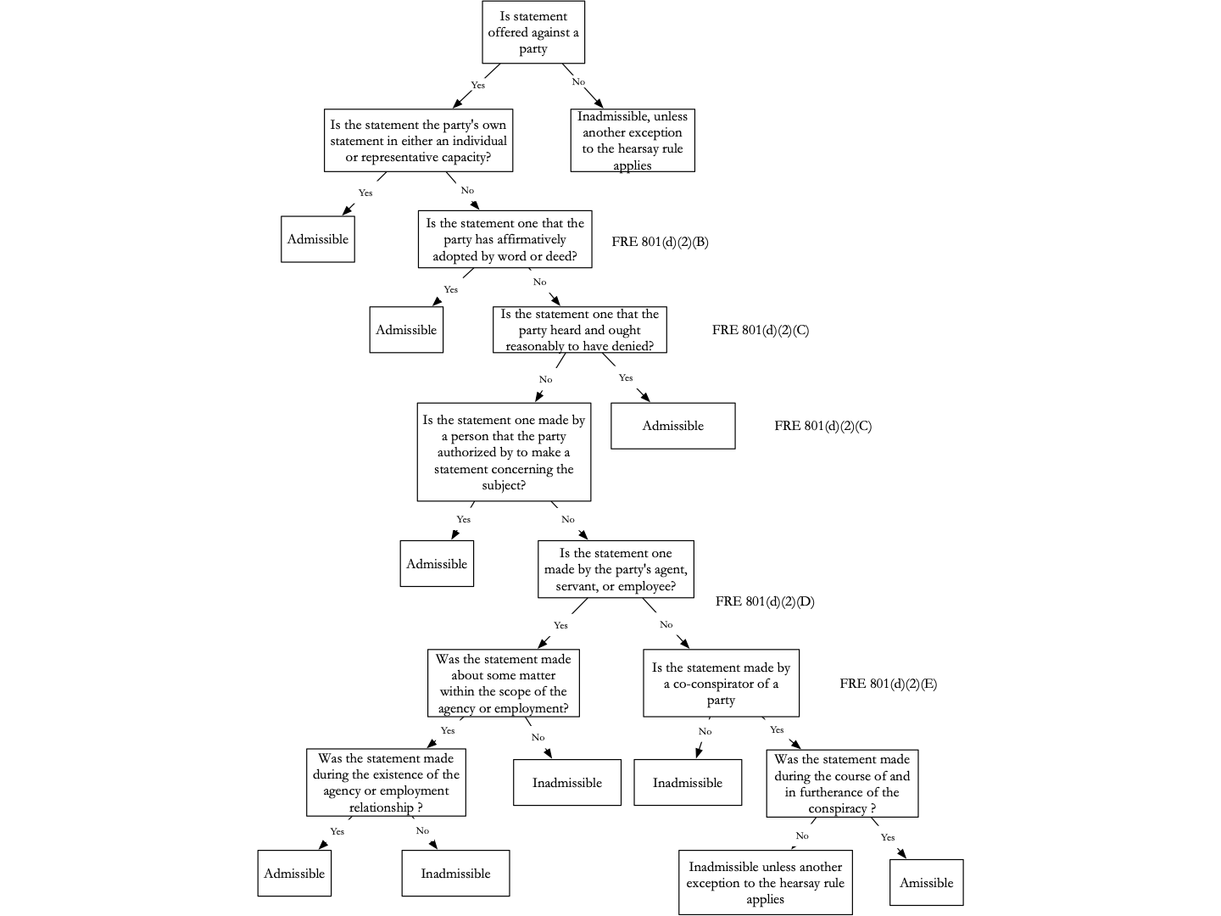
Questions – 3.0, 3.31 – page 119 – 10/18

- EXCEPTIONS TO HEARSAY
  - 803 Exceptions to Hearsay - does not matter if declarant is available to testify
    - Spontaneous Statements:
Now we are passing from the 2nd category to the 3rd which is the 29 exceptions - And we begin with 803 which is very long rule – 803 states available of declarant is unimportant but declarant is required to have perceived the events

Rule 803. Exceptions to the Rule Against Hearsay—Regardless of Whether the Declarant is Available as a Witness
The following are not excluded by the rule of hearsay, regardless of whether the declarant is available as a witness:
- Present Sense Impression. A statement describing or explaining an event or condition, made while or immediately after the declarant perceived it.
- Immediately is important - waiting an hour is not good enough
- On descriptive part of statement is admissible, requires tight connection between statement and event, ex: “my dad ran a red light because he was late picking me up from school” only “my dad ran red light” is admissible
- Excited Utterance. A statement relating to a startling event or condition, made while the declarant was under the stress of excitement that it caused.
- Reliable because made under stress/excitement of moment - scope here is broader than (1) - More time can lapse between statement and event - only matters if declarant was still under excitement when statement was made
- The statement must merely relate to the event discussed - looser connection between statement and event - includes statements that just mention the cause of the event rather than describe what happened, ex: “my dad ran a red light because he was late picking me up from school” - as long as person was excited when they said it the whole statement comes in

US v. Obayagbona (803(1) and (2))
Rule – Under Federal Rule of Evidence 803(2), a statement is admissible as an exception to the hearsay rule if the statement: (1) relates to a startling event and was a spontaneous reaction to that event or (2) describes or explains an event that the declarant was perceiving, either during or immediately after the event.
Facts – Turner, an undercover FBI agent, arranged a meeting to buy heroin from Onaiwu. Turner recorded the meeting on his tape recorder. Obayagbona was also present at the meeting and was charged with conspiracy to sell heroin. At trial turner testified Obayagbona handed Turner a sample of heroin from her purse. Once transaction was complete agents swarmed in and arrested Onaiwu and Obayagbona. Agents asked turner about the heroin and turner said Obayagbona handed him the sample and his voice was excited. The statement was made 14 minutes after Obayagbona handed turner the sample. Onaiwu argues that Obayagbona never handled drugs and that it was only her
Issue – Was Turner’s Excited Utterance admissible at trial?
Holding and reasoning – Turner’s statement is admissible as either present sense impression or excited utterance. Judge says time lapse is not significant to exclude from 803(1) and he was definitely excited when he made the statement so it can also come under 803(2).

People v. Cummings ** come back to class 10/20 ***
Rule – Rule 803 requires personal knowledge on the part of the declarant
Facts – 3 men were shot in a drive by, one of the victims calls 911 and in the background of the call you can hear another man yelling “it was twanek.” The declarant was definitely excited when making the statement but we dont know who the declarant is, he is unidentified.
Issue – is the excited utterance of an unidentified person admissible as excpetion to hearsay?
Holding and Reasoning – No this statement is not admissible. Advisory committee note to rule 803 requires personal knowledge on the part of the declarant. Here there is not way to know the declarant had personal knowledge / actually observed what he claimed to have observed.

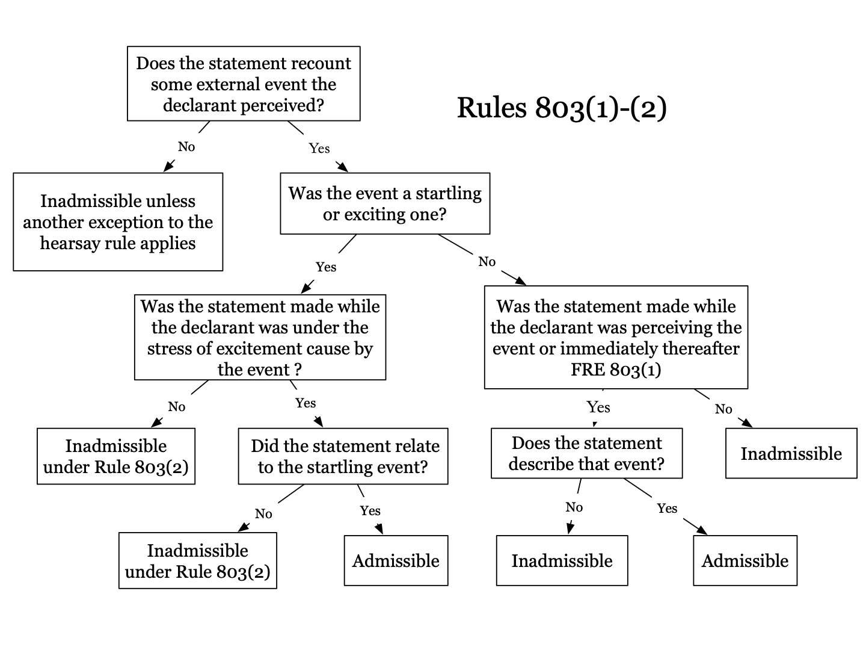
Flow chart for 803(1) and (2)

Questions: 3.36, 3.37, – page

The 3rd type of spontaneous statement is about mental state

803 following not excluded by rule of hearsay, regardless if declarant is available as witness at trial
- Then Existing Mental, Emotional, or Physical Condition. A statement of declarant’s then existing state of mind (such as motive, intent, or plan) or emotional, sensory, or physical condition (such as mental feeling, pain, or bodily health), but not including a statement of memory or belief to prove the fact remembered or believed unless it relates to the validity or terms of the declarant’s will.
- There are kind of 4 separate rules within this rule
  - Something declarant is thinking
    - A statement about a fact is admissible to prove declarant thought the fact to be true but inadmissible to show the fact is true
    - “I saw bill” can be used to prove declarant thought he saw Bill but not that he actually did
  - Something declarant is feeling
    - Statement like “i feel terrible” – this statement is admissible for its truth, that declarant was feeling terrible at the time
  - Something declarant plans to do
    - Statement “i plant to go to the movies tomorrow is admissible as relevant to the issue if declarant went to the movies the next day
    - Hillmon doctrine (below)
  - Something declarant remembers doing
    - Statement like “i went to the movies yesterday” is inadmissible

Mutual Life Insurance Co v. Hillmon (Hillmon doctrine)
Rule – hillmon doctrine – a declarant statement that she plans to do something or intends to do it in the future is admissible to prove that the declarant did in fact do it
Facts – Mrs Hillmon is suing to collect life insurance policies, she argues her husband was shot by his friend at a campsite. The insurance company rejects the claim because they think the dead man was actually Mr Walter and Mr Hillmon was actually still alive and trying to defraud insurance company. Insurance compnay introduce Mr Walter’s letters into evidence, in letters Mr Walters says, “i plan to go to colorado with hillmon”. Mrs Hillmon argues these letters are hearsay.
Issue – Are Mr Walters letters discussing his plans admissible?
Holding and Reasoning – Yes his letters and his statement about his plans are admissible. The statement that Walters planned to go with Hillmon is admissible both to prove Walters mental state that he had a plan to go and the fact that he actually did go.

Hillmon Doctrine = a declarant statement that she plans to do something or intends to do it in the future is admissible to prove that the declarant did in fact do it. Declarant’s statement of her plan or intent is admissible to prove both: (1) declarant mental state, current or future intent to do plan and (2) declarant acted in accordance with plan or intent and (3) third party in the statement also acted in accordance with the plan

United States v. Harris
Rule – Under Federal Rule of Evidence 803(3), an out-of-court statement is admissible as a hearsay exception if the statement is offered as evidence of the declarant’s state of mind, rather than the truth of the matter asserted.
Facts – A government informant posed as a heroin buyer and bought from Harris. Harris was arrested and at trial Harris sought to introduce testimony from his parole officer that harris told him that he knew the government was trying to set him up and that he went along with it because he was afraid of consequences if he did not. Trial judge excluded the testimony as hearsay
Issue – Is an out-of-court statement admissible as a hearsay exception if the statement is offered as evidence of the declarant’s state of mind, rather than the truth of the matter asserted?
Holding and Reasoning – The testimony is admissible. Under 803(3) out of court statement is admissible as exception to hearsay if offered to prove declarant's state of mind, rather than the truth of the matter asserted.
***class notes talk about difference between indirect circumstantial evidence if it was government is trying to set me up, verse direct evidence if it was i believe gov is trying to set me up, what is the different in terms of the rule, because notes say both are admissible one if for non hearsay circumstantial evidence of declarant’s state of mind and other direct evidence of declarant present existing mental condition ***

Shepard v. United States (statement from memory/belief to prove fact)
Rule – statement of memory or belief inadmissible substantively to prove fact remembered or believed / backward looking statements are inadmissible
Facts – Wife dies and husband is arrested for killing her by poison. Husbands introduces evidence that she told others she was tirade from her illness and she wanted to commit suicide. Prosecution tries to rebut this evidence by introducing evidence of a statement the wife made to the nurse, that wife thought husband poisoned her
Issue – is the statement the wife made to the nurse admissible under 803(3)?
Holding and Reasoning – No this statement to the nurse is inadmissible. The court holds this is backwarding looking evidence (unlike Hillmon about future plans). Wife said husband tried to poison her so it is backward looking. Court also said husband introduction of suicidal mental state opened door but prosecution could only introduce evidence that she had will to live/ was not sucidal, couldnt bring in evidence that she thought husband poisoned her.

US v. Houlihan
Rule – Hillmon Doctrine
Facts – Houlihan charged with murder of Boyden. Prosecution sought to introduce statement Boyden made to his sister night of murder that was, “I am going to meet up with Houlihan.” Defendant said this was hearsay
Holding and Reasoning – This state is admissible under 803(3), allows introduction of statement of intent/ future plans (hillmon doctrine)

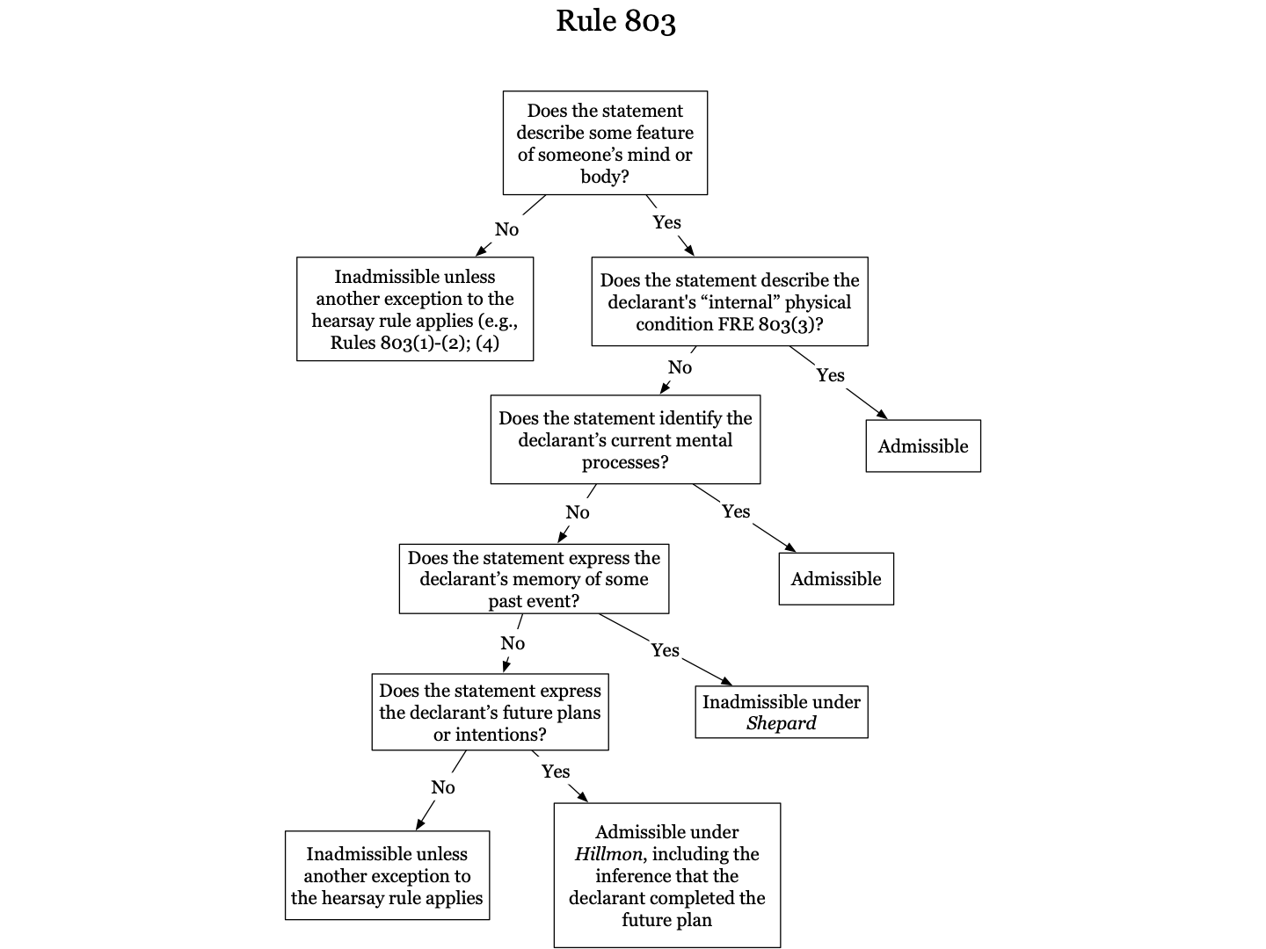
Flowchart for 803(3)

Questions: 3.38, 3.39, 3.40 - page 158 - 10/20

- Recorded Statements
Many types of recorded statements for hearsay exception:
- Injury Reports
- Recorded recollection
- Business records
- Public records
- Former testimony (not sure if this goes in this category)

- Injury Reports:
Rule 803(4) Statement Made for Medical Diagnosis or Treatment. A statement that:
- Is made for—and is reasonably pertinent to—medical diagnosis or treatment; and
- Describes medical history; past or present symptoms or sensations; their inception; or their general cause.
- Primarily for statements made to medical personnel - Can be statements that appear in documents like medical reports, idea is that someone will not lie because then they will not receive proper treatment
- Need not be contemporaneous

Rock v. Huffco
Rule – Details of the injury not necessary for treatment but serving only to suggest fault would not qualify as an exception to the hearsay rule under 803(4)/ Statements that do not report injury but simply cast blame or assert fault are inadmissible under the rule
Facts – Rock twisted ankle while working, he rested then went back to work a couple days later, then he slipped on grease and hurt ankle again, because of injury he got a weird medical condition and needed surgeries and then died of a heart attack. Rock’s family wanted to introduce Rock’s statements about the accidents to the doctors.
Issue – May a statement be admissible under the medical-diagnosis exception to the hearsay rule if the statement is not reasonably pertinent to the diagnosis or treatment?
Holding and Reasoning – Only the portion of the statement pertinent to the diagnosis/ treatment is admissible under 803(4) exception to hearsay. The portions of the statement to the doctors that discuss blame is inadmissible. Only the fact that he twisted his ankle was pertinent to treatment and fact that he slipped on grease was not necessary for treatment.

Ward v. State (confrontation clause)
Rule – In certain cases, like domestic violence cases, a victim’s statements during medical treatment that attribute fault or identify the perpetrator are admissible into evidence under the medical-diagnosis-or-treatment exception to the hearsay rule.
Facts – Ward drops of girlfriend at her parents house, parents called 911 to report she had been beaten and paramedics arrive and find she is covered in bruises, they ask her what happened and she said Ward beat her with a belt, they took her to hospital, at hospital forensic nurse asked her what happened and she told nurse Ward hit her with a belt, nurse took precaution to make sure she was discharged to sage location. Ward charged with domestic violence but the girlfriend did not come to testify against him at trial. Prosecution introduced statement made to the forensic nurse, Ward objected that statements were testimonial hearsay and violated confrontation clause
Holding and Reasoning – Court holds that statements made to the nurse are admissible. Court holds that in certain cases like domestic violence, child abuse, sexual assault, identifying the attacker / person who caused the injury is essential for treatment because treatment can depend if perpetrator is someone in the household or not. Court also holds statements are non testimonial for 3 reasons, (1) it was an ongoing emergency when paramedics arrived because they did not know if assailant was still on premises (2) the primary purpose of statements was treatment, even if secondary purpose was to inform police (3) girlfriend’s primary purpose of
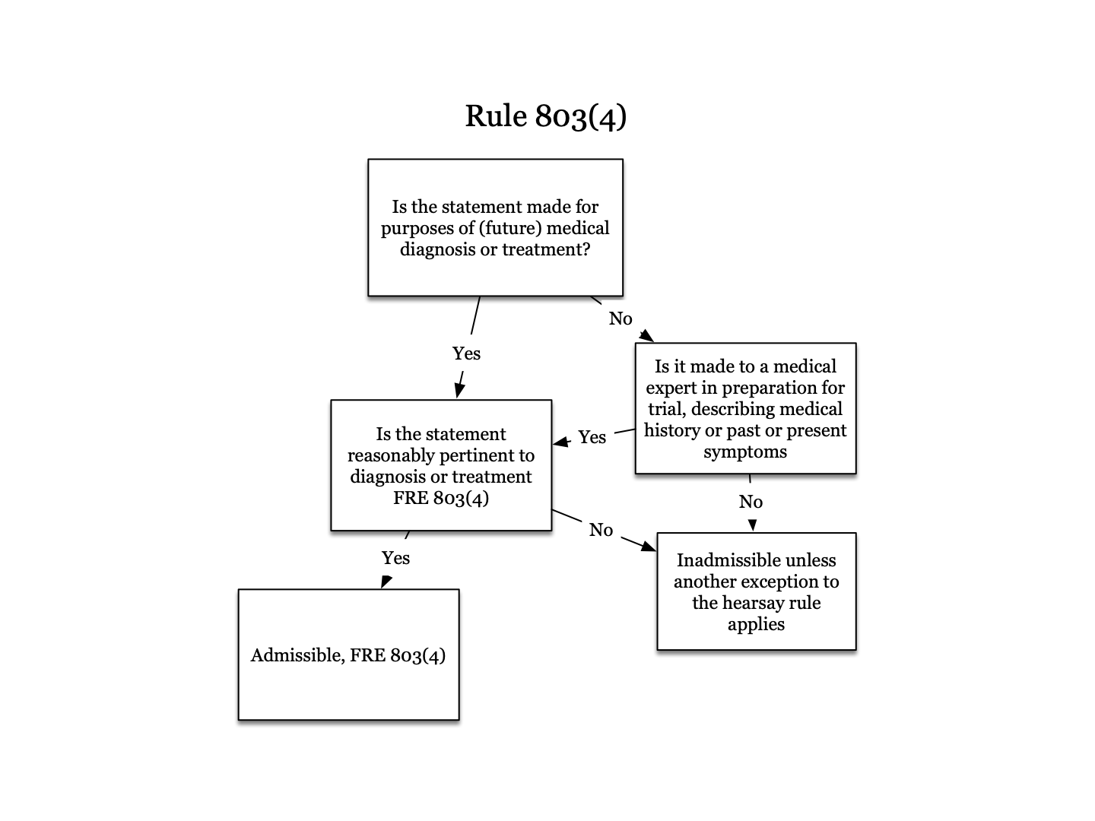
statements was to ensure her health and safety

Rule 803(4) flow chart

Questions: 3.42, 3.43 - page 166 - 10/25

- Recorded Recollection:
Rule 803(5) Recorded Recollection. A record that:
- Is on a matter the witness once knew about but now cannot recall well enough to testify fully and accurately;
- Was made or adopted by the witness when the matter was fresh in the witness’s memory; and
- Accurately reflects the witness’s knowledge
If admitted, the record may be read into evidence but may be received as an exhibit only if offered by an adverse party.
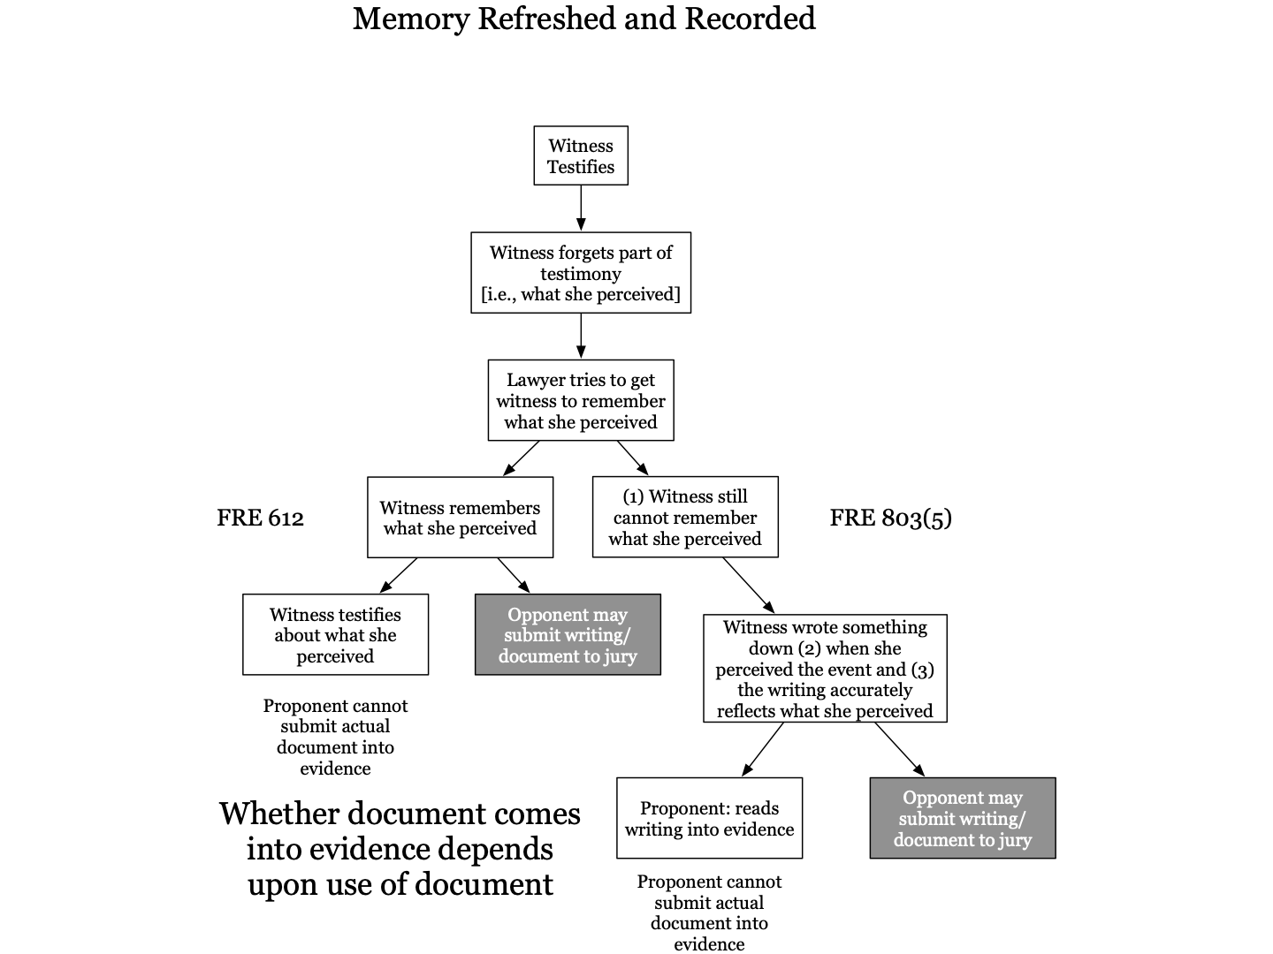
- (B) requires the recording to have been made when memory was fresh
- Requirement of 803(5) is proponent first try to jog memory to show person cannot testify from current memory

Rule 612. Writing Used to Refresh a Witness’s Memory
- Scope. This rule gives an adverse party certain options when a witness uses a writing to refresh memory:
    - While testifying
    - Before testifying, if the court decides that justice requires the party to have those options
- Adverse party’s options; deleting unrelated matters.

Using Rule 612 and Rule 803(5)
- Rule 612 - present recollection refreshed
  - If a witness forgets part of their testimony, the attorney can show something to help jog memory (anything can be used, perfume, photo, etc), but then adverse party can review, inspect, cross)
  - The witness then remembers and testifies to it - The item used to refresh the memory is NOT evidence and only the memory is
- Rule 803(5) - past recollection recorded
  - If a witness forgets part of the their testimony the attorney can show a writing to jog their memory
  - If the witness does not remember then the proponent can introduce the writing as a substitute for the witness testifying from memory. The recorded recollection can be introduced as replacement to witness;s current failed memory as long as it comports with requirements of (A)(B)and (C) of 803(5)
  - The proponent can read the contents of the document but document itself is only admissible if opponent introduces it into evidence - Must try to refresh under 612 before you can introduce through 803(5)

Fisher v. Swartz
Facts – Plaintiff suing defendant to recover for labor and construction materials, during plaintiff’s testimony at trial he used a copy of the bill he has sent to defendant to refresh his recollection of the contents of the bill. Bill contained over 100 items, after the testimony the bill was introduced into evidence over the defendant's objection.
Holding and Reasoning – Trial court did not abuse discretion when allowing the bill into evidence. Because plaintiff was not able to remember details of the bull sufficiently to testify, the plaintiff was permitted to review the bill to refresh pas recollection, given that plaintiff could still not remember even though he was allowed to read from it there isnt justification from allowing it into evidence.

United States v. Riccardi
Facts – Riccardi was charged with interstate transportation of stolen goods. Goods belonged to Farid, thieves packed up goods at her request, but then stole them on route to their destination. Prosecution called Berlow who was an antique expert who had seen the goods many times in Farid’s home. Prosecution used a list of goods to refresh witness’s memory as to what was missing. After reading the list the witness said they knew goods and identify them. Riccardi objected to lists and said they were not created when at a time when thefts facts were fresh.
Holding and Reasoning – the list itself was not admitted it was just read allowed and then witness could remember and testify to it. It can be read a loud to refresh

- Business Records
Rule 803(6) Records of a Regularly Conducted Activity. A record of an act, event, condition, opinion, or diagnosis if:
- The record was made at or near the time by—or form information transmitted by—someone with knowledge
- The record was kept in the course of a regularly conducted activity of a business, organization, occupation, or calling, whether or not for profit;
- Making the record was a regular practice of that activity
- All these conditions are shown by the testimony of the custodian or another qualified witness, or by a certification that complies with Rule 902(11) or (12) or with a statute permitting certification; and
- The opponent does not show that the source of information or the method or circumstances of preparation indicate a lack of trustworthiness
- covers all types of business records from formal documents to marginal notations
- Just because something is out of the ordinary does not mean it is not business (keogh and gibson)
(7) Absence of a Record of a Regularly Conducted Activity. Evidence that a matter is not included in a record described in paragraph (6) if:
- The evidence is admitted to prove that the matter did not occur or exist;
- A record was regularly kept for a matter of that kind; and
- The opponent does not show that the possible source of the information or other circumstances indicate a lack of trustworthiness
- evidence of the absence of business record of some activity is admissible to show that the activity did not happen so long as the business would normally record that kind of event in so long as the opponent does not show that the failure to record was untrustworthy

State v. Acquisto (every link in chain of record)
Rule – A party seeking to introduce business records into evidence under Federal Rule of Evidence 803(6) is not required to proffer the testimony of every individual who participated in creating the record.
Facts – Defendant was charge with sexual assault and his alibi was that he was at home with his mother and her friend that day. Prosecution sought to admit payroll vouchers that showed the mother and her friend were at work on the day. Prosecution had Mari Judge, the custodian of records, testify and she is the one who maintained payroll records for company. Marie presented evidence of payroll showing they were working that day. Acquisto objects and argues every individual who participating in creating the record needs to testify.
Issue – Is a party seeking to introduce business records into evidence required to proffer the testimony of every individual who participated in creating the record?
Holding and Reasoning – No. A party seeking to introduce business records into evidence is not required to proffer the testimony of every individual who participated in creating the record. This court abandons the common-law rule that requires this testimony and instead adopts Federal Rule of Evidence 803(6).

Wilson v. Zapata (multiple hearsay)
Rule – As long as all people who create record work for the business then there is no multiple hearsay issue. / if source of record is outside the business then there is a multiple hearsay issue.
Facts – plaintiff sued defendants alleging sex discrimination in the work place. Plaintiff was in the hospital and plaintiff’s sister made a comment to a social worker that her sister was a “habitual liar”
Issue – can business records be introduced into evidence when source was not employed by the business?
Holding and Reasoning – the sister’s statement is inadmissible because it contained multiple hearsay. The sister does not work for the business and is therefore not acting within the regular course of business required by the rule. (the court ended up allowing it under medical record exception)

Palmer v. Hoffman (regular conducted activity / accident report)
Rule – fact that a company regularly makes a record in certain situations, like accidents, does not necessarily mean that that record is the regular course of business / a report motivated by the prospect of future litigation rather than prepared for the purposes of railroading was inadmissible under 803(6)
Facts – there was railroad accident and the engineer made a statement before he died about the accident and petitioners tried to introduce that statement into evidence.
Issue – does conducting an interview everytime there is an accident count as “in the course of regularly conducted business” for a railroad?
Holding and Reasoning – this statement is inadmissible. The fact that a company makes a business out of recording its employees versions of their accidents does not put those statements in the class of records make “in the regular course of the business” within the act. Also the record was motivated by prospect of future litigation which makes is less reliable.

Lewis v. Baker (regular conduct activity / accident report)
Rule – injury reports and inspection reports conducted after accidents may in some cases be “conducted in regular course of business”
Facts – Lewis was employee and penn central railroad and was in an accident. There were 2 reports that penn central was trying to introduce. One was an injury report (penn central required to file monthly reports of all accidents), and other was inspection report (required to inspect equipment after any accident).
Holding and Reasoning – court distinguishes this case from Palmer case. This case the employees who made reports were not involved in teh accident and were not worried about future litigation regarding accident and therefore did not have motivation to lie unlike engineer in Palmer. both the injury report and the inspection report were required to be conducted after each accident and injury, those reports were made in the regular course of business. They are therefore admissible under the business records exception to the hearsay rule.

Keogh v. Commissioner of Internal Revenue (personal records and business)
Rule – A personally kept business record qualifies under Rule 803(6) of the Federal Rules of Evidence if it is systematically checked and regularly and continually maintained.
Facts – Keogh worked at a casino and underreported the tips he earned. Koegh and Whitlock were in scheme together, they both pooled their money and would split equally. Whitlock kept diary and recorded amount each day. Prosecution sought to introduce diary, Whitlock’s wife testified that he wrote in it everyday after work. Defendant says personal diary is not business record.
Issue – is a personal diary a business record under exception?
Holding and Reasoning – a personal diary may be admitted under business record exception. Personal records kept for business reasons may qualify under exception. He wrote down tips and division and wife testified to how regularly it was updated so the court held it fit within exception.

United States v. Gibson
Rule – cocaine dealership counts as “business” under 803(6)
Facts – Gibson and others were convicted of heroin trafficking. Logan’s ledger was introduced into evidence. Gibson argued it should not be admitted because the records were not kept in course of regularly conducted business activity.
Holding and Reasoning – The court holds the ledger is admissible. Logan testified she kept record of most of her large drug transactions and it was regular practice to enter into the ledger the number of balloons that went out on a particular day and how much money she took in. transactions were recorded contemporaneously. Does not matter that entries were made out of sequence.

Questions; 3.35 - page 187 - 10/25

- Public Records
Rule 803(8) Public Records. A record or statement of a public office if:
- It sets out:
    - the office’s activities
- Statements that record public officials activities
    - a matter observed while under legal duty to report, but not including, in a criminal case, a matter observed by law enforcement personnel; or
- Facts personally observed by public official under which they had duty to observe
- Ex: meteorological official recording weather
- Does not include things observed by lay person and reported official
- Rule specifically excludes investigative reports offered by government against a defendant in a criminal trial, the officer must testify himself about what he observed
    - In a civil case or against the government in a criminal case, factual findings from a legally authorized investigation; and
- Reports filed by government agency after it conducted an official investigation
- Allows statements made by an outsider and adopted by investigator
- Can include opinions
- The opponent does not show that the source of information or other circumstances indicate lack of trustworthiness.
- Both (ii) and (iii) prohibit use of police reports against criminal defendant
- Police reports against defendant in criminal case are not allowed under any hearsay exception (not business record exception or past recollection recorded)
- Public records do not need to be made near the time of event (unlike business records)

Beech Aircraft v. Rainey
Rule – Conclusions or opinions in public agency investigative reports are admissible under Rule 803(8) as long as the conclusion or opinion is based on the factual investigation.
Facts – military aircraft crashed killing both pilots, surviving spouses claimed a manufacturing defect caused the crash, they sought to admit part of an accident report contained in a section entitled opinions that included the possibility that the alleged defect cause the crash
Holding and Reasoning – Court held as long as the opinions were based on the factual investigation they were admissible. “We agree and hold that factually based conclusions or opinions are not on that account excluded from the scope of Rule 803(8)(iii)”

Melendez Diaz v. Massachusetts ((iii)record and confrontation clause)
Rule – In a criminal case, laboratory reports prepared by government analysts are inadmissible against the defendant because such reports constitute testimonial evidence under the Confrontation Clause.
Facts – Melendez was tried for distributing cocaine. Government sought to introduce “certificate of analysis” prepared in state crime lab in order to show substance taken from Melendez was cocaine. Analyst did not testify at trial and Melendez argued this violated confrontation clause because certificate of analysis was testimonial.
Issue – is analyst who prepared certificate not testifying a violation of confrontation clause?
Holding and Reasoning – court holds this is a violation of the confrontation clause. Court noted business and public records are generally admissible absent confrontation because they were created for administrative reasons and not for preparation at trial. Here it was for a trial. Court holds the certificates were testimonial because they were prepared with primary purpose of substituting testimony at trial and analsyt knew that when preparing it. Court thinks it is possible for lab tech to be susceptible to manipulation and therefore they need to take necessary steps to guarantee reliability which would be live witness testimony and cross examination

Bullcoming v. New Mexico ((iii) record and confrontation clause)
Rule – The Confrontation Clause generally requires the prosecution to introduce a forensic-laboratory report containing testimonial certification through the in-court testimony of the scientist who signed the certification or who personally performed or observed the performance of the test reported in the certification.
Facts – Bullcoming was arrested for driving while intoxicated and the principle evidence against him at trial was a tox report saying his blood alcohol content was above threshold. Analyst who did report, Caylor, did not testify at trial and the government had a different analyst testify.
Issue – does surrogate testimony satisfy the confrontation clause?
Holding and Reasoning – Court holds the surrogate testimony is not sufficient. The other analyst can only give background information and cannot answer a question on cross like did you read the machine correctly in this instance. Supreme court rejects argument that this is just ministerial recording and no human error. Court thinks you should still be able to confront the person

US v. Torralba-Mendia (iii) and
Rule – A report of observations by a law enforcement official is admissible under 803(8)(A)(ii) if it is a ministerial, objective observation
- A record of “deportable aliens” is admissible

State v. Davis

US v. Lundstrom
Rule - Government reports are admissible against a criminal defendant if the report is created as part of a routine agency procedure and not in anticipation of litigation
- Reports of federal examiners who supervise banks to ensure their soundness and compliance with financial laws and regulations and do not conduct criminal investigations, collect evidence, or bring criminal charges, are admissible under 803(6) because the reports were created for the administration of the office’s affairs and not for the purpose of establishing facts at trial

Questions: Gianelli 1.77, 1.79, 1.88 on powerpoint - 10/27

*** come back for these 3 cases - that we didnt even have to read :/ ***

803 rules it did not matter if the declarant was available to testify at trial …
Now we get to rules where declarant is required to be unavailable to testify

  - 804 Exceptions - Require Declarant to be Unavailable as a Witness
    - Criteria for being unavailable
Rule 804. Exceptions to the Rule Against Hearsay—when declarant is unavailable as witness
- Criteria For Being Unavailable. A declarant is considered to be unavailable as a witness if the declarant:
    - Is exempted from testifying about the subject matter of the declarant’s statement because the court rules that a privilege applies;
    - Refuses to testify about the subject matter despite a court order to do so;
    - Testifies to not remembering the subject matter;
- Declarant must be sworn in as witness and cross examined to demonstrate he can no longer remember her statement
    - Cannot be present or testify at the trial or hearing because of death or a then-existing infirmity, physical illness or mental illness; or
    - Is absent form the trial or hearing and the statement’s proponent has not been able, by process or other reasonable means, to procure:
- The declarant’s attendance, in the case of a hearsay exception under Rule 804(b)(1) or (6); or
- The declarant’s attendance or testimony, in the case of a hearsay exception under rule 804(b)(2),(3), or (4)
- For (5) just service of process is not enough must demonstrate you made reasonable effort
But this subdivision (a) does not apply if the statement’s proponent procured or wrongfully caused the declarant’s unavailability as a witness in order to prevent the declarant from attending or testifying
- This is how to first establish that the witness is unavailable, this is obviously necessary before you can go on to use any of the exceptions
- The rest is exceptions

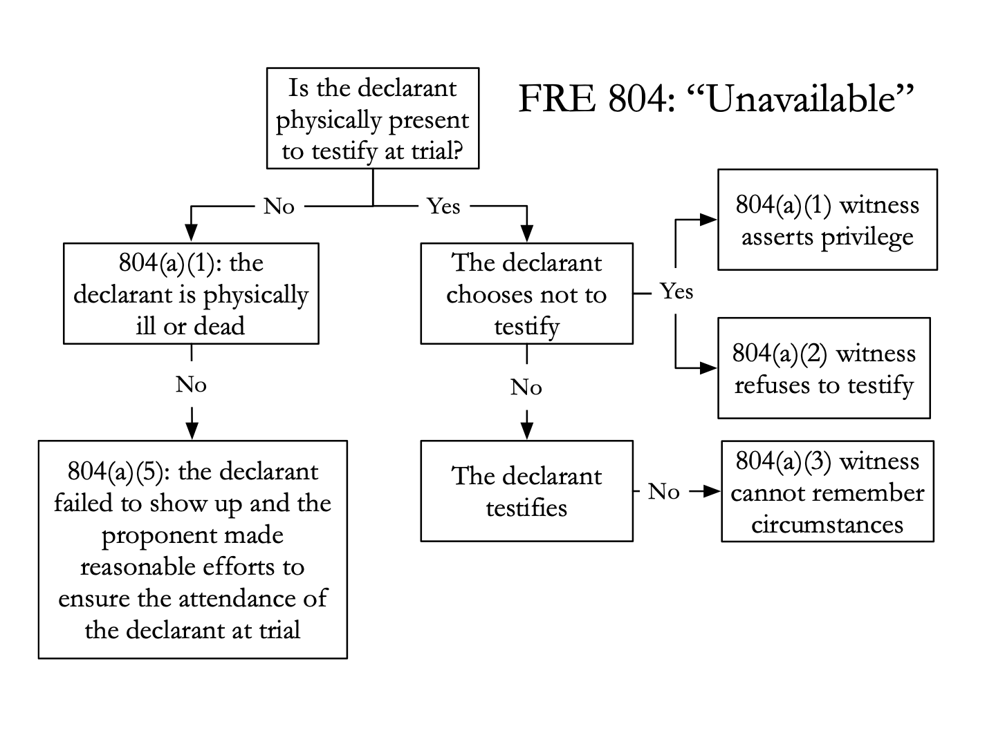

Kirk v. Raymark Industries (804(a)(5))
Rule – 804(a)(5) requires proponent to take all reasonable steps to procure the declarant as the witness at trial, including informal steps if their attempt to subpoena the witness is unsuccessful
Facts – Owens retained doctor Luis Burger, an independent expert on asbestos, and a prior hearing. In the current case plaintiff (Owens is defendant), wants to introduce statements by Burger from the prior trial.
Holding and Reasoning – The court holds that the plaintiff cannot introduce Burgers testimony from the prior trial. 804(a)(5) requires the plainiff to take all reasonable steps to procure the declarant as a witness at trial, including informal steps it their subponea is unsuccessful. Here it is normal to pay an expert witness to testify but the plaintiff here did not pay the expert witness and this is why he did not come to the current trial to testify, so the court said plaintiff did not take reasonable steps. Court also held Burger and experts were not employee under 801(d)(2)(D)

US v. Bolin (804(a))
Rule – a proponent/ declarant makes himself unavailable by asserting 5th amendment privilege
Facts – Bolin is a criminal defendant who asserted 5th amendment privilege. He wants to introduce his own prior statements.
Holding and Reasoning – Bolin cannot introduce his own former testimony. There is proviso to 804(a) that applies if the proponent makes the declarant unavailable. Bolin has made himself unavailable by asserting 5th amendment privilege

- Former Testimony
804(b) (1) Former Testimony. Testimony that:
- Was given as a witness at a trial, hearing, or lawful deposition, whether given during the current proceeding or a different one; and
- Is now offered against a party who had—an opportunity and similar motive to develop it by direct, cross, or redirect examination
- Former testimony rule requires 2 trials
- Requires declarant testified under oath a prior hearing and Be available for cross at prior hearing
- Requires prior cross examiner to have the right relationship to current opponent and share a similar motive in developing testimony (similar motive to cross examine)
- Example: if criminal defendant on trial seeks to introduce prior testimony of a witness that is currently unavailable the prosecutor in the previous trial and current trial must represent the same party, if first was federal and this one is state then they are not same party and testimony is inadmissible
- Example: prosecutor at previous trial sought to cross examine about alibi but at current trial motive to cross examine is to support self defense claim then motives are different
- If its civils then relationship doesnt need to be as close - usually they just need to share the same stake in cross examining, but some jurisdiction require privity

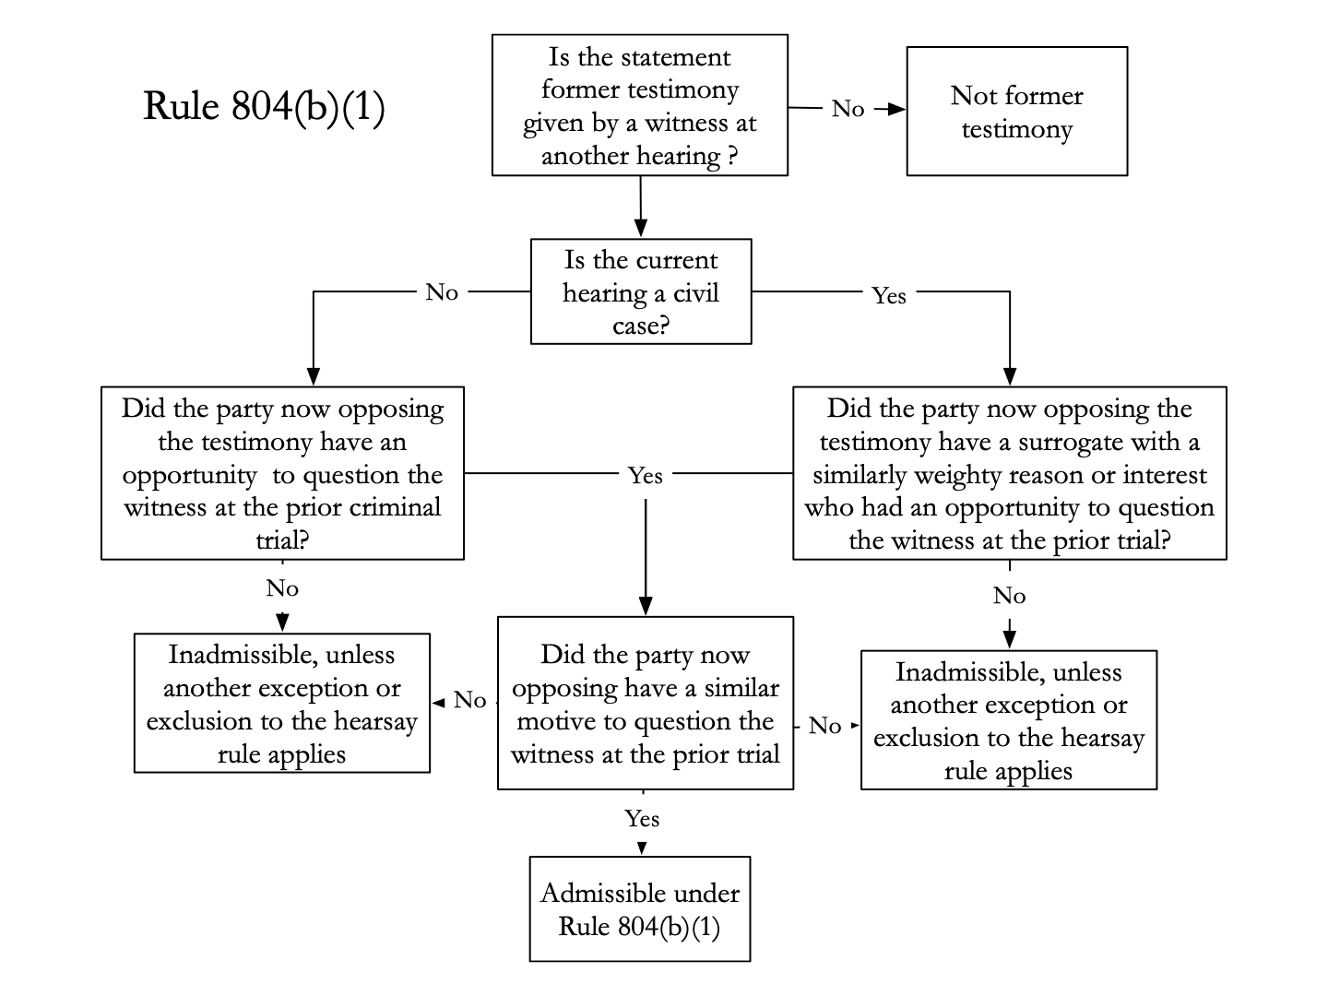

Clay v. John Manville (predecessor in interest)
Rule – For purposes of the former testimony exception to the hearsay rule, a predecessor in interest can be considered a party that had similar motive to cross-examine the witness about the same material facts.
Facts – plaintiffs bring products liability suit against johns-manville and raybestos. Plaintiff sought to introduce testimony from a deposition, from a prior case, of Dr Smith who was the company’s only full time doctor, because he died before the trial. The prior deposition contained statements that the company knew about dangers of asbestos.
Holding and Reasoning – court applies predecessor in interest analysis. The court holds that the defendant in this case had same interest in cross examination as in previous case so it is admissible because they are predecessor in interest. Johnsmanville was a party in previous but Raybestos was not and they were the ones objecting.

Volland-Goland v. City of Chicago
Rule – For purposes of the former-testimony exception to the hearsay rule, a former party will be considered a current party’s predecessor in interest if the former party’s stake in the former litigation is of equal weight to the current party’s stake in the current litigation.
Facts – Officer used pepper spray and physical force to arrest Volland following a traffic stop. Volland is tried for resisting arrest and is acquitted. Volland sues for excessive force but then he died, his sister is continuing with the case and wants to use testimony from his resisting arrest trial in the current trial.
Issue – Can Volland’s testify at the prior criminal trial be used at the current civil trial / Can state be considered predecessors in interest to defendants (especially officers) / Did state have similar motive to develop Volland's testimony by cross examination ?
Holding and Reasoning – Court holds that former testimony is admissible. The current case is a civil one so predecessor in interest rule applies. The court thinks the factual questions in both cases are the same - because it is about who did what and in what order. First case was about securing a conviction and this one is about voiding liability - court says these are not identical but they are close enough because both had similar reason to cross examine Volland and two interests are sufficiently weighty. Both cases were about if force was reasonable.

US v. Salerno
Rule - A court may not admit a witness's former testimony under the former-testimony exception to the hearsay rule if the exception's similar-motive requirement is not satisfied.
Facts – Defendants were charged with activities relating to genovese crime family, At grand jury DeMatteis and Bruno testify that Cedar Park concrete was not involved, But US attempt to show Cedar Park was involved so respondents tried to subpoena DeMatt and Bruno at trial to again testify that Cedar was not involved but they plead the 5th and refused to testify - respondents want to use grand jury transcript as evidence
Issue – Can respondents use grand jury transcript as evidence? / Did prosecutor at grand jury and prosecutor at trial have similar motive?
Holding and reasoning – court said proponents must prove there was similar motive in cross examining. Case remanded to know if there was similar motive. The court does not really know whether grand jury testimony would be admissible because defendant is not present, but defendant is the one who wanted the evidence in the prosecutor is saying they did not have same motive at grand jury and at trial.

Questions: 3.47, 3.48 - page 225, 11/03

- Dying Declarations:
804(b)(2) Statement Under the Belief of Imminent Death. In a prosecution for homicide or in a civil case, a statement that the declarant, while believing the declarant’s death to be imminent, made about its cause or circumstances.
- You dont have to actually die but you need to believe you are about to die now, doent count if you are given 6 months to live or even 6 days you have to be actually in the process of dying or think you are
- Only statements that pertain to who or what cause death under what circumstances are admisible
- In criminal trial only for homicide

Shepard v. US
Rule – declarant must believe death is imminent
Facts – woman drank whiskey from closet, then got sick, and she told her nurse she thought her husband poisoned her with the whiskey.
Holding and Reasoning – This is a homicide case, but at the time mrs shepard made the statement she was not sure she was going to die. At that moment she was actually getting better and thought she might survive. Because she did not believe her death was imminent testimony is inamdissible

US v. Sacasas
Rule – if criminal trial it must be homicide
Facts – after bank robbery conviction. Man who had been indicted with defendant said “if anything happens to me tell them the Greek had nothing to do with the job” then he lost consciousness and died 10 minutes later
Holding and Reasoning – statement is inadmissible because this is criminal case but not for homicide.

State v. Lewis ?? cant find this case
Rule – A dying declaration may be admissible as an exception to the hearsay rule, even if the statement is testimonial in nature. / also must be a statement from personal knowledge

Davis v. State
Rule – The dying-declaration exception to the hearsay rule does not violate a criminal defendant’s Sixth Amendment right of confrontation.
Facts – yvonne was working and man came in to rob place and lit yvonne on fire. When paramedics came she told them it was Davis, she later died of her injuries
Holding and Reasoning – Yvonne’s statements were dying declarations because she knew severity of her injuries and that she would die, she also had personal knowledge because Davis was a client of insurance company and she knew who he was and recognized him. Court said confrontation clause is not violated.

Questions 3.49

- Statements Against Interest:
804(b)(3) Statement Against Interest. A statement that:
- A reasonable person in the declarant’s position would have made only if the person believed it to be true because when made, it was so contrary to the declarant’s proprietary or pecuniary interest or had so great a tendency to invalidate the declarant’s claim against someone else or to expose the declarant to civil or criminal liability; and
- Is supported by corroborating circumstances that clearly indicate its trustworthiness, if it is offered in a criminal case as one that tends to expose the declarant to criminal liability.
- Not enough that declarant would be subject to ridicule or hatred - there must be legal risk
- But only admissible if declarant thought she would be exposed to legal liability, so statement made in confidence to a friend may not count
- In a criminal case, if statement exposes declarant to criminal liability there must be corroborating evidence other than statement itself especially when statement is used for exculpatory purpose

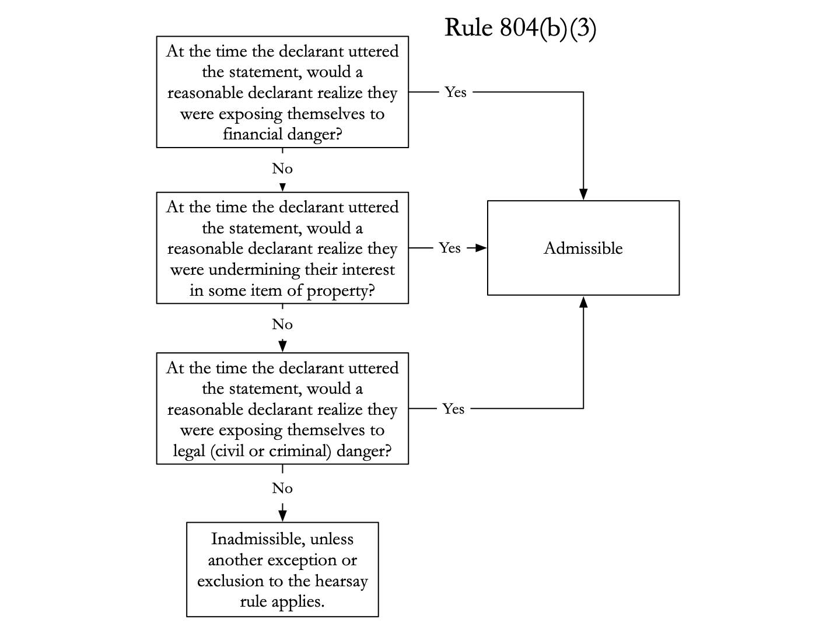
- 3 grounds: financial, property, and civil or criminal liability

US v. Duran Samaniego
Facts – Duran claims his championship belts were stolen by Igelsias. Government trying to figure out who is rightful owner of belts. Duran wants Iglesias to testify but he is from panama and US cannot subpoena him and his family members also could not find him. Duran wanted to introduce family’s testimony that Iglesias told them he is “sorry for stealing the belt”
Holding and Reasoning – statement can be broke up into 2 parts “im sorry” and “for stealing the belt.” court allows “i am sorry for stealing belt” under 804(3) because it could subject him to civil or criminal liability because he could be prosecuted for stealing the belts. (miller says the just the “im sorry” could come in under 803(3) then existing mental state). The court also held Iglesias was unavailable because Duran has taken reasonable steps.

US v. Jackson ***come back for rule***
Rule – williams rule
Facts – Jackson was found guilty of conspiring to import 5kg of cocaine. He wanted to admit the full plea allocution of co conspirator Steve Brown which said that Brown did not supervise Jackson.
Issue – is a statement at a plea allocution a statement against interest?
Holding and Reasoning – Statement from plea allocution is not allowed under 804(b)(1) because gov did not have the same motive in plea hearing as other proceedings and Not allowed under 804(b)(3) because that rule requires that the statement subject the declarant to civil or criminal liability and the statement does not. We dont ask whether the whole plea is against interest we just look at the specific sentence which was “i didnt not supervise jackson” and court thought this statement was not against his interest.

questions : 3.51, 3.52, - page 238 - 11/03

- Forfeiture by Wrongdoing:
Rule 804(b)(6) Statement Offered Against a Party That Wrongfully Cause the Declarant’s Unavailability. A Statement offered against a party that wrongfully caused–or acquiesced in wrongfully causing–the declarant’s unavailability as a witness, and did so intending that result.
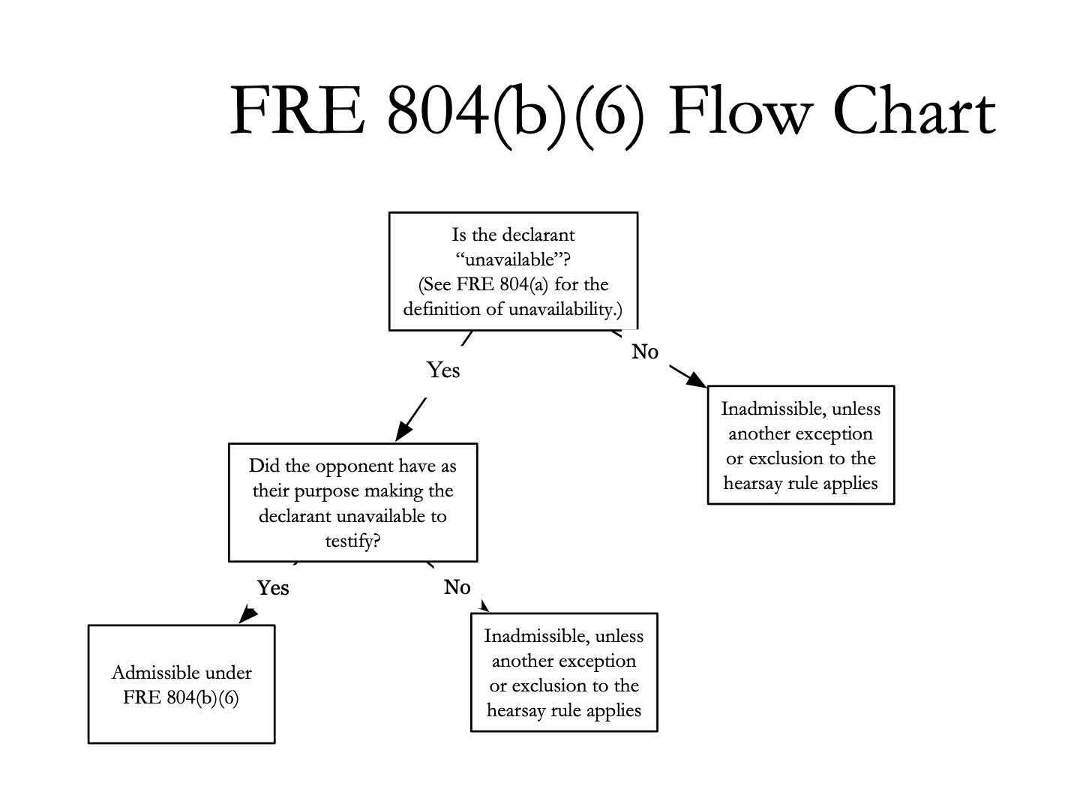

Giles v. California
Rule – A wrongful act of a defendant creates a forfeiture of his Sixth Amendment right to confront a witness against him only when the act was designed to prevent the witness from testifying.
Facts – Giles shot and killed his ex-girlfriend, brenda. Giles claimed self defense. Prosecution sought to introduce statements brenda had made to police in relation to domestic violence report that Giles that choked her and threatened to kill her. There was no dispute the statements were testimonial. California supreme court allowed statement and held giles forfeited his confrontation right because his act of killing Brenda created her unavailability as a witness.
Issue – does defendant always forfeit confrontation clause rights when his wrongful act cause witness to be unavailable?
Holding and Reasoning – court holds that forfeiture by wrongdoing will only apply if the motive for the wrongdoing (here the killing) was for the purpose of the witness not testifying. Here Giles did not kill Brenda in order for her to not testify at trial. Absent evidence of that motive the forfeiture by wrongdoing clause does not apply

- Residual Exception:
Rule 807. Residual Exception.
- In General. Under the following circumstances, a hearsay statement is not excluded by the rule against hearsay even if the statement is not admissible under a hearsay exception in Rule 803 or 804:
- The statement is supported by sufficient guarantees of trustworthiness –after considering the totality of the circumstances under which it was made and evidence, if any, corroborating the statement; and
- It is more probative on the point for which it is offered than any other evidence that the proponent can obtain through reasonable efforts.
- Notice. The statement is admissible only if the proponent gives an adverse party reasonable notice of the intent to offer the statement – …
- Majority view is that if one element of some hearsay exception has not been fulfilled then so long as the other circumstances are sufficiently trustworthy and there is strong showing of necessity then the evidence may be admissible

US v. Slatten
Rule – In exceptional circumstances, hearsay that is inadmissible under Federal Rules of Evidence 803 and 804 may be admitted under the residual-hearsay exception in Federal Rule of Evidence 807.
Facts – slatten was a mercenary paid by the US government. He was accused of murdering innocent civilians in Iraq. Slatten claimed it was another mercenary who killed the victim. Proposed evidence was the statement the co defendant had given under promise of immunity, that the co defendant was the killer and that he shot in self defense. The statement was inadmissible under a variety of exceptions (didnt fit 804(b)(3) because he had immunity when he made them so they werent against his interest)
Holding and Reasoning – DC circuit court allows in the statement under residual exception because the court thought these were exceptional circumstances. There were several surrounding circumstances that guaranteed reliability – the co defendant had immunity so he did not have a reason to lie, also he would lose the immunity if he lied so he had reason to tell the truth because it was part of the immunity deal.

- Hearsay and Machine Generated Proof:
People v. Lopez (hearsay and machine generate proof) *** do we need to know this case? ***
Rule – The prosecution’s use of a machine printout that does not contain a statement from the machine’s operator about the validity of the data shown in the printout does not violate the criminal defendant’s right to confront and cross-examine the machine’s operator.
Facts – lopez convicted of vehicular manslaughter while intoxicated. To prove he was intoxicated the prosecution used lab analysis report, the report had signature of Jorge Pena but no statement of his appears on the report and he does not testify at trial. Pena only printed out a machine generated report.
Holding and Reasoning – machine generated printout is admissible. Because, unlike a person, a machine cannot be cross examined, here the prosecution’s introduction into evidence of the machine generated printouts of non testifying analyst Pena’s laboratory report did not implicate the 6th amendment

- Hearsay and Due Process:
Where the hearsay rules conflict with the constitution the constitution wins. There are 2 clauses that are of special interest
- 6th amendment confrontation clause
- 5th amendment due process clause which is applied to states through 14th amendment due process clause
  - Due process clause requires the defendant be afforded a fair opportunity to defend herself against the state

Chambers v. Mississippi
Rule – ???
Facts – Chambers was caught up in spontaneous protest when cops showed up to arrest two african american men in a pool hall. Police rushed to scene to stop protest and one of protestors shot one of the officers who later died of his wounds. Prosecution alleged that the officer had identified Chambers has his assailant by shooting him during the incident. On a number of occasions McDonald identified himself as the shooter (in the car to some of his friends) and had written a confession and gave it to Chambers’s attorney, but he later recanted the confession. Chambers calls McDonald as a witness at trial. Trial court said statements to friend in the car was inadmissible hearsay (not available under 804(b)(3) because mcdonald was available to testify). Because of some old rule Chambers was not allowed to cross examine McDonald.
Holding and Reasoning – the court held there was a violation of due process, “We conclude that the exclusion of this evidence (the hearsay car statements), coupled with the state’s refusal to permit Chambers to cross examine McDonald, denied him a trial in accord with traditional and fundamental standards of due process.” court held that 2 rights had been violated, (1) right to cross examine witnesses and (2) the right to offer testimony. Court said the multiple confessions should have been allowed because there was garurantee of reliability and it was central to defense and he should have been able to cross examine.

- AUTHENTICATION
Rule 901. Authenticating or Identifying Evidence.
- In General. To satisfy the requirement of authenticating or identifying an item of evidence, the proponent must produce evidence sufficient to support a finding that the item is what the proponent claims it is.
- Examples. The following are examples only–not a complete list–of evidence that satisfies the requirement:
- Testimony of a Witness with Knowledge. Testimony that an item is what it is claimed to be.
- Non Expert Opinion About Handwriting
- Comparison by an Expert Witness or the Trier of Fact
- Distinctive Characteristics and the Like.
- Opinion About a Voice.
- … how many of these do we need to know

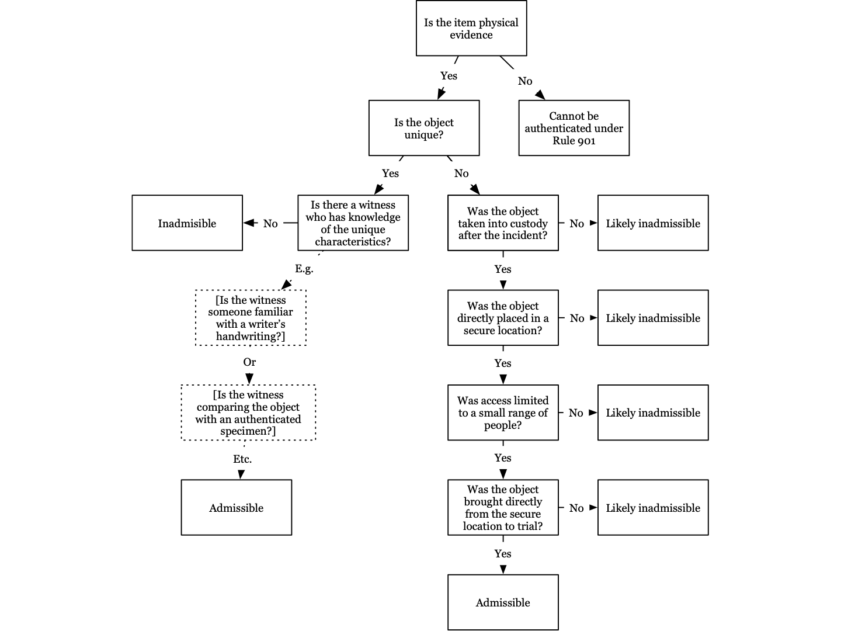

- Standard is the same as 104(b) sufficiency of the evidence
- Two types of evidence that under 901(a) - unique and generic
- Unique item - can be authenticated by someone with personal knowledge testifying that it is what the proponent claims it to be
- Generic item - generic items you need to establish chain of custody (tracing item from when it was seized to trial)
  - If there are gaps we just ask if there is sufficient evidence to believe that the item is what the proponent claims it is
  - Example: plaintiff sues GE about broken bulb, but GE asserts gap in chain of custody because it was in a cabinet that anyone could access – plaintiff offers circumstantial evidence that plaintiff’s factory only used GE bulbs and only 6 people had access to cabinet - this would be enough for 901 generic evidence
  - If gap in chain of custody just ask - could a reasonable juror believe that the item of evidence that was seized the same that is being offered at trial?

US v. Long
Rule – To authenticate a document, the proponent need only prove a rational basis for the claim the document is what the proponent asserts it to be
Facts – Jackson and Long appeals conviction of involvement in check forging and bank fraud. Long called his fiance to the stand, she mentioned a contract that Long signed prior to going to minnesota which led her and Long to believe he was participating in a legitimate business. On cross gov questioned her about the contract, on redirect finance identified an exhibit as the contract. Government and Jackson objected to the exhibit as hearsay. The trial court questioned whether the contract has been authenticated
Issue – had contract been authenticated?
Holding and Reasoning – the document was properly authenticated. The finance was authenticating it as showing it was the document she saw and read at the airport. She was not authenticating it as a valid contract she was authenticating it was the same document she saw at the airport.

US v. Casto
Rule – break in chain of custody is ok as long as reasonable juror could decide evidence is what proponent claims it to be
Facts – Defendant appeals for conviction for conspiracy to possess and distribute meth. Defendant objected to authentication of 2 packages and argues there was a break in the chain of custody because there was a 2 month gap between when the packages were placed in a vault by the lab tech and when they were tested and lab tech did not testify at trial.
Holding and reasoning – court holds it was correct to allow in evidence of the packages. Physical evidence can be presented to the jury as long as a reasonable juror could decide that the evidence is what the proponent claims it to be. Court think sufficiency standard is met.

US v. Grant
Rule – only need to authenticate physical evidence and not live witness testimony
Facts – Grant appeals conviction for conspiracy to import heroine. He objects to evidence and argues there is gap in chain of custody because packages were checked out of airport on Jan 9 and not delivered until Jan 23. But the packages were not introduced at trial and the chemist just testified to results of test.
Holding and Reasoning – Because the chemist just testified about what was in the package there is no need to authenticate (you dont need to authenticate live witness testimony). But the testimony is only relevant if a reasonable juror could believe that the package was the same that was seized from the defendant.

***HE SAID IN CLASS THAT DOCUMENTS RAISE MULTIPLE ISSUES AND IT IS LIKELY AN AUTHENTICATION PROBLEM AND HEARSAY PROBLEM IF THERE IS A DOCUMENT***

- Digital Evidence:

US v. Bertram
Rule – A witness may authenticate an email if the witness can speak to the email’s unique characteristics, contents, and appearance, even if the witness did not send or receive the email.
Facts – 5 doctors were convicted of health care fraud. The government introduced evidence of emails between 2 of the doctors.
Issue – can email be authenticated by someone other than sender or receiver?
Holding and Reasoning – Yes. The other employee can authenticate the emails. She can speak to the unique characteristics of the emails like the senders signature because she knows the normal emails the doctor sends. There were unique factors like doctors would always sign with BW, there were enough distinctive patterns to show that the person creating the document is who the witness claims they are so that a reasonable juror could believe them and that is enough. It was enough under 901(b)(4) which basically covers concept of uniqueness (another things to remember is item counts as physical evidence, and they are unique so can be authenticated by someone familiar with the unique characteristics)

Rule 902. Evidence that is Self Authenticating.
(11) Certified Domestic Records of a Regularly Conducted Activity. The original or a copy of a domestic record that meets the requirements of Rule 803(6)(A)-(C), as shown by a certification of the custodian or another qualified person that complies with a federal statute or a rule prescribed by the Supreme Court. …

(12) Certified Foreign Records of a Regularly Conducted Activity. In a civil case, the original or a copy of a foreign record that meets the requirements of Rule 902(11), modified as follows: the certification, rather than complying with a federal statute or Supreme Court rule, must be signed in a manner that, if falsey made, would subject the maker to a criminal penalty in the country where the certification is signed. Proponent must also meet notice requirements of 902(11)

(13) Certified Records Generated by an Electronic Process or System. A record generated by an electronic process or system that produces an accurate result, as shown by a certification of a qualified person that complies with the certification requirements of Rule 902(11) or (12). The proponent must also meet the notice requirements of 902(11).

(14) Certified Data Copied from an Electronic Device, Storage Medium, or File. Data copied from an electronic device, storage medium, or file, if authenticated by a process of digital identification, as shown by a certification of qualified person that complies with the certification requirements of Rule 902(11) and (12). The proponent also must meet the requirements of 902(11).
- Big ones are 13 and 14,
- 902(11) like a business record - regularly generated or stored and that should be sufficient

US v. Vayner
Rule –
Facts – Z and V were convicted of unlawful transfer of false identity documents, but the only testimony against Z was the from the person who received the document, T, and he says he received documents in an email from Z. The only evidence that the email address belongs to Z is T’s testimony. At trial the government introdcues evidence of a VK (russian facebook) account that has Z’s name and picture and then lists a skype account with the same name as name in email that T received. There is no proof that Z is the owners of the VK account.
Issue – is the VK account admissible?
Holding and Reasoning – rule 901 requires evidence sufficient to support finding that the item is what teh proponent claims it is. There is no evidence that Z created the VK page or was responsible for its contents and anyone could have made that page. The court abused its discretion in allowing this page without proper authentication under 901, there is insufficient evidence for reasonable juror to find what they claim it is . (miller says the government over claims, they could have just said this is a printout from VK and only authenticated as such, instead they said this is a printout of Z’s VK account and they could not authenticate as that)

US v. Browne
Rule – facebook chats are not self authenticating
Facts – Browne was convicted of child porn and sexual offenses based in part on chats on facebook. Browne message dalmida, he convinced her to send him nude photos, then he threatened to publish them if she did not give him her fb password and perform oral sex on him. He got her password and started messaging other minors on fb. Government introduced these 5 different chats as evidence and Browne is arguing they were not authenticated because gov did not establish that Browne was person who authored communications. Gov says it authenticated chats through rule 902(11) self authenticating and (14) and because it is regularly conducted activity it falls within business records exception and it had facebook talk about how it saves chats
Holding and Reasoning – Gov cannot authenticate fb chats through business records exception (rule 803(6)) because fb doed not authenticate the substance of communications. Court holds FB records are not business records and therefore cannot be authenticated through 902(11). But court thinks gov has authenticate sufficiently through 901 - court holds gov had enough circumstantial evidence to authenticate the chats
Substance in the chats were enough to authenticate it as brown.

Question 11.3, 11.4 - page 718, 11/8

- Best Evidence Rule:
The best evidence rule contained in Rule 1001 - 1004 only applies if the issues at trial present some question that requires proof of the content of a document or other recording, rather than the underlying event the document or recording memorializes

Rule 1001. Definitions That Apply to This Article.
In this article:
- …
- …
- …
- An “original” of a writing or recording means the writing or recording itself or any counterpart intended to have the same effect by the person who executed or issued it. For electronically stored information, “original'' means any printout–or other output readable by sight–if it accurately reflects the information. An “original” of a photograph includes the negative or a print form it.
- A “duplicate” means a counterpart produced by a mechanical, photographic, chemical, electronic, or other equivalent process or technique that accurately reproduces the original.

Rule 1002. Requirement of the Original.
An original writing, recording, or photograph is required in order to prove its content unless these rules or a federal statute provides otherwise.

Rule 1003. Admissibility of Duplicates.
A duplicate is admissible to the same extent as the original unless a genuine question is raised about the original’s authenticity or the circumstances makes it unfair to admit the duplicate
- Copies or duplicates are just as admissible as the original
- The major exclusions mentioned by ACN to rule 1001 are typed or handwritten copies of the original which are inadmissible under the best evidence rule

Rule 1004. Admissibility of Other Evidence of Content
An original is not required and other evidence of the content of a writing, recording, or photograph is admissible if:
- All the originals are lost or destroyed, and not by the proponent acting in bad faith;
- An original cannot be obtained by any available judicial process;
- The party against whom the original would be offered had control of the original; was at that time put on notice, by pleadings or otherwise, that the original would be a subject of proof at the trial or hearing; and fails to produce it at the trial or hearing; or
- The writing, recording, or photograph is not closely related to a controlling issue
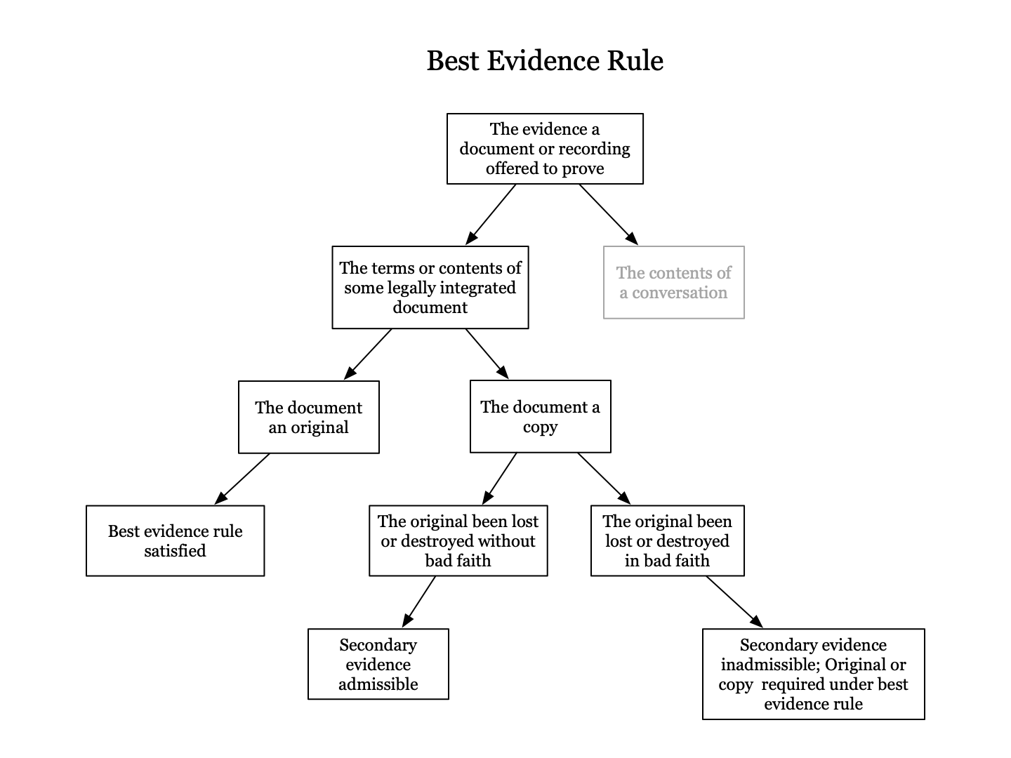
So long as content of document is not in issue, it can be proved by relatively weak (but relevant evidence)

ACN: you can use document/ recording to prove content of conversation, in that case the best evidence rule would apply, but you dont need the document and can prove the conversation through testimony

Meyer v. US
Rule – you don’t have to use transcript to prove testimony, you can use a witness instead
Facts – Meyers gave testimony at a congressional hearing during which he lied under oath. At his subsequent trial for perjury the person who questioned him at the congressional hearing, Rogers, testified for the state about what Meyers said at the hearing. Meyers argued that the state should have produced the hearing transcript instead of witness testifying as to what he said.
Holding and Reasoning – because Rogers was present and heard meyers testimony the best evidence rule did not require the state to produce the transcript rogers testimony was enough. Best evidence rule is limited cases where the contents of a writing are to be proved - here there was no attempt to prove the contents of teh writing - the issue was what Meyers said and not what the transcripts contained. The transcripts of the testimony is evidence but Rogers testimony is equally competent evidence

US v. Gonzalez Benitez
Rules – The best evidence rule is applicable only when a party seeks to prove the contents of documents or recordings.
Facts – GB charged with distribution of heroin. Police officer recorded his conversations with defendants that inculpated them in the crime. The prosecution called the police officer to testify as to what the defendant said in the recorded conversations, but did not admit the tapes into evidence. Defendant objected to the testimony claiming tapes themselves were the best evidence of the conversations.
Holding and Reasoning – court held the best evidence rule does not apply here. The best evidence rule only applies when a party is seeking to prove the contents of a document or recording. (miller points out someone who was not present during the conversations and only heard the tapes could not testify about the conversation only those who had personal knowledge by being present at conversation can testify about teh tapes).

3 major exceptions to BER:
- Photocopy exception - photocopy can be produced
  - But there are exceptions to this exception = 1003 says unless (1) there is genuine question raised as to authenticity of the original or (2) the circumstances would be unfair
  - Also typed or handwritten copies of the original which are inadmissible under the best evidence rule
- 1004 original unavailable through no fault of party seeking to prove content
- 1006 exception for summaries in voluminous records that cannot conveniently be presented in court

US v. Stockton (1003 / photocopy exception)
Rule – rule 1003 allows duplicated to be introduced in the same manner as originals unless (1) a genuine question is raised as to the authenticity of the original or (2) in the circumstances it would be unfair to admit the duplicate in lieu of the original
Facts – during search of defendant’s residence photographs of papers were taken and these photographs were introduced at trial. Defendant argues original papers should have been admitted and not photos
Issue – can photos instead of original papers be introduced?
Holding and Reasoning – court ruled that photos were legit form of duplication and so photos satisfied best evidence rule.

US v. Standing Soldier
Rule – Under 1004 if the original was not lost or destroyed in bad faith any secondary evidence of the contents, either oral testimony or handwritten note is sufficient to satisfy the best evidence rule.
Facts – defendant in a criminal trial passed a note to his jailer waiving his right to silence and stating he wanted to talk. Since the written statement itself constituted the waiver orindarily the best evidence rule required the state to produce an original copy of the document. Government lost the original document and the only evidence of the statement was a handwritten copy made at the time by the jailer.
Issue – is the handwritten copy sufficient under BER?
Holding and Reasoning – handwritten copy is sufficient. Under 1004 because the original was not lost or destroyed in bad faith any secondary evidence of the contents, either oral testimony or handwritten note was sufficient to satisfy best evidence rule

I dont what is different about this flow than one above.
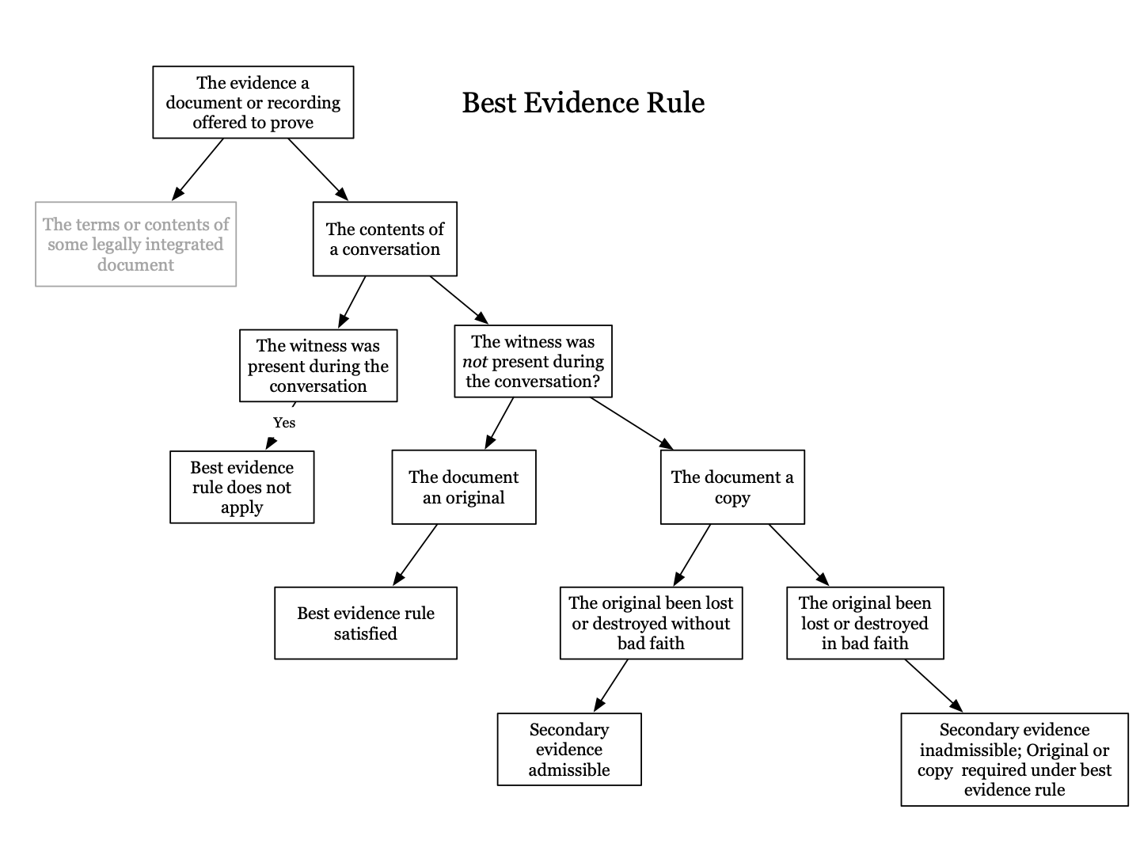
Rule 1008. Functions of the Court and Jury
Ordinarily, the court determines whether the proponent has fulfilled the factual conditions for admitting other evidence of the content of a writing, recording, or photograph under Rule 1004 or 1005. But in a jury trial, the jury determines–in accordance with Rule 104(b)–any issue about whether:
- As asserted writing, recording, or photograph ever existed;
- Another one produced at trial or hearing is the original; or
- Other evidence of content accurately reflects the content.

Seiler v. Lucas Film
Rule
Facts – Seiler sues Lucas for alleged infringement on copyright of science fiction creatures he calls striders, he says imperial walkers in empire strikes back are a copy of his striders. He says he created and published them in 1976, then in 1980 star wars comes out, then in 1981 Seiler gets copyright for it. At trial he wants to present a reconstruction he made of the creatures, but this reconstruction was made in 1981
Issue – can Seiler admit his reconstructions?
Holding and Reasoning – the court holds that the “reconstructions” of the drawings are inadmissible under best evidence rule. Court first finds are drawings are considered writing under 1002, but finds the “reconstruction” drawings are not a duplicate under definition from 1001. In order for the drawings to be allowed in under 1004 the judge would need to find that the originals were either lost or destroyed not in bad faith. Judge makes the opposite finding. There is also a rule 1008 issue. Jury is supposed to determine the if writing, recordin, or photo ever existed, not judge. Jury also determines which between multiple options is the original. So the question in this case is the original drawings ever existed is a question for the jury.
*** i am so confused by this…??****
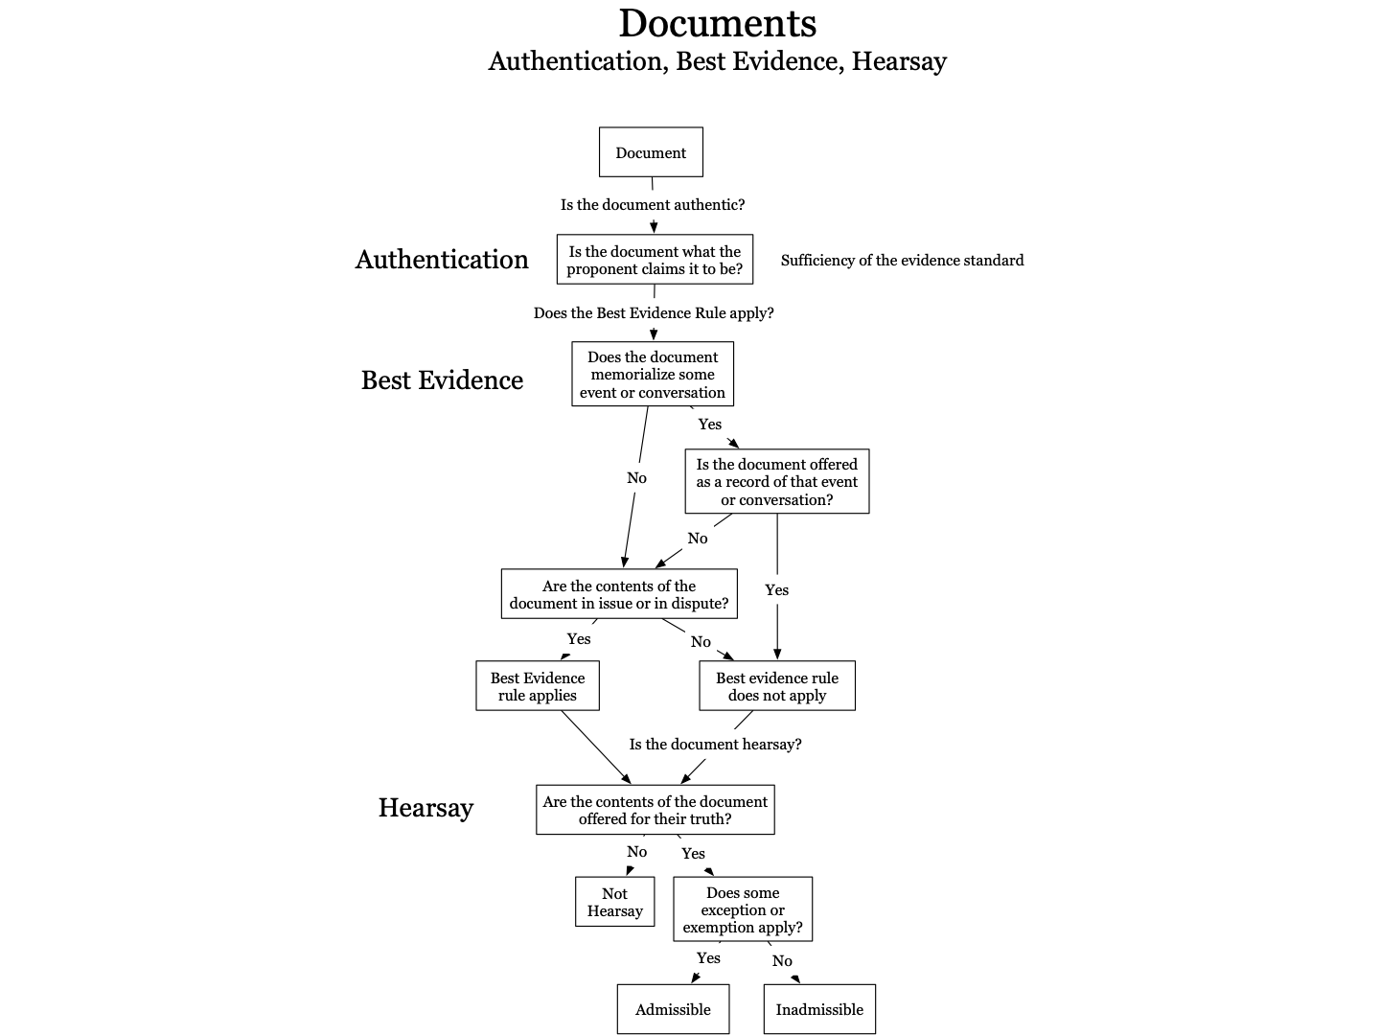

3 rules to apply with documents:
- 901 authentication
- 1001 - 1004 best evidence - determine if the rule applies
- Make sure contents in document are not hearsay

Questions 11.6, 11.7 page 731 - 11/10

Best evidence rule only applies when it is a fully integrated document (like wills, contracts) and percipient witness testimony is hearsay (i missed second part so i am not sure this is correct)

- OPINIONS AND EXPERTS
  - Lay Opinion
There is lay opinions and expert opinion

Lay opinion = testimony derived by common sense, from the perceptions of individuals rather than using specialized knowledge or training. (personal knowledge/ witnessing of event plus common sense inference)

Rule 701. Opinion Testimony by Lay Witnesses.
If the witness is not testifying as an expert, the witness’s testimony in the form of an opinion is limited to one that is:
- Rationally based on the witness’s perception;
- Helpful to clearly understanding the witness’s testimony or to determining a fact in issue; and
- Not based on scientific, technical, or other specialized knowledge within the scope of Rule 702
- An important limit on the admissibility of opinion evidence is the requirement that evidence bet helpful to factfinder – The opinion is helpful it makes it easier for the fact finder to understand some issue in the trial
- ACN suggests difficulties can arise if opinion testimony is based on some experience that enables witness to giver he opinion of something she perceived - if witness’s knowledge of background facts necessary to give her opinion is too specialized then her opinion becomes expert
- This opinion testimony based on special training or education tends to qualify the witness as an expert, were opinion testimony given through ordinary experience or familiarity with some aspect of a trade or institution need not, ex: cop doesnt need to qualify as expert to testify about how heroine is sold on street because anyone who lives in neighbor knows, but does need to qualify as an expert if he testifies about special features of drug distribution that goes beyond his personal perception

Rule 704. Opinion on Ultimate Issue.
- In General–Not Automatically Objectionable. An opinion is no objectionable just because it embraces an ultimate issue.
- Exception. In a criminal case, an expert witness must not state an opinion about whether the defendant did or did not have a mental state or condition that consitutes an element of the crime charged or of a defense. Those matters are for the trier of fact alone
- Both lay and opinion
- Another limitation is rule 403 which operates to exclude evidence if opinion asks the ultimate fact is likely to supplant the fact finder role in drawing that conclusion so the probative danger substantially outweighs the probative value
Government of the Virgin Islands v. Knight
Rule – A lay witness may testify as to his opinion or an inference if it is rationally based on his perception and helpful to clearly understand his testimony or the determination of a fact at issue.
Facts – Knight killed Miller. He was hitting miller in the head with his gun when the gun went off. Knight claimed the firing of gun was accidentally. At trial district court excluded testimony of an eyewitness who was prepared to testify that in his opinion the gun was fired accidentally.
Issue – should the court have excluded this eyewitness testimony?
Holding and Reasoning – court should not have excluded the eyewitness testimony. The eyewitness had firsthand knowledge of the shooting and his testimony would have helped jury make determination of whether gun went off by accident.

Robinson v. Bump
Rule – 701 permits non expert testimony in form of an inference providingthe inference is rationally based on the perception of the witness and helpful to fact finder.
Facts – there was a car accident and Robinson died. Harris’s car hits Bump, then Bump hits Robinson. At trial the jury found Harris negligent but not Bump. Eyewitness who was driving behind Bump said that he was in total control of his car until he was hit by Harris. Robinson’s family objects to the testimony
Holding and Reasoning – court holds testimony was not abuse of discretion. Testimony was cleayl admissible as an inference of a lay witness. 701 permits non expert testimony in form of an inference providingthe inference is rationally based on the perception of the witness and helpful to fact finder, and here it was.

US v. Houston
Rule – rule 701 permits a lay witness to identify a defendant in a photograph when the witness is more likely than the jury to identify the individual
Facts – houston convicted of felon in possession of firearm. Main evidence against him was a video of him with a gun on his brother’s farm. A special agent testified regarding footage that the person on the video is Houston. Houston argues agent should not have been able to testify because he did not personally perceive the event and only watched the video.
Holding and Reasoning – court allows this testimony. rule 701 permits a lay witness to identify a defendant in a photograph when the witness is more likely than the jury to identify the individual. Agent became familiar with Houston, including his typical dress and mannerisms - by observing him in person before dobbs viewed the videos so he was more likely than jury to identify Houston in video and in the video there were jumps and it was grainy so it would have been hard for jury to identify it as houston.

US v. Ayala-Pizarro (lay v. expert opinion)
Rule - Under Federal Rule of Evidence 701, a witness’s opinion qualifies as lay testimony if it is based on perception/observations arising from personal experience and not based on scientific, technical, or other specialized knowledge. (perception + common sense inference, inference form the perception does not require special knowledge)
Facts – AP was arrested outside of a known drug house. Police found packages of heroin in his pocket. At trial the officer who arrested him testified that house was known drug point, he explained how drug points worked and how drugs were usually packaged. Defendant challenged this testimony arguing it was expert and not lay.
Holding and Reasoning – court held this is lay testimony. Officer’s testimony was based on his perceptions and not any scientific, technical, or specialized knowledge. All officers testimony about drugs points and drug packaging was based on his observations arising from personal experience.

US v. Freeman
Rule – Lay opinion testimony must be based on the witness’s personal knowledge and experience that the jurors do not possess
Facts – freeman and others charged with crimes based on their involvement in murder for hire conspiracy. Prosecution argued West paid Freemon to kill Day. prosection evidence was 23,000 phone call conversations which they played at trial. Prosecution called agent lucas to testify about the phone calls and he interpreted some of the statements like nicknames and code words. Prosecution qualified lucas as expert witness to testify about code words and slang based on hearing all 23,000 phone calls and his 15 years experience in fbi but he never identified personal experience that allowed him to interpret. Defense objected and said testimony went beyond his expert qualifications and then prosection said it was lay opinion.
Holding and Reasoning – Lucas’s testimony should not be admitted. Here, Lucas’s purported lay opinion testimony interpreting the phone calls was based on the FBI’s investigation and not on Lucas’s personal knowledge or experience that the jury did not possess. There was thus not a proper foundation for Lucas’s testimony under Rule 701 - he never specified what personal experience led him to obtain this information. Jury may have been unduly persuaded by lucas testimony and not have relied on their own ability to interpret evidence. (he cannot just substitute his own opinions for jury’s / tell the jury what to infer when he has no personal knowledge and also is not an expert?).
*differnce between this adn AP? Because agent wasnt present during conversations?/ what personal knowledge would have been sufficient?*

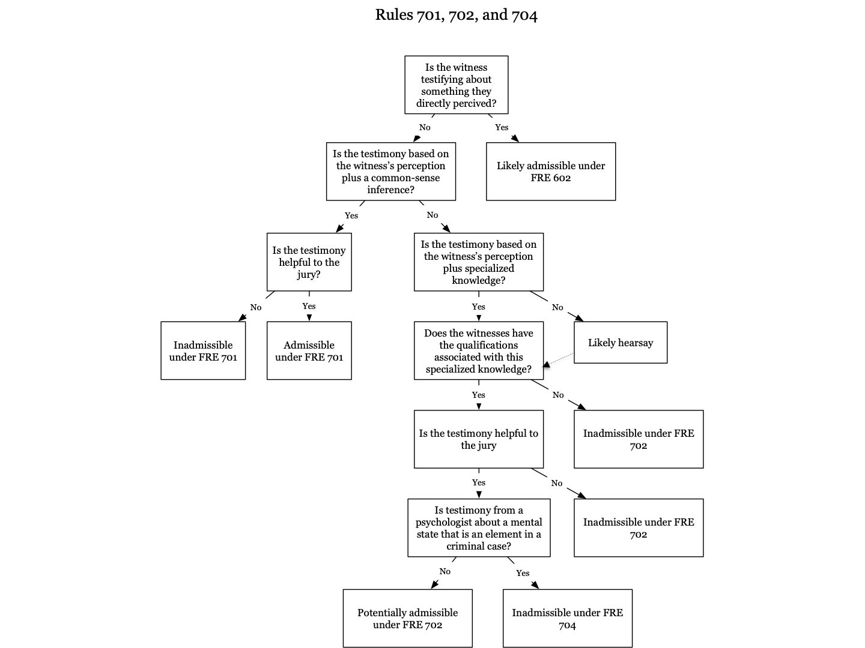
- Expert Opinion
Expert opinion = based on contribution of their specialized training or knowledge when evaluating certain evidence relevant to the case.

Rule 702. Testimony by Expert Witnesses.
A witness who is qualified as an expert by knowledge, skill, experience, training, or education may testify in the form of an opinion or otherwise if:
- The expert’s scientific, technical, or other specialized knowledge will help the trier of fact to understand the evidence or to determine a fact in issue;
- The testimony is based on sufficient facts or data;
- The testimony is the product of reliable principles and methods; and
- The expert has reliably applies the principles and methods to the facts of the case
- … more on this below in daubert revolution part

Rule 703. Bases of an Expert’s Opinion Testimony
An expert may base an opinion on facts or data in the case that the expert has been made aware of or personally observed. If experts in the particular field would reasonably rely on those kinds of facts or data in forming an opinion on the subject, they need not be admissible for the opinion to be admitted. But if the facts or data would otherwise be inadmissible, the proponent of the opinion may disclose them to the jury only if their proactive value in helping the jury evaluate the opinion substantially outweighs their prejudicial effect.
- This rule identifies 3 separate sources for expert testimony (i dont understand where miller is getting these 3)-
  - first matches 701 and personal perception the ACN calls it firsthand observation of witness, ex; doctor observes person’s injury then draws inference based on their specialized doctor knowledge
  - second = hypothetical questions then opinion in response to question, ex: if a person was exposed to this asbestos for 10 years what would happen to them?
  - Third = formation gleaned from data outside the courtroom other than experts own personal observation (thing that opinion is based on is hearsay and it only is admitted if the opponent seeks to admit it)
- For third - So long as an expert's testimony relies on the sorts of sources people in the field would ordinarily rely upon rule 703 permits the expert to offer opinion evidence even if information upon which he bases testimony is inadmissible at trial

Rule 705. Disclosing the Facts or Data Underlying an Expert’s Opinion
Unless the court ordered otherwise, an expert may staten an opinion–and give the reasons for it–without first testifying to the underlying facts or data. But the expert may be required to disclose those facts or data on cross examination.
- if an opponent wishes to challenge the expert testimony rule 705 requires the witness to disclose the basis of her opinion on cross examination

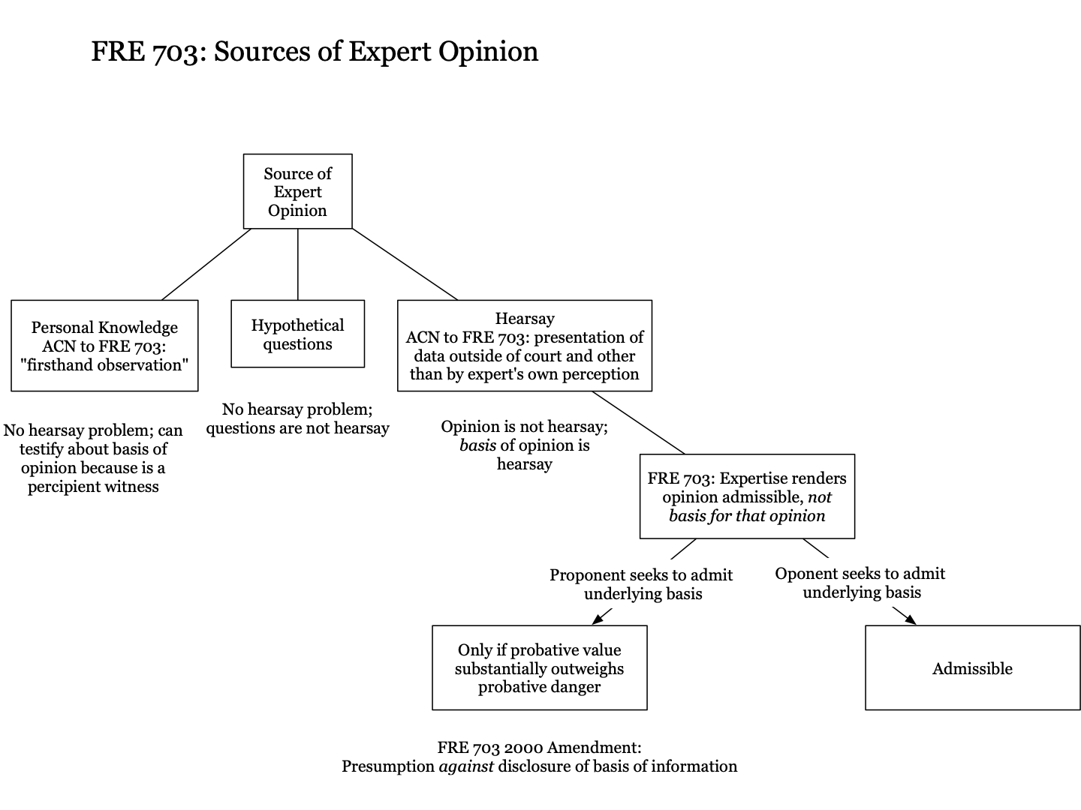

Hatch v. State Farm
Facts – State farm refused to pay for damage caused by fire at Hatch’s home, hatch was charged with arson but jury found him not guilty, then he sued state farm for breach of duty of good faith and fair dealing. Hatch had an expert witness, Cloyd - who was an expertise witness for industry standards of good faith and fair dealing on insurance claims. Cloyd testified about state farm complying with standard it had established through its ad campaign of “like a good neighbor, state farm is there”
Holding and Reasoning – Court held that cloyd’s testimony was properly excluded because this went beyond industry standard for good faith and fair dealing - this opinion was extraneous and a nonlegal standard. Rule 702 concerning opinions of experts offering “specialized knowledge” that will assist trier of fact does not justify such testimony. His testimony about if state farm acted like a good neighbor does not assist the trier of fact. properly excluded

Marten Transport v. Platform
Rule – To be qualified to give an expert opinion on a topic, the witness must have specific knowledge and experience concerning that topic.
Facts – Plaintiff martin alleges that defendant Plattform used marten’s name and trademarks without authorization on websites on which Platform advertised trucker jobs. Defendant used expert witness, Follis, who has experience in the transportation industry, including experience in recruiting truckers. Follis gave testimony about search engine optimization (SEO) and how it works, and Plattform argues Follis was not qualified to give these SEO opinions.
Holding and Reasoning – Follis testimony about SEO should be excluded because His general experiences in trucking industry does not necessarily give him technical knowledge to understand and render an expert opinion about SEO and how it works. Follis was expert on recruiting truckers but not SEO.

Williams v. Illinois (relating basis for expert testimony to jury)
Rule – otherwise inadmissible information forming basis of expert opinion can finds its way into evidence under 703 if it would help the fact finder understand the experts thought process and determine what weight to give to the expert’s opinion / “An expert may express an opinion that is based on facts that the expert assumes, but does not know, to be true” - “in appropriate cases, permits an expert to explain the facts on which his or her opinion is based without testifying to the truth of those facts”
Facts – Williams charged with rape. Prosecution called Lambatos, forensic specialist, as an expert. Lambatos testified about a DNA profile that was created by a lab and DNA profile matched Williams. Lambtos testified the lab was accredited but did not testify about how the specific lab profile had been created. Prosecution did not call the lab technician who created the profile. The def objected that the expert testimony about the source of cellmark DNA was testimonial hearsay.
Issue – can an expert witness base expert opinion on facts she assumes but does not know to be true?
Holding and Reasoning – court held evidence was admissible under 703 and was not testimonial hearsay. The evidence was not offered to prove the truth of the matter asserted but instead offered as facts assumed by experts in rendering their opinion. “out of court statements that are related by expert solely for purposes of explaining the assumptions on which that opinion rests are not offered for their truth and thus fall outside the scope of the confrontation clause” Under rule 703 an expert can state her opinion without first testifying about the facts or data that underlie her testimony

People v. Sanchez (opposite approach than williams)
Rule
Facts – Sanchez charged with gang related offenses. To prove Sanchez was affiliated with a street gang prosecution called detective Stow to testify as a street gang expert. Stow told jury about contents of identification cards that are kept in state gang database these cards has statements from other officers about interactions with sanchez and things sanchez said. Sanchez objected to this evidence under hearsay rules and confrontation clause. The state argued that the statements were not hearsay because they were offered only to show the basis for Stow’s expert opinion and not for the truth of the matter contained in the statements.
Holding and Reasoning – court thinks this part of testimony about the cards is offered to prove the truth of the matter asserted. (not just basis for expert opinion). Testimony from gang expert is so specific (specific statements from defendant) that it is not used to show the gang experts reasoning for his opinion but it is offered for the truth of the statements. If an expert witness relates case-specific out-of-court statements to the jury and treats those statements as true and accurate support for the expert’s opinion, the statements are hearsay. In that situation, the statements are being presented to the jury and admitted for the truth of their contents as the facts on which the expert relied. expert witnesses may not relate case-specific facts from the hearsay statements to the jury unless a hearsay exception applies, or the facts are independently proven with admissible evidence
***i literally do not understand this at all***

Leblanc v. PNS stores

- Daubert Revolution / reliability requirements for experts

Rule 702. Testimony by Expert Witnesses.
A witness who is qualified as an expert by knowledge, skill, experience, training, or education may testify in the form of an opinion or otherwise if:
- The expert’s scientific, technical, or other specialized knowledge will help the trier of fact to understand the evidence or to determine a fact in issue;
- The testimony is based on sufficient facts or data;
- The testimony is the product of reliable principles and methods; and
- The expert has reliably applies the principles and methods to the facts of the case
- Anyone can be an expert as long as they have the relevant knowledge, skill, experience, training, or education and their testimony will help the tier of fact to determine some matter in the case
- Incorporates opinion in daubert
- Court is responsible for evaluating reliability of expert opinion
- under daubert expert must be sufficiently well qualified so their opinion is helpful to the jury (must possess sufficient technical training/education/experience to take out of realm of lay opinion)

Daubert factors test to assess reliability:
- Whether the expert reasoning methodology can be or has been tested and so verified or falsified
- Whether it has been peer review or submitted for publication
- What is the error rate in apply methodology and
- If the methodology has general acceptance within the scientific community

Daubert v. Merrell Dow Pharmaceuticals
Rule – Expert testimony from a qualified expert is admissible if it will assist the jury in comprehending the evidence and determining issues of fact. (and is reliable under daubert factors)
Facts – Daubert was born with birth defects. Daubert and parents sued MDP alleging that their product, benectin, cause the defects. Daubert brought in testimony of 8 experts who concluded bendectin could cause birth defects. Court said daubert’s experts opinions were based on techniques that were not “generally accepted” under Frye.
Holding and Reasoning – Court holds scientific technique does not need to be generally accepted like under frye (court overrules frye). to determine whether scientific knowledge is admissible as expert testimony, the court must make a preliminary determination under Rule 104(a) that the reasoning behind the testimony is scientifically valid and can be applied to the facts of the case. Such a determination should be made by taking into account a number of factors, including, but not limited to the following: the testability of the theory/methodology; whether the theory has been published and subject to peer review; any potential rate of error; and finally, whether the knowledge has reached general acceptance (the test laid out in Frye)

General Electric v. Joiner (do we need to know this???)
Rule – reviewed on abuse of discretion standard
Facts – Joiner got lung cancer and he is suing GE because he says he got the cancer from being exposed to some chemical they manufactured. Joiner sought to introduce expert testimony but the court excluded it.
Holding and Reasoning – this court holds that it was not abuse of discretion to exclude Joiner’s expert’s testimony. These witnesses sought to testify only about clinical studies involving mice that were exposed to the hazardous chemicals in question, not humans. As such, no conclusive evidence exists linking exposure to these chemicals to small cell lung cancer and the trial judge properly held them inadmissible. Additionally, Joiner’s experts sought to introduce four studies about workers in other types of professions who allegedly developed cancer after exposure to other types of chemicals not at issue in Joiner’s case. These studies are irrelevant and unpersuasive given the particular facts of Joiner’s case.

Kumho Tire, Ltd v. Carmichael
Rule – Dauber applies to all expert testimony, not just expert testimony based on science. Also not all of the factors set out in daubert need be applied in every case and factors other than daubert factors can be used in assessing reliability of expert testimony.
Facts – Tire of Carmichael blew out and an accident followed, one of the passengers died and other were severely injured. Carmichaels sues and claims tire was defective - at trial Carmichael has a witness named Carlson testify (he was a tire failure analyst) Trial court ruled Carlson testimony was inadmissible - Carmichael is arguing the testimony was improperly excluded and appeals the application of Daubert factors on technical evidence - he is arguing daubert factors should not apply to technical (non scientific) testimony/ court shouldnt act as Daubert type gate keeper with this type of testimony. Carlson had tesitied that accident was cause by defect and not tire abuse
Holding and Reasoning – a trial court must examine the reliability of expert testimony for not only “scientific” knowledge but “technical” or other specialized knowledge as well and may flexibly apply one or more of daubert's specific factors to determine the admissibility of a technical expert testimony on its relevancy and reliability. (the district court also questioned how Carlson determined that the blowout was caused by a defect despite evidence of each of the four symptoms of tire abuse. These were all valid criticisms of Carlson’s methodology.)

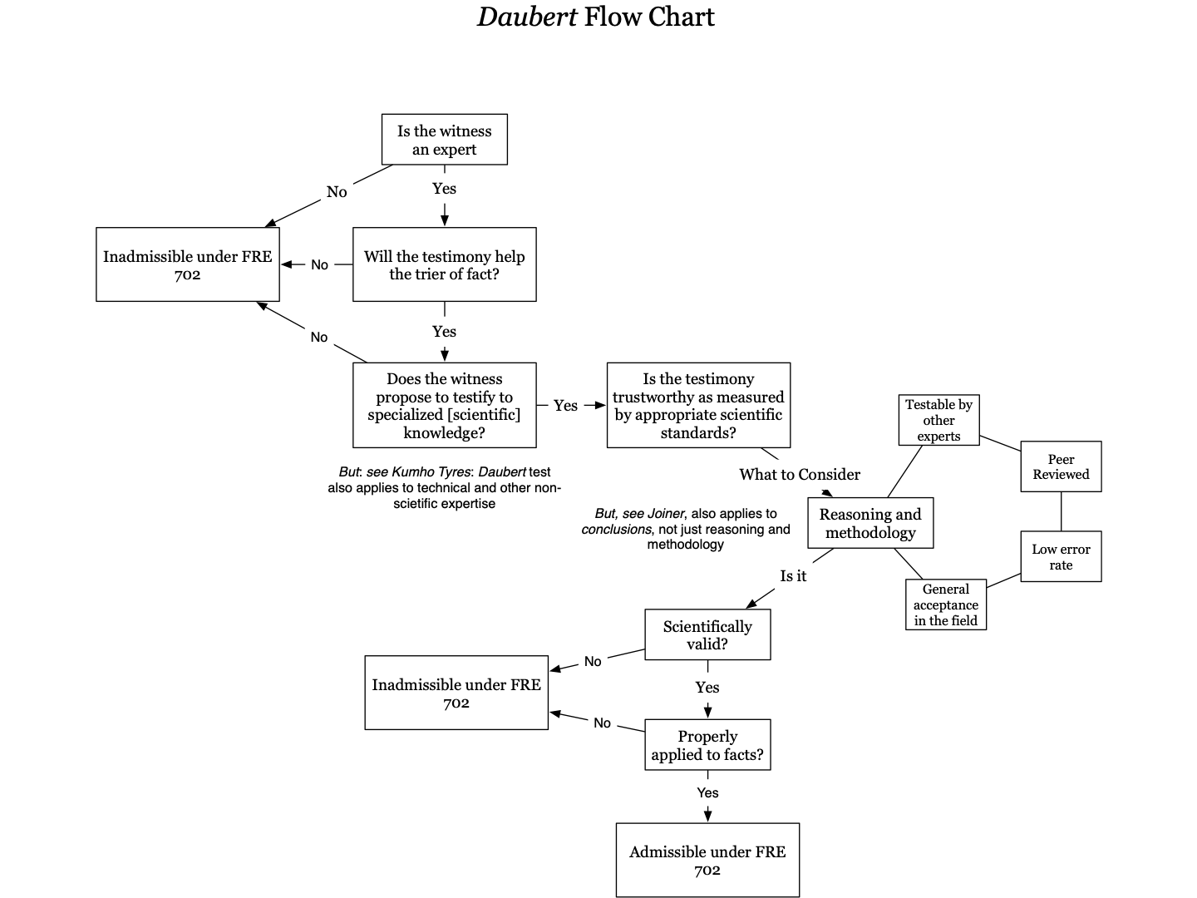

Marsh v. Valyou (current legal landscape) ??? need to know?

- Current Controversies / Social Science Evidence
Courts are increasingly accepting the validity of the “soft” social sciences

State v. Young
Rule – Expert testimony regarding the validity of eyewitness identifications is inadmissible. (this case is an outlier)
Facts – young charges within shooting. Bystander identified young as shooter from a lineup. Young wanted to introduce expert testimony regarding factors that could affect the reliability of eyewitness idenitifcations.
Holding and reasoning – “allowing an expert to testify about the ways in which identifications can be inaccurate and unreliable could influence the jury’s assessment of identification evidence and mislead jurors into disbelieving eyewitnesses.” “Any concerns about the reliability of an eyewitness’s identification can be sufficiently explored during cross-examination and addressed in the trial court’s jury instructions.”

Commonwealth v. Walker
Rule – Almost all jurisdictions allow expert testimony challenging the reliability of eyewitness identifications.
Facts – The prosecution charged Benjamin Walker (defendant) of armed robberies based on four eyewitness identifications. Walker offered expert testimony attacking the reliability of eyewitness identifications on multiple grounds, but the court rejected it. The jury convicted Walker and he appealed, arguing the court should have allowed the expert testimony.
Holding and Reasoning – The court acknowledged the scientific reliability of this form of testimony, stating that expert testimony concerning the limitations and weakness of eyewitness identification is firmly rooted in experimental foundations derived from decades of psych research on human perception and memory and well as impressive peer review literature. The rule of the expert, according to court, is to help the jury understand the issues surrounding any assessment of eyewitness testimony, rather than giving opinion on the reliability of any particular witness.

State v. Salazar-Mercado
Rule – Rule 702(d) does not bar admission of “cold experts” (general and educative) testimony
Facts – SM charged with child molestation. Victims delayed reporting abuse and could not remember certain details when asked at trial. Prosection called dr dutton as an expert witness and dutton sought to testify about child sexual abuse syndrome in order to educate juror about typical behavior of child abuse victims. SM objected to evidence arguing dutton was “cold” expert who would educate on behavior without any direct link to facts of case
Holding and Reasoning – Federal Rule of Evidence 702 permits the admission of general and educative expert testimony, which is also known as “cold” testimony. An expert witness can educate the factfinder on scientific, technical, or other specialized principles so that the jury may apply these principles to the facts of the case at bar. Educating the jury about CSAAS could help explain the victims’ delay in contacting authorities and inability to fully remember the events. Thus, Dutton was properly allowed to educate the jury on CSAAS so that the jurors could then apply their knowledge of CSAAS to the facts of the case.

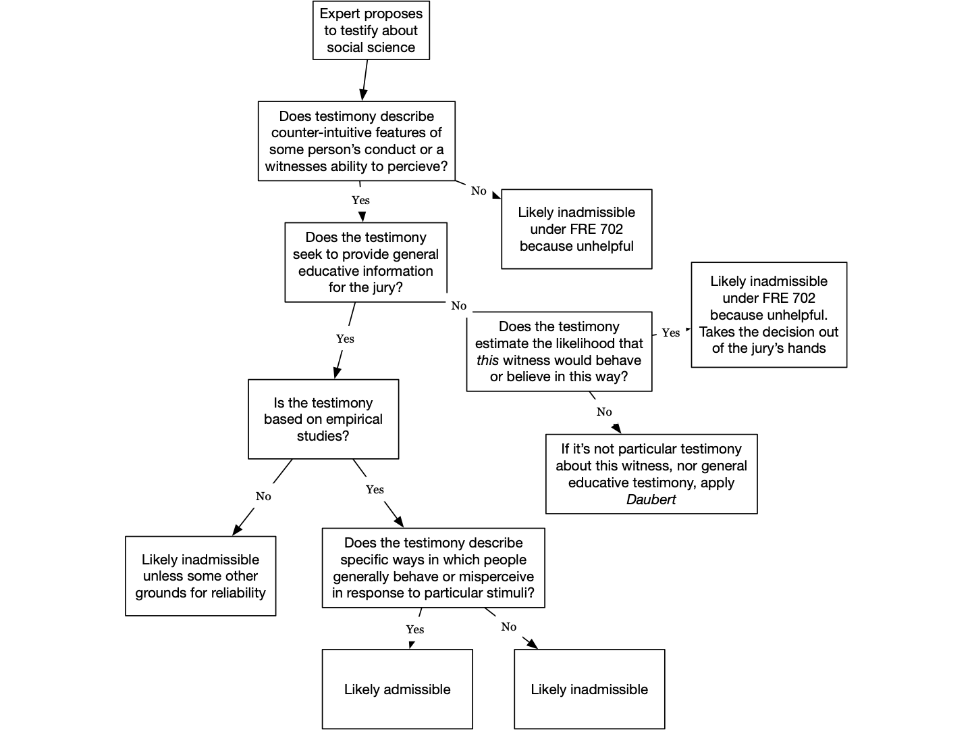

(short version of outline):
- Introduction
- Evidence = sources used to establish that some fact in the case is true or false
- Rule 101
- Rule 1101
- Rule 102 purpose = rules of evidence should be used to preserve accuracy, fairness, and efficiency
  - Juries
- Rule 606
  - (a) juror may not testify before the other jurors at trial
  - (b) jurors cannot testify about juror deliberations
- Substantial authority refuses to allow a juror to disclose irregularities which occur in the jury room, but allows his testimony as to irregularities occurring outside and allows outsiders to testify as to occurrences both inside and out (warger v. shauers)
- Federal approach = you cannot allow evidence of things said during deliberations even if it shows juror misconduct during jury selection unless it was shown an extraneous matter had influenced they jury. You cannot impeach the verdict of the jury by attacking deliberations unless with extraneous evidence.
- If a juror makes a clear statement showing reliance on racial bias or animus to convict a defendant, an exception to the no impeachment rule allows jurors to testify about jury deliberations to determine whether racial bias deprived the defendants of an impartial jury (pena rodriguez v. colorado)
- Privileges
- Rule 501
- Scope of privilege
  - Lasts through client’s lifetime and continues after death
  - Privilege belongs to client not lawyer
  - Privilege may be claimed by client or lawyer
- ACP survived after death (swindler v. berlin)
- Fiduciary exception to ACP occurs when a private person acting as a trustee is seeking legal advice on the trust’s management for the benefit of the beneficiary, making that communication discoverable (US v. Jicarilla Apache Nation)
- ACP elements
  - Communication made
  - In confidence
  - Between lawyer and client
  - In the course of provision of legal services
- Person asserting privilege has burden of proving the privilege applies
  - Element 1: communication made
- Communication = an utterance intended by the speaker to relate some information to a listener. The communication must be intended for the attorney to be protect by privilege, information prepared for other purposes no protected
- Information v. communication = privilege protects against revealing statements made to the lawyer but not protect against revealing information client knows
- Observable facts about physical appearance or demeanor are not “communication” (US v. Kendrick)
- Fee information is not privilege. Payment is not “communication” (Tornay v. US)
  - Element 2: in confidence
- In confidence = an utternace intended to be confidential, conversations are confidential so long as the attorney and client take reasonable steps to exclude third parties
- Third party rule = if third party is present conversation is not confidential
- The burden of enrusing the privilege applies rests with person asserting it who must take reasonable steps to ensure third parties are excluded (us v. gann)
- A third party that is present during a consultation must be acting in their capacity as an attorney in order to not destroy privilege, they cannot be there as a friend (us v. evans)
- When information is transmitted to an attorney with the intent that information will be transmitted to a third party that information is not confidential (us v. lawless - tax preparations)
- In order for the communication to be privileged, the information must be provided to the attorney so that they can sift and assess its legal implications (smithkline beecham v. apotez)
  - Element 3: Between lawyer and Client
- Relationship begins when client seeks legal services, privilege extends to consultations before formal relationship is established, client does not need to have paid attorney
- Privilege cover attorney and those agents employed by the attorney to assist in the provision of legal services
- Is someone misrepresents themselves as an attorney then anyone that client reasonably believes is an attorney count as as one for the privilege
- So long as the non lawyer is working in an agency relationship at direction of lawyer (and rendering legal services) that communication is privileged (us v. kovel)
- Conversations with co defendant’s lawyers are covered by privilege when mountain a joint defense (us v. mcpartlin)
    - Attorney client privilege in corporate setting
- Upjohn test = applies in corporate setting to identify the scope of the privileged client who can assert privilege. If an employee provides information to corporate attorney under upjohn only the corporation can assert. 5 elements
  - (1) communication made by employees to corporate counsel
  - (2) at the direction of corporate supervisors
  - (3) for the purpose of obtaining legal advice
  - (4) regarding matters within the employees duties
  - (5) employee knew the purpose of communications
- Upjohn warning = telling the employee that they are not the client under upjohn and only company gets privilege
- Core work product = sort of material in which the attorney engages in legal analysis
- Work product doctrine = prevents discovery of core work product that is prepared by a lawyer in anticipation of litigation
- If a corporation gives upjohn warning, the information the employee gives to counsel if not covered under ACP (us v. ruehle)
  - Element 4: in the provision of legal services
- Legal services = those activities that are characteristic of a lawyer, such as sifting facts and evidence and providing legal advice. Where a lawyer is simply acting as a conduit between the client and third party, they are likely not providing legal services
- Delivering goods on behalf of a client is not “providing a legal service” required for attorney client privilege (hughes v. meade)
- Preparing tax returns is not the kinds of legal service that is protected by ACP (us v. davis)
- An attorney working as an investigator is not providing a legal service. (an attorney investigating in preparation for litigation can have protection of attorney client privilege, but must be sifting information from investigation with an eye to the law (wartell v. purdue)
- Patent agent client privilege is narrower than attorney client privilege and requires that communication is “necessary for the preparation or prosecution of patent applications” / Communications which are not “reasonably necessary and incident to the preparation and prosecution of patent proceedings are not protected” (luv n care v. williams intellectual property)
  - Waiver of Attorney Client Privilege
- Rule 502 = following apply to disclosure of info
  - (a) intentional = waiver
  - (b) inadvertent = not waiver
    - But must have taken reasonable steps to prevent the disclosure, reasonable steps to rectify after (extent of disclosure, time taken to rectify, etc)
- Either client or lawyer can waive
- Waived by conduct that is incompatible with preserving privilege
- If client or representative is required to testify about privilege information they can preserve privilege by objecting
- Disclosing the content to a privileged communication between attorney and client is “conduct inconsistent with confidentiality” and is a waiver of the privilege (us v. bernard)
- ACP is waived when client attacks his attorney’s competence in giving legal advice, like claiming ineffective assistance of counsel or malpractice (tasby v. us)
- Failure to assert privilege at trial wavies any privilege which have have existed (hollins v. powell)
    - Scope of Waiver
- Fairness doctrine = if you disclose part of a conversation then you waive privilege as to the rest of the conversation.
- Subject Matter Doctrine = once communications are disclosed you waives privilege with regard to parts of other communications on same subject matter
- Non litigation exception = do not disclose rest of conversations or conversations on same subject because disclosure was made outside litigation context. (miller said other courts dont follow this). (in re von bulow)
    - Crime Fraud Exception
- Crime Fraud Exception = when the client seeks an attorney’s advice on how to commit a future crime or fraud the communications are not privileged.
- Attorney client privilege protection only applies to prior criminal acts, the protection does not apply to current or future wrongdoing. (us v. zolin)
- Trial Structure and Judicial Role
- Rule 103(a) = party may claim error to admit or exclude evidence only if error affects a substantial right
  - If ruling admits into evidence party can (a)(i)(1) object and (a)(i)(2) state ground for objection
- Harmless error standard = error that does not affect a substantial right of the party
- Affect a Substantial right = changed or influenced jury’s verdict on an important issue, appellant must prove (1) trial judge has not basis for ruling and (2) error affected the outcome of the case
- Plain error standard = court will only overturn the lower court decision if there was a miscarriage of justice (very difficult to get court to overturn when using this standard)
- Under rule 103 you must object to evidence in a timely manner and state the specific ground on which you object for the harmless error standard to apply, if you do not then the plain error standard will apply on appeal. (bandera v. city of quincy)
- Rule 104 = preliminary questions = judges rules on preliminary questions
- Preliminary question of fact = whether a fact essential to the admissibility of an item of evidence exists, preponderance of the evidence is the standard
- Relevance
- Rule 402 = relevant evidence is admissible, irrelevant evidence is inadmissible
- Rule 401 = test for relevant evidence, evidence is relevant if (a) it has a tendency to make a fact more or less probable and (b) the fact is of consequence in determining the action
- Weight of evidence does not matter only its connection to the fact of consequence in determining the action. Just because something has low probative value does not mean it is irrelevant (knapp v. state)
- Evidence can be relevant even if it is weak and does not prove guilt. (us v. dominguez)
- Other cases = state v. larson
  - Probative value and prejudice
- Rule 403 = court can exclude relevant evidence if the probative value is substantially outweighed by the probative danger of (1) unfair prejudice (2) confusing issues, misleading jury, undue delay, wasting time or (3) needlessly presenting cumulative evidence
- Probative = how much ration weight to give evidence - question of common sense
- A district court’s ruling under 403 will not be distribed except for abuse of discretion (us v. flitcraft)
- Relevant evidence is inherently prejudicial and it will not be excluded unless unfair prejudice substantially outweighs the probative value (us v. mcrae, us v. mehanna)
- Rule 105 = if court admit evidence that is admissible for one purpose but inadmissible for another court can instruct jury to only use evidence for admissible purpose
- In rare circumstances rule 105 may be insufficient to avoid the relevant probative danger, so the court should allow stipulations or exclude evidence (old chief)
- Other cases for examples: us v. noriega, abernathy v. superior hardwood
  - Conditional relevance
- Rule 104(b) = when relevant evidence depends on whether a fact exists proof must be introduced sufficient to support a finding that fact does exist, court may admit on condition that proof may be introduce later
- The conditionally relevant evidence is admissible if the proponent produces sufficient evidence for a reasonable juror to believe the preliminary fact exists (state v. mcneely)
- Steps = (1) what is preliminary fact that needs to be proved to make evidence in question admissible? (2) if preliminary fact is not proved is evidence still relevan? (3) if yes use 104(a), (4) if no use 104(b) and ask if the proponent produced sufficient evidence for a reasonable juror to believe the preliminary fact exists
- Character Evidence
- Rule 404 = character evidence prohibited to prove that on a particular occasion the person acted in accordance with the character trait (propensity purpose)
- There is presumption character evidence is inadmissible but exceptions include
  - 404(a)(2)(A)Character of criminal defendant in criminal trial
  - 404(a)(2)(B) and (C) Character of victim in criminal case
  - 404(a)(3) Character of witness in any case
- Different uses for character evidence are
  - Credibility / impeachment
  - Character is an element of charge
  - Evidence of prior bad act for non character purpose
  - Propensity purpose
- Evidence that has no relevance other than to demonstrate a criminal defendant’s propensity to commit a crime is inadmissible to prove the defendant’s guilt. (people v. zachowitz)
  - Character in issue
- Character in issue = not to prove that because the party is a certain type of character they acted in a certain way on a particular occasion, the only point is to show they are a certain type of character period.
- Cases in which character may be in issue as an element of the law
  - Affirmative defense of truth in defamation (larson v. klapprodt)
  - Negligent hiring of subordinate under respondeat superior (cleghorn)
  - Character of parent in child custody case (berryhill)
  - Status of defense in juvenile case
  - Element of entrap defense / rebut entrapment defense (baez)
    - Element of entrapment defense = (1) showing gov induced person to commit crime and (2) person’s lack of predisposition to engage in criminal conduct absent inducement
  - Character in Criminal Cases
- Rule 404(a)(2) = exceptions to not allowing character evidence
  - Rule 404(a)(2)(A) = defendant can offer evidence of defendant’s pertinent trait, proseuction can rebut with evidence of of same trait - (defendant “opens door”)
  - Rule 404(a)(2)(B) = defendant can offered evidence of vic pertinent trait prosecution can rebut vic doesnt have trait or offer evidence defendant has same trait
  - Rule 404(a)(2)(C) = in a homicide case, if defendant claims vic is first aggressor prosecution can introduce evidence vic was peaceful
- Rule 404(a)(3) = evidence of witness character governed by 607, 608, 609
  - Methods of Proving Character
- Rule 405(a) = if character is admissible can be proved by testimony about person’s reputation or testimony in form of opinion, on cross of the character witness court can allow questions about specific acts (character witness can say person has reputation for trait or in his opinion person has trait)
- Rule 405(b) = can ask about specific instances if character is in issue (on direct?)
- Case examples of proper specific act questions on cross = michelson v. us, gov of virgin island v. roldan)
- Prosecution can only cross examine by asking specific act question if they have a good faith belief defendant did the act in the question (us v. krapp)
- Defendant cannot establish good character through prior good acts/ specific acts (us v. setien, us v. ford)
- Flow charts on outline for 404 and 405
  - Other uses of specific conduct and habit evidence
- Rule 404(b) = uses of crimes, wrongs, and other acts
  - Rule 404(b)(1) = cannot use prior crime / act to prove persons character, and show they acted in accordance with the character train on a particular occasion
  - Rule 404(b)(2) = can use prior act for another purpose (MIMICKOP)
    - Motive (Boyd)
    - Intent (Beechum, Lewis)
    - Mistake (absence of mistake, lack of accident)
    - Identity (Dossey)
    - Common plan (Lewis)
    - Knowledge (Crocker)
    - Opportunity (DeJohn)
    - Preparation
- Case examples of improper uses = US v. wright, Us v. davis, US v. Ekiyor
- Standard for proving prior act is sufficiency of evidence (same of 104(b) conditional relevance) not preponderance of the evidence. (huddleston v. us)
  - Habit Evidence
- Rule 406 = evidence of person’s habit or organizations routine practice can be admitted to prove on a particular occasion they acted in accordance with the habit. Court can admit regardless of eye witness corroborating
- Habit = regular response to a repeated specific situation, no simulus no habit, must show at the very least that person acts in the same way over and over against on lots of occasions in response to specific stimulus
- 2 tests
  - Regularly repeated test = emphasis is on fact that response is regularly repeats less emphasis on response being non volitional
  - Semi automatic test = more emphasis on the response to the stimuli non volitional, not as much emphasis on response being regular
- Case examples = Kornberg v. US, Ortiz v. City of New York
  - Sexual Assault and Molestation
- Rule 412(a) = prohibited uses for victims sexual behavior,
  - Rule 412(a)(1) = offered to prove victim engaged in other sexual behavior,
  - Rule 412(a)(2) = offered to prove victim’s sexual predispostion
- Rule 412(b)(1) = excpetions in criminal cases
  - Rule 412(b)(1)(A) = specific instance of victim’s sexual behavior if offered to prove someone other than defendant was source of semen, injury or other physical evidence
  - Rule 412(b)(1)(B) = specific instances of victims sexual behavior
  - Rule 412(b)(1)(C) = evidence is exclusion would be violation of consittuional rights
- Rule 412(b)(2) = exceptions in civil cases = the court may admit evidence offered to prove a victim’s sexual behavior or sexual predisposition if its probative value substantially outweighs the danger (reverse 403 balacing)
- A defendant charged with sexual assault is permitted, within reasonable limits that avoid undue prejudice to the complainant, to cross-examine the complainant about a motive to lie about the alleged assault. (olden v. kentucky, confrontation clause)
- In a sexual-offense case, evidence of the victim’s sexual contact with a third party is inadmissible if the evidence is not being offered to identify someone other than the defendant as the source of physical evidence. (US v. Willis)
- The defendant generally may not introduce evidence of the victim’s pre-indictment and post-indictment sexual behavior. (US v. Thompson)
- 412(2) reverse 403 balancing for civil cases. In civil cases involving alleged sexual misconduct, evidence of the victim’s sexual behavior or sexual predisposition is inadmissible if the defendant has not established that the probative value of the evidence substantially outweighs its prejudicial effect. (polo calderon)
- Rule 413 = In a criminal case in which a defendant is accused of a sexual assault, the court may admit evidence that the defendant committed any other sexual assault.
- Rule 414 = In a criminal case in which a defendant is accused of child molestation, the court may admit evidence that the defendant committed any other child molestation
- Rule 415 = In a civil case involving a claim for relief based on a party’s alleged sexual assault or child molestation, the court may admit evidence that the party committed any other sexual assault or child molestation.
- when determining if prior offense can be introduced under 414, court must still do a 403 balancing test. (probative danger cannot outweigh probative value) (US v. LeCompte, US v. Majeroni)
- Other forbidden inferences
  - Subsequent Remedial Measures
- Rule 407 = When measures are taken that would have made an earlier injury or harm less likely to occur, evidence of the subsequent measures is not admissible to prove: Negligence, Culpable conduct, A defect in a product or its design, A need for a warning or instruction. But the court may admit this evidence for another purpose, such as impeachment or–if disputed–proving ownership, control, or the feasibility, or precautionary measures.
- Case examples = Clausen v. Storage (to prove control)
- Rule 407 does not exclude subsequent remedial measures taken by a non party (diehl v. blawknox)
  - Compromise Offers and Negotiations
- Rule 408(a) = Conduct or a statement made during compromise negotiations about the claim is not admissible—on behalf of any party—either to prove or disprove the validity or amount of a disputed claim or to impeach by a prior inconsistent statement or contradiction
- Rule 408(b) = The court may admit this evidence for another purpose, such as proving a witness’s bias or prejudice, negating a contention of undue delay, or proving an effort to obstruct a criminal investigation or prosecution
- Rule 408 excludes evidence of settlement offers and negotiations when the evidence is “offered to prove liability for, invalidity of, or amount of a claim” but there is an exception if person is trying to “buy off a witness” (us v. davis)
- A report can represent collection of statement in an effort to compromise and therefore be inadmissible under 408, and rule does not indicate that there must be a pre-trial understanding or agreement between parties regarding the nature of the report (ramada v. rauch)
- Rule 408 is inapplicable when the claim is based upon some wrong that was committed in the course of settlement discussions, e.g. breach of contract or unfair labor practice) (carney v. american university)
- using evidence for estoppel by acquiescence is “another purpose” under the exception of rule 408 (PRL USA holdings v. US polo association)
  - Offers to pay medical expenses
- Rule 409 = offering to pay medical, hospital, or similar expenses resulting from an injury is not admissible to prove liability for the injury
  - Plea deals
- Rule 410
- 410 largely irrelevant, common condition of entering plea negotiations is to waive protections of rule 410 and is it very common for defendant to do so (us v. mezzanatto)
  - Liability insurance
- Rule 411 = Evidence that a person was or was not insured against liability is not admissible to prove whether the person acted negligently or otherwise wrongfully. But the court may admit this evidence for another purpose such as proving a witness’s bias or prejudice or proving agency, ownership, control.
- Case examples = Charter v. Chleborad (used insurance to show bias), Higgins v. Hicks (improper use of insurance evidence
- Trial mechanics
- Rule 611(a) = ultimate authority to mode and order of witnesses rests with judge
- Rule 611(b) = cross shouldn't go beyond scope of subject matter of direct. But court can call additional matter as if on direct
- Rule 611(c) = leading questions should be allowed on direct unless necessary to develop testimony, ordinarily should only allow leading questions
  - On cross
  - When party calls hostile witness
- Leading question = one that suggests to the witness the answer desired by the questioner
- Hostile witness = it is some who is evading questions and is uncooperative in answer non leading direct examine questions or is interfering with elicitation of testimony, need not be angry witness
- Judge has control over order and presentation of evidence, judge can order a plaintiff to take the stand himself first before any other witness to get the chronology or basic facts out in complex case (steon v. peacock)
- plaintiff doesnt have unfettered right to call defendant during his case in chief, Plaintiff can be required to use defendants on case-in-chief only to introduce evidence he could not obtain from other sources (elgabri)
- decision whether to allow a party to present evidence in surrebuttal is committed to the sound discretion of the trial court (us v. wilford)
- Rule 611(b)grants trial court discretion to permit inquiry into additional matters as if on direct examination (us v. carter)
- The “unless necessary to develop testimony” exception of using leading question on direct applies to “the child witness or the adult with communication problems.” (us v. nabors)
- people who work with defendant usually would be seen as an “adverse” witness to the plaintiff (ellis v. city of chicago)
- Rule 106 = If a party introduces all or part of a writing or recorded statement, an adverse party may require the introduction, at that time, of any other part–or any other writing or recorded statement–that in fairness ought to be considered at the same time.
- Competence
- Rule 601 = Every person is competent to be a witness unless these rules provide otherwise.
- 3 categories often charged incompetent = children, people with mental illnesses, and addicts - However, such individuals are not always excluded, the only question is whether they can effectively communicate what they perceived
- jury functions as a lie detector “leaving credit and weight of testimony to be determined by the jury, rather than by the judge rejecting witnesses as incompetent” (rosen v. US)
- for witness to be competent all that is required is personal knowledge; capacity to recall; and ability to understand duty to tell the truth (us v. lightly)
- Rule 603 = Before testifying, a witness must give an oath or affirmation to testify truthfully. It must be in a form designed to impress that duty on the witness’s conscience.
  - Personal Knowledge
- Rule 602 = A witness may testify to a matter only if evidence is introduced sufficient to support a finding that the witness has personal knowledge of the matter. Evidence to prove personal knowledge may consist of the witness’s own testimony.
- Personal knowledge = first hand knowledge acquired by direct perception through one of 5 senses (Personally perceived what she claims to have perceived - seen, heard, smelled, tasted, touched)
- Raises question of condition relevance (rule 104b) - witness claim is only relevant on condition she did or could have perceived it - requires same standard of sufficiency of evidence
- testimony should not be excluded for lack of personal knowledge unless no reasonable juror could believe that the witness had the ability and opportunity to perceive the event that he testified about. (US v. Hickely)
- Impeachment
- Impeachment = effort to prove witness is not telling the truth, usually an attack on one or more qualities like perception, memory, narration and accuracy, sincerity
- Structure for assessing credibility: (1) One party attacks / impeaches witness’s credibility (2) Other party can “rehabilitate” the witness (no rehab wihtout impeachment first)
- Intrinsic evidence = evidence abstained through questioning of the witness on the stand in the current proceeding, comes from the witness themself, witness’s own answers to questions when given on witness stand
- Extrinsic evidence = anything other than evidence given by the witness on the stand. Like documents, testimony of a different witness, video, audio etc
  - Character for truthfulness
- Rule 608(a) = A witness’s credibility may be attacked or supported by testimony about the witness’s reputation for having a character for truthfulness, or by testimony in the form of an opinion about that character. But evidence of truthful character is admissible only after the witness’s character for truthfulness has been attacked.
- Rule 608(b) = extrinsic evidence is not admissible to prove specific instances of a witness’s conduct in order to attack or support the witness’s character for truthfulness. But the court may, on cross examination, allow them to be inquired into if they are probative of the character of truthfulness
- 608 limits:
  - On direct examination proponent can only introduction reputation or opinion testimony
  - A party can only introduce specific act evidence to prove honesty or dishonesty on cross examination of a witness
  - On cross examination if the proponent wants to elicit specific act evidence they can only do this with intrinsic evidence - no extrinsic evidence of specific acts and cross examiner must take the answer that the witness gives and cannot rebut
- A witness may testify about whether he would believe the defendant under oath if the defendant has been called to testify (us v. lollar)
- You cannot ask specific act questions about conduct that does not bear on truthfulness or untruthfulness. (us v. rosa)
- specific instances of the conduct of a witness, for the purpose of attacking or supporting the witness’ credibility may not be proved by extrinsic evidence (us v. white, us v. aponte)
- Other case example = glaze v. childs
  - Impeachment by prior conviction
- Rule 609(a)(1) = can attack character for truthfulness with prior crime that was punishable by prisonment for more than one year (felony)
  - 609(a)(1)(A) = if witness is not defendant , subject to 403 in civil or criminal case
  - 609(a)(1)(B) = in criminal case where witness is defendant subject to modified 403 (if probative value of the evidence outweighs its prejudicial effect)
- Rule 609(b) = if more than 10 years have passed since the witness’s conviction or release from confinement for it, whichever is later. Evidence of the conviction is admissible only if:Its probative value, supported by specific facts and circumstances, substantially outweigh its prejudicial effect
- General balancing test of 403 is not applicable to crimen falsi conviction under 609(a)(2) / prior convictions involving dishonesty (crimen falsi) are not within the discretion of the court to admit or not admit - they are admissible (us v. wong)
- Impeachment of a witness with evidence of a prior conviction under Federal Rule of Evidence 609(a)(1) may include questioning about the statutory name of the offense of which the witness was convicted (us v. estrada)
- shoplifting in itself is not a crime of dishonesty; crimes that are not felonies (have punishment of less than one year imprisonment) are inadmissible for impeachment purposes. (us v. amaechi)
- If crime in prior conviction is the same or very similar …
  - Prior convictions are generally inadmissible in cases where the current offense is the same or similar to the prior conviction (609(a)(1) crimes)( because doesnt pass modified 403?) (us v. sanders)
  - a crime is not per se inadmissible if it is identical to that for which the defendant is on trial. (us v. oaxaca)
  - even if there is a similarity between current charge and prior conviction, the conviction may be admissible if credibility of the witness is important (us v. hernandez)
- introducing evidence constitutes waiver of objection to its introduction / a defendant who preemptively introduces evidence of a prior conviction on direct examination may not claim on appeal that the trial court’s decision to admit the evidence was error. (ohler v. us)
  - Prior inconsistent statements
- Any prior inconsistent statement is allowed to impeach - It need not be given under oath, at a prior hearing, etc. Any statement will do, as long as it is inconsistent - Need not directly contradict prior testimony, just as long as the prior statement conveys a significantly different picture of events than the current testimony, not inconsistent just because it is less thorough
- Rule 613(a) = When examining a witness about the witness’s prior statement, a party need not show it or disclose its contents to the witness. But the party must, on request, show it or disclose its contents to an adverse party’s attorney
- Rule 613(b) = Extrinsic evidence of a witness’s prior inconsistent statement is admissible only if the witness is given an opportunity to explain or deny the statement and an adverse party is given an opportunity to examine the witness about it, or if justice so requires
- Rule 613(b) does not prescribe precise timing for permitting witness to explain or deny past inconsistent statements (us v. lebel)
- a failure to member is inconsistent with a prior statement from memory and failure to remember allows impeachment from prior inconsistent statement (us v. truman)
- Morlang issue = bad faith attempt to use impeachment by prior inconsistent statement as way to get before the jury evidence that is otherwise inadmissible
- When deciding whether to permit the prosecution to impeach its own witness with otherwise inadmissible hearsay evidence containing an alleged confession by the defendant, a trial court must determine whether the evidence is more probative than prejudicial. (us v. ince/ morlang issue)
- impeachment by prior inconsistent statement may not be permitted where employed as a mere subterfuge to get before the jury evidence not otherwise admissible (us v. webster/ morlang issue)
  - Bias
- Bias = motive to slant testimony/ lie, or has a stake in the litigation
- Bias is always relevant and may be proved with specific instances of conduct and extrinsic evidence, it is subject to 403 balancing
- evidence that is sufficiently probative of a witness’s possible bias for or against a party warrants its admission into evidence (us v. abel)
  - Incapacity
- Incapacity general rule = A witness can always be impeached by showing that his capacity to observe, remember, or narrate events correctly has been impaired. / lacked the opportunity or capacity to perceive what she claimed to have perceived or lacked mental capacity to perceive or recall events
- Can show capacity has been impared through = sensory defect, mental defect, drugs and alcohol
- Evidence for incapacity must indicate that witness suffered problems of perceptions (like they were delusion, paranoid, or had other memory problems) or it is inadmissible (us v. sasso, introducing evidence that witness took antidepressant doesnt cut it)
- If proponent uses evidence of drugs use to impeach, it must have connection to capacity to perceive at time of offense and not just generally impeach character (henderson v. detella)
  - Specific Contradiction
- There is not a specific rule that governs impeachment by contradiction, but 403 rule of relevance and collateral matter rule govern admissibility
- Collateral matter rule = limit on admissibility of extrinsic evidence offered to impeach by contradiction
  - You cannot introduce extrinsic evidence to impeach a witness on a collateral matter
  - A matter is collateral if it has no importance to the case except for its tendency to impeach a testifying witness by showing there were wrong about a fact
  - Can only use extrinsic evidence to impeach on material matter, either extrinsic or intrinsic can be use for material matter
- Case examples: simmons v. pinkerton, us v. copelin
- Rehabilitation
- Rehabilitation = opposite of impeachment, suggest that testimony is worthy of belief
- No bolstering = lawyer may not offer evidence supporting his witness’s credibility, unless that credibility has first been attacked by the other side
- Rule 608 = also used for rehabbing witness for character for honesty
- Impeaching for bias or incapacity is not attack on honesty so cannot rehabilitate with honesty
- Impeachment with prior inconsistent statement it is not clear if this is about character for honesty
- If a witness has been impeached for bias, the other side can rehabilitate the witness by showing they do not have an interest in the outcome of the case (US v. Lindeman )
- Impeachment for prior inconsistent statement may be an attack on character for honesty and therefore support rehabilitate for honesty (beard v. mitchell)
  - Vigorous cross examination does not open the door for rehabilitation. / Simply contradicting trial testimony/ pointing out discrepancies between defendant's testimony and other witness’s testimony does not go to character. (danehy, drury)
  - An extended and vigorous cross examination of witness that exposes various illegal activities and sordid activities does open the door for defendant’s character for honesty and allows party to introduce character for truthfulness evidence to rehabilitate (murray)
- Hearsay
- Hearsay = an out of court statement that is offered to prove the truth of the matter asserted
- Rule 801(a) = “Statement” means a person's oral assertion, written assertion, or nonverbal conduct, if the person intended it as an assertion.
- Rule 801(b) = “Declarant” means the person who made the statement.
- Rule 801(c) = “Hearsay” means a statement that: (1) The declarant does not make while testifying at the current trial or hearing; and (2) A party offers in evidence to prove the truth of the matter asserted in the statement.
- Rule 802 = Hearsay is not admissible unless any of the following provide otherwise: (1) Federal statute (2) These rules (3) Other rules prescribed by supreme court
- Hearsay rule “prohibits use of person’s assertion, as equivalent to testimony of the fact asserted, unless the assertor is brought to testify in court on the stand, where he may be probed and cross examined as to the grounds of his assertion and his qualifications to make it” (Leake v. Hagert miller says “a straightforward hearsay case”)
  - Non Hearsay use for out of court statements
- Non Hearsay = statements or conduct that are not offered to prove the truth of the matter asserted
- 3 core non hearsay statements
  - (1) declarant state of mind = statement offered to show declarant’s state of mind like knowledge and intent, What declarant believes, circumstantial evidence of was in declarant’s mind at the time (lyons v. morris costume)
  - (2) listener state of mind = statement offered to show that the listener knew or didn’t know of something (us v. feliz, campbell v. BSC, us v. jefferson)
  - (3) verbal act = a statement which gives rise to legal consequences is not hearsay when offered to show those legal consequences, like words of an offer for a contract, or words of defamation, or threats (hanson v. johnson, craeghe v. iowa home)
- Direct v. circumstantial evidence of mental state - “its barney” is circumstantial evidence that I think it is barney, “i believe/ i think its barney” is direct evidence its barney and is offered to prove the truth of matter assert so it is inadmissible under 802 (but is allow under exception below)
- Statement used to prove misrepresentation element of a crime is not a “statement offered to prove the truth of the matter asserted” under hearsay (us v. saavedra)
  - Statements
- 801(a) rewritten = “Statement” means a person's oral assertion, written assertion, or nonverbal conduct, if the person intended it as an assertion.
- Silence generally does not count as statement
- Conduct Intended as Assertion = conduct is nonverbal but nonetheless may be intended as an assertion and this conduct is capable of being hearsay (ex: pointing as someone to identify them)
- Implied Assertions = non verbal conduct or a verbal conduct that asserts something that the “declarant” did not intend to assert, but there is an assertion that is implied - this is not hearsay because it does not fall within the definition of “statement” because the assertion was not intended (us v. zenni)
  - Only matters intended to be directly communicated by the statements are part of the statement itself; other inferences, even ones directly implied by the statement, are not part of the statement
- Non humans do not make statements = something from animal, machine, sign is not hearsay
- Hearsay within Hearsay / Multiple Hearsay = one hearsay statement includes another hearsay statement, example: John testifies that Jill told him that she overheard Jane saying that she saw a blue car running a red light
- Rule 805 tells us that each level of hearsay must fit within its own exception to be admissible
  - Confrontation clause and hearsay
- 6th amendment contains confrontation clause = “in all criminal prosecutions, the accused shall enjoy the right to be confronted with the witnesses against him”
- Does not apply in 3 major categories; (1) Hearsay in civil cases, (2) Hearsay introduced against prosecution in criminal case, (3) Hearsay declarations from someone who winds up testifying in open court and is subject to cross examination
- Testimonial Statements = statements given to government agent whether law enforcement or substitute as part of interrogation or functional equivalent during investigation
  - confrontation clause only applies to testimonial statements
  - Statements given not during investigation or not to government agent are not testimonial
  - Certain statements to law enforcement delegates such as medical officials under a duty to report domestic violence or child abuse could as testimonial if circumstances suggest delegate was interrogating the person as part of criminal prosecution
  - Clearest class of non testimonial are statements where primary purpose of state is to report on going emergency
- 2 exceptions to confrontation clause: (1) Dying declarations - Rule 804(2) and (2)Statements of witnesses that the defendant wrongfully and intentionally prevented from testifying - Rule 804(6)
- Important case = crawford v. washington
- primary purpose test = statements are testimonial when the circumstances objectively indicate that there is no such ongoing emergency, and that the primary purpose of the interrogation is to establish or prove past event potentially relevant to a later criminal prosecution / non testimonal = statements made under circumstance objectively indicating primary purpose of interrogation is to enable police assistance to meet on going emergency (ohio v. clark)
- Other case examples = davis v. washington, hammon v. indiana
  - Statements that are “not hearsay” Rule 801(d)(1) and (2)
    - Rule 801(d)(1) declarant is required to be available to testify at trial
      - Prior inconsisten statement
- Rule 801(d)(1)(A) = the declarant testifies and is subject to cross examination about a prior statement, and the statement: Is inconsistent with the declarant’s testimony and was given under penalty of perjury at a trial, hearing, or other proceeding, or in a deposition
- Prior inconsistent statement introduced for impeachment purpose cannot be used for substantive purpose by jury. (albert v. mckay)
      - Statement of identification
- Rule 801(d)(1)(C) = The declarant testifies and is subject to cross examination about a prior statement, and the statement:Identifies a person as someone the declarant perceiver earlier.
- Memory loss does not indicate unavailability to testify and be cross examined under 801(d)(1)(C). (US v. Owens)

      - Prior consistent statement
- Rule 801(d)(1)(B) = The declarant testifies and is subject to cross examination about a prior statement, and the statement:Is consistent with the declarant’s testimony and is offered
  - (1) To rebut an express or implied charge that the declarant recently fabricated it or acted from a recent improper influence or motive in so testifying; or
  - (2) To rehabilitate the declarant’s credibility as a witness when attacked on another ground
- The witness must be impeached before the statement is admissible
- Under 801(d)(1)(B), a consistent, out-of-court statement made by a witness is admissible to rebut a charge of a fabrication or improper motive, but only if made before the motive to fabricate arose. (Tome v. US)
    - Rule 801(d)(2) - Statements of party opponents (party opponent doesnt need to be available to testify)
- Rule 801(d)(2)(A) = The statement is offered against an opposing party and: Was made by the party in an individual or representative capacity
- 801(d)(2) does not have a requirement that the declarant have personal knowledge. (Salvitti v. Throppe)
- Case examples = US v. McGee (class 802d2A), US v. Phelps (improper 801d2A)
- Rule 801(d)(2)(B) = The statement is offered against an opposing party and: Is one the party manifested that it adopted or believed to be true
- Watch out for multiple hearsay, but not multiple hearsay problem if you adopt the statement (Reed v. McCord )
- A party’s failure to respond may not be admitted into evidence under the adoptive-admission exception to the hearsay rule, unless the context indicates that a response was reasonably expected. (southern stone v. singer)
- A suspect’s failure to deny an incriminating accusation cannot be introduced into evidence as the suspect’s admission of guilt if, under the circumstances, the suspect would not have naturally contradicted the accusation (us v. fores = silence was adoption, moss v. commonth = the silence was not adoption)
- Rule 801(d)(2)(C) = The statement is offered against an opposing party and:Was made by a person whom the party authorized to make a statement on the subject
- Attorney does not have authority to make an out of court admission for client in all instances, he does have authority to make admissions which are directly related to management of litigation. (hanson v. waller)
- Rule 801(d)(2)(D) = The statement is offered against an opposing party and: Was made by the party’s agent or employee on a matter within the scope of that relationship and while it existed
- Case examples: mahlandt v. wild research center (wolf bite), seland service v. lozen (statement in a email by employee can be used against employer)
- Rule 801(d)(2)(E) = The statement is offered against an opposing party and: Was made by the party’s coconspirator during and in furtherance of the conspiracy
- In making a preliminary determination of whether the preponderance of the evidence reveals that there is a conspiracy present for purposes of determining the admissibility of evidence, a court may use the hearsay statements sought to be admitted. (bourjaily v. US)
  - ^this is bootstrapping and it is allowed?
- Exceptions to Hearsay
  - 803 Exceptions - doesn't matter if declarant is available to testify
- Rule 803 starts = The following are not excluded by the rule of hearsay, regardless of whether the declarant is available as a witness:
    - Spontaneous Statements
- Rule 803 requires personal knowledge on the part of the declarant. (people v. cummings)
      - Present sense impression
- Rule 803(1) = A statement describing or explaining an event or condition, made while or immediately after the declarant perceived it.
  - Only descriptive part comes in not part that allocates fault
      - Excited utterance
- Rule 803(2) = Excited Utterance. A statement relating to a startling event or condition, made while the declarant was under the stress of excitement that it caused.
  - Both descriptive and fault allocation parts can come in
      - Then Existing Mental, Emotional, or Physical Condition.
- Rule 803(3) = A statement of declarant’s then existing state of mind (such as motive, intent, or plan) or emotional, sensory, or physical condition (such as mental feeling, pain, or bodily health), but not including a statement of memory or belief to prove the fact remembered or believed unless it relates to the validity or terms of the declarant’s will.
- 4 things covered un 803(3)
  - Something declarant is thinking = A statement about a fact is admissible to prove declarant thought the fact to be true but inadmissible to show the fact is true
  - Something declarant is feeling = Statement like “i feel terrible” – this statement is admissible for its truth, that declarant was feeling terrible at the time
  - Something declarant plans to do = Hillmon doctrine (below)
  - Something declarant remembers doing = is inadmissible
- Hillmon Doctrine = a declarant statement that she plans to do something or intends to do it in the future is admissible to prove that the declarant did in fact do it. Declarant’s statement of her plan or intent is admissible to prove both: (1) declarant mental state, current or future intent to do plan and (2) declarant acted in accordance with plan or intent and (3) third party in the statement also acted in accordance with the plan (mutual life insurance v. hillon, us v. houlihan)
- Other case examples: US v. Obayagbona, United States v. Harris, Shepard v. United States
    - Recorded Statements
      - Injury Reports
- Rule 803(4) = A statement that: (A) Is made for—and is reasonably pertinent to—medical diagnosis or treatment; and (B) Describes medical history; past or present symptoms or sensations; their inception; or their general cause.
- Statements that do not report injury but simply cast blame or assert fault are inadmissible under the rule (rock v. huffco)
- in certain cases like domestic violence, child abuse, sexual assault, identifying the attacker / person who caused the injury is essential for treatment because treatment can depend if perpetrator is someone in the household or not so can be admissible under 803(4). (ward v. state)
  - Watch out for confrontation clause - still need to make sure statements are non testimonial
      - Recorded Recollection
- Rule 803(5) = A record that: (A) Is on a matter the witness once knew about but now cannot recall well enough to testify fully and accurately; (B) Was made or adopted by the witness when the matter was fresh in the witness’s memory; and (C) Accurately reflects the witness’s knowledge
  - If admitted, the record may be read into evidence but may be received as an exhibit only if offered by an adverse party.
- Rule 612 = This rule gives an adverse party certain options when a witness uses a writing to refresh memory
- Using 803(5) and 612
  - Rule 612 - present recollection refreshed (1) the witness forgets part of their testimony, (2) the attorney can show something to help jog memory (anything can be used, perfume, photo, etc), but then adverse party can review, inspect, cross) (3) The witness then remembers and testifies to it and the item used to refresh the memory is NOT evidence and only the memory is
  - Rule 803(5) = past recollection recorded (1) the witness forgets part of the their testimony (2) the attorney can show a writing to jog their memory (3) the witness does not remember (4) then the proponent can introduce the writing as a substitute for the witness testifying from memory by reading contents, it is replacement to witness;s current failed memory (5) the actual document only admitted unless opponent wants
- Must try to refresh under 612 before you can introduce through 803(5)
- Case examples: fisher v. swartz, us v. riccardi
      - Business Records
- Rule 803(6) = record of an act, event, condition admissible if (A) record was made at/near time of event by someone with knowledge (B) record was of regularly conducted activity (C) making record of the activity was regular practice (D) custodian of record testifies to A,B,C and (E) opponent doesn't show untrustworthiness of record
- Rule 803(7) = Evidence that a matter is not included in a record described in paragraph (6) admissible if: (A) The evidence is admitted to prove that the matter did not occur or exist; (B) A record was regularly kept for a matter of that kind; and (C) opponent doesnt show lack of trustworthiness
- A party seeking to introduce business records into evidence under Federal Rule of Evidence 803(6) is not required to proffer the testimony of every individual who participated in creating the record. (state v. Aacquisto)
- As long as all people who create record work for the business then there is no multiple hearsay issue. / if source of record is outside the business then there is a multiple hearsay issue. (wilson v. zapata)
- fact that a company regularly makes a record in certain situations, like accidents, does not necessarily mean that that record is the regular course of business, but sometimes injury/accident reports can be conducted in regular course of business, kind of depends on facts of case and if report was motivated by prospective of future litigation (palmer v. hoffman, lewis v. baker)
- A personally kept business record qualifies under Rule 803(6) of the Federal Rules of Evidence if it is systematically checked and regularly and continually maintained, even if it something illegal like drug dealing (Keogh v. Commissioner of Internal Revenue, United States v. Gibson )
      - Public Records
- Rule 803(8) = A record or statement of a public office if it sets out (i) the office’s activities (ii) a matter observed while under legal duty to report, but not including, in a criminal case, a matter observed by law enforcement personnel; (iii) In a civil case or against the government in a criminal case, factual findings from a legally authorized investigation;
- (ii) and (iii) do not allow police reports against criminal defendants
- Conclusions or opinions in public agency investigative reports are admissible under Rule 803(8)(A)(iii) as long as the conclusion or opinion is based on the factual investigation. ( Beech Aircraft v. Rainey)
- In a criminal case, laboratory reports prepared by government analysts are inadmissible (unless analyst testifies) against the defendant because such reports constitute testimonial evidence under the Confrontation Clause.(Melendez Diaz v. Massachusetts, Bullcoming v. New Mexico)
- Government reports are admissible against a criminal defendant if the report is created as part of a routine agency procedure and not in anticipation of litigation. / A report of observations by a law enforcement official is admissible under 803(8)(A)(ii) if it is a ministerial, objective observation( US v. Lundstrom, US v. Torralba-Mendia)
  - 804 Exceptions - require declarant to unavailable
    - Criteria for being unavailable
- 804(a) = the declarant is considered unavailable if declarant is
  - (1) Exempted from testifying because of privilege
  - (2) refuses to testify about subject dispute court order
  - (3) testifies about not remembering the subject
  - (4) cannot be present because of death or illness
  - (5) is absent and hearsay statement does fit under other exceptions
  - Subdivision (a) doesnt apple if the proponent caused declarant’s unavailability in order to prevent them from testifying
- Cases = Kirk v. Raymark,
- The proviso at the end of 804(a) includes if the defendant makes himself unavailable bu claiming 5th amend privilege (Us v. Bolin)
    - Former testimony
- 804(b) (1) = (A) was given as a witness at a trial, hearing, or lawful deposition, whether given during the current proceeding or a different one and (B) Is now offered against a party who had—an opportunity and similar motive to develop it by direct, cross, or redirect examination
- For purposes of the former testimony exception to the hearsay rule, a predecessor in interest can be considered a party that had similar motive to cross-examine the witness about the same material facts. (clay v. john manville)
- a former party will be considered a current party’s predecessor in interest if the former party’s stake in the former litigation is of equal weight to the current party’s stake in the current litigation. (volland goldand v. city of chicago)
- Other cases = US v. Salerno
    - Dying Declarations
- 804(b)(2) = In a prosecution for homicide or in a civil case, a statement that the declarant, while believing the declarant’s death to be imminent, made about its cause or circumstances.
- Declarant does not need to actually die but must believe their death is imminent. (Shepard v. US)
- If criminal case must be for homicide (US v. Sacasas)
- The dying-declaration exception to the hearsay rule does not violate a criminal defendant’s Sixth Amendment right of confrontation. (Davis v. State)
    - Statements Against Interest
- 804(b)(3) = (A) A reasonable person in declarant’s position would have only made the state if it were true because it exposes them to criminal or civil liability, (B) is support by corroborating circumstances that indicate trustworthiness
- Cases = US v. Duran Samaniego, US v. Jackson
    - Forfeiture by Wrongdoing
- Rule 804(b)(6) = A Statement offered against a party that wrongfully caused–or acquiesced in wrongfully causing–the declarant’s unavailability as a witness, and did so intending that result.
- Case = Giles v. California
    - Residual Excpetion
- Rule 807 = if hearsay state not allowed under exceptions 803 or 804 can still be admitted if
  - (1) The statement is supported by sufficient guarantees of trustworthiness –after considering the totality of the circumstances under which it was made and evidence, if any, corroborating the statement; and
  - (2) It is more probative on the point for which it is offered than any other evidence that the proponent can obtain through reasonable efforts.
- Case = US v. Slatten
    - Hearsay and Machine Generated Proof
- The prosecution’s use of a machine printout that does not contain a statement from the machine’s operator about the validity of the data shown in the printout does not violate the criminal defendant’s right to confront and cross-examine the machine’s operator.
  - Hearsay and Due Process
- Where the hearsay rules conflict with the constitution the constitution wins
- Case = chambers v. mississippi
- Authentication
- Rule 901(a) = To satisfy the requirement of authenticating or identifying an item of evidence, the proponent must produce evidence sufficient to support a finding that the item is what the proponent claims it is.
- Rule 901(b) = examples of what could satisfy the requirement
  - Testimony of witness with knowledge, non expert opinion about handwriting, comparison by expert witness, distinctive characteristics, opinion about a voice
- Standard is same as 104(b) = sufficiency of evidence
- 2 types of evidence unique and generic
- Unique = can be authenticated by witness with knowledge of item and its characteristics and testify that is it what proponent says
- Generic = authenticate by proving chain of custody and tace item from when it was seized to trial, if there are gaps in chain its ok as long as sufficient evidence that reasonable juror could believe it is what proponent claims it is (sufficiency standard)
- Cases = US v. Long, US v. Casto
- You only need to authenticate physical evidence and not live witness testimony (US v. Grant)
  - Digital Evidence
- A witness may authenticate an email if the witness can speak to the email’s unique characteristics, contents, and appearance, even if the witness did not send or receive the email. (US v. Bertram)
- Rule 902 = Evidence that is Self Authenticating
  - Rule 902(11) = Certified Domestic Records of a Regularly Conducted Activity
  - Rule 902(12) = Certified Foreign Records of a Regularly Conducted Activity
  - Rule 902(13) = Certified Records Generated by an Electronic Process or System
  - Rule 902(14) = Certified Data Copied from an Electronic Device, Storage Medium, or File
- Cases = US v. Vayner, US v. Browne
  - Best Evidence Rule
- The best evidence rule contained in Rule 1001 - 1004 only applies if the issues at trial present some question that requires proof of the content of a document or other recording, rather than the underlying event the document or recording memorializes
- Rule 1001 = definitions
  - (d) “original” = writing or recording itself
  - (e) “duplicate” = counterpart produced by a mechanical, photographic, chemical, electronic or other equivalent process that accurately reproduces original
- Rule 1002 = An original writing, recording, or photograph is required in order to prove its content unless these rules or a federal statute provides otherwise.
- Rule 1003 = A duplicate is admissible to the same extent as the original unless a genuine question is raised about the original’s authenticity or the circumstances makes it unfair to admit the duplicate (exceptions are handwritten copies of the original, generally not a duplicate)
- Rule 1004 = An original is not required and other evidence of the content of a writing, recording, or photograph is admissible if
  - (a) originals lost or destroyed, and not in bad faith by proponent
  - (b) original cannot be obtained by judicial process
  - (c) The party against whom the original would be offered had control of the original
  - (d) The writing, recording, or photograph is not closely related to a controlling issue
- you don’t have to use transcript to prove testimony, you can use a witness instead (meyer v. us)
- The best evidence rule is applicable only when a party seeks to prove the contents of documents or recordings. (us v. gonzalez benitez)
- 3 major exceptions to BER:
  - (1) Photocopy exception - photocopy can be produced
    - But there are exceptions to this exception = 1003 says unless (1) there is genuine question raised as to authenticity of the original or (2) the circumstances would be unfair
    - Also typed or handwritten copies of the original which are inadmissible under the best evidence rule
  - (2) 1004 original unavailable through no fault of party seeking to prove content
  - (3) 1006 exception for summaries in voluminous records that cannot conveniently be presented in court
- Cases = US v. Stockton (proponent is allowed to bring duplicate), US v. Standing Soldier (allow handwriting, i think this is ok because it was not brought in under photocopy exception)
- Rule 1008 = judge usually decides whether to admit evidence under 1004 or 1005, but jury decides
  - (a) if asserted writing, recording, photo ever existed
  - (b) another one produced at trial is the original or
  - (c) other evidence of content accurately reflects the content
- Case = seiler v. lucas film (reconstruction was not “duplicate” there was genuine issue about original so need the original)
- 3 rules that apply to documents = 901 authentication, Best Evidence, Hearsay
- Opinions and Experts
  - Lay opinion
- Lay opinion = testimony derived by common sense, from the perceptions of individuals rather than using specialized knowledge or training. (personal knowledge/ witnessing of event plus common sense inference)
- Rule 701 = If the witness is not testifying as an expert, the witness’s testimony in the form of an opinion is limited to one that is: (1) rationally based on witness’s perception, (2) helpful to factfinder in determining fact in issue and (3) not based on scientific or special knowledge
- Rule 704 = generally an opinion on an ultimate issue is not objectionable, there is an exception for an expert in a criminal trying giving opinion on whether defendant did or did not have mental state the constitutes an element of a charge
- Cases = government of virgin islands v. knight, robinson v. bump,
- rule 701 permits a lay witness to identify a defendant in a photograph when the witness is more likely than the jury to identify the individua (US v. Houston)
- Lay opinion testimony must be based on the witness’s personal knowledge and experience that the jurors do not possess (US v. Freeman)
- Case example of expert v. lay = US v. Ayala Pizarro
  - Expert Opinion
- Expert opinion = based on contribution of their specialized training or knowledge when evaluating certain evidence relevant to the case.
- Rule 702 = A witness who is qualified as an expert by knowledge, skill, experience, training, or education may testify in the form of an opinion or otherwise if:
  - The expert’s scientific, technical, or other specialized knowledge will help the trier of fact to understand the evidence or to determine a fact in issue;
  - The testimony is based on sufficient facts or data;
  - The testimony is the product of reliable principles and methods; and
  - The expert has reliably applies the principles and methods to the facts of the case
- Rule 703 = bases of an expert’s testimony = This rule identifies 3 separate sources for expert testimony
  - first matches 701 and personal perception the ACN calls it firsthand observation of witness, ex; doctor observes person’s injury then draws inference based on their specialized doctor knowledge
  - second = hypothetical questions then opinion in response to question, ex: if a person was exposed to this asbestos for 10 years what would happen to them?
  - Third = formation gleaned from data outside the courtroom other than experts own personal observation (thing that opinion is based on is hearsay and it only is admitted if the opponent seeks to admit it)
- Rule 705 = Unless the court ordered otherwise, an expert may staten an opinion–and give the reasons for it–without first testifying to the underlying facts or data. But the expert may be required to disclose those facts or data on cross examination.
- Cases = hatch v. state farm (no industry standard)
- To be qualified to give an expert opinion on a topic, the witness must have specific knowledge and experience concerning that topic. (Marten Transport v. Platform)
- “An expert may express an opinion that is based on facts that the expert assumes, but does not know, to be true” - “in appropriate cases, permits an expert to explain the facts on which his or her opinion is based without testifying to the truth of those facts” (Williams v. Illinois)
- Cases = people v. sanchez (did not allow basis for opinion , court thought it was hearsay)
    - Daubert revolution
- Use 702 (above) and daubert factors
  - (1) Whether the expert reasoning methodology can be or has been tested and so verified or falsified
  - (2) Whether it has been peer review or submitted for publication
  - (3) What is the error rate in apply methodology and
  - (4) If the methodology has general acceptance within the scientific community
- Cases: daubert, general electric, kumho tire
    - Social science evidence
- Can expert testify about unreliability of eyewitness testimony? (state v. young, commonwealth v. walker)
- Rule 702(d) does not bar admission of “cold experts” (general and educative) testimony (State v. Salazar-Mercado)

