DAMAGES
Compensatory Damages: meant to restore a victim to their status prior to the unlawful act.
- Measurable damages to the victim: medical bills, lost wages (work-life expectancy, future earnings, educational attainment expectancy), medical monitoring (medical cost, loss of business/employment, damage to property); also includes pain and suffering
- Noneconomic damages: pain and suffering, loss of consortium
- May be reduced due to P’s contributory negligence

Punitive Damages: Meant to serve as a deterrent punishment for the guilty party and a warning to the public
- Amount is subject to jury’s discretion within limits
  - Reprehensibility of D’s misconduct
  - Evidence of D’s wealth, income, or profits
  - Some courts say amount must be in reasonable proportion to actual damages or potential actual harm
- P must show bad state of mind (recklessness, malice, intentional/knowing)
- Some courts require higher burden of proof → clear and convincing rather than preponderance of the evidence
- Vicarious liability → some courts require showing that employer/other actor participated in or encouraged the tort

Nominal Damages: only available for intentional torts; token fine paid to victim as recognition that an unlawful act occurred, but there’s no meaningful monetary damage

Contingent Fees: Attorneys in tort cases are paid this way; nothing is paid if they lose and a percentage of recovery is paid to attorney if they win

Economic Loss Rule: plaintiff in negligence or products liability who suffers no injury to her person and no physical damage to her property cannot recover for other losses

Assessing Damages
- Joint and several liability, with contribution: P can enforce tort claim against any tortfeasor up to the full amount of damages. If one D pays total, can seek contribution from other Ds according to allocation of responsibility
- Several liability only (proportionate share/comparative fault): no tortfeasor is liable for more than its allocated share of responsibility. If D is insolvent, unlike in J&SL, P is out of luck
- Preferential treatment for economic harm, i.e. anything you can provide receipts for (J&S), but several liability only for non-economic damages (such as emotional harm)
- J&S only if D’s responsibility exceeds a certain %
- Exception to several only liability where P is unable to collect a D’s share of the judgment

INTENTIONAL TORTS
Intent requirement is satisfied if:
- the actor intends to cause the relevant tortious consequence to a third party, rather than to the plaintiff, but the actor’s conduct causes that consequence to the plaintiff.
- the actor either intends to cause a contact with the person of another or intends to cause the other to anticipate an imminent, and harmful or offensive, contract with his or her person.
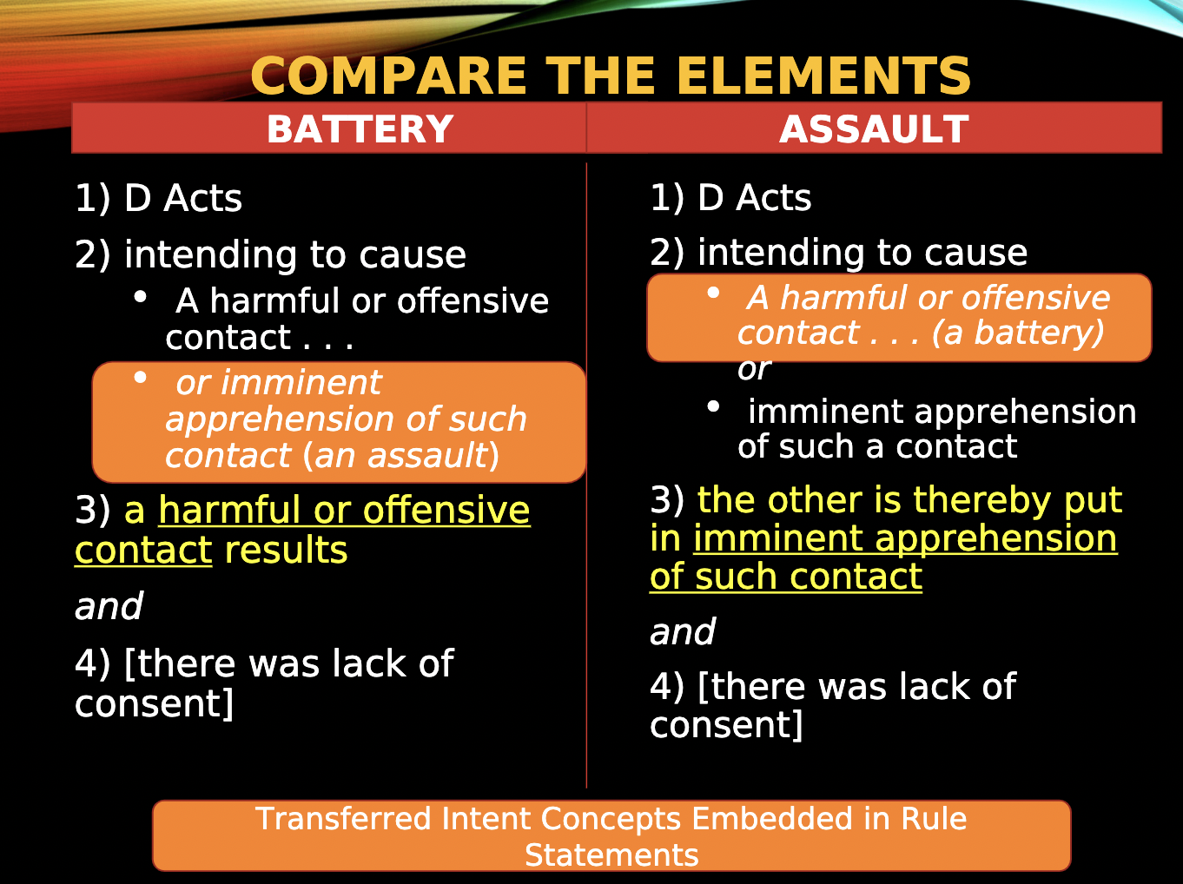
Child Liability (“Rule of Seven”)
- In most states a child may be liable for torts they commit as long as the injured P can prove the required elements
- In some states, particularly young children are conclusively presumed to be incapable of harmful intent (under age 7)
Parental liability for the torts of their minor children: such a lawsuit is possible only if 1) statute authorizes such suit or 2) if parents are themselves at fault in some way
- Child's tort must have been committed willfully or wantonly and damages that may be obtained are limited.

BATTERY:
Intentional, unpermitted contact upon the person of another which is harmful or offensive; no contact, no battery

- D made contact w another’s person
- Contact must be harmful or offensive
- Harmful: Physical harm is not required. Dignitary harm counts.
- Offensive if either:
  - Offensive to a reasonable sense of personal dignity (objective standard)
  - Contact is highly offensive to the other’s sense of personal dignity, and the actor contacts the other with the primary purpose that the contact will be highly offensive
- D intended to cause a harmful or offensive contact
  - If single intent rule, D must have intended contact (favors P)
  - If dual intent rule, D must also have intended to harm or offend
  - Additional rules for proving intent if relevant:
- Knowledge with substantial certainty; transferred intent; special rules for children
- Intent to produce a consequence is either 1) a purpose of producing that consequence or 2) knowing that the consequence is substantially certain to result.
- **The contact is not consented to by the other (sometimes, courts will focus on whether there was consent or non-consent)

PURPOSEFUL INFLICTION OF BODILY HARM:
Contact requirement of battery liability is not satisfied but actor’s culpability is especially pronounced.
- The actor purposely causes bodily harm to the other either by the actor's affirmative conduct or by the actor's failure to prevent bodily harm when the actor has a duty to prevent such harm
- And the other does not effectively consent to the otherwise tortious conduct of the actor.

ASSAULT:
- D acts
- Intending to cause
  - Harmful or offensive contact (a battery)
  - Or an imminent apprehension of such a contact
- The other is thereby put in such imminent apprehension; AND
  - Apprehension: awareness of an imminent touching that would be a battery if completed; Words alone will not suffice to create such an apprehension
  - Imminence means that the conduct will occur without significant delay
- [There was a lack of consent]
Transferred intent concepts embedded in Rule Statements

FALSE IMPRISONMENT:
Conduct by actor which is intended to, and does in fact, confine another within boundaries fixed by the actor where, in addition, the victim is either conscious of the confinement or is harmed by it
- Types of confinement: physical barriers or physical force; false assertion of legal authority to confine; threats of physical force; unspecified “duress”

INTENTIONAL INFLICTION OF EMOTIONAL DISTRESS:
- D engages in extreme and outrageous conduct and
- “Beyond all bounds of decency,” “atrocious,” “utterly intolerable”
- Not generally, insensitive or rude behavior; or mere insults, indignities, etc.
- Intentionally or recklessly causes [or acts in disregard of substantial probability of causing]
- Severe emotional distress to P

3rd Party/Indirect IIED Claims: an actor may also be liable for IIED to a party against whom the extreme and outrageous conduct was not directed if that party is:
- A member of the victim’s immediate family (whether or not such distress results in bodily harm) or to any other person who is present at the time (if such distress results in bodily harm)
- Was present (has sensory and contemporaneous awareness) at the time of the extreme and outrageous conduct
- Exceptions to presence requirement: terrorism and sexual abuse of children

- Supposed to be a gap filler for factional scenarios where the law does not provide any other remedy. Mutually exclusive to other tort claims and CANNOT be tagged onto other claims even if the facts would help satisfy the elements only in some jdx
- Markers of outrage:
  - Repeated or carried out over a period of time
  - An abuse of power by a person with some authority over the plaintiff
  - Directed at a person known to be especially vulnerable
- Exercising legal rights: person cannot be held liable for this tort merely for exercising a legal right, even where he is substantially certain that it will cause emotional distress
- Causation: must prove a sufficient causal link between the defendant's conduct and the plaintiff's distress

DEFENSES TO INTENTIONAL TORTS
Typically defenses do not come into play unless the plaintiff has established every element of a prima facie case of tort liability. Must identify what claim you are talking about first and what defenses you can bring. Defendant has the burden of pleading and proving affirmative defenses. These defenses do not challenge the elements of the plaintiff's prima facie case but supply a legal reason or justification for the defendant's actions that render those actions non-tortious

CONSENT:
Either actual or apparent consent is effective to relieve the actor of responsibility for the acts addressed
Consent defense is negated by incapacity, duress, fraud, special/power relationship, exceeded scope of granted consent, emergency, revoked
- Actual consent: subjective willingness for the act to occur, either in writing or orally agreeing to the contact
- Apparent consent: conduct, including words, that are reasonably understood by another as a reflection of consent. Apparent consent exists if the actor reasonably believes that the other person actually consents to the conduct, without regard to whether the person does actually consent.
- Presumed consent would exist if 1) under prevailing social norms, the actor is justified in engaging in the conduct in the absence of the other person's actual or apparent consent and 2) the actor has no reason to believe that the person would not have actually consented to the conduct if the actor had requested the person's consent

SELF-DEFENSE:
Person is privileged to use reasonable force, not intended or likely to cause death or serious bodily harm, to defend himself against unprivileged harmful or offensive contact or other bodily harm which he reasonably believes that another is about to inflict intentionally upon him
- Mistaken Self-Defense is fine as long as the use of force is reasonable - mistake must always be reasonable, no matter the jdx
- Force cannot be used for other reasons, such as punishment or future deterrence
- “Initial Aggressor” Rule: If D is initial aggressor, then self-defense may not be invoked
  - Where initial aggressor has withdrawn from the encounter and communicates that to the other person, limitation is lifted
- Some jdxs allow limited “defense of others” (i.e. family members)
- Provocation is generally not sufficient to raise self-defense privilege
- Excessive force: a defendant who retaliates or continues the defense after the fight is over is liable
- When the defendant is threatened with sexual attack, or force likely to cause death or serious bodily harm, the defendant is privileged to respond with reasonably deadly force.

DEFENSE OF OTHERS:
- Must be that the person about to be attacked would himself have the privilege to act in self defense, and the other person’s intervention must be necessary
- When can D assert defense of others:
  - Most states: when anyone is danger
  - Minority (Cal): when only family members, servants, guests are in danger
- Mistaken defense of others
  - Most states: same requirement as self-defense, just has to be reasonable mistake as to the need for defending the other
  - Some states: mistake, even if reasonable, defeats the privilege/defense

DEFENSE OF PROPERTY:
Possessor of land has no privilege to use force intended or likely to cause death or serious harm against another whom the possessor sees about to enter their premises or meddle with their chattel, UNLESS the intrusion threatens death or serious harm to occupiers or users of the premises (back to self defense). Force must be reasonable.
- Stand Your Ground Laws declare that there is no duty to retreat before using force, in one's home or in any other place where one has a right to be
- Fresh pursuit: property owner is privileged to use reasonable force in regaining their property only when the owner is in fresh pursuit of the property / within the vicinity. Once fresh pursuit is over, it becomes self-help and you must use courts.
- Human life is more important than property. What is actually necessary vs. what is designed to harm, punish, defend.

PRIVILEGE TO USE FORCE TO CONFINE:
- Privilege to arrest: private person may make an arrest for a misdemeanor if the misdemeanor is a breach of the peace and it occurred in the presence of the person making.
  - Arose of common law and was traditionally not available to shopkeepers because ordinary shoplifting did not breach peace
  - *Mistake defeats privilege
- Privilege to recapture chattel: allows reasonable use of force to recapture chattel only if in “fresh pursuit”
  - No self help → must use the courts/legal process
  - Exception for “fresh pursuit,” but …
    - Must use reasonable force; can’t be excessive
    - Mistake defeats privilege (even if it was reasonable)
  - Very limited statutory exception for auto-repossession
  - *Mistake defeats
- Shopkeeper’s privilege:
  - Reasonable cause (belief that plaintiff shoplifted)
    - Majority: reasonable mistake won’t defeat privilege; jdx-dependant for reasonable mistake
    - This is a question for the jury to evaluate the facts
  - Proper purpose = detention for investigation
  - Reasonableness of the detention: reasonable time and manner: use of force?
  - Need to satisfy the different elements in order to use shopkeeper’s privilege

DISCIPLINING OF MINORS: FORCE AND CONFINEMENT
Parents and other guardians/caretakers are privileged to use force
- The force used against the minor child is reasonable
- The force is reasonably related to the purpose of safeguarding or promoting the welfare of the minor, including the prevention or punishment of the minor's misconduct
- The force used neither causes nor creates a substantial risk of causing physical harm (beyond fleeting pair or minor/transient marks), gross degradation, or severe mental distress

Challenges to proving transgressions of legal limits on force: ability of a population to recognize mental health injury, age + inherently unequal relationship (dependence/vulnerability), institutional failures by public schools, difficulty seeking private recourse

NEGLIGENCE

DUTY | BREACH | LEGALLY COGNIZABLE HARM | CAUSE IN FACT | PROXIMATE CAUSE: SCOPE OF RISK

Overt conduct that creates unreasonable risks that a reasonable person would avoid. Unreasonable conduct may include both acts and a failure to act when action is required.
- Duty: legal and policy question about whether defendants should be required to use reasonable care in particular circumstances
- Breach of duty: factual question and judgment call about whether the defendant failed to use reasonable care to avoid a reasonably foreseeable risk to the plaintiff

DUTY:
Defendant has a duty to everyone to avoid creating an unreasonable risk of harm to foreseeable plaintiffs (those who are in the zone of danger of the defendant’s negligence).
→ Reasonable person standard impacted by emergencies, specialized knowledge/expertise, physical impairments, mental or emotional disability (only if child), age, intoxication, sudden incapacitation (seizure/heart attack)

→ Establishing Standard of Care ←
Statutes may demonstrate a per se breach, but it can still be used as evidence for which normal conduct should be judged. However, statutes are not necessarily conclusive; it merely sets a floor.
Custom (Industry) Standards are evidence of standard by which ordinary care may be judged. They cannot quite be used in the same way safety statutes are used. However, Industry Standards are lagging.
Private (Individual) Standards may factor into the foreseeability of the risk, but it can never be used as a benchmark b/c individual standards have nothing to do with what other people are doing.
Individual’s Status

Common carriers: highest degree of care → requires the carrier to exercise the utmost caution characteristic of very careful prudent men. If P proves injury, burden shifts to D to rebut high presumption of breach. Restatements rejects higher standard → favor general negligence standard of reasonable care under the circumstances
- Host drivers: if jurisdiction has a guest statute (distinguishing between invitee [taxi] and licensee [driving a friend]), D has a lower standard of care: D is only liable for willful and wanton act or gross negligence

Landowners' duties to entrants:

Traditional trichotomy with entrant status: Visitors to property are classified according to one's purpose in entering the property and whether such entry is with the consent of the property's possessor.
Invitee | Person invited onto the land, primarily for business purposes; member of the public or mutual benefit | Normal duty rule in negligence case: use reasonable care to discover and protect against danger
Licensee | Person on land with landowner’s permission, including social guest | Duty not to create a trap or allow concealed danger to exist on property; no duty to discover danger  Duty of ordinary care only kicks in once D knows of danger that entrant does not → duty to warn or make reasonably safe
Trespasser | One on land without permission | Duty to avoid willful and wanton misconduct (D is aware that conduct creates a high degree of risk, or a risk of very serious harm, yet proceeds without concern for the safety of others)

- Attractive nuisance doctrine for child trespassers → landowner owes duty of reasonable care to trespassing child if reasonable landowner would know or foresee that
- There is a dangerous condition on his land
- Children are likely to trespass on his land AND
- Because of their youth and inexperience, such children will face an unreasonable risk of serious injury

Collapsing trichotomy to dichotomy (20 states): treating invitees and licensees the same
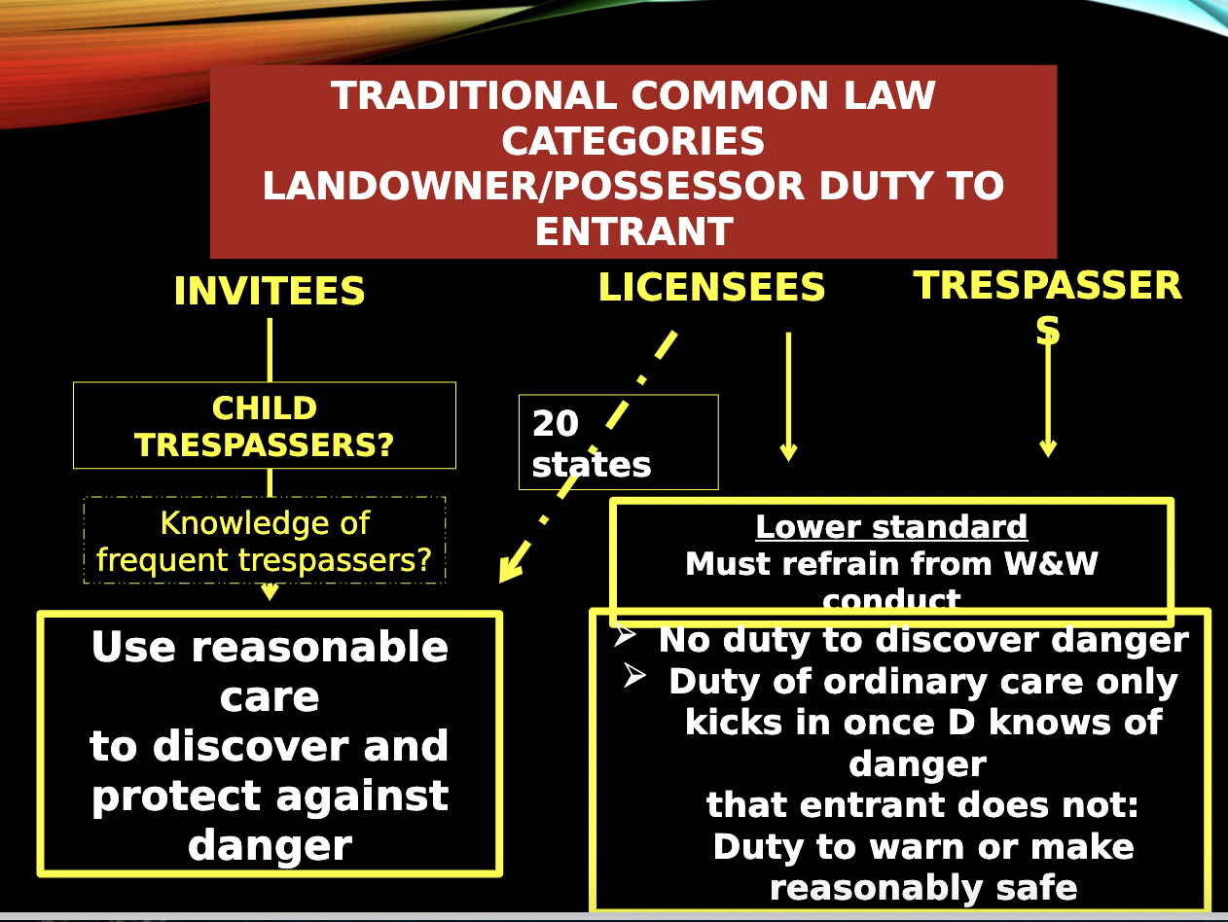
Rejecting Status approach and balancing the following factors:
- Foreseeability of harm to P
- Degree of certainty that P will suffer injury
- Extent of the burden to D
- Closeness of the connection between the D’s conduct and the injury suffered

Open and Obvious Hazards: Land possessors cannot be held liable to plaintiffs who are injured by open and obvious dangers. If the land possessor can foresee the injury, but nevertheless fails to take reasonable precautions to prevent the injury, he can be held liable.
Modern trend is a balancing test that considers whether:
- The danger was known and appreciated by the Plaintiff
- The risk would be obvious to a person exercising reasonable perception, intelligence, and judgment
- There was some other reason for the Defendant to foresee harm despite such knowledge or obviousness

Duty to Discover: Trip & Fall Theory of Liability: D must take reasonable care to prevent injury from dangerous condition and P can show negligence where:
- D created the dangerous condition and failed to take reasonable actions to abate the hazard, OR
- D’s mode or method of business operations made it foreseeable that would create a dangerous condition, and D failed to take reasonable measures to discover and remove it, OR
- D did not directly create the condition but discovered or should have discovered the condition created by others (constructive notice) and failed to take reasonable steps to prevent injury from that condition

Recreational Use Statutes: retain the landowners' immunities as to any non-paying recreational user. Were enacted to limit liability in order to encourage landowners to make land available for recreation in a world becoming increasingly crowded. Most courts have refused to extend protection to governmental entities on the ground that a public entity needs no incentive to open its lands for recreational purposes

Landlords’ duty to tenants:
Lessors have a duty of reasonable care for (extends to the tenants' guests)
- portions of the leased premises over which the lessor retains control
- conduct of the lessor creating risks to others
- disclosure of certain dangerous conditions

Firefighter Rule:
Bars lawsuits by firefighters, police officers and, in some jurisdictions, all government safety professionals from collecting on damages that occur in the course of their duties even in cases of clear negligence by other parties. The rule assumes the firefighter assumed the risk. (Minnich v. Med Waste- this jdx simply did not adopt the Firefighter Rule)
- Does NOT apply to individuals who undertake assistance during a fire (rescuer does not contribute to the negligence, nor do they assume the risk)
- Does NOT apply to intentional torts or negligence unrelated to the rescue

Healthcare Providers:
Medical custom sets the standard of care and is established by expert witnesses. A physician must exercise that degree of care, skill, and proficiency exercised by reasonably careful, skillful, and prudent practitioners in the same class to which they belong, acting under the same or similar circumstances. IF the physician can’t do what the industry standard is, their standard of care becomes referring patients to another physician, expert, or facility that can.
- “Honest Mistakes” or “Errors in Judgment” have been disapproved in many cases bc they typically favor D

Determining Medical Standards of Care:
- Strict Locality Rule: “in the same community”; used before medical education was nationalized
- Modified Locality Rule: “in similar localities”; small community doctors need to pay attention to national standards, but still acknowledges there are inevitable differences in training and experience
- National Standard: “on the same class to which s/he belongs”; doctors need to follow medically accepted standards.“Under the same circumstances” for reasonable care takes care of potential lack or resources

Lack of Informed Consent: Equivalent of the breach element: plaintiff must prove the defendant, a medical professional, failed to disclose a material risk to the plaintiff. What is material?
- Nature of patient’s condition
- Nature and probability of risks involved
- Benefits to be reasonable expected
- Inability of physician to predict results
- Irreversibility of the procedure
- Available alternatives, including risks and benefits
Doctors do not need to disclose ALL risks b/c it would unduly burden doctors. There is also no duty to disclose information the doctors reasonably believes the patient already has. Finally, information may be withheld for therapeutic reasons.

Good Samaritan Statutes: every jdx has some kind of immunity to those who are serving communities that would not otherwise receive it (i.e. roadside accident). Meant to protect trained physicians from liability when they are not working with the equipment or sanitation that is normally available in a medical setting.

Family Members
Parental Immunity:
Negligence claim barred against parents whether either:
- Where the alleged negligent act involves an exercise of reasonable parental authority over the child OR
- Where the alleged negligent act involves an exercise of reasonable parental discretion with respect to the provision of food, clothing, housing, medical services, and other care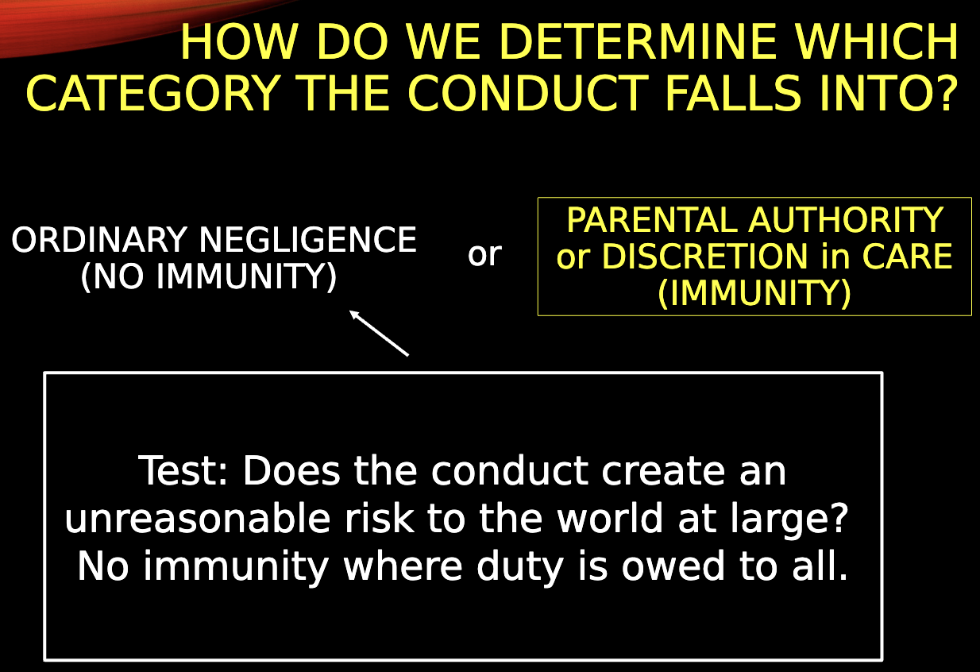
Some jdxs have abandoned Parental immunity in favor of the Reasonable Care Test: What would an ordinarily reasonable and prudent parent have done in similar circumstances? (Broadbent v. Broadbent)

Parental Liability for Dangerous Acts:
General rule: parents are not automatically liable for kids’ torts.
Some states recognize parental liability under negligent supervision theory: parent had reason to know with some specificity of a present opportunity and need to restrain the child to prevent some imminently foreseeable harm.
General notice of dangerous propensity is not enough. Ability to control is also key.

Nonfeasance: No-Duty-to-Act Rule
Person owes another no duty to take active or affirmative steps for the other’s protection.

Exceptions where there is an affirmative duty to act:
- Statutory provisions impose an obligation to protect
  - Dram Shop Statutes: some jdxs only apply to certain alcohol sales or levels of consumption
- Actor’s prior conduct
- Person has created continuing risk of harm, then a duty arises to employ reasonable care to prevent or minimize risk
- When D has special relationship w/ P (Podias v. Mairs- passengers in car had special relationship w/ wrongdoer)
- A common carrier w its passengers
- An innkeeper w its guests
- Business or possessor of land that holds it land open to public w those lawfully on land
- Employer w its employees, who while at work are either in imminent danger or are injured or ill and thereby rendered helpless
- School w its students
- Landlord w its tenants
- A custodian w those in custody, if the custodian has a superior ability to protect P

Third Person Exceptions
Typically, there is no duty to act affirmatively to prevent harm. However, there are exceptions:
- Special Relationship w/ either victim or person who created the harm:
  - Special relationship between the Defendant and the victim is one that gives the victim a right to expect protection from the Defendant.
  - Special between the Defendant and the dangerous third party is one that entails an ability to control the third party's conduct.
- Policy considerations (Rowland v. Christian)
  - Foreseeability of harm to P
  - Degree of certainty that P suffered injury
  - Closeness of connection b/t D and parties
  - Closeness of D’s conduct and the injury suffered
  - Moral blame attached to D’s conduct
  - Policy of preventing future harm
  - Extent of burden to D and the consequences to the community of imposing duty
  - Availability, cost, and prevalence of insurance for the risk involved
- Duty to Aid/Rescue
- Duty to Prevent/Protect
- Negligent Entrustment: D held liable when they permit a third person to use or engage in an activity that is under the control of D, if D knows or should know that such person intends or is likely to use that thing in a way that creates an unreasonable risk to others (Catron v. Lewis- jetski case)
Duty to Aid/Rescue  P already harmed or in danger & D knows  Estate of Cilley, Wakulich, Podias | Duty to Prevent/Protect  Focus is on future or continuing harm
Options for finding duty:  Statute  OR  Special Relationship  OR  D created risk/danger  OR  Undertaking by D to provide relevant care | Harder to find (esp. for criminal/intentional)  Statute OR Special Relationship  AND  Foreseeability  AND  Sometimes an additional act relevant to D’s responsibility or control

Foreseeability in the landowner context:
- Specific harm rule: landowner does not owe a duty to protect patrons from the violent acts of third parties unless he is aware of specific, imminent harm about to befall them (OUTDATED)
- Prior similar incident test: foreseeability is established by evidence of previous crimes on or near the premises - puts the landowners on notice of a future risk
- Totality of the circumstances test: takes additional factors into account; places a greater duty on business owners to foresee the risk of criminal attacks on their property (most common approach)
- Balancing test: seeks to address the interests of both business proprietors and their customers by balancing the foreseeability of harm against the burden of imposing a duty to protect against the criminal acts of third persons → best test. The court concludes that Sam's did not possess the requisite degree of foreseeability for the imposition of a duty to provide security patrols in the parking lot. (CA approach)

Contract as a Limit on Tort Claims: In order to recover in tort, the duty tortiously or negligently breached must be a common law duty, not one existing between the parties solely by virtue of the contract.
(Rest. 3rd § 42): An actor who undertakes to render services to another, when the actor knows or should know that the services will reduce the risk of physical harm to the other, owes a duty of reasonable care in carrying out that undertaking if:
(a) the failure to exercise care increases the risk of harm beyond that which would have existed without the undertaking, or
(b) the other person relies on the undertaking.

(Rest. 3rd § 43): An actor who undertakes to render services he knows or should know reduce the risk of harm to which a third person is exposed, has a duty of reasonable care if:
(a) the failure to exercise care increases the risk of harm beyond that which would have existed without the undertaking,
(b) the actor has undertaken to perform a duty owed by another to a third person, or
(c) the person to whom services are provided, the third person or another person relies on the undertaking.

NEGLIGENT INFLICTION OF EMOTIONAL DISTRESS
D owes general duty to avoid inflicting emotional distress where the D has undertaken some obligation to benefit P, and that undertaking by its nature “creates not only a foreseeable, but an especially likely risk that D’s negligence will cause serious emotional distress.”

Stand-alone or as parasitic (ex. If almost hit by horse vs. actually hit and also suffered emotional harm). For stand-alone NIED claims, courts may impose additional proof requirements regarding the severity of distress, such as physiological manifestations, medical treatment/diagnosis, extreme and outrageous nature of the defendant

Zone of danger test: usually requires P to prove he was immediately threatened with physical injury, and suffered severe emotional distress - like assault, an imminent apprehension of physical harm that causes or contributes to emotional injury

Restatement Bystander Rule: A person who negligently causes serious bodily harm to a victim is liable for serious emotional harm caused thereby to a person who a) perceives the event contemporaneously and b) is a close family member of the person suffering the bodily injury

P as direct victim | P as bystander | End of the evolutionary line
Physical impact  Zone of Danger  D's undertaking or special relationship with Plaintiff | Foreseeability test  - Closeness of P to injured party AND  - Contemporaneous perception of event | Ordinary negligence +  Severity of Emotional distress +  Expert medical proof

Duties of Care to Protect Emotional Well-being Independent of Physical Risks:
D owes a general duty to avoid inflicting emotional distress where the defendant has undertaken some obligation to benefit the plaintiff, and that undertaking by its nature “creates not only a foreseeable, but an especially likely risk that the D’s negligence will cause serious emotional distress”
- Burial/handling of bodies
- Death messages

BREACH OF DUTY:
A defendant breaches a duty to a plaintiff when, judged from the perspective of a reasonably prudent person in the defendant’s position, the defendant failed to use reasonable care to avoid a reasonably foreseeable risk to the plaintiff.

Ways to prove that the defendant failed to use reasonable care:

COMMON SENSE | BALANCING,  HAND FORMULA | CUSTOM | NEGLIGENCE PER SE | RES IPSA LOQUITUR

Negligence Per Se: Elements of duty and breach are taken away from the jury and replaced by the duty of care from a statute or regulation if the following elements must are met:
- The statute or regulation must clearly define the required standard of conduct
- The statute or regulation must have been intended to prevent the type of harm the defendant's act or omission caused
- The plaintiff must be a member of the class of persons the statute or regulation was designed to protect
- Violation must have been the proximate cause of the injury

Legally acceptable excuses for statutory violations / not negligent if:
- Emergency: confronted by emergency not due to actor's own misconduct
- Violation is reasonable in light of the actor’s childhood, physical disability, or physical incapacitation;
- Exercises reasonable care in attempting to comply with statute
- Actor neither knows nor should know of the factual circumstances that render the statute applicable
- Actor’s violation of the statute is due to the confusing way in which the requirements of the statute are presented to the public; OR
- Compliance w/ statute would involve greater risk of physical harm to the actor or to others than would noncompliance

Balancing of risks and benefits:

The Hand Formula: If Burden of adequate precautions (B) < probability of harm (P) x magnitude of harm (L), then D's failure to take the precaution is a breach of due care

Private standard or common custom (industry standard):
- Common custom: existence of a safety custom might prove that harm was foreseeable, that the defendant knew or should have known of the risk, or that the risk was an unreasonable one unless the customary precaution is taken, or that it was unreasonable in the opinion of the community in general. ​​An actor's compliance with the custom of the community or of others in like circumstances is evidence that the actor's conduct is not negligent but does not preclude a finding of negligence.
- Actor’s own private standard may be admitted to help show:
  - Foreseeability/risk
  - Feasibility of precautions
  - P’s reliance on type of care
Res Ipsa Loquitur: In order for RIL to apply, the P must show 3 things:
- This was the kind of accident that doesn’t ordinarily occur in the absence of negligence
- The instrumentality/agent which caused the accident was under D’s exclusive control
- P’s voluntary act or negligence could not have contributed to the accident

CAUSATION:

Factual Causation: The But-For Test of Causation
- ​​Substantial factor test (multiple sufficient causes): a defendant's conduct is a cause of a plaintiff's injury if: 1) the plaintiff would not have suffered the injury but for the defendant's conduct 2) the defendant's conduct was one of multiple causes sufficient to cause the alleged harm. NOT a question of culpability. Were you a contributing cause?

Is the injury divisible?
Yes, causal apportionment → each tortfeasor is only liable for harms that tortfeasor caused and no more
No, fault apportionment → all tortfeasors assigned relative fault and held jointly and severally liable for causation, then jurisdiction dependent to assess damages

Aggravation of preexisting injury: If causal apportionment is possible, the tortfeasor is only liable for the aggravation. Otherwise, the tortfeasor is liable for the entire injury.

Proximate Causation: Scope of Liability
Must prove that the harm resulted from the risks that made the defendant's conduct negligent. Question is whether as a matter of policy the connection between the ultimate result and the act or omission is too remote or insubstantial to impose liability

- Foreseeability Standard: was the specific harm that occurred foreseeable? (i.e. the trampoline specifically blowing away, landing specifically in the middle of the road, and specifically causing a car accident) → D strategy
- Risk Standard: was the harm a result of the risk(s) that made the D’s act negligent? (i.e. would leaving the trampoline outside/unsecured cause some type of foreseeable risk and harm) → P strategy

Unforeseen Extent of Harm:
- P prevails on eggshell rule - take a P as you find them, liable for injuries and harm even if unforeseeable -> P should characterize D’s acts as creating a foreseeable risk of the initial/underlying physical injury
- If negligence aggravates a pre-existing condition, the thin-skull rule does not make D liable for the preexisting condition itself – liability is only for the aggravation

Unforeseen Manner of Harm
- As long as general nature was foreseeable, liability even though manner it occurs in is unforeseeable
- Examples where courts have found no proximate cause:
  - Loaded gun falls on child’s foot
  - Car accident after ambulance fails to show up
  - P injured from rat poison explosion (instead of poisoning w/c was harm contemplated by statute)

Intervening Causes: Defense’s Rebuttal to Causation
- Intentional torts or criminal acts are not per se intervening causes, but P has burden to show foreseeability
- A tortfeasor whose negligence is a substantial factor in bringing about injuries [FACTUAL CAUSATION] is not relieved from liability by the intervening acts of a third person if those acts were reasonably foreseeable by the original tortfeasor at the time of his negligent conduct [PROXIMATE CAUSATION]
- If the intervening act of the third person constituted negligence, that negligence does not constitute a superseding cause if the actor at the time of his negligent conduct should have realized that third person might also act.

- Suicide: Traditional Rule: Where P intentionally attempts to commit or commits suicide, the P’s act is a superseding cause of P’s harm, thus freeing D from liability. There are two main exceptions:
- D’s tortious conduct induces mental illness or “uncontrollable impluse” from which suicide (or attempt) results; AND
- Where there is a special relationship that presumes or includes knowledge by D or P’s risk of suicide.
However, a growing number of jdxs have adopts the foreseeability test and apply it on a case-by-case basis.

HARM:
Negligence: P must suffer legally cognizable harm → NO NOMINAL damages for negligence, only for intentional torts
Injury
Harm
Damage to self or property

Loss of Consortium: loss of support, services, companionship, etc. -If one member of a relationship is tortiously injured, the non-injured party has a cause of action to recover for damage to their relational interest. Typically limited to spousal relationships
- Pregnancy care
- Negligent diagnosis

Lost Chance Doctrine: Permits the P to recover or the harm wrestling from the loss of an opportunity of a better outcome (Mohr v. Grantham)

Fear of Developing Disease: not all courts include #3
Always start by asking whether plaintiff(s) can show either physical injury or physical impact. If not, damages for fear are only recoverable if:
- D's negligence caused P's exposure to toxic substance which threatens cancer [or other disease] and
- P's fear is serious and reasonable [knowledge and reasonable medical evidence]
- It is more likely than not that P will develop cancer [the disease] due to this exposure OR D had a bad state of mind = malice, fraud, oppression, or willful disregard of others' rights and safety (not all courts include)

DEFENSES TO NEGLIGENCE
Defendant Strategy:
- Attack prima facie case
- If fails, argue P’s negligence is an intervening act that severed the causal link
- If fails, argue contributory negligence/comparative fault

CONTRIBUTORY NEGLIGENCE (only a few jdx, old rule)
All-or-nothing defense → D will rebut P’s causation argument by claiming P’s act was a superseding event that severed the causal link

Exceptions to Contributory Negligence Bar
- Rescue Doctrine → one who sees person in imminent danger caused by negligence of another cannot be charged with contributory negligence UNLESS 1) The rescuer assumed the duty AND 2) Acted recklessly. Misfeasance.
- Last Clear Chance→ if D discovered or should have discovered P’s peril, and could reasonably have avoided it, P’s earlier negligence would neither bar nor reduce P’s recovery (does not apply in comparative fault jdx)
- Discovered Peril → apply the rules only if D did discover P’s peril (does not apply in comparative fault jdx)
- Contributory negligence is not a defense to intentional torts or willful, wanton, or reckless torts

COMPARATIVE FAULT (new rule)
NOT a complete bar to recovery - still a defense, but shifts some blame back to P to apportion fault and lessen D’s liability; reduces damages, but may act as a complete bar if P's responsibility is high enough
- Comparative Fault: typically used for proportional reductions in recovery.
- Modified Comparative Fault,:when a P is assigned > 50% fault, the P cannot recover damages; the basic idea is that P’s negligence is greater than D’s
- Combined Comparison Rule: P is not barred from recovery as long as P’s percentage is not greater than (or equal) to the combined percentages of all the Ds

“Very risk/duty” Principle: no contributory negligence defense for policy reasons where D has a duty, but breach of that duty would result in no liability for the very injury the duty was meant to guard against

Nonreciprocal Risks and Known Disability
- Mentally ill people can be comparatively negligent in some circumstances but not where D’s duty of care includes preventing self-abusive/destructive acts that caused injury
- P’s disability or vulnerability might be especially important if
- D knows of P’s disability which prevents or inhibits P’s care for himself and
- P’s risky conduct endangers himself but not others

ASSUMPTION OF THE RISK

Express Assumption of the Risk (Contractual):
Exculpatory clauses, releases, disclaimers, limitations on liability: parties have voluntarily consented to have one party bear the risk of injury
- Requirements for valid waiver: voluntariness and clarity

Defendant: points to express release of liability waiver as barring P's claim
Plaintiff rebuttal strategies:
- Attack requirements for valid waiver
- Define the scope of waiver narrowly
- Argue that public policy prohibits waiver's enforcement

Primary Implied Assumption of Risk (challenging DUTY/BREACH, arguing NO DUTY)
Older rule: Assumption of Risk Defense = complete bar if P knowingly and voluntarily incurred risk (only a few states still use this concept)

Modern approach: Defendant owes no duty to protect plaintiff from the ordinary risks that arise in the course of work, sports / recreation activity, but D may be liable for harm resulting from increased unnecessary risk created by D's negligence.

- Spectators and the Baseball Rule: there may be a limited duty to provide reasonable protection but stadium owners are not expected to eliminate all risk.

Secondary Implied Assumption of the Risk (asserting COMPARATIVE FAULT: think of it as equivalent to consent)
Plaintiff unreasonably went forward / voluntarily and knowingly encountered a risk, which acts as an affirmative defense in a negligence case. When a defendant has been negligent and a plaintiff has been negligent/voluntarily and knowingly encountered the risk from the defendant’s conduct, the jury will be asked to apportion liability between the plaintiff and defendant based upon each party’s share of responsibility

Employer-Employee context: Assumption of risk bars recovery when two conditions are present: 1) the employee knew and understood the risk being incurred 2) the choice to incur the risk was entirely free and voluntary.

STRICT LIABILITY

VICARIOUS LIABILITY/RESPONDEAT SUPERIOR
NOT FAULT BASED - policy decision to prevent future injuries, assure compensation to victims, and equitable spreading of losses caused by the enterprise.
*Note: If an employer is held VL for employee’s tort, the employer has a theoretical right to indemnify the employee. However, it’s rarely asserted b/c the employer’s liability insurance is likely to protect both the employer and the employee.

HOW TO ESTABLISH VICARIOUS LIABILITY
- Plaintiff v. Employee (underlying tort)
  - Negligence: PFC & Affirmative Defenses
OR
  - Intentional Tort: PFC & Affirmative Defenses

- Can P hold Employer VL for Employee’s tort?
- P must show that there is an employer-employee relationship (or similar level of control)
AND
- P must show that the act was within the scope of employment
- Question for the jury. The court may impose a “purpose” or “motive” test, which asks whether the employees actions were motivated by the purpose to serve the employer. However, many courts adopt a broader interpretation, so the scope of employment is indefinite.

Coming & Going Rule
Employee going and coming to work is acting outside the scope of employment, so no vicarious liability except:
- Where employee is “on-call,” as long as particular tortious act was otherwise w/i scope of employment
- Where employer requires employee to drive personal vehicle to work to be used for work-related tasks
- Where employer instructs employee to carry out job-related errands during commute
- Where the commute serves a dual purpose for both employer and employee

“Detours” are trivial pursuits from the job and the employer is still VL.
“Frolic” means that it is a personal mission and the employer will NOT be VL.

When VL fails, P may assert Primary Negligence against employer (ex: negligent hiring, negligent supervision, failure to train).
- Employers and employees have a “special relationship” and have a duty to employ only competent individuals
- Some jdxs require employer to have “actual or constructive knowledge,” while other jdxs permit “general foreseeability” that employee would cause harm if not reasonably supervised.
- P must prove the risks created by the employer came to fruition and that the employer’s negligence is the factual and proximate cause of P’s harm

INDEPENDENT CONTRACTORS
A person who hired an independent contractor to perform work is not vicariously liable for the torts committed by that independent contract. P can argue that D retained a degree of control more consistent w/ an employment-type relationship where vicarious liability could be found.

Independent Contractor or Employee Analysis
- Extent of control that the hiring entity may exercise over the details of the work (usually most important)
- Whether the person employed is engaged in a distinct occupation or business
- Whether the person employed supplies the instrumentalities, tools, and place of work
- The length of time for which the person is employed
- Method of payment– by time or per job
- Whether or not the work is a part of the regular business of the hiring entity

Someone who hires an independent contractor that has a “peculiar risk,” may be VL where the contractor’s negligence causes harm. There is also VL when an actor who hires an independent contractor to construct or maintain instrumentalities used in highly dangerous activities and the contractor’s negligence in connection w/ those instrumentalities causes harm. Someone cannot discharge a non-delegable duty to exercise reasonable care by hiring an independent contractor. Non-delegable just means the person who hires and independent contractor does not escape liability under independent contractor rules.

Hirer is typically not liable for injuries sustained by independent contractor its workers while on the job. There are two exceptions:
- When the hirer retains control over any part of the independent contractor’s work and negligently exercises hat retained control and
- If the landowner knew, or should have known, of a concealed hazard on the property that the contractor did not know of and could not have reasonably discovered, and the landowner failed to warn

Ex. An attorney owes a duty to their clients - cannot hire an independent contractor to assume those duties on their behalf

Employee Status | Independent Contractor Status
Employer D has control over the manner and details of employee’s work  - Employer sets hours, dictates attire, supervises and trains employees  - Employer D provides tools and place for employee’s work  Employee serves employer’s interest  Other indica:  - Employee is paid hourly/monthly  - Length of time | D engaging an Independent Contractor does not control means/details of Independent Contractor work  - D only dictates goals/ends  - D relies on independent contractor expertise  - Independent contractor has their own place of business and provides their own tools  Independent Contractor serves its own distinct business  Other indica:  - Independent contractor is paid by the job  - Limited time/anticipated end date

ANIMALS
- Trespassing animals → owner of animals (other than cats and dogs) that intrude on another person’s land is subject to strict liability for physical harm caused by intrusion
- Abnormally dangerous animals → strict liability is imposed if, but only if, the owner knows or has reason to know of the animal's abnormally dangerous tendencies and liability attaches only if the harm ensues from that dangerous tendency
- Wild animals → for animals said to be “wild by nature,” strict liability imposed for injuries connected with the wild characteristics of the animal, so that person in charge will be held liable in spite of all possible care

NUISANCE
Interference with the plaintiff's use and enjoyment of her land must be substantial, unreasonable
Older/minority rule: landowner can be strictly liable for using land in a way that harms or invades another's interest
Modern rule:
- Plaintiff must prove intentional, reckless or negligent and meet the prima facie case for intentional tort or negligence OR
- Courts can impose strict liability for some substances (noxious)
- Identify the invasion
  - Typically intangible
- Was the invasion substantial and unreasonable
  - Substantial→ interference with P’s use and enjoyment must be substantial
  - Unreasonable
    - if D can compensate for the harm and stay in business, strengthen’s P’s claim
    - Unreasonable to expect P to put up with invasion without compensation
- Was the invasion the factual and proximate cause of
- P’s harm

ABNORMALLY DANGEROUS ACTIVITY
Activity is abnormally dangerous when it creates foreseeable and highly significant risk of physical harm even when reasonable care exercised by all actors AND it is not one of common usage ( *Restatement 3rd)
- Cannot recover under strict liability if
  - P participates in activity → assumption of risk (P attends fireworks show that goes wrong)
  - Significant risk is easily avoidable by the D or P (trains)
- Strict liability strengthened when D has actual knowledge of risky quality of activity in which D is engaging

- Explain why the activity was abnormally dangerous
- § 520 factors → high degree of foreseeable risk, likelihood that harm will be great, inability to eliminate risk with due care, extent to which activity is not common usage, inappropriateness of activity to its location, extent to which value is outweighed by danger
- Did D engage in the activity?
- Was this activity the factual and proximate cause of
- Factual cause
  - Circumstantial evidence and reasonable inferences are permitted
  - P must exclude probability that damage was caused by other forces
- Proximate cause
  - Strict liability only applies for the kind of harm which made the activity abnormally dangerous
- P’s harm

DEFENSES TO STRICT LIABILITY
- Contributory negligence is NOT a defense to strict liability
- P’s assumed risk or knowingly subjecting himself to risk of harm is a defense
- If P seeks contact with abnormally dangerous activity to secure a benefit of his own
- If risk of D’s activity can be reduced to modest level by reasonable care of P, activity is not abnormally dangerous
PRODUCT LIABILITY
Ensure that the costs of injuries resulting from defective products are borne by the manufacturers that put such products on the market rather than by injured persons who are powerless to protect themselves

E-Commerce: D may be strictly liable for a product defect if:
- D received a direct financial benefit from its activities and from the sale of the product
- D’s role was integral to the business enterprise (necessary in bringing the product to the initial consumer market and
- D had control over, or a substantial ability to influence, the manufacturing or distribution process

MANUFACTURING DEFECT
- Product was defective and unreasonably dangerous for its intended use
  - Consumer expectations test: Dangerous to the extent beyond that which would be contemplated by ordinary consumer who purchases it, with the ordinary knowledge common to community as to its characteristics OR
  - Intended design test: A product contains a manufacturing defect when the product departs from its intended design even though all possible care was exercised in the preparation and marketing of the product.
- Such defects existed when the product left D’s control
  - P must exclude the probability that the defect was caused by intermediaries using expert testimony
- The defect was the factual and proximate cause of
  - Inferred that product defect existed at time of sale or distribution caused P’s harm when the event
    - Was of a kind that ordinarily occurs as a result of product defect and
    - Was not solely result of causes other than product defect
- P’s harm

DESIGN DEFECT

- Product was defective and unreasonably dangerous for its intended use
  - Consumer expectations test: Product in defective condition unreasonably dangerous to user if it is more dangerous than an ordinary consumer would expect when used in an intended or reasonably foreseeable manner OR
  - Risk-utility balancing test: Defective in design if risk of danger inherent in the challenged design outweighs the benefits of such design. Benefits of design < risk inherent in such design, then product’s design embodies excessive preventable danger and is defective

**Some courts will not find that a product design is defective and unreasonably dangerous unless P proves**
- Benefits of design < risk inherent in such design AND
- A safer reasonable alternative design (RAD) exists. In order to prove RAD, must show
  - There was a safer design alternative,
  - Which would’ve prevented/significantly reduced risk of injury without impairing the product’s utility, AND
  - The safer alternative was both technologically and economically feasible when the product left the control of the manufacturer
5 factors to consider in determining whether product’s risk outweighs utility:
- Whether gravity and likelihood of injury outweighs product’s utility
- Whether there is a substitute that would meet the same need and not be unsafe or unreasonably expensive
- Whether there is a safer alternative design
- Whether the danger of misuse is obvious and readily avoidable
- Ordinary consumers’ expectations
- And the defect was the factual and proximate cause of
- P’s harm

WARNING OR INFORMATION DEFECTS
- Is there a duty to warn?
General Rule: D has no duty to warn where danger is obvious but the duty to warn may not be obviated merely because a danger is clear. A warning not only highlights danger; it may also inform of alternatives or ways to reduce risk.
- So, is there a duty to warn because danger is NOT obvious or a safer alternative was NOT presented
- Identify the type of defect: Failure to warn OR Inadequate Warning
  - P must show that the product’s foreseeable risks of harm would have been reduced or avoided by the provision of a reason warning or avoided by provision of reasonable warning and omission of such warning renders product not reasonably safe
- Was the lack of or inadequate warning the factual and proximate cause of
  - Failure to warn cannot be cause of P’s harm unless a different warning would have altered the way P used the product or would have prompted P to take precautions to avoid the injury
- P’s harm

Whether warning is needed (jury considerations)
- Even if danger is obvious, a jury may find that foreseeable users wouldn’t know of the
  - Feasibility of reducing risk
  - Availability of safety devices
  - Advisability/essential role of safety devices
- Number of users without the above knowledge and thus at risk of harm
- Cost of warning

Adequacy of Warning (jury considerations)
- Warning must adequately indicate scope of danger→ must not only alert user to danger and how to avoid it but also to extent of harm that can result
- The warning must reasonably communicate the extent or seriousness of the harm
- Physical aspects of the warning must be adequate to alert a reasonably prudent person to the danger
- A simple directive warning may be inadequate when it fails to indicate the consequences that might result from failure to follow it
- The means of conveying the warning must be adequate
- Consider:
  - Content, form, language
  - Urgency, clarity, specificity
  - Learned intermediaries and sophisticated users

DEFENSES TO STRICT LIABILITY
Jurisdictional split about allowing contributory negligence
- No because fault is not the basis of D’s liability
- Yes because can reduce damages (comparative fault approach)
- Maybe where P commits active misfeasance only; does not apply where P’s negligent act is the failure to discover the defect or the failure to guard against its existence
Jurisdictional split about allowing assumption of risk
- If P knew of the defect and voluntarily assumed this known risk, then P’s claim should be barred under traditional assumption of the risk theory (complete defense)
- Some courts treat assumption of risk as a theory within comparative negligence

Misuse
- In many states, manufacturer must design a product reasonably in light of known or foreseeable misuse, not merely for intended use
  - Product would be defective if a RAD or warning would have prevented harm from the foreseeable misuse

