Principal-Agent
Agency indicates the relationship that exists when one person acts for another.

An agency relationship exists where:
- The Principal manifests assent to an agent that
- The agent shall act on the principal’s behalf and subject to the principal’s control
  - Control means that the principal initially states what the agent shall or shall not do and has the right to give interim instructions to the agent once the agency relationship is established. (they don’t need to exercise control)
- Agent manifests assent or otherwise consents to act.

- Intent of the parties is not determinative (does not matter if they had a k saying we are not forming agency relationship).
- Consideration is not required.

Patterson v. Dominos: Sui Juis LLC (sole owner is Poff) executed franchising k with Dominos. Dominos had right to inspect, terminate k, but Sui Juis had the right to manage day to day operations (inc hiring/firing employees). Employee harassed Peterson. Peterson called Dominos to complain. Dominos told Poff to “get rid of this guy”. Was an agency relationship formed?
- Principal = Dominos. Agent = Sui Juis LLC. 3rd party = Peterson
- Prong 1:Met. Dominos manifested assent to Sui Juis by sending out k and inspecting store.
- Prong 2: Ct finds Sui Juis was not subject to Dominos’ control.
- Prong 3: This is met. Sui Juis put up Dominos sign which shows consent to the agmt.
Ct held Dominos did not have enough control over Sui to create an agency relationship. There is a meaningful division of authority between franchisor and franchisee. The k alone, even though it dictates recommended practices, is not enough control. Rule: If you have a franchisee franchisor relationship and the only form of control is the k and the way the breach is handled is through termination of the k, that will not constitute control.
- Dissent argued Dominos did have control “area leaders would come in your office and said you’d be in trouble if you did do what they say”
- What should Dominos have done to better avoid agency? Direct Peterson to Poff and say they have no control over the situation. OR take more direct control and face liability. Cannot have both control and no liability.

CARVE OUTS
Supplier Carveout: One who contracts to acquire property from a 3rd person and covey it to another (Waren buying grain from farmers to sell to Carhill) is the agent of the other only if it is agreed that he is to act primarily for the benefit of the other and not himself.
- If the middleman offers a fixed price to the buyer irrespective of what he paid, indicates supplier.
  - Prof offers Talia book for $15 regardless of price he gets it for = supplier. He bears risk.
  - Prof offers Talia book for $3 higher than he pays for it = agent. Talia bears risk so we impose obligations on agent.

Lender/Creditor carve out: Lenders/creditors only become a principal when they assume de facto control over the debtor’s conduct.
- De facto control: direct control over day-to-day operations. (high standard bc we do not want to make every bank/lender a principal).

Gay Jenson Farms v. Cargill: Warren purchased grain from farmers for resale and operated grain elevators. Warren sought financing from Cargill. In exchange, Cargill was given:
- The right of first refusal to buy Warren’s grain (got to buy grain first)
- authority over Warren’s internal operations
- Access to finance statements/books and criticism of warrens finances
- C’s Approval of some transactions, like restricted Warren from encumbering its assets without Cargill’s permission
- Cargill’s name on docs
- Cargill’s right of entry onto premises
- When Warren's finances down, Cargill sent a manager to work with him day to day.
- C had power to discontinue financing.
  - Ct says All of these indicate de-facto control.
Warren gave C false financials to get more money. Went bankrupt and the farmers who sold their grain to Warren sued Cagill, saying C acted as principal and was liable. Warren owed farmers 2M and C 4M. Ct held that C had de facto control, and an agency relationship was formed. 1) P Cargill to Warren: “buy grain from farmers and sell it to me”, 2) Cargill told Warren how to run his business, and 3) Warren agreed yes ill take your money and sell you grain. Guttentag said this case turned wrong because most of the above factors are standard in lender ks.
- What should Cargill have done?
  - Either take control or don’t.
  - Never make loans to operators you are purchasing from.
  - Keep the status quo and accept that suits like this are the cost of doing business.
  - Reduce officer’s cash withdrawal, prevent bookkeeper from writing own checks.

Once there is an agency relationship established:
P’s duty to Agent
- Duty to reimburse agent and indemnify the agent for promised payments.
- Duty to act in good faith

Agent’s Duty to P
Agent owes fiduciary duties to P for matters within the scope of agency relationship.
Fiduciary: Someone whose position gives them a special/heightened relationship of trust, confidence, or responsibility regarding certain obligations; and by nature of that relationship, the fiduciary must place the other’s interests above their own
- Duty of Loyalty: agent agrees to put P’s needs above their own. Includes:
  - Duty not to acquire a material benefit from a 3rd Party transaction while acting as agent.
  - Duty not to act adversely to P.
  - Duty to refrain from competing with P during agency relationship
    - Can prepare to compete (make marketing materials)
  - Duty of Confidentiality aka duty not to disclose or use P’s confidential info (during and after relationship)
  - Duty to account for P’s prop (cannot use P’s property for A’s own purposes)
  - Duty to act in accordance with any contract with P
  - Duty of information aka duty to furnish info agent has reason to know P would want or provide facts material to agent's duty.
- Duty of care
  - duty to exercise reasonable care, competence, and diligence ordinarily exercised in similar circumstances.
- Duty to act only within scope of actual authority and duty to obey
- Duty of good conduct

Modifying/Negotiating Duties
An agent’s conduct that would be breach does NOT constitute a breach if Principal consents, provided that Agent acts in good faith and discloses all material facts in obtaining the consent.
- KEY is that all duties can be negotiated. “I will get you a coke but I will take as long as I want and make X profit:

Remedy for breach: an agent who breaches their fiduciary duty owes the amount of any profits they made from the breach.

General Automotive v. Singer (breach of fiduciary duty): Singer managed an auto shop. Personally paid bills and put orders in when work was slow. For orders that his shop could not fulfill, he secretly took them to a diff auto shop and kept a profit. Singer’s k with auto shop said Singer was to “devote his entire time” to the shop and was “not to engage in other business of a permanent nature”(2nd clause allows for side gig.)
- Ct held that regardless of k, there was a breach of fiduciary duty of loyalty. No Secret profits! His sid bus was in competition with his shop.
- Breach of k only: If his sid gig was selling textbooks, that would be breach of k not loyalty.
  - Why didn’t they sue for this? Breach of loyalty entitled GM to all profits, but breach of k would only result in lost profits (which was likely none because they didn’t have capacity for the work).
- Breach of fiduciary duty only: if the k did not provide a clause about other employment, it would be breach of loyalty, not k.
Advice to singer?
- Disclose to automotive and work out a deal. Quit and ask to be reimbursed his expenses and continue side gig.

Terminology:
- Revenue: money from sales
- Profit: Revenue less expenses (net income). Bottom line of income statement.
- Income statement: financial statement that indicates results of operations over a specific period (aka P&L statement).
- Profit margin: net income divided by revenues (the percentage of every dollar that makes it to profit).

Agent Authority
GR: an agent with authority can bind a principal to a contract.
There are 5 ways to establish agent authority:

- Actual Authority: Authority that the agent reasonably believes they have based on the principal’s manifestations, expressed through words or other conduct. Agent has auth for acts that are reasonably necessary or incidental to achieving P’s objectives.
  - Express: authority proven by the P’s direct/express statements conferring authority (designated)
  - Implied: implied authority when the agent reasonably believes the P wants the agent to act (implied)

In Mill Street Church v. Hogan, the church hired Bill Hogan to paint. Bill hired brother Sam to help. Sam fell off ladder and filed workers comp claim. Ct held that Bill had actual implied authority to hire Sam. Factors:
- Whether the agent believes, based on present or past conduct, that the principal wishes him to act a certain way or have authority.
  - Had hired Sam in the past.
- Nature of job
  - Church knew this was a 2 person job
- Existence of prior similar practices
  - Hired sam before
- Specific conduct by principal in the past permitting the agent to exercise similar powers.
  - Yes, Bill hired ppl before. Church needed to say “Don’t hire Sam”

- Apparent Authority: authority that a third party reasonably believes the agent has and that belief is traceable to the principal’s manifestations. Auth to act on someones behalf.
  - Direct = P meeting with a 3rd party and telling them “deal with Smith”.
  - Indirect = P clocking agent with auth (giving them business cards, clothing) that indicate auth to 3rd party.
    - If an employee fakes employment, no manifestation by principal, so no apparent authority.
In OSL v. Paychex, Connor worked for OSL and was the payroll contact assigned to paychex. In charge of giving names/addresses/amounts to be paid. Told Paychex to issue her additional checks. OSL sued paychex for over issuing money. Not actual auth be agent (connor) knew he did not have auth to over issue. Ct held Connor had apparent implied authority: OSL previously clocked Connor with authority by making her contact person then stayed silent so presumption is that cloak still applies. Prior interactions made this reasonable. (normally silence cannot be manifestation of apparent but in instances where P cloaked, then was silent, we can use silence as manifestation that cloak applies). OSL should have told Paychex Connor could not write own checks or required his auth.
- Advice to OSL: Have an ind company do audit, don’t allow ppl to write their checks, check statements.
- Note: if OSL fired Connor, they need to communicate that to 3rd party or else agent is still cloaked (survives employment relationship).

- Undisclosed Personal Liability: Used when as a policy matter, it is appropriate to hold P liable. Two scenarios to still hold P liable.
  - 1) 3rd party is justifiably induced to make a detrimental change in position by an agent acting on P’s behalf without actual authority but P, having notice, did not take reasonable steps to notify the 3rd party.
  - 2) An undisclosed P may not rely on instructions given to its agent that qualify or reduce the agent's authority to less than the authority a 3rd party would reasonably believe the agent has under the same circumstances had P been disclosed (hiding behind curtain is not a way to avoid liability).

In Watteau v. Fenwick, Humble owned a bar, transferred it to Fenwick, but stayed on as manager. Humble’s name was on tavern. Humble was only authorized to purchase ale/water, but purchased cigars etc from Wattaeu. When H did not pay, Wattaeu sued Fenwick. Fenwick argued they limited H’s auth and did not hold him out as an agent. Ct held Fenwick was liable because H appeared to have authority - purchases were for items normally sold in taverns and H previously made purchases here when he owned bar. THIS IS (b) where the instructions reduced A’s auth less than what W reasonably believed.
Agent here is lying to 3rd party and the undisclosed principal. Undisclosed P created this situation. Ct says as a policy, 3rd parties cannot investigate all agents.
- No actual auth bc F told H he did not have auth
- No apparent auth even tho his name was on door because apparent is concerned with whether H had auth to act on behalf of someone else. Here, W had no idea H was working for Fenwick.

- Ratification (exercising k at a later point in time): affirmance of a prior act done by another, whereby the act is given effect as if done by an agent acting with actual authority.
  - Express ratification: Principal manifests assent to the transaction verbally/in writing.
  - Implied: P’s conduct justifies a reasonable assumption that P assents to transaction.
    - Ex) Kevin goes to Sonias and ask for the coke to be set aside. Prof can ratify by going to buy the coke. Church ratified by paying invoice.
  - Exception: P cannot ratify if there has been a material change in situation.
    - Ratification will not be completed if inequitable.
    - Ex) Prof owns mansion in santa monica. Friend is real estate broker. She asks someone if they want to buy Prof’s mansion for 10M. Prof did not give any indication she had authority. No apparent or actual. There is fire and the house burns down. Prof now goes to buyer and says he wants to ratify. It was not enforceable at the time it was made, but can be enforceable now. Because there has been a material change, can longer come now and ratify “I’ll take that deal now” lost power to ratify.

- Estoppel: A person who has not made a manifestation that the actor has authority as agent and who is not otherwise liable is subject to liability to a third party who is justifiable induced to make a detrimental change in position because the transaction is believed to be on the person’s account if:
  - He (principal) intentionally or carelessly caused such belief or
    - Ex) person at Ikea impersonates salesperson. Customer pays this person for couch and then they come to pick it up, no record of purchase. Ikea still liable under Estoppel - k can be enforced against Principal idea. Note: principal (ikea) cannot enforce k against 3rd P (cannot force customer to take couch).
  - Knowing of such belief and knowing it might induce change did not take reasonable steps to notify them of the facts.
    - Ex) Prof watches Kevin order coke, doesn’t say anything, then refuses to pay for it. Silence can cause reliance.

Agent and 3rd Party Liability
The P can enforce the k against 3rd party if:
- Actual authority
- Apparent authority
- Undisclosed principal liability
- Ratification, so long as circumstances have no materially changed.
  - NOT ESTOPPEL. Only applies against principal.

3 types of P:
- Disclosed: 3rd party knows agent is working for Prof
- Unidentified: Kevin goes to store and says coke is for “someone else”
- Undisclosed: Kevin goes to store and says “I’ll take a coke”
For undisclosed and unidentified, the agent has personal liability because they are a party to the k.

Agent Liability on the k
- Agent for disclosed P
  - When an agent acting with actual or apparent auth makes a contract on behalf of an disclosed P, the agent is not a party to the k unless the agent and 3rd P agree otherwise.
- Agent for unidentified P
  - When an agent acting with actual or apparent auth makes a contract on behalf of an unidentified P, the agent is a party to the k unless the agent and 3rd P agree otherwise.
- Agent for Undisclosed Principal
  - When an agent acting with actual auth makes a contract on behalf of an undisclosed P, the agent and the 3rd P are parties to the k.

Tort Liability: When can a principal be liable for torts committed by the agent?

Direct Liability when:
- Agent acts with actual authority to commit a tort or P ratifies the agent's conduct.
  - Actual = “go roll over that saxophone with your car” and ratification = “I’m so glad you ran over that saxophone with your car good job”
- P is negligent in selecting, supervising, or otherwise controlling agent.
- Activity contracted for is inherently dangerous (demolition, blasting)
  - For these, agent does not need to be an employee.

Vicarious Liability when 1) Agent is an employee who commits a tort 2) while acting within the scope of employment

Employee: an agent which the p controls or has the right to control the manner and means of the agent’s performance of work. The fact that work is performed gratuitously does not relieve a P of liability.

Factors to see if an agent is also an employee:
- Extent of control that agent and P agree that P can exercise over the details of the work
- Whether the agent is engaged in a distinct occupation or business
  - You own a clothing factory. Plumber comes to work on pipes. Likely not an employee because they have a distinct occupation.
- Whether the type of work done by the agent is customarily done under a p’s director or without supervision
- The skill required in the agent’s occupation
  - Highly skillful = less likely to an employee. If what you do requies a lot of skill, P won’t be taking control.
- Whether the agent or P supplies with tools and other instrumentalities required for the work and the place to perform it
  - If P supplies tools, more likely to be employee. Think taxi drivers using taxi are employees vs uber drivers using their own car as ind contractors.
- Length of time during which the agent is engaged by a P
- Whether the agent is paid by the job or by time worked
  - By the job is more likely to be gig work vs hourly is more likely employee.
- Whether the agents work is part of P’s reg business
- Whether the P and the agent believe they are creating an employment relationship
- Whether the P is or is not in business (less liability if not a business).

Scope of Employment
An employee acts within the scope of employment when performing work assigned by the employer or engaging in a course of conduct subject to the employer’s control. An employee’s act is NOT within the scope of employment when it occurs within an independent course of conduct not intended by the employee to serve any purpose of the employer.

In other words, conduct is within scope of employment if and only if:
- Conduct is the same general nature or incidental to the task the agent was employed to perform.
- Conduct is within authorized time and space limits
  - Frolick = outside scope of employment bc unrelated/frivolous. Detour = within scope of employment.
- Conduct is at least in part to serve employer’s interes
- If force is used, not unexpected by master (not unexpected that bounder will push the customer).

In Clover v. Snowbird, Zulliger worked at the resort restaurant (one on base level and one up the mountain). Was given a ski pass, encouraged to ski. Went to inspect the mountain restaurant, skied 4 more runs on the way down and collided with Clover. Clover sued employer Snowbird. Ct ruled Snowbird vicariously liable bc 1) conduct of skiing was the same general nature as his job bc he needed to ski to monitor mountain restaurant, 2) within work hours and was given a ski pass for this mountain, 3) they gave him a ski pass and encouraged him to ski so purpose was serving employers interest.

Agent commits a tort when acting with apparent authority in dealing with 3rd P on or purportedly behalf of P.
  - Zullinger wearing a snowbird jacket.

Terminating an Agency Relationship
Notice rule: At CL, a relationship is presumed “at will” so either party may terminate by giving notice to the other party(“revocation” by P or “renunciation” by Agent).

Terminating actual authority
- Agreement of parties: the k between P and agent states when it will end or upon the happening of a specified event
- Lapse of time: at the end of a specified time, or if none, a reasonable time period.
- By change of circumstances that should cause A to realize P would want to terminate authority
  - Destruction of subject matter of the authority, change in business conditions or relevant law
- Fulfillment of the purpose of the agency (completion of task)
- By operation of law
  - “Upon deal or loss of capacity of either A or P”

Terminating Apparent Authority
- Apparent auth ends when it is no longer reasonable for 3rd P to believe that A has actual auth. P should notify 3rd parties (Fenwick case). Confidentiality duty remains.

Partnership
A partnership is an association of two or more persons carrying on as co-owners of a business for profit.
- No written agmt needed
- No filing with state needed
- No intent to form partnership needed
- No fed income tax, profits/losses pass through to joint and several liability of partners.

To determine if ppl have formed a partnership:
- Look to see if RUPA 202(a) definition applies (2 or more ppl carrying on as co-owners of a business for profit)
- Check if you opted out by forming a different kind of org. Under RUPA, an association formed under a statute other than RUPA is not a partnership.
- Sharing gross or net returns?
  - Sharing of gross returns does not by itself establish a partnership
  - Someone who receives a share of the profits (net returns) is presumed to be partner unless profits received are:
    - Payment of a debt
    - Payment for services as an ind contractors or wages to an employee
    - Payment for rent
    - Payment of a retirement or health benefit to a beneficiary of a deceased/retired partner
    - Payment of interest or charge on a loan.
- Look at CL factors
  - Intent of parties
  - Profit sharing
    - If you are not sharing profits, that does not automatically mean you are not a partnership. Look to other factors.
  - Sharing of losses
    - If sharing losses, likely a partnership.
  - Sharing management responsibilities
  - Ownership of property (control)
  - Rights of parties on termination/dissolution
  - Representation to 3rd parties.

Diff between eggs and bacon example?
Pig is all in but chicken is disinterested. When you share the revenues (compared to profit), you want to make money but you don’t care about the other parts of the business (chicken). When you share profits, you care about the business as a whole bc you only get what is left. You want to minimize expenses. That is why commission on sales does not presume partner but profit sharing does. Gross = chicken. Employees are like chickens and partners are pigs.

In Martin v. Peyton, brokerage firm KnK had finance issues. Peyton and others agreed to lend KnK $2.5M in exchange for 40% KnK profits until debt was repaid. Lenders appointed 2 trustees - Peyton and Freeman. Trustees were to be kept informed about transactions affecting collateral, veto power, inspection of books, option to buy up to 50% of KNK. Martin, a creditor of KnK sued Peyton, claiming he was a partner. Ct held that no partnership was formed because trustees only had a say on their collateral, could not initiate transactions or bind the firm by their actions. The Intention of the parties was to protect lenders, not form partnership. They were not carrying on as co-owners.
- If lenders could initiate a transaction, it would be more likely a partnership or if they added initials to the firm (rep to 3rd parties).

Partnership by estoppel (RUPA 308(a) (2 doctrines)
These claims do not allege a real partnership existed, but rather that a person becomes subject to partnership liability if that person purports to be a partner or consented to be represented as such and a 3rd party relied on that representation in entering into the transaction.
- If a person purports to be a partner, or consents to being represented by another as a partner, the purported partner is liable to a person to whom the representation is made, if that person enters into a transaction with the partnership.
  - Person who purports to be partner has liability for partnership. Allows you to go after the person.
  - Bill gates tells Lisa “I am a member of this partnership”. Lisa now feels comfortable dealing with partnership and sells something to them. If partnership does not pay, Bill gates is on the hook.
  - When I represent that I am a member of the membership and you then enter into a deal with the partnership, I also have liability. Liability from partnership to person.

- If a person is represented to be a partner in an existing partnership, the purported partner is an agent of persons consenting to the representation. If all the partners of the existing partnership consent to the representation, a partnership act or obligation results.
  - If partnership purports that someone is a partner and you make a deal with that person, partnership is liable for the person. Allows you to go after business.
  - Partners say “Bill gates is one of our partners” and you go on to make a bad deal with Bill Gates, partners can be liable. When partnership alleges someone (Bill Gates) is one of our partners and 3rd party hires partners because they trust that person (Gates), they can be liable for person. Liability going from person to partnership.

Hypo: Suppose Sam Slick tells Big Bank that he is a partner with Rick Rich, and Big Bank extends credit to Sam because of Rick’s good reputation and wealth.

Under what circumstances might a court allow Big Bank to go to purported-partner Rick for money owed by Sam? Which Section of the RUPA are you relying on?
Rick has not done anything (they did not enter into an agreement with pn). So Rick is not liable.
- Only if Rick affirms can bank can go after Rick. If partner says “Sam is one of our partners” under 308(b).

Management roles of a Partner
Rupa 301
- Every partner is an agent of the partnership for the purpose of its business.
- Every partner can bind the partnership in the ordinary course of partnership business, unless partner does not have authority and third party knows this.
  - Can u modify this in Parternship agreement?

In National Biscuit v. Stroud, Stroud and Freeman formed a GP. Partnership agmt did not limit either partner ability to conduct ord business. Stroud told National he would not be responsible for any more bread sold to the partnership. Later, Freeman ordered more bread. Partnership dissolved and National sued partnership and Stroud for money owed. Ct held that Freeman had actual authority to buy the bread, as he was a partner. Differences in partnership affecting matters in ord course of bus are decided by a maj, but for a 2 person partnership, neither can prevent the other from binding the partnership in the ord course of business. Partners both joint and severally liable for cost of bread.
- What could Stroud have done?
- 1) Get rid of apparent auth by telling National that Freemen does not have auth
- 2) For actual, Stroud can end the partnership. Should have negotiated terms before hand to avoid default equality. Take away auth in partnership agmt.
- 3) Instead, Stroud could hire Freeman as employee and get rid of actual by saying “you cannot buy bread” If freeman was agent, he would not have liabiliy so long as 3rd party knew.

Rupa 401(h)
- Each partner has equal rights in the management and conduct of the partnership’s business

A contributes 70% of the partnership capital, B contributes 20% of the partnership capital, and C contributes 10%. How would you describe the rights of management of A, B, and C? (What are their voting rights?)
Equal management and voting rights. You can contract around this. This division only matters when dividing stuff (at dissolution?), A would get her 70% back.

Rupa 401(k)
- “A difference as to a matter in the ordinary course of business may be decided by a majority of the partners. An act outside the ordinary course of business of a partnership and an amendment to the partnership agreement may be undertaken only with the consent of all of the partners.
  - If you want to change partnership, you need unanimous consent.

Duties of partners
Partners are fiduciaries to each other and the partnership. A partner owes the duties of loyalty and care.

Duty of Care: the partner must refrain from engaging in grossly negligent or reckless conduct, willful or intentional misconduct, or a knowing violation of the law.
- (Agents must act with care normally exercised in similar circumstances - partners get more latitude).

Duty of Loyalty:
- To account to the partnership and hold as trustee for it any property, profit, or benefit derived by the partner: from the appropriation of a partnership opportunity
- Refrain from dealing as or on behalf of a party with an interest adverse to the partnership
- Refrain from competing with the partnership in partnership business before dissolution
  - Carve-Outs of Loyalty:
    - Furthering self interest does not mean duty is violated
    - All the partners may authorize or ratify, after full disclosure of all material facts, an act/transaction that would otherwise violate this duty.
    - It is a defense to a claim under this section that the transaction was fair to the partnership.

In Meinhard v. Salmon, Salmon entered into a 20 yr lease for Bristol hotel to convert it to a retail building. Concurrently formed a joint venture with Meinhard. Meinhard would pay Salmon half the amount required to manage/operate the building in exchange for 40% of the profits for the first 5 years, then 50% thereafter. Agreed to bear losses equally. When the lease had 4 months left, Salmon executed a 20-year lease with a new lessor but did not inform Meinhard. Ct held that joint-venturers owe each other a fiduciary duty. This new lease was an extension of the joint venture/resulted from the joint venture, so Salmon should not have acted in secret. Ct gave 49% shares to Meinhard and 51 to Salmon so he could maintain control of the prop.
- Dissent says the fiduciary duties were restricted to the Bristol lease and that lease ended.
- What should Salmon have done? Disclose! You can further self interests, but must disclose. Under Cardozo in this case, disclosure is all that is needed…
- Under RUPA 409(f), partner have veto power as well if there is a conflict of interest. All partners would need to be OK with transaction.
- As Salmons atty: add provision saying you can pursue opps that further self interest or contract that future ventures belong to ind, not pn.
- As Meinhard’s atty: add provision giving you must have notice or right of first refusal in any similar transactions. Add in writing all ventures belong to pn.

In Day v. Sidley Austin, Day was a partner at SA. Partnership agmt provided that all policy matters would be decided by the executive committee, which Day was not on. Executive committee introduced a merger, and all members and partners voted in favor. Day was then forced to relocate and share duties, so he resigned and sued for breach of fiduciary duty by not telling partners the truth about the merger. Ct held that the executive committee partners did not breach their duty because 1) they did not personally gain, 2) Day had no right to control before or after merger, and 3) Day signed the agmt.
- Day should have argued the vote was not fair to the partners. Ct did not want Day to win because it would mean litigation every time there is a change in structure. Day should have negotiated better terms at the beginning. Could have required notice for any changes to his position. Sidley should not have said “no one will be worse off”
- How is this diff than Meinhard case? Here, D implicitly contracted around default right to manage via Exec committee. No secrecy.

Information Duties
- Maintain books and records
- Provide access to books and records
- Furnish without demand information required to exercise rights
- Furnish other information on demand unless unreasonable/improper.

If not manifestly unreasonable, a partnership agmt may:
- Alter/eliminate aspects of the duty of loyalty
  - You can say “I am allowed to work for a competing business”
- Identify specific types of categories of activities that do not violate the duty of loyalty
- Alter the duty of care, but may not authorize conduct involving bad faith, willful or intentional misconduct, or knowing violations of the law.
  - What is Manifestly unreasonable?
    - The court will decide if: 1) the objective of the term is unreasonable or 2) the term is an unreasonable means to achieve. The determination is based on when the term became a part of the agmt and considering only circumstances existing at that time.

In Sum, partnership agreements can:
- Change governance rules (voting, management rights)
- Define scope of duties, so long as not manifestly unreasonable and consistent with RUPA 105
- Establish financial rights between partners (during, at dissolution, or upon termination)
  - Can address a buy out, valuation, continuation.
Partnership agreements cannot:
- Completely eliminate duties/right to accounting
- Alter 3rd parties rights.

Liability of Partners to 3rd Parties
Rupa 301 (in contracts)
- Every partner is an agent of the partnership for the purpose of its business.
- Every partner can bind the partnership in the ordinary course of partnership business, unless partner does not have authority and third party knows this.

Rupa 305 (in torts)
If any partner commits a wrongful act or omission acting in the ordinary course of business of the partnership, the partnership is liable.

Rupa 306 (liability)
All partners are jointly and severally liable for all debts, obligations, and other liabilities of the partnership.
- A person admitted as a partner is not liable for actions before they were a partner.

Ending a partnership
Dissociation: one partner leaves
- Does not necessarily cause dissolution, but if it is a partnership at will, any dissociation means dissolution.
- If no dissolution, a buyout will occur and the partnership continues.
  - Disassociated interest is purchased by partners
  - Buyout price is at the time of dissociation, the greater of:
    - Liquidation value (value of assets)
    - Value as a going concern (value as an operating business inc brand)

A person dissociates when:
- The partner expresses the will to disassociate
- An event agreed upon in partnership agmt occurs
- The partner is expelled pursuant to the agmt

A person always has the power to disassociate, but not always the right. Can dis wrongfully if:
  - if partnership is agreed to be a specific time/undertaking and withdrawal is before completion.
  - If dissociation is wrongful, person is liable to partnership and partners fr damages caused by dissociation. If you leave wrongfully, you have to wait until end of partnership to get any payments.
    - If Justin agrees to 5 year partnership and wants out after 1 year, can ask ct to leave rather than disassociating and being liable for damages.
Note: Partner at will always has power and right to disassociate.

A partnership is dissolved when:
- A partner at will disassociates
- The term is completed for a partnership for a term or specific undertaking
- After a wrongful dissociation unless a maj of remaining partners agree to continue the partnership
- An event agreed in the agmt occurs.
- A judicial determination that
  - Purposes of the partnership likely to be frustrated
  - Another partner’s conduct makes it not practicable to carry on partnership
  - Not otherwise reasonable to carry on partnership business.

In Prentis v. Shekel, P & S formed a partnership at will to acquire/operate a shopping center. S and Iger froze Prentis out so that Prentis could not act as partner. Forced dissolution bc partnership at will. Assets sold and proceeds distributed. S and Iger bought the assets. Prentis sued. Ct held that partners may dissolve partnership at will by freezing out one partner from management duties so long as they act in good faith. Here, prentiss was making it hard for partnership to continue. S and Iger were free to bid on the assets and Prentiss got a check for $350k which seems fair.

In Giles v. Gles, Giles Land Co. was a family owed partnership. Relationship was severed with one partner, Kelly, beyond repair and it was not practicable for partnership to continue. Ct ordered Kelly dissociated but the partnership could continue.

Partnership Finances

Capital Account: refers to an account for each partner containing a running balance of the following: (1) capital contributions, (2) the partner’s share of the profits, (3) the partner’s distributions, and (4) the partner’s share of losses, as shared by all partners.

Capital contributions: money or prop each pn contributes. Not every partner is required to make a capital contribution (some give svs).
- By default, each partner is credited with an amount equal to the prop you contributed you put in before profits get distributed. Ppl giving svs not entitled to compensation (salary). The capital itself belongs to the partnership.
- After capital is distributed, each partner is entitled to an equal share of the profit
- Is this during distribution?

Partnership Prop (includes property and capital - money partners invested)
What counts as partnership property?
- Prop acquired by the partnership
- Prop that is acquired in the name of the partnership
- Prop that is acquired by one or more partners with a doc transferring title that indicates the partner was acting in their capacity as partner
- Prop purchased with partnership funds is presumed to be partnership prop.

A partner may only use or possess partnership prop on behalf of the partnership (not for personal use). A partner is no a co-owner of the prop.

Debt Rules
■ Reimbursement: “A partnership shall reimburse a partner for any payment made by the partner in the course of the partner’s activities on behalf of the partnership (entitled to compensation)
■Indemnity: “A partnership shall indemnify and hold harmless a person with respect to any claim or demand against the person and any debt, obligation, or other liability incurred by the person by reason of the person’s former or present capacity as a partner, if the claim, demand, debt, obligation does not arise from the person’s breach ….”
■Loans: A partner can make a loan to the partnership, “which accrues interest from the date of the payment or advance.”

Transferable interest: the right, as initially owned by a person in the person’s capacity as a partner, to receive distributions from a partnership, whether or not that person remains as partner. This is personal prop.
  - A transfer does not by itself cause a person’s dissociation or dissolution of the partnership.
  - The transferred is not entitled to participate in the management or conduct of partnership
  - The transfer has the right to:
    - Receive in accordance with the transfer, distributions they are entitled
    - Receive info about winding up
    - Seek a judicial determination that is equitable to wind up.
Creditors can only go after transferable interest.

Accounting when partnership is winding up
- Apply assets to creditors, including partners that are creditors
- If surplus, pay out the value of unreturned contributions (return capital investments) and then share in distributions
  - If assets are insufficient to pay off creditors, each partner shall contribute to the partnership an amount equal to the excess of the charges over the credits in the partner’s account.

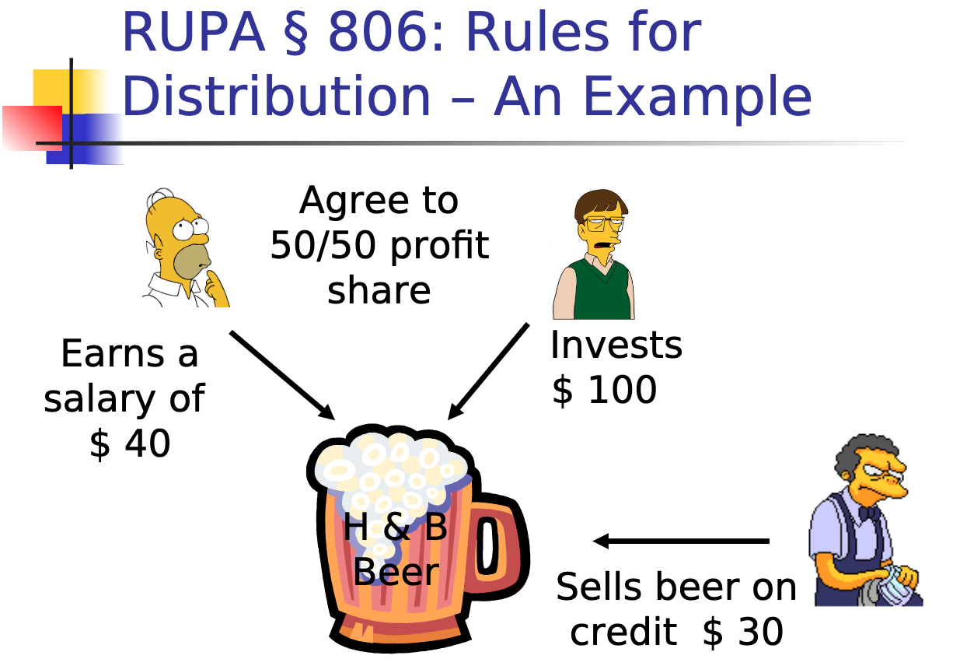
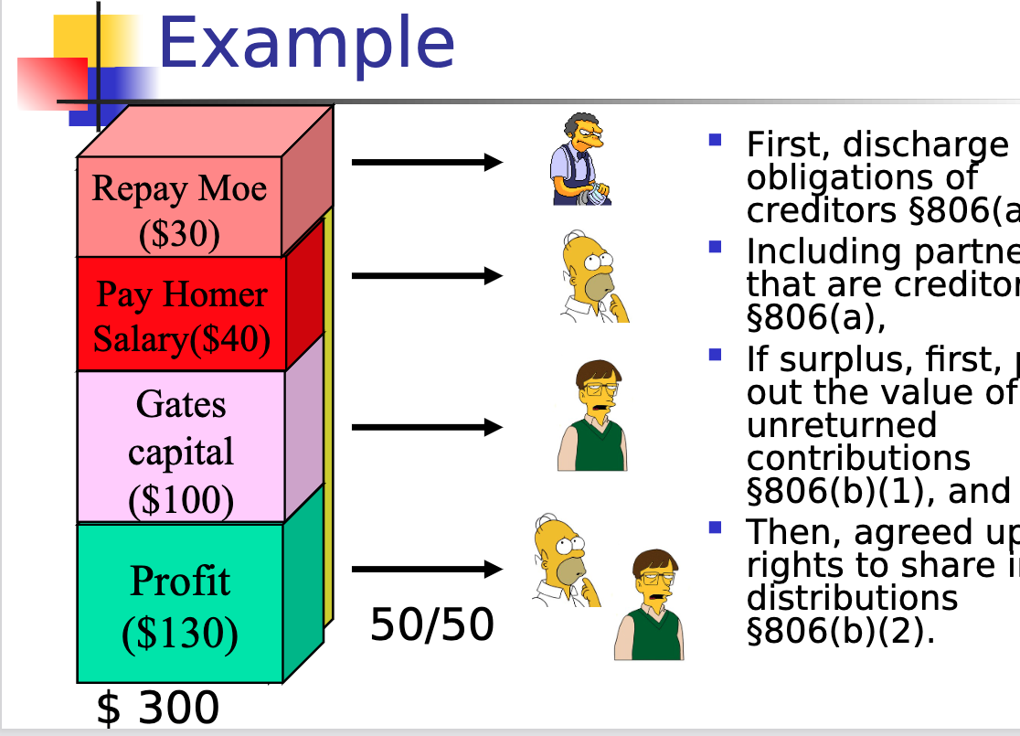

Handling Losses
By default, Partners are chargeable with a share of partnership losses in proportion to the partner’s share of profits.
Ex) Celia and Larry form a partnership to run a catering service. They do not make any agreements changing the default RUPA rules. Celia provides $250k in start-up money and does not work in the business. Larry works full-time in the business but contributes no capital. The partnership ends after a year, paying off all creditors but with nothing left over. The partnership has suffered at $250k loss (per Celia’s $250k capital contribution). For his year of work, Larry received nothing.
- Per the RUPA rules, Larry must pay $125k to the partnership, which will then distribute that amount to Celia. Both Larry and Celia will then have each lost $125k.

Timing of distributions
Statute is silent on when profits are distributed. Partnership agmt should cover this.
- distribution of profits [is] a matter arising in the ordinary course of business to be decided by majority vote of the partners.”

In Kovacik v. Reed (ONLY APPLIES IN CA), K & R entered into a partnership to remodel kitchens. K contributed 10k and Reed contributed labor. Profits were to be shared 50/50 but did not discuss apportionment of losses. Partnership lost money and K asked Reed to cover half of losses. Reed refused. Ct held that the rules dividing losses equally is only applicable when both partners give capital. When one gives labor, they have already taken a loss on their uncompensated labor. Reed is not liable for monetary losses.
- This ruling goes against the default rules which say losses are shared in the same manner as profits (which would be 50/50).
- They should have contracted around the default rules or chosen different ownership structure.
- If Reed had been paid a salary, probably different outcome.

After this case, RUPA reiterated the statute: a person contributes little or no capital should be obligated to contribute toward the capital loss of the large contributor who contributed no services.

Unincorporated Limited Liability Entities.
- Limited Partnerships LP (has two types of partners)
  - Formation: Must file docs with secretary of state
  - Partners:
    - Limited partners are silent/passive partners with no management rights.
    - only have liability if they participate in control.
    - General partners manage business and can bind the partnership.
    - have full personal liability. Jointly and severally liable for pn debts.

- Limited Liability Partnerships (LLP)
  - Formation: must file a form with sec of state
    - Name must include “LLP”
    - Partners are shielded from personal liability for pn debts. Still liable for their own wrongful acts.
- Limited Liability Companies (LLC)
  - Formation: must file with state.
  - Management dictated by the LLC operating agreement
  - Can qualify for partnership-like tax treatment.
  - Two types:
    - Member managed: all members are managers
    - Manager managed: some owners not managers and have no right to vote.
- S-Corporation
  - Advantages: Pass through taxation and limited liability
  - Disad: constraints on # and types of shareholders, sources of corp income, deductions on pass through losses.

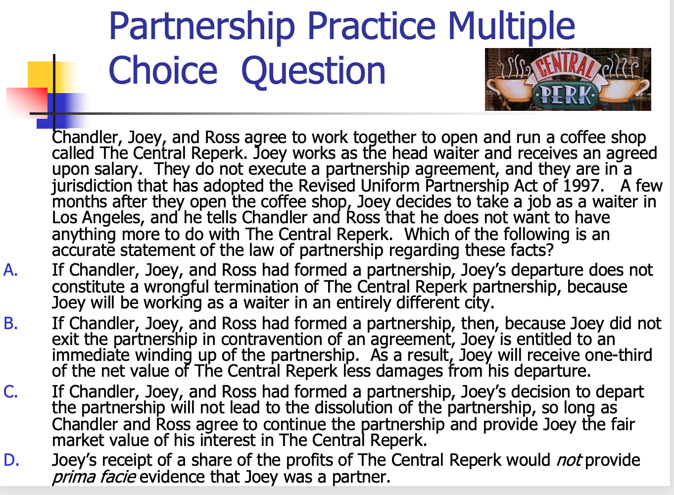

Corporations.
History: Over time, decline of ultra vires doctrine (limited corporation purpose to only purpose clause of its charter. If a transaction was beyond that limited purpose, courts could disaffirm transaction.)
  - Now, corporations can use “corporate powers” for “any lawful purpose”.Can enter into transactions incidental to business purpose.

Sources of corp law:
Internal affairs doctrine: internal affairs are governed by each state where the company is incorporated (many companies chose to inc in Delaware because they like DE’s laws).
- CA has a long arm statute that says if you do business here, you can be sued here. Corps with over ½ taxable income, prop, payroll, voting shares within CA are subject to CA Corporate Code.DE ruled this unconstitutional, so corps inc in DE do not follow this.
- MBCA and Delaware law govern state law.

Key features
- Separate entity: corp is a separate legal entity from owners.
  - Some constitutional rights like free speech, but not personal privacy.
  - Separate taxpayer
    - Double Taxation Problem—The corporation pays taxes on profits, which are distributed to the shareholders as profits. The shareholders must pay taxes on those dividends.
  - Formal creation is required.
- Perpetual Existence
  - Default is perpetual existence. BOD may propose dissolution for submission to the shareholders by first adopting a resolution authorizing the dissolution.
- Limited Liability
  - Key is separation of ownership and control. Shareholders have ownership and limited liability: A shareholder is not personally liable for the acts or debts of the corp except that he may become personally liable by reason of his own acts or conduct (via veil piercing). Liability limited to the amount they invested.
      - Shareholders can come in and out without affecting authority structure.
      - Shareholders elect the BOD at the annual shareholder meeting.
    - Shareholders may receive earnings in the form of dividends
      - In liquidation, get firm’s assets after all other claims are satisfied.
- Centralized management
  - All corp powers shall be exercised by or under the authority of the BOD and the business and affairs of the corp shall be managed by or under the direction of its BOD.
    - BOD directs the affairs of the cop
      - Authority to act for and bind the corp
    - BOD appoints officers to handle day to day operations under BOD discretion.
      - Officers are agents of the corp (scope fo power goes back to agency principals).
    - BOD as a committee have control (not individually). Can take action either:
      - At BOD meeting when notice was given and quorum is present
        - By default, quorum = majority. Bylaws can state otherwise but cannot be less than ⅓.
      - By unanimous written consent.
    - Directors have fiduciary duties to corp and shareholders.
- Divisible ownership (shares of stock)
Process of giving money to corp is through the purchase and sale of securities.
- Securities: permanent, long-term claims on the corp’s assets and future earnings pursuant to formal contractual instruments
  - Debt securities: money the corp borrowed
  - Equity securities: money in exchange for part of company
    - Authorized share: the number of shares the corp can issue as states in articles
    - Company can issue a bond in exchange for money and pay it back once co reaches maturity
      - Together, debt and equity securities make up a corp’s capital structure.
Capital Structure Terminology:
Authorized shares: number of shares the corp can issue
Outstanding shares: number of shares the corp has sold and not repurchased
Authorized but unissued: shares that are authorized but not yet sold
Treasury shares: shares issued and then repurchased by the firm
- Transferable shares and debt obligations.
  - Equity and debt securities may be transferred owners and creditors change as they trade the securities.
    - Significance: Decoupling ownership from management (thru centralized management) allows owners to come and go easily without destabilizing the business

Incorporation Process
- Select state of inc
- Reserve name by applying with secretary of state
- Arrange for a registered agent/office
- Draft, execute, and file articles (charter, cert of inc)
  - Must include corp name, agent address, number of auth shares, ad incorporators
  - May include: initial directos, management limits on rights, liablity on shareholder
  - Proper filing of articles brings corp into existence
- Incorporators have an organization meeting to appoint directors, appoint officers, adopt bylaws, adopt pre-inc promoter’s contracts, authorize issuance of shares. After inc, these ppl do not need any continuing role.
  - Incorporators Typically not liable for their pre-inc acts.
  - Bylaws not filed with state. Set out governing rules for electing directors, filling director vacancies, notice periods, and details for calling meetings of shareholders/directors.
- Prepare board meeting minutes, open corp books, and records, issue shares, get taxpayer ID and any permits needed to do business.
- Plan for shareholder meeting.

Doctrines of defective formation (purpose is to protect shareholders/directors from personal liability if they believed they properly formed)
De Facto Incorp: If you improperly incorporated, still treat the entity as a corp (and thus have limited liability) if organizers did ALL OF THE FOLLOWING:
- Tried to inc in good faith
- Had a legal right to inc
- Acted as if a corp

Inc by estoppel: treat the entity as a corp (limited liability) if person dealing with the firm:
- New the firm was not incorporated AND
- Used this info to generate a windfall (free money/unexpected profits)

Promoter Liability
Promoter: person who directly or indirectly takes initiative in founding/organizing the business or enterprise of an issuer.
- Promotor helps generate interests (find investors, arrange for space, hire employees) before the corp has been formed, but you should not do this anymore because it is so easy to form a corp.
- Liability pre-incorporation:
  - Promoters are liable for k entered into on behalf of a future corp, absent a contrary intent.
    - Contrary intent generally requires showing more than just signing “for a corporation to be formed.”
    - Evidence of the parties’ intentions must be found in the contract or in the surrounding circumstances—for example, that the parties intended the promoter to be a non-recourse agent or a “best efforts” agent
- Liability post-incorporation
  - Corp is liable on the k only if they adopted it (expressly adopt by board resoltiuon giving approval or implied if directors/officers knew of the k and acquiessed in the k.
  - Promoter remains liable unless
    - Corp is formed
    - Corp adopted the k and the parties agreed to release the promoter
- Fiduciary duties before corp formation:
  - To the corp: Deal with entity in good faith (act fairly when making transactions)
  - To other promoters: Disclose relevant info to other relevant parties (conflicts).

Terminology
Income statement: Financial statement that indicates results of operations over a
specified period. Also known as the profit and loss (P&L) statement.

Balance sheet: Summarizes the company’s financial position at a given point in time.
- Usually the end of the month, quarter, or year.
- Describes the assets of the business, and the claims on those assets, either of creditors in form of debt, or owners in the form of equity.
- Numbers on balance sheet should even out bc after debts, the remaining amount in assets goes to shareholders.
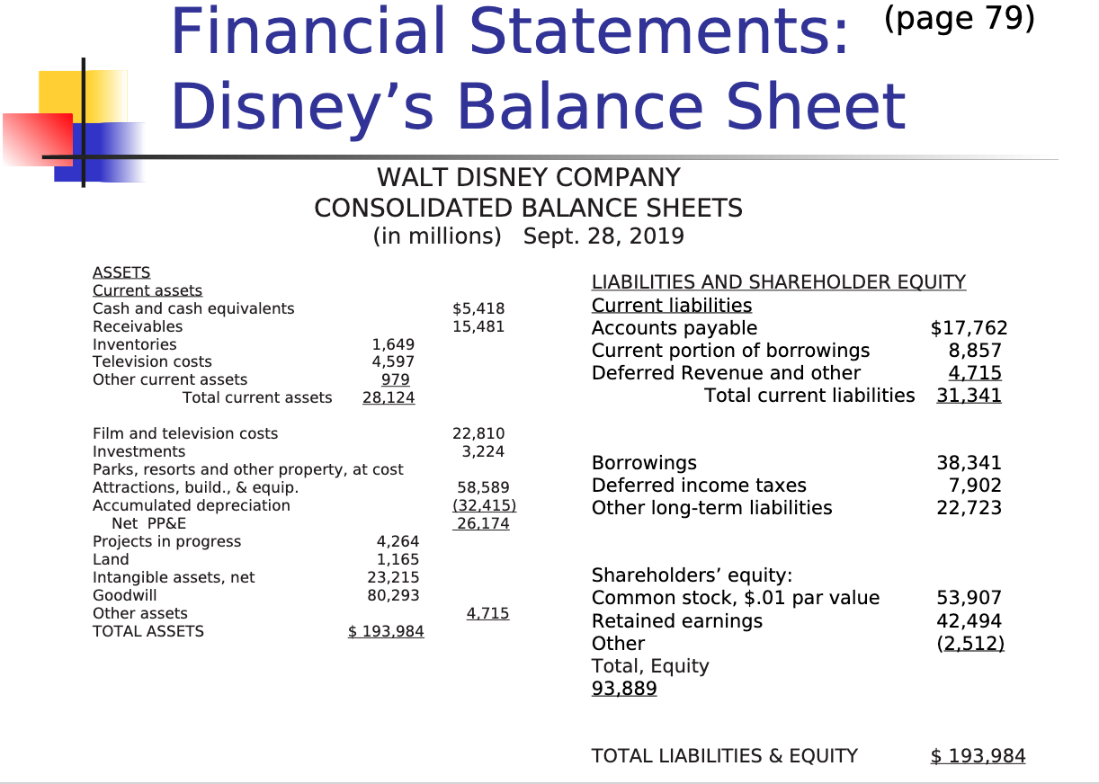
Is it better to have more assets but more equity?
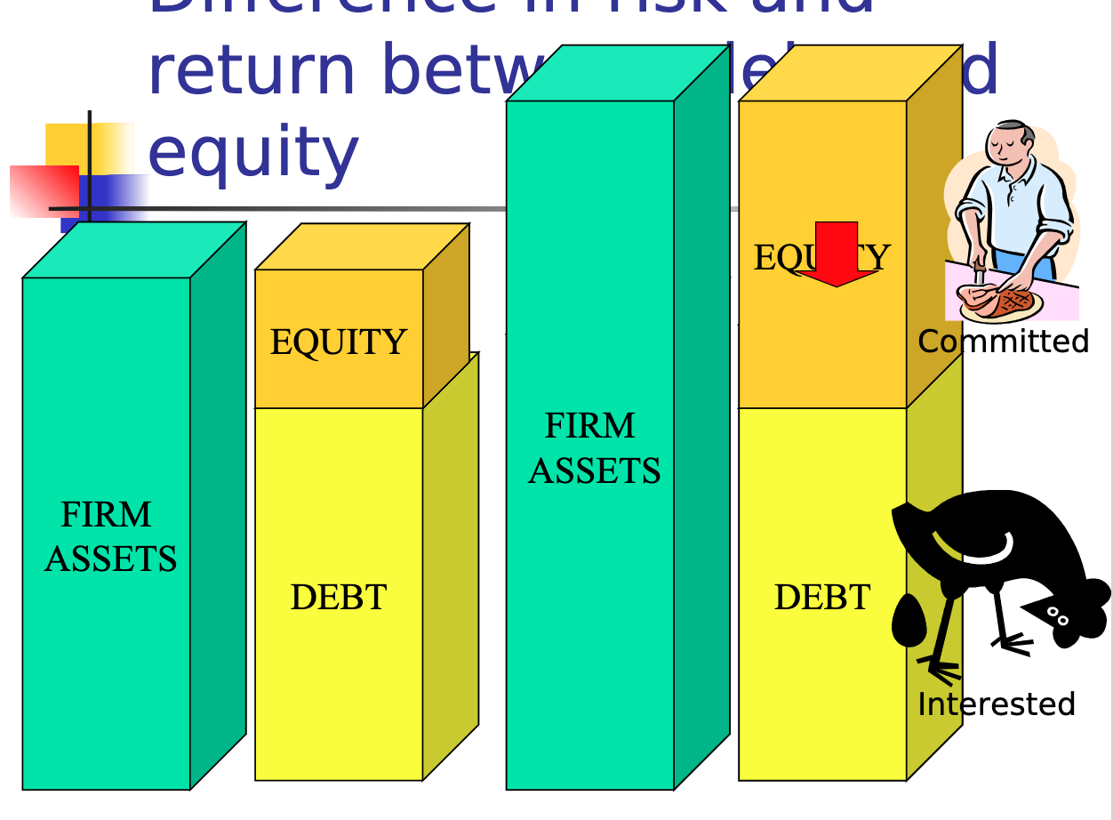
More equity = more money for shareholders.

Two things we want to measure: total equity and total value.
- Total equity is measured in two ways:
  - book value: measure of equity value of the firm provided by the financial statement. Just pull from financial statement.
  - market capitalization: measure of the equity value of the firm implied by the trading value of the firm’s stock (mult trading value of one share of stock x total number of shares outstanding)
    - Many ppl say market capitalization is better measure of equity because under the efficient capital market hypothesis, price of stick reflects all available info. Book value does not account for what ppl value disney.

- Total value is measured in one way:
  - enterprise value: Measure of the total value of the firm’s assets implied by the trading value of the firm’s stock (determined by adding the market capitalization (value of 1 share x. # shares outstanding) + firm’s debt)

Ex) 450k is cost of a house (you borrow 350k to buy the house). Equity = 150k - how much u own.
Value = 450k and equity(amount you have invested) = 150k.
- Book value and market is measures of EQUITY.

What is a share of stock worth?
Value of 1 share = value of assets - debts/liabilities, divided by the number of shares outstanding.

What if the debts are more than assets?
- Shares are worth 0

Subscription agreement: offer to purchase shares of a corp. Corp still gets to accept.
- Can enter into an agmt to buy shares for a corp that hasnt formed yet.
- By default, agreements are irrevocable by the subscriber for 6 months from the date of subscription.

Chart comparing corp to pn

 | Partnership | Corp
formation | Informal | Formalities required; Certificate of incorporation, bylaws, board of directors, minutes, elections, filings, etc.
Limited Liability? | No. Unlimited personal liability. But partnership agmt can have indemnity provisions, can buy insurance, and other partnership forms offer limited liability to various extents (LP, LLP, LLLP) | Yes. Limited liability for shareholders.  But creditors may seek personal guarantees and there is the veil piercing doctrine.
Transferability of interest/shares | No (default rule).  Just the “transferable interest” is personal property that can be transferred; but partners can negotiate and dissociate. | Yes, generally. Can be restricted.
Continuity | Default is at will (dissolution by a partner expressing will to withdraw).  Can agree to continuation agreements. | Default is indefinite/perpetual.  But can limit.  Not tied to human life.
Management | Decentralized (default).  Each partner an agent and equal participation in mgmt is default; but can use exec comm. and limit authority by agreement and notice to third parties. | Centralized (default).  Directors and officers manage the corporation; not shareholders. Separate and specialized functions.
Cost | No cost, but good idea to hire atty. | Filing fees, typically lawyer fees, franchise fees, etc.
Flexibility | Very malleable form for carrying on business; most rules are default. | Not as flexible.
Tax | “Flow-through” (single).  Losses can be used by partners. | Taxed as entity, so shareholders have double taxation on distributed earnings; losses usable only by corporation.  [Exception: S Corporations]

Piercing the Corporate Veil (going after shareholders- this is rare)
Formative test: to invoke Alter Ego, two conditions must be met.
- There must be unity of interests
  - Corp is closely held and Ds are active in business
  - Lack of corporate formalities
    - ex) Shuttling personal funds in an out of corps
  - Commingling of funds and assets
  - Severe under capitalization
    - Means more debt than equity
- There must be an inequitable result if the acts in questions are treated as those of the corp alone. Refusing to allow veil piercing would:
  - Sanction fraud
  - Promote injustice
  - Create unfairness beyond losing money.

In Walanofsky v. Carlton, Carlton owned a big taxi business. Carlton was a shareholder of 10 cab companies, each with 2 cars and each carried 10k in liability insurance, the minimum required. Walkofsky was injured by one of his companies, Seon Cab. W sued Carlton personally, Seon Cab, and the other entities. Carlton moved to dismiss the complaint against him personally. Ct held that W failed to show that Carlton was using his corp as his agent to conduct business in an ind capacity (did not show unity of interest). Seon Cab was undercapitalized, but that is not enough to pierce.
- Dissent: Carlton undercapitalized on purpose and he should not be allowed to abuse corp form.
- Carlton also argues Enterprise Liability Theory which holds the larger corp financially responsible. Requires P to show unity of interest between sister orgs.
  - Ex) Carlton did not respect separate identities of the corp via assignment of drivers, use of bank accounts, ordering of supplies.

Piercing in contracts cases

In Freeman v. Complex Computing (C3), Glazier incorporated C3 with his friend as the sole owner. Glazier had option to purchase the company at anytime for 2k (so it was essentially G as owner but with his friends name on company). C3 hired freeman to sell and license. C3 then sold C3 assets to Thompson (lucrative deal) and Thompson hired Glazier. Freeman terminated. Freeman wanted profits. Equitable Shareholder Doctrine allows Glazier to be held responsible because he acted like a shareholder. Ct held that there was a unity of interest (G exercised control over G3, disregarded corp form, acted like assets were list own, his job description was entire business, G3 located in apt, option to purchase for 2k), but case remanded to see if injustice (prong 2). On Remand, injustice was found. C3 was reduced to a shell and there was no money left to pay Freeman.

Piercing in Corporate groups

In Gardemal v. Westin Hotel: Gardemals traveled to Mexico. Hotel concierge directed Gs to the beach for snorkeling that was known to have rough surf. John Gardemal drowned and wife sued Westin Hotel (parent co) and Westin Mexico (subsidiary) in Texas. Argued alter ego and enterprise liability theory. Ct held Westin was not liable for Westin Mexico’s acts bc they kept their corps separate. Alter ego was not satisfied. Shared stock, common officers and financial agreements are all typical of parent-subsidiary relationships. They adhere to corp formalities, were inc in 2 diff counties, Westin Mexico was not undercapitalized so G should recover from them, they have their own assets, insurance, staff, bank acnts. Also not enough for enterprise liability. SJ for Westin granted.

Reverse Veil Piercing: sought by a 3rd party typically a creditor of a shareholder who seeks access to an entity’s assets to satisfy their claim against the shareholder.
- Shareholder says I don’t have money but they own shares of Disney.
- We don’t want people shielding assets by buying shares. Cannot use corp form to evade liability.
Test:
- Unity of Interest (same as above)
- Equitable justification (same as above)
- The degree to which reverse veil piercing would impair legitimate expectations and adversely affect other shareholders who are not responsible.

In Manichean Capital v. Exela Techs, Source HOV merged into Excela. Manichean LLC got an appraisal award from the merger. Money was order to go from Source HOV subsidiaries to Manichean, but judgment was still not satisfied. M argued Source HOV subsidiaries were abusing corp form to have money flow directly to Excela and outside of Source HOV’s creditors reach. Ct said reverse veil piercing should be allowed bc no innocent shareholders/creditors would be harmed and Manichean has no other equitable remedies.

Directors Corporate Fiduciary Duties
Directors (and controlling shareholders - See Sinclair) owe:
- Duty of Care: directors must act in the shareholder’s best interest and you need to make an informed decision.
    - 12(b)(7) clause may eliminate personal liability of a director for monetary damages.
BJR: A court will defer (not look into substance of decision) to the directors unless their actions:
- Are not in the honest believe that actin is in the best interests of the corp
  - In Kamin v. AmEx, AmEx bought 2 million shares of DLJ stock for $30 million. Value fo shares went down to $4 million total. AmEx gave shares to shareholders but shareholders said they should have sold them bc they would get a tax break. Ct held they would not weigh in on substance of decision because the decision was made with best interests in mind. Did not want company to publicly look bad by selling stock.
    - Could have argued conflict of interest bc directors were making decisions that inc their compensation at the expense of other shareholders.
- Are not based on an informed investigation (not informed decision)
  - In Smith v. Van Gorkom, Van Gorkom was CEO of Trans Union Corp which was having financial issues. Van Gorkam entered into buyout negotiations with his friend and determined the value of Trans Union to be $55 per share (cheap). No evidence as to where this number came from. After a 2 hour meeting, directors approved the buyout. No one read the agmt. Smith sued BOD for making an uninformed decision. Ct held this decision was uninformed and Ps entitled to the fair value of their shares sold in the buyout. Case remanded to determine value
    - Must prove gross negligence to win on this issue.
    - What is the 38 million number?
    - How can directors protect themselves from liability? 1) Don’t rush through agmt, hire atty/banker, get reports. 2) Indemnification: have corp indemnify (promise to make whole) directors/officers. 3) buy D&O insurance (director and officer insurance). In Van Gorkam, D&O insurance paid 10M of the settlement.
- Involve a conflict of interest

In response to Smith v. Van Gorkam, DE and Model Corp code enacted an exculpation clause 12(b)(7) waiving the the right to sue directors:
The cert of inc may include a provision eliminating or limiting the personal liability of the director of officer or its stockholders for monetary damages for breach of fiduciary duty, provided that sich provision does not eliminate or limit:
- Breach of duty of loyalty
- Acts not in good faith or intentional misconduct/violation of the law
- Unlawful payment of dividends
- Transactions from which the director/officer derived an improper personal benefit

- Duty of Oversight: includes (From Francis case):
Obligation of basic knowledge and supervision
Read and understand financial statements
Must object to misconduct and if necessary, resign.
    - In Francis v. United Junior Bank, after dad died, directors of reinsurance brokerage (Pritchard) were wife (lillian) and sons. Dad warned Lillian to watch out for the sons. Lillian drank heavily, never went to office, read any statements, knew nothing about business. The sons then embezzled money from the brokerage and it went bankrupt. Ct finds that Lillian violated her affirmative duty of oversight. Ct uses a RP standard rather than BJR because BJR is only for action, and this was INACTION.
      - Exculpation clause can protect from affirmative duties.

- Duty of Loyalty (2 step analysis)
Step 1: Does the transaction involve a conflict of interest? (need all 3)
- Is a director or shareholder on one side of the transaction?
  - If in Model State, MBCA provides: conflicting interest if:
    - Director is party to the transaction
    - Director had knowledge and a material financial interest in the transactions, or
    - A transaction which the director knew a related party had an interest in.
      - Related = spouse, child, stepchild, grandchild parent, step-pareet., grandparent, sibling, half sibling, aunt, uncle, niece, nephew or spose of such person or person living in the same house as the ind. (prod said do not need to know this)
In Sinclair v. Levien, Sinclair owned 97% stock in its subsidiary Sinven (Sinclair Venezula). Sinclair made Sinven pay out $108M in dividends even though that was more money than they made and made Sinven enter into a k with Sinclair International to sell its oil to S International. International made late payments and did not meet minimum purchase requirements. SInven sued Sinclair (parent Co). Intrinsic fairness test applies to transactions that are self dealing. Ct held that BJR applies to payment of dividends bc transaction was not self dealing - minority shareholders got paid too. There was also no conflict under our test. As for the k, that was self dealing bc forced into k then breached it. Indicates conflict of interest bc firm involved, shareholders involved, and benefit not shared by all bc Sinven not able to sell oil elsewhere.
        - Advice? Get disinterested directors to approve.
2. Is the firm on one side of the transaction? Can be met if firm lost corp opp.
The Guth Test provides that a Corp Opp exists where (court calls these factors):
- The corp is financially able to take the opp
- Opp is the in the corp’s line of business: corp has fundamental knowledge, practical experience, and ability to pursue the activity.
  - Consonant with its reasonable needs/aspirations.
- Corp has an interest/expectancy in the opp
  - Interest: something to which the corp has a right
  - Expectancy: opportunity in ord course of business. (renewal rights in lease)
- Embracing opp would create a conflict between director’s self interest and the corp.
Reasonable need or aspiration for expansion.

In Broz v. Cellular Info Systems (CIS), Broz was Pres and shareholder of RFB. Also a member of CIS, an RFB competitor. PriCellular in the process of acquiring CIS bc CIS had financial issues. Mackinac Cell approached Broz to see if RFB wanted to acquire another license. CIS sued Broz under corp opp doctrine. Ct held a corp opp did not exist because CIS was not able at the time to take the opp (this was before merger), CIS did not have interests/expectancy bc they were not approached, and there would be no conflict (in fact, nothing would change bc Broz already owned the license next to it). Broz did not need to consider the future ability of CIS to take this opp. Had the merger gone through before, it would a corp opp.
- Advice to Broz: Resign from CIS; Buy Michigan much earlier, address CIS directors all together in a board meeting. If he did that, would have board approval and no conflict
- Line of business test covers more opportunities than interest/expectancy test.

3. Is the transaction providing a benefit from the firm not received by all?
- EXAMPLE: Polestar offers to sell you, a Director, a car for $500 down and $30/month. Polestar and a director are on both sides of the transaction. Is it a conflict of interest? Not if every other Director receives the same offer.

Step 2: Has the conflict been properly cleansed? (any of these 3 is sufficient)
    - Approval by informed disinterested directors
    - Independent, disinterested shareholders ratify
    - Transaction is judged fair

- Duty to act in Good Faith
Duty is broken by:
Conduct motivated by an actual intent to do harm to the corp or
Intentional dereliction of duty, a conscious disregard for one’s responsibilities.

In Re Walt Disney Co, Disney hired Ovitz as an executive. Offered severance to get him to leave current job. After 14 months, mutual decision that he was not a good fit and under package he got $130M. Shareholders sued for breach of good faith (bc no conflict of interest) and argued corporate waste. Ct rejected corp waste - It had a rational business purpose: package lured him away from old job and when he came, stocks rose 4%. Ct also said this falls under BJR - informed decision that directors believed was needed. Hired outside counsel, agmt went through many drafts (unlike Van Gorkom).

In Re caremark:
Director’s obligation includes a duty to assure that corp information and reporting systems exist, and failure to do so may render a director liable for losses caused by non-compliance with legal standards.
    - Adequate compliance program: Policy manuals, training, compliance audits, sanctions for violation, provisions for self reporting of violations.

In Stone v. Ritter, AmSouth bank was forced to pay $50M in fines for their employees failing to report suspicious activity as required by law. Shareholders sued the directors for lack of proper oversight. KPMG report shows that directors did have substantial policies in place, including a suspicious banking oversight committee. The fact that employees failed to follow the procedures does not mean the directors did not implement the policies in good faith. Shareholders complaint dismissed.
      - This duty can fall into duty of oversight, but if 12(b)(7) clause, then allege breach of good faith.
Protection when relying on advice provided: DGCL § 141(e) provides: “A member of the board of directors, or a member of any committee designated by the board of directors, shall ... be fully protected in relying in good faith upon [specified documents and persons.
If there is a CONFLICT OF INTEREST, it is a DUTY OF LOYALTY ISSUE. If NO CONFLICT, DUTY OF CARE ISSUE.

Action of BOD only occurs when:
- Board meeting is regular/special
  - No notice required for regular meeting
  - 2 day notice required for special meeting
    - Director may waive notice in writing
  - Must be a quorum (at least ⅓)
- Unanimous written consent in lieu of meeting

Who do directors owe a fiduciary duty?
- Shareholder primacy theory: Directors act to maximize interests of shareholders (inc profits) (THIS IS CURRENT LAW but some states incorporate stakeholder theory)
  - In Dodge v. Ford Motor Co., Dodge brothers were 10% owners in Ford. Ford decided to not give out dividends but rather re invest the money to lower the price of cars and pay workers more. Board ratified this decision. Ct held Ford is for-profit business not charity so issue the dividends! They cannot take action out of humanitarian concern rather than business concern. BJR does not apply because this was not in the interest of shareholders.
    - Ford should have said “This is good for business because…” “I am doing this ultimately to benefit shareholders”
    - Ford offered to buy 10% ownership for $30M. Good deal?
      - Take offer to determine what the firm’s value is = 300M
        - Using balance sheet (stock approach), offer is 3x book value and a good deal
        - If we use income statement, 300M (value) divided by 60M (income), offer is 5x price to earnings (PE). As the PE multiple gets higher, you are paying more for every dollar of earnings. Not a good deal bc of Ford’s big growth. Price per share would be same calc.
  - In Ebay v. Newmark, Craig Newmark and Jim owned 72% of craigslist. EBay owned the other 28% (all shareholders). Ebay wanted to earn profit while Craig and Jim wanted it to remain a community site. C and J implemented Shareholder plan to tat prevented action from EBay. Ebay sued for breach of fiduciary duty. Ct held tha plan was unreasonable bc it was not reasonably related to inc profitability to shareholders, only the community value. This is a for-profit business.
  - Every corp can make reasonable charitable donations. In Theodora Co v. Henderson, Mr. H and Ex-wife (via Theodora) had interest in Alexander Dawson co. Mr. H wanted Alexander Dawson Inc. to make a 500,000 donation to the Alex Dawson Foundation for underprivileged boys. Got rid of 5 directors to get approval. Theodora sued. Ct held this was a reasonable gift. Alex Dawson’s income was 19M so this was below 5% and using capital gains taxes, gift increased net ballance of corp on balance sheet. This was not self dealing.

- Stakeholder Theory: duty is owed to the community, employees, clients, and shareholders.

Constituency statute: Maj of states (not DE) have statutes that expressly allow, but do not require a corp to consider stakeholders and other constituencies’ interests.
- In Re Trados, Trados had finance issues. Obtained financing from venture capitalist in exchange for preferred stock and board control. Venture capitalist sought to sell their interest and the plan would compensated preferred shareholders but not common shareholders. A common shareholder brought suit alleging breach of fiduciary duty. Ct held that while this was self-dealing, stock was valueless prior to the transaction, so the BOD did not breach its duty Fiduciary duty to shareholders.require that corps strive prudently and in good faith to maximize the value of th corporation for the benefit of its residual claimants “Stockholders best interest must be the end. Other constituencies may be considered but only instrumentally.”

Political expenses: ​​Citizens United v. FEC allows corporations to spend unlimited amounts from their general treasury on independent expenditures supporting or opposing candidates to federal office.
- Absent COI, illegality, or fraud, a decision to spend corp $$ on a ind political expenditure is treated as an ord business decision and get BJR presumption.

Protecting Directors from Liability
- BJR (see below)
- Indemnification
  - Corp may indemnify (agree to pay whole after losses) directors and officers. There are some payment that corps cannot indemnify.
    - Cannot indemnify fees if the actor did not act in good faith.
    - No indemnification if the person shall have been adjudge liable to the corporation.
- D&O insurance
  - Corp has power to purchase D&O insurance for any director’s liability, whether or not the corp would have the power to indemnify.

Leveraged buyout: acquisition of all the firm’s outstanding shares using borrowed funds.
- Secured by assets of the company that is being acquired
- Pre-LBO, more equity than debt. After LBO, more debt than equity.

Management buyout: same as LBO but purchaser is the company’s own management.
- Shareholders do not get a say.

Benefit Corporations

Benefit Corporation (type of organizational form)
- Allows pursuit of dual mission: profits and public benefit
- Public benefit must be stated in charter

Certified B-Corp (3rd party certification for meeting standard)

- Both require directors to consider impact of their actions on stakeholders
- Both must publish public report of overall social and environmental performance (except DE).

Shareholder Duties and Roles
Duties: none unless controlling shareholder.
Roles:
- Sue
  - Direct action
  - Derivative suit
- Vote
- Sell

Shareholder Suits
- Direct actions: a suit alleging direct loss to the shareholder
  - Ex) force payments of promised dividend, enjoin activities that are ultra vires, claims of securities fraud, protect participatory rights of shareholders.

- Derivative suit (takes the form of class action): a suit alleging harm to the corp by all shareholders. Brought by shareholder on corp’s behalf saying corp was harmed. COA belongs to corp.
  - Ex) breach of duty of care or loyalty.
  - First lawsuit is against the director and second established who has control over the lawsuit
To determine if direct or derivative claim:
- Who suffered the alleged harm?
- Who would receive the benefit of any recovery?
  - Ex) if the director steals from the company, corp would recover, so derivative action.
  - If ABC’s corp CFO embezzles money and shareholder stock dec in value, again the corp was harmed and recovery would go back to corp.
  - ABC entered into k with Jones and Jones breached. ABC can file derivative bc corp was harmed.
  - Board of ABC inc agrees to sell 80% of its assets. A vote is req under state law. No vote occurs bc board does not think this is 80% od all assets. This would be a direct claim bc it is a shareholder being denied contractual obligation to vote.
- In a derivative suit, corp is required to pay shareholder atty fees if suit is success or settles.

In Tooley v. DLJ, Tooley was a minority shareholder in DLJ. The controller of DLJ, AXA Financial, negotiated a merger with DLJ and CSG. Under the offer, CSG would obtain outstanding DLJ stock, including Tooley’s shares. CSG exercised multiple extensions and Tooley sued DLG directly (requires direct loss to shareholder sep from corp) saying complying with extensions breached their fiduciary duty. Tooley wanted to get paid quicker. Ct held no direct or derivative claim because the directos did not violate contractual obligations to shareholders, nor did they harm the corp.

Procedural Hurdles in a derivative suit
- Bonding Requirements
  - In some states, a claimant with low stakes must post security for a corp’s legal expenses. Purpose is to deter frivolous suits.
- Demand Requirements
  - Most states require shareholders to go to BOD and demand they pursue legal action unless they can claim a valid excuse. Give BOD opp to bring suit before you bc that is their job. States that follow Model rules REQUIRE THIS.
    - Demand must allege wrongdoing, factual basis for wrongful acts, harm cause to corp, and requested relief. Must be specific enough for BOD to understand merits of the cause of action.
    - ISSUE is that once the demand has been made, the BOD decision is subject to the BJR and you lose right challenge decision bc COI. In DE, a rational shareholder will file derivative suit before making demand and plead demand futility.
    - SLC - in charge of seeing if demand should move forward or be dismissed.
      - In UFCW v. Zuckerberg, Zuckerbeg wanted to implement a plan to dispose of some of his stock while still maintaining control. Shareholders challenged and 80M was spent on litigation until Zuckerberg withdrew plan. UFCW, FB shareholder, brought action to recover those costs bc BOD breached duties or care/loyalty. BOD moved to dismiss bc UFCW did not make a demand or plead demand futility. Ct held that to plead demand futility, must plead either.
        - Maj of BOD received a personal benefit from the wrongdoing
        - Maj BOD would face a substantial likelihood of liability
        - Maj BOD lack independence from someone who received a personal benefit or would face sub likelihood of liability.
      - In this case, BOD did not face personal liability bc 12(b)(7) clause and they were all billionaires so not concerned about pleasing Zuck and receiving a benefit.
      - In Aaronson v. Lewis, Ct held the demand requirement was excused because all directors were named as D so the would be suing themselves. BOD could not be impartial so no BJR.
      - It is hard to satisfy demand because no disc yet. You can 1) wait until there has been a public investigation or2) find former employers, hire detective, gather info.
- Special Litigation Committee (there is a jur split - Auerbach for NY and Zapata for DE)
  - Under Auerbach v. Bennet, when the BOD establishes a SLC, the SLC’s decision falls under BJR. Can still have an inquiry to see 1) if members are disinterested and independent and 2) the adequacy of the SLC investigation.
  - Delaware standard for reviewing SLC recommendations: Zapata v. Maldonado 2 step:
    - Evaluate the board’s independence, good faith, and decision process.
    - Court applies it own business judgment as to whether the case should be dismissed. Inc policy considerations.
      - In Zapata, Maldonado was a shareholder in Zapata corp. M brought a derivative action. SLC appointed who decided it was in the corp’s best interests to dismiss maldonado’s claim. Established that the ct has discretion (step 2 of the analysis).
        - Why is court being more intrusive? The BOD was excused bc COI, but they are the ones picking the SLC.
  - In Einhorn v. Culea, shareholders brought derivative suit and BOD appointed SLC. Parties disputed whether SCL was independent.
  - 7 factors (not all required) to determine whether SLC members are independent.
    - Whether the director is a defendant.
    - Did director participate in or approve alleged wrongdoing
    - Business dealings with individual defendants
    - Personal, family, or social relations with defendant
    - Business relationships with the corporation
    - Number of members of the Special Litigation Committee (the more, the more ind.
    - Did the committee hire independent counsel (We want them to hire ind firm to advise them)
In Re Oracle: Oracle shareholders accused directors of insider trading. Ps demanded demand futility and a SCL was appointed by BOD. Ct found the SLC was not independent because SLC were professors at Stanford and some directors were also prof at Stanford, directors were stanford donors, one Prof taught a director.

Effect of these hurdles: shareholders do not benefit.

Shareholder Voting

Who votes? Shareholders of record on the record date vote.
- Company will determine record but if agmt says no more than 70 days before vote and someone buys shares 60 days before the vote, previous owner still votes. A record date fixed under this section may not be more than 70 days before the meeting or action
- requiring a determination of shareholders.
- 1 share = 1 vote.

When is voting?
- Annual shareholder meeting
- Special meeting called by BOD or shareholder if cert/bylaws allow.
- Upon application, a court can call a shareholder meeting if no meeting was called for 13 months
- Shareholders can act by written consent (DGCL § 228(a) unless certificate provides otherwise

Under SEA, It shall be unlawful for any person to solicit a proxy (vote) “in contravention of such rules and regulations as the Commission may prescribe as necessary or appropriate in the public interest or for the protection of investors.
- Rule 14a-9 prohibits false or misleading statements or omissions as to a material fact in connection with soliciting proxies
- Shareholders can bring derivative suit (corp harmed by misinformed vote) or direct action (voting rights infringed on).

How do shareholders vote?
- In person when there is 1) majority of shares under MBCA or 2) maj of shares entitled to vote present under DE

MBCA: Most matters require a majority of shares present at a meeting at which there is a quorum (MBCA § 7.25(c))(simple maj).
Delaware: Default is a majority of outstanding shares entitled to vote (DGCL § 216(1)) (absolute majority)
ABC Corp has 100 outstanding shares with 60 shares present/represented at the meeting. If simple maj, 31 votes is sufficient. If absolute, then 51 shares requires.

Removing shareholdings vs filling vacancies

- By Proxy (on paper)

What do they vote on?
Under State law, shareholder:
- Vote for directors, major transactions (like mergers), amendments to articles,
- Can make proposals
- Have duty of candor
Under Fed law, shareholders
- Regulates disclose of info
- Shareholder proposals only for public companies.

What shareholders are entitled to vote on:
- Election of directors
  - Classified(staggered) board: you don’t vote on them. More insulated
  - Straight v. cumulative voting:
    - Straight: number of votes is accorded to each slot that is up for being voted on. Minority always losses. Default in DE but can adopt cumulative in cert.
    - Cumulative: each shareholders votes is multiplied by the number of available slots and shareholder can split their votes in any way (focus on 1 director and bundle votes). Default in CA and cannot opt out of cumulative voting. Publicly traded corps can opt out.
  - Plurality v. majority voting
    - Maj: director must receive maj of votes. Gives shareholders more power.
    - Plurality = ppl assigned directors based on number of votes. Most votes = director 1, second most = director 2. Issues is sometimes there are 8 ppl running and 8 slots, so vote doesn’t really matter.Just must receive 1 vote.
  - Voting for directors or filling vacancies
    - Vacancies and newly creator position may be filled by a maj of the directors.
    - Shareholders may act by unanimous written consent to elect directors in lieu of annual meeting or by non-unanimous consent to fill director vacancies.
  - Removing directors
    - DE statute on removing directors: Any director or the entire board may be removed with or without cause, by the holders of a maj of shares entitled to vote at an election of directors, except classified board and cumulative voting.
    - Shareholders have power at a shareholder meeting (Auer)
  - Who nominates directors: default is incumbent BOD nominates slate.
    - Competing slate can be offered.
    - If a co. owns 3% of co. for 3 years, they can nominate up to 25% of board.
      - For contested election, each side prepares and distributes to shareholders its own proxy solicitation materials.
    - Under the 2022 universal proxy access rule, shareholders and management must use universal proxy cards (includes all candidates regardless of who nominated them) when soliciting proxy votes in director elections.
- Amendments to articles
  - Under Model code, Changes must be adopted by BOD and approved by a maj of the votes of shareholders present.
  - In DE, changes must be adopted by BOD and holders of the maj of the outstanding stock must vote in favor the change.
Note: amending bylaws is harder: Under Model rules, shareholders may amend or repeal bylaws and directors may amend or repeal unless pertaining to director election or bylaws prohibit. Under DE law, shareholders entitled to vote have the power to adopt, amend or repeal bylaws and directors have this power if provided for in the articles.
- Fundamental transactions (like merger)
- Odds and ends (precatory measures aka proposals)
  - Precatory = express a wish. Fed law allows shareholders to submit proposals to fellow shareholders
  - To submit a proposal, you must have at least 2k worth of voting shares for 3 years, 15k for 2 years, or 25k for 1 year. Calculate by multiplying # of securities the shareholder has for the 1 year period by the highest selling price during the 60 day calendar days before the shareholder submitted the proposal. Must be submitted 120 days before the date proxy materials were sent. Cannot exceed 500 words.
    - Who can submit a shareholder proposal? Ind activists, hedge/private equity funds, pension funds/other investors, charities, non-profits.
  - Company can exclude proposals if they provide justification:
    - Proposal is not proper subject matter
    - Implementing proposal would violate law or proxy rules (proposal says ppl from CA get more votes)
    - Proposal involves personal grievance or special interest
    - Proposal is not relevant to the firm’s operations
    - Company lacks power to implement proposal
    - Prop deals deals with ord business operations (seems like this can also be improper subject matter)
    - Proposal relates to electing directors. (this is cover by state law and cannot be modified)
      - If staff determines it should be excluded, issue a no-action letter. If staff determines it should be included, notify issuer of enforcement action if proposal is excluded.
- Non-binding say on pay vote at least 1x every 3 years.
  - A silly procedural non-binding vote on if ppl are being paid enough or too much. No change is required regardless of vote (95% of ppl saying not paid enough - no change required).

In Auer v. Dressel, shareholders asked the president to call a shareholder meeting to 1) recommend reinstatement of former pres Auer, 2) remove 4 directors for cause, and 3) amend bylaws to provide that vacancies after removal of directors by shareholder can only be filled by the shareholder. Ct held that shareholders have the power to do these at a shareholder meeting.
- Want to avoid getting voted out? Avoid a shareholder meeting. This is when shareholders can express views.

In Blasius Industries v. Atlas Corp, Blasius began accumulating shares of Atlas. When they owned 9%, B wanted to take control by expanding the board. Currently 7 directors and there was a cap of 15. Atlas called an emergency meeting of the board and inc board to 9 and filled these vacancies to block shareholder vote. Ct held that although Atlas and B are free to fill vacancies either at the shareholder meeting or by maj written consent, Atlas undermined shareholder efforts and they are supposed to be acting in shareholders best interests. Blocking was not proper.
- Board could have spent corp funds to educate shareholders on the neg effects of B’s plan.

In Rosenfeld v. Fairchild, company wanted a new board to come in (insurgent board). Rsenfeld did not want company paying all these election expenses. Incumbent board and insurgent board spent $$$ on election. Judge Froessel establishes Froessel rule: corp will pay both sides expenses if insurgents win. Incumbents get expenses paid win or lose bc they need to provide info for the company still. Insurgents only get expenses paid if they win.

In Lovenheim v. Iroquois Brands, Lovenheim was shareholder of Iroquois. Wanted to include in the proxy materials for the shareholder meeting info about inhumane procedures used to feed geese to produce foie gras which Iroquois imported. Iroquois refused, saying the foie gras accounted for less than 5% revenue and was not sig related to the business. Ct held that the materials were significant even tho they were less than 5% of revenue bc related to brand. Doing a little of something inhumane still relevant. “Otherwise significantly related” includes ethical and or social significance.
- If they were not selling ANY foie gras, would not be relevant.
- If his proposal asked them to stop selling foie gras, that would go to ord. Bus. operations and would not be proper.
Shareholder Inspection Rights

Any Shareholder shall, upon written demand, have the right to inspect for a proper purpose, a list of its shareholders and its other books and records.
- Proper purpose: purpose reasonably related to such person’s interest as a shareholder.
- Book and records include at minimum: cert of incorporation, bylaws, minutes of board and shareholder meetings, board/shareholder actions by written consent.
  - DE sup ct held that if you request contracts, correspondence the request must be very narrowly tailored.
- When a demand is made for list of shareholders, burden is on corp to show the shareholder seeks inspection for an improper purpose.

In State ex rel. Pillsbury v. Honeywell, Inc, P bought stock in Honeywell to stop the production of bombs used in Vietnam. Requested a list of shareholders to solicit them for a vote for a new BOD. Ct held that this was for a political purpose and not a proper purpose. Only acquired honeywell stock to force them to cease bomb production. Not reasonably related to interest as a stockholder.
- P could have tried to reframe the purpose to get records by making it about what shareholders can do. Say he needs this info because it might change how he vote for directors.

In Salito v. McKesson HBOC, McKesson merged with HBO on Oct 17, 1998. On Oct 20, Saito purchased McKesson stock but HBO lied to McKesson about how much HBO was worth. Saito requested books to investigate breaches, claims against advisors. Trial ct (a) only allowed docs after the date Saito purchased stock, (b) did not allow stocks related to advisors, and (c) did not allow HBO docs bc he is only a shareholder of McKeson stock. Ct reversed (a) and (b). Stock purchase date is not an automatic cut off for docs. THis derivative suit and he needs to see what directors are getting. As for (c) stockholders of a parent co (Mckesson) are not entitled to inspect a subsidiary’s books absent a showing of fraud or alter ego of parent.

Selling Shares
- Federal securities violations
- Federal insider trading law
  - these coming from the same place (Security and Exchange Acts) in statute, but different things.

14(e)(3) Tender offer: public announcement saying you will tender all shares. Cannot trade on info about tender offer.

Exchange Act 10(b).
It shall be unlawful for any person, directly or indirectly, by the use of any means or instrumentality of interstate commerce or of the mails, or of any facility of any national securities exchange—
(b) To use or employ, in connection with the purchase or sale of any security registered on a national securities exchange or any security not so registered, ... any manipulative or deceptive device or contrivance in contravention of such rules and regulations as the Commission may prescribe as necessary or appropriate in the public interest or for the protection of investors. …
- Issue is that “in contravention of such rules”.... There are no rules yet and ppl were breaking rules.
- That is why the Commission enacted 10-b-5 …to be the rule that 10(b) refers to.

Rule 10(b)(5) (this is basically saying u cannot commit fraud when buying for selling).
It shall be unlawful for any person, directly or indirectly, by the use of any means or instrumentality of interstate commerce or of the mails, or of any facility of any national securities exchange—
(a) To employ any device, scheme, or artifice to defraud
(b) To make any untrue statement of a material fact or to omit to state a material fact necessary in order to make the statements made, in the light of the circumstances under which they were made, not misleading, or
(c) To engage in any act, practice, or course of business which operates or would operate as a fraud or deceit upon any person, in connection with the purchase or sale of any security

Under this rule, 2 ways it can impact litigation. If someone is lying to you when selling securities, and you keep buying shares, they are committing fraud. 1) Gov can enforce rule or there is a private remedy and u can sue corp.(shareholders can also sue derivitatively to say we would not have voted these directors if we knew they were committing fraud). 2) Insider trading litigation.

Elements to proceed with a securities fraud lawsuit:
- Material misrepresentation or omission
  - Material: whether there is a substantial likelihood that a reasonable shareholder would consider the fact important.
- Scienter
  - Facts lead to strong inference that D acted with intent to deceive, manipulate, or defraud. D acted knowingly.
- Reliance: Under the Fraud on the market theory, rebuttable presumption that the investor relied on the integrity of public traded market price when making the investment decision, so investor need not have seen the misrep.
- Causation: misrep caused P a loss (change in stock prices when truth revealed. Trick is to hold on to stock to see loss).

Insider Trading Policy:
Reasons to allow:
- Protects proprietary info by seeding soft info to market
  - More accurate pricing, makes capitalism more efficient
- Encourages insiders to own company stock
  - Your interests would be aligned with SH
- Compensates insiders for developing good news
  - Profit from good new dev
Reasons to not allow:
- Unfair to those w/o info
- Distorts company disclosures
- Constitutes theft of corp IP
- Discourages investors from entering market
- Adds to trading “spreads” in market
  - Makes things more expensive, ppl lose trust in system.
- Wastes resources in efforts to be first to trade on insider info.

Insider trading over time:
1961: In Cady Roberts, Gintel was a broker of Cady Roberts Co. Cutiss Wright Corp. developed a new engine dev. plan. Gintel bought stock in the corp. Director of Cutiss-Wright Crowdin called Gntel office and told them about the dividend cut. Gintel sold stock to protect clients. SEC launched fraud proceeding against Gintel and Cady Roberts. Ct held that Gintel acted fraudulently because a broker who receives nonpublic information from an insider has a duty to disclose the information or avoiding trading

Rule: when insiders have Material Nonpublic Information (MNPI), the insider must disclose or abstain.

1971: In SEC v. Texas Gulf Sulphur (TGS), TGS was mining for minerals in Canada. Drilled a promising sample. Told all employees to stay quiet and they bought surrounding land in Canada. Employees bought TGS stock. Stock price went up. SEC sued TGS. Ct held that info about gold was material, and insiders who purchased shares violated rule 10b-5’s abstain or disclose obligation. Silence was ok as to farmers but insiders it was fraudulent not to tell shareholders. Determining timing of disclosure is a matter of Business Judgment.

In 1980s, congress sais we need a better understanding on insider trading….
Congress has never said “insider trading is illegal and insider trading is ___”
The transaction is considered illegal insider trading if:
- Classical Insider Trading: Fiduciary trades in shares of his or her own firm, based on info gained as a fiduciary (Chiarella)
- Tipper and Tippee Liability: (Dirks and Rule 10b-5)
- A fiduciary trades using information that was misappropriated (O’Hagen)
- Section 14 of ‘34 act (statutory insider trading).

Classical
In Chiarella v. U.S, Cirarella was employee for printing company. He was able to decipher the company involved in a takeout bid from the draft agmt. Traded on this info and made $30k. Ct held that a 10b-5 violation occurs only if the informed trader owed a duty to the corp or shareholder of the firm whose stock he traded in. In other words, insider trading is not always fraud.
- And the duty to disclose arises when one party has information ‘that the other [party] is entitled to know because of a fiduciary or other similar relation of trust and confidence between them. If the purchaser of stock has no fiduciary relationship or insider status with respect to the seller, there is no duty of disclosure. Here, Chirarella did not even know the sellers, so did not owe a duty to them.
- Firm’s use of MNPI to trade in own firm’s shares violates 10b-5 because you have a fiduciary duty to your firm.

A tippee inherits the duty to disclose or abstain if:
- Original tipper provides tip for a personal (direct or indirect) benefit AND
  - Monetary gain
  - Reputational gain
  - Quid pro quo (do this now in return for favor later)
  - Tip a family member or friend
    - Salmon v. US establishes that anytime you tip to fam/friend, you are personally benefiting. In this case, sister provided insider info to brother to help him. Brother then gave info to Salmon and Salmon knew it was coming from sister. Salman is liable for fraud.
NOT desire to provide a public benefit (just bc you want to feel good by donating to charity, this does not count)
- Tippee knows or has reason to know that the info is MNPI and was provide by the tipper for personal benefit.

Tipper/Tippee
- Tipper: gives info
- Tippee: receives info

In Dirks v. Securities and Exchange Commission, Secrist (officer of Equity Funding of America) told Dirks that their company’s assets were exaggerated. Secrist told Dirks to investigate then publicly disclose it. Dirk discussed his investigation with investors who sold the stock they had. Stock price dropped. Accused Dirks of insider trading. Here, Secrist told Dirks to expose the fraud, not to personally benefit. He did not breach any fiduciary duty to Equity Funding, so Dirks did not violate any duty.
- Rule/Loophole: you only inherent duty if you know the person who provided info personally benefited.
- Who counts as an insider?
  - Dirks establishes “constructive insiders” who can violate insider trading provisions. Someone becomes a constructive insider where they where they (1) obtain MNPI from the issuer with (2) an expectation on the part of the corporation that the outsider will keep the disclosed information confidential and (3) the relationship at least implies such a duty
SEC in 2000 enacted Regulation Fair Disclosure (anti Dirks rule) which means you cannot selectively disclose. Must disclose to everyone. No longer looking at motives. Applies to all public companies.
- and if a company accidentally discloses to a select few, it must publicize the information on the SEC website within 24 hours or at the start of the next trading da

Using Info that was misappropriated
Misappropriation theory designed to project against ‘outsiders’ to a corporation who have access to confidential information that will affect the corp’s stock price but who owe no duty to the corp’s shareholders. Imposes liability if he breaches duty to source of information by trading on confidential MNPI.
- Centered around deception. If the fiduciary discloses to the source that he plans to trade on the nonpublic information, there is no “deceptive device” and thus no violation—although the fiduciary-turned-trader may remain liable under state law for breach of a duty of loyalty
- Brazen fiduciary argument: If O’Hagen had disclosed to firm and GM that he was going to use the info and go buy Pillbury stock, that would not be fraud because fraud requires deception. No longer illegal insider trading. They made this argument but ct rejected.

Rule 100b-5 provides a no-exclusive list of situations where a person has a duty of truth or confidence for the purpose of misapp theory:
- When a person agrees to maintain info in confidence
- When the ppl communicating have a history sharing confidences such that the recipient knows or reasonable should know the person communicating expects confidentiality.
- Whenever the info is obtained from a spouse, parent, child, or sibling (unless hist shows otherwise).

In US v. O’hagen, O’Hagen partner at Dorsey & Whitney (law firm). Grand Met hired firm to represent them in taking over Pillbury. O’Hagen did not work on the matter. O’Hagen bought options to purchase stock of Pillbury for $39. After takeover, stock worth $60 and Hagen made $4.3M (not classical bc O’Hagen did not have fiduciary relationship with Pillsbury, only own firm). Ct held that under the misappropriation theory, O’Hagen was liable for fraud because he breached a duty owed to the source of the info by deceiving them (his firm).
- Applies when you trade in ANOTHER COMPANY’S STOCK.
- O’Hagen also guilty under 14-e-3
  - 14(e)(3) is an absolute prohibition against trading using knowledge of tender offer once substantial steps towards tender offer have been taken.

Statutory Insider Trading: ​​If a statutory insider either purchases and sells OR sells and purchases any stock within six months, the firm may recover any profits potentially incurred when calculating to maximize the insider’s profit.
Exchange Act
- 16(a) Reporting obligations
  - If own over 10% or are a director or officer (“Statutory Insiders”), then must report ownership stake and changes to SEC
    - Officer includes pres, CFO, accounting officers, VPs, anyone with policymaking function.
- Bright-line short-swing trading rule (over- and under-inclusive for insider trading)
  - “Statutory Insider” profits from a purchase and sale or sale and purchase within six months are recoverable by the firm. Intent is irrelevant.
How to approach 16(2) issues
- Is the company public?
- Is the defendant a director, officer, or beneficial owner of the company?
  - Directors and Officers- you can match any transactions within 6 months while in position.
  - Beneficial owner - only if she owned more than 10% both at the time of the purchase and of the sale, and within 6 months.
- Can you match any purchase and sale within a 6-month period that yields profits?
  - Buy low and sell high
  - Sell high and buy low
How do u avoid statutory inside trading liability? Wait 6 months.

Termination a Corporation
- Voluntary Dissolution: board submits and shareholders vote on proposal to dissolve
  - Submit articles of dissolution to state
  - Can only carry on to wind up
- Involuntary Dissolution: there is a deadlock.

Notes from Review:

STONE V. RITTER
Duty of Good faith falls within DUTY OF LOYALTY. IMPORTANCE? CANNOT HAVE EXCULPATION ON DUTY OF LOYALTY.
- Exculp clause - breach of duty of food faith u cannot get exculpation. If no caremark values, cannot get exculpation. Why does it matter that duty of good faith is within duty of loyalty? No caremark = no exculpation.

