Damages and Compensatory Justice
- Compensatory Damages
  - Goal of Compensatory damages: Return the PL as closely as possible to his/her condition before the accident
  - Single Judgement Rule
    - A PL can sue only once for the harm she/he has suffered
      - You’re compensated only once for the wrong which was done to you – you CANNOT sue again if you learn of more harm to yourself at later date
    - Rationale for the single judgement rule
      - High admin costs for un-ending litigation
      - Difficult to continuously collect money over time
      - Avoids uncertainty that liable party with flee or fake a reason to not pay
      - Indefiniteness – our society values putting a clear end to a dispute
  - Economic Damages (very quantifiable)
    - Past medical and income loss
      - Lost income takes into account...
        - Past earnings
        - Average earnings across the industry
        - Sunk costs into capital (if owned your business)
        - Employees, insurance costs (if owned your business)
    - Future medical and income loss
  - Non-Economic Damages (harder to quantify, must use discretion)
    - Pain and suffering
    - Loss of enjoyment of life
      - Take into account age/work life/children + economic variables (interest, inflation, taxes, etc.)
    - Rationale for non-economic damages
      - Recognition that emotional trauma is as real as physical or
economic harm
      - Way to deter wrongdoer by forcing him or her to bear the social
cost of harm
      - Way to assure distributional justice; if you think that non-
economic damages should not be correlate to economic loss,
they may serve as a way to level the playing field between jury
awards
      - Promotes court access
    - There is NO hard and fast criteria for the amount of non-economic damages to be awarded
      - Jury instruction: “You are trusted to find a sum of money that you deem fair, reasonable and adequate.”
  - Does the award ‘shock the conscious’? -- Excessive damages test (
- Punitive Damages
  - DEFINITION: Damages awarded to punish the D, require ‘more than a mere tort’ -- NOT intended to compensate
  - Rationale for punitive damages
    - Prevent violent retaliation and replaces it with civil procedure
    - Compensates people for dignitary harm (harm to one’s reputation or honor)
    - Court access
      - A lot of lawyers will get paid out based on amount of punitive damages
  - Was the tort Willful, Wanton, Malicious?
    - In order to award punitive damages, there must be clear evidence of willful, wanton or malicious conduct
      - Wanton = deliberate and unprovoked
    - Malice in fact – conduct intended to cause injury
    - Can also qualify for punitive damages when D exhibits ‘an unjustifiable failure to avoid known risk’ (Accor hotel case)
  - Constitutional Limitations on punitive damages? Considerations must include
    - Moral blameworthiness/reprehensibility of the conduct in question
      - How to establish reprehensibility...
        - Physical harm or purely economic?
        - Was there a reckless disregard for safety?
        - Was there repeated misconduct?
        - Was the PL a vulnerable target?
    - Ratio between compensatory and punitive damages
      - Judges say it should not exceed a single digit ratio
    - Comparison to other criminal and civil sanctions

Intentional Torts
- Level of fault makes intentional torts different --> Requires acting on purpose + a consequence is substantially certain to result
  - Deliberate ignorance or conscious avoidance of knowledge is NOT a defense
  - Deepwater Horizon/BP example
- How does intent differ from other kinds of fault?
  - Intent
    - Acting purposefully
    - A consequence is substantially certain to result
  - Recklessness
    - Liability for consciously taking an extreme and unreasonable risk
    - Knowledge of risk (or obvious risk)
    - Small cost to reduce relative magnitude of harm demonstrates D’s indifference
      - Example: BP Deepwater Horizon
        - The reports and leaked emails support a claim of recklessness but NOT intentional misconduct
        - To prove BP acted intentionally, you’d need to show that by taking/omitting certain action, catastrophe was substantially certain to occur
  - Negligence
    - Cost of precautions outweighed by benefits
    - Liability based on failure to exercise reasonable care
- General Principles
  - Intent requires that you either
    - Act with a specific ‘purpose’ to produce a result which is forbidden by a cause of cation
    - Act with “substantial certainty” that consequences will result
  - Capacity is NOT a defense
    - Think of Garrat case, the fact the D is a little boy does not matter
  - Whether forbidden conduct is viewed as harmful or offensive is judged objectively by a reasonable person of ordinary sensibilities (reasonable person standard)
  - Doctrine of Transferred Intent
    - Someone who intends to harm A but actually harms another, B, instead can be held liable to B
Forms of Intentional Torts
    - NOTE: Each intentional tort requires that D...
      - Reveals a distinct level of fault
      - Cause harm to another
      - That the victim suffers some form of compensable damages
  - Assault
    - Required Elements
      - (1) Intent to put individual in “reasonable fear” of
        - Picard v Barry Pontiac Case
          - FACTS: PL gets second car inspection to rebut dealer’s claims, PL takes picture of break inspector, D charges at PL, grabs camera, and says “Who said you could take my pic?”
          - PL’s apprehension of injury makes D’s acts compensable
          - Apprehension must be the type of fear normally aroused in the mind of a reasonable person
      - (2) “Imminent” bodily harm
        - Words alone are NOT enough and conditional words can negate the threat
          - Words must be put together with other acts or circumstances that put the other in a reasonable apprehension of battery
      - NOTE: We studied this in conjunction with battery and discussed the two together
  - Battery
    - Required Elements
      - (1) Intent to make offensive contact or non-consensual touch
        - Can also be that you willfully set in motion events that caused injury to the body (Garrat v Dailey)
      - (2) To body or object intimately connected to body
        - Examples: Kicking the cane/walker of an elderly person, grabbing camera of paparazzi camera, slapping ass of horse (making it run off)
    - Cases + Takeaways
      - Garrat v Dailey
        - FACTS: Little boy is sitting in backyard with mom, other woman comes outside, and boy moves chair while she’s attempting to sit
        - Takeaway: If you take an action that hurts someone, you still need to prove clear intent to find them guilty of battery (PL needed to prove that boy’s moved the chair so she would have contact w/ ground or knew that harm would occur)
          - If you set something in motion to create offensive contact, that can also qualify as a battery
        - Holding: Boy IS liable for battery, boy set in motion events that show substantial certainty that harm would occur
      - Picard v Barry Pontiac
        - FACTS: PL gets second car inspection to rebut dealer’s claims, PL takes picture of break inspector, D charges at PL, grabs camera, and says “Who said you could take my pic?”
        - Takeaway: Battery can be an offensive touch to an extension of your body (EX: hitting someone’s cane)
          - Policy: try to stop situations from escalating further through violent retaliation
      - Wishnatsky v Huey
        - FACTS: D was talking with colleague in office, PL goes into office unannounced, D slams door shut and knocks PL into the hall
        - Takeaway: NOT a battery, act must violate ‘a reasonable sense of personal dignity’, there was clear intent, but contact was not offensive enough
          - Offensive contact is socially construed, there are certain places you can expect contact

  - False Imprisonment
    - Required Elements
      - (1) Intent to wrongfully confine another within boundaries fixed by actor
        - Boundaries do NOT need to be physical, threats are sufficient as long as they surpass the reasonable person threshold
      - (2) Directly or Indirectly Results in Confinement
        - You are confined if you have no reasonable means of escape
      - (3) Conscious of confinement or harmed by it
      - (4) Through physical force, duress, legal authority
        - “Moral force” does not count
    - Cases + Takeaways
      - Lopez v Winchell’s (accused stealing interrogation)
        - FACTS: Employee accused of stealing from register, Ds bring her into baking room and close door + lock latch, Ds sit next to PL with yellow pad and evidence in briefcase, Ds do not show her evidence, PL then got up and left the room when she felt poorly
        - Takeaway: court did not find false imprisonment as moral force to prove innocence is not confinement, P was not stopped from leaving nor was she threatened, threat of losing job is NOT sufficient ‘force’ for confinement b/c it’s a future
          - Moral pressure, threats about the future, or a desire to clear oneself of suspicion of theft is not enough for a claim of false imprisonment
          - Policy: Courts want to strike a balance against employee’s interest in freedom of movement vs employers investigating misconduct
  - IIED (Intentional Infliction of Emotional Distress) (SOM: Recklessness)
    - Required Elements
      - (1) An intentional or reckless act that, by
        - You do NOT need to prove that D acted w/ the specific purpose of causing emotional distress
        - Rather, the PL must show that D acted RECKLESSLY b/c they had reason to know their actions/words would create a high risk that severe emotional distress would occur and took few to no steps to prevent that outcome
          - Think back to the Womack case below
      - (2) extreme and outrageous conduct,
        - Hallmarks of Outrageous Conduct
          - Continuous or repetitive acts
          - D is in a unique position of power or control
          - Conduct toward a vulnerable group
      - (3) that causes
      - (4) severe emotional distress to another
        - Does it “offend generally accepted standards of decency or morality”?
    - IIED adheres to an objective standard BUT courts may consider whether D has reason to know of PL’s vulnerability
    - Cases + Takeaways
      - Womack v Eldridge
        - FACTS: D private investigator falsely represents herself and takes picture of PL for use in a rape trial. Picture is used and D is hailed into court multiple times. PL experiences IIED as a result of being implicated in the rape case
        - Takeaways: Even though the D did not intend to cause harm, a reasonable person should have realized that falsely representing themselves and implicating someone in a rape case would cause severe emotional distress
- Defenses to Intentional Torts
- NOTE: Policy implications are integral to intentional tort defenses (you may have had a justified reason for your acts EVEN IF you meet all elements of a tort)
- Questions to ask yourself when debating arguments
  - Is the person of interest in the case a public figure?
  - Were the actions of the D contributing to public discourse or related to a public concern?
  - Was there actual malice (knew something was false but said it anyway) or reckless disregard for the truth?
  - 1. Constitution
    - 14th Amendment
      - The Due Process Clause limits punitive damage awards to those that reflect
        - (1) Reprehensibility
        - (2) Proportionate Relationship to actual damage and
        - (3) Other criminal or civil sanction
    - 1st Amendment
      - Limits tort actions like, defamation and IIED, involving public figures or issues of public concern to cases that involve false statements made maliciously or with a reckless disregard for the truth
        - Summary
          - Public figure or issue of public concern
          - Must be a FALSE statement and be made with actual malice (known as false) or reckless disregard to truth
      - Hustler Magazine v Falwell
        - FACTS: hustler had been running spoof Campari ads under the theme of you ‘first time’ drinking Campari but with obvious sexual innuendo. Hustler ran a parody of Falwell talking about his “first time” was with his mom in an outhouse while he was drunk. Hustler included fine print + reference that it was all false
        - Takeaways: Public figures CANNOT recover for IIED unless it’s shown that statements were made with actual malice
          - Actual malice = knowing something is false or recklessly disregarding the truth
          - Court wants to give adequate breathing space for freedoms protected by the first amendment--> You should be able to make jokes about public figures (think political cartoons, they add to the public discourse)
          - “There is value in being able to say things that are not true” --> Political satire adds to positive public discussion
      - Snyder v Phelps
        - FACTS: Westboro Baptist church contends that God kills soldiers in Iraq and Afghanistan as punishment for America's tolerance of homosexuality and for the presence of gays in the U.S. military so they stage protests at soldiers funerals to push their message. They picketed at a soldier’s funeral with signs saying “Thank God for dead soldiers”
        - Takeaway: Court ruled in favor of Church, agreed the statements were morally reprehensible and did not involve a public figure BUT it did involve issues of public concern and thus protected by first amendment
      - NBC to Catch a Predator Activity
        - FACTS: NBC follows/works with police to lure sexual predators to “sting houses” where they then are questioned by show host and usually arrested on camera. One episode involved DA from small town in TX who chatter w/ their decoys but never showed up to sting house. The show host was insistent that they ‘get to him’ and forced police to get warrant (which judge later said he wouldn’t have given had he known all facts) and raid DA’s house. DA shot himself when the raid occurred and his sister sued for IIED
        - Williams (PL) Argument:
          - Reckless + outrageous like Womack/ b/c raiding someone’s house at midnight is likely to cause sever emotional distress + judge who approved warrant said he would not have had he known all facts
          - NOT protected by 1st amendment b/c not protected like Falwell case. PL was not a public figure and little social value in exposing the criminal charges on TV before trial
        - NBC (D) Argument:
          - NOT reckless or outrageous, doing important journalism work and police + judge signed off
          - Protected by first amendment like Falwell, the DA is a public figure and contributed to public discourse by exposing inappropriate behavior of an elected official
  - 2. Consent
    - Main Rule --> One may consent to battery or other limitations on their personal autonomy
      - Consent needs to be given knowingly and voluntarily
    - Limits on Consent
      - No Capacity
        - EX: You’re drunk or too young
      - Not informed
        - EX: Consenting to clinical trials that you aren’t aware enough of risks
      - Not voluntary
        - EX: Fraud or pressure/duress
      - Malicious attack beyond scope of consent
        - EX: “gun to a knife fight” analogy, brass knuckles in a fist fight
      - Consent otherwise violates public policy
        - EX: Statutory rape
    - Hart v Geysel
      - FACTS: In a prize fight, one fighter dies after receiving blow to the head. The statute that existed at the time made prize fighting illegal. Admin of dead man’s estate sues
      - Takeaway: Court presents two rules
        - Majority Rule: NOT ADOPTED BY COURT - When parties engage in “mutual combat in anger” each person is civilly liable for injuries inflicted on the other
          - Voluntary consent is NOT a defense to recovery, want to discourage fighting and people may not realize the extent to what they’re consenting to
        - Minority Rule: SLIGHTLY ADOPTED, Court makes a variation - Parties who engage fighting are acting unlawfully and will be denied relief in a civil action, unless there is a showing of excessive force or malicious intent to cause serious injury
        - Policy: Consent is a defense until a certain threshold
          - Party who loses fight shouldn’t be able to sue for damages b/c both engaged in illegal activity
          - People can exercise discretion to decide how to use their body
  - 3. Justification
  - Underlying Principle: In some cases, judicial remedies won’t practically resolve disputes and self help is needed to avoid greater injury
    - Self Defense
      - General Principle --> People may use “reasonable force” in response to reasonable belief that another will intentionally cause them harm
      - You’re not required to retreat unless you can do so in ‘complete safety’
      - Courvoisier v Raymond (jewelry heist and cop shot)
        - FACTS: D lives above his jewelry store. Men break into his building in the middle of the night. He chases them out with a gun. A crowd gathers. PL, a police officer, steps out from crowd, reaches under his lapel, Courvoisier takes aim and fires, kills PL
        - Takeaway: D defends himself by saying his shooting was justified b/c he felt threatened and could not have reasonably known that PL was a cop. Court ruled for new trial b/c self-defense is a valid defense. The facts of the situation determine if actions were reasonable so compare/contrast w/ this fact pattern
    - Defense of Property
      - Generally, no privilege to use deadly force to protect property unless you’re physically home/present
      - Katko v Briney Case (spring loaded shotgun in unoccupied house)
        - FACTS: D sets up a spring gun in abandoned farmhouse. No trespass” signs existed, but they were over 35 feet away from the house with trap. Gun trap was hidden from view. After two thieves break in, one triggers spring gun and suffered permanent, gruesome injuries to leg.
        - Takeaway: You CANNOT use lethal force to protect property when you’re not present. Policy: Value human life > than physical property.
    - General Justifications for Self Defense + Defense of Property
      - You can use reasonable force in response to reasonable belief that another will intentionally cause harm
      - Deadly force may be used in response to threat to human safety but NOT to protect property
      - Property owners are entitled to use reasonable force, including obvious + non-deadly barriers
      - Not required to retreat unless you can do so in complete safety
  - 4. Necessity
  - Underlying Principle: In some cases, judicial remedies won’t practically resolve disputes and self help is needed to avoid greater injury
    - Private Necessity
      - You have a privilege to take steps to protect yourself or third parties BUT you are required to compensate for any damage occurring as a result
        - Why force compensation?
          - Encourage people to help if they know they’ll be paid back for damage
            - EX: You won’t cut someone’s ship from your dock if you know they’ll fix the dock after a storm
          - Burden is placed on party in best position to avoid harm
          - Burden placed on person best able to manage insurance liability
      - Privilege extends to trespass land, but not necessarily to harm people
    - Vincent v Lake Erie (ship docks w/out consent during storm)
      - FACTS: A violent storm in late November passes through the Great Lakes as the steamship Reynolds is unloading cargo. Unloading finishes at 10:00 p.m., at which time, storm is growing in violence and wind is blowing at 50 m.p.h. No tugs were available, so the lines were reinforced. The bow was to the East, so as the winds blew, it was knocked against the dock creating $500 of damage.
      - Takeaway: Doctrine of necessity: Ship owner was entitled to tie boat to dock to avoid greater harm of losing the entire boat BUT required to pay for damages to the boat
    - Public Necessity
      - A defense when someone acts for the purpose of averting imminent public disaster
        - Purpose: To avert imminent public danger/disaster
      - The welfare of the people shall be supreme law
        - EX: You kill someone’s rabid dog while it attacks someone
      - Generally do NOT need to compensate for damages

Negligence
- The role of the Judge and Jury
  - RULE: Judges decide law, juries decide facts
    - Judges decide duty, jurors decide breach
    - Juries also decide mixed-questions of law and fact, except in exceptional cases where no reasonable juror could decide question as a matter of law
  - Benefits of Judge made rules
    - Need for clear lines + consistency
    - Institutional competence and administrative difficulties
    - Need to promote other valuable social conduct
    - Deference to another branch of gov’t
  - Benefits of Jury
    - Need for discretion
    - Institutional competence
    - Access to courts
    - Democratic Principles
  - Policy Factors for Removing cases from Jury
    - Conflicting social norms about responsibility
    - Conflicts w/ another domain of law
    - Institutional competence and admin difficulties
    - Deference of discretionary decisions to another branch of gov’t
  - Cases which Illustrate Judge v Jury
    - Baltimore & Ohio Railroad v Goodman
      - FACTS: PL drives east and is killed by a train running southwest at 60 miles per hour. PL claims that he was driving at 10-12 mph, but as he approached the train tracks, he slowed down to “5 or 6” mph, 40 feet from the crossing. The PL claimed that he couldn’t see the train, even though it was going straight, b/c it was obstructed by a row of houses.
      - Takeaway: Example of court creating a bright line rule (Judge decides): when you come to train tracks, you need to get out of the car, stop, look and listen. Therefore, no negligence by the train company
        - Judge Holmes decides this case but NEVER drove a car in his life (jury may understand norms better)
    - Pokora v Wabash Railway Co.
      - FACTS: Pokora was driving west across a “switch track” and then a main track. The switch track had box cars, cutting off plaintiff’s view. Distance between tracks was 8 feet, and mostly obscured by box cars. Had almost no view of track to the North.
      - Takeaway: Yes negligence, decided by JURY. The Goodman rule created by judge was not practical, sometimes judges are not in touch with societal norms and issues are better suited for juries
    - Andrews v United Airlines
      - FACTS: Passenger, after flight, was struck by a briefcase from an overhead compartment. No one knows who opened it, or how it was allowed to fall, but the plaintiff claimed that, at a minimum, the airline could have installed netting to prevent baggage from falling
      - Takeaway: Should be a JURY decided case. As a common carrier, United was subject to a heightened standard of care. Better for a jury to decide this case b/c people fly all the time, they ran relate to the experience and make a judgement as to what the standard of care should be.

4 Main Elements of Negligence
  - Duty
    - An obligation to conform to a particular standard of care to another, usually that of an ordinary, prudent “reasonable person.”
      - Ask yourself: What duty did D owe to PL (if any)?
    - 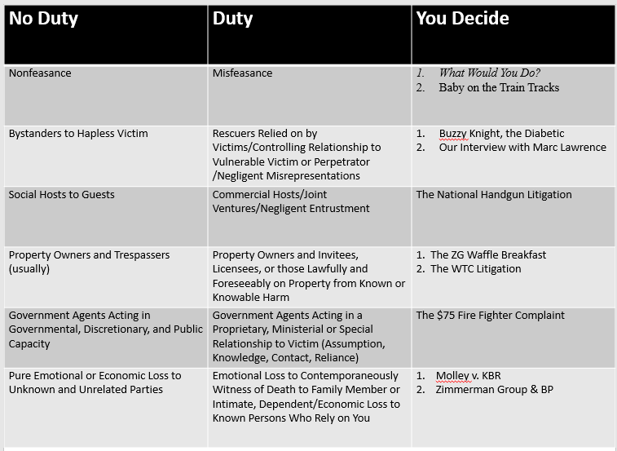
    - Misfeasance vs Nonfeasance
      - RULE: Absent a special relationship or exception, tort law punishes misfeasance but NOT nonfeasance
        - Misfeasance = YOU created the risk through your conduct
        - Nonfeasance = Someone else creates the risk and you fail to act to reduce harm
          - EX: Even if you could easily save a baby tied to a train tracks, you do NOT have an affirmative duty to act
        - Note: Generally, you do not have an affirmative duty to act BUT once you take affirmative action to help you must exercise reasonable care
      - Justifications for difference between misfeasance and nonfeasance
        - Lack of bright line rules
        - Encourage altruism
        - Requiring action would limit autonomy and liberty
        - Want to discourage risky self-sacrifice
        - Multiple rescuers (how many ppl would be held liable?)

      - Exceptions to NOT punishing for nonfeasance
        - You have a special relationship to the victim (Harper)
          - Common Carriers
          - Property Open to public
          - Owner of property/user of property
          - Parents
          - Custodial relationship to helpless person
        - Voluntary assumption of Duty or Service (Farwell)
      - Case: Harper v Herman
        - FACTS: PL is invited on Ds boat (they don’t know one another) and D takes the boat to shallow water, PL announces he’s diving, dives in shallow water and paralyzes himself
        - Takeaways: EX of NONFEASANCE, D is not punished b/c he does not have a special relationship with PL
      - Case: Farwell v Keaton
        - FACTS: 2 dudes get into a fight w/ 6 other dudes. D runs away but PL is severely beaten. D helps PL, drives him around for a while and then leaves him in a car overnight. PL dies as a result of his injuries
        - Takeaways: D made an affirmative duty to act/had a special relationship w/ PL and was held liable for the death. Great example of exception: voluntary assumption of duty
        - Rule: When one voluntarily begins a rescue attempt, they assume the duty to protect and must not leave the person worse than he was (must exercise reasonable care)
      - Buzzy Night Hypo
        - 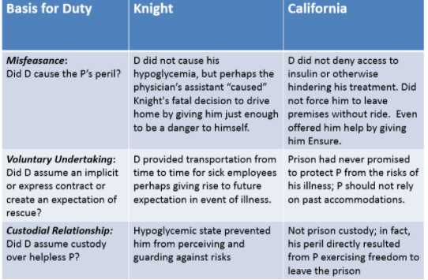

    - Duty Existing due to a Special Relationship
      - General Rule
        - NO duty to prevent others from causing foreseeable harm to third parties, absent a special relationship
      - Exceptions to rule include:
        - Negligent representation that impacts physical safety of others (Half-truths)
        - Parent/Child
        - Owner of Property/User of Property
        - One who “takes charge” of person one knows is likely to cause harm to another
      - Negligent misrepresentation of Physical Safety
        - Elements
          - Negligently provided false information
          - The false info is reasonably relied on and gives rise to physical harm
          - Can reasonably expect harm to others
          - Careless info gathering or communication of info
        - Randi W. v. Muroc [3 school districts + 3 glowing LOR for predator + new hire = Negligence]
          - FACTS: School recommends man for principal job despite knowledge that he molested children. The recommendation specifically said that the man was good with children. Man molested kids at new school
          - Takeaways: Example of Half-truths, courts will hold people liable if they say things in conflict w/ the truth… there is also PHYSICAL harm in this case = court more inclined to reward for injury
        - Policy Grounds for Limiting/Imposing Duty in these situations
          - Foreseeability
          - Certainty of harm to PL
          - Closeness of connection
          - Moral blame
          - Policy of preventing future harm
          - Burden on D and community of duty
          - Availability, cost and prevalence of insurance

    - Policy Situations: Preventing Unlimited Liability
    - 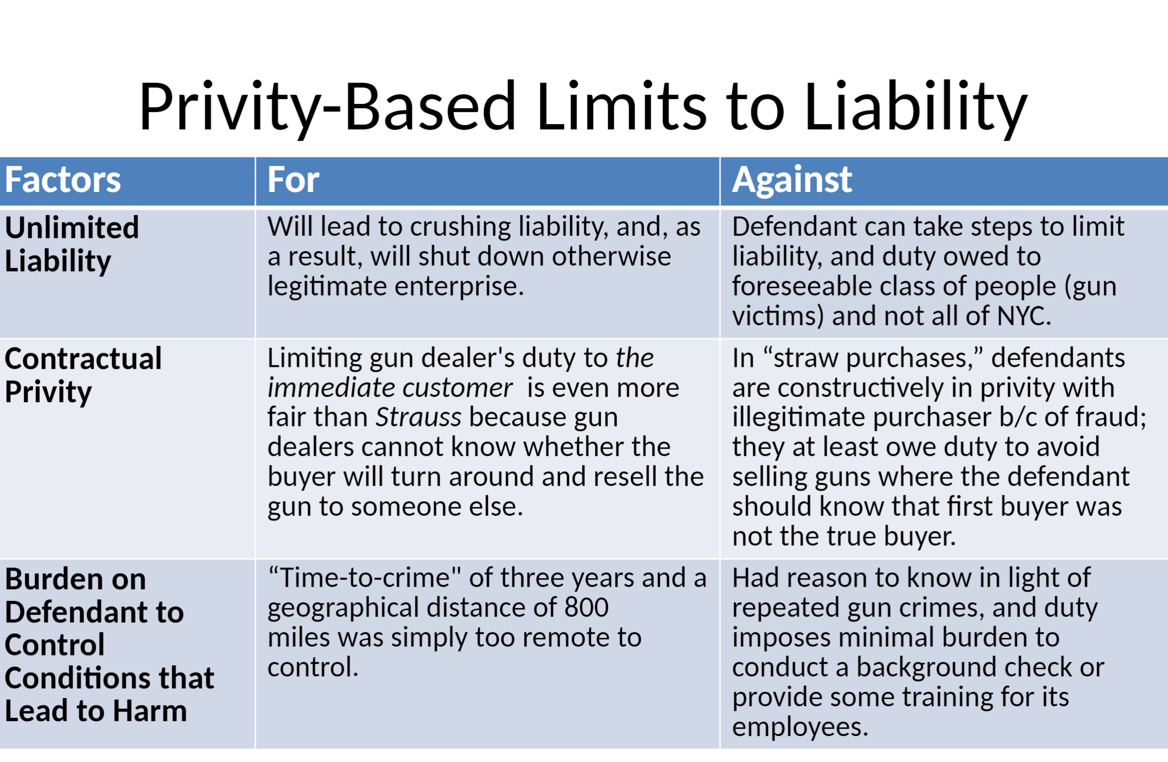
      - Concept = Sometimes courts will make the classic argument that a party’s liability should be limited otherwise they would be exposed to unlimited liability
      - Frank v Adventure Outdoor Hypo (Is there unlimited liability??)
        - FACTS: NY began prosecuting gun dealers across the country, NY investigated and discovered a string of straw purchases. A friend goes in, buys a gun, and then gives it to someone else
        - ISSUE: Whether the dealer can be held liable when a gun they sold a gun through a straw man purchase
        - D Argument
          - We can’t control how people use guns and this would open unlimited liability
          - Only person we owe a duty to is the person who buys the gun, no one else
          - There’s a lot of intervening actors, how are we supposed to limit our out liability to so many people
        - PL Argument
          - Main difference is the service being provided, gun dealers are not public utilities, they are not a necessity
          - There are manageable standards that could be applied
          - The nature of the gun makes it foreseeable that harm could occur
      - Strauss v. Belle Realty [NYC power outage P slips and fall in common area]
        - FACTS: During a serious blackout, a man tripped and fell in the apartment’s common area.
        - Takeaways: Courts limit duty to those in a contractual relationship, privity, (apartment building + Con Edison’ Plaintiff he was in his actual apartment + Con Edison).
        - Courts decline to extend duty to non-customers, limit the company’s liability to prevent unlimited liability
      - Parties in charge of others with “dangerous propensities” (Privity-Based Policy duty)
        - RULE: One who takes charge of a person who they know is likely to cause physical harm to another must exercise reasonable care to prevent harm, including warning to reasonably identifiable third parties of danger
        - Elements
          - The D took charge over the perpetrator of harm
          - D knew or reasonably should have known about danger
          - D can reasonably identify the third party who could be harmed
        - Tarasoff v. UC Reagents [therapist duty + pt wants to kill identifiable gf = duty ]
          - FACTS: Poddar told his therapist he wanted to kill his girlfriend Tarasoff. The therapist told the campus police and his boss, but did not actually tell Tarasoff herself, who was killed by Poddar afterwards.
          - Takeaway: Therapist DID have a duty to warn… therapy counts as taking charge of another person, thus giving you a duty
      - Duties of Social and Commercial Hosts (Policy based duty)
        - RULE: Commercial hosts have a duty to exercise reasonable care while social hosts do NOT
        - Social Hosts:
          - Social host liability is limited
          - Lack expertise, cohesion, and money
        - Commercial Hosts:
          - Have a duty to exercise reasonable care
          - May exercise greater supervision, comprise a discrete class of people, and have more financial power
        - Reynolds v. Hicks [Bride & Groom at wedding + Nephew drinks then crashes =  Negligence)
          - FACTS: Ds hosted a wedding, where their minor nephew gets drunk. The nephew later drove, and was involved in an accident
          - Takeaway: No liability for social hosts, there are differences between social and commercial hosts.
      - Negligent Entrustment (Policy Based Duty)
        - Concept: One who knows or has reason to know property will be used in way that creates an unreasonable risk of harm to another.
        - Applies to anyone who directly or indirectly supplies property for use of another: sellers, lessors, donors, and lenders.
        - Vince v. Wilson
        - FACTS: Grandmother finances nephew’s new car despite knowing he had no DL, was bad driver, drug user)
        - TAKEAWAY: The grandmother was guilty of negligent entrustment. Court: you should not help someone acquire something if you know they’ll use it in a reckless manner
    - Property Based Duties
  - Traditional Approach: Duty is based on the status of the entrant
    - Invitees (business guests)
      - Must be protected from (a) known or reasonable known hazards on the property (b) even if hazard is obvious to victim
      - Property owner receives material benefit from the invitee
    - Licensees (social guests)
      - Must be protected from only (a) known and (b) non-obvious hazards on the property
    - Trespassers
      - Must be protected from (a) known, (b) concealed hazards (c) willfully or wantonly left on the property
      - You CANNOT actively try to hurt the trespasser
    - Child Trespassers
      - Must be protected from (b) crippling or lethal hazards that (c) children won’t recognize, where (d) burden of eliminating danger is slight

        - Illustrative Case: Carter v Kinney (bible study, ice in driveway)
          - FACTS: Couple hosts bible study group for people @ their church. Church has a sign up list for interested people. John signs up, shows up, and slips on ice. Hosts did not know the ice had formed
          - Takeaway: PL was at most a licensee, the hosts did not derive a benefit from the bible study members coming.
        - Exam approach to status of entrant:
          - State and apply the rule taking into account status of the entrant
            - Identify status of the entrant – What’s the relationship?
            - Ask: What’s the foreseeability of harm to host?
            - Ask: What’s the severity/obviousness of harm to the victim?
        - Modern Approach: Property owners owe a duty to exercise reasonable care in the “maintenance of premises” for the “protection of lawful entrants” and in some jurisdictions, even unlawful entrants
          - Factors include:
            - Foreseeability of the harm;
            - Purpose for entering building,
            - The time, manner and circumstances for the entry
            - Use of the property
            - Reasonableness of inspection or warning,
            - Opportunity to repair or give warning,
            - Burden on landowner
        - Illustrative Case: Heins v Webster County (hospital visit, not santa inquiry, visits daughter, Duty imposed)
          - FACTS: PL went to hospital to visit daughter, not to inquire about his role as Santa. On his way out he slipped on snow and ice at the main entrance and injured his hip
          - Takeaway: Creates the modern approach: court eliminates distinction between types of visitors. Standard of reasonable care for ALL lawful visitors
        - Illustrative Case: Posecai v Walmart (customer robbed at gun pt in Walmart parking lot)
          - FACTS: PL robbed in Walmart parking lot in run down area, but Walmart only had 3 crimes occur in lot over long period of time.
          - Takeaway: Walmart NOT liable, the crime. The crime was not foreseeable. Foreseeability test: how foreseeable was the harm? If low, no duty
    - Government Duties
      - 3 Traditional Bases to Hold the Gov’t Liable
        - The lawsuit arises from the gov’t acting in a private nature
          - EX: Breach of contract
        - The government is acting in ministerial (governmental) manner and breaks a clear rule/law
          - NOT acting in a discretionary manner
            - The government CAN be sued when it violates a ministerial rule designed to protect the plaintiff, not when it’s acting in a discretionary manner.
        - Government makes a promise or assumes a special obligation to an individual rather than creating a duty to public in general (Cuffy Factors)
          - Assumption: assumption of duty through promises or actions
          - Knowledge: government knew its inaction would lead to harm
          - Contact: direct contact between government and individual
          - Reliance: plaintiff relied upon the action of the government to his detriment
      - Riss v NYC (pissed ex-lover + several threats + police help req but denied + acid attack)
        - FACTS: ex-gf terrorized by Pugach. Gf told police she was threatened and police did nothing. Gf gets lye thrown in face and goes partially blind. GF called police many times to warn of danger
        - Takeaway: Police did NOT have affirmative duty, acted in gov’t nature. Police protection is gov’t role, can’t tell them how to allocate resources.
        - Modern Rationale for Result
          - Separation of powers (between courts + legislator)
          - Institutional competence of courts
            - Protect against unlimited liability
          - Protects the public fiscal $$
          - Chilling effect on public officers
            - When to act vs not
      - Cuffy v NYC (Neighbor fights + police promise to act next morning + assault next afternoon)
        - FACTS: Father was the one who called police, not the son (the one who was attacked)
        - Takeaway: Son was not the one who called police, therefore the police did NOT owe the son a duty. Cuffy factors 3 and 4 were not met. Police said ‘next day’ relying on them at night did not create a duty on police’s part.
      - Lauer v NYC (Father NOT the murderer)
        - FACTS: medical examiner wrongly reports death of son as homicide and father was investigated for murder. Examiner realizes but fails to correct report in violation of city regulations
        - Takeaway: This was a ministerial duty BUT the duty was not owed to the public, it was owed to the DA. Duty breached must be more than that owed to public to impose liability.
          - Cuffy factors NOT met, examiner never assumed a duty

    - Duty for Pure Emotional Harm
      - 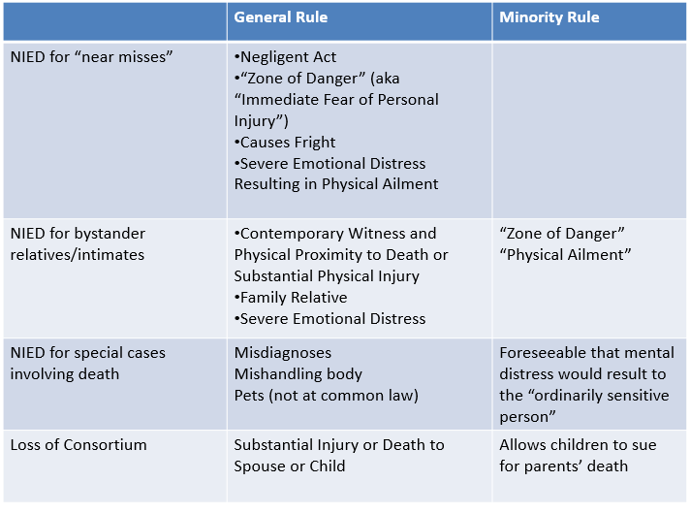
      - Exam Approach
        - Does a duty exist based on misfeasance, special relationships, or policy?
        - What kind of harm occurred, physical or emotional?
          - If physical, PL will likely be compensated, if emotional it must meet one of the exceptions
      - Overall Policy Concerns
        - Proof
        - Fair Compensation
        - Controllable Liability
        - Directness of Relationship
        - Foreseeability/Best Position to Avoid Harm
      - NIED for Near Miss: Falzone v Busch
        - FACTS: wife waiting in car sees husband hit on side of road by negligent driver. Car then gets close to her (BUT does not hit her) and she becomes ill as a result.
        - Takeaway: NO longer need physical contact to recover. Wife could recover damages.
        - Zone of Danger Test (physical contact NOT needed)
          - Negligent act
          - That results in Immediate fear of personal injury
          - That Causes fright (emotional distress)
          - In turn, results in the manifestation of a physical injury
      - NOT a Near Miss: Metro North v Buckley (metro worker + some asbestos exposure but no illness)
        - FACTS: PL worked in tunnels and learns he was exposed to asbestos as a result of working there, exposure put him 1-5% increased risk of cancer; otherwise no serious physical symptoms
        - Takeaway: Cannot recover damages. Harm was NOT imminent enough.
          - Policy: Don’t want flood of trivial claims, difficult to draw the line for when ppl can recover.
      - NIED Special cases: Mishandling body: Gammon v. NY City
        - FACTS: hospital mistakenly sent Gammon random person’s body parts instead of his recently deceased father’s belongings
        - Takeaway: Minority Rule – PL allowed to recover
          - Is it reasonably foreseeable that mental distress would result to the “ordinarily sensitive person” as a result of this action?
      - NIED Special cases: Death of Family Member: Portee v Jaffee
        - FACTS: PL watches, as her son is crushed to death by elevator. PL herself, however, is never exposed to risk of physical danger. But, after death, PL becomes severely depressed and self-destructive. She attempts to commit suicide and requires counseling.
        - Takeaway: NIED for Relatives/bystander
          - family relative/intimate dependent
          - contemporaneous witness [time]
          - physically close to event [space]; and
          - death or substantial physical injury
      - NIED Special cases: Kidnapped Child: Johnson v Jamaica Hospital
        - FACTS: hospital lost newborn baby to kidnapper. Parents didn’t see child for 4 months and then sued for NIED
        - Takeaway: The baby can sue, parents CANNOT b/c they were bystanders and thus indirectly harmed.
        - Circumstances where you CAN sue for emotional harm
          - Mishandling of dead bodies
          - Wrongful death notice
          - Loss of consortium (companion)
          - Misdiagnosis
    - Duty for Pure Economic harm
      - Generally, NO duty for pure economic harm
      - Nycal Corporation v. KPMG
        - FACTS: KPMG audits Gulf and creates an auditor’s report of financial statements. Nycal relies on that report to invest in Gulf. Gulf files for bankruptcy 2 years later.
        - Takeaway: Restatement Test – KPMG not liable
          - Know statements/work will be used for a particular purpose
          - Known parties or limited class will rely on info for the particular purpose
          - D Fails to Exercise Reasonable Care in Obtaining or Communicating Information
      - SoCal Gas v Superior Court
        - FACTS: Gas leak in porter ranch, people had to relocate as a result. Local businesses (Restaurants, a karate studio, a daycare) sue for the financial loss resulting from the gas leak evacuation – All making claims solely for financial loss
        - Takeaway: Court says there is not a concrete standard to award damages. No way to limit liability based on geography or other practical means.
          - 5 things to account for to limit liability
            - Foreseeability
            - Closeness of connections w/ D
            - Degree of certainty to PL who suffered
            - Moral Blame
            - Policy of Preventing future harm
    - Approach to problem
      - Was the conduct misfeasant or nonfeasant?
      - Is there an exception to the rule against holding someone accountable for nonfeasance? (Special relationship)
        - Was there a voluntary undertaking?
        - Did someone assume custody over another who could not take care of themselves
        - Is there a diff. type of special relationship?
      - Did the legal duty end at some point?
      - Is there a compelling policy justification for limiting or imposing a duty?
        - Foreseeability
        - Certainty of harm to P
        - Closeness of connection
        - Moral blame
        - Policy of preventing future harm
        - Burden on D and community of duty

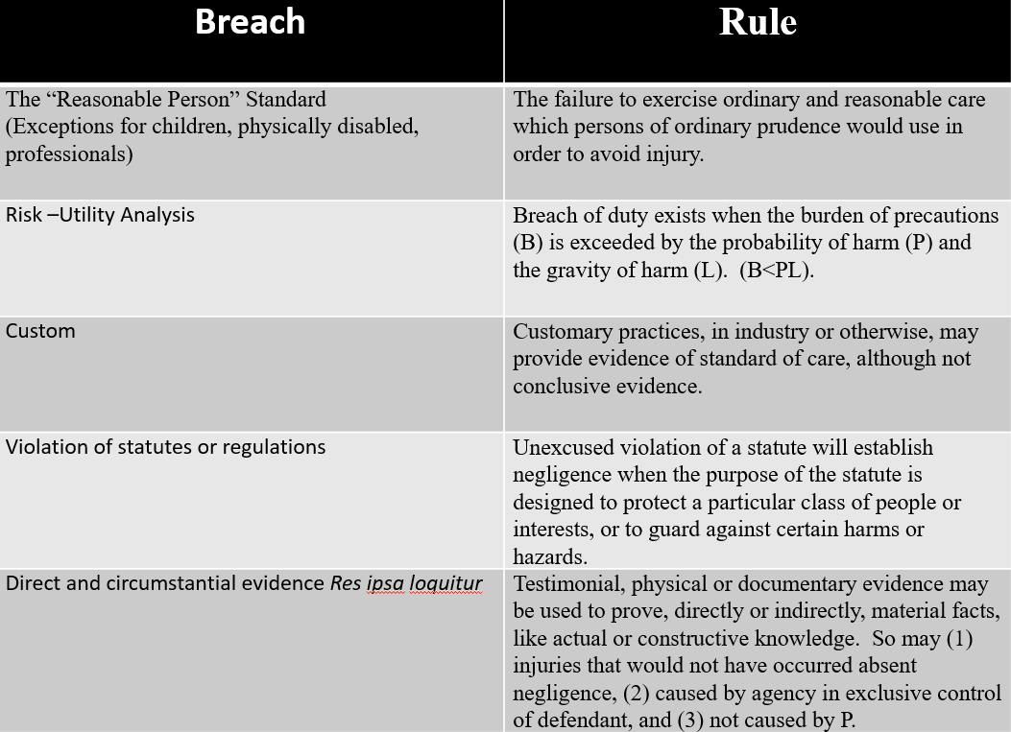
Breach
    - Definition: A failure to use ordinary or reasonable care
      - Exceptions = Common carriers, children + disabled, children engaged in adult activities
    - Breach: The Reasonable Person Standard
      - Ask yourself: Did the PL ‘breach’ a duty of reasonable care?
        - Standard of care is measured by ordinary prudence that a reasonable person would exercise to avoid injury under the circumstances
      - Adams v Bullock (trolley line, operator not liable)
        - FACTS: D operated a trolley line. The trolley’s wires were near a bridge. A 12 yo boy was swinging wire which hit the trolley wire and injured him
        - Takeaway: D did NOT act negligently b/c the injury was not foreseeable (had not happened before), custom was having wires above ground (didn’t go against custom), costs do not outweigh benefit (would be really expensive to prevent against accident that had not occurred before)
      - Braun v Buffalo (wires near development property)
        - FACTS: D strung electric wires over a vacant lot in a busy city and did not cover the wires, many developments started in the area + other developers had covered wires; PL got electrocuted years later.
        - Takeaway: You have a duty to protect against foreseeable danger (knew developments were happening, likely to have workers in the area of wires)
      - Bethel v NYC Transit
        - FACTS: Plaintiff says that the wheelchair accessible seat on the bus collapsed because it was negligently inspected and repaired just 11 days before accident. Main evidence is a computer printout that says seat was “adjusted and aligned” and that a proper inspection would have caught and fixed the problem.
        - Takeaway: This holding is the exception where they apply reasonable person standard to a common carrier. Says the heightened standard came from when railroad was main mode of travel and we no longer need to apply heightened standard. Generally, common carriers are held to a higher standard of care b/c of their relationship to PL or their expertise.
          - (Normal) Common Carrier Standard: “Exercise of the utmost care, so far as human skill and foresight can go,” must act like “an average member of profession”
    - Breach: Risk-Utility Analysis
      - Liability exists when the cost of taking additional precautions (B) is LESS than the probability of harm (P) and magnitude of harm (L)
        - If B < PL --> YES NEGLIGENCE
          - B = cost of taking additional precautions
          - P = probability of harm
          - L = Magnitude of harm
      - Limitations of Risk Utility
        - Information is NOT always perfect
        - Transaction costs of litigation are not factored
        - Not easy to concretely quantify burden, probability and loss
        - May fail to account for externalities, customs, or moral considerations + norms
      - U.S. v Carroll Towing
        - FACTS: Ship broke free from after D cut lines holding ships between Public Pier and commercial pier. PL’s ship floated down river, hitting other ship and sank losing cargo and damaging ship. PL brought suit arguing that if someone was aboard the ship at the time, the cargo and ship could have been saved
        - Takeaway: Owner of ship was held liable for negligence (not the D). B was not high, just needed to pay have someone on the ship. P was very high b/c the bay was filled with activity at the time. L could be quite high, a lot of valuable WWII supplies were being moved. B < PL in this case, established the formula and how to use it.
      - Grey v Pinto
        - We applied the risk-utility formula to the Ford pinto which had a design defect that Ford did not do a recall for.
        - 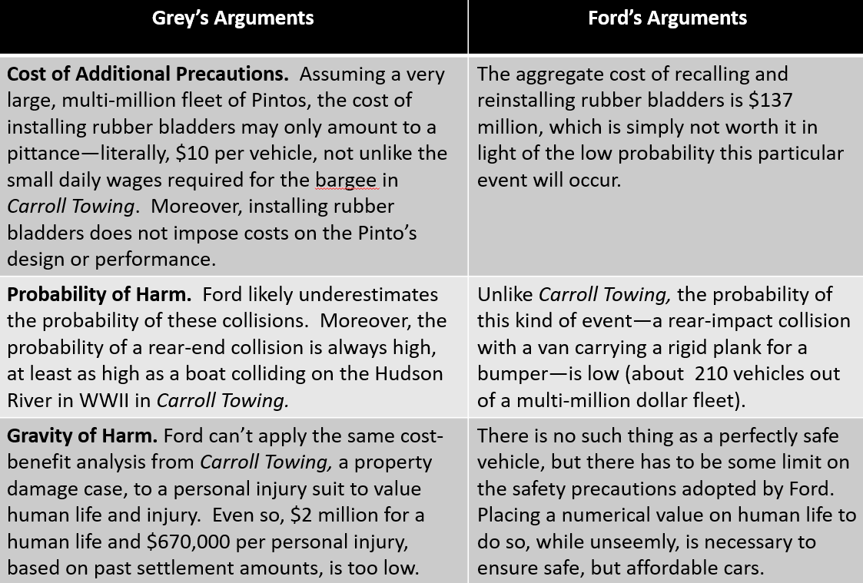
        - Takeaway: Risk utility analysis may force you to put a $ value on human life which is not easy. Showed us how calculations can be sort of arbitrary and you can argue one way or the other about what the values of P, B, and L come out to. Further showed how the formula is limited, it does not always come out with a black and white, perfect calculation
    - Breach: Custom
      - Breaching custom can be really strong evidence of negligence BUT is NOT perfect evidence
        - Approaching custom, ask:
          - Is the relevant custom even applicable?
          - Was the custom adopted to protect against the harm alleged or for some other unrelated reason
          - How persuasive is the custom for the jury?
      - Why adopt custom as a standard of care?
        - Reflects the judgment of many
        - Foreseeable
        - Expertise and experience
          - Reflects industry judgment/knowledge
        - Encourage internal safe norms
      - Cons of applying custom
        - May not reflect full costs of potential harm to society
        - Discourages innovation
        - May be outdated
      - Trimarco v Klein
        - FACTS
          - P fell through glass shower door in apt. The glass looked like tempered glass customarily used in apartments in the 70s but was actually a thin glass installed in the 50s. P argued that the glass failed to adhere to custom and usage of shatterproof glass
        - Holding/Takeaway
          - Proof of common practice may be used to demonstrate that D complied, or failed to comply, with due care
          - A jury could conclude that the modest cost and ready availability of glass, combined with custom, informed the duty to replace the glass to make the bathroom reasonably safe from risk of harm.
    - Breach: Violating Statute or Regulation (Negligence Per Se)
      - RULE
        - Court may adopt legislation or administrative rule as the standard of reasonable care, when purpose of the law…
          - Protects a particular class of people
          - Protects a particular interest
          - Protects against the resulting harm
          - Protects against the hazard from which harm results
        - Steps of analysis
          - Analyze the purpose of the statute
            - Identify who it’s trying to protect and for what purpose
          - Determine if there is a good excuse for not following the statute
            - Compare to Tedla
        - NOTE
          - Compliance w/ the law is a floor, not the ceiling regarding a duty of care
      - Martin v. Herzog [carriage w/o lights killed by driver crossed into wrong lane at night]
        - Facts: Martin was killed in a buggy collision by Herzog. It was nighttime and Martin was driving without headlights on. Herzog was on the wrong side of the road.
        - Holding. Negligence per se. Martin’s failure to use headlights in light of statute requiring use of headlights was contributory negligence barring recovery. A jury cannot relax this duty.
            - ✓ Negligence per se
            - ✓ Contributory negligence
              - The driving w/ lights on statute was intended to protect ‘life and limb’
      - Excuses
        - Childhood, physical disability, or incapacity
        - Reasonable care to comply w/ statute
        - Lack of knowledge or notice
        - Compliance entails greater risk of harm
      - Tedla v. Ellman junk collectors walking on “wrong side” of road
        - Facts: P’s were walking on the wrong side of the road because there were fewer cars driving there. A passing car struck them from behind. Defendant argued there was a contributory negligence because the defendants were in violation of a traffic statute requiring to walk on other side.
        - Holding. Not negligence per se. The purpose of the statute was not for the safety of individuals; it was safer for them to violate the statute than to comply with it.
            -  Negligent per se
            -  Contributory negligence
            - ✓ Excusable (good case to violate statute). Statute to promote public convenience or safety
        - Reasoning.
          - Statute based:
            - Statute for walking on left side was NOT designed to protect “LIFE AND LIMB”, like the statute in Martin v. Herzog. Instead the statute proscribed general “rules of behavior” and whos purpose had little to do with public safety. Tedla did not satisfy the test (to show under doctrine of negligence per se, that the statute was designed to protect a particular class of people or interest from certain harms or hazards. (not prescribe additional safeguards; rather rules to know how to proceed on road share road bikes, cars, pedestrians)
          - Valid excuse
            - Statute could be about public safety like the statute in Martin v. Herzog , but there was a good excuse for not following it because compliance entails greater risk.
      - Effect of Statute Compliance
        - RULE: complying with the law may provide evidence that D was not negligent, but NOT CONCLUSIVE evidence
          - Regulations and laws provide a floor, but not a ceiling, for permissible conduct
          - Expertise, uniformity, cost, and legitimacy may favor rule that allows limited defense to tort when one complies with the law
          - Information, regulatory lapses, capture, and democratic principles of court access disfavor the defense
          - Compliance with custom or statute not just about basis for negligence, but about who decides
    - Breach: Res Ipsa Loquitor (The negligence speaks for itself)
      - Elements
        - The breach would not have occurred w/out negligence (“boy that’s negligent”)
          - Barrel falling from window (Byrne v Boadle)
        - Instrumentality in exclusive control of the D
        - Harm not caused by PL
      - Case: Bryne v. Boadle (element a)
        - FACTS: P was walking down the street when a barrel of flour fell on top of him
        - Takeaway: This is the seminal case for res ipsa, great example of all three elements being met
      - Case: McDougald v. Perry (element a)
        - FACTS: driving behind truck + spare tire loose hits windshield = Res Ipsa Loquitor
        - Takeaway: More modern application of Byrne, good example of how the first element of res ipsa is met
      - Case: Ybarra v Spangard (element b)
        - FACTS: Patient goes for appendectomy, is given anesthesia which makes him unconscious and patient leaves injuries/pain he did not have prior
        - Takeaway: Courts will not deny relief b/c the PL is ignorant of specific facts which they cannot access. Great example of element b of res ipsa
  - Tangent: Direct v Circumstantial Evidence (Relevant to res ipsa loquitor)
    - General Rule: Testimonial, physical, or documentary evidence may be used to prove, directly or indirectly, material facts, like actual or constructive knowledge.
    - Direct Evidence: Includes witness testimony, physical evidence, documentary evidence of facts relevant to a negligence claim
    - Circumstantial Evidence: Facts that support an inference of another fact relevant to a negligence claim
      - Positive EX: woman slips on moldy baby food in a supermarket aisle
        - Evidence was sufficient to infer the supermarket was negligent b/c clearly the baby food had been there for a long time
      - Negative EX: PL slips on wax paper on the steps of the American Natural history museum
        - Insufficient evidence to prove negligence claim, no indication that the wax paper had been sitting there for a long time

Causation (another element of negligence)
→ Must prove both actual causation and proximate causation

Actual Causation – Cause-in-fact
- Actual Causation for SINGLE D
    - Can PL provide enough evidence to show that one event was, in fact, a cause of another event, no matter how remote?
  - “But for” Causation → Looking at 1 possible cause
    - An event was necessary to produce another event, no matter how remote
      - “But for X, Y never would have happened”
  - Substantial Factor Test → Looking at MORE than 1 possible cause
    - D’s conduct is the “cause” if it could at least have been a “material element” in bringing about the complained of event on its own
    - → Even if multiple factors could have caused the harm, an event was substantial enough to bring about the result on its own
      - D’s conduct is the ‘cause’ if it’s a material element and substantial factor in bringing the complained of event
        - Material = jury determination, no clear definition
          - EX – Could be something that made harm even 1% more likely
      - EXAMPLE: one fire starts by lightening. Another fire started by a man. Two fires merge and property is destroyed by joint fire.
        - Either fire on its own would have destroyed the property.
        - THUS, Fire B would still have led to the result even if fire A never took place
  - Scientific Evidence → When the cause of injury is NOT directly clear (EX: arsenic in water), leverage these concepts to prove actual causation
    - General Causation
      - Refers to evidence that something is generally capable of causing harm in the manner that the PL experienced
        - EX: Stubbs - sewage is generally capable of causing the plaintiff’s typhoid
        - EX: cigarettes cause cancer
    - Specific Causation
      - Refers to evidence that an agent specifically caused harm to the plaintiff
      - Do NOT need to rule out every possible explanation, but DO need to rule out alternatively plausible explanations for that harm
    - Bradford-Hill Guidelines
      - → Usually applied to general causation but can sometimes be applied to specific causation
      - Do NOT need to prove all question, but do need to prove some to have convincing evidence of causation
      - (1) Is there a temporal relationship?
      - (2) What is the strength of the association between exposure and disease?
      - (3) Is there a relationship between the dose given and the response?
      - (4) Replicated results?
      - (5) Is the association consistent with existing knowledge?
      - (6) Have alternative explanations been considered?
      - (7) What is the effect of stopping exposure to product?
    - Illustrative Case – Stubbs v City of Rochester
      - FACTS
        - Defendant supplied the city with drinking water and firefighting water using 2 separate systems. Due to the city’s negligence, the systems became intermingled. PL and others in the city contracted typhoid and attributed it to the city’s negligence.
      - Takeaway
        - Substantial Factor Causation (Actual)
        - General Causation
          - Contaminated water can cause typhoid
        - Specific Causation (Bradford-Hill applied)
          - short time period between exposure and onset; physical evidence of water being stinky; examined by doctor; though unclear if new cases of typhoid statistically significant increase
        - No way to differentiate between getting directly from contaminated water vs. contaminated person → court determined PL presented enough evidence to push the question to a jury
    - Case – Zuchowicz v United States
      - FACTS
        - Doctor prescribed double max authorized dosage of drug called danocrine. Patient was diagnosed with rare disease called PPH (effects of taking such a high dose were unknown)
      - Takeaway
        - General Causation: the drug is capable of causing lungs to constrict and cause a condition like PPH
        - Specific Causation: 1 month temporal relationship; physical effects manifested; physician exam
        - B/c prescribed dose violated FDA regulations, the Court was willing to say that the PL was entitled to a presumption that D caused her death
- Actual Causation for MULTIPLE Ds
  - Joint and Several Liability (Loss Allocation)
    - RULE: (a) two or more parties, (b) acting together or concurrently— (c) to cause a single indistinguishable harm – NO proof issue
      - PL may sue multiple negligent defendants, together or separately, for the FULL amount of damages
      - Can sue A, or B, or A + B for full 100% (up to D at that point to implead)
        - BUT if unclear, who caused harm, you cannot leverage this theory
    - Policy: Possible insolvency of Ds, fairness in compensation, inability to prove exact % of blame for each D
    - EXCEPTION → Some states will hold the less culpable party responsible for less damages
    - EXAMPLE → After hurling M&Ms at target, another person negligently bumps you. You slip and fall on the M&Ms that were also negligently left on the ground.
  - Alternative Liability (Proof Problem)
    - RULE: (a) two parties (NO more than 4), (b) acting together or concurrently— (c) to cause a single indistinguishable harm – BUT no clear proof who is responsible
    - Burden of proof shifts to Ds to prove it was one or other
      - If they fail, I can sue one for 100% of damages or both for 50%
    - Policy: Proof issue should not prevent PL from being compensated, deterrence, limited # of wrongdoers
    - Case – Summers v Tice
      - FACTS
        - 2 hunters shot same gun w/ same bullets, other guy got hurt, unclear whose shot hurt him. Ds failed to meet burden of proof to determine who was at fault
      - Takeaway
        - Court: Justice demands that the court shifts the burden of proof
        - Why? (POLICY) Fairness, Ds are in better position to figure out what happened AND If one D has no cash, then the wealthy one can pay for all the damages

  - Market Share Liability (Proof Problem)
    - Courts may find a manufacturer liable upon its participation in a national, state, or local market, when it produces a generic drug that is indistinguishable from others in the same marketplace
    - RULE: PLs who consume a good may recover from multiple Ds jointly or severally even when they cannot identify the D that caused harm when defendants…
      - (a) participate in the same market, (b) produce a generic/indistinguishable from others product, (c) in proportion to their share of the marketplace
    - Case: Hymowitz v Eli Lilly
      - FACTS
        - Generic miscarriage prevention drug called DES became extremely popular in U.S. and was manufactured by over 300 companies. It later became apparent that DES caused vaginal cancer in resulting kids. Often difficult to bring these cases forward since so many manufacturers + length of time until issues arose
      - Takeaway
        - Court: Too many Ds to apply alternative liability
        - Adopted NY Rule: Ds severally (only their share) liable for producing generic products in marketplace according to their % of the national market even if didn’t produce the drug that caused plaintiff’s injury
        - CA Rule: permit burden shifting to Ds to prove they didn’t produce drug used by plaintiff; remaining Ds jointly and severally liable

Proximate Causation – “Scope of Liability” (Foreseeability)
- Proximate cause → there is a sufficient connection between D’s actions and the PL’s harm to hold the D liable as a matter of policy
  - An actor’s liability is limited to those physical harms that foreseeably result from the risks that made the actor’s conduct tortious (Restatement)
- (1) Unforeseeable Harm
  - Unexpected Type of harm: Is PL’s injury totally beyond the type of harm to be expected from D’s conduct? → if Yes, NO proximate cause
    - Case: Rat Urine
      - FACTS
        - Lake is filled with rat urine that can cause disease, owner didn’t put a sign next to lake not to swim in it. Someone jumps into the lake and then drowns
      - Takeaway
        - NO proximate cause b/c type of harm was different than what the sign would have prevented
    - EXAMPLE: Speeding trolley hit by fallen tree and suffers serious damage
      - NO proximate cause b/c although you can imagine a significant amount of damage may occur when a trolley speeds, none of that damage has anything to do w/ the fact that a tree branch cause the train to derail
  - Unexpected Manner of Harm: Did the harm simply arise in an unusual manner? If yes, YES proximate cause
    - Case: Polemis
      - FACTS
        - Ship hands were laying wood on the deck of a ship carrying a large amount of benzene. The ship hands made an error moving some of the wood, dropped it into a hatch, and hit the benzene. A large fire ensured which destroyed the ship.
      - Takeaway
        - The harm, an explosion of benzene was still foreseeable, even if the manner in which the benzene actually exploded was not.
  - Unexpected Degree of Harm: Did the harm involve more serious harm than expected? If yes, YES proximate cause
    - Case: Benn v Thomas (Eggshell PL)
      - FACTS
        - PL suffers heart attack 6 days after simple rear end crash. Duty, breach and causation-in-fact exists. But was the crash the “proximate cause” of heart attack?
      - Takeaway
        - Eggshell plaintiff rule: We take the plaintiff as we find him
        - Court: The accident was the proximate cause b/c although the severity of the harm was unforeseeable, the heart attack was a direct and foreseeable result of the type of harm caused to PL
- (2) Unforeseeable Act (Superseding Cause) → Did another person’s unexpected intervening act cause the harm, or did the action fall within the scope of risks created by D?
  - Case: Stewart v Federated Dept. Stores (Stamford, CT)
    - FACTS
      - Plaintiff is killed in a dimly lit, 3-story, Bloomingdale’s parking lot, while returning to her car.
    - Takeaway
      - ISSUE = Is it really fair to hold the owner of a parking garage liable for the intervening actions of a criminal assailant?
      - Where the negligent conduct of the actor creates or increases the risk of a particular harm and is a substantial factor in causing that harm, the fact that the harm is brought about through the intervention of another force does not relieve the actor of liability
        - EXCEPT where the harm is intentionally caused by a third person and is not within the scope of the risk created by the actor's conduct
      - Evidence used: tons of crimes previously committed in the garage, expert in security said this could have been prevented w/ better controls
  - Case: Doe v Manheimer
    - FACTS
      - PL was raped by a 3rd party on Dt’s property. PL claiming D’s negligently maintained property (“shield” of bushes) was the proximate cause for the assault
    - Takeaway
      - Court says the action isn’t foreseeable, such that it’s not something that we think of within the scope of risks
      - Foreseeable that drinking/loitering would occur behind the overgrown bushes, but sexual assault NOT foreseeable
- (3) Unforeseeable Party → Is the PL in some position, in time and space, to be foreseeably harmed by D’s conduct?
  - Case: Palsgraff v LIRR
    - FACTS
      - Railroad employee helps a man with a package get on the train. The package falls off the train and hits the tracks. Inside there are fireworks that cause an explosion which causes a penny scale 40 ft away to fall on Palsgraf → she sues for damages, claiming the RR was negligent in pushing the man onto the train
    - Takeaway
      - Holding: NO duty owed to PL
      - Rule: the defendant’s conduct must be a “wrong” in relation to a foreseeable plaintiff (looking at it from the perspective of the defendant, rather than at the harm of the plaintiff)
      - Note: duty is a legal question, while proximate cause is a factual question for the jury. By ruling this is a duty question, judge decides without having to get into the factual issues

DEFENSES to Causation (Negligence)
Contributory Negligence & Comparative Negligence
- Contributory Negligence
  - RULE: If PL acted negligently such that their conduct contributed to the accident → TOTAL bar to recovery (traditional/old approach)
    - Even if PL was 1% responsible for an accident, PL wouldn’t have a valid case (no recovery at all)
  - Courts started to become more lenient
    - Last clear chance doctrine: even if PL is to blame, if D could have averted the harm at the last minute and didn’t, D would still be responsible
    - If D was reckless (not negligent), P’s contribution irrelevant
- Comparative Negligence
  - PL’s fault does NOT present a total bar to recovery → Rather, PL’s recovery is only reduced by the PL’s % of fault
  - Pure Comparative Negligence (CA): P 90% of blame for accident can recover 10% of damages from D who was found to be 10% at fault
  - Modified Comparative Negligence: requires P no more than 50% responsible. If not, then can recover under pure model
Assumption of Risk (PL Voluntarily and Knowingly assumes risk of danger)
- Express Assumption of Risk
  - Central question: Does a written or oral contract (exculpatory agreement) expressly bar claims consistent with policy?
  - Exculpatory agreements are enforceable when they are…
    - (1) Freely made
    - (2) Language clearly covers negligent conduct (must mention ‘negligence’)
    - (3) Parties are in relatively equal bargaining positions
    - (4) Consistent w/ policy (Tunkl Factors)
      - i. Public, regulated business
      - ii. Important public service
      - iii. Available to the public
      - iv. Excessive bargaining power
      - v. Contract of adhesion or ‘boilerplate’ language
      - vi. PL under control or custody of D
  - Case: Hanks v Powder Ridge (snow tubing)
    - FACTS
      - PL injures his foot on a man-made snow bank while snow tubing at D’s snow tubing facility. PL had signed an agreement releasing the D from liability resulting from inherent risks of sport and negligence
    - Takeaway
      - The court applies the Tunkl factors and finds that the waiver goes against public policy (even tho all factors don’t favor PL)
      - (3) The mountain was open to the public, (6) PL was in Ds control while going down the mountain, (5) this was a contract of adhesion
      - NOT an essential service (2), (1) NOT a regulated business, (4) PL technically could have just left the mountain
  - EXAMPLE: Mr. Tunkl, wheeled on a gurney into UCLA medical center, asked to sign a liability waiver while suffering from a heart attack
    - (1) publicly regulated hospital, (2) providing one of the most essential services possible. (3) emergency rooms fully open to public, (4)+(5) zero bargaining power b/c PL legit having a heart attack, (6) couldn’t be more gun to head – PL is at mercy of medical staff
- Implied Assumption of Risk
  - Primary Assumption of Risk
    - RULE: PL voluntarily assumes ‘obvious and necessary’ risks by deciding to engage in a risky activity
      - NOT a true affirmative defense but rather determines when a D’s legal duty covers the risks to which PL was exposed
      - Does NOT apply to reckless or intentional conduct
    - EXAMPLE: Someone hits you in the face with a volleyball while you play a volleyball game → No duty owed, you voluntarily assumed the risk when you decided to play
    - Case: Murphy v Steeplechase (“The flopper”)
      - FACTS
        - P falls on an amusement park ride, which was like a moving belt. Had stood in line before getting on ride and observed others while they were on the ride
        - The greatest risk of getting on this ride was falling, which is what happened to PL
      - Takeaway
        - Rule: one who takes part in a sport accepts the dangers that inhere in it so far as they are “obvious and necessary.”
        - If an activity is too dangerous, you wouldn’t let someone assume the risk of that kind of activity, there are limits

  - Secondary Assumption of Risk
    - RULE: Knowing and voluntary assumption of a known risk created by D’s negligence
      - This IS a true affirmative defense
      - Prima facie case of negligence = established, BUT → The PL knowingly assumed the known risk of the danger created by the D’s negligence
      - Courts usually treat this like comparative negligence
    - Case: Davenport v Cotton Hope Plantation
      - FACTS
        - PL rented condo, and informed D (landlord) that the lights were out on one of the staircases
        - D didn’t fix the lights, but PL used stairs anyway and fell because of poor lighting
      - Takeaway
        - All elements of prima facia case of negligence present, but D may use secondary assumption of risk as an affirmative defense
          - B/c PL arguably assumed the risk of that danger by continuing to walk down the stairs knowing what he knew about the lighting
        - Nonetheless, PL not barred from recovery, would be a comparative negligence claim
Preemption
- Concept: Sometimes federal law regulating an activity overrides or preempts state tort claims (3 types)
- Main Argument Point: The final determination turns over whether you can argue that…
  - (1) the ultimate “purpose or objective” of the federal law is to create a floor of minimum safety standards (which can be supplemented by state tort law), OR
  - (2) Whether federal law is meant to comprehensively regulate defendants conduct, which creates a ceiling not to be supplemented by tort law
- Express Preemption
  - Can you read the (1) language, (2) purpose, and (3) legislative history to determine whether a federal statute bars inconsistent state requirements that result from a tort claim
  - Analysis:
    - (1) What does the federal statute say? Is the statute specific enough to govern the alleged misconduct in lawsuit?
    - (2) What does the state lawsuit do? Will the lawsuit require the defendant to do something different than what federal law requires?

  - Case: Riegel v Medtronic
    - FACTS
      - Riegel’s doctor negligently over-pumped a catheter and it burst. Dr. also says there were issues w/ the catheter. PL claims that Medtronic negligently tested, designed, labeled and marketed the catheter
      - D argues the tort claim is preempted because they complied with federal law regulating medical devices. The federal law had an express preemption provision
    - Takeaway
      - Tort claim is preempted by federal law (aka plaintiff cannot sue) tort claim
        - The device went through very rigorous pre-market approval process
        - By allowing a state law tort claim, there would effectively be a new set of state requirements, which would differ from the federally regulated ones
      - Dissent: Where the text of a preemption clause is open to more than one plausible reading, courts ordinarily accept the reading that disfavors preemption
- Implied “Conflict” Preemption
  - Is it impossible to comply with both state and federal law?
    - Such that complying with one set of law would put you in violation with the other set of law
  - EXAMPLE: Car air bags
    - Federal law says no airbags in back seat of car and your tort claim is premised on having airbags in back seat → Preemption applies
- Implied “Obstacle” Preemption
  - NO conflict between state and federal law BUT the tort suit interferes with the purposes and objectives of the federal law
    - What is the purpose of the statute?
      - Does the lawsuit interfere with a “significant” regulatory purpose?
    - What level of regulatory oversight exists?
      - Does agency consistently oversee claims about safety and health? If so, a tort claim might be redundant or over-deter. -- If not, the lawsuit might help fulfill an important regulatory goal
    - What does the regulatory agency say?
      - Does a federal agency say that a tort claim interferes with purpose of the statute or its regulations? If so, courts may defer to what the agency thinks about the lawsuit

  - Case: Wyeth v Levine
    - FACTS
      - PL received the anti-nausea drug in a method (IV push) that caused her to develop gangrene. The drug could have been injected using multiple methods and was injected into PL using one of the methods erroneously
      - She sued, arguing for better labeling against IV push. Ds argued implied conflict and implied obstacle preemption (can’t stay consistent with FDA regulation and state tort jury determinations)
      - Ds argued implied conflict and implied obstacle preemption (can’t stay consistent with FDA regulation and state tort jury determinations)
    - Takeaway
      - (Conflict) Court rejects preemption arguments, pointing to the legislative history of the statute and lack of specific regulations designed to ensure ongoing drug safety.
        - Unlike Riegel, Wyeth could change its labels had it asked FDA for permission. Absent evidence that the FDA would not have approved new label, Wyeth could comply with both federal and state law without conflict.
      - (Obstacle) P demonstrated that the state tort suit actually fulfilled the underlying objectives of the regulatory regime.
        - State lawsuits created an incentive for manufacturers, often in the best position to know about problems that occur with drugs after they come to market, to help inform the FDA, through petitions to make changes in their labels when necessary
- Policy behind Preemption
  - Traditionally, presumption against preemption of state law
  - Evolving: tort law is regulatory in nature, statutory law traditionally viewed as providing only a floor for our obligations to one another
  - Preemption sometimes shows that federal statutes both ceiling and floor for obligations
  - Who decides: congress, agency, or jury?

Strict Liability
Strict Liability (NOT negligence)
Central Question: Are there times when a person should compensate another simply because, through no fault of their own, they caused a lot of harm to another?
General Concepts
- ONLY need to show CAUSATION + DAMAGES
  - NO duty and breach required
- NO specific D is at fault
  - I.e., you CANNOT point to one specific person and say a duty was breached, but the D is still liable to PL
- Tort law Concept: Sometimes D is in a better position to protect against harm and that’s why they’re liable
- Policy Behind Strict Liability
  - Corrective Justice
    - Moral blame assigned to direct cause of harm
    - Provide justice to someone harmed
  - Deterrence
    - Loss avoidance, risk spreading, cost of doing business
  - Compensation
    - Companies can insure all public better than individuals can
    - Loss NOT born by an innocent person
  - Court access and Administration
    - Don’t want to let D get off for lack of clear evidence for an injury

Unreasonably/Abnormally Dangerous Activities (Strict Liability)
- Rule: Some activities are so dangerous that, no matter how much due care the defendant exerted to avoid the harm, the defendant will still be held strictly liable
  - If you’re doing something very dangerous – you should potentially be strictly liable
- “Normal” vs. “Abnormal”
  - Gas in a meter vs. Large quantities of inflammable liquid stored in densely populated city
  - Automobiles vs. Fireworks in public streets
  - Water in household pipes vs. Large quantities of water collected in dangerous place
  - Airplanes vs. Fumigation with cyanide gas
  - Vibration from ordinary construction vs. Excavation that lets in the “sea”
  - Dogs vs. Tigers (and other dangerous wild animals)

- Case: Fletcher v Rylands
  - FACTS
    - D built a large reservoir over a coal mine (in mining country)
    - D was faultless but water flooded through the mineshafts onto a neighboring property because of the weakened earth and possibly the engineer’s negligence
      - → D is held liable for all natural consequences of the escape due to unnatural use of land
  - Takeaway
    - OLD RULE: Ds are strictly liable direct and natural consequences that result from dangerous and non-natural use of land. Causation still applies; superior intervening causes may break the chain of causation i.e. “act of God”
    - The court makes several analogies to make this rule clear
      - cattle gets off your land and destroys neighbor’s crops; fumes/vapors interfering with someone else’s land; sewage getting off your land and onto neighbor’s; hot air balloon in crowded NYC crashing into the city (can’t control the wind; regardless of how much care you take, accident can’t be avoided)
- Modern Rule – Abnormal + Dangerous
  - Abnormal
    - Extent to which the activity is NOT a common usage
    - Inappropriateness of the activity
    - Community value is outweighed by danger
      - “Community” may be construed narrowly or broadly
        - EX: New Orleans residents v. Louisiana as a whole
  - Dangerous
    - Inability to eliminate risk through reasonable care (MOST IMPORTANT)
      - EX: Hot air balloon in NYC
    - Existence of high degree of risk of harm to person, land, or personal property
    - Likelihood of harm
- Case: Indiana Harbor Belt RR v American Cyanamid
  - FACTS
    - D manufacturer ships 20k gallons of flammable toxic chemical
    - B/c the lid on the outlet was broken (a mistake/negligence of the railroad company), the toxic chemical spills just outside of Chicago switching station causing millions of dollars in damages
    - Railroad company sues the chemical company
  - Takeaway
    - Strict liability does NOT apply
    - The accident did not arise from an inherently dangerous aspect of the chemical
    - More care could have been taken to prevent the spill, the broken lid, which reflects negligence rather than an inability to reduce risk
- Case: Hurricane Katrina Hypo
  - FACTS
    - Homeowners sued private contractors for damages after the levees from a major navigation canal broke which caused sand from the piled up dredging to slide onto people’s property
    - There was evidence that revealed the dredging undermined the levees in critical areas around the city causing damages to surrounding land owners.
  - 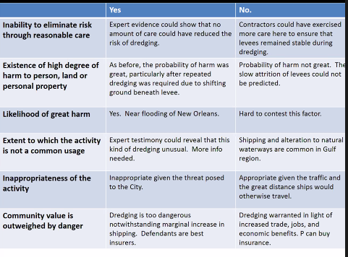

Manufacturing Defects (Strict Liability)
- Central question: Is the product different from, and more dangerous than, its intended design?
- Concept = a departure from what is ‘normal’ in manufacturing process that makes the product dangerous
  - A manufacturing defect exists when products “depart from their intended design even though all possible care was exercised”
- Issue Spotting Indicators
  - Dealing w/ maker or seller of a product
  - Product enters the market dangerously different from intended design
  - The product caused damage/injury to someone
- Rst Rule:
  - (1) One engaged in the selling or distributing products
  - (2) who sells or distributes a defective product
  - (3) is subject to strict liability for harm to “persons or property”
  - (4) caused by the defect
- Proving the Rst. Rule
  - Must show when, how, where injury takes place to demonstrate the cause was due to a manufacturing defect and not other conditions or actions
    - (actual + proximate cause)
  - Lacking direct evidence of defect, can use circumstantial proof: incident that hurt P would be one that generally occurs as a result of product defect; no other major causes (Ex: Coke bottle exploding in your hand)
- Case: McPherson v Buick
  - FACTS
    - Buick sold a car to a retail dealer
    - The retail dealer then sold the car to the PL
    - While in the car, it suddenly collapsed due to wheels made with defective wood.
    - Buick did not make the wheel; it was bought from another manufacturer. Buick argues that because they are not in privity with the P, there is no duty
  - Takeaway
    - Buick IS liable for the injury to PL, abandoning the idea that duty was limited to privity
      - Mass Production means contracting (in privity), by Itself, Insufficient to Regulate Dangerous New Products
    - Rule: Manufacturers owe a duty of care for reasonably foreseeable harm to reasonably foreseeable plaintiffs, including those persons “other than the purchaser” of the product

- Case: Escola v Coke
  - FACTS
    - Waitress was injured when a coca cola bottle exploded in her hand
    - It appears the bottles were in the same condition they were in at the time they left the plant.
  - Takeaway
    - Escola could sue D on a res ipsa loquitur theory
      - Here, bottle would not normally explode absent negligence
      - The bottle was in the exclusive control of the defendant. It does not appear it was the fault of the plaintiff
    - BUT keep in mind that res ipsa is harder to prove than strict liability
    - Concurring Opinion: a manufacturer is strictly liable when (a) places article on the market, (b) knowing that it is to be used without inspection for defects, and (c) proves to have a defect that causes injury
- Case: Schmiegl v ZGE (Evidence for defect when device is destroyed)
  - FACTS
    - P suing manufacturer that a catheter that exploded was a manufacturing defect
    - If representing D, need to try to establish that the catheter burst for some reason other than a manufacturing defect (since it has exploded and can’t test the actual device to see if it was actually defective).
  - Takeaway
    - D needs to show the doctor was at fault who was operating it, or that conditions in patient was not optimal for the device
    - PL: One can infer a product defect harms a plaintiff without specific proof of a defect when:
      - The incident that hurt plaintiff was of a kind that generally occurs as a result of a product defect
      - The incident was not, in that case, solely the result of other cause

Design Defects (Strict Liability)
- Central question: Is the product dangerous because of an aberration in the manufacturing process (manufacturing defect) or because of the design itself (design defect)?
  - Manufacturing Defect → Issue w/ the individual product you bought b/c it strays from intended safety/design
  - Design Defect → Issue w/ the entire product line – the design/product itself makes it dangerous
  - Analysis may turn on questions of proof and expert opinion
      - What type of proof you have?
    - May also turn on tactical concerns for the plaintiff and the defendant
      - Bet the company case (design defects)
      - Class action resources → Design defect
  - Example: H.S. coach w/ pacemaker that had wires poke through sending shocks wildly
    - Manufacturing Defect: To prove it was this, you would want to show infrequency of this happening. If you can show that there was a wire missing in his pacemaker or that there the coating corroded faster than usual, then you could prove manufacturing.
    - Design Defect: To prove this, you would want to show that there was a systematic defect that happened frequently. If company changed the coating recently or the type of wire recently in all of their products, you could likely prove this change was a design defect.
- Concept = Even if a product is made exactly according to specifications, without any manufacturing flaws, the design itself may be dangerously defective
- Issue Spotting Indicators
  - Step 1: Is this the maker or seller of the product? AND is the defect obvious or non obvious?
  - Step 2a: If the defect is obvious → apply consumer expectation test
    - Keep in mind: Consumer will argue for this b/c easier to prove and D (company will argue for below b/c harder for PL to prove)
  - Step 2b: If defect is non-obvious → Excessive preventable danger test + RAD analysis
    - Step 3b: RAD cost benefit analysis
- Analysis
  - Ask: Is the design defect so obvious that an ordinary consumer could infer that the product did not perform as safely as it should?
    - If YES – Consumer Expectation Test
      - A product can be found defective if the product failed to perform “as safely as an ordinary consumer would expect” when used in an intended or reasonably foreseeable manner
        - Use in cases with obvious defects
    - If NO – Risk-Utility Test (Excessive Preventable Danger Test)
      - → Applies to NON-OBVIOUS defects where expert analysis is required
      - Defendant is strictly liable if risk of danger inherent in the design outweighs the benefits
      - How to analyze:
        - (1) probability and gravity of danger created by the challenged design (current/challenged design)
          - Gravity/likelihood of danger w/ current design
        - (2) feasibility and cost of safer alternative design (RAD) and (alt design)
          - Availability of a RAD
        - (3) adverse consequences of alternative design to product and consumer (alt design)
          - Consequences of alt design on consumers/society
            - (Think of changing the VW van – RAD would totally change the product)
      - Reasonable Alternative Design (RAD) Test
        - Must prove a “reasonable alternative design” would have reduced the foreseeable risk of harm
        - Advantages and disadvantages of alternative design including:
          - Cost
          - Product longevity
          - Maintenance and repair
          - Aesthetics
          - Range of consumer choice
- Case: Soule v GM (Consumer Expectation Test EX)
  - FACTS
    - PL’s car gets hit on the driver side
    - The wheel collapses on impact and goes underneath the car
    - The floor panels come up and crush PL’s feet causing her serious injury
    - PL asserted two theories of liability
      - Manufacturing defect → the wheel was welded incorrectly and that’s why the entire floorboard buckled
      - Design Defect → Obvious Defect
        - The placement of the wheel
          - How the frame/bracket is configured with the wheel
  - Takeaway
    - Holding = NOT a situation to apply the consumer expectation test b/c expert testimony is required to asses the design of the car
    - How to use on exam? If a D is arguing that this is not a situation for the consumer expectation test, they’d point to this case as support
- Case: Camacho v Honda
  - FACTS
    - PL is injured in a motorcycle accident
    - Injuries exacerbated by the fact that the motorcycle did not have leg guards
    - Other manufacturers offered leg guards as an option but Honda did not
  - Takeaway
    - P is allowed to bring the suit against Honda
    - RAD = a motorcycle w/ leg guards (would have prevented the severe injuries PL experienced)
      - RAD for the motorcycle does not change the concept of the product
        - The leg guards are also a cheap fix
    - How to use on exam? Good example of a valid RAD that would not change the product very much and would clearly significantly increase safety
- Case: Gray v Pinto
  - FACTS
    - PL drives Ford Pinto, gets into simple fender bender, and due to how the car is designed (where the gas tank is located) it blows up and lights on fire
  - 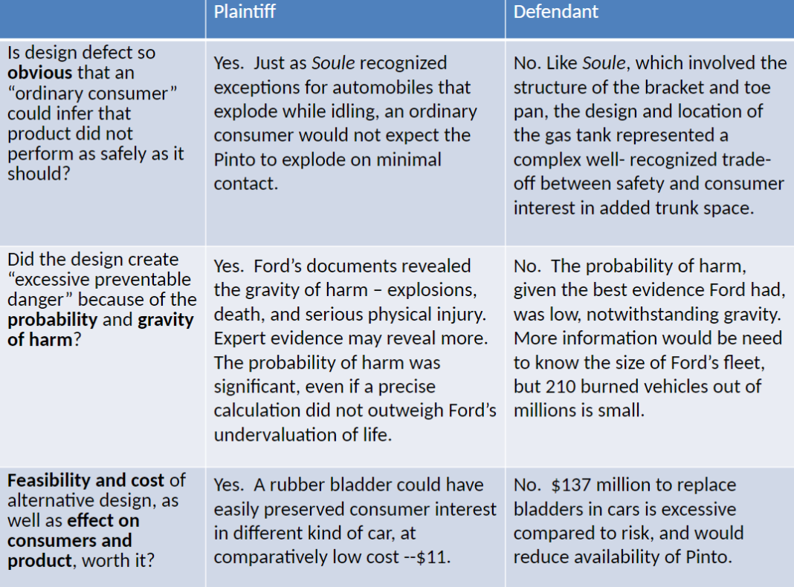

Failure to Warn (Strict Liability)
- General Rule: The seller is required to warn against
  - (1) latent (hidden) dangers resulting from
  - (2) foreseeable uses of product
  - (3) of which it knew or should have known
    - This includes unintended uses of the product, so long as those uses are also foreseeable
- In these types of cases, you ask 3 major questions
  - (1) Is a warning required at all?
    - Rule: Defendants have a duty to warn against dangers it knew or should have known through reasonable testing at the time of sale
        - “Should have known” → State courts disagree about how to define exactly what the manufacturer should have known
          - It may be measured by experts in the same field, by what the industry knew, or the most “state of the art” technology that exists at the time
        - You use an industry wide standard so small companies do not have excuse like “oh we don’t have enough resources”
      - Old Rule: Required D’s to protect against known and unknown dangers
        - Rationale → Company is in better position to insure against danger, Encourages further product research, Deterrence
    - Case: Vassallo v Baxter
      - FACTS
        - P argues a silicone breast implant was negligently designed and accompanied by negligent product warnings
      - Takeaway
        - This cases creates the modern rule (above) and rejects the old rule
        - Modern Rule Applied → Baxter not liable because risks were not reasonably foreseeable at the time of sale
          - Nor could they have been reasonably discovered through reasonable testing
    - Many states, however, require that the manufacturer warn consumers about newly discovered risks after the sale, if that is possible.
      - Know or reasonably know of risk
      - Identify users otherwise unaware of risk
      - Can effectively communicate risk
      - Burden of post-sale warning justified by risk

  - (2) Is the warning adequate?
    - Rule: A reasonable warning NOT ONLY must convey a “fair indication” of the danger, but also warn with the “degree of intensity” required by the “nature of the risk.”
    - When is a warning adequate?
      - Reach
        - Must reach person likely to use product (except children)
      - Scope
        - Describe scope of the danger for people likely to be affected by use
      - Seriousness
        - Describe extent, seriousness and consequences of harm resulting from foreseeable misuse
      - Graphic Power
        - Physical aspects of the warning and means to convey warning must be adequate
    - Case: Hood v Ryobi
      - FACTS
        - P is injured after he removes the blade guard from a saw
        - There were numerous warnings on the saw itself and in the owner’s manual saying not to remove the guards (“Do not remove guards or you will risk serious physical injury”)
        - PL sues the saw manufacturer, arguing the warnings were insufficient to warn against the particular type of harm (the saw blade flew off)
        - Additionally, he only removed the guard because he could not saw effectively with it on.
      - Takeaway
        - Clear case where warnings were adequate
        - The warnings were adequate.
        - The vast majority of consumers do not detach the guard, there are few similar incidents, and adding warnings may dilute the effectiveness of the warnings
  - (3) When will “learned intermediaries” eliminate need for a direct warning to consumers?
    - Rule: The manufacturer owes no duty to the ultimate consumer, so long as the manufacturer adequately warns the prescribing physician of the danger
    - Exceptions to the learned intermediary doctrine?
      - Direct to consumer advertising
      - Managed care weakened doctor patient relationship
      - Medical practice as a shared undertaking (EX: COVID vaccinations)
    - Case: Centocor v. Hamilton
      - FACTS
        - PL sees ticker for a drug on TV
          - Asks her Doctor about the drug
        - Some Dr visits take place and PL begins treatment of the drug
          - Doctor shows PL a video showing the drug but does not warn against a specific side effect (sometimes causes lupus)
        - PL gets lupus and sues
          - Drs were warned about the lupus side effect but the patient was NOT
      - Takeaway
        - PL LOSES – the learned intermediary doctrine applies here
          - Dr. was sufficiently warned about the risks – drug company did not need to warn the PL directly
        - The video shown to PL did not rise to level of direct to consumer advertising and Drs were aware of the side effects of the drug

