Injunctions
- Bivens: If fed §§ create a right but not a remedy: 4 factor test for when remedy is given
  - Was π the intended beneficiary of the §?
  - Legislative Intent (most important)
  - Legislative scheme
  - Area of law left to state or fed control?
- Core parts
  - Prospective: forward looking
  - Modifiable: can change or terminate injunction
  - Equitable remedies
    - Deterrence > punishment.
    - If ∆ violates by mistake (good faith), no punishment needed!
  - In personam orders
  - Enforced with contempt in court (fines/jail)
- Goal: Rightful Position
  - Put π in the position they would have been in but for the harm
  - Rightful position ≠ the original position before the harm
    - Sometimes original position is better than rightful position
    - Doyle: If an employee is fired for both lawful AND unlawful reasons, the unlawful ones do NOT justify an injunction for reemployment since that improves the employee’s position!
    - Mckennon: Court declined to grant an injunction to force her re-hiring. But separately granted back pay for the time between when she was fired and the time she committed the fireable offense.
- Preventative: stops ongoing harm (but no direction on how to do so)
Ie: corp must stop discriminating promotions based on sex orientation
- Reparative: undoes the ongoing consequences of harm
Ie: discriminating corp must promote person they discriminated against
- Prophylactic: Imposes additional protective measures to fix causes of ongoing harm
must adopt non-discrimination policy & diversity training
- Structural: restructure/change how institutions work (schools/jails/companies)
ie: restructure or change the company itself prevent discrimination
- Rizzo: prophylactic
  - §1983 case against Mayor Rizzo and City for failing to address police brutality
  - ∆s didn’t implement unconstitutional policies, only oversaw high pattern of abuse
  - §1983 does not require prevention; only punishes them for the misconduct itself.
  - Proscribing a prophylactic injunction here would intrude on states rights
  - πs couldn't prove that next time they encountered police, they WOULD face brutality. No injury, no relief.
- Brown v Plata: Structural
  - USDC ordered state to reduce prison population. USSC affirmed
  - It did not order the state to perform a specific act, only to form a plan for compliance and submit it for approval.
  - Relief must be based on clear and convincing evidence that overcrowding is causing constitutional violations. Relief must be narrowly drawn and as least intrusive as possible, and only used as a last resort.
  - It is ok that reducing prison populations will not remove all constitutional violations, just that it will remove the biggest cause of them.
  - It is ok that the remedy will have collateral effects, or some adverse effects.
- Injunction 4 part test
  - Real Imminent Direct Threat of Harm elements
    - π must face direct harm themselves
    - Real = facts, not subjective personal fear or hypothetical
    - Imminent = future, immediate (not too early or late for court to intervene)
    - Harm = violation of law (prohibited by law, not just disfavored)
    - Establish threat by past violations, continuing violations, or explicit threat
    - Not moot (too late for court to fix / no RP expectation harm will repeat)
  - No adequate remedy at law (irreparable injury) factors
    - ∆ is judgment proof
    - ∆ is immune from damages
    - Damages are difficult to estimate
    - Damages cannot put π in rightful place (what is lost not on marketplace)
    - Complete recovery would require a multiplicity of suits
    - Allowing injury to happen would be morally repugnant (personal injuries)
  - Balance the Equities
    - Π’s right to remedy vs ∆’s undue hardship and public interest
    - To deny inj., ∆ burden must be MUCH > than π’s benefit
  - Public Interest
    - Social consequences imposed by injunction or averted by injunction
      - Policy issues (Public health/safety, economic issues, etc.)
      - Effect on Third Parties
    - Practicality/feasibility of the injunction
- Scope of Injunction = Scope of Harm
  - Scope is a question of the breadth of injunction (how much relief is appropriate)
  - Aim of injunction must be π’s rightful position
    - But terms of the injunction can go beyond this
  - OVERBROAD if
    - Invades ∆’s constitutional interests (Madsen)
    - Beyond Scope of Harm (Jenkins)
    - Beyond Rightful Position (Jenkins)
  - NOT OVERBROAD if Prophylaxis:
    - May reach facilitators of harm (Swann)
    - May order precautions (Madsen)
- Swann: Court upheld prophylactic injunctions of quotas, gerrymandering, and busing
  - Structural injunction to force district to adopt a more intensive plan
  - Courts have broad discretionary powers to set educational policy
  - Court got tired of waiting for the district to act, and used injunctions to force it to.
- Jenkins: Brown v. BoE only barred de jure segregation, not de facto segregation
  - Injunctions CANNOT exceed the scope of the harm. Remedy MUST be limited to where there was a constitutional violation!
    - Issue of segregation was in the city, therefore remedy must be there too.
    - The court was not allowed to expand the injunction to affect school districts in suburbs! (Intra-district solution YES, inter-district solution NO)

Specific Performance (SP)
- Injunction enforcing the terms of a K
- Same balancing test as other injunctions
  - Irreparable injury
  - Damages inadequate
  - Balance of hardships
    - Undue hardship to π vs unfairness to ∆
    - Difficulty of supervision/enforcement
    - Law and Econ: costs of inefficiency, transaction costs to buy out injunction
  - Public policy
- Special Requirements
  - Terms of K must be sufficiently certain to provide basis for an appropriate order
  - No SP for personal service Ks (negative injunction instead?)
  - Mutuality of Remedy (only in some jdxs): One party must be denied SP of K if the other would be barred from that remedy.
- UCC Buyer’s Right to Specific Performance
  - Where goods are unique or in other proper circumstances.
  - SP may include terms/conditions as to payment of price/damages/other relief.
  - Buyer has a right of replevin for goods identified by K if after reasonable effort he is unable to cover.
- SP for K of Real Property: Land is considered “unique”, so SP is always available
  - Calculating damages for land is difficult
    - Likely no liquid market for real property
    - Subjective values skew (homeowner, family home, personal value, etc.)
  - Costs supervision is low because there is no ongoing relations to supervise
- Ks related to real estate (such as K to clear ice/snow)
  - Not automatic SP, regular balancing rules
  - Ice construct requires continuing supervision, and $$ is easy for replacement
  - If there is an exclusivity clause, more likely to have SP granted.
- Law and Economics: Balancing the costs/benefits of SP
  - Breach should be allowed for profit maxing
  - Market determines loss from breach: Parties forced to negotiate due to SP threat
  - Costs of issuing injunctions (supervision/resources)
  - Inefficient injunctions stop profit-maxing behavior by undue leverage of injunction. Parties should be able to “buy out” injunctions
  - Injunctions should NOT be issued if parties cannot “buy out” injunction
  - If π has so little to gain, but ∆ has so much to lose (such as polluting mill case), SP would cause an injustice. Must easier to let ∆ keep expensive mill, and pay π for the cheap damages
- Sara Creek (Mall case)
  - Walgreen signed a lease with mall landlord Sara Creek. Sara promised in the K not to lease space in the mall to any other pharmacy. Years later, Sara sought to bring a new pharmacy in as the mall’s anchor tenant.
  - Damages are inadequate → SP required
  - Injunctions shift the burden of determining the cost of ∆’s conduct from the courts to the parties. Parties will negotiate and determine the market cost of the breach.
    - However, injunctions require constant court supervision, and may impose costs on third parties. That said, court supervision here = very cheap.
  - If the injunction was granted, and the anchor tenant couldn’t be replaced, the whole mall would go under. This would be bad for Walgreen! Therefore it is likely that the parties will negotiate to a settlement rather than letting entire mall die.
- Poesner’s philosophy: If you issue an injunction, the parties (market) should dictate what the cost of absolving the injunction would be. Therefore it is often better to issue the injunction rather than damages, as it leads to a settlement set by the free market.

Other Injunctions
- Temporary Injunctions AKA Temporary Restraining Order (TRO)
  - Emergency order only granted if risk of immediate + irreparable harm before hearing can be held (Usually 7-14 days max)
  - To prevent immediate harm and maintain the status quo
  - Without notice to losing party = ex parte
    - IF efforts made to give notice and reasons given
    - Motion to dissolve: adverse party may provide 2 day notice to party who got TRO to modify/dissolve the order
  - Usually no Appealing a TRO
    - Can only appeal if TRO is “effectively an injunction”
    - Domestic Violence Exception
      - §§ create exception for this: no notice required for a TRO
      - Notice is required for follow-up Prelim Injunction
- Preliminary Injunctions (PIs)
  - Restraint on ∆’s rights before adjudication of rights; Goal→Preserve status quo
  - Courts apply a higher burden of proof because high risk of due process issue
  - At initial phase of litigation, and operates during litigation until final judgment
    - Unlike TRO (7-14 days)
- 4 part test for a TRO/PI used in 60% of jdxs
Show probability of each of these elements:
  - π is likely to succeed on the merits
    - Unlike perm inj: which requires proven violation of a threat of harm
  - Likely to suffer irreparable harm in absence of injunction
    - For TRO: immediate injury
  - Balance of hardships
    - π and ∆ on equal footing since merits have not been decided,
      - Unlike perm inj. Where ∆ is on lower footing
  - Public interest
Must describe acts to be restrained in detail
Must also satisfy FRCP 65 (notice, hearing, and security)
- Alternative Test: Sliding Scale approach Movant must show either:
    - Likelihood of success on merits + some irreparable harm, OR
    - Serious question on merits + balance of hardships tip strongly in its favor
  - The greater the gravity of harm to the movant, the clearer balance of hardships weigh in favor of the movant and the lesser the need to show success on merits.
  - Used in about 40% of jdxs over the traditional 4-step test
- Posner case with a formula: Grant the preliminary injunction only if:
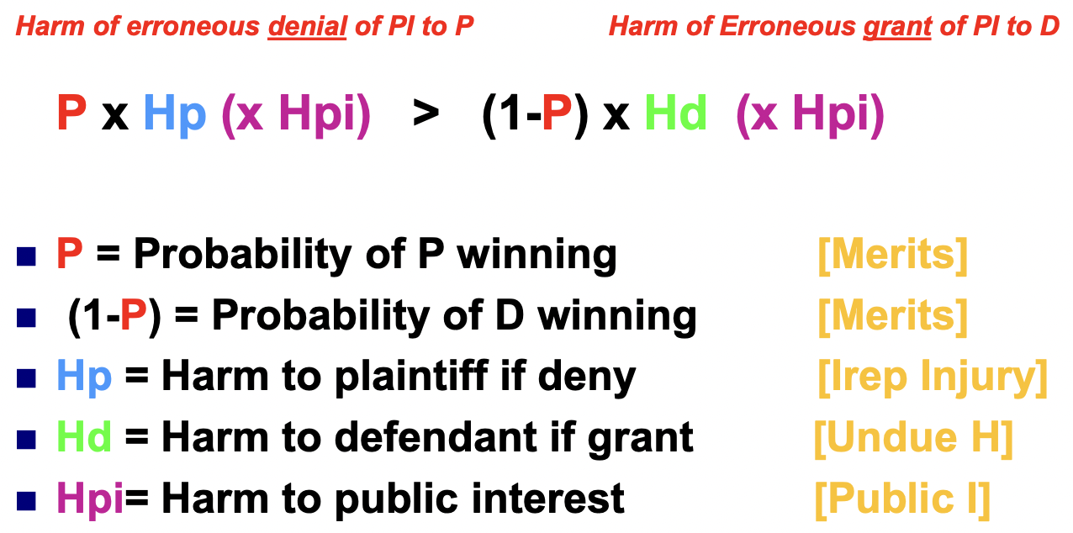
- A quantified version of sliding scale test (don’t need to know formula verbatim)
  - Large Hadron Collider TRO example
    - Chance of winning on the merits was VERY low, but the harm of the apocalypse was high.
    - Traditional test: NO injunction (req. of likelihood of winning on the merits is not met)
    - Sliding scale: YES injunction
    - Merits (low!) x Harm (HIGH!!) > merits (high) x Harm (low)

Modifying Injunctions
- Grounds for Relief IF:
  - Judgment satisfied, released, or discharged
  - Judgment/order based on an earlier judgment which has been reversed/vacated
  - Applying judgment/order prospectively is no longer equitable
- Old standard: Previously difficult to obtain
- Swift: decree remains in effect until showing of grievous wrong evoked by new and unforeseen conditions
- The Rufo Rule (overcrowded prison case): more flexible approach than Swift
  - Modification allowed only if there is a significant change in circumstances
    - Change in fact (political change)
    - Change in law (injunction no longer allowed by law)
  - Modification must be suitably tailored to changed circumstances

Terminating Injunctions
- FRCP 60(b)(5): satisfied order
  - In full compliance with the terms of the decree
  - Substantial compliance
- Dowell: Substantial Compliance IF:
  - ∆ complied in good faith
  - Eliminated original harm and effects to the extent practicable
- Purposes of litigation as incorporated into the decree are fully achieved
- 3 tests for modification/termination
  - Modification (Rufo) because of:
    - Changed circumstances in law/fact
    - Tailored to change
  - 2 Termination Tests
    - Substantial compliance
      - ∆ complied in good faith
      - Eliminated original harm to extent practicable
      - Won’t repeat offense
    - Changed Circumstances
      - No longer equitable prospectively due to change in circumstances
      - Purpose of decree achieved (comply with LAW)

Enforcing Injunctions: Contempt
- Money damages enforced with
  - Attachment (lien) judgment to ∆’s property (in rem)
    - Affects the ∆’s property, not the ∆ themselves
  - ONLY child support can be “in personam” (over the person)
    - Affects ∆ themselves; can be personally fined and/or jailed
- Out of court settlement ⇒ Effectively a K → Enforced with breach of K claim
- If there is a violation of an injunction:
  - Additional remedy of CONTEMPT
  - In Personam (fines/jail; may lose “liberty”)
- Enforcement advantages of injunctions
  - In personam (against ∆ personally)
  - If governmental immunity prohibits damages
  - Contempt power (extra remedial power)
    - Maybe able to recover attorney fees + other costs not usually recoverable
- Prima facie case of contempt
  - Clear, specific court order
  - ∆’s knowledge/notice
  - Violation / noncompliance
  - Intent (willfulness if criminal)
- Where does the power of contempt come from?
  - Courts have inherent discretionary power to punish contempt of its authority:
    - Misbehavior of any person in its presence (“summary”) or so near thereto as to obstruct the administration of justice;
    - Misbehavior of any of its officers in their official transactions;
    - Disobedience/resistance to its lawful writ/process/order/decree/command
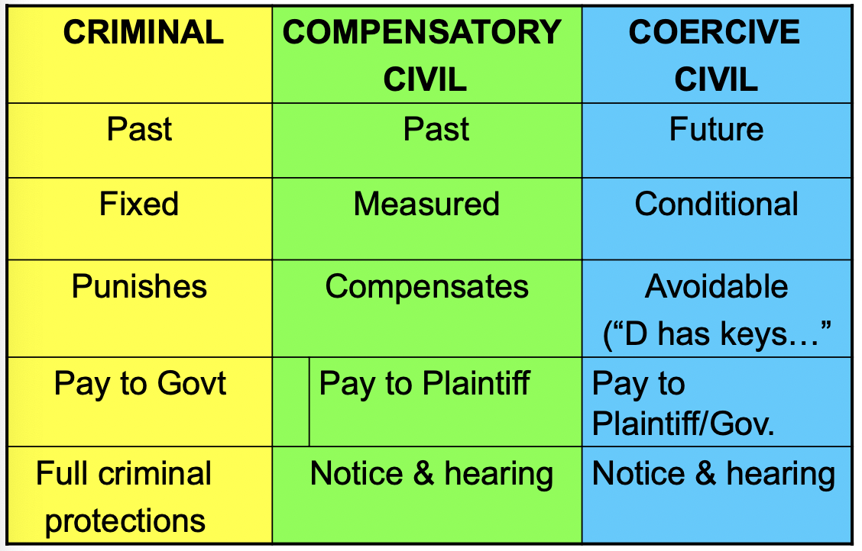
- Procedural safeguards
  - Civil Contempt Remedies
    - Coercive and compensatory
    - Notice and opportunity to be heard (due process)
  - Criminal Contempt
    - Full crim protections: right to counsel, proof beyond reasonable doubt, right against self-incrimination, jury if not petty crime, Notice+hearing, etc.
- Summary Contempt (direct contempt occurring in-court)
  - Immediately judge and sanction summarily
  - No notice/hearing needed (already in court!)
- Criminal Contempt
  - Must prove beyond a reasonable doubt (burden on π [gov])
  - Punitive
  - Retrospective (for completed, past act)
  - Determinate, fixed time/fine
  - $ paid to gov
  - Prohibitory → Complex conduct (fact intensive to determine if violation, Bagwell)
    - More complex order ⇒ more likely it is crim contempt
  - Required procedures: FULL CRIM protections + notice & opportunity to be heard
- Civil Compensatory NOT ALLOWED IN CALIFORNIA!
  - Must prove by clear & convincing standard (burden on ∆)
  - Remedial
    - To compensate π for harm (π’s rightful place / ∆’s unjust enrichment)
    - Remedy for past harm
  - Loss of ∆’s profit (restitution) or attorney fees
  - $ paid to other party
  - Required Procedures
    - π must file action to enforce
    - Notice + Hearing
  - Not recognized in CA and TX
    - Treat as “damages” or a legal remedy
      - Should have the ability to have a jury trial.
    - π may prefer a “civil” trial (lower standard of preponderance to recover)
    - Thus it may be easier to recover in a civil case in CA and TX
- Civil Coercive
  - Must prove by clear & convincing standard (burden on ∆)
  - Force Compliance
  - Just enough fines/jail time to get compliance ⇒ goal is not to punish!
  - Prospective (affects future actions)
  - Conditional (indeterminate, not fixed)
  - Purgeable: AKA can be avoided (∆ holds the key to their cell!)
  - $ paid to party or gov depending on state §
  - Required Procedures
    - π must file action to enforce
    - Notice + Hearing
  - Example: “$100 for each day you don’t comply” → civil coercive
      - “$1000 for not complying” → criminal / civil compensatory
- Measuring Contempt
  - Jail
    - If determinate/fixed → criminal
    - If Conditional/purgeable → civil coercive
  - Fines
    - If determinate/fixed → criminal
    - If escalating, conditional → civil coercive
      - Fines unrelated to the measure of damages (Bagwell)
    - Compensate for loss → civil compensatory
- Challenging Contempt: ∆ can argue the contempt is:
  - not specific
  - lacking notice
  - Impossible
  - no PJ (long-arm §, reasonableness, etc.)
- Collateral Bar Rule: can’t challenge injunction as unconstitutional at contempt phase.
  - Don’t want ∆s to determine which court order to follow or not
    - We trust judge > ∆
    - Must follow order and appeal later
  - Exception: Transparent Invalidity
    - Trying to appeal first before violating will help case, but not mandatory
    - Newspaper case ⇒ could disobey contempt order
      - Only violated injunction after trying to appeal it and being rejected
    - MLK case ⇒ should have followed contempt order and appealed
- Feiock (quasi-crim contempt) Missed alimony payments case
  - Condition of probation: ordered to pay what he previously owned in installments.
    - If he missed a payment → entire payment due and payable
    - ∆ may have lacked ability to pay it
  - Because this is a quasi criminal punishment, burden on π to prove ∆ can pay
  - Would be civil coercive if ∆ could purge sentence by paying all past child support
- UMW v. Bagwell
  - Union protests barred by injunction. Union was charged $20k for for every “violent” violation and $10k for every “nonviolent” violation of the injunction.
    - Added up to a $64M fine ($12M to π company; $54M to state [Virginia])
    - This was a complex injunction with a serious fine
  - SCOTUS Majority: This was a criminal contempt
    - Fine was punitive due to its enormous size
    - This was a complex injunction: no definition of what was a “violent” violation, and each individual violation was a fact-intensive case (100s of individual actions, each unique)
    - Complexity + punitive nature ⇒ requires crim due process
  - If injunction is complex + high contempt fines, there is a high risk contempt will be interpreted as crim, Especially if the money is going to gov, not

Declaratory Judgment
- Authoritative + Definitive statement about rights, status, & legal relations of the parties
  - Declares the parties’ legal rights without imposing any relief
  - Discretionary relief (equitable order)
  - Trying to clarify rights before there is a violation.
  - A final judgment ⇒ Cannot be challenged later
- “Potential” ∆ is now the π trying to clarify rights before breaching and getting sued
  - Remember: parties switch places. Person risking suit is the π seeking DecJ.
- State approach: Courts shall have power to declare right, status, and other legal relations whether or not further relief is or could be claimed
- Fed approach: In case of actual controversy, court may declare the rights and other legal relations of any interested party whether or not further relief is or could be sought
- DecJ is a non-coercive remedy
  - No contempt for noncompliance
  - No irreparable injury requirement (unlike Injunctions
  - Jury trial is usually allowed with DecJ
    - More likely if eventual relief will be money damages
    - Less likely if eventual relief will be equity
- Benefits of DecJ
  - Prevention: resolves uncertainty before the harm occurs
  - Timing advantage: avoids penalty (tax, jail) and harming ongoing relations
  - expedited process through court system
  - Used in tandem with other remedies (damages, injunctions, restitution)
- Qualifying for DecJ
  - Mandatory requirements:
    - Must be a live case in controversy
    - Definite & Concrete
    - Real, substantial, and conclusive (not hypothetical / abstract / advisory)
    - Adverse: Parties disagree
    - Ripe: immediate threat (harm will occur soon after the future breach)
      - Don’t need to subject yourself of risk of breach to prove ripeness
  - Discretionary Factors: Court can use discretion to apply DecJ when:
    - DecJ will serve a useful purpose in clarifying+settling the legal issue
    - DecJ will terminate uncertainty and give relief from the controversy
    - Not for tactical advantage (∆ forum shopping, “procedural fencing”, etc.)
- MedImmune: Patent holder does NOT have to breach license K before it can seek a DecJ that the patent is invalid
  - No dispute that MedImmune would be entitled had they intentionally breached
  - Their own act of continuing payment is what eliminates imminent threat of harm
  - When governmental action is concerned, πs aren’t required to expose themself to liability before bringing suit to challenge a law’s constitutionality.
  - Payments were not made willingly, but out of the coercive threat of losing biz, being sued and having to pay attorneys fees, etc.
- Enforcing DecJ
  - Initial relief is just a statement of rights
  - May later seek “Further Relief” when appropriate
    - Where necessary or proper
    - notice/hearing requirements
    - All other remedies available
    - NO contempt for DecJ

Compensatory Damages
- 7th Amdn right to a jury trial ($20 min)
- Torts:
  - Pecuniary (econ) damages
    - AKA special damages
    - Easy to quantify → lost wages, med bills, replacement costs, etc.
  - Non-pecuniary (general) damages
    - Hard to quantify → varies from π to π even under SSC
    - Defamation / constitutional violation causing harm
    - pain & suffering, emotional distress, loss of consortium, etc.
- Contracts
  - Expectation Damages (benefit of the bargain)
    - Direct losses due to violation/breach
  - Consequential damages
    - Special damages
    - Secondary damages more personal to π due to violation
      - Loss of operating revenue due to a delay in construction
      - Harm to a company's business reputation
      - Loss of time/profit
- Goals of Compensatory damages
  - Make π whole (rightful position)
    - Compensatory: measures value of harm
    - Substitutionary: replaces harm (but can it really?)
    - Torts → backwards looking, place π in position pre-harm
    - Contracts → forward looking, place π in position they would be in if no breach and π received benefit of the bargain.
  - Redress: ∆ acknowledges wrong
  - Deterrence (general/specific)
    - Does it work in constitutional tort violation cases?
      - Are ∆s motivated by economic or political considerations?
    - Political remedies that work better than money damages?
- Nominal Damages Violation with no actual loss (similar to DecJ)
  - Often used as a hook for punitive damages → no loss, but willful misconduct
  - May also allow for recovery of attorney fees
- Presumed Damages π presumed to have suffered damages as a matter of law
  - Right to vote, defamation, etc.
  - NOT for pure constitutional rights violations (Stachura)
  - Sub for compensatory damages when loss is very hard / impossible to measure
    - NOT supplemental to compensatory damages
- Alternative compensation systems
  - Mass settlement cases: Balancing interests of major party with a very large class
    - Agent orange cases, 9/11 case, BP oil spill, etc.
    - Costs of litigation, attorney fees
  - Alternative compensation systems can lead to fairer outcome in unique situations
    - Reduces attorneys fees for everyone
    - Gets relief sooner, even if it is a smaller amount than if they fought it out.
    - Also easier to collect
- Collecting damages post-judgment
  - Unlike equity, these are not self-executing.
    - Court only declares that ∆ owes π. Does not order the payment
    - Ways to collect depends on the jdx
    - If ∆ lacks the funds, too bad!nc
  - Means to collect
    - Execution: Judgment attached to ∆’s prop → sold by sheriff at auction
      - Register jdgm.→ get writ/execution→ submit to sheriff who seizes
      - Can’t force sale of primary home, car, pension, etc.
      - Only recover 25% of income (60% if child/spousal support)
    - Turnover §: In person injunc. to turn over intangible non-exempt prop (IP)
    - Garnishment: File against employer/bank to collect $$ if ∆ refuses to pay
- Attachment: Maintain status quo (notice+hearing needed) so ∆ can’t liquidate assets in anticipation of adverse jdgmt (can't move his assets out of the state, etc.)
  - Fed courts can only do so with a prelim injunction since it can shift balance of suit in creditor’s favor to drag out the suit
- Elements of Loss
  - General/Direct: typical damages presumed by type of tort/breach of K
  - Consequential/Special: secondary losses to particular π
- Limits on damages (Most commonly for consequential damages)
  - Foreseeability: Limits recovery on very remote losses
    - Ks: ∆’s knowledge/notice (reason to know) of special circumstances at time of K formation
      - ∆ is liable if should have foreseen (RPP/SSC)
      - If ∆ is on notice, can bargain for “risk of harm to π”
    - Torts: “proximate cause” foreseeable to π, type of harm, extent, etc.
      - Thin skull rule exception to foreseeability
  - Certainty: No speculation on the damages.
    - 2 components:
      - Causation in fact (but-for or substantial factor)
      - Evidence: Quality and quantum of evidence
    - Risk of future harm (med malpractice; cancerphobia cases)
      - Maj approach: Must have reasonable certainty (>51%) to recover
        - all or nothing
      - Min approach (Dillon): sliding scale
        - Size of award needs to reflect probability of occurrence
        - Low probability → low recovery (but no speculation)
  - Avoidability: No recovery for losses that could have been avoided
    - Reasonableness of π’s actions after violation to avoid further harm
      - Not = contributory/comparative neg (looks at pre-harm actions)
      - Not a duty owed to ∆ to mitigate, but functions to reduce π’s recovery if they behaved unreasonably after the violation
    - K: must “cover” but can recover losses that couldn’t be reason. avoided
    - Applies even if refusing med treatment for religious reasons (JWs)
      - But must not violate 1st A
      - Unreasonable assumption of risk ⇒ bars recovery for unreasonable additional harm
  - No double recovery
  - If π benefited from violation, offset damages
- Measuring Damages
  - Precision needed → not ballpark estimates
  - Focus is on economic losses, not intangible loss
  - Generally measured at the time of loss
  - Rightful position → costing ∆ harm alone + not granting π windfall
- Measuring Economic Loss
  - Mister Prude (MRPRUD)
    - Market value (FMV)
    - Replacement costs
    - Personal value (sentimental; usually disliked by courts)
    - Repair costs
    - Use value (use of lost item while being repaired, etc.)
    - Diminutions in value
  - Choose 1, cannot double dip!
    - Cannot get reliance + expectation damages.
    - But can get expectation damages + consequential damages
  - Market Value: Price a willing buyer would pay a willing seller
    - Be careful about the endowment effect → overvaluing
      - Actual cost: purchase price vs buyer’s willingness to pay
    - Can use comparable costs, list price, etc.
    - Depreciated Value (cost - depreciation)
  - Replacement Costs: Price to replace loss on the market
    - Market = forced sale under pressure; not a perfect market
    - If replacement is “better” than lost prop → subtract “betterment” from cost
  - Personal Value: Sentimentality; emotional attachment
    - Usually not allowed (non-objective)
    - Courts want consistent verdicts and to avoid fraudulent claim leading to overcompensation
    - Exceptions: makes recovering personal value more likely (no guarantee)
      - If ∆’s actions were willful/intentional
      - Trophies/wedding rings (general societal understanding of their personal value)
  - Repair/Restoration Costs: Cost of repairing to pre-harm condition
    - Eg. Car possible repair cost calculation
      - Fix it yourself → cost of supplies
      - Mechanic’s estimate
      - Actual charge by a repair shop that did the repair
  - Use value
    - Different loss: loss of the use of the property
      - Need for uber while car is in the shop
      - Only for a reasonable period (fair rental value, etc.)
    - Different focus: not the loss itself (car) but what you use it for (food deliveries + income earning)
  - Diminution in value: Change in value caused by legal wrong
    - Market value prior to harm - current value
    - Can be combined with repair costs if the repair is not 100% perfect
- Choosing Damages: Can only ONE measure per loss
  - Car accident example
    - Diminution in value (car value before and after accident)
      - OR Repair: reasonable costs, plus any diminution in value
    - AND loss of use (Cost of uber/car rental while car is repaired)
  - Barking Hound Village (Kennel killed π’s dog)
    - Court allowed exception for rule allowing only 1 damage approach
    - Court allowed BOTH fmv of dog AND medical expenses for treating her
      - FMV ≠ value to owners.
      - FMV = purchase price, training, breeding potential, use, etc.
  - Ohio v. DOI (oil spill case)
    - DOI used “lesser of” approach: restoration cost vs lost use value of land
      - Diminution in use value (fmv damage to land) < cost of restoration
      - Therefore it isn’t “efficient” to pay to clean up these areas
    - Court reversed: the lesser-of approach doesn’t work here
      - Goal isn’t for taxpayers to pay for what oil-spillers don’t pay for
      - Natural resources are non-fungible (not sellable/tradeable)
      - Goal is restoration, EVEN IF ECONOMICALLY INEFFICIENT
    - Hierarchy of assessment (use value) Order of priority:
      - Damages limited to diminution in FMV
      - Perform appraisal based on similar goods
      - Use contingent valuation (polling) to determine use value
    - DOI should use ALL reliable ways to measure value. FMV is one factor, but not only one
      - Contingent valuation using polling
      - If using sophisticated questioning & stats → not overly speculative
    - The Lesser-Of rule still exists for K cases!

Tort Damages
- Injury to Person
  - General damages: pain and suffering (past & future)
  - Lost earnings
  - Reasonable med expenses (past & future)
- Injury to Property (chattel or real)
  - Property’s lost value: diminution in FMV or repair costs
  - Loss of use
  - Owner’s discomfort and annoyance (real prop only)
  - Nuisance (use and enjoyment)
- Categorize as Pecuniary / Non-Pecuniary
  - Pecuniary Damages
    - Lost earnings (past & future)
      - Earning capacity (career/salary)
    - Med expenses (past & future)
    - Other expenditures (out of pocket)
    - Property loss (FMV or replacement)
  - Non-pecuniary damages
    - Pain and suffering
      - Pain⇒ physical sensation
        - π in a coma or who lost use of leg does not feel “pain”
      - Suffering⇒ emotional/mental distress (“mental anguish”)
      - Court may reject jury award if against “weight of evidence” or “shocks conscious”
      - Should be consistent with prior awards
    - Loss of services (allowed in most states)
      - Household chores, raising kids, assistance, etc.
      - Pecuniary⇒ replacement of tangible services of deceased in $$
      - Non-pecuniary⇒ loss of love/affection
    - Loss of society
      - Ability to interact with the deceased; care, affection, protection, etc
      - Loss of companionship with family/friend: Intangible contributions of deceased that made survivor better
      - Allows for recovery from child/retiree who didn’t provide “services” but was loved
    - Loss of Consortium: a separate cause of action for relations between spouses (Includes loss of service, society, and sexual relations)
    - Hedonic (loss of quality of life) (only in a few states for wrongful death)
      - Loss of enjoyment of life (inability to ski, swim, etc.)
      - Only awarded in cases where pain/suffering is NOT available
        - Different from pain/suffering since π may not be in pain (spinal injury, etc.)
        - If pain and suffering IS available, juries can consider “loss of joy” when awarding pain/suffering
      - Majority of courts reject hedonic claims for wrongful death cases
- Survival Actions: Losses incurred until time of death
  - For torts that don’t cause death (defamation, etc.)
- Wrongful Death: Most §§ only allow for pecuniary losses
  - Funeral/burial expenses
  - Loss of support from expected earning capacity
    - Reduced by “personal” consumption of decedent.
    - Future lost support discounted to PV
  - Loss of services
  - Loss of society
  - Loss of prospective inheritance to the decedent’s heirs
  - Mental anguish (only in a few jdx)
- Measuring Economic Loss from Torts
  - Future losses (medical, earnings) discounted to PV
  - Collateral source rule: payments/benefits to π from other sources (π’s insurance, friends, family) are NOT credited against ∆’s liability
    - Reduced by tort reform §§
    - Insurance co. might require π to refund them for damages awarded
- Measuring Non-econ loss from torts
  - Common law Excessiveness Standard
    - Is the jury verdict reasonable and supported by the weight of evidence?
    - Or is it so large as to shock the conscience?
      - Is the verdict a result of passion and prejudice of the jury?
    - Decided based on quality of evidence and comparison to similar awards (adjusted for aggravating circumstances)
      - If excessive, court will file a remittitur.
  - Tort Reform Statutory Caps
    - Caps total damages
    - Most found unconstitutional
      - Many state constitutions limit legislature authority to limit damages
      - Some legislatures amend state constitution to allow limits
    - Cap on non-economic damages
      - Often depends on ∆ or claim (limiting med malpractice claims, public entity ∆, etc)
        - California’s ‘Medical Injury Compensation Reform Act’
      - Issue of preventing undue hardship to viz vs. π’s rightful position
      - Insurance crisis & excessive litigation moral panic
      - Concerns that jury verdicts are too speculative
    - Abolish collateral source rule?
- Different approaches to enhanced risk
  - Ayers: state § barred recovery against a public entity for non-permanent pain/suffering. Court found § only applies to subjective feelings of discomfort/annoyance in personal injury cases.
    - Quality of life → not barred by § (feelings due to very real nuisance)
    - Emotional distress → barred by §
    - Enhanced Risk of Exposure → no recovery due to high speculation
    - Medical Surveillance costs→ allowed
  - 10% risk of $100k illness ⇒ $10k award
  - If enhanced risk established → must determine pecuniary and nonpec. damages
    - Still subject to same limits as pecuniary/non-pecuniary normal damages
- Disallowing jury awards
  - Tullis test for compensatory damages
    - Whether award was monstrously excessive
    - Whether there is a rational connection between award and evidence
    - Whether the award has some similarity to awards in similar cases
  - Golden Rule arguments: Can’t ask jury to place themselves in shoes of π or ∆
  - Per Diem arguments only allowed in some states
    - Damages based on accumulation of how many $ for each hour/day/etc.
    - Juries tend to underestimate total cost of per diem damages
  - “Shock the consciousness” and Posner’s approach
  - You are allowed to make a number of assumptions when applying damages
    - Such as assuming an upper middle class canadian who was severely injured in high school would have otherwise gone on to graduate college and earn higher wages

Contract Damages
- Overview
  - Expectation Interest:
    - Put the Plaintiff in the Performance Position (4 Ps)
    - Benefit of Bargain (BoB) + consequential (+ incidental if UCC)
  - Reliance Interest: out of pocket expenses
    - Bring π Back to the Beginning (3 Ps)
  - Limits on Consequential damages
    - Foreseeability, reasonable certainty, avoidability,
    - Contractually limited
  - Unavailability for non-pecuniary damages
    - Reputation of biz
    - Emotional loss (unless for bodily injury)
  - UCC approach for K sale of goods
    - Incidental damages
  - Prejudgment interest added: time of injury until award of damages
  - Liquidated damages agreement
  - Efficient breach
- Buyer Damages = BoB + consequential/incidental
  - Exception for Real Property in a few states (including CA)
    - Non breacher only needs to show Bad Faith to get BoB
    - Buyer recovers only
      - Money paid to seller,
      - Money spent to investigate/clear title,
      - cost of improvements (limited to reasonable expenses)
      - NO BoB
  - Bad Deal: BoB is negative, FMV < K price, and seller breaches
    - Improvements/consequential damages may not cover loss
    - May have to use restitution, specific performance, etc. to recover
- CL Seller Remedies BoB (loss on resale) + incidentals - costs saved
- UCC approach for sale of goods (did he say didn’t need to memorize for final??)
Buyer options for seller breach: Cancel, get money back, AND (one of the following)
  - Cover Eg: K to buy a car and B makes a $1k deposit. Later, seller breaches. K price for car was $20k. Buyer makes RP cover & buys another car for $22k
    - Damages = $3k ($1k deposit refund + $2k for Cover – k price)
  - Market damages Eg: K to buy a car and B makes a $1k deposit. Later, seller breaches. K price for car was $20k and FMV of car was $24k.
= $5k=$1k deposit refund + $4k for FMV of car ($24k) – K price ($20k)
  - Specific Performance: Only if you can prove money damages are inadequate
    - AKA you really want that car
Seller options for buyer breach
  - Resale: BoB (K price - resale price) + incidentals - costs saved
  - Market Price
    - BoB (K price - FMV) + incidentals - costs saved
    - Lost Volume seller ⇒ lost profit (aka the K price of the product)
  - Action on Price (if goods destroyed or no FMV for them)
    - K price + incidentals - costs saved
- UCC Consequential Damage
  - Any loss resulting from general or particular reqs. or needs of which the seller at the time of K had reason to know and which could not reasonably be prevented by cover, etc.
  - Including personal injury or property damages resulting from breach of warranty
  - Sellers are not allowed to recover consequential damages
    - Should already be built into the cost of the good!
- UCC Incidental Damages A subset of consequential damages (minor fees, etc.)
  - Buyers: Expenses reasonably incurred in the inspection/care/transport/etc. of goods rightfully rejected from the seller, and commercially reasonable charges/expenses/commissions in connection with effecting cover or any other reasonable expenses incident to the delay/breach
    - No requirement for foreseeability!
    - These costs are usually minor and easy to calculate
  - Sellers: Any reasonable charges incurred in care of goods after buyer’s breach, in connection with return/resale of goods or otherwise resulting from the breach.
  - Must be after breach. Care/custody of un-bought goods, return/resale, etc.
    - Depends on reliance on buyer
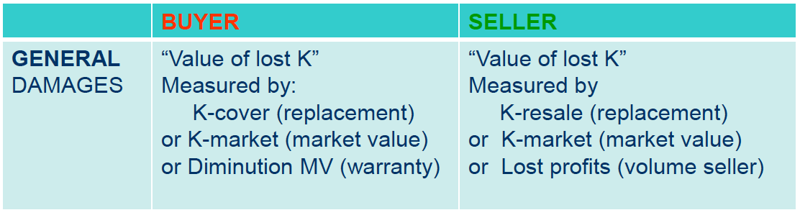
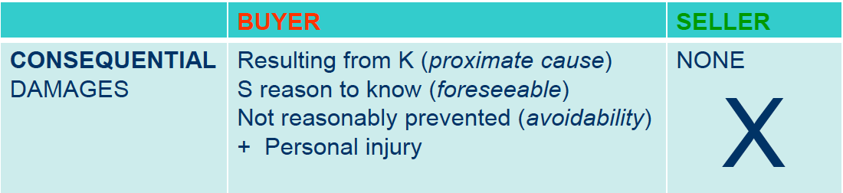
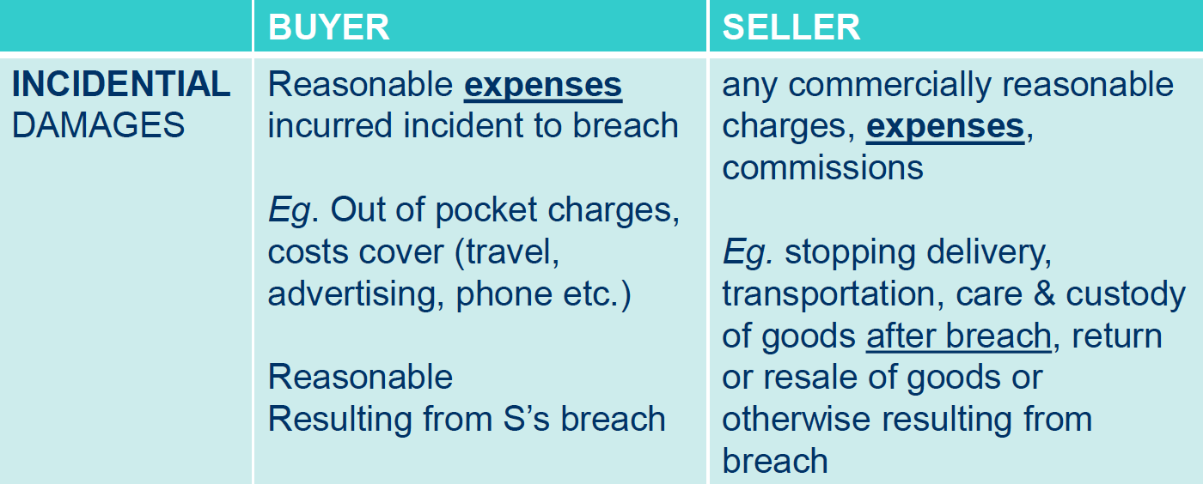
- Pre-Judgment Interest
  - Needed to put the non-breaching party in their “rightful place”
  - Compute from date $ is due/owed until judgment
  - Post-judgement interest determined by §§
- Record pressing case
  - Can ONLY recover reasonable Incidental damages made in reliance
  - AKA only things done to rehabilitate the record after its disastrous release
    - Salaries and travel expenses of π representatives who worked with ∆
    - Extra mailing/handling costs from poor printing
    - Reasonably incurred admin and advertising costs related to printing job.
- Liquidated Damages
  - Agreed upon amount/type/measure of damages in contract
  - Consequential: can be excluded/limited if unconscionable
  - Must be reasonable in relation to anticipated/actual loss, or because it is difficult to prove loss
    - If reasonable → Only liquidated damages allowed
    - If unreasonable → Treated as an unenforceable penalty
      - Actual damages are calculated by usable measures (expectation, reliance, DIV)
      - Inflatable Snowman case: liquidated damages were unreasonably large compared to actual damage ($0)

Punitive Damages
- $ awarded to punish or deter ∆ for outrageous conduct
  - Legal ($) remedy ⇒ entitled to jury trial
  - Discretionary, not mandatory ⇒ no requirement for punitive damages
- Treble Damages
  - §§ damages that automatically 2x or 3x compensatory damages
  - Incentivises private action so burden doesn’t fall on gov
  - Considered “compensatory”, but exist to deter future violations like punitive
- CA Punitive damages §
  - Not allowed for contract cases
  - Must be proven by clear and convincing evidence
  - Guilty of oppression, fraud, or malice
    - Must require a high level of mens rea
  - No cap on damages
- 4 Qualifications for Punitive Damages
  - Parasitic with Compensatory Damages
    - Punitive must attach to ‘host’ compensatory (actual/nominal)
    - AKA you must award compensatory to get punitive (even nominal
  - Claim: Torts only, not Ks (unless K for independent tort)
  - Malice or Conscious Disregard (High degree of blameworthiness)
- Vicarious Liability (Q of when P is responsible for paying punitive for Agent acts) 2 tests (courts apply one or the other)
  - Scope of Employment (the usual test)
  - Complicity Rule (higher standard to find Principal liable)
      - Principal authorized act
      - Recklessly employed unfit employee
      - Manager acts in scope of employment
      - Ratified or approved act
- Exceptions where Punitive NOT available
  - Municipalities and Unions cannot be charged punitive (as TPs or members pay)
  - § exclusions (such as not allowed under ADA)
  - Tort reform §
- Excessiveness Factors (shocks the conscious)
  - Reprehensibility of ∆’s conduct
  - Ratio of compensatory:punitive
  - ∆’s wealth (would the award deter or change behavior?)
  - Other crim/civil sanctions for ∆’s act
  - Did ∆ profit from illegality
  - Multiple πs? → will punitive award prevent recovery for those future πs
  - Litigation costs → if attorney fees > compensatory award, πs won’t even sue ∆!
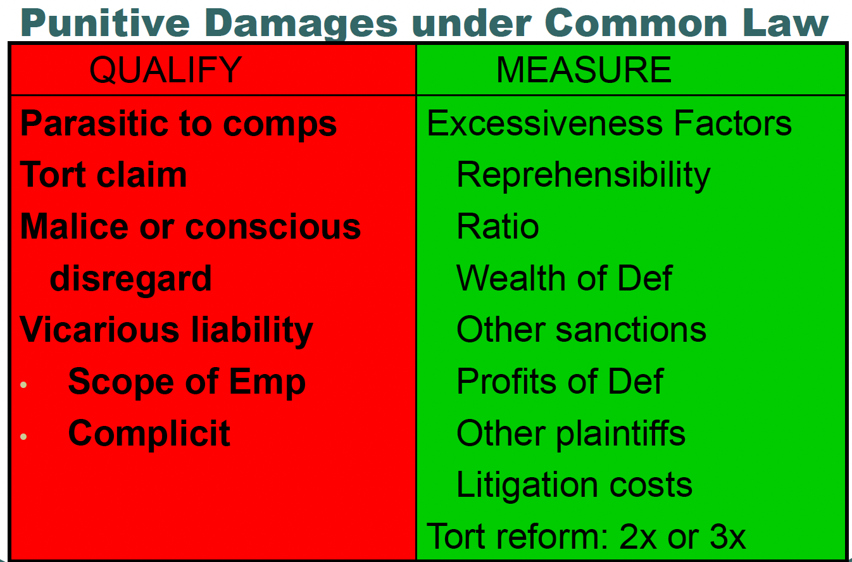
- Fed Constitutional Limits: Dual level of analysis for punitive damages
  - State law: common law based state §
  - Fed law: constitutional limits (grossly excessive → violates due process)
- Due Process
  - 14th A: State cannot arbitrarily deprive property/liberty interest
  - Arbitrary procedure: procedural due process → fair notice/hearing
  - Arbitrary result: substantive due process → Severity; too big award is “arbitrary” taking of ∆ prop
- The 3 Guideposts (BMW v. Gore)
  - Punitive damages must be reasonably necessary to vindicate states’ legal interest in punishment/deterrence, otherwise violates due process
  - 3 factors (in order of importance)
    - Reprehensibility of ∆’s actions (bad faith, recklessness, repeated, etc.)
      - Malice OR conscious disregard of potential harm to others
    - Ratio with compensatory damages (aka the actual harm)
    - Compare punitive to other sanctions in similar cases
- SCOTUS: The Spectrum of Reprehensibility
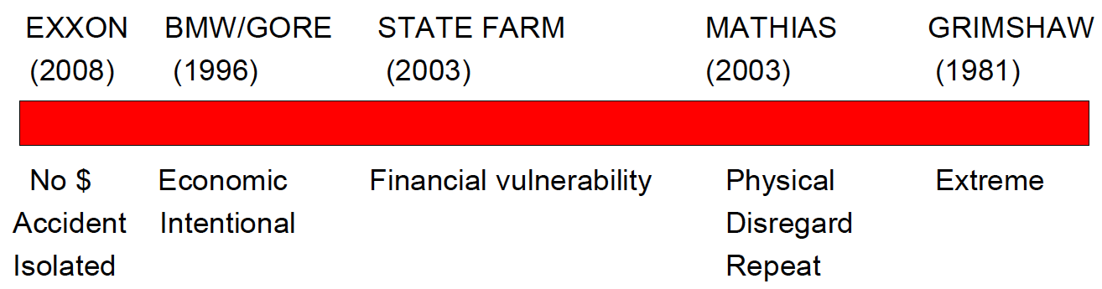
- Campbell: can’t punish State Farm for scheme π was a tiny part of + in multiple states
- Bedbug Motel case: low harm/compensatory + wealthy ∆ ⇒ very high punitive needed!
  - Jury verdict was arbitrary and lacked good evidence. But still OK award
  - Rather deal with this issue in civil court that wastes resources going through crim!

Restitution
- Liability
  - Independent basis for liability in absence of K or Tort claim
  - Unjustified enrichment (UE)
    - Unsolicited: π provides benefit (mistake)
    - Solicited: at ∆’s request (failed K, etc.)
    - Wrongfully acquired: ∆ commits tort
  - Unjust = wrongful acquisition
    - Not a gift
    - Requires ∆ culpability (tort or keeping benefit wrongfully gained)
- Procedure
  - Quasi Contract
  - Constructive trust
  - Others: quantum meruit, rescission, replevin, equitable lien, etc.
- Remedy: π will choose restitution when
  - Unjust enrichment is only source of liability
  - They prefer to measure recovery by ∆’s gain because either it:
    - Exceeds π’s loss
    - Is easier to measure
  - When they prefer specific restitution, either because ∆ is insolvent, because the thing π has lost has changed in value, or because π values the thing he lost for nonmarket reasons.
- Why choose restitution?
  - Unjust enrichment (UE): if no K or tort, restitution is the only source of liability!
  - Election to recover ∆’s gains
    - Alternative claim for UE (waives tort suit)
    - ∆ Gains more than π’s losses OR easier to prove (Olwell)
  - Specific Restoration: Want specific thing/$ back
- Criminal Restitution: General monetary fine paid to victim
  - $$ ordered in crim case to punish ∆, or to compensate for victim’s loss
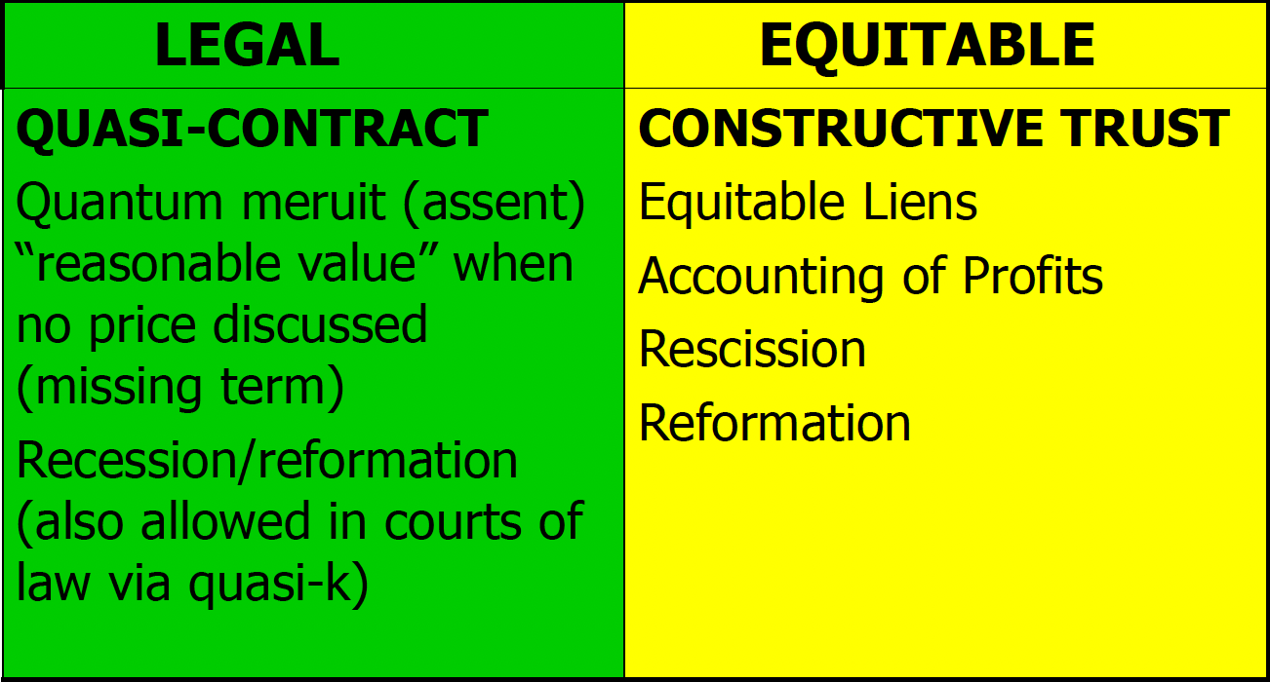
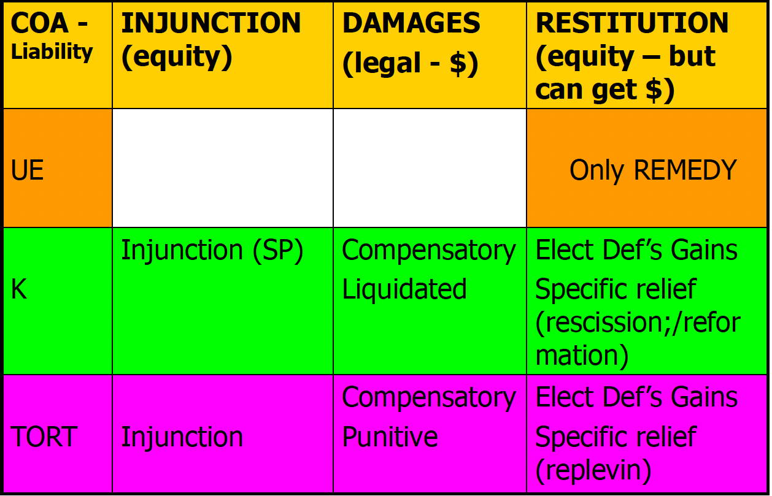
- Quasi K
  - “Implied in law” K: court created fiction
    - Recovery: ∆’s gains or FMV of services rendered
  - “Implied in Fact” K: actual K created by behavior of parties (not legal fiction)
    - Recovery: expectancy damages
- Quantum Meruit (“as much as he deserved”)
  - A type of Quasi-K where there was K between parties but no price decided on
    - ∆ walks into a barber shop, doesn’t say a word, and gets a haircut
      - Other QuasiK: look at benefit conferred on ∆
        - What is the haircut worth to ∆?
      - Quantum meruit: a subset of QuasiK: look at FMV of services
      - Try to use QuasiK first, then Quantum if not
  - Implied K to recover FMV value of services (or replacement costs)
    - NOT gain or value of benefits to ∆!!! (which could be far lower than FMV)
- Issue spotting
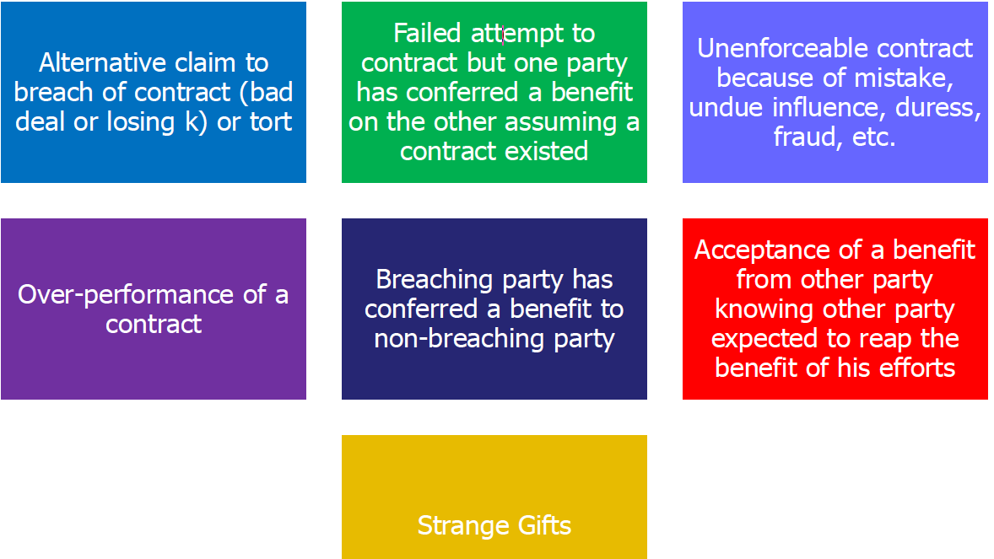
- Summary
  - Restitution: Disgorgement of ∆’s gain
  - Choice: liability or alternative measure
  - How to qualify:
    - Unjust — wrongful benefit
    - Enrichment— gain at π’s expense
    - Procedural device: legal ($) or equitable (specific)
  - Measure
    - ∆’s gain
    - FMV, profits, savings, use/rental value
- Restitution in Contract
  - Alternative liability to K theory, such as where there is no K to breach
  - Restitution vs breach of K
    - Greater gains by ∆ (should this be allowed?)
    - Losing K for π
  - Changing the K
    - Rescind K
    - Restitution for resulting benefit
  - Regular Restitution
    - Quasi K or quantum meruit → if no other basis for liability under K law
    - Equitable restitution (construction trust)
  - Additional specific remedies (Equitable)
    - Recission→ go backwards
    - Reformation→ go forwards
- Rescission
  - Reverse the K (Return parties to original position)
    - Either with $ or a specific order
  - Apply restitution to return any UE to ∆ (EarthInfo)
    - Return benefit obtained
    - Reimburse π for loss (costs under K)
    - Restitution for benefit gained by breaching party (FMV for services π gave to ∆)
  - Used for: Fraud, substantial breach, mistake, duress, and defenses in equitable relief (laches; unclean hands)
  - REMEMBER: Rescission is always paired with restitution!
- Opportunistic breach vs Efficient breach
  - Efficient breach: just allow compensatory damages (small recovery)
  - Opportunistic breach: UE→ can recover part of net profit (large recovery)
    - Must find the part of the profits tied to UE and part tied to ∆’s own efforts
- Losing Contracts: When carrying out the K would hurt π
  - Only allowed by some jdx if ∆ breached in bad faith
    - Taking advantage of a losing K where service costs > payment
    - Give π the value of benefit given to ∆ because ∆ acted in bad faith
  - Can π sue in restitution under quantum meruit
  - Many jdxs dislike losing K cases, and would rather limit such damages to expectation damages
- Reformation Rewrite K to conform to OG understanding of parties (meeting of the mind)
  - Return unjust benefit from mistaken K
  - Possible reasons for reformation
    - Honest mistake/dispute between parties.
    - Successors in interest; original parties no longer around
    - Bad-faith dispute. ∆ tries to take advantage of a mistake in their benefit
  - Requires a valid original K, with a mistake in the writing
  - Defenses: Laches (unreasonable delay) Unclean hands
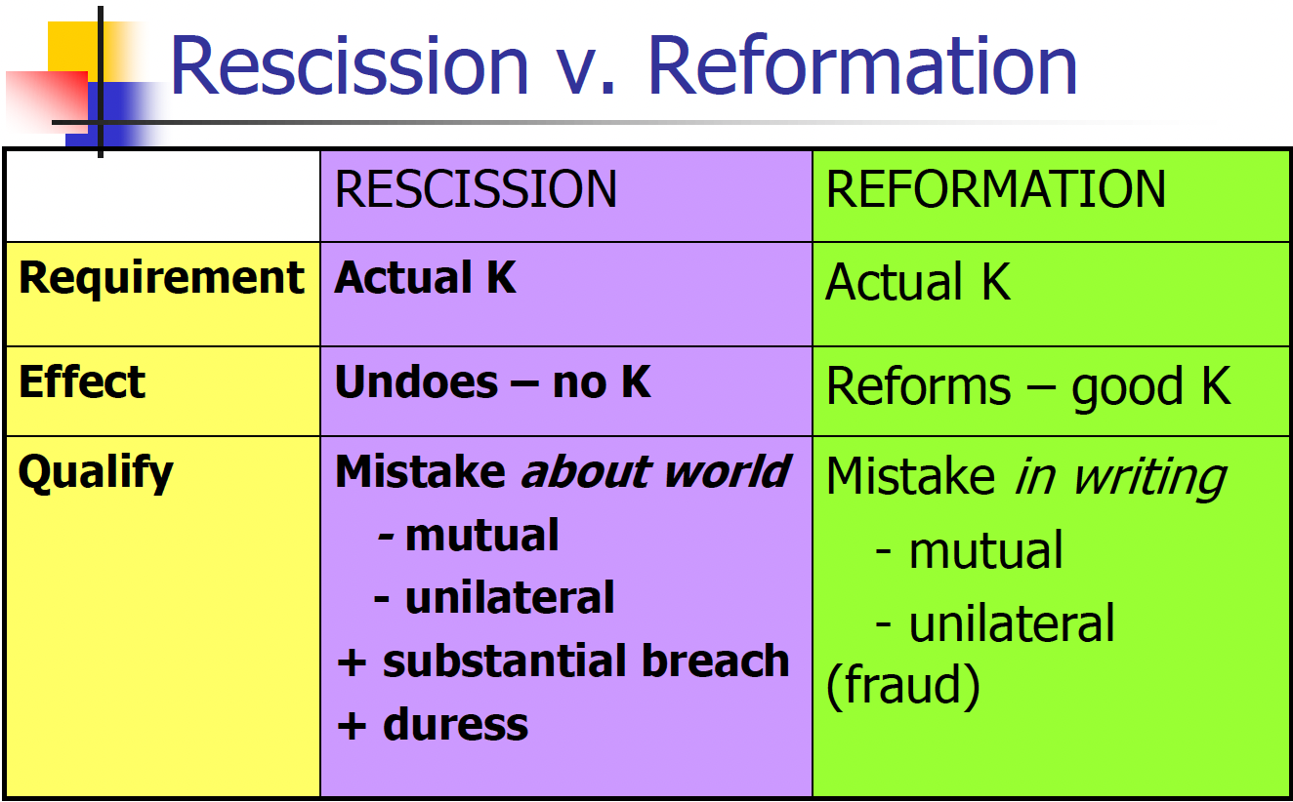
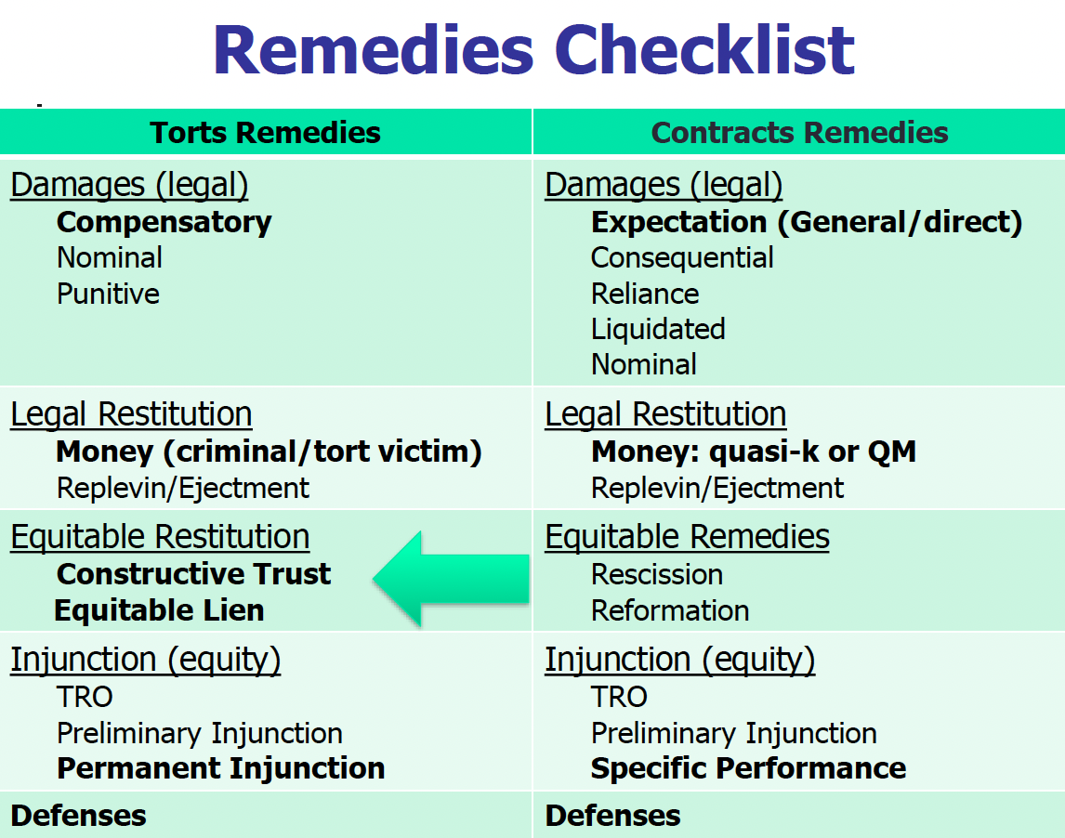

Keep in mind courts can cross over the columns if they want certain remedies
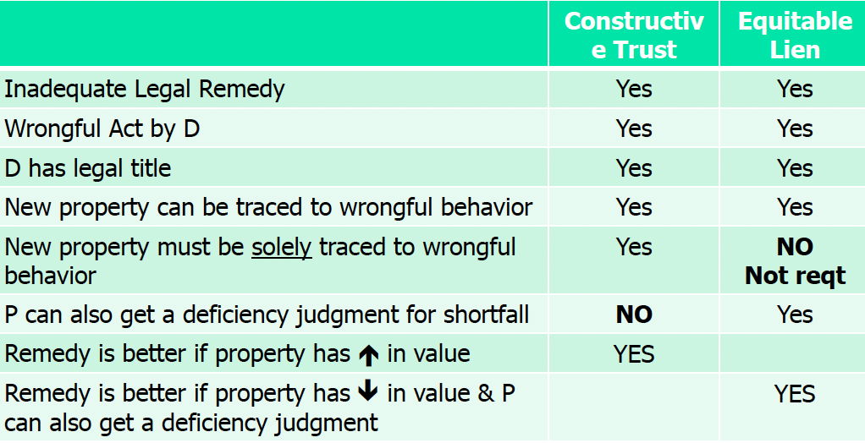

Equitable Restitution
- Requires UE
- Procedural devices: constructive trust, equitable lenient, accounting of profits
- How to measure
  - What: ∆’s gain/benefit
  - How: profits, cost savings, FMV
  - Specific Restoration
  - Tracing: follow money through conversions or subsequent transactions
    - Gets around bankruptcy limits where there is fraud
      - Ex: can obtain ∆’s primary home if obtained with fraudulent funds
      - Cannot normally get home through bankruptcy proceedings
    - May allow for appreciation or for π to reach property that is exempt
- Constructive Trust: trust created to compel title to specific prop re-conveyed back to π
  - Better when the property value has gone UP
  - Fictional Trust implied by law to prevent unjust enrichment (similar to Quasi K)
  - Primarily equitable restitution remedy
    - When property is unique
    - Or when ∆ is insolvent
  - Allows for recovery of gains/profits
    - Not automatic
    - Usually only granted in cases of “conscious wrongdoer”
      - Innocent TPs can limit π’s recovery to equitable lien instead of constructive trust
  - Elements:
    - Wrongful Act (fraud, embezzlement, etc.) that led to unjust enrichment
    - ∆ has legal title to convey
    - Legal remedies ($$) inadequate (though most courts don’t enforce this)
    - Specific prop was acquired by wrongdoer, and property can be traced to wrongful act
  - Default measure: Return of specific prop (tracing) + appreciation in prop’s value
  - Tracing: Must be solely traceable to the new property
    - Lowest Intermediate Balance Rule applies to commingled funds
      - Once traced proceeds are withdrawn, they are gone unless π can show ∆’s intent to “replenish”
    - π gets the benefit of an increase in value
  - Priority over TPs
    - Bona fide purchaser (BFP) with legal title prevail over π (AKA if ∆ uses embezzled funds to buy a car, then sells that car to an innocent BFP, the BFP > π)
      - BFP = took for value ($) without notice of facts giving rise to constructive trust
      - Mortgage holder can be a BFP
    - π > unsecured creditor
- Equitable lien: grants π a lien (a security interest in specific property held by ∆)
  - Does NOT transfer legal title, simply gives π an interest in the property
    - Can foreclose on the property and get the profits of sale
  - Better for when property value has gone DOWN
    - Can also get a deficiency judgment for the remainder of balance owed
  - Also better when property was used to improve other property
  - Elements
    - Wrongful act
    - ∆ has legal title to property
    - Inadequate legal remedy (again, many courts ignore this requirement)
    - Specific prop acquired by ∆ & prop can be traced to wrongful act
      - Unlike constructive trust, it is ok if not solely traceable to new prop
        - Can be a commingled asset
      - Lowest intermediate balance rule applies to commingled funds (once traced proceeds are withdrawn, they are gone)
  - Like CTs: rights to legal title: innocent BFP > π > unsecured creditors
  - Like CTs, can use contempt power to enforce
- Accounting for Profits (A 3rd device)
  - A π’s remedy
  - ∆ must disclose and disgorge profits
  - Default measure: appointment of profits
  - You can also use it on top of equitable lien
  - Both legal and equitable (requires jury trial in fed court)
  - Compared to Constructive trust:
    - Both use tracing
    - Different means of specific qualifications and measurements
  - Painting example: can get back portion of profits associated with materials
    - But only allowed for torts with malintent or opportunistic K breach (not efficient)
  - Fiduciary example: if you aren’t investing a trustee’s money like you’re meant
- Snepp (CIA agent book case): Constructive Trust allowed to recover book profits
  - Natural consequence of breach of trust; acts as a deterrence
  - CT used over accounting for profits as AfP would give Snepp some benefit
- Torres (bankruptcy case): No fraud → not entitled to a Constructive Trust
  - πs wanted to get to the front of the line to get money back from bankruptcy through a constructive trust. Court told them to get in line like everyone else.
- Jolley (LDS embezzlement): Tracing to get a constructive trust over the gifted car.

Remedial Defenses
- Focused on π’s conduct
  - Bad conduct: Unclean Hands
  - Changing positions: Estoppel and Waiver
  - Delay: SoL and Laches
  - Remember Comparative neg vs modified comparative neg (if π >50% fault)
- Unclean Hands
  - Inequitable conduct by π
  - ∆ does not need to show injury, just the conduct
  - Used in equity cases in all jdx, and also for law in some
  - “In pari delicto”: Common law equivalent to Unclean Hands
  - McKennon: wrongful termination for age discrimination. Employer later discovers π committed wrongdoing that would have allowed for lawful termination
    - Front pay and reinstatement do not make sense for an employer who will be immediately fired for a lawful reason right after being reinstated
    - However, recovery of backpay allowed as to the time between firing and time π committed fireable offense
  - Clinton: 2 snake oil salesmen sell “syrup of figs”. Neither can recover because both committed false advertising.
    - Doesn’t matter that Π’s wrongful act did not cause ∆ injury.
- Estoppel Inconsistent acts resulting in detrimental reliance
  - Detrimental reliance causing prejudice
  - Note: Delay/laches is NOT an element in estoppel, though it may be present
- Waiver (CL equivalent) Voluntary and intentional relinquishment of a known right
  - AKA knowingly failing to asset a claim to right → you may lose that right
  - Conduct must be proven by clear and convincing standard
- Estoppel vs Waiver
  - Conduct:
    - Estoppel ⇒ 2 different inconsistent acts
    - Waiver ⇒ 1 unilateral act (express/implied)
  - Mens rea
    - Estoppel ⇒ negligence
    - Waiver ⇒ Intent
  - ∆’s reliance on the act
    - Estoppel ⇒ required element
    - Waiver ⇒ not required element
  - Goal
    - Estoppel ⇒ prevent π from profiting by exploiting action π has induced another to take
    - Waiver ⇒ focus on conduct of π in disavowing a right
- Statute of Limitations
  - Fixed delay in filing complaint
  - Goal is to preserve evidence and to stop fraudulent claims
  - Exceptions: equitable tolling, discovery rule, continuous violations, etc.
- Laches Equity’s version of SoL
  - Unreasonable delay
    - Appliques anytime in case, not just in filing complaint
    - “Substantial length” of time
  - Prejudice to ∆ (because they rely on π’s delay)
- Petralla: Copyright infringement claim on an 18 year old infringement (3 year SOL). π only claims infringement for the most recent 3 years.
  - Laches cannot bar legal relief; only for barring equitable relief
  - This is not unfair to ∆ because it only covers disgorgement for last 3 years of infringement, not for the decades of total infringement.
  - Note: Most courts will allow you to make equitable arguments in a legal claim, though may be weaker as a result of being raised in the wrong type of case.

