SPRING 2023
INTRO TO FEDERAL INCOME TAX
PROF. JUROW-KLEIMAN

UNIT I: INTROUCTION TO FEDERAL INCOME TAX
- Criteria for Evaluating Tax Policies
- What are taxes?
  - When the gov collects $ from the private sector to the public sector for the pursuit of shared public endeavors
  - Tax system used to incentivize behavior
  - Gov spends money via tax benefits -> Spending through tax spending dramatically dwarfs direct spending
- How to evaluate if tax policies are good or bad:
  - Efficiency: Does the tax distort behavior?
    - Tax alters TP’s (individuals or businesses) behavior in an undesirable or arbitrary way
    - Ex: if ppl are indifferent to oranges and apples, a policy that imposes a tax on oranges violates efficiency because it encourages people to buy apples instead
  - Vertical Equity: Does the tax impose a greater burden on individuals with greater income?
    - Better off people should pay more tax
    - Ex: TP 1 makes $100,000 and TP 2 makes $50,000 but they both pay $100 in taxes
  - Horizontal Equity: Does it treat similarly-situated taxpayers the same?
    - Similarly situated people should pay the same tax
    - Ex: TP 1 and 2 both make $100,000 but 1 has a higher tax rate
  - Administrability/Simplicity: Is the tax relatively straightforward to understand, comply with, and administer?
    - Policies should be easy for ppl to understand and apply and for the gov to administer
    - Types of complexity: 1) Rule 2) Compliance 3) transactional
  - Distribution/Disparate treatment: Does the tax law lead to different outcomes among different groups in a systematic way?
    - Policies affect people differently in systematic ways, leading to disparate outcomes by race or gender
    - Ex: White households are more likely to own more expensive housing so they benefit more from mortgage interest deductions
- Different tax rates:
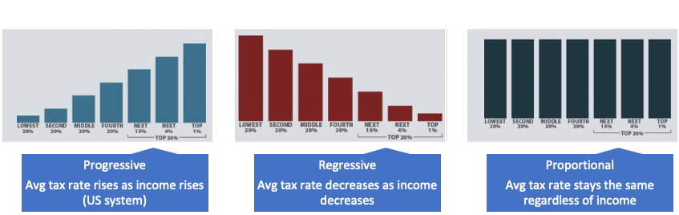

- Understanding Tax Rates and Brackets, Tax Terminology

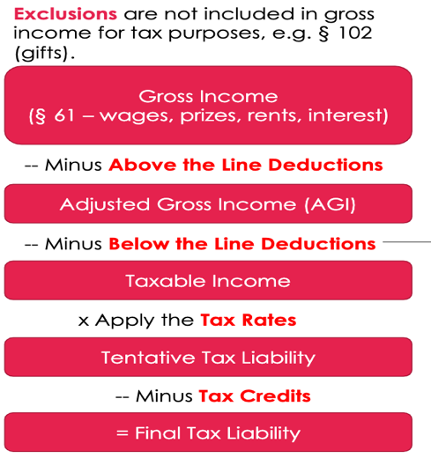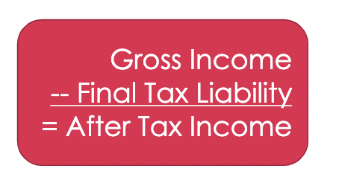
- Steps to calculate tax liability:
- Calculate gross income (GI) = all your income unless specifically excluded
- Subtract above the line deductions = adjusted gross income (AGI)
  - Deductions that the gov wants everyone to take
- Subtract below the line deductions = taxable income
  - Can be standard deductions ($12,950 for single/$25,900 for joint) or itemized deductions -> deduct whichever one is greater
    - If not specifically an above deduction, it’s itemized
  - Less valuable to TPs, you prefer above the line
    - Two reasons:
      - You will only take below the lines if they are greater than the standardized decutions
      - Below the lines are often limited (ie- casualty losses)
- Multiple taxable income by your tax rate = tax liability
  - Tax liability before any tax credits
  - Tax rate changes depending on your income bracket
- Substract tax credits from your tax liability = final tax liability
  - Avg tax rate = total tax liability / taxable income
  - Marginal tax rate = top tax rate on your next dollar of income
- Deductions vs. credits:
  - Tax credits are more valuable -> reduces tax liability at the end at a $ to $ ratio
    - $500 tax credit reduces your liability by $500. $500 deductions reduces your liability by LESS than $500 because you have to multiple it by your marginal tax rate to see what it’s worth.
    - Refundable credits are always worth their full value, if the credit reduces your liability by more than $0 you can claim the leftover via a refund
      - Most credits are refundable
    - Nonrefundable credits can be worth less than their full amount if your taxes owed are less than the credit
      - Normally worth the same as refundable as long as you make enough income
    - Example:
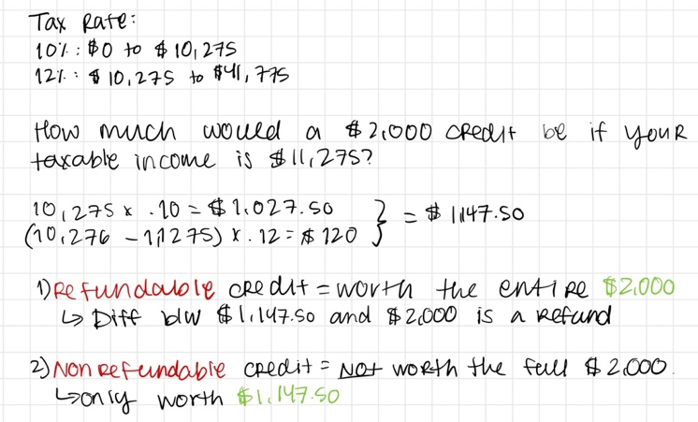
- Value of deductions:
  - A deduction must be multiplied by your marginal tax rate (see tax rate for your income bracket) to determine how much it is actually worth
    - If your deduction straddles two income brackets, use both tax rates. Example:
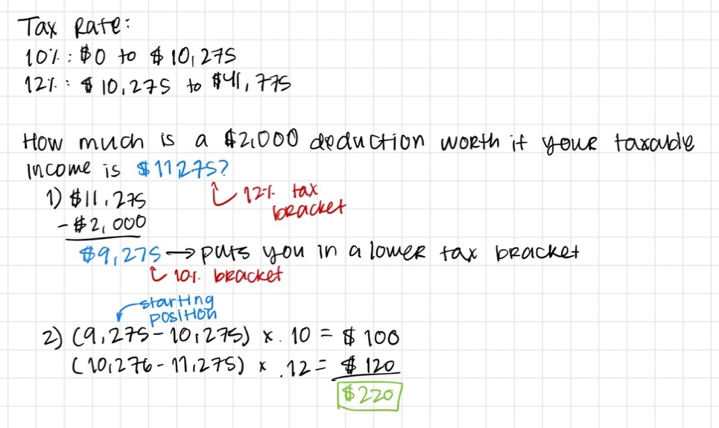
  - Itemized vs. standard deductions: If your itemized deductions are GREATER than your standard deductions, then the difference of those two multiplied by your marginal tax rate is the value of your deduction. If the standardized deduction remains the larger one, you continue to take that one and the deduction is not worth anything.
    - Always assume a deduction is itemized unless specified otherwise
    - Example:
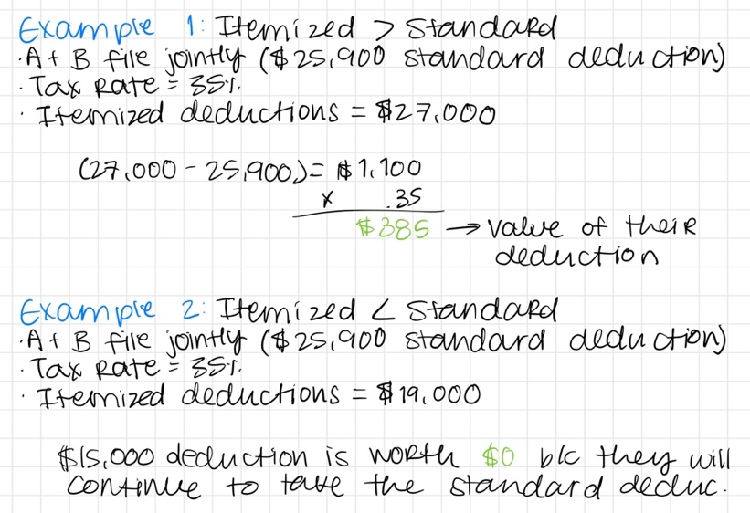

UNIT II: WHAT IS INCOME?

§ 101 – 131A are mainly exclusions

Type | Included or excluded? | Authority (Governing authority: §61: income is all income unless otherwise excluded)
Imputed income | Excluded. A nontaxable increase in consumption. | None—nowhere in the code
Labor compensation | Included.  Tip income = included
Payment of taxes | Included. Income is income no matter the form of receipt, taxes paid as compensation is still income. | Old Colony
Employer paying your tuition | Excluded up to a certain amount. Anything over the threshold for educational assistance is included. | §127
Scholarships | Excluded. Must be a qualified scholarship not in exchange for work/your services. Does not have to be from your school specifically, can be an outside scholarship (ie- Gates foundation) | §117
Fringe benefits | Depends, some are specifically excluded in 132. Others like meals and lodging are excluded under other sections.  Ex:  - Working condition fringe (must be deductible to the employer as an O+N biz expense under 162)  - Qualified parking (but there is a limit on how much can be excluded)—capped at $300  - No additional cost service: benefit has to be provided equally to all employees regardless of rank (ex: airline employees can fly for free on a standby)  - Employee discounts: benefit has to be provided equally to all employees regardless of rank up to 20%  - De minimis fringe: something so small in value that happens infrequently (cash is never de minimis) | §132
Cash given by employer | Usually included. If you can use the money at any time/have the option of when to use it it is included.  Ex: Food vouchers with limits on when you can use it (ie- only at work) are not included, but if you can use it at any time it’s included | American Airlines
Meals and lodging furnished for the convenience of the employer | Excluded. Must be for the convenience of the employer. Meals must be furnished on site and lodging must be a condition of the job  Extends to spouses and dependents | Benaglia, §119
Business trips | Excluded. Only if the dominant purpose of the trip was business (more than 50% of the trip was for business) and not for a personal benefit. | Gotcher
Gifts and bequests | Excluded from recipient, not deductible from giver. | §102
Prizes | Included.  Exceptions:  - Made for recognition of religious, charitable, scientific, educational, artistic, literary, or civic achievement (ex: Nobel Peace Prize). You couldn’t have nominated yourself and you can’t be required to do anything after winning the award to keep the award  - Olympic medals/prizes | §74
Treasure trove | Included. | Cesorini
Cash dividends | Included. | Eisner
Cancellation of debt | Included | § 61(a)(11)
Borrowing $ | Excluded—not income no matter what you borrow the $ for
Reimbursements from employer | Not an exclusion but a Deduction.  Must be if it would ordinarily be a TB expense under 162 if you had your own biz.  Ex: Mark buys a $2,500 computer for work and his employer reimburses him for it. The $2,500 is excluded from his income. | 62(a)(2)(A)
Improvements of property | Excluded  excludes the value of the improvements from gross income so long as they are not substitutes for rent | § 109

- Form of Receipt and Imputed Income
- Two ways to define income:
  - §61: Income is all income from whatever source derived
  - Haig-Simons Income: Income = Consumption + Change in wealth (I = C + ΔW)
- Exclusions vs. deductions:
  - Exclusions are income that is specifically left off a return (not reported/not included in gross income), while deductions are reported but then subtracted from income
  - Exclusions are before the tax math, deduction is in the tax math
  - If you deduct an expense, it’s the same as paying for it with pre-tax income
    - If you have to buy something for $100, you would rather pay for it out of your pre-tax income than your post-tax income -> each pre-tax $ is worth less since taxes will be taken out
  - Exclusions and deductions are equally as valuable, but credits are worth more than both
  - Deductions are more valuable the higher your income is (value of deductions = deduction x marginal tax rate
    - Your tax rate gets higher the more your income is b/c it moves you into higher tax brackets
- Imputed income: Non-taxable income → a noncash increase in consumption from ppl’s self-owned property or self-provided labor
  - No code section says that imputed income is not taxed, but that’s how it works
  - Ex: Sarah grows $10 of red apples but she hates red apples so she sells them for $10. Is the $10 taxed? YES vs. Sarah grows $10 of red apples but she eats them herself. Is the $10 taxed? NO. This is imputed income.
    - Equity problem: similar income in both situations ($10), but one is getting taxed and the other isn’t
  - BUT the bartering of services NOT imputed income
    - Gross income includes barter transactions in which TPs exchange services
    - Ex: Marie is a tax preparer, and she prepares her dentist’s taxes in exchange for a free checkup. Her preparing it is worth $500. Is this 500 included in her income? YES
- Payment of taxes by a third party is taxable income (Old Colony- company paid taxes on Mr. Wood’s behalf as party of his compensation)
  - The form of payment of income does not matter, still income
  - Income does not have to be in cash or received by the TP directly. A company paying your taxes or any other obligation is taxable.
  - If employers pay your taxes, they have to worry about income stacking → must calculate the total amount of gross income that would result in the desired amount of after-tax income
    - Ex: joint filing and one person makes 100K, that puts them in higher tax bracket, if other person gets offered job at 40K that is taxed at the highest bracked.

- Fringe Benefits
- What are fringe benefits? In-kind, Non-cash benefits given to employees as part of their compensation
- Cash is clearly taxed as income b/c you are getting a personal benefit, and in-kind things that are not compensatory are not taxed → on a payment spectrum:
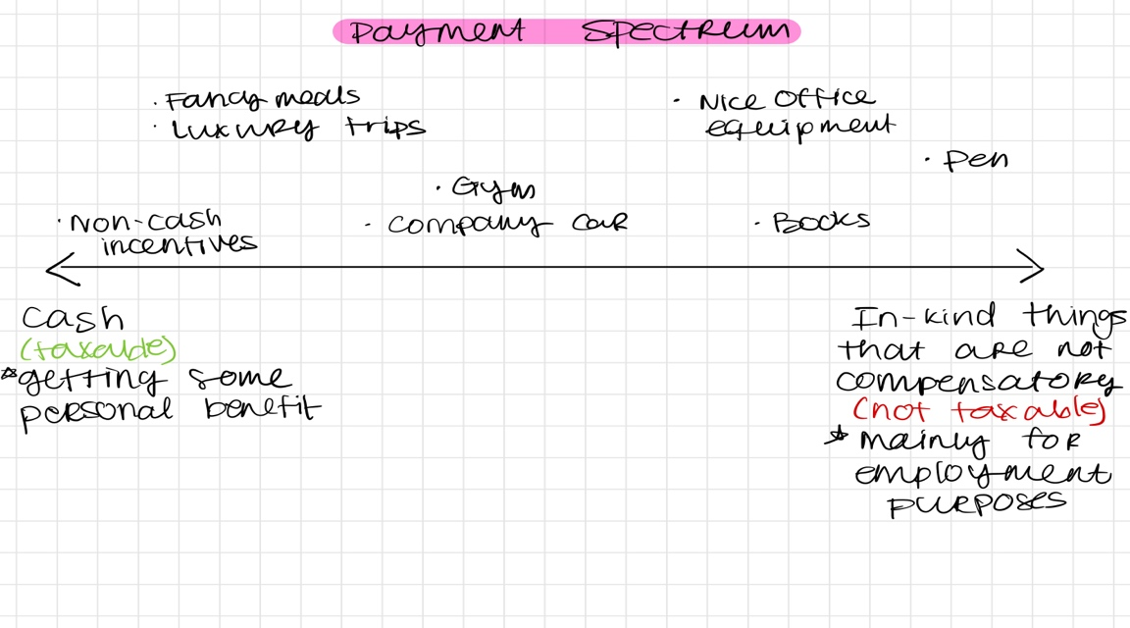
- Meals and lodging can be excluded from taxable income if its necessary for work (Benaglia- TP required to work and live in a hotel as his job)
  - Excluded when it is not just for your personal convenience/benefit but instead a benefit to the employer. Must be necessary for work.
  - Here meals and lodging were necessary for work b/c he was a hotel manager so he needed to be on site at all times
  - Later codified in §119- lodging and meals from an employer are excluded when they are for the convenience of the employer
    - Meals:
      - Employer furnishes meals to employer
      - Meals are provided for the convenience of the employer
      - Meals are provided on the business premises
    - Lodging:
      - Furnished on the business premises
      - Provided for the convenience
      - Lodging must be a condition for the job
- An in-kind (non-cash) related benefit like a work trip is excludable if it serves a dominant business purpose (Gotcher- Mr. and Mrs. G got an all-expense paid trip to Germany so Mr. G could invest in VW cars)
  - Dominant business purpose test: Mr. G’s trip was mainly for business (dominant purpose of the trip was business), so it was excluded. Mrs. G’s trip was mainly a vacation (personal benefit), so it’s included.
    - Today the test is: was more than 50% of your time spent doing business activities?
- Employers will prefer to pay employees via nontaxable fringe benefits because they can pay less but provide employees the same consumption.
  - Fringe benefits are not taxed for either party

- Gifts and Bequests
- Gifts are excluded from income by the recipient and are not deductible by the giver to prevent income shifting
  - Exceptions:
    - Charitable gifts: Deductible by the giver and excluded by the recipient
    - Business gifts: Deductible by the giver and excluded by the recipient
      - Limits on biz gifts: gifts from employer to employee are not excluded (concern with income shifting). § 102(c)
        - A TRANSFER FROM EMPLOYER TO EMPLOYEE IS NOT A GIFT
    - Prizes and awards: Game show prizes are included in income. Exception: Olympic medals and cash prizes
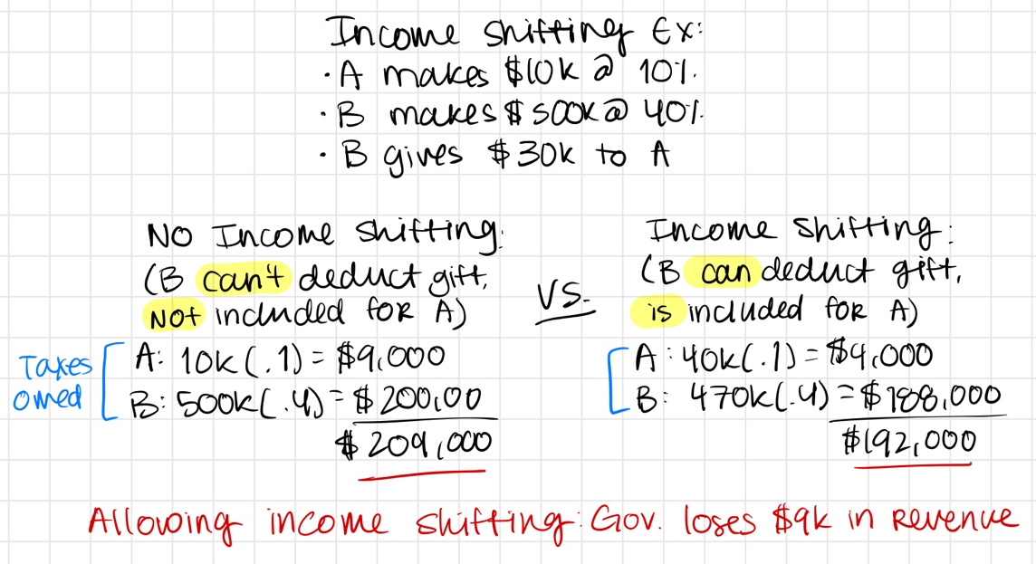
- Test for what is a gift: must arise out of detached and disinterested generosity (Duberstein)
  - Depends on the intention of the giver. If an altruistic motive = more likely to be a gift
  - Transfers b/w family members = more likely to be gifts
  - This issue tends to be decided by lower courts and hare hard to appeal

- Introduction to Basis Recovery
- Income generated from property is taxed → we want to tax the amount by which TPs are better off
  - Ex: You have $100 in cash and buy $100 in stock. If you sell the stock for $105, should we tax the full sale price ($105) or the gain only ($5)? ONLY TAX THE $5
    - Don’t want to tax TPs for property they already have
    - Allows TPs to make sure they are taxed on what the improved/invested into the property → AKA recovery of capital
- GAIN/LOSS = AMOUNT REALIZED – BASIS
  - Amount realized (AR)= the price you get when you sell/transfer your property
  - Basis= TP’s investment in the property (usually it’s price—either what you paid for the property and it’s adjusted for certain things over the property’s life)
    - Covered by § 1012. Basis = cost (what you paid for) unless there is an exception
  - Increasing your basis is like a tax goody, it decreases the amount of gains that you are taxed for
- Default rule = all gains are taxed, unless there is an exception
  - Losses are deductible, but are more limited
- Gain is not taxed until it is realized AND recognized
  - Realization= a triggering event that that is needed for something to be taxable. Usually it’s a sale, but can be any transfer of property (ie- property changes forms or changes hand)
    - Ex: gifts are a realization event, but they are not recognized since they are not included in income
    - Ex: in Y1 you have stock worth $100. In Y2 it increases to $200. Do you have income? Yes, your wealth increased by $100. But the income is NOT taxable because there must be a realization event, like a sale
  - Recognition= the act of including gains or deducting losses in your taxable income
- Timing basis of recovery: you can recover basis (subtract the basis somewhere)
  - Ex: you buy an apt for $100 in Y1, get $20 of rent in Y2, and want to recover $100 of basis. When should you recover—immediately, only upon sale gradually over time? Immediately
    - Time value of $: always better to get a tax benefit now and to pay taxes in the future
      - $1 today is worth more than $1 in the future, $1 in the future is worth less than $1 today.
      - TPs should defer tax payments and accelerate tax benefits → want to deduct $ as quickly as possible
        - TPs want to defer tax b/c you can invest the deferred tax and earn income on it until the tax is later paid to the gov
      - The value of money is discounted over time
      - Present value = the amount you would have to invest today to get a specified amount in the future at a given interest rate
        - Ex: You would have to invest 39 cents at a 10% interest rate to get $1 in 10 years. If someone offers you $1 10 years from now it’s only 39 cents today.
      - Future value = the value at some time in the future of a specified amount of money today at a given interest rate
        - Ex: $1 today is worth $2.59 in 10 years at 10% interest
- Basis and income shifting: TPs can shift income/gains by transferring property with built in gain to lower-tax individuals, but they cannot shift losses
  - This is VERY common and done all the time
  - Ex below: we have allowed A to income shift to B so that she is not taxed on the gain for her property. Does this screw over B? No, she is getting a property
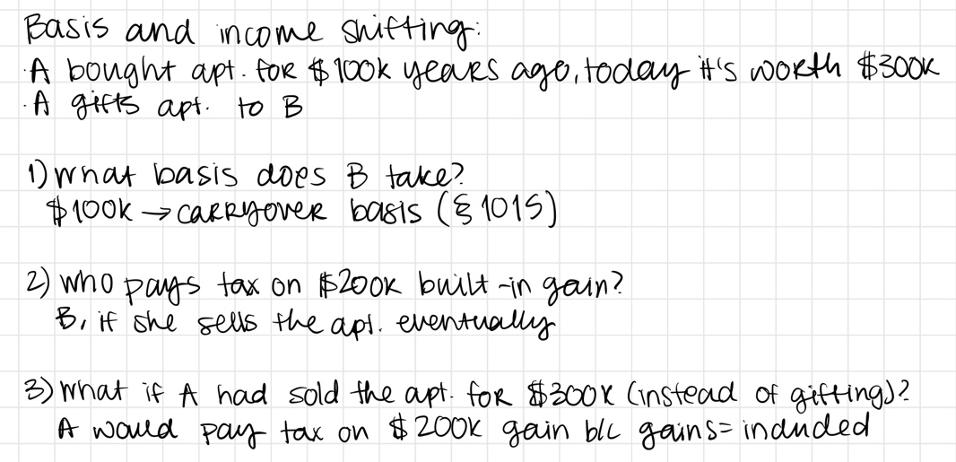
- Calculating basis:
  - GIFTS (§ 1015):
    - Built in gain: FMV is bigger than carryover basis (CO is the donor’s AB at the time of sale)
      - Default rule: Gain = AR – carryover basis
      - Ex: A gifts B stock worth $100 that she bought for $45 years ago. B sells it for $150.
        - FMV is bigger than carryover basis (100 > 45) so it’s a built in gain
        - B’s gain = AR (150) – basis (45, carryover basis) = 105
    - Built in loss: FMV is less than carryover basis
      - 1) Sell for a loss: AR is smaller than the FMV and CO
        - Basis is the FMV at time of transfer
      - 2) Sell for a gain: AR is bigger than both FMV and CO basis
        - Basis is the carryover basis (default)
      - 3) In between: AR is in b/w FMV and CO
        - No gain or loss realized
  - BEQUETHS (§ 1014):
    - Basis is ALWAYS going to be FMV at time of death (stepped up basis)
    - Result is that all gains/losses over the property owner’s lifetime go untaxed at the time of their death/transfer
      - It is astronomically better to receive bequeathed property as opposed to gifted property.
      - Incentivizes TPs to sell their property with built in losses before they die b/c they cand deduct the loss, and hold on to those with built in gains until they die so it can be bequeathed
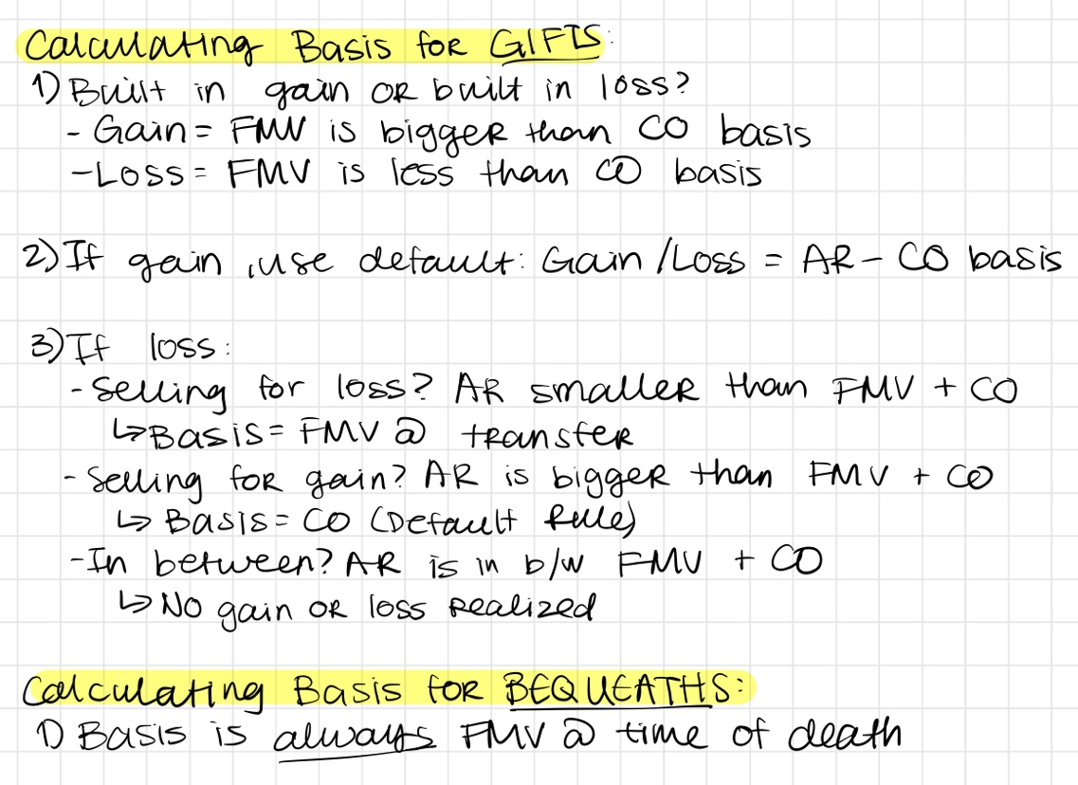
- Rule of thumb for exchanges: For exchange of property, basis in property received is exchange basis, which = FMV of property given (FMV of exchanged properties are assumed to be equal/assumed to be an arms-length transaction)
  - Farid case: What’s your basis when you don’t pay anything and there is a transfer of property? Courts will assign FMV of the property since it’s assumed to be an arm’s length transaction
    - Fiancé gets shares of stocks in exchange for her giving up her marital rights to property once they are married (valued at ~ 1/3 of husband’s property). They divorced and she sold the stocks, what is her basis?
      - If a gift = use carryover basis
      - If an exchange = use exchange basis AKA cost basis
        - Ct concludes it was an exchange even though it was not “equal” (she gave up over $100M for stocks with a FMV of $200K
    - Takeaway: prenup agreements are an exchange for tax purposes and you take the exchange basis, which is the FMV of the property exchanged (assumed to equal the FMV of the property received)
      - Exchanges that occur out of marriage are treated totally different than exchanges b/w spouses (always use CO basis as if it were a gift)
      - Transfers incident to divorce: no gain or loss taken at the time of transfer. § 1041
- Allocating partial basis: if you sell half of the property, you take half of the basis
  - Ex: Someone buys 500 trees for $5,000 total but sells only 100 trees. The basis for the 100 trees would be $1,000 ($10/tree)
  - Ex: You spend $1,000 on materials to create two paintings, and you sell one of them for $5,000. Your basis for each painting was $500, so your gain for selling one painting is $5,000 – $500 = $4,500
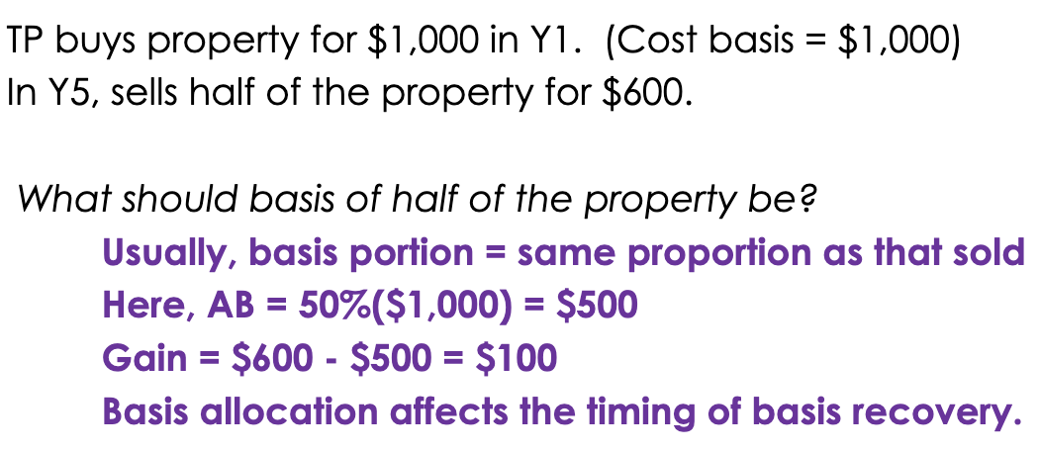
- Substitute payment rule (Hort): if a payment is a substitute for ordinary income (ex: rent, interest), the payment is taxed as ordinary income
  - Hort case: Party entered into commercial lease w/ Hort, lease was cancelled and they paid Hort $140K to get out of it. Hort does NOT report this as income and instead tries to recover it as a loss
    - Ct disagrees: just b/c lease is property does not make it capital income. Rental payments are not a realization event.
    - A payment that is substituted for another type of payment is still income, here the $140K was just a substitute for the years of rent the party was getting out of
    - General rule: TPs can’t choose how to recover basis and to recover you need to sell the property
- Substantial risk of forfeiture:
  - When a TP receives property/something other than cash (stocks, real property) as compensation for services, they must report income as soon as the property is no longer subject to substantial risk of forfeiture AKA when your ownership vests, but you can choose to report in the year received instead
    - § 83(a): must declare as income the difference b/w FMV and amount you paid for the property (Ex: Cai buys an apt from her employer for 1M and the FMV is 1.5M. She would declare 1.5M – 1M = $500K)
    - § 83(b): you can choose to declare it the year the transfer is made or the year it vests
      - If you take the election—you can declare it the year you get it. If you do NOT take the election—you declare it the year it vests.
        - If you do NOT elect, you are waiting until there is no substantial risk of forfeiture to report it as income (AKA the year it vests), so you have 0 income from the property/stock in the year you get it
        - If you CHOOSE to elect, you are choosing to pay taxes in the year it is received
      - When might you choose to declare it immediately when it is transferred?
        - If you are given property at a very low value and expect it to grow a LOT
        - If you plan to stay at a company for many years
        - Sometimes it’s just guess work
      - Example:
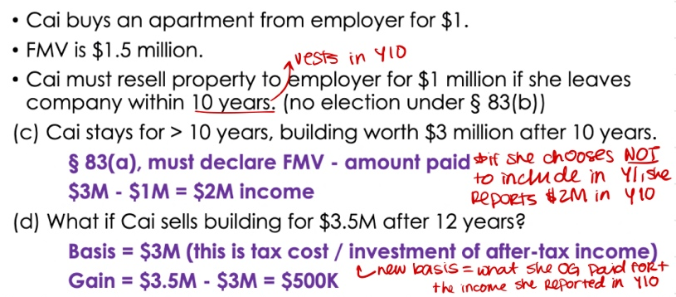
    - § 83(b)(1): if you choose to declare the year you receive the property and then forfeit it (leave the company before your ownership vests) and then sell it for a loss, you can’t deduct the loss
      - Once your ownership vests there are no loss limitations
Basis code sections:
Code | Meaning
$ 1001 | Calculating basis: Gain = AR – Basis (if it comes out to be negative then it’s a loss)
§ 1012 | Basis is cost basis (what you paid for it) unless otherwise provided
$ 1015 | Gift basis rules (see chart above)  - Default rule: use CO basis  - For property with a built in loss and sold for a loss → basis = FMV at time of transfer. By doing this the giver is not allowed to transfer the loss to the seller  - For property with built in loss and the AR is in between CO and FMV at time of transfer → no gain or loss
§ 1014 | Basis for bequests is the FMV at the time of death always
§ 1016 | Renovations/projects that add value to your property increase the basis. Basis = cost basis + added value
§ 1041 | No gain or loss for transfers of property between spouses or incident to divorce
§ 83 | Property transferred as compensation for work/services.  (a) What is included in gross income is the FMV – amount paid for the property. If you later sell the property the basis becomes what you originally paid for plus this amount that you included in your income.  (b) TPs can elect to include this income either in the year the transfer happens or the year the interest vests (no substantial risk of forfeiture)  (b)(1) If you elect to include it in the year you get the property but then sell it for a loss if you forfeit the property (leave the company before your ownership vests), the loss is not deductible
THINGS THAT CHANGE YOUR BASIS | - Default = cost basis  - Gift = CO basis  - Depreciation deductions = reduces basis  - added value to your property (improvements) = added to basis  - Allocating partial basis = changes basis  - Insolvency (total debts – total assets) = reduces basis in your remaining assets  - Like kind exchanges = you keep your OG basis  - Exchange basis = if you exchange something that is hard to value you assume they have equal basis

- Realization Requirement
- Recognized Gains/losses are not taxable unless they have been realized
- Something that happens to property that triggers the realization of built in gains and losses
- How to define a realization event:
  - Sale (must common)
  - Property changed hands
  - TP has new legal entitlements
  - TP is able to consume/control the investment
  - TP must be aware of the benefit/value of the property
- Example:
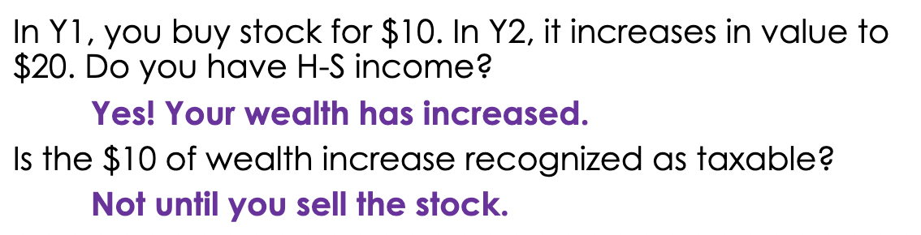
- Cesorini: Income is not taxable/realized until TP is aware of it and can benefit from it in some way
  - TP bought a piano, found cash in it years later— Is it income? Yes. Found $ is not exclusively excluded in the code as income, so it counts.
  - When do they include it income—the year they bought the piano or the year they found the $?
    - The year it was found → $ cannot increase your income if you don’t know about it
  - Is it income? Yes. Found $ is not exclusively excluded in the code as income, so it counts.
  - IRS has a policy of not taxing found property unless its cash, if it’s not cash then it’s only taxable when sold
  - Takeaway: things shouldn’t be taxed until you own it/possess it/control it/etc.
  - TREASURE TROVE IS TAXABLE. Finding cash in piano is taxable income.
- Haverly: TPs cannot “double dip”—take both an exclusion on property and a deduction. Also shows that a deduction can trigger realization of income
  - TP received donation of books and tried to exclude and deduct them
  - Donation of books is the realization event – TP is exercising complete control over them. You can’t try to deduct something that you don’t own.
    - NOT a gift b/c not out of detached and disinterested curiosity
    - NOT a fringe benefit b/c he’s not an employee of the book publishers
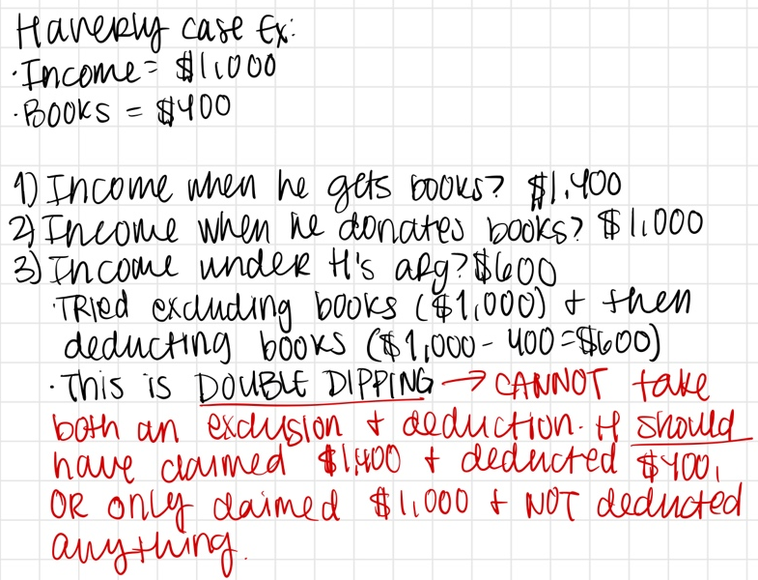
- Eisner: pro-rata stock dividend does not trigger realization (considered to be the case that established the realization req)
  - TP got issued stock dividends from a company—is this taxable income? NO. It just increases your number of stocks in the company, but the total FMV of the stocks/what they are actually worth remains the same (ie, still $200)
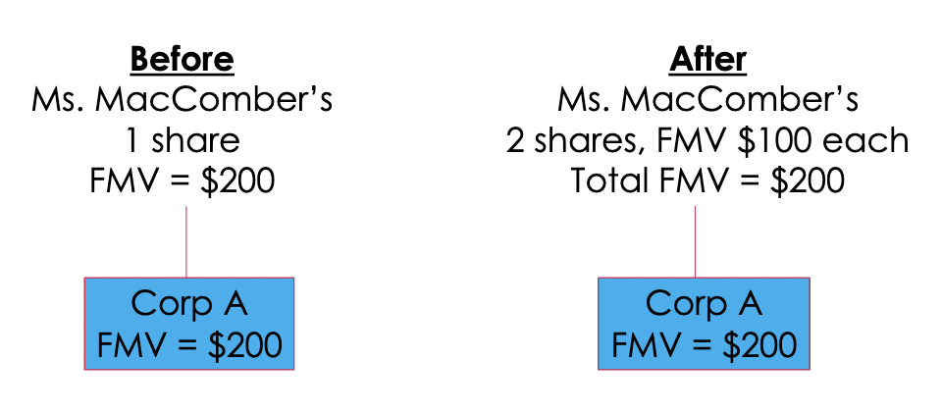
  - Cash dividend (payments made in cash to shareholders based on the number of shares they hold, can be used to buy more stock or just as normal cash) DOES trigger realization
- Cottage Savings: An exchange of properties only triggers realization if the properties are materially different = subject to distinct legal entitlements
  - TP exchanges loan portfolios w/ another bank, they are both essentially equal in value. TP tries to deduct the loss from exchange, is this swap a realization event? YES
    - Loans are materially different b/c they are from different banks → the debtors are different so the collateral for the debts are different
    - Holding allows financial institutions to swap stocks and deduct the loss
  - Ex: A and B purchase $5,000 of gold coins from the same dealer. 2 years later the FMV drops to $3,000. They decide to swap to try to deduct the loss, can they do that?
    - Probably not, not materially different since they are both the same gold coins. Maybe one of them could melt the gold and make jewelry and then it would be different
- § 1031 Like-Kind exchanges:
  - Allows the nonrecognition treatment for exchanges of real property where gain is not recognized upon exchange
  - Permits TPs to swap property and not pay tax on the gains.
  - It is a realization event (property is changing hands) but it’s NOT recognized so gains go untaxed
  - TPs take the OG basis in their property, not what it might be for the property they are swapping for
  - Ex #1: M owns building in DTLA that she bought 10 years ago for $20M, it’s now worth $40M. She wants to sell the building and move to AZ but she doesn’t want to pay tax on gains.
    - Under 1031 she should exchange the office building for one in AZ and she would keep her OG basis of $20M

  - Ex #2:
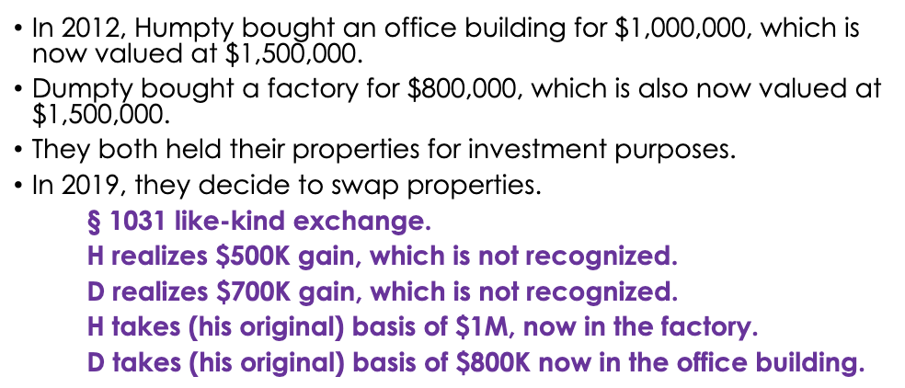
  - Limits to 1031:
    - Can’t be properties held for sale
    - Has to be real property held for investments/business properties (ex: office buildings), can’t be residences
- Major policy reasons in favor of the realization req (ex: why don’t we tax caught baseballs?):
  - 1) Liquidity: unrealized gains do not create cash to pay taxes
    - Ex: if you’re a normal person and you catch a $1M baseball, you won’t have the cash to pay taxes on it (taxes would be approx. $400K)
  - 2) Valuation difficulty: some property is difficult to value until sale
    - Ex: Hard to value how much the baseball is actually worth
  - 3) Administrative simplicity: annual valuation would be very burdensome
  - 4) Fairness: not fair that some could pay and others couldn’t
  - Efficiency:
    - Lock-in: TPs won’t sell property when they otherwise would
      - You should decide to sell/not sell based on economic reasons, not tax reasons
    - Distortions to investment activity: Ppl will buy more growth assets (growth stock, investment real estate) and less income-generating assets (dividend stocks, bonds, rental property)
  - Equity:
    - Vertical: Two people make $30K each, but one of them has a house with a built in gain. The person with the house should be getting taxed more but they are not.
    - Horizontal: Someone makes $30K and is taxed on it, but someone with a $30K built in gain is not taxed on it until its realized
  - Administrative: Annual valuation of gains on your house (in a world without a realization requirement) would be super hard to implement and would increase the burden of calculating your gains and losses.
  - Disparate outcomes: Wealthy ppl who can hold onto their wealth benefit more from the realization requirement b/c they can go without taxing their gains
- What TPs benefit from realization requirement?
  - Those who can hold onto their wealth and not sell
  - Entrepreneurs w/ growing small businesses: they are not realizing early stocks until later when they sell them
  - Savvy commercial investors w/ sophisticated partnerships (can just trade stocks w/ other banks and not get taxed on the gains)

- Borrowing
- When you borrow $ you don’t have to pay taxes, but when you pay back the principal you can’t deduct it either. Loans are not taxed when received and not deducted when paid.
  - Ex: TP borrows $1,000 from the bank and spends it. Is it income? NO. Can he deduct the $ when he pays it back? ALSO NO.
- Paying back the interest (the extra $ you have to pay back on top of the principal) is sometimes deductible → interest is taxable income
  - Any portion of your debt that is deductible does not create COD income. § 108(e)(2)
    - Payments of deductible interested do not create taxable income when cancelled
    - Ex: $500 of deductible student loan interest that is then cancelled is not included in COD income. When calculating how much gross income one would incur from the cancellation of debt, subtract the amount of deductible interest
- Doesn’t matter what you borrow the money for (vacation, clothes, school, etc), it is never income
- Cancellation of debt (COD) IS taxable income: § 61(a)- income is all income including (11): income from discharge of indebtedness
  - Ex: Company sold bonds worth $500K (bonds are corporate loans) and buys them back for $200K. Do they have income? YES, $300K of COD
    - Would the answer change if company were bankrupt? YES, 108 would allow them to exclude COD income but they would have to reduce their assets by the extent of their insolvency
- Exception to the general rule that cancelled debt is taxed: insolvency, § 108
  - Discharged debt is not included in income to the extent the TP is insolvent (total debts are more than total assets)
    - Extent of insolvency = total debts – total assets
    - But then you must reduce your basis in other assets by the amount you excluded the COD income. Reduce by the amount of your insolvency.
    - Ex:
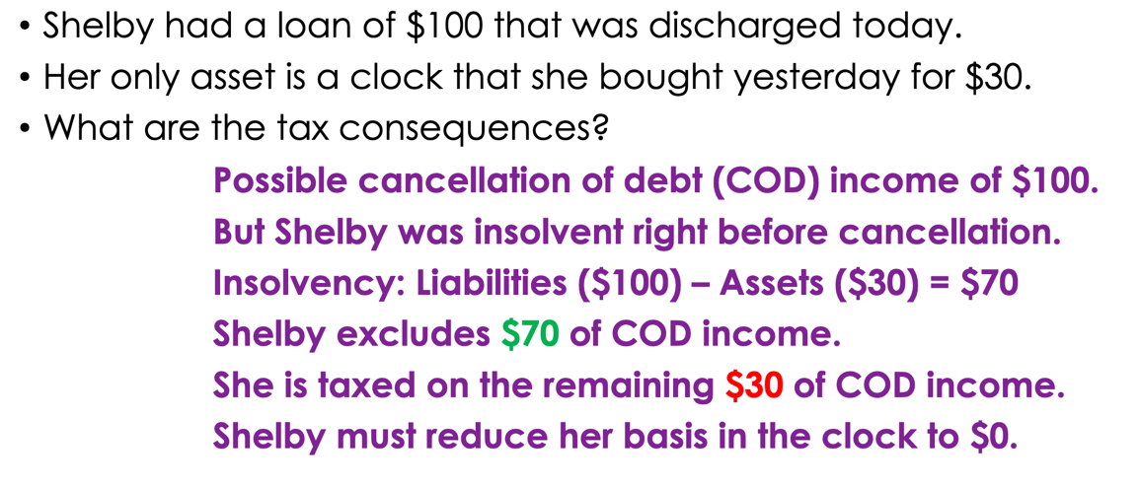
  - Why do we do this?
    - Sometimes debt is cancelled b/c of financial instability, so taxing that would be like a double penalty
    - Don’t want ppl to be extra financially distressed or contribute to a downward economic spiral, want to give ppl a fresh start so they can continue to be productive
    - An uncollectable tax—TP did not have $ to pay back the debt in the first place let alone the tax that is imposed now on the cancelled debt
- Zarin: TP was a big gambler, accrued $3.5M of debt w/ a casino. Eventually he settled the debt for $500K w/ the casino and paid that off. Is the reduction of debt (3.5M – 500K) taxable income? Aka does he have COD income of $300M that is taxed? YES
  - Ct reasoning: He still got something of value, so he should be taxed on it
  - Other approaches (dissents):
    - Enforceability: a debt that is unenforceable may not give rise to COD income (here the debt was unenforceable b/c under NJ state law they were too high)
    - Contested liability/disputed debt doctrine: disputed debt that gets resolved may not be COD income
      - If there is a dispute for debt liability and it’s settled for a smaller amount, this smaller amount is the new true liability
      - In Z case it would be 500K
      - Never going to have COD income
    - Purchase price adjustment: a TP can exclude COD income when the seller is also the lender and the parties agree to reduce the debt amount. § 108(e)(5)
      - Elements
        - Seller is also lender
        - TP can’t be insolvent
        - Specific circumstances where they agree to another debt

Exceptions that may allow TPs to exclude COD income:
Insolvency
§ 108(a)(1)
Enforceability
Contested liability doctrine
Purchase price adjustment
§ 108(e)(5)
Deductible debt  § 108(e)(2) | COD income not realized to the extent that payment of it would have given rise to a deduction. Ex: student loan interest, mortgage interest  Payment of interest that is deductible does not create taxable income when cancelled

UNIT III: DEDUCTIONS AND CREDITS

- Ordinary and Necessary Business Expenses
- Three different ways the tax code treats expenses:
  - 1) Immediately deductible
    - Immediately reduces taxable income
    - Ex: 162 O+N
  - 2) Capitalized
    - Not immediately deducted, instead it creates basis to an asset to later decrease your gains
    - Might be recovered at time of sale or over time via depreciation
    - Tax benefit- defers reduction of taxable income to a later time
  - 3) Personal
    - Not deductible under § 262—personal expenses are not deductible
- Why do we allow ppl to deduct biz expenses?
  - Cost of doing business requires you to spend $ to make $
  - When you spend the $ you are not doing it for personal reasons but out of necessity for your business, so to measure income correctly we need to deduct them
- CODE AUTHORITY:
  - § 162- deduction for expenses related to trade or business
    - Ordinary: was the expense common, accepted, or usual in the line of work
      - occurring regularly or standard in the course of business
    - Necessary: did TP believe the expense was helpful or appropriate
    - If something qualifies as a business expense, the transportation costs to get there are also a business expense. Ex: if going to a seminar is a business expense, then so is the bus ride to the seminar
    - Transportation qualifies as a business expense if the trip is primarily related to your trade and business A
    - Something done continuously and with the expectation of profit
    - 162(a)(1): provides “reasonable allowance” for salaries.
      - Some Cts. apply the independent investor test to determine what is reasonable (Exacto Springs)
    - 162(m): no deduction of salaries for $1M for publicly traded corporations
  - § 212- deduction for expenses related to “income producing activity”
    - Does not need to rise to the level of T/B
    - BUT these are miscellaneous itemized deductions that are temporarily suspended
      - Exception: rental income expenses
- Welch- TP had a prior failing business that incurred lots of debt and he paid off these old depts in order to rehabilitate his professional reputation. Is this debt repayment deductible as an ordinary and necessary biz expense?
  - NO. Why? Two main arguments:
    - 1) it’s necessary, but it’s not ordinary. It does not happen frequently.
    - 2) More similar to a capital expenditure—an investment in the long-term well-being of his business and an improvement to his capital assets (his own reputation being the asset)
      - Capital expenses are NOT deducted, instead he adds it to his basis
      - Capital expenses are NOT necessary business expenses
- Exacto Springs- Company pays CEO a very high salary ($1M +). If it’s too high, it is not allowed as an O+N biz expenses, but if its not, it is and can be deducted.
  - Ct. holds that the salary is a fine amount- applies the “independent investor test”
    - If an investor would be happy with their return then the salary is fine
    - Would an investor be happy with their return? Assumption that the company is performing very well so that the CEO is getting paid well.
    - This test gives lots of deference to company’s decisions on what to pay their employees
- Work related reimburses to employees are not included in income.
  - They are an exclusion if they would be an allowable O+N biz expense under 162 if the person had their own T/B
  - Ex: Mark buys a $1,000 computer for work and its reimbursed, this 1K is not included in his income
  - BUT if it’s a work related expense that is NOT reimbursed, it’s a miscellaneous itemized deduction which is currently disallowed. § 67
    - If 67 were allowed, the $1,000 for Marks computer would be deductible as a misc itemized deduction
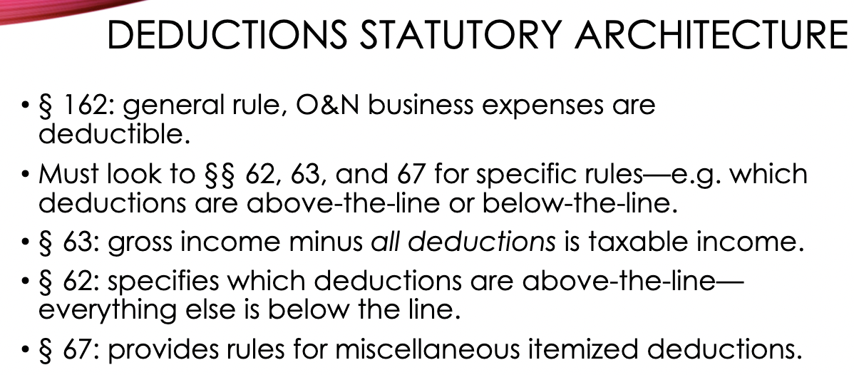

- Business and Investment Expenses vs. Personal Expenses
- § 262 provides that there are no deductions for personal expenses
- Treatment of clothing- clothing you wear on the street is not deductible.
  - Pevsner: TP works at a designer store, she is expected to wear the designer clothes. Can she deduct what she spends on this clothes from her income? No.
    - Test: Clothing for work is deductible if you are required to buy them for work and you wouldn’t be able to wear them outside of work.
      - Objective approach—Can the clothes be worn outside of work? Does not matter what the TPs personal preference is. Under this approach TP cannot deduct b/c they are normal clothes that can be worn outside
        - Ct uses this approach. Why?
          - Similarly situated TP may have different tastes
          - Administratively easier than having to discern TPs tastes
    - Could this be a fringe benefit under a working condition fringe? (§ 132) NO. For a working condition fringe to be deductible it must also be deductible as an O+N biz expense under 162, and it is not here
- Some expenses are too personal in nature and will never be deductible.
  - Going to the dentist
  - Vitale: TP was a writer and was writing a book about a brothel. He took lots of trips to the brothel and tried to deduct them as business expenses, Ct. found that expenditures by TP to visit prostitutes is too personal in nature to make them deductible
    - Some things are inherently personal or against public policy where they don’t merit a deduction
  - Can’t take a deduction for buying drugs if you need them at work
- Commuting- generally commuting from home to office is not deductible
  - Can only deduct transportation form home office to a second office if your home is your principal place of business (most of your work is done from home, including client meetings and storing inventory)
  - Travel from home to a temporary business location is deductible
  - Hantzis: Law student lives in Boston but works in NYC and maintained homes in both placed and deducts her cost of commuting. NOT deductible b/c TPs can only deduct travel expenses b/w two homes if their work requires them to maintain two homes.
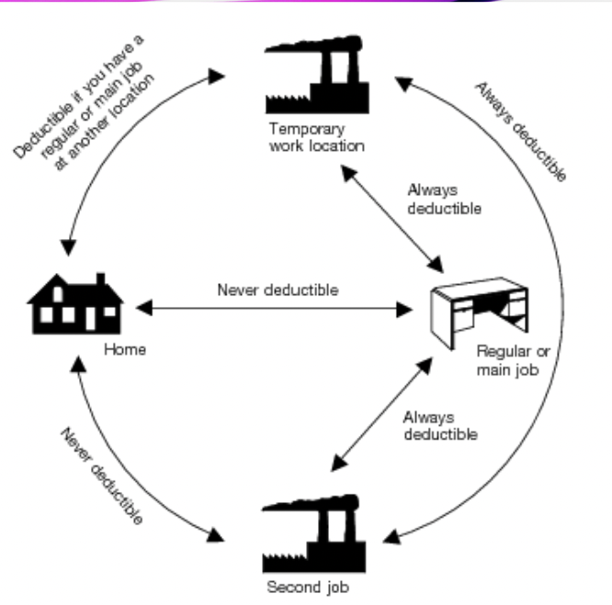
- Childcare expenses- not deductible, having children is a personal choice
  - Childcare tax benefits: § 21 credit or § 129 exclusion. Can’t take 21 credit if you are already taking 129
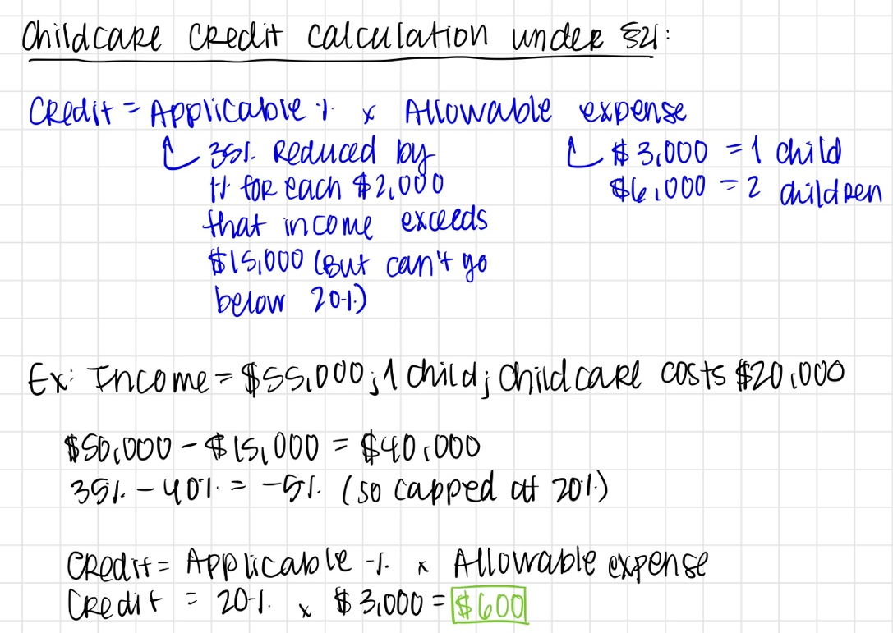
  - § 129 exclusion for employer-provided childcare
    - Can exclude up to $5,000 and must include the rest in income
    - BUT cannot also claim the childcare tax credit under § 21(c)
- Policy considerations for biz v personal expenses

- Business and Investment Expenses-- Capital Expenditures
- Definition of capital expenditures
  - The costs of a business asset with a useful life of more than one year needs to be capitalized
  - § 263: General rule—no deduction shall be allowed for new buildings, permanent improvements, or betterments made to increase the value of any property or estate (and then lists various exceptions)
  - Current biz expenses are immediately deductible in the year they are incurred, but business assets w/ a useful life that extends beyond the year the expense is incurred must be capitalized
    - Key Q: will the value last more than a year? If so, it’s capitalized
    - Exception: 168
      - Applies to all tangible movable property– Ex: copying machine
      - Can deduct the full value of most tangible property immediately, even if it has a value that lasts more than a year
  - O+N business expenses are immediately deductible; capital expenditures are deductible over time via depreciation
  - CAPITAL EXPENDITURE ≠ CAPITAL ASSET. Determining what is a capital expenditure vs O+N biz expenditure just determines how it is deducted (immediately or capitalized over time?)
- Identifying capital expenditures
  - Common examples:
    - Rent? Not capitalized
    - Acre of land? Capitalized
    - Costs of acquiring land? Capitalized
      - Includes legal fees, building materials, salary for construction workers
      - Costs of producing real property must be capitalized
    - Employee salary? Depends, usually not capitalized
      - But salaries for a construction worker who builds capital asset = capitalized
    - Job-seeking expenses? Not capitalized if seeking new work in the same business
      - Does not matter if you are successful or not, just that you are seeking work in the same business
      - Looking for a job in the same industry= deductible.
    - Supplies? Not capitalized
    - Machines? Capitalized
  - INDOPCO: TP wants to deduct expenses associated w/ a friendly merger. NOT deductible immediately as an O+N biz expense, must be capitalized b/c it provides value beyond the year the expenses were incurred
    - Capitalization requirements applies to expenses that produce significant future benefits, even if the benefits are intangible and the expenses do not create a separate and distinct asset
    - RULE: MUST CAPITALIZE IF EXPENSES PROVIDE VALUE BEYOND THE YEAR THE EXPENSES WERE INCURRED, but capitalization can be required even w/o the distinction of a separate asset
- Deductible repairs v. capitalized improvements
  - TPs can immediately deduct the cost of repairs, but must capitalize the costs of improving property. Repairs = deductible; improvements = capitalized
    - Things that are for the maintenance of property = deductible repairs
    - Improvements = capitalized and are added to the basis of your property
  - Test for improvements: expenditure 1) increases the life of the asset beyond what was originally expected OR 2) adds value to the asset OR 3) adapts asset to a different use
  - Goal is to measure the real change in TPs circumstances—are they just making themselves whole or creating something of value?
  - For personal assets, TP prefer improvements b/c you can capitalize them and increase your basis but you can’t do anything with repairs. For biz assets, TP prefer repairs b/c they are immediately deductible

- Depreciation of biz assets
- Theory behind depreciation
  - Biz assets that last more than 1 year must be capitalized, but depending on the type of asset, TP can take depreciation deductions for the decline in the value of the asset
    - Allows TPs to recover from the loss of income due to the wear and tear of their assets
  - There is accelerated depreciation for tangible, moveable items (aka machines) where you can deduct more than the rate that your asset is losing value
    - Policy: trying to incentivize businesses to invest in productive capital assets. More investments in assets = more assets in the economy = higher productivity
  - When you deduct something you take it out of your basis
  - Depreciation deductions are below the line/itemized deductions for biz owners
  - TPs prefer double declining depreciation over accelerated
- Property eligible for the depreciation deduction
  - § 167(a): allows DD for the wear and tear of 1) property used in the T+B or 2) property held for the production of income
    - Ex: cars, computers, buildings
  - NOT depreciable:
    - Land- not subject to W/T, does not have a limited shelf life
    - Inventory- assumption that it won’t be held for long for more than a year b/c you are buying and selling it quickly
  - Simon v. Commissioner: TP buys an antique violin bow that increases in value over time even though they can’t be used, is this depreciable? YES, does not matter that it increases in value, just that the item is subject to W/T
    - Ex: Artwork is NOT depreciable b/c it just hangs on the wall so it is not subject to W/T
    - IRS disagrees: they think anything that increases in value should not be depreciated, it must have a useful like AKA at some point it has to be worth $0 (ex of non-aquiesence)
- Calculating depreciations:
  - Starting place: § 168. Tells you the depreciation method, recovery period, and convention that you need to calculate the DD, which then you subtract from your basis
    - Convention: at what point in the year do you begin to recover
    - 168(e): Classification of property
    - 168(b): Depreciation method
      - Straight line depreciation is usually used for real property, and accelerated depreciation tends to be used for tangible property
      - Double declining
    - 168(c): recovery period
    - 168(k): bonus depreciation for eligible tangible property
  - § 179: Allows business to expense the full costs of assets up to $1M for tangible property that is not real estate
    - If the value of your assets is more than $2.5M, the $1M gets reduced. If you have more than 2.5M worth of assets to buy its advised you push it into later years
    - More geared towards small biz owners to incentivize them to buy assets, big biz spend way more than 2.5M/year on assets so they wouldn’t get to take advantage of this
- Statutory framework:
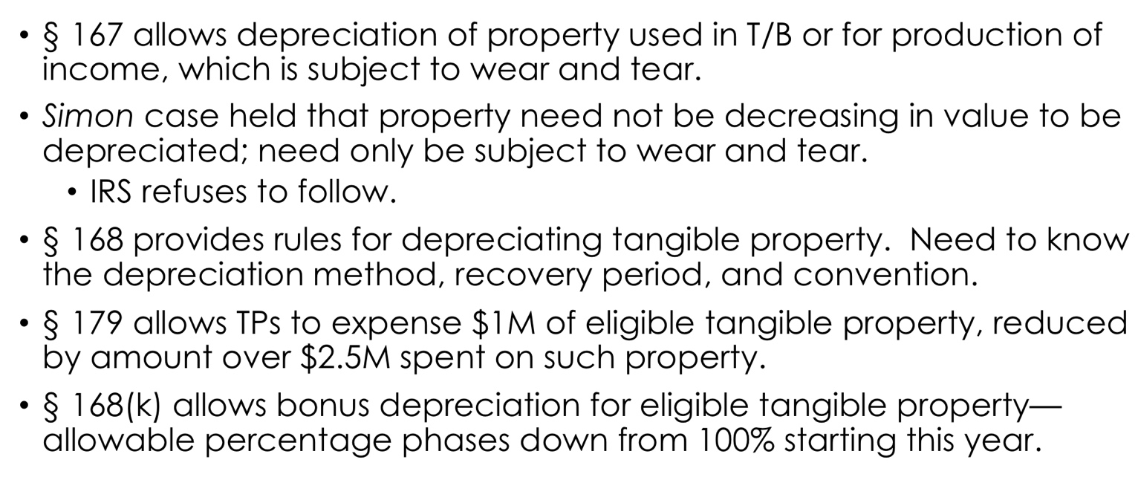

- Losses
- Loss deductions and limitations
  - Types of losses:
    - Business losses
      - The most generous type of loss deductions are T/B losses → above the line and can offset your other taxable income from sources that are not your biz
      - If you operate your biz at a loss, you can fully deduct this loss. § 162
      - If you’re a TP w/ a business and want to deduct losses, you want them to get classified as a T/B loss as much as possible
      - Can be carried over forward to future years
    - Loss from the sale of a capital asset where the basis > FMV
    - Gambling losses
      - Deductible to the extent of your gains
    - Hobby losses
      - Misc itemized deduction which is currently disallowed
    - Personal casualty losses
      - Deductible but very limited
- Gambling losses
  - Don’t allow the deduction of excess gambling losses
  - TPs must “basket” gains and losses, so you can only deduct losses to the extent of your gains and cannot carry losses forward to future years
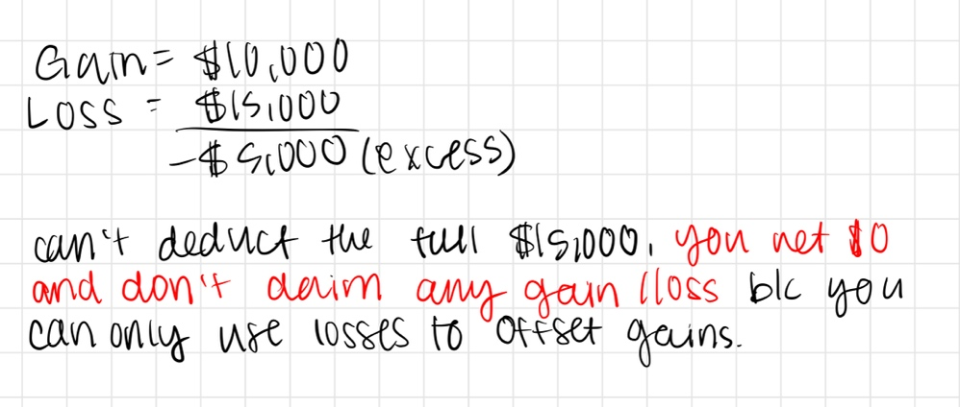
- Hobby losses (Storey)
  - Also basketed like gambling losses—can only deduct to the extent of your gain and can’t deduct your excess loss. Can only use your expenses to offset the income you earned. § 183
  - Currently fully disallowed under § 67(g) as a misc itemized deduction
  - Similar to gambling losses where they are only deductible to the expense of gains
  - Key Q to know whether its deductible: is it a hobby or a business? Can completely deduct T/B losses (§ 162), but not hobby losses (§ 183)
    - Looking for profit motive as evidence that it’s a biz and not a hobby, you were not engaging in the activity for personal reasons
      - There may be both motives, but you have to show the biz motives were the most important ones
      - An activity is presumed not a hobby if it is profitable 3 of the past 5 years. § 183(d)
      - Ex: Storey: TP was an atty who wanted to go into the film making biz and made a documentary about an educational organization and had a lot of losses trying to make the film that she tried to deduct as a T/B loss.
        - Ct. held that she did have a profit motive, so losses were deductible
        - Factors to look at:
          - Professional manner (she hired a bookkeeper, created an LLC, kept all bank accts separate. This is how you professionally run a business, not a hobby)
          - Expertise
          - Time and effort
          - Similar success
          - Occasional profit
          - Enjoyment (is it a problem that she was enjoying it? No, a lot of ppl enjoy their work)
    - Policy reasons why we are concerned with hobby losses:
      - Hard to draw the line b/w hobby and biz, so anything could be deductible
      - Would be subsidizing personal consumption for entertainment
  - Three ways activity can be classified from least profit motive to most
    - 1) Hobbies—not deductible since misc item deductions are not allowed
      - If allowed—only to the extent of gain
    - 2) income producing activity—also misc item deduc
      - If allowed—can deduct the full thing
    - 3) T/B—full deduction
- Casualty losses: loss from fire, storm, shipwreck, theft → unexpected, sudden loss
  - Default rule is that no personal losses can be deducted (they are realized but not recognized so you can’t deduct them), but personal casualty losses are allowed in a very limited circumstances → only allowed if it’s a federally declared natural disaster
  - Biz casualty losses are allowed more broadly: are fully deductible, above the line deductions
    - Usually the starting point for deductions is the lesser of FMV or adjusted basis, but for business casualty losses where the FMV is smaller than adjusted basis and the loss is a total loss, you can deduct the adjusted basis
  - Can’t deduct the full value of personal casualty losses:
    - They are itemized/below the line deductions AKA small losses won’t help, they have to be a large enough loss to be bigger than the standardized deduction
    - Starting point for calculating deductions is the lesser of the FMV or Adjusted Basis
    - Must subtract the first $100 of the loss
    - Then also subtract 10% of AGI to determine the deduction amount
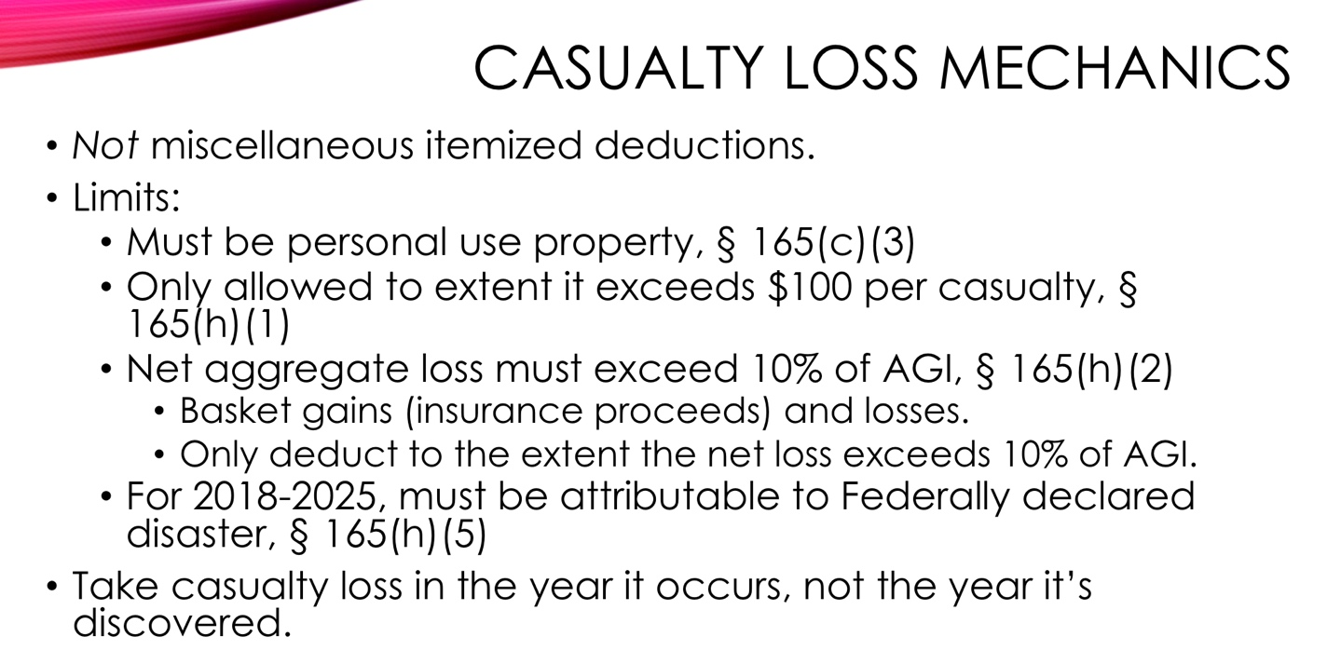
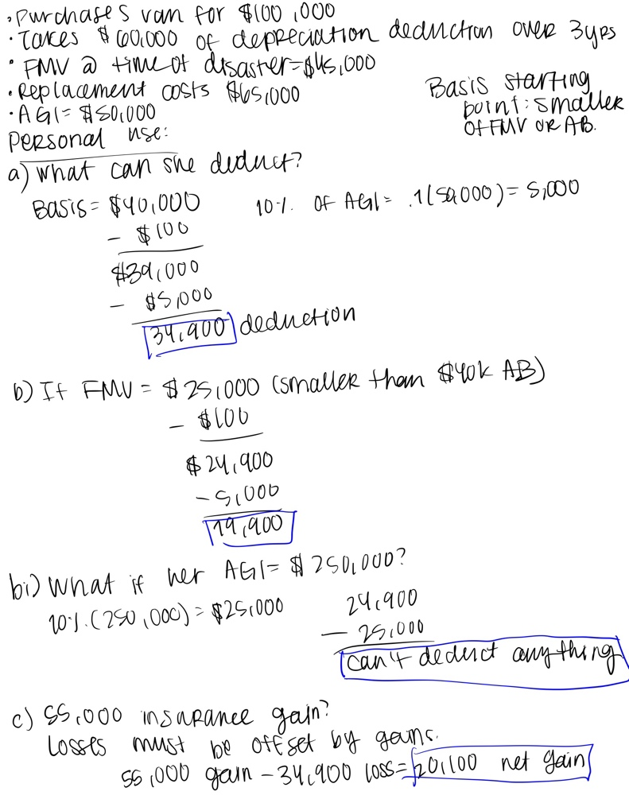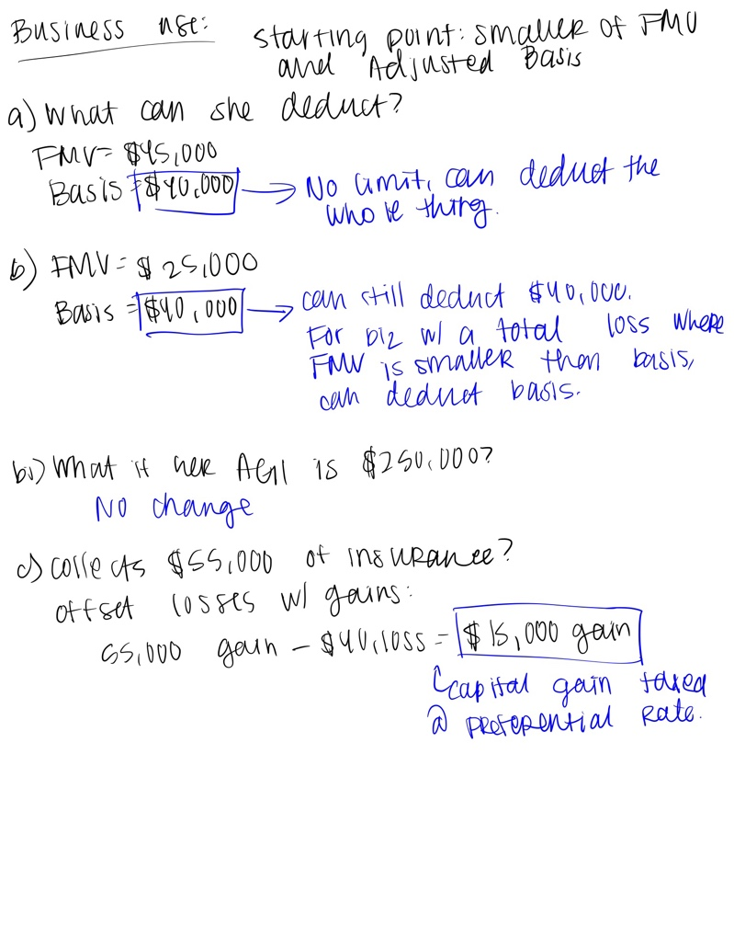
- Losses that aren’t really losses
  - Wash sales: § 1091 disallows loss where TP bought substantially similar stock, applies to repurchases within 30 days before/after a sale of stock
    - Does NOT apply to real estate or tangible property, only to stocks and securities
    - Substantially similar stock = stock in the same company. Ex: Yahoo and Google are similar companies, but they are not identical companies, so it doesn’t count
    - Easy to apply (if you buy back a stock in 31 days you are good to go) but easy to evade
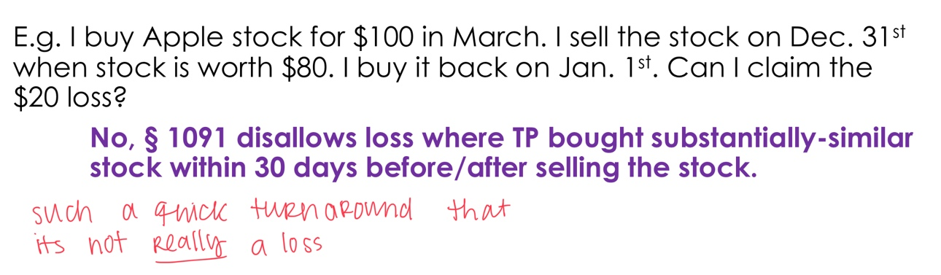
  - Loss from sales between related parties: § 267 disallows loss where TP sells to a related party
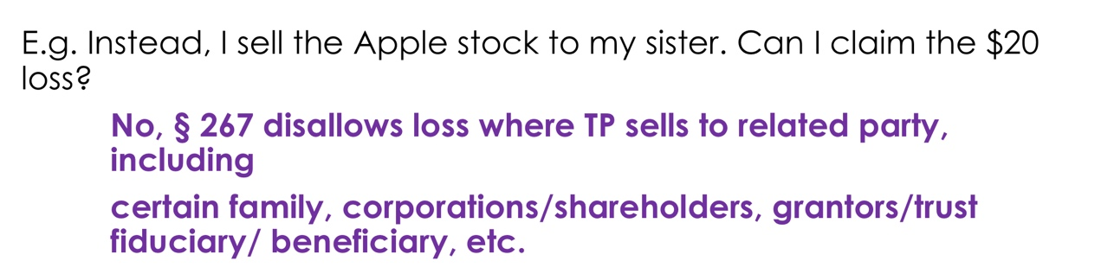
    - 267(b) tells you who is a related party:
      - Family members: immediate family down and up the line
        - Siblings, including half
        - Spouses
        - Ancestors (parents, grandparents)
        - Lineal descendants (children, grandkids)
      - Shareholders who own more than 50% of the stock
      - Grantors and fiduciaries of trust
      - Beneficiaries
    - Why? You have not really given up ownership of something if you just sell it to a related party, you still retain control so it would be too easy to buy and sell it back
    - If you have a disallowed loss under 267, you can use it to offset your gain on a subsequent sale. IF THE FAMILY MEMBER YOU GAVE IT TO SELLS IT FOR A GAIN, THEY CAN OFFSET THEIR GAIN WITH THE AMOUNT OF DISALOWED LOSS
      - Ex: Sale from A to B who are siblings incurs a $170K loss, but A cannot deduct this loss under 267. B then sells to C who is a friend and incurs a $90K gain, but he can offset the gain w/ the previous 170K loss so really he incurs no gain or loss
      - Ex:
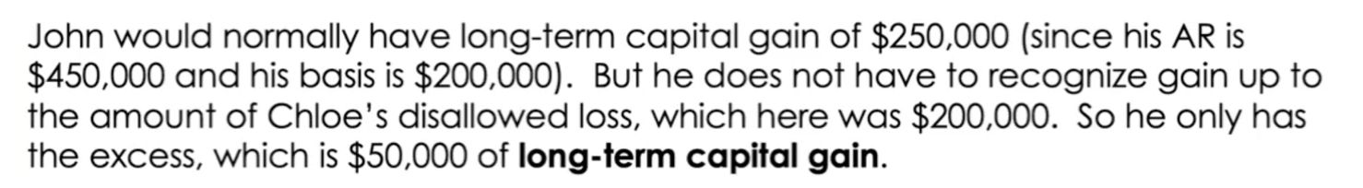
  - Fender: TP held bender bonds in a trust for his son and sold them to a bank where he owned 40% of the stock and then tried to deduct the loss. Can TP claim the loss?
    - He didn’t break the bright line rules of 1091 (was not a wash sale b/c he waited 42 days) or 267 (TP and bank were not related parties because he would have to own at least 50% of the stock and he owned 40%), but Ct still disallowed the loss deduction because TP faced no genuine risk of loss
      - Risk of loss = you have no control whether you will get the property back or not
      - The facts were bad enough that it seemed like an orchestrated transaction
        - TP had given bank legal advice and the bank owned him a favor
        - Were unrated bonds that the bank usually would not buy
        - Bank could not have sold bonds to anyone else
    - Reasoning = substance over form: can look to the real economic substance of the transaction to determine if a TP merits the tax benefits or if they are trying to evade taxes. Opposite = form over substance. Looking beyond the form to the underlying economic substance.
      - Cons for this doctrine:
        - Very vague, allows IRS to cast too broad of a net and disallow too many transactions
        - Hard for TPs to anticipate/plan their financial decisions before hand
        - Hard to apply, similar to a multi factor test where not one factor or reasoning is dispositive
      - Pros:
        - You need vague standards like this or else TPs with sophisticated financial planning can get around bright line rules to evade taxes
        - The whole point is that it’s difficult to anticipate beforehand
      - Non-acquiescence- IRS tries to go against court holdings. NOT the same as substance over form.

UNIT IV: CAPITAL GAINS AND LOSSES
- Intro to Capital Gains
- Definitions:
  - Capital gains = gain/loss from the sale/exchange of capital assets. § 1222
    - Why is the difference b/w capital gains and ordinary income so important?
      - Capital gains get taxed at a preferential tax rate, which is much lower
      - Capital gains and losses have to be basketed before they get combined with ordinary income
        - Basketing = all gains offset each other, then all losses offset each other, and then you net gains and losses against each other at the end
    - Businesses DO NOT get to take advantage of preferential tax rates
    - What is NOT a capital gain:
      - Income from capital (stock dividends, the rent from an apt you lease out)
      - Capitalized expenses: an expense added to the basis of your asset if it provides benefits/value beyond 1 year
      - Ordinary income: anything that is not capital is ordinary. Everything is taxed at either ordinary rates or preferential rates
      - Capital assets that you haven’t sold yet: Not a capital gain until you sell your asset.
        - Ex: if you win stocks on a game show it is not a capital gain b/c you haven’t sold it yet
      - The return rate for corporate bonds w/ interest
    - Limits to capital losses: unfavorable treatment of capital losses
      - Both corporate and individual TPs can deduct capital losses to the extent of their capital gains. § 1211
      - If it’s a capital asset but used for PERSONAL reasons, you can recognize the gain but you CANNOT deduct the loss.
        - Normal rule that you cant deduct personal losses: if you have personal property that you live in, you don’t deduct the loss
      - Individuals can only deduct up to $3,000 of their losses per year. Only offset ordinary income with up to $3,000 of capital losses, but anything more than 3K you can carry back 3 years and forward forever
        - Ex: if you have $100K of capital losses and no capital gains, you can deduct the entire thing but only at a rate of 3K/year so it would take you many years to get to deduct the whole thing.
  - Capital asset: usually an investment asset, like stock or property. Defined by exclusion in 1221.
  - Holding period: tells us whether something is short term or long term
    - For gifted property, the TPs holding period includes the period of the person before them who gifted them the property. § 1223
    - Short term gain/loss: arises from assets that are held for 1 year or less
      - Taxed as ORDINARY rates
    - Long term: held for more than 1 year (at least 366 days)
      - Taxed at PREFERENTIAL rates (chart below). § 1
Rate | Income (single filer bracket)
0% | Up to $41,675
15% | $41,676 to $459,750
20% | $459,751 or more
      - Your CG rate depends on how much income you have if you add up your ordinary income PLUS your capital gains
        - EX: M has ordinary income of 20K and 5K in CG: her rate is 0% and her gains are not taxed
        - EX: M has ordinary income of 100K and 5K of CG: her rate is 15%
        - Ex: M has ordinary income of 600K and 5K of CG: her rate is 20%
        - If you are rich you will always get taxed 20%, but this is still VERY beneficial for you
  - Ex: I buy a parcel of land for $100 and sell it 6 months later for $120
    - Is it a capital asset? Yes, land usually always is
    - Do I have a capital gain? Yes, $20
    - Is it short or long term? Short, held for less than 1 yr
- Netting gains and losses:
  - Step 1: net long term gains and long term losses together, then separately do the same for short term gains and losses
  - Step 2: if you come out with net gains and net losses, you may or may not need to combine them (see chart)
  - What do TPs prefer? TPs want to maximize the capital gains as much as possible and have the most amount of ordinary losses
    - Short term losses are more valuable b/c you get to offset them from short term gains, which are just taxed at ordinary rates. The less gains to tax at a normal rate the better
      - ST losses are more preferable than LT losses because LT losses would offset your LT gains, which you really wany because they have the good preferential treatment
    - Losses are better than gains b/c losses are a deduction
 | Long term gain | Long term loss
Short term gain | DON’T combine gains, keep them separate:  - LT gains taxed at preferential tax rates  - ST gains taxed at ordinary rates | YES combine them, subtract LT loss from ST gain  - If you have more ST gains, it’s taxed at ordinary rates.  - If excess LT loss, its subject to capital loss limits
Short term loss | YES combine them, Subtract ST loss from LT gains  - If positive LT gains, taxed at preferential rate  - If positive ST loss, subject to capital loss limits  Loss limits:  - Can only offset ordinary income with up to $3,000 of capital loss (Ex: if you have 50K loss, you can only take 3K loss a year and the rest you get to keep carrying it forward). If you have both ST and LT losses, you have to use the ST first and then the LT  - Can carry back 3 years and forward forever | DON’T combine losses:  - First offset ordinary income with ST loss first  - Then offset ordinary income with LT loss  - BUT subject to strict limits, you don’t just get to deduct all your losses against your income  Loss limits:  - Can only offset ordinary income with up to $3,000 of capital loss (Ex: if you have 50K loss, you can only take 3K loss a year and the rest you get to keep carrying it forward)  - Can carry back 3 years and forward forever
  - Example:
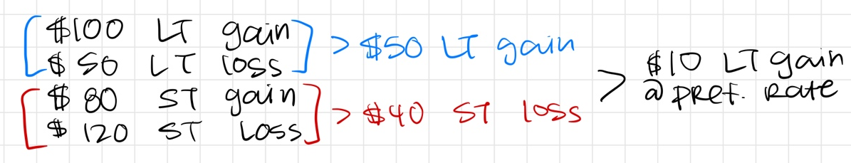
- Policy considerations for the preferential tax rate:
  - Reasons against the tax rate:
    - Efficiency: Highest capital gains tax rate is 20%, highest for ordinary income is 37%, so people will want this lower rate and will change behavior to get it (ex: incentivizes ppl to hold on to capital assets for longer than 1 yr so that they can be long term as opposed to short term gains)
      - When you apply a preferential rate to anything, they will adjust their behavior to get this rate
      - Ex: a TP would rather invest in growth stocks with CGs than bonds with interest or dividend stocks
    - Horizontal Equity: two similarly situated individuals that earn the same amount can have different tac rates if one of them has their entire income in the form of capital gains and the other has their entire income as labor compensation
    - Administration: The rules to calculate CGs are complex and adds an extra step to calculating your income. Also, it is hard to determine what is a capital asset or not.
    - Revenue: Lower tax rates = less revenue for the government to collect, but if capital gains were not taxed at a low rate, then people would never sell their capital assets so the gov would be collecting NO revenue to begin with
  - Reasons in favor of the rate:
    - We want to encourage long term investments and to hold assets for longer
    - Inflation: Capital gains are not technically income, we don’t want to overtax gains that are really just from inflation
      - Lower rates roughly compensate for inflation by reducing tax on gain from assets that have been held for a long time
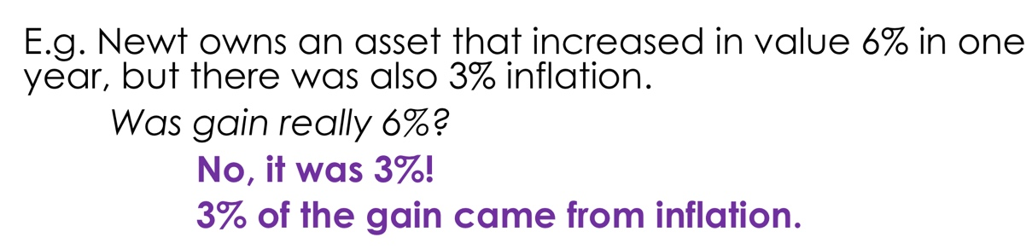
    - Bunching: Since all gains are realized at one time, TPs accrue gains over the years but then are all lumped together at the end in the year the gain is sold
      - Without preferential treatment, TPs would be thrown into a higher tax bracket than the taxpayer would have been than if the gain had been taxed over a number of years
      - Counter to this is that most ppl who have capital gains are in the highest income brackets anyways
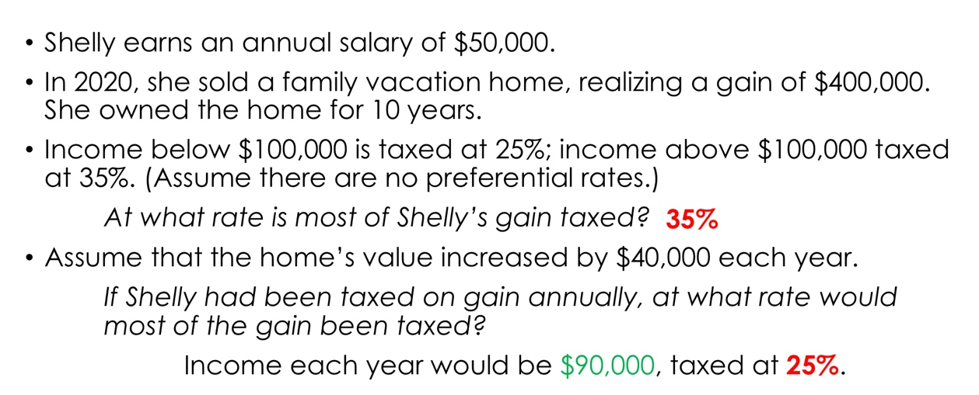

- Capital Assets
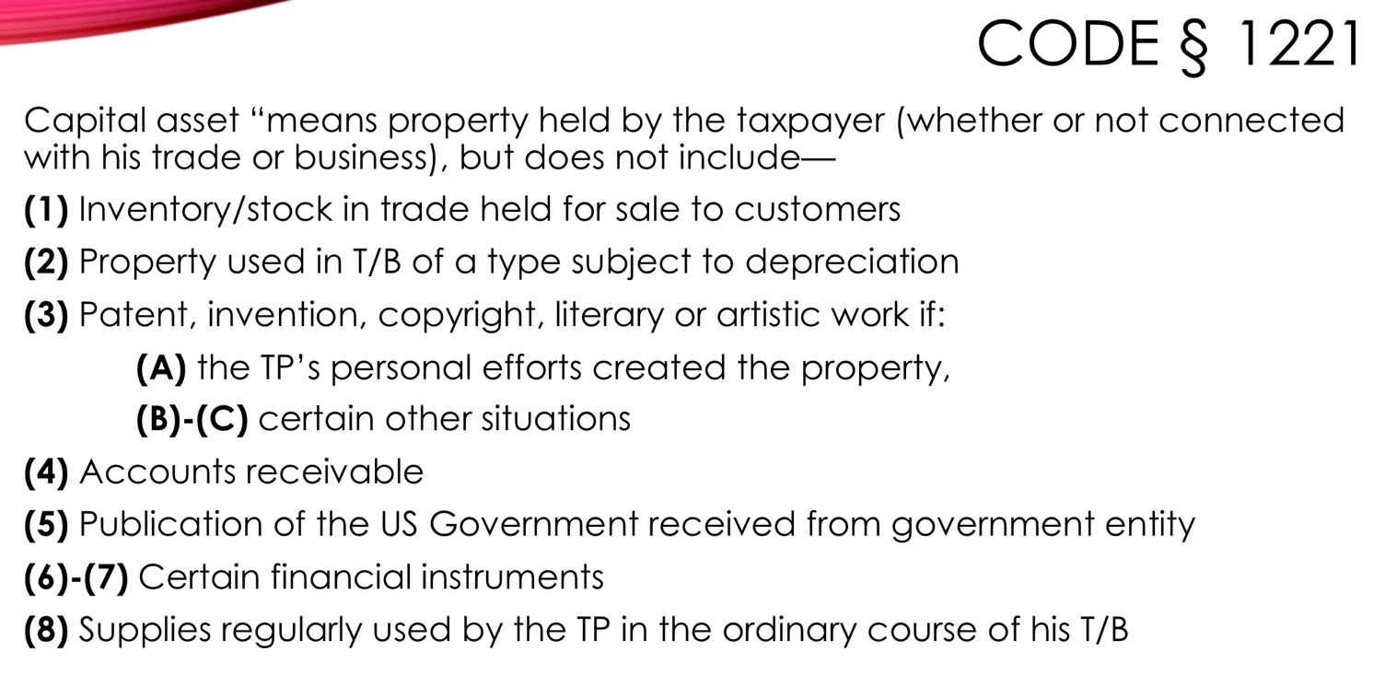
- Things that are commonly capital assets: Land, growth stocks
- Pattern: Things that are NOT an investment (ordinary gains from your labor/business) are NOT capital assets
- Bramlett: Mezquite East and Town East are held by the same four ppl. ME sells land to TE who then develops it and sells it to third parties and ME tries to get capital gains treatment on this. Is it capital or ordinary income?
  - Land was a capital asset because it was held for investment purposes, it was not a result of ME’s business activities but a true investment
  - No evidence of fraud or business misfeasance, very different from Fender case where it was property being exchanged in a tight circle
  - But for T it was NOT a capital asset because it was as a result of their business activities, so the holding is a little odd

UNIT V: WHO’S INCOME IS IT?
- Assignment of Income
- Basic principles: 1) earned income is taxable to the person who earned it and 2) earned income from property is taxable to the owner of the property
  - The law is concerned with ppl who are transferring their income to others (especially those in close units—spouses, parents, children, etc b/c we are worried about pooling resources within a family) in an effort to reduce their taxes
  - For businesses you are allowed to income shift, but you cannot assign income outside of a commercial context
- Earle Case: TP created a valid contract that assigned ½ of his income to his wife
  - Invalid assignment of income – fruit must be taxed from the tree it grew on, so husband gets taxed
  - Income is taxed to the person who earned it
  - Substance over form: Ct was willing to look past a valid, enforceable contract because the assignment was really a gift
    - Cts use judicial doctrines to address behavior that is not covered in statutes but still violates the spirt/purpose of tax law
- Assignment of income via property:
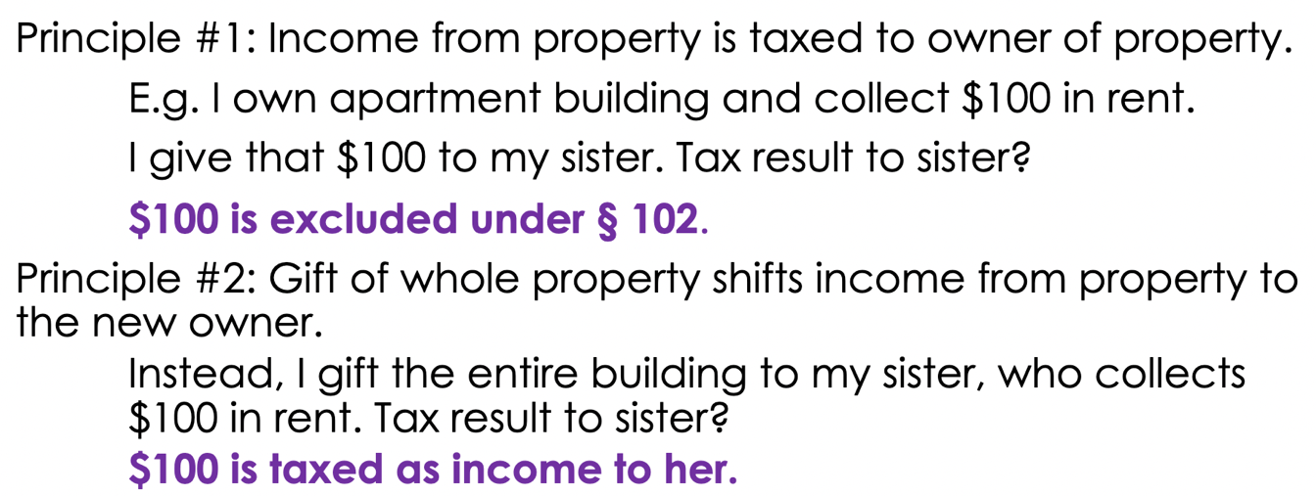
  - But what happens when you don’t give the whole property, just some portion of it?
    - Blair case: TP inherited a portion of his trust income to his children.
    - Valid assignment of income—children now own the property, so they get taxed on it
    - Fruit is taxed to the tree that bore it—you can’t just give away the fruit (income) to avoid tax liability, but here the father is giving away part of his tree (property that creates income) so that is OK
    - Shows how labor and property income are treated differently—you can’t shift labor income (Earle), but you can shift property income (Blair)
- Horst case: TP transferred interest coupons on the bonds he owned to his son. He keeps the principal but gives his son the right to receive the interest.
  - Invalid assignment of income—TP is still controlling the property, so the father is taxed as the holder of the bond and not the son
  - Control of the income is key
  - Cannot gift income or a right to income
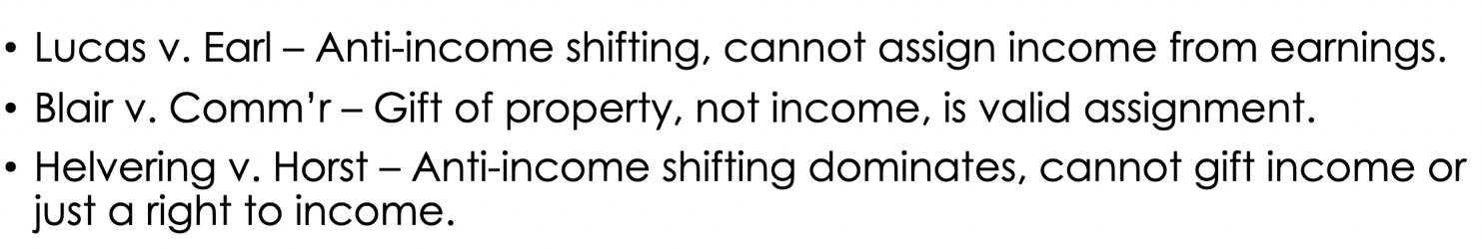

- Takeaways:
  - If you transfer full rights to your property with no future interest, this is a valid transfer of property and you can shift the income.
    - Blair gave up part of his income stream for the rest of his life to his kids, and Horst still owned the property that was making him income
    - If you maintain your underlying property ownership, then you are just shifting the income which is not valid
  - Income is taxed to the person who controls it, which usually means the person who earned it
  - When transferring property, there is a spectrum:
    - If you don’t transfer any portion of the property = CANNOT shift income
    - If you transfer part of the property = CAN shift income only if structured correctly
    - If you transfer the full property = CAN shift income
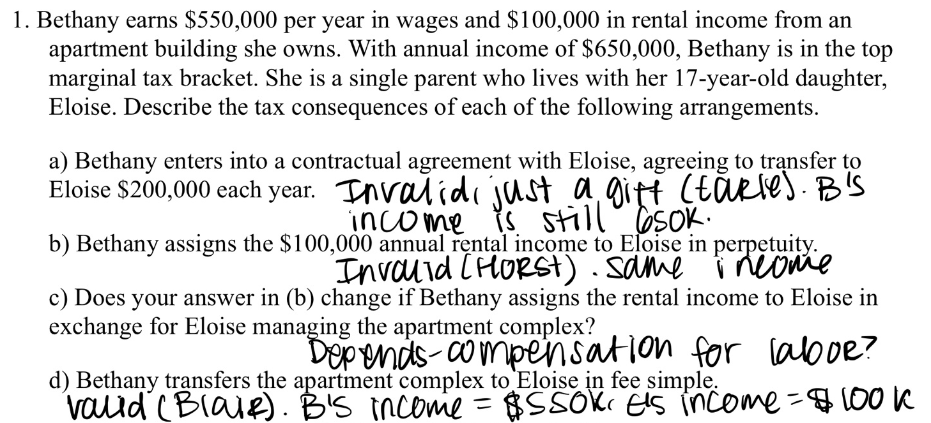

- Borrowing, Basis, and Tax Shelters
- Recourse vs. nonrecourse debt:
  - Recourse= the borrower is personally liable and the lender can go after other assets that the borrower has to get the loan back if the security for the loan does not cover the full value
    - Ex: if you own a house and you are in default but the house does not cover the full value of your loan, the bank can take your house back and go after your other assets
    - You are at risk for the entire value of your loss
  - Nonrecourse= the borrower is not personally liable so the lender can only repossess the security itself to satisfy the loan
    - Same ex as above: all the lender can do is take back your house but they cannot take anything else
    - The MOST you can lose with nonrecourse financing is the cash + equity that you put into a purchase. TPs are at risk for cash + equity
  - For both, the debt is considered like cash when determining the basis, so if you borrow $100K to buy a house and pay another $100K in cash, the cost basis is $200K. The amount realized for any sale also includes any debt that the seller incurred. So if you sold it for 100K and the seller takes on $50K debt, the AR is 150.
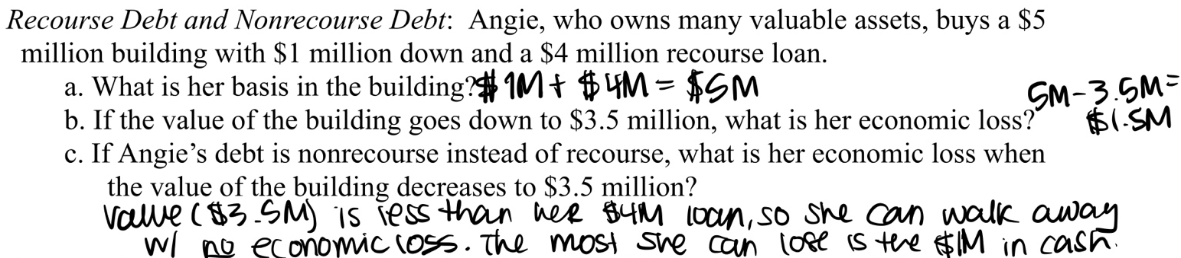
- Crane case: TP inherits a building and does not assume the nonrecourse debt, but she ignores this debt in calculating her basis and the amount realized. Ct holds that both nonrecourse and recourse debt should be included in basis because NRD and RD are treated the same.
  - Must treat basis the same when dealing with NRD or RD
    - Cost basis = equity/cash + the debt
    - Adjusted basis = above number – depreciation deduction
  - Created a tax shelter for TP because she can take full depreciation deductions for the property even though she has nothing at stake because the property was acquired with NRD
  - When the FMV of property is more than the NRD, you have an incentive to keep paying off the debt and not walk away in order to protect your equity. If you walk away you lose your equity, but if you finish paying you get to retain your equity. What happens when FMV is less than debt? This is the Tufts case.
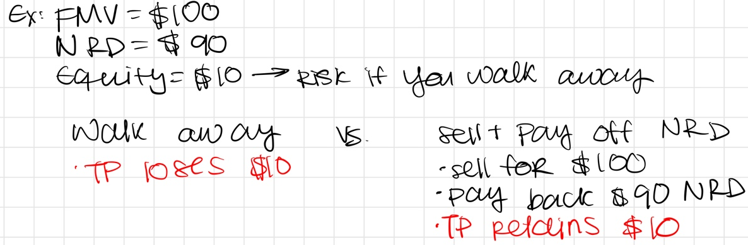
- Tufts case: FMV of building = $1.4M, Adjusted basis = $1.45M ($50K in added renovation value and minus $450K of depreciation deduction), and NRD = $1.85M. TP sold the building and the buyer incurred the NRD. TP argues that her basis should be the FMV (1.4M) b/c that is the most that a lender could recover from him if he goes into default, but ct. disagrees
  - Ct. held that the AR on a sale is the full value of the loan, so it was 1.85M here
  - Since we allow depreciation deductions even when you have nothing at stake with a NRD, the law must include the full value of the NRD in the AR to recapture depreciation
  - Crane holding (when FMV > NRD) applies also when FMV < NRD. So both your adjusted basis and AR must include the value of your NRD, even if it is more than the FMV of the building.
  - TREAT NRD AND RD THE SAME
- Franklin case: Franklin sells old motel to Romney (details below) worth 600K, but really the only cash being exchanged b/w parties is $75K.
  - This plus bad facts (Romneys are responsible for maintaining the property, deed was not recorded and wouldn’t be until they made their final balloon payment) led the Ct to conclude that Franklin’s basis on the property was $0.
    - Basis is supposed to reflect your investment in the property, and here there is no investment
    - When TPs have no equity or not even any anticipated equity that the might get in the future and paid very little for the purchase price, they should not have any basis
  - Franklin paid $75K in interest and in return got property with a $1.2M basis to use for depreciation and deductible interest, Romneys received $75K and can deduct their rent payments as O+N business expenses for running their motel.
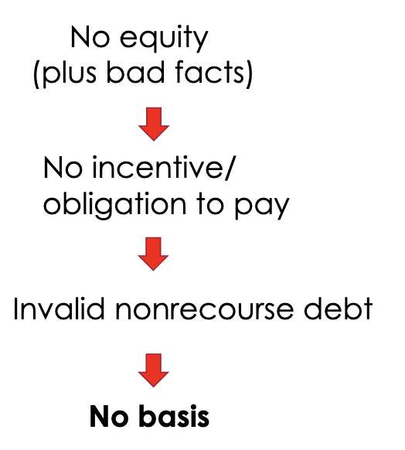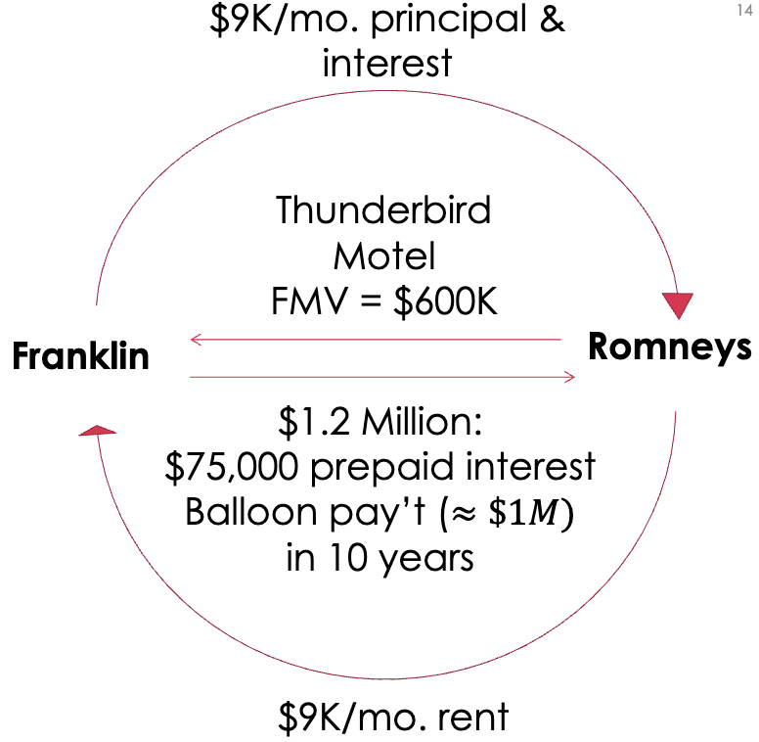
- Takeaways for this topic:
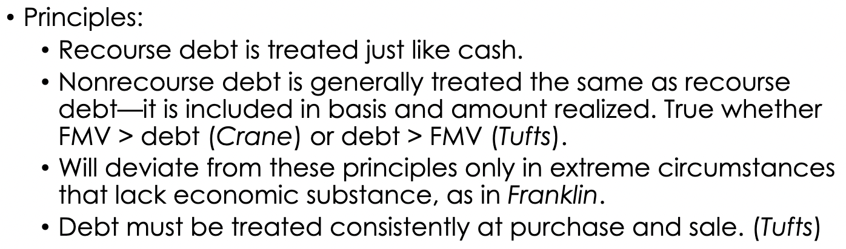
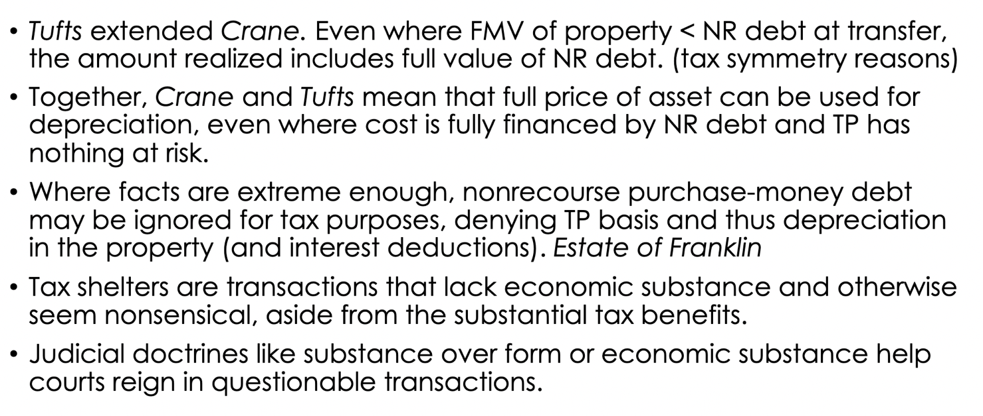

UNIT VI: FEDERAL TAX POLICY
- Charitable Contributions: § 170
- Why do we allow CCs?
  - To properly define income, since a donation is arguably not personal consumption (but it very well could also be consumption) → if you donate $ you are arguably not consuming this, so we allow deductions to accurately measure your income
  - To support/increase charitable giving
  - To incentivize charitable gifts
- Rules:
  - § 170(a)—allows a deduction for CCs for businesses and individuals
    - BELOW THE LINE, but not misc itemized deduction
      - 62 tells us what is above the line, and everything NOT in 62 is below the line. CCs are not in 62, so it is below the line. Consequences for TPs is that in order to actually benefit from the deduction they have to have enough itemized deductions to surpass the standard deduction or else they won’t count → in practice CC deduction does not affect most ppl b/c most ppl take the standardized
      - 67 tells us that anything listed is NOT a misc itemized deduction, and CC deductions are listed, so it is NOT a misc itemized deduction (either way misc itemized deductions are disallowed right now)
  - 170(c)—tells us what entities you can donate to for it to count as a CC-- allows deduction for state, gov, corporation, trust, foundation, etc. → TLDR NOT individuals
- Limits on the deduction
  - You can’t just donate a bunch of $ and have it deduct all your tax liability to 0
  - Trying to prevent income shifting with the complex rules for donating property w/ built in gain
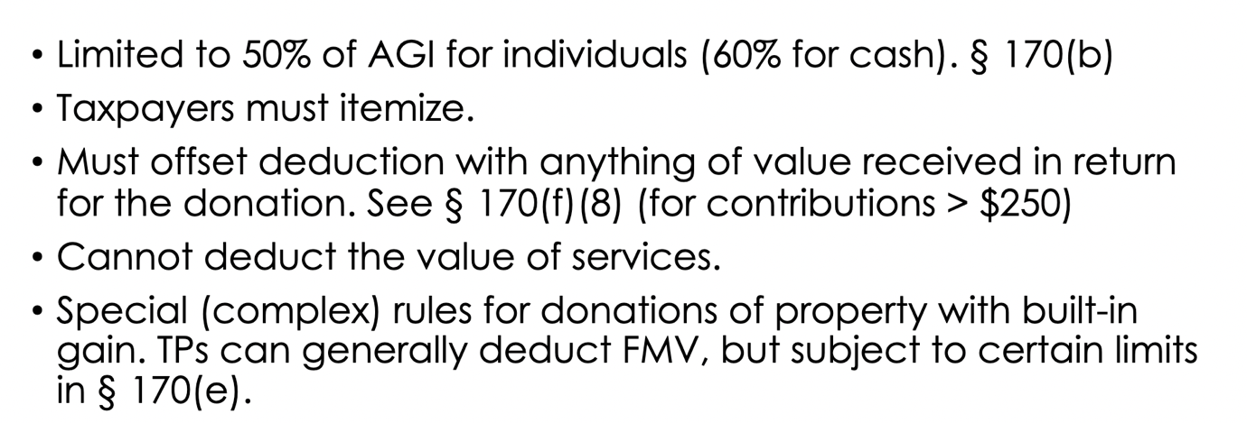
- Hernandez case: Scientology church tries to deduct auditing/training fees.
  - Are they a “contribution or gift”? NO. Payments are not deductible as CCs b/c payors received a quid pro quo (an advantage or favor granted/expected in return for their money)
  - Bad facts that did not help them: there were fixed prices for their services that increased when the length of services increased, TPs had payment accounts, there was a policy to never provide these payments for free
  - Dissent: payments are no different than other fixed payments made for religious services
  - Deductions must be subtracted by the value of quid pro quo, but thinks that can’t be valued are ignored
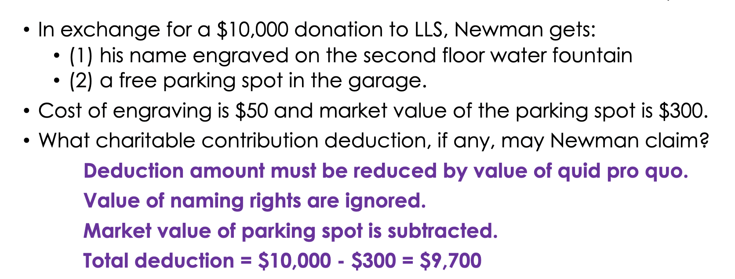

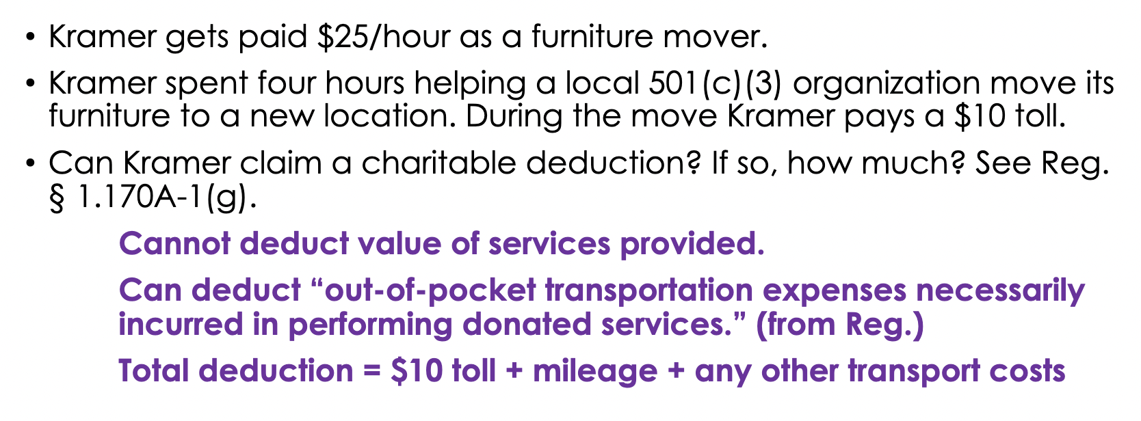
Recap from CCs class:
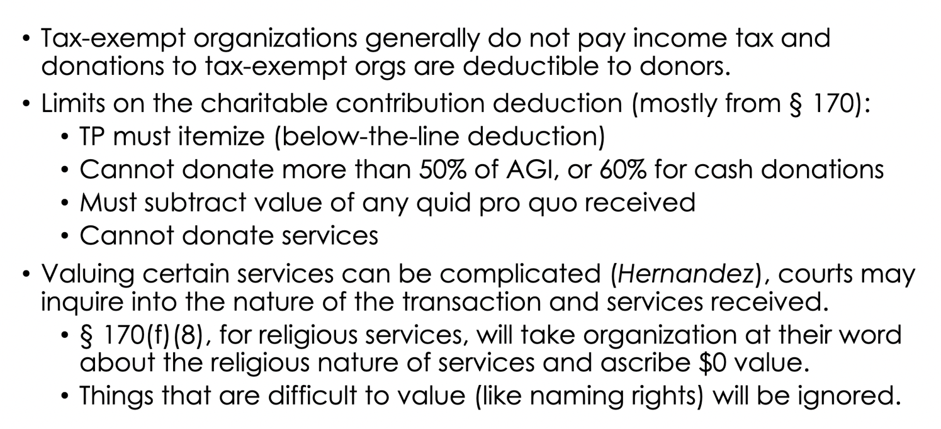
- Tax Expenditures
- Tax expenditures definition:
  - Income tax seems to tax all consumption (HS: I = C + ΔW), so any tax provision that excludes personal consumption from the tax base is considered a tax expenditure
  - Surrey definition: TEs are departures from the normal tax structure that are designed to favor a particular class of people, industries, or class of persons
    - What is Normal? HS Income. → when defining a normative tax base, you include all income. So when you don’t tax consumption or change in wealth, this is a tax expenditure
  - Defining consumption: you have choice and control over the activity/spending
    - If something is consumption and NOT taxed = tax expenditure
- Common examples of tax expenditures (even though you could argue for some of these that they are not consumption):
  - Charitable contributions
  - Medical expenses
  - Childcare expenses
  - Fringe benefits
  - Not taxing unrealized gains
  - Home ownership: various tax benefits subsidize home ownership, including exclusion of 250K/500K capital gain upon sale and deduction of mortgage interest
- Why is it important to identify TEs?
  - TEs are basically spending provisions designed as tax cuts → they are used to promote social policies and political goals, so identifying them is important so we can keep track of spending
  - $1 OF TAX CUT = $1 OF DIRECT SPENDING
    - Getting a $1 tax cut is the same as the gov giving you $1 of direct spending, therefore the Gov should decide how to spend based on other considerations like administration, distribution, procedure, access to benefits, etc
- Capitalization of tax preferences
  - Tax preferences are capitalized into the price of capital assets → meaning that assets that receive tax benefits will be more valuable
  - Prices will increase for assets that receive tax benefits, and if a tax benefit is repealed the prices will fall
  - Ex:
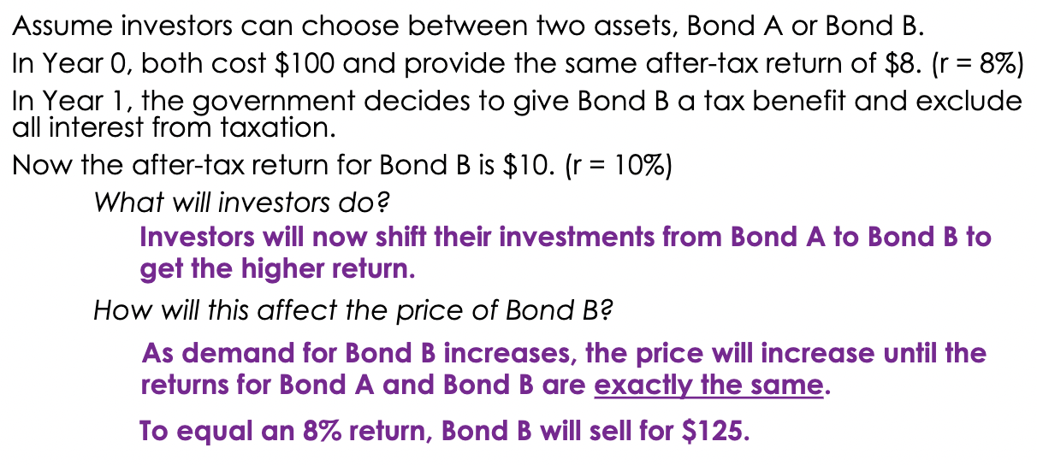

Misc itemized deductions:
§67 Disallowance of “Miscellaneous Itemized Deductions”:
- §67(a) provides that itemized deductions other than the ones listed in §67(b) are allowed only to the extent they exceed 2% of the TP's adjusted gross income. However, TCJA added §67(g), stating “Notwithstanding subsection (a), no miscellaneous itemized deduction shall be allowed for any taxable year beginning after 2017, and before 2026.”
  - Section 67(a) and (g) do not limit the following itemized deductions, which are listed in §67(b): §163 interest deductions; §164 deductions for state and local taxes; §165 deductions for casualty losses and gambling losses; §170 deduction for charitable contributions; §213 deduction for medical expenses; the deduction allowed under §1341. (Others are listed in §67(b).)
  - Deductions that are disallowed by §67: Deductions for unreimbursed employee business expenses and certain investment-related fees are subject to the §67 disallowance. Section 67 also prevents tort plaintiffs from deducting substantial fees they pay their attorneys pursuant to a contingent fee agreement in cases other than employment discrimination suits. (above-the-line, and are not subject to §67, if the case is an employment discrimination case. §62(a)(20), (e).)

168 Analysis:
168: to calculate depreciation you need to know depreciation method, recovery period, and convention
- To figure out method, you have to start by figuring out the classification of property in 168(e) → this is your starting point. Either identified in the statute or she will tell us the revenue regulation
- Once you have classification, (b) tells you method.
  - Default method is 200% declining balance method
  - Nonresidential real property = straight line method
- Recovery period is in (c)—table tells you what the recovery period is

Next part of analysis: do expensing provisions apply? 179 or 168(k)
- If a certain type of property, TP can deduct the full cost right away the year it is purchased. Basically applies to almost all tangible property that is not real, so NOT buildings and machines, airplanes, etc.

