EXAM FORMAT
- Multiple choice, bar style
- Hypothetical Case Study Essay
  - Apply the cases and rules we’ve learned
- Policy Essay Question
  - EX: Effectiveness of sentencing enhancements
  - EX: How would you reform the felony murder rule

Unit 1: Basic Principles and Discretion
- Course Thesis: How to analyze and critique the law
  - Feminism
    - Much of common law comes from before the US existed
    - Woman used to be considered property, their legal status has changed significantly over time
    - Particularly important in cases involving rape and statutory rape
  - Age Awareness
    - Most crimes are committed by people younger than 25
      - The brain is not fully developed until age 25 but we did not know this until recently
    - Younger people….
      - Are more impulsive and less risk averse
      - Are much more inclined to succumb to peer pressure
      - Possess tremendous potential to grow and change
  - Mass Incarceration
    - The US incarcerates more people than any other country in the world
  - Race
    - Always think about time period with regards to race and racial tension
      - i.e., the war on drugs and racially charged laws/policy that arose
  - Intersectionality
    - How are marginalized groups treated by the law?
- Basic Principles
  - What is the criminal justice system?
    - System of accountability
    - Relies on punishment and stigma to govern behavior
    - Regulates everyday life
    - Concerned with the safety + security of society
  - Why is criminal law important
    - Significant impact on society and the distribution of resources
      - i.e., Where to invest tax dollars
    - Establishes rules + quality of life in the community for those deemed ‘criminal’ and ‘non-criminal’
      - COMPLETELY different types of citizenship
    - Profound role in shaping public morality and social norms
      - The law is always evolving, reflecting how society feels about certain behaviors
    - Social consensus and control – how do we influence people’s behaviors?
- Theories of Punishment
  - Backwards Looking
    - Retribution
      - ‘An eye for an eye’ approach
      - You caused pain to someone else, so we as society are going to cause you pain
      - Purpose: Make someone suffer
  - Forward Looking (Utilitarianism)
    - Incapacitation
      - Keep society free from harmful behavior
      - Like a ‘time out’
      - EX: jail time or an ankle monitor
      - Critiques
        - May just be relocating harm to the jail environment
        - Are people really being set up for success in the future?
    - Rehabilitation
      - How does society help you so that this doesn’t happen again?
      - Set the offender up for success so they don’t cause more harm and become a contributing member of society
      - **This concept is at the core of the juvenile justice system**
    - Deterrence
      - If I do something bad and someone else sees me get punished, they’ll be deterred from the same conduct
        - Specific Deterrence
          - Punishment deters an individual
          - If I do something, myself specifically is deterred from the crime
        - General Deterrence
          - Punishment deters others
          - People see me get punished and want to avoid that same punishment
  - Alternative Approaches
    - Restorative Justice
      - Restorative justice refers to the bringing together of offenders and victims to mediate, explain, apologize, forgive, and appreciate their common humanity
      - Asks
        - Who was harmed?
        - How can the needs of the victim be addressed?
        - How can the person who causes the harm repair the harm?
      - Critiques
        - Some people may be only satisfied by punishing their perpetrator
        - Can be traumatizing for victims to recount the events
    - Less Punitive Prison
      - The Norway model, put people into less hostile, comfortable jails
      - Critiques
        - Expensive
        - Lack of retribution
        - May incentivize people in poor life circumstances to commit crimes
    - Abolition
      - Complete abolition of the jail system
      - Critiques
        - Not simple to remove all of criminal justice infrastructure
        - Job displacement of jail workers + cheap prison labor
        - Twin perils
          - Marginalized neighborhoods are simultaneously under policed and over policed
- Jury Nullification
  - Refers to a jury’s decision to render a not guilty verdict despite its belief that the D is technically guilty b/c they believe it would be morally wrong to punish the D
  - Rooted in the 6th amendment
  - Jurys render verdicts, not explanations

Unit 2: Ingredients of a “Crime”
- Ingredients of a Crime – The Crime Equation
  - 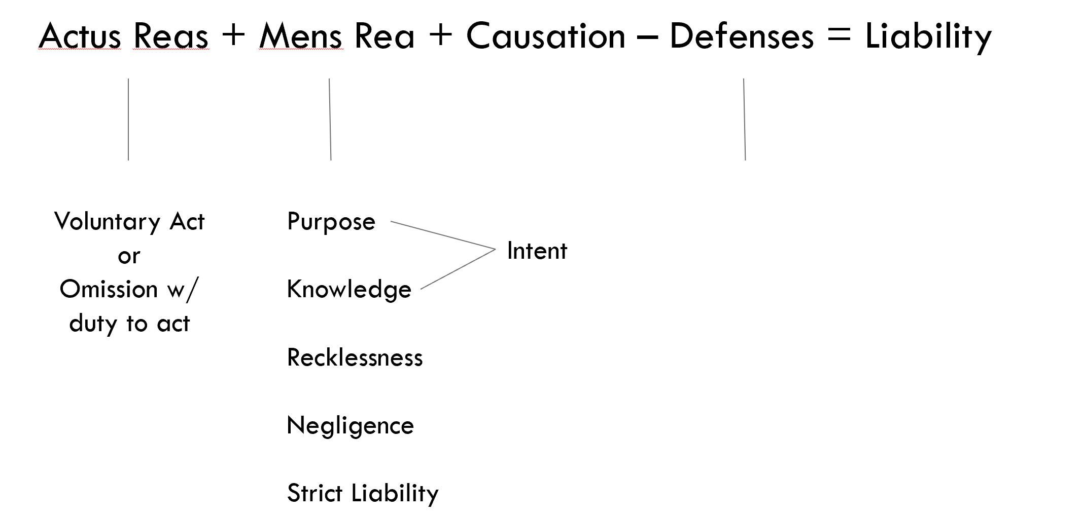

  - Actus Reus
    - Definition: The commission of some voluntary act that is prohibited by law
    - Every crime has an act
    - Voluntary acts or
      - When is someone acting Involuntarily?
        - Reflex or convulsion
        - Bodily movement during unconsciousness or sleep
          - Case to point to: People v Newton
            - FACTS: Traffic stop, altercation happens, struggle for a gun, 2nd cop is shot, D gets shot and wrestles gun away and shoots + kills officer
            - Takeaways: Case was remanded b/c jury did not receive instruction about unconsciousness. D was shot and may have acted irrationally based on being unconscious. You cannot be found guilty if unconscious when crime occurred.
        - Conduct during hypnosis
        - A bodily movement that otherwise is not a product of the effort or determination of the actor, either conscious or habitual
    - Omission where there is a duty to act
      - Duty: Spouse to spouse, parent to child, part of contractual agreement
    - Situations in which a failure to act IS a crime
      - Statute imposes a duty to care for another
      - Special relationship (parent to child, teacher to student)
        - Case to illustrate: Pope v State
          - FACTS: D took mom w/ mental issues and her daughter into shelter. D cared for child while mother went into a frenzy. Mom ends up beating the baby to death in front of D and D does nothing to stop her.
          - Takeaways: Ms. Pope’s status (her relationship to Demiko) did not bring “her within the class of persons specified by the statute” (there was NO special relationship)
      - Contractual duty to care for another person
        - Case to illustrate: Jones v U.S.
          - FACTS: 10-month-old baby is placed in care of D and the baby subsequently dies.
          - Takeaways: Absent a clear contractual duty or voluntarily assuming care, you can’t be held liable for omission to act
      - Someone voluntarily assumes care of another and secluded the helpless person from the help of others
  - + Mens Rea - Every crime has a mental state
    - DEFINITION: the culpable mental state (mens rea does NOT mean motive)
      - Policy: Helps us identify the appropriate level of blame
    - MPC Mental States (most severe to least severe)
      - Purposefully ← Hardest for gov’t to prove
          - D’s conscious objective is to engage in the conduct or to cause the result
            - MUST be aware of the attendant circumstances OR hope they exist
      - Knowingly
          - D’s aware that its practically certain that his conduct will produce such a result
            - Aware that the attendant circumstances exist
      - Recklessly (Default mental state if no MR listed)
          - D “consciously disregards a substantial and unjustifiable risk” & disregarding the risk “involves a gross deviation from the standard of conduct that a law-abiding person would observe” in the D’s situation.
            - Translation: Aware of the risk but acts anyway
      - Negligently ← Easiest for gov’t to prove
          - D should have been aware of a substantial and unjustifiable risk
            - Risk involves “gross” deviation from standard of care of reasonable person in the D’s situation
    - Relevant Cases
      - Regina v Cunningham
        - FACTS: Man rips gas meter off trying to get cash but ends up asphyxiating his neighbor.
        - Takeaways: D could not be convicted unless he acted maliciously and he did NOT possess the malicious mindset to be guilty of the crime. W/OUT evidence of mens rea, you can’t be guilty of a crime
      - Regina Faulkner
        - FACTS: Man goes below the ship deck to steal rum, lights match to see and sets entire vessel on fire.
        - Takeaways: D did not act intentional nor willful and thus did not have the sufficient mens rea to be guilty for the accidental fire he started.
      - Morrissette v US - air force base junk hauling case, did not have mens rea
      - Staples v US – Edit to gun to make it automatic, no mens rea
    - MPC Approach to Analyzing a Crime (NEED to know this cold)
            - Identify the material elements of the offense
              - Conduct
              - Attendant Circumstances
              - Result(s) – if applicable
            - Determine the mens rea for each material element
              - If NO MR listed in statute → “Recklessness” is the default mental state
              - If only 1 MR is listed → Apply that MR to ALL elements of the crime
              - If >1 MR → Determine which elements the MR apply to, consistent w/ the statutory interpretation

    - Common Law Approach to Mens Rea
            - Read the statute to determine the mens rea
              - Malice (reckless)
              - Intentional (purposefully)
              - Willful (knowingly)
              - Depraved heart
            - Differentiate between specific (more serious) vs general (less serious) intent crimes
              - An offense is a ‘Specific intent’ offense if it requires proof of …
                - Intent to commit some future act OR
                - Special motive or purpose OR
                - Awareness of an attendant circumstance
              - NOTE: Courts created general/specific intent to have less harsh punishments for certain crimes
                - Reckless or negligent in MPC = general intent in CL
    - Strict Liability
      - Does NOT contain a mens rea for one or more elements of crime
      - Enables the imposition of criminal liability based on social harm, not moral fault
          - Why? Draw red line that citizens should NOT cross
        - Strong presumption AGAINST strict liability
          - Why? --> Morrissette Case
            - FACTS: D was a junk dealer, entered air force base and took used bomb casings to use in his business. Crime to knowingly ‘convert’ gov’t property
            - Takeaway: D did not have the requisite mental state to be guilty. Don’t want to punish people for things they didn’t intend to do (relate this to theories of punishment)
            - Mere omission” of an MR in a statute does not mean there is no MR required. (Morissette & Staples)
        - Guidance for determining if statute is strict liability:
          - Nature of offense
            - New, not conventional common-law
            - Regulatory/Public Welfare
            - Widespread social harm rather than individual victim
            - Inherently dangerous activity obviously subject to regulation & owner should be on notice
          - Low Penalty
          - Low Stigma associated w/ the crime (EX: traffic violation)
    - Mistake of Fact
      - If a D needs to know a certain fact to act with the appropriate MR, and does NOT know that fact, they CANNOT be proven guilty
      - General Criminal Principle: An individual is subject to blame and punishment because of a choice they have made to fall below society’s minimal standards
          - BUT when a person makes a mistake and causes harm, it makes it difficult to say they made a choice to violate societies’ rules
          - A mistake may negate the mental element required for criminal liability
        - MPC Approach
          - Mistake of fact permitted when…
            - Ignorance or mistake, negates the purpose, knowledge, belief, recklessness or negligence required to establish a material element of the offense OR
            - The law says the state of mind established by ignorance or mistake is a valid defense
          - Mistake of fact NOT permitted when…
            - The D would be guilty of another offense had the situation been as he says
        - Cases
          - Regina v Prince
            - Facts: D was convicted for taking an unmarried girl, who was >16 out of possession of her father without permission
            - Takeaway: D thought Dad gave permission and was allowed to use MoF defense, was NOT allowed to use MoF defense for her age → Often can’t use MoF for things like age that make a crime like rape, statutory rape
          - People v Olsen
            - Facts: Trailer park rape case
            - Takeaway: D found guilty, Mistake of Fact defense not allowed for some “morally wrong”
        - Key thing to remember: When there is a public welfare offense (illegal sale of alcohol, traffic regulations), the law does not require a mens rea
        - 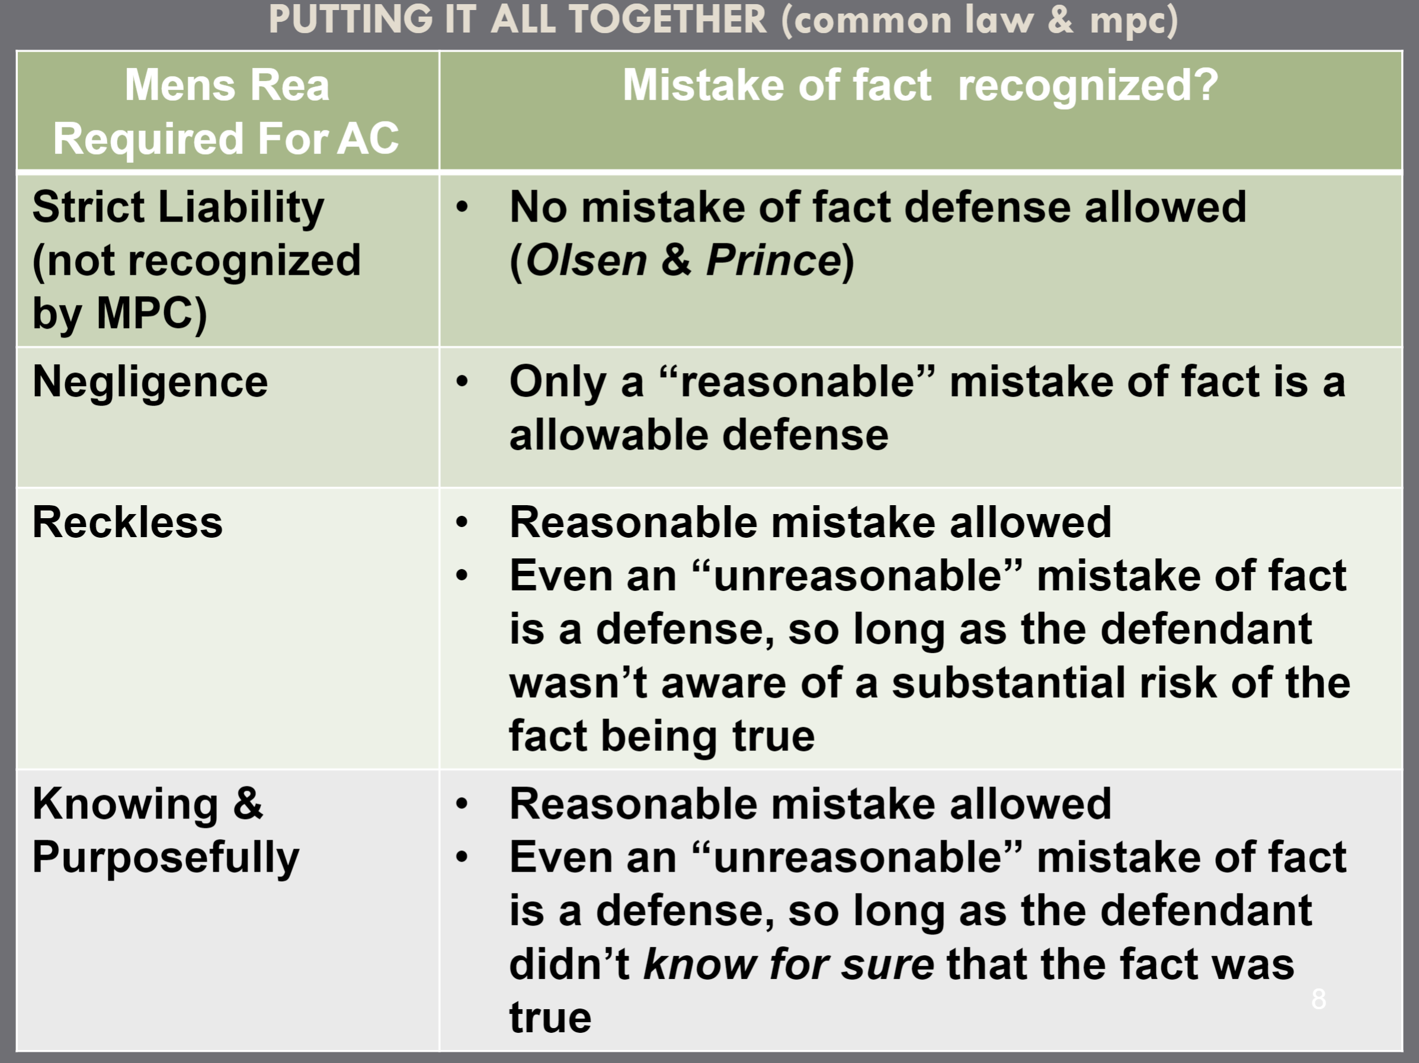
    - Mistake of Law
      - Ignorance of the law is NOT a defense but there are exceptions
          - Exception 1: Mistake of law like a mistake of fact
            - Illustrated by Marrero Case
              - Facts: D was mistaken and thought that he fell into class of officers allowed to carry gun when he in fact was not allowed
              - Takeaway: Incorrectly interpreting the law is NOT a valid defense, Marrero would have had a valid defense if he relied on an official statement of law that was written incorrectly
          - Exception 2: Mistake of law negates the mens rea
            - If you do not possess the required mental state b/c of a mistake of law, you have a valid defense
          - Exception 3: Failure to Act or Register
            - VERY narrow exception
            - Case: Lambert v California
              - Facts: D was a convicted felon, there was a law that required felons to register w/ city and D failed to register
              - Takeaway: D was not guilty for violating the statute b/c court ruled D needed some sort of notice of his duty to register
  - + Causation - Sometimes, depends on the crime
    - 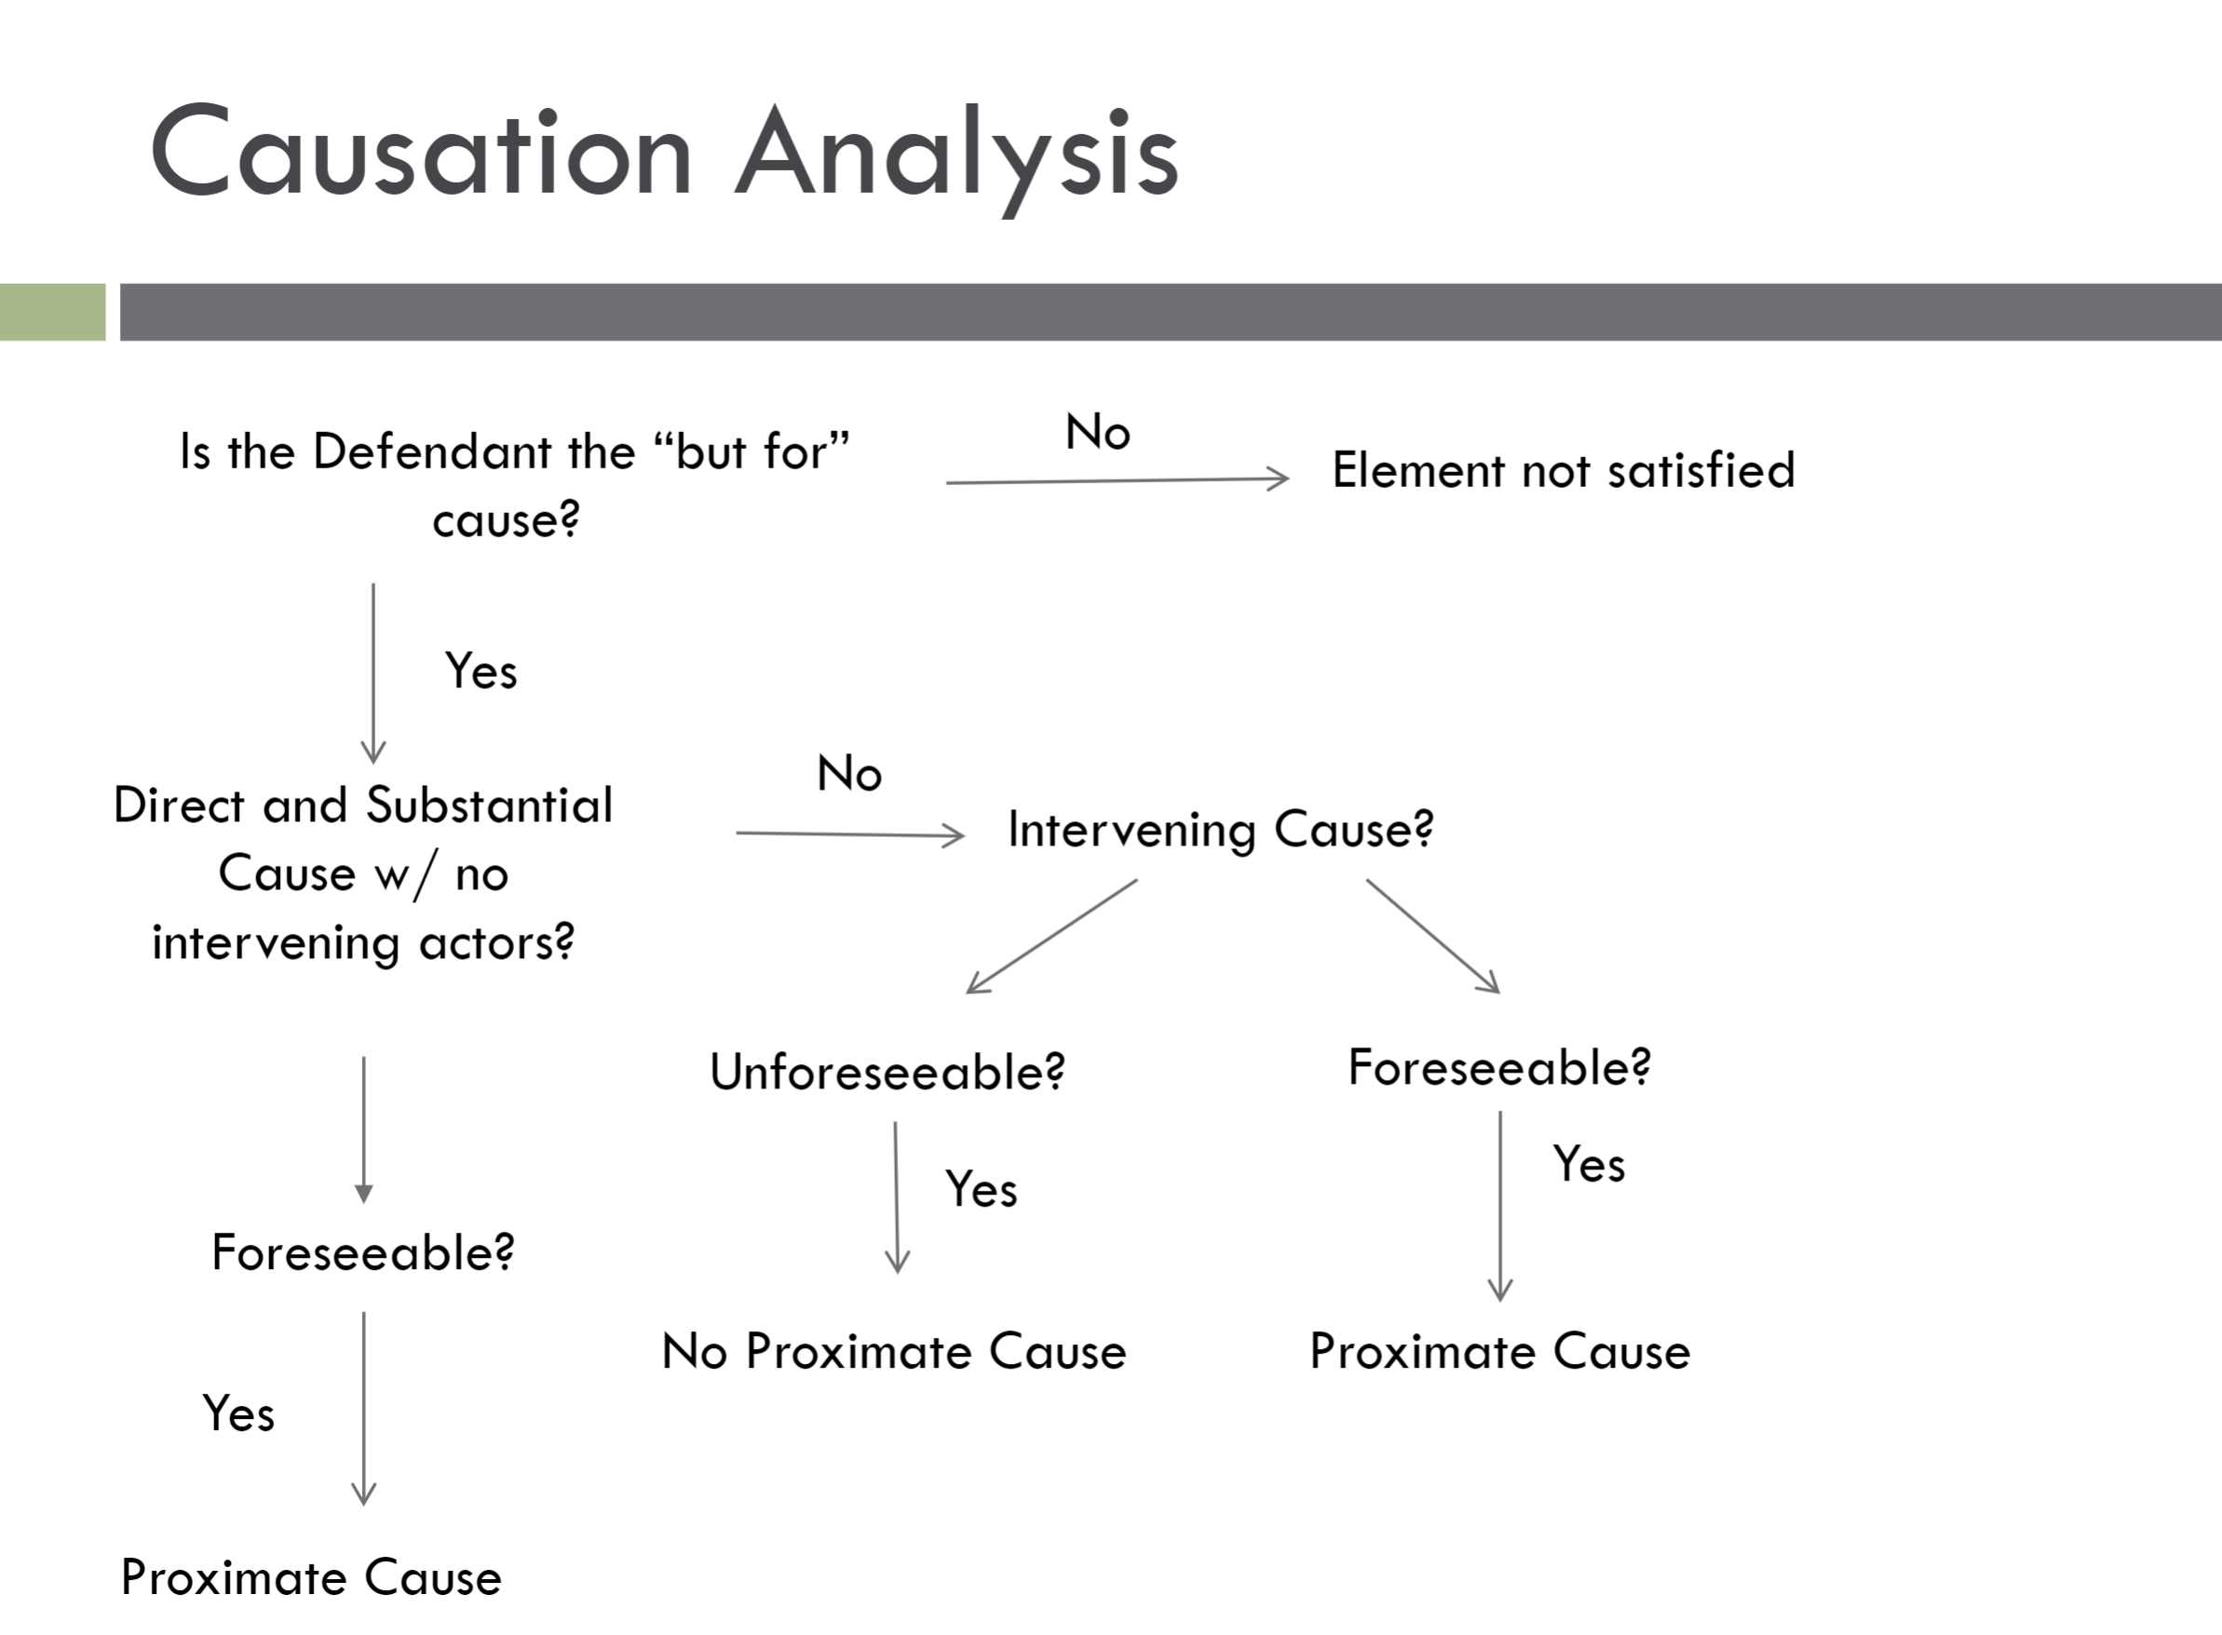
    - ONLY relevant in results crimes (EX: crimes must create grievous bodily harm)
      - Crime has a causation requirement = gov’t must prove that the D’s voluntary act (or omission) resulted in – (caused) – the social harm
    - Common Law Test for Causation
      - Need factual causation and proximate causation
          - Factual causation = (but for causation) harm would not have occurred in the absence of the D’s act
          - Proximate Causation = intervening acts/causes were reasonably foreseeable
            - Some intervening causes -break- the chain of events if they were NOT foreseeable
        - Step 1: Determine actual cause
          - Were the D’s acts a link in the chain of causation?
        - Step 2: Determine proximate cause
          - Was the harm foreseeable?
        - Step 3: Intervening acts
          - Should any intervening acts excuse D from responsibility? Did something break the chain of causation?
    - MPC Test for Causation – designed to be more specific than CL
      - 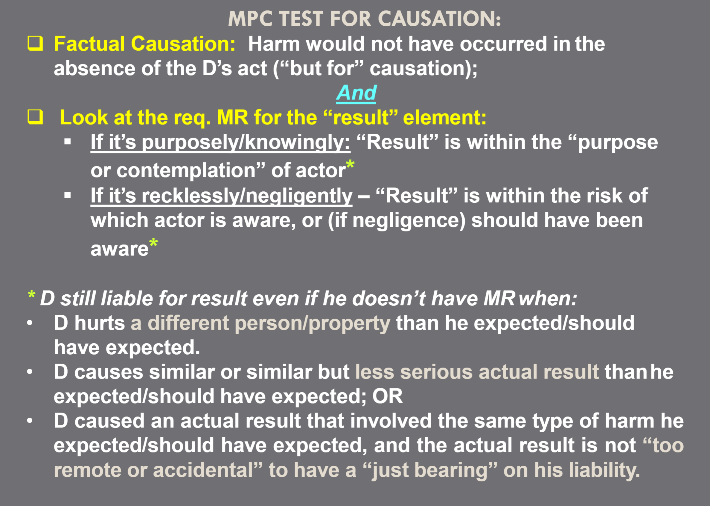
      - Step 1: Cause in fact
          - Would the events have occurred ‘but for’ the D’s act?
        - Step 2: Proximate (legal cause) and required MR
          - Refer for slide above
    - People v Campbell (give a friend a gun, they still need to act on their own)
      - FACTS:
          - B has an affair with Campbell’s wife
          - C encourages Basnaw to kill himself
          - C offers to sell B a gun & shells
          - Cgives B the gun & shells
          - B was intoxicated and depressed
          - C hoped that B would kill himself, and B does shoot himself
      - Takeaways: Issue = Is C guilty of homicide? NO, B needed to act on his own
          - Free, deliberate, and informed (or reckless) human intervention breaks chain of causation
            - ON EXAM: is the human intervention greater or less than Campbell?
    - Commonwealth v Root (encourage friend to drunk drag race)
      - FACTS:
          - 2 co-workers get drunk, one dude convinces other to drunk drag race
          - While racing, the convinced co-worker swerves into other lane and is killed by an oncoming truck
      - Takeaways: D was NOT guilty
          - Mr. Root’s “reckless conduct was not a sufficiently direct cause” of the decedent’s death.
  - + Attendant Circumstances
    - Burglary needs to occur in a dwelling
    - Age – only a crime if committed by someone of a certain age
  - – Defenses
    - = Criminal Liability

Unit 3: Homicide
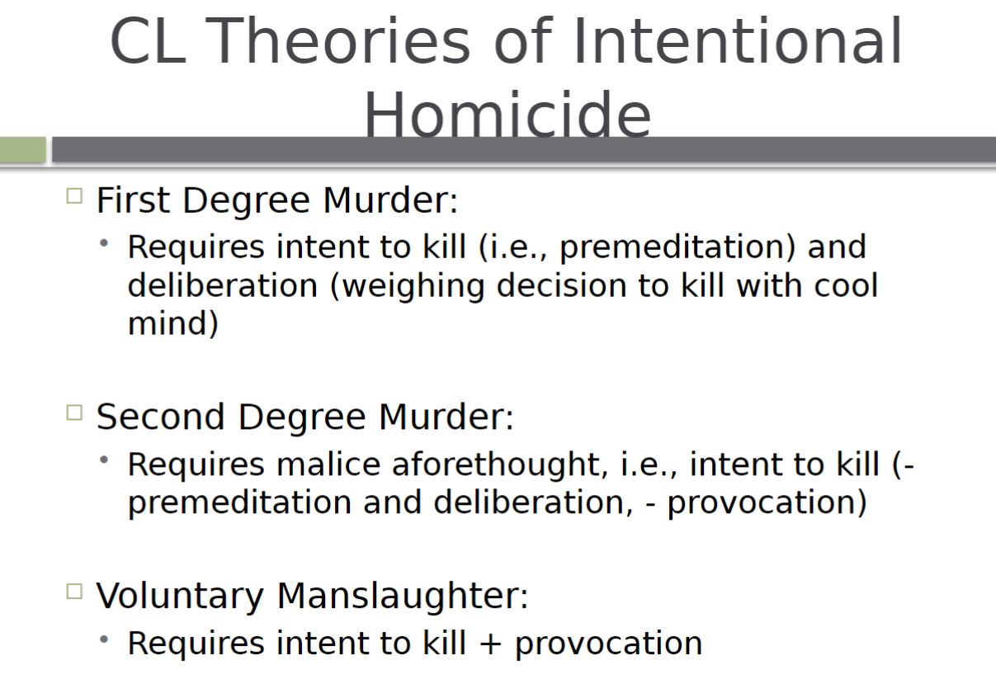
- Homicide Basics
  - = The unlawful killing of another human
  - Defined by the specific MR
  - MPC Approach → No degrees
  - CL Approach → Measured by degrees
- Material Elements of Homicide
  - AR = Killing
  - MR = Depends on the grade
  - Attendant Circ. = A human being
  - Result = death
- Common Law Breakdown of Homicide
  - Intentional Homicide
    - First degree murder
      - Requires Premeditation AND Deliberation
        - Premeditation = design to kill
    - Second degree murder
      - Intent to kill without premeditation and deliberation and without adequate provocation
    - Voluntary Manslaughter
  - Unintentional Homicide
    - 2nd degree depraved heart murder
    - Felony murder
    - Involuntary Manslaughter
- Intentional Killings – Murder (with malice)
- NOTE: CL breaks down into first and second degree, MPC has no degrees
- Malice = Intent to kill, hurt, depraved heart or commit felony
    - Express Malice = Intent to kill
      - Statement/confession
      - Circumstantial evidence
      - Natural and probable consequences
      - Use of deadly weapon
    - Implied Malice = intent to inflict grievous bodily harm
      - Depraved heart murder → Extreme reckless disregard for the value of human life
      - Felony Murder
  - CL: First Degree Murder (with malice)
    - Carrol Approach - Purposeful
      - Premeditation + Deliberation = Purpose, any intent to kill, deliberate
        - Can be formed the instant of the action
        - Easier for prosecution to prove
      - Commonwealth v Carroll
        - FACTS: D was former solider who had many issues w/ his wife while trying to provide for his family. One night, D’s wife made rude comments about D’s children and parents. D then impulsively shot his wife twice while she was asleep in middle of the night.
        - Takeaways: ANY intent to kill is premeditation, intent can be formed in the moment
    - Guthrie Approach – Purposeful+
      - Requires Premeditation AND Deliberation to higher degree
        - Premeditation = intent to kill
          - You thought about killing beforehand and evaluated a court of action
          - NO minimum amount of time
            - Can be formed instantly or during the act
        - Deliberation = “cool reflection” on the decision to kill
          - Planning, motive, manner of killing
      - State v Gutherie
        - FACTS: D had mental issues (was extremely sensitive about his nose) and worked in a restaurant kitchen. Co-worker made jokes and hit D’s nose. D grabbed knife and stabbed the co-worker
        - Takeaways: First degree murder requires purpose PLUS deliberation – “cool reflection” on the decision to kill
  - MPC: Intentional Killing (with malice)
    - Committed murder knowingly or purposefully
    - Still requires premeditation AND deliberation
      - The degree is based on whether you adopt Gutherie or Carroll Approach
  - CL: Second Degree Murder (with malice)
    - Intent to kill without premeditation and deliberation and without adequate provocation
    - MR = Malice aforethought
    - Gutherie is a good example, the D impulsively acted w/out design to kill in advance

- Intentional Killings – Manslaughter v Voluntary Manslaughter (without malice)
  - CL: Voluntary Manslaughter
    - Intentional Killing + Provocation = Voluntary Manslaughter
    - Adequate provocation lowers the MR/intent of the act
    - 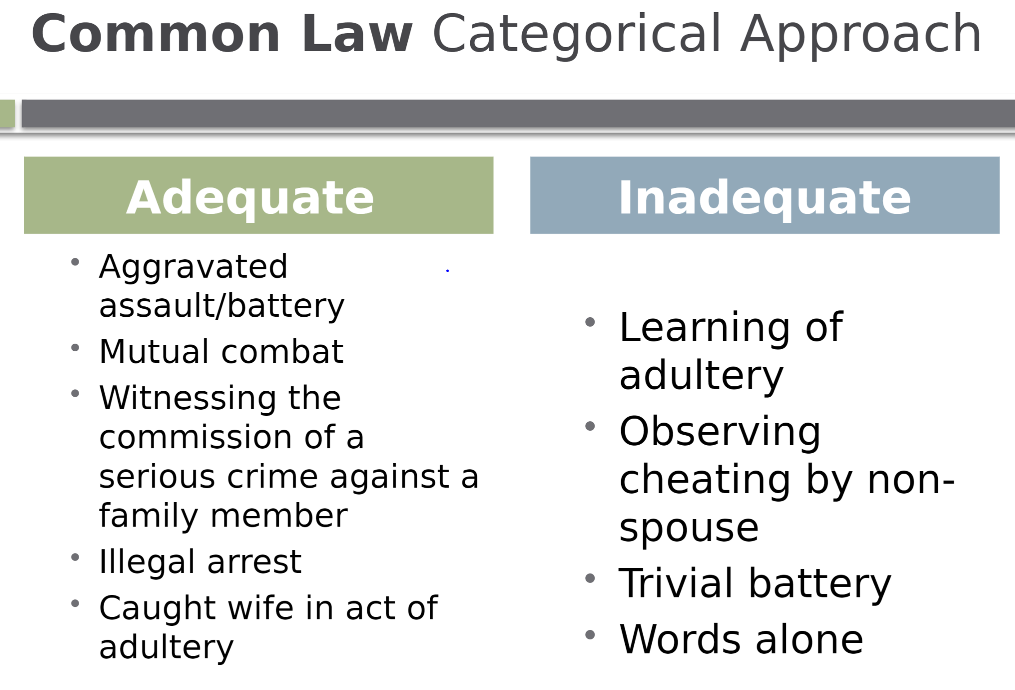 = OLD
    - Modern Provocation Approach
      - Must have been subjectively provoked
      - Reasonable person would have been provoked
        - RP conforms to “objective norms of behavior”
      - D must not have “cooled off”
      - Reasonable person would not have had time to “cool off”
      - Causal link between provocation, passion and killing
      - Does NOT include Unique characteristics of D or idiosyncratic tendencies
    - Maher Approach v Girouard Approach
      - Maher Approach
        - Do facts as a whole demonstrate provocation?
      - Maher Case
        - FACTS: D saw his wife + other dude go in and out of woods together. D followed dude to bar, a guy told him that his wife had sex with other dude the day before. D then shot the dude in the ear in the bar.
        - Takeaway: Facts as a whole demonstrate reasonable provocation before a reasonable amount of time passed
      - Girouard Approach
        - WORDS ALONE are NOT provocation
        - Standard = reasonableness
      - Girouard Case
        - FACTS: D and his wife had a very messy marriage. D’s wife often verbally abused him. One night the wife went on a tirade, insulted D, and said “what are you gonna do?” D then stabbed his wife to death
        - Takeaway: WORDS alone are not sufficient to provoke
    - POLICY: Eliminating the provocation defense could possibly make woman worse off b/c this is often used in domestic violence cases by women who feel helpless
  - MPC: Manslaughter (Extreme emotional disturbance)
    - Requirements
      - D had an Extreme emotional/mental disturbance (EMED)
      - There’s a Reasonable explanation or excuse for EED
    - How different from CL
      - Provocation NOT needed
      - NO issue of ‘cooling time’
        - CAN be built up emotion
        - Can be combination of acts
      - Very subjective
        - Individual’s history/characteristics more likely to be considered
    - Cassassa Case
      - FACTS: D dated girl his building and she ended things. D could not get over and went in her apt often while she was gone (did weird things). D tried giving girl wine, she rejected, and he stabbed her to death and drowned her in tub.
      - Takeaway: If there’s EED, ask: Was it reasonable?
        - Court concluded D’s reaction was peculiar to him and not reasonable

- UNintentional Killings – Manslaughter, Involuntary Manslaughter, and Negligent Homicide (without malice) → You should have been aware of risk
- 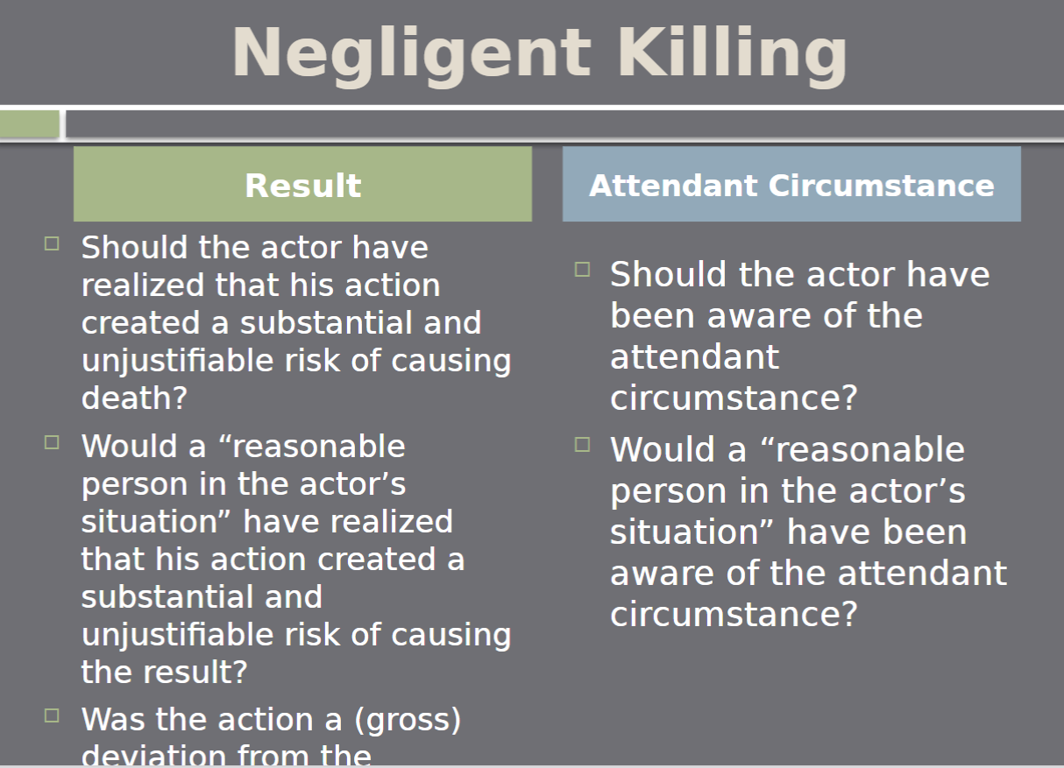
  - CL: Involuntary Manslaughter (Gross Negligence or Reckless)
    - 1. Reckless towards resulting death (Welansky) OR
      - Consciously aware of substantial risk for death and conduct is gross deviation from standard of care
    - 2. Gross criminal negligence towards resulting death OR
      - A reasonable person would be aware of substantial risk of death and conduct is a gross deviation from standard of care
    - (minority approach) Civil negligence (Williams)
    - Welansky Case (Club owner criminal negligence)
      - FACTS: D owned a nightclub. Many entrances were locked/blocked by design. Employee started fire by accident. There was a huge struggle to evacuate and many people died.
      - Takeaway: Welanksy was wanton and reckless in regard to human life. Welanksy intentionally had the club set up in a way that made it difficult for people to leave.
    - Williams (Dead baby of Indian parents)
      - FACTS: Ds were native American parents with a visibly sick child. Ds did not seek medical attention out of fear that child services would take the baby. The child died as a result. Ds were found guilty of involuntary manslaughter.
      - Takeaway: MINORITY approach → Ordinary negligence, not gross negligence is enough to convict for involuntary mansalughter

  - MPC: Manslaughter (Reckless)
    - Criminal homicide is manslaughter when it’s committed recklessly
    - Requires: Conscious disregard of substantial and unjustifiable risk
      - Disregard is a gross deviation from standard of care that a reasonable person would exercise
  - MPC: Criminal Negligent Homicide
    - Criminal homicide committed with negligent MR
    - People v Hall (Reckless Skiier)
      - FACTS: D was an experienced ski instructor and was out for a joy ride. D was going way too fast for conditions and collied with someone causing them severe brain injuries.
      - Takeaway: Jury found that D acted negligently but not recklessly. Important that it was a jury of all skiers and snowboarders

- UNintentional Killings – Depraved Heart Murder and Extreme Reckless Murder (with malice) → You were aware of risk and acted anyway
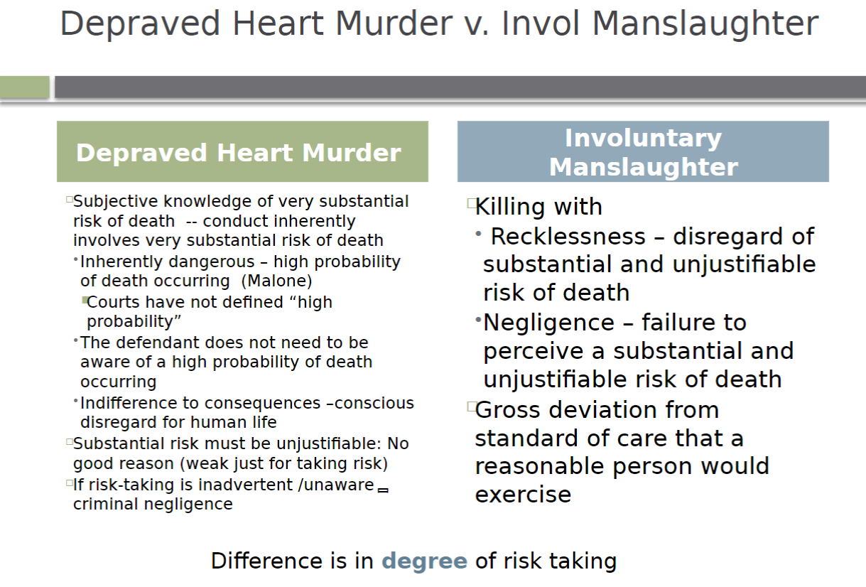
  - CL: 2nd Degree Depraved Heart Murder (Gross Recklessness)
    - Subjective knowledge of substantial and unjustifiable risk of death
    - Depraved heart = extremely reckless disregard for the value of human life
    - D must act with conscious disregard for human life + indifferent to consequences + no justification for taking risk
    - People v Malone (Grossly Reckless Russian Routlette)
      - FACTS: Two kids who were friends met up and one brought a loaded gun + suggested the two play Russian roulette. D pulled the trigger 3 times and then fatally shot his friend. D thought he only loaded the furthest chamber and thus could not kill friend.
      - Takeaway: Perfect example of D acting with reckless disregard for value of human life

  - MPC: Extreme Reckless Murder
    - Reckless AND extreme indifference to human life
    - Actor consciously disregards a risk that is gross deviation from standard of care that a law-abiding person would take
    - People v Flemming (Extremely Reckless Drunk Driving)
      - FACTS: D drove with a .32 BAC going 80 MPH, drove into oncoming lane and killed someone.
      - Takeaway: Perfect example of deviation from standard of care that a law abiding person would take

- Felony Murder (Common Law ONLY)
- 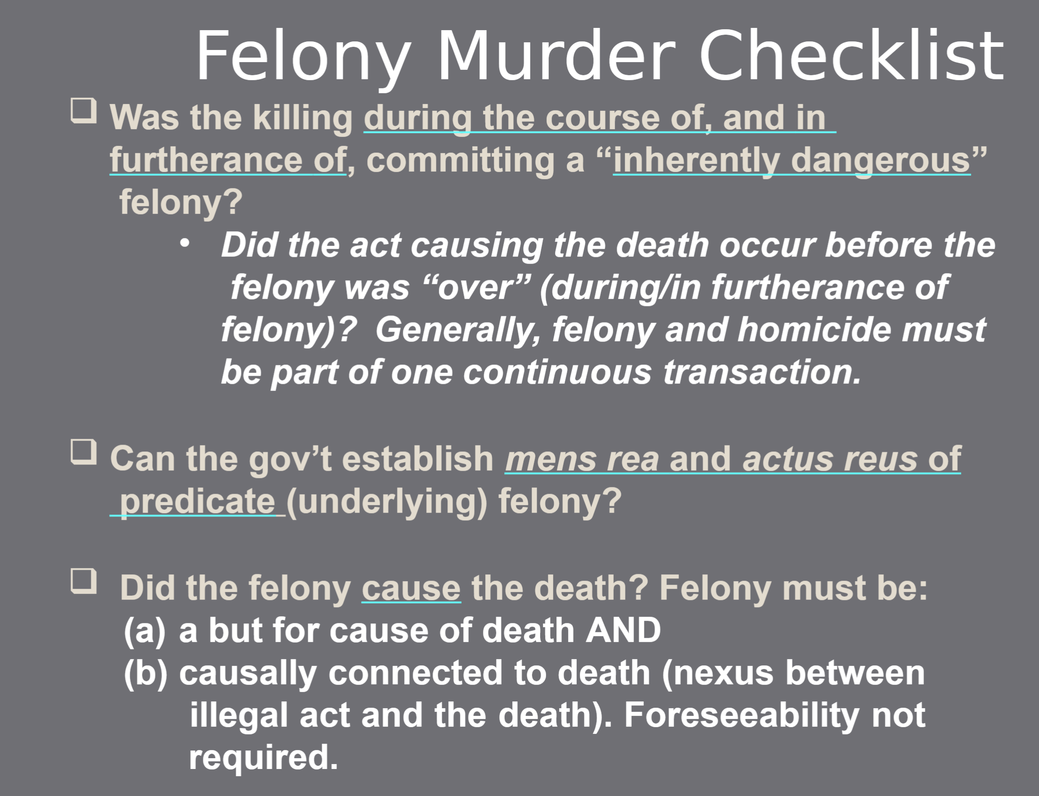
  - UNINTENTIONAL Killing
  - Death in the course of AND furtherance of a felony (Strict liability crime)
  - Must establish the mens rea and actus reus of the underlying felony
  - The death must have occurred while the felony occurred
  - The felony must have caused the death
    - Felony was the “but for” cause of death
    - Felony is casually connected to the death
  - The underlying felony must be inherently dangerous
    - 2 approaches
      - Enumerated: Felonies that qualify for FM are listed in statute, if not listed then its 2nd degree FM
      - If unenumerated: Determine if felony is inherently dangerous to charge 1st degree
  - Misdemeanor Manslaughter Rule
    - “Mini felony murder”
    - Killing in the course of a misdemeanor is automatically involuntary manslaughter
      - Limits = there must be causal connection and some states don’t allow very minor crimes to qualify
  - Example case = People v Stamp
    - FACTS
      - Guy robs convenience store and store clerk dies from heart attack during the robbery. Stork clerk had an underlying heart condition.
    - Takeaways
      - The victims underlying conditions do NOT matter, if someone dies during the course of a felony the felony murder rule will apply

  - People v Phillips (inherently dangerous felonies)
    - FACTS
      - Chiropractor is convicted of grand theft for telling girls family he could cure her using alternative medicine. Girl then forewent other treatments and died as a result.
    - Takeaways
      - Grand theft is NOT an inherently dangerous felony, could not charge FM – Determining whether felony is inherently dangerous is case by case basis determination
- Defenses
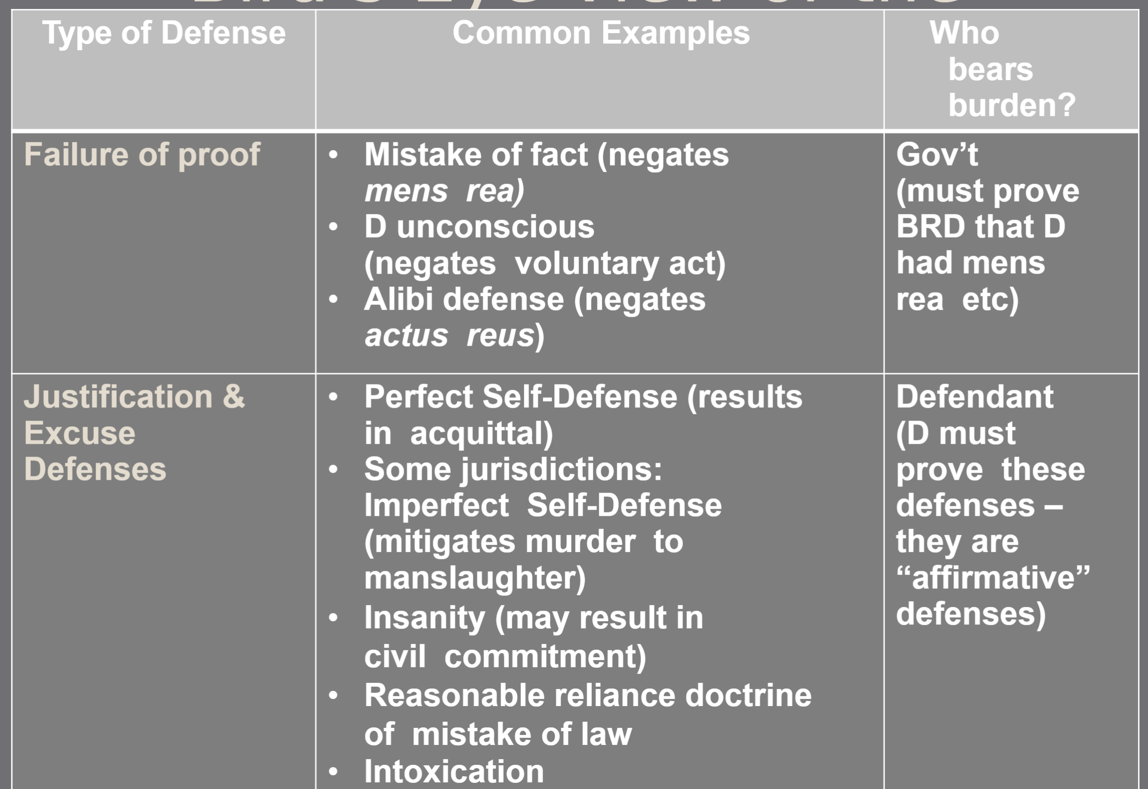
  - Self-Defense
    - Affirmative defense, D must raise it
    - Common Law Perfect Self Defense
      - Honest and reasonable belief that deadly force is necessary to repel an imminent threat
        - Must fear death or grave bodily harm
      - Reasonably believes is subjective AND objective
        - Reasonable mistakes are ok, Unreasonable mistakes are NOT ok
        - Reasonableness is based on what a reasonable person would do in the D’s circumstances
        - Reasonable (Goetz), can take into account…
          - Physical attributes of assailant
          - D’s prior experiences
          - Physical movement + comments of assailant
      - NOTE: Proof that threat turned out to be real is NOT needed
      - CANNOT Claim Self-Defense if…
        - You’re first aggressor
        - You could safely retreat
        - You used excessive force

    - Common Law IMPerfect Self Defense
      - Honestly & unreasonably believe deadly force is necessary to repel an imminent threat
      - Results in either voluntary or involuntary manslaughter
    - MPC Self Defense
      - D’s subjective belief that force was necessary is sufficient unless charged w/ crime that requires recklessness or negligence
      - More subjective approach – “Actor believes”
    - People v Goetz (NYC vigilante)
      - FACTS+
        - Goetz had been mugged before and was riding the NYC subway at a time when crime was peaking in NYC. A black kid makes a comment to Goetz asking for cash and Goetz responds by shooting the boy and the other boys with him.
      - Takeaways
        - Example of how subjective self-defense can be, Goetz was not convicted for shooting the boys.
    - Imminence Requirement
      - To use self-defense, you must be in fear of imminent harm but this creates issues with repeated violence
      - State v Norman (Battered Woman Syndrome)
        - FACTS
          - D had long history as domestic abuse victim and hit breaking point + killed husband in sleep b/c she feared he would kill her.
        - Takeaways
          - D was unable to claim self defense b/c the harm was NOT imminent
    - Duty to Retreat
      - MPC + Half of CL
        - Must retreat if you’re aware you can do so safely
          - State v Abbott (Driveway Hatchet)
            - FACTS
              - D got into dispute with neighbors over driveway. Neighbors came out with hatchet + knife and D ends up hitting neighbors with hatchet.
            - Takeaways
              - D was convicted, example of the rule above
      - Other half of CL
        - Can use deadly force against deadly attack even if you could safely retreat
    - First Aggressor Rule
      - 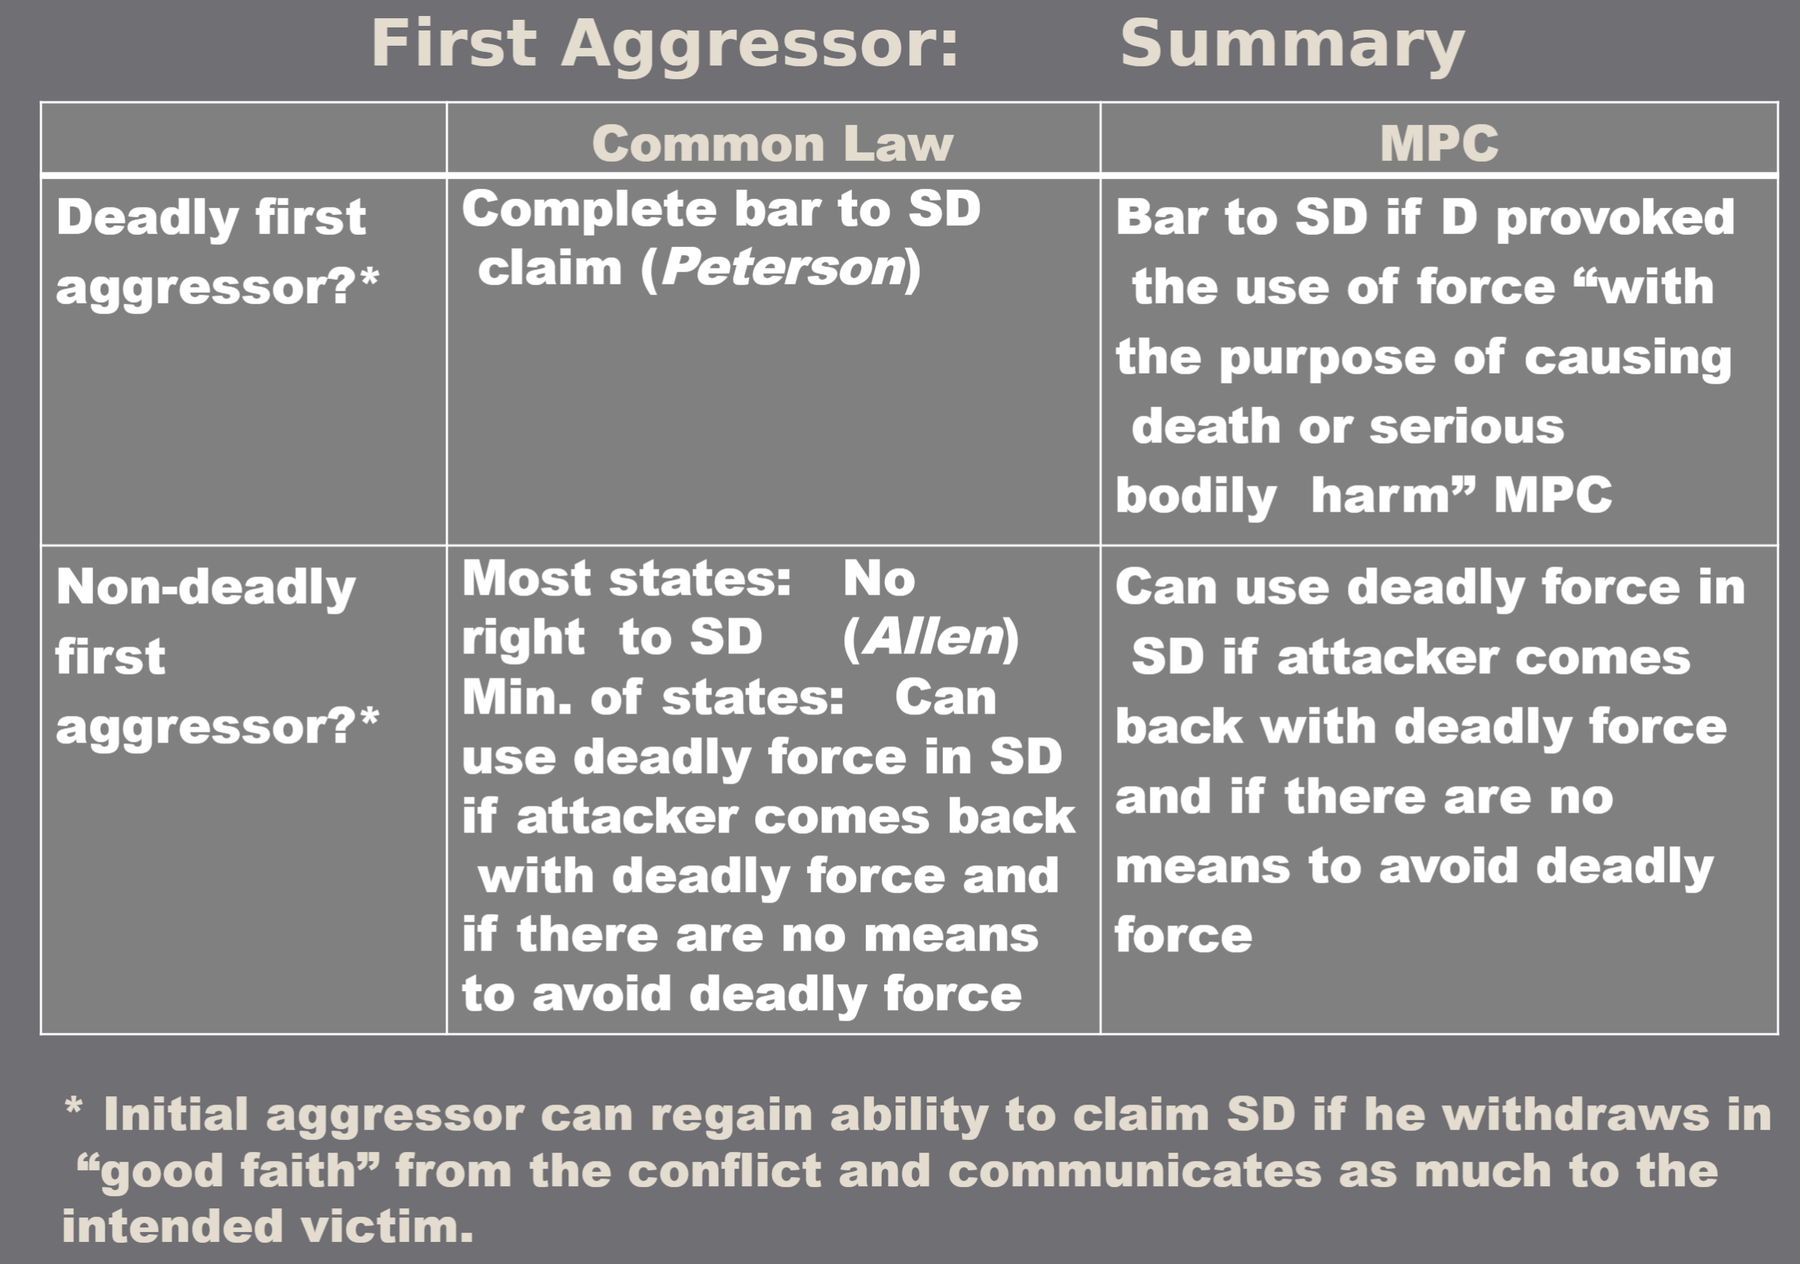
      - Peterson = Majority approach, MPC = minority approach
  - Insanity
    - Insanity = Legal term
      - Refers to mental state at the time of the crime
    - Competency → Must be mentally competent to stand trial
      - Must be able to consult w/ attorney and
      - Must be able to rationally understand proceedings
    - Burden of proof
      - 2/3 of states place burden on D
      - Other states make prosecution prove sanity beyond reasonable doubt
    - M’Naghten Test
      - A person is insane if
        - At the time of the act
        - B/c of a mental disease or defect
        - He did not know the nature and quality of the act OR
        - He did not know what he was doing is wrong
    - MPC Insanity Test
      - A person is insane if
                - At the time of the act
                - B/c of a mental disease or defect
                - He lacked the substantial capacity to appreciate the criminality or wrongfulness of the conduct OR
                - He lacked the substantial capacity to conform her conduct to the requirements of the law
    - What does not qualify for insanity?
      - Mere excitability, stupidity, obtuseness, impulsiveness
  - Diminished Capacity
    - NOT a complete defense, only lowers the mens rea
    - MPC (&most states)
      - Evidence that the D suffered from a mental disease or defect is admissible whenever it is relevant to prove that the D did or did not have a requisite MR of the offense
    - Some states
      - Allow mental disease or defect evidence to negate “specific intent” provisions
    - Minority States (Clark v Arizona)
      - Total ban on mental disease or defect evidence for anything other than insanity defense
      - Clark Case
        - D suffered from schizophrenia and shot cop at traffic stop. D was NOT allowed to present mental illness evidence unless it was used for insanity defense
  - Intoxication
    - Voluntary Intoxication
      - Common Law (most states)
        - Allow voluntary intoxication defense for certain specific intent MR
        - Mitigates specific intent crimes (purposely or knowingly) to general intent crime (recklessly)
        - If there is no lesser crime, then it is not given as a defense
          - People v Hood (Driveway Hatchet)
            - FACTS
              - D got hammered in Napa, resisted arrest and then shot cop.
            - Takeaways
              - Evidence of Ds intoxication was not admissible for general intent crimes (assault w/ deadly weapon)
      - MPC
        - Can use intoxication to negate mens rea, but NOT for recklessness or negligence
          - Same as the common law; only allow this for a higher level of intent

- Rape
  - Common Law
    - Forceful sexual contact
            - Penetration alone is considered force (MTS)
                - MTS Case → MTS was sleeping and boy had sex with her. Penetration without affirmative consent is rape
            - Force or threat of force that is more than penetration
            - Force or threat of force sufficient to overcome the victim’s physical resistance or victim couldn't resist b/c of fear (Rusk)
                - Rusk Case → Victim never physically or verbally explicitly stated no consent out of fear of retaliation, but did not affirmatively give consent.
    - NO consent
            - Rusk = verbal or physical resistance
            - MTS = no affirmative signs of consent
            - Verbal resistance + additional behavior
            - No affirmative, didn’t say yes
  - MPC
    - Male who has sex with a female, not his wife, guilty of rape if
    - He compels her to submit by force or threat of force
      - OR female is unconscious

Unit 4: Inchoate Crimes
- Attempt
  - D performs some act towards carrying out a criminal offense but does not complete the offense
  - Mens Rea = Intent to commit target offense
    - Results Crimes → Proof of purpose of causing result
    - Conduct Crimes → Proof of MR of underlying offense
  - Actus Reus
    - Common Law Dangerous Proximity Test (Rizzo)
      - D crosses the line from “mere preparation” when they are in “dangerous proximity” to proscribed conduct/result
        - Focus is on what’s left to be done
        - Rizzo Case → Ds planned to find a payroll guy carrying money and rob him. D’s never found the guy and were arrested by the police (were NOT in dangerous proximity)
    - MPC Substantial Step Test (Jackson)
      - Actor must take a substantial step toward the commission of the crime – it must be strongly corroborative of actor’s criminal intent
        - Focus is on what is yet to be done
        - Jackson Case → Group planned to rob bank. 1 person cooperated w/ police. Ds were caught outside bank w/ guns and ski masks (Ds DID take substantial step)
  - Defense = Abandonment
    - Only available to Ds who have a genuine change of heart about committing the crime
      - CANNOT be used if just waiting for better time to commit the crime
    - Common Law/MPC
      - C = complete renunciation
      - A = abandon efforts before the crime is completed
      - V = voluntarily abandon his/her criminal efforts

- Accomplice Liability
- 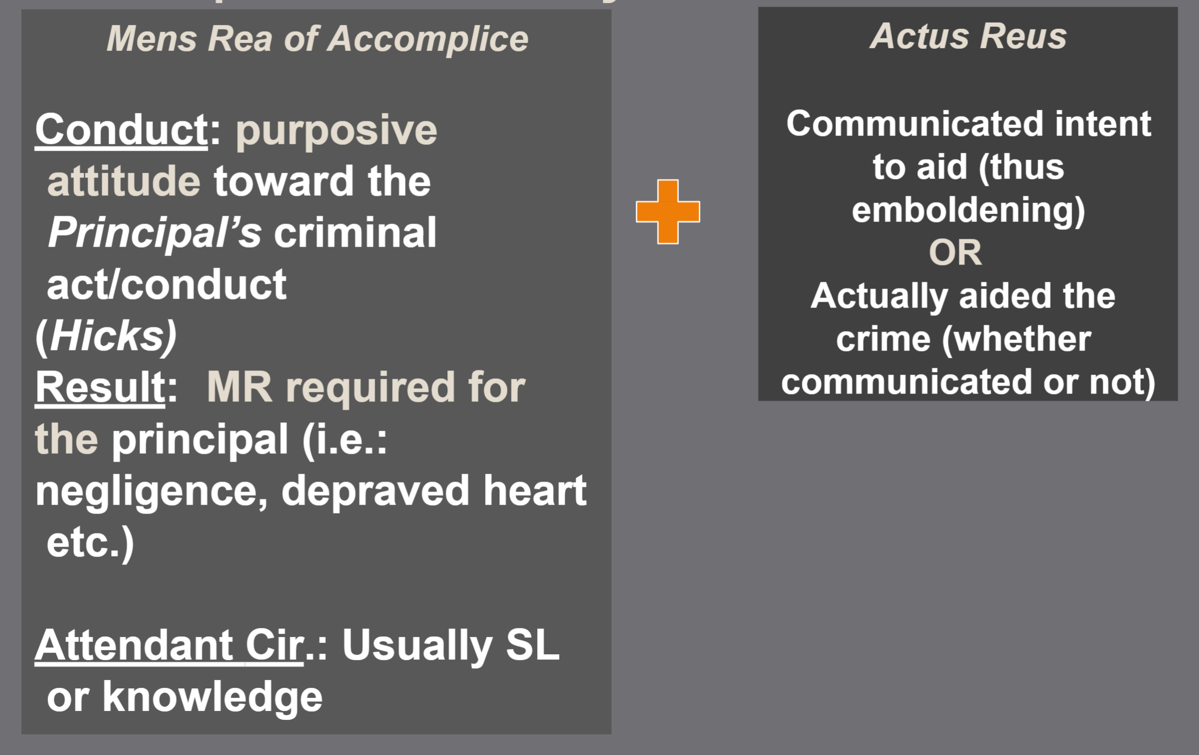
  - Theory of guilt, NOT a separate crime
  - D is held liable for the conduct of another person with whom they are associated
  - Elements
    - Actor must engage in an act of encouragement (Actus Reus)
    - Actor must purposefully encourage the commission of a target crime (Mens Rea)
      - Actor must in fact assist principal in commission of the crime
      - Assistance does NOT need to be substantial, any assistance counts

  - Common Law
    - Purpose to aid or encourage the principal AND requires mens rea for the target crime
      - State v McVay (steamboat negligence)
        - FACTS: D told captain they could leave dock even though he knew about engine defect. Boiler exploded and killed 3 people while on water. D was found guilty as accomplice.
        - Takeaway: For results crimes, must establish the MR of the underlying offense (ex: depraved heart for depraved heart murder)
    - The target crime is a natural, probable, and foreseeable consequence of the accomplice’s act
      - EX: You’re the lookout for a burglary → the natural, probable, and foreseeable consequence is a successful burglary
      - Hicks v US (“take your hat off and die like a man”)
        - FACTS: D was charged with being a murder accomplice for being at the scene of the crime and saying things out of fear for his own safety.
        - Takeaway:
          - Words without proof of intent are NOT enough to establish accomplice liability (NEED intent to encourage principal)
          - Mere prescence is not enough for accomplice liability, unless intended to encourage principal
    - Knowing facilitation is usually not enough to trigger accomplice liability unless related to a serious crime
      - State v Gladstone (weed dealer rec)
        - FACTS: Undercover cop tries to buy weed from D to catch up. D says he has none and directs cop to other dealer.
        - Takeaway: Knowing facilitation is NOT enough for accomplice liability in less serious crimes
      - US v Fountain (prison shank for buddy)
        - FACTS: D lifted up his shirt and allowed other inmate to grab shank and kill guard
        - Takeaway: For serious crimes, knowing facilitation is enough for accomplice liability
    - The more the accomplice knows about the crime and amount of info disclosed by the principal help determine whether you’re liable
    - Its enough that the aid makes it easier for the principal actor to complete the crime
      - State v Tally (intercepted telegram)
        - FACTS: D prevented a warning telegram from getting to a guy who had a mob coming after him.
  - Accomplice Liability for Failed Attempt to Aid Crime
    - Common Law
      - Unsuccessful attempt to be accomplice is NOT a crime
      - Must successfully communicate your aid to be an accomplice
    - MPC
      - Attempt to aid IS a crime
    - Steps to Analyze this
      - Did the principal commit a crime (attempt or complete)?
        - YES
          - MPC
            - If accomplice aided or attempted to aid that crime, D is guilty as accomplice
          - Common Law
            - If accomplice aided that crime, D is guilty as accomplice
        - NO
          - MPC
            - If accomplice did things designed to aid crime, then D is guilty of attempted aiding and abetting
          - Common Law
            - NO liability
  - Abandonment for Accomplice Liability
    - MPC and Common Law
      - 1. Terminate complicity prior to the commission of the offense AND
      - 2a. Wholly deprive the crime of its effectiveness OR
      - 2b. Give timely warning to law enforcement

- Conspiracy
  - The Basics
    - An agreement with at least 1 other person to commit (or help commit) a crime
    - Can be guilty of conspiracy + the actual crime (ex. Conspiracy to commit bank robbery and bank robbery)
      - It’s a SEPARATE offense
    - Accomplices are usually conspirators
      - BUT don’t need to be
  - Mens Rea (CL and MPC)
    - MR for Target Crime
      - Must agree to commit crime w/ purpose of promoting or facilitating its commission
        - Can be knowing facilitation is enough for serious crimes in CL –
        - Knowledge is usually NOT enough, must be intent to further the conspiracy
          - People v Lauria (prostitute phone guy)
            - FACTS: D had voicemail taking service and knew prostitutes used it. However, D did not help further their businesses
            - Stake in the Venture
              - Purpose can be inferred if D has stake in venture, evidenced by
                - Disproportionate profit
                - Disproportionate clientele
    - MR for Attendant Circumstances
      - Case by case basis
  - Actus Reus
    - Agreement AND
      - Can be tacit, implied agreement (wink, wink knod*)
        - EX: Alvarez case → Winking and knoding used as evidence that D conspired
      - Jury can infer agreement from parallel actions (two people working towards one goal)
    - Overt Act
      - Any act manifesting the conspiracy
        - Anything done in furtherance of the felony
      - **Not always required for serious crimes**

    - MPC Approach
      - D only guilty of conspiracy and not liable for substantive offenses committed by co-conspirators
    - Pinkerton v US (whiskey tax fraud, both bros liable)
      - FACTS: Two brothers made illegal whiskey and committed multiple tax fraud crimes. Both D agreed to do the crime but only one brother committed the actual offenses. Both brothers were held equally liable
      - Takeaway:
        - Common Law: D liable for the substantive offenses of co-conspirators that are in furtherance of, and during the course of the conspiracy
        - MPC: Rejects Pinkerton liability
    - State v Bridges (got your boys but they kill at party)
      - FACTS: Guy gets into fight at party. Leaves to come back with his other buddies. On way back they stop and get guns for intimidation. At party, fight ensues, friends shoot and kill dude. The original partygoer is held liable for all crimes committed
      - Takeaway:
        - EXPANDS Pinkerton liability
        - Common Law
          - So long as crime was reasonably foreseeable then D liable for crimes of co-conspirators
          - Doesn’t matter if it was beyond scope of agreement and not strictly “in furtherance” of the conspiracy

