Table of Contents
Basics 2
Objective vs Subjective Assent 3
Case Illustrations of Intent 3
Offer and Acceptance 3
Case Illustrations of Offers 3
Case Illustrations of Acceptance 4
Case Illustration of Unilateral Contracts 4
Case Illustrations of Missing Terms, “Agreements to Agree” 5
U.C.C. Offer and Acceptance 5
Case Illustrations of U.C.C. Applications 6
Case Illustrations of Battle of the Forms 7
Case Illustration of Material Alteration 8
Consideration 9
Case Illustrations of Consideration 9
Layered Contracts 10
Case Illustrations of Electronic/Layered Contracts 11
Promissory Estoppel 13
Case Illustration of Promissory Estoppel 13
Statute of Frauds 14
Case Illustrations of the Statute of Frauds 14
Case Illustration of UCC Statute of Frauds 16
Interpretive Principles 17
Interpretive Principles Case Illustrations 17
Parol Evidence Case Illustrations 19
U.C.C. Parol Evidence Rule 21
Implied Terms Case Illustrations 21
Defenses to Enforcement 23
Duress Case Illustrations 23
Unconscionability Case Illustrations 24
Justifications for Nonperformance 25
Mistake Case Illustrations 25
Changed Circumstances Case Illustrations 25
Modification Case Illustrations 26
Breach 28
Express Conditions Case Illustrations 28
Material Breach Case Illustrations 29
Anticipatory Repudiation Case Illustrations 30
Remedies 32
When Damages Are Appropriate Case Illustrations 32
Expectation Damages Case Illustrations 32
Alternatives to Expectation Damages
Reliance Case Illustrations
Restitution Case Illustrations
Specific Performance Case Illustrations
Liquidated Damages Case Illustrations

Contracts Outline

Basics
What is a contract?
An agreement between the parties over an exchange of performances, and the rights and duties associated with them.
What are the elements of a valid contract?
Formation
- Offer
  - Manifestation of willingness to enter into a bargain, mutual assent
- Acceptance
  - Meeting of the minds, mutual assent
- Consideration or consideration substitute
  - Bargained for exchange, benefit/detriment
After Formation
- Performance
- Breach
- Remedies
  - Damages, specific performance, rescission
Why have contracts?
Purposes
- Facilitates transactions between strangers → economic efficiency
- Promotes autonomy → people get to decide what’s valuable to them
- Morality → accountability to our promises and parties, socially beneficial
- Predictability and certainty → maximizes utility → planning, reliability
- Protection → unfair surprises, changes of position, fraud
- Potential to foster equality → autonomous agency, arena for interaction, non-punitive
- Anti-windfall à damages focus on restoration and prevention of unjust enrichment

Objective vs Subjective Assent
Does intent matter?

Case Illustrations of Intent
- Ray v. Eurice Bros., Inc.: a couple contracts the Brother’s company to build their house, after signing the contract the brother claim they didn’t know about the terms included
  - The test of a true interpretation of an offer or acceptance is not what the party making it thought it meant or intended it to mean, but what a reasonable person in the position of the parties would have thought it meant
- Lucy v. Zehmer: Lucy gets a drunk Zehmer to sign an agreement to sell him some land, Zehmer then claims that he had only been kidding and that it wasn’t intended to be an actual contract
  - If the words or other acts of one of the parties have but one reasonable meaning, his undisclosed intention is immaterial except when an unreasonable meaning is known to the other party
Why has contract law largely adopted an objective approach?
Allows for more standardized procedures in the interest of fairness
Streamlined litigation as subjective ideas are essentially unproveable

Formation

Offer and Acceptance
What is required to make a valid offer?

Case Illustrations of Offers
- Lonergan v. Scolnick: Scolnick placed an ad to sell his land, Lonergan wanted to buy it, they exchanged letters, misunderstanding of intent, Scolnick sold the land to someone else after Lonergan thought he had already agreed to buy it
“An offer is the manifestation of willingness to enter into a bargain, so made as to justify another person in understanding that his assent to that bargain is invited and will conclude it.”
Bilateral contracts involve commitment on both sides with an element of futurity
Direct and complete proposal providing for an exchange of defined performances
Offers must be definite in the sense that no further expression of assent is necessary, and that obligations are ascertainable enough by the courts and parties involved to determine breaches
What is required to make a valid acceptance?

Case Illustrations of Acceptance
- Normile v. Miller: Normile puts an offer on a house, Miller responds with differing terms, Normile believed he held the option to buy the house when really his offer had been rejected when the counter offer was proposed
  - Editing of terms is a rejection and a proposal of a counteroffer
- Beastie Boys v. Monster Energy Co.: Z-Trip said “dope!” in response to a video sent to him by Monster, which they took to mean as permission to use his music that sampled the Beastie Boys
  - Promises must be confirmed by 'clear, unambigious, and unequivocal' language
“Proposed mutual promises must be confirmed by timely acceptance, through ‘clear, unambiguous, and unequivocal,’ language in order for a contract to be formed”
Offerors may specify terms of acceptance in their offers, such as timeline for acceptance.
An ‘option’ contract is made when the offeror binds themselves to keeping an offer open for a set amount of
time, and when it is supported by consideration by the offeree or some other basis for enforcement.
Acceptance must be timely, clear, unambiguous, unequivocal, unqualified, and a mirror image
An acceptance that alters terms or conditions is not an acceptance, but a counteroffer
A counteroffer is really a rejection and a new proposal for formation
A counteroffer terminates the power of acceptance created by the previous offer
Silence can function as acceptance when prior dealings between the parties make it reasonable for the offeror to expect to be notified of a rejection and, in the absence of a rejection, to conclude acceptance

[Revocation of offers]

[Mutual assent]

Case Illustration of Unilateral Contracts
- Cook v. Coldwell Banker: Coldwell Banker offered a bonus program but rescinded the offer after Cook had already rendered performance
  - Acceptance through performance in a unilateral contract
- Sateriale v. R.J. Reynolds Tobacco Co.: Camel offers an illusory promotional program where buyers can save up c-notes and exchange them for goods, but they terminate the program prematurely after performance has been rendered
  - Generally, ads are not offers unless they invite specific performance without further communications and leave nothing for negotiation
“Beginning of performance by the offeree ‘carries with it an express of implied promise to complete the performance’ and an offeror is bound as soon as the offeree has rendered a substantial part of the performance”
When one party offers to commit to some performance, if and only if the other party first accepts by actually rendering their performance, thus limiting the offerors risk
Mutuality of obligations does not apply in unilateral contracts, allowed to stipulate termination without notice
Illusory promises that retain unrestricted rights to both revoke the offer and to not perform are unenforceable
An ad may be considered an offer when it (1) clearly, explicitly (2) lists material terms, (3) invites performance, (4) leaves nothing for negotiation

When are contracts sufficiently definite?

Case Illustrations of Missing Terms, “Agreements to Agree”
- Walker v. Keith: Walker was renting from Keith, they made an agreement to agree to a new rent when the time came for a rental extension
  - No method given for determining rent
- Quake v. AA: Quake was given the go ahead to start construction, AA then rescinded claiming it was a letter of intent and not a contract
  - Extensively detailed letter of intent can be binding
Negotiations are sufficiently definite to constitute an offer and acceptance when a court can determine intent through level of detail and extent of assurances
Agreements to agree are not binding contracts when essential elements are reserved for future agreement, the courts must be able to determine what they are enforcing

If the agreement to agree contains a prescribed method for ascertaining missing essential
terms, it may be sufficiently definite
Parties may be bound when they have reached agreement in principle

U.C.C. Offer and Acceptance
When does the UCC apply?

Case Illustrations of U.C.C. Applications
- Jannusch v. Naffziger: J sold N their concessions business, N changed their mind and tried to say no contract had been formed, tried to determine if the UCC applied
  - Conduct indicating acceptance overcomes subjective differences
- Princess Cruises v. GE: GE messes up repairs to a ship, Princess wants damages, whether the CL or UCC applies will determine their right to damages
  - When the predominant purpose is services, the UCC does NOT apply
“A contract for sale of goods may be made in any manner sufficient to show agreement, including conduct by both parties which recognizes the existence of such a contract”
UCC does not displace all prior law, it uses CL as a backdrop, and it governs goods (tangible, moveable property)
CL fills the gaps between the conflicts that the UCC specifically addresses and governs
The Article 2 of the UCC applies when the predominant purpose is an exchange of goods, if purpose is unclear courts will use the Coakley and Williams test to determine predominant thrust
C&W test looks at the language of the contract, the nature of the business of the supplier, and the intrinsic worth of the materials in relation to the amount of services in order to determine purpose/thrust
Both method require a certain amount of definiteness, enough for reasonable certainty in agreement being reached
Some terms the UCC deems essential: identity of parties, subject matter of the contract, consideration, quantity, substantial performance or conduct
Definite point of formation is not required for a contract to be sufficient, one or more terms can be left open “if the parties have intended to make a contract and there is a reasonably certain basis for giving appropriate remedy”
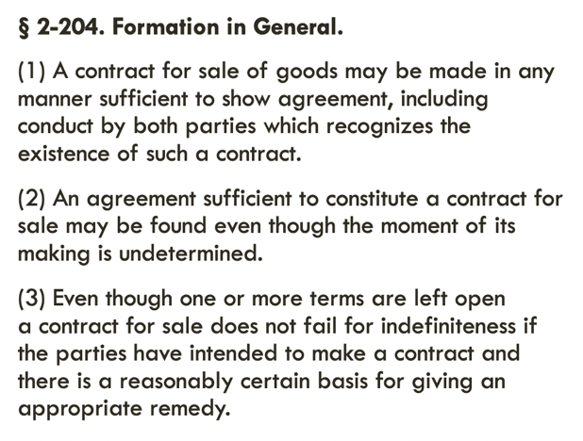
How does the UCC handle differing terms?

Case Illustrations of Battle of the Forms
- Princess Cruises v. GE: GE messes up repairs to a ship, Princess wants damages, whether the CL or UCC applies will determind their right to damages
  - When the predominant purpose is services, the UCC does NOT apply
- Styberg v. Eaton: Eaton contracts Styberg for some parts, differing ideas of how many parts were ordered, partial delivery of some parts, then Eaton backed out
  - Despite partial fulfillment, actions taken were not enough to indicate the letters and negotiations containing differing terms constituted a binding contract
- Brown Machine, Inc. v. Hercules, Inc.: B sold H a machine, employee got hurt on the machine, H’s purchase order stipulated their terms would not be modified without express written acceptance, B’s order acknowledgement terms contained an indemnity clause saying they would not be responsible
  - By accepting through fulfillment, you are accepting differing terms that do not materially alter the agreement unless expressly stated otherwise
2-207 (1) An offerees response to an offer operates as a valid acceptance even though it contains terms additional to or differing from the terms of the offer UNLESS the "acceptance is expressly made conditional" on the offeror's assent to the additional or different terms, in which case it is a counteroffer
UCC §1-103: "An offer is made when the offer leads the offeree to reasonably believe that an offer has been made"
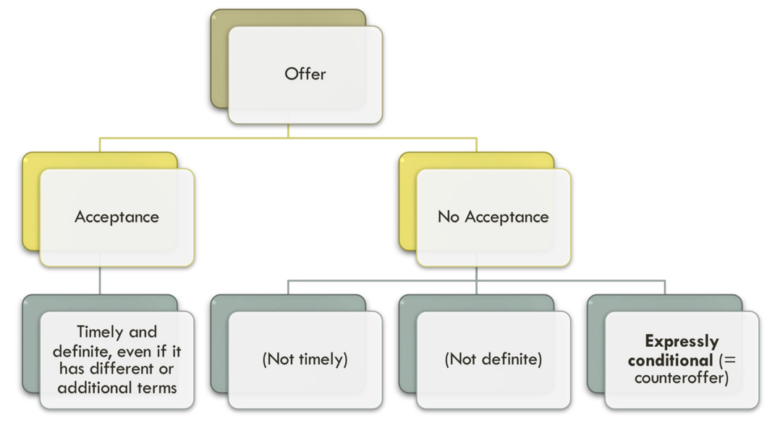
UCC takes an opposite approach to the “mirror image” rule, known as “last shot,” which favors the buyer (assuming offer was not expressly conditional)
It assumes that parties have reached an agreement, the rules are about deciding which terms to enforce
A process for attempting to minimize the potential for any given term to be applied unfairly
(2) The additional terms are to be construed as proposals for addition to the contract. Between merchants, such terms become part of the contract unless: (a) the offer expressly limits acceptance to the terms of the offer; (b) they materially alter it; or (c) notification of objection to them has already been given or is given within a reasonable time after notice of them is received.
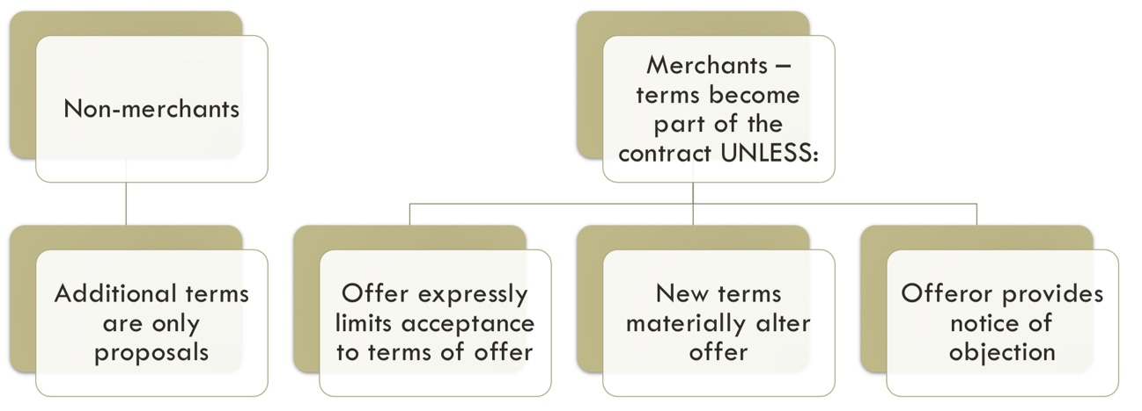
This functions to encourage parties to actually read terms and enter into negotiations
Examples of material alterations include changes in quantity, price, and liability

(3) Conduct by both parties which recognizes the existence of a contract is sufficient to establish a contract for sale although the writings of the parties do not otherwise establish a contract. In such case the terms of the particular contract consist of those terms on which the writings of the parties agree, together with any supplementary terms incorporated under any other provisions of this Act.
To clear the way for commerce, differing terms will not defeat an otherwise established contract
The terms that the parties do agree on will be combined and supplemented with general, default UCC terms

Case Illustration of Material Alteration
- Gottlieb v. Alps: Gottlieb sells Alps fabric but changes the type of fabric partway through production leading to a recall, G includes a limited liability clause in their contract, but A sues for breach because of fabric change
  - Material alteration occurs when it causes unreasonable surprise, of which undue hardship is a consequence but not a requirement
A clause that ‘materially alters’ an agreement will not be included in the terms unless expressly agreed to. Material alteration occurs when it causes unreasonable surprise, in that no reasonable merchant would have agreed to it
Unreasonable surprise is the most relevant criteria of material alteration, and it can lead to hardship but the hardship is not required
Courts determine this by whether a reasonable merchant would have agreed to the additional term
If the clause in question is an industry standard then it cannot be an “unreasonable surprise”
Though not required, a hardship claim must include that the other party knew it would cause the hardship
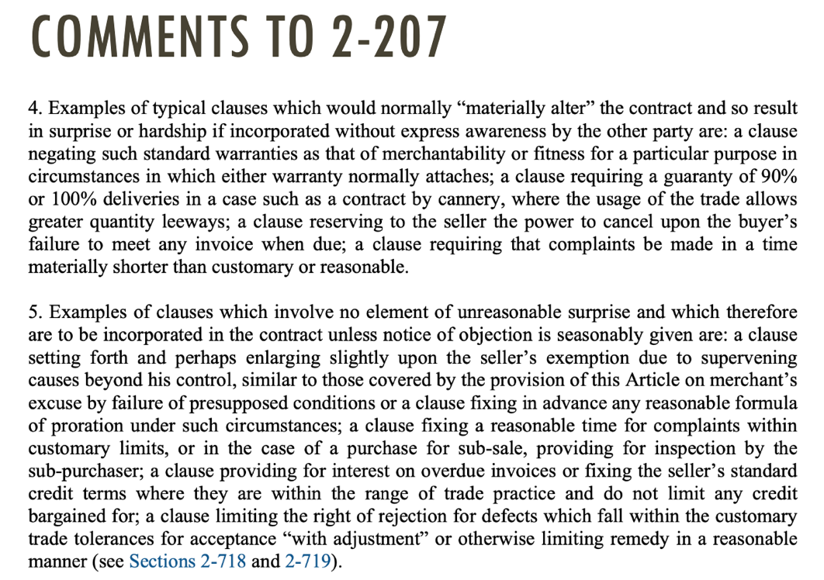
What and who does the UCC method benefit?
A question of policy, geared towards easing of commerce and encouraging negotiations
The assumption is that a deal has been made, this process seeks to forward that deal by providing framework for disagreement resolution and to simplify any subsequent litigation
More clear cut (though seemingly more complicated) than the CL approach, why?


Consideration
Why is consideration required?

Case Illustrations of Consideration
- Hamer v. Sidway: Uncle promises his nephew money if he abstains from vices until his 21st birthday
  - Abstaining from your legal rights is a legal detriment
- Pennsy v. American Ash Recycling Co.: Pennsy receives defective substrate for free from AA, Pennsy must redo the work at great cost, AA claims the substrate was a gift and not a contract, P says AA benefited from gift
  - The promise must induce the detriment and be the reason for it
- Dougherty v. Salt: Child receives promissory note, court decided it was gratuitous and unenforceable
  - The promise was not offered nor accepted with any other purpose
- Plowman v. Indian Refining Co.: workers were promised pensions at the time of their firing, disagreement about the duration of pensions promised, no benefit/detriment exchange occurred
  - Promise was made after performance and moral obligation is not legally enforceable
- Dohrmann v. Swaney: Dohrmann got his elderly neighbor to give him millions of dollars in a bargained-for exchange where he would change the middle names of his sons
  - The court will consider adequacy of consideration only when it shocks the conscience and is accompanied by circumstances of unfairness
- Marshall Durbin Food Corp. v. Baker: Baker was induced to stay at a failing company through the promise of a retirement package, company then says the promise was illusory due to their right to fire him
  - Promisor receiving the benefit that induced the promise is sufficient even if no detriment was suffered by the promisee
- Barfield v. Commerce Bank: Bank refuses to give change for a hundred dollar bill to black individuals, Barfield claims this violated the discrimination laws in contract formation
  - Value does not have to change for an exchange to occur
Consideration is either a bargained-for exchange or an induced benefit/detriment that may or may not be reciprocal
Consideration is examined when trying to determine between a gift and an enforceable contract
Most cases will have consideration but we must still address that it is present
A promise is gratuitous when the promisor receives nothing in return
Consideration occurs when they are induced to make the promise due to a benefit they would receive
Detriment suffered by the promisee is also consideration, but they do not have to happen in tandem
"If a benevolent man says to a tramp: 'If you go around the corner to the clothing shop there, you may purchase an overcoat on my credit,’ no reasonable person would understand that the short walk was requested as the consideration for the promise, but that in the event of the tramp going to the shop the promisor would make him a gift.”
In the tramp hypo, the offer is a conditional gift, as it is unreasonable to view the walk as inducing the promise
Similarly, past acts are not grounds for consideration because there is no possibility of mutual inducement
An illusory promise can create a binding unilateral contract if it induces sufficient performance and detriment from the promisee
Detriment can be suffered in many ways, does not have to be monetary, can also consist of giving up rights or opportunities in service of receiving the promised exchange (inducement)

Layered Contracts
How does/should the law deal with layered and electronic contracts?

Case Illustrations of Electronic/Layered Contracts
- DeFontes v. Dell, Inc.: Dell posts their terms online, in the order acknowledgement, and enclosed in their packaging, but only some of these included the clause letting consumers know they can reject the terms through returning the product
  - T&C must expressly indicate that they can be rejected through return or nonperformance
- Meyer v. Uber Technologies: Meyer joined the app but did not view the T&C posted below the registration button on the apps interface
  - T&C must be obviously binding when accepted through continued use
- Long v. Provide Commerce, Inc.: Long purchased flowers, PC wanted to enforce their arbitration clause, Long claims he did not notice the hard to see T&C and should therefore not be bound by them
  - T&C must be clearly viewable to the reasonably prudent user
“An offeree, regardless of apparent manifestation of his consent, is not bound by inconspicuous contractual provisions of which he is unaware, contained in a document whose contractual nature is not obvious”
Shrinkwrap agreements are where T&C are included in the packaging of products, use of product is assent
Clickwrap agreements ask their users to read and affirmatively agree to T&C before continuing, selecting/clicking agree is assenting to T&C
Browsewrap agreements are where T&C are posted on the website, assent is tendered passively through continued use
T&C must be posted in such a way to give a reasonably prudent user inquiry notice that they are being bound
Inquiry notice is given through obvious visuals and language indicating legal significance, and it is required for mutual assent
These forms assume the right of companies to assert terms over their users, there is no “meeting of the minds”
Layered contracts (money now, terms later) promote the interests of companies by removing obstacles to use
Browsewrap and clickwrap are functionally the same to users and in the eyes of the law
How do these differ from classical notions of contract law?

End of Contract Formation

Promissory Estoppel
Why impose liability without consideration?

Case Illustration of Promissory Estoppel
- Kirksey v. Kirksey: Widowed woman’s brother in law induces her to forfeit her land claim to come live on his land, then kicks it out 2 years later after he has used her to establish claim to more land
  - How does a court decide when a promise is gratuitous and when it is binding
- Harvey v. Dow: Daughter seeking enforcement of land promised to her after she built her house there (relying on the promise that the land would be gifted to her), parents encourage her to build and even substantially help, daughter makes substantial improvements to the land in reliance on their promise
  - When the actions of the promisor are substantial and encourage the forseeability of the promise being kept, than an enforceable contract has been made
- Katz v. Danny Dare, Inc.: Katz is induced to retire by his boss who encourages him to leave for 13 months based on promising him a pension, Katz would not have retired without the promise, boss later tries to claim that Katz would have been fired if he hadn’t retired, Katz ends up working part time so DD stops his payments but he is no longer able to work full time and make up for the money lost in the pension ceasement
  - When you have been actively induced into agreeing to a promise, at your detriment, and there is no remedy except for enforcing the original promise, then the promisee is entitled to the original promise.
- Aceves v. U.S. Bank, N.A.: Bank promised to work with Aceves on reworking her mortgage payments if she withdrew from bankruptcy proceedings, so she did and they still put her house on the market and evicted her
  - A promise need only be definite enough that a court can determine the scope of the duty and the limits of performance must be sufficiently define to provide a rational basis for the assessment of damages, in this case the promise was to “negotiate”
- James Baird Co v. Gimbel Bros., Inc.: Baird quoted for a bid, relying on an offer from GB for linoleum to price it, GB wrongly estimated the amount of lino required and withdrew their offer, Baird sues
  - When a “promise” contemplates acceptance of an offer in the form of a bilateral contract, the promisor has made an offer not a promise
- Drennan v. Star Paving Co.: Similar to previous case, SP miscalculates the amount of paving and Drennan bases their bid on it, they get the bid, SP tries to retract, Drennan sues for the difference between quoted price and actual
  - When it is forseeable that a promise will be relied upon, the promisor is bound to their own promise even if it is in error
The four elements of promissory estoppel: (1) a promise, (2) reasonable/foreseeable reliance, (3) actual detrimental, (4) enforcement of promise is the only way to avoid injustice
PE is an alternative to contract formation, it is a quasi contract that does not require consideration
The reliance is unbargained for and based mainly on the relationship of the parties
It is mainly invoked in familiar disputes and employment benefit or pension cases
Case law generally accepts this concept as a way to enforce what would otherwise be unenforceable
How to determine if the reliance was reasonable?
Foreseeability of reliance | The manner and degree of the reliance
Reliance must induce detrimental action, which can include monetary loss, relocation, taking on stress or anxiety etc.
This is the most important aspect of PE

Injustice can be invoked by the degree of detrimental reliance
Courts will usually only enforce PE if it is the only way to stop the injustice incurred by the promisee
This idea of corrective justice returns us to the values promoted by contract law

Statute of Frauds
What is the Statute of Frauds?

Case Illustrations of the Statute of Frauds
- Crabtree v. Elizabeth Arden Sales Corp.: Crabtree is hired by Arden, Arden writes out a contract and signs it, later there is an addition that Arden does not sign but if referred to in the original document, the addition is deemed part of the overall memorandum
  - Memos can be linked in a strict approach where the signed document refers to the unsigned document
- Beaver v. Brumlow: Beaver sold Brumlow some of his land to live on but never put it in writing, Brumlow cashed out retirement funds and built a home on the area of the property both parties had agree to, their relationship sours and Beaver’s try to evict Brumlow claiming they were just renters
  - Part performance of a deal can establish an exception to the SoF
- Alaska Democratic Party v. Rice: Rice quit her job and moved to Alaska based on an oral contract with the ADP, they ended up firing her, they claim the oral contract was invalid because it fell within the SoF
  - PE can be invoked to substitute for SoF when there are the elements of PE plus “clear and convincing evidence”
The Statute of Frauds requires contracts be signed when the contract is for: the sale of land, for a duration of over a year, and for the sale of goods over $500
The contracts for over a year must be for something that cannot possibly be completed in a year
If duration is unspecified it is unlikely to fall under the SoF
Lifetime contracts do not fall under the SoF because there is always the chance that the term will be under a year
The possibility of breach does not remove a contract from the SoF
This scope is determined by how hard a contract is to prove and the value of the transaction
SoF is generally interpreted relatively relaxedly as more courts do not want to overturn agreements on a technicality
It requires the contract be written down in clear terms (hence lack of duration above) and signed by the party against whom enforcement is being sought
Linking Writings
Strict approach requires express, explicit reference to the unsigned letter in the signed letter | Permissive approach allows for relation in subject matter and consideration of conduct and context

What are exceptions to the writing requirement?
Part Performance Exception
Strict | - Performance must unequivocally refer to the contract  - Other possible reasons do not nullify, but conduct must be unequivocally provable
Permissive | - Not about one possibility, but what a reasonable person would assume the conduct is based on  - For land: taking possession, making valuable, permanent, and substantial improvements
Restatement | - Reasonable reliance and continuing assent of the party against whom enforcement is sought  - Changed position so substantially that enforcement is the only way to avoid injustice

Promissory Estoppel Exception
Requirements for Use | - Clear and convincing (heightened evidentiary standard)  - Reasonable to rely on the promise  - Definite and substantial
Jurisdictional Limits | - Some states do not recognize this exception  - Some do the 3 requirements above  - Restatement recognizes the exception but only when the nature of the promise had to do with the writing
Restatement (first) | - Detrimentally reliance on the defendant’s misrepresentation that a writing had been created  - Detrimental reliance on a promise by the defendant to create such a memo

How does the UCC handle the Statute of Frauds?

Case Illustration of UCC Statute of Frauds
- Buffaloe v. Hart: B bought five barns from H in a handshake-oral agreement, B acts as possessor of barns including making improvements and putting them up for auction, B gives H a check but a few days after H calls back and says they already sold the barns and the deal is off, H returns the unendorsed check to B
  - Part performance is rendered when the seller delivers goods and they are voluntarily and unconditionally accepted by the buyer, however briefly
2-201: Writing is sufficient when (1) contains writing sufficient to indicate a contract of sale between the parties (2) is signed by the party or his authorized agent against whom enforcement is sought and (3) states a quantity
The threshold is low, goods must be $500 or more
Exceptions include: specific manufacturing and promissory estoppel
Writing must indicate a contract for sale has been made, even if some terms are missing, but the quantity must be included

End of Midterm Content


Principles of Contract Interpretation
How do courts interpret ambiguous terms?

Interpretive Principles

Interpretive Principles Case Illustrations
- Joyner v. Adams: J enters lease with Brown, parties modify the lease of tract of land when A takes over, changes rent fee to flat rate contingent on A’s “development” of the land by certain date, A thinks he finished “developing” the land but J disagrees on basis of alt interp of “develop” and demands backpay. “Innocent” parties interpretation wins out.*
- Frigaliment Importing Co. v. BNS: F entered contract to buy “chicken” from newcomer to industry BNS, F wanted only broilers but BNS didn’t know that and sent broilers + fowl, F accepted the order and complained, but allowed the second order to go through, second order also contained fowl and F sued for breach. Complaint dismissed after F failed to show their meaning of “chicken” was more obj. reasonable when considered through the hierarchy of extrinsic evidence.**
- C&J Fertilizer v. Allied Mutual Insurance Co.: C buys insurance plan through a contract of adhesion, it contained an unreasonable definition of “burglary” intended to exclude coverage for inside jobs, court decided classical rules of interp didn’t apply to adhesion contracts because of power differential. Doctrine of Reasonable-Expectation protects consumers from term meanings that are “bizarre or oppressive” even if painstaking study of the contract would reveal other parties unreasonable meaning.
Whose meaning controls the interpretation?
Restatement (Second) Modified Objective Approach
When the parties attach the same meaning to the promise/agreement or specific term à | Interpretation matches that meaning
When the parties attach different meanings to promise/agreement or specific term at the time of agreement à | One parties interpretation will be chosen IF:
 | That party did not know (or had no reason to know)* of a different meaning attached by the other, and the other knew (or had reason to know) the meaning attached by the first party
Otherwise, neither party is bound by the meaning attached by the other, and the contract may fail for lack of mutual assent

Extrinsic evidence can be used to determine if a party knew or had reason to know of different interpretations
Evidence can be specific to the parties previous dealings or to the industry as a whole
Appropriate evidence is partially determined by the Parol Evidence Rules and through examining Implied Terms

*
Underlying principle: which party has the more objectively reasonable interpretation?
- If obj. reasonable, then the other party should have known it
- If both share the same subj. interp, it is reasonable and will be enforced
- If both interps are obj. reasonable, and neither knew/had reason to know of differing interp, there is no contract because no meeting of the mind
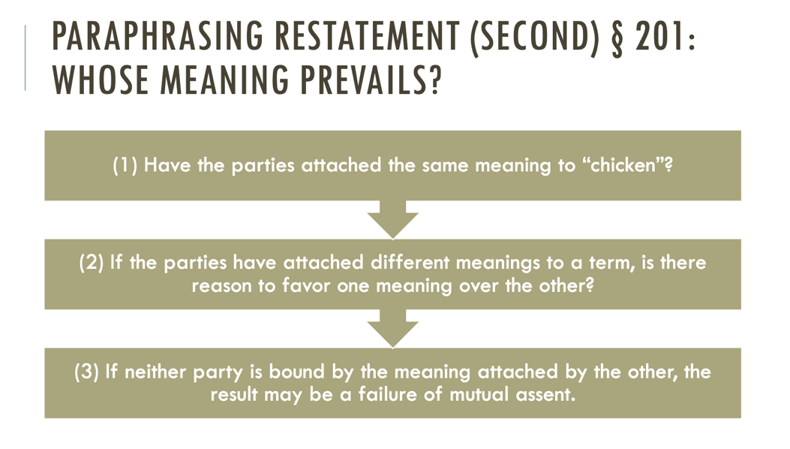
How do we decide whose is more objectively reasonable?
First: determine if parties had knowledge of differing interps, if one sided -> innocent party likely wins, if neither knew -> determine which understanding is more reasonable, if neither or both are reasonable -> no contract, if one is reasonable -> the other party had reason to know (and will likely be disfavored)
Reasonable, lawful, and effective interpretation of all terms is the ideal situation, with no part left unreasonable
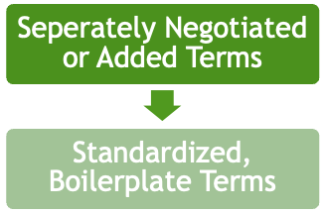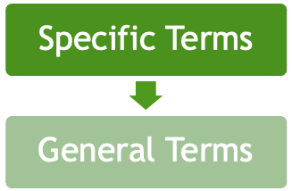
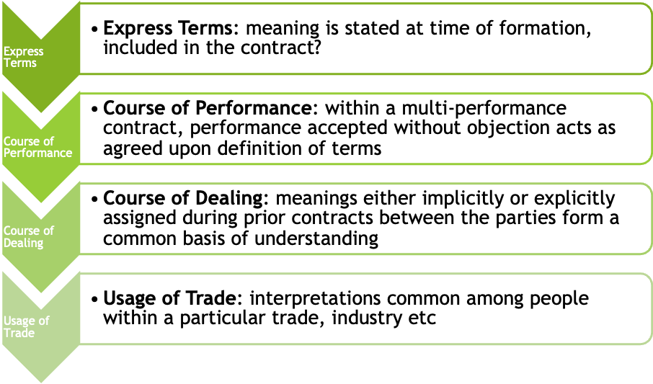**

These hierarchies comport with the general principle that lacking true objective reasoning, meanings agreed upon by the parties through prior conduct or negotiation become reasonable due to demonstrated meaning and intention
Doctrine of Reasonable Expectations
The objectively reasonable expectations of applicants and intended beneficiaries regarding the terms of insurance contracts will be honored, even though painstaking study of the policy provisions would have negated those expectations

Parol Evidence Case Illustrations
- Thompson v. Libby: T sold L logs, L claimed the poor quality constituted a breach of an oral agreement (warranty) contemporaneous to the written sale agreement, L claimed the warranty was collateral to the sale and should therefore be allowed, court said not collateral because it wasn’t about a subject distinct from the contract. Classical approach to when extrinsic evidence is excluded under PaE rule.
- Taylor v. State Farm: T has accident and it goes to court, SF settles outside of his policy limit, T signs a release to get some money from SF, he then sues SF for bad faith in the settlement agreement, SF says that the release prohibits this claim and T argues the release is ambiguous. A judge may consider extrinsic evidence to determine if a term is ambiguous; if determined ambiguous, PaE allows the evidence to be presented to factfinders for purposes of interp.
  - Raises concerns about giving judges too much power over contract interp
- Sherrodd, Inc. v. Morrison-Knudsen Co.: S contracted to move earth and relied on MK’s representation of amount, turned out to be substantially more dirt, MK orally told them the contract would be renegotiated later and refused to pay S until they signed the old contract, never gets renegotiated so S sues, court bars evidence because of explicit terms in the contract. Strict PaE bars a party from introducing evidence that conflicts w/ express terms, unless there is evidence of mistake/imperfection/invalidity/fraud that does NOT relate to the subject of the contract.
  - Raises concerns of unequal parties’ bargaining power leading to court-sanctioned fraud/duress
When the parties have agreed to integrate a final version of their entire agreement in writing, neither party will be permitted to contradict or supplement the written agreement with extrinsic evidence of prior agreements or negotiations.
Total integration: intended to include all previously discussed and negotiated for terms to be adopted by the parties, and is therefore seen as a final expression of their contract
Partial integration: intended to be final for portions of their agreement but not for all terms they may have agreed to
If the parties do not intend the writing to be final, there is no integration.
Determining Integration
Classical, Strict Approach (Williston) | Modern, Extrinsic Approach (Corbin)
A judge will determine whether a writing is integrated (fully or partially) by examining only the writing itself and nothing else  “Four Corners Approach”  Merger clauses are binding unless agreement is obviously incomplete | A judge can use extrinsic evidence offered by the parties to determine whether they intended the writing to be integrated  All evidence should be evaluated  Merger clauses are insignificant

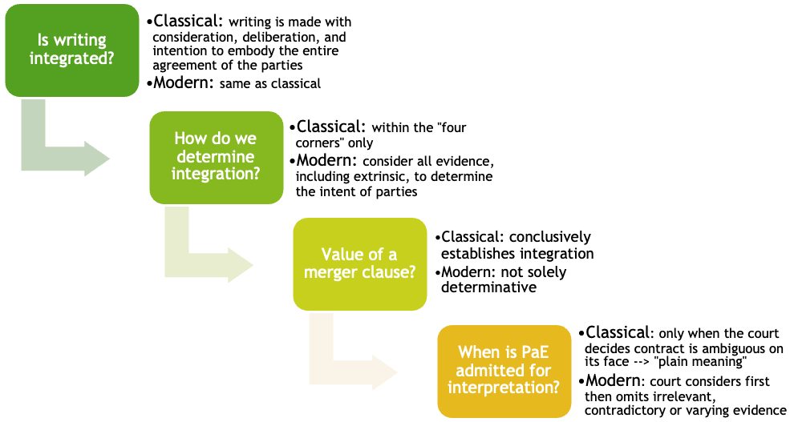
When the writing is intended to be partially integrated, the writing may be collaterally supplemented (although not contradicted) by extrinsic evidence.
Under the modern approach, the first step in determining whether extrinsic evidence should be allowed to supplement a contract is to use the extrinsic evidence to interpret the contract and decide if it is totally or partially integrated
If partially integrated, extrinsic evidence will be allowed to supplement a contract if it relates to a collateral agreement with distinct subject-matter
Limits to Parol Evidence Rule (aka things that are allowed)
- Evidence offered to interpret or explain the meaning of the agreement
- Agreements made after the execution of the integrated agreement
- Evidence offered to show that the written agreement was subject to an oral condition precedent (contingency statement)
- Evidence offered to show that the agreement is invalid* (due to fraud, mistake, duress etc.)
- Evidence introduced to establish a collateral agreement by the parties
  - Classical: the promise must relate to a subject distinct from that to which the writing relates
  - Modern, 2nd R: the promise must be supported by separate consideration or be “such a term as in the circumstances might naturally be omitted from the writing.”
Exception for Evidence of Invalidity
Strict (Sherrod) | Not allowed for showing fraud in the inducement when it substantively contradicts express terms  - You signed it, you’ll be held to it
Permissive (CA) | Allowed for showing fraud in the inducement
Most jurisdictions allow evidence for showing fraud in the execution (ie, “just sign this it doesn’t mean anything”)

U.C.C. Parol Evidence Rule
- Nanakuli Paving v. Shell: S had previously price-protected for N, price of petroleum jumped and S raised price with little notice, N claims implied term of price-protections, S says this contradicts explicit terms, N wants to introduce evidence of trade usage in HI. UCC: Evidence of course of performance and trade usage allowed when its consistent with the terms of the contract and the purported trade usage is common enough that the parties would have meant to incorporate it.
U.C.C. uses the phrase “Final Written Expression” rather than full integration to refer to a complete contract
To effectively exclude course of dealing and trade usage definitions, an explicitly worded clause that recognizes the industry meaning of the term in question can be used
U.C.C. § 2-202: Parol or Extrinsic Evidence
Terms that the parties agree on, or are set forth in the Final Written Expression of their agreement, may not be contradicted by any prior or contemporaneous agreements, BUT may be explained or supplemented by: | Evidence of course of performance, dealing, or usage of trade (same hierarchy as before)
 | Evidence of consistent additional terms UNLESS the court finds the writing was intended to be exclusive (aka not partially, but fully integrated)
This section rejects meanings of terms that exist elsewhere, and makes the meaning that arises from the commercial context in which it was used the most reasonable for interpretation

Implied Terms Case Illustrations
- Wood v. Lucy, Lady Duff-Gordon: L breaches an agreement with W and claims it wasn’t binding because no consideration, says W didn’t actually market her clothes as implied, Cardozo says court can imply a reasonable or best efforts clause when the contract would otherwise fail or be ineffective. In modern contract law, the written word means less and obligations can be properly inferred based on the instinct of the parties.
- Leibel v. Raynor: no duration or reasonable notification of termination specified in distributorship contract for L to sell R’s garage door parts, R suddenly terminates claiming it was an at-will contract bc no duration specified, L sues and court rules that the UCC governs distributorship contracts and thus require good-faith and fair-dealing (including adequate notice of termination) so that the other party will not suffer too much. Terms of good-faith and fair-dealing are “implied in law” terms implicit within all UCC contracts.
- Seidenberg v. Summit Bank: S sold their business to SB and were taken on as new brokers, paid on commission but SB didn’t provide them with leads or help grow their business as promised, TC barred evidence under PaE rule that showed SB breach the implied covenant of good faith and fair dealing, higher court overturned and also added that bargaining power of parties should not be determinative. PaE applies to explicit terms, and the covenant of good faith and fair dealing is implied in all contracts and therefore not subject to PaE rules.
Implied in Fact | Implied in Law
- Conduct  - Circumstances  - Situations  - Relations | - In the law  - UCC  - Imposed regardless of parties intent
Gap-Fillers
Default | Mandatory
- Fills gaps  - Can be waived  - Can be changed | - Cannot be waived (implied in law)

Gap-filing: majoritarian (what the parties would have bargained for, ie reasonable price), forcing information the parties should have included (penalty, ie defaults to zero quantity)
Breach of good faith and fair dealing: (1) Term must be added because the facts reveal that the parties intended it (2) Concern about a party’s discretion in performing under the contract (3) Concern that a party may have used a term as the pretext for terminating a contract unfairly.
Good faith and fair dealing is often defined by the lack of good faith:
Must be a recognized form of bad faith conduct and shown to be caused by ill motive not sharp dealing
Claiming lack of good faith requires a contract exist, otherwise no implied covenant
Implied covenant cannot contradict express terms
Cannot be used to undermine the spirit of the contract (discretion) and its “fruits”
Context is important in determining the “fruits” which good faith and fair dealing are meant to protect
No party should unjustifiable be denied or deprived of the “fruits of their contract”

Defenses to Enforcement

Defenses to Enforcement
Obvious: Minority, Mental Incapacity (cognitive or volitional), Fraudulent/Material Misrepresentation

Duress Case Illustrations
- Totem Marine v. Alyeska Pipeline: T’s first barge journey, many issues on journey, A terminates contract early, T sends invoices, accepted a smaller amount via release agreement to avoid bankruptcy. Economic duress is valid reason for rescinding a settlement/release agreement.
- Odorizzi v. Bloomfield School District: O was arrested for being gay, after being released B came over and made O resign, threatened to release information about his charges, and said no time for lawyer, O was acquitted and sued for undue influence. Undue influence may be found when a dominant party uses excessive pressure to persuade a weaker party into an agreement.
A contract is void when it was never valid and can therefore be challenged by anyone including third parties
A contract is voidable when?
Contract is voidable through duress if a party's manifestation of assent is induced by an improper threat by another party that leaves the victim no reasonable alternative
Elements of an (Economic) Duress Defense
Inducement: | - Threat is the reason for signing  - Effect can be intended or reasonably expected
Improper/Wrongful Threat: | - Requires implicit bad faith  - Deprives the party of unfettered will  - Threat of breach or non-payment are commonly recognized examples
Circumstances: | - “No reasonable alternative or adequate remedy”  - A’s refusal to pay invoices is what put T in the situation  - T’s situation was not caused by their mismanagement, but by A’s conduct

Undue influence exists when persuasion that’s coercive in nature, through excessive pressure, overcomes the will of a vulnerable party without convincing their judgement
Undue influence is different than “sharp dealing” because of 1) vulnerability of coerced party 2) excessive pressure
Must be such that there is no genuine meeting of the minds
Requires a dominating party exercising excessive pressure over a vulnerable party they have power over
Vulnerability requirement presents issues of sexism and prejudice in deciding “subservience”
Total or Lesser Weakness of the Mind and/or Diminished Capacity can show vulnerability
Odorizzi Factors for Evaluating Excessive Pressure
- Unusual or inappropriate time or place | - Insistent demand business must be finished immediately
- Extreme emphasis on consequences of delay (can be threat) | - Multiple persuaders against a single subservient party
- Absence of third party advisors for servient party | - Insistence that there is no time to consult advisors or attorneys

Unconscionability Case Illustrations
- Williams v. Walker-Thomas Furniture Co.: compounding layaway format that applied new balances against all previously rented items even if they were already paid off, in case of default WT could repossess all items purchased,
- Higgins v. Superior Court of LA County: extreme home makeover, Contracts of Adhesion are not definitively unconscionable but help w/ analysis due to lack of negotiation, comes down to bilaterality of terms.
When are terms so unreasonable that they become unconscionable?
Absence of Meaningful Choice (Procedural) + (Substantive) Unfavorable Terms for One Party
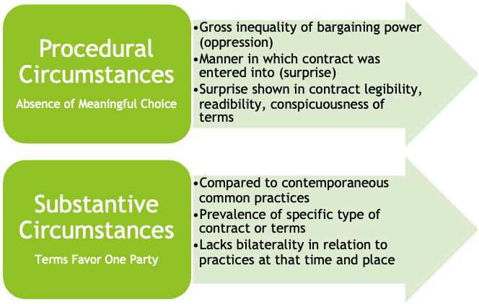
Unconscionability
Factors are examined in relation to each other, need both but they don’t have to be equally present

Justifications for Nonperformance

Mistake Case Illustrations
- Lenawee County Board of Health v. Messerly: too much poop made property unrentable, at time of contract neither party knew about or was responsible for the poop situation, leading to a mutual mistake with a material effect on the exchange. “As is” clauses assign risk and make rescission due to mutual mistake unavailable despite innocence of both parties.
- BMW Financial Services v. Deloach: when does an effect become adverse enough for a party to recover due to unilateral mistake, negotiated settlement because BMW failed to tell settlement group that there was pending litigation, later repudiated the settlement bc of mistake, D sues for enforcement of settlement. Generally, cannot recover if the damages are not unconscionable.
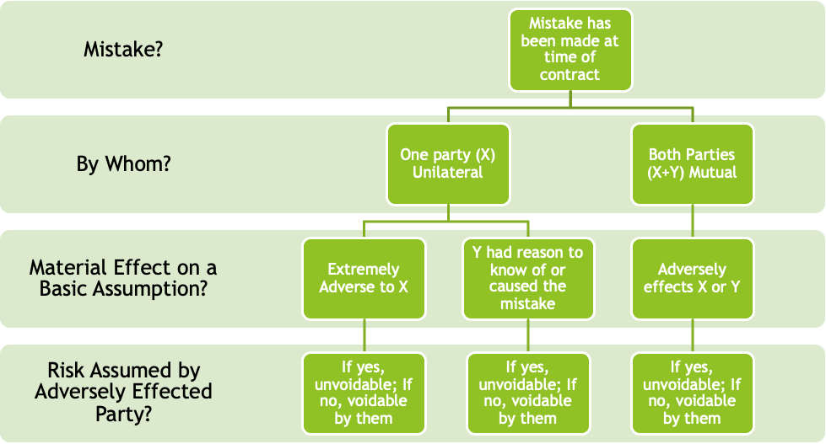
Mistake involved a basic assumption of contract à Mistake had a materially adverse effect à P didn’t bear the risk of the mistake à Mistake’s effect makes enforcement “unconscionable”
When does a party assume the risk? Restatement 2nd, §154
- When it is allocated to him by agreement of the parties
- He is aware at the time the contract is made, that he has limited knowledge with respect to the facts to which the mistake relates, but he treat his limited knowledge as sufficient
- The risk is allocated to him by the court on the grounds that it is reasonable in the circumstances to do so
  - For example, when one party is in a better position to discover the mistake
  - Generally a party that neglects a legal duty bears the risk
    - More than carelessness or mere negligence, must be extreme
    - Example, purposely not complying with a statutory duty

Changed Circumstances Case Illustrations
- Hemlock Semi-Conductor Operations v. Solarworld: had a fixed price/quantity deal for sale, initially S was getting a good price but market changed and they were overpaying, tries to claim impracticability. Impracticability only applies when an unforeseeable event occurs, the non-occurrence of which is a basis for the agreement. Market changes are foreseeable.
- Rosado v. Barry University: R wants tuition back after moving to online learning because of COVID. Extreme or unreasonable expense, injury, or loss are bases for impracticability.
Impracticability | Frustration of Purpose
Restatement: when an event or change happens, that the non-occurrence of which was a basic assumption and it is not the fault of the party, their duty is discharged if it becomes impracticable due to the change | Restatement: when a party’s principle purpose is substantially frustrated by the occurrence of an event that the non-occurrence of was a basic assumption of the contract, the duty is discharged
- What types of changes can parties safely assume won’t occur?  - Global pandemics, for example  - Does not apply to market changes  - Impracticability can be based on extreme/unreasonable expense, injury, or loss that would occur if performance continued | - Applies when performance is still possible but its pointless  - Room rental parade example  - Purpose of the contract has been thwarted
Both rely on lack of language* or circumstances that indicate the contrary, otherwise duty will remain
A vendor has a contract with a stadium to sell hot dogs for sporting event, but the gov’t shuts down all stadiums because of a global pandemic. Vendor can no longer sell hot dogs because it is illegal and there are no sporting events, so their duty is discharged due to impracticability. | The hot dog vendor had a purchase order with Oscar Meyer for 50,000 hot dogs but no longer needs them because they can no longer vend. Hypothetically, the vendor still has the ability to buy the hot dogs but it would be pointless and unnecessary.
*Force Majeure: “act of god clauses” that can release both or one party depending on how its written
Fuzzy line between the two, courts generally have difficulty differentiating
Using one is ok, full points for both
“Impossibility” is just the most extreme version of impracticability, when performance truly become impossible

Modification Case Illustrations
- Alaska Packers’ Ass’n v. Domenico: striking fishermen get supervisor to agree to pay raise, when they get paid it was for the original amount, they sue. Altering an old contract into a new one requires additional consideration/modification from both parties when previous contract has not been waived and only modified.
- Kelsey-Hayes Co. v. Galtaco Redlaw Castings Corp.: G was K’s sole provider of parts, G is struggling, gets K to agree to a price increase so their clients don’t have to stop production, K protests, K cannot find new manufacturer, refuses to pay, cross suits ensue. Inconsistent, overlapping agreements do not preclude suits for breach when the superseding modification was agreed to in duress, which G was aware of.
- Brookside Farms v. Mama Rizzo’s Inc.: no-oral-modification clause in contract (generally enforceable), contract then orally modified w/ reliance on M’s promise to add modification in writing (never did), M can’t pay, B sues, M counterclaims for breach because of price change. Sale-of-goods contract can be modified when one party accepts the goods at a modified price, if SoF reqs have been met.
Traditionally, modifications to existing contracts require consideration from both parties, and promises to perform existing duties is not valid consideration
Why allow modification? | Why restrict modification?
- Circumstances change, modification could be beneficial to both parties  - Promotion of parties’ goal, autonomy, choice  - Keeps relations positive  - Flexibility allows for contracts to succeed despite changing circumstances  - Efficiency, modification can avoid litigation  - Let’s parties adjust contracts to be more mutually beneficial | - Contracts are supposed to promote certainty  - Vulnerability of parties already obligated to each other  - Changing one contract can affect many other contracts held by the parties, ie price increase starts a chain reaction of price increases  - Parties should be able to rely on contracts or why have them

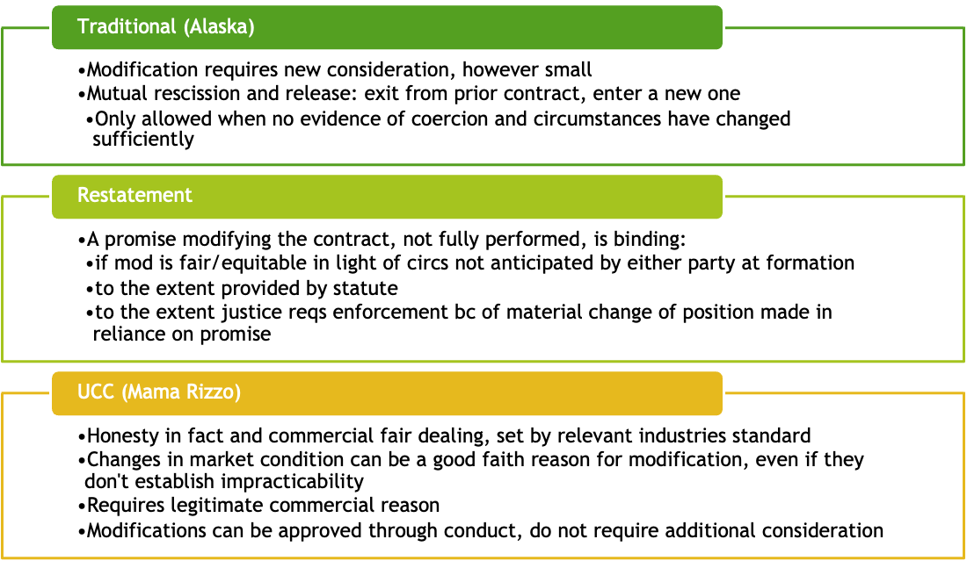
C/L: no-oral-modification clauses not enforced
UCC: modification to contracts that fall within SoF must also meet reqs of SoF, agreements requiring written modification are also enforceable, however waiver of these clauses is possible (must protest)

Breach

Breach

Express Conditions Case Illustrations
- enXco Dev Corp. v. NSP: contract for solar farm was conditional on X getting a permit, X failed to get a permit, not impracticability bc X waited too long, N terminates. When express condition is not met, it discharges a duty, unless condition is excused bc of impracticability.
- JNA Realty Corp. v. Cross Bay Chelsea Inc.: shady real estate co allowed lease renewal to lapse, CB had made improvements. A tenant should not be denied equitable relief* (from conseq. ff his own negligence or inadvertence) if forfeiture would result.
“An event not certain to occur, which must occur before performance under a contract becomes due or the duty to perform is discharged”
Promises vs. Conditions
- Undertaking to act or refrain from acting in a specified way at a future time  - Require substantial performance  - Failure to fully comply does not discharge duties but may require pay of damages | - Event not certain to occur (e.g. obtaining financing)  - Acts as protection for the obligor  - Require strict compliance  - Failure to satisfy discharges obligor from further obligations (acts as a contingency)
A contract can be both a promise and a condition, like a contract that requires performance before the other party renders theirs
Excuses for Nonperformance of Express Conditions**
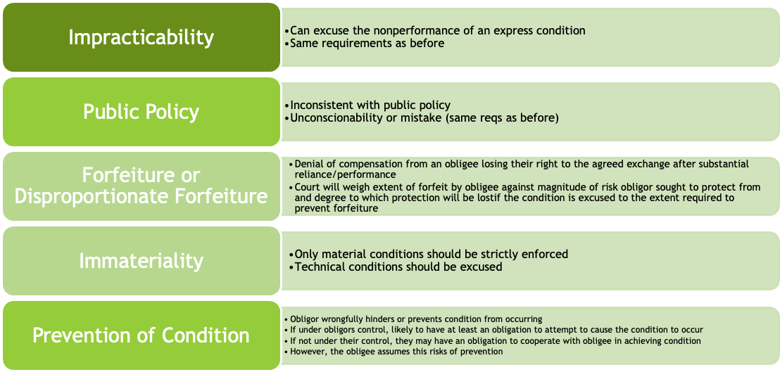
Express conditions are often material but they don’t have to be, often used for material parts of the contracts
Express conditions can be waived through clear and unequivocal words or conduct from the party requiring them
The more material a condition, the more likely that a court will strictly enforce it
A condition is material when it is central to the contract, affecting its value, and central to the reasonable expectations of the parties
Immaterial conditions can be waived but material conditions can only be overcome by estoppel (reliance on the promise of the obligor that the express condition has been waived)
*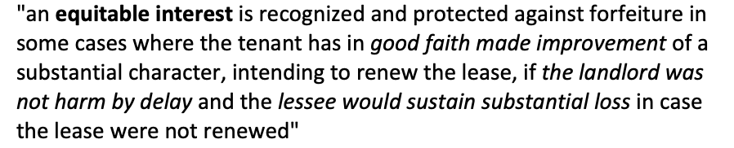
Waiver: intentional relinquishment of a known right, either in orally, in writing, or through conduct

Material Breach Case Illustrations
- Jacob & Youngs, Inc. v. Kent: wrong pipes, Breach was no so pervasive as to frustrate the purpose of the contract.
- Sackett v. Spindler: failure to pay for stock multiple times, kept saying money was coming but it never did, so he repudiated the contract. Total breach justifies repudiation, however if party is found not to be in total breach then you are in total breach if you repudiate.
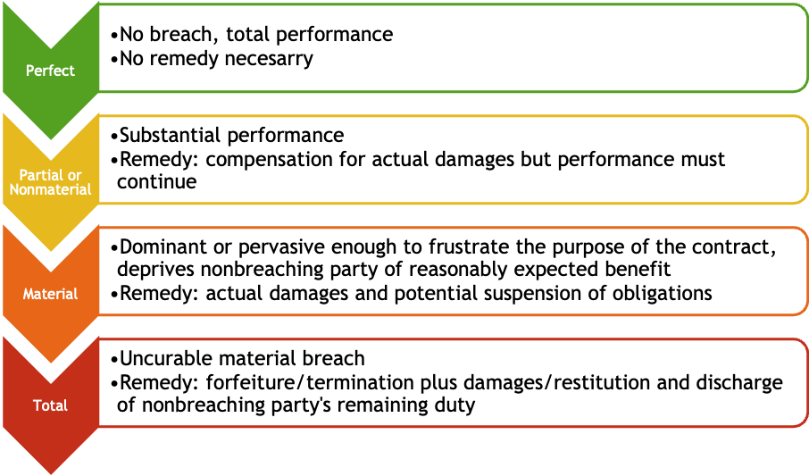
Any nonperformance when performance is due constitutes a form of breach
Level of breach is determined by the materiality of the condition not performed
Reasons why nonperformance might be justified:
Not timely • Failure/nonoccurrence of express condition • Valid justifications listed in above** • Anticipatory repudiation by other party • Material breach by other party
When is a breach material?
The extent to which: | - Injured party will obtain substantial benefit which he could have reasonably anticipated
The extent to which: | - Injured party may be adequately compensated in damages for lack of complete performance
The extent to which: | - Party failing to perform has already partly performed or prepared to perform*
The greater or less: | - Hardship on the party failing to perform if contract is terminated
The greater or less: | - Uncertainty that the party failing to perform will perform the remainder of the contract*
The greater or less: | - Degree of willfulness, negligence or innocence in the behavior of the party failing to perform
Courts use these factors to determine level of breach and generally treat material breaches as total breaches

Courts also look at curability* for when a material breach becomes a total breach
Curability is what it sounds like: can the breach be cured by full or substantial performance?
If a material breach is not cured within a reasonable amount of time it becomes a total breach
When time is of the essence, the cure period is tiny or nonexistent and leads to a total breach

Anticipatory Repudiation Case Illustrations
- Truman Flatt & Sons Co. v. Schupf: contract for sale of land was contingent on acquiring permit, T couldn’t get permit so requested lower price, S rejected, T asked to buy land regardless. A request is not a repudiation.
- Hornell Brewing Co. v. Spry: S was a basically a con man, H realized and asked for assurances, not given, so S anticipatorily repudiates. UCC: Reasonable grounds for insecurity allow concerned party to demand adequate assurances and suspend performance until it is received.
When something happens before date specified for performance that gives party X serious doubts about party Y’s ability to perform, then party X can anticipatorily repudiate the contract
Acts as a pre-emptive termination, doesn’t make sense to wait for the actual breach to occur
However, if courts determine doubts were unreasonable then party X will be in total breach
Can be an outright refusal to perform (orally, written, or conduct) or demanded express condition not in OG contract
UCC and Restatement treat this relatively the same, both want to minimize uncertainty and respect original agreement
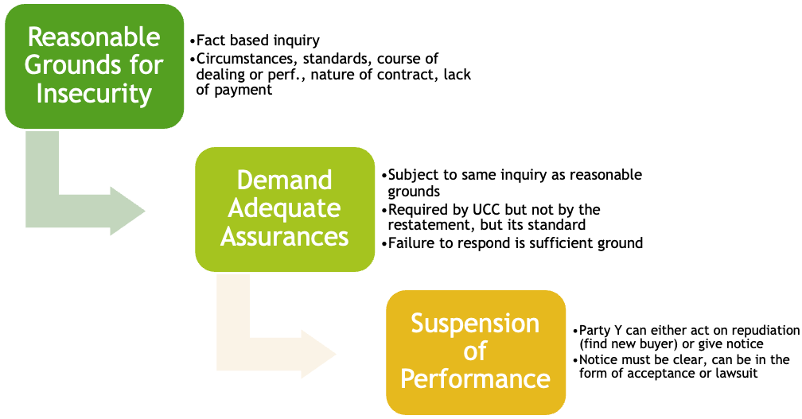
Party X can retract the repudiation up until Y has materially changed their position in reliance of the repudiation, or they receive notice of suit or acceptance
Generally agreed upon that retraction should be timely
Everything must be express and clear because deference is given to original contract, and if party X is unjustified in their anticipatory repudiation, they are in breach
Remedies
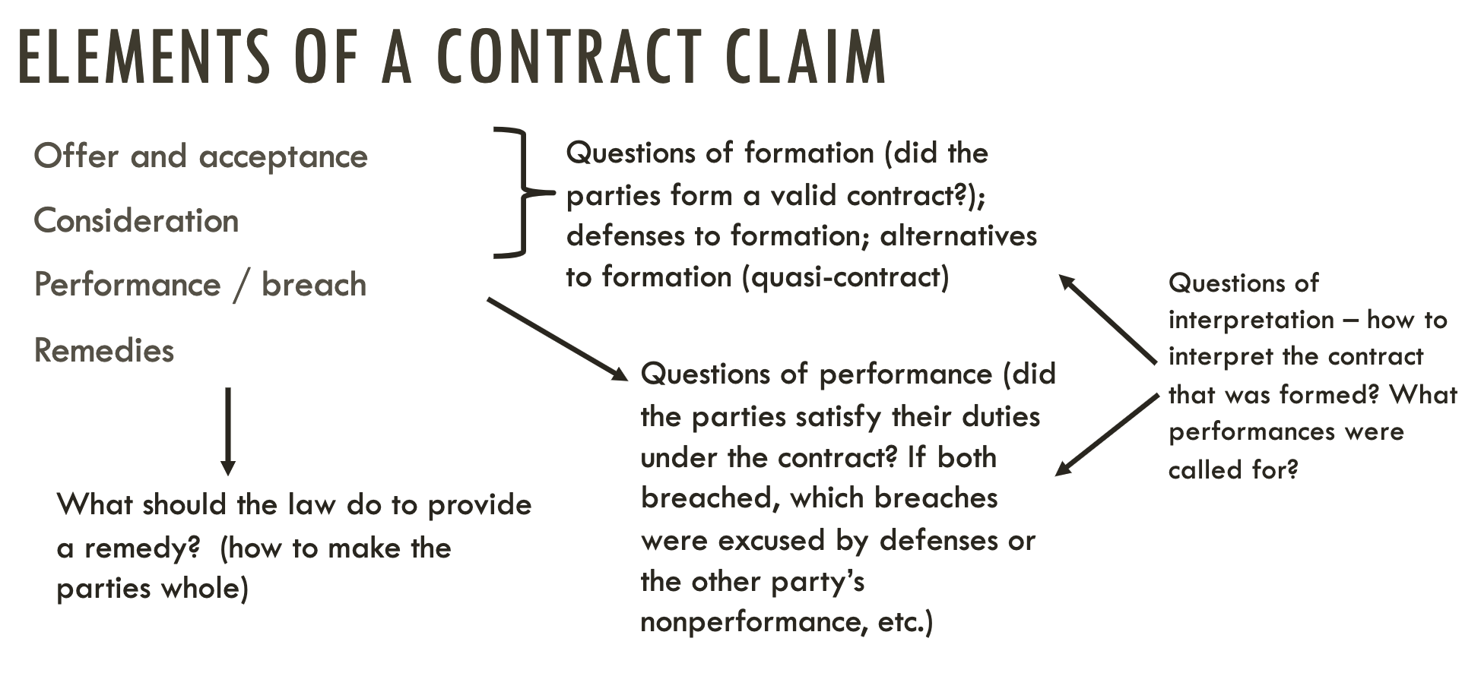

Remedies

When Damages Are Appropriate Case Illustrations
- Crabby’s Inc. v. Hamilton: H backed out of deal to buy C last minute, took C another year to sell during which time they incurred fees and had to sell for less than H was going to buy for, Measure of damages for breach of real property sale is the difference between value of property at time of breach and purchase price eventually obtained.
- American Standard, Inc. v. Schectman: S failed to grade property down to agreed upon depth, A believed deeper grading would increase value of property, S argued that A suffered no loss bc there wasn’t actually a difference in value, Economic waste exception only applies when the error is made in good faith and full performance is unreasonable.
How should the law provide remedies? How to make parties whole?
 | Restitution | Reliance | Expectation
What it protects | Unjust enrichment | Reasonable detrimental reliance on the other party’s promise | The value of expected benefit under the contract
When it applies | Party X has conferred some benefit to Party Y | Party X has incurred expenses in reliance on Party Y’s promise | Party Y has breached an otherwise valid agreement with Party X
How it is calculated | The measure of the value conferred on Party Y | Put Party X back in the position they would have been in had they not detrimentally relied | Put Party X in as good a position as they would have been in had the contract been performed on both sides*

Generally, when a contractor breaches, the measure of damages is the cost of completion
Exception to this is economic waste
When substantial performance has been rendered in good faith, but defects exist, and the correction of the defects would result in unreasonable economic waste à measure is the difference between the value of the property as constructed and the value if performance had been properly completed
Examples are “wrong pipe” case and bad grading (above), in the former court said completion would be large and out of proportion to the resultant benefit to the property because defects were irredeemable and could only be repaired through partial demolition (unreasonable) à economic waste
In bad grading case, court decided this exception did not apply as it was not unreasonable
In calculating real property damages, the seller wants to show that it was above market value?? Buyer wants to show it was below?? Check book..

Expectation Damages Case Illustrations
- Harley v. Baxendale: mill axle repair, Damages must be foreseeable to the breaching party, giving notice is good practice.
- Florafax v. GTE: F loses a contract bc of G’s bad service, disagreement about duration of lost profits, both parties introduce evidence to show how long the lost relationship would have gone on for. Damages can only be recovered for an amount established with reasonable certainty.
- Rockingham Cty. v. Luten Bridge Co.: R terminated a contract with L but they kept building despite notice of repudiation, bridge to nowhere, Repudiation allows for expectation damages but non-violating party has a duty not to increase damages.
How to calculate? So glad you asked…

Difference between what you expected to get and what you received |  | Incidental or consequential* damages you incur bc of the breach  (all loss except for loss in value) |  | Expenses you would have incurred during performance |  | What was salvaged from expenditures already made
Equation boils down to what you lost minus what you didn’t end up losing
Consequential: damages that arise naturally from the breach, or that may be reasonably foreseen at time of contract formation à direct + reasonably foreseeable
Limits to Expectation Damages
Foreseeability | - Requires notice of consequences of breach (Hadley)  - Meant to force parties to disclose value
Certainty | - Damages are not recoverable for loss beyond an amount that the evidence permits to be established with reasonable certainty  - Harder to prove in some cases than other, for example expected profits from a new business or book sales (more appropriate for reliance damages)
Duty to Mitigate | - Must mitigate damages after notice of breach  - Damages are not recoverable for loss that the injured party could have reasonably avoided without undue risk, burden or humiliation  - Does not preclude recovery if reasonable but unsuccessful efforts were made to avoid loss

Contractors use a different formula? Expected net profit + unreimbursed expenses at time of breach? Not in slideshow but remember from book and in my notes?

Alternatives to Expectation Damages

Reliance Case Illustrations
- Wartzman v. Hightower Productions: lawyer did bad job incorporating business, business was for man trying to win the world record, Reliance involves reimbursement for money expended in reliance on agreement.
- Toyota v. Walzer: W relied on promise that he would be awarded a franchise, but the offer was still very preliminary, W bought property in reliance on promise. PE claims may be limited to reliance damages, up to the court, restitution may be more appropriate.
Reliance damages are used when profits are too speculative
Degree and reasonability of reliance are examined, court determines what appropriate measure would be
Limited recovery if full performance would have resulted in net loss, but this must be shown by the breaching party
Justified to allow recovery of out of pocket expenses, but if you struck a bad deal that’s on you
Same limits as expectation damages, but no duty to mitigate if it would require a large amount of money you don’t have (ie Guiness people not hiring a specialist)
For PE claims, relief may be limited to restitution or specific relief measured by degree of reliance rather than terms of promise
Up to courts discretion if reliance damages would be unfair due to unreasonable reliance etc, question of what justice requires

Restitution Case Illustrations
- Coastal Steel Erectors, Inc. v. Algernon Blair, Inc.: B refuses to reimburse C for crane rental, however no expectation damages awarded bc amount they were owed was less than they would have spent to complete performance. Often construction cases of breach are offered restitution on promise to forego suit.
- Lancellotti v. Thomas: L rented business from T, conditioned upon L building an extension in exchange for delayed rent, L backs out and wants down payment back. Breacher is entitled to recover amount conferred in excess of the amount of loss caused by breach.
When are restitution damages available/appropriate?
At the election of non-breaching party | - Usually in cases of losing contracts
By the breaching party when they have rendered partial performance (Modern approach only) | - Non-punitive nature of contracts  - Party should be allowed to recover some value back  - Protection from forfeiture and unjust enrichment  - Otherwise the non-breaching party would be more rewarded the more the breaching party performed prior to the breach
If performance obligations have been discharged | - When contract has been rescinded due to mutual mistake or impracticability  - Unjust to allow gain when contract no longer exists
Because both parties have been impacted, there is a need for equitable relief
No unjust enrichment, contract law is not punitive

Specific Performance Case Illustrations
- Reier Broadcasting Company, Inc. v. Kramer: conflict of contracts for exclusive airing of K’s interviews, R seeks an injunction to keep K from performing for others, Personal service contracts cannot be specifically enforced either positively or negatively.
Specific Performance Ideas
Why isn’t it the default? | When are they awarded?
- Hard to gauge what is and isn’t a “successful” performance (no brightline rule)  - Contentious, we don’t like forcing people to perform (literally)  - Relationships are not good when one party is being forced, leads to animosity  - Damages remedies are easier to calculate and preferable | - Property agreements  - Property is unique and performance is more easily defined than determining actual value of land  - Money can’t fully compensate for some specialized performances (commissioned art)  - Depending on jdx, the more specialized a performance the more likely negative injunctions are to be granted (same for non-compete)

Liquidated Damages Case Illustrations
- Barrie School v. Patch: parents withdraw kid from private school after deadline for refund has passed, contract contained a liquidated damages clause so parents couldn’t recover tuition money, Maj. says the time for assessing reasonableness of LD clauses is at formation, dissent says we should also look at what is reasonable at time of breach in order to avoid windfall.
Liquidated damages clauses act as a reasonable forecast of damages that would occur should the contract be breached
Evaluated at time of formation, and puts responsibility on the challenging party to prove unreasonability
In line with the purpose of LD clauses à deciding ahead of time eliminates the need to prove or calculate damages
Requires a specific sum and reason for inclusion in contract: amount of damages is uncertain or difficult to prove
Parties must intend the clause for recovery, not as a penalty
Because amount is predetermined, there is no duty to mitigate


