Note: Takeaway slides are bolded

Two fundamental Questions:
- Is a particular government action consistent with the constitution
- How could the government achieve its desired result within the limits of its constitutional authority.

Dobbs v Jackson Women Health Organization
Constitutional Rights
- Textual (main body/arguments) guarantees
- 14th Amendment “Due Process” Clause
- Procedural
- Substantive (“controversial”)
- A) Bill of rights extension to states
- B) Non-textual (“Liberty”) text of 9th amendment entails that there are enumerated rights (just disagreement as to which ones)
- 14th Amendment “Equal Protection” Clause
- Sexed based classification gets “heightened scrutiny”

Implied Constitutional Rights
- Deeply rooted in history and tradition
And
- Essential to our Nations Scheme of order and liberty

Case illustration: Dobbs v Jackson Women Health organization:

Before: enumerated right to privacy extended to abortion and were subject to strict scrutiny (Roe)
- Right to pre-viability abortion without “undue” state interference -> bunch of cases interpreting it. Fed gov also passed legislation which was held undue (justified by commerce clause for specific procedure) Ex of undue: have to have privileges within 30 miles, clinics meet full outpatient surgical center health/safety standards, reduced number of clinics
- State can restrict post-viability abortion with health exceptions (to protect mother)
- State interest from outset in protecting fetal and maternal health

Issue? Is there an unenumerated right that gives the people the right to abortions or is this something covered by traditional police power (ability to regulate for health, safety, general welfare, public policy). Banned abortion after 15-week gestational stage. Court struck down and said there was no federal constitutional right to abortion.

What happens now? Federal government can pass legislation, can give more protection then the constitution, but you don’t have a RIGHT to it in the constitution (it can be not mandated but permitted)

History plays large part: originalism, what is reasonably intelligent person at the time think the text of the constitution meant-> a constitutional argument)

They said: not deeply rooted in Nation’s history and tradition and essential to our nations scheme of ordered liberty. Why? Because it was not a recognized right until the latter party of the 20th century. Instead, it was a crime by most states. Different from decisions such as sexual relations, contraception and marriage because it regarding “fetal life.”
Thomas: thinks all substantive due process rights should be overturned.
Dissent: did not make much constitutional arguments, more policy, consequential arguments (can be against protecting women against risk, death, harm, or if they are raped and will disproportionately impact poor women) Stare decisis should be followed to not create legal instability.

In class discussion q: yea we have constitutional right to travel P&A, but states may be able to restrict people from going out of there states.

Stare Decisis Considerations (manipulatable)
- Nature of the Courts error (how damaging)
- Quality of reasoning: logic of court’s reasoning
- Workability: awkward results for society
- Effect on other areas of law: Spillover effect on other areas of law
- Reliance interest: how much have people relied on it

How to court analyzed the factors:
- Nature of the Courts error (how damaging): said it was outside the bounds of any reasonable interpretation of the various constitutional provisions.
- Quality of reasoning: the right to abortion is not grounded in text, history, or precedent. Made a bunch of rules regarding different trimesters, and but never explained how it was teased out from the constitution, history of abortion laws, prior precedent. Relied on erroneous historical narrative. No justification for pre and post viability.
- Workability: undue burden test has scored poorly on workability scale, not predictable and consistent.
- Effect on other areas of law:
- Reliance interest: getting an abortion is unplanned activity. Stronger in property and K rights. Here, the generalized assertions of national psyche-> women organized intimate relationships and made choices that define their views of themselves in reliance on availability of abortion-> not good enough. In class we said: don have sex, or use contraception, as practical matter the women now were not alive when roe decided.

Roberts Concurrence in Dobbs:

The Canon of constitutional Avoidance: The court will not pass upon a constitutional question although properly presented by the record, if there is.. some other ground on which the case may be disposed of” -> trying to say the case should have been decided by saying that state statute was not an undue burden (constitutional avoidance)

General Notes regarding constitution:
- Decl of Independence legal significance: created 13th independent states, committed treason and declared independence from the crown (had declaration of independence, which was generally flawed, did not have the ability to enforce treaties, could not tax, lack of executive, no federal courts-> constitution turns on head and source in popular sov
- Constitution sourced in popular sovereignty. Preamble says “we the people” -> power no longer derived from the states, but from the American people that choose the powers to give to the federal government -> the people ratified the constitution through popular conventions)
- But still leaves substantial authority to states
- Subject of Art I, II, III (short hand meaning)
- Article 1: legislative branch. Biggest chunk. Preamble “we the people”
- Article 2: executive branch (some of the powers of president, like the right to pardon for FEDERAL crimes)
- Article 3: federal courts, establishes judiciary
also includes some rights: right to jury trial, trial in state where crime is committed, limitation on treason
- Article 4: states in national scheme-> constitution wants strong nation, rules to let states function together as a national government
- Article 5: how to amend constitution
- Art I Sec, 8, 9, 10 functions
- Section 8: contains the powers of congress (the source of the federal government enumerated powers. Federal government can only act if it has the power to do so. Some things are straightforward. The ability to borrow money, uniform rules of naturalization, national system of money. Other times have to find provisions which give justification to do more. Ex: commerce clause
- Section 9: Limitations on congress. -> bill of attainder, post facto punishment, etc.
- Section 10: limits on state
- Initially bill of rights only to federal government, 1789 proposed amendments 10/12 ratified, first 8 “bill of rights” (after civil war through convoluted process began to apply to states)
- Supremacy Clause (Art. 6, cl. 2)
- Vertical separation of relationship between states and federal government
- Supremacy clause: the constiuti0on, federal statute, and treaties are supreme law of the land, nothing in the state constitution and statutes to the contrary
- Bill of rights applied to federal government only
- Oath to Constitution for state and federal office holders
- Not only federal gov officials but state gov officials must take an oath to uphold the constitution.
Article 7:
- Ratification process
Marbury V Madison
- Role of Judiciary to say what the law is
- Federal Courts can invalidate law violating the constitution
- Federal courts have authority over ministerial acts by Executive Branch officials
- No authority over “political” acts

Facts: Constitution kept treaties in force but wiped legislative slate clean. Constitution left to congress to set specific rules about courts. Passed Judiciary Act of 1789, set up circuit courts. Politically factions strong. GW president. Puts into cabinet Hamilton (federalist) and Jefferson (anti federalist). Then Adams president, as one of his last acts he appoints his sec of state John Marshall, which was confirmed by senate majority, appointed justice of piece position in District of Columbia (federal enclave). Appointed by president, confirmed by senate, sec of state sealed it but never delivered. Thomas Jefferson (who was the sec of state before) tells Madison, the new sec of state to not deliver it. He is the keeper of the seal and it is his job to deliver it, the administrative task of sealing and delivering. Marbury filed writ of mandamus (to get court to order sec of state to deliver the paper).

Holding:
One: Marbury has right to commission (three steps process, nominated-> political decision to president 2) senate confirmation (vote by simple majority, again a political decision. Note senate can confirm and president can change his mind. 3) Commission: which is a ministerial function. No discretion here, it is an administrative act required by law. If there is discretion involved-> court cannot order, it is a political question. But this was ministerial so you can give writ and compel them to do it.
Two: there is a remedy
Three: The court does not have jurisdiction to hear the case (since it was brought to supreme court even though the judicial act gives the authority because article three of the constitution only gives jurisdiction for so types of cases (ambassadors, dispute between states, etc).

OLC Era MEMO
- All 3 branches have duty to uphold the constitution
- Senior officials all swear oath to support
- Each branch must interpret
- Congress in enacting laws (note: when they pass a law to create a case or controversy to challenge it, violation of oath in a way?)
- Executive in executing laws
- Judiciary in deciding cases

OLC memo:
OLC small office created by attorney general. Help interpret law and provide official position of the executive branch. Equal Rights Amendment in constitution. Congress had imposed deadline, and it had passed. Virginia goes from red to blue and there are talks that it may ratify it. The OLC said that Congress cannot revive a proposed amendment after a deadline for its ratification. It can do so through same procedures required to propose an amendment in the first place.

- Women not given equality by Constitution
- Protections largely statutory
- Civil Rights Act of 1964 Title VII

S Ct and States
- SC has final say on all federal law questions
- Includes Const/statutes/treaties/regulations
- Can hear direct appeal on “final” state decision
- Does not necessarily need to be state supreme court, there is unique situations
- No authority if “adequate and independent” state law basis for decision
- Can reach the decision on state law, without federal law. Ex: something which violates both the state and US constitution, good lawyer will say both is violated, like limits on search and seizure. If can be solely made on state constitution, but if difference in the words of the statute and or they have different interpretations
- Fed constitution (bill of rights) provides a floor to have to satisfy which applies to everyone, every state has to satisfy the floor that every state has to satisfy. If less then not adequate and independent
- States free to provide greater protection in own constitution
- General note: if you provide more then the floor, and it is mandating something that violates the federal constitution you can have them chop I t down. Ex: compliance with local rule, is violation of freedom of religion. (court denied Yeshiva university requires to block state ruling on LGBTQ recognition)
- State court Must cite state law authority to qualify
- If ambiguous on what it rests on SC can take case
Hierarchy:
- Us constitution
- Federal statutes
- Treaties
- Federal regulations-> controversial, nothing says fed gov can make binding rules in any other means then enacting legislation. But in new deal period the federal gov began regulating rules, executive branch agencies then direct legislation by congress
- Federal Common Law
- State constitution
- State statutes
- State regulations
- State common Law

Martin v Hunter Lessee:

Martin v. Hunter’s Lessee: VA allowed confiscation of property belonging to British loyalists, but peace treaty with Britain committed the U.S. to pursue a policy of compensation. When British claimant sought to recover family lands, the highest state court in VA ruled against him, holding the treaty inapplicable to his situation. Martin appealed to the U.S. S.C. The SC said VA had committed an error, but then the VA court said it could refuse to listen to the SC because the VA court’s decision isn’t under purview of SC. Issue once again went to the SC. SC held that they (1) (the U.S SC) had jurisdiction to hear appeals of (2) Federal Questions: cases arising under the Constitution, laws, and treaties of the United States, cases affecting ambassadors, other public ministers and consuls, and cases of admiralty and maritime jurisdiction.

But here, supremacy clause is invoked because one person is claiming a possession as a result of a treaty. Story says: constitution should be interpreted as living document. Fed gov chosen by the people not the states so it is logical for the federal court to have authority. It is necessary for SC to be the final arbiter and issue unified decision, essential to the overall scheme of the constitution. So it must be that they can review federal law questions.

Justiciability

Early in Washington administration, needed help to decide court decides that it will not provide advisory opinions. President could consult his sec of state and attorney general on which government to recognize (separation of powers issue) -> need justiciable case, a case or controversy (applicable to federal courts)

ONE: Is the issue suitable for Judicial resolution?
- Political or legal question? (Executive or legislation discretion).
- Nixon v United States addresses
- Criteria (Baker factors, case where court held politicians using majorities to prevent redistricting was a political question)
- Constitutional text commits to a political branch
- Lack of judicially discoverable/manageable standards for resolution
- Requires an initial non-judicial policy determination
- Would express lack of respect for other branches
- Unusual need for adherence to a prior political decision
- Potential embarrassment for “multifarious pronouncements” by different branches

Examples:
  - Weather a foreign nation is still a treaty party -> up to politicans to devide
  - Which competing government US should recognize
  - Status of conflict between foreign nations
  - When a war has ended
  - National boundaries
  - Whether a state has a republican from of government
  - Also, Marbury v Madison: the appointment of sec of state and the confirmation by senate

Nixon v US:

Nixon v. U.S: Nixon is convicted by a jury and sentenced to prison. Nixon refused to resign. Congress wanted to impeach. The Senate voted to invoke its own Impeachment Rule XI. Pursuant to Rule XI, the committee presented the full Senate with a complete transcript of the proceeding and a Report Stating the uncontested facts and summarizing the evidence on the contested facts. Nixon challenged the senate’s procedures as inadequate under 5th Amend. Crt held that Nixon's claim isn’t justiciable/appropriate for judicial resolution b/c Article I of the Const. committed the entire impeachment process to senate.

- Textual commitment to a coordinate political department. Text says Senate shall have the “sole” power to try all impeachments, indicates authority if reposed in the senate and nowhere else. Nixon makes the argument that the language says to “try” by the full senate and that does not mean being delegated to a committee. Court says try has many modern meetings and it cannot be said that the court was trying to limit can proceed in an impeachment.

- Lack of judicially discoverable means: the word “try” lacks sufficient precision to afford any judicially manageable standard of review of the senators’ actions. There were explicit limitations, and so it suggests that the framers did not intend to impose additional limitations on the form of the senate proceedings by using the word “try”

Hold: judicial involvement in the impeachment process, is counterintuitive because it would go against the “important constitutional check “placed on the judiciary. It would also cause chaos (lack of finality) and unsure what relief would even be given.

General court procedure: don’t have to hear a case (discretionary) unless state suing state
- 9 justices
- 5 majority
- Petitioner person appealing
- Solicitor general represents fed gov
- Amici briefs
- Oral arguments
- Conference of judges
- Chief justice chooses who writes majority, if dissenting, chooses who writes dissent
- Need 5, go with lowest common denominator

TWO: Is the plaintiff entitled to sue
- Constitutional standing issue
- Lujan v Defenders of Wildlife addresses
- Injury in Fact (generally in terms of cost, minus overbreath doctrine)
- Concrete and particularized-> something specific to that individual (opposite of general injury such as I oppose US invasion of Iraq, my tax money is going there. That is something suffered by all. You can have a specific group of people though. Like a class action. Has to be identifiable for particular set of individuals and not American people as whole
- Actual or immanent (something that has happened or harm in the future. It is predictably that you are going to.
- Caused by Defendant (causation)
- Redressable by court decision (redressability) -> need to have a remedy, if there is not lasting consequences and there is no redress and there is nothing you can do to change facts on the ground then it is not redressable.
- No general tax payer standing

Note: if something is a constitutional standard, need to amend constitution rather than lobbying to congress. Get supermajority in congress and 38 states (convention or state legislators)

Lujan v Defenders of wildlife: Federal statute that is the endangered species act. Statute: requires federal agencies to consult with the Secretary of the Interior or Commerce before undertaking actions that might jeopardize endangered or threatened species. Defendants of wildlife, nonprofit organization wants court to decide that the regulation is applicable to foreign projects. Court refuses the hear the merits because they do not have standing.

Issue: if American Wildlife advocates have connection to the harm in foreign countries to bring the case to US courts.
- If person is object of action or forgoing action then little question that the action or actions has caused injury. But here, it is the governments lack of regulation or regulation of someone else, much more is needed in the circumstance. Burden on Plaintiff to show that. There is no injury or redressability here. The respondents are claiming that the certain funded activities abroad “increases the rate of extinction of endangered and threatened species. Injury in gift requires more than a cognizable interest. I require that the party seeking review be himself among the injured. So they had to show that not only were the species being threatened by funded activities aboard, but also that they responded were “directly affect” apart from their “special interest.” Here the party intended to return to Sri Lanka in the future to see the species but she did not know when. Cannot show immanent injury, jus because she had visited them before proves nothing. Such Someday intentions-without any description of concrete plans, or indeed even any specification of when the someday will be do not support the finding of “actual or immanent” injury.
- Reject ecosystem nexus: person uses any part of a contiguous ecosystem adverse effected by the funding activity
- Animal nexus, anyone with interest in studying animals anywhere in globe, vocational nexus-> anyone with professional interest in such animals can sue-> rejected (to broad to say anyone who observes or works with an endangered species, anywhere in the world, is appreciably harmed by a single project affecting some portion of that species which he no specific connection.
- Redressability: agencies funding projects are not parties to the case. Even if the secretory could revise his regulation to require consultation for foreign projects-> not sure if funding agencies are bound by secretary’s regulation. Additionally, agencies only simply a fraction of the funding.
- Holding: We have consistently held that a plaintiff raising only a generally available grievance about government—claiming only harm to his and every citizen’s interest in proper application of the Constitution and laws, and seeking relief that no more directly and tangibly benefits him than it does the public at large-does not state an Article III case or controversy. For example, in Fairchild v. Hughes, 258 U.S. 126, 129-130 (1922), we dismissed a suit challenging the propriety of the process by which the Nineteenth Amendment was ratified. (Only the right, possessed by every citizen, to require that the Government be administered according to law and that the public moneys be not wasted. Obviously, this general right does not entitle a private citizen to institute in the federal courts a suit....)

Prudential Standing Rules (congress can enact law and change this, not constitutional required)
- Party may generally only assert own rights
- Generally, bar “third party” standing
Exceptions:
- Where third party unlikely to be able to sue: child hit by car
- Close relationship between P and Third Party: parents or doctor
- Overbreadth doctrine (First Amendment): congress or state legislature enacts law that imposes a restriction on speech: even though you are not harmed yet you can challenge the statute. Has to be overly broad and threaten to chill your speech.

- Narrow establishment clause exception to bar against tax payer standing: if Congress is spending money in a way that favors religion, you can challenge it. “Congress shall make no law to the establishment of religion”
- Statutory suits limited to “zone of interest” (can create a statutory harm): gives an actionable right to sue: Statute gives a cause of action. Limited to the narrow reading of what the statute is actually about.

Hunt v WA state apple Ad. Comm’n: ASSOCIATIONAL STANDING
Associations can bring suit if:
- Members would have standing in own rights
- Issue is germane to organizations purpose
- Cause/relief does not require individual members

Indicia of membership
- Vote for officers
- Eligible to serve in body
- Finance activities
Prudential standing connection:
Associations can seek injunctions/declaratory judgments on behalf of members

Hunt v WA state apple Ad. Comm’n:
- Association established to facilitate the marketing of Washington state apples. Commission is entity responsible for overseeing the apple grading system adopted and creating adds and marketing.
- Issue: can they bring suit since they are not the producers of the apples on behalf of the apple producers?
- Held: Yes:
- Members would have standing in own rights: yes, they have had to a) obliterate Washington state grades from the large volume of closed containers destined for the North Carolina market, abandon the use of preprinted containers, diminishing efficiency in marketing operations and to lose accounts in North Carolina. Satisfied the “case and controversy”
- Issue is germane to organizations purpose: commissions attempt to remedy these injuries and the secure the injury’s right to publicize its grading system is central to the commissions purpose of protecting and enhancing the market for Washington apples
- Cause/relief does not require individual members: are only requesting declaratory and injunctive relief

Indicia of membership (don’t matter if state agency, has function of traditional association and don’t matter if they are not strict members, as long as there is “indicia”)

- Vote for officers: they select the members of the commission
- Eligible to serve in body: they alone may serve on the commission
- Finance activities: they alone finance the activities, including the costs of this lawsuit, through assessments levied upon them.

THREE: Is the timing, right?
- Ripeness/mootness:
- Ripe -> to early, speculative might not happen.
- Then Moot: might be too late, no longer an injury (if you are suing after the injury then it might be an advisory opinion and cannot have a tangible effect to the suit. For example, if you get run over, the injury remains. But if you pregnant, and the pregnancy is over? Or if in an imprisoned and released for 20 days?
- Mootness is not dispositive:
- Collateral injury survives resolution
Examples:
- Criminal conviction resulting in loss of voting rights: Example: you completed your time in prison but you lost your voting rights or there remains a civil remedy (wrongful incarceration)
- Some civil remedy remains viable
- Capable of repetition yet evading review
- Injury must be of type likely to happen to plaintiff: Example: you are pregnant, well you can get pregnant against-> used mainly in abortion context. Limited tool.
- Type of injury must be of limited duration
- Voluntary cessation
- Defendant free to return to it any time: Prosecutor just drops charges, unless they do a legal settlement then it would be moot
d) class actions
- certified class action can continue w/out named plaintiff

Judicial Relief and Standing
What three types of relief are available and how do they relate to standing criteria?
- Damages -> actual injury (give property back, make someone pay you)
- Injunction-> ongoing/immanent (to do or to stop doing something, like LA to stop using chokeholds)
- Declaratory Judgment-> ongoing and imminent: Based on these facts this is the law (law based on agreed facts, not advisory opinion. Can do if it will change the behavior on the ground).

POWERS OF CONGRESS:
Necessary and Proper Clause: (teacher says, comes more into play when you don’t have a direct enumerated power giving you the right).

M’Culloch V Maryland: There was nothing in the constitution that talked about the establishment of a bank or creating a corporation. Justified by the necessary proper clause which states “to make all laws which shall be necessary and proper for carrying into execution the forgoing powers, and all other powers vested by this constitution in the government of the United States, or any department or office thereof” (article 1 sec.8). In the constitution there is the authority to make a post office and then congress made crimes about robbing a post office, and no one questioned that. So, it does not have to be explicitly authorized. Does not need to be strictly necessary just convenient and useful. (Living constitution view). He is saying making a corporation is not the end but the means by which other objects are accomplished. Can’t be used to pass laws prohibited or laws that are pretext for accomplishing goal not entrusted to the government.

Hold: Can charter a bank, necessary and proper method of raising revenue to carry out its overall tax and spending power. Legislature has discretion to decide how to attain ends “in the manner most beneficial to the people” “Let the end be legitimate, let it be within the scope of the constitution, and all means which are plainly adapted to that end (and) not prohibited are constitutional.
- Courts should defer to legislature as to what is necc and proper
- If constitutional power and they decide on how to execute it, they should have discretion

Prigg v Pennsylvania
- The necessary and proper clause can provide authority to legislature about provisions other than explicit delegations to federal government
- Ex: Article 4, fugitive slave clause “No person held to service or labor in on state, under the laws thereof, escaping into another, shall, in consequence of any law or regulation therein, be discharged from such service or labor, but shall be delivered up on claim of the party whom such service or labor may be do”

Case:

In 1837, Edward Prigg (defendant) captured Margaret Morgan and her children in Pennsylvania. Prigg claimed that Morgan was a fugitive slave. Pennsylvania was a non-slave-holding state and was a common refuge for fugitive slaves. The federal Fugitive Slave Act of 1793 authorized the owner of a fugitive slave to seize the slave and bring the slave before a federal judge or state magistrate to obtain a certificate after proving that the slave was actually a fugitive slave. Prigg did not prove that Morgan was a slave before any federal judge or state magistrate in Pennsylvania. Instead, Prigg forcibly removed Morgan and her children to Maryland, where a county judge adjudged them to be slaves. Prigg was charged and convicted under a Pennsylvania law designed to prevent self-help in the return of fugitive slaves. Prigg challenged this law as unconstitutional.

Held: Congress enacted fugitive slave law was constitutional. The fugitive slave clause along with the necessary and proper clause creates a justification for making the fugitive slave act. (Held for the preservation of the union, did not have scope of commerce clause yet.) PA law unconstitutional. But could not force states to implement the law (anti-commandeering).

Hypo: Real life case, the teacher who was “fired” had to re-apply to get hired each year. But, he never re-applied and he is claiming he was “fired”. Did not suffer injury.

Commerce Clause:

Article 1 Section 8:

Congress shall have the power to regulate commerce with foreign nations, and among the several states, and with the Indian tribes. (for the purpose of having a national economy).
At the time section article 1 sec 9: limit on commerce, that they could not prohibit importation of slaves until 1808.

- Commerce is “intercourse”; includes navigation (G) & leisure travel (H)
- Power limited only by other constitutional provisions (G)
- Can prohibit items from interstate movement (A/D/W)
- Can exclude based on health, morals or welfare
- Minimum wage/working hour rules can be basis
- Tantamount to a “police power”
- Congress can Regulate: (L)
- “channels” of interstate commerce (way things move: example RR/highways)
- Instrumentalities of interstate commerce (people and things moving)
- Intra state activities that have a substantial effect on interstate commerce
- Regulated activity must be economic in nature (buying, selling, growing and producing, staying in a hotel (outlay of money), traveling in state lines (buy gas, money) economic but not necc commercial
- Cannot compel engagement in commerce (S)

Cases:
Gibbons v Ogden

NY Grants Robert Livingston a steam boat monopoly and then extends it for 30 more years. Ogden buys rights of the monopoly. Gibbons seeks to compete with Ogden based on federal coast lining license. New York court rejects Gibbon’s claim. Supreme court holds appeal. Key issue, is NY law pre-empted by federal law. Court had to determine if the federal license issues was valid. Ogden says that commerce power is limited to buying and selling or the interchange of commodes (narrow interpretation).

Hold: “Counsel for appellee would limit it to traffic, to buying and selling, or the interchange of commodities. commerce is something more: it is intercourse in all its branches. Intercourse between nations, parts of nations, and all its branches, and it regulated by prescribing rules for carrying on that intercourse. All America understands. the word “commerce” to comprehend navigation. (or else how would you have laws for what is American vessels or American seaman. Defines the commerce power as the power to regulate, that is, to prescribe the rule by which commerce is to be governed/ This power, like all others vested in the constitution is complete in itself, may be exercised to its utmost extent, and acknowledges no limitations, other than those prescribed in the constitution” (like bill of rights). But, it is not intended to say that these words comprehend commerce… which is completely internal… between different parts of the same state. (but generally don’t stop at the boundary of each state, among, means intermingled with for example: if foreign voyage may commerce or terminate in a state, the power of congress may be exercised within the state-> so can pass the jurisdictional line of NY).

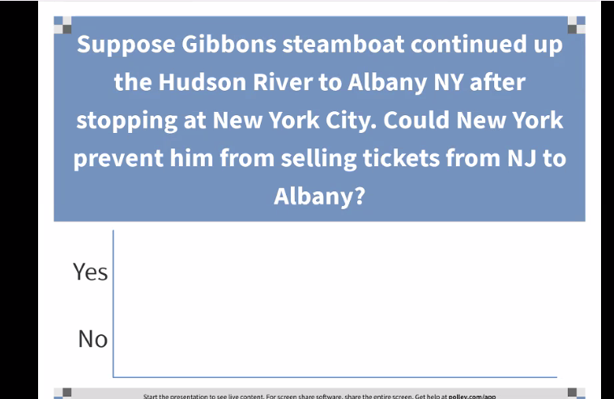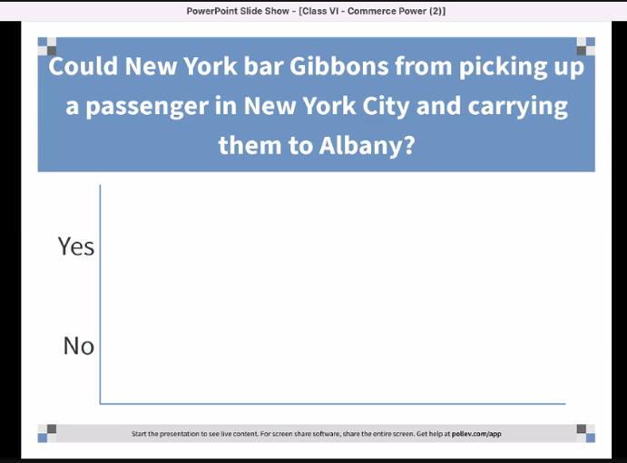
No and Yes can regulate the intra state portion -> my note: unless DCC

Progressive era cases:

U.S v. E.C: Knight American sugar company bought EC knight. Government charged EC knight would monopolize sugar market nationwide. It was brought under Sherman Act. SC held that the government could not prohibit the sugarmaker even it is was intended for export to other states. In other words, commerce comes AFTER an item is manufactured. Commerce not manufacturing. (never formally overturned, but it has no practical meaning anymore)

Champion v. Ames (The lottery case): 5-4 decision upheld federal statute barring sale of lottery tickets across state lines (1) Commerce power held to be “plenary” (2) Includes authority to prohibit commerce in specific good. Lottery subject to traffic and carrying it from state to state-> commerce among state. (But cannot if it is strictly in state).
- Kind of like marijuana: congress can regulate the movement of marijuana, if state wants to legalize it can do so in their own boarder. But can control interstate movement.

Hammer v. Daggenhart: The court held that congress could not prohibit the interstate transportation of goods manufactured with child labor because true aim was to regulate police power of state. Again, kind of like EC nights, manufacturing is not commerce and mining, it is intercourse and traffic.

United States v Darby:
Barred Shipment of lumber if
- Workers were paid less than minimum wage
- Workers dne meet/wage and hour rules
- Mandates extensive record keeping

Congress enacted the Fair Labor Act, which purported to bar interstate shipment of lumber if workers were paid less than the minimum wage or wage and hour rules were not met. It is up to the states police power of how if they are going to pay certain amounts, so it was not saying they must follow the conditions, rather saying if they do not then they cannot move the goods across state lines.

Held: Manufacture is not commerce, but the power to regulate includes the power to prohibit. Congress has power to prescribe the rules by which commerce is governed. Can have regulation to aid commerce or to prohibit. Congress is free to exclude from the commerce articles whose use in the states for which they are destined it may conceive to be injurious to the public health, morals or welfare, even though the state has not sought to regulate their use-> over rule Hammer v Dagenhart. Also, Congressional conception of public policy that interstate commerce should not be made the instrument of competition in the distribution of goods produced under substandard labor conditions, which competition is injurious to the commerce and to the states form which commerce flows. Whatever their motive and purpose, regulation of commerce which does not infringe some constitutional prohibitions are within the plenary power conferred on Congress by the Commerce Clause.
Validity of wage and hour requirement: Chooses to exclude goods produced that do not meet specific wage and hour requirements, then they can choose the mean reasonably adapted to the attainment of the permitted end, even though it involved intrastate activities (Extends to activates interstate that affect interstate commerce or the exercise of the power of Congress over it).
Records: okay because it is an appropriate means to a legitimate end

Wickard v Filburn

Congressional regulation of agricultural production intended for local consumption on farm. They imposed penalties for excess production of bushels. Filburn had not paid the penalty and the committee refused him a marketing card as a result. Filburn was going to use the wheat to feed livestock, feed his family, and to see crop. The court held that. Congress wanted to limit production to ensure the supply and demand operate in a normal economic fashion. The purpose was to control the volume moving interstate and foreign commerce in order the avoid surplus and shortages and to avoid abnormally high or low wheat prices. Congress wants farmers to produce less, and it put a cap on how much farmers can grow, even for local consumption. Even though farmer was not planning to sell and was trying to feed own family and livestock. Issue here: it is not darby where it is trying to regulate the production that ws not intended in any part for commerce but for wholly for farm consumption. Quotes include tha weat that may be consumed on premises. (the wheat needs to pay penalty and give it to the secretary of agriculture. Says it does not matter how you define the subject of the regulation “production” marketing, or consumption but rather it’s the fac that Congress can exert control if it has a substantial economic effect on interstate commerce. Recent years the surplus has tied up railroad cars, caused elevators to turn away grains, caused railroads to institute embargoes to prevent future congestion. The maintenance of the government regulation of a price for wheat undoubtably can be accomplished by sustaining or increasing the demand as by limiting the supply.

Hold: Regulation of commerce includes the authority to regulate prices at which commodities in commerce are dealt in and practices affecting such practices. Local production/consumption of wheat has a substantial effect on commerce/prices (affects trade). Here though Filburn itself may be trivial, taken together with other similarly situated people would make it far from trivial. Purpose was to increase market price, and it cannot be denied that at home consumed wheat would have a substantial influence on price and market conditions. Even if he is to consume it, and not market it, then he would also not purchase it from the market.

Heart of Altana Motel v U.S (use commerce clause to get to private action because 14th amendment deemed to only reach state action> political stretch but good law).

- Case was brought by racist hotel owning lawyer who sought an injunction against civil rights act 1964 enforcement (addressed school segregation and employment discrimination, and discrimination in public accommodations). Act sought to ban racial discrimination engaged in public accommodation-> if you hold yourself out to offer public accommodations then you have special obligations. Previously Civil Rights Act of 1875 which gave persons n US “full and equal enjoyment of accommodations, advantages, facilities, and privileges of inns, public conveyances theaters, and other public amusements” was rejected under the 14th amendment which would have broader scope (limited to state action). Have to use commerce clause for Title II. Congress in committee had people come and describe how their engagement in interstate movement was impacted by the discrimination.
- Characteristics of hotel: accessible to interstate highway and state highways, patronage from outside is solicited with advertising media, including magazines and billboards, 75% of guests are from out of state.

Issue:
- has the rights under the 13th amendment been violated by enforcement of civil rights act
- Has Congress exceeded its power under the commerce clause.

- Held: Commerce is intercourse and traffic between citizens, includes transportation of persons and property. Transportation does not need to be commercial in nature.also includes leisure travel across interstate lines. Like when you are visiting your family. Do not have to be a truck driver carrying goods. Hence, leisure is commerce and as a result congress can legislate when there is an impact on that activity. Hence, reenforces Wickard rule, Congress is able to regulate intrastate activity that has ab impact on interstate commerce as well and they can remove obstructions and restraints on interstate commerce.

Accompanying case: Katzwnback v McClung (ollies bb1)
- Contrasts from Atlanta, because they are no advertising to anyone and not trying to reach people in commerce. Customers were local. Justified regulation by stating 46% of meet that they sold came from other states and hence their local activity has impact on interstate commerce. Disrupts the flow of interstate commerce if allowed to practice racial discrimination because of the effect it may have on the sale of goods shipped across states (stretch for politics).

United States v Lopez (retrenchment)

Federal statute makes it a federal crime to take gun in schools.

Hold: three broad categories that congress may regulate under the commerce power
- Channels of interstate commerce: the way things move, highways, railroads, shipping lines, airport, interstate trucking,
- The “instrumentalities,” Congress may regulate and protect the instrumentalities of interstate commerce, or persons or things in interstate commerce: person and things moving, the things which are being moved. Can be a person engaged in leisure travel, a lottery ticket, passengers on a commercial flight
- Activates that are local that have a “substantial affect” on interstate commerce (economic in nature)

Here:
- there was no requirement in the law that the gun had to be moved in interstate commerce.
- Local activity with substantial effect?
- No, not economic in nature. If “cost of crime” is sufficient nexus Congress can regulate essentially all violent crimes no matter how tenuously related. (Family law would then be regulated because it is connected to economic productivity of citizens)
- If “educational impact” is sufficient nexus, Congress could mandate federal Curriculum Interferes with state rights. Congress may regulate commercial activity that has substantial effect on interstate commerce that also effect the educational process, but this broad view will allow to regulate every aspect of schools. (Child rearing could then be regulated to? (Has similar effect).
- Not like Wickard which was which sought to regulate the price to affect the market. Criminal statute has nothing to do with commerce or any economic enterprise, not an essential part of a larger regulation of economic activity, in which the regulatory scheme could be undercut unless the economic activity was regulated. No jurisdictional element which makes an explicit connection with or affecting commerce that would ensure case by case inquiry that the fire-arm possession in question affects interstate commerce. Ex: “receive possess, or transport in commerce or affect commerce of any fire-arm.” Mere possession not enough. So having a gun in a local school zone is not an economic activity with repetition elsewhere, that may substantially affect interstate commerce.

Dissent: impairs education which affects workforce and impairs economy (gun violence) and the locales impacted by gun violence will particularly suffer, and government only need “rational basis” for action.

NFIB v Sebelius:
Mandate everyone to have insurance, to subsidize the small number of people who have conditions. Either get health insurance or pay a tax. One justification was to pass this with the commerce clause because health care market crosses state lines so it is commerce and health care market is characterizied by a signficcant cost-shiting problem. Even if individuals are not participating in the health care market, they will one day, therefore it is a regulation of commerce. Hospitals are required to give minimum services to people who do not have insurance, and then hospitals recoup prices by increasing their rates, and insurers past cost to policy holders. Individual mandate is congresses solution to cost-shifting problem by those who otherwise would not purchase insurance. Government argues that the individual mandate is within congresses poer because the failure to purchase insurance “has substantial and deleterious effect on interstate commerce” by creating the cost shifting problem.

Hold: No, there has to be a local activity, that is economic, that has a substantial effect on commerce. But here, you are forcing the participation in commerce. Commanding people to engage in commercial activity they otherwise would not have. Power to regulate does not encompass the power to create. They are not “active in the market” -> most people are not engaged in commercial activity involving health care. So even with the necessary and proper clause this is not justified because the clause is involves exercising the authority derivative of, and in service to, the granted power.

- RULE: congress has police power in Washington DC, the district of Columbia, on military basis, and national parks. States have police power and are able to regulate for public health, safety, and morality, can bar anything unless they are trampling on the constitution or constitutional right.
- Necc and proper clause relationship: Commerce power under comer clause is to regulate: if it is a regulation, then you are directly empowered (bus lines can regulate mail) but if you want to for example criminalize stealing of mail, how do they get off on criminalizing the behavior? The necessary and properly clause, it is necessary to do these things to carry out the granted power.

- Commerce clause Hypotheticals:

- May Congress create a federal cause of action allowing female victims of violent crimes to sue for damages in federal court by saying that it included findings that there is a “substantial effect” on interstate commerce?
Answer: No, domestic violence is not economic activity, therefore, Congress has no right to create a cause of action.
- Can congress pass a law regulating who can fly on commercial aircraft or requiring face masks in flight?
Answer: Yes, it is a channel and instrumentalities moving in commerce. Can ban certain people from moving (no fly list). The mask is a straightforward regulation of actual commerce.
- Can congress pass statute making it a federal crime to damage or destroy an aircraft? (That has foreign flights)
Answer: Yes, congress can regulate foreign as well as interstate commerce. So even if aircraft is not American, they can regulate foreign commerce.
- Can congress pass statute making it a federal crime to damage or destroy an aircraft? (Domestic, US flights)
Answer: Yes, this is interstate commerce. Necc and Proper clause can be useful since it seeks to criminalizing an activity since it is not a direct regulation.
- Can congress pass statute making it a federal crime to damage or destroy an aircraft? (LAX to mammoth, local flight)
Answer: Yes, might be a part of a larger interstate travel. OR no, purely intra-state.
- Can congress pass statute making it a federal crime to damage or destroy an aircraft? (Local kite flying activity)
Answer: No, maybe can argue people coming in from outside but NO.
- Can Congress lawfully regulate intrastate commuter railroads?
Answer: the track is used for national infrastructure, so if local trains causing issues you can clog up national infrastructure. Can create collision if they don’t follow same basic standards and procedures.

Spending:

Article 1 Sec 8:
“Congress shall have the power to lay and collect Taxes, Duties, Imposts, and Excises, to pay the debts and provide for the common defense and general welfare of the United States, but all duties, imposts and excises shall be uniform throughout the united states

Identified limits on the spending power
- Must be in support of general welfare
- Congress gets substantial deference
- Any conditions must be unambiguous (so states can make an informed decision)
- Must be related to federal interest in national projects or programs
- Must not violate other constitutional provisions
- Cannot be so coercive that pressure turns into compulsion

( tax and spending cases are kind of together)
United States v Butler:
- Taxed processors of farm products
- Revenue used to pay farmers not to grow crops
- Said tax was not for general welfare
- Held: “The clause confers a power separate and distinct from those later enumerated, is not restricted by them and Congress consequently has a substantive power to tax and appropriate, limited only be the requirement that it shall be exercised to provide for the general welfare of the United States (broader then enumerated powers)

Post Butler developments:

Steward machine Co v Davis
- Court upheld federal unemployment compensation. Employers are required to pay a federal tax, that is abated if they contribute to a state unemployment compensation fund
Halverig v Davis
- Court upheld social security pension program for elders. Congress decides what is general welfare and the concept is not static. Held social security acts special income tax is valid exercise.

Oklahoma v Civil Service Comm’n
- Court upheld application of Hatch Act (barring political participation by government employees) to state officials paid in art by federal funds. Posed condition on states and it was not unconstitutional (spending?).

South Dakota v Dole:

- Issue: Congress want to eliminate a drunk driving by raising the drinking age to 21. Could not be done under Commerce clause because of the 21st amendment which said “the transportation or importation into any state, territory, or possession of the United States delivery or use therein of intoxicating liquors, in violation of laws thereof, is hereby prohibited. Which essentially was interpreted to mean that alchohol use is a matter of state law. Congress wants to incentivize states to raise the age by the spending power, by giving them money. The limits on the power are that (above).
- Must be in support of general welfare: Highway safety is general welfare
- Any conditions must be unambiguous: using money to place a condition to do.
- Must be related to federal interest in national projects or programs: congress giving the funding for federal highways. They can use themselves or they can give it to the states to spend. Therefore, the condition has to be related to highways. Drinking age has to do with how sober they are when they drive. Congress sees a relationship. Highway funds are expended for safe interstate travel, and the condition imposed directly relates to this.
- Must not violate other constitutional provisions: be consistent with the 21st amendment. Cannot make the states engage in an activity that would themselves be unconstitutional.
- Cannot be so coercive that pressure turns into compulsion: Here held 5% of fed highway funds. It is only a small percentage of certain federal highway funds.
Dissent: O’Conner think it is not connected to the federal interest program. Congress wants the roads it builds to be used safety and drunken drivers threaten that but raising age to 21 is over and under inclusive.

Taxation:

Article 1 Sec 8:
“Congress shall have the power to lay and collect Taxes, Duties, Imposts, and Excises, to pay the debts and provide for the common defense and general welfare of the United States, but all duties, imposts and excises shall be uniform throughout the United States. Used to incentivize and disincentivize behavior.

- Federal taxes must be uniform throughout the United States (states can tack on disproportionately)
- Taxes can have regulatory purpose
- Not limited to scope of other enumerated powers
- Can tax things it cannot regulate
- Can tax inactivity
- Validity not dependent on nomenclature (weather it is called a penalty or tax)
- “tax” invalid if an actual penalty (because penalty is a direct regulation and must be based on an enumerated power, do x do y or else).
- Indications include:
- Based on “wrongfulness” of conduct: do not punish unless it is wrongful. If you take money from them for wrongful behavior then I tis a penalty (like parking tickets)
- Knowing conduct taxed/ innocent not
- Magnitude of money
- Payable to regulatory rather than taxing entity (like department of labor)

What are taxes for: Tax shifts money on to the people for the things they use. Or it is used for policy discourage and incentivize activity through deductions and credits (stop smoking, or to buy insurance, tariffs).

NFIB v Sebelius
Obamacare has two provisions
- Individual mandate: to have every American to apply for healthcare
- To expand Medicaid coverage by raising poverty line (Medicaid is for folks with limited income)
- Severability?

- Held: Individual mandate can be justified by tax power. because as a co-equal branch they have a duty to save statutes from unconstitutionality. If you can interpret something in more than one way, then you should to not find it to be unconstitutional. If though it is called a penalty it is “fairly possible” to be read as a tax. The burden was not too high, since it was less then insurance and not more by statute. Not saying not buying the insurance is “wrong,” you have the choice to do or not do an action as long as you are paying the tax, and it is collected by the IRS. Can tax for inactivity.

- Held: the provision to expand medicate was too coercive. It stated that 100% of funding would be withdrawn if states refused to expand the coverage. Not justified by spending power. Nothing in our opinion precludes Congress from offering funds under the Affordable Care Act to expand the availability of health care, and requiring that States accepting such funds comply with the conditions on their use. What Congress is not free to do is to penalize States that choose not to participate in that new program by taking away their existing Medicaid funding.

- Severability: There was an explicit provision in act calling for severability, found medicate expansion to be unconstitutional, but let individual mandate stand.

Treaty(called statute on international realm) and executive power(executive agreements)

Article II section 2
“The president shall have power, by and with the advice and consent of the senate, to make treaties, provided two third of the senators present concur.”

Supremacy clause: “This constitution, and the laws of the United States.., and all treaties.. shall be the supreme law of the land.. anything in the constitution or laws of any state.. notwithstanding” (issue: with treaty not all are)

Background information:
Based on sovereign equality of states (supreme in own territory, must consent to rules/jurisdiction, treaties only bind states that have ratified them)
- ICJ organ of United States (forum for states with dispute to reach a peaceful resolution)
- Statute attachment to UN charter
- Three ways to consent to jurisdiction
- A. Compulsory: adopts UN statute, and can agree to compulsory jurisdiction
- B. Compromissorry clause -> clause in treaty which says law can be taken there
- C. Ad Hod (comprise)
- UN charter says ICJ decision bind parties, but what is the obligation in international law?
- Domestic/international law dichotomy
- Treaty officials negotiate/sign treaty and have obligation to not defeat object and purpose
- President submits to senate for approval
- Appropriate committee hearings held
- Senate votes on “advice consent authorizing president to ratify”
- Present may then ratify (and this binds on international law) (political question, has discretion)

Missouri v Holland
- US government has sovereign authority to make treaties equal to that of all other nations
- Not limited to specific grants of federal power enumerated in the constitution
- Congress may enact legislation “Necessary and property” to implement treaty terms
- Constitutional (individual) Rights can constrain exercise: ex: Cannot ratify a treaty which prohibits criticism of united nations-> 1st amendment issue but can be on something that is generally committed to another branch (like fed gov spend money appropriated by congress, if treaty says have to pay 100 million, then congress probably has to pass law though-> not self-executing)
(so if its in area that don’t belong to him per executive agreement, still international law obligation but no domestic affect)

Missouri v Holland
- Migratory birds threatened with extinction by 1890’s and congress passed the Lacey Act in 1900 which banned interstate traffic in illegally taken birds. Enforcement limited by lack of federal officers. 1913 Weeks-McLean Act extended federal protection and made migratory bird hunting subject to federal regulation, but it was struck down by federal courts. Then in 1916 the U.S and UK migratory bird treaty was ratified in 1916 which called for protecting birds from hinting. Congress then passed a law implementing the treaty, and authorized the Secretary of Agriculture to regulate hunting. The enforcement was challenged by the state of Missouri.
- Issue: states challenging on tenth amendment which states any power not delegated to the United States by the constitutions, nor prohibited by it to the states, are reserved to the states respectively or to the people. Is this a state police power concern, or can the federal government regulate the area?
- Held: treaty + Necessary and Proper clause= Valid Federal Statute (did not have the broad reading of commerce clause to regulate the intrastate activity)-> US has the power to make a treaty just like any other country. Essential take-away that US treaties are not limited to the authority of the constitution. But the bill of rights applies.
Hypo:
- Can congress pass a law pursuant to a treaty which bans the death penalty (no enumerated power)-> based on this holding, Yes.
- Can congress enter into a treaty regarding international enforcement of recognition of child custody issues? Typically, family law left to states, but yes.

Reid v Covert:
- Military court convicted wife of killing husband in UK- Treaty with UK gave U.S. military exclusive jurisdiction. Wife claimed violation of 5th Amendment jury trial right. Supreme Court held jury trial required b/c U.S. civilians outside of jurisdiction of the U.S. cannot be tried by U.S. military tribunal, but instead retain the protections guaranteed by Constitution.
- Hold: cannot deprive individual constitutional rights through the treaty making power.

Bond v United States
- 10th amendment challenge to treaty power. Wife poisons lover of husband. Us is a party to chemical weapon convention, which outlaws production, development or use of chemical weapons in armed conflict. Federal prosecutor decided to pursue under federal law pursuant to the treaty.
- Held: constitutional avoidance, the treaty did not intend to reach something so small and local.

Article 6 cl. 2 Supremacy Clause
“The constitution, and the laws of the United States which shall be made in pursuance thereof and all treaties made, or which shall be made, under the authority of the United States, shall be the supreme law of the land, and the judges in every state shall be bound thereby, anything in the constitution or laws of any state to the contrary notwithstanding”

Enforceability of treaties
Self-executing vs non-self-executing treaty:
- Treaties generally binding internationally
- “Self-executing” treaty effective upon ratification
- Non-self-executing treaty requires implementing legislation to be enforceable by courts
- If treaty and statute conflict, “last in time” prevail (treaty must be self-executing to override statute because they are on the same footing) -> constitutionally treaties and statutes are on same footing. Courts should construe so as to give effect to both if possible without violating language of either, if not possible, the last in date will control the other, provided the treaty provision is self-executing), congress is free to pass a subsequent law that violates a treaty
- Commonly assumed presidents can withdraw U.S. from treaty (no case has reached the merits) -> political question (Goldwater v Carter)
- Executive agreements: legally equivalent to treaties (all aforementioned rules applicable)-> below more rules
- Binding on US international
- Pre-empt conflict state law, though on equal footing w federal law
- President cannot unliterally make a non self-executing treaty, self-executing

Case Foster v Neilson
- Our constitution declares a treaty to be the law of the land, it is, consequently, to be regarded in courts of justices as equivalent to an act of the legislature, whenever it operates of itself without the aid of any legislative provision. But when the terms of the stipulation import a contract, when either of the parties engages in to perform a particular act, the legislature must execute the contract before it become a rule of the court”
- “Self-executing” treaty effective upon ratification
- Non-self-executing treaty requires implementing statute (international law obligation does not necessarily create domestic law obligation, can have domestic obligation that domestic law does not permit you to do)
- How to figure out If it is or is not self-executing? Look at language, some say need to enact legislation to do “x” others ambiguous

Madeline v Texas:
- D appealed after TX convicted him of rape and murder on the ground that his attny failed to inform him of his right to have consular personnel notified of his detention as was required under the Vienna Convention. ICJ asking the US violated the Vienna convention by failing to inform and they should re consider the cases.
- Trying to argue, US joined UN, and UN charter says decisions are binding, it is a self-executing treaty provision.
- Hold: No
- Crt held the Constitution doesn’t require state courts to honor the treaty obligation of the U.S. unless congress has either enacted implementing statutes or the treaty itself conveys an intention that it be self-executing and is ratified on these terms
- “It does not provide that the United States “shall” or “must” comply with an ICJ decision, nor indicate that the Senate that ratified the U.N. Charter intended to vest ICJ decisions with immediate legal effect in domestic courts.”

President power cases?
Executive agreements:
- Has impact of an international treaty, but does not go through domestic ratification process.
- Can have domestic effect if self-executing
- Early on, Washington settles claims with Dutch privateers
- Three types
- 1) Article II treaty agreements
- Made pursuant to senate approved treaty provision
- Make supplemental provisions to a complex treaty
- Ex: authorizing the president to out and trade within certain parameters, or negotiating tariffs.
- Ex: president agrees to send a 100 million and congress appropriates the $
- 2) congressional executive agreement
- Made pursuant to ex-ante authority in statute, or legislatively endorsed ex post by both houses
- 3)sole executive agreement
- No specific congressional authorization or subsequent approval
- Commander in chief (strategizing war), claim settlement, diplomatic recognition (to receive ambassadors and other public ministers)

Am. Ins. Assoc. V Garamendi
- Executive power includes foreign affairs
- Executive agreement pre-empts state law

Am. Ins. Assoc. V Garamendi
- Regarding insurance policy. Typically, a state police power. Executive branch negotiated with Germany for reparations; it addressed insurance. Germany entered believing that it was protecting itself and insurance companies with limits on liability. Agreement reached with US was an executive agreement not a formal treaty. California has proposed an alternate insurance policy, making companies provide reporting’s that may facilitate suet.
- Issue: Does an executive agreement count as a treaty for the purposes of the supremacy clause?
- Hold: Yes, executive power includes foreign affairs (vs congress has power to regulate public and private dealings with other nation in its war and foreign commerce powers) and they have adegree of independent power to act. Also, presidents’ control of foreign relations includes the settlement of claims is undisputable.
- Also, an executive agreement pre-empts state law that is contrary to the terms of the agreement.

Horizontal powers:

Presidential War Powers –
- Article II, § 2: “The President shall be Commander in Chief of the Army and Navy of the United States, and of the Militia of the several States, when called into the actual Service of the United States”
- Authority to direct US military operations, to defend the US if attacked, or to carry out military operations authorized by congress

Congressional War Powers
- Article I, § 8: “The Congress shall have Power: a) To declare War; 15 b) To raise and support Armies [appropriations limited to two years],To provide and maintain a Navy; To make Rules for the Government and Regulation of the land and naval Forces; c) To provide for calling forth the Militia to execute the Laws of the Union, suppress Insurrections and repel Invasions; d) To provide for organizing, arming, and disciplining the Militia, and for governing such Part of them as may be employed in the Service of the United States, reserving to the States respectively, the Appointment of the Officers, and the Authority of training the Militia according to the discipline prescribed by Congress
- To declare war, when us military is used against another country, raise and support armies, no military for president to control unless congress has raised (appropriate, vote every 2 years), militia provide laws (provide direction to president)

Youngstown Sheet & Tube Co.
Three classifications
- President acting pursuant to Congressional authorization
- Has Article 1 + Article 2 authority
- Strong presumption of legitimacy
- If congress can authorize, it is the job of the executive to execute
- And the powers the president has in article 2, inherent authority
- Courts should give strong presumption
- President acting when Congress is silent
- Has only article 2 authority
- Zone of twilight was concurrent authority
- Presidents acts contrary to Congress
- Has article II – Article I authority
- Lowest ebb/court must disable Congress
\

Youngstown & Tube v. Sawyer:

- Background: Korean war: Article 42 of UN called for Un to make binding legal agreements to have forces available on call. No one has entered. Congress passed statute, UN participation Act, said president can negotiate on call force agreements but had to get congressional authorization before agreement can get into force. Did not mean president had authority to commit forces, but troops were sent. Troops were committed based on United Nations Security Council Role alone (they asked us to command the operation). There was little opposition and appropriations were made (cold war)
Youngstown Sheet & Tube Co. v. Sawyer (US 1952):
- during Korean War, United Steelworkers announced a strike and President Truman ordered the Commerce Secretary to seize the mills and permitting them to tell their employees to come back to work. The president argued he had power under Article II because the country was in armed conflict and president was acting as commander in chief/steel is necessary to national defense, his executive power, and to power to take care the laws be faithfully executed, but no law to point to.
- Court noted that Congress could have authority to seize the mills under takings clause (if provided compensation), under commerce clause, or under war powers/necessary and proper clause, but Congress did not do any of this. Instead, previously declined to include seizure authority in Taft-Harley Act.
- Held: No constitutional authority to do this and congress has not authorized either, rejected in taft harly act.Can’t just take private property on order to keep labor dispute form stopping production even though he is the “commander in chief” and with the laws be “faithfully executed” he is limited in vetoing or recommending laws.
- Jackson’s concurrence:
- Set up categorization above
- Indeed, this case falls in third category because congress has not left the seizure of private property an open question but has covered it in three statutory policies and none were followed here.
- Executive power shall be vested in US: not a grant in bulk of all executive powers
- Said the commander in chief power does not give him thr rights to have mastery over internal affairs and constitution expressly places in congress the power to “raise and support armies” only congress can provide him with an army to command. -> not commander in industries, inhabitants, and country.
- Take care laws be executed: no rules

Medellin v Texas pt 2
- President bush thinks he can order Texas to comply with the ICJ’s Aveena decision. He believes his power derived from inherent “foreign affair” authority, and derived authority from US treaties.
- Issue, can the president make a non-self-executing treaty, self-executing?
- Holding on second issue: No, cannot convert a non-self-executing treaty into and not a claim settlement
- Third category of Youngstown, when president triese to “enforce” an non-self-executing treaty because he acts in conflict with the implicit understanding of the ratifying senate
Zivotovfsky v. Kerry
- U.S. IDS current sovereign as birthplace on passport
- Applicant can elect to have locality only
- 2020 statute call for listing “Jerusalem, Israel”
- State department policy by the US president was that a US passport could only list Jerusalem as place of birth (could not put Israel pursuant to US foreign policy), but Foreign Relations Authorization Act by Congress permitted citizens born in Jerusalem to list their place of birth as Israel.
- Held: This case falls in category 3 of Youngstown because there are competing federal powers: legislative branch has control over passports (foreign commerce and naturalization clause) but executive branch has power of recognizing foreign governments, which derives from power to “receive ambassadors.” Congress has no power to initiate diplomatic relations. Court held that the recognition power takes precedence over the authority to make passports because it is more important. Need single policy regarding which governments are legitimate. If congress could alters presidents statements, then it is as if they have the recognition power. Therefore, the president’s authority “disables” Congress’s authority here.

Administrative Law:
- Congress cannot delegate legislative authority
- Non delegation doctrine
- Valid rule making requires: (good way to challenge is to say procedure is not met, no authority to make rules unless congress has authorized) Presidents can alter rules between terms as long as they fallow the APA. Rules have the force of federal law, pre-emption applies.
- Statutory authority providing “intelligible principle”
- Administrative procedure act APA compliance
- Typically requires notice and comment
- Proposed/new rules published daily in federal register (daily publication which provides notice for rulemaking, industries follow to participate and be heard, and notifications are monitored).
- Final rules incorporated in Code of federal regulations
- Not “arbitrary, capricious, or abuse of discretion”
- Agency determinations get judicial deference
- If thorough investigation, well-reasoned, persuasive
- Permissible construction of unclear statute
- Note in OH:

- Congress passes and executive executes. Congress cannot enact laws on everything. Distinction between statute and rulemaking. Rulemaking is permitted to the execute brong as long as congress is doing the actual legislating.

- In addition to making rules, can also allow them to adjudicate issues (immigration courts) Subject to review in actual court.

J.W. Hampton Jr. & Co. v. United States (US 1928)
held that delegation of legislative power to federal agencies is constitutional so long as the agency in its exercise conforms to an “intelligible principle” of action authorized by Congress.

Citizens to Preserve Overton Park v. Volpe (US 1971):
held that agency discretionary action is subject to judicial review to determine if action was arbitrary, capricious, an abuse of discretion, or otherwise not in accordance with the law.

Skidmore v. Swift & Co. (US 1944):
held that an agency’s interpretations and rules are to be given deference according to the agency’s thoroughness of investigation, valid reasoning, consistency, and other persuasiveness. Rulemaking cannot be arbitrary, have to show that they have engaged in a rational process to meet the requirement.

Chevron USA, Inc. v. Natural Resources Defense Council, Inc. (US 1984):
held that if a statute is unclear then deference goes to a permissible construction by the agency.

INS v. Chadah (non-delegation doctrine)
- Congress has only legislative power
- Legislation requires:
- Bicameralism: both houses must act
Exceptions:
- Impeachment- House: put on trial
- Impeachment trial: senate: sole power to conduct the trial and vote
- Treaty advice and consent: senate
- Appointment: senate: confirmed by senate if nominated by the president (executive branch officials, at senior level at least, reviewed by senate).
- Presentment: must go to the president

INS v. Chadah(legislative veto)

I Chadah overstayed his visa and was set to be deported, but immigration judge ordered that his deportation be suspended because he met the statutory requirements to stay in the US. Additionally, the attorney general reviewed his case and recommended that he stay. Nonetheless, the Immigration and Nationality Act allowed Congress to veto the attorney general’s recommendation. The House of Representatives exercised this veto, passing a resolution that Chadah should be deported. This resolution was not presented to the Senate or to the President. The SC held that the one-house legislative veto was unconstitutional. It was an exercise of legislative power because it alters the legal rights, duties, and relationships of people outside the legislative branch, and exercises of legislative power are subject to bicameral requirement (legislation must pass by a majority of both houses) and presentment requirement (legislation must be presented to the president for approval before becoming law). Neither of these were met, so House of Representative’s veto pursuant to the Immigration and Nationality Act was unconstitutional. The requirements to make a legislation valid were not met. Majority of each house has to pass the same exact state. Then goes to president where he can sign into law or veto and then they can 2/3 override. The efficiency and history of use did not matter-> if wrong then wrong. Laws are not pulled of books, just enforceable.
Congress made a deliberate choice to delegate to the Executive Branch, and specifically to the Attorney General, the authority to allow deportable aliens to remain in this country in certain specified circumstances. It is not disputed that this choice to delegate authority is precisely the kind of decision that can be implemented only in accordance with the procedures set out in Art. I. Disagreement with the Attorney General's decision on Chadha's deportation-that is, Congress' decision to deport Chadha-no less than Congress' original choice to delegate to the Attorney General the authority to make that decision, involves determinations of policy that Congress can implement in only one way; bicameral passage followed by presentment to the President.

Clinton v NY:
- Rejects legislative standing
- Exception: only If vote deprived of all meaning
- States can have line-item vetoes

Clinton v NY (line-item veto)

the Line Item Veto Act of 1996 would allow the president to strike out individual spending provisions in an appropriations bill (intended as a way to balance the budget). The court held that there is a difference between a veto, which the president has constitutional authority for, and a line item veto, which he does not. A veto (‘return’) takes place before the law is enacted and involves the president following the constitutional process for how laws are made. A line item veto, however, rewrites the actual law/takes place “after” the bill becomes law. It is amending provision from it. The court held that the line item veto was unconstitutional because it violated the presentment clause. Why? Not only to be presented, but the presidents option to 1) sign into law 2) reject the entire thing (permissible scop of presidents action). Narrowly holds, line item veto violated that. Alternate argument, this is actually a separation of powers issue—line item veto grants president law making authority. But the congress has to make laws and the president to execute them. (president action that either repeals or amends parts of a duly enacted statute is not granted by the constitution).
Also another consideration: Six members of congress went to court and sought to challenge it but they were rejected, they did not have standing, unless subsequent action deprived vote of all meaning. Example: president ignoring the statute, depriving their affirmative vote. Then brought by individual plaintiff, since tax revenue to NY was cut out.

Executive Privilege Takeaways:
- Public (“official”) papers and records of presidential discussion subjects to claim of executive privilege
- President does not have “sovereign immunity” of monarchs
- Cannot be sued for official acts, but not immune for other civil suits even while in office
- May be compelled to comply with state & federal subpoenas
- May only be criminally prosecuted after term ends

- Can be required to produce if “demonstrated, specific need”
- Private papers subject to regular rules

United States v Nixon:
- Watergate scandal. Individuals who worked for Nixon were directly responsible. He tried to cover it up. In testimony, white house employee mentioned there was a taping system in the oval office. Suggested there would be evidence of the president’s involvement. Special prosecutor appointed. The grand jury names Nixon a co-conspirator. The special prosecutor then subpoenaed more tapes. The WHI released partial transcripts. The white house counsel moved to quash the subpoena. The district court denied the motion to quash. And the appeal was filed in the DC circuit. Argument by president counsel was that a president needs to have candid conversations with there key advisors and if the conversions are revealed then it will impair the function of the presidency. Separation of powers issue between the executive branch privilege (article 2) and the need for evidence by the courts (article 3).
- The legal basis for the executive privilege is the “separation of powers” + practical need for confidential communication= presumptive privilege for presidential communications. (implied from separation of powers)
- Held: The court held that there was a presumptive presidential privilege for a president’s confidential communications. However, when the communications do not concern military, diplomatic, or sensitive national security secrets, that presumption may be rebutted if there is a demonstrated specific need. Here, the integrity of the judicial system/the need to produce all relevant evidence in a criminal trial takes precedence over a generalized presidential privilege of confidentiality. The subpoena identified specific conversations, dates and points in time were the evidence was relevant, and the court felt it was reasonable.

Trump v Vance (note: no presidential pardon for state courts/crimes)
pursuant to state criminal investigation into Trump and other individuals, NY state court subpoenaed tax returns from Trump’s accounting firm (personal rather than official information). Trump argued that the supremacy clause gave him absolute immunity from state criminal subpoenas because compliance with those subpoenas would categorically impair a president’s performance of his article II functions because 1) complying would divert him from his duties (time) 2) the stigma would undermine his leadership, (credibility) and 3) could lead to harassment/improper use of subpoena to interfere with duties (vexatious prosecution). The court denied all of these arguments. The court also denied the argument that there would need to be a heightened showing of need since the subpoena sought private papers, not official ones.
Held: Personal information does not have a claim on the impact of presidential advice. Presidents do not have sovereign immunity but they do enjoy immunity from personally being suit for official actions (sue the federal government if you are harmed by their actions). Clinton v Jones rejected similar claim for civil suits. When they are sued in personal capacity, it is not an imposition, they can have their lawyers handle it. Hence, there is a minimal impact for providing information, and the present may only be prosecuted after term of office. As for the stigma, the court said it is the duty of all citizens to comply with the subpoena, and a grand jury is sworn to secrecy, there is not significant adverse impact. The grand jury is prohibited from “dishing expeditions” and president, if anything, can seek protection in federal (or state) courts by making constitutional challenges. Ultimately there is no need for heightened showing for private papers, there is no legal basis, and public interest calls for access. He can challenge on arguments available to all citizens, undue burden/bad faith.

Appointment:
- President appoints principal officers/senate confirms
- Inferior officers may follow same procedure or may be vested in President/Head of Departments(cabinet/secretary)/Courts alone
- Congress can NOT appoint executive officials
- Officers of the US wield significant authority
- Employees lack significant authority/implement policy only
- Distinguishing Principal from inferior officer
- Nature and extent of duties include policymaking
- Who they answer to (report to president/cabinet, or lower down?)
- Tenure of position (the longer the duration to more likely principal, though this is not dispositive. Ex: civil servants. But if for finite period, like a single investigation it is more likely to be inferior.

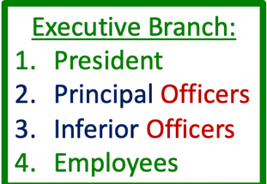

Article II, Section 2, clause 2: “And he shall nominate, and by, and with the advice and consent of the Senate, shall appoint ambassadors, other public ministers and consuls, judges of the Supreme Court, and all other officers of the United States, whose appointments are not herein provided for, but the Congress may by law vest the appointment of such inferior officers, as they think proper, in the President alone, in the Courts of law, or in the Heads of Departments alone.”

Morrison v Olson (at the time public exposure was favorable to special prosecutor, before going on witch hunt with Clinton case)
- The case concerns the legality of the special prosecutor statute.
- Morrison v. Olson (US 1988): in wake of Watergate scandal, Congress passed Ethics in Government Act of 1978, which provided a procedure where, after Attorney General made finding it was necessary, a special three judge panel of the Court of Appeals for the DC Circuit could appoint independent counsel (special prosecutor) In 1986, after assistant attorney general Theodore Olson testified untruthfully, Alexia Morrison was appointed as independent counsel pursuant to this process to investigate/prosecute him and Olson challenged the constitutionality of her appointment.
- Issue: is a special prosecutor an inferior officer?
- Held: The court held that it was constitutional for Congress to vest the power of appointment in the three-judge panel because independent counsel is an inferior officer. The court reasoned that the independent counsel is inferior in rank to the Attorney General (and subject to removal by AG), has limited jurisdiction (appointed to investigate a narrowly defined set of facts), and the office is of limited duration in tenure (appointment ends when investigation is complete).
- Congress eventually let statute expire, because of a political decision, not executive unitary theory (which suggests, the executive branch is subordinate to the president)
- Removal for good cause->not unconstitutional, does not usurp presidents authority

Limits on state taxation: (state and fed gov have concurrent power to tax, states generally have the power to tax not impacted by the constitution)
- McCullough v Maryland held states could not tax federal government institutions (Bank of US)
- The power to tax is the power to destroy
- Applies to legal burden of tax (when legal obligation to pay the tax falls on the government)
- Does not prohibit nondiscriminatory taxes ultimately paid with federal funds
- Tax on government employees/retirees (Navy officer receives money from federal government but they pay California taxes, California can tax you SSI income)
- Taxes on government contractors
- all revenues come from federal government is okay. Example, a defense contractor is creating defense products, and to do so they have a facility, California can tax the facility. When you have a cost-plus contract then you show the cost and a 10% profit is paid to you, so essentially the federal government re-embuses you for the taxes you paid but that is permissible since the burden does not fall on them (indirect)
- contrast cannot tax air force base or bank of us

Supremacy Clause: (jurisprudence of fed gov to state gov)
VERTICAL SEPERATION OF POWER
Article 6 cl 2

“the Constitution, and the laws of the United states shall be made in pursuance thereof; and all treaties made, or which shall be made, under the Authority of the United States, shall be the supreme law of the land, and the judges in every state shall be bound thereby, anything in the Consitution or Laws of any state to the contrary notwithstanding”

M’Culloch v Maryland (pt 2)

- Maryland sought to apply state taxes to the Second Bank of the United States. The way that the statute was written, the state tax only applied to the US Bank.
- Issue: Can Maryland impose a tax on operations of the Bank of the United States within its borders?
- Holding: The court held that the power to tax is concurrent, meaning that both the federal government and the state governments have the power to tax and the tax limits are essentially political, meaning it depends on the constituents’ taxes. Hence, “the power to tax involves the power to destroy”. However, because taxes applied to activities by the federal government are not subject to same political constraints, supremacy of the federal government would be defeated if states could tax federal government’s activities. Therefore, court held that states cannot tax federal government institutions.

Pre-emption Takeaways: (applies to treaty or executive agreement)
Four forms of “pre-emption” (assume the historic police powers of states are not superseded unless there was a clear manifest purpose of congress).
- Express preemption- Congress enacts legislation barring state action (in fact pattern will say states cannot do this)
- Field pre-emption- domain belongs to Fed govt
- State action w more than incidental effect barred
- Ex immigration and naturalization, states don’t get to pick who becomes a citizen
- Dominant federal interest or regulations to pervasive that congress has left no room for congress to supplement it
- Not allowed to parallel
- Conflict pre-emption- Federal approach prevails if actual conflict
- Cannot comply with both federal and statute rules
- Do x, do y
- Obstacle pre-emption – state action constitutes an obstacle to the achievement of federal aims
- Limit that ability of federal aims (judgment call)
- Look at purpose and intended affect of the

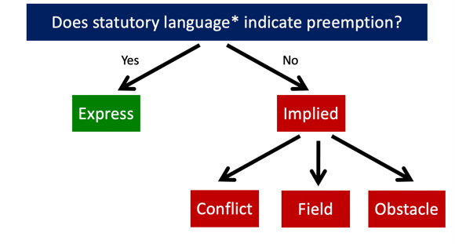

Am. INS. Assoc v Garamendi (Pt 2)
- Facts above. Insurance case for holocaust victim where executive had claimed settled with Germany, while California sought to impose procedures to make them potentially open to suit.
- Issue: does present executive order pre-empt California state law?
- Hold: court identifies two forms of pre-emption 1) field: domain belongs to the federal government and action with more than an incidental effect is barred 2) Conflict pre-emption- federal approach prevails if there is an actual conflict, meaning one cannot comply with both federal and state rules. Here, the court stated there was conflict pre-emption. The disclosure by companies that world prompt suit was against the executives carrying out of international claim settlement. HVIRA's economic compulsion to make public disclosure, of far more information about far more policies than ICHEIC rules require, employs “a different, state system of economic pressure,” and in doing so undercuts the President's diplomatic discretion and the choice he has made exercising it. (Remember executive agreement can pre-empt state law).

Arizona v United States

Arizona v. United States (US 2012): Arizona passed SB 1070, which addressed illegal immigration. Issue was whether four provisions were preempted by federal approach to immigration. In this case, court identified four forms of preemption (field, conflict, obstacle, and express).
  - First, section 3 made failure to comply with federal alien registration a state crime. Court struck this down due to field preemption—alien registration is federal government’s domain because Congress occupies the entire field. They have made a complete system for alien registration. Not even allowed to parallel.
  - Second, section 5 made it a misdemeanor for an illegal immigrant to apply for work in Arizona. Court struck this down due to obstacle preemption—federal approach was to put legal burden on employers, not employees (although goal was the same, Arizona’s method of enforcement was obstacle to federal method of enforcement). If fed gov think it is okay to work in the US and you are saying they cannot, then it is obstacle pre-emption because though this is trying to reach the same end, it is using a different method of enforcement and that is distributive to Congresses overt policy.
  - Third, section 6 permitted a warrantless arrest of individuals believed to have committed a “removable offense.” Court struck this down due to obstacle preemption—federal approach was to only allow warrantless arrests in specific, limited circumstances. Otherwise they follow a process which includes notice. This violates the principal that the removal process is entrusted to the discretion of the federal government. Removal decisions, including the selection of a removed alien's destination, may implicate [the Nation's] relations with foreign powers and require consideration of changing political and economic circumstances” Don’t allow more aggressive state approach when because it is an obstacle to the federal policies that are more lenient.
  - Fourth, section 2B required police to verify a detainees’ immigration status with federal authorities. The court upheld this one. Can go above and beyond to do additional checks on the people you have arrested. Instead, the sharing of information is encouraged by Congress. There was uncertainty of interpretation, but said it can be interpreted to mean they would not detain them longer that may cause constitutional violations.

10th amendment
The powers not delegated to the Untied States by the Constitution, nor prohibited by it to the states, are reserved to the States respectively, or to the people.
- Does not add anything
- Federal government of enumerated powers, everything else reserved to the states absent limitations (pre-emption (statutory) or implied restriction DCC or in Constitution Article 1 sec 10).
- So look to state constitution minus limits on the constitution
- Truism; analysis true with out tenth amendment
- Short hand used for federalism cases
- 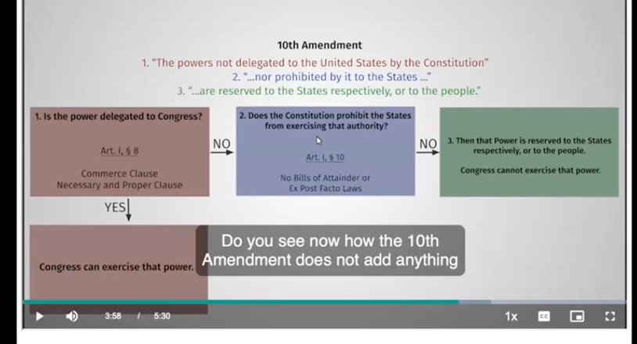

New York v United States:
- Congress cannot force state to legislate, “cannot commandeer” state to legislatures

New York V United States
- Federal low level radioactive waste statute mandated states to 1) provide disposable facilities or 2) take title to waste generated in the state. Ny conceded to the permissibility of federal regulation of nuclear waste but objected to the “take title provision”. NY challenged at a federalist basis, stating that that states have their own sovereignty and the federal government can command them, particularly to legislative.
- How can congress regulate? The commerce clause: a) ability to prohibit items moving from interstate commerce based on police power considerations b) intrastate activity that has substantial effect on commerce. Disposable facility in one state. Have people ship it to you across state lines, can be considered to be commerce. (in class activity)
- Hold: Congress can’t force state to legislate, can mandate that they pass a law. Taking requires legislation and cannot have them legislate. Cannot make them enact and enforce a fed regulatory program (enacting laws is discretionary, and it would be contrary to the meaning of being a legislature).
- Based on the commerce clause though it may be necessary it is not proper to direct a state to legislate
- Can prohibit them from doing something, incentive (spending), or create federal agency to do something (could have passed a federal law and pre-empted).

Prints v United States:
- Congress cannot commandeer state executive officials

Prints v United States
- Congress passed the Brady Act, which required a background check before someone could buy a gun. This called for a federal database to be established so that gun dealers could call in and do a background check, but in the meantime, the Act provided that gun dealers would have local chief law enforcement officers do the checks. Local sheriffs challenged the constitutionality of this law, and the court held that it was unconstitutional because cannot commandeer state’s executive officials. The court’s authority for this was the necessary and proper clause/textualist argument that background checks may be “necessary” but are not “proper.”(justified based on commerce clause).

11th amendment: (purpose to fix supreme court decision that held a citizen of one state can sue another state).
“the judicial power of the United States shall not be construed to extend to any suit in law or equity, commenced or prosecuted against one of the United States by Citizens of another state, or by Citizens or subjects of any foreign state.”
- waivable, can consent to the suit
- 14th amendment can override

Hands v Louisiana
- Cannot sue own state in federal court without its consent

Hans v Louisiana
- Louisiana failed to pay interest payment on bond and alleged Article 1 violation of the “contract clause.”
- Issue: can Hans sue his own state in federal court?
- Hold: No, 11th amendment is not to be read literally, the court recognized state sovereign immunity (inherent) and stated the one cannot sue own state in federal court without its consent.

Seminole Tribe v Florida
- States generally immune from suit by private parties in federal court absent their consent

Seminole Tribe v Florida
- Congress allowed tribes to sue states in federal court for violations of the Indian gaming regulator act.
- Issue: Does the right to sue violate state sovereign immunity>
hold: Commerce power is insufficient to over-ride state sovereign immunity. The gamin act is okay but the provision to allow private parties to sue in federal court is unconstitutional

Alden v Maine
- Congressional authority to abrogate state sovereign immunity limited to the 14th amendment
- Can’t sue state in state court

Alden v Maine
- Federal statute allowed states to be sued in own courts for specified labor law violations.
- Issue: does the ability to sue states in their own court violate state sovereign immunity?
- Holding: Yes. States cannot be sued by private parties in own courts without consent. Essentially saying you cannot commandeer state courts.
- Basically, congress cannot abrogate state sovereign immunity (can’t allow states to be sued) when trying to enforce its powers granted to fed government by the body of the constitution. Exception: 14th amendment, can abrogate state sovereignty and allow suit against states.

Exceptions to state sovereign immunity (above rules applicable to private parties)
- Suits by the US (don’t apply to federal gov, just parties parties)
- Suit by another state (SC OG jurisdiction)
- Bankruptcy proceedings (ex: state creditor, bankruptcy law federal)
- S Ct review of state court decisions
- Suit against named official in both personal and official capacity (rogue official but also only state can violate constitutional rights in the same suit)
- Suit against political subdivision (cities, sue LA)
- Congressional abrogation (do explicitly so everyone understands what they are doing and has to be in enforcing the 14th amendment)
- Requires clear statement and 14th amendment basis

State limitations: (vertical separation of powers- interpreted to be a grant of power to the federal government and a limit on state power with the principal that the constitution was to create a single national market)

Dormant Commerce Clause: (rules from Buck v Kuykendoll):
- Commerce clause bars state “regulation of interstate commerce”
- Highway safety regulation permissible if “indirect burden” on commerce not unreasonable
- Economic protectionism is prohibited

Wilson v Black-Bird Creek Marsh Co.

Delaware passed a law allowing a private company to completely dam off a creek. A vessel broke through the dam and the owner of the vessel argued that it was engaged in interstate commerce and that Delaware impermissibly interfered with interstate commerce by damming off the creek. The court ultimately held for the state but included this language in its decision: “We do not think that the state act empowering the Black Bird Creek Marsh Company to place a dam across the creek, can be considered as repugnant to the power to regulate commerce in its dormant state, or as being in conflict with any law passed on the subject.” This established the existence of the “dormant commerce clause”—the idea that the commerce clause is a simultaneous grant of power to Congress and a limitation on state authority. Even where congress has not regulated, there can be a check on state authority. Believes regulation of commerce is part of the system of government that should be exercised on a national level.

Buck v Kuykendoll
- Buck sought approval for “auto stage stage” from Seattle, Washington to Portland, Oregon. He needed permission from both states to operate a buss line. Oregan granted the license, but Washington denied the “certificate of public convenience and necessity” (law that was an anti-competitive limit protecting existing services).” The court struct down the Washington law.
- Why? The commerce clause bars state “regulation of interstate commerce”. Here, was an attempt to directly regulate commerce.
- Court said state regulations adopted primarily to promote safety upon highways and conservation in their use are not obnoxious to the commerce clause where the indirect burden imposed upon interstate commerce is not unreasonable. Hence, Highway safety regulation would have been permissible (because of strong police powers) if it had an “indirect burden” on commerce and it was not “unreasonable.” Economic protectionism is impermissible and here the consideration of WA was to protect existing industries rather than being grounded in state police powers.

Southern Pacific Co v Arizona:
- Only congress can establish commerce regulating policy
- State safety regulations must be “plainly essential” (high standard that is necessary)

- Arizona law limited train length in state. Had to be 14 cars for passenger trins and 70 cars for freight trains. They justified doing so by saying it was a state police power related to safety, because of the slack action in the couplings of the trains. The regulation had a impact on interstate commerce by effecting the 1) cost/time to alter trains lengths (since most people pass through), 2) effect felt from LA to El Paso, 3) required 30% more trains in Arizona (not efficient). As a result, there was a serious impact on interstate commerce and the safety impact was non-existent. It was a control of train operations beyond the boundaries of the state.
- Hold: Only congress can establish commerce regulation/policy and state safety regulations must be plainly essential. Court ultimately recognizes they have to balance between state police power and the regulation of interstate commerce committed to congress and that the structure is set up to limit a state ability to balkanize the market and create limits on interstate commerce. “The decisive question is whether in the circumstances the total effect of the law as a safety measure in reducing accidents and casualties is so slight or problematical as not to outweigh the national interest in keeping interstate commerce free from interferences which seriously impede it and subject it to local regulation which does not have a uniform effect on the interstate train journey which it interrupts.”

Hunt v WA state apple Ad. Comm’n:
- State has burden of showing laws discriminating against interstate commerce:
- Provide legitimate local benefit
- No less discriminatory means available
- Benefit must be valid exercise of police power
- Economic protectionism impermissible

Hunt v WA state apple Ad. Comm’n:
- North Carolina barred apple Catons form displaying any grade other than US grade or standard in an attempt to regulate instrumentalities of interstate commerce. Stated that it caused confusion and they sought to protect people from fraud.
- Issue? Was this permissible under DCC
- Held: No
- State has the burden of showing that the laws that discriminate against interstate commerce provide a legitimate local benefit and there is no less discriminatory means available to accomplish the objective. The benefit must be a valid police power and economic protectionism is impermissible. Here, the regulation had a substantial effect on interstate commerce and discriminated against out of state applies. It raises cost for doing business in North Carolina market for Washington apple growers and dealers, while leaving NC counterparts unaffected. Strips away from the Washington apple industry the competitive and economic advantages it has earned and has levying effect in favor of local apple producers.
- Hence, it led to substantially greater business costs and a deprivation of investment in the WA grading system. There was evidence of economic protection motivation because there was backing from the NC growers but the court said the finding was not necessary to solve the case. Because when there is discrimination, the burden is on the state to justify both in terms of local benefit and the unavailability of a non-discriminatory alternative adequate to preserve the local interest at stake. Here 1) consumers don’t see th cartons 2) Washington grade is better than USDA so the confusion would be in the consumers benefit. Also, they could have used a less discriminatory means by having them restricted grades inferior to federal grades.
- Note: discrimination when you are putting a standard that affects someone else negatively and not your own people?

Dormant Commerce clause summary: (point was to create commerce across the country, a unified national market)
States may not
- Regulate out of state activity/transaction
- Unduly burden interstate commerce
- Directly regulate interstate commerce
- Engage in economic protectionism
- Discrimination against non-residents/commerce not justified by legitimate police power concerns

States may:
- Exercise police powers if least discriminatory means; no undue burden on commerce/non residents

Hypos:
Buck begins Portland to Seattle service. Can Washington bar buck from picking up passengers at intermediate stop in Olympia, Washington to Seattle Washington?
- Fully intrastate activity, but can bar if doing so would impose an “undue burden” on interstate commerce.

Can congress regulate Olympia to Seattle segment (or limit state ability to do so)?
- Can regulate intra state activity, that in the aggregate has economic effect on interstate commerce.
- Maybe can argue: regulation segment could determine if it would be economically viable to engage in interstate commerce or not
- If said this company could not carry in this segment? Likely the local company would-> economic protectionism.

Can Washington limit buses on intrastate segment from Olympia to Seattle to a maximum length of 40 feet?
- Yes, if there is a compelling safety justification, congress has not enacted a national limit (or conditional spending and you don’t follow), and if the law does not dsicmrinate between intrastate and interstate traffic (different limitation).
- No would be wrong because can regulate with police power absent undue burden

Pig hypo: banning based on moral growth conditions
- If they can show food safety issue, the stress raising toxins then that is a good saftu argument, but moral will likely not fly
- Can regulate how people grow in their own boarders, but not outside
- Problems under DCC
- 1) Attempt to regulate out of state activity (like Washington apples where it is stating you have to keep track of what is labeled)
- 2) unduly burden: Yes, major costs
- 3) economic protectionism: no, moral based
- 4) Direction: more would be no pork shipped across the border of California

Market Participation Exception:
Hughes v Alexandria Scrap
- Court upheld discrimination because state was participating in market, not regulating

Hughes v. Alexandria Scrap (US 1976):

- the state of Maryland purchased junk cars for scrapping/recycling. The state paid “bounty” for those with Maryland plates and required out of state processors to show title because the purpose was to clean up Maryland, not to enter profitable venture. The court upheld this discrimination because the state was participating in the market, rather than regulating it. Held that as a participant in the market, a state’s free to discriminate against out of state players, and contrary to the flow of interstate commerce. Not acting as a government regulator but as a market participant.

Reeves v Stake
- SD built cement plant due to shortages in state and sold surplus to out of state buyers. It restricted sales to in state, during a shortage.
- Court upheld: this is permissible because of market participation.

White v Massachusetts Council of Const.
- Boston mayor ordered 50% of workers on city construction projects to be city residents
- Mass SC held it to be commerce violation (because it violated the CC of US in that it imposed a significant burden on interstate commerce by prohibiting the hiring of construction companies with majority out of state workers)
- Court upheld action by market participation, when the city is building roads or buildings, it is acting like a private party would act in terms of procuring production services, so they are free to impose conditions
- Workers effectively are “working for the city”, though they are hired by companies, who are in turn working for the city

South Central Timber Development
- Post-sale use restrictions inconsistent with market participation
- Can only burden commerce in market that the state is actually participating in (uncut timber v processing of timber)
- Reconfirms state protectionist regulations barred
- foreign commerce restrictions get more scrutiny

state of Alaska selling timber form state land contract required certain in state processing before export. State decided that it wanted to keep revenue to generate more jobs in the state. Therefore, they stated that to purchase wood you had to agree to processing before you take it out of state. South Central timber would sell thse lands to Japan and it did not have a market for processed word. Sued for DCC violation
- Held: Market participation did not apply. Because of the protectionist nature of Alaska's local-processing requirement and the burden on commerce resulting therefrom, we conclude that it falls within the rule of virtual per se invalidity of laws that “bloc[k] the flow of interstate commerce at a State's borders.that the restriction is invalid by the fact that foreign commerce is burdened by the restriction. It is a well-accepted rule that state restrictions burdening foreign commerce are subjected to a more rigorous and searching scrutiny. It is crucial to the efficient execution of the Nation's foreign policy that “the Federal Government ... speak with one voice when regulating commercial relations with foreign governments.”

In class note: this would generally be prohibited under DCC because 1) economic protectionism 2) though it is a legitimate state interest, it is not necessary to impose limit to sustain forest 3) it is burdening commerce since they have the ongoing commercial practice in interstate and foreign commerce and the rule is directly interfering/ directly regulating.
Some differences in this case
- Federal law: typically, congress has the ability to delegate authority to states to allow them to impact commerce in a way they cannot do so on their own. Here, they implicated federal practice to justify what they were doing.
- Foreign v domestic commerce: goal of CC is to create a single national market place. It is even more important for the country to speak with one voice internationally. Foreign commerce connected to foreign policy. More of a limit implicated on state
- Downstream regulation: the downstream regulations, you can choose who to sell things to as a market participant but not put restrictions on what they do with it after. Going outside of the market they are participating in.

Article IV Privileges and Immunities Clause: (exception to market participation doctrine and can be brought independently)

Article IV Sec 2 “The citizens of each state shall be entitled to all privileges AND immunities of citizens in the several states” (focusing on the rights one enjoys by virtue of being citizens of one state, when one is in another state)

Protects limited set of “fundamental rights” (to treat people from out of state equally)- Does not apply to citizens of your own state.
- right to travel/ pass through state (ASK IF THIS INCLUDES RESIDENCY REQ)
- right to reside in state
- right to do business/work in state
- right to buy/hold/sell property in state
- equal treatment in taxation (can’t tax someone 10% because they are from California while Texas residence get 5%)
- right to seek medical treatment in state (can’t deny someone abortion because they are from California)
Analysis
- Is a fundamental right/privilege at issue?
- Is the discrimination covered by the clause?
- Directed at non-residents (HUMANS)
- Does the state have a “substantial reason” justifying the discrimination
- i.e., are non-residents “source of evil” (causing some harm, like taking away the jobs of people)

United Bldg & Construction. Trades Council
- market participation doctrine lets states avoid commerce Cl constraints, not P&I
- P&I does not extend to states own residents
- Action by municipalities are state actions (keep in mind for 14th amendment)
- P&I allows discrimination IF state has “substantial reason” for disparate treatment
- Those being discriminated against must be “source of evil” government is addressing
- Applies to human citizens of other US states, but does not apply to aliens present in US, “legal persons” (corporations), or state’s own residents.
- Action by municipalities are state actions for purposes of P&I analysis.

United Bldg & Construction. Trades Council

- Camden, NJ ordinance required 40% of employees on city construction projects by city residents. Required one year residency and rule extended to subcontractors. Rule was approved by the State Treasurer and the rule was modified during the litigation. It eliminated the residency duration requirement and changed from firm mandate to “goal.”
- Holding: Violation of the P&I clause of Article IV (though this would have been okay under market participation doctrine), they gave adequate reasons but not enough finding of fact, so it was remanded.
- NOTE: when a case can be solved on two grounds, then bring it up.

Hypo:
- Is out of state residents who pay more for college a violation of P&I, does it qualify as market participation?
- Answer: Market participant, states operate universities like market participants, private parties and can place tuition as they want. In terms of P&I, there is no right to seek education in another state.

- In Hawaii, you can show driver license and get 10% of bill, and charge tourists more. As, market participant free to decide who you serve and as private party can engage in discrimination.

- Exception to discrimination by private party? 13th amendment (slavery), and 21st amendment (liquor)

Requirements for taxing commerce (state) (can Montana put taxes on Minnesota truck)
- Activity has substantial nexus to taxing state: ex driving on the states road
- Tax is fairly apportioned: have to be proportional to the impact on the state (example for trucking having apportioned license plate, log of where it traveled, give report, and get taxes based on it).
- Tax is non-discriminatory to interstate/foreign commerce: cannot say someone from your state pays less
- Fairly related to services provided by the state: Cannot tax a truck on a highway to provide for a public park. Not related to service provided, instead can tax on the service you provide, like for repair of the highway.

Dormant Commerce clause summary:
States may not
- Regulate out of state activity/transaction
- Unduly burden interstate commerce
- Directly regulate interstate commerce
- Engage in economic protectionism
- Discrimination against non-residents/commerce nor justified by legitimate police power concerns

States may:
- Exercise police powers if least discriminatory means; no undue burden on commerce/non residents
- Act as private market participation
- Tax

Hypo:
Texas is concerned about economic impact of energy prices on state growth and employment. Wants to bar out of state shipment of oil produced in Texas. Is there a practical way it could achieve this goal?
Answer: It could purchase oil itself and sell to companies which are only engaged in the sale of oi in Texas.
Can’t enact legislation barring out of state shipment
And it could produce it cannot put downstream requirement to bar purchasers from shipping oil out of state.

Flow chart

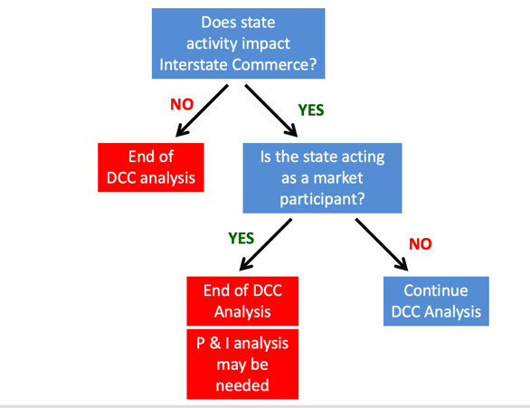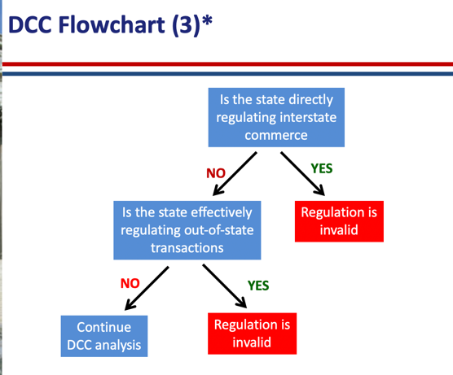

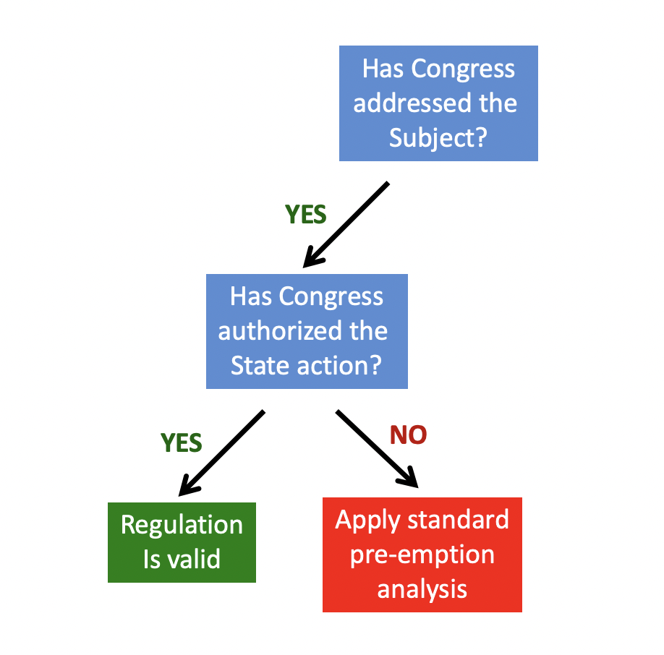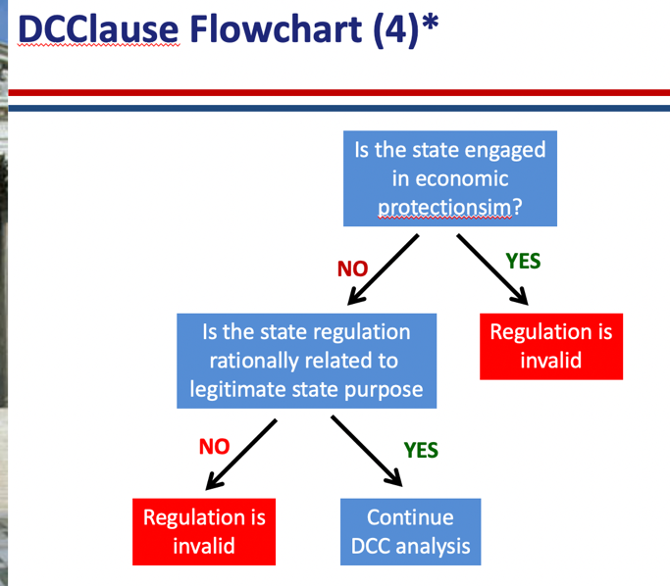

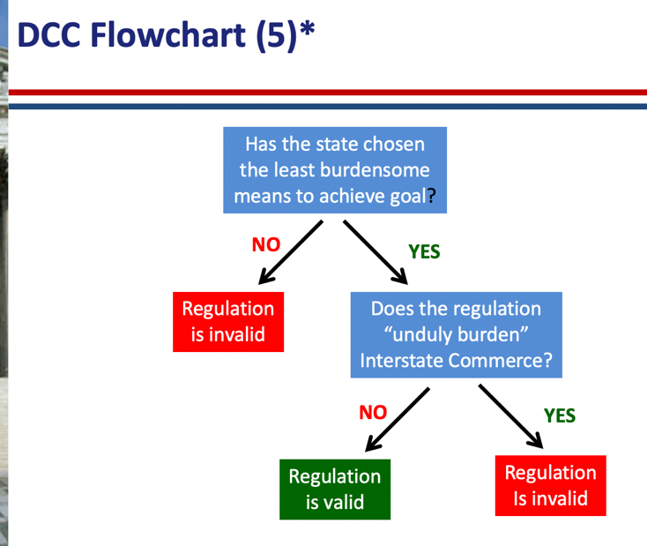

13th amendment
(Private individuals and government action)
“Neither slavery no involuntary servitude except as a punishment for crime whereof the party shall have been duly convicted, shall exist within the US, or any place subject to their jurisdiction”
Sec 2: “congress shall have power to enforce this article by appropriate legislation” -> can enact laws to end slavery (as if in article 1 sec 8-> powers)
- Applies to private and government conduct
- Includes “badges and incidents” of slavery
- Jones v Alfred Mayer (held congress could use bar to bar private racial housing discrimination)
- Justified legislation against sex trafficking
- Not limited to state action
- Today, prison labor is justified by this language (cant challenge do not have a claim)
- Court said that it did not extend to public accommodations because when there was slavery, individuals freely discriminated against free blacks, hence it was not a “badge or incident” since there was always discrimination (vs. Outlaw of black codes)
- Still remains a tool today
- Congress may make whatever laws are necessary and proper for enforcing the Thirteenth Amendment’s abolition of “all badges and incidents of slavery in the United States.” There is nothing present in the Thirteenth Amendment itself or the legislative history surrounding the adoption of the Thirteenth Amendment that suggests it only applies to discriminatory conduct by state officials. The Amendment itself permits Congress to pass laws that address all forms of racial discrimination, including discrimination against African Americans in the housing market. Congress acted rationally in passing §1982 to address this type of discrimination, as permitting race-based housing discrimination to go unchecked can have significant detrimental effects on racial groups. Thus, §1982 is a valid exercise of Congressional power to enforce the Thirteenth Amendment by prohibiting discriminatory conduct; even when that conduct is performed by private individuals

14th amendment: (Dredd Scott-> black people are not citizens, pass 14th amendment to ensure the contrary and ass support for 1866 civil rights act)

“All persons born or naturalized in the US, and subject to the jurisdiction thereof, are citizens of the United States and of the state wherein they reside. No state shall make or enforce any law which shall abridge the privileges or immunities of citizens of the US< nor shall any state deprive any person of life, liberty, or property, without due process of law; nor deny to any person within its jurisdiction the equal protection of the laws” (gave congress authority over naturalization)
(due process of law -> 5th amendment same words, meant to mean same thing, 5th for fed gov, 14th for state)
Due process of law: read more into it, and read it into the 5th amendment
Section 2: how representatives will be counted (whole number of persons in each state vs 3/5) and gave right to vote to men (then developed pre-textual means)
Sec 3: can’t be president if engaged in insurrection-> relic, people trying to use for trump
Sec 4: Don’t pay debts for insurrection-> relic, trump
Sec 5: congress shall. Have the power to enforce, by appropriate legislation, the provisions of this article (as if in article 1 sec 8, but key provisions gutted, so for example congress had to use commerce clause to stop racial discrimination in public accomdoation)

Recap of section 1:
- Citizenship clause: imp for eligibility to be president and immigration
- Privileges or immunities
- Due process clause
- Qual protection clause
Sec 5
- Power to enforce

Retrenchment slaughter house cases regarding privileges or immunities (though it was intended to not subordinate states to federal gov, SC interpretation blew it and held for rights below)

Privileges or immunities of US citizens include (protection against states?)
- Right to peaceably assemble/petition for redress
- Free access to ports, sub-treaties, land offices, courts
- Demand care of federal govt on high seas/abroad
- Use of navigable waters
- Writ of habeas corupus
- Does not extend to the butchers claims at issue

Today also includes
- CA 1 year welfare residency requirement overturned
- Interfered with fundamental right to travel (both privilege and & or immunity)
- Distinguished from “portable benefits” like tuition

Saenz v. Roe (US 1999):
- modern reliance on privileges or immunities. The court held that California’s one year residency requirement for receiving welfare benefits interfered with the fundamental right to travel and therefore violated PorI clause. The court distinguished this residency requirement from “portable benefits” like tuition (can still charge higher tuition for out of state students because graduates can then take the benefit, they receive for that tuition out of state).
- Quimbee: allowing citizens to move freely between states; securing the right to equal treatment in all states when visiting; and securing the rights of new citizens to be treated the same as long-term citizens living within the state.

Slaughterhouse Cases (US 1873):
New Orleans public health was significantly impacted by animal slaughter upstream of water supply. State legislation provided for consolidated site run by a state-chartered corporation, which would be open for any butcher to use for set fees. A group of butchers challenged the law as violating the privileges or immunities clause (note: 14th amendment not Article IV because challenging how it applies to Louisiana’s citizens, not citizens from other states). The court held that the 14th amendment was NOT intended to subordinate the states to the federal government. The privileges or immunities of US citizens include only a set list of rights (see list above). Because none of these rights extend to the butcher’s claims at issue, court upheld the Louisiana law.

Bradwell v Illinois
- Potential for legislative remedies for judicial errors (passing law subsequently)

Bradwell v Illinois
- Women denied entrance into Illinois bar by Illinois Supreme Court
- Later statute opened profession to women (potential for legislative remedies for judicial errors)
- Held 14th amendment did not guarantee a women’s right to hold the same occupation as a man.

Cruikshank
- Held 14th amendment privileges or immunities clause did not extend to the Bill of Rights to states

U.S. v. Cruikshank (US 1875):
after horrible massacre in which over 100 African Americans were killed, one of the lynchers, William Cruikshank, was prosecuted in federal court for interfering with the victims’ constitutional rights, including their right to peaceably assemble and their second amendment right to keep and bear arms. In this case, the SC overturned his conviction and held that the 14th amendment privileges or immunities clause did not extend the Bill of Rights to the states. This case left protection of black people against violence to the states and facilitated the KKK reign of terror. (Federal gov prosecuted not for murder-> since this was something that the state law prosecutes, murder and assault tend to be state law. Challenged on violating civil rights of the massacres. Court overturned convictions by stating the bill of rights does not extend to the states or private individuals, only protected against the federal government).

15th amendment
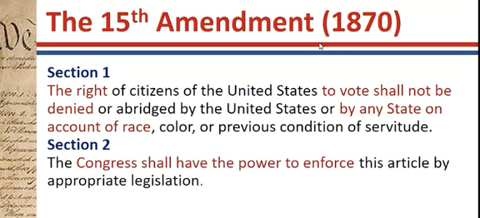

- Shortly after tried to find ways to disenfranchise people
- States turned blind eye
- Only addressed overt discrimination
- Modern day disproportionate application (gerrymandering, felony leading to loss of voting right)

STATE ACTION: 14TH amendment requires state action

Civil Rights cases 1833- challenged on both 14 and 13th amendment (sought to end discrimination on 1) public rights, political rights, social rights, and jury service)
- Court held 14th amendment enforcement limited to “correction” of “state action”
- Could reach discriminatory state laws
- Could reach state court enforcement
- Sec 4 Jury discrimination ban upheld (since core state action)
- But could not bar private owners’ discrimination

State action cases:

Marsh v Alabama
- Private entity performing traditional state function= state action for 14th amendment

Marsh v Alabama

Issue: can state punish Jehovah’s witness for distributing literature in company owned town?
If Marsh had actually been on the public sidewalk of a municipality, her conviction would certainly have been reversed because states may not completely prohibit the distribution of religious literature in public areas under the First and Fourteenth Amendments. However, in the present case Alabama contends that the Company’s ownership of the town gave it certain property interests which allowed it to control the activities of its inhabitants. Regardless of whether a corporation or a municipality owns the town, the public it allows in has an identical interest in the town’s functionality and the freedom of communication within its borders. Alabama cannot suspend people’s First and Fourteenth Amendment rights while they are located in the town because the Company has opened up the town to the public, and many residents from other surrounding areas frequently use the town for commercial purposes. In balancing the interests of the Company as property owners, with the interests of the people in freedom of press and religion, the latter are more important. Alabama acted unconstitutionally in assigning criminal sanctions to Marsh, and the decision of the lower court is reversed. (Because the private property is open to the public, they can enjoy the same political and constitutional rights enjoyed by everyone) contrast with a shopping center.
- PUBLIC FUNCTION DOCTRINE: private but doing trad public thing (maintaining streets and sidewalks, here even had a police officer that was a sheriff local company they paid him to be the local police man, people ret stores and business places on the business block, US uses one of the places as a post office). So freely used by public and nothing to distinguish it from a regular town.
- if private performing functions that are characteristic of gov activities then it is state action for 14th amendment purposes (and subject to state regulation).

Pruneyard v Robbins
- State constitution can grant rights in excess of those provided by US constitution

Pruneyard v Robbins

- Private shopping center in CA barred solicitation/political activity Student petitioner challenged constitutionality.
- Held: Did not violate the US constitution but the activity was protected under the CA Constitution.
- Was not on public side walk/public street, instead private shopping center
- If raise state law question in federal court, can provide greater protection

Shelly v Kraemer
- State court enforcement of racial discrimination violates 14th amendment equal protection

Shelley v. Kraemer (US 1948):
- private parties agreed amongst themselves to engage in discrimination by entering into a restrictive covenant barring black people from purchasing homes in or living in their neighborhood. The court held that state enforcement of racial discrimination violates 14th amendment equal protection because the state is providing the “full coercive power of government” to enforce private discrimination through the courts. The existence of the covenants is not the problem, rather it is the enforcement.
- (so state action can be by statute, or by judicial enforcement-> though they can enforce it towards white races, there is no case , state or federal, that has been called to enforce a covenant excluding members of white majority from ownership or occupancy of real property on the grounds of race.

NCAA v Tarkanian
- UNLV basketball coach Tarkanian found in violation of multiple NCAA rules. NCAA required UNLC to suspend Tarkanian or risk increased sanctions. University contested finding but did suspend him State court enjoined action/awarded legal fees. Tarkanian sued UNLV. State cour agreed said you do not have due process. Then NCAA, said we are a required party. Tarkanian needed a cause of action against NCAA, they want to say he is denied due process of law, but that applies to states and requires state action, therefore, to prevail he had to argue that NCAA was acting under color of state law.
- Here: university is a state actor: it is a state school. Hence, they have to follow due process clause of the 14th amendment in firing its employees (harder if private, even with funding have held it is not)
- NCAA state actor? No, it is an organization made up of members, they do not have a formal sanction from the government.
- Does the fact that the sanction process involves a partnership between the University (state actor) and NCAA, make NCAA a state actor (public and private partnership? The answer is it can
- Here was not found on the facts.
- This may occur if the State creates the legal framework governing the conduct; if it delegates its authority to the private actor; or sometimes if it knowingly accepts the benefits derived from unconstitutional behavior. Thus, in the usual case we ask whether the State provided a mantle of authority that enhanced the power of the harm-causing individual actor.
- Here the sanction came from UNLV, so the question is if UNLVs actions in compliance with the NCAA rules and recommendations turned the NCAA conduct into state action
- Reasons why it’s court said NO
- 1) other hundreds of other public and private member intuitions affect NCAA policies, some outside of Nevada, hence the legislation adopted by the NCAA is not Nevada but a collective membership
- 2) ABA formulates rules, code of professional responsibility, but that does not mean they are a state actor, state supreme court could re-examine the standards and if necessary, reject it. Here UNLV had authority to withdraw from the NCAA and to establish its own standards and or influenced change in their policies.
- 3) Delegation of power by UNLV to NCAA? Possible that state may delegate authority to a private party and thereby make the party a state actor (private physician K with state was state actor), but UNLV delegated no power to NCAA to take specific action against its employees.
- 4) The NCAA enjoyed no governmental powers to facilitate its investigation. It had no power to subpoena witnesses, to impose contempt sanctions, or to assert sovereign authority over any individual-> ultimate decisions was the universities
- 5) just because a private party is threatening refusal to deal with state agency, does not mean they are acting under color of state law.
- Conclusion: NCAA imposition of sanction against UNLV is not attributable to Nevada law.

State action Approaches
- Is deprivation caused by exercising right or privilege create by state or rule of conduct imposed by it? (Example, like shelly, the fact that they can go to court and sue, right of priveldge by state to go and have covenents enforced”
- Is party charged with deprivation fairly said to be a state actor?

Other factors functionally equivalent to categorical approach:
- State official (ex: sheriff)
- Private party aided by state official
- Conduct otherwise chargeable to the state

Categorical approach: (which now just fits in to step 2 and is same as above characteristics)
- Private performance of public function (Marsh)
- Judicial enforcement of private agreements (shelly)
- Joint state/private actions (NCAA)
- Concrete or “symbiotic” action resulting in deprivation of right
- State endorsement of private conduct

Not found:
- Issuing Liquor license to discriminatory private club
- Service cut off by privately owned utility company
- Operation of private schools (even if there is state funding)

- Hypo: discriminatory club to not only allow the people in and they have been granted a liquor license by the state? Someone has sued because state has given a liquor license to the club? Actionable under the two-- prong test?

- Hold: when issuing the license, you are not asked if you are discriminating, has nothing to do with discrimination. Deprivation is not caused by the state. Law of liquor license is neutral. The second prong instead is met, because the official is issuing the liquor license.

- Hypo: Your service is internet service provider licensed by the city without due process.

- Held: license not sufficient to make it a state action (teacher thinks if it was the only service provider there might have been a different result).

SECOND FOUNDING: DUE PROCESS AND EQUAL PROTECTION CLAUSE UNDER 14TH AND 5TH AMENDMENT (IF FOR FEDERAL GOVERNMENT)

Due process clause: 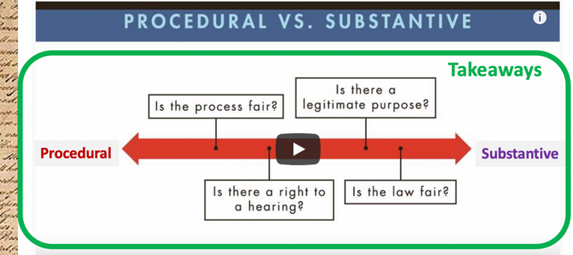
- Incorporation(had to nickel and dime since the privileges or immunities did not encompass it)
- 1st amendment incorporated by 14th amendment
- Procedural due process (asks if the procedure to deprive was a fair one, reasonable for the circumstance, balancing task)
Rules are situational
- Scope depends on interests at stake
- Applies both to 5th and 14th amendment
- Core components
- Notice (sufficient detail of what benefit and entitlement is at issue)
- Opportunity to be heard (can be upfront or after depending on circumstance and orally or in writing, might have right to an attorney (again depends on the circumstance).
- Neutral decision maker (people who cut off benefit cannot be the one that makes the decision, though might be okay if they have some prior involvement).
2) Mathews balancing factors
a) Private interest affected
b) risk of erroneous deprivation/probable value of additional safeguards (having a more formal process and what is the value that adds)
c) government interest/ fiscal(monetary) and administrative burden of additional procedures (efficiency, timeliness, cost)

Goldberg v Kelly
- (termination of benefits is a state action)
- Challenge to NY termination of welfare benefits. Cutoff was based on administrative determination, based on if they find belief that you are not entitled to the benefits (like you are employed, married to someone who has a high paying job, etc.). They give notice in a week that your benefits will be cut off, and beneficiary could get a hearing a month later. Could take several months to get a hearing while you are not getting any money. Is this a violation of the due process of law?
- Yes. Though it does not have to be quasi-judicial trial. The extent to which procedural due process must be afforded the recipient is influenced by the extent to which he may be “condemned to suffer grievous loss’” and depends upon whether the recipient’s interest in avoiding the loss outweigh the government interest in summary adjudication.
- ONE: Notice
- 7-day notice was not unconstitutional per se, though some cases may require longer time, nor was there a deficiency in the content of the notice.
- Opportunity to be heard: The question was doing they have to be afforded a pre-termination hearing? Does not allow the recipients to be heard with or without counsel, so they can not present there evidence orally and have a cross examination of the adverse witnesses.
- TWO: opportunity to be heard
- Private interest to be affected
- 1) criticality/time it takes to be heard: welfare provides the means to obtain essential food, clothing, housing, and medical care (life or death), critical for them to have pre-termination hearing.
- Risk of errnous deprivation
- 2) can have written submission: not satisfactory-> most people lack education and can’t rely on case workers since they are the ones who think they are ineligible for the benefits in the first place. Hence should be able to present orally.
- 3) Nature of evidence: it is important for them to have the opportunity to disprove the allegations since the evidence consist of testimony of individuals whose memory might be faulty, who may be motivates by malice or jealousy (someone is an informant in these types of cases). Don’t necc require an attorney but should be permitted to have one
- Government interest/fiscal monetary and administrative burden: both the welfare and the people want speedy resolution. Hence, safecguard to pre-termination hearing will be minimal procedural safeguards, adapted to the particular characteristic of the welfare recipient, and limited nature of the controversies to be resolved.
- THEEE: Regard to neutral decision making:
- decision maker must rest on the legal rules and evidence adduced at hearing, should not be someone who participated in making the determination under review, though some prior involvement may be okay.

Mathews v Eldridge
- Challenge to termination of SSDI (disability) benefits. Cutoff based on administrative determination. Beneficiary could get hearing only months later. Eldridge challenged the finding that he no longer had a disability. They gave him notice one month in advance and then gave him the ability to seek reconsideration within 6 months of the initial determination.
- first, the private interest that will be affected by the official action: not based on financial need. Unrelated to worker income or support from other sources, such as earnings of other family members, workmens compensation, tort claim awards, savings, private insurance, etc. Deprivation is likely less.
- second, the risk of an erroneous deprivation of such interest through the procedures used, and the probable value, if any, of additional or substitute procedural safeguards: the determination turns on Routine, standard and unbiased medical reports by physician specialist. So the need for an evidentiary hearing or even an oral presention to the decision maker is less. Information critical to decision comes from medical sources, and even though there is no oral presentation, there is a detailed questionnaire that you can fill out with assistance. And they get full access to all information relied upon by the state agency and they have the opportunity to submit additional evidence or arguments
- finally, the Government's interest, including the function involved and the fiscal and administrative burdens that the additional or substitute procedural requirement would entail: benefit of evidentiary hearing? It would be a lot of cost and administrative burden, and If there undeserving money comes out of pockets of other people who are deserving (like social welfare program)
- the prescribed procedures not only provide the claimant with an effective process for asserting his claim prior to any administrative action, but also assure a right to an evidentiary hearing, as well as to subsequent judicial review, before the denial of his claim becomes final.

Note: deprivation of life and liberty governed by criminal procedure so we refer to property (remember it can be that a case raises both equal protection and due process of law issues)

- Substantive due process (asks if it is fair for the government to be enacting this law at all, controversial, read to have rights that are not necc found in the bill of rights-> this Is used for beyond enumerated rights, incorporation is used for the bill of rights)
- Early focus was economic liberty (Lochner era)
- Not there is a shifting emphasis on personal liberty
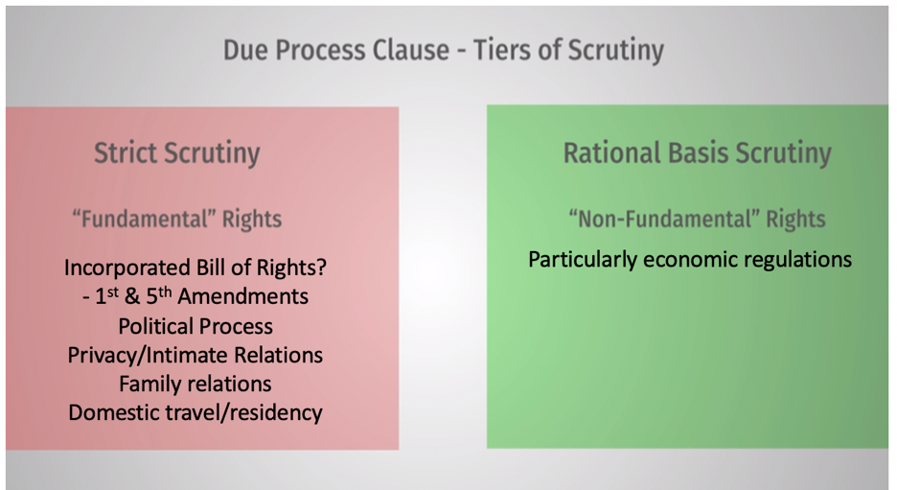

(though constitution does not protect, a statute can-> abortion).
Rational basis review: (burden on party challenging, just show rational relationship between legitimate purpose and statute at issue)
- Economic/police power regulations get rational basis review
- Up to legislature, not courts, to make value judgements
- Constrained only be constitution and other valid federal law
Strict scrutiny: (fundamental rights get it)

      - Incorporated bill of rights
- 1 and 5 amendments (for sure, maybe the rest of the bill of rights, not sure)
      - Political process (open to interpretation, to make it less likely to correct the legislature)
      - Unenumerated right to privacy/intimate relations
      - Family relations (right to marry)
      - Domestic travel/residency

Lochner Era Cases: (ECONOMIC CASES) (essentially held the right to contract outweighed the police power concerns, but now they just have to identify a police power concern on rational basis)

Allgeyer v. Louisiana:
- LA law limited state residents to dealing with insurance companies with office in state. Landmark S. Ct. decision invalidated statute 9-0- found unenumerated “liberty to contract” Liberty includes right to be free in the enjoyment of all his faculties, to live and work where he will, to earn his livelihood by any lawful calling . . . [and] to enter into all contracts which may be proper, necessary, and essential to his carrying out to a successful conclusion the purposes above mentioned

Lochner v. NY: (bad law)
- NY Bakeshop Act of 1897 regulated small bakeries regulated sanitary conditions- mandated 60 hour maximum workweek. Court held the act violated due provess because “liberty to K” outweighed police power (later called substantive due process).

Muller v. Oregon:
Oregon law limited women to 10-hour workday working hours for men not subject to limit- challenged as violation of 39 “right to contract.” Court upheld statute despite Lochner because it was justified by sexism.

Buchanan v. Warley: (today equal protection)

Louisville Ky law mandated residential segregation barred sale of real property to opposite race- black NAACP attorney contracted to buy land- refused to complete purchase because of law - white property owner challenged law. Court held statute violated white owner’s right to contract.

Adkins v. Children’s hospital: (bad law)
3 Court struck down D.C. female minimum wage-based on 5th Amendment due process 2. Different then mular because of switch in court composition.

NOW PERSONAL LIBERTY CASES

Meyer v Nevbraska: (1st amendment)
- Court overturned Nebraska law barring foreign language education. Held “liberty includes the right to contract, to engage in common occupations, to acquire useful knowledge, to marry, to establish a home and bring up children, to worship God according to the dictates of how own conscience, and generally to enjoy those privileges. essential to the orderly pursuit of happiness by free men.” Since at the time the bill of rights did not apply to states, it was not decided on a first amendment basis. But, protected the ability under due process-> if you want to have your kinds learn a foreign language in a school you should have that rights.

Pierce v Society of Sisters (1st amendment)
- Oregan law banned private schools to eliminate parochial/catholic schools. Motivated by anti-immigrant bias. Court struck down law as a liberty violation. Parental right to control children education. “unreasonably interfered with the liberty of parents and guardians to direct the upbringing and education of children under their control”

Buck v Bell (“personal liberty”)
- 8-1 court upheld Virginia eugenics sterilization law. They rejected the 14th amendment due process challenge. They gave a greater power/lesser power argument. “three generations of imbecilic is enough”

Gitlow v New York

Court upheld conviction of Socialist party member for publishing “left wing manifesto”, said to advocate overthrowing the government. The could held that the 1st amendment was incorporated by the 14th amendment, but this speech was outside the protection. First time holding that the bill of rights extends to the states. Any case before 1925 bill of rights did not apply to the states.

Post Lochner Era (overturning the economic right)

Nebbia v. NY: 4

Decision upheld NY law fixing price of milk- states can regulate businesses affecting “public interest”- laws only require “reasonable relation” to proper purpose”-- cannot be arbitrary nor discriminatory. Rebuttable “presumption of constitutionality” Today called “Rational Basis Review-> Burden on party challenging to show that it is unconstitutional

West Coast Hotel v. Parrish:

The “switch in time” case. Crt upheld WA state minimum wage for women. Crt held protection of women legitimate “state interest”- minimum wage valid means to achieve. Overruled Adkins. Formal end of the Lochner era

U.S. v. Carolene Products:

Court upheld federal statute banning interstate shipment of filled milk. Allowed argument against constitutionality - “rebuttable presumption.” Congress gets presumption of constitutionality. Footnote four identified exceptions to presumption. (which are later adopted by the court and refined).

Williamson v. Lee Optical:

Court upheld Oklahoma law significantly limiting opticians. Opinion noted:“[T]he law need not be in every respect logically consistent with its aims to be constitutional. It is enough that there is an evil at hand for correction, and that it might be thought that the particular legislative measure was a rational way to correct it
“the day is gone when this court uses the due process clause of the 1th amendment to strike down state laws, regulatory of business and industrial conditions, because they may be unwise, improvident, or out of harmony with a particular school of though.
- State law now rarely fails “rational basis review” -> just have to show rational linkage of legitimate exercise of police power
- But normally fails “strict scrutiny”
Ferguson v. Skrupa (US 1963):

Kansas statute limiting the practice of “debt adjustment” to lawyers was challenged as 14th amendment due process violation. The court affirmed that both Lochner and Adkins are no longer good law. It is up to legislatures, not courts, to make value judgments on policy, which is constrained only by the Constitution and valid federal law. States can classify people as long as the classification is not “invidious.” It is okay to limit debt adjustment to lawyers. This case is the true nail in the coffin of the Lochner Era—stands for proposition that economic regulations enacted by states are going to get minimal interference.
- We conclude that the Kansas Legislature was free to decide for itself that legislation was needed to deal with the business of debt adjusting. Unquestionably, there are arguments showing that the business of debt adjusting has social utility, but such arguments are properly addressed to the legislature, not to us.
- Nor is the statute's exception of lawyers a denial of equal protection of the laws to nonlawyers. Statutes create many classifications which do not deny equal protection; it is only "invidious discrimination" which offends the Constitution. If the State of Kansas wants to limit debt adjusting to lawyers, the Equal Protection Clause does not forbid it.

SUBTANTIVE DUE PROCESS RIGHT CASES

Griswold v. Connecticut (US 1965): Challenge Connecticut statute barred provision of contraceptives to a married couple. The court found an unenumerated right to privacy that is a fundamental right based on “penumbra” of 1st, 3rd, 4th, 5th, and 9th amendments.-> also applied to people not married , intrusion into matters so fundemntally affecting a person as the decesion to weather to beget a child

Lawrence v. Texas (US 2003): challenge to Texas statute criminalizing homosexual conduct. Previously, Bowers v. Hardwick had upheld Georgia statute, but that case framed the issue as “fundamental right to homosexual sodomy.” Here, issue was framed as right to intimate conduct in one’s own home. Court held that intimate conduct in one’s own home is a fundamental right and could not satisfy strict scrutiny. Therefore, struck the law. Note: if this case were reviewed as equal protection—homosexual discrimination—would probably survive because sexual orientation is not a protected class and court would hold there is some basis for the law because of morality.
- This also could have been addressed as a equal protection case, treating gay people unequally but (at the time it was strongly correlated to race) the core of the holding goes to substantive due process -> there is a fundamental right to privacy in our home and state should not be involved
- The right at stake here is to enjoy and get substantive protection (logical extension of Griswold)
- The case does involve two adults who, with full and mutual consent from each other, engaged in sexual practices common to a homosexual lifestyle. The petitioners are entitled to respect for their private lives. The State cannot demean their existence or control their destiny by making their private sexual conduct a crime. Their right to liberty under the Due Process Clause gives them the full right to engage in their conduct without intervention of the government.
- The Texas statute furthers no legitimate state interest which can justify its intrusion into the personal and private life of the individual.

Invidious discrimination (likely to fail any level of scrutiny, primarily in equal protection, essentially it is okay to treat people unequally as long as it is not invidious, there can be laws for genders not invidious-> biology related)
- more applicable to equal protection, since refers to “who” is treated differently under the law, not necc unconstitutional if it’s on permissible basis- can be said to apply to substantive due process, generally will not invoke invidious discrimination. Can be situation which you would want to argue that the right at issue is being violated because of some animus
- Definition: treating a class of persons unequally in a manner that is malicious, hostile, or damaging. If there is rational justification for the different treatment, then the discrimination is not invidious
- Invidious discrimination generally refers to treating one group of people less well than another on such grounds as their race, gender, religion, caste, ethnic background, nationality, disability, sexual orientation, sexual preference or behavior, results of IQ testing, age, political views

Equal protection (majority cases based on race)
- 14th amendment equal protection all to all (including non-citizens)
- Discriminatory application of neutral federal law is unconstitutional

Establishing discrimination
- Facial – text of law demonstrates discrimination
- “only persons of white race”
- “no person descendent from slaves”

- As applied
- Discriminatory or disparate impact
Petitioner must demonstrate (burden on petitioner)
- Law disproportionately impacts protected group and
- Impacts is intentional
- If both established, law will get heightened scrutiny that group is entitled to
- Facial challenges normally result in laws being struct down
- As applied challenges often result in limits on applications
- Law may be allowed to stand with respect to other groups or circumstances

Yick Wo v. Hopkins (US 1886):

San Francisco ordinance required Board of Supervisors permit for laundry in wooden building, valid safety concerns, but permit was completely discretionary. White got permits, Chinese did no. No appeal process, 1/200 applicants who were Chinese got the permit. Yick Wo convicted for operating laundry without permit, court overturned
Holding: 14th amendment equal protection applies to all (including non-citizens). Discriminatory application of neutral laws is unconstitutional. It was not the requirements for getting permits that was unconditional but rather the way the rule was being applied.
- Though the law itself be fair on its face, and impartial in appearance, yet, if it is applied and administered by public authority with an evil eye and an unequal hand, so as practically to make unjust and illegal discriminations between persons in similar circumstances, material to their rights, the denial of equal justice is still within the prohibition of the constitution
- No reason for it is shown, and the conclusion cannot be resisted that no reason for it exists except hostility to the race and nationality to which the petitioners belong, and which, in the eye of the law, is not justified. The discrimination is therefore illegal, and the public administration which enforces it is a denial of the equal protection of the laws, and a violation of the fourteenth amendment of the constitution.

Plessy v Ferguson

Louisiana required separate train cars for black and whites. Challenged on equal protection. Court upheld separate but equal. Could have been a commerce clause issue: state is trying to regulate interstate commerce. (Overturned later, peace meal).

Brown v. Board of Education I (US 1952):

Held separate but equal inherently unequal
- Recognized white supremacy purpose
- Harm to black students from segregation
- Decision applied to public education only
- Bolling v Sharpe read equal protection into 5th amendment
- Gradually extended to other government activities

Brown v. Board of Education I (US 1952):

court considered whether school segregation violated equal protection. Held that separate is inherently unequal in the context of schools. The court recognized the white supremacy purpose of school segregation and the harm to black students from segregation. Looked at the effect itself on segregation. Education is important to succeed in life, so the right must be available to all in equal terms. Believe that regardless of the facilities and other tangible factors being “equal” there is still a negative impact. To separate them from others of similar age and qualifications solely because of their race generates a feeling of inferiority as to their status in the community that may affect their hearts and minds in a way unlikely ever to be undone. The effect of this separation on their educational opportunities was well stated by a finding in the Kansas case by a court which nevertheless felt compelled to rule against the Negro plaintiffs.

Brown v. Board of Education II (US 1955): first case did not address remedy. This one ordered desegregation “with all deliberate speed.” -> accelerated white flight, growth of private schools, gerrymandering of school districts, reluctance to mandate cross boarder remedies (had to change something on the ground, so parties came back year after to argue for remedy)

Loving v Virginia
- Virginia law criminalized interracial marriages. Loving’s married in DC but resided in Virginia. They were convicted but allowed to avoid jail time by leaving the state. The state court upheld purpose of protecting racial pride. Contended law applied equally to black and whites.
- Held: Race based marriage restriction violated 14th amendment equal protection. Court also held marriage as a “fundamental right” under 14th amendment substantive due process.
- The state argued that it was a “equal application” of the statute removed it form the 14th amendments analysis and it should be rational basis.
- The mere fact of equal application does not mean that our analysis of these statutes should follow the approach we have taken in cases involving no racial discrimination where the Equal Protection Clause has been arrayed against a statute discriminating between the kinds of advertising which may be displayed on trucks in New York City, Railway Express Agency, Inc. v. New York, 336 U.S. 106 (1949), or an exemption in Ohio's ad valorem tax for merchandise owned by a nonresident in a storage warehouse, Allied Stores of Ohio, Inc. v. Bowers, 358 U.S. 522 (1959). In these cases, involving distinctions not drawn according to race, the Court has merely asked whether there is any rational foundation for the discriminations, and has deferred to the wisdom of the state legislatures. In the case at bar, however, we deal with statutes containing racial classifications, and the fact of equal application does not immunize the statute from the very heavy burden of justification which the Fourteenth Amendment has traditionally required of state statutes drawn according to race.
- The fact that Virginia prohibits only interracial marriages involving white persons demonstrates that the racial classifications must stand on their own justification, as measures designed to maintain White Supremacy. We have consistently denied the constitutionality of measures which restrict the rights of citizens on account of race. There can be no doubt that restricting the freedom to marry solely because of racial classifications violates the central meaning of the Equal Protection Clause.
- In class questions? Why equal protection? Well, it didn’t apply to other races. Also, it was invidious, it was based on white supremacy. A state may legislate for health and safety and public welfare but has to be actually valid. If someone gets rational basis review then the state gets the benefit of the doubt. If protected right like under sub due process right to marry can show there is genetic evidence of harm. Equal protection requires strict scrutiny, need good arguments-> but with race there is no evidence like that for the marrying.

AFFIRMATIVE ACTION CASES

5th amendment and 14th amendment due process clause have same meaning/impact for federal and state governments. Use of race as classifications get “strict scrutiny” regardless of whether intended to help or hurt.

City of Richmond v. JA Croson Co. (US 1989):

court overturned municipal preference for minority businesses. Law used race criteria that was intended to help minorities, but court applied strict scrutiny and held that societal differences based on unjust past was not a compelling interest.

Adarand Constructors v. Pena (US 1995):

court overturned federal incentives for minority subcontractors. Because it was the federal gov, court applied 14th amendment standards through 5th amendment (see above/Bolling case). Again, applied strict scrutiny and failed to show compelling interest.

Gratz v. Bollinger (US 2003):

undergraduate admissions at University of Michigan had policy giving 20 points to
racial/ethnic minorities in scoring system, where an applicant needed 100 points to get admitted. The court held that this formalistic approach violated the equal protection clause. Because this automatic distribution made race “decisive for virtually every minimally qualified underrepresented minority applicant”, it was not narrowly tailored to achieve goal of educational diversity.

Grutter v. Bollinger (US 2003):

law school admissions at University of Michigan considered all the ways in which applicants added to diversity—race was one of multiple “plus” factors. The court upheld this holistic approach as a narrowly tailored means to achieve compelling interest in diversity because it did not operate as a quote or as a “two track admission system.” Race was one factor but also took into account economic disadvantages, first generation status. Without the mandatory scoring criteria, the court approved it.

Fisher v. University of Texas I (US 2013):

University of Texas adopted a “race conscious” admissions policy in which it considered race as one of various factors. The SC held that the courts must apply strict scrutiny and UT must show means narrowly tailored. They remanded for consideration.
A public college may consider race as a factor in admissions only if the admissions program is narrowly tailored to further a compelling governmental interest. The United States Supreme Court has previously held that the interest in the educational benefits flowing from a diverse student body qualifies as a compelling governmental interest. However, the application process must be narrowly tailored to achieve this purpose. A university is not entitled to deference on this issue.
Pt2: SC upheld policies after “concrete and precise” goals met strict scrutiny.

EQUAL PROTECTION GENDER (only protection is voting under the 19th amendment, 14th amendment passively discriminates against women)

Frontiero v. Richardson (US 1973): woman in Air Force sought military benefits for her husband who was full time student, but her application was denied because she failed to demonstrate her husband was dependent on her for more than one half of his support—if it was wife applying for benefits, would not have to make such a showing. Challenged on equal protection basis. In plurality decision, held that it was unconstitutional based on fact that sex is an immutable characteristic but majority of court could not agree that classifications based on sex are “inherently suspect” and therefore did not establish strict scrutiny review for all sex classifications.

Craig v. Boren (US 1976): Oklahoma statute prohibited the sale of 3.2% beer to males under the age of 21 and to females under the age of 18. Challenged as violation of equal protection and Oklahoma argued that young men were more likely to drive drunk so law was substantially related to traffic safety. In this case, the court adopted a middle approach—held that sex-based classifications were subject to heightened standard of review that is more rigorous than rational basis but not as rigorous as strict scrutiny. Court overturned the statute because not substantially related to state interest since did not actually prohibit drinking beer, just buying it.

United States v Virginia
- Court held 14th amendment equal protection violation
- Justified under intermediate scrutiny
- Rejected generic “assumptions” about women as basis for denying all women opportunities

United States v. Virginia (US 1996):

Equal protection challenge to VMI all-male policy. Virginia offered VWIL at Mary Baldwin as alternative. The Court held 14th amendment equal protection violation. Justified under intermediate scrutiny. Virginia argued that its adversative methods of training students could not be made available unmodified to women. Virginia argues that the existence of a single-sex school furthers the important state purpose of maintaining a diversity of public education institutions.
Held: Court stated that “generic assumptions” about women as a basis for denying all women opportunities could not stand. Essentially said they cannot give justifications like women will ruin our school and that women are kinder and gentler AND rejected argument on diversity, stating that it has never existed for the purpose of promoting diversity, evidenced by its exclusion of women.

OTHER GROUPS, LGBTQ AND DISABELED

City of Cleburne v Cleburne Living Center

Issue: Whether a city’s denial of a permit for a group home for mentally disabled persons violated the Equal Protection Clause of the Fourteenth Amendment, and whether the review of such a denial required intermediate scrutiny.
Hold: not category that qualifies for special protection. Get rational basis review. But fail on rational basis review.
- City does not require a special use permit for apartment buildings, multiple dwellings, boarding and lodging houses, fraternity or sorority houses, dormitories, hotels, hospitals, sanitariums, nursing homes for convalescents or the elderly, private clubs, and fraternal orders. In contrast, the City requires a special use permit for a group home for mentally disabled persons. This difference in treatment is irrelevant because the Center’s proposed home would not threaten legitimate interests of the City in a way that other permitted uses would not. The City’s arguments that the home would create negative attitudes about the mentally disabled in the community, or that it would elicit harassment of residents from children in a nearby school, are rejected as this concern is speculative and thus irrelevant. The City’s concern that the home is located on a floodplain is not sufficient for denying the permit for the home because other similar buildings are located there. Finally, the City’s concerns about the size of the home and the amount of residents are also rejected because if the residents were not mentally disabled, the city would have no objections. Thus, there is no rational basis for the City to conclude the group home would impact its legitimate interests, and therefore the denial of the special use permit violates the Equal Protection Clause. The decision of the court of appeals is reversed.

Romer v Evans

- Amended constitution of Colorado to deny giving equal rights to LGBTQ community.
- Sc hold: should get rational basis, but that there was no rational basis to constitutionally deny rights. It was invidious discrimination to try to send a signal that the LGBW community is inferior.
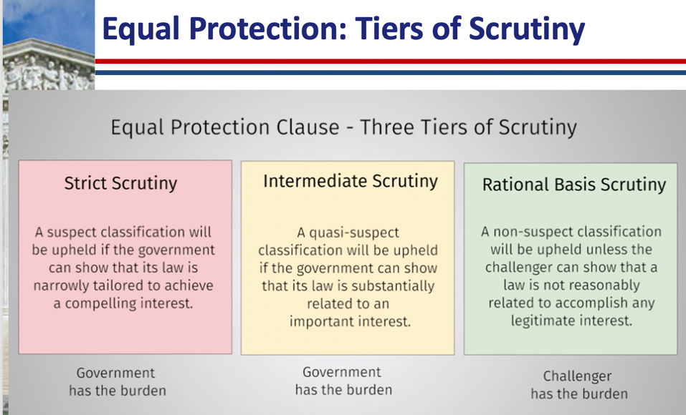

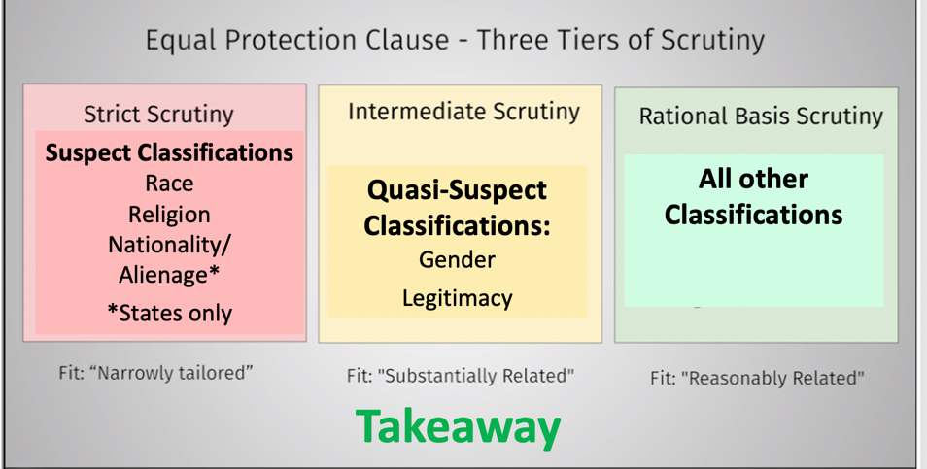
Alienage: only applies to states not federal government under 5th amendment
Legitimacy: referring to if parents are married

Hypo: there can be a situation that you get one level of scrutiny for EP and another for DP. Example, suppose discrimination in employment based on race. You get rational basis under due process but strict scrutiny under equal protection.

