CIV PRO FALL ATTACK SHEET
Cases

- PLEADINGS
Rule 7-
Rule 8(a)- short and plain statement to
12(b)(6)- failure to state a claim upon relief that could be granted
9(b)- fraud/mistake
12(b)1- Subj matter-
12b2- personal jdx
3- venue
6- failure to state a claim upon which relief can be granted
1. Define pleadings
- A written document where a party asserts a claim for cause of action/relief or defense or challenges the claim or defense
- Goal is to set forth an allegation of facts that will later prove your claim in court

2. ID the parties and the court
- Who is P and D?
- State Court- Code pleadings (Doe v. City of LA)
- Federal Court- Notice pleadings (Iqbal) standard
  - Pre-Iqbal- Leatherman and Conley standard -> simply notifying the other party and stating the claim is enough
- Recognize that both state and federal courts use the Iqbal standard now

3. ID the claim and its elements
- If unsure what the elements are, use 1) Duty 2) Breach 3) Harm test

4. Set aside conclusory allegations
- Definition: mere repetition of the elements of the claim
- These allegations do not count

5. Analyze the remaining factual allegations
- Presume all remaining factual allegations are true
- The remaining allegations have to match up with each element defined in step 2
- Focus on the contested elements of the claim

Pleading cases:
Name | Facts | Holding | To Note
Doe v. City of LA | LAPD/Boy Scouts sexual misconduct | Pleadings not sufficient | Doctrine of less particularity: leniency with pleadings b/c of asymmetry of information (still didn’t help P at the end)  Per the statute they could not sue Khalish directly so they had to sue the entity as a whole
Conley v. Gibson | Railroad workers sued their labor union for race discrimination | Pleadings were sufficient, under the lenient notice pleading standard you don’t need specific facts just set forth the claim to give D enough notice | PRE IQBAL -> notice is now stricter  Pleadings were legally sufficient where if it were proved in court it would prove P’s claims
Leatherman | Police misconduct | Pleadings were sufficient, not many facts but it was enough to give the other side notice | PRE IQBAL -> notice is now stricter  Emphasized that 9(b) exceptions should be the only exceptions to pleadings standard
Iqbal | Muslim discrimination post 9-1, violation of constitutional rights | Pleadings not sufficient  DOES NOT ESTABLISH HEIGHTENED PLEADING STANDARDS, BUT TRANSFORMS CLASSIC NOTICE PLEADINGS INTO CODE PLEADINGS | Plausibility standard, very murky but basically means code pleading  Court follows the three step method we should use: 1) ID the claim 2) break up claim into elements 3) set aside conclusory allegations and see if the remaining factual allegations meet each element of the claim
Palin v. NYT | Libel/defamation suit for an article linking her to shootings at political rallies | Pleadings were sufficient | Weird procedure where lower court held an evidentiary hearing before granting D’s motion to dismiss -> court disagrees, we don’t need to prove the evidence set forth in the pleadings just if they were sufficient  After the pleading stage is when you can prove allegations

II. PERSONAL JDX- can be satisfied either via traditional jdx or under the minimum contacts test
Steps:
1. Service of process
2. traditional jdx
3. Due process/Minimum contacts
A. Purposeful connections
B. General jdx
C. Specific jdx- arise out of / related to
D. Reasonableness

1. Does it satisfy service of process? (assume yes since we didn’t cover this)

2. Does it satisfy traditional Jdx?
- Doctrine of territoriality- jdx applies only to those persons bound within a state
- Ways to satisfy traditional jdx:
  - Domicile- you are a citizen of the state
  - Transient- you are physically present in the state when served, even if just traveling through
    - Only applies to people not businesses
  - Voluntary appearance- you did not object to jdx and showed up to court OR there is a choice of forum clause in a contract you signed
  - Service on an Appointed agent- you appointed someone inside the state to accept service for you
- Owning property used to be the 5th way to satisfy but not anymore

2. Modern approach
1. Does it satisfy the long arm statute?
- 4k1- fed court borrows the jdx rules of the forum state
- In CA it’s a due process statute so we don’t have to worry about it
2. Does it satisfy the minimum contacts test so that the suit does not offend traditional notions of fair play and substantial justice? Did they establish purposeful, direct, and meaningful connections with the forum state so that they have a fair warning of a lawsuit? NON-RESIDENT D ENGAGED IN PURPOSEFUL CONTACTS WITH THE FORUM STATE AND THAT EITHER THE STANDARDS FOR GENERAL JDX (AT HOME) OR THE STANDARDS FOR SPECIFIC JDX (ARISE OUT OF/RELATED TO) HAVE BEEN SATISFIED
- ID the purposeful contacts to the forum state
  - Activities in the forum state (International Shoe, Bristol Meyers if it was correctly filed by just CA plaintiffs)
  - Contractual obligations (Burger King)
  - Activity outside the forum state but effects felt in the forum state. Trigger is when an act occurred outside the forum state.
    - Strict effects test (Calder): Def did something out of the state that was AIMED at the state with the understanding that the brunt of the harm would be faced in the state.
      - Intentional tort?
      - Aimed at the forum state?
      - Brunt of the harm felt in the forum state?
    - Loose restatements test: the Def did something outside of the state that had foreseeable consequences in the state? Does not have to be an intentional tort.
      - Do something outside the forum state?
      - Did the claim arise from this act?
      - Were the effects felt in the forum state?
  - Examples of NO purposeful contacts: Walden, World-Wide Volkswagen
- General jdx- were the purposeful contacts so significant that you were at home in the forum state?
  - Do NOT need to prove arise out of/relatedness
- Does the claim arise out of or is it related to the purposeful contacts? SET THE PURPOSEFUL CONTACTS ASIDE THAT ARE NOT RELATED
  - Relatedness:
    - Not enough that the contacts were the but for cause of the claim, have to be a bit more than that (AKA but for +) (Ciolino- commercial contact by OOS resident that ultimately leads to a tort)
    - Conceptual relatedness: Ford
      - Chain of causation that goes from but for, but for + (part of the chain but its closer or prox cause but not there yet- economic activity that leads to a tort (Ciolino), arise out of- direct, tight causal relationship. The contacts play a substantive role in the claim- IS, BK, Calder)
      - Ford: we don’t require causality- contacts with forum state were not part of the causal chain that leads to injury, but there is a conceptual relation, so conceptually the fact that were driving a Ford that was. You have contacts that aren’t enough for general jdx, but it’s substantial enough to be conceptually related.
      - Only go to ford if u don’t have causation
    - Fair warning: contacts are so related that you should reasonably expect to get sued in the forum state
  - Arise out of/Proximate cause
    - Contacts would be the direct evidence of the claim if proved at trial (International Shoe, Burger King, Calder)
    - But do not have to directly cause the claim, can just be the thing that triggered the liability
    - If arise out of is met relatedness is automatically met
  - Example of NO relatedness: Bristol Myers
- Reasonableness- Even if minimum contacts is satisfied, D may rebut if exercising jdx is unreasonable
- Strong presumption of reasonableness if minimum contacts is satisfied, so this is hard to meet
- D has the burden to prove this
- Factors to determine reasonableness:
  - D burden of appearing in court
  - State’s interest in adjudicating the dispute
  - P’s interest in effective relief
  - Judicial system’s interest in effectiveness
  - Promoting social policies
- Ex of D not meeting burden: Burger King (not enough that his witnesses are in FL)
- Stream of commerce: another way to establish personal jdx, but only in products liability cases
  - All companies in the stream of commerce liable for personal jdx in the RETAIL state (where the product is ultimately sold), but you have to do something in the retail state (ie, advertisement, design, sales, etc)
  - Stream of commerce ends in the retail state and the forum state has to be the retail state
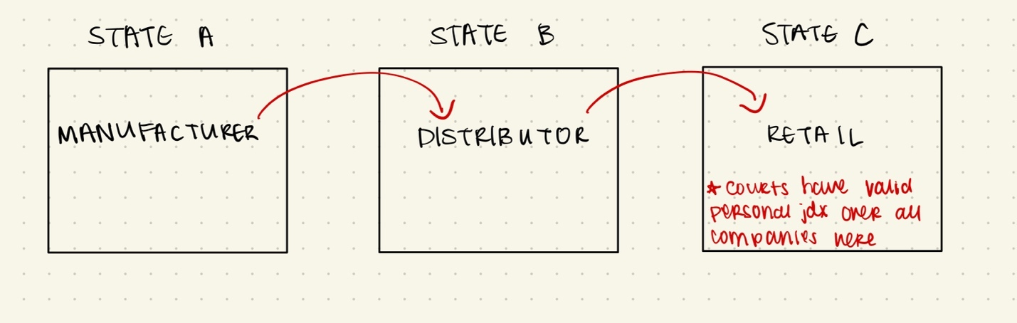

Personal Jdx Cases:
Name | Facts | Analysis- Jdx met? | Concepts that apply positively/  negatively
Int Shoe | - Delaware company getting sued by tax collectors in WA  - No offices in WA, but has 12 salesman that have been working there for 4 yrs and bring in $31k of commission | Yes  - Satisfies minimum contacts  - Contact w/ state is continuous and systematic  - Claim arises out of systematic contact  - Contacts were purposeful and they benefitted from the state  - Int Shoe benefitting from business in forum state | Purposeful contacts (business activities in the state)  Arise out of
Burger King | - Michigan resident sues FL-based company with Miami HQ  - BK sues Def for breach of contract  - Def has BK franchise in MI  - Def went through training in Miami, negotiated with Miami HQ, and communicated frequently with Miami HQ  - Choice of FL law clause in contract but no choice of forum | Yes  - Def entered into business with FL company and purposefully directed activity to forum state  - Purposeful availment (they got the benefit from FL)  - Def should have had a fair warning that they could be sued in forum state based on contacts  - Foreseeability to be hailed into court  - Choice of law doesn’t automatically satisfy jdx (choice of forum does), but still good evidence  - Did not prove that it would be unreasonable- inconvenience is not enough | Purposeful contacts (contractual obligations)  Arise out of  Fair warning  Reasonableness
Calder | - Hollywood actress suing in CA for libelous article written by FL magazine  - Def didn’t do anything specific in CA, only made calls into the state for research  - Thousands of magazines circulate in CA | Yes  - Effects test: 1) an intentional tort 2) Directed at forum state 3) Brunt of harm felt in forum state  - Article was aimed at CA and Plaint would feel the harm here since it is where she works, her reputation is important | Purposeful contacts (effects test)  Arise out of
Walden | - Couple stopped in Georgia airport and gambling $ was confiscated by a DEA agent  - Couple does not get money back for a while and sues in NV  - Def drafted affidavit to State Atty in GA showing probable cause of seizure | No  - No part of the claim touches NV, no purposeful contacts  - All of Def’s actions were in GA  - Plaint can’t be the only link b/w the Def and forum state  - You have to aim actions in the state, not just to the person that lives in the state  - Ex: If you get in a car crash in GA you can’t go home to another state and sue there | Purposeful contacts
World Wide Volkswagen | - P buys car in NY, gets injured while driving through OK, suing in OK court  - D sells cars and distributes parts in NY, NJ, CT only, all business is here | No  - D did nothing in OK that would lead to a suit there  - P raises foreseeability arg -> cars are mobile so its foreseeable that something could happen in OK. Court disagrees -> Its not about foreseeability of your product being in that state but that you did something that could bring you into court there | Purposeful contacts
Bristol Meyers | - D is a DE/NY/NJ pharmecutical company  - 600+ Ps suing for a drug that D produced, Ps are from all over the US and suing in CA  - D contacts in CA: distribute the drug, have some employees, a small office in Sacramento. Substantial business, about $900 million | No  - D does have purposeful contacts, but they claims do not all arise from this contact since Ps from many states outside of CA were suing  - If it was just the CA residents suing, then jdx would be met, but not all of the claims arose out of or were related to the contacts in CA  - P should sue in all the different states they were coming from | Purposeful contacts  Arise out of/relatedness
Ford | - P suing in MO and MN after two separate car accidents in these states  - P did not buy cars in forum state, but Ford did heavily advertise there  - Ford has dealers, suppliers, ads, and an active market in forum state | Yes  - Ford has so much business and advertisement in forum state that they not only encourage ppl to buy their cars but make it easy for them to be lifelong Ford drivers -> dealerships in forum state regularly maintain cars sold anywhere  - “keep your Ford a Ford”  - Relation b/w Ford activities and the claim is enough | Purposeful contacts  Arise out of  Relatedness
Ciolino v. Keystone | - P citizen of MA, D is a DE/PA company  - P worked for Keystone for 10 years as crew on their boats, inhaled asbestos and became sick, sued Keystone in MA  - Keystone contacts in MA: reached into MA many times over 14 years to recruit crewman, hired from the local Boston union, contacted P to hire him for other trips, sent P paychecks and tax docs to his home in MA | Yes  - Commercial contact by Keystone ultimately led to the tort, the injury arose out of the business transactions that Keystone was doing in MA  - Not just the but for cause, but a bit more substantial than that (but for +)  - If he hadn’t been employed/recruited heavily by Keystone, he would not have faced the injury  - Acts should have given Keystone a fair warning of suit in MA | Relatedness (but for +)  Reasonableness (but Ides said not to worry about this part, he couldn’t even remember what the court said about reasonableness here lol)
Daimler | - Argentina residents filed complaint in CA that Daimler + subsidiaries collaborated with Argentina security forces to kidnap, detain and torture employees  - D contacts in CA: sales in CA are 2.4% of their business, has multiple facilities, largest supplier of luxury vehicles | No  - Contacts are NOT enough to be at home in CA, standard is much higher  - Basically must be HQd in forum state with the majority of your business there.  - Could not argue specific jdx because nothing happened in CA, everything happened in Argentina  - At home test is VERY hard to satisfy -> only way is if it is the place you are incorporated, your principle place of business, or more than 50% of your sales happen here (Ides rule of thumb, not exact) | General jdx
Perkins | - D was from the Philippines and had mines there, but the president moved to OH where he had an office, maintained all company files, and oversaw the company’s activities | Yes  - Even though the claim was not related or arose out of contacts in Ohio (everything happened in the Philippines) OH was the principal place of business so they were at home there | General jdx

III. VENUE
Dismissal under 12b3- raised only in the beginning, FNC- can be brought up later
1404: proper to proper—law does travel
1406: improper to proper or if not dismiss
FNC: improper and no where proper to dismiss to so dismiss

A. 1404 TRANSFER- PROPER TO PROPER- LAW DOES TRAVEL
1. Is venue proper in the current forum via 1391 or consent via forum selection clause? YES
- B1- resident/domiciled in forum state
  - Residency defined in C1 (residency of ppl) and C2 (residency of corporations. If the venue is a state, would personal jdx be satisfied? If yes, then venue is proper under B1)
  - If Def is domiciled in the district you can sue there regardless where the cause of action occurred – just looking at Def only, never looking at P
  - CAN USE SR FROGS
- B2- substantial events occurred in forum state that gave rise to the claim (Bramlet)
  - Does not have to be where the MOST events happened, anywhere where events were substantial counts
  - Used to say “where the claim arose” which indicates where the most events happened, but now just “where substantial events occurred” which broadens it
    - Older version made it so that only one venue was proper, newer version makes it so that multiple venues may be proper
- B3- Fallback (rarely used)
  - Only use when there is nowhere else in the US that you could be sued
  - Even if it does apply, it might be a good indication that personal jdx doesn’t apply. Unless maybe its general jdx, which is so hard to satisfy anyways.
  - Only one Def has to satisfy PJdx, but then the others would likely respond w/ a 12b2 motion to dismiss for lack of personal jdx
- Forum selection clause: clause in a contract that denotes where a suit may be raised
  - Steps to determine if it can apply:
- Is it a permissive or mandatory clause?
  - Permissive = may be filed in venue X
  - Mandatory = must be filed in venue X
- Does the clause provide a federal court option?
- Does the clause apply in this situation?
  - Claim must arise out of the contract or be related to the contract
- Is the clause enforceable?
  - Usually yes unless it is 1) unreasonable 2) unjust 3) it violates the public policy of the forum 4) or is invalid (a fraud contract)
  - If it does apply, personal jdx is waived and if it happens to be filed in another proper venue, there is a strong presumption to transfer via 1404
  - A VALID, ENFORCEBLE FORUM SELECTION CLAUSE WAIVES ALL PRIVATE GILBERT FACTORS, ONLY USE THE PUBLIC ONES
  - If FSC does not have a federal option (only a state one) Def can counter with a motion for forum non conveniens to completely dismiss since venue is proper but an alternate forum is more proper but can’t be transferred to

2. Is the proposed venue also proper?
- Same steps as above
- Still go through this step if there is a strong presumption for the venue of choice under the forum selection clause

3. Is the proposed venue SIGNIFICANTLY more convenient than the original venue?
- Weigh the Gilbert factors (Skyhawke v. DECA)
  - Private factors:
    - Access to sources of proof
    - Non-compulsory processes-Getting nonparty witnesses
    - Cost of attendance to witnesses
  - Public factors:
    - Administrative difficulties of the court
    - Local interest
    - Familiarity with the law
- Must be CLEARLY more convenient to have case heard in new venue than the original venue. Deference given to P’s choice of forum.
- If it just simple transfers the inconvenience from one party to another it doesn’t count (Skyhawke)
- Still have to weigh the gilbert factors if the FSC is valid and enforceable but ONLY PUBLIC ONES
- A VALID, ENFORCEBLE FORUM SELECTION CLAUSE WAIVES ALL PRIVATE GILBERT FACTORS, ONLY USE THE PUBLIC ONES

B. 1406 TRANSFER- IMPROPER TO PROPER OR DISMISS- LAW DOES NOT TRAVEL
1. Is venue proper in the current forum via 1391 or consent via forum selection clause? NO
- Same analysis as above

2. Is the alternate forum proper via 1391 or forum selection clause?
- Presumption towards transferring so case does not have to get dismissed (Graham)

3. Do not have to weigh Gilbert factors unless there are two potential proper venues you are deciding between (Graham)
- A VALID, ENFORCEBLE FORUM SELECTION CLAUSE WAIVES ALL PRIVATE GILBERT FACTORS, ONLY USE THE PUBLIC ONES

C. FORUM NON CONVENIENS- PROPER TO DISMISS B/C NONTRANSFERRABLE VENUE
**FNC is a doctrine that allows a case to be dismissed even when venue is proper because the suit may be filed in another more convenient forum that is non-transferrable (not a US federal court)**
1. Is venue proper in the current forum via 1391 or consent via forum selection clause? YES
- The propriety of the initial venue is almost assumed. Despite this it should be filed somewhere else, but that somewhere else is a state or foreign court so that federal court has no authority to move the case to the proper venue where it should be litigated.
- When to use FNC: when the alternate forum is not transferrable
  - Alternate forum is a court outside the US (Piper v. Reyno)
  - Alternate forum is a state court (cant transfer from federal district court to state)
  - Relationship b/w FSC and FNC: If a FSC is valid and enforceable and does not include a federal option (only includes a state court), can dismiss with a FNC because you can’t transfer from a federal court to a state court
- FNC should be granted when the alternate forum is not transferrable, either not a federal court or outside the US
- If there is no alternate forum, cannot use FNC

2. Is the non-transferable venue more convenient than the original venue? Weigh Gilbert factors.
- Alternate forum that is non-transferrable should be more convenient than original forum (Piper)
- Usually there is a strong preference for the Plaint’s choice of forum, unless there is a foreign P in those cases you have no connection to the US (Piper)
  - Ex of Gilbert factors as applied in Piper:
    - Private:
      - Evidence located in the UK
      - Key witnesses in the UK
    - Public:
      - Accident occurred in Scotland, public would be interested about it
      - Victims were Scottish and other parties are Scottish or English
      - Applying Scottish law in PA would confuse a PA jury
- A VALID, ENFORCEBLE FORUM SELECTION CLAUSE WAIVES ALL PRIVATE GILBERT FACTORS, ONLY USE THE PUBLIC ONES

Venue Cases
Case Name | Facts | Analysis/Holding | Type of venue transfer
Bramlet | - FL couple invests money with Michigan Bank  - Most of the events occurred in FL, but substantial events still occurred in MI | - Was there proper venue in MI? YES  - Does not matter that most of the events occurred in FL, substantial events still occurred in MI so venue is proper under 1391(b)(2)  - Venue would also be proper in FL | 1404
Skyhawke v. DECA | - P is from Mississippi, D from CA  - P is suing for patent infringement, records for the patent were kept in company HQ in Mississippi, D is a Korean corporation with business in CA | - Forum that P chose is proper, but D is trying to transfer to another proper forum via 1404  - P’s choice of forum is the preferred forum, D has a high burden to prove that the Gilbert factors weigh in his favor  - D did not meet the burden, 1404 is DENIED  - All the Gilbert factors were pretty neutral towards both parties, so switching venues would merely transfer the inconvenience from D to P, and this is not enough | 1404
Graham v. Dyncorp | - P injured in Afghanistan when in the military that was driven by a Dyncorp employee  - P sues in TX, D is a DE/VA corporation | - 1391 is not satisfied in the original forum (southern district of TX), courts consider two alternate forums (northern district of TX or eastern district of VA)  - Usually you don’t need to analyze the Gilbert factor under 1406, but here they do because there are 2 potential proper venues to transfer so they want to pick the best one  - Judge picks the ND of TX b/c P is closest to it, again shows courts deference to P’s interest | 1406
Piper v. Reyno | - Plane crash occurred in Scotland, P is the administrator of the deceased estates and sues in CA even though the people who died were from UK and Scotland  - Case eventually makes its way to a PA district court before FNC is raised | - Usually P’s choice of forum has a lot of weight (here it’s a PA district court), but not when they are foreign residents  - Alternate proposed forum is in Scotland  - FNC premised that they are in the right court but there’s an alternate forum that’s more convenient that can’t be transferred to (Scotland)  - Gilbert factors were enough to say that Scotland was a way more convenient forum than PA (ie, PA jury would not understand Scottish laws)  - Standard is that the alternate, non-transferable forum has to be SIGNIFICANTLY more convenient. Ie here Scottish court had to be more convenient than PA court | Forum non conveniens

IV. SUBJECT MATTER JDX
**Personal jdx is the authority courts must exercise judicial power over a person or entity, subject matter jdx is the judicial power to hear a case**
Can’t be waived (unlike Personal jdx), can be raised by either party at any time (in fact courts have a duty to check it)
1. ID the P and the claim
- Wrinkle for declaratory reliefs/injunctions:
  - You can look at both parties, not just the P’s claim. If either P or D have a claim that satisfies subject matter jdx it counts.
    - Remember that it has to be their CLAIM not a potential defense (that doesn’t count in establishing subject matter jdx)
  - Ex- Smith: P asking for an injunction to stop D from investing in farm-loan bonds

2. Can 1331 or 1332 get you into federal court? AKA is there an independent basis for jdx?
- 1331: the claim arises out of a federal question. District courts have jdx over all civil actions arising under federal laws. CAN BE SATISFIED VIA CREATION TEST OR EFI TEST
  - Well-pleaded complaint rule: if a P’s complaint anticipates that D’s defense will include federal law, this does NOT count to satisfy subject matter jdx
    - Another way of saying that arise out of is PLAINTIFF CENTRIC
  - Creation test: Is it a claim that is created by federal law? OR
    - What law created the right you are suing for? If its state law, then it’s a state law claim and does not satisfy the creation test
    - Ex: P has a business law claim, has nothing to do with federal law so it’s a state law claim (American Well Works- not met)
  - Essential Federal Ingredient (EFI) test: is it a state law claim with an essential federal ingredient? (Smith- met, Minton- not met)
1. Federal ingredient is necessarily raised
2. Federal ingredient is actually disputed- Did the other side dispute it? Usually yes. Is it literally disputed because the other side dispute it?
3. Federal ingredient is substantial- Is there a need to hear this in federal court?
      - If you are simply applying a federal statute, no
      - If you are interpreting a statute or verifying its unconstitutionality (so much so that it would maybe change the way the statute is used moving forward), then yes
        - Will it create a ripple effect? Change statutes?
4. Not hearing the case in fed court would upset the balance b/w fed and state courts- Would fed courts be flooded with future claims if they allowed this one?
- 1332: complete diversity jdx + amount in controversy
  - Diversity: No P is from the same state as ANY D -> cannot be any overlap
    - How to determine where someone is a citizen? DOMICILE (Sr. Frogs)
      - Courts look at Bank 1 factors (not an exhaustive list just some ideas of what courts look at):
        - REGISTERED TO VOTE = THIS IS SUPER STRONG
        - Pays taxes
        - Real and personal property
        - Driver’s license or other license
        - Bank account
        - Has a job or owns a business
        - Attends church
        - Clun memberships
      - Domicile is measured AT THE TIME THE SUIT IS FILED, not at the time of the activities that gave rise to the claim
    - Citizenship of business entities: where they are incorporated and their principal place of business. AKA they can have more than 1 place of domicile if they are different (humans can only have 1 domicile
    - Even if diversity is satisfied, fed court still wont hear some cases (ie probate)
  - Meets the AIC minimum ($75k). This is not in Art 3, just in the 1332 statute
    - AIC ONLY APPLIES IN DIVERSITY CASES, NOT FEDERAL QUESTION CASES
    - It is assumed that the amount in controversy was decided by P in good faith. If AIC is challenged, you must show that it is a legal certainty that the claim is less than the AIC aka was not made in good faith (would be a challenge under a 12b1 lack of SMJdx)
    - P has the burden to prove that AIC minimum can be satisfied. How? Look at past damages that have been awarded if the cost of physical damages doesn’t add up to $75k (Bucksar)
    - Attorney fees usually DO NOT COUNT in the AIC unless a statute permits it or a contract allows you to
    - Legal certainty/good faith test = if it is legally certain that P cannot recover the required AIC minimum, it usually follows that P’s allegations of the AIC were not made in good faith
    - P’s claims can be aggregate claims against 1 D, but if multiple D’s all claims against each D have to meet AIC
    - Can only aggregate if there is 1 Plaint claim and multiple Ds
    - WRINKLE FOR DECL RELIEFS: you’re not seeking damages, so how do you determine that the AIC was met? There are different ways:
      - Look at P POV- what is the material value of the injunction? How much would P win?
      - Look at either P or D POV- or what would it cost D to implement? Whichever amount is higher is used
      - POV of whoever is asserting federal jdx- if P is filing in fed court then its him, if D is removing from state to federal than its him

3. Are there remaining claims/parties that would not normally get into federal court? Apply supplemental jdx. Apply 1367
- Does a claim get you into federal court via 1331 or 1332? Step 2 from above
- Does a joinder rule allow this other claim/or party to be sued? Assume yes since we have not covered this
- Is there independent basis for jdx for the remaining claims (same 1331 and 1332 analysis)? If yes, you are done
- For the claims that there is no IBJ, does supplemental jdx allow the court to hear them? Courts can hear a state law claim if there is enough factual overlap so that bringing the claims together makes sense. (Gibbs)
  - Power: common nucleus of operative facts b/w this claim and the one that got you into federal court
    - Is there a factual overlap in the claims?
  - Diversity (only apply if 1332 diversity got you into fed court). Kroger evasion
  - Discretion: Any practical reasons to keep the claim in fed court.
    - Just b/c the district court has the power to hear the case doesn’t mean they have to, they have discretion to do so. It is not an absolute right of the parties.
    - Would bringing claims together in one proceeding make sense? Does it promote fairness and justice?
    - Ex: federal overlap is really strong, would promote efficiency, the state law on the matter is super complex so it would dominate the entire hearing

Subject Matter Jdx Cases
Case Name | Facts | Analysis/Holding | Issues that apply positively/  negatively
American Well Works | - Dispute arises over a patent, but P seeks relief for libel and slander (torts)  - P had to prove that D was interfering with his business  - Does the fact that it involves a patent mean it arises out of patent law? No | SMJdx met? No  - Does not meet 1331- the fact that it involves a patent does not mean the claim arises out of patent law. It’s a state law libel claim  - P seeking relief for claims under tort law  - Would satisfy generic Art 3 but not 1331  - Not enough to say that the D might have to bring up patent law to make his argument  - Art 3 on its own does not grant subject matter jdx | Art 3  1331- Creation test
Smith v. Kansas City Title | - P brings suit against D to stop them from investing in farm-loan bonds pursuant to Federal Farm Loan Act  - P sought a declaration that the Act was unconstitutional and thus invalid so D could not use it | SMJdx met? Yes- EFI test  - Does it arise out of federal law? Yes  - A case may arise out of federal law when it would require the interpretation of the US constitution  - Flunks the creation test b/c P is suing for a breach of fiduciary duty (state law claim), but the Federal Farm Act is what passes the EFI test | 1331- Creation test  1331- EFI test  Declaratory relief
Gunn v. Minton | - Minton first sues NASDQ for patent infringement (this easily satisfies the creation test b/c claim arises out of federal patent law), but then loses and sues his atty Gunn for malpractice  - Now Minton’s claim is malpractice, which is a negligence/torts case (every state has their own malpractice laws)  - Minton appeals to TX appeals court, and THEN he raises that SMJdx issue, claims that this is a federal question so must be heard my a fed court | SMJdx met? No  - Court recognizes that creation test is the easiest/most common standard to test 1331  - Creation test EASILY NOT satisfied- his claim is malpractice which is a state law claim  - Is it a state law claim with an essential federal ingredient? (here the ingredient is patent law) NO. Does not meet the substantial or balance elements of the EFI test | 1331- Creation test  1331- EFI test
Señor Frogs | - P gets in a car accident, sues D for negligence  - Both are PR citizens at the time of the accident, but P is a CA citizen at the time the suit is filed so she files in federal court under diversity  - P opened a CA bank acct, had a CA license and job, gave birth to son in CA, enrolled in CC classes at CA, and had a cell phone with CA area code | SMJdx met? Yes- Diversity  - Does not meet creation test or EFI test so only way to get into fed court is through diversity  - What matters is your citizenship AT THE TIME the suit was filed  - How to determine citizenship= where she is domiciled. Can only have 1 domicile but you can have more than 1 residence  - Where you are registered to vote is VERY strong evidence of citizenship, although this didn’t come up here  - Bank 1 factors are some factors that courts look at as evidence of where you are domiciled (but not conclusive) | 1332- Diversity
Bucksar v. Mayo | - P fell on D’s property  - P seeking $150k in damages, but her physical damages were only $22k, so non-economic damages made up the rest  - D challenged the AIC with a 12b1 motion to dismiss for lack of SMJdx | SMJdx met? Yes- Diversity (AIC)  - If you have damage that is not economically measurable, how do you determine if AIC was met? Atty looked at past cases to determine what the court has awarded before as reasonable damages  - P responsible for proving that AIC min  - No formula to calculate non-economic damages, but can look at past cases | 1332- AIC
United Mine Workers v. Gibbs | - Gibbs suing mining labor union b/c an uprising made him lose his job at a new mine that was opening  - Claims are: 2 breach of contract claims, and a breach of the Labor Management Relations Act (makes it unlawful for a union to engage in secondary boycott) | SUMJdx met? Yes- LMRA claim via 1331 and breach of contract via supplemental jdx  - LMRA gives Gibbs a claim arising out of Federal law- gets him into court via 1331. But what about the other 2 breach of contract claims? Those are state claims without an EFI  - Elements of supp jdx met: power (there was a factual overlap b/w the claims) and discretion (court did not abuse discretion in joining them, the factual overlap was nearly perfect) | Supplemental jdx
Owen v. Kroger |  | - Court is saying you don’t have the power b/c you would violate complete diversity or used a joinder device that would try to violate complete diversity | Supplemental jdx  Kroger evasion

V. REMOVAL
Allows a D to remove case from a state court to federal court

1. Can it be removed under 1441(a)?
- Applies to both federal question cases and diversity cases
- Can be removed under this if the entire case could be filed in fed court- same analysis as subject matter jdx
- Can only be removed to a fed court within the same geographic region as the OG state court

2. If it’s a diversity case, does it meet the limits of 1441(b)?
- Even if diversity is satisfied under 1332, it can’t be removed if any D is from the forum state. Applies even when removal would otherwise be OK
- ONLY APPLIES TO DIVERSITY CASES

3. Is there a non-removable state law question that didn’t satisfy personal jdx? Apply 1441(c)
- ONLY APPLIES TO FEDERAL QUESTION CASES and when 1441(a) does not work b/c a state law claim does not satisfy supp jdx
- Case can be removed, but the federal court must sever the state law claims -> now you have 2 diff suits
- The state law claim that couldn’t satisfy supp jdx is sent back to state court
- ENTIRE CASE DOES GET REMOVED, BUT STATE LAW CLAIM SEVERED
- CAN ONLY GO TO C IF A DOESN’T WORK AND IT’S A FEDERAL QUESTION

4. 1446- When does this apply?
- from the time service of process is done you have 30 days to remove it
- All D’s properly joined need to consent

5. 1447-
- process to remand the 1441(c) cases

VI. RULES TO NOTE
PLEADINGS
8(a): Notice pleadings must be short and plain statement that contain: 1) P’s claim 2) Demand for relief sought and 3) Subject matter jdx

9(b): Exceptions to 8(a), has heightened standards for fraud cases and those cases that congress created statutory exceptions for (ie, securities)

12(b)(6): motion to dismiss for insufficient pleadings

§ 1983- Enforcing constitutional rights against state agencies, gives P right of action in federal court for civil claims against a state actor (not specific to pleadings but we saw it in this unit, could apply to subject matter jdx b/c it’s a federal statute that would satisfy the creation test)

PERSONAL JDX
4(k)(1)(a): fed courts apply jdx laws of the state they are in

12(b)(2): motion to dismiss for lack of personal jdx

VENUE
12(b)(3): motion to dismiss based on improper venue. Usually followed with a 1406 since that tells you what do when venue is improper. Can file conjunctly with a 1404 so that if the 12(b)(3) is wrong and the venue is proper, 1404 applies

1404: if venue is proper you may transfer to another proper venue
1406: if venue is improper you may transfer to a proper venue or dismiss the case
Forum non conveniens: if venue is improper and no alternate venue is proper you may dismiss the case completely

1391(b)(1): Def is a resident/domiciled in the forum, where they intend to establish permanent residency
1391(b)(2): Substantial events occurred in the forum that gave rise to the claim
1391(b)(3): fallback provision, designed for events giving rise to the claim outside the US. If you can’t establish venue in any US district court, use this. If any D is subject to personal jdx in the forum than its OK.
1391(c)(2): If a court can establish personal jdx over a corporation in the selected forum, then they are considered residents for purposes of 1391(b)(1)

SUBJECT MATTER JDX
12(b)(1): motion to dismiss for lack of subject matter jdx

Article 3: Vests power to federal courts to hear any cases with a federal ingredient (Very generic- only question is if there is some potential fed ingredient) or meets the “minimum diversity” (as long as any one Def and one Plaint are from diff states its OK even if there is overlap). But you can’t satisfy SMJdx on this alone, must satisfy 1331 (arising out of federal law) or 1332 (complete diversity).

1331: arises out of federal question- creation test or EFI

1332: complete diversity + AIC

SPRING SEMESTER ATTACK SHEET

- SUPPLEMENTAL JDX OVER JOINDER CLAIMS
- Is there an IBJ that gets you into fed court?
  - § 1331: Federal question
    - Creation test
    - Essential federal ingredient test
      - Federal ingredient is necessarily raised
      - Federal ingredient is disputed
      - Federal ingredient is substantial
      - Not hearing the case would upset the balance b/w fed and state courts
  - § 1332: Complete diversity + AIC
    - Contamination theory: if we don’t have complete diversity at the onset, the case is dead. Do not go through the rest of the supp jdx matrix
      - Applies only to P’s brining in parties, not D
- Joinder—is there a federal rule that allows for the joinder of a party/claim past the basic litigation unit? (listed out of order b/c fed rules are weird)
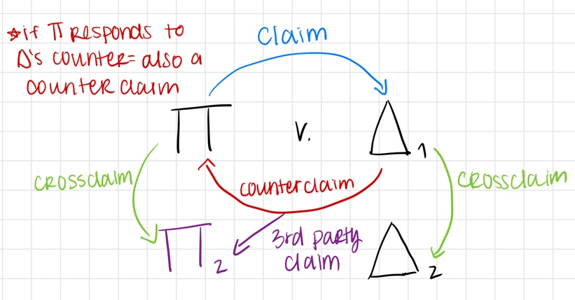
  - FRCP 18: Joinder of Claims
    - Any party (P or D) asserting a claim, counterclaim, crossclaim, or 3rd party claim can bring any of it.
    - VERY LIBERAL → You can bring as many claims as you want.
    - Once you assert a claim, you can bring any other claim you have (permitted as long as they meet subject matter jdx)
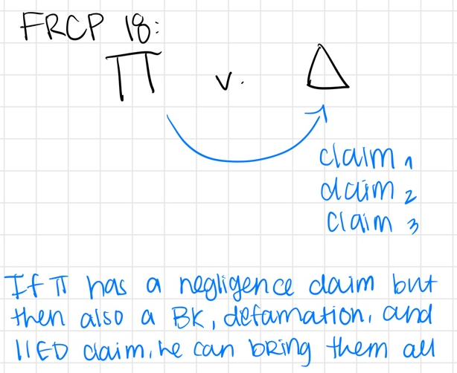
  - FRCP 13: Counterclaims and Crossclaims
    - Allows a party to bring a counterclaim whether its compulsory or permissive, but if it’s compulsory its barred from being brought in a subsequent suit
    - 13(a)(1): Counterclaims are compulsory if they arise out of the same transaction w/ common question of fact or law
      - Same transaction = Enough factual or legal overlap so that it makes sense to bring the claims together
        - ST test is harder to satisfy than CNOF
        - Example of NOT the ST/failing the ST test: Jones: first claim was about discrimination and the second claim was about P defaulting on their car payment
      - If you don’t file a compulsory counterclaim, you cannot bring this claim up later
      - Compulsory effect applies to P’s counters as well
      - Only worry about a compulsory counter of the party didn’t file it originally and they are seeking to file it later in time
    - 13(a)(2): Exceptions:
      - Even when they are in the same transaction, they are not compulsory when:
        - Subject to pending action/claims is already being adjudicated in another suit (if you already sued for that)
        - Participation of party that ct can’t get jdx over
    - 13(b): Anything not compulsory is permissive and you can still file it later
      - Old rule: a permissive CC needs an IBJ to get them into court since it’s not the same transaction
      - New rule: if it’s permissive, it can still satisfy CNOF and get supp jdx, even if the factual overlap is small – 9th Circuit
    - 13(g): can assert a crossclaim against a like party if it arises from the same transaction (D v D or P v P)
      - All crossclaims are permissive, NOT compulsory
      - CAN file a crossclaim for indemnity
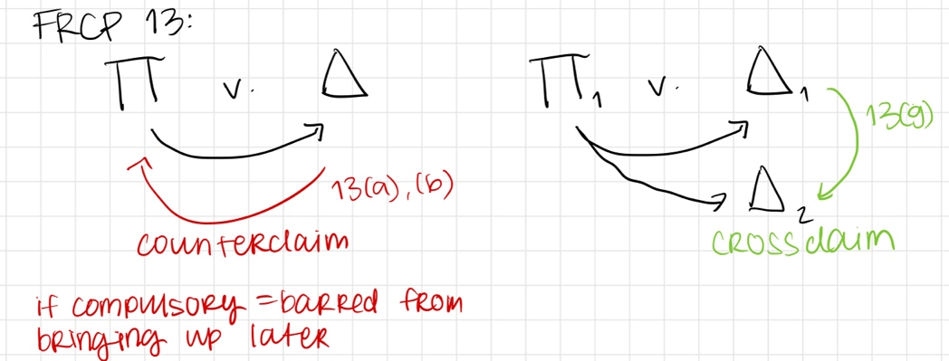
  - FRCP 20: Permissive Joinder of Parties
    - Allows multiple Ps to join together if their claim is from the same transaction, series of transactions, or a common question of law or fact
    - Allows P to join multiple Ds if the relief sought is from the same transaction or series of transactions, or a common question of law or fact
    - It’s giving FRCP 18 except 18 is for claims and 20 is for parties and 20 includes series of transactions where 18 is only same transaction
    - Apply liberally → courts are generous w/ permissive joinder
    - FRCP 13(h): Rule 19 and 20 applies to joining parties on a crossclaim or counterclaim
      - Allows a party to join a 3rd party in a cross or counter as long as it arises from the same transaction or series of transactions or common question of law or fact
      - 13(a-b) lets you file a counterclaim at any point (does not have to be same transaction if it’s permissive), and 13(h) allows you to add a party to that counterclaim but it must be the same transaction
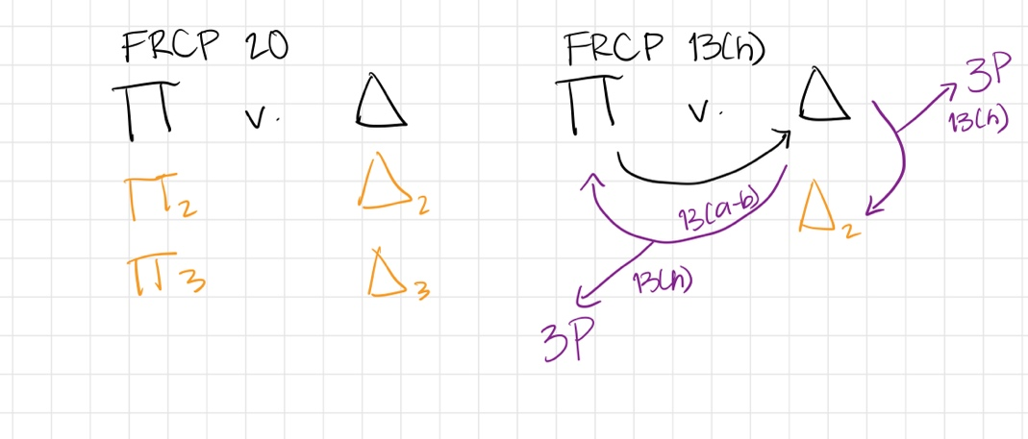
  - FRCP 14: Indemnity/Impleader
    - D is allowed to bring in another party through indemnity, making D a 3rd party P. The person they bring in becomes a 3rd party D with all the same rights/permissions as other parties
    - P can also indemnify another party if they are counterclaimed
    - “I may be liable but if I lose, this other person has to pay” = indemnity
    - “I am not liable, this other person is” or “It’s not my fault, it’s this other person’s fault” = NOT indemnity
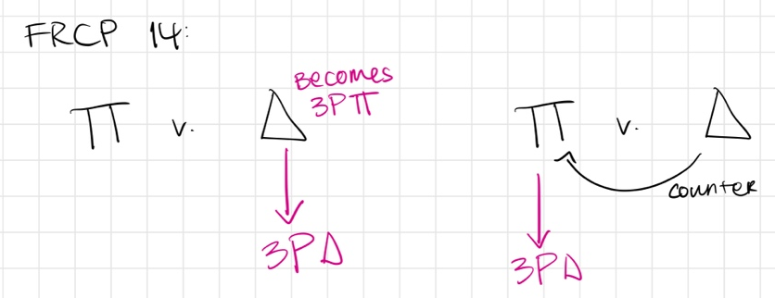
  - FRCP 24: Intervention
    - Allows a party to enter a case, either as P or D
    - Cts have a policy in favor of intervention – they want to allow parties in who have an interest in the case for efficiency purposes
    - Intervention of right: party MUST be allowed to enter when
      - Party is intervening in a timely manner
        - Measured from the moment the party realized they are not being adequately represented, not from the onset of the case or from when the party realizes they will be impacted by the outcome of case
        - Contextual inquiry- would letting this party intervene put the original parties at risk, or will the OG parties be harmed b/c the intervenor waited too long?
      - Intervenor has a significantly protectable interest in the transaction at issue
        - Ex: economic interest, legal interest → more than just mere curiosity in the case
        - Usually this requirement is chill
      - Intervenor’s interest in the transaction would be practically impaired if he were not in the case
        - A party not being allowed to intervene may impede it’s interest in the manner
      - Other parties in the case do not adequately represent the intervenor’s interest
        - No one else represents the POV of the intervening party
    - Permissive intervention: party MAY be allowed to enter if there is a common question of law or fact
    - What if an intervening party violates complete diversity?
      - Courts have allowed intervention anyways it if they are NOT an indispensable party (Mattel v. Bryant)
        - Indispensable = so important to the case that you shouldn’t proceed w/o them. So if they are NOT indispensable, it’s OK to bypass the rules of complete diversity. If they WERE indispensable, you would want to dismiss the whole case and have them re-file as an OG party
        - If they are not indispensable, you’re not using this maneuver to try to violate ct’s jdx
        - Add this to “does it violate the jdx requirements of 1332” toolbox of 1367(b)
  - FRCP 22: Interpleader
    - When there is one property (stake) and multiple claims of ownership (stakeholders/adverse claimants)
    - Claimants have to be adverse—either they each want the whole thing (100%) or each wants a part of the claim that adds up to more than the whole (ex: each wants 60%)
    - Ex: If the stake is an insurance policy w/ multiple claimants, the insurance company says: “I know I have to pay the insurance out but I’m not sure who to pay it to”
      - Stakeholder could become a claimant. Insurance company could say: “We don’t owe anyone any money, we think we should keep it”
    - Stake is deposited at Ct where it’s held until the claim is litigated
    - Two different types of interpleaders:
      - Statutory
        - AIC- § 1335
          - AIC $500 minimum
          - Minimal diversity (NOT complete)—any 2 parties need to be diverse, not all Ps from all Ds
        - Venue- § 1337
          - Venue is proper where any 1 claimant resides
        - Personal jdx- § 2361
          - Nationwide service of process—personal jdx is proper over everyone if 1 claimant resides in that forum
          - Allows enjoinment
      - Rule 22
        - AIC- § 1332
          - AIC $75,000 minimum
          - Complete diversity
        - Venue- § 1391
          - (b)(1)- resident/domiciled in forum
          - (b)(2)- substantial events occurred in forum that gave rise to the claim
          - (b)(3)- fallback provision
          - A valid forum selection clause also denotes venue
        - Personal jdx- FRCP 4k(1)(a)- Minimum contacts
          - ID purposeful contacts
            - Activities in forum state?
            - Contractual obligations?
            - Effects test?
          - General jdx—were purposeful contacts so strong that you are “at home” in forum state?
          - Does claim arise out of/is related to the purposeful contacts
            - Related:
              - But for +
              - Conceptual relatedness
              - Fair warning
            - Arise out of/Prox cause:
              - Purposeful contacts would be the direct evidence of the claim if proved at trial
          - Reasonableness?
          - Stream of commerce
    - Statutory is WAY easier to satisfy, but they both work so at least touch on both even if you dispose of one briefly
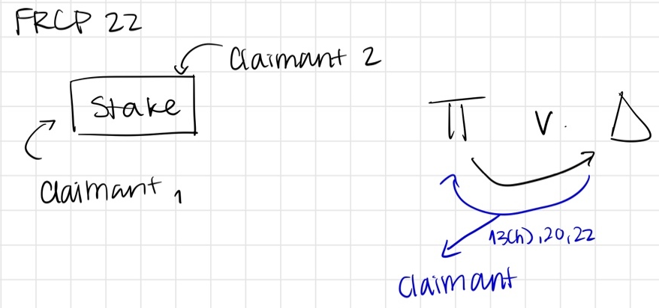
  - FRCP 19: Required Joinder of Parties
    - Filed as a 12(b)(7) motion—failure to join a required party (only rule that gets triggered from a motion as opposed to the actions of the party)
    - D is claiming that there’s an absent party (AP) that ought to be in the case
    - 19(a)(1): Should AP be in the case?
      - Can P get complete relief without AP in the case?
        - Can P get everything he wants from D without the AP being in the case?
        - Refers to complete relief b/w existing parties
      - Harm to AP?
        - Does AP have an interest in the case that would be impaired if the case proceeds without them?
        - Ex: Provident Bank- asking to enforce an insurance policy that you already bought is not impairing your interest—nothing makes you more/less responsible for the excess $ that isn’t covered by your policy
      - Harm to existing parties?
        - Would D incur multiple liability or inconsistent obligation?
        - Does NOT include inconsistent judgements, if one Ct says you are negligent and another Ct says you are not negligent, that is not an inconsistent obligation
          - Inconsistent = one Ct orders you to do something and another Ct orders you to do the opposite and you can’t physically do both
          - Having to pay twice is not an inconsistent obligation when you can just pay both times (Ex: one life insurance policy cannot be paid to two people so it would be inconsistent if ordered to pay twice)
        - Ex: Maldonado v. National Western- if NW loses in the first suit and makes Francisco give back the annuities b/c they are void, then Francisco would sue NW later to get the annuities back and would claim that they are not void, which is an inconsistent obligation
        - Inconsistent obligation- Physically impossible to perform both
    - 19(a)(2): if AP is a required party, is it feasible to join them?
      - Feasible if they do not violate SMJdx or PJdx
    - 19(b): If joinder is not feasible, should we procced in their absence?
      - Should we dismiss the case entirely or proceed without them?
      - If you cannot proceed, then they are an indispensable party and you need to dismiss the whole case.
      - Presumption towards not dismissing it → very discretionary
      - Factors:
        - What is the potential harm to the AP and D?
        - If there is a harm, can we shape the relief in a way that it doesn’t cause harm?
        - What is most efficient? (Does not carry much weight)
        - Will P have a remedy if we dismiss the case?
- Is there an IBJ for the joined claim? Usually no
- Does Supp Jdx allow the joined claim to brought?
  - § 1367(a): CNOF? If Rule 20, then yes b/c the same transaction test for rule 20 is harder to satisfy than CNOF
  - § 1367(b): If 1332 got you through the door
    - Diversity? Did 1332 get you through the door
    - Was it a claim by P? If D is bringing in someone, 1367(b) is immaterial
    - Joining a party as a D under 14, 19, 20, or 24?
    - Did P enter under 19 or 24?
    - Is it inconsistent with the jurisdictional requirements of 1332?
      - Only get here if you get a yes to either of the previous questions. If it’s a no to both, DO NOT GO HERE
      - How can it be inconsistent:
        - No complete diversity
          - Non-diverse, non-indispensable parties do not violate complete diversity (Mattel)
        - AIC not met for each P
        - Kroger evasion
  - § 1367(c): Discretion to decline supp jdx—are there practical reasons to keep the claim in fed court?

- ERIE DOCTRINE
- Definitions
  - Erie Doctrine = idea that a federal ct sitting in diversity over a state law claim must apply the substantive law of the state but federal procedural law
    - Substantive law = laws that govern everyday life (ex: torts, negligence, property, etc)
    - Procedural law = laws that govern litigation, governs how substantive law is enforced
    - Sometimes it’s not so obvious whether something is a substantive right or procedural right. Ex: SoL could be procedural b/c it gives you a time frame to file or could be substantive because it strips you of a right if you don’t timely file claim
  - When there is a conflict b/w federal procedural law and state substantive law = Erie Problem. If there is no conflict = apply state substantive and federal procedural law
- Tracks for ED analysis when there is a conflict b/w federal and state law:
  - Track 0: state law conflicts with the constitution → Constitution prevails. Any state law that is inconsistent w/ constitution is unconstitutional
  - Track 1: state law conflicts with federal procedural statutes (28 U.S.C)
    - Step 1: ID the issue
    - Step 2: Is the statute sufficiently broad enough to cover resolution of the issue? (applicability)
      - Does it address the exact issue we are worried about?
    - Step 3: Is the statute reasonably classified as procedural/arguably procedural? (validity)
  - Track 2: state law conflicts with federal rules (FRCP)
    - Step 1: ID the issue
    - Step 2: Is the FRCP sufficiently broad enough to cover resolution of the issue? (applicability)
    - Step 3: Is the FRCP reasonably classified as procedural/arguably procedural? (validity)
    - Step 4: Does the FRCP abridge, enlarge, or modify a substantive right? (validity)
      - Changed element
      - Changed SoL
      - Changed remedy
        - Ex: Gasporini: state law had a “deviates materially” standard for appealing damages, def law has a “shocks the conscience” standard. This state law would change your remedy b/c applying the state law standard would significantly reduce his damages
      - Ex of NOT A/E/M: Hannah 1: conflict b/w state law and federal law about what service of process is proper, but the substantive right (negligence) is not at issue. So the sub right is not A/E/M
  - Track 3: state law conflicts with federal judge-made doctrines (case law, common law)
    - Step 1: ID the issue
    - Step 2: Is the doctrine sufficiently broad enough to cover resolution of the issue? (applicability)
    - Step 3: Is the doctrine reasonably classified as procedural/arguably procedural? (validity)
    - Step 4: Is the doctrine outcome determinative at the forum shopping stage? (validity)
      - Can use same abridge, enlarge, or modify analysis from track 2
      - Ex: State ct door is locked while fed law door is open would breach the outcome determinate test
      - Ex: Hannah 2: is NOT OD because you are not getting a substantive advantage in fed ct over state ct
      - Ex of SoL/Element: Guaranty trust: state law had a “latches” law similar to a SoL. Under latches it was not too late to file but under federal SoL it was too late to file. Does it change the SoL? Yes, it resurrects a state law claim that you wouldn’t have been able to file otherwise

- MOTION FOR SUMMARY JUDGMENT (MSJ)
- Definitions
  - MSJ = post-discovery, pre-trial motion where a party challenges the other side’s ability to prove the elements of their claim/defense
  - Allegations = statement of facts that appears in a pleading that give rise to your claim (Ex: D ran a stop light)
  - Evidence = supports/proves your allegation (Ex: We have camera footage of D running a stop light)
  - Discovery = process of collecting evidence and the formal exchange of evidence by both sudes
  - Order of a case = Pleadings → 12(b) motions → Discovery → MSJ → Trial
- How to evaluate a MSJ (can be filed by either party, usually cross-filed by both. If two are filed, analyze them separately)
  - ID the parties and whoever the moving party is (the party claiming a MSJ)
  - ID the issue on which the MSJ stands
  - ID who had the burden of persuasion at trial?
    - The non-moving party has the burden of persuasion to prove the elements of their claim/defense at trial
    - Will come into play later when you are seeing if moving party met their burden of production
  - Did moving party meet their burden of production on summary judgment?
    - What a party must produce for MSJ to be granted
    - Recognize what the legal standard of proof is in the case, the answer of whether burden of production was met could change depending on the standard of proof
      - Three standards of proof exist:
        - Preponderance of evidence: More probable that the claim is true than not (general standard) AKA 51%
          - Easiest to satisfy, if the scale is slightly in favor of one party over the other it’s been met
        - Clear and convincing: In the middle, more rare.
        - Without a reasonable doubt: Strictest standard, 100%
          - Used in crim cases
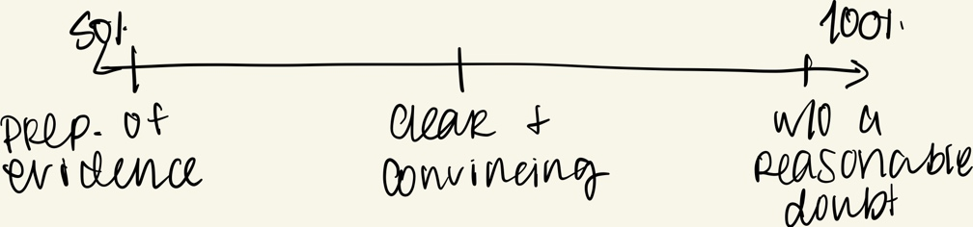
    - How to satisfy burden of production:
      - If you are the moving party WITHOUT the burden of persuasion at trial, you have two options:
        - Affirm: Affirmative evidence that the other side’s claim is not met
          - Ex: Celotex: P sues after husband was allegedly exposed to Celotex products and died, Celotex moves for summary judgement and brought forth affirmative evidence that decedent was never actually exposed to their products. Ct. grants MSJ
        - Zero evidence: The other side has zero evidence to prove their claims
      - If you are the moving party WITH the burden of persuasion at trial, you only have one option:
        - Affirm: Affirmative evidence that you have enough facts to support your claim or that a reasonable juror could grant in your favor.
    - Moving party must produce material that if, undisputed, would make them win at trial if it goes to a jury. Must show that no reasonable juror could rule against them.
      - If MP is successful, then the non-moving party has the burden of production to show that there is a sufficient material issue of fact that it should go to trial
        - If trial could go either way = genuine issue of material fact

- DEFAULT JUDGMENT AND DISMISSALS
- Default = failure of properly served D to respond in a timely fashion (21 days), but they are technically not in default until clerk enters in the Cts docket
  - Consequences: D won’t be able to challenge the claims of the merit/liability, maybe you can challenge damages, but not the claim itself
  - Default judgment = final judgment in the case
  - Courts disfavor DJs, so there is a deference to hear the case on the merits
  - Steps for DJ:
    - Step 1: Entry of default
      - P asks Ct to enter in default by filing an affidavit that they filed a complaint, properly served the complaint, and D didn’t respond within the allotted time. But final judgment has not yet been entered. (default ≠ default judgment) (Rule 55(a))
      - How D can stop this: Invokes Rule 55(c) to lift/rescind the default for “good cause shown” (pretty low threshold, pretty much any reasonable excuse will do to set aside the default)
    - Step 2: Entry of default judgment/default judgment hearing
      - Assuming default was not set aside
      - Clerk must enter DJ if the amount of $ sought is sum-certain (aka no calculation of damages/proof of damages is required, ex: defaulted credit card debt. Bad example: Hartford case: long term disability is not a sum-certain)
        - MANDATORY for clerk to enter default judgment in these cases, no notice required
        - All other cases must go to a DJ hearing to determine damages. Rule 55(b)(1)
          - Ct has a lot of discretion in this hearing
          - Pretty one side evidence
          - Mini investigation to see if DJ should be entered
          - Hearing can be held w/out D, but if D appeared in the case, then they are entitled to notice of the hearing so they can contest the amount of damages
            - NOT here to dispute the merits of the claim, just the damages
            - Ex: Hartford: appearance is demonstrating your intent to defend the suit. Executing a waiver of service is not an appearance.
    - Step 3: Post default judgment
      - DJ is entered and becomes fully enforceable
      - How D can stop this: Under FRCP 55(c) + 60 they can seek to set aside DJ, but this is harder to do than setting aside the default in step 1
        - FRCP 60: allows any party to challenge any judgment (including a DJ) on the following grounds:
          - Mistake, excusable neglect – 1 yr to file
            - Ex: Hartford: D claims that the service papers were never delivered which is excusable neglect, Ct disagrees. D is a big company and should have procedures in place to make sure this doesn’t happen
          - Newly discovered evidence – 1 yr to file
          - Fraud – 1 yr to file
          - Judgment is void – no time limit → BIG ONE
            - Party didn’t serve me properly
            - Absence of Pjdx b/c no minimum contacts
            - If you can show this, you will get the judgment reversed
          - Judgment has been satisfied – no time limit
          - Other reason – no time limit
      - Only after D fails to set aside DJ is DJ entered
- Dismissals. FRCP 41
  - Voluntary dismissals
    - P can voluntarily dismiss the case if you do so before D files an answer or MSJ or all parties can agree to dismiss
    - If dismissed = dismissed WITHOUT prejudice AKA you can file it again (unless there was a previous dismissal of the same case, can only voluntarily dismiss once)
    - Do not need Ct approval, all other types of dismissals do need Ct. approval
  - Dismissal for failure to prosecute
    - Can be filed by the Ct (sua sponte) or by the opposing party
    - Effect = presumed to be an adjudication on the merits WITH prejudice
    - Filed the lawsuit, other party answered, and you sat on it (no action has been taken)
    - Factors cts looks at: fairness to the parties, efficiency to the judicial system
  - Dismissals as a judicial sanction
    - Dismissal for misbehavior: Some behavior you engaged in the case leads the Ct to dismiss your case as a sanction
    - Ex: failure to disclose discovery, failure to comply w/ court orders

- MOTIONS FOR JUDGMENT
- Similar to MSJ, but instead of pre-trial it is post-evidence
- Types of MJs in state court that can stop a case:
  - Motion for nonsuit
    - At the close of Ps case, D can seek nonsuit of they think P’s evidence is not enough to meet the elements of their claim
    - Can ONLY be filed by D
  - Motion for directed verdict
    - If nonsuit is denied, then D presents their evidence and now either side can move for directed verdict so case does not go to trial
  - Motion for JNOV (judgment not withstanding verdict)
    - If case goes to a jury and a judgment is rendered, either party can seek JNOV to go against the jury verdict
    - Usually can only do this if you previously filed a nonsuit
- In federal court, they are all called motions for judgment → no nomenclature with different names but you can use the same buzz words
  - Same timing elements as in State Ct: motion can be filed at the end of P’s case by D, at the end of D’s case by either party, or after a jury verdict by either party
  - Same reasonable juror standard used in MSJ: no reasonable juror could rule against the moving party at trial
    - Ex: Honaker v. Smith: P’s house burns down under sus circumstances and he sues the mayor of the city/fire marshal for negligently supervising the fire and on a 1983 claim for setting the fire
      - Ct. denies P’s MJ: everyone who testified said that the firefighters were doing their best to put out the fire so no reasonable jury could rule in favor of P
    - Ex: Tesser: P is an assistant principal who brings a religious discrimination and retaliation claim against her employer when she does not get promoted to principal
      - D wins and P files JNOV. Ct denies b/c a jury would need to find that D intentionally discriminated against her, and no reasonable juror would have decided any differently

- MOTION FOR A NEW TRIAL
- Rule 59: MJ is asking the Ct to overturn jury verdict and rule the opposite way, MNT is asking for a do-over b/c there is some kind of error in the trial. Slightly easier to get than MJ b/c it doesn’t flip the verdict
  - Something went wrong during the trial that creates a manifest injustice: Requires a showing of a prejudicial error that infected the verdict such that the verdict demonstrates a manifest injustice
    - Harmless errors don’t count, must ID an error that occurred during the case and that it infected the verdict
  - Must file w/in 20 days of entering judgment
  - Different standard than MJ (reasonable jury standard) → Ct can deny a MJ but later grant a MNT
  - No presumption that the jury got it right—judge gets to weigh evidence independently (not viewing the evidence in light of moving party)
  - Ex: Tesser: seeks MNT on grounds of sufficiency of evidence and credibility of defense witness. P claims that jury only deliberated for 2 hours.
    - Ct. denies, nothing in the case shows that the potential errors were a miscarriage of justice
    - Almost never is the length of time that jury deliberates will be grounds for granting MNT. There is no magic number for how long a jury should deliberate
- Typical grounds for granting MNT (procedural, prejudicial errors):
  - Errors in jury selection
  - Erroneous evidentiary hearings
  - Erroneous jury instructions
  - Verdict being against the weight of the evidence
  - Excessiveness or inadequacy of the verdict
  - Misconduct by the judge, jury, attys, parties, or witnesses
  - Newly discovered evidence

- CLAIM AND ISSUE PRECLUSION
- Claim Preclusion
  - Elements:
    - Same claim
      - Same transaction test (Fed Ct): Do the claims arise out of the same transaction? Is there a common overlap of facts?
      - Primary rights test (CA Ct): Do the claims violate the same primary right?
        - There are many examples of primary rights, but these are the main ones:
          - Right against personal injury
          - Property rights
          - Right to enter into a contract
          - Right to maintain your reputation
    - Final, valid, on the merits
      - Final
        - Whichever case is final first is what binds the second one
          - If CA is the first binding judgement and the second case is in Fed Ct, Fed ct has to use the CA standard even though it is different
        - Fed Ct: final when the trial ct. enters the judgment into the docket
        - CA: final when the appellate process has come to an end (either the time to appeal has expired or the appeal was filed and a judgment on the appeal was reached)
        - Equity exceptions? CA recognizes them but Fed Ct does not
          - Ex: Moite- doesn’t seem fair that the other 5 Ps in the case got the benefit of the lower ct judgement being reversed, but Moite and Brown do not because they chose to relitigate and not appeal the first case. SCOTUS holds that equity does not matter.
      - Valid
        - Usually a non-issue unless we are dealing w/ default judgments
        - Reasons why it would not be valid:
          - Improper service
          - Lack of Pjdx
          - Lack of SMJdx
          - Fraud on behalf of the Ct. (throwaway, this never happens)
      - On the merits
        - If judgment entered in favor of P, it is always on the merits
        - If judgment entered in favor of D, it can be on the merits UNLESS:
          - D wins on procedural grounds (dismissed for lack of venue, transfer of venue, dismissed for lack of personal or subject matter jdx, etc)
          - The dismissal was without prejudice (aka you can file it again)
          - By statute the judgment is not a bar to another suit on the same claim
            - SoL wrinkle:
              - If your claim is denied b/c your SoL ended, it is NOT on the merits if your SoL is still open in another claim
              - If there’s another opportunity to file the suit = NOT on the merits
              - Ex: SoL in CA ended, but you could refile in another state where the SoL is still open—Not on the merits
              - Ex: Samara—Ct assumed it was on the merits but it really wasn’t b/c it got denied for failure to meet SoL but she had the option to re-file against another party w/ a longer SoL
        - Ex: Lumpkin v. Jordan (anti-gay reverend not appointed to human rights commission)—the state law claim was not decided on the merits b/c Fed Ct refused to exercise its discretion and join the claim under supp jdx
    - Same parties
      - Must be the same party or a party who ought to be treated as such. A party who should be treated as such falls w/in RBG’s six categories
      - Can only benefit from a preclusive judgment only if you are bound by the judgment (AKA negatively impacted). Only a person who is bound can raise claim preclusion to prevent relitigating (mutuality requirement)
        - Same concept applies w/ issue preclusion but with a twist: a party can raise issue preclusion even if they are not bound as long as the other party is bound
      - RBG’s six categories of when parties should be treated the same:
        - Contract
          - Non-party agrees to be bound by a contractual agreement
        - Privity
          - There is a pre-existing, legal relationship b/w the parties
          - Most common: property relationships
          - Ex: successive owners of property, employer/employee, easements
        - True representation
          - One party represents the other in a formal representative capacity and you know they are representing you on your behalf
          - Ex: Class actions, guardian/child, beneficiaries, union suing on behalf of its members
        - Control
          - Second party controlled the first suit
          - Ex: second party funded and planned the strategy of the first suit
          - Hiring the same atty is not enough (Taylor)
        - Agency
          - The opposite of control— first party controls the second suit AKA relitigating the proxy
          - Asking someone to file for you is not enough
          - Possible example: Taylor- have the same atty, shared the same documents, were part of the same aviation group that wanted the information, but would need more facts to find out.
        - Statutory exceptions
          - Some things just have to be final, so congress creates statutes for them
          - Ex: Bankruptcy, Probate
      - Do not need to go through categories when they are literally the same exact party, just when they are a non-party that we want to know if they should be treated as the same party
      - Virtual representation is recognized by some states as the 7th category, but fed cts and CA does NOT follow this
        - If the non-party’s interest are the same or the factual overlap is strong they should be treated as the same party
- Issue Preclusion
  - Elements:
    - Same issue
      - Key Q: Should we treat them as the same issues? Are they close enough that out of fairness and efficiency we should treat them the same?
        - In CA it’s identical issue test, but in practice its approached the same way even if the language may suggest its stricter
      - Ex: Lumpkin v Jordan- P files a federal discrimination claim + state law discrimination claim in fed ct. Ct decides that there was not discrimination but refuses to exercise supp jdx to hear state law claim. Is this the same issue? YES. Using the same facts and it’s the same legal context, and there is no real policy argument for why they shouldn’t be the same issue.
    - Actually litigated and decided
      - Raised by one party, formally contested by the other, and submitted to the Ct for consideration
      - Does not have to literally go to trial
      - If an uncontested issue or an facts that D admits = NOT actually litigated
      - Can be decided expressly or implicitly decided
    - Necessary
      - Has to be essential to the judgement so that if you take it out of the case the judgment would be different
      - If the issue had been decided the opposite way in the prior case, would the judgment have been the same? If yes = then not necessary
      - Ex: Lumpkin v. Jordan- if Ct. had held the opposite in the first case (there was no discrimination), it would have changed the judgement in favor of the reverend, so the issue was necessary.
      - Alternative determinations- when there are two grounds for a decision that can stand alone to solve the issue, which one is necessary?
        - First restatement approach: both alternative determinations are binding, unless one of them is reversed on appeal
        - Second restatement approach: Neither are binding until they are affirmed on appeal (if not appealed, not binding)
          - Ex: Samara (P sues after a tooth implant)- the two ADs were 1) causation and 2) SoL passed. Only the SoL was appealed, was causation necessary? No, it was not binding b/c it was not affirmed on appeal.
        - NY approach: Ct looks at case and makes a discretionary judgment call (practical approach, case by case inquiry)
    - Same parties
      - Same inquiry as claim preclusion but w/ a twist:
        - You don’t need to be bound by previous suit to benefit from issue preclusion (you do for claim). You can benefit from it as long as the other side is bound even if you are not.
          - Eliminates the mutuality requirement
        - Two types:
          - Non-mutual defensive preclusion
          - Non-mutual offensive preclusion
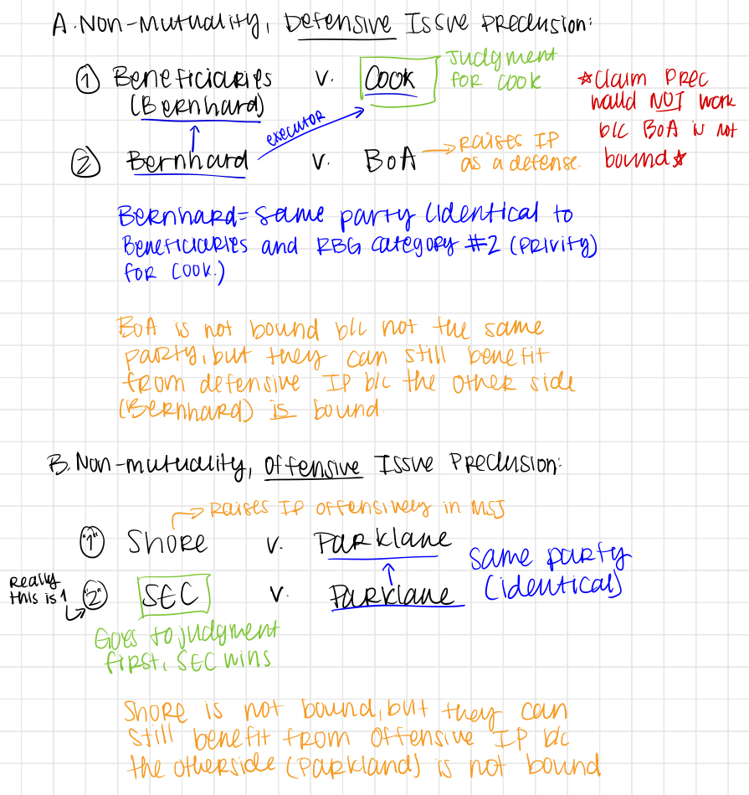

Claim preclusion
Fed Ct. | Elements | CA Ct.
Same transaction test | Same claim | Primary rights test
Final: Trial ct. has entered final judgement into the docket | Final, valid, merits | Final: appellate process has ended
Same parties or those who ought to be the same (RBG 6 factors)  NO Virtual representation  Mutuality requirement- must be bound to get benefit | Same parties | Same parties or those who ought to be the same (RBG 6 factors)  NO virtual representation  Mutuality requirement- must be bound to get benefit
No | Equity considerations | Yes

Issue Preclusion
Fed Ct. | Elements | CA Ct.
Should they be the same issue? | Same issue | Identical issues (stricter test in theory but basically the same in practice)
Raised, contested, submitted  Express or implicit | Actually litigated and decided | Raised, contested, submitted  Express or implicit
Essential  Twist for alternative determinations | Necessary | Essential  Twist for alternative determinations
Same parties or those who ought to be the same (RBG 6 factors) w/ twist | Same parties  (w/ non-binding party twist) | Same parties or those who ought to be the same (RBG 6 factors) w/ twist

