- Forum Selection
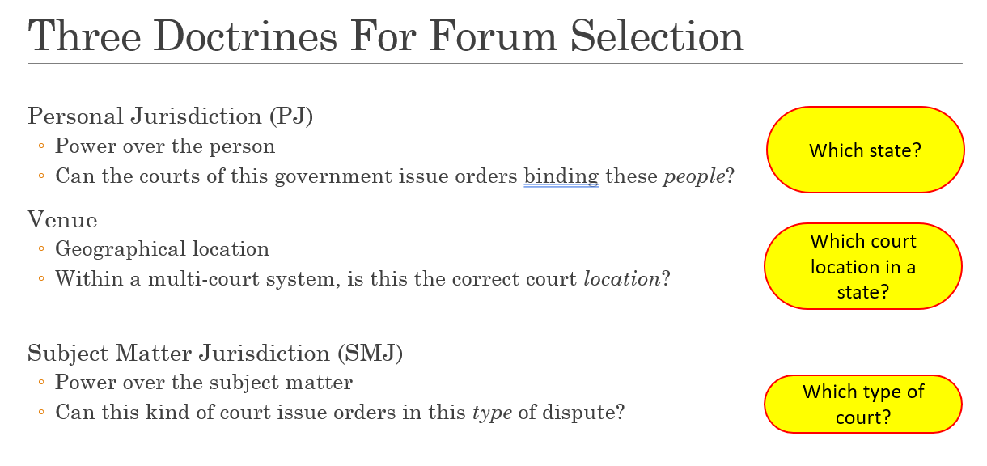
  - Personal Jurisdiction – power over the person. Can courts of this gov’t issue orders binding THESE PEOPLE. Which state.
    - Constitution
      - Traditional Basis
        - 14th Amendment and Other limits on state courts –“ cannot deprive any person of life, liberty or property without due process” = limits state court power on out of state residents
          - Personal Jurisdiction Values to consider:
            - Meaningful participation: Obstacles for defendants
            - Consent
              - Expressly – by agreeing
              - Implicitly – by operating in FL and taking advantage of its laws. (connections to state)
            - State Sovereignty – does the court have interest in these parties?
        - Rule 4(k)(1) Limits on federal courts (generally apply in state and federal court) . The federal district court has personal jurisdiction over a defendant who:
          - Who is subject to the PJ of a court of general jurisdiction in the state where the district court is located. IE: If a state can exercise PJ over a defendant then a federal court located in that state can exercise PJ over a defendant.
        - The old Rule: Pennoyer v Neff:
          - Defendants had to be “present” in a state’s territory for a judgement to personally bind them.
          - Proceedings in a court of justice to determine the personal rights and obligations of parties over whom that court has no PJ do not constitute due process of law.
            - IE if a state court asserts PJ improperly, it is a constitutional violation.
          - Every state possesses exclusive jurisdiction and sovereignty over persons and property within that territory. No state can exercise direct jurisdiction and authority over persons or property without (outside) its territory.
          - For a defendant to be “present”
            - Service of process within forum (presence in forum)
            - Domicile in forum
            - Consent
            - Service on agent in forum
          - Issues:
            - Corporation and other entities where presence is a legal fiction
            - Intangible injuries
            - Cross border transactions
            - Technology
      - Modern Basis
        - Rule: Minimum contacts and fairness and substantial justice
          - International Shoe v WA.: Due process requires only that if he be not present within the territory of the forum, he have certain minimum contacts with [the forum] such that the maintenance of the suit does not offend ‘traditional notions of fair play and substantial justice’. (Activities in the state carried out by those who are authorized to act for it. To symbolize the activities of the corporations agent within he state that court deems sufficient )
            - While it has been held, in cases on which appellant relies, that continuous activity of some sorts within a state is not enough to support the demand that the corporation be amenable to suits unrelated to that activity, there have been instances in which the continuous corporate operations within a state were thought so substantial and of such a nature as to justify suit against it on causes of action arising from dealings entirely distinct from those activities.
            - “[T]o the extent that a corporation exercises the privilege of conducting activities within a state, it enjoys the benefits and protection of the laws of that state. The exercise of that privilege may give rise to obligations; and, so far as those obligations arise out of or are connected with the activities within the state, a procedure which requires the corporation to respond to a suit brought to enforce them can, in most instances, hardly be said to be undue.”
          - McGee v International Life Ins Co.
        - General (Personal) Jurisdiction (All purpose or sue for anything jurisdiction) is fair when the defendant is “at home” in the state—usually, where it is incorporated or has its principal place of business in the state.

          - Defendant has so many contacts with the forum that PJ is ALWAYS proper there, even for lawsuits unrelated to forum contacts.
          - Corporation needs so many contacts they are “essentially at home”
          - Why give Parties the option of suing defendants in “home” jurisdiction even if lawsuit isn’t related?
            - No question about state’s authority under traditional view
            - State may have interest in deciding dispute about its citizen
            - Good likelihood of available assets to satisfy judgment.
            - Nice for P’s to have knowledge of one for-sure correct forum that is easy to identify without much chance of having to brief a 12(b)(2) motion.
            - History and precedent says this is a proper doctrine.
            - No due process problem to sue D in home state, due to ideas like consent, reciprocity, expectation, burden, etc.
          - Old Standard: Defendant has continuous and systematic contacts w forum state
            - Perkins v. Benguet (held: jurisdiction) – Plaintiff sues in Ohio over events in the Philippines. Defendant is a Philippines mining co, but virtually all bus activities were conducted from “temp” Ohio offices. Suit was not related to Ohio contacts. Held there was jurisdiction because defendant carried out “continuous and systematic: amount of business on Oh.
          - New Standard: Defendant has so many “constant and pervasive contacts” it is essentially at home. (Ex: where the company is inc., or has principle place of business. May be exceptional cases if companies operations in that state are so substantial and of such nature to render it home. Think: subjecting big cos to all purpose jurisdiction everywhere they do a lot of business would not allow them to predict where they will be sued based on how they act.
            - State sovereignty: states have an interest in regulating citizens in their own territory.
            - Certainty: Place has benefit of being “unique” and “ascertainable.” Out of State Ds can “structure their primary conduct” knowing where they will be sued.
            - Tradition:
            - Fairness: Fair to hold defendants responsible, even for conduct that has nothing to do with state, because it is in a limited number of places where companies expect it. It is less fair when rooted in test that is “unnecessarily grasping.”
            - Consent: D or P consented to jurisdiction even if not bargained for, when there is notice in good faith and w/o fraud
              - Living there, conducting business there, or taking advantage of its laws but more specific:
              - Signing Contracts
              - Waiver by litigating without objection
              - Possibly registering to do business in a state on the condition you agree to jurisdiction in that state
              - Carnival cruise – including a forum clause in a form ticket is ok if reasonable.
              - Imerys register in PA to do business consented to jurisdiction there.
          - Goodyear v. Brown (no jurisdiction)
          - Daimler v. Bauman (no jurisdiction)
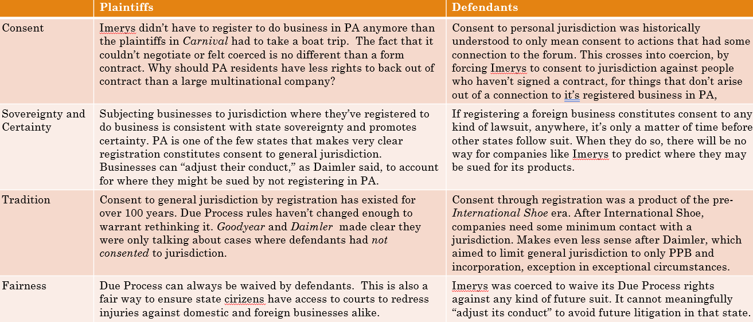
        - Specific (Personal) Jurisdiction (aka case related jurisdiction) -requires a connection between the “case” and the jurisdiction you want to sue in. (Defendant has enough contacts with the forum that are related to THIS lawsuit that personal jurisdiction is proper for THIS lawsuit). It is satisfied when:
            - The defendant has “purposefully availed” itself of the benefits of the market in the forum state (i.e., has “minimum contacts” with the state). (Ex: Employment in the state – int’l shoe, Ongoing K for services – Mcgee/Denkla, Stream of commerce (WWV, Nicastro), Tort with “effects” in state (Calder/Keeton), Website interactivity (Zippo) )
            - The plaintiff’s claims “arise out of or relate” to the defendant’s contacts with the forum state (Ex: Defendants forum contacts in some way caused P injury, or related Def forum contacts at least loosely relate to elements of the claim P has to establish;
              - Bristol-Myers Squibb Co. v. Superior Court., 137 S. Ct. 1773 (2017). In a mass action, Supreme Court held CA courts could not exercise “specific” personal jurisdiction over non-residents based on defendant’s substantial contacts with CA. The fact that CA plaintiffs “were prescribed, obtained, and ingested Plavix in California–and allegedly sustained the same injuries as did the nonresidents–does not allow the State to assert specific jurisdiction over” nonresidents from Utah. But the Court left open whether it applied to class actions in federal court.
and
            - It is not otherwise unfair or unreasonable to exert jurisdiction, taking into account the D, P, forum, and other states’ shared interests in relief.
          - Reasonableness:
            - Private: Burden on defendant /Plaintiffs interest in access to local court
            - Public: Forum states interest in adjudicating the case/defendants states shared or conflicting interest in furthering its own policies/judicial efficiency
        - No personal Jurisdiction
          - Defendant has too few contacts with the forum for PJ
        - Purposely avail or directly make contact w states for unintentional actions
          - WW Volkswagon v Woodson – Car purchase in NY. Plaintiff in NY. WWVW in NY (local distributor). Manufacturer out of country. Accident OK. Potential Forum OK. Holding WWVW did not avail itself to OK.
            - “Hence if the sale of a product of a manufacturer or distributor such as Audi or Volkswagen is not simply an isolated occurrence, but arises from the efforts of the manufacturer or distributor to serve, directly or indirectly, the market for its product in other States, it is not unreasonable to subject it to suit in one of those States if its allegedly defective merchandise has there been the source of injury to its owner or to others.”

Personal Jurisdiction
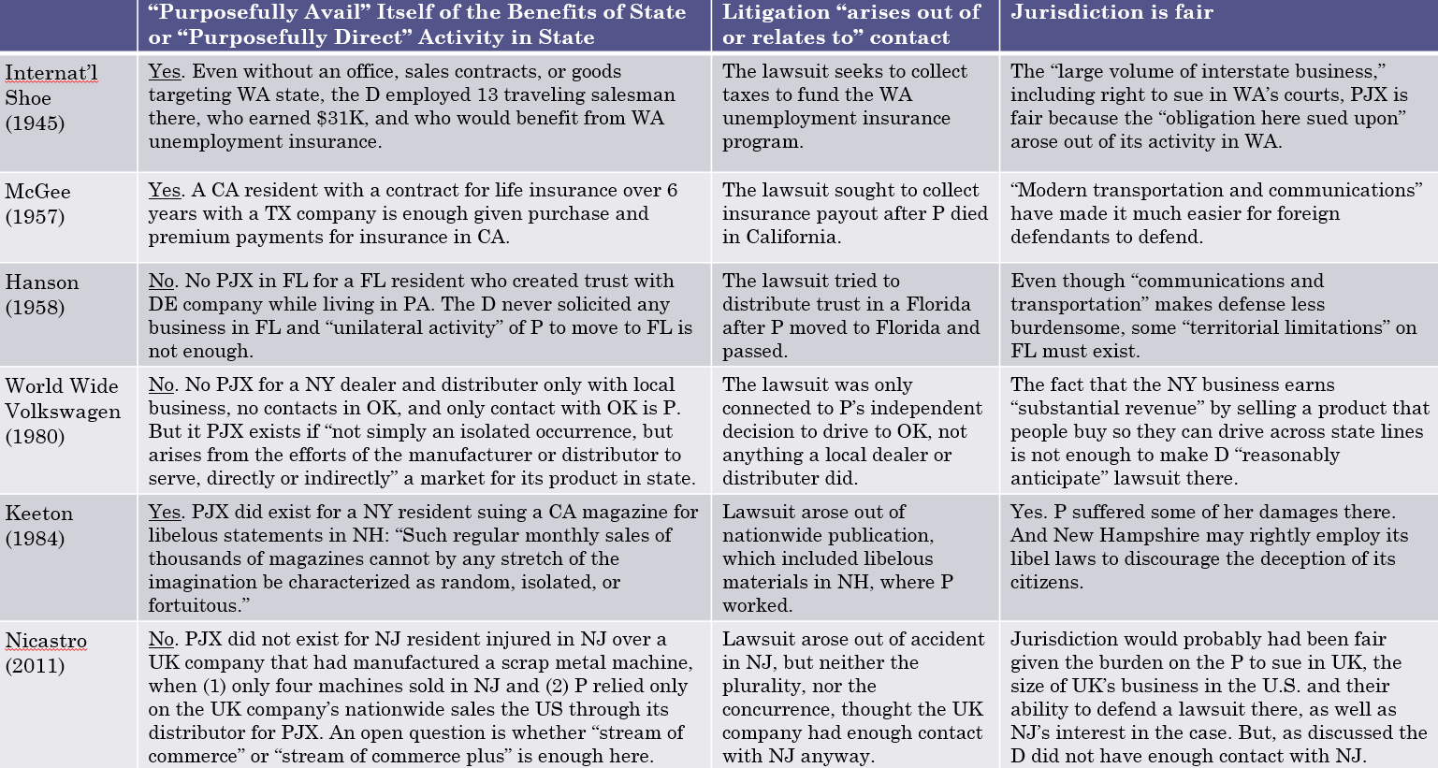
        - Stream of commerce “The forum State does not exceed its powers under the Due Process Clause if it asserts personal jurisdiction over-- a corporation -- that delivers its products into the stream of commerce -- with the expectation that they will be purchased by consumers in the forum State.”
          - Forseeability Test (Justice Brennan) Stream of commerce: Placing a product in the stream of commerce satisfies jurisdiction if the defendant is aware the final product is marketed to forum state and lawsuit unsurprising.
          - Purposefully directed test (stream of commerce plus) (Justice O’ Connor): Must be more than placing product in the stream of commerce, but also some evidence the manufacturer “purposefully directed” item into state.
            - Ex: Holds US Patents and promises service wherever customers are based.
            - Markets at largest US scrap metal conventions because “single most comprehensive” site to do it.
            - Agents meet with P’s employer at trade shows.
            - Worked closely with American distributor to promote products in trade journals, conventions and demo sites.
          - Gray v American Radiator - Can the OH valve maker, be sued in IL, even though it never sold its product to IL, because it knew it would be incorporated in a radiator sold there? Answer: Yes! Stream of commerce
        - WEBSITE Interactivity and Personal Jurisdiction
          - Zippo Test - “The exercise of jurisdiction is determined by examining the level of interactivity and commercial nature of the exchange of information that occurs on the Web site.”
            - Passive Site (Less contact) - Defendant has simply posted information on an Internet Web site which is accessible to users in” forum
            - Interactive Site (middle) - Web sites where a user [in the forum] can exchange information with the host computer
            - Sales site (most contact) - A defendant clearly does business over the Internet [if it] enters into contracts with residents of a foreign jurisdiction [through the website].
          - Effects test - Where, as here, a case sounds in tort, we employ the purposeful direction test. The test, often referred to as the “effects” test, derives from Calder v. Jones (1984). The defendant must have
            - committed an intentional act,
            - expressly aimed at the forum state,
            - causing harm that the defendant knows is likely to be suffered in the forum state.”
            - Axiom Foods, Inc. v. Acerchem Int'l, Inc., 874 F.3d 1064 (9th Cir. 2017)
          - Abdouch v Lopez – show defendant purposefully availed:
            - Zippo Test: JURISDICTION failed: Although interactive, only made 2 sales, or $614 out of $3.9 million in total sales over website unrelated to claim. Beyond that, contacts with Nebraska “non-existent.”
            - Effects Test: JURISDICTION failed: Although interactive, only made 2 sales, or $614 out of $3.9 million in total sales over website unrelated to claim. Beyond that, contacts with Nebraska “non-existent.”
        - RELATEDNESS: Bristol Meyers Squibb v Superior Court - In a mass action, Supreme Court held CA courts could not exercise “specific” personal jurisdiction over non-residents based on defendant’s substantial contacts with CA.
          - The fact that CA plaintiffs “were prescribed, obtained, and ingested Plavix in California–and allegedly sustained the same injuries as did the nonresidents–does not allow the State to assert specific jurisdiction over” nonresidents from Utah.
        - RELATEDNESS: Ford Motor Corp v Eight Judicial Dist: By every means imaginable—among them, billboards, TV and radio spots, print ads, and direct mail—Ford urges Montanans and Minnesotans to buy its vehicles, including (at all relevant times) Explorers and Crown Victorias. . . . [A]part from sales, Ford works hard to foster ongoing connections to its cars’ owners. The company’s dealers in Montana and Minnesota (as elsewhere) regularly maintain and repair Ford cars, including those whose warranties have long since expired. And the company distributes replacement parts both to its own dealers and to independent auto shops in the two States. Those activities, too, make Ford money. And by making it easier to own a Ford, they encourage Montanans and Minnesotans to become lifelong Ford drivers.”
          - In other words, [1] Ford had systematically served a market [2] in Montana and Minnesota for the very vehicles that the plaintiffs allege malfunctioned and [3] injured them in those States.
        - REASONABLENESS: Worldwide VW, Burger King and Asahi
    - Long Arm Statutes & Personal Jurisdiction– consider before constitution
      - Does the state forum’s law (long arm statute) assert PJ over the defendant? (If no, forum does not assert PJ, dismissed. If yes move to next)
      - Does the forum’s assertion of PJ in this case satisfy the constitutional due process clause? (If no, PJ is unconstitutional, case dismissed. If yes PJ ok)
      - CHECKLIST:
        - Is Personal Jurisdiction Consistent with the State Long Arm Statute?
        - Is Personal Jurisdiction Consistent with Due Process?
          - Is there general jurisdiction or consent?
            - For general jurisdiction, remember is the Defendant “essentially at home”?
            - Parties can always consent, but contracts will always be reviewed for “fundamental fairness” to ensure no fraud or bad faith.
          - Is there specific jurisdiction?
            - The defendant has “purposefully availed” itself of the benefits of the market in the forum state (i.e., has “minimum contacts” with the state).
            - The plaintiff’s claims “arise out of or relate” to the defendant’s contacts with the forum state; and
            - It is not otherwise unfair or unreasonable to exert jurisdiction, taking into account the D, P, forum, and other states’ shared interests in relief.
      - CA Long Arm Statute: Constitutional Maximum: A court of this state may exercise jurisdiction on any basis not inconsistent with the Constitution of this state or of the United States.
        - Constitutionally Permissible PJ Over Non-Present, Non-Consenting, Non-Residents
      - DC Long Arm Statute: Enumerated acts
        - Carry on business in state
        - Cause injury in state through acts outside of state while regularly doing business w/in state
        - Commit tort on state
        - Fail to perform contractually required acts in state
        - Own mortgage on property in state
      - Gibbons v Brown (FL) : Statute: “A Defendant who is engaged in substantial and not isolated activity within this state, whether such activity is wholly intrastate, interstate or otherwise, is subject to the jurisdiction of the courts of this state, whether or not the claim arises from that activity.”
  - Venue - Geographical Location. With a multi-court system is this the right court LOCATION. Which court location (within sovereign).
    - Venue In General: A Civil action may be brought in
      - A Judicial district in which any defendant resides
        - If all defendants are residents of the state in which the district is located
OR
      - A judicial district in which
        - A substantial part of the events or omissions giving rise to the claim occurred/A substantial part of the property that is subject of the action is situated
          - Giving Rise” Consider only events that “directly give rise to a claim” Thompson v. Greyhound
          - “A Substantial Part” - In this statute, “substantial” means “not insubstantial” “The district in which the plaintiff brings suit need not be the district where the most substantial portion of the relevant events occurred, but the plaintiff must show that a substantial part of the events or omissions giving rise to the claim occurred in that district.”
OR
      - If there is no district in which an action may otherwise be brought as provided in this section, any judicial district in which any defendant is subject to the courts personal jurisdiction with respect to such action
    - Same as above described differently: Can assert in 3 ways:
      - We look at where all the parties live. 1391(b)(1). In the federal statute, we look only at the defendants. Ordinary people live where they’re domiciled. For corporate plaintiffs, it’s where their principle place of business is (HQ). For corporate defendants, it’s where you can assert personal jurisdiction. 1391(c)(2).
      - We look at where a “substantial part” of events occurred. 1391(b)(2).
      - Finally, there is a “catch-all provision.” 1391(b)(3). It ensures that there will always be somewhere that is a proper venue, wherever there is personal jurisdiction, if the other two aren’t available.
    - Thompson v Greyhound Bus - Plaintiff gets a one way ticket from Florida to Mississippi. The bus stops in AL, informs him he needs to transfer in Jackson, MI, but never wakes him up. Plaintiff (AR) sues Greyhound Lines (TX), Colonial Trailways (AL), and Reeves (FL)
    - Residency defined:
      - A natural person including someone lawfully admitted for permanent residency resides in the judicial district they are domiciled
      - Entity whether or not incorporated shall be deemed to reside if a defendant in any judicial district where they are subject to courts personal jurisdiction and if a plaintiff only the judicial district in which it maintains its principal place of business.
      - A defendant not resident in US may be sued in any judicial district and joinder of defendant shall be disregarded in determining where the action may be brought with respect to other defendants
    - Venue: Transfer
      - Within a court system – transferee court MUST accept control of the case
      - No direct Transfer between Nations
      - No direct Transfer between States
    - Venue: Dismissal for Forum Non Conveniens
      - Court dismisses case using forum non conveniens
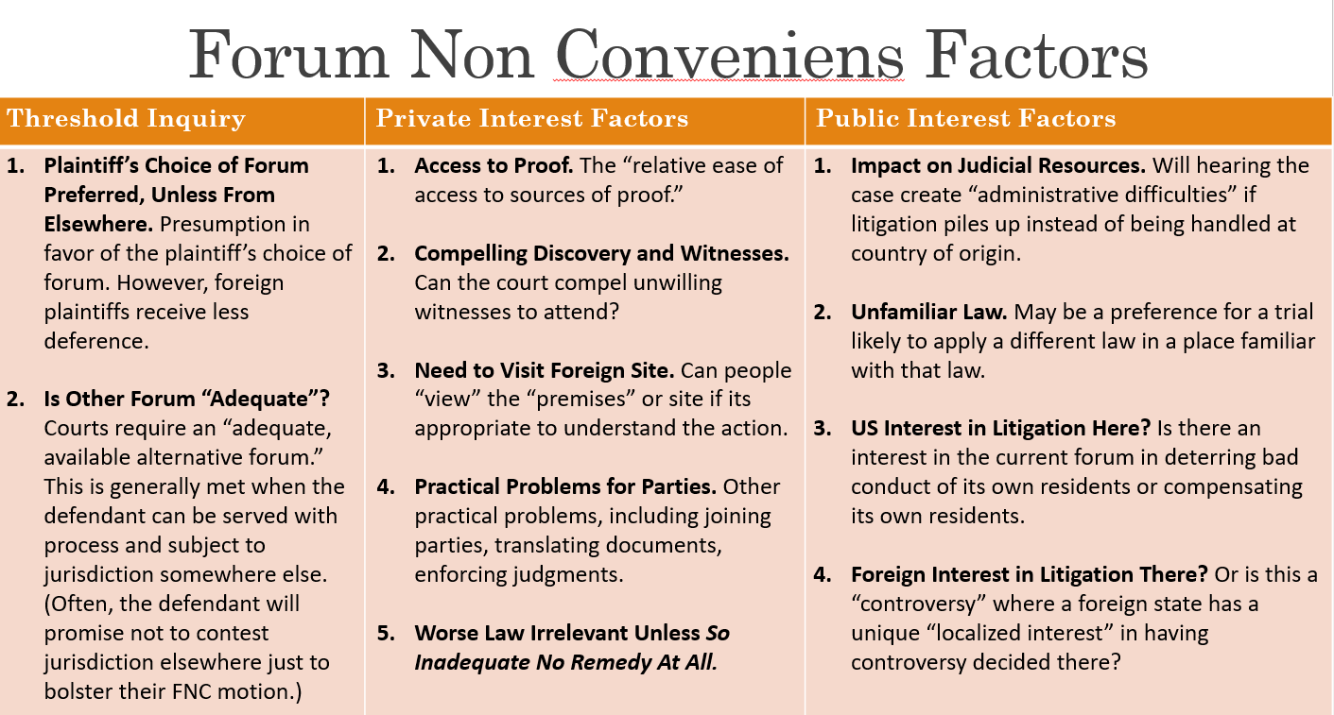
      - Plaintiff is allowed to refile in different court system
    - Piper Aztec
      - Threshold: Plaintiff choice of forum is typically preferred, especially for US citizens because it is more convenient for them to sue in US Courts. But that’s not true for foreign citizens, who have to travel far away from an accident just to sue here. Defendants consented to jurisdiction in Scotland. Moreover, even though change of law could hurt plaintiffs, it was wrong to reject a FNC motion only on these grounds. A less favorable law should not be given “substantial weight” because (a) it will make FNC motions really tough to bring—plaintiffs are always hoping to sue where the law will advantage them and (b) it will lead to more suits in the United States, which is more favorable to litigants. Worse law only relevant if so inadequate no remedy at all.
      - Private Interest The private interests technically point in both directions because the plaintiffs hope to get some records from the propeller and plane manufacturer in the US, including the design and testing info. But a large proportion of other relevant data existed in Great Britain, including: (1) hanger full of the old plane parts was in UK, (2) crash site on land in UK, and (3) joinder of UK pilots and company crucial to manufacturer’s defense of pilot error.
      - Public Interest: The Court concluded that the use of some foreign law, Scottish law, favored dismissal and litigation in a forum more familiar with Scottish law. The Court highlighted that the US interests in incrementally improving safety of this one, small airliner was “insignificant” and did not warrant “judicial time and resources” to try case here.The Court also highlighted Scotland’s strong interest in hearing a dispute where all potential plaintiffs and defendants are from the UK and where the accident occurred in its airspace.
    - Key Forum Non Conveniens Questions
      - Is the plaintiffs’ choice of forum entitled to more or less deference than the Scottish plaintiffs' choice in Piper?
      - Are the foreign courts a viable “alternative forum” to hear the case, like the Scottish courts were in Piper?
      - Do the private and public interest factors in Piper—including proof, getting relevant witnesses and parties, and each courts interests in resolving the dispute—make the foreign or domestic forum a better place to litigate?
  - Subject Matter Jurisdiction– power over subject matter. Can this kind of court issue orders in this TYPE OF DISPUTE. Which type of court.
    - Courts of Limited (subject matter) Jurisdiction – may only hear cases on particular topics:
      - Ex: Traffic, juvenile, small claims, divorce, probate, tax
    - Courts of General (subject matter) jurisdiction may hear any cases not exclusively assigned to a specialized court

    - FEDERAL Court has 9 subject matters – congress may authorize federal courts to hear cases on these matters but no others
        - Federal Questions
        - Ambassadors
        - Admiralty
        - USA as a party
        - State v State
        - Citizens of different stares
        - Competing claims to state land grants
        - Citizens v aliens
        - State v citizen of other state
    - Exclusive v Concurrent subject matter jurisdiction
      - Exclusive Federal – congress authorizes suits that may ONLY proceed in federal court
        - Antitrust, bankruptcy, copyright, patent
      - Concurrent – congress authorizes suits in federal court but allows them in state
        - Most federal law claims, state law claims where parties are diverse
      - Exclusive state – congress does not authorize suits in federal court
        - suits not based on federal statutes and where parties are not diverse
    - FEDERAL QUESTION JURISDICTION - The [US] district courts shall have original jurisdiction of all civil actions arising under the Constitution, laws, or treaties of the United States.
      - A case “arises under” the laws of the United States—and thus presents a federal question—if
        - Under the well-pleaded complaint rule, federal law must creates plaintiff’s entitlement to a remedy, not just a defense.
          - A well pleaded complaint: Describes a claim where the plaintiff’s entitlement to relief is created by federal law and Does not rely on federal questions that would arise only as defenses
        - In rare cases, a federal “ingredient” to a state law claim will suffice when it: (a) necessarily raises a federal issue, (b) that is actually disputed and substantial, and (c) a federal court can hear without upsetting Congressionally approved balance between federal and state courts.
          - bringing a state tort suit that alleges someone violated a federal statute or regulation isn’t usually enough because state courts hear state law tort cases all the time, the lawsuit won’t make it harder for federal agents to enforce federal law, and there’s eventually Supreme Court review of state courts anyway. But a state lawsuit that requires the federal gov’t to do its job differently (like an IRS foreclosure sale) can.
      - Louisville & Nashville RR v Mottley – 1871 L&N gives Motley free passenger passes for life. 1906 Federal statute comes into effect that says no railroad shall directly or indirectly give any interstate free tickets. Mottley sues for breach of K
    - Strategy: Why it matters:
      - Jury pool, xfer between federal courts, judicial expertise, preferred procedures in federal courts, neutral forum, greater resources in federal court, elected vs non elected judges, delay, politics

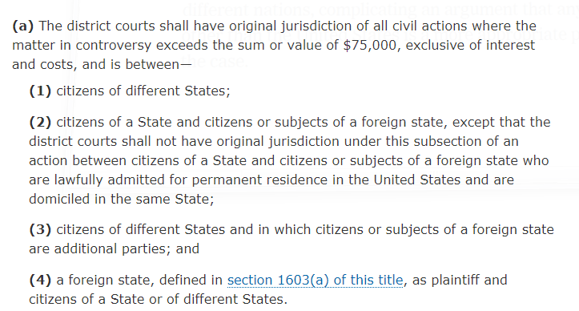
    - DIVERSITY JURISDICTION (1332)
      - Exception: The Supreme Court has held that the existing diversity statute does not to authorize federal court SMJ over the following types of suits – EVEN IF the parties are completely diverse and the amount in controversy is met.
        - Domestic Relations
        - Divorce
        - Probate
      - Checklist for Diversity Jurisdiction (a)
        - Diversity of Citizenship (With few exceptions parties must be “completely diverse.” That means that no plaintiff and defendant can be from the same state.)
          - Determining the parties’ citizenship
            - Natural persons (need evidence of current residents and intent to stay there)
              - To be a “citizen of a [US] State” under §1332, a natural person must be:
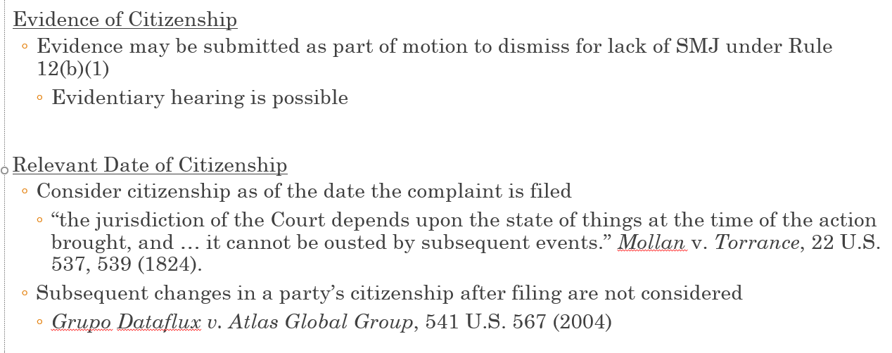
                - a United States citizen who is “domiciled” in a [US] State
A natural person has only one domicile at a time
Initial US domicile = State where born or naturalized
Domicile changes upon:
Physical presence in another jurisdiction
[US or foreign]; plus Intent to remain there indefinitely
            - Corporations (citizens of 2 places: state of inc and principal place of business)
              - a corporation shall be deemed to be a citizen of every State and foreign state by which it has been incorporated and of the State or foreign state where it has its principal place of business
              - Corporations are citizens of up to 2 states (incorporation and principal place of business)
            - Unincorporated entities (citizen of every state in which its members are citizens.)
              - Partnership
              - LLP or LLC
              - Membership Organization
              - Labor Union
              - Condo Association
              - Other Non-Corporate Entities
          - With few exceptions parties must be “completely diverse.” How to identify an eligible combination of parties
        - Amount in Controversy
          - Must Be More Than $75,000
          - You can aggregate amounts from different claims by one person against same person, but not by or against different people to reach that amount (unless it’s a joint theory of liability by or against them).
            - If it’s just one plaintiff and one defendant, you can still add up totally unrelated claims to meet the amount in controversy requirement
            - Different people - Joint Liability: Δ¹ & Δ² acted together (snap chat negligently encouraged someone to drive negligently, claim against person and snap = over 75k)

    - SUPPLEMENTAL JURISDICTION - The entire action before the court comprises but one constitutional ‘case’ [when the state and federal claims] derive from a common nucleus of operative fact”
        - Supplemental SMJ is allowed over factually related claims, subject to the limitations in (b) and (c)
        - Exceptions involving joinder of multiple parties where the plaintiff’s original claim relies solely on diversity statute
        - Discretion to decline supplemental SMJ
Said another way:
        - A. Except as in B & C, court “shall have” supplemental SMJ over claims that are part of the same case/controversy as the anchor claim
        - B. Court “shall not have” supplemental SMJ over some claims identified in A
          - Relevant when plaintiffs join multiple parties to a diversity-only original claim
        - C. Court “may decline” supplemental SMJ if
          - (1) the claim raises a novel or complex issue of State law,
            - Factors to consider:
              - Does the state law claim seem hard to decide?
              - Have the courts of State X decided similar cases before?
              - Is the case law from State X inconsistent or confused?
              - Is this case distinguishable from prior State X cases?
              - If the case involves a state statute, is it new? Unambiguous? Previously interpreted in case law? Modeled on other state statutes with case law?
              - Would the state be harmed if a federal court were to decide this state law question incorrectly?
              - Would this combination of state and federal claims cause confusion for a jury?
          - (2) the claim substantially predominates over the claim or claims over which the district court has original jurisdiction (tail wagging the dog)
            - Factors to consider:
              - Number of supplemental claims
              - Amount of damages associated with each claim
              - Trial time needed for each claim
              - Discovery needed for each claim
              - Logical and factual relationship between the claims
          - (3) the district court has dismissed all claims over which it has original jurisdiction, or
          - (4) in exceptional circumstances, there are other compelling reasons for declining jurisdiction.”
      - Checklist for Supplemental SMJ
        - Does at least one of the filed claims have SMJ?
          - Does it “arise under” federal law?
          - Is there “complete diversity” and involve claims over $75K?
        - Are claims so related they form part of the same case or controversy?
        - Is it a diversity claim by a plaintiff against a party joined under Rules 14 (impleader), 19 (necessity), 20 (joinder), or 24 (intervention)? (Or necessary party/intervener)?
        - Are there discretionary reasons to dismiss?
          - Novel or complex state law issues
          - State law claims predominate
          - District Court dismissed all the original federal claims
          - Other exceptional, “compelling reasons”
          - In re Ameriquest
          - Szendry-Ramos v First Bancorp
    - REMOVAL to Federal Court – Defendant Δ may “remove” a case from state trial court that could have been originally filed in federal trial court. If case is improperly removed, it must be “remanded” back to state trial court
      - RULE: An action filed in state court may be removed if it could have been filed in federal court.
        - In-State Defendant Exception
        - Timing of Removal
          - Federal Question:
            - (b)(1): Within 30 days of receipt of an initial pleading (i.e., complaint); OR
            - (b)(3): Within 30 days of receipt of document making a previously unremovable case removable
          - Diversity:
            - (b): Same 30 day periods under (b)(1) and (b)(3), EXCEPT
            - (c)(1): removal under (b)(3) cannot be later than one year after commencement of the action (unless π delayed in bad faith)
        - Timing of Remand Motions
          - Federal SMJ – any time
          - Remand for non SMJ
            - Within 30 days of removal.
            - Examples of non-SMJ reasons to remand:
              - Not all properly joined & served Δs consented to removal
              - §1441(a) & §1446(b)(2)(A)
              - Removal violated in-state defendant rule
              - §1441(b)(2)
              - Δs waited too long to remove
              - §1446(b), (c)
- Due Process
  - No person shall be deprived of life, liberty, property without due process. (private interest).
    - Liberty, for example, is not merely freedom from jail, but also can include "the right of the individual to contract," "to engage in any of the common occupations of life," "to acquire useful knowledge," "to marry, establish a home and bring up children, to worship God according to the dictates of his own conscience," and "generally to enjoy those privileges long recognized at common law as essential to the orderly pursuit of happiness by free men."
    - Property (Goldberg v. Kelly) isn't just tangible stuff; it can represent any "legitimate claim of entitlement" the government creates for you—whether it's a license to practice, a pension, airwaves granted to television stations, or government benefits
  - Test for due process
    - the private interests impacted by the official action;
    - the risk you will be "erroneously deprived" of those interests, and the "probable value" if any, of additional procedural safeguards;
    - the Government's interest, including the costs that the additional or substitute procedures would entail.
  - Goldberg v Kelly – Welfare Case – Focuses on private interest. welfare provides means for food, clothing, housing. Unable to pursue remedy if he can’t feed himself. Risk of error – needs notice, personally appear, may not be able to communicate properly in writing. Government interest – same gov’t interests that counsel the provision of welfare – states can also save money by having better process.
    - Private interest – Welfare provides mean for food, clothing, housing. Need to concentrate is affected by sustenance. Adversely affects his ability to seek redress.
    - Risk of Error – consulting a social worker isn’t enough. People need notice, explanation, personally appear, present evidence, confront witnesses, argue, assess credibility of witnesses.
    - Gov’t Interest – same governmental interests that counsel the provision of welfare counsel its uninterrupted provision. States can save money by developing procedures for prompt termination hearings.
  - Matthews v Eldridge – disability benefits Held due process was followed. Different then Goldberg. After Eldridge, Courts consider what process is due, under a three-part test: (1) What is the nature of protected interest? (year long waits impose hardship but not as bad as welfare) (2) What is the chance of error under the old process in comparison to the new one? (Consulting social worker etc was enough, and reports are mainly based on Dr reports) (3) What is the governments interests in the existing scheme? (burden of incremental cost of hearings too high)
    - Private interest – year long delays can impose hardship but not as bad as welfare
    - Risk of error – consulting w social workers, access to info and written submissions are enough. Decision to stop benefits here turn upon routine medical reports by unbiased Drs.
    - Gov’t interest – incremental cost is a burden for increased hearings and the expense of providing benefits while waiting for decision.
        - As a result, many cases, rarely receive a full evidentiary hearing before crucial governmental decision. But there are some exceptions
          - Exception for Opportunities to “Consult.” Even though no full evidentiary hearing is required, courts appear to require some opportunity for notice and an opportunity to respond.
            - Before suspension from school
            - May also receive full hearing before permanent deprivations–like permanent loss of child custody.
          - Emergency Exception to Exception. For over a century, however, the court has also held that a hearing may be delayed when the rules are specifically tailored to an “emergency.”
      - Latif v Holder (2014) – No fly list
        - Holding: The procedures afforded to Plaintiffs through the DHS process are wholly ineffective and, therefore, fall short of the "elementary and fundamental requirement of due process" to be afforded "notice reasonably calculated, under all the circumstances, to apprise interested parties of the pendency of the action and afford them an opportunity to present objections.
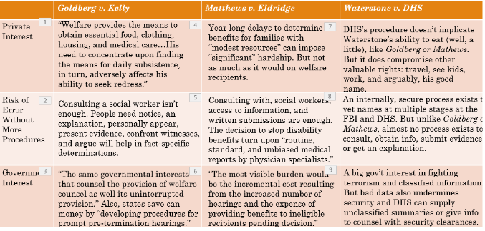
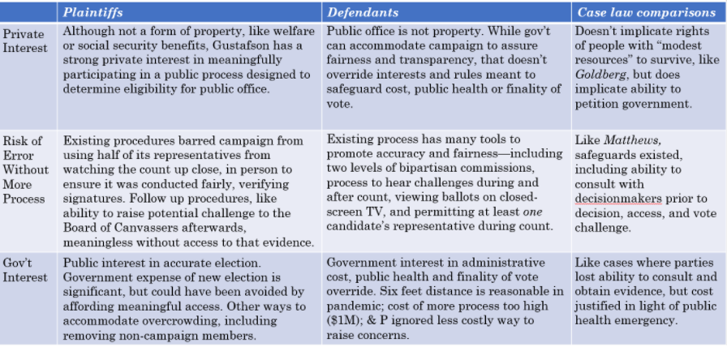

- Preliminary Remedies
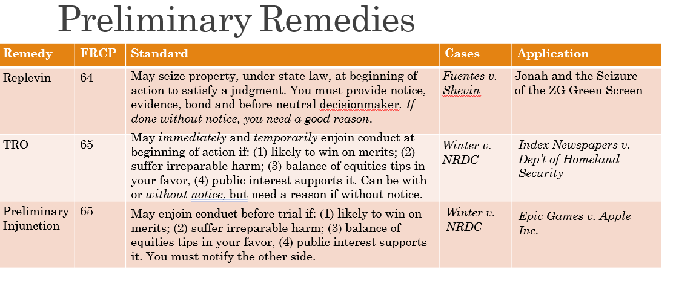

  - Replevin
    - Rule 64 – May seize property, under state law, at beginning of action to satisfy a judgment. You must provide notice, evidence, bond and before neutral decisionmaker. If done without notice, you need a good reason
      - you’re entitled to rely on all the kinds of state remedies, like replevin, “at the commencement” of case to secure “satisfaction of a potential judgment” at the end of a trial.
    - Case: Fuentes v Shevin – Firestone seized the stove without warning, violated due process.
    - Application: Jonah and Seizure of ZG green screen
    - Some exceptions apply – think domestic violence cases, cases where notice will cause goods to be destroyed, pulling bad products off shelves.
  - Rule 65 (TRO and Preliminary Injunctions) - allows you to get a temporary restraining order or a preliminary injunction—an order that someone stop doing something or change their behavior before trial.
    - preliminary injunctions typically take a little bit of time to do, often at least a week or two before they can be heard. Can last through the end of a trial on the merits.
      - Rule from Winters:
        - he or she is likely to succeed on the merits;
        - he or she is likely to suffer irreparable harm in the absence of preliminary relief;
        - the balance of equities tips in his or her favor;
        - that an injunction is in the public interest.
    - Temporary restraining orders, by contrast, can be heard immediately and are reserved for emergencies. Unlike a preliminary injunction, in some cases you may be able to get a temporary restraining order without notice. In such a case, you have to show not only that you will suffer immediate harm, but you have a good reason not to inform the other side. Third, temporary restraining orders are, as the name suggests, only “temporary.” They can last for no more than 14 days, unless the court extends it. And they can be dissolved in as little as two.
        - Issuing without notice: the court may issue a TRO without written or oral notice to the adverse party or its attorney only if:
          - Specific acts in the affidavit or a verified complaint clearly show immediate and irreparable injury, loss, or damage will result to the movant before the adverse party can be heard in opposition AND
          - The movants attorney certifies that any efforts made to give notice and the reasons why it should not be required.
    - Winter v NRDC (navy, sealife)– standard for obtaining an injunction.
        - Merits: Deference to “complex subtle and professional” decisions of military may mean a narrowly tailored injunction towards producing an environmental report even if plaintiff won on merits.
        - Harm: court doesn’t question importance but thinks they can be accommodated with a narrower injunction
        - Equities: although speculative, balance favored Navy given their judgements on it reducing military effectiveness
        - Public interest: strong public interest in effective training of navy.
  - Index Newspapers v Portland
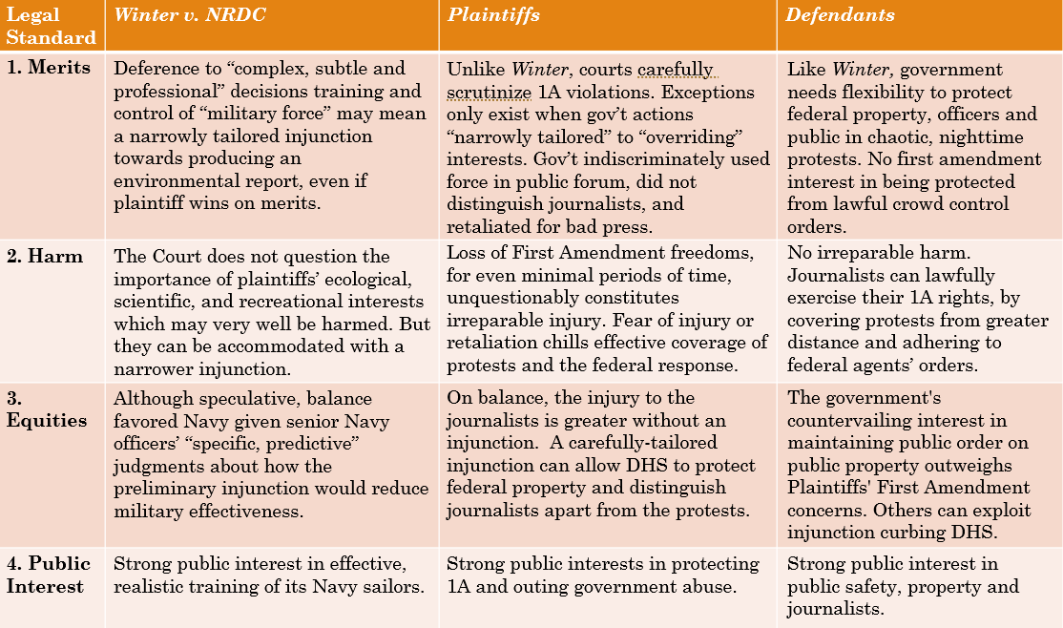
    - (journalists covering protests in Portland, claim assault by federal agents, violation of first amendment). Want a TRO to stop officers from seizing their items, using force etc. Ultimately judge issued injunction – then another judge panel stopped it.

  - Epic v Apple (sample)
    - Epic wants to stay in Apple’s store – risk losing customers, reputation, people not having access to social game during pandemic
  - Permanent Injunctions– these come after a trial.

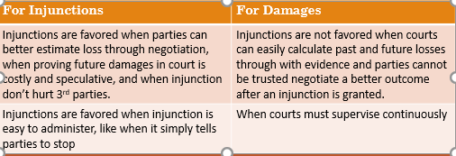

      - To obtain, must show other forms of relief are inadequate (like money). Kind of like TRO – show more than just harm.
      - Ex: money isn’t enough: child separation, constitutional rights, destruction of endangered, buying selling house
      - Ex: money is enough – personal injury, contracts, libel
      - Lucy Webb v Geoghegan (patient no longer needs hospital care – damages would be inadequate – needs man out of hospital not just money)
      - Walgreens v Sara Creek – Walgreens tries to stop Sara Creek from allowing other drug store in mall.
    - Permanent versus Preliminary
      - Preliminary injunctions come before trial. So, they require a party show (1)a likelihood of success on the merits, and (2) irreparable harm if the injunction isn’t granted before trial.
      - Permanent injunctions come after a trial. So, if you (1) win on the merits, you need to show that (2) money damages will not adequately provide you with relief.
      - Legal relief is “inadequate” for harm that is difficult for a court to value, including loss of family, constitutional violations, real estate or harms third parties or broader public interests.
      - Courts may take into account other considerations in determining whether damages are inadequate, including speculative nature of damages, impact on third parties, and whether parties may be able to negotiate a better result with an injunction than what a court can provide with damages
  - Contempt
    - An injunction... must be obeyed.., however erroneous the action of the court may be, even if the error be in the assumption of the validity of a seeming but void law going to the merits of the case." a person who disobeys a court order, even one that relies on a unconstitutional law, cannot challenge the lawfulness of that order as a defense to criminal contempt.
    - Walker v Birmingham (Protestors applied for a permit to march but were denied. Planned to march anyway. City obtained injunction to stop March before King’s speech.)
      - According to the Court, the City obtained an injunction at 1:00 a.m. before King’s march on Good Friday, without prior notice or an opportunity to respond. Did that violate Due Process under Fuentes v. Shevin?
      - Martin Luther King could not subsequently challenge the merits of an ex parte injunction, delivered in the dead of night, based on a law that likely violated the First Amendment.
      - City of Birmingham court did recognize two exceptions to its rule. First, the court suggested that "a different result would follow were the question of jurisdiction frivolous and not substantial." Second, the Supreme Court stated that "[t]his case would arise in quite a different constitutional posture if the petitioners, before disobeying the injunction, had challenged it in the Alabama courts, and had been met with delay or frustration of their constitutional claims."
- Choice of Forum
  - Personal Jurisdiction
      - The parties usually must have some connection to the location of the court. If so, the court is said to have “personal jurisdiction” over those parties.
      - A court can hear a case if the state where it is located has some connection to the (a) defendant or (b) the event that gave rise to the claim.
      - First, you can sue where Defendant is essentially “at home.” This is called “General Jurisdiction.”
      - Second, you can sue where the Defendant (1) made “minimum contacts” with the state, (2) the claim arose out of or related to those contacts, and (3) hearing the dispute there is “reasonable.” This is called “Specific Jurisdiction.”
  - Subject Matter Jurisdiction
      - Most state courts can hear all kinds of claims, but federal courts are limited to certain “subjects.” “Subject matter jurisdiction” refers to the kinds of subjects courts can hear and whether you can sue in federal court.
      - Federal courts can hear cases between people from different states, when the lawsuit involves more than $75,000. This is called “diversity jurisdiction.”
      - Federal Question Jurisdiction: Federal courts can also hear cases that arise under federal law—like the Constitution or a federal statute.
- Pleadings
  - Rule 8 – pleading must contain
    - Short and plain statement of the claim showing that the pleader is entitled to relief
    - Claim must be legally sufficient ie supported by the law
      - Example: Haddle v. Garrison – at will employee, claim for dismissal. By legal sufficiency, we mean this: Assume all the facts are true. If so, and not entitled to relief, dismiss.
    - That also means the claim must be factually sufficient. The Supreme Court has said this means complaints cannot only express legal conclusions, but must be supported by facts. Facts need to be more than theoretically “possible,” but at least “plausible”
      - Conley v Gibson railroad fired 45 black employees. Union doesn’t do anything. Employees sue union. Holding: A complaint should not be dismissed for failure to state a claim unless it appears beyond doubt that the plaintiff can prove no set of facts in support of his claim which would entitle him to relief.”“The decisive answer to this is that the Federal Rules of Civil Procedure do not require a claimant to set out in detail the facts upon which he bases his claim. All the Rules require is ‘a short and plain statement of the claim’ that will give the defendant fair notice of what the plaintiff's claim is and the grounds upon which it rests.” Superseded by Iqbal.
      - Ashcroft v Iqbal – 3000 muslim men imprisoned after 9/11 and treated very poorly. The Court singles out several allegations, and finds they are not sufficient to support a complaint. The Court says two principles govern how a complaint “states a claim that is plausible on its face: Must be more than a legal conclusion: “First, the tenet that a court must accept as true all of the allegations contained in a complaint is inapplicable to legal conclusions. Threadbare recitals of the elements of a cause of action, supported by mere conclusory statements, do not suffice.” Must be plausible and cannot have some other obv explanation.
      - Twombly – phone case – argued that there was a conspiracy between phone companies because they all had the same price, but a much more reasonable explanation is that they just all thought it was a good price.
      - Judd v Weinstein – had to show the relationship was likened to teacher landlord etc for sexual harassment. Describing his position of power was key – not just reciting the law.
      - Facts must “plausibly” support a claim: “When there are well-pleaded factual allegations, a court should assume their veracity and then determine whether they plausibly give rise to an entitlement to relief” or instead whether there is an “obvious alternative explanation.”
  - If plaintiff fails Rule 8, defendant could move to dismiss Rule 12(b)(6)
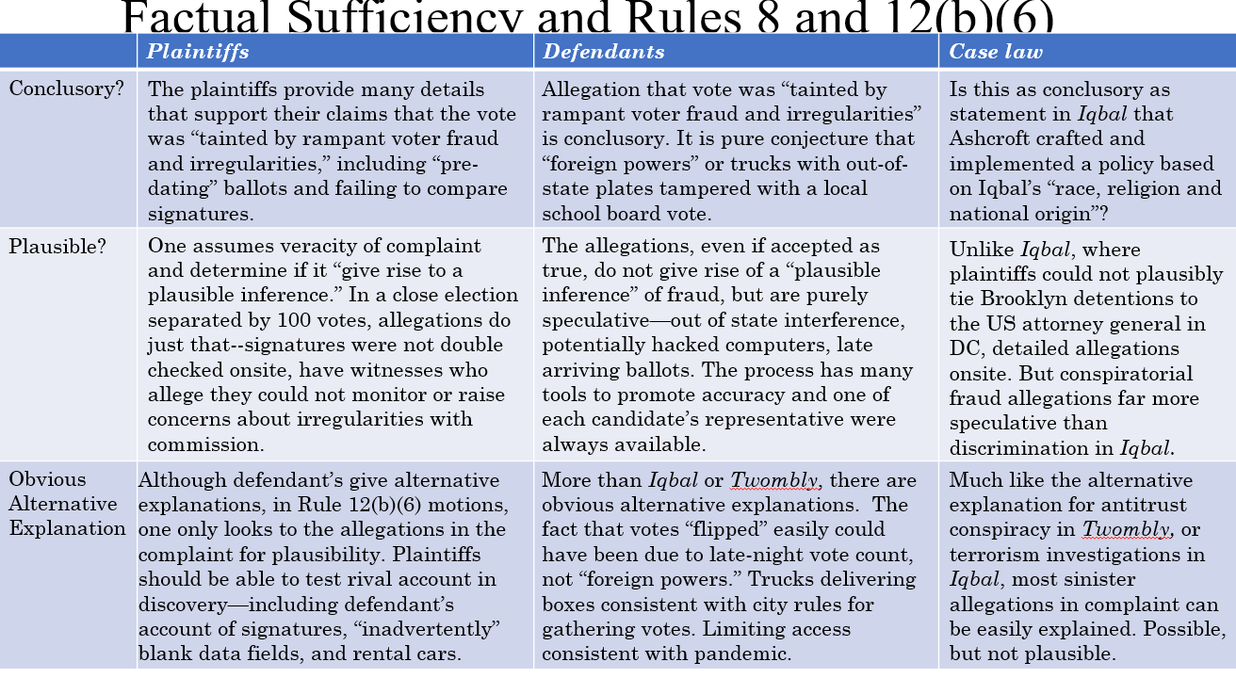

    - “[F]ailure to state a claim upon which relief can be granted.”
  - "proximate causation," I shouldn't be held legally responsible for the totally unforseeable, indirect and remote consequences of releasing a butterfly from my window.
  - Evolving standard reflects trade offs:
    - Screening out more weak claims sacrifices some good claims, particularly for unstated policies and practices unearthed in discovery
    - Gives judges more power to determine “plausible claims” to save costs takes power from juries to assess facts
    - Same tradeoffs between accuracy, efficiency, participation, and transparency
        - Notice Pleading: General Nature of the Suit (Less detail, General, Short)
        - Fact Pleading: Specify evidence proving liability: More detail, Specific, Long
        - Legal Sufficiency: Haddle v Garrison (can someone be fired from their job for cooperating in a gov’t investigation sue under 1985 civil rights act?) By legal sufficiency, we mean this: Assume all the facts are true. Does an injury to “person or property,” under the law of Section 1985, include losing your job?
        - Rule 8(d): Each allegation must be simple, concise, and direct. No technical form is required.
        - Rule 9(b): “Malice, intent, knowledge, and other conditions of a person's mind may be alleged generally.”
  - Amendment – you can amend in one of two ways before trial
    - (1)“As a Matter of Course” You can freely amend your complaint once. You can do it up to 21 days after you originally filed it. You also can do it up to 21 days after the defendant answers or moves to dismiss it under Rule 12. Rule 15(a)(1) .
    - (2)Permission from Parties or Court. In other cases, you need your permission from the Court or the opposing party. The court should freely give leave “when justice so requires.” Rule 15(a)(2). That usually means courts will consider whether changing the complaint: (1) prejudices the defendant, (2) took too long, (3) reflects bad faith or is (4) futile.
        - Rule 15(c) details some circumstances when you can add new claims or parties to your complaint—after the statute of limitations has run—so long as you filed your original complaint on time.
          - To Add Claims. 15(c) The claim or defense must arise out of the “conduct, transaction, or occurrence” set out in the original pleading, and be consistent with what justice requires. That usually means courts will consider whether new changes to the complaint: (1) prejudices the defendant, (2) took too long to do, (3) reflects bad faith or is (4) futile.
          - To Add or Change the Names of People. 15 (c) The parties must have (1) “notice” of the lawsuit and (2) known or should have known that the lawsuit would have been brought against them, but didn’t because of a mistake about their identity.
          - Moore (Look up)445
          - Bonerb (look up)446
- Motions/Answers
  - Motions
    - Motion to dismiss A motion to dismiss can put a stop to the case, right away, without requiring you answer the substance of the complaint at all.
    - 7 motions you can file before your answer:
      - lack of subject-matter jurisdiction;
        - You won’t lose 12(b)(1) if you don’t include it before your answer. Unlike every other ground, you can always contest whether or not a court has subject matter jurisdiction—even after trial for the first time on appeal! Rule 12(h)(3).
      - 12(b)(2) lack of personal jurisdiction;
        - You will lose 12(b)(2) if you don’t include it in your motion before your answer. You can waive your right to contest personal jurisdiction if you appear and don’t raise it before your answer. Rule 12.h.1.
      - improper venue;
      - insufficient process; (12(a)(1)(A) – 60 days
      - insufficient service of process;
      - 12(b)(6) failure to state a claim upon which relief can be granted;
        - You don’t lose 12(b)(6) if you don’t include it in your motion before your answer. You can move to dismiss for failing to state a claim even at trial. Rule 12(h)(2).
      - failure to join a necessary party
  - Answers – Rule 7 and 8 - The point of the answer isn’t to dismiss a case, but instead to narrow the issues that are in dispute (denials), raise any defenses or excuses for doing what you did (affirmative defenses), and give defendants an opportunity to lodge their own lawsuit against plaintiff (counterclaims).
    - Admit
    - Denial - Under Rule 8(b), you have to deny only those allegations you actually dispute, and anything you don’t deny, you admit. You technically can deny everything—using a “general denial”—but it has to be done in “good faith.”
      - Make clear, at the beginning, that anything you don’t specifically admit, you deny. Fed R. Civ. P. 8(b)(3).
      - you have a good faith obligation, when you answer, to admit what you know is true, deny what you think is false, and if you can’t do either, explain why you lack knowledge or information to do so. See Fed. R. Civ. P. 8(b)(5).
      - 8(b)(4): -
    - Affirmative Defense - Affirmative defenses are different from denials. With an affirmative defense, you are not responding to a specific allegation in a complaint. Instead, you are saying that, even assuming the plaintiffs can establish all the elements of their claim, you can show you have a legal excuse to avoid liability.
      - Examples of Affirmative Defenses
        - Contributory Negligence
        - Fraud
        - Consent or Contractual Release
        - Defamation: (must show)
          - That the factual statement is false,
          - That it was published or communicated to a third person,
          - That there is fault amounting to at least negligence, and
          - That some harm was caused to the person or entity.
    - Counterclaim - Counterclaims, unlike denials or defenses, don’t address allegations in the complaint. Instead, they are new claims that the defendant can (and sometimes must) raise against the plaintiff.
      - Rule 13 You don’t have to assert a counterclaim against a plaintiff, unless the claim arises out of the “same transaction and occurrence” that is the “subject matter of the opposing party’s claim.”
      - You can state as a counterclaim against an opposing party any claim that is not compulsory. R. 13(b).
  - Joining Claims
    - Liberal Joinder for Claims by Any Party (Rule 18)
      - “A party asserting a claim, counterclaim, crossclaim, or third-party claim may join, as independent or alternative claims, as many claims as it has against an opposing party.”
      - Federal Rules 13 and 18 allow Plaintiffs, Defendants and Third Parties brought in the lawsuit to liberally join lots of claims against people in a lawsuit. Only if counterclaims arise out of the same “transaction or occurrence” that is the subject of a lawsuit, must you bring them now or risk waiving them. Compulsory Counter claims
    - Joinder for Plaintiffs – (Rule 20) Plaintiffs can join together other plaintiffs or defendants when they assert: (dented box hypo)
      - any right to relief … arising out of the same transaction, occurrence, or series of transactions or occurrences; and *transaction hinges more on logical relationship then immediateness of connection
      - any question of law or fact common to all [plaintiffs or defendants] that will arise in the action.
      - Things to think about:
        - Same counterparty? We would probably need to know more than the fact it was just same delivery person. If he simply damaged four different boxes, it wouldn’t be same transaction (three different orders) or occurrence (three different accidents).
        - Same kind of lawsuit? The fact that all involve same legal violation is good, but not enough.
        - Same accident. All boxes damaged in the same truck or warehouse. That could work depending on facts.
        - Same inadequate handling procedures. A failure to stock boxes safely and appropriately.
        - Other system-wide policies, patterns or practices attributable to organization. Quotas, deadlines, penalties or other policies that encourage rushed deliveries.
      - Rule 21
      - Mosley v GM (plaintiffs allege Union discrimination)
        - African americans in hiring, promotion and firing, African americans and women not granted same relief, women not hired bc of gender. the court was willing to allow ten different plaintiffs to join together in a lawsuit for discrimination against General Motors. The Court held that, even though plaintiffs’ claims arose at different times, involved different theories and categories of discrimination, and alleged different injuries at the hands of GM and their union, they still all involved the same "discriminatory policy" at GM.
        - Temple v Synthes – NECESSARY PARTIES (A hospital and doctor are not necessary parties to the same litigation involving defective “plate and screw.” “Necessary” parties must be connected by shared property ownership, contract, or some other shared obligation under Rule 19.

      - A court may be more willing, for example, to join a case like this against GM for the purpose of efficiently promoting discovery, but choose to sever some of the cases once the case reaches trial. Factors a court may consider include: whether they can (1) efficiently managing a trial with everyone, (2) use common evidence and witnesses that advance the litigation, and (3) do so without prejudice to parties.
    - Joinder for Defendants: Rule 14 Defendants can join other parties who are, or who may be:
      - liable to them
      - for all or part of the claim against them.
      - Price v CTB (chicken coop and faulty nails)
        - Latco asserts implied agreement for ITW to indemnify for faulty nails.
      - When you implead another party under Rule 14, you're not saying “it wasn’t me, it’s someone else.” You’re saying “if it is me,” someone else must pay me for what I have to pay the plaintiff. An insurer is a good example.
    - Necessary parties When people are connected by property ownership, contract, or some other shared obligation, they may have to be joined under Rule 19.
        - (Rule 19) A person must be joined, if feasible, if the court cannot:
        - (a) “accord complete relief among existing parties” without that party or
        - (b) a party has an interest that cannot be protected without her or there is a “substantial risk” she will incur “double, multiple, or otherwise inconsistent obligations.”
      - Summit v Mallinckrodt (big pharma example)
    - Multi District Litigation (§1407) –
      - Civil Actions involving one or more common question of fact are pending in different districts.
      - Centralization is in convenience of parties and witnesses and will promote the just and efficient conduct of such actions
        - Parties may petition a panel of seven judges to centralize lots federal cases before a single judge raising “common questions of fact.
        - The transferee judge then hears all “pre-trial” motions, including discover, for all cases. When finished, that judge is supposed to send them back to the panel, which sends them back to where they came from. BUT once transferred cases rarely return to home district.
          - “[I]t is almost a point of honor among transferee judges acting pursuant to Section 1407(a) that cases so transferred shall be settled rather than sent back to their home courts for trial.” MDL judges “hang on to transferred cases to enhance the likelihood of settlement. Indeed, MDL practice actively encourages retention even of trial-ready cases in order to ‘encourage’ settlement.
      - MDL Notes
        - MDLs, although seemingly just a transfer provision, is a powerful tool to aggregate the largest numbers of cases in the federal docket, like a massive joinder or class.
        - Built on legal fiction that they will return to where originally filed.
        - But functionally, work like large class actions, often being dismissed or settled before a single judge, lead by a small group of attorneys.
        - But note how casually this important decision to centralize is made:
          - With very little information
          - Often more cooperative argument
          - Frequently the product of side deals agreeing to a particular judge
          - Almost unreviewable discretion about whether to centralize and where
      - Shoulder Pump Liability
      - Aviation Liability Litigation
      - Why or when do D’s and P’s favor or disfavor MDL
        - Defendants
          - Reduce overlapping discovery
          - To buy time
          - To cherry pick cases
          - One federal court’s decisions sets tone
          - But also lose control over which cases proceed, precedent set
        - Plaintiffs
          - More information about which cases proceeding and/or settling
          - Broaden opportunities for discovery
          - Filing strong and weak claims together
          - Effect on law and settlement
          - But some plaintiffs may be shut out
        - Standards Favoring Centralization
          - Is it relatively early in litigation?
          - Conserving resources for large numbers of cases
          - Overlapping discovery needs
          - Risk of conflicting judicial decisions
          - Common defect, design or problem across cases
          - Common defendant or type of defendant
          - Common legal claims
        - Standards Disfavoring:
          - Is it later in litigation or discovery process?
          - Different defendants or theories of liability
          - Different products or parties without overlapping claims
          - Can parties coordinate on their own
          - The boundary cases are when legal claims are common, different parties, but some factual overlap
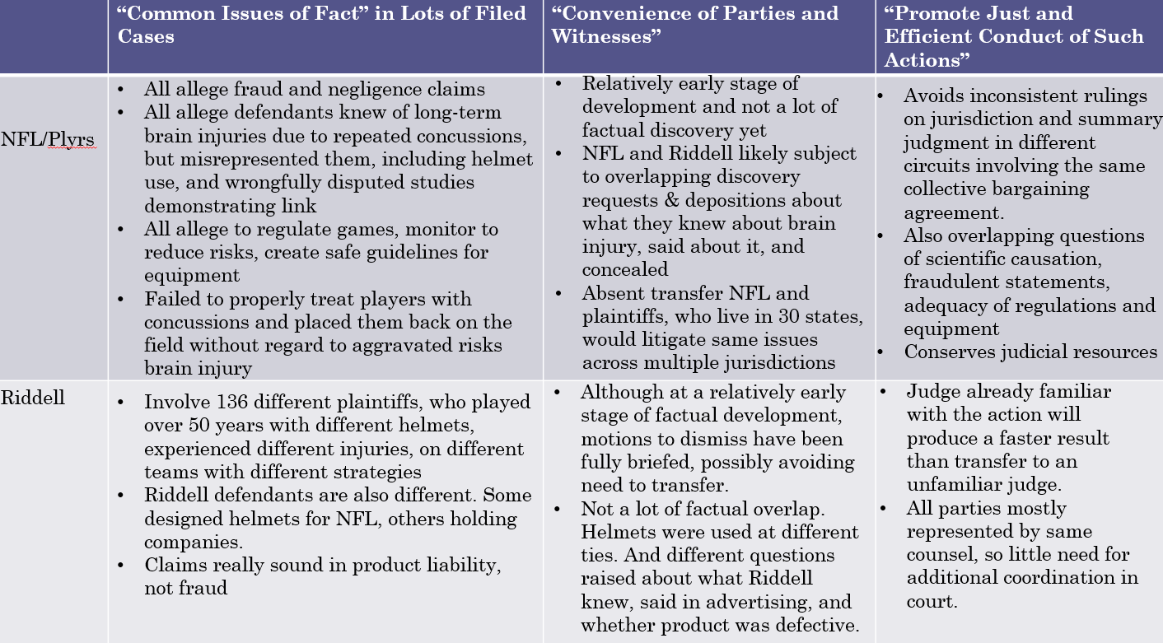
    - Class Actions – many plaintiffs, one defendant. Class representative named.
      - 23a Prerequisites
        - Is there a class?
          - (a)(1) Numerosity;
            - the class is so numerous that joinder of all members is impracticable”
            - Guidelines
              - No magic number exists; practicability of joinder will vary from case to case
              - 40 or more is usually numerous
              - 20 or fewer is usually not sufficiently numerous
and
          - (a)(2) Commonality
            - there are questions of law or fact common to the class”
            - Guidelines:
              - Class members must have suffered the same kind of injury (Compare Wal-mart and Tyson)
              - Sub-classes are possible
and
        - Is this a good representative?
          - (a)(3) Typicality;
            - the claims or defenses of the representative parties are typical of the claims or defenses of the class”
              - Class representative must
                - Have suffered injuries similar to the class
                - Seek relief similar to the class
                - Not be subject to significant defenses not shared by the class
and
          - (a)(4) Adequacy
            - the representative parties will fairly and adequately protect the interests of the class”
              - Class representative must
                - Be adverse to the other side
(no sweetheart deals)
                - Not be adverse to unnamed class members
                - Have adequate class counsel
      - 23b Types of Class actions
        - (b)(1) Risk of Inconsistent Judgments
        - (b)(2) Seeking Injunction;
          - Uniform relief only
(e.g., injunction)
          - Does not require finding of superiority; little discretion for judge; 23(b)(1) or (b)(2)
          - Chance to opt out not required
          - “appropriate” notice
          - 23(c)(2)(A)
or
        - (b)(3) Typically Class Actions Seeking Damages; Must Give Notice and a Right to Opt-Out
          - Individualized relief possible
(e.g., damages)
          - Court must find that a common issue predominates, and find superiority; 23(b)(3)
          - Chance to opt out required
          - “the best notice that is practicable”
          - 23(c)(2)(B)
      - Settlement
        - Rule 23(e)(2): Settlements must be “fair, reasonable and adequate”
      - Walmart v Dukes – Allegedly Walmart denied equal pay and promotions against female employees. It was a company wide policy affecting the whole class and used statistics to demonstrate gender pay gaps. Wanted an injunction, backpay and punitive damages.
        - Some thought Wal-Mart would severely limit class actions. This is because it says plaintiffs’ “claims must depend upon a common contention” such that “determination of its truth or falsity will resolve an issue that is central to the validity of each one of the claims in one stroke.” And every case is always a little different.
        - That hasn’t really born out. At least, not yet. First, Wal-Mart itself distinguished itself from smaller classes and other civil rights cases. Second, appellate courts have affirmed class actions targeting systemic problems in government agencies “in one stroke,” even when the merits of individual government benefits remain.
        - Held there were not enough commonalities. Also this was 1.5 million people.
          - Discriminatory hiring process varied store to store
          - Non standard damages
      - Tyson Foods – denied workers overtime pay for time to put on gear. Company wide policy affecting all employees. Used statistics to prove time.
        - Held there were enough common issues. And only 3,000 people.
          - Discrete unlawful policy against defined group
          - Common practice across all
          - Damages evenly calculated
      - Lyall v Denver – Homeless Sweeps – there was enough
        - Class is numerous—whether 600 or 3,000. It involves a “shifting” population and thus appropriate for class.
        - Court rejects Denver’s argument that “every one of the alleged Sweeps took place under differing circumstances, at the direction of differing authorities, and for different reasons—so there is no common question that can generate a common answer.” P’s declarations are enough for now to show common issue. The court can resolve whether or not an illegal policy actually exists, for the whole class at the merits stage.
        - Lead plaintiffs are typical and adequate. If police have lawful basis for seizure in some individual circumstances, that can be handled later. It is not relevant to whether systemic policy is unlawful.
      - Hooper v Seattle – Homeless Sweeps – more willing to accept gov’t view that there wasn’t enough evidence
        - Class is also numerous, consisting of over 2,000 homeless in Seattle. They also lack access to counsel, are transient, or unknown, making individual joinder impracticable.
        - Plaintiffs don’t offer “substantial” proof to demonstrate a common practice. The declarations and videos cited do not provide enough context for the court to determine policy to destroy class’ property. Questions listed in complaint insufficient.
        - Lead plaintiffs not typical or adequate because they cannot show their risk of injury and the proposed class’s risk of injury derives from the same course of conduct. They also received notice and have goals that go beyond what class wants.
      - Amchem Products v Windsor (re: Settlement) – asbestos
        - Asbestos exposure. Some older w cancer, some mesothelioma, some not sick yet
        - Court rejects class action bc issues are not common enough. Not sufficient unity: exposed different products, different ways, different periods. Could maybe have sub classes.
        - Between 13 and 21 million workers have been exposed to asbestos in a variety of different ways in the workplace, military, construction—over the past 40 or 50 years. But the most severe instances of such exposure probably occurred between 1960s and1970s. This exposure led to 300,000 lawsuits--15% of which involved claims for cancer and about 30% for mesothelioma. The remainder are for “pleural plaques”—thickness on the lungs, that could lead to more serious illness—but for now produces no other symptoms.
        - Why wasn’t representation adequate? The named parties with diverse medical conditions sought to act on behalf of a single giant class rather than on behalf of discrete subclasses. In significant respects, the interests of those within the single class are not aligned. Most saliently, for the currently injured, the critical goal is generous immediate payments. That goal “tugs” against the interest of exposure-only plaintiffs in ensuring an ample, inflation-protected fund for the future.

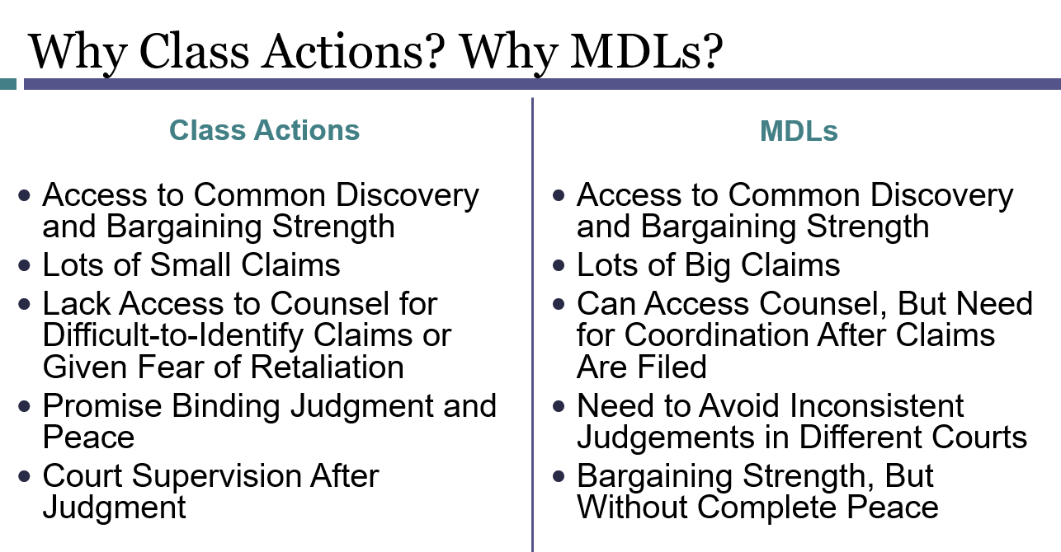
  - Information Exchange/Resolution
    - Settlement Discussion 26(f) requires settlement discussions shortly after pleading stage
    - Popper v Davidson (car accident) Negotiation strategy activity
- Discovery
  - Discovery – what do you need to know and why?
    - Rule 16(b) – except as exempted from initial disclosure by 26(a)(1)(b) or when court orders otherwise, parties must confer as soon as practicable and at least 21 days before a scheduling conference or scheduling order
    - 26(a)(1) parties must consider the nature and basis of their claims and defenses and the possibilities for promptly settling or resolving, make or arrange required disclosures under 26(a)(1), discuss issues about preserving discoverable info, develop a discovery plan. Attorneys are jointly responsible for arranging the conference and attempting in good faith to agree on proposed discovery plan and for submitting it to the court within 14 days after conference.
    - Under Rule 26(b)(1), parties may obtain discovery regarding any
      - Non privileged matter (Hickman)
      - Relevant to any party's claim or defense (Farvale – sex harassment)
      - That is proportional to the needs of the case considering: (Cerrato/Nutribullet)
        - The importance of the issues at stake in the action,
        - The amount in controversy.
        - The parties’ relative access to relevant information
        - The parties’ resources,
        - The importance of the discovery in resolving the issues, and
        - Whether the burden or expense of the proposed discovery outweighs its likely benefit.
      - Must be reasonably accessible 26(b)(2)(B)
      - Cannot duplicate info you can get somewhere else less expensive
      - Potential for embarrassment or annoyance (must outweigh the importance of the info collected) 26c
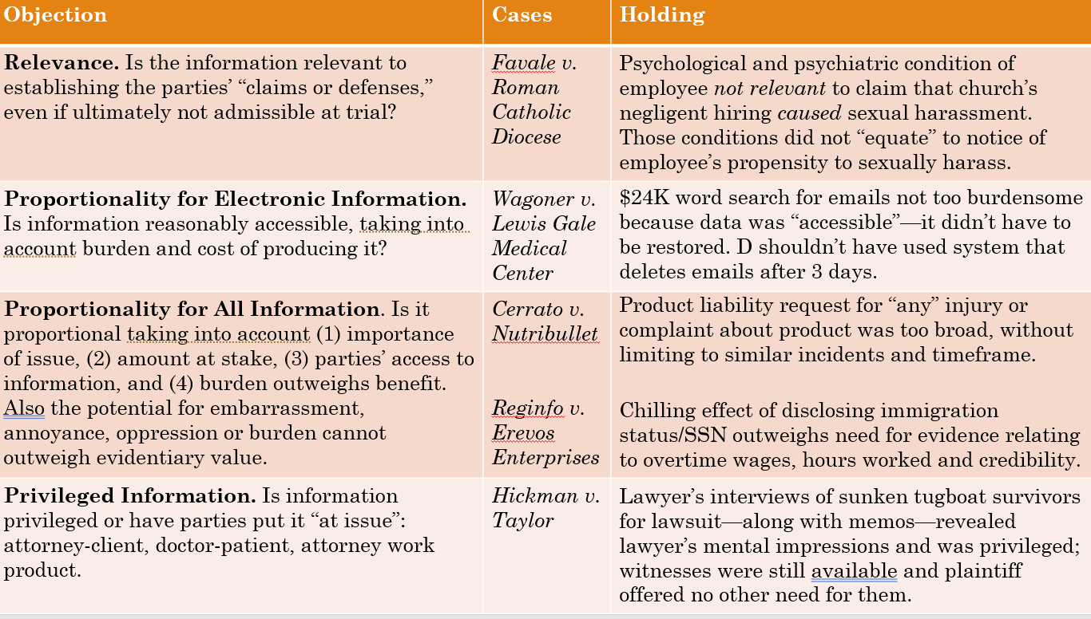
      - Automatic Disclosures. Rule 26 requires parties produce certain automatic disclosures, including: (1) information about witnesses they may use to support their claims or defenses, (2) documents, records or physical things that they will use to support their claims, (3) computations of damages and evidence upon which its based; and (4) insurance policies that may be available to satisfy a portion of a judgment. (But note: As you can see, most only apply to information and evidence your adversary is using to support their claims and defenses.)
      - Expert Reports. Rule 26(a)(2), you get their report and all the opinions the expert will offer, but the evidence and materials they rely on, the exhibits they have used, information about other cases those experts have testified in, as well as their compensation. This only applies to testifying experts, those people who take the stand at trial. You generally cannot learn facts about consulting experts retained for the litigation, unless you can show "exceptional circumstances" in which it's "impracticable" to get that same information from somewhere else. Fed. R. Civ. P. 26(b)(4)(D).
      - Medical Examinations. Rule 35, which allows a court to order a medical or physical inspection of someone, gives that person the right to ask to see the report and any earlier reports for the same condition. But that rule applies when the court orders the medical examination, not voluntary requests like this done in advance of discovery.
      - Develop a plan:
Example:

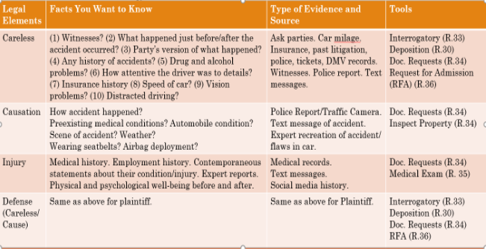

        - What initial disclosures must be made?
        - What facts and evidence do you want to establish to the claims and defenses in this case?
        - Where are you going to get it from?
        - What discovery tools are you going to use? (Depositions, Admissions, Interrogatories, Production Requests)
      - If you want, you have to ask for:
        - Interrogatories. Fed. R. Civ. P. 33. Questions you can ask the other side to guide your discovery. Must be relevant to the case, not seek privileged info, or be unduly burdensome under rule 26. Under rule 33 you are limited to 25 questions, which include subparts that raise independent new issues and can only ask them to parties, and cannot ask follow up questions.
        - Requests for Admission. Fed. R. Civ. P. 36. Admissions ask counterparties to admit or deny facts. Once admitted they are conclusively established 36(b). You can ask admissions about how law applies to facts, their opinions, genuineness of documents. Cannot apply legal conclusions, and must also be relevant, non-privileged and not duly unburdensome. You can ask for an unlimited amount and can only direct them at the parties.
            - Saget v Trump (do I need this?)
        - Production of Documents, Electronic Record, inspection of property. Fed. R. Civ. P. 34.
        - Depositions. Fed. R. Civ. P. 30.
        - Cost and Benefit
          - Cost: burdensome, expense and games, opportunity to harass, could undermine trial rights
          - Benefits: eliminate surprise, even playing field, more accurate view of occurrences, discovery is a kind of trial
      - Favale v Roman Catholic Diocese – Relevance Favale worked at a school, alleged principle sexually harassed her. Sued school for harassment and retaliation – not the person who harassed her. She wants to compel the principle to testify to any prior treatment for anger mgt or psych issues. Holding was those items were unrelated. Would have had to show the institution was negligent in hiring and as a result there would be a greater propensity for the harm to occur. Psych claim not relevant to sexual harassment do not show he is more likely to sexually harass. the court held that information about whether a church employee’s anger management and therapy was not relevant to another employees sexual harassment claim. The court held, that under the relevant state law, a plaintiff had to show that the church should have known that the employee had a propensity to engage in a particular type of conduct. The plaintiffs could not show how therapy and other psychological conditions contributed or caused the harassment she alleged. Nor did the plaintiffs allege that the church employee’s emotional condition actually harmed her as part of a different claim.
      - Wagoner v Lewis Gale Medical Center Proportionality for electronic info– ADA claim against a medical center where an individual says he has been discriminated against based on his disability. He wants electronic records (thousands of emails), he is dyslexic, the company is claiming it is too expensive to produce (they claim 24k bc they were hiring a 3rd party to do it) because the emails need to be recovered. They court holding said they had to do the discovery bc it was their fault the emails deleted after 3 days.
      - Cerrato v Nutribullet–Proportionality for all info Plaintiff suffered an exploding nutribullet liquid all over. Plaintiff wants disclosure of all consumer complaints and accident reports relating to this model. They say any injury to to broad, so they limit it to 5 years, similar incident. Courts may strike a balance like here – somewhere in the middle.
      - Reginfo v Erevos – Privileged info want immigration status and SS info/tax info for credibility. They basically say if you aren’t legal, we don’t owe you the money. Chilling effect of disclosing this info for evidence relating to overtime. Would make plaintiff just go away. Not fair. This info is targeted and designed to chill and would affect the right to vindicate private rights. The burden outweighs the benefit by calling the docs.
      - Hickman v Taylor – Privilege lawyer interviews of sunken tugboat survivors along w memos wanted can we get attorney notes from their interviews of these parties who are not protected by attorney client privilege. Not allowed because attorneys might stop taking notes if they know they have to produce them. Rule: attorneys don’t have to turn over their notes UNLESS the opposing attorney can provide a very good reason like it would be irretrievably lost, etc. Also battle of the wits. This attorney just wanted to know the other attorneys plan.
- Summary judgement and directed verdict (pre trial resolution)
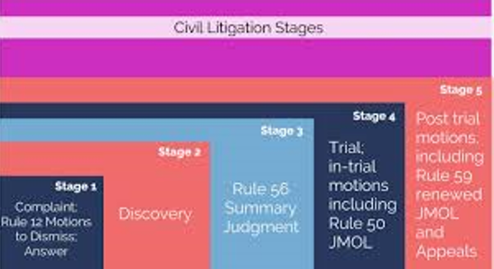
      - Rule 56 & the summary judgement standard
        - Summary judgment allows courts to resolve a case, without trial, when there is no material, factual dispute. (main rule)
        - Under Rule 56, parties can move for summary judgment there is (a) no “genuine issue of material fact” and (2) they are “entitled to judgment as a matter of law.”
        - A dispute of fact is genuine when a reasonable jury viewing the evidence could find in favor of either party. The facts are also viewed in the light most favorable to the person opposing the motion. (important to rule)
        - If there is a genuine material factual dispute, summary judgement should be denied and the case should go to jury. Examples include credibility or weighing evidence. When no evidence exists to support the essential element of a case or it rests only on speculation, there is no genuine issue for trial. (important to rule)(this standard applies for motions files during or after trial like Judgement as a matter of law.)
        - But when no evidence exists to support an essential element of a case or rests only on speculation, there is no genuine issue for trial.
        - 12(b)(6) are there enough Plausible and non-conclusory facts to support a claim?
      - Why judges or juries? What’s the advantage of a jury trial here? What’s the advantage of allowing judges to decide cases? Why do you think a jury or a judge would be better these different disputes?
        - Judges:
          - Precedential Impact. Need for clear lines and consistency
          - Guardrail. Protect the rights of defendants from the passions of a jury when the plaintiff's “claims and defenses have no factual basis.” Celotex v. Catrett.
          - Separation of Powers. Deference to expertise of another branch of government
          - Judges decide law
          - EXCEPTIONAL cases judges can resolve factual disputes where no reasonable juror could determine the outcome another way
        - Jury –
          - Intent, Community Standards, Norms. Resolving questions of intent, community standards, or norms that turn on direct and circumstantial evidence. Adkins.
          - Credibility of Competing Witness Testimony. They are presumably better at unraveling complicated factual disputes, including competing witness “perceptions, recollections, and even potential biases.” Tolan v. Cotton.
          - Diversity. Access to diverse body capable of resolving dispute from a variety of perspectives.
          - Democratic principles. Separate body capable holding other institutions, particularly government bodies, to account.
          - Juries decide facts (like if you ran a red light) or mixed questions of law and act (like if someone acted safely)
      - Adickes v S.H. Kress – white schoolteacher, black children. Was asked to leave library by police, then was not served in café and asked to leave and arrested when leaving. Store owner and police introduced affidavits denying they coordinated with each other. Store owner says Adickes was relying on circumstantial evidence. Question: Has the Plaintiff introduced enough evidence of conspiracy to withstand the store owner’s motion for summary join? Answer: Yes. As the moving party, the store owner had the burden of showing “the absence of a genuine issue as to any material fact.” Viewing the evidence in the light most favorable to Ms. Adickes, the store owner failed to meet that burden: “it would be open to a jury, in light of the sequence that followed, to infer from the circumstances that the policeman and a Kress employee had agreed to refuse her service.”
      - Celotex Corp v. Catrett – Catrett alleged her husband died as a result of Celotex’s asbestos. Celotex moved for summary judgement arguing she couldn’t say Celotex’s product caused the harm. The lower court cited Adickes said Celotex didn’t satisfy its burden to show there was an “absence” of any genuine issue of material fact relating to whether its product and not another has caused the harm.
      - Tolan v Cotton – Young baseball player, arrested because PD mistakenly enters wrong license plate and pulls him over. During altercation at his driveway, officer just on the scene shot him. Dispute over lighting, over the mom’s behavior, over if he was on his knees or feet. Tolan (cop) moved for summary judgement. Lower court found for Tolan, Supreme court found the lower court should not have weighed evidence (contradicting statements re facts). Very important juries weigh the facts, not judge.
      - One could say that the Court in Adickes and Tolan permitted the case to go to the jury because of the jury’s superior (1) discretion to resolve factual questions about defendant's intent based on direct and circumstantial evidence (Adkins), (2) competence to resolve complicated factual disputes, including competing witness "perceptions, recollections, and even potential biases," (Tolan) and (3) ability to provide a democratic check against unelected judges, ensuring that jurors also decide important questions of social policy and welfare (Adkins & Tolan).
      - By contrast, the Court in Celotex (and the lower court in Tolan) arguably felt that it was appropriate for the judge to dismiss the case and take it away from the jury so as to (1) establish clear lines and rules of conduct for similar situations in the future (Celotex), (2) to defer to other government agents (lower court in Tolan), (3) to promote personal responsibility by the plaintiff, who may be in a better position to identify evidence in their control and avoid getting hurt (Celotex); or (4) to protect the rights of defendants from the inconsistent passions of a jury when the plaintiff's "claims and defenses have no factual basis.
      - Scott v Harris Example (speeding case). Court upheld summary judgement. Video evidence very compelling.
- Preclusion - A person is precluded from re-litigating certain things when there has already been one fair opportunity to litigate.
  - Claim Preclusion - Someone is precluded from asserting a claim in a subsequent lawsuit f/k/a “res judicata” (among others)
    - Elements
      - It is the “same claim” asserted in Lawsuit #1; (Claims are “same” if they could have and should have been brought together; and
        - 3 things to know re “same claim”
          - TO determine whether same, don’t just look for same legal claim, look for all claims that could have and should have been brought
          - Law varies – 3 tests:
            - Same Transaction (Majority)
            - Claims arise from the same factual occurrence.
            - Rst 24 (1) After a final judgment, the claim extinguished includes all rights to relief “with respect to all or any part of the transaction, or series of connected transactions, out of which the action arose.
            - Rst 24 (2) What factual grouping constitutes a "transaction", and what groupings constitute a “series”, are to be determined pragmatically, giving weight to such considerations as:
whether the facts are related in time, space, origin, or motivation,
whether they form a convenient trial unit, and
whether their treatment as a unit conforms to the parties' expectations or business understanding or usage.
              - Same Evidence (Minority)
                - Evidence proving the elements in lawsuit 1 would also prove the elements in lawsuit 2
              - Same “legal injury” (primary rights, same harm) (very small minority rule)
                - Claims involve the same type of legal harm
            - If the 1st and 2nd lawsuit takes place in different states, use the law of the state where the first lawsuit took place to determine which test to use.
      - The claim is asserted by the “same parties” (specifically, the same claimant against the same responding party) Parties are “same” if: the same claimant asserts claim against the same defending party. Includes those “in privity” with either; and
        - Two things to know about “same party”
          - First, even if the lawsuits arise out of the same transaction of events, they still have to involve the same claim between the same parties.
          - Second, sometimes a non-party will be bound if he or she is in “privity” with a party to the lawsuit. This includes people with a shared interest in property, cases where someone is a legal agent for another, insurers when they have an opportunity to litigate (car accidents), and class actions.
      - Lawsuit #1 resulted in a “valid” and “final” judgment “on the merits”
        - Definition: A final judgment on the merits involves decision in a proceeding (1) where the court had power to issue a binding decision, (2) the court issued a final judgment, and (3) a party had a fair opportunity to prevail on the merits.
        - Not Final. In federal court and most states, this generally means that lawsuits dismissed for lack of personal jurisdiction, venue, or subject matter jurisdiction will not involve a final judgment on the merits. The court lacks power to issue a binding judgment.
        - Final. But in can include decisions that don’t seem to reach a decision on the merits, like a judgment issued after the parties settle and voluntarily dismiss a case. It also includes Rule 12(b)(6) dismissals with prejudice, even if the parties simply haven’t yet alleged enough facts to state a claim. Finally, it can include cases dismissed for failing to prosecute a case, because of discovery abuse, and even settlement.
        - On the Merits Rule 41(b) “Unless the dismissal order states otherwise,
          - a dismissal under this subdivision (b) and
          - any dismissal not under this rule
            - except one for
              - lack of jurisdiction,
              - improper venue, or
              - failure to join a party under Rule 19
          - operates as an adjudication on the merits.”
    - Claim preclusion is just a way to say that we don’t want claim splitting: Plaintiff may try to split a single transaction in several different ways, including:
      - splitting the injury (for example, suing for medical expenses and pain and suffering in separate cases);
      - using separate legal theories (for example, products liability and breach of warranty); and
      - splitting the relief (for example, suing separately for damages for past harm and for an injunction to prevent threatened future harm.
    - If the elements of claim preclusion are established, the court in Lawsuit #2 must preclude the claim. The precluded claim is terminated in its entirety.
    - Frier v City of Vandalia – guy gets his car towed without notice.
      - Frier files suits in Illinois state court seeking replevin
        - IL st. ct. conclusion: police properly took the cars into the City’s possession and declined to issue a writ of replevin b/c City had the right to remove the cars from the street. Frier loses.
      - Frier then turns to federal court and claims a due process violation, a §1983 claim, because the City didn’t offer him a hearing until a month after the towing occurred.
    - Taylor v Sturgell
- No Issue Preclusion Because Due Process Problems:
Case 1: P1 v. D1 (wins)
Case 2: P2 v. D1
ß (D1 cannot use preclusion to prevent P2's relitigation of the issue D1 won against P1 in Case 1, violates due process)
- Issue Preclusion - Someone is precluded from contesting particular issues in a subsequent lawsuit f/k/a “collateral estoppel” (among others)
    - Elements
      - Lawsuit #2 involves the “same issue” decided in Lawsuit #1; and
        - An “issue” is a case-specific* decision regarding facts or the application of law to fact under a similar or higher standard of proof.
      - The issue was “actually litigated and determined” in Lawsuit #1; and
        - How can we tell if an issue was actually litigated and decided?
          - Bench Trial
          - Written findings of fact
see Rule 52(a)
          - Jury Trial
          - Special Verdict
see Rule 49
          - General Verdict
      - Lawsuit #1 resulted in a “valid” and “final” judgment; and
        - Same as claim preclusion
      - Preclusion is asserted against a party who had “adequate opportunity and incentive” to litigate the issue in Lawsuit #1.
        - Precluded party:
          - Must have been a party in Lawsuit #1
          - or “in privity” with such a party
          - Must have had opportunity and incentive to litigate the issue
        - Considerations: limited procedure in 1st forum (ie small claims vs. federal court), limited incentive to litigate based on stakes
          - The Restatement of Judgments 29 lists other considerations:
            - Person seeking to invoke preclusion could have joined earlier action
            - Determination being relied on was itself inconsistent with another earlier litigation
            - Implicates other people or parties unable to participate in the first action.
            - Involves an issue of law that would foreclose other courts from reconsidering important constitutional questions.
    - If the elements of issue preclusion are established, the court in Lawsuit #2 may preclude further litigation on that issue. Depending on the facts, this might dispose of the entire claim.
    - ISSUE PRECLUSION IS FOR LOSERS
      - If a litigant has an opportunity to litigate and loses on an issue, a new defendant or plaintiff in a new lawsuit may be able to use that judgment against them.
      - But if a litigant wins a judgment, that litigant cannot use that judgment against totally new plaintiffs and defendants who never got their chance in court. Everyone gets at least one bite at the apple.
      - Moral of the story: Issue Preclusion is only used against losers!
      - Issue Preclusion exceptions:
        - Heavier burden of persuasion in the initial action
        - Unclear if the issue is actually litigated or decided
        - Issue is one of law and the claims are unrelated or there’s an intervening change in applicable law
        - Differences in the quality or extensiveness of the procedures or ability to appeal
        - Adversely affects public interest, no opportunity to obtain a full and fair adjudication in initial action
    - Moore v Baker/Moore v Hospital – Patient sued Dr. for negligence, was passed SOL. Court found suit was untimely under SOL. Then sued Hospital – Summary judgement for the Hospital, no genuine dispute re discovery date and filing date, so defendant entitled to summary judgement under same 3yr SOL.
    - Illinois Central Gulf RR v Parks – Husband and wife get hurt. Wife sues for bodily injury, husband for loss of consortium. She wins, he loses. Later he sues for bodily injury. Railroad defends using Preclusion. Look up holding
    - Example of adequate opportunity and incentive: Voting case wins $1000 small claims then sues 1 billion $ federal court and says it is already decided. No, there wasn’t opportunity. Small claims is small, no attorneys, less incentive to fight
    - Parklane Hosiery v. Shore
      - Parklane allows new plaintiffs to preclude losing defendants, but with caveats:
        - Could the stranger (party seeking to use issue preclusion offensively) “easily have joined” into the previous action? a. Mere fact that she could've joined w/ P under Rule 20 isn’t enough. But, if she was invited to join or if she knew about it and could've intervened as of right (a Rule 24 concept), then this first factor will prevent the use of preclusion.
        - 2. Will it be “fair” to allow offensive use? a. Factors that might make it unfair include:
          - D did not have a full & fair opportunity to litigate the first case (i.e., case was for a small amount);
          - Serious procedural disadvantages existed in Case 1, or
          - Inconsistent prior judgments exist
Mere fact that there are some prior judgments is not enough. But, if enough Plaintiffs prevail in their individual suits against the D, 1 or 2 inconsistent judgments will not by themselves prevent the use of nonmutual issue preclusion.
- Nonmutual Offensive Issue Preclusion: (ex: Parklane)
Case 1: P1 v. D1 (loses)
Case 2: P2 v. D1
← (P2 can use preclusion to prevent relitigation of issue D1 lost in Case 1)

