Taxation of High Tech Enterprises
Professor Hoose – Spring 2022

- Overview and Introductory Material
- Taxable Income
- Taxation of IP
- R&D credit
- State tax issues
- International issues
- Tax Policy issues

Overview and Introductory Material:

What is a High Tech Enterprise?
- Business that operates in the high technology industry
- Typical business lines:
  - Communications equipment manufacturing
  - Electronic shopping and mail-order houses
  - Internet publishing and broadcasting and web search portals
  - Software publishers
  - Computer and peripheral equipment manufacturing
  - Semiconductor and related device manufacturing

Choice of Entity:
- Legal System:
  - Sole proprietor
  - Corporation
  - Partnership
  - LLP
  - LLC
- Federal Income Tax System:
  - Only 2 choices for a business: corporation, or “something else”
    - Corporation = separate taxpayer
    - Partnerships and disregarded entities are not separate taxpayers. They are passthrough entities
  - From a pure tax perspective, it is often beneficial for business owners to operate in a form other than a corporation. This is because a corporation, under section 11 of the IRC, is a separate taxpayer, meaning that its income is subject to double taxation—taxed once when earned by the corporation, and taxed again (as a dividend) when those earnings are distributed to the owners of the corporation. Also, so-called “passthrough” businesses can benefit from the new “passthrough deduction” under section 199A, which reduces the rate of tax on income earned by those businesses.

Choice of entity considerations:
- Limited Liability
  - Owner not liable for debts of entity
  - But can now get this with LLC
- Employee Status
  - Sole proprietors and partners are not employees
- Taxation
  - Corporations are taxpayers (21%)
  - And then shareholders pay tax again when profits distributed (currently at a lower rate: 15-23%)
- Pass-through of loss
  - Again, corporations are taxpayers so their losses do NOT “pass through” to shareholders
  - Also character of income (capital, tax exempt) does NOT pass through to shareholders
- Capital formation
  - Corps can issue stock, get access to capital markets (but see SPACs)
- Fiscal Period
  - Corps can choose any period (partnerships cannot)

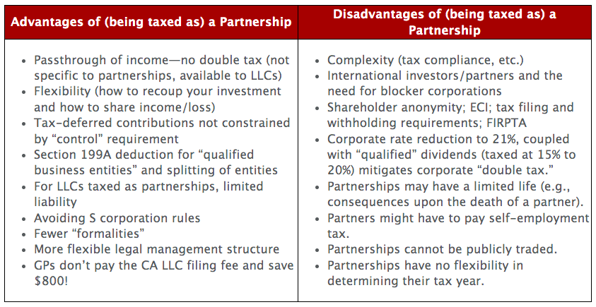

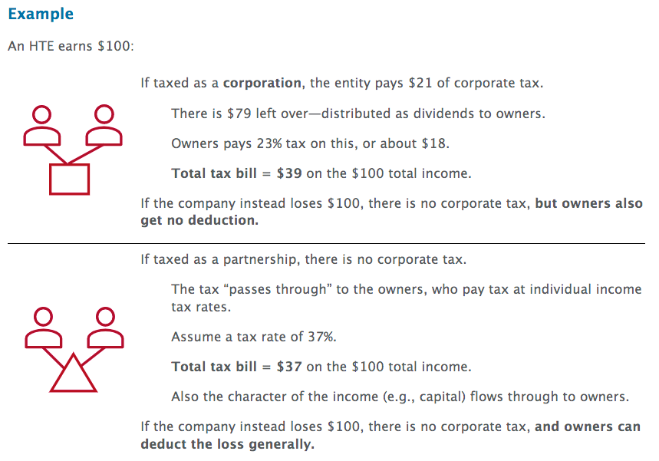
Other considerations:
- Self-employment tax: partners may have to pay this, shareholders will not
- Capital markets: corporation could float stock
- Fiscal period: partners must use majority interest taxable year
- Passthrough 199A deduction (new, 2018): 20%; would reduce tax from $37 to $29.6

Despite the benefits to being taxed a partnership, most HTEs opt to be taxed as a corporation.
- Why?
  - Usually it is for one reason—the ability to “go public” on a traded stock exchange. As is well known, many HTEs want to “go IPO,” and right now, the only truly effective way to do this is to form a corporation and then “float” the corporation’s stock on a recognized stock exchange such as NASDAQ. This desire to “go public” (which can also be accomplished by forming a publicly traded Special Purpose Acquisition Vehicle, or SPAC, which then acquires another business) usually outweighs all other considerations and is the reason most HTEs are corporations.

Classification Rules: Check the Box
Analytical steps: (a) business entity?, (b) eligible entity? (c) default? Or file an election
- So what is a business entity?
  - Treas. Reg. § 301.7701-1(a)
    - Certain joint undertakings give rise to entities for federal tax purposes:
      - A joint venture or other contractual arrangement may create a separate legal entity for federal tax purposes if the participants carry on a trade, business, financial operation, or venture and divide the profits therefrom
        - For example, a separate entity exists for federal tax purposes if co-owners of an apartment building lease space and in addition provide services to the occupants either directly or through an agent.
        - Nevertheless, a joint undertaking merely to share expenses does not create a separate entity for federal tax purposes
          - For example, if two or more persons construct a ditch merely to drain surface water from their properties, they have not created a separate legal entity for federal tax purposes
        - Similarly, mere co-ownership of property that is maintained, kept in repair, and rented or leased does not constitute a separate legal entity for federal tax purposes
    - Certain local entities not recognized:
      - An entity formed under local law is not always recognized as a separate entity for federal tax purposes.
        - For example, an organization wholly owned by a State is not recognized as a separate entity for federal tax purposes if it is an integral part of the State
    - Single owner organizations:
      - Under §301.7701-2 and 301.7701-3, certain organizations that have a single owner can choose to be recognized or disregarded as entities separate from their owners.
- Once you have a “business entity”, is it a corporation, partnership or disregarded entity?
  - Treas. Reg. § 301.7701-2(a)
    - “… a business entity is any entity recognized for federal tax purposes (including an entity with a single owner that may be disregarded as a n entity separate from its owner under §301.7701-3) that is not properly classified as trust or otherwise subject to special treatment under the IRC. A business entity with two or more members is classified for federal tax purposes as either a corporation or a partnership. A business entity with only one owner is classified as a corporation or is disregarded. If the entity is disregarded, its activities are treated in the same manner as a sole proprietorship, branch, or division of the owner.”
- Eligible entity:
  - Treas. Reg. §301-7701-3(a): an entity that is not classified as a corporation under 301.7701-2(b) (1),(3),(4),(5),(6),(7) or (8) (an eligible entity) can elect its classification for federal tax purposes as provided in this section.
    - 301.7701-2(b) (1): “a business entity organized under a federal or state statute, or under a statute of a federally recognized Indian tribe, if the statute describes or refers to the entity as incorporated or as a corporation, body corporate, or body politic”;
    - 301.7701-2(b) (3): “a business entity organized under a state statute, if the statute describes or refers to the entity as a joint stock company or a joint stock association”;
    - 301.7701-2(b) (4): “an insurance company”;
    - 301.7701-2(b) (5): “a state-chartered business entity conducting banking activities, if any of its deposits are insured under the federal deposit insurance act or a similar federal statute”
    - 301.7701-2(b) (6): “a business entity wholly owned by a state or any political subdivision thereof or a business entity wholly owned by a foreign government ..”
    - 301.7701-2(b) (7): “a business entity that is taxable as a corporation under a provision of the IRC other than section 7701(a)(3)”;
    - 301.7701-2(b) (8): certain foreign entities (See regulation for list)
- Default Rule:
  - Treas. Reg. 301.7701-3(b)
    - Classification of eligible entities that do not file an election –
      - (1) domestic eligible entities: Except as otherwise provided in paragraph (b)(3) of this section, unless the entity elects otherwise, a domestic eligible entity is:
        - A partnership if has two or more members
        - Disregarded as an entity separate from its owner if it has a single owner
- Election
  - Check the box
  - IRS form 8832
  - Limitations:
    - Timing
    - Treas. Reg. 301.7701-3(c)(1)(iv)
      - “If an eligible entity makes an election under paragraph (c)(1)(i) of this section to change is classification (other than an election made by an existing entity to change its classification as of the effective date of this section), the entity cannot change its classification by election again during the sixty months succeeding the effective date of the election. However the commissioner may permit the entity to change is classification by election within the 60 months if more than 50% of the ownership interest in the entity as of the effective date of the subsequent election are owned by persons that did not own any interest in the entity on the filing date or on the effective date of the entity’s prior election. An election by a newly formed eligible entity that is effective on the date of formation is not considered a change for purposes of this paragraph (c)(1)(iv)”
  - Advantages of being disregarded
    - Tax compliance and accounting
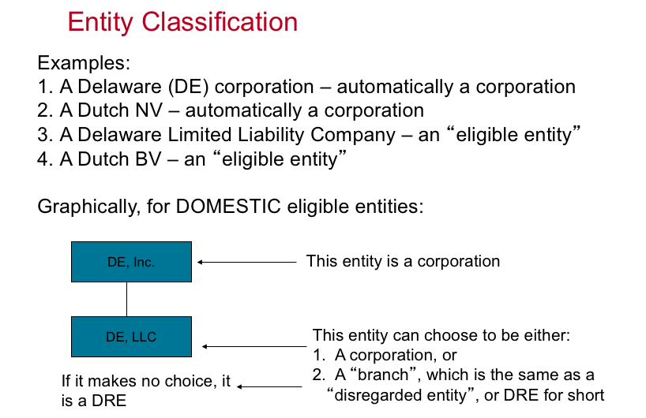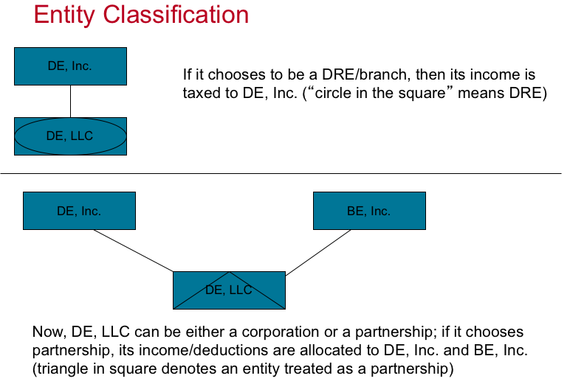

IPO:
- Do you need to form a corporation in order to go public?
  - UP C transaction
- Or can you use a SPAC?
- If you are setting up a corporation, where do you incorporate it?
  - A US state like DE or CA?
  - Or a foreign country like Singapore?
  - What are the considerations in making this choice?

Incorporating in the US?
- If the entity is incorporated in a U.S. state, then it becomes a U.S. tax resident, which means it will be taxed on its worldwide income, no matter where such income is earned. Also, the income of its controlled foreign subsidiaries (called “controlled foreign corporations,” or CFCs) will also be taxed in the U.S., as earned, under either the “Subpart F” or “GILTI” tax regimes
- if it incorporates under foreign law, then the entity will only be taxed in the U.S. on its U.S.-connected income (though of course it could be subject to tax by foreign countries), and the income of its subsidiaries should also escape U.S. taxation (unless such income has an actual U.S. connection).
- It would seem advantageous to incorporate the HTE outside the U.S., and in fact the head of tax at Intel Corporation (an early HTE) once told a Congressional committee that he would have incorporated outside the U.S., if given the choice at the time of his testimony.
- Nonetheless, it appears that most HTEs still incorporate in the U.S. Why is this? For the same reason as noted above—going public. It appears that it is beneficial to be a U.S.-incorporated entity when going public, and hence even today, most (if not all) HTEs choose to incorporate as U.S. corporations.
Financing (in General)
- Equity (IPO)
- Debt
  - Different types of debt
- Tax consequences of each
  - Interest = deductible
  - Dividends = not deductible

Revenue Models
- The US federal income tax recognizes a variety of different types of income, and categorizes those types of income as follows:
  - Gain from the sale of “personal” property (i.e., anything other than real estate)
  - Gain from the sale of real property (such as land)
  - Income from services
  - Rents (from leasing tangible property) and royalties (from licensing intellectual or intangible property)
  - Dividends
  - Interest
- HTEs tend to earn most of their income from the sale of personal property (such as computer equipment, mobile phones, or networking equipment), services (such as providing cloud computing services or storage), and royalties (from licensing intellectual property).
- Some types of income earned by these enterprises are not easy to classify—for example, income earned from providing cloud storage might be considered services income, but perhaps it is instead income from the use of intellectual property, or maybe even income from the lease of tangible property (i.e., space on a computer server).
- The type of income can sometimes be important, for determining the timing of revenue recognition and the source of the income under the international tax rules.

Select Business and other issues:
- HTEs face a number of other issues that are relevant to the corporate tax issues they encounter as a separate taxable entity:
- Employee Compensation and Benefits:
  - Employees can be compensated by their corporate employers in a number of ways
    - The standard way: pay a salary
    - Over the past few decades, employees have expanded the ways in which they compensate their employees
      - Some of these mechanisms are still payments of cash (such as employee bonuses)
      - Other mechanisms have included equity compensation and employer provided enhanced non-cash employee benefits, such as meals, transportation benefits, and other things like gyms or memberships
    - The main issue is whether these other items (such as employee benefits) constitute income to the recipient employees
      - If so, then the employer must withhold tax from such payments, and include the items in the income of its employees ( as reported on their W-2s)
      - Whether particular benefits are taxable to employees is governed by a complex set of code sections, including sections 106 and 132
      - Many benefits, such as employer-provided health insurance (under section 106) are tax-free, in general to employees while the costs are still deductible to the employer.
      - Other benefits, such as employer-provided meals, are sometimes tax-free to employees. Section 132 governs whether such benefits are taxable or not
- Equity (Stock-Based) Compensation
  - The use of equity compensation (also referred to as stock-based comp or SBC) has increased significantly in the past 30 years or so. There are many forms of SBC, but the most common forms are stock options, restricted stock, and employee stock purchase plans
    - Stock Options: a stock option is a right to purchase stock from a corporate at a set price. The price will often be the price of the stock on the date of issuance of the option. The option usually is not “vested” when it is granted; typically, it will “vest” (ie become nonforfeitable) at some future date
      - Example: Corporation HTE grants its employee an option to buy HTE stock at the then-current market price of $500. The option will not “vest” until 1 year after it is granted, and vesting requires that the employee still be employed by HTE on that date. On this vesting date, the market value of HTE stock is $600. Thus, at that point, the option is “in the money,” because the employee can now exercise the option (since it is now vested and is not forfeitable), acquire the share for $500, and then immediately sell the share on the open market for $600. If the employee instead had quit the position prior to 1 year after granting of the option, the option would have lapsed and not vested (and hence been worthless).
    - Restricted Stock: Restricted Stock units (RSUs) are grants of a specific number of shares to be transferred to an employee on a set date in the future (the vesting date). The employee will receive that number of shares on that date, no matter the market price of the shares at that time
      - Example: Corporation HTE grants 1,000 RSUs to its employee. The ¼ of the RSUs will vest at the end of each of the next 4 years. Hence, at the end of year 1, 250 RSUs will vest, and the employee will receive 250 shares at that date. However, as we will see, the employer will typically sell some of the shares in order to withhold an appropriate amount of tax on this income. If the employee had left the company before the end of year 1, the RSUs would have expired unvested and hence had no value (or tax consequence, as we shall see).
    - Employee Stock Purchase Plans: these plans, called ESPPs for short, give employees the right to buy stock of their employer at a discount, typically a 15% discount
      - Example: Corporation HTE has an ESPP, under which employees can contribute money and purchase HTE stock at a 15% discount. Hence, an employee can contribute money to the plan, and buy HTE stock for $85 on a date when its market value is $100.
- Intellectual Property – Types
  - Patents and patent applications
    - These represent a bundle of rights to make, use, sell, transfer, or sue for infringement arising from a particular technology. These rights are established under federal law and have a 17- to 20-year life. There is a special tax provision, section 1235, that governs the treatment of income from the transfer of patents.
  - Trademarks/trade names/ trade dress/ service marks
    - These are also protected by federal law, and represent a brand or other identifiable mark. These have a 10-year registration but are renewable indefinitely. There is a special tax provision, section 1253, that governs income on transfer of a trademark
  - Trade secrets and “know how”
    - These are governed by state law, and represent information or a pattern that derives value from not being widely known, where the owner takes reasonable actions to keep it private
  - Copyrights
    - These are governed by federal law for a duration of the life of the author plus 50 years (75-100 years in the case of works for hire). This is a work of original authorship in a tangible medium such as a film, literature, music, or drama
  - Franchises
    - These are governed by state law and are basically a distribution agreement (a McDonald’s franchise right is the most common example). There are special provision in sections 1253 and 197 that deal with franchises
  - Computer Software (1.861-18) and domain names
    - This has a specific tax definition in section 197, which states that these are programs or routines that make a computer perform a specific task. Domain names fall here as well
  - Covenants not to compete
    - This is a state-law-enforced contract that restricts an individual from engaging in a competing business
  - Government licenses and permits
    - These are rights issued by a government. A good example is a taxi medallion, which is right to drive a taxi in certain jurisdictions like New York
  - “Information base”
    - This is defined in section 197 as general information of value that allows a business to operate. This includes things like advertiser lists, medical records, technical literature, and data files.
  - Customer and supplier intangibles
    - Similar to information base, but these are limited to existing relationships with customers (contracts with customers, a customer list) and likewise with suppliers (contracts in force, insurance in force, etc)
  - Goodwill, going concern, and workforce
    - This is essentially a “residual” category of value. It represents the value of a company’s existing employees, the expectancy of continued patronage by customers, and the ability of a business to continue even if the ownership changes.

ASC 740 – financial statement accounting for income taxes
- The rules that govern the calculation of income tax expense for financial statement purposes are contained in Accounting Standards Codification (ASC) number 740
- Basic Rules
  - Income tax expense (federal, state, foreign)
    - Current
    - Deferred
  - Effective tax rate
    - Rate reconciliation
  - PBT (profit before tax)
  - Annual and interim periods
  - Tax disclosure – Form 10-k
    - MD&A
    - Tax footnote
  - “uncertain tax positions” (UTPs) – “accrue a reserve”
    - Position (unit of account)
    - MLTN, measurement
    - “unrecognized tax benefit” = amount of return – amount reflected in FS (ie amount that has 50.1% probability of success)
- Basic Principles
  - Taxable income
  - Temporary differences (federal, state, foreign, GILTI?)
    - DTLs (basis differences)
    - DTAs (carrybacks, carryforwards, etc)
    - Valuation allowance (VA)
  - Permanent differences
- Interim reporting (10-Q)
  - Estimated annual effective tax rate (EAETR)
    - Does not include “significant, unusual” items
    - Usually relies on forecasted data
  - Multiply AETR time pretax income
    - And then take into account the tax effect of “discrete” (non-recurring) items
- Changes in tax law
- Intercompany transactions (ARB 51)
- Currency (ASC 830)
- Disclosure:
  - The tax line is often the largest single item in the financial statements
  - What are some elements that you can see in disclosures? Look at the “rate reconciliation”
    - SBC
    - R&D credit
    - Effect of global tax rates (APB 23)
  - Other notable items
    - Audit status (statute of limitations)
    - Acquisitions
  - Balance sheet – current/noncurrent (payables, DTL/DTA)
  - UTPs
  - Controls (SOX) are needed!

Taxable Income

Basic Taxable Income Issues for HTEs:

Corporate Taxation overview:
- Corporations are separate taxpayers, subject to tax under IRC section 11. Currently the corporate tax rate is 21%
- Corporate income is effectively taxed twice if distributed – the distribution is usually a dividend to the shareholder, and the shareholder pays tax (often at a reduced rate) on the dividend.
  - Hence, “double” taxation of corporate profits.
  - This is in contrast to partnerships and other passthroughs where the income is subject to only one level of tax.
- If a corporation receives a dividend from another corporation, there is a deduction available under IRC 243, which will reduce or eliminate the taxation on that dividend.
  - This dividend received deduction is
    - 100% in the case of dividends from an 80% or more domestic corporation
    - 80% in the case of dividends from a 20-79% owned domestic corporation
    - And 70% in the case of a dividend from a domestic corporation that is less than 20% owned by the corporate recipient
- Corporations do not enjoy a special lower rate on capital gains
- Corporations are still subject to capital loss limitations
- Nonrecognition provisions, such as IRC 351, are widely available to defer recognition of gain on certain corporate transactions
  - Back to section 1001: AR-AB, “realized gain” then “recognized”
  - In subchapter C, we have many “nonrecognition” provisions
- Corporations can generally file consolidated tax returns if there is a common domestic corporate parent that owns 80% of the stock of its domestic subsidiaries
  - The group would file form 1120, the corporate income tax return on a consolidated basis
- A number of special provisions, like IRA 199A (relating to a special deduction for qualified business income) and 469 (imposing a limitation on the deductibility of “passive” losses) are generally NOT applicable to corporations.

US Corporate Taxable Income Items
- Corporations are separate taxpayers, section 11
  - Normal rules of income, deductions, etc apply to them, but not all
  - Some special rules apply, example charitable contributions (10% of ATI)
- Accounting Periods and methods
  - Free to choose! Must use accrual method, generally
- Capital gains/losses
  - No tax rate preference
  - But loss limitation still applies – section 1211 (back 3, forward 5)
- Net operating losses (2017 changes, plus CARES Act)
  - Generally carried forward indefinitely, but limited to 80% of TI
- Related taxpayers
- Organizational and startup expenses – elect to amortize 180 months
- Dividend received deduction – section 243 (see above)
- 199A- generally not available
- Credits – R&D credit, low income housing, energy
- Executive Compensation – section 162(m)
- Passive activity losses – section 469
  - Generally not applicable to corporations (no 183, no 165(c))
  - Applicable only to closely held C Corps (50% of stock held by 5 or fewer individuals) and personal service corporations

US Corporate Taxable Income Calculation
- Taxable Income. = gross income (revenue) – deductible expenses (including usually R&D per section 174; but no PE, no standard, no AGI)
- Items of gross income and deduction are then assigned to a particular taxable year (usually a 12 month period, and often a calendar year) under the tax accounting provision of the IRC (sections 441 – 483)
- The rate structure: 21% flat rate for now
- Corporate AMT: repealed in 2017 (for now)
- Controlled Groups: Consolidated Returns
  - 80% common parent
  - Domestic corporations only, generally
  - Elimination of intercompany items
- The Corporate Tax Return – Form 1120
  - Estimated quarterly payments
  - Schedule M-1: reconciles book income to taxable income
  - Schedule M-3: assets of $10M or more, use this instead of schedule M-1

Accounting Methods and Periods
- Taxable income must be computed annually – sec 441
  - Corporations can generally choose any year they want
  - Corporations may also choose the so called 52/53 week year, under 441(f), under which their accounting period will always end on the same day every year, and the number of days in the tax year will vary from year to year
- Then income and deductions must be “assigned” to a particular taxable year
- Methods of accounting; cash and accrual
  - Two special rules apply no matter what method of accounting is used: Section 1001 and section 83
    - Section 1001: disposition of property
      - “realization” doctrine and related issues
      - States that there is no tax impact on disposition of property unless there is a “realization event” with respect to the property
    - Section 83: receipt of property for services (SBC)
      - Income when no “substantial risk of forfeiture” (vesting)
      - Income included at that time, at FMV as described in section 83
      - Requires income inclusion upon vesting of property received in return for the performance of services
- Cash method:
  - Who can use it? Section 448
    - 448(a): who cannot use it
      - C corps
      - Partnerships with c corp partner
      - “tax shelter”
    - Exceptions
      - Farmers (sec 447)
      - Qualified personal service corporation
      - “entities” with gross receipts not more than $5M
        - 3 year average under $5M
      - Rev. Proc. 2001-10: no accrual or inventory required for small taxpayers (GR <$1M)
- Accrual Method: as corporations most HTES will be required to use this method
  - Income is included in the year the right to receive the income is fixed and the amount is determinable. The deduction is available in the year the liability is fixed, the amount is determinable, and economic performance has occurred. See IRC 461.
  - Revenue Side:
    - Section 451: defaults to inclusion no later than in year for financial statement purposes (451b – defaults to f/s)
    - All events – must include in the tax year in which:
      - Right to receive income becomes fixed
      - The amount of income is determinable
      - Treas. Reg. 1.451-1(a) – called the “all events” test
    - Taxpayer also try to argue that “performance” of the events giving rise to the income must occur too in order for inclusion to be required
    - The timing of revenue recognition is governed by section 451 of the Code and was substantially changed by 2017 tax reform. Under section 451(a), the timing of revenue recognition is still generally governed by the “all events” test described above. However, due to new section 451(b), the timing of revenue recognition for tax purposes is now generally the same as it is for financial statement (”book”) purposes. This conclusion is reinforced by new section 451(c), which codified the conclusions of Rev. Proc. 2004-34 regarding advanced payments. Under section 451(c), recognition of revenue for advanced payments can only be deferred for 1 year, in limited circumstances. This rule applies often to HTEs.
    - Advance Payments
      - Rights to receive fixed
      - Amount determinable
      - Real question: is there a performance requirement? In other words, can you defer inclusion if the underlying performance not yet done, even if right fixed and amount determinable?
        - Generally, no – see section 451b and c
  - Section 451c: the modern deferral rule
    - 1 year deferral for “advance payments”
    - “advance payment” must be deferred for book
    - And must be for things like services, IP (software), goods (not rent or insurance premiums)
    - Summary: on the revenue side, tax now really follows book (ASC 606) due to 451b and c, which were changed as part of the 2017 tax bill
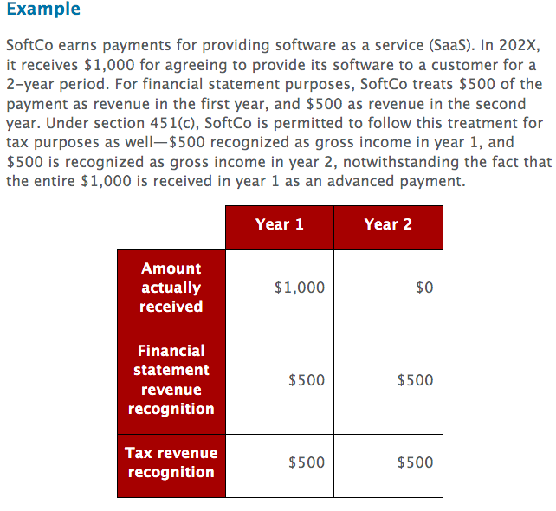
  - Deduction side: section 461
    - Unlike revenue, the timing of deductions is not governed by the treatment of those items for financial statement purposes. Instead, a deduction can only be taken under the accrual method in the year in which the underlying liability is fixed, the amount is determinable, and the underlying economic performance has taken place. The fact that actual payment takes place after the year in question is not dispositive, so long as the payment occurs within 2 ½ months of the end of the tax year (for items like bonuses—see section 404).
    - Bonuses fall under this category – what year is it deductible?
    - Issue here often is, can you deduct PRIOR payment?
    - Test is flip side of revenue test (1.461-1(a)(2)) – “all events” test:
      - Liability must be fixed
      - Amount of liability must be determinable and
      - Economic performance, if any, underlying liability must have taken place (461(h))
        - As services for the property provided, in general
        - Sometimes performance happens as payment takes place, including but not limited to
          - Torts
          - Refunds
          - Awards
          - insurance
    - Example: General Dynamics: deduct in ’05 estimate of employee health care costs for ’05 services, not paid until ‘06
      - Liability fixed? Yes
      - Amount determinable? NO – won’t know for sure amount until employees submit reimbursement requests
      - Economic performance? Yes (service provided)

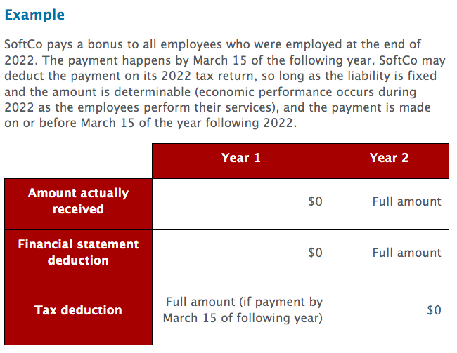
- Special deductions and limitations
  - Fixed Asset Expensing – section 168(k)
    - In general, expenditures for items like equipment must be capitalized under section 1016 of the Code
      - this capital expenditure can then be depreciated under sections 167 and 168, which means that the capital expenditure can be deducted over a number of years (under current law, the periods are between 3 and 20 years, depending on the type of property in question)
    - however, with the enactment of section 168(k) in 2017, capital expenditures for assets with a 20-year or shorter useful life (under section 168) can be fully deducted in the year incurred.
      - Section 168(k) treatment is elective
      - This provision begins to phase out in 2023
    - Example: ChipCo spends $10 billion on equipment to manufacture semiconductors in 2022. This property is “5-year property” under section 168. Per section 168(k), ChipCo may elect to deduct this entire $10 billion investment on its tax return for 2022.
  - Charitable contributions – section 170(b)(2)
    - “charitable contribution” = gift to organization described in section 170(c) (public or private)
      - “contribution” = you get nothing back (Elmo rule); also must own what you give
    - Can be in cash, or property; generally FMV of the property is the deduction (some special rules apply – eg if charity sells it)
      - Property must be in “good” condition; no deduction til paid
    - No deduction for services performed for charity (but costs are allowed)
    - Must have receipts/ substantiation
    - Limits:
      - 1. total deduction for charitable contributions for corporations is limited to 10% of the corporation’s “adjusted taxable income,” which is essentially its taxable income calculated before taking charitable contributions (and other items) into account.
      - 2. deduction for contributed property is limited to the tax basis in the property (as opposed to its value) if the property, if sold instead, would have created ordinary income. This typically means that property such as inventory will only generate a deduction equal to that property’s tax basis, rather than its value.
        - Deduction for charitable contribution if property (other than cash) given to charity
          - No realization event to donor (ie no gain)
          - And donor generally gets a deduction equal to FMV of property
          - But must reduce amount of deduction by amount of ORDINARY (ie noncapital) gain inherent in property donated (ie deduct BASIS if gain w/b ordinary)
    - Example: MedCo contributes medical devices (which it sells to customers) to its charitable foundation. The devices are worth $1,000, but have a tax basis of $500. MedCo’s charitable deduction for each device is limited to $500, the tax basis of the device, since the sale of the device would create ordinary income (as a sale of inventory).
  - Capital Losses – section 1211
    - Corporations do not enjoy the capital gains tax rate preference that is available to individuals
    - However, corporations are still subject to the rule that limits the use of capital losses, which can only offset capital gains (see IRC 1211)
    - Therefore, corporations like HTEs must monitor their gains and losses, in order to ensure that they have sufficient capital gains to utilize and offset their capital losses
    - If a corporation creates a net capital loss in a particular tax year, that loss can be carried back 3 years and forward 5 years
    - Hence, the corporation effectively has 9 years to utilize the capital loss by generating sufficient capital gains to utilize the loss
  - Start-Up Expenditures - section 195
    - Section 195 of the Code limits deductibility for costs incurred before a taxpayer is “carrying on” a trade or business.
      - These are costs that would otherwise be deductible, had the business been operational. A taxpayer is generally considered to be “carrying on” a business once it earns revenue from multiple or recurring sources; prior to this time, section 195 applies to its otherwise deductible expenses.
      - Under section 195, those expenses are effectively capitalized, and can be deducted beginning in the month that the business commences. The taxpayer can deduct $5,000 of those expenses in that year that the business commences (or the total ”pool” of section 195 expenses, whichever is less); the remaining total of those expenses can then be deducted over the subsequent 180 months. It is important to keep this provision in mind when starting a new business.
    - “carrying on” a business
      - ‘carrying on’ = business is underway (Frank)
      - Stages of a business
        - Investigate – see sec 195
        - Establish/acquire – capitalize (see sec 263(a))
        - Start-up – sec 195
        - Operation – sec 162
    - What do you do with these expenses? Sec 195
      - “investigation/creation” expenditures CANNOT be deducted immediately, but must be capitalized
      - Can then elect to deduct them WHEN business “begins”
      - Can deduct a small amount in the year the business begins (lesser of $5,000 or total 195 expenses)
      - Remainder of ‘pool’ are deducted ratably over 180 month period following start of business (change in law)
  - 163j – Interest Expense
    - Interest is payment for the use or forbearance of money
      - In general interest is deductible for tax purpose
      - By contrast, corporate dividends are not deductible
      - This creates the often-noticed preference for debt financing over equity financing
    - The deduction for interest is subject to a number of limitations
      - Most relevant to HTEs is 163j (enacted in 2017)
        - Under this provision, a taxpayers net interest expense deduction is limited to 30% of a taxpayers adjusted taxable income (ATI)
          - ATI is basically taxable income, calculated without regard to certain items (including the interest deduction).
        - Any interest expense that is disallowed by section 163j can be carried forward indefinitely
  - Taxes – section 164
    - HTEs are also allowed a deduction for taxes under section 164
    - Deductible taxes include state income taxes, property taxes, payroll taxes, any “use” taxes paid by the corporation, and other types of taxes like business license fees
    - Foreign taxes are also deductible but HTEs can instead elect to take a credit for foreign taxes paid (or deemed paid) per IRC 901
      - More on this under the ‘international tax’ section
    - Unlike individuals, corporate HTEs are not subject to the new $10,000 limitation of the deduction for state and local taxes
  - R&D – section 174 (2022 change)
    - HTEs are allowed a deduction for research and experimentation expenditures, pursuant to. IRC section 174 (more discussion under ‘R&D tax credit section)
    - Used to be deductible, now it must be capitalized and amortized

Capital Gains and Losses
- Two operative rules for corporations
  - 1. If a taxpayer has a “net capital gain”, that gain is taxed as ordinary income
    - No preference for corporations
  - 2. If a taxpayer has an “overall” capital loss, then that loss cannot be deducted against “ordinary” income in any tax year (sec 1211(a))
- Section 1212
  - Carried back 2 years, forward 5 years
  - So you basically have 9 years in which to use the loss
  - Must have some net capital gain in the c/b or c/f year in order to use the loss that year

Compensation Issues
- Stock Based Compensation
  - Stock Options (NQ) – section 83
    - Relevant date = employee exercise of option
      - No tax consequences upon grant or vesting
    - Employee income = market value – option strike price
      - Difference = income
    - Corporate deduction – same as employee income (83(h))
  - RSU – section 83
    - Relevant date = vesting
    - Employee income = market value at vesting
    - Corporate deduction = same as employee income (83(h))
  - ESPP – section 423
    - Relevant date = disqualified disposition of shares
      - Sale of acquired shares within 2 years after purchase
    - Employee income = sale value – discount value
    - Corporate deduction = same as employee income (if w/in 2 years of employee acquiring shares)
  - Difference between tax deduction available for stock based compensation and the financial statement treatment of stock based compensation
    - Often the tax deduction is larger than the financial statement charge taken for stock based compensation
      - This difference is often referred to as the excess tax benefit resulting from stock based comp., and can also be seen in the effective tax rate reconciliation that corporations are required to summarize in the tax footnote of financial statements
- Other Compensation and related issues
  - Employee benefits – section 132
    - Excludes certain fringe benefits from income of receipt
    - Only if paid by employer to employee
    - 1. No additional cost service
      - Offered to customers in ordinary course of business where employee works
      - And no substitute additional cost (including revenue) to employer
    - 2. Qualified employee discount
      - “qualified” property/service – one offered to customers in employee’s work
      - Services – discount no more than 20% off price to customers
      - Goods – discount no more than “gross profit %” of employer on the product
    - 3. Working condition fringe (deductible)
    - 4. De minimis fringe (too small)
    - 5. Qualified transportation fringe
      - Per month combined vanpool/ metro pass (amount?)
      - Per month parking
      - NEW – corporate deduction now DENIED for this
    - See also 132(h) (spouses and dependents) and sec 132(j) (nondiscrimination)
  - 162m
    - Section 162(m) is a provision that limits the deductibility of executive compensation paid to certain high ranked employees of public corporations.
    - The provision limits, to $1 million per person, the deduction for any type of taxable compensation (including SBC, salary, and bonuses) to the five most highly compensated executives working for the corporation.
      - In 2017, various changes were made to expand this group of impacted employees.
      - Now the company Chief Financial Officer (CFO) is automatically included in the limitation, and also once an employee is limited by section 162(m), they continue to be limited in future years. This latter provision means that the group of impacted employees will now be greater than five individuals.
    - From a financial statement perspective, this disallowance of a deduction is a “permanent” difference which will increase ETR.
    - What is covered? Salary and bonuses; equity awards
    - Example: CEO is paid a $700,000 salary, a $200,000 bonus, and becomes vested in $500,000 of RSUs during 2022. In this case, the corporation may deduct only $1 million of this total of $1.4 million in compensation (the other $400,000 is denied as a deduction, creating a “permanent” difference between book and tax treatment that will increase ETR).
  - 274 – meals and entertainment
    - Section 274 puts a limit on the deductibility of expenses for meals and entertainment.
    - First, as a simple rule, it denies a deduction for any expenditure that is predominantly for entertainment or amusement, including club dues.
      - This denies a deduction for things like baseball tickets and country club dues.
    - The rule also contains a complicated limitation on the deduction for employer-provided meals.
      - In general, the deduction for such meals is limited to 50% of the costs of providing the meals. However, there are a number of exceptions to this rule.
    - Highlights:
      - Entertainment is no longer deductible
      - Meals are 100% deductible for 2021 and 2022 if paid to “restaurants”
        - 50% deductible in 2020 and again in 2023 in most situations
        - Some situations are still 100% deductible – section 274(e)
    - Example: BigCo pays dues for its CEO to join a country club, buys baseball tickets for its executives, takes clients to lunches, and provides overtime meals to its employees. Under section 274, the club dues and baseball tickets are fully nondeductible; the client lunches are 50% deductible, and the overtime meals should be 100% deductible under an exception to the 50% meal limitation.

Losses:
Background:
- For tax purposes, a corporation has a loss when its deductions exceed the amount of its income. Of course, in such a year, the corporation will not pay tax; however, the corporation would like to be able to use these net losses in the future to offset future income. Without such a “carryforward” provision, unfairness can result in cases where the entity has significant deductions in one year, and significant income in future years.
- Likewise, certain credits, such as the R&D credit, might not be utilizable in certain tax years with losses (where there is no tax liability). Hence, these credits also often can be carried forward and used in future periods where there is positive taxable income. Further, there are other tax “attributes” (such as the section 163(j) disallowed interest amount, and capital losses) that can also be carried forward.
- In both of these situations, the carryforward of losses, credits, and other attributes create what are called “deferred tax assets” (DTAs) for financial statement purposes. The creation of the DTA provides a “benefit” to the tax expense line (a DTA will reduce deferred tax expense, and hence overall tax expense and also the ETR). Therefore, the inability to utilize a carryforward will ultimately increase tax expense and increase ETR.
- Corporations are required to periodically analyze whether they will be able to use their DTAs. If for some reason a DTA will not be usable (for example, if it is anticipated that a loss carryforward will expire before being utilized), then the corporation must establish a “valuation allowance” (VA) as an offset to the DTA. This VA has the effect of increasing tax expense and ETR, and hence the need for a VA is a negative development that tax advisors try to avoid.

Net Operating Losses – section 172
- Definition: expenses > income
  - loss occurs when deductions exceed income in any taxable period. That loss, called a net operating loss (NOL), is available as a deduction in future periods.
- Old Law
  - Carried back 2, forward 20
- 2017 changes
  - Indefinite carryforward only
  - But limited to 80% of TI in the c/f year
- CARES act changes – 2020

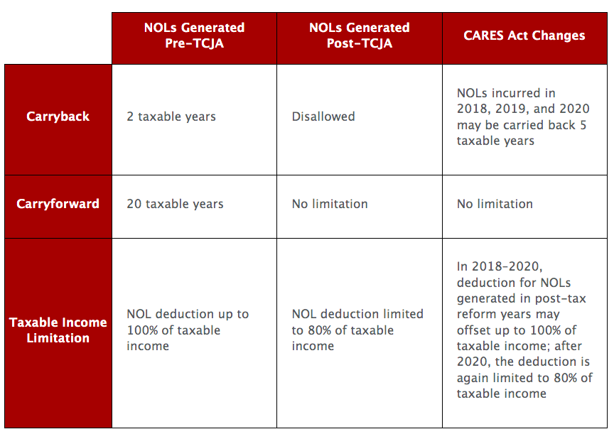
- Other tax “attributes”
  - Capital loss c/f
  - 13j c/f
  - R&D credit c/f

Combining Tax Attributes – Section 382 and Other Limitations on Losses
- Introduction:
  - Section 381: these rules apply to liquidations, and so called section 368(a)(1)(A), (C), (F), non-divisive D, and (G) reorgs
    - NOLs, E&P, capital loss carryforwards, and credit carryforwards move over to the survivor entity in the reorganization
    - But these attributes can’t be carried back; they can only be carried forward
  - Section 382: this rule applies only to net operating losses (and section 163j carryforwards), and only when a “change of control” of a “loss corporation’s” stock occurs
    - Upon a change of control, the entity’s NOLs are limited
    - The maximum income that the entity may offset with NOLs in a “post-ownership-change-year” is equal to the value of the entity at the time of the ownership change multiplied by the long-term “applicable federal rate” that IRS uses to determine interest charged
  - Section 383: applies part of the sec 382 limitation to any capital loss carryforwards or tax credit carryforwards of the loss corporation
  - Section 384: “pre-acquisition” losses of a loss corporation cannot offset “built-in-gain” of a gain corporation following an acquisition
  - Section 269: No NOL or other deductions allowed if control of a corporation is acquired with the “principal purpose” of reducing tax
  - SRLY: no NOL of a “separate return” year is useable against combined income of a consolidated group

Section 382:
- Overview:
  - What does it do?
    - 382(a) – puts limit on amount of TI of “new loss corporation” for “post change” year, which may be reduced by “pre-change” loss (NOL)
    - Basically, two limits
      - COBE – “new loss corporation” must continue business (COBE) of old loss corporation or else it can’t use the NOLs at all (sec 382(c))
      - 382 limit – maximum amount of “pre-change loss” that can be used each year is limited to the section 382 limitation which is
        - 1. Value of the old loss corporation, multiplied by
        - 2. Long-term tax exempt rate
    - This latter limit is an ANNUAL limit – limits amount of “pre-change loss” that can be used in a post-change year, each year
  - Definitions:
    - Loss Corporation: section 382(k)(1) – any corporation entitled to use an NOL, or with an “unrealized built-in loss” or section 163j carryforward
    - New and Old Loss Corporation
      - The old loss corporation is the loss corporation that existed before the ownership change
      - The new loss corporation is the loss corporation after an ownership change
      - Importantly, they can be the same legal entity, and often are!
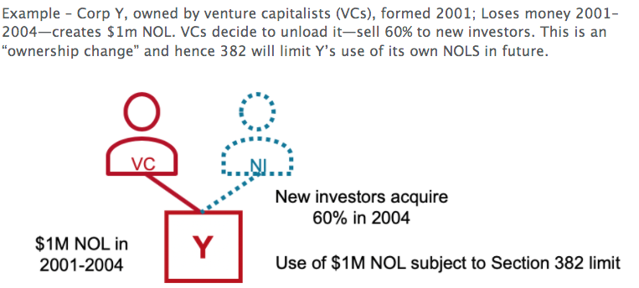
- Ownership Change – this is the key- section 382(g)
  - Generally ownership change occurs if immediately after either
    - An owner shift involving a 5% shareholder; or
    - An equity structure shift
  - In either case, the percentage of stock in the loss corporation owned by one or more 5% shareholders has increased by 50 percentage points over lowest percentage of the loss corporation owned by such shareholders during the testing period
  - Example: VC owns 20% and buys another 51% = ownership change.
  - “testing period”
    - The testing period for determining an ownership change is the 3-year period ending on a 5% owner shift or equity shift, or shorter if there was a prior ownership change. There can be MULTIPLE ownership changes over time
  - “5% owner shift”
    - Simple: change in ownership by 5% shareholders
      - 5% shareholder – some who owned or now owns (after shift) a 5% interest in the entity
      - 5% determined at individual level, using section 318 attribution rules
      - Family treated as one individual (section 318(a)); look-though entities
      - All non-5% shareholders treated as one
    - Examples:
      - Buying 10% of Corp Y = 5% owner shift
      - Publicly traded entity turns over 50% - not an owner shift
      - Mere fluctuations in value – not an owner shift
  - “Equity Shift”
    - Includes certain tax free reorganization and IPOs where there is a 50 percentage point ownership change by 5% shareholders
    - 382 will apply to an A, C or forward merger/332
      - Because survivor is entitled to NOL (per sec 381)
      - 382 ends up applying if shareholders in the entity going out of existence do not own enough of the survivor
      - Also, here, a special 5% rule – under 5% shareholders of the two entities in a reorg are treated as two shareholders, not one
  - other special rules
    - 382 will not apply to an old loss corporation that is in title 11, if shareholders and creditors of old loss corp own 50% or more of new loss corporation after any ownership change
  - Observations
    - Ownership change can be a sale, redemption, merger, IPO, 351, stock issuance, stock for stock reorg (B) – testing period
    - Got to look to see if transaction creates a 50% point change in 5% shareholders, keeping in mind that below 5% shareholders are all 1 shareholders, and also that each family is one shareholder
- Consequences of an Ownership Change
  - COBE limit – 382(c)
    - No NOLs can be used unless old loss corporation business is continued for at least 2 years or “substantial portion” of assets are used
  - The 382 limitation
    - “value” at “change date” multiplied by the long-term tax exempt rate
      - Change date = date of ownership change (date of equity shift or last 5% owner shift that pushed over the limit)
      - Value = value of stock of old loss corporation immediately before ownership change
      - Long-term tax exempt rate – published on monthly basis by the IRS
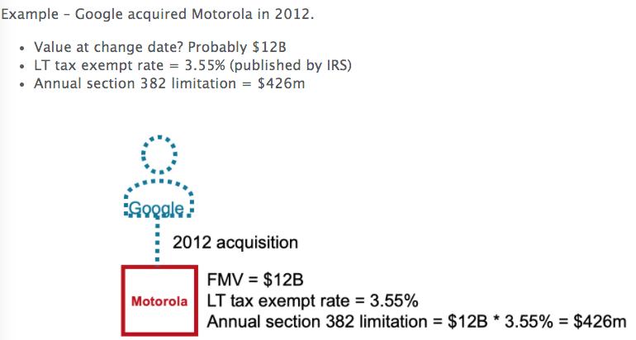

    - Mid-year change = prorate limit
      - So if Google/ MMI happens on July 1, then limit for 2012 = 213 M
    - Carryforward unused limitation
      - Example above – if only could use 200M in 2012, then
      - 13M c/f and is added to 2013 limit (taking it to 249M)
- Value of Old Loss Corporation – Issues and special rules
      - The value of the old loss corporation, for purposes of the section 382 limitation, is the value of its stock at change date
      - Special rules used in determining this value:
      - Anti-stuffing – value does not include any 351 or other property contributed within 2 years of ownership change
      - Nonbusiness assets – if loss corporation has > 1/3 nonbusiness assets, then these re ignored in determining its value
      - Purchase/redemption combo – value is considered after taking into account the redemption
- Built-in Loss – BIL, and Built in Gains - BIG
  - BIL
    - 382 limit applies to NOLs and also to any built in loss recognized within 5 years of ownership change
      - Example Google’s 382 limit is 426M
        - But MMI also has assets with value 100M, basis 500M, at ownership change date
          - This 400M is built in loss
          - If realized (by sale of asset or through depreciation) within 5 years of 2012 ownership change, then loss only allowed if within the 426M 382 limit (when also considering NOLs and credits, to make life more complicated)
    - De minimis rule – no BIL if such amount is less than the lesser of 5% of FMV of the loss corporation’s assets, or 10M
  - BIG
    - 382 limit increased for any built in gain recognized during the 5 years following ownership change (subject to same de minimis rule as above)
    - Example: assume Motorola instead has assets with a FMV of $500m, basis $100m; in this case, Motorola has a built-in gain (BIG). Under this rule, if these assets were sold within 5 years of the ownership change, then the 382 limit for that year of sale goes up by $400m.

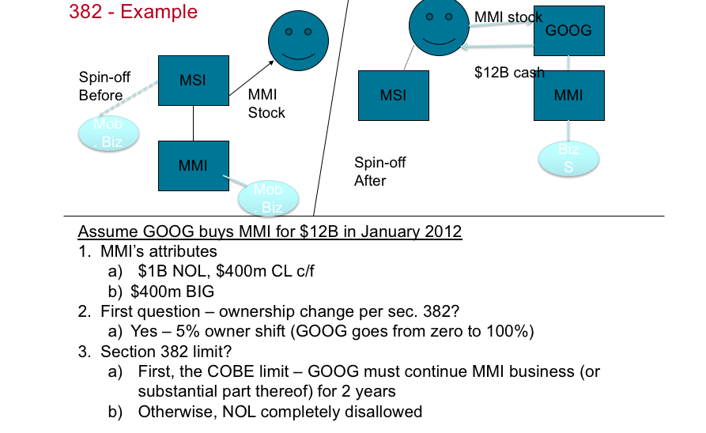
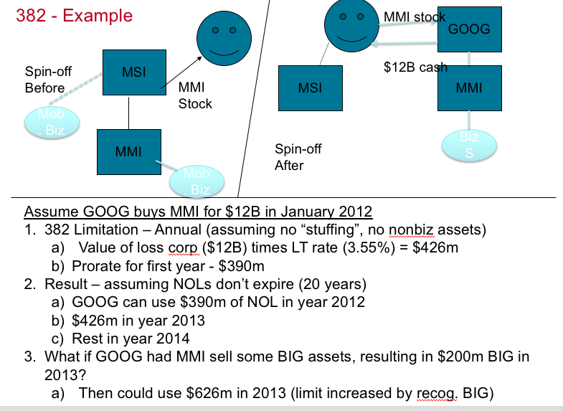

Summary of other limitations
- Section 383:
  - Applies part of the 382 limitation to any capital loss carryforward or tax credit carryforward of the loss corporation
  - To go back to the Motorola example, 426M = 382 limit
    - Assume 1B NOL, 400M capital loss c/f
    - This limit applies to pre-change capital losses, NOLs and credits of MMI
    - Need ordering rules:
      - 1. Capital losses first
      - 2. Then NOLs
      - 3. Then credits
    - Example: in 2013, Google has a capital gain and wants to use the 400M MMI capital loss carryforward,
      - this 400M of capital loss is allowed, but
      - only 26M of NOL would be allowed (426M 382 limit)
  - credits (R&D credit) must be adjusted (beyond out scope)
- Section 269:
  - No NOL or other deductions allowed if control of a corporation is acquired with the principal purpose of obtaining a deduction that would not otherwise be allowed
  - this provision is likely rarely applied in practice, but must be kept in mind when doing acquisitions
- Section 384:
  - Applies to stock acquisitions of “control” (80%) or section 368(a)(1)(A),(C), or (D) reorganizations, where one entity (buyer or seller) is a “gain corporation”
    - In those situations, income from BIGs of the gain corporation that are recognized within 5 years after acquisition date cannot be offset by a pre-acquisition loss of the non-gain corporation
  - Example:
    - T merges into L; T has 100k NOL, which moves over to L under section 381
    - L has BIG of 75k
    - If BIG realized within 5 years, 100k NOL cannot offset 75k BIG
- SRLY
  - Consolidated return provisions
  - NOL (or 163j c/f) arising in a “separate return limitation year” of a corporation cannot offset income of the other members of a consolidated group
    - A SRLY is a year when the corporation was solo, or a member of another group
    - this rule does not apply if 382 applies to the acquisition of a corporation (which is usually the case)

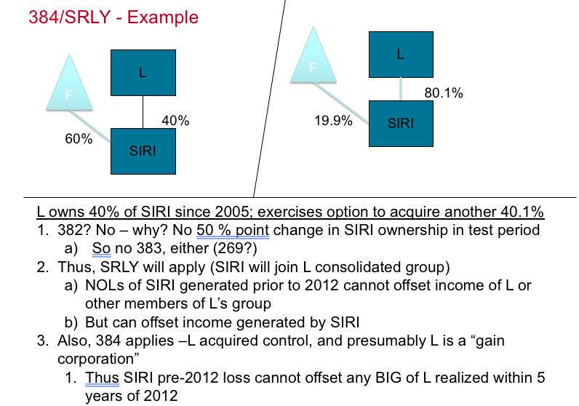

Taxation of Intellectual Property

Federal Tax Overview – IP related provisions
- Gross income from IP
  - Royalties
    - IP can create royalty income, which is basically periodical income earned from allowing others to use IP that a taxpayer owns. Often royalties are calculated based on a percentage of revenue that the user (“licensee”) of the IP earns from its use of the IP.
  - gain on sale (realization, AR-AB, recognition)
  - settlement proceeds
- Deductions
  - Business, generally
  - Deductions related to IP development
  - Capital expenditures and amortization
    - particularly when IP is acquired by purchase. If IP expenditures must be capitalized, then the issue arises as to whether those capitalized expenditures can be “amortized” or “depreciated,” which basically means that the costs can be deducted over a period of time.
- Tax Rates
  - Capital gains and losses
  - Certain taxpayers, mostly individuals, can get preferential tax rates on items such as net capital gains.
  - All taxpayers are limited in their ability to take capital losses against ordinary income; in general, such losses are only deductible against capital gains.
  - In certain circumstances, the disposition of IP can give rise to capital gains or losses.
- Tax Credits (for R&D)
  - As we will see in the following week, IP development costs can sometimes give rise to the R&D tax credit under section 41 of the Code.
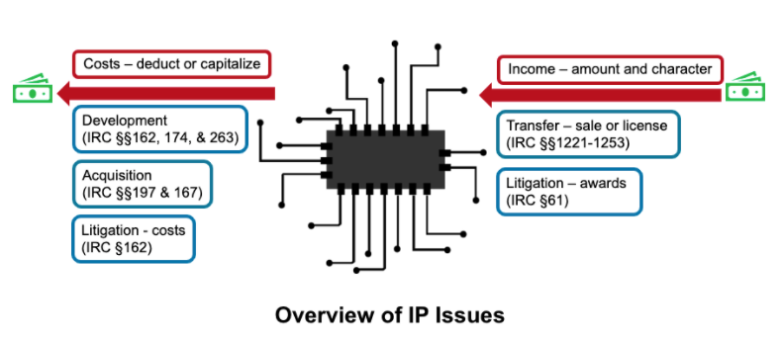

IP Overview – What is IP?
- Often referred to as “intangible” property (more accurate)
- “intangible” = right/privilege with no physical substance
- Specific types of IP sometimes matters
  - Many tax provisions apply to all types of IP (example section 174, 263, etc)
  - But there are some provisions that apply only to certain types of IP (example section 1235 for disposition of patents)
  - And some provisions apply differently to different types of IP (example section 197)
  - And internationally, type of IP still matters (section 367(d), 482)
- Patents
  - Federal statutory law
  - 3 types: utility, design, plant
  - 17- 20 year life
  - “bundle of rights”
    - Make
    - Use
    - Transfer or sell
    - Sue for infringement
  - Special provision – section 1235
- Trademarks
  - Federal statutory law
  - 3 types: trademark, tradename, service mark (services rather than goods)
  - 10 year registration – renewable indefinitely
  - Requirements
    - Designation
    - Distinctiveness
    - Intended use
  - Special provision – section 1253
- Trade Secrets and Know How
  - State-level law – uniform trade secrets act
  - Definition – information, pattern, program, method, etc
    - Derives value from not being known, and
    - Owner takes reasonable actions to keep it private
  - Can be discoverable = not protected
  - No special tax provisions (section 197)
- Copyrights
  - Federal statutory law
  - Works of original authorship fixed in a tangible medium
    - Film
    - Literature
    - Music, drama, etc
  - Employer can get the copyright (work for hire)
  - Duration is life of the author plus 50 years (or 75-100 years for works for hire)
  - Rights, which are severable
    - Distribute
    - Reproduce, perform
    - Create derivative works
  - Special provision – capital asset definition (section 1221)
- Franchises
  - State law (uniform franchise act)
  - Basically a distribution agreement (duration can vary)
    - Example – McDonalds
  - Characteristics
    - Franchisee gets right to sell good or service in an area
    - With restrictions placed by franchisor
    - And pays a fee to franchisor
  - Special provisions- section 1253, also see section 197
- Computer Software and Domain Name
  - Federal tax law definition (section 197)
    - Program/routine that makes a computer perform a specific task
  - Types
    - Standard
    - Customized
    - Custom (internal developed)
    - Bundled
  - Distinct from the medium (disk) on which it runs
  - Special provisions – section 197; treas. Reg. section 1.861-18
  - Domain name – web name
  - Software and domain name may fall under copyright, patent or other IP legal protection
- Covenant not to compete
  - State law concept
    - Some states, example CA, won’t enforce
  - What is it? A contract that
    - Restricts individuals from engaging in competing business
    - For some period, and in some geography
    - Usually entered into as part of business sale
    - Must be reasonable
  - Federal tax definition – section 197 – includes any service arrangement entered into by selling owners/employees
    - Means 15-year amortization for any purchase price allocated to these contracts
- Government Licenses, Permits, etc
  - Basic concept: some sort of right issued by the government
  - Federal tax definition – section 197 – includes
    - Taxi medallions
    - Broadcast license
    - Liquor license
    - Airline route
    - Landing slots
  - Special provision- section 197
    - Whether you get 15-year amortization for any purchase price allocated to these contracts
    - Also issue on what costs need to be capitalized to acquire the license
- Information Base
  - Basic concept: general information of value that allows a business to operate
  - Federal tax definition – section 197 – includes
    - Customer and subscriber lists
    - Supplies lists and supplier
    - Patient list
    - Advertiser list
    - Medical records, technical literature, data files, and databases
  - Special provision -section 197 (also 482)
    - Whether you get 15-year amortization for any purchase price allocated to these assets
    - “marketing” intangibles in cross-border situations
  - Closely related to know how and goodwill
- Customer and Supplier Based Intangibles
  - Basic concept: contractual rights and similar information of value to a business
  - Customer-based intangibles
    - Customer base and related contracts
    - Underdeveloped market
    - Insurance in force
    - Investment contracts in force
    - Depositor base (if a bank)
  - Supplier-based
    - Supplier contracts and relationships
  - Important in cross-border situations
  - Closely related to goodwill and going concern
- Goodwill, Going Concern, and Workforce
  - Basic concept – goodwill
    - Goodwill = expectancy of continued patronage
    - Goodwill is often the residual value paid over and above value allocated to specific assets
  - Basic concept – going concern
    - Ability to continue even if ownership changes
    - In question in cases of service time, but not so for publicly traded entities
  - Basic concept – workforce
    - Value of the efforts, education, etc of employees over and above the value of the tangible assets
    - Often thought of as a component of going concern
  - Special provisions – section 197, 1060, and the international provisions (see below)
    - New Sec. 367(d) In general Except as provided in regulations prescribed by the Secretary, if a United States person transfers any intangible property to a foreign corporation in an exchange described in section 351 or 361—
      - (A)subsection (a) shall not apply to the transfer of such property, and
      - (B)the provisions of this subsection shall apply to such transfer.
    - New Sec. 367(d)
    - (2)Transfer of intangibles treated as transfer pursuant to sale of contingent payments
      - (A)In general
      - If paragraph (1) applies to any transfer, the United States person transferring such property shall be treated as—
      - (i)having sold such property in exchange for payments which are contingent upon the productivity, use, or disposition of such property, and
      - (ii)receiving amounts which reasonably reflect the amounts which would have been received—
        - (I)annually in the form of such payments over the useful life of such property, or
        - (II)in the case of a disposition following such transfer (whether direct or indirect), at the time of the disposition.
    - The amounts taken into account under clause (ii) shall be commensurate with the income attributable to the intangible.
    - NEW Sec. 482. Allocation of income and deductions among taxpayers
      - In any case of two or more organizations, trades, or businesses (whether or not incorporated, whether or not organized in the United States, and whether or not affiliated) owned or controlled directly or indirectly by the same interests, the Secretary may distribute, apportion, or allocate gross income, deductions, credits, or allowances between or among such organizations, trades, or businesses, if he determines that such distribution, apportionment, or allocation is necessary in order to prevent evasion of taxes or clearly to reflect the income of any of such organizations, trades, or businesses. In the case of any transfer (or license) of intangible property (within the meaning of section 367(d)(4)), the income with respect to such transfer or license shall be commensurate with the income attributable to the intangible. For purposes of this section, the Secretary shall require the valuation of transfers of intangible property (including intangible property transferred with other property or services) on an aggregate basis or the valuation of such a transfer on the basis of the realistic alternatives to such a transfer, if the Secretary determines that such basis is the most reliable means of valuation of such transfers.
    - New Rule:
    - Sec. 367(d)(4) Intangible property -
      - (4)Intangible property - For purposes of this subsection, the term “intangible property” means any—
        - (A)patent, invention, formula, process, design, pattern, or know-how,
        - (B)copyright, literary, musical, or artistic composition,
        - (C)trademark, trade name, or brand name,
        - (D)franchise, license, or contract,
        - (E)method, program, system, procedure, campaign, survey, study, forecast, estimate, customer list, or technical data,
        - (F)goodwill, going concern value, or workforce in place (including its composition and terms and conditions (contractual or otherwise) of its employment), or
        - (G)other item the value or potential value of which is not attributable to tangible property or the services of any individual.

IP Development

Overview
- What is IP development? It is any activity to create or develop (as opposed to acquire or buy) an asset recognized as IP for tax purposes
- So why do we care about IP development for tax?
  - It is all about the IP development costs – what do we do with the costs? What are the options?
    - 1. Deduct currently OR
    - 2. Capitalize
  - If we must capitalize the costs, then what happens? The taxpayer takes a tax basis in the IP.
    - With a tax basis, the taxpayer may:
      - 1. “amortize” the capitalized costs (ie deduct over time), or
      - 2. Wait and offset the basis against the amount realized on sale (amount realized less adjusted basis)
- What are the IP development costs? Two major categories:
  - 1. Direct costs – employee time, supplies, etc that are otherwise deductible costs (ie costs not otherwise requiring capitalization, like equipment) directly incurred in developing IP
  - Indirect Costs – office space, interest, other “overhead” costs that are otherwise deductible and are costs that support IP development (but are not costs directly incurred to create or develop IP)
- Goals:
  - DEDUCT as much of these costs as possible on a current basis under IRC sections 162 or 174
  - AND also (or instead) get a credit for certain development costs (the R&D credit)
  - Or, if the costs are not deductible, at least have the costs amortizable
    - Section 197 or 167
- Critical Code sections: 162, 174, and 263
  - In analysis – start with 162 (which allows a deduction for ordinary and necessary expenses incurred in carrying on a trade or business). If 162 is satisfied – then the cost is deductible
    - However, under 162, costs are not deductible if they are instead required to be capitalized under sections 263 or 263A.
    - This is the critical question for IP development costs – do the rules require capitalization, or can the costs be deducted currently, in full, in the year incurred?
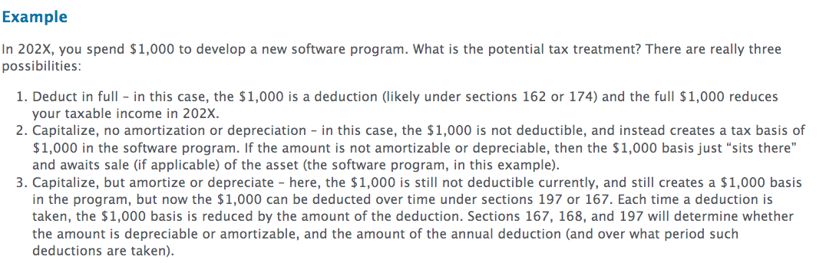

First- Deduction- per 162: what is the rule?
- 1. Ordinary – “normal”
- 2. Necessary – useful
- 3. “expense” (or is it capital?)- next
  - If the expenditure is capital, then NOT an expense and therefore not currently deductible
  - Instead expenditure becomes the tax basis in the IP
  - So when is capitalization required? Treas. Reg. 1.263(a)-4
    - Amounts paid to acquire an intangible, such as a patent, copyright, franchise, trademark, tradename, goodwill, customer list, customer-based intangible, and computer software
    - Amounts paid to create certain financial interests 1.263-4(d))
    - Amounts paid to create or enhance a “separate and distinct intangible asset” as defined in regs. 1.263(a)-4(b)(3)
      - “distinct” IP – sellable IP
    - Amounts paid to create or enhance a future benefit that is noted in guidance published in the federal register or internal revenue bulletin
    - Amounts paid to facilitate the acquisition or creation of an intangible that falls into one of the categories listed above
    - Amounts paid to facilitate an acquisition of a trade or business, a change in ownership of a business entity, and certain other specified transactions involving capital structure 1.263(a)-5
  - Sounds tough- but there are big exceptions
    - 12-month rule – does not apply to creation of any property with useful life less than 12 months (“significant future benefit”)
    - De minimis – costs under $5k not considered
    - Big One – employee time does NOT have to be capitalized, if incurred to “facilitate creation” of IP
    - In practice -for creation of IP – 1.263(a)-4 requires capitalization only of significant (ie > $5k), non-employee costs that create or enhance “separate and distinct” (ie sellable) IP with 12 month life
    - See also 263A and 174 (below)
  - Note, this rule is generally for costs that would otherwise be deductible; if the cost is already capital (example equipment) then this rule is inapplicable
  - 263A
    - Requires capitalization of direct and indirect costs (example office space, interest, etc) related to capitalized property – complicated
    - Capitalized property = IP in “tangible medium” (films, books, etc)
    - Sounds bad – but see exception for self-employed writers, artists & photographers – 263A(h) (individuals only + employee-owned corp)
    - Also see 174 (below)
- 4. Carrying on – business underway
- 5. Trade or business – not defined

174 – an election
- Special exception or costs that would have otherwise been capitalized under 263 or 263A (ie direct or indirect IP costs)
- If the costs are R&E costs under 174, then taxpayer has a choice:
  - Either deduct in year of expenditure OR
  - Deduct ratably over 5 year period
- What are R&E costs? Trade/business costs only!
  - Experimental or laboratory nature and
  - Intended to eliminate uncertainty in development/improvement of product
  - Costs of obtaining a patent clearly qualify
    - What about costs of getting a copyright? Probably fail because there is no technological uncertainty in obtaining a copyright
      - If copyrights don’t fall under 263A(h), they might be capital (but would amortize over 3 years per notice 88-62 for individuals) – also see section 195
  - See also rev. proc. 2000-50 for computer software, which generally provides for a full deduction for costs to develop computer software
- What does this mean for IP creation costs?
  - 1. Due to section 174, we generally deduct non-equipment IP creation costs (as 174 trumps 263 and 263A, in most cases, keeping in mind that copyright development costs might be different) and
  - 2. our self-created IP has a basis of zero
- 2022 changes
  - Section 174 expenditures incurred beginning on Jan 1, 2022 – taxpayers must capitalize these costs and amortize them either over 5 years (for costs incurred within the US) or 15 years (for costs incurred outside of the US)

Amortization of Self-Created IP
- Hopefully we can see that in most cases, creation of IP costs will just be deducted, and not capitalized
- This is due to sec. 162, the new 263(a) regs (with their exception for employee time), and also section 174, which allows a current deduction for otherwise capital (nonequipment, nondepreciable) R&E expenditures.
- So in real life, the only IP creation costs that get capitalized are
  - those that fall outside sec. 174 because they are not technological in nature.
    - An example here would be copyright costs incurred by corporations (there are certain exceptions to capitalization of copyright costs for individuals).
  - Copyright costs that fall outside of the 263A(h) exception for artists, writers, and photographers
- Rare cases when created IP is capitalized (263A applies, 174 does not apply – example copyright)
  - What happens?
    - No deduction (that’s what capitalization means)
    - Expenditure becomes tax basis in property
  - Then what? Can we amortize (ie deduct the basis over time) the asset?
    - Relevant sections 167 and 197
    - They permit deduction of the basis, generally, over 15 years
  - However, most self-created IP is not amortizable under 197
    - only self-created franchises, trademarks, tradenames, government licenses, and covenants not to compete can be amortized
    - self-created copyrights cannot be amortized under section 197 (however, there are exceptions for individuals—see Notice 88-62).
    - Self-created patents, others under 167? Useful life? Used in business?
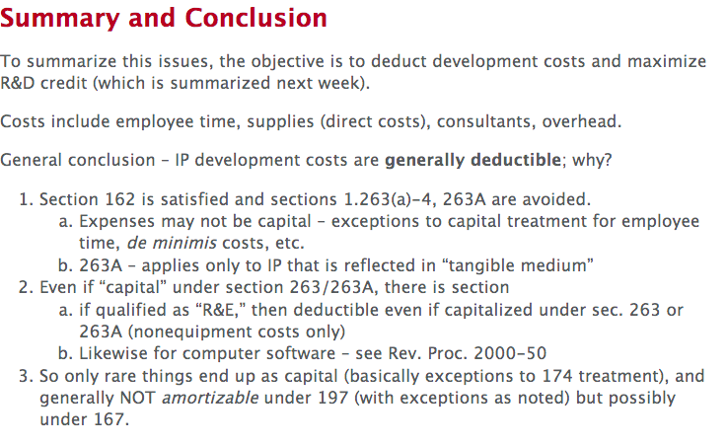

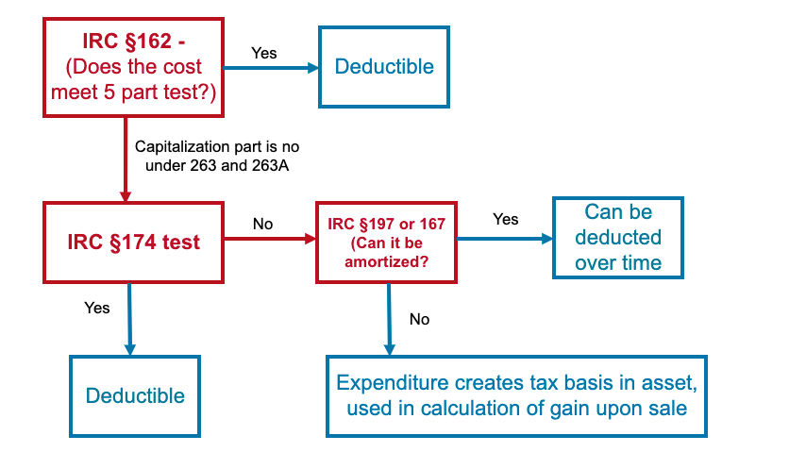

IP Acquisition

Overview
- IP development is spending money to try to create IP or enhance existing IP.
- IP acquisition is spending money to buy already existing IP (patents, copyrights, etc.)
- Why does anyone buy IP?
  - To use in your existing products to create sales income on the sale of products;
  - To keep out of hands of competitors;
  - To sue people for using it (“patent trolls”);
  - To license it to others—which earns royalties.
- What is the general consequence of acquiring IP? Capitalization!
  - Why? Treasury regulation section 1.263(a)-4 governs, and sec. 174 doesn’t help, because it is limited to development costs with a technological angle (as we saw), and does not apply to asset purchases.
    - However, if employees “facilitate” acquisition of IP, they don’t have to capitalize the salaries paid for their time.
  - Meaning IP acquisition costs are not deductible
  - Instead get a tax basis in IP = acquisition costs
  - Assumes you bought the IP – what if you license it instead?
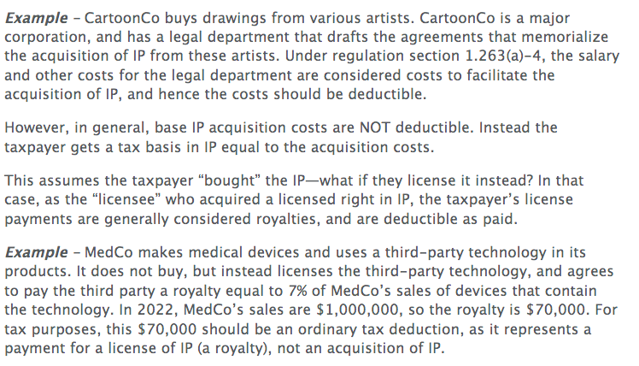
- What happens to capitalized acquisition costs? Two things
  - 1. Either deduct them over time (amortization) under sections 197 or 167 OR
  - 2. Wait, and use the adjusted basis (AB) to offset the amount realized (AR) on eventual disposition of the IP (AR-AB)
- How do you know which applies? It depends on the application of sections 197 and 167.
  - The default position is that you wait until disposition of the property (ie you CANNOT amortize a portion of the basis over a number of years) and offset the adjusted basis against the amount realized on sale
  - You can only amortize or depreciate the basis (ie deduct a portion of it each year during this year plus the next few years) IF a specific statute authorizes it
    - First look at section 197 for IP
    - If 197 doesn’t apply, then look to section 167

Section 197
- Allows amortization on certain other types of intangibles acquired for business/ investment
- The following, if NOT “self-created” (i.e., if instead acquired by purchase from someone else)
  - “Goodwill” (more in a second…), going concern, workforce, customer list
  - Patents, copyrights, films, recordings, books, BUT ONLY IF acquired as part of an overall business (i.e., NOT acquired separately— 197(e)(4))
- Plus, the following, whether self-created or acquired:
  - License,
  - covenant not to compete,
  - franchise, trademark, trade name
- Exceptions to 197 treatment
  - Financial interests (like corporate stock, bonds, etc.)
  - Land
  - Readily available or bundled software (shelf)—see instead section 167(f), which generally allows for 3-year amortization of these costs (and hence is favorable—shorter amortization period)
  - Contingent payments for trademarks (but these might be deductible—akin to royalties)
- To calculate the 197 deduction
  - Period – 15 years
  - Method – ratable (ie equal deductions each year)
  - Convention – monthly (convention is the methodology for allocating the first and last year deduction)
  - Sec. 1016(a)(2) – each time amortization is taken, the basis is reduced by that amount (by amount “allowed” by law).

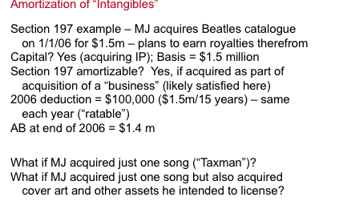
Section 167
- Allows amortization IF:
  - Section 197 does NOT apply to the IP,
  - The IP has an ascertainable useful life, and
  - The IP is used in a business
- To calculate the section 167 deduction
  - Period – useful life
  - Method – straight line (or “income forecasting”)
  - Convention – monthly
- For separate, readily available software, such costs should be deductible ratably over 36 months (special rule) under 167(f)(1)
  - Also under sections 179 and 168km which allow full expensing of these costs, might apply; see also rev. proc 2000-50
- Here, it is important to note that section 167 might give a better answer than section 197. This is because section 167 allows for amortization over the useful life of the IP, while section 197 requires a 15-year amortization period, even if the actual useful life of the IP is shorter. Hence, it might be advantageous to avoid section 197. One common way is to utilize section 197(e)(4) proactively—that section states that section 197 will not apply to certain types of IP that are NOT acquired as part of a “trade or business.” Hence, if a taxpayer can prove that the acquisition was not part of a trade or business, it can get a shorter amortization period
- Example: MegaCo buys a portfolio of patents from TrollCo for $1.5 million. The patents only have 3 years of legal life remaining. If section 197 applies, the amortization deduction will be only $100,000 per year for 15 years. If section 197 does not apply, and section 167 applies instead, then the amortization deduction could be $500,000 per year for 3 years. Hence MegaCo might argue that it did NOT acquire the portfolio as part of a trade or business, and hence 197 does not apply, but section 167 could still apply.
- Note on acquired licenses – almost never capitalized

Purchase Price Allocation and Section 1060
- In dreaded “real life”, you often don’t know what you are buying!
  - Example – we spend $10m to buy assets of a small company
    - Assets include some equipment, “IP”, software
    - How much did we pay for each?
  - In order to find out, we must do a PPA – actually, the accountants do
  - But it might matter to us, how it turns out – why?
  - Why? Recall that anything allocated to IP is amortized over 15 years
  - What about anything allocated to computers? 3-5 years; equipment? 5 years
  - Going back to our example….
    - $1m was for computers and equipment – will “depreciate” over 3-5 years
    - $5m was for “IP” – (transfer tax issue) – 15 years
    - Rest? “goodwill” – also amortized over 15 years, per 197
- Prior to 1993, we would fight to allocate to IP, because there was no section 197 and thus goodwill was not amortizable

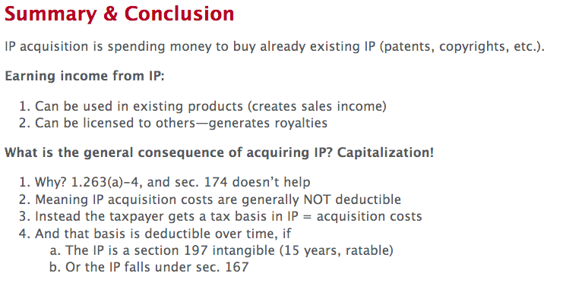

IP Transfer

Overview
- IP transfer is the transfer of rights to IP, usually either via a sale or a license.
- The main consequence is income to the former owner, and the question is how much income, and of what “character” (capital versus ordinary) the income will be.
- What are the main IP transfer issues?
  - Sale v. License – did the transferor sell the IP, or is the transferor retaining it and merely allowing others to use it (a “license”) in some limited way?
  - If sale, what is the “character” of gain or loss – is the gain or loss capital gain or ordinary income?
  - Also, section 199 (prior to 2017—NOT an issue today) – this section gave a lower rate on certain types of income, but is no longer relevant.
- So why care about IP transfer for Tax?
  - Sale versus license is the fundamental initial question: When you transfer IP, have you sold the IP, or are you merely licensing it? Licensing IP is basically the IP equivalent of renting property—you, as the owner, still own the IP, and are just letting someone else use it, temporarily. Whereas, by contrast, a sale of IP means you have disposed of all your substantial rights to the IP.
    - License = If your transfer is a license, then you earn royalty income as the recipient, and the taxpayer paying you the royalty gets a deduction as the payor.
    - Sale = By contrast, if you have a sale of the IP, then you (as seller) have gain or loss (amount realized, or AR, less adjusted basis, or AB) for “seller,” and IP acquisition (see above) for acquiror.
  - Sale v license? How do you tell whether you have sold IP, or are merely licensing it?
    - Sale only if “all substantial rights” transferred; otherwise a license
    - How do you tell?
      - Time – perpetuity (the lnger the time, the more it sounds like a sale)
        - Example- 99 year right sounds like a sale
        - Whereas a right to use for 1 year sounds like a license
      - Exclusivity (ie no one else can use the IP) – this sounds like a sale
      - Geography – the more geography covered (“worldwide rights”), the more it sounds like a sale
        - Example – the right to use in the US only sounds like a license (geographically limited)
      - Exclusive right to make, use and sell” = sale
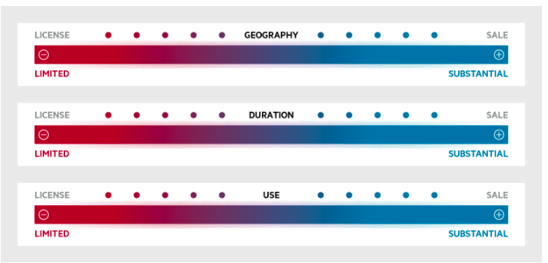
- Sale -- what result?
  - A sale of IP creates realized gain or loss, in the amount by which the amount realized (AR) exceeds the adjusted tax basis of the IP (AB), in the case of a gain, or in the case of a loss, the excess of the AB over the AR.
  - The next question is whether the gain is recognized, which means that the gain is taxable. For IP generally gains are taxable unless nonrecognition applies, potentially as follows
    - 351/721 – “property” transferred to PS/Corp.
      - these sections provide nonrecognition for transfers of “property” to either a corporation (section 351) or a partnership (section 721). The question here is whether IP is “property” for purposes of these provisions. Generally, IP should be considered to be property under these rules.
    - 1031? Sec 267 – sales to related parties
      - Section 1031 – this is the like-kind exchange provision. Following the 2017 tax reform, IP is no longer eligible for tax-free treatment under the like-kind provisions, which are now limited to real property only.
      - Section 267 – this section defers recognition of a loss on sales to related parties. Hence a sale of IP at a loss to a “related party” will create a loss that is deferred for tax purposes, until the IP is eventually sold to an unrelated party.
    - sec 197(f)(1) – sell some, retain some = no loss
      - under section 197(f)(1), if the taxpayer sells some IP rights, but retains some rights in the same IP, then no loss is allowed on such a sale.
  - “sale” or “contribution” to a dependent minor (see sec. 1(g))
    - if the taxpayer sells or contributes IP to a dependent minor, consider sec. 1(g), which will basically tax any income related to the IP at the contributor’s tax rate, not the dependent minor’s tax rate.
- “Character” of Gain or Loss
  - Capital, or “ordinary”
  - Why care? “net capital gain” of individuals taxed at just 15%
    - Generally capital loss can only offset capital gains
    - Hence, even corporate taxpayers tend to prefer for gains to be capital, but for losses to be ordinary.

Sale of IP – Income Characterization Issues
- Capital Gain or Loss – requirements to determine capital gain or loss
  - “Recognized” gain or loss (AR-AB)
  - From “sale or exchange”
    - Abandonment not sale/exchange
    - Theft not sale/exchange
  - Of a “capital asset” – see sec. 1221
    - “inventory” not capital – professional inventors
    - 197 intangibles not capital – but fall into 1231 (more on this next)
    - copyrights, literary, musical, etc., compositions created by “personal efforts” not capital
      - Limited exception for sale of musical works – 1221(b)(3)
  - Held “long term” – more than 1 year
- If all are satisfied, then the particular gain/loss is a “regular” capital gain or loss (and goes into “netting” process to determine net capital gain, or overall capital loss).
- The net result of this analysis is usually a net long-term or net short-term capital gain or loss. If a net loss, that loss is limited in deductibility against ordinary income; if instead you have a net long-term capital gain, then such gain might be taxed at a lower rate if the taxpayer is an individual.
- Special Characterization Provisions
  - Section 1231
    - a special rule that deals with the sale or exchange of “depreciable” assets “used in a trade or business” (“1231 asset”) and thus are NOT capital assets.
    - “1231 assets” must be held long term, and do NOT include either inventory or created copyright but DO include 197 IP.
    - The special rule under 1231 (simplified):
      - You put all “1231 gains and losses” into a “pot” (i.e., you net them against each other);
      - If the overall result is a gain, the gain is CAPITAL—thus go into overall capital gain netting process described above;
      - If the overall result is a loss, then the loss is ORDINARY (does NOT go into the regular capital gains “netting process”—instead deductible against OI).
    - This is taxpayer-favorable—capital gains are good (15%) and ordinary losses are good, too (not subject to limitation).
  - Section 1245
    - applies to transfers of amortizable IP (under sec. 167 or 197)—a 1231 asset.
    - The provision applies only to gain on these transfers.
    - The rule re-characterizes what would otherwise be capital gain (due to 1231) into ordinary income, to extent any gain is “due to” amortization.
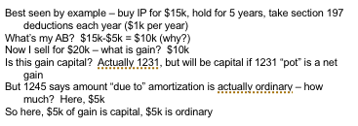
  - Section 1235
    - Applies to patents only
    - Three requirements of section 1235
      - 1. Transfer to an unrelated person
        - Also excludes transfers that arise from employment
      - 2. By holder
        - Individual whose personal efforts created it
        - Individual who acquired it from holder for money
        - Corporations are NOT holders
      - 3. Of all substantial rights – any of the following would NOT apply
        - Geographic limit
        - Duration limit
        - Trade/industry limit
        - Claim/invention limit
  - Section 1253
    - applies to trademarks and tradenames.
    - Under this provision, the taxpayer gets ordinary treatment on all payments that are contingent on use, productivity, or disposition of trademark/tradename.
    - Also, taxpayer gets ordinary treatment on noncontingent payments received if transferor retains any significant power, right, or interest in the mark/name.
  - Section 453
    - Sale of IP for contingent payments
    - Can defer the gain if payments received in later years
    - Gain on each payment = payment X total gain/total purchase price
    - Can elect out (why?), and also must charge interest on unpaid balance

Other Transfers of IP
- Transfer to business entities
  - 351 – Transfer of “property” to corporations.
  - 721 – Transfer of “property” to partnerships.
  - Issue in both cases is this: Is the IP “property”? Usually, IP will be “property,” but in cases of more amorphous types of IP (like “know how”), it is less clear that IP is property.
  - If section 351 or 721 is applicable, then there is no gain or loss recognized on the transfer.
    - However, section 367(d) will overrule this treatment in the context of transfers to foreign corporations, which become taxable instead.
- Transfer to Charities
  - Generally, can deduct the FMV of IP contributed
  - BUT must reduce deduction by amount of any ordinary income that would have been created if IP was sold instead (example) – 170(e)
  - So for patents – FMV deduction if 1235 applies
  - For trademarks – generally tax basis deduction if 1253 applies
  - For self-created copyrights – generally tax basis deduction
  - See also 170(m) – if deduction reduced by this rule, can be increased each year, up to 12 years, for % of income earned by donee charity from the contributed IP
199 Under PRIOR law
- Issue: will income from IP transfer (sale or license) qualify as “DPGR” and thus be eligible for 199 deduction (prior to 2018)
  - Sec. 199 in general – a deduction equal to 9% of “QPAI”
    - (effectively reduces tax rate on QPAI by 3 percentage points)
  - QPAI = DPGR – cost of DPGR sales – other allocable expenses
  - DPGR = gross receipts derived from qualifying activities:
    - Sale or license of QPP made “in whole or significant part” in US
      - QPP includes “computer software”
      - Also includes ad revenue for newspapers, magazines, qualified film and software
      - Includes online software if same software also sold or downloaded
    - Sale or license of “qualified film”
    - Qualified film = any production where 50% or more of compensation paid for work in US

IP Transfer – State Tax Issue
- To date, we’ve been discussing federal income tax
- States also have taxes, too
  - Both income taxes, and
  - Also “sales & use” tax – tax on the value of transfer of goods (including, often, IP) & services to a final buyer
- Issue on deals – we buy “software” or “IP” – is it subject to sales/use tax? (What is it? Copyright? Tradename?)
- Depends on the state, and the method of delivery
  - Eg – CA:
    - Copy on to CD & carry (or carry server) – taxable
      - But maybe “copy” not taxable
    - Send electronically – NOT taxable
  - Some states (eg OR) have no sales/use tax – so what’s the best protocol? More on this on July 28….

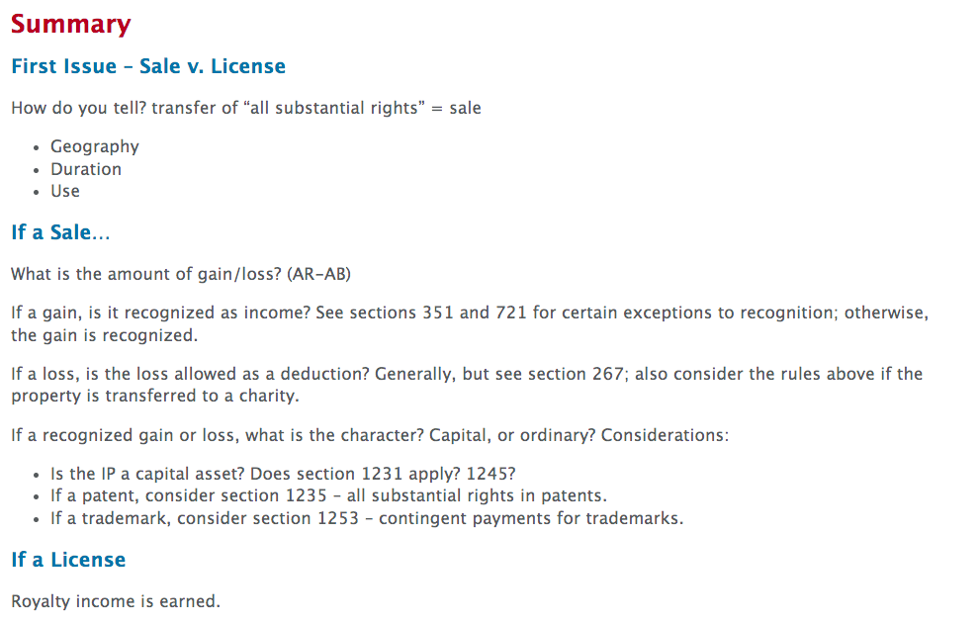

IP Litigation

Overview
- What happens in IP litigation that impacts tax? You incur costs, and you also can get income, in the form of settlements or judicial awards. So the issues are as follows:
  - Costs – can you deduct your litigation costs?
  - Awards (settlement or judicial)
    - As payee (recipient) – must you include in income?
    - As payor – can you deduct the payment of the award?

Treatment of Litigation Costs
- no special rule—look to sec. 162, which is the general rule for business expenses.
  - Under this rule, courts have said that you look to the “origin of the claim.” In other words, you ask what the costs are being incurred for.
- Under this rule, in general, costs will be capital if the costs have an origin in acquisition/disposition of an IP asset. Otherwise, the costs should be deductible. Here are some specific costs and how they are treated:
  - Patent/ copyright litigation costs
    - Defending validity = deductible
    - Defending ownership = capital
    - Infringement = deductible (recovering lost profits)
  - Trademark litigation costs
    - Validity = capital
    - Infringement = capital
  - Unfair competition
    - Generally costs are deductible. See also 162(f), 162(g)
  - Award of fees
    - Includible in income if fees already deducted (example)

Treatment of Litigation Awards
- Taxpayers can earn income from litigation either by settling, out of court, or by winning judgements in court
- Either way, the tax rules are the same for these awards
- In general, such awards will be income (with one possible exception, noted below) and the only real question is whether such amount are capital or ordinary
- Here the technical rule is also “origin of the claim” which generally results in the following, by type:
  - For payee (recipient)
    - Patent/copyright infringement awards = ordinary income (replace royalties)
    - Damage to capital asset (e.g., goodwill) – nontaxable return of capital (and then capital gain in excess of basis)
    - Trademark – generally capital gain
  - For payor of an award
    - If ordinary income to payee, should be deductible
    - If for damage to capital asset – then likely not deductible
    - If for acquisition of new IP – then capital
    - Paying a liability related to acquired IP = capital
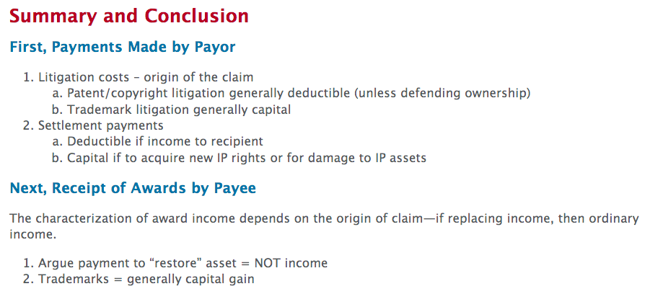

The R&D Tax Credit

The R&D Credit

Big Issues:
- What is qualified research?
- Which expenses are QREs?
- Practically, how do you tie the expenses (QREs) to the qualified research? Proof issues (IRS audits)
  - Some proof issues
    - Cost centers
    - Interviews
    - LB&I directive
- How do you calculate the credit? Regular, ASC, or basic and the 280C limitation

- Overview
  - The R&D credit is an incentive for companies to develop new or improved
    - Products
    - Processes
    - Techniques
    - Formulas
    - Inventions
    - Software
  - The credit is determined based on the incremental qualified expenses over an established period of time
  - IP development costs also trigger the R&D tax credit
    - Costs to develop IP are generally deductible under sections 162 and 174; then, those same costs (with some additions and subtractions) can trigger the R&D credit (though, as we will see, it is not possible to take a deduction and a credit with respect to the same costs).
  - R&E tax credit – section 41
    - This is a credit – reduces tax liability dollar for dollar
      - Tf, better than a deduction
    - the R&D credit is part of the section 38 General Business Credit, and is subject to the limitations contained in that provision.
    - There are rules in place to prevent taxpayers from taking both a deduction and a credit on the same R&D expenditures (see section 280C).
  - The credit was first enacted by Congress in 1981. Until 2015, the credit was subject to expiration, and had to be extended most years by Congress as part of its standard year-end “tax extenders” process. However, in 2015, the credit became permanent. Economically, the credit is worth about 5.5% to 7.9% of the expenses in question. There is also the potential for state-level R&D tax credits as well.
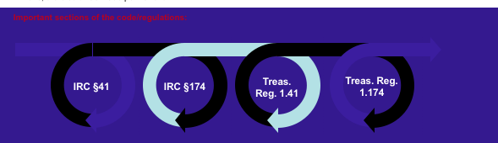
  - Because section 41 is a credit, it is considered a “permanent” tax benefit, and hence it will reduce a corporation’s effective tax rate (ETR) as reported in its financial statement. The benefit of the credit can often be seen in looking at the ETR reconciliation set forth in the tax footnote of the public financial statements of corporations that take the credit.
    - Permanent tax benefit can:
      - Lower an entity’s effective tax rate
      - Increase earnings per share
      - Increase cash flow
  - Example industries that take the credit


The basic calculation
- The section 41 credit is actually two credits:
  - 1. The taxpayer’s choice of either the “regular” R&D credit or the “Alternative Simplified Credit” (ASC) and
    - Regular credit: 20% of excess of “qualified research expenses” (QREs) for year over a “base amount
    - ASC:
      - 14% of excess of QREs over 50% of average QREs for 3 preceding tax years
      - Or 6% of current year QREs if no QREs in the 3 preceding years
  - 2. The credit for basic research
    - 20% of “basic research payments” – to universities – over base period amount
- Regular credit or ASC?
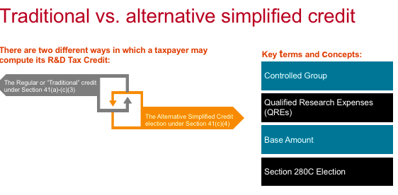
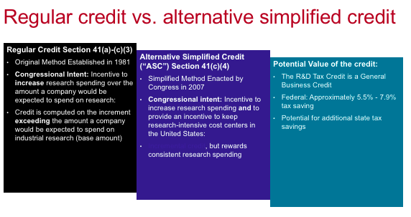
  - the concept of the QRE is critical to the section 41 R&D credit. (more on this below)
  - it is not worth spending much time on the mechanics of the regular credit, because no one uses it any more (with limited exceptions). This is because its “base period” requires (for many taxpayers) going back to the 1980s to determine QREs in those periods (see IRC section 41(c)(3)). Because of this, and because of the availability of the ASC, very few taxpayers take this regular credit.
    - Example of regular research credit:
      - Computation (with QREs from 1984 - 1988):
        - 1984-88 QREs of $400,000
        - 1984-88 Gross Receipts of $4,000,000
        - Current Year QREs of $600,000
        - Average Gross Receipts of 4 Previous Years = $5,000,000
      - Fixed-Base Percentage = $400,000/$4,000,000 = 10%
(less than 16%)
      - Base Amount = Greater of [10% x $5,000,000 = $500,000] or [$600,000/2 = $300,000]
      - Excess QREs = $600,000 - $500,000 = $100,000
      - Gross Credit = $100,000 x 20% = $20,000
  - most taxpayers instead elect to take the ASC—see Code section 41(c)(4). Under this alternative, the calculation is still driven by QREs.

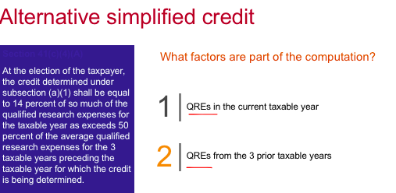
  - However, the actual calculation of the credit is much easier. The credit is 14% of the excess of current year QREs over 50% of the average QREs for the taxpayer in the 3 preceding taxable years.
  - Hence the ASC only requires looking back to the prior 3 years (and special rules exist for taxpayers in their first 3 years). Also, because the base period is only 50% of the average of the 3 prior years, this means that a credit is available under the ASC even in periods where QREs are not increasing:
    - Example: TechCo incurs $50 in QREs in 2017, $100 in QREs in 2018, $150 in QREs in 2019, and $150 in QREs in 2020. Its credit for 2020 will be 14% of the current year QREs ($150) over 50% of the average QREs in 2017–2019 ($50 = ($300/3) x 50%), for a credit of $14 ($100 times 14%).
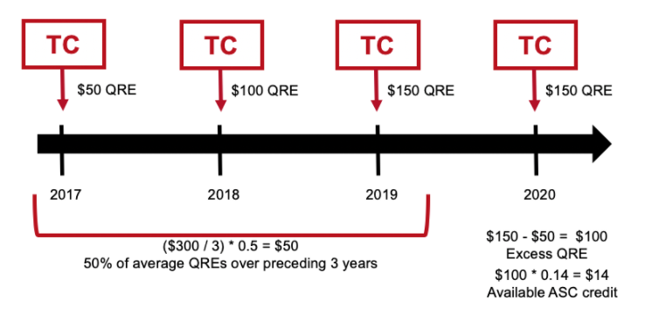
- The basic research credit:
  - The basic research credit is equal to 20% of the excess of current year “basic research payments” over a base period amount.
    - Basic research payments = cash payments made during a taxable year by a corporation to a qualified organization pursuant to a written agreement
  - This credit is available even if the taxpayer chooses the ASC for its standard R&D tax credit. Here, basic research payments are those payable to qualified organizations such as universities. See Code section 41(e) for details.
    - Qualified organization
      - Educational institutions
      - Scientific research organizations & tax-exempt organizations
      - Certain grant organizations
  - Cannot get both a regular and basic credit for the same costs
    - It is generally better to take the basic credit where it is available, because the same costs would be “haircut” down to 65% under the regular credit, but are available at 100% as part of the basic credit. The basic credit and the regular credit cannot be taken on the same expenditure.
  - Example: TechCo pays $1,000 to Johns Hopkins University to perform research on its behalf. This cost will qualify as a “basic research payment,” and hence 100% of this cost is eligible to be included in the calculation of the basic research credit. However, this cost will also likely qualify as a contractor cost under the regular R&D credit. As such, only 65% of such cost will qualify as a QRE under the regular credit. Since TechCo cannot take both a basic credit and a regular credit with respect to this $1,000 cost, TechCo will be better off including the full $1,000 as an expenditure in calculating its basic research credit, rather than taking only $650 of this amount as a QRE in its regular credit calculation.
- Limitations:
  - R&D credit is subject to the section 280C limitation
    - section 280C is a provision that prevents taxpayers from taking both a deduction and a credit with respect to the same expenses.
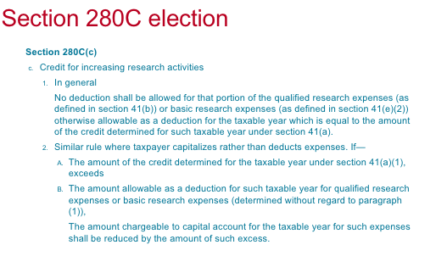
    - Hence, taxpayers can elect under this provision to either forego the deduction, or reduce the credit by a percentage that equals one minus the applicable tax rate (so for corporate taxpayers, this means that they can either forego the deduction, or take 79% of the calculated credit—this is calculated by taking 1 – the current tax rate of 21% = 79%).
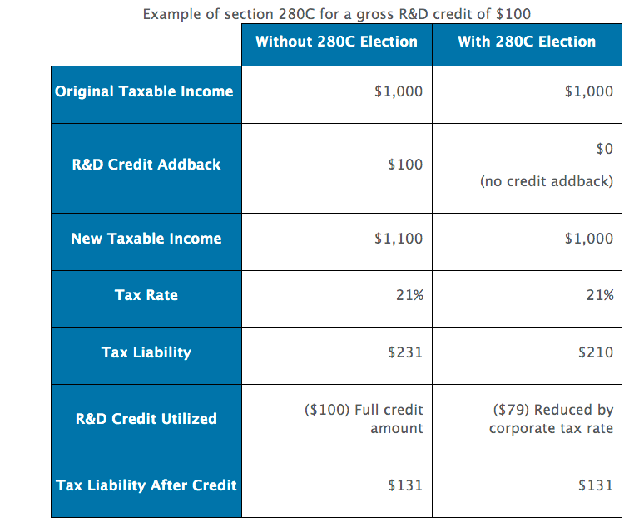
    - The choices will not necessarily always create the same result—recall that other limitations apply to the credit (section 38), and the deduction is only valuable if the taxpayer has taxable income against which to offset it. Hence taxpayers will need to consider these other limitations in making their choice under section 280C.
  - R&D credit is also subject to the section 38 limitation, contained in Code section 38(c)
    - Limitation basically imposes a maximum credit equal to 75% of a taxpayer’s pre-credit tax liability
    - Example: if a taxpayer has $1,000,000 of tax liability, pre-credit, then the maximum section 38 credits (which includes the section 41 R&D credit) that this taxpayer can take is effectively $750,000.
  - Any credit that is not used due to this limitation can be carried forward indefinitely. These credit carryforwards are subject to the rules of section 383 if there is an ownership change (discussed in a prior week). Also these carryforwards create Deferred Tax Assets (DTAs) for financial statement purposes, and can often be seen in the tax footnote of public companies who have these carryforwards.
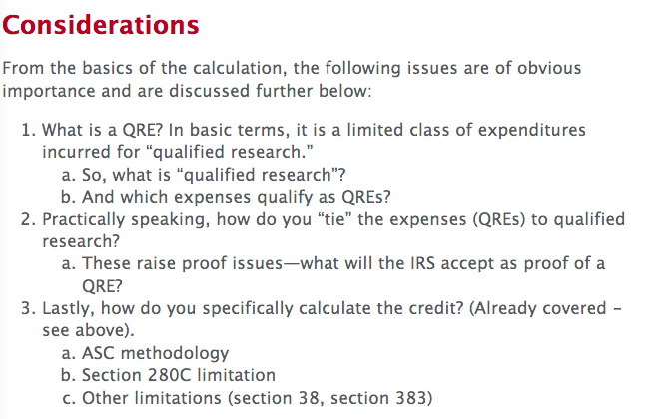

Qualified research
- Whether an activity is “qualified research” is the true trigger for the R&D credit
- All expenses that qualify as potential QREs must be incurred in connection with qualified research
- Tf, whether an activity is qualified research or not is the true starting point for section 41 analysis
- What is qualified research?
  - An expense under section 174 (ie not equipment)
  - In sum, it is technological research undertaken through a process of experimentation for a permitted purpose
  - 4 part test:
    - “technological in nature” = “science”; need not be successful
    - “process of experimentation” = testing
      - NOT including anything readily discernible
      - NOT including choosing between alternatives
    - “permitted purposes” are those related to new or improved function, performance, reliability, or quality
    - “technical uncertainty” – activity intended to eliminate technical uncertainty relating to developing or improving a business component.
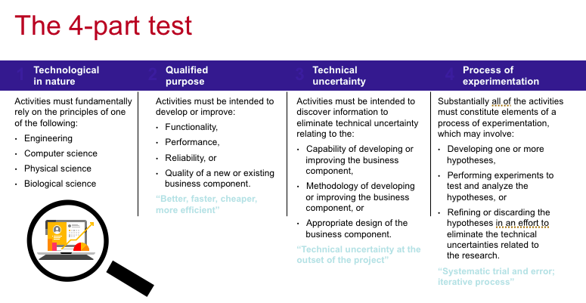
  - There is no longer a “new discovery test”
    - Activities do not need to discover something new to humanity, only represent an attempt to eliminate uncertainty for this particular taxpayer
  - Also the fact that the effort is a failure is not determinative
    - In particular a pilot model itself can be sold without disqualifying any of the R&D costs that go into the pilot or prototype
  - Patent safe harbor:
    - Patent = qualified research
    - The test is applied separately to each “business component” and “production process”
    - Generally costs for pilot models will qualify
  - Under relevant caselaw, the “product” and the process to make the product are separate and need to be analyzed separately. This means that the product might be done (production) but process costs can still count as QREs if experimentation is going on. Also, material costs of a component can qualify as R&D even if the rest of the product is already functional.
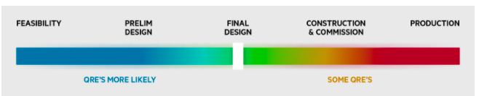
- Qualified research does NOT include
  - Anything that relates to “style, taste, cosmetic or seasonal design factors”
  - Research after commercial production (eg trial runs, debugging production, etc.)
  - Adaption or duplication of existing components;
  - surveys; studies; mgmt function, market research, data collection
  - Ordinary testing or quality control
  - Internal-use computer software
    - unless “highly innovative”
    - Or used in qualified research
  - Foreign research
  - Social science research
  - “Funded” research
    - Funder gets the credit (65% as a contractor cost)
  - Lease payments, in general
- Additional requirements for internal-use software (IUS)
  - IUS defined: computer software developed by the taxpayer primarily for the taxpayer’s internal use in general and administrative functions (such as finance, human resources, other support services) that support the taxpayer’s trade of business
    - Software that is developed to enable a taxpayer to interact with third parties, or allow third parties to initiate functions or review data on taxpayer systems, is not IUS
    - The final regulations provide that whether software is or is not developed primarily for internal use depends upon the intent of the taxpayer and the facts and circumstances at the beginning of the software development.
  - The high threshold of innovation test does not apply when the internal-use software has been developed for use in:
    - An activity that constitutes qualified research (other than the development of the internal-use software itself); or
    - A production process that satisfies the requirements of the four-part test
  - 3 additional requirements
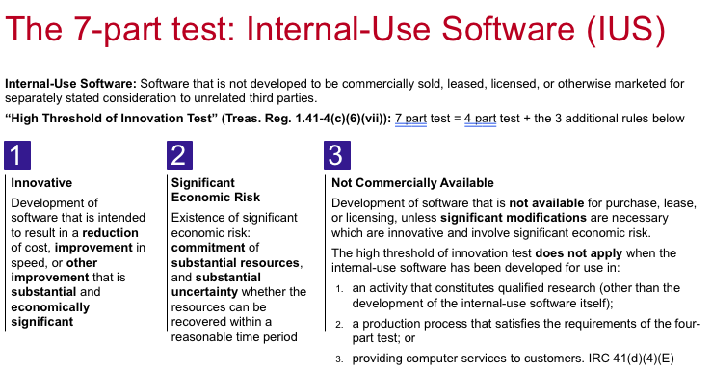
  - Example: ACE Inc. designs, manufactures, and sells tools and equipment that are used by semiconductor manufacturers to make semiconductors. To improve customer service, ACE undertakes to develop computer software that will monitor the manufacture and delivery of ACE’s tools to enable ACE’s customers to track their tool orders from origination to delivery. At the time ACE undertakes development of this software, it is uncertain whether it can develop the software. None of its competitors have a similar system. ACE commits resources to this development and cannot determine if it will recover its investment within a reasonable period. IUS?

Qualified Research Expenses (QREs)
- Section 174: is the starting point for determining what expenses will qualify for the section 41 R&D tax credit
  - under 174 – taxpayers may either deduct research and experimentation cost paid in connection with a business or instead amortize these over a 5-year period
  - The purpose of this provision was to encourage taxpayers to carry on R&E expenditures by eliminating the uncertainty concerning the tax treatment of these expenditures.
  - further taxpayers have some flexibility, under code section 59(e) to capitalize certain portions of their R&E costs and amortize those over a 10-year period
  - taxpayers can choose to capitalize under 174(b) or 59(e) on a project-by-project basis
  - Lastly, 174 changed in 2022 – now costs must be capitalized and amortized over either 5 years (for US costs) or 15 years (for foreign costs)

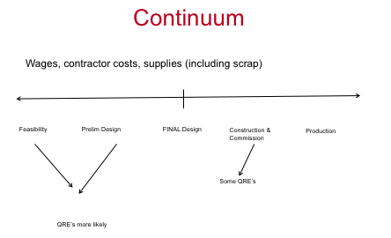
- The continuum (technically 174)
  - Ultimate failure not relevant, so you can sell a product with “materials” that you deducted
  - material and labor costs of a component can be R&D expense even though the rest of the property is functional (Union Carbide)
  - Examples also conclude that all material and labor costs of a product being developed and eventually sold can qualify if the uncertainties about development apply throughout the product; a
  - A pilot model itself can be sold without disqualifying any of the R&D expense going into the pilot/prototype
- 174 overview
  - Specific definition - What are section 174 costs?
    - Treas. Reg. 1.174-2(a)(1): Expenditures incurred in connection with the taxpayer's trade or business which represent research and development costs in the experimental or laboratory sense. The term generally includes all such costs incident to the development or improvement of a product.
  - How to measure impact?
    - Need to identify activities – Similar to Research Credit “4-part test” – Costs incidental to the conduct of research - no process of experimentation requirement
    - Sec. 41 exclusions – Funded and Foreign Research do not apply
    - Costs – Direct costs and costs incidental to research (e.g. utilities, depreciation, occupancy costs, etc.) Costs must be considered reasonable
    - Other key cost differences v. Sec. 41 – (1) Contract research not reduced to 65%; (2) Ability to use gross wages rather than Box-1 W-2 wages; (3) No substantially all gross-up (the “80% Rule”)
- 174: what is in or out
  - Common examples of Section 174 eligible activities
    - Product Development, Process Research, Pilot Models, Software Development, Formulation Research
  - Other Section 174 information
    - An accounting method change is generally required to change from currently deducting to capitalizing and amortizing (or vice versa) R&D expenditures under section 174.
    - The determination to deduct or to capitalize R&D expenditures under section 174 is made at the project level and can be applicable to specific R&D projects without necessarily applying to all other R&D expenditures paid or incurred in the same tax year. Specific tracking rules apply.
    - The definition of section 174 costs may differ from financial statement R&D costs, which focus on product development.
- 174: Accounting methods and elections
  - General accounting method options for Section 174 costs
    - Sec. 174(a) – Allows for deduction of research and experimental costs, not chargeable to a capital account, which are paid or incurred during the year.
    - Sec. 59(e) – Allows for capitalization of research expenditures currently deductible as 174(a) costs with a 10 year ratable recovery period.
    - Sec. 174(b) – Allows for capitalization of research expenditures and ratable recovery period of no less than 60 months (beginning with the month in which the taxpayer first realizes benefits from such expenditures) or if charged to a capital account, the taxpayer may follow the treatment for property of a character which is subject to the allowance under section 167 (relating to allowance for depreciation, etc.).
    - Rev. Proc. 2000-50 – Allows for deduction of costs as paid or incurred with respect to internally developed software.
  - Note: Due to tax reform, the capitalization requirement will require 5-year (domestic) / 15-year (foreign) amortization and will render Rev. Proc. 2000-50 moot for tax years beginning after 12/31/2021.
- What are QREs?
  - 3 types of examples:
    - Salaries for employees engaged in qualified research
    - Supplies used in qualified research (including “scrap”)
    - 65% of payments made to third parties to conduct qualified research on behalf of taxpayer
- Section 41(b) contains the rules for QREs
  - as noted, the basic starting point is section 174—most (but not all) expenses that fall under section 174 will also create QREs. However, there are a number of costs that qualify for section 174 (such as costs incurred for foreign research) that will not qualify as QREs under section 41(b).
- 1. Wages
  - Wages are W-2 costs (including salary, bonus, and stock-based compensation) paid to employees who perform “qualified services”, which is basically qualified research
    - Does not include overhead, 401(k) and other deferred compensation
    - Need to also track wages by state for state research credit
(offered in most states; Box 15 states and Box 16 state wages)
    - Qualified wages include taxable fringe benefits subject to withholding tax (e.g., vacation, sick pay, bonuses,
severance pay)
    - Also SBC is included
  - Since it is mostly wages that qualify for the credit, it is important to determine which employees qualify for the credit
    - Generally, the employees in question must directly perform, support, or supervise a qualifying activity or initiative, and
    - all activity must take place within the US
  - Under an 80% test, if an employee spends 80% or more of their time performing qualifying services, then 100% of their wages count as QREs. As to which employees qualify, it is generally employees who perform technical activities and employees who directly support or supervise technical activities.
    - Individuals who are:
      - 1. Performing technical activities
      - 2. Directly supporting or supervising technical activities
  - Note:
    - An individual does not need to be in a R&D cost center in order to qualify, as this is an activity-based tax credit benefit
    - Job titles to look out for: Product Manager, Architect, Engineer, Research fellow, etc

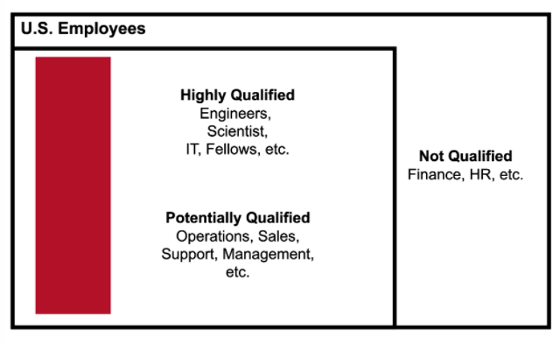
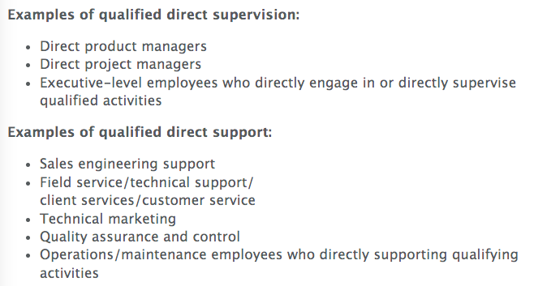
- 2. Supplies
  - Supplies costs that qualify are for materials that are deductible, and not capital, and are used in the conduct of research
  - Tangible property used in the U.S. as part of the qualified research activity
  - Excludes land, improvements to land, and property subject to depreciation
  - Classic examples include chemicals and beakers
    - Other examples include materials used in trial runs, prototypes, qualifying raw materials and similar activities
- 3. Contract Costs
  - equal to 65% of amounts paid to third parties (not employees) for the conduct of research. Included are costs to temporarily increase R&D staffing, perform testing services, do design, and consulting fees.
  - The work must physically take place in the U.S. For contract costs, once the activity is determined to be potentially qualified, additional determinations must be made as to whether the research performed is considered contract research or is "funded."
  - Generally, research and experimentation expenditures are not eligible for the credit "to the extent funded by any grant, contract or otherwise by another person (or government entity)."
  - In those cases, the "funder" can get QREs equal to 65% of the contract expense. The funder will get QREs only to the extent that the amount is paid or incurred pursuant to an agreement that:
    - Is entered into prior to performance of qualified research,
    - Provides that research is performed on behalf of the taxpayer (payor), (RIGHTS)
    - Requires the taxpayer (payor) to bear the expense even if the research is not successful. (RISK)
  - Also certain costs to lease computers from third parties can qualify (but are rare in practice).
- 4. Rental or lease costs of computers: IRC section 41(b)(2)(A)(iii)
  - Rental or lease costs of computers: any amount paid or incurred to another person for the right to use computers in the conduct of qualified research.
  - In order to qualify for the credit, the costs must meet the following requirements:
    - The computer must be owned and operated by someone other than the taxpayer;
    - The computer must be located off the taxpayer’s premises; and
    - The taxpayer may not be the computer’s primary user.
- QRE Proof and other issues
  - Union Carbide & McFefrin cases
    - No more “new discovery” test
    - Use of estimates are fine in documenting the QRE’s (McFerrin)
    - Also ok are reconstruction methodologies including the use of historical data, testimony corroborated by documents, testimony taken alone, and estimation (Union Carbide)
  - LB&I Directive (ASC 730)
- Examples- Are these QREs?
  - Wages paid to R&D dept
  - Wages paid to tax department
  - SBC for R&D dept
  - SBC for tax department
  - Equipment used in R&D process
  - Contractors paid to do R&D
  - Beakers used in R&D
  - Third party entity paid to do R&D
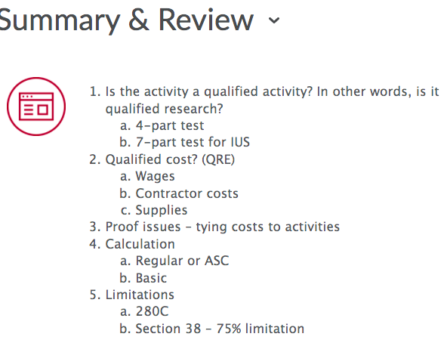
State Tax Issues for HTEs

Corporate Tax issues

- Basic Corporate Tax issues
  - Most (but not all) U.S. states impose income taxes, including income taxes imposed on corporations.
  - State-level corporate income tax is very similar, in that it starts with a tax base (generally, income minus allowable deductions).
  - However, state tax differs in that the tax base typically is not fully taxable—states need some manner to take the tax base, and allocate or apportion the tax base to their particular state
- Tax Base
  - States have to determine their tax base, which is basically taxable income.
    - Most states start with federal taxable income.
    - Then, the states make specific adjustments, and must deal with specific income inclusions like the new international income inclusion under IRC section 951A for “GILTI.”
    - Other adjustments
  - Then, because the tax base is determined at the federal level, the next step is to then allocate or apportion that income to the particular state.
    - States are not entitled to tax all federal income! But before we talk about how states allocate or apportion income, we need to talk about the basic approach that states take to taxation of corporations.
- Unitary or Separate Filing
  - States have chosen 2 ways to treat corporate taxpayers
    - 1. Unitary filing: where all members of a commonly controlled group of corporations (similar to a consolidated group filing one tax return for federal purposes) is treated as one taxpayer
    - 2. Separate filing: each separate legal entity is treated as a separate taxpayer
  - For unitary states, the corporate group is treated as one taxpayer, meaning that all intercompany transactions within the group are ignored. The group’s income is then apportioned to a particular state based on the factors described below
  - For separate filing states, transfer pricing principles (which treat each legal entity as a separate taxpayer, operating at arm’s length) are used to determine the income of each separate legal entity. These basic principles will be covered later in this course. Then, only legal entities with some sort of presence in the separate filing state will have income tax liability in those states (which is apportioned to the state using the apportionment methodologies described below).
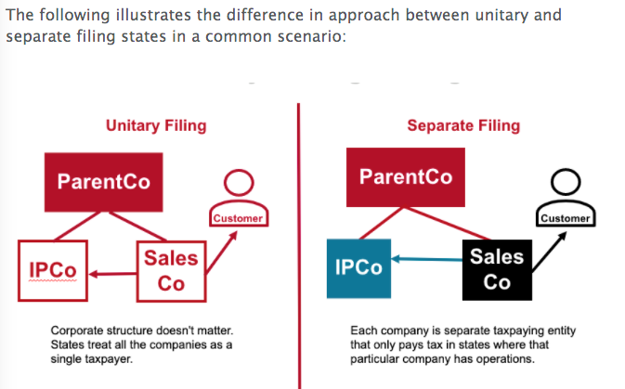
- Apportionment Approaches
  - Under either approach, once a taxpayer’s taxable income is determined (either at a separate entity or unitary level) then such income must be apportioned to a particular state based on some set of standardized factors
  - Some states (such as CA) use a “single factor”, while other states use a combination of factors (sometimes a weighted average of property, payroll, and sales into the state).
  - Because of these disparate approaches, it is likely that either more than or less than 100% of federal taxable income will be apportioned to the states
  - Example: BigCo is a single corporation (not part of a corporate group). BigCo’s federal taxable income is $1,000,000. Let’s assume that the states do not adjust its taxable income and just use federal taxable income (which is not the case in real life). Assume further that BigCo operates only in two states, State C and State O. State C uses single sales factor as its apportionment factor, and 50% of BigCo’s sales are in State C. State O uses an average of a taxpayer’s sales, payroll, and property in State O as its apportionment factor. For BigCo, 50% of its sales are in State O, but only 20% of its property and 20% of its payroll are in State O. Hence its State O apportionment factor is 30% (the equal average of its 50% sales, 20% property and 20% payroll in state). Therefore, 50% of BigCo’s income is apportioned to State C, but only 30% is apportioned to State O, meaning that only 80% of BigCo’s federal taxable income is taxed to states in this example.
- Tax Credits and Other Incentives
  - Many states have their own R&D tax credit, similar to the federal one
  - Also, states will offer a variety of incentives intended to attract investment into their state

Transaction Taxes (Indirect Taxes)

- Overview
  - Sales tax and use tax are state- and local-level transaction taxes.
  - The U.S. is one of the few countries without a national transaction tax. Other countries have versions of what is called the Value Added Tax, or VAT for short. Sales and use tax differ from VATs in the collection point.
    - Sales tax is typically charged as a percentage of the sales amount, at point of sale, and is collected only by the final vendor (VATs, by contrast, are collected at each point in the production process).
  - Use tax, by contrast, is not collected by the seller, but is still legally owed by the purchaser of taxable products.
  - Most (but not all) U.S. states have sales and use taxes. Sales and use tax revenue and procedures are often shared between the state and its constituent entities such as counties and cities (for example, in California, sales and use revenue is shared between the State of California, counties such as Santa Clara county, and localities such as Sunnyvale).
- Sales Tax
  - Sales tax is charged as a percentage of the value of a sale, typically a sale of a tangible product. In most states, most services are not taxable.
    - So, for example, a $1 pack of gum would attract 9 cents of sales tax in California, but lawyer fees of $1,000 would not attract any sales tax. There are a number of commentators who find this to be unfair and outdated in a modern economy.
  - Also, sales tax must be collected by vendors. Typically, vendors must only collect sales tax in states where they have a physical presence. Vendors then collect and remit that sales tax to governments. Vendors can be liable for the tax and penalties if they fail to appropriately charge tax on taxable sales.
  - 1. Charged on certain sale transactions, in certain states
  - 2. Generally collected and remitted
- Use Tax
  - Use tax is just the same as sales tax, but in situations where the vendor does not charge and collect the tax for some reason (if, for example, the vendor has no taxable presence in the purchaser’s state).
    - In those situations, if a transaction is taxable, it is the responsibility of the purchaser to pay the use tax on its own.
    - This is the case even for individuals—in fact, the California individual income tax return even has a question that asks whether the filer has paid appropriate use tax on purchases from out-of-state vendors.
  - For HTEs and other corporations, use tax is typically due on inputs to their businesses, where vendors are not required to charge sales tax. Examples of such inputs might be supplies used in conducting research.
  - 1. Paid on company’s inputs (buildings, equipment)
  - 2. Cost to company – not just collection and remittance
- Number of issues arise – sales and use tax
  - Nexus to collection (Amazon)
    - Physical connection required?
  - Services and/or bundled transactions (and leases)
  - Exemptions available
    - CAEATFA
    - Other examples
- IP Transfer Issue – Use Tax
  - There is a common use tax issue that arises on the common corporate transaction of acquiring IP from another party.
    - For HTEs, it is very common to purchase patents, software, or other types of IP, like a copyright or trade name.
    - In these situations, the question arises as to whether this IP acquisition is subject to use tax.
  - This question depends on the state, and the method of delivery.
    - For example, in California, generally the transfer of IP in some sort of tangible medium (such as on a server or CD) would be taxable, but the electronic transfer of the same IP would not be taxable.
    - So the best practice when acquiring IP in California would be to transfer the underlying IP electronically, not in a physical form.
    - Some states (eg OR) have no sale/use tax
  - Example: BigCo acquires the assets of LittleCo. The assets include software and other computer programs owned and developed by LittleCo. If BigCo has LittleCo transfer the software and programs electronically to servers owned by BigCo, then there should be no California sales tax imposed on the acquisition of those assets. However, if BigCo asks LittleCo to transfer the software and programs on CDs, computer discs, or servers (or any form of tangible medium), then the transfer of that software and programs is likely subject to California sales and use tax.
- Audits
  - Many states (especially California) carry out periodic sales and use tax audits. These are done to ensure that corporations are appropriately charging, withholding, and remitting sales tax on taxable sales to their customers, and also paying use tax on their inputs in situations where vendors have not withheld the tax.
- Exemptions
  - Many states (especially California) have exemptions from their sales and use tax system. Some transactions are just not taxable at all (such as most services, as noted above). In other situations, the law will make explicit exceptions for certain types of purchases that would otherwise be taxable. For example, California has a sales and use tax exemption system for manufacturers who use energy efficient inputs in their manufacturing or building process
  - Other states use sales and use tax exemptions in order to attract investment to their state.

Property Taxes
- Many states and localities also rely on property taxes.
- The U.S. federal government does not impose any property taxes, and in fact is prohibited from imposing property taxes, in effect, under the U.S. Constitution.
- Property taxes can be personal property taxes, or real property taxes. Only a few states impose personal property taxes of any magnitude (an example is Virginia, which imposes a limited personal property tax on certain inputs, like research equipment).
- Most property taxes tend to be real property taxes.
- Notwithstanding this, all property taxes share certain considerations.
- Valuation:
  - Property tax is typically an annual exercise, taking the value of property and multiplying it by a tax rate that is set by statute or regulation.
  - Hence, valuation of property is an important consideration in calculating property tax.
  - This is particularly the case given increasing property values around the country.
    - In some states, like California, the valuation process is limited by law. In California, real property valuations are limited by the famous Proposition 13, passed by California voters in 1979, which limits increases in valuation to basically the rate of inflation.
    - In other states, like Texas, the valuation process is subject to an entire process of appeals and valuation reports.
- Taxability
  - Another question is whether the property in question is taxable.
  - Most states and localities provide exemptions from property tax for certain items, either as an incentive or because the state chooses not to tax that particular type of property.
  - In situations where a piece of property has both taxable and nontaxable elements (such as a new office building), it is often advisable to engage in what is called a “cost segregation” study, which analyzes the property in attempt to break down the elements that are not taxable (like pizza ovens or fixtures) from the elements that are taxable as real property (such as the walls, elevators, etc.).
  - Example: BigCo builds a new HQ building, spending $39 million. BigCo does a cost segregation study and determines that $9 million of the costs are for items that are considered real property under local law. Hence, only $30 million of the costs will go into the valuation base for determining its annual property tax liability on the building.

Payroll and Withholding
- HTEs, as corporate employers, are required to withhold tax from wages paid to their employees.
- This withholding often is required at the state level. In order to do withholding appropriately, employers must know where their employees are located. Also, as noted above, the location of employees is important to the corporate tax liability of HTEs that operate in so-called “separate filing” states.
- Returning to withholding, two issues arise in determining where to do withholding for employees. One is employee standard work location, and the other is the issue of employees that travel for business
- On the work location question, employees generally should have only one work location.
  - However, given the new challenges of remote work, employees might work in multiple locations.
  - Also, some employers might not know exactly where employees are located (HTEs typically rely on self-reporting by employees as to their location).
  - Example: BigCo just announced that its employees can work 1 month a year in any state they wish. Bonnie, an employee, works 11 months in California and 1 month in Utah. Under technical law, BigCo should withhold tax from her paycheck to represent 11 months in California, and 1 month in Utah, if local law requires.
- On employee travel, the issue there is tracking such travel and deciding when withholding is required.
  - In many states, even one day in the state could technically trigger tax reporting and other obligations.
  - So the question arises as to whether an employer will withhold tax in those states to which employees travel for only a few days, even if technically required by local law. Doing so will likely create an individual tax filing obligation for those employees, and hence the decision whether to withhold (or not) has significant employee relations implications.
  - Example: BigCo executives from Seattle visit New York often. Technically, even a few days in New York could create a tax filing obligation for these executives, and a withholding obligation on the part of BigCo to withhold New York tax from their paychecks.

International Tax Issues

Introduction to International Taxation
- Background:
  - The basic problem in international income taxation is jurisdiction over income. There are a myriad of other international tax issues, but this is the fundamental problem—there are two countries that arguably have a right to tax a piece of income, and which one gets to tax it?
  - The two countries in question are called the country of “residence” and the country of “source.” For example, when a U.S. multinational HTE earns income in France, the U.S. is the country of residence, and France is the country of source.
  - All countries have tax law that governs how they tax their own residents (when the country is the country of residence), and also tax law governing how they tax nonresidents (when the country is the country of source).
  - What is this topic about?
    - Rules contained in the United States Internal Revenue Code (I.R.C.) governing application of the U.S. INCOME tax in multinational settings (income w/ an international element)
      - Need an understanding of U.S. income tax principles (from basic tax)
      - Also recall that there are two types of taxpayers under the U.S. income tax system – individuals and corporations (both “persons” in the terminology)
        - Thus corporate tax knowledge is helpful
  - What this topic is NOT about
    - The United Nations, or the law of any other country – this is about the U.S. income tax
    - Though of course foreign law does matter – OECD developments, etc
  - There is no such thing as “international” tax – only governments (national or provincial) impose taxes! (but see OECD, UN, etc)
  - Usually, international tax situations involve a “person” (individual or corporation) earning income from a country (the “source” country) different from its country of “residence”
    - For example, a United States person earning income in Kuwait (the “outbound” international tax problem)
    - Or, a non-U.S. person (a “foreign” person) earning income somehow connected to the United States (the “inbound” international tax problem)
    - As we will see, characterization of the situation/transaction will be important
  - Most important topic facing IRS, according to officials
  - Major global issue as well

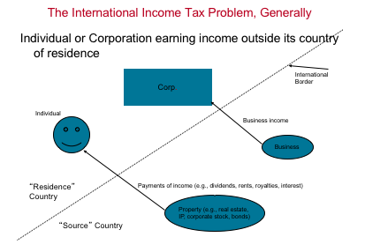
- Residence Country Approaches
  - “Worldwide” taxation – tax your residents on ALL their income, no matter where they earn it (foreign or domestic)
    - Worldwide taxation could be based on residence, or it could be based on citizenship. The U.S. imposes worldwide taxation on its citizens (and certain non-citizens who are permanent residents), which makes the U.S. very unusual
    - If a country takes a worldwide approach, that residence country should give a credit (or perhaps a deduction) for foreign taxes paid by their residents, in order to eliminate or mitigate double taxation.
  - “territorial” taxation – tax your residents only on domestic income (i.e., exempt foreign income)
    - This is often reserved for corporate taxpayers, and in limited countries (such as Hong Kong).
  - Partial territoriality – tax your residents on all income, but exempt certain types of foreign income
    - France has a model like this
- Source Country Approaches
  - When a country is the source country, it is attempting to tax individuals or entities that it acknowledges are not residents of that country.
  - Usually, just territoriality – tax NONRESIDENTS only on their income connected to your country
  - Otherwise, a country could tax foreigners who had no connection to the country (for example, the U.S. could tax French residents who earn no income that is connected to the U.S.). Most source country approaches only permit taxation of nonresidents on income that is somehow connected to, or arises in, the source country.
  - This is the basic U.S. approach. For foreign persons, the U.S. only taxes U.S.-connected passive income (“fixed determinable, annual or periodical,” or FDAP), or income that is “effectively connected” with a U.S. business
- Factors in Determining Which Approach a Country Should Take:
  - “capital export neutrality” – US persons should pay same tax on foreign versus domestic investments (encourage domestic investment)
  - “capital import neutrality” – foreign and domestic persons should be taxed in the exact same manner
  - Revenue needs

The US Approach to International Taxation – In General
- discussion here will focus on how the U.S. taxes its own resident HTEs that earn income outside the U.S
- Who is the Taxpayer – Entity Classification and Residency
  - Residency
    - Determining residency is very easy under U.S. tax law. Basically, the rule is place of incorporation—so if an entity is organized under U.S. state law (like Delaware or California), then it is a domestic entity. Otherwise, it if a foreign entity.
  - Entity
    - Is it a corporation, or some other type of entity which is not a separate taxpayer?
    - Per Se corporations
      - Under the relevant Treasury regulations, certain entities are automatically considered to be corporations for U.S. tax purposes (“per se” corporations):
        - 1. Any entity organized under U.S. federal or state law if such law refers to the entity as a “corporation” (domestic entities). For an example, see the, Delaware incorporation laws.
        - 2. Certain foreign entities that are listed in §301.7701-2(b)(8). These entities are the foreign-law equivalent of a domestic corporation.
    - Eligible Entities
      - Any other entity (foreign or domestic) that is NOT a “per se” corporation may ELECT its classification under these rules. Entities that are NOT “per se” corporations are called “eligible entities.” Hence, a Limited Liability Company (LLC) formed under U.S. state law is an eligible entity. Hence, these rules are called “check the box” rules, because you merely check a box on a tax form (Form 8832) to determine classification.
      - An “eligible entity” may choose to be either:
        - A corporation,
        - A partnership, if it has more than one owner, or
        - A “disregarded entity” (DRE) or “branch” if it has only one owner
      - Partnerships and DREs/branches are not separate taxpayers, and instead their results “flow through” to their taxpayer owners.
      - Default Rules
        - A domestic “eligible entity” (such as an LLC) that does NOT make a choice is:
          - A partnership if it has more than one owner
          - A “branch” or “disregarded entity” if it has one owner only
        - A foreign “eligible entity” that does NOT make a choice is:
          - A partnership if it has more than one owner, and at least one owner does NOT have limited liability
          - A corporation if ALL owners have limited liability
          - A “branch” (or “disregarded entity,” or “DRE” for short, which means the same thing) if it has one owner who does NOT have limited liability
        - If a choice is made (other than the “initial” classification of the entity when it is formed), then no change is allowed for five years.
      - Practice note – Whether or not you prefer the default classification, you are permitted to change your “initial” classification at any time. However, once you change the classification, you cannot change again for five years. So, if you decide to file a Form 8832 for an initial classification, make certain that it is effective on the first day of the entity’s existence (elections may be made up to 75 days retroactive, i.e., an election made on March 15 can be made effective on the previous January 1), so that it is considered an “initial” classification.
      - Examples:
        - A Delaware or California corporation – automatically a corporation, as it is an entity incorporated in a U.S. state under a state statute that signifies that the entity is a “corporation” or “incorporated”
        - A Dutch Naamloze Vennootschap (“NV”) – automatically a corporation (on the foreign entity “per se” list in the regulations)
        - A Delaware Limited Liability Company – an “eligible entity”
        - A Dutch Besloten Vennootschap (“BV”) – an “eligible entity,” because it is NOT on the foreign entity “per se” list in the regulations
- Source of Income
  - is the income in question from United States “sources” (i.e., U.S. source, or USI for short), or is it not (in which case it is “foreign source income”, or FSI for short)
    - They will be important for purposes of the foreign tax credit limitation
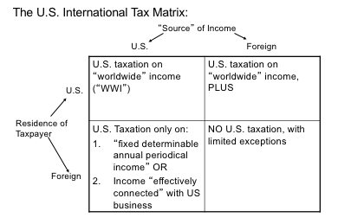
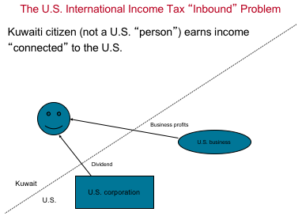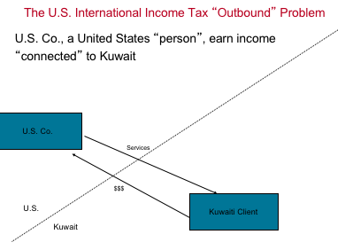
- US Outbound Taxation – Generally
  - The new U.S. system, enacted in 2017, taxes all worldwide income earned directly by a U.S. person such as a U.S. resident HTE, with a partial deduction for certain “foreign” income (“FDII”).
    - The income of a controlled foreign subsidiary is subject to certain “anti-deferral” rules (e.g., Subpart F and “GILTI”), under which most foreign subsidiary income is currently taxable in the U.S. at either 21% (for Subpart F income) or 10.5% (for GILTI).
    - Foreign tax credits are allowed against income included as Subpart F or GILTI (the latter with a 20% “haircut”).
    - Certain payments by the U.S. to related foreign persons may cause a U.S. corporation to be subject to tax under the new alternative tax, called BEAT. Repatriation (e.g., dividends paid) to the U.S. is generally no longer taxable, and no foreign tax credits are allowed for foreign taxes paid arising out of the exempt dividend
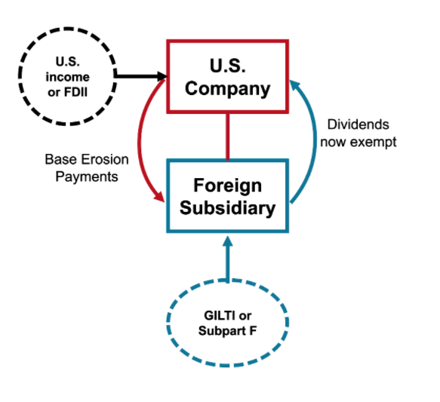
  - Called “outbound” because we are here dealing with U.S. “persons” earning income with some “foreign” connection
  - Issues:
    - Will the U.S. tax this income? YES – U.S. “persons” are subject to “worldwide taxation”
    - Will Kuwait tax this income? Maybe (here we do care, but we still won’t be discussing Kuwait’s rules)
    - Why do we care if Kuwait taxes it? Because we want to avoid paying tax in BOTH places
      - Avoidance of “double taxation”
      - And here the U.S. is the country of “residence”, so US rules must provide relief from double taxation
      - So really international tax is about JURISDICTION over income
  - How is double taxation relieved under the U.S. system?
    - Via the foreign tax credit (IRC sections 901-907)
  - How does it work, in general?
    - What if US Co earns $4,000 in income
      - U.S. taxes it (WWI), at 21% = $820
      - Kuwait taxes it too, at 40% = $1600
      - $2420 of tax on $4k of income (over 50% total rate)
    - But US will give you a credit against your U.S. income tax for the Kuwaiti income tax paid
      - If you get the credit, it will be $1,600 (the amount of Kuwaiti income tax paid)
      - This credit will then wipe out your US tax liability (credits reduce tax liability dollar for dollar – what happens to the “excess”?)
    - Problem – sec. 904 says that your foreign tax credit cannot exceed the U.S. tax imposed on your “foreign source income”
      - And here, your “foreign source income” might be ZERO (?)
      - Thus, you get no foreign tax credit! BAD! Why?
    - There is a comprehensive regime (sections 901-961) that governs the credit for foreign taxes (FTC)

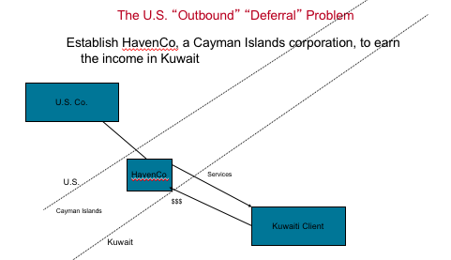
US Outbound Taxation - Issues
- Who is the taxpayer now? HavenCo
  - Corporations are generally respected as being separate taxpayers, as we will see (actually, it is often your choice whether the entity is a separate taxpayer)
- Is HavenCo a “U.S. Person” – NO!
  - only U.S. corporations are U.S. persons
  - Thus, HavenCo is not subject to worldwide taxation
  - And as a “foreign” corporation is, in general, only taxed on its U.S.-connected income (here, does it have any?)
- So what is the result?
  - Pre-2017
    - Prior to 2017, there was generally no tax on foreign sub earnings until the earnings were distributed (“deferral”)
    - Created the “lockout effect” – (“tax deferred = tax saved”)
    - However, HavenCo still was subject to the “anti-deferral” regime of Subpart F
  - After 2017, dividends from HavenCo would be tax free to a corporate US owner
    - However, Subpart F would still potentially apply
    - And now “GILTI” ensures that HavenCo’s income is taxed at least at a 10.5% rate in most cases
- Anti-deferral – there are now 2 regimes (Subpart F and GILTI) applicable to MNCs
  - These rules “reach out” and tax the earnings of foreign subsidiaries in the U.S.
  - These are RULES (called “anti-deferral” rules – IRC sections 951-964)
  - Now we add GILTI (sec. 951A) to this mix – 10.5% taxation on most subsidiary income
- FDII
  - “carrot” compared to the GILTI “stick”
- “Income-Shifting”, generally
  - Because foreign corporations are generally respected as separate taxpayers, there is temptation to try to shift income to them
  - Especially to entities in “tax preferred jurisdictions”
  - The anti-deferral rules try to stop this
  - Also, the “transfer pricing” rules (IRC sec. 482) try to prevent this income shifting as well
Overview of US International Tax System
- Issues that are addressed:
  - Taxation of dividends from foreign subs (Sec. 245A)
    - Pre-2017 deferral regime
    - 2017 changes
  - Relief from Double Taxation (sections 901-907, 960-961)
  - “anti-deferral” regimes
    - Subpart F (sections 951-964)
    - GILTI (section 951A)
  - FDII – foreign derived intangibles income deduction
    - Gives you a 13.1% tax rate on many foreign sales from the US entity
  - BEAT – Base erosion alternative tax
    - Similar to an AMT, but triggered by outbound deductible payments
    - Consider if paying foreign affiliates for R&D or other services

Dividend Taxation
- Overall, after 2017 tax reform, dividends from foreign subsidiaries are generally not subject to tax when brought home to the U.S. parent.
  - This result is a big change from the system in place prior to 2018, under which dividends from foreign subsidiaries were generally taxable when distributed to the U.S. parent.
  - This prior regime created an incentive not to distribute dividends to the U.S., which was often referred to as the “lockout effect.” This detrimental incentive was mostly eliminated by the 2017 tax reform effort
- With the enactment of tax reform in 2017, dividends from most foreign subsidiaries are now exempt from U.S. taxation.
  - This is because the U.S. has now adopted what is often called a “territorial” tax regime, which provides for a general exemption from tax of certain foreign dividends, under new §245A of the Code.
  - This new regime is best referred to as a “quasi-territorial” regime, because, as discussed below, unlike a true territorial regime where no foreign source income would be taxed, the income of foreign subsidiaries is often subject to current U.S. taxation under either the Subpart F or GILTI regimes
- Actual distributions are not taxed because the income of the foreign subsidiary has already been taxed as a “deemed dividend” under one of these regimes.
  - This “deemed dividend” approach in the GILTI and Subpart F regime is just the mechanism for taxing the earnings of subsidiaries on a current (as earned) basis. Hence, distributions of income that were already taxed under one of these “anti-deferral” regimes are also not subject to tax when distributed.
  - These distributions are called distributions of “previously taxed earnings & profits” (“PTEP”).
- Although this system may actually be closer to a quasi-worldwide system, it was often called a “quasi-territorial” regime by the proponents of the regime.
- Section 965 – Transition Tax
  - One time-tax on all “deferred earnings” existing at 12/31/17
  - Rates at 15.5% on earnings in “cash”, and 8% on other earnings
- Section 245A – dividend exemption system
  - Qualification – only available to domestic corporate shareholders who are 10% or more owners (“United States shareholders”)
  - Foreign source – dividend must be foreign source
  - Holding period & Hybrid rule
  - No foreign tax credit (FTC) for taxes paid w/r/t the dividend
  - Note on “CFCs” – 245A won’t apply that often (why?)
  - Sale of stock at gain – sec. 1248 – and loss (sec. 961(d))

Double Taxation Relief
- Because the U.S. imposes worldwide taxation on its residents (including U.S. MNCs), the U.S. also grants a credit for foreign taxes paid.
- This credit is for taxes directly paid by U.S. corporations (under section 901), and also a credit for taxes “deemed” paid by its foreign subsidiaries under section 960. A full discussion is beyond the scope of this course, but it is important to keep in mind that under section 960, U.S. parent corporations only get a credit equal to 80% of taxes deemed paid that are attributable to their inclusions of “GILTI” income, described below.
- Foreign Tax Credit Overview
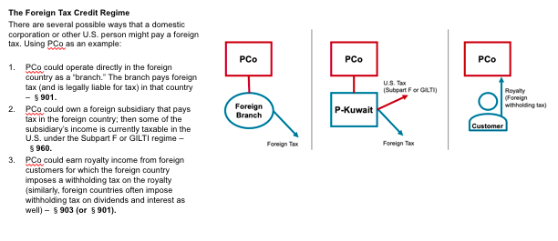
  - Credit vs. Deduction
    - First, some background on §901, which grants the foreign tax credit. Technically, §901 is an election—the US person can choose to credit or deduct foreign taxes. Most choose to credit—credits are better, as they reduce tax liability dollar for dollar, while deductions only reduce taxable income, not tax liability. This is demonstrated in the following example:
    - Assume USP, a U.S. corporation, does business in country X; it earns $100 in gross income there, and pays $20 in country X income tax. Should USP take a foreign tax credit, or deduct the foreign taxes paid (assuming 21% flat U.S. corporate income tax rate)?
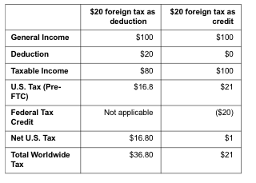
  - Section 901 – what is a “creditable” foreign income tax?
    - Really, this is two questions:
      - Is the foreign levy a “tax”, and if so
      - Is it a tax on “income”?
    - The tax must be BOTH in order to be a creditable tax
    - Forces us to analyze foreign law!
    - First, what is a tax? Compulsory levy imposed by a government that is NOT payment for some sort of direct benefit you receive
      - E.g. you pay UK income tax – that should be a tax
      - Conversely, you rent property from UK government – that’s NOT a tax
    - New regulations would add a “nexus” requirement as well, to address the “digital services taxes” (DSTs that are now being implemented), along with other requirements (big issue now – more on this later)
  - OK next, what if payment is a tax, is it an “income” tax?
    - Yes, if it’s predominant character is that of an income tax, which taxes:
      - 1. Realized (i.e., tax arises only from transactions)
      - 2. Net gain (i.e., deductions allowed) derived from
      - 3. Gross receipts (i.e., gross income, similar to sec. 61)
    - New regulations make it harder to meet the “net gain” requirement, call into question creditability of certain taxes of foreign countries (e.g. Brazil, many services withholding taxes)
  - Sec. 904 limitation = U.S. income tax (pre-credit) X (FSI/Total worldwide taxable income)
    - Note on FSI and allocation/apportionment of expenses
    - Example - $100 FSI, taxed at 50% in foreign country, $100 US income:
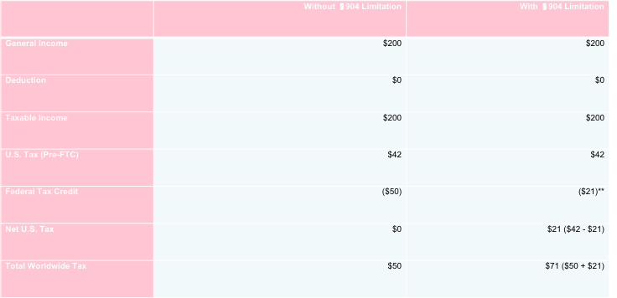

  - 904 Baskets
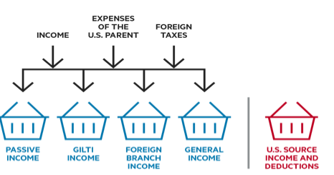
  - Foreign Tax Credits on GILTI and Subpart F – Section 960 and 78
    - Section 960 – GILTI and Subpart F
      - Credits “lifted” to US, or otherwise gone (compare to old sec. 902 approach)
      - Once “lifted”, can be carried forward (but not GILTI taxes)
      - Amount “lifted” is amount “attributable to” the Subpart F or GILTI inclusion
    - Sec. 78 – equalizes “branch” v. subsidiary treatment (see below)
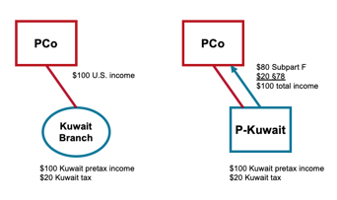
  - Foreign Tax Credit approach
    - A U.S. taxpayer, usually a corporation,
    - paying foreign income taxes, either directly as the taxpayer (under §§901 or 903), or “indirectly” via the “deemed paid” FTC, under §960 (U.S. corporation “deemed” to pay taxes paid by foreign sub, due to either GILTI or Subpart F deemed dividends), and
    - the taxes are “creditable” foreign income taxes.
    - Calculate the amount of net FSI and creditable taxes:
      - For “direct” taxpayers (i.e., branch), the FSI is the business income.
      - For “indirect” taxpayers, calculate the DPC, and add the §78 gross-up to dividend to determine FSI.
    - Allocate the FSI, foreign taxes, and certain U.S. deductions to the various baskets (passive, GILTI, foreign branch, and general).
    - Calculate the §904 limitation by basket, to determine the maximum FTCs allowed in the tax year in question.
    - Apply the available FTC for each basket up to the§904 limitation for each basket, in order to determine the FTC to be utilized for the year.
    - Carryback excess credits for one year and/or carryforward excess credits for up to 10 years (excluding the GILTI basket).

Anti-Deferral Regimes
- The U.S. now has two mechanisms for taxing the income of foreign subsidiaries of U.S. MNCs: Subpart F and GILTI.
- These so-called “anti-deferral” regimes reach out and tax, on a current basis, income earned by foreign subsidiaries (called “controlled foreign corporations” (CFCs), which are generally foreign subsidiaries that are at least 50% owned by U.S. shareholders) that would otherwise not be subject to current U.S. taxation.
- The mechanism is in the form of a “deemed dividend”—the U.S. shareholder is deemed to receive a taxable dividend from the CFC in an amount equal to its share of “Subpart F income” or “GILTI” income
- Subpart F
  - U.S. corporate shareholders must include in income their pro rata share of “Subpart F income” earned by their CFCs every year. Subpart F income falls into three categories:
    - passive-type income like royalties,
    - sales income where product is either purchased from or sold to a “related party,” and
      - Generally income for out-of-country sales where a RP is involved
    - certain services income for services performed on behalf of a related party
      - Generally for services performed outside CFC’s country of incorporation
  - If its Subpart F income – the amount is a “deemed divided” taxable to the US parent at 21%
  - CFC is a FC MT 50% owned by US shareholders, which are only 10% (or more) owners
  - In general, Subpart F income is fairly easy to avoid, by merely structuring transactions to avoid creating the type of income that becomes Subpart F. Because of this, Congress gave us GILTI in 2017.
    - Usually can avoid subpart F by “checking the box”
- GILTI
  - GILTI stands for Global Intangible Low-Taxed Income. This is another deemed dividend, but the amount is much broader. Basically, all income of a CFC will be GILTI, except for an amount equal to a 10% deemed return on the CFC’s tangible assets (so-called “QBAI”). GILTI ends up being taxed at a rate between 10.5% and 13%, due to the impact of two mechanisms:
    - Under IRC section 250, the U.S. parent gets a deduction equal to
      - 50% of GILTI income (reducing the rate from 21% to 10.5%), and
      - 80% of foreign taxes “attributable to” GILTI as a potential foreign tax credit (and the credit amount must also be included in income, under section 78, to prevent utilization of both a deduction and a credit for the same foreign tax),
      - meaning that the total rate of tax (U.S. and foreign) on GILTI is usually in the 12–13% range, usually about 13.1% (10.5%/80%)
  - Example: CFC earns $110 and pays $10 of foreign tax, and has no foreign fixed assets (no “QBAI”). For USP, the initial GILTI inclusion here is $100 (“tested income” = $110 - $10). USP then gets a foreign tax credit of $8 (80% of the foreign taxes attributable to the GILTI inclusion). Under section 78, this $8 must also be included in income, increasing U.S. taxable income to $108 ($100 GILTI plus $8 section 78 gross-up). Then, USP gets the section 250 deduction, reducing its U.S. taxable income to $54. Hence, the U.S. tax liability is $54 times 21% = $11.34. This is then reduced by the $8 foreign tax credit, resulting in a net U.S. tax liability of $3.34 ($11.34 - $8). Hence, the total tax burden on this income is $13.34: $3.34 of U.S. tax, and $10 of foreign tax, for an effective rate of 12.1% in this example ($13.4/$110).
  - 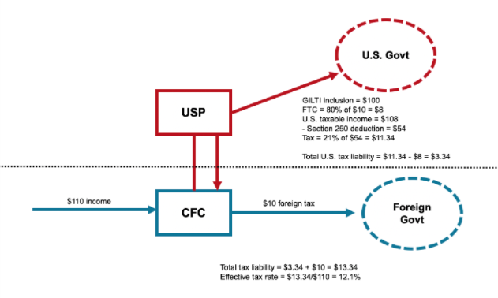
- CFC Taxation – Summary
  - the earnings of any particular CFC effectively fall into one of three categories:
    - Subpart F income (which takes precedence over GILTI), taxable at 21% under current law, as earned;
    - GILTI, taxed at 10.5%, as earned; or
    - Fully exempt income, not taxable when distributed under §245A.
  - all income of a CFC will be either Subpart F or GILTI, except for the amount of income equal to the deemed ordinary return
  - Since this amount (deemed ordinary return) is equal to only 10% of the tangible asset basis (i.e., QBAI) of the CFC, it is likely small for most CFCs
- CFC Taxation - Sec. 959 & 961 – PTEP Distributions & Basis Adjustments
  - 959 – previously taxed income (PTEP) generally not taxed again when actually distributed
  - 961 – tax basis in CFC stock generally adjusted upward for GILTI/Sub F inclusions (and down when PTEP is distributed)
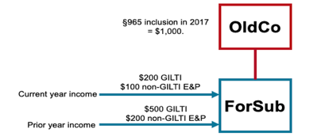

FDII
- Foreign Derived Intangibles Income (“FDII”) deduction, also contained in IRC section 250. This is a deduction equal to 37.5% of FDII, which reduces the rate of tax on such FDII to about 13% (21% tax rate times the 62.5% of FDII that remains taxable). FDII is basically income earned by the U.S. parent itself on sales of product to foreign persons for “foreign use,” in excess of a routine return on U.S.-based tangible assets.
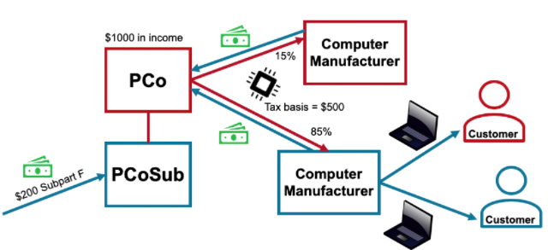
- In the example above, the goal of the FDII incentive is to reduce the rate of tax on the foreign sales made by PCo, which in the example above, are about 85% of its total sales. The rules do this by forcing you to calculate
  - “FDII,” which is described as “deduction eligible income” (DII), multiplied by the ratio of “foreign derived deduction eligible income” (FDDEI) to total “deduction eligible income” (DEI).
    - DII is just all income earned by the U.S. parent directly, less 10% of its U.S. tangible assets (“QBAI”).
      - So in the example above, DII is $950 - $1,000 of income directly earned by PCo (the $200 of “Subpart F” earned by PCoSub is ignored), less $50, which is equal to 10% of the basis in its domestic tangible assets.
    - FDDEI is $850, which is the portion of total DEI (85%) earned on sales to foreign persons for “foreign use.”
      - Total DEI here is $1,000, which, again, is the total taxable income earned by PCo directly (ignoring any U.S. taxable income, such as GILTI and Subpart F), that is included in income as a deemed dividend, due to earnings by foreign subsidiaries.
- So numerically the tax rate on foreign income can be calculated as follows:
  - FDII = DII ($950) x (FDDEI ($850)/DEI ($1,000)) = $807.5.
  - DEI = $1,000; FDDEI = $850; DII = DEI – (10% of QBAI) = $1,000 - $50 = $950
  - Hence, the FDII deduction is $302.81. This means that of the total $807.5 of FDII, only $504.69 is taxable at 21%, for a tax liability of $106.
- This means that the effective tax rate on the FDII income is about 13.1% ($106/$807).
- FDII was designed to work with GILTI. Under these provisions, income earned from foreign customers should be taxable at about 13%, whether earned by a CFC, or whether earned by the U.S. parent
BEAT
- BEAT is another new tax added in 2017.
- It is basically an alternative minimum tax that is triggered by deductible payments made to foreign related parties.
- Those payments are added back to regular taxable income, and the result is taxed at 10%—if this BEAT tax is greater than “regular” tax, then the BEAT is payable instead.

Summary – US Taxation of Foreign Income
- Income of a U.S. multinational group can be considered to fall into one of the following categories:
  - Domestic income earned by the domestic parent—taxable at 21%
  - Foreign income earned by the domestic parent—potentially FDII, taxed at 13%
  - Subpart F income of the group’s CFCs—taxable at 21%
  - GILTI income of the group’s CFCs—taxable at 10.5%
  - Exempt foreign income of the group’s CFCs (equal to 10% of the CFC group’s QBAI)—exempt from U.S. taxation (This last category is also the only income that is truly subject to the §245A dividend exemption.)
- Example:
  - As a comprehensive example, let’s say MegaCo is a U.S. corporation with one foreign subsidiary, MegaSub. In 202X, assume the following:
    - MegaCo earned $100 in taxable income selling to domestic customers;
    - MegaCo earned $200 in taxable income selling directly to foreign customers;
    - MegaSub earned $400 of income and had the following:
    - $100 of the income was Subpart F;
    - MegaSub’s average QBAI for the year was $200;
    - MegaSub paid no foreign tax.
  - What is the overall tax result on this $600 of worldwide income earned by MegaCo and its subsidiary?
    - The $100 of domestic income is taxable at 21%.
    - The $200 in direct sales to foreign customers could qualify for FDII, meaning it will be taxable at 13% after the §250 deduction (after considering US QBAI).
    - The $100 of Subpart F income is taxable to MegaCo at 21% as a deemed dividend.
    - MegaCo will have a GILTI inclusion of $280 ($300 of tested income minus 10% of QBAI of $200 = $280), and will get a GILTI deduction of $140, meaning the effective rate of tax on this $280 inclusion will be 10.5%.
    - The remaining $20 of MegaSub’s income (basically equal to 10% of its QBAI) is tax exempt (and this is the amount that is potentially subject to the §245A DRD).
Quick Note – Foreign Tax Issues
- Most nations around the world impose taxes similar to the US regime:
  - Corporate income tax, rates between 9-32%
    - The main issue for HTEs in the income tax area is the increase in attempts by foreign countries to tax the income earned by nonresident entities, such as many HTEs. These nations, as the “source” country, typically only tax nonresident entities on income that is connected with their country. However, these countries recently have attempted to expand the category of income that is considered “connected” to include any income earned from selling to customers located in the country. This “customer-based” taxation is likely a wave of the future. In this, these countries have been helped along by the Organization for Economic Cooperation and Development (“OECD”), which, through its “Base Erosion and Profit Shifting” (BEPS) project, is enhancing the ability of source countries to impose income tax on nonresident entities (the so-called “Pillar 1” portion of the BEPS 2.0 project).
  - International tax rules that are similar – “territorial”
    - OECD initiative – 190 countries are now going to agree to an international tax approach
  - Transaction Tax – VAT
    - For HTEs, VAT is mostly a compliance exercise—similar to U.S. state and local sales tax, HTEs must often collect and remit VAT on their sales. VAT is a tax on the consumer, not the producer, so in general it should not be a liability of an HTE, but is merely a collection exercise. However, it is getting more complex, and HTEs must ensure that their capability to collect and remit VAT is robust.
  - DST
    - These are relatively new taxes that are intended to target HTEs. Usually, these taxes are a tax on revenue, at a small percentage (say 3%), but only on certain categories of revenue. The type of revenue that is taxable will vary by country, but is usually revenue earned from “digital services” such as online advertising, or downloading. These taxes, as a tax on revenue, are likely not creditable under the U.S. foreign tax credit regime, and hence these taxes are an “out of pocket” cost to HTEs. The U.S. government is attempting to get foreign countries to repeal these DSTs as part of the OECD BEPS 2.0 project, described above and discussed further in our tax policy discussions later in the course.
  - Other taxes (Payroll, property)
  - Sub-national taxes?
Transfer Pricing
- U.S. and other country tax law views a U.S. “parent” and each of its foreign subsidiaries as separate taxpayers, with the U.S. parent being a U.S. person, and the foreign subsidiaries being foreign person
- These parties are considered “related” in these situations, which creates transfer pricing issues. Given that one party “controls” the other, these related parties may set an unfair “intercompany price” (or transfer price), in transactions between the related parties, as a mechanism for shifting profit between tax jurisdictions. Transfer pricing law attempts to prevent this result, and is reflected in U.S. law in IRC section 482
  - The rule in IRC §482 states that when there are transactions between “controlled” parties, the IRS may re-allocate income between the controlled parties to “clearly reflect income.”
  - Generally, “control” for §482 purposes is common ownership of 50% or more (so certainly a foreign corporation and its 100%-owned U.S. subsidiary are commonly controlled).
  - What “clearly reflects income” – An “arm’s length” price
    - The regulations state that the price for transactions between related or controlled parties should be a price that would have been charged for the service or good if the parties had been unrelated (i.e., had operated “at arm’s length”)
- Two other things:
  - The regulations state that the controlled transactions should lead to an arm’s length result – in other words, the result of the controlled transaction should be “comparable to” uncontrolled ones
  - “Methods” – the regulations then state that you must use the “best method” to determine if your controlled results are comparable to uncontrolled ones (1.482-1)
- What does this mean in practice? Depends on the type of income:
  - Intercompany Interest – generally, must charge what the federal government charges you for unpaid taxes (table put out monthly) 1.482-2(a)
  - Intercompany services – a complicated formula, usually the cost of the services plus a small “markup” (“cost plus”) 1.482-9
  - Intercompany royalties (licenses of IP) – 1.482-4 (also section 367(d))
    - CUT
    - CPM
    - Profit split
    - Periodic adjustment?? ”commensurate with income” standard
  - Intercompany sales – depends – a “heirarchy” of methods 1.482-3
    - Comparable uncontrolled price (CUP) – seller sells the same thing to unrelated parties
    - Resale price method (RPM) – buyer re-sells the same thing to unrelated parties; just figure out how much buyer makes on these sales and this is how much it should make on controlled sales
    - “cost plus” method – determine the seller’s costs in making the product, and make sure seller earns a good “return”
    - Other methods
    - “cost sharing” IP (instead of selling it) takes you out of this rule, and into 1.482-7
Transfer Pricing – Outbound Context
- US tax law views US “parent” and each of its foreign subsidiaries as separate taxpayers, with US parent being US person, and the foreign subsidiaries being foreign persons
- So what happens when:
  - US parent engages in transactions with foreign subs?
  - Commonly controlled foreign subs engage in transactions with each other?
- Well, you have transfer pricing issues - what should be the “price” on transactions entered into between these “related” parties, given that one party “controls” the other
- In other words, tax authorities view this as opportunity for using this “intercompany price” (or “transfer price”) as a mechanism for shifting profit between tax jurisdictions or avoiding/minimizing Subpart F income & enhance “deferral”
- Keep transfer pricing in mind as we look at the international tax rules
IP Cost Sharing
- “Cost Sharing” – contract b/w USP & ForCo – 1.482-7
- Agreement to jointly develop IP (“share costs”)
  - USP gets US rights
  - ForCo gets foreign rights (“exclusive license”)
- Share costs in proportion to relative benefits obtained from the IP
  - If one party bears more than its proportion of cost, the other party must reimburse it (cost sharing payment)
- Party must be compensated for its “platform contributions” to the arrangement (“buy-in” royalty)
- If arrangement sustained - NO ongoing royalty required to be paid (takes you out of 1.482-4 and 1.482-3)
- Shared costs now include SBC (Altera case)
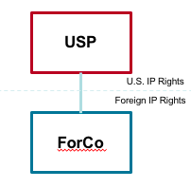
- Intercompany compensation for IP depends upon the mechanism for transferring IP.
  - If IP is sold, generally the seller must be paid the fair market value for the IP, all at once.
  - If, instead, IP is contributed by a U.S. person to a foreign corporation, even in a transaction that would otherwise be tax-free (under §351), such contribution is treated as a sale of the IP in return for contingent payments to be made over the useful life of the IP (see §367(d)).
  - If IP is licensed, it creates intercompany royalties (which are compensation for the use of intangible or intellectual property), which are governed by a complex set of rules in Treas. Reg. §1.482-4, and basically create income annually equal to the value of the use of the licensed IP
- However, all of these rules (i.e., the rules governing sale, contribution or license of IP) can be avoided through the use of cost sharing, as provided by Treas. Reg. §1.482-7.
- Under cost sharing, a legal owner of intellectual property (IP) can make the IP available to another participant (whether controlled or not). The owner then must be compensated for this platform contribution of IP to the cost sharing arrangement. This compensation is often referred to as the buy-in payment; this payment can be structured in the form of a royalty over a period of years (usually the useful life of the IP at the time of the platform contribution)
- The amount of the buy-in payment is subject to significant controversy [note—this has caused much controversy and tax litigation]. The amount of the buy-in payment, historically, was limited to the then-existing value of just the “hard” IP (things like patents and trademarks); the buy-in payment did not need to include the value of non-specific IP items such as “business opportunity.” Accountants and the tax law refer to this non-specific IP as "goodwill, going concern value, and workforce in place” (i.e., the value of employees who created the IP and related business); these amounts can be thought of as representing the value of a business that is in excess of the value of its actual tangible and intangible assets. However, as part of the 2017 tax reform, Congress changed the law and clarified that the buy-in payment must include the value of goodwill, going concern, and workforce in place. See IRC §367(d)(4).
- In addition to the initial buy-in payments, the parties also agree to share development costs (hence the term cost sharing) of the IP that was made available by the owner to the other cost share participant. The parties share costs based upon their reasonably anticipated benefits (RAB) that they expect to enjoy from the cost shared IP. The RAB share is often determined using the relevant revenue percentages that each party anticipates to earn from the IP. The costs that must be shared include all development costs incurred to actually develop the IP, which now includes stock-based compensation costs (i.e., the tax deduction for stock options and other equity interests provided to employees) following the government’s victory in the Altera case in 2020
- In summary, the cost sharing arrangement provides for two streams of payments from the non-owner participant (in practice, this is typically a foreign subsidiary located in a lower-tax jurisdiction such as Ireland) to the owner participant (which is typically the U.S. parent corporation):
  - 1. The buy-in payment: This is technically called the platform contribution payment and is intended to compensate the owner participant for the then-existing value of IP, including goodwill and “going concern” value (which is basically the value of the business opportunity that the owner is giving up by making the IP available). The buy-in payment is often structured as a royalty over a period of years, but it eventually ends.
  - 2. The cost share payment: Each participant must pay its share of future development costs. If one party doesn’t directly incur its share, it must reimburse the other party, if that party has paid more than its share. This is typically the case, where the U.S. parent pays most (if not all) of actual development costs, and the foreign participant must reimburse the U.S. parent for its share.
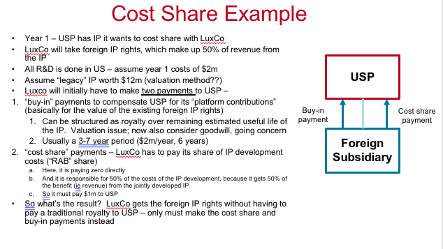
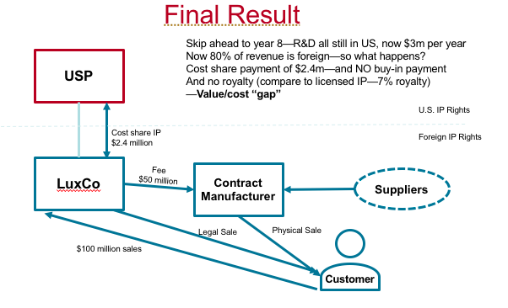
The Choice – How to Operate
- Existing foreign principal structure. Does the company have a historic structure through which it operated its foreign business? If so, a number of issues arise:
  - "Bring the IP back" - in these cases, the HTE will have to de-struct its foreign structure, which creates the following issues:
    - U.S. tax issues in "repatriating" IP to the U.S. HTEs will be required to carefully determine the tax consequences of terminating their cost sharing agreements and bringing back the IP. They will want to make sure of the following:
      - No U.S. tax is triggered on the repatriation, and
      - The new U.S. owner gets a "stepped up" tax basis in the IP, which can then be amortized for U.S. tax purposes
    - Foreign tax issues (exit taxes) in moving IP rights out of the foreign country
      - Will there be some sort of "exit tax" imposed by the foreign government when the IP rights are transferred to the U.S.?
  - FDII reliability
    - Will the FDII tax incentive be retained in U.S. tax law? The FDII incentive faces two broad categories of challenges:
      - The Biden administration proposed to repeal it in its budget released in 2021, which indicates that perhaps Democrats are not supportive of this provision, and
      - The European Union or other foreign governments might challenge the provision as being an inappropriate income tax subsidy for exports. The U.S. has lost on this issue twice in the past in international trade forums, and has had to repeal provisions due to those losses
  - Operational elements
    - FDII structures are perhaps easier to operate, if most R&D and management happens in the U.S.
      - Good alignment between IP ownership and functional activity
    - GILTI structures require functional activity in the location of IP ownership ("substance") in the foreign country where IP ownership takes place
Practical Application – IP & High Tech
- US persons (in particular, US corporations) taxed on WW income
  - But FDII is available on foreign sales
- And income of foreign subsidiaries not directly taxable in US
  - prior law – not taxable until distributed
  - new law – dividends from foreign subsidiaries exempt (245A)
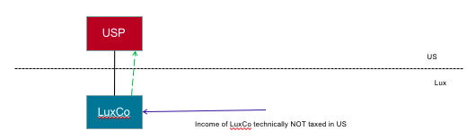
- However, any “subpart F” income of Luxco (a “CFC”) is “deemed” distributed and thus taxable in US WHEN earned
- “Subpart F” income includes:
  - “passive” income like royalties (FPHCI)
  - Sales income when selling to or buying from a “related” party (FBC sales income)
  - Services income when performing services on behalf of a “related” party (FBC services income)
- PLUS, now there’s GILTI!! Also taxable currently, but at a lower rate… (10.5%)
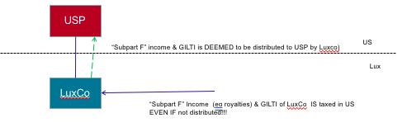
- Income earned by foreign subsidiaries that does not trigger application of Subpart F is still taxable, but only under GILTI regime (10.5%, higher effective rate)
- Initial issue – section 482 – “transfer pricing” rules
  - These rules basically say that each entity must be treated as an independent third party, at “arm’s length”
  - So any income earned by foreign subsidiaries must be an amount equal to what would have been earned by the entity, had it been unrelated
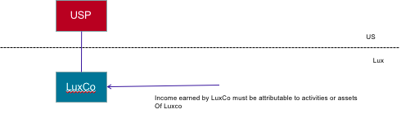
- CFC IP ownership
- Can develop/acquire own IP receive from USP by sale, contribution, or license
- Must consider sec. 367(d) (&1.482-3 & -4)
  - Section 367(d) denies tax-free treatment under sec. 351 for the contribution of IP to a foreign subsidiary
- Instead, the USP must include in income, annually, a royalty equal to the income “commensurate” with the value of the intangible – as if licensed
- Also the definition of “intangible” was expanded in 2017 – now includes “goodwill”, “going concern” & “workforce”
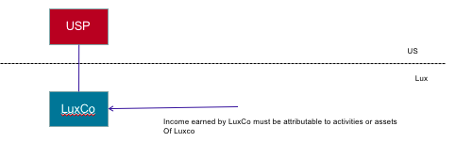

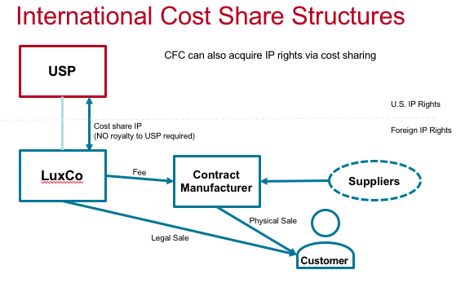
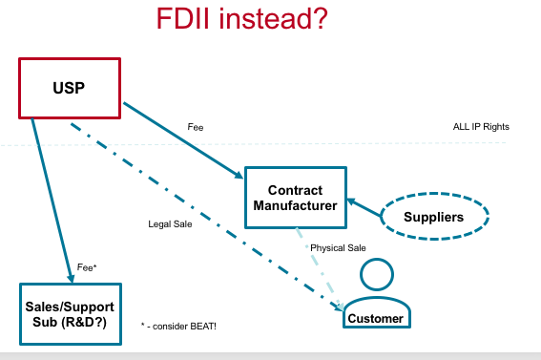

Tax Policy

Introduction to Tax Policy
- What is a Tax?
  - a tax is a compulsory payment to a governmental entity.
  - Most taxes share common characteristics in their calculation. Typically, there is a “tax base,” and that amount is multiplied by a tax rate, typically in the form of a percentage. So, for example, the tax base for an income tax is taxable income, and the tax rate is a percentage, somewhere between 0 and 37% for U.S. individuals, and currently 21% for U.S. corporations. By contrast, the tax base for a property tax is the value of property, and the tax base in a sales tax is the amount of the sale.
- Tax Policy Criteria
  - Revenue:
    - Does the tax raise revenue for the government, efficiently?
  - Vertical Equity:
    - Does the tax impose a higher burden on those with more income or resources? In other words, is the tax “progressive”? Or is it more burdensome on those with fewer resources or less income (and hence is “regressive”)?
  - Horizontal Equity:
    - Does the tax treat similarly situated taxpayers (i.e., those with similar income and resources) in the same manner?
  - Economic Efficiency: Neutrality:
    - Does the tax cause economic actors to make different decisions than they would without the tax, in a manner not intended by policymakers? A tax that alters decisions is not considered neutral, and is instead considered to be “distortive.” An example of a “distortive” element is the realization doctrine—under the income tax, gains are not taxed until “realized” (i.e., until the asset is disposed of), and this distorts the economy because it acts as an incentive for people to retain assets that they might otherwise sell, and this result is not specifically intended by policymakers.
  - Economic Efficiency: Subsidy:
    - Does the tax cause actors to make different decisions, but in a manner intended by policymakers? An example is the home mortgage interest deduction, which arguably causes people to want to buy houses who might otherwise choose renting, but is generally a result intended by policymakers.
  - Transparency or “salience”:
    - Is the tax visible to taxpayers, so that they may alter their behavior in response to it? An example of a tax that has little salience is the federal gas tax—it is an 18 cents per gallon tax on all fuel purchases, but it is not displayed on the pump nor on the receipt.
  - Administrability:
    - Simplicity and cost of collection. Can the tax authority efficiently collect the tax in a manner that minimizes noncompliance?
  - Stability or permanency:
    - Is the tax a permanent feature of the law, so that taxpayers may plan on it in the future? Going back to the home mortgage interest deduction, can home buyers count on this provision being in the law for 30 years, or will it be repealed or changed?

US Federal Tax Policy
- Budget – Revenue and Process
  - Overview
    - Revenue sources – over 80% from individual income tax and payroll tax
      - over 57% from just individual income and corporate income taxes. Hence, our tax system can be thought of as really a tax on “wages,” because over 30% of government revenue comes directly from social taxes on wages, and another large percentage comes from income tax on wages.
    - Spending – 63%+ is mandatory or interest
      - Mandatory + defense = ~80%
      - Mandatory = no action required by Congress
      - All tax revenue eaten by mandatory (SS, Med, Int.)
      - 2/3 of all spending = benefits
      - Firing all gov’t employees wouldn’t solve ½ of deficit
      - 25% of entire budget spent on health care
      - Non-defense discretionary is not much = ~20%
    - The “deficit” (700MM = 2.8B-3.5B in 2013)
      - Every year for a long time
    - The debt (each deficit adds to it)
      - $28T - $22T held by public, $6T by gov’t (Social Security Trust Fund)
      - This public debt is growing, and could turn out to be economically detrimental if interest rates go up. Also, this amount of public debt could theoretically cause interest rates to go up. Given these increases in public debt, and the threat of higher interest rates causing economic issues, there is a high likelihood of tax increases in future years, and perhaps even introduction of new taxes like VAT. HTEs need to be aware of this potentiality
      - Note on “debt limit” – coming again!
- Budget Considerations
  - In its budget determinations each year, the following are considerations taken into account by the Congress and the presidential administration when making changes to tax law that will either increase or decrease government revenue
    - “Revenue Neutrality”
      - Overall neutrality – do the revenue measures in a particular budget create enough revenue to fund all the spending in the budget
      - Neutrality within certain taxes (e.g., corporate tax) – if changes are going to be made to a particular tax, will the changes reduce the overall amount collected from that type of tax?
        - For example, in 2017, corporate tax rates declined, but other provisions created revenue, such that overall corporate tax receipts were relatively unchanged
        - Why has corporate tax revenue declined since the 1950s? An explosion of business conducted through other legal forms such as Limited Liability Companies (LLCs), which are not corporations for tax purposes.
    - “Dynamic scoring” - an a tax change alter behavior in a way such that overall tax revenue is actually increased? For example, does a reduction in tax rates actually encourage enough economic activity such that the revenue from the tax actually goes up? The answer is generally no, and the governmental entity that “scores” the revenue impact of various tax proposals (the Joint Committee on Taxation) does not assume that this will be the case, despite political pressure to consider this so-called “dynamic” scoring.
    - Targeted funds - there are certain taxes that are “targeted” only for certain types of spending. For example
      - Gas tax funds the so-called “Highway Trust Fund” (HTF)—this HTF runs dry periodically
      - Social security withholding (FICA) funds the Social Security Trust Fund, and this fund (currently in surplus) is intended to pay only social security benefits
    - Progressivity
      - Will the tax change increase or decrease the overall “progressivity” of the federal income tax?
      - E.g., repeal of 529 accounts
    - Reconciliation
      - The process –
        - process that allows the Senate to pass legislation with only 51 votes instead of 60, by avoiding the so-called “filibuster” that otherwise requires a vote of 60 senators to advance legislation in the U.S. Senate.
      - Limitations
        - Reconciliation is limited to bills that impact revenue and spending, and requires first passing a budget resolution and then passing specific revenue (tax) and spending legislation
    - Tax expenditures
      - concept was developed by U.S. Treasury in the late 1960s and is now documented by the Joint Committee on Taxation, annually.
      - The idea of a “tax expenditure” is that certain deductions, credits, and exclusions (such as the R&D tax credit we covered in this course) deviate from a “true” income tax in a quantifiable way, and hence documenting the value of such “tax expenditures” is a useful exercise for policymakers to understand the value of these benefits
      - What is it? Deviation from a “true” tax base
        - Exclusions
        - Deductions
        - Rate preferences
        - Credits
      - Technical definition: "revenue losses attributable to provisions of the Federal tax laws which allow a special exclusion, exemption, or deduction from gross income or which provide a special credit, a preferential rate of tax, or a deferral of tax liability." (BCA of 1974)
      - Examples – the big 10 (individuals), per CBO
        - Exclusions
          - Employer-provided health
          - Pension contributions
          - Carryover basis at death
          - SS and retirements benefits (pension contributions)
        - Deductions
          - State & local tax
          - Mortgage interest
          - Charitable contributions
        - Rate preference – capital gains
        - Credits – child credit and EITC
      - What else is on the list?
        - energy-related (G&G, IDC, % depletion, credits, a/d)
        - Int’l tax “deferral” (formerly), also FDII and GILTI
        - Like kind exchanges
        - Life insurance exclusion
        - Tuition credits
      - For most recent years, the largest tax expenditure is the exclusion from income of the value of employer-provided health insurance, under section 106—employers can deduct the premium payments, but employees are not required to include the bulk of this value in income

Tax Reform – Recent Proposals and Considerations
- BAT
  - “Border Adjusted Tax,” which is basically an income tax where exports are not included in taxable revenue, and imports are not deductible. This was a serious proposal put forward by Republicans in 2016. Such a tax creates extreme “winners and losers” (i.e., it benefits exporters and punishes firms that rely on imported inputs, such as oil refiners) and hence would be politically difficult to implement. However, it is not dead.
- VAT
  - Value Added Tax, is the gold standard of a consumption tax. Many other nations have them, and they are very effective at raising revenue. They are basically the same as a sales tax—the difference is that a sales tax is only collected at the point of sale to a final consumer, while a VAT is charged at each point in a production process, and hence is harder to avoid. VAT would require massive changes to our commercial system in order to implement, and would require federal/state coordination, as a federal VAT would likely replace state sales and use tax. However, there are many commentators who believe that a VAT is inevitable for the U.S
- Consumed Income Taxes
  - Another, more remote, idea is to convert the existing income tax into a “consumed” income tax. This is more like a “cash flow” tax, where all receipts (including borrowed amounts) are included as taxable revenue, and all expenditures (including amounts invested) are deductible. The difference between all receipts and all expenditures and investments is considered to be “consumption,” and this consumption can be taxed, even at progressive, graduated rates. There are implementation challenges with this idea as well (probably the most important being the treatment of borrowed money), and for now it remains mostly a conceptual idea
- Carbon Tax
  - A more definitive idea (and likely more useful) is a tax on carbon emissions. A carbon tax is a variation of what are called “sin” taxes, which are taxes on detrimental behavior or outcomes. A cigarette tax is another example of a “sin” tax. Since carbon emissions are negative for the environment, it makes sense to tax them, in order to try to discourage the behavior (emitting carbon) while at the same time providing government with resources to mitigate harm from carbon emissions.
  - The problem with carbon taxes is design. The tax must be a comprehensive tax (such as a per ton of emissions tax, such as $50 per ton of emissions, for example) that impacts all emissions of carbons, not just certain types of emissions. Under this standard, the U.S. federal gas tax of 18 cents per gallon fails, because it taxes only the use of one type of carbon emitting fuel, while letting others go untaxed. Also, carbon taxes are regressive, which means that they typically have a larger impact on lower income people (because such individuals spend a higher percentage of their income on fuel). Further they are difficult to design internationally—without widespread agreement on a carbon tax regime, carbon emissions will just move to countries that do not impose the tax.
  - The regressivity issue could be addressed by making the carbon tax partially refundable, with refunds distributed only to lower income individuals. Or the carbon tax revenue could be used to reduce other types of taxes, such as payroll taxes. Notwithstanding these ideas, these issues make carbon tax a difficult political issue, and neither party in the U.S. has made a serious proposal to impose a carbon tax.
  - HTEs need to be aware of the possibility of carbon tax. Even though most think about energy companies when the topic comes up, carbon tax would have a major impact on companies that use energy as well, not just companies that sell energy. And some HTEs are major users of energy—for example, cloud computing companies need large server farms that run on electricity, and most gadgetry requires electricity to power it. Further, crypto requires a lot of energy to do the data mining necessary to run blockchain. Hence, carbon taxation will likely be a critical issue for HTEs in the near future.

US International Tax Policy
- 2017 tax reform
  - The U.S. approach to jurisdiction over income underwent fundamental change in 2017. For its own residents, the U.S. imposes worldwide taxation, meaning that income is taxable in the U.S. no matter where it is earned. In order to prevent double taxation, the U.S. grants a credit for certain foreign income taxes paid. For nonresidents, the U.S. imposes taxation on only certain U.S.-connected, and U.S.-source, income
  - U.S. approach to income earned by foreign subsidiaries of U.S. multinationals such as most major HTEs. Prior to 2017, the U.S. allowed this foreign income earned by foreign subsidiaries to escape current U.S. taxation, so long as such amounts were retained offshore. This system, often called “deferral,” created an incentive for U.S. MNCs to retain their foreign profits offshore. Also, this system of “no U.S. taxation until repatriation” (with limited exceptions) created an incentive for MNCs to try to earn income in low- or no-tax foreign jurisdictions. This latter objective could be accomplished by moving IP rights into low-taxed jurisdictions, and thus earning IP income in those jurisdictions
  - Under the new system, the lockout effect is mostly eliminated, and dividends from foreign subsidiaries are generally free of tax. With respect to the problem of IP income, Congress created a dual track system, under which all IP income is taxable (whether earned by the U.S. parent or a foreign subsidiary) under the GILTI/FDII regime reflected in section 250 of the Code
  - The question is whether this structure is sustainable. The FDII deduction, in particular, is under the microscope—European governments think that it violates trade rules (as an improper income tax subsidy for exports), and the Biden administration proposed its repeal in 2021.

Non-US International Tax Policy
- Multilateral Organizations
  - The IP “mobile income” structures led to an initiative by the Organization for Economic Cooperation and Development (OECD) to try to limit the efficacy of these structures through a variety of initiatives, often referred to as the “Base Erosion and Profit Shifting” (BEPS) initiative.
  - The first BEPS initiative (BEPS 1.0) mostly focused on reporting, requiring MNCs to report income, assets, payroll, and other characteristics on a “country by country” basis to tax authorities. This was deemed insufficient, however, and since 2019 or so, the OECD has focused on BEPS 2.0, which contains two major parts, or “pillars” in the OECD parlance
    - Pillar 1 gives “source” countries (i.e., countries where customers are located) greater taxing rights, based on a formula and other characteristics.
    - Pillar 2 requires all countries to implement a 15% “minimum tax” on their residents. This tax would apply to the extent that income is earned by a resident, or its subsidiaries, and is not otherwise subject to tax in another jurisdiction. This minimum tax, in basic concept, is similar to the U.S. GILTI
    - This latter initiative is key, as many commentators objected to the ability of MNCs to create “nowhere income” that was not taxed anywhere, under the prior regime
    - In late 2021, 136 countries agreed to this Pillar 1 and Pillar 2 BEPS 2.0 approach. These countries still must take individual initiative to implement the agreement.
- Foreign Governments
  - foreign governments must implement the BEPS 2.0 agreements, and have committed to do so by some time in 2023. As part of this, foreign governments should repeal a new initiative that they started in 2019 or so, called “digital services taxes,” or DSTs for short. DSTs were a unilateral action taken by some foreign governments in order to impose some amount of tax on “mobile IP” income that otherwise escaped taxation under the prior regime. With the agreement on BEPS 2.0, foreign governments have committed, over time, to repeal these taxes

State and Local Policy Issues
- Income Tax Policy
  - Initial question whether to have an income tax at all
    - Policy perspective: states that choose to not impose income tax are typically making this choice as a way to attract investment into their states
  - Corporate Income Tax
    - Once state decides to impose corporate income tax, following factors become relevant
      - Tax Rate - What rate should states choose? Most are in the 3–13% range
      - Tax Base - Should states just use federal taxable income, or make adjustments to this amount? In particular, how should states handle special items like the “GILTI” inclusion?
      - Unitary or Separate Filing - Should states take a unitary approach, or separate filing? Most now take a unitary approach.
      - Apportionment Factor Approaches? This seems like an arcane issue, but it has important policy implications. In 2011, California adopted “single sales factor” apportionment, after determining that apportionment based on other factors (like payroll and property) created a disincentive for businesses to locate payroll and property in the state. Single sales factor bases apportionment only upon place of sale (customers), and since California is a large market, it creates significant taxation in California for entities that have lots of sales in California but few other characteristics like property or payroll in that state.
      - Credit and other incentives - The question here is whether states should offer credits, like the R&D credit, as an incentive. Or are other types of credits, like payroll tax credits, more valuable?
      - Tax audits - States here must decide how aggressive to be in auditing corporations.
  - Individual Income Tax
    - Main issue for HTEs is wage withholding
      - As employers, HTEs are required to withhold individual income tax from the wages of their employees, and remit to both the federal government, and the appropriate state where withholding is required by law.
      - This requires being familiar with the laws of all 50 states. And, of course, these laws vary—in some states, technically only 1 day of an employee working will trigger a withholding requirement in that state, while in other states, it can take between 10 and 60 days of working to trigger the withholding requirement.
      - policy perspective, some states have realized that it is not good for their business environment to have strict rules, and have taken some actions to relax withholding obligations, particularly during Covid-19. Further, many have advocated for the federal government to take action here, given the lack of uniformity in these rules. For years, there has been a bill introduced in Congress that would prohibit states from requiring withholding unless an employee worked in their state for more than 30 days during the year.
      - Unfortunately, despite business community support, this federal proposal has yet to be enacted (likely because some powerful states, such as New York, would potentially lose tax revenue due to its enactment). Nonetheless, HTEs and many other businesses would still welcome such a federal intervention, in order to set some standards in an otherwise wide-open scenario which permits states to set their own standards as to what constitutes a “taxable presence” in a particular state.
- Other Taxes
  - Sales and Use Tax
    - Initial issue is whether to impose at all
    - Most states, but not all, do impose such a tax
    - Next question is what is taxable
      - For the most part, only tangible asset transfers are subject to sales and use tax
      - And there are a number of exemptions even for tangible property
        - Often, the exemptions are used to encourage behavior that the state wants to promote. So states sometimes use exemptions to attract business from out of state (similarly, they will use property tax exemptions for the same reason). But also states will use exemptions to promote beneficial policies like clean energy. An example of this is the California CAEATFA program, which gives sales and use tax exemptions (on inputs) to manufacturers that utilize alternative energy and transportation methodologies.
    - The other big issue is withholding: which sellers are required to withhold sales tax on their sales of tangible property?
      - Prior to 2018, states could not compel sellers to withhold sales tax unless that seller had a physical presence in the state. A number of online sellers took advantage of this rule, and were able to legally avoid the obligation to withhold sales tax on internet sales, because such sellers avoided having a physical presence in many of the states where they sold product. This allowed online sellers to have a competitive advantage over “brick and mortar” sellers, because the total price (including sales tax) on a product seemed lower to customers of online retailers since online sellers did not have to charge sales tax on the sale. However, in 2018, the U.S. Supreme Court decided (in Wayfair) that states can compel withholding of sales tax by nonresident sellers that do not have a physical presence in that particular state.
  - Property Tax
    - First question is whether to have property taxes at all
    - Next, assuming a state or local government will impose property taxes, which types of property are taxable?
      - In most states, property taxes are limited to real estate
      - However some states do impose property tax on certain types of personal property
    - Once the type of taxable property is determined, next question is the tax calculation
      - usually a tax rate (often 1–3%) multiplied by a tax base, which is typically the value of the property in question.
      - This requires determining value of property in most states.
      - However, in California, famously, the value of property for property tax purposes is limited by Proposition 13, passed by voters in 1979. Under Prop 13, the value of property for tax purposes is determined only at certain types of acquisitions (such as purchases) of the property, and then that initial value can only be increased by a certain percentage annually (tied to the rate of overall inflation) until there is another taxable transaction in the property that would trigger an updated valuation. The Prop 13 limitation applies both to residential and commercial property; there was an initiative on the ballot in California in 2020 to remove Prop 13 protection for commercial property only (“split roll”), but it was defeated by the voters.
    - Like with sales and use tax, states will offer property tax exemptions to certain business, often to entice those business to build property and hire people in a particular location
- City and Municipal Taxes
  - relatively new development is the proliferation of city-level taxes, imposed by cities such as Portland and San Francisco. New York City for years has had its own income tax, but now other cities are getting into the act. These municipal level taxes are often imposed on a different tax base. For example, in Portland, the tax is imposed upon “gross receipts.” San Francisco has a new “overpaid CEO” tax, which is based on the compensation paid to a company’s CEO. HTEs and other businesses need to be aware of these taxes, and take them into account when advising their businesses on location and other decisions

