Finance Terminology:
Revenues - the amount of money that results from selling products or services to customers (AKA sales, gross, top line)
Profit - (Revenues - expenses) (AKA net income, net, bottom line)
Income Statement - financial statement that indicates results of operations over a specified period (AKA profit and loss statement- P&L)
Profit Margin - % of every dollar of sales that makes it to the bottom line (net income/revenue) (AKA return on sales- ROS)
Debt - funds borrowed by the firm in exchange for claims of a fixed amount against the firm’s assets and future earnings
Equity - funds invested in the firm in exchange for the residual value of the firm → if the firm is shut down, right to assets after liquidation once all other claims are satisfied + right to firm’s earnings
Options - gives the investor the right to buy or sell a stock at an agreed upon price and date, but not obligated
Assets - what the company owns
Liabilities - what a business owes

 | Principal-Agent | Partnership | Corporation
Formation | Patterson v. Domino’s Pizza  Jensen v. Cargill | Martin v. Peyton
Internal Governance | General Auto v. Singer | Meinhard v. Salmon  National Biscuit Company, Inc. v. Stroud  Day v. Sidley & Austin (on Brightspace)
Relating to 3rd Parties | Contract: Mill Street Church v. Hogan, Opthalmic Surgeons v. Paychex, Watteau v. Fenwick  Torts: Dynamex v. Superior Court, Arguello v. Conoco | NONE | Walkovsky v. Carlton; Sea-Land Services, Inv. v. Pepper Source (on Brightspace)
Termination | [no cases] | Prentiss v. Sheffel (on Brightspace)  Pav-Saver v. Vasso (on Brightspace)  Kovacik v. Reed (on Brightspace)

1) Principal Agent
- Formation of Principal-Agent Relationships (common law)
  - An agency relationship exists where:
    - One person (principal) manifests assent to another person (agent)
    - That the agent shall act on principal’s behalf and subject to principal’s control and
    - The agent manifest assent or otherwise consents so to act
  - Patterson v. Domino’s Pizza
    - Facts: Sui Juris LLC entered into a franchising contract with Domino’s Pizza -> Daniel Poff, sole owners of Sui Juris, signed the franchising contract with Domino’s Pizza -> Franchising contract established detailed standards and procedures, Domino’s right to inspect and terminate contract, but not the right to manage day-to-day operations -> a male supervisor employed by Sui Juris sexually harassed female subordinate -> Girl’s father called dominos to complain -> Domino’s employee told Suis Juris owner “you’ve got to get rid of this guy”
    - Issue: Was the employee of Sui Juris an agent of Dominos?
    - Holding: No
    - Reasoning:
      - Franchisor and franchisee are doing different things- “meaningful division”
      - The comprehensive operating agreement given by Dominos doesn’t constitute control
      - However, just because contract says they are independent contractors doesn’t mean they are
      - If this was P-A, it would disrupt the franchise relationship
    - Dissent
      - Dominos people would come into the office and basically threaten franchisees to do something
      - “it is not essential that the right of control be exercised”- just because they didn’t fire him doesn’t mean they couldn’t have
      - Agree with maj that language in contract is only one factor
    - Notes:
      - Was an agency relationship created?
        - (0) explain who is principal, agent, and third party
        - (1) was there assent by the principal? (yes, entered into contract)
        - (2) did principal ask another person to act on their behalf subject to their control?
        - (3) did agent manifest assent or otherwise consent to act? (yes singed contract)
      - Did Domino’s have enough control over Sui Juris to create an agency relationship?
        - Maybe, fact specific inquiry
      - What should Domino’s have done when Patterson’s father called?
        - Say we don’t have any ability to control what happens with the franchisees
      - Are the test for employment and agency relationship the same
        - No
      - Why do firms enter into a franchise relationship?
        - Way to cut off liability (cynical)
        - Business rationale- tapping into entrepreneurial zeal of Americans
      - Why do franchisor’s rely on detailed contract business plan provisions to describe the extent of their control over the franchisee?
        - Product of transactional lawyering- don’t want to engage in ongoing management
      - What advice would you give Domino’s pizza?
        - Nothing. You won.
        - Make sure your employees do not exert direct control (do less).
        - Take more direct control and face liability.
      - Ideas:
        - Contract consideration isn’t required to create a principal agency relationship
        - Intent to form a P-A relationship isn’t required to create one
        - Potential for principal agency relationship in many circumstances
          - Easy to make → just asking someone to do something for you can create the P-A relationship, even if no physical control
  - A principal need not exercise physical control over the actions of the agent, so long as the principal may direct the result or ultimate objectives of the agent relationship
  - “When one ... asks a friend to do a slight service for him, such as to return for credit goods recently purchased from a store,” an agency relationship exists even though no compensation or other consideration was contemplated.
  - Ease of creating principal/agency relationships matters because:
    - Actions of the agent create liability for the principal
    - Agent owes a fiduciary duty to the principal
  - Jensen v. Cargill
    - Facts: 3rd party (P) were farmers that contracted w/ Warren Seed & Grain Co (agents). who purchased grain from them → Warren and Cargill (D) entered into a contract for financing in exchange for appointing D as its grain agent and also got right of first refusal to purchase Warren’s grain sold to the terminal market → D would later loan Warren more money and sent officers to monitor and make recommendations → Warren eventually went under and ceased ops → P sued D for the money that Warren owed, saying D was a principal
      - Cargill loans money for “working capital” to Warren. (like credit card)
      - Cargill is Warren’s grain agent at the Commodity Credit Corporation.
      - Cargill has right of first refusal to purchase grain sold by Warren at terminal market.
      - Warren to act as Cargill's agent for Bounty 208 and sunflower seeds. (did it but deal eventually ended)
    - Issue: Did Cargill become liable as a principal on contracts between Warren and P?
    - Holding: Yes because it exerted control over Warren
    - Rule: RST 14 O - A creditor becomes a principal at that point at which it assumes de facto control over the conduct of the debtor (hands on, day-to-day control rather than written agreement telling you what to do)
    - Reasoning:
      - Principal - Cargill, Agent - Warren, Third Party - A. Gay Jensen Farms
      - Manifestation of Consent? Cargill manifested consent by having Warren implement its recommendation
      - Consent by the other? Warren did so without opposition
      - Act on Cargill’s behalf? Warren acted on Cargill’s behalf by procuring grain for it and Cargill totally financed it
      - Subject to Cargill’s control? Cargill interfered with Warren’s internal affairs
      - Cargill tried to argue that it was just a loan situation (a lender carve out that doesn’t create P-A), but the court disagreed since Cargill had the power to discontinue the financing of Warren’s operations (this was on a list of things the court considered to be evidence of de facto control, but it’s what the court emphasized most)
      - Gut’s additions
        - A third party called Cargill about Warren’s payments and they said they responded on their behalf
        - Cargill took over operations in the final days
        - (Warren’s owners were falsifying financial statements)
    - Guttentag rejects the case holding because he thinks a lot of what was happening looked like a typical lender-debtor relationship
      - Cargill was buying most of Warren’s grain, but just because you are the best customer does not mean there is a P-A relationship
      - Warren is selling to others as well, and just because Cargill doesn’t purchase it doesn’t mean someone else won’t buy it
      - What Cargill was telling Warren to do is just what you do when you loan money
      - Consider the Best Buy and Mastercard example (people can’t sue your credit card over your actions even you have a contract and there’s control)
        - If I buy bicycle with credit card and hit someone with bike → they try to sue bank → I say bank is principal because I’m paying interest to them → bank would say we had no control → but there is contract saying how credit card can be used and that they can cut you off from using money
      - Warren is arguably supplier because Cargill has the right of first refusal to purchase market grain sold → if you are a supplier, can’t be an agent too
    - What advice would you give Cargill next time they want to work with a group operator?
      - Draft documents so they do not suggest de facto control
      - Never make loans to operator you are purchasing grain from
      - Take more control over the operators you lend money to
      - Take less control over the operators you lend money to
      - Pay closer attention to amounts actually being disbursed
      - Keep the status quo, and recognize lawsuits like this are a cost of doing business
  - Carveouts: creditor and supplier
    - Lender test: de facto control
    - Supplier vs. Agent
      - Supplier: Motive is to make a profit for self, gets paid a markup, profit depends on business sense
        - Factor indicating supplier rather than agent: he is to receive a fixed price for the property irrespective of price paid by him
        - Ex: Student pays fixed price no matter what and GT’s profit is based on how much he is able to buy the book for
      - Agent: Motive of finding a book, paid a fixed fee
        - Rst 2nd 14K - one who contracts to acquire property from a third person and convey it to another is the agent of the other only if it is agreed that he is to act primarily for the benefit of the other and not for himself
    - 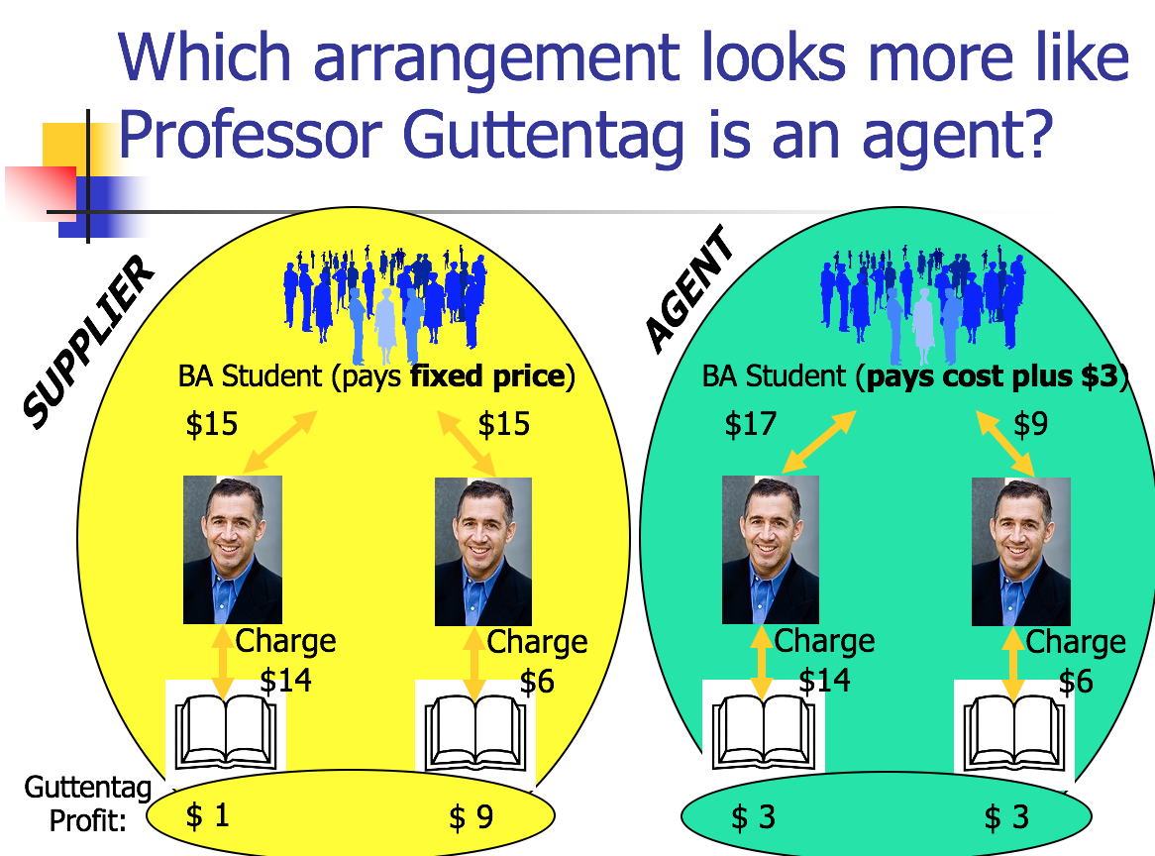
- Internal governance
  - Agency is the fiduciary relation that arises when one person (a “principal”) manifests assent to another person (an “agent”) that the agent shall act on the principal’s behalf and subject to the principal’s control, and the agent manifests assent or otherwise consents so to act. Restatement 3rd
    - Duties of Loyalty of Principal to Agent
      - Pay or reimburse agent what they were promised
      - Deal with agent fairly and in good faith
    - Duty of Loyalty (of agent)
      - Not to acquire material benefit from third party transaction
      - Not to deal as adverse to the principal
      - Provide information to the principal
      - Not to compete with the business of the principal
        - CL: But you can prepare to compete (ex: can start making marketing materials, an advertising plan, etc)
        - CL: You cannot take a client list, BUT you can take clients from your memory
          - Can change via contract
      - Keep account of principal’s property (can’t take principal’s property for yourself)
      - Not to use/ disclose confidential information (goes until death)
    - Duty of Care
      - The level the level of care, competence, and diligence that an agent exercises. If an agent claims to have special skills or knowledge, then the agent has a duty to act with the care normally exercised by agents with such skills or knowledge.
      - If paid- ordinary care
      - If not paid- gross negligence
    - Duty of information (part of loyalty)
    - Conduct by A that would otherwise breach the below-listed duties does not constitute a breach if P consents, provided that A acts in good faith and discloses all material facts in obtaining the consent. Rest 3d.
  - Breach of fiduciary duty Remedy called disgorgement- get part of profits
    - General Automotive Manufacturing Co. v. Singer
      - Facts: P was a machine shop that hired D as a general manager → part of his job was to solicit work for the shop → he attracted a lot of work and thought the shop wouldn’t be able to handle it all → made a deal with another shop for a cheaper price to do the work and kept the difference between the quoted price and the actual price → P sued for breach of contract which had a clause stating he couldn’t work for anyone else and also breach of fiduciary duty as manager
      - Issue: Did Singer’s action constitute a violation of his fiduciary duty?
      - Holding: Yes
      - Rule: Rst 2nd §387 - Duty of Loyalty - Unless otherwise agreed, an agent is subject to a duty to his principal to act solely for the benefit of the principal in all matters connected with his agent
      - Reasoning:
        - Under his fiduciary duty, he was bound to exercise good faith and loyalty and not act adversely to P’s interests by serving or acquiring any private interest of his own
        - Hi side business was in direct competition with automotive
          - Even though it may have been helping automotive
        - He also had an obligation to act for the furtherance and advancement of the interest of Automotive
        - Singer should’ve disclosed the facts to Automotive and give them the opportunity to make a choice, regardless of what he thought was best
        - By failing to disclose all the facts relating to the orders from Husco and by receiving secret profits from these orders, he violated his fiduciary duty to act solely for the benefit of Automotive
      - Class Questions:
        - In Section 8.A. what is the difference between “devote his entire time...” and “not to engage in other business of a permanent nature”?
          - Bad contract drafting- two different tests
        - Would it be possible to conclude that Singer breached the contract but not the duty of loyalty? GUTTENTAG LOVES THIS QUESTION
          - Yes, if his side business was completely unrelated and not during work hours
          - Or if his contract said he didn’t have a duty of loyalty (modification of fiduciary obligations), but also couldn’t work for another auto shop
          - What is it was the other way around? Didn’t breach contract, breached loyalty
            - Maybe if he didn’t actually spend much time/ the court found the other business wasn’t of a permanent nature
        - Why didn’t P sue on contract theory?
          - One answer is that the contract language was bad
          - Under contract theory, P could get damages for what it would’ve made had P made the sale
          - Disgorgement: Under breach of fiduciary duty, P would get D’s profit - 3%. Get part of profits.
            - Has a defense of he was trying to help automotive and its employees
          - Gen. Auto’s profits would’ve been less than what D made by going to a cheaper shop
        - What advice would you give Singer
          - Disclose
          - Quit and do the deals on his own
          - Re-write the contract to allow for side-deals
        - (from later in semester): what if Singer had been a director of the corporation?
          - Probably would have been in trouble with Guth factors- duty of loyalty
- Relating to third Parties
- Liability to Third Parties via Contract
  - Want an agent to be able to make contracts because otherwise the 3rd party will want to go directly to the principal every time.
    - Agent can be authorized
  - If the agent is authorized to enter into the contract, the principal will be bound by that contract
  - Liability of principal to contracts entered into by agent- when does principal have to abide by the terms of the contract?
  - Three kinds of principals: Rest. 3rd: §1.04 (2):Disclosed, undisclosed, and unidentified principals.
    - (a) Disclosed principal. A principal is disclosed if, when an agent and a third party interact, the third party has notice that the agent is acting for a principal and has notice of the principal's identity.
    - (b) Undisclosed principal. A principal is undisclosed if, when an agent and a third party interact, the third party has no notice that the agent is acting for a principal.
    - (c) Unidentified principal. A principal is unidentified if, when an agent and a third party interact, the third party has notice that the agent is acting for a principal but does not have notice of the principal’s identity.
  - If the agent is AUTHORIZED, then they can enter into a contract
  - Types of Agent Authority: (1) Actual Authority (AcA); (2) Apparent Authority (express or implied); (3) Undisclosed principal liability; (4) Ratification (express or implied);; (5) Estoppel
    - Type #1: Actual Authority (perspective of the agent)
      - Rule: Rst 3rd 2.02 (1): An agent has actual authority to take action designated or implied in the principal’s manifestations to the agent and acts necessary or incidental to achieving the principal’s objectives
      - Rule: Rst 3rd §2.01 An agent acts with actual authority when, the agent reasonably believes, the principal wishes the agent so to act
      - Mill Street Church of Christ v. Hogan [Actual Authority- implied]
        - Facts: Church hired Bill Hogan to paint the building → Bill and Waggoner discussed the project and Waggoner told Bill that Petty would be tough to reach for help → Bill asked brother Sam to help, who had helped in previous projects → Sam broke his arm while helping → Bill reported the accident and was told the church had insurance → debate over whether Sam was an employee of the church
        - Issue: Was Sam an employee of the church?
        - Holding: Yes
        - Reasoning:
          - Reasonably necessary - clear Bill would need an assistant in the job since it was difficult to reach → Bill has implied authority
          - Usually accompanies - Sam Hogan had been hired in the past
          - Agent reasonably believes?
            - It was reasonable for Bill to believe because the church had allowed him to hire Sam for help in the past
            - Discussion with Waggoner made it seem like Petty wouldn’t be reachable
          - Incidental: (not covered)
          - The court also thought it would be unfair to Sam, who thought Bill had the power to hire him, and relied on it
            - for actual authority, it doesn’t matter what 3P (Sam Hogan) thinks (does for apparent)
        - Is Sam hogan’s belief that his brother had authority to hire Sam relevant to the issue of whether Bill had actual authority
          - No, would be apparent authority
        - Did it matter that “this was a very high, difficult portion of the church to paint”?
          - Yes, makes Bill’s belief that he needed another person to help reasonable
      - Look at the perspective of the agent to figure out actual authority
    - Type #2: Apparent Authority
      - Exam question: what if agent pretended he had authority? Doesn’t matter to third party, but not manifested by principal THIS WILL BE ON EXAM
        - Third party reasonably believes
        - Second element is not meant. Burns did nothing to cloak him in authority
      - Doctrine that protects the reasonable beliefs of third parties
      - Look at the perspective of the third party to figure out apparent authority
        - Rule: Rst 3rd §2.03 - Apparent authority is the power held by an agent to affect a principal’s legal relations with third parties when a third party reasonably believes the actor has authority to act on behalf of the principal and that belief is traceable to the principal’s manifestations.
          - 1. Third party must reasonably believe
          - 2. That belief must be traceable to the principal’s manifestations
      - "“Apparent authority may survive the termination of actual authority or of an agency relationship."
      - Ophthalmic Surgeons Ltd. v. Paychex Inc
        - Facts: P entered into K with D for payroll processing services and later entered into another for D to provide direct deposit payroll services → At P’s office Carleen Connor handled payroll and was the designated contact → Connor was requesting multiple unauthorized payments for herself and D complied → P sued D for breach of contract
        - Issue: Did Connor have apparent authority such that D could have reasonably relied on her authority to issue additional paychecks?
          - Communication between principal and 3rd party happened a long time about. Principal was now silent
        - Holding: Yes, she had apparent authority and D’s belief was reasonable
        - Reasoning:
          - Third party reasonably believes?
            - She was the designated payroll contact, and after K was made, she was the only person D had contact with
            - P never expressly conveyed a limitation on Connor’s authority
            - Reasonable for D to assume the payroll contact could authorize changes
              - Although probably should have been suspicious of 250k amount, reasonable belief may have gone away
          - Belief is traceable to principal’s manifestations?
            - P didn’t object to her transactions for years
            - There’s a pattern of inaction by P
            - Silence can’t create a manifestation, but once there is a manifestation, it can’t end one. Have to specify when it is ending
        - Notes:
          - Connor obviously didn’t have actual authority to take extra money
          - But court said she was “cloaked with apparent authority”
          - To avoid situation, should have checked payroll records
          - Manifestation includes inaction
        - Did Connor have actual authority to pay herself an extra $233,159?
          - No, no reasonable belief
        - Was Connor “cloaked with apparent authority”?
          - Yes. Reasonableness questionable- why did Paychex think she could pay herself more money?
        - What are the indicia of Connor’s apparent authority?
          - Doctor said originally they should work with her
          - Continued silence of the doctor
        - Were these direct or indirect?
          - Direct- when he originally met with Paychex and say work with Connor. Indirect- she continued to work there (cloak)
        - a principal can be held liable on a contract with a third party on the basis of apparent authority even when the agent acted beyond the scope of actual authority.
          - OSL/Paychex could have sued Connor for stealing money
          - The doctor should have set up the situation better, more oversight or not let her pay herself
        - If the principal fired the agent, he would need to make it clear to third party that agent no longer has authority, otherwise the agent is still cloaked with authority
    - Type #3: Undisclosed principal Liability (UPL)
      - Only occurs when the principal is undisclosed, but as a policy matter, it is appropriate to hold the principal liable
      - Watteau v. Fenwick
        - Facts: Humble owned a beerhouse and transferred it to D, but stayed on as a manager → store name and license remained under his name → he was only allowed to purchase ales and water → he purchased cigars, bovril from P → P sued D for payment
        - Issue: Could D be liable as a principal even though he told Humble not to buy those items and P didn’t know there was a principal that existed?
        - Holding: Yes
        - 1950s Old rule: Rule: Rst 2nd §8A - Inherent agency power is a term used in the restatement of this subject to indicate the power of an agent which is derived not from authority, apparent authority, or estoppel, but solely from the agency relation and exists for the protection of persons harmed by or dealing with a servant or other agent. Focuses on inherent agency power.
          - Note: Rst 3rd rejects inherent agency power, in a situation like this, could use Rst 3rd 2.06 liability of undisclosed principal
            - Rule: Rst 3rd §2.06 - An undisclosed principal is subject to liability to a 3P who is justifiably induced to make a detrimental change in position by an agent acting on the principal’s behalf and without actual authority if the principal, having notice of the agent’s conduct and that it might induce others to change their positions, did not take reasonable steps to notify them of the facts
              - Elements
                - Undisclosed principal
                - 3rd party induced to make detrimental change
                - Acting on principal’s behalf
                - Principal has notice
              - Important is that principal has notice of agent’s conduct
              - wouldn’t work here because the principal Fenwick never had notice that Humble was buying things from Watteau
            - (2005- most like Wattaeu) Restatement 3rd § 2.06 (2): An undisclosed principal may not rely on instructions given an agent that qualify or reduce the agent’s authority to less than the authority a third party would reasonably believe the agent to have under the same circumstances if the principal had been disclosed.”
              - GT thinks this would fail as well
              - Elements
                - Undisclosed principal
                - Cannot rely on instructions that reduce agent authority (he normally would be able to buy cigars, so saying he can’t doesn’t matter)
                - To less than agent would have if principal disclosed
              - Would there have been authority if principal was disclosed? No- then he can’t buy cigars
        - Reasoning:
          - Not actual authority - D forbade Humble from buying those things
          - Not apparent - 3P had no notice of D as a principal
          - It was reasonable for P to believe he was dealing with someone authorized to make purchases because Humble’s name was on the door, had a license, etc
          - Fenwick knew people still though Humble was the owner
          - Court said it wasn’t necessary for the 3P to know of the principal, because 3P would always lose if he didn’t know the principal (Policy rationale)
            - Watteau reasonably expected that she was dealing with an entity that owned and operated a bar, not just with a bar tender acting on his own
        - Notes:
          - Why did Humble buy cigars and Bovril in addition to ale?
            - Maybe he is running a side business
            - Maybe the profits are going back to the company (in this case, we would want the principal to pay as they are benefitted)
          - What are the “mischievous consequences” of a decision in favor of the defendant?
            - An undisclosed principal could tell someone never enter into these contracts and then would never reveal himself so he could escape liability
          - Is there any basis for holding the defendants liable on a theory of actual or apparent agency?
            - no
          - Why not estoppel?
            - Fenwick did not intentionally or carelessly cause such belief, or know that 3P believed and didn’t take reasonable steps
          - If see a question about it, you should disregard the Restatement and ask does this situation look like Fenwick?
    - Type #4: Ratification (express or implied)
      - allows a person to retroactively bind herself to a contract entered into purportedly on her behalf, even though the agent or purported agent was not acting with authority at the time he entered into the contract.
      - Express ratification refers to when a person objectively manifests acceptance of the transaction, such as through oral or written statements.
      - Implied ratification occurs when the person engages in conduct that justifies a reasonable assumption that the person consents to the transaction. For example, implied ratification commonly occurs when a principal accepts the benefits of an unauthorized transaction entered into purportedly on her behalf, such as by accepting payment.
      - But have to do it before there is a material change that would make it inequitable to bind the third party
      - Rule: Rst 3rd §4.01 - Ratification is the affirmance of a prior act done by another, whereby the act is given effect as if done by an agent acting with actual authority
      - Rule: Rst 3rd §4.03 - A person may ratify an act if the actor acted or purported to act as an agent on the person’s behalf
      - Ex: Rachel buys a coke at Sonia’s for prof g. G walks in later and they give him the coke that he wanted to buy. Ratified by accepting the deal.
    - Type #5: Estoppel
      - doctrine that can prevent a principal or purported principal from avoiding an obligation by arguing that no authority existed at the time the agent or actor entered into a contract.
        - Saw what was happening at the time and didn’t do anything to prevent it
      - A person who has not made a manifestation that an actor has authority as an agent and who is not otherwise liable as a party to a transaction purportedly done by the actor on that person's account is subject to liability to a third party who justifiably is induced to make a detrimental change in position because the transaction is believed to be on the person's account, if:
        - He intentionally or carelessly caused such belief, or
        - Knowing of such belief and that it might induce change, did not take reasonable steps to notify them of the facts.
      - Ex: Sonia’s leaves the coke for G. another person comes in and says they’ll pay more for it. They say no it’s for G. G says I never told her to do that, I don’t want it. G will be estopped from saying Rachel wasn’t his agent
  - Third party liability on the contract: When can the principal enforce a contract against the third party?
    - Third Party is bound to principal if:
      - Actual express authority
      - Actual implied authority
      - Apparent authority
      - Ratification
        - Exception: If there is a material change in the situation
    - Third party not bound if it is an estoppel situation
  - Agent liability on the contract
    - § 6.01 Agent for Disclosed Principal- (2) the agent is not a party to the contract unless the agent and third party agree otherwise.
    - § 6.02 Agent for Unidentified Principal- (2) the agent is a party to the contract unless the agent and the third party agree otherwise.
    - § 6.03 Agent for Undisclosed Principal- (2) the agent and the third party are parties to the contract;
      - Cant be apparent authority here because third party doesn’t know who principal is
- Liability to Third Parties via Tort
  - Direct liability when: (ANY RELATIONSHIPS)
    - A acts with actual authority to commit tort or P ratifies A’s conduct (§ 7.04).
    - P is negligent in selecting, supervising, or otherwise controlling A (§ 7.05).
    - Activity contracted for is inherently dangerous (e.g., demolition, blasting).
  - Vicarious liability when: (ONLY EMPLOYEE RELATIONSHIPS) (not an authority issue)
    - A is an 1. employee who commits a tort while acting within the 2. scope of employment (§ 7.07)
    - Employee carveout: A commits a tort when acting with apparent authority in dealing with T on or purportedly on behalf of P [§ 7.08]- GT can’t think of example
    - Employee vs. Independent Contractor
      - Definition of an employee:
        - an employee is an agent whose principal controls or has the right to control the manner and means of the agent's performance of work
          - the fact that work is performed gratuitously does not relieve a principal of liability.
        - Difference from agent: higher degree of control for an employee
          - Ten Factors in determining if agent is employee:
            - The extent of control, which, by the agreement, the master may exercise over the details of the work
            - Whether or not the one employed is engaged in a distinct occupation or business
            - The kind of occupation, with reference to whether, in the locality, the work is usually done under the direction of the employer or by a specialist without supervision
            - The skill required in the particular occupation
            - Whether the employer or the workman supplies the instrumentalities, tools, and the place of work for the person doing the work
            - The length of time for which the person is employed
            - The method of payment, whether by the time or by the job
            - Whether or not the work is a part of the employer’s regular business
            - Whether the principal and the agent believe that they are creating an employment relationship
            - Whether the principal is or is not in business (less liability if not a business)
    - Scope of employment:
      - “An employee acts within the scope of employment when performing work assigned by the employer or engaging in a course of conduct subject to the employer's control. An employee’s act is not within the scope of employment when it occurs within an independent course of conduct not intended by the employee to serve any purpose of the employer.”
      - Factors:
        - Of a kind employed to perform;
        - Substantially within authorized time and space limits;
        - At least in part to serve master; and
        - If force used, not unexpected by master (bouncer rule- intentional tort)
      - Frolic (abandoned scope of employment) v. detour (within scope)
    - Clover v. Snowbird Ski Resort (vicarious liability)
      - Facts: employee worked at restaurant at base of resort-> instructed employee to go to operations at restaurant -> was skiing a few runs after making a requested trip to the restaurant further up the mountain-> hit someone
      - Issue: Is there vicarious liability for employee’s actions?
      - Holding: enough evidence to go to the tier of fact (SJ issue)
      - Reasoning:
        - Elements:
          - First, an employee’s conduct must be of the general kind the employee is employed to perform. . . . In other words, the employee must be about the employer’s business and the duties assigned by the employer, as opposed to being wholly involved in a personal endeavor.”
          - Second, the employee’s conduct must occur substantially within the hours and ordinary spatial boundaries of the employment.
          - Third, the employee’s conduct must be motivated at least in part, by the purpose of serving the employer’s interest.
        - Was part of the same general task he was supposed to perform
        - Probably looked like a detour
        - Was a little out of bounds (above the second restaurant on the mountain), but within the general duties he was supposed to perform
        - Note: use purpose test (foreseeability test is an alternative)
  - Agents’ liability in tort
    - An agent does have liability if 3rd party is hurt by tort by agent (principal may indemnify)
- Terminating an Agency Relationship
  - principal (by revocation) or the agent (by renunciation) (actual authority)
    - Agreement of parties:
      - The contract between principal and agent states when it will end or upon the happening of a specified event.
    - By lapse of time:
      - At end of specified time, or if none, then within a reasonable time period
    - Any time by either party after notice: (MAJOR ONE- at will)
      - At common law, presumed “at will” relationship so either party may terminate (terminology is a “revocation” by P or “renunciation” by A).
        - Ends fiduciary relationship, even though they may be liable to a contract agreement.
    - By change of circumstances that should cause A to realize P would want to terminate authority:
      - E.g., destruction of subject matter of the authority, drastic change in business conditions, change in relevant laws.
    - Fulfillment of the purpose of the agency relationship:
      - i.e., completion of task
    - By operation of law:
      - Termination occurs automatically; e.g., upon death or loss of capacity of either A or P, such as dissolution of a corporation or insanity of a person.
  - Termination of actual authority does not end any apparent authority held by A.
  - Apparent authority ends when it is no longer reasonable for 3rd party to believe that A continues to act with actual authority. The test is whether 3rd party knows or reasonably should have known of the termination of A’s authority.

2) Partnerships
- Introduction
  - “[A]n association of two or more persons to carry on as co-owners a business for profit…”
  - A general partnership can be formed without any filing with the state.
  - Once such association occurs, general partnership law determines the parties’ relative rights and duties. Sources of law: statutes adopted by states = UPA (1914) or RUPA (1997) (harmonized/amended 2013), and case law interpreting the statute.
  - Most RUPA provisions are default rules the partners can alter by agreement (written, oral, or implied unless Statute of Frauds requires otherwise). RUPA 105(a) and (b) state this; 105(c) tells you which provisions are mandatory and cannot be altered by agreement.
    - CA uses RUPA
  - Some notable characteristics: Partnership pays no federal income tax, instead any profits or losses “pass through” to the partners; joint and several liability of partners.
  - Default type of firm
- Sources of Law
  - States have partnership statutes → that’s the law to follow
  - Uniform Partnership Act (1914) - UPA
  - Uniform Partnership Act (1997) - RUPA
    - Primary differences between this one and the older one:
      - Mandatory v. Default fiduciary duties → RUPA allows more modification, UPA more black and white
      - Financial consequences of wrongful termination
Creating a partnership
- How do you know if you formed a partnership?
  - Four Part Test for Formation of Partnership
    - RUPA § 202(a): partnership definition
      - “[A]n association of two or more persons to carry on as co-owners a business for profit
    - RUPA § 202(b): check if opt out
      - “An association formed under a statute other than the RUPA is not a partnership.”
    - RUPA § 202(c): sharing of gross or net
      - RUPA § 202(c): “In determining whether a partnership formed, the following rules apply:
        - (2) The sharing of gross returns does not by itself establish a partnership…
          - Gross revenue sharing does not automatically establish
        - (3) A person who receives a share of the profits is presumed to be a partner …
          - Revenue less expenses sharing = presumed partnership
          - unless profits received in payment …
            - (A) of a debt by installments or otherwise;
            - (B) for services as an independent contractor or of wages to an employee;
            - (C) of rent;
            - (D) of a retirement or health benefit to a beneficiary of a deceased or retired partner;
            - (E) of interest or other charge on a loan.
        - Joke: what is the difference eggs and bacon? The chicken is interested but the big is committed. Gross= chicken. You’re getting a share of the returns (like salary), so you aren’t that invested.
    - Look at a list of common law factors
      - Intention of parties
      - Profit sharing
      - Sharing of losses (Risk) (what happens if there’s not enough money)
      - Management (Control)
      - Ownership of property (Control)
      - Rights of parties on termination/dissolution
      - Conduct/holding out to third parties
- Martin v. Peyton
  - Facts: Peyton and Freeman are called “trustees.” -> Trustees are to be kept informed. -> Trustees loan securities to act as collateral and not to be mingled with other K. N. & K. assets -> Loaned securities permit hypothecation for $2 million (basically lends 2 mil). -> Until securities returned John R. Hall manages firm and buys life insurance. -> Trustees can inspect books and veto speculative business, but cannot initiate transactions (have some control, but not full management control)-> Option permits trustees to buy up to 50% of K. N. & K. and all others must give resignation letters to Hall to hold.
  - Issue: Are the loan people partners?
  - Holding: No
  - Reasoning:
    - Holding 1: Statements that no partnership is intended are not conclusive.
    - Holding 2: Sharing profits is not decisive if “merely the method adopted to pay a debt or wages, as interest on a loan or for other reasons.”
    - Holding 3: Central question is whether they “carry on as co-owners of a business for profit.”
    - Holding 4: “A point may come where stipulations immaterial separately cover so wide a field that we should hold a partnership exists…. Here that point has not been reached.”
      - We will look at roles you are playing in the firm- if you are playing just one, you probably aren’t a partner. If you are playing many roles, you may be a partner
  - Like Jensen v. Cargill
    - Both lending money and putting restrictions
  - Class questions:
    - What changes to the facts in Martin v. Peyton would make it more likely that a partnership was formed?
      - Exercise option of buying into ownership or initiating business (like Cargill taking over grain)
- Partnership by estoppel
  - Like agency. If you are acting like a partnership to third parties, you are estopped from saying you actually aren’t a partnership
    - RUPA 308: (a) If a person purports to be a partner, or consents to being represented by another as a partner, the purported partner is liable to a person to whom the representation is made, if that person enters into a transaction with the partnership.
      - This is liability for person who isn’t actually in the partnership
    - (b) If a person is represented to be a partner in an existing partnership, the purported partner is an agent of persons consenting to the representation. If all the partners of the existing partnership consent to the representation, a partnership act or obligation results.
      - This is liability for the partnership
- Internal governance
- Partnership Duties and Partnership Roles
    - Partners are fiduciaries of each other and the partnership.
      - Partnership law replaces agency law (they are agents of each other, but they follow these rules)
    - RUPA § 409(a): “A partner owes to the partnership and the other partners the duties of loyalty and care stated in subsections (b) and (c).”
  - RUPA Scheme
    - Duty of Care
      - RUPA 409(c) - The duty of care of a partner . . . is to refrain from engaging in grossly negligent or reckless conduct, willful or intentional misconduct, or a knowing violation of law.
        - Lower standard than reasonable care (which is agency standard)
          - Gut thinks this is because courts didn’t want them coming to court all the time because they were angry with their partner
    - Duty of Loyalty
      - RUPA 409(b) - The fiduciary duty of loyalty of a partner includes:
        - To account to the partnership and hold as trustee for it any property, profit, or benefit derived by the partner: …
          - (C) from the appropriation of a partnership opportunity;
          - Be careful of their property and tell them about any opportunities
        - Refrain from dealing as or on behalf of a party with an interest adverse to the partnership; and
        - Refrain from competing with the partnership in partnership business before dissolution.
      - (e) Furthering self-interest does not mean duty violated;
        - Different from competition
      - (f) After disclosing material information, may authorize the other partner to do something that otherwise would have violated the duty of loyalty.
      - (g) It is a defense to a claim under subsection (b)(2) and any comparable claim in equity or at common law that the transaction was fair to the partnership.
    - Duty of Information (more forthright than UPA about disclosure obligations)
      - RUPA 408(a) - maintain books and records
      - RUPA 408(b) - provide access to books and records
      - RUPA 408(c)(1) - furnish without demand information required to exercise rights
      - RUPA 408(c)(2) - furnish any other information on demand unless unreasonable or improper (I want more information)
    - Modifying RUPA duties:
      - RUPA §105 Ability to Modify Duties
        - Relations between partners are governed by agreement
        - To the extent the partnership agreement doesn’t provide for a matter, RUPA governs the matter
          - If you didn’t specifically draft something, the statute may cover
        - Agreement may not: (4) unreasonably restrict access to books and records (5) Alter or eliminate duty of loyalty or duty of care, except as otherwise provided
        - 105(d)(3) - If not manifestly unreasonable (determined by court, should make determination at the time the terms became part of the partnership agreement and only considering the circumstances at the time, and may only invalidate if the objective of the term is unreasonable or the term is an unreasonable means to achieve the term’s objective), the partnership agreement may:
          - Alter or eliminate the aspects of the duty of loyalty stated in 409(b)
          - Identify specific activities that do not violate the duty of loyalty
          - Alter the duty of care, but may not authorize conduct involving bad faith
          - Alter or eliminate any fiduciary duty
  - Meinhard v. Salmon
    - Facts: Gerry leased a premises to Salmon for use as shops and offices → Salmon and Meinhard formed a partnership for the venture, where Salmon did more work as a manager and Meinhard provided more funding → lease ended and new owner of the property proposed a new plan to Salmon → Salmon entered into a deal without telling Meinhard → Meinhard sued arguing that the new lease belonged to the joint venture and wanted it to be held in trust but Salmon said no, the venture terminated when the first lease ended
    - Issue: Was Meinhard entitled to an interest in the new lease?
    - Holding: Yes
    - Rule: RUPA 409(f) All the partners may authorize or ratify, after full disclosure of all material facts, a specific act or transaction by a partner that otherwise would violate the duty of loyalty
    - Reasoning:
      - If new owner had known about the partnership, he likely would’ve approached both rather than just Salmon
      - The opportunity was an incident of the enterprise → Salmon wouldn’t be in the position he is without the venture
      - He breached his fiduciary duty of loyalty by not notifying Meinhard → it wasn’t honorable to not tell him
        - Cardozo ““The two were coadventurers, subject to fiduciary duties akin to those of partners...owe to one another, the duty of finest loyalty”
    - Various damages:
      - Original Referee – 25 percent to Meinhard
      - Appellate Division one-half of whole lease to Meinhard
      - Cardozo solution: add an extra share for Salmon (he did more)
    - Class Questions:
      - Would disclosing the opportunity to Meinhard have allowed Salmon to proceed under the RUPA default?
        - No, RUPA 409(f) required disclosure AND the other partners would have to be ok with it
        - Under Cardozo’s reasoning, disclosure would be required and maybe more (less strict)
      - How could Salmon have satisfied Cardozo?
        - Running from bear or fight bear?
          - Person could see a bear and start running (competition)
          - Give information that there’s a bear and run (disclosure and then competition)
            - Fastest wins
          - Could fight the bear and take care of the others (do it together)
        - Might have warned M so he had a chance to compete (providing information)
        - But also he was a managing co-adventurer (fight bear)
      - If you represented Salmon, what would you do?
        - Contract that future ventures belong to the individual, not the partnership
      - If you represented Meinhard, what would you do?
        - Default presumption was in his favor
        - Reduce or expand obligations
        - Specify 409(f) - like all opportunities belong to partnership, don’t leave it up to chance
      - Which of the above situations would the parties agree upon?
        - We don’t know. That’s why we have default rules- disclosure and information
      - What was the basis of Salmon’s defense?
        - Opportunities beyond the 20 years to do something with this property did not belong to the partnership. The partnership had a well-defined scope (basis of dissent)
          - Maj: opportunities that are generated out of working together belong to the partners (default rule but can be changed)
      - Suppose Meinhard and Salmon want a different rule. Maybe that neither partner owes fiduciary duties to the other. Is that valid?
        - No, Compare RUPA 404(b)(1) and 103(b)(3)
        - RUPA 103b Partnership agreement “may not…(3) eliminate the duty of loyalty under Section 404(b)...but (i) the partnership agreement may identify specific types or categories of activities that do not violate the duty of loyalty, if not manifestly unreasonable”
      - What should the default rule be?
        - You should at least be obliged to say “I see a bear”, you can’t just run from it.
        - Seems extreme to fight the bear yourself.
      - What would Cardozo think of rupa 409E?
        - Seems like this is what he had in mind, probably included to address Cardozo’s language
      - This case describes a fundamental idea- when you create a firm you have responsibilities to each other apart from contractual responsibilities
  - Management role of a partner (default roles- equality, but can contract around)
    - RUPA § 301(1):
      - Every partner is an agent of the partnership for the purpose of its business.
      - Every partner can bind the partnership in the ordinary course of partnership business, unless partner does not have authority and third party knows this.
    - RUPA § 401(h):
      - Each partner has equal rights in the management and conduct of the partnership’s business.
    - Hypo: A contributes 70% of the partnership capital, B contributes 20% of the partnership capital, and C contributes 10%. How would you describe the rights of management of A, B, and C? (What are their voting rights?) EQUAL TO BOTH
    - 401(k): “A difference arising as to a matter in the ordinary course of business may be decided by a majority of the partners. An act outside the ordinary course of business of a partnership and an amendment to the partnership agreement may be undertaken only with the consent of all of the partners.”
      - A, B, and C form a partnership to run a bakery. All agree between themselves that A shall have the exclusive authority to order supplies, B shall have exclusive authority to handle advertising, and C shall have exclusive authority to hire help for the partnership.
      - Could the partnership be liable on an advertising contract that A entered into on behalf of the partnership?
        - A does not have actual authority to enter into an advertising contract. But if an advertising contract is in the ordinary business of the partnership, A has apparent authority. So the answer is yes. Would need to have been told “only deal with B”
- National Biscuit Company v. Stroud, 249 N.C. 467 (1959)
  - Facts: Stroud & Freeman entered into a partnership to sell groceries for “Stroud’s Food Center” → Stroud told P he personally wouldn’t be responsible for extra bread by P to the center → later P delivered bread to the center at Freeman’s request → later the partnership dissolved and Stroud was responsible for liquidating assets and discharging liabilities → didn’t want to pay P
  - Issue: Was Stroud bound to pay?
  - Holding: Yes
  - Reasoning:
    - Freeman and Stroud were partners and there were no restrictions on Freeman to act within the scope of the partnership → Stroud couldn’t have restricted Freeman from buying bread
    - As partners, they are jointly and severally liable for costs reasonably incurred
    - Buying bread was an “ordinary matter connected with the partnership business”
    - ½ of members saying no is not a majority → that’s the only way activities within the scope of business can be limited
  - Lessons from this case:
    - Default rules apply unless otherwise agreed
    - Default rule provides for equal rights to management
    - Default rules allow every partner to spend money in the ordinary course of partnership business
    - Default rule is that disagreements as to ordinary matters require a majority vote to be resolved
  - Class Notes:
    - What has to be lacking for the partner to not have authority?
      - Partner has neither actual or apparent authority
      - Here Freeman has actual authority since he is a partner and the action was in the ordinary course of business
      - He also has apparent authority since the third party reasonably believes he has the authority
    - How could Stroud remove apparent authority from Freeman?
      - Authorized partner would have to do something to make it unreasonable for the third party to believe Freeman had authority
      - Notice alone to third party likely not sufficient because Freeman could just come in and be like hey I’m a partner and I can buy the bread
    - Does previous business with Nabisco matter?
      - Gt says no, case is decided on actual authority
      - Previous business goes toward apparent authority (e.g. Ophthalmic case where the lady had called in many times before)
    - Is Freeman personally liable to Nabisco for the costs of the bread?
      - Yes, jointly and severally liable
    - What if Freeman had only been an agent of Stroud’s?
      - Freeman wouldn’t have any personal liability if the principal is disclosed and the agent was not acting within his authority and 3p knew.
    - Why wasn’t Stroud’s notification to Nabisco enough?
      - Freeman still had actual authority and Stroud did not make it clear that the partnership wouldn’t buy bread, just him
    - What was Nabisco’s risk?
      - If Freeman had not had actual authority, they wouldn’t be able to recover any money
      - Freeman could not have had apparent authority since Stroud had told them they didn’t want to buy any more bread
    - What could Stroud do to protect himself from obligations entered into by Freeman?
      - Restrict Freeman’s ability to enter into contracts through the Partnership Agmt
        - Give Stroud more votes than Freeman
  - Day v. Sidley & Austin
    - Facts: P was a senior underwriting partner of Sidley & Austin → in 1972 D merged with another firm after a series of meetings by an executive committee → P agreed to the final Partnership Agreement → it was later decided that the WA offices would be combined and P was mad bc he helped establish the original and he lost his role as sole head → said firm didn’t disclose to him and breached its fiduciary duty
    - Issue: Did D breach its fiduciary duty?
    - Holding: No (law can let move really far away from default)
    - Reasoning:
      - No cause of action for fraud because he 1.wasn’t deprived of any legal rights 2. Could not have believed there would be no changes→ no contractual right to a certain job status or keeping the office and he supposedly read the agmt. so he couldn’t have reasonably thought his committee was untouchable
        - Also even if P voted against the merger, he couldn’t have stopped it. No real measurable damage
      - No Conspiracy: even if he had voted against this, it would have passed anyway
        - P argues that if he would have known he would have had other people vote against it, but the judge says it’s not their job to decide what could have happened (Cardozo says this in Meinhard)
      - No breach of fiduciary duty bc the executive committees supposed “concealment” didn’t benefit them at all or cause any losses for the partnership as a whole
        - Under the Partnership Agreement, they were allowed to make the internal changes and did not have to disclose (example of contracting around default)
          - They opted out of it by contracting for an executive committee.
            - EC can NOT do self-dealing transactions, but that’s about its only duty. Can keep secrets in advancing the interests of the firm
    - Class Notes:
      - How is this case distinguishable from Meinhard v. Salmon?
        - Application of default principles in absence of contract in Meinhard
          - Here D implicitly contracted around default duty that partners have equal rights to management
        - Also in Meinhard, the secrecy was for a profit solely to Salmon, excluding Meinhard and the partnership
          - Here the other partners received no benefit
      - What was Day’s right to control before merger? Basically nonexistent. Did it change? No
      - Is this system sensible? Probably, there’s a lot of partners
      - What should Sidley & Austin have done to avoid this litigation?
        - Been more clear and straightforward when they made the announcement
      - What could Day have done to protect himself?
        - He could have demanded that the partnership agreement notify him if there would be any changes to his position (although unlikely to happen)
      - Was the partnership agreement well drafted?
        - GT says “provided however” is dumb
      - Takeaway: Courts allow partnership agreements to modify the statute
        - Executive Committee
        - Majority approval for matters requiring unanimity per statute
Relating to Third Parties
- RUPA § 301 (1): (in contract)
  - “Every partner is deemed to be an agent of the partnership, … and
  - The act of every partner … carrying on in the usual way the business binds the partnership,
  - unless the partner has no authority … and the person with whom he is dealing has knowledge of the fact.
- RUPA § 305: (in tort)
  - “Where wrongful act or omission of any partner acting in the ordinary course of the business of the partnership, partnership is liable.”
- RUPA § 306 (a):
  - “All partners are liable jointly and severally for all debts, obligations, and other liabilities of the partnership; …”
    - Anyone can come after a partner for the whole amount and then the partner has to come after the other partners to collect
Termination of a Partnership
  - Three things can happen:
    - Sale of assets/business (disassociation and dissolution)
      - Like craigslist
      - Share all the profits
      - Default option
    - Continuation per agreement (not covering)
      - Arrange a process that determines what happens when someone leaves or get voted out
    - Continuation following wrongful disassociation (disassociation without dissolution)
  - Dissociation is a change in the relationship of the partners caused by any partner ceasing to be associated in the carrying on of the business.
    - Partnership disassociation is the first of three phases (disassociation, winding up, termination) by which a partnership can come to an end.
  - Dissociation does not necessarily cause a dissolution and winding up of the partnership business.
  - A partner ALWAYS has the power to dissolve, but doesn’t always have the legal right
  - 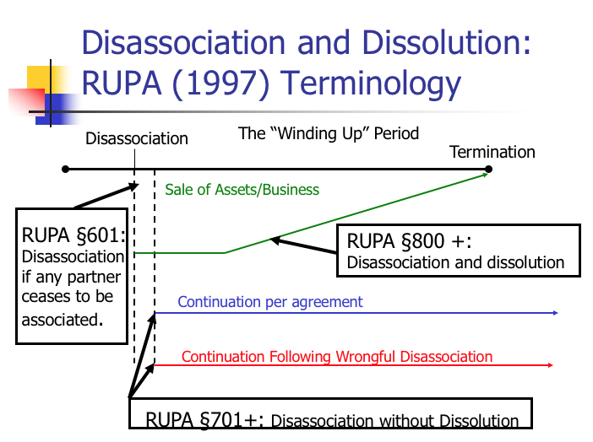
    - Green line - if partner has the power AND the right to dissolve
      - If a partner has the power and the right to dissolve, then the business must be wound up unless there is a pre existing agreement that says the other partners can continue
    - Blue line – what happens when someone leaves is covered in contract
    - Red line - if partner has the power, but not the right to dissolve (partnership keeps going on)
    - RUPA § 601: A person is disassociated as a partner when:
      - (1) the partner expresses the will to disassociate;
      - (2) an event agreed in the partnership agreement occurs;
      - (3) the partner is expelled pursuant to the partnership agreement;
    - RUPA 602
      - (a)(1) A person has the power to dissociate at any time, rightfully or wrongfully, by withdrawing by express will;
      - (b) A partner’s dissociation is wrongful only if:
      - (1) the dissociation is in breach of an express term of the partnership agreement; or
      - (2) the partnership is for a definite term or particular undertaking and the partner withdraws before the end of the term or completion of the undertaking.
      - (c) A person who wrongfully dissociates is liable to the partnership and other partners for damages caused by disassociation.
    - ONLY DEDUCT DAMAGES IF WRONGFUL TERMINATION
    - RUPA 603- Effect of Dissociation
      - If the event is listed in RUPA § 801, then dissolution is also triggered. (Green arrow)
      - If the event is not listed in RUPA § 801, then a buyout will occur pursuant to RUPA § 701 and the partnership business continues (red and blue arrows)
    - RUPA 801- Dissolution and winding up
      - 801: A partnership is dissolved, and its business must be wound up upon occurrence of:
      - (1) in a partnership at will, a partner chooses to disassociate…,
      - (2) in a partnership for a term or a particular undertaking upon completion of the term or undertaking, unless at least half of remaining partners vote for winding up after wrongful disassociation,
          - If they leave wrongfully (early), but people vote to lose the business rather than keep it, then we will go up to the green line. But the leaving partner keeps liability
            - Damages of leaving partner are taken out of share of assets
      - (3) an event agreed in the partnership agreement; …
      - RUPA § 802(b): Partnership continues after dissolution only for the purpose of winding up.
        - We’re in liquidation mode
    - RUPA § 701: If there is disassociation without a dissolution:
      - (a) the disassociated partner’s interest is purchased by the partnership;
      - (b) the buyout price is based on the price if partnership assets sold at that time and equal to the greater of:
        - (1) liquidation value (sell the stuff)
        - (2) value as a going concern (sell the business, brand)
      - (c) damages (see § 602(c)) are deducted from the value of the disassociated partner’s interest; …
      - (h) a partner who wrongfully disassociates not entitled to payment until expiration of term or completion of undertaking. (have to wait for money)
  - Prentiss v. Sheffel (consequences of dissolution, have both power and right, GREEN line)
    - Facts: P (2 partners) sued D (1 partner) to dissolve the partnership (formed by default) and have a value fixed on D’s interest → D countered saying he was wrongfully excluded → trial court ruled it was a partnership at will that was dissolved when D was excluded → court appointed a receiver for liquidation and sale of the partnership property → at the sale, Ps bid and received the business → D appealed
      - Can’t just get rid of one person, you have to dissolve the entire thing
    - Issue: Could plaintiffs be allowed to bid for the business?
    - Holding: Yes
    - Reasoning:
      - No evidence that D’s exclusion was done in bad faith, he was excluded because they couldn’t cooperate and work together
      - Also no evidence that D was injured by them purchasing the business, and he actually benefited because without their bid, the selling price would’ve been much lower
      - He also had a right to bid on the property for himself
    - Notes:
      - What did the court find to be the basis of dissolution?
        - Freeze out → decision by 2 partners not to carry on
        - Freeze out leads to dissolution because if partner is frozen out, then they can no longer carry on as a partner
        - “Partnership is an association to carry on as co-owners”
          - The partnership ends when they are no longer carrying on
          - Doesn’t matter that the one guy didn’t want to
      - Why did the plaintiffs continue to inform the minority partner?
        - Because they are still a partner, and if you want to carry on the partnership, then you have a fiduciary duty to inform
      - The 2 got paid out a percentage of their own bid, so ultimately, all dissolution cost was what they needed to pay out Prentiss.
      - Is the court correct to allow the partners to bid benefits the other partner?
        - Yes money wise (the plaintiffs bid more than maybe it was worth, so he made more money than he would have), but he isn’t really better off since he clearly wanted the original partnership to continue → otherwise he wouldn’t sue
  - 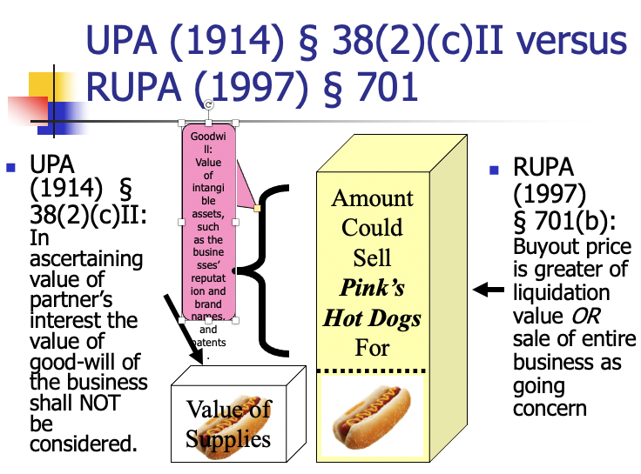

  - Pav-Saver v. Vasso (consequences of dissolution, has the power but not the right, RED line)
    - Facts: Dale, Pav-Saver, and Meersman (owner of Vasso) formed Pav-Saver Manufacturing Company to manufacture and sell Pav-Saver machines → partnership was dissolved and replaced with one between Pav Saver and Vasso → business did well for a while and then it went bad → PSC wrote a letter to Meersman terminating the partnership → Meerseman got mad and physically took over and PSC sued for court order dissolution → Trial court ruled that PSC wrongfully terminated and that Vasso was entitled to continue using PSC’s trademark
    - Issue: Did the trial court err in allowing Vasso to keep the patents and trademark?
    - Holding: No
    - UPA 31 (SIMILAR TO RUPA 800) Dissolution is caused:
      - Without violation if
        - Term over; or
        - Will of a partner, unless for term.
      - In “contravention of an agreement”
    - Rule: UPA 38(2) When dissolution is caused in contravention of agreement (if you leave with power and not the right):
      - Right to damages for breach
      - Other partners may continue business
      - Partner who causes dissolution gets:
        - If business terminates → remaining cash less damage
        - (different part of old rule) If business continues → value of interest, less damage, but value of goodwill NOT considered in value (intangible assets like business reputation, brand names, and patents). So just “liquidation value” (rupa)
    - UPA 32 (1) (SIMILAR TO RUPA 701): Dissolution by court
      - ©Partner hurts partnership
      - € Business can only be carried on at loss
    - Reasoning:
      - The termination was wrongful → invokes UPA 38(2) which allows Meersman to continue the business (partner who doesn’t wrongfully terminate can continue business)
      - If partner causes a dissolution, the other partner may continue the business, but the business cannot continue without the machines with the patents and trademarks → court overruled contract provision on having to return patents
      - UPA says the value of business goodwill shall not be considered → Dale is only entitled to the value of business - goodwill
    - Notes:
      - How important is the language about forming a permanent partnership?
        - If business wasn’t referred to as a partnership? Wouldn’t matter as long as it looks like a partnership
        - If not referred to as permanent? It matters because it would make the partnership a default partnership at will
      - Majority Resolution of Issues:
        - Can the partnership continue to use the Pav-Saver patents after the departure of Dale? Yes
        - What is the value of the partnership excluding goodwill at the time of dissolution? $330,000 ($165,000 owed to Dale)
        - What is the implication of the agreement as to liquidated damages? Used to determine damage payment owed to Meersman, not to replace all provisions of UPA 38(2) (384k owed to Meersman)
  - Partnership property (RUPA 203, 204, 401, 501)
    - What counts as partnership property?
      - Acquired in the name of the partnership.
      - Acquired by one or more partners with a document transferring title that indicates the partner was acting in his capacity as a partner.
      - Property purchased with partnership funds is presumed to be partnership property.
    - “A partner may use or possess partnership property only on behalf of the partnership.”
    - “A partner is not a co-owner of partnership property and has no interest in partnership property which can be transferred, either voluntarily or involuntarily.”
    - RUPA § 401(b): “A partnership shall reimburse a partner for any payment made by the partner in the course of the partner’s activities on behalf of the partnership (entitled to compensation)
    - RUPA § 401(c): “A partnership shall indemnify and hold harmless a person with respect to any claim or demand against the person and any debt, obligation, or other liability incurred by the person by reason of the person’s former or present capacity as a partner, if the claim, demand, debt, obligation does not arise from the person’s breach ….”
    - RUPA § 401(g): A partner can make a loan to the partnership, “which accrues interest from the date of the payment or advance.”
  - Transferable Partnership Interest
    - RUPA § 102(23) defines a “transferable interest” as “the right, as initially owned by a person in the person’s capacity as a partner, to receive distributions from a partnership, whether or not the person remains a partner or continues to own any part of the right. The term applies to any fraction of the interest, by whomever owned.” (kids can get partnership money)
    - RUPA § 502: “A transferable interest is personal property.”
    - Comments: “Absent a contrary provision in the partnership agreement or the consent of the partners, a ‘transferable interest’ is the only interest in a partnership that can be transferred to a person not already a partner.”
    - RUPA § 503:
      - A transfer does not by itself cause a person’s dissociation or dissolution of the partnership business.
      - A transfer does not entitle the transferee to participate in the management or conduct of the partnership.
      - A transferee has the right to:
        - receive, in accordance with the transfer, distributions to which the transferor would otherwise be entitled; and
      - If the partnership dissolves and winds up, the transferee also has a right to receive specified information pertaining to the partnership from the date of dissolution, Section 503(c).
      - CREDITOR CAN ONLY GO AFTER TRANSFERRABLE INTEREST (distributions out of the partnership)
  - Partnership Capital Account RUPA 401(a)
    - An accounting for each partner that is a running balance reflecting:
      - Their contributions (money plus the value of any other property),
      - Their share of profits,
      - Less any distributions (taking a “draw”), and
      - Their share of losses.
  - Capital Contributions
    - As a matter of default, initial capital contributions are not required from partners.
      - Some or all partners may contribute only services.
    - Default: each partner is credited with an amount equal to the value of any other property contributed. The contributed capital itself belongs to the partnership and can be any property (real, intangible, etc.).
  - Default is that you don’t get compensation for services (but you can contract for it)
  - Settlement of Accounts and Contributions in Winding Up
    - RUPA 806
      - (a) A partnership must apply its assets to discharge the obligations of creditors, including partners that are creditors. (If a partner lends money, they get it back)
      - (b) If there is any surplus:
      - (1) First, pay out the value of unreturned contributions,
      - (2) Then, agreed upon rights to share in distributions.
      - (c) If assets insufficient to pay off creditors, each partner shall contribute to the partnership an amount equal
    - Order:
      - Creditors other than partners
      - Money to partners other than capital (like salary)
      - Unreturned contributions of partners
      - Profits or losses
        - Share the profits equally
        - Share losses proportionally to profits
          - Ex: bill gates has a loss of $20. Only two partners, other partner owes him 10 and bill takes 10 loss.
  - Share of Profits and Losses
    - So the default = equal share of profits, and losses are shared proportionately to how they are sharing profits.
    - Does it make any difference if the partners contributed unequal amounts of capital or labor? NO
    - If A and B agree to split profits 60/40 but say nothing about losses, how would losses be split? EQUAL
  - Timing of Distributions
    - The statute is silent on when profits are distributed. A well-drafted partnership agreement will address this.
    - Comment to § 401 (1997 version): “Absent an agreement to the contrary…the interim distribution of profits [is] a matter arising in the ordinary course of business to be decided by majority vote of the partners.”
  - Compensation for services
    - Capital account
      - An accounting for each partner that is a running balance reflecting:
      - Their contributions (money plus the value of any other property),
      - Their share of profits,
      - Less any distributions (taking a “draw”), and
      - Their share of losses.
  - Kovacik v. Reed (sharing losses- who bares the loss?)
    - Facts: Kovacik remodeled kitchens and asked Reed to be his job superintendent and estimator → Kovacik would invest and they could split profits 50/50 → did not discuss possible losses → later Kovacik told Reed that there were losses and demanded he contribute → trial court found Reed liable for losses and he appealed
    - Issue: Is Reed liable for losses sustained?
    - Holding: No
    - Rule: A partner who only contributes skill and labor to the partnership is not liable for losses (may only be applicable in California, but rule is open)
    - Reasoning:
      - Two possible rules:
        - All capital losses were to be borne by the capital partner alone (Kovacik v. Reed)
        - Sharing of capital losses in accordance with sharing of profits (statute)
      - General rule presumes that partners intended to equally split any losses, irrespective of amount contributed, but these cases are when both parties contribute some kind of capital or else was to receive compensation for services rendered to the undertaking before computation of profits or loses
        - Here Reed did not contribute any capital and was not paid for his services
        - Court’s idea was that Reed lost by using his time
      - Case law says upon loss of money, the party who contributed it is NOT entitled to recover any part of it from the party who contributed only services
      - 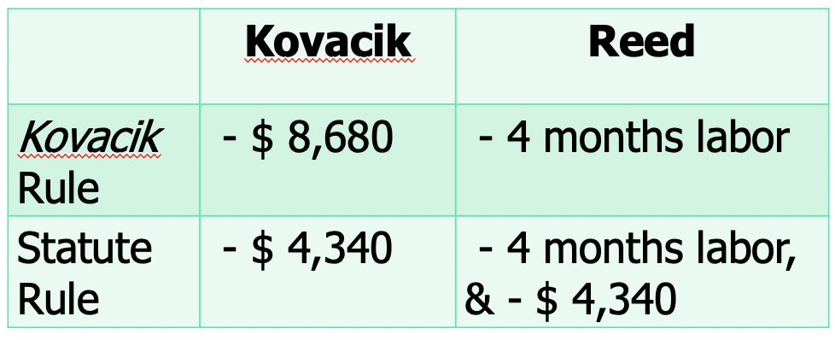
    - Notes:
      - Financial structures: Option (if things go up, you gain, if things go down, you don’t lose) vs. ownership (where it goes up, you get more, if it goes down, you lose)
      - Is the holding consistent with the statute?
        - No, the presumption is that capital can only be money
        - Statute says that the share of losses be equal to the share of profits and each partner must contribute towards losses
          - Ownership. The holding indicates that Reed had an option.
        - Example according to statute: If $15,000 was remaining when the business dissolved → return $10,000 to Kovacik for his capital investment → remaining $5,000 would be split equally between Reed and Kovacik
        - Example according to statute: If $5,000 was remaining when the business dissolved → return $10,000 to Kovacik → split loss of $5,000 between Reed and Kovacik
      - Which provisions of the default rules leads to this problem?
        - Lack of compensation for salary
      - What if Reed had been paid a very nominal salary?
        - Probably different
        - How is this different than an agency relationship?
          - No share of revenue here. If he was getting a salary, would still ask if they were carrying on as co-owners of a business
      - What is the intuition behind the court’s rejection of the statutory scheme
        - Reed lost 9 months of his labor → he still lost that so the decision is fair
      - What if Reed had contributed a nominal amount of capital?
        - He’d be a capital partner, and would be required to share in half of the loss
      - Why didn’t Kovacik and Reed adopt a different rule?
        - Unclear, maybe they both thought they would make money, or Kovacik really thought Reed would be liable anyways because he knew the law
      - What might the effect of the no loss sharing by service partner be on his behavior?
        - No downside, only upside. Other people’s money (OPM). Reed may be more reckless because he gets to play with other people’s money without consequence to himself
  - RUPA makes new statute after this case.
    - Amendments: if person contributes little or no capital, should be obligated to contribute toward the capital loss of the large contributor who contributed no services (reiterated statute)
      - partners should take advantage of their power to vary by agreement the allocation of capital losses
- Default: Wrapping up partnership agreements
  - Can:
    - Change governance rules (i.e., voting and mgmt rights)
    - Define scope of duties, so long as “not manifestly unreasonable” & consistent with RUPA § 105 rules
    - Establish financial rights between partners (during, at dissolution, or upon termination)
      - E.g., can address a “buy-out,” valuation, continuation
  - Cannot:
    - Completely eliminate duties/right to accounting
    - Alter third parties’ rights
      - Cant say 3rd parties cant come after partnership

3) Corporations
- Why use a corporate entity?
  - Ability to accumulate capital from many sources
  - More permanent ownership of assets
  - Able to handle larger size tasks
- History
  - Ultra Vires Doctrine
    - At common law, a corporation was limited to the powers enumerated in the purpose clause of its charter.
      - The “purpose clause” is a statement describing the business the corporation is to conduct.
      - The term “corporate powers” refers to methods the corporation may use to achieve its purpose (e.g., power to contract and power to borrow money).
    - Historically, if a corporation engaged in conduct that was not authorized by its express or implied powers, the conduct was deemed “ultra vires” and void. Whenever a transaction was beyond the corporation’s limited purposes or powers, either party to the contract could disaffirm it. That is what is known as the “ultra vires doctrine.”
    - Over time, courts began to interpret corporate powers more broadly. State legislatures began to allow corporations to specify in their charter that they were formed to engage in “any lawful purpose.” Corporations need not specify a single purpose, nor do they need to list their specific powers.
    - Today, most modern corporation statutes expressly grant incidental/implied powers. Corporate managers, in the absence of express restrictions, have discretionary authority to enter into contracts and transactions reasonably incidental to its business purpose, which may be broadly defined. (DGCL §§ 121, 122)
    - Use of the ultra vires doctrine is very rare; many legal commentators view it as a historical relic.
- Sources of Corporate Law:
  - Individual State Law (Internal Affairs Doctrine) (choice of law)
    - Generally the “internal affairs” of the corporation are governed by the law of the state of incorporation.
    - Courts apply the law of the state of incorporation when adjudicating governance and fiduciary duties that arise within the corporation, including the rights of and relations among stockholders, the duties and obligations of the officers and directors, issuance of shares, acquisition procedures, etc.
    - Hence, the act of incorporation also selects the law that will apply to the corporation’s internal affairs. (E.g., “a Delaware corporation,” “a California corporation”)
    - Qualifications of “foreign” corporations to do business
      - A business incorporated in one state may conduct business in another if “qualified” to do business in that state.
      - To “qualify” the corporation usually has to file a form and attach a certified copy of its certificate and/or a certificate of good standing from its state of incorporation, pay a filing fee, and appoint a local agent to receive service of process.
      - Exception: California
        - California Corporations Code § 2115 (sometimes referred to as a “long-arm statute” or the “pseudo-foreign corporation statute”).
        - With the exception of publicly traded corporations, it makes “foreign” corporations with more than half of their taxable income, property, payroll, and outstanding voting shares within California subject to certain provisions of the California Corporations Code.
        - Controversial: (Delaware courts have ruled it unconstitutional and there was a California legislative attempt to get rid of it).
        - Why does California law require cumulative voting and class voting?
          - Cumulative voting- representative system
          - Class voting- have to get majority approval of each group
            - Non-class system- everyone gets a vote, majority rules
          - CA- Democratizing corporate shareholder power. Minority shareholders need representation on the board
        - Is shareholder voting an “internal affair”?
          - Yes. Violates internal affairs doctrine
        - In 2018 California adopted a rule for public corporations to have a certain number of women on their boards if California is where “principal executive office” is located
    - Delaware
      - When incorporating a business, most people choose to incorporate in either their home state where their principal place of business is or in Delaware.
      - Nearly 60% of publicly traded U.S. corporations are incorporated in Delaware. Nearly 90% of public corporations that re-incorporate do so in Delaware.
      - Delaware corporate law is also very influential on other state’s corporate law.
      - Why? Race to the bottom (Prof Cary)
        - driving the race to the lowest regulatory standards so people will stay in DE
        - Race to the top:
          - Markets are good, even legal markets.
      - DE has:
        - The largest body of precedent interpreting its corporation code – meaning it has the most comprehensive body of corporate law in the U.S.
        - Relatively stable and modern corporate law. The DGCL is kept current and radical reform of its corporation code is unlikely as Delaware’s constitution mandates a 2/3 vote of both state legislative houses to change the corporation code. Delaware courts frequently issue unanimous opinions. MOST IMPORTANT TO GT
        - A special court for business matters (the Court of Chancery), which has a reputation for excellence and experience in corporate law (as well as the Delaware Supreme Court, which is similarly respected).
        - Procedures that facilitate timely decisions (which can be especially important for some corporate issues like takeovers).
        - Many lawyers across the country are trained in Delaware corporate law, especially business savvy lawyers.
  - Federal Law (doesn’t affect all corporations!)
    - Securities and Exchange Acts
    - Sarbanes Oxley Act of 2002
    - Dodd Frank Act 2010
    - JOBS Act of 2012
    - Primarily cover “public” corporations
- Vocabulary
  - Securities = permanent, long term claims on the corporation’s assets and future earnings instead
    - Debt securities + equity securities = capital structure
      - Debt normally stays stable, while as assets grow, equity grows
      - Debt gets paid back first if bankruptcy/ liquidation, then equity gets paid out
    - Two ways a company gets money
      - Shareholders
        - Elect directors and vote on major corporate decisions
        - May receive firm’s earnings in the form of dividends
        - In liquidation, get firm assets after all other claims are satisfied (residual claimants)
      - lenders (creditors)
        - Funds borrowed by the firm (bonds)
        - Firm pays interest
        - At “maturity,” firm returns the principal
  - Debt = held by bondholders, return of a fixed amount
  - Assets = things bought by the company
  - Equity = shares held by shareholders, goes up or down when the value of assets goes up or down
  - 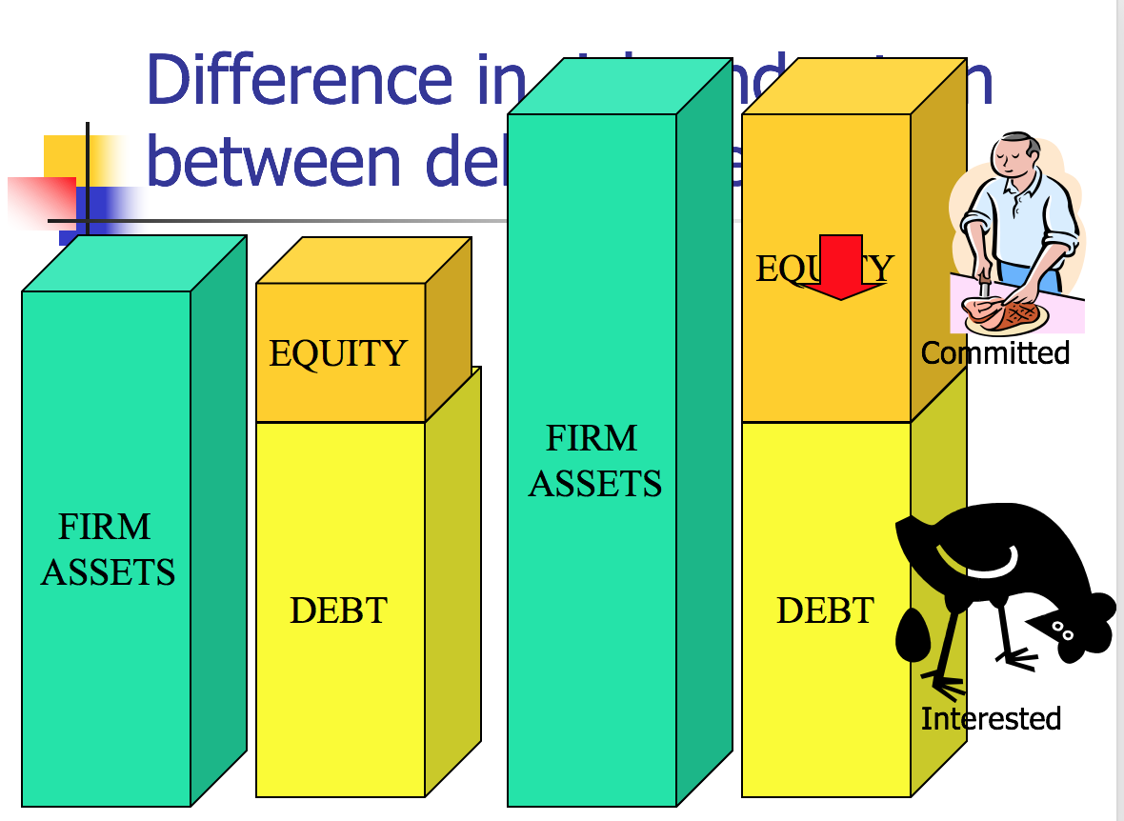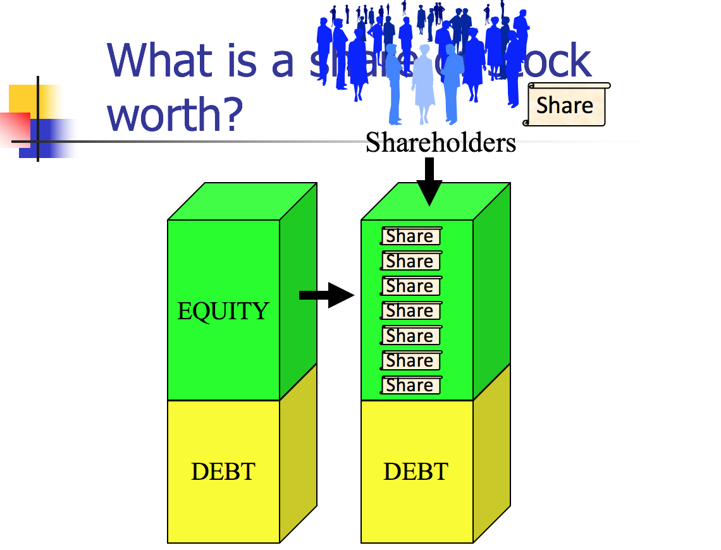
  - Income Statement/ Profit & Loss Statement = Financial statement that indicates results of operations over a specified period
    - Tells more of a story of how the company is doing. Shows how much is coming in.
  - Balance Sheet: = summarizes the company’s financial position at a given point in time
    - Describes the assets of the business and the claims on those assets (by the creditors in the form of debt, or owners in the form of equity)
  - Goodwill = (value for what you purchase (like Disney brand)) - (what it is actually worth)
  - Shares =
    - Equity typically split equally by all the outstanding shares
    - Authorized shares = number of shares the corporation can issue
    - Outstanding shares = number of shares sold and not repurchased
    - Authorized but unissued shares = shares authorized but not yet sold
    - Treasury Shares = shares issued and then repurchased by the firm
    - Total value of firm- debt
    - 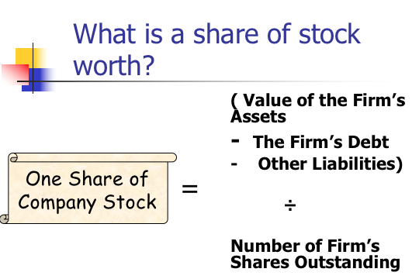
    - Efficient Capital Market Hypothesis = the price of a stock reflects all available information
  - Book value = measure of the equity value of the firm provided by the financial statement
    - This is what the accountants will use
    - General accounting principals: based on cost of obtaining the asset, vs. what others think it is worth
    - Looking at how much it cost to get those assets
  - Market capitalization = measure of the equity value of the firm implied by the trading value of the firm’s stock
    - (trading value of one share of stock) x (total number of outstanding shares) ON TEST
    - Note: GT prefers to look at market capitalization over book value because people buying and selling shares can accumulate many different sources of info, while accountants are limited to for the most part, cost information
      - Example: Actual cost of acquiring vs. what people think it is worth
  - Enterprise value = measure of the total value of the firm’s assets implied by the trading value of the firm’s stock
    - Market cap (one share x outstanding shares) + firm’s debt (EQUATION ON EXAM)= enterprise value
    - 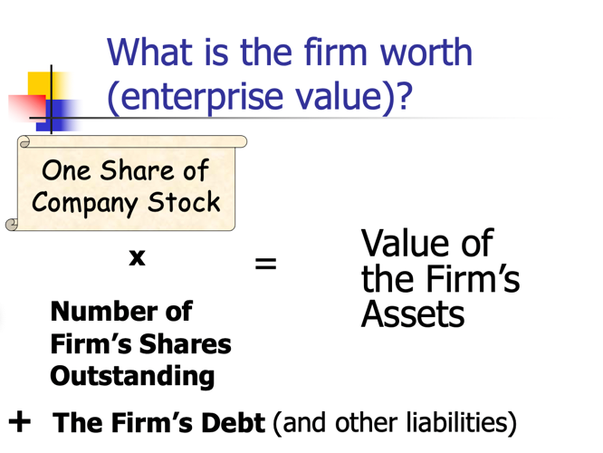
    - Market to book: value of equity re: market cap vs. book value
      - Two major ways to estimate value of corporation:
        - Estimation provided by accountants based primarily on cost of assets (book value)
        - Estimation based on perceived value of business interpreted by price at which share of stock is traded (market value)
- Critical Attributes of Corporations:
  - Six key attributes of the corporation
    - Separate entity (from its owners)
      - Possess some constitutional rights (Citizen’s United)
      - Separate tax identity
    - Perpetual existence
    - Limited liability
      - Shareholders not personally liable
    - Centralized management
      - the stockholders (aka “shareholders”)
      - the board of directors, and
      - the officers (aka “managers” or “executives”)
    - Divisible ownership (shares of stock)
      - Claims on the corporation’s assets and future earnings issued in the form of securities
    - Transferable shares and debt obligations (unless limitations imposed)
  - Structure:
    - Stockholders are the equity investors
      - Their ownership interests are reflected in the stock of the corporation.
      - They elect a board of directors, who in turn select the officers who run the business.
      - Shareholders have a few key rights, but they do not participate in managing the corporation’s business or affairs. They cannot act on behalf of the corporation.
    - The board of directors directs the affairs of the corporation
      - Authority to act for (and to bind) the corporation originates in the board as a collective body.
      - Directors have fiduciary duties to the corporation and the body of shareholders.
        - Not agents!!
      - An individual director acting alone generally has no rights or powers.
      - The board of directors takes action on behalf of the corporation either:
        - at a meeting at which notice was properly given and a “quorum” is present; or
        - by written consent.
      - Action at a board meeting:
        - A majority (quorum) of members must be at a meeting to vote. Can change this in the bylaws, but can’t be less than 1/3
      - Action by written consent (DGCL § 141(f)):
        - Authorizes a board to act without a meeting by means of written consent, but it requires unanimity.
      - Right of directors to delegate (DGCL section 141(e))- highly favored practice
    - The officers handle the day-to-day management of the corporation and are under the direction of the board.
      - The officers are appointed by the board. E.g., CEO, CFO, etc.
      - They are agents of the corporation
      - Execute firm strategy
  - Public v. Private
    - “Public” corporations are large firms with stock traded on public stock markets
      - The shareholders typically do not expect to participate actively in the operation of the business. Many Americans invest indirectly through mutual funds, pension funds, etc. and thus a significant % of public corporation stock is held through institutional investors.
      - There is a large amount of federal law that applies to public corporations (securities laws, etc.).
    - “Private” corporations (also “close” or “closely held”)
      - Not subject to public reporting requirements under federal securities laws (Take the Securities Regulation course to learn more!)
      - Typically, private corporations have a small number of shareholders who hold stock that is not publicly traded. The stock is generally less “liquid” and may be subject to shareholder agreements that limit its transferability.
      - Generally (though not always) private corporations are of relatively modest economic scope, and the people in the top managerial positions may also own a substantial amount of the corporation’s stock.
- “Hybrid” Organizations (“Unincorporated Limited Liability Entities”)
  - More hybrid organizations exist today with aspects of different traditional organizations

 | General Partnership | Corporation | Unincorporated Limited Liability Entities
Limited Liability | None | Yes (b/w board and shareholders) | Some
Formation | Informal | Formalities Required | Formalities Required
Tax Treatment | Flow-through (taxed once). Losses can be used by partners | Double Taxation [Exception: S Corporations] | “Pass-through”
Governance Malleability | Lots | Limited | Lots
Continuity | Default is at will (dissolution by a partner expressing will to withdraw).  Can agree to continuation agreements. | Default is indefinite/perpetual.  But can limit.  Not tied to human life.
Cost | Zero.  But often good idea to hire a lawyer. | Filing fees, typically lawyer fees, franchise fees, etc.
Management | Decentralized (default).  Each partner an agent and equal participation in mgmt is default; but can use exec comm. and limit authority by agreement and notice to third parties. | Centralized (default).  Directors and officers manage the corporation; not shareholders. Separate and specialized functions.
  - Four most common “unincorporated limited liability entities”
    - Limited Liability Partnership (LLPs)
      - General partnership with limited partner liability
      - RUPA 306(c) - a debt, obligation, or other liability is solely the obligation of the LLP
      - Formed by filing a form with Sec. of State
      - General partnership can convert to LLP by filing
      - The partnership name must have a signifier i.e., “LLP”
      - The effect is to shield partners from personal liability for the partnership debts. A partner remains personally liable for her own wrongful acts.
    - Limited Partnership (LP)
      - A type of partnership with 2 types of partners:
        - General partners: General partners manage the business and have the power to bind the partnership. They are personally (and jointly and severally) liable for the partnership debts.
        - Limited partners: Silent/passive partners without management rights. Not personally liable unless they participate in management or control of the LP (old “control rule”- Cal.); current uniform act has modified to not personally liable except in extraordinary circumstances.
      - The partnership must have at least one general partner and one limited partner.
      - The partnership name must have a signifier – i.e., “LP”
      - Default rule is that partners in a LP share profits and losses in proportion to their respective capital contributions. – different from partnership
      - Requires a formal filing (a “certificate of limited partnership”) to create a LP; each state has a LP statute.
        - Most states either have some version of RULPA or ULPA (2008) (aka Re-RULPA).
    - Limited Liability Company (LLCs)
      - Gives limited liability of corporation, but tax benefits of a partnership
      - Formed by filing with Sec. of State
      - Flexibility: like a partnership, most aspects of management and sharing dictated by the LLC’s operating agreement
        - Makes it more expensive to form → must provide the state with details on how it plans to operate
      - Two types of LLCs:
        - Member-Managed: all members are managers
        - Manager-Managed: some owners aren’t managers and have no right to vote
      - There are limitations on capital structure complexity and share transferability
      - Allows businesses to avoid some of the cost of their activities
    - S Corporation
      - Created by tax code
      - Still technically a corporation, not a hybrid
      - Advantages: Pass-through taxation and limited liability
      - Disadvantages: constraints on number of shareholders, source of corporate income, one class of shareholders only, deductions on pass through losses
- Corporation Formation
  - Corporations require formal creation under state auspices
  - Select state of incorporation.
  - Reserve the desired corporate name by application to the secretary of state or other designated state office.
  - Arrange for a registered office and registered agent.
  - Draft, execute, and file the certificate of incorporation (aka “charter,” “articles of incorporation”) with the relevant state agency, according to the requirements of state law (e.g., DGCL § 102).
    - Note: The role of incorporators can be purely mechanical. They sign the certificate and arrange for the filing. If the certificate does not name directors, the incorporators select them at the first organizational meeting (to serve until first shareholder meeting). After incorporation, the incorporators can fade away and do not need any continuing interest or role.
    - Filing the certificate is a straightforward task. The DGCL requires state officials to accept certificates for filing if they meet the specifications. DGCL § 103(c). Certain filing or organization fees and any franchise tax must be paid.
  - Properly filing the certificate brings the corporation into existence. (DGCL § 106) Next step is to have an organizational meeting of the incorporators or of the subscribers for shares to elect the directors, if not named in the certificate. (DGCL § 108) Also:
    - Appoint officers
    - Adopt bylaws (DGCL § 109)
    - Adopt pre-incorporation promoters’ contracts
    - Authorize issuance of shares, stock certificates, corporate seal, corporate account, etc. (use a checklist to be meticulous)
  - Prepare board meeting minutes, open corporate books and records, issue shares, qualify to do business in states where business will be conducted, obtain any needed permits, taxpayer ID numbers, etc.
  - Plan for shareholder meeting as required.
  - Key corporate documents
    - Certificate/articles of incorporation
      - Terminology:
        - Delaware uses the term “certificate of incorporation”
        - California uses the term “articles of incorporation”
        - Colloquial term is the “charter”
      - Filed with the state in order to incorporate, must meet statutory requirements
        - Typically must include basic provisions required by the state, such as the corporate name, agent address for service of process, number of authorized shares, etc.
        - Model code only has four requirements and does NOT include naming the officers
        - MC Things you MAY add:
          - Names of directors
          - Stuff from the bylaws
          - Provision limiting/ eliminating liability of a director except a few things (intentional infliction of harm for example)
          - Provision permitting/ making obligatory indemnification of a director for liability (with a few exceptions)
    - Bylaws
      - Not filed with the state
      - Set out the governing details of the corporation
        - Typically longer than the certificate of incorporation and include governing rules for electing directors, filling director vacancies, notice periods and details for calling and holding meetings of shareholders and directors, etc.
  - Alternative to DE laws: model rules MBCA (basically the same)
    - Under MBCA § 10.03, an amendment to the articles of incorporation: (a) must be adopted by the board of directors, and (e) approved by a majority of the votes of the shareholders present (as long as a quorum), whereas under DGCL § 242(b)(1) the directors shall adopt a resolution and holders of a majority of the outstanding stock must vote in favor of the amendment.
  - Promoter liability
    - A “promoter” is a “person, who acting alone or [with others], directly or indirectly takes initiative in founding and organizing the business or enterprise of an issuer.”
      - E.g., find investors, arrange for space/facilities, hire employees for the entity, enter into contracts.
      - Often referred to as the “founder” or “organizer.”
    - Contrast with an “incorporator” who has the limited, mechanical task of preparing the incorporation documents and filing them with the state. Incorporators are often lawyers, paralegals, etc. In contrast to the rules of promoter liability, incorporators are typically not liable for their pre-incorporation acts.
    - Pre-incorporation:
      - Promoters are liable for contracts entered into on behalf of a future corporation, absent a contrary intent.
        - Contrary intent generally requires showing more than just signing “for a corporation to be formed.”
        - Evidence of the parties’ intentions must be found in the contract or in the surrounding circumstances—for example, that the parties intended the promoter to be a non-recourse agent or a “best efforts” agent.
    - Post-incorporation:
      - Corporation is liable on the contract only if the corporation adopted it.
        - Can be express (e.g., formal board resolution) or implied (e.g., if directors or officers knew of and acquiesced in the contract).
      - Promoter remains liable unless:
        - Corporation is formed;
        - Corporation adopted the pre-incorporation contract; and
        - The parties agreed to release the promoter from liability (either in the initial contract or through subsequent novation).
      - It’s possible for the corporation and the promoter to both be liable on the contract.
    - Promoter fiduciary duties:
      - deal with the entity in good faith. This requires promoters to act fairly in transactions they enter into with the corporation.
      - disclose relevant information, like opportunities and conflicts vis-a-vis the entity, to other relevant parties. (e.g., no secret profits)
    - Subscription agreement: An offer to purchase shares from a corporation. Subscriptions can be made to existing corporations or corporations to be formed.
  - Limited liability w/ defective formation:
    - De Facto Incorporation: Treat improperly-incorporated entity as corp. if organizers
      - tried to incorporate in good faith,
      - had a legal right to do so, and
      - acted as if a corporation.
      - Ex: you think you formed a corp, someone is injured, they go after director. Court will say corp will be formed/ liable instead (often used with torts)
    - Incorporation by Estoppel: Treat as proper corporation if person dealing with the firm
      - Third party thought firm was a corporation, and
      - a windfall if allowed to argue that firm was not corporation. (third party found out it wasn’t a corp and wanted to go after deep pockets)
      - Another way people can’t go after individuals but have to go after the corp even if it wasn’t formed.
- Corporation Liability to Third Parties
  - General Rule: Liabilities incurred by the corporation cannot be imposed on the shareholders
    - Unless you can “pierce the corporate veil” PCV doctrine
      - Other way: can put personal shareholder liability in the charter
  - When do shareholders have personal liability?
    - MBCA 6.22(b) - “a shareholder is not personally liable for the acts or debts of the corporation except that he may become personally liable by reason of his own acts or conduct”
    - 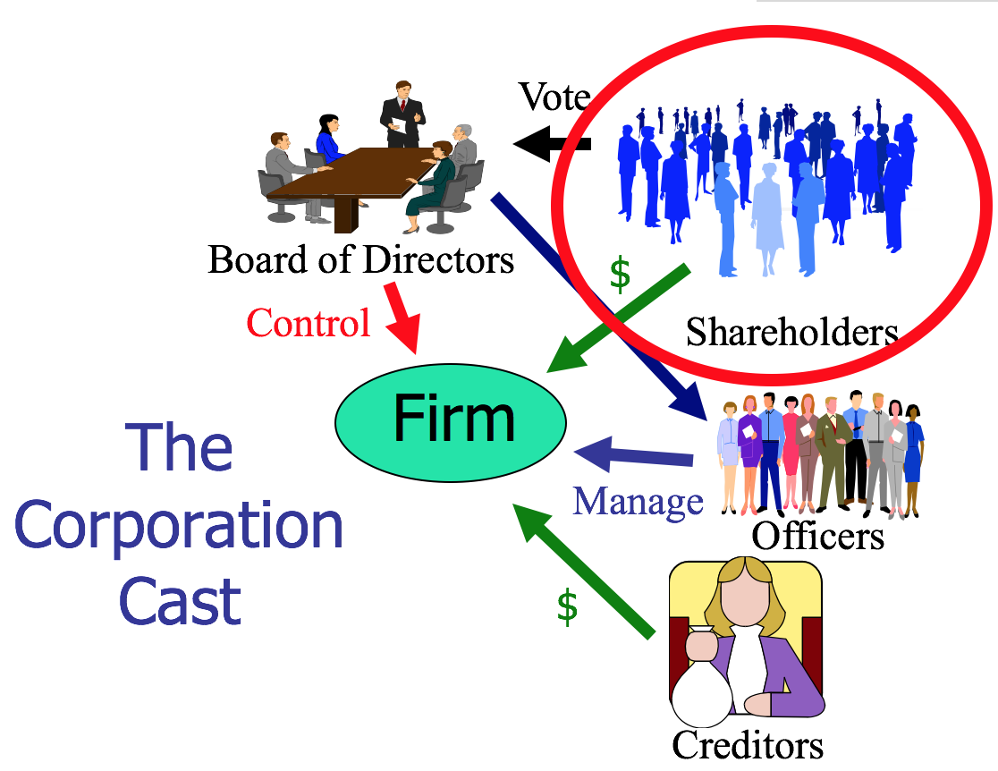
    - The officers kind of act as agents of the directors, but they really are agents of the corporation since they are acting on behalf of the firm
      - No principal-agent relationship between shareholders and the corporation because shareholders have no control
- Walkovsky v. Carlton
  - Facts: P was injured after being hit by a taxi owned by Seon Cab Corp. → Carlton was a stockholder of Seon and 9 other corps. → P alleged that the corps. operated as a single enterprise with regard to financing, supplies, employees, etc. → P said he was entitled to hold the stockholders of the other 9 corps. liable because their structure was an unlawful attempt to defraud the public who might be hurt
  - Issue: Is Carlton liable for P’s damages as a stockholder?
  - Holding: No
  - Rule: If stockholders are respecting the formalities of the corporate form, then the court cannot pierce the corporate veil.
    - Note: Can only pierce the corporate veil for shareholders for whom there is a unity of interest between the firm and the corporation (you wouldn’t really go after someone who has a tiny share)
  - Rule: If corporation is a dummy for individual stockholders who are actually carrying out business for personal rather than corporate ends, then the stockholders could be held personally liable
  - Reasoning:
    - P didn’t provide enough evidence to show that D was doing business in his own interest rather than the business’s interest
    - Just because an enterprise is comprised of multiple corporations does not mean it is fraudulent → also not fraudulent to take out the min amount of insurance
    - Although the court found that there was evidence of commingling and that there was undercapitalization of the corporation, the plaintiff failed to allege that Carlton failed to respect the formalities of the corporate form
  - Class Notes:
    - Three Theories of Imposing Liability:
      - Theory 1: Piercing Corporate Veil
        - Rejected because no allegation of failure to respect formalities of corporate form
          - E.g. Annual meeting, pay taxes, keep written records (corporate minutes)
        - Must show unity of interest with the shareholder
        - What would a plaintiff have to show in order to pierce the corporate veil?
          - “That defendant Carlton and his associates are actually doing business in their individual capacities, shuttling their personal funds in and out of the corporations ‘without regard to formality and to suit their immediate convenience’”
      - Theory 2: Enterprise Liability (get access to the larger corporate entities/ sister companies)
        - If one organization is working on behalf of and subject to control of other organization, operations are intermingled → appropriate to have shared liability
        - Must show comingling of funds because they are sister companies
        - Difference from piercing corporate veil?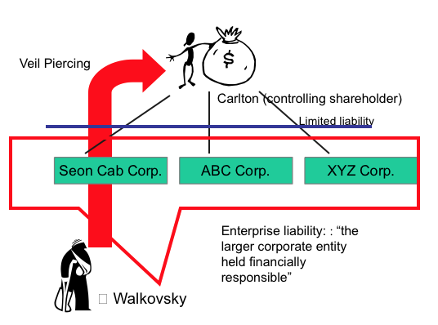
          - In enterprise liability, you go after the sister corporation (or holding company) and are claiming that the corporation is a fragment of a larger corporation which actually conducts the business
          - In piercing, you go after the shareholder and are claiming that the corporation is a dummy for its individual shareholders who are carrying on the business in their personal capacities for purely personal rather than corporate ends
        - What would a plaintiff have to show in order to recover under the enterprise theory?
          - That Carlton didn’t respect the separate entities of the corporations
            - Assignment of drivers, use of bank accounts, ordering of supplies, etc.
        - There was some evidence of intermingling, but wouldn’t create liability for Carlton since he is just a shareholder, not a parent corporation
        - Rejected because would need to show Carlton didn’t respect separate personalities of the corporations
      - Theory 3: Principal-Agent
        - Rejected because Carlton is a shareholder, not a principal
        - The board is controlling operations, not Carlton
        - NOTE: a holding company and subsidiary may have a principal agent relationship
    - What problems are there with Judge Fuld’s deference to the legislature
      - Making legislature responsible for doing the right thing rather than the business owner
    - Can you incorporate your business for the express purpose of avoiding personal liability?
      - Yes
    - Can you split a single business enterprise into multiple corporations so as to limit the liability exposure of each part of the business?
      - Yes
- Sea-Land Services, Inc. v. Pepper Source
  - Facts: Sea-Land shipped peppers on behalf on D → D didn’t pay for the freight bill so P sued to recover → default judgment was entered, but it was found that D has been dissolved and had no assets → P sued Marchese and five business entities he owned, including D, alleging the corporations existed for the purpose of defrauding → also said marchese should be liable since he created and used the corporations for his own personal use
    - Pierce Corporate veil to get to Marchese → reverse pierce → get to the other corporations
      - Reverse pierce - after piercing the corporate veil, reverse piercing allows you to gain access to the assets of other corporations that the shareholder owns
      - Same test applied, just now between the shareholder and the other corporation
  - Issue: Did P show that the separate corporate existences “would sanction a fraud or promote injustice”?
  - Holding: No
  - Rule: Van Dorn Test - A corporate entity will be disregarded and the veil of limited liability pierced when: 1) There is such unity of interest and ownership that the separate personalities of the corporation and the individual (or other corporation) no longer exist; and 2) Circumstances are such that adherence to the fiction of separate corporate existence would i.sanction a fraud or ii.promote injustice (Test for Piercing the Corporate Veil)
    - There is a unity of interest determined by these factors (weighed, don’t need all):
      - Failure to maintain adequate corporate records or to comply with corporate formalities (E.g. Annual meeting, pay taxes, keep written records (corporate minutes))
      - The commingling of funds or assets
      - Severe undercapitalization (equity is suspiciously small)
      - One corporation treating the assets of another corporation as its own
    - Refusing to allow PCV would:
      - Sanction fraud OR
      - Promote injustice
  - Reasoning:
    - Court agreed that there was shared control/unity of interest and ownership→ Part 1 of Van Dorn Test satisfied
    - Sea-Land hasn’t shown that D intended to defraud it → tried to argue that honoring separate identities would promote injustice
      - Court said an uncollected debt isn’t enough to show that the separate corporate existence promotes injustice → no evidence
      - Would need to show something like the corporate facades to avoid its responsibilities to creditors
      - There must be something wrong beyond inability to pay the creditor
  - Class Notes:
    - What should Sea-Land have to show on remand to prove unjust enrichment?
      - If Marchese was portraying Pepper Source as a legitimate business, because it wasn’t and that he never intended to pay (for fraud there’s an intent requirement)
    - Easy to avoid liability- just do you paperwork and you can’t meet the first element
    - Why reverse pierce if you can just do enterprise liability?
      - If the other business have all the assets, should just do enterprise liability. May want to reverse pierce is the shareholder holds some of the assets. Also, may not be comingling so you have to reverse pierce
Internal Governance
- Roles and Duties with Respect to Creditors
  - Bottom Line: Governed by contract law
    - Legal analysis turns on:
      - Interpretation of express terms
      - The implied duty of good faith and fair dealing
    - No fiduciary duties to debtholders
- Corporate Fiduciary Duties
  - Directors generally do not owe much to shareholders, but all shareholders have equal standing to challenge a director if he fails to act as an appropriate fiduciary
  - To whom are fiduciary duties owed?
    - Two competing theories:
      - Shareholder Primacy - Firm only owes a duty to shareholders (Dodge v. Ford)
      - Stakeholder Theory - Firm owes a duty to shareholders, officers, client/customers, community, employees
      - Business roundtable: does not view these two positions as being in conflict. It is in the long-term interests of stockholders for a corporation to treat its employees well
  - Who is bound by fiduciary duties?
    - Board of Directors are bound by the fiduciary duties to the shareholders
    - Senior Officers
    - Controlling shareholders (>50%)
- Dodge v. Ford Motor Co. [Duty of Care]
  - Facts: D manufactured cars → in 1916, Henry Ford announced that no special dividends would be paid out in the future and profits would instead be reinvested → the Dodge brothers complained and offered to sell his shares to Ford, who refused to buy them → brothers sued him
    - Dividend = a distribution of a portion of the company’s earnings, decided by the Board of Directors, to a class of its shareholders in the form of cash, stock, or property
  - Issue: Could the court enjoin Ford from building the new smelting plant and order the payment of the dividends?
  - Holding: No on the smelting plant, but yes Ford is required to distribute the dividend payment
  - Rule: A business corporation is organized and carried on primarily for the profit of the stockholders. SHAREHOLDER PRIMACY
  - Reasoning:
    - Ford had a huge surplus, and building the plant was payable over a considerable period of time, so it seems too arbitrary not to distribute the dividend
    - Ford admitted that he had an interest in doing so outside of maximizing profits
      - The Court took biggest issue with this, Ford said the reason for not distributing was because he cared about the stakeholders, and by doing this he wasn’t fulfilling his obligations to the shareholders
      - “It is not within the lawful powers to shape and conduct...for the merely incidental benefit of the shareholders and for the primary purpose of benefiting others”
  - Class Notes:
    - Courts may not scrutinize decisions about how to maximize profits, but they will scrutinize decisions about whether to do so
    - Generally the Court will not interfere with management of directors unless it is clearly made to appear that they are guilty of fraud or misappropriation of the corporate funds
    - Does this decision support shareholder primacy?/ Why did Ford lose on the dividend issue?
      - Yes, by not paying the shareholders and admitting other interests, Ford was not fulfilling his obligations to the shareholders
        - Ford testified that he was thinking about employees and other stakeholders
          - All he had to argue is that this was the best decision for shareholders
    - If Dodge v. Ford is a correct statement of the law, why do scholars still argue for stakeholder theory?
      - Some scholars argue for stakeholder theory as normative claim, rather than as a descriptive claim.
      - Courts give Boards broad discretion to determine means, and many times benefiting other stakeholders benefits shareholders.
      - Some state statutes incorporate stakeholder theory ideas (this is DE law).
    - Did Ford really think that his company made too much money
      - Semi-eleemosynary (relating to charity)???? Gut doesn’t know
    - Does it matter that judges are not business experts
      - No, they aren’t making a business decision
    - Was 30 million a fair offer to Ford? *
      - Stock and flow
        - Stock is the stuff (cows) OR at how much money a company is generating (flow)
      - Depends on whether you look at the balance sheet (stock) or income statement (flow)
      - Translate into implied firm value: $30mil for 10% of shares → means the Dodge brothers value the company at $300mil
      - Balance Sheet
        - Balance sheet said Ford Book Value (accountants valuation of the equity) = $114 million → accountants would’ve told Ford that Dodge’s offer was 3x book value and too expensive
          - Note: But accountant are locked into numbers
        - This is pretty much the same ratio as Disney
      - Income statement
        - Price to Earnings Multiple (flow): 5x price/earnings (P/E Multiple)
          - How much more am I paying than the company is generating every year
          - ($300 mil)/($60 mil) = approximately 5
            - Means in 5 years would get money back
          - The lower the number the better → here this is a really good deal for Ford. Really low price. Ford was being a bad guy
          - Usually should pay out around 10-20x
- Holdings and legislation related to corporate purpose
  - eBay Domestic Holdings, Inc. v. Newmark (Del. Ch. 2010)
    - shareholder primacy
  - In re Trados (Del. Ch. 2013)
    - Shareholder primacy
    - “maximize the value of the corporation” “other constituencies may be considered only instrumentally”
  - Constituency statute
    - A majority of states have “constituency” statutes that expressly allow (but do not require) a corporation to consider stakeholders’ and other constituencies’ interests alongside shareholders’ interests.
      - Delaware does not have a constituency statute.
  - Charitable giving
    - All 50 states have statutes providing for corporate authority to make charitable contributions.
      - Three perspectives (corporations are part of the success of our society- it’s the duty of a citizen, maybe its wise because it’s in the best long term interest of the corporation, this is a scam)
      - Does NOT need to benefit the corporation
    - Theodora holding Corp v. Henderson (challenge)
      - Issue: was this a reasonable contribution? (reasonable standard)
        - Not reasonable: if it gave all of its money. 2%? Probably okay
        - Dollar number divided by the share for price per share
      - Charitable giving proceeded the statute ("A.P. Smith Mfg. Co. v. Barlow)
        - Common law allowed charitable giving
      - Corporate gifts as self-dealing
        - Kahn v. Sullivan, 594 A.2d 48 (Del. 1991) (upholding chancery court’s conclusion that charitable donations approved by independent directors are subject to review under business judgment rule)
          - “cleansing” – charity could be a conflict of interest
      - Should shareholders decide instead of directors?
        - Maybe
  - Political spending
    - Citizens United v. FEC allows corporations to spend unlimited amounts from their general treasury on independent expenditures supporting or opposing candidates to federal office.
      - Absent a conflict of interest, illegality, or fraud, a decision to spend corporate money for an independent political expenditure is treated as an ordinary business decision (and would get BJR presumption).
      - To date, the SEC has not specifically mandated disclosure of corporate political spending. It has been heavily debated since Citizens United. Some corporations have received shareholder proposals on this topic and have agreed to make annual voluntary disclosures, but there is no standardized, mandated disclosure to shareholders/investors.
      - What can a shareholder do if she opposes the political spending of a corporation she is invested in?
  - Current trends
    - ESG (environmental, social, & governance) and CSR (corporate social responsibility)
      - Same group of concerns. What are corporations doing as citizens
      - One way to deal with this is disclosure. A lot of companies are doing this because their stakeholders care about a lot of things
  - Benefit corporations
    - Entirely separate form of business entity from a traditional corporation.
    - 30+ states (incl. Delaware) have adopted a benefit corporation statute.
    - Enables pursuit of dual mission of profits and a public benefit (state variation on how defined).
    - Requires specified public benefit stated in the charter.
    - Mandates boards to consider in their decision making for the corporation the impact on non-shareholder interests (e.g., the environment, society, stakeholders).
    - Most statutes require a benefit report (disclosure) and provide for a “benefit enforcement proceeding” mechanism that may be brought by the corporation or derivatively by a shareholder.
    - B-corp
      - May or may not be a benefit corporation (third- party certification by B Lab for meeting standards)
      - Ex: Ben & Jerrys, Allbirds, Patagonia
      - Mostly used for advertising/ branding purposes
- Fiduciary Duties
  - Two main, and maybe more
    - Duty of care
    - Duty of Loyalty
    - Duty to act in good faith
    - Duty of Oversight
  - What is the content of corporate fiduciary duties?
    - Duty of Care
      - Regulates diligence in performing tasks
        - Failure to act and carry out basic supervision can violate Duty of Care (Van Gorkom)
      - Limited by the Business Judgment Rule (BJR) - most actions are covered
      - Director may be found liable if (MBCA 8.31):
        - Corporate charter indemnification or cleansing doesn’t preclude liability AND
        - Didn’t act in good faith (see Stone) or
        - Director did not believe she was acting in the best interest of the corporation (Ford) or
        - Director was not informed (Smith v. VanGorkom) or
          - Procedural, not substantive
            - Made a decision without informing himself- how he made a decision (i.e. flipping a coin)
        - a lack of objectivity due to Director’s lack of independence (Broz) or
          - Directors can make a decision that they personally benefit from, but can’t claim protection by BJR in court
          - You lose the BJR because it is a conflict-of-interest transaction
          - Shareholders can cleanse still
          - Apply same analysis as in Duty of Loyalty
        - Director failed to devote ongoing attention to oversight or devote timely attention when particular facts arise. Or
          - Inaction of a director not covered by BJR (Francis)
      - Delaware’s Duty of Care Standard
        - Limited by the Business Judgment Rule (shorter list)
          - Courts defer to the BOD’s actions unless (BJR will protect unless):
            - Actions are not in the honest belief that action is in the best interests of the corporation (not doing it for the right reason); or
            - Actions are not based on an informed investigation; or
            - Actions involve a conflict of interest
      - Duty of care violation can be cleansed (Smith v. VanGorkom)
    - Duty of Loyalty
      - Regulates self-dealing transactions
      - NO BJR SHIELD
      - “Essentially the duty of loyalty mandates that the best interests of the corporation and its stockholders takes precedence over any interest possessed by a director...and NOT shared by the stockholders generally”
      - We’ve adopted a sort of middle ground rule between BJR and banning related party transactions altogether
      - Controlling shareholder= 50% or more of the shares
      - Dominant shareholder- maybe over 20%?
      - Two-Step Analysis:
        - Step 1: Does the transaction involve a conflict of interest? (need all three to be true)
          - Is the director/ controlling shareholder on the other side of the transaction?
            - MBCA 8.60 - There is a conflicting interest if:
              - Director is a party to the transaction;
              - If Director had knowledge and a material financial interest in the transaction; or
              - A transaction which the Director knew a related party had a material financial interest in
                - See MBCA for who a “related party” is
                - Grandparents, spouses, aunts, uncles, niece or nephew, people living in your house etc
                - Cousin isn’t on the list!
          - Is the firm on one side of the transaction?
            - Does the opportunity belong to the firm?
              - Meinhard v. Salmon, Singer v. General automotive
            - Corporate Opportunity Doctrine (Guth v. Loft) (Broz v. Cellular)
              - Corporate Opportunity Doctrine exists where (weighed factors):
                - Corporation is financially able to take the opportunity
                - Opportunity is in the corporation’s line of business (aspirations, what you dream of)
                - Corporation has an interest or expectancy in the opportunity
                - Embracing the opportunity would create a conflict between director’s separate interests and that of the corporation
              - Interest vs expectancy
                - Interest: Something to which the firm has a legal right (If officer bought land to which the corporation had a contractual right)
                - Expectancy: something which, in the ordinary course of things, would come to the corporation (If the officer took the renewal rights to a lease the corporation had)
              - Which covers more opportunities: the line of business test, or the interest/expectancy test?
                - Line of business (includes aspirations)
          - Is the director/shareholder receiving a benefit from the firm not received by all (all the shareholders)?
        - Step 2: Has the transaction been properly “cleansed”? (MBCA 8.61, DGCL 144) (need at least one of three)
          - Approved by informed, disinterested directors
            - Disinterested - no financial interest in transaction
          - Ratified by independent shareholders
          - Judged substantively fair to corporations
        - DE first step is much more simple: “no contract or transaction between a corporation AND 1 or more of its directors or officers shall be void or voidable if: (cleansing elements above)
      - 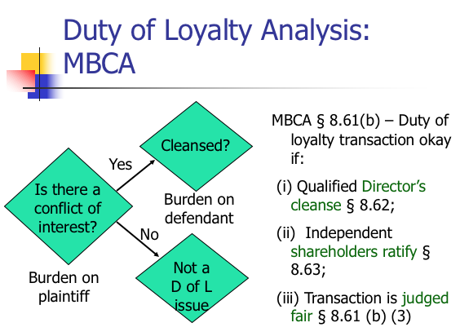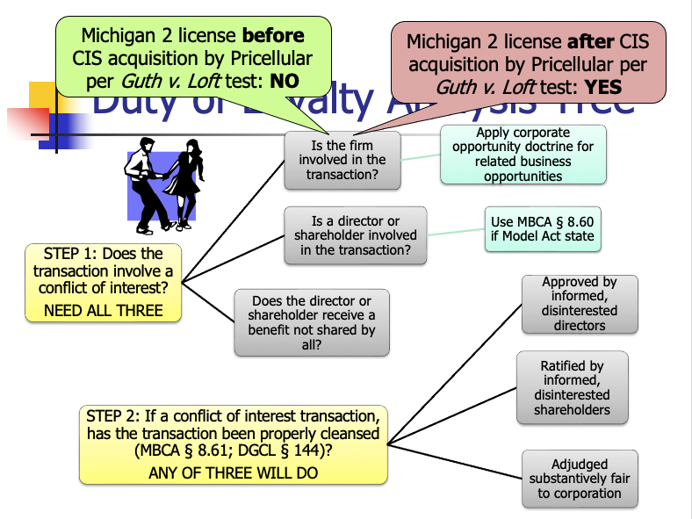
    - Duty to Act in Good Faith (also just duty of care) (DE)
      - Possible interpretations of what constitutes a breach of the duty to act in good faith:
        - Intentional dereliction of duty (failure to do your duties) (Disney)
        - Failure to provide adequate oversight (Frances v United Jersey Bank)
        - Failure to gather information and comply with law (Caremark)
      - Not in common law
      - Stone v. Ritter: “although good faith may be described colloquially as part of a ‘triad’ of fiduciary duties that includes the duties of care and loyalty, the obligation to act in good faith does not establish an independent fiduciary duty that stands on the same footing as the duties of care and loyalty.”
      - Things that would be duty of care but doesn’t allow directors to say “well this was our business judgement)
      - Appears in statute about fiduciary duties, but is not clearly defined (four places)
        - Limitation on indemnification in DGCL §145(a)
        - Required to justify reliance on advisors in DGCL §145(e)
        - Limitation on exculpatory charter provision in DGCL § 102(7)(b)
        - Statement of the business judgment rule in MBCA § 8.31 (a)
    - Duty to Disclose (?)
- Kamin v. American Express [Duty of Care]
  - Facts: American Express (defendant) authorized dividends to be paid out to stockholders in the form of shares of Donaldson, Lufkin and Jenrette, Inc. (DLJ). Kamin, et al. (plaintiffs), minority stockholders in American Express, brought suit against the directors of American Express, alleging that the dividends were a waste of corporate assets in that the stocks of DLJ could have been sold on the market, saving American Express about $8 million in taxes.
    - Providing dividends vs. reporting the loss and having to pay fewer taxes
  - Rule: Courts will not interfere with a business decision made by directors of a business unless there is a claim of fraud, bad faith, or self-dealing.
  - Standard of review
    - Kamin: “the question of whether or not a dividend is to be declared or a distribution of some kind should be made is exclusively a matter of business judgment for the Board of Directors”, unless:
      - “the powers have been illegally or unconscientiously executed; or unless … fraudulent or collusive, and destructive of the rights of stockholders”
      - “fraud, dishonesty or nonfeasance”
      - “it appears that directors have [not] been acting in good faith”
  - Questions
    - What standard does the court adopt for the duty of care of directors?
      - Defer to the business judgement, look at procedure (if it was an informed decision)
    - What were the offsetting benefits of providing the stock as a dividend?
      - Reporting the loss of earnings would be bad in the marketplace (value)
        - Earning x 10/20= valuation (he says multiply it by ten to make it easy)
    - What is the relevance of the ECMH (efficient capital market hypothesis) to this decision?
      - Description
        - All information is already incorporated in share prices
          - If you know public information, you can’t trade on that information because it is already incorporated in the stock price
        - Says value of securities affect available information
          - You can’t make money with information that everyone has
      - Applicable: no benefit to not reporting the loss. People already know there was a loss because the stock price is so low. There’s no secret and they should have taken the lower taxes
    - What other type of fiduciary duty claim could be made?
      - Self-interest- duty of loyalty
        - If bonus tied to income, want income to stay high?
    - How should employee compensation contracts be drafted?
      - Compensation tied to the stock price (if you believe in the efficient capital markets hypothesis). Don’t want to tie it to revenue because then they don’t care about profits (option- other people’s money).

- Smith v. VanGorkom [Duty of Care]
  - Facts: Transunion was having difficulty generating sufficient taxable income to get investment tax credits → Transunion CEO Van Gorkom met with senior management and discussed a buyout → Van Gorkom met with Pritzker and proposed a leveraged buyout with a per price share for sale of the company without consulting anyone except controller Peterson → Pritzker didn’t want to make an offer and have someone else make one bc it would make him look like a loser-> gave him authorized shares (aside from outstanding shares) at market price -> TU directors eventually approved a proposed merger agreement even though senior management was pissed→ later approved a revised deal → shareholders voted to approve → signed and announced
    - Tender offer acquisition- I will purchase your shares from you. As a result, I will own all the shares/ equity.
      - This constitutes an acquisition.
      - DE law says if you get most of the shares (like 90%) you can cash out the other shareholders (force out)
    - Leveraged Buy Out - acquisition of all outstanding shares using borrowed funds
      - Subcategory of tender offer
      - Loans secured by the assets of the company to be acquired
      - Basically saying you will pledge the company you just bought as collateral to the loaners (similar to a mortgage)
    - Management Buy Out - a type of LBO where management acquires all outstanding shares
  - Issue: Did the directors act in an informed and deliberate manner in determining whether to approve the agreement of the merger?
  - Holding: No
  - Rule: MBCA In making a business decision, the directors of a corporation must act on an informed basis, in good faith, and in the honest belief that the action taken was in the best interests of the company
  - Reasoning:
    - Was the BOD informed when it made the decision?
      - No, BOD made its decisions on Van Gorkom’s representations
      - All they knew was that Pritzker was willing to pay $17 million premium over the prevailing market price → but they didn’t know how the price was set
      - They didn't know about the Pritzker meeting or what it was for
      - Also BOD didn’t receive any written documents with terms, support, etc. and weren’t told how the price per share came to be, they only knew it was above the market selling price and based on a study of feasibility
    - Did the Board’s subsequent action in voting cleanse?
      - No, still not informed
      - There was a competing bid of $60 so they didn’t have to look far
    - Did the shareholder vote cure?
      - No because they also didn’t know how the numbers were reached and also didn’t know the price was based on a study of feasibility and not one of value
  - Main Takeaways:
    - Duty to make informed decisions
    - Burden of proof: party attacking board’s decision
    - If grossly negligent, will be found to have breached duty to shareholders
  - Class Notes:
    - Dissent
      - Look how sophisticated these people are, they aren’t getting swindled
    - This failed the BJR → “are not based on an informed investigation”
      - Who has the burden of proof on this issue? Party attacking the board’s decision
      - What must the party prove? Gross negligence
      - How often do directors lose on this ground? Very rarely
    - How can directors protect themselves from liability for being uninformed?
      - (1) Business judgement rule
        - (1) Say I believe this is in the best interests of the corporation
        - (2) Be informed
          - Rely on the reports of the executives
          - Hire an investment banker
          - You can rely on outside opinions!
      - (2) Indemnification (MBCA 8.51 - 8.56) (DE 145)
        - DGCL § 145 (abbreviated!):
          - (a) A corporation shall have power to indemnify a person who is or was a director against expenses (including attorney’s fees), judgments, fines and amounts paid in settlement if the person acted in good faith and no reasonable cause to believe conduct was unlawful. Termination by settlement does not create a presumption not in good faith or conduct was unlawful. (you can be indemnified even if you settle)
          - (b) No indemnification if a person shall have been adjudged liable to the corporation unless the Court of Chancery permits. (if you lose in trial, can’t get indemnification. Is why you would want to settle)
          - (c) If successful on the merits such person shall be indemnified.
          - € expenses may be paid in advance of the final deposition of such action
          - (g) A corporation shall have power to purchase and maintain insurance on behalf of a director for any liability, whether or not the corporation would have the power to indemnify such person against such liability.
      - (3) Directors and Officers’ Insurance (MBCA 8.57)
        - Protects from broader range of liability and is good if the corporation doesn’t have enough money to indemnify
        - Corporation will pay for insurance
    - DE Legislative reaction after Van Gorkum
      - DGCL May include in certificate of incorporation a provision eliminating or limiting the personal liability of a director … for monetary damages for breach of fiduciary duty … provided such provision shall not eliminate or limit liability of a director: (i) for breach of director’s duty of loyalty ..; (ii) for acts or omissions not in good faith or which involve intentional misconduct; …
        - Even if directors make an uninformed decision and breach their duty of care, they still don’t owe any money. Don’t even need insurance! Replaces needing insurance if this is in your charter
        - Essentially an anti-lawyer lawsuit provision
        - Still owe duty of loyalty
- Broz v. Cellular Information Systems, Inc. [Duty of Loyalty]
  - Facts: Broz was president and sole stockholder of RFBC which provided cell service → he was also a director of CIS, a competitor → CIS was in financial difficulty but was in the process of being acquired, and ultimately was acquired, by PriCellular-> Makinac company was trying to divest its Michigan-2 cell license → reached out to Broz about an acquisition for RFBC, but not CIS which was having financial difficulties → CIS had been divesting its cell licenses → Broz spoke with a few higher-up members of CIS about his interest in Michigan-2 → Pri-Cellular begins acquisition process of CIS and tried to also get Michigan-2 → RFBC outbid them and got the Michigan-2 license → Pri-Cellular offer for CIS closes
  - Issue: Did Broz breach his fiduciary duty to CIS?
    - Outbid his own future interest-holder (but deal hadn’t been closed at the time).
  - Holding: No, he was under no duty to consider the “contingent and uncertain plans of Pri-Cellular”
  - Rule: Corporate Opportunity Doctrine → Guth Factors (see above)
  - Rule: If the director or officer believes, based on one of the factors that the corporation isn’t entitled to the opportunity, then he may take it for himself
  - Reasoning:
    - A corporation fiduciary agrees to place the interests of the corporation before his or her own interests
    - Step 1: Does the transaction involve a conflict of interest? (need all three)
      - Is the director or shareholder on the other side of the transaction?
        - Yes, the director is a party to the transaction between RFBC and had knowledge and a material financial interest in the transaction
      - Is the firm on one side of the transaction? Court said no
        - Corporate Opportunity Doctrine
          - Corporation is financially able to take the opportunity? No, CIS was struggling financially
          - Opportunity is in the corporation’s line of business? Was in line with business, but CIS had been divesting itself of licenses and its articulated business plan involved no new acquisitions (seemed to be exiting business)
          - Corporation has an interest or expectancy in the opportunity? No, Mackinac never offered it to CIS
          - Embracing the opportunity would create a conflict between directors separate interests and that of the corporation? No. There was a conflict in the first place! Him being a director of CIS and president/sole stockholder of RFBC was a conflict
      - Does director receive a benefit not received by all? DNR?
    - Trial court said Broz was obligated to formally present the opportunity to the CIS board → this court said no, DE law doesn’t require one in order to find that a corporate opportunity had not been usurped
    - Broz had no duty to consider Pri-Cellular because:
      - The acquisition plan wasn’t certain at the time
      - Would be impractical if a director or officer had to consider all potential future occurrences in determining if there was a conflict
  - Note:
    - If happened after pri-cellular acquisition (no delay in tendering):
      - Yes conflict of interest, within line of business.
      - Has to consider the conflicts with p-c rather than just CIS.
    - Point of decision is to say that you don’t have to get every single director action cleansed at a director’s meeting
    - Was the court fair in treating CIS’s interest in Michgan-2 as separate from that of Pri-Cellular?
      - Depends on if you think the timing is right
    - What advice would you give to Broz?
      - Resign as director from CIS
      - Cleanse → make a formal presentation to the board (safe-harbor)
    - Can still win without cleansing if it’s proved to not be a conflict of interest.
  - Requirements for formal board of directors action (MBCA
    - Action of the Board only occurs when:
      - MBCA § 8.20 – Board meeting are either regular or special.
      - MBCA § 8.21 – Action without meeting requires unanimous written consent.
      - MBCA § 8.22 – No notice necessary for regular meeting; two day notice required for special meeting.
      - MBCA § 8.23 (a) – A director may waive notice. Except as provided by subsection (b), waiver must be in writing.
      - MBCA § 8.23 (b) – A director’s attendance at a meeting waives any required notice unless the director objects.
      - MBCA § 8.24 – Quorum – default rule – majority; minimum quorum requirement acceptable – 1/3. Vote decided by majority present.
- Sinclair Oil v. Levien [Duty of Loyalty by Shareholder]
  - Facts: Sinclair is primarily a holding company in the oil business → Sinclair is a 97% shareholder of Sinven, a subsidiary of Sinclair in Venezuela → Sinclair nominates all directors of Sinven’s BoD and almost all of them worked in another corporation belonging to Sinclair → Sinven sued for damages arising from dividends to Sinclair paid by Sinven, denial of industrial development, and breach of contract from transaction with International. (three transactions)
  - Controlling shareholders are basically the directors, which is why law lets them have liability. If you control the shares of the company, you control the directors
  - Issue: Were the dividend payments objectively fair?
  - Holding: Yes, under the BJR
  - Reasoning:
    - Step 1: Is there a conflict of interest transaction for dividends? No Conflict
      - Was a controlling shareholder on one side of the transaction? Yes Sinclair was
      - Was corporation on one side of the transaction? Yes Sinven was
      - Shareholder received benefits not received by all?
        - No the minority shareholders received a proportionate share of the money that was transferred
    - Step 2: Does not reach
  - Issue #2: Did Sinclair deny Sinven of industrial development (were they prevented from expanding)?
  - Holding #2: No
  - Reasoning #2:
    - It applied the BJR because it so clearly wasn’t an opportunity for Sinven
      - P didn’t prove any business opportunities which came to Sinven independently and Sinclair took or denied to Sinven → no self-dealing
      - Sinven also didn’t show that there were any business opportunities that came to it independently and Sinclair took or denied it to them
  - Issue #3: Did Sinclair breach its contract? (not bringing the breach of contract action was the breach of fiduciary duties)
  - Holding: #3: Yes?
  - Reasoning #3:
    - Step 1: Is there a conflict of interest transaction? Yes
      - Shareholder on one side of transaction? Sinclair was a party
      - Corporation on one side of transaction? Sinven was a party
      - Shareholder received benefit not shared by others? Sinclair received all the benefit from International while Sinven didn’t get anything
    - Step 2: No cleansing occurred
      - Approved by disinterested, informed directors? There was no cleansing by disinterested directors because they didn’t exist, almost all directors worked for Sinclair in some other way
    - Step 3: Apply Intrinsic Fairness Test since no cleansing (adjudged fair?)
      - Sinclair must prove that its causing Sinven not to enforce the contract was intrinsically fair to the minority shareholders of Sinven
      - Court kind of applying its own BJR
      - Court said this was self-dealing where it caused Sinven to contract with another Sinclair subsidiary, “International”
      - Sinclair received products, but didn’t pay Sinven on time or comply with a minimum purchase requirement → clear breach
      - Sinclair got all the benefits of the transaction without adhering to its obligations so it is unfair
  - Notes:
    - Why is this a duty of loyalty case?
      - Rare, but because sometimes shareholders have a fiduciary duty to other shareholders
      - If dominant or controlling shareholder or group of shareholders, then the controlling shareholder has a fiduciary duty to other shareholders
      - “A director is a fiduciary… So is a dominant or controlling stockholder or group of stockholders… [W]here any of their contracts or engagements with the corporation is challenged the burden is on the director or shareholder not only to prove the good faith of the transaction but also to show its inherent fairness from the viewpoint of the corporation and those interested therein.” Pepper v. Litton
    - How might a corporation that owns a large percentage of stock in another corporation deal with a minority shareholder that may file a fiduciary duty lawsuit?
      - Bring in some disinterested directors who would probably vote in your favor and make sure they stay informed
      - Buy out the minority shareholders to avoid issue completely
- Executive compensation
  - Board of directors choose compensation for themselves and executives
  - Possible executive compensation package:
    - Salary (cash)
    - Bonus
    - Plan-based compensation
      - Stock awards
      - Stock options
      - Non-equity incentives
    - Deferred compensation
      - Pension plan
      - Non-qualified deferred compensation
    - Other
      - Executive loans
      - Fringe benefits (aka “perquisites” & “perks”)
  - Policy debates typically focus on:
    - (1) how to align executive incentives with corporate performance and shareholder value (“reduce agency costs”); want everyone to get rich!
    - (2) what is “fair pay”?
  - Federal Regulation
    - Tax laws (e.g., IRC § 162(m) exec comp deduction rule- if you pay an exec more than a million dollars you can’t deduct it (but can deduct below that)).
    - SEC disclosure rules for public companies (Reg. S-K) (Compensation Discussion & Analysis (narrative disclosure of objectives, design, elements of pay, how determined) and summary comp tables) policy of full disclosure
    - SOX: prohibition of loans to insiders; clawback provision that allows for disgorgement of incentive pay when a company’s financials are misstated
    - Dodd-Frank: Additional public company disclosures incl. “pay vs. performance” and pay-ratio of median employee to CEO; Say-on-Pay nonbinding SH vote on executive pay; nonbinding SH vote on golden parachutes (special pay for pay packages from M&A); expanded on the SOX clawback.
    - Also, per Dodd-Frank, and NYSE & NASDAQ exchange rules, public company boards must have a compensation committee (and there are rules generally requiring the committee to be composed of independent directors).
  - State Corporate law
    - Directors must act with care and in good faith in informing themselves and making decisions about executive compensation.
    - What is the standard if plaintiff-shareholders challenge?
      - Waste (“so one-sided that no business person of ordinary, sound judgment could conclude that the corporation has received adequate consideration”)
        - Waste is a way to get around BJR
      - Loyalty/good faith (interested directors – entire fairness (process & substance); lack of good faith)
    - Shareholder approval – process
      - American Tobacco (classic case, p. 653): court rejected claim, bylaw setting compensation had been previously approved by SHs
        - Form of cleansing – SH voted on it to be in the bylaws
  - Points for discussion
    - Federal vs. state
      - Should executive compensation be governed by federal or state law? What are the advantages and disadvantages of each?
        - Fed
          - Pros: Covers all companies
          - Disadvantages: not tailored to different companies, fed not good at writing legislation
        - State
          - Pro: competition between states to come up with the best law
          - Disadvantage: company gets to choose their favorite law (forum shop)
            - Choose to incorporate in a state that will pay them lots of money
    - Regulation vs. litigation
      - Federal approach – ex ante regulations to govern conduct
        - If you design rules well, you don’t have to litigate every time
      - State approach – ex post adjudicating conduct in litigation
        - Relying on common law approach to regulating the law
        - No systematic evaluation of the process
      - Which approach is more likely to be effective in the area of executive compensation?
        - Depends, political conversation
    - Director compensation
      - Directors have an unavoidable conflict of interest in fixing their own compensation.
        - Directors should ensure they engage in a thorough, deliberative decision-making process and can demonstrate they have considered the information or received independent advice necessary to reach a fair decision, including data on peer companies, relevant market practices, and an analysis of any factors relating to their particular circumstance, such as the complexity of the company and a director’s expected time commitment.
      - Director self-compensation decisions are interested transactions subject to entire fairness review if challenged.
        - Shareholder ratification of specific compensation awards or a “self-executing” compensation plan could get judicial review to BJR (if no further director discretion used after SH ratification).
      - SEC proxy disclosure rules require detailed disclosure of all elements of director compensation and the processes for determining director compensation, including any perquisites and charitable donation programs.
- In re The Walt Disney Co. derivative litigation [Duty to Act in Good Faith- Case on executive compensation]
  - Facts: Ovitz→non-fault termination provision (NFT)→ Ovitz terminated without cause, got 130 mil for 14 months to avoid court (written into contract)→ shareholders mad- too much money
  - Issue: Were the actions of the Disney directors in approving the employment agreement, hiring Ovitz, and then terminating his employment “not for cause,” made without any violations of the fiduciary duties of due care?
  - Analysis: Duty of Care (did not breach)
    - What did plaintiff need to prove to show breach of the duty of care?
      - 1) not a decision made in the best interests of the company
        - Was in best interest- orvitz good executive
      - 2) not an informed decision
        - Judge says they weren’t as informed as he would have been
      - 3) or there was a conflict of interest
        - No- wasn’t trying to benefit Ovitz
    - What did the court suggest would be “best practice”?
      - Spreadsheet explaining the downside of the deal
    - What actually happened?
    - Were the directors liable for breach of the duty of care?
      - No
    - How can you distinguish this from Smith v. Van Gorkom?
      - These directors could waive some papers and show numbers they had- they at least tried. Smith, didn’t have any evidence that they were informed.
  - Analysis: Waste (no)
    - Did the payment of the NFT to Ovitz constitute corporate waste?
      - A plaintiff who fails to rebut the BJR is not entitled to a remedy unless the transaction constitutes waste.
      - What must plaintiffs show for a waste claim?
      - Did the plaintiffs succeed with their waste claim here?
  - Analysis: duty of good faith (declined to decide whether there is a distinct fiduciary duty to act in good faith independent of the duties of loyalty and care.)
    - Were the actions of the Disney directors in approving the employment agreement, hiring Ovitz, and then terminating his employment “not for cause,” made without any violations of the fiduciary duties of good faith?
      - Identified two possible reasons not acting in good faith:
        - Conduct motivated by an actual intent to do harm, or
        - “Intentional dereliction of duty, a conscious disregard for one’s responsibilities”
    - Gave examples of conduct not in good faith!
      - intentionally acting with a purpose other than advancing the best interests of the corporation,
      - intent to violate the law,
      - intentionally failing to act in the face of a known duty to act, demonstrating a conscious disregard for duties.
    - How can directors show their actions were in good faith?
      - Say you’re working for the best interests of the company, can’t be trying to break the law, and can’t be failing to act
- Francis v. United Jersey Bank [Duty of care (too early for Good Faith)- Case on basic oversight, inaction]
  - Facts: Pritchard & Baird was a reinsurance broker (provides the insurance for what the insurance company actually sells) → mother Lillian had a 48% interest and was a director → remaining shares were owned by her sons who were also directors → the sons withdrew money from funds the corporation was supposed to hold in trust for its clients in the form of “loans” → when they take cash, the balance sheet “balances” by taking money from the shareholders (equity), so instead, they issued IOUs which counted as an assent and didn’t effect the equity part of the balance sheet -> Lillian was in a deep depression and didn’t know what was happening → the misappropriation was discovered and the corporation became insolvent → Lillian died → creditors sued her estate
  - Issue: Did Lillian have a duty to the clients, did she breach it, and was her breach the proximate cause of her loss?
  - Holding: Yes
  - Rule: Affirmative Duties of a Director for duty of care:
    - Obligation of basic knowledge and supervision
    - Read and understand financial statements
    - Object to misconduct and if necessary, resign
  - Rule: court will not give deference to your inaction
  - Reasoning:
    - Needed three elements: fiduciary obligation, breach the obligation, causation
    - Generally directors should have at least a rudimentary understanding of the business of the corporation and are obligated to keep informed
    - Directors are immune is they rely on financial statements in good faith and if one discovers an illegal course of action → duty to object
      - She should have read them and would have discovered the “loans”
    - This corporation looks like a bank → her relationship to the clients is like a director of a bank to its depositors and thus she DID have a fiduciary
    - The funds were held in a trust → trust relationship gives rise to a duty to guard the funds with fidelity and good faith
    - It was proximate cause because (but-for her conduct, this wouldn’t have happened):
      - She didn’t resign until just before the bankruptcy
      - No factual basis for argument that losses would’ve occurred even if she had objected and resigned
      - Her duties extended to reasonable attempts to prevent misappropriation
      - Her negligence was a substantial factor contributing to the loss
    - Duties owed to customers
      - If hold funds of others in trust
    - Why is this not duty of loyalty? Delaware courts haven’t said that it is.
  - Notes:
    - Guttentag says there probably wasn’t much Lillian could’ve done, but the court wants to find liability because they wanted to find someone to blame, maybe wanted to deter bad behavior
    - Transaction was heavily regulated because of the amount of money involved
    - Did Lillian have a duty to the Pritchard clients?
      - No, shareholder primacy
      - BUT exception. If bank, you have a fiduciary if you are a director of a bank
        - Here, like a bank
    - Why does the court use a reasonable person standard here?
      - Failure to act rather than action
    - The BJR does NOT apply here because it applies to actions, not inaction
  - 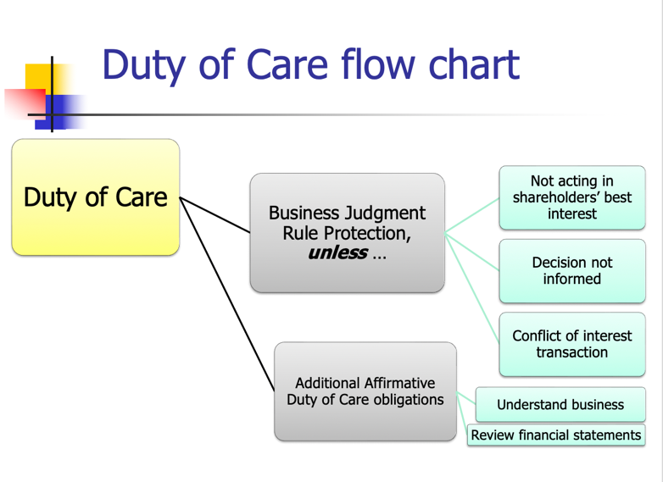
- Graham v. Allis-Chalmers
  - Does the board have to adopt a law compliance program?
    - Old Rule: Directors are entitled to rely on the honesty of their subordinates until something occurs to put them on notice
    - If they are put on notice and then fail to act, liability may follow
      - “One Free Bite” rule
- In re Caremark
  - Does the board have a special duty to adopt information gathering programs?
    - New Rule: “Director’s obligation includes a duty … to assure that a corporate information and reporting systems … exists, and that failure to do so …may, in theory at least, render a director liable for losses caused by non-compliance with legal standards.”
    - Why? To “reach informed judgments concerning both the corporation’s compliance with law and its business performance.”
    - This was purely dicta
    - Called the “caremark duty”
  - Elements of an adequate law compliance program
    - Policy manual
    - Training of employees
    - Compliance audits
    - Sanctions for violation
    - Provisions for self-reporting of violations to regulators

- Stone v. Ritter [Duty of Loyalty (Good Faith)- gathering information and complying with law]
  - Facts: AmSouth Bank got in trouble for failing to file “suspicious activity reports” → was also penalized for operating an inadequate anti-laundering program → report said the compliance program lacked adequate board management and management oversight
  - Issue: Did the directors fail to act in good faith regarding their oversight responsibilities?
  - Holding: No
  - Rule: Caremark Standard → Failure to gather information to avoid violations of law
  - conditions predicate for director oversight liability:
    - Directors utterly failed to implement any reporting or information systems or controls
    - Having implemented such a system or controls, consciously failed to monitor or oversee its operations thus disabling themselves from being informed of risk or problems requiring their attention
  - Rule: “Director’s obligation includes a duty to attempt in good faith to assure that a corporate information and reporting system … exists, and that failure to do so …may, in theory at least, render a director liable for losses caused by non-compliance with legal standards.”
  - Reasoning:
    - Graham case → directors/officers may assume the integrity of employees and honesty of their dealings unless there are grounds to suspect deception
    - Report found that the Board dedicated considerable resources to the compliance program and put many measures and systems in place to attempt to ensure compliance
    - Board reasonably relied on periodic reports by employees and departments who were responsible for filing SARs and monitoring compliance
  - Notes:
    - Stone v. Ritter rejects the duty of good faith
    - Says the obligation to act in good faith does NOT establish an independent fiduciary duty → it belongs under one of the other existing duties → probably belongs in duty of care, but court puts it under duty of loyalty, this way the obligation can’t be contracted out of
      - Don’t have to pay money for duty of care violations after Van Gorkum legislative response, but do have to pay money for duty of loyalty violations
    - Does the board have a duty to adopt a law compliance program?
      - Old Rule: Directors entitled to rely on honesty of subordinates until something occurs to put them on notice (Graham v. Allis-Chalmers)
      - New Rule: Director’s obligation includes a duty...to assure that a corporate info and reporting systems...exists, and that failure to do so...may, in theory, at least, render a director liable for losses caused by failure to oversee
- 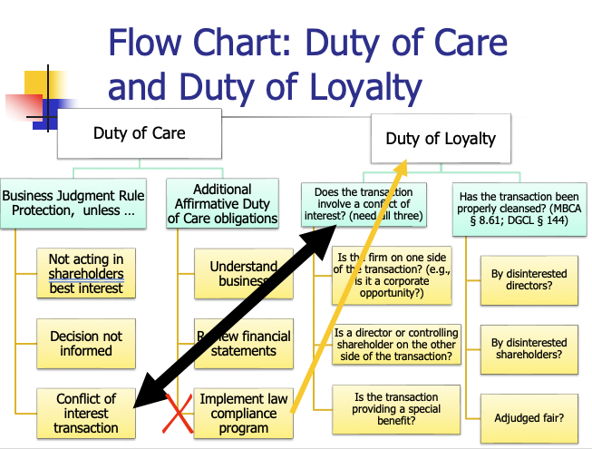

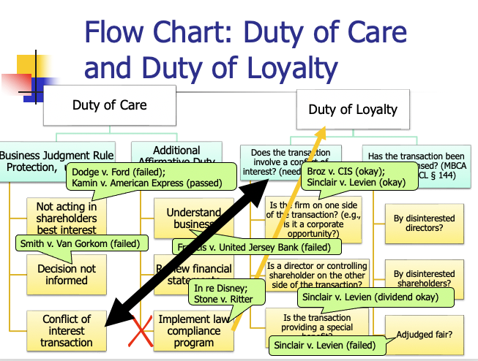
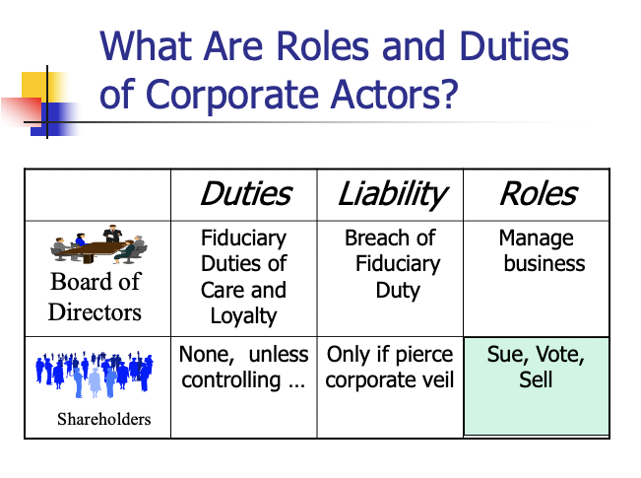

Shareholder Duties and Roles
  - Duties: None, unless they are a controlling shareholder
  - Roles: Sue, Vote, Sell
- SUE: Two Kinds of Lawsuits a Shareholder Can Bring:
  - Direct Suit - suit alleging a direct loss to the shareholder
    - 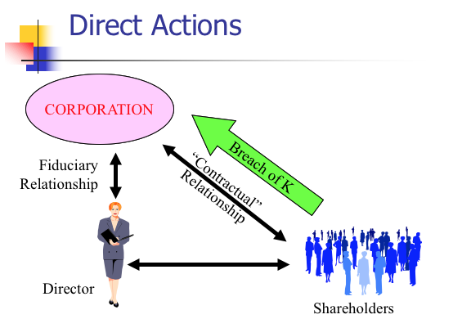
    - Bases for Direct Claims:
      - Force payment of promised dividend
      - Enjoin activities that are ultra vires (beyond legal authority)
      - Claims of securities fraud
      - Protect participatory rights for shareholder (like if you are supposed to get a vote but don’t get one)
  - Derivative Suit - a suit alleging a loss to the shareholder caused by a loss to the corporation
    - 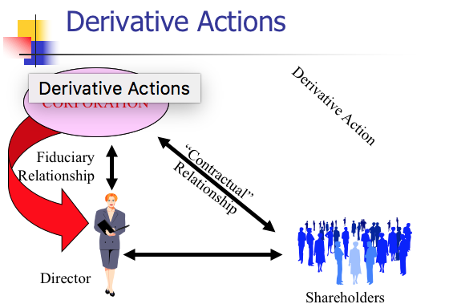
    - Bases
      - Breach of duty of care
      - Breach of duty of loyalty
      - By either directors or a majority shareholder who has fiduciary duties
    - Technically the corporation has been harmed by directors, and as owner, shareholder has been harmed
      - The corporation should bring the lawsuit against the directors, but it is weird because essentially directors suing directors → unlikely to happen in real life
    - Two kinds of suits contained in a derivative lawsuit:
      - Compel corporation to sue another; and the suit against that other party.
        - Suit by corporation against directors for failure to carry out fiduciary duties; and
        - Suit by plaintiff arguing that he or she should substitute for the directors in managing this particular aspect of the corporation’s business (becomes agent)
      - First part is that the corporation has been harmed
      - Second part of the derivative lawsuit is a request to remove authority of this claim from the directors to the plaintiff (I should be able to act on behalf of the corporation)
    - Remedies: The shareholder is suing “in right” of the corporation, so …
      - Remedy from principal suit goes to corporation;
      - Corporation is required to pay shareholder attorney’s fees if suit is successful or settles.
    - Tooley v. .DLJ
      - Facts: Board agreed to 22-day delay in closing
      - Dicta explains distinction between derivative or direct determined by:
        - Who suffered the alleged harm, the corporation or the suing shareholders individually? (first harm, we guess)
        - Who would receive the benefit of any recovery or other remedy, the corporation or the shareholders individually?
    - Three Procedural Hurdles to a Derivative Action (Bonding requirements, demand requirements, special litigation committees)
      - Bonding Requirement
        - In a minority of states (not DE), a derivative claimant with “low stakes” must post security for corporation’s legal expenses
        - Required to deter frivolous lawsuits
      - Demand Requirement (Grimes v. Donald)
        - Most states require shareholders in derivative suits to approach BoD first and demand that they pursue legal action (unless you have a valid excuse not to)
        - Typically a letter from shareholder to BoD
          - Must request board bring suit on the alleged cause of action
          - Must be sufficiently specific as to apprise the board of the nature of the alleged cause of action and to evaluate its merits
        - DGCL – Demand excused if plaintiff can show the demand is futile by showing reasonable doubt using the tools at hand that:
            - Majority of directors are disinterested and independent, or that
            - Challenged transaction was product of valid exercise of BJR
        - What recourse does shareholder have if Board decides not to pursue?
          - Director refusal of demand request subject to business judgment review, but..
        - Does making the demand affect one’s subsequent rights?
          - Yes
            - Bringing a demand would theoretically create a conflict of interest but…
            - Once demand made (in Delaware) waive the right to say there’s a conflict of interest (citing Spiegel)
            - Only Board’s handling of the demand request can be challenged
            - In Delaware, you should just go to court first
        - A rational plaintiff will file derivative suit before making demand
          - Consequences of not making demand trivial - if required, slight delay while you make demand
          - Preserves right to litigate
          - Don’t get the same discovery rights (can only use facts on hand)
        - Aaronson v. Lewis (demand futility)
          - (Meyers) entered into an employment agreement with Leo Fink, a director who owned 47% of the outstanding shares of the company. The terms were highly in favor of Fink. Meyers’ board also granted interest-free loans to Fink amounting to $225,000. plaintiff, a stockholder of the company instituted an action, challenging the transactions entered into by Fink and Meyers. According to Lewis, the aforementioned transactions were approved only because Fink personally selected each director and officer of Meyers. Lewis further contended that the transactions violated the business judgment rule.
          - Demand only excused “where facts are alleged with particularity which create a reasonable doubt that the directors’ action was entitled to protections of the business judgment rule.”
            - Want more detailed pleadings
            - “Unless facts are alleged with particularity to overcome the presumptions of independence and a proper exercise of business judgment, a bare claim of this sort raises no cognizable issue under Delaware corporate law.”
        - Mcba- UNIVERSAL DEMAND
        - Tools to plead with particularity when you don’t have discovery *
          - Information rights you have as a shareholder (but these are so limited)
          - Piggyback on someone else’s work (i.e. federal government prosecution)
            - Stone v. ritter- gov brought a case first
          - Corporate intelligence (spying internally)
        - United Food V. Zuckerberg
          - Replaces Aaronson test
          - To excuse demand under the “refined test,” a complaint must allege with particularity that at least half of the members of the demand board:
            - (1) received a material personal benefit from the misconduct that is the subject of the litigation demand;
            - (2) face a substantial likelihood of liability on any of the claims that would be the subject of the litigation demand; or
            - (3) lack independence from someone who received a material personal benefit from the alleged misconduct that would be the subject of the litigation demand or who would face a substantial likelihood of liability on any of the claims that are the subject of the litigation demand.
          - The Court noted that because its new test was conceptually consistent with Aronson and Rales, earlier precedents properly applying those rulings remain good law.
      - Special Litigation Committee (not always)
        - Group of independent directors. The SLC investigates the claims in the complaint, and then acts for the corporation to recommend to the court whether to allow the litigation to proceed. SLCs frequently recommend against the litigation proceeding and move to dismiss.
        - New York precedent (Aurebach v. Bennett)
          - Derivative suit filed by GTE shareholders against GTE officials who paid bribes.
          - Three SLC directors hired after wrongdoing formed SLC, conducted investigation, concluded no breach of duty of care or personal profit.
          - Procedural not substantive scrutiny of SLC
            - SLC decision covered by BJR (“The committee’s substantive decision falls squarely within the embrace of the business judgment doctrine,…”)
            - But judicial inquiry permitted with respect to:
              - Disinterested independence of SLC members
              - Adequacy of SLC’s investigation
            - Burden of proof on plaintiff.
        - Delaware Precedent (Zapata v. Maldondo)
          - Demand not made
          - Demand excused as futile
          - Board appoints a special litigation committee
            - New board members
            - Recommends dismissal
          - Legal issues:
            - Can the Board committee “seize” the derivative litigation? (we don’t need the outside plaintiff’s attorney anymore) Maybe.
            - Can the tainted Board members appoint a non-tainted committee? Yes.
            - How should a court review the decisions of the special litigation committee? Court’s Business Judgment.
          - Two step Test
            - Step 1: Inquiry into the independence and good faith of the committee and the bases supporting its decisions
            - Step 2: Court applies its own business judgment as to whether the case should be dismissed (Zapata test)
          - Zapata far more intrusive judicial review than usual. Why?
            - Because they are cynical- SLC appointed by the board, so they may not be truly independent
- 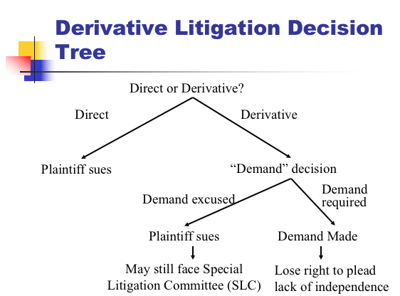
- Shareholder Voting
  - Sources of law
    - State corporation law
      - state law requires only minimal information when shareholders vote. Shareholders receive notice of when and where the shareholder meeting will happen, but generally do not get information about the matters on which they will vote.
      - Shareholder voting for directors, on major transactions, amendment of certificate and bylaws
      - Shareholder proposals (state law)
      - Fiduciary duty of disclosure/candor
    - Federal securities laws
      - Regulates disclosure of information in connection with shareholder voting
      - Shareholder proposals (federal law for public companies)
    - SEC Statutory Authority – rules about soliciting shareholder votes, PUBLIC COMPANIES
      - Rule 14a
        - specifies required proxy (shareholder vote) disclosures
        - prohibits false or misleading statements
        - provide specified proxy assistance to requesting shareholders
        - allows shareholders to submit shareholder proposals
      - Rule 14a-9 prohibits false or misleading statements or omissions as to a material fact in connection with soliciting proxies
        - Public enforcement: SEC can sue for violations of § 14(a)
        - Private enforcement (J.I. Case Co. v. Borak (U.S. 1964))
        - *Suit can be derivative (e.g., corporation harmed by misinformed vote) or direct (e.g., shareholder’s voting rights infringed by misrepresentation)
    - Recent trends toward activism
      - Historic paradigm of rational apathy
        - Why bother voting?
        - Low turnouts are common from individual shareholders
      - Rising importance of institutional investors and proxy advisors
        - Public companies no longer have dispersed shareholders
        - ~ 75% of US public company stock is held by institutional shareholders
      - Shareholder activism
        - Historically, low potential payoff to mounting an insurgency
        - Behind-the-scenes engagement and settlement much more common
      - Trend that increase shareholder voice
        - Majority voting bylaws, proxy access, say on pay, fed government trying to give more power to shareholders.
  - Who votes? Shareholders on record, usually one vote per share
    - Holder on the record date votes (MBCA § 7.07)
      - No more than 70 days before vote (but will be different per company, could be less)
      - So if you buy someone’s share 60 days before the vote, you cannot vote, but the previous owner can
    - Default rule is one share – one vote (MBCA § 7.21)
      - Unless Articles of Incorporation provide otherwise (can change the different class votes)
  - When do they vote? Shareholders meetings or through Unanimous Written Consent
    - Delaware
      - Annual shareholder meetings (DGCL § 211)
      - Location designated in certificate or bylaws
      - Unless directors elected by written consent, annual meeting shall be held for election of directors on date and time designated in bylaws
        - Any other proper business may also be transacted at annual meetings
        - Directors may be reluctant to vote meeting bc they may be voted out
      - Upon application, a court can call a shareholder meeting if no meeting was called for 13 months
      - Special meetings may be called by board, or by shareholders if certificate or bylaws allow
      - Advance notice of meetings required (DGCL § 222)
      - DGCL § 228(a) provides shareholders may take action without a meeting, unless certificate provides otherwise.
        - It “shall be signed by the holders of outstanding stock having not less than the minimum number of votes that would be necessary to authorize or take such action at a meeting at which all shares entitled to vote thereon were present and voted…”
        - Special rules for voting for directors (see below)
    - Annual meetings (MBCA § 7.01)
      - Time set in bylaws
    - Special meetings (MBCA § 7.02)
      - By request of Board of Directors, or
      - At written request of at least 10% of shares
    - Unanimous written consent (MBCA § 7.04)
  - How do they vote? (jxd split MBCA and DE)
    - MBCA- Most matters require a majority of shares present at a meeting at which there is a quorum (MBCA § 7.25(c)) SIMPLE MAJORITY
      - Shareholders vote either in person or by proxy (MBCA § 7.22)
        - Proxy is like a mail in ballot where a shareholders appoints a proxy (AKA proxy agent) to vote on his behalf at the shareholder’s meeting
        - Appointment affected by means of a proxy (Card)
          - May specify how shares should be voted or give the agent discretion
          - revokable
    - Delaware: Default is a majority of shares entitled to vote (majority of shares outstanding) ABSOLUTE MAJORITY
      - Certificate or bylaws can opt out of default, but never less than 1/3 of the shares (DGCL § 216)
    - Ex: "ABC Corporation has 100 shares outstanding, with 60 shares present or represented at a shareholders’ meeting. If a simple majority is required for shareholder approval, the vote of 31 shares entitled to vote is sufficient. If an absolute majority is required, 51 of the 100 shares entitled to vote is required."
  - What do they vote on?
    - Entitled to vote on:
      - Election of directors (MBCA §§ 8.03-8.08)
        - Who nominates directors
          - Incumbent board nominates a slate of directors
            - The company sends out the official proxy solicitation materials
          - A competing slate can be offered in separate proxy materials (see below)
          - Dodd-Frank / SEC allows director nomination (of one or more, up to 25% of Board) if > 3% shareholders for three years.
        - Classified/staggered board
          - "Directors on a “staggered board” (sometimes called “classified board”) are elected for multiple-year terms, typically three years. This means only part of the board (one-third) is up for election each year, making a takeover or voting insurgency more difficult."
            - Makes it harder to overthrow
        - Straight voting vs. cumulative voting (how many votes you have)
          - In “straight” voting, when a shareholder votes, the # of votes the shareholder has is accorded to each slot that is up for election/being voted upon. (traditional)
          - In “cumulative” voting, each shareholder’s # of votes is multiplied by the number of director positions up for election and the shareholder can split their votes any way they like among the different positions
            - Ex: 20 outstanding shares, 5 directors. 20x5= 100 VOTES. Alexsan has 14 shares. 14x5= 70 votes.
            - Gives minority voice
          - The nominees with the highest number of votes are elected.
          - Delaware: Straight voting by default. To allow for board representation of minority shareholders, corporations may adopt cumulative voting for director elections (= opt in). Must be in the certificate. (DGCL § 214)
          - California: By default, cumulative voting is available to shareholder elections of directors. Cumulative voting cannot be denied in the articles or bylaws, Cal. Corp. Code § 708(a); only publicly traded corporations may opt out of the requirement, Cal. Corp. Code § 301.5(a).
        - Plurality voting vs. majority voting (how many votes it takes to win)
          - Plurality = whoever gets the most votes for the seat
            - Voting against them is basically meaningless
            - only works if there are multiple nominees for just one seat
            - If one nominee, one vote will win them the seat
          - Majority = must get majority of votes to receive seat
          - Default in Delaware is a plurality of votes present or represented by proxy and entitled to vote (DGCL § 216(3))
          - Examples
            - Plurality Example 1: more nominees than available seats
            - One board seat open and 3 nominees: Al, Beth & Carol
            - Quorum is present, Al receives 35% of votes, Beth 40%, Carol 25%. Beth wins
            - Plurality Example 2: single nominee for the seat
            - One board seat open for election and 1 nominee.
            - Quorum is present, 955M votes to “withhold” support, 512M votes in favor.
            - Does the nominee win the seat? yes
            - Majority: Procedures for what happens when a director fails to receive a majority vote depends on how the provision is written, for example:
              - a strict rule under which the candidate is refused the seat;
              - the candidate is required to submit a letter of resignation and the board has discretion over whether to accept it;
              - the candidate is required to submit a letter of resignation but only after a replacement director is appointed.
            - Nearly 90% of the S&P 500 has adopted majority voting – a significant increase in recent years. Just 29% of Russell 2000 has adopted majority voting; most small and mid-cap companies elect by plurality standard.
        - Voting for directors vs. filling vacancies
          - DGCL § 211(b) provides that shareholders may act by written consent to elect directors in lieu of an annual meeting only if (i) the action is by unanimous written consent or (ii) the action by non-unanimous consent is exclusively to fill director vacancies (under certain circumstances as specified in the statute)
          - If empty seat, just need written consent to fill seat
        - Removing directors
          - Auer v. Dressel
            - Shareholders request a special meeting to:
              - Endorse Joseph Auer and demand his reinstatement
              - Amend bylaws/articles so vacancies are filled only by shareholders
              - Remove and replace 4 Class A directors for cause
            - The president wouldn’t call the meeting, against the bylaws
            - Holdings:
              - Expressing approval of Joseph Auer okay (legit item for shareholders to vote on)
              - Inherent power to remove directors for cause; change in bylaws okay (shareholders can remove directors)
                - Can’t change certificate
              - Class A shareholder can remove and replace Class A directors
            - Obstacles to removing directors?
              - Getting a shareholder meeting to happen
          - DGCL § 141(k): Removal of directors
            - “Any director or the entire board may be removed with or without cause, by the holders of a majority of shares entitled to vote at an election of directors, except:
              - Classified board;
              - Cumulative voting (if minority got their director in there, maj can’t come in and remove their director)
          - Blasius Industries v. Atlas Corp
            - DGCL § 228: Consent of Stockholders in Lieu of Meeting
            - “Unless otherwise provided in the certificate of incorporation, any action required to be taken at a stockholders meeting may be taken without a meeting, if written consent from holders of outstanding stock having not less than the minimum necessary to take such action.”
            - Blasius owns 9% of Atlas and wants a restructuring
            - Atlas and new CEO Weaver not interested
            - December 30: Blasius delivers written consent with 1) precatory resolution, (expressing a wish) 2) amend Atlas bylaws to go from 7 to 15 board members, 3) filling eight new spots. Plans to invite more shareholders per DGCL § 228
              - Blasius wants to pack the board
            - Weaver calls emergency meeting of the board, expands board to 9 and appoint two new members (Weaver packs the board instead)
            - Holdings:
              - Obvious Weaver wanted to beat Blasius; unclear if motive is corrupt
              - Is purpose of blocking shareholder director vote proper?
              - No. Not a business judgment decision. Shareholders entitled to employ mechanisms provided by corporation law.
              - Directors don’t have business judgement protection when what they’re doing is deciding who should get to be directors. Shareholders have mechanism for deciding who is on the board, which is decided by Delaware legislature
      - Amendments to Articles of Incorporation and By-Laws (MBCA §§ 10.03, 10.20)
        - Amending Corporate Charter
          - MBCA Modifying Articles of Incorporation:
            - MBCA 10.03 An Amendment to the articles of incorporation:
              - Must be adopted by the Board of Directors, AND
              - Approved by the majority of shareholders present, as long as there is a quorum
          - DGCL Modifying Certificate of Incorporation:
            - The directors shall adopt a resolution and holders of a majority of the outstanding stock must vote in favor of the amendment
        - Modifying By-Laws
          - MBCA 10.20
            - Shareholders may amend or repeal and
            - Directors may amend or repeal, unless pertaining to director election or the bylaws prohibit it
          - DGCL 109
            - The power to adopt, amend, or repeal bylaws shall be in the stockholders entitled to vote (directors may also have this power if given to them in the carter)
      - Other things shareholders vote on
        - Fundamental transactions (e.g. mergers - MBCA § 11.04)
        - Odds and ends such as “precatory” measures (Lovenheim)
        - Non-binding “say on pay” vote at least every three years (Dodd Frank Act)
    - 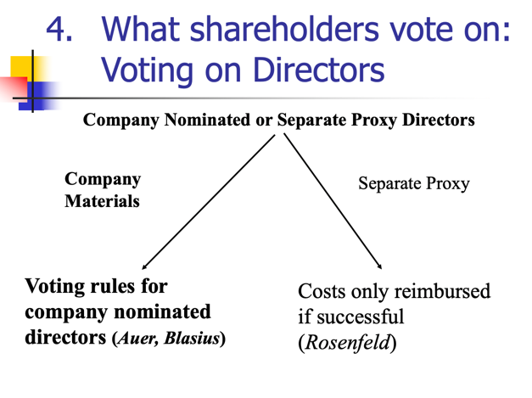
  - Which directors can you vote for?
    - Incumbent board nominates a slate of directors (company sends out official materials)
    - A competing slate (currently needs to be offered in separate proxy materials and the insurgents need to pay all costs, including mailing)
- Review of Shareholder Process for Proxy Contests (obstacles from carrying out proxy- costly)
  - Proxy process regulated by federal SEC (federal regs)
  - Insurgents must send out “unofficial” proxy solicitation before their solicit proxies (advertising costs)
    - The company sends out official proxy solicitation materials
      - May include shareholder proposals (Rule 14a-8)
  - Froessel rule: incumbent board proxy costs paid regardless of outcome by company; insurgent costs may be reimbursed if insurgents win. (Froessel rule)
- Alternative to proxy vote: takeover the whole company
- Rosenfeld v. Fairchild Engine & Airplane Corp.
  - Facts: Rosenfeld is a stockholder who sued to recover money that had been taken out of the corporate treasury to reimburse both sides in a proxy contest for their expenses → ratified by majority vote of stockholders
    - Proxy Contest = unfriendly contest for control over an organization, basically occurs when an insurgent group tries to out incumbent directors
  - Issue: Can the board use funds from the corporate treasury to cover expenses from the proxy contest?
  - Holding: Yes
  - Rule: Froessel Rule - In a policy contest, corporate directors have the right to make reasonable and proper expenditures from the corporate treasury for the purpose of persuading the stockholders of the correctness of their position and soliciting their support for policies which the directors, believe, in all good faith, are in the best interests of the corporation
    - Exception: If it is purely a personal power contest, then cannot be reimbursed
    - 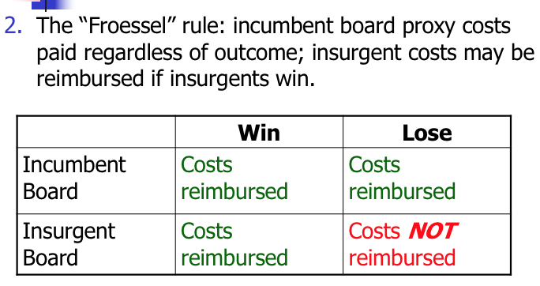
  - Reasoning:
    - Other jurisdictions have said it is ok for management to use corporate treasury for the reasonable expenses of soliciting proxies to defend self
    - If directors unable to do this, then corporate business might be severely interfered with → can’t freely answer any challenges or defend their actions
  - Notes:
    - What was the issue at the heart of the proxy fight to take control of the Fairchild Board?
      - That Ward, former officer and director, was getting paid too much
      - The issue of the suit was who pays for the campaign
    - What would happen to the costs incurred by the insurgents if they were unsuccessful under the Froessel rule?
      - If the insurgents win → insurgents will be reimbursed and the incumbent board’s proxy costs will be reimbursed as long as it is a policy dispute and not personal
      - If the insurgents lose → insurgents will be responsible for costs and the incumbent board’s proxy costs will be reimbursed
      - Under the Froessel Rule, the incumbent board’s proxy costs will always be reimbursed as long as it is a policy dispute and not personal
        - Idea is that they shouldn’t always be forced to defend constantly
        - Otherwise the really wealthy can always challenge directors and the directors may not have their own money to defend
    - What kind of incentives does this provide for proxy contests?
      - Proxy contests are very expensive because they are federally regulated
      - Froessel rule prevents proxy contests from happening too often
- Uncontested vs. Contested director elections
  - In the ordinary course, board elections are uncontested.
    - Only the company puts up a slate of directors.
  - Contested elections:
    - Each of the competing sides prepares (and, for public companies, files with the SEC) and distributes to the shareholders its own proxy solicitation materials
    - Typically occur in 2 situations:
      - In the case of a hostile takeover, the bidding company puts up a full slate of directors that is sympathetic to the acquisition.
      - The activist investor who is dissatisfied might put up a “short slate” of directors, a minority of the board if elected.
- Rule 14a-8: Shareholder Proposals
  - Allows qualifying shareholders to put a proposal before their fellow shareholders
    - And have proxies solicited in favor of them in the company’s proxy statement
    - Expense thus borne by the company (less expensive than proxy, so there are more)
  - Primarily deal with social and ethical issues of the time, but also governance issues
  - Proposals are just precatory, can’t just usurp power. Not trying to shift power of the company
  - 14a-8(b)(1): Must have owned at least 1% or $2,000 (whichever is less) of the issuer's securities for at least one year prior to the date the proposal is submitted.
    - Calculation: (# of securities held for 1 year period) x (highest selling price during the 60 calendar days before the shareholder submitted the proposal)
    - this IS CHANGING IN 2023 PER TRUMP ADMIN- MORE EQUITY NEEDED
  - Proposal must be submitted at least 120 days before the date on which the proxy materials were mailed for the previous year’s annual shareholder meeting
  - Proposal plus supporting statements can’t exceed 500 words
  - 14a-(8)(i)(1) - Company may exclude proposal:
    - “If the proposal is not a proper subject of action for shareholders under the laws of the jurisdiction of the company’s organization”
    - Reasons for Exclusion:
      - 14a-(8)(i)(2) - Implementing would violate the law
      - 14a-(8)(i)(3) - Implementing would violate proxy rules
      - 14a-(8)(i)(4) - Proposal involves personal grievance or special interest
      - 14a-(8)(i)(5) - Proposal isn’t relevant to firm’s operations
      - 14a-(8)(i)(6) - Company lacks power to implement the proposal
      - 14a-(8)(i)(7) - Proposal deals with company’s ordinary business operations
      - 14a-(8)(i)(8) - Relates to electing directors
    - Excludes both proposals not relevant to firm operations AND proposals within the company’s ordinary course of business (decided by directors)
      - Has to do with something ethical
- Corporate Responses to Shareholder Proposals
  - Attempt to exclude on procedural or substantive grounds
    - Corporation is required to include the proposal unless can prove to the SEC that it may be excluded under Rule 14a-8
  - Include with opposing statement
  - Negotiate with proponent
    - Wide range of possible compromises
  - Adopt proposal as submitted
- SEC Response:
  - Staff level action:
    - If it determines proposal can be excluded: issue a no-action letter
    - If it determines proposal should be included: notify issuer of possible enforcement action of proposal if excluded
  - The SEC reluctantly referees the shareholder proposal process
- Lovenheim v. Iroquois Brands, Ltd.
  - Facts: P was a shareholder of the corporation D → he had a proposed resolution regarding having investigating feeding geese for foie gras → he wanted it included in the proxy materials sent to shareholders → D refused to include it (proposal not relevant to firm’s operations)
  - Issue: Is D required to include the proposal?
  - Holding: Yes
  - Reasoning:
    - 14a-8 of SEA (1934) requires the issuer to include the proposal in the proxy statement as long as all conditions are met
    - D argued for an exception to the rule which allows omission of proposals that relate to less than 5% of the issuer’s total assets and are not otherwise significantly related to the issuer’s business
    - Court said although the proposal implications would account for less than .05% of assets, the history of the rule indicates that “significantly related to the issuer’s business” is not limited to economic significance
      - Pate operations are not economically significant, but they are ethically/ socially significant
  - Notes:
    - Why did Lovenheim offer a proposal instead of reaching out to the board directly or writing a proposal prohibiting it?
      - He can’t just ask them to stop since he would be overstepping the precatory boundary into regulating everyday operations
    - Why did L offer this proposal?
      - Concerned about animals and wanted to have a voice
    - Why did Iroquois get annoyed and say no?
      - It was making a lot of money
    - How do you feel about the motivation as a shareholder of Iroquois?
      - Other shareholders might get mad because it would be using corporate money to address Lovenheim’s political interest
    - What can you say about the price of a share of Iroquois stock in the period when Lovenheim submitted his proposal?
      - Shares were approximately $10 because Lovenheim had approximately 200 shares, and needs to have a minimum of $2000 in shares to make a proposal
    - If the majority of shareholders voted for Lovenheim’s proposal, it is only precatory (recommendation), so directors do not have to accept it
INSIDER TRADING- (rules re selling shares)
- Securities Act of 1933 (how companies raise money)
  - Regulates the public offering of new securities
  - Disclosure at the time of public offering
  - Key Section: §5 regulates offering procedure
- Securities Act of 1934 (trading activity)
  - Regulates trading activity
  - Ongoing disclosure required
  - Key Sections:
    - §10b - no fraud
    - §14a - proxy contests
    - §14e - tender offers
    - §16 - insider trading
- Statute SEA-> rule 10(b) (anti-fraud) so if you violate rule, you violate statute
- Rule 10b-5: It shall be unlawful for any person, directly or indirectly, by the use of any means or instrumentality of interstate commerce, or of the mails or of any facility of any national securities exchange,
  - (a) To employ any device, scheme, or artifice to defraud,
  - (b) To make any untrue statement of a material fact or to omit to state a material fact necessary in order to make the statements made, in the light of the circumstances under which they were made, not misleading, or
  - (c) To engage in any act, practice, or course of business which operates or would operate as a fraud or deceit upon any person, in connection with the purchase or sale of any security.
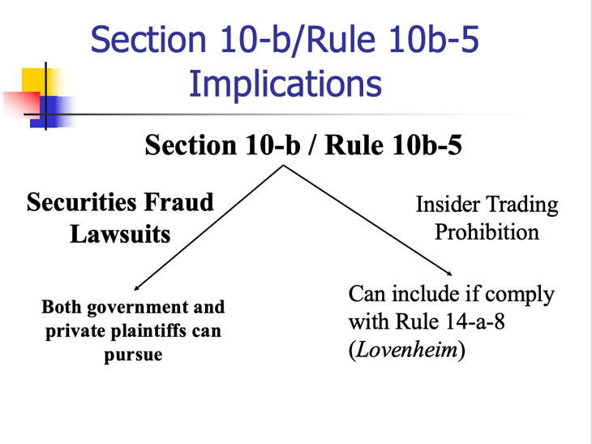
- Who can bring an action under 10b-5?
  - DOJ can bring a criminal action
  - SEC can bring a civil action
  - No express cause of action for private parties, but the Supreme Court implied a private right of action in Superintendent v. Bankers Life and it has been upheld since (not derivative action- direct action)
- Required Elements for Private Securities Fraud Suit Under 10b-5
  - Material misrepresentation or omission
    - General Standard: “whether there is a substantial likelihood that a reasonable shareholder would consider the fact important” TSC Indus., Inc. v. Northway Inc. (1976)
      - A highly face-dependent probability/magnitude balancing approach
    - “Silence, absent a duty to disclose, is not misleading under Rule 10b-5.”
      - “‘No comment’ statements are generally the functional equivalent of silence…” fn. 17
  - Scienter (they knew they were lying)
    - PSLRA requires pleading with “particularity facts giving rise to a strong inference that the defendant acted with the required state of mind.”
    - State of mind required = intent to deceive, manipulate, or defraud
      - This means the defendant was aware of the true state of affairs and appreciated the propensity of her misstatement or omission to mislead.
      - Supreme Court left open whether recklessness suffices for scienter.
  - Reliance (we relied on their lie)
    - What is the “fraud on the market” theory?
      - Rebuttable presumption that investor relied on integrity of public trading market price when making investment decision—so investor need not have seen misrepresentation
        - We assume if you told a lie, and the stock went up because of the lie, everyone purchased in reliance of the lie.
    - Invoked when?
      - Material & public misrepresentation
      - The stock traded in an efficient market
      - Plaintiff traded the stock between when the misrepresentations were made and when the truth was revealed
  - Causation (we relied on their lie)
    - Loss causation
      - Akin to proximate cause
      - The fraud caused the plaintiff’s loss
        - Show change in stock prices when the misrepresentations made and then an opposite change when corrective disclosures were made
        - The shareholder sold after misleading disclosure but before the corrective disclosure
- Insider Trading Policy
  - Pros
    - Sends “soft information” to markets – thus protecting proprietary info
    - Encourages insiders to own company stock
    - Compensates insiders for developing “good news”
  - Cons
    - Unfair to those without information
    - Distorts company disclosures as insiders manipulate company info
    - Constitutes theft of corporate intellectual property
    - Discourages investors from entering market
    - Adds to trading “spreads” in markets
- Is the transaction illegal insider trading? Yes if…
  - Classical insider trading: A fiduciary trades in shares of his or her own firm, based on information gained as a fiduciary (Chiarella v. US), or
  - Tipper and tippee liability (Dirks v. SEC) (Rule 10b-5), or
  - A fiduciary trades using information that was misappropriated (US v. O’Hagan) (Rule 10b-5),or
  - Section 16 of ‘34 Act applies (statutory insider trading).
    - Bright Line Prohibition: All gains within six months by statutory insiders forfeited to firm
  - 14-e3 can’t trade at all if you know of a tender offer
- Cady Roberts
  - In the Matter of Cady, Roberts & Co., 40 S.E.C. 907 (1961)
    - Curtiss-Wright: “we are developing a new internal combustion engine.”
    - Curtiss-Wright: Directors decide we need to cut our dividend.
    - Director calls his office: “Curtiss-Wright will cut its dividend.”
    - Sales rep at office hears news, sells stock, makes profit.
    - Brought 10b-5 fraud
    - Creates managerial duties and liabilities unknown to the common law
    - When insiders have Material Nonpublic Information (“MNPI”) the insider must “disclose-or-abstain.” Because:
      - Received the information for corporate purpose not personal benefit
      - Unfair because other investors could never know
- Texas Gulf Sulphur Co.
  - SEC v. Texas Gulf Sulphur (2nd Circuit (1971)):
    - TGS begins exploring for minerals in eastern Canada in the 1950s
    - Oct. 30, 1963: Drill a sample that is very, very promising
    - Demand silence of all employees and start buying up all surrounding land in Canada
    - Insiders start buying stock
    - Reveal astonishing find April 16, 1964
    - Stock price goes up over 3x (from $18 per share to $58 per share)
  - Holdings:
    - Information about ore find was material
    - Determining the timing of public disclosure is a matter of business judgment
    - Insiders who purchased shares violated Rule 10b-5 abstain-or-disclose obligation
    - Justifications:
      - Insiders have unfair informational advantage
      - Insiders have fiduciary duty to shareholders
- Chiarella Case [classic]
  - D worked for company P which was going to merge with Target → D bought Target stock → court said it was ok because he didn’t owe a fiduciary duty to Target shareholders → Court said there was no insider trading
  - Pushed forward the idea that trading with insider information is unfair, but not necessarily wrongful
  - Silence is not fraud except when you (as an agent) have a fiduciary obligation to disclose all relevant information to the principal
  - Duty to disclose to shareholders of the company you purchase stock in
  - Violation of 10b-5 occurs only if informed trader owed a duty to the corporation or shareholders of the firm whose stock he traded in → he didn’t trade in P’s stock
  - Majority:
    - Throws out the “level playing field” theory for prohibiting insider trading. (our job isnt to decide what fair, it’s to decide what is deceptive)
    - Violation of 10b-5 occurs only if informed trader owed a duty to the corporation or shareholders of the firm whose stock he traded in. Did he?
      - NO. wasn’t an insider (agent) of the second company, just the pre-merger company
- Dirks v. Securities & Exchange Commission [Tipping]
  - Facts: Dirks worked for a firm which provided investment analysis of insurance company securities to investors → Secrist, a former officer of Equity Funding, told him that Equity had fraudulent corporate practices → Dirks investigated → he told clients and investors about it → some of them sold their securities holdings → Dirks told WSJ about it → price of Equity stocks fell → WSJ posted a story on it → SEC began investigating and charged Dirks with violating SEA 10b
  - Issue: Did Dirks violate the provision by disclosing?
  - Holding: No, he had no duty to abstain from using the insider information
  - Rule: In order for a tippee to inherit the insider’s “disclose or abstain” duty:
    - Tipper must fail the Personal Benefit Test AND
      - Personal Benefit Test - will the insider personally benefit, directly or indirectly, from his disclosure
        - What constitutes a personal benefit:
          - Monetary gain
          - Reputational gain
          - Tip a family member or friend
          - Quid pro quo
        - … but not:
          - Desire to provide a public good
    - Tippee must know or have reason to know of the breach
  - Passing along the fiduciary obligation to the next person
  - Reasoning:
    - A tippee does not acquire a duty to disclose or abstain unless the info was made available to them improperly
    - To determine if the tippee is under an obligation to disclose, must determine if the tip constituted a breach of the insider’s fiduciary duty
      - If no breach by insider → no derivative breach by tippee
    - Dirks had no fiduciary duty or expectation by Equity
    - No monetary or personal benefit, they were motivated by a desire to expose the fraud
  - Notes:
    - Guttentag this the test is stupid because it is basically up to the court to decide if you benefit
    - Does Secrist owe a duty to Equity and its shareholders?
      - Yes duty to disclose or abstain → but court determined that he did not violate it because he disclosed it for no personal benefit and he didn’t trade in the stocks
    - Does Dirks inherit Secrist’s “disclose or abstain” duty by being a tippee?
      - No, the tippee must fail the Personal benefit Test and know/have reason to know of the breach in order to inherit the duty
    - What if Secrist had routinely exchanged stock tips with Dirks?
      - Personal benefit. Dirks inherits
    - What if Secrist had disclosed the Equity Funding fraud in part because he had been fired over an unrelated matter?
      - Not a personal benefit. The judge probably wants money changing hands
    - Suppose Secrist had disclosed material non-public information (MNPI) to Dirks because of a bribe from Dirks. Dirks then advised his clients to sell their Equity Funding stock. Would the clients of Dirks have violated the rule?
      - Probably not. They did not inherit the fiduciary duty bc they don’t know the original exchange of a tip
    - Dirks also established a category of “constructive insiders” who can violate insider trading prohibitions
      - FN 14: A person becomes a constructive insider when they (1) obtain material nonpublic information from the issuer with (2) an expectation on the part of the corporation that the outsider will keep the disclosed information confidential; and (3) the relationship at least implies such a duty
        - Example: lawyers, anyone inside the circle of trust
- Note on regulation Fair Disclosure
  - Regulation FD, adopted by the SEC in 2000
    - SEC concluded selective disclosure to analysts undermined confidence in the integrity of the stock markets (before wall street people used to exchange information all the time)
    - SEC concluded the Dirks tipping regime inadequately constrained tipping because of difficulty proving the tipper received a personal benefit from the disclosure
    - “Reg FD” restricts selective disclosure of material nonpublic information (MNPI) even by someone acting on behalf of a public corporation
      - Intentional disclosures must be disseminated simultaneously; unintentional disclosures within 24 hours or start of next trading day on NYSE
      - Enforcement only by SEC (no private action)
    - Call up Morgan Stanley and tell them earning will be bad (done for the company so company can have better relationship with MS- allowed under dirks) not allowed under here
- United States v. O’Hagan [Misappropriation]
  - Facts: O’Hagan was a partner at a law firm which represented Grand Met → Grand Met planned to make an offer for common stock of Pillsbury → O’Hagan began purchasing Pillsbury stocks and call options → Grand Met made the announcement → stock prices rose → O’Hagan sold all of his stock for a profit of $4.3 million
  - Issue: Did O’Hagan violate 10(b)?
  - Holding: Yes
  - Rule: Misappropriation Theory - a person commits fraud “in connection with” a securities transaction, and thereby violates 10(b) when he misappropriates confidential information for securities trading purposes, in breach of a duty owed to the source of the information
  - Reasoning:
    - He breached his fiduciary duty to the source of the information
    - Was there deception?
      - Yes, he pretended loyalty while secretly using the information for personal gain
      - Deception works through non-disclosure
    - In connection with the purchase or sale of a security?
      - Yes, consummated when he used the info to purchase securities without disclosure to the principal
  - Notes:
    - Essentially Ginsburg says where you get the information from is what matters, not who you buy the shares from
    - If O’Hagan informed both the firm and Grand Met of his intention to buy Pillsbury stock, and they approved. What would the result be?
      - Then his hands are clean with respect to getting the source of the information
    - Under O’Hagan, Chiarella would’ve violated insider trading law
      - Doesn’t matter if he didn’t have a fiduciary duty to Target
      - He misappropriated the information
      - Chiarella had a fiduciary duty to P
- Rule 10b5-2
  - Rule 10b5-2 provides a non-exclusive list of three situations in which a person has a duty of trust or confidence for the purpose of the misappropriation theory:
    - Whenever a person agrees to maintain information in confidence;
    - Whenever the person communicating information and the person to whom it is communicated have a history, pattern or practice of sharing confidences, such that the recipient of the information knows or reasonably should know that the person communicating the information expects the recipient to maintain confidentiality; or
    - Whenever the information is obtained from a spouse, parent, child or sibling, unless recipient shows that history, pattern or practice indicates no expectation of confidentiality.
- Rule10b5-1 (safe harbor- pre-commit to certain pattern of selling)
  - = A written plan for trading securities that is designed in accordance with Rule 10b5-1(c).
  - Any person executing pre-planned transactions pursuant to a Rule 10b5-1 plan that was established in good faith at a time when that person was unaware of MNPI has an affirmative defense against accusations of insider trading.
  - 10b5-1 plans are especially useful for people presumed to have inside information, such as officers and directors.
  - Exchange Act § 16(b) still applies to trades made pursuant to a Rule 10b5-1 plan.
- Rule 14e-3 (fifth insider trading rule)
  - Prohibits insider trading during a tender offer and thus supplements Rule 10b-5.
    - Once substantial steps towards a tender offer have been taken, Rule 14e-3(a) prohibits anyone, except the bidder, who possesses material, nonpublic information about the offer from trading in the target’s securities.
    - Rule 14e-3(d) prohibits anyone connected with the tender offer from tipping material, nonpublic information about it.
  - Rule 14e-3 is not premised on breach of a fiduciary duty.
    - O’Hagan upholds it anyway.
  - If you get tender offer information innocently (wind blows paper onto your path), you can’t trade on that information. kind of a presumption you got it incorrectly.
- Salman v. United States
  - Brother: Michael and Maher Kara. Maher married Suzie Salman. Suzie’s brother traded.
  - Holding: A family member personally benefits by giving confidential information to a relative.
    - Doesn’t have to be cash changing hands.
  - Everyone has liability in the chain
- Statutory restriction on insider trading: section 16 (Elon Musk example) PUBLIC COMPANIES
  - Exchange Act § 16
    - (a): Reporting obligations
    - (b): Bright-line short-swing trading rule (over- and under- inclusive for insider trading)
  - Section 16 (a):
    - If own over 10% or are a director or officer (“Statutory Insiders”), then must report ownership stake and changes to SEC.
      - Report every single trade you make
    - Officer: SEC definition includes president, CFO, chief accounting officers, VPs of principal business units and any person with significant “policymaking function.”
  - Section 16 (b):
    - “Statutory Insider” profits from a purchase and sale or sale and purchase within six months are recoverable by the firm.
    - Compare Rule 10b-5 based insider trading, which applies to all individuals and issuers (regardless whether public or private)
  - Section 16 (b) is “both over- and under-inclusive”
  - Intent is irrelevant
  - Will compute profit in a way that produces the maximum possible number
  - Example of liability:
    - 1
      - On May 1 Michael Scott (a Director of Dunder Mifflin, Inc. (DMI)) buys 5 shares of DMI for $3 per share.
      - On June 1 Michael Scott sells 5 shares of DMI for $13 per share.
      - What is the amount, if any, of Michael Scott’s statutory insider trading liability?
        - $50
    - 2
      - Assume there are 100 shares of Dunder Mifflin, Inc. (DMI) outstanding.
      - On May 1 Michael Scott (not a Director or Officer of DMI) buys 5 shares of DMI for $3 per share.
      - On June 1 Michael Scott buys 10 more shares of DMI for $13 per share.
      - On June 30 Michael Scott sells 3 shares for $10.
      - What is the amount, if any, of Michael Scott’s statutory insider trading liability?
        - SC says insider starts the day you buy the stock (that day is included)
        - None, he sold the shares he had before he was an insider
    - 3
      - Assume Michael Scott is a director of Dunder Mifflin, Inc. (DMI).
      - On May 1 Michael Scott buys 3 shares of DMI for $3 per share.
      - On June 1 Michael Scott buys 5 shares of DMI for $12 per share.
      - On June 10 Michael Scott buys 4 shares of DMI for $5 per share.
      - On June 30 Michael Scott sells 5 shares for $10.
      - What is the amount, if any, of Michael Scott’s statutory insider trading liability?
        - $31
    - How do you avoid statutory insider trading liability
      - Wait six months, buy less than 10%
    - Approach
      - Is the company public?
      - Is the defendant a director, officer, or beneficial owner of the company?
        - Directors and Officers- you can match any transactions within 6 months while in position.
        - Beneficial owner - only if she owned more than 10% both at the time of the purchase and of the sale, and within 6 months.
      - Can you match any purchase and sale within a 6-month period that yields profits?
        - Buy low and sell high
        - Sell high and buy low
- Terminating a Corporation
  - Voluntary Dissolution
    - Board submits and shareholders vote on proposal to dissolve: MBCA 14.02(b)
    - Submit Articles of Dissolution to state of incorporation
    - Can only carry on to wind up
  - Involuntary Dissolution
    - If there is a deadlock: MBCA 14.30 can go to court

