Course overview

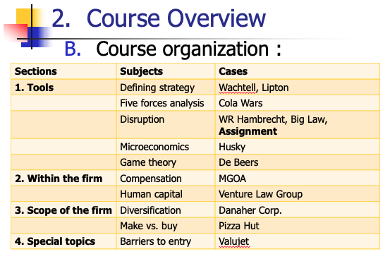

_________

---PART 1: TOOLS---

_________

I. DEFINING STRATEGY

**Subj: “What is Strategy?” (Porter)

1) Operational Effectiveness ≠ Strategy

Operation Effectiveness (OE): Performing similar activities better than rivals do.
  - Ex: Japan in the 80s
  - OE is not enough. We're seeing diminishing profit returns now from too much focus on OE
  - OE competition leads to absolute improvements for everyone, but relative improvement for no one.
    - Productivity gains are captured by customers and equipment suppliers, not the firms themselves.

‘work harder, run faster’ is NOT strategy.
- Operational effectiveness: Only gets you to productivity frontier
Productivity frontier:
    - The sum of all existing best practices at any given time.
    - Constantly shifting outward as new tech/mgmt strategies are developed.

Competitive Convergence: All companies are doing the same things, and they end up becoming too similar.
- Competition based on OE alone is mutually destructive.

2) Strategy Rests on Unique Activities

Competitive Strategy:
- Deliberately choosing a tailored set of activities to deliver unique mix of value and contribute to company’s strategic position.
- It’s about being different!

Strategic Positioning (3 types)

Strategic Positioning: Performing different activities from rivals or performing similar activities in different ways.
- Strategic positioning = Tailored activities
- Choosing to perform different activities than rivals.

3 Sources of Strategic Positioning

- 1. Subset of Products/Variety-Based positioning: Producing a subset of an industry's products or services
  - Jiffy Lube: Only offers lubricant services at low prices, no other repair/maintenance services.
  - Vanguard Group: Predictable, reliable investments. No high risk high reward.
- 2. Needs-Based Positioning (needs of a particular customer group): Serving most or all of the needs of a particular group of customers
  - Bessemer Trust Co: Investment banking/financial mgmt for high net worth families. Private meetings, personal account manager, etc.
- 3. Segmenting/Access-Based Positioning: Segmenting customers who are accessible in different ways
  - Carmike Cinemas: Operates movie theaters in small towns with under 200k population

Activity Mapping

Examples:

Southwest airlines activities
- Avoids large airports
- Connects mid-size cities
- No long flights
- Frequent departures, low fairs
- No meals, assigned seats, “interline baggage checking,” first class
- Automatic ticketing
- Standardized fleet of 737’s
- Higher pay for ground crews
- Flexible labor contracts

Ikea activities
- Fewer salespeople
- Self-design furniture
- Furniture is “ready-to-assemble”
- Every product displayed
- Adjacent warehouse
- Limited selections
- Limited delivery
- In-store childcare
- Extended hours

Vanguard Activities
- No marketing changes
- No broker-dealer relationships
- Redemption fees to discourage trading
- On-line information access
- Bonuses tied to cost savings
- Very few retail locations
- In-house management of standard funds
- Emphasis on bonds and equity index funds
- No executive first class travel

Southwest
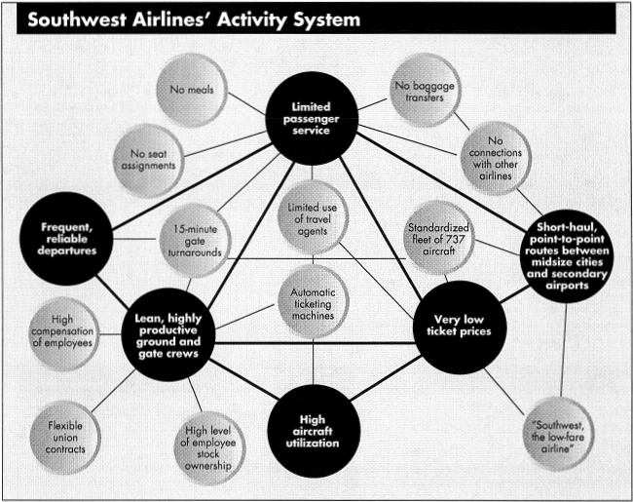

Ikea
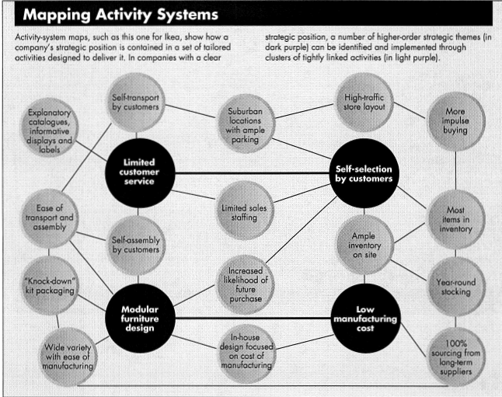

Vanguard
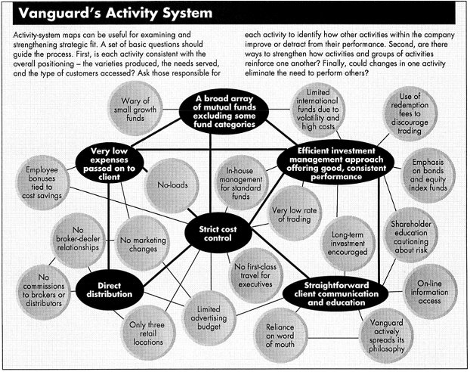

3) Sustainable Strategy Requires Trade-offs

Strategy is making trade-offs in competing.
- The essence of strategy is choosing what not to do.
  - When to say NO

Trade-offs: More of one thing means less of another.
- Example: Neutrogena (no deodorants or skin softeners)

Trade-offs arise b/c:
- Inconsistencies in image/reputation
  - Timex can't sell luxury watches b/c of reputation as budget watchmaker
- Incompatible activities
  - Ikea can't offer self-service and high service at the same time.
- Limits on internal coordination and control.

4) “Fit” Drives Competitive Advantage & Sustainability

Strategy is about combining activities that complement each other.
How dense is the map? How closely do the activities/nodes fit together?

Ex: Southwest
- Rapid gate turnaround (allows frequent departures and less aircraft downtime) is a function of other factors:
  - Well paid gate and ground crew
  - No meals, no seat assignment, no baggage transfers
  - Smaller airports and shorter routes
  - Standardized aircraft (Boeing 737)

Companies with strong fit do not attract new entrants.
- Therefore, they create sustainable advantage.

Types of Fit (3 types)

1. First order fit: Simple consistency between each activity (function) and the overall strategy.
- Vanguard: aligns all activities with low-cost strategy

2. Second order fit: Activities are reinforcing
- Neutrogena markets to upscale hotels. Hotels let them use their own packaging, and hotel guests go and buy Neutrogena when they get home.

3. Third order Fit: Optimization of Effort
- Gap: Low in-store inventory but frequent restocking of basic items, and Gap specializes in basic items in limited colors. Higher inventory turnover

For all types:
- The whole matters more than any individual part of the system

5) Rediscovering Strategy

Reasons for strategy failures:

- Failure to choose
  - Mgmt tries to pursue operational effectiveness over choosing a particular strategy
    - Ie they want to do "everything" the best. Not productive.
    - Also trade-offs are scary: Means you cant do something
- The growth trap
  - Pressure to grow results in lack of strategy:
  - Ie mgmt wants ALL the customers so they don't commit to a strategy where they lose some customers.
- Failed leadership
  - Need strong leaders willing to make choices.
  - Not leaders solely focused on operational improvements.

Questions to uncover core of uniqueness:
- Which products or services are most distinctive?
- Which are most profitable?
- Which customers are most satisfied?
- Which customers are most profitable?
- Which activities are most distinctive and effective?

**Case: Wachtell Lipton

Activities

Case selection/innovation
- No yearly retainers
- Clients went to them in desperate circumstances. No routine legal work
- Developing innovations: Cross border equity mergers, poison pill, state business combination takeover laws, innovative M&A transactions

Staffing/growth
- Slow growth, small team for an AMLAW 100 firm.
- No hiring non-partner track ppl.
- Low ratio of associates to partners
- Only top law students

Compensation
- Lockstep pay: Everyone in same age group gets the same pay, regardless of hours worked.
- Bonus tied to firm performance

Billing
- Not hourly, but based on the value of the services to the client
- NO yearly retainers

Work ethic
- Every situation treated as a crisis. 24/7 service
- Super high pressure, but attys work as a team

Task force approach
- 6 practice groups, but all attys work on all matters.

Coordination/Control
- Informal mgmt structure
- High overhead, inefficient system

Only one office

Learning Points

- Wachtell Lipton has created a relatively unique position in the market for legal services. They specialize in providing services to clients who are in “crisis” and need innovative solutions to their non-routine – and extremely challenging – problems. “Serving the few needs of many customers.”

- Wachtell Lipton has created “fit” among its activities. They are distinguished by an interlocking set of policies and activities that serve to complement and support their market position. For example,
  - They screen associates very carefully at the entry level. This is consistent with their 50% promotion-to-partner rate.
  - The 1:1 leverage ratio is consistent with the non-routine nature of their projects.
  - The lawyers can self-select into six different practice areas and projects are pursued in interdisciplinary teams. A more rigid organizational structure would have difficulty delivering value to its clients.

- Wachtell Lipton has successfully recognized tradeoffs
Wachtell Lipton rejects projects that are routine. This makes sense –Wachtell Lipton’s existing partners and associates are not well-matched to routine tasks. They realize that they cannot simultaneously (1) “serve the few needs of many customers” and (2) “serve the broad needs of a few customers.”

- Wachtell Lipton has successfully avoided the “growth trap”
Michael Porter describes how firms can easily fall into a “growth trap” where they lose the fit among their activities and policies. Wachtell Lipton has been careful to avoid this. Hiring more associates (and raising the leverage ratio) would compromise the unique way that they are creating value for clients and undermine their reputation.

- Difficult for competitors to imitate
Their success can’t be replicated by simply hiring high-IQ lawyers. The self-motivation, the culture, the reputation with corporate counsel, etc. are critical, too. In the words of Porter, “… rivals will get little benefit from imitation unless they can match the whole system.”

_________

II. FIVE FORCES ANALYSIS

**Subj: “The Five Competitive Forces That Shape Strategy” (Porter)

Summary

If the forces are intense, less industry profits (airlines, textiles, hotels)

If the forces are benign, more industry profits (software, soft drinks, toiletries)

Forces determine industry profitability in medium and long run

Industry structure matters
- To understand competition and profitability one must analyze “industry’s underlying structure.”
- Why? Industry structure determines how the economic value created by the industry is divided (p. 10).
- Industry maturity, technology, or regulation are less significant.
- Understanding industry structure is necessary for strategic positioning.

Configuration differs by industry
- Ex: Commercial aircraft industry
  - Rivalry between producers is strong, buyer leverage strong.
  - Threat of entry, threat of substitutes, power of suppliers are weak

Five Forces

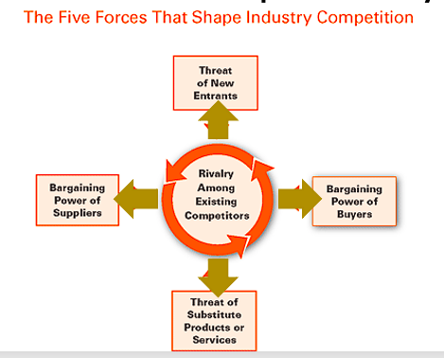

1) Threat of New Entrants

Entry of new competitors
- Taking your market share, must work harder to compete

1A. Barriers to Entry/Incumbency

Barriers to entry (incumbent advantages):

Barrier to Entry: | Concepts (if any) | Specific Example
1. Supply economies of scale | Bigger is cheaper:  Firms producing at high volume have lower cost per unit. New entrants must come into industry at large scale or pay more. | Local cable service, Intel, UPS
2. Demand-side benefits of scale | Network effects: The more people buy them, the more valuable they are to customers. | Social media, eBay, fax machines
3. Switching costs | High cost when switching suppliers. Locked-in customers | Email service, set-top boxes
4. Capital requirements | Banks will loan money for certain purchases (oil rigs, airplanes), but will not finance others (R&D, marketing, software dev) | Advertising campaigns (not airplanes)
5. Incumbency advantages | E.g., proprietary technology, material sources, brand identity, experience, etc. | Patents, brands, locations
6. Unequal access to distribution channels |  | Supermarket limited shelf space. Sellers compete for space to sell product.
7. Restrictive govt policies | E.g., licensing requirements, regulations, tax, patent laws. | Taxis (no more?), lawyers, doctors

1B. Expected Retaliation

How potential entrants believe incumbents may react might cause them to stay out of an industry
- Ie if incumbents have substantial resources, are likely to cut prices, or industry growth is slow

Indicators of High Expected Retaliation:

- Previous vigorous response
- Substantial incumbent resources
- Incumbents likely to cut prices
- Slow growth in industry (fight over limited profit pool)

2) Bargaining Power of Suppliers

Bargaining Power of Suppliers; greater if:

- More concentrated that the industry it sells to
  - e.g., Microsoft
- Supplier doesn’t depend heavily on a certain industry for revenue (ie: they serve different industries)
  - Ex: Paper industry. Serves lots of different industries.
- Industry participants face high switching costs if they change suppliers
  - e.g., Bloomberg terminals
- Suppliers offer differentiated products
  - e.g. pharmaceutical companies with patented drugs
- No substitute for the supplier’s product
  - e.g. pilot’s union
- Supplier can credibly threaten to integrate forward into the industry
  - “Integrate Forward”: supplier becomes an industry participant.

3) Bargaining Power of Buyers

Powerful buyers (customers) can play industry participants off each other:
- Force down prices
- Demand better quality/more services
- erodes profitability

Power of Buyers; greater if:
- Few buyers, or large volume buyers (each one purchases in volumes that are large relative to size of a single vendor)
  - Worse if Industry has high fixed costs and low marginal costs
    - High fixed costs/low marginal costs: Ex- Bottling facility
    - Need expensive factory, but low cost to create an individual bottle.
- Industry products are undifferentiated/standardized
  - buyers can go elsewhere for same product
- Buyers face low switching costs
- Buyers can threaten to integrate backward and produce the product themselves
- Price sensitive buyers, especially if:
- The product buyer purchases from the industry is a significant % of its cost structure/budget. Likely to shop around and negotiate hard.
- Buyer group earns low profit, or has pressure to trim purchasing costs.
- Quality of buyers’ product is not affected by the industry’s product (input quality)
  - Ex: Buying sugar for cookies. Cookie maker doesn’t care what kind of sugar it is. The cookies will be the same.
- Industry’s product has little effect on buyer’s other costs.
- Examples of non-price-sensitive: Tax accounting, investment banking

4) Threat of Substitute Products or Services

Substitute products perform the same or similar function and creates a price ceiling.

Threat of substitute is high if:

- Substitute product offers good price-to-performance tradeoff to industry’s product
  - Ex: long distance phone services suffer from cheap internet phone services (Skype, Vonage)
  - Blockbuster suffered from online video services (Netflix, Youtube)
- Buyer’s cost of switching to the substitute is low

Examples:
- Plastic for steel
- Skype for telephone service

5) Rivalry Among Existing Competitors

2 factors:
- The intensity of rivalry
- The basis on which rivals compete (ie: Price-based competition likely to erode industry profitability)

More intense if:
- Competitors are numerous or equal in size/power
- Industry growth is slow. Fight for market share
- Exist barriers are high
- Rivals are committed to the business and have aspirations for leadership
- Firms cannot read each other’s signals well

Price-based competition more likely if:
- Products/services of rivals are identical, and no switching costs. Encourages rivals to cut prices
  - Airline seats
- Fixed costs are high, marginal costs are low
  - (paper, aluminum)
- Capacity must be expanded in large increments to be efficient
  - Ie: large factories need large sales
- Product is perishable
  - need to sell product while you can, cut prices
    - tomatoes, hotel rooms
  - Some industries, information is valuable and perishable: Knowing it today is valuable, but knowing it tomorrow is worthless (eg, stock market)
- Less customer segmentation

Other dimensions: product features, support services, delivery time, brand image.
- Less likely to erode profitability, unless firms compete on the same dimensions (zero sum)

How to Perform Industry Analysis

How to analyze industries
  - Define the relevant industry (how big is the industry)
    - What products are in it?
    - What is its geographic scope?
  - Identify industry participants
  - Determine which forces are strong and weak
  - Understand time horizon (3-5 years typical)
  - Quantify elements where feasible
    - Not “a lot” of transactions, how many transactions? Metrics, context, dollar amounts.
    - Affects income statement and balance sheet
  - Describe the system (not just pluses and minuses)

Industry analysis pitfalls (Mistakes that can be made)
  - Gravitating to one element of overall structure
  - Focusing on growth, instead of industry structure, e.g., personal computers
  - Focusing on technology, instead of industry structure
  - Treating government/law as a separate force
  - Emphasizing complementary products, e.g. cars and gas stations

Changes in industry structure, which is relatively stable, but for:
  - New entries (loss of patent – easy; ice cream shelf space – hard).
  - Changing supplier or buyer power (e.g., Best Buy, Home Depot).
    - Ex: There used to be lots of local hardware stores, but no more. Buyer power is much higher.
  - Shifting threats of substitution (microwaves getting cheaper, displacing ovens).
  - New bases of rivalry (televisions vs. casinos).

Strategy Implications

Implications for strategy
- Industry analysis comes before strategy
- After analysis, position company
  - Build defenses / find a position (Paccar, Wachtell)
  - Consider entry or exit
- Exploit change (e.g. music industry)
- Shape industry structure (toward ways of competing that increase profits)
  - Shaping industry structure
    - 2 ways:
      - Redividing profitability in favor of incumbents
      - Expanding the overall profit pool
    - Redividing Profitability
      - Need to determine which forces are constraining industry profitability, and address them
      - Neutralize supplier power: standardize parts specs to make it easier to switch suppliers
      - Counter buyer power: expand services that raise switching costs
      - Temper price rivalry: invest in unique products or support services
      - Scare off new entrants: elevate fixed cost for competing (raise R&D or marketing spend)

**Case: The Cola Wars

Learning Points

2 big industry takeaways for CSDs:
- C and P have invested heavily in a defensible industry
  - Very simple product, but very profitable
  - High barriers to entry with incumbent advantages, advertising, brand equity.
  - Only major threat is substitutions
- The Cola wars were not defined by price competition.
  - Major players (C and P) found other things to fight about other than price
  - A battle without blood. Major competitors are playing nice.

- The success of the carbonated soft drink (CSD) industry described in this case is a prime example of how firms can create and exercise market power. Coke and Pepsi did not just inherit this business – they created it!
- To really understand business strategy, we need to look at the underlying basic economic forces of the firm and the industry, and its related (upstream and downstream) parts.

Five Forces Analysis (2 industries: Concentrate producers & Bottlers)

- The concentrate business has been one of the most profitable businesses in the industrial world. The Five Forces Framework helps us to understand the sources of this profitability.
  - Barriers to entry are strong. Brand equity is high – Coke and Pepsi are well established parts of our culture. Although it is hard for many of us to distinguish the brands in a taste test, many people are brand loyal and “perceive” product differences. Access to shelf space, vending spots, and fountains are limited, and bottlers are bound by exclusive contracts. There are scale economies in advertising.
  - Substitute products – including water, coffee, juice, etc. – abound. But soft drinks are distinctive for many people, are often convenient, and represent a “lifestyle choice.”
  - Supplier power is low. The concentrate formulas are proprietary, but the ingredients probably don’t cost much and are likely to be competitively supplied. (Recall that sweeteners are typically added at the bottling stage.)
  - The bottlers have had relatively little buyer power over the last few decades. Concentrate accounts for about 37% of the bottlers’ cost of goods sold. They have high switching costs due to dedicated machinery and the exclusive nature of their franchise contracts.
  - Rivalry among the concentrate producers is softened due to high concentration (Coke and Pepsi together have about 72% of the market), a high degree of perceived differentiation. They have focused their competition on advertising and have avoided head-to-head competition on price.

- Bottlers have been less profitable. This may also be understood in light of the forces at play in the industry as well.
  - On the positive side, barriers to entry are strong, and include pre-existing exclusive franchise contracts and high capital requirements. There are no substitutes for the bottlers, except perhaps for direct delivery to the fountains by the concentrate producers. Exclusive territories soften intra-brand rivalry and help to protect the bottlers’ profit margins. Bottlers of course face price competition from the bottlers of rival brands, although this inter-brand rivalry is softened by brand loyalty and preferences of consumers.
  - On the negative side, the bottlers face considerable supplier power. The concentrate producers have monopolies over a key input of production and charge high markups on the concentrate. Although buyer power varies by channel, some channels like supercenters have considerable buyer power. (Other channels, like the vending channel, have much less buyer power and the bottlers earn higher profits in these channels.)

_________

III. DISRUPTION

Graph: Disruptive vs. Nondisruptive Tech

Innovator’s Dilemma

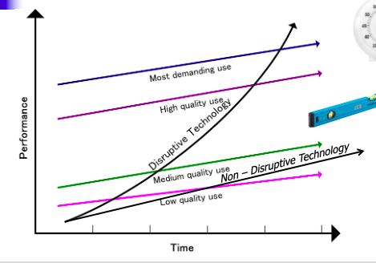

Christensen’s idea: “Disruptive Technology” line
- Something comes along that can replace a higher-end product at lower cost, etc.
- At the beginning, it can’t compete in the high-end use space.
- But eventually, it becomes a true substitute for more high-end products

Alternative: “non-disruptive technology” line
- It can only compete in the low and medium quality use spaces.
- It will never fully replace the existing technology
  - Ie: HBS Online will never replace traditional HBS

Disruptive vs Non disruptive technology examples: (iPhone)

- Disruptive: Cooking timer.
  - iPhone completely replaced the use of cooking timer
  - Will never need cooking timer again
- Non-disruptive: Level app (hanging pictures and such)
  - iPhone level app does not completely replace a physical level at high-end use cases.

**Subj: “Value Networks and the Impetus to Innovate” (Christensen)

Failure to Innovate

Why do good companies fail when confronted with new tech?

3 explanations of why firms stumble when confronting technology change:
- Organizational/managerial responses
- Firm’s ability to deal with new technology
- Value network concept

Organizational Causes

Organizational causes of failure to innovate
- Focus on “managerial, organizational, and cultural responses” to technological change.
- Could be bureaucracy, complacency, or “risk-aversion.”
- Henderson & Clark – organization structure facilitates component-level innovation.
  - But: If the product’s fundamental architecture requires change, this structure can impede innovation

Capabilities Causes

Capabilities causes of failure to innovate
- Capabilities claim is that the key is “magnitude of technological change relative to the companies’ capabilities.”
- New entrants appear to be better at exploiting radical new technologies.
- But: case study disc drives – great firms can deal with many big technological changes, but stumble over straightforward, but disruptive changes.
- Key: does the demand for change come from existing customers.

studies show that great firms can deal with large tech changes, but stumble with simple changes if they are disruptive.
- So it’s not the evolution of technology that causes failure, it is the company’s specific capabilities/expertise

Value Networks

Firms apply resources toward the innovations that its customers care about, and divert resources away from innovations that disrupt.

Value networks and the failure to innovate
- Value network: “the context within which a firm identifies and responds to customers’ needs, solves problems, procures input, reacts to competitors, and strives for profit.”
- Value network defines “the customers’ problems to be addressed by the firm’s products and services and how much can be paid for solving them.” (p. 14).
- Value network includes a firm’s competitive strategy and choice of market.
- Value network determines perception of the economic value of new technology.
- Perceptions of economic value shape expected rewards.
- Expected rewards drive resources toward sustaining innovations and away from disruptive innovations.
- The way value is measured across networks.
  - Example – the relative value of disk drives attributes across uses.
- As a result, for each value network there is a rank-ordering of product attributes and specific cost structure.
- Effects on the sorts of innovations that will seem profitable.

Technology S-Curves and Value Networks

Innovator’s Dilemma:

Conventional S-Curves
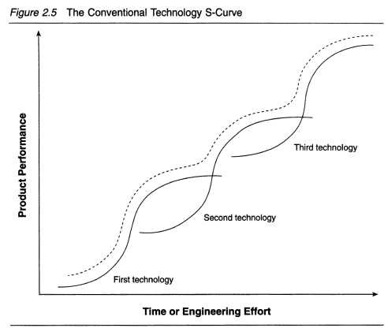

Technology S-Curves and value networks
- Evolution of magnitude of performance improvements over time is predictable.
  - Early stage: rate of progress is slow as just learning.
  - Middle stage: rapid progress as understand better.
  - Mature stage: slower progress as easy improvements are already made.
- Some argue, strategy is about know and when to move to new S-Curve.
- But all of this is about sustaining innovation.

Disruptive Tech S-Curves

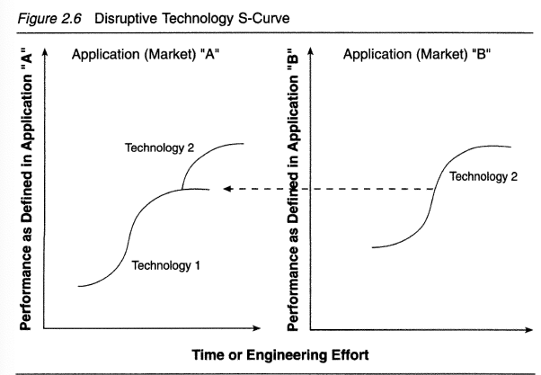

^^ disruptive technology S-Curve

- A product that delivers 80% of the value for 20% of the cost is developed in a different market, then jumps over into the existing market .
- Firms in the existing market might try to produce the disruptive product now, when they never would have considered it before.

Ex: AI. Being developed outside many industries, but will eventually disrupt them

Examples of Disruptive Tech

Examples of disruptive technologies:
- Digital storage tech - Film Photography industry
  - Digital storage tech (flash drives, etc.) made it possible for digital cameras to become competitive in the photography industry
  - Film industry wouldn’t have invested in digital storage otherwise
- Cloud storage – disrupted physical/digital storage
  - Amazon was developing it.
- Computer mouse
  - First computer mouse: Apple
  - Where did Steve jobs get the idea? Stole it from xerox
  - Xerox engineers created a bunch of major PC innovations, and Xerox didn’t care. So other industries used the tech in their products.

Pattern of Invasion

Typical Pattern of Invasion -
  - Disruptive innovation allows new entrants to offer 80% of the functionality for 20% of the price
  - Incumbents start to offer higher-priced products to an increasingly smaller group of customers

Decision-Making and Disruptive Tech

Good managers are able to deal with implementing sustaining innovations, but struggle with disruptive innovations.

Typical 6-step response dealing with disruptive innovations:
    - Disruptive technology developed at established firm
    - Marketing asks lead customers about new technology; existing customers express little interest.
    - Continue to invest in sustaining innovations
    - Markets for disruptive technology found by trial and error
    - Disruptive technology invades established firm’s market
    - Established firms try to defend their customer base

Implications

Implications of value network framework
- Value network of firm affects ability to marshal resources to overcome technological and organizational hurdles.
- Incumbent firms likely to lead when addressing needs of customer within their value networks. Likely to lag when addressing needs of customers in new value networks.
- Ignoring technologies that do not address customers becomes fatal if technology has “diminished the relevance of differences in the rank-ordering of performance attributes.”

Ex: Flash Memory

Flash memory and the value network
  - Flash memory initially developed for heart monitoring devices, modems, industrial robots, etc.; not computers.
  - Flash is not that different a technology from disk drives.
- Other Examples?
  - Digital vs. film photography
  - The “cloud” vs. corporate data centers

Correct Incumbent Response to Disruptive Innovations

What do managers do to avoid being disrupted?

- Create autonomous business unit (“skunkworks”)
  - Unit should have all the functional skills it needs to succeed.
  - No reliance on parent organization
  - Must not report to the business that is being disrupted
- Recruit leaders who come from relevant “schools of experience”
  - Leaders know how to address challenges, esp. the kind that the new growth business will face
  - Usually sourced from outside the organization, by necessity
- Set up separate resource allocation process
  - Ensure funding for the unit regardless of the fortunes of the core business
- Set up independent sales channels
  - Should not be required to coordinate with/defer to existing sales organization
- Create new profit model
  - Usually: it will reflect different priorities from core business
  - Formula for generating profit (ie: gross margins, asset turns) must be different than core business)
- Ensure unwavering commitment by CEO
  - They must be willing to spend lots of time understanding/guiding the new business
  - Must protect new business from natural desire of core business mgrs to shut it down and take its resources.

**Case: Disruptive IPOs/W.R. Hambrecht

Why are we reading this case?
- Clay Christiansen: how an incumbent should deal w/ disruption
- This case: I am a disruptor. How do I disrupt the industry?

Typical IPO: IB bundle of services
- Research reports
- Talk to investors / institutional investors
- Set meetings w/ investors
- Price the IPO
- Underwrite the shares: IBs purchase the shares from the company and resell to market
- create liquid secondary market

Disruptive tech: Open IPO. Bundle of services
- more participants
- less risk
- fairer price than underwriter valuation (IBs practice underpricing)
- lower fee than IBs (3% vs 7% for IB)
- real owners, not flippers
- works for smaller companies

Big Food (Google), or Smaller companies?

What would Clay Christensen say? No, can’t disrupt. Don’t have the capabilities as Investment Banks

- They can’t make the jump yet, they don’t have the capabilities
  - Traditional IPO delivers research reports, liquid secondary market, etc.
  - WRH can’t do that.
- WRH should wait until they have the capabilities.
- Stick with the smaller companies:
  - WRH can deliver 80% of the value of IBs for lower cost, so stick with that model for now.
  - IBs don’t even care about WRH smaller customers

**Case: Business School, Disrupted

Background

Harvard Business School (HBS)
- Starting to see online education becoming more popular
- President of HBS talks to Porter and Christiansen
  - Porter: Focus on your core activities
  - Christiansen: Skunk works, hire new manager from industry, give him unlimited resources

Online MBA disruptors
- Trying to deliver 80% of value for 20% of cost
- Different group of competitors than the physical MBA program competitors

HBS worried it might undermine its in-person education programs by offering online programs.

Porter:
- Yes, but don’t undermine the school’s existing strategy
- Stay the course while constantly improving/extending its distinctive positioning

Christensen
- Need to disrupt existing business. Only way to survive as a market leader (like HBS)
- “In a time of technological upheaval - do it cheap and simple, get it out there”
  - Offer your Minimum Viable Product asap. Start moving up-market

Porter Approach
- Find the online activities that support/reinforce HBS core strategy

Porter industry view: stay the course, focus on strengths, create unified system of activities, read signals

HBS Activity map
- Case generation method
- “world-famous” faculty
- Student placement (Networking)
- Case-based teaching, hands-on instruction
- Executive education
- “best” students
- Deep alumni base
- Ongoing investment in campus

^^MOOC is not consistent with these types of activities

Christensen Approach

Christensen industry view: fragile, easily duped into focusing on current customers instead of taking advantage of disruptive technologies

Christensen:
- Get an outsider Director (Saul Kahn, etc.), give them the HBS brand, financial backing, and full autonomy. “Go make HBS”

Christensen’s steps:

- Create autonomous business unit
- Leaders who come from the relevant “schools of experience”
- A separate resource allocation process
- Independent sales channels
- A new profit model
- Unwavering commitment by the CEO

**Case: Big Law to Lean Law

1. Ribstein’s critique of Big Law
  - Law firms produce: “a system to filter out less able or trustworthy lawyers.”
  - Law firms don’t just “provide more specialized services.”
  - Creates possibility for opportunism and decline in firm’s reputational capital, which is occurring because:
    - Bad incentives: reward individuals
    - Diluted selection criteria: to maximize short term profits
    - Inadequate supervision: excessive leverage
    - Lack of downside risk sharing: LLC structure
    - Proliferation of exit
  - Therefore, Big Law now “brittle and unstable”
  - Also, rise of in-house legal departments

2. Contemporary market data
  - Revenue per lawyer: flat at ~$800,000 since 2007 (lack of growth “sows doubt” about rewards)
  - Firms continue to get bigger:
      - Through lateral hiring; not entry level hiring
      - Also growing with mergers
      - Why? Striving for “too big to fail”
      - Consequence: dissipate firm’s reputational capital
  - Firms add leverage
    - 4.49 total lawyers to equity partners in 2011 vs. 2.87 in 1994
  - Big Law organization form “conferring little of no direct value to clients”
  - Emergence of non-lawyer legal entrepreneurs, despite:
    - Prohibition on non-lawyer investment in law firms
    - Highly insular guild of lawyers
  - Evidence: Change in employment:
    - Law Office Employment (1,075,723) vs Other (23,504)
  - Shift to packaged and commoditized (Susskind model) / disaggregation of legal services:
      - Contract attorneys
      - Document review technology

3. Lean Law

Lean law
  - Trends on the wane:
      - High partner-associates leverage
      - Annual rate increases
      - Partnership as a reward

  - Previous drivers of growth:
      - World more complex and regulated
      - Shortage of specialized lawyers with deep technical expertise
      - Lawyers could specialize with larger firms and handle bigger and more complex matters
      - Partner-associate training model
      - Imbalance between specialized business lawyers and needs of corporate clients

  - Drivers of change:
      - Excess capacity: average firm size grew from 105 to 535 from 1978 to 2008
      - New entrants: disaggregation leads to less work flowing to large firms
      - Will lead to dramatically more competition, and
      - Pressure to be: better, faster, and / or cheaper

Lean Law: better, faster, cheaper

- Porter: “better faster cheaper is not strategy”
  - Race to the bottom. Competing over existing resources, not creating new resources

4. Conclusion

Ribstein Conclusion
  - Big Law model no longer viable:
      - Insufficient demand to support perennial growth
      - Will need to increase leverage, making firm services less attractive
      - Not investing in brand capital

In reality: (looking at the actual numbers from 2010-2020, looks like Ribstein was wrong)

_________

IV. MICROECONOMICS

**Subj: “Microeconomics for Strategists”

Demand/WTP

Demand turns on willingness to pay (WTP)
- A buyer’s willingness to pay: The highest price at which the buyer would choose to purchase the good.
- Doesn’t come from what people actually pay. It’s the absolute maximum they’re willing to pay

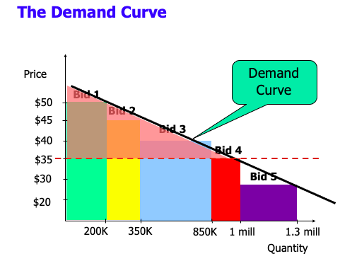

WTP Factors

Factors that influence WTP:
- Buyer’s tastes or needs
  - determine buyer’s desire to purchase a good relative to competing goods
- Consumer’s income or wealth
  - Willingness to pay for some goods increases as buyers become wealthier, but might fall for others (potatoes)
- Substitute goods
  - Goods that perform same function
- Complimentary goods
  - 2 goods are complements if buyer is willing to pay more for one when they already own the other
  - Ex: inexpensive CDs boosted willingness to buy CD players
- Demand curve is aggregating WTP
  - Buyer’s willingness to pay for various quantities
  - Usually slopes down: Pay less for greater quantities

Elasticity of Demand

- Not all demand curves are equally steep.
- The elasticity of demand is the percentage change in quantity divided by the percentage change in price. “If price rises by 1 percent, by what percentage will quantity fall?”
  - Elasticity is a useful measure of the responsiveness of demand to a change in the price.
  - Elastic demand curves are more responsive and appear flatter.
  - Inelastic demand curves are less responsive and appear steeper.

- High elasticity of demand: Quantity that buyers want is highly sensitive to price
  - Goods with close substitutes: Butter/margarine
- Inelastic demand curve: Buyers buy about the same amount of the good even if price rises or falls
  - Necessities with few substitutes: Water
  - Or brand loyalty
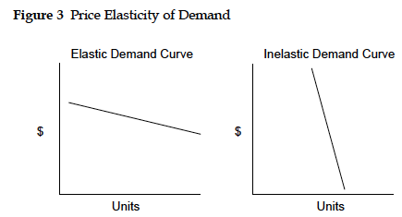

Price Discrim. vs One-Price Rule

The demand curve tells us the relationship between the market price and the quantity demanded by the market.

One-price rule vs Price Discrimination

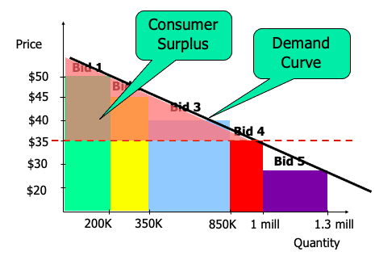
One-price Rule
- Seller charges same price for all buyers, regardless of WTP
  - Buyers with highest WTP are getting a great deal (they will buy at highest price, so will definitely buy at a lower price)

Price discrimination
- Price discrimination: Charging different prices to different buyers to try to match the price to the buyer’s willingness to pay.
- Achieves maximum potential revenue.
  - Seller wants to charge everyone an amount close to their WTP
    - Need to identify buyer willing to pay more and sell them higher-priced good.

Ex: Basketball floor seats (high WTP) vs cheap seats (low WTP)
- Seller captures max value from all buyers

Supply

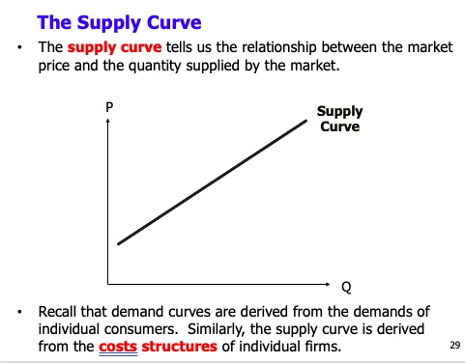

Firm supply decision is 2 decisions:
- Whether to compete in the market at all
  - long-run choice: looking at all costs, fixed and marginal
- How much to produce in light of current market conditions, given that the firm is in the market
  - Short-run choice: only look at marginal cost

Fixed costs vs. Marginal costs:
- Fixed costs: expenses that must be paid for firm operating, regardless of volume of goods produced
- Marginal costs: Vary with the level of production.

Elasticity of Supply
- High elasticity: supply curve is fairly flat, small increase in price evokes lots of new output.
- Low elasticity: Supply curve is steep, increase in price brings little additional output.
  - Hotels rooms.

Supply curve becomes inelastic as more firms in industry run into capacity constraints.

Market (Competitive) Equilibrium

Equilibrium: Price when supply=demand

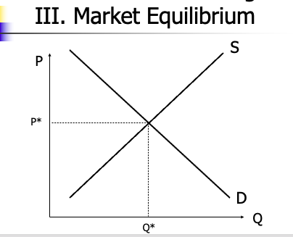

- A competitive equilibrium is the price, P*, where the quantity supplied by producers, Q*, is exactly equal to the quantity demanded by consumers.
  - In other words, the competitive equilibrium is the point where the market clears.
  - In our graph, it is the point where the demand curve and the supply curve cross one another.
- What would happen if the market price were below P*?
- What would happen if the market price were above P*?
- The competitive equilibrium is also “efficient.” Every consumer to the left of Q* should purchase the product (because their “willingness to pay” exceeds the marginal cost) while those to the right should not.

Market Adjustment
When supply/demand shifts, the market equilibrium moves predictably.
- Increase in supply = price falls, quantity rises
- Increase in demand = Price and quantity rise

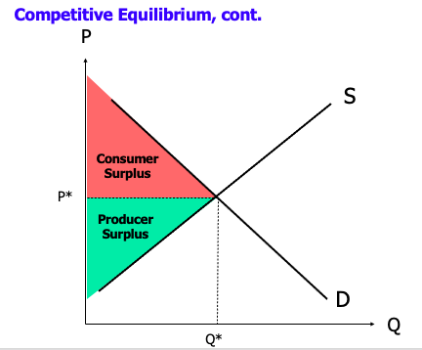

Perfect Competition

3 assumptions underlie market equilibrium theory:
- Products are identical: Sellers’ products indistinguishable, and buyer are willing to purchase from all sellers.
- Price-Taking (many small participants): numerous suppliers and buyers. No individual firm can affect the market price.
  - Price takers, not price makers.
- Full information: buyer/sellers are fully informed about products/prices available on market

Other features of perfectly competitive markets:
- Identical sellers: sellers have same production tech/inputs as each other
- Free entry: new firms can enter market on same terms as existing firms
- Free exit: Firms can exit market without incurring extra costs

Monopoly/Departure from Perfect Comp.

Certain market conditions (ie departures from perfect competition) lead to profitability:

- Few Participants
  - Markets dominated by handful of sellers/buyers with large influence over market prices
  - Dominant seller can raise prices, dominant buyer can force price down.
  - Collusion between firms to raise/force down prices.
- Barriers to Entry and Exit
  - Established firms have advantages that new entrants cant replicate easily.
  - Also no free exit
- Differences among products
  - Goods are actually varied. Differ in physical characteristics, brand image, distribution channels, etc.
  - Products are not perfect substitutes
- Differences among Sellers
  - Seller firms don’t actually have equal access to technologies and inputs.
  - Some firms have access to tech/inputs that give them lower costs or higher willingness to pay.
- Imperfect Information
  - Buyers and sellers must gather info and interpret.

Extreme Example: Monopoly

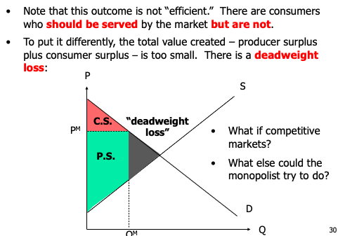

**Case: Husky Injection Molding Systems

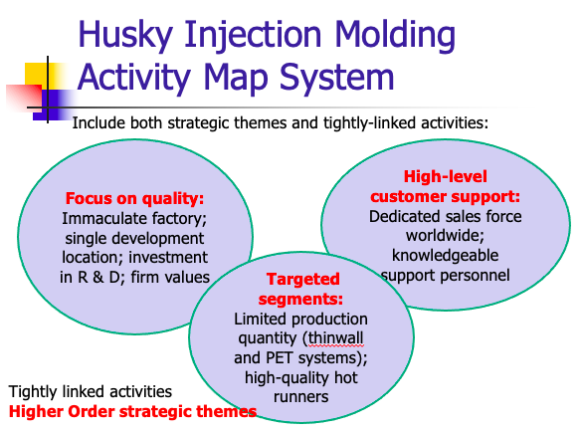

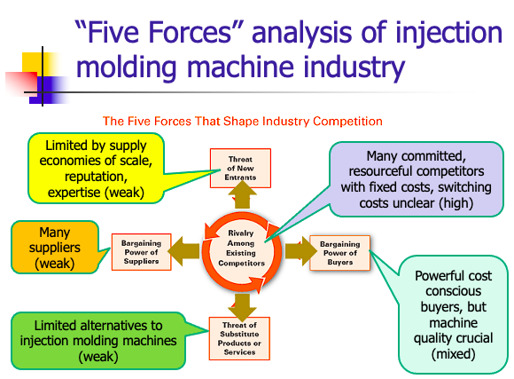

Threat of new entrants
- Limited by supply economies of scale, reputation, expertise (weaks)

Bargaining power of suppliers
- Mostly weak. Some inputs are cheap (steel), some are more limited/expensive (hydraulics, electronic controls)

Bargaining power of buyers
- Powerful, sophisticated buyers (bad news), but they care about things other than price, like machine quality (good news)
- Sensitive to resin prices somewhat

Threat of substitute products or services
- Limited alternatives

Rivalry among existing competitors
- Sophisticated competitors with fixed costs
- Competitors engage in price competition

- What is Husky’s strategy? How is it positioned relative to its competitors? Why has the company been so successful in the period prior to the recent problems?

Delivering distinctive value that other competitors don’t:
- High quality machines, great service, integrated systems, etc.

- Are Husky injection molding systems worth the premium price the company charges?

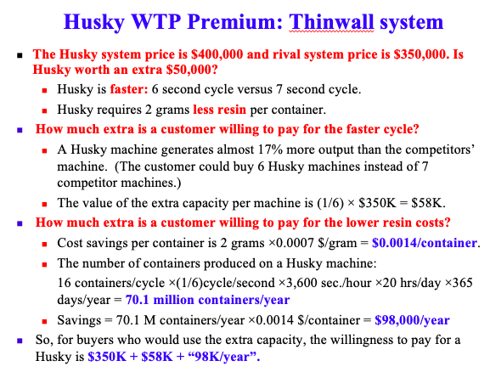

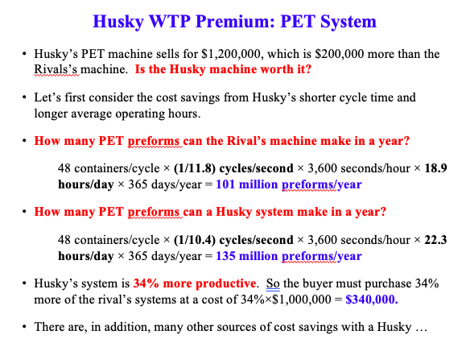

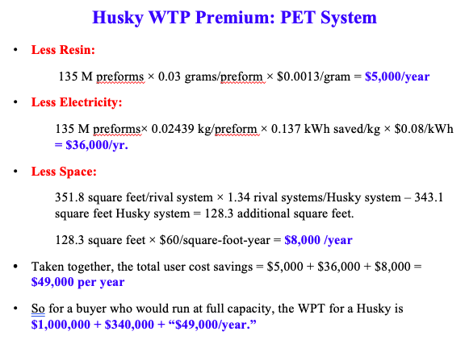

Yes. Worth the premium

- Recall that for a given customer, the relative willingness to pay advantage is equal to the price premium a firm can charge without losing the customer. To measure this premium, begin by identifying the reasons that customers are willing to pay more for Husky’s system. Then ask which of these reasons you can quantify given the information provided in the case.

- What has caused Husky’s current difficulties?

New competitors, resin shortage

- How should Robert Schad, Husky’s CEO, respond to the current challenges?

Be careful about reinvestment
- Heavy investment in R&D and manufacturing ($25mil in Advanced Manufacturing Center)

_________

V. GAME THEORY

**Subj: Economics of Strategy: Game Theory

Simultaneous-Move, Nonrepeated Interaction
- rock paper scissors

Sequential Interactions
- Tic tac toe

Repeated strategic interactions
- chess

Game Theory Definition

- Game theory = general analysis of strategic interaction*

- * “Strategic” can have three related but different meanings:
  - General policies mangers use to generate profits
    - ^^^This is the meaning we’re focused on
  - Consider behavior of identifiable rivals (for example, price)
    - How you should interact with your rivals
  - Formal game theory sense: set of moves in a game
    - A set of equations to dictate what moves you should make.

- Two branches of game theory:
  - Cooperative games – can negotiate contracts; implement joint strategies.
  - Non-cooperative games – binding contracts not possible.

  - The difference between cooperative/noncooperative games is functioning legal institutions: binding contract law

- Simultaneous vs. Sequential:
  - Whether or not decisions are made simultaneously.
    - Simultaneous: rock paper scissors
    - Sequential: Chess

Simultaneous Move, Nonrepeated Interaction

  - Analyzing payoffs: Normal form payoff (box with joint choices and payoffs).
    - 1st tool: Put all the payoff information in one place.

  - Dominant strategy: Optimal (highest return) strategy to choose regardless of behavior of others.
    - Once you figure out the possible payoffs, is there a move that you should always make?

  - Nash equilibrium: Each firm is doing the best it can, given the actions of its rivals (self-enforcing, arrow technique can identify)

  - Competition vs. Coordination: Coordination games usually have multiple equilibria (focal points can guide selection of an equilibrium. Examples: driving, “Battle of the Sexes”).
  - Mixed Strategies: Randomize choice to maintain element of surprise.

Prisoners’ Dilemma

Normal form payoff matrix

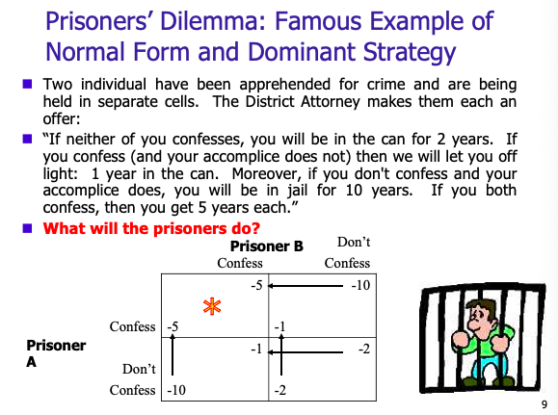

Dominant Strategy

Dominant strategy: No matter what the other person does, there is a specific course of action that you should always make.
- How to figure out:
  - Look at the courses of action that the other player can take, and decide what you would do in each scenario
    - If B confesses, A should confess
    - If B doesn’t confess, A should confess
  - Thus, for Player A, the dominant strategy is always to confess. Regardless of what Player B does.
    - Same for Player B.

If you only consider your short-term self-interest, it’s always best to act competitively.

- Adam Smith, The Wealth of Nations: "It is not from the benevolence of the butcher, the brewer, or the baker that we expect our dinner, but from their regard to their own interest."

Nash Equilibrium

Nash equilibrium: A set of strategies/actions in which each firm is doing the best it can, given the actions of its rival.
- “No regrets choice”: Given what the other players chose, none of the players have any regrets about their choice.
- There Can be multiple Nash equilibria

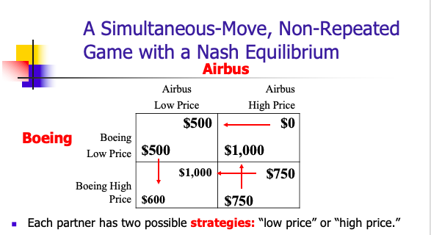

Dominant strategy for Airbus?
- Airbus should always go low price (regardless of what Boeing does)

Dominant strategy for Boeing?
- No. Depends what Airbus does (A high, B low. A low, B high)

Nash equilibrium: Boeing goes high, Airbus goes low.

Coordination Game

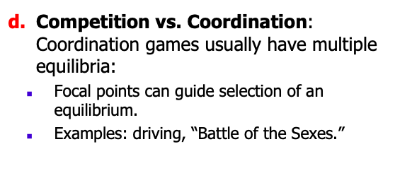

Coordination Game
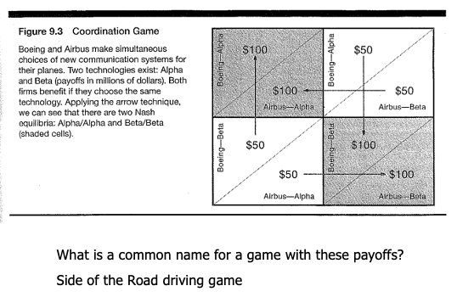
Here, both firms benefit if they choose the same technology

There are 2 Nash equilibria:
- Both choose Alpha
- Both choose Beta

“Side of the road driving game”: Doesn’t matter if you choose left or right, as long as everyone chooses the same side.

Coordination/Competition Game

Coordination/Competition Game

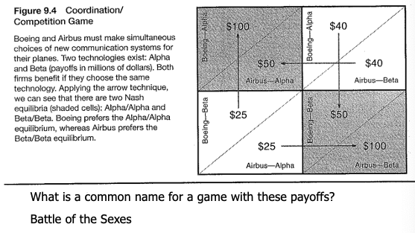

Here, both firms benefit if they choose the same technology, but each firm prefers a different outcome:
- Boeing wants Alpha/Alpha
- Airbus wants Beta/Beta

Why is this a coordination game?
- Everyone is better off if both firms choose the same tech.

“Battle of the sexes”: Both parties want to be together, but each prefers a different outcome.

Example: US and Canada

USS Lincoln, Game of Chicken

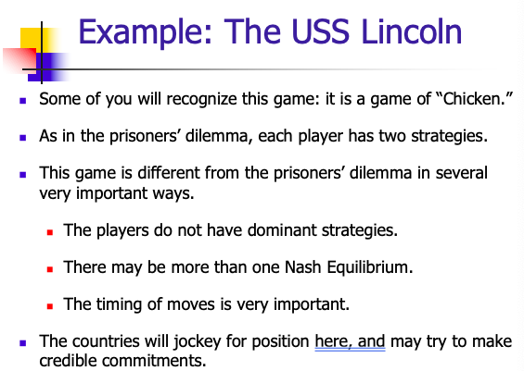

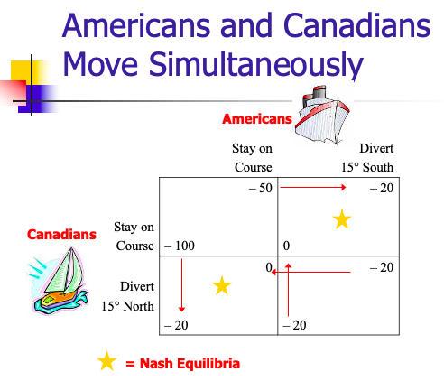

2 Nash Equilibria
- 2 arrows pointing at 1 box = Nash equilibrium

Mixed Strategies



Randomization: Maintains element of surprise.

Sequential Interactions

Games where players take turns.

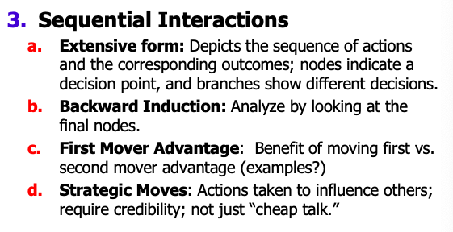

Extensive form: Charting out all possible sequences of actions and outcomes.
- Nodes: decision points
- Branches: different decisions

Backwards Induction
- Looking forward to the final decision nodes and reasoning backwards

First-Mover Advantage
- Outcome depends on who moves first.
  - But sometimes the follower has the advantage

Extensive Form

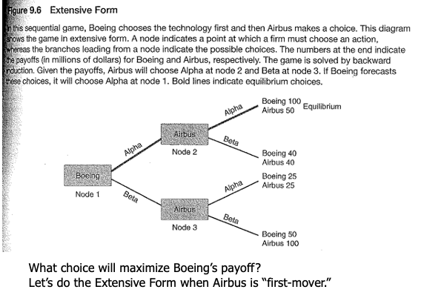

Boeing goes first, Airbus responds.

Backward Induction

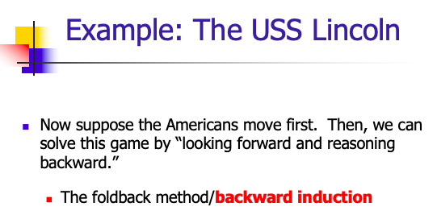

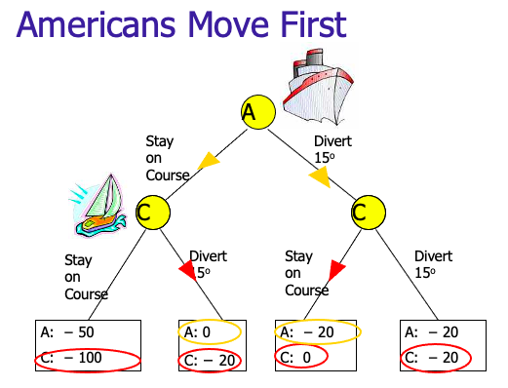

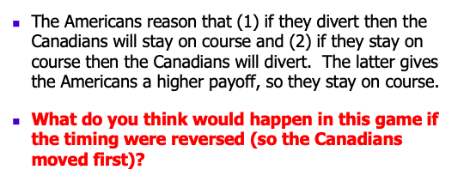

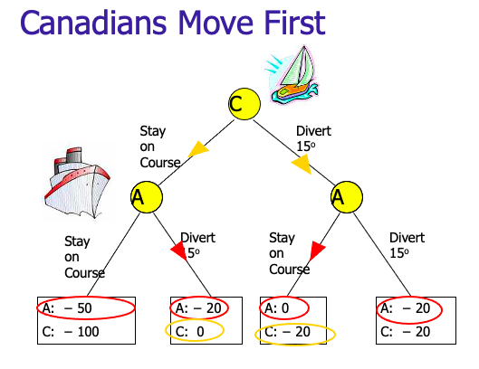

First Mover Advantage

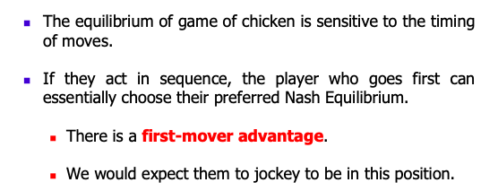

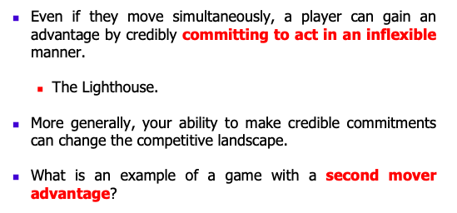

In game of chicken, there is a first mover advantage.

In rock paper scissors, there is a second mover advantage.

**Case: De Beers & Antitrust

Learning Points

- For over a century, the international diamond market has been dominated by one of the most successful cartels on earth: the legendary De Beers Corporation.
- De Beers has convinced millions of consumers that all sizes of diamonds should be highly prized. “A Diamond is Forever.” One of the important ways that De Beers achieves this by actively managing the supply and demand for diamonds. Specifically, they use their stockpile to keep diamond prices steady and increasing.
- De Beers activities give “sightholders” (as the buyers – cutters and polishers – are called) an incentive to stay with the cartel. They rarely turn down the shoeboxes offered by De Beers. Some reasons:
  - De Beers has unusual expertise in sorting and classifying rough stones. This expertise, together with the convenience of dealing with De Beers (one-stop shopping) creates value for the sightholders (their willingness to pay is higher with De Beers).
  - If a buyer rejects a shoebox (or purchases from a defecting diamond producer) the buyer runs the very real risk of not being able to do business with De Beers in the future. De Beers has a reputation for punishing those that take action to hurt the cartel.
- De Beers makes it attractive for its producers to stay with the cartel rather than “defect” and compete with it.
  - De Beers can credibly commit to punish defectors. It is in the diamond producers’ collective best interest to restrict joint production to the monopoly quantity and earn the monopoly price. The monopoly outcome is inherently unstable, however. Each producer has an individual incentive to defect from the cartel by producing extra diamonds and selling them directly to cutters. There are potentially large short-term profits to be earned by a unilateral defection from the cartel. This game is analogous to the prisoners’ dilemma.

_________

---PART 2: WITHIN THE FIRM---

_________

VI. COMPENSATION IN ORGANIZATIONS

**Background: Economics of Compensation

Principle/Agent Relationship

A principal/agent relationship is defined by three characteristics:
  - The agent acts on behalf of the principal and is supposed to advance the principal's goals.
  - The agent and the principal have different objectives.
  - The actions taken by the agent and/or the information available to the agent are not perfectly observable to the principal.

Hidden Action/Moral Hazard

A principal/agent relationship is characterized by hidden action (or moral hazard) when the principal cannot observe the agent's actions.

- An Agent is working on behalf of a Principal:
  - The Principal’s revenues and profits are $10 for each hour of Agent effort.
  - The Agent dislikes effort: he must personally bear a cost of effort, and his cost of working an additional hour is rising as the number of hours increases he has already worked increases.

Hidden Information/Adverse Selection

A principal/agent relationship is characterized by hidden information (or adverse selection) when the principal cannot determine the agent's type.

- There are two types of Agents who might work on behalf of a Principal that is selling encyclopedias:
  - Agent Justin Bieber is lazy, rich, and dislikes hard work.
  - Agent Justin Timberlake is eager to make more money and likes hard work.
  - Whether someone is a Bieber or a Timberlake cannot be observed.

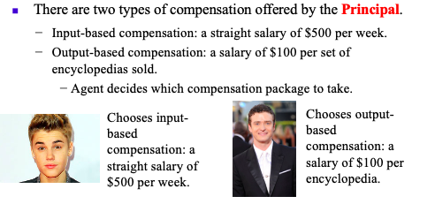

The economist solution: change your compensation system depending on who they are
- Input based: straight salary, $500/wk
- Output based: $100 per sale

According to economists, you want to pay based on output. You’ll get harder workers without having to supervise them

**SUBJ: Variable Pay or Straight Salary? (Lazear)

Output-based Pay

Output based pay
  - Screening Workers: All workers whose payment exceeds alternative stay on the job (encyclopedia sales/Biebers); hidden information (adverse selection).
  - Using Incentives: Example 1 - Taxidriver’s compensation; hidden action (moral hazard example).
  - Sorting: Underpaying will cause adverse selection; B&W vs. Red Cab; Example 2 –charging the salesperson for their desk is most efficient.
  - Reality versus Theory: Taxicabs and implicit payments; one hundred percent commissions: gross vs. net; capital distortions; hybrid schemes.

Factors that Favor Output-based pay:

This basic tradeoff suggests factors that favor “output-based” incentive contracts:
  - Revenue/Output is sensitive to the agent’s effort. (The benefit of extra effort is high.)
  - The agent is not very risk averse.
  - The agents effort is difficult to observe.
  - The agent can easily respond to the higher powered incentives by putting in more effort.
  - The level of risk that is beyond the agent's control is low. (The revenue/output measure is tightly linked to effort.)

Safelite Example:

After implementing variable pay:
- Productivity increased (hard workers worked, bad workers left)
- Customer satisfaction increase
- Sick leave dropped

Input-based Pay

Input: Time-based pay
  - Cost Advantage in Measurement: Output more costly to measure.
  - Quantity versus Quality: Quality is usually more costly to measure.
  - Appropriate Time Unit: More difficult to state task ex ante, longer the time period for compensation.

Risk Aversion & Intermediation

Risk Aversion and Intermediation:
  - Risk Aversion: Most workers do not like volatile earnings.
  - Intermediation: Compensation to firm may differ from compensation to worker (GM: car purchaser vs. worker pay); result is firm is intermediary, hiring factors of production. Another example: contingency law firm pays associates an annual salary – acting as an intermediary.

**Case: MGOA Physicians Performance Pay

Pay based on Input or on Output
  - Output-based pay addresses two agency problems:
    - Hidden action (moral hazard)
    - Hidden information (adverse selection)
  - MGOA Physicians Case Discussion
    - Case emphasizes benefits from switch to pay-for-performance
    - Actual effects of the pay scheme here are on incentives, not agency costs

_________

VII. HUMAN CAPITAL/INTERNAL LABOR MARKETS

**Subj: Attracting & Retaining Qualified Employees (Brickley)

Internal Labor Markets
  - Exist because: firm specific human capital, aligns motivations, and provides information.
  - Attributes include: efficiency wage, seniority pay, promotions

How to use pay to enhance employee motivation:

1. Efficiency Wage
- Efficiency wages
  - Output based compensation: Helps solve the hidden action problem
  - Pay compensation above market rate

2. Seniority pay: Investing in general human capital development
- Long-term compensation scheme
- Offering more money as they become more valuable
- Pay them more than they are worth to get them to stay
- Risk: firm has incentive to get rid of them, b/c they’re getting paid more than they’re worth

3. Tying pay increase to promotions
- Employee productivity increases as they compete for the promotion

The Level of Pay

Gen/Specific Human Capital
Competitive Model: All labor is hired on a “spot” market, for cash, and all information is available. Then, wages determined by supply and demand like liters of Diet Coke.

Human Capital: Recognizes varying ability among employees, and so different skills to “rent” to employers. Human capital can be:
      - General Human Capital – applicable in a broad array of firms, or
      - Specific Human Capital– more valuable to a specific employer.

In otherwise competitive market, workers pay to increase their general human capital and firms pay for the workers’ specific human capital.

Compensating Differentials: Working conditions vary; a compensating wage differential will need to be paid to attract workers to unpleasant jobs, all else being equal. Creates incentive to offer a more pleasant and safer work environment.

Costly Information about Market Wage Rates: Many labor markets not readily observable. Individuals vary, and salaries can be hidden. Numbers of qualified applicants and rates of attrition are indicators of whether a firm’s wages are at market.

Internal Labor Markets

Firms invest in general human capital and workers in specific human capital. Explanation: internal labor markets and long-term employment, often with implicit contracts.

  - Why Long-Term Employment:
      - Develop firm-specific human capital;
      - Align employee motivation with the firm’s;
      - Learn employee attributes.
  - Costs of Internal Markets: access to more limited labor pool (therefore, internal more likely to be preferable when company-specific expertise required).

Pay in Internal Labor Markets

Careers and Lifetime Pay: Employee will consider earnings over anticipated career, but firms need to make sure future payments are sufficient to retain employees. Benefits from career pay include:
      - Efficiency wage (output-based compensation) – creates incentive to stay with firm;
      - Job seniority and pay – links employee motivation with the firm’s;
      - Promotions – increase productivity in order to win these contests (but less cooperation, crude, mismatch).

Influence Costs: Pay differentials can lead to an arm’s race among employees trying to outdo their peer’s compensation.

**Case: Venture Law Group

Learning Points

- VLG attorneys have client-specific human capital, not firm-specific human capital. Therefore VLG faces the problem of retaining both attorneys and clients. Successful attorneys can leave VLG taking the clients with them. (Indeed, Craig Johnson left Wilson Sonsini and started VLG in exactly this way!)
- Several personnel policies helped to support the zero voluntary turnover objective:
  - They try to pay their attorneys well.
  - The associates received “tenure” much earlier than in other firms.
  - Employees accumulate “profit-sharing points” while working at VLG. This helps to bond the attorney to VLG – if he or she quits, the points are lost.
  - Finally, a “fun” work environment – parties, retreats, interesting projects – makes the attorneys want to stay. This is related to the compensating wage differentials in the reading.

Activity Map

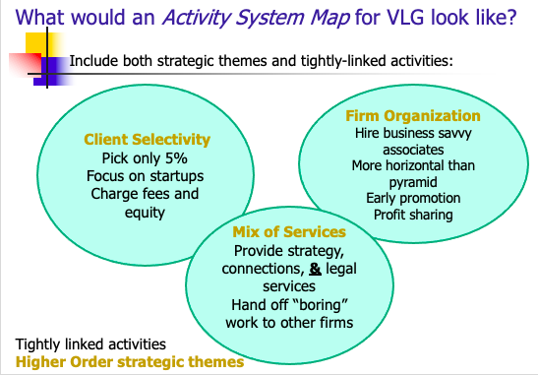

_________

---PART 3: SCOPE OF THE FIRM---

_________

VIII. DIVERSIFICATION

**Subj: Corporate Diversification (Oster)

What is Diversification

What is diversification
  - Diversified firm definition: A firm that operates in a number of different markets.
  - Vertical Diversification: Ie you compete in the industry that supplies to you, or the industry that you supply to
    - Backward Integration: Entering the business of a supplier (e.g. rubber for tires); or
    - Forward integration: Entering the business of a distributer of products (e.g. retail tire stores).
  - Conglomerate Diversification: Can include both related and unrelated moves.
    - Conglomerate diversification: broadening the corporate portfolio into different industry segments
      - Related business units: support/complement each other
      - Unrelated units: limited opportunities to exploit joint skills or assets

Why Diversify?

Most important concept from this article:
Why Diversify?:
  - Economies of Scope: Reduce costs when two units are joined together. These cost savings can come from centralizing: marketing, research, distribution. Also, leveraging core competencies (vs Economies of Scale?). Examples:
    - Levi Strauss move into children’s and women’s jeans.
    - Airlines maximizing use of hub-and-spoke system.
    - Relation to firm life cycle.
  - Market Power: Increased market power by expanding into related markets, or to exploit existing market power.
- Profit Stability: Reduce variance in earnings. Investors can do this outside of the firm, but increases returns to managers.
- Internal Capital Markets: For firms that have valuable, but proprietary information in their business.
- For Growth: But may not benefit shareholders.

Effects of Diversification on Performance

Effects of Diversification on Performance
  - Evidence: Firms that follow a pattern of related diversification do better than those that follow a conglomerate strategy.
  - More evidence: Perhaps single product firms outperform diversifiers (but may be a result of selection bias).

**Case: Danaher Corp.

Final thoughts on DH

- Connection to diversification
  - Gives understanding that the core driver of diversification is usually economies of scope
    - Being in related businesses can bring cost advantages
  - DH economies of scope:
    - Bolt-on companies: smaller acquisitions to increase synergies between anchor businesses and new targets
    - Meta scope: DBS expertise can apply to a number of related businesses

Activity Map

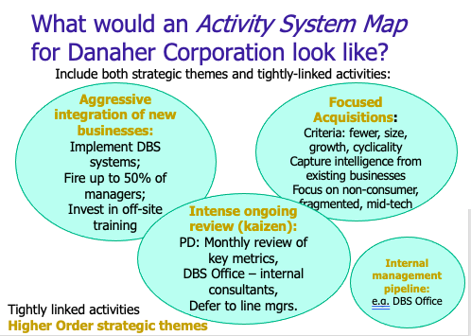

_________

---PART 4: SPECIAL TOPICS---

_________

IX: Barriers to Entry

**Subj: Entry and the Advantage of Incumbency (Saloner)

Types of incumbency advantages

Types of incumbency advantage
  - Scale advantages/Economies of Scale: Average cost declines as the firm produces more output. Example – spreading fixed cost over more units. Numerical example with a monopolist.
      - “The upshot is that economies of scale can block entry even when the potential entrant is as efficient as the incumbents and when incumbents are earning above normal returns.” (Saloner et. al., p. 220)
    - Minimum efficient scale (MES): Minimum output to minimize average costs. MES only important if large relative to demand.
      - IE: How big do you have to be to take advantage of the economies of scale?
      - Ex: if you have to be as big as Amazon to take advantage of the economies of scale (higher MES), no one will enter.
      - If MES is smaller, entrants will enter
- Incumbency advantage from cumulative investment: Unlike scale advantage, cost advantage grows over time. Best example: Learning economies.
  - Cumulative investment: cost advantage grows over time
    - Some advantages come from doing something for a long time
    - Ex: UPS. Needs to deliver a package every other house to be efficient. They’ve also been doing it 10 yrs. Driver knows the door codes, the route, the people, the scary dogs
    - Ex: Manufacturing: If people operate a machine for 10 yrs, they will do it better/faster/stronger. Creates cost advantage.
  - Learning economies:
      - Also called learning curves and experience economies.
      - Cost savings that come with experience.
      - Can occur in production, distribution, marketing, and R&D.
      - Some claim this is the primary source of competitive advantage.
      - Amount new entrant would need to spend depends on how much learning required and extent of savings.

Learning Economies: Do it a lot and you’ll get better. You will lower costs in ways other than efficiency

- Marketing: Brand recognition
  - Ex: Coca Cola
  - Not about efficiency this year. It happens over decades
- R&D. Know how to invent things, know when you’re reaching a solution/improvement
- Some claim this is primary source of competitive advantage
  - Ex: Coke and Pepsi has invested 50 yrs of marketing. No one can catch them

- Innovation advantage: Knowledge from solving one stage in a problem can help solve the next stage as well.
- Promotional advantage: Advertisements can have a cumulative effect, e.g., Coke and Pepsi.
- Incumbency advantage from consumer loyalty: Especially strong if experience good – need to experience to learn how valuable the good is.

  - Incumbency advantage from switching costs and demand-side increasing returns: Switching costs when complementary products compatible with buyer’s current product: razors and razor blades, auto parts. Sources of switching costs include:
    - Durable productive assets (software for specific operating system);
    - Employees trained for one system;
    - Complementary assets (razor blades, printer cartridges);
    - Transactions costs (existing suppliers); Loyalty programs (frequent flyer programs).

- Incumbency advantage from sunk costs: High costs of exiting the industry also can create entry barriers.
  - Compare a port where ships can come and go to a train track that cannot be moved (a la Williamson’s transaction cost analysis).
  - Value of ability to commit (a la game theory first-mover advantage. Canadians: “We are a lighthouse.”).

- Firm scope: A full line of products and economies of scope can also serve as an incumbency advantage.
  - Examples include BIC selling pens and lighters, but may not be a barrier to entry, if not coupled.

Curve C
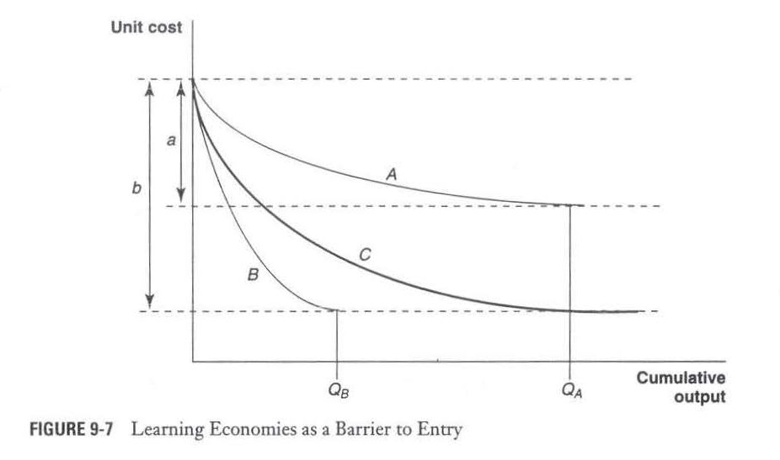

Ex: we have a machine in our factor, this graph tells us when you will get the most out of our machine.

If you’re an incumbent, which learning economies do you like the best?

Curve C: Incumbent has time advantage. Once they put the large time investment in and achieve the high cumulative output/low unit cost, it will be hard for new entrants to catch up.

- Creates a higher barrier to entry.
- New entrants are less willing to put in the time commitment.

Entry barriers at work

  - Small towns example.

Strategically creating entry barriers

  - Packing the product space: With consumer brands, different products to meet different consumer demands. Changes the payoff matrix for potential entrants.
  - Blocking through contract or vertical integration.
  - Signaling to prevent entry.
  - Entry barriers and antitrust.

**Case: Valujet

(long pricing discussion)

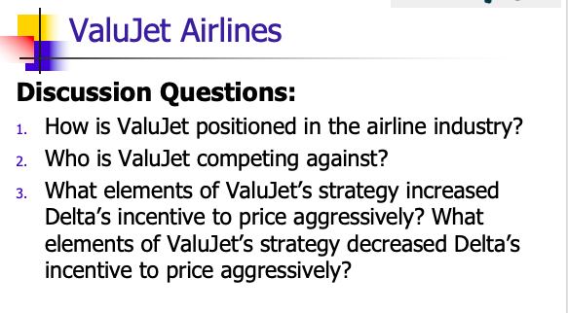

Who is VJ competing against?
- Greyhound bus

What elements of ValuJet’s strategy increased Delta’s incentive to price aggressively?
- The fact that VJ operated out of Atlanta

What elements of ValuJet’s strategy decreased Delta’s incentive to price aggressively?
- Limited number of flights, low price

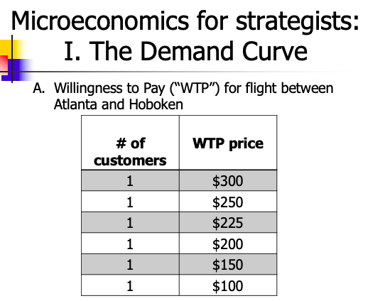

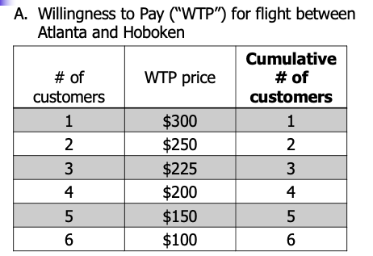

Create a demand curve for “WTP” information
- Chart the Price and # of Customers

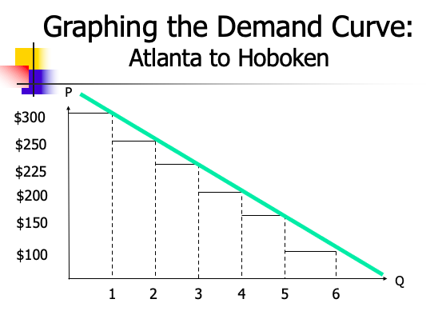

Ie:
- If you charge $300 you get 1 customer
- If you charge $100, you get all the customers

2 ways to use information about demand:
- Option 1. Pick a single price.
- If I charge that price, how much revenue will I get?
  - $100: 6 customers, $600
  - $150: 5 customers at $150/ea = $750
  - $200: 4 customers, $800
  - $225: $675
  - $250: $500
  - $300: $300

Best outcome: charge $200, get 4 customers, make $800

- Option 2: Price Discrimination
- Charge all customers a price equal to their WTP
  - Ie: 1 customer at $300 ($300), 2 at $250 ($500), 3 at $225 ($675), 4 at $200 ($800), 5 at $150 ($750), 6 at $100 ($600)
    - Add them together: $1,225

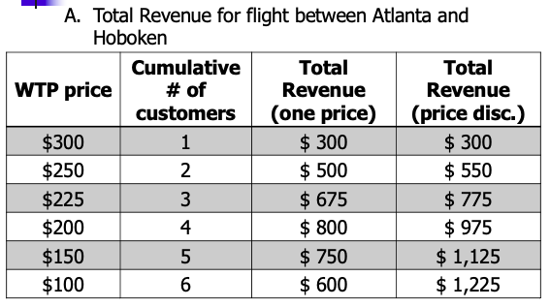

Now: Throw costs into the equation
- We can figure out the value-maximizing equation

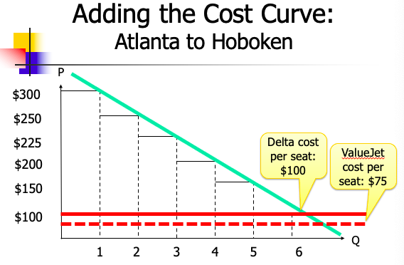

Delta:

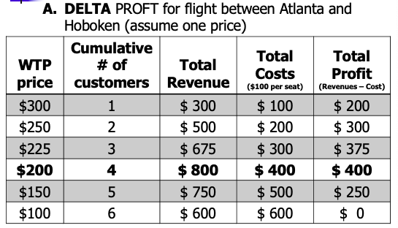
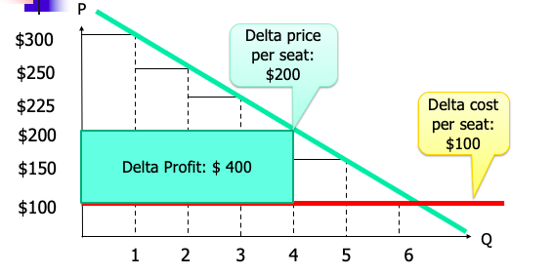

ValueJet
- This creates an opportunity for VJ. VJ can take advantage of unmet demand without competing with Delta

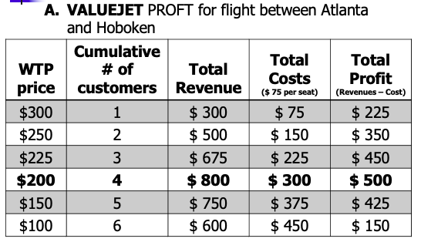

VJ offering 1 seat at $150
- Not harming Delta at all, b/c they have already said no to offering a seat at $150
- Judo economics: focus on not being a threat to the incumbent

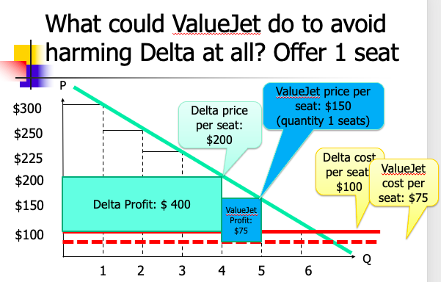

VJ getting greedy:
- Offer 2 seats at $150, try to steal a customer from Delta who is willing to pay $200

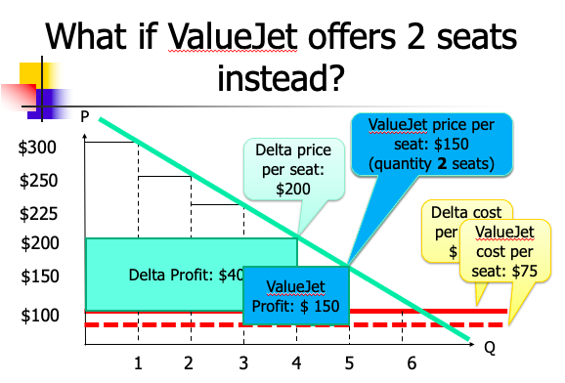

Delta has 2 response options:

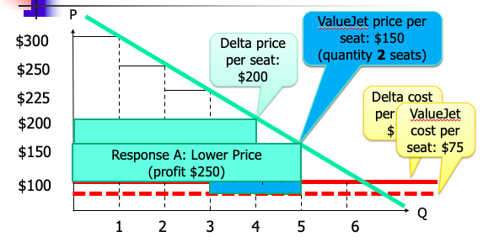
Response A: Lower price, try to crush VJ

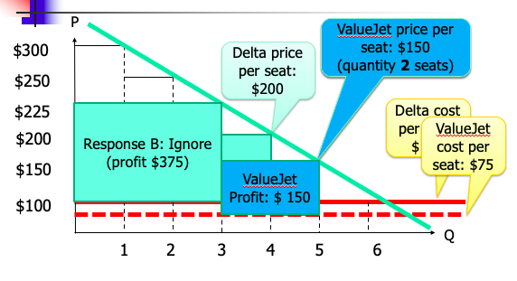
Response B: Ignore

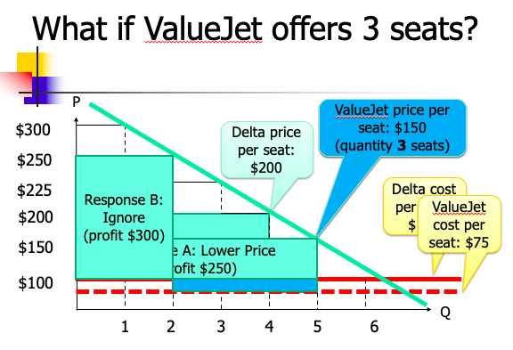

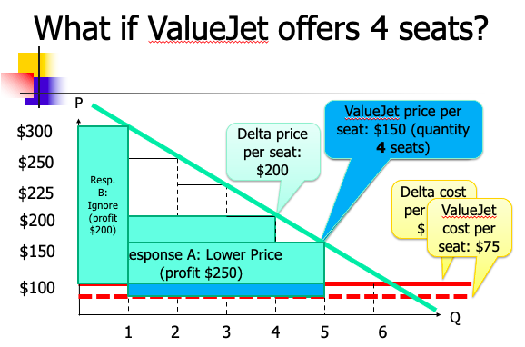

(Office hours pricing)

Valujet walkthrough

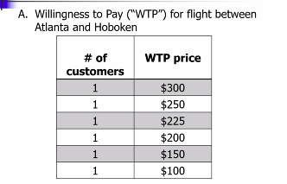

Step 1: how many customers do you get at each price?

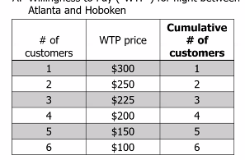

Use this information to create a demand curve: how many customers at each price?

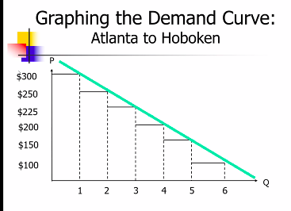

$100 – 6 customers
$300 – 1 customer

Next: revenue

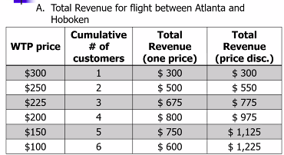

Revenue (One price): WTP Price x # of customers

Revenue (price discrim): need to look at Demand Curve

Adding costs, calculating profit (for one-price)
- Revenue minus Cost

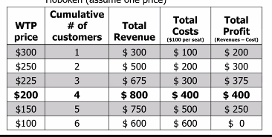

Find out which price will maximize profit

Reflected on graph:

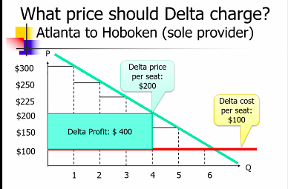

Adding costs, calculating profit (for price discrim)
- Revenue minus Cost

For Valujet:
- Valujet seats cost less

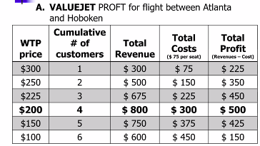

But then: Delta and VJ will be at war.
- Should VJ do judo strategy (go where Delta is not)?
  - VJ pricing in a way to NOT compete with Delta at all.


