Midterm: everything you need to know is in the book and powerpoint slides; so if something doesn’t make sense from the slides → book. Issue spotter / short answer memo style. 3 week period to take it. Accessible on exemplify and submit on brightspace

- Overview of advertising, marketing, and promotions law
  - Why advertise?
    - Purposes:
      - Brands ID source → trademark law
      - Inform
      - Persuade
    - Economics: advertisers will buy more advertising so long as it increases profits
    - Psychology: change consumer preferences
      - Signal trustworthiness
      - Manufacture a consumer problem that the advertiser can solve
      - Change consumers’ subconscious (subliminal advertising)
  - Advertising - good or bad?
    - IN general, good advertising achieves 3 purposes: 1) maximize profits; 2) improve competition; and 3) influence consumer behavior
    - Legit ads can educate consumers and improve marketplace efficiency
      - Nothing is free - consumers indirectly pay for ads
    - Illegit ads can cause economic and other harms
    - Consumerist society and feelings of inadequacy
    - Competitive barriers to entry
    - Consumers are not rational actors and they can be manipulated - where do we draw the line as to what's unfairly persuasive
  - 4 Ps of marketing
    - Product - consumer driven product design
    - Place - distribution channels
    - Price - price setting
    - Promotion - advertising, press relations, and sales
    - Note that Londre has 9s: 1) People/targeting; 2) Planning (research); 3) Product or service; 4) Place/distribution; 5) Promotion; 6) Price; 7) Partners/alliances; 8) Passion; 9) presentation
  - Types of advertising by goal
    - Direct response advertising (“direct marketing”) = get an immediate response from consumers
    - Brand advertising = establish brand in consumers’ minds
    - Informational advertising = communicate facts
  - Types of advertising by payment method
    - Fixed fee = fixed amt for exposure
    - Per impression (CPM) = number of consumers exposed to the ad copy
      - “Make-goods” = free ads to reach contracted quantity
    - Per click/per call (CPC) = # consumers who inquire
    - Per action (CPA)
      - Cost per action = # consumers who take desired action
      - Cost per acquisition = # new customers
    - Revenue share = share incremental revenues from ads
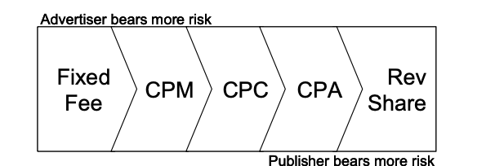
  - Credence attributes
    - Relieves headache pain
    - Effective legal representation
    - BeVier: “The rational advertisers’ reaction to consumer skepticism, moreover, will be not to waste resources making direct, inherently unbelievable quality claims at all - either true or false.”
  - Experience attributes
    - Tastes great, less filling
    - MPG
  - Irrelevant attributes
    - Not material to product purpose
    - Emotional
    - Self-identification
    - Brand loyalty
  - Challenges and responses to saturation and intrusiveness
    - Creativity, innovation, and fraud
    - Ad skipping
    - Viral; WOM
    - Product placement and brand integration
    - Sweeps and content
    - Brand / consumer engagement
      - UGC
      - Social media
      - Crowd sourcing
  - Consumer and competitor protection
    - False, misleading, unfair
      - Protects whom
      - Who enforces?
    - Ad claims
      - Substantiation
      - Typicality
    - Comparative ads
    - Childrens ads
    - Privacy and data security
    - The FTC is extremely interested in regulating Ads for products that claim health benefits or can be used as drugs. If you claim your product can cure ailments or cause structural changes in skin/tissues, etc. then such claims are considered drug claims and are held to the same standard as drug claims by the FDA. Also, if you have consumers or sponsors claiming that your product can be used as a drug, then you’re on the hook as well!
    - The Lanham act is available for consumers or competitors to sue advertisers over unfair or misleading claims
  - Others affected / stakeholders
    - Rights holders
      - IP
      - Publicity
      - False endorsements
    - Talent (unions / guilds)
- The advertising ecosystem
  - The old model - You essentially just had the Ad agency act as the go-between between the advertiser and consumer

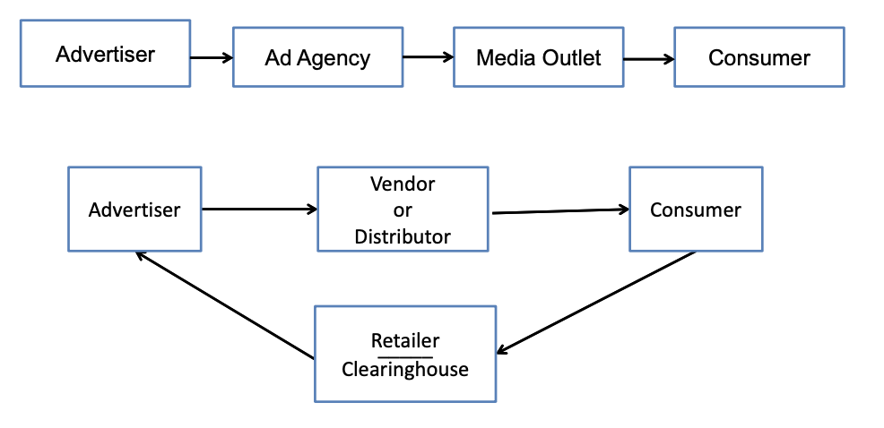
    - Back then there was only radio, print and tv
  - Today’s complex ecosystem
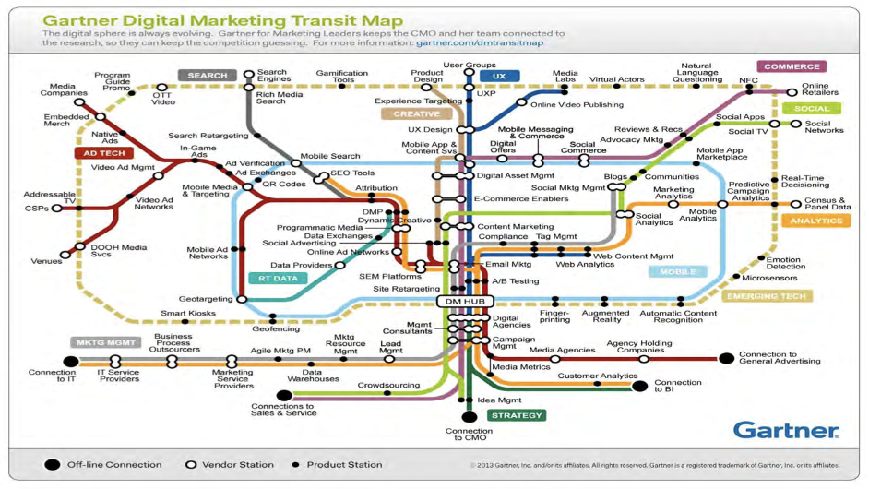
    - Advertiser → ad agency → broadcaster → consumer (lots of intermediaries in between the advertiser and consumer - this isn't the only model, either)
      - The presence of intermediaries increases costs of advertising but each intermediary brings specialized expertise to the process
      - For example, an affiliate marketer can access niche communities
    - But a complex web of outsourced relationships can diffuse responsibility for any problems - who bears the responsibility of an illegal ad? Harder to say these days
    - Todays advertising ecosystem is tech driven and digital
    - For example, an affiliate marketer can access niche communities
    - In the past, it was tough to show efficiency of Ads. However, with digital Ads, companies can efficiently track whether you’ve see the ad, clicked on the ad, and then followed the Ad to the product website. Who’s job is it to safeguard your privacy information that is being tracked?
    - The more targeted the ad, the more valuable it is and more the advertiser will be willing to pay for it
    - Some terms:
      - An Ad server is a party that is serving the ad.
      - CPM- cost per thousand - traditional way of selling/pricing advertising.
      - Analytics - aggregated statistics (e.g 70% of ad viewers are women; 65% of people who purchase the product are men) - these data sets have a low risk of privacy concerns becasue they are more general.
      - CRM- data on the consumers of a company. It’s called 1st party if the data is gathered by the vendor, and 3rd party if gathered by an intermediary
      - Data matching occurs when a publisher and advertiser share informaiton on the demographics of the consumers who are viewing the Ads and use it to match a potential user with an ad/product. Data brokers are companies that can supplement the data from the publisher and advertiser to help make the match
  - Agency theory
    - Traditional ad agency relationship is agency relationship, including the ability to contract and bind
      - Concept of sequential liability
      - What about intermediaries and affiliates -- how are they different?
      - To what degree should the Ad agency be able to rely on the substantiation of claims from the client? This should all be laid out in the initial contract. The responsibilities of the client, Ad agency, Ad publisher, sub contractors should all be laid out in the contract. This includes substantiation of claims, ensuring that IP rights are not infringed, ensuring that there is insurance for cybersecurity breaches/risks/leaks etc.
    - Generally, agents and principals are equally liable for any tortious behavior within the agency’s scope
      - So, advertisers are generally responsible for the acts of their advertising agencies
      - Agencies may also be liable for the ad copy they help prepare and disseminate
    - Knepper v Brown case (pg. 708 of course book) - example of liability extended to Ad agency
      - Ad company implies Dr. Brown has board certification in surgery by running Ad in liposuction/cosmetic surgery section of yellow pages. However, Dr. Brown only has board certification in dermatology. Dr. Brown approves Ad and it is published in surgery/liposuction section.
      - Plaintiff saw the ads and engaged with him for liposuction. Plaintiff sustained major injuries/deformities from the surgery and sued. Court held that the Dr. and the Ad company were both responsible for knowingly publishing and promoting false and fraudulent information which materially affected the decision of the plaintiff.
    - Doherty v. FTC (6th Cir 1968)
      - The FTC determined that certain ads for Sucrets and Children’s Sucrets cough medicine, manufactured by Merck, constituted false advertising. The FTC issued a cease-and-desist order against both Merck and its advertising agency, Doherty.
      - The Commission held that the advertising agency was an active participant in the preparation of the advertisements and that the agency knew or had reason to know that Merck’s claims were false or deceptive.
      - Doherty urges that it acted only as agent for its client, relying in good faith on the information furnished by Merck.
      - Doherty asserts that having used every available source to assure itself of the accuracy of Merck’s claims, there was nothing else the advertising agency could have done.
      - Doherty seeks to have the Commission’s order set aside and the complaint dismissed as to the agency.
      - Legal standard under which cease and desist order should be issued is to the extend to which the ad gency actually participated in the deception
      - Participation = agency must know or have reason to know of the falsity of the ads
      - To be aware of the extent of the therapeutic qualities of the product, all the agency needed to do was read the packaging. The ads went far beyond the modest claims appearing on the labels and instructions
      - Document in the record outlines an ambitious ad program aimed at selling product to the self medicating market (middle/lower socio economic group) and designed to encourage mothers to buy the product under the impression that sucrets will kill germs, cure sore throat/strep throat and alleviate pain
    - FTC has held agencies liable for FTC act violations but the scienter standards for agency liability are higher than for the advertiser
      - Agency liable only if it committed a knowing violation while advertiser may be liable with less scienter
    - Some case law suggests that agencies may be held jointly liable with their clients under the lanham act
      - Nestle v. blue buffalo - court allowed counterclaims against agencies to proceed when (1) one agency allegedly “designed and built” the website focused on the allegedly false claims, and (2) another agency allegedly “developed the content” of allegedly false ads on the advertiser’s Facebook & Twitter accounts and “arranged for these links to [the challenged website] to appear when Google.com users search for terms related to Blue Buffalo”);
      - Duty free americas v. estee lauder - recognizing the existence of contributory liability under the Lanham Act’s false advertising provision; liability requires material contribution to the false advertising “either by knowingly inducing or causing the conduct, or by materially participating in it”
    - Courts routinely treat agencies at jointly and severally liable for other types of claims (Waits v. Frito Lay - Frito’s ad agency helped recruit sound alike singer for ad. Agency held jointly liable for 2.6m)
    - Statutes may also expressly made advertising agencies liable for legal violations
  - Affiliates
    - Agents act on behalf of the advertiser and an affiliate tries to generate sales
    - FTC is pretty aggressive ab holding sellers responsible for their affiliates
    - Advertisers typically police their affiliates
    - CAN-SPAM (federal anti spam law) has provision holding advertiser liable for illegal spam sent by marketing affiliates
    - Marketing other than spam is not codified in §§ so rely on CL
    - Ps have not found it easy to hold advertiser accountable for affiliates’ illegal activities
    - Fenn v. redmond venture (utah ct. App. 2004)
      - Ps received unsolicited email messages advertising various RedV computer software products. Prior to receiving the email advertisements, Ps had no contact or relationship with D.
      - After receiving the unsolicited email messages, Ps filed separate actions alleging that RedV had violated the Unsolicited Commercial and Sexually Explicit Email Act by sending email messages that did not comply with the Act’s requirements.
      - The Act requires a sender of unsolicited commercial email to include certain information in the subject line and body of each email message
      - the Act clearly imposes liability upon a company that causes its independent contractors to send unsolicited commercial email messages in violation of the Act
      - Crucial to our inquiry is an understanding of the contractual relationship between RedV and its promoters.
      - RedV submitted an affidavit stating that it requires all promoters to adhere to the terms of a marketing contract. The marketing contract requires promoters to comply with RedV’s “Anti- Spam Agreement”
      - We conclude that the anti spam agreement unambiguously prohibits RedV promoters from using unsolicited email messages as a marketing tool. Thus, RedV’s affidavit, if undisputed, establishes that RedV did not “cause” illegal email to be sent within the meaning of [the Act].
      - Ps contend that because the email messages advertised RedV products, we must infer that RedV’s Anti-Spam Agreement was a sham. This inference is not reasonable based on the record. Although we can properly infer that the email messages were sent by RedV promoters, we cannot, absent additional evidence, infer that RedV encouraged or required its promoters to send the unsolicited email.
      - Ps presented no evidence suggesting that RedV encouraged/ required its promoters to send unsolicited email, or that the Anti-Spam Agreement was a sham.
    - Anti spam agreements are not determinative - advertisers can adopt policies but then look the other way in the spam procured customers are profitable
  - Publishers
    - Publishers are generally liable for the ads they publish subject to some exceptions
    - In some cases the scienter preprequisitie for liability is higher for publishers than advertisers
    - Publishers are to act as gatekeepers and police the ads they publish
    - NYT v. Sullivan (U.S. 1964)
      - Commissioner of the city of montgomery brings libel action against NYT among others
      - Key holdings: constitutional limits of 1st amendment. The publisher is equally culpable as Ad agency for statements published against an individual which are defamatory. However, easier to prove malicious intent on the part of the Ad agency which generated the content, than on the publisher which simply published the content provided by the ad agency.
      - NY times may have been negligent in publishing the content and not verifying the truthfulness of the comments. But it could not be held liable for defamation because it did not have the required malice.
  - 47 USC § 230(c)(1) immunity
    - No provider or user of an interactive computer service shall be treated as the publisher or speaker of any info provided by another info content provider
    - Goddard v. google
    - Roommates.com
      - Website provides platform for providing rental availability. However, the website asked very pointed specific questions regarding race, sex, sexual orientation, etc. These questions violated state and local laws that prevent discrimination against renters based on these issues. As such, they got sued for violating the law.
      - They argued that the website simply provides platform for user-generated content. However, court held that because the website required users to fill out the form before using the platform, they became content generators, not just publishers. As such, they could be held liable.
      - By contrast, Craigslist simply provides platform for one to advertise their products/services. However, the website does not shape the content provided by the users. As such, it has survived similar law suits.
    - § 230 is a very strong immunity and it favors publishers
      - Unless there is co-creating
      - Also where human trafficking is involved - publishers are liable for these types of communications
  - 47 USC § 230(c)(2) immunity
    - Any action voluntarily taken in good faith to restrict access to or availability of material that the provider or user considers to be obscene, lewd, lascivious, filthy, excessively violent, harassing, or otherwise objectionable, whether or not such material is constitutionally protected…
    - CANT police constitutionally protected speech
    - Langdon v google
  - Media must-carry vs editorial discretion
    - FA discretion
      - Right of reply?
      - Miami herald v. tornillo
    - Broadcast rules
    - State vs private actors
  - Publisher ad pricing and practices
    - How ads priced and measured
    - What does the K say?
      - Go2net case
      - Issue was whether click fraud was involved - publisher gets paid by advertiser based on how many times the ad gets clicked on from the publisher’s site. The contract simply stated that click counts would be counted by number of impressions recorded by the publisher. No third party was used to verify these counts. Also, the contract explicitly stated that Go2Net made no representations as to the accuracy of the counts. Despite there being evidence of rampant click fraud (e.g. robotic click fraud, and competitor click fraud), there was no evidence of fraud by Go2Net. Thus, Go2Net not found liable.
      - Lesson to be learned, include monitoring/verification of click counts by a neutral party.
    - Click-fraud
    - IAB
  - Agency / vendor agreements
    - Difference between MSA, SOW, WO, IO, Change Order
    - Most important for brand?
    - Most important for agency / vendor?
    - How do you work around unequal leverage?
- False and misleading advertising
  - Overview
    - In competitor/consumer law suits, the plaintiff has the burden of proving the Ads are false. In FTC/NAD proceedings, the defendant has the burden to prove their Ads are NOT false or misleading!
    - The FTC and FDA are most interested in going after actors who make false and misleading claims which materially affect (i.e. influence purchasing behaviors) of consumers. The FTC can send you requests for information, can sue you, can require you to sign a consent agreement, they can serve you with a cease and desist letter. FTC usually can’t seize assets, but they can pursue retribution of harmed consumers. FTC looks at totality of product from the targeted reasonable consumer standpoint and would it trigger a reaction - puffery would not be considered misleading comments that would materially affect a reasonable consumer.
    - FTC Act - regulates competition and consumer protection; gov agency w power to enforce
      - 15 USC 45(a)(1): “Unfair methods of competition in or affecting commerce, and unfair or deceptive acts or practices in or affecting commerce, are hereby declared unlawful”
        - Unfairness requires injury and balancing of interests Section 45(n)
        - Advertising misleading in material respect Section 55(a)(1)
      - Administrative litigation
        - ALJ can order C&D, enforceable in federal court after 60 days
        - Appeals: Commission => Appeals Court => Supreme Court
      - Federal litigation
        - Enforce ALJ C&D
        - Violations of FTCA
        - FTC can seek TRO and damages
        - Consent Orders
      - Rulemaking, Guidelines and Advisory Opinions
      - Consent order - usually advertiser and the ftc will come to a settlement which is a consent order
        - A consent order is an order of the court (has the weight of the court) so if you violate, you're in contempt, the court can impose penalties, and the opposing party can bring a new action to enforce the order
    - Lanham Act - trademark, competitors can bring claims against each other; no agency but a law under which private lawsuits can be brought; this is NOT available to consumers
      - 15 U.S.C. § 1125(a) (a/k/a “Section 43(a)”): “Any person who . . . uses in commerce any word, term, name, symbol, or device, or any combination thereof, or any false designation of origin, false or misleading description of fact, or false or misleading representation of fact, which ... in commercial advertising or promotion, misrepresents the nature, characteristics, qualities, or geographic origin of his or her or another person’s goods, services, or commercial activities, shall be liable in a civil action by any person who believes that he or she is likely to be damaged by such act.”
      - Elements:
        - a false or misleading statement of fact
        - in interstate commerce
        - in connection with commercial advertising or promotion
        - that actually deceives or has the tendency to deceive an appreciable number of consumers in the intended audience
          - How do you show this? By survey - order a survey and the audience responds to the ad and the responses are surveyed
        - that is material
        - that is likely to cause injury to the plaintiff
      - Enforcement only by competitors, not consumers
    - Better Business Bureau (BBB) / self regulation - good because they’re run by industry and business people; easier on the courts; also cheaper than formal litigation; ability to better develop standards ..? - ftc isnt concerned with this
      - Advertising Self-review Councils (ASRC) of Better Business Bureau (BBB)
        - National Advertising Division (NAD)
        - Children’s Advertising Review Unit (CARU)
        - National Advertising Review Board (NARB)
        - Electronic Retailing Self-Regulation Program (ERSP)
        - DAA / IAB Compliance for OBA
      - NAD - act like the ftc in that they investigate and bring their own cases but have no power to enforce; they just refer matters to the ftc
        - Governs “ads disseminated on a nationwide or broadly regional basis”
        - Competitor typically initiates proceeding
        - If advertiser declines to participate or refuses to comply with NAD ruling, NAD can only refer to FTC
        - NAD stops if participant publicizes proceeding or litigates
        - Possible outcomes: ad is substantiated or changes recommended. Advertiser can append response to NAD’s written decision
        - NAD can on its own decide to pursue action/proceeding against a company. For example, Dyson started challenging claims top competitors made regarding HEPA filters. Dyson had their own unique way of testing HEPA filters due to the nature of their filters. Dyson was essentially trying to move the goal post on the testing standards so only it could meet them. Competitors refused. Dyson solicited the NAD to enforce the new testing standards. Competitors still refused to comply with the NAD determination (which was influenced by Dyson). NAD then referred this up to the FTC for enforcement. The FTC refused to pick it up.
        - Note that it’s usually more convenient for competitor to ask the NAD to investigate another competitor because the NAD will force the competitor to respond to its inquiry. If the plaintiff competitor would instead pursue legal action against the defendant competitor, the plaintiff would actually have the burden of proof to prove that the defendant’s claims are false and misleading! Thus, even though actions through NAD do not have force of law, the burden on the plaintiff is non-existent.
    - State Laws
      - Contracts
        - General rule: ads aren’t offers
        - Exception: when ad is “clear, definite, and explicit, and leaves nothing open for negotiation”
        - Lefkowitz ad copy: “Saturday 9 AM Sharp, 3 Brand New Fur Coats, Worth to $100.00, First Come First Served $1 Each”
          - Plaintiff sued once store refused to honor their ad. Court held that this was a valid contract and they were wrong in not providing plaintiff with coat when he showed up per the conditions.
        - Carbolic smoke ball
        - Leonard v. pepsico
          - Harrier Jet – Pepsi Rewards
          - Terms weren’t sufficiently definite and were conditioned on order form
          - Terms were obviously a joke
          - Fraud claim dismissed based on pleadings
        - Harris v. Time
          - Ad copy: “JOSHUA A. GNAIZDA, I’LL GIVE YOU THIS VERSATILE NEW CALCULATOR WATCH FREE Just for Opening this Envelope Before Feb. 15, 1985”...
            - ...“AND MAILING THIS CERTIFICATE TODAY!”
          - Court: this is a unilateral offer (watch for opening envelope)
          - But “de minimis non curat lex”
            - “absurd waste” of judicial resources; “junk litigation”
            - “Our courts are too heavily overburdened to be used as a vehicle to punish by one whose only real damage is feeling foolish for having opened what obviously was junk mail”
          - FTC “Free” Guidelines: Terms and conditions must be set forth clearly and conspicuously, “at the outset” and “in close conjunction” with the free offer
      - Fraud
        - Elements
          - False and material representation
          - Scienter (recklessness) of falsity with intent to deceive
          - Purchaser’s justifiable reliance on misrepresentation
        - Vokes v arthur murray
          - Vokes was an old lady who started taking dancing classes at arthur murray school - ends up buying 2300 hours of dance classes spending 31k
          - Issue: school kept encouraging her and telling her that her dancing is getting better (which she wasn’t), which lead her to pay more for more lessons. Is this encouragement fraud?
          - Elements
          - 1) false and material representation - was she really paying to become a good dancer? Or did she just want company and some attention? If thats the case then this misrepresentation was not material because it wouldmt have changed her behavior because she was never really trying to become a world class dancer in the first place
          - 2) scienter of falsity with intent to deceive - there's no way a 70 y/o woman can become a world class dancer
          - 3) purchaser’s justifiable reliable on misrepresentation -
          - She successfully stated fraud claim
          - The dance company was essentially involved in a predatory pyramid scheme and used fraud to induce an elderly dancer.
          - Should a reasonable person have fallen for it? A factor here that tipped it in the plaintiff’s favor is that the plaintiff was elderly and vulnerable. Also, the company was fraudulent in their statements
      - Unfair competition statutes
        - California B&P § 17200
          - “unfair competition shall mean and include any unlawful, unfair or fraudulent business act or practice and unfair, deceptive, untrue or misleading advertising”
        - California B&P § 17500
          - “It is unlawful...to make or disseminate or cause to be made or disseminated before the public...in any newspaper or other publication, or any advertising device...any statement...which is untrue or misleading, and which is known, or which by the exercise of reasonable care should be known, to be untrue or misleading...”
        - Proposition 64
          - Private enforcement only for individuals actually injured by, and who suffered financial/property loss because of, an unfair business practice
        - Consumer Legal Remedies Act ("CLRA") (Civil Code § 1770): enumerates 23 unlawful acts
        - Unruh Civil Rights Law (Civil Code § 51)
    - Who should regulate false advertising?
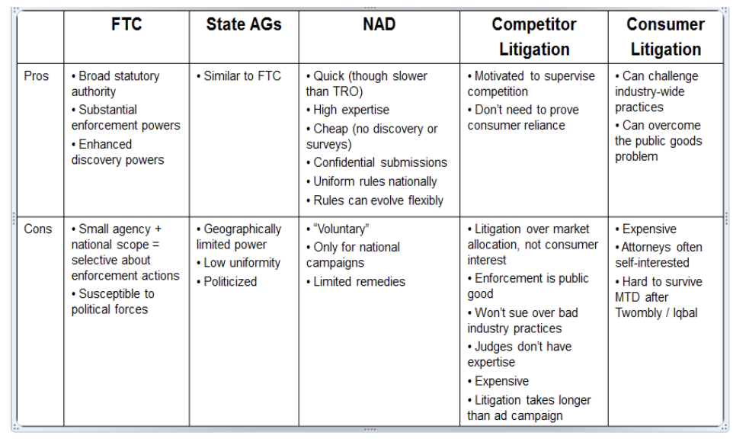
  - Regulating false / deceptive advertising
    - An advertiser’s false statement of fact (express or implied) can create competitive advantage
    - To avoid losing market share, competitors will respond with their own falsity / deception
    - If unchecked, competitors will try to out-fib each other
    - Consumers ultimately won’t believe any advertiser statements…
      - ...substantially increasing consumer research/verification costs
      - ...discouraging quality vendors from entering the market
    - False advertising law should prevent this downward spiral toward a “market for lemons”
    - Why not require truthfulness rather than prohibit falsity?
    - NOTE: The FTC used to only look at the packaging of your product for false or misleading claims. However, now they look at the totality of you product’s marketing materials: Ads, packaging, consumer reviews, social media content, websites etc. If you are a cosmetic company and you have a product for acne, to avoid scrutiny by FTC/FDA, you need to be sure that you do NOT say it treats acne and make sure no consumer reviews on your website state that it treats acne. Instead, need to market that it covers blemishes. Typically, FTC will not go after a company if a consumer posts therapeutic effects of product on their own website…UNLESS that consumer is being paid for or sponsored by the company! Also, note that when you are doing substantiation claims, you MUST test individuals comprising your target population!
  - Lanham act false advertising
    - Elements:
      - (1) a false or misleading statement of fact
      - (2) in interstate commerce
      - (3) in connection with commercial advertising or promotion
      - (4) that actually deceives or has the tendency to deceive an appreciable number of consumers in the intended audience
      - (5) that is material
      - (6) that is likely to cause injury to the plaintiff
    - What is a fact?
      - Fact = “specific and measurable claim, capable of being proved false or of being reasonably interpreted as a statement of objective fact”
      - Puffery = “(1) an exaggerated, blustering, and boasting statement upon which no reasonable buyer would be justified in relying; or (2) a general claim of superiority over comparable products that is so vague that it can be understood as nothing more than a mere expression of opinion” (Pizza Hut v. Papa John’s)
      - Rule of thumb: the more specific you are, the more it’ll be considered a fact (e.g. this is the best tomato sauce in LA). The less detail you give, the more likely it’ll be considered puffery (e.g. the best pizza ever)
    - Federal express v usps
    - Pizza hut v papa johns
      - The original Ads by Papa Johns would not have been considered false or deceiving because they only generally stated “Better ingredient, better pizza.” However, Papa Johns kept pushing it, and started suggesting that specific methods they employ are better than the competitors. The level of detail provided ended up inherently pointing to a specific competitor. As such, the courts ruled that these Ads were indeed false, misleading, and materially impacted consumer behavior. Were able to show that these ads indeed impacted consumer behavior
  - Falsity
    - When reviewing an ad…
      - EVERY BIT OF INFORMATION MATTERS!
      - Consumers have very heterogeneous perspectives!
    - Literally false claim = courts presume consumer deception
      - Ex: “fastest cure for headaches” when other solutions are faster
    - Implied false/misleading claim = not untrue claim that creates false net impression. Evidence (usually survey) required to show consumers got implied false message [not required with FTC/NAD]
      - Ex: “strongest medicine you can buy” when strongest ≠ more effective
      - “False by necessary implication” = consumers treat implied claim as if explicitly made
        - Ex: “More restaurants chose our food processor over competitor’s” when advertiser didn’t make professional-grade processor
        - Courts treat like a literally false claim
    - Substantiation = advertiser must have reasonable basis for claim before making it
      - Contrast non-advertising rules – advertising exceptionalism • Establishment claim (e.g. “tests show...”)
      - Advertiser must have amount/type of substantiation actually represented
      - Claim may be false if tests are bad science
      - Preference claims must be supported by adequate study/survey and reflect apples-to-apples comparison
    - Schick v. gilette
      - Claims:
        - Voiceover that razor changes beard hair angles = literally false
        - Animation showing hair extension = literally false
        - Claim that vibrations cause hairs to emerge = not shown as false (plaintiff did not meet burden of proof)
      - Note: Ad allowed in France, Belgium and Netherlands, but not Germany or Australia. Class action law suits in U.S. and Canada.
    - Special substantiation situations
      - Endorsements and Testimonials
        - Formerly “Results not Typical”
        - Now clearly & conspicuously disclose generally accepted performance in the depicted circumstances based on adequate substantiation
      - Scientific / Health Claims
        - Food or a drug (FDA authorization)
        - Health benefits (competent and reliable scientific)
        - Beware net impression
    - Likely mislead consumers
      - How
        - if consumers “receive” the message = understand what advertiser wanted them to believe, even if they aren’t deceived
      - Who = “reasonable” targeted consumer
      - How many = “not insubstantial number” (Lanham Act) / “substantial number” (FTC)
        - >20% favors plaintiff; <10% favors defendant
    - Materiality
      - Materiality = likely to affect purchasing decision
        - if advertiser makes the claim, it must think the claim matters to consumers
        - if it is related to an inherent quality or characteristic
        - if harm (but not required)
      - FTC presumes materiality when…
        - express claims
        - implied claims where seller intended to make the claim
        - omissions where seller knew that ordinary consumer would need omitted information to evaluate product/service
        - claims involve health/safety/similarly important matters
      - SC Johnson v Clorox
        - Glad had to modify ads because their ads misrepresented the rate at which ZipLoc bags leaked. These Ads were false and misleading, and were deemed to materially affect a consumer because the Ads specifically raise issued over a matter that a consumer would be interested in when purchasing a sealable bag (i.e. ability to keep contents in/out)
      - Ftc v. kraft
        - Alleged false implied claims:
          - slice of Kraft Singles contains same calcium as five ounces of milk
          - Kraft Singles contain more calcium than most imitation cheese slices
        - Material?
          - Health claim
          - Survey/expert evidence about calcium deficiencies
          - Intent
          - Increased sales + price premium
        - Kraft survey: only 1.7% would stop buying Singles if told how processing affects calcium content
      - Omissions
        - FTC Act (15 U.S.C. § 55(a)(1)): prohibits omissions that are “material in the light of [affirmative] representations or material with respect to consequences which may result from the use of the commodity to which the advertisement relates under the conditions prescribed in said advertisement, or under such conditions as are customary or usual”
        - Lanham and NAD
          - Not required to disclose all information consumers would find relevant
          - Advertisers may fail to correct a popular misconception unrelated to their own claims without fear of Lanham Act liability.
          - Omissions that lead to erroneous conclusions about claims made may be actionable in the courts or through the NAD.
        - Tire Kingdom, Inc. v. Morgan Tire & Auto, Inc.
          - A tire reseller may advertise that its tire is better than a cheaper tire due to its warranty without disclosing that the tires are the same in all physical respects.
        - American Home Products v. Johnson & Johnson
          - Drug manufacturer can advertise that hospitals trust its drug 10 times as much as the next four combined without disclosing that the manufacturer supplies it to hospitals at very low prices.
        - Church & Dwight Co. v. SPD Swiss Precision Diagnostics, GMBH
          - Taking advantage of well-known consumer lack of understanding about medical calculation of pregnancy duration was misleading
        - Gillette Co. v. Norelco Consumer Products Co.
          - Due to Norelco’s knowledge and failure to disclose the 2-3 week acclimation period, Gillette would likely succeed on its Lanham Act claim.
        - Literal Falsity:
          - Performance Indus. Inc. v. Koos Inc.
            - Omission related to efficacy per pound of product.
        - Misleading:
          - San Juan Star v. Casiano Communications, Inc.
            - Omission related to newspaper circulation frequency.
        - Apples to Oranges:
          - E.R. Squibb & Sons, Inc. v. Stuart Pharmacy
            - Omission of side effects.
        - State laws related to omissions set varying standards for disclosure requirement.
- The FTC Act and State UDAPs
  - The FTC and the FTC Act - no private right of action; only gov can bring action (lanham act is only for competitors, not consumers)
    - Created in 1914 re antitrust to prevent monopolies and protect competition in the marketplace
    - 1938 Wheeler-Lea Amendment
      - Section 5 (15 U.S.C Sec. 45)
      - “unfair or deceptive acts or practices”
      - False advertising in foods, drugs, devices, cosmetics
    - 5 Commissioners (max. 3 from Prez’s party)
    - No private right of action under FTCA
    - Section 13(b) injunctive relief and restraining orders – scope in question
    - Enforces FTCA, CANSPAM, COPA and more
    - 13(b) gives ftc remedies in the form of injunctive relief and restraining orders (ftc does not have power to fine companies unless there's a statute giving it that authority like CAN SPAM and COPA)
      - Injunctive relief = an order by the court to either do or refrain from doing certain activities (example: to no longer violate the law by doing the following things)
      - This is essentially what the consent orders apply; this is also why violation of a consent order = contempt
  - Commission authority
    - The FTC has a number of avenues for exercising its broad regulatory mandate:
      - CIDs and Settlements / Consent Orders.
        - Most common is to start with a CID (civil investigative demand), basically a subpoena asking target company to provide all info it has on a specific subj matter of interest to the ftc - full blown discovery is too expensive for both ptys
          - Failure to comply can result in administrative or federal proceedings to enforce (companies usually comply, sometimes there is some narrowing in scope)
          - Typically result in a consent order
      - Federal Court litigation.
        - If the company wants to dispute the ftc
      - Adversarial administrative proceedings to cease and desist unfair or deceptive practice, as well as opinions on practices pursuant to a final crase and desist order
        - fed judges and admin judges give substantial deference to the FTC esp regarding how a consumer would interpret something - ftc gets to step into the shoes of the consumer
      - Rulemaking.
        - Ftc has limited rulemaking authority
      - Public statements of enforcement policies / guides.
      - Formal and informal advisory opinions.
      - USSC to decide circuit split on scope of 13(b) power.
    - FTC deceptiveness authority
      - The FTC Act (FTCA) defines a “false advertisement” as
        - “an advertisement, other than labeling, which is misleading a material respect.”
        - Misleadingness determinations must take into account (among other things)[ § 55(a)(1)]:
          - representations made or suggested by statement, word, design, device, sound, or any combination thereof
          - the extent to which the advertisement fails to reveal facts material in the light of such representations or materials with respect to consequences which may result from the use of the commodity to which the advertisement relates under the conditions prescribed in said advertisement, or under such conditions as are customary or usual.
      - Also, advertisers must have sound substantiation for all claims BEFORE making them. 49 Fed. Reg. 30999 (1984) - Gov can go to an advertiser and ask for substantiation – consumers on the other hand, must show that the Ad is false
      - Key differences between ftc and private actors is that the burden is on the advertiser to prove any factual claims it makes and it must have had advance sound substantiation before making the claim
    - FTC unfairness authority
      - After a variety of controversies in the 1970s in which many politicians concluded that the FTC was overreaching itself, Congress codified a definition of “unfair’ designed to limit the FTC’s authority:
      - Unfairness requires that:
        - “the act or practice causes or is likely to cause substantial injury to consumers
        - which is not reasonably avoidable by consumers themselves; and
        - not outweighed by countervailing benefits to consumers or to competition.” § 45(n)
      - Data Privacy and Security / Evolving Technology:
        - What rises to unfair?
        - What constitutes harm?
        - How compared to benefits?
      - Apple case → childrens apps were buying upgrades in their games without parent consent in the 15 min window where you dont need to re enter pw to make charges
    - Rulemaking authority
      - Under the Administrative Procedure Act (APA):
        - agencies publish Federal Register notices of proposed rulemaking, and give interested persons at least 30 days to participate in the process
        - The proposed regulation interprets and implements the authorizing statute, and when it becomes effective, rules have the force of statutory provisions and receive great judicial deference
        - By contrast, rules issued under the APA procedure will only be overturned if they are arbitrary or capricious.
      - The Magnuson-Moss rulemaking procedure for the FTC, 15 USC § 57(a) contains more hurdles:
        - Practice is “prevalent” - they do this by bringing a series of CIDs to which they obtain consent orders and then they take all of the consent orders to show that a practice is in fact prevalent
        - The statute demands a much more detailed public notice, comment, and hearing process.
        - Rules issued under Magnuson-Moss can be overturned by a court if the rulemaking was not supported by "substantial evidence" that the regulated unfair or deceptive practice is prevalent in the market.
    - Staff Reports, Commission Reports, Policy Statements, Guides
      - Easier to enact than regulations / rules
      - Workshops and public comments
      - Not “law” but
        - Recommendations / best practices
        - Expression of what FTC thinks would be unfair or deceptive
      - USSC says FTC gets only “some deference” and depends on demonstrated expertise, reasoning, and consistency
        - It depends on the totality of the circumstances. In the Apple case, for instance, the court gave deference to FTC findings likely because a vulnerable population was targeted (children) and the activities spanned across multiple states
    - FTC Common Law
      - Consent Orders – merely fencing in of single actors in a settlement of claims
        - Consent orders aren't court decisions; they're essentially settlement agreements; a contract between the gov and a company
          - Involve concept of fencing in where company agrees to more than whats required by the law
          - Because its a settlement agreement, the ftc can require a company to agree to things that the law does not require
        - So are consent orders a kind of common law? Does it have the same weight as law?
          - Some people say yes some say no bc there is no statutory authority for that and there's no precedential value
          - Concept of fencing in becomes problematic here because if consent orders are given precedential value, then ftc is exercising broader rulemaking powers than it is allowed to
      - Guides and Reports not law and only entitled to limited deference
      - Sanfield v. Finlay Fine Jewelry (7th Cir. 2001)(starting point not ending point in Lanham case)
      - But see FTC and New Common Law of Privacy, 114 Columbia Law Review (2014) (http://ssrn.com/abstract=2312913)
    - Example of guides: endorsement and testimonial guides - endorsement/testimonial is an advertising message of an individual/org that consumers are likely to believe reflect the beliefs of that party
      - The FTC’s Guides Concerning the Use of Endorsements and Testimonials in Advertising (16 C.F.R. Part 255), designed to clarify the FTC’s Section 5 powers, define an “endorsement” and “testimonial” (the FTC equates the two as:
        - Any advertising message (including verbal statements, demonstrations, or depictions of the name, signature, likeness or other identifying personal characteristics of an individual or the name or seal of an organization) that consumers are likely to believe reflects the opinions, beliefs, findings, or experiences or a party other than the sponsoring advertiser, even if the views expressed by that party are identical to those of the sponsoring advertiser.
      - Endorsements must reflect the endorser’s actual beliefs or experiences
      - Endorsers may not make representations that would be deceptive if made by the advertiser
      - If the ad copy says an endorser uses the product, that must be true
      - If the ad copy represents that the endorser is an expert, the endorser must have the requisite qualifications; and
      - The advertiser must disclose any unexpected connections with the endorser that would affect the endorsement’s credibility
      - Must clearly and conspicuously explain typical results
    - What’s a “material connection”?
      - Employees, contractors and spokespersons have a material connection because they are all paid.
      - Merely giving a blogger free products to sample and write about or sweepstakes entries to consumers each time they Tweet may also be enough to trigger disclosure requirements.
      - The FTC (and the UK’s OFT) have initiated investigations and enforcement actions against companies that gave gift bags to bloggers attending an advance product demonstration, paid for blog posts, and gave sales lead commissions to bloggers that linked readers to an e-commerce site – all where the bloggers failed disclose they got something of value from the company.
      - When we see celebs in a commercial, we know they're being compensated. It gets fuzzy with influencers because they are not always hawking products
      - How material does the connection need to be? Getting paid 100k is obviously material; but what about free products? Free trips? Ftc’s updated guides give examples
      - Why are journalists treated differently than influencers? There are journalistic standards that prohibit journalists from accepting compensation for what is purported to be objective. blogs/social media platforms are known to be a place for peoples unique opinions
      - Journalists don't have to disclose free samples but bloggers do
    - How to disclose…
      - In recent guidance regarding online and mobile disclosures, the FTC warned that notice using icons and abbreviations, such as in Twitter, would be inadequate if the meaning was not clear to consumers.
    - Guidelines require companies to train and monitor those that speak for the company and take corrective action when violations occur
      - In social media promotions it is not practical for the company to review and select or approve the messages its social media influencers are making.
      - The FTC will nonetheless hold the company liable if its influencers fail to make the required disclosures or if they make false, misleading, atypical or unsubstantiated claims.
      - To minimize the risk of this happening, companies need to educate their influencers on what the law requires and how to comply, require them to follow these rules, make reasonable efforts to monitor them and take appropriate corrective action for violations.
        - Holding back half compensation until after the ad runs so that you can ensure that the right disclosures are given
        - What about bonus posts? Depends on the amt of time between agreed upon posts and the bonus posts, but they probably need to require disclosures as well. Esp if its under contract and also if the influencer is likely to be trying to garner a good relationship with the company
    - Maintaining a good social media policy, which influencers are contractually obligated to follow, may help to stave off liability.
      - Although the FTC has stated that having a good social media policy and compliance program is not a safe harbor, it has shown that it takes such efforts into account in exercising prosecutorial discretion.
    - But look what happens when agencies collide…
      - To avoid running afoul of the FTC’s requirements, many companies have simply prohibited employees from using social media to talk about the company or its products or services absent company review and consent.
      - However, the National Labor Relations Board has been very active in prosecuting companies taking this approach for illegally restricting an employees’ right to organize and to speak about the conditions of their work and workplace.
        - The laws protecting employee rights are even more protective of employee speech in Europe.
    - Example of rule enforcement: tashman
      - Franchise / Bus Oppty Rule
      - USDC judgment in favor of defendants reversed
      - No basis for claims = likely to mislead customers under the circumstances
      - Dissent: FTC failed to show lack of reasonable basis for claims – the reg’s stated standard
    - Example of reigning in the FTC: POM
      - Health claims case
      - FTC attempted to apply “new standard” for food and dietary supplement claims developed via Nestle and Lovate Consent Orders
        - Double Blind Clinical Studies
      - POM: contrary to 20 years of FTC food advertising rules and regulations ... and FTC would need to engage in formal rulemaking to make these changes...(D.DC 2010)
      - How did the ALJ rule?
    - Case study: MLM and Bus Oppty Rule
      - Amway (1975-79)
        - Unprovable claims about income
        - Encouraged to buy and not necessarily sell
        - Reforms:
          - Hypo Profits: explain average profits
          - 70%: distributors to sell 70% of products purchased
          - 10 customer: one sale at retail to at least 10 customers
      - 2004 Advisory Opinion:
        - amount of internal consumption in a MLM does not determine whether it’s a pyramid scheme
      - 2011 Rejection of MLM additions to Bus Oppty Rule
      - 2013 NCL Complaint against Herbalife
      - 2016 Herbalife Settlement – self use
    - State consumer protection laws
      - Lack of faith in FTC in ’60s/70s, rise in consumer advocacy and difficulty in winning contract and fraud claims lead to:
        - UDAP “little FTC” statutes
        - AG or private right of action
        - Statutory damages
        - Trend now to reign in with causation/harm/public interest requirements
        - Cy Pres / charitable and Atty Fees issues
        - AGs authority
      - Case study: CA privacy laws
        - Original CA OPPA
        - CA AG Mobile Report
        - Develops platform provider pact
        - Warning Letters / Delta Case
        - 2013 CA OPPA Amendments
        - Shine the Light
        - CCPA
        - CPRA?
- Disclosures; advertising in evolving media
  - Disclosures
    - Space, time, and creative direction all limit the amount of factual information and advertisement can communicate
    - Solution is small type at bottom of screen or rapid fire narrative at end of commercial
    - An effective disclosure is CLEARLY WRITTEN and PROMINENT
    - Written disclosures or fine print may be ineffective to correct a misleading representation
    - Disclaimer won’t remove the deceptive effect of a literally false claim. Why? Because you’ve already intentionally misstated a property of the product, service, etc. and no additional disclaimers could cure this defect or initial confusion. The initial confusion has already sufficiently misled the consumer into a purchasing action. An example of this is drip pricing with hotels.
    - Whereas as Lanham act claims can be cured through disclaimers, rights of publicity claims cannot. Why? Because it does not matter if you confuse a consumer under rights of publicity, because you’ve misappropriated the celebrity’s property rights
    - Can’t use disclaimers to change the ordinary meaning of your claim
    - General distrust of small print disclaimers for important qualifications that change the meaning of the claims made in the main message
    - Scholars argue that these misleading Ads can usually be written very simply, easily, and in a cost-effective way
    - Disclosures must be CLEAR and CONSPICUOUS
      - Section 5 of the FTC ACT
    - Bad disclosures = small, inconspicuous portions of lengthy descriptions hidden away in places that only the most meticulous consumer would spot
    - Claim limitations/qualifications must be “clear and conspicuous”
      - Prominence = big/loud enough to be noticed?
      - Presentation = understandable?
      - Placement = in a noticeable place
      - Proximity = close to claim
    - Disclosures can’t reverse the claims
      - Ex: “Unlimited* cellphone minutes” where * says “Limits apply”
    - Same space and time as claim it modifies – some media not appropriate for some claims
    - Technically a max of how many words can be shown per minute in a disclosure (180 words per minute)- but many break this
      - This really depends on what is the content/purpose of the disclosure is- like they are easier on stuff like a car lease stuff written below
      - Too short- overly general, ambiguous
      - Too long- causes consumer to tune out
    - Criticisms & Praise for Mandatory Disclosures
      - More info is always better
      - Disclosures are ineffective because consumers don’t pay attention to them
      - Some say they almost never work because of the flawed incentives of the regulators
      - Gov attempted to define certain terms, but gov control goes much farther
    - Prof’s commentary:
      - Think about materiality of the disclosure (info the consumer would want or need to know in order to prevent a misleading impression)
      - Disclosure can’t cure a false message
      - Frequently regulated terms- like car lease; will be more tolerance for mouse print (v small print)
      - 1st amendment- have to balance free speech against the harm
        - Ex: smoking- “this product will kill you”, advertisers don’t want to say that but the government is making them
    - Given context, must be readily understood
    - Some Rules and Laws require disclosures and disclosure specifics
    - Lanham Act: converts literally false to
ambiguous / potentially misleading (issue of fact)
    - .DotCom Disclosure Guides (2000 / 2013): if disclosure necessary and cannot be effectively made change the claim or the medium
    - .Com Disclosures
      - Clear and conspicuous, shouldn’t be separate disclosures
      - Prominence & proximity should be as close to the topic as possible
      - They assume people won’t read the whole site; take different devices into consideration; evaluate color, sizing, graphics
      - Avoid trying to use hyperlinks for disclosures
        - If you need to use one, link directly there not a main page with the different disclosures
      - Audio- volume & pace should be so that consumers can understand
        - For podcasts & videos, in the description is not enough. They want the disclosure before the video or recording, not at the end
  - Digital advertising
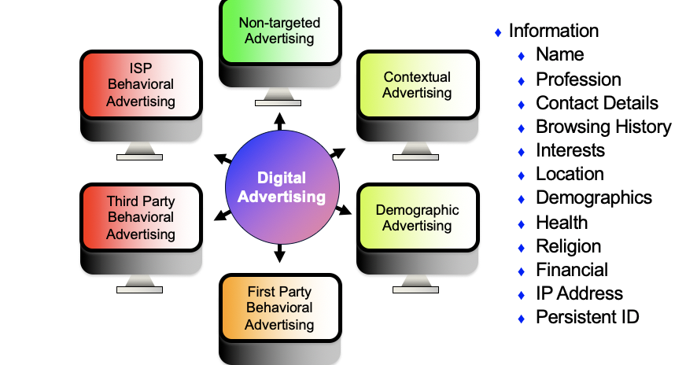
    - First party behavioral advertising

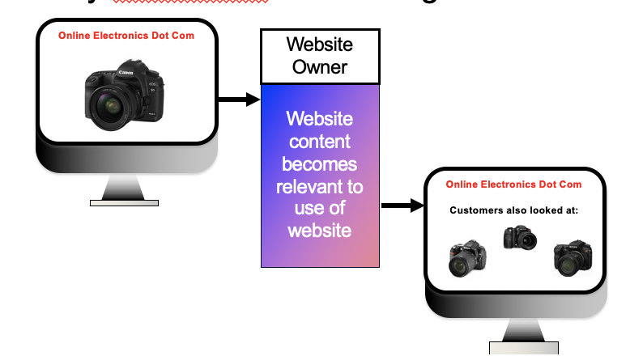
    - Third party behavioral advertising
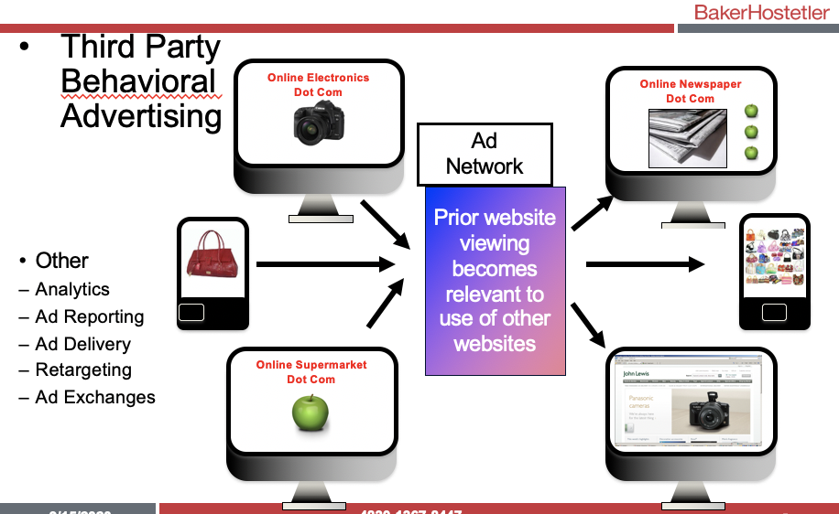
    - What choice should consumers have
      - FTC Do Not Track Proposal:
        - There should be a universal setting similar to a persistent cookie on a consumer’s browser and conveying that setting to sites that the browser visits, to signal whether or not the consumer wants to be tracked or receive targeted advertisements. To be effective, there must be an enforceable requirement that sites honor those choices.
      - CA OPPA Amendments:
        - Must disclose how respond to DNT signals, if collect PII & track across time and 3rd party sites
        - Must disclose if other parties collect PII
        - Device ID = PII (according to AG)
      - CCPA (1/1/20):
        - Broad definition of Personal Information
        - Transparency
        - Rights to delete
        - Transportability
        - Do Not Sell
      - Key defenses for Do Not Track Claims
        - Harm
          - Article III Standing
          - Economic Loss under the ECPA
        - Consent
          - Privacy Policy
          - Terms of Use
          - Hyper Notice
        - Class action waivers via mandatory arbitration - The federal arbitration act preempts state law that favors arbitration – thus potentially overriding individual state arbitration clauses which look to prevent class actions
        - The few successful do not track cases were brought under theory of wiretapping and other tort laws
      - DAA disclosure/opt-out
        - FTC can regulate deception and unfair practices, but they do not have authority to require advertisers to allow consumers to opt out of tracking. As such, FTC has produced recommendations to encourage self-regulation, but has warned that it would seek legislative action from congress if companies do not self-regulate. In order to create law, the FTC would have to show a long history of deception in a certain area.
        - Hyper-notice and opt-out for OBA
        - DAA / BBB enforcement actions
        - Do not target not do not track
        - New Mobile Self-regulatory program
      - DAA self-regulatory principles
        - New Guidelines explain how the DAA’s Online Behavioral Advertising Principles (“OBA Principles”) and Multi-Site Data Principles (“MSD Principles”) apply in the mobile environment to companies covered by the principles. DAA working with DAA stakeholders to develop and implement a companion or choice mechanism for Cross-App data. Once operational the guidelines will apply.
        - The Education Principle calls for organizations to participate in efforts to educate individuals and businesses about online behavioral advertising and the Principles.
        - The Transparency Principle calls for clearer and easily accessible disclosures to consumers about data collection and use practices associated with online behavioral advertising.
      - DAA self-reg principles
        - The Consumer Control Principle provides consumers with an expanded ability to choose whether data is collected and used for online behavioral advertising purposes. This choice will be available through a link from the notice provided on the Web page where data is collected.
        - The Consumer Control Principle requires "service providers", a term that includes Internet access service providers and providers of desktop applications software such as Web browser "tool bars" to obtain the consent of users before engaging in online behavioral advertising, and take steps to de-identify the data used for such purposes.
        - The Data Security Principle calls for organizations to provide appropriate security for, and limited retention of data, collected and used for online behavioral advertising purposes.
        - The Material Changes Principle calls for obtaining consumer consent before a Material Change is made to an entity's Online Behavioral Advertising data collection and use policies unless that change will result in less collection or use of data.
        - The Sensitive Data Principle recognizes that data collected from children and used for online behavioral advertising merits heightened protection, and requires parental consent for behavioral advertising to consumers known to be under 13 on child-directed Web sites. This Principle also provides heightened protections to certain health and financial data when attributable to a specific individual.
        - The Accountability Principle calls for development of programs to further advance these Principles, including programs to monitor and report instances of uncorrected non-compliance with these Principles to appropriate government agencies.
        - Mobile Guide recognizes that it may not be possible to comply with all the Principles in the mobile environment in the same manner as on computers.
        - Notices should be clear, meaningful and prominent, especially if can’t appear where the data is actually being collected.
        - Transparency is key (type of data, use of data, way to exercise choice)
        - Notice of practices before installation AND in-app
        - Precise Location Data – Requires clear, meaningful and prominent notice of transfers, collections or use.
        - Notice should include – fact that the data is transferred or collected; instructions for withdrawing consent; use of data; and acknowledgement that adhere to the Principles.
        - Enhanced notice should be provided by First Parties if transferring the Precise Location Data to Third Parties or if Third Parties are using the data
        - Mobile Guide also addresses consent for access to Personal Directory Data
    - What laws apply to marketing in evolving media activities

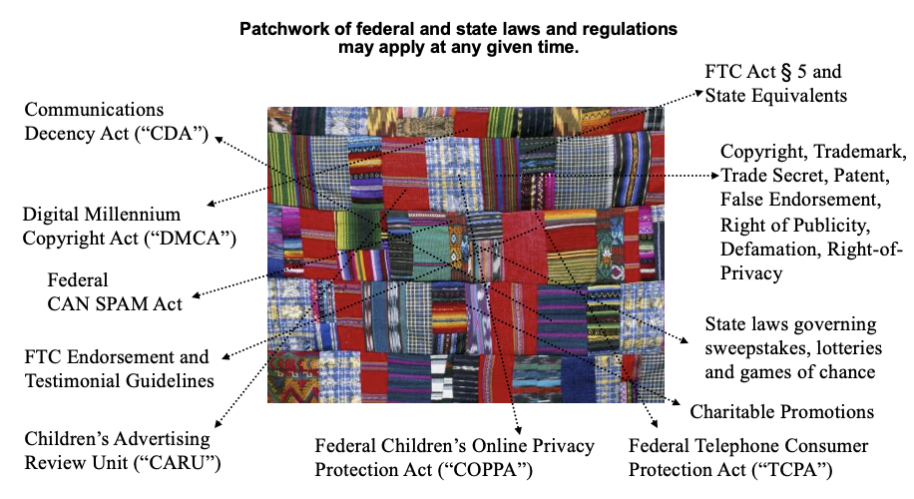
    - Sweepstakes Rules
      - Necessitates 2 things: 1) compliance with state laws on contests and sweepstakes; 2) releases from winners so you can use their name and likeness and also waive rights to sue if they die or get injured during the trip/activity they won
      - What is difference between a contest, sweepstake, and lottery? A lottery has 3 elements: 1) prize, 2 ) chance, 3) consideration. This is similar to gambling. Companies that advertise a product cannot hold lotteries. As such, during any promotion when they are looking to give something away, they must eliminate at least one of the 3 elements from a lottery. They are never going to eliminate prize, so they either eliminate chance (by making the promotion a contest which requires more than skill), or they eliminate consideration (e.g. by making entry into the promotion free).
      - How do they eliminate consideration? There must be an equal and free way of entering the promotion to match any way of entry which requires purchasing of a product.
    - Federal FTC act § 5A and state equivalents apply in evolving media too
      - Prohibits “unfair or deceptive acts in or affecting commerce.”
      - Gives the FTC authority to regulate commercial advertising, including commercial web sites and mobile content.
      - Any misleading statements in:
        - marketing materials
        - public statements
        - privacy policies
        - online and offline registration forms
        - press releases
        - advertising copy
        - social media posts
      - could result in FTC enforcement action.
      - Nike was sued in violation of California’s false-advertising laws for false Nike's public statements of its labor policies. Nike paid $1.5 to the Fair Labor Association (FLA) for “program operations and worker development programs focused on education and economic opportunity.”
    - Federal CAN-SPAM Act 15 USC §7701 et seq
      - Regulates sending of commercial e-mails
      - Impacts all e-mail marketing activities, including send-to-a-friend e-mails and sending e-mails in conjunction with third party promotional partners.
        - Does not necessarily prohibit sending of unsolicited commercial messages
        - E-mails must include:
          - Mailing Address
          - Link to Unsubscribe
          - Identify the Sender
          - Accurate Subject Matter
        - Consider opt-in to receive marketing materials:
          - Yes, I want to receive promotional offers and updates.
          - Must provide opt-out and maintain a Suppression or “Do Not Send” List
        - Must scrub against FCC mobile domains
      - Beware of e-mails with multiple senders
      - FTC actions are frequent with fines typically in the six figures.
    - Federal Telephone Consumer Protection Act (“TCPA”) 47 U.S.C. § 227. et seq.
      - Regulations and penalties against spamming by phone or text are stiff because unlike digital advertising, phone calls and texts can be much more intrusive and can cause the consumer economic harm (e.g. data overage charges)
      - Prohibits sending commercial text messages to wireless devices without express prior consent from recipient
        - $500 in statutory damages per violation or actual damages, whichever is greater
      - Carriers/industry self regulators also have rules
(see www.mmaglobal.com/mobile advertising)
      - Class Action Activity
        - Violators have faced class action claims
          - Jiffy Lube $48 million settlement
      - Responsible for vendors/partners
      - Don’t run send-to-a-friend
    - Digital Millennium Copyright Act (“DMCA”) - 17 U.S.C. §512
      - UGC often contains copyrighted materials (background music, pictures, videos).
      - DMCA Safe Harbor - Affords web site operators certain protections from copyright infringement claims where web site operator allows third parties to post content on its web site.
      - Company must register a Copyright Agent with U.S. Copyright Office
        - Company must follow statute’s notice and take down requirements and bar repeat offenders
        - Company can lose safe harbor protection if it receives a financial benefit attributable to the infringement and has the right and ability to control the content
    - UGC – Communications Decency Act (“CDA”) – 47 U.S.C. Section 230
      - CDA affords web site operators and users certain protections from some types of tort claims when third parties post content on web sites
        - To claim immunity, content must be created/provided by a third party.
        - Permissible to block/filter/remove “obscene, lewd, lascivious, filthy, excessively violent, harassing or otherwise objectionable content”.
        - No immunity for IP infringement.
        - Courts are split on rights of publicity.
        - No immunity for your content and risk loss of immunity if you go beyond traditional publisher functions of reviewing, editing, selecting, etc.
    - E-commerce
      - Contract of adhesion – a contract that is procedurally and substantively unconscionable. Any terms and conditions in a contract must be conspicuous and clear to be enforceable.
      - In e-commerce, it’s preferable to also have a user perform an active step to show that they have read and understood the contract. This will typically involve the clicking or unclicking of a button to indicate acknowledgement and acceptance of the terms
      - Forming an electronic agreement
      - Mail Order Rule
      - Terms of Service/Terms of Sale/EULA
      - Return/Shipping Policies
      - MAP
      - Arbitration/Terms of Use
      - Payment processors
      - EU Directives
    - License or stored value?
      - Sale and reselling of codes and credits for access to digital content
      - Measure of a license
        - For specific access or downloads
        - Term, revocable
        - No cash value
        - EULA
      - Stored Value, Gift Cards, Prepaid Access
        - AML
        - FinCEN
        - Reg E
        - Eschaet
        - CARD Act and state gift card laws
        - Money transmitter laws
        - Most states prevent money from gift cards from being lost/reclaimed by issuer after a period of inactivity. A way companies get around this is by offering non-monetary gift cards (e.g. points that can be used for purchasing items, e-currency, etc.). However, if a company chooses this approach, they can NOT EVER equate a certain value of points to a certain dollar value
    - Gift cards
      - The Federal Credit Card Act amends the Electronic Funds Transfer Act by implementing federal regulation of general-use pre-paid cards, gift certificates and store gift cards. The law addresses three key areas:
        - dormancy fees, inactivity charges and service fees;
        - expiration dates; and
        - the relation to state laws.
      - Almost every state has its own regulations that apply to gift cards as well.
      - And don’t forget:
        - AML
        - Escheat
        - Banking and money transmitter regulations
    - Social media and marketing
      - Social media has changed the way people communicate, and enabled brands to directly engage with consumers
      - Innovative campaigns can include:
        - user-generated content
        - text messaging
        - Twitter messaging
        - Facebook applications
        - Blogging
        - viral marketing
        - “social ads” “sponsored stories” “likes”
      - The tech-savvy marketing professionals entrusted to do so are often unaware of the complex legal overlay of the digital world and the potential pitfalls for their company’s failure to comply.
    - Companies may be responsible for what their customers, employees, celebrity spokespersons and contractors say about them in social media.
      - FTC Endorsement and Testimonial Guidelines address use of social media to promote a company or its products or services.
      - In the U.K. the Advertising Standards Authority and the Office of Fair Trading (“OFT”) take a similar approach.
      - If a material connection between the speaker and the company, it must be disclosed in a clear and conspicuous manner proximate to the message.
    - Do’s and Don’ts
      - What not to do: 5/6/11 Allure Beauty to Bloggers: “…we send new and interesting products to a select group of bloggers…we ask you to follow our mother’s philosophy that: ‘if you can’t say anything nice, don’t say anything at all.
      - What to do:
        - Have a social media policy and contractually require compliance
        - Educate
        - Monitor
        - Take corrective action
      - How would you deal with “social ads”, how should they be disclosed to those mentioned and to those viewing the ad?
        - Is it a testimonial?
    - Terms of Use/Sale and EULAs
      - Terms
      - Clickwrap / browsewrap
      - E-sign
      - Layers - FTC encourages this. Generally, this involves placing on the front page of the contract a summary of the various terms and conditions that are contained in the contract with links to the specific sections. This allows a user to read the first 1-2 pages of a contract and generally know what they are agreeing to.
    - Rights
      - Limited license to user
      - Broad license to publisher -broad license as opposed to grant of full rights is preferable because if a publisher takes full rights it will lose the DMCA and CDA safe harbor protection which protects it from 3rd party content which violates certain policies
      - License to other users
      - Collaborative content
      - DMCA notice and takedown
    - Operational
      - Guidelines and use restrictions
      - Accounts / Profiles / Featues
      - Terms of Sale / Subscription
      - Digital Items / Virtual Currency
      - How to change terms - can’t be changed retroactively. However, you can place users on notice that all new changes to policies will be posted on a particular site and it’s up to users to stay up to date on the new terms of use
      - Questions / customer service
      - Links
      - Third-party ads / services / iOs
      - “Additional Terms” (e.g. contest rules, refund policies, warranties)
    - Protective
      - Reps and warranties
      - Limited warranty
      - Limitation on liability
      - Arbitration and class action waiver
      - Waiver of inj / equitable relief
      - Ability to change / discontinue services
      - Incorporate Privacy Policy
      - Indemnity
    - Insurance and indemnity in general
      - Insurance available for Cyber/Privacy Risk and Advertising Practices
      - Companies should consider if they have coverage for
      - IP infringement
      - Advertising injury
      - Consumer privacy claims/class actions
      - Governmental investigations
      - Indemnity obligations if indemnifying others for mobile or online targeted advertising campaigns
      - Penalties & fines
      - Indemnity/insurance obligations from and to others
      - Consider obtaining indemnity from their vendors and request minimum insurance
      - Are you required to indemnify?
- Competitor Claims – Self-regulatory and Lawsuit (input ppts)
  - The NAD, FTC, CARU proceedings are the regulatory agency’s ways to regulate advertisement without getting courts involved. Why would one want to avoid courts? 1) costs less to avoid court litigation; 2) faster end date; 3) no one knows each-other better than competitors - so these proceedings are a good way to remove players who do not understand ad law or products in question. What are the pitfalls? Proceedings do not have the power of law because they are not recognized as binding since the discovery process in these proceedings is not as rigorous as discovery in litigation.
  - The Lanham act - main avenue by which competitors bring actions against each other for false ad
    - TLRA also broadened the Lanham Act language to clarify that virtually any type of false advertising or promotional claim may be actionable.
    - 6 factor inquiry to determine a Lanham act violation. P will prevail when there is:
      - a false or misleading statement of fact,
      - in interstate commerce (this element is almost always satisfied and rarely contested),
      - in connection with commercial advertising or promotion,
      - that actually deceives or has the tendency to deceive an appreciable number of consumers in
      - the intended audience,
      - that is material, and
      - that is likely to cause injury to the plaintiff.
    - False messages vs misleading messages
      - false messages = claims that are simply untrue on their face
      - misleading messages = claims that are technically or literally true, but whose ambiguities lead reasonable consumers to draw mistaken inferences.
      - A plaintiff has a substantially easier time prevailing against a false statement than a misleading one, in large part because courts require evidence that consumers are actually deceived by misleading statements, usually with a consumer survey.
  - BBB/ASRC/NAD (self regulation)
    - Quicker and cheaper than court if you go through one of these self regulation agencies
    - The staff lawyers are versed in ad law and the issues / more expertise bc its an industry org
    - They develop industry standards re substantiation for certain products
    - advertising Self-Regulatory Council (ASRC), part of the Better Business Bureau (BBB), oversees the National Advertising Division (NAD) and other divisions focusing on children’s advertising and direct-response advertising.
    - NAD provides a venue to adjudicate competitor disputes as an alternative to Lanham Act lawsuits in court.
      - Like the FTC and unlike the Lanham Act, the NAD requires substantiation from advertisers. Moreover, like the FTC, NAD staff attorneys often rely on their own expertise to determine that an ad is likely to deceive consumers; consumer surveys are not required, and discovery is not available. Thus, the NAD can be substantially cheaper and quicker than litigation in federal court.
      - NAD cannot compel anyone to participate in its adjudicative process / comply with its decisions. If an advertiser declines to participate, or refuses to change its advertising after an adverse decision, NAD closes the case. The challenger then must seek redress elsewhere (ie. lawsuit). NAD then notifies the FTC when a business refuses to participate in its proceedings, and the FTC pays close attention to such referrals.
      - NAD only evaluates national ads i.e., “if it is disseminated nationally or to a substantial portion of the United States, or is test market advertising prepared for national campaigns.”
      - NAD defines “advertising” broadly, including product labels
    - CARU is a part of NAD and it reviews children's advertisers
    - NARB is like the appellate court
    - Why WOULDN'T you want an NAD case? When its not brand v brand / if you have a really bad actor and you know they won't cooperate / if you need an injunction / if you want damages
    - Rules of evidence dont apply
  - Bruce prez - the role of surveys in litigation
  - Lanham act false advertising
  - Lanham act standing
    - 4 sep circuit standards for standing - no uniformity → venue shopping
    - 1125(a): standing = “any person who believes that he or she is or is likely to be damaged”
      - “any person” ≠ consumers
    - Categorical approach: direct/actual competition suffices
    - Conte Bros. balancing approach: Is it an injury Congress sought to protect via 43(a)?; Injury directness; Proximity to conduct [is an identifiable group more likely to bring a 43(a) enforcement?]; Speculativeness of damages; Duplicative or overly complex damages?
    - Lexmark case (Zone of interest and Proximate Causation tests)
      - This case is key for understanding what type of entity constitutes a competitor for purposes of bringing a Lanham Act case.
      - 2014 Scalia opinion settles circuit split. SC rejects the Multifactor Balancing Test from Conte, the Categorical Test (Direct competitors), and the Reasonable Interest Test.
      - SC adopts a new standard: Commercial interest in sales or business reputation (zone of interest) and Damage proximately caused by defendant’s misrepresentations
  - Consumer surveys
    - Battle of the experts - attacking the cred of the expert or the study/survey (aka bruce, who crafts objective questions that wont lead or skew results)
    - Standards for admissible / persuasive surveys: Universe properly defined; Sample properly chosen; Questions clear and not leading; Survey conducted by qualified persons following proper procedures; Data were accurately reported; Data analyzed in accordance with accepted statistical principles; and Process was conducted objectively (interviewers unaware of purpose)
    - Red Wing case
      - key case for testing the validity of a survey in a step-by-step fashion.
    - Another example is the “reader’s digest survey” in the 1920s which, although targeted 2 million people, only asked people who owned a car and subscribed to reader’s digest. This sample tended to skew towards richer and literate people, and did not consider a huge demographic of the population. As such, the survey grossly overestimated that Roosevelt would lose the election…he did not.

- Remedies Overview
  - Injunctions
    - TRO/Prelim Injunction factors:
      - (1) strong likelihood of success on the merits
      - (2) irreparable injury without injunctive relief
        - Irreparable = can’t be fixed by money damages (IDT v. CVT) • Historically presumed
• eBay v. MercExchange
      - (3) if injunction will substantially harm defendant
      - (4) public interest
    - Permanent injunction factors:
      - (1) remedies at law are inadequate
      - (2) irreparable injury
      - (3) balance of hardships
      - (4) public interest
    - Types of injunctions
      - Prohibition of further dissemination of false advertising
      - Corrective advertising/consumer education
      - Product recall/destruction
    - Lanham Acts Defenses to Equitable relief:
      - Delay/Laches
      - No express statute of limitations (but sometimes imported from analogous claims)
      - Unreasonable delay can bar preliminary relief; and possibly permanent injunctions if defendant prejudiced by the delay
      - Acquiescence
      - Mootness
      - Unclean hands
  - Money Damages
    - 15 U.S.C. §1117: “(1) defendant’s profits, (2) any damages sustained by the plaintiff, and (3) the costs of the action”
      - Courts often require demonstrated evidence of consumer deception
      - Defendant’s profits
        - Courts may require scienter before awarding
        - Typical formula: plaintiff must show revenues attributable to false advertising, then defendant must show allowable deductions
      - Plaintiff’s damages
        - Ex: diverted sales, reduced prices, goodwill harm, counter-advertising
        - Treble damages possible
        - No double-dip
      - Costs
    - Punitive damages = not available under Lanham Act
    - Attorneys’ fees = discretionary in “exceptional” cases
- PROMOTIONAL MARKETING
  - Sweepstakes, contests, and promos
    - Regulated by lottery, gambling, promo, sweepstakes, games of chance and/or contest laws from all 50 states and fed law
    - Lottery = prize, chance, consideration
      - Illegal in all 50 states under federal law
    - Sweepstakes includes chance and prize and eliminates consideration
    - Contest eliminates chance
      - Requires element of skill
    - Prize is anything of tangible value, even if nominal (not bragging rights)
    - Premium promotion eliminates chance
  - Coupons
    - In general, coupons must comply with the ordinary rules requiring ads to be truthful and non- misleading, with specific attention to price claims and, where necessary, to the regulation of the use of “free” by the FTC and state laws.*
    - false advertising law constrains coupon offers, and the advertiser must disclose material conditions
    - Martin v. Coca-Cola Co. → Coca-Cola put an ad on bottles of Diet Coke: “Save 25 cents on your next purchase of a 2 or 3 liter bottle or multi-pack of Coca-Cola products with coupon on back of label.” But the coupon was only good for twenty-five cents off Diet Sprite or Diet Minute Maid soda. The court deemed the plaintiff’s argument that this was deceptive “preposterous.”
    - In re Kentucky Grilled Chicken → class action against KFC and parent company Yum!
      - Ds promo’d new product “kentucky grilled chicken” as a healthier option
      - Campaign giveaway announced by Oprah on her talk show. Pursuant to the terms of the giveaway, any individual could obtain a free meal at KFC by first downloading a coupon from either unthinkfc.com or from Oprah’s website and then redeeming the coupon at a participating KFC franchise between May 5, 2009 and May 19, 2009, with the exception of May 10, 2009 (Mother’s Day). When presented at a KFC restaurant, the coupon entitled the bearer to a free two-piece “Kentucky Grilled Chicken” meal, with two sides and a biscuit.
      - Ds “began almost immediately to refuse to honor the coupons.” At first they did so by “limit[ing] the promotion to the first 100 coupons presented at each KFC restaurant, per day.” On May 7, Ds “stopped the promotion altogether . . . [and] instructed franchises to stop honoring the coupons.” Many of the KFC locations that refused to honor the coupon continued to offer “Kentucky Grilled Chicken” for purchase. From May 5 to May 7, at least 10.2 million coupons were downloaded and only 4.5 million coupons were actually redeemed at KFC franchises.
      - Ds then offered consumers the option of applying for a “rain check” for the promised free meal. To apply for a “rain check,” the consumer was required to fill out a form with the consumer’s name and address, attach his or her coupon to the form, and mail the form to KFC or give it to a KFC team member. Ds told consumers these procedures were necessary “so that KFC could verify the coupons’ validity.” Following receipt of the “rain check” app, KFC would then send the consumer a new coupon for a free meal at a later date, as well as an additional complimentary Pepsi product. . . .
      - On the issue of fraud - Ps allege in their Master Complaint that “Defendants, in fact, never intended to honor the Coupons as represented.” the court finds it plausible that Ds never intended to honor the coupon as represented. It can be reasonably inferred from Ds choice to publicize their offer “on the highly popular ‘Oprah’ show” that Ds hoped their promotion would reach millions. It is also reasonable to assume that Ds contemplated the possibility that millions of consumers would seize the opportunity to obtain a free meal, and that Ds considered what would happen if KFC restaurants ran out of the product. these considerations in mind, the court finds that it is plausible Ds intended all along to offer a “rain check” in place of the coupon, or otherwise limit redemption of the coupon beyond the terms stated on its face.
      - On issue of consumer protection - Because Ps alleged that Ds never intended to honor their promotion, Ps allegations “involve [ ] more than the mere fact that a d promised something and then failed to do it.” this court finds that the K at issue in this litigation implicates an “inherent consumer interest” on its face, insofar as Ds offer was accepted by millions of consumers. For these reasons, the court declines to dismiss Ps § claims as being redundant to the claim for breach of K
        - Because the “Kentucky Grilled Chicken” giveaway can reasonably be considered an attempt “to induce directly or indirectly any person to enter into any obligation or acquire any title or interest in any merchandise,” the “Kentucky Grilled Chicken” giveaway can be considered an “advertisement” for purposes of the ICFA.
        - Ds also argue that “[t]his case has nothing to do with the failure to clearly and conspicuously disclose the terms of the promotion.” In response, Ps contend that the Master Complaint is “rife with allegations of after-the-fact conditions placed on the offer by Ds and their employees.” The conditions include (1) that redemption of the coupons would be limited “to the first 100 coupons presented at each KFC restaurant, per day, regardless of the supplies of ‘Kentucky Grilled Chicken’ on hand” and (2) that consumers would not be able to redeem the coupon after a certain date, at which point consumers would be required to provide their names and addresses before receiving a “rain check” good for a free meal at a later date. Section 2P requires disclosure of “all material terms and conditions relating to the offer . . . at the outset of the offer,” for purposes of ensuring that the there is “no reasonable probability that the offering might be misunderstood.” . . . Ps have set forth sufficient allegations in the Master Complaint to plausibly suggest that Ds at some point made a decision to revise the terms of the offer and did not “clearly and conspicuously” disclose the new contract terms to Plaintiffs before Plaintiffs accepted the offer. . . .
    - Distributing coupons electronically can cost less than other distribution methods, but electronic coupons may be harder to control. Among other things, coupon issuers should consider the possibility that a coupon will go viral and plan accordingly.
    - Types of coupon problems:
      - Redistributed coupons - Often, coupons are meant to induce consumers to switch brands. If too many coupons end up in the hands of existing brand loyalists, their redemptions allow the loyalists to make their already-planned purchases at a lower cost. Thus, the advertiser may want to restrict coupon transferability to keep existing consumers from getting too many coupons.
      - Violation of redemption restrictions - Coupons often restrict who can redeem them. Redemptions in violation of those terms—whether due to fraud or ignorance by the consumer or sloppy oversight by the person accepting the redeemed coupon—can undermine the coupon issuer’s economic expectations.
      - Fraudulent coupons - The person accepting redemption may not recognize the fake. Coupon counterfeiting may sound like a nickel-and- dime problem, but it can be a lucrative and sizable business.
    - Price match offers - By allowing a consumer who proves the existence of a cheaper price elsewhere to get the same deal at her usual store, the retailer avoids losing a customer.
      - Beware of walmart situation where customers were price matching dollar store items containing less in quantity to walmart items resulting in customers getting 75% off
    - Other giveaways
      - “free” gifts have implicit strings attached. Therefore, the 2009 CARD Act bars credit card issuers from offering “any tangible item,” such as t-shirts or pizza, to students who sign up for a credit card. Issuers also can’t offer any gifts “near the campus” or at an “event sponsored by or related to an institution of higher learning.”
  - Sweepstakes and contests
    - Sweepstakes take many forms: instant win games, scratch cards, and random drawings
    - Contests
      - Bona fide skill must determine outcome
      - Degree of skill required varies greatly from state to state
        - State range from any chance to pure chance
        - Some games fall somewhere in the middle
    - An illegal lottery has three components: (1) a prize, which can be anything of tangible value, (2) determined on the basis of chance, (3) where consideration is paid to participate.
      - A sweepstakes eliminates the third factor (consideration) so that it involves a prize awarded based on chance, but people may participate without payment
      - A contest eliminates the second factor (chance) so that people are eligible for the prize if they provide the specified consideration, but there is no element of chance in the prize allocation. An example is a talent contest where the prize goes to the person who experts judge as the most talented
    - Element 1: prize
      - George v. National Collegiate Athletic Ass’n→ Indiana Supreme Court concluded that the NCAA’s ticket-allocation process was not an illegal lottery under Indiana law because winners (those who got tickets) received no “prize”—they got nothing more than losers did. Both winners and losers were out of pocket for the handling fee, and “[t]hose applicants whose offers to purchase tickets are accepted receive tickets for $150 per ticket, whereas those applicants whose offers are rejected receive $150 in cash per ticket.”
      - Another issue about prizes does not relate to illegal lotteries, but to trademark owners’ possible objection to the use of their marks in describing prizes.
    - Element 2: chance
      - If the element of chance is absent, then the promotion is a contest of skill and not a game of chance. This is important because, in most states, it is legally permissible for contests of skill to require an entry fee or proof of purchase, though some states prohibit skill contests that require consideration.
      - Chance includes future events, such as the predicted winners of sports competitions—that is, even an educated guess may turn the contest into illegal gambling in some states, if consideration is required. Fantasy leagues have generated substantial controversy on this point, though they are now generally tolerated. Most states allow consideration-based contests of skill as long as skill is the dominant factor in determining who wins, though a minority will allow such contests as long as winning isn’t purely the result of chance.
      - Courts that apply the “dominant factor” test ask: (1) whether the contest is impossible to win without skill / whether there is enough opportunity for entrants to make informed decisions; (2) whether the average player has enough skill to participate; (3) whether skill determines the actual result of the game, not just some element of the promotion; and (4) whether participants are aware of the skill and criteria that will be used to determine the winner.
    - Element 3: consideration
      - Consideration may be monetary or non monetary
        - Surveys? Text message rates? Watching a show and answering qs? Using entrals personal info for marketing purposes?
      - cases on this element vary a lot from state to state
      - Currently, all states permit sweepstakes in connection with advertising products and services as long as no consideration is required. In this context, consideration means something different than its definition in the contract formation sense. Consideration includes buying a product, even when the price is the standard price. If the prize is merely a discount coupon, some states will view that as a consideration issue, because a winner must spend some of her own money to obtain the prize.
      - majority view is that any substantial expenditure of effort, such as taking a long survey or making multiple visits to a store, constitutes consideration. In the minority view, any effort that provides commercial value to the advertiser, such as “refer a friend” promotions, will be consideration.
      - In some states, requiring the consumer to visit a store constitutes consideration
      - In most states, filling out an entry form, taking a short survey, or mailing or phoning in an entry don’t qualify as consideration.
      - “Post consideration”—some type of payment before the winner can claim the prize—is also illegal in many states.
    - Alternate means of entry - beware of no pay-to-play states (Couch)
      - Sweepstakes usually provide at least two different methods of entering the sweepstakes. The first entry method requires the consumer to do something valuable for the advertiser, such as buying something from the advertiser. That entry method will qualify as consideration, creating an apparent illegal lottery.
      - To avoid an illegal lottery, the advertiser must provide a second entry method that doesn’t require any consideration. This is typically called an “alternate means of entry” or “AMOE.” The chances of winning through the alternate means of entry must be equal to the chances of winning through purchase.
      - i.e. let the consumer enter the sweepstakes by mailing in a postcard. Although the postcard imposes some costs on consumers—postage etc —typically those costs aren’t treated as “consideration” (except in South Carolina and Vermont).
      - must prominently disclose that no purchase is necessary and explain the alternate means of entry
      - Online-only alternate means of entry may not be sufficient because some states believe that not all eligible potential participants have free access to the Internet
      - Couch v telescope
- Privacy / Security (ch 14)
  - The ambiguity of “privacy”
    - Privacy has many definitions but is often associated in law with the four privacy torts:
      - 1) Intrusion upon the plaintiff’s seclusion or solitude, or into his private affairs
        - This occurs when there is an offensive intrusion into a private place. For example, a homeowner enjoys nude sunbathing in his backyard, which is well screened by hedges to prevent people from ordinarily being able to see him. An intrusion into seclusion might occur if a photographer uses an unusually high-powered zoom lens to take photos of the nude sunbather from a distant skyscraper or hill.
      - 2) Public disclosure of embarrassing private facts about the plaintiff
        - This occurs when someone publicizes a true but private fact without a sufficient public interest. For example, publishing photos of a critically injured person as she is being wheeled from an ambulance into the emergency room can be a public disclosure of private facts. The facts are true (the accurate depiction of the victim’s injuries) and they were visible in a public place (the ER), but there may be weak justifications for publishing the photos of a person in a medically vulnerable condition.
      - 3) Publicity which places the plaintiff in a false light in the public eye
        - This occurs when someone offensively publishes a true fact that recklessly places someone else in a false light. For example, false light might occur if a newspaper publishes an article about sexually transmitted diseases in the pornography industry and includes a stock photo of a pornography actress with the story, even though the article does not state or imply the actress has an STD and she does not, in fact, have an STD. You might think of the relationship between false light and defamation as analogous to literal falsity and falsity by necessary implication. Defamation applies to false assertions of fact, while false light applies when everything said is true but the combination nevertheless creates a false impression.
      - 4) Appropriation, for the defendant’s advantage, of the plaintiff’s name or likeness (covered in ch 13)
  - Privacy harms
    - Advertisers have to be sensitive to all the possible privacy harms they may contribute to, which can include:
      - Unwanted intrusion
      - Out of pocket receiving costs
      - Overly personal targeting
      - price/service discrimination
      - Unwanted disclosures to the gov
      - Unwanted disclosures to other parties
    - Privacy harms can be difficult to measure bc they may not occur immediately or be recognized
      - May take months or years to realize your data has been stolen from a hacker or maybe the data was never actually decrypted and used
      - “de minimis non curat lex”—the law disregards trifles
        - a junk mail recipient claimed that the mailer induced him to open the envelope on
    - Cookies and tracking technologies
      - Cookies are small datastrings that are stored on a user’s computer and uniquely identify an individual or computer
      - Cookies are especially valuable to ad networks that want to uniquely ID individuals as they travel across the Internet. The cookie’s unique identifier lets the ad network know if it has seen the user before. This can help the ad network customize the ad shown to the user. Customization may be as targeted as an ad customized to the user’s interest or as generic as imposing a “frequency cap” that prevents a specific ad from being shown too many times to the same person.
      - LaCourt v. Specific Media
        - alleged use of Adobe Flash local shared objects (“LSOs” or “Flash Cookies”) to track class members’ use of the Internet without their knowledge or consent
        - Specific Media is an online TP ad network that earns its revenue by delivering targeted ads
        - Allegedly, Specific Media used LSOs in order to circumvent the privacy / security controls of users who had set their browsers’ to block TP cookies, block Specific Media’s cookies, or who deleted Specific Media’s cookies. In addition, it used LSOs to restore or “re-spawn” Specific Media cookies that were deleted by users.
        - LaCourt and Ps purport to represent a class consisting of “[a]ll persons residing in the US who, during the Class Period, used any web browsing program on any device to access web pages during which time and related to which Specific Media stored Adobe Flash local shared objects (LSOs) on such persons’ computers.” Each of the named plaintiffs allege that they “are persons who have set the privacy and security controls on their browsers to block third-party cookies and/or who periodically delete third-party cookies,” and that they each had a “Flash cookie” installed on their computer by Specific Media without their notice or consent.
        - Ps allege that D’s conduct has caused econ loss to Ps in that their personal info has value, both to D and to Ps, and of which D has deprived Ps and, in addition, retained and used for its own econ benefit
        - D disputes Art III standing which requires Ps to show: “(1) it has suffered an ‘injury in fact’ that is (a) concrete and particularized and (b) actual or imminent, not conjectural or hypothetical; (2) the injury is fairly traceable to the challenged action of the defendant; and (3) it is likely, as opposed to merely speculative, that the injury will be redressed by a favorable decision.”
        - D challenges Ps ability to satisfy the first element “injury in fact”
        - Court held:
          - Plaintiffs’ mere use of the subjunctive does not mean that they have not alleged an injury that is “imminent.” The threat that Plaintiffs’ previously deleted cookies will be re-spawned when they visit websites in the Specific Media’s network is, potentially, a threat of imminent harm sufficient to satisfy the “injury in fact” requirement of standing. However, it is not clear that Plaintiffs have even alleged this
          - the Court probably would decline to say that it is categorically impossible for Plaintiffs to allege some property interest that was compromised by Defendant’s alleged practices.1 The problem is, at this point they have not done so. Plaintiffs—who have more or less completely accepted Defendant’s framing of the issue—make the problematic argument that “by taking and retaining [Plaintiffs’] personal information,” i.e., their browsing history, Defendant has deprived Plaintiffs of this information’s economic value. While the Court would recognize the viability in the abstract of such concepts as “opportunity costs,” “value-for-value exchanges,” “consumer choice,”Ps fail to give example of their application of these concepts to this case
          - the Complaint does not identify a single individual who was foreclosed from entering into a “value-for-value exchange” as a result of Specific Media’s alleged conduct.
          - If the loss of the ability to delete cookies counts as harm to Plaintiffs’ computers, then maybe Plaintiffs have alleged some de minimis injury, but probably not one that would give rise to Article III standing. If Plaintiffs are suggesting that their computers’ performance was compromised in some other way—a claim that was made in the first iteration of the Complaint but all but abandoned in the FACC—then they need to allege facts showing that this is true.
      - Claridge v. RockYou
        - P brings the instant action against D for allegedly failing to secure and safeguard its users’ PII, including email, pws, and login credentials for social networks like MySpace and FB.
      - Personal Data as “Payment”
        - It has become popular in the privacy community to think of personal data as the person’s commercially valuable “property.” According to this logic, “free” Internet services aren’t actually free; instead, they require people to “pay” by providing their personal data.
      - In the Claridge case, the misappropriated data was described as “sensitive PII”, including email addresses, pws, and login credentials for social networks. This implies different ways to classify data:
        - “Sensitive” vs. “non-sensitive” data. Sensitive data can include personal health or financial information. People are more reluctant to share these types of information and are more easily embarrassed or harmed when others learn it.
        - “Personally identifiable” vs. “non-personally identifiable” information. PII can be used to uniquely identify a person. Unfortunately, there is no consensus about what constitutes PII. Many privacy statutes define PII using a laundry list of data items, but there is little analytical rigor to what specific data items are included or excluded in those definitions.
      - Consuming a Device’s Capacity.
        - Ps can get around Art III standing by claiming that the D consumed some of a device’s battery life. Yet power consumption as a harm does not create an injury-in-fact with respect to a desktop or laptop computer that’s plugged into a charging source.
  - Regulating the lifecycle of data
    - Who enforces privacy violations?
      - regulatory institutions for false advertising also regulate privacy concerns, including federal government agencies (especially the FTC), state attorneys’ general, and consumer class action lawyers.
      - competitors rarely sue each other over consumer privacy issues, often because competitors engage in similarly dicey practices and don’t wish to indirectly implicate their own practices. Because competitor disputes over privacy are rare, the NAD also does not play a major role.
      - many industry participants voluntarily adopt industry standards. For example, the Network Advertising Initiative’s (NAI) Code of Conduct “is a set of self-regulatory principles that require NAI member companies to provide notice and choice with respect to Interest-Based Advertising (IBA), Cross-App Advertising (CAA), and Retargeting (collectively, Personalized Advertising) as well as Ad Delivery and Reporting (ADR) activities
      - FTCA § 5 authorizes the FTC to enforce against “unfair or deceptive acts or practices in or affecting commerce.” The FTC has a capacious view of what constitutes consumer deception. For example, the FTC has brought numerous deception-based enforcement actions against companies based on language in their privacy policies that many advertising lawyers would have considered puffery.
      - Even with the FTC’s broad definition of deception, some privacy incidents still don’t implicate any possible deception claims. In those cases, the FTC can rely on § 5’s “unfairness” prong, defined as acts that “cause or are likely to cause substantial injury to consumers that consumers themselves cannot reasonably avoid and that is not outweighed by countervailing benefits to consumers or competition.” The FTC has used its unfairness authority to pursue dozens of enforcement actions against companies that suffered data breaches, claiming lax security practices constitute an unfair trade practice.
    - The law of advertising and privacy
      - Advertiser goes through 3 stage process in trying to improve advertising efficacy using consumer data: aggregate → sort → use
        - Aggregate
          - 3 main ways of acquiring consumer data: obtain directly from consumers, license data from TP databases, and aggregate data from other publicly available sources (gov records, property titles, scraping data)
          - Collecting data from users by asking them for it or observing their behavior (i.e. in a department store)
            - Data collection from users is subject to a wide variety of §§ restrictions
              - ECPA - protects private electronic communications such as telephone calls and email from real-time third-party interception, and it less strongly protects those communications (such as voicemails or emails sitting in an in-box) while in storage. When advertisers or their proxies (such as ad networks) try to gather information from users’ online activities, the ECPA can come into play, and the ECPA is frequently alleged in Internet privacy lawsuits.
              - CFAA -restricts accessing a networked computer without proper authorization and obtaining information from that computer. 18 U.S.C. § 1030(a)(2). Among other things, this prohibits surreptitious monitoring devices installed on computers or cellphones.
              - a data collector can address the ECPA and CFAA by getting informed user consent through a properly formed privacy policy
              - Children’s Online Privacy Protection Act (“COPPA”) restricts online data collection from children under thirteen years of age without verifiable parental consent.
            - Pineda v. Williams-Sonoma → sales associate asked for Ps zip code and then recorded it after cc transaction. Issue is whether a cardholder’s ZIP code, without more, constitutes personal identification information within the meaning of section 1747.08 of the credit card act. court holds that it does.
              - A cardholder’s ZIP code, which refers to the area where a cardholder works or lives, is certainly information that pertains to or regards the cardholder.
              - ZIP code is readily understood to be part of an address; when one addresses a letter to another person, a ZIP code is always included.
              - There are several reasons to prefer this latter, broader interpretation over the one adopted by the Court of Appeal. First, the interpretation is more consistent with the rule that courts should liberally construe remedial statutes in favor of their protective purpose, which, in the case of section 1747.08, includes addressing “the misuse of personal identification information for, inter alia, marketing purposes.”
            - Even when not legally required to do so, advertisers may voluntarily choose to restrict data collection from consumers. Most commonly, an advertiser will publish a privacy policy that describes how the advertiser collects, uses and discloses consumer data—and often promises to restrict such activities more than the law requires. To prove that consumers agreed to a privacy policy’s provisions, consumers should be required to affirmatively assent to its terms.
          - Acquiring data from TP databases: Once a company acquires consumer data, usually it can be licensed to other entities without any restrictions (other than those voluntarily imposed through a privacy policy during the data collection). Indeed, many companies license consumer data to third parties, some as 100% of their business and others as a complement to their core business. There are a few §§ limits on consumer data licensing. For example, the Fair Credit Reporting Act restricts the licensing of consumer credit data for use in making credit decisions.
          - Acquiring data from public sources:Advertisers can acquire data from public records generally without restriction. e.g., advertisers can obtain real property titles, mortgage info, from county records offices. In some cases, the government may charge a fee to provide the info in a more advertiser-friendly format, but the underlying data is in the public domain. The government also may choose to withhold selected information for good reason, such as privacy concerns, but those decisions are subject to FA scrutiny and must be narrow in nature.
          - Scraping: If the database publisher doesn’t make the dataset available for downloading in a convenient way, advertisers or independent services may engage in a process sometimes called “scraping.” Advertisers configure an automated tool (scraper, robot, spider) to access the database and automatically download its contents.
        - Sort - legal restrictions on the advertiser’s ability to use data to estimate consumer interest and target its advertising accordingly
          - Two ways to target ads: contextually and behaviorally
          - Contextual: publisher publishes editorial content that attracts consumers and creates advertising inventory adjacent to the editorial content. e.g., a print newspaper contains several topically distinct sections—local news, sports, biz, entertainment—and show different ads in the sections that might appeal to readers of that editorial content, i.e., tire ads in the sports section, insurance ads in the biz section, movie ads in the entertainment section.
          - Behavioral: develops targeting criteria based on a consumer’s actions. e.g., if a consumer searches for a flight to Hawaii, advertisers might develop a list of possible targetable criteria implicit in this search—the consumer may be looking for flights, but also hotels, rental cars, activities, luggage. The holy grail of behavioral advertising is to combine this piece of data (trip to HI) with other facts gleaned from the consumer’s prior behavior. if the consumer elsewhere had visited veg websites and booked horseback riding on a previous vacation, advertisers could refine their pitches even more granularly to reflect those manifested interests.
        - Use / ad delivery
          - advertisers have First Amendment-protected rights to disseminate their messages to consumers but advertisers’ messages are commercial speech, which receives only a medium level of protection.
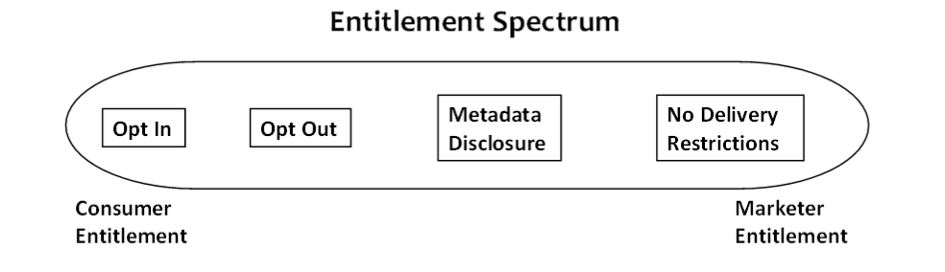
          - An opt-in scheme requires marketers to obtain consumer consent before disseminating marketing to them. Currently, the only marketing delivery media governed on an opt-in basis are fax marketing and certain text messages.
          - An opt-out scheme allows consumers to prevent future marketing exposures across all marketers (such as a do-not-call registry) or from only particular marketers (such as marketer-specific opt-outs from future email marketing or telemarketing). Several direct marketing media, such as email marketing, telemarketing and (to a lesser extent) direct mail, are governed by opt-out regulatory schemes.
          - mandatory metadata disclosure scheme requires marketers to make disclosures that help the consumer assess its trustworthiness. Metadata can provide consumers with more info about the marketer, such as their phone numbers readable by Caller ID or requiring that marketing display the marketer’s address. Metadata can also provide a description of the marketing contents, such as a summary label that marketing is “advertising.”
          - Some media have no delivery restrictions on marketing at all. In these situations, a consumer cannot avoid unwanted exposures to marketing in that medium. Unrestricted media include most broadcasting (tv, radio and cable) and print periodical marketing, as well as billboards and other physical signs.
          - Opt-ins represent one end of the allocative spectrum—the consumer has an entitlement to be free from marketing. At the other end of the spectrum, a marketer has entitlement to disseminate marketing to consumers in those media where the marketer’s rights are unrestricted. In between these two end points are opt-outs and mandatory metadata schemes, where the entitlement is not absolute. Instead, each party shoulders some burden and, in effect, “shares” the entitlement.
          - Tillman v Distribution → We hold that neither a publisher nor a distributor has any constitutional right to continue to throw a newspaper onto the property of an unwilling recipient after having been notified not to do so.
            - An individual’s right to communicate must be balanced against the recipient’s right ‘to be let alone
            - [W]e do not believe that, in extending constitutional protection to commercial speech, in general, the Supreme Court necessarily eroded the privacy protection afforded to a landowner who, as an individual, has knowingly decided to bar a certain type of speech, commercial or otherwise, from his or her property.
            - The constitutional right of free speech does not correspond to the “right” to force others to listen to whatever one has to say.
  - Privacy in the EU
    - The European Union’s General Data Protection Regulation, or GDPR, which came into effect in May 2018. The GDPR has many implications for advertising law both in Europe and internationally, not all of which are clear at the time of this writing (June 2018).
    - In addition to the GDPR, European advertisers must comply with the ePrivacy Directive , sometimes called the “Cookie Directive.” The ePrivacy Directive regulates communication privacy in numerous ways, requiring consumer consent for:
      - any direct marketing by phone, fax, email, text, or other electronic message. Consumers must affirmatively opt-in—i.e., the checkbox must be presented as unchecked—to receive these marketing materials (with limited exceptions).
      - placing or reading cookies or other client-side persistent identifiers. Consumer consent usually can be obtained by displaying a web banner. This is why you often see websites asking for permission to place cookies.
    - The GDPR applies to anyone who “processes” personal data, defined as “any operation or set of operations which is performed on personal data or on sets of personal data, whether or not by automated means.”
    - The GDPR defines two roles: data “controllers” and “processors.” The GDPR places a heavier compliance burden on controllers, so the distinction between the two is critical.
    - A controller “determines the purposes and means of processing personal data.” A processor “processes personal data on behalf of a controller.”
      - an advertiser who collects information directly from consumers would be the controller; and third party vendors who help the advertiser communicate with those consumers would be processors
    - GDPR defines “personal data” as “any info relating to an identified or identifiable natural person (‘data subject’); an identifiable natural person is one who can be identified, directly or indirectly, in particular by reference to an identifier such as a name, an identification number, location data, an online identifier or to one or more factors specific to the physical, physiological, genetic, mental, economic, cultural or social identity of that natural person.”
    - The GDPR has extra protections for “sensitive” personal data; prohibits processing data “revealing racial / ethnic origin, political opinions, religious / philosophical beliefs, or trade union membership, and the processing of genetic data, biometric data for the purpose of uniquely identifying a natural person, data concerning health or data concerning a natural person's sex life or sexual orientation,” subject to many exclusions. There are also extra protections for info re crim convictions/offenses
    - GDPR Article 5 enumerates six “principles” that apply to all processing of personal data:
      - Lawfulness, Fairness and Transparency. Personal data shall be “processed lawfully, fairly and in a transparent manner.”
      - Purpose Limitation. Personal data shall be “collected for specified, explicit and legitimate purposes and not further processed in a manner that is incompatible with those purposes” (subject to some public interest exceptions).
      - Data Minimization. Personal data shall be “adequate, relevant and limited to what is necessary in relation to the purposes for which they are processed.”
      - Accuracy. Personal data shall be “accurate and, where necessary, kept up to date.”
      - Storage Limitation. Personal data shall be “kept in a form which permits identification of data subjects for no longer than is necessary for the purposes for which the personal data are processed” (subject to some public interest exceptions).
      - Integrity and Confidentiality (a/k/a Security). Personal data shall be “processed in a manner that ensures appropriate security of the personal data.”
    - In addition to the Article 5 principles, Chapter III of the GDPR describes 8 consumer rights:
    - Right to Be Informed. Consumers have the right to know when their data is being collected and why. Articles 13 and 14 enumerate minimum requirements of privacy disclosures.
    - Right of Access. Consumers have the right to see their data.
    - Right to Rectification. Consumers have the right to correct erroneous information about them.
    - Right of Erasure (also called the “right to be forgotten”). Consumers have the right to delete personal data about them in many circumstances.
    - Right to Restrict Processing. Consumers have the right to suppress their personal data file or to restrict its processing in many circumstances.
    - Right to Data Portability. Consumers have the right to obtain data about themselves and provide that data to others.
    - Right to Object. Consumers have the right to object to and prevent their data from being used for specified purposes, including an absolute right to stop their data being used for direct marketing purposes.
    - Rights Related to Automated Decision-Making. A decision with legal effects may be made solely by a machine, and consumers may be profiled, only with consumers’ explicit consent, or where necessary for the contract, or as otherwise legally authorized.
  - A data processor must comply with its contracts with data controllers and:
    - not use a sub-processor without the controller’s permission;
    - cooperate with regulators;
    - ensure the security of its processing;
    - keep records of processing activities;
    - notify the data controller of any personal data breaches;
    - employ a Data Protection Officer (in some cases); and
    - appoint a representative within the European Union (if the processor isn’t established in the EU).
  - Remedies
    - GDPR authorizes direct consumer lawsuits for violations, either individually or through public interest organizations. Violations also can be enforced by government agencies, which can seek fines of up to €20M or 4% of a company’s global annual revenue (and, in the case of a group of companies, 4% of the group’s global annual revenue), whichever is greater.
  - Jx
    - The GDPR applies to:
      - (1) Companies established in the EU, regardless of whether data processing takes place inside or outside the EU or the data relates to EU residents. Thus, a U.S. company with a physical presence in the EU will be subject to GDPR both for EU consumer data and non-EU consumer data.
      - (2) Companies not established in the EU that process EU residents’ data where the processing is (a) related to offering goods or services to EU residents, or (b) related to monitoring EU residents’ behavior within the EU. These companies must appoint a representative in the EU.
- Children’s Advertising and Privacy
  - Childrens ad review unit (CARU)
    - Protects kids, a vulnerable population
    - Children have less exp sorting truth from untruth
    - Children's TV act requires each TV station to air core programming and limits the amount of time they can dedicate to ads
      - Core programming: serves educations and informational needs of children, at least 30 mins long, 6a-10p, regularly scheduled programming
      - Specific rules re displaying web address during childrens programming
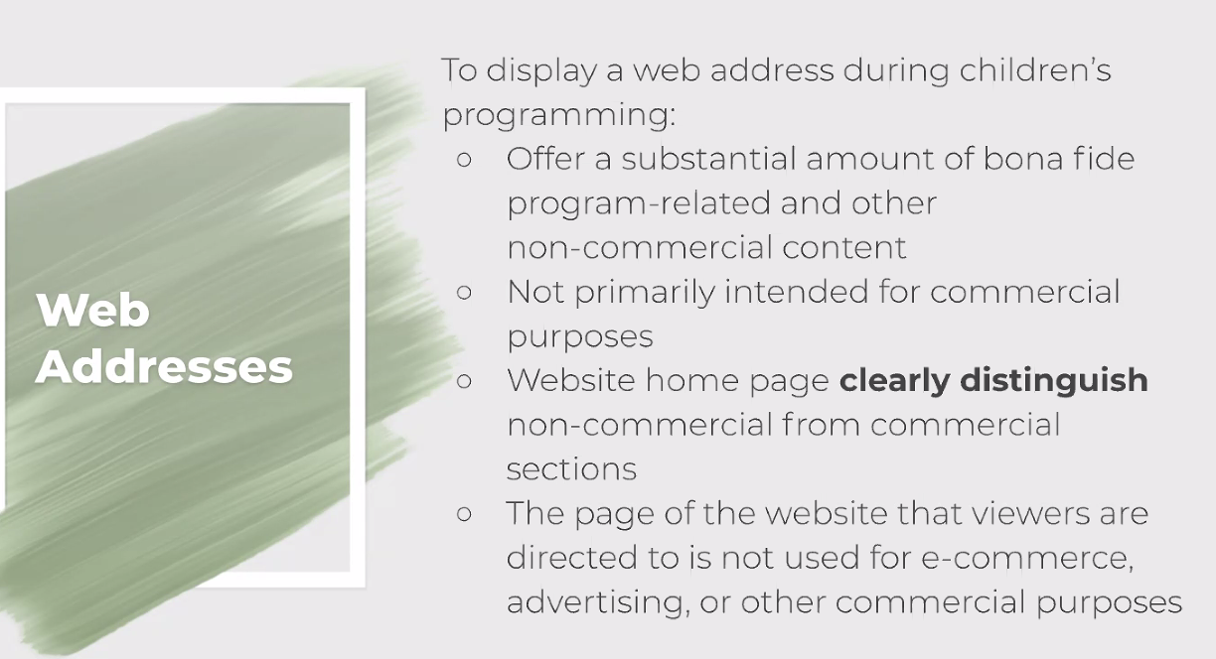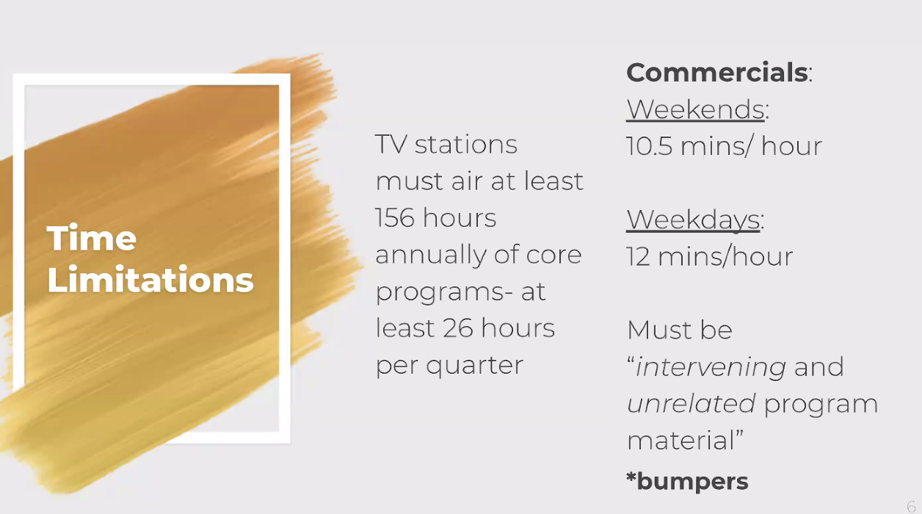
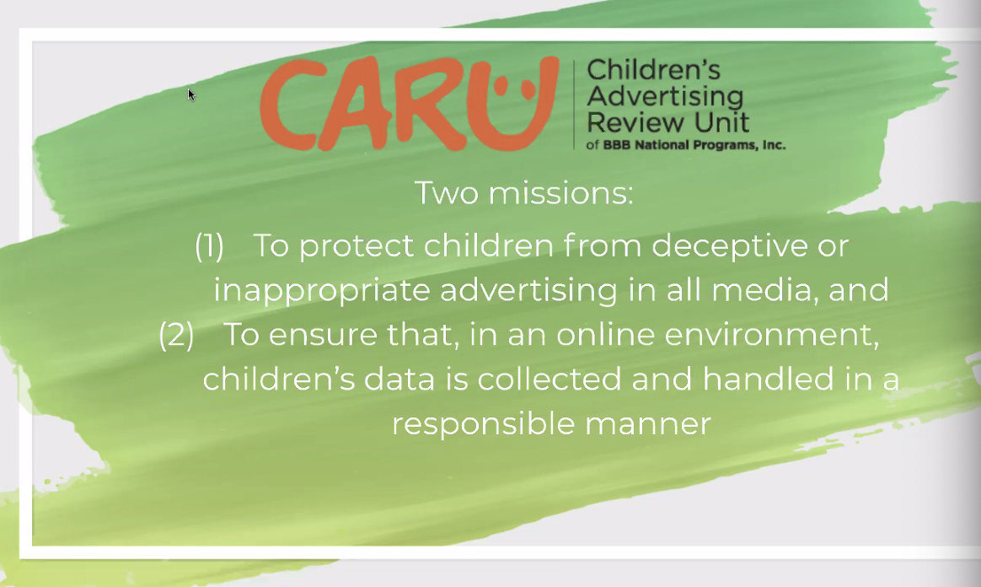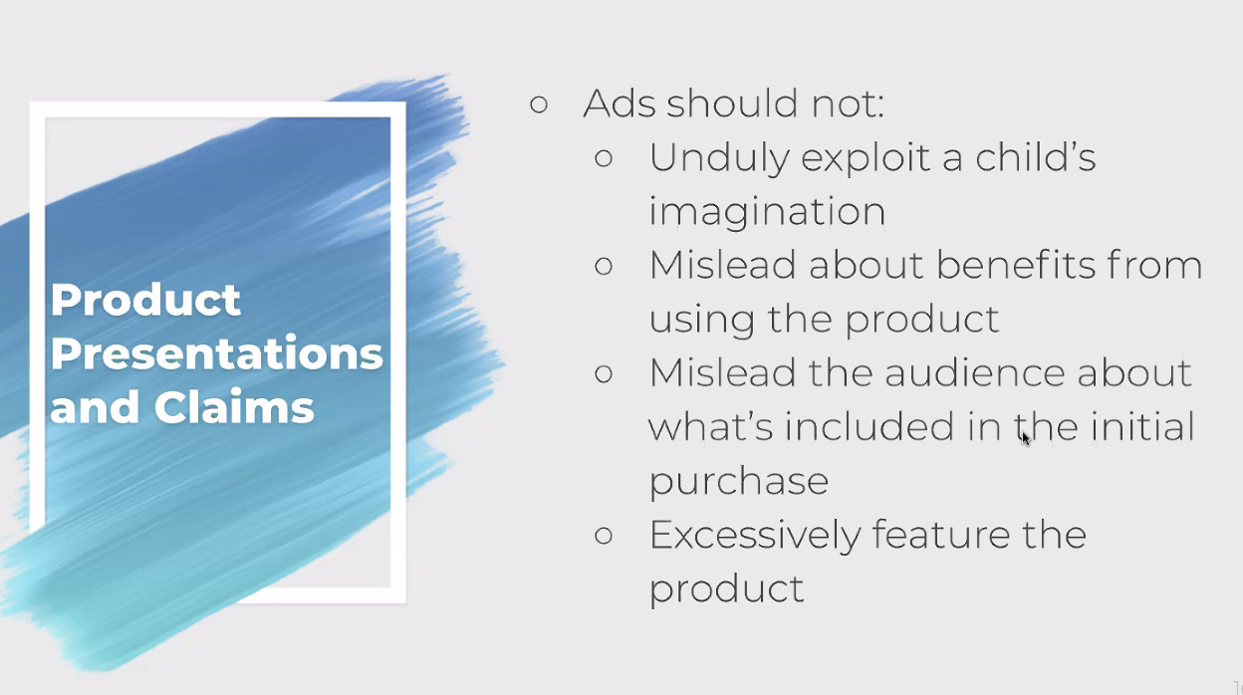
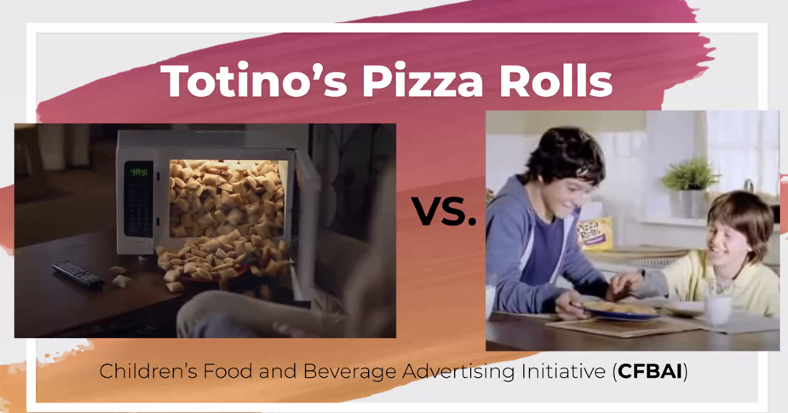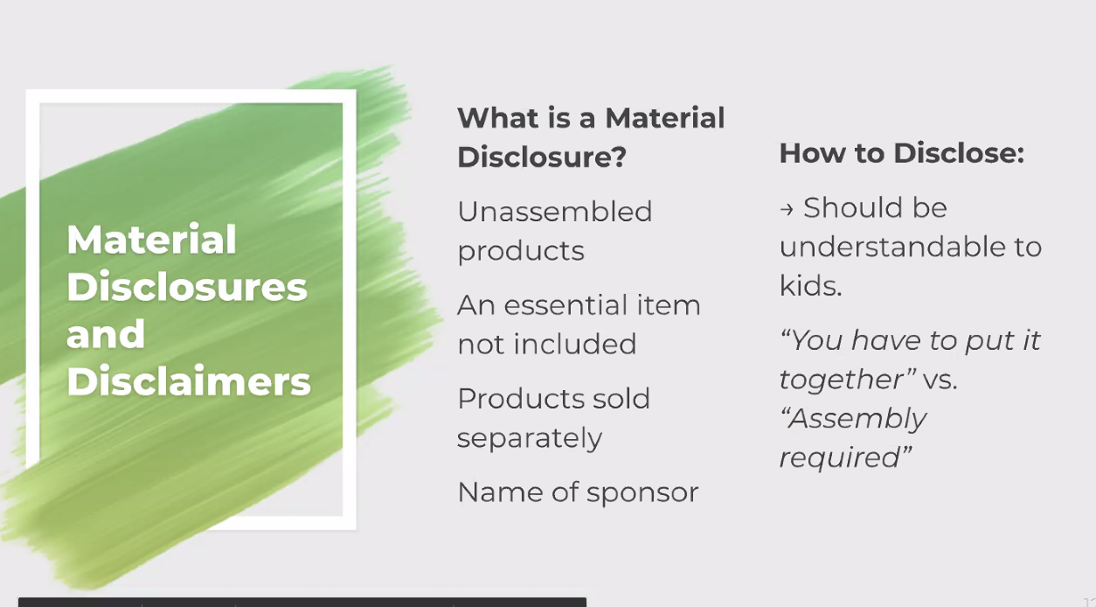
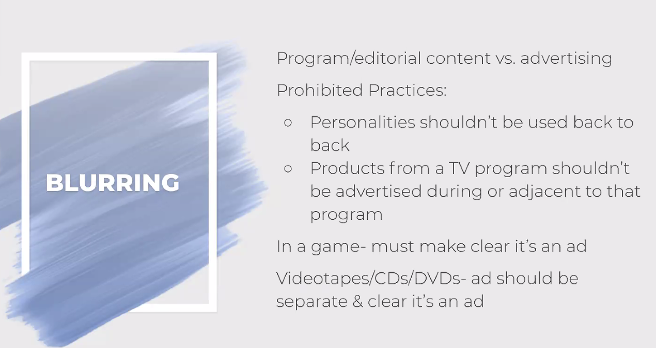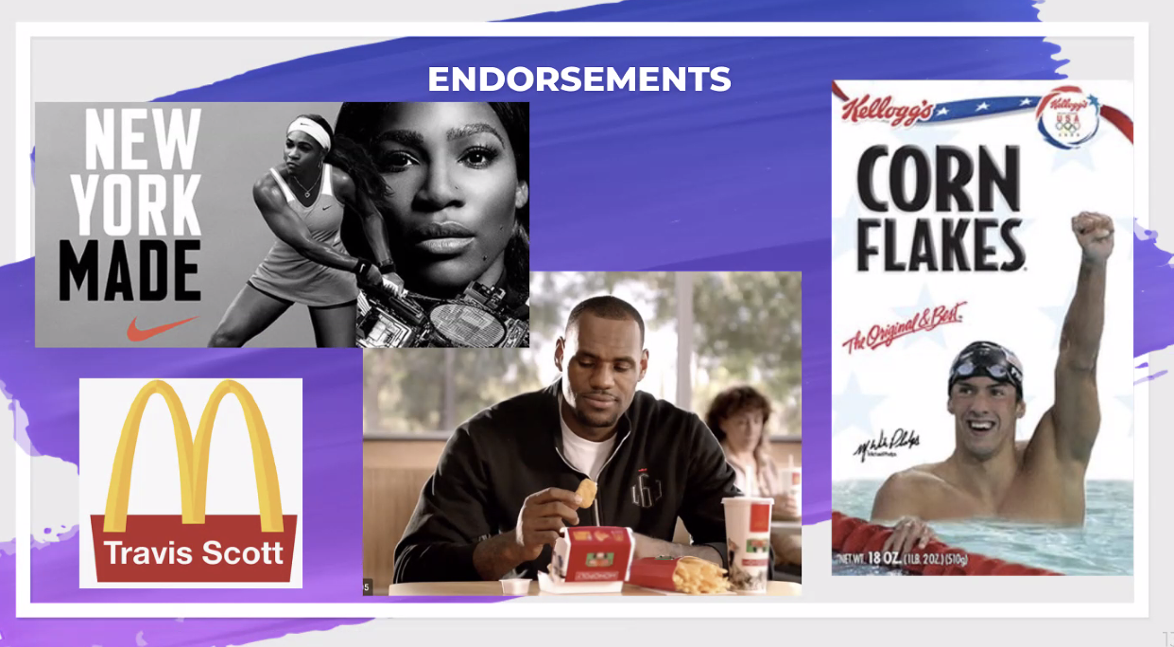
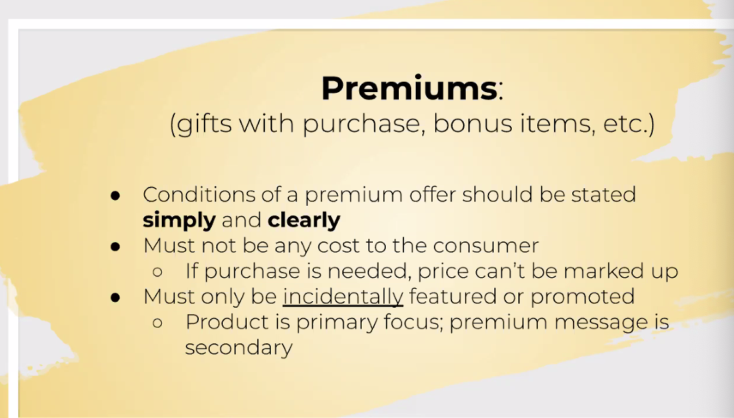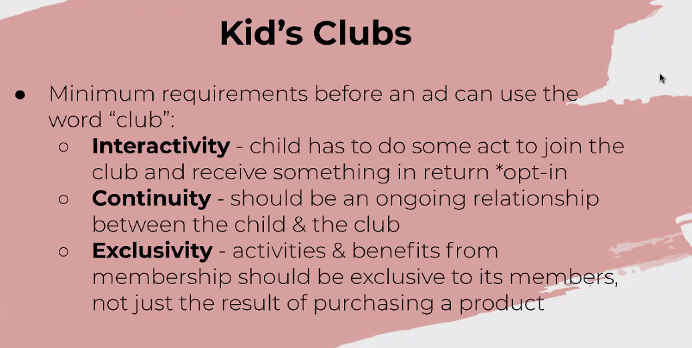
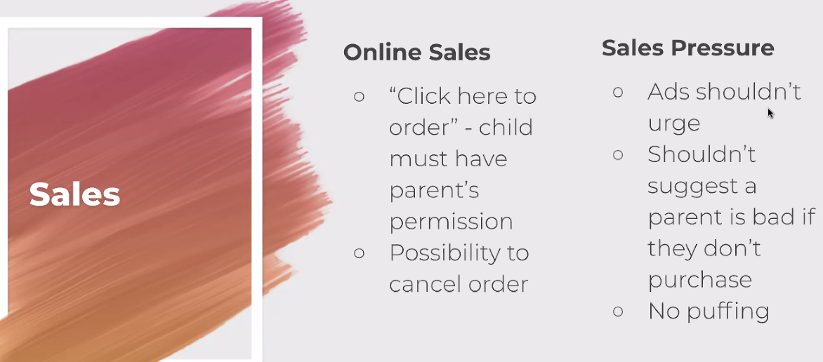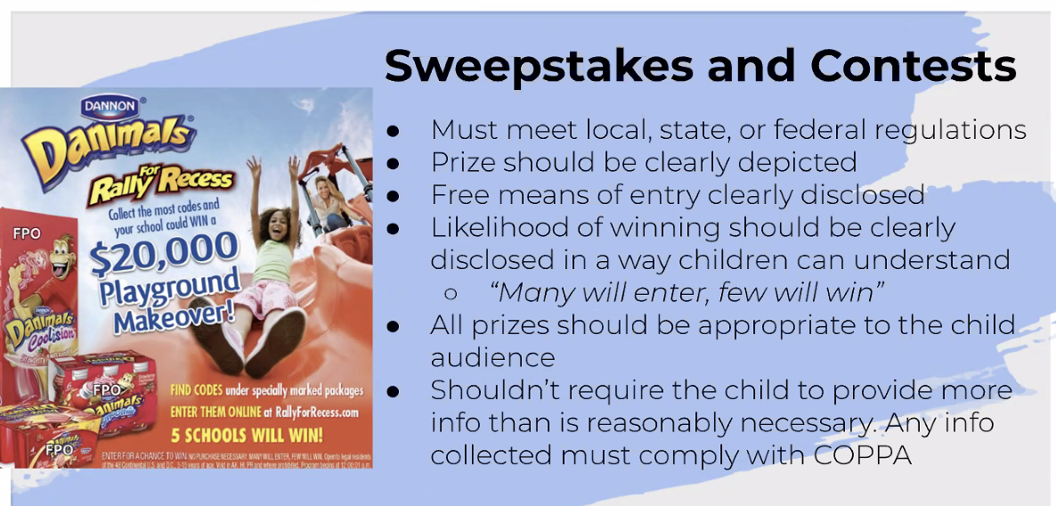
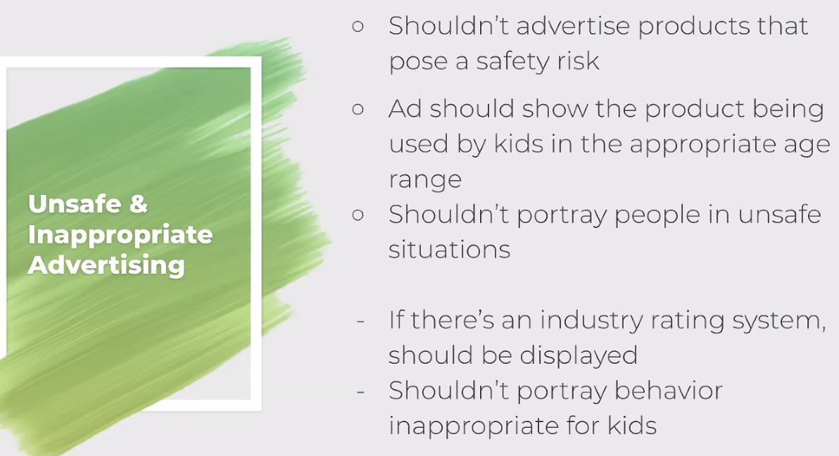
  - Childrens online privacy protection act (COPPA)

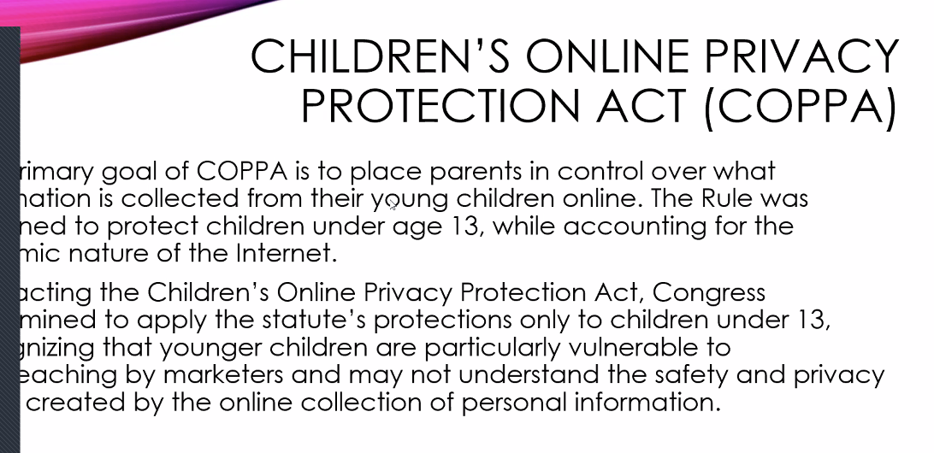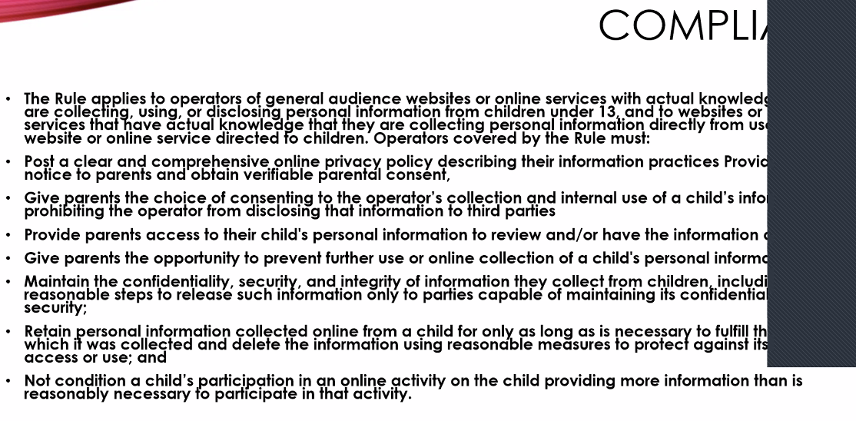
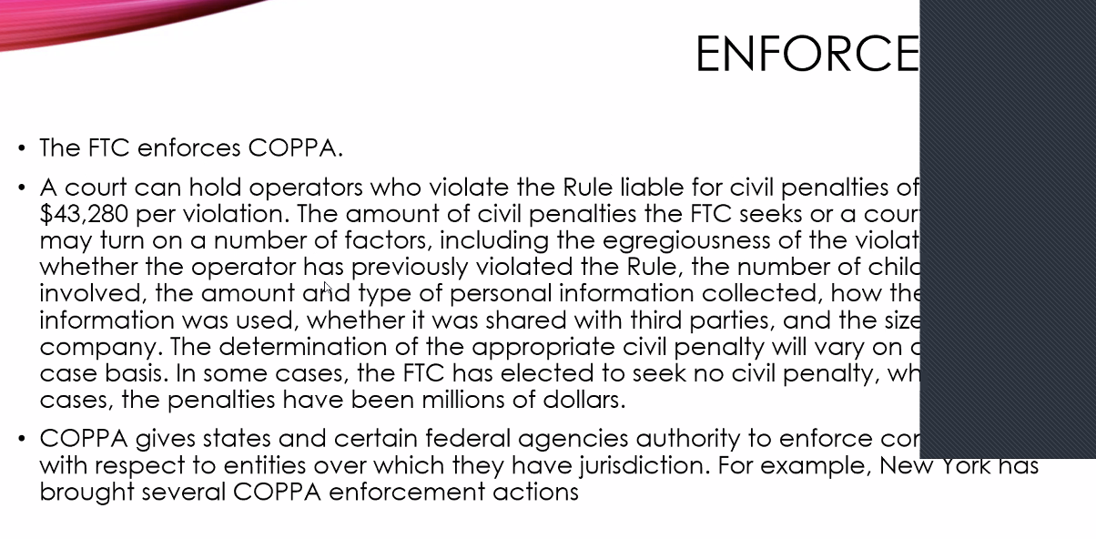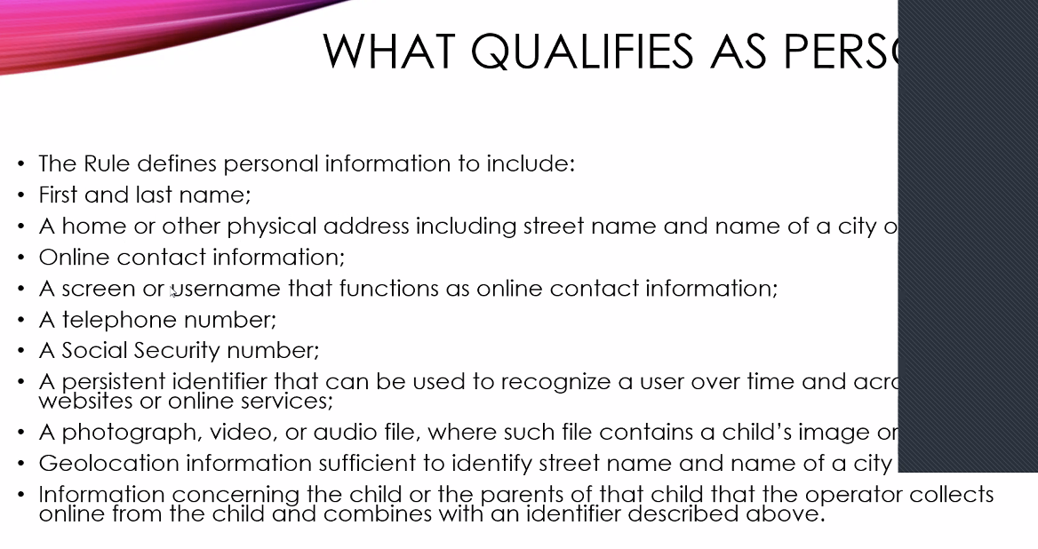
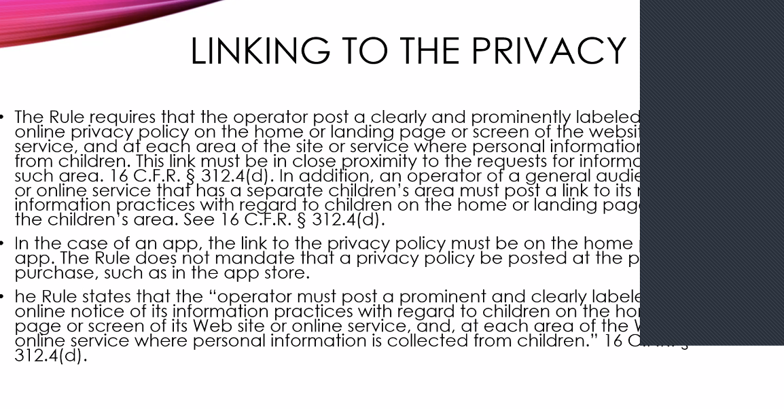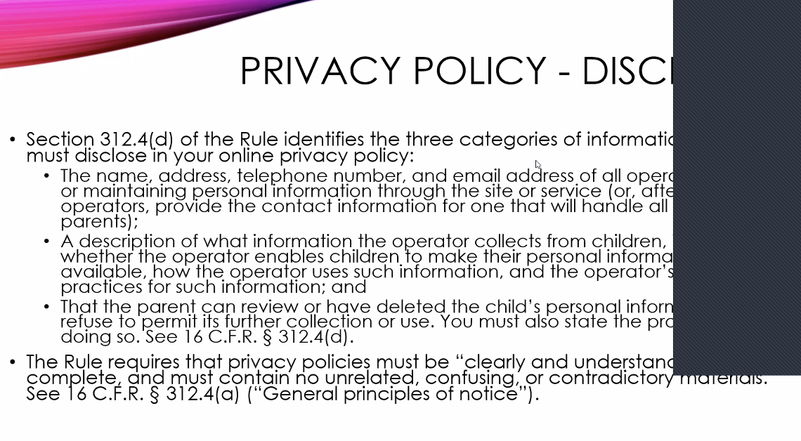
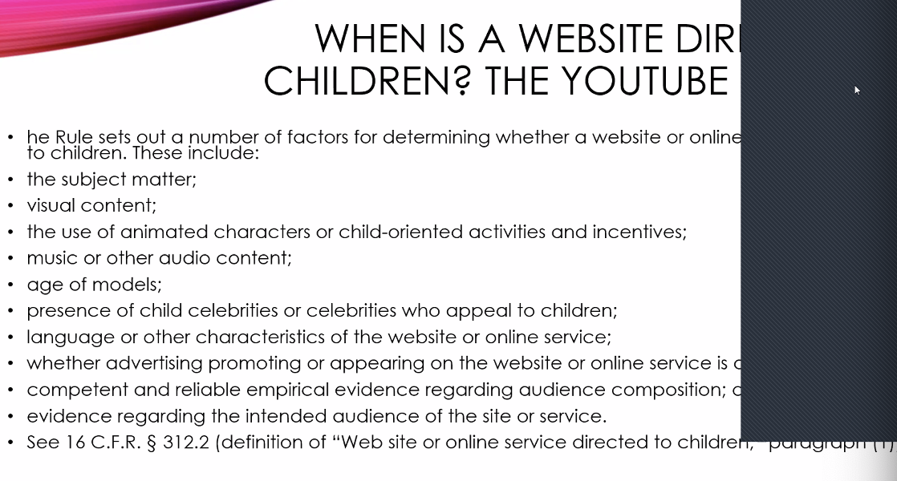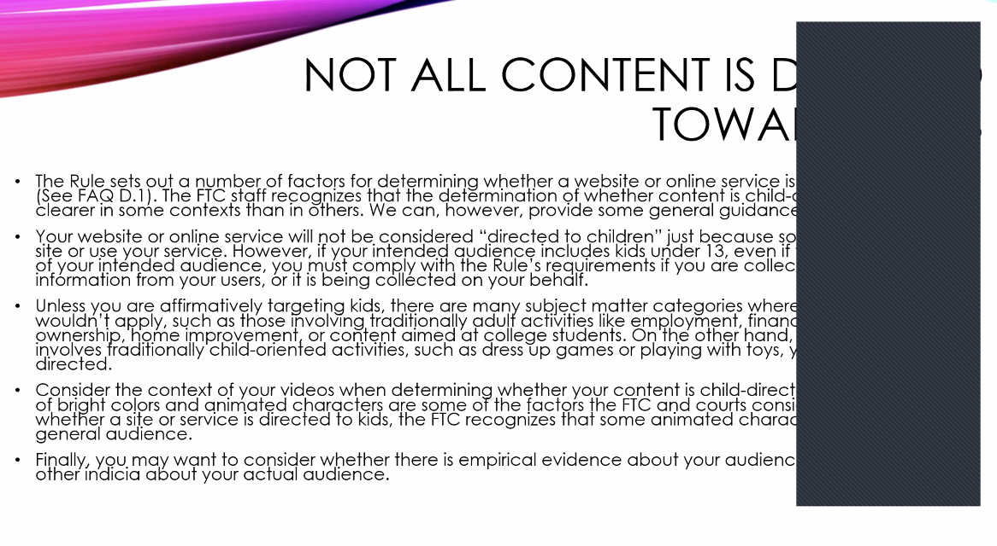
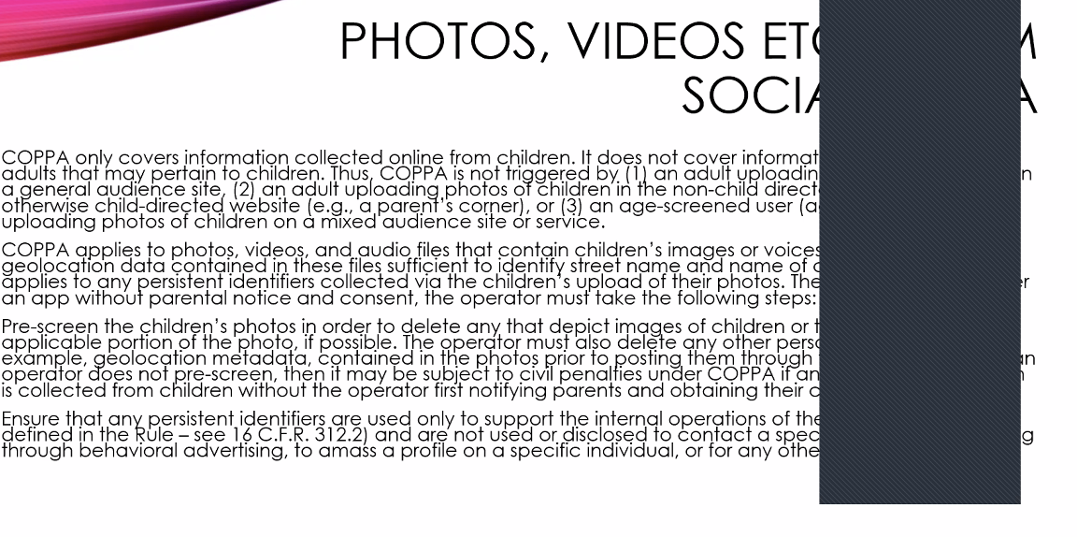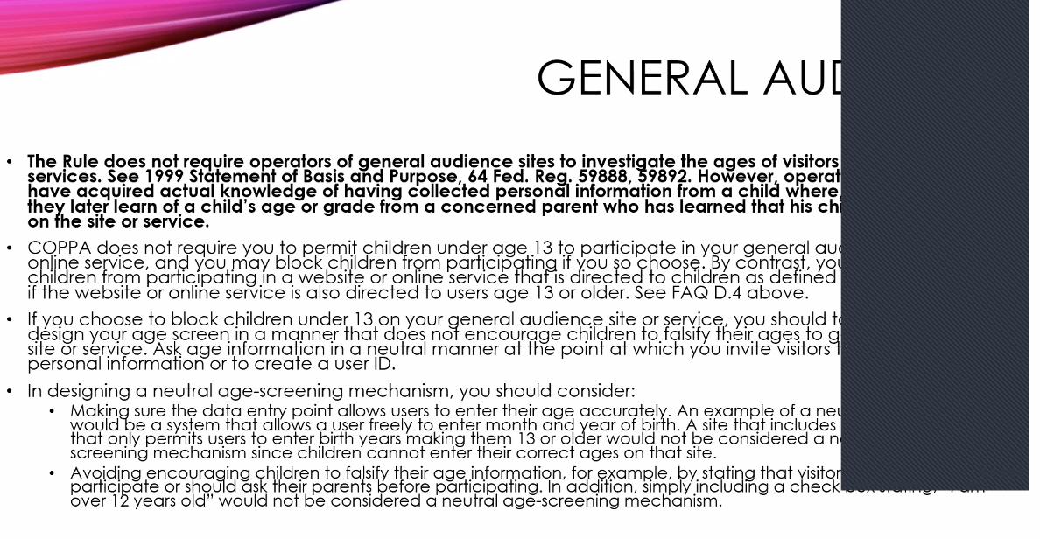
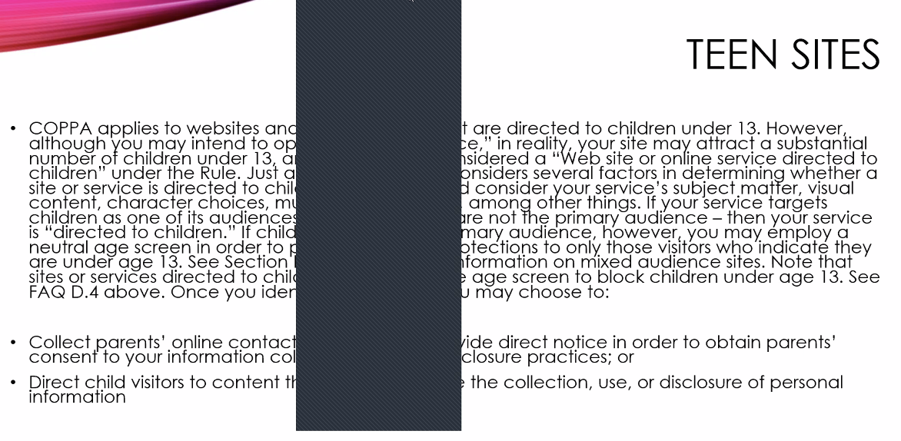
- First Amendment student presentation
  - What kinds of info is legally defined as advertising and how is this regulated?
  - Courts apply 3 levels of scrutiny
    - Strict scrutiny - restrictions on speech are subject to strict scrutiny
    - Intermediate scrutiny
      - Central Hudson Gas
        - In response to fuel shortage, New York utilities commission executes gag order on advertising which promoted use of energy.
        - Does the gag order violate the First Amendment?
        - Four-Part test:
          - Is it protected by the First Amendment?
          - Is the asserted government interest substantial?
          - Does the regulation directly advance the asserted interest?
          - Is it not more extensive than is necessary?
    - Rational basis scrutiny
      - Very low bar to prohibiting speech under rational basis scrutiny. Typically, unprotected speech or activity unrelated to protected class.
      - Commercial speech: Kasky v. Nike
        - Speech which is largely directed to protect the financial interests of a company, especially when made towards potential customers, is not protected by the First Amendment.
- Copyrights, Trademarks, and other IP issues (part I)
  - Copyright in the US protects original works of authorship fixed in a tangible medium of expression (published or unpublished). Copyright protects most books, movies, music and software as well as choreography and architectural works. Copyright does not protect facts, ideas, systems, or methods of operation.
  - copyright protects all original creative works without judging their merit. Copyright equally protects major cultural contributions, advertising, and pornography
  - Copyrights provide right to control: reproduction, distribution, public performance, derivative works.
  - Bleistein v. Donaldson
    - Rule: An illustration designed and produced for use as an advertisement is not precluded from copyright protection solely on the basis of its commercial nature.
    - Facts: P was hired to design / produce chromolithographs to produce posters used as ads for a circus. designs depicted circus acts, including ballet / bicycle performances. Ps alleged that the Ds copied the chromolithographs w/o permission, and thus, the P brought a copyright infringement suit. circuit court found for the D, holding that the chromolithographs were not protectable works under copyright law. The court of appeals upheld the decision, and the plaintiff appealed to the USSC
    - Holding: an illustration designed / produced for use as an ad is not precluded from copyright protection just bc its commercial. Copyright Clause of the USC grants protection to authors of the useful arts, and the courts should not pass judgment on what constitutes art for purposes of this protection. The fact that a picture / illustration is used as an ad and serves a commercial purpose has no independent bearing on whether the work otherwise satisfies the criteria for copyright protection. here, the chromolithographs included original design elements and details authored by the plaintiff and were accordingly entitled to copyright protection as pictorial illustrations. As a result, the D infringed the P’s copyright when its employees made unauthorized copies of the chromolithographs.
  - When an advertiser creates an ad completely in-house using only employees’ labor, the advertiser will automatically own the copyright to the ad copy (unless it Ks with its employees otherwise).
  - Under default copyright law, independent TPs creating the copyrighted work own the copyright—even if the advertiser pays them to do custom work.
  - Parties typically spell out ownership rights in K
    - SoF requires assignments / exclusive licenses of copyrighted works to be in writing, so always get any copyright deals in writing, and remember that a deal involving the creation of ad content almost always involves the creation of copyrightable works
  - Ets-Hokin v. Skyy Spirits
    - Issue: whether professional photographer Joshua Ets-Hokin’s commercial photographs, dubbed “product shots,” of the Skyy Spirits vodka bottle merit copyright protection.
    - Facts: issue re stylized photographs of vodka bottle
    - Holding: photographs at issue cannot be derivative works because the vodka bottle—the alleged underlying work—is not itself subject to copyright protection. Professional photographer who had entered into license agreement with vodka producer brought action against producer and others, alleging that producer's use of photographer's “product shots” constituted copyright infringement, fraud, and negligent misrepresentation. The United States District Court for the Northern District of California, Susan Yvonne Illston, J., 1998 WL 690856, granted summary judgment for producer on copyright claims and dismissed other claims. Photographer appealed. The Court of Appeals, McKeown, Circuit Judge, held that: (1) “product shots” of vodka bottle were sufficiently original to merit copyright protection; (2) preexisting work underlying derivative work must itself be copyrightable; (3) bottle was not copyrightable, so photographs of bottle could not be deemed derivative works; and (4) merger doctrine and scènes à faire doctrine do not affect copyrightability but provide defenses to infringement.
  - Infringement:
    - Substantial Similarity:
      - Actual copying: did the infringer actually copy the protected work?
      - Lay-observer: would a lay observer recognize copying of protected works?
    - Defenses:
      - Merger doctrine: limited ways to express given idea.
      - Scenes a faire: elements expected due to genre.
        - Many very similar advertisements can be defended under this doctrine. See Culver Franchising v. Steak N Shake.
  - Shrock v. Learning Curve
    - Photos plaintiff took of Thomas and Friends train set not protected by copyright due to status as derivative works.
  - Fair Use
    - Use is permitted for educational purposes, criticism, comment, news reporting, research, etc.
    - Factors considered include:
      - The purpose of the use, including whether the use was commercial or for educational purposes.
      - The nature of the copyrighted work.
      - The amount or proportion of the copyrighted work used in relation to the whole.
      - The effect of the use on the potential market for the copyrighted work.
    - Davis v. Gap
      - Fair use defense rejected after court finds that use of copyrighted artistic eyewear was prominent in ad and that Davis lost royalty revenue as a result of use.
  - MGM v. Honda
    - Court finds that Honda character infringes upon unique and copyrightable character of James Bond and that the ad in question uses an unacceptably large proportion of scenes from Bond movies.
  - Eveready v. Adolph Coors
    - Use of Energizer bunny motif protected due to minimal risk of confusion or market loss, minimal proportion of content relative to total ad, and the nature of the parody.
  - Parody
    - Leibovitz v. Paramount
      - Use protected as a humorous critique of a stern photograph.
    - Columbia Pictures v. Miramax
      - Proximity of parody ad to industry of original producer defeats fair use.
      - No humorous take on Men in Black image.
- Copyrights, Trademarks, and other IP issues (part II) - CH 11 and 12
  - Overview of trademark law
    - intro/general info
      - Constitution does not authorize congress to provide ™ protection so they've enacted legislation pursuant to its commerce clause authority
      - Protected under fed and state law
      - Main federal ™ law is Lanham Act
      - Unregistered tms are also protectable
    - Acquiring trademark rights
      - Trademark owners acquire their trademark rights principally by making a “use in commerce” of the trademark. See Lanham Act (15 U.S.C. § 1127)
      - tm owner starts accruing rights by offering products / services for sale with the tm displayed on the product / in ad for the tm—so long as the offering is actually available
      - Most consumers brands federally register tms - in advance of a new product, a ™ owner will file an intent to use (ITU). ITU app establishes the ™ owner’s priority as the application date rather than first use
        - ITU is just a placeholder - ITU applicant must file a statement that it has made a use in commerce; at that point, the application converts into a normal tm registration but with the ITU application date as the ™’ds priority date.
      - registration is not required to have enforceable tm rights, but registration offers several advantages:
        - The registration gives national priority to the tm owner. Without this, a tm owner’s rights typically are limited only to the geographies where it has made a use in commerce.
        - The registration gives the tm owner guaranteed access to federal courts and gives several procedural benefits in litigation
        - A federal registration provides eligibility for enhanced remedies in court, including potentially triple damages and attorneys’ fees. As a practical matter, except when dealing with counterfeiters, the enhanced remedies are far less important than the registration’s presumption of validity.
      - The stronger the tm, the greater legal protection it gets. A tm can gain strength from recognition.. If it is widely recognized, courts will give the tm greater protection. tm strength is also measured by a hierarchy of semantic distinctiveness. From strongest to weakest:
        - Fanciful tms
        - Arbitrary ™ s
        - Suggestive tms
        - Descriptive tms
        - Generic words
  - ™ infringement
    - Prima facie elements
      - the p has valid and protectable tm rights,
      - the p’s use in commerce date (determined either through usage or the ITU date) predates the d’s, giving it “priority,”
      - the d has used the tm in commerce, and
      - the d’s usage creates a likelihood of consumer confusion about the product’s source, sponsorship, or affiliation.
      - If the p establishes a prima facie case, the d can assert a number of possible defenses, such as nominative use.
    - Consumer confusion
      - Evaluation using multi factor test
      - Mastercard v. Nader
        - Fax: MasterCard International, Inc. (p) ran a series of ads listing a # of purchased items / their costs, and ending with an intangible item that cannot actually be purchased and the word “Priceless.” A voiceover then stated: “There are some things $ can’t buy, for everything else there’s MasterCard.” Ralph Nader (d) ran for president in 2000. Nader ran a campaign ad referencing alleged prices of dinners at fundraisers, campaign ads “filled with half-truths,” and promises to special interest groups. The ad ended by stating: “finding out the truth: priceless. There are some things that $ can’t buy.” MasterCard sued Nader for tm dilution.
        - Issue: Are noncommercial uses of a trademark exempt from the Federal Trademark Dilution Act?
        - Holding/reasoning: Yes. Noncommercial uses of a tm are exempt from the Federal Trademark Dilution Act. In other words, a user of mark is not guilty of tm dilution if the use is noncommercial. Political speech does not qualify as commercial speech under the Lanham Act. In this case, Nader’s use of MasterCard’s mark is not actionable under the Federal TM Dilution Act. Nader’s use of the mark is noncommercial because Nader is not seeking to sell a good or service by using the mark. Nader uses the mark solely for a political purpose. Even if Nader’s ad resulted in increased donations to his campaign, this would not constitute a commercial use of the mark. Congress intended to exclude political speech from the definition of commercial use under the Lanham Act. Nader’s noncommercial use of MasterCard’s mark is exempt from the Federal TM Dilution Act.
    - Use in commerce
      - Controversial element
        - First, the federal § defines the terms “commerce” and “use in commerce” in irreconcilable ways. The “use in commerce” definition suggests that ps must show that they used the p’s tm in ad copy or on packaging as part of the p’s prima facie case. The “commerce” definition simply requires the p to satisfy the Constitutional Commerce Clause reqs. This poor drafting creates an unresolvable ambiguity in the § that may ultimately require congressional fixing.
        - Second, and perhaps more importantly, courts often gloss over this element when the d clearly made a use in commerce of the p’s tm. For example, referencing the p’s tm in ad copy almost always will qualify as a use in commerce of the tm. In those cases, courts are not very careful to acknowledge this prima facie element.
      - Keyword advertising triggering
        - The Second Circuit held that WhenU’s behind-the-scenes association of the 1-800 Contacts domain name with advertising categories such as “contact lenses” did not constitute a trademark use in commerce.
      - Billboards
        - In Howard Johnson International, Inc. v. Vraj Brig, LLC, 2010 WL 215381 (D. N.J. 2010), Tucci owned a hotel building that Vraj Brig operated as a franchised Howard Johnson’s hotel. Tucci stopped operating the building as a hotel, but he left up a billboard bearing the “Howard Johnson’s” name. Johnson sued Tucci for tm violations. The court ruled in Tucci’s favor, rejecting Howard Johnson’s argument even though the billboard might have frustrated consumers who exited the freeway looking for the hotel, only to be disappointed. p has produced no evidence that Tucci did anything other than passively allow a preexisting billboard containing HJI’s marks to remain. Therefore, Tucci never “used” the protected marks. even if Tucci were held to have “used” HJI’s marks, he never offered / provided any goods / services at the facility. his display of the marks does not satisfy the “in connection with goods or services” req either.
    - Defense: descriptive fair use
      - Descriptive fair use occurs when a d uses the p’s descriptive tm to describe the d’s own product. 15 U.S.C. § 1115(b)(4) provides a defense to tm infringement when using “a term or device which is descriptive of and used fairly and in good faith only to describe the goods or services of such party.” The descriptive fair use defense may only be invoked against descriptive tms; arbitrary, fanciful and suggestive tms are not subject to the defense. Examples:
        - Sunmark, Inc. v. Ocean Spray Cranberries→ Sunmark makes SweeTARTS, a classic sweet-and-sour sugar candy. Ocean Spray subsequently decided to advertise its cranberry juice as having a “sweet-tart” flavor. The court held that Ocean Spray’s use of “sweet-tart” qualified as a descriptive fair use.
        - Cosmetically Sealed Indus., Inc. v. Chesebrough-Pond’s USA Co.--> the p marketed lip gloss under the registered tm “Sealed with a Kiss.” Chesebrough subsequently offered long-lasting lipstick in a counter display that included free postcards and an encouragement to mark the postcards with a lip-print, which ended with the exhortation to “Seal it with a Kiss!!” (the “it” referring to the postcard). The court held that this display constituted descriptive fair use.
    - defense: comparative advertising and nominative use
      - tm law does not categorically permit the use of tp tms in ad copy for comparative statements. Each ad copy reference must be independently analyzed under the applicable tm doctrines.
      - Nominative use is a doctrine that facilitates some comparative references. Nominative use, sometimes called “nominative fair use,” differs from descriptive fair use in how the d uses the p’s tm. In nominative use, the d uses the tm to refer to the p’s product. Unlike descriptive fair use, which is only applies to terms that are descriptive for the d’s products or services, the nominative use defense can be invoked against all types of tms, even fanciful ones.
      - The Ninth Circuit has the best-developed standards for nominative use, which requires 3 elements for a successful defense:
        - The p’s product is not readily identifiable without using the tm.
        - The d uses the p’s tm only as reasonably necessary to ID the p’s product.
        - The d’s usage does not imply the p’s sponsorship / endorsement.
      - Smith v. Chanel
        - Fax: Smith (p) manufactured fragrances, including one called “Second Chance,” that copied famous designer fragrances. Smith advertised that these fragrances were perfect duplicates of their more expensive counterparts. Specifically, one ad dared consumers to try and find the difference between Smith’s “Second Chance” perfume and Chanel’s (d) “Chanel No.5” perfume. Each of Smith’s fragrances had a note printed on the packaging that stated the famous fragrance that it was duplicating. Chanel sued Smith. The district court found that Smith had violated Chanel’s tm because Smith was profiting off of the goodwill associated with Chanel’s tm. Smith appealed this decision.
        - Issue: Can a manufacturer who has copied an unpatented but tmd product use that tm in ad to ID the product that has been copied?
        - Holding / Reasoning: Yes. A manufacturer who has copied an unpatented but tmd product can use that tm in ad to ID the product that has been copied. So long as the ad does not misrepresent the products / cause consumer confusion, a manufacturer may use the tm in this manner. Furthermore, it does not constitute unfair competition so long as the copied product is in the public domain and so long as there is no consumer confusion that may cause dilution of the tm. The purpose of the tm is to ID the tm owner’s products. To extend this protection further would impede competition in the market. Furthermore, the copier’s reputation, rather than the original producer’s, is the one that would suffer from the ad if his product were inferior In this case, Smith used Chanel’s tm merely to ID the comparative fragrance. This was clearly labeled in Smith’s ad. Smith also only copied an unpatented fragrance. Therefore, Smith has the right to use Chanel’s tm in its ad in order to label a comparative fragrance and so long as it is not misleading.
  - Trademark dilution
    - Federal tm law provides extra protection for “famous” marks, defined as tm that are “widely recognized by the general consuming public of the US as a designation of source of the goods or services of the mark’s owner.” These famous marks are protected against “dilution,” which can occur in one of two ways: by “blurring,” a use that “impairs the distinctiveness of the famous mark,” and by tarnishment, a use that “harms the reputation of the famous mark.” 15 U.S.C. § 1125(c).
    - No consumer confusion required
    - Deere & Co v MTD Products
      - Facts: Deere (p), a supplier of agricultural equipment, tmd its logo. The logo depicted a deer and was used on its various products. MTD (d) manufactured and sold lawn tractors. MTD’s ad agency wanted to produce an ad comparing the 2 companies’ tractors. MTD used the Deere logo, but changed the proportions of the deer and removed the name “John Deere” from the logo. In the ad, the deer in the logo was also animated so that it would run from an MTD tractor. Deere sued MTD for tm dilution
      - Issue: Can tm dilution occur when a competitor alters another’s tm and uses the altered tm to ridicule his competitor’s products in order to increase sales?
      - Holding/reasoning: Yes. tm dilution may occur when a competitor alters another’s tm and uses the altered tm to ridicule his competitor’s products in order to increase sales of his / her own products. Under the anti-dilution §, a tm holder must show that its tm is distinctive or has secondary meaning and that there is a likelihood of dilution. A d’s intent to cause dilution or damage the brand of the tm holder is also relevant, but not conclusive. Dilution may occur when a company or individual uses another’s tm to identify its goods / services. Thus, the tm no longer uniquely identifies only the tn holder’s goods and services. Dilution may also occur when the tm has been tarnished by being linked to low quality goods, or if it is used in an unsavory context that damages the reputation of the tm holder’s products / services. Dilution is also likely to be found when a direct competitor of the tm holder creates an altered tm because that competitor has an incentive to portray the tm holder’s products negatively. Furthermore, the competitor has plenty of other options to promote his or her products. This is different from a parody because the purpose here is to sell a competing product rather than to express an opinion / convey a message. It is not dilution if a tm is used in a comparative ad to convey facts about the competing products. In this case, MTD altered Deere’s logo in order to promote its own products. MTD’s alteration of the deer in the logo was meant to portray Deere as weak, and running scared from MTD’s competition. This dilutes Deere’s tm by implying that Deere is not a quality producer / consumers should buy MTD products instead. Also, it is not a simple comparative ad with facts about the 2 different products in question. MTD is still able to run comparative advertisements with factual comparisons of the two products under the district court’s injunction. Therefore, the district court’s injunction is upheld.
  - Ambush marketing
    - Examples of ambush marketing include running an ad campaign while the Olympics are ongoing that shows athletes without explicit reference to the Olympics, or finding unauthorized ways to get advertising incorporated into photos or broadcasts of the events.
    - Despite the temptation of characterizing ambush marketing as “free riding,” ambush marketing typically is not legally actionable in the United States
      - an advertiser can freely run a sports- or athlete-themed ad during the Olympics so long as the ad copy does not reference any Olympic trademarks
    - Heartland v Forest
      - Heartland employees improperly target individuals gathered for Forest River vehicle show.
  - Online advertising issues
    - Domain names
    - Metatags
    - Keyword advertising
  - Trade secrets
    - Overview
      - Can’t register something as your trade secret
      - Whether something is entitled to trade secret protection depends on how you treat that secret
      - Trade secrets are governed in the US by state and federal laws including the UTSA
      - Misappropriation by improper means is punishable: may include theft, bribery, misrepresentation, breach of duty to maintain secrecy, or espionage
      - In 2016 congress passed the DTSA creating a federal right of action for trade secret misappropriation
      - However you can't prevent others from independently discovering or reverse engineering your trade secrets
    - Penalties for trade secret misappropriation
      - Civil liability: $ damages, injunction, double damages, atty fees
      - Criminal statutes - state and federal
    - Future marketing plans as a trade secret
      - Pepsico v redmond
        - P filed action to enjoin redmond from divulging pepsico’s trade secrets and confidential info in his new job and from assuming any duties in his new job relating to bev pricing, marketing, and distribution
        - DC granted prelim inj
        - Appeal court affirmed holding that p may prove a claim of trade secret misappropriation by demonstrating that redmond’s new employment would inevitably lead him to rely on pepsico’s trade secrets. Pepsico proved that redmond possessed extensive confidential info and in his new job would inevitably use this info
        - This case is a flagship example on the inevitable disclosure doctrine
    - Customer lists as trade secret
      - Gary van Zeeland v. Sandas
        - Former employee absconds with list of customers used to check Christmas card deliveries.
        - Because list did not contain contact information or matrix matching band to venue, list did not constitute a trade secret.
  - Patents
    - Overview
      - Infringement in the US
        - Patents grant a protectible right to the patent holder. Can litigate if patent is violated.
    - Patents and the ad industry
      - Patents for “methods of advertising” are highly contested and generally not granted, especially when the “method” describes a process or software program.
  - Idea submissions
    - Burgess v. Coca Cola
      - Burgess claims that idea submitted to Coca Cola for Coke-themed winter wonderland with polar bears loading ice served as the basis for Coke’s later ad campaign featuring polar bears lounging under the Northern Lights.
      - Coke demonstrates that animated animals are common imagery in ad campaigns and that there was not a substantial enough link between the resulting ad and the original idea to constitute theft of the idea.
    - Taco Bell Corp v. TBWA
      - Taco Bell suing ad agency for indemnification. Despite processing and considering an idea submission for a “psycho chihuahua” years earlier, Taco Bell ran ad campaign from TBWA featuring a chihuahua.
      - Court finds substantial similarity between the two campaigns and holds Taco Bell liable for damages.
        - Taco Bell cannot sue TBWA for indemnification as they bore the liability.
  - Antitrust
    - In the matter of polygram holding inc
      - Three Tenors album. Actions of recording labels constitute collusion.
- Influencers, endorsements, and testimonials
- Branded content

