Partnership Tax 2 Outline
Sunday, April 18, 2021
10:50 AM

  - Transactions Between Partners and the Partnership
    - Three Treatments
      - Roadmap
        - Question: Were the services rendered in the partner's capacity as a partner?
          - If no, 707(a)
          - If yes, then ask, did allocation depend on income of the partnership:
            - If yes, allocation with linked distribution
            - If no, guaranteed payment

  - Allocations with Section 731 Linked Distributions
    - In general, distributions do not result in income to the distributee partner unless she receives a distribution of cash in excess of outside basis. But allocations paralleling those distributions are often made to the partner, in which case her income will be determined under the allocation rules and will have the same character as it has in the partnership’s hands.

  - So, for example, a partner in a law firm might be distributed 25% of the firm’s operating cash flow and might also be allocated 25% of the firm’s income. The character of that income will have the same character as it has in the partnership’s hands. The allocation increases the partner’s outside basis; the distribution reduces it. So long as we have sufficient outside basis, no outside gain results from the distribution.

  - Section 707(a) Payments
    - Second, a payment to a partner may be treated as payment for a transaction between the partnership and a partner “other than in his capacity as a member of such partnership” under §707(a)(1), which tells us:
      - If a partner engages in a transaction with a partnership other than in his capacity as a member of such partnership, the transaction shall, except as otherwise provided in this section, be considered as occurring between the partnership and one who is not a partner.

  - If so, we analyze such payments under the applicable non-partnership rules. The character of such payments will be determined under such rules, and may be ordinary or capital.

  - The timing of such payments will be determined under the standard accrual or cash accounting rules, with each party using his, her, or its own method.
    - Thus, for example, so far as §707 is concerned, we might have an accrual method partnership deducting the obligation even if it is not paid, while the cash method partner does not take the same amount into income until it is paid.

  - Assume, for example, that our law firm partner has a side business giving surfing lessons. The firm retains her—in her capacity as a surfing instructor—to give lessons to the firm’s summer associates. Assuming that this qualifies as a §707(a) payment, we treat the two, for the most part, as if they are operating completely at arm’s-length.

  - Class Notes
    - Treat these payments as payments between unrelated parties. Look at relationship between partnership and partner and if the partner is not providing services in the normal course of the partnership's business, then it is a 707a payment.

  - 267(a)(2) provides that when both parties are related, the party makes a payment from one to the other, the party making the payment can't take the deduction until the payment is also recorded in income.

  - 707a payments typically apply to transactions such as
    - A lease of property between a partner and the partnership
    - A loan from a partner to the partnership
    - Fees for services rendered to a partner by the partnership or fees for services rendered by a partner to the partnership, if in the provision of the services the partner is not acting as a partner

  - Section 707(c) Guaranteed Payments
    - Third and finally, a payment from a partnership to a partner may be treated as a “guaranteed payment” under §707(c), which tells us:
      - To the extent determined without regard to the income of the partnership, payments to a partner for services or the use of capital shall be considered as made to one who is not a member of the partnership, but only for the purposes of section 61(a) (relating to gross income) and, subject to section 263, for purposes of section 162(a) (relating to trade or business expenses).

  - This category is limited to payments for services or for the use of capital, and we know from Pratt v. Comm’r, 64 T.C. 203 (1975), aff’d, 550 F.2d 1023 (5th Cir. 1977), that “use” of capital does not include loans. Interest on bona fide loans is treated as payment to a partner not acting in his capacity as a partner under §707(a).
    - Use of capital occurs when a partner makes an excess contribution to a partnership but the allocations don't reflect the capital contributions. Payments for the use of capital which compensate for this are guaranteed payments.

  - Guaranteed payments are treated as made to one who is not a member of the partnership, but—the statute says—only for purposes of §61 and §162, subject to rules requiring capital expenditures to be capitalized (that is, included in the basis of an asset rather than being immediately deductible).
    - This means guaranteed payments are ordinary income to the recipient and deductible to the partnership as trade or business expenses unless they must be capitalized under the capital expenditures rules.

  - Reg §1.707-1(c) states, "Guaranteed payments are considered as made to one who is not a member of the partnership only for the purposes of section 61(a) (relating to gross income) and section 162(a) (relating to trade or business expenses). … For the purposes of other provisions of the internal revenue laws, guaranteed payments are regarded as a partner’s distributive share of ordinary income.
    - Thus, a partner who receives guaranteed payments for a period during which he is absent from work because of personal injuries or sickness is not entitled to exclude such payments from his gross income under section 105(d).
    - Similarly, a partner who receives guaranteed payments is not regarded as an employee of the partnership for the purposes of withholding of tax at source, deferred compensation plans, etc.”

  - The guaranteed minimum is a guaranteed payment to the extent it exceeds his share of partnership income. Reg. §1.707-1©
    - Income is 100K and Gorsuch is a 25% partner. Here, Gorsuch’s share of partnership income is $25,000. His minimum draw out of profits is $50,000. So the first $25,000 is his distributive share of partnership income; the remaining $25,000 is a guaranteed payment.
    - Income is 200K and Gorsuch is a 25% partner. Now Gorsuch’s share of partnership income is $50,000. The entire $50,000 distributed to Gorsuch is out of his distributive share, and is therefore subject to the normal allocation and distribution rules. There is no guaranteed payment and no corresponding §707(c) income or deduction.

  - Class Notes:
    - 707(c) payments will be compensation income to the partner and deductible to the partnership
      - These payments are ordinary income, they do not reflect the income composition of the partnership

  - The timing of income and expense recognition is governed by the methods of the partnership.
    - The TPs method does not matter here.

  - If payment is 707(a) or 707(c), then we use 263 to determine whether it is capitalized.

  - If a payment is an allocation with linked distributions, 263 and 263A do not apply. You can circumvent the deduction because you are simply allocating income to the partner and that partner takes a distribution. So if you never take a deduction, then you would need to capitalize.

  - Comparison Between Three Treatments
    - There are at least two major differences between §707(c) guaranteed payments and §707(a) payments.
      - One is a timing difference.
        - Under §707(c), the partnership’s method of accounting applies for all purposes.
          - So an amount accrued but not paid will either be includible and deductible (if the partnership uses the accrual method) or not includible and not deductible (if the partnership uses the cash method).

  - Under §707(a), by contrast, each party (that is, the partner and the partnership) uses his, her, or its own accounting method to determine includability and deductibility.

  - A second major difference arises when we try to apply the various Code provisions that govern relationships between employers and employees to partnerships and their partners.
    - Employer–employee rules might apply to §707(a) payments if the §707(a) relationship is employer–employee.
      - But at least as a matter of theory, they ought not apply to §707(c) payments

  - Your book gives you conflicting cases about whether partners are eligible for the §119 exclusion for meals and lodging provided to employees. Section 119(a) provides:

"There shall be excluded from gross income of an employee the value of any meals or lodging furnished to him, his spouse, or any of his dependents by or on behalf of his employer for the convenience of the employer, but only if—

  - in the case of meals, the meals are furnished on the business premises of the employer, or
  - in the case of lodging, the employee is required to accept such lodging on the business premises of his employer as a condition of his employment."

In Armstrong v. Phinney, 394 F.2d 661 (5th Cir. 1968), the Fifth Circuit held that the exclusion might be available under §707(a). The Court analyzed the payments under §707(a) even though the partner in question served as manager for a ranch owned by the partnership—which looks a lot like a §707(c) relationship.

By contrast, the Claims Court, in Wilson v. US, 376 F.2d 280 (Ct. Cl. 1967), reached the opposite conclusion, apparently holding that a partnership per se could not be treated as the employer of one of its partners.

Armstrong, of course, is inconsistent with Pratt—which focused on whether the services in question were isolated or continuing. Indeed, it’s hard to come up with an articulable line between §707(a) and §707(c) consistent with Armstrong. And Wilson didn’t even bother to mention §707.

  - In the rest of the employer–employee universe, the law is clearer but more pragmatic.
    - In general, §707(c) payments are not subject to standard employer–employee rules.
      - So, for example, Rev. Rul. 91-26 holds that the §106 exclusion (which excludes from income the value of health or accident insurance premiums paid by your employer) does not apply to health insurance premiums paid by a partnership for the benefit of its partners.

  - Such payments are, instead, §707(c) guaranteed payments, includible in the partners’ income and deductible to the extent permitted under IRC §162(l)—which allows deduction of amounts paid for medical care insurance premiums.

  - Rev. Rul. 69-184, similarly, holds that members of a partnership are not employees for Social Security tax purposes.
    - Partners are subject to self-employment tax

  - By contrast, as your book notes, the §132 regulations treat partners who perform services for the partnership as employees for most fringe benefit purposes—specifically for purposes of the exclusions for no-additional-cost services, qualified employee discounts, working condition fringes, and de minimis fringes.
    - Why? Because the regulations say so, notwithstanding §707(c). Treas. Reg. §1.132-1(b)(1), (b)(2)(ii), (b)(3), and (b)(4).

  - Differences between Allocations with Linked Distributions and 707(a) or 707(c) payments
    - Tax Rates
      - When we pay a partner $100,000 for his or her services under 707(a) or 707(c), we know the character of the resulting income: compensation income, which is taxed as ordinary income.

  - When we allocate $100,000 of partnership income to a partner and make a corresponding $100,000 distribution to that partner, the character of the allocated income will depend on its character at the partnership level.
    - Thus, for example, if all of the income is capital gain, the partner will report $100,000 of capital gain—even if he’s received his profits interest in the partnership for his services as a hedge fund manager.
    - Therefore taxed the partnership allocations and distributions are taxed to the partner at the then capital gains rate, even though as a business matter it was allocated and distributed to him in exchange for his services to the hedge fund.

  - Thus, if you provide services to a partnership whose income consists of capital gains, you can be taxed on the compensation paid for your services at capital gains rates, so long as the partnership structures your compensation in the form of matched allocations and distributions.

  - There’s another big difference between matched allocations and distributions, on the one hand, and 707(a) or 707(c) payments, on the other; this one was created by the December 2017 tax act.
    - As you may have learned, IRC §199A allows a 20% deduction for so-called “qualified business income.” We’re not going to go into the details of that section in this course. For our purposes, what’s important is that 707(c) payments cannot constitute qualified business income; 707(a) may or may not.
    - But matched allocations and distributions will, so long as the remaining requirements of that section are met.

  - Disguised Payments
    - Overview:
      - If we have what would otherwise be a guaranteed payment for services or property and attempt to disguise it as a linked special allocation and special distribution, IRC §707(a)(2)(A) treats the two transactions as a transaction between the partnership and a partner acting other than in his capacity as a member of the partnership notwithstanding the disguise.

  - 707(a) is an anti-abuse rule intended to limit the ability of the partners and partnerships to disguise transactions as partnership distributions under 731 that are in reality payments to partner in exchange for services provided.
    - Section 707(a)(2)(A) states that if a partner performs services for a partnership or transfers property to a partnership, and there is a related allocation and distribution to the partner, the transaction may be treated as an transaction between the partner and the partnership subject to 707(a)(1) rather than an allocation of partnership income and a distribution.

  - Congress was concerned about disguised payments for services of this sort, and therefore enacted IRC §707(a)(2)(A), which tells us:
If—
  - a partner performs services for a partnership or transfers property to a partnership,
  - there is a related direct or indirect allocation and distribution to such partner, and
  - the performance of such services (or such transfer) and the allocation and distribution, when viewed together, are properly characterized as a transaction occurring between the partnership and a partner acting other than in his capacity as a member of the partnership, such allocation and distribution shall be treated as a transaction described in paragraph (1).

  - To date, a third of a century after enactment of the subsection (in 1984), no final regulations on disguised payments for services have been issued. Proposed Treas. Reg. §1.707-2(b)(1)(iii) tells us that an arrangement will only be treated as a disguised payment for services if:

  - “The performance of such services and the allocation and distribution, when viewed together, are properly characterized as occurring between the partner and a person acting other than in that person’s capacity as a partner.”

  - In other words, the disguised payment for services rules will apply only if the arrangement is, in substance, a §707(a) arrangement.

  - What this means is that if and when the proposed regulation is finalized, only §707(a)-like arrangements will be at risk of recharacterization. A §707(c)-like arrangement restructured in form as a set of matched allocations and distributions will apparently be respected. And this, in turn, means that the proposed regulation, even if finalized, will continue to permit carried interests in the hedge fund context. Returning to our problem, this also means that our restructuring to qualify the payment as an allocation and matched §731 distribution would probably work.

  - Timing Issues
    - Partner bills partnership for fees in one year, but partnership does not pay the expense until subsequent year. Partnership uses accrual method and partner uses cash method. Assuming 707(a) payments, presumably partnership can take expense in year 1, and partner recognizes income in year 2, but IRC 267 rejects this.

  - IRC §267(a)(2) tells us that: "No deduction shall be allowed in respect of any loss from the sale or exchange of property, directly or indirectly, between persons specified in any of the paragraphs of subsection (b). The preceding sentence shall not apply to any loss of the distributing corporation (or the distributee) in the case of a distribution in complete liquidation.

  - Subsection (e)(1)(A) and (B)(i), tell us:
"In the case of any amount paid or incurred by, to, or on behalf of, a pass-thru entity, for purposes of applying subsection (a)(2)— (A) such entity, (B)in the case of— (i) a partnership, any person who owns (directly or indirectly) any capital interest or profits interest of such partnership … shall be treated as persons specified in a paragraph of subsection (b).”

On our facts, Bob owns a capital or profits interest in the partnership and therefore is related for purposes of §267(a)(2), regardless of the size of that interest. So notwithstanding the apparent windfall afforded us by §707(a), the partnership can't take the deduction.

  - Under same facts as above, if payment is 707(c) payments, deductible and includable in year 1.

  - Possible Timing Mismatch in Favor of the IRS
Yes. If the payment is a §707(a) payment, the partnership is cash method, the partner receiving the payment is accrual method, and the payment is deferred. The partner will accrue the income in Year 1, but the partnership won’t take the deduction until the payment is made. Section 267 does not require timing consistency generally; it merely prohibits deduction until the corresponding income is taken into account by the recipient.

  - If guaranteed payment is made on August 1 Year 2 and partnership taxable year end is July 31 Year 2, the payment would be includable in partner's income for the calendar year end December 31 Year 2. The payment is included in the partnership's Year 2 and thus, it would be included in Partner's year 2 income.

  - Transactions Between Partners and the Partnership: Sales of Property
    - The Game:
      - Property with a large BIL, sell the property to a related party, recognize the loss and use that loss to soak up income.

  - General Rule
    - IRC §267(a)(1) provides: No deduction shall be allowed in respect of any loss from the sale or exchange of property, directly or indirectly, between persons specified in any of the paragraphs of subsection (b). The preceding sentence shall not apply to any loss of the distributing corporation (or the distributee) in the case of a distribution in complete liquidation.

  - In Sum: If we have a sale at a loss between persons specified in 267(b), the loss is disallowed.
    - This is just the general rule throughout of the code.

  - 267(b) Relationships - Relationships Where Losses Will be Disallowed
The persons referred to in subsection (a) are:
(1)Members of a family, as defined in subsection (c)(4);
(2)An individual and a corporation more than 50 percent in value of the outstanding stock of which is owned, directly or indirectly, by or for such individual;
(3)Two corporations which are members of the same controlled group (as defined in subsection (f));
(4)A grantor and a fiduciary of any trust;
(5)A fiduciary of a trust and a fiduciary of another trust, if the same person is a grantor of both trusts;
(6)A fiduciary of a trust and a beneficiary of such trust;
(7)A fiduciary of a trust and a beneficiary of another trust, if the same person is a grantor of both trusts;
(8)A fiduciary of a trust and a corporation more than 50 percent in value of the outstanding stock of which is owned, directly or indirectly, by or for the trust or by or for a person who is a grantor of the trust;
(9)A person and an organization to which section 501 (relating to certain educational and charitable organizations which are exempt from tax) applies and which is controlled directly or indirectly by such person or (if such person is an individual) by members of the family of such individual;
(10)A corporation and a partnership if the same persons own—
(A)more than 50 percent in value of the outstanding stock of the corporation, and
(B)more than 50 percent of the capital interest, or the profits interest, in the partnership;
(11)An S corporation and another S corporation if the same persons own more than 50 percent in value of the outstanding stock of each corporation;
(12)An S corporation and a C corporation, if the same persons own more than 50 percent in value of the outstanding stock of each corporation; or
(13)Except in the case of a sale or exchange in satisfaction of a pecuniary bequest, an executor of an estate and a beneficiary of such estate.

  - What happens to the disallowed loss? Subsection 267(d) tells us that:
If—
  - in the case of a sale or exchange of property to the taxpayer a loss sustained by the transferor is not allowable to the transferor as a deduction by reason of subsection (a)(1), and

  - the taxpayer sells or otherwise disposes of such property (or of other property the basis of which in the taxpayer’s hands is determined directly or indirectly by reference to such property) at a gain, then such gain shall be recognized only to the extent that it exceeds so much of such loss as is properly allocable to the property sold or otherwise disposed of by the taxpayer.

In other words, the disallowed loss floats around in the ether until the buyer in the original transaction disposes of the property. At that time, the original buyer (now the seller) may use the disallowed loss to shelter any gain he, she, or it would otherwise recognize on the sale.

  - Partnership Relationships defined in 267(b) and 707(b):
    - A partner and partnership are not a related party relationship described in 267.

  - 267(b)(10) is really the only partnership relationship that is described in 267,

  - HOWEVER, but 707(b)(1) provides more detail on related party partnership transactions.
    - 707(b)(1) that states "no deduction shall be allowed in respect of losses from sales or exchanges of property, directly or indirectly, between--
(A) a partnership and a person owning, directly or indirectly, more than 50 percent of the capital interest or profits interest in such partnership.

  - Relevant Statute:
707(b): Certain sales or exchanges of property with respect to controlled partnerships
(1) Losses disallowed
No deduction shall be allowed in respect of losses from sales or exchanges of property (other than an interest in the partnership), directly or indirectly, between—
(A) a partnership and a person owning, directly or indirectly, more than 50 percent of the capital interest, or the profits interest, in such partnership, or
(B) two partnerships in which the same persons own, directly or indirectly, more than 50 percent of the capital interests or profits interests.

In the case of a subsequent sale or exchange by a transferee described in this paragraph, section 267(d) shall be applicable as if the loss were disallowed under section 267(a)(1). For purposes of section 267(a)(2), partnerships described in subparagraph (B) of this paragraph shall be treated as persons specified in section 267(b).

(3) Ownership of a capital or profits interest
For purposes of paragraphs (1) and (2) of this subsection, the ownership of a capital or profits interest in a partnership shall be determined in accordance with the rules for constructive ownership of stock provided in section 267(c) other than paragraph (3) of such section.

707(b)(3), says that you go back to 267(c) to analyze ownership of partnerships and corporations to determine whether a sale is a related party sale which would then be disallowed.

  - Constructive Ownership Statutes
267(c):Constructive ownership of stock
For purposes of determining, in applying subsection (b), the ownership of stock—
(1) Stock owned, directly or indirectly, by or for a corporation, partnership, estate, or trust shall be considered as being owned proportionately by or for its shareholders, partners, or beneficiaries;

  - 261(c)(1) only comes into play when you are trying to attribute
    - (1) STOCK;
    - (2) OWNED BY A CORPORATION OR PARTNERSHIP;
    - (3) TO THE CORPORATION'S SHAREHOLDERS
  - So this doesn't come into play when you try to attribute the corporation's underlying assets to the shareholders.
  - You basically need to three levels of entities for this to apply: shareholder--corporation--stock/assets/partnership interest.

(2)An individual shall be considered as owning the stock owned, directly or indirectly, by or for his family;

(3)An individual owning (otherwise than by the application of paragraph (2)) any stock in a corporation shall be considered as owning the stock owned, directly or indirectly, by or for his partner;

(4)The family of an individual shall include only his brothers and sisters (whether by the whole or half blood), spouse, ancestors, and lineal descendants; and

(5)Stock constructively owned by a person by reason of the application of paragraph (1) shall, for the purpose of applying paragraph (1), (2), or (3), be treated as actually owned by such person, but stock constructively owned by an individual by reason of the application of paragraph (2) or (3) shall not be treated as owned by him for the purpose of again applying either of such paragraphs in order to make another the constructive owner of such stock.

You can only use double attribution if an interest is first attributed to an individual using 267(c)(1)--stock attribution. You cannot use family attribution twice.
  - Can do family attribution, stock attribution, and then family attribution. This was the quiz question.

267(e)(3): Constructive ownership in the case of partnerships
For purposes of determining ownership of a capital interest or profits interest of a partnership, the principles of subsection (c) shall apply, except that—
(A)paragraph (3) of subsection (c) shall not apply, and

(B)interests owned (directly or indirectly) by or for a C corporation shall be considered as owned by or for any shareholder only if such shareholder owns (directly or indirectly) 5 percent or more in value of the stock of such corporation.

  - Disaggregation Regulations
    - General Rule
      - Any time we have a transaction between a partnership and someone that is not a partner, the disaggregation regulations become relevant.
        - If the loss is not disallowed under 707(b)(1) (between partnership and more than 50% partner), then you need to apply the disaggregation rules.

  - Further, that this means is that if any partner and the transferee (i.e. not the partnership) are within any of the relationships specified in 267(b), no deductions with respect to such transactions between other persons and the partnership shall be allowed.
    - One to look out for is transactions between a person and a corporation more than 50% controlled by that person.
    - Also, look out for members of family.

  - Relevant Regulation
    - Treas. Reg. 1.267(b)-1(b)(1) states, "Any transaction described in section 267(a) between a partnership and a person other than a partner shall be considered as occurring between the other person and the members of the partnership separately."

  - Problem:
    - A, B, C, and D are partners in ABCD partnership. A owns 40%, B owns 30%, C owns 20%, and D owns 10%.
    - A sold Blackacre, an office building that had a basis of $120K to the partnership for $100K.
    - Two years later, the partnership sold Blackacre.

Problem 1: What is the tax consequences of the sale to the partnership
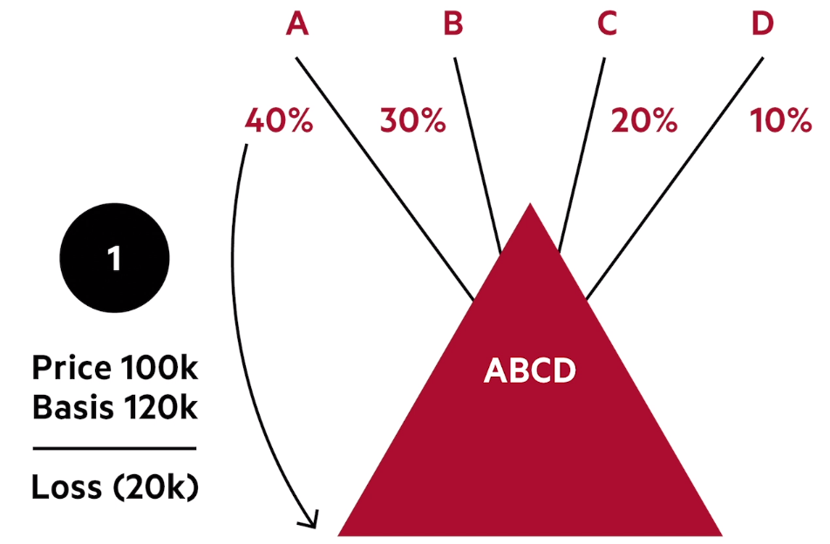

Answer:
  - In the absence of special rules, Andy would recognize a $20K loss
  - 267(b) does NOT say that a partner and his partnership are related parties. The reason is that the corresponding partnership rule is in 707(b)(1).
  - 707(b)(1) states, "No deduction shall be allowed in respect of losses from sales or exchanges of property (other than an interest in the partnership), directly or indirectly, between
    - A partnership and a person owning, directly or indirectly, more than 50 percent of the capital interest, or the profits interest, in such partnership OR
    - two partnerships in which the same persons own, directly or indirectly, more than 50 percent of the capital interests or profits interests.
  - So the first question is whether 707(b)(1) applies to the sale by Andy to the partnership. The answer is no, Andy does not have MORE than a 50% interest in the partnership, so Andy can take the loss.

Problem A: What are the tax consequences of the two transactions if Andy and Dean are siblings; the partners are otherwise unrelated. The partnership sold Blackacre for $80K to X Corp, which is equally owned by Andy and Andy's spouse.
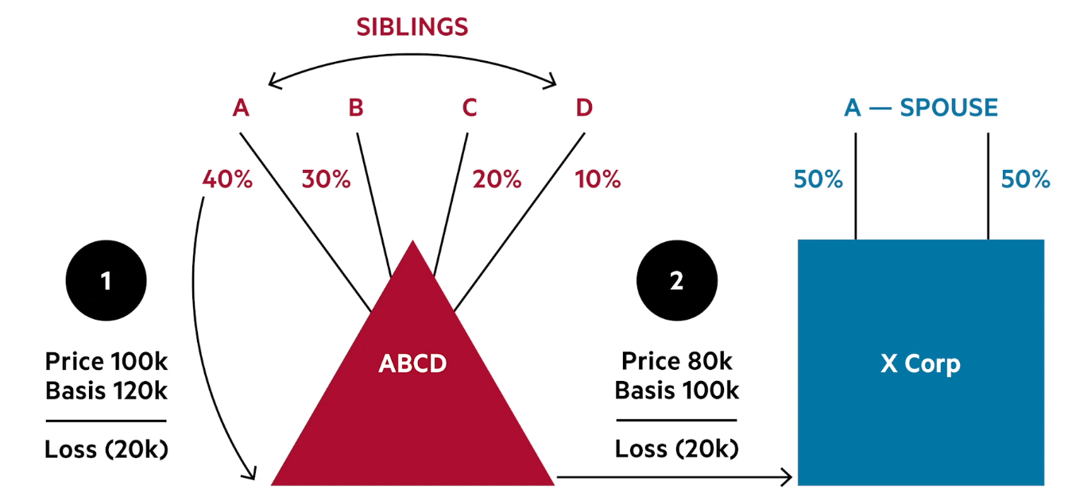

Answer:
  - First issue is whether the 20K loss is disallowed when Andy sells Blackacre to the partnership.
  - In the absence of special rules, Andy would recognize a $20K loss
  - 267(b) does NOT say that a partner and his partnership are related parties. The reason is that the corresponding partnership rule is in 707(b)(1).
  - 707(b)(1) states, "No deduction shall be allowed in respect of losses from sales or exchanges of property (other than an interest in the partnership), directly or indirectly, between
    - A partnership and a person owning, directly or indirectly, more than 50 percent of the capital interest, or the profits interest, in such partnership OR
    - two partnerships in which the same persons own, directly or indirectly, more than 50 percent of the capital interests or profits interests.

  - However, 707(b)(3) provides, "For purposes of paragraphs (1) and (2) of this subsection, the ownership of a capital or profits interest in a partnership shall be determined in accordance with the rules for constructive ownership of stock provided in section 267(c) other than paragraph (3) of such section."
    - So, we use the stock attribution rules in 267(c ) to determine deemed ownership of partnership interests as well.

  - Section 267(c)(2) states, "An individual shall be considered as owning the stock owned, directly or indirectly, by or for his family"

  - Family is defined in 267(c)(4) that states, "The family of an individual shall include only his brothers and sisters (whether by the whole or half-blood), spouse, ancestors, and lineal descendants.

  - So, Andy is deemed to own D's 10% interest. But, even so Andy and Dean's interest equals 50% and this is NOT MORE than 50% as required by 707(b)(1). Thus, the loss on the sale to the partnership is not disallowed.

  - Second issue here is whether the loss on the sale to X corp is allowed.

  - 707(b)(1) does not apply here because the transaction is not between a partnership and its partner or two partnerships. Thus, we need to turn to 267.
    - Since Andy owns an interest in the partnership and X corp, this is potentially a sale between commonly controlled businesses.

  - Reminder, 267(a) states that losses from the sale of property between persons under any relationship described in 267(b) are disallowed. 267(b)(10) states a covered relationship is "A corporation and a partnership if the same persons own—
    - more than 50 percent in value of the outstanding stock of the corporation, and
    - more than 50 percent of the capital interest, or the profits interest, in the partnership;

  - So, we have to figure out the attribution rules for both the corporation and the partnership.
    - For the corporation, 267(c)(2) states, "An individual shall be considered as owning the stock owned, directly or indirectly, by or for his family."
      - 267(c)(4) that states, "The family of an individual shall include only his brothers and sisters (whether by the whole or half blood), spouse, ancestors, and lineal descendants.
      - So, Andy is deemed to own 100% of the X corp.

  - For the partnership, Andy is deemed to own 50% of the partnership, but since 267(b)(10) requires more than a 50% ownership interest, we fail the test here and this rule does not apply.

  - Any time we have a transaction between a partnership and someone that is not a partner, the disaggregation regulations become relevant.
    - If you conclude that the loss is NOT disallowed under 707(b), THEN we treat the sale as by each of the partners to X corp.
    - For purposes of the disaggregation regulations, you don’t attribute interests for the partners, so you wouldn’t group Andy's interest and B's interest for the disaggregation regs.

  - Treas. Reg. 1.267(b)-1(b)(1) states, "Any transaction described in section 267(a) between a partnership and a person other than a partner shall be considered as occurring between the other person and the members of the partnership separately."
    - X corp is a person other than a partner. So, the sale to X corp will be treated as a sale by the partners to X corp and this is the disaggregation rules and we need to analyze partner by partner.
    - So, if the sale between any partners and X corp are within any of the relationship described in 267(b), then no deduction with respect to such transaction between the other person and the partnership shall be deductible.

  - Andy is a 40% partner. He also owns 100% of the stock of X corp per 267©(2) and (4). So, 267(b)(2) kicks in which describes as a covered relationship, "An individual and a corporation more than 50 percent in value of the outstanding stock of which is owned, directly or indirectly, by or for such individual"

  - So, Andy and X corp are related for purposes of 267(b)(2) the loss on the sale between Andy and X corp will be disallowed. Total loss is 20K, his share is 40%, so the 8K loss is allocated to Andy. This loss needs to be specially allocated to the affected partner (A). This disallowed loss results in a reduction to outside basis per 705(a)(2)(B).

  - Dean constructively owns Andy's stock per 267©(2). However, he is only treated as owning 50% of the stock of X corp. You don't attribute Andy's spouses stock to Dean. This is stated in 267©(5) which states,
    - "Stock constructively owned by a person by reason of the application of paragraph (1) shall, for the purpose of applying paragraph (1), (2), or (3), be treated as actually owned by such person, but stock constructively owned by an individual by reason of the application of paragraph (2) or (3) shall not be treated as owned by him for the purpose of again applying either of such paragraphs in order to make another the constructive owner of such stock."

  - So, since Andy is constructively deemed to own X corp stock through 267©(2), you do not treat that stock as owned by him for purposes of making Dean the constructive owner of Andy's spouses stock.

Thus, because Dean only owns 50% of X corp and not more, that relationship is not described in 267(b)(2) an that loss is not disallowed.

Problem B: Andy and Cleo are siblings; the partners are otherwise unrelated. The partnership sold Blackacre to a unrelated party for $150K.
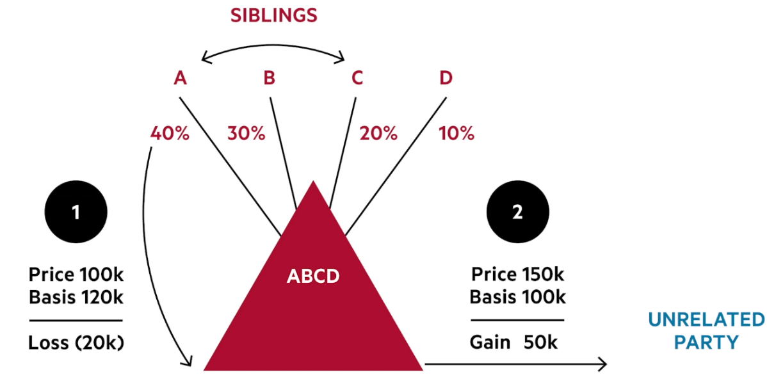

Answer: First question is whether the loss is disallowed under 707(b)(1). Here, it doesn't because Andy only owns 40%. So, you need to see whether you can attribute the sibling's interest to Andy. 707(b)(3) punts you to 267© to determine whether you can attribute Cleo's partnership interest to Andy.

Any is treated as owning Cleo's partnership interest per 267©(2). So Andy owns 60% of the partnership for purposes of 707(b)(1). So, Andy's loss is disallowed.

  - 267(d) then states, "
If—
(A)in the case of a sale or exchange of property to the taxpayer a loss sustained by the transferor is not allowable to the transferor as a deduction by reason of subsection (a)(1), and

(B)the taxpayer sells or otherwise disposes of such property (or of other property the basis of which in the taxpayer’s hands is determined directly or indirectly by reference to such property) at a gain,

then such gain shall be recognized only to the extent that it exceeds so much of such loss as is properly allocable to the property sold or otherwise disposed of by the taxpayer.

  - So, Andy was the transferor where a $20K loss was disallowed. The partnership is now selling the property for a $50K gain. However, 267(d) says that Andy's loss can be used to offset the partnership gain. So, the partnership only recognizes $30K in gain.

  - The result is that the partners would need to increase their outside basis by 20K for the gain that was not recognized.

Problem C: Andy and Cleo are siblings; the partners are otherwise unrelated. The partnership sold Blackacre to an unrelated party for $75K.

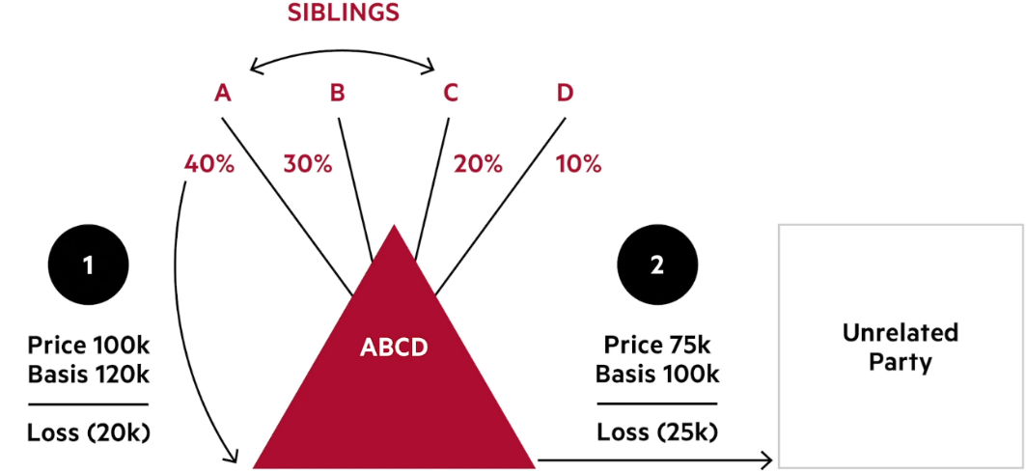

  - This is very similar to B. Andy is deemed to own 60% of the partnership per 267©(2). Thus, the loss is disallowed per 707(b)(1). Only difference is that the property is sold for a further loss.

  - The relief that would have been afforded in 267(d) is not available because the sale is not at a gain. There is no related party issue on the sale.
  - Thus, the partnership recognizes the $25K loss.
  - Andy's 20K disallowed loss evaporates and no adjustment to outside basis is required.
  - The partnership got the asset at 100K and that is its inside basis in the property. So when it sells for loss, there is no need to adjust basis.

Problem D: The partners of ABCD are unrelated. The ABCD partnership sold Blackacre for 75K to the CA partnership in which Cleo's spouse has a 90% interest in profits and capital and Andy's son's wholly owned corporation has a 10% interest.

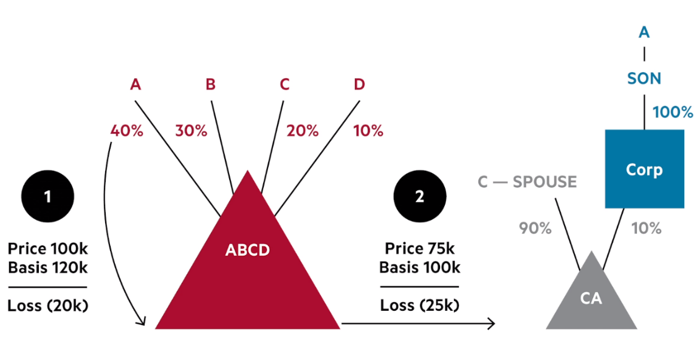

  - Because Andy only owns 40% of the partnership, the loss is not disallowed under 707(b)(1)(A).

  - Section 707(b)(1)(B) states, "No deduction shall be allowed in respect of losses from sales or exchanges of property (other than an interest in the partnership), directly or indirectly, between two partnerships in which the same persons own, directly or indirectly, more than 50 percent of the capital interests or profits interests."

  - So if there is a loss on the sale between two commonly controlled partnerships, the loss will be disallowed.

  - 707(b)(3) states, "For purposes of paragraphs (1) and (2) of this subsection, the ownership of a capital or profits interest in a partnership shall be determined in accordance with the rules for constructive ownership of stock provided in section 267(c) other than paragraph (3) of such section."

  - The first question then is are the ABCD and CA partnership commonly controlled.
    - 267(e)(3) states, "For purposes of determining ownership of a capital interest or profits interest of a partnership, the principles of subsection (c) shall apply, except that—
(A) paragraph (3) of subsection (c) shall not apply, and
(B) interests owned (directly or indirectly) by or for a C corporation shall be considered as owned by or for any shareholder only if such shareholder owns (directly or indirectly) 5 percent or more in value of the stock of such corporation.

  - 267(c)(2) says that Cleo constructively owns the 90% partnership interest that is owned by his spouse.

  - For Andy's son's corporation that owns the 10% interest in CA partnership, 267€(3)(B) states that interest owned by or for a C corporation shall be considered owned by any shareholder only if a shareholder owns more than 5%.

  - 267©(1) then states, "Stock owned, directly or indirectly, by or for a corporation, partnership, estate, or trust shall be considered as being owned proportionately by or for its shareholders, partners, or beneficiaries"
    - So, Andy's son is deemed to own the 10% interest in the CA corporation.
    - Next question is whether Andy's son's interest in the CA corporation can be attributed to Andy (double attribution).
    - The answer is in 267©(5) which states, "Stock constructively owned by a person by reason of the application of paragraph (1) shall, for the purpose of applying paragraph (1), (2), or (3), be treated as actually owned by such person, but stock constructively owned by an individual by reason of the application of paragraph (2) or (3) shall not be treated as owned by him for the purpose of again applying either of such paragraphs in order to make another the constructive owner of such stock."
    - Here, Andy's son is deemed to constructively own an interest in CA by virtue of 267©(1). Thus, that stock is treated as actually owned AND further attribution will be allowed.
    - So, Andy will be deemed to own the 10% interest as well under 267©(2) and thus, Andy and Cleo will constructively own 100% interest in CA partnership.

  - Since you are looking at 267 by mandate from 707, then "stock owned" per 267 means "partnership interest" owned.

  - Andy and Cleo own 60% of the ABCD partnership. Under 707(b)(1)(B) the two partnerships will be treated as commonly owned and the losses on the sale from the ABCD partnership to the CA partnership is disallowed and we need to allocate the disallowed loss to the partners to reduce outside basis.

Problem E: The partners of ABCD are unrelated. The ABCD partnership sold Blackacre for 75K to Bev's grandchild.
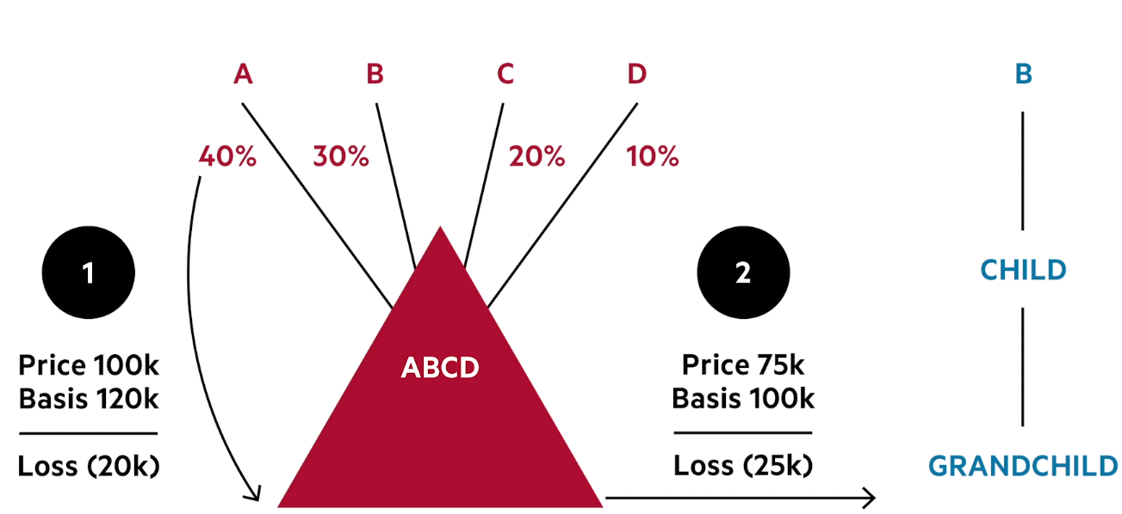

  - Original sale will not be disallowed under 707(b)(1)(A).
  - Now, question is what happens on subsequent sale.
  - Here, we don't meet the 50% requirement in 707(b)(1)(A) and we move to the 267 disaggregation regs.
  - Now, the only related party issue is Bev's sale to her grandchild. Losses between sales on family is disallowed per 267(b)(1). 267(c )(4) states, "The family of an individual shall include only his brothers and sisters (whether by the whole or half blood), spouse, ancestors, and lineal descendants"
  - The grandchild is a lineal descendant so this would be a related party transaction and the loss would be disallowed.
  - Outside basis adjustment to Bev along with disallowed loss.

Problem F:Andy and Cleo are siblings, partners are otherwise unrelated. The partnership sold Blackacre to Cleo for $150K.

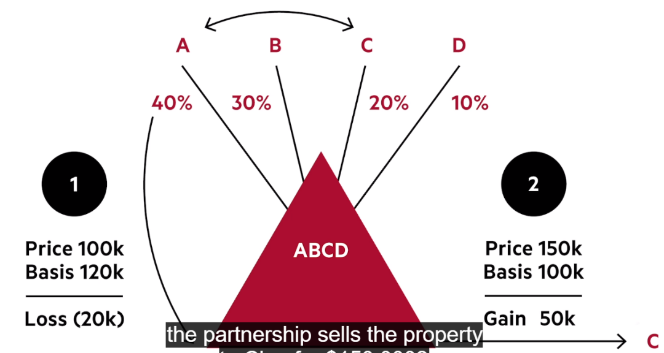

  - Loss is disallowed per 267©(2)
  - Partnership recognizes 50K gain on sale. Under 267(d), partnership can use disallowed loss to shelter the gain. The partnership reports 30K in gain, then we make upward outside basis adjustments to the partners.

  - 707(b)(2) Gain Recharacterization Anti-Abuse Rule
    - The Game
      - Party 1 sells an asset to related Party 2, recognizing capital gain. Party 2 is going to hold the asset either as an ordinary asset or as a §1231 asset. This means that if the asset is sold at a loss, the loss will be ordinary. Even if it’s not sold at a loss, if it’s a depreciable asset, it will generate ordinary deductions.

  - What they want to prevent is overstated sales where the seller will recognize capital gain and the buyer will get inflated ordinary income deductions. If the asset is capital in the hands of the transferree however, then there is no issue because there is no depreciation deductions.

  - Any time you have one of the situations that are in 707(b)(1), you have to worry about the character of the gain as well.

  - Rule
    - If gain is recognized on a sale or exchange between a person and a more than 50% controlled partnership, 707(b)(2) requires that the gain bet treated as ordinary gain if the property is not a capital asset in the hands of the transferee.

  - Relevant Statute
    - Section 707(b)(2)
In the case of a sale or exchange, directly or indirectly, of property, which in the hands of the transferee, is property other than a capital asset as defined in section 1221— (A) between a partnership and a person owning, directly or indirectly, more than 50 percent of the capital interest, or profits interest, in such partnership, or (B) between two partnerships in which the same persons own, directly or indirectly, more than 50 percent of the capital interests or profits interests, any gain recognized shall be considered as ordinary income.

  - Disguised Sales Anti-Abuse Rule
    - The Game
      - You and I are partners. I contribute property with built-in gain. The property is worth $100. At the same time, or some time later, the partnership distributes $100 in cash to me. In effect, I’ve turned my property worth $100 into cash.

The contribution transaction was tax-free. So long as we arrange things so that I have enough outside basis, the subsequent distribution is tax-free as well. In effect, I’ve disposed of my property for cash without recognizing my built-in gain.

Congress thought this was too rich, and in response to Otey enacted §707(a)(2), which authorizes the Treasury to provide by regulations that a transfer of property to a partnership coupled with a related distribution of money to the contributing partner should be treated as a sale under §707(a)—that is, as a transaction with one who is not a partner. The resulting regulations are sometimes known as the anti-Otey rules.

A sale, of course, is a recognition event. To the extent the contribution and distribution are recharacterized as a sale, the partner making the transfer to the partnership will recognize any built-in gain or loss. Obviously, Congress was concerned primarily with disguised sales involving built-in gain, but the rules do not depend on whether the transferred property involves built-in gain or built-in loss.

  - Rules:
    - Reg. §§ 1.707-3 through -5 deal with disguised sales by a partner to a partnership. Reg. §§ -6 deals with disguised sales by a partnership to a partner. We’re going to focus on the first, which is more common. Reg. §1.707-3(b)(1) tells us that:

A transfer of property (excluding money or an obligation to contribute money) by a partner to a partnership and a transfer of money or other consideration (including the assumption of or the taking subject to a liability) by the partnership to the partner constitute a sale of property, in whole or in part, by the partner to the partnership only if based on all the facts and circumstances -
(i) The transfer of money or other consideration would not have been made but for the transfer of property; and
(ii) In cases in which the transfers are not made simultaneously, the subsequent transfer is not dependent on the entrepreneurial risks of partnership operations.

Reg. §1.707-3(b)(2) the states, "The determination of whether a transfer of property by a partner to the partnership and a transfer of money or other consideration by the partnership to the partner constitute a sale, in whole or in part, under paragraph (b)(1) of this section is made based on all the facts and circumstances in each case. The weight to be given each of the facts and circumstances will depend on the particular case. Generally, the facts and circumstances existing on the date of the earliest of such transfers are the ones considered in determining whether a sale exists under paragraph (b)(1) of this section."

  - Factor Analysis Outlined in 1.707-3(b)(2)
Among the facts and circumstances that may tend to prove the existence of a sale under paragraph (b)(1) of this section are the following:
(i) That the timing and amount of a subsequent transfer are determinable with reasonable certainty at the time of an earlier transfer;
  - The problem here is that well-advised parties will never include the timing in their written documentation. In our problem, we have no idea what the parties’ deal was, and they probably won’t tell us.

(ii) That the transferor has a legally enforceable right to the subsequent transfer;
  - So long as the parties’ agreement is not reduced to writing, this is going to be hard for the IRS to prove.

(iii) That the partner's right to receive the transfer of money or other consideration is secured in any manner, taking into account the period during which it is secured;

(iv) That any person has made or is legally obligated to make contributions to the partnership in order to permit the partnership to make the transfer of money or other consideration;

(v) That any person has loaned or has agreed to loan the partnership the money or other consideration required to enable the partnership to make the transfer, taking into account whether any such lending obligation is subject to contingencies related to the results of partnership operations;

(vi) That a partnership has incurred or is obligated to incur debt to acquire the money or other consideration necessary to permit it to make the transfer, taking into account the likelihood that the partnership will be able to incur that debt (considering such factors as whether any person has agreed to guarantee or otherwise assume personal liability for that debt);
  - Factors (iii) through (vi) all address techniques to reduce the transferor’s anxieties about whether he or she will get paid. If the parties trust each other, these techniques are unnecessary. The less trust, the less likely a transferor will be able to get away with a disguised sale.

(vii) That the partnership holds money or other liquid assets, beyond the reasonable needs of the business, that are expected to be available to make the transfer (taking into account the income that will be earned from those assets);
  - The problem here is that any business can come up with plausible needs for money or other liquid assets. It is for this reason that, in the corporate context, the accumulated earnings tax is never enforced.

(viii) That partnership distributions, allocation or control of partnership operations is designed to effect an exchange of the burdens and benefits of ownership of property;
  - This adds very little to the basic requirements of Reg. §1.707-3(b)(1).

(ix) That the transfer of money or other consideration by the partnership to the partner is disproportionately large in relationship to the partner's general and continuing interest in partnership profits; and
  - Helpful, but this is only one factor.

(x) That the partner has no obligation to return or repay the money or other consideration to the partnership, or has such an obligation but it is likely to become due at such a distant point in the future that the present value of that obligation is small in relation to the amount of money or other consideration transferred by the partnership to the partner.
  - This deals with distributions disguised as debts or refundable distributions—rarely used techniques.

  - Two-Year Disguised Sale Presumption
Reg. §1.707-3(c)(1), however, tells us:
  - For purposes of this section, if within a two-year period a partner transfers property to a partnership and the partnership transfers money or other consideration to the partner (without regard to the order of the transfers), the transfers are presumed to be a sale of the property to the partnership unless the facts and circumstances clearly establish that the transfers do not constitute a sale.

  - Circumventing the Anti-Otey Rules
Alternatively, if transactions are more than two years apart, it is presumed that the transfer is not a sale unless the facts and circumstances clearly establish that it is. Reg. §1.707-3(d) says:

“For purposes of this section, if a transfer of money or other consideration to a partner by a partnership and the transfer of property to the partnership by that partner are more than two years apart, the transfers are presumed not to be a sale of the property to the partnership unless the facts and circumstances clearly establish that the transfers constitute a sale.”

Therefore, distributions more than 3 years after a tax-free contribution will likely be protected.

  - Notes:
    - There can be loss recognized on the disguised sale if the basis allocable to the portion sold exceeds the amount realized in the transaction.
    - With these disguised sales rules, the contribution of property into a partnership can recharacterize the transaction as a sale.
      - Thus, we need to watch out if the sale will cause the contributing partner to realize a loss. If so, the rules from 707(b)(1)(A) come into play and may preclude the recognition of the loss due to related party loss limitation rules.
      - Thus, this creates situations where the losses are suspended and may be applied against the partnership's future income from a subsequent sale to an unrelated party.
      - If the partnership sells the property at a loss, then the 704(c) rules kick in as well and say that loss is allocated to the contributing partner, even though the rules recharacterized the initial contribution as a sale.

  - Disguised Sales and Debt
    - The Game
      - You and I are partners. I own property with built-in gain on it. I want to cash out immediately without recognizing that gain. I don’t want to wait two years. The Treasury has promulgated rules effectively shutting down direct Otey transactions. What do I do?

I borrow against the property, then contribute the property to the partnership. Suppose the property is worth $1,000. I borrow $1,000, securing the debt with a mortgage on the property. Then I contribute the property to partnership. I’ve just cashed out without any cash distribution from the partnership whatever.

Obviously, we can’t make all mortgages suspect. It could be that the mortgage on my property was the debt I used to acquire the property. Or it could be debt that’s been on there for years. So we’re going to have to have rules that distinguish between good debt and bad debt. They talk about qualified liabilities and liabilities other than qualified liabilities—let’s call them “nonqualified liabilities.”

  - General Rule
    - The fact that the partnership assumes or takes subject to a qualified liability does not create a disguised sale. But if it assumes or takes subject to a nonqualified liability, the partner’s reduction in liability is going to be treated as consideration on a deemed sale.

  - Rules
    - Reg. §1.707-5(a)(5), first sentence, tells us:
      - If a transfer of property by a partner to a partnership is not otherwise treated as part of a sale, the partnership's assumption of or taking subject to a qualified liability in connection with a transfer of property is not treated as part of a sale.

  - There is, however, an exception to this general rule—
    - if a transfer of property by a partner to the partnership would be treated as part of a sale anyhow, without regard to the partnership's assumption of or taking subject to the qualified liability.
    - If this exception applies, a part of the qualified liability may be treated as additional consideration on the sale.

  - Jumping back to §1.707-5(a)(1), second sentence, we learn that:
    - By contrast, if the partnership assumes or takes property subject to a liability of the partner other than a qualified liability, the partnership is treated as transferring consideration to the partner to the extent that the amount of the liability exceeds the partner's share of that liability ….

  - We’re told in Reg. §1.707-5(a)(2)(ii) that:
    - A partner's share of a nonrecourse liability of the partnership is determined by applying the same percentage used to determine the partner's share of the excess nonrecourse liability under §1.752-3(a)(3).

  - Solely for purposes of the anti-Otey rules, we allocate debt using the third non-recourse debt allocation step only—in other words, in accordance with the partners’ interests in profits (which, you will recall, didn’t really mean just profits). We don’t allocate any portion based on minimum gain or on §704(c) gain.

  - Why?
    - An example. Assume that I own property with a basis of zero and a FMV of $100. I borrow $100 against the property and contribute it to our partnership. If we don’t change the debt allocation rules for anti-Otey purposes, what happens?

  - Under the second step of the §752 algorithm, all of the partnership debt is allocated to the contributing partner, because it’s all §704(c) gain that would be recognized if the property were sold for the amount of the debt.

  - Since all of the debt is still allocated to the contributing partner after the contribution, there hasn’t been any decline in the contributing partner’s share of that debt. And remember, the regulations only treat the decline in the partner’s share as consideration on a deemed sale.

  - Under the modified nonrecourse allocation rules, by contrast, if our partnership is a 50–50 deal, in our hypothetical my share of the debt drops from $100 to $50. This gives me $50 of consideration on a deemed sale. Bingo! Anti-Otey.

  - What is a Qualified Liability?
    - Qualified liabilities are elaborated on in §1.707-5(a)(6) that states:
      - A liability assumed or taken subject to by a partnership in connection with a transfer of property to the partnership by a partner is qualified liability of the partner only to the extent (i) The liability is—

  - We then have two sets of rules, one for qualified debt generally, recourse or nonrecourse, the other specifically for recourse debt.
    - First, qualified debt generally:

  - Old and cold debt: “A liability that was incurred by the partner more than two years prior to the earlier of the date the partner agrees in writing to transfers the property or the date the partner transfers the property to the partnership and that has encumbered the transferred property throughout that two-year period ….” If the nonrecourse debt has been on the property at least two years, it’s qualified.

  - Debt not incurred in anticipation of the contribution: “A liability that was not incurred in anticipation of the transfer of the property to a partnership, but that was incurred by the partner within the two-year period prior to the earlier of the date the partner agrees in writing to transfer the property or the date the partner transfers the property to the partnership and that has encumbered the transferred property since it was incurred ….” I’m going to call this “who knew?” debt; “who knew” the property would be contributed to a partnership?

  - Capital expenditure debt: “A liability that is allocable under the rules of §1.163-8T to capital expenditures … with respect to the property ….” This is debt that involves capital expenditures with respect to the property—in other words, that increases taxpayer’s basis in the property.

  - Debt incurred in the ordinary course of a trade or business: “A liability that was incurred in the ordinary course of the trade or business in which property transferred to the partnership was used or held but only if all the assets related to that trade or business are transferred other than assets that are not material to a continuation of the trade or business ….“

  - Debt incurred in connection with a trade or business: “A liability that was not incurred in anticipation of the transfer of the property to a partnership, but that was incurred in connection with a trade or business in which property transferred to the partnership was used or held but only if all the assets related to that trade or business are transferred other than assets that are not material to a continuation of the trade or business ….”

  - Finally, a special rule for recourse debt:
    - A liability is qualified only to the extent that [i]f the liability is a recourse liability, the amount of the liability does not exceed the fair market value of the transferred property ….

  - What if Debt is a Qualified Liability
    - The normal rules governing non-recognition and §752 apply

  - Two-Year Presumption
Coming back to our second and fifth categories, “who knew?” debt and debt incurred in connection with a trade or business but not in anticipation of the transfer of the property to a partnership, we have a presumption in paragraph §1.707-5(a)(7):

if within a two-year period a partner incurs a liability (other than a liability described in paragraph (a)(6)(i) (C) or (D) of this section) and transfers property to a partnership or agrees in writing to transfer the property, and in connection with the transfer the partnership assumes or takes the property subject to the liability, the liability is presumed to be incurred in anticipation of the transfer unless the facts and circumstances clearly establish that the liability was not incurred in anticipation of the transfer.

Again, we a two-year presumption in favor of a finding of bad debt. Unfortunately, this time we don’t have a corresponding more-than-two-year presumption the other way.

  - Sales of Partnership Interests
    - Seller Side
      - Gain or Loss Computation Issues
        - Basis Allocation Rules of Rev. Rul. 84-53
          - Problems arise when a partner sells an interest in their partnership holdings because each partner has one basis. So when you sell a partial interest, you need to allocate between basis retained and basis sold.

  - Rev. Rul. 84-53 tells us that in computing the partner’s gain or loss we must pro rate the partner’s outside basis between the portion sold and the portion retained in proportion to their fair market values. This sounds reasonable in the abstract and may be unavoidable, but it can produce bizarre and unexpected results.

  - Problem 1(a): Blake is a GP in the BCD LP; Charlie and Dave are LPs. Blake's interest is 20% and Charlie and Dave's interests are each 40%. The basis of Blake's general partnership interest is $200, and its FMV is $300. Each Charlie and Dave have a $400 basis in their partnership interests, which are worth 600. The partnership has no debts and distributes all TI.

  - Blake buys one-half of Charlie's LP interest for $300. What are the tax consequences to Charlie.

Here, the amount realized will be $300. Rev. Rul. 84-53 tells us to pro rate a partner’s outside basis between the portion being sold and the portion being retained in proportion to their FMVs.

Charlie's amount realized would be $300. The basis allocable to that interest would be $200 ($400 * (300/600)). So, Charlie would recognize $100 of gain.

  - Blake buys all of Charlie's limited partnership interest for $600, following which Blake sells all of the limited partnership interest to Dave for $300. What is the impact to Blake?

Blake's basis in the partnership interest after purchasing Charlie's share is $800. This is computed by adding basis from the GP and LP interests. Under Rev. Rul. 84-53 and Reg. §1.704-1(b)(2)(iv)(b), he has a single outside basis and a single capital account—not a separate outside basis and capital account for each of the two types of interests he owns.

When Blake sells his GP interest to Dave for $300, we allocate his single basis between the interest retained and the interest sold in proportion to their respective fair market values. The FMV of the property is $900. Thus, a 1/3 interest is being sold. Thus, basis allocated to the sale would be $267 (800/3). Thus, gain would only be $33 dollars. His outside basis in the interest retained would be $533 (800 total basis less $267 interest sold).

  - Blake buys all of Charlie's limited partnership interest for $600, following which Blake sells all of the limited partnership interest to Elvis for $600. What is the impact to Blake?

Blake's basis in the partnership interest after purchasing Charlie's share is $800. This is computed by adding basis from the GP and LP interests. Under Rev. Rul. 84-53 and Reg. §1.704-1(b)(2)(iv)(b), he has a single outside basis and a single capital account—not a separate outside basis and capital account for each of the two types of interests he owns.

Blake's amount realized on the sale is $600. The FMV of the property is $900. So, the portion sold is 2/3. So, the basis allocated to the sale would be (800*(2/3))=$533. So, the gain on the sale would be 67 dollars.

  - When you analyze the portion of basis to allocate to a portion of the property sold, you need to segment out what portion of basis is allocable to debt. Only, the non-debt basis should be allocated to the sale to determine gain/loss. Debt is handled separately
    - When a GP interest is sold
      - debt relief will contribute to the amount realized.
      - Also, basis allocable to the property sold will be (1) percentage of non-debt basis and (2) percentage of debt basis.

  - When an LP interest is sold
    - Debt relief does not contribute to amount realized
    - Basis allocable to property should only consist of non-debt basis allocable to the property

  - Hot Asset Rules of 751(a)
    - The Game:
      - You contribute a bunch of ordinary income asset to a partnership and then sell that partnership interest for a gain and get capital gain treatment per 741. The hot asset rules in 751 overrule this game.

  - Under IRC §741, when we sell a partnership interest, up until now we’ve treated any resulting gains or losses as capital. Making the gain/loss and character results on an interest sale match perfectly those on an asset sale would be unbelievably complex and cumbersome. But failing to make at least some attempt to do so would allow taxpayers, in effect, to sell ordinary assets at capital gain rates.

  - 751 Overview:
    - Congress has enacted §751, which, in appropriate circumstances, converts a portion of any gain recognized on a sale of a partnership interest into ordinary income. We’re told in subsection 751(a):

"The amount of any money, or the fair market value of any property, received by a transferor partner in exchange for all or a part of his interest in the partnership attributable to—

(1) unrealized receivables of the partnership, or
(2) inventory items of the partnership,

shall be considered as an amount realized from the sale or exchange of property other than a capital asset."

  - There are at least two ways of thinking about §751.
    - One is as an anti-abuse rule: that is, as a band-aid patched on over the foundational rules to prevent the use of sales of partnership interest to convert ordinary income into capital gain. That’s how Congress and the practicing bar thought of it initially.

  - But you might instead think of it as part of the inherent structure of partnership taxation itself: as an attempt to match the consequences on the sale of a partnership interest to those of an asset sale—recognizing, of course, that it’s sometimes not practical to match those consequences exactly.

  - Unrealized Receivables and Inventory
    - What are “unrealized receivables” and “inventory items”? When we turn to the statutory and regulatory definitions, we discover that they don’t mean what we expect them to mean.
      - In fact, it turns out that, for the most part, any inside asset which, if sold, would have produced ordinary income if sold is a “hot asset.”
      - And any inside asset which, if sold, would have produced capital gain is not.

  - Thus we find that in Roth v. Comm’r, 321 F.2d 607 (9th Cir. 1963), the Ninth Circuit says that Congress “meant to exclude from capital gains treatment any receipts which would have been treated as ordinary income to the partner if no transfer of the partnership interest had occurred.”

  - The Fifth Circuit, similarly, in US v. Woolsey, 326 F.2d 287 (5th Cir. 1963), says: “Section 751 has defined ‘unrealized receivables’ to include any rights, contractual or otherwise, to ordinary income from ‘services rendered, or to be rendered,’ to the extent that the same were not previously includable in income by the partnership, with the result that capital gains rates cannot be applied to the rights to income under the facts of this case, which would constitute ordinary income had the same been received in due course by the partnership.”

  - The IRS, in Rev. Rul. 60-352, 1960-2 C.B. 208, frames the same principle as follows:
    - Thus, while the partnership interest generally may be regarded as constituting a partner's interest in the profits and surplus of the partnership, the fundamental principles of Federal income taxation require that an interest in income earned by the partnership which has not been realized, or has not yet been subjected to taxation, be treated as distinct from any `partnership interest' which is recognized as a capital asset for income tax purposes. Therefore, unrealized or untaxed rights to partnership income may be transferred with, but not as a part of, the partnership interest which constitutes a capital asset.

  - Example: Problem Set 1, Problem 3

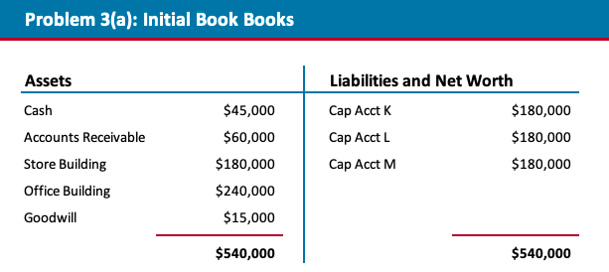
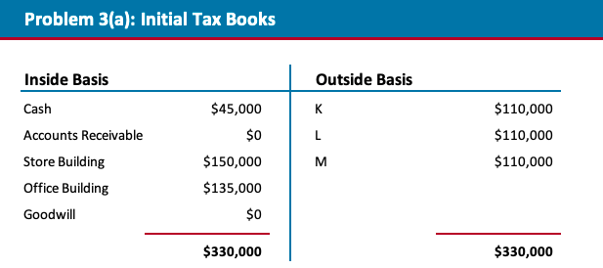

Here, Ken is selling an 33% interest in which he has an outside basis of $110,000 for $180,000. Obviously, he’s going to recognize $70,000 of gain.

The assets that are "hot assets" are AR and the store building sold in the course of business. The total built in gain is $90K (60 for the AR and 30 for the building). Thus, Ken's share of that is 30% of $30K. So, $30K will be ordinary, the remaining $40K will be capital.

  - Statutes
    - Recall that IRC §741 provides: In the case of a sale or exchange of an interest in a partnership, gain or loss … shall be considered as gain or loss from the sale or exchange of a capital asset, except as otherwise provided in section 751.

  - IRC §751(a) then provides:
The amount of any money, or the fair market value of any property, received by a transferor partner in exchange for all or a part of his interest in the partnership attributable to—
(1) unrealized receivables of the partnership, or
(2) inventory items of the partnership,
shall be considered as an amount realized from the sale or exchange of property other than a capital asset.

  - IRC §751(c) then defines the term “unrealized receivables” in an obscenely complex way. It begins straightforwardly:
    - [T]he term “unrealized receivables” includes,
to the extent not previously includible in income under the method of accounting used by the partnership,

any rights (contractual or otherwise) to payment for—

(1) goods delivered, or to be delivered, to the extent the proceeds therefrom would be treated as amounts received from the sale or exchange of property other than a capital asset, or

(2) services rendered, or to be rendered.

For purposes of this section and sections 731, 732, and 741 (but not for purposes of section 736), such term also includes mining property (as defined in section 617(f)(2)), stock in a DISC (as described in section 992(a)), section 1245 property (as defined in section 1245(a)(3)), stock in certain foreign corporations (as described in section 1248), section 1250 property (as defined in section 1250(c)), farm land (as defined in section 1252(a)), franchises, trademarks, or trade names (referred to in section 1253(a)), and an oil, gas, or geothermal property (described in section 1254) but only to the extent of the amount which would be treated as gain to which section 617(d)(1), 995(c), 1245(a), 1248(a), 1250(a), 1252(a), 1253(a), or 1254(a) would apply if (at the time of the transaction described in this section or section 731, 732, or 741, as the case may be) such property had been sold by the partnership at its fair market value. For purposes of this section and sections 731, 732, and 741 (but not for purposes of section 736), such term also includes any market discount bond (as defined in section 1278) and any short-term obligation (as defined in section 1283) but only to the extent of the amount which would be treated as ordinary income if (at the time of the transaction described in this section or section 731, 732, or 741, as the case may be) such property had been sold by the partnership.

You will note that the items on the list are all items of ordinary income. Is this list complete? We don’t know. If an item of ordinary income is not on this list, would it be treated as an unrealized receivable or inventory item? My guess is that there is a pretty good chance the IRS and the courts would so construe it.

  - Receivables in Accrual Method Partnerships:
    - Because the relevant income has already been taken into the partnership’s taxable income, there shouldn’t be any built-in gain yet to be recognized because all of the income was recognized when the receivables were accrued.
    - So, these receivables are not "unrealized receivables" but realized receivables and are treated as inventory for 751 purposes.
    - But, of course, the partnership currently has no built-in gain or loss on the receivables, so they don’t produce any §751 ordinary income or loss anyhow.

  - IRC §751(d) defines the term “inventory items” broadly: "For purposes of this subchapter, the term 'inventory items' means—
(1) property of the partnership of the kind described in section 1221(a)(1),

(2) any other property of the partnership which,
on sale or exchange by the partnership, would be considered property
  - other than a capital asset and
  - other than property described in section 1231, and

(3) any other property held by the partnership which, if held by the selling or distributee partner, would be considered property of the type described in paragraph (1) or (2).”

Notice that inventory for purposes of 751(d) does not have a substantially appreciated requirement that exists under 751.

  - Method of Analysis
    - In other words, we take all our §751 assets and sell them at FMV. This may produce both gains and losses. The portion of the resulting net gain, if any, that would be allocable to the selling partner is then the portion of the partner’s gain from the sale of his partnership interest that is treated as ordinary under §751. The remainder, if any, is treated as capital under §741.

  - 704(c) Issues:
    - If there is any 704(c) gain, when you run the hypothetical sale analysis, that gain or loss would be allocated to the contributing partner.

  - Any residual gain or loss would be then allocated to the selling partner.

  - Hot Asset w/ 704(c) gain

Amy, Bruce, and Cathy are each 1/3 partners in Cadillac Mountain, a general partnership. If the partnership’s book books were booked to fair market value, they would be as follows.
Assets |  | Liabilities and Net Worth
Cash | $40,000 | Cap Acct A | $140,000
Accounts Receivable | $30,000 | Cap Acct B | $140,000
Blackacre | $130,000 | Cap Acct C | $140,000
Whiteacre | $150,000
Greenacre | $70,000
Total | $420,000 | Total | $420,000

The partnership’s tax books are as follows.
Inside Basis |  | Outside Basis
Cash | $40,000 | A | $90,000
Accounts Receivable | $30,000 | B | $150,000
Blackacre | $220,000 | C | $150,000
Whiteacre | $40,000
Greenacre | $60,000
Total | $390,000 | Total | $390,000
The partnership uses the accrual method of accounting. It holds Blackacre for investment and Whiteacre and Greenacre for sale to customers in the ordinary course of its trade or business. Upon the formation of the partnership, A contributed Whiteacre at a time when its fair market value was $100,000 and its tax basis was $40,000. The partnership subsequently purchased Blackacre and Greenacre for cash.

Amy proposes to sell her interest to Dolores for $140,000 in cash—its fair market value. How much gain or loss will she recognize, and of what character?

The partnership’s hot assets consist of its accounts receivable, Whiteacre, and Greenacre. It has built-in gain of zero on the accounts receivable, $110,000 on Whiteacre, and $10,000 on Greenacre—a total of $120,000 of built-in gain on its hot assets. $60,000 of the built-in gain on Whiteacre is IRC §704(c) gain attributable to Amy. Amy’s share of the remaining built-in gain on Whiteacre ($50,000) and built-in gain on Greenacre ($10,000) is therefore is $20,000 = ($50,000 + $10,000)/3. The total built-in ordinary income on Amy's share of the partnership's assets is $80,000 ($60,000 of 704(c) gain on Whiteacre plus $20,000 of the remaining built-in gain on Whiteacre plus built-in gain on Greenacre. Her net gain on the sale of her partnership interest will be $50,000. Under IRC §751(a), this will generate $80,000 of ordinary gain and $30,000 of capital loss. See Treas. Reg. §1.751-1(g), Example 1.

  - Debt Relief
    - When you have debt relief in a sale, amount realized will be
      - Cash received
      - Debt relief

  - So, when computing gain, you need to do take the formula above less outside basis to determine gain recognized.

  - Problem with Debt Relief
Amy, Bruce, and Cathy are each 1/3 partners in Cadillac Mountain, a general partnership. If the partnership’s book books were booked to fair market value, they would be as follows.
Assets |  | Liabilities and Net Worth
Cash | $40,000 | Nonrecourse debt | $60,000
Accounts Receivable | $30,000 | Cap Acct A | $120,000
Blackacre | $130,000 | Cap Acct B | $120,000
Whiteacre | $150,000 | Cap Acct C | $120,000
Greenacre | $70,000
Total | $420,000 | Total | $420,000
The partnership’s tax books are as follows.
Inside Basis |  | Outside Basis
Cash | $40,000 | A | $120,000
Accounts Receivable | $0 | B | $120,000
Blackacre | $100,000 | C | $120,000
Whiteacre | $160,000
Greenacre | $60,000
Total | $360,000 | Total | $360,000
The partnership uses the cash method of accounting. It holds Blackacre for investment and Whiteacre and Greenacre for sale to customers in the ordinary course of its trade or business. The partnership purchased Blackacre for $100,000, paying $40,000 in cash and incurring a $60,000 nonrecourse debt secured by Blackacre. The partnership purchased Whiteacre and Greenacre for cash.
Amy proposes to sell her interest to Dolores for $120,000 in cash—its fair market value. How much gain or loss will she recognize, and of what character?

Upon the sale of her interest, Amy’s amount realized will be $140,000—the $120,000 of cash she receives from Dolores plus the $20,000 of debt of which she is deemed relieved. She will therefore recognize a total of $20,000 of gain ($140,000 amount realized minus $120,000 basis). The partnership’s hot assets consist of its accounts receivable, Whiteacre, and Greenacre. It has $30,000 of built-in gain on the accounts receivable, $10,000 of built-in loss on Whiteacre, and $10,000 of built-in gain on Greenacre—a total of $30,000 of net built-in gain on its hot assets. Amy’s share is $10,000. Of Amy’s $20,000 of gain, $10,000 will therefore be ordinary income and $10,000 capital gain.

  - Partnerships With Intangibles:
    - Distinguish whether the partnership's intangible assets relate to either:
      - Goodwill: Not an unrealized receivable
      - Concession Rights: Unrealized Receivables under Ledoux

  - Problem 4 with Intangibles

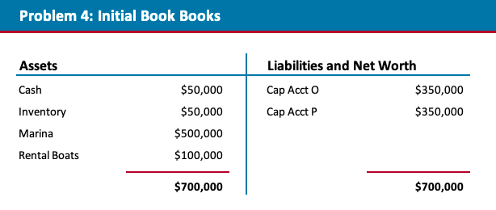
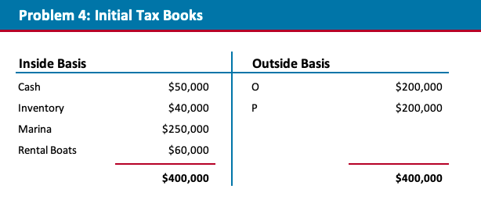

Pam is selling her interest for $600,000 cash. Obviously, since her share of the total fair market value of the partnership’s tangible assets is only $350,000, the partnership must have some intangible assets (of which her share is worth $250,000) as well.

Amount realized is $600K. Basis is $200K. So, gain is $400K.

Inventory: Total gain = $10,000. Her share = $5,000.

Marina: Not §1245 gain, so not §751 gain.

Rental boats: Total §1245 gain = $40,000. Her share = $20,000.

Intangible assets: Value = $1,200,000 (value of the partnership) - $700,000 (value of the tangible assets) = $500,000. The partnership's basis in the intangible assets is zero. Therefore, the partnership's total built-in gain on the intangible assets is $500,000. Her share = $250,000.

The answer depends on whether it’s attributable to goodwill or to concession rights. Goodwill is not an unrealized receivable. Under Ledoux, concession rights appear to constitute unrealized receivables.

Ledoux v. Comm’r, 77 T.C. 293 (1981), also suggests that the parties might be able to characterize the intangibles as goodwill by identifying a portion of the purchase price (e.g., $250,000) as attributable to goodwill.

What is the result if the $250,000 is treated as consideration for an unrealized receivable?

If the Intangibles Are Unrealized Receivables
Total gain = $400,000. Ordinary = $275,000. Capital = $125,000.

And what is the result if the $250,000 is treated as for goodwill?

If the Intangibles Are Goodwill
Total gain = $400,000. Ordinary = $25,000. Capital = $375,000.

Note that the difference in tax liability is going to be quite large.

  - Mixed Gains and Losses
    - When there are realized gains and losses on hot assets of a partnership, you do the following:
      - Recognize the ratable portion of the gain on the hot asset as ordinary income
      - Recognize the rest of the loss as a capital loss.

  - Statute: Treas. Reg. 1.751-1
    - The income or loss realized by a partner upon the sale or exchange of its interest in section 751 property is the amount of income or loss from section 751 property (including any remedial allocations under § 1.704-3(d)) that would have been allocated to the partner (to the extent attributable to the partnership interest sold or exchanged) if
      - The partnership had sold all of its property in a fully taxable transaction for cash in an amount equal to the fair market value of such property (taking into account section 7701(g)) immediately prior to the partner's transfer of the interest in the partnership.

  - Any gain or loss recognized that is attributable to section 751 property will be ordinary gain or loss.

  - The difference between
    - the amount of capital gain or loss that the partner would realize in the absence of section 751 and
    - the amount of ordinary income or loss determined under this paragraph (a)(2) is the transferor's capital gain or loss on the sale of its partnership interest.

  - When you have gains and losses on hot assets, you net the gains and losses ON HOT ASSETS ALONE to determine what the ordinary gain will be.
    - This is because if you sold all assets in a taxable transaction, the ordinary gains and losses would offset with each other so this makes sense.

  - Mixing Gains and Losses - Problem Set 1, problem 3(b)
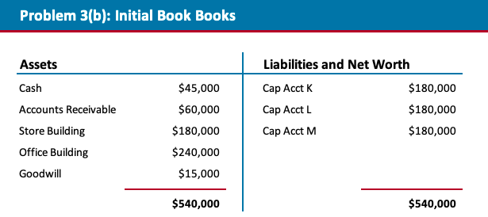

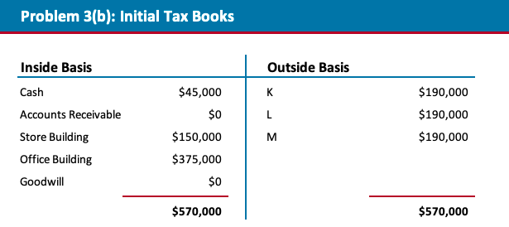

Here, the sale of Ken's interest will result in a $10K loss. Reg. §1.751-1(a)(2) is construed to mean that we break Ken’s $10,000 loss into an ordinary gain of $30,000 and a capital loss of $40,000.

Ordinary gain of $30K is computed by taking BIG from AR (60K) and store building (30K) which is a total of $90K. A 33% interest is $30K. So that is the ordinary income. To balance the loss to $10K, you need capital loss of $40K.

  - Buyer Side Issues
    - 754 Election
      - Overview
        - When an existing partner sells his or her partnership interest, under IRC §1012 the new partner takes that interest with a cost basis. Unless the purchase price exactly equals the original partner’s outside basis, this rule will create an inside–outside basis differential. And this, in turn, creates all sorts of problems for the new partner.

  - To solve these problems, Congress has enacted IRC §§754 and 743. IRC §754 tells us:

  - If a partnership files an election, in accordance with regulations prescribed by the Secretary, the basis of partnership property shall be adjusted, in the case of a distribution of property, in the manner provided in section 734 and, in the case of a transfer of a partnership interest, in the manner provided in section 743. Such an election shall apply with respect to all distributions of property by the partnership and to all transfers of interests in the partnership during the taxable year with respect to which such election was filed and all subsequent taxable years. Such election may be revoked by the partnership, subject to such limitations as may be provided by regulations prescribed by the Secretary.

  - The election is made by the partnership by filing a written statement with the return for the taxable year in question. That’s Reg. §1.754-1(b)(1). The election then remains in effect until properly revoked.

  - Two points:
    - First, the election is optional.
    - Second, if made, it applies to all property distributions and transfers of partnership interests made within the taxable year. You can’t make the election transaction by transaction.

  - Impact of an Election
    - If a 754 Election is made, we adjust inside basis under 743(b)

  - Under §743(b), we learn that:

In the case of a transfer of an interest in a partnership by sale or exchange or upon the death of a partner, a partnership with respect to which the election provided in section 754 is in effect … shall—
(1) increase the adjusted basis of the partnership property by the excess of the basis to the transferee partner of his interest in the partnership over his proportionate share of the adjusted basis of the partnership property, or

(2) decrease the adjusted basis of the partnership property by the excess of the transferee partner’s proportionate share of the adjusted basis of the partnership property over the basis of his interest in the partnership.

  - In other words, we adjust inside basis up or down to eliminate any inside-outside basis disparity created by the transfer.

  - But this basis adjustment is to benefit the purchasing partner only:
    - Per IRC §743(b)(2), "[S]uch increase or decrease shall constitute an adjustment to the basis of partnership property with respect to the transferee partner only."

  - 754 and Book Up Elections
    - §1.704-1(b)(2)(iv)(f)(5) does not authorize a book-up on the sale of all or part of an interest from one person to another.
    - The problem here is that the same tax gain remains built-in at the asset level. A book-up merely fixes the book problem, not the tax problem.
    - 754 fixes tax basis differences, book-ups are for book basis differences.

  - How to Compute 743(b) Adjustment
    - General Formula
      - Determine how much cash the purchasing partner would receive in a constructive liquidation. In the process, we allocate any book gain or loss that might be recognized on such a liquidation to come up with our final capital account balances.
        - This should be equal to the FMV of the partnership's assets, less debt, multiplied by the partner's percentage interest.

  - Add the amount of tax loss or subtract the amount of tax gain she would recognize in that constructive liquidation. The result is the purchasing partner's interest as a partner in the previously taxed capital.
    - Subtract tax gain that would be allocated to transferee, including:
      - §704(c) gain, remedial allocations, and
      - Special allocations, such as qualified income offsets or minimum gain chargebacks.
    - Add any tax loss that would be allocable to the transferee including
      - 704(c) loss or remedial losses.

  - Add the purchasing partner's share of partnership debt. The result is the purchasing partner's share of the adjusted basis of partnership property.

  - Subtract this from the partner's outside basis. The result is the §743(b) adjustment.

Cash on constructive liquidation
+ Loss on constructive liquidation
- Gain on constructive liquidation
Interest in previously taxed capital
+ Share of partnership debt
Share of inside basis

  - Allocating the 743(b) Adjustment Across Partnership Assets
    - Let's suppose we've computed the total amount of our §743(b) adjustment. Now, how do we spread this basis adjustment among the partnership's assets?

  - Code §743(c) tells us: “The allocation of basis among partnership properties where a subsection (b) is applicable shall be made in accordance with the rules provided in §755.”

  - We're told in §755(a) that: “Any increase or decrease in the adjusted basis of partnership property under §743(b) shall, except as provided in subsection (b), be allocated in a manner which has the effect of reducing the difference between the fair market value and the adjusted basis of partnership properties.”

  - But subsection (b) then tells us: “In applying the allocation rules provided in subsection (a), increases or decreases in the adjusted basis of partnership property arising from a transfer of an interest attributable to property consisting of capital assets and property described in §1231(b), or any other property of the partnership, shall be allocated to partnership property of a like character except that the basis of any such partnership property shall not be reduced below zero.”

  - In other words, the portion of the adjustment that's attributable to capital assets and §1231 property has to be allocated among the capital assets and §1231 property. And the portion of the adjustment that's attributable to ordinary income property has to be allocated among the ordinary income items.

  - When you allocate gain/loss in each of the baskets (i.e. capital and ordinary). If you have a gain in a basket, but an individual asset has built in loss, you only allocate the gain in the basket to those assets with BIG.

  - But we're not allowed to take the basis in any property below zero.

  - 754 Election Problem
Cliff's share of the inside basis is $80K. His outside basis is $165K. So the difference between his outside basis and his share of the inside basis is $85K.

If anything interesting is going on with respect to allocations, the approach used by the regulations should take it into account.

In Reg. §1.743-1(d)(1), we learn that: “A transferee's share of the adjusted basis to the partnership of partnership property is equal to the sum of
  - the transferee's interest as a partner in the partnership's previously taxed capital, plus
  - the transferee's share of partnership liabilities.”

Computation of Interest in Previously-Taxed Capital
What is the transferee's interest in the partnership's previously-taxed capital?

To figure this out, Reg. §1.743-1(d)(2) requires that we perform yet another constructive liquidation. We imagine that the partnership sells all of its assets in a fully taxable transaction for cash equal to the fair market value of its assets.

Reg. §1.743-1(d)(1) then tells us:
“Generally, a transferee's interest as a partner in the partnership's previously taxed capital is equal to
  - the amount of cash that the transferee would receive on a liquidation of the partnership following the hypothetical transaction,
  - increased by the amount of tax loss that would be allocated to the transferee from the hypothetical transaction, and
  - decreased by the amount of tax gain that would be allocated to the transferee from the hypothetical transaction.”

So what is this hypothetical transaction?
We're told in Reg. §1.743-1(d)(2) that: “the hypothetical transaction means the disposition by the partnership of all of the partnership's assets in a fully taxable transaction for cash equal to the fair market value of the assets.”

The problem tells us the fair market value of the partnership's assets is $330,000. Of that amount, $30,000 must go to pay off the debt. The remaining $300,000 will be distributed in accordance with positive capital account balances, which should reflect the economic deal.

To compute those capital account balances, we have to add the amount of book gain, or subtract the amount of book loss, Cliff would recognize on the constructive liquidation. Here the partnership would receive $330,000 for assets with the total book basis of $160,000.

This means that the partnership would recognize $170,000 of book gain on the constructive liquidation.

The business deal here is that 50% of that book gain would be allocated to Cliff. His capital account would therefore be increased by $85,000, from $65,000 to $150,000. Liquidating distributions in accordance with positive capital account balances, and therefore Cliff would be entitled to $150,000 in cash on the constructive liquidation
(THIS IS THE OLD PARTNERS CAPITAL ACCOUNT PLUS THE GAIN FROM THE HYPOTHETICAL SALE)

But we then have to add any tax loss or subtract any tax gain that would be allocated to Cliff on the constructive liquidation, including §704(c) gain, remedial allocations, and special allocations, such as qualified income offsets or minimum gain chargebacks.
Here we have only $85,000 of vanilla-flavored tax gain, coincidentally exactly equal to the book gain we credited to Cliff's capital account in the constructive liquidation. We subtract that $85,000 of tax gain from the $150,000 and get $65,000 FOR INTEREST IN PREVIOUSLY TAXED CAPITAL

Coming back to our problem, we had $15,000 of built-in tax gain on accounts receivable, $15,000 of built-in tax gain on the inventory, $25,000 of built-in §1245 recapture on the equipment, and $30,000 of built-in capital gain on the goodwill.

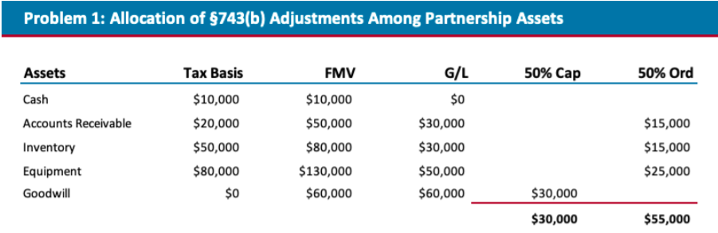
In other words, we had $30,000 of built-in capital gain and §1231 gain and $55,000 of built-in ordinary gain. This means that $55,000 of the $85,000 basis adjustment must be allocated to ordinary income property. The remaining $30,000 must be allocated to the capital gain property. The tax basis of the property will then be adjusted accordingly.

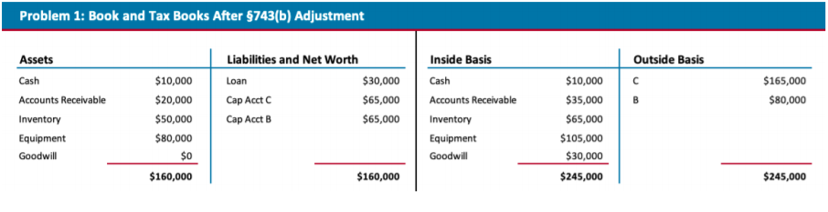

What happens if the assets are sold by the partnership at fair market value?
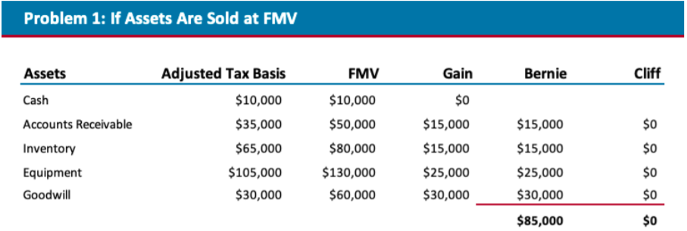
Cliff gets all the benefit of the §743(b)adjustment; Bernie doesn't get any.

  - 754 Election Problem with 704(c) gain
Amy, Blake, and Carol are equal partners in the Alhambra general partnership. The partnership owns the following assets:

Asset | FMV | Inside Basis
Cash | $90,000 | $90,000
Accounts Receivable | $60,000 | $0
Inventory | $120,000 | $90,000
Blackacre | $130,000 | $160,000
Whiteacre | $100,000 | $70,000
Greenacre | $100,000 | $70,000
Blackacre, Whiteacre, and Greenacre are all held for investment. Whiteacre was contributed by Carol; at the time of the contribution, its fair market value was $130,000 and its tax basis was $70,000. Greenacre was contributed by Blake; at the time of the contribution, its fair market value was $100,000 and its tax basis was $70,000. None of the partnership’s other assets were contributed. The partnership has not made any optional book-up. The partnership has borrowed $60,000 on a recourse basis, which debt is shared equally among the partners. Amy sells her interest to Dorothy for $180,000 cash. The partnership makes a §754 election. What is the amount of the §743 adjustment?

Question options:
$50,000
$30,000
$20,000
$40,000
If the partnership were to sell all of its assets for fair market value and liquidate (the constructive liquidation), Dorothy would get $180,000 ($600,000 of assets minus $60,000 of debt, divided by three). The partnership would recognize $120,000 of net gain, of which $60,000 would be IRC §704(c) gain allocated to Blake and Carol. Therefore $20,000 of gain (1/3 of the remaining $60,000) would be allocated to Dorothy. Therefore Dorothy’s interest in previously taxed property is $160,000. Her share of the partnership debt is $20,000. Therefore her share of inside basis is $180,000. Her outside basis after the purchase is $200,000 ($180,000 cost plus $20,000 share of debt). Therefore the §743(b) adjustment is $20,000.

  - 754 Election Problem with 704(c) loss

Amy, Blake, and Carol are equal partners in the Alhambra general partnership. The partnership owns the following assets:
Asset | FMV | Inside Basis
Cash | $30,000 | $30,000
Accounts Receivable | $60,000 | $0
Inventory | $120,000 | $90,000
Blackacre | $100,000 | $140,000
Whiteacre | $100,000 | $70,000
Greenacre | $100,000 | $30,000
Blackacre, Whiteacre, and Greenacre are all held for investment. Blackacre was contributed by Carol; at the time of the contribution, its fair market value was $110,000 and its tax basis was $140,000. None of the partnership’s other assets were contributed. The partnership does not have any debt. The partnership has not made any optional book-up. Amy sells her interest to Dorothy for $170,000 cash. The partnership makes a §754 election. What is the amount of the §743(b) adjustment?

Question options:
$40,000
$30,000
$50,000
$60,000
If the partnership were to sell all of its assets for fair market value and liquidate (the constructive liquidation), Dorothy would get $170,000. The partnership would recognize $150,000 of net gain. Of this amount, a loss of $30,000 would be allocated to Carol under IRC §704(c). Of the remaining $180,000 of net gain, $60,000 would be allocated to Dorothy. Therefore Dorothy’s interest in previously taxed property is $110,000. There is no partnership debt. Therefore her share of inside basis is $110,000. Her outside basis is $170,000. Therefore the §743(b) adjustment is $60,000.

So unlike the 704(c) gain where you subtract the gain from the total gain to be allocated, when you have 704(c) loss, that has the effect of INCREASING the total gain to be allocated to the partners.
  - That makes sense because the non-contributing partners don't get an allocation of the 704c loss. So, their gains will be higher.

  - Partnership Distributions
    - Current Distributions
      - Basic Rules
        - Current distributions of reduce a partner's outside basis by the amount of the distribution, but not below zero
        - Distributions in excess of outside basis trigger gain.
          - That gain is capital gain unless 751(b) applies and it treats such gain as a phantom exchange.

  - Property Distributions
    - General Rules
      - For tax purposes, a distribution of property not in liquidation of a partner’s interest (a “current distribution”) is normally a nonrecognition event.
      - The partner takes the property with carryover basis under §732(a)(1). The distributee partner reduces her outside basis by the basis (NOT FMV) of the distributed property. That’s §733(2).

  - Complications - Tax Side
    - If the distributee partner’s outside basis is less than the partnership’s basis in the distributed property, the partner’s basis in the property is limited to his outside basis after taking account of any distribution of cash.
      - That’s §732(a)(2), which I’m going to call the outside basis cap. His outside basis is then reduced to zero.

  - If the partnership distributes more than one asset to a partner with inadequate outside basis, his outside basis is first allocated to any distributed §751(a) assets (“hot assets”), to the extent of the partnership’s basis in those assets.
    - If he has enough outside basis to take all of the distributed hot assets with carryover basis, then any reduction in basis required by reason of the fact that he has insufficient outside basis is allocated among the other distributed properties—the “cold” assets.
    - Hot first, then cold
    - Pro-taxpayer rule to allocate more basis to ordinary income assets

  - Finally, if the distribution changes the partner’s relative interests in hot and cold assets, §751(b) treats the distribution as a deemed exchange. We’ll come back to §751(b) shortly. None of the problems we’re going to explore in this submodule present this issue.

  - Complications - Book Side
    - On a distribution of property, the regulations require that the distributed property be revalued to FMV and the capital accounts of all the partners be adjusted to reflect the gain or loss that would have been allocated to each partner if the property had been sold for its FMV.
      - So you calculate the BIG or BIL and then allocate that to the partners.

  - The distributee partner’s capital account is then reduced by the fair market value of the distributed property. That’s Reg. §1.704-1(b)(2)(iv)(e).

  - Often times when you make a property distribution to reduce a partner's partnership interests, the capital accounts will not reflect the intended ratios. This is because the built in gain on the assets to bring everything to FMV, which was the values used to determine the property distribution in the first place, have not been recorded.
    - Partnership could do a book-up if it wanted to even things out.

  - Basis of Property Received in a Distribution
    - Generally, in a current (non-liquidating) distribution of property, under 732(a)(1), the partnership's basis in the distributed property is transferred to the distributee partner, with a corresponding reduction of the distributee's basis in the partnership interest pursuant to 733(2).

  - 732(a)(2) limits the basis of distributed assets to the distributee partner's basis (i.e. outside basis) in the partnership interest.
    - This is the outside basis cap

  - Distribution of Multiple Assets
    - Issue:
      - The issue presented when multiple assets are distributed in a property distribution is how to allocate outside basis amongst the property distributed.

  - General Rule:
    - The rule is that we first allocate outside basis to any distributed hot assets up to carryover basis in those assets.
    - Then, we allocate any remaining outside basis to any distributed cold assets.
      - Note that this is taxpayer-favorable: the rule minimizes future ordinary income in Regan’s hands.
      - This is a basic rule that assumes one hot and cold asset are distributed. These issues become complicated when there are multiple hot and cold assets distributed and when outside basis is less than the sum of the inside basis of assets distributed.

  - Further Allocation of Basis Rules:
    - Hot Assets
      - We’re told in §732(c)(1)(A) that: “The basis of distributed properties … shall be allocated — (A) … (ii) if the basis to be allocated is less than the sum of the adjusted bases of such properties to the partnership, then, to the extent any decrease is required in order to have the adjusted bases of such properties equal the basis to be allocated, in the manner provided in paragraph (3)….“

  - In subsection (c)(3), we’re then told:
    - “Any decrease required under paragraph (1)(A) or (1)(B) shall be allocated —
      - (A) first to properties with unrealized depreciation in proportion to their respective amounts of unrealized depreciation before such decrease (but only to the extent of each property’s unrealized depreciation), and
      - (B) then, to the extent such decrease is not allocated under subparagraph (A), in proportion to their respective adjusted bases (as adjusted under subparagraph (A)).”

  - “Unrealized depreciation” in this context means built-in loss. Don’t make a basis adjustment in the first step such that basis falls below FMV.
  - Our task, please recall, is to reduce the carryover basis of distributed hot assets so as to fit within the outside basis cap.
  - Subsection (c)(3) tells us how to make this reduction.
  - In the case of distributed hot assets, we allocate any decrease in basis required by the outside basis cap (A) first to properties with built-in loss in proportion to their respective built-in losses, and (B) then in proportion to their remaining adjusted bases.

  - Cold Assets
    - We start by allocating outside basis to hot assets. See above

  - If we have any left over, we allocate any remaining outside basis “to other distributed properties”—that is, to any distributed cold assets.

  - If we have enough remaining outside basis to give the transferee partner full carryover basis in those cold assets, we’re done.

  - If we don’t, we allocate the required “decrease” among those cold assets the same way we did among hot assets—that is, (A) first to properties with built-in loss in proportion to their respective built-in losses, and (B) then in proportion to their remaining adjusted bases.

  - Per §732(c)(1)(B), “to the extent of any basis remaining after the allocation [to hot assets] under subparagraph (A), to other distributed properties [e.g., cold assets] —
    - (i) first by assigning to each such other property such other property’s adjusted basis to the partnership [e.g., carryover basis], and
    - (ii) then, to the extent any increase or decrease in basis is required in order to have the adjusted bases of such other distributed properties equal such remaining basis, in the manner provided in paragraph (2) or (3), whichever is appropriate.”

  - If we don't have any leftover basis after allocating basis to the hot assets, cold assets take zero basis.

  - Hypo: What if you get distributed one hot asset and one cold asset
    - Allocate basis first to hot asset up to outside basis, residual gets allocated to cold.

  - Hypo:
    - What if you get distributed two hot assets and outside basis is less than combined inside basis of the two assets
      - Allocate the basis decrease to:
        - The asset with BIL such that adjusted basis = FMV
        - Allocate the residual basis decrease to both assets on a relative basis using the adjusted bases after the adjustment above.

  - 704(c) Considerations with Property Distributions
    - To prevent avoidance of 704c through the subsequent distribution of contributed property having BIG or BIL to a different partner, 704(c)(1)(B) treats the distribution of such property within 7 years of its contribution to the partnership as a recognition event to the contributing partner.
      - These are the mixing bowl rules

  - Section 704(c)(1)(B) does not apply if the contributing partner's interest in the partnership is completely liquidated before the contributed property is distributed to another partner.
    - This is governed by 737 where remaining partner's basis (I think) gets stepped up to FMV at the time of contribution.

  - Distributions of Encumbered Property
    - Under the rules of 752(a) and (b), a distribution of property encumbered by nonrecourse debt, or in connection with which a partner assumes a recourse debt of the partnership, gives rise to three simultaneous events:
      - A distribution of property
      - A deemed distribution of cash to a partner whose share of debt is reduced
      - A deemed contribution of cash by a partner whose share of debt is increased.

  - Deal with the distributee's change in debt share first before running through the property distribution analysis.

  - Finally the partner who received the property subject to the nonrecourse debt or assumed the partnership debt has made a deemed cash contribution to the partnership under 752(a) because the amount of the debt encumbering that property or that partner has assumed exceeds the partner's share of that debt when it was a partnership indebtedness

  - Treas. Reg. 1.752-1(e ) provides that if property is distributed by a partnership to a partner is subject to a liability, the distributee partner is treated as having assumed the liability to the extent that the amount of the liability does not exceed the FMV of the property at the time of the contribution or distribution, apparently without any regard to whether the debt is recourse or nonrecourse.
    - Thus, it would appear that the limitation in Treas. Reg. 1.752-1(d) applies only to debts that do not encumber the distributed property or the amount of debt encumbering the distributed property that exceeds the value of the property.

  - For reference, Treas. Reg. 1.752-1(d) treats a liability as assumed by the distributee partner only if:
    - The partner is personally obligated to pay the liability
    - The creditor knows of the assumption and can directly enforce the partner's obligation for the liability
    - No other partner bears economic risk for the liability.

  - Phantom Exchanges
    - The Game:
      - The concern these rules address is the following: Assume that one partner would prefer capital gains or losses and another ordinary income or losses. One way to accomplish this would be to specially allocate capital gains to the first and ordinary income to the second.

  - The issue is that such allocations would run into substantiality problems

  - Another way to accomplish the same thing is by distributing assets with built-in capital gains or losses to one and assets with built-in ordinary income or losses to the other. Now when the gains or losses are recognized, they’re recognized by their new owners, and the substantiality rules can’t reallocate them back to the other partners.

  - Basic Rules
    - The §751(b) rules are designed to shut down this technique for circumventing the substantiality rules. Conceptually, they work like this:

  - Suppose a partnership has $10 of capital gains assets and lots of ordinary income assets. We have two equal partners, A and B. Each, in effect, owns $5 of the capital gains assets through the partnership. The partnership is going to distribute all of the capital gains assets to A.

  - A’s pro rata share of the capital gains assets was $5. He’s getting an extra $5 worth. So we break the distribution into two transactions.
    - First, we treat the partnership as having distributed $5 of capital gains assets (his share of the capital gains assets) and $5 of ordinary income assets to A.
    - Second, we treat A as having exchanged the $5 of ordinary income assets for the remaining $5 of capital gains assets in a fully taxable exchange, sometimes known as a phantom exchange.

  - A ends up with all $10 of the capital gains assets. But he only gets his pro rata share of those assets in a nontaxable §731 distribution. He gets the remainder in a taxable exchange. The remaining partners end up without any capital gains assets. But they recognize their share of the built-in gain on those assets in the phantom exchange.

  - Section 751(b)(1) tells us:
    - To the extent a partner receives in a distribution—
(A) partnership property which is—
(i) unrealized receivables, or
(ii) inventory items which have appreciated substantially in value [that is, “hot assets”], in exchange for all or a part of his interest in other partnership property (including money) [that is, “cold assets”], or
(B) [other] partnership property (including money) [that is, “cold assets”]… in exchange for all or a part of his interest in [“hot assets”] …, such transactions shall, under regulations prescribed by the Secretary, be considered as a sale or exchange of such property between the distributee and the partnership (as constituted after the distribution).

  - This tells us that for purposes of §751(b) hot assets consist of unrealized receivables and substantially appreciated inventory items and cold assets consist of everything else. Note that this is a little different from the way we categorized assets for purposes of §751(a)—which dealt with the character of gain recognized on the sale of a partnership interest.
    - For purposes of §751(b), we include inventory in the hot asset category only if it is substantially appreciated in the aggregate.
      - Under 751(a) for sales of partnership interests, inventory is always hot.
      - For 751(b) though, inventory is only hot if it is substantially appreciated.
      - If the inventory is not substantially appreciated, it is cold.
      - If AR is accrued and recognized, it is not unrealized AR. Rather, it is realized AR and it will be treated as inventory for 751 purposes.
        - Because FMV of AR often equals basis, this means that accrued and realized AR are likely not hot assets for 751(b) rules.

  - We’re told in subsection (b)(3)(A) that:
    - Inventory items of the partnership shall be considered to have appreciated substantially in value if their fair market value exceeds 120 percent of the adjusted basis to the partnership of such property.

  - Note also that §751(b) applies regardless of whether we get more than our share of either the hot assets or other assets.

  - Method of Analysis
    - Mechanically, here’s how to analyze phantom exchange situations:

  - First, identify the assets that fall into the two categories—hot and cold.
  - Second, determine what the partner would have received in each category if the partnerships assets had been distributed proportionately. If that’s what the partner actually received, you’re done; there is no phantom exchange. But if that’s not what the partner actually received, identify any hot-for-cold or cold-for-hot exchanges.
  - Third, in any hot-for-cold or cold-for-hot exchanges, pretend that the partner did receive what she should have received and that the partner then exchanged what she should have received but didn’t for what she actually received, and compute the partner’s and the partnership’s gain or loss on the deemed exchange. (I’ll show you what this means in just a moment.)
  - Finally, treat everything else that was actually distributed as having been distributed under IRC §731.

  - Note that when multiple cold assets or multiple hot assets are involved in the phantom exchange the partnership is allowed to choose which cold or hot assets to use in that exchange. Reg. §1.751-1(g), Ex. 4(c). Here, I’m going to assume that the partnership has chosen to use cash, which makes things simple and minimizes taxes on these facts.

  - When there is debt in the partnership and you need to see what the change in share of the debt is before and after a transaction, make sure to do the book up before the distribution and then run the constructive liquidation on the stepped-up capital account balances.

  - To determine when you run the phantom exchange, you should look at whether the hot and cold assets within their respective buckets and whether they net to zero. If they don't then you run the phantom exchange.

  - 1231 assets are cold (depreciable assets used in trade or business), not inventory or AR

  - Mixing Bowl Transactions
    - 704(c)(1)(B): Anti-Abuse Rule for Shifting 704(c) gain to other partners

  - The Game:
    - A contributes appreciated property into a partnership, B contributes cash. Partnership then distributes property with BIG to B. B takes the property with carryover basis. B then sells the property. A has effectively shifted the BIG on his property to B.
      - Section 704(c)(1)(A) has thus been circumvented. If the partnership had sold the property, any gain would have been specially allocated to A (the contributing partner) under §704(c)(1)(A).

      - Partnership must wait at least two years to avoid the disguised sale rules. If B’s contribution of cash and receipt of the property occur within a two-year period, the disguised sale rules presume a taxable transaction. Bottom line: Unless we have more rules, we’ve left a hole in the Code.

  - To prevent this circumvention, Congress has added §704(c)(1)(B), which treats the distribution of contributed property with 704(c)(1)(A) gain on it to anyone other than the contributing partner as a recognition event to the contributing partner if the distribution occurs within seven years of the contribution.

  - General Notes & Conditions:
    - Got to check in these cases when there is a distribution if there is a disguised sale too, that could overrule the mixing bowl rules here.

  - Two conditions for this rule to apply:
    - Property contributed with 704(c ) gain or loss
    - Property must be distributed to a partner other than the contributed partner other than the contributing partner in 7 years

  - Consequences if 704(c)(1)(B) is Triggered
    - In the event of a distribution of contributed property within seven years of the contribution to someone other than the contributing partner, we trigger any remaining built-in gain (notwithstanding the IRC §731 nonrecognition rules) and allocate it to the contributing partner.

  - The Mixing Bowl Rules of IRC §704(c)(1)(B)
  - Subsection (c)(1)(B)(i) provides:
    - “if any property so contributed is distributed … by the partnership (other than to the contributing partner) within 7 years of being contributed—
    - … the contributing partner shall be treated as recognizing gain or loss (as the case may be) from the sale of such property
    - in an amount equal to the [§704(c)] gain or loss which would have been allocated to such partner … if
    - the property had been sold at its fair market value at the time of the distribution ….”

  - Note:
    - This statute is not saying the 704(c) gain to be recognized is calculated by taking the fair market value at the time of distribution less the adjusted basis when the asset was contributed.
    - Rather, it is saying that the contributing partner shall recognize the 704(c) gain, which is equal to the FMV at time of contribution less adjusted basis, ASSUMING the property was sold at distribution. Fair market value at distribution is NOT an input when computing 704(c) gain.

  - Basis Adjustments
    - Contributing partner's outside basis is increased by the amount of gain recognized.
    - Partnership's inside basis in the property is increased immediately before the distribution to the distributee.
      - So, the distributee gets carryover basis that INCLUDES the upward adjustment for the 704(c ) gain recognized by the contributing partner.

  - Example:
    - Example 1: “On January 1, 1995, A, B, and C form partnership ABC as equal partners. A contributes $10,000 cash and Property A, nondepreciable real property with a fair market value of $10,000 and an adjusted tax basis of $4,000. Thus, there is a built-in gain of $6,000 on Property A at the time of contribution. B contributes $10,000 cash and Property B, nondepreciable real property with a fair market value and adjusted tax basis of $10,000. C contributes $20,000 cash. On December 31, 1998, Property A and Property B are distributed to C in complete liquidation of C's interest in the partnership.”

  - Note that all of the assets involved are cold, so the IRC §751(b) phantom exchange rules do not apply. The distribution occurs more than two years after the contribution, so the presumption under the disguised sales rules is against characterizing the transactions, taken together, as a sale.

  - But the distribution to someone other than the contributing partner occurs within the seven-year period, so the mixing bowl rules apply.

  - To make the mechanics of this rule a bit clearer, I’d like you to assume that each of the two properties was worth $10K when it was contributed and is worth $12K when it’s distributed. (The regulation assumes a FMV of $10K at the time of distribution. As we will see, this difference has no effect, but it’s useful to understand why.)

  - Tax Consequences on Distribution of Property A
  - So A recognizes $6,000 [not $8,000] of gain on the distribution of Property A to C.

  - The character of that gain is the same as the character of the gain the partnership would have recognized if it had sold the property for its fair market value at the time of distribution.

  - As a result of this gain recognition, A’s outside basis is increased by the amount of her recognized gain. And the partnership’s inside basis in the property immediately before the distribution to C is increased by the amount of the recognized gain as well.

  - So, the distributee partner gets carryover basis of the partnership's inside basis that includes the upward adjustment for gain.

  - Tax Consequences on Distribution of Property B
  - Since there is no 704© gain on this property, that means that B doesn’t recognize any gain under §704(c)(1)(B) on the distribution of Property B to C.

  - IRC §737 - When the Partnership Sells property with 704© property but the contributing partner has left the partnership
    - The Game:

A contributes property with built-in gain on it. B and C contribute property without any built-in gain or loss on it. More than two years later, the partnership distributes the B and C property to A in liquidation of his interest. The property that A contributed with the built-in gain on it is still in the partnership. Next, the partnership sells the property.

We can't allocate the 704(c) gain on the property to the contributing partner because he is no longer a partner. Further, 704(c)(1)(B) doesn't apply as it only applies if the A property is then distributed to a partner other than the contributing partner.

Section 704(c)(1)(B) was enacted to prevent circumvention of §704(c)(1)(A). But we’ve now circumvented §704(c)(1)(B) as well.

To plug this hole, Congress enacted IRC §737. Subsection (a) tells us that:

In the case of any distribution by a partnership to a partner, such partner shall be treated as recognizing gain in an amount equal to the lesser of—
(1) the excess (if any) of
(A) the fair market value of property (other than money) received in the distribution over
(B) the adjusted basis of such partner’s interest in the partnership immediately before the distribution reduced (but not below zero) by the amount of money received in the distribution, or
(2) the net precontribution gain of the partner.

In English: If A contributes property with a built-in gain (“precontribution gain”) and the partnership later makes a distribution of property other than cash back to A, A will recognize that precontribution gain to the extent the fair market value of the distributed property exceeds A’s outside basis.
  - Said another way, 704(c) gain is recognized UNLESS FMV of distributed property less outside basis, reduced by money received, is less than 704(c) gain.

  - Notes:
    - Two conditions for 737:
      - Property is contributed with BUILT IN GAIN, NOT LOSS,
      - Property of whatever (except cash) sort is distributed to that contributing partner

  - 737 applies for any property distribution within 7 years back to the partner who contributed property with 704(c) gain, whether or not, the distribution is a liquidating distribution.

  - Q: My first question is: Why is §737(a) limited to property other than cash? Why doesn’t it trigger gain when cash is distributed to A in an amount greater than A’s outside basis?
    - A: Because §731(a)(1) already does so: “In the case of a distribution by a partnership to a partner— (1) gain shall not be recognized to such partner, except to the extent that any money distributed exceeds the adjusted basis of such partner’s interest in the partnership immediately before the distribution ….”

  - Alternatively, 704(c )(1)(B) applies when there is a property distribution with BIG going to a non-contributing partner.

  - When you have two partners that contribute property with BIG and property is distributed to one partner, that triggers 704(c)(1)(B) and 737.
    - Partner receiving property has a 737 issue
    - Partner that contributed the distributed property has a 704(c)(1)(B) issue.

  - If a disguised sale has occurred, that precludes the occurrence of a distribution because a sale has occurred and therefore there cannot be a distribution.

  - Result if 737 Rules are Triggered
    - The partner receiving the property distribution will recognize gain of the lesser of :
      - FMV of property RECEIVED IN DISTRIBUTION, not the contributed property, over adjusted basis.
      - Precontribution gain under 704(c)(1)(B) if the property with BIG was distributed to another party.
        - This is basically the 704(c ) gain when the original property was contributed.

  - Hypo 1
Assume, for example, that A contributes property worth $10K with a tax basis of $4K, and B and C each contribute $5K in cash. More than two years later (to avoid the disguised sales rules), the partnership distributes the cash ($10K) to A in liquidation of his interest. The property A contributed with the built-in gain on it remains in the partnership.

  - He’ll recognize $6K of gain on the distribution. His outside basis is only $4K, so he’s receiving a distribution in excess of basis of $6K.

  - Bingo! IRC §731(a) prevents this circumvention using cash. We don’t need IRC §737 to stop the deal.

  - Hypo 2
But assume instead that, instead of cash, B and C each contribute property with a fair market value and basis of $5K. More than two years later, the partnership distributes the B and C properties to A in liquidation of his interest. The property that A contributed with the built-in gain on it remains in the partnership.

Ignoring IRC §737, what happens? A takes the B and C properties with carryover basis, subject to the outside basis cap. A ends up holding the B and C properties with the same built-in gain he had accrued on the property he originally contributed to the partnership. In effect, he has exchanged that property for the B and C properties without recognizing the built-in gain. So long as the two transactions are outside the two-year presumption window of the disguised sales rules, it will be hard for the IRS to prove a disguised sale. And IRC §731(a) doesn’t trigger the gain either, because the B and C properties aren’t cash.

Now let’s bring in IRC §737. Remember what it says: If A contributes property with a built-in gain (“precontribution gain”) and the partnership later makes a distribution of property other than cash back to A, A will recognize that precontribution gain to the extent the fair market value of the distributed property exceeds A’s outside basis.

Here, A has precontribution gain of $6,000K. He is receiving distributed property worth $10,000K. His outside basis is $4,000. Under §737, he will recognize his precontribution gain ($6,000) to the extent the fair market value of the distributed property ($10,000) exceeds his outside basis ($4,000). On these facts, he will recognize all of his precontribution gain on his receipt of the B and C properties.

  - Liquidating Distributions
    - Statutory Overview
      - 26 USC 736: Payments to a retiring partner or a deceased partner’s successor in interest
(a)Payments considered as distributive share or guaranteed payment
Payments made in liquidation of the interest of a retiring partner or a deceased partner shall, except as provided in subsection (b), be considered—
(1)as a distributive share to the recipient of partnership income if the amount thereof is determined with regard to the income of the partnership, or

(2)as a guaranteed payment described in section 707(c) if the amount thereof is determined without regard to the income of the partnership.

  - Summarizing 736(a)
    - If the liquidating distribution with regard to partnership income, then it will be treated as distributive share and therefore taxable to the partner whose interest is being liquidated

  - And if the amount of the liquidating distribution is not determined by reference to partnership income, it will be treated as a guaranteed payment—and therefore, taxable to the partner whose interest is being liquidated and deductible (in general) to the partnership.

  - There is nothing in §736(a) about liquidating distributions being made in accordance with positive capital account balances. And the treatment of liquidating distributions seems to be completely at odds with everything we've learned about distributions to this point.

  - But 736(b)(1) then provides a huge exception:
    - “Payments made in liquidation of the interest of a retiring partner or a deceased partner shall,
    - to the extent such payments (other than payments described in paragraph (2)) are determined, … to be made in exchange for the interest of such partner in partnership property,
    - be considered as a distribution by the partnership and
    - not as a distributive share or guaranteed payment under subsection (a).”

  - Summarizing 736(b)
    - Liquidating distributions made in accordance with positive capital account balances would seem to fall within this exception and therefore, ought to be treated as distributions, not as distributive shares or guaranteed payments.

  - §736(b)(2)
    - Subsection (b)(2), however, provides an exception to the subsection (b)(1) exception:
“[P]ayments in exchange for an interest in partnership property shall not include amounts paid for—
(A) unrealized receivables of the partnership (as defined in section 751(c)), or
(B) goodwill of the partnership…”

  - This exception for goodwill, however, will not apply if “the partnership agreement provides for a payment with respect to goodwill.”

  - §736(b)(3)
Finally, subsection (b)(3) tells us that the subsection (b)(2) exception to the subsection (b)(1) exception to subsection (a) will apply
“only if—
(A) capital is not a material income-producing factor for the partnership, and
(B) the retiring or deceased partner was a general partner in the partnership.”

  - How to Analyze 736
Ignore the statute as written. Here's the law—that is, how the statute is actually read.
  - First, the general rule appears in subsection (b)(1): In general, payments made in liquidation of a retiring or deceased partner’s interest are treated as §731 distributions, not as distributive share, or guaranteed payments.

  - Second, subsection (a) is an exception that applies only to distributions
    - (1) in liquidation of a
    - (2) general partner interest in a partnership in which
    - (3) capital is not a material income-producing factor.
      - Generally speaking, capital is a material income producing factor for partnerships other than partnerships engaged in a business that only provides services
      - If it has a lot of goodwill but no hard assets, then capital will not be an income producing factor.

  - Third, even distributions in liquidation of a general partner interest in a partnership in which capital is not a material income-producing factor will not be treated as §736(a) payments unless they are (4) for unrealized receivables (as defined in §751) or for partnership goodwill.
    - But even if they are for partnership goodwill, they will not be treated as §736(a) payments if the partnership agreement provides for payments to a retiring partner for the partner’s share of goodwill.

  - Fourth, everything else is covered by §736(b), including inventory, receivables, and goodwill of a partnership in which capital is a material income-producing factor, and goodwill of a service partnership if the partnership agreement provides for payments to a retiring partner with respect to the partner’s share of partnership goodwill.

  - 736(a) Payments
    - Next question: If liquidating distributions are classified as IRC §736(a) payments, how are they treated?

  - First, payments classified as §736(a) payments are either
    - that partner’s distributive share of partnership income (if they are determined by reference to the income of the partnership) or
    - as guaranteed payments (if they are not).
    - To determine which are which, we apply the rules of §707.
      - If they are distributive share, they may be either ordinary income or capital gains, depending on the character of the partnership’s income. If they are guaranteed payments, they are ordinary income.

  - Second, §736(a) payments that represent the retiring partner’s distributive share of partnership income reduce the distributive shares of the other partners.

  - §736(a) payments that are treated as guaranteed payments are deductible (or capitalizable) by the other partners.

  - Why do we have §736(a) at all? Back in the old days, before partnerships could have qualified pension plans, they commonly provided for continuing payments to retiring partners over and above the value of the partnership’s readily identifiable assets. Section 736(a) was intended to capture these continuing payments—essentially pension payments—as income.

  - Section 736(a) also applies to contingent payments for goodwill.

  - 736(b) Payments
    - Assume instead that liquidating distributions are classified as IRC §736(b) payments. If so, how are they treated?

  - First, §736(b) payments represent payments to the retiring partner for the partner’s interest in partnership property.

  - Second, §736(b) payments are therefore treated as §731 distributions, subject to §751(b). Thus, cash payments that take out a partner’s interest in the partnership’s appreciated inventory and unrealized receivables may trigger a §751(b) phantom exchange, because the retiring partner’s interest in hot assets may thereby be reduced.

  - Third, it follows that §736(b) payments of cash, including deemed cash distributions by reason of a reduction of the partner’s share of partnership debt, reduce outside basis until outside basis is exhausted. Thereafter, they result in capital gain. This is 731(a)(1).

  - If money received in a liquidating distribution exceeds the withdrawing partner's basis for the partnership interest and the partnership recognizes gain under 731, any property received in the distribution will take a zero basis.

  - Liabilities
    - As with current distributions, the effect of changes in the partner's share of partnership liabilities must be taken into account.
    - A distributee partner has a deemed cash distribution under 752(b) equal in amount to the partner's entire share of partnership liabilities prior to the liquidation of the partner's interest.
    - If a partner assumes a greater amount of the partnership liabilities than the partner is relieved of, the partner increases the partner's basis in the partnership interest by the net increase prior to determining the basis of distributed property.

  - Fourth, if the §736(b) payments are cash (or debt relief) only and total less than the partner’s basis, the result is a capital loss. That’s IRC §731(a)(2).
    - A withdrawing partner may recognize loss if:
      - Distribution consists solely of cash that is less than the distributee's basis in the partnership interest
      - The distributee partner receives only cash and hot assets and the sum of the amount of cash and distributee's partner's basis under 732(a)(2) for the unrealized receivables and inventory is less than the partner's basis in the partnership interest.

  - Losses recognized are capital losses
  - If non-inventory/non-AR assets are distributed, no loss will be recognized, and the distributed assets will acquire the entire remaining basis of the partner in the partnership interest.
    - So, if you get cold assets distributed, no loss recognition.

  - Fifth, in the case of distributions in kind, the retiring partner’s outside basis (not partnership's inside basis) is allocated first to distributed §751(a) assets to the extent of carryover basis, then to other property.

  - Recall that §735(a)(2) tells us that: “Gain or loss on the sale or exchange by a distributee partner of inventory items (as defined in section 751(d)) distributed by a partnership shall, if sold or exchanged within 5 years from the date of the distribution, be considered as ordinary income or as ordinary loss, as the case may be.”

  - We’re told in §732(c)(1)(A)(i) that: “The basis of distributed properties [in a distribution in liquidation] shall be allocated— (A)
    - (i) first to any unrealized receivables (as defined in section 751(c)) and inventory items (as defined in section 751(d)) in an amount equal to the adjusted basis of each such property to the partnership ….”

  - We’re told: 731(a)(2)
    - “In the case of a distribution by a partnership to a partner— …
    - (2) loss shall not be recognized to such partner, except
      - that upon a distribution in liquidation of a partner’s interest in a partnership where no property other than that described in subparagraph (A) or (B) (i.e. HOT ASSETS) is distributed to such partner,
      - loss shall be recognized to the extent of the excess of the adjusted basis of such partner’s interest in the partnership over the sum of—
        - (A) any money distributed, and
        - (B) the basis to the distributee, as determined under section 732, of any unrealized receivables (as defined in section 751(c)) and inventory (as defined in section 751(d)).”

  - The statutes above mean effectively state that if cold assets are distributed in liquidation of a partnership interest, then loss recognition is precluded.

  - Any property distributed generally will take an exchanged basis equal to the distributee's basis for the partnership interest less any money received. This is 732(b).

  - If there are multiple assets that are distributed, and outside basis is less than the sum of the distributed assets' inside bases, then you would need to allocate outside basis to the assets using 732(c)(3).
    - If a partner's basis for the partnership interest is less than the partnership's basis for distributed inventory and unrealized receivables, the partnership's transferred basis in these assets is decreased as provided in 732(c )(3)
      - First by allocating the decrease to loss inventory
      - Then among the inventory and receivables in proportion to adjusted basis
      - Any other distributed assets take a zero basis.

  - If you receive a distribution of inventory that is not substantially appreciated, then that is a 751(a) hot asset for purposes of 736(b) but not for 751(b).

  - Sixth, if the distribution is only of §751(a) hot assets (unrealized receivables and inventory items) and the partner’s outside basis is greater than the carryover basis of the distributed assets, the retiring partner recognizes a capital loss.
    - If there is cash and hot assets coming out, view as two distributions. First cash comes out, then the inventory is viewed as a distribution of a singular hot asset.

  - Seventh, the continuing partners do not deduct §736(b) payments.

  - Practical Observations
    - You will observe that §736(b) payments are advantageous to the retiring partners, since they generally either constitute a nontaxable return of capital or trigger capital gain. Conversely, they are disadvantageous to continuing partners, since they don’t carry out partnership income and are not deductible.

  - Because the partners have conflicting interests in the characterization of liquidating distributions, they are given considerable latitude in specifying the fair market value of items of partnership property. Reg. §1.736-1(b)(1) states:

    - Generally, the valuation placed by the partners upon a partner's interest in partnership property in an arm's length agreement will be regarded as correct.

  - In addition, as I’ve noted, the partnership agreement can designate payments as being made for goodwill. The effect will be to cause such payments to be treated as §736(b) payments, even if they might otherwise be characterized as §736(a) payments.

  - As a practical matter, this means that the partnership and the retiring partner must agree on the fair market value of all partnership assets. But we need to do this to restate capital accounts anyhow.

  - 736(b) Payments with Phantom Exchange
    - Whenever there is a 736(b) payment, we need to evaluate whether there was a non-pro rata distribution of hot and cold assets such that 751(b) would be triggered.

  - 736(a) Payments
General Note from Book
  - Distributions from a continuing partnership to a withdrawing partner that are not in exchange for the withdrawing partner's interest are governed by 736(a) and are treated as ordinary income to the distributee.
  - In addition, 736(b)(2) and (3) provide that payments to a withdrawing general partner in a service partnership for that general partner's share of the partnership's unrealized receivables and goodwill are not distributions to attributable to partnership property under 736(b), and thus are also 736(a) payments.
  - 736a payments are deductible by the partnership or reduce the continuing partners' distributive shares of partnership income.
  - The interaction of 736 and 751 will ensure that the exiting partner will be taxed on the partner's share of unrealized receivables as ordinary income
  - If the partner is a general partner in a service partnership, 736(a) will apply and the payments for unrealized receivables will be ordinary income, treated as a 707© payments or as distributive share.
    - If the partner is not a general partner in a service partnership, payments that are for unrealized receivables will be 736b distributions subject to analysis under 751b.

Requirements for 736(a)
IRC §736(a) is an exception to the general rule of IRC §736(b). It applies only to distributions
(1) in liquidation of a
(2) general partner interest in a partnership in which
(3) capital is not a material income-producing factor.

Distributions in liquidation of a general partner interest in a partnership in which capital was not a material income-producing factor will not be treated as §736(a) payments unless they are
(4) for unrealized receivables (as defined in §751) or for partnership goodwill.

Exception to the Rule
Even if such payments are for partnership goodwill, they will not be treated as §736(a) payments if
  - the partnership agreement provides for payments to a retiring partner for the partner’s share of goodwill.

Note About Goodwill
Note, however, that the partnership’s goodwill has positive basis. Reg. §1.736-1(b)(3) tells us:
“[P]ayments made to a retiring partner or to a successor in interest of a deceased partner in exchange for the interest of such partner in partnership property [that is, IRC §736(b) payments] shall not include any amount paid for the partner’s share of good will of the partnership in excess of its partnership basis, including any special basis adjustments for it to which such partner is entitled, except to the extent that the partnership agreement provides for a reasonable payment with respect to such good will.

Such payments shall be considered as payments under section 736(a).”

So we need to break goodwill into two parts:
(1) a portion equal to the partnership’s basis in its goodwill and
(2) the rest.

Payments for goodwill to the extent of basis are treated as §736(b) payments.
  - That is, they are treated as a distribution

Payments for the rest are taxed under §736(a), “except to the extent that the partnership agreement provides for a reasonable payment with respect to such good will”—which is not true on our facts.

With respect to liquidating distributions to a GP of a service partnership, payments for goodwill are classified as 736(a) payments, EXCEPT TO THE EXTENT THAT THE PARTNERSHIP AGREEMENT PROVIDES FOR A PAYMENT WITH RESPECT TO GOODWILL.

Impact on Remaining Partners
736(a) payments will not reduce the continuing partner's capital accounts, because its recharacterization as a guaranteed payment is made for tax purposes only.
  - If the payments to the withdrawing partners are classified under 736(a) as a distributive share or guaranteed payment, the payments reduce the income of the remaining partners.
    - If the payments are treated as distributive share, the withdrawing partner is taxed directly on the partner's distributive share and, as a consequence, that distributive share is not taxable to the other partners
    - If the 736a payments is treated as a guaranteed payment, it is a deductible partnership expense.
  - Section 736(a) payments treated as 707c guaranteed payments in effect often represent the purchase price to the partnership and one would think that they should be capitalized.
    - However, the rules indicate that all 736(a) payments treated as 707© payments are to be deductible in all events.

Phantom Exchanges
Phantom exchanges only occur when you have non-pro rata distributions of hot assets.

When there are 736(a) payments, you need to analyze whether the portion of the payment that is subject to 736(b) is treated as received in exchange for an interest in §751 property.

So you would take the 736(a) payments out entirely and then run the phantom exchange analysis on the residual 736(b) payments.

When you have inventory in a 736(a), then you might have a phantom exchange problem.
  - This is because 736(a) does not cover payments for inventory. Those payments will be under 736(b) and the distribution may be in exchange for hot assets.

Premium in Excess of BV
If the partnership continues to value the goodwill at $40,000, the extra $3,000 is treated as a “premium in excess of book value.” Under Smith v. Comm’r, 313 F.2d 16 (10th Cir. 1962), a premium in excess of book value is treated as a §736(a) payment. So it’s a §707(c) guaranteed payment: ordinary income to Jean, deductible to the other three partners.

Here, the extra $1,000 deduction to each of the other partners must be charged against their capital accounts, not merely against outside basis, because the extra $3,000 payment actually reduces the overall book value of what’s left.

Even if the partnership agreement says that the payments should be made to the partner for goodwill, any payment in excess of the FV of goodwill will be a 736a payment.

Fixed Payments Over Time
What should we do about the fact that the payments will be received over three years?

We pro rate the characterization over the payments.

Reg. §1.736-1(b)(5)(i) tells us: “If a fixed amount (whether or not supplemented by any additional amounts) is to be received over a fixed number of years, the portion of each payment to be treated as a distribution under section 736(b) for the taxable year shall bear the same ratio to the total fixed agreed payments for such year (as distinguished from the amount actually received) as the total fixed agreed payments under section 736(b) bear to the total fixed agreed payments under section 736 (a) and (b).”

So we spread the §736(b) payments pro rata over the three years.

Jean’s share of the receivables is $3,000. So $3,000 of the $27,000 is a §736(a) payment for the receivables. The partnership has goodwill in excess of basis of $32,000 ($40,000 - $8,000). Her share of that goodwill in excess of basis is $8,000. Therefore $11,000 of the $27,000 attributable to partnership property is a §736(a) payment. The remaining $16,000 is a §736(b) payment.

But Jean is actually receiving $30,000—$3,000 more than the $27,000 that represented her interest in the partnership. Under Smith, such a payment is treated as a §736(a) payment as well. So of the $30,000 total being distributed, $16,000 is a §736(b) payment and the rest ($14,000 = 11,000 + $3,000) a §736(a) payment.

On our facts, $5,333 of each payment is a §736(b) payment. The rest is a §736(a) guaranteed payment—ordinary income to Jean and deductible to the partnership.

  - If the total payments to be made are fixed in amount, each payment is pro-rated between an amount governed by 736(a) and an amount governed by 736(b).

Payments Determined by Reference to Profits
We’re told in Reg. §1.736-1(b)(5)(ii): “If the retiring partner or deceased partner's successor in interest receives payments which are not fixed in amount, such payments shall first be treated as payments in exchange for his interest in partnership property under section 736(b) to the extent of the value of that interest and, thereafter, as payments under section 736(a).”

On the facts above, The first $16,000 is treated as a §736(b) payment. This is received by Jean with no gain or loss, completely exhausting her outside basis. Thereafter, all payments are treated as §736(a) payments.

If the total amount to be received is not fixed, the withdrawing partner is merely to receive a certain percentage of partnership income for a period of time, then the payments received are treated entirely as distributions subject to 736(b) until they equal the FMV of the payments made in exchange for the withdrawing partner's interest in the partnership.

When you have inventory in a 736(a), then you might have a phantom exchange problem. So you would take the 736(a) payments out entirely and then run the phantom exchange analysis on the residual payments.

