CONSTRUCTION LAW
FALL 2020—Professor Senet

Construction Participants:

Owner:
- Has “land” or entitlements
- Has the money or can get it
- Generally, Owner’s satisfaction is the goal of the other participants, but once contracts are signed—it’s about time and money
- Generally, Owner has the right to change the Project, but must pay for extra costs

Architect/Engineer/Designer:
- Professionally licensed
- Typically under contract with Owner, not the Contractor
- Duty to turn Owner’s goals into constructible design
- Often, has a duty to administer aspects of the project

Design Sub-Consultants:
- Professionally licensed
- Typically is under contract with Architect, not the Owner
- Civil engineer, geotechnical engineer, structural engineer, mechanical (HVAC), electrical, plumbing (MEP) engineer, acoustical engineer, security/controls, etc.
- Duty to turn Owner’s goals into a design

General Contractor:
- Licensed
- Typically is under contract with Owner, not the Architect
- General building contractor/general engineering contractor
- Duty to turn design into a finished project
- Typically responsible for subcontractors/suppliers
- Completion on schedule and within budget/price
- Warrants project conforms to design and is defect free
- Sometimes warrants performance

Subcontractor:
- Licensed
- Duty to preform limited scope of work
- Flow down requirements from prime contract
- Responsible for its supplier and sub-subs
- Responsible for means and methods
- Warrants its scope of work

Construction Manager/ Owner Representative:
- Licensed
- May be at risk or not at risk
- Represents the owner’s interests vis-à-vis the designers and the contractors

Lenders:
- In contract with Owner to provide financing
- Typically controls funding for its own benefit
- Can take over a project if Owner defaults
- Wants priority over other secured parties
- Wants limited risk

Insurers:
- Major covered risks include:
  - Property insurance
    - Insurance which pays an insured for loss to its own property (e.g., homeowner’s insurance)
  - Liability insurance
    - Insurance which pays an insured for loss arising out of legal liability to others (e.g., Auto liability insurance)
  - Workers compensation
  - Payment and performance bonds
  - Financial and performance guarantees

Sureties:
- Payment/Performance bonds obtained by Contractors
  - Guaranty Contractual performance or payment
  - Paid with premiums
  - Secured by indemnities and collateralization

Governing Agencies:
- Generally immune from liability
  - Issues permits and entitlement
  - Inspections
  - Issues certificates of occupancy
  - Regulates and licenses

Common Types of Project Delivery Systems:

Design-Bid-Build
- Traditional project delivery system
- United States v. Spearin: “Spearin Doctrine”
  - The owner impliedly warrants that the plans and specifications are accurate and that the project can be constructed from the plans and specifications
    - The risk here= defective plans
    - Ways that a party can mitigate risk= insurance, indemnity
      - Insurance and indemnities flow in the opposite direction of the money
        - Owner pays money—wants indemnity and insurance from everyone he is paying
    - From a risk management standpoint, want to put the risk on the party most equipped to avoid the loss

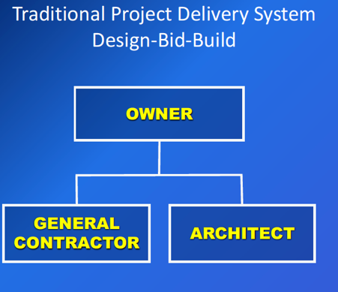

Multi-prime
- Broadway Maintenance v. Rutgers
  - Risk= delay caused by not supervising
  - This case shows the problem of multi-prime
  - In CA—have statutes that prohibit public entity from exculpating
  - Rutgers entered into multiple prime contracts to build its medical school. Two prime contractors (Broadway and Dobson) sued Rutgers for damages caused by delays in the construction, alleging that Rutgers was liable because it failed to coordinate the work of all of the contractors.
    - The trial court found for plaintiffs on some grounds, but not for their claim that Rutgers failed to coordinate the activities of the prime contractors. The Appellate court affirmed.
  - The Supreme Court of New Jersey reviewed this case on appeal, answering the narrow question of whether Rutgers, as the owner, had a duty to coordinate all of the contractors.
    - The court stated that if no one was designated to supervise the project, it is the owner’s responsibility to fulfill those duties.
    - However, if the owner appoints a third party or one of the contractors to perform the coordination, the owner does not have to supervise.
    - Here, Rutgers delegated the overall responsibility of the supervision to one of the contractors, Briscoe, who essentially became the general contractor.
  - Additionally, the contract signed by the prime contractors included an exculpatory clause which stated that no claims for damages caused by a delay can be made against Rutgers. All that could be asserted against Rutgers is a claim for an extension of time resulting from the delay. The court recognized the validity of this clause and affirmed the trial court’s decision.

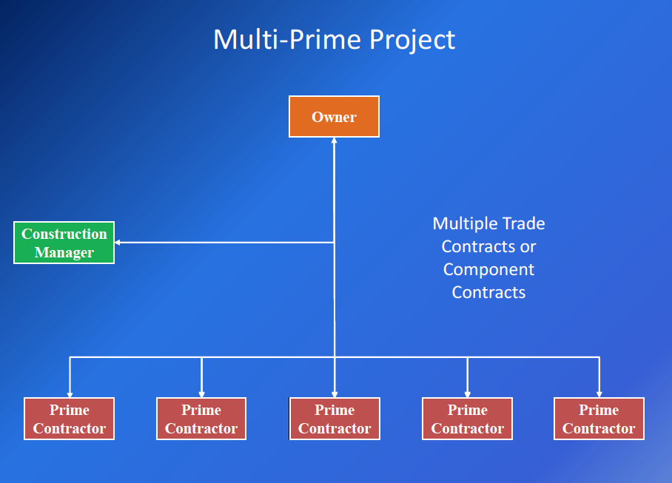

Design Build
- Owners don’t want liability for errors in plans
  - Some owners have gone to this model and hire 1 entity
  - Spearin Doctrine and problems with multi-prime not applicable
  - Why isn’t every project this way?
    - Problem: owner has less control over the design

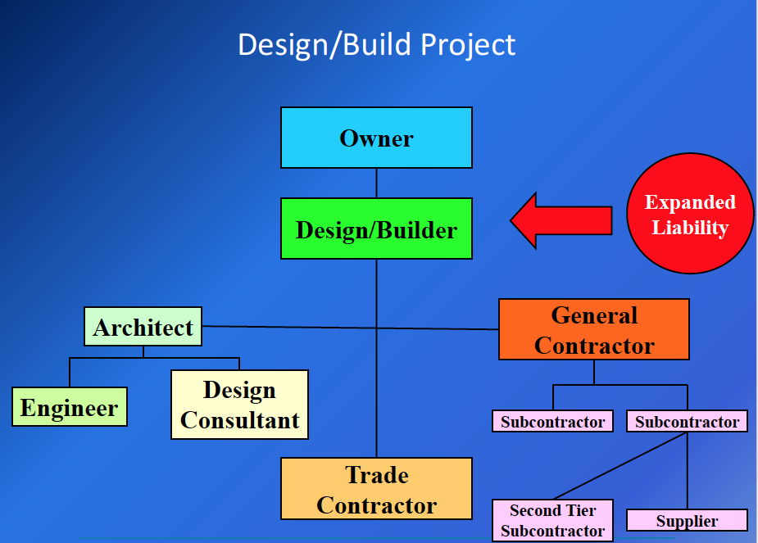

Design-bid vs Design-bid-build:
- Whether it will cost more in design bid vs design bid build is not determined by the chosen project delivery system
  - Just one factor
  - In design bid build
    - Owner is not obligated to give to lowest bidder (unless request for bid says so)
    - Multiple people bidding—can drive down cost
      - Competitive
      - Owner assured he is getting the best value
    - In design build
      - Request for proposals
        - Different ways to score the proposals
        - Selection based on different criteria
      - Design-builder has greater control, but greater responsibility (liability)

Construction Management—agency

Construction Management—at risk
- Akin to design-build system

Integrated Project Delivery
- Joint venture between owners and __
- All parties share in risk and profit

Public Private Partnership (P3)
- Right now, used primarily for building toll roads
- Private party builds, public entity uses

Public Works:
- In public works, have to award the contract to the lowest responsible, responsive bidder
- All contractors who are successful bidders must post a bond (bid bond)
  - Private works can require it too
Once a contract is signed, contract will require
- A performance bond
  - If contractor performs to the terms of the contract—bond released
  - If doesn’t perform, performance bond surety will step in and finish or hire another contractor to finish
  - Benefit of owner (guaranty against default by gc)
- Payment bond
  - Benefit of subcontractor and suppliers
  - Gives these parties statutory right to get paid
    - Statutory bond
  - If GC fails to pay for labor/materials/etc, payment bond surety will pay for it
    - There are steps parties must take to secure claim
- Most private owners wont requires performance bonds, but lenders will

In residential, there is more liability for owner/architect/ contractor, regardless of delivery method
- Usually a defect that appears every home
- A lot of litigation here
  - Construction defect litigation
- Very hazardous -> cost of insurance reflects inherent risks

Top 10 Causes for Construction Disputes:

- Incomplete, uncoordinated or erroneous plans
  - Spearin
- Nonconforming or defective work
- Pricing disputers over changes
- Insufficient owner funds—value engineering
  - Owner running out of funds
- Unforeseen conditions/ force majeure
- Too much work—lack of qualified personnel
  - Results in delays and extra costs
  - Fluctuations in the labor market and financing market
- Poor administration and management of project
- Substitutions
  - Public works: usually cannot designate suppler (public policy against favoritism)
    - Can identify a list of suppliers that are acceptable.
    - Contractors can make a request for substitution
  - Private works: usually a 3rd party looks at suggested substitution
- Bid busts
  - When contract submitted bid, grossly underestimated the cost of some work
    - Some contractors cannot absorb this type of loss, which can result in claims
- Regulatory issues, permits and inspections

Contract Documents:

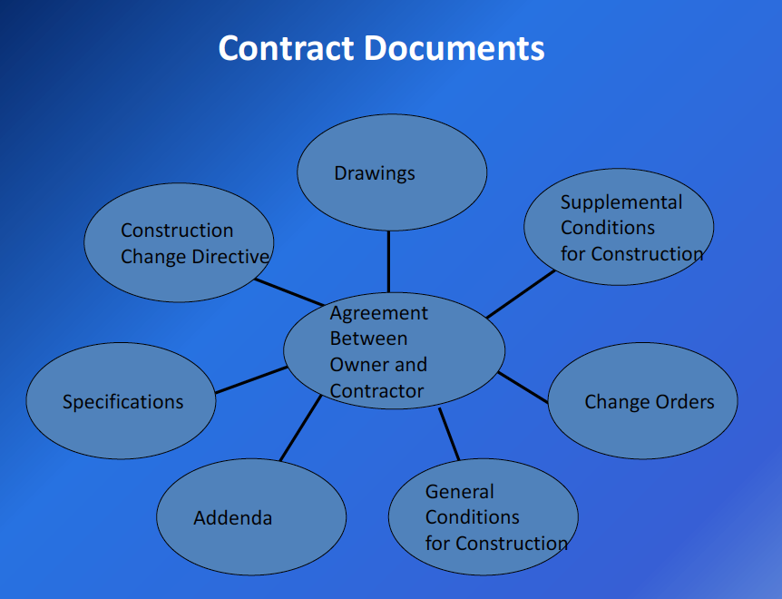

- All documents intended to form a part of the contract should be specifically identified
- Generally they include:
  - Contract;
  - General Conditions;
  - Drawings;
  - Specifications; and
  - Schedules
- Other documents should be considered as appropriate
- Components of Contract Documents:
  - Contract Agreement
    - Essential elements of relationship
  - General Conditions
    - More complete (very detailed) terms re: obligations, duties, rights, remedies
  - Supplementary Conditions
    - Modify form general conditions
  - Plans and Drawings
    - Graphical representation of work
  - Technical specifications
    - Text describing requirements for work in great detail
  - Addenda
    - Revisions to contract docs issued pre-bid or pre-contract execution
  - Change orders & CCD’s (change directive)
    - Revisions to contract docs issued after contract execution
- Precedence Clause:
  - Generally, drawings govern specifications as to quantity and location
  - Specifications over drawings for quality and performance
  - Catch-all clause requiring the higher quality and greater quantity
- Incorporation by Reference
  - “Flow Down”—make all or parts of general contract part of subcontract
  - “Flow Up”—incorporates duties owner owes general contractor into the subcontract

The Construction Contract:

Standard Form: Prime Contract Document
- AIA Documents
- ConsensusDOCS documents
- DBIA documents
- EJCDC documents
- FIDIC documents

Key GC Contract Provisions:

Parties
- Are the parties properly identified?
- Do they have the capacity to contract?
  - Does the owner own the land
- Are they properly licensed to perform the work?
- Are the individuals signing on behalf of a party duly authorized?
- Are the parties consistently identified in the Contract Documents and ancillary agreements?

Scope of Work
- Vague, ambiguous, conflicting and/or incomplete scopes of work are one of the most frequent sources of disputes and litigation
- Usually defined by contract documents
- Include specific description with reference to contract documents

Payment
- Common Basis for Compensation:
  - Lump Sum (aka “stipulated price” or “fixed price”)
    - Contractor agrees to provide all necessary labor, materials and services to accomplish a fixed scope of work for a set price
  - Cost plus fee
    - Owner agrees to pay all of the actual costs of the labor, materials and equipment required to accomplish the work described in the contract documents, plus a set fee for the Contractor’s overhead costs and profit
      - “Fee” may be a fixed amount or a percentage of the total cost, or a hybrid of both
        - The more the project costs, the higher the fee the contractor gets
    - This method of payment requires a lot of time and material accounting
  - Guaranteed maximum price (GMP)
    - An agreement between the Owner and the Contractor that the Contractor will be paid for the actual costs of labor, materials and equipment up to a maximum amount, inclusive or exclusive of fee
    - If Contractor goes above GMP, contractor assumes risk of costs
    - Commonly used in commercial
    - Creates incentive on part of contractor to save money
    - Contractor has to be very careful to get a change order to change GMP when owner changes scope of work
  - Unit price
    - Contractor is paid a pre-determined, or agreed upon, amount per unit or item of work multiplied by the actual quantities of work performed
      - Based upon quantity
      - Usually not a basis of payment for entire contract
    - Commonly used where qualities are unknown: excavation, soil import and export, subsurface conditions, hazardous material abatement, etc.

Time
- Scheduling (schedules are important)
  - Attach a workable, complete baseline schedule to the contract
  - Tie the parties to the schedule
  - Define substantial and final completion
    - Substantial completion:
      - The project is “sufficiently complete in accordance with the Contract Documents so that the Owner can occupy or utilize the Work for its intended use.” AIA A201
        - Basically: point in time when Owner can make beneficial use of the project
        - Temporary certificate of occupancy
          - This triggers when contractor can put in request for final payment
      - Cutoff of liquidated damages
      - Triggers generation of punch list
      - Transfer of risk of loss
      - How you define completion triggers date when retention is due
        - CA statute: retention due 45 days after completion of project
    - Final completion:
      - Punchlist (list of minor details that need to be finished after substantial completion) is finished
  - Deal up-front with potential delays such as:
    - Weather
    - Governmental inspections
    - Work of separate contractors
- Types of Schedules:
  - Gant Charts
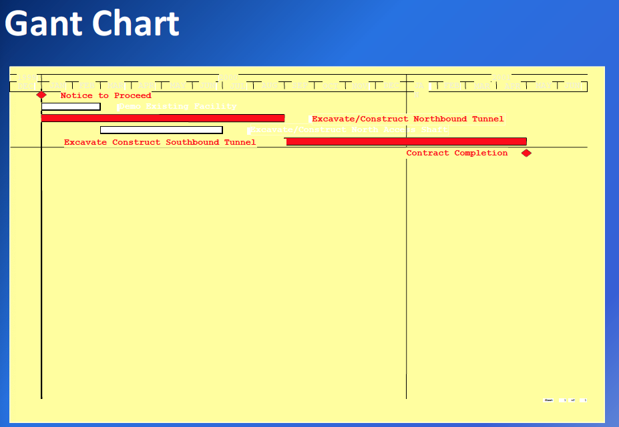
  - Critical path method (shortest time to completion)
    - Thanksgiving dinner example
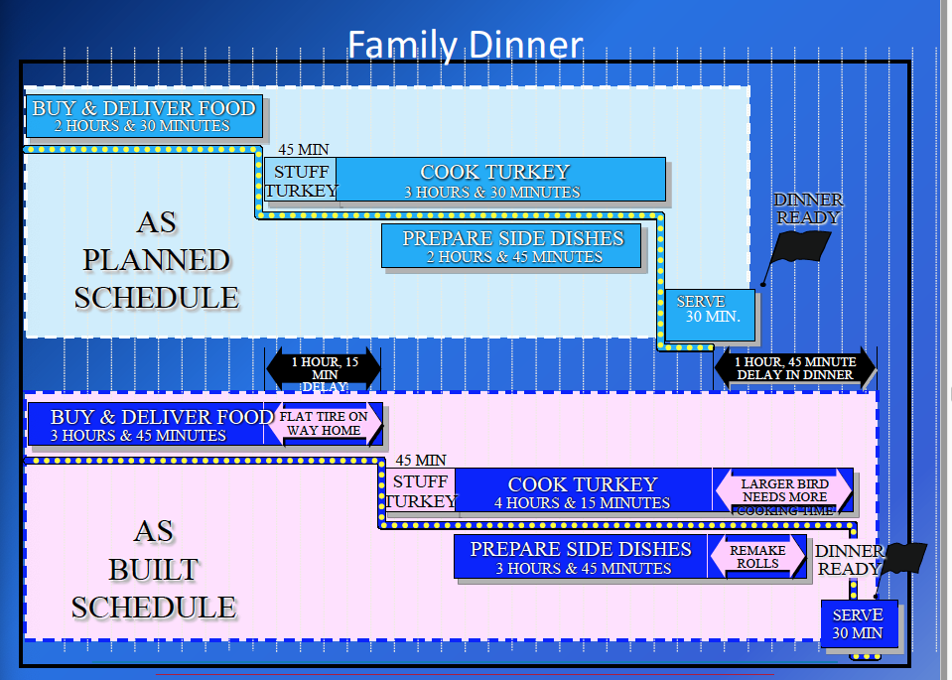
    - Schedule of activities that are crucial to continuation
      - Which activities must proceed others
      - At some point all activities can become critical
    - As planned
      - Plan where parties have set out how they anticipate the work will go
    - As built
      - History of what happened on the project
  - Most projects schedule in “float” time
    - Contingency in schedule to give parties sufficient time to complete
- No Damages for Delay—PCC §7102
  - Restrictions on public works projects
  - Generally enforceable on private projects, as long as delay encountered was within the reasonable contemplation of the parties
    - Owners will build in a no damages for delay provision
      - Get time extension but do not get more money
  - Strictly construed by most courts because of harshness
  - Damages for acceleration and disruption may not be barred
- Progress Payments
  - Procedures and timing
    - Frequency (monthly vs. bi-monthly)
    - Owner time for evaluation/payment
    - Precise identification of required supporting documentation
      - Pay application
        - Contractor submits application of payment
      - Certified payrolls (under oath)
      - Material invoices
        - Appropriate documentation
      - Releases
        - Owner doesn’t want mechanic liens
        - With every payment application, contractor required to get payment release from subcontractors
      - Schedule updates, etc
  - Retention: part of every payment is withheld to make sure that general contractor and subcontractors provide everything they need to provide
    - 5% on public works
      - 10% if city makes a specific finding that the project is “substantially complex”
    - Usually 10% on private works
- Schedule of Values: basis for computing progress payments by percentage complete of each line item
  - Architect and contractor agree on %
  - Owner, A/E or CM verified progress claimed
  - Contractors sometimes “front load” payment applications
  - Issue: is the remaining contract balance sufficient to complete the project?

Changes
- Change Orders
  - Definition:
    - An alteration or modification to an existing contract concerning the work that is required to be done; or
    - An addition to the contract involving work that was not included within the original agreement
  - There usually is a requirement that all changes to the contract be in writing
  - Include any additional time or a statement that the contract time is not extended by the change
    - If changing time—need to amend schedule
  - Include a statement of an accord and satisfaction of all claims for costs and time
  - Change orders= bilateral, signed by contractor and owner (and sometimes architect too)
- Change directive:
  - Unilateral; initiated by owner without any agreement
  - Contractor must proceed with change as long as its related to the scope of his work
- Field order
  - Minor change
  - no impact on contract time or cost
    - if it has an impact—then it has to be a change order or change directive
- Change Clauses
  - Important
  - Gives right to make changes
  - Ex: The District, without invalidating the contract and as provided by law, may order extra work or make changes by altering, adding to, or deducting from work, the contract sum being adjusted accordingly. All such work shall be executed under conditions of the original contract, except that any claim for extension of time caused thereby shall be adjusted at the time of ordering such change.
- Limitation on Right to make changes
  - The proposed change must be considered to be within the contemplation of the parties at the time they entered into the contract
  - The proposed change must be within the “general scope” of the original contract
- Duty to Proceed
  - Duty to proceed without agreement as to price and time adjustment
  - Most contract require the contractor to perform the work while the dispute is pending
    - Issue: contractor is funding owner’s changes
    - Issue: maintenance of proper records
- Methods for Pricing Change Orders
  - Agreed lump sum
  - Unit prices
  - Cost plus
- Disputed Work:
  - Contractor has a duty to keep detailed records, including the daily reports
  - Failure to maintain the requisite records may waive the right to pursue a claim
  - The records should be submitted and reviewed by the owner daily
  - Records should substantiate the contractor’s claim for additional compensation and/or time
  - Contractor gives notice that work is disputed and that he is going to make a claim

Delays
- See section later on

Force Majeure
- See section later on

Notice
- See section later on

Indemnity
- Indemnity provision
  - Allocates risks
  - Often backed up by insurance
  - Duty to defend
  - Duty to indemnify/ pay for loss, damage or injury
  - Limited by statute

Insurance
- Type
- Amount

Bonding
- Bid Bonds
- Payment Bonds
- Performance Bonds
- Release Bonds

Limited Liability Provisions
- Limitation of liability for errors and omissions
  - Limit on owners ability to collect against the insurance
- Impacts ability to gather money
- To protect owner: need to make sure the architect maintains those limits
- No damage for delay
  - Invalid in public works if caused by owner
- Waiver of consequential loss
  - Needs definition
- Waiver of subrogation
  - Protects project participants
    - Someone who pays a loss cause by a 3rd party can sue a 3rd party (insurance)

Warranty
- Quality of materials/service
- Express v. implied warranties
- 1 year “call back” warranty
- Limitation provisions
- Subcontractor warranties
- Manufacture warranties

Completion
- See schedule section

Termination
- Termination for cause
  - Usually the result of a default
  - Should give notice and opportunity to cure
  - Should notify performance bond surety and provide surety an opportunity to take over or otherwise complete the project
  - Can go both ways (O->C; C->O)
- Termination for convenience
  - Need mutual agreement or must be included in contract terms
  - Can’t sue for opportunity loss, lost profits

Dispute Resolution
- Arbitration or litigation
- Mediation non-binding
- Conditions precedent
- Venue/choice of law/ discovery/ right to appeal
- Virtual proceeding and remote testimony

Liability for Design:

Architect’s standard of care:
- professional negligence standard
  - Based on what another professional would do
- not strict liability
- absent express warranty, no promise that plans are defect-free or fit for intended use
- Standard of care provision: Architect shall perform the services in accordance with the degree of skill and learning ordinarily possessed by architects in good standing in the community regularly engaged in the design of facilities similar in scope and magnitude to the project and must apply that knowledge with the diligence ordinarily exercised by reputable architects under similar circumstances.
- Non-standard provisions
  - Different standard of care based on the type of facility
  - Highest professional standard of care
  - State-of-the-art facilities
  - Fiduciary relationship of trust and confidences
    - Monitor payments
  - Express warranty/ guarantee
    - Prescriptive specification: requirement that work be done in a specific way
    - Performance specification: how the work performs

New Design Standards and Guidelines
- 3D and 4D CAD Design
  - Computer assisted design (CAD)
    - Becoming extremely sophisticated
- BIM (Building Information Modeling)
  - 3D, 4D, 5D models
    - Utilized computer programming to create a multi-dimensional model of building structures, and combines documents, information and data into a single comprehensive database
  - Can tell you if there are design errors (constructability issues)
    - Can be used for conflict or clash detection to minimize changes during construction
    - Can be used for modeling energy use, schedule, cost under different designs
  - Becoming standard for larger projects
- Web based project controls
- Design build systems and components
- Integrated project delivery systems
- High performance buildings

Markbrorough Cal. v. Superior Court:
- Summary:
  - A developer hired an engineer to build a lake and, when the lake liner failed, the developer sued for breach of contract. The contract contained a clause that limited the engineer’s liability.
  - The court held that, under Civ. Code §2782.5, this clause is valid as long as the parties have a fair opportunity to accept, reject, or modify the limited liability provision. This is true even if there is no actual discussion regarding the provision. In this case, the developer had an opportunity to modify any provision in the contract and did not. Therefore, the clause is valid.
- Limitation of liability provisions have long been recognized as valid in CA.
  - “The validity of [such clauses] is not open to doubt”
- Limited liability provisions are important to “high-risk, low-compensation” service
- Liability does not exceed available insurance
  - Would be good risk management
- Not enforced when unequal bargaining power and contrary to public policy
  - Unconscionable
- “Although these provisions generally have been upheld as reasonable and valid, nonetheless, because they do in fact exculpate or insulate a party, at least to a certain extent, from liability for his or her own wrongful or negligent act, the law both ….. was that such provisions may be declared unenforceable if the provision is unconscionable or otherwise contrary to public policy.”
- Look at the economic settings of the transaction
- These are exculpatory provisions -> courts will construe very narrowly against the drafter
- Absence of meaningful choice?
- Can’t be take it or leave it contract
  - Shows inequality of bargaining power
- Opportunity to make changes
- “One of the factors in determining whether a contract provision is against public policy is whether the provision is the result of an arm's length transaction between parties of relatively equal bargaining power. ” As a result of the essential nature of the service, in the economic setting of the transaction, the party invoking exculpation possesses a decisive advantage of bargaining strength against any member of the public who seeks his services.”
- “In exercising a superior bargaining power the party confronts the public with a standardized adhesion contract of exculpation, and makes no provision whereby a purchaser may pay additional reasonable fees and obtain protection against negligence." Similarly, a contract provision may be unconscionable if there is an "'inequality of bargaining power which results in no real negotiation and "an absence of meaningful choice."'
- Can a limited liability provision limit insurance recovery?
  - Yes

Beacon Residential v. Skidmore
- Summary:
  - A homeowner’s association sued over construction design defects, in part alleging that the architects’ negligent home design made the condominiums unsafe and uninhabitable during high temperatures.
  - The issue is whether the architects owed a duty of care to a third party in the absence of privity. The Supreme Court of California held that when an architect is the principal architect on the project, a duty of care is owed to future homeowners. This duty exists even when the architect does not actually build the project or exercise ultimate control over construction decisions.
- Trial court: There was no common law duty without privity
  - Appellate court and supreme court disagree
- Look at when 3rd party does have duty in absence of privity
- Court thinks allegations of complaint is sufficient to establish architect owed a duty of care to the homeowners who constitute the Association
- Biakanja factors (tort principles applied to a case involving professional negligence)
  - 6 factors to determine duty
    - 1. The extent to which the transaction was intended to affect the plaintiff
      - Defendants’ work was intended to benefit the homeowners living in the residential units that defendants designed and helped construct
    - 2. The foreseeability of the harm
      - It was foreseeable that these homeowners would be among the limited class of persons harmed by the negligently designed units
    - 3. The degree of certainty that plaintiff suffered injury
      - Plaintiff’s members have suffered injury—the design defects have made their homes unsafe and uninhabitable during certain periods
    - 4. The closeness of the connection between the defendant’s conduct and the injury suffered
      - In light of the nature and extent of defendants’ role as the sole architects on the project, there is a close connection between defendants’ conduct and the injury suffered
    - 5. The moral blame attached to the defendant’s conduct
      - Because of defendants’ unique and well-compensated role in the project as well as their awareness that future homeowners would rely on their specialized expertise in designing safe and habitable homes, significant moral blame attached to defendants’ conduct
    - 6. The policy of preventing future harm
      - The policy of preventing future harm to homeowners reliant on architects’ specialized skills supports recognition of a duty of care
- How are design professionals dealing with this?
  - Indemnity for designing condos
  - Project specific insurance bought by owners
  - Include in sale documents dispute resolution procedures
  - In CA have specialized law that deals with this: Right to repair act
- Unlimited liability in duration?
  - Depends on the type of liability
    - Statute of limitations depends on the claim
      - Contracts: 4 years
      - Personal injury: 2 years
      - Property damage: 3 years
    - Statue of repose (outside limit)
    - Latent defects

Two Primary Roles of a Construction Attorney:
- Drafting and advising: attorneys allow parties to manage their circumstances in a predictable manner without suffering losses and harm
- Dispute resolution and litigation: attorneys provide their clients with remedies to previously suffered losses and harm

Licensing:
Business and Professions Code §7026:
- A contractor’s license is required for any work on a building or structure in excess of $500

Business and Professions Code §7031
- (a) prohibits collection of compensation for a contractor who is not licensed at all times during the performance of the contract
- (b) if someone hires an unlicensed contractor, can sue for all compensation paid
  - Disgorgement: can be a severe penalty in that the unlicensed contractor gets no deductions or offsets for the value of the materials or service provided
  - Intended to punish unlicensed contractor
- (e) general rule: no substantial compliance
  - Exception: court may determine there has been substantial compliance with licensure requirement if it is shown that:
    - 1. Unlicensed contractor was licensed prior to beginning work
    - 2. Contractor acted reasonably to maintain licensing
    - 3. Acted promptly and in good faith to remedy the failure to comply

MW Erectors, Inc:
- Facts:
  - Owner= Disney (building hotel)
  - General Contractor= Turner
  - Subcontractor= Niederhauser
  - Sub-subcontractor= MW erectors
    - 2 contracts: structural contract; ornamental contract
    - MW was a new company in the process of getting a license
  - MW began work on the structural contract on Dec 3
    - But did not obtain license until Dec. 21
    - Began the ornamental contract in January
  - MW sued Niederhauser for amount due under both contracts
  - Niederhauser moved for summary judgement—says MW was not properly licensed at all times during performance of contracts
  - Trial court grants motion for summary judgement for Niederhauser
    - Msj= no disputed issue of material fact
  - Court of appeals reversed
    - Held that the subcontractor was entitled to prove amounts due for its work on the structural contract after the license was issued
    - Under section 7031(a), a contractor must be duly licensed at all times during performance of the “act or contract” for which compensation was sought. Thus, MW could not recover for work it performed under the agreements during the relatively short time before it had secured a C-51. Nonetheless, the Court of Appeal held section 7031(a) allowed MW to obtain compensation for every individual act it performed under its contracts after all necessary licensure was in place. Thus, MW was entitled to prove amounts due for its work on the structural contract after the C-51 license was issued. MW had a valid C-51 license at all times during performance of the ornamental contract.
  - Supreme Court reversed in part
    - The Supreme Court reversed insofar as it permitted the subcontractor to sue for compensation for work under the structural contract, and affirmed the judgment in all other respects. Because the subcontractor was not duly licensed at all times during performance of the structural contract, and could not alternatively establish its substantial compliance with the licensure requirements in that it had never held a valid California contractor’s license prior to beginning performance, the subcontractor could not sue to recover any compensation for work performed under that contract.
    - Upheld : As the Contractors’ State License Law, did not automatically void all contracts entered into by unlicensed contractors, the subcontractor was not barred from recovering compensation for its work under the ornamental contract on the sole ground that it was unlicensed when it executed that agreement
  - What is the fundamental argument as MW counsel? Fairness
    - Supreme Court said fairness does not matter—statute says “regardless of the merits of the cause of action”, no equitable relief unless you fall into narrow categories of the exception
    - Ambiguity in the statute?
      - Back to appellate court’s argument” performance was more than 1 act
        - Throughout this argument still point out unfairness and injustice (windfall to Niederhauser)
        - Not an unscrupulous contractor trying to take advantage -> technical violation while waiting to get application
    - Intent of statute
      - Prevent unscrupulous contractors from taking advantage of the public
      - Public not involved with this case-> sophisticated parties
  - Niederhauser counsel/ state Supreme Court:
    - Slippery slope—cant chop contract into little acts
    - Law not intended to cover fairness -> states it in the statute

Emerging Building Technologies:

Modeling:
- Buildings are not static -> are functioning
- Buildings of the future are going to be sustainable
  - Generate as much (or more) energy than they consume

Building Codes and Energy Laws:
- Buildings consume 72% of total electrical use in the US
- How is energy generated?
  - Fossil fuel energy generating plants
  - Renewable energy
- Buildings generate approximately 50% of total greenhouse gas emissions in the US
  - If can reduce emissions by our buildings, can reduce a large % of total CO2 emissions
- AB32-> basic framework under which CA has sought to control emissions
  - Building codes
  - Key elements:
    - 1. Cap and trade program
    - 2. Renewable energy
    - 3. Building and appliance standards
    - 4. Transportation related emission
  - Elements 3 and 4 have been key in driving down emissions since enactment

Green Building Codes:
- Building codes revised every 3 years
- Local building codes can be more stringent than state, but cannot be less stringent
  - State building codes= baseline
- In 2010, California adopted the California Green Building Standards Code (CALGreen)
- 2013: Title 24, Building energy efficiency standards – 25% more efficient for residential construction and 30 % more efficient for nonresidential construction
- 2019: new standards include better windows, insulation, lighting, ventilation and other features that reduce energy and water use in homes and businesses

What has changed in Title 24?
- Commissioning (done by a commissioning agent)
  - What is commissioning?
    - An intensive quality assurance process that begins during design and continues through construction
    - Ensures that the new building operated initially as the design intended, and that building staff are able to properly operate and maintain its systems
    - Requirements that before building can be put to use, commissioning agent tests every function in building—makes sure each system operates properly
    - Owner pays; LEED wants commissioner to be independent from contractor
      - Checking contractor’s work
- Light fixture controls
- Daylighting requirements
- Increased HVAC efficiencies
- Power Controls—Demand response
  - Demand response: during periods of high demand, the utility sends signals to buildings with demand response control systems to cause certain electrical power-using devices to be turned off.
    - Smart buildings and smart meters
    - Helps avoid power outages

High performance buildings:
- Consumes less power/energy
- LEED

Where is the California Energy Commission Headed?
- Zero net energy buildings (ZNE)
  - A building where the energy provided by on-site renewable energy sources is at least equal to the energy consumed by the building annually
  - As a practical matter—not very feasible in old buildings
    - Can ger close with new buildings
  - Single family homes have to have a solar component
    - Gets them very close to being zero net energy buildings
  - In state: big push to de-carbonize our buildings
    - Take natural gas out and go to electrical
      - Can generate energy through renewable sources

Main energy efficiency issues:
- Lighting (try and use natural lighting)
- Try and use natural air into buildings
- Water efficiency

In new buildings -> architects and engineers look at how building is oriented to the sun
- Energy efficient models
- Shading and structure of building to retain/absorb hear (in winter)
- Solar orientation = really important
- Can program energy use in the building using controls
  - Communicate with utilities and respond
  - With smart buildings can monitor energy use

Exception for residential solar:
- Don’t have to have solar on site if building is part of power generation system
  - Has to be qualified by the state
  - Track homes

California Energy Use Reporting:
- Biggest impact = existing buildings
- Require buildings to monitor the amount of energy they use
- Have to publicly report it
- Building Energy benchmark program requires owners of large commercial and multifamily buildings to report energy use to the California energy Commission by June 1 annually
  - Due to the hardship caused by COVID, owners of large commercial and multifamily buildings may delay compliance with the benchmarking reporting requirements
- Why is it important? Will encourage renovation when you see what others are doing
- How to report energy use:
  - “benchmarking” = measure energy and water consumption
    - put energy bill into a software program
    - Benchmarking compares 12 months of consecutive energy consumption of a building (eclectic and gas) against other similar buildings
    - Benchmarking the building is performed with the EPA’s Energy Star Portfolio Manager Software
- City of LA ordinance: all buildings must be benchmarked and report uses
  - Effective in 2017, privately owned buildings in Los Angeles that are 20,000 square feet or more that are 7,500 or more are required to be benchmarked, and owners must disclose annual energy and water consumption.
  - Following the initial year of compliance, buildings must continue to report by June 1st of each year.
  - Due to COVID-19, certain EBEWE compliance deadlines are suspended until further notice
- Impact of energy use reporting:
  - Owners learn how energy efficient their buildings are compared to similar buildings
  - Allows buyers, tenants, and lenders to compare buildings as part of the decision making process
    - Information about a building is subject to disclosure during sale—including energy consumption
  - Energy efficiency of retrofits and capital improvements can be tracked
  - Data can be analyzed to improve building performance and building systems
  - Increase in retrofits and capital improvements
    - Increase
      - Sooner building owners retrofit, the sooner they save money
      - Retrofits basically pay for themselves
    - in the long run, building owners save money by making capital improvements now
  - Reduction in operating costs, energy use and pollution

Existing building retrofits:
- From 2010-2015, the green retrofit market grew from $3 billion in projects nationwide to an estimated $14-18 billion in 2015
- This is a big market in the industry

Building information modeling (BIM):
- Legal community has not really been involved by design and construction community have been
  - Lawyers need to be aware of it—can begin to show up in case law
- Differs from energy efficiency modeling
- It’s a process—uses sophisticated software programs
- Will determine elements of building that are not coordinated and clash
- 4D
  - Can look at building over time
- 5D-> adds in dimension of cost
- Can look at any part of the building as if you are actually in it
- Use it for stadiums
- Lawyers deal with this through contract
  - AIA E203TM-2013: Building Information Modeling and Digital Data Exhibit
    - Example of how these terms are being used
    - Everything that is a defined term is capitalized (see slides for language)
  - How is digital information handled in construction projects
    - Who owns models
      - Big fight over who owns all of the data after the building is built
        - Architects want to own plans, license owners use
        - Owner wants to own instruments of design
        - Often meet in the middle—let owner own plans but can’t reuse them
    - Who is responsible/liable
      - This type of system is usually design build
        - Have to make sure that the correct party has liability
    - Is owner getting what they are paying for
- Why is it important for an owner to have a BIM Model?
  - Information rich source
    - Electronically accessible data
  - Has the plans if something goes wrong

Prefabrication:
- Structural elements are always prefabricated
- Ex: Wilshire Grand building—prefabricated bathrooms (assembled offsite)
  - Reduced labor costs
  - More precise building
  - Overall reduced constriction costs
- Modeling is a large part of prefabrication
  - Build a mock up and test it
    - Done with windows to see if they leak
    - Different levels of testing
- One way you can make sure that costs stay low, efficiency stays high

Virtual reality:
- Can go into BIM Model with headset
- Drones on projects to photograph measurements

How do construction lawyers keep up with emerging tech?
- Periodicals
  - ENR magazine
  - AGC
  - ABA forum on construction

Construction Insurance Issues:
Role of Insurance in Construction:
- Construction inherently risky activity
- Risk mitigation if essential to protect the project and assets of the parties
- If you can’t get insurance, you can’t build
- Impact on contractual indemnities, bonds, warranties, limitations of liabilities and liability waivers

Keys to Specifying Insurance Requirements:
- Assess risks of each project
  - Understand roles and responsibilities of parties (owner, designer, CM, contractor, sub, etc.)
  - Understand peculiar risks related to:
    - Type of project
    - Types, probabilities and magnitude of potential risks
    - Duration of risks
- Availability and cost of insurance
- Contractual risk transfer (indemnity, hold harmless provisions, etc)
- Consider exclusions and coverage extensions

How the insurance requirements set:
- Usually the owner and its lenders dictate insurance requirements
- Will ultimately pay for insurance in contract pricing
- If representing owner—want to make sure gets money’s worth and benefit of insurance
- Insurance specifications should be drafted by experienced counsel
- All parties should be represented by experienced and qualified insurance brokers

Liability v. Property Insurance
- Liability insurance: insurance which pays an insured for loss arising out of legal liability to others
  - 3rd party claims
  - Ex: auto liability insurance
- Property insurance: insurance which pays an insured for loss to its own property
  - Covers own property
  - Ex: homeowners’ insurance
- Business “package” policy contains both
  - In construction—they are separate

Typical Types of Construction Project Insurance:

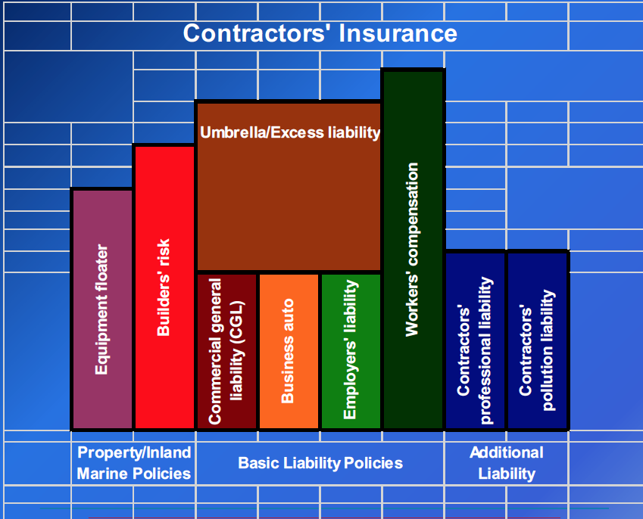
- Commercial General Liability (CGL)
  - Covers property damage and bodily injury
    - Usually must show “bodily injury” or “property damage” caused by an “occurrence” to trigger coverage
      - “occurrence” defined as “accident”
    - Includes a duty to defend the insured against “suits”
      - Duty to defend is broader than the duty to indemnify
        - Must defend if there is any potential that the claim might be covered
        - Any doubt must be resolved in the insured’s favor
        - Facts extrinsic to the complaint can generate duty to defend
        - The insurer is only required to indemnify the insured for covered claims
    - Defense costs do not typically deplete dollar limits of coverage available
    - Claims made CGL not preferred
  - Coverage provision for insured’s legal obligations
  - What confers rights upon the insured
    - Types of risks insurance company is taking
  - Duty to defend and obligation to pay damages (duty to indemnify)
  - Vandenberg case deals with this
  - Examples of types of claims covered:
    - Ongoing operations
      - Damage to property adjacent to jobsite during the project
      - Injury to third parties at jobsite during the project
    - Contractual liability
      - Liability assumed through an “insured contract”, such as an indemnity agreement from a general contractor to an owner
    - Products/ Completed Operations
      - Property damage or bodily injury resulting from a contractor’s completed work
      - After completion; no construction going on
      - Defect lawsuits covered by this
  - Doesn’t cover injuries to workers/employees
    - Workers compensation insurance
  - Additional CGL Issues:
    - Significant endorsements
      - Limitation of defense obligations
      - Mold exclusions
      - Known loss exclusions
      - Asbestos exclusions
      - Residential construction exclusions
    - Bottom line: know what is in your insurance policies
- Workers Compensation
  - Wrap up rare in projects
    - Unless project is $2million +
  - Major risk
    - Need to make sure this is in place before anyone comes onsite
  - If contractor is “exempt for workers comp”
    - Means has no employees -> be careful
    - If contractor says exempt buy has employees -> suspended automatically
      - Subject to §1731 (disgorgement; MW Erectors)
- Automobile Liability
- Builders Risk
  - Form of property insurance
  - Covers damage to project while being built
  - Typically covers direct physical loss or damage to:
    - The buildings or structures under construction
    - Other specified property intended to become part of the building or structures under construction
    - Certain temporary structures related to the construction
  - Other forms of first-party property insurance, such as fire polices, tools and equipment, boiler and machinery polices and installation floaters, may also provide coverage, but are often excluded
  - Course of Construction property insurance (only covers project while its being built)
    - Protects against direct physical damage to the construction project
    - Coverage can be purchased on either a “name perils” or an “all risk” basis
      - Named perils—covers only losses from “specified” perils (eg fire, lightning, explosion, vandalism)
      - All risk—covers any peril, except those specifically excluded
        - Common exclusions:
          - Flood and earthquake
          - Loss from fault, defect, error or omission in design, plan or specification
          - Cost of correcting faulty of defective workmanship or material
          - Loss by vermin, inherent vice, latent defect, wear and tear
          - Pollutants, hazardous materials, mold, bacteria and virus
          - Can pay extra to delete exclusions and for broader coverage
    - Can sometimes cover material to be installed, but stored off-site
    - Can cover loss of use or delay in completion
  - Other Builders’ Risk Issues
    - Who are the insureds?
    - Deductibles
      - Self-insured retention
      - How much? Who pays?
    - Waivers of subrogation
      - Subrogation is a concept that allows an insurance company that has paid a loss to step into the shoes of its insured to then sue a party that may be responsible for causing the loss. So, if a contractor’s crane drops steel onto the project and the owner’s builder’s risk insurer pays the loss, the owner’s insurer can step into the shoes of the owner and sue the contractor for the loss it caused.
      - When a party to a contract waives subrogation, it means that a party’s insurer will not step into that party’s shoes and demand payment for any loss paid that the insurer paid. For example, in the example above, if the contractor’s crane drops steel onto the project, and the owner’s builder’s risk insurer pays the loss, the owner’s insurer will not sue the contractor for the loss it paid to the owner.
      - The theory behind waiver of subrogation clauses is to minimize lawsuits and claims between the parties
    - Reporting increases in value
    - Optional coverages
      - Delay in opening/soft cost coverage
      - Code upgrades/ ordinance and law
      - Costs of correcting defects (LEG endorsements)
      - Green building coverage for additional certification costs
- Professional Liability
  - Architects and engineers
  - Covers against 3rd party claims but also claims by the owner
  - If design-build, typically must be carried
    - In design-build need both general liability and professional liability
  - Usually “Claims made”, not “occurrence” triggered
    - Policy in place at time claim is made must address loss, not that in place when activity (“occurrence”) giving rise to claim occurred
    - Scope of coverage broader than general liability
      - Covers economic loss
  - Covers damages caused by act, error or omission on part of insured
  - Usually does not require “bodily injury” or “property damage” to trigger coverage; only need an “error” or “omission”
  - No additional insured endorsement on errors and omissions
    - Because it is tied to acts of professional
  - What does construction manager need? Typically professional liability
    - But owner will generally require that be named as additional insured on contractors general liability policy
  - Language = broader; but coverage is more restrictive
    - Coverage narrowed by time
  - “Professional Services” Definition:
    - Means those services specifically described in the application for which you are legally qualified to perform for others, including but not limited to your “professional services” as an:
      - Architect or engineer
      - Landscape architect, land surveyor or planner
      - Construction manager
      - Interior designer/space planner
  - Professional Liability—Other Issues
    - Claims made (and reported) nature of policy
    - Defense costs within limits
    - Consent clauses
      - Give professional right to object/consent to any settlement
    - Deductibles
      - Large deductibles
    - Mediation incentive clauses
    - Extended reporting periods
    - Variation between insures
      - Manuscript policies -> not standard forms, most carriers write their own
  - Limits of coverage are generally for an entire practice. Therefore, a claim paid on one project depletes limits available for other occurrences on all other projects in practice
  - Not project specific unless otherwise specified
    - Owners should request “dedicated limits”
      - Why? Policies go to professionals, not for specific projects
  - Common Exclusions for Professional Liabilty insurance:
    - Liability assumed under contract
    - Exceeding construction cost estimates
    - Damage from failure to complete drawing or specifications on time
    - Punitive or exemplary damages
    - Return of professional fees
    - Warranties and guaranties
- Pollution Liability
  - 2 types: contractor/ owner
  - Deals with hazardous waste
- Umbrella/Excess Liability
  - Policies that sit above CGL (usually)
    - Adds an additional layer of coverage if underlying policy exhausted
  - Designed to provide the insured with high limits of coverage for catastrophic loss
  - Excess insurance is over underlying primary liability insurance polices
  - May be broader or more limited than primary levels of insurance
  - Sometimes not standard form—insureds should specific “following form” if broad coverage is available
    - Don’t want gaps in coverage
- Equipment Floater
  - Contractors buy insurance on their equipment
  - Property insurance
  - Essential to make contractors buy coverage on their own equipment

Anatomy of a liability policy
- Declarations page
- Forms schedule
- Insuring provisions
- Definitions
- Exclusions
- Endorsements

Work Product Exclusion
- Excludes “property damage to your work or any part of it” or “damage to work performed by the named insured arising out of such work or any portion thereof.”
- Insurer will require resulting or consequential damage to something other than the insured’s work
- The work product exclusion generally contains an exception for damage to “work performed on behalf of” the insured (ie by subcontractors)

Certificates of Insurance and Additional Insured Endorsements
- Another area of litigation: proof of insurance
  - Evidence of insurance
    - Most common form—certificate of insurance
      - However the certificate conder no rights on certificate holder
        - Do not rely on certificate
        - Want to see endorsement in addition to certificate
        - Want to make sure a broad form of endorsement is used (as opposed to narrow)
- Additional insured status
  - What is it and how is it obtained?
    - An additional insured is a person or an organization that is not a named insured, but who is later added to a third party’s insurance policy
    - Additional insured status is usually obtained by an endorsement to the 3rd party’s insurance policy
    - Additional insured status is most commonly obtained with respect to CGL policies
  - What are the benefits?
    - The benefits of additional insured status are determined by the terms of the additional insured endorsement
    - Depending on the form of the additional insured endorsement, the additional insured may be entitled to have the insurance company pay for:
      - 1. Costs of defense; and/or
      - 2. Payment of judgment or settlement
  - How is it used on Construction Projects?
    - The prime construction contract will require the general contractor to name the owner as an additional insured on the general contractor’s polices
    - The general contractor, in turn, will require its subcontractors to name it as an additional insured on the subcontractor’s policies
  - What types of forms are used?
    - Two of the most common additional insured endorsements used are ISO form 20 10 (sometime called “Form B”) and ISO Form 20 09 (sometimes called “Form A”)
    - Even the same ISO form can vary in substance, as they are revised every few years
  - Presley Homes Inc v. American States: Scope of Duty to Defend Additional Insured
    - Issue: must a subcontractor’s insurance carrier provide a defense to an entire action, including covered and non-covered claims alleged against an additional insured, general contractor?
    - In Presley Homes, the court affirmed an insurance carrier’s duty the entire “mixed” action against an additional insured developer
  - Used to aggregate insurance when everyone has one policy to make sure there is enough money
    - Problem: carriers stopped issuing these for certain types of projects
    - Solution: Wrap Up insurance

Wrap Up Insurance Polices:
- One insurer insures all project participants
- Owner or contractor controlled
- Single project or multi-project
- “Sold” as cost saving to owner
- Sometimes exclude Workers’ comp
- OPPI (Design Policies)
- Extensively used on high risk projects
- Owner will ask for rebate on bids because other parties don’t have to pay for own insurance
- No additional insured endorsements
- Less likelihood of fighting (cross-complaint)
  - 1 insurance company takes care of all issues that arise
- Ability to negotiate with carrier
- By paying 1 large premium -> get broader, more efficient coverage

Basic Wrap up insurance questions:
- Who is insured?
  - Everyone who is enrolled
- What risks are covered?
  - Broader coverage available
- Where—what locations?
  - Project specific
- When—how long is coverage afforded?
  - Extended completed operations
- How much money?
  - Cost in premiums v. payout

Major Issues on Wrap-Up Policies (OCIPs and CCIPs)
- Course of construction property damage
  - Builders risk
- Cross liability exclusions
  - Effect of reservation of rights
- Deductibles and self-insured retentions
  - How to allocate
- Rolling wraps-one policy covers multiple projects
  - Dedicated limits

Changes in the work:
Almost all construction contracts require changes once work begins
- Changes dealing with design; substituting materials

Limitation on Right to Make Changes:
- The proposed change must be considered to be within the contemplation of the parties at the time they entered into the contract
- The proposed change must be within the “general scope” of the original contract
  - If its within scope—the contractor has to do it
  - Example of outside of scope: building guesthouse on adjoining land

Change Order:
- What is it?
  - Amendment to a contract
    - Have to be careful in drafting because you are changing the contract requirements
- Definition:
  - An alteration or modification to an existing contract concerning the work that is required to be done; or
  - An addition to the contract involving work that was not included within the original agreement
- What do they typically change?
  - A change is an alteration of the construction contract which modifies:
    - The scope of the work,
    - The contract amount, and/or
    - The contract time
  - Can be initiated by:
    - Bulletin
      - Document
      - Issued by the architect
    - Field work order
      - Typically done with small/minor changes
    - Field directive
    - RFP (Request for proposal)
    - RFI (Request for information)
    - Change order request
    - Notice of change
- If change is initiated by owner or architect---owner is responsible for paying for it
- Typical change process
  - Initiation of change (bulletin, RFP, RFP,CE, RFI response, CCD, FWO, field condition observation)
  - Contractor submits proposed change to price and schedule
  - Owner, E/E, CM review submission
  - Options:
    - Agree to change order
    - Change directive—proceed on time and material
      - Contractor retains costs and submits to get repaid
    - Proceed by dispute change and possible claim
      - Owner pays what it sees as the cost, contractor submits claim for difference
    - Abandon change request
- Change per AIA Classifications
  - Minor changes
  - Change orders
  - Constriction change directives
- Change Orders and Extra Work
  - Change orders: Bilateral; agreed upon change order, signed by Owner, Architect and Contractor
  - Change Directive: Unilateral; initiated by Owner without any agreement
  - Field Order: minor change, no impact on contract time or cost
- There is usually a requirement that all changes to the contract be in writing
- Include any additional time or a statement that the contract time is not extended by the change
- Include a statement of an accord and satisfaction of all claims for costs and time
- Course of dealing= “primrose path” defense by contractor

Methods for Pricing Change Orders:
- Agreed Lump Sum
- Unit Prices
- Cost Plus

Pricing of Changes:
- Owner/designer defines desired scope of changed work
- Contractor submits proposal for cost/time
- Negotiation
  - If successful—owner issues change order
  - If unsuccessful—owner issues construction change directive, agreeing to adjust contract by undisputed portion of cost/time proposal

Change Order Costs:
- Actual Costs
- Indirect Costs
  - Project manager
  - Home office overhead
  - Financing/interest costs
- Impact costs

Change Orders—Practical Tips
- Treat as a “mini-contract”
- Comply with notice requirements
  - Required when contractor discovers issue that will result in a change-> must give reasonable notice to owner -> notice of change usually isn’t too difficult (can be an email)
  - What happens when contract says contractor must submit change order X number of days after notice?
    - Has to get pricing (but usually no design for change) -> an issue for the contractor
    - Architect will respond with a bulletin on how to make the change and the contractor can ger pricing and submit change order
- Include a precise description of the scope of work to be performed in the Change Order
- Set forth adjustment to the contract price and pricing method
- Memorialize any adjustment to the contract time and schedule
- Understand release/waiver language

As an owner’s attorney-> want to make sure all adjustments associated with change (time and price) are embodied in the change order
- Owner will push for accord and satisfaction (stops disputes)
  - Example language: This Change Order is in full compromise and settlement of all adjustments to Contract Time and Contract Price, and is compensation for any and all delay, extended or additional field and home office overhead, and other extraordinary or consequential damages arising directly or indirectly from the performance of Work described in this Change Order. By execution of this Change Order, Contractor agrees that this Change Order constitutes a complete accord and satisfaction with respect to all claims and of any costs arising out of or incidental to this Change Order and the Work described herein.

Claims and Disputes:
- Claims arise when parties cannot agree that there has been a change or agree upon the amount of time or money for the change
- Usually better for the parties to attempt to resolve claims as early as possible through executed change orders
- Review contract provision applicable to claims, notice and dispute resolution
- There are more disputes in public works because there isn’t a relationship between owner and contractor
Duty to Proceed:
- Duty to proceed without agreement as to price and time adjustment
- Contractor must proceed (continue to perform the work) while the dispute is pending
  - Provision in most contracts
- Owner, after a reasonable time, must pay the undisputed amount
- Under time and material—audit become critical
- Issue: contractor is funding owner’s changes
- Issue: maintenance of proper records

Disputed Work Claims:
- If there is a change, and no agreement on a price, owner might issue a directive and pay per contract (often time and material)
- If owner disputed that a change has occurred, it might direct to Contractor to proceed, and the Contractor must make a claim
- Contractor has a duty to keep detailed records, including the daily reports
- Contractor’s failure to give notice of claim and maintain the requisite records may waive the right to pursue a claim

Disputed Work:
- Contractor has a duty to keep detailed records, including daily reports
- Failure to maintain the requisite records may waive the right to pursue a claim
- The records should be submitted and reviewed by owner daily
- Records should substantiate the contractor’s claim for additional compensation and/or time

Change Order Request Log:
- Can track changes using logs
- Date when the problem/issue arose
- The date the request for a change order was made
- The date the change order was issued/denied
- Date, cost, and time associated with the work
- Date change was billed/paid
- Impact

Dillingham-Ray Wilson v. City of Los Angeles:
- Hyperion Water Reclamation Plant
  - Primary waste water treatment plant west of the Mississippi
  - Dumping hazardous products into the ocean
  - City underwent cleanup of Hyperion
    - Took 12 years, cost $12.6 billion
- First lines of the opinion tells you where the court is going to go:
  - “The City of Los Angeles (City) obtained millions of dollars worth of construction work that it does not want to pay for. It believes it is absolved of any obligation to pay by Public Contract Code section 7107 and Amelco Electric v. City of Thousand Oaks (2002) 27 Cal.4th 228 [115 Cal.Rptr.2d 900, 38 P.3d 1120] (Amelco) on the theory that they dictate a method of proving contract damages, a method that the contractor, Dillingham-Ray Wilson (DRW), says is impossible under the circumstances.”
- “DRW asserted its own claims and pass-through claims of subcontractors against the City for breach of a public works contract and obtained an award in excess of $ 36 million for delays, unpaid contract retention, prompt pay penalties, prejudgment interest and attorney fees.
- But prior to that, the trial court granted in limine motions and excluded $ 25 million of DRW’s claims on the theory that it could not document its actual costs as required by contract, it was not permitted to prove damages with engineering estimates, and it was not entitled to prove damages using a modified total cost theory.”
- Issues on appeal: contractor appealing motion in limine ruling that it was not permitted to:
  - (1) prove damages with engineering estimates
  - (2) prove damages using a modified total cost theory
- Holding: “we conclude that the trial court erred because section 7107 and Amelco impact the measure of damages, not the method of proving them, and also because a modified total cost theory is permissible. Further, DRW is entitled to litigate whether it was required to document its actual costs as a condition of payment.”
  - Examined public contract code 7105: on a public works contract can only modify if the modification is provided for in the contract
  - Prior case law: Amelco case
    - On a public contract that was awarded pursuant to competitive bidding, a public works contractor may not sue for abandonment of contract and recover the reasonable value of its services in violation of Public Contract Code Section 7105
  - Looked at the contract itself -> can parties determine method based on contract language?
    - GC 38(c)
    - Court found the contract language confusing
    - Because it was ambiguous and had multiple possible interpretations—entitled to a trial on contract interpretation
      - If jury determines that can’t prove damages any other way—then would be able to use engineering costs
    - Course of dealing evidence: city did not reject contractor’s estimates for lack of documentation
      - Court essentially finds that city’s behavior is inconsistent with the contract
      - The City never directed DRW to keep track of the cost of the work as it was being performed. This was because the resolution of the changes was dependent on engineering estimates. For some of the work performed under GC Section 38(c)(4), the parties negotiated lumpsum payments after the changed work was completed. As for other work, the City did not reject DRW’s estimates based on a lack of actual documentation of costs. Rather, the City adopted its own engineering estimates and rejected DRW’s estimates as inaccurate. When the City requested an estimate under GC Section 38(c)(4) and the parties could not agree on a price before the work commenced, DRW often asked to proceed on a time and materials basis. With rare exception, the City refused.
- Trial Court’s granting of motion in limine reversed
  - “Given the patent ambiguity of GC Section 38 and the extrinsic evidence offered or referenced by DRW in its papers, it was entitled to a trial on contract interpretation. On remand, the trial court must require “the jury to make special findings on the disputed issues and then base … interpretation of the contract on those findings.”
  - Affirms Modified Total cost method
    - Under the total cost method, damages are determined by subtracting the contract amount from the total cost of performance
    - This method may be used only after the trial court determines that the following can be shown:
      - 1. It is impractical for the contractor to prove actual losses directly
      - 2. The contractor’s bid was reasonable
      - 3. Its actual costs were reasonable and
      - 4. It was not responsible for the added costs
    - If some of the contractor’s costs were unreasonable or caused by its own errors or omissions, then those costs are subtracted from the damages to arrive at a modified total cost

In a public works contract—not very easy for contractors to deal with disruptive changes
- Owner/engineer estimates do not include the time it takes general contractor to relay change to everyone in the project

How to avoid litigation as an owner
- Be liberal with pricing; get contractor to sign change order with accord and satisfaction

Concealed conditions, Non-disclosure, and force major:

How are risks contractually allocated?
Risk usually allocated to the party best equipped to avoid/prevent the loss
- Errors and omissions in design
  - Spearin
    - Implied warranty by owner
  - Design-build
    - Risk allocated to designer
- Increases in the cost of labor and material
  - Usually allocated to contractor
  - But if owner causes delay of project and in that period, increase in cost—contractor may have a claim
- Weather and natural losses beyond parties control
  - Usually covered by insurance
  - But not always
- Changes in the law, codes and regulations
  - Usually falls upon the owner
- Subcontractor defaults
- Arson, theft, vandalism, cyber-attack and human caused losses
- Hazardous materials—existing on site v. brought on site
- Pollution, mold, disease, and epidemics
- Concealed or subsurface conditions

What is a “Differing Site Condition?”
- A material difference between anticipated concealed conditions and those actually encountered
- Typically subsurface conditions, but can be other hidden conditions -i.e., items concealed by wall or floor in renovation contract
- Difference between anticipated and actual conditions results in modification to contractor’s planned approach, or required additional labor and material

General Classifications of Differing Site Conditions:
- Type 1 and Type 2
  - Type 1: Actual conditions differ materially from those indicated in the contract documents
  - Type 2: contract documents are silent or inconclusive, but actual conditions differ materially from what experienced contractors familiar with conditions in the vicinity would expect

Typical Contractual Treatment of Differing Site Conditions
- Prompt notice is almost always required
  - Why would an owner want notice?
    - Ex: boulder—owner would want notice before it is removed so that he can verify it is actually there
    - A201-2017: has sample provision
  - Why would you want a contractor to stop work once he encounters hazardous materials? Safety.

Risk of Loss in Public and Private Constriction Contracts
- In competitive bid public works projects, the bidders typically do not have the ability to negotiate contract terms
  - Somewhat a contract of adhesion
  - Addendum to bid documents -> public work bidders questions are answered
- In private works, the parties typically have the ability to negotiate terms and allocate risk
- In both public and private work, some subsurface investigation is required in order for the design team to design the structure
- Because bidders on public works do not have the ability to negotiate terms and allocation of risk, many jurisdictions enact laws that protect contractors from extra costs due to unknown subsurface conditions.

Condon-Johnson v. Sacramento Municipal Utility District (SMUD):
- Facts:
  - Bid Documents state: The District has performed soil boring along the penstock, adjacent to the jobsite. The subsurface description and boring logs are provided in Appendix D. The core samples taken from these borings … are actually closer to the powerhouse than the proposed pier locations. Based on the historical photo, included in the Technical Conditions, the District expects much less backfill at pier locations as compared to the sample locations. It is the inten[t]ion of the District to provide the soil boring information for the p[ur]pose of determining what type rock may be encountered and not for determining the profile of backfill to rock.
  - A bid addendum provided: “The District has completed compression testing on two samples from the M-2 boring, at 20.0 and 25.7 feet. These tests were completed to give additional information as to what may be expected in the pier drilling.
  - In the early stages of drilling, Condon-Johnson encountered rocks it suspected were harder than 3,500 to 7,300 psi, and tests confirmed the rock strength was 13,070 psi. Condon-Johnson informed SMUD it had encountered changed conditions and made a claim for additional money pursuant to the changed conditions clause. SMUD denied the claim based on its determination the contract did not represent a condition so there was no changed condition.
  - The contract provides that “[i]t is the sole responsibility of the Contractor to evaluate the jobsite and make his own technical assessment of subsurface soil conditions for determining the proposed drilling process, equipment and make his own financial impact assessment prior to bidding. The District makes no guarantees for the soil reports accuracy, findings or recommendations. The District will make no additional compensation or payments, nor will it accept any claims if the subsurface soil conditions are different than that assumed by the Contractor.”
- This case was preceded by 50 years of CA law (affirmative misrepresentation)
- Public entity relied on disclaimer, consistent with line of cases
- Public contract code 7104: enacted to protect contractors from subsurface conditions
  - 7104(2): Subsurface or latent physical conditions at the site differing from those indicated by information about the site made available to bidders prior to the deadline for submitting bids.
- Court struggled with meaning of “indicated”
  - Wunderlich v. State of California:
    - “ The crucial question is … one of justified reliance.” () Upon what information provided by a public entity can a contractor bidding on a local public works project rely in making a bid? The nature and accuracy of the information provided by the public entity manifestly bears on the risks to be undertaken by the bidder. To that extent the risk affects the amount of the bid. The more risk the greater the bid. Accordingly, it is to a public entities' advantage to provide information upon which the bidder can rely in order to obtain the lowest qualified bid.
      - Logic of rule comes from this language
  - SMUD gave information about test samples. Why? To lower the bids
  - Holding: Court says public contract code governs
    - Informed contractor and caused him to lower his bid

LAUSD v. Great American
- Facts:
  - In an action brought by a school district to recover a disputed payment to a contractor, the superior court granted summary adjudication and judgment on the pleadings in favor of the school district on the contractor's cross-complaint for breach of contract based on nondisclosure of material information. The district had accepted the contractor's bid to complete a school construction project begun by another company. The contractor sought extra compensation for correcting undisclosed defects. The superior court ruled that the contractor could not recover for breach of contract by misrepresentation, nondisclosure, and breach of warranty because the facts it had alleged would not allow a conclusion that the district either actively concealed or intentionally omitted material information.
  - After beginning work, Hayward informed the District it had significantly underestimated the cost of the remedial work, explaining that the existing work had deficiencies that had not been noted on the pre-punch lists and could not have been detected by observation. For example, the pre-punch lists called for repairing portions of the exterior stucco, but Hayward reported that upon removing some of the plaster surfacing, it discovered it could make acceptable repairs only by removing and replacing the entire exterior surface and underlying material. The pre-punch lists also called for fixing tiles at a few locations, but Hayward reported that after removing selected tiles for repair, it determined the entire installation of tile was unacceptable. In the end, Hayward sought extra compensation in the amount of $ 2,847,592 for work necessitated by what it characterized as latent defects.
- Allegation: Hayward asserted the District had failed to disclose a consultant’s report that would have alerted Hayward to the defects in the stucco work and further asserted that the District was aware Hayward’s intended method for curing stucco discoloration would not be effective
  - Trial court first granted the District motion for summary adjudication on the issue of contract interpretation, rejecting Hayward’s claim that the contract, properly interpreted, limited Hayward’s responsibility for correcting defects to the defects listed on the pre-punch lists.
  - Then, it granted the District judgement on the pleadings, rejecting Hayward’s claims of breach of contract by misrepresentation or nondisclosure, and breach of warranty because the contractor had not recited evidence that the District either actively concealed or intentional omitted material information
- Supreme Court: set aside precedent
  - Contractor may be entitled to relief for public entities nondisclosure in the following limited circumstances:
    - (1) the contractor submitted its bid or undertook to perform without material information that affected performance costs;
    - (2) the public entity was in possession of the information and was aware the contractor had no knowledge of, nor any reason to obtain, such information;
    - (3) any contract specifications or other information furnished by the public entity to the contractor misled the contractor or did not put it on notice to inquire; and
    - (4) the public entity failed to provide the relevant information.
  - The public entity may not be held liable for failing to disclose information a reasonable contractor in like circumstances would or should have discovered on its own, but may be found liable when the totality of the circumstances is such that the public entity knows, or has reason to know, a responsible contractor acting diligently would be unlikely to discover the condition that materially increased the cost of performance.

Force Majeure:
- Casualties or causes that are unforeseeable, unavoidable, objectively insurmountable, and beyond parties’ reasonable control
- Acts as a defense against breach of contract claims
- Foreseeability is key in force majeure
- Force Majeure Considerations
  - 1. Governing law and jurisdiction
    - Civil law systems—implied duty of good faith
    - Common law systems—purely creature of contract language
  - 2. Express terms of force majeure clause
    - Sets forth events beyond parties’ reasonable control/expectation
    - Force majeure clause occasionally refers to a pandemic or epidemic
- Specific v. non-specific clauses:
  - Specific: “Neither Buyer nor Seller shall be liable for delays or failures in performance…that arise out of or result from causes beyond such party’s control, including without limitation: acts of God, acts of the Government or the public enemy; natural disasters; fire; flood; epidemics; quarantine restrictions; strikes; freight embargoes; war; acts of terrorism; equipment breakage....”
  - Non-specific: “Any delay or failure of either party to perform its obligations under this Agreements shall be excused if, and to the extent that the delay or failure is caused or materially contributed to by force majeure or other acts or events beyond the reasonable control of a party hereto.”
- AIA A-210-2017: Termination or suspension by contractor
  - Article 14.1.1.2 (“Termination or Suspension of the Contract”) gives the contractor the right to terminate the contract if the work is stopped for a period of 30 consecutive days through no fault of the contractor for “An act of government, such as declaration of national emergency, that requires all work to be stopped.”
- AIA A201-2017: Suspension by the Owner for convenience
  - AIA A-201, Article 14.3, “Suspension by the Owner for Convenience” provides that if the contract is terminated for convenience, the owner is required to pay the contractor for work properly executed to the date of termination; costs incurred by reason of termination, including costs attributable to termination of subcontracts; and certain other contractual termination fees.
  - Most owners will modify to exclude lost profit on work not performed, or lost opportunity costs
- Federal Acquisition Regulations
  - Federal procurement contracts typically do not use the term “force majeure”
  - Federal contracts often contain a time extension provision for delays outside the contractor’s control
  - FAR 52.249-14 (“Excusable Delays”) lists examples of excusable events of delay, including “epidemics” and “quarantine restrictions,” which could provide a contractor a time extension on the project for Covid-19 delays
- Defenses:
  - Impossibility
  - Impracticability
  - Frustration of Purpose
  - Other Common law defenses include: Acts of God; Against public policy

- RIGHT to adequate assurances
  - See this in construction cases—powerful remedy; especially when contemplating termination/suspension of the work
  - Be aware of it
  - UCC 2609
- Statutory limit on public work delay and force majeure clauses
  - PCC 7105 Acts of God
    - Contractor not responsible for the cost of repainting or restoring damage to the work,
      - Proximately caused by an Act of God, in excess of 5% of the contracted amount,
      - Provided, that the work damaged is built in accordance with accepted and applicable building standards and the plans and specifications
    - Contract may be terminated upon Act of God
  - As a drafter, need to determine how you will handle this risk
- Force Majeure or time extension provision may require notice within a specific time
- Duty to mitigate may be required by contract or implied by law

Insurance—Giving notice and preserving claims
- Timely notify carriers
  - Notice/ prejudice rule on property claims in California
  - Time limitations on “claims made” policies are often strictly enforced
- When in doubt, send it out!
  - Can use e-mail, but copy broker and request confirmation of receipt
- Preserve evidence and track losses
  - Duty to cooperate and to prove losses
- Determine suit limitation periods in policies and calendar last day to file
  - Contractual suit limitation periods can be tolled until date of denial
  - Request a tolling agreement while monitoring judicial interpretations

Surety Bonds, Termination, and Takeover Agreements:

Surety Bond:
- A surety is one who promises to answer for the debt, default, or miscarriage of another, or hypothecates property as security therefore
- A surety bond is written instrument executed by the principal and surety in which the surety agrees to answer for the debt, default, or miscarriage of the principal.
  - In suretyship, the risk of loss remains with the principal, while the surety merely lends its credit so as to guarantee payment or performance in the event that the principal defaults.
  - In the absence of default, the surety has no obligation
  - Typically obligated surety to finish the project or hire someone to finish the project
  - Principal = contractor

No surety bad faith on private works performance bonds—Cates construction v. Talbot Partners

Cates construction v. Talbot partners:
- Facts:
  - In 1989, Talbot Partners hired Cates Constriction to build a condo project in Malibu on property that Talbot purchased for $1 million
  - The construction contract called for Cates to complete the project and have it ready for occupancy in 8 months. Talbot received financing for the construction through the Bank of Montecito (the bank)
  - The financing was secured by a deed of trust on the property and was conditioned on the issuance of a performance bond in favor of the bank
  - At the time the construction contract was signed, Talbot required Cates to furnish a performance bond and a labor and materials payment bond
  - Transamerica Insurance Company (TIG), a surety company, issued the bonds in favor of Talbot as oblige and the bank as co-obligee
  - Talbot paid the $27k premium on the bonds. TIG and Cates also executed an indemnity agreement which allowed TIG to recover from Cates all good faith disbursements made under the bonds
  - The performance bond given by Transamerica stated that Cates (as principal) and Transamerica (as surety) agreed "jointly and severally" to be "held and firmly bound unto" Talbot (as obligee) in the amount of $ 3.9 million. The bond referred to the contract between Cates and Talbot and "by reference made [it] a part [t]hereof.” The bond further provided: "Whenever [Cates] shall be, and declared by [Talbot] to be in default under the Contract, [Talbot] having performed [Talbot]'s obligations thereunder, [Transamerica] may promptly remedy the default, or shall promptly complete the Contract in accordance with its terms and conditions ….
  - A fund control agreement required Cates to submit monthly applications to Talbot for reimbursement of costs incurred. Funds were to be disbursed only after review of the requests by Talbot and the bank and after confirmation of the progress of the work
  - During construction, Cates submitted 22 payment requests which were paid as submitted. The 23rd request submitted was not paid because both Talbot’s and Cate’s records showed that Talbot had already paid more than the cost of the work
  - After attempts to resolve disagreements failed, Cates threatened to abandon the project, unless additional amounts were paid
  - On Nov. 29, 1990, 6 months after the contract should have been completed, Talbot advised TIG that Cates intended to default and that Talbot had already paid everything it owed under the contract
  - Talbot demanded that TIG perform under the bond. In Dec., Cates abandoned the project and recorded a mechanic’s lien
  - On Jan. 9, 1991. TIG informed Talbot of its position that Talbot had breached the contract by failing to make payments. TIG refused to arrange performance of the contract, claiming a legitimate dispute existed between Cates and Talbot
  - In Feb. 1991, Cates assigned its rights against Talbot to TIG
  - March 1, 1991, Talbot and the bank informed TIG that as a result of the delayed completion of the construction contract, Talbot was in. default on its loans and the bank began to foreclose. At that time, there was over 935k in mechanics’ liens against the project, including Cates’s lien.
  - On March 14, 1991, by which time Cates was out of business, TIG filed an action on Cates’s behalf to foreclose on its mechanic’s lien. TIG join In the action and added the bank as a defendant.
- The lawsuit
  - On March 14, 1991, by which time Cates was out of business, TIG filed an action on Cates’s behalf to foreclose on its mechanic’s lien.
  - On march 19, 1991, TIG began the process of completing the job pursuant to the performance bond
  - TIG later joined Cates’s lawsuit against Talbot, alleging causes of action for breach of the construction contract, foreclosure on the mechanic’s lien, and declaratory relief. They later named the bank as a defendant
  - Talbot cross-complained against Cates for breach of the construction contract and against TIG for recovery under the performance bond, breach of the labor and materials payment bond, and breach of the implied covenant of good faith and fair dealing in the performance bond
  - In Dec. 1991, the bank cross-complained against TIG for breach of the bonds
  - On June 18, 1991, the bank foreclosed on the project. At that time, Talbot owed the bank over $7 million
- Trial on Contract
  - On Talbot’s cause of action against Cates, court found that Cates breached the contract by failing to construct the project in good quality, charging rates substantially higher than standard local rates, and failing to use the construction funds to pay subcontractors, resulting in mechanics’ liens on the project
  - Court awarded damages over $3 million in favor of Talbot
  - With regard to the bank’s claims—court found that the bank, as co-obligee, had the same rights as Talbot and was owed the same duties by TIG.
- Trial on Tort Action
  - After trial on the contract claims, Talbot tried its tort cause of action against TIG to a jury. On TIG’s motion, the jury was not informed of the finding or award in the breach of contract trial. The parties also stipulated to compensatory tort damages in the total amount of one dollar
  - After hearing evidence regarding the conduct between all the parties, the jury determined that TIG breached the implied covenant of good faith and fair dealing and was guilty of malice and oppression. Jury awarded 28 million in punitive damages
- Issues on Appeal
  - Owner sought recovery against the performance bond surety for delays and for bad faith
  - The surety argued that the bond only covered the completion of the project and not the contractor’s timely performance
  - Prior split of authority on surety bad faith liability before the Supreme Court rule, in the insurance context, that only insureds, not claimants, could sue for bad faith and recover punitive damages
- Supreme Court held surety was liable, under its performance bond, for damages caused by contractor’s delay where the bond incorporated, by reference, the construction contract
- The court held compensation for the breach of the covenant of good faith and fair dealing, implicit in the performance bond, was limited to contract remedies
- Because owner could not recover in tort for surety’s breach of the implied covenant of good faith and fair dealing, the court held the award of punitive damages was improper
- No bad faith liability
  - CA supreme court held that the surety could not be liable for bad faith and punitive damages because:
    - 1. The surety held a fiduciary duty to the contractor. The tripartite relationship among the surety, bond principle, and oblige (owner) undermines the assumption in a bilateral insurance relationship that the insurer must give at least as much consideration to the welfare of its insured as it gives to its own interests; and
    - 2. The owner was protected by the fact that it held construction funds. Owners/ bond obliges can often control the risk of default through progress payment and retention

The Consequences of the Cates Decision:
- The language of the performance bond matters: if the bond is drafted broadly, performance bonds can cover all of the contractor’s obligations under the construction contract, including warranties
- No bad faith against sureties: sureties will often stonewall a valid claim, and settle only one the eve of trial
- Motivation to perform: must consider remedies, attorneys fees and interest in the bond language

Implied covenant of good faith:
- A covenant of good faith and fair dealing is implicit in every contract
- The essence of the implied covenant is that neither party to a contract will do anything to injure the right of the other to receive the benefits of the contract
- The breach of this implied covenant can be the basis of a cause of action for breach of contract
- Because the covenant of good faith and fair dealing essentially is a contract term that aims to effectuate the contractual intentions of the parties, compensation for its breach has almost always been limited to contract rather than tort remedies
- One exception to that general rule: tort remedies are available for a breach of the covenant in cases involving insurance policies
  - A way to keep the insurance companies in check
  - an insurer must act in good faith and give at least as much consideration to the welfare of its insured as it gives to its own interests
  - in the insurance context, an insured may recover damages, such as emotional distress damages resulting from the insurer’s bad faith conduct and punitive damages if there has been oppression, fraud, or malice by the insurer

Tort Recovery in the insurance context is appropriate for public policy reasons:
- unlike most other contracts for goods or services, an insurance policy is characterized by elements of adhesion, public interest and fiduciary responsibility.
- In general, insurance policies are not purchased for profit or advantage; rather, they are obtained for peace of mind and security in the event of an accident or other catastrophe
- An insured faces an “economic dilemma” when its insurer breaches the implied covenant of good faith and fair dealing. Unlike other parties in contract who typically may seek recourse in the marketplace in the event of a breach, an insured will not be able to find another insurance company willing to pay for a loss already incurred

How are performance bonds different from most insurance?
- Insurers indemnify insureds for accidental events whereas a surety “answers for the debt of another”
- Unlike insurance policies, the form of the bond and constriction contract are not dictated by surety
- Unlike insurance, there is not strong public policy reason to protect the public by expanding the liability of bond sureties
- The cost of insurance of accidental losses can be spread widely. Surety bonds are based upon the financial status of an individual contractor. Potential increases in the cost of bonds would decrease the availability of bonds in the commercial market.

Recommendations for Owners—Performance Bonds:
- Require contractor to use proper bond forms
- Investigate and qualify surety
- Notify surety of all contractor defaults and delays and stop notice claims
- Secure surety consent to settlements, release of retention and final payment
- Practical tip: Do not “release” the bond unless contractually required to do so

Owner’s Options for Contractor’s Defaults:
- Issue notice of default
- Withhold payment
  - But have to be careful—if subs don’t get paid, walk off project
- Assess liquidated damages
- Allow contractor to complete and sue
- Reduce the scope of the contractor work
- Termination for convenience
- Termination for default (pursue surety)

Notice of Default:
- Owner must strictly comply with the notice and cure provisions of the contract
- Where a default is material and could result in termination, notify surety
- Should set forth a demand to cure and a time limit

Owner’s Right to Withhold Payment
- Documentation= key (should be well documented)
- Must give notice
- Beware of prompt payment act
  - Public contract code sections 7107 and 10261.5
  - Good faith dispute
  - May not exceed 150% of disputed amount
  - Penalties, attorney’s fees and costs

Considerations before terminating contractor:
- How the project will be completed?
- Desired time frame for completion?
- Need to rebid or declare emergency?
- What will the cost be?
- Can the cost be recovered?

Owner’s termination of contractor:
- Termination= extreme remedy
  - Only do it under extreme situations and do it carefully
- To justify termination for cause, owner must show:
  - The contractor is in “material” breach of contract
  - The owner has given the contractor an opportunity to cure the breach
  - The contractor has failed to cure the breach
  - The contractor’s breach of contract is not excused or otherwise justified by some act of omission on the part of the owner
  - Basically:
    - 1. Failure to cure material breach
    - 2. No other option
- Termination for convenience
  - Many contracts contain a termination for convenience clause
  - Gives the owner, government or general contractor the right to terminate the contract without cause
  - Remember: every contract has an implied covenant of good faith and fair dealing

Surety’s options in case of contractor default
- Allow the contractor to dispute the termination and assert a claim
- Finance the contractor who cures default
- Take over the project and finish it with same or different contractor
- Tender a replacement contractor in exchange for a release of the bond
- Allow the owner to complete the project and pay the additional costs

Surety’s Proposed Takeover agreement
- Taking over project can expose the surety to cost above the bond amount
- Sureties will request that the bond oblige (owner) sign a “takeover agreement” before restarting work
- No authority for requiring obligee (owner) to waive or release rights under the bond as a condition to restarting work

Surety’s Proposed Tender Agreement:
- A surety will sometimes propose paying for a replacement contractor to complete the work under a new bonded contract with the public entity
- The surety will request that the bond obligee (public entity) sign a “tender agreement” releasing the old bond
- No authority for requiring oblige to waive or release rights under the performance bond as a condition to restarting work

Exoneration of Bonds:
- Civil Code 2819 provides that a surety is exonerated, if by any act of the creditor (claimant), the principal’s original obligation is altered in any way without the surety’s consent.
- R.P. Richards v. Chartered Construction Corp.—settlement with contractor released surety

Payment and Statutory Remedies:

Avenues of Recovery:
- Mechanics Lien
- Stop Payment Notices
- Payment Bonds
- Contractor’s License Bond
- Contract Rights
- Rights against 3rd parties

Proper Use of Statutory Releases:
- Submitted with applications for payment
- Subs sign release saying were paid before (unconditional) or what they want to be paid for (conditional)
- Can’t get someone to release lien rights unless use one of these forms

Procedures for Enforcing Statutory Remedies:
- Timely service a preliminary notice
- Timely service of mechanics lien, stop payment notice, or payment bond claim
- Timely recording mechanics lien (for mechanics lien claim only)
- Timely initiating lawsuit

Persons Entitled to Mechanics Lien, Stop Payment Notice and Payment Bond Claims
- Direct Contractor (private works)
- Subcontractor
- Material Supplier
- Equipment Lessor
- Laborer
  - Fringe benefit trust funds
- Design Professional
  - Architects, landscape architects, registered engineers, surveyors

Person NOT entitled to mechanics lien, stop payment notice, and payment bond claims
- Material supplier to material supplier
  - Eggers v. Flintco (2011)
    - Fabricator who agreed to supply custom doors to project was subcontractor and not materialman
    - Federal miller act vs. “Little miller Act”
- Landscape Maintenance Companies
- Unlicensed Contractors

Preliminary Notice Requirement:
- Expected to serve one
- It’s the first step to securing lien rights
  - Failure to send one or missing the deadline usually invalidates lien rights and eliminate the ability to file a mechanics lien in the event of nonpayment
- Fill In parties
  - Mail certified mail
  - Personal service
  - Proof of service
- Estimated total price needs to be filled in
  - Generally accurate, in good faith
  - If amount later higher because of change orders-> amended notice

Who Must serve the preliminary notice?
- Private Works:
  - All claimants except:
    - A laborer
    - Direct contractors must fiver preliminary notice only ___ lender or reputed lender, if any
- Public Works:
  - All claimant except:
    - A laborer
    - Any claimant that has a direct contractual relationship with a direct contractor
- Don’t be shy: subcontractors MUST serve preliminary notice (§8216)
- Separate preliminary notices required for Work furnished to different subcontractors

To whom must claimant give preliminary notice?
- Owner/ reputed owner/ public entity
- Direct contractor/ reputed direct contractor
- Construction lender/ reputed construction lender
- Lessee/ reputed lessee (for tenant improvements)

Where does claimant obtain lender/owner information for the preliminary notice?
- Direct contractor required to provide (§8208)
- Direct contract/subcontract to include space on contract for lender information
- Building department records for lender information
- County recorder’s office for construction trust deed
- Can claimant rely upon a “job information sheet”?
  - Duty to inquire if there is (1) no lender information or (2) untrustworthy lender information”

When to serve the preliminary notice:
- Within 20 days after claimant first performs work
- Recommended: contract signing/ first performs work
- If claimant failed to serve preliminary notice at the outset…

The Mechanics Lien:
- CA is the only state where mechanics lien is a constitutional right
- Claimants may generally only waive statutory remedies through statutory waiver and release forms (Civil Code §§ 8122-8128)
  - 4 forms:
    - Conditional + progress payments
    - Conditional + final payment
    - Unconditional + progress payments
    - Unconditional + final payment
- General contractor can subordinate lien rights to lenders
  - Agreement to change order of liens
    - If construction has already started, lenders will require this
  - Lenders:
    - Suspend work for period of time to make sure no lien claims
    - Will require owner and general contractor to agree to construction loan agreement
    - Then deed of trust
- Mechanics lien consists of:
  - Claim of lien
  - Notice of lien
  - Proof pf service affidavit
- Mechanics lien= lien against property
  - Have to foreclose on the property to get payment (file suit to foreclose mechanics lien within 90 days of lien being recorded)

Steps to perfect the mechanics lien:
- Properly complete mechanics lien
- Serve copy of mechanics lien upon owner
  - Registered mail, certified mail, or first class mail
  - Serve at owner’s residential/business address, or address on permit
  - If owner cannot be served, serve lender or direct contractor
    - CA-> must serve copy of lien BEFORE recordation
- Record mechanics lien with county recorder
- File suit to foreclose mechanics lien within 90 days
- Records lis pendens within 20 days of filing suit
  - Record with county recorder
    - Makes sure lien has priority over subsequent lenders
- Priority of liens might be final question
  - If deed of trust recorded before work is started—priority
  - If deed of trust recorded after work—mechanics lien has priority

When should the lien be recorded?
- The Earliest a lien can be recorded:
  - The direct contractor cannot record until completing the contract
  - All others cannot record until they have ceased furnishing labor/materials and services
- If valid notice of completion is recorded
  - Direct contractor has 60 days to record lien
  - All others have 30 days to record lien
- If no notice of completion is recoded
  - All claimant have 90 days from “actual completion”
- Lien periods differ from state to state

Notice of completion—statutory requirements
- Have to serve everyone who served preliminary notice
- Written notice signed by the owner
- Date of completion
- Description of site
- Recorded within 15 days of completion
- Operates to shorten lien claim period
  - Private projects: to take advantage of notice of completion, owner must properly serve copy of notice to the direct contractor and all claimants who served a preliminary notice within 10 days of recordation

“Actual Completion” (disputed issue):
- Acts signifying completion:
- Actual completion of the work of improvement
- Occupancy or use by owner + cessation of labor
- Cessation of labor for 60 continuous days
- Recordation of a notice of cessation after cessation of labor for 30 continuous days
  - If project subject to acceptance by public entity, completion occurs on acceptance

Notice of Non-Responsibility (Private Works)
- Tenant improvements
- Written notice signed and verified by the owner
- Notifies potential lien claimants that the owner is not responsible for the work
- Must be posted upon the job site and recorded in the Country recorder’s office within 10 days of the owner’s first knowledge of the commencement of a work of improvement
- “Participating Owner Doctrine” may undermine notice of non-responsibility
  - Example: paying for it, hiring gc

Other Mechanics Lien Issues:
- No attorney’s fees
- Costs + interest—7% or 10%
- Priority of liens (relation back)
- One claim on multiple projects
  - But better to file a lien for each project
- Separate site improvement contracts
  - Cannot record mechanics lien on public land
  - E.g., demolition, clearing & grubbing, drilling test holes, grading, filling, streets, sidewalks, sewers, public utilities
- Willfully overstated liens
  - Mechanics lien can be voided if willfully overstated
- Release bond
  - Can be recorded by owner of gc
  - once bond is recorded, lien cannot attach
  - if trying to foreclose lien—would need to amend the complaint to list bond surety
- petition to release lien )§8480)
- Lamber Motion
  - Property owner (not lender) may file motion to release unjustified lien claim
  - If lien willfully overstated, not perfected, didn’t file suit on time, etc—property owner can file motion to release mechanics lien
- Extension of credit
  - Agreement to extend time to file suit
- Statute of limitations
  - 90 days from recordation of lien
  - If release bond recorded, 6 months from notice
- Lis Pendens
- Owner bankruptcy
  - Bankruptcy court has ability to deal with mechanics lien -> doesn’t mean you will necessarily get paid

Stop Payment Notice
- What is it?
  - A notice to the public entity, owner, and/or construction lender to withhold construction funds to satisfy the claim
  - Creates a lien on undisbursed construction funds
    - It’s a lien on funds—not real property
  - In general, anyone with right to file mechanics lien has stop payment rights
- On private works—only effective if there is a bonded stop payment notice
- On public works—bond not required

When should stop payment notice be served?
- The earliest a stop payment notice can be served:
  - It can be served at any time, but may only include amount due claimant for work provided through date of stop payment notice
- Timing for a stop payment notice
  - If valid notice of completion
    - Direct contractor has 60 days
    - All others have 30 days
  - If not valid notice of completion
    - All have 90 days from “actual completion”

Who should the stop payment notice be served on for…
- private works
  - If a construction lender
    - Served on the manager or other responsible officer or person at the office/branch administering or holding the funds
  - If owner funded
    - Serve at the owner’s address shown on the direct contract, the building permit, or the construction trust deed
- Public works
  - If public project
    - If a state of California project
      - Served on the director of the department awarded the contract
    - All others
      - Served on the officer of the controller, auditor or other public disbursing officer who has the duty to make payments, or body awarding the contract

Other Stop Payment notice issues:
- Stop payment notice bond (private)
- Attorney’s fees—bonded stop payment notice
- Owner’s demand for stop payment notice (private)
- Summary proceedings (public) / Lamber Motion (private)
- $10 fee to receive notice of completion or recordation of notice of completion/cessation (public)
- Pro-rate distribution of funds
- Release bond
- Willfully false stop payments
- When to file lawsuit
- Release/reduction of stop payment notice
- Effect of Golden State Boring v. Eastern Municipal

Payment Bond claims
- Payment bond required on California public works over $25k
- Persons entitled to recover
  - Subcontractors of any tier
  - Their suppliers
- Procedural requirements
  - Serve preliminary notice; OR
  - Serve notice of bond claim to principal and surety

Notice of Bond Claim:
- If claimant fails to give preliminary notice, it may still give notice of bond claim to principal and surety no later than 15 days after recordation of notice of completion or, if no notice of completion, within 75 days after completion of work
- Must be served by
  - Registered mail
  - Certified mail
  - Personal delivery
  - Overnight delivery

Filing of Lawsuit on Bond Claim:
- Timing for filing of lawsuit
  - Private works: generally, 6 months from completion
  - Public works: 6 months after completion PLUS 30 or 90 days

Contractor License Bond Claims (remedy)
- Every contractor has to post one
- Remedy only $15k
- If contractor going out of business- should sue on it
- To recover on contractor license bond, need to show “willful and deliberate violations” of the contractions state license law; most common:
  - B&P Code §7107: Abandonment of a construction project or operation without legal excuse.
  - B&P Code §7108: Diversion/misapplication of funds received for a project.
  - B&P Code §7108.5: Failure to pay a subcontractor not later than 7 days after receipt of each progress payment
  - B&P Code §7119: Willful failure or refusal to diligently prosecute a construction project or operation without legal excuse.
  - B&P Code §7120: Willful or deliberate failure to pay money when due for materials or services rendered or false denial of any amount due or the validity of a claim with intent to secure a discount or delay.

Construction Defects, statutes of repose, and dispute resolution:

Construction Defects:
- The manifestation of a construction defect may be the entirety of the defendant itself or it may be just the tip of the iceberg
  - Sometimes a crack in the concrete is just a crack , and that’s the only problem
  - Sometimes a crack in the concrete is indicative of a much bigger problem
- A crack in concrete may be the result of no error, contractor error, material supplier error, architect error, engineering error, owner error:
  - Poor quality materials—bad batch mixed by concrete supplier
  - Poor quality workmanship in pour—concrete subcontractor did not timely poor correctly
  - Poor design of concrete mix
- Whenever there is a construction defect, there must be an investigation to determine
  - How it was caused, and
  - What is required to fix it

Contractor’s potential breaches of contract involving construction defect:
- Failure to build according to plans—contract typically has express duty to build according to plans
- Contract typically requires defective work to be redone at no extra charge
- If rework is required due to someone else’s fault, contract typically requires contractor to do repaid, but also entitles contractor to additional compensation
- If defect is due to design, owner owes additional compensation to contractor based on implied covenant of the correctness of plans and specifications (Spearin Doctrine)

Owner Warranty of Plans and Specifications:
- The owner impliedly warrants that the plans and specifications are accurate and that the project can be constructed from the plans and specifications. In US v. Spearin, the Supreme Court held: “If the contractor is bound to build according to plans and specifications prepared by the owner, the contractor will not be responsible for the consequences of defects in the plans and specifications.”

Construction Defect—Typical Causes of Action
- Breach of express warranty
  - Contractor’s warranty typically lasts for certain time, then expires
  - Failure to rework/cure defects within warranty period after notice is a breach of contract
- Breach of implied warranty
  - Residential—implied warranty of habitability
  - Typically only with new home
- Express warranties v. Implied warranties
  - Implied warranties usually give way to express warranties
- Statutes may have express duties imposed by law
  - Cal. Civ. § 896: Basic minimum standards for residential constriction
  - Building codes
- Tort liability? Economic Loss Rule!!
  - No liability for negligence unless property damages or physical injury
- In most jurisdictions, the contractor and designer have no right to relief against the other
  - Not in privity (Beacon Residential, Biakaja factors)
  - Not a third-party beneficiary
  - Not within scope of tort duty
  - Economic loss rule
  - Exception: comparative liability
- Easier to find liability based upon designer’s constriction administrative duties than design duties because administrative duties require designer to have some control over the construction, and therefore a duty to exercise that control properly
- Performance specifications:
  - Design professionals have a duty to design project which performs in accordance with owner’s needs and desires (e.g., climate control system which makes comfortable space under normal weather conditions)
    - Sometimes performance level is quantifiable—e.g., so many tons of BTU moved per hour
    - When quantified, the number is the standard for determining breach
  - Contractor’s hate performance specifications

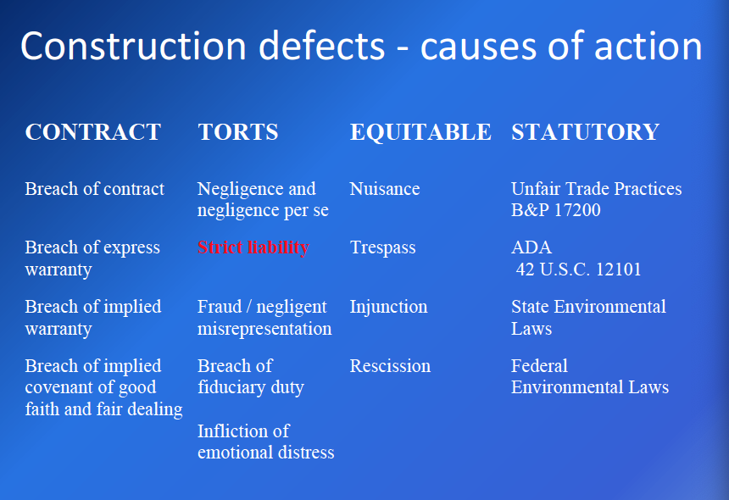

Strict Liability and the Economic Loss Rule:
- What is strict liability?
  - it is a duty to make something safe
  - does not require a contractual relationship
  - liability that does not require proof of negligence or intent to harm
- Why do courts impose strict liability?
  - Public safety
  - To insure that the costs of injuries (or damage) from defective products are borne by those who put the products on the market
  - Manufacturers are in the best position to protect against injury from the products
- Economic loss rule
  - Strict liability not intended to apply to products that simply do not perform to consumers expectation
  - strict liability does NOT allow recovery for solely “economic loss”
    - economic losses, generally, are the loss of value or the cost of repairs or replacement
- Aas—The defects alleged by the homeowners:
  - Homeowners sued the project developer, general contractor, and subcontractors in negligence for building code violations, including:
    - The failure to properly construct shear walls
    - The failure to properly construct one-hour and two-hour fire protection in party walls; and
    - Violations of the National Electrical Code
    - Alleged no consequential property damage
  - Lower courts’ holding
    - The lower courts found that certain of the homeowners’ damages, including violation of minimum building code standards were solely economic losses
      - 1. None of the homeowners had been physically injured by the substandard conditions; and
      - None of the substandard conditions had caused any property damage
    - The homeowners were not allowed to recover for these economic losses, in negligence, against the project’s developers, general contractors, or subcontractors
  - CA Supreme Court—affirms
    - Court relied primarily on the distinction that the law has drawn between tort recovery for physical injuries and warranty [contract] recovery for economic loss
  - Practical significance of Aas:
    - In the absence of a contractual relationship with a party, a building owner will be able to recover only for personal injury or physical damage caused by the defective construction, but not for the diminution in value of the building or the cost to repair the defective work itself

California’s “Right to Repair Law”—Civil Code §895
- This act provides homeowners with a cause of action against builders and product manufacturers for violations of building standards pertaining to new residential construction and allows homeowners to recover for economic losses absent proof of property damage or personal injury
- However, it mandates that homeowners must allow the builder a right to repaid before filing suit
- Key points
  - Applies to residential construction only
  - Defines construction standards and actionable defects
  - Establishes mandatory repair procedures and timelines
  - Establishes regulations for the litigation of claims

Prelitigation procedure
- Notice of claim
  - Triggers insurance and extension of limitation begins
- Document sharing
  - Builder provides plans, specifications, grading plans, final soils reports, DRE reports, engineering calculations, etc
- Builder acknowledges claim
  - Within 14 days of claim

Potential Green Building Liability
- Failure to meet current and anticipate regulatory requirements for energy use and emission standards
- Failure to obtain LEED certification or other third part certification standards
- Failure to meet performance specifications

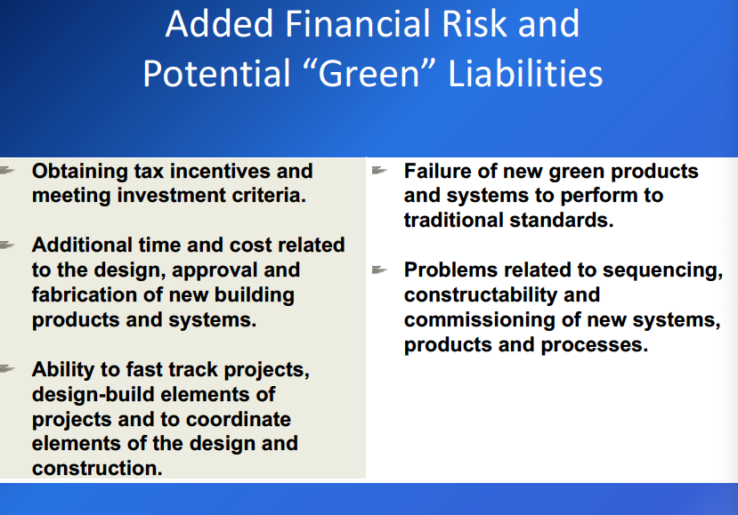

10 year statute of repose for construction defects:
- In most jurisdictions, there is an extended limitation period for latent defects based upon discovery
  - Latent defects—not apparent
    - Latent defect—limitation period for latent defects accrue upon discovery (when causing personal injury or property damage)
    - May require expert investigation to determine that defect exists
    - CA: 10 year statute of repose (10 years after substantial completion)
      - Statue of repose impose final end date for liability, but subject to internal statutes of limitation
    - California CCP §337.15
      - This section bars an action for latent defects in the development of real property, including the construction of improvements thereon, filed more than 10 years after the substantial completion of the development or improvement
        - Does not apply to injuries or death
        - Does not apply to fraud and intentional conduct
        - Importance of retaining documents
    - Within statute of repose—still need to file within statute of limitations
- Patent defects are controlled by normal statute (e.g., breach of written contract is 4 years, property damage is 3 years, etc.)

Impact of Construction Defect Litigation on Construction Liability insurance
- Increased premiums and deductibles
- Loss in progress exclusions
- Limitations on completed operations coverage
- Limitations on additional insured coverage
- Residential work exclusions

Strategies for Mitigating Shrinking Liability Insurance Coverage
- Loss prevention programs
  - Quality control
  - Right to repair/ customer service/ ADR
- Contractual risk allocation
  - Indemnities
  - Extended warranties
- Other forms of insurance coverage
  - Project specific coverages
  - Wrap up policies, OCIPS, CCIPs

Construction Fosters Complex Disputes
- Statutory dispute resolution procedure
- Contractual dispute resolution procedures
- Court mandated procedures

Dispute Resolution Methodologies
- “Partnering” (preventative)
  - Process whereby parties discuss issues that may occur on project and then develop processes that are STILL WITHIN CONTRACT OBLIGATIONS to allow project parties to successfully manage such issues and:
    - Have real time dispute resolution
    - Avoid adjudicative processes
    - No longer widely used
  - Integrated project delivery systems
- Contract Administrative review (administrative)
  - Administrative guidelines within contract for hearing and ruling on disputes prior to adjudicative relief being pursued
- Dispute review boards (preventative and adjudicative)
  - Experts selected to board with agreement of both parties
  - Make periodic site visits to observe construction
  - Decide disputes in real time
  - Proceedings are informal
  - Decisions normally are unenforceable buy may be admitted in court
  - Board’s role, enforceability and admissibility of decisions usually governed by parties’ contract
- Negotiation (non-adjudicative)
- Mediation (can be within adjudicative process)
  - Party to party with trained facilitator
  - Often a condition precedent to litigation or arbitration
  - Commonly court ordered
  - Selection of mediator important
  - Decision makers should be required to attend
  - Confidentiality
  - Preparation is key
- Special Master/ Voluntary Trials (adjudicative)
  - Can be court appointed or agreed upon by parties
  - Fact finding by appointed or selected person(s)
  - Special master—commonly handles discovery matters
  - Voluntary trials—parties select “judge”
- Arbitration (binding vs. non-binding)
  - Binding vs. nonbinding
  - Federal Arbitration Act vs. Stata Arbitration Act
  - American arbitration association
  - Limited or no discovery permitted
  - Rules of evidence generally do not apply
  - Limited review of arbitrator’s award
  - Waiver of right to arbitrate
  - Cost and time benefit analysis
  - Specialized experience of arbitrator
  - Arbitrator has broad discretions
    - Doesn’t have to follow the law
    - Very limited grounds for appeal
  - Why go to arbitration?
    - In Pinnacles, the developer did not want to go to litigation with homeowner who he may/may not have had privity with
      - Juries usually side with homeowner
  - In consumer context, courts usually find arbitration contexts unconscionable
  - But, public policy likes arbitration (federal)
    - Faster, cheaper, more efficient
  - Court preempt state law by saying agreement under FAA (federal arbitration act)
- Litigation (adjudicative)
  - Try to avoid if possible
  - In construction--expensive, ineffective
  - Plaintiffs want to be in front of a jury, developers don’t want to be

Liquidated Damages—Sword or Shield
- CA Civil Code § 1671:
  - California courts do not enforce liquidated damages provision that serve as a penalty for breach
  - Instead, liquidated damages provision must be a reasonable estimate of damages that would result from breach
  - Under 1671, liquidated damages provisions for breach are valid unless proven “unreasonable under the circumstances existing at the time the contract was made.”
  - The burden of proving unreasonableness is on the party seeking to invalidate the provision
    - Also, unreasonableness is shown through the actual facts of the dispute, not just the wording of the provision
- Liquidated damages proper if difficult at time of forming contract to determine actual damages
- Incorporate language from civil code into contract
- Make sure some basis for liquidated damages
- Actual damages could be very difficult to prove
- The parties are very careful on how they reach the number
  - Sword vs shield
- Owners put liquidated damages both ways
  - 2 different numbers
    - 1. If contractor is late
    - 2. If contract had to work over because of owner
- Public Contract Code § 7203(a)
  - Clauses for delay damages are valid in public works contracts only if the public works contract expressly identifies them and liquidates them to a set number
  - Delay damages definition: damages incurred each day after the scheduled date of completion has passed; this will not include damages incurred after the notice of completion has been filed
- Jasper Construction v. Foothill Jr. College District
  - Issue: whether a liquidated damages clause should be enforced against a contractor when the delay is caused in part by both the contractor and the owner
  - Earlier cases ruled that liquidated damages could not be apportioned (see Aetna Cas. & Sur Co. v. Board of Trustees)
  - Holding: concurrent delays allow for proportioning of liquidated damages
    - This means that liquidated damages provisions will still be enforced even if some of the delay is caused by the owner and some by the contractor
    - The enforcement of the provision against the contractor will be proportional to his delay

Miscellaneous:
- When representing multiple parties in a suit -> need to consider whether you need a conflict waiver letter

