Civil Procedure – Caplan – Fall 2020 Outline
**
Civil procedure – process we use to resolve non-criminal legal disputes.
- GOAL – resolve disputes between two dissatisfied parties.
- REASON (why is this necessary) – American system of law is adversarial. It works best when both sides have a chance to present the best case for themselves. For this reason, we have a defined rule set for how the case will operate.

Overview

Lawsuits Overview

Resolution
- Voluntary dismissal – dispute ends in private agreement which stops claim (this includes private arbitration or when a plaintiff abandons action and tells court)
- Involuntary dismissal – plaintiff abandons suit, failure to proceed leads to dismissal, alternatively, judge could dismiss because of behavior of the plaintiff.
  - Abandon because P does not feel strongly about your case OR P had run out of money
- Ones that go to trial (overwhelming majority are tort claims followed by higher value contract claims)
  - Most filed cases are contract disputes, but these typically go away because there is not an abundance of substance to dispute

Goals
Reasons both sides will continue up legal pyramid, discussed below. Note that this has to start above level 5 because if there was no dispute then there would be no cause of action.
- Difference in goals causes difference in wants for Civ.P. P wants it to be easy, more lawsuits more forced changes. D wants it to be difficult, harder to go through process and expensive it is more likely things will stay as they are.
Plaintiff | Defendant
- Change status quo (i.e., new common law precedent) | - Maintain status quo (i.e., they like the way it happened. They do not want P’s solution)
- Obtain judicial remedy (damages, injunction) | - Emotional satisfaction (vindication)
- Emotional satisfaction (vindication, hold other party accountable)

Shadow of the law
If most cases do not go to trial, why do we care so much about procedure?
- Important because how much legal involvement you get is contingent on prior decisions due to common law and stare decisis.
  - At step 3 on hierarchy of legal involvement (on left), if counsel can show a Supreme Court decision that fairly decides your case you can stop going up the pyramid and prevent excessive expense.
Hierarchy of legal involvement | Litigation hierarchy
- Litigation | - Supreme Court
- Negotiated solution (with counsel) | - Court of appeals decisions
- Negotiated solution (without counsel) | - Trial court decision after trial
- Tolerated violation | - Trial court decision before trial
- Law obeyed / no dispute | - Lawsuit initiated

Semester Roadmap
Pretrial | Trial | Post-Trial
Forum Selection  - Personal Jurisdiction  - Subject Matter Jurisdiction  - Venue | Judgement as a Matter of Law (JMOL) | Post-trial Motions  - Renewed JMOL  - New Trial  - Vacate Judgement
Information Exchange  - Service of Process  - Pleadings  - Discovery |  | Appeals
Pretrial Resolution
- Settlement
- Default Judgements
- Voluntary Dismissal
- Involuntary Dismissal
- Summary Judgement
Litigation Management

Overarching Concepts

R1 – Scope and Purpose
There rules should be construed, administered, and employed:
- By the court and the parties
- To secure the:
  - Just
  - Speedy and
  - Inexpensive
- Determination of every action
**
- HOW is R1 used?
  - R1 is used to interpretation of other rules and as a tool for decision making within the rules.
  - Where there is doubt, use R1 to guide how to proceed.
- R1 is a balancing act
“Just” | v. | “Speedy and Inexpensive”
- Avista v. Wausau – dispute over where deposition will be taken resolved by rock, paper, scissors on the courthouse steps.
  - Consider that motion practice was expensive in both attorney time and court time
  - Solution of rock, paper, scissors was genius as it was speedy, cheap, showed the parties they were being ridiculous, and was fair in light of the result not being of critical importance for the suit on the whole

R6 – Calculating Time

Overarching Concepts
- There is no penalty for filing early
**
- Where time is stated in:
  - Days – exclude the day that triggered the event
  - Hours – start counting immediately once the triggering event has occurred
- For counting
  - Days / hours – count all time, even time that occurs on a weekend or legal holiday
  - Expiration on weekend or holiday – extend the timeline to the next day that is not a weekend or legal holiday
    - e.g., if 21 days from service of the complaint falls on a Saturday, the deadline for answer is the upcoming Monday
    - e.g., if the paper is due by 4:00pm on Christmas, and Christmas is a Friday, then it is due by 4:00pm on December 28 (i.e., the Monday following the weekend)
**There is nothing that prohibits a triggering event from occurring on a weekend or holiday**

Legal Holidays
R6(a)(6) – “Legal holiday” means:
- (A) The following days that are set aside by statute
New Year’s Day | MLK Jr.’s Birthday
Washington’s Birthday | Memorial Day
Independence Day | Labor Day
Columbus Day | Veterans’ Day
Thanksgiving Day | Christmas Day
- (B) Any day declared a holiday by the President or Congress
- (C) For periods measured after an event, any other day declared a holiday by the state where the Dist. Ct. is located.

Extension of Time
- R6(b)(1) - The court may, for good cause, extend the time:
  - (A) Pre-deadline
    - With or without motion or notice
    - Can occur by the courts own action or request of one of the parties
  - (B) Post deadline
    - Only on motion
    - Party’s failure to meet the deadline must be from excusable neglect

Other
- R6(c) – Motions, Notices of Hearing, and Affidavits
  - Written motion and notice of hearing must be served at least 14 days before the time of the hearing
  - Does not apply:
    - When the motion can be heard ex parte (e.g., temporary injunction)
    - When the rules set a different time
    - When a court order sets a different time – a party can motion for a different time ex parte for good cause
      - Determining good cause would be an appropriate instance to apply R1

Service of Other Papers (i.e., Anything Post Complaint)
- R5(b)(1) – If a party is represented, send it straight to the party’s attorney
- R5(b)(2) – covers methods for sending documents back and forth
  - R5(b)(2)(E) – Electronic methods - Most courts use an electronic filing system
    - Email would also be covered under this rule if the party consented to exchange information by email.
  - R5(d)(3) – When a document has to be filed, a represented party has to filed documents with the electronic filing system

Motion Practice
- Motion: request for the court to do something
  - Can be either written or oral
  - e.g., pre-trial motion “I move to dismiss this action for failure to state a claim” - R12(b)(6)
  - e.g., I move to allow this witness to testify
- Motion practice – how a court “hears” and decides written motions
  - (1) Opening brief – moving party describes what is being requested and explains why the requested judicial action is legally proper
  - (2) Opposition brief – non-moving party explains why the motion should be denied
  - (3) Reply brief – the moving party’s opportunity to directly counter the opposition brief – i.e., specifically address the points made there
    - Reply brief should (theoretically) not bring up new topics as opposition has not chance to respond – called “sandbagging”
  - (4) Oral Argument – not a required step, but judge may want to get the parties together to talk in person prior to deciding
  - (5) Order – the judge’s decision on the motion
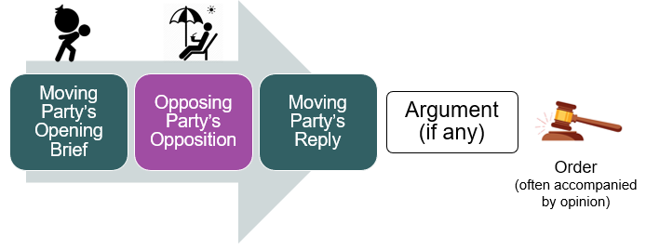

Pretrial

Pretrial Timeline
- Pleadings
  - P files complaint
  - P serves complaint
  - D responds (i.e., pre-trial motion or answer)
- Discovery
- Pretrial conference (speak now or we are going to court)
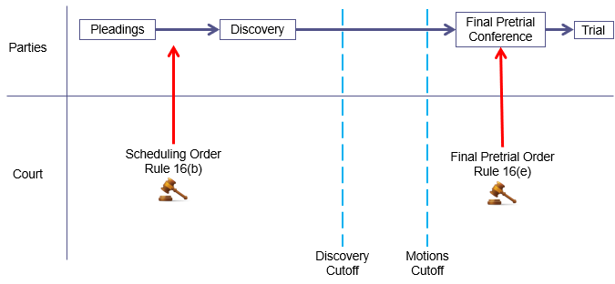

Pleadings

Overview
- What are pleadings?
  - Documents that start a lawsuit
  - Goal of pleadings is to provide the opposing party with the information they need to understand what is at issue at trial
- Pleadings do not contain evidence – pleadings contain allegations (however, they could contain evidence)
  - Evidence is what is presented at trial to prove the allegations
- Rule 7(a) – Only the following pleadings are allowed
  - R7(a) also provides the option for a reply to an answer on court order
Pleadings that State a Claim (a/k/a pleadings to which a responsive pleading is required) | Responsive pleadings
Complaint (by P against D)  - Rule 8(a) | Answer to a complaint (by D)  - Rule 8(b), (c)
Counterclaim (by D against P)  - Rule 13(a), (b) | Answer to a counterclaim (by P)  - Rule 8(b), (c)
Crossclaim (by D against D, or P against P)  - Rule 13(g) | Answer to a crossclaim (by P or D)  - Rule 8(b), (c)
Third-party complaint (by P or D against a new party)  - Rule 14 | Answer to a third-party complaint (by new party)  - Rule 8(b), (c)
- R10 governs the form and structure of the pleadings
  - R10(a) – Caption and Name of the Parties – The following must be included in a pleading:
    - Court’s name
    - A file number
    - A R7(a) designation (see table above)
    - A title
      - The title of the complaint must name all the parties.
      - All other pleadings name the first party on each side and refer to others generally
  - R10(b) – Paragraphs; Separate Statements
    - A party must state its claims or defense in numbered paragraphs
      - Later pleadings can refer to information in earlier paragraphs by number
    - Each numbered paragraph should be limited (as practicable) to a single set of circumstances
  - R10(c) – Pleadings can reference themselves and exhibits can be included for reference.

Guidance on Writing Pleadings - R8(d)
**Applies to answers, replies, etc.**
- R8(d)(1) – KISS – “each allegation must be simple, concise, and direct. No technical form is required”
- R8(d)(2) – allows party to set out two or more claims (or defenses) in the same lawsuit
- R8(d)(3) – consistency is not required, claims (or defenses) can contradict each other

When things need to be done with particularity – R9(b), (c)
- Things that need to be done with particularity – PURPOSE, alert the opposing party what is specifically being challenged so they can appropriately defend themselves.
  - R9(b) – Alleging Fraud or Mistake
    - Four Requirements:
      - (1) Specify what was said
      - (2) Identify who said it
      - (3) State where and when it was said
      - (4) Explain why it is fraudulent or mistaken
    - e.g., P alleges that because of D’s fraudulent statements they were induced to take some action. P needs to state with particularity what D said, who specifically said it (image D is a corporation), where and when they said it and why it is fraudulent.
  - R9(c) – Denying conditions precedent
    - e.g., P alleges that D breached a contract (i.e., contract is condition precedent). In denying P’s allegation, D will need to state with particularity which part of the contract was not breached.

Complaint

R3 – Commencing an action
- A civil action is commenced by filing a complaint with the court
**
- In drafting a complaint, always consider the response you will get in the answer for choice of wording

Claim for Relief (i.e., complaint)
R8(a) - A pleading that states a claim for relief must contain:
- (1) A S&P statement of the grounds for court’s jurisdiction
- (2) A S&P statement of the claim showing the pleader is entitled to relief
- (3) A demand for relief, which may include alternative or different types of relief
**
- (1) Samuel L. Jackson – “WHY ARE WE HERE” – prove jurisdiction to SLJ
- (2) Frank Costanza – The Airing of Grievances – “I got a lot of problems that entitle me to relief and now you’re going to hear about them”
- (3) Ryan Gosling followed by Spaulding Smails – a “what do you want” followed by “I want a hotdog, no a hamburger, and some chips”

The Frank Costanza – S&P Statement of Claim
- “I got a lot of problems that entitle me to relief . . .”
  - The pleading is valid so long as one of the claims gives P grounds for legal relief
    - Initial idea was (1) party, (2) court
    - Unrepresented / represented party seeks remedy first, court steps in second to determine under which legal theory they remedy should be provided
      - *Potentially altered with Twombly / Iqbal*
- Pleadings do not have to include evidence, but they could
- From Twombly / Iqbal - Complaint can include both legal conclusions and supporting factual allegations, both are encouraged, but cannot have conclusions with out factual allegations

How to State a Claim in a Short and Plain Statement

Original Idea – notice pleading
- Notice pleading: a general party could plead a complaint; no need for special words
- “The Federal Rules
  - reject the approach that
    - pleading is a game of skill
    - in which one misstep by counsel may be decisive to the outcome and
  - accept the principle that
    - the purpose of pleading is to facilitate a proper decision on the merits
  - Conley v. Gibson (U.S. 1957)

New Idea – fact pleading
- Fact pleading: requires plausible suggestion (if not probable) of violations and corresponding facts to show it is likely true that the pleader is entitled to relief
  - If notice pleading requires allegations that could lead to a claim; fact pleading requires allegation of specifics that lead to smoking gun evidence
  - e.g., Bell Atlantic Corp. v. Twombly and Ashcroft v. Iqbal


Notice Pleading | Fact Pleading
- Indicate the general nature of the suit  - This level of information will tell D that they are subject to a claim, that they need to start gathering evidence | - Specify evidence that would establish liability at trial  - e.g., instead of just statement about “negligent driving,” you would want to include (i) specific date; (ii) specific conduct that harmed party; (iii) etc.
- Les detail (general, short, less technical – i.e., someone could do it without an attorney) | - More detail (specific, long, more technical) – detail might induce settlement as the opposition knows you are serious
- Requires no special expertise | - Requires expertise
- e.g., Dioguardi v. During & Doe v. Smith | e.g., Bell Atlantic Corp. v. Twombly & Ashcroft v. Iqbal

How to Review if a Claim Has Been Stated – Ruling on 12(b)(6)
- Put elements of legal theory on the left and line up allegations on the right
  - The allegations in the complaint should be viewed in the light most favorable to the non-moving party
    - EXCEPT the following should be crossed out for review (changes from Twiqbal)
      - Legal conclusions should be disregarded
      - Remaining allegations must tell a “plausible story of liability” – “plausible claim for relief”
        - Plausibility is based on if there is a likely explanation based on common sense
        - Two equally valid interpretations, one lawful and one unlawful are insufficient to survive summary judgement
        - Look for “obvious alternative explanation” (Iqbal)
  - Inferences are allowed and should be drawn in favor of the non-moving party
    - i.e., has this party stated a claim in its best-case scenario

Example of 12(b)(6) Review
- Unlikely to have Twiqbal issues as battery is straightforward and discovery will not be lengthy
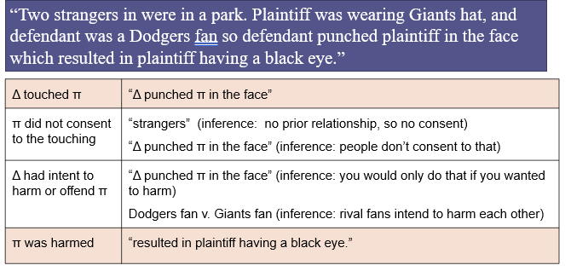

Legal Conclusions / Plausible Story of Liability
- Legal conclusions and plausibility concerns most frequently arise:
  - (1) Mental state - In cases where actions could be either lawful or unlawful depending on D’s mental state
  - (2) Lengthy Discovery - Cases where discovery is likely to be length or expensive
    - i.e., at pleading state, P does not have robust facts to support its case and may fall victim to legal conclusions
  - (3) Disfavor to SCOTUS - Cases involving legal theories that courts are not current interested in supporting (antitrust; discrimination; suits against govt. officials).

Legal Conclusions
*General idea – look for elements of legal claim that you cannot specifically prove with additional facts*
- Harassment
  - Conclusion: D engaged in harassment
  - Factual allegation: D called P repeatedly, emailed her, waited by her car
- Naruto (monkey selfie)
  - Conclusion: D have repeatedly infringed on Naruto’s copyright by publishing Monkey selfies
  - Factual allegation: Naruto is a monkey who possesses the requisite mental capacity to understand when he is engaging taking photos. D’s published books that contained the photos Naruto took. D sold those books in both hard copy, paperback and ebook format.
- Elton v. Mercury – sexual orientation discrimination
  - Conclusion:
    - Elton is a gay man.
    - Mercury is prejudiced against gay people and has intent to harm them.
    - Mercury demoted Elton because he is gay and has violated Cal. Fair Employment Act.
  - Factual allegation:
    - Elton is a gay man.
    - Mercury is prejudiced against gay people and has intent to harm them. Mercury has vocally shown distain for gay rights when they’ve come up in news events and been specific about not supporting his feelings on legislative efforts related to fair treatment of same sex couples.
    - Mercury demoted Elton by moving him from job X to job Y that pays $100k difference. This demotion happened after Elton wore buttons and hung signs on his desk supporting gay rights. Elton’s performance did not otherwise change over this period as supported by his performance reviews.

Plausible Story of Liability
- Bell Atlantic Corp. v. Twombly (U.S. 2007) – related to antitrust
  - From complaint: D telephone companies have agreed not to compete with one another and otherwise allocated customers and markets to one another.
  - Plausible explanation: Telephone service requires significant infrastructure, so it makes general sense in doing business to limit overlap in markets to avoid duplication of infrastructure.
- Ashcroft v. Iqbal (U.S. 2009) – related to religious, race, and national origin discrimination
  - From complaint: FBI director Robert Muller engineered a plan to arrest and detain thousands or Arab men after 9/11 based on their status as Arab and subject them to harsh conditions of confinement. Attorney General Robert Ashcroft read and approved these plans thereby condoning them.
  - Plausible explanation: (1) could be arrest, detain and subject to harsh conditions based on religion, race or national origin; (2) also could be because all 9/11 attackers and others from extremist groups fit this profile so a policy targeting terrorists has a disparate impact on Arab Muslims.
- Elton v. Mercury – sexual orientation discrimination
  - From complaint:
    - Elton is a gay man.
    - Mercury is prejudiced against gay people and has intent to harm them.
    - Mercury demoted Elton because he is gay and has violated Cal. Fair Employment Act.
  - Plausible explanation:
    - Without additional facts or notes about Elton’s performance in the complaint, Mercury could have also demoted Elton because his performance was lacking.
**

Examples of Pleading Standards and Idea
Dioguardi v. Durning (notice pleading; (1) party, (2) court)
- Dioguardi, an Italian American immigrant, files a claim in very poorly written English related to bottles of tonic he had imported from Italy being improperly seized by the Port Authority of NY headed by Durning.
- Durning files the equivalent of a 12(b)(6) motion. U.S. Dist. Ct. for S.D.N.Y. dismisses the case for failure to state a claim.
- 2d Cir. – reverses. Notes that based on what Dioguardi has explained, Durning can figure out what event is in question and enough specifics to defend himself.
  - 2d Cir. HELD - facts demonstrating evidence are unnecessary and will come out in discovery.
    - In review, court should consider if there is a claim for relief based on included facts
    - Also, all facts and inferences that comes from them should be taken in light most favorable to non-moving party.
Doe v. Smith (notice pleading; facts for each element of legal theory are unnecessary; can be inferred)
- In 2002, P and D were dating. P was 16 and D was 17. D made a video of the two of them engaging in intercourse. D shared the video with classmates over the internet after they stopped dating. P found out and brought claim in 2003 for among other things federal wiretapping.
- To violate federal wiretapping, D must (1) intercept (2) an oral communication, and (3) disclose it in interstate commerce.
- Dist. Ct. – dismissed wiretapping claim as P did not demonstrate (2) oral communication or (3) interstate disclosure in the complaint.
- HELD - 7th Cir. – reversed based on inferences that can be drawn in light most favorable to P.
  - (2) Complaint states video tapping. Most video taping comes with sound. Taken in the light most favorable to P we can infer the video in this instance had sound thus had oral communication. P will need to demonstrate this at trial.
  - (3) Disclosed in interstate commerce. Complaint said it was distributed over the internet which could be inferred to mean it crossed state lines. P will need to demonstrate this at trial.
Bell Atlantic Corp. v. Twombly (U.S. 2007) – Fact pleading is required; legal conclusions are insufficient
- Antitrust case. Antitrust has the following elements
Elements of Antitrust | Allegations in Complaint
Ds sell the same products or services | Sufficiently alleged
Ds do not compete in each other’s markets | Sufficiently alleged
Ds stay out of each other’s markets because of an agreement to limit competition | “Ds have agreed not to compete with one another and otherwise allocated customers and markets to one another.”
- HELD – allegations of agreement are insufficient without additional facts demonstrating agreement to withstand summary judgement. This allegation is a legal conclusion unfounded, thus the complaint should be dismissed.
Ashcroft v. Iqbal (U.S. 2009) – Fact pleading is required; plausible story of liability
- Iqbal brings action related to discrimination on the basis of race, religion and national origin against FBI Director Muller and AG Ashcroft related to Muller’s policies of arresting and confining Arab Muslim men in harsh conditions post 9/11.
- Complaint alleges that these policies, designed by Muller, unfairly targeted Arab Muslims and that AG Ashcroft signed off on the policies.
- PROCEDURE
  - Ashcroft moved to dismiss for failure to state a claim upon which relief can be granted – 12(b)(6)
  - U.S. Dist. Ct. – citing Conley, denied motion by determining, when taken in a light most favorable to Iqbal, there is a factual scenario where relief could be granted.
  - 2d Cir. – citing Twombly, upheld denial of dismissal. Noted that Twombly was limited to instances of particularly complex cases that require specific facts to “nudge” competing inferences over the conclusion and into plausibility range and that it did not apply here.
  - SCOTUS – reversed by citing Twombly. Twombly is not limited to certain circumstances of complex cases, but rather all cases. Where there are two competing inferences, one unlawful and the other lawful, the complaint cannot survive a motion to dismiss without additional facts to nudge the allegation with competing inferences over the plausibility line to the unlawful side.
    - Remanded to U.S. Dist. Ct. to determine if Iqbal should be given a chance to amend the complaint.

Service of process

Overview of Topic
- Service of process = bringing a new party into the lawsuit for the first time
  - Most frequently - “How to Get Complaint to Defendant”
- Vocabulary
  - File – (see R3) delivering the summons and complaint to the court for the official record
  - Serve – sending summons and complaint to the opposing party according to the rules
- Why does this matter?
  - U.S. has an adversarial justice system where each party must represent itself
    - Need both parties to be aware of matter for adversarial process
    - For D to respect process, they need to be involved in its outcome
  - Notice standard – duty to inform D that government action is pending against them
    - Supported by “due process” in constitution
  - Service Rules – the specifics of R4 on how to appropriately give D notice

Overview of Rule
- Who is responsible - R4(c)(1)?
  - P is responsible for getting the summons and complaint to D according to the rules
  - P is also responsible for giving them to the person who will give them to D
- Who can actually give D the documents R4(c)(2), (3)
  - R4(c)(2) - NOT P – “any person . . . not a party may serve a summons and complaint” – do not want oil and water to mix
    - Any person at least 18 years old
  - R(4)(c)(3) - At P’s request, the court can order service by a U.S. Marshal or Deputy Marshal
- When?
  - P has 90 days from when the complaint is filed to appropriately serve D - R4(m)
  - See limitations under “When P or D Falls Short”
- What is in the summons – R4(a)(1)?
  - Generally, gives D all administrative information they need about the lawsuit.
    - What court, the other party, notification of when they need to be present
  - Also tells D about what happens if they fail to appear (i.e., default – R55(b)).

Answering a Service of Process Question
- Identify the appropriate piece of R4 that applies (i.e., (e) – individuals in U.S., (f) – individuals in foreign, (h) entities)
- Work through different options available and note why they are or not supported
  - e.g., for entities in the U.S.: (1) options available for service of an individual – R4(h)(1)(A); (2) options available for service on an agent – R4(h)(1)(B)
- Consider standards as applicable to interpret rules (i.e., Mullane standard)
- Consider notice requirement and Due Process Clause section below

Waiving Service – R(4)(d)
- R4(d) – Allows the following to be served by first-class mail or other reliable means so long as they waive their right to service of process under R4:
  - Individual in the U.S. – R4(e),
  - Individual outside the U.S. – R4(f), or
  - An entity – R4(h)
- P can notify D the suit has commenced and request them to waive service of a summons
- Created because hiring a process server is expensive and time consuming
  - R4(d)(1) – List above “has a duty to avoid unnecessary expenses of serving the summons.”

Administrative Necessities
- R4(d)(1) The notice and request for waiver must:
  - (A) be in writing and be addressed
    - (i) to the individual D
    - (ii) a D subject to service under R4(h)
  - (B) Name the court where the complaint was filed
  - (C) Be accompanies by the complaint and two copies of the waiver for AND a prepaid means for returning the form
  - (D) Inform D of the consequences of waiving and not waiving service
  - (E) State the date the request was sent
  - (F) Give D a reasonable time to return the waiver
    - 30 days in the U.S.
    - 60 days outside the U.S.
  - (G) Be sent by first-class mail or other reliable means

Sticks and Carrots - Consequences of Not Waiving and Waiving
- Not waiving - R4(d)(2) – Failure to Waive
  - Only applies to Ds and Ps in the U.S.
  - If D fails, without good cause, to sign and return a waiver requested by P, the court must impose on D:
    - (A) expenses incurred for making service
    - (B) the reasonable expenses, including attorney’s fees, of any motion required to collect the service expenses
- Waiving – R4(d)(3) – Waiving Service
  - Benefit of additional time to respond to complaint
    - D’s in the U.S. – 60-day timeline to respond (as opposed to 21)
    - D’s outside the U.S. – 90-day timeline to respond (as opposed to 21)

What is Required to Waive Service?
- The D must actually sign and return one of the copies of the waiver form provided to it
- R4(d)(1)(G) requires the waiver be sent via first-class mail, first-class mail often comes with a receipt to sender once it has reached the address
  - THIS IS INSUFFICIENT FOR WAIVER OF SERVICE – actual waiver form must be returned

“It Depends” - How to Serve Depends on Who and Where
- Always remember to consider methods prescribed by state law
  - Especially true where a statute is available on an exam

Individuals in the U.S. – R4(e)
Unless federal law provides otherwise, an individual who has not waived service can be served in a judicial district of the U.S. in the following ways:
- Two options: state of federal
  - (1) Following state law in either:
    - The state where the Dist. Ct. is located
    - The state where service is being made
  - (2) Three Federal Options
    - (A) Personal service – delivering summons and complaint to the person individually
    - (B) Substituted service – leaving the summons and complaint at the individuals “dwelling or usual place of abode with someone of suitable age and discretion who resides there (see NDC v. Khashoggi)
    - (C) Service on an agent – delivering summons and complaint to an agent authorized by appointment or by law
**
Example: Lawsuit is filed in the U.S. Dist. Ct. in the C.D. Cal. P lives in Colo. D lives in Miss. P is served while attending a conference in Ga. What state laws apply for service?
- Cal. and Ga.

Individuals outside the U.S. – R4(f)
Unless federal law provides otherwise, an individual who has not waived service can be served in a foreign country in the following ways:
- (1) By any internationally agreed means of service
- (2) Where there are no internationally agreed on means or if the agreement allows, but does not specify alternative means, use a method reasonably calculated to give notice.
  - (A) Means of service under laws of the foreign country for a court of general jurisdiction
  - (B) Ask the foreign country with a letter, follow what they say
  - (C) Unless prohibited, could delivery summons and complaint:
    - (i) To the individual personally
    - (ii) By having the court clerk address and mail it with a method that requires a signed receipt by the recipient
- (3) Under court order, by any other method not prohibited by international agreement

Entity (Corporation, Partnership, Etc.) – R4(h)
Unless federal law provides otherwise or D has filed a waiver an entity (i.e., domestic or foreign corporation or partnership, etc.) can be served in the following ways:
- (1) In a judicial district of the U.S.
  - (A) In any manner prescribed for serving an individual under 4(e)(1)
    - i.e., Following state or local law in the state where the Dist. Ct. is located or where service is made
  - (B) By delivering a copy of the summons and complaint to:
    - An officer, a managing or general agent (e.g., a senior-decision maker or other party with a job title that specifies they are the correct party. Often the entities bylaws will list this party).
    - Agent authorized by appointment (e.g., some states require entities to appoint a person)
    - Agent authorized by law (e.g., the secretary of state may be specified by statute to receive the summons and complaint on behalf of out of state corporations)
      - Where the agent is authorized by statute, and the statute requires, also mail a copy to each defendant
- (2) Outside a judicial district of the U.S.
  - Any method specified by 4(f), except personal service
**
- Shorthand
  - (1) In the U.S.
    - (A) – State and local laws in accordance with 4(e)(1)
    - (B) – Delivery to one of the following:
      - Officer, a managing or general agent
      - Agent authorized by appointment
      - Agent authorized by law
        - Mail where state law requires

Other Type of Defedants
- Minors or Incompetent Persons – R4(g)
- The United States – R(4)i)
- U.S. State or Local Govt. – R4(j)
- Foreign Govt. – R4(j)

Proving Service, R4(l)
- (1) – Service is proved by an affidavit signed by the server
  - Poof is not necessary where service has been waived
    - WHY? Because the party signed a written acknowledgement, R4(d)(4))
  - Special rules also apply to U.S. marshals or deputy marshals
- (2) – Where service occurs outside any judicial district of the U.S. it must be proved
  - International Agreed Means (4(f)(1))
    - As provided in the applicable treaty or convention
  - Method Reasonably Calculated (4(f)(2)), Means Not Prohibited and ordered by the court (4(f)(3))
    - By a receipt signed by the addressee
    - Evidence indicating the summons and complaint where delivered to the addressed – this evidence must satisfy the court

When Traditional Means of Service Fail
- As a method of last resort (after all other methods are exhausted and P can demonstrate they are exhausted), P can use alternative mans to serve summons to D
  - The notice P gives will include instructions on how to receive the complaint
- Methods are based on:
  - State Law – for Ds inside the U.S.
  - Means not prohibited by international agreement and agreed to by the court for international Ds
- Examples: publication in newspaper, via FB message where it could be shown that D checked FB regularly

When P or D Falls Short
- P has 90 days from when the complaint is filed to appropriately serve D - R4(m)
  - DOES NOT APPLY TO:
    - Individuals outside the U.S. – R4(f)
    - Entities outside the U.S. – R4(h)(2)
    - Foreign governments – 4(j)(1)

Where P Fails to Serve
- If P does not serve D in the applicable time period, THEN the court must, on motion or on its own AFTER notice to P:
  - Order that service be made in a specific time; OR
  - Dismiss the action without prejudice against D. HOWEVER
- If P can show good cause for the failure, the court must extend the time for an appropriate period.
**
- If P does serve D, but service is not proper, D can move to dismiss under R12(b)(5) – insufficient service of process.

Where D Fails to Respond
- If P has appropriately served D (and can prove service under 4(l)), but D has not responded, THEN:
  - P obtains a default judgement against D – R55(b)
- Where:
  - (1) default has been entered; and
  - (2) D can demonstrate there has not been proper service and notice
- Then the default judgement can be set aside.
  - Combination of R55(c) – set aside an entry of default for good cause and R60(b) – relief from final judgement.
    - Specifically (4) – the judgement is void or (6) – any other justifiable reason.
    - See attempt of this in NDC v. Khashoggi (suggested improper service) & success in Jones v. Flowers (notice)

Due Process Clause
- Due process is standard on which R4 is based
- U.S. Const. (5th (Federal) and 14th Amendments (State)) – government may not “deprive any person of life, liberty, or property, without due process of law.”
- Mullane Standard – for due process, P must take steps “reasonably calculated under the circumstances” to provide D the information they need.
  - GOAL – plaintiff must give notice, message has to be delivered and include specific information
    - Does not say that defendant must receive message – constructive notice, as opposed to actual notice, is required
    - Constructive notice – legal fiction or presumption that the defendant received actual notice, even if actual notice cannot be proven
    - Actual notice – where P can confirm that D has seen the notice they were supposed to be provided.
  - See Jones v. Flowers below – constructive notice does not exist where P knows D has failed to receive the information despite their reasonable attempts under the circumstances to provide them notice.
**
Examples
- Dusenbery v. United States, case explaining due process and constructive notice
  - Dusenbery, arrested on drug charged. FBI sent notice saying they were claiming $22k in cash. FBI sent first-class mail to prison where they had Dusenbery’s last address on file. Prison mail room signed for envelop, but Dusenbery claims he never saw it.
    - HELD - this qualified as constructive notice, by virtue of signing for it, can reasonably assume that Dusenbery saw it
    - COUNTER – to avoid issue, FBI should have followed R4(d) process. I.e., include two copies of the notice, one for Dusenbury to sign and send back

- Jones v. Flowers, case explaining due process and constructive notice, when it did not work.
  - Jones divorces wife, wife lives in house which fell into back property taxes.
  - Notice of tax seizure was sent to house three times via first-class mail. Each time, no one home to receive it. County Commissioner got three notices that it was not delivered. Proceeded with foreclosure anyway.
    - HELD - this does not qualify as constructive delivery because County Commissioner knew that Jones never received notice.
      - Also, County Commissioner had many other reasonable means available to them
        - e.g., Just leave notice at the house instead of sending it by first-class mail where the mail required someone to sign for it.

Examples of Service of Process
NDC v. Khashoggi - what does it mean under rule 4(e)(2)(B) to leave a summons and complaint at someone’s dwelling or usual place of abode?
- P filed suit against D and a corporation owned by D for $3.5m. D has 12 residences that he visits throughout the year. One of them at Olympic Tower in NYC has two full-time live in staff.
- P served D at his Olympic Tower residence using substituted service and left the summons and complaint with one of the full-time, live in staff.
- D failed to defend. P moved for default under R55 – this means the court grants P their $3.5m verdict. D moved to vacate judgement under R60(b)(4) alleging that service was not proper as the Olympic Tower residence does not qualify as his dwell or usual place of abode. There was debate over whether he had actual notice.
- HELD - In modern age where people have several homes, dwelling or usual place of abode is determined by indica of permanence.
  - Look for lengths taken to make it inhabitable.
    - Here, D has made significant renovations and other outfits to allow himself to live at the property.
  - Still necessary for someone of suitable age and discretion to live at the property
- HELD – actual notice v. proper service, actual notice of the lawsuit does not matter. P still must fulfill rules of service.

Responding to the Complain

Timeline for Response
A defendant must serve an answer - R12(a)(1)(A):
- 21 days – post being served with summons and complaint
- 60 days – where service has been waived
- 90 days – where it was sent to a party outside the U.S.
When a motion is served under R12 – R12(a)(4):
- 14 days – post notice of the court’s action
  - 14 days is also the timeline for D to respond after D has received a more definite statement (i.e., where D has moved for more definite statement under R12(e) and received that more definite statement, 14 days to respond)

Options for Response
- (1) Nothing
  - Leads to default under R55 (usually only used by judgement proof parties)
- (2) Settle
  - Leads to voluntary dismissal – R41(a).
  - If there is a settlement, you do not have to responds or otherwise file a motion. Simply talk to opposing counsel and tell them you want to have settlement discussions.
    - They have the power to delay the timing of the response
- (3) Litigate
  - Pre-answer motion - i.e., R12
  - Pre-answer motion for SJ – i.e., R56
    - **NOTE – Does not stop the timeline for answer like R12 motion**
  - Answer - i.e., R8(b) and/or (c)
    - In responding, consider R11(b) – Based on the signer’s knowledge, belief and information “formed after an inquiry reasonable under the circumstances” the pleading, motion or other paper:
      - (1) is not to harass,
      - (2) is supported at law or non-frivolous,
      - (3) is factually supported or will be after reasonable discovery, and
      - (4) contains denials of factual contentions that are warranted by evidence, or where noted the party simply does not know

Pre-answer Motion

Non-dispositive Pre-Answer Motions
- Two options:
  - R12(e) – Motion for a More Definite Statement
    - Used for incomprehensible or excessively long complaints – rarely used
    - CONSIDER – as oppose to R12(e) motion, move for dismissal with R12(b)(6)
  - R12(f) – Motion to Strike
    - Covers two categories:
      - Insufficient Defense (i.e., one presented in answer) – used by P
      - Redundant, Immaterial, or Scandalous Matter – could be used by D, rarely used
        - CONSIDER – if this material is already in the complaint, it is part of the court record. Moving to strike will make it part of additional motions.
        - Just deny of state “no response” and move on.

Dispositive Pre-Answer Motions
- R12(b) – Must be raised prior presenting a responsive pleading
Ruling on R12 motions
- (6) – all that is necessary is the complaint
  - Taken in the light most favorable to the non-moving party, does the complaint state a claim?
  - Remember 12(d) – a 12(b)(6) motion with information outside the complaint converts to a motion for SJ
- (1) – (5), & (7) – likely need more information
  - e.g., (3) improper venue – if you can show both parties are from the same state, you can get your case thrown out of federal court.

Waiver Trap
- R12(g)(2) – Limits a party to one motion raising defenses or objections (R12 motion)
  - UNLESS the second motion raising a defense or objection was for some reason unavailable to them at the time of the first motion
- R12(h)(1)(A) – A party waives the defenses listed in R12(b)(2)–(5) where they:
  - Omit them from a motion under R12
  - Fail to raise them in either: (i) a motion under R12 or in response to an amended pleading under R15(a)(1) as a matter of course – i.e., the “free” amendment
**
- THE POINT – Efficiency.
  - Forces a party to raise all defenses at the same time for efficiency
  - Also, P typically just amends their complaint to correct the deficiencies pointed out by R12(b)(2)-(5) as a matter of course under R15(a)(1).
    - See that R12(b)(6) and (7) are more focused on the merits of the claim.
- PROCEDURE – If P wants to asset the waiver trap, they can do so in their reply brief.

Practical Approach to R12
**There will most likely be a timing question mixed in with how a court will rule on a R12 motion**
- Consider the deadline for an answer
  - R12(a)(1)(A) – 21 days unless service is waived (60 days) or served on a party outside the U.S. (90 days)
- Consider if there has been a R12 motion and how that affects timeline
  - R12(a)(4) – 14 days from notice of court action / 14 days from receipt of more definite statement
- Consider if there has been a counterclaim or crossclaim
  - R12(a)(1)(B) – 21 days to respond to a counterclaim or crossclaim
  - Also consider that a R12 motion can be filed on a counter or cross

Answer – Rule 8(b) & (c)

Rule 8(b) – Defenses; Admissions and Denials
- R8(b) Governs how to assert defenses
- R8(b)(1) In responding to a pleading, a party must:
  - (A) State in S&P terms its defenses to each claim asserted against it
  - (B) Admit or deny the allegations asserted against it
- Admissions – D gives up the right to further challenge the fact in litigation
  - See R8(b)(6) – allegations that are not responded to are admitted
- Denial – A party does not have to give reasons for its denial - simply state “denial”
  - Further, for strategy reasons it would not want to give reasons for its denial.
  - A denial must fairly respond to the substance of the allegation (R8(b)(2))
    - This means no word games or equivocal language.
**
Exam Tip / Practice Tip!
- R8(b)(2) requires a response to the substance of the complaint.
- R8(b)(4) allows a party to admit / deny pieces of an allegation
  - As such, it is necessary to be cautious in responding with either admit / deny
- Example: the allegation may say “per the contract for delivery of the goods signed on October 1.” How should the party respond if the contract was signed in June 15?
  - “Defendant admits there was a contract for delivery. Defendant denies that it was signed on October 1.”
**
Responding to pleadings under R8(b) is effectively ordering at a juice counter
(1) | Be ready when you get to the counter | Admit or deny the allegations with a S&P statement of defense
(2) | Stick to the main substance | Denials must fairly respond to the substance of the allegation
(3) | You can order off the menu or create your own | - You can generally deny all claims (i.e., off menu)  - You can admit some and deny some (i.e., create your own)
(4) | Modifications are allowed | You can deny part and admit part; or admit part and deny the rest
(5) | Ask if you are unsure of ingredients | If you lack knowledge to appropriately admit or deny, say so and the court will count it as a denial
(6) | Speak now before it is blended | Other than the amount of damages, an allegation that is not responded to is admitted  - Where a response is not required, an allegation is considered denied or avoided

Rule 8(c) – Affirmative Defenses
- R8(c)(1) – A part must affirmatively state any avoidance or affirmative defenses.
  - This means that those not stated are waived.
- WHY?
  - Affirmative defenses must be stated as proving or disproving them at trial requires evidence that is outside the four corners of the complaint – P needs to know so P can prepare to defend against the affirmative defense.
- It is left up to the law in each jurisdiction whether D must prove its affirmative defense or whether P must disprove it.
- R8(c)(2) – if a party mistakenly includes an affirmative defense as a counter claim, the court must, if justice requires, treat the pleading as it if was correctly designated
**
Standard for Pleading Affirmative Defenses
- Affirmative defenses are pleadings – the same pleading requirements from R8(a)(2) apply to the affirmative defenses.
  - Affirmative defenses must set for a “short and plain statement” of the basis for the defense – R8(b)(1)(A)
- Either direct or inferential allegations as to each element of the defense must be included – i.e., there must be a basis for D’s assertion of the defense based on the information contained in the pleadings

Motion to Strike – R12(f)
- P’s version of 12(b)(6) related to defenses.
- Where P wants to challenge the sufficiency of D’s defense, it can move to strike the defense under R12(f).
- Review a motion to strike challenge:
  - Under the same principals as a 12(b)(6) motion, consider if the short and plain terms adequately state a defense where:
    - The allegations are taken in the light most favorable to the party alleging them.
- Where a defense is struck, the party is not obligated to refile its answer, the defense is simply not included as part of that answer
Review of Rule 12(f)
- The court may strike from a pleading an insufficient defense (or any redundant, immaterial, impertinent or scandalous matter)
- The court may act:
  - On its own
  - On motion made by a party either before responding to the pleading or, if a response is not allowed, within 21 days after being served with the pleading

Signing Pleadings (and other Papers) and Honesty in Litigation (Rule 11)
- Rule 11 – applies to all documents that are filed with the court including pleadings, written motions, and all other papers.
  - Does not apply to documents not filed with the court
- Goal – prevent people from making arguments that are frivolous or time wasters to the court

Rule Overview
- 11(a) - signature required on all court papers
- 11(b) - signature acts as certification of good faith and diligence
- 11(c) - sanctions for improper signature
- 11(d) - does not apply to discovery, see Rule 26(g)

Rule 11(a) – Signature and Requirements
- All pleadings, written motions, and other paper must be signed by one attorney or unrepresented party
- Must also include the signors: (i) address, (ii) email, (iii) telephone number
- The court must strike the paper if it is unsigned unless promptly corrected
  - Reality – if a paper is unsigned, the court will ask the party to sign it and they will

Rule 11(b) – Certification of Good Faith and Diligence
- By presenting a paper an attorney or unrepresented party certifies that to the best of the person’s knowledge, information and belief, formed after an inquiry reasonable under the circumstances the paper:
  - (1) Is not for improper purpose – does not harass, waste time, or needlessly increase cost
  - (2) Contains an argument:
    - Warranted by (current) law
    - That is not frivolous related to extending, modifying, reversing, or establishing new law
  - (3) Is factually supported – there is factual evidence or there will be after a reasonable opportunity for discovery
  - (4) Is a factually supported denial – there is factual evidence to support denial or it is reasonable based on belief or lack of information
- This does not mean all information is 100% correct
- What Rule 11 means is that you have acted in good faith based on what was reasonable prior to filing with the court.
**
- Arguments under Rule 11 should be evaluated on a continuum
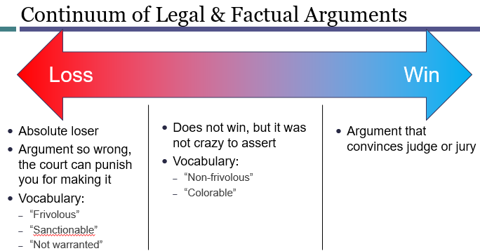
- Sanctions under Rule 11 come from far left “Loss” category
- Arguments exist on the dividing line between far left and middle
- REASON for the middle column
  - Boundaries must be pushed for the word to evolve – Brown v. Board of Education
  - Attorneys also need it to undertake zealous representation for client (sometimes)

“Reasonable Under the Circumstances”
- Depends on the complexity of factual basis and legal issue in question
- The attorney’s duty to make a reasonable inquiry is non-delegable
Situation | Note for Consideration
Opposing party controls the facts | Did you at least ask for them?  - Ideally with reasonable time for them to provide the information  - If the opposing party does not respond it is not your problem
The client provided the facts | Common sense based judgement call.  - If the story is straight forward, rely on it  - If it is outrageous, verify it (e.g., client totaled their new Mercedes while in a parking lot)
The case was accepted from another lawyer | Same as reliance on statements from client.  - The duty is non-delegable.
Resource available to the lawyer | Our system is premised on people bringing claims at little to no cost.  - It is understandable that a small town single does not have the same resources as a mega-firm

Hays v. Sony Corp. of America
- P, a high school teacher, wrote a manual for how to use a word processor for use by students and faculty at their school. The following year, P’s school purchased new word processors from Sony. The school asked Sony to update the manual which they did as a favor at no cost. Sony did not distribute the manual to any other clients.
- P filed suit for copyright violation seeking relief under a state law and the Federal Copyright Act where federal relief was based on (i) lost profits, and (ii) recovery of unlawful profits that Sony had earned.
- Sony moved for SJ which was granted and separately filed a motion for sanctions Rule 11(c)(2).
  - State law claim – abolished at the time the complaint was filed – violation of 11(b)(2)
    - Could have prevented trouble with basic research
  - Federal Copy Right Act
    - Predicated on Sony stealing the work without permission – the school asked them to do it – violation of 11(b)(3).
      - Should have asked client to confirm this detail
    - Lost profits relief – P did not sell the manual so there were none – violation of 11(b)(3).
    - Recover of unlawful profits – Sony gave the manual to the school and did not further distribute it – violation of 11(b)(3)
      - Should have at least sent Sony a letter asking about profits.

Nonfrivolous Argument to Extend, Modify, Reverse Current, or Establish New Law
- Relates to violation of Rule 11(b)(2) – claims, defenses and other legal contentions are:
  - Warranted by existing law
  - Nonfrivolous argument for extending, modifying, or revising existing law or establishing new law
- Sanctions should be imposed only where the argument has absolutely no chance – far-left category
Hunter v. Earthgrains Co. Bakery (W.D.N.C. & 4th Cir.)
- P filed a class action suit based on enforcement of an arbitration clause. P’s attorney relied on a learning ruling – not hard and fast yes / no decision – from the U.S. Sup. Ct. to present at Dist. Ct. Dist. Ct. quickly ruled for SJ in favor of D and separately issued a show cause order for P’s attorney. Six other Cir. had decided the same issue the opposite way and she failed to bring these cases up. W.D.N.C. really did not like this and issued a 5-year ban on her practice in Dist. Ct. as a result.
- 4th Cir.
  - Agreed that P’s attorney could have argued better with cases from other Cir.; however, disagreed with 5-year ban as her argument had some chance. It was in the middle, not far left. Reversed ban.

Process for Changing the Current Law
- (1) File complaint and pursue case in the Dist. Ct. knowing you will lose as you are against current law
- (2) Appeal to the Cir. Ct. App. – present argument for change, you will probably lose again
- (3) Options
  - (i) Petition for rehearing en banc – review of argument by all judges in Cir. Ct. App.
    - To get a rehearing en banc, a majority of judges must agree to grant review
    - If you lose again, then you can file a cert. petition to the U.S. Sup. Ct.
  - (ii) Directly file cert. petition for review by the U.S. Sup. Ct.
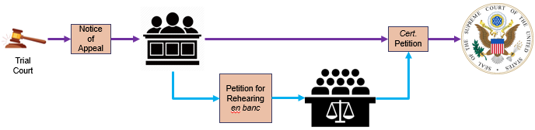

Rule 11 – Procedure & Timeline
- Rule 11(c)(2) – Motion for Sanctions (by the opposing party)
  - **NOTE – R11 motion does not stop timeline for responding to a complaint under 12(a)**
  - The motion must be made separately from other motions and must describe the specific conduct that violates Rule 11(b).
  - Timeline
    - Write motion and serve it on the opposing party under Rule 5
    - Only after 21 days period, if the party has not withdrawn or corrected the paper in question file the motion with the court
      - Purpose of 21 day period is to give the opposing party a proactive chance to remedy their negligent conduct
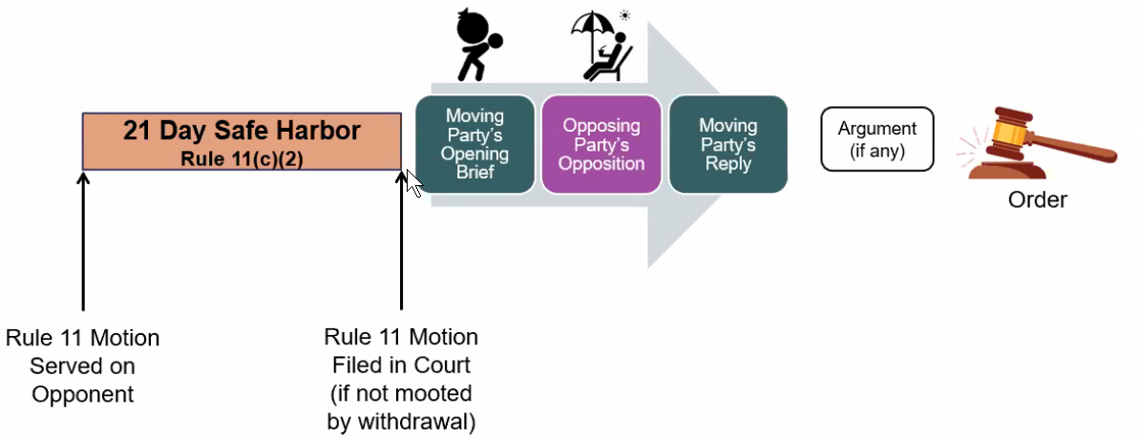
- Rule 11(c)(3) – (Sanctions) On the Court’s Initiative
  - Colloquially referred to as a “show cause order”
  - The court may ask an attorney, law firm, or party to show cause why its conduct has not violated 11(b)
  - The show cause order does not contain the 21 days safe harbor exception

Rule 11(c)(1), (4), (5), (6) – Sanctions

Nature of Sanctions – 11(c)(4)
- Must be limited to deter the conduct from the same party or another similarly situated party
- May include: (i) nonmonetary directives; (ii) order to pay a penalty into court; and (iii) if on motion and if warranted for deterrence, an order directing payment to the movant for part of all of their attorney’s fees and other expenses related to the violation.

Parties that can be sanctions – 11(c)(1)
- (1) The court may impose sanctions on:
  - An attorney
  - Law firm – absent exceptional circumstances a law firm will be held jointly responsible for the conduct of its employees
  - Party – sanctions against a party are generally limited to bogus factual stories.
    - Represented party – see limitation on monetary sanctions below.
    - Unrepresented party – 11(c)(4) limits sanctions to prevent the conduct from happening again, as an unrepresented party is unlikely to be back they are unlikely to receive sanctions.

Procedural Technicalities
- (5) Limits on Monetary Sanctions. A court cannot impose monetary sanctions:
  - On a represented party for violation of 11(b)(2) – legal basis for argument.
  - On its own, UNLESS it issued a show cause order prior to voluntary dismissal or settlement
- (6) An order imposing sanctions must describe the sanctioned conduct and the basis for sanctions

Amending Pleadings
- Pleadings serve as a guide to litigation – need process for amending to get best information
- Amendments require a balancing of two interests:
  - Avoidance of surprise (reason to not allow amendment)
  - Accuracy & consistency in the pleadings that matches what occurred in the world (reason to allow amendments)
- Why parties amend the pleadings:
  - (i) Add a new party; (ii) allege new facts from discovery; (iii) change the damages they have asked for; (iv) amend to cure an issue (i.e., D files a 12(b)(6))
- Two options for amending pleadings: R15(a)(1) – Matter of Course and R15(a)(2) – Opposing Party’s Consent or Court Leave
  - Most amendments happen under R15(a)(2) because they occur post 21-day time frame
- Benefit to amending considering use of pleadings as a guide to litigation
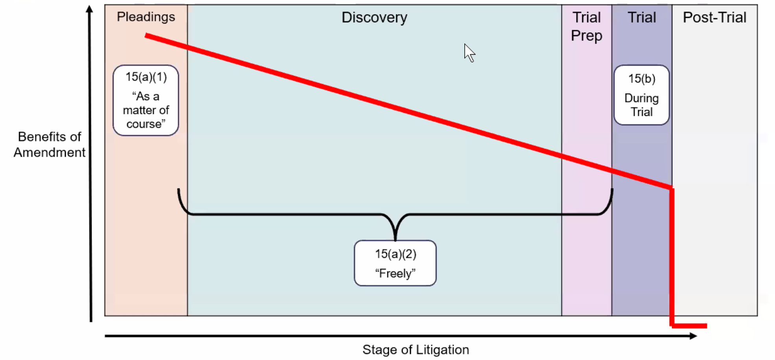

Timeline for Amending Pleadings

R15(a)(1) - Matter of course
- (A) A party can amend 21 days after serving the pleading
- (B) Where the original pleading requires a response - two options for amending the original:
  - 21 days after service of the responsive pleading
  - 21 days after service of a motion under 12(b) – defense asserted by motion, (e) – motion for more definite statement, or (f) – motion to strike
Depiction of (A) | Depiction of (B)
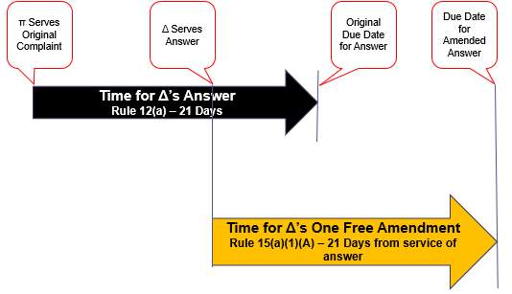 | 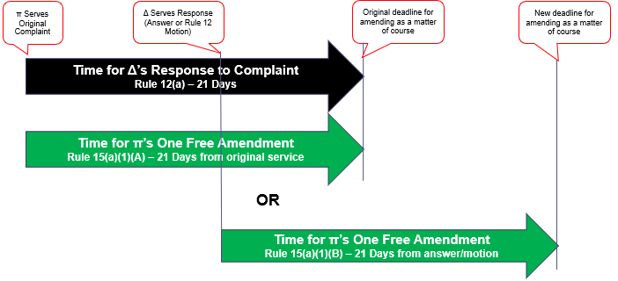

Rule 15(a)(3) – Time to Respond
- UNLESS the court orders otherwise, either:
  - Within the time to respond to the original pleading
  - 14 days after service of the amended pleading
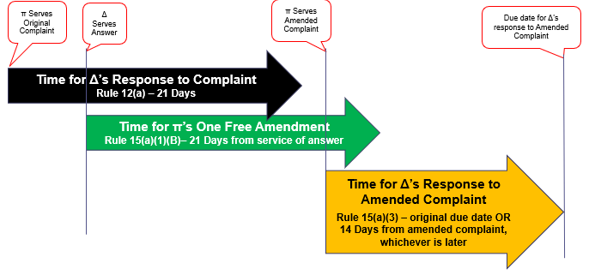

Exam Tip!
- When considering timing problems where there are two things stacked, first consider if timing from the triggering event was appropriate.
  - Example 1 - P filed a complaint and serves D on day X (D has not waived service), D responds X + 14 days later. P wants to allege additional facts based on the answer and does so X + 14 + 22 days later. On what timeline is D required to respond?
    - Answer – D is not required to respond because P failed to amend its complaint according to R15(a)(1)(B) – “21 days after service of a responsive pleading.”
      - To move forward, P must request written consent from D on leave of court to amend.

Matter of Course
- A voluntary amending of the pleading
- A party does not get two bites at the apple – amendment as a matter of course can only be done ONCE!

Opposing Party’s Consent or Leave of Court
- R15(a)(2) – Applies outside of 21-day window for amendment as a matter of course
  - Option 1 – Opposing party’s written consent
  - Option 2 – Court’s leave - “The court should freely give leave when justice so requires.”
- Parties typically consent to amendment because the court is very likely to grant it
**
- To amend by court leave, motion for leave to amend.
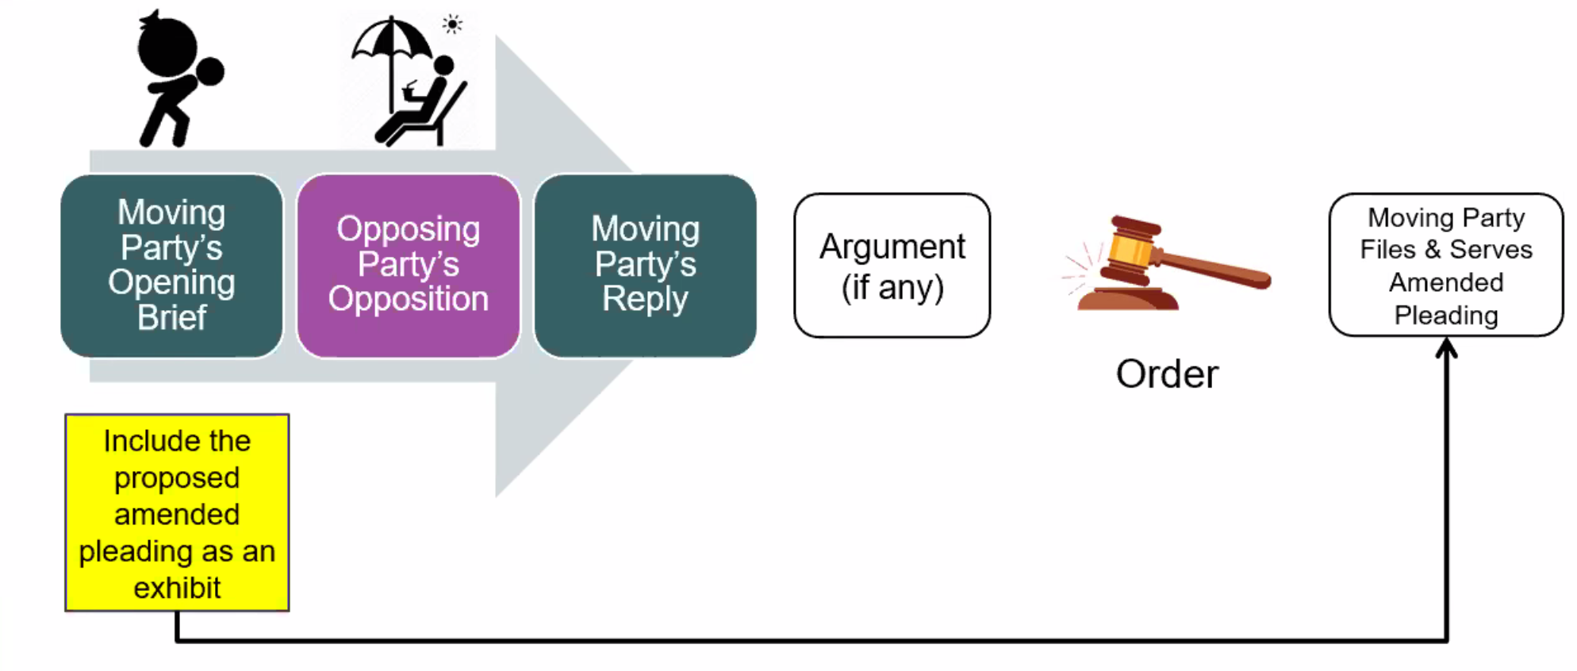

Factors Court Considers When Granting Leave
- A motion to amend under R15(a)(2) could be denied if one of the four considerations are triggered, considerations are numbered according to their importance (1 is most important):
  - (4) Bad faith
    - Aggravating factor – if the amendment is not futile, not unduly prejudicial, and does not cause undue delay, how can it be in bad faith?
  - (3) Prejudice to the opposing party
    - Courts consider “preparation prejudice” – the determination is based on how the non-moving party will be affected in preparing for trial.
  - (2) Undue delay
  - (1) Futility of amendment
    - Futility = amendment that does not state a claim or does not further advance a claim that has already been said to be “dismissable”
Beeck v. Aquaslide
- July 15, 1972 - P was injured while using an Aquaslide. Oct. 31, 1972 - D learned of the incident from the insurance company of the pool P was attending. At some point, D’s insurance company separately verified the slide as well. Dec. 12, 1973 – having not information to the contrary, D admitted they had manufactured, designed and assembled the slide in question.
- July 15, 1974 – the statute of limitations on P’s claim ran out. Jan. / Feb. 1975 – D’s company president visits the injury site prior to a deposition and determines that it is actually not their slide, but a counterfeit.
- D filed a motion for leave to amend under R15(a)(2). Additionally, D files a motion under Rule 42(b) for separate trial on who manufactured the slide. The court granted both.
- A jury found for D in the separate trial. D moved to dismiss under 12(b)(6) in the original trial given that it was not their slide. P appeals abuse of discretion in granting motion to leave at such a late stage in the litigation.
- HELD – there was no abuse of discretion as none of the four factors were met.
  - No bad faith or delay as both insurance companies has verified who made the slide.
  - Court also held it was not prejudice to P to grant leave at this stage as D still must demonstrate at (the separate trial) that it was not their slide.

Exam Tip!
- Review for futility is a 12(b)(6) question.
  - Taken in the light most favorable to P, does amended pleading state a claim up on which relief could be granted?

Consolidation / Separate Trials – Rule 42
R42(b) – Separate Trials
- Separation occurs when it is convenient, and to avoids prejudice or for expeditious or economical reasons
- Typically to resolve a threshold issue – i.e., if we can resolve this, then we do not have to resolve the more complicated question at trial.
  - e.g., in Beeck v. Aquaslide – if Aquaslide can demonstrate it was not their slide there is no reason to spend time at trial proving damages.
  - For this reason, separation is common in personal injury cases
R42(a) - Consolidation
- Where there is a common question of law or fact, the court may group hearings or trial on any and all issues, consolidate actions, or do as they see fit to avoid unnecessary costs.

Relation Back
- Governed by R15(c) – only triggered where the statute of limitations has tolled
  - Only applies where the SoL allows relation back – R15(c)(1)(A)
- Covers two types of alterations after SoL has tolled:
  - (B) Addition of a Claim or Defense
  - (C) Change in the Party / Naming of the Party
- Purpose of R15(c)
  - Allows for claims or defenses to change as information comes out in discovery
  - Allows for change in parties as necessary
- Purpose of SoL (i.e., why we even need R15(c))
  - (1) Repose to D – SoL provide a fixed period where claim can be brought.
    - Necessary to avoid leaving D with uncertainty of pending litigation
  - (2) Protection against loss of evidence
    - Over time things get lost in translation, to adequately adjudicate claims based on the merits, necessary to bring them (somewhat) swiftly

Procedure for Relation Back
- Occurs through a motion for leave to amend R15(a)(2) – consider four factors.
  - “The court should freely give leave when justice so requires” – however, not mandatory
  - EXAM TIP – be careful of different in SoL between original claim and the claim that is trying to be newly added. Original claim may have a longer SoL, thus it could be filed post the claim that is trying to be added has tolled.
SoL Break Out – what are D’s Options if it thinks P has filed a claim after the SoL has tolled?
- The answer depends on the information that is contained in the complaint.
  - Where the complaint includes the information sufficient to dismiss – R12(b)(6)
  - Where more information is necessary – SJ

Adding a Claim or Defense - R15(c)(1)(B)
- Relation back is allowed where the amendment asserts a claim or defense that arose out of the conduct, transaction, or occurrence in the original pleading
- Based on “notice” standard – goal of pleading is to provide parties with notice of events giving rise to claim
  - So long as the “operative facts” stated in the original complaint encompass the claim or defense covered by the amendment, the opposing party has notice.
    - Connection to “Procedure” section above – assume a party has moved for leave to amend a complaint after the close of discovery and the new claim does relate to the operative facts form the original complaint.
      - The amendment would not be futile; however, the court will need to consider preparation prejudice to D, undue delay and bad faith – motion will not be automatically granted.
- Bonerb v. Richard J. Caron Foundation
  - P was in the custody of D’s drug and alcohol recovery program. P was injured while participating in a “mandatory” basketball game because D’s facility was poorly kept. Negligence and counseling malpractice both have a two-year SoL in the jurisdiction where P filed suit. P filed a complaint for negligence in facilities maintenance within SoL period. Post two-year SoL, P moved for leave to amend to add counseling malpractice.
    - HELD – P was granted leave to amend.
      - The two claims both arise from the basketball game so the amendment was not futile.
      - Discovery was not yet closed so D was not unfairly prejudiced related to defending the new claim – and it likely already had lots of information it needed related to defending the initial claim.

Changing the Party or the Name of the Party – R15(c)(1)(C)
- An amendment relates back to the date of the original when the amendment changes the party or the naming of the party AND both of the following are met:
  - (a) 15(c)(1)(B) is satisfied
  - (b) Both of the following happen within the time period specified by R4(m) – typically 90 days:
    - (i) The new D received notice of the action such that it will not be prejudiced in defending AND
    - (ii) The new D knew or should have known that the action:
      - Would have been brought against it,
      - But for a mistake concerning the proper party’s identity
- R15(c)(1)(C) does not apply to altered legal strategy – only covers mistake in identity.
  - e.g., D1 and D2 are J&S liable. D2 is insolvent. P brings suit solely against D1, then D2 later wins the lottery. P’s motion for leave to amend to add D2 as a party to the suit should be denied for bad faith.
- Suits implicating a “Doe”
  - A claim may be listed as against Party 1 and “Jane Doe” – one Jane Doe’s identity comes to light, can rule 15(c)(1)(C) be used to add the person’s real name?
  - Ct. App’s are split
    - (Majority view) Arg. Against – inclusion of Doe is a legal strategy to implicate others later. P’s are required to undertaken DD “reasonable under the circumstances” prior to filing (and signing) a pleading, motion or other paper (R11).
    - EXAM TIP!
      - If this problem comes up, undertake reasoning consistent with R11 to resolve why Doe should or should not be added – i.e., determine why there was a mistake concerning proper identity based on the reasonably inquiry undertaken prior to filing the complaint.

Peter v. Mary Millionaire
S, an LLS student, lived with MM while she was in school. On July 1, 2019, S and MM hosted a joint dinner party and together prepared a dish that gave one of their guests, P, serious food poisoning. P decides to sue only MM given S’s lack of resources as a student. On June 13, 2021, P files suit against MM. That same day, P’s adult process server goes to MM’s house and delivers a copy of the summons and complaint to S who reads them prior to giving them to MM. MM files and serves he answer on July 2, 2021. On July 20, 2021, S wins the lottery and P decides to would be wise to add S as a defendant. Assume the SoL on P’s claim is two years. Should the court grant P’s motion for leave to amend to add S?
- HELD – the court should likely deny P’s motion under R15(a)(2) on grounds that the addition of S is no mistake, but rather a change in legal strategy that could be seen as being done in bad faith.
  - (1) Rule 15(c)(1)(B) is satisfied as P’s claim against both MM and S relates to the same occurrence so all relevant operative facts are captured in the original complaint thus the amendment is not futile.
  - (2) S received notice of the action (literally) and knew that she could have been implicated as she was co-host of the event so she is not prejudiced – HOWEVER – reasonable minds may differ as to whether P leaving S out as an original party was a mistake or legal strategy.
    - In reply to P’s motion to amend, S should state the timeline of lottery winning and when the amendment happened. This may demonstrate to the court that P was not mistaken in the original complaint and is now acting in bad faith.

Discovery

Overview – Discovery
- Discovery – pre-trial information exchange where parties learn what information the other has and allows parties to unearth new evidence
  - Informal discovery – research on your own, ask people questions that they voluntarily choose to answer
  - Formal discovery – tool for information exchange provided by the F.R.C.P.
    - Required by rules to answer formal discovery or be held in contempt of court
- General idea:
  - The court does very little besides set schedule and resolve disputes as needed.
  - The parties should conduct discovery themselves
    - Where disputes do arise, the parties must certify that they have attempted in good faith to resolve them between themselves prior to court getting involved.
- Main Rules governing procedure (not individual discovery tools)
  - Rule 16 – Pretrial conferences; Scheduling; Management
  - Rule 26 – Duty to Disclose; General Provisions Governing Discovery
  - Rule 37 – Failure to Make Disclosures or to Cooperate in Discovery; Sanctions
  - Rule 45 – Subpoena to Nonparty Witness
  - Generally, Rule 26 – 36 related to discovery.

What is Discoverable?
- Any non-privileged matter that is relevant to the party’s claim or defense and proportional to the needs of the case (F.R.C.P. 26(b)(1))
  - Tripartite requirements for discovery:
    - (i) relevant,
    - (ii) non-privileged, and
    - (iii) proportional to the needs to the case
- Rule 1 is heavily in consideration for discovery – just, speedy, inexpensive resolution – same concerns are often explicitly mentioned in the discovery rule.
- In the case of Rule 26(c)(1) or Rule 37(a)(1), the moving party must certify that it sought to resolve the dispute without court action.

Compelling Discovery and Discovery Limits
Rule 26(b)(2)(C) – Court must limit discovery where
- (i) Discovery sought is unreasonably cumulative or duplicative or can be obtained from some other source that is more convenient, less burdensome, or less expensive.
- (ii) Party seeking discovery has had amply opportunity to obtain the information by discovery in the action.
- (iii) Proposed discovery is outside the scope of Rule 26(b)(1)
Rule 26(c)(1) – Court may issue a protective order to protect a party from:
  - annoyance,
  - embarrassment,
  - oppression, or
  - undue burden or expense
- Court may issue order on motion from the party.
  - Motion must include certification that the movant has in good faith attempted to confer with the other affected party to seek a resolution.
- Options (listed in Rule 26(c)(1)) include:
  - Forbidding the disclosure or discovery
  - Specifying what can be disclosed or discovered, specifying on what terms it can be disclosed or discovered, or limited the method of discovery
  - Designating who can be present for discovery
  - Designating that the discovered information be sealed until the court orders it to be opened
  - Requiring a trade secret not be revealed or be revealed in a confidential way
Rule 37(a)(1) – “Judge, please tell order the other side to give me information I am entitled to.”
- On notice to other parties and all affected persons, a party may move for an order compelling disclosure or discovery.
  - Motion must include certification that the movant has in good faith attempted to confer with the other affected party to seek a resolution.

Relevance
- Relevance is not formally defined by the F.R.C.P.
- Key question – does this further your argument trail?
  - Yes, if it tends to make a fact more or less probable than it would be without the information
    - E.g., if you are trying to establish that it was cold outside it would be “relevant” to ask someone if they were wearing a jacket, but would not be relevant to ask them if they are right or left handed
- Pre-trial discovery does not have to be trial evidence
  - Information within the scope of discovery need not be admissible in evidence to be discoverable (F.R.C.P. Rule 26(b)(1) final sentence)
  - Pre-trial discovery can include questions otherwise irrelevant for trial that lead to information being discovered that is relevant for trial
    - E.g., location of information, manner information is kept, and the party who is responsible for it
- Gatekeeper questions that can be asked around relevance?
  - (1) How does this information link to a claim or defense?
  - (2) Does the information asked for demonstrate that a consequential fact is more or less probable?
  - (3) Will the information asked for lead to information that will demonstrate a consequential fact is more or less probable?

Not Privileged
- Privilege information falls into two general categories:
  - (1) attorney-client privilege; and
  - (2) work product

Attorney-Client Privilege
Society recognizes certain relationships that we want to protect
- Idea – person engaged in relationship does not have to worry about what they say being used against them in court
  - Protected relationships: doctor-patient, spouse-spouse, clergyman-penitent, attorney-client
Three rules related to the revealing of privileged communications:
- Client cannot be forced to reveal
- Attorney cannot be forced to reveal
- Attorney must not volunteer the information without client consent
**Client can voluntarily answer questions – this would qualify as wavier of privilege.

What is protected?
(Restatement of Law Governing Lawyering §68)
- Attorney-client privilege may be invoked with respect to:
  - (1) A communication
  - (2) made between privileged persons
  - (3) in confidence
  - (4) for the purposes of obtaining or providing legal assistance for the client.
What qualifies as a communication? | Expression by which a privileged person conveys information to another privileged person  - Oral communication  - Document or other record
Who qualifies as a privileged person? | Not just limited to lawyer and client:  - Client (including a prospective client)  - The client’s lawyer  - Agents of either who facilitate communication between them (e.g., an interpreter)  - Agents of the lawyer who facilitate representation (e.g., a paralegal)
What does in confidence mean? | A communication is in confidence IF:  - at the time and in the circumstances, the communicating person reasonably believes that no one will learn the contents of the communication except:  - The privileged person; OR  - Another person with whom communications are protected under a similar privilege
What does purpose of providing or obtaining legal assistance mean? | A communication is for this purpose IF it is made to assist a person:  - (1) who is a lawyer or who the client reasonably believes to be a lawyer  - (2) whom the client consults for the purpose of obtaining legal assistance
How long does the attorney client privilege last? | Unless waived or subject to exceptions, the a-c privilege may be invoked at any time during or after termination of the relationship between client or prospective clients and a lawyer.
- What could cause a communication between two privileged persons to lose its privilege?
  - Talking about something in public – violates confidence.
  - Talking about something other than a legal matter – violates purpose of obtaining or providing legal advice.
    - E.g., if an attorney serves a dual role as lawyer and general business partner, then their communications in the capacity as business partner are not privileged.
- The burden rests with the party invoking the privilege to establish a “foundation” for it
  - This means demonstrate the four criteria listed above

Waivers of privilege
Three situations give rise to waiver of the a-c privilege.
- The a-c privilege is waived if the client, the client’s lawyer, or another authorized agent of the client:
  - (1) Agrees to waive the privilege
    - A lawyer cannot do this without the permission of the client
  - (2) Disclaimer of protection of privilege AND
    - Another person relies on it to their detriment OR
    - If reasons of judicial administration require the client not to be permitted to revoke the disclaimer.
  - (3) If there is failure to properly object to an attempt by another person to give or exact testimony or other evidence of a privileged communication
- Attorney-client privilege is waived for subsequent disclosure where it has already been voluntarily disclosed

What is not protected?
- Facts about the world – still discoverable
  - Facts about an event that has happened in the world are still discoverable
    - This is so regardless of if the attorney and client have spoken about them

Application of attorney client privilege
- Key indicators that a question violates attorney client privilege
  - “What did you tell your client concerning . . .?”
  - “What did you tell your attorney concerning . . .?”
- Context is key
  - Does the question specifically include that it occurred during a business or personal meeting?
    - If so, then it is not related to legal advice.
  - Does the question specify that other non-privileged parties were present and able to hear?
    - If so, then it was not made in confidence.
- How to handle situations on the fence?
  - E.g., what do you do where question is vague such that it could include a communication covered by attorney-client privilege?
    - Respond “I will not talk about what was discussed with my attorney, but related to others . . .”

Work Product Doctrine
Rule 26(b)(3) – Discovery Scope and Limits
(A) Documents and Tangible things. D or TTs “prepared in anticipation of litigation” or for trial are not discoverable.
- Includes items by party’s attorney, consultants, surety, indemnitor, insurer or agent.
- EXCEPTION – May be discovered IF:
  - they are otherwise discoverable under Rule 26(b)(1)
  - the party shows it
    - (i) has substantial need for the materials to prepare its case AND
    - (ii) cannot, without undue hardship, obtain their substantial equivalent by other means
(B) Protection Against Disclosure
- If the court orders discovery, it must protect against disclosure of mental impressions, conclusions, opinions, or legal theories of a party’s attorney or other representative concerning the litigation
(C) Previous Statements
- Any party or other person may obtain a person’s own previous statement about the action or its subject matter on request without the required showing.
  - If refused, a person may move for court order compelling the statement (Rule 37(a)(1))
    - Could be either a written statement that someone has signed or a reproduced version of what they said orally.
**
- Who do we prevent work product from being shared?
  - Chilling effect.
    - For the same reason we invoke the a-c privilege. We want the work product to be open and honest without fear that it will be seen by the opposing party.
      - Parties may not fully write down what they think or will try to use a weird code to refer to ideas.
      - Could lead to bad representation at trial
  - Lawyers should not be treated as witnesses
  - Free riding
    - Not sporting to rely on “borrowed wits”
    - Against traditions of adversarial system
    - Discovery of strategies would “demoralize” attorneys
**
Related to the exception:
- What is included by substantial need for the materials to prepare its case?
  - This relates to ordinary or factual work product.
  - Opinion work product produced by the attorney will almost never be turned over
- What is necessary to demonstrate undue hardship to obtain the substantial equivalent of work product by other means?
  - Typically, where a third party has died, or is beyond the reach of the court (i.e., hostile or memory impaired)
  - Undue hardship could be demonstrated in instances where one side might have ready access to the data where the other does not.
    - E.g., in the casebook that talked about a case between an individual and a corporation where the corporation has ready access to 750k records the individual needs.
    - Here, the court might grant the undue hardship exception if it was otherwise met to avoid prejudicing the individual (remember Rule 1 – just, speedy, and inexpensive trial)

Application of Work Product Doctrine
- Things “prepared in advance of litigation” – the test: was the document created in advance of a specific litigation event or one that is occurring?
  - Memos
  - Diagrams of the scene of events
  - Notes on visits to the scene of events made in anticipation of litigation
  - A question that asks to identify all witnesses to an accident that a party or a party’s client know about.
    - This is not work product. For this to be work product, it would have to end with “that you have interviewed”
      - If it ended this way it would be a privileged list as it would reveal strategy by who they have spoken with.
  - Not just limited to documents prepared by the attorney.
    - If at the first meeting of a client and his attorney, the attorney says “go write down a timeline of events.” The resulting timeline would qualify as work product.
    - Expert testimony – opinions held, and facts known by a testifying expert are discoverable – be careful with this distinction, they have to be a testifying expert.
- Labels can be helpful reminders, but the documents substance what counts for this determination.
  - Do not be fooled by the ATTORNEY WORK PRODUCT – CONFIDENTIAL labeling
- Hickman v. Taylor
  - A tugboat sank and five of nine crew died. Lawyer was retained to represent D. Four remaining crew gave a public statement concerning the wreck to the U.S. Steamboat Inspectors. Lawyer also interviewed the remaining four survivors in anticipation of trial.
  - Representation for P sent thirty-nine interrogatories to D related to incident. Number thirty-eight asked if the remaining four had given statements and if so asked that they be attached.
  - HELD – Lawyer for D does not have to turn over this information because it contains his notes and was prepared in advance of litigation.
    - Court cites the reasons listed above for why work product is protected.
    - In this case, note too that they could have gotten the statements from the public report to the U.S. Steamboat Inspector.

R26(b)(5) - Claiming Privilege or Protecting Trial Preparation Materials
- (A) A party claiming privilege must:
  - (i) expressly make the claim
  - (ii) describe what is withheld, without revealing its contents, so the opposition can evaluate the claim
- (B) If a party accidently turns over information and later wants to claim privilege:
  - The party making the claim should notify the receiving party per 26(b)(5)(A)
  - The receiving party
    - Should promptly return, sequester or destroy the specified information
    - Must not use or disclose the information until the claim is resolved
    - May promptly present the information to the court under seal for a determination of the claim.
  - The producing party must preserve the information until the claim is resolved.

Proportionality
Proportionality is fact dependent. Factors to consider per Rule 26(b)(1):
Broad Group | Specific listing in Rule 26(b)(1)
Size of the case | - the importance of the issues at stake in the action
Size of the case | - the amount in controversy
Administrative | - the parties’ relative access to relevant information
Administrative | - the parties’ resources
Benefits v. cost | - the importance of the discovery in resolving the issues
Benefits v. cost | - whether the burden or expense of the proposed discovery outweighs its likely benefit

Application of What is Discoverable
- Tucker v. American Insurance Group (relevance and proportionality) – P won on a claim for unlawful discharge and was attempting to collect his judgement from his employer’s insurance policy from AIG. Marsh sold his employer the AIG policy. P is attempting to find information that Marsh sent to AIG to prove he fits into the policy through a motion to compelling discovery.
  - P asked to see computer hardware used by Marsh salesman who sold the policy to AIG, all computer records related to that employee, details on how Marsh’s email system saves information, etc.
  - HELD – based on balancing the factors included in Rule 26(b)(1) request is too broad. The burden of the proposed discovery outweighed the benefit it will provide.
    - (1) Administrative - Marsh does not have ready access to all email records as the salesman no longer works for the company
    - (2) Administrative - Marsh will either have to hire someone or deploy a current resource to dig the information out of their reserves
    - (3) Benefit v. cost - This was fact specific, but the information being searched for was supportive of other information already collected so it was not of the upmost importance.

- Rivera v. NIBCO (proportionality and protective orders) – Ps were undocumented immigrants suing NIBCO for back pay. During deposition, D asked questions such as (i) where were you born?; (ii) what is your immigration status; (iii) do you have any criminal convictions; (iv) what is your educational background, etc.
  - HELD – court viewed case from Ps’ shoes. If you are undocumented, you will never bring a lawsuit if you fear deportation. Limited discovery under Rule 26(c) related to oppression. As such, NIBCO was not allowed to ask questions purely related to immigration status such as where were you born or what is your immigration status?
    - NIBCO was allowed to ask questions related to criminal convictions and education level as these questions were proportional to employment which was relevant to the claim and defense in the case.

Discovery Tools
Where and when to use tools?
- Rule 26(d)(3) - Unless the parties stipulate or the court orders otherwise
  - (A) methods of discovery may be used in any sequence;
  - (B) discovery by one party does not require any other party to delay its discovery.
    - This is for the parties’ and witnesses’ convenience and in the interest of justice.
- General order for discovery:
  - 1. Interrogatories are used to locate and identify evidence
  - 2. Requests for document production are used to collect the identified written evidence or ESI
  - 3. Depositions are used to collect spontaneous evidence from witnesses and parties
    - Depositions are typically not taken till later in the process so you have a base knowledge on which to ask relevant questions
    - Key witnesses are typically deposed last so that you have collected all other relevant information
  - 4. Finally, a party will use requests for admission – this allows undisputed facts to not be proved at trial and for the authentication of documents that will be used at trial.
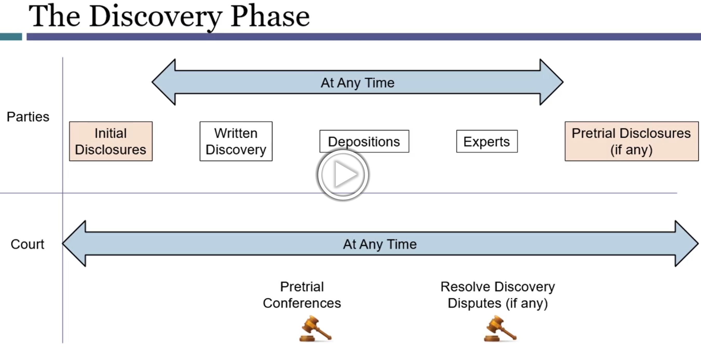

Required Disclosures
Three categories that must be provided to the other party under Rule 26(a).
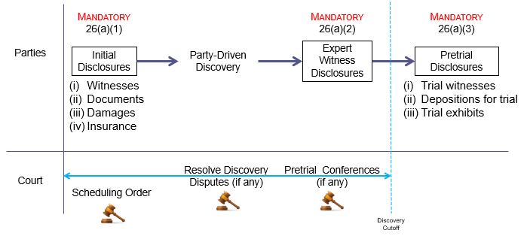

Initial Disclosures – Rule 26(a)(1)
- Reason for Initial Disclosures – arm the parties as early as possible with the basic information they need to prepare for trial and to make informed decisions about settlement.
- Four main areas:
  - (i) Witnesses
  - (ii) Documents
  - (iii) Damages
  - (iv) Insurance
- Witnesses / Documents
  - The disclosing party only needs to providing information that it will use to support its claims or defenses
    - The opposing party can later gather other information available, but they will have to ask for it during discovery
    - This means that a party does not have to disclose unfavorable witnesses or documents so long as they will not be used to support its claims or defenses.
  - Items required for inclusion
    - Witnesses – (i) name; (ii) address; (iii) telephone number; (iv) subject of the information they have
    - Documents – copy (or a description by category and location) of all documents, ESI, and tangible things disclosing party has in its custody or control
- Calculation of Damages
  - Per Rule 8(a), the complaint will list the damages. There is no specified way to calculate them, but you are required to show your work under this rule.
  - It is common to include place holder language for damages as things are often ongoing (e.g., medical bills in a personal injury action)
- Insurance
  - Copy of agreements under which an insurance business may be liable to satisfy all or party of a possible judgement

Expert Witness Disclosures – Rule 26(a)(2)
- A party must disclose the expert witnesses it will use at trial

Pretrial Disclosures – Rule 26(a)(3)
- Three categories of information:
  - (i) Trial Witnesses
  - (ii) Depositions for Trial
  - (iii) Trial Exhibits
- Pretrial disclosures do not conflict with the work product rule because it merely reveals what will come out at trial anyway.
  - Conducted in the spirit of avoiding trial by surprise.

Sanctions for Failure to Give Required Disclosures
- Self-executing sanctions (meaning not one that requires a motion) – a party who fails to make a required disclosure without substantial justification is precluded from using the undisclosed evidence or witness in support of a motion, during a hearing or at trial. (Rule 37(c)(1))
  - The court may, on motion, also impose other sanctions.

Party Driven Discovery
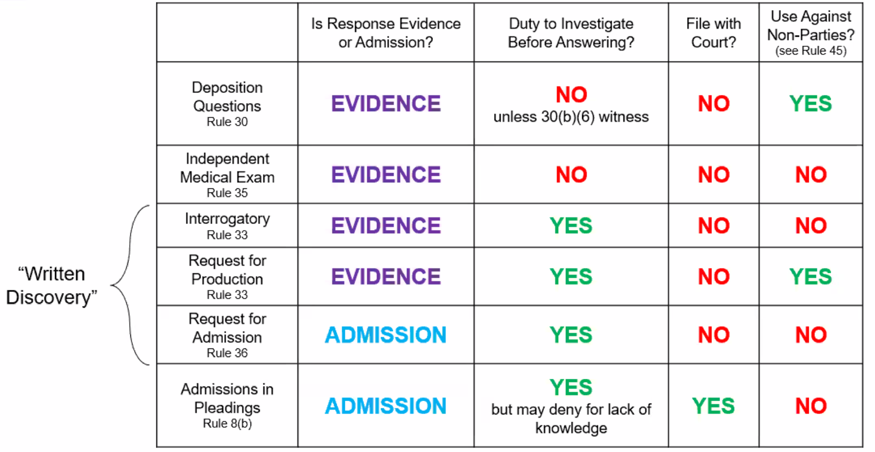

Depositions
- Oral Deposition – live examination of a witness under oath outside the presence of the judge.
- Deposition on written questions – questions are served on the deponents in advance and then read to them by the court reporter at the deposition; the answers are live and under oat
  - How a deposition will be used varies based on how the evidence will ultimately be used.
    - For use in place of trial testimony – questions will be shorter, guarded and more direct.
    - For use purely as a discovery tool – questions will be more open ended
- During the deposition
  - The questions asked are supposed to have a single answer to avoid getting facts mixed up.
    - To raise this objection state “compound.”
    - E.g., “did they reach and consensus and did you join in with questions?”
  - Evidentiary objections
    - Inadmissible evidence is discoverable. But since depositions could be used at trial, evidentiary objections can be raised during a deposition. If the deposition is later used during trial the court will rule on what is admissible.

Procedure for Obtaining a Deposition
- Serve a notice to the party to be deposed (called “noticing”)
- Must include:
  - Time and place of the deposition
  - The method of recording
  - A copy must go to all other parties.

Interrogatories
- Must be answered with all information available to the parties
- See Rule 26(g) – all discovery requests, responses, or objections must be sign – by signing the signer certifies that to the best of that person’s knowledge, information, and belief formed after reasonable inquiry the disclosures are complete or the requests are made consistent with the rule, not frivolous, and not unduly expensive or burdensome.

Requests for Production of Documents and Things
- Must describe with reasonable particularity the document or category of documents or things that you seek and then serve the request on a party with copies to all other parties.
  - The party has 30 days to comply or object in writing unless the parties stipulate a longer time.

Production of Documents and Things
- A party must produce documents as they are kept in the usual course of business or must organize and label them to correspond to the categories in the request (Rule 34(b)(2)(E)(i)).
- As opposed to providing reems of documents, if you are comfortable having the opposing party go through your records, you can make a broad library of information available to them and let them find what they need.
- Rule 26(b)(5) – Claiming Privilege or Protecting Trial-Preparation Materials
  - The party withholding the information is responsible for claiming privilege.
  - That party has to describe the nature of the documents in a manner that does not reveal their content but enables the other party to assess its claim of privilege.

Requests for Admission
- A party may request that an opposing party admit or deny the truth of statements in the request or the authenticity of documents attached to it
- The purpose of discovery is to narrow the issues for trial
  - An admission conclusively establishes the matter admitted meaning the fact finder will take it as a given.
- What can you do about admissions that substantially hurt your case?
  - If it is true and there is no waiving based on the evidence, you just have to admit it.
  - Ambiguities in the evidence can serve as a crutch related to admissions.

Supplementing Disclosures and Responses
Rule 26(e) – Supplementing Disclosures and Responses
- A party must supplement or correct a disclosure or response:
  - (A) If it learns that in some material respect the disclosure or response is incomplete or incorrect, and if the additional or corrective information has not otherwise been made known during discovery or in writing
  - (B) As ordered by the court

Signing Disclosures
Rule 26(g) – Signing Disclosures and Discovery Requests, Responses, and Objections
- Every Initial Disclosure, Pretrial Disclosure, and every discovery request, response, or objection must be signed by at least one attorney of record in the attorney’s own name (or the party personally if unrepresented)
  - Must also include the signors email and phone number
  - The person signing certifies that to the best of the person’s knowledge, information, and belief formed after reasonable inquiry that:
    - The disclosure is complete and correct when made
    - The discovery request, response or objection is (i) consistent with the rules and warranted by existing law or is for a nonfrivolous legal argument; (ii) not improper (e.g., to harass or increase cost needlessly); (iii) not unduly burdensome or expensive considering the needs of the case.
- If the person fails to sign they must do so properly or the information will be stricken from the record.
- If a party violates this rule, the court, on motion or on its own, must impose sanctions on the signer, the party on whose behalf the signer was acting, or both.
  - Sanctions can include reasonable expenses, including attorney’s fees, caused by the violation.

Discovery Management

Rules Governing Timeline
Rule 16(b) – Scheduling Order
- (1) Scheduling Order. District judge, or magistrate judge where authorized must issue a scheduling order (except where exempt by local rule)
  - (A) after receiving the 26(f) report
  - (B) after consulting with the parties’ at a scheduling conference
- (2) Time to Issue. Judge must issue order as soon as practicable. Must be issued at the earlier of:
  - 90 days after D has been served with the complaint; OR
  - 60 days after D has appeared.
- (3) Contents of the Order.
  - (A) Required Contents. Must limit the time to:
    - Join other parties
    - Amend the pleadings
    - Complete discovery
    - File motions
  - (B) Permitted Contents. Schedule order may – see rule
    - Modify the timing of disclosure under Rules 26(a) and 26(e)(1)
    - Modify the extent of discovery
    - Provide for disclosure, discovery, or preservation of electronically stored information
    - Include agreements reached by parties regarding privilege (including F.R. of Evidence 502)
    - Direct that before moving for discovery the movant must request a conference with the court
    - Set dates for pre-trial conferences and trial
    - Include other appropriate matters
Rule 26(f) – Conference of the Parties; Planning for Discovery
- (1) Conference Timing. Parties must confer as soon as practicable – at least 21 days prior to a conference or scheduling order is due under Rule 16(b)
- (2) Conference Content; Parties Responsibilities.
  - Consider nature of claims and defenses and the possibilities for prompt resolution.
  - Make arrangements for mandatory disclosure.
  - Discuss issues with discovery and develop a discovery plan.
    - A written report outlining the plan is to be submitted to the court 14 days after the conference.
- (3) Discovery Plan. Must state the parties’ view and proposals on:
  - Changes to timing form, or requirement of initial disclosure
  - Subjects on which discovery is needed, when it should be completed and if it will be conducted in phases, or limited in focus on any issues
  - Issues that will arise in discovery related to information available or claims or privilege
  - Orders the court should issues under Rule 26(c) or 16(b) and (c).

Timeline Management
A party may not seek discovery before the parties have conferred as required by Rule 26(f) – Rule 26(d)(1).
- Complaint is filed and service of process takes place.
- First, “Meet and Confer” - Conference of the Parties
  - Rule 26(f) – at least 21 days in advance of a scheduling conference or scheduling order becoming due under Rule 16(b).
    - Proposed Discovery Plan – Rule 26(f)(2) – a written plan submitted to the court 14 days or less after the Conference of the Parties
- Initial Disclosures
  - Rule 26(a)(1) – 14 days or less after the Conference of the Parties the Initial Disclosures must be provided to the opposing party.
    - Ways to get around disclosure:
      - Informal - The parties can stipulate a different timeline in the Proposed Discovery Plan – Rule 26(f)(3)(B)
      - Formal – The party can object to the initial disclosure at the “meet and confer” then note the objection in the Proposed Discovery Plan
        - The court will then rule on the objection in approving the discovery plan and timeline and decide what needs to be disclosed and when.
- Scheduling Conference and Order
  - Rule 16(b). Court order stating agreement on timeline, the extent of discovery, and if there will be any modifications to the mandatory disclosures, the dates for pretrial conferences, the date for the end of discovery, etc.
- Party Driven Discovery
  - Rule 26(d)(3) – can occur on any sequence; discovery by one party does not require any other party to delay its discovery
    - Could technically occur prior to Initial Disclosures
- Expert Witness Disclosures
  - Rule 26(a)(2)(D) – at least 90 days before the date set for trial or for the case to be ready for trial
    - If the evidence is intended to contradict or rebut evidence from the opposing party on the same subject matter from an expert under Rule 26(a)(2)(B) or (C), within 30 days after the other party’s disclosure
- Then, Discovery Cut Off
  - As stipulated by the parties Proposed Discovery Plan – Rule 26(f)(3)(B)
- Then, Pretrial Disclosure
  - Rule 26(a)(3)(B) – disclosures must be made at least 30 days before trial.
    - Within 14 days after disclosure, a party may serve and promptly file a list of designated objections.

Serving Discovery Materials
- Disclosures under Rule 26(a)(1) or (2) and depositions, interrogatories, requests for documents or tangible things or to permit entry onto land, and requests for admission must not be filed until they are used in the proceedings or the court orders filing. (Rule 5(d)(1)(A)).

Application of Discovery Tools & Management
Flores v. Southern Peru Copper Corp. – Issues related to mandatory disclosure.
- D filed a dispositive motion. Parties stipulated that because of the dispositive motion they agreed to wait for the Initial Disclosure of (i) witnesses, (ii) documents, (iii) damages. Parties could not come to an agreement related to waiting on (iv) insurance. D did not want to produce insurance policies because the time-period covered by the claim was long and it would be an undertaking to get them all together.
- D objected to the need for disclosure of the insurance policies until after resolution of the dispositive motion for undue burden or expense. In its response brief, P did not substantiate a good reason for production.
- HELD – the Initial Disclosure of Insurance can wait until after the dispositive motion.
  - TIMING – note the sequence of events. D had to move to stay discovery because the insurance information was otherwise required per Rule 26(a)(1)(A).
  - COURT’s DECISION – remember relevance, Rule 26(b)(1). The court could have relied on the insurance information not being relevant at the current stage and noted the burden or expense to get it together outweighs the benefits at this stage in the litigation.

Pretrial Resolution

Overview – Pretrial Resolution
- Settlement (Agreements)
- Default Judgements
  - Rule 55 – Default; Default Judgements
- Voluntary Dismissal
  - Rule 41(a) – VD
- Involuntary Dismissal
  - Rule 41(b) – IVD
- Summary Judgement
  - Rule 56 – SJ

Pretrial Resolution Timeline
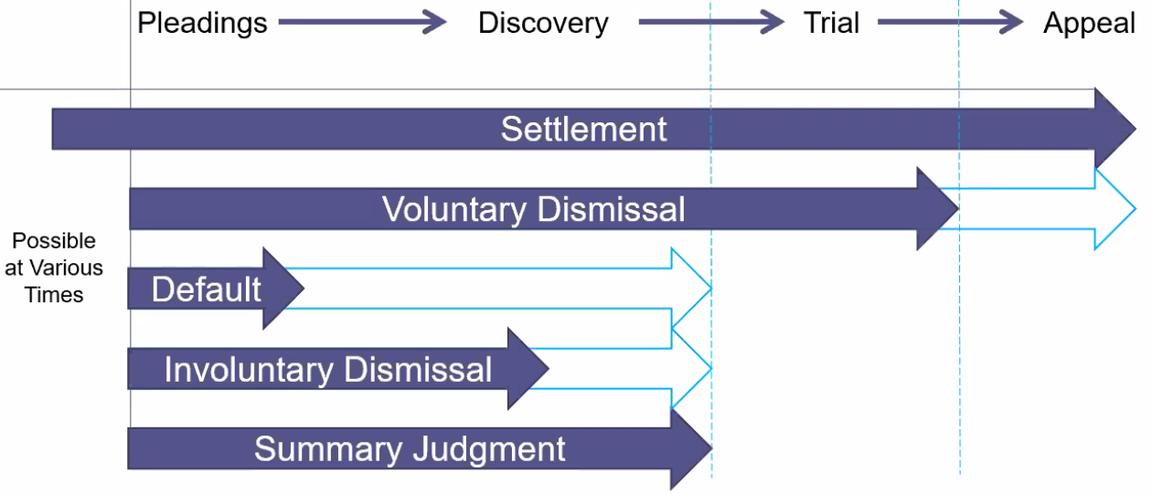
- VD goes all the way to the end because certain procedures in appeal can apply
- Default typically happens up front for failure to defend, but could result up to the close of discovery for D’s failure to (i) attend the pre-trial discovery conference; or (ii) comply with discovery orders
- IvD typically happens up front for failure to prosecute, but could result up to the close of discovery for P failure to (i) comply with pre-trial orders; or (ii) discovery orders

Settlement (Agreements)
Two types: (i) prevention of future lawsuit; (ii) resolve current lawsuit
- In both cases, parties resolve that the D will [do X]; in exchange P will:
  - Prevention of future lawsuit
    - Release D from any future claims of liability arising from [events]
  - Resolve current lawsuit
    - (1) Dismiss the current lawsuit
    - (2) Release D from any future claims of liability arising from [events]
- Pleading response
  - If there is a prior settlement agreement, the responding party can raise it as an affirmative defense in a response under Rule 8(c)(1) – release; waiver

Default
Default is kind of like a forfeit
- Arises where a party:
  - Fails to answer a complaint (i.e., does not respond to a complaint)
  - Is not actively engaged in motion practice
  - Does not come to a pre-trial conference
  - Does not answer discovery
Obtaining a default judgement – Rule 55(a) Entering a Default.
- The clerk must enter the party’s default:
  - When a party against whom a judgement for affirmative relief is sought has failed to plead or otherwise defend, AND
  - That failure is shown by affidavit or otherwise

Voluntary Dismissal

Rule 41(a)(1) – By the Plaintiff
P may dismiss without a court order by filing:
- (i) a notice of dismissal before the opposing party serves either (i.e., before reaching the VD point of no return):
  - An answer; or
  - A motion for SJ.
- (ii) a stipulation of dismissal signed by all parties who have appeared.

“Two Dismissal Rule”
- Set out in Rule 41(a)(1)(B), governs voluntary dismissals under Rule 41(a)(1)(A)
  - P’s first voluntary dismissal is without prejudice
  - P’s second voluntary dismissal based on or including the same claim operates as adjudication on the merits.
- EXCEPTION – P’s first voluntary dismissal could be “with prejudice” if their notice or the stipulation of the parties so stated.
  - E.g., as a condition of agreeing to the stipulation to voluntarily dismiss, D could request that the first dismissal be with prejudice to avoid a future claim

Rule 41(a)(2) – By Court Order
If (i) the voluntary dismissal point of no return has been reached; and (ii) all the parties who have appeared cannot reach an agreement on the stipulation of dismissal:
- An action may be dismissed at the P’s request only by court order, on the terms the court considers proper
- A dismissal by court order is without prejudice UNLESS the order states otherwise
Why does this situation arise?
- Cease fire v. End the war - Voluntary dismissal operates like a cease fire, it is usually without prejudice and the claim(s) can be brought again. If D wants to end the war, but P only wants a cease fire they can let the court decide under this rule. (The VD point of no return will have to be reached for this to arise)
What does the court consider as part of “terms the court considers proper?”
- The unfair prejudice to the opposing party (almost always the D)
  - This is plain legal prejudice – this means, has D spent a significant amount of time, effort, and expense defending the suit
    - This is not D being prejudiced because P now has some tactical or other advantage as a result of the cease fire, that is the point of allowing voluntary dismissal.
  - Courts can grant voluntary dismissal on the condition that P pays some or all of D’s expenses.

Involuntary Dismissal
Essentially default judgement against P.
- Involuntary dismissal generally only applies to claimant (i.e., P or bringer of action)
  - Why? D (obviously) wants the case dismissed. They are comfortable with status quo, or else they would bring their own lawsuit.
    - Where a D has committed their own sins, they are sanctioned by default judgement

Adjudication on the merits
- Rule 41(b) – Unless the dismissal order states otherwise, a dismissal under Rule 41(b) and any dismissal not under Rule 41(a) operates as an adjudication on the merits.
  - EXCEPT (all of these situations prevent a claim from being adjudicated on its merits):
    - Lack of jurisdiction
    - Improper venue
    - Failure to join a required party

Situations that lead to involuntary dismissal
- Rule 12(b)(6) Motion to Dismiss for Failure to State a Claim
  - Dismissal is involuntary and does not require P’s consent
- P’s Failure to Prosecute
  - At a point set by rule or statute, P’s inaction justifies involuntary dismissal
    - Granting involuntary dismissal depends on:
      - P’s excuse for their inaction
      - If the case has progressed to a point where D would be prejudiced if the party was allowed to bring the claim again
- P’s Failure to Comply with the Rules
  - Reserved for serious violations of the litigation process.
    - Rule violations that could lead to involuntary dismissal
      - Pretrial orders
        - Scheduling order under Rule 16(b)(1)
        - Other orders under Rule 16(d) (see Rule 16(f)(1)(C) – Sanctions for violating orders)
      - Discovery orders
        - Protective orders under Rule 26(c)
        - Order compelling discovery under Rule 37 (see Rule 37(b)(2) – Sanctions for violating discovery orders)
      - Others

Summary Judgement

Overview – Summary Judgement
Key Question - “Do we need a trial?”
- Trials are for: (i) weighing credible evidence; (ii) resolving credibility questions; (iii) choosing among possible inferences.
- Summary judgement is proper when there is:
  - No genuine dispute as to any material fact; and
  - The movant is entitled to JMOL.
Timing
- Any time until 30 days after the close of all discovery
- A party may file a motion for summary judgement at any time until 30 days after the close of evidence, unless a different time is set by local rule or the court orders otherwise.
- **NOTE - Moving for SJ does not stop other timelines. Must confer with opposing parties to extend time**
Common Result
- Motion is usually denied as a genuine dispute of material fact exists that requires a fact finder to:
  - (i) weigh the evidence; or
  - (ii) make a credibility determination.
    - The judge in ruling on SJ is not supposed to do either

Rulebook 56 – Summary Judgement
- Motion for Summary Judgement or Partial Summary Judgement
- A party may move for summary judgement
  - Identifying each claim or defense – or the part of each claim or defense – on which summary judgement is sought.
- The court shall grant summary judgement if the movant shows that
  - There is no genuine dispute as to any material fact; and
  - The movant is entitled to JMOL.

Rule 12(d) – Conversion to Summary Judgement
Conversion
- If on a 12(b)(6) motion or 12(c) motion, matters outside the pleadings are:
  - Presented to; and
  - Not excluded by the court
- The motion must be treated as one for summary judgement.
- All parties must be given a reasonable opportunity to present all the material that is pertinent to the motion.

The Record for the Motion
SJ – preview of the evidence to be presented at trial.
- The motion is decided on paper.
- The paper details what witnesses and/or other exhibits presented at trial will say.

The record for a SJ motion consists of the materials in the record submitted with the motion.
- Examples:
  - Admissions (in Answers or responses to Requests for Admission)
  - Affidavits*, declarations*, deposition transcripts, discovered documents, interrogatory answers and other evidentiary materials
    - *Rule 56(c)(4) – Affidavits or Declarations - In support of a motion for SJ, an affidavit or declaration:
      - Must be made on personal knowledge
      - Set out facts that would be admissible in evidence
      - Show that the affiant or declarant is competent to testify on the matters stated
- Allegations in pleadings are not relevant.
  - Allegations are just allegations. A motion for SJ must present evidence to support the allegations in the pleadings.
- To be considered, the materials must be in the record.
  - Rule 56(c)(3) - The court need consider only the cited materials, but it may consider other materials in the record.

Nonmovant – Facts Unavailable
Rule 56(d) – When Facts are Unavailable to the Nonmovant
- If a nonmovant shows by affidavit or declaration, for specified reasons, it cannot present facts essential to justify its opposition, the court may:
  - (1) defer considering the motion or deny it
  - (2) allow time to obtain affidavits or declarations or to take discovery or
  - (3) issue any other appropriate order
- To assert Rule 56(d), a separate motion would not be required. You would invoke it in your opposition brief.

Procedure
Timeline
- (1) Moving Party’s Brief – including declarations and other documents or exhibits
- (2) Opposing Party’s Opposition Brief - including declarations and other documents or exhibits
- (3) Moving Party’s Reply – Rebuttal exhibits only
- (4) Argument (this may or may not happen)
- (5) Order
Court’s decision process
- First, review moving party’s evidence in the record demonstrating that there is no genuine dispute of material fact and that they are entitled to JMOL. If they succeed, proceed.
- Second, burden shifts to non-moving party. Reviews non-moving party’s evidence in the record that must demonstrate there is a genuine dispute of material fact.

Information Included in Briefs / Argument
- Rule 56(c)(1) – Supporting Factual Positions
- A party asserting that a fact cannot be or is genuinely disputed must support that assertion by:
  - Citing to particular parts of materials in the record
    - Showing that the materials cited do not establish the absence or presence of a genuine dispute, or
    - That an adverse party cannot produce admissible evidence to support the fact.

Granting Summary Judgement
Motion will only be granted if non-moving party cannot win even under its best-case scenario.

Reviewing a Motion for Summary Judgement
- Starting point – identify the applicable substantive law
  - Identifying the substantive law alerts you to the relevant facts
    - Be careful where elements are interrelated. Where you need to make a gateway decision on A before resolving B, make sure that you tackle them in order for SJ.
- SJ Rose Colored Glasses
  - All disputed facts resolved in favor of the non-moving party
  - Undisputed facts accepted as true
  - Permissible inferences drawn in favor of non-moving party

Standard for Review – Genuine Dispute of Material Facts
- There is a genuine dispute if a reasonable jury could return a verdict for the non-moving party.
- This is a binary decision.
  - Zero evidence v. some evidence – summary judgement is possible
  - Some evidence v. some evidence – there cannot be summary judgement
- In determining if a jury could find for the non-moving party there should be no:
  - Weighing of the evidence
  - Engaging in a credibility analysis
- Example
  - Gold sues Caplan because he believes Caplan broke into his wine cellar on day X and trashed it.
  - Caplan moves for summary judgement
    - Caplan presents declaration that says he was out of town on day X
    - Gold offers video evidence showing someone who looks a lot like Caplan was the trespasser
  - Analysis
    - What fact is in dispute? Is Caplan the culprit.
    - Does it matter that Gold seems to have much stronger evidence?
      - Not for summary judgement. This would qualify as weighing the evidence.
    - Does it matter that Caplan and is a self-interest declarant?
      - Not for summary judgement. This would qualify as a credibility determination.

Inferences on Summary Judgement
- Inference – combination of two of more observable facts to determine something about a situation on the whole. Generally, we let the jury draw inferences
  - For SJ – permissible inferences should be drawn in favor of the non-moving part - but not more favorably
- The judge is allowed to draw inferences on SJ where all parties agree on the facts and only one reasonable conclusion results.

How to Prevail on Summary Judgement
This depends on if the party also has the burden at trail.
- Movant
  - Demonstrate that no genuine dispute of material fact exists; and
  - That you are entitled to JMOL
- Nonmovant
  - Dispute the facts
  - Demonstrate that the movant is not legally entitled to JMOL
    - Show an element has not been met with facts included or that facts to prove element are absent
- Example
  - Moving party does not have the burden at trial (e.g., usually D in demonstrating P has no claim, could also be P in demonstrating D’s affirmative defense in invalid)
    - For movant to win – must present undisputed facts disproving one element
    - For non-movant to defeat SJ – dispute the facts that disprove the one element
  - Moving party also has the burden at trial (e.g., usually P in proving its claim, could also be D proving its affirmative defense)
    - For movant to win – must present undisputed facts supporting every element (i.e., no genuine dispute of materials facts for each element)
    - For non-movant to defeat SJ – dispute the facts for one element
Evaluation – four column table
- Column 1 - List elements that need to be proved (or disproved)
- Column 2 – List moving party’s material facts (i.e., evidence of element in the record)
- Column 3 – List non-moving party’s material facts
- Column 4 – determine if there is a genuine dispute as to the material facts

Summary Judgement Examples

Competing Motions
Facts
- Where the both parties agree on the facts, and both think they deserve JMOL.
- This gives rise to cross motions for summary judgement.
Analysis
- The judge will follow the review timeline to answer the question “do we need a trial.”
- Result
  - Both motions could be denied because (i) the judge determines that there is a genuine dispute of material fact; or (ii) there are competing inferences based on what the parties have submitted.
    - In this case, a trial is needed to resolve the dispute of fact or allow a fact finder to draw its inference.
  - One motion could be granted because there truly is no genuine dispute of material facts.
    - This also means that one party is wrong about the substantive law.
  - KEY POINT – cross motions for SJ does not mean there will not be a trial.

Substantive Law is Key to Deciding Motion (Slaven v. City of Salem)
Facts
- P’s brother committed suicide in jail by hanging himself with belt.
- P sued D claiming D’s negligence in failing to prevent a risk they knew about allowed it to happen
- Local law states jail has a duty to protect prisoners from risks they knew or should have known about.
Analysis
- D moved for SJ based on affidavits from officers saying they did not know brother was a suicide risk.
- P offered her own competing affidavit to conflict D’s affidavits saying her brother was wearing a belt.
- HELD – SJ granted for D. Wearing a belt does not establish that the jail knew he was a suicide risk.
  - In the absence of other genuine disputes, SJ granted.

Rule 12(d) Example - Elton v. Mercury (from coursepack – 229-34)
Facts
- Elton, a gay man, brings suit against Mercury, his company’s president, for discrimination.
- Mercury’s attorney files a 12(b)(6) motion including a declaration from Michaels, a co-worker, stating that Mercury does not know Elton is gay.
- Mercury is away on a month-long vacation when the motion is filed.
Analysis
- By including the declaration from Michaels (a matter outside the pleadings), the Rule 12(b)(6) motion converts to a Rule 56 motion.
  - The declaration is inadmissible because Michaels is making it about Mercury’s knowledge – see Rule 56(c)(4) (Affidavits and Declarations must be on personal knowledge)
- Elton should argue:
  - The declaration should not be recognized, and the Rule 12(b)(6) motion should be denied because there is a claim within the four walls of the complaint.
    - This will allow his claim to proceed – see below that he wants more time to gather evidence.
  - If the matter outside the pleadings will be recognized, ask the court to consider this a Rule 56 Motion for Summary Judgement.
    - Then tell the court:
      - (i) Per Rule 56(c)(4) this material cannot be recognized because the declaration is not made on person knowledge.
      - (ii) That you need more time per Rule 56(d) to take additional discovery directly from Mercury.
        - It is necessary to specify reasons as to why facts were not readily available for presentation. Here, Mercury is on vacation.

Trial

Trial Timeline
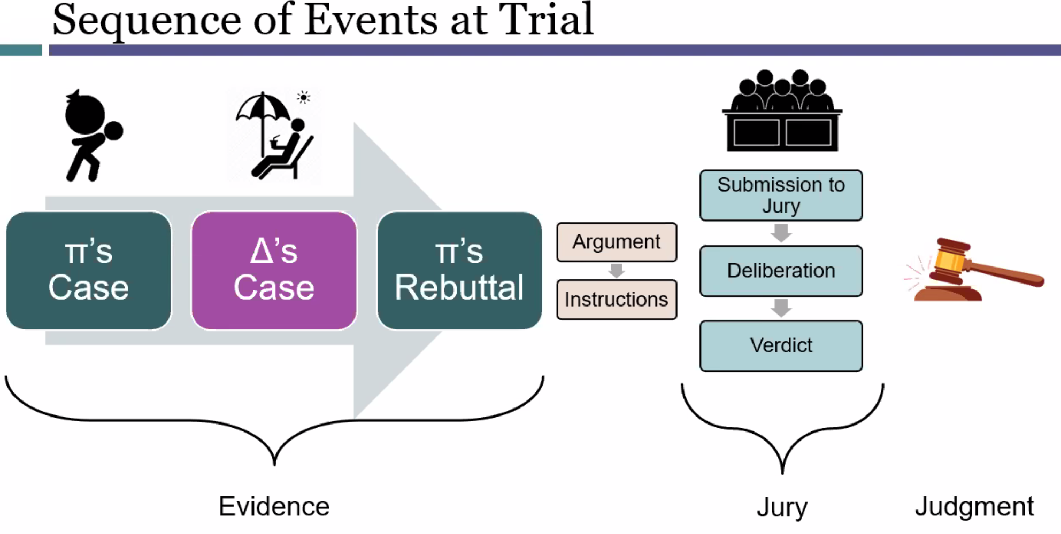

Trial Overview
- Right to a Trial by Jury
  - U.S. Const., Seventh Amendment
    - Rule 2 – One Form of Action
  - Rule 38 – Right to a Jury Trial; Demand
  - Rule 39 – Trial by Jury or by the Court
- Judgement as a Matter of Law (JMOL)
  - Rule 50(a) – Judgement as a Matter of Law

Right to a Trial by Jury

U.S. Const., Seventh Amendment (1791)
“In suits at common law, where the value in controversy shall exceed twenty dollars, the right of trial by jury shall be preserved . . .”
- General rule of thumb – the right to a jury trial depends on the relief requested
  - Right to jury trial for . . . Money damages
  - No right to jury trial for . . . Injunction, declaration, equitable relief

Rule 2 – One Form of Action
“There is one form of action – the civil action.”
- In England and at the start of the U.S., there used to be:
  - (Common) Law Courts - money damages
  - Equity Courts – nonmoney damages
- Rule 2 is in place to note all civil actions are governed by F.R.C.P.

Arguments for and Against Jury Trial
Against
- Time intensive – selecting the jury, evidence required for presentation, jury instructions add to the length of trial
  - Could be twice as long
- Continuous process – jury trials need as few interruptions as possible considering the lives of the jurors are being interrupted.
For
- Brings Public into Judicial Process – a jury trial prevents the biases of courts from affecting outcomes
- Group consensus – common sense consensus of group is desirable; multiple view points; prevention of inherent bias from a single group
- Right decision – evidence shows that juries reach the right decision in most cases, about 80%.
Complex litigation
- In complex litigation, there is an argument for not using jury trials because of the inherent nature of the litigation.
  - (1) Massive amounts of evidence to be understood by the fact finder
  - (2) Duration of cases, often last more than 1 year
  - (3) Factual Complexity – cases often involve really complex factual issues
  - (4) Legal Complexity – cases often involve several legal issues that must be applied to multiple claims and parties
- In re Japanese Electronic Product Antitrust Litigation – a jury trial might actually deprive the litigants of due process. The case is so complex the jury could not adequately handle it.
  - This decision is very rarely followed

Rule 38 – Right to a Jury Trial; Demanded
- Wavier – Rule 38(d) – jury trial is waived unless it is properly served and filed
  - Demand can be withdrawn on consent of the parties
- Demand – Rule 38(b) – on any issue triable of right by jury, a party may demand a jury trial by:
  - (1) Serving the other party with a written demand no later than 14 days after the last pleading directed to the issue is served
    - Demand can be included in pleadings
  - (2) Filing a demand in accordance with Rule 5(d)
- Specifying Issues – Rule 38(c)
  - A demand for TBJ is considered to be demanded on all issues UNLESS otherwise specified
  - If a party has only demanded a jury trial on some issues, the opposing party can demand TBJ on any or all remaining issues
    - Must serve demand for TBJ on other issues on original party within 14 days of receipt of demand for TBJ

Rule 39 – Trial by Jury or by the Court
- When demand is made
  - The action must be designated on the docket as a jury trial
  - The trial on all issues so demanded must occur by jury UNLESS:
    - The parties or their attorneys file a stipulation to a nonjury trial or so stipulate on the record
    - The court, on motion or on its own, finds that on some or all of those issues there is no federal right to a jury trial
- When no demand is made
  - The issue(s) are tried by the court
  - The court, on motion, may order a jury trial on any issue for which a jury might have been demanded
- Advisory Jury; Jury Trial by Consent - Just know that this section exists

Judgement as a Matter of Law
Rule 50 – JMOL
(a)(1) – JMOL – In General
- If a party has been fully heard on an issue during a jury trial; AND
- The court finds that a reasonable jury would not have a legally sufficient evidentiary basis to find for the party on that issue the court may:
  - (A) resolve the issue against the party; and
  - (B) grant a motion for JMOL against the party on a claim or defense that, under the controlling law, can be maintained or defeated only with a favorable finding on that issue.
(a)(2) – JMOL – Motion
- Can be made at any time before the case is submitted to the jury.
- The motion must specify:
  - The judgement sought; and
  - The law and facts that entitle the movant to the judgement

Procedural Consideration
- How do you move for JMOL?
  - The moving party can do this orally during trial.
  - However, see that Rule 50(a)(2) requires the law and facts that entitled the movant to judgement be specified – must be included as part of the motion.

Purpose of JMOL
- (1) Prevention of inadequate claims
  - Addresses the situation where a non-moving party has failed to introduce evidence at trial to adequately support their claim or defense
  - This ensures that unnecessary time and expense is not spent on claims unsubstantiated by evidence.
- (2) Ensures a case turns on its merits; Notification of inadequacy of evidence
  - The motion must specify the unsupported claims or defenses – a party seeing this motion can recognize their error and resolve it.
Pros | Cons
- Avoids unjust jury decision | - Disregards jury verdict  - Generally, jury verdicts are a good thing under out system.  - Prevent the courts for being a rubber stamp for the king
- Saves some time and money | - Costs of motion  - The non-moving party will almost always appeal  - It is costly and time consuming to appeal – a jury verdict might have prevented the appeal

JMOL v. Summary Judgement
Similar motions, both are dispositive, and both are based on the evidence at trial; however, key differences.
Differences | Summary Judgement | JMOL
Timing | - Raised before trial  - Up to 30 days after the close of discovery | - Raised during trial
Record | - Based on documents that preview the trial evidence (i.e., a paper record) | - Based on trial evidence  - At trial, witnesses describe things differently than they did on affidavit  - Additional facts come out on cross examination
Standard of review | - No “genuine dispute as to any material fact and the movant is entitled to JMOL” | - “A reasonable jury would not have a legally sufficient evidentiary basis to find for the non-moving party”
Action of the court | - Court “shall” grant relief to the successful moving party | - Court “may” grant relief to the successful moving party
Reasons explained:
- Limited discovery – in cases where there was limited discovery, the party with the burden’s lack of evidence was not apparent until trial
- Quality of evidence; Difference in review standard
  - The evidence that arose during discovery was sufficient to support a genuine dispute of material fact, BUT
  - At trial, the evidence was insufficient to support a legally sufficient evidentiary basis for a reasonable jury to find for the non-moving party

When is a motion for JMOL granted?
- The motion is granted when the non-moving party CANNOT WIN even under its best-case scenario
- Where a reasonable jury would not have a legally sufficient evidentiary basis to find for the nonmoving party

Record for JMOL
- The trial record (witness testimony, exhibits, admission) is viewed in the light most favorable to the non-moving party (i.e., their best-case scenario).
  - Undisputed facts are accepted as true
  - Disputed facts are resolved in favor of the non-moving party
  - Witness credibility is resolved in favor of the non-moving party
  - (Permissible) inferences are draw in favor of the non-moving party

Legally Sufficient Evidentiary Basis
Is the evidence such that:
- Without weighing the credibility of the witnesses; or
- Otherwise considering the weight of the evidence
  - There can be but one conclusion as to the verdict that a reasonable jury might reach?
**
- Witness credibility and weighing the evidence is the job of the jury.
- For JMOL, courts can evaluate the evidence side-by-side to determine if a reasonable jury could find for the non-moving party
- (Permissible) inferences – the court should draw permissible inferences in favor of the moving party, but not more so
  - Where the inferences could legitimately go either way, it should be drawn in favor of the non-moving party
    - This does not mean the court invokes supernatural powers to justify all inferences in favor of the non-moving party
- Circumstantial evidence – can be used to support a claim or defense so long as there is not direct evidence that contradicts it.

“Scintilla” Advantage
- Under the scintilla advantage basis, the motion for JMOL is denied if the non-moving party can produce a shred of evidence
  - Pros - This preserves trial by jury. It also makes the matter easier on the judge.
  - Cons – Stops the courts ability to prevent unreasonable jury verdicts.
- All federal courts follow the Legally Sufficient Evidentiary Basis approach. The Scintilla Advantage is only followed by a small number of states.

Timing
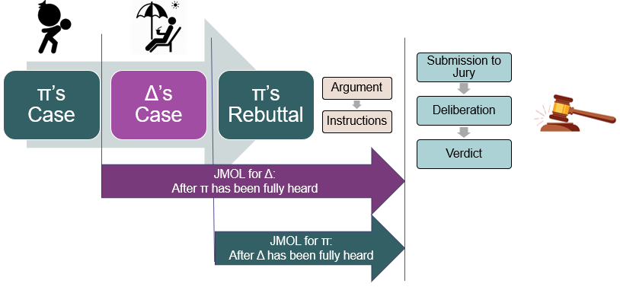
- There can be a motion for JMOL after a party has been fully heard on an issue and until the claim has been submitted to the jury.
  - This usually corresponds to D moving for JMOL after P says “I rest my case”
  - Assuming there is more than one issue at trial, JMOL could come up after the party has been fully heard on that issue
- Timing is important for deciding a motion for JMOL.
  - The motion is decided based on the record at trial.
    - If D moves for JMOL after P’s case then the trial record does not include D’s evidence.
    - If D moves for JMOL after they have presented their case then the trial record also includes their evidence.

Difference in Burden of Persuasion v. Burden of Production
- Burden of persuasion – the objective of the party at trial whose claim or affirmative defense is being litigated
  - I.e., the party must demonstrate each element of their claim or affirmative defense
- Burden of production – the objective of the party to produce evidence sufficient to avoid an adverse JMOL on an issue
  - I.e., the moving party on a motion for JMOL
**
- Most common scenario for JMOL
  - D moves for JMOL because P has not established a legally sufficient evidentiary basis to support its claim
- Others
  - P moves for JMOL:
    - Where D is fully relying on an affirmative defense and P feels they can demonstrate that D does not satisfy each element of the affirmative defense
    - Where D has a counterclaim and P (acting more like a D) feels they have not demonstrated each element of the counter claim
    - (A rare circumstance) Where after D has presented its case, P feels that they have demonstrated each element and D has not legally sufficient evidentiary basis to refute any of the element.

Application of JMOL
- Lane v. Hardee’s Food Systems, Inc. – Importance of Timing; Standard for Review
  - P enters the restroom at Hardee’s shortly after 10:30am. Coming out of the restroom, P slips on what he alleges is standing water and sustained injuries to his head and neck. Hardee’s manager testifies that they usually mop the bathroom at 10:30am and put out a caution sign. The manager could not say whether they mopped that day. P alleges he saw no sign indicating water.
  - D moved for JMOL under Rule 50(a) after P presented his case (meaning they did not present evidence at trial). Motion granted.
  - HELD (on appeal) – reversed and remanded for new trial.
    - P has met the standard of a legally sufficient evidentiary basis for a reasonable jury to find for him as the non-moving party based on the evidence presented.
    - D has no evidence in the record as they moved for JMOL after P’s case so no evidence from their side to evaluated next to P’s evidence.

- Penn. RR v. Chamberlin – Importance of Timing; Evaluation of evidence
  - Chamberlin is a brakeman for Penn. RR. He is riding a two-car cut over a hump through a switch to connect it to another train. There is a seven-car cut in front of him and a nine-car but behind him. P falls off and is run over by the nine-car cut killing him.
  - P’s estate files suit against the RR alleging negligence in operation of the RR switch. Specifically, P alleges that D allowed the nine-car cut to bump P off to his death.
  - Six eyewitnesses, all RR employees, were standing near the place where the cars would have bumped, and all testify that there was no bump. At trial P presented one witness, B who was not directly watching and was standing about 900 ft away. B testified that he saw the deceased pass on the two-car cut, heard a loud crash, then looked back at a steep angle and could not longer see P on the cut.
  - D moved for JMOL under Rule 50(a) after presenting their own evidence. Motion granted. Ct. App. reviewed and reversed stating that B’s testimony conflicted with D’s evidence so the case should proceed to the jury.
  - HELD (by the Sup. Ct.) – when evaluating the evidence by the two parties, the inference drawn by B is insufficient to rebut D’s direct eyewitness testimony.
    - A reasonable jury does not have a legally sufficient evidentiary basis to find for P on their circumstantial evidence offered by B in the face of eyewitness testimony from six people.
  - CRITIQUE – the job of the judge is not to evaluate the credibility of the witnesses or weight the evidence to decide a JMOL. P has met the standard needed to allow a jury to review these things and render a verdict.
    - At the very least, this case is a good candidate for denial of the motion under Rule 50(a) to at least see what the jury has to say.

Post-Trial

Post-Trial Timeline

Post-Trial Overview
- Renewed JMOL
  - Rule 50(b) – (JMOL) Renewing the Motion After Trial; Alternative Motion for New Trial
  - Rule 50(c) – Granting the Renewed Motion; Conditional Ruling on a Motion for a New Trial
- New trial
  - Rule 59 – New Trial; Altering or Amending Judgement
- Vacate Judgement
  - Rule 60(b) – Grounds for Relief from a Final Judgement, Order, or Proceeding
  - Rule 60(c) – Timing and Effect of Motion
  - Rule 61 – Harmless Error
- Appeals
**
- Purpose of Post-Trial Motions
  - Shouldn’t we just go straight to appeals?
    - Appeals take a year or a year and a half. If the trial judge agrees with your post trial motion, the issue can be resolved immediately.

Renewed Judgement as a Matter of Law
Rule 50 – JMOL
(b) – JMOL – Renewing the Motion After Trial; Alternative Motion for New Trial
- If the court does not grant a motion for JMOL made under Rule 50(a):
  - The court is considered to have submitted the action to the jury . . .
    - Subject to the court’s later deciding the legal question raised by the motion
- No later than:
  - 28 days after the entry of the judgement OR
  - 28 days after the jury was discharged if the motion addresses a jury issue not decided by the verdict
- The movant may file a renewed JMOL AND may include an alternative or joint request for a new trial under Rule 59.
- In ruling on the renewed motion, the court may:
  - (1) Allow judgement on the verdict, if the jury returned a verdict
  - (2) Order a new trial
  - (3) Direct the entry of JMOL
(c) – JMOL – Granting the Renewed Motion; Conditional Rulings on a Motion for a New Trial
In general.
- If the court grants a renewed motion for JMOL (i.e., Rule 50(b)), it must also conditionally rule on any motion for a new trial by:
  - Determining whether a new trial should be granted if the judgement is later vacated or reversed
- The court must state the grounds for conditionally granting or denying the motion for new trial
- Conditionally granting the motion for a new trial does not affect the judgement’s finality
  - If the judgement is reversed
    - the new trial must proceed unless the appellate court orders otherwise.
  - If the motion for new trial is denied
    - the appellee may assert error in that denial.
      - If the judgement is then reversed, the case must proceed as the appellate court orders.

Procedural Consideration

Moving for renewed JMOL
- To raise a renewed JMOL under Rule 50(b), a party must first have moved for JMOL under Rule 50(a) during trial.
- If a party does not move for JMOL during trial it has waived its chance to move for renewed JMOL.
- A renewed JMOL can only be raised on the specific issue of law that is raised by the original Rule 50(a) motion.
  - A renewed motion for JMOL cannot raise new law and facts that entitle the movant to judgement (i.e., outside of those that were presented at trial).
  - Conflict with purpose of JMOL – The purpose of a motion for JMOL is to ensure that a case turns on its merits. When a renewed JMOL is raised it is after the parties have presented evidence.
    - This means the non-moving party no longer has a chance to correct their evidentiary insufficiency (i.e., their omission of evidence to support an element of their claim or defense).
- Where there will be a motion for new trial, the motion for renewed JMOL and motion for new trial are frequently brought together

Entry of the Judgement (Timeline Triggering Event for Renewed JMOL)
- “Entry of the judgement” – this does not mean the jury verdict.
  - Judgement means the judge writing down the verdict and the particulars.

Moving Party Appealing a Denied JMOL
- To appeal a denied JMOL, the moving party must have first raised the motion for JMOL under Rule 50(a) during trial AND raised the motion for renewed JMOL under Rule 50(b).
- Reasoning
  - The trial judge has heard the facts and witness testimony. They should have the first opportunity to grant or deny the renewed motion before it being raised on appeal.
- Appellate review of a renewed JMOL is on a de novo standard

Denial of the original JMOL
- Judges often deny the original motion for JMOL to allow the claim to go to the jury which gives an answer that can be reverted to if necessary.
- Since a granted JMOL is almost always appealed, denial of the original JMOL to allow a jury verdict prevents unnecessary time and expense on appeal.
  - If the case does not go to the jury for a verdict, then should the judgement be appealed, and the appeal reverse the granted JMOL, there will have to be a new trial with a newly empaneled jury – time consuming and expensive!
  - With a jury verdict, should the judgement be appealed, and the appealed reverse the granted JMOL, the originally jury verdict can be reverted back to.

Conditionally Granting a New Trial - Rule 50(c)
- Big picture – both a renewed JMOL and conditional granting of a new trial can be reviewed by the appellate court
- Under Rule 50(c), where the judge grants a R-JMOL, it must also conditionally rule on any motion for new trial
  - What does the conditional ruling do? Provides initial direction should the Ct. App. overturn the granted R-JMOL.
  - In ruling, the judge must state their grounds for conditionally granting or denying the motion for new trial

Purpose of Renewed JMOL
- Original name for renewed JMOL – judgement non obstante verdict (“JNOV”)
  - Allows a judge to correct a jury verdict that is unreasonable based on the evidentiary basis presented at trial.

Motion for New Trial
- Reserved for situations where a party presents enough evidence at trial to avoid a JMOL, but then the jury subsequently returns an unfair verdict in favor of the party that moved for JMOL
  - Party A moves for JMOL
  - Non-moving party presents enough evidence to avoid JMOL (i.e., they have enough evidence that a reasonable jury might have a legally sufficient basis to find for them)
  - Jury returns an unfair verdict against moving party (i.e., Party A)

When to grant a new trial
- Standard set by Rule 59 for when to grant a new trial is not clear
  - Generally – if it has happened before, it can happen again
    - JURY TRIAL – “for any reason for which a new trial has heretofore been granted in an action at law in federal court” - Rule 59(a)(1)(A)
    - NONJURY TRIAL – “for any reason for which a rehearing has heretofore been granted in a suit in equity in federal court” - Rule 59(a)(1)(B)
- For jury trials, new trials are generally granted for two types of errors: process errors or verdict errors

Process Errors
- Trial was not operating properly
  - As a result of the process errors, we cannot tell if the jury reached the right verdict, might be right, might not be right.
  - Situations that might give rise to process errors
    - Legal error by the judge
      - Incorrect jury instructions; incorrect evidentiary rulings (i.e., omitted evidence that should have been allowed)
    - Attorney misconduct
      - Improper argument; introducing or alluding to inadmissible evidence
    - Jury tampering (e.g., bribery, threats, etc.)
    - Jury misconduct (e.g., facts outside the record based on their own research)
- Decisions on a new trial for process errors are a three-step process
  - (1) Did an error occur?
  - (2) Did the error probably or to a substantial degree affect the right to a fair trial or jury verdict?
  - (3) Did the party raise a timely objection to the error?
  - In considering question (2)
    - Remember Rule 61 – “At every stage of the proceeding, the court must disregard all errors and defects that do not affect any party’s substantial rights.”
    - E.g., In a case on employment discrimination, if a judge admits 20 employment records and erroneously includes 3 others that are simply further support, there has been no error based on the evidence already in the record.
- Based on the nature of process errors, it may be necessary to review additional witness testimony, declarations or exhibits in deciding a motion for new trial based on process error.

Verdict Errors
- Verdict errors result where comparison of verdict to the truth in the world does not make sense
  - “Should we have a new trial because this verdict was contrary to the weight of the evidence?”
  - This situation can also arise where there is newly discovered evidence
- In review the judge may view the record somewhat like a 13th juror
  - In this way the judge can prevent a unanimous verdict (effectively hang the jury)
    - This means there are no rose-colored glasses for reviewing a weight of the evidence verdict error
  - The judge is allowed to assess “weight” of the evidence
    - The judge should be reluctant to override jury decisions about witness credibility
      - Generally, the judge defers to the jury’s conclusion on witness credibility, but does not have to
    - Judge is allowed to weigh evidence and make credibility determinations because, unlike JMOL, they are not the final say in a motion for new trial.
      - If the motion is granted a new jury will get to assess the same facts
- Should we allow the granting of new trials for weight of the evidence verdict errors?
Yes | No
- Juries are sometimes wrong  - Under common law, we need consistent adjudication  - Juries have a tendency to replace sympathy for justice  - New trials are a furtherance of democracy – the second jury still has a chance to be involved with the case | - New trials remove the democratic process out of jury decisions  - These issues should just be resolved by appeal

Standard of Review - Where the judge should grant a motion for new trial
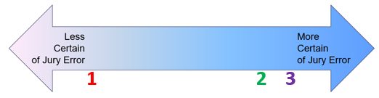
 | What the judge says post trial | Result
1 | - “If I had been on the jury, I would have voted differently.” | - Motion should not be granted. This does not respect the jury’s verdict.
2 | - “Firm and definite conviction the verdict is against the weight of the evidence”  - “The result is seriously erroneous”  - “There has been a miscarriage of justice” | - Motion for a new trial should be granted (based on weight of the evidence standard)
3 | - “There is no legally sufficient evidentiary basis for the jury verdict.” | - Motion for renewed JMOL should be granted

Application of Weight of the Evidence Verdict Errors
You be the Judge HYPO – How should you rule in the following scenarios where a renewed JMOL and motion for a new trial (i.e., motions under 50(b) and 59, with conditional ruling on new trial necessary under 50(c) where renewed JMOL is granted).
- I agree with the verdict.
  - R-JMOL – denied. Allow the judgement on the verdict.
  - MfNT – denied. No issues to be resolved.
- I would not have decided the case that way, but I cannot say that the verdict was wrong.
  - Same as above.
  - Where there is no evidence the verdict was wrong err on the side of deference to the jury.
- I think the verdict was clearly wrong, but I cannot say the jury was unreasonable.
  - R-JMOL – denied. The motion should be decided based on a reasonable jury standard.
  - MfNT – if based on the weight of the evidence I have a firm and definite conviction of jury error then I could grant the motion for new trial.
    - This does not deprive the litigants of trial by jury, in fact it could be seen as a furtherance of the democratic process.
- I think the verdict was unreasonable, no reasonably jury could have reached the verdict.
  - R-JMOL – granted. I do not see that there is legally sufficient evidence for a reasonable jury to reach this result.
  - MfNT – conditionally granted so there was a new trial so long as my ruling on R-JMOL was not overturned on appeal.

Trivedi v. Cooper
- Key take-a-ways
  - Timing for Renewed JMOL (Rule 50(b)) – to move for renewed JMOL, you first have to move for JMOL prior to the case going to the jury. If you do not move for JMOL during trial you waive your right to move for renewed JMOL.
    - P presented three claims. D moved for JMOL during trial on the first two. Post-trial when the motion for R-JMOL was raised on all three it was not considered on the third claim that had not been raised during trial.
  - Standard for Review Motion for JMOL – “reasonable jury would not have a legally sufficient evidentiary basis.” Judge must make this determination without weighing the credibility of witnesses or otherwise considering the weight of the evidence. This is a side by side comparison to determine if a reasonable jury could find for the non-moving part.
    - On the two claims were D did raise its motion for JMOL during trial the R-JMOL was denied. The jury found for P on both claims indicating they found P’s case credible. As such, without making credibility determinations the judge should leave the jury verdict alone unless the sufficiency of the evidence suggests a reasonably jury could not have ruled for D – i.e., there is no legally sufficient evidentiary basis for a reasonable jury to find for the plaintiff.
  - Standard for Review Motion for New Trial – standard for granting a motion for new trial is a fair and definite conviction that the verdict is against the weight of the evidence. The judge is allowed to weight the evidence and can make credibility determination; however, should generally defer to the jury on credibility.
    - The jury found for P on all three claims. The judge denied the motion related to liability on all three. On one of the claims, despite the weight of the evidence leaning away from the jury verdict, the judge left it alone because the judge should give deference to the jury’s weighing of the evidence and credibility determinations.
      - For this claim, the judge granted remittitur and a new trial in the alternative. See notes from 10/29 for discussion of remittitur.
      - Related to the new trial on damages, the judge decided that since this was a harassment claim and the amount of damages depends on the D’s liability, both the liability and damages issues would need to be retried.

Procedural Considerations

Waived Right to a New Trial – Sufficiency of Evidence
- To preserve all their options on appeal, where a party believes there was an error at trial based on insufficiency of the evidence:
  - They must move for renewed JMOL (obviously after moving for JMOL during trial); and
  - A new trial in the alternative.
- If the party does not, the U.S. Sup. Ct. has held that they have waived their options on appeal (Unitherm Food Sys., Inc. v. Swift-Eckrich, Inc.)

What issues should be reviewed during a new trial?
- “The court may, on motion, grant a new trial on all or some of the issues” – Rule 59(a)(1).
  - The court determines if a new trial is necessary on all or some of the issues depending on how intertwined the issues are.
  - Where damages for emotional distress or pain and suffering are at issue, the issues of liability and damages are both reviewed in the new trial because the amount of damages is predicated on liability and the severity of the harm caused.

MfNT (Verdict Errors) v. JMOL
- Key difference – the result of the motion (i.e., a new trial results with a verdict error)
Differences | JMOL | Motion for New Trial (Verdict Error)
Timing | - Raised after a party has been “fully heard” at trial, but before submission to the jury (renewed JMOL - 28 days after the entry of the judgement) | - Raised 28 days after the entry of the judgement
Record | - Trial Record (i.e., witness testimony, exhibits, admissions) | - Trial Record (i.e., witness testimony, exhibits, admissions)
Standard of review | - “A reasonable jury would not have a legally sufficient evidentiary basis to find for the non-moving party” | - Grant if judge has a firm and definite conviction that verdict is against the great weight of the evidence
Action of the court | - Court “may” grant relief to the successful moving party | - Court “may” grant relief to the successful moving party

Motion to Vacate Judgement
**Can only happened after the final judgement**
- In general, courts have interest in judgements having a finality to them, so a party seeking to vacate should offer extremely strong reasons for doing so
  - Granting this motion is incredibly rare
- The rule stipulates on “just terms” the court can relieve a party from judgement. This means a judge must decide if fairness requires:
  - A new trial
  - Outright reversal without a new trial
  - A change in the amount of money in the judgement
  - Alteration of the terms of an injunction
  - Something else

Ground for Relief from A Final Judgement
Rule 60(b) - On motion and just terms, the court may relieve a party or its legal representative from a final judgement, order, or proceeding for the following reasons:
- Mistake, inadvertence, surprise, or excusable neglect
- Newly discovered evidence that, with reasonable diligence, could not have been discovered in time to move for new trial
- Fraud, misrepresentation, or misconduct by an opposing party
- The judgement is void
- The judgement has been satisfied, released, or discharged; it is based on an earlier judgement that has been reversed or vacated; or applying it prospectively is no longer equitable; or
- Any other reason that justifies relief

Timing
- The timeline starts after entry of the judgement
  - For newly discovered evidence, starts de facto 28 days after trial – i.e., after the period to move for new trial tolls (R59).
- R60(c)(1) stipulates the motion must be brough in a reasonable time.
  - Additionally, for reasons (1) – (3), the motion must be brought in one year
- For reasons (1) – (3), a reasonable time still applies.
  - E.g., if you know of newly discovered evidence 33 days after entrance of the judgement but do not raise it until 9 months after trial the judge could say it was not within a reasonable time.

Error
- Errors must substantially alter the ability to fairly litigate the case

Harmless Error
Rule 61 – Unless justice requires otherwise, no error in admitting or excluding evidence – or any other error by the court or a party – is ground for:
- Granting a new trial
- Setting aside a verdict
- Vacating, modifying, or otherwise disturbing a judgement or order.
At every stage, the court must disregard all errors and defects that do not affect any party’s substantial rights.

New Evidence
**These motions are typically denied**
- The matter can be reopened where there is later discovered evidence that calls the justice of the final judgement into serious doubt
- There is a five-part test for granting a motion for relief based on new evidence
  - (1) The evidence must be newly discovered since trial
  - (2) Due diligence on the part of the movant to discover the new evidence must be shown
  - (3) The evidence must not be merely cumulative or impeaching
  - (4) The evidence must be material
  - (5) The evidence must be such that a new trial would probably produce a new result
- Tool v. Baxter Healthcare Corp.
  - Trial concerned manufacturing defects in breast implants. A new scientific study came out after trial. In denying motion for relief from judgement under Rule 60(b)(2) could held:
    - “A trial can be no more than a resolution of an immediate dispute on the basis of present knowledge . . .” Outcome must be based on present science as can be presented by the parties at the time of trial.
      - Science is continually evolving so reopening because of new evidence runs squarely against fundamental principle of certainty.

Fraud
**Courts are highly skeptical of this**
- The motion for relief from judgement due to fraud is typically accompanied by a motion for relief from judgement based on newly discovered evidence
  - The new evidence alerts the litigant of the fraud.
- Where a party can prove by clear and convincing evidence that the opposing party engaged in fraud, misrepresentation, or other litigation misconduct that substantially altered the ability to fully and fairly litigate the case, a court may set aside the deceitfully obtained judgement.
- Two pieces necessary:
  - (i) Proof by clear and convincing evidence
  - (ii) That the fraud substantially altered the ability to fully and fairly litigate the case
- Why this motion is limited to one year?
  - Claims of fraud are typically actionable on their own
- Karak v. Bursaw Oil Corp. – Interplay between motion to vacate for new evidence and motion for fraud.
  - Bursaw Oil’s 12(b)(1) was granted (dismissal for lack of jurisdiction); Karak did not appeal, but instead filed a combined motion to vacate for new evidence and fraud (i.e., 60(b)(2) and (3)).
  - In support of its motion, Karak introduced a declaration from former employee of D alleging misrepresentation and deceit on the evidence D presented to support its 12(b)(1) motion.
    - Also introduced a declaration from its lawyer stating the evidence was not available at trial because the lawyer did not know about the former employee.
  - HELD
    - P’s lawyer simply not knowing about the witness at trial is not new evidence. This is just P’s lawyer not being thorough.
    - The former employee’s declaration was not clear and convincing evidence of fraud. It was merely a contradiction of what D presented in their 12(b)(1) motion.
      - This fails to show that P was unable to fully prepare for trial and fairly litigate the case.

Others – Reasons (4) – (6)
- Void judgement
  - Very difficult to set aside a final judgement where the parties have had a chance to fairly litigate
  - Reserved for instances of jurisdictional error or violation of due process (e.g., improper service)
- Changed Circumstances (judgement satisfied, released . . .)
  - Reserved for post-trial changes that implicate the judgement’s validity
- Other reasons
  - Used incredibly sparingly

Appeals

Overview of Appeals
- Why have appeals – mistakes happen!
- Purpose – correct legal errors of the trial court judge by reviewing objections to the proceedings of the trial court.
  - Where the problem is based on the jury, you ask for a review of jury instructions which the judge did, so it is still a problem with the judge.
- Appeals are not a new trial – conducted based on paper evidence
  - No new evidence
  - No new arguments for reversing a trial court
Reversing Trial Court | Affirming Trial Court
- New legal theories for reversal are not allowed  - Arguments can be rephrased and new authorities can be cited | - Appellate court may affirm on any basis supported by the trial record, even if it relies on a new legal theory
(EXCEPTION) Subject matter jurisdiction – may be raised for the first time on appeal even when not argued below
- Parties have a right to appeal from the Trial Court to the Court of Appeals - mandatory review
  - For second level review, i.e., the Supreme Court, appeal is discretionary
    - Sup. Ct. – chooses cases on issues that them deem of importance
- Why do Ct. App. get things right?
  - More judges – in the Ct. App., there are three judges v. one. There is more opportunity to discuss issues
  - Time pressure and singularity of issue – Ct. App. has more time to decide and focuses only on one issue as opposed to operating an entire trial.

Appellate Decision Options
- Regarding the Trial Court decision, the Ct. App. could:
  - Affirm
  - Reverse
    - Could be with / without remand
      - Decision to remand is case specific depending on what is necessary to resolve
    - If the case is remanded, it typically goes back to the same trial judge
      - Leverages knowledge that the judge already has of the case
  - Dismiss the appeal (only in very rare circumstances)

Appeals Procedure
- Typically, about one to one and one half year process
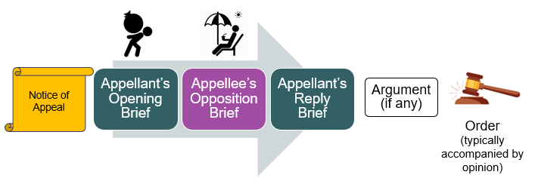

Notice of Appeal
- Must be filed with the district court within 30 days after the judgement - F.R.A.P 4(a)(1)(A)
- In the event of a renewed JMOL or MfNT, the timeline to file an appeal begins when these motions are ruled on

Appellate Brief
- Presents the arguments of the party moving for appeal.
  - Describes five things:
    - (i) Statement of the proceedings
    - (ii) The facts that give rise to the case
    - (iii) A statement of the issue(s) it claims were wrongly decided
    - (iv) A statement of the proper standard of review
    - (v) An argument explaining its position on each of the legal issues raised on appeal

Record Appendix
- A compilation of a documentary record of trial proceedings relevant to the issue appeal
  - Goal – allows appellate court to understand the issue without reviewing the full trial record
  - Includes – all documents and transcript excerpts necessary for the appellate court to understand the proceedings below relevant to the appellant’s claim of error by the trial judge

Reviewability – What may be appealed?
- Three Ps: prejudice, preserved below, presented above
**
- Prejudice
  - Only a party aggrieved by the trial court’s decision may appeal
    - Aggrieved means you were wronged by the trial court
  - Harmless errors – R61
    - “At every stage of the proceeding, the court must disregard all errors and defects that do not affect any party’s substantial rights.”
- Preserved below
  - A party must “preserve” its argument for appeal by asserting it in the trial court.
    - Ct. App. will not consider any arguments that were not made to the trial court.
    - If the argument was not raised to the trial court, then there is no opportunity for the trial court to correct their supposed error either because (i) the argument was not raised; or (ii) there was no objection for the trial court to consider
- Presented above
  - Parties must “present” their arguments to the Ct. App.
    - This means included in the notice of appeal and appellate brief
      - Inclusion in the notice of appeal is necessary so the appellee knows what to prepare their opposition brief on
  - Ct. App. does not consider things that are not before it

Application of Reviewability
MacArthur v. Univ. of Tex. Health Center
Trial
- P files a complaint alleging five causes of action: (a) first amendment retaliation; (b) sex discrimination; (c) IIED; (d) equal protection clause violation; and (e) Title VII retaliation. At trial, P presents evidence on (a), (b), and (c). D moved for JMOL after P presented evidence, denied. The judge instructed on (a), (b), and (c).
  - P objected stating the court also should have instructed based on (d).
- The jury returned verdicts for D on (a) and (b) and issued a $65k verdict for P on (c).
  - P moved for partial new trial on (a) and (b) and was denied.
  - D renewed its JMOL on (c) and was denied.
Appeal (cross appeals)
- P raised the issue of failure to instruct on (e).
- D raised the issue of denial of the RJMOL on (c).
- HELD
  - P cannot raise any issues regarding (e) because they failed to “preserve below.”
  - D did everything procedurally correct and the Ct. App. reversed the trial court granted the JMOL meaning D was not liable.

Appealability – When can it be appealed?
- General Rule – a decision must be final before it can be appealed
  - 28 U.S.C. § 1291 - “U.S. Ct. App. shall have jurisdiction of appeals from all final decisions of the district courts.”

Final Decision Rule
- Final decision – a final decision ends the litigation and leaves nothing for the trial court to do but execute the judgement
  - Why have the final decision rule?
    - Avoids piecemeal litigation – this would drastically slow the trial court
      - Bouncing arrows diagram (up, down, up, down)
    - The trial court decision to which the party objects may not even be necessary
      - Suppose the judge denied a motion to compel discovery and the moving party still wins anyway . . .
    - Context is key – the Ct. App. needs context of the proceedings to accurate decide the appeal
- Interlocutory decision – decisions of the trial court that are not yet final; opposite of final decision

Exceptions to the Final Decision Rule
- (1) Partial Judgement
- (2) Congressionally Approved Statutes – Review of Injunctions
- (3) Collateral Order
- (4*) Certified Question
- (5*) Class certification
  - Related to (4) and (5), the Ct. App. must agree to review.
**
- (1) Partial Judgement – R54(b) - where an action presents more than one claim for relief (could be claim, counterclaim, crossclaim, or third-party claim) OR where multiple parties are involved
  - Only if the court expressly determines that there is no just reason for delay it may direct entry of a final judgement as to one or more, but fewer than all claims or parties
  - THRESHOLD QUESTION – are there multiple claims or multiple parties? Only if yes, can R54(b) apply.
    - Liberty Mutual Insurance v. Wetzel – in a sex discrimination case, Wetzel (P) moved for SJ strictly related to liability at the end of discovery and it was granted. Remedies were yet to be decided. LMI (D) appealed under the partial judgement exception. 3d Cir. affirmed Dist. Ct.
      - HELD – Sup. Ct. reviewed and noted that partial judgement (R54(b)) only applies where there are multiple claims or parties. Here only one claim, sex discrimination – so decision of liability on SJ is not yet reviewable.
- (2) Congressionally Approved Statutes – congress can enact a statute authorizing interlocutory appeal
  - Most frequent case relates to appeal of Injunctions – 28 U.S.C. § 1292(a)(1) – i.e., a trial court’s granting or denying an injunction (including pretrial injunctions) is a congressionally authorized interlocutory decision that can be appealed
- (3) Collateral Order (unusual and difficult) – interpretation of 28 U.S.C. § 1291 that allows for appeal of decisions not yet final, but that resolve rights that are not reviewable on appeal
  - e.g., if D may have absolute or qualified immunity, a trial court order denying it can be immediately appealed as if the denial is reversed the party avoids standing trial
- (4*) Certified Questions – 28 U.S.C. § 1292(b) - the TC can ask the Ct. App. for review where the TC has a controlling question of law that (i) has substantial grounds for difference of opinion AND (ii) immediate appeal may materially advance the ultimate termination of the litigation.
  - Request of the trial judge must be in writing
  - Appellant must request review within 10 days of trial judge entering the order for review
  - Ct. App. must agree to review
    - If review is granted, it does not stop the trial court’s proceedings unless the trial court judge or Ct. App. says it should.
- (5*) Class Certification – trial court orders granting or denying a class action may be immediate appealed.
  - This exists as it has a massive effect on the litigation
  - Ct. App. must agree to review

Standards for Appellate Review
- Standard for review depends (in large part) on the advantage the original decider has at trial based on hearing and seeing evidence in person
  - TC – advantage in making determinations of facts
  - Ct. App. – advantage in decisions on the law
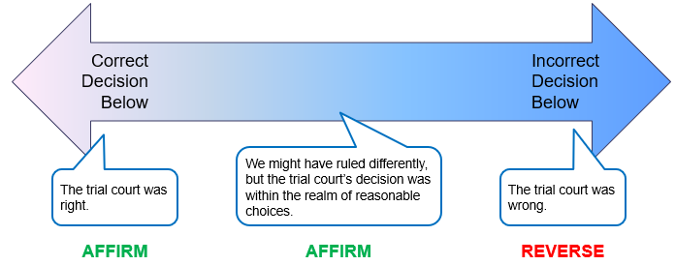
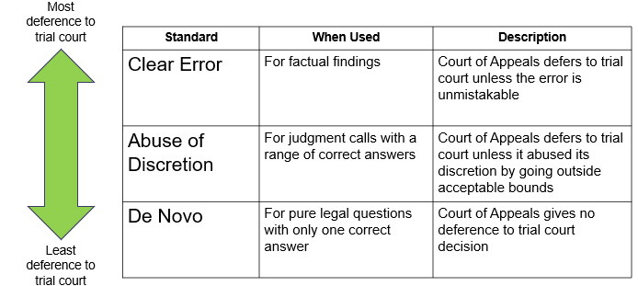
Deference to trial judge | Standard of review | When to use? | Notes
Deference unless | Clearly erroneous | - Used for factual decisions made by judge | - Deference is given b/c of trial judges ability to determine credibility  - Not a duplication of the trial court’s role  - Only reversed where after reviewing the evidence there is one result, not the one picked by trial court
Deference depending | Abuse of discretion | - Used for discretionary orders | - Depending on the type of discretionary order deference is different  - Admin. – case management orders, high deference  - Substantive – default judgements, less deference
Almost none (independent review) | De novo | Used for questions of law  - Used for mixed questions  - Where the facts and the law are agreed on and the judge must determine if the rule of law applies (especially for findings related to const. rights) | - Promotes uniformity in the law  - See comparative advantages above  - For mixed questions, the more factual the more deference

Litigation Management (Other)
- Topics that do not fit into pre-trial, trial, and post trial.
  - Could be used at various times throughout the litigation process

Injunctions (and Temporary Restraining Order)
- Injunction: a court order to do (or not do) an action, a specific remedy provided by law
  - e.g., you must put your dog on a leash when it is outside your home
  - e.g., you cannot go within 500 ft. of X person
- Three options:
  - Final Injunction (post final judgement)
  - Preliminary Injunction (post TRO, but prior to final judgement)
  - Temporary retraining order (earliest option)
- Injunctions are punishable by contempt of court
  - In this way they are like a law for a specific person

When are Injunctions Available?
- Injunctions are available where there is “no adequate remedy at law” – i.e., when there will be irreparable harm meaning money damages are not available
  - Money = good enough, then no injunction
  - Money is preferable to an injunction because:
    - Easier to administer
    - Courts are reluctant to impose forced labor or otherwise limit the rights of individuals
- **Reasonable minds can differ about whether there will be irreparable harm**
  - In deciding if money damages are adequate, check case law
Damage | Irreparable harm?
D has dammed a stream that runs through P’s property. | Maybe.  - It depends on what will happen if D continues to have the stream dammed.
D refuses to vacate an apartment owned by P after the lease has expired. | Maybe.  - If tenant is doing no harm to the community, money damages in the form of rent could be adequate.  - If tenant is harming the community, there should be an injunction to force them out and make them pay back rent.
D cuts down a 100-year old tree that P believes is on P’s property | No.  - Harm has been done. There is no harm to stop with an injunction.
D plans to cut down a 100-year old tree that P believes is on P’s property | Maybe.  - This is likely a good case for an injunction.  - Since P “believes” it is on their property, P would need to demonstrate some chance of success in proving this at trial.

How to Decide if an Injunction is Appropriate
Four Part Test
(1) P proves that D’s actions are unlawful (or will be if they are carried out)
(2) P will suffer “irreparable harm” without an injunction | Used to determine if an injunction is appropriate
(3) Balance of equities are in favor of an injunction  - Compare impact between P and D | These factors are the court exercising their discretion
(4) Injunction is consistent with public interest  - Compare impact between parties and society | These factors are the court exercising their discretion

Contents and Scope of Injunctions – R65(d)
- R65(d)
- (1) Contents - Every injunction or restraining order must:
    - (A) State the reasons why it issued
    - (B) state its terms specifically
    - (C) describe in reasonable detail the act or acts restrained or required
      - This description cannot be based on referring to the compliant or other documents
- (2) Persons – the order binds only the following who receive actual notice by personal service or otherwise:
  - (A) the parties
  - (B) the parties’ officers, agents, servants, employees and attorneys
  - (C) other persons who are in active concert or participation with anyone described in (A) or (B)
**
For preliminary injunctions and TROs:
- Issued based on normal motion practice – i.e., a paper-based record similar to SJ
- Instead of argument – judge can hold an “evidentiary hearing” if necessary
  - Evidentiary hearing is essential trial lite
- For TRO:
  - P will file complaint and motion for TRO simultaneously if necessary – in these cases, P will want to find a judge to hear the motion the same day it is filed

Final Injunctions
- When issued: after / as part of final judgement
  - Used to prevent irreparable harm from occurring in the future on an ongoing basis
- Who knows: obviously both parties because they were both at trial
- Standard for review / How to review
  - Use four step process
- Example Lucy Webb Hayes National Training School v. Geoghegan
  - D was a patient at a hospital operated by P. P, in their professional opinion felt D no longer needed to be a patient and asked D’s husband to move her to another care facility. D refused and offered to continue paying the hospital.
  - P argued at trial that as a hospital their public mandate was to keep beds open and available for those that needed them.
  - HELD – injunction is proper.
    - (1) D had become a trespasser in the hospital based on no longer requiring their services.
    - (2) P seeks the bed D fills in order to provide services for additional patients (i.e., paying for D’s stay cannot cure the remedy they seek)
    - (3) P has a right to serve the population they have a mandate to serve.
    - (4) The public has an interest in keeping hospital beds open.
  - BONUS – you be the judge, what kind of enforcement do you use for this injunction?
    - Civil contempt. Considering D is not heavily motivated by money you would either need to make the monetary penalty so high D could not withstand it for long or alternatively threaten D with jail. In either scenario, D controls when whatever is levied against them stops.

Preliminary Injunction
- When issued: before final judgement
  - Used to prevent irreparable harm during the time final judgement is in process of being issued
- Who knows: the court may issue a preliminary injunction only on notice to the adverse party – R65(a)(1)
- Standard for review / How to review
  - Use four step process with a SUBSTITUTED STEPS
    - For (1), P must show a likelihood of success on the merits rather than actual success because trial has yet to occur
      - i.e., for an injunction, because it is granted after final judgement it will be clear if D’s actions are unlawful)
    - For (2), P must show a likelihood of irreparable harm
  - For balancing of harms, (sometimes works on a sliding scale)
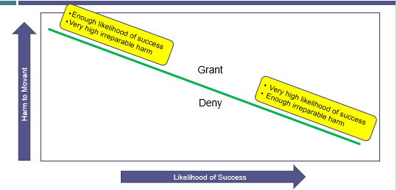
- Example: Winter v. National Resources Defense Council, Inc.
  - D, the Navy, wanted to do a training exercise using MFA sonar. P believed that MFA sonar would cause harm to marine mammals. P seeks an injunction on the Navy’s use of sonar and asks for a preliminary injunction to stay the use of sonar in training prior to trial.
  - Dist. Ct. / 9th Cir. – preliminary injunction granted
    - P was able to demonstrate that Navy did not always use actual sonar in training so balancing of harms was in P’s favor.
  - Sup. Ct. – reverses preliminary injunction.
    - Reasoned that as a matter of national security (i.e., public policy) it was more important to allow training exercise.

Temporary Restraining Orders
- When issued: immediately upon filing if desired (P will file both complaint and TRO simultaneously if necessary)
  - Used to prevent irreparable harm prior to a hearing on a preliminary injunction
- Who knows: adverse party may be aware, alternative, they may not be
  - R65(b)(1) – Court may issue a TRO without written or oral notice to the adverse party or its attorney only if:
    - (A) the facts support doing so
    - (B) the movant’s attorney certifies in writing reasonable steps taken to give notice or why it should not be required
- Standard for review / How to review
  - To issue, P must demonstrate they will suffer irreparable harm prior to hearing on a preliminary injunction

Ex Parte TRO – Additional Information
- Time: Ex parte TRO must state the date and time it was issued – the order expires 14 days after issue
  - Can be extended for good cause or if the adverse party submits to its extension
  - R65(b)(2)
- Dissolution: on two days notice to the party who obtained the TRO (or a shorter notice as set by the court) the adverse party may appear and move to dissolve or modify the order.
  - The court must hear and decide the motion as promptly as justice requires
  - R65(b)(4)

Enforcement of Injunctions
- Injunctions are punishable by contempt of court – civil contempt v. criminal contempt
  - The punishment should be determined to appropriately motivate the offender
- Civil Contempt
  - Goal is to pressure D to obey the injunction
  - “Contemnor holds the keys to the cell” – consequences stop once person in contempt complies
    - You will stay in jail until you do X
    - You will pay $Y per day until you do X
- Criminal Contempt
  - Goal is to punish violation of court order
  - People are prosecuted like a criminal and the punishment is fixed

Appealing an Injunction / TRO
- Interlocutory appeal is authorized - 28 U.S.C. § 1292(a)(1)
- Standards for review
  - Factual findings are reviewed for clear error
  - Decision to grant relief is reviewed for abuse of discretion (mistake of law)
  - Scope and duration of injunction is reviewed for abuse of discretion (mistake of law)

Preclusion
- Relates to the “next lawsuit” – is this lawsuit even possible?
  - For P - a consideration at the end of the first lawsuit (usually if there has been an adverse outcome)
  - For D – during pleadings phase of the second lawsuit
- Reasons for in ability to bring the same suit twice
  - (1) Avoid prejudicing D
  - (2) Efficiency – there is no need to decide the same issue over and over
  - (3) Public perception – if there were adverse results, the public would lose confidence in the judicial system
- Two types of preclusion:
  - Claim preclusion (res judicata)
    - Rule preclusion – see section on R13(a)
  - Issue preclusion (collateral estoppel)

Conceptual Overview

How to Assert Preclusion
- Motion for summary judgement - R56.
  - Additionally, preclusion would be raised as an affirmative defense in answer - R8(b) & R8(c).
  - Do not move to dismiss for failure to state claim – the complaint with the precluded claim might state a claim within the four walls of the complaint (i.e., the record for a 12(b)(6) motion)

How to Review Preclusion Problems
RED FLAG – There are two lawsuits
- Consider L#1 – the first suit that finishes at trial where the parties had a full and fair opportunity to litigate
  - May not be the first lawsuit that was filed
- Consider L#2
  - Apply elements of claim preclusion
  - Apply elements issue preclusion

Claim Preclusion
- Claim preclusion - someone is precluded from asserting a claim in a subsequent lawsuit
  - F/k/a – res judicata

Elements of Claim Preclusion
If the following three, then move for SJ:
- (1) It is the same claim asserted in Lawsuit #1
- (2) Lawsuit #1 resulted in a valid and final judgement on the merits
- (3) The claim is asserted by the same parties

Same Claim
Claims are the same when they could have and should have been brought together

Could Have
Could have means it was:
- Factually possible - the facts for both claims were available at the time of the suit
- Legally possible – the court has jurisdiction over the claims; court allows claims to be brought together in one action (joinder)

Should Have
Should have – three approaches, determined based on where first lawsuit took place.
- Transaction approach – claims arise from the same factual occurrence; same story = go together
  - Most widely used
  - Likely also the most efficient – not dependent on the type of relief, but rather from the same factual situation
- Same evidence approach – evidence proving the elements in L#1 would also prove the elements in L#2
  - The evidence observed is the evidence needed to prove liability, not damages.
  - Key issue – there is often overlap in evidence, but not total overlap. How much is sufficient?
- Primary rights / same harm approach – claims involve the same type of harm go together
  - Most narrow of the preclusive approaches.
  - The approach followed in Cal.
HYPO – Caplan walking Ocen’s dog
- Facts: PO hired PC to walk her dog while she was on vacation. While in PO’s home, PC raided PO’s wine cellar and drank the most valuable bottle of wine without permission. PC then let the dog out unleashed and it ran away.
  - L#1 – conversion of wine.
  - L#2 – negligent dog walking.
- Transaction approach – should be brought together
- Same evidence approach – could probably bring them separately, consider issue about evidentiary overlap – the evidence to prove liability would be different.
- Primary rights – could bring them separately
HYPO – Car Wreck (example of primary rights)
- Facts: A hits B’s taxi while they are driving. B suffers a broken leg, lost income from inability to use his taxi, and property damage.
- Primary rights – B could technically bring three separate lawsuits against A – (1) harm to person, (2) harm to property, (3) harm to pursuit of economic livelihood.
Boeken v. Philip Morris (Cal. 2010)
- P’s husband smoked from 1957 to 1999 when he was diagnosed with lung cancer. Husband died after L#1.
  - L#1 – Loss of consortium (Oct. 2000)
    - P sues as she has lost companionship, affection, household services, etc. both currently while husband is still alive and in the future once gone.
    - Dismissed by P in Jan. 2001 with prejudice (likely as a result of a settlement)
  - L#2 – Wrongful death (Jan. 2002)
    - P sues as she is injured by loss of her family member post death.
- Philip Morris moves for SJ in L#2 asserting claim preclusion.
- HELD (majority) – L#1 and L#2 seek the violation of the same primary right, i.e., right to companionship and all that comes with it.
- HELD (dissent) – L#1 and L#2 violate separate rights. L#1 is focused on loss while that person is still living where L#2 is post persons death. Dissent asserts that wrongful death is broader to encompass a separate type of harm related to loss of financial benefit.

“Valid” and “Final” Judgement “on the Merits”
DO NOT BE FOOLED - These terms do not have straight forward meanings
- Valid – means court #1 had power to bind the parties to the dispute
  - Does not mean the court was “correct”
    - Personal jurisdiction – court #1 must have had personal jurisdiction over the parties
    - Subject matter jurisdiction – most states DO NOT require court #1 to have had subject matter jurisdiction
- Final – meant court #1 is done with trial
  - Decision on appeal does not matter (in most places)
- On the Merits – means the party had a full and fair opportunity to litigate
  - Does not preclude a trial that was dismissed for “administrative” reasons
  - See R41(b) – on the merits related to dismissals
    - If P fails to prosecute or comply with these rules, D may move to dismiss any action or claim against it.
    - Unless the dismissal states otherwise, a dismissal under R41(b) and any dismissal not under R41 operates as adjudication on the merits EXCEPT one for:
      - Lack of jurisdiction
      - Improper venue
      - Failure to join under R19
Examples of on the merits
Rule | On the merits?
R58 – Judgement after a jury trial | Yes – of course!
R50(a) – JMOL | Yes – you were fully heard, just did a poor job presenting your claim.
R56 – Summary judgement | Yes – same as JMOL
R16(f) / R41(b) – Dismissal for failure to prosecute or to obey court orders | Yes – see the first party of R41(b) text.
R12(b)(1) – Dismissal for lack of SMJ | No – however, see that if this is not raised during trial it can be a final judgement on the merits
R12(b)(6) – Dismissal for failure to state a claim | MAYBE – Adjudication on the merits unless the court says otherwise  - Legal sufficiency – on the merits, e.g., late to a party  - Twiqbal – without prejudice, i.e., you have a chance to revise^{[a]}
- [a] Where a party is given a chance to revise, the judge will likely conditionally dismiss the complaint with the condition that refiling an amended complaint could occur within 30 days.

Same Parties
- KEY: Is it the same claimant v. the same defending party?
  - Includes parties “in privity” with each other – means standing in another party’s shoes
  - Richards v. Jefferson County (U.S. 1996)
    - “Deep-rooted historic tradition that everyone should have his own day in court”
    - Telling a 2d P they cannot bring a separate lawsuit (even one on the same claim) against D is a violation of due process
      - 2d P, however, should understand the precedent exists
Six Ways for a Nonparty to be Precluded
# | Summary | Full | Explained
1 | Agreement to be bound | A person who agrees to be bound by the determination of issues in an action between others is bound in accordance with the terms of his agreement | If separate actions involving the same transaction about brought by multiple Ps against the same D, all parties can agree that D’s liability will be determined in the ‘test case.’
2 | Pre-existing substantive legal relationships | Nonparty preclusion may be justified based on a variety of pre-existing substantive legal relationships between the person to be bound and a party to the judgement.  *Heavily property law based | - Preceding and succeeding owners of property  - Bailee or bailor  - Assignee and assignor
3 | Adequate representation | (In certain limited circumstances) A nonparty may bound by judgement because she was adequately represented by someone with the same interest who was represented | - Properly conducted class actions  - Suits brought by trustees, guardians, and other fiduciaries
4 | Assumption of control | Nonparty is bound by judgement if she assumed control over the litigation in which judgement was rendered | Why? Person has the opportunity to present their proofs and arguments – they have had their day in court.  E.g., where an insurance company really controlled the first suit
5 | Relitigating through proxy | A party bound by a judgement may not avoid its preclusive force by relitigating through a proxy | Limits a separate person bringing suit as the designated representative of a person who was a party to the prior adjudication.  This would also apply to an agent bound by a prior judgement.
6 | Statutory scheme | A special statutory scheme may “expressly foreclose successive litigation by nonlitigants if the scheme is otherwise consistent with due process.“ | - Bankruptcy  - Probate proceedings  - Suits that may be brought only on behalf of the public at large

Example – Taylor v. Sturgell
- Taylor, the president of the Antique Aircraft Assoc., and his friend Herrick are restoring an old plane.
- L#1 – Herrick v. Sturgell – files freedom of information act suit against FAA for failure to turn over diagram related to plane.
- L#2 – Taylor v. Sturgell – files similar suit seeking the same diagram. The same lawyer that represented Herrick represented Taylor. Herrick also gave Taylor documents he obtained during discovery.
- D.C. Cir. – Taylor’s claim is precluded because he was “virtually represented” by Herrick.
  - SCOTUS HELD – claim preclusion does not apply and “virtual representation” does not exist.
    - (1) Taylor was not in agreement to be bound by the earlier case; (2) Taylor is not Herrick’s successor in interest; (4) Taylor had no control over Herrick’s litigation; (6) not special statutory system applies; and (3) while their interests are aligned, the court did not specifically seek to protect Taylor.
    - (5) Taylor is not Herrick’s express agent; however, remand to see if Taylor is his implied agent.

Rule Preclusion
- Claim preclusion does not apply to cases where P sues D, then D successively brings a separate suit against P; HOWEVER
- R13(a) – a party is required to “state as a counterclaim any claim that . . . the pleader has against an opposing part if the claim
  - (A) arises out of the transaction or occurrence that is the subject matter of the opposing part’s claim
  - (B) Does not require adding another party over whom the court cannot acquire jurisdiction
- Thus, if D fails to bring its counterclaim during the same suit it is likely barred by “rule preclusion”
  - These rules also apply to separate suits alleging different legal theories that arise after the counter claim
    - How to deal:
      - 1. Recognize the set of facts and the violated rights that arise in the initial case
      - 2. Apply the claim preclusion test applicable to determine if it is the same claim
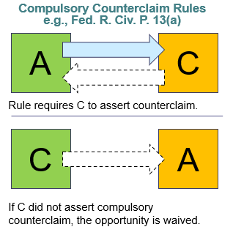

Issue Preclusion
- Issue preclusion – someone is precluded from contesting particular issues in a subsequent lawsuit
  - If we already have an answer, we should not open it up again
  - F/k/a - collateral estoppel
- Could be used as either a sword or a shield
  - To assert issue preclusion, raise it on an early motion for SJ – R56
 | SWORD (used by P) | SHIELD (used by D)
 | Issue X was already resolved against you, I will use it to prove my claim  - Could allow P to skip proving liability and move straight to damages | Issue X was already resolved against you, I will use that issue to defend against your claim
 | E.g., If P sues D over breach of K in 2016 and P wins, if D breaches the same K in the same way again in 2018 P can sue again and move straight to proving damages. | E.g., if P sues D over patent infringement in 2016 and D wins, if P sues D again over patent infringement three years later D can
Notes on SJ Motion | SJ related to part of the claim or defense that does not need to be decided at trial | SJ will dispose of the entire claim

Key distinction between issue and claim preclusion:
- Issue – you actually did litigate this originally and cannot do it again now
- Claim – you should have litigated this originally and did not
- Issue preclusion is broader than claim preclusion because the same issues can arise in very different contexts
  - e.g., negligent performance of a profession may come up in a fee suit then later in a malpractice suit, ownership of an automobile may arise in a negligence action then later in a bankruptcy filing

Elements of Issue Preclusion
A party may be precluded from relitigating an issue in L#2 when:
- (1) L#2 involves the same issue as L#1
- (2) L#1 ended in a valid, final judgement
- (3) The issue was actually litigated and decided in L#1
- (4) The precluded party had adequate opportunity and incentive to litigate in L#1
- (5) The decision was essential to the judgement in L#1

(1) Same Issue
- Can be one of two things: facts (e.g., did D run the red light) or law and facts (e.g., negligence)
  - Pure issues of law are not preclusion, this is stare decisis
Criminal case v. civil case (special considerations for issue preclusion)
- Facts: A batters B, criminal charges and civil suit ensue. Assume criminal and civil battery have the same elements.
- L#1 – Criminal case – Govt. v. A – Govt. would have to prove A’s guilt beyond a reasonable doubt.
- L#2 – Civil case – B v. A – B must demonstrate A’s liable by preponderance of the evidence.
  - Guilty – A is precluded from contesting issue in civil suit. BaRD means liable to B by a preponderance of the evidence at a civil suit.
  - Not guilty – A still must contest the issue in a civil suit. Not guilty BaRD does not mean not liable by preponderance of evidence.
    - Consider OJ Simpson criminal v. civil case.
- BONUS – is there claim preclusion? No. Not the same parties.

(2) Valid, Final Judgement
- Same as for claim preclusion
  - Valid – court #1 had jurisdiction
  - Final – L#1 is “finished” in trial court #1 – same as for appealability

(3) Actually Litigated and Decided
- How to tell if the issue was actually litigated?
  - Look to the trial record and evidence
- How to tell if it was actually decided?
  - Bench trial – results in written findings of fact, R52(a).
  - Jury trial – two options:
    - Special verdict, R49 – judge can ask jury to make specific finds of fact on issues
    - General verdict – jury just says who wins (here is damage or D wins)
Actually Decided Example
- L#1 – P brings medical malpractice suit against Doctor.
- L#2 – P brings medical malpractice suit against Hospital.
**
Scenario – special verdict
- Doctor raises two defenses – (i) I did not commit malpractice. (ii) The claim was outside the SoL.
- Because it is a special verdict, the jury will have to issue its ruling on both issues. Assume they say Dr. did not commit malpractice, but the affirmative defense fails (i.e., claim was within SoL).
- L#2 – P is precluded from contesting issue of malpractice against Hospital. This was already decided.
  - Hospital should file R56 motion for SJ asserting issue preclusion.
  - Hospital should also raise preclusion in answer supposing P does not agree to stay timeline for answer till post ruling on motion for SJ.
Scenario – general verdict
- Doctor raises two defenses – (i) I did not commit malpractice. (ii) The claim was outside the SoL.
- Jury returns general verdict for D.
- L#2 – no issues are precluded as we are not sure what was actually decided in resolution of L#1.

(4) Opportunity and Incentive to Litigate
**Some states treat absence of “opportunity and incentive” as an exception rather than element**
- Opportunity – party on receiving end of preclusion must be a party to L#1; rules vary on whether precluding party also had to be a party to L#1 (newer, but majority rule)
  - If not a party, then no opportunity to litigate
  - The same alignment of parties is not necessary in L#1
    - EXCEPTION – party on receiving end of preclusion was in “privity” with someone in the first lawsuit.
- Incentive – consider interplay between small claims court and regular trial court or disparity in damages between the two issues
  - Facts: person rents a car. Person is involved in a one car accident on a bridge as a result of city negligently maintaining bridge.
  - L#1 – Rental Car Co. v. City - $1000 in damages resulting from negligence.
    - Lawsuit happens in small claims court where there has to be (i) less than $5000 in damages, (ii) there is no discovery, (iii) there are no witnesses, (iv) no lawyers.
    - Result is judgement for Rental Car Co. (i.e., City is deemed to have been negligent)
  - L#2 – Driver v. City - $1.5 million in physical harm.
    - City is not precluded from litigating the issue in L#2 because there was no (or more accurately less) incentive to litigate in L#1.

(5) Essential to the Judgement
- A fact or mixed question of fact and law becomes adjudicated when it was the:
  - Basis for relief
  - Denial of relief
  - Other ultimate right established by judgement
- Issue must have affected the outcome of L#1 to be precluded in L#2
  - No affect on outcome, then might not have been reviewed with same level of scrutiny
  - If the issue is not decisive in the outcome of L#1, then L#1 could end with the issue being unfavorable to the winning party which means they have not opportunity to appeal it
Example – Cambria v. Jeffery
- Facts: two cars collide, one is operated by Jeffery, the other by Cambria’s employee
- L#1 – J brings tort claim against C alleging negligence on the party of the employee.
  - HELD – J and C’s employee were both negligent, so no recovery for J (i.e., contributory negligence applies)
- L#2 – C brings tort claim against J alleging negligence.
  - HELD – damages awarded to C, but judge set the verdict aside as C’s servant was found negligent in L#1.
  - Mass. Sup. Ct. – Reversed. C’s servant being negligent was ancillary to L#1 (i.e., the only thing required for verdict was finding J negligent). As such, jury verdict in L#2 can stand.
- BONUS – claim preclusion?
  - Not in this case as the parties are differently situated; however, modern rules would bar this as C should have counterclaimed against J.

Examples of Issue Preclusion
Felger v. Nicholas
- Nicholas represented Felger in his divorce proceedings. It did no go well.
- L#1 – Nicholas sues Felger for unpaid fees.
  - In deciding L#1, Nicholas was required to demonstrate his skill in conducting the case, fidelity in pursuit of the legal strategy, and diligence in representation.
  - He did this. Court order $345 in fees.
- L#2 – Felger sues Nicholas for malpractice.
  - In deciding L#2, Felger was required to demonstrate Nicholas’ lack of diligence, knowledge and skill.
  - Nicholas moves for SJ related to issue of malpractice.
- HELD – Felger is precluded from bringing issue of representation in L#2 because it was already covered in L#1.
  - (1) It is the same issue – adequacy of legal representation in both cases.
  - (2) L#1 resulted in a verdict (i.e., R58) – valid, final judgement
  - (3) The issue had to have been actually litigated and decided for L#1 to conclude
  - (4) Felger had the opportunity and incentive to litigate L#1 to avoid paying Nicholas fees
  - (5) The issue was essential to the judgement in L#1 as without it Nicholas could not prevail.
Panniel v. Diaz
- Facts: P, injured by NJM has personal injury protection (PIP) benefit with her auto coverage. D, an ambulance driver, and RWJ, the hospital D works for, are also insured by NJM. P and D collide while D is driving the ambulance.
- P then goes to RWJ for treatment for her chest and shoulder – later the following day, P notices a cut on her foot and tries to treat it herself. P could not do so and ends up returning to RWJ later and all five toes are amputated from her foot.
- L#1 (actually arbitration) – P seeks PIP benefit against NJM
  - Arbitrator issues a lengthy statement and finds P’s injuries were caused by accident so NJM should pay its PIP policy.
- L#2 – P v. D and RWJ
  - P files claim against D and RWJ. P immediately seeks partial SJ on issue of liability on the grounds that it Arbitrator already decided accident had been the cause of her injuries.
  - P notes that she will not seek damages in excess of $1m liability limit on D and RWJ’s policy with NJM so NJM is really the party with interest in this suit.
  - D and RWJ oppose SJ motion on grounds they were not party to the original suit.
Should issue preclusion apply?
- (1) Does L#2 involve the same issue?
  - Yes – in both cases the issue was if the accident was the proximate cause of P’s injuries.
- (2) Did L#1 end in a valid, final judgement?
  - Yes – arbitrator has issue a statement so L#1 is final and the parties had authority to arbitrate.
- (3) Was the issue actually litigated and decided in L#1?
  - Yes – P and NJM used medical expert testimony during the arbitration so it was actually litigated. Arbitrator issued a detailed report in L#1 so it is possible to see what was specifically decided.
- (5) Was the issue essential to the judgement of L#1?
  - Yes – without determining proximate cause, P could not have recovered under PIP.
- (4) Did the precluded party have an adequate opportunity and incentive to litigate in L#1?
  - Maybe – the precluded parties were not involved in L#1. Well, they sort of were actually as L#1 related to NJM’s liability and NJM insures both parties. So in this case, D and RWJ are in privity with NJM.
  - HOWEVER, issue preclusion is not mandatory. In this case, court decided that there could be ripple effects related to D’s liability on his personal insurance, so they allowed D to further contest the issue.
Method for Major Motions Review
- Identify the correct record
- Rose colored glasses - View the record in the light most favorable to the non-moving party (i.e., assume the non-moving party’s best-case scenario)
- If the non-moving party CANNOT WIN even on its best-case scenario, court should grant the dispositive motion
Dispositive Motions (“Major Motions”)
Rule # | Name | Relevant Record (most important part of this table) | Who moves | Timing | Notes
12(b)(6) | Motion to dismiss for failure to state a claim | Strictly limited to the pleading (i.e., complaint).  - Would have to resolve based on allegations in four corners of the complaint. | D | Pre-answer motion  Must be made within time to respond to the complaint  - If the court denies, 14 days after court notice to respond to the complaint  Consider limitation on further motions, 12(g)(2) | Consider 12(d) conversion and if you should just move for SJ  To review:  - Elements on left, line up allegations to elements on right  - View allegations in the light most favorable to the P  - Reasonable inferences can be made (Doe v. Smith)  - Twiqbal – cross out any legal conclusions and determine if remaining allegations state a plausible claim for relief  - Be on lookout for Twiqbal where mental state must be alleged or case is likely to have length discovery
12(b) – not (6)  - (1) lack of subject matter jurisdiction  - (2) lack of personal jurisdiction  - (3) improper venue  - (4) insufficient process  - (5) insufficient service of process  - (7) failure to join a party under R19 | Motion to dismiss for other reasons | Pleadings +  e.g., to demonstrate insufficient process likely need more proof than what is included in pleadings | D | Pre-answer motion  Must be made within time to respond to the complaint  - If the court denies, 14 days after court notice to respond to the complaint  Consider waiver trap for defenses (2) through (5) – combo of 12(g)(2) and 12(h)(1)(a)  Consider limitation on further motions, 12(g)(2)
12(c) | Motion for judgement on the pleadings | Strictly limited to the pleadings. | Either P or D | After the pleadings are closed – but early enough not to delay trial. | Extremely rare  Consider 12(d) conversion and if you should just move for SJ
56 | Motion for summary judgement | A preview of evidence the party plans to use at trial.  Where evidence is witness testimony, it goes on paper.  R56(c)(1) - In supporting brief, party will cite to relevant piece of record to support itself – must support the assertion.  R56(c)(4) - For affidavits or declarations:  - Must be made on personal knowledge  - Must set out facts admissible as evidence  - Show that affiant or declarant is competent to testify on the matter  R56(d) - If nonmoving party cannot support its opposition the court may:  - (1) defer considering the motion of deny it  - (2) allow the party time for discovery  - (3) issue any other appropriate order  Allegations in pleadings are not relevant for SJ. | Either P or D  - Where party with burden at trial moves, must prove all elements  - To defeat, non-moving party must show genuine dispute of material fact on only one element  - Where party without burden at trial moves, must demonstrate one element is not met | Can happen from pleadings through 30 days after the close of discovery.  Does not stop other timelines. Must confer with other parties to extend or stay other deadlines. | Key question – do we need a trial?  Granted where (1) there is no genuine dispute of material fact; and (2) the movant is entitled to JMOL.  In deciding motion:  - NO – weighing evidence  - NO – making credibility determinations  To decide motion:  - (1) Identify the applicable substantive law  - (2) Line each party’s positions up against elements  - (3) Rose colored glasses  - All disputed facts resolved for nonmoving party  - Undisputed facts accepted as true  - Permissible inferences drawn in favor of nonmoving party (but not more favorably)
50(a) | Motion for judgement as a matter of law | Trial record – up to point of motion  - Witness testimony  - Exhibits  - Admissions  Record at trial only includes information so far presented  R50(a)(2) – The motion must specify the judgement sought and the law and facts that entitle the movant to judgement.  R50(a)(1) – “The court may . . .” | Either P or D  - See above for proof related to party with burden v. party without burden | At trial  - After a party has been fully heard on an issue  - Before the case goes to the jury | Granted where court finds a reasonable jury would not have a legally sufficient evidentiary basis to find for the non-moving party on that issue  - NO – weighing evidence  - NO – making credibility determinations  - Inferences can be drawn and should be done in favor of non-moving party (but not more so)  - Circumstantial evidence can be used so long as there is not direct evidence that contradicts it (Chamberlin)  Is there “but one conclusion a reasonable jury could reach?”
50(b) | Renewed motion for judgement as a matter of law | Full Trial record (same as Rule 59)  - Witness testimony  - Exhibits  - Admissions | Either P or D  - Always the party who has lost at trial | Post-trial  - Party must first have raised JMOL during trial  - Cannot happen 28 days after entry of the judgement | See standard for review above.  Movant may include a MfNT in the alternative or as a joint request with the RJMOL  R50(c) – if court grants an RJMOL it must also conditionally rule on any MfNT and state the grounds for its ruling
59 | Motion for new trial | Full Trial record (same as Rule 50(b) / could be 50(a) as well)  - Witness testimony  - Exhibits  - Admissions  No rose-colored glasses. Judge may view record somewhat like a 13th juror – judge can hang the jury (if necessary).  R59(a) - “The court may, on motion, grant a new trial . . .” | Either P or D  - Always the party who has lost at trial | Post-trial motion  R59(b) – must be filed no later than 28 days after entry of judgement  For verdict errors (i.e., wight of the evidence) a party must:  - Moved for JMOL during trial  - Post-trial – (1) Renewed its motion for JMOL and move for a new trial in the alternative  - Unitherm Food Sys., Inc. v. Swift-Eckrich, Inc. | For jury trial, MfNT raised for:  - Process errors  - Verdict Errors  In acting as the 13th juror, judge is not as freewheeling as a juror would be. Judge can assess the weight of the evidence but should not assess witness credibility.  Grant motion if there is a firm and definite conviction that verdict is against the weight of the evidence.
60(b)  - (1) Mistake, inadvertence, surprise or excusable neglect  - (2) Newly discovered evidence that was undiscoverable in the R59(b) timeline  - (3) Fraud, misrepresentation, or misconduct by opposing party  - (4) Judgement is void  - (5) Judgement has been satisfied, released, or discharged  - (6) – Other reason that justifies relief | Motion to vacate judgement | Full Trial Record +  Moving party will present additional information with its motion | Either P or D  Typically the party who has lost at trial | Post-trial motion  R60(c)(1)  - Period starts after entry of the final judgement  - Motion must be brought in a reasonable time  - For (1) – (3), must be brough in one year from entry of the judgement  - Reasonable time still applies (i.e., period could be shorter than one year)  - For (2) new evidence, technically starts 28 days after trial (i.e., post period to move for NT) | Moving party must have strong reasons for doing so. Courts like finality.  When is it used?  - Improper Service of Process - R60(b)(4) or (6) - P fails to adequately serve and/or provide notice to D – combo with R55(c), “court … may set aside a final default under R60(b)”  - Newly discovered evidence – R60(b)(2) – evidence must have been available at the time of trial, but for some reason undiscovered, see 5 considerations (Tool v. Baxter Healthcare Corp.)  - Fraud – R60(b)(3) – if a party can demonstrate by clear and convincing evidence that the opposing party engaged in fraud, misrepresentation or other misconduct that substantially altered the ability to fully and fairly litigate the case a court may set aside the deceitfully obtained judgement

Civil Procedure (Caplan) – Spring 2021 Outline

Spring Semester Overview
Broad semester topics:
- Forum selection – rules surrounding where you can bring a suit
  - A court is a proper forum is it has:
    - Subject matter jurisdiction – can this kind of court issue orders in this type of dispute?
    - Personal Jurisdiction – can the court of this government issue orders binging these people?
    - Venue – within a multi-court system, is this the correct court location?
- Joinder – joining multiple claims or multiple parties into a single action

Forum Selection

Overview
- Where options exist, choosing one over another is an art, not a science
- Reasons for choice in forum (i.e., between State and Federal):
Convenience | What court is the easiest for the lawyer and client involved  - Usually a consideration on P’s side
Familiarity | Lawyers often choose one system over another because they litigate there frequently
Jury pool | - State court: smaller pools  - Federal court: draw from larger, more geographically diverse pool
Speed | Generally:  - Federal court: faster  - State court: slower
Case assignment to one judge | Popularity  - If the case is unpopular, party may prefer federal because a Federal judge is an Art. III, §1 lifetime appointment. State court, judges are often elected.  Number of judges  - Federal court: one judge goes to each case  - More complex the case, go to federal  - State court: the judge that is available handles certain motions
Attorney control | Preference of the attorney:  - Federal court: strict control over timelines  - State court: more relaxed, lets the attorney drive more
Out-of-state litigants | Out of state litigant may want to avoid state court due to in-state bias
Expertise | Consider what court has heard more of the issue  - Federal court has advantage on cases where Congress has given it exclusive jurisdiction
Other | Rules of evidence, rules of discovery, court’s power to compel parties to appear, the size of the jury and rules on unanimity of jury decisions

Court Structure
- U.S. Const., Art. III
  - Sec. 1 – Court Structure.
    - One Supreme Court, and other inferior courts that Congress may ordain and establish.
    - Judges shall hold office during good behavior.
  - Sect. 2 – Jurisdiction of Courts
    - Extends to both cases of law and equity – includes laws of the U.S. and treaties
    - Supreme Court has original jurisdiction in all cases:
      - Affecting ambassadors, other public ministers and consuls, and those in which a state shall be party
    - All other cases, the Supreme Court has appellate jurisdiction, both as to law and fact per regulations made by Congress

Choice of Law – Not the same as choice of forum
- A state court can apply the laws of another jurisdiction – however, not with regard to procedural rules
  - e.g., two Cal. citizens have a car crash in Arizona. P sues D in a Cal. court for convenience. Cal. court will apply Arizona substantive law, but its own procedural rules.
- Federal courts
  - Federal courts always use F.R.C.P.
  - Federal courts apply substantive law based on Erie Doctrine / Klaxon
    - Erie RR v. Tompkins – federal courts apply state law, there is no free floating body of federal common law
    - Klaxon Co. v. Stentor Elec. Mfg. Co. – to decide which state law to apply, look to the choice of law rules for the state in which the federal court sits.
      - e.g., in car crash example above – apply Cal. choice of law rules (statutes)

Subject Matter Jurisdiction
- Statutes or court rules establishing the type of disputes the court may resolve.

Federal Subject Matter Jurisdiction
- Step 1 - U.S. Const., Art. III, §2 – delineates nine matters over which the federal courts have SMJ
  - This makes the federal district courts courts of limited SMJ
    - If it is not included in one of these matters, the federal court cannot hear it
Federal questions | State v. State | Competing claims to state land grants
Ambassadors | USA as Party | Citizens v. aliens
Admiralty | Citizens of different states | State v. Citizen of Other State

- Step 2 - Congress has the power to grant jurisdiction to the federal courts based on the nine subject matters included in this list
  - A federal court can only hear a case if Congress has passed a statute allow it
Three options for subject matter jurisdiction:
Exclusively Federal | Concurrent Jurisdiction | Exclusively State
Congress authorizes suits that may ONLY proceed in federal court | Congress authorizes suits that can proceed in federal court, but can also proceed in state court | Congress has not authorized these type of suits in federal court
- Antitrust  - Bankruptcy  - Copyright  - Patent  - Etc. . . . | - **Most federal law claims**  - State law claims where parties are diverse | - Suits not based on federal statute  - Suits where parties are not diverse
- Exclusively state matters
  - Case law has determined domestic relations (e.g., divorce, family law) and probate (i.e., wills) are exclusively state matters

Diversity Jurisdiction
- 28 U.S.C. §1332(a) – Two components
  - Appropriate combination of diverse parties
  - Amount in controversy
- Why did the framers allow diversity jurisdiction to be under the SMJ of the federal courts?
  - Citizens of different States – avoidance of home-town bias for plaintiff.
    - Art. III judges are lifetime appointments so they should be unbiased and not worried about re-election
  - U.S. Citizen and a citizen of a foreign state – might concern issues of foreign policy
    - Framers were worried about State courts upsetting a foreign power and it coming back to harm the U.S. as a whole

Combination of Diverse Parties
- Two-step process:
  - (1) Determine the citizenship of each party
  - (2) Ensure the resulting combination of Ps and Ds falls within one of the authorized combinations in §1332(a)(1)-(4)
  - (3) Ensure there is complete diversity
    - Complete diversity – no P can be a citizen of the same state as any D
      - e.g., if each claim could have been brought separately in federal court there is complete diversity

Citizenship of Individuals
The Test (Gordon v. Steele; Krasnov v. Dinan) | Depends on person’s place of domicile  - A person can only have one place of domicile  - Old domicile is not lost until a new one is gained  - All people start with initial domicile based on birth or place of naturalization  - Domicile can change when the person has:  - (i) Physical presence in a different jurisdiction WITH  - (ii) Intent to remain in that jurisdiction indefinitely (not permanently)  How to determine intent to remain indefinitely:  - Indefinitely – make the jurisdiction home AND no present intention of going elsewhere  - Declarations of the person, exercise of political rights, payment of income taxes, housing, set up of a place of business
Relevant date (Gordon v. Steele) | Determined as of the date the complaint is filed  - A party’s citizenship changing afterward is not considered
Other | Must be a U.S. citizen in order to have state citizenship  - HOWEVER, being a U.S. citizen does not automatically make you a State citizen – e.g., person born in Ga., but indefinitely residing the Tanzania is a U.S. citizen but not a State citizen – does not fit into 1332(a).  Permanent Fuzzy Foreigners - 1332(a)(2) Exception  - There is no diversity jurisdiction where citizens or subjects of a foreign state who are lawfully admitted for permanent residence (not U.S. citizens) are involved with a U.S. citizen and both are domiciled in the same state

Gordon v. Steele
- Feb. 1972 – P suffered a wrist injury while living with parents in Pennsylvania. As a result of a misdiagnoses from two doctors in Pennsylvania, P had continued pain in wrist. P is a practicing Mormon. Aug. 1972 – P enrolled in Rick’s College (a Mormon college) in Idaho. P rents an apartment in Idaho and says she plans to stay there post getting her degree because there are more Mormons in Idaho so it will be easier to live the Mormon life there.
- Aug. 1973 – P files suit in federal district court for the W.D.Pa. based on diversity jurisdiction; D subsequently moved to dismiss for lack of SMJ.
- HELD – diversity jurisdiction is appropriate.
  - The date at which time the case is filed is what controls party’s place of domicile.
  - Place of domicile is dependent on physical presence with intent to remain permanently.
    - Since she has rented an apartment and says she wants to stay post school to live the Mormon life, place of domicile is Idaho when suit was filed.

Citizenship of Corporations
The Rule | §1332(c)(1)  - Corporations are citizens of the State or foreign state of incorporation and the State or foreign state where it has its principal place of business
Principal Place of Business Test (Hertz v. Friend) | Principal place of business  - Based on the company’s nerve center – where the companies officers and directors control and coordinate everyday operations of the company  - Typically, is the business’ “headquarters”  - Not an office where the corporation occasionally holds board meetings
Relevant date (Gordon v. Steele) | Determined as of the date the complaint is filed  - A party’s citizenship changing afterward is not considered
Other | - Corporations are dual citizens – meaning they have two places of residence for diversity jurisdiction purposes  - e.g., GP is incorporated in Del., but its PPB is in Ga., so not diverse against an opposing party from either Del. or Ga.  - Principal place of business – singular  - A company may only have one PPB
Special Rules
- Direct Actions Against Insurers (where the insured is not a party)
  - 1332(c)(1) – for diversity jurisdiction, in an action against an insurance company where the insured is not joined as a defendant, the insurer is deemed a citizen of:
    - (A) every State or foreign state of which the insured is a citizen
    - (B) every State or foreign state by which the insurer has been incorporated
    - (C) the State or foreign state where the insurer has its principal place of business
- Legal representatives of decedents, infants, or incompetents
  - 1332(c)(2) - deemed to be citizens only in the same state as the party they represent

Citizenship of Unincorporated Associations and Other Entities
Partnerships and unincorporated associations (e.g., labor unions, churches, advocacy groups) | Citizenship of each partner or member is reviewed for purposes of diversity jurisdiction  - For LPs – even the citizenship of LPs need to be considered
LLCs
Professional corporations | Treated as corporations  - Reason: they are created under state incorporation statutes
- Treatment of partnerships and LLCs presents a real problem as the citizenship of each party is rarely public information

Combinations from §1332(a)(1)-(4)
- (1) Citizens of different States
- (2) Citizens of a State and citizens or subjects of a foreign state
  - Two special cases:
    - Permanent Fuzzy Foreigner Exception
    - U.S. citizen and also a foreign citizen
- (3) Citizens of different States and in which citizens of subjects of foreign states are additional parties
- (4) A foreign state as P and citizens of a State or of different States as D

Tough Cases and Options for Lack of Diversity SMJ
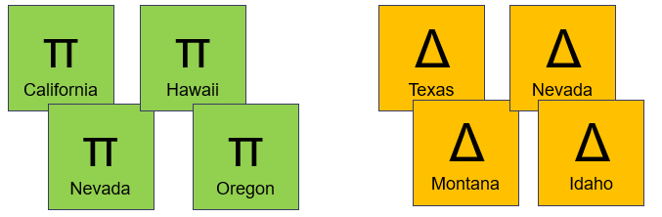
- See P and D both from Nev., not completely diverse
- Option 1 – go to state court. Most claims fall under concurrent SMJ.
- Option 2 – get to federal court under another method.
- Option 3 – drop the Nev. defendant so there is complete diversity.
- Option 4 – drop the Nev. plaintiff so there is complete diversity.
  - Unlikely to do this given J&S liability for defendants
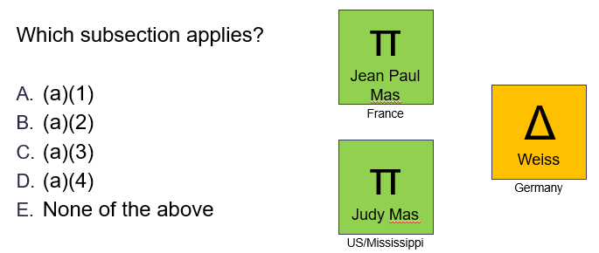
- ANSWER – E. none of the above.
  - This one does not fit (a)(3) because Weiss is not an “additional party.” Weiss is a main party in this case.
- Option 1 – get to federal court under another method.
- Option 2 – go to state court.
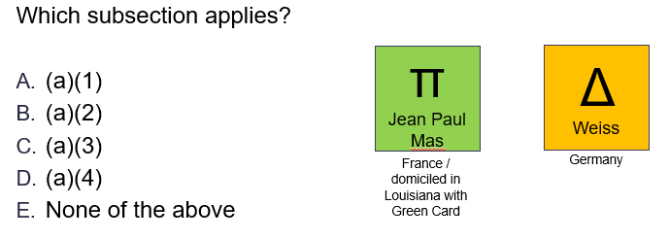
- ANSWER – E. none of the above.
  - Why not (a)(2) considering the permanent fuzzy foreigner exception?
  - (a)(2) applies where there is at least one State citizen. Jean-Paul is not a State citizen.
    - To be a State citizen you first have to be a U.S. citizen.
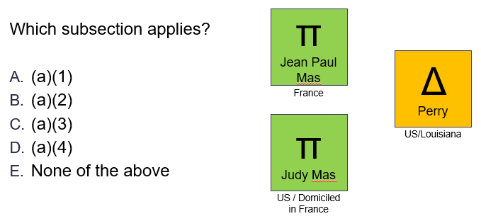
- ANSWER – E. none of the above.
  - Why not (a)(2)? Judy is considered neither a State citizen or a foreign citizen. She renounced her state citizenship once she is domiciled in France, but is not yet a foreign citizen with her U.S. passport.
- Option 1 – get to federal court under another method.
- Option 2 – go to state court.
**
- AMAZON PROBLEM - Citizenship of corporations: Amazon, HQ1 in Seattle / HQ2 in Virginia
  - Corporation can only have one PPB
    - Where do the company’s officers live?
    - Which location sits more high-level officers?

Amount in Controversy
- 1332(a) – “. . . where the matter in controversy exceeds the sum or value of $75,000, exclusive of interest and costs . . .”
  - More than $75,000 = ok
  - $75,000 or less = no diversity jurisdiction
- Why did congress include the jurisdictional amount for diversity jurisdiction?
  - Federal courts are not meant to be small claims courts – the amount is an arbitrary limit.
  - Note – jurisdictional amount is not included in the Constitution. This is a congressionally imposed limit to reign in docket of federal courts.
**
- ISSUE – how does the court determine what the amount in controversy is prior to hearing the case?
- RULE – a claim for more than the required amount in controversy will generally be accepted if it appears to be in “good faith,” UNLESS:
  - It appears to a “legal certainty” that the claim is really for less than the amount
- PRACTICALLY – judge considers the amount requested in the claim and asks if a reasonable jury could award more than $75k based on the claim
  - P is given benefit of the doubt – (Gaia test) where P probably will not recover the amount, but might could, the amount requirement is met

Meaning of “Good Faith” and “Legal Certainty”
- Good faith – request for relief supported by factual allegations and declarations
- Legal certainty – statute or law limits requested damages on a claim, yet P asks for damages in excess
Diefenthal v. C.A.B. (Civil Aeronautics Board)
- Ps purchase first class tickets in a smoking section of an Eastern Airlines flight. During boarding, flight attendant tells them their request for smoking seats cannot be granted because the section was full.
- Ps bring, among other things, a tort claim against Eastern Airlines in federal district court based on diversity.
  - Ps allege flight attendants “brusquely” treated them causing extreme embarrassment, humiliation, and emotional distress – however, failed to allege specific language used by the flight attendants.
  - Complaint alleged damages in excess of $10k (amt. in controversy requirement from the time).
- Eastern Airlines moved to dismiss, R12(b)(1) – lack of SMJ for failure to meet amt. in controversy.
- HELD – granted, dismissed for lack of diversity jurisdiction. P’s complaint used lots of adjectives to describe the tortious behavior of the flight attendants but was incredibly sparse on facts or specifics.
  - Without physical contact or more facts that support how Ps were injured by D “it failed to demonstrate how the Diefenthals had suffered anything more than a trivial loss.”

Calculation of Amount in Controversy
- Steps to determine the amount in controversy:
  - Begin with amount request in complaint – R8(a)(3), complaint must include a request for relief
  - Subtract amounts that are “to a legal certainty unavailable” – rarely taken step
  - Subtract interest and cost
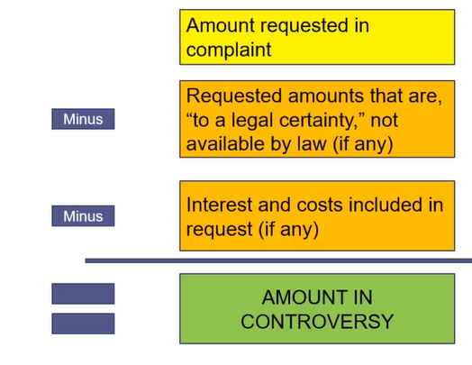
- Amount in controversy must typically be satisfied by damages only
  - In a small subset of cases where attorney fees and expenses are reimbursable, the P can add them to the damages amount as well

Interest and Costs
- R54(d) – “costs” can be awarded to the prevailing party in court
  - §1920 - List of costs that can be awarded
    - (1) Fees of the clerk and marshal
    - (2) Fees for printed or electronically recorded transcripts necessarily obtained for use in the case
    - (3) Frees and disbursements for printing and witnesses
    - (4) Fees for exemplification and the costs of making copies of any materials where the copies are obtained for use in the case
    - (5) Docket fees under §1923
    - (6) Compensation of court appointed experts, compensation of interpreters, and salaries, fees, expenses, and costs of special interpretation services under §1828

Aggregation of Claims
- RULE – only the claims of a single P against a single D may be aggregated (however, there are exceptions)
- Rules for aggregation of the value of claims
 | - Single D | - Multiple D
- Single P | - YES (Ex. 1) | - NO (unless joint liability for single harm) (Ex. 2)
- Multiple P | - NO (unless harm is to a “common, undivided, or joint” interest) (Ex. 3) | - NO
Examples 1 and 2
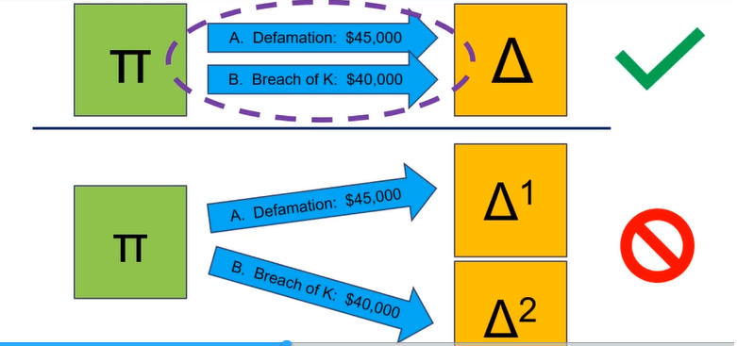
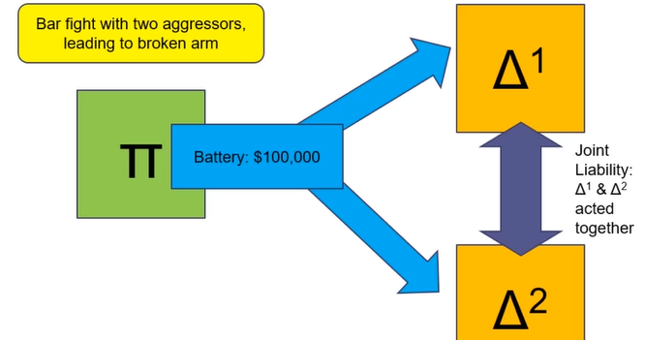
Example 3
- VERY RARE – because the item is jointly owned, we do not have to think about each P as a different party
  - Situations were this could come up: two Ps are beneficiaries of a trust
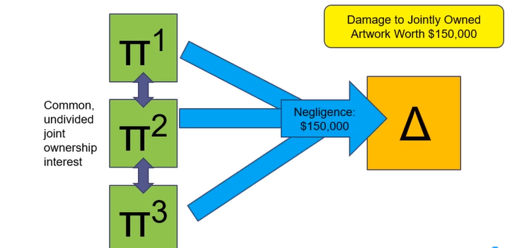

Penalty for Failure to Receive a Damages Award in Excess of the Jurisdictional Amount
- Option 1 – §1332(b), post judgement
  - Applies where:
    - P files the case originally in Federal court
    - P is finally adjudged to be entitled to recover less than the sum or value of the jurisdictional amount
      - Computed without regard to setoff or counterclaim and exclusive of interest and costs
  - Hammer - The district court may deny costs to the plaintiff AND may impose costs on the plaintiff
- Option 2 – R11 Motion, pre-trial
  - R11(b)(3) – factual contentions must have an evidentiary basis, or likely will after reasonable opportunity for discovery
  - R11(c) – motion for violation of R11(b), see specifics in R11(c)(2)
  - USE
    - P’s lawyer likely will not be sanctioned because damages are hard to calculate
    - However, if their claim is precarious, could be used to encourage voluntary dismissal of the claim

Federal Question Jurisdiction
- §1331 – The district courts shall have original jurisdiction of all civil actions arising under the Constitution, laws or treaties of the United States
  - Note – not exclusive

Well-pleaded Complaint Rule
- Well-pleaded complaint - P’s claim for relief must include a basis for relief based on federal law for it to fall under federal question jurisdiction
  - Does not include complaints that simply reference federal law
  - Does not count if D raises a federal question in their response, must be P’s complaint
- Application Approach
  - Step 1 – determine the allegations necessary to state a claim for relief based on federal law
  - Step 2 – cross others out
    - Where allegations remain that state a claim for relief under federal law there is federal question SMJ
Louisville & Nashville R.R. v. Mottley
- Mottleys were involved in a train crash while riding Louisville & Nashville R.R.’s line in 1871. In exchange for not bringing suit, L&N RR gave the Mottley’s free annual train passes for life. Mottleys are domiciled in the same state as L&N RR. In 1907, L&N RR did not renew the passes. Congress passed a new federal law saying lifetime passes were no longer allowed.
- Procedure
  - Mottleys sued L&N RR in Federal Dist. Ct. under federal question jurisdiction for breach of contract. Their complaint alleged that L&N RR will raise the new federal law as a defense – they alleged the law did not apply to their type of passes, and if it does the law violates their 5th Amendment rights by depriving them of property without due process.
  - Fed. Dist. Ct. – ruled in favor of Mottleys.
  - Sup. Ct. – dismissed case for lack of SMJ.
- HELD – this is a breach of contract claim between parties from the same state (i.e., no diversity). The complaint does not allege violation of a federal law; therefore, there is no federal question jurisdiction.
  - “Well pleaded allegations in P’s complaint must establish a right to relief under federal law or the Constitution.”
- APPLICATION APPROACH
  - Step 1 - What allegations were necessary to state a claim for relief – D breached a contract we had with them.
  - Step 2 – language concerning new law is crossed out
    - No federal question is left, this is a state breach of contract claim.
Narrow exception (not covered in class)
- In a rare case, P must demonstrate a federal law issue in order to prove a state claim. A court may find the federal district court has jurisdiction depending on:
  - (i) the importance of the federal issue at stake
  - (ii) whether federal jurisdiction would disrupt the allocation of business between state and federal courts
  - (iii) other relevant factors.

Choosing Federal v. State
- Concurrent jurisdiction exists for most claims. Why choose federal over state?
Federal | State
- State courts might not have the same experience applying federal laws  - Federal court might have more specialization in one area of the law  - Federal judges answer to Congress, not local voters – might be more comfortable with an unpopular decision | - More State courts exist  - More courts = more docket space, trial will occur faster  - More courts = easier to access  - State courts have court of general SMJ, several claims can be grouped  - State courts are obligated to correctly apply federal law & any errors can be corrected by the Sup. Ct  - Art. VI, Sec. 2 – Supremacy Clause – U.S. Const. and U.S. Laws are the supreme law of the land  - Art. VI, Sec. 3 – State judicial officers take an oath to support U.S. Const.

SMJ – Other within Scope of Art. III, Sec. 2
- §1251 – Original Jurisdiction
  - (a) Supreme Court has original and exclusive jurisdiction of all controversies between two or more states.
  - (b) Supreme Court has original but not exclusive jurisdiction of:
    - (1) Actions which ambassadors, other public ministers, consuls, or vice consuls of foreign states are parties
    - (2) All controversies between the U.S. and a State
    - (3) All actions and proceedings by a State against the citizens of another State or against aliens
- §1257 – State Courts; Certiorari
  - By writ of certiorari the Supreme Court can review:
    - Final judgements of State supreme courts concerning:
      - the validity of a U.S. treaty or statute or State statute is questioned on the grounds it is repugnant to the Const., treaties or laws of the U.S.
OR
      - title, right, privilege, or immunity claimed under the Const., treaties or statutes of, or any commission held or authority exercised by, the United States.
- §1333 – Admiralty, Maritime, and Prize Cases
  - “The dist. courts shall have original jurisdiction, exclusive of the courts of the States . . .”
    - Federal – yes, only option
    - State – not allowed by congressional statute
- §1343 – Civil rights and elective franchise
  - “The dist. courts shall have original jurisdiction of any civil action authorized by law . . .”
    - Federal – could be
    - State – could be

Removal and Remand
- Removal – moving a civil action from a state trial court to a federal trial court
  - Purpose, give defendant a chance to choose forum (like P when the suit is initially filed)
  - Covered by §1441 and §1446
- Remand – moving a case from federal trial court back to a state trial court after removal
  - Literally, “send it back to where it came from”
  - Covered by §1447

Removal
- §1441 – Removal of Civil Action
  - (a) Except as otherwise expressly provided by Act of Congress, any civil action brought in a State court of which the district courts of the United States have original jurisdiction
    - MAY be removed by the defendant or defendants to the district court of the United States for the district and division embracing the place where such action is pending
  - (f) An action may be removed to federal court even if the state court where it was originally filed lacked jurisdiction
**
- IF
  - A civil action is brought in State court AND it could have been filed in federal court AND no other statutes expressly forbids removal
- THEN
  - D can remove to the U.S. Dist. Ct. that covers the place where the state court action is pending
- This applies even when the state court originally lacks jurisdiction because original jurisdiction over the claim is exclusively federal (see §1441(f))

Removal Based on Diversity of Citizenship, §1441(b)
§1441(b)(2)
- IF
  - A civil action is otherwise removable based on diversity jurisdiction (i.e., 1332(a) and not federal question)
- BUT
  - Any of the parties in interest properly joined and served as defendants are citizens of the forum state
- THEN
  - The action is not removable.
§1441(b)(1)
- Defendants sued under fictitious names are disregarded for purposes of determining diversity for removal
  - Consider “Jane Doe” inclusions
§1446(c) – Requirements; Removal based on Diversity of Citizenship
- (1) A case cannot be removed under (b)(3) – i.e., removal based on amended pleading – on the basis of jurisdiction under §1332 – i.e., diversity – more than a year after the action commences
  - UNLESS the district court finds P has acted in bad faith to prevent removal
- (2) When removal is based on diversity, the amount in controversy is the amount demanded in good faith in the initial pleading
  - (A) If the initial pleading seeks non-monetary relief OR a state law bars relief in excess of the jurisdictional amount THEN
    - The notice of removal may assert the amount in controversy
  - (B) Removal is proper where the district court finds by a preponderance of the evidence that the asserted amount exceeds the jurisdictional amount in §1332(a).
- (3) Removal blocked strictly based on the amount in controversy in the initial pleading.
  - (A) If the case is not removable because of the amount in controversy from §1332(a), information regarding the amount in controversy in the record from the State proceeding is treated as “other paper” for (b)(3) – i.e., remove based on amendment or other action later in the case
  - (B) If the notice of removal is filed more than one year after commencement of the proceeding and the district court finds P failed to disclose the actual amount, this is deemed to be bad faith for paragraph (1).
**
- (1) After one year, an action cannot be removed under (b)(3) after an amended pleading on the basis of diversity
  - UNLESS P included a D they actually did not care about in the original pleading strictly to prevent removal based on diversity
  - Consider instance where P includes an insolvent D just to break diversity
- (2) For the amount in controversy, use the amount from the initial pleading
  - (A) If the initial pleading doesn’t contain an amount, D should assert one in the notice of removal
  - (B) If the court finds by a preponderance of the evidence the jurisdictional amount is exceeded, removal is proper.
- (3) Removal blocked by amount in controversy
  - Information in the State record related to the amount in controversy is other paper for purposes of (b)(3)
  - IF
    - The notice of removal is filed more than one year after commencement of the action AND the district court finds P deliberately failed to disclose the full amount to prevent removal
  - THEN
    - This is bad faith for purposes of paragraph (1)

Removal Procedure
How to remove a case from State court to Federal District Court | §1446(a)  - To remove, D or Ds file in the district court of the United States for the district and division within which such action is pending a notice of removal signed pursuant to R11  - Notice contains:  - S&P statement of the grounds for removal – together with  - Copy of all process, pleadings, and orders served upon such D or Ds in such action  - Because it is a notice, happens automatically (i.e., not a motion the court needs to agree with)  §1446(d)  - After filing notice of removal, D or Ds shall give written notice to all adverse parties and shall file a copy of the notice with the clerk of such State court  - The State court shall proceed no further unless the case is remanded
Timing for notice of removal | §1446(b)(1)  - Notice must be filed 30 days after receipt by the D, through service or otherwise, a copy of the initial pleadings  OR  - 30 days after the service of summons upon the D if such initial pleading has been filed in court and is not required to be served on the D  - Whichever is shorter  §1446(b)(3)  - Except as provided in sub (c), when the case stated by the initial pleading is not removable THEN  - P files an amended pleading or motion, or other paper, which means it is now removable THEN  - D may file a notice of removal in 30 days  - See above related to removal on the basis of diversity
Multiple Defendants | §1446(b)(2)  - (A) All Ds properly joined must join or consent to removal of the action  - (B) Each individual D has 30 days upon receipt of the initial pleading or summons to file a notice of removal  - (C) A later served D can still file notice within 30 days  - In this case, any earlier-served D may consent to removal (it does not matter if the earlier served D did not previously initiate removal)
Breakout on §1446(b)(3)
- A later change is only a valid basis for removal where it makes the action removable for the first time – i.e., if the initial pleading was removable and D failed to remove, and an amendment contains additional facts that make it removable, D cannot later remove
- Example – C, from Colorado, sues D, from Delaware, based on a breach of contract claim for $200k. Three months later, C amends the complaint to add a violation of federal law. Can the case be removed after the amendment based on §1446(b)(3)?
  - NO! D could have filed a notice of removal on the basis of diversity jurisdiction under the original complaint.
    - When D fails to do this within 30 days (see §1446(b)(1)) they waive the right to later remove the action
§1447(e) – Addition of D’s
- If after removal the P seeks to join additional Ds whose joinder would destroy SMJ, the court may:
  - Deny joinder
  - Permit joinder and remand the action to the State court

How a Plaintiff can Prevent Removal
- Avoid bringing a claim under federal law
- For diversity
  - (i) Sue where D is a citizen / (ii) enjoin an instate defendant, see 1441(b)(2)
  - Enjoin a D that is a citizen of your same state so there is no diversity
  - Limit the amount of damages under the jurisdictional amount
Exam Tip! Removal is a question within a question – to understand if the case is removable, you must understand if the federal district courts have SMJ first

Remand

Remand Procedure
§1447(c) – Procedural Remand
- This does not cover a motion to remand for lack of SMJ
  - If at any time before final judgement it appears the district court lacks SMJ, the case shall be remanded.
- A motion to remand based on a defect other than lack of SMJ must be made within 30 days of filing of the notice of removal under §1446(a)
  - Covers all removal procedural issues
- Result of granted motion
  - (1) Triggers a certified copy of the motion to remand being mailed from the federal district court clerk to the clerk of the State court – once received the State can proceed
  - (2) The party who incorrectly sought removal may have to pay the other parties’ costs and any actual expenses, including attorney’s fees, resulting from removal
§1447(d) – Remand not reviewable on appeal
- Order remanding a case to the State court from which it was removed is not reviewable on appeal
  - EXCEPT a remand order based on a removal action under §1442 or §1443
- What does this mean?
P makes a motion to remand and it is erroneously granted
- D goes back to state court and live with it.
P makes a motion to remand and it is erroneously denied
- Interlocutory appeal under §1292 is unavailable.
- P waits until they are done in federal court and appeals the final decision of the district court under §1291

Case Explanation - Removal and Remand
Avitt v. Amoco Production Co.
- D is a citizen of Texas. P files suit against D in Texas State court. P’s original complaint stated without specifics that it expected D violated both State and Federal law.
- Oct. 1990 - Based on this, D filed a notice of removal and a R12(e) motion for more definite statement on which federal law was violated.
  - Court denied motion R12(e) motion and said the parties should handle it through interrogatories.
- July 1991 - After they were already in federal district court, P eventually amended its complaint and removed the wording about violation of federal law.
- Oct. 1991 – two additional parties were named as co-defendants, Apache and MW.
- During the pre-trial conference, Ds asked that the case be dismissed for lack of SMJ; however, P argued against it. A federal law was used by P as a reference point to to calculate damages.
  - HELD (by federal district court) – judgement for Avitt, required Amoco, Apahce, and MW to complete and environmental study and pay $650k plus attorney’s fees.
- Amoco appealed to the 5th Cir. on the basis of the federal district court lacking SMJ.
  - HELD (by 5th Cir.) – there is no federal question here as P’s basis for relief was not predicated on violation of a federal law.
    - There is also no diversity given the §1441(b)(2) exception about an instate defendant.
- After 5th Cir. vacated, P moved for costs and actual expenses including attorney’s fees in federal district court related to improper removal under §1447(c).
  - HELD (be federal district court) – costs and actual expenses awarded in the amount of $641,509.
- Amoco, Apache, and MW again appeal to 5th Cir. on the grounds that holding them liable was improper given Avitt’s actions.
  - TEST for removal – was the notice of removal proper based on the federal district court having SMJ?
  - If not, do the circumstances include a bad mistake such that costs should be awarded penalizing the party who incorrectly removed?
  - HELD (by 5th Cir.)
    - Removal was improper in this case; however, costs should not be awarded based on P’s behavior in keeping the case in federal court and with their vague reference to a federal law violation to get it there initially.
    - Additionally, even if Ds were liable for costs and actual expenses, Apache and MW cannot be held liable since they were not Ds at the time of removal.

Personal Jurisdiction
- Is the defendant subject to the powers of the government acting through its court system?
  - A government acting through its courts may only issue orders that bind people who are properly subject to the powers of that government.
  - Basic idea – there must be a suitable relationship between the court, the parties, and the dispute – the nature of that relationship varies from case to case
- Two overhanding PJ concerns:
  - Fairness to parties – is it fair to the parties to litigate in this jurisdiction?
  - Governmental power contest – is it right that this government should be able to resolve this dispute?

Rulebook Basis for PJ
U.S. Const.
- Amendment 5 – No person shall be . . . be deprived [by the federal government] of life, liberty, or property, without due process of law
- Amendment 14, §1 – All persons born or naturalized in the United States, and subject to the jurisdiction thereof, are citizens of the United States and of the state wherein they reside. No state shall . . . deprive any person of life, liberty, or property, without due process of law . . .
R4(k)(1)(A)
- (k) Territorial Limits of Effective Service
  - (1) In General. Serving a summons or filing a waiver of service establishes personal jurisdiction over a defendant:
    - (A) who is subject to the jurisdiction of a court of general jurisdiction in the state where the district court is located
**
- Step 1 – U.S. Const., Amend. 5 makes it unlawful for the federal government to deprive someone of life, liberty, or property (i.e., level a judgement against them in a civil suit) without due process of law, U.S. Const., Amend. 14 sets up the same for the states
- Step 2 – R4(k)(1)(A) establishes that the federal court system has PJ based on a person being subject to the jurisdiction of the state court of general jurisdiction where the district court is located

Process for approaching PJ
- 1. Does the forum’s long-arm statute assert PJ over the D?
- 2. If so, does the forum’s assertion of PJ satisfy the Constitution’s due process clause?

Long-arm Statutes
- State statute concerning what defendants the state courts can compel to appear in their jurisdiction – which Ds are captured by the “long arm of the law”
- Two types of State statutes:
  - Laundry list
  - Constitutional maximum – Exam Tip! In these instances, proceed straight to Constitutional question (see step 2 above).
- Federal long-arm statute – R4(k)(1)(A)

Laundry List
- Deemed laundry list because the long-arm statute lists out the types of people and cases that are subject to jurisdiction in the State’s courts
- EXAM TIPS!
  - If there is a laundry-list long arm statute, you would need to read it and make your best argument on how to apply it.
    - Look to state supreme court cases for guidance
  - If the state long-arm statute does not cover the D (and you are positive about this and that the state is your only option), then do not analyze the constitutional question.
- Example – Fla. laundry list long-arm statute
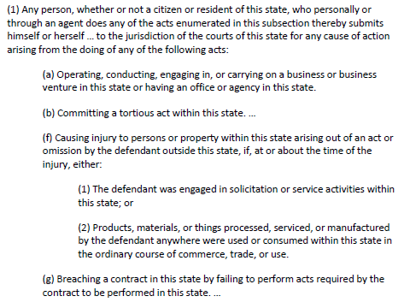
- Questions
  - 1. A citizen of California runs a red light in Florida, injuring a pedestrian who is a citizen of New York.
    - Fla. has PJ – (b) tortious act committed within the state.
      - Logic – someone has violated Fla. traffic laws, Fla. courts want to be able to enforce those laws against them.
  - 2. A toaster manufacturer in Wisconsin sells a shipment of toasters to an online retailer in Washington. A Florida customer buys a toaster online from the Washington retailer, and it starts a fire in Florida causing injury. The customer seeks to sue both the manufacturer and retailer.
    - Manufacturer – Fla. has PJ – (f)(2).
    - Retailer – Fla. has PJ – could be covered by (f)(1) or (a).
      - If there was a dispute between the applicability of (f)(1) or (a), look to Fla. Sup. Ct. cases.
  - 3. A theatrical producer who lives in Fla. agrees to finance a play to be performed in Fla. An actor who lives in Cal. agrees to appear in the play, but reneges on the agreement by cancelling at the last minute.
    - Fla. has PJ – (g) the contract required acts to be performed in Fla.
      - Whether the K was valid does not matter for PJ, the court would resolve this question in deciding the case, but will not come up as a result of PJ.
      - This creates a preclusion problem – Fla. court deems the contract invalid which means there is no PJ. When producer then tries to sue in Cal., there is issue preclusion as the validity of the K has already been decided;
        - HOWEVER, the parties did not have property opportunity and incentive to litigate.
  - 4. Same facts as 3, but the producer is a citizen of Cal. and the alleged breach of contract is failure to pay the actor.
    - Fla. may or may not have PJ. The breach would depend on its being facts specific as the payment may or may not occur inside of Fla.’s borders which makes (g) potentially applicable but not definitely.

Constitutional Maximum
- State does not specify types of cases subject to PJ, says that if the Constitution allows it so do they

Federal Long-arm Statute
- R(4)(k)(1)(A) – Federal district court has personal jurisdiction over defendants who are subject to the jurisdiction of a court of general jurisdiction in the state where the district court is located
- Federal piggy backs on states - to determine federal PJ, look to the state long-arm statute
- Notes:
  - (1) Serving a summons (or obtaining a waiver of service) is the act triggering PJ, the service may occur anywhere – does not have to be within forum
  - (2) “Court of general jurisdiction” refers to state court of general SMJ, usually a superior court
- EXAM TIP! – Do not forget to say R4(k)(1)(A) tells us to look at the relevant state long-arm statute
- Example – An actor in California agrees to appear in a play in California, financed by a producer in Florida. The actor reneges on the contract. Would the federal long-arm statute allow a suit by the producer to proceed in U.S. Dist. Ct. in Fla.?
  - Step 1 – what long-arm statute is applicable?
    - Per federal long-arm statute R4(k)(1)(A), Fla.’s long-arm statute is applicable in this case.
  - Step 2 – is the actor captured by the Fla. long-arm statute?
    - No. (g) specified that for a breach of contract case, the contract was to be performed in Fla.
    - No PJ means do not proceed to Const. question related to Fla.

Constitutional Limits on PJ
- Two approaches:
  - Traditional bases – present party, domicile, consent, present agent
  - Modern bases – Int’l Shoe

Traditional Basis
Short name | Long name | Explained
Present Party  (Service must be proper for this to be sufficient) | If the party was present in the forum at the commencement of the lawsuit | Ds who lived out of state would be considered present on if they were served with process within state boarders
Domiciled = Dominated | If the party was domiciled in the forum  - **Entities do not have domicile** | A citizen of the forum could be sued in the forum even if process was served elsewhere
Consent | If the party consented the court’s power | Some Ds would consent, and all Ps consent by the act of filing suit in that forum
Present Agent | If the party had an agent for service of process who was served within the forum
- Problem with traditional bases: it is hard to sue a defendant from out of state
  - e.g., driver from Va. caused an accident in Cal. with a Cal. P, unless Cal. P can get Va. D to consent or catch the Va. D while they are present in the state, there is no traditional bases that satisfies the Const. limits

Present Party
- R4(k)(1)(A) – serving a summons “establishes PJ over a D”
  - Consider that each state has jurisdiction and sovereignty over person and property within its territory – act of service demonstrates power over D
- Pennoyer v. Neff – Pennoyer, an attorney, represented Neff in Oregon court. Neff refused to pay after case concluded. Neff subsequently moves to Cal. Pennoyer sues Neff in Oregon.
  - HELD – Oregon has no PJ over Neff. Pennoyer has to either wait for Neff to return to Oregon and serve him or sue him in Cal.

Domiciled = Dominated
- If D lives in the forum state, it does not matter if they are served elsewhere (living in the forum makes means it is fair to sue you there
- Milliken v. Meyer – Milliken sued his former business partner Meyer (a Wy. citizen) in Wy. State court. Milliken served Meyer in Colo.
  - HELD – No problem. “The authority of a state over one of its citizens is not terminated by the mere fact of his [temporary] absence from the state.”
- **Entities do not have domicile**

Consent
- PJ is waivable, if a party chooses not to insist on it, then so be it
  - P consents by filing suit in the forum
  - D can either expressly consent or impliedly consent
    - Express – affirmative statement of willingness to be sued in a given forum
      - e.g., parties sign a contract that includes a choice-of-forum clause
    - Implied – D shows up and begins litigating without objection to PJ
      - R12(h) – PJ must be asserted at the earliest opportunity

Present Agent
- Use for business entities where there is a designated agent to accept service
  - Blend of present party and consent
    - Agent = present party; designation of an agent is consent to accept suit
    - Agent is often mandated by state law where multi-state corp. has significant ongoing in-state activity with full-time employees or permanent facilities
      - Selling to instate customers from out of state usually does not require an agent
    - Example - R4(h)(1)(B), a government official is deemed to be an agent for service, also requires mailing a copy to the D

Modern Basis - Overview
Int’l Shoe Co. v. Washington (U.S. 1945)
- Creates two options in addition to Traditional Basis:
  - Specific in personam jurisdiction – a claim arising out of the D’s deliberate contacts with the state that are specifically related to the case
  - General in personam jurisdiction – a claim can arise out of D’s ongoing contacts with the state
- Why was Int’l Shoe necessary?
  - Traditional basis – Pennoyer v. Neff (Present party) – a party’s presence within the territorial jurisdiction of the court was a prerequisite to its issuing a binding judgement against them
    - PROBLEM - This made the capture of out-of-state corporations difficult
  - Modern basis – Int’l Shoe Co. (SOLUTION) – due process requires only that a D have:
    - certain minimum contacts with the forum
    - such that suing them there does not offend the traditional notions of fair play and substantial justice
- REASONING
  - The two principles of PJ are (i) fairness to the parties, and (ii) governmental exercise of power
  - Int’l Shoe Co. is based on fairness to D – based on their contacts with the forum, is it fair to sue them there?
  - Explain why this is fair?
    - Contacts imply D has taken advantage of the benefits and protections of the state’s laws and resources and when it enjoys those benefits and protections it is obligated to answer to the call of the state’s courts
    - This also gives D the chance to control where they have contacts
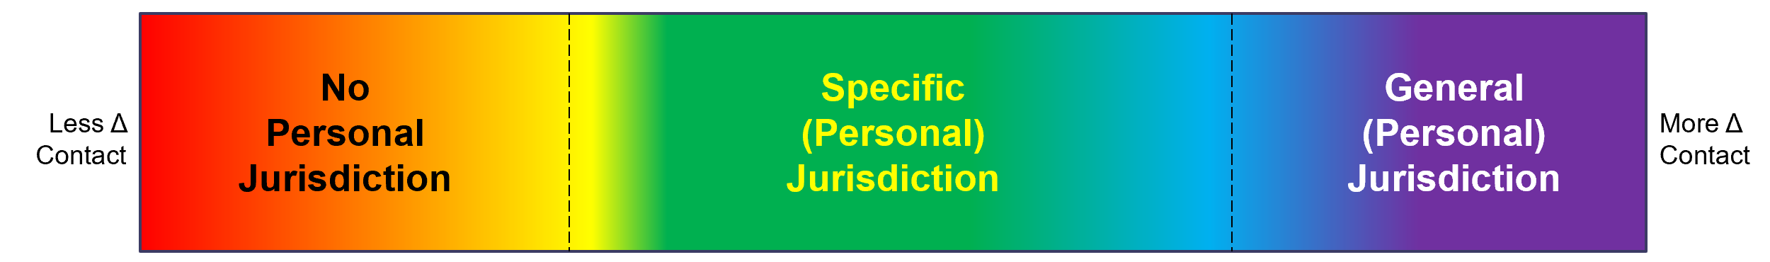
No Personal Jurisdiction | Specific Personal Jurisdiction | General Personal Jurisdiction
D has too few contacts with the forum to allow PJ | D has enough contacts with the forum that are related to THIS lawsuit to make PJ proper for THIS lawsuit | D has so many contacts with the forum that PJ is ALWAYS proper – even for lawsuits unrelated to forum contacts

Application / Examples, Modern Basis - Overview
- Step 1 – identify D’s contacts with the forum.
- Step 2 – do those contacts give rise to specific jurisdiction / general jurisdiction such that the notions of fair play and substantial justice are not offended?

Overview
Gooby, Inc. sends a truck filled with bacon wrapped diamonds from Salisbury, N.C., where it is domiciled and has its PPB, to Birmingham, Ala. On the North end of 285 outside Atlanta, Ga. the truck causes a collision.
- Is PJ constitutional in Ga.?
  - Y – Gooby, Inc. has availed itself of the benefits of Ga. by making use of its roads. As such, it has case specific contacts in Ga. so it is subject to specific PJ there.
- Is PJ constitutional in N.C.?
  - Y – Gooby, Inc.’s PPB and place of incorporation in N.C. always render it subject to general PJ in the state. Note, it is also subject to the traditional basis of present party. As such, it is fair to subject it to the laws of N.C.
  - Additionally, to the extent Gooby, Inc. did truck maintenance / driver training in N.C. you could also make an argument for specific PJ.
This is the drivers third collision in three months. Gooby, Inc. fires the driver once he returns to N.C. The driver then moves to Atlanta, Ga. Is PJ constitutional in Ga. for a wrongful discharge suit?
- N – All events related to employment and termination occurred in N.C. Gooby, Inc. has no contacts with Ga. related to its employment practices that subject it to PJ there, personal or specific.
Int’l Shoe Co. v. Washington
Int’l Shoe Co.’s PPB and state of incorporation is in Mo. Int’l Shoe Co. has no offices, manufacturing facilities, or distribution infrastructure in Wash.; however, they do have a sales force of around 10. The salespeople take samples to customers in the state, occasionally rent space to show samples to groups of customers, send orders back to Mo. from Wash. and deliver products to customers in Wash. The salespeople are paid commissions by Int’l Shoe Co. Int’l Shoe Co. fails to pay state unemployment tax on the salespeople. Wash. serves process on one of its salespeople and mail a copy of the notice to Int’l Shoe Co.’s HQ in St. Louis stating they are being sued for failure to pay.
- ISSUE – does Wash. have personal jurisdiction over Int’l Shoe Co. such that it can subject it to a binding order from its court?
- TRADITIONAL METHODS
  - Present party – a corporation is not three dimensional so it cannot be “present.”
  - Domicile – as a corporation, Int’l Shoe Co. is domiciled where it has its PPB and in its state of incorporation.
  - Consent – no, they have not consented.
  - Present agent – in this case, the salesperson is not an appropriate agent of Int’l Shoe Co. as required by law.
- MODERN METHODS (created as a result of this case)
  - Contacts with forum – Int’l Shoe Co. has hired people in Wash., it sends communications to those people while they are in Wash., it ships boxes of product to Wash. for which it receives revenue, it receives benefits from Wash.’s existence – i.e., use of its infrastructure (roads, electricity, phones, rental spaces for customer show room), and it benefits from the customer based that is housed in Wash. It could also use a Wash. court to enforce a contract entered into there.
- HOLDING – while the traditional methods are insufficient, related to this specific matter, i.e., employment taxes paid on workers who operate based in Wash., Int’l Shoe Co. has enough case specific contacts to render it subject to specific jurisdiction in Wash.
  - Since it has all these contacts and derives benefits from them it is fair to subject them to specific jurisdiction in Wash. related to this case.

Specific Jurisdiction, Modern Basis – The BK Two Step (Breach of Contract)
- Burger King Two Step
  - Step 1 – are there minimum purposeful case-related contacts (i.e., contacts between the D, the litigation, and the forum state)?
    - Looks back in time at events that occurred pre-lawsuit
  - Step 2 – from a holistic view, is PJ in the forum state is reasonable?
    - Looks forward in time with focus on litigation – will it be fair and reasonable to have D litigate in this forum?
**
- Where D wants to challenge PJ
  - When a D who has purposefully directed activity at a forum resident seeks to defect jurisdiction
  - They must present:
    - A compelling case that
    - The presence of some other consideration renders jurisdiction unreasonable

Minimum Purposeful Case-Related Contacts
- Purposeful – for contacts to count, they must be the result of the D’s activity
  - Purposeful contacts cannot be the result of unilateral activity of someone other than the D, see Hanson v. Deckla
- Think concretely about what contacts exist
  - Look for a party triggering something headed to the forum.
  - e.g., Internet / mail
    - If customer in Ga. sends a check by mail to Cal. it will likely cross the southern part of the U.S. and go through Tex. There is no PJ in Tex. despite their transaction crossing Tex.
    - If customer in Ga. sends a payment over the internet and the data package bounces from Ga. to Ky. to Wy. to Mt. to Cal., there is no PJ except where the person triggered sending the payment.
- Examples:
  - The D has called, emailed, or sent letters to the forum state in order to derive benefit for itself
  - The D has negotiated with the forum state
  - The D is availing itself of the states economy by receiving payments from customers there

Reasonableness & Fairness
- Factors that speak to fairness
Relative importance to . . .
Liberals | Conservatives
Neutral  Neutral  ( - )  ( - )  ( + )  ( + ) | Neutral  Neutral  ( + )  ( + )  ( - )  ( - ) | - Reciprocity  - Probable location of evidence  - D’s control over its fate – i.e., consent  - Fair warning to D it might be subject to suit  - The forum state’s interest in accountability and law enforcement  - P’s access to court

- Factors that speak to reasonableness
Relative importance to . . .
Liberals | Conservatives
( - )  ( + )  ( + ) | ( + )  ( - )  ( - ) | Private Factors  - Burden on D  - WW VW – “always a primary concern”  - BK – only relevant if burden creates a “severe disadvantage” to ability to defend  - P’s interest in access to local courts  Public Factors  - Forum states interest in adjudicating the case  - WW VW – states should not “reach out beyond the limits imposed on them by their status as coequal sovereigns in a federal system”  - BK – “a State generally has a manifest interest in providing its residents with a convenient forum for redressing injuries inflicted by out-of-state actors”  - Judicial efficiency across jurisdictions  - “Shared interests” of states in furthering “substantive social policies” (rarely relevant, usually resolved with choice of law)

Choice of Law & Forum Selection – Contract Clauses
Contractual Agreement | Relation to PJ
Choice of Law Provision - Parties agree as part of their contract what law will govern any disputes that arise between them – aids in contractual interpretation | - Binding on the parties to the transaction; however, this does not necessarily confer personal jurisdiction on that state’s courts  - Choice of law provisions are a relevant factor to consider as they often indicate a party availing itself of the forum state via the choice of law clause
Forum Selection Clause – requirement that any  dispute be litigated in a particular state | - Ideally, prevents challenges to PJ on the front end  - Courts will enforce so long as the forum is reasonable in relation to the parties’ transaction

Application – Modern Basis – The BK Two Step
Burger King v. Rudzewicz
- BK is HQ’ed and has its PPB in Miami, Fla. It operates a business model where it enters into contracts with franchisees who report to 10 district offices around the U.S. (mostly). BK controls all aspects of operations and provides franchisees plans on how to appropriately operate in exchange for royalties paid directly to the BK HQ in Miami. The contracts BK signs with its franchisees all specify that their relationships are “established in Miami” and governed by Fla. law – i.e., choice of law clause.
- Rudzewicz, an accounting firm partner in Mich., and an associate enter into a franchise agreement with BK. The agreement personally obligates Rudzewicz for more than $1m in expenses over a 20-year period. Rudzewicz and his associate primarily interact with the Detroit district office. In fact, Rudzewicz has never been to Fla.
- BK sues Rudzewicz for breach of contract in Federal Dist. Ct. in Fla. where a dispute arises in their relationship.
- ISSUE – does the Fla. Dist. Ct. have PJ over Rudzewicz?
- ANALYSIS
  - S1 – Minimum purposeful case-related contacts – despite never having been to Fla. personally, Rudzewicz did reach out to Fla. to negotiation a contract with them. He did this repeatedly during the franchise agreement process.
    - The choice of law provision in their contract does not on its own confer PJ to the Fla. court over Rudzewicz. This provision mixed with the contractual negotiations, however, does. It demonstrates Rudzewicz established a long-term relationship to avail himself of the benefits of Fla. law.
  - S2 – are the contacts reasonable to establish PJ over D?
    - D is responsible for presenting a compelling challenge to why this is unreasonable and he failed to do so.
    - Private
      - Rudzewicz will be inconvenienced by having to travel to Fla. to litigate. However, he knew he was entering into a relationship with an Fla. business when he signed the contract so this is not an issue.
      - Considering he purposefully reached out and touched Fla. he should have known a dispute there was a possibility – in the contract he also agreed to litigate under Fla. law. The ongoing contractual obligation mixed with the choice of law clause shows he availed himself of Fla. law.
    - Public
      - Fla. will want to provide a forum for one of its residents to resolve their dispute for a contract entered into within its borders.

Hanson v. Deckla – premise that the contacts must be “purposeful”
Donner, a Pa. citizen, puts over a million in stock in a trust administered by Wilmington Trust Co., a Del. corporation with its PPB in Del. Donner leaves instructions to mail her checks as dividend interest accrues and to distribute the assets on her death. Several years later, Donner moves to Fla. On her death, Donner’s two surviving relatives, Hanson and Deckla fight over her estate. One of them obtains a ruling form a Fla. court saying Wilmington Trust Co. is subject to PJ in Fla. and should obey the court order to distribute the assets.
- Wilmington Trust Co. objects to PJ in the Fla. court.
- HELD – personal jurisdiction over Wilmington Trust Co. is unconstitutional.
  - Wilmington Trust did not have sufficient contacts with the forum state to make it constitutional – never purposefully availed itself of the forum state.
    - The trust was set up while the client was a Pa. resident, Wilmington mailed all checks from the Del. office.
    - Only contacts it has with Fla. are a result of Donner’s unilateral decision to move there.
  - KEY – unilateral activity of those who claim a relationship with a nonresident D cannot satisfy the minimum contacts for that nonresident D. D must “purposefully” take action to connect itself to the forum.

McGee V. Int’l Life
Franklin, a Cal. citizen, buys a life insurance policy from Empire Mutual Insurance, and Ariz. corporation and names McGee as the beneficiary. Int’l Life, a Tex. corporation, purchases Empire Mutual. Franklin dies. Int’l Life refuses to pay out on the policy claiming Franklin committed suicide which violates the agreement.
- McGee sues in Cal. state court. Int’l Life objects to PJ in Cal.
- Int’l Life argues it has no agents in Cal., never advertised in Cal., has no salespeople in Cal. and only one customer – insufficient contacts for personal jurisdiction.
- HELD – Int’l Life has sufficient contacts to make PJ constitutional in Cal.
  - Contacts – contract delivered in Cal., policy premiums were paid from Cal. – Int’l Life was availing itself of the Cal. economy by taking money received there, insured was residing in Cal. when he died.
  - Reasonableness
    - Private – Int’l Life will be disadvantaged, but it is not serious enough that it should bar PJ. In David v. Goliath cases Goliath can travel.
    - Public – Cal. as a state will want to provide an option for its residents to resolve a dispute like this, the witnesses and evidence related to the suicide will all be located here.

Specific Jurisdiction, Modern Basis – PJ for Intentional Torts
- For PJ over intentional tortfeasor, the plaintiff must show the D’s acts were:
  - (1) Intentional
  - (2) Uniquely or expressly aimed at the forum state; and
  - (3) Caused harm in the forum state
**
- For (2), D must purposefully avail itself of conducting activities in the forum states, thereby invoking benefits and protections of its law - D must purposeful reach out and touch forum with their action (holding from Calder v. Jones)
- D connection to the forum cannot be random, fortuitous, or attenuated, or on the unilateral activity of the P (holding from Walden v. Fiore)
- Exam Tip! Show that both exist to justify PJ.
Calder v. Jones
Cal. actress brings libel suit against Nat’l Inquirer, editor, and reporter in C.D. Cal. Nat’l Inquirer, editor, and reporter are all based in Fla. The article was written and edited in Fla. Nat’l Inquirer did purposefully send issue of magazine to Cal. and has a circulation of about 600,000 there.
- ISSUE – does C.D. Cal. have PJ over editor and reporter in this suit?
- ANALYSIS
  - (1) Federal long-arm statute is R4(k)(1)(A) – looks to Cal. long-arm statute which has constitutional max.
  - (2) Does PJ fall within constitutional max?
    - Specific contacts – Ds relied on phone calls to Cal. for source information; Ds wrote about P’s activities in Cal.; the article was widely circulated in Cal. and that is where it caused P harm.
    - Reasonable – because D reached out and touched Cal. and because for libel it is necessary to publish the information to a large number of persons which happened in Cal. PJ is reasonable – D directed its conduct at Cal. which caused harm.

Walden v. Fiore
Fiore, a pro poker player, leaves Puerto Rico with a bag of $97k in cash. In Puerto Rico, security stops Fiore on suspicion the bag is drug money. They let her go but call ahead to Atlanta where her connecting flight is to stop her. Fiore is passing through Atlanta on the way to Nevada where she lives. Drug Enforcement Officer Walden stops Fiore in Atlanta, has a dog sniff the bag, nothing comes up, but Officer Walden takes her money anyway. Officer Walden later files an affidavit to satisfy why the search and seizure was reasonable.
- Fiore files suit in Dist. Ct. in Nev. alleging unreasonable search and seizure and filing a false affidavit to delay return of their funds.
- Dist. Ct. – Walden files a motion to dismiss based on lack of PJ over the claims. Cites Calder v. Jones in support – Walden’s knowledge that their home was in Nev. is insufficient to exert PJ over him there. Granted.
- 9th Cir. – affirms dismissal on search and seizure claim, reversed on claim related to filing a false affidavit.
  - Stated Walden “expressly aimed” conduct at Nev. by submitting a false affidavit with knowledge it would harm a Nev. resident.
- HELD - Sup. Ct. – there is no PJ in Nev. in this case. D never contacted or sent anything to Nev. Ps were harmed in Nev. by D’s actions; however, it was on their own choice that they traveled to Nev. after being harmed by D.
Online Bookseller – Important – exam question will likely involve internet
Lopez runs a rare book business in Massachusetts. The business has no storefore; instead, it advertises and sells books in three ways.
- (a) A website. The site describes available books and also describes the business generally and some of its notable past offerings. Customers may order books from the web site.
- (b) Print catalogue. Contains similar material to website as well as information for sending payments through U.S. mail.
  - Lopez mails the catalogue to 1,000 regular customers annually, two of whom are in Nebraska; both of whom contacted Lopez to ask to be on the mailing list.
- (c) Conventions. Lopez displays books and conventions and book fairs around the U.S. and abroad. None of the fairs were in Nebraska.
One of the books Lopez sold was a rare first edition of a book (Revolutionary Road by Richard Yates) that included the author’s inscription that read in part: “To Helen Abdouch – with admiration and best wishes. Dick Yates. 8/19/63.” The description of the book on Lopez’s website and book catalogue explained that Abdouch had been an officer in JFK’s Nebraska campaign, that Abdouch and Yates knew each other personally, and that Lopez believed the book was an author copy that Yates had given to Abdouch. After this copy of the book sold, Lopez retained the description of the book on the website as an example of the type of books he traded.
Abdouch, a citizen of Nebraska, sued Lopez in Nebraska state court for violation her right of publicity – the right not to have your name or likeness used for commercial purposes without your permission. Does Nebraska have personal jurisdiction over Lopez?
**
ANALYIS – skips step of discussion R4(k)(1)(A) and traditional methods.
- The inquiry should focus on (1) Lopez’s case specific contacts with Nebraska and if they are purposeful AND (2) if they reasonably confer PJ over him there. The case specific contacts are publishing Abdouch’s name (1) on the internet; and (2) in the catalogue.
  - Related to the catalogue; Lopez arguably has intentionally reached out and touched the forum state by sending the catalogues to two potentially customers. The customers did sign up to receive the catalogue; however, he had to take the step of authorizing it to be sent to them. He wanted to send it to them to sell products there and in an attempt to sell products he used Abdouch’s name. As such, it could be said that his purposeful case related contacts have touched Nebraska and are the basis for the potential harm suffered.
  - The website uses Abdouch’s name with the same intent; however, it is more difficult to say Lopez purposefully aimed publishing Abdouch’s name on the website at Nebraska.
    - Arguing this is a purposeful aiming, Lopez knew the internet existed in Nebraska so he could be said to have purposefully aimed his publication of her name at all places where the internet is accessible. This, however, is a broad standard. In assessing a reasonableness test, this type of contact may be struck down as it does not really show Lopez has consented to suit in Nebraska by making use of a medium that happens to be available there.
    - Arguing against this being purposeful, this could be seen as similar to Walden v. Fiore where it is another party’s action inside of Nebraska’s boundaries that connects Lopez’s action with the forum state.
- If the catalogue is seen as sufficient minimum contact to justify personal jurisdiction, it will likely be seen as reasonable to grant PJ over Lopez in Nebraska. Related to reasonableness, Lopez’s business activity indicates that he is a proficient traveler. It will be a burden on him to access the forum state, but it likely does not create a severe disadvantage to him. Nebraska also likely has an interest in adjudicating the claim of Abdouch, its citizen.
- Therefore, as Lopez purposeful directed his catalogue containing Abdouch’s name and potentially could be seen as having published her name on the internet there he has established minimum contacts with Nebraska. Given his travel record it will not be a severe disadvantage to him to litigate there. As such, there is personal jurisdiction over Lopez in Nebraska.
Generous Hacker - see PDF 296 of the coursepack for another practice example.

Specific PJ – Torts and the Internet
- Key distinction – passive v. active content
  - Passive
    - Harder to say PJ exists where content was passively posted for people to discovery
      - Raises unilateral actions of others argument.
      - Other argument is that this will subject the poster to personal jurisdiction everywhere which is not fair or reasonable, nor could be said to be purposeful
  - Active conduct
    - Line gets blurred related to “purposefully” directed at the forum
      - Consider the hunter near the state line – no line of demarcation in the forest. If he shoots and intentionally or accidently hits someone what is important is that he cause harm and it was to someone who was located in that forum

Specific Jurisdiction, Modern Basis – PJ for Product Liability
- For product liability claims – apply BK Two Step
  - Step 1 – are there minimum purposeful case-related contacts (i.e., contacts between the D, the litigation, and the forum state)?
  - Step 2 – from a holistic view, is PJ in the forum state is reasonable?

“Stream of Commerce”
- Used to justify minimum case related contacts
- ONLY APPLIES in product liability cases where D does not have lots of direct contacts with the forum state – i.e., would apply for a component parts supplier
Stream of commerce
- World-wide Volkswagen v. Woodsen
  - The forum State does not exceed its powers under the Due Process Clause if it asserts PJ over a corporation that delivers products into the stream of commerce with the “expectation” that they will be purchased by consumers in the forum state.
- Limits on stream of commerce (also World-wide Volkswagen)
  - The stream of commerce stops where the consumer encounters the product and takes it from the stream.
    - Voluntary movements of the product by the party that removed it from the stream of commerce after this point do not implicate D.
Definition of “Expectation”
- Asahi Metal Industries Co. v. Superior Court of Cal. – divided Supreme Court decision
  - Brennan – D is “aware” that the final product is being marketed in the forum state.
    - A reasonable prediction its products are sold in forum is sufficient for minimum contacts
      - e.g., The supplier knows a substantial amount of final products are sold in the forum
    - D benefits from retail sales in forum which means they indirectly benefit from State’s laws to regulate and facilitate commerce
  - O’Connor – D had “intent or purpose” to serve the market in the forum state.
    - Requires knowledge of forum sales or intent to reach that forum
    - Indicators of intent
      - For non-U.S. suppliers, manufacturing products in imperial where they otherwise would use metric units
      - For non-U.S. suppliers, printing warnings and instructions in English
      - Compliance with regulatory approvals that are necessary prior components landing in forum (e.g., Cal. state specific requirements)
      - Contractual indicators – are end markets listed on supply contract
      - Advertising – e.g., component supplier lends its logo to be included as part or final product advertising in the forum.
World-wide Volkswagen v. Woodsen
- A VW manufactured in Germany was sold to World-wide Volkswagen, a dealer in N.Y. WWVW sold it to Robinson. Within one year of purchase, Robinson moved to Az. On the way, Robinson was hit by a drunk driver in Okla. In the complaint, Robinson alleged the car burned for longer than it should have from manufacturing defects. They sued WWVW and other parties.
  - ISSUE – does the stream of commerce allow for personal jurisdiction in a forum to where the final customer has moved the product? I.e., is there personal jurisdiction in Okla. over WWVW?
  - HELD – No. The stream stops where the consumer encounters the product and takes it from the stream.
    - Where D’s only purposeful contact with the forum is based on P’s voluntary action there is no PJ even if it was not unforeseeable that P’s action might occur.
Asahi Metal Industries Co. v. Superior Court of Cal.
- Zurcher, while riding with his wife, lost control of his motorcycle on a Cal. highway and crashed. He was badly injured and his wife dead.
- Zurcher filed a product liability action against Cheng Shin Rubber Industrial Co., Ltd. – the Taiwanese tube manufacturer that was in his tire.
- Cheng Shin field a crossclaim seeking indemnification from its co-defendants and a third-party claim against Asahi Metal Industry Co., Ltd. – the Japanese tube valve assembly maker.
- Asahi moved to quash service of summons arguing Cal. did not have personal jurisdiction over it.
- Asahi’s claims
  - It is a Japanese company, all of its sales to Cheng Shin took place in Taiwan, of its total sales, only a very small portion were the Cheng Shin in the year in question, Cheng Shin said only 20% of its U.S. sales go to Cal. and purchases valves from several other parties around the world.
- Cheng Shing’s support
  - Cheng Shin looked at sales to U.S. stores and found a fair number had Asahi tubes, in his deposition, a Cheng Shin production manager said during a conversation with the Asahi rep. that “we sell to the U.S., including California.”
- ISSUE – is PJ over Asahi in Cal. proper?
- HELD – Supreme Court used BK Two Step.
  - Purposeful minimum contact – hinges on meaning of “expectation”
    - Brennan – there are minimum sufficient contacts because Asahi was aware its product would likely end up in Cal.
      - Cheng Shin’s U.S. sales are substantial enough and Cal. is a large enough market that Asahi cannot say it is wholly surprised its products ended up there.
    - O’Connor – there are not minimum sufficient contacts because Asahi did not have the intent or purpose to sell in Cal.
      - The overall amount of product Asahi sold to Cheng Shin was small. There was no targeting of products that went to the U.S. in terms of specific design or regulatory requirements. Asahi did not ask Cheng Shin specifics about where the final tubes were to be sent.
  - Reasonableness – court unanimously concludes PJ over Asahi is unreasonable.
    - Burden on D – high.
      - Asahi will have to travel to Cal. to defend itself. Neither Asahi or Cheng Shin are domiciled in the U.S.
        - The main claim between Zurcher and Cheng Shin settled so the case is pretty much done in the U.S. If Cheng Shen wants indemnification, it should seek it from Asahi in its own legal system.
    - P’s Interest in the Forum
      - Where there is a high burden on D – P’s interest in justice within the forum will usually overrule.
      - Here, Cheng Shin is not domiciled in the forum. It has not demonstrated its wish to litigate in the U.S. as opposed to in Japan or Taiwan.
    - Interest of Forum
      - P is not a Cal. resident so Cal. is not implicated to provide its residents an avenue for relief.
      - Cal. may want to hold foreign manufacturers responsible as a duty to its citizens, but this has already been done in this case as the headline claim is settled.
    - Foreign policy.
      - The U.S. might not want to assert PJ over a foreign D in this case. It raises international policy questions similar to how 1332 allows claims involving a foreign party to be brought in Federal court.
J. MyIntyre Machinery – see 02/24 notes for practice example.

Expanded Definition of Purposeful – Permeating Suppliers
- Ford Motor Co. v. Bandemer; Ford Motor Co. v. Montana Eight Judicial District Court
- Purposeful – where a party has a permeating presence in a jurisdiction such that they have fostered a market for its products inside that jurisdiction, PJ exists regardless of if any of the contracts are “case specific”
  - e.g., Ford operated a number of dealerships in the jurisdiction, sold several of the same product that caused the injury within that jurisdiction (but not the product in question), made available parts and servicing centers such that it was convenient to own the product in question in the jurisdiction, and generally advertised within the jurisdiction to promote ownership of its products

General Jurisdiction, Modern Basis
- D has so many contacts with the forum that PJ is ALWAYS proper – even for lawsuits unrelated to forum contacts

Corporations
- General personal jurisdiction over a corporation exists where they are essentially at home, Daimler v. Bauman.
- Essentially at home
  - State of incorporation
  - Principal place of business
- Very, very, very limited exception – Perkins v. Benguet Mining (1952)
  - Benguet Mining was based in the Philippines. Due to the Korean War the company had been pushed out of the Philippines. The company president was running the day to day business operations, holding director’s meetings, and storing company files at an office in Ohio.
    - HELD – general personal jurisdiction existed in Ohio
    - Reconciliation with modern view form Daimler – Ohio effectively was the company’s PPB when they were sued there.
- Exam Tip! Where a parent company and a subsidiary are involved, general PJ may exist for one in a location, but not for the other
  - i.e., a U.S. based corporation with a sub. in France - the sub may have a valid challenge to PJ in the state of incorporation but the U.S. parent will not.
- Exam Tip! Corporations do not have a place of “domicile.” Corporations are “at home.”

Entities
- General personal jurisdiction over an “entity” – i.e., not a corporation – where they are essentially at home
- Essentially at home
  - Principal place of business
- Exam Tip! An entity is not “at home” based on where its member are residents – only at PPB
- Example – Partnership, one partner lives in Dallas, TX and runs the day-to-day operations of the company. Other partner previously ran the day-to-day; however, now they live in Nashville, TN. They are still a limited partner.
  - For SMJ . . . the “citizenship” (based on a person’s place of “domicile”) of the individual partners, including the limited partners, is considered.
    - Partnership is considered a “citizen” of TX and TN for diversity.
  - For PJ . . . general personal jurisdiction can be exerted over an entity where they are “essentially at home.” (Note! This is also relevant for venue based on how (c)(2) defines “residency” for an entity (i.e., a corporation or unincorporated entity) as where they are subject to PJ)
    - Partnership is considered “at home” in Dallas, TX. Limited partner being in TN does not matter for the “at home” distinction.

Individuals
- General personal jurisdiction over an individual exists in their place of domicile
- Exam Tip! This also satisfies the traditional basis of “domicile.” On an exam where applicable, note traditional basis is satisfied and mention general personal jurisdiction is also satisfied.

Review of Two Questions
- (1) Case specific contacts
  - Not relevant. This looks more to the constant contacts the company has with the location.
- (2) Fairness and reasonability
  - Consent – for corporations, by locating its PPB or incorporating in a state, or for individuals for being domiciled in a location they have essentially consented to litigate in that jurisdiction
  - Burden – the burden to litigate in that jurisdiction should be incredibly light considering this is where they do most business.
  - Government interest – satisfied on the basis that the government has power over citizens within its borders.

Personal Jurisdiction – Framework
- (1) Mention that R4(k)(1)(A) directs the district court to look to the long-arm statute for a state court of general jurisdiction
**For the remainder – consider similar parties and discuss them together**
- (2) Apply state long-arm statute – ONLY necessary where it is a laundry list – if Const. max, skip ahead
- (3) Confirm there is Constitutional basis for PJ
  - (i) Traditional methods
  - (ii) Modern (if necessary)
    - General first
    - Specific second
      - Consider cases read in class and try to fit fact pattern into the cases – not cases onto facts
      - Where there is no case on point – considering principals

Venue
- Venue – determination of where to being a suit within a particular court system
  - Of all the locations in a judicial system, which is the correct one?
  - Only considered after SMJ and PJ
- Goal of venue – restrict litigation to courts convenient to the facts of the case and the location of the parties (especially the defendant)
- Rules – two types of statutes govern venue: specific & general
  - Specific - §1396 (tax collection), 1441(a) / 1390(c) (removal from state court), etc.
    - For our class, just understand that there are specific venue statutes for certain claim types
  - General - §1391

Application of Venue
- For a court to hear the case, venue must be correct for each claim
  - NOTE! SMJ is similarly for each claim; PJ is for each party
- For districts that have divisions, local rules govern which division hears the case
  - e.g., Cal. has four judicial districts – N.D., E.D., C.D., and S.D.; within the C.D. there is the Western Division, Eastern Division, and Southern Division
    - §1391 (or a specific venue statute) gets the claim to the C.D. Cal.
    - Local rules determine which division it goes to.
- Strategy – where there is a choice in venue in federal district court, consider which appellate circuit you want to potentially hear your claim

General Venue Statute - §1391
- (b)(1) – any D’s place of residence where all Ds are “in state” neighbors
- (b)(2) – substantial part of the events
- (b)(3) – fallback option
**
- Note on PJ – (b)(1) (in part) and (b)(3) rely on PJ to resolve questions of venue. A D may waive PJ on accident; however, that does not waive PJ for venue purposes
  - i.e., waiving PJ means a venue challenge based on PJ can still result.

(b)(1) – Any D’s Residence where all Ds are “In State” Neighbors
**ONLY APPLIES if all Ds are residents of the same state or if there is only one D**
- (b)(1) – a judicial district in which any D resides if all Ds reside in the State in which the district is located

Residency for venue purposes
- Governed by 1391(c)
- (c)(1) – Natural persons
  - Residence = judicial district where person is domiciled
  - Includes aliens lawfully admitted for permanent residency
- (c)(2) – Entities with the capacity to be sued
  - Residence = depends on if entity is P or D
    - D – judicial distribution where entity is subject to the court’s PJ
    - P – only in judicial district where it maintains its PPB
  - Corporations in States with multiple districts – 1391(d)
    - Choose district based on where Corporation D would be subject to PJ had each district been its own State
    - If there is not a judicial district that satisfies this test – then D is deemed to reside in the district where it has the most significant contacts
- (c)(3) – Non-U.S. residents
  - Residence = any judicial district
    - Ignore this D for joinder questions related to where a claim can be brought with respect to other D’s

(b)(2) – Substantial Part of the Events
- (b)(2) – a judicial district in which a substantial part of the events or omissions giving rise to the claim occurred, or a substantial part of the property that is the subject of the action is situated
- Uffner v. La Reunion Francaise
  - “. . . district in which a substantial part of the events occurred . . .”
  - Meaning - A district where at least one event took place that was a more-than-insubstantial part of the story
- How to find this district
  - It can be more than one place
  - Look at the whole sequence of events underlying the triggering event – anyone where “a more-than-insubstantial part of the story” is sufficient
Uffner v. La Reunion Francaise
Uffner lives in the U.S.V.I. The defendants are La Reunion Francaise (French insurance company with its PPB in Paris), T.L. Dallas (English marine underwriting manager in Bradford, UK), and Schaeffer (American underwriting agent who works with yacht owners from Georgia). Uffner sets sale in his yacht covered by a La Reunion policy from Puerto Rico. Shortly after leaving his mooring a fire breaks out and his yacht is a total loss. La Reunion ends up denying his claim based on failure to have a “current out-of-water survey.” Uffner files suit in federal district court for the district of Puerto Rico.
- ISSUE – is P.R. proper venue where the ultimate reason for the claim being denied was due to a survey last conducted in the U.S.V.I.?
- HELD – the claim arose from an incident in P.R. P.R. is involved in a way that makes it “substantial” for venue purposes.

(b)(3) – Fallback Option
**ONLY APPLIES where there is no judicial district under (b)(1) or (b)(2)**
- (b)(3) – fallback option – if there is no district in which an action may otherwise be brought, then any judicial district in which any D is subject to the court’s PJ with respect to the pending action

Examples of General Venue Statute
Pat from Colorado claims Dean who lives in Los Angeles (C.D. Cal.) and Debbie from Omaha (D. Neb) assaulted him during a bar fight in Mexico. Where can Pat file suit against Dean and Debbie?
- (b)(1) – does not apply because Dean and Debbie live in different states.
- (b)(2) – also does not apply because the substantial events took place outside of a U.S. judicial district.
- (b)(3) – since (b)(1) and (b)(2) do not apply, (b)(3) as the fallback option allows Pat to bring suit in any U.S. judicial district where any D is subject the court’s PJ related to his claim. In this case, in the absence of Dean or Debbie leaving their home district to be a present party elsewhere or consenting to PJ in another judicial district, there would be PJ based on the traditional method of domicile which also satisfies the modern method of general personal jurisdiction for an individual.
  - Venue is proper in the C.D. Cal. or the D. Neb.
Pat from Colorado claims Dean who lives in Los Angeles (C.D. Cal.) and Dave from San Francisco (N.D. Cal.) assaulted him at the Giants game. Where can Pat file suit against Dean and Dave?
- (b)(1) – does apply because both Dean and Dave are from the same state. Because they are from the same state, Pat could file suit in either the N.D. Cal. or C.D. Cal. and venue would be proper.
- (b)(2) – also applies as the assault took place in the N.D. Cal. As such, N.D. Cal. would also be proper venue based on the judicial district where a more than insubstantial part of the story occurred.
Facts change – Dave is now from Arizona.
- (b)(1) – no longer applies as Dean and Dave are not domiciled in the same state.
- (b)(2) – still applies as above given where a more than insubstantial part of the story occurred.

Transfer of Venue
- What is transfer of venue
  - Intrasystem transfer - a transfer within the same court system, i.e., from one federal district court to another federal district court.
- When does this come up?
  - §1404 - Assume that SMJ and PJ are proper, also assume venue allows for filing in either A or B.
    - If P files in A, but D would rather litigate in B, D can move to transfer venue.
  - §1406 - P filed in the wrong venue.
    - D can move to dismiss or in the alternative transfer venue to place where it is proper.
- Why would a party want to transfer venue?
  - Party feels it has a better chance of winning in the other venue.
    - The other venue is in a Cir. with more favorable authority
    - Convenience – witnesses, evidence are more easily accessible in transfer venue
    - The other venue has a less crowded docket (i.e., more swift resolution)
    - You find the judges or jury pool more favorable in the other venue
  - P chose wrong, you want to get to some place legally allowed
- How does a party transfer venue?
  - On motion – transfer of venue must be granted by judge
    - Contrast with SMJ removal which happens automatically
  - Technically – either P or D could move to transfer venue

Statutory Basis for Transfer
- Two options:
  - § 1404 – Change of venue - use where transferor court is a proper district, and the transfer is for the convenience of the parties and in the interest of justice
  - § 1406 – Cure of waiver or defect – use where transferor court is a wrong district and venue has not been waived (i.e., always filed together with 12(b)(3))

Use of Statutes
- A, B, C analysis
§1406 (together with 12(b)(3)) | §1404
A. Select Statute  - If transferor court is a wrong district (i.e., no venue), court “shall”  - dismiss the action, or  - transfer if in the interest of justice | A. Select Statute  - If transferor court is proper district, court “may”  - transfer if in the interest of justice
B. Identify Proper Transferee Forum  - Transferee forum must have proper original venue and PJ | B. Identify Proper Transferee Forum  - Transferee forum must have either:  - Proper original venue and PJ; or  - Consent from all parties
C. Evaluate Interest of Justice  - Cure venue problem  - Cure PJ problem | C. Evaluate Interest of Justice  - Consider private and public factors

Step A. – Select Statute
- To select - is original venue proper?
  - KEY – PJ does not have to be proper in the original venue to use 1404
- If yes – 1404
- If no - 1406

Step B. – Identify Proper Transferee Forum
- Exam Tip! Make sure the transferee forum is a place where the case “might have been brought” originally
  - That is - PJ and original venue exist
  - Note - SMJ is not at issue because if you’re in federal district court then you can go to another federal district court
- Alternatively, for § 1404 transfer can occur on consent from all parties
  - This includes Ps and Ds – UNLESS facts exist to indicate otherwise, the opposing party will likely not consent – often, P would be the consenting party and P filed in the original venue correctly for a reason

§ 1406 - Step C. – Evaluate Interest of Justice
- Cure PJ problem – a district court that lacks PJ can transfer the case to a district court that has PJ

§ 1404 – Step C. – Evaluate Interest of Justice
- Consider – the venue were the case was initially filed is P’s choice
- P’s choice is given great deference – only overridden where factors clearly favor transfer
  - **NOTE – where there is a forum selection clause and D files a motion under § 1404 the analysis is altered such that P’s forum choice is given no deference**
Private Factors | Public Factors
- Accessibility and convenience for parties  - Availability of witnesses  - Location of counsel  - Location of evidence (i.e., documents & things)  - Trial expenses  - Place of alleged wrong  - Delay or prejudice from transfer  - Ability to enforce a judgement  - Defendant’s preference  - Anything else that is reasonable | - Judicial economy  - Consolidation with related litigation  - Case loads of transferor & transferee court  - Choice of law difficulties (i.e., what law will the court have to apply)  - SME of transferor & transferee courts  - Local interest in deciding local controversies  - Anything else that is reasonable

McMunn v. Eli Lilly Co.
P’s mother took DES while pregnant with P – this caused P To have issues. P’s mother was living Massachusetts when she took DES while pregnant, she still lives in Massachusetts, all her medical records are in Massachusetts, and the physicians who treated her are likewise in Massachusetts. P files complaint in D.C. Superior Court. Later, D removed to D.C. federal district court. D then filed a motion to transfer to the district of Massachusetts.
- Private factors
  - All witnesses and evidence are in Massachusetts.
  - Operative facts all took place in Massachusetts.
  - Significant discovery has yet to take place so there is no preparation prejudice to transfer.
- Public factors.
  - This case required the D.C. district court to apply Massachusetts law – the district of Massachusetts likely has some advantage in doing that over D.C.
  - Massachusetts may have local interest in resolving this controversy.
  - Massachusetts had a lighter docket at the time so the case would be resolved more quickly there.
- HELD – while P’s original choice was D.C. The private and public factors in this case outweigh P’s choice and point to transfer under 1404(a) being appropriate for the convenience of the parties and in the interest of justice.

§ 1406 – Procedure for Dismiss or Transfer
- A motion to dismiss for improper venue § 1406 and a motion to dismiss for lack of venue 12(b)(3) should be filed together
- Wording
  - The court should either dismiss for lack of proper venue, § 1406(a), 12(b)(3), or in the alternative transfer to district X where venue is property, § 1406(a).
- Transfer or dismiss
  - Where a proper federal venue exists, the federal district court will usually decide to transfer because it conserves time and expenses and potentially avoids SoLs issues
    - Conservation of time and expenses – P does not have to administratively refile, P does not have to pay a new filing fee, P does not have to reserve D
    - SoL – for transfer, the case is considered filed when lodged in the transferor court so transferring it does not raise issues.
      - If the case is dismissed, the case is considered filed once it is with the transferee court (i.e., the district where venue was proper)

Timing for Transfer of Venue
- Timing – neither § 1404 or § 1406 prescribe a time limit
  - Remember, transfer occurs with judge’s permission - practically, the transferor court will be more likely to grant transfer at the outset.

Forum Non Conveniens
- Situation – only used when case is filed in a proper forum – i.e., SMJ, PJ and venue are all satisfied
- Purpose – change of venue where a case would be more convenient to take place somewhere else
- When is FNC used?
  - **Rarely – because if we’re ok to go in venue 1 then why do we need to move?**
  - (1) Dismiss out of U.S. court to go to a foreign court - **most common application**
  - (2) Dismiss from one U.S. state court to go to another U.S. state court - **very, very, very rare**
    - Circumstances would need to be like Hawaii to Maine.
  - (3) Intrasystem transfer – from federal district court to federal district court - however, see that 1404(a) serves the same purpose
  - (*) Important Note – remember, it is impossible to procedurally move a case from U.S. district court to U.S. state court.

FNC Procedure
- P or D moves for dismiss based on FNC
- If granted, P must refile in the alternative venue
  - To protect P’s ability to refile, the granting court may order D not to assert defenses based on PJ, venue, or timeliness in the new forum (i.e., no challenging SoLs)

Deciding a FNC Motion
IF
  - An adequate alternative forum exists
AND
  - The current forum is very inconvenient in comparison
    - Determined by comparing:
      - Strong preference with P’s chosen forum, WITH
      - Significant inconvenience in current forum / significant convenience in transferee forum
        - This is not a way to shift burdens from one side to the other (i.e., from P to D)
THEN
  - The court may dismiss the current suit for FNC

Determining Comparison
- Use similar factors to § 1404 Private v. Public Evaluate Interest of Justice to decide comparison.
- Choice of law – since FNC is mostly applicable to transfer from a U.S. court to a foreign court, choice of law also deals with choice of remedy
  - U.S. is typically a very plaintiff favorable jurisdiction – e.g., a lot of European countries do not recognize strict product liability
  - In considering the remedy available . . .
    - Where some remedy exists – choice of law is a factor to consider with others
    - Where no remedy exists – choice of law should be a heavily weighed factor
      - I.e., no remedy = do not grant motion
- Other – instances where the U.S. court will not grant the motion
  - If the foreign jurisdiction has no dispute resolution forum that resembles a trial
    - e.g., if P files in the foreign jurisdiction all they will have available to them is an administrative remedy
  - If there is a risk of safety element such that P will not file in the foreign jurisdiction
    - e.g., reporters who alternatively have Iran as an available option; however, they will be murdered if they go to trial in Iran.

Venue Change Summary Table
 |  | P properly files in . . .
 |  | US Federal Judicial District | US State
D wants to move to . . . | US Federal Judicial District | Transfer of venue statutes:  - §1404  - §1406 (if wrong) | Removal statutes  - §1441 et al.
D wants to move to . . . | Different US State | Not possible | Forum non conveniens  (dismissal with leave to re-file)
D wants to move to . . . | Different Country | Forum non conveniens  (dismissal with leave to re-file) | Forum non conveniens  (dismissal with leave to re-file)

Grading Rubric from Peerceptive - Venue
- Venue
  - Is §1391(b)(1) accurately handled?
    - By this, has residency of each party been accurately described according to 1391(c) and has this been described as applicable to 1391(b)(1)
  - Is 1391(b)(2) accurately handled?
    - By this, have the substantial part of events been described as occurring in the jurisdiction
  - Has the catch all theory been described as why it does not apply?
    - I.e., because (1) or (2) do not apply.

Forum Selection - Procedure

D’s Challenge to Forum Selection
- Move to challenge under Rule 12(b):
  - (1) - SMJ
  - (2) – Personal Jurisdiction
  - (3) – Venue
- Evidence can be submitted as part of the motion
  - Declarations, depositions, etc.
**
- Waiver trap
  - Personal jurisdiction and venue are waivable
    - R12(h)(1) - If not raised in a R12 motion or, if no R12 motion, in a responsive pleading then a party’s challenge is lost
  - SMJ is not waivable

Court’s Actions
- R12(h)(3) – If the court determines at any time that is lacks SMJ, the court must dismiss the action
  - Typically, dismissal without prejudice
- Can happen “sua sponte” – on its own

Joinder
- Rules for suits with:
  - More than one P or D
  - More than one claim
- Joinder is not relevant where there is one P, one D, and one claim – only rule necessary for this situation is R8(a)
Used by P in Complaint | Used by Party Responding to a Pleading
Claim Joinder  - R18(a) – multiple claims of one P against one D can be joined  Party Joinder  - R20(a)(1) – multiple Ps can join together against one D  - R20(a)(2) – one P can join a claim with multiple Ds  **There is no issue mixing claim and party joinder | Claim Joinder  - R13(a), (b) – Counterclaim against claimant  - R13(g) – Crossclaim against co-party  - R18(a) – Claims against the parties to counterclaims or crossclaims  Party Joinder (addition of new parties)  - R13(h) – Additional parties to counterclaims or crossclaims  - R14 – Third-party claim against a new D
**A “counterclaim” in Cal. state court is confusingly called a “crossclaim”**

Overarching Procedural Considerations
Rule 21 – Misjoinder and Nonjoinder of Parties
- R21 – Misjoinder and Nonjoinder of Parties
  - Misjoinder of parties is not a ground for dismissing an action
  - The court may, at any time, on just terms, add or drop a party:
    - On motion
    - On its own
  - The court may also sever any claim against a party
- When is R21 used?
  - A party may be added or dropped to maintain diversity
  - A claim may be severed if it is auxiliary to an action and confusing when brought together
Rule 42 – Consolidation; Separate Trials
- R42(b) – Separate Trials
  - The court may order separate trials of one or more issues or claims for
    - Convenience
    - To avoid prejudice
    - The expediate and economize
- R42(a) – Consolidation
  - WHERE – actions before the court involve a common question of law or fact
  - THEN – the court may:
    - (1) join for hearing or trial any or all matters at issue in the actions
    - (2) consolidate the actions
    - (3) issue any order to avoid cost or delay

Rule 18 – Joinder of Claims
- REMINDER – P is the master of the complaint and can choose which claims to bring and which parties to bring them against.
- R18 – Joinder of Claims
  - (a) In general.
    - Plain English - If you have two existing parties and there is another claim between them you can generally add it
      - The claims can be:
        - Independent – (1) D assaulted me in the store; (2) D also negligently hit my car the next day leaving the post office
        - In the alternative – (1) Painter claims D breached their contract in failing to pay for painting, seeks return of painting; (2) in the alternative Painter alleges they have unjustly enriched D and wants money from D
    - Rulebook – a party asserting a claim, counterclaim, crossclaim, or third-party claim may join, as independent or alternative claims, as many claims as it has against an opposing party.
- When is R18 used?
  - P joining multiple claims against one D
  - Responding party joining multiple claims against the parties to a counterclaim or crossclaim
- Remembering R8
  - R8(d)(3) – a party may set forth as many claims as it has against an opposing party

Claim Preclusion
- R18(a) does not require a party to join claims into the same lawsuit – “a party . . . may join . . .”
- HOWEVER claim preclusion may prevent the party from bringing a claim at a later time
Claim preclusion review
- If the following three exist, move for SJ:
  - (1) It is the same claim asserted in Lawsuit #1
  - (2) Lawsuit #1 resulted in a valid and final judgement on the merits
  - (3) The claim is asserted by the same parties
- Same claim – those that “could have” and “should have” been brought together
  - Could have – means it was factually possible (i.e., the facts for both existed at the time of the suit) and legally possible (i.e., the court had jurisdiction over the claims and the court allowed joinder of the claims)
  - Should have – transactional approach, same evidence approach, primary rights / same harm approach
- Example
  - Pamela, previously a Chicken Salad Chick franchisee, arbitrarily stopped making franchise payments, but continues to operate.
    - L#1 – Chicken Salad Chick asserts a breach of franchise agreement claim against Pamela
    - L#2 – Chicken Salad Chick asserts a trademark infringement claim against Pamela
  - CSC cannot asset the trademark infringement claim in L#2.
    - R18(a) determines that the claims “could have” been brought together
    - Should have
      - Transactional – both claims are from the same transaction or occurrence, Pamela looses her rights to the trademark when she stops making franchise payments.
      - Same evidence – likely connected enough.
      - Primary rights / same harm – arguably yes because harm to a party’s business (i.e., trademark infringement) is harm to their franchise model
**
- UPSHOT – R18(a) does not mean claims must be brought together; however, claim preclusion will prevent them from acting otherwise

Rule 20 – Permissive Joinder of Parties
- R20 is “permissive” – parties may join (i.e., Ps consent to litigate together) or be joined (P decides to join other Ds)
Multiple Ps and Multiple Ds
- R20(a)(1) – persons may join in one action as Ps / R20(a)(2) – persons may be joined as Ds
- IF:
  - (A) they assert / have asserted against them a right to relief arising out of the same transaction, occurrence, or series of transactions or occurrences AND
  - (B) a common question of law or fact arises between them
- Meaning of same transaction, occurrence, or series of transactions or occurrences
  - Should be liberally interpreted where it supports convenience and efficiency – look for an overlap in evidence
    - P will argue:
      - Similar conduct gave rise to all claims
      - Claims are related in temporal scope
    - D will argue:
      - Bringing together is prejudicial to us as there is more to manage
      - Bringing together in one suit may confuse the jury
        - May be persuasive depending on complexity
  - Considerations
    - Court also has administrative tools to aid with multiple claims – i.e., joint discovery may at least be appropriate with R42(b) separate trials later
    - It will definitely be efficient if one attorney handles all pre-trial papers (i.e., complaint, motions, etc.)
      - Otherwise separate filing fees, duplicate paperwork, etc. result
  - Example
    - Allowed – Ten Ps, all employed by GM but by two different divisions and factories, joined as Ps alleging sex and race discrimination. Each individual act of discrimination was different, e.g., failure to hire, failure to promote, retaliation for asserting rights, denial of break time, etc.
      - HELD – allowed to join because they were all injured by the same policy which promulgated the discrimination
    - Disallowed – four individuals were injured at four separate railroad crossings in four separate cities all by the same D corporation, but not the same train or engineer.
      - HELD – not allowed to join as the events were not the same transaction or occurrence – evidence for each would be different, not overlap in demonstrating one claim to another.
  - Policy argument
    - From ’19 / ’20 model answer – “R20(a)(2) is geared towards allow an entire story to be told and resolved in one proceeding.”
    - More efficient to proceed together – efficiency relates to speedy and inexpensive – so long as it is also just, supported by R1.
**
- R20(a)(3) – Extent of relief
  - Joining parties does not require the parties to want the same relief or to defend against all relief demanded
  - Accordingly, judgement can be granted to one or more Ps according to their rights and one or more Ds according to their liabilities

Preclusion and Party Joinder
- Consider where two Ps have a similar or the same claim or where one P has a similar claim against two Ds
  - e.g., truck wreck where a truck hits a car with driver and passenger.
  - Can driver bring L#1 and passenger later bring L#2 against Trucking Co.?
- Claim preclusion – sure! Requires “same parties” and here driver and passenger are not the same.
- Issue preclusion – depends . . .
  - Passenger may be able to assert issue preclusion as a sword related to fault against Trucking Co. if they are found liable in L#1.
  - Trucking Co. likely could not assert issue preclusion against passenger as passenger did not have an opportunity and incentive to litigate in L#1.

R20(b) – Protective Measures
- The court may issue an order – including for separate trials (R42(b)) – to protect a party against:
  - Embarrassment
  - Delay
  - Expense
  - Other prejudice
That arises from including a person against whom the party asserts no claim and who asserts no claim against the party.

R13(a), (b) - Counterclaims
- Counterclaim – a claim for relief by a defending party against the party who is claiming relief from them - Not a defense
- Two types:
  - Compulsory counterclaim – 13(a)
  - Permissive counterclaim – 13(b)

Compulsory Counterclaim
“Take me to bed or lose me forever . . .”
- R13(a)(1) – A pleading must state as a counterclaim any claim that – at the time of service – the pleader has against an opposing party if the claim:
  - (A) arises out of the transaction or occurrence that is the subject matter of the opposing party’s claim; and
  - (B) does not require adding another party over whom the court cannot acquire jurisdiction
**
- “. . . must state . . .”
  - If the party does do not it now, then they cannot do it later.
- What does “arise out of the transaction or occurrence that is the subject matter of the opposing party’s claim” mean?”
  - The focus - The events that gave rise to the litigation
  - Do both come from the same nucleus of operative facts.
  - Are the issues of fact and / or law the same
  - DOES NOT depend on the parties legal theories or the type of relief sought
    - Example - a car crash, P sues D. If D wants to assert a claim against P for damage to its vehicle from the same collision, they must raise it in their answer to P’s complaint.

Preclusion v. Compulsory Counterclaim
- Claim preclusion – same claim between same claimant and same defending party
  - Compulsory counterclaims are not “precluded” later because the parties would be switched from the original suit
  - Compulsory counterclaims are barred as a result of failing to be asserted at the earlier time under 13(a)(1)

Issue Spotting Antenna – Compulsory Counterclaims and Insurance Cos.
- Situation – L#1, insurance company appoints counsel to represent their insured. Counsel should have the interest of the insured in mind; however, their primary concern is the hand that feeds.
- If insured has a counterclaim against the party asserting a claim against it, counsel hired by the insurance company may forget to assert it / not ask questions to tease it out because they are focused on limited their employer’s liability (i.e., the insurance company’s liability).

Exceptions to Compulsory Counterclaims
- 13(a)(2) – The pleader need not state the (*counter*)claim if:
  - (A) When the action commenced, the (*counter*)claim was already the subject of another pending action
  - (B) The opposing party sued on its claim by attachment or other process that did not establish PJ over the pleader on that claim, and the pleader does not assert any counterclaim under this rule (i.e., consent to litigate).

Permissive Counterclaim
“We’re in court any way so might as well bring up that they also . . .”
- R13(b) – a pleading may state as a counterclaim against an opposing party any claim that is not compulsory
- If the opposing party also has another claim against the party asserting a claim against it, it can raise it if it so chooses
  - e.g., a car crash, P sues D. If D wants to assert a claim against P for being past due on rent they can. Might as well. Both parties are going to be in court anyway.
- This is essentially D’s way of using R18(a).
- NOTE! Permissive counterclaims must independently have SMJ – cannot use § 1367 – supplemental jurisdiction statute due to limitation on same transaction or occurrence / same case or controversy

Counterclaims – Procedure

How to assert a counterclaim
- D will answer P’s complaint – in addition to answer will add its counterclaim
- The caption (i.e., the header) will become extremely long
  - Will list the original case and then below the reverse for the counterclaim (i.e., P will be come D and D will become P for counterclaim)

How to defend against a claim that should have been brought as a compulsory counterclaim
- Do not respond to the complaint – instead raise a 12(b)(6) motion

Separate Trials
- NOTE! Given the preference for P to be the master of the complaint, a permissive counterclaim that dwarfs or shadows the original claim or is inordinately complex is an appropriate time for R42(b) – separate for trial
  - Both claims would proceed together through discovery then be separated for trial

R13(g) - Crossclaims
- Crossclaim – a claim against a coparty – i.e., a party on the same side of the “v”
  - Could be between original Ps or original Ds.
- R13(g) – a pleading may state a crossclaim if the claim arises out of the transaction or occurrence that is the subject matter:
  - of the original action; or
  - a counterclaim; or
  - if the claim relates to any property that is the subject matter of the original action
**
- Why does the claim have to be from the same transaction or occurrence of something already present?
  - P is and should always be the master of the complaint – i.e., get to pick the main area of dispute
  - If coparties can assert whatever they want against one another, P’s original claim could get lost
    - e.g., P sues a car dealer and car manufacturer. The dealer and manufacturer may end up with an unrelated crossclaim that is 10x the amount of P’s original case.
- Why aren’t crossclaims mandatory?
  - D’s may choose to present a united front and not fight with each other in the same lawsuit. They should be allowed this option.

Crossclaims – Procedure

How to assert a crossclaim
- The coparty will answer P’s original complaint – in addition to answer will add its crossclaim
- The caption (i.e., the header) will again become extremely long
  - Will list the original case then below the crossclaim claim as well

13(h) – Adding Third Parties for Crossclaims and Counterclaims
- R13(h) – [Rule 20] governs the addition of a person as a party to a counterclaim or crossclaim.
- R20(a)(2) – Refresh - persons may be joined as P / Ds
  - IF:
    - (A) they assert / have asserted against them a right to relief arising out of the same transaction, occurrence, or series of transactions or occurrences AND
    - (B) a common question of law or fact arises between them
- Example – Hospital brings a claim for unpaid bills against Peter Patient. Peter Patient responds with a counterclaim for malpractice, R13(a)/(b) - depending. If Peter Patient also wants to add Derek Doctor as a defending party to the counterclaim, they can, R13(h), R20(a)(2).
- Exam Tip! The first pleading that makes someone party requires service of process.
  - Peter Patient would be responsible for serving Derek Doctor under R4.

R14 – Third Party Claims

R14(a)(1) – When can D bring in a third party?
- R14(a)(1) – the Original D may, as a third-party plaintiff (3PP), bring in a non-party who is or may be liable to it for all or part of the claim against it
  - MEANING - someone original D can seek contribution or indemnity from
- Terminology
  - Original D – becomes “third-party plaintiff” – 3PP
  - New D (i.e., non-party) – “third-party defendant” – 3PD
  - Third-party claim process is a/k/a impleader – however PC does not like this term – use “third party claim”

Contribution or Indemnity
- Very narrow area where the original D can bring in a non-party
  - Reasoning – P is the master of the complaint and we want to leave them that way
What is Contribution and Indemnification? | What is it not?
Contribution - Partial reimbursement by parties that are also found to be liable  - **The ability to seek contribution is often dependent on state tort law**  - e.g., does state tort law allow the additional party to be held liable such that J&S liability might apply?  Indemnification – full reimbursement for any judgement the defendant incurs to P  - **The ability to seek indemnification is often dependent on contractually assigned risk** | A way to bring in a party that is only directly liable to P.  - NOT “It was not me, they did it.”    - Example - Wayne and Garth are standing around, Garth is throwing Stan Mikita’s sugar pucks off a bridge. One hits a Benjamin Kane. Ben sues Wayne. Wayne cannot use R14 to rope in Garth and pass liability off to him.

Tricky situations
- If the 3PD is both liable to the 3PP (i.e., the original D) and the P, this is ok
- Can an original D (acting as 3PP) implead its insurance company to seek indemnity?
  - No. This is not a reimbursement for liability arising out of the same transaction of occurrence. This is a separate collection / contract for generally covering a party’s risk.

R14 Procedural Considerations
- Exam Tip! The first pleading that makes someone party requires service of process.
- R14(a)(1) – Timing, Deadline to add a 3PD?
  - If the 3PP serves the 3PD . . .
    - Within 14 days or less from its original answer – it can add a 3PD on its own
    - 14 days or after from its original answer – it must by motion obtain the courts leave to add a 3PD
  - Factors the court should consider in granting leave – earlier is better!
    - (1) The timeliness of the motion
    - (2) The potential for complication of issues at trial
    - (3) The probability of trial delay
    - (4) Whether the P may be prejudiced by the addition of parties.
  - The 16(b) scheduling order may set a deadline for bringing in third-parties.
- Crossclaim or third-party claim?
  - IF - the original P also sues the party who is or may be liable for all or part of the claim against the original D
  - THEN – R14 is unnecessary. The original D can crossclaim under R13(g).
- R14 and SMJ, PJ and Venue
  - When bringing a claim against a 3PD, all forum selection doctrines still apply as if it was an original claim.
  - NOTE! For SMJ with a third-party claim based on diversity, only consider the third-party plaintiff and third-party defendant

R14(a)(2) – 3PD’s Claims and Defenses
- The 3PD has all options available under R12, R13(a), (b) and (g)
- The 3PD:
  - (A) must assert any defenses against the 3PP under R12
  - (B) counter / crossclaims
    - Must assert any counterclaims under R13(a)
    - May assert any counterclaims under R13(b)
    - May assert any crossclaims against another 3PD under R13(g)
  - (C) May assert against the original P any defenses that the 3PP has to the P’s claim
  - (D) May also assert against the original P any claim arising out of the same transaction or occurrence that is the subject matter of the P’s claim against the original D (i.e., R14(a)(2)(D) = R18(a) + the same transaction or occurrence requirement)

R14 – Other
- Can a 3PD bring a third-party claim?
  - R14(a)(5) – Yes! A 3PD may proceed under R14
- Can P add a claim against a 3PD?
  - R14(a)(3) – Yes! But only if the P asserts a claim arising out of the same transaction or occurrence.
    - This is not a time to air all dirty laundry – only that which is related.
    - e.g., if P decided to leave the 3PD out for some reason, but the original D ropes them in P can add related claims.
- Can an original P bring a third-party claim?
  - R14(b) – Yes!
    - First, a claim has to be asserted against P.
    - Then P can bring in a third party so long as R14 would otherwise allow it.

Examples
Paradise Northwest, Inc. v. Randhawa
- Paradise initially sues Randhawa for breach of contract and Violation of R.I.C.O. Act. Paradise was supposed to provide Randhawa environmental services including the installation of certain parts at a lake. Paradise is looking to recover the fee it would have earned had they been able to perform the services.
- Randhawa answers and serves Air Diffusion Systems seeking contribution and/or indemnity for any loss possibly sustained from the suit with Paradise. Air Diffusion failed to deliver certain parts that Paradise needed to perform its services.
  - Paradise – original P
  - Randhawa – original D / 3PP
  - Air Diffusion Systems – 3PD
Erkins v. Case Power & Equipment Co.
Erkins’ decedent was riding in the bucket of a backhoe manufactured by Case Power & Equipment Co. They fell out, got caught under the wheel and died. The decedent was employed by Thomas J. O’Bernie & Co. who was under contract with ECRACOM to perform work. ECRACOM was under contract with T.A. Fitzpatrick for a piece of a larger project. T.A. Fitzpatrick was the lead project company in contract with Tenacre Foundation Nursing Home for removal of 17 underground fuel tanks on Tenacre’s property.
- Erkins files suit against Case Power on a theory of strict liability.
- Case Power answers and:
  - (1) Claims Erkins’ decedent was solely responsible for his own death; and
  - (2) In the alternative, moved to seek contribution – i.e., moved to file a third-party complaint against (R14(a)(1)) – from T.A. Fitzpatrick and ECRACOM for negligence in failure to conduct a construction safety meeting at the job site.
- ISSUE – can Case Power seek contribution from third-party defendants on a SPL action under N.J. tort law?
- HELD – yes, motion granted as it was timely, adding T.A. and ECRACOM will not unnecessarily complicate trial, there should not be any delay, and Erkins will not be prejudiced by the addition.

Joinder and SMJ – Supplemental Jurisdiction
- What do the joinder rules do?
  - Allow claims to be brought together or parties to be brought to court together
- What do the joinder rules not do?
  - Grant SMJ over each claim
  - **Also do not grant PJ (by party) or venue (by claim)**
- Problem – it will be inefficient if certain claims can be / must be filed in federal court based on SMJ, but others are barred and the only option is to proceed in state court.
- Solution – Supplemental jurisdiction, §1367(a)
  - §1367 is the codification of the U.S. Supreme Court’s holding in UMW v. Gibbs

§1367(a) - Supplemental Jurisdiction
Actual Statute
- Except
  - as provided in sub. (b) and (c) or
  - as expressly provided otherwise by Federal statute
- In any civil action of which the district courts have original jurisdiction,
- The district courts shall have supplemental jurisdiction over all other claims
  - That are so related to claims in the action within such original jurisdiction that they form part of the same case or controversy under Article III of the U.S. Const.
Rewording of Statute
- The district courts shall have supplemental SMJ over claims that are so related to the anchor claim they form part of the same case or controversy as the anchor claim
  - Except as in (b) and (c) or otherwise in Federal statute
Note!
- Citizenship nor the amount in controversy matters for (a) – SMJ is through a separate avenue

What is the Anchor Claim?
- The anchor claim is the claim over which the district court has original jurisdiction
  - e.g., district court has §1331 - federal question jurisdiction, §1332 – diversity jurisdiction, otherwise
- Anchor Claim – the claim “holding” / “anchoring” the case in federal court
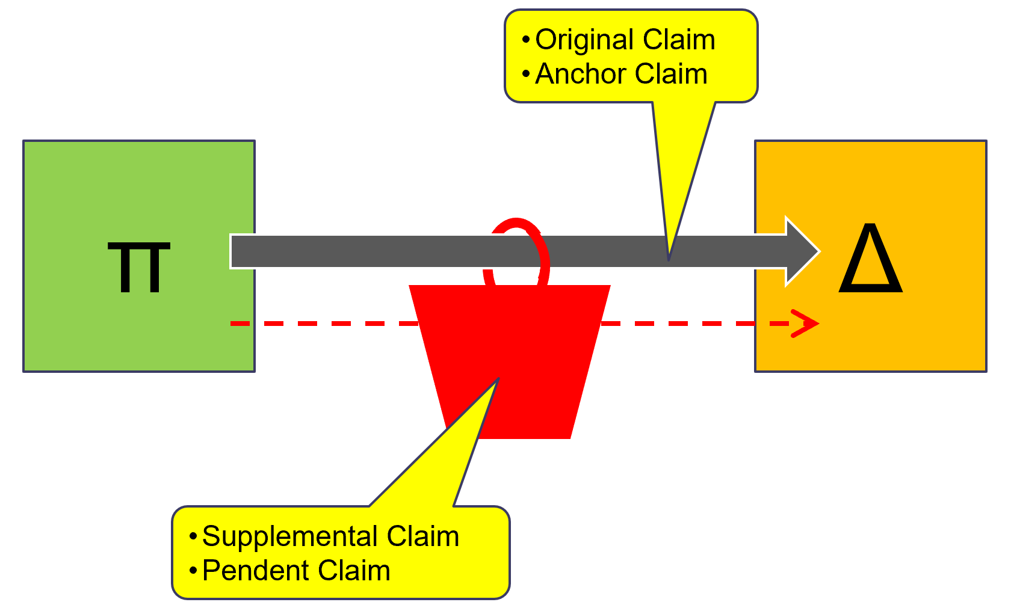

What does “same case or controversy” mean?
- “Same case or controversy” means both the claim over which there is federal SMJ and the claim arising under state law come from a common nucleus of operative facts
  - United Mine Workers v. Gibbs
- Stated another way – they are the same “conduct,” “transaction,” “occurrence,” or “series of transactions or occurrences”
**
- “Same case or controversy” does not have to involve the same party – final sentence of 1367(a) “Such supplemental jurisdiction shall include claims that involve the joinder or intervention of additional parties.”
  - Example - The anchor claim could be against D1. So long as the pendent claim comes from a common nucleus of operative facts it could be against D2.

§1367(b) - Supplemental Jurisdiction Based on Diversity
- Situation – the original P is in federal district court on the basis of diversity and wants to join a non-diverse D as a co-defendant or assert a claim against a 3PD – should they be able to do this?
  - NOTE! Had they attempted to assert this claim on its own it would have been blocked.
**
§1367(b)
- IF – original jurisdiction is founded solely on diversity (i.e., §1332)
- THEN – the district court does not have supplemental jurisdiction under sub. (a):
  - over claims by (the original) Ps against persons made parties under R14, R20 [also includes R19 and R24 – not relevant for this class]
  - [additional info about R19 and R24 situations]
- WHEN exercising supplemental jurisdiction over such claims would be inconsistent with the jurisdictions requirements of §1332
**
- NOTE! - §1367(b) only applies if there is no:
  - Federal question jurisdiction, §1331
  - Diversity jurisdiction, §1332

§1367(b) – Analytical Framework
Related to the claim in question:
(a) Is there federal question jurisdiction - §1331? | If yes, stop. You are finished.  - Federal question jurisdiction exists
(b) If (a) is no, is there diversity jurisdiction - §1332? | If yes, stop. You are finished.  - Diversity jurisdiction exists
(c) If (a) and (b) are no, is there supplemental jurisdiction? | To proceed, the claims must have arisen from a common nucleus of operative facts.
- Is original jurisdiction based on diversity - §1332? | - If yes, proceed.  - If no, stop – skip to (d).
- Is this claim an action by the original P? | - If yes, proceed – you might be in trouble.  - If no, stop - skip to (d).
- Is this claim made using R14 or R20? | - If yes – there is no supplemental jurisdiction.  - If no – proceed to (d).
(d) Does the court want to decline to exercise supplemental jurisdiction, §1367(c)? | - See section below.
- NOTE – this same chart is reproduced below with the other relevant joinder questions.

§1367(c) - Discretionary Refusal of Supplemental Jurisdiction
§1367(c)
The district court may decline to exercise supplemental jurisdiction over a claim under sub. (a) if:
- the claim raises a novel or complex issue of State law | Factors to consider  - Does the state law claim seem hard to decide?  - Have the courts of the State decided similar cases?  - Is the case law inconsistent or confused?  - Is the case distinguishable from prior State cases?  - If the case involves a state statute, is it new?  - Has it been previously interpreted by case law or can prior case law from another statute be used to interpret it?  - Would the combination of state and federal claims confuse the jury?
- the claim substantially predominates over the claim or claims over which the district court has original jurisdiction | The tail wagging the dog – i.e., pendant claim wagging the anchor claim  - Consider how much time and energy will be needed for supplemental claim v. main claim  - Only decline where the supplemental claim substantially predominates  - Need to be very, very sure as inefficiency results from declining supplemental jurisdiction  - Rule of thumb – if facts from supplemental claim are much more involved and mostly separate from the federal claim – consider declining
- the district court has dismissed all claims over which it has original jurisdiction | Included so the federal court can keep claims that are far along in the process  - To decline supplemental jurisdiction, the anchor claim must actually have been dismissed
- in exceptional circumstances, there are other compelling reasons for declining jurisdiction | Rarely used because of roadblocks already laid out above  - Really need “exceptional” circumstances or “compelling” reasons

Supplemental Jurisdiction – Analytical Framework
- Two step:
  - (1) Threshold question - Do the Rules allow these parties and claims to be joined in a single action?
    - Answer in 8(a), 18(a), 20(a), 13(a), 13(b), 13(g), 13(h), 14
  - (2) Is there a statutory basis for SMJ over each claim?
(a) Is there federal question jurisdiction - §1331? | If yes, stop. You are finished.  - Federal question jurisdiction exists
(b) If (a) is no, is there diversity jurisdiction - §1332? | If yes, stop. You are finished.  - Diversity jurisdiction exists
(c) If (a) and (b) are no, is there supplemental jurisdiction? | To proceed, the claims must have arisen from a common nucleus of operative facts.
- Is original jurisdiction based on diversity - §1332? | - If yes, proceed.  - If no, stop – skip to (d).
- Is this claim an action by the original P? | - If yes, proceed – you might be in trouble.  - If no, stop - skip to (d).
- Is this claim made using R14 or R20? | - If yes – there is no supplemental jurisdiction.  - If no – proceed to (d).
(d) Does the court want to decline to exercise supplemental jurisdiction, §1367(c)? | - See section on factors above.
- In analyzing, consider a diagram with a joinder column and a SMJ column
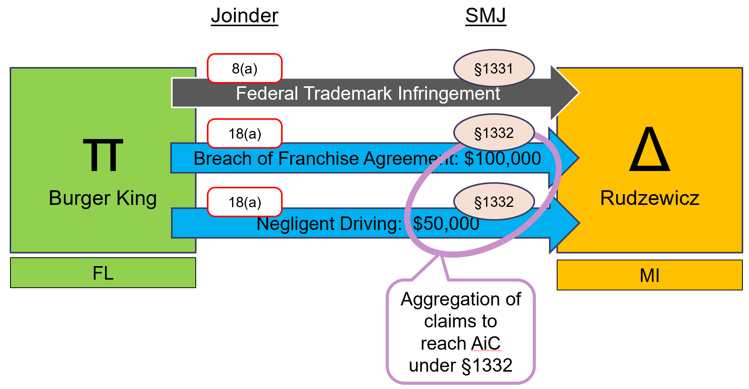

Supplemental Jurisdiction – Examples
Hair-ass Mint – Leaves a bad taste in your mouth
Tarski, a Cal. resident, subjects Bashara, also a Cal. resident, to age-based harassment at the Orange County Gazette. Bashara sues Southern California Media Group (SCMG), his employer and a Cal. incorporated company with its PPB in Cal., under Title VII – ADEA. Assume ADEA only works to bring a suit against the employer (unsure about this). Bashara also sues Tarski for a violation of Cal. State law. If Bashara wishes to bring his case in the C.D. Cal., can he?
- Q1 – joinder allows the claim against SCMG and Tarski to be brought as part of the same suit. R20(a)(2) allows them to be joined as Ds because (A) Bashara is asserting a right to relief against them jointly with respect to the same series of transactions or occurrences; and (B) the questions of fact in this case that will arise are common between them (note the questions of law are separate because the basis for relief is asserted under two separate theories.
- Q2 – there is also a statutory basis for SMJ over each claim.
  - There is a federal question against SMCG, so the C.D. Cal. has SMJ under §1331 federal question jurisdiction.
  - There is no federal question jurisdiction for the claim against Tarski. There is also not diversity jurisdiction because they are both citizens of the same state. There is, however, supplemental jurisdiction under §1367(a) in this case as the Cal. State claim against Tarski and the claim against SCMG arose from a common nucleus of operative facts so the State claim can be pendant to the federal question anchor claim.
United Mine Workers v. Gibbs
Tenn. Consolidated Coal laid off 100 United Mine Workers (UMW) from a mine in southern Tenn. in the summer of 1960. Later that summer, Grundy Co., a sub. of consolidated coal, opened a new mine near the one that was shut down. Grundy hired Gibbs to manage the mine and truck coal to the nearest R.R. Grundy also hired Southern Labor Union to work the mine. UMW protested at the new mine and ultimately had it shut down – they thought Consolidated Coal owed them jobs. Gibbs lost that contract as well as others in the area.
- Gibbs sued UMW for (1) violation of the LMRA; and (2) State law claims for conspiracy and unlawful boycott for both (i) the shutdown of the Grundy mine and (ii) for losing his other contract in the E.D. Tenn.
- ISSUE – both Gibbs and UMW have residency status in Tenn. Did the federal district court have SMJ to hear adjudicate both claims since the parties were not diverse?
- HELD – it did as the claims arose from a “common nucleus of operative facts.” Court also held they were the type of claims that would be brought together – however, key piece of the holding is that they were from a common nucleus of operative facts – i.e., the same transaction or occurrence or series of transactions or occurrences.

§1367(b) – Examples
Owen Equipment & Erection Co. v. Kroger
- Kroger, an Iowa resident, was electrocuted when he walked by a steel boom crane that was too close to an electrical power line. Kroger’s widow filed a wrongful death action in the D. Neb. against Omaha Public Power District (OPPD) alleging negligence in maintenance of its powerline
  - Basis for jurisdiction = diversity, Kroger – Iowa and OPPD – Nebraska).
- OPPD field a third-party complaint against Owen Equipment & Erection Co., the owner of the crane. Owen is a Neb. corporation; however, its PPB is in Iowa OPPD then moved for SJ.
  - Owen’s PPB in Iowa is potentially confusing based on the original way the Missouri river routed around Carter Lake Iowa then later altered its course.
- Prior to deciding on OPPD’s motion for SJ, Kroger sought leave to amend its complaint and add Owen as a D. Granted and they did.
- D. Neb. then granted OPPD’s motion for SJ leaving the only claim between Kroger and Owen.
- On day 3 of trial it comes out that Owen’s PPB is in Iowa – Owen then moves to dismiss, 12(b)(1).
- ISSUE – because the claim against Owen arose from the same set of operative facts, does the D. Neb. have supplemental jurisdiction to hear the claim between Kroger and Owen?
- HELD – no – reasoning - what eventually became §1367(b)
  - NOTE! The result would have been the same under R20(a) – i.e., Kroger sued Owen originally.
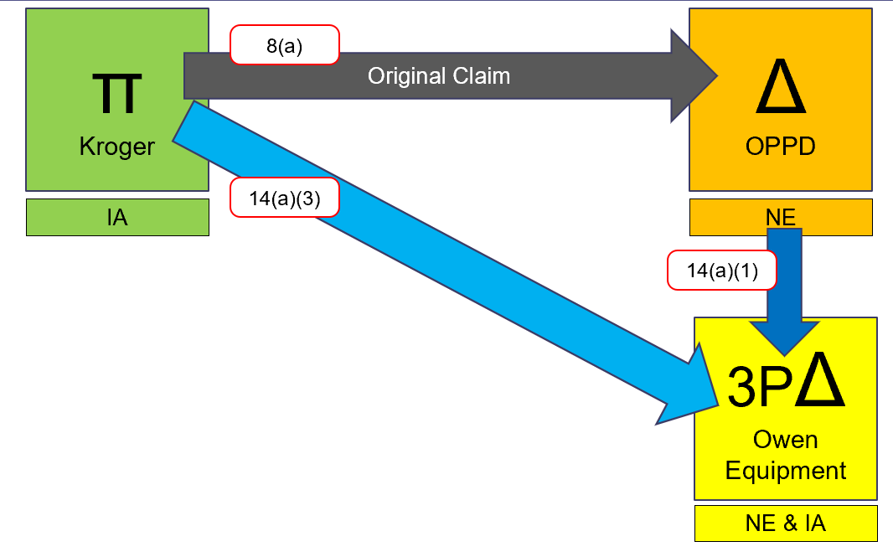
- The claim being analyzed is between Kroger and Owen
  - (a) Is there federal question jurisdiction – no, no federal question.
  - (b) Is there diversity jurisdiction – no, lack of complete diversity.
  - (c) Is there supplemental jurisdiction – well . . . the claim does arise out of a common nucleus of operative facts with the original claim.
    - (1) Is original jurisdiction based on diversity – yes, IA and NE + amt. in contro.
    - (2) Is it an action brought by the original P – yes . . .
    - (3) Is the claim an action brought under R14 or R20 – yes, R14(a)(3) in this case
    - CONCLUSION – then the D. Neb. does not have supplemental jurisdiction.
OPPD v. Owen
Does §1367(b) preclude OPPD from asserting its third-party claim against Owen?
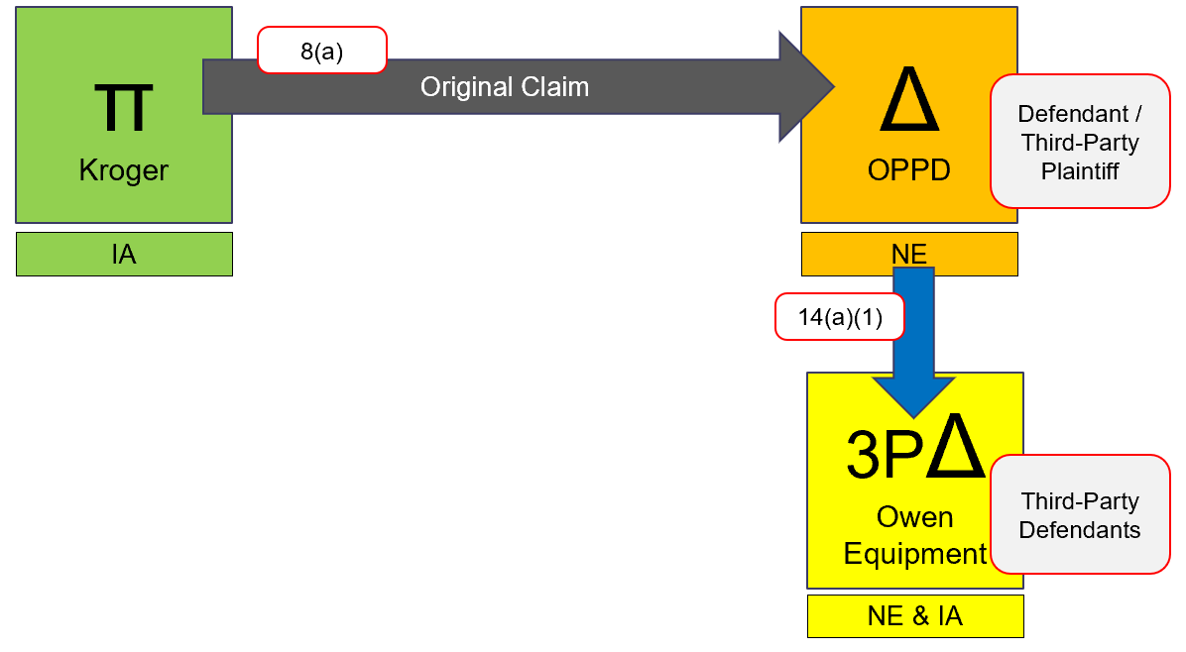
- The claim being analyzed is between OPPD and Owen
  - (a) Is there federal question jurisdiction – no, no federal question – it was state tort law.
  - (b) Is there diversity jurisdiction – no, lack of complete diversity.
  - (c) Is there supplemental jurisdiction – well . . . the claim does arise out of a common nucleus of operative facts with the original claim.
    - (1) Is original jurisdiction based on diversity – yes, Kroger’s claim against OPPD is IA and NE + amt. in contro.
    - (2) Is it an action brought by the original P – no
    - CONCLUSION – supplemental jurisdiction exists unless the court wants to decline it per the factors from §1367(c)
Gibbs v. Union
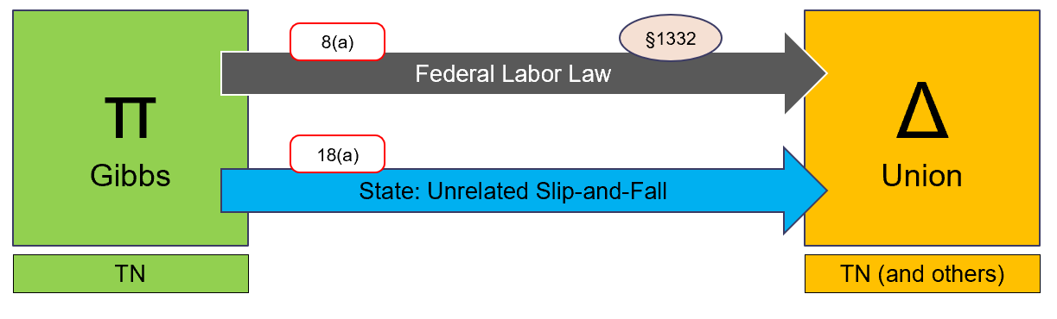
- The claim being analyzed is the state slip-and-fall claim unrelated to the federal labor law claim.
  - (a) Is there federal question jurisdiction – no, no federal question – it was state tort law.
  - (b) Is there diversity jurisdiction – no, lack of complete diversity, both from TN.
  - (c) Is there supplemental jurisdiction – no – the claim does not come from a common nucleus of operative facts.
    - CONCLUSION – supplemental jurisdiction does not exists.

Joinder Review Example
See notes on 03/31 for big example in using joinder rules.
Also see PPT for P v. Dealer and Manu. Invent a story around this to study.

Forum Selection and Joinder Framework
Consider implementing this.

Class Actions

Overview
- Class action – joinder tool to aggregate claims of several Ps with the same question of law or fact
  - Class representative – the P who litigates on behalf of all class members
  - Class members – Ps who are absent, but (theoretically) have their interest represented by the class representative
Class action pro / con
PROS – instrument of salvation | CONS – engine of destruction
- Parties can reduce the cost of litigation individually by splitting it across the group making it more viable  - Class members have a larger settlement value so contingent fees for attorneys are possible  - Efficiency - Conserves judicial resources by bringing several claims together | - Procedural concerns around class members who are not present and actively litigating  - Can be seen as preventing someone from having their day in court – i.e., class rep. does a poor job representing the class members  - Due Process Concerns – R23 does not perfectly ensure adequate representation  - Class actions are really driven more by the lawyer than the class members – attorney is really the benefitting party

Alternatives to Class Action
- 28 U.S.C. §1407 – Multi-district Litigation
  - Several cases filed all over U.S. with similar issues – judicial counsel on multi-district litigation can order thy all be moved to a single jurisdiction
  - Partial transfer – usually, the cases are combined for pre-trial and discovery for efficiency then spread back out for individual trial
- R20(a)(1) – Joining Ps
  - Parties can be joined as Ps if:
    - (A) they assert a right to relief arising out of the same transaction, occurrence, or series of transactions or occurrences; and
    - (B) they have common question of law or fact
  - Inefficient
    - Each P is required to individually prove its claim

Preclusion and Representation
- IF – class members are adequately represented in the class action
- THEN – they are precluded from late bringing a separate claim
- Claim Preclusion Review
  - Same claim – could have / should have been brought together
    - Arguably it was already brought together
  - Valid, final judgement on the merits
    - Applicable if the class action finished in trial court
  - Same parties
    - Taylor v. Sturgell – adequate representations in recognized setting qualifies as same parties
    - R23 is in place to ensure adequate representation
- Inadequate Representation
  - Hansberry v. Lee – no adequate representation, potential class members are not bound
  - Richards v. Jefferson Cnty. – the Due Process clause of the 14th Amendment is violated if litigants are bound by an earlier decision:
    - (*) to which they were not parties; and
    - (**) in which they were not adequately represented

Procedure
Class Action Litigation Timeline
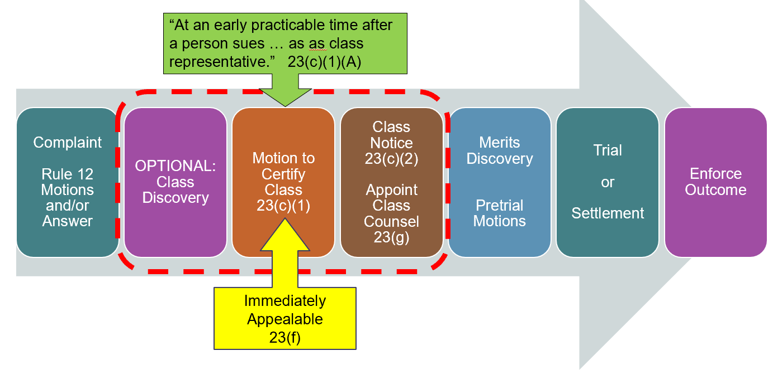
- Step 1 – file complaint
- Step 2 – file a motion for a certification order, R23(c)(1)
  - Motion must show all R23(a) requirements are met and that class falls into at least one group from R23(b)

Complaint
- Pleading must include a request that the case be certified as a class action under R23
- Pleading will allege facts necessary to meet all of R23(a) and at least one R23(b) – these will also go in motion to certify the class

Discovery
- **Additional discovery may take place prior to certification**
  - To file the complaint, counsel will need to get over R11 signature hump; however, the court may want more information prior to certifying the class
  - Pre-motion to certify the class - D will usually take deposition of class representative to ensure “typicality” and “adequacy” are met

R23(c)(1) - Certification of Class
- Timing – R23(c)(1) – “at an early practicable time after a person sues . . . as a class representative, the court must determine by order whether to certify the action as a class action”
- R23(c) is . . . easy as . . .
  - R23(a) – all thee
  - R23(b) – one suits me
- R23(c) – order from judge certifying the class – includes
  - The definition of which people are part of the class
  - Which claims or issues will be jointly resolved
  - Who will be counsel for the class

R23(a) – Prerequisites
- (a) One or more members of a class may sue or be sued as representative parties on behalf of all class members only if: all of the following are met
Prerequisite | Defined
Related to the class - Relationship of class members to each other
(a)(1) Numerosity | The class is so numerous that joinder of all members is impracticable  - No hard number requirement  - Generally . . . 20 is too small to proceed as a class – 40 is too large to proceed individually  - Geography might matter – the more spread out the more likely it is to e certified – those close might have an easier time all litigating together
(a)(2) Commonality | There are questions of law or fact common to the class  - Low bar – usually always some common question  - What matters – Wal-Mart Stores, Inc. v. Dukes - the capacity of a class wide proceeding to bring about a common answer, P must be ready to show this can be done through common questions that drive the litigation  - Objectively ascertainable - you can tell who is in v. out based on common questions  - Sub-classes are possible  - State law – in tort cases, where state law differs on proof necessary you could designate classes by state
Related to the representative – Relationship of class to class representative
(a)(3) Typicality | The claims and defenses of the representative parties are typical of the claims or defenses of the class  - Are the class representative and the class members interests really aligned?  - Questions for consideration  - Did they suffer the same type of injury?  - Is the class representative seeking the same type of relief?  - Is there a special defense or counterclaim that could be used against the class representative that is not available against the class?
(a)(4) Adequacy | The representative parties will fairly and adequately protect the interest of the class – includes: class rep. and counsel  - The class rep. cannot  - Have a conflict of interest with the opposing party  - Be adverse to its class members  - Be unsuitable for other reasons – e.g., might die before suit is over  - Counsel must be adequate to represent the class  - i.e., experience, knowledge of the law, and resources

R23(b) – Types of Class Actions
- A class action may be maintained if R23(a) is satisfied and if: one of more of the following is met
Class Type | Defined
(b)(1) Risk from separate parties | Outside the scope of this class  - Infrequently applicable
(b)(2) Injunctive Class | Final injunctive or declaratory relief is appropriate respecting the class as a whole
(b)(3) Superiority Class (Damages Class) | Two threshold questions:  - (*) The questions of law or fact common to class members predominate over individuals questions  - Common generally predominates if they are more complicated to solve than individual questions – consider:  - Evidence required to prove each  - If resolution of a common issue will significantly advance the litigation  - If the same basic liability theory is asserted which D can defend against with the same basic defense  - (**) Class action is superior to other available methods for fairly and efficiently adjudicating the controversy  - Does it make more sense to (1) go alone; (2) have a “test case;” (3) join Ps using R20(a)(1); (4) seek remedy from government oversight board  Factors to consider:  - (A) Class members interest in controlling their own case  - (B) The extent and nature of litigation already begun by class members  - (C) Desirability or undesirability of concentrating the litigation of claims in a particular forum  - (D) Difficulties in managing a class action

Differences between (b)(2) / (b)(3)
- Damages
  - (b)(2) – one injunction applies to all class members
  - (b)(3) – liability will be determined for the class, damages can be more individualized based on the individual person
- Judge’s Discretion in Certification
  - (b)(2) – little, you either have it or you do not
  - (b)(3) – lots, requires considering if common question predominate over individual ones and if the class action is superior
- Chance to opt. out
  - (b)(2) – no chance, not really required
  - (b)(3) – must give people a chance to opt. out of inclusion in class and again prior to settlement
- Notice
  - (b)(2) – R23(c)(2)(A) – the court may direct notice to be given
  - (b)(3) – R23(c)(2)(B) – notice must be given of both inclusion in class and proposed settlements

R23(f) – Appeals
- Interlocutory appeals allowed - Court of appeals may permit an appeal from an order granting or denying class-action certification
- Timing – petition for appeal must be filed:
  - Within 14 days after R23(c)(1) order is entered
  - If any party if the United States within 45 days
- Lower court – appeal does not stay proceedings unless district court judge or court of appeals judge orders so
**
- Why allow for interlocutory appeals?
  - Class certification has a massive impact on the remainder of litigation
    - P’s POV – if the class does not get certified, the suit may just be over – (sometimes) no incentive to litigate individually
    - D’s POV – if class does get certified, they may be more likely to pursue immediate settlement

Example - Class Action Procedure
See also Orndorff v. Jefferson Cnty. from course pack
RE: Teflon Product Liability Litigation
DuPont produced Teflon and non-stick cookware coating (NSCC) in 1938 and began selling it in 1946. It sold NSCC to other companies for use on their products. By the 50s and 60s it knew with normal use the chemical would decompose and create flu-like symptoms in people that used it. It kept selling it anyway. P files complaint alleging (1) DuPont made false or misleading statements regarding the safety of its products; and (2) DuPont knew or should have known about the risks and failed to inform consumers. Relief sought:
- Class certification – 23 separate classes split based on how state tort law defines a product liability action
  - Sub-classes – also, 3 subclasses within each class
    - Sub. 1 – individuals who purchased NSCC marked “Teflon” who still possess the cookware, packaging, or other documentation of possession
    - Sub. 2 – individuals who purchased NSCC not marked with a DuPont tradename, but believed to contain DuPont’s NSCC who still possess the cookware, packaging, or other documentation of possession
    - Sub. 3 – all purchasers or owners of cookware coated with DuPont NSCC who do not qualify for subs. 1 or 2
- Remedies
  - (1) Injunction requiring DuPont to place a warning label on its products
  - (2) Replace or provide cash equivalent to all class members for non-hazardous cookware
  - (3) Creation of a fund for scientific research to investigate adverse health effects of NSCC
Should the class be certified?
R23(a) Prerequisites – All are required to proceed
- (a)(1) – Numerosity – DuPont conceded numerosity exists
- (a)(2) – Commonality – DuPont argued and court agreed that the sub. classes were not objectively ascertainable – would require speculation about falling into a sub. class.
  - Sub. 1 – definition is too stringent to be readily applicable. People generally do not have the information required to meet the documentation requirements and the actual pots and pan do not specifically say “Teflon” on them.
    - E.g., the Texas class rep. had no idea when or where she acquired her pan or if it was “Teflon” coating.
  - Sub. 2 – P claimed DuPont should have information about which manufacturers used NSCC; however, they do not. This again requires P to produce documentation evidence, similar to with Sub. 1, it unlikely exists.
  - Sub. 3 – there is no way to tell who is actually included in this group. It does not require hard evidence to be included so there is no way to tell in or out.
- (a)(3) – Typicality – does not exist because to seek relief P must show that it was improperly warned. Each individual P will need to demonstrate what warning it saw and why they were improper. DuPont would theoretically have the right to depose each P related to this information and they plan to.
  - Depositions from class reps. already show a wide variety of variation on this.
- (a)(4) – Adequacy – not met in this case because class reps. are not seeking damages based on risks to health. They are only seeking injunction related to warning.
  - Other members likely will want to seek damages related to health.
HELD – prerequisites are not met.
R23(b) Type of Class – trying for (b)(2) related to injunctive relief and (b)(3) related to replacement
- (b)(2) – is injunctive relief appropriate?
  - Court held that this was a toss in window dressing request for relief – i.e., not the main reason the Ps are here - so did not qualify for class action.
  - Also said this class is not bound in the same way – this point is arguable – usually reserved where class members are grouped by gender, common belief, or membership
- (b)(3) – are the threshold questions met?
  - Do the common questions of law or fact predominate over individual ones?
    - Not in this case – each P saw different advertisements concerning safety, so it is hard to saw there really are common questions. Ps also used the products differently and purchased them at different times so individual questions exist.
  - Is class action superior to other litigation types?
    - Not in this case – court does not see class action as superior as it does not want to preclude P from raising personal injury actions. Each class member likely wants to control its own prosecution – R23(b)(3)(A).

Settlement, Voluntary Dismissal, or Compromise
- Non-class action – parties can decide to settle on their own
- Class action – to protect the interest of the class members, the judge must approve the settlement to ensure it adequately protects the interest of the class

R23(e)(2) – Approval Process
- If it binds the class members, the court may approve only after a hearing and only on finding that it is fair, reasonable, and adequate after considering whether:
  - (A) The class rep. and counsel have adequately represented the class
  - (B) The proposal was negotiated at arm’s length
  - (C) The relief is adequate – consider (i) cost of trial, (ii) method of distribution, (iii) attorney fees
  - (D) The proposal treats all class members equitably in relation to one another
**
- The approval process exists because class actions can be prone to sweetheart deals – attorneys and class rep. might take a payout to dismiss or settle on the down low

R23(e)(5) – Class Member Objections
- (A) Class member can object to settlement
  - The objection must state:
    - If it applies to the specific class member, on the whole, or to a sub. class
    - The grounds for objection
- (B) Unless approved by the court, not payment or other consideration may be provided in connection with:
  - (i) withdrawing or forgoing objection
  - (ii) forgoing, withdrawing, or abandoning an appeal of a settlement, VD, or compromise approval

Notice Requirements

Summary
- Is notice required?
Class type | For certification | For proposed settlement
(b)(1) and (b)(2) | Not required | Required, R23(e)(1)
(b)(3) | Required, R23(c)(2)(B)  - Must provide opportunity to opt. out, (c)(2)(B)(v) | Required, R23(e)(1)  - May have to provide a second opportunity to opt. out, (e)(4)

At time of certification
- For (b)(1) and (b)(2) classes
  - Notice is not required - (c)(2)(A) – the court may direct appropriate notice to the class
  - What’s the point?
    - An injunction is the result, and it is only broadly applicable – opt. out. is nonsensical
- For (b)(3) damages classes
  - Required – (c)(2)(B)
    - Purpose is to let potential class members know the action is pending and that it may affect their rights.
    - (c)(2)(B)(v) – “the court will exclude from the class any member who requests exclusion”
  - Standard for providing notice
    - “. . . the best notice that is practicable under the circumstances, including individual notice to all members who can be identified through reasonable effort.”
    - May use any appropriate means including:
      - U.S. mail
      - Electronic means (e.g., emails, texts, advertisements)

At time of settlement
- Required for all class types – R23(e)(1)
- For (b)(3) classes – the court may refuse to approve the settlement if it does not provide another opportunity for class members to opt. out.

Class Action – Forum Selection

Subject Matter Jurisdiction

Federal question
- No difference

Diversity - §1332(d)
Part of the Class Action Fairness Act of 2005
- (2) District Court shall have original jurisdiction of:
  - (*) Any civil action in which the amt. in controversy exceeds $5m, exclusive of interest and costs; AND
  - (**) Which is a class action which
    - (A) any member of a class of Ps is a citizen of a State different from any D
    - (B) any member of a class of Ps is a foreign state or citizen and D is a citizen of a state
    - (C) any member of a class of Ps is a citizen of a State and any D is a foreign state or citizen
      - “Class” means class rep. and class members - §1332(d)(1)(A)
- (3) District court may decline SMJ over a class action where:
  - More than 1/3 but less than 2/3 of the class members + the D are from the state the action is filed in
  - Action has attributes that make it “state centric”
**
- Amt. in controversy – (d)(6) – claims shall be aggregated to determine whether the amt. in controversy exceeds the sum or value of $5m
  - i.e., it would be possible to have 1,000,000 people with a $5 claim
  - For injunctive relief – court needs to estimate value
  - Can P state in its complaint that it will seek $5m or less?
    - You cannot do this.
    - Standard Fire Insurance v. Knowles (U.S.) – P cannot state in complaint it will seek less than $5m in relief. At the time of the complaint, P is not a representative of the class. In certifying the class, P will not be an adequate representative where they seek less than full damages amount.
- Minimum Diversity – (**) is only prohibited where all parties are citizens of the same state
Class Action Fairness Act of 2005
- Chambers of commerce and corporations wanted class actions to be more readily available in federal court. Reasons:
  - Smaller dockets – federal courts are generally less busy than state so resolution will be faster
  - National focus – where national issues are at stake, federal government wants to be involved in their resolution

Personal Jurisdiction
- NOTE! – Philips Petroleum was a 23(b)(3) damages class action – potentially leaves the door open for different rules for a (b)(1) / (b)(2) mandatory class class actions
- ISSUE - can a forum bind an out-of-state P concerning a claim for money damages or another remedy at law?
  - Yes – so long as:
    - (*) the out-of-state P has notice and an opportunity to be heard (notice is based on Mullane standard)
    - (**) the out-of-state P has had an opportunity to remove itself from the class
    - (***) the out-of-state P is, at all times, adequately represented by the named class rep.
- Philips Petroleum Co. v. Shutts – Petro company had leases to drill for natural gas on Ps’ properties. Plaintiff class spanned 11 different state. Petro was not paying what it had promised. The selected forum was Kansas. Review of PJ:
  - D – PJ existed for normal reasons (i.e., either traditional or modern methods)
  - P (class rep.) – consented to litigate in Kansas
  - P (class members) – this case decided that this was ok so as the requirements above are met.

Venue
- Normal rules apply

Removal
- §1453 – Removal of Class Actions
  - Generally . . . follow §1446; however, §1453 makes the following changes to make it easier to get to federal court
 | Removal of Non-Class Action | Removal of Class Action Post CAFA of 2005
Consent | 1446(b)(2)(A)  - All served Ds must consent to removal | 1453(b)  - Any served D may force removal without the consent of others
In-State Defendant | 1441(b)(2)  - Ds who are citizens of the forum state cannot remove diversity cases | 1453(b)  - D may remove any class action, regardless of citizenship in forum
Removal Deadline | 1441(b)(1)  - D must remove within 30 days of a removable pleading  1446(c)(1)  - If jurisdiction is based on diversity, no removal 1 year after action starts (i.e., for amended pleadings) | 1453(b)  - No one-year limit for removing diversity class actions
Interlocutory Appeal | 1447(d)  - Not allowed.  - Orders denying motion to remand are not appealable final judgements  - Orders granting remand are not appealable at all | 1453(c)(1)  - With some exceptions, orders granting or denying motion for remand of a class action are subject to interlocutory appeal

1453(c) – Exceptions to Review of Remand Orders
- (c)(1) – Application to Ct. App. for review of remand order may be accepted when filed not more than 10 days after the district court has entered the order granting or denying remand
- (c)(2) – Ct. App., if it accepts the appeal, has 60 days to decide
- (c)(3) – Ct. App. can extend 60-day window if:
  - (A) all parties agree – indefinite time period
  - (B) for cause or in the interest of justice – 10 additional days

ROADMAP FOR PERSONAL JURISDICTION
- Long-Arm Statute
Does the relevant long-arm statute authorize this court to exercise PJ in this case?
**
- Federal Long-arm Statute – R4(k)(1)(A) – the U.S. district court is directed to rely on the long-arm statute for a state court of general jurisdiction for the state where the district court is located.
  - Exam Tip! Don’t talk about “State” generally as this is a conclusory restatement of the rule – mention the State from the facts
- State long-arm statute – two types: (*) laundry list; (**) constitutional maximum
  - IF – laundry list, (1) decide if case is covered and list which statutory provision covers it; (2) confirm the assertion of PJ satisfies the Constitution’s due process clause
  - IF – constitutional max, proceed to B

- Constitution
Would exercising PJ in this case violate due process?
  - Traditional Bases of PJ
Short name | Long name | Explained
Present Party  (Service must be proper for this to be sufficient) | If the party was present in the forum at the commencement of the lawsuit | Ds who lived out of state would be considered present on if they were served with process within state boarders
Domiciled = Dominated | If the party was domiciled in the forum | A citizen of the forum could be sued in the forum even if process was served elsewhere
Consent | If the party consented the court’s power | Some Ds would consent, and all Ps consent by the act of filing suit in that forum
Present Agent | If the party had an agent for service of process who was served within the forum

  - Modern / Minimum Contacts / Int’l Shoe Method
Begin by identifying:
  - D’s contacts with the forum
  - That are purposeful

    - Specific Personal Jurisdiction (case-linked)
May be used when case “arises out of” or “is related to” D’s purposeful contact with the forum.
    - D’s purposeful contact must be more than the “minimum;” and
    - PJ over D in this forum must be “reasonable”
**
Contacts
- Categories are listed as structure from how we studied in class – could apply across fact patterns.
Contracts
- Things to consider
  - D has called, emailed, or sent letters to the forum state in order to derive benefit for itself
  - D has negotiated with a party in the forum state
  - D is availing itself of the forum state’s economy by receiving payments from customers there
- Hanson v. Deckla – Contact must be purposeful
  - Unilateral activity of the party claiming a relationship with the non-resident D does not, on its own, give the non-resident D purposeful contracts with the forum.
- McGee v. Int’l Life – Party can walk into purposeful contacts
  - If non-resident D acquires a relationship with P and proceeds to receive benefit from P, then it is subject to PJ in P’s jurisdiction.
    - Public factor – forum state will want to provide an option for its resident to resolve a dispute; evidence may be located in the forum.
- Burger King v. Rudzewicz
  - A party intentionally reaching out and touching a forum is sufficient minimum contacts.
  - Choice of law provision do not grant PJ over a party; however, they do evidence a long-term relationship under which the party intends to avail itself of the forum state.
Torts
- Things to consider
  - For negligence, consider two step
  - For intentional torts, tortfeasor’s actions must have been:
    - (1) Intentional
    - (2) Uniquely or expressly aimed at the forum state and
    - (3) Resulted in harm in the forum state
      - Breakout on aimed at forum – Calder v. Jones & Walden v. Fiore should both be satisfied
- Calder v. Jones – Purposeful Contacts with forum
  - D called and messaged people in forum
  - The harm was caused based on activities that occurred in the forum
  - D sent the harmful story to forum and widely circulated it
- Walden v. Fiore – Purposeful cannot be the result of P’s unilateral activity
  - Where intentional harm is caused then P travels to the forum state and is harmed there, D’s actions are not expressly aimed at forum state. Consider flip side – P could have traveled anywhere, D has no control over P’s movements.
Steam of Commerce – Ds without “actual” contacts
- Things to consider
  - Stream of commerce is a way to justify minimum case related contacts
  - Only applies where D does not independently have actual contacts with the forum state
  - Applies where D delivers products into the stream of commerce with the expectation they will be purchased in the forum state
- Asahi Metal Industries Co. v. Superior Court of Cal. – Meaning of “expectation”
  - Justice Brennan – D is “aware” the final product is being marketed in the forum state – all that is required is a reasonable prediction
  - Justice O’Connor – D has “intent or purpose” to serve the market in the fourm state – requires knowledge of forum sales or intent to reach that forum – things to look for that indicate intent:
    - For non-US suppliers:
      - Manufacturing products in imperial units when they would otherwise use metric
      - Printing warnings and instructions in English
    - Compliance with forum specific regulatory requirements
    - Contractual indicators – i.e., does it say stuff is going to a specific market
    - Advertising – does the component part supplier want its logo on package in the forum?
Fairness and Reasonableness
- Fairness factors
Relative importance to . . .
Liberals | Conservatives
Neutral  Neutral  ( - )  ( - )  ( + )  ( + ) | Neutral  Neutral  ( + )  ( + )  ( - )  ( - ) | - Reciprocity  - Probable location of evidence  - D’s control over its fate – i.e., consent  - Fair warning to D it might be subject to suit  - The forum state’s interest in accountability and law enforcement  - P’s access to court
- Reasonableness factors
Relative importance to . . .
Liberals | Conservatives
( - )  ( + )  ( + ) | ( + )  ( - )  ( - ) | Private Factors  - Burden on D  - WW VW – “always a primary concern”  - BK – only relevant if burden creates a “severe disadvantage” to ability to defend  - P’s interest in access to local courts  Public Factors  - Forum states interest in adjudicating the case  - WW VW – states should not “reach out beyond the limits imposed on them by their status as coequal sovereigns in a federal system”  - BK – “a State generally has a manifest interest in providing its residents with a convenient forum for redressing injuries inflicted by out-of-state actors”  - Judicial efficiency across jurisdictions  - “Shared interests” of states in furthering “substantive social policies” (rarely relevant, usually resolved with choice of law)

    - General Personal Jurisdiction (all-purpose)
May be used whether or not case “arises out of” or “is related to” D’s purposeful contact with the forum.
    - Natural persons in their domicile; or
      - NOTE! Also satisfies the traditional method of “domicile.”
    - Corporations or other business entities where they are “essentially at home,”
      - Daimler v. Bauman – essentially at home means:
        - State of incorporation
        - Principal place of business
      - Narrow exception – Perkins v. Benguet Mining – PPB may temporarily move for extraneous reasons and re-establish where day to day operations are taking place.
    - Fairness and Reasonableness
      - Consent – based on domiciling / locating itself there, party has essentially consented to litigate in the jurisdiction
      - Burden – conceptually should be none beyond normal burden of litigation
      - Government interest – satisfied as government has power over citizens within its borders

Name | Rule | Existing Parties | Same Transaction / Occurrence / Property | Common Question of Law or Fact | Derivative Claim (Contribution / Indemnification) | Outsider Interest
(Permissive joinder of claims | 18(a) | Additional or alternative claims can be brought against existing parties | Not required | Not required | Not required
Permissive counterclaims | 13(b) | One party must exist – but if the asserting party wants to add another they can through R13(h) – so long as 20(a) requirements are met. | No – would be compulsory if so | Not required | Not required
Compulsory counterclaims | 13(a) |  | Required | Not required | Not required
(Permissive) Crossclaims | 13(g) |  | Required to relate to:  - The original action  - A counterclaim  - Property | Not required | Not required
Permissive joinder of parties | 20 | Governs how parties can be joined in one action | Required | Required | Not required
Required joinder of parties | 19
(Permissive) third-party claims | 14 | No – 14(a)(1) governs the addition of another party | Not necessary  - However, if P wants to add a claim against the 3PD it must be from the same transaction or occurrence | Not required | YES – can only be asserted to seek contribution or indemnity
Permissive intervention | 24(b)
Intervention of right | 24(a)
*Civ. Pro. 1L does not cover the greyed out interests.

JOINDER BASICS
- For joinder . . . start with the simplest lawsuit imaginable. One P, one D, one claim
- To add more claims or parties, each joinder rule requires a claimant to identify one or more of the following relationships between (a) the action as pleaded so far and (b) the claim or party to be added
  - (A) Same Parties
    - A new claim is asserted between parties already named in the action.
  - (B) Same Transaction / Occurrence
    - A new party or claim is connected to events already at issue in the action.
  - (C) Common Question of Law or Fact
    - A new party or claim is connected to an identified question of law or fact already at issue in the action.
  - (D) Derivative Claim
    - A defending party seeks reimbursement from another party in the event of an adverse judgement on a claim already in the action. Derivative claims will be available depending on the substantive law or contribution or indemnification.
  - (E) Outsider Interests
    - Outsider interests may allow or require joinder when a person or entity not named as a party to the action has legal interests that affect (or are affected by) claims already in the action.

