What is a K?
- Contract:
  - Promise or set of promises for the breach of which the law gives a remedy, or the performance of which the law in some recognizes as a duty. Agreement between parties regarding something to be done in the future by one or both parties. Law of contracts is a legal mechanism to protect expectations from private agreements.
- Agreement: (Rst 2d 3
  - A Manifestation of mutual assent (basis of contractual obligation) on the part of the 2 or more persons. Offeror is the master of the offer and specifies the way the offer should be accepted.
- Bargain: (Rst 2d 3)
  - Agreement to exchange promises or to exchange a promise for a performance or to exchange performances
BQ1: What law applies?
- Else → CL/Rst
- UCC:
  - Article 2 applies to K for SOG Uniform state proposal.
  - Tangible, movable goods + UCC gap-fillers w/ CL-RST
    - E.g. manuf. Goods, livestock (born/unborn, growing crops) ; NOT: $ in which price to paid, real property (house, vacant lot, etc.), services (empl. K), various intangible rights (IP)
  - If no UCC rules for a ter→ , CL fills in gaps e.g. “Offer” definition
  - UCC trumps restatement
- Mixed K
  - Maj. Predominate purpose test / Min. Graveman of complaint test
  - Predominate Purpose Test
    - Rule: Where a K is mixed, its predominant character controls and is determined on the facts the same at sea as ashore, the wording, nature of the supplier’s business and intrinsic worth of material are relevant. If predominate purpose is rendering services rather than the furnishing of goods, the UCC is inapplicable. Courts must interpret the contract under common law doctrines
    - CL / Rst
      - Princess v. GE K
Facts: Complaint for services; allegation of breach related to goods parts. Princess supplied offer to GE; GE provided C/O,
Holding: BQ1: UCC applies for SOG. Princess could only recover expectancy damages
Rule: Under last shot rule GE’s terms controlled to limit liability to expectancy damages, NOT consequential damages. Pred. Purp Test = for service of cruise ship, goods were ancillary to service of K even though value in respect to overall K was high. Princess accept C/O through conduct (told GE to go ahead with repairs). GE’s terms controlled (last shot rule); GE had limitation of liability clause for expectancy damages only, NOT consequential damages (loss of Christmas and Easter cruise revenue)

    - UCC
      - Festival Foods
-Where pred. purp of K was for sale of goods moveable and tangible food truck/itemized equipment, and business name and know how [services] were ancillary / NOT the significant aspect of transaction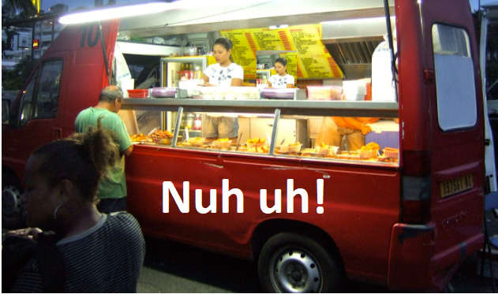)
-F: Defendants (Buyer) returned food truck after not making as much income as expected; sale was for more than $500.
-H: Agreement was found even though time of formation was indefinite. Transaction was primarily for the goods (moveable truck, refrigerator, other equipment itemized). D breached K by returning goods. bc Formed by 2-204 (conduct, moment of making undet., open terms not fail for indef. If intend to be bound and area reasonable basis for giving approp. remedy) otherwise no MA fail for CL indefiniteness like Walker v. Keith so no enf. K.
-Rule: Under UCC, time of making the K not important so long as subject matter and quantity is specified)

BQ2: Is there an ENF agreement?

- Look for termination events, who says/does what?
- Formation :
With limited exception a bargain which there is manifestation of assent to the exchange and a consideration (Rst 2d 17 (1))
- Mutual Assent:
manifestation to be bound (can be verbal, written, conduct) by both parties. Requires each party make a promise or being to render performance (Rst 2d 18). Requires Offer and Acceptance.
- Offer:
a direct, complete proposal that a K be entered into, providing an exchange of defined performance. A ends O. All O’ee needs to say is “yes”.
. an offer is the manifestation of willingness to enter into a bargain, so made as to justify another person in understanding that her assent to that bargain is invited and will conclude it
- Consideration:
BFE = Reciprocal inducement to enter into the agreement

- Formation (requires MA (O + A) + C):
  - CL/Rst:
    - Agreement by parties (usually 2 or more) that something will be done by 1 or more of them in the future. Requires a bargain in which there is manifestation of mutual assent to the exchange and consideration.
  - UCC:
    - Contract for SOG may be made in any manner sufficient to show agreement, including conduct. An agreement sufficient to constitute may be found even though moment of making K is undetermined (Festival Foods). Contract does not fail for indefiniteness if there are open terms if parties intended to make a K and there is a reasonable basis for remedy. (need subject matter and qty 12 frozen turkeys)

- Mutual Assent (Intention to be bound)
  - Background
    - MA: O + A:
      - Requires that each party make a promise or begin to render performance.
    - Objective Theory:
      - manifestation of MA; words and conduct of the parties – would a reasonable person in the position of the party who seeks to enforce the K conclude that K had had been formed?
    - Subjective Theory: Based on intent of the parties (meeting of the minds)
  - Offer:
    - Offer:
      - the manifestation of willingness to enter into a bargain, all Offeree needs to do is say “yes” . Reasonably interpreted to invite an acceptance to form an enf agreement
      - An offer is assent to bargain invited and concludes the offer
      - Manifest objective willingness to be bound, end negotiations by inviting assent
      - That a K will arise w/o any further approval being required from the offerror
    - RST
      - Always ask if Offer invites acceptance specifically explicitly by performance, or promise, or both, or is silent. Otherwise RST 32 = O’ee CHOOSES
      - Rst 30: An offer invites acceptance in any manner and by any medium reasonable in the circumstances unless otherwise indicated by the language or the circumstances
      - Rst 24 (Basic Test):
        - inviting acceptance in any manner/medium reasonable under the circumstances
(1) must be communicated to the person to whom it is addressed
(2) must indicate desire to enter into a K, specifies performances exchanged and terms…can prescribe the manner of acceptance …invites acceptance…reasonable understanding that acceptance will create a K.
    - Advertisements:
      - Generally
        - Not an offer, but an invitation to make an offer.
        - language of commitment or some invitation to take action without further communication. Needed to be an offer
        - Ads are not offers because of risk of over-acceptance.
      - Exception
        - RST 26
          - Where it invites action w/o further commitment and specifies subject matter and quantity
      - Ad is an offer (fur stole case)
        - Lefkowitz (fur stole case)
Ad specifies price, allocation, and quantity = sufficiently definite
Facts: Fur stole for $1, first come first served. First person is a man, doesn’t get stole b/c of sex. Man sues.
Holding: Court says ad was on offer b/c it specified quantity and process to allocate limited quantity.
Rule: Enough specificity for an offer; ad invited acceptance. Ad with quantity of item specified and “first come, first served” = offer
      - Ad is an offer (bait and switch)
        - Izadi
Facts: P attempted to buy Ford advertised in D’s ad based on what P believed to be an offer with certain provisions. D did not accept P’s interpretation of ad and refused to sell Ford to P. P brought forward claim.
Holding: Ct ruled that regardless of D’s intention, language of ad could spell out an offer to a reasonable person. D’s ad was also intentionally misleading (bait and switch)
Rule: Ad was deliberately designed to mislead; reasonable consumer could be misled by ad.
      - Ad is an offer (No over acceptance problem)
        - YYS Shop Hypo

Ad was an offer; invites acceptance by performance, no over-acceptance problem
      - Ad is an offer (Rewards Programs)
        - Camel Cash.
  - Usually NOT offers
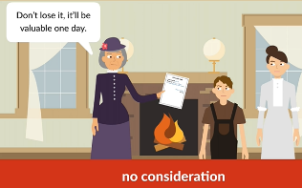
    - Gift promise (no BFE)
      - Doughterty v. Salt
Facts: An aunt’s promise to pay $3000 to her nephew upon death with a promissory note stating “value received”. Guardian of nephew’s testimony that aunt gave promissory note with nothing in exchange for the note.
Holding: No ENF K. No BFE. Nothing of value exchanged, nephew (8 at the time) did not exchange anything for consideration.
Rule: The promise was neither offered nor accepted with any other purpose. “
    - Preliminary Negotiations
      - Rst 26:
not an offer …knows not intend to make bargain without further manifestation of assent (examples: price quotes, ads, form letters, -don’t invite acceptance
      - Form Letters / Reply letters / Incomplete Offer
        - Form letter: analog of ad; Joshua Tree case
        - Reply letter: not an offer; inviting acceptance Joshua Tree case
        - Incomplete Offer: (An offer = assent to bargain invited and concludes offer Rst 24.)

        - Lonergan v. Scolnick (Joshua Tree Case)
Facts: D wrote a form letter to P re: 40 acres in Joshua Tree, who wrote D a letter asking for details regarding property. D responded and said P needed to act fast. D sold land to another before P wrote back accepting.
Holding: Appellate ct ruled there was no offer, only form letter and letter answering questions & necessity to act fast. Not reasonable to think offeror would make offer to 2 buyers. Illustrates that offer is close to being done but not done, NOT an offer; there are still parts to be filled in – shows difference between preliminary negotiations and offer. No MA; ad is not an offer; An Ad doesn’t invite assent to a bargain which concludes it (Rst 24 Joshua Tree case). to use of a form letter, and answering questions regarding where communication between the parties NOT evidence a definite offer and acceptance.
Rule: O’ee knows or has reason to know based on the circumstances at the time, that the O’or does NOT intend their expression as an offer until O’or gives further assent .
    - Price quotes:
      - Hercules v. Brown.
Facts:
Holding: Price quote was not an offer, but invitation to enter offer; purchase order was the offer
Rule:


    - Joke Offers
      - Cases: Lucy v. Zehmer: parties at restaurant; sale of farm for 50k. Intoxication not a defense; D claimed K to sell farm on napkin wasn’t an offer, was a joke. Ct stated it was reasonable to think seller was serious (objective test for obj.MA; if a reasonable person in that matter would have thought the O’or was serious, there was a contract)

      - Pepsi Harrier jet case: Ad to get people to drink Pepsi. Issue was whether P should’ve known TV commercial was a joke. Objective test: a reasonable person wouldn’t have taken the ad seriously.
      - Paraphrased: An offer can be determined to be made if based on reasonable conduct (words and acts) could be judged to manifest intention to agree or if a reasonable person would have taken the ad seriously when the details of the offer were reserved in a separate writing (Lucy v. Zehmer and Pepsi Harrier jet case)
  - UCC:
    - Overview
      - If K for SOG (Article 2) under UCC and conflict with CL, UCC rules control over CL
        - 2-106 (1) (Sale definition)
          - Sale is the passing of title (ownership) from the seller to the buyer for a price (not included leases or gifts)
          - “K for sale” includes both present and future SOG
        - 2-105(1) (Goods definition)
          - Goods: All things…which are moveable
      - Gap fillers if no UCC rules by UCC 1-103(b) e.g. “offer” definition so CL/RST gap fills
      - Subject matter and quantity are essential (material) terms;
    - 2-204: Formation in General
      - Any manner sufficient to show agreement, including conduct by both parties, which recognizes the existence of a K.
      - Moment of K’s making can be undetermined
      - K for sale not fail for open terms bc of indefiniteness for if (1) the parties intended to make a K (2) AND there is a reasonably certain basis for giving an appropriate remedy (Festival Foods)

- Termination of Offer
  - CL: To be ENF an option K requires MA and separate Consideration
  - UCC

  - RST
    - Generally
      - Rst. 36: (Free revocation before acceptance)
        - Revocation; free revocability of Offer by O’or until Acceptance
        - Rejection
        - C/O (bc not mirror image of offer. “Inquiries” are not C/O)
        - lapse of time (at end of face-to-face meeting)
        - A promise to keep open without consideration = gift promise.
        - For option K so can freely revoke any time before acceptance by O’ee
        - death/incapacity of offeror (but not terminated if there is a K and one of the parties dies, that party’s personal rep. would have the right to enforce the K),
      - Rst. 59: (Acceptance Varying Offer)
        - Purported acceptance w/ varying term = counteroffer which functions as a rejection; depends on offeror’s assent to the new terms
      - Rst 43: (O’or inconsistent action terminates)
        - Indirect communication of Revocation. Offeree’s power of acceptance is terminated when O’or takes definite action inconsistent with an intention to enter into the proposed K and the O’ee acquires reliable info from a credit source to that effect.

      - Normile v. Miller (snooze you lose)
Facts: P wanted to buy home from D and drafted offer to purchase. D returned C/O with changed specifications (form filled in blank #9 “offer must be accepted by 5pm 8-5pm”). D returned with changes (material). P did not accept but P held onto C/O, thinking property was off market (option K), but made no rejection/acceptance of C/O. D sold house to another P. P sued for BOC and specific performance (sell home to her).
Holding: Ct affirmed judgment because D rejected initially offer by providing C/O which terminated the offer. P never accepted D’s C/O – no K was formed bc O1 terminated when C/O. D no acceptance C/O. No consideration for Option K (alleged option in Normile’s identifiable handwriting is not a term Miller intended to include in C/O).
Rule: Indirect communication by a credible 3rd party terminated Normile’s power of acceptance.

    - Exception
      - for Option K
        - Rst 38-49
          - Notwithstanding, power of acceptance under option K is NOT terminated by rejection of C/O, by revocation, or by death or incapacity of the offeror, UNLESS the requirements are met for the discharge of contractual duty.
          - An enforceable option makes the underlying offer irrevocable during the option period.
      - Complete Performance
        - Acceptance by completing performance where the Offer could only be accepted by performance
      - “Until-Substantial-Performance” Revocability
        - Cook Case
- Revocation of Offers
  - Generally
  - CL:
    - Free revocability:
      - Accepted by performance ONLY, O’or can revoke until O’ee accepts by completing performance
      - Brooklyn Bridge Hypo
        - Offer'or $100 cross bridge, performance ONLY way to accept. Was there acceptance, is there a contract? NO K bc free-revocability UNTIL complete performance by O’ee. O’ee accepted by completion = ENF K. O’or attempted revocation legally inconsequential once accepted
      - IMPORTANT BC if hypo gives fact pattern and says jdx follows Rst 2d 45 --> beginning performance is enough to make it irrevocable. If CL only complete performance 'ee accept and K formed.
      - 4 rules dep. on Jdx (ONLY used when Acceptance by PERFORMANCE ONLY)
        - CL – free revocability, revocation valid
        - Rst
          - Rst 45 – revocation not valid beg perf. = offer irrev. Can complete by 8/31
        - Cook – subs. Perform offer not revok. Can complete by 8/31
        - RJR –
        - Yogurt Shop Summer Sale Hypo (Offer can be accepted by PERFORMANCE ONLY)
          - Promise to buy 15 yogurts in August? → accept by perf. ONLY no enf. Agmt
          - Buys 15 in August? → compl. perf → enf. K → free yog. In Sept.
          - Buys 13 in August? → no compl. Perf. → no enf. K
            - If Rst, begin perf. makes offer irrev., revok. Legally inconsequential. Must provide opportunity to complete same day
          - Buys 1 in August?
            - If Rst, begin perf. makes offer irrev., revok. Legally inconsequential. Must provide opportunity to complete same day
          - Buys 0 yogurt in August? → not beg. Perf or cmplt perf -> O’or free to revoke
  - RST
    - 32 Interpretation
    - 62 Performance only, beg makes Offer irrevo but not acceptance until complete
    - 45 Promise or Performance - Begin makes offer irrev. Acceptance + promise to complete
    - Camel Cash
      - O’or can explicitly RESERVE an unrestricted right to revoke
      - But with notice to customer O’or (Camel Cash) WAIVED that right
    - Brooklyn Bridge Hypo Rst 45
      - Offer'or $100 cross bridge, performance ONLY way to accept. Was there acceptance, is there a contract?
      - 'ee begin NOT acceptance. 'or can't revoke offer. ONLY performance = acceptance
      - 'ee begin --> offer irrevocable --> 'ee complete performance? --> 'ee accepts then K formed
      - 'ee begin --> offer irrevocable --> 'ee NOT complete performance? --> 'ee NOT accepts, then NO K formed
      - IMPORTANT BC if hypo gives fact pattern and says jdx follows Rst 2d 45 --> beginning performance is enough to make it irrevocable. If CL only complete performance 'ee accept and K formed.
- EXCEPTIONS
- Irrevocable Offers by the Offeror
  - Substantial perf, beginning performance, option Ks, reliance on offer, firm offers
  - CL:
    - N/A bc free revocability until complete performance when Offer can be Accepted by performance ONLY
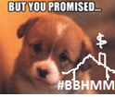
    - SUBSTANTIAL Performance (Realtor Bonus case)
      - Cook v. Coldwell Bank “Until Substantial Performance Revocability”
Facts: Was purported revocation of Bank’s Mar ’91 Offer valid when Cook substantial performed? Bank made verbal Offer to Cook re: if stay through ’91 and step performance get step bonuses. Cook hit bonus targets and stayed through ’91. Cook tried to revoke Offer stating Cook couldn’t Accept until end of 91’ when she “completed performance”
Rule: Offer becomes as option K after promisee begins performance because substantial performance makes offer IRREVOCABLE. Promise to perform = consideration
  - Offer invites Acceptance by PERFORMANCE ONLY
    - CL:
      - Offeror can freely revoke until complete performance free revocability
        - Exception Cook v. Coldwell Bank; RE broker case; Offeror can revoke until substantial performance by offeree
    - RST:
      - 32 (Interpretation) Interpretation rule: IMPORTANT fork in the analysis
      - 45 (Beg. = Offer Irrevo.) Offeree beginning performance → irrevocable.
      - 87: (Reliance on offer PE) O’ee reliance (1) an offer the O’or should reasonably expect the O’ee to rely on before acceptance is binding as an option K if the O’ee relies on it
      - Camel Cash
Facts: Camel Cash Rewards program started to invite customers to buy their products in return for camel cash that could be exchanged for camel merch. Years later, sent notice to customers ending program. When customers tried to use their saved camel cash, there was no merch to exchange for them.
Holding: Ads was not offer because no risk of over acceptance. Camel wanted only performance, not promise to perform.
Rule: The ad invited performance of a specific act without further communication and left nothing for negotiation therefore it’s an offer. Camel cash WAIVED right to revocability making their ad which was an offer IRREVOCABLE for the STATED period
    - OPTION Ks (revocation of)
      - Option: An exchange quid pro quo anything of value can be other than money
    - held open and irrevocable for a specified period of time; this provision must be expressly stated in the agreement. Separate C required for consideration.
    - Rst 37:
      - Cannot be revoked during option period (1) the power of accep. Under option K is NOT terminated by rejection of C/O, or by death or incapacity of th eO’ore, unless the req’s are met for discharge of a contractual duty
- Pre-acceptance reliance (facts REALLY important for reasonable foreseeability analysis)
  - CL:
    - Star paving (majority view) ; Baird (minority view)
  - Rst 87 (1) and 87 (2) (typ. Limit to construction industry)
    - Offer is binding as an option to the extent necessary to avoid injustice if
      - Offeror has made an offer & O’ees pre-acceptance reliance on the offer was reasonably foreeseable by O’or AND there was action or forbearance by O’ee
    - E.g. sub-C’s offer / bid to GC Star paving (example of limits revocability to otherwise irrevocable offer)
      - Limits use of PE to make offer irrevocable if bid expressly stated revocable at any time before acceptance; inequitable bad faith conduct by offeree (bid shopping/chopping); O’r bona fide mistake and O’ee knew or should have known
    - Pop’s Cones Inc. v. Resorts Int’l (example of limits revocability to otherwise irrevocable offer by PE)
      - Lots of back and fourth. Resorts told Pop’s “pack up the Margay store and plan on moving” and not renew their current location. Pops did that, put in storage, started design etc. Resorts withdraws its bid. Took Pop’s Cones 1.5 years to find new location. Lost 1.5 years of profit because relied on Resorts representation.
      - BQ2 : no enf. K (MA is lacking bc Pops not accept offer, nor Resorts accept Pop’s C/O) BUT theory of recover under PE limits revokation
    - UCC
      - 2-205: Firm Offers (UCC version of CL Option K where the O’or MUST be a merchant)
        - No consideration required for firm offers if req. of 2-205 are met
          - “merchant” (with respect to the transaction at issue); is signed writing (signature can be typed, electronic, email sig or text): writing gives assurance states will be held open O’or to O’ee = irrevocable (NO consideration required) ; if writing supplied by O’ee it’s signed by O’or
        - Maximum Offer Period (limits period of irrevocability)
          - Limits the period of irrevocability to a maximum of 3 months, so that neither a stated time nor a reasonable time [of subject matter] can exceed that period unless it is renewed by the Offeror or the Offeree gives consideration
          - Option Period = SHORTER of (1) stated time/ period or reas. Period (2) OR 3 months if no period is stated
        - In class hypo:
          - Not firm offer (revocable): I offer to sell you 10 widgets and hold offer open for 2 days and I sign it but I’m not a merchant it’s NOT a firm offer.
          - Is a firm offer (not revocable):
            - I’m a widget manufacture and offer to sell you 10 widgets for $100 and hold offer open for 2 days = firm offer. It’s ENF and widget manuf. Cannot revoke within those 2 days.
            - X, a merchant, makes an offer to sell goods to Y, stating in a signed writing that this is a “firm” (irrevocable) offer for 10 days. irrevocable for 10 days.
      - 2-104 (1) (Merchant)
      - deals in goods of the kind involved in the transaction OR who otherwise by occupation holds himself out as having knowledge or skill in regard to the practices or goods involved in the transaction
- Acceptance
  - Basic Test:
    - Acceptance of offer is a manifestation of offeree’s assent to be bound / assent to terms of offer
  - CL:
    - Think Brooklyn bridge hypo, Mirror image rule
    - freely revoke until O’ee completes perf. ( commissions, bonuses, rewards, prizes, lost dog ad, some ads)
    - Mirror Image Rule
    - Last Shot Rule (Binary; winner and loser)
      - Terms of the last form sent (C/O with varying terms) control if the counterparty either: explicitly accepts the C/O or does not explicitly accept the C/O but accepts the C/O implicitly by performing)
      - In class hypo: non SOG K, service K and Customer orders service on a form and service provider accepts the offer on the service provider form and that form has lots of boilerplate in it. CL states last form sent is which terms control.
    - Ray v. Eurice
      - obj. theory intent (conduct) reasonable person.

Facts: P desired build a home on their lot. P (finicky engineer) drafted plan, which was revised into a K by D (hammer and saw builders). P had lawyer add new specs (C/O), which D signed w/o reading carefully bc assumed “specs” were D’s 3 pages not finnicky engineer’s 5 page terms (A of C/O). intention to be legally bound D had a duty to read and breached K; no fraud or duress (no def. to ENF of K).
Rule: A person who signs a document is bound by the document.
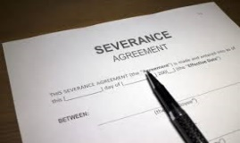
    - Skrbina v. Fleming: (Severance)
      - Rule: duty to read; signed K so can’t bring claim (Severance)
  - RST
    - Mirror Image Rst 50 Acceptance offer is a manifestation of the O’ee’s assent to the terms of the offer.
      - Counter Offer Rst 59 Purports accept but conditional on the O’or’s assent varying terms = C/
    - “Master” of Offer Rst 60
      - O’or =“master” of the offer and can specify the way in which the offer must be accepted
    - Ambiguous “HOW” to Accept RST (32, 62, 45)
      - 32 (Interpret) UNLESS unambigious, O’ee can CHOOSE how to accept;
      - 62: (promise or performance) If O’ee can accept by EITHER performance OR promise, O’ee can BEGIN performance = Acceptance AND promise to complete performance.
      - 45: (performance ONLY) If O’ee can ONLY except by acceptance PERFORMANCE, O’ee BEGIN performances makes Offer IRREVOCABLE, but is NOT acceptance; complete performance = Acceptance Situations where performance can be speculative (lost dog, bonus, etc.)
  - Brooklyn Bridge Hypo – Revoke offer prior to cross the bridge fails under Rst; works under CL
    - Rst 32: (offer ambiguous)
      - unless offer unambiguously (by language or context) requires acceptance by performance only, O’ee can accept by promise OR performance. BEGIN performance = A, O = irrevo.
    - Rst 62: (Promise can = breach)
      - When offer invites offeree to choose by acceptance by either promise or performance – tendering of invited performance is acceptance and promise to render complete performance; if either party backs out they’re in breach
    - Rst 45: (Beg. ≠ Acceptance)
      - Applies if unambiguous and acceptance of offer is only by performance; acceptance = complete performance. Offer is irrevocable once offeree begins performance. Beginning performance is not by itself acceptance. To have acceptance, still need to complete performance.
    - Rst 50: (need BFE)
      - Acceptance by performance requires at least part of what the offer requests includes acceptance by performance, which operates as a return promise (BFE).
      - Sometimes not clear whether offeree can perform, but offeror wants them to try (e.g. rewards cases , I’ll pay you $100 to find my lost dog)
      - Lost Dog Hypo: Bob offers to pay Jane $100 if she can find his dog. Bob not looking for a promise to find dog; unclear if Cindy can perform. Bob looking for a completed performance (find and return dog); otherwise Bob won’t pay unless the dogs is returned.
  - UCC: (Special UCC K Formation Rules)
    - §2-204: Formation in General
    - §2-205: Firm Offers
    - §2-206: Offer and Acceptance in Formation of K (Mirror Image)
    - §2-207: Additional Terms in Acceptance or Confirmation [aka “Acceptance Varying Offer”] ONLY applies in mismatch between offer and acceptance (Battle of the Form(s))
    - 2-204: Formation in General
      - any manner sufficient for mutual assent), including conduct by both parties which recognizes the existence of a contract
      - moment of K formation is NOT essential
      - Open terms;
        - not fail for indefiniteness if parties intended to contract and there is a reasonably certain basis for determining remedy
        - Gap fill by UCC 2-203 (3) price of goods, mode of delivery, time of delivery, time and place for payment but NOT subject matter and qty terms.
      - Festival Foods Jannusch v. Naffziger
Rule: Under UCC, time of making the K not important so long as subject matter and quantity is specified)
    - 2-206: (Offer and Acceptance in K Formation : Mirror Image activities by parties)
      - order or other offer to buy goods from prompt or current shipment shall be construed as inviting acceptance EITHER by a prompt promise to ship OR by the prompt or current shipment of the goods
      - Assumes BOSO (Buyer = Offeror, Seller = Offeree)
      - In class hypo: Buyer requests emails Seller for price quote 10 widgets (Offer). S sends B quote 10 widgets. B sends S B’s PO (A form) fills in fields 10 widgets + quoted price. B emails PO to S. S doesn’t email back but packs and ships (acceptance) widgets’. IS there a K?
        - Answer is NOT under 2-207. It’s under 2-206 bc not acceptancy varying term which only applies to 2-207. Here acceptance by prompt or current shipment or prompt promise to ship is enf. K under UCC 2-206 = mirror image acceptance.
    - 2-206 (2) (O’or not notified of Acceptance …may treat Offer…lapsed before Acceptance)
      - If an O accepted by perf. , the o’ee has to notify the o’or of the acceptance
      - Where the beginning of a requested performance is a reasonable mode of acceptance, an Oferror who is not notified of acceptance within a reasonable time may treat the offer as having lapsed before acceptance
    - **compared to the general rule where beginning performance is acceptance. Here O’ee MUST notify or else O’or can terminate even if O’ee wanted to accept

    - 2-207 Acceptance Varying Offer (Battle of the Form(s))
      - Overview
        - 2-207 (1) Enf K based on WRITINGS ?
          - Is the purported acceptance
            - Acceptance → exchange of writings creates a K → Varying Terms per 2-207 (2) to answer are varying terms part of Agmt
            - OR a C/O → (terms by 2-207(2))
        - 2-207 (3) Enf K. based on CONDUCT
          - if no formation based on exchange of writings under 2-207 (1) based on writings or C/O can still be a contract based on the parties conduct e.g. C/O not expressly condition but parties still perform, (terms by 2-207 (3))
          - Sellers AF does not “mirror” Buyer POs. Under UCC varying terms do not prevent formation.
      - Dickered terms: to negotiate terms
      - Other terms: boiler plate or non-dickered terms
      - In class hypo:
        - Parties negotiate “dickered terms” . B sends S an offer in standard form PO, with blanks fill in (PO includes “dickerted terms” + “other terms”) → S sends B a purported acceptance in a standard form Acknowledgement Form (AF), with blanks fill in (Dickered terms in AF match PO, but Other terms in AF vary from PO) → Parties perform: seller ships; Buyer accepts goods
      - If party merely suggest a term “would be okay if made it 8am?” = Acceptance and is not a C/O under CL
    - General Rule:
      - Acceptance or written confirmation w/ varying term operates as an ACCEPTANCE.
    - Exception:
      - Acceptance/written confirmation does not operate as an acceptance if “unless clause applies” (i.e., if Acc. clearly states that “Acceptance is expressly made conditional on assent to the [varying] term.”
    - ACCEPTANCE:
      - NOT expressly conditioned (exchange of varying forms)
      - 2-207 (1) based on exchange of the WRITINGS (AF and PO) not expressly conditioned of Buyer’s PO boiler plate → Acceptance based on exchange WRITINGS
      - TERMS? → Terms per 2-207(2); add’l terms = proposals for addition → Q:Merchants? A: Yes; exception of 2-207(1)(a-c)
        - Are both parties’ merchants?
        - Additional – 1 form has term, other silent/not contradict
        - Different – both have term and it conflicts
    - Brown Machine Inc. v. Hercules (cool whip machine) Hercules PO was last form with varying term of limiting acceptance to PO which included limitation of liability. This form controlled because Brown implicitly accepted the C/O through Conduct
      - BQ1 (UCC) → BQ2 (Yes; O & A, C n/a bc BFE) → BQ3 (2-enf. K WRITINGS 2-207(1); Terms by 207(2) proposals between MERCHANTS
      - Rule: When an offer expressly limits acceptance to the terms of the offer, any additional terms to those of the offer will not become part of a contract between merchants.
    - Paul Gottleib v. Alps South (medical device fabric x prosthetic) mismatched terms (add’l term)
      - Rule: Under UCC, additional terms made to a contract will NOT be enforced if the contract terms are MATERIALLY altered
      - BQ1: UCC BQ2: yes; 2-207(1) WRITINGS btwn MERCHANTS, BQ3: add’l term unless 207(2)(a-c); b (materially alter) ; Surprise (no bc 6 K w/ terms in them between them) /hardship (no bc consequences/damages not foreseeable) BQ4: yes per K spec. BQ5: BOC yes ; BQ6: per BQ3 terms damages limited to direct (K costs) not indirect (resulting from BOC)
    - C/O
      - Purported Acceptance Varying Offer EXPRESSLY CONDITIONED + no Express Assent + no conduct = C/O
        - 2-207 (1) : B sends PO, S sends AF, but S’s AF says “accept offer [dickered terms] in PO …but our acceptance is expressly made conditional on your [buyer’s] assent to our [seller’s] terms [other terms] → C/O
        - Terms? No enf. K
  - 2-207 (3) enf. K based on CONDUCT (C/O + no EA + Conduct)
    - C/O (expressly limited boiler plate) → 2-207 (3)
    - Terms: only terms parties agreed on. Varying terms are not part of the agreement and get knocked out + UCC gap-fillers
    - ACCEPTANCE
      - Example
        - 2-207 (3) : B sends PO, S sends AF, but S’s AF says “accept offer [dickered terms] in PO …but our acceptance is expressly made conditional on your [buyer’s] assent to our [seller’s] terms [other terms] → C/O → B says nothing. S ships goods. B accepts goods. → Enf. K based on writing + conduct of shipping goods
        - Terms: 2-207 (3) ; terms on which parties AGREE; otherwise KO + UCC Gap fillers (assuming all essential open terms under UCC, otherwise fail for indefin.)
- Acceptance by “PROMISE OR PERFORMANCE”
  - CL:
    - if acceptance is ONLY by performance, acceptance requires COMPLETE performance. Offeror retains right to freely revoke the offer anytime before complete performance
  - RST 32:
    - interpret to allow acceptance by promise OR performance + Rst 62: if choice, beginning performance = Acceptance + promise to complete performance. Offer is irrevocable
  - UCC
    - 2-206 (1) – liberalizing formation
      - 1(a) any form of acceptance that’s reasonable is accepted, unless Offeror specifies
      - 1(b) offer and acceptance – establishment of mutual assent under UCC
      - Seller can choose whether to promise to ship or to ship (perform)
    - 2-206 (2):
      - When the beginning of the requested performance is a reasonable mode of acceptance, an offeror who is not notified of acceptance within a reasonable time may treat the offer as having lapsed before acceptance

      - C/O
        - Brown v. Hercules (UCC): Brown accepted Hercules’ PO by returning their own acknowledgement form (AF). It was not C/O because it did not expressly condition state the acceptance was conditional on the offeror’s assent to the new terms. It was acceptance with different terms which did not become part of the offer bc Hercules’ purchase order expressly limited acceptance to the terms of the offer in their PO which limited liability.
        - Rule: When an offer expressly limits acceptance to the terms of the offer, any additional terms (additional and different) to those of the offer will not become part of a contract between merchants.
- Acceptance Varying Offer
  - CL:
    - Mirror Image Rule
    - Last Shot Rule (Binary; winner and loser)
      - Terms of the last form sent (C/O with varying terms) control if the counterparty either: explicitly accepts the C/O or does not explicitly accept the C/O but accepts the C/O implicitly by performing)
      - Last party to send forms controls the terms (favors seller); terms of acceptance carrying offer control if counterparty explicitly accepts the C/O or accepts the C/O implicitly through conduct
    - In class hypo:
      - non SOG K, service K and Customer orders service on a form and service provier accepts the offer on the service provider form and that form has lots of boilerplate in it. CL states last form sent is which terms control.
    - Princess Cruise v. GE
      - Illustrate Mirror Image and Last Shot Rule
      - GE sent the last form and Princess accepted C/O implicitly through conduct so GE’s terms control to limit liability
      - Facts: PM for cruise ship + some parts making (high value) K blended one lump sum price for all by GE to PC
      - Holding:
      - Rule: The UCC does not apply to maritime contracts that are predominantly for services determined by (1) language of the contract (2) the nature of the business of the supplier (3) the intrinsic worth of the materials.
  - RST
    - Varying Terms
      - Rst 59;
        - Acceptance conditional on O’ors assent to additional or different terms from those offered = C/O. Purported acceptance with additional terms is not an acceptance, but a C/O
        - Normile v. Miller – D made C/O – did not accept P’s terms.
        - Rule: An offeree cannot enforce a contract to sell property when he did not accept the offer to sell until after the offer had been validly revoked.
      - Rst 61;
        - An acceptance which requests a change or addition (inquiry) to the terms of the offer is not thereby invalidated unless the acceptances is made to depend on an assent to the changed or added terms of the C/O
  - UCC:
    - Overview
      - UCC drafters wanted to CHANGE
        - CL Mirror Image Rule &
        - CL Last Shot Rule
    - 2-207 (1): Acceptance VARYING Offer: Is there a K?
      - Overview
        - Varying acceptance (acceptance w/ additional or different term) to act as acceptance and form K
        - Additional to = a term that appears in one writing and other form is silent / not contradicted by other form
        - Different from = a term that’s addressed in both forms but are different (conflict)
          - e.g. one form says mandatory arbitration, one form says nothing about mandatory arbitration
        - In some circumstances, allows varying term to become part of the K (terms are not based on last shot rule)
      - General Rule
        - Acceptance or written confirmation with varying term operates as an acceptance
      - Exception
        - Acceptance / written confirmation does not operate as an acceptance if “unless clause applies” (i.e. if Acceptances clearly states “acceptance is expressly made conditional on assent to the [varying] term.”
      - 2-207 (3): Is there a K?
        - If no enforceable K based on writings, conduct can establish enforceable contract.
    - UCC 2-207 (1) Battle of Form (s) = Acc. Varying Offer enf. K based on WRITING(s)
      - General
        - Definite (language of commitment, clear expression of assent using a reasonable person standard)
        - AND Seasonable (timely or no lapse, offer must still be in effect) Acceptance with varying terms =Acceptance (despite varying term in boilerplate)
        - TERMS → 2-207 (2)

- Exception
        - NOT w/in the “unless clause” –
          - A reply to an offer which purports to accept but is CONDITIONAL on the O’ors assent to terms “varying terms” (additional to or different from those ) offered = NOT AN ACCEPTANCE
        - ONLY language that tracks with the “Unless Clause” otherwise “Subject To” NOT enough to meet exception of “expressly conditioned” assent
        - “differing terms without more” are not enough for Unless Clause. There is a enf. K go to 2-207(2) based on mismatched forms
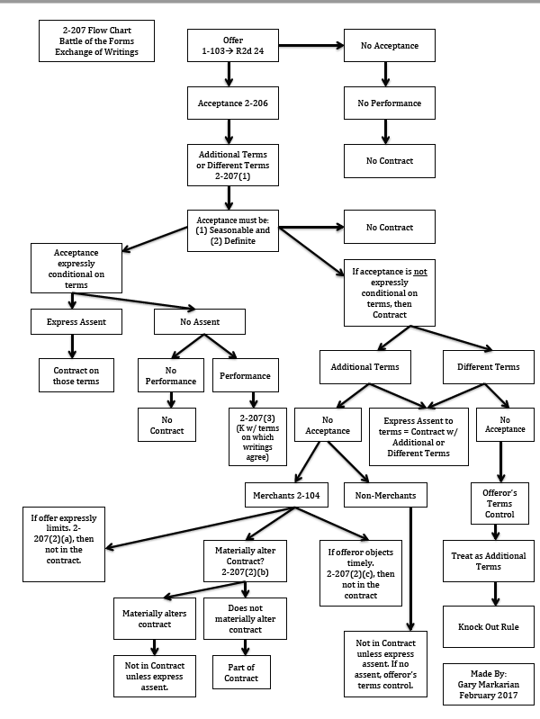
- Battle of Forms
      - K CONDUCT (2-207(3))
        - If the K is based on parties’ conduct (not based on the writings), UCC-2-207(3) applies for terms
      - K WRITINGS (2-207(2))
        - If K is based on writings, when the S discloses add’l terms to B, the S’s terms would NOT be part of the K if B is NOT a MERCHANT
        - If MERCHANT, add’l term is a proposal for inclusion & analyzed 2-207(2)
    - ORAL Agreements
      - Oral offer and Oral Acceptance, followed by seller sending the B a written term sheet = WC
        - Different from OA?
          - S’s terms NOT part of K
        - Additional to OA?
          - Term is NOT part of K if one party is NOT a merchant AND that party NOT assent to the term
- Electronic & Layered Contracting
  - Rule: Actual or Constructive (reasonably adequate notice) notice needed for Acceptance
  - MAJORITY View: Seller = Offeror; Buyer = Offeree “SOBO”
    - Buyer’s acceptance = mirror image of Seller’s offer by promise to ship/provide with S’s T&C in packaging or otherwise provided to B); Seller’s term are part of Agreement under Big Question 3
    - Formation timing = when B keeps good past return period
  - MINORITY. view: Buyer = Offeror; Seller = Offeree “BOSO”
    - S accepts B’s offer by promising to ship/providing goods/taking payment.
      - K formed when S accepts, by performing re: UCC-2-206

      - Terms per 2-207 as proposals for additional terms
    - Step-Saver Data
      - Held that a licensing agreement affixed to the packaging constituted a proposal for additional terms that was NOT binding UNLESS EA by the B
    - Klocek
      - Held B’s act of KEEPING the computer past 5 days was insufficient to show B agreed to standard terms
  - Shrinkwrap (Money now, terms later) aka layered and rolling contracting
    - Rule: Under UCC additional terms in a shrinkwrap agreement will only become part of the contract for SOGs if the agreement explicitly provides that the consumer can reject the terms by returning the goods.
    - Terms inside packaging or affixed outside … keeping the product = Buyer’s acceptance of the Seller’s terms.
      - 2 contracting decisions
        - decision to purchase is made without regard to the S’s boilerplate terms.
        - decision to assent to the S’s terms by keeping or returning the good

    - ProCD
      - Held that B was bound by agreement that was included in software packaging and later appeared when the B first used the software
    - Hill v. Gateway
      - Held B can accept and be bound by T&C packaged with a product if the consumer is given the opportunity to reject the terms by returning the product and choosing not to do so but doesn’t

    - Defontes v. Dell case:
      - Held: T&C did NOT make clear to Buyer they could reject D’s T&C by RETURNING the computer.
      - D’s T&C said “by accepting delivery, B agreed to D’s terms. Customer could return the computer if not satisfied” Dell did not reasonably invite acceptance because it was not clear when the consumer was accepting to the terms and when they could reject the terms (docs stated if “unhappy/unsatisfied” return ≠ notice to return if not accept terms by returning goods)
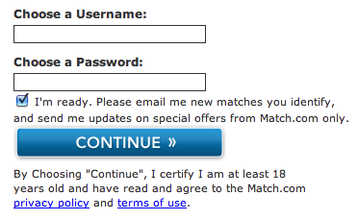
  - Clickwrap (clickthrough)
    - Rule: B must have actual notice or constructive notice of T&C. (2) clicking “I agree” box = Assent. (3) an inconspicuous link at bottom of the page (which the B would not see if following purchase prompts ≠ Assent)
    - B required to “agree” to S’s terms (either by checking or initialing a box) to continue a pending purchase transaction
    - Some sellers require the B to click through the S’s terms before allowing the B to check or initial the box
    - Meyer v. Uber.

      - Clicking I agree … conspicuous hyperlink gives notice of terms and notice clicking submit is assent to be bound. Paragraphy 1 & 2 upfront T&C important + arbitration clause
      - Actual notice OR Constructive notice (design and content; conspicuous) from perspective of reasonably purdent smartphone user of the existence of contract terms
      - AND O’or must have unambiguously manifested assent to those terms.
    - Spect v. Netscape
      - Held: Ps did NOT assent to arbitration term
      - Site included arbitration provision. BUT site did NOT REQUIRE that Ps check “I agree”. Netscape did not establish that Ps were:
        - Actually aware of OR had reasonably adequate notice of Netscapes T&C
  - Browsewrap
    - Rule: Absent actual notice, a browsewrap agreement is valid if the website puts a reasonably prudent user on inquiry notice of the terms of the agreement
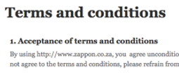
    - Info made available by IP on their websites that users accesses but does not always DL; user not req. to read the terms or assent
    - Site users typical can locate the terms by navigating around the site and clicking on links. Users of the site typically are not required to check or initial a box to indicate the user’s consent to the terms. The site typically states that using the site itself constitutes the user’s consent to the provider’s terms.
    - Long v. Provide Commerce

      - Enf. of Arbitration okay? Did B assent to Terms? an inconspicuous link at bottom of page which Buyer wouldn’t see even if following purchasing prompts, is NOT assent – not actual or constructive notice
      - no affirmative action … validity …depends reasonably prudent user on inquiry notice (actual or constructive knowledge of T&C
      - factors: Placement, color, size, and other qualities. Checkout flow is laid out…to conceal the fact that placing an order was an EA of S’s T&C
      - Dicta- inquiry notice regardless of each consumer’s degree of technological savvy
- Mailbox Rule
  - General Rule
    - Offer, Rejection, C/O are effective upon receipt
    - RST (63, 65, 66)
      - UNLESS Offeror specified receipt = acceptance
      - Acceptance is effective on upon dispatch
      - Requires that acceptance is in the manner and by the medium invited by offer, & properly sent with stamp/address.
  - Exception
    - If option K applies to underlying offer
      - Acceptance is effective on receipt
      - requires consideration. Recital suff. To show C (presences of recital creates a rebuttable presumption of consideration unless evidence otherwise like Dougherty)
  - Conflicting Communication
    - Rule: conflicting responses to offer, which ever gets there first is effective.
      - Acceptance is eff. UNLESS rejection gets there FIRST
      - AND O’or detrimentally relies on the rejection
        - Example B1 sends conflicting response to offer but S gets B1’s rejection for home offer first, then S accepts another B2’s offer. S is NOT bound by B1’s Acceptance.
        - Rst 40: a rejection terminates the O’ees power of acceptance bc of the prob. Of reliance by the O’or

- Incomplete Bargaining
  - Whether a K is formed … TURNS on the factual questions of intention to be bound when they agreed in principle OR ONLY after further negotiations prove successful.
  - Postponed Bargaining / Agreement to Agree
    - one or more terms left open for a future negotiation ≠ contract;
  - CL:
    - Parties had to agree on ALL material terms for a court to enforce the K
    - Agreement to agree + failure to reach agreement on that term (gap fillers), there is NOT and ENF K.
    - If a court decides that an incomplete bargain = an enforcable K, the court can fill in missing terms
  - Doctrine of indefiniteness
    - dickered term missing
    - K’s indefinite = unenforceable K
    - essential term is missing OR no reasonable method for determining the essential term
        - Walker v. Keith (rent tbd in 10 years) - INDEFINITENESS

Facts: Is the rental price term so indefinite and uncertain that the parties cannot be held to have agreed upon the essential rental term of the lease? P sought adjudication that he effectively exercised option to extend a least at fixed rental rate when K said rent tbd in 10 years by “comparative business conditions”.
Rule: court will not gap fill AMBIGIOUS terms; parties did not agree to a rental rate “comparative business conditions [local, state, usa, global = ambiguous] and there was no method of determining a reasonably certain rental rate. An agreement to agree does not fix an enforceable obligation. Open terms can be objective manifestation of failure to complete K formation (fact-circumstances test adopting a reasonable person standard)
  - RST 33
    - Open or uncertain terms “may” indicate lack of assent to be bound
      - terms of the K are “reasonably certain,” meaning that it is possible to determine if breach AND an appropriate remedy for breach
  - UCC
    - 2-207: could be K if dickered terms match
    - Default “Gap Fillers” Objectively reasonable under the circumstances
    - 2-204(3) (relaxed re: open terms)
      - When the parties to a bargain sufficiently defined to be a K have not agreed with respect to [an essential] term, the court may supply ‘a term which is reasonable in the circumstance.’” (e.g. Festival Foods)
      - Gap fillers supply open terms where the parties otherwise enforceable K have not agreed about certain terms
        - Price of goods (2-305)
          - Doesn’t prevent enforcement of a K if the parties intended to be bound. But if parties provide, they intended NOT to be BOUND UNLESS price is fixed or agreed, and it is not, then no K and court will NOT fix a “reasonable price”
          - If the parties later fail to agree on price, the court may enforce a “reasonable price”, parties can in “good faith”
        - Mode of delivery (2-307), Place of delivery (2-308), Time of delivery (2-309), Time and place for payment (2-310)
      - NO Gap fillers (12 frozen turkeys) Subject matter of the K OR quantity term
  - Formal K contemplated
    - CL
      - Agreement to major terms; no executed formal agreement (anticipate execute a formal writing in the future)
      - Quake v. AA (Formal K contemplated from LOI)
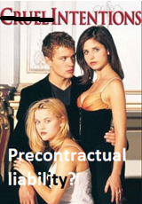
Facts: Was there an enf. K, based on LOI, between Quake and Jones (AA)? Pending execution of formal K, Jones Bros (AA) sent Quake LOI , “we have elected to award the K for the project to your firm…” Brief summary of project follows. Jones Bros. (AA) “reserve the right to cancel this letter of intent if the parties cannot agree on a fully executed subcontract agreement.”
…ct held cancelation clause was suff. to show parties agreed not to be bound until finalization of formal contract…ct find the wording of the intent letter to AMBIGUOUS because could be interpreted to show intent to be bound/intent not to be bound until
Holding: no formal K was executed
Rule: A LOI to enter K will be ENF if parties INTEND LOI to be BIND. If letter is AMBIGUOUS, parole evidence heard to determine intent
      - Letter of Intent (3 outcomes)
        - Contract
          - LOI is binding even though formal agreement was never executed because intended to be bound. Dickered terms must be agreed upon (subject matter and quantity terms). Don’t need to have everything in the LOI
        - No Contract
          - LOI not binding; no K if anticipated formal writing was never executed (K must state there will be no legally enf. K until formal writing is executed) bc parties not intend LOI to be binding
        - Agreement to bargain in good faith
          - Agreement to negotiate in good faith in effort to reach K; LOI is binding only as to promise to bargain in good faith towards the complete formal
    - RST
      - Rst 33 K formation requires termf of K are reasonably certain – possible to determine whether there has been a breach and if so, appropriate remedy for breach
      - Rst 27:Turns on factual question of whether parties intended to be bound when the agreed in principle, or only after formal negotiations.
    - UCC
      - 2-204: (formation in general)
        - No gap-fillers for subject matter of the K or quantity terms of K. Gap fillers supply open terms where the parties to an otherwise enforceable K have not agreed about certain terms. UCC 2-204 is looser regarding open terms.
      - 2-305:
        - open price time will not prevent enforcement of K if parties intended to be bound. Court may enforce a reasonable price. If one party has the power to fix the price, it must be done in good faith. If parties provide they intended not to be bound unless price is fixed or agreed, no K, court will not fix a reasonable prices

- Consideration
  - Policy : K enforcement requires a real exchange because exchange serves functions of contract formality (functionary, evidencitary etc.)
  - ALWAYS START HERE: CL benefit-detriment test largely supplanted by Homes & Rst BFE test. Difference btwn the 2 ONLY matter in rare cases at the margin
  - WARNING: students frequently misapply benefit detriment test
  - START analysis with modern BFE Rule (quid pro quo)
    - If there IS consideration, MOVE on to next issue
    - If you conclude NOT consideration, re-analyze facts under CL benefit-detriment test
  - Consideration
    - A “legal formality” required by K law. Modern day vestige of an earlier K formality: use of seal to create a binding contractual promise
    - Generally, Courts do NOT examine the adequacy of consideration
  - Function (can overlap and reinforce each other)
    - Evidentiary function: to show enforceable K ; Cautionary function: to encourage deliberation before entering K ; Channeling function: to mark or signalize the enforceable promise
  - CL
    - Benefit-Detriment Test:
      - DON’T start with this test
      - Consideration
        - benefit to the promisor OR detriment to the promise
        - Did person making promise get something? Did promise part with something?
      - Detriment
        - Promisee does or promises to do something (or not do something) that Promisee was under no prior legal duty to do (or not to do).
        - Change in legal position
      - Benefit
        - Promisor obtains or is promised something which Promisor had no prior legal right

      - Hamer v. Sidway:
Facts: Deceased uncle promised P that if he refrained from drinking, tobacco, etc.until age 21, he would pay P $5k. P complied. D argued P’s refraining from the acts benefitted P but decedent received no benefit.
Holding: Court held there was consideration because P’s refraining forced him to part with acts which he was legally allowed to do as part of he uncle’s promise; not as much about one party profiting as it is about one party abandoning something in reliance of the promise.
Rule: Detriment to promise sufficient for consideration. A parties agreement to incur a detriment constitutes adequate consideration.
      - In class Hypo
        - refraining using cocaine would NOT have satisfied test of case bc not legally permitted to use cocaine
  - RST
    - Homes “Bargain” Test (BFE)
      - Reciprocal Inducement: promise must induce detriment and detriment must induce promise (reciprocal conventional inducement)
      - Consideration is the “reciprocal conventional inducement, each for the other, concept of quid pro quo (something for something; this for that)
      - If found and it’s valid, MOVE ON to defenses to enf of an otherwise enf K
      - RST 71 (1):
        - To constitute a consideration, a performance OR return promise must be bargained for
        - A performance or return promise is “bargained-for” if
          - Sought by the Promisor in exchange for her promise AND given by the Promisee in exchange for THAT promise.
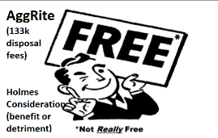
        - Pennsy Supply v. American Ash (Free aggrite case)
          - Moves towards modernization of benefit-detriment test applied in Hamer v. Sidway.
Facts: P brought action for damages against D. D supplied substitution aggregates for P’s construction project at NY high school. Aggregates were provided at no cost, but were defective and a hazardous waste and required removal. P was forced to remove the AggRite as hazwaste at his cost and repave
Holding: Court held there was consideration because D enjoyed benefit to P’s detriment of removing the hazardous waste
Rule: There may be sufficient consideration (BFE I take the AggRite for free in exchange for you not having to pay a disposal fee) to form an enforceable contract even though the parties have not bargained from the specific terms of the agreement.

    - Other Consideration in Rst
      - 87 (1): Recital of Consideration is enough in option K binding if K is:
          - signed writing by O’or / fair terms / reasonable time / recital of purported consideration. / less concerned with sham Consideration. / proposed exchange on fair terms within reasonable time
        - Rst 72 (anything bargained for is consideration)
        - Any performance that is bargained for is consideration
  - UCC
    - Policy : Tends to resolve in favor of encouraging market transactions
    - 2-205 Firm Offer: (UCC version of CL Option K)
      - Offer by merchant is signed writing which gives assurances it will be held open
      - No consideration required if
        - Btwn merchants / signed / states held open/irrevocable / 3 months max / no consideration req. ( If assurance on form supplied by O’ee, O’or must sign assurance separately.)
      - “Merchant” – party either has knowledge re: goods bc sells goods of kind or gains knowledge of goods in kind through occupation
          - E.g. Merchant: Manufacture, wholesaler, retailer
      - Time period for irrevocability of firm offer – time stated (capped at 3 months); if no time stated, reasonable time period (not to exceed 3 months
      - Option term:
        - Can be included within a K (e.g., lease renewal option in Walker v. Keith).
        - is entered into as part of the underlying K; is not a separate K; does not require separate consideration from the underlying K; but is not enforceable unless the underlying K is formed and enforceable.
  - PROMISES re: consideration
    - Generally
    - Conditional Gift (Williston’s tramp)
      - Promisee must DO something in order to receive a gift
      - Williston’s tramp – tramp having to walk to the store to buy the coat was a condition of the gratuitous promise, rather than a detriment to the promise – not consideration
    - Promise to make a gift (Donative Promise bc no consideration it was “sham”)
      - No K., No consideration
      - If promise is unENF, due to lack of BFE, consider PE as an alt. theory of recovery
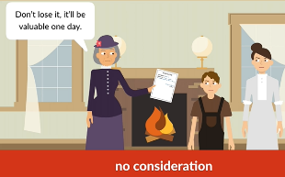
      - Daugherty v. Salt (Aunt letter to nephew promise for gift)
Facts: 8 year old boy given promissory note for 3k for “value received” for his aunt.
Holding: The court held the note was not sufficient evidence for consideration because the note was a voluntary and unenforceable promise of an executory gift and the aunt received no value for the promise. Recital consideration (default rule) but aunt’s testimony – there was no BFE and the promise was unenforceable. “sham” no “value received”. Distinguish between gift and quid pro quo (BFE). Purely donative gift, exchange was absent.
Rule: a promise for future gift [for no consideration) is UNENFORCEABLE. Recital creates a rebuttable presumption of consideration but not conclusively establish consideration. Facts are relevant.
    - Exceptions
      - Option K
        - CL – enf. option k requires consideration. Recital = rebut. Presumption unless sham bc consideration not tendered
        - RST – if option K is signed O’or and in writing, purported consideration okay + reasonable terms
        - UCC 2-205 – no Consideration. Offer irrevocable for period stated of reasonable period independent of the underlying K
      - Reliance: (Promissory Estoppel)
        - When Promisee reasonably relies on the promise (not vague promises)
        - Rst 90
          - A Promise is made, option K, PE can substitute for consideration if all 4 elements met as BFE
            - (1) a promise was made
            - (2) reasonably foreseeable reliance
            - (3) change in legal position “detriment”
            - (4) injustice avoided only if K enf.
          - Berryman v. Kmoch
            - Sell me your land offer for $10 plus other valuable consideration. Held: not consideration because no consideration for option K (RST requires) and PE did not substitute consideration because did not meet Rst 90 reqs (1) a promise was made (2) but not reasonably foreseeable reliance (3) no change in legal position (4) no injustice to avoid
          - Pop’s Cones (pre-acceptance reliance)
            - Resorts reasonably knew or should have known Pop’s reliance on Resort’s Offer
            - Rep of Resorts knew about the need to renew the lease or move and said “don’t renew your lease pack up the Margey store and get ready to move”
          - Hoffman v. Red Owl Stores Rst 90 Illustration 10 (pre-acceptance reliance)
            - Franchisor of supermarket sold sell your store, get experience at another store, sell at a loss, then do this, they did it kept losing money, ultimately not receive franchisee from franchisor
            - The assurances from B to A, are promises on which B reasonably should have expected A to rely, and A is entitled to his actual losses on the sales of the bakery and grocery and for his moving and temporary living expenses

  - NOT CONSIDERATION
    - Generally, Courts do NOT examine the adequacy of consideration, only examine in extreme cases but a “sham” recital of consideration is NOT consideration at all
    - Past Consideration / Moral Obligation ≠ Consideration
      - Rule: Past performance has already occurred & cannot be the INDUCEMENT for the present promise, there is NO BFE
      - Plowman v. Indian Refinery (Past consideration ≠ Consideration)
        - Depression era pensions x layoffs. Ps were given contracts for D to pay them, for the rest of their lives, sums equal to half the wages they were paid. No conduct was necessary other than coming to pick up the check. Payments were cut off. Ct held there was no authorization of the contract and no consideration because the employee’s services were rendered prior to agreement’s execution (past consideration ≠ consideration). Pension was gratuitous. No agreement, and even if there was, no consideration, so no contract.
        - Rule: One cannot enforce a promise that has not been supported by consideration. P’s action was NOT consideration bc it was benefit to employees to go to plant not a detriment
      - Mills v. Wyman (Moral Obligation ≠ Consideration)
        - case of adult son who was ill after voyage; father promised to pay P who took care of son and didn’t. There was a moral obligation to pay but no legal obligation bc there was no consideration. No BFE
  - Adequacy of Consideration
    - Policy K enforcement requires a real exchange
    - UCC Rare for consideration to be an issue in commercial settings because always an exchange of goods for $ and consideration NOT required.
    - CL/RST
      - Generally
        - Courts do NOT examine the adequacy of consideration, only examine in extreme cases but a “sham” recital of consideration is NOT consideration at all
        - Option K: courts give greater weight to recitals for option Ks
      - Exceptions:
        - No Consideration if promise is exchanged for:
          - Sham or nominal ≠ consideration
            - Dougherty v. Salt = false recital
            - a mere pretense of a bargain does NOT suffice, as where there is a false recital of consideration of where the purported consideration is merely nominal (rst 71)
            - Formality is not essential consideration; nor does formality supply consideration where the element of exchange is absent (Rst 72)
            - Disparity in value, with or without other circumstances, sometimes indicates that the purported consideration was not in fact bargained for but was a mere formality or pretense. Such a sham or nominal consideration does NOT satisfy the requirement of Rst 71 (Rst 79 cmt)
          - Grossly inadequate, shocking consideration

            - Dohrmann v. Swaney (Ms. Roger’s case)
            - Facts: Decedent signed a K entitled P to property (apartment + $1.4M) in exchange for his carrying on Decedent’s name through his children and for “past and future services and other good and valuable consideration”The ct held C was grossly inadequate; Decedent did not receive much benefit in exchange for what would have been a great benefit for P. There were also unfair circumstances surrounding the contract’s creation. Terms to use name as last name (instead of middle name);
            - K wasn’t valid. Grossly disproportionate …adequacy of consideration NOT met. req. to keep name and not remove in future absent = illusory promise bx BFE is so little benefit not really consideration.
            - Rule: a K will be invalidated for gross inadequacy for consideration if the provided consideration is illusory
          - Past performance ≠ Consideration
            - Exception to general rule: (Ct not consider adequacy of consideration)
              - If a promise is given to compensate Promisee for Promisee’s prior performance, that prior performance is NOT consideration for the Promisor’s promise
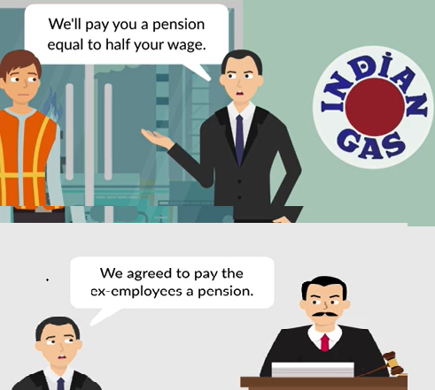
            - Plowman v. Indian
            - Stock market crash 1929. Employer felt bad firing older employees. Promised half their pay as appreciation for services to come pick up check at worksite at regular interviews. <1yr later notified no longer pay after new management
            - Holding: No consideration for past performance. No enf. K.
            - Rules: Past performance (already occurred at time of new promise made) CANNOT be the inducement for the present promise, so there is no “exchange”
          - Exception to Exception of Past Performance
            - PED with previous BFE
          - Pre-existing duty (PED) ≠ Consideration
            - Where parties exchange a NEW promise for a PED, there is NO consideration for the new promise
            - The performance of, or promise to perform a PED is NOT consideration
            - This consideration issue arises in context of attempted modifications to a K
            - Cab Driver Hypo
.No Consideration: Cab driver LLS → LAX for $50. Halfway there says it’s $100, you agree. No consideration because PED to go from LLS to LLX.
.Exception: There’s consideration: cab driver LLS -> LAX $50. Flight rebooked out of LBG, instruct cab driver go to LGB now, cab driver says $100 there is a new promise and new consideration
  - Illusory promise ≠ consideration
    - RST
      - Rst 77 cmt a: an illusory promise is not consideration and a promise made in exchange for an illusory promise is NOT enforceable
    - Rule: A promise, in form, that in substance, requires nothing of the promisor is unenforceable
In class: I promise I will sell you my house if I feel like it. Made a promise. But it doesn’t bind me to do anything.
    - Exception: (Illusory promise exception)
      - Otherwise illusory promise, consideration found in performance as substitute
      - Marshall Durbin Food Corp. v. Baker
        - Facts: Key MDF employees worried what would happen if Mr. D died. Mr D (82% SH) and kids (18% SH). “Agmt of termination &/or early retirement” MDF to pay Baker 5 years salary if Agmt is “triggered”. While Mr. Baker still at MDF triggering event occurred. Went to enforce 5 year salary of K. Kids say no because no consideration for MDF promise to pay you. Baker yes there was I promise to work for you for 5 years. Kids = nope promise = illusory but because you’re at-will you made a promise in form that required nothing from you so not enforcable K.
        - Holding: Baker’s promise to work for 5 years was an illusory promise bc could quit at any time bc at-will. Nonetheless, Ag. ENF bc Baker’s consideration was not promise to work for 5 years itw as his performance continuing to work at MDF for 5 years and being at MDF at time of triggering event.
        - Rule: Consideration for a promise as an (a) an act other than a promise, or (b) forbearance, or (c) the creation, modification or destruction of a legal relation, or (d) a return promise, bargained for and given in exchange for the promise
    - Exceptions to Illusory Promise continued (type K’s that give a lot of discretion to Promisor but are not failure of consideration cases because GFFD)
      - Implied Covenant of Good Faith and Fair Dealing (GFFD) → illusory promise → consideration.
        - Implied in ALL K’s, can be BOC bc no GFFD. It limits discretion
        - Bolsters enforceability of certain types of contracts where could be issue of illusory contract
        - Can convert otherwise illusory promise → consideration
        - RST
          - Satisfaction clause: objective and subjective
            - Rule: A promise to perform that is subject to the Promisor’s satisfaction with the counter parties performance is NOT an illusory promise
            - Objective (Promisor’s duty is condition on objective satisfaction)
              - In Class Hypo: Promisor to build tool shed to specifications, promise to pay $1000 if satisfied with construction of tool shed. You build it perfectly to spec but Promisor is not satisfied. Can sue for breach of promise bc constrained by duty of GFFD (2) whether toolshed meets specs can be det. Obj. therefore obj. std applies so sue for BOC ∴ Consideration satisfied
            - Subjective: (Promisor’s duty is conditioned on subj. satisfaction
              - In Class Hypo: Pay $1000 to paint portrait of son and pay you only if satisfied w/ portrait. You paint a masterful piece of art but Promisor is not satisfied. There is an enf. K, if truly not satisfied not in breach. But sue and records show you truly satisfied then Promisor is in BOC. ∴ Consideration satisfied
        - UCC
          - 2-306 (1) Outputs & Requirements Ks (QTY TERM NOT SET – NOT ILLUSORY PROMISE)
            - Constrained by GFFD
            - Rule: Reqs or Outputs qty term “means such actual output or requirements as may occur in good faith”. A promise to sell “output” or buy “requirements” is NOT an illusory promise
            - Quantity term = Seller’s “Output” everything Seller can make
            - Quantity term = Buyer’s “Requirements” everything the Buyer needs
            - requirement could be 0 if engaging in good faith
            - In class E.g. I say I will sell output and sell 0 because I think I made a bad deal = breach of GF requirement; output requirements must be consistent with DGG, GF gets rid of consideration problem of enforceability for illusory promises
            - In class E.g. Southwest Airlines a K to buy jet fuel in Ft. Lauderdale. Flys into Lauderdale and Orlando. If K for jet fuel more expensive at one airport over the other Southwest might say “requirements” is less and fuel up at cheaper airport. “Fuel Freighting” is NOT illusory promise. Is consideration for promise.
          - 2-306 (2) Ks for exclusive dealings (NOT illusory promise)
            - K for exclusive dealing in a certain good;
            - Imposes…an obligation by the seller to use best efforst to supply the good and by the buyer to use best efforts to promote their sale.”
            - In class E.g. Seller may be the exclusive supplier of the good or Buyer may be the exclusive promotor/distributor of the goods
  - Reliance as subs. for consideration = BFE
    - Detrimental reliance / PE
    - Promissory Restitution

- BQ2 B. Defenses x ENF → unENF? Makes otherwise ENF K UnENF
    - Indefiniteness Doctrine Doctrine of indefiniteness – dickered terms not there, at least one dickered term is missing.
    - Incomplete bargaining – “Acceptance Varying Terms”
    - Agreement to agree; indefiniteness all terms must be agreed upon for there to be a legally enforceable
      - In many cases, a K may be nearly incomplete (doesn’t express terms governing various potentially important aspects of the parties’ relationship); a dickered term is missing.
    - CL Rule: Parties have to agree on all material terms for there to be an enforceable K
    - Rst
      - 33: Agreement not enforceable unless it provides method for determining breach and remedy. terms reasonably certain / possible to determine.
        - Incomplete agreements may fail to consummate a contract
      - 204 trend
    - UCC
      - 2-204: missing essential terms (subject matter and quantity)
  - SOF
    - Overview
      - General Rule: Oral Ks are enforceable
      - Exceptions: Forbids enforcement of K unless in writing. Certain types of Ks must be memorialized in writing to be enforceable
      - If SOF applies and is NOT SATISFIED, the K is VOIDABLE by the D, which renders the K unenf. By the P
      - The SOF “defense” makes K is UNENFORCEABLE if
        - Alleged K is “within” OR
        - The SOF is “satisfied” OR
        - No SOF exception applies (which would take the K “out” of SOF)
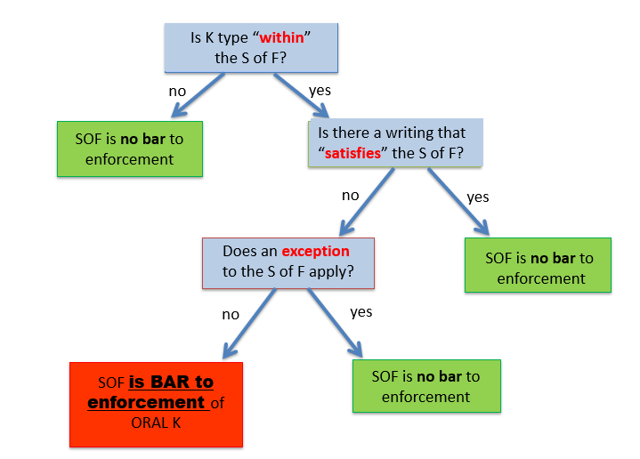
    - Is this K “WITHIN” the SOF? (6 types)
      - Rst 110: MYLEGS
        - Interest in land / real estate (most states incl. leases longer than a year) unless detrimental reliance (PE)
        - “> 1-year”
          - Has to do with time, nothing to do with subject matter of K
          - Duration of Performance not a lynch pin
          - Regardless of duration of performance, K cannot be LOGICALLY IMPOSSIBLE to complete w/in a year of the making of K
          - Example (“Within”)
            - [Future holiday event] On October 1, 2016, B enters into an oral contract with Forum Productions. The contract provides that B will give a 3-hour Halloween Night music performance at the October 31, 2017. The contract is within the SOF.
            - Employment K with a 5-yr employment term
            - K to go to Mars (likelihood close to zero, but logically possible although not factually possible using the reasonable person standard) could be completed w/in a year
          - Example (“NOT Within”)
            - Employment K “lifetime” or indefinite
        - “Within” → go to next question
        - “Within” → No? SOF is NO a BAR to enforcement (Move on to BQ3)
      - UCC
        - 2-201: K for SOG with total K price ≥ $500 or more are “within” SOF (must be in writing to be enf.)
    - Is the SOF “satisfied”
      - Types of K within that “SATISFIES” SOF??
        - CL/RST
          - Rst § 131:
“[A] contract within the [SOF] is enforceable if it is evidenced by any writing, signed by or on behalf of the party to be charged, which reasonably identifies the subject matter of the contract, is sufficient to indicate that a contract with respect thereto has been made between the parties or offered by the signer to the other party, and states with reasonable certainty the essential terms of the unperformed promises in the contract.
          - Rst § 132:
“The memorandum may consist of several writings if one of the writings is signed [by the party to be charged] and the writings in the circumstances clearly indicate that they relate to the same transaction.
          - Rst § 133:
“[T]he SOF may be satisfied by a signed writing not made as a memorandum of a contract.”
          - Crabtree v. Elizabeth Arden Sales Corp.
            - Common law rules regarding what constitutes a sufficient “writing.” There is no particular formality needed for the writing as long as it contains the statute’s minimum content and signature.
            - “Writing” could be compilation of multiple writings that relate to the same transaction, with at least one signature by the party to be charged and parts together state the essential K
          - Writing
            - No specific form/ formality required
            - Doesn’t need to be the joint product of the parties or even delivered to the other party.
            - internal memo or a document written for some other purpose, even a diary.
            - Not need to be prepared at the time of contracting.
          - 1-201(b)(43):
            - “‘Writing’ includes printing, typewriting, or any other intentional reduction to tangible form [includes electronic records that are retrievable and printable]. ‘Written’ has a corresponding meaning.”
          - 1-201(b)(37):
            - “‘Signed’ includes using any symbol executed or adopted with present intention to adopt or accept a writing.”
            - Initials or printed letterhead is sufficient.
            - If the evidence includes multiple pieces of paper or records:
              - Most courts just require that the various parts of the writing all seem to refer to the same transaction and that one part of the writing is “signed” by the party to be charged.
              - Some courts require that the signed part of the writing refer specifically to the unsigned parts of the writing.
            - In class hypo
A orally agrees to sell B his car for $6k. A sends B a letter saying, “Glad you‘re buying my car. $6k is a fair price. As we agreed, I’ll deliver it to you next Friday. /s/ A.” B changes his mind & refuses to accept delivery or pay. A sues B. Is the K enforceable by A against B?
No. (1) K is w/in S of F (sale of goods for $500+) (2) Writing specifies a quantity, subject matter, and evidences a sale was made (3) But the writing was not signed by the party against whom enforcement is sought, B. B wins by asserting S of F as an affirmative defense.
          - 2-305
            - Provides UCC rules for filling in a missing price term.
            - Buffaloe v. Hart.

        - Exception
          - UCC a writing can be enforced against the party who did not sign it if:
          - 2-201:
            - Both parties are merchants
            - Within a reasonable time of making an oral K, one of the parties sends a written confirmation to the other,
            - Which is signed by the sender & otherwise satisfies the statute as against the sender (§ 2-201(1));
            - The recipient has reason to know its contents; and
            - The recipient does not give written notice of objection to it within 10 days of receipt.
          - In Class Hypo
            - Cheese Co. (“CC”) phones in an order for a $8k cheesemaking machine from Whiz Inc.; Whiz accepts during phone call. (Oral K)
            - Whiz sends CC a written confirmation, signed by Whiz’s agent, confirming CC’s promise to pay $8k.
            - Now K can be enforced v Whiz but not v CC.
            - CC receives the confirmation and does not give written notice of objection within 10 days.
            - Now both parties have lost their SOF defense;
            - Neither can use S of F to prevent enforcement.

      - EXCEPTIONS that take an alleged contract outside the SOF.
        - CL/RST
          - Part performance/reliance regarding contract for the transfer of an interest in land.
          - Beaver v. Brumlow.
            - Older version of “unequivocally referable” test: “There must be [part] performance ‘unequivocally referable’ to the agreement, performance which alone and without the aid of words of promise is unintelligible or at least extraordinary ….”
            - Court in Beaver v. Brumlow says that this means that “an outsider, knowing all the circumstances of the case except for the claimed oral agreement, would naturally and reasonably conclude that a contract existed regarding the land, of the same general nature as that alleged by the claimant.”
            - In reliance on the oral contract, Buyers cashed out their retirement plans, took possession of the property, and spent $85,000 improving the property, and Sellers knew and implicitly consented to Buyers’ actions.
            - Court refused to invalidate the oral contract on “mechanical” S of F grounds.
        - Rst rejects the “unequivocally referable” test.
          - Rst § 129: “A contract for the transfer of an interest in land may be specifically enforced notwithstanding failure to comply with the SOF if it is established that the party seeking enforcement, in reasonable reliance on the contract and on the continuing assent of the party against whom enforcement is sought, has so changed his position that injustice can be avoided only by specific enforcement.”
      - Promissory estoppel.
        - Rst § 139 provides:
          - “(1) A promise which the promisor should reasonably expect to induce action or forbearance on the part of the promisee or a third person and which does induce the action or forbearance is enforceable notwithstanding the SOF if injustice can be avoided only by enforcement of the promise. The remedy granted for breach is to be limited as justice requires.
          - (2) In determining whether injustice can be avoided only by enforcement of the promise, the following circumstances are significant:
          - (a) the availability and adequacy of other remedies, particularly cancellation and restitution;
          - (b) the definite and substantial character of the action or forbearance in relation to the remedy sought;
          - (c) The extent to which the action or forbearance corroborates evidence of the making and terms of the promise, or the making and terms are otherwise established by clear and convincing evidence;
          - (d) the reasonableness of the action or forbearance;
          - (e) the extent to which the action or forbearance was foreseeable by the promisor.”
      - Alaska Democratic Party v. Rice.
        - Rst § 130 provides
          - an exception to the “one-year” SOF rule if the plaintiff has completed her performance. (Part performance is not enough to take such a contract outside the SOF.)
        - UCC exceptions to the SOF:
          - 2-201(2): Merchants confirmation exception.
            - In a transaction between merchants where one merchant orally places an order and the other sends a written confirmation, which is signed and states the quantity, the Statute of Frauds is satisfied for both (even though the ordering merchant hasn't signed and is the party to be charged) if the ordering merchant does not object to the confirmation within 10 days.
          - § 2-201(2) requirements for a writing to be enforced against the party who did not sign it:
            - Both parties are “merchants”;
            - 2-104(1): “Merchant means a person who deals in goods of the kind or otherwise by his occupation holds himself out as having knowledge of skill peculiar to the practices or goods involved in the transaction or to whom such knowledge or skill may be attributed by his employment of an agent or broker or other intermediary who by his occupation holds himself out as having such knowledge or skill.”
            - Within a reasonable time of the oral contract, one of the parties sends a written confirmation to the other,
            - Which is “signed” by the sender and otherwise satisfies the statute as against the sender (§ 2-201(1));
            - The recipient has reason to know its contents; and
            - The recipient does not give written notice of objection to it within 10 days of receipt.
          - 2-201(3)(a)
            - Where the seller has begun to make specially manufactured goods for the buyer.
              - UCC § 2-201(3)(b): Where the party charged admits “in his pleading, testimony or otherwise in court” that a contract was made.
              - UCC § 2-201(3)(c): Payment for goods has been made and accepted, OR goods have been delivered and accepted.
    - UCC
      - SOGs ≥ $500;
        - Exceptions: merchants’ confirmation exception, SOGs specially manufactured for the buyer and production has began, party admits in pldg/testimony that a K was formed, payment/goods have been accepted and received (part performance defense applies here (Buffaloe)
      - Exceptions: specially manufactured goods for the buyer
        - Payments for goods have been made or accepted; where seller has begun to make manufactured goods for the buyer; cannot be easily marketed to another customer
        - Statute of frauds - b/c can’t reasonably sell them
      - Buffaloe v. Hart: P sued D after D sold tobacco barns to same party P was going to sell them to. D argued check was not signed by D and was therefore not satisfied under 2-201. Court held check was not sufficient to satisfy written doc under UCC, but P’s part performance took K out of SOF under doctrine of part performance. Hand delivered the check - taking it is considered acceptance

  - 3 Question Test; General Principles
    - When SOF is asserted as an affirmative defense against enforcement, series of Qs likely to be raised:
      - Is K “within” one of the types of K to which SOF applies so that the signed memo is required for enforcement?
      - Is SOF “satisfied”?
        - Writing
        - signed
      - Other factors for “exceptions”?
        - MYLEGS
    - Crabtree v. Arden: P began working for D, who specified P’s pay would increase over 2 6-month terms. This agreement was provided in an unsigned memo and further stated in 2 payroll cards, which were signed. P didn’t receive second price increase and sued. Court stated payroll cards (signed) constituted a memorandum. The unsigned office memo referred to the same transaction as the signed payroll card and D assented to the unsigned memo; there was therefore an enforceable K.
    - Beaver v. Brumlow (illustrates part performance of a K for sale of land as exception to SOF; unequivocally referable test): P made verbal K to sell land for home site to D. P reneged on verbal K after D left employment to work for competitor. Court ruled part performance for sale of land was exception to K because D retained possession of property for years and performed substantial improvement on it. Beavers had a choice; chose remedy of specific performance rather than expectancy damages.
    - Alaska Democratic Party v. Rice (illustrates promissory estoppel exception to SOF): Rice was promised a job as an executive director by Wakefield & Party. After moving to AK, the job never materialized. Court applied Rst. Sec. 139 and held it was reasonable for Rice to rely on Party’s promise, Wakefield made promise with expectation Rice would rely, Rice did rely by moving, and injustice could be avoided only by enforcement of the promise.
  - Defense to BOC
    - Doctrine of Substantial Performance; a defense to BOC asserted by a party who was substantially performed their contract obligations prior to breaching the contract.
    - Policy: the need for fairness and equity in the enforcement of contracts outweighs the need for consistency and certainty in legal principles as a policy matter, and justifies awarding expectation damages for Jacob on the contract which it substantially performed.
    - Absent some forfeiture or unjust enrichment, substantial performance is not applicable to excuse the nonoccurrence of an express condition precedent. Doesn’t apply to express conditions, not applicable to performance of a condition precedent
    - Where the breaching party has substantially performed, the remedy of restitution is available when there has been a substantial breach and an action for damages can be maintained where there has been minor non-performance.
    - There is substantial performance when the completed performance meets the essential purpose of the contract, unless the parties specifically made the specifications of performance the essence of the contract.
    - A material breach is a failure to perform an essential term or condition that substantially defeats the purpose of the contract for the other party.
    - If a party substantially performs its obligations under a contract, that party will not be forced to bear the replacement cost needed to fully comply with the agreement but instead will owe the non-breaching party the difference in value between full performance and the performance received.
    - The proper measure of damages in cases involving the breach of a construction contract is generally the difference between the amount due on the contract and the amount necessary to properly complete the job or to replace the defective construction.
    - Generally (1) Promises that are plainly independent of the K the are not conditions(2) Promises that are dependent must always be conditions
    - Dependent promises = conditions → viewed as independent when the departure is insignificant . The margine of departure varies .
      - Substituion of equivalents may not have same significance in fields of art of mere utility. No change will be tolerated with substantially frustrates the purpose of the K. (e.g. no GC license to install whatever they want as long as it’s “just as good”
      - Factors weighed to determine whether literal fulfillment is to be implied by law as a condition
        - Purpose to be served
        - The desire to be gratified
        - The excuse for deviation from the letter
        - The cruelty of enforced adherence
      - Courts do NOT gap will where risk of forfeiture
      - Willful transgressor must accept the penalty of this transgression
      - Partial nonperformance MAY be excused and not sufficient for BOC where substantial performance was met IF the default is unintentional and trivial
    - Remedies depend on if (1) returnable subject-matter if defective in shape to be returned or (2) not returnable. Remedies are practically adapted to attain a just result.
    - Intention of the parties is important. Intion presumed hold in contemplation the reasonable and probble.
    - Jacob and Young v. Kent (specific Reading plumping pipe in K but provided some equivalent = BOC?)
      - Issue: Whether literal fulfillment is to be implied by law as a condition.
      - Facts: GC builds home for Kent. The K specifies all piping to be manufactured in Reading, Pennsylvania, however GC only used 2/5th specified “Reading “. Kent sued x BOC, refused to pay remining balance ~$3500. GC argued pipe used same quality as Reading pipe so any harm trivial + we “substantially performed” by piping your entire house + replacement cost is too high = unjust to find BOC and forfeit benefit of K.
      - Holding: Kent must pay GC for remaining balance of $3500. Literal fulfilment is not implied by law as a condition of this K. Remedy appropriate is the “measure of allowance” not the “cost of replacement” , the difference in value from “reading” pipe to the pipe used in the project. Here that measure of allowance was either nominal of nothing.
      - Rule: Omission that ardly appreciable aand do not affect value of the prescribed brand of pipe was neirther fraudulent nor willful. Remedy in cases of substantial perfromacne with compensation for defects of trivial or inappreciable importance devcelped by the courts a an instrument of justice.
      - Reasoning: Use of other piping was not BOC by GC. GC substantially performed its K with Kent with only trivial defects and is entitled to receive the remainder owed under the K as “Expectation damages”. Substantial performance is a question of degree and is appropriate for trier of fact which concluded substation of pip insignificant in relation to overall project. Even though full performance of K not complete, principles of fairness and equity justify not penalizing GC significantly by withholding payment when the effect of the defect itself was so insignificant.
- BQ2.B Avoiding enforcement
  - Minority (Rst 14 KCB 571-578)
    - Concerned with the competency of parties to make an agreement, with the bargaining process by which an agreement is reached, and with the substance of any resulting agreement.
    - Void v. Voidable in “infant” K’s
      - Contracts to be to the infant’s prejudice = void
      - Contracts for necessaries (benefit) = good K
      - Rst 14. When the K is for any uncertain nature (as to benefit or prejudice) = voidable only by infant
    - Infancy Doctrine.Protects minors from their lack of judgement and from squandering their wealth through improvident (rash/incautious) K with crafty adults who would take advantage of them in the market place.
    - Modern Trend. Balance rights of against those of innocent merchants.
      - Benefit Rule. When the minor recinds an agreement, the minor will receiv back the full purchase price minus a deduction for the minor’s use of the merchandise (pay for benefit received)
      - Use Rule. The minor’s recovery of the full purchase price is subject to deduction for depreciation or deterioration of the merchandise while in the minor’s possession
    - Dodson v. Shrader (1992)(Minority Truck Sale)p. 572
      - RULE: One rescinding a contract because of minority is not always entitled to recover the full purchase price. In reference to a contract of a minor where the minor has not been overreached in any way, and there has been no undue influence, and the contract is a fair and reasonable one, and the minor has actually paid money on the purchase price, and taken and used the article purchased, that he ought not to be permitted to recover the amount actually paid, without allowing the vender of the goods reasonable compensation for the use of, depreciation, and willful or negligent damage to the article purchased, while in his hands.
      - For Trier of Fact = defrauded or subject to overreaching or undue influence + what is the fair market value of the property
      - FACTS: The minor was 16 years of age at the time of purchase and used the vehicle for nine months without incident. After nine months, the vehicle had mechanical problems, but the minor continued to drive the truck until the truck's engine "blew up" and the truck became inoperable. At the time of the purchase, there was no inquiry by defendant sellers and no misrepresentation by plaintiff minor concerning his minority. Based on previous common-law decisions, the trial court reluctantly granted rescission of the contract.
      - ISSUE:Could a non-overreached minor rescind a contract, where he had taken and used the property bought under the contract?
      - HOLDING + REASONING: No. A contract with a minor is not void, but voidable by the minor either before or after attaining majority. However, when the minor rescinds the contract, he may or may not be able to recover the full purchase price. Where the minor has not been overreached, there is no undue influence, and the contract is fair and reasonable, the minor may recover the purchase price less reasonable compensation to the vendor of the goods for the use of, depreciation, and willful or negligent damage to the goods by the minor. In the current matter, Dodson was a minor when he entered into the contract and, therefore, is entitled to rescind. However, he may or may not be entitled to recover the full purchase price. The facts show that Dodson continued to drive the truck for a month, until it “blew up,” despite his awareness of mechanical problems. The trial court must determine whether this behavior was negligent or willful. Additionally, because the truck was damaged by a hit-and-run accident while in Dodson’s possession, the trial court must determine the amount of depreciation that accident caused to the vehicle. Dodson is entitled to the purchase price of the vehicle, less these amounts. Accordingly, the case is remanded to the trial court for proceedings in accord with this judgment.
      - CONCLUSION:The court remanded and adopted a new rule concerning contracts with minors. Where the minor was not overreached, there was no undue influence, and the contract was fair, the court held that the vendor was entitled to reasonable compensation for the use, depreciation, and willful or negligent damage to the article purchased.
  - Mental Incapacity (Rst 15 KCB 579-591) Sparrow v. Demonico
    - RULE: Medical evidence is necessary to establish that a person lacked the capacity to contract due to a mental condition. There may be circumstances when, although a party claiming incapacity has some, or sufficient, understanding of the nature and consequences of a transaction, a contract would still be voidable where, by reason of mental illness or defect, the person is unable to act in a reasonable manner in relation to the transaction and the other party has reason to know of his condition. This modern test--also described as an "affective" or "volitional" test--recognizes that competence can be lost, not only through cognitive disorders, but through affective disorders that encompass motivation or exercise of will.
    - FACTS: Due to a dispute over ownership of what had been the family home, the first sister sued the second sister and her estranged husband. Prior to trial, the parties agreed to voluntary mediation. However, the second sister and her husband left the mediation before it was over because the second sister was crying uncontrollably.
    - ISSUE: May emotions cause incompetency, and may that incompetency end--allowing continuation of settlement negotiations--after the emotional litigant has regained composure?
    - HOLDING + REASONING: Yes. The Supreme Judicial Court found, inter alia, that even if the second sister suffered from a "breakdown" as the trial judge concluded, she had some understanding of the nature of the transaction and was aware of its consequences. There was no evidence that the settlement agreement was unreasonable. There was also no evidence that the first sister was, or should have been, aware of the second sister's condition. Finally, there was no indication that the second sister was not represented by independent, competent counsel. Therefore, as the evidence did not support a conclusion that the second sister lacked the mental capacity to authorize settlement on the day of the mediation, it was error to deny the first sister's motion to enforce the agreement.
  - Duress and Undue Influence (Rst 174, 175 Economic Duress, 176, 177 Unfair Persuasion)
    - Duress – KCP p. 594. Any wrongful threat of one person by words or other conduct that induces another to enter into a transaction under the influence of such fear as precludes him from exercising free will and judgment, if the threat was intended or should reasonably have been expected to operate as an inducement
    - Essay
      - The defense of duress may be asserted by a party whose assent was induced by an improper threat that left no reasonable alternative. Improper threats are not limited to crimes or acts of violence, but they also can include torts and other wrongful civil actions. Restatement (Second) of Contracts § 176(c) (1981). Threats may be either express or implied.
      - Here, the landlord stood to suffer significant damages if the tenant did not move out on the agreed-upon date. The tenant made an implied threat not to honor the previous contract if the landlord did not pay him $20,000 for the worthless paintings. The landlord did not have a reasonable alternative, because regular eviction proceedings would have taken months and delayed demolition at great cost. Under these circumstances, the tenant’s threats constituted duress, and the landlord will likely be able to void the contract. See, e.g., Wou v. Galbreath-Ruffin Realty, 195 N.Y.S.2d 886 (1959). Note that a threat to break a contract or wrongly institute civil action will not generally constitute duress, but it will if it is made in bad faith or if the remedy provided by the courts will be inadequate. See, e.g., Kaplan v. Keith, 377 N.E. 2d 279 (Ill. App. 1978) (“If there is no full and adequate remedy from the courts for the breach, the coercive effect of the threatened action may be inferred.”). Here, any remedy from the courts would serve only to evict the tenant. This remedy would be inadequate because it would not restore the landlord’s opportunity to begin construction on the originally scheduled date.
    - Totem Marine Tug v. Alyeksa Pipeline Services (1978)(Economic duress)
      - Issues. Is economic duress a ground for avoiding a contract
      - Facts. Contracted 2k load found 6k disorganized requiring significant change of business, lots of delays , reach a deal for the changes. Instead 3 days to load takes 30 daysTotem Marine Tug & Barge, Inc. (Totem) (P) claimed that Alyeska Pipeline Service Co. (Alyeska) (D) had used economic duress it knew (knew Totem personally guaranteed payments to others, sends attorney to ask for K) Totem (P) was under to get Totem (P) to sign a new binding contract release of all claims it had against Alyeska (D) in exchange for immediate payment of 1/3 of invoice after Alyeska (D) terminated a contract with Totem (P). Totem can plead as an affirmative defense of fraud . want rest of money that release of claim is not an enforcable contract due to fraud economic duress to enter K. rescid otherwise enforcable agreement. Whether settlement K is unenforceable bc it ws obtained by economic duress by Alyeska to Totem.
      - Holding. Yes. Avoidance of a contract on the grounds that it was entered as a result of economic duress is recognized by this and many other courts to make K voidable (diff. than voided). According to Professor Williston, the party alleging economic duress must show that he has been the victim of a wrongful or unlawful act or threat and that such act or threat deprived him of his unfettered will. Thus, Totem (P) would have to show that wrongful acts or threats by Alyeska (D) intentionally caused Totem (P) to involuntarily enter into the settlement agreement. This would mean showing that Totem (P) had no reasonable alternative to agreeing to Alyeska’s (D) settlement terms. Certainly, the facts of this case are such as would lend themselves to such proof. It is up to Totem (P) to prove its allegations, but the facts indicate that a summary judgment was improper. Reversed and remanded.
      - Rule. A contract for settlement and release of all claims can be voided if it was entered as the result of economic duress (withholding payment = wrongful act). Duress exists where:
        - (1) one party involuntarily accepts the terms of another
        - (2) circumstances permit no other alternative, and
        - (3) such circumstances are the result of coercive acts of the other party.
          - The third element is further explained as follows: In order to substantiate the allegation of economic duress or business compulsion, the plaintiff must go beyond the mere showing of reluctance to accept and of financial embarrassment. There must be a showing of acts on the part of the defendant which produced these two factors. The assertion of duress must be proven by evidence that the duress resulted from defendant's wrongful and oppressive conduct and not by the plaintiff's necessities.
          - Illustration exception Alyeska extended the credit to Totem so they caused the financial duress
          - Totem new to the business relevant
        - Economic Duress (Rst 175) Totem Marine Test
          - Wrongful or improper threat (not need to be “illegal”, threats made in “bad faith” are improper)
            - Add in class examples
              - Fair terms Rst 176(1)
              - Unfair terms Rst 176 (2)
          - A lack of reasonable alternative
            - Rst 175 cmt b
            - Financial Distress
              - Majority Rule
                - Exception
              - Minority Rule
          - Actual inducement of the contract by threat (substantially contribute to the manifestation of assent under the circumstances) Rst 175 cmt c
            - Majority view: causation required
            - Minority view: causation not required
          - ISSUE SPOTTING IMPORTANT P. 594 “Typically those claiming such coeercision are attempting to avoid the consequences of a modification of an original K or a settlement an release agreement.
    - Odorizzi v. Bloomfield School District (1966)(Undue influence, gay teacher coerced immediately after release from arrest to sign resignation under threat of humiliation and blackball at future teaching jobs)
      - UNDUE INFLUENCE Improper influence that deprives the individual freedom of choice or substitutes another’s choice for the person’s own choice. High pressure persuasion that approaches the boundaries of coercion…involves unfair advantage taken of another’s weakness or distress. …prevent one from freely and competently applying her judgement to the problem before her. Mismtach of mental capacities and force used.
      - RST 177 (1) . unfair persuasaion of a party who is under the domination of the person exercising the persuasion who vy virtue of the relationship between them is justified in assuming that the person will not act in a manner inconsisten with his welfare (+ 7 characteristics)
      - To make a K one must be a free agent.
      - Issues. Did the school district induce plaintiff’s resignation and was such tantamount to constructive fraud, duress, or undue influence?
      - Facts. Odorizzi (P) was arrested on homosexual charges. Immediately after his release the Bloomfield School District (D) convinced him to resign
      - Holding. Yes. When a party’s will has been unduly influenced so that in effect his actions are not his own, a charge of undue influence may be sustained. While none of Odorizzi’s (P) allegations has any basis, he has made out a prima facie case of undue influence. In essence the charge involves the use of excessive pressures to persuade one vulnerable to such pressures to decide a matter contra to one’s own judgment. Extreme weakness or susceptibility is an important factor in establishing undue influence. It is normally found in cases of extreme youth or age or sickness. While it normally involves fiduciary or other confidential relationships, they are not necessary to the action. Here, extreme pressures were leveled against Odorizzi (P). He had just gone through an arrest, booking, and interrogation procedure for a crime that, if well publicized, would subject him to public humiliation. He was threatened with such publicity if he did not immediately resign. He was approached at his apartment immediately after his release. He was not given the opportunity to think the matter over or to consult outside advice. He was told that in any event he would be suspended and dismissed. These factors present a jury issue. If Odorizzi (P) can establish that he wouldn’t have resigned but for these pressures and the jury finds that they were unreasonable and overbore his will, Odorizzi (P) could rescind his resignation. Judgment reversed.
      - Rule. Undue influence is a valid reason to rescind a K. If a number of these elements are simultaneously present, the persuasion may be characterized as excessive 7 characteristics. Overpersuasion is generally accompanied by certain characteristics which tend to create a pattern. The pattern usually involves several of the following elements:
        - (1) discussion of the transaction at an unusual or inappropriate time,
        - (2) consummation of the transaction in an unusual place,
        - (3) insistent demand that the business be finished at once,
        - (4) extreme emphasis on untoward consequences of delay,
        - (5) the use of multiple persuaders by the dominant side against a single servient party,
        - (6) absence of third-party advisers to the servient party,
        - (7) statements that there is no time to consult financial advisers or attorneys
  - Misrepresentation and Nondisclosure (Rst 159-164, 168, 169)
    - Essay
      - The defense of misrepresentation may be asserted by a party whose assent was induced by a misrepresentation, or untrue assertion, that was either fraudulent or material, as long as the party’s reliance on the assertion was justified. A misrepresentation is fraudulent when intended to induce the party’s assent and made by someone who knows or believes that the assertion is untrue or who isn’t confident that the assertion is true. A misrepresentation is material when it is likely to induce a reasonable person’s assent, or when it is known to be likely to induce the party’s assent. Restatement (Second) of Contracts § 162 (1981).
      - Here, the seller knew that the buyer would be more inclined to purchase the house if the granite in the countertops had been mined in his home country. Therefore, the misrepresentation is material because it was known to be likely to induce the buyer’s assent.
      - Answer option A is incorrect because “mere puffery” applies to subjective statements of opinion that do not reasonably induce reliance. The seller’s statement was a misrepresentation of fact, not opinion. A statement that the countertops were made of “the best granite in the world,” by contrast, would likely be viewed as puffery.
      - Answer option B is incorrect because a misrepresentation is material if it is likely to induce a reasonable person’s assent or is known to be likely to induce the particular party’s assent. Although a reasonable person would probably not be induced to purchase the house based on the seller’s statement, it was known that this particular buyer would likely be induced. Therefore, the statement was a material misrepresentation.
      - Answer option C is incorrect because the misstatement was not fraudulent, but rather material. A misstatement is only fraudulent if the person making it knows or believes that the assertion is untrue or is not confident that the assertion is true. Here, the seller honestly but mistakenly believed that the statement was true. The misrepresentation was therefore not fraudulent.
    - The defense of misrepresentation may be asserted by a party whose assent was induced by a misrepresentation, or untrue assertion, that was either fraudulent or material, as long as the party’s reliance on the assertion was justified. A misrepresentation is fraudulent when intended to induce the party’s assent and made by someone who knows or believes that the assertion is untrue or who isn’t confident that the assertion is true. A misrepresentation is material when it is likely to induce a reasonable person’s assent, or when it is known to be likely to induce the party’s assent. Restatement (Second) of Contracts § 162 (1981).
    - Here, the seller knew that the buyer would be more inclined to purchase the house if the granite in the countertops had been mined in his home country. Therefore, the misrepresentation is material because it was known to be likely to induce the buyer’s assent.
    - Answer option A is incorrect because “mere puffery” applies to subjective statements of opinion that do not reasonably induce reliance. The seller’s statement was a misrepresentation of fact, not opinion. A statement that the countertops were made of “the best granite in the world,” by contrast, would likely be viewed as puffery.
    - Answer option B is incorrect because a misrepresentation is material if it is likely to induce a reasonable person’s assent or is known to be likely to induce the particular party’s assent. Although a reasonable person would probably not be induced to purchase the house based on the seller’s statement, it was known that this particular buyer would likely be induced. Therefore, the statement was a material misrepresentation.
    - Answer option C is incorrect because the misstatement was not fraudulent, but rather material. A misstatement is only fraudulent if the person making it knows or believes that the assertion is untrue or is not confident that the assertion is true. Here, the seller honestly but mistakenly believed that the statement was true. The misrepresentation was therefore not fraudulent.
    - Doctrine of Justifiable Inducement
      - Motivated to enter into K or enter into it on agreed terms
      - Not entitled to relief
        - Would have entered K eitherways
        - Not justified in relying on misrepresentation must be plausible reasonable or not so obviously untrue that a victim would ot be justifie din relying on it
    - Misrepresentation
    - RST 164(1) – K voidable when….
    - Rst 162 (1) Fraudulent misrepresent
      - Intends (mental subjective element)
      - AND
        - Knows or believes…
        - Does not have confidence…
        - Knows that he doesn’t have the basis….
  - RST 162 (2) Material Misrepresentation
    - Misrep definition
      - Modified objective approach
      - Subjective approach
      - 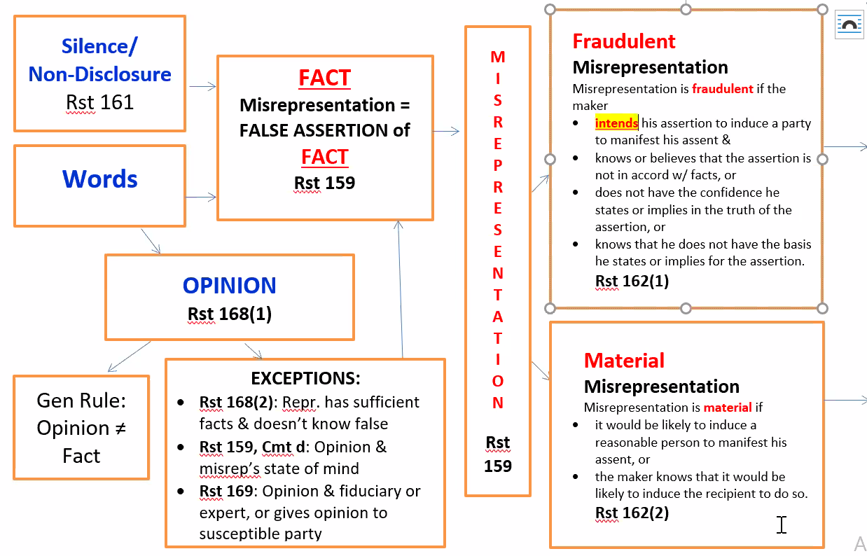
      - Syester v. Banta (p. 611)(1965)(young man scheme to prey on old widow in dance studio lessons)
        - Rule. A contract may be deemed unenforceable due to fraudulent misrepresentation. A release obtained in good faith is binding . Plaintiff has burden to prove fraud. The general rule is that a settlement is binding and effectual if fairly entered into without fraud or overreaching. But in this case the jury was convinced that there was a predatory play on the vanity and credulity of an elderly widow. The question of actual and exemplary damages (benefit of the bargain, out of pocket costs. Exemplary damages are question for jury per legal basis) was properly submitted to the jury, and the evidence of shocking greed and avariciousness supported the award of such damages.
        - RST 159. Cmt d, A statement of opinion amounts to a misrepresentation of fact if the person giving the opinion misrepresented their state of mind (i.e. stated that she held certain opinions when in fact she did not)
        - RST 159 a false assertion of fact mde by one of the parties at the time of contracting
        - A misrepresentation is an assertion that is not in accord with the ract
          - Fradulent Misrepresentation 162(1)
            - 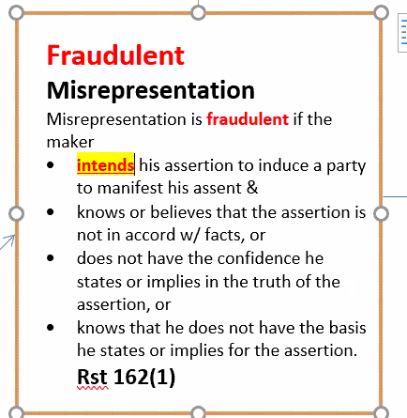
          - Material Msrepresentation 162(2)
            - 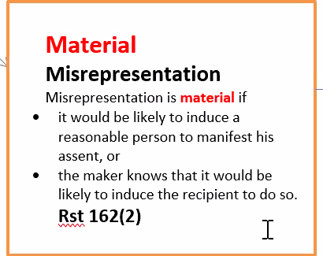
        - RST 161 Silence / Non-disclosure
        - RST 162 (2) and cmt c KCP p. 620 a contract may be subject to recision because of an innocent but material misrepresentation
        - RST 164 (1) KCP p 619. A contract is voidable if a party’s “manifestation of assent is induced by either a fraudeulent or a material misrepresentation y the other party upon which the recipient is justified in relying in…”
        - RST 168(1) Opinion – as the expression of a belief without certainty as to the existence of a fact typically of quality or value of a property (best car in class, can’t do better than this model Bayliner case consumers expect “puffery” sales pitch and consumers should take with grain of salt
          - General rule opinin is not fact and cannot be isrepresentation
          - Exceptions 159 cmt d
            - 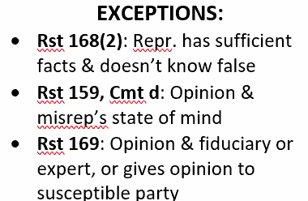
              - 168 (2) a statement of opinion amounts to an implied representation that the person giving the opionoi
                - Doesn’t know any facts that would make the opinion false AND
                - The person giving the opinoing knows sufficient facts to be able to render theoption (not hiding information)
              - 159 cmt d a statement of opinion is a misrepresentation of fact if the person giing the opinion mispresresnts his state of mind. (opinion is a lie) e.g. this is best car in class at time when people who work at VW knew terrible action give rise to class action suite. Sales person knows that but not the customer buying the car. So assertion is treated as misrepresentation of fact even though statement of quality because you know (salesperson) VW prepping gor 20M car vevhible and suit for mass tort.
              - 169 opinion
                - A. relationship of trust or confidence to the recipient (fidicuiar)
                - Is an expert on matter covered by the opinion
                - OR given to one who susecptivle to misrepresentation due to age or other factors (rememver after bargaining misconduct where on e party takes advantatge of another of wless informed suspetible party_
        - RST 169. A statement of opinion may also be actionable if the one giving the opinion (a) stands in relationship of trust or confidence to the recipient (a fiduciary relationship) (b) is an expert on matters concerned by the opinion , or (c) renders the opinion to one, who because of age or other factors, is peculiarly susceptible to misrepresentation.
        - Issue. Can a K be deemed unenforceable due to fraudulent misrepresentation?
        - Facts. Syester (P) was talked into signing up for 4,057 hours of dancing lessons at a price of $29,174. Syester (P), an incredibly gullible 68-year-old widow, was continually flattered and cajoled into signing up for more and more lessons through a planned campaign of the school’s staff. Syester (P) finally learned the truth about the operation and brought suit against the studio’s owner Banta (D) to recover the payments. Various tricks and other devices were used to persuade Syester (P) to drop the suit and to get her to distrust her attorney. Syester (P) executed a full release for $6,090, apparently without consulting her attorney. The suit was dropped. A second release with an unsigned note for $4,000 was executed subsequently. No payments were ever made on it. Syester (P) then brought suit alleging fraud and misrepresentation in the sale of lessons and in the obtaining of the two releases
        - Goal to set aside release agreements to return to underlying claim against dance to allow proceed in underlying lawsuit against the studio.
        - Suit for tort ( punitive damages) and K loaw for breach of K
        - IMPORTANT 2 alternative routes
          - Sue for tort in fraud + punitive damages + show intention to defraud and shorter SOL
          - Sue in K law for breach of K or here, misrepresentation suit seeking recision of a settlement or release in the case.
        - D argues in absence of fraud, execution of release bars further action.
          - Concerted effort to obtain releases by fraudulent overreaching. Predatory play on vanity and credulity of lady
          - Combo K + torts = underlying suit is in tort. The alleged settlement of that suit is in K or allegedly enforcable K. The only way the elderly widow can be awarded anything in the tort suit is if she can get court to rescind settlement K (two of them)
        - Set up as a defense of enforcement of a settlement contract or a modification of a K. Asserted when a different deal worked out . Must run through all BQ6 questions. Is e.g. Taylor case scope of insurance coverage and whether bad faith breach could be asserted against insurance company where insurer signed release of claims
        - Settlement and releases are agreements themselves that must be run through big 6
        - Here, release unenf. Bc defnse of fraudulent misrep by studio and people employed by studio. Actions of employees attributed to Employer under agency theory (not testable)
          - E.e.g manuf also has retail store. Good bough by consumer, burns half of consumer home. PRseents tort claim for product liability (strict liability) + claim under UCC for breach of warranty of merchantability. P can argue in the altnerative not limited to proceed in one or the other
        - D complains about jury instructions
        - No proof of damage argued. Verdict not beyond scope of evidence/instructions
        - Punitive damages awarded. D’s averishiocness shocking to court and jury , so properly submitted, evidence to support a verdict.
        - Recently widowed, 68, takes free class, plus puffery omg you’re so good flattery, refined sales pitch through eaves dropping, very manipulative sales pitch . Tell her she could be a proessional dancer off the stree dancer at 68-years old. You could be a “gold star dance” which would take years of dancing bought 3 life-times membership. She sues for faud, but Banta shows up in her home and follows at café with young guy she’s infatuated with “diamond ring” to sign 2 releases that are like a settlement
        - Holding.Yes. Exemplary damages are appropriate where a D acts in malice (to deter improper social acts). Where the other party’s conduct has been egregious, equity may relieve a party of the consequences of a release signed under a mistaken belief of law and facts. There was sufficient evidence from which a jury could find overreaching influence, unconscionability, misrepresentation, and fraud throughout the course of dealings between Banta (D) and Syester (P). Under such circumstances a jury may relieve a party of unread or misunderstood contracts or releases. The original release for $6,090 was wholly inadequate and the second release was unenforceable since it was never signed by Banta (D). The judgment for Syester (P) is affirmed. concerted effort constituting fraudulent overreaching.
    - Non-Disclosure
      - Hill v. Jones (1986)(Termite disclosure in house sale is material and required to disclose otherwise fraud)
        - Material – a matter is material if it is one to which a reasonable person would attach importance in determining his choice of action in the transaction in question
        - Rule. Where a seller of real property knows of facts that materially affect the value of the property and are not readily observable and known to the buyer, the seller has a duty to disclose these facts to the buyer.
        - (1)A contract provision that is in the nature of an integration clause that purports to insulate a party from all liability, even for its own fraud in procuring the contract, is invalid as a defense to such fraud.
        - A seller has a duty to disclose to the buyer the existence of termite damage in a residential dwelling known to the seller, but not to the buyer, which materially affects the value of the property.
        - Terms that remove liability for fraud in K are not enforceable. Parol evidence is always admissible to show fraud, and this is true, even though it has the effect of varying the terms of a writing between the parties.
        - Suppression of a material fact which a party is bound in good faith to disclose is equivalent to a false representation
        - Rst 153 When mistake of one party makes a K voidable
        - Rst 161 When non-disclosure is equiv to an assertion: Modern view: (1) disclosure is necessary to prevent a previous assertion from being a misrep or from being fraudulent or material (2) disclosure would correct a mistake of other party as to a basic assumption on which that party is making the contract and if nondisclosure amounts to a failure to act in good faith and in accordance with reasonable standards or fair dealings (3) Disclosure would correct mistake of other party as to the contents or effect of a writing, evidencing or embodying in agreement in whole or in part (4) The other person is entitled to know the fact because of a relationship of trust and confidence between them
          - Cmt d: a party may…reasonably expect the other to take normal steps to inform himself and to draw his conclusions
        - Rst 164 (1) When a misrepresentation makes a k voidable – where a misrepresentation is fraudulent or where a negligent misrepresentation is one of material fact, the policy of finality rightly gives way to the policy of promoting honest dealings between the parties
        - Facts. Before buying the Joneses’ (D) home, the Hills (P) asked whether it had been infested with termites, and the Joneses (D) denied that there had been previous infestations, despite firsthand knowledge of them. When the Hills (P) discovered that, in fact, there had been prior termite infestations, they sought to rescind the real estate purchase contract on grounds of misrepresentation and intentional nondisclosure
        - Holding.
    - Park 100 Investors v. Kartes (1995)(Fraud induced guarantee)
      - Rule. One cannot enforce a contract when he fraudulently induced the other party to enter into the contract. To establish fraud, one must establish the following elements: “(1) A material misrepresentation of past or existing fact by the party to be charged, which (2) was false, (3) was made with knowledge or in reckless ignorance of the falsity, (4) was relied upon by the complaining party, and (5) proximately caused the complaining party injury.” Regarding reliance, one must act with ordinary care and diligence in guarding against fraud.
      - A contract of guaranty cannot be enforced by the guarantee, where the guarantor has been induced to enter into the contract by fraudulent misrepresentations or concealment on the part of the guarantee.
      - Rst 163 When a misrepresentation prevents K formation. If a misrepresentation as to the character or essential terms of a proposed contract induces conduct that appears to be a manifestation of assent by one who neither knows nor has reasonable opportunity to know of the character or essential terms of the proposed contract, his conduct is not effective as a manifestation of assent
      - Rst 166. “Fraud in the execution” where the part is deceived as to the nature of the writing and “Fraud in the inducement” where the party knows what he is signing but does so as the result of misrepresentation
      - Facts. Park 100 Investors, Inc. (P) sought to collect unpaid rent from the Karteses (D) under a provision of the lease that was induced through fraudulent means. The Karteses (D) negotiated with Park 100 Investors, Inc. (Park 100) (P) to lease space for their growing business in 1984. A lease agreement was signed that did not include any provisions for a personal guaranty of the lease and a personal guaranty was never mentioned. A representative of Park 100 (P) later had the Karteses (D) also sign a ‘‘lease agreement,’’ but did not tell them that what they were signing was actually a personal guaranty of lease. The Karteses (D) called their attorney, who confirmed that he had examined and approved the lease agreement, and then signed. When the Karteses (D) later found out about the personal guaranty, they immediately disavowed the guaranty and refused to affirm that part of the tenant agreement. Park 100 (P) later brought suit to collect the unpaid rent from the Karteses (D) under the personal guaranty. The trial court found that Park 100 (P) obtained the signatures of the Karteses (D) on the personal guaranty of lease through fraudulent means, that the Karteses (D) had acted with ordinary care and diligence, and that they were not liable for any unpaid rent. Park 100 (P) appealed
      - Holding. The Kartes have shown that Scannell, as a representative of Park 100, acted fraudulently. Scannell called the personal guaranty “lease papers,” it was titled “Lease Agreement,” and Scannell stated that KVC could not move in until they were signed. These statements were made despite Scannell’s knowledge that the signatures were a guaranty. The Kartes, through ordinary care and diligence, believed the papers to be a lease and signed them accordingly. The Kartes demonstrated reasonable care by calling Kaplan before signing them and confirming that KVC’s lawyer had approved the papers. Park 100 cannot establish that the Kartes, as knowledgeable business people, could not have reasonably relied on Scannell’s misrepresentations. Though a contracting party is obligated to know the terms of what he is signing, that party will not be bound when misrepresentation was used to induce him to sign it.
  - Unconscionability; Public Policy (Rst 208, 178, 187, 188 / UCC 2-302)
    - Unconscionability (sliding scale) - A determination that a contractual term was so procedurally or substantively unfair and offensive that the harmed party should be relieved from its consequences. "UNCONSCIONABILITY Rule of law whereby a court may excuse performance of a contract, or of a particular contract term, if it determines that such term(s) are unduly oppressive or unfair to one party to the contract.
    - Generally, recognize to include an absence of meaningful choice on the part of one of the parties together with contract terms which are unreasonably favorable to the other party. Where meaningful choice is determined in particular case by consideration of all the circumstances surrounding the transaction.
    - ESSAY
      - The couple might have an unconscionability defense based on substantive unconscionability, procedural unconscionability, or both. A contract is procedurally unconscionable if it results from unequal bargaining power between the parties. Here, the couple lacked financial savvy, without advanced education, making it likely that they were in a weak bargaining position compared to the timeshare company. A contract is substantively unconscionable where it contains terms that are overly harsh or one-sided against one of the parties. Such is possibly the case here, where the contract provided for a high interest rate and forfeiture of the couple’s entire investment in the event of a late payment.
    - Prevents the oppression and unfair surprise to defendants.
      - No meaningful choice for one party (some cases meaningfulness of a choice is negated by gross inequality of bargaining power.)
        - Significant inequality in the parties’ bargaining power
        - Suspect behavior by the more powerful party
      - Terms that unreasonably favor the other party
    - Adhesion contract – standardize contract + take-it-or-leave-it basis
    - Williams v. Walker-Thomson Furniture (1965)(rent-to-own pro-rata)
      - What is the public policy the court refers to p. 640 “no ground upon which this court can declare the contracts in question contrary to public policy.”
      - Courts have power to develop CL, especially to use as other law as persuasive authority on matters of first impression.
      - UCC 2-302 - provides courts may refuse to enforce a contract which it finds to be unconscionable at the time it was made
      - Rule. Generally, sign agreement held to enf. K Exception Unconscionable contract provisions are not enforceable in court. (very fact specific) because hardly likely that his consent, or even objective manifestation of his consent, was ever given to all the terms. U.C.C. § 2-302 Provides that courts exercise their discretion to limit specific contract provisions that have unconscionable results.
        - Unconscionability has generally been recognized to include an absence of meaningful choice on the part of one of the parties, given the circumstances, together with contract terms that are unreasonably favorable to the other party.
      - Facts. Company sells rent-to-own products/goods to customers on credit and make installment payment. Until merchandise is paid in full company retains title. In case of default company repossess item and keeps all payments made to that point. K included “cover-all” provisions where balance due on new items also applies to everything else customer buys from the company, EVEN items already PAID OFF. In cases of default, the company may repossess ALL items BOUGHT PREVIOUSLY even those paid in full. Company sued 2 P’s who defaulted, and P stated K invalid because cover all provision is unconscionable.
      - Issue. Can a contract be held unenforceable because of unconscionability? Yes
      - Conclusion. UCC § 2-302 and that a court had authority to refuse to enforce a contract found to be unconscionable at the time it was made, the court reviewed the contract to consider the contract's terms in light of the general commercial background and the commercial needs of the particular trade or case. Ordinarily, one who signs an agreement without full knowledge of its terms might be held to assume the risk that he has entered a one-sided bargain. But when a party of little bargaining power, and hence little real choice, signs a commercially unreasonable contract with little or no knowledge of its terms, it is hardly likely that his consent, or even an objective manifestation of his consent, was ever given to all the terms. The court remanded the case, stating that the trial court could refuse to enforce a contract that it found to be unconscionable at the time it was made.
      - Dissent. Court should let congress do it’s job to make corrective legislation that protects public from such exploitive contracts. Business who sale rent-to-own expect their pricing policies will afford a degree of protection commensurate with the risk.

    - Higgins v. Superior Court of LA County (2006)(orphaned DIY Home Improvement Arbi Clause)
      - Rule. A party can avoid enforcement of an arbitration clause that is unconscionable. There is no rule that bars if a party reads an agreement party is barred from claiming it is unconscionable.
      - Facts. Charles Higgins, 21, became guardian for his minor siblings (plaintiffs) after their parents died, and the family moved in with the Leomatis. The Higginses were chosen to participate in the television program, Extreme Makeover, in which the Leomitis’ home would be renovated. The Higgins and the Leomitis each received a 24-page agreement. The agreement advised the reader not to sign until reading it completely. A “miscellaneous” section contained an arbitration clause. No special font was used to draw attention to the clause. The clause required only the Higginses to submit to arbitration, barred them from appealing an arbitration decision, and required the parties to split the arbitration costs. Charles Higgins quickly initialed the document in 6 places required but not next to the arbitration clause. The Leomitis home was reconstructed, and their mortgage was paid off. After the show was broadcast, the Leomitis kicked the Higgins out. The Higgins sued the networks, producers, construction crew, and the Leomitis (defendants) under various theories. The defendants petitioned the court to compel arbitration, which was granted for most of the claims. The Higginses petitioned for a writ of mandate from the California Court of Appeal, arguing that the arbitration clause was unconsiconable.
      - Reasoning. Arbitration clauses are generally valid and enforceable, but subject to the same grounds at law or equity for revocation as any contract, including unconscionability. Unconscionability refers to both procedural and substantive aspects of the agreement. (SLIDING SCALE) Procedural unconscionability usually means some amount of oppression or surprise because of the unequal bargaining power of the parties. Substantive unconscionability involves terms that are “overly harsh” or one-sided. Though both procedural and substantive unconscionability must exist, unconscionability will be found so long as any combination of the two meets the necessary threshold. Arbitration clauses may exist in adhesion contracts, which are standardized contracts written by the party with all the bargaining power that leave the other party with no options but to accept or reject. An adhesion contract is not per se unenforceable, but may be if it is unconscionable. In this case, the contract was drafted by the television defendants, Charles Higgins reviewed the documents for only five to ten minutes, and the contracts were presented on a take-it-or-leave-it basis (inferred bc Charles saw P hand K to Leomatis and told to sign here and here over 5-10 minutes). The agreements were contracts of adhesion. The Higginses were young and unsophisticated, vulnerable from the loss of the parents, and without bargaining power. The arbitration clause was buried in the miscellaneous section. The clause was procedurally unconscionable despite the warning to read the document before signing. Regarding substantive unconscionability, the arbitration clause required only the Higginses to submit to arbitration and the P was the only one who could compel arbitration without fear of losing other seeking injunctive or other equitable relief in a court of record. It additionally provided that the television defendants had the right to submit their claims to a court. The clause also required the Higginses to pay half the arbitration costs and forbade them from appealing. The arbitration clause is completely one-sided and, therefore, substantively unconscionable. The arbitration clause is both procedurally and substantively unconscionable and thus unenforceable. The writ of mandate is granted, and the trial court is directed to vacate the order compelling arbitration.
  - Minority and Mental Incapacity (p. 571-591 / Rst 14, 15)
- Alternative theories of recovery (see BQ6 for remedies)
  - PE (rst 87, 90), pre-reliance acceptance, restitution (unjust enrichment)
  - Liability in absence of BFE (PE)
    - Promissory Estoppel
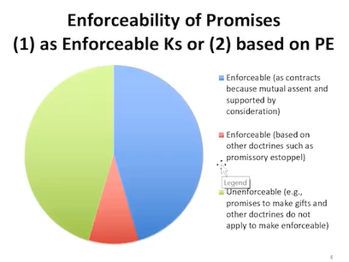
    - Generally
      - Rst 90 (PE for promise)
        - Rule:
          - Promise
          - Promisee’s reliance …reasonably foreseeable
          - Actual “detriment”
          - Injustice can be avoided only by the enf. of the promise
            - AND remedy to character and extent of reliance

        - Kirksey v. Kirksey (Historical background for Doctrine of PE) Sister Antillico
          - Held no enf K (as promise for PE bc consideration (no BFE)

        - Harvey v. Dow (express / implicit promise. ) Dad + Daughter land convey
          - Conduct of …manifestation of intention to act a certain way, specifically manifestation to confirm his “general promise” (1) Daughter rely, (2) reasonably foreseeable (3) “detriment”, (4) injustice can only be avoided by enf. of implied process
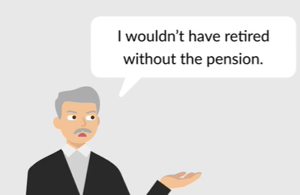
        - Katz v. Danny Dare (enforce commercial PE) Employee retired after robbery
          - (1) Promise? = yes (2) reasonably forsee (yes, twice said no, this induced Katz (3) “detrimental” reliance? Yes gave up job in reliance on promise to pay pension for life (4) can injustice be avoided only be enforcement of promise?
        - Vastoler (Promotion = PE? → yes)
          - … “ change of position, by accepting promotion, was detrimental reliance bc promotion made changers other than higher salary)
        - Hayes (retired, then pension offered = PE → no)
          - No action (act or forbearance) in reliance of the promise
          - Held” Hayes count NOT recover under PE bc he did not rely on employers promise; he decided to retire before the employer made the promise
    - Liability in absence of Acceptance (PE)
      - Option K in promise; in context of enforcing Option K
        - Rst
          - Rst 87(1)
          - Rst 87 (2)
      - Pre-Acceptance Reliance on promise (alt. recovery by PE)
        - Rst 87 (2) -
        - Rst 90 Pop’s Cones v. Int’l Resorts . promise Pop’s cones argument about fairness under Rst 90 to recover out of pocket economic damages (not expectations damages)
      - Exception to SOF
        - Rst 139

    - Unjust Enrichment (Rst of RESTITUTION)
      - 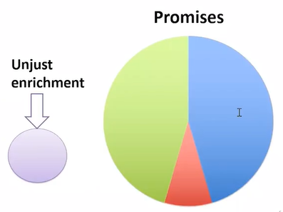
      - Not enf. of a promise, so NO PROMISE required
      - In class hypo Tree delivered by mistake
      - Exchange of benefit without compensation bc unjust
      - Synonyms: quantum meruit, quantum velebant
    - Pre-acceptance reliance and reliance damages: Pop’s Corner
  - Restitution

BQ3: If there is an enforceable K, what are the terms?

  - CL:
    - Mirror Image Rule
      - a purported acceptance with a term that varies from the offer is a REJECTION of the offer, terminates Offeree’s Power of Acceptance and is a C/O by the original offeree. Even if it uses language of acceptance “we accept but want to change this term…”
      - Need acceptance of counteroffer, or there’s no agreement.
    - Last Shot Rule (Binary; winner and loser)
      - Terms of the last form sent (C/O with varying terms) control if the counterparty either: explicitly accepts the C/O or does not explicitly accept the C/O but accepts the C/O implicitly by performing)
      - Last party to send forms controls the terms (favors seller); terms of acceptance carrying offer control if counterparty explicitly accepts the C/O or accepts the C/O implicitly through conduct
    - In class hypo:
      - non SOG K, service K and Customer orders service on a form and service provier accepts the offer on the service provider form and that form has lots of boilerplate in it. CL states last form sent is which terms control.
    - Princess Cruise v. GE
      - Illustrate Mirror Image and Last Shot Rule
      - GE sent the last form and Princess accepted C/O implicitly through conduct so GE’s terms control to limit liability
      - Facts:
      - Holding:
      - Rule: The UCC does not apply to maritime contracts that are predominantly for services determined by (1) language of the contract (2) the nature of the business of the supplier (3) the intrinsic worth of the materials.
      - .
  - RST
    - Varying Terms
      - Rst 59;
        - Purported acceptance conditional on O’ors assent to additional or different terms from those offered = C/O.
        - Consistent with 2-207 unless clause
        - Normile v. Miller – D made C/O – did not accept P’s terms.
      - Rst 61;
        - An acceptance which requests a change or addition (inquiry not intend to be bound) to the terms of the offer is not thereby invalidated unless the acceptances is made to depend on an assent to the changed or added terms of the C/O
  - UCC:
    - Varying Terms Overview
      - UCC drafters wanted to CHANGE
        - CL Mirror Image Rule &
        - CL Last Shot Rule
    - 2-207 (1): Acceptance VARYING Offer: Is there a K?
      - Permits
        - Varying acceptance (acceptance w/ additional or different term) to act as acceptance and form K
          - Additional to = a term that appears in one writing and other form is silent / not contradicted by other form
            - 2-207 (1) WRITINGS; Terms = 2-207 (2)
            - 2-207 (3) CONDUCT; Terms = 2-207(3)
          - Different from = a term that’s addressed in both forms but are different (conflict)
            - 3 Approaches (argue all in the alternative)
              - Cmt 3 approach; analyze as “add’l” terms 2-207(2)
              - Cmt 6 KO approach; KO diff (no term or gapfillUCC)
              - Literalist Approach; Diff. terms NOT UNLESS EA
            - e.g. one form says mandatory arbitration, one form says nothing about mandatory arbitration
      - General Rule (2-207 (1))
        - Acceptance or written confirmation with varying term operates as an acceptance
      - Exception (2-207 (3)
        - Acceptance / written confirmation does not operate as an acceptance if “unless clause applies” (i.e. if Acceptances clearly states “acceptance is expressly made conditional on assent to the [varying] term.”
        - “unless clause” – A reply to an offer which purports to accept but is CONDITIONAL on the O’ors assent to terms additional to or different from those offered = NOT AN ACCEPTANCE
          - WARNING: ONLY language that tracks with the “Unless Clause” “Subject To” NOT enough to meet exception of “expressly conditioned” assent
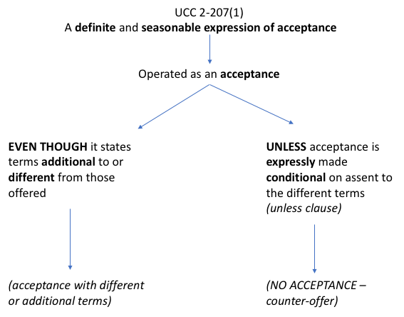
          - “differing terms without more” are not enough for Unless Clause. There is a enf. K go to 2-207(2) based on mismatched forms 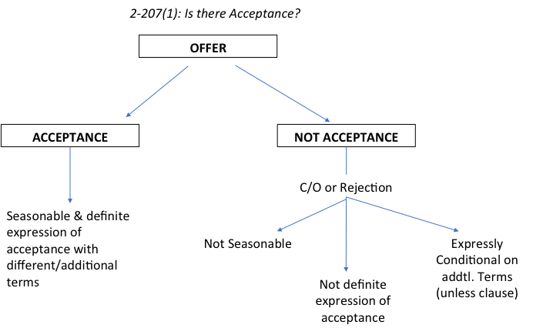
    - 1 WRITTEN CONFIRMATION + ORAL AGREEMENT 2-207
      - Oral Offer + Oral Acceptance (OA) = Binding Oral K.
      - 1 party’s WC follows formation of oral K;
        - WC has DIFFERENT term than OA
          - OA controls; WC term is NOT part of the K
        - WC ADDS a term to the OA
          - If K btwn “merchants” → apply 2-207 (2) re: add’l term analysis including exclusions (a-c; expressly limits, materially alters, rejects)
          - If K is NOT between merchants → add’l WC term is NOT part of K
    - 2 WC re: Oral K 2-207
      - Oral Offer + Oral Acceptance = binding Oral K.
      - BOTH parties exchange WC AFTER formation
        - If WC term is DIFFERENT than a term in the counterparty’s WC
        - AND OA did NOT address issue → KO diff. terms and apply UCC gap fillers (like 2-207(3))
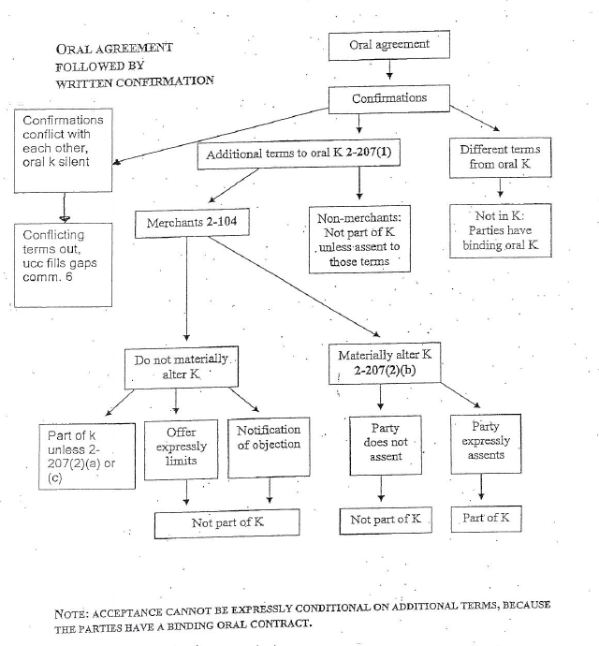
    - UCC 2-207 (1) Battle of Form (s) = Acc. Varying Offer
      - General
        - Definite (language of commitment, clear expression of assent using a reasonable person standard)
        - AND Seasonable (timely or no lapse, offer must still be in effect) Acceptance with varying terms and

      - =Acceptance (despite varying term in boilerplate)
      - Terms analyzed under 2-207 (2)
      - No K based on writings, but performance creates an enf. K
      - Terms of K are those on which the parties agree
      - KNOCKOUT terms that don’t match (see below Knockout rule)
      - UCC gap-fillers
      - Terms analyzed under 2-207 (3) gap fillers except for qty and subject matter (12 frozen turkeys)
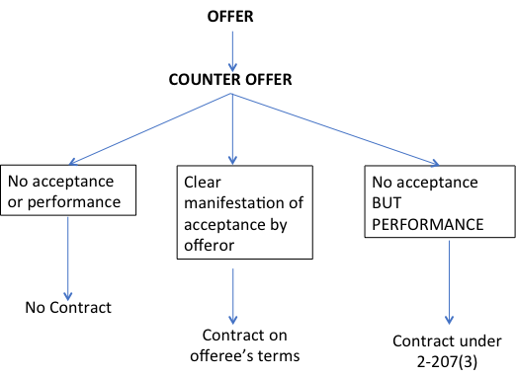
    - Unless clause
      - A reply to an offer which purports to accept but is CONDITIONAL on the O’ors assent to terms additional to or different from those offered = NOT AN ACCEPTANCE
  - 2-207(2) for K based on 2-207 (1) WRITING(s)

  - 2-207(3) for K based on 2-207 (3) CONDUCT NOT on WRITINGS

- Electronic/Layered Terms
  - Majority view - SOBO
  - Minority view - BOSO
- Implied Terms and Obligations (Rst 205, 227, 228)
  - The Rationale for Implied Terms
    - Wood v. Lucy, Lady DG (1917 Influencer)Implied-in-fact) [ by the parties]
      - Issue. If promise may be implied from writing even though it is imperfectly expressed, is there a valid K?
      - Facts. Lucy (D), a famous-name fashion designer, contracted with Wood (P) granting him exclusive right to endorse, market and license all her designs, profits split 50-50. The exclusive right was for a period of one year, renewable on a year-to-year basis, and terminable upon 90 days’ notice. Lucy (D) placed her endorsement without Wood’s (P) knowledge violating the K. Lucy (D) claimed no K for lacking consideration bc P allegedly was not bound to do anything.
      - Holding. K enf. bc implied “reasonable efforts” term for P to do for D bc context of exclusive rights, sole compensation was from best efforts, opened an LLC, and promised to account monthly to D, and take out copyrights/patents as need is evidence of value exchanged. Without such implied [return] promise, the K could not have had the business efficacy as parties must have intended the K to have.
      - Rule. If a promise of a term may be implied from a writing [based on the parties intent] even though it is imperfectly expressed, there is a valid K
    - Leibor v. Raynor Manuf (1978)(Garage doors distributor-dealers)(implied-in-law)
      - Issue. Is reasonable notification required in order to terminate an ongoing oral agreement creating a manufacturer-distributor relationship?
      - Facts. Raynor Manufacturing Co. (D) orally contracted with Leibel (P) for Leibel (P) to become an area-exclusive distributor of Raynor’s (D) products. Raynor (D) subsequently became dissatisfied with Leibel (P) and sent Leibel (P) notice of termination effective immediately. Leibel (P) sued for breach of duty of good faith and fair dealings, contending that reasonable notice was not given prior to termination . The trial court granted summary judgment for Raynor (D) as to the breach of contract cause of action, and Leibel (P) appealed
      - Holding. Reasonable notification is an implied term bc it does not contradict the writing (U.C.C.) applies. Section 2-309 provides that where successive performances over an indefinite period of time are involved, reasonable notification of termination is required. An exception is made where invocation of this rule would be unconscionable. However, in a situation such as that presented here, the distributor undoubtedly incurs expenses in reliance upon continuing the relationship. It is certainly not unconscionable to require reasonable notification.
      - Rule. UCC 2-309 when a K does not provide a specified duration, the party terminating the agreement must provide reasonable notice of termination
  - Obligation of Good Faith (GF)
    - Seidenverg v. Summit Bank (2002)(Seller of business and purchaser of business agree employ. K to “work together collaboratively” (implied-in-law)
      - Issue. Can a claim of breach of implied covenant based on GFFD be dismissed bc the allegations of the case where it stted that D made a K with P with intention of exercising his right to terminate such in bad faith?
      - Facts. The employees first became employees when they sold their successful employee benefits business to a bank, with the understanding that the bank would help them build the business and would employ them until they were ready to retire. Instead, the employees alleged, the bank did not help them, preferring to freeze them out of the business, in order to eventually replace them with employees the bank had chosen. The appeals court held that despite the employees' relative sophistication, the trial court acted prematurely in dismissing their claim as precluded by the parol evidence rule. If the employees could show the bank acted in actual bad faith, or exercised its discretion in a manner to frustrate contractual expectations, the employees might recover.
      - Holding. No. The duty of GFFD is implied term in all Ks which prohibits either party from doing anything that would destroy or injure the other party’s right to receive the “fruits of the K”, not an express term. The PER prohibits introducing parol evidence that contradicts the express terms of K so intro of parole evid regarding breach of implied term of GF not violate PER.
      - Rule. One may introduce parol evidence when claiming that a party breached the duty of good faith and fair dealing. . The implied covenant of good faith and fair dealing is applied in three (3) general ways, each largely unaffected by the parol evidence rule.
        - (1) the covenant permits the inclusion of terms and conditions that have not been expressly set forth in the written contract. (1a) The covenant acts in such instances to include terms the parties must have intended because they are necessary to give business efficacy to the contract.
        - (2), the covenant is utilized to allow redress for the bad faith performance of an agreement even when the defendant has not breached any express term. And
        - (3), the covenant permits inquiry into a party's exercise of discretion expressly granted by a contract's terms.
    - Morin Blgd Prod v. Bayston Construction [GM] (1983)(GC/SC “mills finish aluminum siding of addition”. Satisfaction clause; was it objective (reasonable person std) or subj. (D’s honest satisfaction std for artistic effect”)
      - Issue. "Will acceptance of performance in a contract whose purpose is primarily functional be based on an objective standard?
      - Facts. " General Motors Corp. refused, for aesthetic reasons, to approve aluminum siding installed by Morin Building Products (P), which was subsequently not paid. As part of a construction project for General Motors Corp., Baystone Construction, Inc. (Baystone) (D) subcontracted with Morin Building Products (Morin) (P) to install aluminum siding. General Motors retained final approval rights. General Motors’ agent rejected the siding due to a minor aesthetic flaw. The purpose of the siding was strictly functional. Baystone (D) had another subcontractor redo the job, and refused to pay Morin (P), which sued for breach. The trial court held that the standard of acceptability of Morin’s (P) performance was objective, and the jury held it objectively adequate. Baystone (D) appealed.
      - Holding. Yes. Acceptance of performance in a contract whose purpose is primarily functional will be based on an objective standard. The majority rule is that where the contract in question involves performance of commercial quality, an objective, reasonable person standard will be used in determining whether performance was adequate. It is unreasonable to expect a party to such a contract to permit his financial outcome to depend on whim. The “artistic effect” term seemed like boilerplate to apply in limited situations because of immediate qualifying phrase “if within the terms of the K documents”. If D wanted uniform finished apperance, would have included it in the terms. Some objective uniformity expected “a mill finish…to match finish…of existing metal siding.” Therefore, Affirmed
      - Rule in the absence of explicit language to the contrary, only if performance is inadequate objectively (obj. reasonable person standard commercial quality, operative fitness, or mechanical utility which other knowledgeable persons can judge) will performance be considered inadequate. in the alternative, subjective satisfaction depends on the owner’s good faith “honest” judgment when the contract involves personal aesthetics or fancy.
  - Warranties
    - Bayliner Marine Corp. v Crow (30mph offshore fishing boat; prop matrixes (1999). Express warranty, implied warranty of merchantability, implied warranty of fitness for a particular purpose
      - Issue. Was there sufficient evidence to support the trial court's ruling that the manufacturer of a sport fishing boat breached an express warranty and implied warranties of merchantability and fitness for a particular purpose?
      - Facts. An individual bought a sport fishing boat from a manufacturer. Unhappy with the performance and the low speed of the boat, he returned the boat and filed a case against the manufacturer. The buyer argued that the particular purpose for which the boat was intended was use as an offshore fishing boat capable of traveling at a maximum speed of 30 miles per hour, which the boat was not doing. The trial court held that the manufacturer breached an express warranty and implied warranties of merchantability and fitness for a particular purpose to the buyer. On appeal to the Supreme Court of Virginia, the manufacturer alleged that there was insufficient evidence to support the lower court's ruling.
      - In August 1989, John R. Crow (plaintiff) purchased a boat manufactured by Bayliner Marine Corporation (Bayliner) (defendant) to be used for offshore fishing. Prior to purchasing the boat, Crow asked John Atherton, a sales representative for the retailer, about the boat's maximum speed. Atherton gave Crow Bayliner’s promotional materials for the model that Crow had test driven. The materials described that model as having a maximum speed of 30 miles per hour provided certain conditions and specifications were in place. The materials also stated that this model was well suited for offshore fishing. Although Crow and Atherton discussed the boat's maximum speed in the context of offshore fishing, Crow never told Atherton that he required a boat with a maximum speed of 30 miles per hour. The boat that Crow purchased proved to have a maximum speed of 23-25 miles per hour, and as a result, Crow found the boat unsuitable for offshore fishing. Nevertheless, Crow used the boat for offshore fishing and logged 850 miles of engine use within the first few years after purchasing it. Crow’s boat had different specifications from the boat described in the promotional materials, including a smaller propeller and a higher gear weight. Crow brought an action against Bayliner, the retailer, and the manufacturer of the engine alleging that the promotional materials created an express warranty that the boat he purchased would reach the maximum speed of 30 miles per hour as described in the written materials. He also alleged breaches of the implied warranty of merchantability and fitness for a particular purpose. The trial court held in favor of Crow, and the defendants appealed.
      - Holding. No. The court held that buyer failed to establish a breach of an implied warranty of fitness for a particular purpose because the evidence failed to show that he made known to the sport fishing boat manufacturer the particular purpose for which the goods were required. The evidence showed that the boat manufacturer did not know that a boat incapable of travelling 30 miles per hour was unacceptable to the buyer.
      - Rule. all contracts for the sale of goods by a merchant, a warranty is implied that the goods are merchantable. In order to prove that a product is not merchantable, the complaining party must first establish the standard of merchantability in the trade.
      - A seller's statement of opinion about a product’s potential performance does not create an express warranty that the product will conform to that description
      - Warranty. A guarantee of quality of a product or service for a specified period of time.
      - Merchantable. Goods must be such as would “pass without objection in the trade [significant segment of the buying public]” and as “are fit for ordinary purposes for which such goods are used [ reasonably capable of performing their ordinary functions].”
      - UCC 2-313 Express Warranties. Does not require that the seller have the intent to create an express warranty, and this represents a substantial change from CL approach to warranties
      - UCC 2-314 Implied Warranty of Merchantibility. A merchant (UCC-2-104) who regularly sells goods of a particular kind implied warrants to the buyer that the goods are of good quality and are fit for the ordinary purposes for which they are used
      - UCC 2-315. Implied warranty of fitness for a particular purpose. Differs from merchantibilty because the warranty is created only when the buyer relies on the sell’ers skill or judgment to select suitable goods and the seller has reason to know of this reliance. Also, breach of the warranty does not require a showing that the goods are defective in any way – merely that the goods are not fit for the buyer’s particular purpose
- Terms Creating or Limiting Remedies
Terms Creating Conditions and Promises of Performance (Relevant to BQ4)
Q4 Does each party have a duty to perform? Conditions/events discharging performance obligation?
- Justification for Nonperformance
  - Changes in circumstances that have either occurred or come to light since the original agreement was made
  - Parties generally make K with aim of binding each other despite changes of circum that may occur before the time of performance arrives.
  - Exception: a more particular type of mistake has been made
  - Mutual Mistake (Rst 151-154; KCP 719-741) (barren cow case)
  - VERY SPECIFIC MEANING, AN ERRONEOUS SASSUMPTION OF FACT THAT EXITED AT TIME OF ENTERINK k AN ITS MATERIAL, RISK IN BARGAIN AND MISTAKE NOT ALLOCATED .
  - TIP: SOMETHING CHANGES AFTER FORMATION (SUPERVENING EVENT) IT IS NOT MISTAKE.
    - 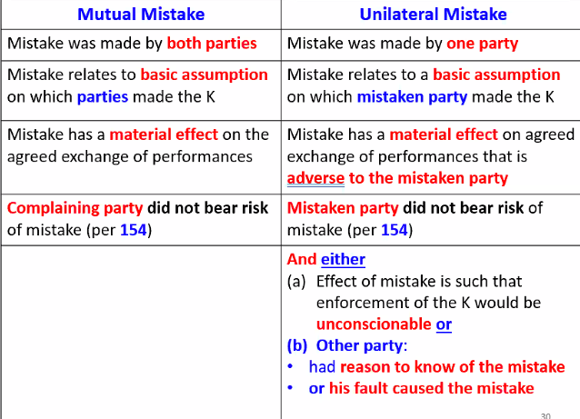
    - RSt 151; Mistake - a belief that is not in accord with the facts (property was income-producing capacity…but all the parties subsequently learned in fact, that the property was unsuitable for any residential use). Contractual mistake - cannot be discovered until after K executed. Inception date of defect (if before K executed than mutual mistake) v. defect date detected after K executed ≠ mutual mistake.
    - Rst 152; (When Mistake of both parties make a K voidable)
    - Rst 153; (When mistake of one party makes a K voidable)
      - K voidable
    - Rst 154; (When a party bears the risk of a mistake) (b) conscious ignorance = deny rescission for mutual mistake)
    - 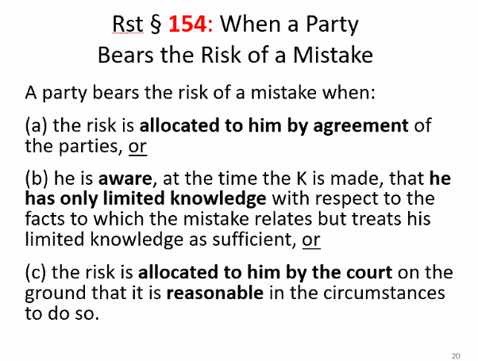
    - Lenaway County Board of Health v. Messerly (p. 720)(oh Shit! Septic tank rental property. MUTUAL “Mistake” but Buyer assumed risk of loss by “as-is” clause in K ∴ no rescission of K)
      - RULE. Rescission is appropriate when the mistaken belief relates to a basic assumption of the parties upon which the contract is made, and which materially affects the agreed performances of the parties, but rescission is not available to relieve a party who has assumed the risk of loss in connection with the mistake.
      - Rescission is an equitable remedy which is granted only in the sound discretion of the court. A court need not grant rescission in every case in which the mutual mistake relates to a basic assumption and materially affects the agreed performance of the parties.
      - FACTS: A landowner constructed an apartment building on his property and installed a septic system without a permit and in violation of the health code. The landowner conveyed title to the property to the sellers who are the appellants in this case. The appellants sold the said property to the appellees “as-is” clause (Purchaser has examined this property and agrees to accept same in its present condition. There are no other or additional written or oral understandings), but shortly thereafter, the county health board then obtained a permanent injunction prohibiting human habitation of the property due to the defective sewage system. The buyers initiated an action against the sellers to rescind the land sale contract on the basis of mutual mistake and failure of consideration. The appellate court entered judgment in favor of the buyers.
      - ISSUE: Whether a contract may be rescinded at all times on the basis of mutual mistake.
      - HOLDING + RATIONALE: Yes. On appeal, the court found that the buyers were not entitled to recission. Both the buyers and the sellers believed that the property was suitable for human habitation when they entered into the land sale contract. Both parties were blameless because neither the sellers nor the buyers knew of the defective septic system (needed 2500 ft sq to support sewage system adequate…and 750 ft sq for one-family home, so 600 ft sq septic illegal and defective). The court was faced with two equally innocent parties and concluded that the risk should be allocated to the buyers. The parties' land sale contract also contained an "as is" provision allocating the risk to the buyers (Rst 154)
    - BMW Financial Services v. Deloach (p.730) (Mutual mistake but no assumption of risk loss by any party and enf. K would be unconscionable, UNILATERAL “mistake”)
      - 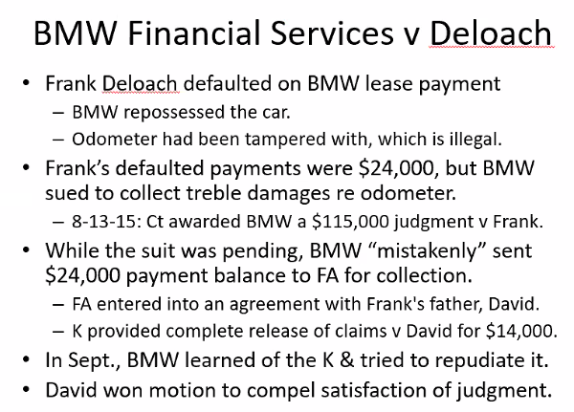
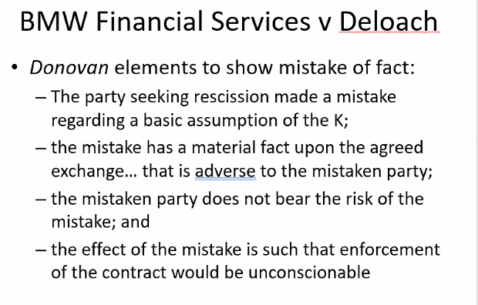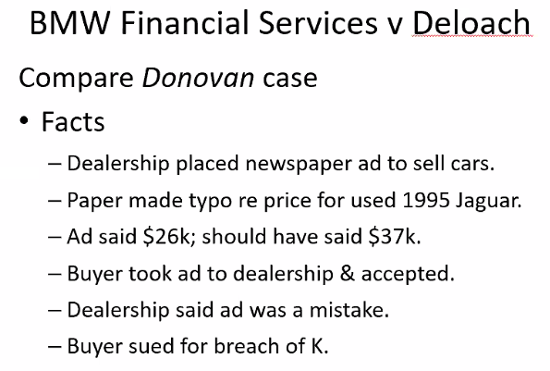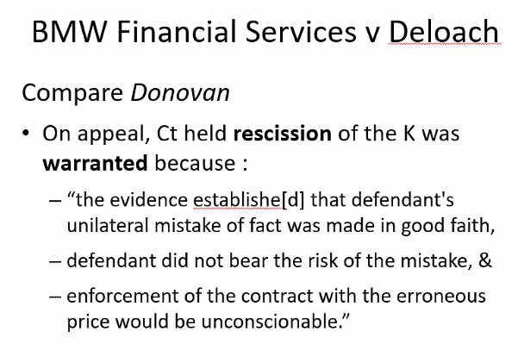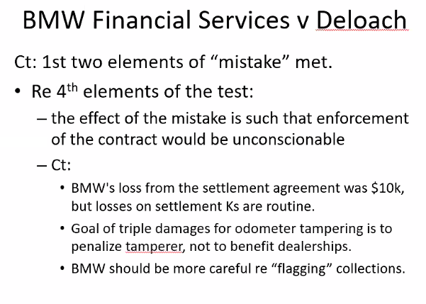
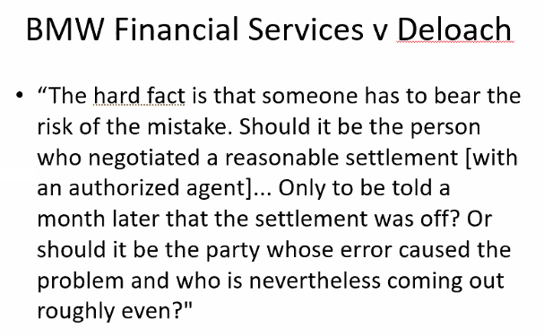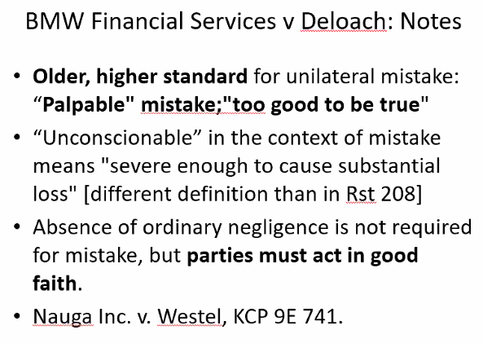
      - RULE. A contract may be rescinded based on mistake of fact if the party seeking rescission made a mistake regarding a basic assumption in the contract, the mistake had a material adverse effect on the agreed-upon exchange, the party did not bear the risk of mistake, and enforcement of the contract would be unconscionable on account of the mistake.
      - FACTS. Frank Deloach (defendant) leased a BMW from BMW Financial Services NA, LLC (plaintiff). Deloach did not make his lease payments, and BMW repossessed the car. At that point, BMW determined that the odometer had been tampered with. BMW sued Deloach for breach of the lease and for tampering with the odometer. BMW sold the car at auction for $25,000. Because BMW did not properly flag Deloach’s account as being part of ongoing litigation, the account was sent to a collection agency with an outstanding balance of approximately $24,000. Deloach’s father negotiated a settlement with the collection agency for $14,000 in exchange for a complete release of claims. The settlement was signed on August 17, 2015. On August 13, 2015, BMW won a default judgment against Deloach in the amount of $114,677. Most of this amount was treble damages for the odometer tampering. BMW did not learn of the settlement until after the default judgment. BMW sought to rescind the settlement on account of its mistake in sending Deloach’s account to a collection agency when litigation was pending. Deloach filed a motion to compel acknowledgment of satisfaction of judgment. The trial court granted the motion. BMW appealed.
      - ISSUE. May a contract be rescinded based on mistake of fact if the party seeking rescission made a mistake regarding a basic assumption in the contract, the mistake had a material adverse effect on the agreed-upon exchange, the party did not bear the risk of mistake, and enforcement of the contract would be unconscionable on account of the mistake?
      - Holding and Reasoning (Bedsworth, J.). Yes. Mistake made by collection agenecy of BMW that case was not in litigation and could not be settled. A contract may be rescinded based on mistake of fact if (1) the party seeking rescission made a mistake regarding a basic assumption in the contract, (2) the mistake had a material adverse effect on the agreed-upon exchange, (3) the party did not bear the risk of mistake, and (4) enforcement of the contract would be unconscionable on account of the mistake. A party may bear the risk of mistake by neglecting a legal duty. However, a party may also be found to bear the risk of mistake when it is reasonable under the circumstances for the court to so allocate the risk. In this case, the trial court correctly granted Deloach’s motion. There is no dispute that BMW made a mistake regarding a basic assumption in the contract and that the mistake had a material adverse effect on BMW. The court finds, however, that BMW bore the risk of mistake. Although BMW did not neglect a legal duty, the sending of Deloach’s account to collections was solely the fault of BMW. It is reasonably clear that BMW bore the risk of its own mistake. Further, enforcing the settlement is not unconscionable. BMW received $25,000 for the car and an additional $14,000 in the settlement. The majority of the default judgment was the result of treble damages, and BMW’s actual loss was only just over $10,000. Punitive damages are not meant to compensate the opposing party, and settlements frequently result in satisfaction of judgments for less than the actual judgment. That amount here is not unconscionable. In sum, BMW may not rescind the settlement agreement on account of its mistake. The judgment is affirmed.
- Anticipatory Repudiation
Reasonable Insecurity

BQ5 Assuming a duty to perform, was a failure to perform a breach?
- Mistake; Failure to perform
- Changed Circumstances; Failure to perform
  - Overview
    - There is a lot of overlap among the contractual defenses of impossibility, commercial impracticability, and frustration of purpose. All three defenses require that an unforeseen event alter a basic assumption that the parties made when they formed the contract. However, the frustration-of-purpose defense also requires that the unforeseen event thwart the parties’ primary purpose for having entered the contract to such an extent that one party’s performance became virtually worthless to the other party
    - Policy. Nonperformance is actionable bc any failure to perform what promised by D; not because of “culpable”
    - Remedy. If not specific performance, compensate the P for the lost value of the D’s expected performance.
    - Foreseaability.Foreseeability or even recog. Of risk does not necessarily prove its allocation.
    - Risk Allocation. When a K specifically allocates the risk to a party, that party is the superior risk bearor. In the absence if K provisions, the risk should be assigned to the part who is in the vest position to precent the event from occurring, or if the prevention is not possible, to minimize its consequences at the lowest costs, typically by purchasing insurance.
    - Decision by Judge or Jury? Rst takes position that a defense such as mistake, impracticability, or frustration of purpose should be decide by the court as a question of LAW, rather than being submitted to the jury for a finding fo fact. To result in “stability and predicatively in contractual relationships (Rst 212)
  - UCC-2-615; Excuse by Failure of presupposed condition. Broad enough to cover instances of both traditional impossibility, and impracticability, as well as FOP
  - Doctrine of Impossibility (Rst 262, 263, 264) by incapacity or destruction
    - Objective impossibility – “no one could do it” p. 743
    - Subjective impossibility – “I cannot do it”
    - Taylor v. Caldwel (p. 742); discharged duty for “acts of God”. Caldwell agreed to rent a music hall from Taylor for musical performances. The hall burned down shortly before the first performance was to take place, and Taylor sued for BOC. Ct discharged Caldwell duty and liability because the hall itself was “essential” to the performance of the K, and the parties had contracted “on the basis of [its] continued existence.
    - RULE. RSts 262, 263; UCC 2-613
      - When a person or thing, “necessary for performance” of the agreement dies or is incapacitated, is destroyed or damaged, the duty of performance is accordingly excused.
  - Doctrine of Impracticability (rst 261, 266)
    - A K expressly or implicitly assumes that a given event won’t occur, yet it occurs anyways (like frustration)
    - Impracticability for performance to be impracticable, it must involve “extreme and unreasonable difficulty” that renders performance of the promise “vitally different” from what the parties contemplated at the time the K was made.
    - Cts generally unwilling to grant relief for natural disaster or war as basis for relief.
      - Ship owners denied relief for increased expense under doctrine of impracticability when the Suez Canal was closed due to war
    - Duty is discharged by supervening event rendering performance commercially impracticable can discharge duty to perform and render otherwise enf K unenforceable.
    - Mineral Park v.Howard; (p. 744); D’s duty to perform (take all gravel requirements from P) was discharged bc D showed It removed all gravel from P’s land above water level, and that removal of that which lay below water level would have entailed not only a diff. means of extraction but 10-12 X #. Ct held extreme increase in cost of gravel extraction justified D’s nonperformance.
    - Hemlock v. Solar Saschen Gmbh (p. 744) . (China (3P) market manipulation of polysilicon crashed price sue for BOC of LTA and liquidated damages sought)
    - RULE.
        - Changes in market conditions are not a basis for the impracticability defense because changes in market conditions are ANTICIPATED basic assumption contemplated by both parties when they entered into the K.
        - Liquidated damages clause in a K is enf where the agreed amount is reasonably intended to compensate for injury suffered, it’s not unconscionable or excessive, the potential damages from breach are uncertain and difficult to anticipate when the K is made, and the K expressly indicates that the damages are intended to cover costs incurred by the non-breaching party.
      - FACTS. Hemlock entered K to supply SolarWorld Sachsen GmbH with specific quantities of polysilicon at fixed prices over a 14-year period. In exchange, SolarWorld agreed to a take-or-pay provision stating that SolarWorld would pay for a minimum amount of polysilicon each year, even if it took delivery of less than that amount. Further, under the agreements’ liquidated-damages provision, if SolarWorld failed to pay this minimum amount in a given year, then it had to pay Hemlock the minimum amount for that year plus any future years still left in the agreements. China caused unexpectedly down market prices. Although temporary price adjustment x one year’s agreement, unable agree future agreements. The next year, SolarWorld did not pay the contractual minimum amount. Hemlock sued for BOC, seeking damages under the liquidated-damages provision. SolarWorld argued that these illegal actions were unforeseeable events that supported the defenses of impossibility, impracticability, and frustration of purpose. Ct held (1) market shifts, for any reason, were a basic assumption of the parties’ agreements and (2) the parties’ primary contractual purpose was to provide SolarWorld “with a stable supply of polysilicon at a predictable price.”
        - REASONING. FOP defense also requires that the unforeseen event thwart the parties’ primary purpose for having entered the contract to such an extent that one party’s performance became virtually worthless to the other party. Further, in general, it is rare for parties to assume that market conditions will remain unchanged when making a contract, because market conditions are always changing. Here, an underlying assumption of the parties’ agreement was that market prices would fluctuate. Thus, the primary purpose of the agreements was to provide SolarWorld with polysilicon at a fixed price that eliminated having to gamble with market prices. The district court correctly concluded that the possible illegal source of major market fluctuations was irrelevant. The only relevant fact is that the parties had assumed fluctuations might occur. Therefore, a market decrease was not an unforeseen event that could support the defenses of impossibility, impracticability, or frustration of purpose. Further, the agreements’ purpose was not to assure that SolarWorld would always get a good price—just a steady price. The decrease in market price did not frustrate this purpose.
  - Doctrine of Frustration of Purpose (Rst 265, 288)
    - A K expressly or implicitly assumes that a given event won’t occur, yet it occurs anyways (like impracticability)
    - Three conditions
      - Object of K must frustrate and of sufficient importance that without the K doesn’t make sense
      - Frustration must be substantial (not enough profit reduced or loss, severe enough to not have been considered as risk assumed under the K)
      - The event must be such that its nonoccurrence is basic assumption underlying the K.
    - The frustration-of-purpose defense requires that an unforeseen event substantially frustrate the parties’ primary purpose in making the contract.
    - Krell v. Henry (king’s coronation parade cancelled) D agreed to pay P for use of a room overlooking the route that the coronation procession of Kind Edward 7th would travel. The sudden illness of the kin forced the cancellation of his coronation, however, making the P’s room useless to the D for that purpose on that day. The court held that the defendant was excused from his duty of payment because of a supervening change in extrinsic circumstances.
    - Mel Frank Tool v. Di-Chem (p.757) (Storage and distribution [hazardous chemicals]When a subsequent gov’t regulation prevents a tenant from using the premises as originally intended > the tenant’s purpose is substantially frustrated > the tenant can be relived from paying rent > unless there’s still a serviceable use available under the lease. Limited use not render benefit of bargain valueless (so not frustrated purpose. Leasee’s purpose was partially frustrated but that’s not enough to discharge duty because of supervening event leading to less profit is not enough for substantial frustration bc basic risk assumed doesn’t have to be express or acknowledged. Could still use premises to store other non hazardous materials. Need to establish that ordinance deprived Di-Chem of the beneficial use of the leased premises for other uses related to nonhazardous chemicals but here didn’t bc no evidence of amount all inventory was of hazardous material inventory + no est. possible lost profits without stored hazardous materials. So no discharge of duty, Di-Chem still owe Mel Frank rent.
    - RULE. A party’s performance under a lease may not be excused when a law or ordinance restrict use of the premises,but does not completely render the premises unusable by the party.
  - UCC 2-615
    - Broad enough to encompass all 3 doctrines that justify nonperformance (impossibility, impracticability, and frustration of purpose)
    - Cmt 9 ; some courts allow defense of impracticability can apply to both sellers and buyers of goods
  - UCC 2-209 Integrated Agreements
    - 209(2) . the Code authorizes parties to employ a NOM clause to create a “private statute” of frauds governing modifications by providing that a “signed agreement” which excludes modification or rescission except by a signed writing cannot be otherwise modified or rescinded “ intended to protect against false allegations of oral modificatn” DIFFERENT from Cl by generally making NOM enforceable.
    - 209(3) requirement of the SOF section of this article must be satisfied if the K as modified iw within its provisions unless (UCC-2-201(1)) the modification would either change the qty term or increase the price above the $500 UCC threshold.
    - 209 (4) . both 209(2) and 209(3) must be read with 209 (4), …although an attempt at modification or rescission does not satisfy the requirements of subsection (2) or (3) it can operate as a waiver.
- Modification of Contract
  - DURESS Unlawful threats or other coercive behavior by one person that causes another to commit acts he would not otherwise do.
  - MODIFICATION A change to the terms of a contract without altering its general purpose."-Casenote Legal Briefs Contracts,
  - RESTATEMENT
    - Rst 73 Performance of Legal Duty

    - Alaska Packer’s Assn’ v. Domenica (p.773) (Pre existing duty modifications without new consideration are not enforceable)Fisherman demanded $ change mid-season; issue whether a modification to a K for price change for same services is enforceable without new consideration. No) Fishermen first agreed tp be paid $50 + $0.02 per fish. During fishing season, fisherman demanded $100 or they’d stop fishing. Which they did. Once APA agreed to $100 rate, Domenica continued fishing. Even so, APA made payments based on first rate. Domenica sued for breach of contract for modification. Because the sailors refused to perform the original contract and agreed to do no more in the new contract than perform what they had already obligated themselves to do in the original contract, the promise by the APA representative to pay $100 is not enforceable and earlier K remains in full force. Vulnerable party (impossible to find replacement workers + short fishing season) not waive rights bc no new consideration. And is not enf. even though the other party has completed his K in reliance of the modification).
    - Rst. 73 An enforcebale modification requires consideration . and a PED is not consideration. If duties change on both sides (quid pro quo BFE) as a result of the modification(e.g. K for catch salmon only → catch salmon and repair nets with holes in them then modification would have been enforceable) then modification could be enforceable
    - Modifications at CL/RSt require consideration. If no Consideration a defense to enforcemtnt of modification K.
      - Exceptions
      - Unforeseen circumstances. When solid rock uneqxpectedly encounetered making removal nine times more expensive, owner’s promise to pay increased amount for excavation is binding. Modification that increased size of promised medical building would be enforceable without add’l consideration in light of need to resolve unforeseen safety concerns not addressed by original architect plans.
      - Rst 89 Modification of executory (a K not yet performed)contract. (Reliance rule) Reliance on a promised modification despite absence of a fresh consideration.
      - Rst 89 b Mutual release. Legal fiction. Pretend old agreement torn up eliminating old duty (old K terminated) and aparties enter into a “new” K .
        - If actually terminated and entered into a new agreement could be a BFE but usually just a charade for one parties duty changing
  - UCC-2-209 Modification, Rescission & Waiver
      - UCC 2-209 (1). examples of mutual recession. Parties regularly modify agreements without having new consideration on both sides and that such “one-sided” modifications should be routinely enforced except in the presence of special circumstances.
    - MODIFICATION AND ECONOMIC DURESS (IMPORTANT COMMON FACT PATTERN
      - IMPORTANT : bc fact pattern very common
      - Kelsey-Hayes v. Galtaco (p.782) (Modification Rst 89 Modification of Executory K, UCC 2-209 Modification, recession, waiver, for modification entered into under economic duress)
        - When Galtaco Redlaw Castings Corp. (D) experienced financial losses and threatened to shut down operations, Kelsey-Hayes Co. (P), which had signed a three-year requirements contract. Galtaco breached K of fixed-price to Kelsey-hayes and demand #1 , enter into first modififed K for higher prices to keep operations going. 3-year “requirements” K, Galtaco sole source to Kelsey-Hayes of brake casTings in return for 30% fixed price increase of brake casings = K modification made under duress (not suitable alternatives, tried 6 other vendors, alt. source 18-24 week lead time, and reject would results severe damages/reputation damage). KH agreed to modiication and did not reserve any rights under the 1987 contract when entered into June 1989 modification K (30%+ price for brake casings). Second demand additional 30% increase because Kelshey-Hayes is the only customer of Galtaco.All casings shipped were accepted but KH didn’t pay Galtaco for 84 of 85 casting shipments ($2M). Threat = BOC and go out of business, stop production and delivery of castings unless KH agreed to significant price hikes. Protest to price hike could reasonably be determine by trier of fact to put Galtaco on notice that the 1989 agreements were agreed to under duress.
        - ISSUE: Is modification of price term enforceable?
          - Rule: K is VOIDABLE if a party’s manifestation of assent is induced by an improper threat by another party that leaves the victim no reasonable alternative. (Rst 175)
          - UCC SOG Using Totem Marine test + PROTEST to determine if economic duress is a defense to enforcement of modification to price term?
          - (1) A wrongful or improper threat [must pay 30% increase or BOC] (2) no reasonable alternatives [tried 6 other suppliers but not successful], and (3) threat actually induced victim to enter into K [+ Ford had liquidated damages clause so threat of supply chain cut off induce agreement to modification] + Kelsey-Hayes also made clear they were not happy with the change, language doesn’t have to be exactly “protest” or we will sue you later for BOC. It’s enough to say it’s unfair/have us over a barrel
        - RULE. K modification is not enforceable and therefore does not supersede an earlier K when the subsequent K was entered into under duress and the other party did not “protest”

BQ5 Assuming it was a breach, was it partial, material, or total?
- Promises / Conditions / Promissory Conditions
  - Obligor – the party whose performance is so conditioned
  - Obligee – the one to whom the performance obligation is owed, and the one who is presumably attempting to enforce it
  - Express Conditions p. 803 (Rst 224-227, 229) + Handout
    - Rst 224. Condition defined. an event not certain to occur, which must occur…before performance under a K becomes due. (must be unambiguous language bc subs. Performance will not suffice e.g. “if, unless, until” = unmistakable language of condition
    - Rst 225. Effects of the non-occurrence of a condition
    - Rst 226. How an event may be made a condition
    - Rst 227. Standards of preference with Regard to Condition. In making the determination whether a term is an express condition, Rst prefers an interpretation that aterm or event is NOT an express condition in order to reduce the risk of forfeiture. An express condition will NOT be found if there is another reasonable interpretation.
    - Rst 229. Excuse of a condition to avoid forfeiture. Forfeiture Cmt b. A forfeiture refers to the denial of compensation that results when a party loses his right to a business arrangement after substantially relying on the expected performance.
      - Counsel represented sophisticated parties
      - K includes express termination clause
      - No forfeiture occurs when the breaching party maintained ownership of the assets compromising the K
    - Rst 237 Effect on Other Party’s Duties of a Failure to Render Performance. Cmt d. Rejects the application of substantial performance qualitification to the strict enformcent of express conditions
    - enXco Dec. Corp. v. Northern States Power Co (p.805)
    - RULE. A party to a contract may not use the defense of temporary impracticability to excuse the performance of a condition precedent if the party’s own inaction caused the non-performance.
    - (1)Even assuming the doctrine of temporary impracticability applies to conditions precedent and may be used as an offensive legal mechanism by a party to pursue a breach of contract claim, that doctrine will not apply to excuse a party’s failure to comply with a condition precedent where the party has failed to exercise appropriate diligence to fulfill the condition precedent.(2)Even assuming the doctrine of disproportionate forfeiture applies to conditions precedent and may be used as an offensive legal mechanism by a party to pursue a breach of contract claim, that doctrine will not apply to excuse a party’s failure to comply with a condition precedent where the parties to the contract are sophisticated and represented by counsel, where the contract contains an express termination clause, and where the party asserting the doctrine has not parted with anything.
    - FACTS. enXco Development Corp. (enXco) (P), a renewable energy developer, contended under the doctrines of temporary impracticability and disproportionate forfeiture, its failure to satisfy a condition precedent by timely obtaining a required permit did not permit Northern States Power Co. (NSP) (D), a utility company, to terminate a contract the parties had to construct a wind-energy-generation project.
    - HOLDING & REASONING. P’s sources of delay were foreseeable and would have been manageable in time frame agreed by K if P acted timely manner. (applying earlier for permit, working with conservation groups to work around endangered birds, etc.) . Rst 229 cmt b P did not part with anything, but rather maintained possession and ownership of project assets and real property. Neither did NSP receive any assets or real property from termination the K.
- Breaches (Rst 234, 235, 237, 240-242)(UCC 2-601, 2-508) + Handout
  - Breach – any non performance of a contractual duty at a time when performance of that duty is due
  - Partial
  - Material
  - Total
  - Constructive Conditions
BQ6 To what remedies is the party entitled?
- 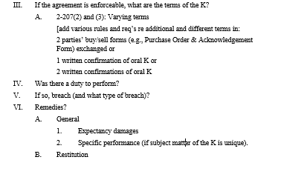
- General
  - Expectancy damages
  - General Rule: Cost to complete; Exception: Diminution value
    - Rst 344 : Relief types (restitution, reliance, expectancy)
    - Restitution – where a P in reliance on the promise of the D conferred some value on the D + D fails to perform his promise. Prevention of gain.
    - Reliance – Where a P has in reliance on the promise of the D changed his position. Goal to return P to position as he was in before the promise was made
    - Expectancy – no reliance by promise or no enrichment required. Seeks the value expected when the promise was created. Goal to put the P in as good a position as he would have been had the D performed as promised benefit of the value.
    - General Rule
      - (1) general rule of damages for breach of a construction contract is that the injured party may recover those damages which are the direct, natural and immediate consequence of the breach AND which can reasonably be said to be in the contemplation of the parties when the contract is made. (2) When the usual case where the contractor's performance is defective or incomplete, the reasonable cost of replacement or completion is the measure of damages.
      - Exception: (3) When, however, there is a substantial performance of the contract made in good faith but defects exist, the correction of which would result in unreasonable economic waste, courts measure the damages as the difference between the value of the property as constructed and the value if performance is properly completed.
    - Rst 346; Availability of Damages; general principle is that all loss, however characterized, is recoverable. If the breached caused no loss or amount is not proved, a small sum fixed w/o regard to the amt of loss will be awarded as nominal damages
    - Rst 347 General Measure of Expectation damages (4 types) – ALL PURPOSE FORMULA
      - General Measure of Damages = loss in value + other loss – cost avoided – loss avoided
      - Explain the rules: Loss in value requires…. Here $5000 because ; other loss is incidental and consequential damages. Incidental damgaes require…. Here $2; consequential damages require….; cost avoided requires…..; loss avoided requires…. Thus, recovery here for total breach is E.g. Expectation damages = $5000(loss in value) + $2000(other loss) - $1000(cost avoided) - $1500 (loss avoided)
      - 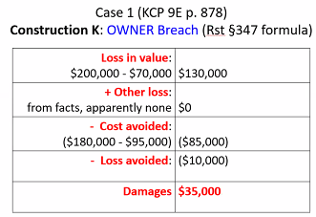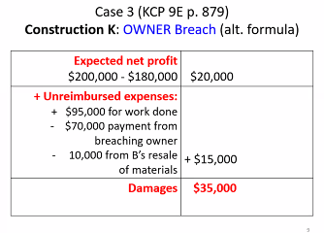
      - Partial breach (ADVERSE to INJURED PARTY)
        - Loss in value – difference between value of the injured party of the performance that should have been received and the value of to that party of what, if anything, was actually received. Thediff in value btwn what should have been received (aka ben of barg) and what, if anything was received) Aka “unpaid K amount” or diminution of value
        - Other loss (incidental and consequential)
          - Requirements limitations (a)the req. that damages be reasonably foreseeable (i.e. breaching party had reason to foresee that harms as a probable result at the time of the K); (b) the harm must be measured with reasonable certainty (i.e. the amount of damages cannot be speculative; (c); AND the duty to mitigate damages (e.g. damages may not be recovered to the extent that they could have been avoided or minimized by reasonable efforts). P. 889
          - Incidental – add’l cost incurred AFTER the breach in a reasonable attempt to avoid loss, even if the attempt is unsuccessful. Admin.cost of attempts to mitigate
          - Consequential – injury to a person or property caused by the breach. Collateraol affects that gobeyond the expectation damanges (e.g. Kelsey v.Hayes (YES foreseeable + YES certainty of calcl.of damages) and Gotlieb v. Alps South (NOT foreseeable and NOT certainty of calc. damages)
    - Rst 348(2) Alternatives to Loss in Value of Performance
      - if the loss in value to the injured party is not proved with sufficient certainty, damages may be measured by either (a) diminution in market value OR (b) by the reasonable cost of completing performance OR of remedying the defects if that cost “is clearly not disproportionate to the probably loss in value to him.”
      - Total breach (2 damages below are BENEFIT to INJURED PARTY)
        - Includes loss in value and other loss above
        - Cost avoided – further expenditure that would otherwise have been incurred. if the injured party terminates and claims damages for total breach, the breach my have a beneficial effect on that party by saving further expenditure that would otherwise have been incurred. Any saving on costs the non-breaching party would have otherwise incurred
        - Loss avoided – value salvaged and reallocated resources that otherwise would have been allocated to performance of the K.
    - Real Estate K’s; (∆ K price – FMV at time of breach)
    - Construction; ∆ builder’s expec. net profit on entire K + builder’s unreimbursed $ at time of breach

    - Crabby’s v. Hamilton (p.879) (FMV and Waiver of express condition)
      - Issue: Is a seller’s measure of damages for BOC for the sale of land with a structure on it the ∆ btwn the purchase price and the FMV of the property on the date of breach?
      - Rule: (1) Measure of damages (RE K) = the ∆ K price – FMV.
(2) Proof of Market Value with a reasonable time supported by (3) substantial evidence at time sale should have completed. FMV variance “within range” is okay. (4) FMV is price when B and S offer and accept under no compulsion. FMV = price which property will bring when it is offered for sale by an owner who is will but under no compulsion to sell & is bought by a buyer who is willing or desires to purchase but is not compelled to do so. Compulsion ≠ highly motivated seller
(5) waiver of K condition - the intentional relinquishment of a known right. If intention of waiver not shown by express declarations but implied conduct, waiver must be clear, unequivocal, and decisive act of party showing such purpose, as so consistent with the intention twaive that no other reasonable explanation is possible.
      - Analysis: (1) Waiver of express condition for finance contingency: although Seller not produce copy of financing to Seller, the Buyer waived the condition by clear, unequivocal, and decisive conduct consistent with the intention to waive because B and S executed 3 add’l written K to extend closing date + Rider for possession for cleaning after the express condition on obtaining finance/copy of finance furnished to S expired. ∴ B’s express condition was excused, B’s DTP not discharge, so failure to perform is a BOC.
(2) Proof of market value; FMV relative to damages; Damages are loss in value +other loss; LIV (K price (295k) – FMV (235)) + other loss ~ 35.6k) = ~95.6k damages. 11.5 months was reasonable time. Subs. Evid. Of FMV was price at time of sale because highly sale was not a distress/compulsion sale (of liquidation, threat of condemnation or forced sale).

(3) BOC and Repudiation; (1) B claimed S BOC 1st bc improperly removed property from restaurant / left tax liens. (aka S not perform their duty). Not issue raised in court. (2) B’s Express condition intended to protect B from BOC when DTP not arise bc express condition was not satisfied. Here B said express condition was not satisfied and B’s DTP was discharged accordingly.
      - Conclusion: ~$95.6K to S for damages of loss of value + other loss.
    - American Standard v. Schectman (Damages for BOC good faith (diminished value) v. bad faith (cost to complete)
      - Issue - In a construction contract, can the injured party recover the cost of completing unfinished work if the value of the property as a whole is not diminished by the unfinished work? Was the cost of completion the proper measure for the award of damages?
      - Rule – In a construction contract, the injured party may recover the cost of completing unfinished work even if the value of the property as a whole is not diminished by the unfinished work. Ct. apply dim. value as “instrument of justice” when D NOT breach K intentional and must show subs. perf. in good faith.
      - Analysis – K $275K with express condition to remove all foundations, piers, etc. …to a depth of approx.. one foot below the specified gradelines. D failed and refused to perform bc cost to complete K ~$110.5 per D’s expert witness. P sued D for BOC, trial court found in P’s favor, awarded cost to complete damages. D appealed (1) stating damages should have been diminished value bc D substantially performed, and remaining work did not objectively diminish value of P’s property bc sold for only $3k less without D completing the grading. Ct. of App. Affirmed. Because D did not perform in good faith. Diminished value damages applied if “unreasonable economic waste” to correct and D subs. performed in good faith. D’s BOC was (1) not incidental to P’s purpose of K (2) diminished value damages do not “flow directly” from BOC like general rule requires (3) Not adding actual value to property is not for D to decide and is not a defense (4) remedy sought by D for diminished value is inline with subs.perf.in.GF which is not the case here bc D’s completed perf. would not have infolved undoing what in GF was done improperly but only doing what was promised and left undone (Rst 346) (5) Disparity in relative economic value ≠ unreasonable economic waste required to apply diminished value as appropraoate measure of damages (6) express condition not satisfied by subsperf bc 90-110K cost to complete is not “trivial” (7) D not act in GF and cannot claim to be “transgressor whose default is unintentional and trivial” hoping for mercy for court if offer atonement.
      - Conclusion – Yes. Cost of completion is appropriate measure of damages when D not satisfy express condition by subs. performance in good faith.
  - LIMITS OF RECOVERY OF EXPECTATION DAMAGES (Foreseeability, Certainty, Causation, mitigation of damages)
    - RST 351 and UCC 2-715(2) UNFORSEEABILITY and related LIMITATIONS on damages
      - Both Rst 351 cmt a and UCC 2-715 cmt 2 require that the breaching part must “explicility or tacitly” agree to be responsible for consequential damages to likely occur in event of breach. (p. 908)
      - UCC 2-715 (2)
      - Rst. 351 Hadley v. Baxendale (corn mill grinder – NOT Forseeability –  consequences $)
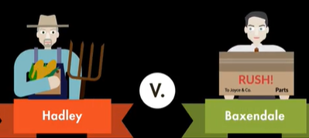
        - Issue May an award of damages for one party’s breach of a contract include all damages reasonably foreseeable to both parties at the time of contract formation, as well as damages stemming from any special circumstances, even if those circumstances are not known by all parties at contract formation?
        - Rule When one party breaches a contract, the other party may recover all damages that are reasonably foreseeable to both parties at the time of making the contract, as well as damages stemming from any special circumstances, provided those circumstances were communicated to and known by all parties at contract formation.
        - Analysis P’s crank shaft broke stopping mill operations. Hadley was informed that if the crank shaft was delivered to Pickford before noon, it would be shipped and delivered to Greenwich the following day. The following day, Hadley delivered the crank shaft to Pickford before noon and paid the shipping price in full. However, Pickford negligently delayed shipping, and the crank shaft was not delivered until several days later. As a result, Hadley obtained the new crank shaft several days later than expected, during which time the mill remained closed. Hadley brought suit against Baxendale for damages, including lost profits from the delay. The jury awarded Hadley lost profits, and Baxendale appealed. “Rush” delivery of shafts was not uncommon and had many other reasons for request for rush (aka rush delivery designation was not unique to only P’s situation/circumstances).

        - Conclusion No.Hadley (P) never told Baxendale (D) that a delay in shipping corn-milling shaft would result in P’s lost profits. Thus, D is NOT liable for consequencse of these special circumstances as consequential damages that were NOT reasonably FORSEEABLE at K formation by BOTH parties.
      - Rst. 351 Florafax v. GTE (global flower deliver with 3PP – shows Forseeabilty - ✓ conseq. $)
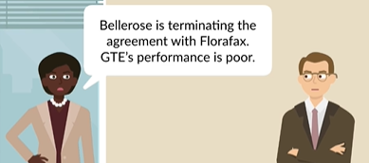
        - Issue In a breach of contract claim, can an injured party recover lost profits for a third-party, collateral contract?
        - Rule an injured party may recover lost profits for a third-party, collateral contract. (1) if the loss is within the contemplation of the parties at the time the contract was made, (2) if the loss flows directly or proximately from the breach—i.e. if the loss can be said to have been caused by the breach—AND (3) if the loss is capable of reasonably accurate measurement or estimate.” (4) Uncertainty as to exact amount of profits that have been lost will not preclude recovery, though the amount may not be based upon “mere speculation, conjecture and surmise alone….”
        - Analysis; (1) Foreseeability: lost profits clause in K Florafax/GTE satisfied reasonable foreseeability + GTE aware and positive regard for Florafax’s (P) 3PP activities bc lead to more $ for GTE (D). (2) Uncertainty: sufficient evidence to show reasonable certainty (more than speculation) P’s lost profits within a range of $750k based on established and known volume of 3PP sales of 100-200K orders per year and increasing. Enough evidence to show causation and amount lost profit was not speculative.
        - Conclusion . Yes Florafax can recover net lost profits from GTE for 2 years as a result of GTE’s failure to perform which caused lost profits with 3PP. Additionally, Florafax can recover expectancy damages for loss in value of K between Florafax/GTE.
    - Rst 352 UNCERTAINTY as LIMITATIONS on damages (CAUSATION)
      - Florafax v. GTE (global flower deliver with 3PP – shows “reasonable certainty” calculation for damages)
        - Issue – See above
        - Rule – See above
        - Analysis– See above
        - Conclusion– See above
    - RST 347 and 350 DOCTRINE OF AVOIDABLE CONSEQUENCES /DUTY TO MITIGATE

      - Limits P’s right to recover damages by duty to mitigate.
      - P.924 the doctine of avoidable consequences / duty to mitigate referes to the idea that the P may not recover for consequences of D’s breach that the P could be reasonable action have been avoided.
      - Notes: P should have demand for adequate assurace is your client is in Luten’s position, facing uncertainity about their counterparty’s performance of the K.
      - Duty to mitigate is a misnomer, bc not a “duty”. Instead, mitigation is a limitation on P’s right to recover damages
        - Failure to mitigate damages is an affirmative defense
        - Burden of proof is on the D
        - Standard of proof is preponderance of evidence
      - Rst 350
        - (1) except as stated in subsection (2), damages are not recoverable for loss tht the injured party could hve avoided without undue risk, burden or humilation
        - (2) the injured party is not precluded from roecovery by the rule stated in the (1), to the extent that he has made reasonable but unsuccessful efforts to aboid loss.
      - Rockingham County v. Luten Bridge (duty to mitigate costs after BOC on Bridge to nowhere, illustrates doctrine of avoidable consequences) p. 922
        - Issue – Whether Luten Bridge co. can recover remedy equivalent to full performance of K after completing a bridge even if Luten received a AR for total breach and continued to build anyways? Whether Luten bridge can recover, taking into account the exepnses that were actually incurred by Luten bridge, incompleting the bridge?
        - Rule – If a P reasonably could have mitigated his damages, but fails to do so then, he will be unable to recover that from D and will forced to absorb it himself (RST 350 cmt b. The measure of P’s damanges, upon it’s appearing that notice was duly given not to build the bridge, is an amount sufficient to compensate P fro (1) labro and materials expended and expenses incurred in the part of performance of the K,prior to [County’s] reupidation, plust (2) the prof which would have been realized if it had been carried out in accordance with its terms. (aka Luten can’t recover cost expended following the repudation)
        - Analysis– Rockingham’s total BOC by repudiation of K before completion entitles Luten to general measure of LIV + OL – CA – LA. Luten should have stopped performing after BOC and cannot recover full performance value bc doctrine of avoidable consequences, Luten has duty to mitigate. County entered into a K w/ Luten to build a bridge. Following change of personnel on county commission- but before Luten started work on the bridge -County repudiated the K and told Luten not to build the bridge. Luten was uncertain whether County would reverse its position and retract repudiation. Luten build the bridge and sued the county to recover under the K.
        - Conclusion– No. Money spent after repudation to complete the bridge are not recoverable. Luten (D) can only recover for profit expected + cost of supplies – cost avoided – loss avoided.
      - Mitigation by Employees following breach of employment K by E’er;
        - E’ee;s damages = the amt of salary he would have received during the rest of the K term minus any sum that was no earned or reasonably, could have been earned through mitigation p. 937
        - E’er has burden of proving Ee’s failure t mitigate
          - E’er has to prove both
            - The availability of suitable and “comparable” employment and
            - E’ees lack of reasonable diligence to obtain substitute employment
          - What is comparable employment
            - Ee must take offer for reinstatement p. 938 n.4
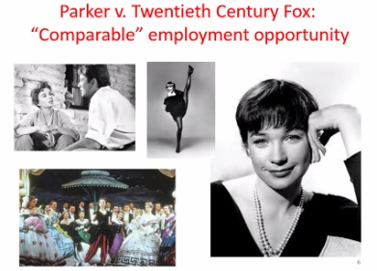
            - Not comparable if substitute (1)signif. Diff, (2)inferior duty, (3) involves greater risk, subject to harassment or humiliation)
      - Parker v. 20th Century Fox
        - Fox claimed that Shirley MacLaine failed to mitigate after she declined Fox’s offer to subs role in big country big man for role in Bloomer girl. Cal Supreme ct held 2 rols were different types so that 2 roles are not comparable bc not have had Director approval alternative offer. Attributes are important . Doctrine of avoidable consequences did not include loss damages from
        - Contract law damages are reduced by …wages from the inferior job reduced E’ee’s K damage p. 940 n. 6
        - Nonbreaching party takes comparable opportunity but is not required to take an inferior opportunity (employment, lease or any other context)
      - Mitigation of RE Leases breach by lesee (Tenant) [p. 941 n8
        - Trad’l rule: lessor does NOT have to mintage
        - Modern trnd; lessor has duty to mitigate (Lessee has burden of proving lessor’s failure to mitigate)
      - Application of UCC “LOST VOLUME” theory of non – UCC Ks’s
        - Non-breaching party’s damages are reduced by the amounts that party received from a mitigating K (one the P was able to form only bc D BOC freed P from obligation of original K… FILL IN THE REST
        - Rst 350 cmt d. if he would have entered into both transaction but for the breach, he has “lost volume” as a result of the breach. In that case, the 2nd transaction is NOT a “:substitute” for the first one
        - Lost volume theory could apply to a service K, based on facts
          - Rst 350 illustration 10 p. 948-48 n3
          - 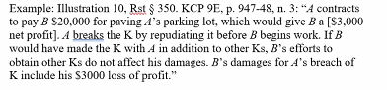
  - NONRECOVERABLE DAMAGES P. 948-49; 956-57; 966-71
    - Generally, the following are EXCLUDED from P’s damages for BOC
      - Attorney’s fees (“American rule” denies recovery for attorney’s fees)
      - Damages for mental distress (& intangible, noneconomic injury; and
      - Punitive damages
    - Effects: In some instances, this means that recovery is actually below the level that true expectations would require (e.g. attorney fees). In other cases it prevents brining P’s recovery above the net-expectation level (e.g. punitive)
    - Exception
      - Attorney’s fees
        - Statutes provide for payment of attorney’s fees in certain circumstances
        - A K might provide for payment of attorney’s fees (split fees, losing party pays fees for dispute resulting in litigation,
        - Attorney’s fees in collateral dispute may, in some circumstances, be treated as incidental damages in the main K dispute. (e.g. Bellarose sues Florafax. GTE can liable for breach of collateral K with Bellarose as incidental damages)
      - Emotional Distress
        - Exception if BOC causes bodiliy harm
        - Very Narrow exception if emotional distress is a “particularly likely” consequence of the breach. (e.g. referring to example of K to transport a dead body).
      - A plaintiff can recover punitive damages for bad faith breach of an insurance K by an insurance K by an insurer (powerful play for K of adhesion).

  - UCC: B and S Remedies
    - 2-703; S’ remedies in general
      - a
    - 2-706; S’s resale including K for resale
      - a
    - 2-708 S’s damages for non-acceptance or repudiation; damages for nonacceptance or repudiation by buyer = ∆ market price – K price of goods.
    - 2-716; B’s right to specific performance or replevin

- ALTERNATIVES TO EXPECTATION DAMAGES
  - Reliance damages.
    - Wartzman v. Hightower Productions. (a party MAY RECOVER damages it INCURRED due to its RELIANCE upon a contract)( Where a breach has prevented an anticipated gain and proof of loss is difficult to ascertain, a party can recover damages based upon his RELIANCE INTEREST on the contract)


    - Facts: (Hightower) (P) as a corporate promotional venture x entertainer would live in a mobile perch to establish world record for flagpole sitting. They hired Wartzman (D), a law firm, to incorporate it so they could sell stock to raise money for the venture. Wartzman (D) filed the articles of incorporation, and Hightower (P) hired an entertainer, a company to build the perch, and public relations specialists, and it sold STOCK. Hightower (P) still needed to sell more stock when Wartzman (D) announced that Hightower (P) had been STRUCTURED INCORRECTLY and that a securities attorney would need to be hired for approximately $15,000. Hightower (P) asked Wartzman (D) to pay the costs of restructuring, but they refused. The stockholders decided to discontinue the project because of the added costs that accrued because of this mistake. Hightower (P) sued Wartzman (D) for failure to create a corporation authorized to issue stock.
    - US v. Algernon Blair(A subcontractor who JUSTIFIABLE CEASES work under a contract BC of the prime contractor's BREACH may recover in QUANTUM MERUIT the value of labor and equipment already furnished pursuant to the contract IRRESPECTIVE of whether he would have been entitled to RECOVER in a suit on the CONTRACT.)
    - Facts. Blair (D) was acting as general contractor in constructing a naval base and had subcontracted certain work to Coastal Steel Erectors, Inc. (Coastal). Coastal STOPPED PERFORMANCE when 28 percent of its work was done BECAUSE of a MATERIAL BREACH of SC by Blair (D). Another subcontractor was hired to complete the job. Coastal then brought an ACTION, in the name of the United States (P), to RECOVER for LABOR and EQUIPMENT FURNISHED. The district court found $37,000 was still due Coastal under the contract but held that it would have lost more than that if it had to complete the contract. Therefore, there could be no recovery on the contract. Appeals REVERSED. Recovery of RELIANCE INTEREST by QUANTUM MERUIT IRRESPECTIVE RECOVER on suit for BOC in underlying K.
  - Resitutionary damages. RST 374 Resitution in favor of breaching party
    - Lancellotti v. Thomas(a breaching party MAY be entitled to RESTITUTION of amounts paid under K minus damages or loss suffered by the nonbreaching party to PREVENT FORFEITURE)
    - Facts. Lancellotti (P) contracted to buy Thomas’s (D) business. Pursuant to this, Lancellotti (P) paid $25,000. A dispute subsequently arose regarding certain improvements called for in the contract, and Lancellotti (P) eventually abandoned the business. Lancellotti (P) sued for a return of the $25,000. Thomas (D) counterclaimed for $6,665 in rent, which had been deferred under the contract. The trial court instructed under COMMON LAW the jury that a breaching party was NOT ENTITLED to RESTITUTION. The jury awarded Thomas (D) $6,665. Lancellotti (P) appealed. Ct Appeals REVERSED holding Lancellotti (P) was ENTITLED to RESITUTION under RST 374 bc purpose K law NOT PUNISH, so recover if forfeiture would otherwise occur and prejudice to the nonbreaching party will not occur.
  - Specified performance.
  - Agreed remedies.

  - Spec. perform
- Liability in absence of BFE (PE) – Promise made
    - Promissory Estoppel
    - Generally
      - Rst 90 (PE for promise)
        - Overview
          - Equitable doctrine developed within noncommercial , promise made within family…extended to commercial
          - Promise can be made enforceable under doctrine of PE even if a binding K doesn’t exist
        - Remedies
          - A promise binding under Rst 90 is a K, and full-scale enf. by normal remedies is often appropriate. Relief based on character and extent of the remedy. Can be limited to
            - Restitution
            - Damages
            - Specific relief measured by the extent of promisee’s reliance rather than by the terms of the promise
        - Rule:
          - Promise required (can be explicit (stated) or implicit (inferred by conduct/words)
          - Promisee’s reliance on the promise was reasonably foreseeable (objectively by person in promisee’s shoes) by the promisor
          - Actual “detrimental (change of legal position, doeesn’t mee Promsiee is worst off. Promisee did rely and did act to change their legal entitlement) reliance by the Promisee on the promise;
          - Injustice can be avoided only by the enf. of the promise
          - AND

        - Requires a PROMISE
          - RSt 1: a manifestation (objective reasonable person standard) of intention to act or refrain from acting in a specified way, so made as to justify promisee in understanding that a commitment has been made
          - PE requires “detrimental” reliance (Change of legal position)
            - Detrimental reliance is not what it sounds like
              - Does not require being worse off – financially or otherwise
              - Change of position (action or foreberance) is enough
        - If k if UNENF. Due to technical defect, try to enforce promise via fairness / equitable doctrine of PE
        - Cases turn on Specific function of PE varies based on CONTEXT
        - PE might be used to enforce a PROIMSE where
          - No (or nominal) consideration is given for promise
          - Pre-acceptance reliance
        - Rst includes many specific rules based on the concept of reasonable “reliance”
        - Kirksey v. Kirksey (Historical background for Doctrine of PE)
          - Husband dies. “Sister Antillico”…Widowed wife receives letter from BIL “I should like to come and see you but can’t…if you come here I will let you have a place to raise your family, and I have more open land than I can tend;…on account of your situation…I feel like I want you and the children to do well.”
          - Held no consideration (no BFE)
        - Harvey v. Dow (express / implicit promise. expand PE into commercial setting)
          - Express promise v. implicit promise
          - Daughter claims Father’s promise (to convey land property but later). Daughter detrimental relied on Father’s promise + with his knowledge + participation to permit/building support, prepared site built 200k home on land. Dad and Daughter fell out, dad refused to convey land.
          - Q: Whether a promise need to be expressed / implied? A: Father’s conduct of approving site, obtaining permit, and building a substantial part of it himself seem to be a manifestation of intention to act a certain way, specifically manifestation to confirm his “general promise” to convey land to daughter and to direct it to that specific parcel. Led (1) Daughter rely, (2) reliance was reasonably foreseeable (he saw her as she was doing it facts = reasonable she would rely), (3) she changed her legal position “detriment”, (4) injustice can only be avoided by enf. of implied process
        - Katz v. Danny Dare (enforce commercial PE)
          - Promise to pay retirement benefit, after employee suffered major injury preventing robbery from Danny Dare store. Employee couldn’t really function afterwards. DD tried to get Katz to retire but refused. DD made offer (with $ breakdown stating actually make more because of technicalities). Katz accepted DD’s offer approved by Board for pension. Kataz retired, 3 years later DD stopped sending checks
          - (1) Promise? = yes (2) reasonably forsee (yes, twice said no, this induced Katz (3) “detrimental” reliance? Yes gave up job in reliance on promise to pay pension for life (4) can injustice be avoided only be enforcement of promise?
        - Vastoler (Promotion = PE? → yes)
          - Vastoler accepted a promotion to be a supervisor based on an offer and extra pension benefits but later reneged on the promise. Vastoler argued he could recover under PE. Court found “ change of position, by accepting promotion, was detrimental reliance bc promotion made changers other than higher salary)
        - Hayes (retired, then pension offered = PE → no)
          - No action (act or forbearance) in reliance of the promise
          - Hayes announced his decision to retire. A week before retirement, Employer told hayes they company “”would take care of him” and paid Hayes a pension for 4 years, then stopped.
          - Held” Hayes count NOT recover under PE bc he did not rely on employers promise; he decided to retire before the employer made the promise
        - Vastoler accepted a promotion to be a supervisor based on an offer and extra
    - Liability in absence of Acceptance (PE)
      - Option K in promise; in context of enforcing Option K
        - Rst
          - Rst 87(1)
          - Rst 87 (2)
      - Pre-Acceptance Reliance on promise
        - Pop’s Cones v. Int’l Resorts H
      - Exception to SOF (for PE can substitute consideration
        - Rst 139
        - Berryman v. Kmoch
          - Alleged option agreement “for $10 and other valuable consideration…. Offer terms…land sale”. Q: Recital of Consideration sufficient for enf option K? A: Searching buyers ≠ consideration for option K bc not BFE. $10 not paid, false recital = sham; motive is not consideration. (like Dougherty v. Salt)Q: Q: Does PE substitute for consideration sufficient to enforce the option K? A: go through 4 elements of PE (1) a promise was made (2) not reasonably foreseeable or sought bc not BFE (3) no change in legal position by Kmoch (4) no injustice.
- Restitution (remedy)
  - Goal:
    - Restore to the transferor the money, property, or the value of property or services that were transferred, when it would be unjust to permit the recipient to retain what was received without paying for it.
  - True K
    - Express K (true K)
    - Implied in fact (true K)
  - Unjust Enrichment (action, no promise made)
    - Overview
      - Requires one party to be benefited by the counter party. Exchange of benefit without compensation
      - If no enf. K and a party is benefited by the counter party, the counterparty can try to recover under theory of UE/Restitution
      - P can recover for UE if P conferred a benefit on someone and it would be unjust for that person to retain the benefit without compensation the P
      - UE is a sep. COA from K action. Where remedy = restitution can be pled in the alternative . “if court conclude arguendo, P can recover under UE"
        - Synonyms: quantum meruit, quantum velebant

    - Elements for COA x UE (Rst Restitution)
      - P must have conferred a BENEFIT on the D
      - D must know of and retain the benefit
      - Circumstances are such that it would be UNFAIR for the D to retain the benefit WITHOUT paying for it
        - P must intend to be compensated e.g. NOT a good Samaritan/volunteer
        - P must NOT be an officious intermeddler
          - Presume they expect compensation (Rst 3rd 20), Professionals are entitled to recover reasonable fees if circumstances justify the decision to intervene without a request for service.
    - Not recoverable under Restitution
      - Good Samaritan Distinguished
        - Good Samaritan – benefit given without expectation compensation in return
      - Officious Intermeddler
        - Officious Intermeddler – benefits foist upon you in hope of compensation, had opp. To K but didn’t ≠ recovery for restitution (window washers on street)
    - Rst 1st of Restitution 1, 2, 116
    - Rst 3d of Restitution 20, 21, 107
    - Not enf. of a promise, so NO PROMISE required
    - Commerce Partnership v. Equity
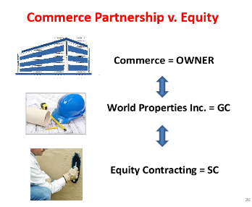
      - SC sues Property Owner for UE claims GC not pay SC so Property owner owes them under UE
      - To recover from Owner, SC must
        - Exhaust its remedies against GC
        - AND show that the Owner received the benefit without paying anyone, including GC: “Owner can be liable only where it received a windfall benefit, something for nothing. (see elements x COA of UE)
    - In class hypo
      - Unjust enrichment
        - Tree delivered by mistake to my home. Give back don’t owe anything. Keep it (retain the benefit) you have to pay even without a K. Pay whatever is reasonable under circumstances. (A benefit conferred on one party by another party, no exchange of promises, it would be unfair to not compensation the other party for the benefit when benefit is retained)
    - In class hypo
      - Express K (true K)

        - A I sitting on his veranda when B comes along and offers to mow A’s lawn for $25. “Proceed”, A said between bites of bon bons, “I promise to pay” B mows the lawn, but A refuses to pay. B sues, does he win?
          - Yes. “Express” contract, where agreement is entered into by express words, oral or written
      - Implied in fact (True K)
        - A is sitting on his veranda eating bon bons, when B approaches with his lawnmower. From their past dealings, A knows that B charges $25 to mow the lawn. B looks at A inquiringly, and A nods. B cuts the lawn. A refuses to pay. B sues. Does he win?
          - Yes. Implied through conduct [not words]. Here, the K is implied in fact from conduct.
      - Implied in Law (not a true K)

        - A suffers serious injuries in a car accident. B, a doctor, is driving by, stops, and performs emergency medical services. A never regains consciousness and dies, in spite of B’s best efforts to save A’s life. Is A’s estate liable to B for the value of the benefit received as a result of B’s efforts?
          - Yes. A K is implied in LAW (aka “quasi-contract”). Legally, NOT a true contract. Based instead on the law of restitution, which seeks to prevent unjust enrichment.
          - Absence of promise, BQ2 no enf. A able to negotiate for MA, but UE limited to reasonable charge x services (Rst Restitution 20)
      - RST (Restitution)
        - Restitution 20 Protection of Another’s LIFE OR HEALTH
          - A person who performs, supplies, or obtains professional services required for the protection of another’s life or health is entitled to restitution from the other as necessary to prevent UE, if the circumstances justify the decision to intervene without request
          - UE under this section is measured by a [objective] reasonable charge for the services in question
          - Pelo case
        - Restitution 21 Protection of Another’s PROPERTY
          - A person who takes effective action to protect another’s property from threatened harm is entitled to restitution from the other as necessary to prevent UE, if the circumstances justify the decision to intervene without request. Unrequested intervention is justified ONLY when it is reasonable to assume the OWNER would WISH the action performed.
          - UE under this section is measured by the LESSER OF
            - Loss avoided
            - A reasonable charge for the services provided
          - In class example
            - Fire in your neighborhood, you save neighbors horses while they’re out on vacation, you lodge/feed/vet them is very expensive = UE for out of pocket expenses
        - Case Sub contractor not paid for services performed, sued project owner x UE because we conferred a benefit to the project owner and therefore entitled compensation from project owner bc never paid from general contractor. Did project owners retention of beneft from subcontract UE? No if not exhausted remedies against general contract AND project owner NEVER paid general contractor
          - In class example
            - Party X performs a service for Party Y, conferring a benefit on Y. After receiving benefits from X, Y makes a promise to pay X. Is Y’s promise enforceable?
              - Yes, if expect to be compensated for necessary medical services provided UE to keep without paying. Presume expect to be paid
    - Restitution x Past consideration / Moral obligation
      - Generally (in UE Restitution)
        - Not consideration to make a promise enforceable
        - When a promise is made in response to an act or forbearance previously undertaken, the promise cannot have been made as part of the BFE.
        - Such promise is not supported by consideration and thus is unenforceable
        - Plowman v. Indian Refining
        - Mills v. Wyman
          - Son of D fell ill, cared for by Mills and sought compensation from Wyman (father). But moral obligation ≠ legal obligation. Only when there is consideration for the promise does the law give the promise validity
      - Exceptions (to past consideration for UE Restitution)
        - Must have been some preexisting obligation which has become inoperative
          - Debt barred by SOL, debts incurred by minors, debts of bankruptcy
          - Express promises founded on preexisting equitable obligations because there originally was a quid pro quo (BFE). They’re not promsies to pay something for nothing; …but voluntary revival or creation of “new “ obligation which previously existed…

      - RST (K) x Restitution alt. theory of recovery\
        - Moral obligation is not enough to make a promise enforcable. But moral obligation + BFE can be unforceable
        - At some point in past there was a promise to pay that resulted from BFE that became unenforceable. A new promise is enforceable even though no new BFE because previous BFE, no new consideration
        - 82 (SOL)
          - A promise to pay a debt barred by the statute of limitations.
        - 83 (bankruptcy)
          - An express promise to pay debts previously discharged in bankruptcy.
            - Bankruptcy dischared $1000 I owed you, then I promise to pay $400
        - 85 ( ? )
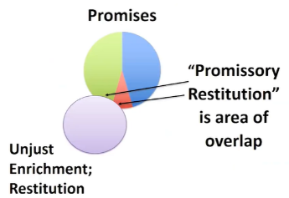
          - Obligations of minors that are affirmed either expressly or by failure to disaffirm within a reasonable time after reaching the age of majority.
        - 86 (Promise for Benefit received, recovery by restitution to prevent injustice PAST CONSIDERATION)
          - If a person receives a material benefit from another, other than NOT gratuitously, a subsequent promise to compensate the person for rendering such benefit is enforceable
          - (1) A promise made in recognition of a benefit previously received by the promisor from the promisee is binding to the extent necessary to prevent injustice.
          - (2) A promise is not binding …
            - (a) if the promisee conferred the benefit as a [gratuitous] gift or for other reasons the promisor has not been unjustly enriched [no material benefit conferred]
          - (b) [or] to the extent that its value is disproportionate to the benefit.

          - Webb v. McGowin (Past consideration = material beneft = consideration_
            - Promisor received material benefit. Webb saved McGowin from death of grievous bodily harm. This was material benefit to him. A moral obligation is suff. Consideration for promise to pay if promisor received material benefit
          - In class example: A gives emergency care to B’s adult son while the son is sick and without funds far from home. B subsequently promises to reimburse A for his expenses. The promise is not binding under this Section. (Why?)
            - Benefit conferred to adult son not B himself (Mills v. Wyman)
          - In class example A saves B’s life in an emergency and is totally and permanently disabled in so doing. One month later B promises to pay A $15 every two weeks for the rest of A’s life, and B makes the payments for 8 years until he dies.
            - Promise is binding (Webb v. McGowin)
          - In class example “By virtue of the policy enforcing bargains, the enrichment of one party as a result of an unequal exchange is not regarded as unjust, and this [§] has no application to a promise to pay or perform more or to accept less than is called for by a preexisting bargain between the same parties.”
          - In other words, a promise to pay an additional sum for an existing obligation is not enforceable. (cab driver hypo)

