Securities Regulation FULL Outline
Fall 2020
Primary v. Secondary markets:
- Primary Market: transactions between a company and the public, where the company is selling something to the public
  - Issuers (sellers) to investors (buyers)
  - These securities are covered by the Securities Act of 1933
  - Process by which companies create and sell securities to raise money
  - Compare: like buying a new car from a Toyota manufacturer, comes with owner’s manual and some guarantees.
- Secondary Market: transactions where the public sells something to other members of the public
  - Investors (buyers) to investors (other buyers)
  - Transactions which are trades between people who already own securities and people who want to buy securities
  - Much larger market for the secondary market
  - These securities are covered by the Securities Act of 1934
  - Compare: like buying a used car, Toyota (the issuer) is not really involved in the transaction
    - Unlike cars, securities GROW in value over time, they don’t depreciate because the business is growing
History/Overview of the Securities Act of 1933 & 1934:
- History/Background:
  - The stock market crashed in 1929, but in 1930 it went back up but then it went down again and stayed down; around the same time was the Great Depression
  - Many people believed the crash of the stock market and the Great Depression were related
  - FDR ran for president and part of his plan was to do something about Wall Street; when he was elected, he enacted the Securities Act of 1933
    - The professors who wrote this focused on the primary market because they only had a week – they wrote rules about when companies made money
- Securities Act of 1933 regulates primary transactions (offerings). Prohibits the offer as well as the sale of unregistered, non-exempt securities
  - Issuer must file registration statement with the SEC (an agency created to publicly file investments with)
  - Issuer must provide certain information in a prospectus (aka prospects of business) to potential buyers
  - Establishes a public offering timeline and procedure (gun jumping rules gives people the opportunity to read the information in the prospectus)
    - SPACs get around the gun-jumping rules
  - Public and private remedies: heightened anti-fraud liability (creates real liability, federal government and investors can come after you)
  - Note: Idea behind the act is disclosure in order to protect people from being taken advantage of
- Securities Exchange Act of 1934 (the “Exchange Act”) regulates secondary market transactions:
  - Created a category of “public companies” and periodic reporting and disclosure requirements for “public” companies
  - Anti-fraud liability (section 10)
  - Also regulates broker, dealers, exchanges (entities involved in trading)
  - Regulates shareholder voting and tender offers (i.e., takeovers)
  - Insider trading rules

The Securities Act of 1933:

- The Definition of a Security
- What are securities?
  - General Definition: Securities are permanent, long-term claims on the corporation’s assets and future earnings issued pursuant to formal contractual instruments.
    - Securities are a deal where you exchange money with a firm and you receive a piece of paper; this paper guarantees the individual some interest of the firm
    - When you buy a security, the assets section on your balance sheet will increase however much you purchased it for; on the liabilities side, it will state the security that the firm is obligated to give you
  - Equity v. Debt
    - Equity (ex. Share of stock, you become partial owner of the corporation)
      - Shareholders: owners of the corporation
      - Elect directors and vote on major corporate decisions
      - May receive firm’s earnings in the form of dividends
      - In liquidation, get firm assets after all other claims are satisfied
      - NOTE: Equity is more expensive to issue than debt. Common stock is the most expensive because investors demand a higher return to enter into this deal; they wouldn’t do it otherwise
    - Debt: when company borrows your money, they will give the money back plus interest (ex. A bond)
      - Funds borrowed by the firm
      - Firm pays interest
      - At maturity, firm returns the principal
    - 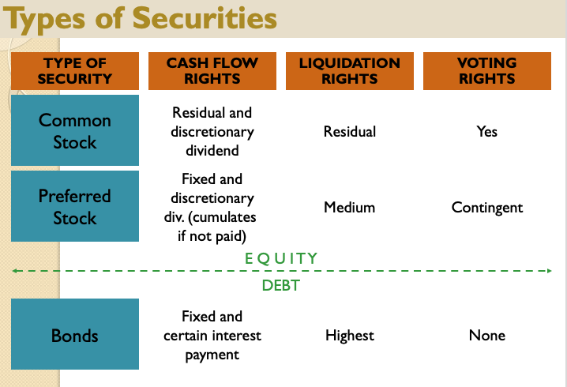
  - Statutory Definition: Securities Act §2(a)(1): “The term "security" means any note, stock, treasury stock, security future, bond, debenture, evidence of indebtedness, certificate of interest or participation in any profit-sharing agreement, collateral-trust certificate, preorganization certificate or subscription, transferable share, investment contract, voting-trust certificate, certificate of deposit for a security, fractional undivided interest in oil, gas, or other mineral rights, any put, call, straddle, option, or privilege on any security, certificate of deposit, or group or index of securities (including any interest therein or based on the value thereof), or any put, call, straddle, option, or privilege entered into on a national securities exchange relating to foreign currency, or, in general, any interest or instrument commonly known as a "security," or any certificate of interest or participation in, temporary or interim certificate for, receipt for, guarantee of, or warrant or right to subscribe to or purchase, any of the foregoing.”
    - Takeaways:
      - Instruments commonly known as securities: lists stocks, bonds, debentures
        - Unless the context otherwise requires, these will be considered securities
      - Broad, catch-all phrase of “investment contract”: courts determine whether financial instrument is a security
      - Other instruments specified by the Act to be securities: fractional undivided interest in oil, gas, or other mineral rights
      - Note: internet coin offerings (ICOs) like Bitcoin are not immediately identified as a security
- Investment Contracts and the Howey Test
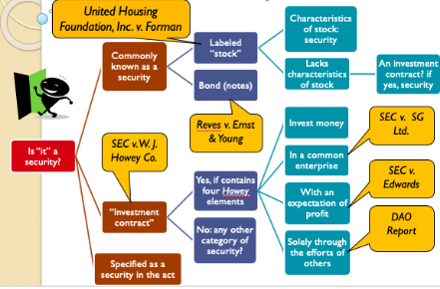
  - In SEC v. W.J. Howey Co. (p. 114), W.J. Howey Co. (defendant) is a Florida corporation that plants and sells orange groves. Howey-in-the-Hills Service is under common management with Howey and services orange groves in a large-scale farming operation. In order to raise money, Howey sold tracts of land to individuals, and the buyers – who were not farmers or residents of the state. The buyers were offered both a land contract and a service contract, although buyer was not required to purchase services. 85% of the buyers signed the service agreements, giving H-H Service almost total control of the property and the operations. The buyers would then share in the profits from the sale of oranges. The SEC (plaintiff) brought an action against Howey for using interstate commerce to offer and sell unregistered securities in violation of §5(a) of the Securities Act of 1933. Howey argued they were not offering a security.
    - Here the issue is whether the contract is a security.
    - Securities Act prohibits offer as well as the sale of unregistered, non-exempt securities.
    - The term “investment contract” is undefined by the Securities Act, but broadly construed by state courts. Thus, the court applied the “Howey Test” to determine if a contract is an investment contract: The term “investment contract” means “a contract, transaction or scheme whereby a person (#1) invests money in a (#2) common enterprise and (#3) is lead to expect profits (#4) solely from the efforts of the promoter or a third party.”
      - #1: Investment of Money
        - An investment is a contribution of value
        - Investment of “money” need not take the form of cash (aka can be BitCoin or other virtual currency)
        - To be considered a security, an investment decision must be at stake
      - #2: Common Enterprise
        - Was the investment in something we may call a common enterprise?
        - It will look like a share of stock, an investment in a business – here all the oranges were grouped together and you get paid out of the pool of oranges
        - Two approaches:
          - Horizontal commonality: Is there a common pool of profits?
          - Vertical commonality: relying on the same people
            - Broad vertical commonality
            - Narrow vertical commonality
        - 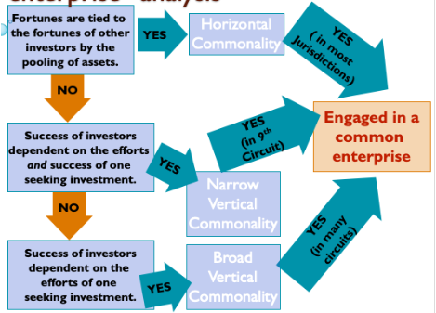
      - #3: Expectation of Profits
        - The Howey orange grove purchasers bought the land in expectation of profits
        - Profits, not consumption
        - Fixed returns can count as “profits”
      - #4: Efforts of Another
        - The orange growers were relying on others to do the picking
        - Not too much investor effort or power to control
    - Hypotheticals:
      - Variation #1: The offer and sale of the tracts of the orange grove without the service agreement would not be a security.
        - Are they investing money? Yes (maybe they think there will be a return on the land)
        - Common enterprise? NO – it was the service contract that pooled the interests of the land owners together
        - Expectation of profits? NO – purchaser of real property may not be seeking a profit, but purchases simply for the enjoyment or consumption of the land.
        - Efforts of another? NO – without the service contract, there is no 3rd party providing the effort to generate a return for the purchaser
        - This is just selling land, there is no common enterprise or reliance on efforts of another.
        - Note: there could still be an investment because they purchased the land and expectation of profits if they intended to resell it
      - Variation #2: If the service agreement was offered by a separate, unaffiliated company, would the service agreement standing alone be a security?
        - No, the service agreement alone would not be considered a security because there would be no investment of money, there would just be payment for a service.
        - Are they investing money? No – Here, the purchasers are investing their oranges – not money into the company - no connection with the capital markets – unlikely that the securities law are designed to protect oranges
        - Common enterprise? Yes – the profits are pooled together and indeed go up/down for each individual based on how well the company sells the oranges as a whole (horizontal commonality)
        - Expectation of profits? Yes – people are hiring the company in hopes of a percentage of the profits from the sale of the oranges
        - Efforts of another? Yes – here the individuals are passive (and may not know anything at all about the orange market), so everything depends on the company that they hired
      - What if the purchasers were wealthy citrus tree company executives who understood the economics of the industry?
        - Lack of sophistication is not part of the Howey test, except indirectly through the “efforts of another” prong
    - Note: It does not matter that the service contracts are optional because they are still offered, and the Securities Act regulates offers and sales of securities, even if no one buys it.
      - Offers AND sales are regulated under ’33 – doesn’t matter if nobody buys it, even if you offered a security you are regulated under ‘33
    - Rationale: This type of regulation is probably not what Congress had in mind when they wrote the Securities Act, but maybe still fulfills their intention of regulating potential scams in general

  - In SEC v. SG Ltd. (p. 125), SG operated a website offering the purchase of shares in 11 virtual companies, including a privileged company whose shares were supported by the owners of SG so their value would constantly rise. 800 U.S. persons purchased shares, with opportunity to earn referral fees of 20% to 30%, with over $4.7 million deposited in a Latvian bank by fall 1999. By March, 2000 SG share price of privileged company plummeted and SG stopped responding to participants. SG warned that this is a game, not an investment. The Securities and Exchange Commission (SEC) (plaintiff) filed suit, alleging that the website users’ purchases of stock in the virtual companies were investment contracts, thus requiring SG and its website to comply with federal securities laws. The issue is whether the “game” is a securities investment, based on whether it is an investment contract, which is determined by the application of the Howey test.
    - Application of the Howey Test:
      - Here, the court combines #1: Investment of money and #3: expectation of profits into 1 criteria, and says this is met. So, the court focuses on element #2: common enterprise.
      - Court’s Analysis of #2: Common enterprise:
        - The court first discusses that there are several ways to be engaged in a “common enterprise”:
          - #1: Horizontal Commonality (pooled assets): you are getting a share of a common pool of profits; requires more than pooling along, it also requires that investors share in the profits and risks of the enterprise – don’t have to share equally, but most share in some way; multiple investors pool funds or assets; share the risks/profits of an enterprise. [enough in most jurisdictions]
            - Example: In Howey, all the oranges were put into the same container and all investors got a share of profits from selling together
            - Example: If the promoter is successful, all investors get a 10% return. Or if it does poorly, all investors lose 15%
            - If the promoter makes separate deals where they do not get the same returns, there is NO horizontal commonality
            - Most limited test: requires all money is pooled, rise/fall together, and the same promoter
              - Note: This is not necessarily the most expansive approach. If the oranges weren’t pooled but all else remained the same, there would be no horizontal commonality but there would still be vertical commonality because all the investors are relying on the same harvester.
            - Horizontal matches our conception of what a constitutes a security, it is what the legislatures intended to reach
          - #2: Vertical Commonality (pooled assets plus same promoter): brought together by the same promoters (variation of Howey ex: profits received are separate, but the people who did the harvesting are the same); Investors’ and promoter’s interests are aligned; fortunes of investors tied to promoter’s success
              - Looks at the person who brought everyone in, if they are the same person then there is a common enterprise even if did not get the same deal or a pro rata share of a pool
              - Prevents promoters from evading securities laws by paying out different profit shares; catches the sketchy promoters
            - Broad vertical commonality → requires that the well-being of all investors be dependent upon the promoter’s expertise
              - some connection between efforts of promoter and collective success of investors (promoter needs not share risk with investors). [enough in a few Circuits]
              - Promoter needs not share risk with investors, can just be a central linchpin who brought everyone together who they all relied on (all relying on the same promoter)
              - Can have different deals if all handled by the same promoter
              - Least restrictive test because essentially just requires investors share one promoter
              - Differs from “efforts of another” because it ALSO requires that investors share this dependence on the effort of a specific “other” with other investors
            - Narrow vertical commonality → requires the investor’s fortunes be interwoven with and dependent upon the efforts and success of those seeking the investment or of third parties”
              - some connection between profits of promoter and collective success of investors. [enough in 9th Circuit]
              - If the promoter profits when the investors do, there is narrow vertical commonality
              - Promoter is investing in each deal and his profits are tied to the investors’ success
              - Requires the profits are all somehow tied together
              - More restrictive than broad vertical commonality which because different payoffs but still requires promoter share in deals
          - 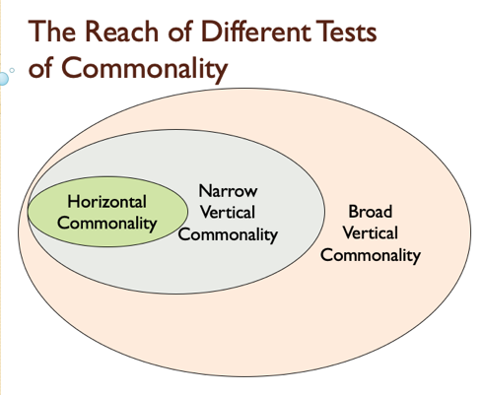

        - Note: SG argued this was a game, not an investment. However, it looks more like an investment than a game because the average investor put in $6k. If it WAS a game, it might not be considered an investment contract because there needs to be an expectation of profits; however, even if it is a game as long as there is that expectation, how SG is classified (investment v. game) is irrelevant
        - Note: In determining whether SG offered a security, it does not matter that the participants were deceived.
        - Contrast: A ponzi scheme if when your money feeds earlier investors and the promoter pays off investors with money from new investors. A pyramid scheme if when you get compensation from bringing in other investors.
        - Here, the court determines that there is a showing of horizontal commonality because they are sharing in the profits and the losses because it is a pyramid scheme.
          - NOTE: Once you have established horizontal commonality, you do not need to establish vertical
          - Ponzi scheme: take new investor’s $ to give to older investors
          - Pyramid scheme: bring in more and more new people
        - When would you be relying on the efforts of another but not have broad vertical commonality?
          - Only one person is investing – one promoter asks for just your money
          - No common interest because it is just you alone – so security acts don’t protect you because you lack the common enterprise element
          - For exam purposes – don’t count the promoter as another person
  - United Housing Inc. v. Forman [applies two different tests – (1) what does it mean if something is labeled a stock; (2) does the purchase of stock constitute an investment contract]
    - In United Housing Foundation, Inc. v. Forman (p. 133), New York would provide Co-Op City – a housing cooperative – with long-term, low-interest mortgage loans and tax exemptions if they lease apartments to people whose income fell below a certain level. The United Housing Foundation organized the Riverbay Corporation to operate Co-op City. In order to acquire an apartment in Co-op City, a prospective renter would have to buy stock in Riverbay – 18 shares per a desired room, with each share costing $25. Shares were not transferable; had no dividend; If the renter ever moved out, they had to be resell their shares to Riverbay; and had voting rights allocated by apartment rather than unit of stock. In 1965, an “Information Bulletin” said the average monthly rental charge per room would be $23.02. However, the construction loan ended up being $125 million more than was estimated and in 1974, the average rental charges per room were $39.68. Residents of Co-op City sued based on the increased rental charges, claiming that the 1965 Rental Bulletin falsely represented that the contractor would bear all subsequent cost increases. The issue is whether the purchase is a securities transaction a) because labeled “stock,” or b) because an “investment contract”.
      - The court held that this is not a stale of stock because the characteristics of a “stock” were not present in the Co-op “stock.” The characteristics of a stock include dividends contingent on profit; transferable; voting rights; ability to appreciate in value. Doesn’t look like an investment contract because people bought the “stock” because they wanted to live in the building, NOT because they had an expectation of profits. It was not an investment as they could only purchase by living there.
      - Are stocks always stock?
        - A security called stock is a “stock” only if it “embodies some of the significant characteristics typically associated with the named instrument”.
        - In other words, so long as it is not entirely mislabeled.
      - Is this purchase a securities transaction because an in “investment contract”?
        - Not an “investment contract,” because expectation of profits prong requires that investors “be attracted solely” by the prospects of a return on the investment → the point is that if you buy something as a consumption good, and not as an investment, it looks less like an investment contract; here they are putting money in order to have a place to live, not because they are expecting to get money back later
        - “By contrast, when a purchaser is motivated by a desire to use or consume the item purchased – “to occupy the land or to develop it themselves,” as the Howey Court put it – the securities laws do not apply
        - What is a profit?
          - The test looks at whether you are PRIMARILY looking to consume or PRIMARILY looking to profit
          - Observe footnote 16 cites Ninth circuit opinion that “solely the efforts of others should not be taken literally.”
        - What if the Court held that anything labeled “stock” fell within the definition of a security?
          - It would be a significant issue, because anybody could sell anything and call it a stock and the securities act would apply to everything.
      - With Kickstarter, investors have no expectation of profits, the investors get nothing other than the good will of contributing.
      - If Howey orange grove purchasers bought the land to occupy it or develop it themselves, they would not be purchasing the plot with an expectation of profits.
  - In SEC v. Merchant Capital, LLC. (p. 147), Wyer and Beasley formed Merchant to buy, collect, and resell consumer debt. Wyer and Beasley raised money by selling interest to members of the general public to become partners; they sold interests in 28 limited liability partnerships (LLPs) to 485 people for $26 million (average > $50,000 per investor). The LLPs hired Merchant (owned by Wyer and Beasley) to be Managing General Partner (MGP). Merchant invested into pools of bad credit card debt. The issue here is whether the LLP interests considered investment contracts under the Howey test, and in particular whether “solely through the efforts of another” prong of the Howey test met.
    - The court held that the LLP interests DID meet the “solely through the efforts of another” prong and were securities. “Solely” is not literally interpreted but instead the focus is on the dependency of investors on the entrepreneurial or managerial skills of another.
Rule: The term “solely” should not be construed literally; nominal involvement will NOT be enough. Simply not enough much investor effort or power to control such that the investor is not fully engaged in the business.
- Focus on how much investor depends on the managerial or entrepreneurial skills of another
- Economic reality of the transaction trumps form

Rule: The efforts of another inquiry focuses on the investors’ expectations at the time of their investment rather than how the partnership actually operates
    - The court references the Williamson case, which says there is a presumption that general partnership interests are not securities, but presumption may be rebutted in any one of three situations [under Williamson, only one of the factors below needs to be met in order to render a general partnership interest an investment contract]:
      - (1) where the partners have little power in their hands;
      - (2) the partners are inexperienced or unknowledgeable in business affairs; OR
      - (3) the partner cannot replace the manager of the enterprise or otherwise exercise meaningful partnership powers
    - The court applied the Williamson factors as follows:
      - Power distribution. Although the partnership agreement gave the LLP partners significant authority on paper, the power to name the managing partner was less important than it appeared.
      - Experience and Knowledge of Partners. The court focused on the specific knowledge and skill of the partners in the debt-pooling business.
      - Ability to Replace Merchant. The court found that Merchant had permanent control over each partnership’s assets.
    - In this case, the court found that RLLP interests were investment contracts.
    - NOTE: LLP interest is more likely a security than a general partnership because limited liability protects the partners, thus leading them to be more passive
    - Should the “efforts of another” inquiry focus on investors’ expectations at the time of their investment rather than how the partnership actually operates?
      - The opinion seems to use both factors – but it also says that it is only using information about how the partnership operates because it gives an idea of the investor’s expectations
      - Group discussion ideas:
        - Should look at both – at the offering stage the investors may be told that they are going to be very involved, but after the fact they were not actually involved – so you need to look at how the business operates
    - The RLLP partners self-reported business experience between “average” and “excellent.” Each partner also had a net worth of at least $250,000 (and most had a net worth above $500,000). Is evidence of general business expertise on the part of the partners enough to show that it is possible for the partners to exercise their contractual powers of control? Must all of the partners have the same level of expertise?
      - Court’s view → can’t be an effective manager if you don’t understand the specific industry
        - Counter argument → every business focuses on making money, so you just need general knowledge
    - Review: “Solely on Efforts of Others”
      - The term “solely” should not be construed literally: nominal involvement will not be enough.
      - Focus on how much investor depends on the managerial or entrepreneurial skills of another.
      - Economic reality of the transaction trumps form.
    - Review: Are partnerships investment contracts?
      - General Partnership interests are presumed not to be securities.
      - BUT: Just naming something a general partnership is not enough.
- Stock
  - Rule: A security called stock is a “stock” only if it “embodies some of the significant characteristics typically associated with the name instrument.”
    - In other words, a stock is always a stock - so long as it is not entirely mislabeled
    - Example: If you sell potatoes, they are potatoes even if you call them a stock.
    - Rationale: Don’t want too high of a penalty for mislabeling
    - Note: Courts should NOT use the Howey test to determine whether the stock of particular companies count as securities. Howey is for determining if something is an investment contract; something can still be a security if it fits elsewhere in the statute.
    - Courts look at the substance of the transaction, but form DOES matter because if it is called a stock, there is a presumption it is a security.
  - Characteristics of Stock
    - Dividends contingent on profits
    - Transferable
    - Voting rights
    - Appreciable value
  - Examples:
    - Seminal case - United Housing Foundation, Inc. v. Forman: Public housing cooperative had prospective renters purchase stock in a Co-op for 18 shares per room. The shares were not transferable, had no dividend, and had to be resold to Riverbay for a set price if the purchaser ever moved. Voting rights were allocated by apartment rather than unit of stock. An info bulletin said the average rent per room was $23/mo, but was actually $39/mo. The “stock” was not a sale of stock because characteristics of stock (dividends contingent on profit, transferable, voting rights, ability to appreciate in value) were not present. Thus, even though it was named “stock”, it did not resemble stock. These were mislabeled and nothing like a stock.
      - Variation: If the stock was transferable or had voting rights attached, would look more like a stock. If tenants/investors could capture appreciable gains, it would look much more like a stock. If dividends were received based on profits from the community center stores, it would not make much difference because they were already using this money for rent reductions. If all of these changes together were implemented, then it would certainly be a stock.
      - Applied to Howey: If Howey had called the plot of orange groves “stock”, this would probably not have been considered mislabeling. Their dividend was contingent on profits, it was transferable because they could sell the land, and had appreciable value because the land could become more valuable (although no voting rights tied to it).

- Notes
  - Overview:
    - A note is giving money to the company in exchange for a promise your money will be returned plus interest.
    - Rule: The law presumes that every note is a security because the statute says “any note” is a security, but there are a lot of transaction that involves notes which look nothing like security market transactions, so they could not have meant ANY note, it depends on the context.
      - Rationale: Notes are not quintessential securities like stock. This makes sense because while stocks are the quintessential security, many notes are commercial transactions (like the sale of a car)
      - Certain types of notes are not securities (e.g., if delivered in consumer financing, to mortgage a house, for lien on small businesses, bank customer, part of account receivable, etc.). Loans made for commercial rather than general business purposes are not securities because we don’t want securities laws to cover everything, the scheme was set up to regulates companies, not individuals
    - 2 ways to determine if a note is NOT a security:
      - Fits into enumerated categories OR
      - Create new category based on 4 factors
  - In Reves v. Ernst & Young (p. 169), the Co-Op – an agricultural cooperative – issued promissory notes (these notes were payable on demand by the holder – this means that if I lend you $5000 on the condition that I can get my money back whenever I want) to members and nonmembers in order to raise money to support its general business operations. The notes paid a variable rate of interest that were adjusted monthly to keep it higher than the rate paid by local financial institutions. Co-Op filed for bankruptcy, and a class of holders of the notes filed suit against Ernst & Young., that was the firm who audited Co-Op’s financial statements. The petitioners argued that Ernst & Young failed to follow generally accepted accounting principles and inflated the assets and net worth of Co-Op. The issue is whether the promissory notes issued by the Co-Op are securities.
    - The court holds YES, the notes ARE securities. The court begins with the presumption that every note is a security, and this “may only be rebutted by showing that the note bears a strong resemblance (in terms of the four factors we have identified) to one of the enumerated categories of instrument.”
      - Reves 4 factors to determine NOT a security:
        - Motivations of lender and borrower use of funds - not for profit
        - Plain of distribution - not widely distributed
        - Investor expectations - not expected to be a security
        - Existence of alternative regulatory scheme
    - If it strikes the proper balance (ie not all 4 have to be met), shows a strong resemblance to one of the enumerated categories and should not be treated as a security
    - Court says that after examining the four factors, they find that the demand notes ARE securities.
    - If an instrument is correctly described as a stock, it IS a security (Forman); BUT if an instrument correctly describes a note it may or may not be a security (Reves).
    - NOTE: The Co-Op demand notes would also be considered securities under the Howey test:
      - Invests money? Yes, they are investing money
      - Common enterprise? Here, this is all pooled so it is horizontal commonality b/c all money is going to the co-op
      - Expectation of profits? Yes
      - Efforts of another? Yes
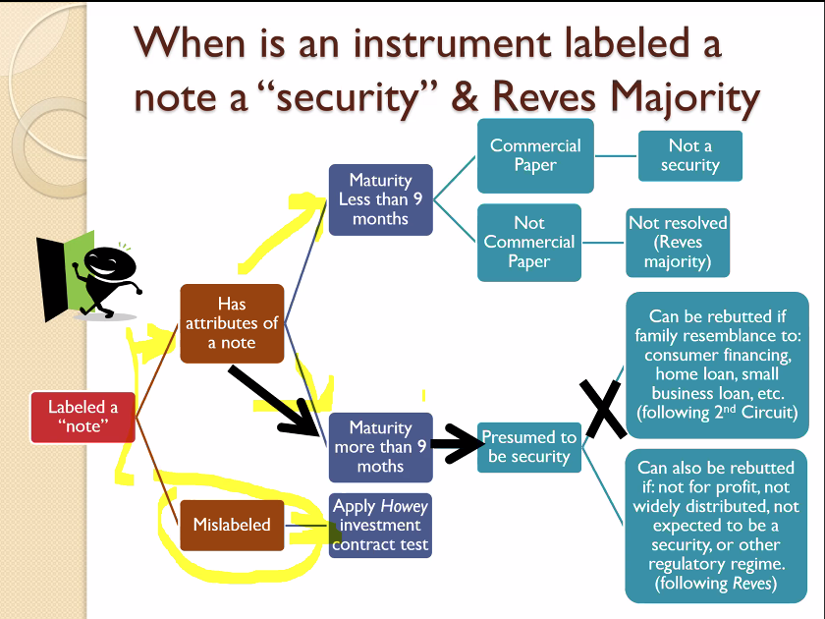

        - Commercial paper: when companies need money they need a lot (minimum $1 mil) so they cannot just to to a bank, there is a separate department on Wall Street that provides this money for short term transaction of large amount of money. This is known as the commercial paper market, which the federal government does not regulate
        - Maturity means → how long you have to repay the money
          - Rule on Maturity: There is a statutory exception for notes with a maturity of 9 months or less which might affect the presumption that the note is a security. But ability to demand back does NOT mean there is 0 maturity
          - A note payable in 6 months, renewable at the discretion of the creditor for an additional 12 months, might be a security or might not depending on the economic reality
          - Seminal case - Reves v. Ernst & Young: The majority says the Co-Op demand notes have a maturity of more than 9 months, but the dissent says the maturity is less than 9 months because they are demand notes so the maturity is 0. Per case law, the maturity of a demand note is 0 because you can demand back your money at any time, but the majority disregards this. The majority also argues the 9 month provision only applies to special commercial paper (not covered).
            - Dissent would say that if maturity less than 9 months, not a security. Because it’s a demand note, has a maturity of less than 9 months because can demand money back at any time, so maturity should be 0. Dissent in Reves says because of this 9 month maturity, the demand notes here should not be considered securities.
            - Under majority, we don’t know what happens if the note maturity is less than 9 months. Court says they aren’t worrying about this because the question is not germane to this case.
        - Why does the dissent refer to Sec 3(a)(10) while the majority refers to Sec 3(a)(3)?
          - Sec 3(a)(3): has to be a current transaction and a maturity of less than 9 months – majority said this exception doesn’t apply here (based on the “33 Act)
          - Sec 3(a)(10): the case is actually based on the ’34 Act, so the dissent is claiming the majority is looking at the wrong act
- Cryptocurrency
  - In the Matter of the DAO (p. 188): DAO sold DAO tokens (a virtual currency) in exchange for Ether (another virtual currency). DAO is a virtual organization without central control, it is controlled by democratic action but is created by an organizer, Slock.it. DAO token holders shared in the assets of projects funded by DAO tokens. To fund a project, a “Contractor” needed to submit a proposal and the DAO would pay them if a majority of DAO token holder voting voted for it. But the proposal would only be voted on if a “Curator” adds it to the “whitelist”. Curators also determine the order and frequency of proposals, and can reduce the voting quorum requirement. The structure created a strong bias to vote yes. Investors in the DAO used Ether to make their investments. Investors in the DAO were investing in a common enterprise and reasonably expected to earn profits. Slock.it and its founder led investors to believe they could rely on their managerial efforts to make the DAO a success and investors had little choice but to rely on their expertise. DAO token holders had voting rights that were quite limited in practice, as they could only vote on proposals approved by Curators and it was difficult to effect change or exercise meaningful control. The Curators chosen by the promoters were running the DAO, which means the DAO token holders were relying on the efforts of others.
  - The DAO tokens were securities because foundational principles of the securities law still apply to virtual organizations or capital raising entities that make use of distributed ledger technology
    - The investors in the DAO invested money - even though it wasn’t cash, it was still a form of virtual currency (ETH)
    - There was a reasonable expectation of profits – equated the rewards to dividends; the ETH was pooled and available to the DAO to fund projects
    - Derived from the managerial efforts of Slock.it, Slock.it’s Co-Founders and the DAO curators
  - Questions:
    - What if the Curators did not play a mediating role and The DAO did provide a truly democratic form of selecting and approving projects?
      - The prong that this most easily would affect is “relying solely on the efforts of another”
- Regulation of the Offering Process
- Introduction to the Public Offering Process (p. 487-501)
  - If a company is raising money by issuing a security, we ask if we have to go through the federally regulated registration process (aka public offering)
  - An IPO is a type of capital that can be used to fund a company – companies that need lots of capital assets to start their company (i.e. General Motors would need lots of steel, other materials, and factories up front to build the cars/trucks that will later produce a profit – also referred to as a “capital-intensive business”)
    - Businesses can gain money through (1) bank loans – downside is interest payments, minimum debt-equity ratios and limitations on the company to spend the money, (2) investors – either individuals at the company or outside investors, (3) sell equity in a public offering– downside is that it may dilute the company’s return for pre-existing owners because so many new equity members are being brought on
  - Underwriters:
    - The first step of making a public offering is contacting a Wall Street investment bank – these banks play a role as an “underwriter” – a salesman who market the securities to the public
    - The underwriters also provide advice on the structure of the corporation, the securities to be offered, and the offering amount/price
    - Underwriters also guide the companies through the SEC’s registration process
    - Role of the Underwriter: Underwriters assist the company in selling securities. They are repeat players who have contracts with institutional investors and dealers, giving them reputational capital. Underwriters buy then resell the whole offering with money from the company.
    - Underwriters as Gatekeepers: Underwriters can serve as “screeners” bringing only “good offerings” to investors. They have an incentive to screen out bad offering to keep their reputation. But underwriters don’t have that much of their own money on the table, so they are willing to risk because their first concern is not the investors. Therefore, regulation is still necessary
    - Underwriting Process: Typically there are multiple underwriters in one offering. 1-3 will be the managing underwriter keeping track of everything, but all will work together to sell the securities. The lead underwriter will negotiate with issuers, put together the syndicate of underwriters, manage distribution, and walk the issuer through the process. The managing underwriter and issuer will spell out the plan in a “letter of intent” which specifies the role of the underwriter. After the registration statement is filed, the managing underwriter will invite other underwriters to join the syndicate pursuant to an agreement. Just before the offering, the issuer and lead underwriter will enter into a formal agreement setting the number of shares, prices, gross spread, and over allotment option. It is only at this moment that the underwriter has any risk.
  - Types of public offerings:
    - Firm commitment: Underwriter syndicate purchases the entire offering from the issuer at a discount from the offering price (usually about 7% of the public offering price when raising equity for the first time) which constitutes their fee. The underwriters then sell these shares to investors (mostly institutional) at the offering price. These institutional investors keep some of the shares and sell some to other investors.
      - Most common type of offering
      - Underpricing phenomenon in Firm Commitment Offerings: The investment bank has to sell for the price set by the company even though the stock price will typically shoot up after a public offering. IPO markets are characterized by large first-day returns in the secondary market above the IPO price. This tells you the offering price received by the issuer was too low. The profit is seen by investors rather than the company.
        - Explanation: Lawsuit avoidance (you get sued if share price goes down), risk averse underwriters (still have some risk because they have to sell the shares), liquidity, market exuberance, underwriter corruption (they want to make sure institutional investor clients make a profits)
    - Best efforts: investment bank acts solely as a selling agent, receiving a commission on sales.
      - The underwriters don’t want to commit to taking the shares, so they just go out and sell them
      - Note: This has not worked on Wall Street
    - Direct Public Offering without Bankers: Issuer sells directly to public. Usually as “rights” offering to existing shareholders.
    - Listing without Offering (“Public Listing”): Issuer lists shares publicly without offering new shares (e.g., Spotify and Slack).
      - Companies cutting out the middlemen investment companies
    - Dutch Auction Offering: Issuer and underwriter do not fix a price for offering; rather, investors place bids for desired number of shares. Issuer selects highest price that will result in offering selling out. (Google is the one company that has tried this)
      - Ask people how much they would pay, then sell it to them for that price
      - Anyone can participate; if you bid higher than the “clearing price” then you get the shares. You are essentially saying “I will buy at this price or below” when you bid
      - Note: This is painful for the issuer because they know people would purchase it for more and you want to charge people the max amount possible here (called “price discrimination”) but they can’t with this system. But at least they don’t lose money to underwriters
      - Example: Google (who did this type of offering) wants to sell 1 million shares at the highest price possible and it solicits bids from all investors. Bid 1 is for 200k shares at $50/share. Bid 2 is for 150k shares for $45/share. Bid 3 is for 500k shares for $40/share. Bid 4 is for 150k shares for $35/share. Bid 5 is for 300k shares at $30/share. Bid 6 is for 400k shares for $20/share. If Google wants to sell 1 million shares, they have to set the price at $35/share (even for Bidder 1, 2, and 3 who bid higher dollar amounts, they will get the shares for $35/share).
    - Special Purpose Acquisition Companies (SPACs) – used to not be used, but now is being more modernly used (more than half the companies that went public this year were SPACs)
      - SPAC IPO: An entity, the SPAC, goes through the formal IPO process (2% underwriting fee; 3.5% when acquisition done). The initial SPAC does not have operations and money raised is held in cash.
      - SPAC Acquisition: The managers of the SPAC have two years to find a private company to acquire. The private company they acquire becomes public through the merger with the SPAC and SPAC sponsors get 20% of business.
      - Shareholder Approval: The SPAC investors vote on the proposed acquisition and can also redeem their SPAC shares rather than remain an investor in the combined company.
      - Recent Examples: DraftKings (DKNG), Virgin Galactic (SPAC), Nikola Motors (NKLA).
  - Consequences/Considerations of a Public Offering
    - The costs of going public include: underwriter’s discount (take a 7% charge), out of pocket costs for lawyers/accountants/printing (can be $1 mil-$3 mil), restructuring corporation to prepare for public (changing the legal structure of the company), time of management (distraction), dilution effect on shareholders (selling additional equity at a discount lower the equity value others have), risk of takeover (another company buying your shares), ongoing cost of public filing
    - Getting the house in order: Companies come to IPO with an operating/financial history and a pre-existing ownership base. The ownership structure in private companies can be complex (eg different classes of shares, convertible securities). Prior to IPO, structure will be simplified to make it more attractive. Companies must also incorporate or re-incorporate in Delaware (familiar with public companies). Corporate governance must be restructured because public companies require independence and an audit committee must oversee the accounting reports.
    - Public offering disclosure: Investors need information to value securities as they have less information than the issuers selling the securities. To even the playing field, securities laws require the issuer to disclose certain information in the registration statement and prospectus. These documents will rise to different levels of liability. There is some incentive to make these documents vague and superficial to reduce potential liability and to prevent competitors from getting too much information.
- Steps of the Public Offering Process
  - #1: The firm has to produce certain disclosure documents → (1) registration statement and (2) prospectus.
    - Why does the firm have to provide disclosure documents?
      - Investors need information to value securities; and those who are selling have more information than outsiders.
      - To even out the playing field, securities laws requires the issuer to disclose certain information in the registration statement and prospectus.
      - These documents give rise to different levels of liability (which we will cover later on).
    - Registration Statement (filed with the SEC)
    - Prospectus (sent to potential investors)
      - The prospectus contains (1) risk factors: including legal, business, operational, and country risk factors that can be both specific and more general; (2) a summary of financial results and management’s discussion and analysis (MD&A) which discusses trends or differences across years in various metrics; (3) an overview of the industry, including the structure of competition and regulation; (4) a description of the issuer’s business, including production, distribution, the property itself, management, strategy, and litigation; and (5) financial statements.
      - Plain English Rules for the Prospectus:
        - Prospectus must contain language drafted in a “clear, concise and understandable” manner.
        - Rule 420 - Legibility : Roman type, at least 10pt., so that it is big enough to read
        - Rule 421 - Presentation of Information: Follow plain English principles; use short sentences, active voice; no legal or financial mumbo-jumbo.
        - Note: SEC can make you rewrite if too confusing or long
    - Additional Documents/Disclosures NOT Included in the Prospectus
      - Undertakings by management
      - Undertakings by auditors
      - Authorization documents
      - Documents that the SEC has asked, or is likely to ask for (bylaws, material contracts, etc.)
  - #2: Public offering process is divided into three periods, each with different restrictions. These are often referred to as the “gun jumping rules.” [Discussed in Section C.]

- Gun Jumping Rules
  - The gun jumping rules restrict timing and content of dissemination of information to investors
  - Public offering process is divided into 3 periods, each with different restrictions: (1) Pre-filing period; (2) Waiting period: and (3) Post-effective period
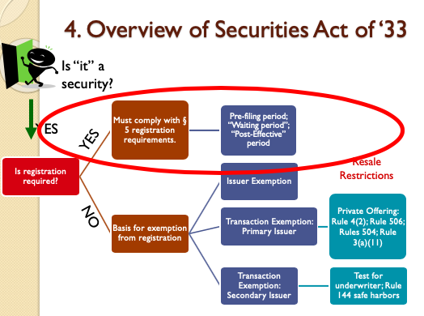
  - Section 5 of the 1933 Act:
    - Rule: Cannot sell a security until the registration is in effect → §5(a) of the 1933 Act: If a registration statement IS NOT IN EFFECT as to a security, it is unlawful for any person, directly or indirectly to (1) make use of any means of communication to sell such security or (2) to carry by any means any such security for the purpose of sale, or for delivery after sale.
    - §5(b) of the 1933 Act: It shall be unlawful for any person, directly or indirectly-
(1) to make use of any means... in interstate commerce... to carry or transmit any prospectus relating to any security with respect to which a registration statement has been filed, unless such prospectus meets the requirements of section 10; or
(2) to carry... in interstate commerce... any such security for the purpose of sale or for delivery after sale, unless accompanied or preceded by a prospectus that meets the requirements of subsection (a) of section 10
      - Takeaway: Anything you give them must be a prospectus

      - Takeaway: You need to have the right documents ready to sell a security and you can’t carry around documents you gave to the SEC unless they meet the requirements of §10(a)

➔Key term: “prospectus”
→ §2(a)(10) of the 1933 Act: The term “prospectus” means any prospectus, notice, circular, advertisement, letter, or communication, written or by radio or television, which offers any security for sale or confirms the sale of a security . . .
- Note: the term is very broadly defined and encompasses basically any written document (and probably anything on the internet would qualify)
- Idea is the SEC wants to restrict what issuers give out to potential shareholders

    - Rule: Cannot make any offer unless registration statement has been filed
      - 5(c) of the 1933 Act: It shall be unlawful for any person, directly or indirectly, to make use of any means... in interstate commerce... to offer to sell or offer to buy through the use... of any prospectus or otherwise... any security, unless a registration statement has been filed as to such security, or while the registration statement is the subject of a refusal order or stop order...
    - §2(a)(3) of the 1933 Act: The term “offer to sell”, “offer for sale”, or “offer” shall include every attempt or offer to dispose of, or solicitation or of an offer to buy, a security...
      - [These terms] shall not include preliminary negotiations or agreements between an issuer (or any person...controlling or controlled... by an issuer) and underwriter or among underwriters who are or are to be in privity of contract with an issuer...

  - #1: Pre-Filing Period (p. 507-520)
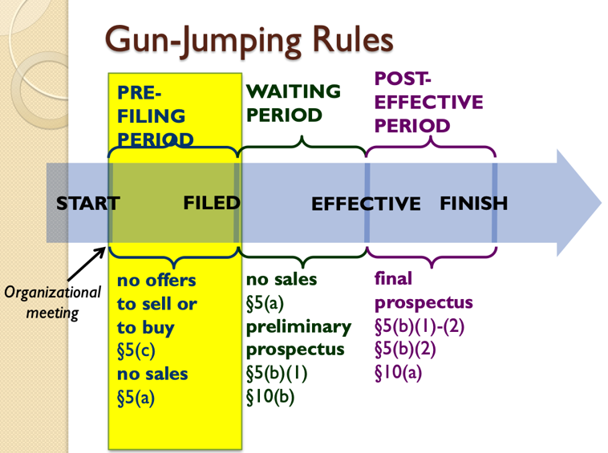

    - Key Issues to Consider under Pre-Filing Period:
      - Are we “in registration”?
      - Is the communication an “offer” under §5(c) or §2(a)(3)?
      - Does a safe harbor or exemption apply? (Rules 135, 163, 163A, 168, 169)

    - When is the pre-filing period?
      - The pre-filing period restrictions begin when the security is “in registration”, which the SEC Release No. 5009 (1969) defines as the time an issuer reaches an understanding with the broker-dealer, who is to act as the managing underwriter. The pre-filing period ends when the documents you file become public.

    - What is ALLOWED during the pre-filing period?
      - Discussions with underwriters: Preliminary negotiations are excluded from the definition. Companies can still have preliminary negotiations because they are making an offer to the underwriter, and need to be able eto have a discussion about the security.
        - Applicable rule (excludes preliminary negotiations) → §2(a)(3): The term “offer to sell”, “offer for sale”, or “offer” shall include every attempt or offer to dispose of, or solicitation or of an offer to buy, a security. These terms shall not include preliminary negotiations or agreements between an issuer (or any person controlling or controlled by an issuer) and underwriter or among underwriters who are or are to be in privity of contract with an issuer

    - What is NOT ALLOWED during the pre-filing period?
      - Companies are NOT allowed to make offers to sell or buy.
      - SEC Release 3844 (1957): Conditioning the market (considered an offer)
        - Factors showing they are “conditioning the market” and therefore offering securities (rather than just carrying on with business):
          - Motivation of the communication (eg was it prearranged before the financing decision, scheduled prior)
          - Type of information: soft, forward-looking information looks more like an offer (talking about how great the company is)
          - Breadth of the distribution: broader means more likely an offer (aka more people spoken to)
          - Form of the communication: written makes it easier to reproduce so more likely to be broadly distributed and more likely an offer
          - Whether the underwriter is mentioned by name (or other particular facts about the offering are specified)
        - Examples of Conditioning the Market:
          - Example #1: Underwriter distributes a brochure with positive information on the issuer’s industry but does not name the issuer, although it does name the underwriter.
            - Under 1957 this is not allowed because underwriters can’t even write about the industry - Violates Sec. 5, because “the first step in a sales campaign to effect a public sale of the securities.”
          - Example # 2: Company and underwriter arranged for a series of press releases describing the activities of the company. The press releases contained representations, forecasts and quotations which could not be supported as reliable.
            - In 1957, this is disallowed; violates Sec. 5.
          - Example # 6: A presentation by the CEO to analysts (including projections of demand, operations, and future profits) that was scheduled well before the decision to make a public offering.
            - In 1957 → Not a violation of Sec. 5 (mainly because it was scheduled before the decision), although the SEC recommended that printed documents not be distributed.
          - Example #7: CEO runs an ad saying the company is “optimistic about fracking” and “revolutionize the industry”. This might be conditioning the market because they are future-oriented.
        - SEC Release 5180 (1971) → Public Companies
          - Securities Act Release No. 5180 (1971): addresses conflict between (a) satisfying Exchange Act periodic disclosure requirements (and other business communications), and (b) restricting information disclosure to meet gun-jumping rules.
          - In general, issuer should not initiate publicity, but can respond to legitimate inquiries. Should also be careful about providing projections, forecasts or opinions about value and limit communications to factual information.
          - Examples: advertising products and services, periodic reports to shareholders, press releases about factual business developments, answer unsolicited inquiries about factual matters from stockholders or analysts, proxy materials, etc.

    - Safe Harbors:
      - Certain safe harbors were created as a result of public companies wanting more freedom. If you follow the following safe harbor rules, you will be safe under §5.
      - Breaks up gun jumping rules by the type of company (public v. non-public v. small) so each has different gun jumping rules

      - Safe Harbor Rules:
        - Rule 135: Tombstone Ads
        - The SEC’s 2005 Public Offering Reforms implement 4 new safe harbors applicable to Pre-Filing Period communications. These 4 safe harbors include:
          - Rule 163
          - Rule 163A
          - Rule 168
          - Rule 169
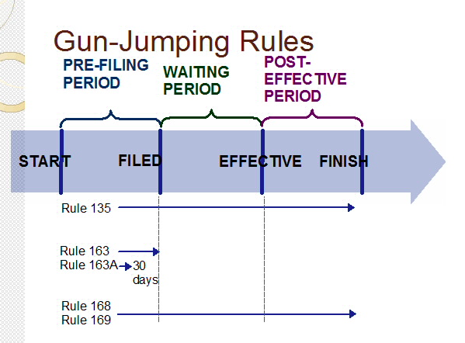
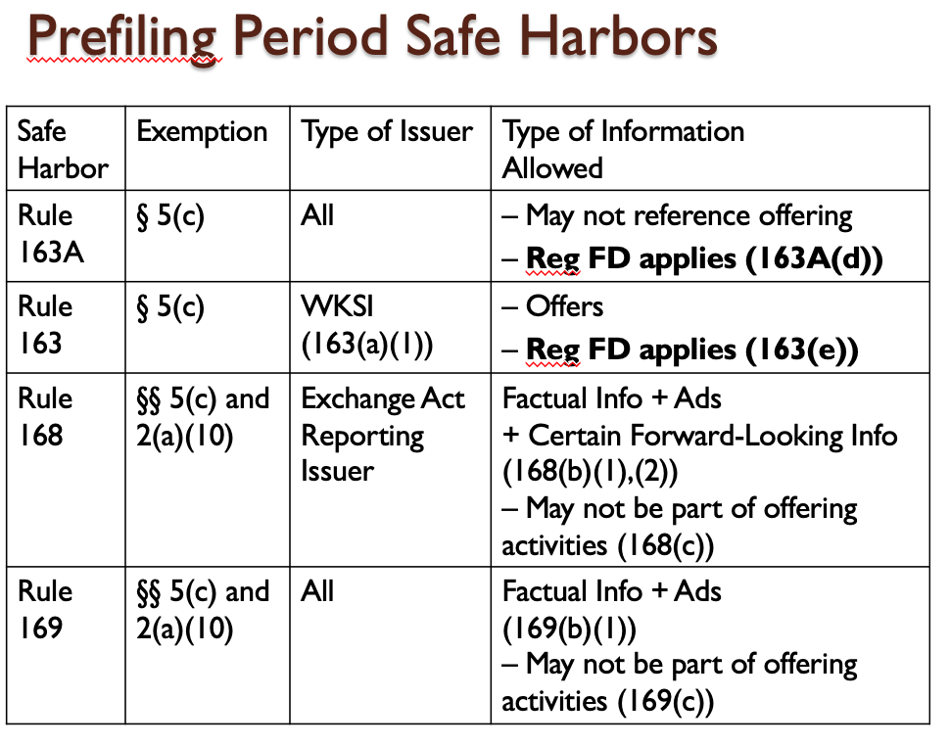
Reg FD means → a rule that came up in 2000; Reg FD stands for Regulation Fair Disclosure

- Before 2000, one of the things you could do as a public company was to call people on wall street and give them insider information – this was legal because it was for the benefit of the company
- BUT the SEC said this wasn’t fair, b/c people in Wall Street shouldn’t have access to insider info so they created Reg FD, which says if you disclose info you have to disclose to everyone at the same time

      - Rule 135: Tombstone Ads (applies in pre-filing, waiting, and post-effective period)
        - Companies are allowed to run a “tombstone ad” to say they are thinking of selling securities (called this because it is very basic and formal)
          - Popular in the 50s and 60s, but not really used or needed now
          - Applies to any medium (i.e., could be a press release)
        - Rule 135: Short, factual notices announcing a proposed registered offering by the issuer will not be deemed an offer if:
          - (a)(1): Ad contains legend clarifying that ad is not an offer
          - (a)(2): Information limited to that listed in the rule: name of issuer; title, amount and basic terms of securities; manner and purpose of offering (NOT naming underwriters), anticipated timing of the offering
        - Note: ANY additional information not listed in (a)(2) may be considered an offer. If you follow these rules, can post a tombstone ad
        - Example: Company issues a tombstone ad which does not mention the underwriter but say the managing underwriter is “a well-known investment bank”. While they don’t mention the name of the underwriter, this is going beyond the scope of the ad by adding this information, so Rule 135 safe harbor will not apply
      - Rule 163: Communications by Well-Known Seasoned Issuers (WKSIs)
        - Rule 163 allows communications prior to the filing of the registration statement by well-known seasoned issuers.
          - Big companies can go about their business without worrying about these rules
          - Only companies (not bankers/underwriters) are protected
          - Can communicate any way you want with investors (don’t need to worry about conditioning the market)
        - 4 Categories of Issuers created by the 2005 Public Offering Reforms:
          - Well-known seasoned issuers (Rule 405): reporting companies with a market capitalization exceeding $700 mil
          - Seasoned issuers: reporting companies eligible for Form S-3 (over $75 mil or public filer for at least 12 months)
          - Unseasoned issuers: reporting companies not eligible for Form S-3 (under $75 mil)
          - Non-reporting issuers: no publicly traded securities
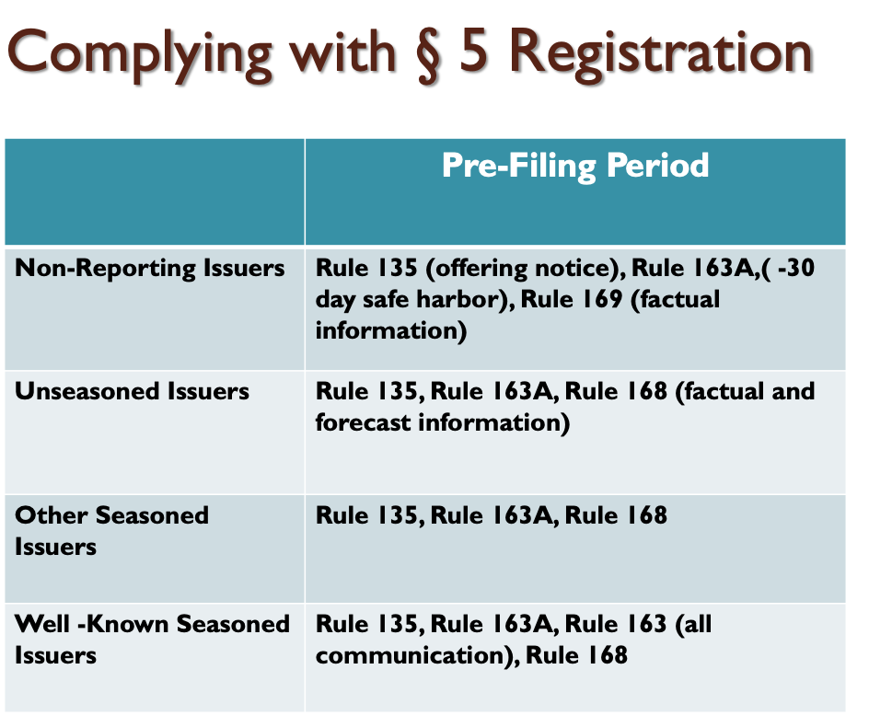

        - Rule 163: Communications are exempt if:
          - Issuer is a WKSI
          - Communication contains a specific legend (clarifying it is not a public offering)
          - Communication is filed upon the filing of the registration statement (or amendment) covering the corresponding securities (aka need to include documents given to people in the information given to the public)
          - Exclusions: Cannot relate to business combination transactions, issuer not an investment or business development company, etc.

      - Rule 163A: 30-day exemption
        - Rule 163A exempts statements made by the issuer (not underwriters) prior to 30 days before the filing of the registration statement (may not reference the offering)
          - Essentially says that all companies do not have to worry about conditioning the market if their disclosures are more than 30 days before they file the registration statement; SEC is basically saying they don’t care if you condition the company if it is so far in advance of when you file for registration Issuer must take reasonable steps to prevent the dissemination of these communication during the 30 days before the filing of the registration statement (hard to do, minimum is just not to spread the information intentionally)
          - This safe harbor is generally available to all issuers
          - Rule 163A(b) Exclusions (no safe harbor): Investment or business development companies, business combinations, etc.
        - RULE 163A: Communications that took place more than 30 days before the filing of the registration statement are not offers for 5(c) purposes, provided that:
          - they were made by the issuer (not underwriters)
          - they do not refer to the offering
          - the issuer takes reasonable steps to prevent the dissemination of these communications during the 30 days before the filing of the registration statement
        - Examples:
          - Communications to analysts and investors about historical financials 50 days prior to filing probably → allowed under 163A
          - Soliciting offers to buy the securities → not allowed under 163A; cannot discuss the offer
          - If the issuer does not tell analysts to stop distributing information in the 30-day cool down period → not allowed under 163A
          - 50 days prior to filing, underwriter provides information to analysts and investors about historical financials → not protected under 163A; 163A is only available to the ISSUER; it does not protect underwriters
          - Issuer provides information just to analysts → this is allowed under 163A if outside of the 30-day period, but not if it is within the 30-day period
      - Rule 168
        - Rule 168 exempts regularly released factual and forward-looking information by reporting issuers (may not reference offering).
          - NOTE: Rule 168 allows you to provide more information than Rule 169
        - RULE 168: Communications containing factual business information or forward-looking information are excluded from the definition of offer for purposes of sections 2(a)(10) and 5(c) if:
          - Communications by issuer that is a reporting company (not by underwriter or dealer)
          - Information is not about the offering
          - Factual information about issuer, financial developments, or other aspects of its business; etc.
          - Forward-looking information: projections of the revenues, income, dividends, capital structure, or statements about management’s plans and objective for future operations, etc.
          - Issuer must have previously released the same type of information in the ordinary course of business and the information must be materially consistent in timing, manner, and form with past releases (aka keep doing what you’re doing, can’t go after a new audience or give new types of information.
        - Examples:
          - Exchange Act reporting issuer sends 10-K (annual report) with MD&A information about future uncertainties and trends. → This is allowed under 168 and required by the SEC.
          - Issuer sends out advertisement to trade journals touting products and past track record for safety and reliability. → This is allowed under 168 if the issuer has done this in the past.
          - Issuer expands advertisement to several financial magazines. → This is not allowed under 168 because it is additional audience
          - Issuer provides press release as part of its regular course of communications with investors to the market containing projections on future profitability → this is allowed under 168 because it is the regular course of business.
          - If an underwriter sends out the press release on behalf of the issuer, this is not covered by 168 because it is the underwriter, not the issuer. Safe harbors are only for the issuers, NOT the underwriters.
          - Instead of an ad, the issuer sends information in the press release to only select institutional investors. This is a change in the usual course and thus not covered by 168.

      - Rule 169
        - Regularly released factual information by non-reporting issuers given only to persons other than in their capacities as investors or potential investors (may not reference offering).
        - Similar to Rule 168, but for non-reporting issuers (e.g., those accessing markets for the first time)
        - Key differences:
          - Does NOT exempt forward-looking information
          - Communications may not be directed towards new investors
        - Examples:
          - Non-Exchange Act reporting issuer sends press release discussing future uncertainties and trends (MD&A-like materials). This is not permissible under 169 because it is future-looking.
          - Issuer sends out advertisement to trade journals touting products and the issuer’s past track record for safety and reliability. This is permissible under 169 if it is consistent with past action.
          - Issuer expands advertisement to several financial magazines. This is not permissible under 169 because they are reaching out to investors and this is a change in behavior.
          - Issuer provides press release as part of its regular course of communications with investors to the market containing historical information on the issuer’s business. This is technically a violation because it is directed at investors, but the concern is going after NEW investors and here it was practice to talk to their own investors, so this is probably permissible under 169.
          - An underwriter sends out information in the press release to customers on behalf of the issuer. This is not permissible under 169, which does not protect underwriters.
          - Instead of an ad, the issuer sends the information in the press release to only select institutional investors. This is not permissible under 169 because it is soliciting investors.
          - CEO says “Company’s strong future ensures that we’ll be around a long time to help customers like you!” This sounds like a future projection, so Rule 169 will not work
    - Safe Harbor Hypotheticals (applying Rules 135, 163, 163A, 168, 169):
      - Hypothetical #1 (p. 516)
        - Facts: Suppose that Ewing Oil pursue a public offering; company faces a number of issues. Consider whether the following actions raise any 5(c) gun jumping concerns:
          - Before finding an underwriter or filing a registration, the CEO telephones a number of people and says “I can get you in at under $20/share”
        - Issue: Does this violate the gun jumping rules?
        - Analysis: The rule says you can’t make an offer unless the registration statement has been filed. Here it seems like she is making an offer
          - The one argument you could make that it does not violate is that the pre-filing period hasn’t started because an underwriter hasn’t started yet and her activity took place before the organizational meeting – BUT that relies on the SEC definition of the prefiling period; however, the federal statute is the strongest law so you would have a hard time convincing a court/judge that the period has not started because you have so clearly violated the statute
        - Conclusion: This violates §5(c)
      - Hypothetical #2 (p. 516)
        - Facts: Assume Ewing Oil is in registration (in registration means that they are in the pre-filing period); CEO places an ad in World Oil magazine touting the company’s business; Ewing placed a similar ad about a year earlier; the ad does not mention IPO or say offer; the ad says that they are “optimistic about fracking” and this will “revolutionize the industry”
        - Issue: Does this raise any gun-jumping concerns?
        - Analysis:
          - Rule 163A → will apply depending upon when they are planning to file; 163A requires you to be able to pull the info off the market
          - Rule 168 doesn’t apply because they are not a public company yet
          - Rule 169 → this addresses non-public companies because Ewing falls in this category; running an ad that they ran a year earlier is good, but it is concerning that they are making forward looking companies and are saying that they are raising money to raise
          - Rule 163 doesn’t apply because they are not a WKSI
        - Conclusion: If we were the lawyers on the deal, we would remove this language immediately because this language is most problematic under rule 169
      - Hypothetical #3:
        - Facts: Also includes financial projections, with the statement ““Ewing Oil’s strong financial future ensures that we’ll be around
a long time to help customers like you!”
        - Analysis: Even more problematic than #2, so definitely not okay under Rule 169 – definitely forward looking
      - Hypothetical #4:
        - Facts: Excited for the upcoming IPO, the CEO places a press release discussing the upcoming IPO and says ““We expect to raise $200 m. Proceeds will be used for research and development. Managing underwriter is a well-known investment bank.”
        - Issue: is this acceptable under the prefiling period?
        - Analysis:
          - 163A, 168 and 169 don’t apply because it is a press release
          - 163 doesn’t apply because not WKSI
          - One more place you have to check → Rule 135, Tombstone Ad rule
            - Under Rule 135, it says that the notice can only include the name of the issuer, a brief statement of the manner/purpose without naming the underwriter, etc.
            - Cannot say it’s a “well known investment bank” – the rule is very limiting
        - Conclusion: It violates Rule 135
SIDE NOTE: JOBS Act of 2012 Modifications to Pre-filing Period Rules (Addendum)
- Definition of “Emerging Growth Company”: Section 2(a)(19) of the Securities Act
  - An issuer that is an emerging growth company as of the first day of that fiscal year shall continue to be deemed an emerging growth company until the earliest of—
    - (a) the last day of the fiscal year of the issuer during which it had total annual gross revenues of $1,000,000,000 … or more [indexed for inflation]
    - (b) The last day of the fiscal year of the issuer following the fifth anniversary of the date of the first sale of common equity securities of the issuer pursuant to an effective registration statement under this title.
- Notes on JOBS Act
  - A hodgepodge of fixes regarding securities
  - They wanted to create an easier onramp to the initial public offering process
  - Created the “Emerging Growth Company,” which is a type of company that the act is going to help by reducing the regulatory burden
    - These companies were those that were less than $1 billion in sales or had been public for less than 5 years – once you hit $1 billion in sales or been public for more than 5 years you don’t get the help anymore
  - Other changes:
    - Confidential draft registration statement review by the SEC prior to public filing (Title I, Section 106) [Amends Section 6]
    - Exemption from definition of an “offer” in Section 5(c) for certain research reports about an emerging growth company (including investment bank analyst pre-IPO reports) (Title I, Section 105 (a)) [Amends Section 2(a)(3)]
    - Expanded test the waters in the Pre-Filing Period with QIBs and institutional accredited investors reports) (Title I, Section 105 (c)) [Amends Section 5]

  - #2: Waiting Period (p. 520-535)
    - Overview:
      - After filing the registration statements, most issuers wait for the SEC to declare the registration statement effective.
      - Per §5(a), have to wait 20 days (at least) from when public gets documents to when you can sell to give people time to digest the information
        - Most companies make filing public 3 weeks - 1 month before you want to sell
      - Have to show your back and forth to the SEC to the public
      - Aside: There is a section in the Securities Act which gives companies the option of a 20 day waiting period instead of waiting for SEC permission. No one really uses the 20 day waiting period option, but several companies have recently used it because of the government shutdown. Under this path, the issuer does NOT need SEC approval, but they can’t change the offer in those 20 days. If you choose SEC approval, you can offer for sale the same day (called SEC acceleration) which is what everyone normally does because the 20 day rule is “unworkable.”
      - Rule: Making filing public is what takes you into the waiting period. You can do this when you file with the SEC, but many file confidentially. If you come out of confidential filing, you can then make offers without entering post-effective process, then request that the SEC makes the document effective. This does shorten the waiting period, but doesn’t eliminate it.
    - Note: History of Confidential Filing
      - Before 2012, registration was filed with the SEC by sending them the documents which they publicly posted. The filing process discouraged companies from going public because the need to disclose made them vulnerable to competitors.
      - The JOBS Act of 2012 said “emerging growth” companies can get “secret filing” when they are going public called a confidential filing. These companies file with the SEC but no one see the documents. Gives competitors less time AND gives the company the option to back out. Now documents have been filed, but not considered filed because confidential filing, so NOT in the waiting period, still in the pre-filing period.
        - Now any company can do a confidential filing (not just emerging growth companies). Almost every company does this.
    - What is NOT allowed during the waiting period?
      - §5(a) of the 1933 Act: Unless a registration statement is in effect as to a security, it shall be unlawful for any person, directly or indirectly:
        - To sell a security through the use or medium of any prospectus or otherwise OR
        - To carry any security for the purpose of sale or for delivery after sale
      - §5(b)(1): It shall be unlawful for any person to transmit any prospectus relating to any security with respect to which a registration statement has been filed under this title unless such prospectus meets the requirements of section 10
      - §2(a)(10) - Prospectus: any prospectus, notice, circular, advertisement, letter, or communication, written or by radio or television, which offers any security for sale or confirms the sale of a security
        - Prospectus is essentially any written document
        - Compare: Basically like saying before the sale of Priuses, can only give the Prius manual and not the Prius brochure
      - §2(a)(3): The term "offer to sell", "offer for sale", or "offer" shall include every attempt or offer to dispose of, or solicitation of an offer to buy, a security or interest in a security, for value.

    - Safe Harbors: What information IS allowed to be communicated during the waiting period? **REWATCH THIS LECTURE

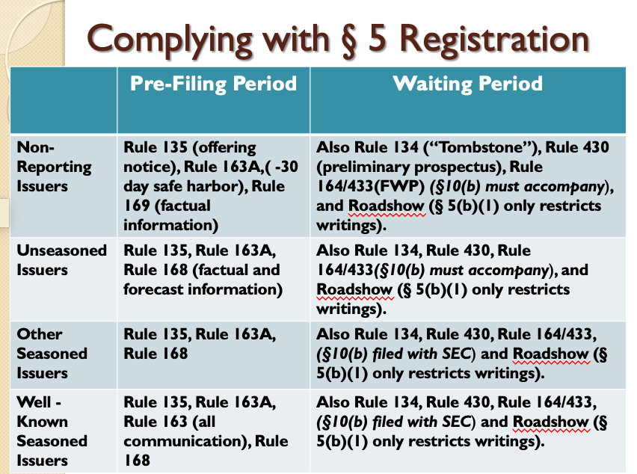

      - Rule 430: Information meeting the preliminary prospectus requirements of Sec. 10
        - Rule 430 relates to §5(b)(1)
          - §5(b)(1): It is unlawful for any person to transmit any prospectus relating to any security with respect to which a registration statement has been filed under this title unless such prospectus meets the requirements of section 10
          - Rule 430: A form of prospectus filed as a part of the registration statement shall be deemed to meet the requirements of section 10 of the Act for the purpose of section 5(b)(1) thereof prior to the effective date of the registration statement, provided such form of prospectus contains substantially the information required by the Act and the rules and regulations thereunder to be included in a prospectus meeting the requirements of section 10(a) of the Act for the securities being registered, or contains substantially the same information as the final statutory prospectus with the exception of price-related information.
        - A preliminary prospectus contains substantially the same information as the final statutory prospectus with the exception of price-related information. The final prospectus requires most of the information required for the registration statement.
      - Free Writing Prospectus: Rule 164, 405, and 433
        - Information deemed an acceptable prospectus for purposes of §5(b): Exception to the requirement you can only hand out the prospectus. Can do some documents other than the huge prospectus document if they meet these requirements, but the rules are quite tricky
          - Rule 164 allows distribution in the waiting period of “prospectuses” that do not meet the requirements of a preliminary prospectus under §10(b)
          - Rule 405 defines a free writing prospectus as offers made during the effective period which will not comply with §10(a) (aka not with a prospectus)
        - Rule 433: Ways in which one can use a free writing prospectus depends on what kind of company the issuer is
          - For non-reporting or unseasoned issuer, must be accompanied or preceded by prospectus satisfying §10 (aka need to hand out the full manual)
          - For seasoned issuer or well-known seasoned, a statutory prospectus has to be on file with the SEC (can just hand out the note and have the manual on file)
          - A well-known seasoned issuer can even use a free writing prospectus before waiting period (Rule 163) (aka during the pre-filing period)
        - Limitation: Rule 433 requires that the information released not be inconsistent with information in the filed statutory prospectus, must include a legend indicating the issuer has filed a registration statement, and must also must be filed with the SEC.
          - Cannot be inconsistent with prospectus
          - Has to include legend with reference to the registration statement
          - If new or interesting information, need to file with the SEC
        - Example: Barnes sends out a preliminary prospectus with no pricing information yet with the note attached saying “I think this is a good investment that might interest you. Please call me if you want to talk further about Ewing Oil’s upcoming public offering. Hook ‘em Horns!” It was correct to include the preliminary prospectus, but as there is no legend on the top of the note indicating the registration statement, this is not permissible.
      - Oral Offers
        - You’re allowed to say whatever you want. Basically all of the rules include “written or graphical communications” so oral offers are the “glorious exception”
      - Road shows: Rule 433(d)(8)
        - Road show is “hitting the road’ to show your product to investors
        - Rule 405: A graphic communication shall NOT include a communication that originates live, in real-time to a live audience, although it is transmitted through graphic means
        - Applies to all types of issuers (seasoned users, WKSIs, non-reporting and unseasoned issuers)
        - Rule 433(d)(8): Written communications used only in connection with a real time road-show are not graphic communications. Otherwise a written communication that is an offer contained in a separate file from a road show will be a free writing prospectus subject to filing requirements in paragraph (d) of this section.
          - NOTE: If available outside of the road show, it counts as a writing again (e.g., if you can take it outside the room, if it is available online, etc.)
        - Note to Rule 433 paragraph (d)(8): A communication provided simultaneously with a road show and provided in “a manner designed to make the communication available only as part of the road show” is deemed to be part of the road show.
        - You need someone speaking along with the powerpoint to qualify as an oral communication
          - Rule 433(d)(8): Must file road show that qualifies as written communication with the SEC, unless a “bona fide” version is available without restriction.
          - Rule 433(h)(5): To be “bona fide” one or more of the issuer’s officers must make the presentation.
          - Bona fide road show: If you make the road show available to everyone, then you can do it remotely (like making available on the web) if it is conducted by a company’s officers
        - Examples:
          - J.R. and Cliff hold a series of meetings with large institutional investors interested in investing in high-growth, initial public offering stock. They fly to Boston, New York, Miami, Chicago, Los Angeles, and other cities in a couple of weeks. In each city, they make a presentation to a group of investors and answer questions. This is a road show, permissible under the rules.
            - Variation: If the material is not part of the road show, can still qualify as a free writing prospectus under Rule 433 (have to file with the SEC and need a legend)
          - Barnes tells her favored investor-clients verbally that the Ewing has great growth prospects, strong management, and the IPO stock prices will rise after the offering. Because this is all oral, it does not violate the gun jumping rules

      - Tombstone Ads and Notice of Offering: Rule 134 and 135
        - Applies to all types of issuers (seasoned users, WKSIs, non-reporting and unseasoned issuers)
        - Rule 134: The term "prospectus“ or “free writing prospectus” shall not include a communication limited to the statements required or permitted by this section:
          - Such communication may include:
            - (1) the name of the issuer of the security;
            - (2) The title of the security and the amount being offered;
            - (3) A brief indication of the general type of business of the issuer (new from Rule 135)
            - (10) The names of the underwriters (new from Rule 135)
            - (11) The anticipated schedule for the offering and a description of marketing events
        - Examples:
          - Ewing is a non-reporting company. They post an ad for investors who want a high return, intent to sell $200m in common stock, 5-year projection of future profits. This is not a tombstone ad because it has projections and tells investors they will get a high return. But if filed with the SEC could be a free writing prospectus if the prospectus was attached
          - Ewing is a non-reporting company. They post an ad that mentions Barnes-Wentworth (underwriter), briefly describes Ewing Oil’s business, summarizes audited income statements from the last 3 years, and says no sales before effective date. This is not a tombstone ad because summarizing audited income is too complicated and the rule does not allow financial information
    - Waiting Period Hypotheticals
      - Facts: J.R, working closely with Cliff and Barnes-Wentworth Investments, the managing underwriter for Ewing’s offering with the SEC. J.R> is eager to take Ewings’s story to investors and persuade them to purchase stock in the upcoming IPO> J.R. and Cliff hold a series of meetings with large institutional investors interested in investing in high-growth, initial public offering stock. They fly to Boston, New York, Miami, Chicago, Los Angeles, and other cities in a couple of weeks. In each city, they make a presentation to a group of investors and answer questions.
        - Does this violate gun-jumping rules?
          - Answer: NO
        - What if material is not deemed to be part of the road show?
          - This is troubling, because then people are given a writing. (it is only okay if it is part of the road show, that the people don’t have access to when the road show is over) Still may qualify as free writing prospectus under Rule 433, but must comply with FWP requirements – See Scenario 5.
      - Facts: Sue Ellen, a broker working for Barnes-Wentworth Investments, learns of the upcoming Ewing Oil offering through internal communications within Barnes-Wentworth. She immediately calls her list of “favored” investors consisting of all recent college graduates from her alma mater (which she obtains from her school’s alumni website). For each potential investor who takes her call, she spends about 5 minutes touting Ewing Oil’s great growth prospects, the strength of the management team, and the tendency of IPO stocks to rise quickly in price after the offering.
        - Issue: Does this violate gun-jumping rules?
        - Analysis:
          - This is an oral offer
        - Conclusion: Since it is an oral offer, it does NOT violate
      - Facts: J.R. has Ewing’s newly-appointed investor relations director, Holly, put together an advertisement touting the upcoming offering for placement in the Wall Street Journal. Among other things, the ad is directed at investors who want “in on the new energy economy” and states Ewing’s intent to sell $200 million in common stock within the next year. The ad also includes a detailed 5-year projection of future profits. The ad does not mention Barnes-Wentworth Investments.
        - Issue: Does this violate gun-jumping rules
        - Analysis:
          - Here we have a writing, is this writing part of the preliminary prospectus? NO
          - Is this a tombstone ad? No, the financial projections alone are enough to disqualify the ads
          - Rule 168 – regularly released factual and forward-looking information by reporting issuers
          - Rule 169 (this is the rule that actually applies here) – regularly released factual information by non-reporting issuers given only to persons other than in their capacities as investors or potential investors – may not reference the offering
        - Conclusion: She is disqualified because she has the projections; but she CAN state that they are going to sell $200 million in common stock
      - Facts: J.R. has Holly put together a “tombstone” announcement of the offering that is carried in the WSJ ad. The tombstone mentions Barnes-Wentworth Investments and Ewing Oil and has a brief description of Ewing’s business. In addition, the tombstone provides a summary table on the past 3 years audited income statements of Ewing (including revenues, costs, and earnings).
        - Issue:
        - Analysis:
          - She is not allowed to do the income statement
          - She is allowed to do everything else
        - Conclusion:
        - It does violate, but so long as they remove the financial information it will be allowed.
      - Facts: Sue Ellen mails out a copy of the preliminary prospectus (omitting, among other things, pricing information) to all members of her college graduating class. She includes with the preliminary prospectus a letter stating, “I think this is a good investment that might interest you. Please call me if you want to talk further about Ewing’s upcoming public offering”
        - Issue: Does this violate?
        - Analysis:
          - If you do something in writing, it is a writing and so if it is not the actual full document, she has to treat it as a free-writing prospectus
        - Conclusion: She would not be allowed to include the note, since it won’t qualify as a free-writing prospectus since it doesn’t include a legend and she has to file with the SEC; also it has to be consistent with the prospectus*?
      - Facts: Kristing, one of the clients solicited by Sue sends a check in the amount of $20,000 to Barnes-Wentworth. With her check, Kristin sends a note indicating that she is making a “down payment” on Ewing Oil shares from the upcoming public offering.
        - Issue: Does this violate the gun-jumping rules?
  - #3: Post-Effective Period (p. 539-547)

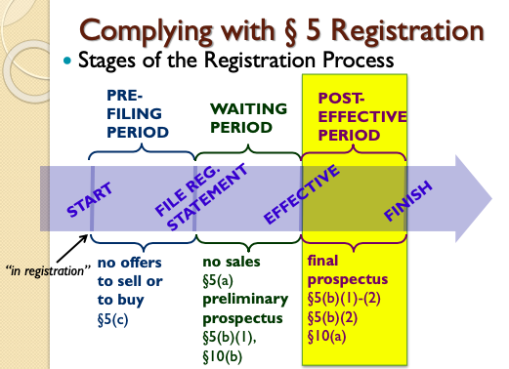

    - What is the post-effective period?
      - The post-effective period marks the end of prohibition on sales because now the registration statement is in effect
        - § 5(a)(1): Unless a registration statement is in effect as to a security, it shall be unlawful for any person, directly or indirectly to ... sell [a] security).
      - Timing of registration effectiveness: If you change what the offering document says, unless the SEC gives permission you need to wait 20 days → so need to set the price 20 days early
        - § 8(a) of the 1933 Act: the effective date of a registration statement shall be the twentieth day after the filing... or such earlier date as the Commission may determine. If any amendment is filed the registration statement will be deemed to have been filed when the amendment was filed.
        - In practice, the Registration Statement becomes effective once the SEC declares it effective (they send you a letter saying the registration statement is effective).
          - Rule 473 allows issuer to state in advance that they will file an amendment.
    - Form of the final prospectus: The final statutory §10(a) prospectus usually looks very much like the preliminary prospectus BUT adds price related information AND reflect changes in the offering or SEC comments
      - Price can be set at the last moment. Rule 430A allows issuers to go effective with a registration statement that contains a form of the statutory prospectus that omits certain information such as price relates information, which allows for price to be set at the last moment. Issuers have to eventually file the price related information. If they do so within 15 business days, then no post-effective amendment is necessary (just file a prospectus with information under Rule 424(b)(1)). All companies do this.
        - Rationale: If you go effective, we want that document to be final
        - Need a final offering document to the SEC with price still
    - What is required during the post-effective period?
      - After security is sold, need to delivery security and prospectus (but these rules are essentially eliminated)
      - §5(b)(1)-(2): It shall be unlawful for any person to transmit any prospectus relating to any security with respect to which a registration statement has been filed under this title unless such prospectus meets the requirements of section 10 OR to carry any such security for the purpose of sale or for delivery after sale, unless accompanied or preceded by a prospectus that meets the requirements of subsection (a) of section 10.
    - Obligation to deliver the prospectus varies
      - An ordinary purchaser has NO obligation to deliver a prospectus → Section 4(1) of the 1933 Act: The provisions of section 5 shall not apply to transactions by any person other than an issuer, underwriter, or dealer
        - Takeaway: If you re-sell shares after buying, you do not need to deliver the prospectus. An ordinary purchaser has no obligation.
      - The issuer has an on-going obligation.
        - When does the obligation to deliver a prospectus end?
          - For the issuer and the underwriter → NEVER
        - Note: The prospectus is dated, you have an obligation for it to continue to be accurate. If you want to sell again, need to update the prospectus
      - If the underwriter did not immediately distribute them, their obligation never ends for any they distribute in the future (called unsold allotments) (see §4(a)(3)(C))
      - If the underwriter and dealers sold the allotment, their obligation to deliver the prospectus ranges between no obligation and 90 days (not covered)
    - Access Equals Delivery
      - As long as you can access the prospectus, issuer does not need to attach to receipt of sale
      - Rule 172: If the registration statement is effective, and a §10(a) prospectus is filed with the SEC:
        - (a) Written confirmations and notices of allocation are exempt from §5(b)(1), and thus they do not need to be accompanied by §10(a) prospectus
        - (b) §5(b)(2) is deemed to be satisfied; no prospectus delivery required upon transfer of securities
    - NOTICE
      - Need to provide notice within 2 days
      - Rule 173: Within 2 days, issuers and underwriters must provide purchaser final prospectus, or notice that the sale was made pursuant to a final prospectus

- Civil Liability under the Securities Act
- Section 11 Liability
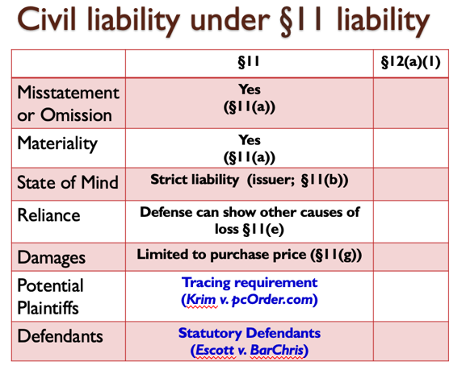
  - Overview:
    - Section 11 Liability (basically says you have to provide honest statements; creates liability for material misstatement)
    - Section 11: In case any part of the registration statement, when such part became effective, contained an untrue statement of a material fact or omitted to state a material fact required to be stated therein to make the statements therein not misleading, any person acquiring such security … may … sue –
      - (1) every person who signed the registration statement;
      - (2) every person who was a director of ... the issuer at the time of the filing of the part of the registration statement with respect to which his liability is asserted;
      - (4) every accountant, engineer, or appraiser, or any person ... who has with his consent been named as having prepared or certified any part of the registration statement …;
      - (5) every underwriter with respect to such security.
    - Summary of §11 Liability:
      - Critical issue for plaintiff class:
        - Tracing, i.e., standing
      - Litigation points for issuer:
        - Materiality
        - Affirmative causation defense
      - For secondary defendants:
        - Due diligence
  - Materiality Standard (p. 48-51)
    - Overview
      - General rule: If the information is not material, you won’t be liable → then the issue becomes, what is material? This is determined through Supreme Court cases
        - Objective standard – would information assume actual significance in decision of reasonable investor
        - Forward-looking information = probability x magnitude (Basic v. Levinson)
        - Market reaction (or lack thereof) important evidence (In re Merck)
        - Information regarding management integrity and transactions between the firm and management particularly salient (In re Franchard)
        - Quantitative measures relevant, but not conclusive
      - The law on materiality includes (1) relevant statutes and (2) relevant cases
        - Relevant statutes:
          - SEC mandated disclosure items (e.g. Regulation S-K)
            - Item 101.a. Provide information from earlier periods if material…
            - Item 402.a.2. Disclose all compensation awarded to named executives and directors…
            - Item 406 Disclose whether adopted code of ethics. If did not adopt, explain why not
          - Securities Act (SA) Rule 408 / Exchange Act (EA) Rules 12b-20
            - “In addition to information expressly required to be included, there shall be added such further material information necessary to make the required statements not misleading.”
          - Rule 10-b-5
        - Relevant cases:
          - TSC Industries, Inc. v. Northway (reasonable investor and total mix standards)
          - Basic v. Levinson (materiality under 10-b-5 of forward looking statements)
          - In re Merck & Co., Inc. Securities Litigation (relevance of share price movement)
          - In the Matter of Franchard Corporation (materiality of management integrity)
      - NOTE: There used to be a “Numerical Rule of Thumb,” which stated that if the dollar magnitude of a particular piece of information is less than 5% of the net income, revenues, or assets of a company then the information is not material. → This rule is now GONE, and the SEC stated that the rule of thumb is okay as an INITIAL step, however there is much more to materiality.
    - TSC Industries, Inc. v. Northway
      - “The court also explicitly has defined a standard of materiality in the proxy-solicitation context that ‘an omitted fact is material if there is a substantial likelihood that a reasonable shareholder would consider it important in deciding how to vote.”’
      - “It further explained that to fulfill the materiality requirement ‘there must be a substantial likelihood that the disclosure of the omitted fact would have been viewed by the reasonable investor as having significantly altered the ‘total mix’ of information made available.’”
    - In Basic v. Levinson (p. 61), Basic, Inc. (a publicly traded company) entered into merger negotiations with Combustion Engineering. Basic denied talks of a merger three times, even though the talks were going on. The plaintiffs previously owned stock in Basic, but sold their shares after the first time Basic announced that they were not in merger negotiations. The plaintiffs brought suit against Basic, claiming that they sold their shares based on reliance of Basic’s statements. The issue here is whether the ongoing merger negotiation statements are material facts. In order to bring a suit, the plaintiffs must establish that the ongoing merger negotiation statements are material facts. The court held that the determination of materiality was fact specific, and remanded for determination based on a weighing of the significance of the information (based on the probability of the event x the magnitude). Here, the court adopts Adopts Texas Gulf Sulphur's probability (: board resolutions, investment bankers, negotiations are all indicia of interest that may indicate an increased probability of merger) X magnitude (also look at merger premium, relative capitalizations of the two companies to determine magnitude of the merger to a company’s shareholders) test. The rule that derives from Basic v. Levinson is that: materiality “will depend at any given time upon a balancing of both: (1) the indicated probability that the event will occur and (2) the anticipated magnitude of the event in light of the totality of the company activity.”
      - Materiality under §10-b-5 of forward looking statements: An event can be contingent and probabilistic and still be material. When talking about something that MAY happen: Materiality = probability x magnitude
        - Materiality depends upon a balancing of both the indicated probability that the event will occur and the anticipated magnitude of the event in light of the totality of the company activity
        - Examples of what increases probability: Board resolutions, investment bankers, negotiations
        - Examples of what increases magnitude: Merger premium, relative capitalizations of the two companies (ie the size of the companies: a smaller company merger would be material, but for a company “eating” a small company it would not be material)
      - NOTE: The court in Basic rejects the 3rd Circuit test of only disclosing when “agreement-in-principle” AND also rejects the 6th Circuit test.
        - 3rd circuit said a merger is material when there is an agreement in principle because: don’t want to overwhelm the investor with tentative information, preserves the confidentiality of discussions (so the buyer can back out), and provides a bright-line rule. The Court rejected this because investors understand that the merger is tentative and might not happen, usually no affirmative obligation to talk (so can just remain silent to maintain confidentiality), and ease of application is not a good enough reason to abandon the purposes of the Securities Acts (want burden on companies to decide what is material).
        - 6th circuit said anything you lie about is material (even if it wasn’t material before) because then the company is a liar. The Court rejected this as overbroad under the reading of the statute; if it was not initially a material fact, it doesn’t automatically become one just because the company lied about it.
          - Rule 10-b-5(b): To make any untrue statement of a material fact or to omit to state a material fact necessary in order to make the statements made, in the light of the circumstances under which they were made, not misleading
          - Note: Guttentag thinks the 6th circuit was on to something here because a reasonable investor would want to know if the CEO is a liar. Other statutory obligations are not as clear on this
      - What are we trying to achieve by requiring disclosures?
        - Improve share price accuracy
        - Alter behavior
          - Discourage managers mischievous use of funds (reduce agency costs)
          - Reduce fraud in securities markets
          - Alter behavior in other ways
        - Reduce preferential / insider access to information
      - Consequences of requiring disclosures
        - Companies won’t approach each other if they know they will be in the headlines. Shareholders are not necessarily better off if merger negotiations must be disclosed
        - Companies can stay silent to maintain confidentiality of merger negotiations (absent a duty to disclose, silence is not misleading under Rule 10b-5)
        - All mergers are not automatically material
        - No clear rule on how to determine what a reasonable investor considers important (guesses from judges/jury? Expert testimony?)
    - Efficient Capital Markets Hypothesis: (**Will need this to spot this issue on the exam if it applies and determine whether weak/semi-strong/strong applies)
      - Definition: In an efficient market, current prices always and fully reflect all relevant information about commodities being traded.
      - ECMH describes a relationship between information and the price of a security.
        - Essentially the idea is that securities markets are like information marketing machines – the info gets accumulated and then reflected in stock prices
        - HOWEVER – not all info is reflected
      - Weak: All information concerning historical prices is fully reflected in the current price, so prices change only in response to new information
      - Semi-strong (most popular theory): Current prices incorporate all historical information AND all current public information, so investors cannot expect to profit from studying available information as the market has already incorporated that information accurately into the price
      - Strong; Price incorporates all information, whether publicly available or not. If true, no identifiable group can earn systematic positive abnormal returns from securities trading (ie you can’t beat the market) (Note: problem of insider trading debunks this)
      - 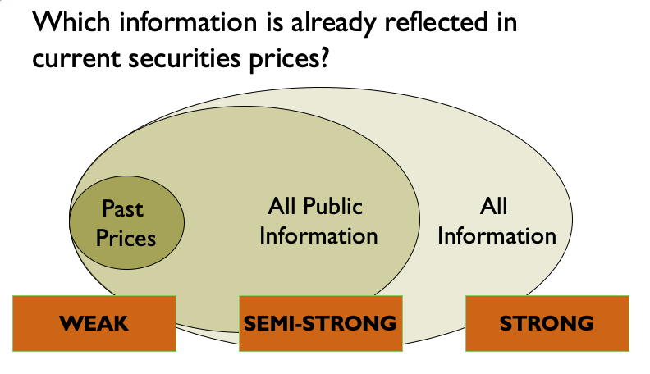
      - Note: All courts assume there is SOME truth to the ECMH
      - Rule: The lack of market movement immediately following disclosure establishes the non-materiality of that disclosure. A significant market response is typically conclusive evidence of materiality (unless defendant can rebut)
        - Note: Companies rarely make a clear disclosure alone; there are a lot of other moving parts (eg other disclosures, movement in the rest of the market) so need to control other factors to find the relationship between the disclosure and the stock price
      - Factors relating to stock price changes as evidence of materiality: (economists control for these factors to find the effect of disclosure on the stock price)
- Was there an abnormal return, or was the entire market moving?
- Were there other confounding disclosures made at the same time?
- Did the stock price change solely as a result of anticipated litigation costs? (the news itself might not be material, but the litigation)
- Was the market response not “efficient” for some reason?
- Was there information leakage before the announcement? (if so, price might drop before disclosure)

    - In re Merck & Co, Inc. Securities Litigation (p. 76)
      - Discusses the relevance of share price movement [Example: If a company releases that they have finished the vaccine for coronavirus, the price will jump – we can use this to infer that the information was material]
      - In January 2002, Merck & Company, Inc. (Merck) (defendant) announced a planned initial public offering (IPO) of its subsidiary, pharmacy benefits manager Medco Health Solutions, Inc. Medco recognized customers’ co-payments as revenue. Merck did not initially disclose this revenue recognition on its SEC Form 10-K. On April 17, 2002, Merck did disclose the revenue recognition but not the total amount of co-payments it recognized. After this filing, Merck’s stock price rose from $55.02 to $55.05 and its stock continued to rise for the next five days. On June 21, 2002, The Wall Street Journal published an article reporting its estimate of the dollar amount of co-payments Medco had recognized. Right after the article was published, Merck’s stock fell from $52.20 to $49.98. On July 5, 2002, Merck finally disclosed the full amount of co-payment (co-payments like the ones from health insurance) revenue it recognized. Merck eventually cancelled the IPO. Union Investments brought a securities fraud suit on behalf of Merck stockholders, claiming a violation of section 10(b) of the Securities Act of 1934. Merck filed a motion to dismiss on the ground that Merck’s disclosure or omission was not material. The district court granted Merck’s motion. Union appealed. The issue is: In efficient markets, is information material if it alters the price of the firm’s stock? The court discusses its “clear commitment” to the efficient market hypothesis. The materiality of disclosed information may be measured post hoc by looking to the movement, in the period immediately following disclosure, of the price of the firm’s stock. Here, Merc’s stock price rose immediately following its initial, minimal disclosure. Merck was clearly treading a fine line … but in efficient markets materiality is defined as “information that alters the price of the firm’s stock. Thus, the court held that the plaintiff failed to establish a material misstatement.
      - Factors relating to stock price changes as evidence of materiality
        - Was there an “abnormal” return, or was entire market moving?
        - Were there other confounding disclosures made at the same time?
        - Did the stock price change solely as a result of anticipated litigation costs?
        - Was the market response not “efficient” for some reason?
        - Was there information leakage before the announcement?
      - Note: There are securities analysts whose jobs are to analyze and report on the company, making it more likely information is quickly and fully reflected in the stock price. Securities analysts covered Merck but hedge funds look more closely into things because they can profit off of anticipating price changes so they really look into the details of the company
      - Guttentag Opinion: It is possible for information to be public, but not clear enough to impact the stock price. Only when the WSJ article came out was the fraud revealed, not when the paperwork was filed with the SEC. This doesn’t necessarily violate the ECMH (but the Court thought it did)
      - Questions:
        - Should the lack of market movement in response to a disclosure establish the non-materiality of that disclosure? Conversely, should a significant market response be conclusive evidence of materiality?
          - Price is not a bad starting point, but obviously, you have to consider other factors
          - Must control for other factors (see #3 above)
        - Did securities analysts cover Merck? What’s the significance of this?
          - Yes, securities analysts (people on wall street who write reports about companies) DID cover Merck
          - This is significant because for this court, that means that it is less likely that information slipped through the cracks
        - Which form of the ECMH is the court embracing?
          - Semi-strong; but it’s a strong form of the semi-strong
        - Does 3rd Circuit adopt a “bright line” materiality rule?
          - Yes, in an “efficient” market.
          - “Our standard for measuring the materiality of statements in an efficient market holds that ‘the materiality disclosed information may be measured post hoc by looking at the movement, in the period immediately following disclosure, of the price of the firm’s stock.”
          - “We created a test for materiality under … which the TSC materiality definition ‘ordinarily’ applies, but in efficient markets materiality is defined as information that alters the price of the firm’s stock.’”
    - In the Matter of Franchard Corporation (p. 99) → materiality of management integrity
      - Here, Louis J. Glickman was a real estate developer who conducted business through several corporations, the most successful of which was Venada Corporation. When Venada encountered financial difficulties, Glickman started Franchard Corporation, and purchased the majority of its shares. He also elected himself to the board of directors. Subsequently, funds were funneled from the sale of shares of Franchard Corporation to Venada, without the knowledge of Franchard’s shareholders or board of directors, except for one board member who served on the board for both Franchard and Venada. The Securities and determine whether Franchard had properly disclosed Glickman’s involvement in both Franchard and Venada. The issue is whether a corporation must disclose situations in which a conflict of interest may arise for members of the board of directors. The court held YES, these disclosures were highly material to an evaluation of the competence and reliability of registrant’s management. The main takeaway from this case is that disclosure of management integrity is highly relevant.
        - Glickman’s withdrawals were material transactions. Registrant’s argument withdrawals never exceed 1.5 percent of gross book value ignores the significance to prospective investor of information concerning Glickman’s managerial ability and personal integrity
        - How can Glickman’s withdrawals, which accounted for less than 1.5% of the gross book value of the Registrant, be material?
          - higher fraction of equity or cash flow
          - unsavory behavior or relationships, regardless of magnitude, is important to investors
        - What basis does the SEC have for concluding that the Registrant should have disclosed an “encumbrance[] on a
controlling stockholder’s shares”?
          - Rule 408 (and now Reg. S-K, Item 402 (c)).
          - RULE 408 requires mandatory disclosures to be supplemented with “further material information, if any, as may be necessary to make the required statements in light of the circumstances under which they were made not misleading.”
          - Regulation S-K, Item 403 (c): Describe any arrangements … including any pledge .. The operation of which may … result in a change in control.
        - What if Glickman had a heart condition that increased his probability of death?
          - “We … cannot agree with registrant’s contention that disclosure of Glickman’s borrowings and pledges of registrant’s stock would have been ‘unwarranted revelation’ of Glickman’s personal affairs.”

        - Did the SEC let the Franchard directors off too lightly?
          - Requiring such disclosures would “stretch disclosure beyond the limitations contemplated by the statutory scheme and necessitated by considerations of administrative practicality” → there won’t be director liability under the federal thing for just doing a bad job
          - If directors aren’t paying attention, there are things you can do – shareholder derivative suit, etc. so the SEC did the right thing
        - Is the disclosure required in this case only intended to give investors better information about the integrity of management?
          - NO! Disclosure also deters negative behavior
          - Footnote 36: “The deterrent effect of disclosures required by the Securities Act and other provisions of the Federal Securities laws do, of course have an impact on standards of conduct for directors. As Mr. Justice Frankfurt stated: ‘The existence of bonuses, of excessive commissions and salaries, of preferential lists and the like, may all be open secrets among the knowing, but the knowing are few. There is a shrinking quality to such transactions; to force knowledge of them into the open is to restrain their happening.’”
        - Regulation S-K, Item 404: Requires disclosure of any transactions in excess of $120,000 between the issuer and directors, officers, 5% stockholders and the family members of any of those classes.
        - Section 402 of Sarbanes-Oxley Act: Prohibits loans by public companies to executive officers and directors.
      - What are Sections 8(c) and 8(d) of the 1933 Act, and why are they relevant here?
        - 8(c) and 8(d) are the levers that the SEC has in order to control the process → allows the SEC to block a misleading or false registration statement
          - The SEC is saying that if we think the registration is untrue, we will block it from being deemed effective
  - NOTE: Primary v. Secondary IPOs
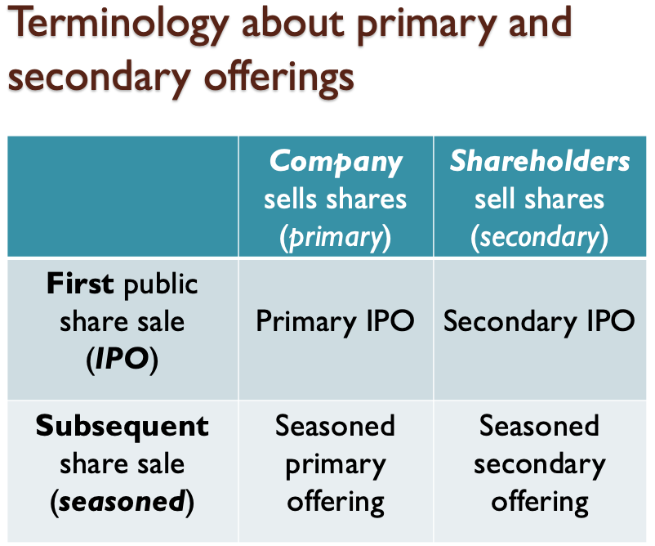
    - Note: The Krim Court calls the seasoned offering a secondary public offering, but there is no such thing. A seasoned offering means it is not the company’s first public offering and there are shares already being publicly traded. Secondary offering is when shareholders are selling to each other - they cannot be secondary if they come from the issuer.
    - Primary IPO: First time selling securities to the public. Shares are being sold by the company to investors.
    - Primary and Secondary IPO: First time selling securities to the public. Some shares sold by the issuer pursuant to registration statement. Other shares also sold by existing shareholders are also sold pursuant to registration statement. Thus, this is both a primary and secondary offering (because of those “used” shares coming from existing shareholders).
      - Note: The company gets to decide which shareholders (if any) can include their shares as a secondary offering. Shareholders do this to sell shares without restrictions, get money at IPO price and get their money right away.
    - Secondary IPO (IPL): No new shares, just make existing shares available for public trading. Making the company public without raising a specific amount of money or selling a specific number of shares. NO shares are issued pursuant to the registration statement.
    - Seasoned: A subsequent share sale (either primary if company sells or secondary if shareholder sell)
    - The shareholders who are buying the secondary offering goes to the shareholders who are selling
      - The Initial Public Listing would go in the Secondary IPO box
    - Secondary IPO is when a firm shareholder sells their shares under a registration statement, BUT it is the first time those specific shares are on the market
  - Potential Plaintiffs
    - Tracing Requirement → Anyone who purchased securities issued pursuant to registration statement has standing. This means you can bring a suit if you can prove you bought at the time of issue OR if the only share you could have bought were issued pursuant to a registration statement by logical deduction. Must demonstrate ability to trace their shares to the faulty registration.
        - Not just any person with security has standing, don’t treat all shareholders the same
        - Note - Pre-Securities Act: only people holding shares issued pursuant to the registration statement could sue, which was determined based on the share #. Now, there are no share #s. This system did not make sense because there was no difference in practice in the shares.
        - Easiest to prove when you purchased directly from the underwriter, harder to prove when you bought it on the public market
        - Rationale: This is a limit on who can bring a claim so there are not a bunch of people bringing lawsuits. The intent of the drafters was only to deal with people who purchased directly from the issuer, so this is a reasonable way to limit standing.
      - Section 11(a): Persons possessing cause of action; persons liable. In case any part of the registration ... contained an untrue statement of a material fact … any person acquiring such security … may, either at law or in equity, in any court of competent jurisdiction, sue –
      - Under 11(a), the people who can get their money back is narrowly prescribed (Krim case helps answer this)
    - In Krim v. pcOrder.com, Inc. (p. 571), pcOrder.com, Inc. had an initial public offering in February, and then no insiders sold shares – so this company sold 10 new shares, and for a period of time, these were the only shares available – there were 1000 other shares, but these were not sold on the public market. Then, in December, they sold more shares in a seasoned offering. Beebe purchased 1,000 shares in April and Petrick purchased sales in July. The purchasers of PCOrder stock (plaintiffs) brought suit under § 11 of the Securities Act of 1933, alleging that the registration statements contained false information. Burke and Petrick purchased shares at a time when 91 percent of PCOrder shares on the market were purchased via the public offerings. Burke and Petrick presented expert testimony stating that, given the number of shares they owned and the percentage of public-offering shares in the market at the time of purchase, there was close to a 100 percent chance that at least one of their PCOrder shares was purchased pursuant to one of the allegedly false registration statements. Nevertheless, the district court granted PCOrder’s motion to dismiss, finding that Burke and Petrick did not have standing under § 11. The court held that for a plaintiff to have such standing, 100 percent of the stock at issue must come directly pursuant to a public offering. Burke and Petrick appealed. The issue is whether the investors have standing to bring a lawsuit under §11 based on their allegation that the registration statement for pcOrder.com was false and misleading. The court held that Beebe has standing because he can prove that he bought shares pursuant to the market; BUT Burke and Petrick are purchasing shares that were not part of the original IPO – so more shares have seeped into the public trading market. Thus, Burke and Petrick do not have standing.
      - Aftermarket purchasers seeking § 11 standing must demonstrate that their shares are traceable to the challenged registration statement → You have to be able to show that you purchased those actual shares that were purchased from the faulty registration statement
      - Plaintiffs claim that anyone selling securities was harmed by a misstatement, but the Court says this broadens too much to reach any shareholder
      - Securities Act of 1933 is concerned with initial distribution of securities. Section 11 standing provisions limited to a narrow class of persons…Must demonstrate ability to trace their shares to the faulty registration.
      - In Barnes v. Osofsky, Second Circuit confronted an intermingled stock pool. That court “rejected the plaintiffs’ broad reading of Section 11’s standing requirement as ‘inconsistent with the over-all statute scheme’ and ‘contrary to the legislative history.’”
      - RULE/TAKEAWAY: In sum, aftermarket purchasers seeking Section 11 standing must demonstrate that their shares are traceable to the challenged registration statement.
      - Why was this case brought under both Sec. 11 and Sec. 15?
        - Sec. 15 (Sec. 15 aids investors by making “control persons” liable) refers to control entity liability, and here we have a controlling shareholder, Trilogy Software.
        - If this was on exam, you analyze Sec. 11 and do the test
        - THEN, analyze Sec. 15
      - What type of offerings are at issue in Krim?
        - Case involved shares offered as part of a primary IPO, and shares offered as part of a primary and secondary, seasoned offering.
      - Did Burke purchase the shares directly from the company or the company’s underwriter?
        - Burke did not purchase directly from the underwriter
        - Would Burke have standing to bring a section 11 claim if he bought directly from the company’s underwriter? YES, he would automatically have standing because you have standing if you purchase shares issued by the registration statement
      - Which particular shares did Burke hold?
        - None. The actual shares are held at the Depository Trust Corp. Burke gets an electroni9c entry giving him an interest in the pool of shares in the hands of the DTC The interest, however, is undifferentiated, not giving Burke an entitlement to any particular shares.
      - Section 11 does not require plaintiffs to demonstrate any reliance on the registration statement. Does the lack of a reliance requirement justify imposing a strict tracing requirement for § 11?
        - Maybe, maybe not.
        - You don’t have to prove causation
  - Statutory Defendants; Element of the Cause of Action (p. 578-579)
People with liability under to §11:
- §11(a)(1) every person who signed the registration statement
  - §6(a): A registration statement must be signed by each issuer, its principal executive officer or officers, its principal financial officer, its comptroller or principal accounting officers and the majority of its board of directors
- §11(a)(2) every person who was a director of the issuer at the time of the filing of the part of the registration statement with respect to which his liability is asserted
- §11(a)(4) every accountant, engineer, or appraiser, or any person who has with his consent been named as having prepared or certified any part of the registration statement
  - Limit: §11(a)(4) Experts may be liable only for those parts prepared or certified by them
- §11(a)(5) every underwriter with respect to such security
- §15: controlling shareholders
Note: Liability reaches beyond the company, makes people pay more attention because they might be personally liable. The Securities law casts a wide net, but doesn’t include the lawyer! Defining attorneys as experts would allow others to rely on the lawyer’s

    - Which participants are defendants under §11 (in other words, who can the plaintiffs sue?)
      - As a CEO and Director, Zoe had to sign the document so he can be sued and she can also be sued as just a director
      - CTO – he did not have to sign the document; Elmo is off the hook
      - The treasurer and CFO → 11(a)(1)
      - Outside director → yes
      - Managing underwriter → yes under 11(a)(5)
      - Shareholder → Sec. 15
      - Outside director → 11(a)(2)
      - Attorneys → No, we are just working on the behalf of our clients
      - Auditor → Yes, 11(a)(4)
      - Senior Accountant → he did all the work, so isn’t he just as much a defendant as the auditor?
      - Russo: CEO & Director
        - §11(a)(1):
        - §11(a)(2):
      - Vitolo: Officer & Director
        - §11(a)(1):
        - §11(a)(2):
      - Pugliese: Officer & Director
        - §11(a)(1):
        - §11(a)(2):
      - Kircher: Treasurer, CFO & Director
        - §11(a)(1):
        - §11(a)(2):
      - Birnbaum: Secretary, Inside Counsel & Director
        - §11(a)(2):
      - Auslander: Outside Director
        - §11(a)(1):
        - §11(a)(2):
      - Grant: Outside Counsel & Director
        - §11(a)(1):
        - §11(a)(2):
      - Drexel Burnham: Managing Underwriters
        - §11(a)(5):
      - Coleman: Underwriter & Director
        - §11(a)(2):
      - Peat Marwick: Auditors
        - §11(a)(4):
      - NOT Statutory defendants:
        - Casperson:: Associate at Drexel
        - Drinker, Biddle & Reash: Drexel Burnham’s attorney
        - Ballard: Partner at Drinker, Biddle & Reath
        - Stanton: Associate at Drinker, Biddle & Reath
        - Berardi: Senior Accountant
          - Tricky question – the individual accountant is not liable, it was the accounting FIRM
  - Affirmative Defense: Due Diligence
    - Section 11: Defenses
      - Plaintiff knew of misstatement/omission when she acquired security (11(a)).
      - A year after earning release (11(a)).
      - Statute of Limitations: 1yr after learning / but never more than 3yrs after purchasing security (Section 13).
      - Whistleblower defenses (11(b)(1),(2)).
      - Drop in price due to other factors (11(e)).
      - Due Diligence Defense (11(b)(3)).
        - Anyone except the company itself can claim they did due diligence (aka have to prove you did your homework) with “a reasonable investigation,” which is a loose requirement (see below)
        - [N]o person, other than the issuer, shall be liable as provided therein who shall sustain the burden of proof -
          - that (A) as regards any [non-expertised] part of the registration statement ... , he had, after reasonable investigation, reasonable ground to believe and did believe, at the time such part of the registration statement became effective, that the statements therein were true and that there was no omission to state a material fact required to be stated therein or necessary to make the statements therein not misleading ... .
          - that (B) As regards any part of the registration statement purporting to be made upon his authority as an expert, ... (i) he had, after reasonable investigation, reasonable ground to believe and did believe, at the time such part of the registration statement became effective, that the statements therein were true and that there was no omission to state a material fact required to be stated therein or necessary to make the statements therein not misleading, or (ii) such part of the registration statement did not fairly represent his statement as an export…
          - that (C) As regards any part of the registration statement purporting to be made on the authority of an expert (other than himself) he had no reasonable ground to believe and did not believe, at the time such part of the registration statement became effective, that the statements therein were untrue or that there was an omission to state a material fact required to be stated therein or necessary to make the statements therein not misleading, …
        - 11(a)(4): experts may be liable only for those parts prepared or certified by them.
    - What constitutes due diligence?
      - Section 11(c) gives general guidance
      - In determining ... what constitutes reasonable investigation and reasonable ground for belief, the standard of reasonableness shall be that required of a prudent man in the management of his own property.

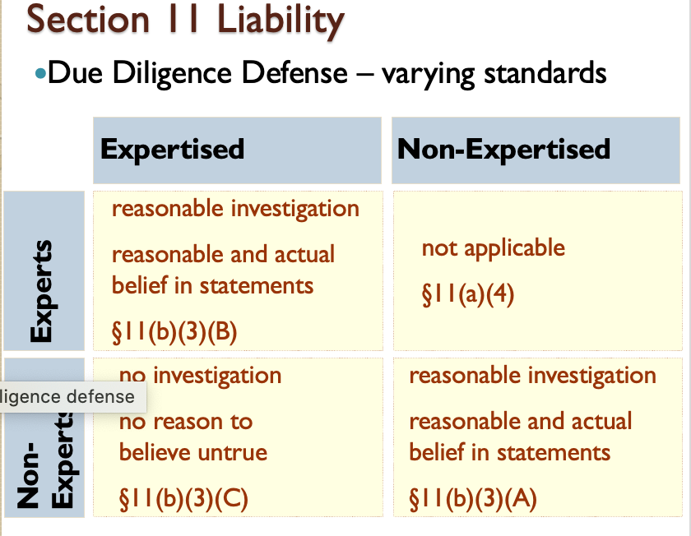
      - On the vertical axis, where it says expertised and non-expertised → according to the statute there are 2 types of info in a registration statement: (1) expertised: could only have been prepared by an expert; example: financial statements bc only a certified public accountant could prepare this and (2) non-expertised: everything else in the registration statement not prepared by an expert
      - On the horizontal axis, this is what are the obligations of the experts
      - In the experts – expertised box, you have to meet all requirements
      - In the non-experts – expertised box; you are a non-expert defendant but say there is a mistake in the expert’s financial statement; all you have to say is that you have no reason to think what the person wrote is untrue
      - In the experts – non-expertised box → you prepared the financial statement and its good, but there are material misstatements in other parts of the registration statement you are not liable; you are ONLY liable for the expert info that you prepared
      - In the non-experts – non-expertised box → non-experts, like directors have a very high burden in order to make sure that the info is true and there are no material misstatements
Varying Standards
Non-expertised: need to do a reasonable investigation
- §11(b): No person shall be liable that had, after reasonable investigation, reasonable ground to believe and did believe that the statements in the registration statement were true

Expertised: only liable for expertise sections of the registration and need to do a reasonable investigation
- §11(b): No person shall be liable that, as regards any part of the registration statement made upon his authority as an expert, had after reasonable investigation, reasonable ground to believe and did believe that the statements in the registration statement were true OR such part of the registration statement did not fairly represent his statement as an expert
- §11(a)(4) Experts may be liable only for those parts prepared or certified by them
Example: Auditors are only liable for the certified financial statements. They cannot be sued for misstatements relating to other areas of the registration statement (like misstatements about future competitive threats in the risk factor section)

Reasonable Investigation: Obligation to look at the actual documents. Can have your lawyer look at the documents. CANNOT rely on the statements of company insiders, have to ask to see the actual documents. At the very least, due diligence requires not ignoring red flags and looking at easily obtainable written documents to verify oral disclosures by company insiders (lesson: gotta make fake documents if you want to commit fraud)
- §11(c): In determining what constitutes reasonable investigation and reasonable ground for belief, the standard of reasonableness shall be that required of a prudent man in the management of his own property
- Rationale: If you make everyone do this, someone will catch the falsity. Low requirement because to require more would be too burdensome on all of the participants in the underwriting process (would have to go to the other side of the transaction, get a copy of the agreement from them, contact 3rd parties, etc.; essentially an audit, too much work)
- Note: Insiders will have a difficult time meeting the due diligence defense. To satisfy due diligence, insiders would have to convince a court that they lacked actual knowledge of wrongdoings in the own company, and that they had also made a reasonable investigation (which together is counterintuitive)

    - Rule 176: In determining whether or not the conduct of a person constitutes a reasonable investigation, relevant circumstances include:
      - Type of issuer; type of security
      - Type of person; office held when the person is an officer
      - The presence or absence of another relationship to the issuer when the person is a director or proposed director
      - Reasonable reliance on officers, employees, and others whose duties should have given them knowledge of the particular facts
      - For underwriters, the type of underwriting arrangement, the role of the particular person as an underwriter and the availability of information with respect to the registrant
    - In Escott v. BarChris Construction Corp. (p. 597), Barchris built bowling alleys, a business that grew substantially with the introduction of the automatic pin setting machine in 1952. A Barchris registration statement for 5 ½% convertible bonds became effective on May 16, 1961, and the financing closed on May 24, 1961. Barchris entered into contracts with a small down payment, and was paid with notes due over a number of years. Barchris then sold these notes to a factor, James Talcott Inc., in exchange for cash, but also guaranteed some of the notes. The registration statement contained the following misrepresentations: 1960 sales figures included bowling alleys that were not yet sold (incorrect revenue recognition); Barchris did not reveal that they had guaranteed not 25%, but 100% of the notes (incorrect revenue recognition, hidden liabilities); Claimed all loans by corporate officers had been repaid (non-disclosure of insider liabilities to the firm); and Misrepresented use of offering proceeds. The issue here is whether any of the defendants have an adequate affirmative defense in response to the §11 claim based on the misrepresentations in the registration statement discussed above. Only those portions of the registration statement purporting to be made on Peat Marwick’s authority were expertised portions. The court held that: as to Russo, the chief executive officer, he could not have believed there were no untrue statements or material omissions in the prospectus; as to Vitolo and Pugliese, founders and construction men of limited education, “they must have know what was going on…. And, in any case, there is nothing to show that they made any investigation of anything which they may not have known about or understand. They have not proved their due diligence defenses.”; as to Kircher, treasurer and chief financial officer, he was a CPA and an intelligent man. He knew the underlying facts, so (i) he had reason to believe the expertised part of the prospectus was incorrect, and (ii) he must have known that parts of the rest of the prospectus were untrue; as to Birnbaum, the young lawyer who joined BarChris as secretary and director on April 17, 1961, he was not an executive “in any real sense.” Still, he made no investigation. While he was entitled to rely upon Peat, Marwick, he was not entitled to rely on Kircher, Grant, and Ballard for non-expertised matters; as to Auslander – he was an “outside” director, i.e. not an officer of BarChris. Auslander was entitled to rely upon Peat, Marwick, but not on others for non-expertised matters in the prospectus; Grant was a director at BarChris and his law firm was the firm’s counsel. As between Grant and Ballard, the underwriter’s counsel, Grant did the first draft of the registration statement and Ballard did the first draft of the debenture.
      - “I am satisfied as to [Grant’s] integrity.” But Grant relied on the statements of his clients, and did not examine the original written record. “He never asked to see the contract.” Would it have mattered?
        - YES! You have to review the underlying documents!! According to the court, due diligence would have been satisfied if he had reviewed the contract
        - How can fraudsters get around this?
          - Forge the docs
        - What are things you need to do to have a real due diligence effort beyond the statutory requirement?
          - Make sure that the business is legit by reaching out to accountants, etc.
          - Talk to the customers that they claim to have contracts with
        - Grant was entitled to rely upon Peat, Marwick, but he was not entitled to rely on Kircher, Russo, and Ballard for non-expertised matters.
        - The underwriters other than Drexel made no investigation. Ballard relied on the information which he got from Kircher and “no effectual attempt at verification was made.” This means no due diligence defense and they face liability
        - Peat, Marwicsk failed to follow generally accepted accounting standards, and therefore had failed to show due diligence
      - Do you think attorneys drafting the registration statement should be deemed experts for the entire registration statement? Why do you think the Escott court rejected this approach?
        - Defining attorneys as experts would allow others to rely on the lawyer’s investigation, and would create liability for lawyers.
      - The Escott court focuses on the fact that a number of defendants simply relied on the representations of BarChris insiders. What more is required in addition to listening to insiders?
        - At the very least due diligence requires not ignoring red flags and looking at easily obtainable written documents to verify oral disclosures by company insiders.
      - Is there any way that insiders (Russo the CEO and Kircher the CFO in particular) can meet the due diligence defense?
        - Insiders will have a difficult time meeting the due diligence defense. To satisfy due diligence, insiders would have to convince a court that they lacked actual knowledge of wrongdoings in their own company, and that they had also made a reasonable investigation.
      - What would you have done if you were in Birnbaum’s shoes?
        - Ask more questions? Quit? Blow the whistle?
        - Section 11(b)(1) provides for a whistleblowing defense → probs the best choice
      - Why does the Escott court not require each defendant to undertake a “complete audit” of BarChris to meet his/her due diligence requirement?
        - Too burdensome on all of the participants in the underwriting process.
      - BarChris itself is not in the list of insider and outsider participants. Can a plaintiff contemplating suing for fraud in the BarChris public debenture offering’s registration statement also sue BarChris under § 11?
        - Yes. BarChris (strictly speaking, an executive officer of Bar Chris acting as an agent of BarChris) must sign the registration statement under § 6(a) and thus is liable under § 11(a)(1).
      - Can we sue Peat Marwick, the auditors for BarChris, for misstatements relating to future competitive threats contained in the risk factor section of the registration statement?
        - No; these statements are not part of the certified financial statements. Peat Marwick is liable solely as the auditor for the certified financial statements.
- Section 12 Liability
  - Overview:
    - Section 12(a)(1) Liability (about enforcing gun-jumping rules; creates liability for failing to comply with § 5 procedures)
    - Section 12(a)(1) assigns liability to those who fail to comply with §5 procedures
    - Section 12(a)(1): Any person who – offers or sells a security in violation of section 5, shall be liable to the person purchasing such security from him ... to recover the consideration paid for such security with interest thereon, less the amount of any income received thereon, upon the tender of such security, or for damages if he no longer owns the security.
      - Any violations of §5 are actionable
      - Strict liability
      - No loss causation defense
      - The plaintiff is the person purchasing the security and the defendant is the person that sold it to them
      - Defendant must be a “seller” → Per the statute, the class of defendants are those who offer or sell unregistered securities. Securities Act defines “sell” broadly.
        - Passing title: Owner who passed to the buyer is obviously selling (easy case)
        - Soliciting investment for defendant’s or issuer’s benefit.
          - Includes a person who successfully solicits offers to purchase securities motivated at least in part by a desire to serve his or her own financial interests OR for those of the securities owner
          - Can be selling even if you’re not the one consummating the transaction. Encompasses anyone actively involved in the marketing of the securities
          - Need not be involved in actual transaction - solicitation counts as selling
          - Note: would probably encompass underwriter and the issuer, not accountants or directors
          - See §2(a)(3): The term 'sale' or 'sell' shall include every contract of sale or disposition of a security or interest in a security, for value. The term 'offer to sell', 'offer for sale', or 'offer' shall include every attempt or offer to dispose of, or solicitation of an offer to buy, a security or interest in a security, for value.

    - Scope of Section 11 v. Section 12(a)(1)
      - Section 11 covers statements in the registration statement
      - Section 12(a)(1) covers an offer or sale of a security in violation of §5 of the 1933 Act
  - In Pinter v. Dahl (p. 631), Maurice Dahl (plaintiff) advanced $20,000 in Pinter (defendant), to acquire leases that would be held in his oil and gas company. Dahl would have a right of first refusal to drill certain wells. Dahl invested $310,000 in properties and told other respondents about the venture. Dahl assisted friends & family in investing in Pinter and received no commission. Many of Dahl’s friends and family members did invest in Pinter, receiving unregistered shares of the corporation in return. When Pinter failed to drill for oil successfully, Dahl and the other investors brought suit against Pinter, as offeror of securities seeking rescission under § 12(a)(1). Pinter sues Dahl for contribution as a fellow offeror. The lower courts granted judgment for respondent-investors, but did not find that Dahl was a “statutory seller.” The issue here is whether Dahl is a fellow offeror because he encouraged others to invest in a corporation without receiving financial benefit a seller pursuant to Section 12(1). The court held NO. An individual who encourages others to invest in a corporation without receiving financial benefit is not a seller pursuant to Section 12(1). Per the statute, the class of defendants are those who offer or sell unregistered securities. §12(a)(1) imposes liability on owner who passed to the buyer for value. Thus, §12(a)(1) also only applies to a defendant from whom the plaintiff “purchased” securities
    - NOTE: Securities Act defines “sell” broadly in § 2(a)(3) → §2(a)(3) says: The term 'sale' or 'sell' shall include every contract of sale or disposition of a security or interest in a security, for value. The term 'offer to sell', 'offer for sale', or 'offer' shall include every attempt or offer to dispose of, or solicitation of an offer to buy, a security or interest in a security, for value
    - NOTE: § 2(a)(3) includes “solicitation of an offer to buy,” so need not be involved in actual transaction
    - Why does this case involve Pinter and Dahl, and not the other investors?
      - Pinter is trying to get Dahl on the hook for some of the damages. If Dahl is found to be a seller under § 12(a)(1), he could be named as a defendant and held liable for offering and selling unregistered securities in violation of § 5. Thus, Pinter would not have to pay the whole judgment.
    - What is the easy case for concluding someone is a “seller”?
      - Owner who passes title to purchaser in exchange for value.
    - What else may qualify as a statutory “seller”?
      - Includes a person who successfully solicits offers to purchase securities motivated at least in part by a desire to serve his or her own financial interests or for those of the securities owner.
    - The Pinter court rejects including “substantial participants” as potential § 12(a)(1) defendants in part because this class of defendants is “unpredictably defined.” Is the class of defendants who help “solicit” the offers more definite?
    - Which § 11 defendants would (and would not) meet the requirements of Pinter?
      - The only statutory defendants of Sec. 11 liability under Sec. 12(a)(1) would seem to be those actively involved in the marketing of the securities.
- Exemptions from Section 5 of the Securities Act: Exempt Offerings
- Overview: Obligations when offering securities
  - How to avoid §5 registration requirements
    - Issuers exempted under § 3
    - Primary offerings exempted under § 4(2)
    - Exemptions for secondary market transactions § 4(1)
- #1: Issuers exempt under §3 of the ’33 Act → Certain issuers and types of securities are exempted automatically under §3
  - § 3(a) The provisions of this act shall not apply to any of the following classes of securities:
    - (2) any security issued by the United States, …
    - (3) any note with maturity less than 9 months, …
    - (11) any security offered and sold within a single State, …
  - § 3(b): The Commission may [exempt] any class of securities where the aggregate amount offered [does not] exceed $5 million
- #2: Primary offerings exempted under § 4(2)
  - Overview:
    - #1: § 4(2) (not involving a public offering) → §4(2) states that the provisions of section 5 shall not apply to transactions by an issuer not involving a public offering
    - #2: Regulation D (safe harbors for § 3 and 4(2))
    - #3: Regulation A (small issuers with offerings not exceeding $50 million)
    - #4: Crowdfunding
    - #5: Intrastate Offerings (§ 3(a)(11) and Rule 147)
    - #6: Regulation S
  - #1: SECTION § 4(2)
    - Overview:
      - Section §4(2) of the 1933 Act: The provisions of section 5 shall not apply to transactions by an issuer not involving a public offering
        - Problem is they never defined what it would mean to raise money NOT through a public offering
        - Courts may look to legislative purpose
        - Burden of proof on the issuer to prove private offering
    - SEC General Counsel’s Opinion (1935) states that the FACTORS in determining if a “public offering” include:
      - Number of offerees
      - Relationship of the offerees to each other and to the issuer (tied to ability to fend for themselves)
      - Number of units offered
      - Size of the offering (but Court specifically rejects numerical test as determinative)
      - Manner of the offering
    - Ability to fend for themselves: Private offering and transactions exempt if no practical need for application because investors can fend for themselves meaning BOTH:
      - Sophistication: if even one investor cannot fend for themselves, it is a public offering
      - Information: must have disclosure or access to the same kind of information the Act would make available. If you did not request or have access, then not a private offering
        - Note: No actual delivery of info is needed, just power to access.
        - Relationship to issuer and sophistication more important if only have access
      - Note: The exemption depends on the offerees and not the purchasers. All offerees must meet this test, or the entire offering falls out of the exemption.
      - Rationale: Looked at the purpose of the statute which is to protect investors. If they can all fend for themselves, would not need the SEC to protect them. If they are able to access the information, then the possibility of having to disclose will have the desired effect of securities laws
      - In SEC v. Ralston Purina Co., Ralston Purina Co. (defendant) offered its stock to its “key” employees for sale. “Key” employees included any employee eligible for a promotion, including many low-income workers that may not otherwise have the opportunity to engage in securities transactions. The Securities and Exchange Commission (plaintiff) brought an action against Ralston, alleging that the sale of stock by Ralston required it to register said stock. Ralston argued that the sale was exempted as a private offering since the stock was only offered to employees. The district court ruled in favor of Ralston, with the court of appeals affirming. The SEC then petitioned for certiorari to the United States Supreme Court. The issue here is whether Ralston Purina’s offering to “key employees” are within the § 4(2) non-public offering exemption. The court held that not all “key” employees had “access;” therefore, not private offering. Exemption would be available if made to corporate officers if “have access to the same kind of information that the act would make available.”
        - Why did Ralston Purina concede that the sale of stock to all its employees would be public?
          - That would seem more like a public offering?
        - Why would Ralston Purina want to sell stock to its own employees? Why did it define its “key employees” as it did?
          - Typically, shares are sold to employees to (a) get employees to work harder for company as “owners”; (b) to increase morale as employees get to share in the upside of the company’s success.
        - Under the Court’s interpretation, can we say definitively that an offering to ten is private? Or that an offering to 1,000 is public?
          - The Court specifically rejects numerical tests as determinative.
        - What types of investors can “fend for themselves”?
          - “Executive personnel who because of their position have access to the same kind of information that the act would make available in the form of a registration statement.”
        - Who bears the burden of proof to show whether an exemption to § 5 applies?
          - “Keeping in mind the broadly remedial purposes of federal securities legislation, imposition of the burden of proof on an issuer who would plead the exemption seems to us fair and reasonable …”
        - Note: Ralston conceded that the sale of stock to ALL of its employees would be public (which makes it seem more like a public offering)
        - Note: Typically, shares are sold to employees to (a) get employees to work harder for company as “owners”; (b) to increase morale as employees get to share in the upside of the company’s success
      - In Doran v. Petroleum Management Corp. (1977), Petroleum Management Corp. (PMC) (defendant) formed a limited partnership for the purpose of operating drilling wells. PMC offered an interest in the drilling program to eight investors. There were only a small number of shares offered for relatively low value, and the offering was made to the eight investors personally, without any public advertising. PMC did not file a registration statement in connection with this offering of securities. William Doran (plaintiff) was the only one out of the eight who ended up investing in PMC. A little more than a year after Doran invested in PMC, the Wyoming Oil and Gas Conservation Commission ordered the drilling wells sealed for about a year due to deliberate overproduction by PMC. As a result of the shutdown, a note on which Doran was liable went into default, and Doran lost a state-court case requiring him to pay significant costs. Doran then brought suit against PMC seeking damages for breach of contract, as well as rescission of his contract with PMC based on a failure to register the offering in violation of the Securities Acts of 1933 and 1934. The district court found that the PMC offering was exempt from registration because the offering was private, as Doran was a “sophisticated investor” and did not need federal securities protection. Doran appealed. The issue is whether offering to Doran (a sophisticated investor) was within the §4(2) non-public offering exemption. The court held that if Doran did not have information or effective access to information then not a private offering. The knowledge of offerees is key; therefore focus on number of offerees and their relationship to each other and the issuer. Defense case on number and relationship of offerees is the weak point (even though only four/eight and all sophisticated). One necessary condition for an offering to be private (from SEC v. Ralston) is access to information. Determined by employment, family, or economic bargaining power. Remanded to determine if information delivered or “true” access provided.
        - How does the Doran court tie Ralston Purina together with the 1935 SEC General Counsel Opinion’s factors?
          - The court states that the first factor, “the number of offerees and their relationship to each other and to the issuer,” is closely related to Ralston Purina’s notion of “fend for themselves.” This analysis reinforces the link between the ability of investors to fend for themselves and their access to information.
        - What test does the Doran court use to determine whether an offering qualifies for § 4(2)?
          - The court mentions several factors. First are the factors from the 1935 Opinion (number of offerees and relationship to each other and the issuer, number of units, size of offering, manner of offering). Second, is the notion of fend for themselves from Ralston Purina. Within the concept of fend for themselves is (a) sophistication and (b) information.
        - Would the Doran court treat an outside investor that had considerable financial resources and represented the only possible source of financing for the issuer as having “access” to information similar to that in a registration statement?
          - Probably, so long as he or she had actual access as well.
        - What happens to the offering if Doran is sophisticated and given full access to the information but one of the offerees (who did not eventually purchase) was not given the same information or was not sophisticated?
          - The exemption depends on the offerees and not the purchasers. If an offeree lacks sophistication and/or information then entire offering (including sales to Doran) may fall out of the § 4(2) exemption.
        - How important is sophistication to the court? Would a completely unsophisticated offeree qualify for the exemption?
          - It is hard to imagine the court permitting an offer to a completely unsophisticated investor, even if he is provided with complete disclosure. But is this consistent with the statutory scheme?
    - Summary: What makes an offering “not public” under Section 4(2)?
      - The plain language of the statute is “not public”
      - The court in Purina interpreted this to mean that an offering is “not public” if it is offered to those who can “fend for themselves.”
      - The court in Duran says that an offering is exempt if investors have information, or have access and are sophisticated.
  - #2: Regulation D (safe harbors for § 3 and 4(2))
    - Overview:
      - As the gun-jumping rules became more complex, companies wanted the SEC to create some rules about when something is or is not a public offering, and the SEC did do this and these rules have evolved and become what we know as “Regulation D.
      - Regulation D is a system of rules that the SEC has put in place to allow companies to raise money in ways that will not require the companies to comply with Section 5.
        - Nowadays, companies have 2 pathways to raise money: either (1) the public IPO process or (2) Regulation D – so Regulation D is a major pathway for fundraising and a majority of companies do use Regulation D.
      - Regulation D set up safe harbors in response to the confusion of §4(2) exemptions which made it difficult for companies to raise money privately without some risk investors would be considered unsophisticated
      - Rules:
        - Rule 501: Definitions for Reg. D offerings (important!)
        - Rule 502: Common requirements for Reg. D offerings
        - Rule 503: Must file Form D with the SEC (have to fill out a form when you do Reg D)
        - Rule 504: Exemption for offerings under $5 million
        - Rule 506: Exemption for offerings without monetary limit
        - Rule 507: Prohibition on Reg. D offerings for certain issuers (not really used)
        - Rule 508: Excuse provisions for Reg. D offerings (can make little mistakes without liability)
    - Two main pathways to creating a private offering: Rule 504 and 506
      - The defining feature is that Rule 504 is only good if you want to raise up to $5 million, but Rule 506 allows you to raise as much money as you want – up to billions of dollars
      - 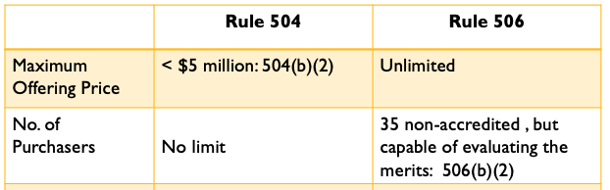
    - Aggregate Offering Price
      - RULE:
        - Rule 504 offerings cannot exceed an aggregate offering price of $5 million (Rule 504(b)(2)).
        - Rule 506 has no limit because it is a § 4(2), rather than a § 3(b), offering.
          - Section 3 of the statute were certain types of offerings where you get a free pass, and you don’t have to comply by this statute; one of the things under Section 3 said that the SEC can make up whatever rules they need if the offering is under $5 million
          - Rule 504 is promulgated under Section 3(b), which means the SEC has a free hand in deciding Rule 504
          - BUT Rule 506 is different because it is designed to make since of Section 4(2)
      - Could you do two $5 million Rule 504 offerings by spacing them over 8 months?
        - No, you cannot do two $5 million offerings under Rule 504 by spacing them out, because there is a 12-month rolling window.
        - Limitation on Aggregate Offering Price:
          - Rule 504(b)(2): The aggregate offering price for an offering of securities under this rule 504 . . . shall not exceed $5,000,000, less the aggregate offering price for all securities sold within the twelve months before the start of and during the offering of securities under this section in reliance on any exemption under section 3(b) of the Act or in violation of section 5(a) of the Act.
          - In plain terms, you cannot raise more than $5 million in 12 months using Rule 504.
        - Example: If an issuer sold $5,000,000 of its securities on January 1, 2014 under Rule 504 and an additional $500,000 of its securities on July 1, 2014, Rule 504 would not be available for the later sale, but would still be applicable to the January 1, 2014 sale.
    - Number of Purchasers
      - RULE:
        - Rule 504: No limit on number of purchasers
        - Rule 506: 35 or fewer purchasers (Rule 506(b)(2)(i)).
          - BUT Rule 506 has a HUGE carve out – excludes accredited investors
          - Because of this design feature that accredited investors don’t count, Rule 506 offerings are really offerings for accredited investors
      - Rule 501(e): explains how to calculate the number of purchasers
        - If an individual is (1) the relative, spouse or relative of the spouse of the purchaser, (and who lives in the same residence as the purchaser) [Rule 501(e)(I)(i)] OR (2) an accredited investor [Rule 501(e)(I)(i)], they are excluded from the count.
          - Technically, since accredited investors are excluded from the count, issuers can sell to an unlimited number of accredited investors under Rule 506.
          - Rule 506 has no price limit, so issuer can sell unlimited amount of securities to unlimited number of investors.
          - BUT you need to find interested accredited investors and there are resale restrictions limit the demand for these securities.
          - In practice, Rule 506 offerings typically exclude non-accredited investors. There is a vague section of the Rule allowing sophisticated and expertised non-accredited investors, but given its vagueness companies usually just exclude non-accredited.
        - The following individuals are considered “accredited investors” under Rule 501(a), and are excluded from the count of purchasers:
          - Various financial institutions
          - Directors, executive officers [(executive officer means president, vice-president in charge of a principal business unit division or function or any other officer that performs a policy making function (501(f)], general partners of the issuer
          - Corporations with assets exceeding $5 million (sort of) (see Rule 501(a)(3)
          - Natural persons that at the time of purchase who have a net worth exceeding $1 million (modified by Dodd Frank Act to exclude value of primary residence → came up with $1 million in 1986, and then in the mortgage meltdown it would be too easy to count as an accredited investor SO they kept the number at $1 million, BUT you cannot count your house and your net worth is adjusted for inflation) (also** note that your assets are determined after accounting for your liabilities), or
Similar to Ralston Purina, perhaps the SEC may have chosen these natural persons who are either worth $1 million or make a high income because these people can “fend for themselves.”

** This is not a fact, just a theory presented by Guttentag
          - Natural persons who at the time of purchase have an income of $200K individually OR $300K jointly w/ spouse reasonable expectation of reaching same income that year (subject to future Dodd Frank Act modification)
          - Categories added in August 2020:
            - The SEC created a new category called “spousal equivalent” defined as “a cohabitant occupying a relationship generally equivalent to that of a spouse.”
            - For individuals, the SEC designated three FINRA‐administered exams as the initial certifications that qualify an individual as an accredited investor even if they aren’t rich → under Rule 501(a)(10): the General Securities Representative license (Series 7), the Licensed Investment Adviser Representative (Series 65), and the Private Securities Offerings Representative license (Series 82).
        - Sophisticated, Non-Accredited Investors:
          - If someone is an accredited investor, it doesn’t matter if they are sophisticated or not.
          - BUT if you are a non-accredited investor, you MUST be “sophisticated” – meaning you have “such knowledge and experience in financial and business matters that you are capable of evaluating the merits and risks of the prospective investment,” then you are not counted in the 35 purchasers.
          - Rule 506 also let you sell securities to up to 35 purchasers (that are not accredited investors).
          - Rule 506(b)(2)(ii): Each purchaser who is not an accredited investor … has such knowledge and experience in financial and business matters that he is capable of evaluating the merits and risks of the prospective investment, or the issuer reasonably believes immediately prior to making any sale that such purchaser comes within this description.
            - Given the vagueness of this requirement, many Rule 506 offerings exclude non-accredited investors.
          - Who determines if the non-accredited investor is sophisticated?
            - The issuer → “or the issuer reasonably believes immediately prior to making any sale that such purchaser comes within this description”
    - Treatment of Organizations when Counting Investors
      - Rule 501(a)(3): “Any [charitable organization], corporation, Massachusetts or similar business trust, or partnership, not formed for the specific purpose of acquiring the securities offered, with total assets in excess of $5,000,000” counts as an accredited investor
      - What about a corporation formed to acquire these securities?
        - Corporations, partnerships and non-contributory employee benefit plans are treated as one purchaser. Except if organized for “specific purpose of acquiring the securities offered and is not an accredited investor under paragraph (501)(a)(8).”
      - Companies formed to acquire these securities NOT considered accredited investor
        - Count all investors, the subtract the accredited ones
      - Corporation worth less than $5 mil but not formed for this purpose count as one person (if over $5 mil, accredited)
      - Rule 501(a)(8): Corporation counts as one accredited investor if all equity owners are accredited investors – the owners themselves do not count.
      - 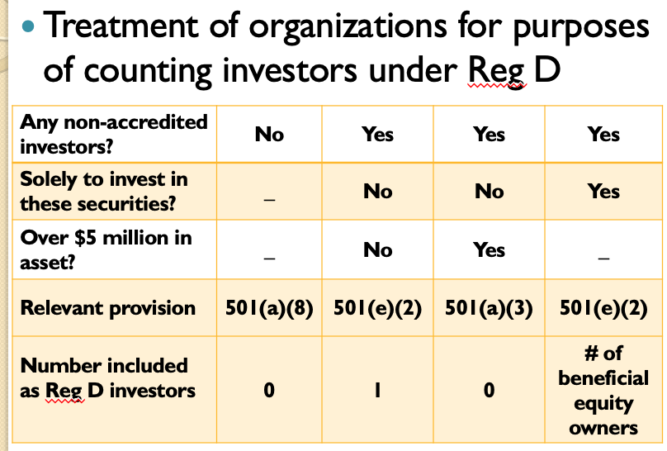
        - Column #1: Everyone in the corporation is an accredited investor, so the corporation counts as an accredited investor AND thus does not count in the 35 purchasers.
        - Column #2 and #3 has some accredited investors…
          - BUT if its assets are not over $5 million it counts as one purchaser
          - BUT if its assets are over $5 million, it counts as 1 accredited investor and doesn’t count towards the 35 purchasers
        - Column #4: This column is trying to prevent people from playing games
          - Example: We have 100 non-accredited investors that get together and form a corporation that counts as one investor → BUT the SEC says no, we are going to look at the number of equity owners you have
      - Hypotheticals (p. 677)
        - Hypo 2, Scenario 1: Trendy decides to do a Reg D offering to raise capital for its contemplated expansion of the marketing and distribution of Trendy’s Lean Green drink. Suppose that Trendy raises $1 million per month over a 5-month period from January 2019 to May 2019. Sales are made to 25 unsophisticated non-accredited purchasers. Do either of the Regulation D offering types exempt Trendy from §5?
          - Under 504, Trendy is exempted because $5 mil exactly works (not exceeding $5 mil).
          - Under Rule 506, Trendy is not exempted because the purchasers are not sophisticated.
        - Hypo 2, Scenario 2: Trendy decides to do a Reg D offering to raise capital for its contemplated expansion of the marketing and distribution of Trendy’s Lean Green drink and has raised $5 million through their 5-month period of $1 million/month. Trendy then conducts a second round of financing two months later and raised an additional $5 million in an offering to twenty unsophisticated purchasers. Can Trendy sell securities under either of the Regulation D exemptions?
          - Cannot use 504 for the second round because it would be over $5 million in less than 12 months.
          - Cannot use Rule 506 if they are NOT accredited investors, but it would be okay if the purchasers WERE accredited investors.
          - NOTE: You can use Rule 504 for the first offering and Rule 506 for the second offering if everything checks out under the rules.
        - Hypo 3, Scenario 1: Trendy does a 506 sale to 35 sophisticated, non-accredited purchasers. Trendy also sells securities to all of its executive vice presidents, including Alan, the VP for drink research and Laura, the VP for human resources. Do these additional sales create any problems under Reg D?
          - If Alan and Laura are accredited investors, there is no issue.
          - BUT if they are not accredited investors, they are likely exempt from the 35 count because under 501(f), the determination depends on whether drink research and human research are “a principal business unit division or function”
          - If they do qualify as an executive officer, they don’t count because they are accredited investors.
        - Hypo 3, Scenario 2: Trendy does a 506 sale to 35 sophisticated, non-accredited purchasers. Trendy also sells securities to Dale, who is retired and has a stock portfolio of $1.1 million, but has no other assets or debts, and lives off the dividends to pay for his monthly expenses. Dale has no other sources of income. Does this additional sale create any problems under Reg D?
          - Yes, Dale is an accredited investor because he is worth more than $1 million. It doesn’t matter if he is sophisticated or not.
        - Hypo 3, Scenario 3: Trendy does a 506 sale to 35 sophisticated, non-accredited purchasers. Trendy also sells securities to Beth, who is a barista with a Ph.D. in financial economics from Berkeley. Beth made $2 million as a broker before being fired for insider trading. Today, Beth has a net worth of $700k, and makes $15/hr. Does this additional sale create any problems under Reg D?
          - She is not an accredited investor because she is not worth over $1 million and she doesn’t make more than $200,000/year, despite probably being able to “fend for herself”
          - She is definitely sophisticated, so she could be a purchaser, but she doesn’t meet the criteria for an accredited investor.
        - Hypo 3, Scenario 4: Trendy does a 506 sale to 35 sophisticated, non-accredited purchasers. Beth shares an apartment with Andrei, one of 35 sophisticated purchasers in the offering. If Beth and Andrei are good friends (but nothing more), does Beth count as a purchaser, thereby increasing the total to 36 purchasers?
          - Assuming they are merely roommates, she will count as a separate purchaser. If they were married or if they are in a spouse-like relationship – new August rule -, she would NOT count as a separate purchaser.
        - Hypo 3, Scenario 5: Trendy sells securities to the Trendy Investment Partnership. Trendy Investment Partnership was formed a month prior to Trendy’s offering and has 50 partners. None of the partners, individually, is an accredited investor. TIP’s total net assets are $1 million.
          - As this partnership was created for the purpose of investing in Trendy, the company will count as 50 unaccredited investors (one for each of the beneficial owners) – and it is a problem. (Column #2)
          - If it was not formed to invest in Trendy, it would count as 1 investor (Column #2) – would not count as 0 because it is worth less than $5 million
    - General Solicitation
      - Overview:
        - Under Rule 504, general solicitation is banned, unless state law exists.
        - Under Rule 506, general solicitation is banned by the Rule 502(c), and if not use 506(c).
      - In In re Kenman (1985), Kenman assisted in selling unregistered securities in two limited partnerships structured to meet Rule 506 of Regulation D. As part of its efforts, Kenman mailed out materials on the private placement to a wide variety of investors, including persons who had participated in prior offerings by Kenman; executive officers listed in the Fortune 500 companies; persons who had previously invested $10K or more in real estate offerings; physicians in CA; managerial engineers; and presidents of companies in a NJ Industrial Directory. Kenman did not file a registration statement with the Securities and Exchange Commission (SEC). The SEC brought an enforcement action against Kenman. Kenman argued that it was entitled to a registration exemption under SEC Regulation D. The issue here is whether Kenman ran afoul of the general solicitation ban under Regulation D and thus lost the exemption (and violated § 5 as a result). The court held YES, this does count as a general solicitation.
        - Footnote 6 provides SEC’s view on what constitutes a general solicitation: offers to a person with whom the issuer (or those working on behalf of the issuer) do not have a “pre-existing relationship.”
        - A registration exemption is not available under SEC Regulation D to an offeror engaged in a general solicitation or general advertising. A registration exemption is generally available for non-public offerings, but a general solicitation does not constitute a non-public offering. In determining what constitutes a general solicitation, a key inquiry is whether the offeree had a preexisting relationship with the offeror. If not, then the solicitation is likely a general solicitation. In this case, a registration exemption is not available under SEC Regulation D to Kenman. Most of the recipients of Kenman’s mailing had no prior relationship with Kenman. Accordingly, Kenman engaged in a general solicitation for the limited partnership interests in Missiondale and Orem. The registration exemption is thus not applicable. As a registration exemption is not available to Kenman, Kenman violated securities laws by not registering its offerings
        - If you want to do a Reg D offering, your first call should be to Goldman Sachs because if you can’t do a general solicitation, you can’t reach out to previous investors. BUT Goldman Sachs has a pre-existing relationship with multiple companies, and they can send out materials on your behalf.
        - Why is a pre-existing relationship important?
          - SEC notes that some of the lists used by Kenman did imply something about the “degree of investment sophistication or financial well-being” of the offerees.
          - However, the broad solicitation did not comply with Rule 502(c) and SEC found that Kenman willfully violated §5.
          - SEC seems to endorse two reasons to reject “private” offering: 1) investors unsophisticated, OR 2) no pre-existing relationship.
        - If you applied a plain language-dictionary meaning to the phrase
“general solicitation or general advertising,” would you find Kenman’s offers problematic?
          - Doesn’t feel like it would fit the definition of a general solicitation – but doesn’t matter to us bc not the SEC rule
        - What result if Kenman had only sold to those investors that had purchased before from Kenman?
          - If Kenman keeps records and knows about prior investor’s wealth, position, sophistication then this should count as pre-existing relationship. This would be neither a general solicitation nor to unsophisticated investors.
        - The Kenman court wrote: “The exemption from registration under Section 4(2) is not available to an issuer that is engaged in a general solicitation or general advertising.” Is this interpretation consistent with Ralston Purina and Doran?
          - Ralston Purina and Doran focused on whether the offerees were able to “fend for themselves” or received information equivalent to that of a registration statement
      - In Mineral Lands Research and Marketing, someone wrote a “no action” letter to the SEC and said that they want to raise $500K and their officer of the issuer was also an insurance broker, and was going to offer securities to its clientele (with whom he had a pre-existing business relationship – e.g., selling insurance products). Most of the clientele would not qualify as accredited investors. The court held that the SEC’s pre-existing relationship is an “important factor” in determining whether the offer is a general solicitation. Pre-existing relationship must be of a kind that “enable the issuer ... to be aware of the financial circumstances or sophistication of the persons with whom the relationship exists or that otherwise are of some substance and duration.”
    - JOBS Act and Pre-Jobs Act
      - Pre-Jobs Act: How do we get around 502(c)?
        - Contact people (investors) with whom you have pre-existing relationships (In the Matter of Kenman Corp., fn. 6).
        - The relationship must give enough information for the issuer (or someone working on its behalf) to assess the sophistication of the investor (Mineral Lands No Action Letter).
        - Pre-existing relationships can be bought: hire a brokerage firm with a set of pre-existing relationships.
      - JOBS Act §201(a)(1)
        - SEC to adopt rules removing the prohibition against general solicitation and general advertising for Rule 506 offerings sold solely to accredited investors.
        - Under rules, issuers to take "reasonable steps" to verify that the purchasers are in fact accredited investors.
    - Disclosure
      - Rule 506(c) – Conditions to be met in offerings using general solicitation/advertising
        - (1) General conditions. To qualify for exemption under this section, sales must satisfy all the terms and conditions of Rule 501 and Rules 502(a) and (d).
        - (2) Specific conditions.
          - (i) Nature of purchasers. All purchasers of securities sold in any offering under this Rule 506(c) are accredited investors.
          - (ii) Verification of accredited investor status. The issuer shall take reasonable steps to verify that purchasers of securities sold in any offering under this Rule 506(c) are accredited investors.
      - Rule 502(b)(1) – Information Requirements
        - If the issuer sells securities under Rule 506 to any purchaser that is not an accredited investor, the issuer shall furnish the information specified in paragraph (b)(2) of this section to such purchaser a reasonable time prior to sale. The issuer is not required to furnish the specified information to purchasers when it sells securities under Rule 504, or to any accredited investor.
      - Information Requirements
        - For Rule 504 Offerings, there is no mandated disclosure at all. BUT careful with state law requirements…
        - For Rule 505 and 506 offerings:
          - If investor is an accredited investor, there is no mandated disclosure.
        - For non-accredited investors you need to disclose certain information, depending on:
          - Type of issuer
          - Size of the offering
      - 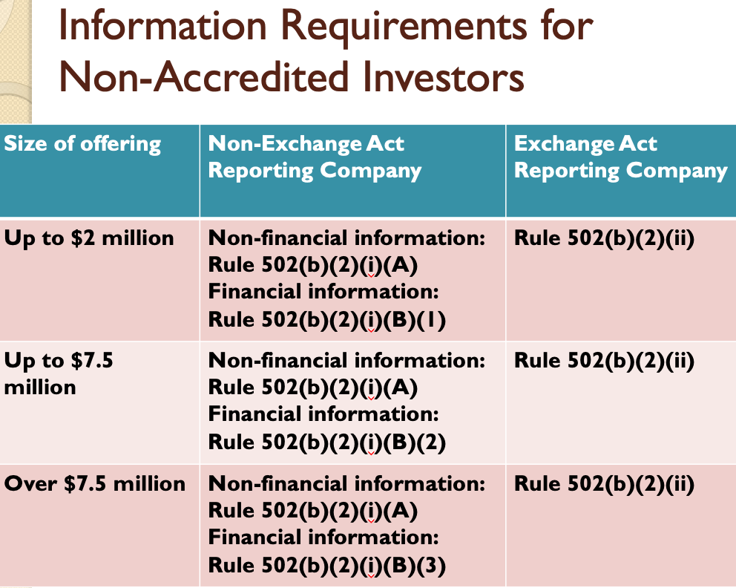
    - Resale Restrictions
      - 502(d): Securities acquired... under Regulation D... shall have the status of securities acquired under section 4(2) of the Act and cannot be resold without registration under the Act or an exemption there from.
      - For Rule 504 transactions, there is no limit on resales, if offering complies with state law registration requirements.
      - 502(d): Issuer must show reasonable care that purchasers are not underwriters by:
        - inquiry that purchaser acquires securities for himself
        - written disclosure of the limitation to resell
        - placement of a legend on the certificate or document
    - Innocent and Insignificant Mistakes → Rule 508
      - RULE 508:
        - (a) A failure to comply with a term, condition or requirement of Regulation D will not result in the loss of the exemption ... if the person relying on the exemption shows:
        - (1) The failure to comply did not pertain to a ... requirement directly intended to protect that particular individual... ; and
        - (2) The failure to comply was insignificant with respect to the offering as a whole, provided that any failure to comply with [Rule 502(c), Rule 504(b)(2)(i), Rule 505(b)(2)(i) & (ii), or Rule 506(b)(2)(i)] shall be deemed to be significant to the offering as a whole; and
        - (3) A good faith and reasonable attempt was made to comply with all applicable... requirements ...
      - Hypotheticals:
        - Trendy (Hypo 9 p. 697) → Trendy conducts a private placement for $10 million of common stock under Rule 506, selling to five large hedge funds (all accredited investors with pre-existing relationships with Trendy and the placement agent for the offering) and 36 sophisticated, non-accredited purchasers (all lower-level Trendy employees). Two of the non-accredited purchasers tell Trendy they are cousins and live in the same house.
          - Scenario 1: It turns out that the 2 investors are not cousins but just friends (and they lied on their offeree questionnaire about their status). The 5 large hedge funds seek to sue under § 12(a)(1) to rescind their purchases. Can they recover under §12(a)(1) or will Rule 508 protect the investors?
            - (Rule 506(b)(2)(i)) → limitation on number of purchasers: “There are no more than or the issuer reasonably believes there are no more than 35 purchasers”
            - We get the benefit, because we reasonably believed that there were 35 purchasers – and we complied with all 3 requirements under Rule 508 and this counts as an insignificant error.
          - Scenario 2: Suppose instead that Trendy simply forgot to mail the required disclosures under Rule 502(b) to the cousins. The cousins eventually get the information after they make their purchases. The hedge funds sue under §12(a)(1) to rescind their purchases.
            - The failure to comply did not pertain to a requirement directly to the investors
            - We are okay because we made a good faith and reasonable attempt to get them the disclosures -we are okay because this is an insignificant error
          - Scenario 3: Suppose that one of the non-accredited investors was not an employee and had no pre-existing relationship with Trendy. The hedge funds sue under §12(a)(1) to rescind their purchases.
            - We are in trouble because we failed to comply with Rule 502(c) [Rule 508(a)(2)] – this counts as a general solicitation because we did not have a prior existing relationship with one of the investors
    - Filing Notice of Sale
      - Rule 503(a): An issuer offering or selling securities in reliance on Rule 504 or Rule 506 must file with the Commission a notice of sales containing information required by Form D within 15 days after first sale of securities
  - #3: Regulation A (small issuers with offerings not exceeding $50 million)
    - Regulation A provides an offering exception from §5 for private issuers. Similar to Rule 504, Regulation A allows for the free resale of securities, which cerates the possibility of a liquid secondary market following an offering. Initially, Reg A had little appeal due to a $5 million ceiling on the offering amount, but in 2012, part of the JOBS Act increased the amount to $50 million
    - Mini public offering → very similar process to a public offering, and still requires issuers to file a registration statement and prospectus and to go through the “pre-filing”, “waiting”, and “post-filing” periods.
    - The JOBS Act increase created a new 2-tier exemption authority called “Regulation A+”
      - Tier 1: could raise up to $20 million in any 12-month period
      - Tier 2: could raise up to $50 million in any 12-month period
        - Tier 2 offerings are not required to register or qualify the offering under state law
    - Benefits of a Reg A offering:
      - If you are already a reporting company, you cannot use Reg A
      - You can immediately resell the securities you purchase in Reg A (another way it is like a mini-IPO)
      - Issuers gain the ability to “test the waters” with investors and raise up to $50 million (in a Tier-2 offering).
      - Reduced and simplified disclosure compared with a registered offering
      - No § 11 liability (materially misleading statements), but § 12(a)(2) applies
  - #4: Crowdfunding
    - Crowdfunding began when people would pool their money through websites to raise money for artistic or creative endeavors.
    - Section 4(a)(6): Transactions involving the offer or sale of securities by an issuer (including all entities controlled by or under common control with the issuer), provided that—
      - (A) the aggregate amount sold to ALL investors by the issuer, including any amount sold in reliance on the exemption provided under this paragraph during the 12- month period preceding the date of such transaction, is not more than $1 million;
      - (B) the aggregate amount sold to ANY investor by an issuer, including any amount sold in reliance on the exemption provided under this paragraph during the 12- month period preceding the date of such transaction, does not exceed—
        - (i) the greater of $2,000 or 5 percent of the annual income or net worth of such investor, as applicable, if either the annual income or the net worth of the investor is less than $100,000; and
        - (ii) 10 percent of the annual income or net worth of such investor, as applicable, not to exceed a maximum aggregate amount sold of $100,000, if either the annual income or net worth of the investor is equal to or more than $100,000
      - (C) the transaction is conducted through a broker or funding portal that complies with the requirements of section 4A(a); and
      - (D) the issuer complies with the requirements of section 4A(b) [See below]
    - Section 4A(b):
      - Make certain basic information available to investors (names of directors and officers, description of business, and certain financial information)
      - Use of proceeds, target offering amount, and deadline to reach target
      - Price of the offering
      - Ownership and capital structure
      - May not advertise the terms of the offering except for notices directing investors to the funding portal or broker
      - Limits on ability to pay others to promote the offering
      - Periodic disclosure requirements with SEC and investors
    - Notes:
      - Securities are restricted securities and may be resold only through an exemption from § 5 (such as Rule 144) or through registration under § 5
      - Investors in § 4(a)(6) securities are not considered as record holders for purposes of determining public company status under the Securities Exchange Act
      - Section 12(a)(2)-style liability applies to issuer and those who offer or sell the security in the offering
  - #5: Intrastate Offerings (§ 3(a)(11) and Rule 147)
    - Section 3(a)(11): [t]he provisions of this title shall not apply to any of the following classes of securities:
      - 11. Any security which is a part of an issue offered and sold only to persons resident within a single State or Territory, where the issuer of such security is a person resident and doing business within or, if a corporation, incorporated by and doing business within, such State or Territory.
    - Securities Act Release 4434 (1961)
      - § 3(a)(11) involves three basic prerequisites:
        - Local investors: Investors must be residents of same state. Issuers must consider the possibility of other offerings outside the state being integrated with an in-state offering. Securities must “come to rest” in the hands of in-state investors. Issuer cannot blindly rely on representations by buyers.
        - Local Companies: Issuer must be resident in-state (e.g., incorporated) and must have its predominant income-producing, operational activities in-state. Issuer’s operations must be substantially in-state and not consist of mere “bookkeeping, stock record and similar activities”.
        - Local Financing: Proceeds must be for activities in-state.
        - 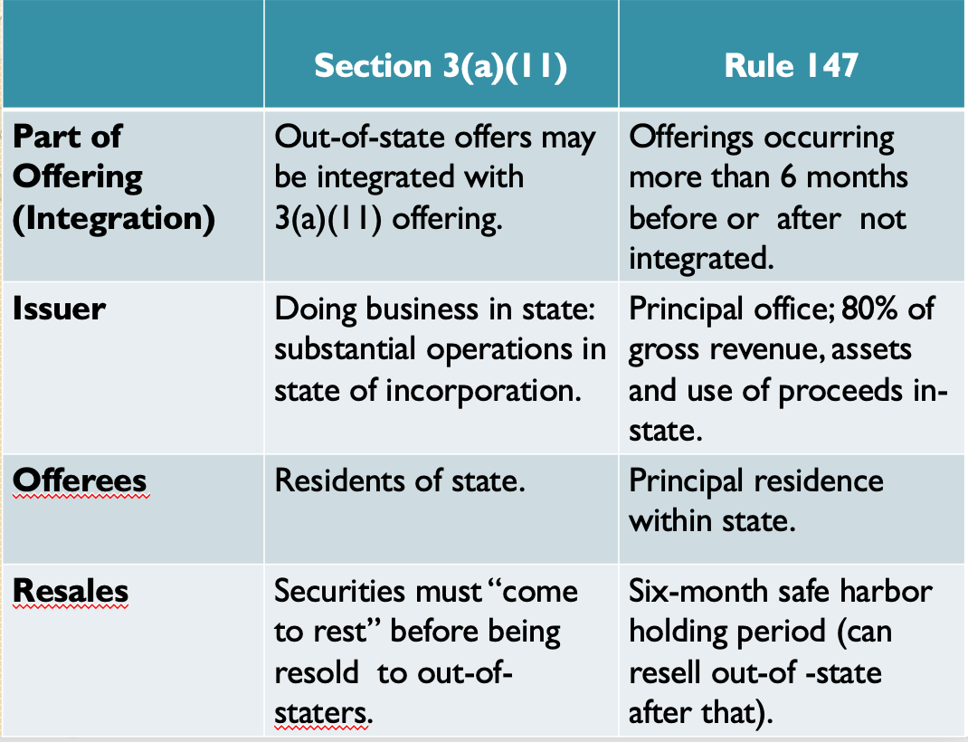
  - #6: Regulation S → Regulation S exempts non-U.S. transactions from registration requirements.
    - Reg S only applies to off-shore transactions (off-shore transactions involve transactions where offers are not made to a person in the United States)
      - A person may be a U.S. citizen, but if she receives the offer while on vacation in France, then this qualifies as an offshore offer because it is made to someone outside of the U.S.
      - NOTE: Not only must the offer take place outside of the U.S., but the actual purchase transaction must take place offshore as well.
    - Whether a securities transaction is deemed to be outside of the U.S. depends on whether the transaction falls into Category 1, 2, or 3.
      - Two basic requirements are imposed on all 3 offering categories: (1) all offerings must take place through an “offshore transaction” and (2) all offerings must involve no “directed selling efforts” into the U.S.
    - NOTE: An exemption from §5 frees the issuers from the gun-jumping rules and the liability of §11, BUT it does not exempt the issuer from Rule 10b-5 antifraud liability.
- Exemptions from Section 5 of the Securities Act: Secondary Market Transactions ** RECOMPARE TO STM OUTLINE
- Overview: Obligations when offering securities
  - How to avoid §5 registration requirements
    - Issuers exempted under § 3
    - Primary offerings exempted under § 4(2)
    - Exemptions for secondary market transactions § 4(1)
      - Securities Act of 1933 §4(1): The provisions of section 5 shall not apply to –
        - (1) Transactions by any person other than an issuer, underwriter, or dealer
      - Issuer: Section 2(a)(4)
      - Underwriter: Section 2(a)(11)
      - Dealer: Section 2(a)(12)
  - Issue here is when an individual purchases shares and then wants to resell them – cases show that it is difficult to prove you are purchasing for investment (both cases failed to show this)
  - Summary of case law:
    - “Underwriter” sweeps broadly
      - Not necessary to be in the business
    - The individual who wants to sell shares MUST show that the shares obtained in an exempt offering “come to rest” before resale – the individual really has to hold them and treat them as an investment before selling them
    - Exceptions to showing the shares “came to rest”:
      - Change of circumstances – example is that you have to resell because you are bankrupt
      - Resale that is not a “distribution”
    - Case law seems to suggest 3 years is good and 2 years is probably good
- Definition of underwriter (p. 773-777)
  - Overview:
    - Section 2(a)(11) defines underwriter as:
      - The term "underwriter" means any person who has purchased from an issuer with a view to, or offers or sells for an issuer in connection with, the distribution of any security, or participates or has a direct or indirect participation in any such undertaking, or participates or has a participation in the direct or indirect underwriting of any such undertaking;
    - If you are determined an underwriter, you have to comply with Section 5
    - Example: If Prof. Guttentag wants to sell his shares (aka a secondary offering), he may fall under the legal definition of an underwriter because the SEC will say that Prof. Guttentag purchased not to invest (purchasing to hold onto the stock), but to buy and resell (aka an underwriter)
  - In Gilligan, Will & Co. v. SEC (p. 777), Elliot & Co. agreed with Crowell-Collier Publishing Company to try and sell, without registration, $3 million of Crowell-Collier debentures. Gilligan purchased $100,000 of the Crowell-Collier debentures “for investment” one month later, on August 10, 1955. Gilligan assured Crowell that it was making the purchase only as an investment and that it did not intend to further distribute the securities. However, in May, 1956, Gilligan decided to convert debentures into stock and sold that stock for a profit on the American Stock Exchange. Purchasers on the ASE did not have information about the securities that would normally be contained in a registration statement. The Securities and Exchange Commission (SEC) (plaintiff) brought an enforcement action against Gilligan and found that Gilligan had violated federal securities law by buying and selling unregistered securities. Gilligan appealed the SEC’s order, asserting that it was not an underwriter and thus was exempt from the requirement to register the securities. Gilligan claimed that it had planned initially to hold the securities for investment purposes, but sold after a change in Crowell’s circumstances. The issue here is whether Gilligan was an underwriter, and therefore was unable to rely on the §4(1) exemption from §5. The court held that the “underwriter” definition requires there be a distribution, which there was by the sale on the stock exchange. Here. there was a distribution here because Gilligan publicly offered these shares on the American Stock Exchange. The court finds that that the people to whom this “offering” was made did not have the type of information that would be disclosed in a registration statement, and thus it is a public offering subject to federal registration requirements. Gilligan’s argument that since held for ten months, debentures were not purchased “with a view to distribution” was rejected by the court. Court thinks Gilligan was intending to resell the entire time.
Rule: Shares obtained in an exempt offering must “come to rest” before resale
- Seminal case - Gilligan, Will & Co. v. SEC: Crowell agreed to try and sell $3 mil of unregistered debentures, an unsecured loan. Gilligan purchased 100k of these securities which he converted into stock and sold 10 months later because he did not like that Crowell was not advertising. He distributed a security by selling it on the exchange and the people to whom the offering was made did not have the type of information that would be disclosed in a registration statement. Merely holding the debentures for 10 months did not prove the debentures were not purchased with a view to distribution. Gilligan is an underwriter because he just sold the shares when the company wasn’t doing as well as he wanted, like any other underwriter
- Note: Courts presume that you bought with view to invest (not distribute) if you’ve held the security for 2 years or more

    - Would the decision have been different if the initial sale of debentures was part of a registered offering? Why?
      - Yes, because “it is universally understood that after a public offering, investors reselling shares are not underwriters, and thus are able to take advantage of Sec. 4(1) exemption.”
    - If the issuer’s changed circumstances (such as downturn in profits) do not qualify as enough of a change to exclude the investor from status as an underwriter *aka the holding here*, what sort of changed circumstance would be consistent with having “investment intent” at the time the securities were initially purchased?
      - Here, the holding was that because Gilligan sold due to a downturn in profits, he initially purchased with a view to a distribution – because he was just there until the business changed.
        - However, if you decide to sell because you find yourself completely penniless, you may not be deemed to be an underwriter – because you did intend to invest, but your personal circumstances changed so much that you had no choice but to sell.
        - So, courts focus on changed circumstances involving the investor’s individual situation.
    - Suppose Gilligan resold his shares to Goldbuck Brothers, a Wall Street investment bank, within days of purchasing them from Crowell-Collier. Goldbuck Brothers signs a letter stipulating that “said debentures are being purchased for investment and the undersigned has no present intention of distributing the same.” Has Gilligan violated § 5?
      - Is Gilligan an underwriter?
        - We automatically think this could be a violation of Section 5 because Gilligan is an underwriter, because he likely purchased with a view to distribution and was a “fair weather friend” because he sold the securities after just a few days.
    - HOWEVER, Gilligan is not an underwriter because this is a private offering. The definition of an underwriter includes a “distribution” requirement, which the court says is synonymous with a public offering. The transaction with Golbuck was probably not a public offering for the reasons discussed in analyzing Sec. 4(2).
- In SEC v. Chinese Consolidated Benevolent Association (CCBA), the Chinese government issued $500 million in bonds. CCBA held mass meetings, advertised, etc. to urge member of the Chinese communities near NYC to invest in offering. CCBA collected funds ($600K) and transmitted them to NY agency of Bank of China with applications. When issued, CCBA received some of the bonds for the purchasers. Chinese Consolidated (defendant) set up a committee that arranged purchases of Chinese government bonds with Chinese citizens living in the New York metropolitan area. The Securities and Exchange Commission (plaintiff) brought suit, alleging that Chinese Consolidated was providing an unregistered security in violation of federal securities laws, requiring registration of securities sold by an issuer or underwriter. The issue is whether the CCBA offers were legal, and thus was CCBA entitled to the §4(1) exemption from §5. The court held that CCBA is an underwriter under § 2(a)(11) – offer in connection with a distribution – for China (issuer) despite the lack of any formal arrangement or compensation. Whether China knew did not matter; it is enough that the solicitations were for the benefit of the Chinese government. Even if CCBA is not an underwriter, it is still participating in a transaction where an issuer, underwriter, or dealer is present and thus § 4(1) does not apply to the transaction.
  - Court focuses on (1) systematic and continuous nature of the solicitations (resulting in distribution of securities) and (2) CCBA’s role in the collection and transmission of the funds.
  - Questions:
    - The Association did not accept any money from the Chinese government for its actions, nor was it considered an agent for the government. Nonetheless, the court held that the Association was acting “for the issuer.” Is this a sensible reading of the statute?
      - The court treats the “for the issuer” language of § 2(a)(11) as focused on the benefit to the issuer.
      - The difference between this and Pinter v. Dahl is that here, they were trying to benefit the Chinese government. Compare with Pinter * listen to 11/4 lecture
    - Would the result change if the Association had not collected or transmitted any money but simply urged people to send money directly to the Bank of China?
      - The Association could still be an underwriter based on the broad interpretation of “offering” – an offering can involve encouraging interest and facilitating an action taking place
    - What if the Wall Street Journal’s editorial page opines that the bonds are not only a good investment but also a good way of showing America’s support for China? Would the editorial page be considered a part of the issuer’s transaction?
      - It seems that the court would not go so far as saying that – instead “this is a case where there was systematic continuous solicitation, followed by collection and remission of funds to purchase the securities, and ultimate distribution of the bonds in the United States through defendant’s aid.”
- Rule 144 (p. 791-803)
  - Overview:
    - Rule 144 is a safe harbor allowing § 4(1) exemption for sellers of securities, which:
      - (1) allows sale (and participation in sale) of restricted securities without becoming an “underwriter”
      - (2) allows participation in sale by control persons (affiliates)
    - Rule 144 has information requirements.
    - Under Rule 144, non-affiliates get a free pass after a year
  - Rule 144: Preliminary Note
    - If a sale of securities complies with all of the applicable conditions of Rule 144:
      - Any affiliate or other person who sells restricted securities will be deemed not to be engaged in a distribution and therefore not an underwriter for that transaction;
      - Any person who sells restricted or other securities on behalf of an affiliate of the issuer will be deemed not to be engaged in a distribution and therefore not an underwriter for that transaction; and
3. The purchaser in such transaction will receive securities that are not restricted securities – [so if an individual complies with Rule 144, then the buyer who purchases the securities, they can automatically resell]
  - Rule 144(a)(3): Restricted Securities
    - The term "restricted securities" means you cannot buy and automatically resell the securities. Restricted securities include:
      - (i) Securities acquired directly or indirectly from the issuer, or from an affiliate of the issuer, in a transaction or chain of transactions not involving any public offering; or
      - (ii) Securities acquired from the issuer that are subject to the resale limitations of Rule 502(d) under Regulation D. . . ; or
      - (iii) Securities acquired in a transaction or chain of transactions meeting the requirements of Rule 144A; or . . .
  - To avoid being found an underwriter, the individual must meet certain holding period requirements and provide specific information.
    - 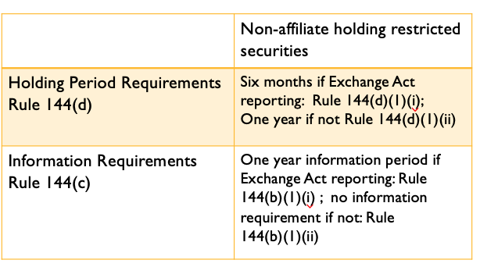
  - Rule 144(d)(1): Holding Period
    - For RESTRICTED securities ONLY:
      - If the company you purchase the securities from is a reporting companies, you must hold the securities for six months before reselling otherwise you will be deemed an underwriter.
      - If the company you purchase the securities from is a non-reporting companies, you must hold the securities for one year before reselling otherwise you will be deemed an underwriter.
  - Rule 144(c): Information Requirements:
    - Non-Affiliates
      - If the company is a public company, there must be 1-year of information available. (144(b)(1)(i))
      - Non-Exchange Act Reporting Issuer
        - If you buy securities through a Reg D offering, there is no information requirement. (144(b)(1)(ii)) → pg. 58 of the securities rules
    - NOTE: the 1 year holding period under Rule 144(d)(1)(ii) for restricted securities
  - 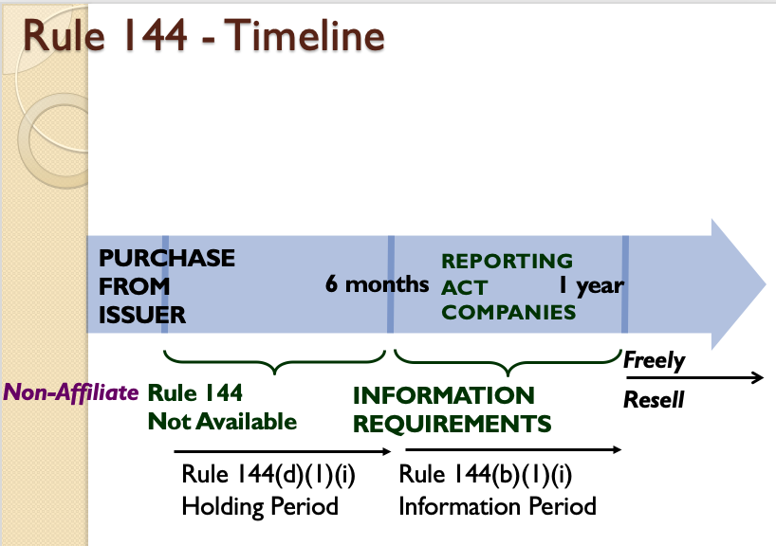

The Securities Act of 1934:

- Disclosure Requirements
  - Difference between 1933 and 1934 Act → 1933 Act only required disclosures when you sell the security; however, the 1934 Act requires ongoing disclosure obligations if you are a public company
  - Who is a public filer?
    - 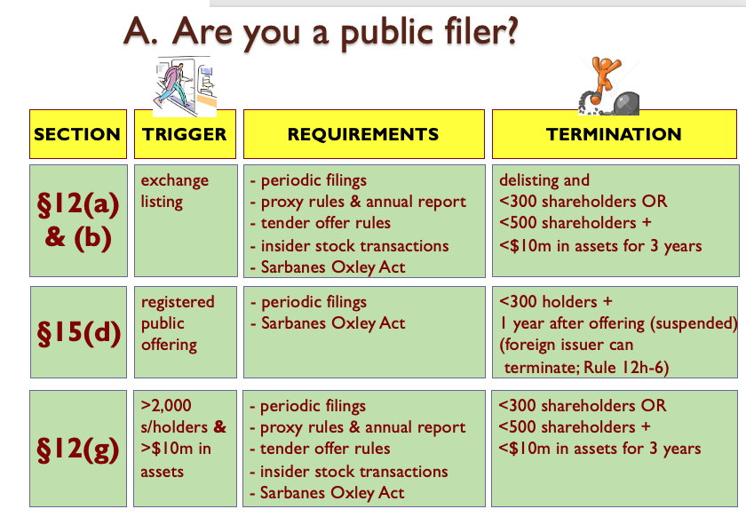
    - §12(a) & (b) → The first group of firms that get pulled into the disclosure requirements are those that get reported on a public exchange (aka NY Stock Exchange)
      - Rationale: The idea of the Act was to clean up Wall Street, so they want to focus on these companies
      - Termination = what do you have to do not have to make these disclosures
        - If the company does what it says in column 3, row 1, you will come off the exchange, and you can avoid the disclosure requirements
    - §15(d) → Added in 1937, which says if you have done a public offering, then you must continue doing the periodic filings, EVEN IF your security is not traded on the exchange
    - §12(g) → Added in 1964, and modified in 2012 with Jobs Act which applies to any company that has more than 2,000 shareholders & more than $10 million in assets
    - Includes (1) companies with securities traded on an exchange; (2) companies that have carried out a public offering; (3) companies with more than 2,000 shareholders, and (4) if you voluntarily elect to become a public filer
  - When must you disclose?
    - Must disclose annually, quarterly, and “news flash” events
    - Form 8-K (p. 685 of statute book)– filed on occurrence of specified events deemed to be of particular importance to investors.
      - Form 8-K will be used for current reports … (General Instructions A.1.)
      - Unless otherwise specified, a form is to be filed within four business days after occurrence of the event. (General Instructions B.1.)
      - Details of 8-K Filing Triggers:
        - Events to be reported on Form 8-K:
        - Item 1.01. Entering into a material definitive agreement not made in the ordinary course of business.
        - Item 1.02. Terminating a material definitive agreement not made in the ordinary course of business.
        - Item 1.03. Entering into bankruptcy or confirming a plan of reorganization.
        - Item 2.01. Acquisition or disposition of assets other than in the ordinary course of business.
        - Item 2.02. If any public announcement of material, non-public information about operations or financial condition, unless information made broadly available to the public.
        - Item 2.03. If registrant becomes obligated on material financial obligation.
        - Item 2.04. If triggering event occurs which increases or accelerates a financial obligation that is material.
        - Item 2.05. Costs associated with agreeing to sell assets or terminate employees, if material.
        - Item 2.06. If there is a materially impairment of a company asset.
        - Item 3.01. If the company’s stock is delisted.
        - Item 3.02. If there is an unregistered sale of equity securities.
        - Item 3.03. If there is a material modification of the rights of securities holders.
        - Item 4.01. If the firm changes the certifying accountant.
        - Item 4.02. If the board of directors determines that previous financial statements cannot be relied upon.
        - Item 5.01. If a change in control of the firm has occurred.
        - Item 5.02. If there is a departure of a director or principal officer.
        - Item 5.03. If there is an amendment to the articles of incorporation, by-laws, or a change in the fiscal year.
        - Item 5.05. If there is an amendment to the Code of Ethics or waiving a provision of the Code of Ethics.
        - Item 7.01. Information registrant elects to disclose under Reg. FD.
        - Item 8.01. Information the registrant deems of importance to security holders.
      - In In the Matter of Hewlett-Packard Company (2007), the court analyzes the issue of when an 8-K disclosure is required. Hewlett-Packard Company (HP) (defendant) came to believe that one of its directors was leaking confidential information to the media. The chairman of the board identified the director in front of the board at the next board meeting. The board gave the director a chance to respond to the allegation and explain his conduct. The director then left the room to enable to the board to freely discuss any punishment. Another HP director, Thomas Perkins, did not like how HP handled the matter, believing that the chairman should have first discussed the matter with the accused director privately before bringing it up in front of the full board. Perkins voiced these concerns with the board during this meeting. Nevertheless, the board voted to ask the director who had leaked information to resign. Perkins disagreed with this decision, in addition to the process that led to it. As a result, at that same board meeting, Perkins resigned as director over the handling of the matter. HP filed a Form 8-K disclosing Perkins’s resignation. HP did not, however, include the reasons for the resignation. The Securities and Exchange Commission (SEC) commenced an investigation into this failure to disclose. The issue is whether a publicly traded company is required to disclose the circumstances surrounding the departure of a director or principal officer if the departure resulted from a disagreement over company operations, policies, or practices. The court held YES, Form 8-K requires that a reporting company disclose information when a director resigns from the board. If the resignation is due to a disagreement with the company on a matter relating to its operations, policies, or practices, the Form 8-K must provide a brief description of the circumstances of the disagreement. HP’s Form 8-K reported that Perkins had resigned but did not disclose that there was any disagreement with the company. HP argued that Perkin’s resignation was due to a disagreement with HP’s Chairman of the Board and not with the company on a matter relating to operations, policies or practices. The SEC concluded that the disagreement and the reasons for Perkin’s resignation should have been disclosed in the Form 8-K (Item 5.02(a)), because (1) the disagreement related to the decision to present the leak investigation findings to the full board and the decision by majority vote to ask the director identified in the leak investigation to resign and (2) these both related to corporate governance matters and HP’s policies on how to handle sensitive information – and thus was related to HP’s operations, policies, or practices.
        - Questions
          - Do investors need to know the reasons for a director’s resignation?
            - Yes, why not!
          - Do the 8-K disclosure requirements risk chilling candid discussion at board meetings?
            - It could be, if you know your convo has to be part of public knowledge then you might not say as much
          - When will a director resignation not involve a disagreement with the company over operations, policies, or practices?
            - If there is not a conflict of interest, etc.
    - Form 10-K – filed annually.
      - Audited financial data and complete business description required.
      - This is the most comprehensive explanation/description of the company.
      - This will show you the most about the company in the fastest amount of time
    - Form 10-Q – filed quarterly.
      - Here, the idea is that the SEC wants to have a system to get quarterly financial info to the market as quickly as possible
      - Every quarter, companies get new financial results, and the SEC requires the company to disclose that financial data
        - Financial data need not be audited, but chief executive officer and chief financial officer still required to sign.
  - What must you disclose? 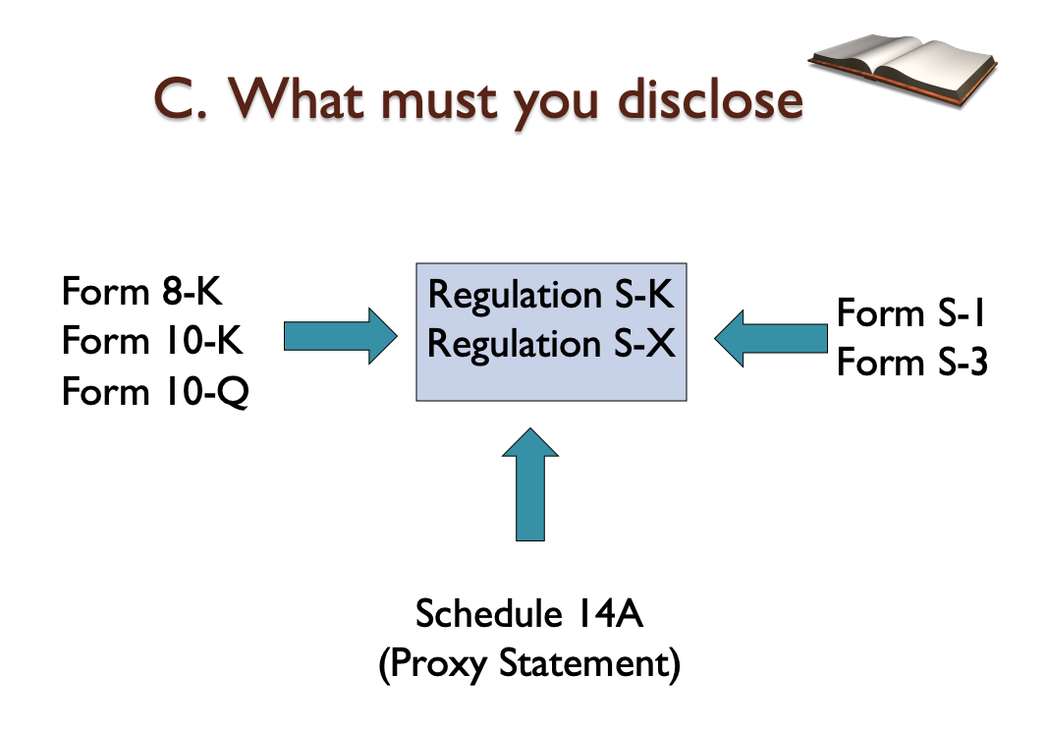
    - Under the prior system, if a company had to disclose certain things, they would have to ask which “instructions” they had to follow – there were different instructions for each form. BUT then, they came up with a unified set of instructions → Reg S-K and S-X.
      - Reg S-K and S-X explain how to fill out the different forms. (pg. 219)
    - Information to be reported on Form 10-K:
      - Item 1. Business information required in Item 101 of Regulation S-K.
        - Item 101.a. of S-K. General development of business.
        - Item 101.b. of S-K. Financial information about industry segments.
        - Item 101.c. of S-K. Narrative description of business.
        - Item 101.d. of S-K. Financial information about geographic areas.
      - Item 1A. Risk factors described in Item 503(c) Regulation S-K.
        - Item 503.c. of S-K. Discussion of risks that make the offering speculative or risky.
      - Item 1B. Unresolved Staff comments.
      - Item 2. Properties information required in Item 102 of Regulation S-K.
        - Item 102 of S-K. State briefly location and general character of principal plants.
      - Item 3. Legal proceedings required in Item 103 of Regulation S-K.
        - Item 103 of S-K. Describe briefly any material pending legal proceedings.
      - Item 4. Reserved.
      - Item 5. Market for companies required in Item 201 and 701of Regulation S-K.
        - Item 201.a – d. of S-K. Includes information about equity compensation plans.
        - Item 701 of S-K. Unregistered sales of securities, if any.
      - Item 6. Selected financial data required by Item 301 of Regulation S-K.
        - Item 301 of S-K. Last five years of summary financial information.
      - Item 7. Management discussion of results required by Item 303 of Regulation S-K.
        - Item 303 of S-K. Description of content of MD&A section.
      - Item 8. Financial information pursuant to Regulation S-X.
      - Item 9. Changes in and disagreements with accountants required by Item 304 of Regulation S-K.
      - Item 9A. Controls and procedures information in Items 307 and 308 of Regulation S-K.
      - Item 10. Information about directors and officers in Items 401, 405, and 406 of Regulation S-K.
      - Item 11. Executive compensation Information in Item 402 of Regulation S-K.
      - Item 12. Security ownership described in Items 201(d), 403 of Regulation S-K.
      - Item 13. Information about related transactions in Item 404 of Regulation S-K.
      - Item 14. Information about accounting fees and services.
      - Item 15. Exhibits.

- Rule 10b-5 Litigation
- Origins of the Private Cause of Action
  - Section 10 of Exchange Act
    - It shall be unlawful for any person, directly or indirectly, by the use of any means or instrumentality of interstate commerce or of the mails, or of any facility of any national securities exchange—
    - (b) To use or employ, in connection with the purchase or sale of any security registered on a national securities exchange or any security not so registered, . . . any manipulative or deceptive device or contrivance in contravention of such rules and regulations as the Commission may prescribe as necessary or appropriate in the public interest or for the protection of investors.
    - Takeaway: It is only a violation under Section 10 if you are being deceptive under the rules.
  - Rule 10b-5 (1943)
    - It shall be unlawful for any person, directly or indirectly, by the use of any means or instrumentality of interstate commerce, or of the mails or of any facility of any national securities exchange,
    - (a) To employ any device, scheme, or artifice to defraud,
    - (b) To make any untrue statement of a material fact or to omit to state a material fact necessary in order to make the statements made, in the light of the circumstances under which they were made, not misleading, or
    - (c) To engage in any act, practice, or course of business which operates or would operate as a fraud or deceit upon any person,
    - in connection with the purchase or sale of any security.
    - Takeaway: They broadened Section 10 in 1943 by adding in 10b-5. NOW, if you commit a fraud, you are violating a rule because it says you can’t do it
  - Private Securities Litigation Reform Act of 1995 (PSLRA)
    - After a series of cases in 1946 and 1983, the SEC created the PSLRA.
    - The major provisions included in this act are:
      - Rebuttable presumption lead plaintiff in the class is the shareholder with the largest financial interest in the class action litigation.
      - Plaintiff must plead with particularity facts leading to a strong inference of scienter.
      - Stay on discovery until after a motion to dismiss is heard.
      - Provides safe harbor for forward looking statements.
      - Limits liability of defendants not involved in intentional fraud to their proportionate share of harm caused.
  - 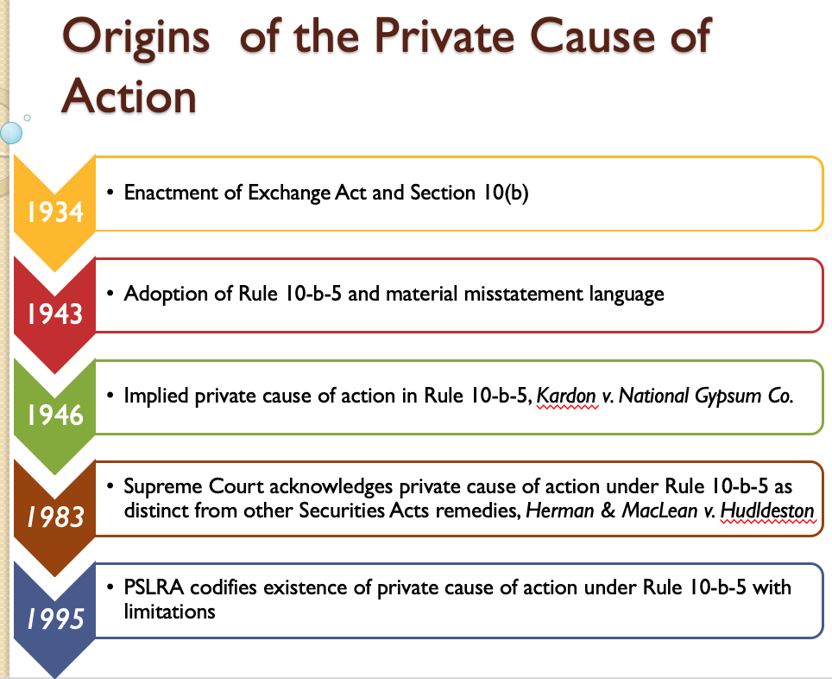
- Who can sue under 10b-5?
  - In Blue Chip Stamps, et al. v. Manor Drug Stores (1975), a group of retailers launch Blue Chip Stamps as a competitor to S&H Green Stamps. Blue Chip Stamps as part of a consent decree agrees to sell shares to retailers who used the stamp services, but were not founders. Shares registered and the prospectus was distributed to all offerees; with more than 50% of shares purchased. An offeree (retailer mailed prospectus) claims materially misleading, overly pessimistic. The issue here is whether the respondent can base their action on Rule 10b-5 without having either bought or sold the securities described in the allegedly misleading prospectus. The court held NO. In Birnbaum v. Newport Steel Corp., the 2nd Circuit concluded that the plaintiff class for purposes of a private damage action under Sec. 10(b) and Rule 10b-5 was limited to actual purchasers and sellers of securities. The court in Blue Chip Stamps applies the logic of Birnbaum and holds that the respondent is barred from maintaining this suit under Rule 10b-5. A plaintiff who neither buys nor sells is more likely to be seeking a largely conjectural or speculative recovery. People who do not purchase or sell, but already hold shares have other remedies in corporate law.
  - RULE: If you do not purchase or sell the securities, you do not get to bring a lawsuit.
  - Questions regarding the case:
    - What are the categories of investors who are harmed from fraud without engaging in a securities transaction?
      - Investors who choose not to purchase due to the fraud;
      - Actual shareholders who choose not to sell shares;
      - Shareholders, creditors, and others who are harmed by insider activities in connection with the purchase or sale of securities.
      - “…it has been held that shareholder members of the second and third of these classes may frequently be able to circumvent the Birnbaum limitation”
    - The Court emphasize that without the Birnbaum rule “[p]laintiff’s entire testimony could be dependent upon uncorroborated oral evidence of many of the crucial elements of his claim, and still be sufficient to go the jury”. Does it follow that vexatious litigation will follow?
      - Not necessarily, but likely. Court here weighs policy considerations, because Congressional intent absent.
    - Does eliminating non-purchasers and sellers from Rule 10b-5 actions solve the vexatious litigation problem?
      - Not necessarily. Attorney just needs to find a shareholder who purchased or sold during the relevant time period.
- Elements of the Private Cause of Action
  - Misstatement of a Material Facts
  - Scienter
  - Reliance
  - Loss Causation
  - Secondary Liability

