Finance Terminology:
Revenues - the amount of money that results from selling products or services to customers (AKA sales, gross)
Profit - (Revenues - expenses) (AKA net income, net)
Income Statement - financial statement that indicates results of operations over a specified period (AKA profit and loss statement)
Profit Margin - % of every dollar of sales that makes it to the bottom line (net income/sales) (AKA return on sales)
Debt - funds borrowed by the firm in exchange for claims of a fixed amount against the firm’s assets and future earnings
Equity - funds invested in the firm in exchange for the residual value of the firm → if the firm is shut down, right to assets after liquidation once all other claims are satisfied + right to firm’s earnings
Options - gives the investor the right to buy or sell a stock at an agreed upon price and date, but not obligated
Assets - what the company owns
Liabilities - what a business owes

 | Principal-Agent | Partnership | Corporation
Formation | Gorton v. Doty  Jensen v. Cargill | Fenwick v. UCC | MBCA 2.02-2.06
Relating to 3rd Parties | Contract: Mill Street Church v. Hogan, Opthalmic Surgeons v. Paychex, Watteau v. Fenwick  Torts: Dynamex v. Superior Court, Arguello v. Conoco | National Biscuit Company v. Stroud | Walkovszky v. Carlton  Sea-Land v. Pepper Source
Role & Duties | General Auto v. Singer | Meinhard v. Salmon  Day v. Sidley & Austin | Dodge v. Ford, Smith v. Van Gorkon, Francis v. United Jersey Bank, Broz v. Cellular, Sinclair Oil v. Levien, Stone v. Ritter
Termination | [no cases] | Owen v. Cohen, Page v. Page  Prentiss v. Sheffel, Pav-Saver v. Vasso, Kovacik v. Reed | [no cases]

1) Principal Agent
- Formation of Principal-Agent Relationships
  - Gorton v. Doty
    - Facts: Gorton’s son was on a football team travelling to a game in Doty’s car driven by the coach → Doty volunteered her car after asking the coach if he needed one → she told him only he could drive the car, but didn’t give other instructions or employ him → she was not compensated → car accident and Gorton sued Doty
    - Issue: Was the coach an agent of Doty while he was driving her car?
    - Holding: Yes
    - Rule: RSA 2nd §1 Agency is the fiduciary relation which results from the manifestation of consent by one person to another that the other shall act on his behalf and subject to his control, and consent by the other so to act
      - Doesn’t matter if the agent actually follows the principal’s instructions as long as all the elements are met (basically outcome doesn’t matter that much)
    - Reasoning:
      - Principal - Doty, Agent - Coach, Third Party - Gorton
      - Manifestation of Consent? Consented by loaning the car
      - Consent by the other? He accepted and drove the car
      - Act on her behalf? Instead of her driving, he drove
      - Subject to her control? She said only he could drive her car
      - Other factors considered: if there was a contract, compensation, who brought it up, presumption that the owner of the car is liable, the parties’ understanding
    - Notes:
      - This is different from loaning the car → loaning would make it a market transaction and there is no principal-agent relationship
      - In this case, the strongest element was control, weakest was consent by principal
        - Strongest because she said ONLY the coach could drive
          - Could argue though that she didn’t control how he would drive
        - Weakest because coach wasn't really acting on her behalf, he was doing it in the interest of the school football team
      - What advice do you give Ms. Doty next time she wants to lend her car to the team?
        - Enter into an agreement describing the arrangement as a loan
          - Loans are market transactions which don’t create P-A relationship
            - But lender can become principal → See next case
        - Exert less control over the Coach so that the control prong is not met
        - Do not lend the car to coach
        - Exert more control (e.g. drive car herself)
      - Lessons:
        - Contract consideration isn’t required to create a principal agency relationship
        - Intent to form a P-A relationship isn’t required to create one
        - Potential for principal agency relationship in many circumstances
          - Easy to make → just asking someone to do something for you can create the P-A relationship, even if no physical control
  - A principal need not exercise physical control over the actions of the agent, so long as the principal may direct the result or ultimate objectives of the agent relationship
  - Ease of creating principal/agency relationships matters because:
    - Actions of the agent create liability for the principal
    - Agent owes a fiduciary duty to the principal
  - Supplier vs. Agent
    - Supplier: Motive is to make a profit for self, gets paid a markup, profit depends on business sense
      - Factor indicating supplier rather than agent: he is to receive a fixed price for the property irrespective of price paid by him
      - Ex: Student pays fixed price no matter what and GT’s profit is based on how much he is able to buy the book for
    - Agent: Motive of finding a book, paid a fixed fee
      - Rst 2nd 14K - one who contracts to acquire property from a third person and convey it to another is the agent of the other only if it is agreed that he is to act primarily for the benefit of the other and not for himself
      - 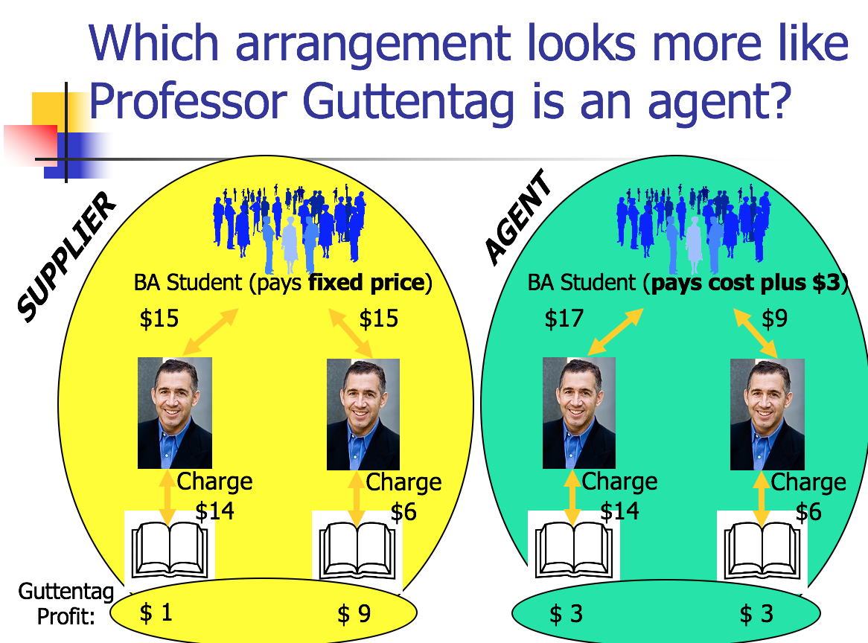
  - Jensen v. Cargill
    - Facts: P were farmers that contracted w/ Warren Seed & Grain Co. who purchased grain from them → Warren and D entered into a contract for financing in exchange for appointing D as its grain agent and also got right of first refusal to purchase Warren’s grain sold to the terminal market → D would later loan Warren more money and sent officers to monitor and make recommendations → Warren eventually went under and ceased ops → P sued D for the money that Warren owed, saying D was a principal
    - Issue: Did Cargill become liable as a principal on contracts between Warren and P?
    - Holding: Yes because it exerted control over Warren
    - Rule: RST 14 O - A creditor becomes a principal at that point at which it assumes de facto control over the conduct of the debtor (hands on, day-to-day control rather than written agreement telling you what to do)
    - Reasoning:
      - Principal - Cargill, Agent - Warren, Third Party - A. Gay Jensen Farms
      - Manifestation of Consent? Cargill manifested consent by having Warren implement its recommendation
      - Consent by the other? Warren did so without opposition
      - Act on Cargill’s behalf? Warren acted on Cargill’s behalf by procuring grain for it and Cargill totally financed it
      - Subject to Cargill’s control? Cargill interfered with Warren’s internal affairs
      - Cargill tried to argue that it was just a loan situation (a lender carve out that doesn’t create P-A), but the court disagreed since Cargill had the power to discontinue the financing of Warren’s operations (this was on a list of things the court considered to be evidence of de facto control, but it’s what the court emphasized most)
    - Guttentag rejects the case holding because he thinks a lot of what was happening looked like a typical lender-debtor relationship
      - Cargill was buying most of Warren’s grain, but just because you are the best customer does not mean there is a P-A relationship
      - Warren is selling to others as well, and just because Cargill doesn’t purchase it doesn’t mean someone else won’t buy it
      - What Cargill was telling Warren to do is just what you do when you loan money
      - Consider the Best Buy and Mastercard example
        - If I buy bicycle with credit card and hit someone with bike → they try to sue bank → I say bank is principal because I’m paying interest to them → bank would say we had no control → but there is contract saying how credit card can be used and that they can cut you off from using money
      - Warren is arguably supplier because Cargill has the right of first refusal to purchase market grain sold → if you are a supplier, can’t be an agent too
    - What advice would you give Cargill next time they want to work with a group operator?
      - Draft documents so they do not suggest de facto control
      - Never make loans to operator you are purchasing grain from
      - Take more control over the operators you lend money to
      - Take less control over the operators you lend money to
      - Pay closer attention to amounts actually being disbursed
      - Keep the status quo, and recognize lawsuits like this are a cost of doing business
- Liability to Third Parties via Contract
  - General Rule: Rst 2nd §144 - A disclosed or partially disclosed principal is subject to liability upon contracts made by an agent acting within his authority if made in proper form and with the understanding that the principal is a party
    - Rule: Rst 3rd 6.01 - agent with authority can bind a principal to a contract
  - Types of Principals: (1) Disclosed; (2) Partially disclosed; (3) Undisclosed
    - Rule Rst 2nd §4
      - (1) If, at the time of a transaction conducted by an agent, the other party thereto has notice that the agent is acting for a principal and of the principal’s identity, the principal is a disclosed principal
      - (2) If the other party has notice that the agent is or may be acting for a principal but has no notice of the principal’s identity, the principal for whom the agent is acting is a partially disclosed principal
      - (3) If the other party has no notice that the agent is acting for a principal, the one for whom he acts is an undisclosed principal
    - Rule: Rst 2nd §320 - An agent doesn’t become a party to a contract if acting as an agent for a disclosed principal, unless otherwise agreed
      - If partially disclosed (Rst 2nd 321) or undisclosed (Rst 2nd 322) → party to contract
  - Types of Agent Authority: (1) Actual Authority; (2) Apparent Authority; (3) Inherent Agency Power; (4) Ratification; (5) Estoppel
    - Type #1: Actual Authority
      - Mill Street Church of Christ v. Hogan [Actual Authority]
        - Facts: Church hired Bill Hogan to paint the building → Bill and Waggoner discussed the project and Waggoner told Bill that Petty would be tough to reach for help → Bill asked brother Sam to help, who had helped in previous projects → Sam broke his arm while helping → Bill reported the accident and was told the church had insurance → debate over whether Sam was an employee of the church
        - Issue: Was Sam an employee of the church?
        - Holding: Yes
        - Rule: Rst 3rd §2.01 An agent acts with actual authority when, at the time of taking action that has legal consequences for the principal, the agent reasonably believes, in accordance with the principal’s manifestations to the agent, that the principal wishes the agent so to act
        - Rule: Rst 2nd §35 Unless otherwise agreed, authority to conduct a transaction includes authority to do acts which are incidental to it, usually accompany it, or are reasonably necessary to accomplish it
        - Rule: Rst 3rd 2.02 (1): An agent has actual authority to take action designated or implied in the principal’s manifestations to the agent and acts necessary or incidental to achieving the principal’s objectives
        - Reasoning:
          - Reasonably necessary - clear Bill would need an assistant in the job since it was difficult to reach → Bill has implied authority
          - Usually accompanies - Sam Hogan had been hired in the past
          - Agent reasonably believes?
            - It was reasonable for Bill to believe because the church had allowed him to hire Sam for help in the past
            - Discussion with Waggoner made it seem like Petty wouldn’t be reachable
          - The court also thought it would be unfair to Sam, who thought Bill had the power to hire him, and relied on it
            - Guttentag thinks the court decided the case incorrectly bc for actual authority, it doesn’t matter what 3P thinks
    - Type #2: Apparent Authority
      - Rst 2nd §8 Apparent authority is the power arising from the principal’s manifestations to such third person
      - Rst 2nd §27 Apparent authority is created by written or spoken words or other conduct of the principal, which reasonably interpreted, causes third person to believe principal consents to have the act done on his behalf
      - Rst 2nd §159 A disclosed or partially disclosed principal is subject to liability upon contracts made by an agent acting within his apparent authority
      - Ophthalmic Surgeons Ltd. v. Paychex Inc
        - Facts: P entered into K with D for payroll processing services and later entered into another for D to provide direct deposit payroll services → At P’s office Carleen Connor handled payroll and was the designated contact → Connor was requesting multiple unauthorized payments for herself and D complied → P sued D for breach of contract
        - Issue: Did Connor have apparent authority such that D could have reasonably relied on her authority to issue additional paychecks?
        - Holding: Yes, she had apparent authority and D’s belief was reasonable
        - Rule: Rst 3rd §2.03 - Apparent authority is created by a person’s manifestation that another has authority to act with legal consequences for the person who makes the manifestation, when a third party reasonably believes the actor to be authorized and the belief is traceable to the principal’s manifestation
          - Note: Rst 2nd 27 on apparent authority is simpler since it doesn’t require the belief be traceable, but GT thinks Rst 3rd is better
        - Reasoning:
          - Third party reasonably believes?
            - She was the designated payroll contact, and after K was made, she was the only person D had contact with
            - P never expressly conveyed a limitation on Connor’s authority
            - Reasonable for D to assume the payroll contact could authorize changes
          - Belief is traceable to principal’s manifestations?
            - P didn’t object to her transactions for years
            - There’s a pattern of inaction by P
            - Note: GT disagrees and thinks manifestation should be an actual action
        - Notes:
          - Connor obviously didn’t have actual authority to take extra money
          - But court said she was “cloaked with apparent authority”
          - To avoid situation, should have checked payroll records
      - If the principal fired the agent, he would need to make it clear to third party that agent no longer has authority, otherwise the agent is still cloaked with authority
    - Type #3: Inherent Agency Power
      - Only occurs when the principal is undisclosed, but as a policy matter, it is appropriate to hold the principal liable
      - Watteau v. Fenwick
        - Facts: Humble owned a beerhouse and transferred it to D, but stayed on as a manager → store name and license remained under his name → he was only allowed to purchase ales and water → he purchased cigars, bovril from P → P sued D for payment
        - Issue: Could D be liable as a principal even though he told Humble not to buy those items and P didn’t know there was a principal that existed?
        - Holding: Yes
        - Rule: Rst 2nd §195 - A general agent for an undisclosed principal authorized to conduct transactions subjects his principal to liability for acts done on his account….if usual, or necessary in such transactions, although forbidden by the principal to do so
        - Rule: Rst 2nd §8A - Inherent agency power is a term used in the restatement of this subject to indicate the power of an agent which is derived not from authority, apparent authority, or estoppel, but solely from the agency relation and exists for the protection of persons harmed by or dealing with a servant or other agent
          - Note: Rst 3rd rejects inherent agency power, in a situation like this, could use Rst 3rd 2.06 liability of undisclosed principal
            - Rule: Rst 3rd §2.06 - An undisclosed principal is subject to liability to a 3P who is justifiably induced to make a detrimental change in position by an agent acting on the principal’s behalf and without actual authority if the principal, having notice of the agent’s conduct and that it might induce others to change their positions, did not take reasonable steps to notify them of the facts
          - But Rst 3rd wouldn’t work here because the principal Fenwick never had notice that Humble was buying things from Watteau
        - Reasoning:
          - Not actual authority - D forbade Humble from buying those things
          - Not apparent - 3P had no notice of D as a principal
          - It was reasonable for P to believe he was dealing with someone authorized to make purchases because Humble’s name was on the door, had a license, etc
          - Fenwick knew people still though Humble was the owner
          - Court said it wasn’t necessary for the 3P to know of the principal, because 3P would always lose if he didn’t know the principal (Policy rationale)
        - Notes:
          - The 2nd Rst is better for when the agent is cheating, but the 3rd is better for dealing with a cheating principal
            - Fenwick wouldn’t be liable under 3rd because he had no notice
          - Why not estoppel?
            - Fenwick did not intentionally or carelessly cause such belief, or know that 3P believed and didn’t take reasonable steps (see Rst 2nd 8b)
    - Type #4: Ratification
      - Rule: Rst 2nd §82 - Ratification is the affirmance by a person of a prior act which did not bind him but which was done or professedly done on his account, whereby the act is given effect as if originally authorized by him
        - “Done on his account” - Must be a disclosed principal
      - Rule: Rst 3rd §4.01 - Ratification is the affirmance of a prior act done by another, whereby the act is given effect as if done by an agent acting with actual authority
      - Rule: Rst 3rd §4.03 - A person may ratify an act if the actor acted or purported to act as an agent on the person’s behalf
      - NOTE: Guttentag prefers the 2nd restatement rule
      - Rule: Rst 2nd 89 If the affirmance of a transaction occurs at a time when the situation has so materially changed that it would be inequitable to subject the other party to liability thereon, the other party has an election to avoid liability
        - Ex: Agent purports to act for Principal, but doesn’t actually have power to bind him. Agent contracts to sell a house to T, but then the house burns down. P later affirming the sale does not bind T.
    - Type #5: Estoppel
      - Rule: Rst 2nd §8B - A person who isn’t otherwise liable as a party to a transaction purported to be done on his account, is nevertheless subject to liability to persons who have changed their positions bc of their belief that the transaction was entered into by or for him if: (1) He intentionally or carelessly caused such belief, or (2) Knowing the belief and that others might change positions bc of it, he didn’t take reasonable steps to notify them of the facts
  - When can the principal enforce a contract against the third party?
    - Third Party is bound to principal if:
      - Actual express authority
      - Actual implied authority
      - Apparent authority
      - Inherent Agency Power
      - Ratification
        - Exception: If there is a material change in the situation
    - Third party not bound if it is an estoppel situation
- Liability to Third Parties via Tort
  - Employee vs. Independent Contractor
    - Rst 2nd §2 -
      - (1) A master is a principal who employs an agent to perform service in his affairs and who controls or has the right to control the physical conduct of the other in the performance of the service
      - (2) A servant is an agent employed by a master to perform service in his affairs whose physical conduct in the performance of the service is controlled or is subject to the right to control by master
        - Rst 2nd 220 - In determining whether one acting for another is a servant or an independent contractor, the following matters of fact, among others, are considered:
          - The extent of control, which, by the agreement, the master may exercise over the details of the work
          - Whether or not the one employed is engaged in a distinct occupation or business
          - The kind of occupation, with reference to whether, in the locality, the work is usually done under the direction of the employer or by a specialist without supervision
          - The skill required in the particular occupation
          - Whether the employer or the workman supplies the instrumentalities, tools, and the place of work for the person doing the work
          - The length of time for which the person is employed
          - The method of payment, whether by the time or by the job
          - Whether or not the work is a part of the employer’s regular business
          - Whether or not the parties believe they are creating the relation of master and servant
          - Whether the principal is or is not in business
      - (3) An independent contractor is a person who contracts with another to do something for him but who isn’t controlled by the other, not subject to the other’s right to control with respect to his physical conduct in the performance of the undertaking. He may or may not be an agent.
        - Type 1: Independent Contractor Agent
          - Subject to limited control by principal with respect to the chosen result
          - Agent has power to act on principal’s behalf
        - Type 2: Nonagent independent contractor
          - Perhaps less control on principal’s part, but agent has no power to act on principal’s behalf
    - Dynamex Operations West, Inc. v. Superior Court
      - Facts: P is a courier and delivery service → in 2004 it converted all drivers from employees to independent contractors in order to save money → P obtains the customers and assigns deliveries to drivers → drivers must pay for all expenses and insurance, wear a uniform → drivers generally can choose routes and the sequence of deliveries → P could terminate without cause with a 3-day notice
      - Issue: What standard should be adopted to determine if workers should be classified as independent contractors or employees?
      - Holding: ABC Standard (AB5): The hiring entity has the burden of showing that a worker is is an independent contractor and must show:
        - Worker is free from control and direction of the hiring entity with the performance of the work; and
        - Worker performs work that is outside the usual course of the hiring entity’s business; AND
        - Worker is customarily engaged in an independently established trade, occupation, or business of the same nature as the work performed
Otherwise presume all workers are employees
      - Reasoning:
        - The Borello Test (Rst 2nd 220) isn’t great in an hour and wage context
          - Makes it confusing for businesses to determine how workers will be classified and have to wait for judicial determination
          - Multifactor test gives businesses more opportunities
        - Independent contractors are usually understood to have independently made the choice to go into business for one’s self
        - Applying the ABC Test to Dynamex:
          - Free from control or direction? Free to pick destination, not routes
          - Performs work outside course of hearing? Probably not
          - Worked engaged in independently established trade? Probably Not
          - If no to any of the three → not an independent contractor
      - Notes: The Dynamex decision does not mean that the ABC test will be applied to determine if the principal has tort liability → just a state test for whether the worker is an IC or an employee
        - If an independent contractor → not a servant
  - Liability to Third Parties for Agent’s Torts
    - Rule Rst 2nd §219 -
      - (1) A master is subject to liability for the torts of his servants committed while acting in the scope of their employment
      - (2) A master is not subject to liability for the torts of his servants acting outside the scope of their employment, unless:
        - The master intended the conduct or consequence, or
        - The master was negligent or reckless, or
        - The conduct violated a non-delegable duty of the master, or
        - The servant purported to act or to speak on behalf of the principal and there was reliance upon apparent authority, or he was aided in accomplishing the tort by the existence of the agency relation
    - Rule: Rst 2nd §228 Conduct is within scope of employment if:
      - (a) of a kind employed to perform;
      - (b) substantially within authorized time and space limits;
      - (c) at least in part to serve master;
      - (d) if force used, not unexpected by master
    - Rule: A principal only has liability for an agent’s torts if a master-servant relationship also exists AND the act is within the scope of employment
    - Agent Liability for the Tort?
      - Rst 2nd §343 An agent who does an act otherwise a tort is not relieved from liability by the fact that he acted at the command of the principal or on account of the principal
      - Rst 3rd §7.01 An agent is subject to liability to a third party harmed by the agent’s tortious conduct
    - 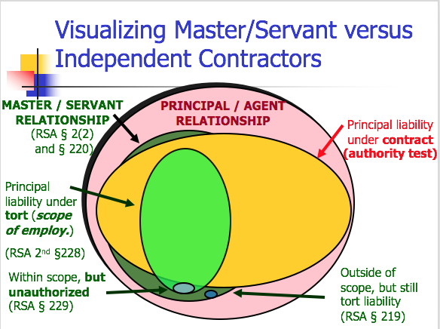
    - Arguello v. Conoco, Inc.
      - Facts: 3 separate incidents where Hispanic and African American customers were subjected to racial discrimination → 2 occurred at Conoco-branded stores, 1 occurred at a Conoco-owned store
      - Issue: #1: Is there a P-A relationship between Conoco, Inc. and the Conoco-branded stores?
      - Holding #1: No
      - Reasoning:
        - The stores had Petroleum Marketing Agreements (PMAs) with Conoco, Inc. and the plain language states that they are separate entities
          - Consistent with other holdings
          - Also said that it would have no control over day-to-day activities
        - Note: Guttentag says Conoco actually had a lot of power over the branded stores, but it created a contract with a lot of economic control rather than physical control, which is what RST requires for there to be P-A. However, just because a contract says it isn’t P-A does not mean that it is dispositive, really should be looking at the conduct
      - Issue #2: Was Smith, working at the Conoco-owned store, acting within the scope of her employment?
      - Holding #2: Yes
      - Rule: Rst 2nd §229 Factors to Determine if Unauthorized Conduct in Scope of Employment
        - The act commonly done by such servants
        - Time, place, and purpose of act
        - Previous relations between master and servant
        - Extent business apportioned between different servants
          - There is more liability when a master has one servant versus multiple because responsibility is clearly delineated, so what they can and can’t do is more clear
        - Outside master’s enterprise or not entrusted to servant
        - Would master expect such an act
        - Similar in quality to authorized acts
        - Instrument of harm furnished by master
        - Extent of departure from normal authorized methods
        - Whether or not the act is seriously criminal
      - Reasoning:
        - Time, place, and purpose of the act: she was at work, on the job, and the confrontation occurred while Smith was completing the customer’s purchase
        - Similarity to acts which the servant is authorized to perform: her actions were similar, she completed purchases, made sales, used the intercom system
        - Whether the act is commonly performed by servants: yes, they were customary functions of a gasoline store clerk
        - Extent of departure from normal methods: she did depart from the normal methods of conducting a purchase, but the slurs occurred when she was performing normal duties
        - Instrument of harm furnished by master? She used an intercom that was provided by the master
        - Master would reasonably expect such an act would be performed: there is no evidence of this, but even if D could show they couldn’t have expected it, the jury could find that the other factors outweigh this
      - Class Questions:
        - Why have Conoco owned stores at all?
          - More control, might want to brand stores that are in rural areas where it is harder to supervise them
        - Did Pamela Escobar act appropriately in refusing to help the Escobedos?
          - No morally, but yes for Conoco’s argument because it reinforces the idea that Conoco isn’t responsible for the branded stores’ actions
        - Why did the court say no agency relationship between the Conoco-branded stores and Conoco?
  - Fiduciary Duties
    - Rst 2nd §376 - General Rule [Duties of Agent to Principal] - Duties are determined by the agreement between the parties
      - There are default rules, but the agreement can contract around them
    - Rst 2nd §379 - Duty of Care and Skill - Unless otherwise agreed, duty to act with standard care and skill which is standard in the line of work
    - Rst 2nd §381 - Duty to Give Info - Unless otherwise agreed, an agent is subject to a duty to use reasonable efforts to give his principal information which is relevant to affairs entrusted to him and which, as the agent has notice, the principal would desire to have and which can be communicated without violating a superior duty to a 3P
    - Rst 2nd §387 - Duty of Loyalty - Unless otherwise agreed, an agent is subject to a duty to his principal to act solely for the benefit of the principal in all matters connected with his agent
      - If going to act adversely in any way, must provide notice
    - More duties:
      - 288 - account for profits arising out of employment
      - 289, 301 - not act adversely without disclosure
      - 390 - If adverse, be fair/disclose
      - 393 - not to compete in subject matter of agency
      - 394 - Not to act with “conflicting interests”
      - 395-396 - Not to use/disclose confidential information
    - General Automotive Manufacturing Co. v. Singer
      - Facts: P was a machine shop that hired D as a general manager → part of his job was to solicit work for the shop → he attracted a lot of work and thought the shop wouldn’t be able to handle it all → made a deal with another shop for a cheaper price to do the work and kept the difference between the quoted price and the actual price → P sued for breach of contract which had a clause stating he couldn’t work for anyone else and also breach of fiduciary duty as manager
      - Issue: Did Singer’s action constitute a violation of his fiduciary duty?
      - Holding: Yes
      - Rule: Rst 2nd §387 - Duty of Loyalty - Unless otherwise agreed, an agent is subject to a duty to his principal to act solely for the benefit of the principal in all matters connected with his agent
      - Reasoning:
        - Under his fiduciary duty, he was bound to exercise good faith and loyalty and not act adversely to P’s interests by serving or acquiring any private interest of his own
        - He also had an obligation to act for the furtherance and advancement of the interest of Automotive
        - Singer should’ve disclosed the facts to Automotive and give them the opportunity to make a choice, regardless of what he thought was best
        - By failing to disclose all the facts relating to the orders from Husco and by receiving secret profits from these orders, he violated his fiduciary duty to act solely for the benefit of Automotive
      - Class Questions:
        - Would it be possible to conclude that Singer breached the contract but not the duty of loyalty?
          - Yes, if his side business was completely unrelated and not during work hours
          - Or if his contract said he didn’t have a duty of loyalty (modification of fiduciary obligations), but also couldn’t work for another auto shop
        - Why didn’t P sue on contract theory?
          - Under contract theory, P could get damages for what it would’ve made had P made the sale
          - Under breach of fiduciary duty, P would get D’s profit - 3%
          - Gen. Auto’s profits would’ve been less than what D made by going to a cheaper shop
- Terminating an Agency Relationship
  - Rst 2nd 118 - Authority terminates if the principal (by revocation) or the agent (by renunciation) manifests to the other dissent to its continuance
  - Rst 2nd 124A - The termination of authority does not terminate apparent authority
  - Rst 2nd 136 - apparent authority terminates when the 3P has notice
- Agent’s Fiduciary Duties to Principal After Termination
  - Rst 2nd 396 - Unless otherwise agreed, after termination of the agency, the agent: (a) has no duty not to compete; (b) has a duty to not to use or disclose trade secrets...The agent is entitled to use general info...and the names of customers retained in his memory

2) Partnerships
- Sources of Law
  - States have partnership statutes → that’s the law to follow
  - Uniform Partnership Act (1914) - UPA
  - Uniform Partnership Act (1997) - RUPA
    - Primary differences between this one and the older one:
      - Mandatory v. Default fiduciary duties → RUPA allows more modification, UPA more black and white
      - Financial consequences of wrongful termination
- How do you know if you formed a partnership?
  - Three Part Test for Formation of Partnership
    - Look to the definition of a partnership
      - UPA §6(1) - A partnership is an association of 2 or more persons to carry on as co-owners of a business for profit
    - Consider if UPA 7(3) and 7(4) are relevant
      - UPA §7(3) - the sharing of gross returns does not establish a partnership
      - UPA §7(4) - the receipt by a person of share of the profits is a prima facie evidence that he is a partner (only receiving profits and no salary)
        - (b) But if receiving profits and salary, then not prima facie evidence, but also is not evidence against there being a partnership
    - Look at the list of common law factors (e.g. 9 factors in Fenwick)
  - Make sure that they didn’t opt out of a partnership and created something else
- Fenwick v. Unemployment Compensation Commission
  - Facts: Fenwick operated a beauty shop and employed Mrs. Cheshire as a cashier and reception clerk → she asked for a raise → they entered into an agmt. to enter a partnership where she would get a raise if the business was doing well → partnership terminated → Fenwick argued that the agmt. was just fixing the compensation, but the trial court held it was a partnership
  - Issue: Was Mrs. Cheshire a partner?
  - Holding: No
  - Reasoning: Fenwick Factors
    - Intention of the parties - signed a “Partnership Agmt”, but business operations remained the same and the intent of the agmt. was for the possibility of a pay raise
    - Right to share in profits - the right to share in profits did exist here
    - Obligation to share in losses - agmt. said Mrs. Cheshire is not to share in the losses
    - Ownership and control of partnership property - Fenwick reserved control and ownership
    - Contribution of capital - Fenwick contributed all capital
    - Right to capital on dissolution - No right to capital upon dissolution
    - Control of Management - She had no power or control over operations
    - Conduct toward third parties - Didn’t inform customers they were partners, but did file joint tax return which suggests a partnership → not conclusive evidence and alone not enough
    - Rights on dissolution - Nothing would change once she left and she had no rights
  - Note: Guttentag says it looks like the court is leaning evidence toward her not being a partner
- Liabilities of Partners to Third Parties:
  - UPA §15 - All partners are liable (a) Jointly and severally for everything chargeable to the partnership under sections 13 and 14 and (b) Jointly for all other debts and obligations of the partnership; but any partner may enter into a separate obligation to perform a partnership contract
  - UPA §9 (CONTRACT) - Every partner is deemed to be an agent of the partnership..and the act of every partner...carrying on in the usual way of business binds the partnership, unless the partner has no authority... and the person with whom he is dealing has knowledge of the fact
  - UPA §13 (TORT) - Where wrongful act or mission of any partner acting in the ordinary course of business of the partnership, all partners are liable (no master-servant test necessary)
- Roles and Duties of a Partnership
  - UPA Scheme
    - Default rules for management role of a partner (may be modified):
      - UPA §9 - every partner deemed to be an agent of the partnership
      - UPA 18(b) - every partner can spend partnership money if reasonably incurred in ordinary and proper conduct of business
      - UPA 18(e) - partners have “equal rights” to management
      - UPA 18(h) - difference in “ordinary matters” decided by “majority”
      - RST §376-396 applies
    - Mandatory:
      - UPA §20 - obligation to render true and full info on demand of all things affecting the partnership
      - UPA §21 - must account for profits from any transaction connected with the partnership
      - UPA §22 - any partner shall have the right to a formal account as to partnership affairs
  - RUPA Scheme
    - Duty of Care
      - RUPA 409(c) - gross negligence, reckless conduct, intentional misconduct, or a knowing violation of the law is violation of duty of care
    - Duty of Loyalty
      - RUPA 409(b) - must account for profits from any transaction connected with the partnership (same as UPA 21)
      - RUPA 409(e) - self-interest is not dispositive (compare to Rst 387)
        - UPA says that an agent is to act solely for the benefit of the principal, while here RUPA says self-interest is not dispositive of breach
    - Duty of Information (more forthright than UPA about disclosure obligations)
      - RUPA 408(a) - maintain books and records
      - RUPA 408(b) - provide access to books and records
      - RUPA 408(c)(1) - furnish without demand information required to exercise rights
      - RUPA 408(c)(2) - furnish any other information on demand unless unreasonable or improper
    - Modifying UPA and RUPA duties:
      - UPA Allowable Modifications of Fiduciary Duties
        - Restatement duties 376-396 can be changed
        - No provision to modify UPA 21 and 23
      - RUPA §105 Ability to Modify Duties
        - Relations between partners are governed by agreement
        - To the extent the partnership agreement doesn’t provide for a matter, RUPA governs the matter
        - Agreement may not: (4) unreasonably restrict access to books and records (5) Alter or eliminate duty of loyalty or duty of care, except as otherwise provided
        - 105(d)(3) - If not manifestly unreasonable (determined by court), the partnership agreement may:
          - Alter or eliminate the aspects of the duty of loyalty stated in 409(b)
          - Identify specific activities that do not violate the duty of loyalty
          - Alter the duty of care, but may not authorize conduct involving bad faith
          - Alter or eliminate any fiduciary duty
  - Meinhard v. Salmon
    - Facts: Gerry leased a premises to Salmon for use as shops and offices → Salmon and Meinhard formed a partnership for the venture, where Salmon did more work as a manager and Meinhard provided more funding → lease ended and new owner of the property proposed a new plan to Salmon → Salmon entered into a deal without telling Meinhard → Meinhard sued arguing that the new lease belonged to the joint venture and wanted it to be held in trust but Salmon said no, the venture terminated when the first lease ended
    - Issue: Was Meinhard entitled to an interest in the new lease?
    - Holding: Yes, 49%
    - Rule: RUPA 409(f) All the partners may authorize or ratify, after full disclosure of all material facts, a specific act or transaction by a partner that otherwise would violate the duty of loyalty
    - Reasoning:
      - If new owner had known about the partnership, he likely would’ve approached both rather than just Salmon
      - The opportunity was an incident of the enterprise → Salmon wouldn’t be in the position he is without the venture
      - He breached his fiduciary duty of loyalty by not notifying Meinhard → it wasn’t honorable to not tell him
    - Class Questions:
      - Why were the damages split 49% to Meinhard and 51% to Salmon?
        - They had about equal economic interests, but 51% would allow Salmon to retain his managerial power
      - Would disclosing the opportunity to Meinhard have allowed Salmon to proceed under the RUPA default?
        - No, RUPA 409(f) required disclosure AND the other partners would have to be ok with it
        - Under Cardozo’s reasoning, disclosure would be required and maybe more
      - If you represented Salmon, what would you do?
        - Contract that future opportunities belong to the individual, not the partnership
      - If you represented Meinhard, what would you do?
        - Reduce or expand obligations
        - Specify 409(f) - like all opportunities belong to partnership
      - Suppose Meinhard and Salmon want a different rule. Maybe that neither partner owes fiduciary duties to the other. Is that valid?
        - Compare RUPA 404(b)(1) and 103(b)(3)
        - RUPA 103b Partnership agreement “may not…(3) eliminate the duty of loyalty under Section 404(b)...but (i) the partnership agreement may identify specific types or categories of activities that do not violate the duty of loyalty, if not manifestly unreasonable”
      - How does Cardozo justify his decision against Salmon?
        - “The two were coadventurers, subject to fiduciary duties akin to those of partners...owe to one another, the duty of finest loyalty”
  - Day v. Sidley & Austin
    - Facts: P was a senior underwriting partner of Sidley & Austin → in 1972 D merged with another firm after a series of meetings by an executive committee → P agreed to the final Partnership Agreement → it was later decided that the WA offices would be combined and P was mad bc he helped establish the original and he lost his role as sole head → said firm didn’t disclose to him and breached its fiduciary duty
    - Issue: Did D breach its fiduciary duty?
    - Holding: No
    - Reasoning:
      - No cause of action for fraud because he wasn’t deprived of any legal rights → no contractual right to a certain job status or keeping the office and he supposedly read the agmt. so he couldn’t have reasonably thought his committee was untouchable
        - Also even if P voted against the merger, he couldn’t have stopped it
      - No breach of fiduciary duty bc the executive committees supposed “concealment” didn’t benefit them at all or cause any losses for the partnership as a whole
        - Under the Partnership Agreement, they were allowed to make the internal changes and did not have to disclose (example of contracting around default)
    - Class Notes:
      - When a partner retires, under UPA 29 and 31, the partnership is dissolved and a new partnership is formed with the remaining partners → Partnership Agreements will usually have some kind of continuation agreement to address this
      - If the partner dissociates, under RUPA 601, the partnership continues as to the remaining partners and the disassociated partner is entitled (if not agreed otherwise) to be paid an amount that is equal to value of liquidation or based on sale of business
      - How is this case distinguishable from Meinhard v. Salmon?
        - Application of default principles in absence of contract in Meinhard
          - Here D implicitly contracted around default duty that partners have equal rights to management
        - Also in Meinhard, the secrecy was for a profit solely to Salmon, excluding Meinhard and the partnership
          - Here the other partners received no benefit
      - What should Sidley & Austin have done to avoid this litigation?
        - Been more clear and straightforward when they made the announcement
      - What could Day have done to protect himself?
        - He could have demanded that the partnership agreement notify him if there would be any changes to his position (although unlikely to happen)
      - Takeaway: Courts allow partnership agreements to modify the statute
        - Executive Committee
        - Majority approval for matters requiring unanimity per statute
- National Biscuit Company v. Stroud, 249 N.C. 467 (1959)
  - Facts: Stroud & Freeman entered into a partnership to sell groceries for “Stroud’s Food Center” → Stroud told P he personally wouldn’t be responsible for extra bread by P to the center → later P delivered bread to the center at Freeman’s request → later the partnership dissolved and Stroud was responsible for liquidating assets and discharging liabilities → didn’t want to pay P
  - Issue: Was Stroud bound to pay?
  - Holding: Yes
  - Rule: UPA §9(1): Every partner is an agent of the partnership for the purpose of its business, and the act of every partner, including the exclusion in the partnership name of any instrument, for apparently carrying on in the usual way the business of the partnership of which he is a member binds the partnership, unless the partner so acting has in fact no authority to act for the partnership in the particular matter, and the person whom he is dealing with has knowledge of the fact that he has no such authority - ALSO SEE UPA §18
  - Reasoning:
    - Freeman and Stroud were partners and there were no restrictions on Freeman to act within the scope of the partnership → Stroud couldn’t have restricted Freeman from buying bread
    - As partners, they are jointly and severally liable for costs reasonably incurred
    - Buying bread was an “ordinary matter connected with the partnership business”
    - ½ of members saying no is not a majority → that’s the only way activities within the scope of business can be limited
  - Lessons from this case:
    - Default rules apply unless otherwise agreed
    - Default rule provides for equal rights to management
    - Default rules allow every partner to spend money in the ordinary course of partnership business
    - Default rule is that disagreements as to ordinary matters require a majority vote to be resolved
  - Class Notes:
    - What has to be lacking for the partner to not have authority?
      - Partner has neither actual or apparent authority
      - Here Freeman has actual authority since he is a partner and the action was in the ordinary course of business
      - He also has apparent authority since the third party reasonably believes he has the authority
    - How could Stroud remove apparent authority from Freeman?
      - Authorized partner would have to do something to make it unreasonable for the third party to believe Freeman had authority
      - Notice alone to third party likely not sufficient because Freeman could just come in and be like hey I’m a partner and I can buy the bread
    - Does previous business with Nabisco matter?
      - Gt says no, case is decided on actual authority
      - Previous business goes toward apparent authority (e.g. Ophthalmic case where the lady had called in many times before)
    - What if Freeman had only been an agent of Stroud’s?
      - Freeman wouldn’t have any personal liability if the principal is disclosed and the agent was not acting within his authority and 3p knew
    - Why wasn’t Stroud’s notification to Nabisco enough?
      - Freeman still had actual authority and Stroud did not make it clear that the partnership wouldn’t buy bread, just him
    - What was Nabisco’s risk?
      - If Freeman had not had actual authority, they wouldn’t be able to recover any money
      - Freeman could not have had apparent authority since Stroud had told them they didn’t want to buy any more bread
    - What could Stroud do to protect himself from obligations entered into by Freeman?
      - Restrict Freeman’s ability to enter into contracts through the Partnership Agmt
- Termination of a Partnership
  - 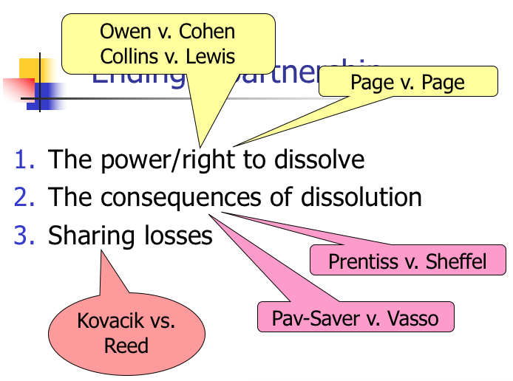
  - A partner ALWAYS has the power to dissolve, but doesn’t always have the legal right
  - Terminology: Dissolution (UPA) and Disassociation (RUPA)
    - Under the UPA a dissolution includes: 1) sale of assets/business; 2) continuation per agreement; and 3) Continuation following wrongful disassociation
    - Under the RUPA a dissolution includes: 1) sale of assets/business
    - Under the RUPA a disassociation includes: 2) continuation per agreement; and 3) continuation following wrongful disassociation
  - 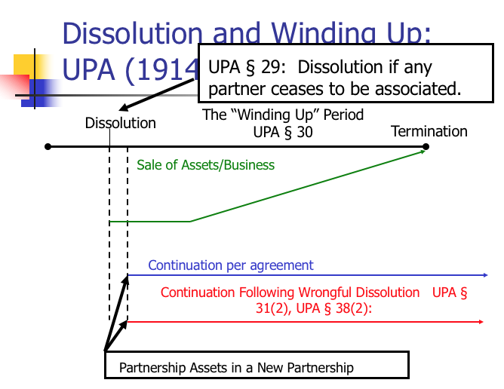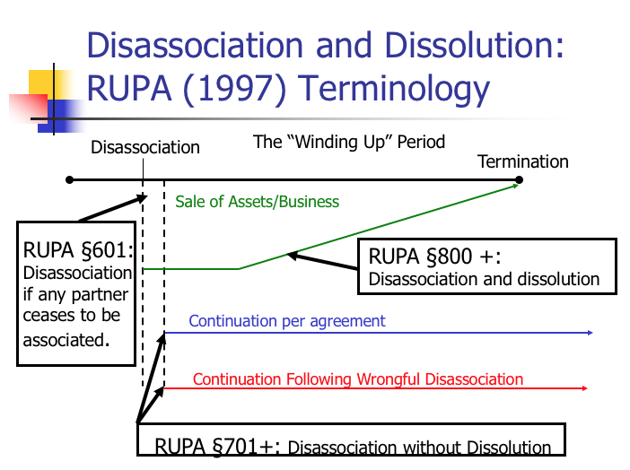
    - Green line - if partner has the power AND the right to dissolve
      - If a partner has the power and the right to dissolve, then the business must be wound up unless there is a pre existing agreement that says the other partners can continue
    - Red line - if partner has the power, but not the right to dissolve
    - Blue line - if partner has the power, but not the right to dissolve but the business may continue per agreement (?)
  - UPA §29 - The dissolution of a partnership is the change in the relation of the partners caused by any partner ceasing to be associated in the carrying on as distinguished from the winding up of the business
  - UPA §30 - On dissolution the partnership is not terminated, but continues until the winding up of the partnership affairs is completed
  - (GT prefers to RUPA) Rule: UPA §31 - Dissolution is caused:
    - (1) Without violation of the agreement between the partners
      - Termination of a definite term or particular undertaking specified
      - Express will of partner when no definite term or particular undertaking specified
    - (2) In contravention of the agreement between the partners
    - (3) By any event which makes it unlawful for the business of the partnership to be carried on or for the members to carry it on in partnership
    - (4) By death of any partner
    - (5) By the bankruptcy of any partner or the partnership
    - (6) By decree of court under UPA§ 32
  - Rule UPA §32 - Dissolution by Decree of Court
    - On application by or for a partner the court shall decree a dissolution whenever:
      - Partner has been declared a lunatic or is declared of unsound mind
      - Partner becomes incapable of performing his part of the partnership contract
      - Partner has been guilty of such conduct as tends to affect prejudicially the carrying on of the business
      - A partner so conducts himself in matters relating to the partnership business that it is not reasonably practicable to carry on this business in partnership with him
      - The business of the partnership can only be carried on at a loss
      - Other circumstances render a dissolution equitable
  - Owen v. Cohen (power/right to dissolve)
    - Facts: P and D entered into an oral agmt. to become partners in operating a bowling alley → had a lot of disagreements and P sued to dissolve the partnership → term of partnership was not fixed and they still had unpaid business loans
    - Issue: Does the evidence warrant a decree of dissolution?
    - Holding: Yes
    - Rule: UPA 32 - On application by or for a partner the court shall decree a dissolution whenever: a partner so conducts himself in matters relating to the partnership business that it is not reasonably practicable to carry on this business in partnership with him
    - Reasoning:
      - It looks like the relationship fell apart because of D for various reasons (D publicly humiliated P, wouldn’t do manual work but still tried to dominate)
      - Court ordered sale of assets and first repayment of the loan before the parties received anything in accordance with UPA §40(b)
        - UPA §40(b) - Order of payments after sale before distributing profits: 1) the claims of the firm’s creditors are paid; 2) claims of a partner other than those for capital and profits; 3) those owing to partners in respect of capital; 4) those owing to partners in respect of profit
    - Notes:
      - Why did Owen sue for dissolution rather than doing it on his own?
        - By taking out the loans, they created an implicit term for the partnership
        - Implicit term - if the partner advances to the partnership with the understanding that the amount contributed was to be a loan and was to be repaid as soon as feasible from prospective profits, then partnership is for term reasonably required to repay the loan
          - GT says: It is based on the understanding of the partners surrounding the loan. Just because a partner makes a loan doesn’t mean it automatically created an implicit term
          - Also a loan from an outside party can create an implicit term
        - Owen sought and received judicial dissolution to avoid possible dissolution in “contravention of agreement” finding
        - If it was implicit, then the court can allow dissolution before the term ended and he doesn’t wrongfully dissolve the partnership
        - By getting the court to dissolve, Owen has the power and the right
      - Legal effect of the court order for dissolution?
        - Owen now has the right and the power to dissolve
        - They must start liquidating the partnership assets and Owen would get his loan repaid before anything else is distributed
  - Page v. Page (power/right to dissolve)
    - Facts: P and D were partners in a linen supply business → business wasn’t doing well and owed a lot to its creditor, a corporation owned by P → business got better, but P still wanted to dissolve the partnership → trial court said the partnership was for a term that is reasonable necessary to repay the debts
    - Issue: Was the partnership for a term or at will?
    - Holding: The partnership was at will
    - Reasoning:
      - It’s true that the partners wanted to pay off the loans, but the facts did not show an implied agreement to continue the partnership for a term
      - Just because the partnership hoped to make a profit doesn’t make it such that it’ll exist until all losses have been recovered
      - D was concerned that P would take advantage of him, but the court said D was protected by the fiduciary duties of co-partners (although it is not clear what the duties are…)
      - Page allowed to terminate partnership since “for profit” does not equal a term, but still owes fiduciary duties
    - Notes:
      - Did the brother have the power and right to dissolve?
        - He had the power because partners always have the power to dissolve
        - Also was deemed to have the legal right because the partnership was at will
      - Why didn’t the brother’s investment create a partnership for a term?
        - Because the money they put in was put in equity, not a loan
        - If it was a loan, then it would be a partnership for a term
      - Why didn’t the loan from the brother’s company create a partnership for term?
        - Because the loan was a demand note → demand notes have no term
        - If the loan has no term, then the partnership can’t have an implied term
  - Prentiss v. Sheffel (consequences of dissolution)
    - Facts: P (2 partners) sued D (1 partner) to dissolve the partnership and have a value fixed on D’s interest → D countered saying he was wrongfully excluded → trial court ruled it was a partnership at will that was dissolved when D was excluded → court appointed a receiver for liquidation and sale of the partnership property → at the sale, Ps bid and received the business → D appealed
    - Issue: Could plaintiffs be allowed to bid for the business?
    - Holding: Yes
    - Reasoning:
      - No evidence that D’s exclusion was done in bad faith, he was excluded because they couldn’t cooperate and work together
      - Also no evidence that D was injured by them purchasing the business, and he actually benefited because without their bid, the selling price would’ve been much lower
      - He also had a right to bid on the property for himself
    - Notes:
      - What did the court find to be the basis of dissolution?
        - Freeze out → decision by 2 partners not to carry on
        - Freeze out leads to dissolution because if partner is frozen out, then they can no longer carry on as a partner
        - “Partnership is an association to carry on as co-owners”
          - The partnership ends when they are no longer carrying on
      - Why did the plaintiffs continue to inform the minority partner?
        - Because they are still a partner, and if you want to carry on the partnership, then you have a fiduciary duty to inform
      - Is the court correct to allow the partners to bid benefits the other partner?
        - Yes money wise, but he isn’t really better off since he clearly wanted the original partnership to continue → otherwise he wouldn’t sue
  - Comparison of UPA and RUPA in what partner receives in sale of business
    - UPA 38(2)(c) - value of supplies only, goodwill NOT included
    - RUPA 701 - buyout price is greater of liquidation value OR sale of entire business as going concern
    - Goodwill is NOT deducted after wrongful dissolution under RUPA
      - Goodwill - an intangible balance sheet asset, may also represent intangible things such as an acquired company’s excellent reputation, brand names, patents, etc.
      - But under UPA, would not include goodwill
    - 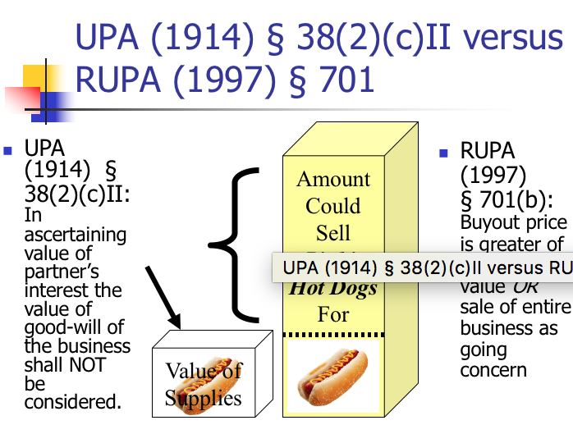
  - Pav-Saver v. Vasso (consequences of dissolution)
    - Facts: Dale, Pav-Saver, and Meersman (owner of Vasso) formed Pav-Saver Manufacturing Company to manufacture and sell Pav-Saver machines → partnership was dissolved and replaced with one between Pav Saver and Vasso → business did well for a while and then it went bad → PSC wrote a letter to Meersman terminating the partnership → Meerseman got mad and physically took over and PSC sued for court order dissolution → Trial court ruled that PSC wrongfully terminated and that Vasso was entitled to continue using PSC’s trademark
    - Issue: Did the trial court err in allowing Vasso to keep the patents and trademark?
    - Holding: No
    - Rule: UPA 38(2) When dissolution is caused in contravention of agreement:
      - Right to damages for breach
      - Other partners may continue business
      - Partner who causes dissolution gets:
        - If business terminates → remaining cash less damage
        - If business continues → value of interest, less damage, but value of goodwill NOT considered in value
    - Reasoning:
      - The termination was wrongful → invokes UPA 38(2) which allows Meersman to continue the business (partner who doesn’t wrongfully terminate can continue business)
      - If partner causes a dissolution, the other partner may continue the business, but the business cannot continue without the machines with the patents and trademarks → court overruled contract provision on having to return patents
      - UPA says the value of business goodwill shall not be considered → Dale is only entitled to the value of business - goodwill
    - Notes:
      - How important is the language about forming a permanent partnership?
        - If business wasn’t referred to as a partnership? Wouldn’t matter as long as it looks like a partnership
        - If not referred to as permanent? It matters because it would make the partnership a default partnership at will
      - Majority Resolution of Issues:
        - Can the partnership continue to use the Pav-Saver patents after the departure of Dale? Yes
        - What is the value of the partnership excluding goodwill at the time of dissolution? $330,000 ($165,000 owed to Dale)
        - What is the implication of the agreement as to liquidated damages? Used to determine damage payment owed to Meersman, not to replace all provisions of UPA 38(2)
      - Argument that the majority is incorrect in its decision?
        - There are 2 possible interpretations of the liquidated damages clause:
          - If either party dissolves, that is wrongful, so §38 may come into play
            - In determining the damages, under §38, the amount is as specified under paragraph 11
          - OR – the partnership can be “terminated” (overriding § 38), subject to the damages provision
        - There are also two ways of interpreting the patent return provision:
          - They agreed that the patents would be returned UNLESS there is wrongful disassociation
          - They agreed the patents to be returned REGARDLESS of whether disassociation was wrongful
      - Three Damage Scenarios:
        - Majority Opinion:
          - Meereseman retains patents
          - Dale receives ½ of value of Pav-Saver excluding patents (goodwill)
          - Dale owes Meerseman liquidated damages
        - Majority Opinion under RUPA:
          - Meerseman retains patents
          - Dale receives ½ of value of Pav-Saver including patents (goodwill included)
          - Dale owes Meerseman liquidated damages
        - Dissent:
          - Meerseman gives up patents
          - Dale receives ½ of value of Pav-Saver excluding patents (goodwill)
          - Dale owes Meerseman liquidated damages
  - Losses After Dissolution
    - UPA 18(a) Each partner shall be repaid his contributions,...and share equally in the profits and surplus remaining after all liabilities, including those to partners, are satisfied; and must contribute towards the losses, whether capital or otherwise, sustained by the partnership according to his share in the profits
    - UPA 40(d) partners shall contribute, as provided by 18(a) the amount necessary to satisfy the liabilities
  - Kovacik v. Reed (sharing losses)
    - Facts: Kovacik remodeled kitchen and asked Reed to be his job superintendent and estimator → Kovacik would invest and they could split profits 50/50 → did not discuss possible losses → later Kovacik told Reed that there were losses and demanded he contribute → trial court found Reed liable for losses and he appealed
    - Issue: Is Reed liable for losses sustained?
    - Holding: No
    - Rule: A partner who only contributes skill and labor to the partnership is not liable for losses (GT says this is all you need to know for exam) (CA law only!)
    - Reasoning:
      - General rule presumes that partners intended to equally split any losses, irrespective of amount contributed, but these cases are when both parties contribute some kind of capital or else was to receive compensation for services rendered to the undertaking before computation of profits or loses
        - Here Reed did not contribute any capital and was not paid for his services
        - Court’s idea was that Reed lost by using his time
      - Case law says upon loss of money, the party who contributed it is NOT entitled to recover any part of it from the party who contributed only services
    - Notes:
      - Is the holding consistent with the statute?
        - No, the presumption is that capital can only be money
        - Statute says that the share of losses be equal to the share of profits and each partner must contribute towards losses
        - Example according to statute: If $15,000 was remaining when the business dissolved → return $10,000 to Kovacik for his capital investment → remaining $5,000 would be split equally between Reed and Kovacik
        - Example according to statute: If $5,000 was remaining when the business dissolved → return $10,000 to Kovacik → split loss of $5,000 between Reed and Kovacik
      - What is the intuition behind the court’s rejection of the statutory scheme
        - Reed lost 9 months of his labor → he still lost that so the decision is fair
      - What if Reed had contributed a nominal amount of capital?
        - He’d be a capital partner, and would be required to share in half of the loss
      - Why didn’t Kovacik and Reed adopt a different rule?
        - Unclear, maybe they both thought they would make money, or Kovacik really thought Reed would be liable anyways
      - What might the effect of the no loss sharing by service partner be on his behavior?
        - Reed may be more reckless because he gets to play with other people’s money without consequence to himself

3) Corporations
- Vocabulary
  - Securities = permanent, long term claims on the corporation’s assets and future earnings instead
  - Capital Structure = the debt securities and equity securities together
  - Debt = held by bondholders, return of a fixed amount
  - Assets = things bought by the company
  - Equity = shares held by shareholders, goes up or down when the value of assets goes up or down
  - 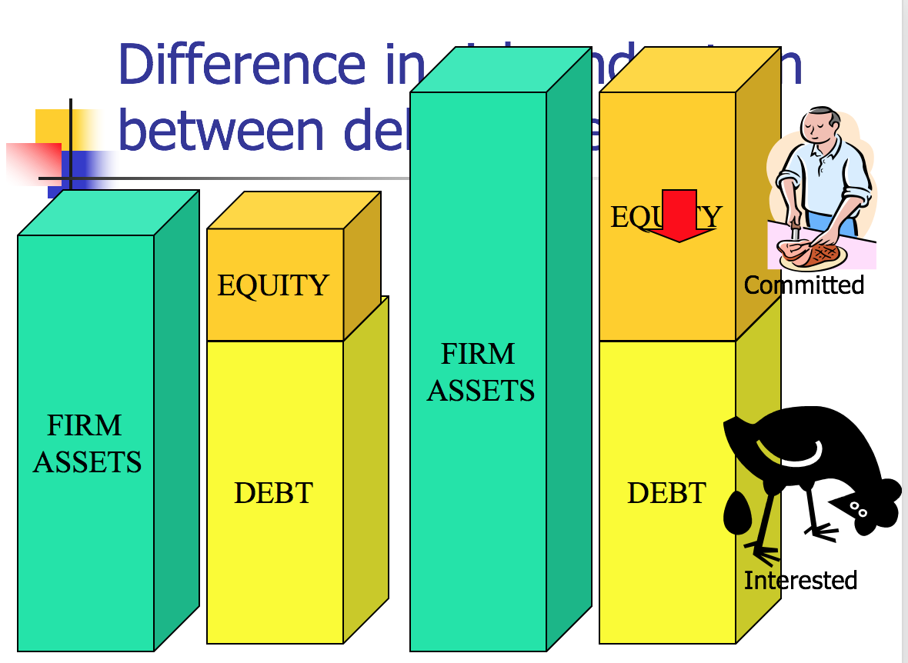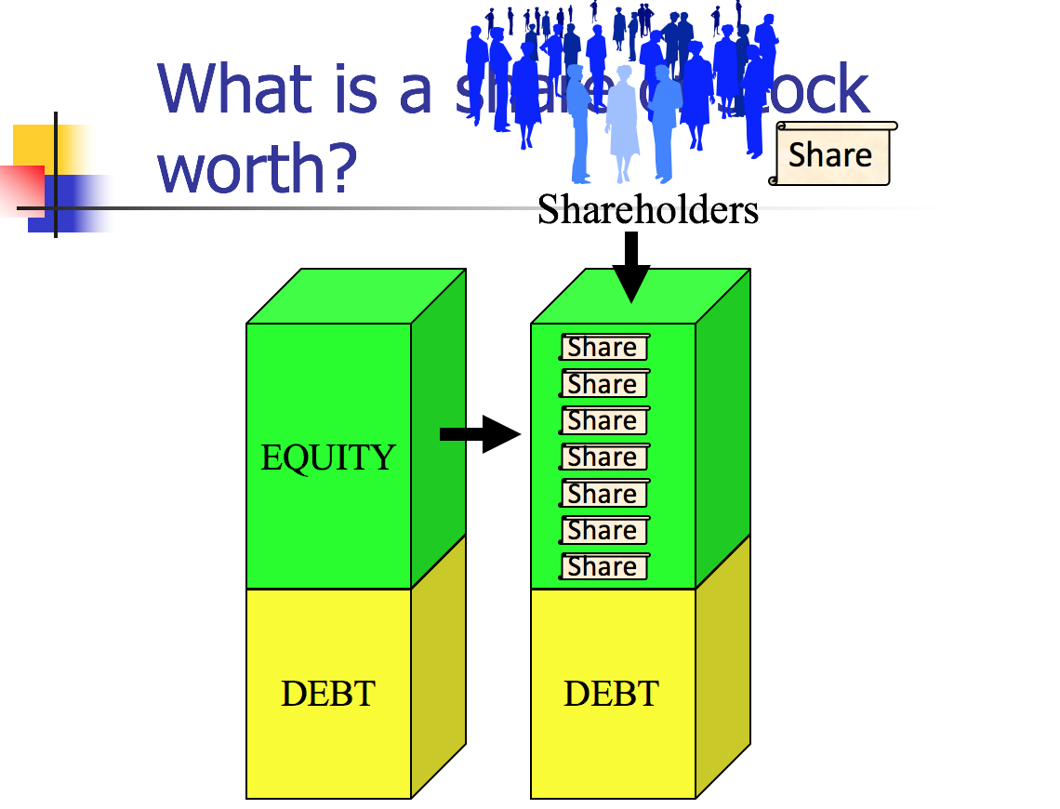
  - Shareholders =
    - Shareholders get to elect directors and vote on major corporate decisions
    - May receive firm’s earnings in the form of dividends
    - If firm is liquidated, will get firm assets after all other claims satisfied
  - Directors = managers of a corporation
  - Shareholders = owners of a corporation
  - Income Statement/ Profit & Loss Statement = Financial statement that indicates results of operations over a specified period
  - Balance Sheet: = summarizes the company’s financial position at a given point in time
    - Describes the assets of the business and the claims on those assets (by the creditors in the form of debt, or owners in the form of equity)
  - Goodwill = (value for what you purchase) - (what it is actually worth)
  - Shares =
    - Equity typically split equally by all the outstanding shares
    - Authorized shares = number of shares the corporation can issue
    - Outstanding shares = number of shares sold and not repurchased
    - Authorized but unissued shares = shares authorized but not yet sold
    - Treasury Shares = shares issues and then repurchased by the firm
    - 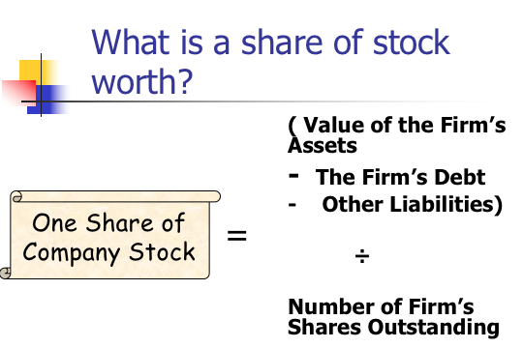
    - Efficient Capital Market Hypothesis = the price of a stock reflects all available information
  - Book value = measure of the equity value of the firm provided by the financial statement
    - This is what the accountants will use
    - General accounting principals: based on cost of obtaining the asset, vs. what others think it is worth
    - Looking at how much it cost to get those assets
  - Market capitalization = measure of the equity value of the firm implied by the trading value of the firm’s stock
    - (trading value of one share of stock) x (total number of outstanding shares)
    - Note: GT prefers to look at market capitalization over book value because people buying and selling shares can accumulate many different sources of info, while accountants are limited to for the most part, cost information
      - Example: Actual cost of acquiring vs. what people think it is worth
  - Enterprise value = measure of the total value of the firm’s assets implied by the trading value of the firm’s stock
    - Market value + firm’s obligations
- Sources of Corporate Law:
  - Individual State Law (Internal Affairs Doctrine)
    - Delaware - large number of corporations incorporated there
    - Model Business Corporations Act (MBCA)
  - Federal Law (doesn’t affect all corporations!)
    - Securities and Exchange Acts
    - Sarbanes Oxley Act of 2002
    - Dodd Frank Act
    - JOBS Act
    - Primarily cover “public” corporations
- Critical Attributes of Corporations:
  - Legal Personality
    - A corporation has its OWN legal personality
    - Separate legal existence from its owners
      - Possesses (some) constitutional rights
      - Separate taxpayer
      - Requirement for formal creation
  - Limited Liability
    - MBCA § 6.22(b) - A shareholder of a corporation is not personally liable for any liabilities and liabilities from acts of the corporation except for what is provided for in the articles of incorporation and the shareholder’s own acts or conduct
  - Separation of Ownership and Control
    - MBCA § 8.01(b) - Except as may be provided in an authorized agreement, all corporate powers shall be exercised by or under the authority of the board of directors, and the business and affairs of the corporation shall be managed by or under the direction, and subject to the oversight, of the board of directors
    - Directors control business operations, shareholders do not, but they can vote on directors
  - Formal Capital Structure
    - Claims on the corporation’s assets and future earnings issued in the forms of securities
      - Securities = permanent, long-term claims on the corporation’s assets and future earnings issued pursuant to formal contractual instruments
    - Capital structure = debt securities (loans) + equity securities (shares)
  - Liquidity
    - Can sell ownership stake in corporation without affecting business
    - Secondary trading markets (e.g. NYSE & NASDAQ)
- Two major ways to estimate value of corporation:
  - Estimation provided by accountants based primarily on cost of assets (book value)
  - Estimation based on perceived value of business interpreted by price at which share of stock is traded (market value)
- “Hybrid” Organizations (“Unincorporated Limited Liability Entities”)
  - More hybrid organizations exist today with aspects of different traditional organizations

 | General Partnership | Corporation | Unincorporated Limited Liability Entities
Limited Liability | None | Yes (b/w board and shareholders) | Some
Formation | Informal | Formalities Required | Formalities Required
Tax Treatment | Pass-through (taxed once) | Double Taxation | “Pass-through”
Governance Malleability | Lots | Limited | Lots
  - Four most common “unincorporated limited liability entities”
    - Limited Liability Partnership
      - General partnership with limited partner liability
      - RUPA 306(c) - a debt, obligation, or other liability is solely the obligation of the LLP
      - Formed by filing “statement of qualification” with SoS
      - General partnership can convert to LLP by filing
      - If one partner commits a tort, other partner not liable
    - Limited Partnership
      - Made up of general (oversee operations) and limited partners (just give money)
      - Formed by filing documents, usually with SoS
      - ULPA 303(a) - Only limited partners who participate in control can be held liable
      - General partners have full personal liability
        - A corporation can be a general partner
    - Limited Liability Company
      - Gives limited liability of corporation, but tax benefits of a partnership
      - Formed by filing with SoS
      - Flexibility: like a partnership, most aspects of management and sharing dictated by the LLC’s operating agreement
        - Makes it more expensive to form → must provide the state with details on how it plans to operate
      - Two types of LLCs:
        - Member-Managed: all members are managers
        - Manager-Managed: some owners aren’t managers and have no right to vote
      - There are limitations on capital structure complexity and share transferability
      - Allows businesses to avoid some of the cost of their activities
    - S Corporation
      - Created by tax code
      - Still technically a corporation, not a hybrid
      - Advantages: Pass-through taxation and limited liability
      - Disadvantages: constraints on number of shareholders, source of corporate income, one class of shareholders only, deductions on pass through losses
- Corporation Formation
  - Corporations require formal creation under state auspices
  - Articles of Incorporation
    - MBCA 2.02(a) - must include name, number of shares, address, incorporators
    - May include MBCA 2.02(b) - initial directors, management, limits of rights, liability on shareholders
    - DGCL 102(a) and 102(b)
  - By-Laws
    - May include MBCA 2.06(b) - Provision for managing the business and regulating the affairs of the corporation
  - Final Steps
    - MBCA 2.05 Organizational Meeting
    - Pick a state
    - Draft Articles of Incorporation and Bylaws
    - File Articles with Secretary of State
    - MBCA 2.05 Finalize directors
    - MBCA 2.05 Appoint officers
    - MBCA 2.06 Adopt by-laws
- Corporation Liability to Third Parties
  - General Rule: Liabilities incurred by the corporation cannot be imposed on the shareholders
    - Unless you can “pierce the corporate veil”
  - When do shareholders have personal liability?
    - MBCA 6.22(b) - “a shareholder is not personally liable for the acts or debts of the corporation except that he may become personally liable by reason of his own acts or conduct”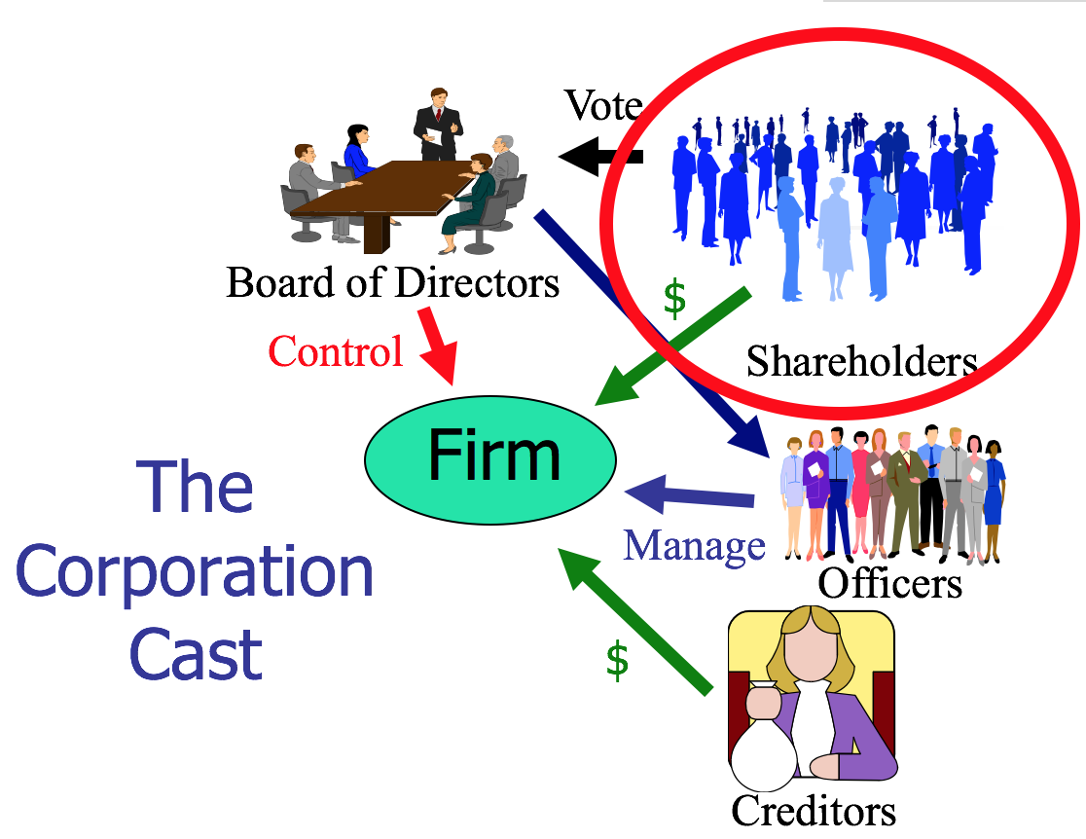
    - The officers kind of act as agents of the directors, but they really are agents of the corporation since they are acting on behalf of the firm
      - No principal-agent relationship between shareholders and the corporation because shareholders have no control
- Walkovsky v. Carlton
  - Facts: P was injured after being hit by a taxi owned by Seon Cab Corp. → Carlton was a stockholder of Seon and 9 other corps. → P alleged that the corps. operated as a single enterprise with regard to financing, supplies, employees, etc. → P said he was entitled to hold the stockholders of the other 9 corps. liable because their structure was an unlawful attempt to defraud the public who might be hurt
  - Issue: Is Carlton liable for P’s damages as a stockholder?
  - Holding: No
  - Rule: If stockholders are respecting the formalities of the corporate form, then the court cannot pierce the corporate veil.
    - Note: Can only pierce the corporate veil for shareholders for whom there is a unity of interest between the firm and the corporation (you wouldn’t really go after someone who has a tiny share)
  - Rule: If corporation is a dummy for individual stockholders who are actually carrying out business for personal rather than corporate ends, then the stockholders could be held personally liable
  - Reasoning:
    - P didn’t provide enough evidence to show that D was doing business in his own interest rather than the business’s interest
    - Just because an enterprise is comprised of multiple corporations does not mean it is fraudulent → also not fraudulent to take out the min amount of insurance
    - Although the court found that there was evidence of commingling and that there was undercapitalization of the corporation, the plaintiff failed to allege that Carlton failed to respect the formalities of the corporate form
  - Class Notes:
    - Three Theories of Imposing Liability:
      - Theory 1: Piercing Corporate Veil
        - Rejected because no allegation of failure to respect formalities of corporate form
          - E.g. Annual meeting, pay taxes, keep written records (corporate minutes)
        - Must show unity of interest with the shareholder
        - What would a plaintiff have to show in order to pierce the corporate veil?
          - “That defendant Carlton and his associates are actually doing business in their individual capacities, shuttling their personal funds in and out of the corporations ‘without regard to formality and to suit their immediate convenience’”
      - Theory 2: Enterprise Liability
        - If one organization is working on behalf of and subject to control of other organization, operations are intermingled → appropriate to have shared liability
        - Must show comingling of funds because they are sister companies
        - Difference from piercing corporate veil?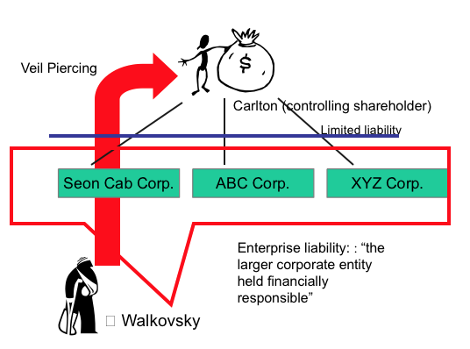
          - In enterprise liability, you go after the sister corporation and are claiming that the corporation is a fragment of a larger corporation which actually conducts the business
          - In piercing, you go after the shareholder and are claiming that the corporation is a dummy for its individual shareholders who are carrying on the business in their personal capacities for purely personal rather than corporate ends
        - What would a plaintiff have to show in order to recover under the enterprise theory?
          - That Carlton didn’t respect the separate entities of the corporations
            - Assignment of drivers, use of bank accounts, ordering of supplies, etc.
        - There was some evidence of intermingling, but wouldn’t create liability for Carlton since he is just a shareholder, not a parent corporation
        - Rejected because would need to show Carlton didn’t respect separate personalities of the corporations
      - Theory 3: Principal-Agent
        - Rejected because Carlton is a shareholder, not a principal
        - The board is controlling operations, not Carlton
    - Takeaway: You can split a single business enterprise into multiple corporations so as to limit liability exposure of each part of the business, as long as you respect the corporate form
- Sea-Land Services, Inc. v. Pepper Source
  - Facts: Sea-Land shipped peppers on behalf on D → D didn’t pay for the freight bill so P sued to recover → default judgment was entered, but it was found that D has been dissolved and had no assets → P sued Marchese and five business entities he owned, including D, alleging the corporations existed for the purpose of defrauding → also said marchese should be liable since he created and used the corporations for his own personal use
    - Pierce Corporate veil to get to Marchese → reverse pierce → get to the other corporations
      - Reverse pierce - after piercing the corporate veil, reverse piercing allows you to gain access to the assets of other corporations that the shareholder owns
      - Same test applied, just now between the shareholder and the other corporation
  - Issue: Did P show that the separate corporate existences “would sanction a fraud or promote injustice”?
  - Holding: No
  - Rule: Van Dorn Test - A corporate entity will be disregarded and the veil of limited liability pierced when: 1) There is such unity of interest and ownership that the separate personalities of the corporation and the individual (or other corporation) no longer exist; and 2) Circumstances are such that adherence to the fiction of separate corporate existence would sanction a fraud or promote injustice (Test for Piercing the Corporate Veil)
    - Four Factors to justify disregarding separate identities:
      - Failure to maintain adequate corporate records or to comply with corporate formalities (E.g. Annual meeting, pay taxes, keep written records (corporate minutes))
      - The commingling of funds or assets
      - Severe undercapitalization (equity is really suspiciously small)
      - One corporation treating the assets of another corporation as its own
  - Reasoning:
    - Court agreed that there was shared control/unity of interest and ownership→ Part 1 of Van Dorn Test satisfied
    - Sea-Land hasn’t shown that D intended to defraud it → tried to argue that honoring separate identities would promote injustice
      - Court said an uncollected debt isn’t enough to show that the separate corporate existence promotes injustice → no evidence
      - Would need to show something like the corporate facades to avoid its responsibilities to creditors
      - There must be something wrong beyond inability to pay the creditor
  - Class Notes:
    - What should Sea-Land have to show on remand to prove unjust enrichment?
      - If Marchese was portraying Pepper Source as a legitimate business, because it wasn’t and that he was trying not to pay for delivery
- Roles and Duties with Respect to Creditors
  - Bottom Line: Governed by contract law
    - Legal analysis turns on:
      - Interpretation of express terms
      - The implied duty of good faith and fair dealing
    - No fiduciary duties to debtholders
- Corporate Fiduciary Duties
  - Directors generally do not owe much to shareholders, but all shareholders have equal standing to challenge a director if he fails to act as an appropriate fiduciary
  - To whom are fiduciary duties owed?
    - Two competing theories:
      - Shareholder Primacy - Firm only owes a duty to shareholders (Dodge v. Ford)
      - Stakeholder Theory - Firm owes a duty to shareholders, officers, client/customers, community, employees
  - Who is bound by fiduciary duties?
    - Board of Directors are bound by the fiduciary duties to the shareholders
    - Senior Officers
    - Controlling shareholders
  - What is the content of corporate fiduciary duties?
    - Duty of Care
      - Regulates diligence in performing tasks
      - Failure to act and carry out basic supervision can violate Duty of Care (Van Gorkom)
        - DGCL 102(b)(7) - May eliminate personal liability of a director for monetary damages
      - Limited by the Business Judgment Rule (BJR) - most actions are covered
      - MBCA 8.30 Director may be found liable if:
        - Corporate charter indemnification or cleansing doesn’t preclude liability AND
        - Didn’t act in good faith (see Stone)
        - Unless not acting in shareholder’s best interest (Ford)
        - Unless information-gathering process flawed (Smith v. VanGorkom)
        - Unless conflict of interest transaction (Broz)
          - Directors can make a decision that they personally benefit from, but can’t claim protection by BJR in court
          - You lose the BJR because it is a conflict of interest transaction
          - Shareholders can cleanse still
          - Apply same analysis as in Duty of Loyalty
        - Failure to devote ongoing attention to oversight, or devote timely attention when particular facts arise
          - Inaction of a director not covered by BJR (francis)
      - Delaware’s Duty of Care Standard
        - Regulates diligence in performing tasks
        - Limited by the Business Judgment Rule
          - Courts defer to the BOD’s actions unless (BJR will protect unless):
            - Actions are not in the honest belief that action is in the best interests of the corporation; or
            - Actions are not based on an informed investigation; or
            - Actions involve a conflict of interest
      - Duty of care violation can be cleansed (Smith v. VanGorkom)

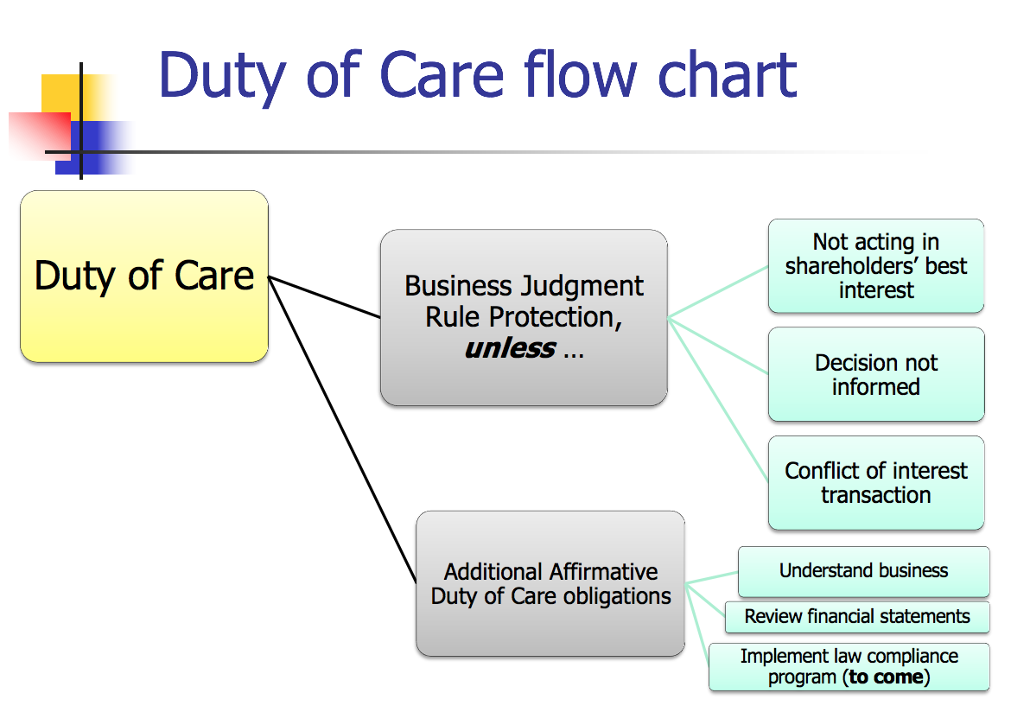
    - Duty of Loyalty
      - Regulates self-dealing transactions
      - NO BJR SHIELD
      - “Essentially the duty of loyalty mandates that the best interests of the corporation and its stockholders takes precedence over any interest possessed by a director...and NOT shared by the stockholders generally”
      - We’ve adopted a sort of middle ground rule between BJR and banning related party transactions altogether
      - Two-Step Analysis:
        - Step 1: Does the transaction involve a conflict of interest? (need all three)
          - Is the director/shareholder on the other side of the transaction?
            - MBCA 8.60 - There is a conflicting interest if:
              - Director is a party to the transaction;
              - If Director had knowledge and a material financial interest in the transaction; or
              - A transaction which the Director knew a related party had a material financial interest in
                - See MBCA for who a “related party” is
                - Generally includes immediate family
          - Is the firm on one side of the transaction?
            - Corporate Opportunity Doctrine (Guth) (Broz v. Cellular)
              - Corporate Opportunity Doctrine exists where:
                - Corporation is financially able to take the opportunity
                - Corporation has an interest or expectancy in the opportunity
                - Embracing the opportunity would create a conflict between director’s separate interests and that of the corporation
                - Opportunity is in the corporation’s line of business
          - Is the director/shareholder receiving a benefit from the firm not received by all?
        - Step 2: Has the transaction been properly “cleansed”? (MBCA 8.61, DGCL 144) (need at least one of three)
          - Approved by informed, disinterested directors
            - Disinterested - no financial interest in transaction
          - Ratified by informed, disinterested shareholders
          - Adjudged substantively fair to corporations
      - 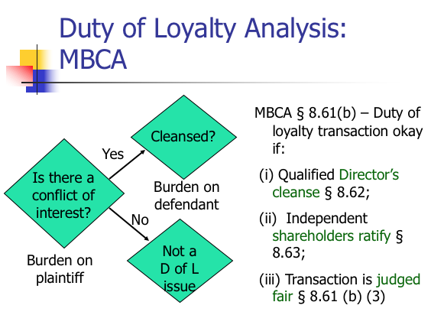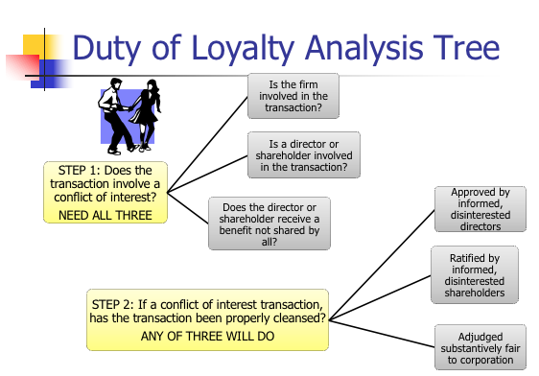
    - Duty to Act in Good Faith
      - Failure to gather information to avoid violations of law
      - Stone v. Ritter: “although good faith may be described colloquially as part of a ‘triad’ of fiduciary duties that includes the duties of care and loyalty, the obligation to act in good faith does not establish an independent fiduciary duty that stands on the same footing as the duties of care and loyalty.”
      - 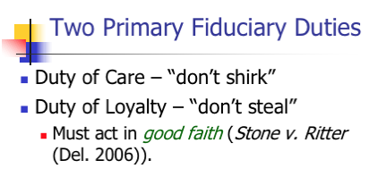
    - Duty to Disclose (?)
  - 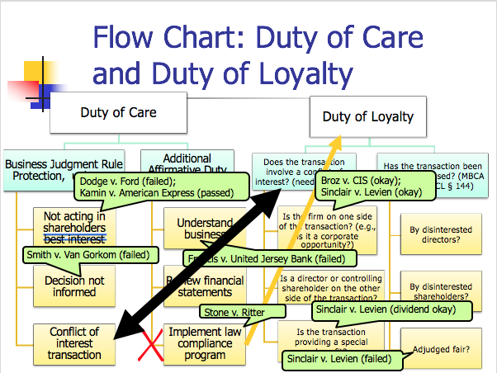
- Dodge v. Ford Motor Co. [Duty of Care]
  - Facts: D manufactured cars → in 1916, Henry Ford announced that no special dividends would be paid out in the future and profits would instead be reinvested → the Dodge brothers complained and offered to sell his shares to Ford, who refused to buy them → brothers sued him
    - Dividend = a distribution of a portion of the company’s earnings, decided by the Board of Directors, to a class of its shareholders in the form of cash, stock, or property
  - Issue: Could the court enjoin Ford from building the new smelting plant and order the payment of the dividends?
  - Holding: No on the smelting plant, but yes Ford is required to distribute the dividend payment
  - Rule: A business corporation is organized and carried on primarily for the profit of the stockholders
  - Reasoning:
    - Ford had a huge surplus, and building the plant was payable over a considerable period of time, so it seems too arbitrary not to distribute the dividend
    - Ford admitted that he had an interest in doing so outside of maximizing profits
      - The Court took biggest issue with this, Ford said the reason for not distributing was because he cared about the stakeholders, and by doing this he wasn’t fulfilling his obligations to the shareholders
      - “It is not within the lawful powers to shape and conduct...for the merely incidental benefit of the shareholders and for the primary purpose of benefiting others”
  - Class Notes:
    - Courts may not scrutinize decisions about how to maximize profits, but they will scrutinize decisions about whether to do so
    - Generally the Court will not interfere with management of directors unless it is clearly made to appear that they are guilty of fraud or misappropriation of the corporate funds
    - Does this decision support shareholder primacy?
      - Yes, by not paying the shareholders and admitting other interests, Ford was not fulfilling his obligations to the shareholders
    - Was 35 million a fair offer to Ford?
      - Depends on whether you look at the balance sheet or income statement
      - Translate into implied firm value: $35mil for 10% of shares → means the Dodge brothers value the company at $350mil
      - Balance Sheet said Ford Book Value = $112 million → accountants would’ve told Ford that Dodge’s offer was 3x book value and too expensive
        - Note: But accountant are locked into numbers
      - Price to Earnings Multiple: 6 x price/earnings
        - ($350 mil)/($60 mil) = approximately 6
          - Means in 6 years would get money back
        - The lower the number the better → here this is a really good deal
- Smith v. VanGorkom [Duty of Care]
  - Facts: Transunion was having difficulty generating sufficient taxable income to get investment tax credits → Transunion CEO Van Gorkom met with senior management and discussed a buyout → Van Gorkom met with Pritzker and proposed a leveraged buyout with a per price share for sale of the company without consulting anyone except controller Peterson → directors eventually approved a proposed merger agreement → later approved a revised deal → shareholders voted to approve → signed and announced
    - Leveraged Buy Out - acquisition of all outstanding shares using borrowed funds
      - Loans secured by the assets of the company to be acquired
      - Basically saying you will pledge the company you just bought as collateral to the loaners (similar to a mortgage)
    - Management Buy Out - a type of LBO where management acquires all outstanding shares
  - Issue: Did the directors act in an informed and deliberate manner in determining whether to approve the agreement of the merger?
  - Holding: No
  - Rule: MBCA In making a business decision, the directors of a corporation must act on an informed basis, in good faith, and in the honest belief that the action taken was in the best interests of the company
  - Reasoning:
    - Was the BOD informed when it made the decision?
      - No, BOD made its decisions on Van Gorkom’s representations
      - All they knew was that Pritzker was willing to pay $17 million premium over the prevailing market price → but they didn’t know how the price was set
      - They didn't know about the Pritzker meeting or what it was for
      - Also BOD didn’t receive any written documents with terms, support, etc. and weren’t told how the price per share came to be, they only knew it was above the market selling price and based on a study of feasibility
    - Did the Board’s subsequent action in voting cure?
      - No, still not informed
    - Did the shareholder vote cure?
      - No because they also didn’t know how the numbers were reached and also didn’t know the price was based on a study of feasibility and not one of value
  - Main Takeaways:
    - Duty to make informed decisions
    - If grossly negligent, will be found to have breached duty to shareholders
  - Class Notes:
    - This failed the BJR → “are not based on an informed investigation”
      - Who has the burden of proof on this issue? Party attacking the board’s decision
      - What must the party prove? Gross negligence
      - How often do directors lose on this ground? Very rarely
    - How can directors protect themselves from liability for being uninformed?
      - Be informed
      - Convince the court to defer to your business judgment and show that there is no personal gain
      - Indemnification (MBCA 8.51 - 8.56) (DE 145)
        - DGCL § 145 (abbreviated!):
          - (a) A corporation shall have power to indemnify a person who is or was a director against expenses (including attorney’s fees), judgments, fines and amounts paid in settlement if the person acted in good faith and no reasonable cause to believe conduct was unlawful. Termination by settlement does not create a presumption not in good faith or conduct was unlawful.
          - (b) No indemnification if a person shall have been adjudged liable to the corporation unless the Court of Chancery permits.
          - (c) If successful on the merits such person shall be indemnified.
          - (g) A corporation shall have power to purchase and maintain insurance on behalf of a director for any liability, whether or not the corporation would have the power to indemnify such person against such liability.
      - Directors and Officers’ Insurance (MBCA 8.57)
        - Protects from broader range of liability and is good if the corporation doesn’t have enough money to indemnify
        - Corporation will pay for insurance
- Francis v. United Jersey Bank [Duty of Care]
  - Facts: Pritchard & Baird was a reinsurance broker → mother Lillian had a 48% interest and was a director → remaining shares were owned by her sons who were also directors → the sons withdrew money from funds the corporation was supposed to hold in trust for its clients in the form of “loans” → Lillian was in a deep depression and didn’t know what was happening → the misappropriation was discovered and the corporation became insolvent → Lillian died → creditors sued her estate
  - Issue: Did Lillian have a duty to the clients, did she breach it, and was her breach the proximate cause of her loss?
  - Holding: Yes
  - Rule: Affirmative Duties of a Director:
    - Obligation of basic knowledge and supervision
    - Read and understand financial statements
    - Object to misconduct and if necessary, resign
  - Reasoning:
    - Generally directors should have at least a rudimentary understanding of the business of the corporation and are obligated to keep informed
    - Directors are immune is they rely on financial statements in good faith and if one discovers an illegal course of action → duty to object
      - She should have read them and would have discovered the “loans”
    - This corporation looks like a bank → her relationship to the clients is like a director of a bank to its depositors
    - The funds were held in a trust → trust relationship gives rise to a duty to guard the funds with fidelity and good faith
    - It was proximate cause because:
      - She didn’t resign until just before the bankruptcy
      - No factual basis for argument that losses would’ve occurred even if she had objected and resigned
      - Her duties extended to reasonable attempts to prevent misappropriation
      - Her negligence was a substantial factor contributing to the loss
  - Notes:
    - Guttentag says there probably wasn’t much Lillian could’ve done, but the court wants to find liability because they wanted to find someone to blame, maybe wanted to deter bad behavior
    - Transaction was heavily regulated because of the amount of money involved
    - The BJR does NOT apply here because it applies to actions, not inaction
- Broz v. Cellular Information Systems, Inc. [Duty of Loyalty]
  - Facts: Broz was president and sole stockholder of RFBC which provided cell service → he was also a director of CIS, a competitor → Makinac company was trying to divest its Michigan-2 cell license → reached out to Broz about an acquisition for RFBC, but not CIS which was having financial difficulties → CIS had been divesting its cell licenses → Broz spoke with a few higher-up members of CIS about his interest in Michigan-2 → Pri-Cellular begins acquisition process of CIS and tried to also get Michigan-2 → RFBC outbid them and got it → Pri-Cellular offer for CIS closes
  - Issue: Did Broz breach his fiduciary duty to CIS?
  - Holding: No, he was under no duty to consider the “contingent and uncertain plans of Pri-Cellular”
  - Rule: Corporate Opportunity Doctrine → Guth Factors (see above)
  - Rule: If the director or officer believes, based on one of the factors that the corporation isn’t entitled to the opportunity, then he may take it for himself
  - Reasoning:
    - A corporation fiduciary agrees to place the interests of the corporation before his or her own interests
    - Step 1: Does the transaction involve a conflict of interest? (need all three)
      - Is the director or shareholder on the other side of the transaction?
        - Yes, the director is a party to the transaction between RFBC and had knowledge and a material financial interest in the transaction
      - Is the firm on one side of the transaction? Court said no
        - Corporate Opportunity Doctrine
          - Corporation is financially able to take the opportunity? No, CIS was struggling financially
          - Corporation has an interest or expectancy in the opportunity? No, Mackinac never offered it to CIS
          - Embracing the opportunity would create a conflict between directors separate interests and that of the corporation? No conflict because Broz didn’t take any CIS opportunity
          - Opportunity is in the corporation’s line of business? Was in line with business, but CIS had been divesting itself of licenses and its articulated business plan involved no new acquisitions
      - Does director receive a benefit not received by all? DNR?
    - Trial court said Broz was obligated to formally present the opportunity to the CIS board → this court said no, DE law doesn’t require one in order to find that a corporate opportunity had not been usurped
    - Broz had no duty to consider Pri-Cellular because:
      - The acquisition plan wasn’t certain at the time
      - Would be impractical if a director or officer had to consider all potential future occurrences in determining if there was a conflict
  - Note:
    - Point of decision is to say that you don’t have to get every single director action cleansed at a director’s meeting
    - What if PriCellular had no delay in tendering the offer to CIS?
      - Likely court would’ve seen the opportunity to get Michigan-2 as within the opportunities of CIS
    - Was the court fair in treating CIS’s interest in Michgan-2 as separate from that of Pri-Cellular?
      - Depends on if you think the timing is right
    - What advice would you give to Broz?
      - Resign as director from CIS
      - Cleanse → make a formal presentation to the board
      - RUPA allows you to modify the Duty of Care and loyalty → Broz could’ve had a provision in agreement to waive corporate opportunity doctrine
    - There was a conflict in the first place! Him being a director of CIS and president/sole stockholder of RFBC was a conflict
- Sinclair Oil v. Levien [Duty of Loyalty by Shareholder]
  - Facts: Sinclair is primarily a holding company in the oil business → Sinclair is a 97% shareholder of Sinven, a subsidiary in Venezuela → Sinclair nominates all directors of Sinven’s BoD and almost all of them worked in another corporation belonging to Sinclair → Sinven sued for damages arising from dividends paid by Sinven, denial of industrial development, and breach of contract
  - Issue: Were the dividend payments objectively fair?
  - Holding: Yes, under the BJR
  - Reasoning:
    - Step 1: Is there a conflict of interest transaction? No Conflict
      - Was shareholder on one side of the transaction? Yes Sinclair was
      - Was corporation on one side of the transaction? Yes Sinven was
      - Shareholder received benefits not received by all?
        - No the minority shareholders received a proportionate share of the money that was transferred
    - Step 2: Does not reach
  - Issue #2: Did Sinclair deny Sinven of industrial development?
  - Holding #2: No
  - Reasoning #2:
    - It applied the BJR because it so clearly wasn’t an opportunity
      - P didn’t prove any business opportunities which came to Sinven independently and Sinclair took or denied to Sinven → no self-dealing
      - Sinven also didn’t show that there were any business opportunities that came to it independently and Sinclair took or denied it to them
    - Note: The court incorrectly applied the BJR when it should have applied to the Corporate Opportunity Doctrine Guth factors
  - Issue #3: Did Sinclair breach its contract?
  - Holding: #3: Yes?
  - Reasoning #3:
    - Step 1: Is there a conflict of interest transaction? Yes
      - Shareholder on one side of transaction? Sinclair was a party
      - Corporation on one side of transaction? Sinven was a party
      - Shareholder received benefit not shared by others? Sinclair received all the benefit while Sinven didn’t get anything
    - Step 2: No cleansing occurred
      - Approved by disinterested, informed directors? There was no cleansing by disinterested directors because they didn’t exist, almost all directors worked for Sinclair in some other way
    - Step 3: Apply Intrinsic Fairness Test since no cleansing (adjudged fair?)
      - Sinclair must prove that its causing Sinven not to enforce the contract was intrinsically fair to the minority shareholders of Sinven
      - Court kind of applying its own BJR
      - Court said this was self-dealing where it caused Sinven to contract with another Sinclair subsidiary, “International”
      - Sinclair received products, but didn’t pay Sinven on time or comply with a minimum purchase requirement → clear breach
      - Sinclair got all the benefits of the transaction without adhering to its obligations so it is unfair
  - Notes:
    - Why is this a duty of loyalty case?
      - Rare, but because sometimes shareholders have a fiduciary duty to other shareholders
      - If dominant or controlling shareholder or group of shareholders, then the controlling shareholder has a fiduciary duty to other shareholders
      - “A director is a fiduciary… So is a dominant or controlling stockholder or group of stockholders… [W]here any of their contracts or engagements with the corporation is challenged the burden is on the director or shareholder not only to prove the good faith of the transaction but also to show its inherent fairness from the viewpoint of the corporation and those interested therein.” Pepper v. Litton
    - How might a corporation that owns a large percentage of stock in another corporation deal with a minority shareholder that may file a fiduciary duty lawsuit?
      - Bring in some disinterested directors who would probably vote in your favor and make sure they stay informed
      - Buy out the minority shareholders to avoid issue completely
- Stone v. Ritter [Duty of Good Faith]
  - Facts: AmSouth Bank got in trouble for failing to file “suspicious activity reports” → was also penalized for operating an inadequate anti-laundering program → report said the compliance program lacked adequate board management and management oversight
  - Issue: Did the directors fail to act in good faith regarding their oversight responsibilities?
  - Holding: No
  - Rule: Caremark Standard → conditions predicate for director oversight liability:
    - Directors utterly failed to implement any reporting or information systems or controls
    - Having implemented such a system or controls, consciously failed to monitor or oversee its operations thus disabling themselves from being informed of risk or problems requiring their attention
  - Rule: “Director’s obligation includes a duty to attempt in good faith to assure that a corporate information and reporting system … exists, and that failure to do so …may, in theory at least, render a director liable for losses caused by non-compliance with legal standards.”
  - Reasoning:
    - Graham case → directors/officers may assume the integrity of employees and honesty of their dealings unless there are grounds to suspect deception
    - Report found that the Board dedicated considerable resources to the compliance program and put many measures and systems in place to attempt to ensure compliance
    - Board reasonably relied on periodic reports by employees and departments who were responsible for filing SARs and monitoring compliance
  - Notes:
    - Stone v. Ritter rejects the duty of care, duty of loyalty, and duty of good faith
    - Says the obligation to act in good faith does NOT establish an independent fiduciary duty → it belongs under one of the other existing duties → probably belongs in duty of care, but court puts it under duty of loyalty, this way the obligation can’t be contracted out of
    - Does the board have a duty to adopt a law compliance program?
      - Old Rule: Directors entitled to rely on honesty of subordinates until something occurs to put them on notice (Graham v. Allis-Chalmers)
      - New Rule: Director’s obligation includes a duty...to assure that a corporate info and reporting systems...exists, and that failure to do so...may, in theory, at least, render a director liable for losses caused by failure to oversee
    - What would an “adequate” law compliance program include?
      - 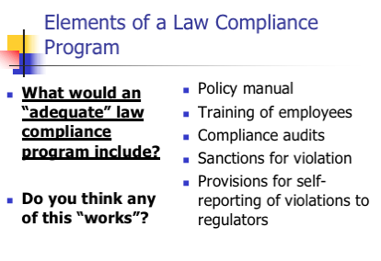
- Shareholder Duties and Roles
  - Duties: None, unless they are a controlling shareholder
  - Roles: Sue, Vote, Sell
- Two Kinds of Lawsuits a Shareholder Can Bring:
  - Direct Suit - suit alleging a direct loss to the shareholder
    - 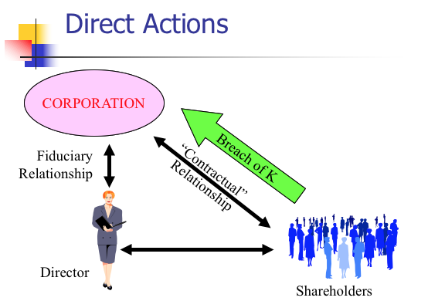
    - Bases for Direct Claims:
      - Force payment of promised dividend
      - Enjoin activities that are ultra vires (beyond legal authority)
      - Claims of securities fraud
      - Protect participatory rights for shareholder
  - Derivative Suit - a suit alleging a loss to the shareholder caused by a loss to the corporation
    - 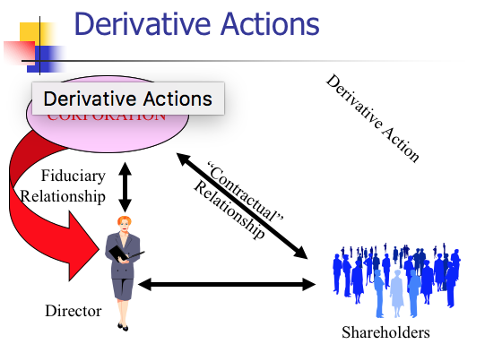
    - Bases
      - Breach of duty of care
      - Breach of duty of loyalty
      - By either directors or a majority shareholder who has fiduciary duties
    - Technically the corporation has been harmed by directors, and as owner, shareholder has been harmed
      - The corporation should bring the lawsuit against the directors, but it is weird because essentially directors suing directors → unlikely to happen in real life
    - Two kinds of suits contained in a derivative lawsuit:
      - Suit by corporation against directors for failure to carry out fiduciary duties; and
      - Suit by plaintiff arguing that he or she should substitute for the directors in managing this particular aspect of the corporation’s business
    - Remedies: Since shareholder is “suing in right” of the corporation, remedy from principal suit goes to the corporation
      - Corporation is required to pay shareholders’ attorneys fees if suit is successful or settles
    - Three Procedural Hurdles to a Derivative Action:
      - Bonding Requirement
        - In a minority of states (not DE), a derivative claimant with “low stakes” must post security for corporation’s legal expenses
        - Required to deter frivolous lawsuits
      - Demand Requirement (grimes v. donald)
        - Most states require shareholders in derivative suits to approach BoD first and demand that they pursue legal action
        - Typically a letter from shareholder to BoD
          - Must request board bring suit on the alleged cause of action
          - Must be sufficiently specific as to apprise the board of the nature of the alleged cause of action and to evaluate its merits
        - DGCL - Shareholders must make “demand” before filing suit...unless futile
          - Futile if plaintiff can create reasonable doubt that:
            - Directors are disinterested and independent, or that
            - Challenged transaction was product of valid exercise of BJR
      - Special Litigation Committee (Zapata Corp.)
        - Step 1: Inquiry into the independence and good faith of the committee and the bases supporting its decisions
        - Step 2: Court applies its own business judgment as to whether the case should be dismissed
- Grimes v. Donald
  - Facts: DSC & Donald made an Employment Agreement in which Donald would be general manager of the company and he would report to the Board → he was permitted to declare “constructive termination without cause” if Board unreasonably interfered with his judgment → shareholder Grames objected because it gave him too much power
  - Issue #1: Has Grimes stated a claim for abdication of directorial duty?
  - Holding #1: No
  - Reasoning #1:
    - Allegations are not well-pleaded
      - Directors may not delegate duties which lie “at the heart of the management of the corporation” → this Agreement doesn’t do this and allows the directors to still fulfill its fiduciary duties
      - It is not an abdication just because it limits the board’s freedom of future action
  - Issue #2: Should the claim for excessive compensation be dismissed?
  - Holding #2: Yes
  - Rule: A stockholder filing a derivative suit must allege either that the board rejected his pre-suit demand that the board assert the corporation’s claim or allege why stockholder was justified in not doing so
  - Reasoning #2:
    - Derivative action because it belongs to the corporation
    - If demand was made and the Board rejects it → Board is entitled to BJR presumption unless reason to doubt otherwise → if rejected for wrongful reason, then could continue suit
    - Problem here is that P made a pre-suit demand but then later said it was excused → by making demand he waived his right to contest the Board’s independence
    - What he was supposed to do was plead with particularity why the Board’s refusal to act on the derivative claims was wrongful
  - Notes:
    - What standard of review applied to compensation and why?
      - Business Judgment Rule because Grimes made a demand
    - What were Grimes’ claims?
      - Abdication Claim - direct claim - Grimes loses on merits
        - Court applied BJR and said no power was abdicated, just made a judgment call based on bank reports and lawyers’ advice
      - Excessive Compensation Claim - derivative claim - Grimes loses on procedure
    - What recourse does a shareholder have if the Board decided not to pursue?
      - Director refusal of demand subject to BJR by Court
    - Does making the demand affect one’s subsequent rights?
      - Yes, in DE, once the demand has been made, the person can no longer challenge the Board’s independence
      - Only the Board’s handling of the demand request can be challenged
    - A rational plaintiff in DE will file derivative suit BEFORE making a demand
      - Consequences of not making demand trivial - if required, slight delay while you make demand
      - Preserves the right to litigate
- 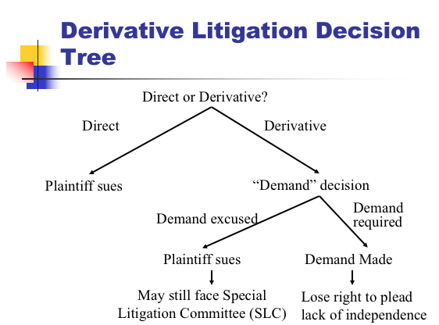
- Zapata Corp. v. Maldonado
  - Facts: Stockholder of Zapata, Maldonado, instituted a derivative action on behalf of Zapata against 10 officers/directors alleging breach of fiduciary duty → didn’t make a demand to the board, claimed it was futile → some directors left Zapata → an independent Investigation Committee was formed and it was determined by them that the suit should be dismissed
  - Issue: Does the Committee have the power to cause the action to be dismissed?
  - Holding: Yes, but it must satisfy the Zapata Test
  - Rule: Zapata Test:
    - Step 1: Court should inquire into the independence and good faith of the committee and the bases supporting its conclusions
    - Step 2: Court should apply its own independent business judgment and determine whether the motion should be granted
  - Reasoning:
    - 141(c) allows a board to delegate authority to a committee → the committee may dismiss if the board had the power to
    - A board has the power to choose not to pursue litigation when demand is made upon it, as long as the decision is not wrongful
    - Court said it is ok for tainted board members to appoint a non-tainted committee
  - Notes:
    - Can the Board seize the derivative litigation?
      - Maybe, must satisfy Zapata Test
    - Can the tainted Board members appoint a non-tainted committee? Yes
    - How should a court review the decisions of the special litigation committee? Court’s Business Judgment
    - Why is the judicial review far more intrusive than usual?
      - Context: Demand was excused because the board was disabled from acting due to conflicted interest
      - Committee was appointed by a disabled board → suspicious enough situation to warrant it
- Shareholder Voting
  - Who votes? Shareholders on record, usually one vote per share
    - Holder on the record date votes (MBCA § 7.07)
      - No more than 70 days before vote
      - So if you buy someone’s share 60 days before the vote, you cannot vote, but the previous owner can
    - Default rule is one share – one vote (MBCA § 7.21)
      - Unless Articles of Incorporation provide otherwise
  - When do they vote? Shareholders meetings or through Unanimous Written Consent
    - Annual meetings (MBCA § 7.01)
      - Time set in bylaws
    - Special meetings (MBCA § 7.02)
      - By request of Board of Directors, or
      - At written request of at least 10% of shares
    - Unanimous written consent (MBCA § 7.04)
  - How do they vote?
    - Most matters require a majority of shares present at a meeting at which there is a quorum (MBCA § 7.25(c))
    - Shareholders vote either in person or by proxy (MBCA § 7.22)
      - Proxy is like a mail in ballot where a shareholders appoints a proxy (AKA proxy agent) to vote on his behalf at the shareholder’s meeting
      - Appointment affected by means of a proxy (Card)
        - May specify how shares should be voted or give the agent discretion
  - What do they vote?
    - Entitled to vote on:
      - Election of directors (MBCA §§ 8.03-8.08)
        - Incumbent board will nominate a slate of directors and send out official proxy solicitation materials
        - A competing slate will offer in separate proxy materials (Rosenfield)
          - Must be a shareholder in order to do this
      - Amendments to Articles of Incorporation and By-Laws (MBCA §§ 10.03, 10.20)
        - Amending Corporate Charter
          - MBCA Modifying Articles of Incorporation:
            - MBCA 10.03 An Amendment to the articles of incorporation:
              - Must be adopted by the Board of Directors, AND
              - Approved by the majority of shareholders present, as long as there is a quorum
          - DGCL Modifying Certificate of Incorporation:
            - The directors shall adopt a resolution and holders of a majority of the outstanding stock must vote in favor of the amendment
        - Modifying By-Laws
          - MBCA 10.20
            - Shareholders may amend or repeal and
            - Directors may amend or repeal, unless pertaining to director election or the bylaws prohibit it
          - DGCL 109
            - The power to adopt, amend, or repeal bylaws shall be in the stockholders entitled to vote
      - Fundamental transactions (e.g. mergers - MBCA § 11.04)
      - Odds and ends such as “precatory” measures (Lovenheim)
      - Non-binding “say on pay” vote at least every three years (Dodd Frank Act)
    - 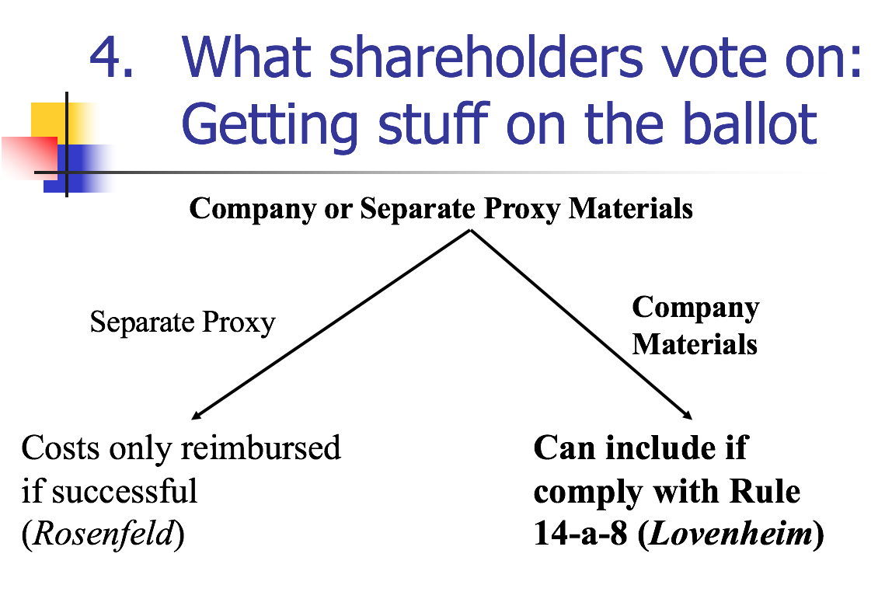
  - Which directors can you vote for?
    - Incumbent board nominates a slate of directors (company sends out official materials)
    - A competing slate (currently needs to be offered in separate proxy materials and the insurgents need to pay all costs, including mailing)
- Review of Shareholder Process for Proxy Contests
  - Proxy process regulated by federal SEC
  - Insurgents must send out “unofficial” proxy solicitation before their solicit proxies
  - The company sends out official proxy solicitation materials
    - May include shareholder proposals (Rule 14a-8)
- Rosenfeld v. Fairchild Engine & Airplane Corp.
  - Facts: Rosenfeld is a stockholder who sued to recover money that had been taken out of the corporate treasury to reimburse both sides in a proxy contest for their expenses → ratified by majority vote of stockholders
    - Proxy Contest = unfriendly contest for control over an organization, basically occurs when an insurgent group tries to out incumbent directors
  - Issue: Can the board use funds from the corporate treasury to cover expenses from the proxy contest?
  - Holding: Yes
  - Rule: Froessel Rule - In a policy contest, corporate directors have the right to make reasonable and proper expenditures from the corporate treasury for the purpose of persuading the stockholders of the correctness of their position and soliciting their support for policies which the directors, believe, in all good faith, are in the best interests of the corporation
    - Exception: If it is purely a personal power contest, then cannot be reimbursed
    - 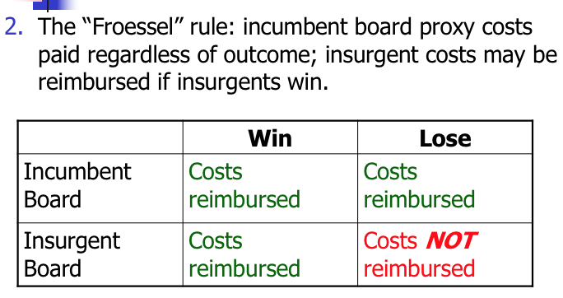
  - Reasoning:
    - Other jurisdictions have said it is ok for management to use corporate treasury for the reasonable expenses of soliciting proxies to defend self
    - If directors unable to do this, then corporate business might be severely interfered with → can’t freely answer any challenges or defend their actions
  - Notes:
    - What was the issue at the heart of the proxy fight to take control of the Fairchild Board?
      - That Ward, former officer and director, was getting paid too much
      - The issue of the suit was who pays for the campaign
    - What would happen to the costs incurred by the insurgents if they were unsuccessful under the Froessel rule?
      - If the insurgents win → insurgents will be reimbursed and the incumbent board’s proxy costs will be reimbursed as long as it is a policy dispute and not personal
      - If the insurgents lose → insurgents will be responsible for costs and the incumbent board’s proxy costs will be reimbursed
      - Under the Froessel Rule, the incumbent board’s proxy costs will always be reimbursed as long as it is a policy dispute and not personal
        - Idea is that they shouldn’t always be forced to defend constantly
        - Otherwise the really wealthy can always challenge directors and the directors may not have their own money to defend
    - What kind of incentives does this provide for proxy contests?
      - Proxy contests are very expensive because they are federally regulated
      - Froessel rule prevents proxy contests from happening too often
- Rule 14a-8: Shareholder Proposals
  - Allows qualifying shareholders to put a proposal before their fellow shareholders
  - 14a-8(b)(1) - must have owned at least 1% or $2,000 (whichever is less) of the issuer’s securities for at least 3 years prior to the date the proposal is submitted (or $15,000 for 2 years, or $25,000 for 1 year)
    - Calculation: (# of securities held for 1 year period) x (highest selling price during the 60 calendar days before the shareholder submitted the proposal)
    - Multiply the number of securities the shareholder held for the one-year period by the highest selling price during the 60 calendar days before the shareholder submitted the proposal.
  - Proposal must be submitted at least 120 days before the date on which the proxy materials were mailed for the previous year’s annual shareholder meeting
  - Proposal plus supporting statements can’t exceed 500 words
  - 14a-(8)(i)(1) - Company may exclude proposal:
    - “If the proposal is not a proper subject of action for shareholders under the laws of the jurisdiction of the company’s organization”
    - Reasons for Exclusion:
      - 14a-(8)(i)(2) - Implementing would violate the law
      - 14a-(8)(i)(3) - Implementing would violate proxy rules
      - 14a-(8)(i)(4) - Proposal involves personal grievance or special interest
      - 14a-(8)(i)(5) - Proposal isn’t relevant to firm’s operations
      - 14a-(8)(i)(6) - Company lacks power to implement the proposal
      - 14a-(8)(i)(7) - Proposal deals with company’s ordinary business operations
      - 14a-(8)(i)(8) - Relates to electing directors
- SEC Response:
  - Staff level action:
    - If it determines proposal can be excluded: issue a no-action letter
    - If it determines proposal should be included: notify issuer of possible enforcement action of proposal if excluded
  - The SEC reluctantly referees the shareholder proposal process
- Lovenheim v. Iroquois Brands, Ltd.
  - Facts: P was a shareholder of the corporation D → he had a proposed resolution regarding having investigating feeding geese for foie gras → he wanted it included in the proxy materials sent to shareholders → D refused to include it
  - Issue: Is D required to include the proposal?
  - Holding: Yes
  - Reasoning:
    - 14a-8 of SEA (1934) requires the issuer to include the proposal in the proxy statement as long as all conditions are met
    - D argued for an exception to the rule which allows omission of proposals that relate to less than 5% of the issuer’s total assets and are not otherwise significantly related to the issuer’s business
    - Court said although the proposal implications would account for less than .05% of assets, the history of the rule indicates that “significantly related to the issuer’s business” is not limited to economic significance
      - Pate operations are not economically significant, but they are ethically significant
  - Notes:
    - Why did Lovenheim offer a proposal instead of reaching out to the board directly?
      - He can’t just ask them to stop since he would be overstepping the precatory boundary into regulating everyday operations
    - Why did Iroquois get annoyed and say no?
      - It was making a lot of money
    - How do you feel about the motivation as a shareholder of Iroquois?
      - Other shareholders might get mad because it would be using corporate money to address Lovenheim’s political interest
    - What can you say about the price of a share of Iroquois stock in the period when Lovenheim submitted his proposal?
      - Shares were approximately $10 because Lovenheim had approximately 200 shares, and needs to have a minimum of $2000 in shares to make a proposal
    - If the majority of shareholders voted for Lovenheim’s proposal, it is only precatory (recommendation), so directors do not have to accept it
- INSIDER TRADING
- Securities Act of 1933
  - Regulates the public offering of new securities
  - Disclosure at the time of public offering
  - Key Section: §5 regulates offering procedure
- Securities Act of 1934
  - Regulates trading activity
  - Ongoing disclosure required
  - Key Sections:
    - §10b - no fraud
    - §14a - proxy contests
    - §14e - tender offers
    - §16 - insider trading
- Rule 10b-5: It shall be unlawful for any person, directly or indirectly, by the use of any means or instrumentality of interstate commerce, or of the mails or of any facility of any national securities exchange,
  - (a) To employ any device, scheme, or artifice to defraud,
  - (b) To make any untrue statement of a material fact or to omit to state a material fact necessary in order to make the statements made, in the light of the circumstances under which they were made, not misleading, or
  - (c) To engage in any act, practice, or course of business which operates or would operate as a fraud or deceit upon any person,
in connection with the purchase or sale of any security.
- Who can bring an action under 10b-5?
  - DOJ can bring a criminal action
  - SEC can bring a civil action
  - No express cause of action for private parties, but the Supreme Court implied a private right of action in Superintendent v. Bankers Life and it has been upheld since
- Required Elements for Private Securities Fraud Suit Under 10b-5
  - Material misrepresentation or omission
    - General Standard: “whether there is a substantial likelihood that a reasonable shareholder would consider the fact important” TSC Indus., Inc. v. Northway Inc. (1976)
      - A highly face-dependent probability/magnitude balancing approach
    - “Silence, absent a duty to disclose, is not misleading under Rule 10b-5.”
      - “‘No comment’ statements are generally the functional equivalent of silence…” fn. 17
  - Scienter
    - PSLRA requires pleading with “particularity facts giving rise to a strong inference that the defendant acted with the required state of mind.”
    - State of mind required = intent to deceive, manipulate, or defraud
      - This means the defendant was aware of the true state of affairs and appreciated the propensity of her misstatement or omission to mislead.
      - Supreme Court left open whether recklessness suffices for scienter.
  - Reliance
    - What is the “fraud on the market” theory?
      - Rebuttable presumption that investor relied on integrity of public trading market price when making investment decision—so investor need not have seen misrepresentation
    - Invoked when?
      - Material & public misrepresentation
      - The stock traded in an efficient market
      - Plaintiff traded the stock between when the misrepresentations were made and when the truth was revealed
  - Causation
    - Loss causation
      - Akin to proximate cause
      - The fraud caused the plaintiff’s loss
        - Show change in stock prices when the misrepresentations made and then an opposite change when corrective disclosures were made
        - The shareholder sold after misleading disclosure but before the corrective disclosure
- When is the insider trading transaction illegal?
  - Classical insider trading: a fiduciary trades in shares of his or her own firm, based on info gathered as a fiduciary (SEC v. TGS)
  - Fiduciary uses information that was misappropriated (O’Hagan)
  - Tipper and Tippee Liability (Dirks v. SEC)
  - §16 of 1934 Act applies (statutory insider trading) (Reliance)
  - 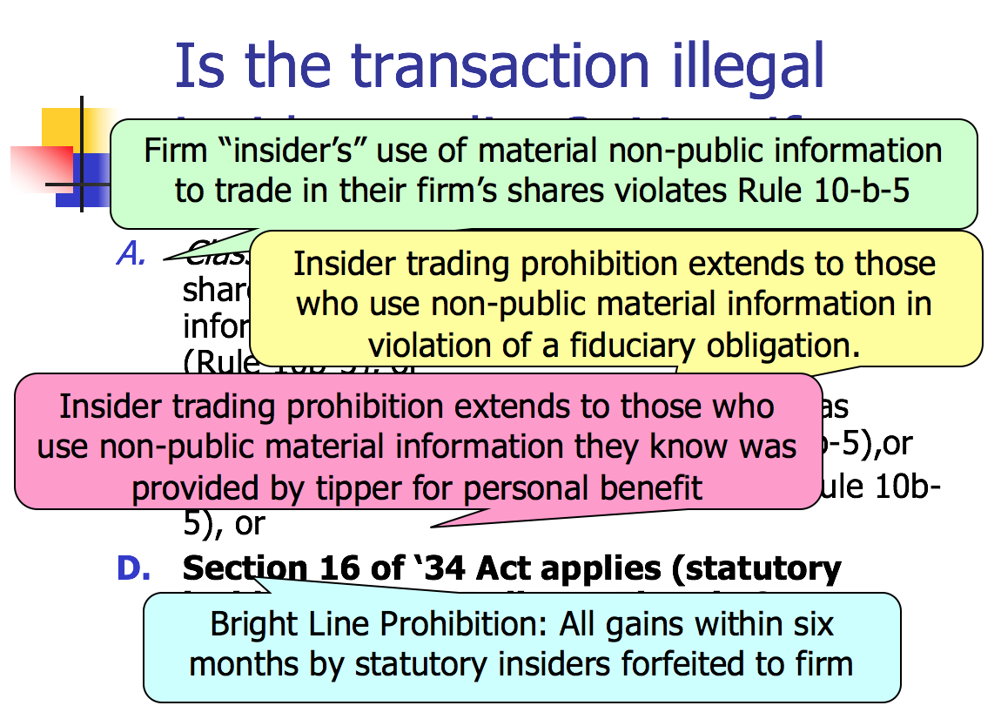
- Securities & Exchange Commission v. Texas Gulf Sulphur Co.
  - Facts: TGS was a mining firm → found a promising location to drill and found land with abundant resources → to keep the land price low, the President told the employees to keep it secret → several employees and tippees purchased a bunch of stock → rumors of an ore strike spread → TGS issued a statement that the press releases on a strike were misleading → later made an announcement that a mine had been found
  - Issue: Did TGS violate Rule 10b-5?
  - Holding: Yes (Guttentag says though that the court’s rationale is unclear here)
  - Rule: If you have material, non-public information, cannot trade in shares of the company’s stock
  - Reasoning:
    - An insider may invest in his own company, but he has a duty to disclose information or abstain from dealing in his company’s securities if the situation is extraordinary in nature and likely to have a substantial effect on the market price of the security
  - Notes:
    - Is there evidence that the K-55-1 find was “material”?
      - General Standard of materiality: “whether there is substantial likelihood that a reasonable shareholder would consider the fact important”
      - Yes, looked at trade publication and the fact that employees knew of its importance and bought a ton of stock
    - Is there evidence that the press release was misleading?
      - Court said it wasn’t because the stocks went up anyways
      - No one really believed the press releases, so it’s hard to say they misled people
    - Did TGS have a duty to disclose the K-55-1 discovery?
      - Footnote 12: “the timing of disclosure is a matter for the business judgment of the corporate officers….within the affirmative disclosure requirements promulgated by the exchanges and the SEC”
      - Wouldn’t be a good plan for TGS since it wanted to buy the surrounding land for cheap price
      - TGS doesn’t have a duty to disclose anytime they discover something, that is up to them → but if they plan to buy/sell stocks, would need to disclose
    - What choice did the managers at TGS have with respect to stock purchases?
      - SEC: An insider in possession of material nonpublic information must disclose such information before trading or if disclosure is impossible or improper, abstain from trading
      - Once publicly disclosed, may purchase or sell own stock
- Chiarella Case [not good law]
  - D worked for company P which was going to merge with Target → D bought Target stock → court said it was ok because he didn’t owe a fiduciary duty to Target shareholders → Court said there was no insider trading
  - Pushed forward the idea that trading with insider information is unfair, but not necessarily wrongful
  - Silence is not fraud except when you (as an agent) have a fiduciary obligation to disclose all relevant information to the principal
  - Duty to disclose to shareholders of the company you purchase stock in
  - Violation of 10b-5 occurs only if informed trader owed a duty to the corporation or shareholders of the firm whose stock he traded in → he didn’t trade in P’s stock
- United States v. O’Hagan [overturns Chiarella]
  - Facts: O’Hagan was a partner at a law firm which represented Grand Met → Grand Met planned to make an offer for common stock of Pillsbury → O’Hagan began purchasing Pillsbury stocks and call options → Grand Met made the announcement → stock prices rose → O’Hagan sold all of his stock for a profit of $4.3 million
  - Issue: Did O’Hagan violate 10(b)?
  - Holding: Yes
  - Rule: Misappropriation Theory - a person commits fraud “in connection with” a securities transaction, and thereby violates 10(b) when he misappropriates confidential information for securities trading purposes, in breach of a duty owed to the source of the information
  - Reasoning:
    - He breached his fiduciary duty to the source of the information
    - Was there deception?
      - Yes, he pretended loyalty while secretly using the information for personal gain
      - Deception works through non-disclosure
    - In connection with the purchase or sale of a security?
      - Yes, consummated when he used the info to purchase securities without disclosure to the principal
  - Notes:
    - Essentially Ginsburg says where you get the information from is what matters, not who you buy the shares from
    - If O’Hagan informed both the firm and Grand Met of his intention to buy Pillsbury stock, and they approved. What would the result be?
      - Then his hands are clean with respect to getting the source of the information
    - Under O’Hagan, Chiarella would’ve violated insider trading law
      - Doesn’t matter if he didn’t have a fiduciary duty to Target
      - He misappropriated the information
      - Chiarella had a fiduciary duty to P
    - Rule 14e-3
      - Prohibits insider trading toward a tender offer and thus supplements Rule 10b-5 (basically, can’t trade at all if you know of a tender offer)
        - Once substantial steps toward a tender offer taken, Rule 14e-3(a) prohibits anyone, except the bidder, who possesses material, nonpublic information about the offer from trading in the target’s securities
        - Rule 14e-3(d) prohibits anyone connected with the tender offer from tipping material, nonpublic information about it
      - Not premised on breach of fiduciary duty
        - O’Hagan upholds it anyways
- Dirks v. Securities & Exchange Commission
  - Facts: Dirks worked for a firm which provided investment analysis of insurance company securities to investors → Secrist, a former officer of Equity Funding, told him that Equity had fraudulent corporate practices → Dirks investigated → he told clients and investors about it → some of them sold their securities holdings → Dirks told WSJ about it → price of Equity stocks fell → WSJ posted a story on it → SEC began investigating and charged Dirks with violating SEA 10b
  - Issue: Did Dirks violate the provision by disclosing?
  - Holding: No, he had no duty to abstain from using the insider information
  - Rule: In order for a tippee to inherit the insider’s “disclose or abstain” duty:
    - Tipper must fail the Personal Benefit Test AND
      - Personal Benefit Test - will the insider personally benefit, directly or indirectly, from his disclosure
        - What constitutes a personal benefit:
          - Monetary gain
          - Reputational gain
          - Gift to a family member
          - Quid pro quo
    - Tippee must know or have reason to know of the breach
  - Reasoning:
    - A tippee does not acquire a duty to disclose or abstain unless the info was made available to them improperly
    - To determine if the tippee is under an obligation to disclose, must determine if the tip constituted a breach of the insider’s fiduciary duty
      - If no breach by insider → no derivative breach by tippee
    - Dirks had no fiduciary duty or expectation by Equity
    - No monetary or personal benefit, they were motivated by a desire to expose the fraud
  - Notes:
    - Guttentag this the test is stupid because it is basically up to the court to decide if you benefit
    - Does Secrist owe a duty to Equity and its shareholders?
      - Yes duty to disclose or abstain → but court determined that he did not violate it because he disclosed it for no personal benefit and he didn’t trade in the stocks
    - Does Dirks inherit Secrist’s “disclose or abstain” duty by being a tippee?
      - No, the tippee must fail the Personal benefit Test and know/have reason to know of the breach in order to inherit the duty
    - What constitutes a personal benefit?
      - Monetary gain, reputational gain, quid pro quo, family member benefits
      - A desire to give a public good is NOT a personal benefit
    - Dirks also established a category of “constructive insiders” who can violate insider trading prohibitions
      - FN 14: A person becomes a constructive insider when they (1) obtain material nonpublic information from the issuer with (2) an expectation on the part of the corporation that the outsider will keep the disclosed information confidential; and (3) the relationship at least implies such a duty
        - Example: lawyers
- Reliance Electric Co. v. Emerson Electric Co.
  - Facts: In 1967, Emerson acquired 13.2% of common stock of Dodge → Dodge merged with Reliance → Emerson followed a plan to dispose of just enough shares to bring the amount of shares they owned under 10% to immunize the rest of its shares under SEA 16(b) → sold the remaining shares about a month later → Reliance demanded the profits realized on both sales
  - Issue: Can the profits from Emerson’s second sale of shares be recovered by the corporation?
  - Holding: No, Emerson wasn’t a statutory insider then
  - Rule: SEA 16(b) - Statutory insider profits from a purchase and sale or sale and purchase within six months are recoverable by the firm
    - 16(a) If own over 10% or are a director or officer (statutory insiders), then must report ownership stake and changes to the SEC
    - Must be a statutory insider at the time of both the purchase and the sale
  - Reasoning:
    - Court of Appeals held that the statute permits splitting of the sale to avoid liability as long as the sales aren’t legally tied and are made at different times to different buyers
    - During the second sale, although it was within six months, Emerson wasn’t a 10% or more shareholder
    - A person avoids liability if he doesn't meet the statutory definition of an “insider” or if he sells more than six months after purchase
- Terminating a Corporation
  - Voluntary Dissolution
    - Board submits and shareholders vote on proposal to dissolve: MBCA 14.02(b)
    - Submit Articles of Dissolution to state of incorporation
    - Can only carry on to wind up
  - Involuntary Dissolution
    - If there is a deadlock: MBCA 14.30

Practice Exam Question:
In January 2018, Molly and Lenny started a computer software business. Molly prepared marketing materials and Lenny made sales calls. During the first year, Lenny sold 20 copies of certain software programs for $50,000 each. The business had a net profit of $480,000 and Molly and Lenny each received $240,000. In January 2019, Molly and Lenny decided to incorporate their business under the name "Software Inc.; however, it is unclear if they correctly filed a certificate of incorporation with the Secretary of State.
Lenny continued to make sales calls to sell the software. He also sold a five-year service contract developed by Molly. Due to brisk sales, Software Inc. projected income of about $300,000 per year for the next five years from the service contracts alone.
Software Inc. obtained a $100,000 business loan from National Bank secured by the accounts receivable for the service contracts. In May 2019, Lenny had an automobile accident, caused solely by his own negligence, on the way to visit a prospective buyer. The accident injured a pedestrian. As a result of the accident, Lenny stopped working and sales collapsed.

In July 2019, Software Inc. went out of business, leaving negligible assets and the unpaid loan to National Bank.
- Is Software Inc., Molly, and/or Lenny liable to the pedestrian for the injury? Discuss.
  - Software Inc. Liability to Third Party
    - Is Lenny in a master/servant relationship
    - Is Lenny working within scope of employment?
    - If not, if this a situation where tort liability for principal anyway?
  - Molly Liability to Third Party
    - If Software, Inc. properly incorporated, could the veil be pierced?
    - If not, what kind of firm is Software, Inc.? Partnership? Liability?
  - Additional Issue for Lenny
    - Does the agent who commits a tort have personal liability?
- Is Software Inc., Molly, and/or Lenny liable to National Bank for the loan? Discuss.
  - Software Inc. Liability to Third Party
    - Presumably entered into by agent with authority
  - Molly Liability to Third Party
    - If Software, Inc. properly incorporated, could the veil be pierced?
    - If not, what kind of firm is Software, Inc.? Partnership? Liability?

