Criminal Law—Ocen—Fall 2018

Theories of Punishment
- Retribution – intentional infliction of pain/suffering to punish the wrongdoer. Backward looking.
  - Assumptions: actor capable of making rational choices, individual autonomy, proportional punishment
- Utilitarian – forward looking, punishes wrongdoer to better society and discourage future acts
  - Deterrence – regulates behavior
    - Specific – individual / General - society
  - Incapacitation – physical prevention (incarceration, death, ankle bracelets, etc.)
  - Rehabilitation – acquire skills/values to convert criminal to a law-abiding citizen
    - Focus on punishment of minors is rehab instead of retribution
- Cases:
  - Dudley: Stranded on boat, ate boy- can’t kill innocent to save own life
  - Suitte: Unregistered handgun, 1-year mandatory min. jail reduced to 30 days

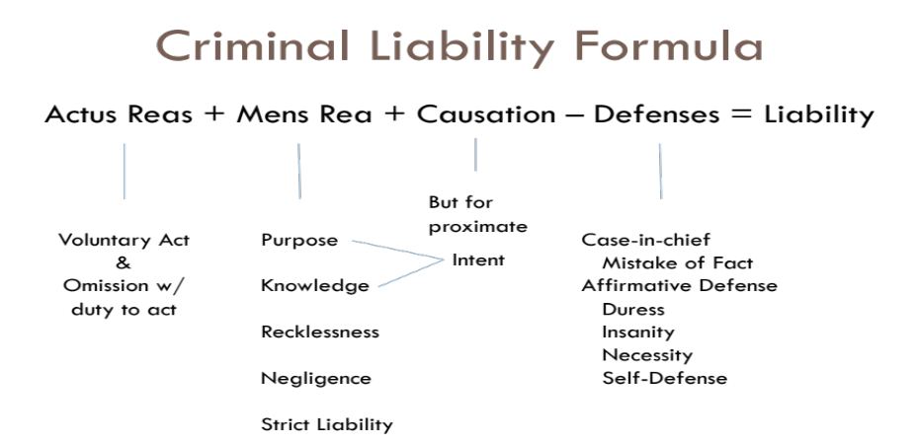
Administration of Justice
Statutes and Elements of Crimes:
- Add:
  - Voluntary Act (Actus Reus) or Omission when legal duty to act
  - Guilty Mind (Mens Rea)- Prohibited mental state
  - Attendant Circumstances- Fact that has to be present for crime
  - Causation- Links defendant’s action with social harm
- Subtract:
  - Defenses
    - Case-In-Chief
    - Affirmative
Jury Nullification Sources:
- 6th Amendment right- trial by jury
- Juries deliberate in secret
- 5th Amendment- Double jeopardy
- = Criminal Liability
Presumption of innocence: Burden on Prosecution to prove every element of crime beyond reasonable doubt
Jury Nullification: Not guilty despite sufficient evidence of guilt beyond a reasonable doubt.
Cases:
  - Curley: No contracts/ constant fraud enough evidence for beyond reasonable doubt.
  - Williams: Juror removed for refusing to adhere to judge’s instructions for statutory rape

Legality, Lenity, & Due Process
- Legality – there must be a law before someone is punished (5th amendment)
- Due Process Clause (5th & 14th Amendments)
  - Fair warning to public; control discretion of policy, prosecutors & courts; bars retroactivity & vagueness
- Statutory Construction: Order= Plain language ⇒ Canons of Construction ⇒ Rule of Lenity
- Respect plain language of statutory text (consider all parts of the statute when construing any one part)
- Canons of Construction (discerning and putting into practice the intent of the legislature)
- Legislative intent
- Lists and associated terms
- Statutory structure
- Amendments
- Avoiding absurdity
- Constitutional avoidance
- Rule of Lenity: ambiguities resolved in defendant’s favor (tie breaker – last resort)
- Cases:
- Dauray: Child pornography, ambiguity- “other matter”
- Mochan: Court uses common law for new law (Dissent wins argument long-term)
- Morales: Statute- gang members loitering, too much police discretion/ too little notice
- McBoyle: Stolen plane, ambiguity- “motor vehicle”
- Keeler: Murder for viable fetus as ‘human being’ would be ex post facto/ no fair warning

5th Amendment- Due Process, Double Jeopardy
6th Amendment- Right to a jury trial
8th Amendment- Cruel and Unusual Punishment, status crimes
14th Amendment- Due Process

Actus Reus- Voluntary Act Requirement
- Can’t be punished for mere thoughts
- Human agency required (willed bodily movement/ conscious and desired movement)
- Courts can extend the timeline of a voluntary act (Omissions)

Common Law | MPC
Physical action taken toward commission of crime  Act must be voluntary (Martin)  Treats habitual movements as voluntary (distinction from MPC) | Person not guilty unless:  1. conduct was voluntary or  2. Omission to perform act of which he is capable  Involuntary Movement:  - Reflex, movement during sleep, hypnosis, and bodily movement that otherwise not a product of effort (habitual)

Omissions
Common Law | MPC
Voluntary act requirement satisfied when:  -D engaged in voluntary act OR  -Legal duty to act AND failure to act caused social harm. | Liability may not be based on omission unless:  -The omission is expressly made sufficient by law defining the offense; OR  -A duty to perform omitted act is otherwise imposed by law
Omissions analysis: (1) did the D act? If not, was the D under a duty to act?; (2) did the D discharge the duty to act? Was the failure to discharge the duty the but-for proximate cause of the harm? If yes, did the D have the required mental states?
Legal Duty to Act: | - Duty Listed in the Statute (failure to pay taxes)  - Special Relationship (husband/wife, parent/child)(Howard)  - Contractual Relationship (provide care)(Pestinikas) | - Statutory Duty (Criminal and Civil)  - Creation of Risk  - Voluntary Assumption of Care
- Cases:
  - Beardsley – not under legal duty to care for a houseguest
Status Crimes – 8th Amendment prohibits criminalization of person’s status
- Cases: Robinson (drug addict); Powell (public drunkenness); Jones (homelessness = status)

Mens Rea Generally, each material element of a crime must have mental element (Mens Rea = Guilty Mind)

Common Law: Judge resp. for meaning of terms | Common Law | MPC | MPC: Recognizes 4 mental states ONLY
MALICIOUSLY (Cunningham, Faulkner)  -Foresight of consequences,  -Awareness of risk, and disregard (roughly recklessness)  INTENTIONALLY  -Purpose to cause harmful result  -Awareness (knowledge) that harm is likely- almost certain- to result from act, although harm is not primary purpose of the act  -Includes conditional and unconditional intent  RECKLESSLY, Willfully, Wantonly  NEGLIGENTLY(Santillanes- statute: offense to endanger child)  Generally- Failing to exercise the standard of care a reasonable person would under the circumstances.  Specific Intent  -Actor must act with either:  -Intent to commit future act; or special motive or purpose; or awareness of attendant circumstance  General Intent  -Only requires D to commit an act  -D doesn’t need to intend consequences of act  CL Recklessness/negligence=GI | Intentionally or Willfully  With intent to  Maliciously  Specific Intent  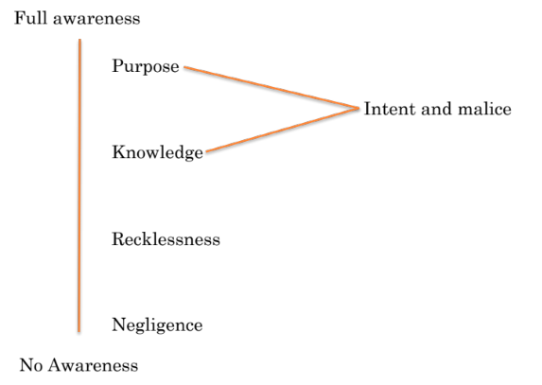  General Intent | Purposefully or Knowingly  Purposefully  Recklessness  Purposefully  Recklessness  or Knowingly | PURPOSEFULLY  -Defendant’s goal/ aim to engage in particular conduct or achieve certain result.  KNOWINGLY  -Virtually or practically certain conduct will lead to a particular result.  -Deliberate ignorance- Jewell  RECKLESSLY  -Consciously disregards that conduct will cause a substantial and unjustifiable risk.  -Gross deviation from standard of conduct of a law-abiding person in same situation.  Subjective standard- D realizes risk -> disregards)  NEGLIGENTLY (objective standard)  -Unaware and takes a risk an ordinary person would not take  -What a “reasonable person” would perceive

Mistake of Fact & Mistake of Law (“case-in-chief” defenses)
Mistake of Fact:
Mistake of Fact

Specific Intent? General Intent?

Must be honest Must be honest & reasonable

CL: Relies on distinction between specific and general intent crimes (no MoF for SL)
- Specific Intent: an honest mistake made in good faith (doesn’t need to be reasonable)
- General Intent: must be both honest and reasonable mistake
MPC: mistake must negate the mens rea required in the statute
- Purpose, knowledge, or recklessness (meaning D is aware of a risk) then mistake must be honest
- Negligence: mistake must be honest and reasonable.

Mistake of Law:
CL: Typically, not a defense, but an excuse under narrow circumstances:
- Reasonable reliance on an official interpretation of the law that is later to be found erroneous (Clegg & Fridley)
- if law requires individual to know the prohibited conduct is unlawful (Cheek & Bryan)
- lacks fair notice of legal duty (Lambert)
- Can’t have a MoL for your own interpretation (Marrero)

MPC: reasonable reliance upon an official interpretation of the law that is later to be found erroneous contained in:
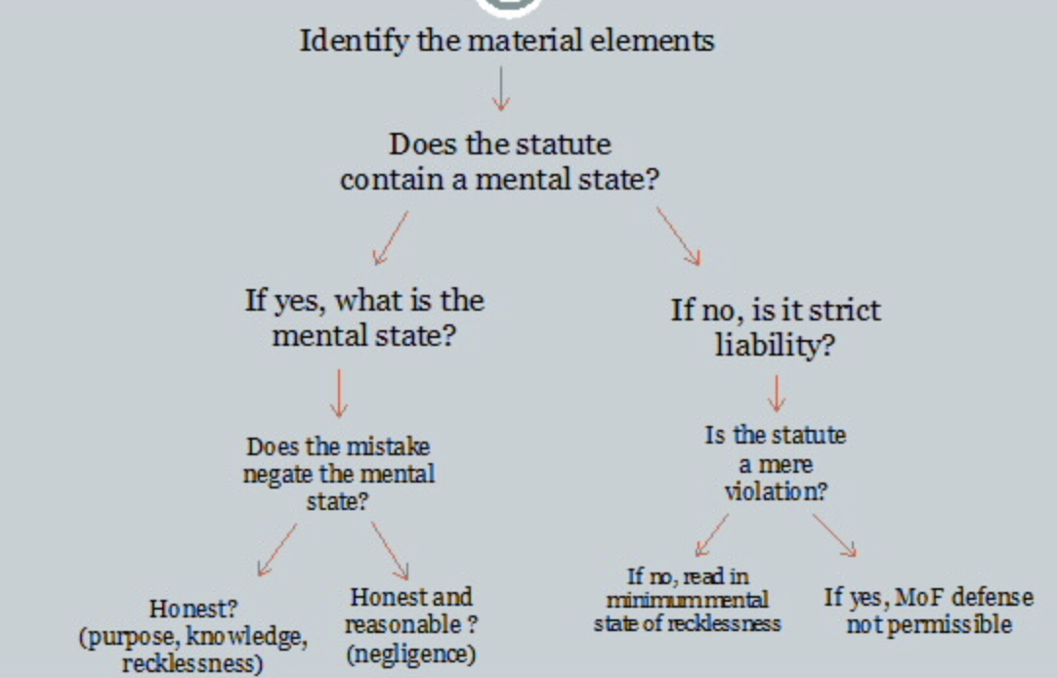
- statute, opinion, administrative order, or
- official who is responsible for interpreting the law

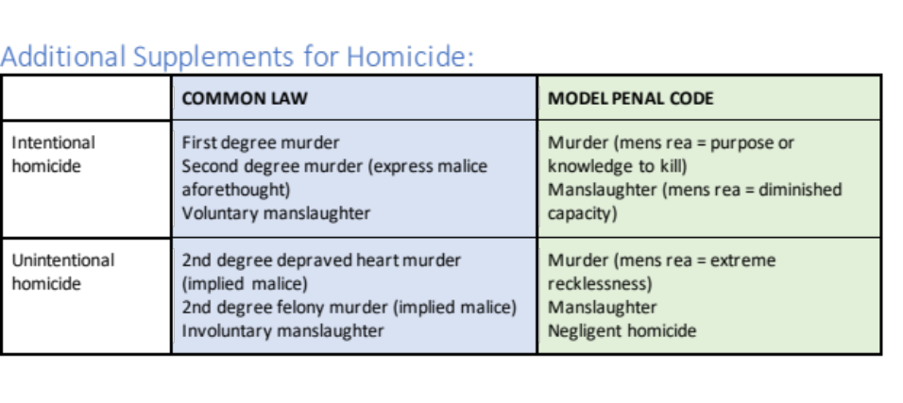
Causation and Introduction to Homicide

Causation definition
- Connection between the act and the harmful result.
- Prosecutors must prove this beyond a reasonable doubt.
- both affirmative acts and omissions can be legal causes.

Conduct crimes v. result crimes
- Conduct crimes: conduct itself is illegal. Therefore, causation not applied here.
- Result crimes: B/C defined in terms of a prohibited result, causation is applied to these types of crimes. Most importantly, homicide.

Common Law | MPC
Two types of causation: Must have actual (“but for”) cause AND proximate cause.  1. Factual/actual cause: “Operative link in chain of events that led to the result.” Not necessarily only cause.  2. Proximate cause (Ocen notes this is a policy question). Is there a sufficiently direct cause to warrant imposition of criminal liability?  Was the result foreseeable? Unfair to hold D accountable if not.  Were there intervening actors?  -“Preserve” or “break” the “causal chain” enacted by D’s conduct depending on whether the intervening actors are foreseeable.  -Use language “extremely unusual or bizarre” to describe something that may break the causal chain.  -May be foreseeable even if related to V’s own conduct. | Adopted by very few states.  1. MPC “cause in fact” (equivalent to common law’s “actual cause”)  2. No “proximate cause” but what happens w/results that are different from D’s intention?  When purposely or knowingly causing a particular result is an element of the offense, the element is not established if the actual result is not within the purpose or contemplation of the actor unless  The actual result differs only with respect that a different person or property is injured or that the injury or harm designed or contemplated would have been more serious or more extensive than that caused  The actual result involves the same kind of injury or harm as that designed or contemplated and is not too remote or accidental in its occurrence to have a just bearing on the actor’s liability

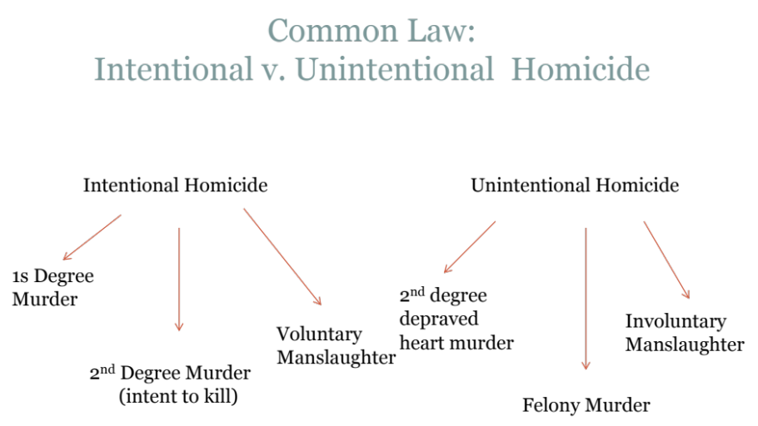
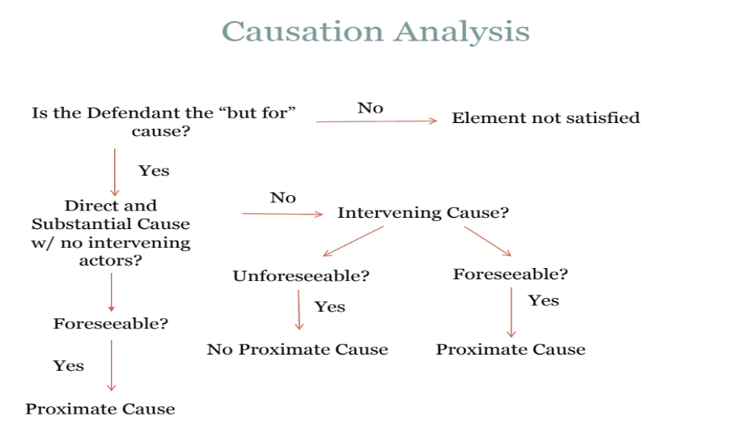

Intentional Homicide *malice aforethought- the technical label for “the mens rea of murder” intent to kill
Common Law | MPC (Written by its Common Law Equivalent)
Murder: the unlawful killing of a human being (actus Reus) with malice aforethought (expressed or implied):  Malice Aforethought exists if def has any of the following:  - intent to kill (express malice)  - intent to inflict great bodily injury (implied)  - abandoned heart- reckless to an unjustifiably high risk to human life (implied)  - Felony Murder (implied)  Evidence of malice aforethought  - statement/confession  - circumstantial evidence - what were they doing, what was their motivation,  - natural and probable consequences rule- if conduct leads to death = proof of intent  - deadly weapon rule- pointing deadly weapon at vital organ (only common law)  1st Degree - Requires Intent with BOTH premeditation and deliberation  - premeditation- thought/design of the killing beforehand  - no minimum time  - can occur during the course of committing an act  - deliberation- measured and evaluated course of action with cool head  -Brown - not first, but second deg. b/c premeditation not beyond a reasonable doubt. Father always hit baby and always intended to harm but not to lead to death  -Bingham- choking and raping of woman not 1st murder because cannot deliberate during sex.  -Gilbert- old man kills wife because she is in pain = enough deliberation and premeditation for guilt | 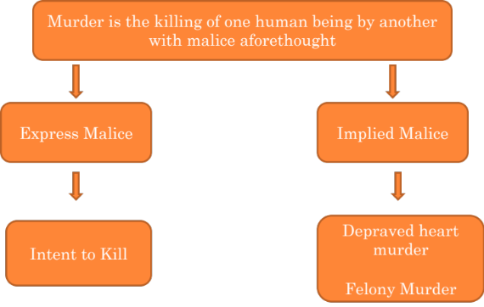  §210.1 - Criminal Homicide (overview)- defined as the purposeful, knowing, reckless, or negligent death of another human being.
2nd Degree- Requires intent to kill:  - Implied intent -  - Depraved Heart Murder rule - Can show that D acted with gross recklessness “a conscious disregard of a substantial and unjustifiable risk of death yet committing the action anyway.” Wanton (and other terms) is another name in some jurisdictions  - Felony Murder rule - homicide committed the course of an Inherently dangerous felony  - In the abstract  - As applied  - Res Gestae (causation between felony and the killing)  - Killing must be done during or in the course of the felony  - Felony must not "merge" with the killing (independent felony)  - Killing must not be caused by a "third party"  - express intent to kill without adequate provocation  Malone- Russian Roulette: no provocation, knew substantial and unjustifiable risk yet still shot the gun. had intent  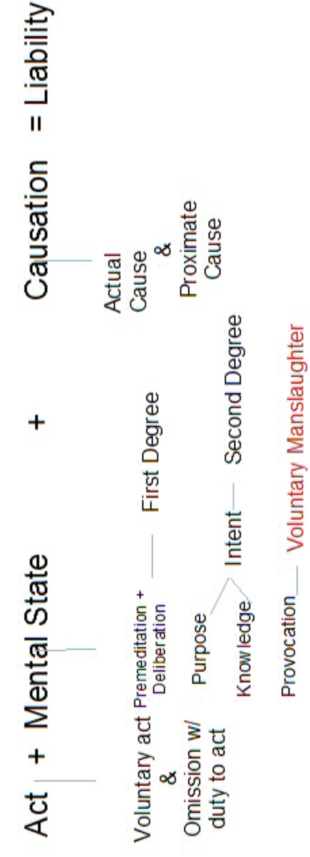  Knoller- D charged with 2nd degree for keeping dogs in apartment with a wanton disregard for the value of human life (implied intent). Supreme court says awareness that death may occur. Strong evidence that dogs were dangerous.  James - manufacturing meth is inherently dangerous.  Hines - possession of a firearm by a felon who is hunting and drunk is inherently dangerous (as applied).  Stamp - jewelry robbery where owner dies of heart attack. But-for the robbery, the death would not occur → FMR applies  Bodely - hits a man while driving away from the store he robbed. One continuous transaction test. FMR applies until reach a place of temporal safety.  King - flying a plane with 500lbs of weed when flew into mountain and co-pilot died. FMR does not apply when killing doesn’t relate to the furtherance of the felony.  Rose - Accidentally killed his girlfriend while play with gun. Merger doctrine = assaultive felonies merge with homicide so no FMR.  Canola - Jewelry store robbery and owner returned fire killing co-felon. Only death caused by felons are up for FMR.  intent defined as- purpose or knowledge in MPC | §210.2 Criminal Homicide as Murder: is Committed in a manner that is:  - purposefully (conscious desire) or  - knowingly (awareness to a practical certainty),  - or extreme recklessness under circumstances manifesting extreme indifference to the value of human life. Includes:  - Felony murder  - Accomplice  - Attempt  - Flight post commit
Manslaughter- unlawful killing without the malice aforethought.  In order to be entitled to Voluntary Manslaughter instruction:  - Categorical Test  - Aggravated Assault/Battery  - Witnessing serious crime to family  - caught spouse in adultery (must be spouse and must be in the moment of the act)  - mutual combat and illegal arrest  Ambro- exception to “mere words are not enough” rule: Woman berated (sexual) husband for 7 years, extramarital relations, wanting to take his kids away. he kills her during an argument. courts said sufficient provocation  - Reasonable Person test (as determined more or less by Jury) :  - acted in heat of passion  - reasonably provoked  - no sufficient time to cool off  - a reasonable person in the def’s shoes would not have had sufficient time to cool.  - embraces certain cultural norms but not others  - includes demographics like age  - does NOT include temper and bad judgements  *must be causal connection b/w provocation, passion, and killing with the provoker being the one killed (misdirected retaliation rule).  Voluntary- a killing that would normally qualify as 2nd degree murder, but reduced due to a partial defense i.e. provocation, imperfect self-defense, diminished capacity.  Berry- passage of time can induce opposite effect of cooling off  Carr- disturbed man shoots lesbians. psychosexual history not permitted to the jury since reasonable person test does not allow. | §210.3 Criminal Homicide as Manslaughter-  - Recklessness- indifference to human life  - murder committed under influence of extreme mental or emotional disturbance for which there is reasonable explanation or excuse (heat of passion)  In order to be entitled to voluntary manslaughter instruction:  - Extreme Mental or Emotional Disturbance (EMED)  - under the influence of extreme mental or emotional disturbance for which there is reasonable explanation and excuse  - determined from the viewpoint of a person in the actor’s situation as he believed them to be  - no requirement to “cool off”  Dumlao- extreme jealous husband thought wife was constantly cheating on him. shot her mother. Court ruled evidence sufficient for manslaughter instruction due to his extreme mental disturbance. Doctor’s testified his extreme paranoid personality disorder.

Unintentional Homicide
2nd Degree Depraved Heart Murder – (1) subjective knowledge of substantial & unjustifiable risk of death; (2) D conscious disregard for life; (3) indifference to consequences; (4) weak justification for taking risk.
- Knoller – malice/ extreme recklessness. D made conscious decision & engaged in conduct that D subjectively knew had a high probability of death to another human being

Felony Murder: A person who kills during the commission or attempted commission of a qualifying felony has committed second degree murder (may be elevated to first degree depending on type of felony & jurisdiction)
- James (abstract test) – 2nd deg. Murder if committed in perpetration of any felony that is inherently dangerous to human life
- Hines (as committed/applied test) – poss. of a firearm by a convicted felon is inherently dangerous & may serve as underlying felony
- Bodely (“escape rule”) - killing & felony are parts of one continuous transaction. D ran over V escaping felony.
- Stamps (“but for” cause of death) – felony put into a series of motions that led to death. Operative link in the chain to death
- Commonwealth (narrow approach) – death consequence of felony, not coincidence. Plane crash while transporting drugs.
Common Law | MPC
Strict Liability (no mens rea or intent to kill req’d)  Limits on FMR:  - Inherently dangerous felony limitation - a murder during a felony is FM if it is committed in the perpetration or attempted perpetration of any felony that is inherently dangerous to human life (James)  - Res Gestae -  - close in time and distance btwn. the homicide and felony  - place of safety rule  - causal connection btwn. felony and homicide  - Merger Doctrine - felonies that are assaultive in nature merge with the homicide and cannot serve as the basis for FM. Must provide malice aforethought.  - Agency Rule - 3rd party killing rule. If a 3rd party kills (not felon nor his agents), must show aforethought | Criminal homicide is murder when:  Committed Recklessly under circumstances demonstrating extreme indifference to the value of human life:  - Recklessness and indifference presumed if actor is engaged in or accomplice to:  - rape  - robbery  - arson  - burglary  - kidnapping  - felonious escape  - presumption of extreme recklessness when death results during the commission of certain felonies,  - BUT, presumption may be rebutted by the def.  - place of safety rule

Involuntary Manslaughter
- killing with (gross) negligence or recklessness. D NOT aware of risk, but should have been. Gross deviation from the standard of care that a reasonable person would exercise.
- Gross Negligence: failure to perceive a substantial and unjustifiable risk of death
- Recklessness: disregard of substantial and unjustifiable risk of death
- Welansky- D is nightclub owner and fire broke out at club. patrons trapped inside and died. Def’s failure to take safety measures to protect visitors to his business in disregard of the probable harmful consequences is inv. mans.
- Williams- Native American baby with bacterial infection dies due to indigent parents’ failing to exercise ordinary caution that a reasonable man would exercise under similar circumstances and such negligence proximately causes death is involuntary manslaughter
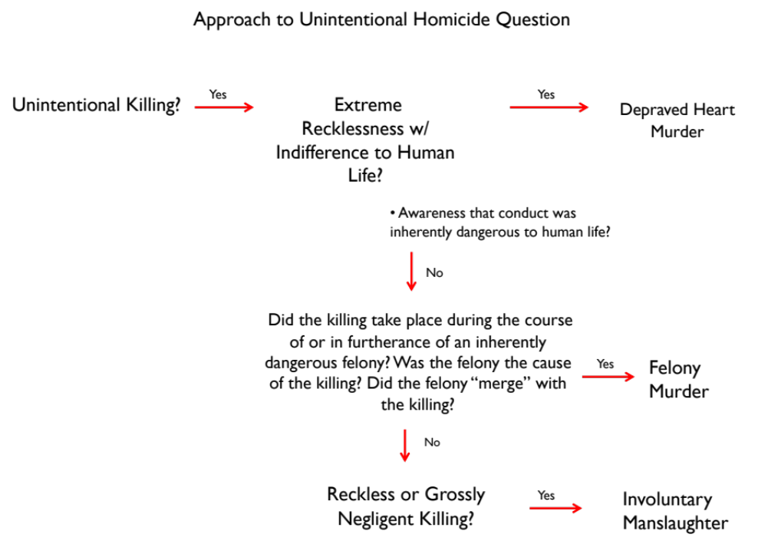

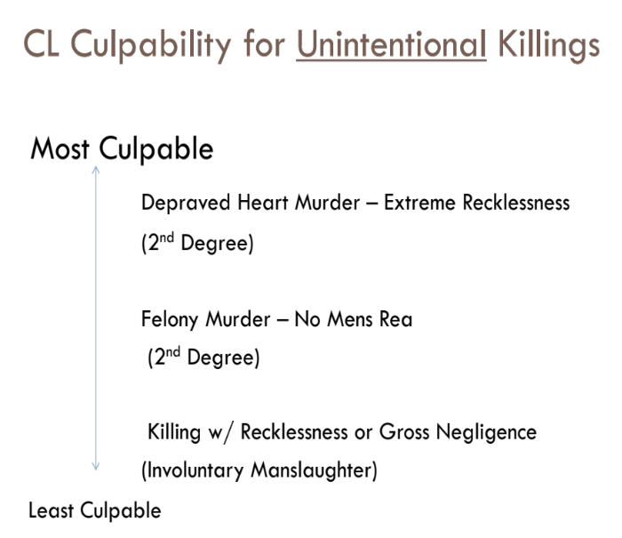

Attempt Liability: A person with the intent to commit an offense, performs some act done towards carrying out the intent.
Common Law | MPC
Two components:  Mens Rea: intent or purpose to commit the target offense (must be found beyond a reasonable doubt)  - People v. Harris- attempted murder requires highest level of mens rea  the purpose to kill  - Intent to cause grave bodily harm not enough  +  Actus Reus: (beyond “mere preparation”) must fulfill either:  - Dangerous Proximity (traditional rule) - evaluating the act on how close the def has come to the completion of the offense. Must come dangerously close to be sufficient.  - People v. Rizzo-not dangerous proximity because defs did not find payroll man in the building. No money present to be stolen.  - Unequivocal - “Beyond mere preparation” and asks whether conduct of def undeniably demonstrates intent to commit crime  - People v. Staples - Drilling of the ground was unequivocal and direct step toward completion of burglary of bank vault.  - Substantial-Step Test (same in MPC and Majority)  Differences and Similarities: Both use the Substantial-Step Test which is a better test for the prosecutor since it requires a lower standard of proof Abandonment is taken into consideration for MPC. | Two components:  Mens Rea: § 5.01- def who acts “with the purpose of causing or with the belief that [his conduct] will cause” the prohibited result.  - State v. Hinkhouse- Def. with HIV guilty because he had knowledge/belief that partner can get infected (despite not having intent to infect)  +  Actus Reus: sufficient if passes Substantial-Step Test:  - Did D take substantial step corroborative of actor’s intent toward the commission of the crime. i.e. Substantial steps:  - lying in wait  - enticing victim  - surveying for location for commission of crime  - unlawful entry of location of commission of crime  - possession of materials for the crime  - intentional possession/collection at or near potential location of crime  - soliciting innocent to engage in conducting an element of crime.  2. Did D abandon his intent?: Giving up criminal purpose, then not guilty (opposite of holding in Staples case)  - Latraverse- Can be used to argue that there was an attempt. Holding: D should have had opportunity to bring up abandonment defense under this test despite the fact he went beyond mere preparation.
Defenses:
Legal Impossibility- D thinks he is attempting to commit a crime/illegal act, but is mistaken on the legal status (i.e. it is not illegal) valid defense for common law only .
- U.S. v. Thomas- impossible to rape a dead person.
  - MPC→ guilty since they believed she was alive / CL → not guilty
Factual Impossibility- When the intended crime is impossible because of physical impossibility unknown to D. Not a defense for either.

Accomplice Liability

Requirements: Actor must…
- Actus Reus – engage in an act of encouragement
- Mens Rea – purposefully encourage the commission of the target crime

Overview
- Derivative in nature
- D held responsible for the conduct of another person she is associated with
- Theory of guilt, not a separate category of crime
  - Ex. No guilty of being accessory to murder, guilty of murder

Actus Reus
- There must be some act or omission to encourage the commission of the target offense
- Mere presence is not enough
  - Unless have a legal duty to act
- Must be affirmative conduct, acts or words, from which a reasonable inference can be drawn that A’s purpose was to encourage the commission of the crime

Mens Rea

1. (Traditional) Purpose to aid or encourage principle & purpose for crime to be committed
2. (Modern/Broader) Intent to aid & mens rea required for target crime
- Mens rea less than purpose/knowledge
3. Natural, probable, and foreseeable consequences doctrine
- Liability extended to reach the actual crime committed, rather than the crime intended, when the criminal harm is naturally, probably and foreseeably put into motion
  - An accessory is liable for any criminal act which in the ordinary course of things was the natural and probable consequence of the crime that he advised or commanded, although such consequences were not intended by him

Cases

-Pace: need affirmative conduct; Mere presence not sufficient for accomplice liability;

-Foster – mens rea for accomplice liability; D may be held liable as an accessory to a criminally negligent act if he has the requisite culpable mens rea for the commission of the substantive offense, and he intentionally aids another in the crime;

-Wilson – a feigned accomplice is not criminally liable for the felony; To be criminally liable, accomplice must have same criminal intent as the principal actor

-Roy – natural & probable consequences doctrine; D arranged for the sale of a handgun, man delivering the gun robbed the buyer

Conspiracy
An agreement by two or more persons to commit either one or more criminal acts, or one or more acts that are illegal.
Common Law | MPC | DISTINCTION
Mens Rea - specific intent  intent to enter into agreement (can be tacit) (See Lauria) with purpose to commit or aid crime  Overt Act- Most jurisdictions today require proof of some “overt act” in furtherance of the conspiracy in order to demonstrate the existence.  - overt act need not be central to accomplishing the ultimate goal of the conspiracy  -considered inchoate crime: no need to prove that def. came close to accomplishing  Pinkerton Rule - a conspirator may be held liable for a crime committed by another member of the conspiracy even if that other crime was not part of the original agreement as long as that crime was in furtherance of the conspiracy within the scope reasonably foreseeable consequence of the agreement  Defenses: statute of limitations | • §5.03- to be convicted, the actor must have the purpose to promote or facilitate the target offense, or to aid others in committing, attempting, or soliciting the action that constitutes the crime.  • (See Lauria despite CL court because both share the same Mens Rea)  Defenses  • abandonment (renunciation/withdrawal)  • voluntarily and completely renounce his criminal purpose | for MPC the crime of conspiracy merges with the completed crime so that the actor cannot be punished for both conspiracy and the target crime.  Bilateral (CL) vs. Unilateral (MPC- looks at everyone individually, not collectively like CL does) (see: Pacheco)  MPC rejects Pinkerton Rule  both reject defense of impossibility (for most part)  MPC does not require an “overt act” unless it is only a minor offense.

Affirmative defenses: Excuses

Insanity
Common Law | MPC | DISTINCTION
Relies on M’Naghten  A person is insane if :  - At the time of the act,  - Because of a mental disease or defect,  - she/he did not know the nature and quality of the act, or  - She did not know what she was doing was wrong | A person is insane if  - At the time of the act  - Because of a mental disease or defect,  - She/he lacked the substantial capacity to appreciate the wrongfulness of the conduct, or  - She lacked the substantial capacity to conform her conduct to the requirements of the law.  Freeman – D sold heroin to undercover cops | In general, focus is on cognition or ability to control behavior  Lack of knowledge v. lack of substantial capacity  MPC ultimately sees more of a “gray area” than common law  Ds w/no chance under CL may have a better chance under MPC.

Involuntary Intoxication: treated as temporary insanity claim
Situations
(1) Intoxication caused by the fault of another;
(2) Intoxication caused by an innocent mistake on the part of the D;
(3) D unknowingly suffers from a condition that renders her abnormally susceptible to a legal intoxicant;
(4) Unexpected intoxicant results from legally prescribed drug

Duress: Generally, not available for homicide
Cases:
Hunter – use duress to challenge underlying felony for FMR
Pachon – D under duress to transport cocaine to US from Colombia
    - A defense of duress requires:
        - Threat of death/grievous injury
- From human being/to D or family member
- Must be present, imminent and impending
- Reasonable belief that threat was real
        - No reasonable escape from threat except through compliance
        - D not at fault for exposure to threat

Affirmative defenses: Justification
Cases:
Schoon – necessity defense NOT available for indirect civil disobedience
Hutchins – legislature must not have spoken on issue to qualify for necessity. Medical Marijuana case
In Re Eichorn – Danger of missing sleep clear & imminent and D had no reasonable alternative

Necessity: generally not available for homicide
A D claiming necessity in CL jurisdiction may be acquitted if:
(1) Harm avoided caused is less than harm
(2) Harm avoided was clear and imminent
(3) Reasonable to believe act will alleviate harm
• Objective test
(4) No reasonable/effective legal alternative
(5) D not at fault
(6) Legislature not spoken

Self-defense
“Pure” Self-Defense
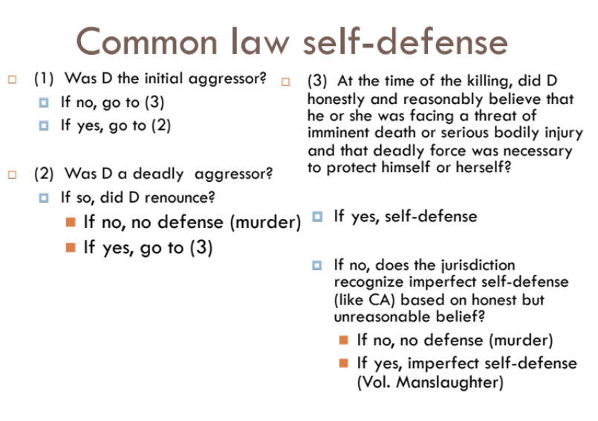
- Justification: A successful self-defense tells D he/she was justified in his/her action under the circumstances
Reasonable Person Standard
- Threat must be imminent
- The force D uses is necessary to repel the threat
- The force D uses is proportional to the threat (deadly force may be used to
repel a deadly threat)
- D’s belief that all three factors exist need not be accurate, but must be
objectively reasonable, which may consider:
  - Size of the parties, physical space occupied by the parties,
events leading up to the deadly encounter, defendant’s prior
knowledge of assailant, defendant’s specialized knowledge of similar situations

Also consider:
- Was D initial aggressor?
- Was there a duty to retreat (if can do so safely, duty to retreat from threat)?
- Defense of habitation: in CA presumption that deadly force is reasonable when V unlawfully entered home

Honest but unreasonable belief in need for self-defense?
- Most CL jurisdictions: No defense.
- Some CL jurisdictions: Mitigation to voluntary manslaughter. Partial defense. See Goetz.

