Civil Procedure Outline Spring Term 2018

SEMESTER 1 REVIEW

OVERVIEW

VOCABULARY
Pleading: Specified documents, filed early in the action, identifying the parties and describing their claims and defenses. Rule 7(a)
Motion: Request for judicial action. Rule 7(b)
Brief
  - Written explanations why a motion should be granted or denied.
  - In some courts, called “Memorandum” or “Statement of Points and Authorities”
  - Depending on local rules, motion and brief may be separate documents or combined in a single document.
Order
  - Document announcing a decision or commanding action
  - Local rules may require counsel to submit proposed orders.
Judgment: Document terminating a case. Rule 54, 58.
Claim: A claim is facts that entitle the pleader to a remedy from a court.

Rule 1: Rules should be construed and administered to secure the just, speedy, and inexpensive determination of every action and proceeding.
- Rule 1 is a guide to interpreting the Rules in ambiguous situations, but it cannot change the meaning of rules that are not ambiguous.
- In 2015 there was an amendment to rule 1… the big change here is that they added the court and the parties… because they wanted to show how much happens with the parties.. not just the court.
- There is an inherent tension between Just, Speedy, and inexpensive..
AVISTA MANAGEMENT, INC v. WAUSAU UNDERWRITERS GROUP: Avista wanted deposition to take place in Esquire Deposition Services office and Wausau wanted it to be in his office; sent various notices to ∆. Court ordered denying the motions and since could not adequately interpret Rule 30(b), told the lawyers to play rock, paper, scissors, to decide who wins and if couldn’t do that, hearing would be at courthouse.

DUE PROCESS ATANDARD [MULLANE]

The Due Process Clause for SERVICE.
- We don’t peoples process and liberty taken away without the due process of the law.
- At the end of the process.. when someone is making property decisions… The question is, what counts as being good enough for due process?

Mullane v. Central Hanover Bank: Many known and unknown beneficiaries to an estate. A bank tried to reach the unknown by having a published notice in the newspaper for 4 weeks. Got sued for not reasonable notice Won. Court makes the mullane standard which is that the method of notice must be reasonably calculated to achieve success.

The Mullane Standard- ON DUE PROCESS
- Due process requires “notice reasonably calculated, under all the circumstances, to apprise interested parties of the pendency of the action.”
- “The notice must be of such nature as reasonably to convey the required information and it must afford a reasonable time for those interested to make their appearance.”
- “The means employed must be such as one desirous of actually informing the absentee might reasonably adopt to accomplish it.”
- ON personal Service
  - “Personal service of written notice within the jurisdiction is the classic form of notice always adequate in any type of proceeding.”
  - “Personal service has not in all circumstances been regarded as indispensable …”

PLEADINGS ALLOWED

Rule 7. Pleadings Allowed; Form of Motions and Other Papers
(a) Pleadings. Only these pleadings are allowed:
(1) a complaint;
(2) an answer to a complaint;
(3) an answer to a counterclaim designated as a counterclaim;
(4) an answer to a crossclaim;
(5) a third-party complaint;
(6) an answer to a third-party complaint; and
(7) if the court orders one, a reply to an answer.
(b) Motions and Other Papers.
(1) In General. A request for a court order must be made by motion. The motion
(A) be in writing unless made during a hearing or trial;
(B) state with particularity the grounds for seeking the order; and
(C) state the relief sought.

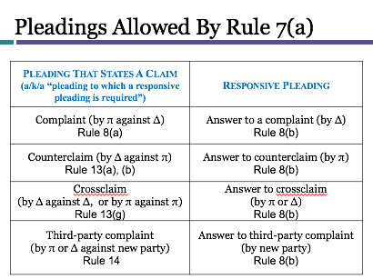

HOW TO PLEAD
RULE 8: How to Plead
        - A short and plain statement of the grounds for the court’s jurisdiction.
          - For diversity, what are parties’ citizenship and amount in controversy?
          - For federal question, what is the federal statute, reg. embedded issue?
          - To avoid dismissal, are PJ and original venue proper?
        - A short and plain statement of the claim showing that the pleader is entitled to relief; and
          - Which substantive legal theories justify relief?
          - What are the elements of each theory?
          - What facts exist to satisfy each element?
          - Does Rule 9 require special pleading for this claim?
        - A demand for the relief sought:
          - What are you legally entitled to?
            - Damages
            - Injunction/Declaratory judgment.
            - Costs/ fees
          - Which of the available remedies do you want?
          - How will the request for relief affect bargaining positions?

Rule 8 (b and c) – Responses to complaint
(b) Defenses; Admissions and Denials.
(1) In General. In responding to a pleading, a party must:
(A) state in short and plain terms its defenses to each claim asserted against it; and
(B) admit or deny the allegations asserted against it by an opposing party.
(2) Denials—Responding to the Substance. A denial must fairly respond to the substance of the allegation.
(3) General and Specific Denials. A party that intends in good faith to deny all the allegations of a pleading—including the jurisdictional grounds—may do so by a general denial. A party that does not intend to deny all the allegations must either specifically deny designated allegations or generally deny all except those specifically admitted.
(4) Denying Part of an Allegation. A party that intends in good faith to deny only part of an allegation must admit the part that is true and deny the rest.
(5) Lacking Knowledge or Information. A party that lacks knowledge or information sufficient to form a belief about the truth of an allegation must so state, and the statement has the effect of a denial.
(6) Effect of Failing to Deny. An allegation—other than one relating to the amount of damages—is admitted if a responsive pleading is required and the allegation is not denied. If a responsive pleading is not required, an allegation is considered denied or avoided.
(c) Affirmative Defenses.
(1) In General. In responding to a pleading, a party must affirmatively state any avoidance or affirmative defense, including:
• accord and satisfaction;
• arbitration and award;
• assumption of risk;
• contributory negligence;
• duress;
• estoppel;
• failure of consideration;
• fraud;
• illegality;
• injury by fellow servant;
• laches;
• license;
• payment;
• release;
• res judicata;
• statute of frauds;
• statute of limitations; and
• waiver.
(2) Mistaken Designation. If a party mistakenly designates a defense as a counterclaim, or a counterclaim as a defense, the court must, if justice requires, treat the pleading as though it were correctly designated, and may impose terms for doing so.

9(b, c): Pleading Special Matters
- Fraud or Mistake; Mind Conditions: must state particularly the circumstances constituting fraud or mistake. Malice, intent, knowledge, & other conditions of a persons mind may be alleged generally.
            - Must give a more detailed account of the fraud, such as who said what to whom, when, and where the representation was made, in what way the representation was false, and how the plaintiff relied on it.
- Conditions: Adequate to say they have been met but if not, say why not with particularity.
            - STADFORD v. ZURICH INSURANCE CO: π filed an action to receive money from a flood in his medical office. Didn’t have coverage but got it again and filed a claim 10 days later, insurance counterclaimed and refused to pay the rest saying he was fraudulent in claiming the damages. The court held that the insurance company was not specific enough. Said that there was fraud but failed to identify the fraud.
            - This is an example of a case where the mistake would be easily fixed by the party (just expanding what the fraud is) so it might not be worth to use a motion for this issue.

Rule 12. Defenses and Objections: When and How Presented; Motion for Judgment on the Pleadings; Consolidating Motions; Waiving Defenses; Pretrial Hearing
(a) Time to Serve a Responsive Pleading.
(1) In General. Unless another time is specified by this rule or a federal statute, the time for serving a responsive pleading is as follows:
(A) A defendant must serve an answer:
(i) within 21 days after being served with the summons and complaint; or
(ii) if it has timely waived service under Rule 4(d), within 60 days after the request for a waiver was sent, or within 90 days after it was sent to the defendant outside any judicial district of the United States.
(B) A party must serve an answer to a counterclaim or crossclaim within 21 days after being served with the pleading that states the counterclaim or crossclaim.
(C) A party must serve a reply to an answer within 21 days after being served with an order to reply, unless the order specifies a different time.
(2) United States and Its Agencies, Officers, or Employees Sued in an Official Capacity. The United States, a United States agency, or a United States officer or employee sued only in an official capacity must serve an answer to a complaint, counterclaim, or crossclaim within 60 days after service on the United States attorney.
(3) United States Officers or Employees Sued in an Individual Capacity. A United States officer or employee sued in an individual capacity for an act or omission occurring in connection with duties performed on the United States’ behalf must serve an answer to a complaint, counterclaim, or crossclaim within 60 days after service on the officer or employee or service on the United States attorney, whichever is later.
(4) Effect of a Motion. Unless the court sets a different time, serving a motion under this rule alters these periods as follows:
(A) if the court denies the motion or postpones its disposition until trial, the responsive pleading must be served within 14 days after notice of the court's action; or
(B) if the court grants a motion for a more definite statement, the responsive pleading must be served within 14 days after the more definite statement is served.

Rule 12(b) – MUST BE DONE BEFORE PLEADING. BASICALLY SAME TIMEFRAME AS 12(A) 21 DAYS TO ANSWER. But a party may assert the following defenses by motion:
- lack of subject-matter jurisdiction;
  - Only certain courts can hear certain things. Not on exam.
- lack of personal jurisdiction;
  - Means this court doesn’t have pwer over the defendant. Happens when the def is being sued in a forum where the person doesn’t live.
(3) improper venue;
(4) insufficient process;
- Something wrong with the summons..
(5) insufficient service of process;
  - Not delivered in the right way per rule 4
(6) failure to state a claim upon which relief can be granted; and
(7) failure to join a party under Rule 19.
  - Some cases where in order to decide the case, we need another person involved in the lawsuit.

Rules 12(b),(g),(h) WAIVEABLE DEFENSES ****!!!!!
- BASIC IDEA: The waivable defenses (PJ, venue, service) are waived unless asserted at the first available opportunity.
- That first opportunity will either be:
  - The very first Rule 12 motion; or
  - The very first responsive pleading (as originally filed or if amended as a matter of course under Rule 15(a)(1))

12(g): Joining Motions:
  - A motion under this rule may be joined with any other motion allowed under this rule.
  - You must make all pre-answer motions at the same time.
  - If you bring a Rule 12 motion but omit some of the defenses, then you will have lost your opportunity to make a motion based on the omitted defenses, except for failure to state a claim and failure to join an indispensable party.
  - 12(h)(1): A party waives a defense by (A) Omitting it from a motion in the circumstances described in rule 12(g)(2); or (B) failing to either : (i) make it by motion under this rule; or (ii) include it in a responsive pleading or in an amendment allowed by Rule 15(a)(1) as a matter of course. So he still has an opportunity to amend the pleading as a matter of course. BUT CAN U AMEND THE MOTION>

Making a Dispositive 12(b) Claim
- A motion under 12(b) must be made before pleading if a responsive pleading is allowed.
      - A PRE-ANSWER MOTION IS AN ALTERNATIVE TO ANSWERING COMPLAINT. YOU CAN PUT FORTH 12(b) DEFENSES IN EITHER AN ANSWER OR MOTION BUT IF YOU DO MOTION YOU HAVE TO DO IT BEFORE THE ANSWER.
    - RULE 12(a)(4): After filing a motion, if the court denies the motion or postpones it until trial, a responsive pleading is due 14 days after courts notice of the action.
        - If the court grants a motion for a more definite statement, the responsive pleading must be served within 14 days after the more definite statement is served.

WHEN ANSWERING A PLEADINGS:
- 8(b) & 8(c): When drafting a responsive pleading (answer):
      - SERVE ANSWER:
        - An answer responds to the substance of the complaint.
        - Rule 12(a): Must Serve a Responsive Pleading within 21 days after being served w/ summons & complaint.
        - State defenses to each claim asserted against it;
      - Three Types of Defenses:
          - DENIAL
            - That’s not what happened
            - Archaic term= “traverse”
            - Cannot be resolved on pleading alone.
          - AFFIRMATIVE DEFENSE
            - Even if that happened, I win because some other thing(s) happened.
            - E.g., lack of jurisdiction, improper venue, statute of frauds, consent, self-defense.
            - Requires facts outside the complaint to succeed
          - FAILURE TO STATE A CLAIM
            - Even if that happened, it was lawful
            - Arachaic term= “demurrer” (still used in CA state courts)
            - Does not require facts outside the complaint to succeed.
- Admit or deny allegations.
      - 8(b)(3-5):Generally Deny, Specifically Deny, Deny Part of an Allegation, State that Lacks Knowledge or Information.

Rule 42. Consolidation; Separate Trials
(a) Consolidation. If actions before the court involve a common question of law or fact, the court may:
(1) join for hearing or trial any or all matters at issue in the actions;
(2) consolidate the actions; or
(3) issue any other orders to avoid unnecessary cost or delay.
(b) Separate Trials. For convenience, to avoid prejudice, or to expedite and economize, the court may order a separate trial of one or more separate issues, claims, crossclaims, counterclaims, or third-party claims. When ordering a separate trial, the court must preserve any federal right to a jury trial.
PRECLUSIONS

Definition: A person is precluded from re-litigating certain things if there has already been one fair opportunity to litigate.
- Preclusion comes from the common Law Traditions
- Where do you put the preclusion argument? In the answer…
  - Look at 8c..

Two types of Preclusion
- Claim Preclusion
  - Someone is precluded from asserting a claim in a subsequent lawsuit
  - f/k/a “res judicata” or “bar” or “merger” or “the rule against splitting claims”
  - this is a shield
- Issue Preclusion
  - Someone is precluded from contesting particular issues in a subsequent lawsuit
  - f/k/a “collateral estoppel”
  - this is a sword and shield

- When do we have Preclusion?
  - Identical claims are precluded
  - Wholly unrelated claims are not precluded
    - Different facts.. different issue.. different everything.
    - Gaining no efficiency if we did preclude.
  - Arguably unrelated claims..
    - Eg Ison Case—THE SAME THEORY
      - Plaintiff suing defendant over property damage to a car as a result to his car. Second lawsuit was about the personal injuries that he suffered forom the car crash.
        - Easy to see how these two are related together. The legal theory in both is negligence. The duty to drive safely is going to be the same in both. However, this would be different witnesses, different causation questions.. conceivably.. lawsuit #1.. is a short trial.. and the negligence is a longer trai.
        - Was this the same UNDERLYING TRANASACTION? In this case the court said it was.

CLAIM Preclusion
- A claim is precluded in Lawsuit #2 when:
  - It is the “same claim” asserted in Lawsuit #1; and
  - The claim is asserted by the “same claimant against the same responding party” ; and
  - Lawsuit #1 resulted in a “valid” and “final” judgment “on the merits”
    - “Could have” been asserted”
      - Factually and legally possible to litigate first time.
    - “Should have” been asserted
      - In some jurisdictions: arises from the same “transaction”
      - In some jurisdictions: arises from the same “cause of action”
            - Precise meaning of “cause of action” varies
            - In general, a “cause of action” usually mans a law that gives a person the right to sue.
            - For preclusion, one shorthand can be “legal theory”

Transaction Approach: Focuses on event (MAJORITY)
- Claims arise from the same set of facts
- Asks whether the claim asserted in the second lawsuit arose out of the same underlying factual situation as the first.
- Variations:
  - Transaction or occurrence; series of transactions or occurrences
  - used in Restatement, Federal Courts, and a majority of state courts.

Cause of Action Approach: Focus on Legal Theories (MINORITY)
- Claims represent the same cause of action
- Variations:
  - Identical elements; claims involve the same “primary rights”; Evidence for elements in Lawsuit #1 would prove all elements in Lawsuit #2.
  - Used in minority of state courts. See Frier.

When are the parties the same?
- Claims are between the “same parties” when:
  - Claim in Lawsuit #2 is asserted by the same claimant as in Lawsuit #1 against the same defending party as in Lawsuit #1
  - Includes persons in privity with those parties

When are parties in Privity? Those that stand in the shoes of earlier litigants… NOT ON TEST.
- Each jurisdiction may have its own approach to deciding when parties are “in privity” with earlier litigants
- Federal court examples of preclusion by parties in privity in Taylor v. Sturgell, 553 U.S. 880 (2008):
  - Successor in interest to party in earlier suit
  - Agreement to be bound by earlier result
  - Adequate representation in earlier suit (e.g., trustee)
  - Party assumed control of earlier litigation (e.g., insurance)
  - Special statutory systems (e.g., bankruptcy)
  - Parent suits for child.. child cant later sew again..

Judgement on the first lawsuit must be valid and final and on the merits..
- Same claim
- Same parties
- Judgment that is:
  - Valid
  - Final
  - On the Merits

What is a Valid Judgement?
- “Valid” does not mean “correct”
- “Valid” means Court #1 had power to bind the parties to the dispute
  - Personal jurisdiction over the parties (required under preclusion law of all states)
  - Subject matter jurisdiction (varies under preclusion law of different states)

What is a final judgement?
- “Final” = trial court has entered final judgment (as opposed to pretrial or interlocutory order).
- Related to the “final decision” rule of appealability.
- SAME AS FINAL DECISION RULE AT APPEALS. IF FINAL ENOUGH TO APPEAL, FINAL ENOUGH TO BE PRECLUSIVE.
  - If someone files two cases in different courts.. may be a strategy thing… but usually one of the courts will stay.. and then sometimes they will kick it over to someone else who is hearing the court.

ON THE MERITS: A decision from a proceeding where the party who is now precluded had a fair opportunity to prevail on the merits.
  - YES-on the Merits:
    - Court enters judgment on jury verdict
    - Court reaches judgment in bench trial after reaching findings of fact and conclusions of law.
    - Summary judgment
    - Judgment as a matter of law
    - Dismissal for failure to prosecute or violation of court rules: 16(f) or 41(b).
  - 12(b)(6) Failure to State a Claim:
    - Rule 41(b): Unless a dismissal order states otherwise (i.e, judge doesn’t say “not on the merits,”i.e., without prejudice), a dismissal operates as adjudication on the merits—except one for lack of jurisdiction, improper venue, or failure to join a party under Rule 19.
      - Lack of PJ—12(b)(2)
      - Improper Venue—12(b)(3)
      - Failure to Join Required Party—12(b)(7)
    - “With prejudice” meaning precluded
    - “Without prejudice or “with leave to amend” meaning not precluded.

FRIER v. CITY OF VANDALIA: π brought suit against city for replevin when his cars were towed on the street. The trial court concluded that the City properly took cars into possession to remove obstructions to the street and denied to issue a writ of replevin.
    - Plaintiff’s legal theories:
      - Lawsuit #1: Replevin—You have unlawful possession of my car. (State law of property)
      - Lawsuit #2: Due Process—You do not provide adequate hearings for the owners of towed cars (Federal constitutional law).
    - The court holds that π is precluded from bringing the due process theory because he was free to join one the due process theory with the replevin theory.
    - RULE: One suit precludes a second “where the parties and the cause of action are identical.” Causes of action are identical where the evidence necessary to sustain a second verdict would sustain the first, i.e, where the causes of action are based upon a common core of operative facts.
    - MINORITY OPINION

GARGALLO v. MERRILL LYNCH, PIERCE, FENNER & SMITH: ∆ initially filed suit against π for unpaid debt. Then π counterclaimed against ∆ alleging ∆ caused his losses through negligence, misrepresentations, etc” and that the firm had violated Federal Securities Law (a federal issue). The state court dismissed π’s counterclaim “with prejudice” for refusal to comply with ∆’s discovery requests and the court’s discovery requests. π then filed suit in federal court against the executive of Merrill Lynch, Larry Tyree. The district court dismissed the claim with prejudice saying it was precluded through the state court. The court reversed the district’s courts decision.
- π’s claims may not be given preclusive effect in a subsequent federal court action asserting those claims because Ohio courts would not give claim preclusive effect to a prior final judgment upon a cause of action over which the Ohio court had no Subject Matter Jurisdiction.
- RULE: When a claim has federal exclusivity, cannot be given preclusive effect in a state court even if judgment was given on the merits (jurisdictional).

12b6.. can be on the merits.. but
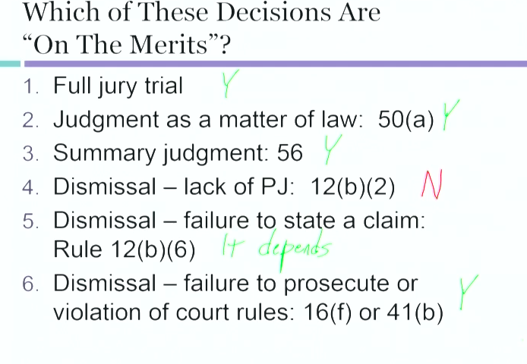

ISSUE PRECLUSION
- An issue can be precluded if its already been proven.
- Issue preclusion can be partial or total.
- This is the sword in a case. – when someone gets hit by a car and sued the driver. The driver also hit a house. The car driver was negligent in the suit against the other driver. You can use this now to say that there is summary judgement on the case.
When something has been satisfied in a previous case, you can use that issue outcome in your case, showing

Elements of Preclusion

A party may be precluded from relitigating an issue in Lawsuit #2 when:

1.It is the “same issue” decided in Lawsuit #1;
2.The issue was “actually litigated and decided” in Lawsuit #1; (Illinois central Gulf RR v. Parks)
3.Lawsuit #1 resulted in a “valid” and “final” judgment;
4.The decision on the issue was “essential” to the judgment in Lawsuit #1;
5.The precluded party had adequate opportunity and incentive to litigate the issue in Lawsuit #1.
–[In a minority of states, but not federal courts (Parklane): the party benefitting from preclusion must have been a party to Lawsuit #1 (“mutuality” requirement).]

Do we have the same issue?
- An “issue” is a case-specific decision regarding facts or the application of law to fact.
–Decisions announcing pure rules of law that go beyond the instant case become precedents, applicable to all future cases via stare decisis.
- When something has been decided criminally, it is a without a reasonable doubt standard vs a preponderance in a civil. So a criminal non-finding doesn’t necessarily mean a preclusion in civil. But a positive finding would.

What does it mean to be Actually Litigated and Determined?
- Bench Trial
  - Written findings of fact.
    - Rule 52(a).
- Jury Trial
  - Special Verdict
    - Rule 49
  - General Verdict

ILLINOIS CENTRAL GULF RR v. PARKS: Jessie and Bertha Parks were involved in an accident with ∆ railroad. Bertha sued for injuries and Jessie for loss of consortium. The plaintiffs claimed RR was negligent. RR denied negligence and asserted Jessie’s contributory negligence as an affirmative defense. Bertha won $$ and Jessie lost in trial court, showing that RR was negligent.
    - Jessie brought suit against RR for his own injuries in subsequent suit. RR tried to use issue preclusion saying that his contributory negligence was brought up in the prior case.
    - Court held that contributory negligence was not actually decided. *Jessie could use the negligence claim against RR because that was actually decided.
    - The issue was not precluded just because Jessie lost on consortium claim because he could have lost on some other reason, not merely because he was contrib. neg.

Was the judgement Valid and Final?
- Same as for claim preclusion
- Valid = Court #1 had jurisdiction
- Final = Lawsuit #1 is completely finished in Court #1
  - Same standard as for appeal ability

Rule 54. Judgment; Costs
(a) Definition; Form. “Judgment” as used in these rules includes a decree and any order from which an appeal lies. A judgment should not include recitals of pleadings, a master's report, or a record of prior proceedings.
(b) Judgment on Multiple Claims or Involving Multiple Parties. When an action presents more than one claim for relief—whether as a claim, counterclaim, crossclaim, or third-party claim—or when multiple parties are involved, the court may direct entry of a final judgment as to one or more, but fewer than all, claims or parties only if the court expressly determines that there is no just reason for delay. Otherwise, any order or other decision, however designated, that adjudicates fewer than all the claims or the rights and liabilities of fewer than all the parties does not end the action as to any of the claims or parties and may be revised at any time before the entry of a judgment adjudicating all the claims and all the parties’ rights and liabilities.

Was it Essential for the Judgement?
- Yeazell & Schwartz Teacher’s Manual: “This topic is, at one level, a curiosity not worth a lot of time.”.. its important that it was actually litigated and debated… not really sure it is doing any extra work…… that isn’t takenc are of in Adequate opportunity and incentive..
- Closely related to other elements
  - “actually litigated and determined”
  - “adequate opportunity and incentive”
- Restatement (2nd) of Judgments §27, comment h
  - Decisions on non-essential issues “have the characteristics of dicta”

Was the Issue decided ESSENTIAL?

- Restatement of Judgments §27, cmt. i
  - “If a judgment of a court of first instance is based on determinations of two issues, either of which standing independently would be sufficient to support the result, the judgment is not conclusive with respect to either issue standing alone.”

Similarly to essential… Did the parties have an essential opportunity and incentive to LITIGATE
- The precluded party (precludee) must have had “adequate opportunity and incentive” to litigate the essential issue to a valid final judgment in Lawsuit #1.
  - The person needed to be able to fight a lawsuit. And fight it hard.
  - Why is the incentive part important? Because there may be a certain fact that is more important to another person.. it may be low stakes to find negligence for a car insurance company that is just trying to get the car damages covered. But say someone was injured and wasn’t a party to the suit.. well the original person didn’t have a huge incentive to pusht hat they werend negligent because it was a small claim.. and now with a bodily injury issue.. all the sudden the stakes are much higher.
- Includes persons in privity with that party

Who may issue Issue preclusion Against Whom? (MUTUALITY)
- In all jurisdictions, the precluded party (precludee) must have been party in Lawsuit #1
- Rules vary on whether the party asserting issue preclusion (precluder) must also have been a party in Lawsuit #1.
- “Mutual” issue preclusion (older rule): Precluder must have been party to Lawsuit #1
- “Non-mutual” issue preclusion (new rule):
  - Precluder not required to have been party to Lawsuit #1

Blonder-Tongue: Patent Holder sued a company alleging infringement but the court found π’s patent invalid. π then tried to sue another company for infringement but ∆ used preclusion. Court held because efficiency, consistency, and finality were furthered by non-mutual issue preclusion, it was ok. This case abandoned the mutuality requirement.

PARKLANE HOISERY CO. v. SHORE: Shore brought an action against Parklane alleging that its officers, directors, and stockholders had issued materially false and misleading proxy statements in connection with a merger. Parklane was previously sued by SEC for the same misleading proxy statements. The court allowed the use of offensive preclusion.
- Joinder (efficiency): The court justifies the use of offensive preclusion by saying that Shore did not have an opportunity to join as a party in the previous lawsuit.
- Fairness: It is not unfair to allow Shore to use offensive preclusion because Parklane had adequate incentives to defend themselves properly in the prior sit because its foreseeable that subsequent private suits would follow a government action.
- Consistency: Judgment is not inconsistent.
- There are no procedural opportunities available here that were not available in the previous action that would cause a different result.
- RULE: Offensive nonmutual issue preclusion should be allowed when the precluder was unable to join in the prior lawsuit, it would not be unfair to preclude the party because they had a full and fair opportunity to litigate, and if all prior judgments were consistent against the precludee.

Why (offensive non mutual) issue preclusion is discretionary…
- Scenario A…
  - Mass tors. 50 plaintiffs.. 50 trials.. same defendant.. negligence… involving a train accident..
    - In lawsuits 2-50.. all plaintiffs get to use offensive issue preclusion…
- Scenario B..
  - Lets say Defedend (railroad) wins…
  - Then 2-25.. they win.. but because they have different plaintiffs.. the railroad cant use defensive issue preclusion…
  - Defedent has to fight these claims one at time..
  - Lawsuit #26.. plaintiff win…
  - Lawsuits 27-50.. all the other plaintiffs can then claim issue preclusion as a soward..
    - This one is hard.. bc maybe lawsuit 26 was a fluke.
    - SO for this reason….. the judge has a DESCRETION.. to not allow to preclude.. doesn’t have to….. so that’s how that works..
    - Don’t have to have the same aprties.. but if there is specific situations where that seems unjust.. then the court doesn’t have to do it…
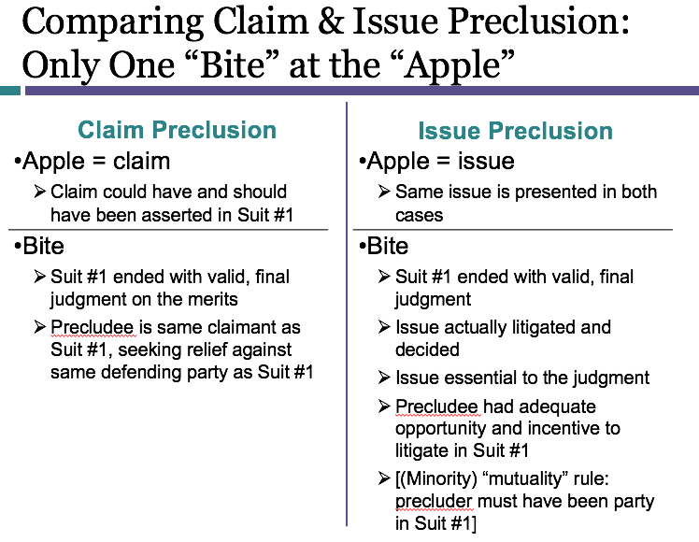
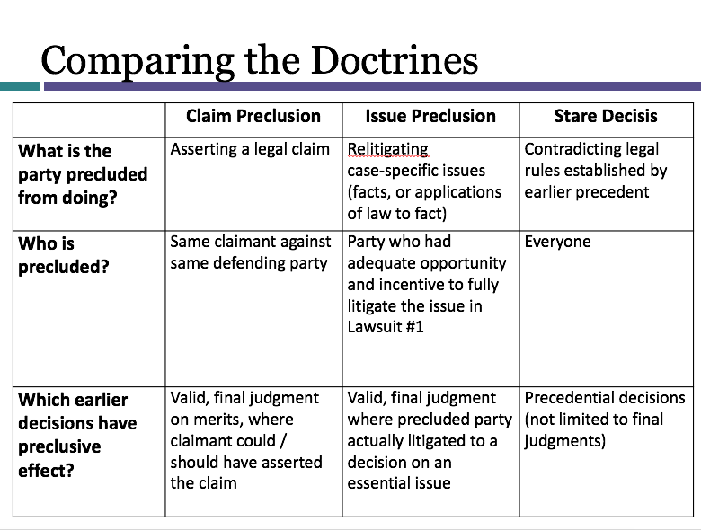

SEMESTER 2

- Forum Selection: Proper forums come when we have the correct Subject Matter Jurisdiction, Personal Jurisdiction, and venue.
  - Plaintiff choses the forum. So long as the forum is one that is legally acceptable, the plaintiff can choose.
  - Why does a lawyer care about forum selection? You believe there will be a benefit to the client.
    - Better juries? Better judge? Convenience? If client is going to have to pay to send you far away, maybe the client doesn’t want to take on that expense.
  - What does the court care about? See three interlocking doctorines that determine if a court is an acceptable (legal) one. If you are fighting these, need to find a defect in one or more.
    - Personal Jurisdiction (Which soverign (state))?
    - Power over the person
    - Can the courts of this sovereign issue orders binding these people?
  - Subject Matter Jurisdiction (Which type of court)
    - Power over the subject matter
    - Can the court issue orders in this type of dispute?
      - In states, there is usually a court of general jurisdiction if there isn’t a rule that says you must take a case somewhere else.
  - Venue (Which court location)
    - Geographical location
    - Within a multi-court system, is this the correct court motion?

Subject Matter Jx [which type of court]
- Power over the subject matter. Ask, can the court issue orders in this type of dispute?
- Defined by Constitution and Statutes.
- There is exclusive SMJ.. and CONCURRENT SMJ and Exclusive SMJ. Exclusive is only federal. Concurrent is both federal and state.
- Limited vs General SMJ JDX: limited JDX can only hear certain cases. Courts of general can hear anything that isn’t prescribed to a specialized court. In CA we are a court of General SMJ.
- FEDERAL QUESTION: In Federal court, they only have limited jdx courts. Constitution gave us one supreme court and gave congress the poer to create lower courts as needed. So today we have:
  - Federal questions
  - Ambassadors
  - Admiralty
  - USA as Party.
  - State v. State
  - Citizens of different states
  - Competing claims to state land grants
  - Citizens v. Aliens
  - State v. Citizen of Other State [limited by 11th Amendment]
- Exclusively Federal SMJ: Where congress specifies via statute (antitrust, bankruptcy, copyright, etc).
- Concurrent SMJ: When there is a statute to put a case in federal court but it is not required.
- Exclusively State: When congress has not given federal court the power to hear a case.
    - Why do we allow state courts to hear federal cases? Accessibility.. it is easier to get to a state court (there Is one or more in every county)
    - Why do we allow federal courts to exist? State judges may be biased on certain federal issues…
- If there is a review of federal questions decided by state court, then it will go up to the US supreme Court.
- Courts care a lot about Federal SMJ
  - Federal SMJ is not waivable
    - Parties cannot consent to federal SMJ
  - Federal Court may raise SMJ sua sponte
    - Sua sponte = on its own motion
    - Even if the parties don’t raise the question
  - Federal Court may raise or rule on SMJ at any time
    - Trial court: before, during, or after trial
    - Court of Appeals: at any time in appeals process, even if never raised in trial court

Three common statutes FOR SUBJECT MATTER JURISDICTION
      - 28 USC 1331 (Federal Question jdx): “The [US] district courts shall have original jurisdiction of all civil actions arising under the Constitution, laws, or treaties of the United States.”
        - Tricky Areas:
          - “Well-pleaded complaint” rule: A claim arises under federal law only if the federal question would be necessary to a “well-pleaded complaint.”
            - This means:
              - A well-pleaded complaint does not anticipate federal questions that would arise only as defenses.
              - The addition of a federal defense in an answer does not make the claim arise under federal law.
            - Louisvill And Nashvill RR v. Mottley: Defendants, the Mottleys, were issued a free lifetime pass for use on the Louisville and Nashville Railroad. Several decades later, Defendants sued Plaintiff Louisville for refusing to honor the free pass pursuant to an act of Congress making free passes unlawful. The people fighting for the tiket suied in federal court.. court dismissed this though bc of well pleaded complaint rule.
          - “Embedded” federal questions
            - When there is a real federal question in a complaint.. but it’s a states law claim……
            - Eg - Plaintiff files a complaint.. breach of k.. this is a states law issue. There was a contract for D to build a bridge. The contract required to follow federal standards. The federal standards used for bridges on military bases. If it breaks.. sues for negligence.. state claim. But its about a federal law standard.. embedded question.
            - Grable and Sons v. Darue Engineering: .π and Δ both claim to be the owners of Property X. Δ claims to be the true owner because it bought Property X from the IRS. π is the true owner, because the IRS had no rights to it. The IRS had no rights to the property
              - Federal statute requires IRS to provide personal service of seizure notice
              - IRS did not provide personal service
              - RULE FROM GRABLE:
              - “[T]he question is, does a state-law claim
                - 1) necessarily raise a stated federal issue,
                - 2) actually disputed (in complint and answer don’t match) and
                - 3) substantial, ( Substantial = important enough to justify original jurisdiction in federal trial court)
                - 4)which a federal forum may entertain without disturbing any congressionally approved balance of federal and state judicial responsibilities.”

      - 28 USC 1332 (diversity jdx)
        - Federal jdx can be Citizens of different states, or citizens vs. Aliens, or citizens with a foreign subject matter.
        - Diversity specifically is: between citizens of different states
          - “(a) The district courts shall have original jurisdiction of all civil actions where the matter in controversy exceeds the sum or value of $75,000, exclusive of interest and costs, and is between—(1) citizens of different States … ”
          - ALLOWS AGGREGATION OF CLAIMS BETWEEN P AND D TO MEET AMOUNT IN CONTROVERSY!!!!!!!!!!!!!!!

1332 Language
a) The district courts shall have original jurisdiction of all civil actions where the matter in controversy exceeds the sum or value of $75,000, exclusive of interest and costs, and is between--
(1) citizens of different States;
(2) citizens of a State and citizens or subjects of a foreign state, except that the district courts shall not have original jurisdiction under this subsection of an action between citizens of a State and citizens or subjects of a foreign state who are lawfully admitted for permanent residence in the United States and are domiciled in the same State; [NATURALIZED FOREIGNS ARE LOCAL NOW NO DIVERSITY]
(3) citizens of different States and in which citizens or subjects of a foreign state are additional parties; and
(4) a foreign state, defined in section 1603(a) of this title, as plaintiff and citizens of a State or of different States. [actual govt]

(b) Except when express provision therefor is otherwise made in a statute of the United States, where the plaintiff who files the case originally in the Federal courts is finally adjudged to be entitled to recover less than the sum or value of $75,000, computed without regard to any setoff or counterclaim to which the defendant may be adjudged to be entitled, and exclusive of interest and costs, the district court may deny costs to the plaintiff and, in addition, may impose costs on the plaintiff.

(c) For the purposes of this section and section 1441 of this title--
(1) a corporation shall be deemed to be a citizen of every State and foreign state by which it has been incorporated and of the State or foreign state where it has its principal place of business, except that in any direct action against the insurer of a policy or contract of liability insurance, whether incorporated or unincorporated, to which action the insured is not joined as a party-defendant, such insurer shall be deemed a citizen of

Roadmap to §1332
- A. Diversity of Citizenship
  - 1.Determining a Party’s Citizenship
  - 2.Determining “Complete” Diversity
- B. Amount in Controversy
  - 1.How to Calculate
  - 2.Aggregation of claims

Determining a party’s citizenship

          - What does it mean for someone to be a citizen of a state? If you are borne here, you are a citizen of the us.. and also going to be a citizen of the state in which you reside.
          - What does it take to be a citizen of a state? (1) have to be a US citizen.. if you are not, then be naturalized.Then (2) also have to be domiciled in the state.
          - What does domicile mean?
            - A natural person can only have one domicile at a time. Already looks different from the Kasogi case.. One can have more than 1 place of abode, but the domicile, as a legal matter, you only have one at a time.
            - First there will be some initial domicile. or where you took the oath.. Then it is possible to change your domicile after that..
            - Redner v. Sanders. Brief Fact Summary. Redner (Plaintiff) was a citizen of New York state currently residing in France. He brought suit against Sanders and others (Defendants), all New York state citizens, in Federal court alleging diversity of jurisdiction Defendants were residents of New York. Court said didn’t have the intent. Synopsis of Rule of Law. For purposes of determining whether diversity jurisdiction exists, a person is a “citizen”� of the state in which he or she is “domiciled.”� For adults, domicile is established by physical presence in a place in connection with a certain state of mind concerning one’s intent to remain there. – pleading was sloppy.. don’t know enough about where the defedants were citizens of. Needed to say domiciled to get diversity. Still a US citizen.. but for purposes of this statute hes not a citizen in a us state..
          - Change of domicile.. What do you need? (1) Physical presence in another state.. plus (2) intent to remain there indefinitely.
          - Need to have the intent to remain here indefinitely… does not mean I specifically live in CA. its indefinite how long I want to be here..
          - Hawkins v. Master Farms inc [stands for change of domicile rule.. must reside somewhere and intent to]: Lived with girlfriend in Missouri, but had his address on his license and insurance listed at troy Kansas. Had moved memorabilia, clothes furnature to Missouri. Dies in tractor accident.. looked to sue in federal court for diversity jdx. Was there fiversity jdx? Yes.. court says that he had physical presense in the state plus an intent to remain there.
          - Deciding parties citizenship
            - Relevant Date of Citizenship
              - At the time of filing
              - Subsequent changes in a named party’s citizenship do not change diversity
            - Presenting Evidence of Citizenship
              - Written evidence may be submitted as part of motion to dismiss for lack of SMJ under Rule 12(b)(1)
                - Evidentiary hearing is possible
              - Rule 12(d) (conversion of 12(b)(6) motions and 12(c) motions to summary judgment if matters outside the pleadings considered) does not apply.
            - Minimal or Bare Diversity: Atleast ne plaiontiff is a citizen of a different state than at least one defendant. Congress MAY authorize SMJ with minimal diversity if it chooses.
              - Interpleader, multi-district suits, class actions.
            - Complete Diversity: No Plaintiff is a citizen of the same state as any defendant. AKA citizens of the same state cannot be on both sides of the V. 1332 is interpreted to require complete diversity—see Strawbridge.
            - Stawbridge v Curtiss (1806): [1332 requiers compelte diversity] Facts: Citizens of Massachusetts brought an action in federal court against other Massachusetts residents and one resident of Vermont. Issue: Can federal diversity jurisdiction be established in a suit in which there is no diversity between the plaintiffs and one of the defendants? Rule: (Marshall, C. J.) In order to establish diversity jurisdiction in federal courts, diversity must be “complete” (i.e., none of the plaintiffs can be a citizen of the same state as any of the defendants).
            - When plaintiff has multiple claims against multiple D’s: SMJ must be proper for each claim.
              - What if we have a lawsuit with two aprties. One from the same state, federal issues. And one from a different state with damages over 75k. Is there proper smj? IF one relies on diversity.. we look at ALL PARTIES IN THE LAWSUIT.. Not just the one to that claim.
            - It is plaintiffs responsibility to property allege diversity. Dismissed if not proper.
            - Corporations residents: Residents in two place—1 where it is incorporated.. and 2 where its principle place of business is. Can potentially be a citizen of two states.
            - In situations when a case is dismissed in rule 41.. no preclusion if dismissal is for lack of jdx.
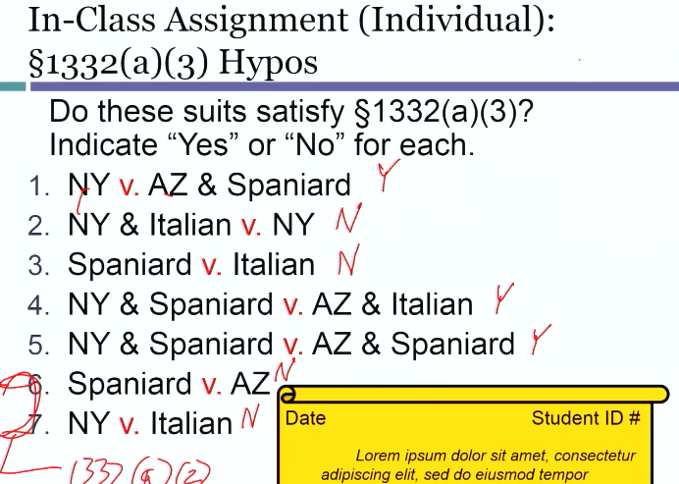

Corporations Under 1332
      - Coprs may enter into contracts. Sue and be sued. Authorize agents to at for them..
      - Corporations do not: Die of natural causes. Exsist without approval of the creating government. Have tangible form in three dimensional space.
      - Under 1332: “For the purposes of this section … a corporation shall be deemed to be a citizen
        - of every State and foreign state by which it has been incorporated and
        - of the State or foreign state where it has its principal place of business …”
          - 28 U.S.C. §1332(c)(1)
      - Where is a corporations principle place of business? It’s the nerve center.. see hertz v friend. Ask.. where is HQ?
        - So for diversity purposes in 1332.. look to see where its incorporated.. and also where its principle place of business is. Either will screw diversity. Don’t have compelte diversity if either is overlapping.

Unincorporated Entities Under 1332
- An unincorporated entity is a citizen of every state in which its members are citizens. If a partnership is in multip[le areas.. then only the citizen locations.. not nerve center analysis
- Examples:
  - Partnerships (partners)
    - Limited Liability Companies, Limited Liability Corporations, and Limited Liability Partnerships are hybrid forms authorized by some state laws. Under §1332, they are NOT treated as corporations.
  - Homeowners/Condo Associations (members)
  - Labor unions (members)
  - Political parties (members)
  - Nonprofit organizations (members)
    - Nonprofit corporations are corporations under §1332

      - Amount in Controversy
- Why dopes this matter? Bc in 1332 for diversity the matter in controversy needs to exceed 75k. Exclusive on interests and costs.
- What is a cost? Specifically defined term that cover certain things.. and not others. They are typically much smaller than expenses. NEED TO READ THE STATUTE.
- Only get attorneys fees.. if allowed by statute. To add to the 75k in dispute.
- Needs to EXCEED 75k.. not meet 75k.
  - How to calculate: Don’t include the costs. Look at the amount requested in complaint… minus to a certainty that certain reqested amount is not available by law. Also minus interest and costs included in requests (if any).
  - Aggregation of Claims: Can you aggregate multiple claims to exceed 75k?
    - Basic Rule: Only the claims of a single plaintiff against a single defendant may be aggregated (except in cases of COMMON UNDIVIDED JOINT INTEREST joint ownership for Plaintiffs 3 siblings are co owners of an appraised artwork values at 150k) or joint liability for defendants).
- Thing’s that wont make it to federal court even with diversity: Divorce, family law, and probate.

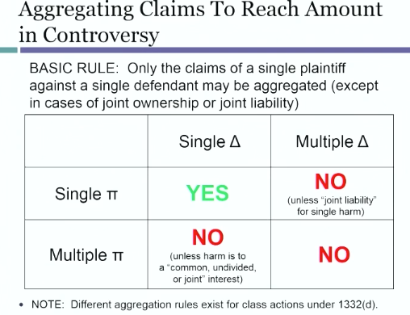

Exceptions:
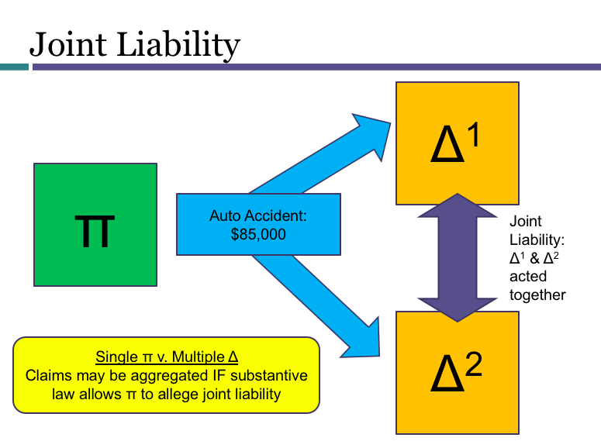
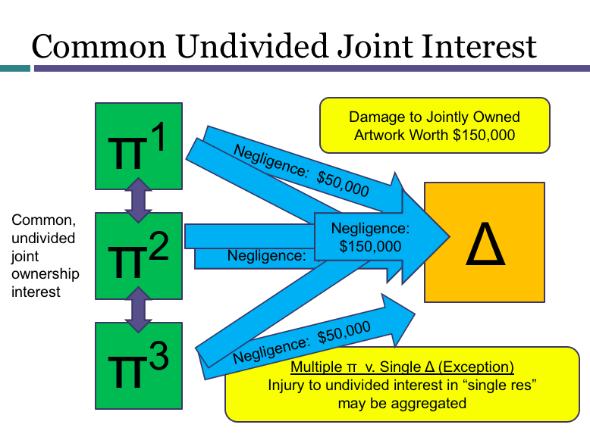

Rules Decision Act: “The laws of the several states, except where the Constitution or treaties of the Unites or Acts of Congress otherwise require or provide, shall be regarded as rules of decision in civil actions in the courts of the United States, in cases where they apply.”28 U.S.C. §1652

Eerie Doctorine: The law of the states will be the rules for decision if there is a civil action in a court of the US.. in other words.. if you are in a US federal court.. but you are there because of diversity.. the law of the state is going to be your law. There is no federal law of contracts.. may have a case in federal court and they may use a state law.
- Boiled down: If a federal court is ruling on a state law claim.. a federal court applies state substantive law of the state and the procedures however.. they are going to use the federal procedures.
- Potentially tricky question? What is substantive law and procedural law? Look at the federal rules.

28 USC 1367 (supplemental jdx) aka Pendant (supplemental claum) Claims (hangs on like a pendant to the federal claim) or Anchor Claims (gets anchored by the federal claim)
- USC 1367 (made by congress) Reliance.. is a claim that hangs on to a real claim (Anchor Claim) for proper SMJ in federal court.
- General structure:
  - (a) General rule allowing supplemental SMJ over factually related claims, subject to the limitations in (b) and (c) [GIBBS]
  - (b) Exceptions involving later-added parties in diversity actions (we will study later, during unit on joinder) [KROGER]
  - (c) Discretion to decline supplemental SMJ in appropriate cases [GIBBS]
    - A federal court may (this is discretionary to the court)decline to exercise supplemental SMJ where:
      - (1) the claim raises a novel or complex issue of State law,
      - (2) the claim substantially predominates over the claim or claims over which the district court has original jurisdiction,
      - (3) the district court has dismissed all claims over which it has original jurisdiction, or
      - (4) in exceptional circumstances, there are other compelling reasons for declining jurisdiction.”
  - (d) in any civil action of which the district courts have original jurisdiction,
  - (e) the district courts shall have supplemental jurisdiction over all other claims that are so related to claims in the action within such original jurisdiction that they form part of the same case or controversy under Article III of the United States Constitution.
  - (f) Such supplemental jurisdiction shall include claims that involve the joinder or intervention of additional parties.”

PER GIBBS:
- Keeping the claim in federal court would not advance judicial economy, convenience, and fairness to litigants
- Federal court would have to make “needless” decisions on state law issues
- Federal claims are dismissed before trial, leaving only state claims
- State issues substantially predominate over the federal issues
- Differences between the claims would pose a likelihood of jury confusion

Using Supplemental Jurisdiction—How do we know if a case involves the same facts as another?
- UMW v. Gibbs “common nucleus of operative facts”
- Supplemental SMJ Statute, §1367(a) “so related .. that they form part of the same case or controversy under Art. III of the US Constitution.”
- Amended Pleadings, Rule 15(c)(1)(B) “the amendment asserts a claim or defense that arose out of the conduct, transaction, or occurrence set out – or attempted to be set out – in the original pleading”
- Compulsory Counterclaims, Rule 13(a)(1)(A) “arises out of the transaction or occurrence that is the subject matter of the opposing party’s claim”
- Joinder of Multiple Parties, Rule 20(a) & (b) “arising out of the same transaction, occurrence, or series of transactions or occurrences”

Practice tip: use the simplest SMJ State when possible (first 1331, then 1332, then 1367 only when you have to).

UMW v. Gibbs (1966)
- Facts: Mr Gibbs owned a coal hauling company. He was having a labor dispute with the Unite Mine Workers, whom were boycotting him. He was unhappy about this.
- What legal claims can he pursue?
  - Claim #1[FEDERAL]: US Labor mgt Relations Act (LMRA)
  - Claim #2 [ NO FEDERAL QUESTION]: State Tort
- Could he rely n diversity jdx? Only if the two were not from the same state. In this case a union is part of any state that it has memebers. IN this case.. there was no diversity JDX.. because there were members from the same state as Gibbs.
- No federal question.. for part 2.
- The Solution.. we know we are in federal court.. they said that the state claim was Pendent on the first claim. Gibbs said.. the entire action before the court comprises but one constitutional case derive from a common nucleaus of operative fact.
- AKA… If the claims are sharing a lot of facts, then its okay for the federal court to exersize Subject matter jurisdiction. We lump them up in PENDANT justisdiction. AKA supplemental jdx.

In Re Ameriquest Mortgage co Lending Practices Litigtion
- Facts: Plaintiff Barbara Skanes makes an amended complaint which alleges that in April 2004, she consummated a mortgage transaction with Ameriquest. Before the transasction occurred, Ameriquest ordered a property appraisal for which they allegedly inflated the value of to increast the loan value, and increase their profits. SO basically they had aother claim going to a second D but arising out of the same facts.
- Issue does the federal court have supplemental jurisdiction? Yes.
  - Section 1367(a) says that if the federal court has jdx over a claim, any supplemental state claims get wrapped up with it… IN this case, Skanes has the Truth in Lending act clasim (Federal) Claims 2 and 3 were state law frauds against people besides Ameriquest. But we cant separate them.. they hinge on the first claim which was a federal issue.

SZENDREY-RAMOS v. FIRST BANCORP [novel and complex reason not to allow supplemental jdx]
  - Facts: Plaintiff Szendrey worked for Defended First bankcorp as general councel. In march 2005, Plaintiff received a report from an outside law firm about ethical and or legal violations committed by the bank officials in relation to accounting for a bulk purchase of mortgage loans from other financial institutions. Plaintiff reported these findings to the board of directors. Plaintiff was then fired and the company claimed she was to blame for the conduct. Plaintiffs claim contains a TITLE VII claim for Discrimination and retaliation and a state claim for professional responsibility Under Puerto Rico Lay.
  - Question: Does the court have supplemental jurisdiction? Holding: No.
  - The Court finds that two of §1367(c)’s subsections are at issue here: (1) that the state law claims raise complex or novel issues and
    - PR code of ethics for professionals.. Canon 21.. is unique and a separate issue from anything in this case. Too novel and complex.
  - (2) that the state-law claims substantially predominate over the federal claim.
    - The PR law was basically the same as federal. No reason to litigate twice.
  - Basically in this case they look at 1367©1 and say.. erie doctrine… in federal court on state law issue.. will it be hard to apply state law? Factors to consider:
    - Does the state law claim seem hard to decide?
    - Have the courts of State X decided similar cases before?
    - Is the case law from State X inconsistent or confused?
    - Is this case distinguishable from prior State X cases?
    - If the case involves a state statute, is it new? Unambiguous? Previously interpreted in case law? Modeled on other state statutes with case law?
    - Would the state be harmed if a federal court were to decide this state law question incorrectly?
    - Would this combination of state and federal claims cause confusion for a jury?
  - Also in 1367 ©(2).. if the state claim is the bigger issue than the federal (dog being wagged by the tail).. no dicve. Factors to consider:
    - Number of supplemental claims
    - Amount of damages associated with each claim
    - Trial time needed for each claim
    - Discovery needed for each claim
    - Logical and factual relationship between the claims
  - 1367©(3): Dismissal of the Original SMJ Claim..
    - Something for the court to consider.. when does the court actually rely on C3.. depends when in the life of the case.. the federal calim disappears..
    - What if it gets dismissed by 12b6 motion.. would probably get dismissed.
    - If it’s a later issue.. then likely wouldn’t make someone do it all over again in state court…
    - What happens if u are in the middle though? Summary judgement mid way through?? It’s DISCRETIONARY.. ITS WHAT PPL WANT…
  - 1364©(4)
    - Because declining supplemental SMJ is less efficient, this exception is not favored
    - Therefore:
      - –the circumstances must be “exceptional”
      - The reasons to decline must be “compelling

28 USC 1441 (removal jdx)
- Removal is the transfer of a case from state court to federal court.
- Jurisdictional statutes give plaintiffs an initial choice of state or federal court for cases in which federal and state court jurisdictions overlap. Congress has also given defendants the power to trump plaintiffs who choose a state court in cases that could have been brought in federal court. The process, known as removal, has as its basic text 28 U.S.C. §1441.

- General Rule: An action filed in state court may be removed if it could have originally been filed in federal court.
- Basic Rule: An action filed in state court may be removed if it could have been originally filed in federal court.
  - In general plaintiff picks the forum. As such we give D a shot to remove if its valid. Why do we do this? Because federal just will probably know federal law better.. if we are worried about state judges playing favorites for the hometown aprties.. then we let the D’s do this..
- What is removable?
  - Exclusively federal issues: Congress has specified. Antitrust, bankrupsy, patent, etc.
  - Concurrent can be in federal or state court.. where congress has authorized but doesnot require cases to be brough in federal court.
    - Most fall under this.
  - Exclusively State: Where Congress has not authorized SMJ in federal court
- You can avoid diversity by making sure that a D is from the same state. How do I make sure its not a federal issue? Only cite the state statute.. not any federal one if one exsists.

YOU CAN REMOVE THINGS ON DIVESRITY CEPT PER IN STATE DEFEDNANT RULE.

- EXCEPTIONS:
  - In State Defendant
    - 1441 b2… a civil action removable solely on the basis of diversity… it may not be removed if any of the parties who are defedents are citizens of the state where the action is brought…
    - If defendant has home court advantage.. why let defendant go to the more neutral forum……….MULTIPLE CHOICE QUESTION
  - Timing of Removal
    - 1146 b1If it’s a federal question.. if you want to remove.. do it within 30 days of receiving a complaint and counter claim!
    - 1446b3 – if federal question Within 30 days of receipt of document making a previously unr-emovable case removable
    - 1446b – for diversity…
      - (b): Same 30 day periods under (b)(1) and (b)(3), EXCEPT
      - (c)(1): removal under (b)(3) cannot be later than one year after commencement of the action (unless π delayed in bad faith)
    - Removal hypos 243///

Hayes v. Bryan Cave LLP
- Facts: Attorney malpractice case. Plaintiff is a dr..suing doctors.. my lawyers committed malpractice. Complaint originally filed in Illinois.. Then removes to federal court..
- Says when it gets to appeals level.. there should be a SHORT AND COMPLAINT statement for REMOVAL.. There were 3 defendants.. 3 gave notice.. yjey were claiming federal question jdx.
- This guy gets his case dismissed by federal judge bc of issue preclusion… his case had already been heard once in criminal case.. .. then it gets appealed… Then appellate courts says this shouldn’t be in federal court.. vacates the lower courts ruling, and remand back t state court…
- Grable and Sons.. relatively rare tax issue.. in a state law claim..
- Note that there is a difference between Embedded federal question and the well pleaded complaint rule…

28 USC 1441

(a)Generally.—
Except as otherwise expressly provided by Act of Congress, any civil action brought in a State court of which the district courts of the United States have original jurisdiction, may be removed by the defendant or the defendants, to the district court of the United States for the district and division embracing the place where such action is pending.
(b)Removal Based on Diversity of Citizenship.—
(1)In determining whether a civil action is removable on the basis of the jurisdiction under section 1332(a) of this title, the citizenship of defendants sued under fictitious names shall be disregarded.
(2)A civil action otherwise removable solely on the basis of the jurisdiction under section 1332(a) of this title may not be removed if any of the parties in interest properly joined and served as defendants is a citizen of the State in which such action is brought.
(c)Joinder of Federal Law Claims and State Law Claims.—
(1)If a civil action includes—
(A)a claim arising under the Constitution, laws, or treaties of the United States(within the meaning of section 1331 of this title), and
(B)a claim not within the original or supplemental jurisdiction of the district court or a claim that has been made nonremovable by statute,
the entire action may be removed if the action would be removable without the inclusion of the claim described in subparagraph (B).
(2)Upon removal of an action described in paragraph (1), the district court shall sever from the action all claims described in paragraph (1)(B) and shall remand the severed claims to the State court from which the action was removed. Only defendants against whom a claim described in paragraph (1)(A) has been asserted are required to join in or consent to the removal under paragraph (1).

28 USC 1446 [Proceedures for Removal]

28 USC 1446
(a)Generally.—A defendant or defendants desiring to remove any civil action from a State court shall file in the district court of the United States for the district and division within which such action is pending a notice of removal signed pursuant to Rule 11 of the Federal Rules of Civil Procedure and containing a short and plain statement of the grounds for removal, together with a copy of all process, pleadings, and orders served upon such defendant or defendants in such action.
(b)Requirements; Generally.—
(1) The notice of removal of a civil action or proceeding shall be filed within 30 days after the receipt by the defendant, through service or otherwise, of a copy of the initial pleading setting forth the claim for relief upon which such action or proceeding is based, or within 30 days after the service of summons upon the defendant if such initial pleading has then been filed in court and is not required to be served on the defendant, whichever period is shorter.
(2)
(A)When a civil action is removed solely under section 1441(a), all defendants who have been properly joined and served must join in or consent to the removal of the action.
(B)Each defendant shall have 30 days after receipt by or service on that defendant of the initial pleading or summons described in paragraph (1) to file the notice of removal.
(C)If defendants are served at different times, and a later-served defendant files a notice of removal, any earlier-served defendant may consent to the removal even though that earlier-served defendant did not previously initiate or consent to removal.
(3) Except as provided in subsection (c), if the case stated by the initial pleading is not removable, a notice of removal may be filed within thirty days after receipt by the defendant, through service or otherwise, of a copy of an amended pleading, motion, order or other paper from which it may first be ascertained that the case is one which is or has become removable.
(c)Requirements; Removal Based on Diversity of Citizenship.—
(1)
A case may not be removed under subsection (b)(3) on the basis of jurisdiction conferred by section 1332 more than 1 year after commencement of the action, unless the district court finds that the plaintiff has acted in bad faith in order to prevent a defendant from removing the action.

28 USC 1447 [Remand]—the transferring of a case from a federal trual court back to a state trial court after removal.
- If a court lacks subject matter jurisdiction, the case must be remanded.. if it’s been removed..
- There are actual sanctions if one iproperly rmoved.. 1447©.. an order remanding the case may require the just cost including the attorneys fees incurred because of the removal…
- Defedants need to be hunanimous..

USC 1447
(a) In any case removed from a State court, the district court may issue all necessary orders and process to bring before it all proper parties whether served by process issued by the State court or otherwise.
(b) It may require the removing party to file with its clerk copies of all records and proceedings in such State court or may cause the same to be brought before it by writ of certiorari issued to such State court.
(c) A motion to remand the case on the basis of any defect other than lack of subject matter jurisdiction must be made within 30 days after the filing of the notice of removal under section 1446(a). If at any time before final judgment it appears that the district court lacks subject matter jurisdiction, the case shall be remanded. An order remanding the case may require payment of just costs and any actual expenses, including attorney fees, incurred as a result of the removal. A certified copy of the order of remand shall be mailed by the clerk to the clerk of the State court. The State court may thereupon proceed with such case.
(d) An order remanding a case to the State court from which it was removed is not reviewable on appeal or otherwise, except that an order remanding a case to the State court from which it was removed pursuant to section 1442 or 1443 of this title shall be reviewable by appeal or otherwise.
(e) If after removal the plaintiff seeks to join additional defendants whose joinder would destroy subject matter jurisdiction, the court may deny joinder, or permit joinder and remand the action to the State court.

- Artis v. District of Columbia

PERSONAL JX [WHICH SOVEREIGN (STATE)]

What is personal jurisdiction?
- Power over the person. Can the courts of this sovereign issue orders binding these people?
- Persona; jurisdiction is complicated because we have a lot of person interests competing
  - First we attach things first at the level of statutes and regulations.. then you go to the constitution.
  - Preference is to resolve things as low on the totem as possible though, bc no one wants to mess up a constitutional question.
- Defined by Constitution and Statutes (LONG ARM)
  - First start at the bottom- the relevant long arm statute (state/ federal.
  - Then ask if the statute is constitutional per the due process clause.
    - This is like service of notice. Start with the rule on how to service. Then as. is this good enough for the due process clause… in the constitution.
    - If a statute is too vague then you look at some supreme court decisions.

In Analyzing Personal Jurisdiction ask this flow:
- Does the forum’s law (long-arm statute) assert personal jurisdiction over the defendant?
  - If NO, forum does not purport to assert PJ (case dismissed)
  - If YES, continue to Question 2
- 2. Does the forum’s assertion of personal jurisdiction satisfy the constitution’s due process clause?
  - If NO, PJ is unconstitutional (case dismissed)
  - If YES, PJ is constitutional

STATUTE: LONG-ARM STATUTES

Personal JDX is California- Long arm Statute
- A court of this state may exercise jurisdiction on any basis not inconsistent with the Constitution of this state or of the United States.”
- California Code of Civil Procedure §410.10

Long- Arm Jurisdiction in Federal Court Rule 4(k)(1)(A)
- (k) Territorial Limits of Effective Service.
- (1) In General.
- “Serving a summons … establishes personal jurisdiction over a defendant:
  - (A) who is subject to the jurisdiction of a court of general jurisdiction in the state where the district court is located…;”
- Aka- Federal court will exercise PJ if a basic state court in the same geographical location would exercise PJ

Courts of General Jurisdiction: Will listen to ANYTHING as long its no explicitly supposed to be heard somewhere else.

CONSTITUTION: DUE PROCESS AND PJ
IN order to have DUE PROCESS.. we need to have PROPER Personal Jurisdiction
- “Proceedings in a court of justice to determine the personal rights and obligations of parties over whom that court has no [personal] jurisdiction do not constitute due process of law.”
  - Pennoyer v. Neff (1878)
- Aka- Improper assertion of personal jurisdiction by the sovereign = a constitutional violation.

Traditional Constitutional Bases (acceptable Due Process) for PJ VIA Pennoyer v. Neff

- (a) Service of process within forum (presence in form)
  - One act has two legal ramifications: one there is notice. Two there is now Personal JDX of someone.. why is this? It’s a symbol of the long arm
  - Symbolic.. to sovereign power over the defendant..
    - Why is this a symbol we care about? This all had to do about where you got served with your papers. The state has the power within its borders and not outside its borders.
      - Served in CA? You are in CA. Thus JDX.
- (b) Consent
  - If the defendant doesn’t object to a certain jdx.. fine.. don’t object.. then I can be sued
  - This means that person jdx is waivable.. waivable defenses under rule 12… Rule 12H is the on that says this is a waiveable defense.
  - Also can do it in advance in contract.. if there is a dispute between us.. the forum will be whatever.
- © Service on agent in forum
  - Including agent appointed by law (see. Hess v. Pawloski)
  - If you have an agent in a forum.. you can serve that person and that just like serving the person directly. The idea is that if you accept papers in a state, you must think its okay to be sued there.
  - In reality wy would anye do that? They do it bc there is some law requiring to.
- (d) Divorce
  - If your spouce disappears.. then you can basically have the divorce proceedings.. in your state. CA just adjusts your status from.. married.. to single.. no prob that the defendant might be somewhere else.

- Then a 5th element – Natural Person Domiciled in forum (wherever Served – see Milliken v. Meyer

- Legal Consequences of Service
- Service of process that is properly performed according to the relevant statutes or court rules:
- 1.provides constitutionally-required NOTICE to the defendant that a lawsuit is pending (unless service method is constitutionally flawed); and
- 2.establishes constitutionally-required PERSONAL JURISDICTION over the defendant
  - Service of summons symbolizes the sovereign’s power over the defendant

- Service of Process To Establish PJ Under Rule 4(k)
  - Serving a summons.. established personal jurisdiction over a defendant
    - Rule 4k1
    - Rule 4k2
Presence and STATE Power in Pennoyer
- “every State possesses exclusive jurisdiction and sovereignty over persons and property within that territory”
- “no State can exercise direct jurisdiction and authority over persons or property without [outside] its territory

The Letter, but not the spirit: Hess v. Pawloski
Facts: MA resident was injured in an automobile accident on a MA highway. Other driver was resident of PA. MA resident brought a personal injury action against the PA resident by filing a complaint in MA state superior court. MA resident delivered the complaint and $2 dollars upon the MA registrar and sent by registered mail to the PA defendant notice of the service and a copy of the complaint.
Rule:
    - Statute assigning instate agent to be served with complaint does not violate 14th amendment
    - State has right to govern what happens on its roads
    - If anything, this is treating residents and non-residents alike
  - For a nonresident, driving on a MA highway “shall be deemed equivalent to an appointment by such nonresident of the registrar [of motor vehicles] to be his true and lawful attorney upon whom may be served all lawful processes in any action … against [the nonresident] growing out of any accident or collision.” [ PJ]
  - Plaintiff must also send copy of summons and complaint to defendant via registered mail. [NOTICE]

The Spirit, but not the letter: Milliken v. Meyer
- Facts: Milliken sued Meyer, a WY resident in a WY state court. Meyer was in CO at the time and service was effected in CO under a WY statute that permitted service by publication on absent residents. Meyer did not appear and an in personam judgment was entered against him. Tried to enforce it later
- Rule: Domicile in state is enough to bring an absent defendant within reach of state’s jurisdiction – authority over a state over one of its citizens is not terminated when that citizen is absent.

Issue: Where is a Corporation “Present” or “Doing Business” under Pennoyer? This we get.. INTERNATIONAL SHOE. Which rewrites the law basically.. from a proceeduralanalysis to a substantive one of MINIMUM CONTACTS.

International Shoe Co. v Washington 1945- Creates minimum contacts analysis
    - Facts:
      - ISC, a DE Corp headquartered in MI, manufactured and distributed shoes. ISC employed 11 to 13 salesmen who resided and worked in WA. WA had statue which said all people who worked there had to chip in for fund. ISC wouldn’t so their salesman got SERVED.ISC objected bc they didn’t have office there, or contract for sales, or inventory or intrastate deliveries. Also said that service on salesman not service on company, ISC was not WA corp and did not conduct business there, also that ISC did not authorize WA agents to receive service and that ISC was not employer under WA stature
    - Rule:
      - WA had in personam jurisdiction over ISC because ISC had "minimum contacts" with the State of Washington and the assertion of personal jurisdiction was reasonable; therefore, the State of Washington had power to collect payroll taxes from ISC.
      - Location of a Corp is determined by its activities and dealings in a state.
Due process is satisfied if the nature and quality of the contacts are such that the exercise of jurisdiction based on these contacts does not offend traditional notions of fair play and justice.
      - Due process permits a state court to assert personal jurisdiction over an out-of-state corporate defendant provided that the defendant has "minimum contacts" with the state so that the maintenance of the suit does not offend "traditional notions of fair play and substantial justice."
        - "minimum contacts" refers to the nature and quality of the defendant's activities in the state and the relationship between those activities and the legal action.
        - Even if a defendant has minimum contacts with the state, compelling the defendant to litigate in that forum is not allowed to offend "traditional notions of fair play and substantial justice."
      - ISC had continuous and systematic contacts with the State of Washington through its employment of salesmen, marketing efforts, product sales and profit derived in the state of Washington. The continuous and systematic contacts were related and gave rise to the legal action against it
    - Justice Black’s opinion: The constitution leaves to the states a power to tax and open the doors of its courts for its citizens to sue Corps whose businesses take place within that state. Can’t stretch the meaning of due process so far that it would take a way a state’s right to afford judicial protection to its own citizens on the ground that it would be more “convenient” for the Corp to be sued somewhere else.
- International Shoe modifies Pennoyer's jurisdictional model to reflect the emergence of Corps and the growth of interstate commerce
  - Took a functional approach to determining jurisdiction

Minimum Contacts
  - International Shoe does not tell us what minimum contacts are.
  - Court proposes a case by case approach—functional, not formal
  - Gives us 4 categories to see whether there are minimum contacts
    - Continuous and Systematic with cause of action
    - Continuous and Systematic with no cause of action
    - Isolated and sporadic with cause of action
    - Isolated and sporadic with no cause of action

Paradigm shift from PRESENSE to Contacts and REASONABLENESS
- Historically … [the defendant’s] presence within the territorial jurisdiction of a court was prerequisite to its rendition of a judgment personally binding him. Pennoyer v. Neff.
- But … due process requires only that in order to subject a defendant to a judgment in personam, if he be not present within the territory of the forum, he have certain minimum contacts with it [the forum] such that the maintenance of the suit does not offend ‘traditional notions of fair play and substantial justice’.” – International Shoe.

International Shoe Reinterprets the “Corporate Presense” Cases
- [many related ontacts] No doubt” that corporation is present when:
  - “continuous and systematic” activities in forum state that “give rise to the liabilities sued on”
- [Many unrelated contacts/ a few related contact] Inconsistent results when:
  - “continuous activity of some sort” in forum state, but that activity is not related to the lawsuit
  - “single or occasional acts” in forum state, but “the nature and quality and circumstances” of the acts are related to the lawsuit
- [ A few UNRELATED contacts]“Generally recognized” that corporation is not present when:
  - “single or isolated” activities in forum state that are “unconnected” to the lawsuit

General v. Specific (Personal JDX
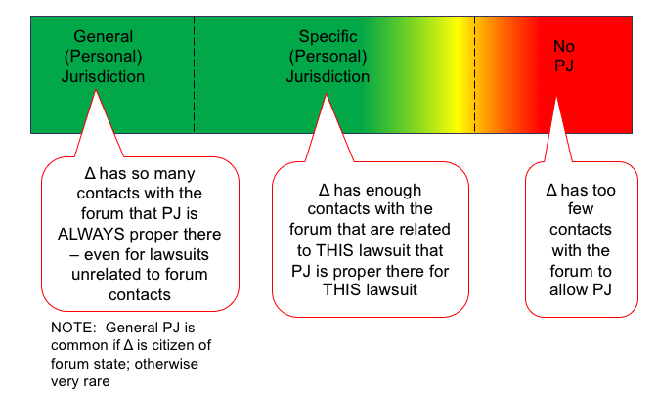

Paradign Shift: From Rules to Standard
- Traditional Bases [RULES]
  - Δ present and served in forum state
  - Δ consents to litigation in forum state
  - Δ’s agent present and served in forum state
  - π present in forum state for divorce (marital status only)
- Minimum Contacts Approach [ STANDARD]
  - Δ has at least “minimum contacts” with forum state so that PJ is “reasonable”
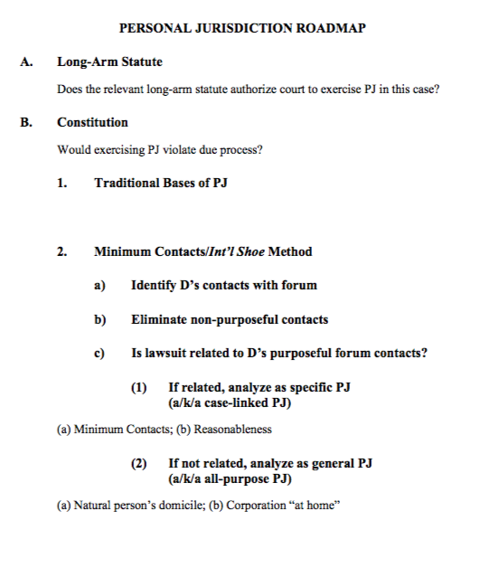
Begin to apply International Shoe standard to various factual scenarios.

PJ over the parties to a contract
    - We don’t have to get mystical about where a contract is.. you ask what are the parties.. what did they do..

McGee v. Intl Life Insurance [one purposeful contact enough]
      - Facts: Lowell Franklin a CA resident purchased a life insurance policy from a company in texas. He paid the insurance premiums from CA, through to his death in 1950. When asked to pay for his insurance, they refused to pay saying it was suicide. Respondant did not have any office or agent in California.
      - Question: Which state should the case be tried? CA
      - Holding: Sufficient that the suit was based on a contract which had “substantial connection with that state.” CA has a manifest interest in being able to provide its residents with redress from foreign businesses. There was also nothing shown that the defendants had inadequate time to prepare for this suit, etc.—just because it was inconvenient for them does not mean that CA did not have jurisdiction over them

Hanson v. Denckla (non purposeful contacts don’t count)
      - Facts: Mrs. Donner created a trust in Delaware and then moved to Florida. Who has JDX over the trust?
      - Questions: Who has JDX Delaware or FL? Delaware.
      - Holding:
                - Minimum contacts cannot be satisfied by the unilateral activity of those who claim some relationship with the state
                - There must be some act by which the defendant “purposefully avails” himself of the privilege of doing activities within the state this invoking the benefits and protections of its laws.
                - Hanson qualifies the test from McGee by adding a quid pro quo requirement
                - No significant state interest—no long arm statute.
        - What is wrong with these arguments?
          - “All of the other parties to the lawsuit (plaintiff Denckla and the Hanson defendants) are citizens of Florida.”
          - Assume that Wilmington Trust has an office in Georgia, right across over the Florida state line: “Trial in Florida imposes no difficult burdens on defendant.”
            - Subjdx acts as a tool of interstate federalism.. its an insult of constitutional magnitude.. if florida improperly puts jdx ove a Delaware citizen.. the state boundaries still matter… bc it’s a fiction hat it is harmful to the interests of a state..

PJ over the parties in complex sales transactions

Woldwide Volkswagen- Need PURPOSEFUL (Not just stream of commerce) minimum contacts, and it must be reasonable for a court to hear a case. Not sure if 1 or 2 steps though.
      - Facts: Person bought audi from a dealer in NY, Audi is from Germany, and was on a roadtrip to AZ WHERE THEY GOT IN AN ACCIDENT IN OKALHOMA. IN the lawsuit they joined the manufacturer, its importer, and its regional disturber. Audi and the retail distrib asked for the district judge in Oklahoma to say they couldn’t exercise jdx
      - Question: The question is whether a state may exerciser personal jdx over an out of state auto retailer when the retailers only connection was that a car they sold in New York got in an accident in the state of Oklahoma. OKLAHOMA IS NOT A VALID FORUM. SHOULD BE NYC.
      - Holding
        - Court cites the need to have minimum contacts with a state. See Shoe.
          - It protects the defendant against the burdens of litigating in a distant or inconvenient forum. The protection against inconvenient litigation is typically described in terms of “reasonableness” or “fairness.”
    - We also must look to what is reasonable in hearing a case. It must be an efficient outcome.
          - Foreseeability that an audi would end up in Oklahoma is not a reasonable benchmark. Slippery slope for anyone who sells a chattel. Needs to have some intention that it ends up there. They say no dealerships in Oklahoma.. thus no contacts.
        - Worldwide VW on the Stream of Commerce
          - “The forum State does not exceed its powers under the Due Process Clause if it asserts personal jurisdiction over a corporation that delivers its products into the stream of commerce with the expectation that they will be purchased by consumers in the forum State.”
          - –Worldwide Volkswagen (majority) (dicta)
        - WWVW on Forseeability:
          - “[T]he foreseeability that is critical to due process analysis is not the mere likelihood that a product will find its way into the forum State. Rather, it is that the defendant’s conduct and connection with the forum State are such that he should reasonably anticipate being haled into court there.”
          - –Worldwide Volkswagen (Majority)
        - PROF THINKS ULTIMATELY THE COURTS ARE TRYING TO AVOID PEOPLE BEING LIABLE IN ALL 50 STATES AT ANY TIME.
        - Also note.. we don’t hold a company responcible for what a user UNILATERALY goes and does. Unless there was some intent it be used that way and expects to potentially go to a court hearing bc of it.

- Minimum Contacts- International Shoe.
- Introduce Frequently Used Sub-Concepts
  - “Purposeful” contacts with the forum
    - WWVW, Mcgee, Hanson
  - “Foreseeability” of PJ in the forum
    - WWVW, Asahi
  - “Reasonableness” of PJ in the forum
    - Burger King

- Burger King v. Rudzewicz- Creates the WWVW Holding in to 2 steps.
  - Facts: Plaintiff, a Florida corporation, and Defendants, Michigan residents, had a franchise agreement specifying that Defendants may be subject to suit in Florida. Plaintiff sued Defendants in Florida federal court based on diversity of citizenship for non-payment under the franchise agreement. Defendants moved to dismiss on the grounds that Florida did not have personal jurisdiction over Defendants.
  - Burger Kings 2-step method
    - “Once it has been decided that a defendant purposefully established minimum contacts within the forum State,
    - these contacts may be considered in light of other factors to determine whether they comport with fair play and substantial justice”

CURRENT AND MDOERN TEST THUSLY FOR MINIMUM CONTACTS IS:
Step 1: Are there Purposeful minimum contacts?
Step 2: Is PJ reasonable? [BK factors + WWVW Factors]
  - The burden on the defendant
  - The forum State’s interest in adjudicating the dispute
  - The plaintiff’s interest in obtaining convenient and effective relief
  - The interstate judicial system’s interest in obtaining the most efficient resolution of controversies
  - The shared interest of the several States in furthering fundamental substantive social policies
  - Burger King, quoting Worldwide VW

Big takeaway on reasonableness.. think about everyones interests.

Does it matter if there is a better forum for someone to have a case? The answer is no. There are often alternative forums. It does not matter. It only has to be legally fit. Just needs to be reasonable.
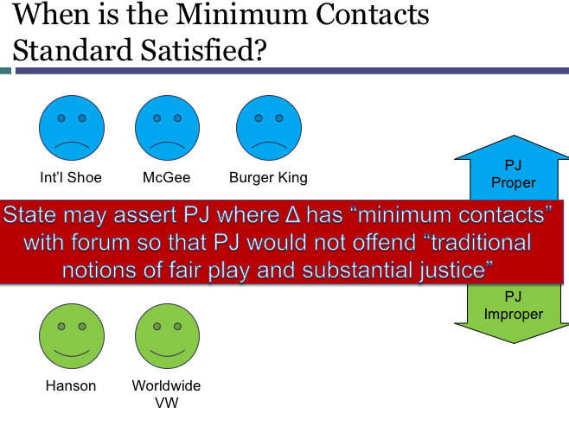
Applying Old Law to New Technology
- What result if the facts had involved the most analogous old technology?
- Does something about the new technology require a different result?

Browne v. McCain
- Facts: Ohio republican party used a song that was owned by someone else in commercials that ran in ohio. Was sued by the artist in CA.
- Question: Personal jdx in ca? No.
- Holding: Said that the effects were not felt in CA, and that the infringement was not directed towards CA.

Right of Publicity: Control over Commercial Use of Name or Likeness

Abdouch v. Lopez- re read
- Facts: Lopez ran a book shop that sold an autographed copy of a book that was stolen from Abodouch. Who was at one time the campaign manager for J F kennedy. The books author was the speech writer for Kennedy. The book was sold online and for 3 years after was advertised as sold on Lopez website. Abdouch lives in Nebraska and is trying to sue in Nebraska for a breach of her publicity rights.
- Question: Does Nebraska have jdx? NO
- Holding
  - States two approaches to the Internet PJ Question… and either could work ( Both are applications of International Shoue to specific factual settings)
    - Zippo (Internet Test): For special jurisdiction you look at the spectrum: If intended to do business in a state, then there is special jdx. If its completely passive, no ability to jdx. This is in between.
      - This case they say it was interactive…on the spectrum. Zippo says go figure it out. When figuring it out look at contacts, reasonability, etc.
    - Calder (Effects Test) were a non resident and non consentint tort feaser can subject themselves to PJ in a different state if their actions were
      - 1) were intentional,
      - (2) were uniquely or expressly aimed at the forum state, and
      - (3) caused harm, the brunt of which was suffered—and which the defendant knew was likely to be suffered—[in the forum state

Shirley Jones (with Marty Ingels)

Calder v. Jones
- Facts: Celebrity sued national enquierer in florida for a tabloid issue that was false.
- Question: was the writer of the articles contacts sufficient in CA?
- Holding
  - Contacts were in CA. Paper was distrib in CA. neww shirly jones lived in CA. coud forsee it hurt her reputation.
  - Overall defedents have aimed their conduct at CA.
  - Gives calder test.. use it for intentional torts.

CALDER EFFECTS TEST
- “A [non-resident, non-consenting] defendant’s tortious acts can serve as a source of personal jurisdiction [if] the plaintiff makes a prima facie showing that the defendant’s acts
  - 1.Were intentional,
  - 2.Were uniquely or expressly aimed at the forum state, and
  - 3.Caused harm, the brunt of which was suffered – and which the defendant knew was likely to be suffered – [in the forum state]”
Walden v. Fiore
- Professional gambler.. flys in to atlanta.. and seizes all of her money. Needed the money for a tournament in Nevada. Sues in Nevada.
- From the US supreme court.. they basically said… look this wasn’t aiming for Nevada.. Uses Calder Effects.
- Part of it is knowing where the victim is located.. and then somehow aiming the conuct at them….

Unabomber Hypo: wants it to go to CA. But blow sup in route in Arkansas. Is this potential? We will allow for it. We will find transferred intent. Etc.

The Zippo Sliding Scale [Image]
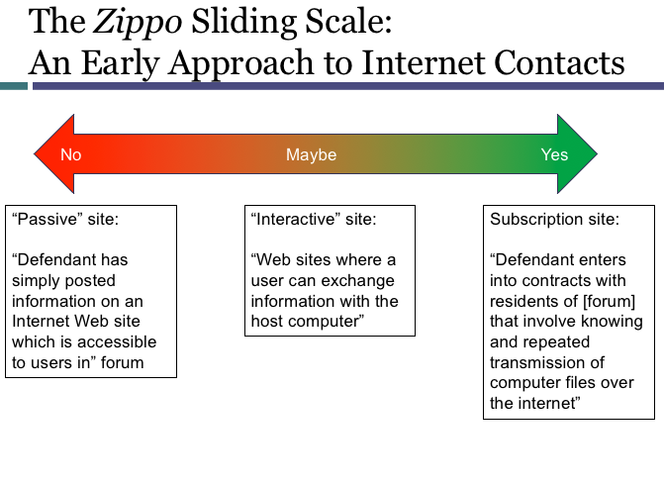
USE ZIPPO AND CALDER when trying to figure out if contacts are ABOVE miimum (b2a) in the fold.

Ebay Hypo
Seller in TX sues a buyer in FL. Ebay is in CA. Where is PJ reasonable?
Seller in TX sells a fake, buyer in GA wants to sell. Whereis PJ reasonable?

The Stream of Commerce
“The forum State does not exceed its powers under the Due Process Clause if it asserts personal jurisdiction over a corporation that delivers its products into the stream of commerce with the expectation that they will be purchased by consumers in the forum State.”
–Worldwide Volkswagen (Majority)

Asahi Case
- Asahi Metal Industry Co. v. Superior Court REASONABLENESS
  - Facts:
    - Products liability case, Cheng Shin brings in Asahi as 3rd party in indemnity action, only those two parties are left when plaintiff drops out.
  - Rule:
    - Not enough affiliating contacts to meet the minimum contacts standard.
      - Everyone agrees forum is inconvenient bc both are foreign corporations
Like Worldwide, foreseeability is not enough
    - Justice O’Connor:
      - said that the “substantial connection” between the defendant and the forum State necessary for finding of minimum contacts must come about by an action of the defendant purposefully directed towards the forum state.
      - Mere foreseability that product will reach state is not enough.
      - Defendants should be able to “reasonably anticipate” they may be hailed there.
    - Justice Brennan:
      - Asahi did purposefully avail itself, but agree that the exercise of personal jurisdiction over Asahi in this case would not meet the idea of fair play and substantial justice. In this case CA’s exercise of jurisdiction would not be reasonable. (Balancing/ test)
    - Justice Stevens:
      - If inconvenience is so strong, court does not have to look at purposeful availment, but there were plenty of contacts
    - Scalia:
      - Only one who says minimum contacts is threshold test, once you have them THEN look at reasonableness.

Fairness Factors for Reasonableness (See Worldwide VS, Burge King, and Asahi)
- Intra-Forum Concerns
  - Burden on Δ
    - Must create a “severe disadvantage” to ability to defend (Burger King)
  - Interests of forum state- plaintiff has a fair and convenient place to get compensation.
  - π’s interest in obtaining relief
- Inter-forum concerns
  - Judicial efficiency- where is discovery going to happen?
  - Conflicting substantive law

Intent in the Stream of commerce (Argue both on exam)- LOOK AT BARNIES B OATS Q ON TWEN FOR OLD TEST.
- WWV: “expectation that they will be purchased by consumers in the forum State”
  - Asahi (Brennan): “aware that the final product is being marketed in the forum State” – more liberal view.
    - Should allow the same sort of coverage given how the economy works.
  - Asahi (O’Connor)[stream of commerce plus]: “intent or purpose to serve the market in the forum State”
    - Often called “stream of commerce-plus. The plus is you wanted that to happen.
    - For an intentional tory.. need to have INTENT to affect the forum state.
    - Why should someone who is merely negligent get treated worse than someone who is intentional?
    - Demands a higher level of proff..

J. McIntyre Machinery v. Nicastro
- Facts
- Question
- Holding

Other Theories of PJ
- Variations on International Shoe

  - Specific PJ and Real Property*

    - Shaffer v. Heitner
      - Jurisdiction over property really means “jurisdiction over the interests of persons in a thing.”
        - “Assertion of jurisdiction over property is … an assertion of jurisdiction over the owner of the property.”
      - “Any assertion of jurisdiction [over people, including people claiming interests in property] must satisfy the International Shoe standard.”
      - However, “the presence of property in a State may bear on the existence of jurisdiction by providing contacts among the forum State, the defendant, and the litigation.”
        - Important contact point.
    - Real Estate Hypo 1: Ask what are the sellers contacts with the forum? If it’s the property theyre selling General jdx! Go through the whole roadmap.
    - Another hypo.. To buy property in delware a buyer gets a loan at a CA bank. Is that acceptable? Yes you can… contacts..
    - Freds Delaware Property: ginger trips and falls on the property in delware. PJ there?
    - Get damages in CA but want to attach to a properties in different state.
      - Ca is PJ.. lives here general jdx. Specific too bc accident happened here. Lawsuit is not about delaware..do the suit in CA.. and then collect around wherever you want. **KNOW THIS

  - General “All-Purpose” PJ
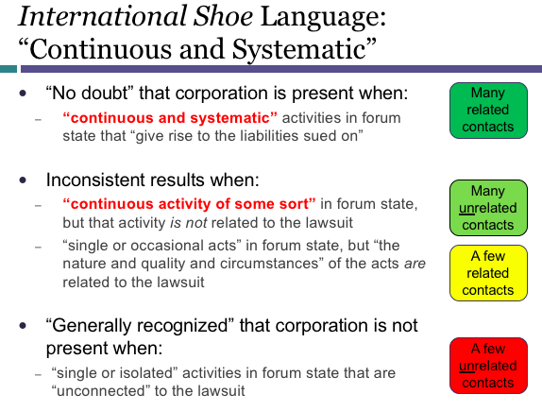
Perkins v. Benguet Mining (Continuous and Systematic Case)
- π sues Δ in Ohio over events in Philippines
  - Suit not related to Δ’s Ohio contacts
- Court said Ohio may assert general PJ over Δ
  - Δ is Philippines corporation, but most of its business activities had been conducted from Ohio ever since Japan invaded Philippines during WWII
  - Δ carried out a “continuous and systematic” amount of its general business in Ohio
  - Δ may be sued in Ohio on any claim, including claims unrelated to its Ohio contacts

Helicopteros v. Hall
- π sues Δ in Texas over helicopter crash in Peru
  - Δ is Colombian corporation that holds some meetings, purchases some equipment, and sends some employees to trainings in Texas
  - Suit not related to Δ’s Texas contacts
- Texas may not assert general PJ over Δ
  - “We thus must explore the nature of [Δ’s] contacts with the State of Texas to determine whether they constitute the kind of continuous and systematic general business contacts the Court found to exist in Perkins. We hold that they do not.”

Changes in Legal Standard- top of page 141

- Old: Continuous and Systematic with the forum state DON’T SAY THIS LANGUAGE
  - See Perkins and Helicopteros
- New Standard USE INSEAT “ESSENTIALLY AT HOME IN THE FORUM STATE”
  - See
    - Goodyear Dunlop v. Brown (2011)
    - Daimler v. Bauman (2014)
    - Bristol Myers Squibb v. Superior Court (2017)

Words have changed. Does it change the meaning? Professor says yes.

Amazon Hypo: Incorporated in WA. Busness in WA. But they have contacts all over. In Continuous and systematic.. You can get PJ no problem. Now ESSENTIALLY AT HOME… this would mean any person in any state.

Goodyear Dunlop Tires v. Brown [first case to show continuous and systematic]
- Facts: Tire co. based in Ohio. Has a factory in NC. Injured in France by a tire. Lives in NC. Sues in NC. Goodyear Turkey actually made the tire. Turkey subsidiary suing.
- Question: PJ in NC? Via specific jdx? No. Via general? No. Not essentially at home in NC.
  - Under stream of commerce.. and one of the tires ewas exploded in NC. Then maybe we have Specific. But selling thigns everywhere doesn’t make you essentially home there.
  - What about connecting to a subsidiary? No. A subsidiary cant just get pierces to look at different cos.
  - Need something more to be at home than just a bunch of products.
- GENERAL v. SPECIFIC JDX: In contrast to general, all-purpose jurisdiction, specific jurisdiction is confined to adjudication of “issues deriving from, or connected with, the very controversy that establishes jurisdiction.”
- COURT SAYS THAT..FOR GENERAL JDX: A court may assert general jurisdiction over foreign (sister-state or foreign-country) corporations to hear any and all claims against them when their affiliations with the State are so “continuous and systematic” as to render them essentially at home in the forum State.
- Specific jurisdiction, on the other hand, depends on an “affiliatio[n] between the forum and the underlying controversy,” principally, activity or an occurrence that takes place in the forum State and is therefore subject to the State’s regulation.
  - Because the episode-in-suit, the bus accident, occurred in France, and the tire alleged to have caused the accident was manufactured and sold abroad, North Carolina courts lacked specific jurisdiction to adjudicate the controversy.
- However they still believed that they were entitled to JDX.. because some tires had been manufactured with the defect.. and then were sold in North Carolina via the stream of commerce. SOT HEY PURSUE A GENERAL JDX CLAIM
  - But the scourt cites two other cases.. basically saying that the operations of the business need to take place in the state. If they don’t.. not general JDX.

DaimlerChrysler AG v. Bauman
- Facts: A subsidiary of the parent company did unlawdul things in argentina. So we are going to sue the parent company over that, in California? They have nother subsidiary that sells a lot of cars in CA.Tried to go subsidiary to subsidiary.
- Question: General JDX? No way. Not associated. Specific claims arise in argentina.
- Can we rule out the possibility that USA MB is at home in CA, court doesn’t go there.
- Dissent: Concerned with continuous contacts to basically at home. She wants it to be possible to sue amazon for anything in CA.

Bristol-Myers Squibb hypo
- Facts: Plaintiff in Washington says that Plavix violated all of these laws and sues in CA. We know Bristol meyer squib would not be at home in CA. You can have 5 research labs. 250 employees. A lobbying office in CA. Not enough to be at home.
- Re: Specific. There were contacts between the D and CA, but none were related to the incident.
- Specific in WA: Could have been possible… incidents there. Shoe.
- IN real case.. if not a class action.. bring a bunch of D’s.. just bc some have issue in CA.. need everyone to have had to. Dissent says… By getting rid of the defedents we aren’t reducing the burden? All we are doing is making it hard for plaintiffs? Why are we doing it.. just bcause?

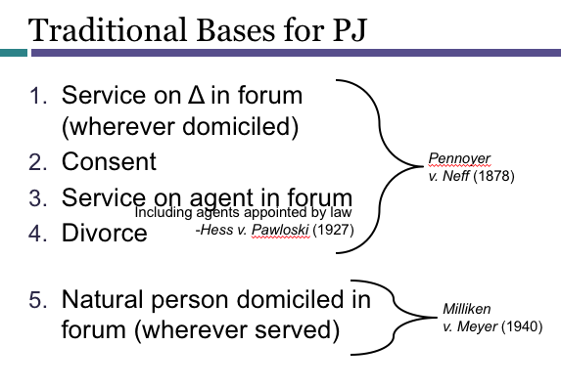

Service on D in a Forum (Can you get served in Reno when out to lunch even though you’re domiciled somewhere else)

Carnival Cruise Lines v. Shute- EX on Consent
  - Facts: Plaintiff slip and fell on a cruise going between MX and CA. In the ticket agreement says all suits must go in Florida. Is this enforceable?
- Question
- Holding
  - Majority says yes. People wouldn’t negotiate this, and it makes sense why its there.. bc the home location for carinval is in florida. Otherwise it coujld be subjected to suits across the country and world which would not be fair.
  - Dissent says this is BS.. it’s a contract of adhesion and thus since people cant negotiate shoudnt be enforceable.
  - Because this was an admiralty case.. and federal courts have jdx over admiralty case.. they think this is okay.. There are some legitimate reasons why contracts in FL make sense..

Contract Clauses that Affect Forum Selection
- Consent to Jurisdiction Clause
  - If party signs contract consenting to PJ in Forum X, that party may be sued as Δ in that forum
  - Example: National Equipment Rental v. Szukhent (1964)
- Choice of Law Clause
  - If party signs contract agreeing to apply the substantive law of Forum X in the event of a dispute, the clause can be considered a purposeful contact with Forum X
  - Example: Burger King Corp. v. Rudzewicz (1985)- this is A contact. Doesn’t mean drive the result. This is A CONTACT. Can consider it. If we have to do one, can consider in the PJ analysis.
- Forum Selection Clause
  - If party signs contract agreeing to sue only in Forum X, that party may not sue as π in a different forum; court outside Forum X will enforce contract by dismissing case
  - Exception: contract will not be enforced if it violates the law of contracts (e.g., fraud, duress, unconscionability, etc.)
  - Example: Carnival Cruise Lines v. Shute (1991)
    - Different than consent to jdx.. in this says we argree to where litigation is going to happen. Consent is sue me her eor ther.e
- Arbitration Clause
  - If party signs contract agreeing to use private arbitration instead of public litigation, court will enforce it by dismissing case.
  - Example: AT&T v. Concepcion (2011)

  - PJ and Complex Litigation

- Modern Variations on Traditional Bases
  - Consent to PJ via contract
  - “Transient” or “Tag” PJ*
DOMINOS PIZZA WEBSITE
- Facts:
  - “You agree that: … the Domino's Website shall be deemed a passive website that does not give rise to personal jurisdiction over Domino's, either specific or general, in jurisdictions other than Michigan.” In re. Zippo
  - “These Terms of Service shall be governed by the internal substantive laws of the State of Michigan…” Choice of law clause.
  - “Any claim or dispute between you and Domino's that arises in whole or in part from the Domino's Website shall be decided exclusively by a court of competent jurisdiction located in Washtenaw County, Michigan.”

Are we stuck with this language? Is there any options.. any defenses you have to the contract. That con obviate the consent. Figure out what the claim is.. or does it really arise formt he website or does it arise from something else…

Transient Personal Jurisdiction: Burnham v. Superior Court
- Facts
- Question
- Holding

Dueling approaches to Due Process
- Scalia:
  - “The short of the matter is that jurisdiction based on physical presence alone constitutes due process because it is one of the continuing traditions of our legal system.”
  - “We have conducted no inquiry into the desirability or fairness of the prevailing in-state service rule…; for our purposes, its validation is its pedigree.”
- Brennan:
  - “Although I agree that history is an important factor in establishing whether a jurisdictional rule satisfies due process requirements, I cannot agree that [history] is the only factor such that all traditional rules of jurisdiction are, ipso facto, forever constitutional. Unlike Justice Scalia, I would undertake an independent inquiry into the fairness of the [rule].”

VENUE

Venue [which court location within a sovereign]
- Geographical location. Within a multi-court system, is this the correct court location?
- For a state court there are more than one. For federal courts mre than one. Even within a state. Venue helps you pick.
- Defined by statutes.
- In general venue statutes are broad in the sense if you can get person jdx and subject jdx ironed out, venue will suually be good.

Waivability/ Constitutional/ Party (KNOW THIS)

- Subject matter jurisdiction
  - Waivability: Not waivable.
  - Claim/ Party: Must be correct for each claim.
  - Constitutionality: Same as PJ. Only wrote statutes that were permissable under article 3. So yes constitutional.
- Personal jurisdiction:
  - Waivability: Waivable.
  - Claim/ Party: Must be correct for each party.
  - Constitutionality: Combination. Start with long arm. Then ask is there anything that makes this improper from due process.
- Venue:
  - Waivability: Waivable. Forum selection clauses in contracts.
  - Claim/ Party: Must be correct for each claim. Can have multiple venues per case.
  - Constitutionality: Not really anything constitutional here. No limit.

12h1: some defenses will be waive 12b2-12b5. Waivability. When you think venue isn’t proper: make a 12b3 motion.

Good Example of motions for lack of PJ, Venue, Etc.
Browne v. McCain (2009)
- Coursepack 376 et seq.
- Issues in the briefing:
  - Lack of PJ [12(b)(2)]
  - Venue
    - Improper Venue* [12(b)(3)]
    - Motion to Transfer Venue [28 USC Section 1404 or section 1406]
- *NOTE: 28 U.S.C. §1391 was modified in 2011, but not in ways that affect the reasoning in Browne v. McCain.

Venue preclusion: If you file the wrong venue, does this create claim preclusion? No.
Unless stated otherwise. A dismissal is on the merit except for:
- Lack of jurisdiction
- Improper Venue
- or failure to join a party under rule 19.

Venue in state Court:
- General venue statute: Cal. Civ. Pro. Code § 395(a)
- Venue is proper in the superior court for the county:
  - where one or more of the defendants reside; or
  - where the events occurred

Federal person jdx rule piggy back on the state rule. Federal long arm basically. rule 4k. Nothing like this for venue, however.

VENUE STATUTES
- Original Venue: 28 U.S.C. §§1390, 1391
- Change of venue: 28 U.S.C. §§1404, 1406

28 U.S.C Section 1391: Original Venue in Federal Court
(b) Venue in General. A civil action may be brought in –
(1) a judicial district in which any defendant resides, if all defendants are residents of the State in which the district is located; [or]
SAO this means.. if one person in SOCAL.. and one in NORCAL. Eaither works. Bc defedents are int he same state.
(2) a judicial district in which [ THOMPSON CLARITY]
a substantial part of the events or omissions giving rise to the claim occurred, or
a substantial part of [the] property that is the subject of the action is situated; or
(3) if there is no district in which an action may otherwise be brought as provided in this section, any judicial district in which any defendant is subject to the court’s personal jurisdiction with respect to such action.

Thompson v. Greyhound Lines [Clarity on 1391b2] BIG VENUE CASE.
- Facts: Guy was from Arkansas. Rode a bus through alabama to mississippi for a court date. Corporation defendants were NOT from arkansas. Falls asleep on the bus, and gray hound doesnt wake him up in Jackson. Misses his court date because of that. Suit is brough in alabama against grayhouse. Grayhound fights.
- Issue: This is a diversity case. But fighting over venue. Was venue proper in alabama? No.
  - They didn’t make a motion for a 12b2.. in Alabama.. probably jdx over them in Alabama. Probably their minimum contacts.. or they have an agent for service of process in Alabama..
  - SO they fight about venue in Alabama
    - in 1391:
      - b1: atleast 1 defendent isnt from alabma. no good.
      - b2.: Was venue proper here? No not a substantial porton of the incident happened here.
        - If this is what we are fighting about. We need to askl.. did ANYTHING happen in alabama. And if so could anyone say that anything is substantial. Maybe some but for causation.. got on the bus in alabama.. but thats about it.
      - B3: If no other district in which an action may be brought.. any judicial district in which defedent is subject to personal jdx.
        - When will this be rel? Its in here because we dont want the venue to break the case. So this is a gap filler for a really rare situation.
      - What if an alien .. not a resident? Look at domicile. 1391 (c)(1)
      - 1391(c)(3): domiciled in the us.. congress is assuming it would be lawful. A natural person. KNOW the C RULES!!!!!!!!!
      - Also in c3. any venue work shtat you have personal jdx.
1392(b)(2): A Substantial Part of Events or Property
- “The district in which the plaintiff brings suit need not be the district where the most substantial portion of the relevant events occurred, but the plaintiff must show that a substantial part of the events or omissions giving rise to the claim occurred in that district.”
  - Murdoch v. Rosenberg & Associates, LLC, 875 F.Supp.2d 6 (D.D.C. 2012)
- “Substantial” implies “not insubstantial”
- But Thompson says they must be facts that “directly give rise to a claim.”

HYPO:
While on vacation in TX, a ca resident is assaulted by a GA residen, a NM resident, a UKL resident. SMJ in federal court. mIs venue proper in New Mexico?
- B1: Any non residents? Yes so no good.
- B2: Substantial part of action? No.
- B3: Is there a place alternativly could be brought? Yes texas. So no good in 3.

Sam question, but now the assault happens in the Bahamas. Now the answer is YES. via b3. No venue is proper, and thus SMJ is good. Still need personal jdx. May not be a go.

TRANSFERS OF VENUE
- If there are more than one appropriate vnues, within one system. There may be laws that allows this.
- Transfer of venue is within a particular court system.
- Vocab: Transforor court (where someething car from) and transferr (where something is going to)
- KNOW THAT THERE MUST BE ANOTHER COURT TO GO TO. Organize the inquiry to first ask if there is another court that could have been brought to originally.

Transferee Court- This is REUIERED.
CHANGE OF VENUE. 28 U.S.C. §1404(a)
For the convenience of parties and witnesses, in the interest of justice, a district court may transfer any civil action to any other district or division where it might have been brought or to any district or division to which all parties have consented.

CURE OR WAIVER OF DEFECTS. 28 U.S.C. §1406(a)
The district court of a district in which is filed a case laying venue in the wrong division or district shall dismiss, or if it be in the interest of justice, transfer such case to any district or division in which it could have been brought.

APPROACH OR ANSWERING A TRANSFER OF VENUE QUESTION THIS IS GOING TO B ON THE TEST.. HAS EMBEDDED QUESTIONS.. HAS A PJ QUESTION.
A.Which transfer statute?
1.1406(a): “shall” dismiss or transfer from “wrong” district (wrong = no PJ or no venue)
2.1404(a): “may” transfer from (proper) district
B.Does a proper transferee forum exist?
1.Both statutes: need PJ plus venue
2.1404(a) only: if for convience not a fatal problem.. all-party consent
C.Is transfer in the interests of justice?
1.1406(a): justice = cure defects of PJ or venue (Higher inetersts of justice here)
2. 1404(a): justice = convenience, etc.

Smith v Colonial Penn
- Defedents tries to move a forum selection from Galveston to Huston.
Which was the transfer statute? 1404a... the venue it was in was not improper.
- Is there a transferee district...
- In the transfer from Galveston to Huston division..

Under 1404: there is a presumption against transferring. Because the plaintiff chose it. So need good unjust reasons.

FACTORS.. from what is just.. re smith and coloniol penn
Intra-Forum factors.. are concerns to keep something in the forum. Inter.. is concerns that would make more sense to leave.

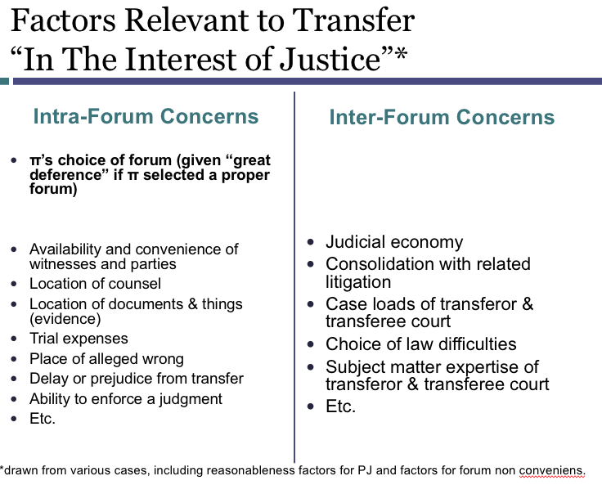

WEHere you can TRANSFER TO
- There is no Direct transfers from one nation to eachother.
- The same thing is true between US States.
  - A state cant make another state do something.
- Also no mechanism to get form federal court to state court.
  - Note Section 1441 allows removal (not transfer) from state to federal, but nbot vica versa.
  - Federal court cant transfger. The federal court can say hey, wrong court. And then it would go.
- Forum non conveniens is a way to dismiss a case from one state court, and put it in another state court.
  - 1. We only use forum non conveniens when the first court was proper
    - SO because this was already a proper court, then it will be reluctant to dismiss a case if it was properly filed.
    - Basically means that usually this is where another court in another country would be better to hear the case.
  - 2. The original court can only dismiss if there was another court that the case could be heard. Has to be able to REFILE in another court.

FORUM NON CONVENIENS

- Understand and apply the forum non conveniens doctrine.
  - Both §1404(a) transfer and forum non conveniens dismissals flow from the same perception: that there will be circumstances in which a court has the power to hear a case but, for reasons of justice or efficiency, should not do so.
  - for example, the judge may conclude that although jurisdiction is clear, the preponderance of witnesses, perhaps some of them severely disabled, will have to travel long distances to testify. Under these or similar circumstances, a federal court may decide to either transfer the case to another federal court under §1404(a) or dismiss it under the forum non conveniens doctrine for trial in another country. A state court might take a similar action, transferring (under a state statute analogous to §1404(a)) to another court in the same state or dismissing under the forum non conveniens doctrine for refiling in another state or country.
- Distinguish forum non conveniens dismissals from other doctrines, including:
  - transfer of venue and
  - dismissal for improper venue
  - Dismissal for lack of personal jurisdiction

Piper Aircraft v. Reyno [if the substantive law is worse for the plaintiff. Is that a reason to keep the case where it is? No.]
- Facts
  - Airplane manufacturer piper, in Pennsylvania. Propellers made in Ohio. Scottish aircraft carrier in Scotland. Airplane goes down 6 people died. Survivor to one of the deceased files a suit in Pennsylvania… bc of favorable laws. Motion to dismiss. Plaintiff says no motion to dismiss bc of forum non conveniens.. aka going to a different court and jdx.. will harm their case.. bc this court has the most favorable law.
- Question: is there a cause for forum non convenience to fight a dismissal claim to go to a different court? No
- Holding
  - The District Court granted these motions in October 1979. It relied on the balancing test set forth. The the Court stated that a plaintiff’s choice of forum should rarely be disturbed. However, when an alternative forum has jurisdiction to hear the case, and when trial in the chosen forum would
    - (1) “establish … oppressiveness and vexation to a defendant … out of all proportion to plaintiff’s convenience,”
      - Analyzing the factors says.. that first doesn’t make sense bc the manufaturers may not even have any liability.
    - (2) or when the “chosen forum [is] inappropriate because of considerations affecting the court’s own administrative and legal problems,” the court may, in the exercise of its sound discretion, dismiss the case.
      - Second having two different bodies of law, scottuish and pensylvania is confusing for a jury.
  - To guide trial court discretion, the Court provided a list of “private interest factors” affecting the convenience of the litigants, and a list of “public interest factors” affecting the convenience of the forum.
    - The factors pertaining to the private interests of the litigants included the “relative ease of access to sources of proof; availability of compulsory process for attendance of unwilling, and the cost of obtaining attendance of willing, witnesses; possibility of view of premises, if view would be appropriate to the action; and all other practical problems that make trial of a case easy, expeditious and inexpensive.” Gilbert, 330 U.S., at 508. The public factors bearing on the question included the administrative difficulties flowing from court congestion; the “local interest in having localized controversies decided at home”; the interest in having the trial of a diversity case in a forum that is at home with the law that must govern the action; the avoidance of unnecessary problems in conflict of laws, or in the application of foreign law; and the unfairness of burdening citizens in an unrelated forum with jury duty.
  - Court says if choice of law alone was enough of an issue, then there would never be dismissals because of forum non conveniens since there are so many places a plaintiff can bring a case.
  - So the court says, no reasons to keep a case for the choice of law, unless the other law is so bad there is no remedy at all.
  - Court Also says when a foreign plaintiff choses a foreign forum.. the idea that a plaintiffs choice should be given deference goes out the window. The point it to make sure.. that people are local and convenient.
  - WHO IS LIKELY TO WIN IS NOT PART OF THE CALCULOUS.

Proceedural History: I THINK THIS WILL BE EXAM FACT PATTERN
1.Filed in LA County Superior Court
2.Removed to USDC for C.D. Cal.
3.Transferred to USDC for M.D. Pa.
4.Motion to dismiss (forum non conveniens)
–M.D. Pa. grants motion
–Third Circuit reverses (motion denied)
–Supreme Court reverses (motion granted)

When we can have FORUM NON CONVENIENS DISMISSAL per PIPER
A Court may dismiss for forum non conveniens upon a strong showing by the defendant that:

- Current forum is inconvenient
  - Inconvenience must be significant
  - Ordinarily, strong preference for π’s chosen forum
AND
- An adequate alternative forum exists that cannot accept direct transfer
  - Alternative forum is significantly more convenient
  - Alternative forum is jurisdictionally proper
  - Conditions may be imposed on moving party: e.g., in new forum, Δ agrees not to assert defenses based on PJ, venue, or timeliness

PIPER factors for deciding forum non conveniens

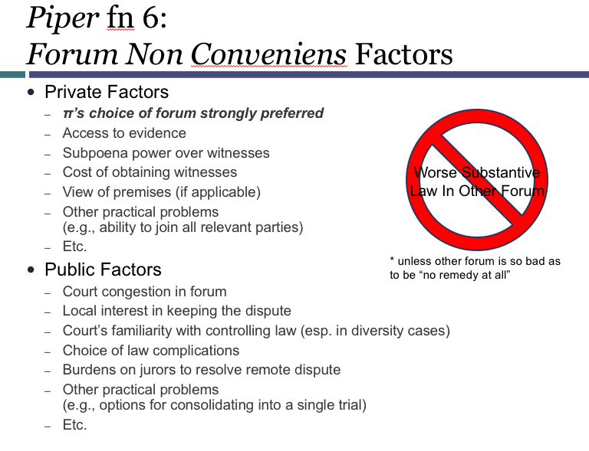

Process for forum selection:
- First ask if there is PJ.
- Then ask if it can be removed from state to federal court

Piper questions:
Was the superior jdx proper subject matter jdx? Yes. State courts are of general jdx.
was PJ over piper proper in CA: yes under agent process theory.. and older general jurisdiction (before at home idea).. piper was assuming they were stuck with general jdx.
What about the propeller manufacturer? No no minimum contacts bc the contacts were nothing to do w the accident.
What about if it crashed in CA instead of scottlant? PJ on the propeller company? Yes.

THIS IS THE XAM RIGHT HERE> THIS IS IT>

STEP 1: LA County Superior Court ROADMAP
- Subject matter jurisdiction?
- State Court Venue? (not studied)
- Personal jurisdiction over Piper?
- Personal jurisdiction over Hartzell?

STEP 2: Removal to CD Cal. In Piper (ROADMAP TO ASNWERING A SMJ QUESTION)
- Was removal timely? Yes needs to be within 30 days.
- Removed to correct court? Yes just to federal court.
- Removal by all defendants? yes
- Removable Case (SMJ)?
  - Amount in controversy? yes
  - Diversity of citizenship? Plaintiff is rayno who is a citizen of the law firm in CA… but she is representing the estates of deciest people.. so go to 1332c2… the law firm is only a citizen of the decedent.. so apply residency to the deciest people.
    - We have international ppl involved.. does this qualify under 1332a? Yes under a2.. if its between citizen of a state and with foreign memebers of a state.
  - Probate exception to diversity jurisdiction?
Removable Case (In-State Defendant)? If the defedent is the one who wants to remove.we are not going to allow removal if they are already in a HOME FORUM… subsection in 1441… the defedents were not citizens of CA SO ITS REMOVABLE!!!!!!!!!! ** KNOW THIS

STEP 3: Motion to Transfer Venue to MD PA
- Which Transfer statute? §1404, §1406
- Proper transferee court?
  - Personal jurisdiction?
  - Venue?
- Convenience of parties and interests of justice?
- Forum non conveniens motion still possible?

- Joinder

- General introduction to joinder
  - Joinder is joining multiple defedents or plaintiffs into a lawsuit. Joinder rules allow sensible cases to be lumped.. limits are usually jdx.. rather than joinder issues.
  - History on Joinder
    - In merry old England.. no joinder. Each lawsuit was shorter and more predictable.. downside is it doesn’t resolve every dispute that the two parties have with each other..
    - IN the USA though, we have liberal joinder rules… allow things to get packaged tgether.
  - What happens when a joinder claim.. gets too big to handle in one trial? The court can actually split it up into separate trials. Judges has discretion to split things up.
    - Rule 42(b): Separate Trials if Joinder Becomes Unmanageable
      - “For convenience, to avoid prejudice, or to expedite and economize,
      - the court may order a separate trial of one or more separate
        - issues,
        - claims,
        - crossclaims,
        - counterclaims, or
        - third-party claims.
      - When ordering a separate trial, the court must preserve any federal right to a jury trial.”

  - When do you think about joinder? IN THE PLEADINGS. [Incorporate pleadings from first semester]
    - Plaintiff: while writing the complaint.
    - Defendants: think about this when they are doing an answer… also can bring in a 3rd party defendant in a 3rd party complaint.
    - All of these happen at the beginning of the process.

Joinder Choices: need to think about JDX and Preclusion.
- Subject Matter jdx[Maybe keeps you from a particular court]
  - If you really want to be in federal court.. need to make sure that one of the claims that you are joining is a federal question theory.
  - Also if you want to be in state court, you need to think about whether you can be removed to federal.
- Personal JDX
  - You could name a defendant in a case, but if court has no personal jdx, they are dropped.
- Preclusion
  - Claim Preclusion… if it turns out that there is a claim that you could have brought in the first lawsuit.. if you try and bring the second claim, then you might be precluded.
  - If you had a full and fair opportunity to litigate this.. this was your one bite at the apple. So if you don’t join them now, you will be precluded clate BRING UP PRECLUSION.

Where does the law comes from?
- SMJ and PJ: Constitution and Statutes.
- Joinder: Rules and regulations made by the court (never statutes about this).
- Preclusion: Common Law.

When doing Joinder analysis:
- the relationship between the original claim and the claim to be joined;
- the basis of the original jurisdiction over the case;
- the identity of the party—plaintiff or defendant—seeking to invoke supplemental jurisdiction; and
- the Rule authorizing the joinder of the party or claim over whom supplemental jurisdiction is p. 788sought.

Joinder and SMJ: Separate but Related Questions
1.Do the Rules allow these parties or claims to be joined in a single action?
–Consult relevant joinder rule
(usually F. R. Civ. P. 8, 13, 14, 18, 19, or 20)
2. Is there a statutory basis for SMJ?
–Consult relevant statute
(usually 28 U.S.C. §1331, §1332, or §1367)
–Joinder rules do not create or expand SMJ
–Remember:
Each claim must have a statutory basis for SMJ
Complete diversity rule looks at all parties to the action, not just parties to a single claim

Order of opps for joinder analysis:
- Start with the rules on joinder… (can these claims and parties be brought in one lawsuit)
- Then go to statutory basis for SMJ…

When doing SMJ analysis:
1331: Federal Question
1332: Diversity
1367: Supplemental jdx….

Remember on diversity:
- Need to think about all the parties of the actions… look at ALL defendants.. even if there is a plaintiff suing only one specific D… need to look at all D’s.. cant have people on both sides from the same state.

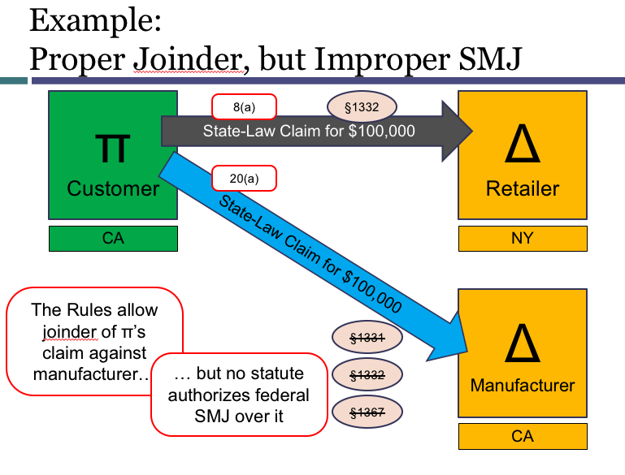

- Explore rules used to join multiple claims
  - Multiple claims by one party against another (Rule 18)
  - Counterclaims: by defending parties against claimants (Rule 13(a) & (b))
  - Cross-claims: π v. π or Δ v. Δ (Rule 13(g))

Rule 8.. ALWAYS START WITH RULE 8… THIS IS HOW YOU START A CLAIM AGAINST A DEFEDANTsays that when you are stating a claim.. here is wht you do…
- Also note in 8(d)(3) that a party may state as many separate claiums or defenses as it has, regardless of consistancy

Rule 13. Counterclaim and Crossclaim [ACTION DEFEDANTS CAN TAKE- EVERYTHING ELSE IS FOR PLAINTIFFS]
(a) Compulsory Counterclaim.
(1) In General. A pleading must state as a counterclaim any claim that—at the time of its service—the pleader has against an opposing party if the claim:
(A) arises out of the transaction or occurrence that is the subject matter of the opposing party's claim; and
(B) does not require adding another party over whom the court cannot acquire jurisdiction.
(2) Exceptions. The pleader need not state the claim if:
(A) when the action was commenced, the claim was the subject of another pending action; or
(B) the opposing party sued on its claim by attachment or other process that did not establish personal jurisdiction over the pleader on that claim, and the pleader does not assert any counterclaim under this rule.
(b) Permissive Counterclaim. A pleading may state as a counterclaim against an opposing party any claim that is not compulsory.

(g) Crossclaim Against a Coparty. A pleading may state as a crossclaim any claim by one party against a coparty if the claim arises out of the transaction or occurrence that is the subject matter of the original action or of a counterclaim, or if the claim relates to any property that is the subject matter of the original action. The crossclaim may include a claim that the coparty is or may be liable to the crossclaimant for all or part of a claim asserted in the action against the crossclaimant.

(h) Joining Additional Parties. Rules 19 and 20 govern the addition of a person as a party to a counterclaim or crossclaim.

Rule 18. Joinder of Claims
- In General. A party asserting a claim, counterclaim, crossclaim, or third-party claim may join, as independent or alternative claims, as many claims as it has against an opposing party. {ONLY NEED SAME PARTIES]
          - YOU CAN PELASE ALTERNATIVE THEORIES EVEN IN CONFLICYT WITH THE ORIGINAL CLAIM.
          - ALLOWS for two unreleated claims to be joined in a single action.

(b) Joinder of Contingent Claims. A party may join two claims even though one of them is contingent on the disposition of the other; but the court may grant relief only in accordance with the parties’ relative substantive rights. In particular, a plaintiff may state a claim for money and a claim to set aside a conveyance that is fraudulent as to that plaintiff, without first obtaining a judgment for the money.

Rule 20 PERMISSIVE JOINDER… says that if multiple parties are involved in the same set of facts.. yes you can bring them together … … IF U CAN GET THIS IT SATISFIES 1367(a)… Same facts.. if it’s the same transaction.

Rule 21. Misjoinder and Nonjoinder of Parties
Misjoinder of parties is not a ground for dismissing an action. On motion or on its own, the court may at any time, on just terms, add or drop a party. The court may also sever any claim against a party.

28 USC 1367(a) and (b) – SUPPLEMENTAL JDX
- Except as provided in subsections (b) and (c) or as expressly provided otherwise by Federal statute, in any civil action of which the district courts have original jurisdiction,
  - the district courts shall have supplemental jurisdiction over all other claims that (can hear a case)
  - are so related to claims in the action within such original jurisdiction that they form part of the same case or controversy under Article III of the United States Constitution. (if it is similar enough)
  - Such supplemental jurisdiction shall include claims that involve the joinder or intervention of additional parties. (joinder claims are similar enough)

- In any civil action of which the district courts have original jurisdiction founded solely on section 1332 (diversity of citizenship) of this title, the district courts shall not have supplemental jurisdiction under subsection (a) over claims by plaintiffs against persons made parties under Rule 14 (3rd aprty defendant), 19 (joinder), 20, or 24 of the Federal Rules of Civil Procedure, or over claims by persons proposed to be joined as plaintiffs under Rule 19 of such rules, or seeking to intervene as plaintiffs under Rule 24 of such rules, when exercising supplemental jurisdiction over such claims would be inconsistent with the jurisdictional requirements of section 1332.
  - Need to ask if with the diversity statute.. if we allow a joinder of something that breaks a diversity statute.
  - NOTE THAT THIS STATS CLAIMS BY PLAINTIFFS may not be satisfied by DIVERSITY. So COUNTER CLAIMS ARE OKAY!!!!!!
- The district courts may decline to exercise supplemental jurisdiction over a claim under subsection (a) if—
  - (1) the claim raises a novel or complex issue of State law,
  - (2) the claim substantially predominates over the claim or claims over which the district court has original jurisdiction,
  - (3) the district court has dismissed all claims over which it has original jurisdiction, or
  - (4) in exceptional circumstances, there are other compelling reasons for declining jurisdiction.

SO ORDER OF OPPS
- Rule 8..
- Then rules 18 (a)
- Then subject matter jdx..
  - 1331
  - 1332
  - 1367
    - A
    - B

COUNTER CLAIMS
- Difference between compulsory and compulsory counterclaims, is in compulsory,. You have issue preclusion.

IN NEGLIGENCE LAW… re: Counter Claims
- In states where there is contributory negligence.. then you don’t have a counter claim. Its just a defense. In states where there is no contributory negligence, then contributory negligence is just a counter claim.

FAILURE TO ASSERT a COMPULSORY COUNTER CLAIM
- Then you are precluded from bringing it later.

Plant v. Blazer Financial Services- Written befor 1367. So somewhat out dated. BUT STATES>. SAME UNDERLYING TRANSACTION. SAME PROCEEDURE FOR EVERYONE
- Facts
  - Plaintiff took out a loan for 2,520 with a bank which they defaulted on. Apparently there was some disclosure that the bank did not make, which the plaintiff sued for. Then the banmk counter claimed for the value of the loan. Plaintiff wins some damages for the breach of no disclosure as required in the truth and lending acts, and offsets these damages against the amount of the loan that they owe.
  - Plaintiff challenges the lower courts decision: (1) the jurisdiction of the court to entertain the counterclaim, (2) defenses to the counterclaim under Georgia law, and (3) the offset of attorney’s fees
- Question
  - Issue here was since 1367 wasn’t written yet.. if the issue was compulsory, then there must have been supplemental jdx. However, if there was not compulsory.. then we have a supplemental jdx issue.
- Holding
  - Lower court says the debt claim was compulsory. Plaintiff challenges and says it’s a jdx issue. Says the counterclaim must have its owen independent jdx basis.
  - Court says there is no indepedant basis as there is no diversity and its not a federal issue.
  - Rule 13(a), Fed. R. Civ. P., provides that a counterclaim is compulsory if it “arises out of the transaction or occurrence” that is the subject matter of plaintiff’s claim. Four tests have been suggested to further define when a claim and counterclaim arise from the same transaction:
    - Making a judgement as to weather this is the same. DON’T OVER THINK.
  - Says they adopt a judicial economy approach.. and also these exact claims have to be taken together. They are so intrinisically related.. and the point is to be even handed.
  - IF THESE ISSUES ARISE OUT OF THE SAME OVERALL TRASNACTION.. THIS IS REL FOR… 13a if something is compulsory.. and then also section 1367… if there is SMJ…

RULE 13(g) CROSSCLAIMS:
- A pleading may state as a crossclaim any claim
  - –by one party
  - –against a coparty
- if
  - –the claim arises out of the transaction or occurrence that is the subject matter
    - of the original action or
    - of a counterclaim,
- or
- –if the claim relates to any property that that is the subject matter of the original action.

QUESTION WHEN DOES JDX GET FUCKED FOR DIVERSITY?

- Multiple Claims
- Multiple Parties

Third-party claims

JOINING MULTIPLE PARTIES
- Do we need a joinder that allows there to be mrore than one plaintiff in a lawsuit? Yes 20(a)(1) Says you can allow multiple plaintiffs.
- Can you have multiples defendents? Yes. 20(a)(2)
- Third Party Claim (Rule 14): This is a situation when an existing, usually defendant, brings a new party in.
  - Example would be a product liability case. Retailer brings in the manufacturer. This is a 3rd party claim.
  - This is called Impleading someone.
- Under what circumstances can you have more than one plaintiff or defedent? Check 20(a)..
- The name of the rule is permissive joinder of the parties meaning it is up to the plaintiff to decide..
- SStandard for 20a1 and 20a2 are pretty much the same..

Rule 20(a): Permissive Joinger of Parties
- Persons Who May Join or Be Joined.

(1) Plaintiffs. Persons may join in one action as plaintiffs if:
(A) they assert any right to relief
jointly, severally, or in the alternative with respect to or arising out of the same transaction, occurrence, or series of transactions or occurrences [ company that sold defective product in march, April, may.. could be part of the same lawsuit if we can say that they are all connected to each other.. ]; and
(B) any question of law or fact common to all plaintiffs will arise in the action. [ usually you don’t have to o a lot of separate thinking with these two things.. but it is a requirement.. why is it there.. is there a commonality with the plaintiffs]

(2) Defendants. Persons … may be joined in one action as defendants if:
(A) any right to relief is asserted against them jointly, severally, or in the alternative with respect to or arising out of the same transaction, occurrence, or series of transactions or occurrences; and
(B) any question of law or fact common to all defendants will arise in the action

VOCAB ON RULE 20: Joint and severally liability
- Joint liability is each defendant is totally responcible for the injury.
- Several liability: each D is responcible only for the portion of the injury caused by the D. P may collect from each D only to the extent of the judgement against that D.
- Joint and several liability: P may collect full judgement from any D…
- If P collects all from one D, than D has claim for ideminifcation of contribution against other D.s…

Rule 21: Misjoinder of Parties..
- You don’t throw out the whole lawsuit.. You either (1) sever the claim.. two suits.. or (2) just drop that claim.
- “Misjoinder of parties is not a ground for dismissing an action. On motion or on its own, the court may at any time, on just terms, add or drop a party. The court may also sever any claim against a party.”

Mosley v. General Motors [EXAMPLES OF SAME SERIES OF TRANSACTIONS]
- Facts
  - Class action suit against GM for employment discrim base don race.
  - 12 different racial and sexism issues from different departments in GM.
  - Lower court severd separate causes of action.
- Question: Should these be joined by 20a? YES.. SAME SERIES OF TRANSACTIONS>..
- Holding
  - Court looks at rule 20.. where we can join if it’s a similar finding or issue.. and also 20b and 42 which allows courts to unjoin..
  - 2 elements to a joinder claim:
    - The rule imposes two specific requisites to the joinder of parties:
      - (1) a right to relief must be asserted by, or against, each plaintiff or defendant relating to or arising out of the same transaction or occurrence, or series of transactions or occurrences; and
        - What is the same transaction??No-- all “logically related” events entitling a person to institute a legal action against another generally are regarded as comprising a transaction or occurrence. Absolute identity of all events is unnecessary.
      - (2) some question of law or fact common to all the parties must arise in the action.
        - Was it the same law here? Yes… with respect to employment discrimination cases under Title VII, courts have found that the discriminatory character of a defendant’s conduct is basic to the class, and the fact that the individual class members may have suffered different effects from the alleged discrimination is immaterial for the purposes of the prerequisite.

RULE 42: CONSOLODATION
- When a common question or fact.. there could be a consolidation or separation! At the COURTS DISCRETION.
- So re: Mosley ..these 10 plaintiffs have joined together under one action. But I think the mechanics would work better if we broke them apart

THIRD PARTY COMPLAINT
- Third party complaints are complaints of a defedent against another person who is not a party.
- How do you file a third party complaint? It looks like a real complaint. Has to go along with 8a.
- Air diffusion systems (a third part) can then file an answer once they receive.
- The defendant in a third-party claim is a defendant and also a third party plaintiff.

Paradise Northwest v. Randhawa
- Facts: Paradice sues randamwa a retailer. And randawa says if I am liable,. Then it is because air diffusion systems product.
- Question
- Holding
  - Rule 14.. in order to have a 3rd aparty claim that belongs in the same lawsuit. DERIVATIVE CLAIMS. Asking to be reimbursed in the event htat you lose on some exsisting claim.

Rule 14(a)(1): THIRD PARTY CLAIMS BY DEFENDING PARTY: A defending party may bring a third party claim by serving a summons and complaint on a nonparty who is or may be liable to it for all or part of the claim against it. But the third-party of the claim against it—but the third party plaintiff must, by motion, obtain the court’s leave if it files the third-party complaint more than 14 days after serving its original answer.

Third Party Claims can plead in the ALTERNATIVE: SO they can say.. I didn’t do it! But in the alternative, if I did do it, this other party is liable (either by Contract, or by law).

- How do we know if this new D is actually liable? It’s a matter of substantive law.. there are a few patterns though
- COMMON PATTERS of 3rd PARTY COMPLAINTs
  - Contracts: If there is a contract.. we will reimburse you if you get sued under certain circumstances..
    - Idemnifying Employees -- There are a lot of employers will identify employees..
    - Driver was sued for negligence. They say.. I wasn’t negligent.. but if I DID my employer has a contract, and they should indemnify me.
  - CONTRIBUTION: When a third party has a LEGAL duty to reimburse me. Would be found in the states law. Doesn’t matter of a contract isn’t there.

A third party claim is a NON party. A cross claim, is a claim to someone who is already a aprty. The substance may be the same.

What is the timing of a 3rd party complaint? Rule 12(a) is the rule on filing an answer. 21 days. What is the deadline for filing a 3RD PARTY COMPLAINT: an unspecified time. But if they want to do it more than 14 days after the answer, they are going to have to get permission from the judge.

MISTAKE IDENTITY FOR THIRD PARTY CLAIMS
- When a defedent gets looped in, in this situation you don’t file a third party complaint.. because the wrong naimee isn’t required to get reimbursed in any way for the mistaken identity.
- SO what you do.. you deny it and say TED DID IT.

Price v CTB: [example of product liability. The obligation to indemnify is the matter of substantive law]
- Facts
  - Chicken farmer sues the maker of a chicken coup. The chicken coup maker looks to join the maker of the nails for the coup because they were defective.
  - Nail maker says 3rd party complaint cant attach to them bc they are barred by laches.
- Question: Is the attachment proper? Yes.
- Holding
  - Rule 14(a)
  - Coup maker says that they are liable bc of the defective nails.. so thus it is protypical that their liability is dependent.
  - Court says that when you sell something you impliedly indemnify.. that youre responsible if its defective. Thus it can get attached.
  - May be some fault sharing if there was a bad use by coop maker, but does not need to get decided at this point.
  - ALLSO ALLOWED UNDER RULE 18(a)

So Third party claim. CAN do 14(a) and 18(a). KNOW FOR EXAM.

How do we do SUPPLEMENTAL Subject Matter JDX for third party claims?
What we do for a claim against a 3rd party.. if two people are the same defedents. Weve got a a CA party against another CA party. We cant rely on deiversity for that. We instead apply 1367.. we say there is supplemental subject matter jdx.
- Ask is this the same case or controvery? Yes. Nature of 3rd party claim is if I owe money to plaintiff you woe money to me.
- Then ask since this is via diversity.. we ask does this undue the point of diversity jdx.
- The goal of 1367 B.. want to make sure that plaintiff wasn’t going to do.. cant let them circumvent the usual limits of diversity……. In this situation we are still good.

There can be Chains of 3rd party claims: Still need personal JDX over each defedent.
So have to have personal JDX over the parties. And then have to have Subject Matter JDX over the claims.

SO REMEMBER: SUBJECT AMTTER JDX IS TO THE CLAIM.
PERSONAL JDX IS TO THE DEFEDENT.

When can a PLAINTIFF bring in a third party defedent? Rule 14(b). If there is a counterclaim against the Plaintiff, then they can use 14 (b) to hit another D.

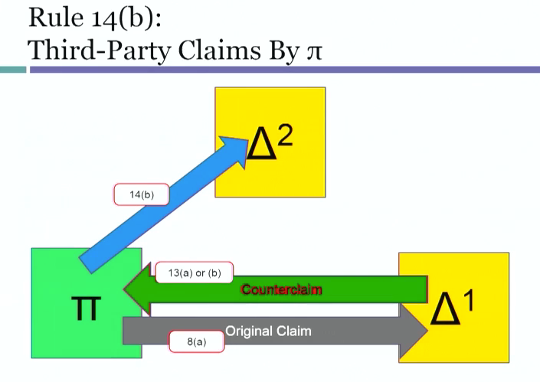

14(a)(3): This allows you to then sue D2 after you find out that there is a 3rd party plaintiff that is liable to you. Issue is., this creates a SMJ problem.
- §1367(b): No supplemental SMJ over claims “by plaintiffs against persons made parties under” Rule 20 (joinder), if inconsistent with §1332.
- §1367(b): No supplemental SMJ over claims “by plaintiffs against persons made parties under” Rule 14 (third party complaint), if inconsistent with §1332.

Owen Equipment v. Kroger: This stops the usual diversity.
- Facts: added a defedent later.
- Question: Can this allow for diversity if the plaintiff sues later?
- Holding: The answer is no. The point of 1367(b) is to not allow a plaintiff in a diversity action circumvent the usual limits of diversity.

So USC 1367 codifies some cases:

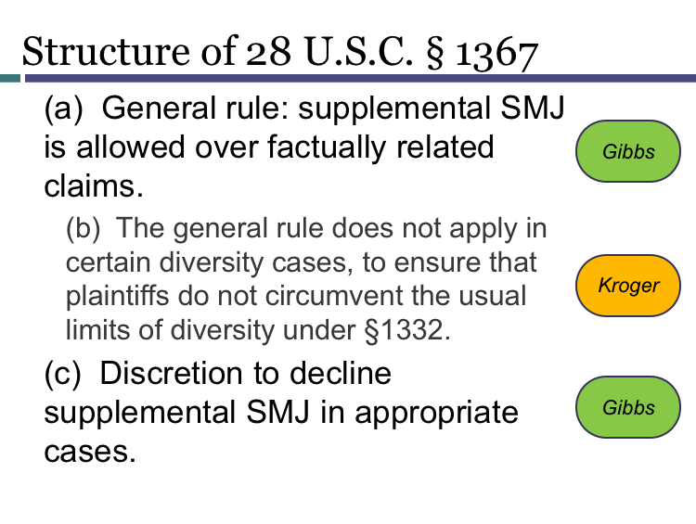

JOINDER OF PARTIES with OUTSIDER INTERESTS

Required Parties Under Rule 19
- THE RULES that we’ve looked so far have all been when the general shape of the lawsuit has been generated from the parties. Plaintiff.. gets to use rule 8, 18, and 20 deciding who is going to be in in the lawsuit. Defendants also can shape.. add counter claims to a plaintiff. Ad a new person on 3rd party complaint.
- What we are talking about here are the OUTSIDER interests. Someone who isn’t a plaintiff or defendant. Either their absence or desire to be present is what’s in 19 and 24. What if the existing parties left out someone important.
- These are part of 1367. LOOK UP 1367….

Basic set up 19:
- Starting point. Plaintiff sues a defendant. And there is an absentee who is neither a plaintiff nor a defendant. We are now asking.. is this lawsuit going to be unfair to someone if we don’t make this person part of the lawsuit (rule 19).,
  - Need to either join the absentee, r dismiss the lawsuit, or restructure so it only hits a certain lawsuit.
- These are situations where we want to join people if feasible, that makes it so there are not conflicting judgements.
- This comes up with contesting ownership of property, or if based on an exclusive contract.

Basic Set up 24
- IF UNFAIR.. or if same question of law.. Person who is left out says hey let me in. I don’t care if the defendant and plaintiff didn’t include me.

Rule 19: Required Joinder of Parties
- When do you think about rule 19? WHEN IT IS UNFAIR TO NOT BRING A PERSON IN .. IF THEIR LEGAL RIGHHTS ARE BEING INFRINGED.. IF WE DON’T BRING SOMEONE IN.
π: When writing complaint
Rule 19(a)(1) & (b): required parties “must be joined” if doing so is “feasible”
Rule 19(c): π must identify in the pleading any required parties who have not been joined
Δ: When responding to complaint
Rule 12(b)(7): motion to dismiss “for failure to join a party under Rule 19” may be made before answering
Rule 12(h)(2): not one of the waivable defenses

RULE 19.. IS best thought of as a 3 part test.
- 1. Is there a required party?
- 2. Is it feasible to join them?
- 3. Should the action be dismissed for failure to join the party?
- Then finally.. if its unfair.. then DISMISS THIS under action under Rule 12b7.. or if possible to go forward if its possible then retool under 19b2

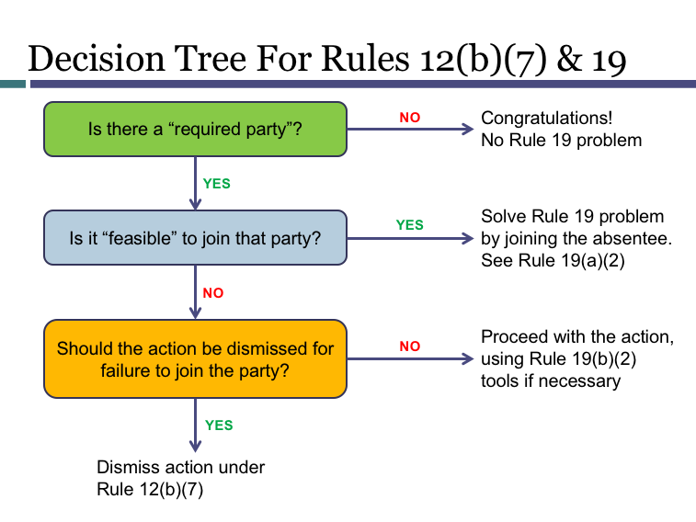

STEP 1: Is there a REQUIERED Party? Under rule 19.
(a) Persons Required to Be Joined if Feasible.
(1) Required Party. A person … must be joined as a party if:
(A) [efficacy] in that person's absence, the court cannot accord complete relief among existing parties; or (RARELY COMES UP..Ownership of contents in a safe deposit box.. and both people have keys.. and only one person is in the lawsuit..then need to get the other person.)
(B) [prejudice] that person claims an interest relating to the subject of the action and is so situated that disposing of the action in the person's absence may: (MORE COMMON)
(i) [ prejudice to absentee]as a practical matter impair or impede the person's ability to protect the interest; or
(ii) [ prejudice to existing parties] leave an existing party subject to a substantial risk of incurring double, multiple, or otherwise inconsistent obligations because of the interest.
For ex… D in selling a house twice hypo.. may have to do damages twice.. are you going to be the end of the result that’s really unfair.. where you paid twice or more than twice.. or got conflicting orders.

- Mentally.. run through what the prejudice will be to each party.. THINK USUALLY ABOUT PRECLUSION QUESTIONS. IS THERE SOME OTHER WAY? What happens, and what could go wrong?
- Not mutually exclusive.. could be prejudice to an existing party, or an absentee, or both.
- PRECLUSION: Absantee will not be subject to preclusion. Why not? TO be precluded, you will have needed to be in the first lawsuit.
  - NEED TO KNOW PRECLUSION in re: FINAL EXAM. Everyone whould get 1 fair opportunity.
  - Not an incosistant obligation.. if there are a series of lawsuits against multiple Ps.. one plaintiff wins one plaintiff loses.. its not an incosistant obligation udner rule 19 to have plaintiff paying d 1 and not 2.. inconsistent.. is its not physically possible for me to do both thigns. THUS USUALLY SPECIFIC PERFORMANCE. May be a contractual relationship that impledes someone.
- Temple v. Synthes [ JOINT TORT FEASERS.. NOT GOING THROW OUT IF one PERSON IS JOINED AND THE OTHER ISNT> JOINT TORETFEASOR NOT REQUIERED PARTY. GOING TO BE THE EXAM]
  - Facts
    - Medical Mal setting.. patient.. Mr temple sued manufacturer in federal court and dseperatly the hospital ad Dr in state court.
      - Rule 20.. plaintiff could have brought in these absantees.
      - Prof thinks this is suitable for a 3rd party complaint (rule 14).. contribution idea for damages.
    - Temple, a MI resident, has a plate put in his back and screws broke off.
    - Device was manufactured by Synthes, a pensyvania corp.
    - Temple filed a complaint for product liability in the eastern district of Louisiana federal court. Concurrently he sued for malpractice and negligence of the dr in state court.. dr. LaRocca.
    - Synthes did not attempt to bring the doctor and the hospital into the federal action by means of a third-party complaint, as provided in Federal Rule of Civil Procedure 14(a). Instead, Synthes filed a motion to dismiss Temple’s federal suit for failure to join necessary parties pursuant to Federal Rule of Civil Procedure 19.
    - DC federal ordered a joining of the dr and hospital or risk dismissal. Temple failed to do this and the court dismissed the case with prejudice. Court says that in two different claims he could claim two different theories around the same incident.

  - Question
  - Holding
    - Plaintiff is not OBLIGATED to join a joint tort feasor.
      - Why? NO prejudice to person who is left out. Not facing preclusion. Not getting screwed in extra litigation.
        - Is there prejudice to exsisting parties? IS there inconsistent damages? No.. damages not injunction.. Are there going to be DOUBLE.. MULTIPLE obligations? The D in this situation wont get double the money.. the D is not facing inconsistent.. if they want to hit the hospital; or doctor later, fine. Doesn’t foreclose opps. No one pays twice.
          - May be more efficient to bring absantees in.. but that’s the plaintiffs choice.
    - Temple stands at least for the proposition that Rule 19 does not require the most efficient possible packaging of lawsuits. Nor does it require the joinder of anyone who might be affected by precedent. E.g., Janney Montgomery Scott, Inc. v. Shepard Niles, Inc., 11 F.3d 399, 407 (3d Cir. 1993).

STEP 2: Is it FEASABLE TO JOIN THIS PERSON
- Without PJ over parties and SMJ over claims, joinder is not feasible.NOTE: On rare occasions, joinder may be infeasible for some other reason, but these two reasons are the most common.

ACTUAL RULE:
(a) Persons Required to Be Joined if Feasible.
(1) Required Party. A person who is
–subject to service of process (can you get personal jdx)and
–whose joinder will not deprive the court of subject-matter jurisdiction (when does this happen..? If it’s a diversity case)
[may be a required party if the rest of 19(a)(1) is satisfied].
(2) Joinder by Court Order. If a person has not been joined as required, the court must order that the person be made a party. A person who refuses to join as a plaintiff may be made either a defendant or, in a proper case, an involuntary plaintiff.(to a large extend has to do with a diversity problem)
Called aligning a aprty.. calling them a defedent then you make them a plaintiff.. or then you make them a defended to help with divsity.
Does this mean you can put anybody on either side of the case? No.. still has to be some logic about why you are on the opposite side of the case from someone else. SO need to find a way in which.. that someone is adverse to a defedent in some way..
Co-parties can have disagreements between eachother.. so the key is.. am I adverse to someone on the other side? If there is some sense to be adverse to a defedent. This is a way to make JOINDER MORE PHEASABLE.

“Alignment” of the Required Party as π or Δ to Preserve Feasibility of Joinder
19(a)(2)…

STEP 3.. What if non Feasable?
b) When Joinder Is Not Feasible. If a person who is required to be joined if feasible cannot be joined, the court must determine whether, in equity and good conscience, the action should proceed among the existing parties or should be dismissed.
The factors for the court to consider include:
(1) the extent to which a judgment rendered in the person's absence might prejudice that person or the existing parties;
(2) the extent to which any prejudice could be lessened or avoided by:
(A) protective provisions in the judgment;
(B) shaping the relief; or
( C) other measures;
(3) whether a judgment rendered in the person's absence would be adequate; and
(4) whether the plaintiff would have an adequate remedy if the action were dismissed for nonjoinder.

Ex of case where a tribe is a required party under setep 1.. we don’t want a secretary of the interior to administer a particular settlement.. but we cant join them bc they have soverign immunity.. cant grant the plaintiff what they want.. shouldn’t deny what they want and bind in a preclusion sense.. thus we dismiss.. CLINTON v. BABBITT..

  - HELZBERGS DIAMOND SHOPS V. VALLEY WEST DES MOIINES SHOPPING CENTER
    - FACTS
      - Helzberg, a jewery company. From Missouri, signed a lease with Valley west, a commercial real estate company based in iowa.
      - The lease stipulated that the shopping center can only have a maximum of 2 sfull line jewelry shops.
      - Valley west in the time following leased 2 additional spacves for full line jewelry stores.
      - Also subsequently.. Lords opened as a full line jewelry store though they were leased only as a specialty retailor.
      - Helberg sued for injunction.. in Missourt federal court. SMJ was invoked by 1332 for diversity. Personal JDX was extablished with the Missouri long arm statute.
      - Valley west moved to dismiss pursuant to Rule 19.. bc Lord was not joined. Motion denied .. and ordered to not allow the other business. Valley appealed.
        - it challenges the District Court’s denial of its motion to dismiss for failure to join an indispensable party and argues that the District Court’s order fails for lack of specificity in describing the acts of Valley West to be restrained.
    - QUESTION: Is the dismissal of the motion for failure to join proper? Yes
    - HOLDING

      - STEP 1—required party? Yes.
        - Because Helzberg was seeking and the District Court ordered injunctive relief (EQUIVILENT OF SPECIFIC PERFORMANCE) which may prevent Lord’s from operating its jewelry store in the Valley West Mall in the manner in which Lord’s originally intended, the District Court correctly concluded that Lord’s was a party to be joined if feasible. See Rule 19(a)[(1)(b)*
      - ^{Step 2—is joining} feasible? Need adiquite subjectmatter jdx and personal jdx o.. Person jdx problem. No contacts with Missouri.
        - Because Lord’s was not and is not subject to personal jurisdiction in the Western District of Missouri, the District Court was required to determine whether or not Lord’s should be regarded as indispensable. After considering the factors which Rule 19(b) mandates be considered, the District Court concluded that Lord’s was not to be regarded as indispensable. We agree. …
      - Step 3—Should this be dismissed by the court (12b7)? No.
        - Prjudice lords? Says Lords is not prejudices under 19b.. bc even if it is not a party.. its rights aren’t being infringed.. it is breaking the lease…. It still has rights, but it is breaking them.
        - Prejudice valley? Futher.. absence will not prejudice Valley West in a way contemplated by Rule 19(b). Valley West contends that it may be subjected to inconsistent obligations as a result of a determination in this action and a determination in another forum that Valley West should proceed in a fashion contrary to what has been ordered in these proceedings.
          - Basically saying this is their own fault if they have inconsistent obligations..Valley West’s contention that it may be subjected to inconsistent judgments if Lord’s should choose to file suit elsewhere and be awarded judgment is speculative at best.
        - Rule 19(b) also requires the court to consider ways in which prejudice to the absent party can be lessened or avoided. The District Court afforded Lord’s an opportunity to intervene in order to protect any interest it might have in the outcome of this litigation. Lord’s chose not to do so. In light of Lord’s decision not to intervene we conclude that the District Court acted in such a way as to sufficiently protect Lord’s interests.
        - IN SUM… n sum, it is generally recognized that a person does not become indispensable to an action to determine rights under a contract simply because that person’s rights or obligations under an entirely separate contract will be affected by the result of the action
          - Prof thinks it should have been dismissed.. bc it could be packaged up correctly… in a different state with diversity. Still federal. And the mall is in a situation where they are screwed 2 different ways possible.

Yeazell @822:3 (helzberg variation) Supplemental jdx.. 1367.. and rule 19..
- Changing lords from iowa resident to MO resident (same as helberg… in the actual case reason not possible was person jdx.. now the problem is subject matter jdx..
- Then helzberg also wanted to sue lords.. could you get mizoui residents? No bc diversity is ruined?
- Could yo rely on 1367.. supplemental jdx? Is tyhere a federal q? Yes. Is it the same case and controversy? However under 1367b.. a claim by a plaintiff against a party who is under rule 19.. and its inconsistent with diversity.. then no GO! So no.
  - Why is it structured this way? If helzberg had just sued the ml and lord.. youc ant do that.. its diverse.. you cant accomplish in 2 steps what owould be done in 1 step.. or not possible in 1 step.

(a) Persons Required to Be Joined if Feasible.
(1) Required Party. A person who is subject to service of process and whose joinder will not deprive the court of subject-matter jurisdiction must be joined as a party if:
(A) in that person's absence, the court cannot accord complete relief among existing parties; or
(B) that person claims an interest relating to the subject of the action and is so situated that disposing of the action in the person's absence may:
(i) as a practical matter impair or impede the person's ability to protect the interest; or
(ii) leave an existing party subject to a substantial risk of incurring double, multiple, or otherwise inconsistent obligations because of the interest.
(2) Joinder by Court Order. If a person has not been joined as required, the court must order that the person be made a party. A person who refuses to join as a plaintiff may be made either a defendant or, in a proper case, an involuntary plaintiff.
(3) Venue. If a joined party objects to venue and the joinder would make venue improper, the court must dismiss that party.
(b) When Joinder Is Not Feasible. If a person who is required to be joined if feasible cannot be joined, the court must determine whether, in equity and good conscience, the action should proceed among the existing parties or should be dismissed. The factors for the court to consider include:
(1) the extent to which a judgment rendered in the person's absence might prejudice that person or the existing parties;
(2) the extent to which any prejudice could be lessened or avoided by:
(A) protective provisions in the judgment;
(B) shaping the relief; or
(C) other measures;
(3) whether a judgment rendered in the person's absence would be adequate; and
(4) whether the plaintiff would have an adequate remedy if the action were dismissed for nonjoinder.
(c) Pleading the Reasons for Nonjoinder. When asserting a claim for relief, a party must state:
(1) the name, if known, of any person who is required to be joined if feasible but is not joined; and
(2) the reasons for not joining that person.
(d) Exception for Class Actions. This rule is subject to Rule 23.

INTERVENTION

- It’s the flip side of the required party doctorine. Instead of people inside the lawsuit we are missing someone, you have an outsider saying LET ME IN.
- There are two very different scenarios where the rule allows intervention..
  - Intervention of right where the interviener would be prejudice.
    - HAS to be let in.
  - Permissive intervention.. There is a common question of fact.
    - Can be let in.
- See these more foten than rule 19 motions.
- Common scenario in impact litigation…
- Difference between 24(a)(2) and 19a1b1 is that there must be a timely notice in the rule 24 motion. Ask when did the itnerviener learn aout the lawsuit. Motion must be timely. If its not timely the coart can say, do some subsequent lawsuit if you really thingk you have to.
  - Also there is also language in rule 24 “unless exsisting parties adequetly represents that interes.” – If someones already got it and they are the first party, we generally think they get to handle thing.

Natural Resources Defense Council v. Nuclear regulatory commission
- Facts
  - This was a case on federal statute. So we don’t have to worry about diversity and 1367.
  - These two agencies they shouldn’t be issuing nuclear licneses without environmental inmpact staements first. So the united nuclear corp.. already got their licnse… and they were not supposed to issue that license. So they wanted to get in. A timely motion was made..
    - UNC established claims in an interest..
    - UNC will not be able to defent itself if not incolced..
    - And lastly.. their interests are different than the govt.. so not really represented.
  - Then two other parties interviened also.. American mining congress and kerr McGee..
    - Ker mcgee says we are slightly different bc UNC had their license.. and we don’t. SO we should get involved. Doesn’t have to be on all fours though. This didn’t matter.
    - Is it going to impair orimpeed them if they are not part fo this lawsuit.. 826.. you could take a anrrow vision of this.. how is it going to affect you.. if you are not part of this case? Res judicata.. a preclusion issue. Even if this is going to give rise to a abd decision on a legal principle.. that’s a problem. That effects them..
    - 10th circuit sayd you sould let in Kerr McGee and American Mining Congress… said that they are not adequitly represented by UNC bc the
    - Synopsis of Rule of Law. A party seeking intervention must prove that they have an interest in the litigation, that their interest would be impaired if they were unable to intervene, and that the Defendants do not adequately represent their interests.
    - Says court may be open to letting the americn mining congress bc its interests are probably slightly different than its members asking to be in..

As a practice pointer.. start with 24a.. for MANDATORY.. but then pelad.. IN THE ALTERNATIVE.. grant me permissive intervention.

(b) Permissive Intervention (1) In General. On timely motion, the court may permit anyone to intervene who: …
(B) has a claim or defense that shares with the main action a common question of law or fact. …
(3) Delay or Prejudice.
In exercising its discretion, the court must consider whether the intervention will unduly delay or prejudice the adjudication of the original parties' rights.

Intervention Under Rule 24
- ISometyime the case just gets to big. So instad of getting to be a party.. so instead they let other parties file an amicus brief.

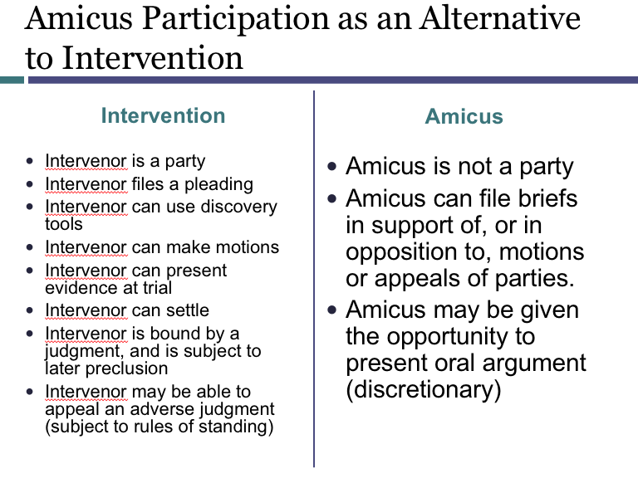

- Martin v Wilks: If you are an absentee: You do not have any obligation to try an interviene. You wont be said to have waived any of your rights. And you will not be precluded if you want to come in later.
- NAACP and then a union and a bunch of white firefighters.. others just stayed on the outside

- Required Parties
- Intervention
- Class actions
Class Actions

- What are they? A bunch of plaintiffs are suing one defendant about roughly the same thing. This is a package to make one lawsuit headed up by one Plaintiff on behalf of a class.
  - Other options would have been a bunch of one-off lawsuits.
  - Or with joinder lawsuits, a bunch of plaintiffs could be joined.
- IN a class action you have all these members of a class who are not there in court.
  - One or more people is the CLASS REPRESENTITIVE. This person brings the lawsuit. And the result of the lawsuit is going to be applicable to everyone in the class.
- In Plaintiff wins, then there is releasf that applies to the whole class.

Class actions are usually detrimental to the defendants. SO what happens often, a defendant who is in court often just settles.

Class actions and CLAIM Preclusion:
- We always have lawsuit #1 and then Lawsuit #2. Lawsuit 2 was not part of the class.
- There can be offensive issue preclusion as a sword (park lane hosiery). So defendant cant rebut that they lost or settled in lawsuit 1.
- Lets just say the defendant won issue one .. the typical rules of preclusion is you can only preclude someone who had a full and fair opportunity to litigate the first time around.
  - SO something about the usual preclusion changes if we have class actions. Because this means that people can come out of the woodwork later and continue to sue the defendant.

Basic Rule on Claim Preclusion
A claim is precluded in Lawsuit #2 when:
- It is the “same claim” asserted in Lawsuit #1; and
- The claim is asserted by the “same claimant against the same responding party” ; and
- Lawsuit #1 resulted in a “valid” and “final” judgment “on the merits”

However there is a GLOSS on Claim Preclusion. Claim Preclusion requires “Same Parties” (or Those “In Privity” With Them)
- Each jurisdiction may have its own approach to deciding when parties are “in privity” with earlier litigants
- Federal court examples of preclusion by parties in privity in Taylor v. Sturgell, 553 U.S. 880 (2008):
  - Successor in interest to party in earlier suit (Company A litigated something. And then an acquisition of company. I’m the successor in interest.)
  - Agreement to be bound by earlier result
  - Adequate representation in earlier suit (e.g., trustee) IE a class Representative
  - Party assumed control of earlier litigation (e.g., insurance)
  - Special statutory systems (e.g., bankruptcy)

Procedural Due Process in Class Action: Hansberry v. Lee [ Adequate representation is very important. May even be unconstitutional if adequate representation is not had]
- “In Hansberry v. Lee, we held that it would violate the Due Process Clause of the Fourteenth Amendment to bind litigants to a judgment rendered in an earlier litigation to which they were not parties and in which they were not adequately represented.”
  - Richards v. Jefferson County, 517 U.S. 793, 794 (1996)

Hansberry v. Lee [ need in fact adequate representation.]
- Facts: Black person was trying to move in to a white neighborhood. Was sold by a real estate agent who had litigated that you couldn’t have someone sued previously to keep a black person out. The plaintiffs in the new lawsuit to keep the Black people out were claiming that there was issue preclusion
- Question: Should offenseive issue preclusion be allowed? Was the burke plaintiffs adequitly representing the black class. THE ANSWER IS NO.
- Holding
  - White residents tried to claim that the person in the original lawsuit, was adequately representing. THIS IS BS THO. Bc the black people were not.
  - It is possible to have a class action where #1 binds someone else.. but the class members need to be IN FACT adequitly represented. Its not enough for both people to be property owner. We need to look at what were your REAL interests.

HANSBERYY on Class Actions and Due Process
- “[O]ne is not bound by a judgment in personam in a litigation in which he is not designated as a party.”
- Exception: a proper class representative “may bind members of the class or those represented who are not made parties.”
- Class action will be binding only where class members are “in fact adequately represented by parties who are present.”

Personal Jurisdiction and Class Action

Phillips Petroleum v. Shutts [need to allow opt outs]
- Facts: just a handful of plaintiffs in Kansas who are representing plaintiffs worldwide who were cheated out of money.
- Question: was there PJ here for the people not in the state?
- Holding
  - PJ on the D?
    - Is there a long arm? Yes.
    - Is it constitutional. Yes there are minimum contacts here. Company
    - Is it reasonable? Yes.
  - PJ on the plaintiff? Usually not a big deal because they submit the issue to the court.
  - However, the court says, for allt he other plaintiffs, they need to have opten out or ascented to the class. Plaintiff must receive a notice, be allowed to be heart, or opt out to preserve their own claim.
- Case holds that YES… the court can have power over all of these plaintiffs.
- They allow this because otherwise there would be no class actions!

Procedural Requirements for Plaintiff Class Action Members (Schutts)
- “If the forum state wishes to bind
  - an absent plaintiff
  - concerning a claim for money damages or similar relief at law,
- it must provide minimal procedural due process protection.
  - The plaintiff must receive notice plus an opportunity to be heard. [Mullane.]
  - Due process requires at a minimum that an absent plaintiff be provided with an opportunity to remove himself from the class…
    - Why do we allow this? Maybe we don’t believe in what the suit is going to do. What if people don’t want to consent.
  - Finally, the Due Process Clause of course requires that the named plaintiff at all times adequately represent the interests of the absent class members. [Hansberry.]”

Diversity SMJ and Class Actions.
- Use the Class Action Fairness Act of 2005 28 USC section 1332(d)(2)
  - The district courts shall have original jurisdiction of any civil action in which
    - the matter in controversy exceeds the sum or value of $5,000,000, exclusive of interest and costs, and
    - is a class action in which---
  - (A) any member of a class of plaintiffs is a citizen of a State different from any defendant; …

LIFE CYCLE OF A CLASS ACTION
- How to file a class action? Startt with a complaint per rule 8.
- If judge decides to deny a certification, then you can still go ahead one plaintiff and cone coplaint.
- The next move is a motion to certify a class under 23©(1)—this is immediately appealable in 23(f) (can ask to do discovery, etc to show not adequate rep and more)… says it should be as early as practicable.
  - OPN a decision to cewrtify a class.. you CAN have an interloculatory appeal on that. Why? Because class certification is a huge event and is important.
- If judge decides to certify the class, there will be an appoiuntment of class council.
- Once we have a class action, then the members of the class are to be notified.
- Then proceed to trial and settlement. Judge has to okay if its fair at settlement.
- Enforce outcome. The settlement will then be put ito an account, sent to the council.. and the memebers. Then any other members.. it wil get donated after a certain amount of time.
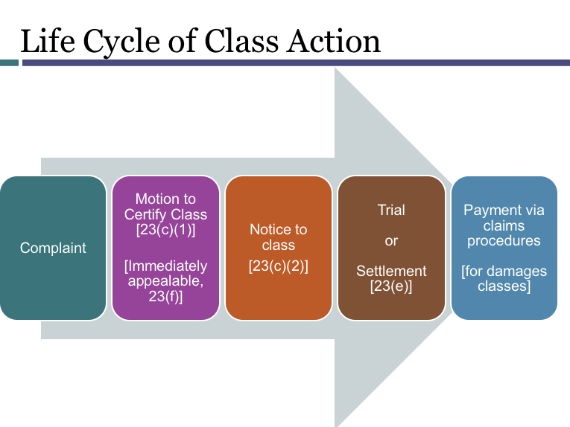

Which Class actions should be certified? Rule 23
Two steps:
- NEED THE RIGHT KIND OF CLASS (a)
- THEN NEED THE RIGHT KIND OF LAWSUIT (b)

Rule 23. Class Actions
(a) RIGHT KIND OF CLASS Prerequisites. One or more members of a class may sue or be sued as representative parties on behalf of all members only if:
(1) the class is so numerous that joinder of all members is impracticable; [THIS MEANS 40 - HUNDEREDS] Why so big? Bc otherwise just join and move on.
(2) [COMONALITY] there are questions of law or fact common to the class; [litigating in the same direction] SIMILAR TO PERMISSIVE INTERVENTION UNDER RULE 24(b) .. the thing that wal mart did to all of us. It allowed individual variations at all its sotres. It was in trouble bc it wasn’t doing anything.. there was no commonality in wal-mart.. not trying to be treated in a common manner.
(3) [typicality] the claims or defenses of the representative parties are typical of the claims or defenses of the class; and.. cant be idiosyncratic.. and must need similar damages. Need to litigate in the same interests as the group.
Simialr kinds of injuries seeking similar kinds of reliec. Not subject to a different defense.
(4)[adequacy] the representative parties will fairly and adequately protect the interests of the class. Flows from hansburry.. first looking at the actual representivie. Are you adverse, or now?
(b) Types of Class Actions. A class action may be maintained if Rule 23(a) is satisfied and if: [ SIMILAR TO RULE 19.. there is a required party.. if we don’t get them in.. there may be prejudice.. get reflected in rule 23b1a.
(1) prosecuting separate actions by or against individual class members would create a risk of:
(A) inconsistent or varying adjudications with respect to individual class members that would establish incompatible standards of conduct for the party opposing the class; or [ IS THIS A PARTICULAR TYPE OF PREUDICE TO THE DEFENDANT..] This happens with injuncitions. If we have one compelling of a house to one person, and then another person to another.. cant possibly do it. Is the other side going to be prejudiced if we don’t bring these in.
(B) [HARMED OUTSIDER CLASS] adjudications with respect to individual class members that, as a practical matter, would be dispositive of the interests of the other members not parties to the individual adjudications or would substantially impair or impede their ability to protect their interests; If there are separate actions… will someone be left out? .. analgous to 19a1bi.. comes up infrequently. Ex is the limited fund situation..
(2) [ INJUNCTIVE CLASS] the party opposing the class has acted or refused to act on grounds that apply generally to the class, so that final injunctive relief or corresponding declaratory relief is appropriate respecting the class as a whole; or
(3) [ superiority (Damages Class)] the court finds that the questions of law or fact common to class members predominate over any questions affecting only individual members, and that a class action is superior to other available methods for fairly and efficiently adjudicating the controversy. The matters pertinent to these findings include:
(A) the class members’ interests in individually controlling the prosecution or defense of separate actions;
(B) the extent and nature of any litigation concerning the controversy already begun by or against class members;
(C) the desirability or undesirability of concentrating the litigation of the claims in the particular forum; and
(D) the likely difficulties in managing a class action.

Why do we care what type of class you are? It matters if you are a B3 class or not.
- Has to do with opting out.
  - B1 and b2 the chance to opt out is not required (see Wal-Mart)
  - In B3 Classes.. chance to opt out is required (see Schutts 23©(2)(b)(v))
- Indivisible relief (suaulyl injunctive)
  - See Walmart
- Notice is different
  - For b1 and b2.. the court shall give appropriate notice.
  - For b3.. the court will give the best notice that is practicable.
    - Ties to the opt out. Opting out is more important for a b3.
- Court must find a common issue poredominated over all the uncommon issue- court ust find it’s a superior way of going about it (for b3)

Wal-Mart v. Dukes
- Facts: A small group of women who alleged discrimination on the basis of gender filed a suit against Wal-Mart Stores, Inc. (D). The action was sought to be changed to a class action, with the certified class represented by the original small group of women who sued the company. This class was the largest ever class.

- Question: should this be certified as a b2 class?
- Holding
  - No b2 is designed for injunctions. SO it should have procveeded as a b3 class.
  - Why did the lawyers bring to b2?
  - Didn’t have commonality via 23(a): the thing that wal mart did to all of us. It allowed individual variations at all its sotres. It was in trouble bc it wasn’t doing anything.. there was no commonality in wal-mart.. not trying to be treated in a common manner.

Class Actions have been slowing down bc of hostil litigation. Then judicial hostility… and then arbitration agreements.. keeps you from a class action.



