Business Associations Outline

Associations aka “Firms”
- A gathering together of people
- Law gives special treatment (special rules/laws)
- Contrast with transactions involving “markets” and “contracts”
- People trying to make money: business (for profit entities)

- Types of Business Associations
  - Principal/Agency Relationships
    - Agency indicates the relationship that exists where one person acts for another. Gorton v. Doty
    - Legal definition:
      - An agency relationship exists where (RSA 2nd §1):
        - One person (the principal) consents that another (the agent) shall act on principal’s behalf,
        - Subject to principal’s control, and
        - The agent consents so to act
    - Agency law → common law
  - Partnerships
    - Legal definition:
      - “A partnership is an association of two or more persons to carry on as co-owners of a business for profit.” UPA §6(1)
    - Statutory law
  - Corporations
    - Legal definition:
      - A legal “person” possessing the following attributes:
        - Separation of ownership and control
        - Limited liability for owners
        - Criminal liability
        - Constitutional free speech right
    - Requires formal creation under state auspices
  - Common Topics:
    - Formation
    - Relating to those outside the firm
      - When do the actions of those “associated” with the firm have legal consequences for the firm as a whole?
      - The circumstances under which principals have liability for an agent’s actions
    - Roles and duties within the firm
      - Governance
      - Fiduciary Duties
    - Termination
- Why create an agency relationship?
  - You cannot do everything yourself
    - Having others work on your behalf
    - Extends your capabilities/get more done
  - Where are they?
    - Everywhere
      - Asking a friend to run an errand
      - The Chief Executive Officer of Apple (agent of the corporation)
- Why create a partnership?
  - Sometimes there needs to be more than one owner. Why?
    - Complementary assets (money, skills) – both want a stake in the firm
- Why use a corporate entity?
  - Ability to accumulate capital from many sources
  - More permanent ownership of assets
  - Able to handle larger size tasks

- Principal Agency Relationship
  - Formation:
    - Gorton v. Doty: Doty volunteered her car for use in transporting some of the members of the Soda Springs team to and from the game. Appellant told the coach, Russell Garst, that he could use her car if he drove it. Trial court found that Russell Garst was at the time of the accident the agent of appellant and that she was chargeable with the acts of her agent as fully and to the same extent as though she had been driving the automobile herself.
      - Issue: was an agency/principal relationship formed?
      - Holding: yes, a principal/agency relationship formed. Therefore, Doty is liable.
      - Agency Test RSA §1:
        - Agency is the fiduciary relation which results from
          - The manifestation of consent by one person (the principal) to another (the agent) that the other shall act on his behalf and
          - Subject to his control, and
          - Consent by the other so to act
        - Prong 1: Teacher Doty: “Garth, I want you to be my driver.” [weakest]
        - Prong 2: Teacher Doty: “Only Garth can drive.”
        - Prong 3: Coach Garth: “I will be your driver.” [strongest]
      - Don’t need a contract/consideration – objective test based on actual behavior
      - Intent not required → just need to meet 3 prongs
        - If you behave in a certain way, then create an agency relationship
    - Lessons from Gorton v. Doty:
      - Contract consideration not required to create a principal/agency relationship
      - Intent to form a principal/agency relationship is not required to create such a relationship
      - Potential for principal/agency relationships in many circumstances
    - Why does ease of creating agency relationships matter?
      - Actions of the agent may create liability for the principal
      - Agent owes a fiduciary duty to the principal
    - What advice do you give Ms. Doty next time she wants to lend her car to the team?
      - Enter into an agreement describing the arrangement as a loan
      - Exert less control over Coach Garst, so second prong (control) not met
      - Don’t lend the car
      - Exert more control (e.g. drive the car yourself)
      - Make it seem more like a loan (more like a market transaction; loan suggests it is not on “my” behalf)
    - Gay Jensen v. Cargill: Cargill is a large grain company. Cargill loaned money to Warren (a local company that collected grain from farmers) and in exchange for the financing Cargill had authority over some of Warren’s internal operations. Warren owed plaintiffs $2 million. Plaintiffs alleged that Cargill was jointly liable for Warren’s indebtedness as it had acted as principal for the grain elevator.
    - Guttentag: A large grain distributor was found liable for the obligations of a grain operator with which the distributor had contracted to purchase grain, despite the fact that the large distributor was also a victim of a fraud only took de facto control (the criteria for when a lender becomes a principal under Restatement § 14 O) of the grain operator’s operations after the fraud was uncovered.
      - Issue: Whether Cargill became liable as a principal on contracts made by Warren with plaintiffs
      - Holding: Warren was an agent and Cargill the principal. Thus, Cargill is liable for the contracts entered into by Warren.
        - Evidence: Cargill was in control of and kept lending money to Warren
        - Agency is the fiduciary relation which results from
          - The manifestation of consent by one person (the principal) to another (the agent) that the other shall act on his behalf and
          - Subject to his control, and
          - Consent by the other so to act
        - Prong 1: Cargill: “Warren, I want you to buy grain from farmers for me.” [Warren is Supplier]
        - Prong 2: Cargill: “I’ll tell you how to run your grain business” [Cargill as Lender]
        - Prong 3: Warren: “I will be your agent.” [Warren is supplier]
      - 3-prong test is too broad; if applied in real world everyone would be forming principal/agent relationships; businesses have created carve outs:
        - Cargill is Lender → Cargill loans money for “working capital” to Warren
          - Agency Test for Lender [Rst. §14O]
            - Creditor becomes a principal at that point at which it assumes de facto control over the conduct of the debtor
              - Cargill had a good argument that they did not do more than a typical lender would do
              - Guttentag: farmers should be out of luck – only have liability as of the date of de facto control (happened after Warren entered contracts with farmers)
        - Warren is Supplier → Cargill has right of first refusal to purchase market grain sold by Warren at terminal market
          - Agency Test for Supplier [Rst. §14K]
            - One who contracts to acquire property from a third person and convey it to another is the agent of the other only if it is agreed that he is to act primarily for the benefit of the other and not for himself
            - Factors indicating that one is a supplier, rather than an agent, are: (1) that he is to receive a fixed price for the property irrespective of price paid by him
              - Fixed price = supplier
                - In business for myself
                - Bearing the risk
                - Incentive to get product for as cheaply as possible so I will profit; more my own business man
                - Chances of greater/lesser profit
                - Economic reality affecting how law treats the relationship
              - Mark-up = agent
                - Buyer is bearing the business risk
    - What advice do you give Cargill next time they want to work with a grain operator?
      - Draft documents so they do not suggest de facto control (doesn’t really work)
      - Never make loans to operators you are purchasing grain from
      - Take more control over the operators you lend money to
      - Take less control over the operators you lend money to
      - Pay closer attention to amounts actually being disbursed
      - Keep the status quo, and recognize law suits like this are a cost of doing business
  - Relating to Third Parties:
    - Liability of principal for agent’s contracts
      - Rule: if agent is authorized, then principal is bound
        - Rst. 2nd § 144: a principal “is subject to liability upon contracts made by an agent acting within his authority if made in proper form and with the understanding that the principal is a party.”
        - Rst. 3rd § 6.01-6.03: agent with authority can bind a principal to a contract
      - Types of Agent Authority:
        - Actual Authority (AcA): principal communicating authority to agent; focuses on agent’s reasonable interpretation of principal’s manifestations
General Rule: authorized to degree reasonably necessary to accomplish task
          - Rst. 2nd § 35: unless otherwise agreed, authority to conduct a transaction includes authority to do acts which are incidental to it, usually accompany it, or are reasonably necessary to accomplish it
Guttentag says same thing; no difference between these two
          - Rst. 3rd § 2.02(1): “an agent has actual authority to take action designated or implied in the principal’s manifestations to the agent and acts necessary or incidental to achieving the principal’s objectives”
          - Includes:
            - Express
            - Incidental to
            - Usually accompany it
            - Reasonably necessary to accomplish it
          - Standard: reasonable belief by the agent
            - Rst. 3rd § 2.01: “an agent acts with actual authority when, ..., the agent reasonably believes that the principal wishes the agent so to act.”
          - Mill Street Church v. Hogan: Church hired Bill Hogan to paint the church building. Bill had been allowed to hire his brother, Samuel Hogan, as a helper in the past. Dr. Waggoner and Bill Hogan discussed hiring Gary Petty to help Hogan finish the job. None of the evidence indicates that Hogan was told that he had to hire Petty. Sam Hogan was hired and a half hour after he began the leg of the ladder broke. Sam fell and broke his left arm.
            - Issue: Whether Sam Hogan is an employee of Mill Street Church
            - Holding: Sam Hogan is an employee of the church
              - Bill had actual authority to do things incidental
              - Church did not say that he could not hire Sam
              - Usually accompanies it: in past years, Bill Hogan hired his brother to assist
              - Reasonably necessary: “this was a very high, difficult portion of the church to paint”
          - Is Sam’s belief that his brother Bill had authority to hire Sam relevant to the issue of whether Bill had actual authority?
            - Views of the 3rd party not relevant to determination of actual authority
            - Standard is the reasonable belief of the agent
          - Did it matter that this was a very high, difficult portion of the church to paint?
            - Yes, reasonably necessary to have help
          - Argument that church ratified the contract by paying Sam for the amount of time he worked on the job
        - Apparent Authority (ApA): authority based on manifestations made to the 3rd party; focuses on 3rd party’s reasonable interpretation of principal’s intent traceable to principal’s manifestations
          - Rst. 2nd §8: Apparent authority is the power arising from the principal’s manifestations to such third person
          - Rst. 2nd §27: Apparent authority is created by written or spoken words or other conduct of the principal, which reasonably interpreted, causes third person to believe principal consents to have the act done on his behalf
          - Rst. 2nd §159: A disclosed or partially disclosed principal is subject to liability upon contracts made by an agent acting within his apparent authority
          - Three kinds of principals [§4]:
Apparent authority applicable to disclosed and partially disclosed principals
            - Disclosed: notice + identity of principal
            - Partially disclosed: notice
            - Undisclosed: don’t say acting on behalf of someone else
          - Rst. 3rd §2.03: Apparent authority is the power held by an agent to affect a principal’s legal relations with third parties when a third party reasonably believes the actor has authority to act on behalf of the principal and that belief is traceable to the principal’s manifestations → clearly covers indirect apparent authority
          - Inaction cannot create apparent authority → the principal’s manifestation needs to be an action
Rst. 2nd §8  - Principal’s manifestations to 3rd party  - Problem: direct manifestations = actual communication with 3rd party | Rst. 3rd §2.03  - Traceable  - Explains current law better
- Indirect apparent authority → agent wearing hat with logo; “cloaked in authority”
- Opthalmic Surgeons, Ltd. v. Paychex: OSL hired Paychex for payroll processing services. Connor handled payroll for OSL/designated payroll contact. Connor began requesting that Paychex direct deposit into her bank account more money than was required to pay her annual salary. Paychex never contacted anyone at OSL to verify Connor’s request. Between 2001 and 2006, Paychex paid Connor a total of $233,159 more than her authorized annual salary. However, Paychex did send OSL reports confirming all payments made. These reports were sent to Connor’s attention and Dr. Andreoni alleges that he saw none of these reports because they were not sent directly to his attention.
            - Issue: Whether Connor was cloaked with apparent authority such that Paychex could have reasonably relied upon her authority to issue additional paychecks in her name.
            - Holding: Paychex’s reliance was reasonable and that Connor had apparent authority because OSL put Connor in a position where it appeared that she had the power to authorize additional paychecks.
            - Argument for OSL: unreasonable to believe that she was authorized to pay herself an extra $250K
              - 3rd party’s belief needs to be reasonable
              - court wants to put it back on principal (should have been checking)
          - Did Connor have actual authority to pay herself an extra $233,159?
            - Connor did not have actual authority
          - Was Connor “cloaked with apparent authority”?
            - Connor was cloaked with apparent authority
          - What are the indicia of Connor’s apparent authority?
            - Gave her title and let her handle all communication
          - Were these direct or indirect?
            - Certainly, indirect apparent authority
          - What could Andreoni have done to prevent his outcome?
            - Could have read the reports
            - Change organization (internally)
              - External accountant (periodic review)
            - Set-up system differently (get alerts when request checks for more money)
            - The one check she couldn’t handle is her own payment/check
          - Can silence count as manifestation?
            - No, silence cannot
            - Court meant to say his entire conduct created impression that Connor had authority
        - Inherent Agency Power (IAP): liability of undisclosed principal; agent secretly working on someone else’s behalf
          - Rst. 2nd § 8A: “Inherent agency power is a term used in the restatement of this subject to indicate the power of an agent which is derived not from authority, apparent authority or estoppel, but solely from the agency relation and exists for the protection of persons harmed by or dealing with a servant or other agent”
          - Rst. §195: an undisclosed principal “is subject to liability to third persons with whom the agent enters into transactions usual in such businesses.”
            - Principal not disclosed
            - Agent enters into ordinary transaction
          - Rst. 3rd §2.06(1): “an undisclosed principal is subject to liability to a third party who is justifiably induced to make a detrimental change in position by an agent acting on principal’s behalf and without actual authority if the principal, having notice ..., did not take reasonable steps to notify them of the facts.”
Rst. 2nd §195  - (1) Principal not disclosed  - (2) Agent enters ordinary transaction | Rst. 3rd §2.06(1)  - Undisclosed principal only has liability if they knew what was going on and didn’t take reasonable steps and 3rd party had detrimental change  - Principals prefer this over 2nd Restatement  - (1) undisclosed principal  - (2) 3rd party induced to make detrimental change  - (3) acting on principal’s behalf  - (4) principal has notice  Doesn’t address facts of Watteau/reflect holding in Watteau – there would be no liability for Fenwick under §2.06(1) because no notice
          - Why allow inherent agency power?
            - There are situations where other theories of principal liability do not apply, but...
            - As a policy matter it is appropriate to hold principal liable
          - Watteau v. Fenwick: The plaintiff is suing the defendants for the price of cigars and bovril supplied to a beerhouse owned by the defendants. The beerhouse was managed by Humble, whose name was over the door. The plaintiffs gave credit to Humble and had never heard of the defendants. However, the business really belonged to the defendants and they had forbidden Humble to buy cigars on credit. Although Humble did not have express authority to purchase these items, they are normally bought in the course of such a business.
          - Issue: Is a principal bound by an agent’s unauthorized actions in the course of duty when the agent does not disclose the identity of the principal to a third party with whom the agent contracts?
          - Holding: Yes – an undisclosed principal is strictly liable for any usual business transactions of its agent, even if the agent wasn’t authorized.
            - Is there any basis for holding the defendants liable on a theory of actual or apparent agency?
              - No actual authority
              - No apparent authority – only relevant when disclosed or partially disclosed principal
            - What are the “mischievous consequences” of a decision in favor of the defendant?
              - Find someone judgment proof, have them buy/sell on your behalf and remain an undisclosed principal
              - Can set-up a judgment proof front to run business
              - Have contract that says agent isn’t allowed to do XYZ to avoid actual authority
            - Why wouldn’t a claim of estoppel have worked for Watteau?
              - Estoppel only available if plaintiff knows of principal’s existence – doesn’t apply in undisclosed principal situations
            - Would there be liability for Fenwick under the Rst. 3rd rule?
              - No liability because no notice
              - Under RSA 3rd, in order to have liability, Fenwick would have had to have notice and then not taken reasonable action to notify the third party. Here, Fenwick did not have notice, so he would not be liable under RSA 3rd.
        - Ratification (R): never authorize transaction, but later on authorize the transaction; occurs at a later point in time
          - Rst. 2nd §82: “ratification is the affirmance by a person of a prior act which did not bind him but which was done or professedly done on his account, whereby the act is given effect as if originally authorized by him.”
Guttentag says same thing; no difference between Rst. 2nd and 3rd
          - Rst. 3rd §4.01: “(1) Ratification is the affirmance of a prior act done by another, whereby the act is given effect as if done by an agent acting with actual authority.”
          - Rst. 3rd §4.03: “a person may ratify an act if the actor acted or purported to act as an agent on the person’s behalf.”
            - Note: distinct from Inherent Agency Power because here there is a disclosed principal, it’s just that the agent doesn’t actually have authority
        - Estoppel (E) → only for disclosed and partially disclosed
          - Covers a situation where the principal did not cloak the agent in authority, but the principal knew that a 3rd party thought the agent was authorized and the principal didn’t do anything to correct them
          - Rst. 2nd §8B: (1) “A person who is not otherwise liable as a party to a transaction purported to be done on his account, is nevertheless subject to liability if 3rd changed position, and: (a) Intentionally or carelessly caused such belief, or (b) knowing of such belief, did not take reasonable steps to notify them of the facts.”
            - Change in position indicates payment of money, expenditure of labor, suffering a loss or legal liability
      - When can the principal enforce contract against the 3rd party?
        - 3rd party is bound to principal if:
          - actual express authority
          - actual implied authority
          - apparent authority
          - inherent agency power
          - ratification
            - exception: can’t take advantage of material change [Rst. 2nd §89]
            - Illustration: Purporting to act for P but without power to bind him, A contracts to sell Blackacre with a house thereon to T. The next day the house burns. The later affirmance by P does not bind T
        - 3rd party not bound to principal if it is estoppel
          - Estoppel doesn’t create existence of a contract; just prevents principal from bringing up a defense
          - A 3rd party an enforce the contract against the principal, but the principal cannot enforce it against the third party
      - When do agents have liability?
        - If the agent has a fully disclosed principal, then agent does not have any liability
        - If the principal is not disclosed (partially disclosed or undisclosed) then agent has personal liability on the contract.
          - §Restatement 2nd § 320 (full text): Unless otherwise agreed, a person making or purporting to make a contract with another as agent for a disclosed principal does not become a party to the contract.
          - §Restatement 2nd § 321 (full text): Unless otherwise agreed, a person purporting to make a contract with another for a partially disclosed principal is a party to the contract.
          - §Restatement 2nd § 322 (full text): An agent purporting to act on his own account, but in fact making a contract on account of an undisclosed principal is a party to the contract.
Sample Question:
Paul signs a contract with Annie, hiring Annie to in turn hire a manager for a grocery store. Annie is to be paid $1,000 to perform this service. As Paul anticipated, Annie shows the contract to several candidates for the manager job, including Thomas. Thereafter, Paul sends a letter to Annie revoking Annie’s authority to hire a manager for the store. The revocation is not communicated to Thomas. At this point:
A. As to Thomas, Annie has actual implied authority to hire a manager for Paul’s store.
B. As to Thomas, Annie has no authority to hire a manager for Paul’s store.
C. As to Thomas, Annie has apparent authority to hire a manager for Paul’s store.
D. As to Thomas, Annie has inherent agency power to hire a manager for Paul’s store.
E. None of the above.
- Answer: C
    - Liability of principal for agent’s torts
      - A master is subject to liability for the torts of his servants committed while acting in the scope of their employment – Rst. 2nd §219(1)
        - Servant (special type of agent) – physical conduct controlled by the master
        - Scope of employment
      - Master/Servant relationship:
        - § 2 (2) A servant is an agent whose “physical conduct … is controlled or subject to the right of control by the master.”
        - § 2 (3) An independent contractor is a person who contracts with another but is not controlled or subject to control of physical conduct. He may or may not be an agent.
          - Control over physical conduct moves you into master/servant relationship → higher degree than principal/agent relationship
        - Independent Contractor Types:
          - Independent contractor (agent-type)
            - Subject to limited control by principal with respect to the chosen result
            - Agent has power to act on principal’s behalf
          - Nonagent independent contractor
            - Perhaps less control on principal’s part, but agent has no power to act on principal’s behalf
Quick guide:
1. Are they a servant? [§220]
2. If so, were they acting within the scope of employment?
[§228 or §229]
          - Not possible to be liable for tortious conduct of an independent contractor (agent)
        - RSA 2nd § 220: 10 matters to consider in determining if agent is also a servant.
          - Extent of master control over details of work;
            - [examine the agreement] → more control = more likely to be a servant
          - Whether one employed is a distinct occupation;
            - [different business then more like an independent contractor]
            - A specialized employee is less likely to be a servant because they have more autonomy over how they do their job
          - Whether customarily done with or without supervision in this locality;
            - Without supervision = less likely to be a servant
            - With supervision = more likely to be a servant
          - Skill required in the particular occupation;
            - [the more skilled the person the less likely an employee or servant]
          - Who provides the instrumentalities, tools and where the person is doing the work;
            - [principal provides the tools and work on his property then more likely a servant]
          - Length of time for which person employed;
            - [longer amount of time more likely a servant]
          - Whether paid for time or for the job;
            - [paying for the job is more likely an independent contractor; paying for time is more likely a servant because more control]
            - Hourly pay = more likely to be a servant
            - Flat pay = less likely to be a servant
          - Whether part of employer’s business;
            - [more likely to be a servant when part of employer’s regular business]
          - Parties beliefs about whether or not creating master servant relationship; and
            - [Guttentag does not think this belongs on the list because test is not what they said, but what they did]
            - If you think you had a master/servant relationship, more likely you do
          - Whether the principal is or is not in business
            - [business = more likely a servant]
        - RSA 2nd § 228: General definition of scope of employment.
          - Conduct within scope of employment if an only if:
            - Of a kind employed to perform;
            - Substantially within authorized time and space limits;
            - At least in part to serve master; and
            - If force used, not unexpected by master
              - E.g., security guard or bouncer
        - RSA 2nd § 229: List of 10 factors to consider if unauthorized conduct is in scope of employment.
          - The act commonly done by such servants;
          - Time, place, and purpose of act;
          - Previous relations between master and servant;
          - Extent business apportioned between different servants;
            - One person in charge instead of hiring multiple different people
            - Then if do something unauthorized then more likely within scope of employment because given broad latitude
          - Outside master’s enterprise or not entrusted to servant;
          - Would master expect such an act;
          - Similar in quality to authorized acts;
          - Instrument of harm furnished by master;
          - Extent of departure from normal authorized methods; and
            - Really unexpected then less likely to be within scope of employment
          - Whether or not the act is seriously criminal
            - Seriously criminal then less likely within scope of employment
        - RSA 2nd § 219: When liable even outside scope.
          - A master is liable for a servant’s torts outside the scope of employment if:
            - Master intended the conduct or consequences;
            - Master was negligent or reckless;
            - Conduct violated a non-delegable duty of the master; or
            - Servant purported to act on behalf of principal and there was reliance upon apparent authority
        - When can 3rd party hold agent liable for torts?
          - Agent always has liability
            - Restatement 2nd § 343: An agent who does an act otherwise a tort is not relieved from liability by the fact that he acted at the command of the principal or on account of the principal,…
            - Restatement 3rd § 7.01: An agent is subject to liability to a third party harmed by the agent’s tortious conduct.

Humble Oil & Refining Co. v. Martin [LIABILITY]: Mrs. Love left her car at a filling station owned by Humble for servicing and before any station employee had touched it the car rolled off the premises. Mrs. Love did not set the hand brake when she handed over her car, and no employee made sure the car was secure. The car struck Mr. Martin and his kids from behind as they were walking into the yard of their home (a short distance downhill from the station). Humble says he is not liable because the gas station was owned by an independent contractor (Schneider) and he is not responsible for an independent contractor’s negligence. Humble owned the property and the gas but contracted with Schneider to run the station.
Issue: Was there a master/servant relationship?
Holding: Humble is liable because there was a master/servant relationship between Humble & Schneider because Humble retained so much control over the station
- The court relied heavily on the contract provision which said Humble Oil could make direct orders in regards to how the business was run

Hoover v. Sun Oil Company [NO LIABILITY]: Fire started at the rear of plaintiff’s car where it was being filled with gasoline. The service station was operated by Barone and the fire was allegedly caused by the negligence of Smilyk, an employee of Barone. Plaintiffs brought suit against Barone, Smilyk and Sun Oil Company which owned the service station. Sun moved for summary judgment by claiming that Barone was an independent contractor and therefore the alleged negligence of his employee could not result in liability as to Sun. The plaintiffs argue that Barone was acting as Sun’s agent and that Sun is therefore responsible for plaintiff’s injuries.
- The dealer’s agreement allowed Barone to sell products from competing oil companies, but required him to sell the Sun products under the Sun label.
- The service station had large signs advertising Sun products, but Barone’s name was posted as proprietor
- A Sun representative made weekly sales calls to the service station where the Sun rep would discuss various business issues with Barone and advise him on station operations, but Barone was not required to follow Sun’s advice
Issue: Was there a master/servant relationship?
Holding: No, Barone was an independent contractor.
- The Sun Oil Contract said that Barone did not need to abide by Sun’s recommendations. Therefore, Sun did not have the physical control necessary to establish a master/servant relationship, and Sun was not liable

- Both cases: gas company owned the land, leases equipment, and supplies gasoline
- Why the different outcome?
  - Important elements of business relationships include duration, control, risk of loss and return
  - Application of 220(2): 10 matters to consider in determining if agent is also a servant
§ 220(2) | Humble (liability found) | Sun Oil (no liability)
(a) Extent of master control over details of work | May give orders | Recommendations
(b) Whether one employed is a distinct occupation | Schneider does repairs | Barone may sell other products
(c) Whether customarily done with or without supervision in this locality | Local custom? | Local custom?
(d) Skill required in the particular occupation | Moderate | Moderate
(e) Who provides the instrumentalities, tools, and where the person is doing the work | Humble owns property and stock | Sun Oil owns property but not stock
(f) Length of time for which person employed | At will | 30 day/annual notice
(g) Whether paid for time or for the job | Volume-based rent | Volume-based but cap
(h) Whether part of employer’s business | Core part of business | Core part of business
(i) Parties beliefs about whether or not creating master servant relationship | No belief | ?
(j) Whether the principal is or is not in business | Humble in business | Sun Oil in business
- In both cases, nature of relationship was similar
- Extent of control over work details was key
  - Giving orders in Humble = killer
  - Don’t expressly state this in the contract
- Why do you suppose the oil companies chose what may be thought of as a hybrid of an employment and independent contractor relationship?
  - On the one hand the gas company wants to make promise to customers → uniform quality (some degree of control) so customers can rely on national brand
  - On the other hand, as a matter of business gas company wants to tap into the entrepreneurial zeal of the local businessman to meet the need of local customers
    - Gas company did not want to take complete control; hard to monitor employees in every town
- How do you respond to the decisions in Humble and Hoover when advising a gas company?
  - No provision giving direct orders – not controlling the details of work
  - Include provision re right to terminate: gives power over agent without cost over legal obligations (does not create impression that there is a master/servant relationship)
  - Find economic ways to exert control
    - The ability to pull out of an agreement at any time – a credible threat that forces the agent to behave the way the principal wants them to without having to put it in writing
- Guttentag: sees this as a crazy loophole in the law – his theory is that if the principal benefits from the relationship it should have liability for its agent’s torts
  - But the law’s theory is, if the principal has control over the physical conduct of its agent, then it should have liability for their torts

Arguello v. Conoco, Inc.: A group of Hispanic and African-American consumers sued Conoco alleging that they were subjected to racial discrimination while purchasing gasoline and other services. Three different incidents:
- Arguello and Govea (along with other family members) stopped at a Conoco-owned store in Fort Worth, Texas. They entered the store to pay and the cashier (Smith) asked to see Arguelllo’s identification. Smith said that an out-of-state driver’s license was not acceptable identification. Arguello disagreed with Smith and Smith began to insult her by using profanity and racial epithets. Smith also knocked a six-pack of beer off the counter toward Arguello. Smith also used the store’s intercom to continue yelling racial epithets when Arguello left and made obscene gestures through the window. After the incident, Arguello and Govea called a Conoco customer service line to complain. Govea attempted to re-enter the store to learn Smith’s name but Smith and another employee locked the doors. Corbin (district manager) received their complaints and reviewed the video tape from the store (did not have audio) and concluded that Smith had acted appropriately. However, Smith admitted to Corbin that she used profanity, racial epithets and obscene gestures. Corbin counseled Smith about her behavior but did not suspend or terminate Smith.
- Ivory, Pickett, and Ross visited a Conoco-branded store in Fort Worth. While in the store, they were followed by a store employee and after complaining the employee said that “we don’t have to serve you people” and “you people are always acting like this.” The employee refused to serve them and asked them to leave.
- The Escobedos went to a Conoco-branded store in San Marcos, Texas. A store employee refused to provide toilet paper for the restroom, shouted profanities at his wife and said that you Mexicans need to go back to Mexico. Escobedo called Conoco to complain and a customer service supervisor said there was nothing Conoco could do because that station was not owned by Conoco. Escobedo was also told by a store clerk at a different Conoco-branded store that “you people steal gas.” Escobedo also alleges that at two Conoco-branded stores in Laredo, Texas he was required to pre-pay for his gas while Caucasian customers were allowed to pump their gas first and then pay.
1. Conoco-owned | Liability – master/servant relationship
2. Conoco-branded | No liability
3. Conoco-branded | No liability
Incident #1: unauthorized but still within the scope of employment
- Why have Conoco-owned stores at all?
  - Get control
  - Business decision
  - If location is centralized, then easier to maintain careful monitoring (company-owned in the big cities)
- Factors listed by court as indicative of unauthorized conduct within scope:
  - Time, place, and purpose of act: RSA § 229(2)(b);
    - Occurred while Smith was on duty inside the station where she was employed
    - The purpose of Smith’s interaction was to complete the sale of gas and other store items
    - Initial confrontation and subsequent epithets occurred while Smith was completing purchase and processing credit card transaction
  - Similar to authorized acts: RSA § 229(2)(g);
    - The sale of gasoline, other store items, and the completion of credit card purchases are the customary functions of a gasoline store clerk
  - Whether commonly performed by servants: RSA § 229(2)(a);
    - Used intercom which is also a customary action of gasoline store clerks
  - Extent of departure from normal methods: RSA § 229(2)(i); and
    - Did depart from the normal methods of conducting a purchase
    - But took place while she was performing her normal duties as a clerk
  - Whether could reasonably expect: RSA § 229(2)(f)
    - No evidence in the record
- Did Pamela Harper act appropriately in refusing to help the Escobedos?
  - Good business decision because it shows Conoco does not have control
  - Make conduct consistent with the agreement
- Does the statement in the PMA establish that there was no agency relationship between Conoco and the Conoco branded stores?
  - No doesn’t reveal anything/impact the agency relationship
  - Shows up as a factor for master/servant test
    - PMA explicitly stated that no principal/agent relationship was to be created

Cindy Smith shows up within the scope of employment but unauthorized
- Master/servant relationship because employee
- Possible for her conduct to be within scope of employment despite being unauthorized

When can 3rd party hold agent liable for torts?
- Agent always has liability

  - Roles and Duties:
    - Roles – principal tells agent what to do and agent does it
    - Duties – principal wants agent to devote all efforts to principal; agent wants to do a reasonable job
    - Agency is the fiduciary relation which results... (one result of forming a principal/agency relationship is fiduciary relation/duty)
      - Fiduciary obligations you assume are default
        - Can contract away from default rules
        - Legal obligation that can be modified by contract
      - Agent’s fiduciary duties to principal:
        - RSA 2nd § 376: General Rule
          - The existence and extent of the duties of the agent to the principal are determined by the terms of the agreement between the parties...
            - These are default rules if you don’t contract to other rules
        - RSA 2nd § 379: Duty of Care and Skill
          - Unless otherwise agreed, a[n]...agent is subject to a duty to the principal to act with standard care and with the skill which is standard...
        - RSA 2nd § 381: Duty to Give Information
          - Unless otherwise agreed, an agent is subject to a duty to...give his principal information which is relevant to affairs entrusted to him...
        - RSA 2nd § 387: Duty of Loyalty
          - Unless otherwise agreed, an agent is subject to a duty to his principal to act solely for the benefit of the principal...
      - Other duties of loyalty of agent to principal
        - §388: Duty to account for profits arising out of employment
          - an agent who makes a profit in connection with transactions conducted by him on behalf of the principal is under a duty to give such profit to the principal
        - §389: Acting as adverse party without principal’s consent
          - An agent is subject to a duty not to deal with his principal as an adverse party in a transaction connected with his agency without the principal’s knowledge
        - §391: Acting for adverse party without principal’s consent
          - an agent is subject to a duty to his principal not to act on behalf of an adverse party in a transaction connected with his agency without the principal’s knowledge
        - §390: Acting as adverse party with principal’s consent
          - duty to deal fairly with the principal and to disclose to him all facts which the agent knows or should know would reasonably affect the principal’s judgment
        - §393: Competition as to subject matter of agency
          - an agent is subject to a duty not to compete with the principal concerning the subject matter of his agency
        - §394: acting for one with conflicting interests
          - an agent is subject to a duty not to act or to agree to act during the period of his agency for persons whose interests conflict with those of the principal in matters in which the agent is employed
        - §395: Using or disclosing confidential information
          - an agent is subject to a duty to the principal not to use or to communicate information confidentially given him by the principal or acquired by him during the course of or on account of his agency or in violation of his duties as agent...
General Automotive v. Singer: Automotive sued Singer (former employee) to account for secret profits received while in its employ. Singer worked for Automotive making a salary in addition to 3% commission. In his contract, Singer had to “devote his entire time” to his work at Automotive and not engage in other “permanent” vocation. Singer decided that for jobs that couldn’t be filled by Automotive due to capacity, he would take the order and fill it through a different machine shop and take a small middleman commission without telling Automotive. Automotive sued, arguing that Singer violated his fiduciary duty in regards to a side deal he made with Husco, for which he made $64,000 in profit.
- Issue: Whether the operation of Singer’s side business was a violation of his fiduciary duty to Automotive.
- Holding: Yes (breach contract and duty of loyalty)
  - Why did both parties agree that the amount Singer might owe should be reduced from $64,088 by $10,183?
    - If Singer had done this deal through GA, then he gets 3% commission of the revenue
  - In Section 8.A what is the difference between “devote his entire time...” and “not to engage in other business of a permanent nature”?
    - Company prefers the first clause (devote entire time) → more onerous
    - The other one could do something temporary
    - Lesson: short, sweet, simple (did not need second line)
  - Would it be possible to conclude Singer breached contract but not duty of loyalty? Vice versa?
    - [If you don’t personally benefit, then looks more like duty of care violation and not duty of loyalty violation]
    - Guttentag example: when he got hired by GA – contract away from fiduciary duties so that you only owe contractual obligations and do not owe any other fiduciary duties
    - Remove contract provisions – won’t be breach of contract but breach of loyalty (profits from related business operation)
  - Why didn’t they just sue on a contract theory?
    - Remedies under breach of contract are different than breach of fiduciary duty
    - Breach of contract: expectation damages – lost profits (how much they would have made if he followed the contract)
      - If you believe Singer, it would have been $0 because GA did not have capacity to fill the order anyway
    - Breach of fiduciary duty: disgorgement
  - What advice might you give to Singer?
    - Quit and start his own business
    - Disclose side business and GA gets some of the profit
    - Just abide by the contract and don’t have a side business
    - Accounting Terminology:
      - Revenues: The amount of money that results from selling products or services to customers. Also known as Sales or, more colloquially, Gross.
      - Profit: Revenues less expenses (where expenses include taxes). Also known as Net Income or, more colloquially, Net. The “bottom line” of the income statement.
      - Income Statement: Financial statement that indicates results of operations over a specified period. Also known as the profit and loss (P&L) statement.
      - Profit Margin: The percentage of every dollar of sales that makes it to the bottom line. Profit margin is net income divided by sales. Also known as the Return on Sales (ROS).
  - Termination:
    - Relationship requires mutual consent for continued existence
    - Revocation (principal) or Renunciation (agent)
    - Need to manifest that you ended relationship
      - RSA 2nd § 118 - Revocation and Renunciation. Authority terminates if the principal (by revocation) or the agent (by renunciation) manifests to the other dissent to its continuance.
        - Has to be manifested directly to the other party
        - Manifestations can be actions rather than statements
      - RSA 2nd § 124A - Effect of Termination of Authority upon Apparent Authority. The termination of authority does not terminate apparent authority.
      - RSA 2nd § 136 - Notification Terminating Apparent Authority. Apparent authority terminates when third party has notice.
    - Apparent authority: can end agency relationship but agent will still have apparent authority until principal informs 3rd party → principal needs to take steps to let world know he is not his agent/not authorized anymore
    - Confidential information after termination of agency:
      - RSA 2nd § 396 - Using Confidential Information After Termination of Agency: “Unless otherwise agreed, after termination of the agency, the agent: (a) has no duty not to compete; (b) has a duty not to use or disclose trade secrets… The agent is entitled to use general information…and the names of customers retained in his memory, …
  - What kind of “relationship” is principal/agency?
    - Guttentag’s answer: dating

- Partnerships
  - Default business association – must affirmatively state that you are not creating one in order to opt out and rebut the presumption that one has been created
  - Statutory law – partnership act of CA dictates rule regarding partnerships; CA will most likely reflect the newer Act
    - Uniform Partnership Act (1914) – UPA
    - Uniform Partnership ACT (1997) – RUPA
      - Differences between UPA and RUPA:
        - Mandatory v. default fiduciary duties
        - Financial consequences of wrongful termination
        - Terminology (different words to describe the same thing, i.e., dissolution and disassociation)
  - How do you know if you formed a partnership?
    - Look to the definition of a partnership
    - Consider if UPA (1914) Sections 7(3) and 7(4) are relevant
    - Look at a list of common law factors, such as the nine factors listed in the Fenwick case
      - Look to the definition of a partnership
        - UPA (1914) Section 6(1):
          - “A partnership is an association of two or more persons to carry on as co-owners of a business for profit.”
      - Consider if UPA (1914) Sections 7(3) and 7(4) are relevant
        - “Carry on as co-owners.” When does that happen? [law looking at economic relationship]
          - UPA §7: “In determining whether a partnership exists:
            - (3) The sharing of gross returns does not establish a partnership... [chicken]
              - sharing of gross revenues does not establish a partnership; just because someone is getting a commission does not mean a partnership has formed
            - (4) The receipt by a person of a share of the profits is prima facie evidence that he is a partner... [pig]
          - What is the difference between eggs and bacon, and what does this have to do with forming a partnership?
            - Egg/chicken is interested while the bacon/pig is committed
            - Share of profits (bacon): care about the business; the bottom line; interested in how the business is doing
              - Pig is all in – profits vary more than share of gross
            - Share of revenue (eggs) – “chicken can live to see another day”
      - Look at a list of common law factors, such as the nine factors listed in the Fenwick case
        - The intention of the parties
        - The right to share in profits
        - Obligation to share in losses
        - Ownership and control of partnership property
        - Contribution of capital
        - Right to capital on dissolution
        - Control of management
        - Conduct toward third parties
        - Right on dissolution
Fenwick v. Unemployment Compensation Commission: Fenwick operated a beauty shop and hired Chesire as a cashier and reception clerk. Her duties were to receive customers, take their orders for services to be performed by the operators, and collect the charges thereof. Chesire wanted a raise and Fenwick expressed a willingness to pay higher wages if the income of the shop warranted it.
- Issue: Whether a partnership had formed.
- Holding: No, a partnership has not been established. The agreement was nothing more than one to provide a method of compensating Chesire for the work she had been performing as an employee
  - What were the “deal points” (that is, the important terms of the economic relationship) between Fenwick and Chesire?
Attribute | Allocation
Return | Chesire: $15/wk + 20% of profits, if warranted  Fenwick: $50/wk + 80% of profits
Risk | Fenwick bore all losses
Control | Fenwick had all management control
Duties | Both Full Time / Management (Fenwick); Clerical (Chesire)
Duration | Either could sever (10 days notice)

- How do you determine if Chesire was a partner?
  - Was she carrying on as a co-owner in a business for profit?
    - Main issue was that Chesire did not demonstrate ownership, management, or control fo the business
    - Share of profits is prima facie evidence
    - Judicial considerations (9)
            - The intention of the parties
              - Superficial test: did they say they want to be partner? Entered into a partnership agreement
              - Substantive test: was the intent of the parties to carry on as co-owners of a business for profit
            - The right to share in profits
              - Weighs in favor of partnership
              - However, not relevant here because she is also an employee
            - Obligation to share in losses
              - Fenwick took all losses – weighs against finding a partnership
            - Ownership and control of partnership property
              - Fenwick had all ownership and control – weighs against finding a partnership
            - Contribution of capital (money)
              - Fenwick contributed all capital – weighs against finding a partnership
            - Right to capital on dissolution
              - Fenwick would be entitled to receive it – weighs against finding a partnership
            - Control of management
              - Fenwick exclusive control
            - Conduct toward third parties
              - Didn’t hold themselves out to the public as partners
              - But filed partnership tax returns
            - Right on dissolution
        - either could terminate at will
  - Does it matter that Chesire worked at the beauty shop for purposes of forming a partnership?
          - Share of profits and not an employee = prima facie evidence of partnership
          - Share of profits and an employee = not prima facie evidence of partnership
            - If partner and an employee, then share of profits is no longer prima facie evidence
            - There’s a reason for giving an employee a share of the profits without wanting to make them a partner
            - Giving share of profits will make them also worried about the costs
            - Doesn’t mean you want them to also be co-owners
          - UPA § 7: “In determining whether a partnership exists:
            - (3) The sharing of gross returns does not establish a partnership…
            - (4) The receipt by a person of a share of the profits is prima facie evidence that he is a partner…, but no such inference shall be drawn if such profits were received in payment: …
              - (b) As wages of an employee …”
  - Does it matter that Chesire and Fenwick signed a “partnership agreement”?
          - Yes – superficially shows intention of parties (gives some weight to how it is labelled)
          - Different than principal/agency
          - Similar to master/servant
      - Practically, how much do you have to do to form a partnership
        - Default business firm you’ll form; don’t need to do anything affirmatively to form a partnership
        - Partnership grab all/default firm we create
        - Can create a partnership easily
        - The law will determine that you created a partnership
  - Liability to 3rd Parties
    - Any liabilities incurred by the firm are liabilities of every partner (joint and several liability)
    - UPA § 15: “All partners are liable...jointly for all debts and obligations of the partnership”
      - UPA § 9 (in contract):
        - Every partner is deemed to be an agent of the partnership, ... and
        - The act of every partner...carrying on in the usual way the business binds the partnership,
        - Unless the partner has no authority...and the person with whom he is dealing has knowledge of the fact.
          - Partner as co-owner is authorized to incur contract liability
          - Exception: outside scope of usual course of business
      - UPA § 13 (in tort):
        - Where wrongful act or omission of any partner acting in the ordinary course of the business of the partnership, partnership is liable.
          - Partner commits tort during ordinary course of the business of the partnership, then partnership is liable
  - Duties
    - Fiduciary Duties Among Partners
      - UPA Scheme (1914)
Default | Mandatory
- Every partner deemed to be agent of the partnership (UPA § 9) | - Obligation to render true and full information on demand (UPA § 20) [obligation to answer]  Bottom-line floor of information that needs to be disclosed → cannot alter these
- RSA § 376 through § 396 apply  Affirmative obligation to provide information unless you contract around it → higher standard can be altered by contract | - Must account for profits from any transaction connected with the partnership (UPA § 21)
UPA incorporates RSA in its provisions; RSA by default is incorporated into the UPA | - Each partner has a right to a formal accounting (UPA §22)

      - RUPA Scheme (1997) – does not incorporate RSA
 | Duty of Care | Duty of Loyalty | Information Duties
RUPA (1997 Act) Section (amended 2013) | RUPA § 409(a) and (c) | RUPA § 409(a), (b) and (e) | RUPA § 408
        - RUPA § 409(a):
          - A partner owes to the partnership and the other partners the duties of loyalty and care stated in subsections (b) and (c).
        - RUPA § 409:
          - Duty of Care (subsection c)
            - Gross negligence, reckless conduct, intentional misconduct, or a knowing violation of the law is violation of duty of care
        - Comparing UPA and RUPA Duties of Care
          - RSA § 379 – Duty of Care and Skill
            - Unless otherwise agreed, agent is subject to a duty to the principal to act with standard care and with the skill which is standard
          - RUPA § 409:
            - Duty of Care (subsection c) → gross negligence or worse is violation
          - Why lowered duty of care? Everyone messes up and prevent people from going to court all the time (only want people going to court if partner really messed up)
        - Duty of Loyalty - RUPA § 409(b)
          - The fiduciary duty of loyalty of a partner includes:
            - 1) No secret profits: To account to the partnership and hold as trustee for it any property, profit, or benefit derived by the partner: ...
              - (c) from the appropriation of a partnership opportunity;
            - 2) No dealing in conflicting business: Refrain from dealing as or on behalf of a party with an interest adverse to the partnership; and [conflict of interests]
            - 3) No competing: Refrain from competing with the partnership in partnership business before dissolution [can’t compete with partnership]
          - RUPA §409(e): self-interest does not mean duty violated
          - RUPA §409(f): all partners may authorize or ratify, after full disclosure of all material facts, a specific act or transaction by a partner that would otherwise violate the duty of loyalty
      - If the partners do not authorize the transaction, then even though the other partner disclosed all of the material facts, that partner cannot pursue the transaction without violating his duty of loyalty
        - Comparing UPA and RUPA Loyalty Duties
          - UPA § 21: Must account for profits from any transaction connected with the partnership
          - RUPA § 409(b): Must account for profits from any transaction connected with the partnership
          - RSA § 387: unless otherwise agreed, an agent is subject to a duty to his principal to act solely for the benefit of the principal
          - RUPA § 409: [duty of loyalty subsection e] self-interest is not dispositive
        - Information duties under RUPA (1997)
          - Maintain books and records (RUPA § 408(a))
          - Provide access to books and records (RUPA § 408(b))
          - Furnish without demand information required to exercise rights (RUPA § 408(c)(1))
          - Furnish any other information on demand unless unreasonable or improper (RUPA § 408(c)(2))
Joke: two friends encounter a bear (You can’t outrun a bear, but I can outrun you)
- Zero loyalty: no disclosure - don’t tell your friend about the bear
- Fair thing to do: tell your friend and run together
  - RUPA – self-interest is not dispositive
- Heroic (highest level of loyalty): I’ll stay here and distract the bear while you run → seems to be what the RSA is calling for

        - Partners’ Information Duties (UPA v. RUPA)
UPA | RUPA
- Obligation to render true and full information on demand (UPA § 20) | - Maintain books and records (RUPA § 408(a))
- Each partner has a right to a formal accounting (UPA § 22) | - Provide access to books and records (RUPA § 408(b))
- RSA 2nd § 381 | - Furnish some information without demand (RUPA § 408(c)(1))

        - Comparing Fiduciary Duties under UPA (1914) and RUPA (1997)
 | Duty of Care | Duty of Loyalty | Information Duties
UPA Section | RSA 2nd § 379 | RSA 2nd § 387 to 394 (default), and UPA § 21 (mandatory) | RSA 2nd § 381 (default), and UPA §20 and §22 (mandatory)
RUPA Section | RUPA § 409(c) | RUPA § 409(b) and (e) | RUPA § 408

- Ability to Modify Duties under 1997 Act (RUPA § 105)
  - a) Relations between partners are governed by agreement.
  - b) To the extent the partnership agreement does not provide for a matter described in subsection (a), RUPA governs the matter.
  - c) Agreement may not:
    - 4) Unreasonably restrict access to books and records §408.
    - 5) Alter or eliminate duty of loyalty or duty of care, except as otherwise provided in subsection (d).
  - d) (3) If not manifestly unreasonable the partnership agreement may:
    - a) Alter or eliminate the aspects of the duty of loyalty stated in section 409(b)
- No secret profits
- No dealing in conflicting business
- No competing
    - b) Identify specific types or categories of activities that do not violate the duty of loyalty;
    - c) alter the duty of care, but may not authorize conduct involving bad faith, willful or intentional misconduct, or knowing violation of law
- can contract to a requirement lower than gross negligence, but not willful misconduct

- RUPA: more nuanced system for modifying fiduciary duties
  - (a) can make an agreement, but if left blank RUPA acts default
  - (c) agreement may not go below the floor level
  - (d) how you can modify duty of care and loyalty – (a) can’t completely wipe out but can modify aspects

- What is “manifestly unreasonable” RUPA § 105(e)?
  - (e) The court shall decide as a matter of law whether a term of a partnership agreement is manifestly unreasonable. The court:
  - (1) shall make its determination as of the time the challenged term became part of the partnership agreement and by considering only circumstances existing at that time; and
  - (2) may invalidate the term only if, in light of the purposes and business of the partnership, it is readily apparent that:
  - (A) the objective of the term is unreasonable; or
  - (B) the term is an unreasonable means to achieve the term’s objective.

- Allowable modifications of fiduciary duties (UPA v. RUPA)
UPA | RUPA
Restatement duties can be changed | May not unreasonably restrict access to books (RUPA § 105(c)(4))
No provision to modify UPA §20 - §22 | May not eliminate duty of loyalty or care, but can remove specific categories if not manifestly unreasonable (RUPA § 105(d)(3)

Sample Partnership Opportunity Waiver:
- No Person shall be obligated to present any particular investment or other opportunity to the Company or any Partner by virtue of this Agreement even if such investment or other opportunity is of a character that, if presented to such Person, could be taken by such Person.
- In addition, nothing in this Agreement shall restrict or otherwise prohibit any Person from taking, for its own account or to recommend to others any such particular investment or other opportunity.

Generic Related Party Waiver:
Partners Dealing with the Company. Upon receiving the approval of a Majority of the Partners, a Partner shall have the right to contract and otherwise deal with the Company with respect to the sale or lease of real or personal property, the rendition of services, the lending of money, and for other purposes, and to receive compensation, fees, commissions, interest, and other forms of consideration in connection therewith, without being subject to claims for self-dealing or conflict of interest.
- Partner renting his own lecture hall to the partnership
- Without related party waiver there would be a violation of duty of loyalty – conflict of interest
- Mechanism for these deals to go through

        - Meinhard v. Salmon: Salmon (defendant) executed a 20-year lease (Bristol Lease) for the Bristol Hotel which he intended to convert into a retail building. Concurrent with his execution of the Bristol Lease, Salmon formed a joint venture with Meinhard (plaintiff). The joint venture’s terms provided that Meinhard would pay Salmon half the amount required to manage and operate the property, and Salmon would pay Meinhard 40 percent of the net profits for the first five years, and 50 percent thereafter. Both parties agreed to bear any losses equally. The joint venture lost money during the early years, but eventually became very profitable. During the course of the Bristol Lease another lessor acquired rights to it. The new lessor, who also owned tracts of nearby property, wanted to lease all of that land to someone who would raze the existing buildings and construct new ones. When the Bristol Lease had four months remaining, the new lessor approached Salmon about the plan. Salmon executed a 20-year lease (Midpoint Lease) for all of new lessor’s property through Salmon’s company, the Midpoint Realty Company. Salmon did not inform Meinhard about the transaction. Approximately one month after the Midpoint Lease was executed, Meinhard found out about Salmon’s Midpoint Lease, and demanded that it be held in trust as an asset of the joint venture. Salmon refused, and Meinhard filed suit.
        - Issue: Is a co-adventurer required to inform another co-adventurer of a business opportunity that occurs as a result of participation in a joint venture?
        - Holding: Yes, co-adventurers owe each other a high level of fiduciary duty
          - What were the various damages?
            - Referee – 25 percent to Meinhard
            - Appellate Division one-half of whole lease to Meinhard
            - Cardozo solution: add an extra share for Salmon
              - In partnership, Salmon had management authority, so extra share to ensure it continues as before
          - How does Cardozo justify his decision against Salmon?
            - “The two were coadventurers, subject to fiduciary duties akin to those of partners. … As to this we are all agreed.”
            - “Joint adventurers, like copartners, owe to one another, while the enterprise continues, the duty of finest loyalty. Not honesty alone, but the punctilio of an honor most sensitive, is … the standard of behavior.”
            - Punctilio: signification; point; strict observance of or insistence upon minutiae of action or conduct
          - What could Salmon have done to satisfy Cardozo?
            - Have to disclose opportunity at a minimum
            - “The pre-emptive opportunity, that was thus an incident of the enterprise, Salmon appropriated to himself in secrecy and silence.”
            - “[Salmon] might have warned Meinhard that the plan had been submitted, and that either would be free to compete for the award…The trouble about his conduct is that he excluded his coadventurer from any chance to compete… This chance, if nothing more, he was under a duty to concede.”
            - “Salmon had put himself in a position in which thought of self was to be renounced, however hard the abnegation. He was much more than a coadventurer. He was a managing coadventurer…”
          - Would disclosing the opportunity to Meinhard have allowed Salmon to proceed under the RUPA default?
            - No disclosure is not enough [409(f)] – need authorization
            - RUPA 409(f) – need consent from other partners
              - Disclosure not enough (even though it was enough in Cardozo’s opinion)
              - Need to disclose and get approval – shouldn’t be easy to switch sides and competition
            - RUPA 409(f): all of the partners or a number specified in the partnership agreement may authorize or ratify, after full disclosure of all material facts, a specific act or transaction that otherwise would violate the duty of loyalty.
          - What was the basis of Salmon’s defense?
            - Salmon took advantage of opportunity that was distinct from/separate from the joint venture with Meinhard
            - Meinhard’s argument: this opportunity is part of the property of the joint venture
          - Suppose you represented Salmon. What provision would you include?
            - Opportunities that might arise are not property of the joint venture and should be free to pursue any such obligations without any requirement to provide notice to the other party
          - Suppose you represented Meinhard. What provision would you include?
            - Any opportunity that has arisen out of the partnership – each partner has the option to continue to play the same role
          - Which of the two above rules would be agreed upon?
            - Impossible to know → chancery
            - “No answer is it to say that the chance would have been of little value even if seasonably offered. Such a calculus of probabilities is beyond the science of chancery.”
          - Suppose Meinhard and Salmon want a different rule. Maybe that neither partner owes fiduciary duties to the other. Valid?
            - Can’t be partners and not owe each other any fiduciary duties
              - Compare UPA (1997) § 409(b)(1) and § 105(d)(3)
              - Partnership agreement “may not . . . (c)(5) eliminate the duty of loyalty under Section 409(b) . . . But if not manifestly unreasonable, the partnership agreement may (B) identify specific types or categories of activities that do not violate the duty of loyalty,”
          - What should the default rule be?
            - Guttentag prefers duty to disclose
          - What would Cardozo think of RUPA § 409(e)?
            - § 409(e): alright if personally benefits
            - Cardozo might disagree unless renounce all self-interest
          - Why is Meinhard v. Salmon such a famous case?
            - Quintessential statement that a special set of obligations are owed if in a partnership
            - “Joint adventurers, like copartners, owe to one another, while the enterprise continues, the duty of finest loyalty. Many forms of conduct permissible in a workday world are forbidden to those bound by fiduciary ties. A trustee is held to something stricter than the morals of the market place.”

        - Meehan v. Shaughnessy: Meehan and Boyle, were partners at the law firm Parker Coulter (PC). They decided to form their own firm and wanted to take some associates with them. PC allowed partners leaving the firm to take clients they brought in, as long as they paid a fee and the client agreed to leave. In preparation of their leaving, Meehan and Boyle started to meet with clients. They used PC letterhead when contacting the clients about following them to their new firm. When asked by another partner at PC, Meehan denied that he was leaving. PC asked for a list of clients that had been contacted so it could inform them they could stay with PC if they wished. Boyle waited several weeks to provide that list. Meanwhile, Meehan and Boyle obtained authorizations from many PC clients, agreeing to become clients of the new firm.
        - Holdings: Meehan and Boyle cannot compete with the partnership until they leave it, but they are allowed to prepare to compete (common law doesn’t want to stifle business). Meehan and Boyle violated their fiduciary duty when they lied and said they were not leaving after being explicitly asked (violation of UPA § 20). Additionally, Meehan and Boyle contacted clients in a way that did not fairly give them a chance to stay with PC.
          - Cases handled improperly: claim rejected
          - Secretly competing: claim rejected
            - May plan to compete (preparation)
          - MBC breached their duties to the partnership, but how?
            - They contacted their clients in December in a way that did not fairly give the clients a choice to stay with PC
            - Until December, they lied to their partners about their plans to leave
        - Why did Meehan and Boyle want to leave?
          - They were after the money
        - On December 3, 1984, what options were available to Parker Coulter?
          - Do more than form a committee and wait 2 weeks for them to answer
          - Think Jerry Maguire
        - Once Meehan and Boyle decided to leave the firm, what were they free to do? Did they need to inform their partners? Could they solicit clients? Lease a new office?
          - Prepare to compete, but couldn’t actually begin to compete [entrepreneurial opening in the law]
          - “We have stated that fiduciaries may plan to compete with the entity to which they owe allegiance, ‘provided that in the course of such arrangements they do not otherwise act in violation of their fiduciary duties.’”
        - What about Schafer (the associate)? Did he have an obligation to inform Parker Coulter partners?
          - Schafer = agent; legal obligation is to inform principal about relevant information; try to argue you did inform the partners because partners approached you
        - However, Meehan is not the last word on client contact → many firms explicitly ban such behavior in partnership agreements
        - Meehan = default common law rule; can contract around it, but need to know partnership agreement
          - Rule: Fiduciaries may plan to compete with the entity to which they owe allegiance provided that in the course of such arrangements they do not otherwise act in violation of their fiduciary duties
          - Rule: When asked, a partner must provide true and complete information of any and all things affecting the partnership
- UPA – on demand must answer truthfully
- RUPA – affirmative obligation to inform

    - Roles
      - Unless otherwise agreed to, all partners are equals [equal roles, equal power] → default scheme
      - UPA § 9: every partner is an agent of the partnership
      - UPA § 18(b): every partner can spend partnership money if “reasonably incurred” in “ordinary and proper” conduct of business
      - UPA § 18(e): partners have “equal rights” to management
        - A partnership could create an executive committee that has rights other partners do not – Day v. Sidley & Austin
      - UPA § 18(h): difference in “ordinary matters” decided by “majority”
        - If there is no majority decision, then the issue remains unresolved and the partners default to UPA § 18(b)

        - National Biscuit Company v. Stroud: Stroud and Freeman entered into a general partnership to sell groceries under the firm name of Stroud’s Food Center. Several months before February 1956, Stroud advised plaintiff that he personally would not be responsible for any additional bread sold by plaintiff to Stroud’s Food Center. After such notice to plaintiff, from Feb. 6 – Feb. 25, at the request of Freeman, sold and delivered bread in the amount of $171.04 to Stroud’s Food Center. The partnership agreement did not limit either partners’ authority to conduct ordinary business on behalf of the partnership. The partnership was dissolved and Stroud refused to pay for the bread delivered at Freeman’s behest. National Biscuit Company sued the partnership and Stroud for the price of the bread.
        - Holding: Freeman’s purchase of bread bound the partnership and his co-partner Stroud
          - Explain the basis for deciding in favor of National Biscuit.
            - Every partner has authority to do things in ordinary course
            - Could be no majority → neither partner can prevent the other from binding the partnership in the ordinary course of business
            - UPA (1914) § 9(1): “Every partner is an agent of the partnership for the purpose of its business, and the act of every partner, including the execution in the partnership name of any instrument, for apparently carrying on in the usual way the business of the partnership of which he is a member binds the partnership, unless the partner so acting has in fact no authority to act for the partnership in the particular matter, and the person with whom he is dealing has knowledge of the fact that he has no such authority”
          - Does previous business with Nabisco matter?
            - Past relationship can be used to show what is the ordinary course of business
            - Freeman calling for 1st time would still bind the partnership
          - Is Freeman personally liable to Nabisco for the cost of the bread?
            - Yes - Partners can have personal liability (jointly and severally liable)
          - What if Freeman had only been an agent of Stroud’s?
            - Agents in contracts are only liable if principal is partially disclosed or undisclosed
            - Here, disclosed principal so therefore he would not have liability
          - Why wasn’t Stroud’s notification to Nabisco enough?
            - Freeman’s authority was automatic/default
            - Nothing in agreement says otherwise (that he is not an equal partner)
            - Freeman is authorized (by default) – had actual authority no matter what Stroud said
          - What risks did Nabisco face?
            - Nabisco taking a chance in selling bread because had notice that Freeman wasn’t authorized to purchase the bread (may not have had a valid claim against Stroud if default rule wasn’t in place)
          - What could Stroud have done to protect himself from obligations incurred by Freeman?
            - Make Freeman an agent/employee; define the roles; give Stroud 2 votes and Freeman 1 vote (could have contracted around the default rule §18(e) and given Stroud a majority vote to revoke Freeman’s authority)
        - Lessons from National Biscuit Company v. Stroud
          - Default rules regarding roles apply in a partnership unless otherwise agreed
          - Default rule provides for equal rights to management, UPA § 18(e)
          - Default rules allow every partner to spend money in the ordinary course of partnership business, UPA § 18(b)
          - Default rule is that disagreements as to ordinary matters require a majority vote to be resolved, UPA § 18(h)

        - Day v. Sidley & Austin: Mr. Day was a senior underwriting partner at Sidley Austin. He was entitled to a certain percentage of the firm’s profits, and privileged to vote on certain matters which were specified in the partnership agreement. However, he was never a member of the firm’s executive committee, which managed the firm’s day-to-day business. Between February 1972 and July 1972 the executive committee explored the idea of a possible merger between them and Liebman. Partners not on the committee did not know about the proposal until it was revealed at a meeting if its underwriting partners. At that meeting, each partner present, including Mr. Day, voiced approval of the merger idea. The firm decided to consolidate the Washington offices – formed a new co-chairmen of the Washington office committee and moved to a new location. Mr. Day resigned in December 1972 claiming that the changes which occurred after the merger in the Washington office the appointment of co-chairmen and the relocation of the office made service with the firm intolerable.
        - Day’s two main claims: fraud & breach of fiduciary duty
          - Fraud: firm said “no one will be worse off”
          - Dismissed because:
            - “not deprived of any legal right,” and
            - could not have believed there would be no changes
          - Is this claim properly dismissed?
            - Guttentag: No. The partnership agreement retained certain rights with the partners. Needed to get 75% of vote from all partners. Day could have prevented the merger by lobbying other partners at the firm.
          - Breach of Fiduciary Duty: Secrecy about merger consequences
          - Dismissed because:
            - Partnership agreement modified the default rule; allowed them to operate without disclosure → “The Committee shall advise and consult with other Partners to such an extent as the Committee may deem advisable and in the best interest of the Firm”
            - Not on executive committee and only executive committee gets that information and gets to make day-to-day decisions
          - Is this claim properly dismissed?
            - Yes.
          - How can this holding be reconciled with Meinhard v. Salmon?
            - Here, they modified the duty
        - What was Day’s right to control before merger? Did it change after merger?
          - Day gets his share after 75% and lobby; did not change after merger
        - Is the Sidley & Austin control system sensible? Why?
          - Sensible system because too large a firm
        - What should Day have done to protect himself when he joined Sidley & Austin?
          - In 1970, right to information/notice if any changes
        - What could Sidley & Austin have done to avoid this litigation?
          - Could have been more forthcoming with the information/plan
          - Don’t say “no one will be worse off”
          - Could have given Day the “corner office”
        - Was the Sidley & Austin partnership agreement well drafted?
          - Guttentag’s pet peeve: “provided, however” (bad legal drafting); make agreement transparent
    - Example of a continuation per agreement

Courts allow partnership agreement to modify statute:
- Executive Committee
- Majority approval for matters requiring unanimity per statute

  - Termination
    - The power/right to dissolve
      - Owen v. Cohen
      - Collins v. Lewis
      - Page v. Page
    - The consequences of dissolution
      - Prentiss v. Sheffel
      - Pav-Saver v. Vasso
    - Sharing losses
      - Kovacik v. Reed
The power/right to dissolve
        - You always have the power, but not necessarily the right to dissolve a partnership
        - Causes of Dissolution:
          - UPA § 29: a partnership is dissolved when one of the partners is no longer “carrying on”
          - UPA § 31 (1914)
            - Without violation of the agreement between the partners,
(a) Termination of definite term or particular undertaking specified in agreement,
(b) Express will of partner when no definite term or particular undertaking specified,
…
(e) Expulsion of any partner in accordance with powers conferred by the agreement between the partners;
            - In contravention of the agreement, where the circumstances do not permit dissolution under any other provision.
          - UPA § 32 (1914): Dissolution by Decree of Court
            - On application by or for a partner the court shall decree a dissolution whenever:
(a) A partner has been declared a lunatic in any judicial proceeding or is shown to be of unsound mind;
(b) A partner becomes in any other way incapable of performing his part of the partnership conduct; …
(d) A partner … so conducts himself in matters relating to the partnership business that it is not reasonably practicable to carry on this business in partnership with him;
(e) The business of the partnership can only be carried on at a loss.
        - Whenever a partner leaves, there is a dissolution (always have the power)
          - UPA § 29: The dissolution of the partnership is the change in the relation of the partners caused by any partner ceasing to be associated in carrying on

Power & Right | UPA § 31: Dissolution is caused:  - Without violation of the agreement between the partners,  (a) Termination of definite term or particular undertaking specified in agreement, [i.e., 5 year term or open 100 spin studios – once reach that point anyone can end partnership without violation]  (b) Express will of partner when no definite term or particular undertaking specified [i.e., no set date]
Power, But No Right | 2. In contravention of the agreement, where the circumstances do not permit dissolution under any other provision. [i.e., kicking partner out without express authority/provision to do so]  → UPA 38(2)(b) & (c)
Power & Right | UPA § 32(1): Dissolution by court:  (c) Partner hurts partnership  (e) Business can only be carried on at loss

- When partnership dissolves, there is a winding up of partnership affairs → UPA § 30 [E-Bay Rule]
          - UPA § 30: on dissolution the partnership is not terminated, but continues until the “winding up” period is completed
          - Put everything together and put it up for auction
        - Two ways to avoid winding up:
          - Remaining partners have an option (don’t have to, but can choose to if you want) to continue the business → Continuation following wrongful dissolution UPA § 31(2), 38(2)
          - Provision in original partnership agreement that specified what would happen if a partner left → Continuation per agreement
            - Only possible if when you wrote partnership agreement it sets forth provision of how partnership will continue after dissolution
            - Continuation per agreement: agreement obligating the remaining partners to continue to associate with one another as partners under the existing agreement [Day v. Sidley & Austin]
          - In both ways, partnership assets continue to new partnership

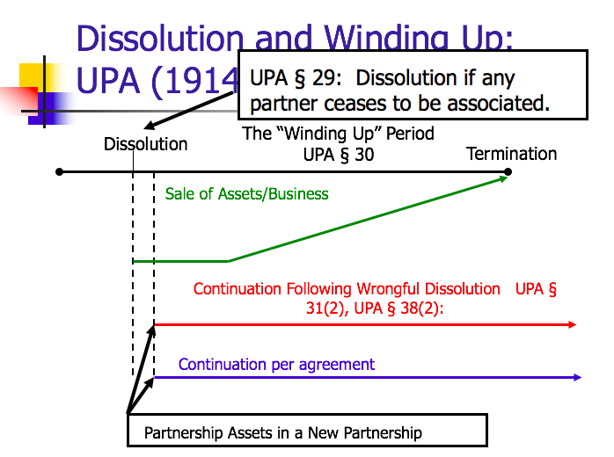

      - Differences between UPA (1914) and RUPA (1997)
        - Terminology: Dissolution v. Disassociation
          - UPA § 29: The dissolution of the partnership is the change in the relation of the partners caused by any partner ceasing to be associated in carrying on.
          - RUPA § 601: A person is disassociated as a partner when:
            - The partner’s express will;
            - An event agreed in the partnership agreement;
            - The partner is expelled pursuant to the partnership agreement; ...
          - RUPA § 801: A partnership is dissolved and its business must be wound up only upon occurrence of the following events:
            - In a partnership at will, the partner’s express will...,
            - An event agreed in the partnership agreement; ...
            - Only a dissolution if it is a disassociation resulting in a wind up → not every disassociation is a dissolution
        - Goodwill is not deducted after wrongful dissolution in RUPA
          - How we calculate the value of what is owed to a partner who wrongfully disassociates

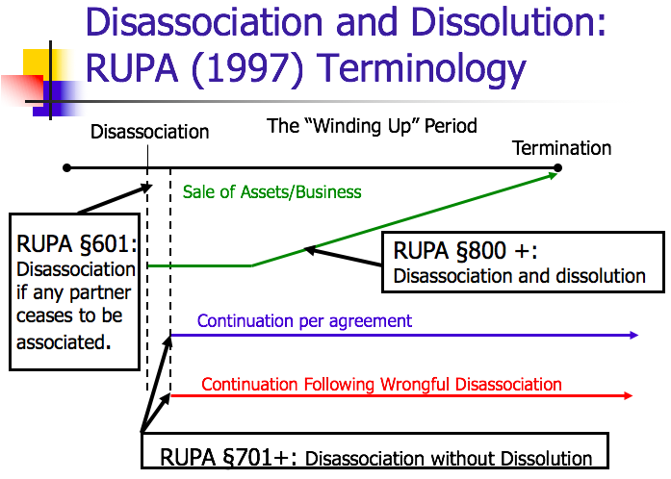
Power and the Right
Owen v. Cohen: Plaintiff and defendant entered into an oral agreement whereby they contracted to become partners in the operation of a bowling-alley business in Burbank, CA. Plaintiff advanced $6,9836.63 to the partnership with the understanding that the amount was to be considered a loan and was to be repaid to the plaintiff out of the prospective profits of the business as soon as it could reasonably do so. However, shortly after the business was begun differences arose between the partners with regard to the management of the partnership affairs and their respective rights and duties under their agreement. The breach between the partners was due in large measure to defendant’s persistent endeavors to become the dominating figure of the enterprise and to humiliate plaintiff before the employees and customers of the bowling-alley.
- Cohen: doesn’t like working, a little greedy (took money) and wanted to set-up a gambling room
- No express term...but was there an implied term?
  - Implicit term: “when a partner advances a sum of money to a partnership with the understanding that the amount contributed was to be a loan to the partnership and was to be repaid as soon as feasible from the prospective profits of the business, the partnership is for the term reasonably required to repay the loan.”
    - Implied term because Owen’s loan created an expectation that they would stay in business long enough to pay back the loan
    - $7K loan made by Owen → negative consequence was creating an implied term; loaning money created a partnership for a term
    - Take a snapshot when partnership was formed – i.e., reasonably thought we could repay it in 5 years
    - Q: what if you make a loan during the partnership?
      - Can create an implied term at that point; partners can change the term (go from at will to term)
- Exam question: Would Owen have been better off if just saying going to invest instead of calling it a loan that need to be repaid?
1. Why does Owen file a lawsuit seeking dissolution rather than just give notice and demand a winding up?
- Owen wants the right; other partner can continue the business if Owen dissolved without the right
2. Proper to repay loan before distributing profits?
- Yes → § 40(b): order in which amounts are repaid
  - (1) the claims of the firm’s creditors are paid;
  - (2) claims of a partner other than those for capital and profits;
  - (3) those owing to partners in respect of capital;
  - (4) those owing to partners in respect of profits.
- So, Owen is entitled to repayment of his loan before Cohen gets anything
3. What is the legal effect of the order for dissolution? What is the likely practical effect?
- Executes dissolution of the partnership → winding up; assets are prepared for sale [e-bay rule]
  - Winding up = converts everything to cash
- Practical effect: Owen is paid out his loan before he and Cohen have to split anything
- Owen can easily bid on the company
4. What was the statutory basis for the court dissolution?
- UPA §32(1): dissolution by court:
  - (d) a partner conducts himself in matters relating to the partnership that makes it not reasonably practicable to carry on the business in partnership with him...

Power without the Right
Collins v. Lewis: In 1948, Lewis (appellee) approached Collins (appellant) that he would furnish the lease, the experience and management ability for the operation of a cafeteria, and Collins would furnish the money. All revenue of the business, except for an agreed salary to Lewis, would be applied to the repayment of such money, and that thereafter all profits would be divided equally between Lewis and Collins. Lewis and Collins entered into a partnership agreement to endure throughout the term of the lease contract (30 years). Collins was to furnish all of the funds necessary to build, equip, and open the cafeteria for business. Lewis was to plan and supervise such construction, and, after opening for business, to manage the operation of the cafeteria. Each controlled equal 50% interests in the business. Lewis estimated that the cost of completing the cafeteria would be $300,000, but it ended up exceeding $600,000. Lewis guaranteed repayment to Collins at a minimum rate of $30k plus interest in the first year, and $60k plus interest annually thereafter until it was repaid. Collins sought to dissolve the partnership and Lewis accused Collins of interfering with the management of the business when Collins started pressuring him about the profitability of the cafeteria.
1. Why is the jury finding that the cost of opening the cafeteria ($697,603) relevant?
- Proves that Lewis met his obligations – not in breach
- Collins did not have right to dissolution because Lewis met his obligations
2. What did Collins hope to gain by obtaining a decree of dissolution?
- Assets go up for sale (winding up) and he gets them and Lewis is gone
3. Where does the court’s refusal to order dissolution leave Collins? What is likely to happen next?
- Power without the right
- Lewis can continue the business
- If business could only be carried on at a loss, then Collins could get judicial dissolution § 32(e); however, jury found that cafeteria was successful
4. What protection should Collins have requested?
- Bad provision: to furnish all the funds necessary
- Should’ve put a specific number/capped the amount

- Comparing Owen and Collins
  - In both, there was bad blood between the partners
  - In both, one partner got fed up and wanted out
  - Court let Owen out; Collins is stuck. Why?
    - If you’re the one causing the disruption, then a court of equity is unlikely to be sympathetic.
Case | Business | “Bad” Guy | Party Seeking Dissolution
Owen v. Cohen | Bowling Alley | Lazy Cohen | Owen
Collins v. Lewis | Cafeteria | Interfering Collins | Collins

Power and the Right
Page v. Page: Plaintiff and defendant (brothers) are partners in a linen supply business. Entered into an oral partnership agreement in 1949. Each partner contributed $43K within the first 2 years. From 1949 to 1957, the enterprise was unprofitable. The partnership’s major creditor is a corporation, wholly owned by plaintiff, that supplies the linen and machinery necessary for the day-to-day operation of the business. The partnership operations began to improve in 1958, but the plaintiff wishes to terminate the partnership. They did not discuss a specific term for the partnership, but agreed that the partnership should stay in existence long enough to make a profit and pay its debts.
1. What were the economics of the transactions?
- In 1949, each contributed $43K
- From 1949 to 1957, plaintiff’s corporation lent the partnership $47K
2. Did plaintiff have the power to dissolve the partnership?
- Yes, you always have the power
3. Did plaintiff have the right to dissolve the partnership?
- Yes, court held It was an at will partnership. Therefore, it could be ended at any time by either brother.
4. Why didn’t the brothers’ $86K investment in the partnership create a partnership for term?
- Equity and not a loan
  - Loan = partnership for a term
    - Loan: promised repayment of a fixed amount
  - Pool money (equity/capital) = partnership that can be dissolved at will
    - Capital: no guaranteed point of time at which funds will be returned nor a fixed return
- Look at economic terms → money to fund business
  - Debt:
    - Funds borrowed by the firm
    - In exchange for claims of a fixed amount against the firm’s assets and future earnings
    - Typical terms: firm pays interest and, at “maturity,” returns the principal
  - Equity:
    - Funds invested in the firm. Owners of the firm.
    - In exchange for residual (left over) value of the firm
    - Right to firm’s earnings and, in liquidation, firm assets after all other claims are satisfied
5. Why didn’t plaintiff corporation’s loan of $47K to the partnership create a partnership for term?
- Fact that loan was demand note → term of a demand note = zero
- Loan made by corporation and not one of the partners (different entity)
  - However, could have created a term if the partners agreed to pay back in X years
- Can go from at will to loan for term; however, more clear/more likely if loan made at beginning like in Owen v. Cohen
  - Possible Exam Question: What facts would make it more likely that this created a partnership for a term?
    - Consider it a loan to the partnership and was to be repaid out of the prospective profits of the business as soon as it could reasonably do so
    - Initial investment had terms that resembled equity – they didn’t each put in the $43K with the understanding that they would each get repaid, but rather, they would just share the profits
    - While there was also a loan made in Page v. Page, that loan was made after the original investment, was payable on demand, and was not made by a partner. Therefore, the court did not find evidence of an intent to enter into a partnership for term.
    - Debt: funds borrowed by the firm → Owens v. Cohen involved debt because repayment was expected
    - Equity: funds invested in the firm → Page v. Page involved equity because repayment was not expected
6. Suppose the plaintiff wishes to buy the partnership assets and continue with a new partner (who will manage and get a 25 percent share)?
- No problem – can do this
7. Suppose the plaintiff intends to liquidate the business and pick up its better accounts with a new entity?
H.B. says I don’t want to continue, then they sell the machines for $15K and after H.B. contacts former customers to tell them starting a new business and come be new customer...
- Potential breach of fiduciary duty of loyalty
- Taking opportunity that should be for the partnership and benefitting himself solely
- How to avoid this?
  - Ideally fire sale includes customer list; whoever buys gets access to customers → clear asset for sale, so it is not done secretly
  - Disclosure; being up front

- Can’t dissolve partnership in a way that breaches fiduciary duties
  - i.e., partial sale

Comparing Owen and Page
Owen v. Cohen  - Implied term found. Why?  - When a partner loans money to the firm, to be repaid from profits, the partnership may be for a term until the loan is repaid  - DEBT | Page v. Page  - No implied term. Why not?  - Parties’ hope to repay start-up loan out of partnership profits not enough  - EQUITY

- When does a loan create a term partnership?
  - No implicit term: Page v. Page
    - “Viewing this evidence most favorably for [Page], it proves only that the partners expected to meet current expenses from current income and to recoup their investment if the business were successful.”
    - “It is true that Owen v. Cohen and other cases hold that partners may impliedly agree to continue in business until a certain sum of money is earned…, or one or more partners recoup their investments or until certain debts are paid. … In each of these cases, however, the implied agreement found support in the evidence.”

The Consequences of Dissolution:

- Dissolution with Power and Right
Prentiss v. Sheffel: Plaintiffs seeking dissolution of partnership formed for the purpose of acquiring and operating a shopping center in Phoenix, Arizona. Alleged that the defendant had in general been derelict in his partnership duties, and in particular that he had failed to contribute the balance of his proportionate share ($6k) of the operating losses incurred by the shopping center. Plaintiffs also sought permission to continue the partnership business both during the pendency of the suit and thereafter, and requested that a value be fixed on the defendant’s interest in the partnership. Defendant argued for a winding up of the partnership and that his rights as a partner had been violated in that he had been wrongfully excluded from the partnership.
- Sheffel (42.5%) and Iger (42.5%) sue for dissolution
- Trial court finds partnership dissolved by freeze out, no bad faith, appoints receiver, and orders sale of property
- Sheffel and Iger buy property for $2.25 million
- Prentiss appeals Sheffel and Iger purchase of partnership property
- No breach of fiduciary duty → just ignored Prentiss; had power and right to exclude Prentiss – no fiduciary duty to remain partners
1. What did the court find to be the basis for dissolution?
- “Trial court concluded that a partnership-at-will was dissolved as a result of a freeze-out or exclusion of the defendant from the management and affairs of the partnership.”
- UPA §6(1): “A partnership is an association of two or more persons to carry on as co-owners of a business for profit.”
- UPA § 18(e): partners have “equal rights” to management
  - Case relying on common law fact that no longer carrying on as co-owners → didn’t meet test for partnership
  - The partnership no longer existed
2. Why continue to inform a minority partner?
- Fiduciary duty issue → information; maybe want to continue partnership – Prentiss off the side effectively dissolves the partnership
3. Is the court correct that allowing the partners to bid benefits Prentiss?
- Rather take less money than have former partners own the business

Entitled to end the partnership because at will – not breach of fiduciary duty [court gave them benefit of the doubt]

The Paper Dollars Argument:
- Sheffel and Iger pay $2.25 million
  - Each pays $1.125 million
- Receiver distributes per UPA § 40(b):
  - Assume no debt
  - $337,500 to Prentiss (15%)
  - §956,250 each to Iger and Sheffel (42.5% each)
  - Iger and Sheffel are out of pocket only $168,750 each to acquire a business worth $2.25 million
  - Effect is a forced sale of business

- Dissolution Without Right
  - UPA § 31(2): dissolution is caused in contravention of the agreement between the partners, where the circumstances do not permit a dissolution under any other provision of this section, by the express will of any partner at any time
  - Rights when dissolution in contravention of agreement:
    - UPA § 38(2): when dissolution is caused in contravention of the partnership agreement the rights of the partners shall be as follows:
      - (a) Each partner who has not caused dissolution wrongfully shall have
Good guys - Partners who did not wrongfully dissolve

        - I. divide partnership assets based on terms of partnership agreement
        - II. Damages against partner(s) who have wrongfully dissolved [right to damages for breach]
      - (b) The partners who have not caused the dissolution wrongfully, if they all desire to continue the business in the same name, either by themselves or jointly with others may do so [option to continue the business for partners who did not cause dissolution]
      - (c) A partner who has caused the dissolution wrongfully shall have:
Bad guys - Partners who wrongfully dissolve

        - the business, then partner has all rights under paragraph (1), subject to clause (2a II) – damages
        - II. If the remaining partners continue the business, then value of interest less damage but value of good-will not considered
          - Get value of interest but deduct damages – calculation based on value of underlying assets
    - Key difference with RUPA (1997): goodwill is not deducted after wrongful dissolution in RUPA
      - Goodwill: value of intangible assets, such as the businesses’ reputation and brand names, and patents
      - Goodwill exclusion only applies if the non-breaching partner continues the business
      - RUPA (1997) § 701(b): buyout price is greater of liquidation value or sale of entire business as going concern
Goodwill
UPA § 38(2)(c)(II)  - Bad guy (partner who wrongfully dissolved) does not get share of goodwill | RUPA § 701  - Even if person was bad guy that person is entitled to his share of the true value of the business  - Liquidation value or sale of entire business as going concern  More forgiving, but still need to pay damages

Partnership is like a canoe

Pav-Saver Corp. v. Vasso Corp.: In 1974, Dale, PSC and Meersman formed Pav-Saver Manufacturing Company for the manufacture and sale of Pav-Saver machines. Dale agreed to contribute his services, PSC contributed the patents and trademark necessary to the proposed operation, and Meersman agreed to obtain financing for it. In 1976, upon mutual consent, the partnership was dissolved and replaced with an identical one between PSC and Vasso, so as to eliminate the individual partners. They encountered bad business in 1981 and on March 17, 1983 Attorney Charles Peart on behalf of PSC wrote a letter to Meersman terminating the partnership and invoking the provisions of paragraph 11 of the parties’ agreement. Vasso received the letter and decided to exercise its statutory right to continue the business after Pav Saver’s wrongful dissolution. Vasso claimed it was entitled to liquidated damages and the patents because, without them, it couldn’t exercise the right to continue the business under UPA § 38(2)(b).
- Partnership agreement stated that license for certain patents would revert to plaintiff following dissolution
- Agreement contemplated mutual dissolution, but provided for liquidated damages in the case of a unilateral dissolution
- Provisions:
  - “3. Agreed that copies of all patents shall be returned at the expiration of the partnership.
  - 11. It is contemplated this joint venture partnership shall be permanent,…
If, however, either party shall terminate or dissolve, the terminating party shall pay to the other party, as liquidated damages, …”
- Vasso got to keep the patents, Vasso entitled to damages, and all Dale is entitled to is half of the value of the tangible items
1. What is the majority decision?
- Vasso may continue the business under §38(2). To do so, he needs patents and trademarks, so PSC allowed to retain them (contra Paragraph 3 of Agreement)
- Damages calculated based on liquidated damages per paragraph 11, but goodwill exclusion not superseded by liquidated damages of paragraph 11
2. Can the partnership continue to use the Pav-Saver patents after the departure of Dale?
- Yes
3. What is the value of the partnership excluding goodwill at the time of dissolution?
- $330,000 ($165,000 owed to Dale)
4. What is the implication of the agreement as to liquidated damages?
- Used to determine damage payment owed to Meersman, not to replace all provisions of UPA § 38(2)
5. What argument can you offer that the majority decision is incorrect?
- Majority misinterpreted the contract; the liquidated damages provision was supposed to be instead of § 38(2) → Dale gets his stuff back but needs to pay Meersman
- Meant to wipe out whole provision
- Dale would get the patents back
- Could read agreement as an effort to say it even though said it incorrectly
  - Two possible interpretation of Paragraph 11, liquidated damages clause:
    - If either party dissolves, that is wrongful, so § 38 comes into play
      - In determining damages under §38 the amount is as specified under paragraph 11
    - The partnership can be terminated (overriding § 38) subject to the damages provision
  - Key provision of agreement: “3. Agreed that copies of all patents shall be returned at the expiration of the partnership”
    - Majority: “unless there is a wrongful disassociation, at which time the other partner may elect to continue the partnership with the patents”
    - Dissent: “whether or not there is a wrongful disassociation”
6. Is the partnership agreement forming Pav-Saver Manufacturing Company well drafted?
- Not well drafted if you are Dale – not the picture of clarity
7. Would the Pav-Saver remedy be different under the RUPA provisions?
- Yes – amount Dale entitled to would be full value – going concern value – include value of patents
8. How important is the inclusion of the language about forming a “permanent partnership”?
- Suppose the business was not referred to as a partnership?
- Suppose the arrangement was not referred to as permanent?
  - Pav-Saver should have sought judicial dissolution to avoid wrongfully terminating
  - It would have both the power and right and Vasso would not have been able to continue the business
  - Can be partnership whether or not you call it a partnership
    - 90%: permanent matters
    - 10%: calling it a partnership isn’t determinative

Sharing Losses
- UPA (1914) § 40: Rules for Distribution
  - § 40(b): subject to contrary agreement, upon dissolution partnership assets should be distributed as follows: [can contract around these default rules]
    - (I) Those owing to creditors other than partners,
    - (II) Those owing to partners other than for capital and profits [Owen v. Cohen]
    - (III) Those owing to partners in respect of capital [Page v. Page]
    - (IV) Those owing to partners in respect of profits
  - § 40(d): “partners shall contribute, as provided by [§ 18(a)] the amount necessary to satisfy the liabilities [set forth in § 40(b)].” → if there is a shortfall what the partners need to contribute
  - § 18: equality is the default rule in terms of sharing profits; default is profits shared equally between partners
    - “The rights and duties of the partners in relation to the partnership shall be determined, subject to any agreement between them, by the following rules:
      - “(a) Each partner shall be repaid his contributions, … and share equally in the profits and surplus remaining after all liabilities, including those to partners, are satisfied; and must contribute towards the losses, whether capital or otherwise, sustained by the partnership according to his share in the profits.”
    - If there is a shortfall, then partners must contribute towards losses according to his share in the profits
    - Therefore, if you don’t change default profit sharing rule, then partners will have to share/pay losses equally

Example:
- Bill Gates invests $100
- Homer earns a salary of $40
- Agree to 50/50 profit share (don’t need this fact because this is the default rule)
- Moe sells beer on credit for $30
  - Applying § 40:
    - Sell the business for $300
    - 1. Repay Moe $30
      - [§ 40(b)(I): those owing to creditors other than partners]
    - 2. Pay Homer salary $40
      - [§ 40(b)(II): those owing to partners other than for capital and profits]
    - 3. Gates capital $100
      - {§ 40(b)(III): those owing to partners in respect of capital]
    - 4. Profit $130 gets split 50/50
      - [§ 40(b)(IV): those owing to partners in respect of profits]
    - Sell the business for $150
    - There is now a $20 shortfall
      - § 18(a) says that each partner must contribute towards the losses
      - § 40(d) says partners shall contribute as provided by § 18(a)
      - Therefore, Gates pays himself $10 and Homer pays Gates $10 → the shortfall is split between them

Kovacik v. Reed: Kovacik told Reed that he had some kitchens to remodel in SF and asked Reed to be his job superintendent and estimator. Kovacik said that he had about $10K to invest and that if Reed did this he would share profits on a 50-50 basis. Kovacik did not ask Reed to share any losses that might result, and Reed did not offer to do so. Reed accepted Kovacik’s proposal. In August 1953, Kovacik told Reed that the venture had lost money and demanded Reed to contribute to the amount that he had advanced beyond the income he received. Reed claimed that he never agreed to be liable for losses and refused to pay.
- At most partnership lasted 9 months and lost $8,680
- Capital contribution:
  - Kovacik: $10,000
  - Reed: $0
- Profits: equally divided; no salaries
- 10 months later – Kovacik dissolves, and explain partnership is losing money
  - Remaining assets: $1,320; loss of $8,680 (= $4,340 x 2)
Holding: Reed does not owe Kovacik $4,340
- “Upon loss of the money the party who contributed is not entitled to recover any part of it from the party who contributed only services.”
- Is the holding in Kovacik consistent with the statutes?
  - No
  - Under 18(a) each partner needed to contribute to shortfall based on share in profits
  - Based on statute, it should be 50/50 loss sharing since it was 50/50 profit sharing

Comparing the Kovacik Decision with the Default Rule
 | Kovacik | Reed
Kovacik Rule | - $8,680 | - 4 months labor
Statute Rule | - $4,340 | - 4 months labor % - $4,340

- Kovacik Rule: Kovacik bore full loss and giving Reed a credit for his labor
- § 18(f): default rule is that you don’t get paid for working for the partnership
- What would an alternative rule be?
  - If no salary, then partner gets credit for services/labor contributed

Finance
- Red line: asset (ownership stake) → UPA rule
- Green line: an option (right to participate in upside but not suffer losses) → Kovacik rule
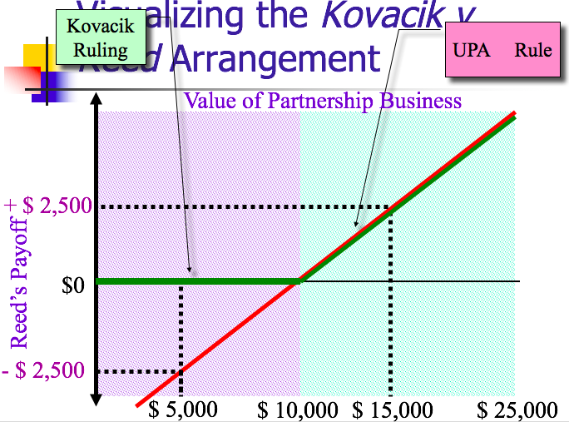

- What is the intuition behind Kovacik’s rejection of the statutory scheme?
  - Court wants to give Reed an option value
  - Court thought there should be some value attributed to the labor that Reed put in
  - Court found the fact that they were sharing 50/50 in profits means they thought they were contributing equally, so losing equally
    - “Where one party contributes money and the other contributes services, in the event of a loss each would lose his own capital—the one his money and the other his labor. Another view would be that in such a situation the parties have, by their agreement to share equally in profits, agreed that the value of their contributions—the money on one hand and the labor on the other—were likewise equal; it would follow that upon the loss . . . of both money and labor, the parties have shared equally in the losses.”
- Which provisions of the default rules leads to this problem?
  - Default rules say you don’t get paid for your labor
- What if Reed had contributed a nominal amount of capital?
  - Become unclear what CA rule should be
- Why didn’t Kovacik and Reed adopt a different rule?
  - Reed didn’t have the bargaining power
  - Kovacik knows what law is and taking advantage of default rule (knows he can get half from Reed)
  - Didn’t think they would lose money
- What might the effect of no-loss sharing by service partner be on behavior?
  - Encourages risk taking (risky behavior)
  - Not worried about the losses
  - Not working as hard → other people’s money (OPM)
- Kovacik is still precedent in CA, so need to analyze under UPA § 18 and Kovacik on the exam

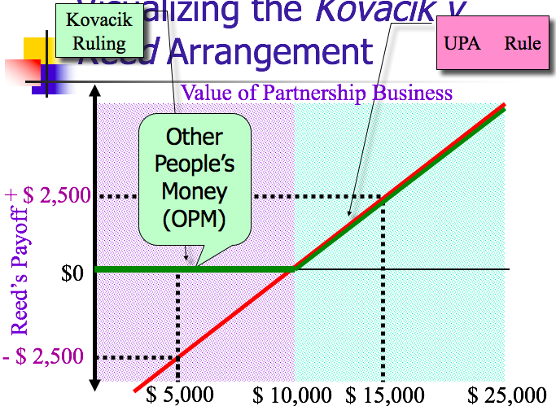

Practice Multiple Choice Question
Chandler, Joey, and Ross agree to work together to open and run a coffee shop called The Central Reperk. Joey works as the head waiter, and receives an agreed upon salary. They do not execute a partnership agreement, and they are in a jurisdiction that has adopted the Uniform Partnership Act of 1914. A few months after they open the coffee shop, Joey decides to take a job as a waiter in Los Angeles, and he tells Chandler and Ross that he does not want to have anything more to do with The Central Reperk. Which of the following is an accurate statement of the law of partnership regarding these facts?
A. If Chandler, Joey, and Ross had formed a partnership, Joey’s departure does not constitute a wrongful termination of The Central Reperk partnership, because Joey will be working as a waiter in an entirely different city.
B. If Chandler, Joey, and Ross had formed a partnership, then, because Joey did not exit the partnership in contravention of an agreement, Joey is entitled to an immediate winding up of the partnership. As a result, Joey will receive one-third of the net value less goodwill from the liquidation of The Central Reperk.
C. If Chandler, Joey, and Ross had formed a partnership, Joey’s decision to depart the partnership will not lead to the dissolution of the partnership, if Chandler and Ross agree to continue the partnership and provide Joey the fair market value of his interest in The Central Reperk.
D. Joey’s receipt of a share of the profits of The Central Reperk would not provide prima facie evidence that Joey was a partner.

Answer: D
D is the best answer, since it appears that if Joey was not a partner he was an employee for whom profit sharing does not provide prima facie evidence of a partnership (UPA § 7(4)(b)). A is incorrect, because wrongful termination is not caused by a partner exiting and then competing. B is incorrect, because if termination is not wrongful, then goodwill should not be deducted. C is incorrect, because under the old UPA disassociation automatically causes dissolution

Practice Short Answer Question
Can you reconcile the decisions in Owen v. Cohen and Page v. Page?

Answer:
- In Owen v. Cohen the court found that there was partnership for a term, and so judicial dissolution needed to be provided if Owen was going to have both the power and right to dissolve the partnership before the term expired. The court found that Cohen’s bad behavior provided a basis for judicial dissolution. In Page v. Page there was not an implied term, so Page had the power and right to terminate the partnership at will, which is what he did.
- There are several apparent similarities between these cases, but they are sufficiently different to distinguish the cases. Most important, while both cases involved an initial investment in the partnership, in the case of Owen v. Cohen a loan funded the start of the partnership, since it was fixed amount to be repaid, while in Page v. Page the initial investment had terms that resembled equity. While there was also a loan made in Page v. Page, that loan was made after the original investment, was payable on demand, and was not made by a partner. Therefore, the court did not find evidence of an intent to enter into a partnership for term.
- [One might also argue that the two decisions are inconsistent and difficult to reconcile, as long as a similarly detailed consideration is provided.]

Principal/Agency → dating
Partnerships → living together
Corporations → Marriage
- Distinctive because of massive scale/size
- Designed to undertake long-term economic ventures that take time and patience
- Important driver of economic activity in society

- Corporations
  - Sources of Corporate Law
    - Individual state law (internal affairs doctrine) → how internal affairs of corporation will be governed; state of incorporation
      - Delaware
        - More than 850,000 companies are incorporated in Delaware including:
        - 60 percent of the Fortune 500
        - 50 percent of the companies listed on the New York Stock Exchange
        - Why?
          - Race to the bottom theory
            - Choice is destructive; corporation can’t be trusted to pick the law that regulates its operations
            - William L. Cary, Federalism and Corporate Law: Reflections on Delaware, 83 Yale L. J. 663 (1974)
          - Race to the top theory
            - Providing system of laws – market where different states compete (competition is a good thing)
            - Ralph K. Winter, State Law, Shareholder Protection and the Theory of Incorporation, 6 J.Leg.Stud 251 (1977)
      - Model Business Corporations Act (“MBCA”) [CA looks like this]
    - Federal Law [focuses on public corporations]
      - Securities and exchange acts (’33, ’34)
      - Sarbanes-Oxley Act of 2002
      - Dodd Frank Act of 2010
        - Disclosure of average employee salary and CEO salary
        - Insider trading law
        - Proxy battles
      - JOBS Act of 2012
        - Primarily cover “public” corporations
  - Critical Attributes of Corporations [Distinctive Features of the Corporation: Five Attributes]
    - Legal personality
      - The corporation is an entity with separate legal existence from its owners
        - Possesses (some) constitutional rights
          - Yes: free speech (Citizens United)
          - No: personal privacy (FCC v. ATT)
        - Separate taxpayer (independent status as a legal person)
        - Requirement of formal creation (state website) → contrast with partnerships
        - More stable than partnership – the legal identity of a corp. gives it more permanence while a partnership can dissolve easily
      - Advantage: can live forever
    - Limited liability
      - Shareholder (owner) does not have liability (not personally liable) → contrast with partnerships
        - MBCA § 6.22(b):
          - “Unless otherwise provided in the articles of incorporation, a shareholder of a corporation is not personally liable for the acts or debts of the corporation except that he may become personally liable by reason of his own acts or conduct.”
    - Separation of ownership and control
      - Shareholders are owners but not in charge of corporation
        - Rationale for no liability because shareholders are not running the operations
      - Intermediary body → Board of Directors
        - MBCA § 8.01(b):
          - “All corporate powers shall be exercised by or under the authority of, and the business and affairs of the corporation managed by or under the direction of, its board of directors….”
      - Facilitates trading/liquidity
        - Insulates business from changes in ownership
    - Formal capital structure
      - Capital structure:
        - Claims on the corporation’s assets and future earnings issued in the form of securities
        - Formal/standardized system of claims → securities
    - Liquidity
      - Secondary trading markets
        - E.g., NYSE and NASDAQ
      - Ability to easily buy and sell ownership in a corporation
      - All 4 attributes above make liquidity possible

Capital Structure Vocabulary
- Securities: permanent, long-term claims on the corporation’s assets and future earnings issued pursuant to formal contractual instruments.
- Capital Structure: The debt securities and equity securities together constitute the firm’s capital structure.

Comparing Debt and Equity
Equity  - Shareholders: owners of the corporation  - Get share(s) of stock = an owner of the corporation; can elect the directors  - Elect directors and vote on major corporate decisions  - May receive firm’s earnings in the form of dividends  - Dividend = elective payment; Board of Directors can choose to make to shareholders (not required)  - In liquidation, get firm assets after all other claims are satisfied (residual claimants) | Debt  - Bonds/notes by lenders (creditors)  - Funds borrowed by the firm (fixed amount plus interest)  - Firm pays interest  - At “maturity,” firm returns the principal

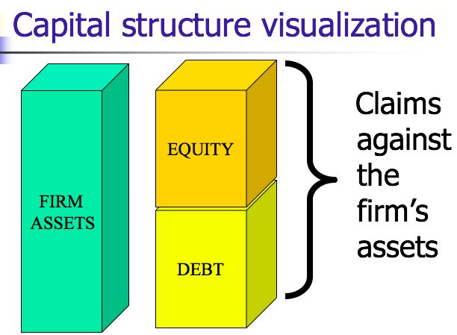
- Which is riskier? Debt or Equity?
  - Answer: Equity
    - More like bacon (committed) v. chicken (interested)

Financial Statements: Income Statements and Balance Sheets
- Income Statement: Financial statement that indicates results of operations over a specified period. Also known as the profit and loss (P&L) statement.
  - How much you earned
- Balance Sheet: Summarizes the company’s financial position at a given point in time. Usually the end of the month, quarter, or year.
  - Describes the assets of the business, and the claims on those assets, either of creditors in form of debt, or owners in the form of equity.
    - Numerical representation of how much you earned
    - List of firm’s stuff
    - List of various claims against firm’s stuff
- Both are prepared according to Generally Accepted Accounting Principles (“GAAP”). → cost based accounting

Balance Sheet Terms
- Current assets: like cash in the bank
  - Assets matched by claims against those assets
- Receivables: bills you need to collect, money you will be receiving
- Goodwill: money spent by Disney in acquiring stuff (like Pixar, Star Wars, etc.)
  - Nothing tangible
  - Spending money for something there’s not an obvious value for

What is a share of stock worth?
- Share of stock worth slice of equity value
- Equity value divided by number of outstanding shares
- One share of company stock = (value of the firm’s assets – firm’s debt – other liabilities) / number of firm’s shares outstanding
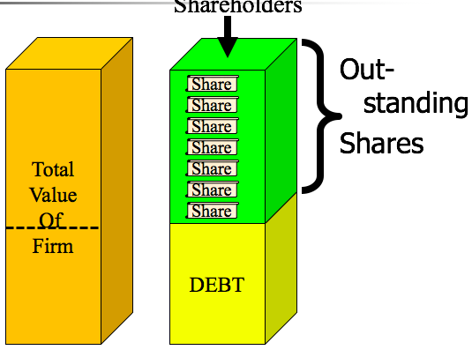

- Authorized shares: Number of shares the corporation can issue.
  - Look in articles of incorporation (state website application) → number put in certification of corporation
- Outstanding shares: Number of shares the corporation has sold and not repurchased.
  - Shares actually in use and not repurchased by the corporation
  - Care about this one!!
- Authorized but unissued: shares that are authorized, but not yet sold.
- Treasury shares: shares issued and then repurchased by the firm.
  - Shares bought back by the corporation

- Book Value: Measure of the equity value of the firm provided by the financial statement (balance sheet).
  - According to the accountants
  - What accountants tell you equity of a company is worth
- Market Capitalization: Measure of the equity value of the firm implied by the trading value of the firm’s stock (determined by multiplying the trading value of one share of stock times the total number of shares outstanding).
  - What people willing to pay for a share multiplied by number of shares
  - Trading value of one share of stock
  - What people are willing buy shares of stock for (i.e., 1 billion shares – each worth $1 so implicitly determining that equity of the firm is $1 billion)
- Enterprise Value: Measure of the total value of the firm’s assets implied by the trading value of the firm’s stock (determined by adding the market value to the firm’s obligations).
  - Value of whole firm by working backwards
  - Multiplying stock + debt = total value of the firm
  - Total value of firm’s assets + firm’s obligations

What is the firm worth (enterprise value)?
- One share of company stock x number of firm’s shares outstanding + firm’s debt (and other liabilities) = value of the firm’s assets
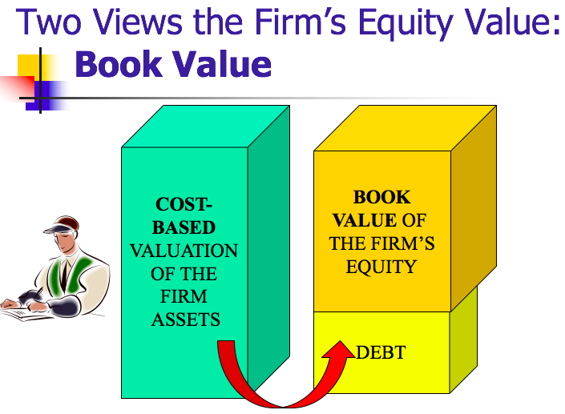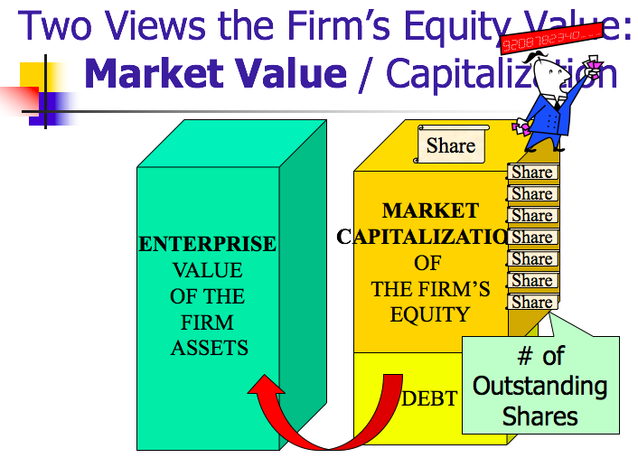

Best way to see how big a company is = Market Capitalization
- Using market capitalization to determine Apple/Amazon were trillion dollar companies
It isn’t true that market capitalization has to be more than book value
- Market capitalization can be lower than book value (more unusual today)
Market price accurately depicts number
- Market capitalization more realistic measure of true value
- Efficient Capital Market Hypothesis (“ECMH”)
  - The price of a stock reflects all available information

 | General Partnership | Corporation | Unincorporated Limited Liability Entities
Limited Liability | None | Yes | Some!
Formation | Informal | Formalities Required | Formalities Required
Tax Treatment | “Pass-through” | “Double Taxation” | “Pass-through”
- Double taxation: corporation pays taxes then distributes to shareholder (dividend) also taxed (personally)

- Partnerships: great for tax bad for liabilities purposes
- Corporations: great for liability and bad for tax
  - Unincorporated limited liability entities → combining the best of both

Five “unincorporated” limited liability entities
- Partnerships
  - 1. Limited Liability Partnerships (LLPs)
  - 2. Limited Partnerships (LPs)
  - 3. Limited Liability Limited Partnerships (LLLPs)
  - 4. Limited Liability Companies (LLCs)
  - 5. S Corporation
- Corporations

- Limited Liability Partnership
  - General partnership with limited partner liability - UPA (1997) § 306(c)
  - Formed by filing a “statement of qualification” with secretary of state
    - Need to file a form with the State → unlike normal/general partnership that is informal
  - General partnership can convert to LLP by filing
  - No longer true that all partners have joint and several liability → avoid liability for tortious conduct by other partners
    - Popular with law firms

- Limited Partnerships
  - General and limited partner(s).
    - Two kinds of partners:
      - General partners → actively engaged
      - Limited partners → money guys
        - Just put money in and not involved in management so limit liability to what they invest
        - Get flow through tax treatment
        - Useful vehicle if what you care about is favorable tax treatment
    - Buy and sell limited partnership interests in the market
  - Formation:
    - Must file documents (usually with Secretary of State)
  - Limited partner liability:
    - Only limited partners who participate in control can be held liable - ULPA (1985) § 303(a)
  - General partner has full personal liability
    - But, corporation can be general partner
    - Popular in oil and gas industry

- LLLP’s
  - Limited Liability Limited Partnership (LLLP)
    - Limited Partnership (LP) in which general partners get limited liability (LLP treatment)
  - Some people are limited partners (not involved in management)
  - General partners would not have full exposure to tortious conduct by other general partners

- Limited Liability Companies [Vehicle of Choice]
  - LLCs introduced in Wyoming in 1977
  - In 1988, IRS ruled LLC could qualify for partnership-like tax treatment
  - Formation: File with State
  - Flexibility: Like partnership, most aspects of management and sharing dictated by the LLC’s “operating agreement.”
  - Two types: 1) member managed, all members are managers, and 2) manager managed, some owners not managers and no right to vote.
  - Limitations on capital structure complexity and share transferability.
  - Unfavorable state franchise taxes in some states.
    - Great tax treatment and liability treatment
    - Have to have agreement specifying how LLC would work → operating agreement (no default rules)
    - Vary state by state
    - Law firms cannot be LLCs

- S Corporation [only corporation]
  - Creation of tax code (actually a corporation)
  - Advantage:
    - Pass-through taxation and limited liability.
  - Disadvantages:
    - Constraints on # of shareholders, source of corporate income, types of shareholders (one class only), deductions on pass-through losses.
  - IRS lets you not pay corporate taxes

- Formation of Corporations
  - Pick a state that will govern internal affairs of corporation
    - Delaware
    - California
    - Nevada (place where you can take advantage of shareholders)
  - Draft Articles of Incorporation and By-Laws
    - Articles of incorporation: [Certificate of Incorporation/Corporate Charter]
      - Must include - MBCA § 2.02(a): Name, # of shares, address, incorporators
      - May include - MBCA § 2.02(b): Initial directors, management, limits on rights, liability on a shareholder
        - Hard to change articles of incorporation later because you need votes of the board members, so better to put it all in the beginning
      - (DGCL § 102 (a) and (b)) – Delaware
        - 2.02(b)(4): can limit or eliminate liability of a director
        - Delaware § 102(b)(7): can limit or eliminate liability of a director
    - By-Laws:
      - May include - MBCA § 2.06(b): “Provision for managing the business and regulating the affairs of the corporation.”
      - (DGCL § 109 (b)) – Delaware must include – the purpose of the corporation
        - dictate stuff but easier to change than Articles of Incorporation
  - File Articles with Secretary of State
    - MBCA § 2.03
  - Organizational Meeting
    - MBCA § 2.05
  - Final Steps:
    - Finalize Directors (MBCA § 2.05)
    - Appoint Officer (MBCA § 2.05)
    - Adopt By-Laws (MBCA § 2.06)
      - Simple but formal process

- Liability to 3rd Parties
  - By agents in contracts where there is authority
  - Torts → master/servant relationship and tort occurred within scope of employment
  - Who in corporation bears that liability?
    - MBCA § 6.22(b): “… a shareholder of a corporation is not personally liable for the acts or debts of the corporation except that he may become personally liable by reason of his own acts or conduct”
    - Primarily “piercing the corporate veil” → PCV doctrine
      - When shareholders have liability
      - Must:
        - Respect formalities, have annual meetings and keep records of those meetings, set-up separate bank accounts so no commingling of funds

Walkovszky v. Carlton: Plaintiff was injured after he was run down by a taxicab in NYC four years ago. The taxicab is owned by the defendant Seon Cab Corporation and negligently operated by defendant Marchese. Carlton is claimed to be a stockholder of 10 corporations, including Seon. Each of the 10 corporations contained two cabs and each cab had the “minimum liability” insurance coverage mandated by the Vehicle and Traffic Law ($10,000). Carlton specifically structured it this way to limit his liability (at worst he would lose the 2 cabs of a single corporation, but they couldn’t go after the other 18 cabs). This structure also allowed Carlton to take out the minimum amount of insurance on each cab. At the end of every night, Carlton took the money from the day out of the business.
- W designed corporation to minimize exposure and take cash out of corporations whenever he could
- Need to prove he failed to respect the corporate formalities
Holding: Two theories of liability:
- Enterprise Liability Theory: sister companies have liability
- Piercing Corporate Veil Theory: shareholder has liability
- Who do you feel sorry for: Walkovszky or Carlton?
  - Feel sorry for Walkovszky
- Did Carlton “attempt to defraud members of the general public”?
  - Carlton makes other people bear the costs of his accidents (the law allows this)
  - The court says not fraudulent
    - “It is not fraudulent for the owner-operator of a single cab corporation to take out only the minimum required liability insurance,…”
- What is the difference between: enterprise liability and piercing the corporate veil?
  - Enterprise liability → going after sister companies
  - Piercing corporate veil → going after shareholders
- What problems are there with Judge Fuld’s deference to the legislator?
  - Raise insurance level by legislation but vicious cycle (Carlton buys off legislators who make the laws)

What would plaintiff have to show in order to pierce the corporate veil? | What would plaintiff have to show in order to recover under the enterprise theory?
“That defendant Carlton and his associates are actually doing business in their individual capacities, shuttling their personal funds in and out of the corporations ‘without regard to formality and to suit their immediate convenience.’” | That Carlton did not respect the separate identities of the corporations:  - Assignment of drivers  - Use of bank accounts  - Ordering of supplies, etc.  Holding larger corporate entity financially responsible

The dark side of limited liability:
- Allows businesses to avoid some of the cost of their activities
  - Dissent: in these kinds of cases should not let people escape liability
  - Reminds Guttentag of Kovacik v. Reed (not following standard rule)
    - Arbitrary rule → how do you draw the line
Questions after Walkovszky:
- Can you incorporate your business for the express purpose of avoiding personal liability?
  - Yes
- Can you split a single business enterprise into multiple corporations so as to limit the liability exposure of each part of the business?
  - Yes → respect corporate formalities
- What if he didn’t comply with law and didn’t carry the required insurance?

Sea-Land Services, Inc. v. Pepper Source: Sea-Land Services, Inc. shipped peppers on behalf of The Pepper Source and Pepper Source did not pay for the freight bill. The district court entered a default judgment against Pepper Source in the amount of $86,767.70. However, Pepper Source had been dissolved in mid-1987 for failure to pay the annual state franchise tax. Then, Sea-Land brought another suit against Marchese to pierce the corporate veil and hold his personally liable for the judgement owed to Sea-Land and then “reverse pierce” Marchese’s other corporations so that they, too, would be on the hook for the $87k. Sea-Land claimed that the corporations are alter egos of each other and also alter egos of Marchese who should be held individually liable for the judgment because he created and manipulated these corporations and their assets for his own personal uses. In early 1989, Sea-Land added Tie-Net International, Inc. as a defendant, which is not solely owned by Marchese.
- What is the holding in this case?
  - Holding: not enough to show complete disregard for separate corporate personhood; need to show promoting injustice; business risk is not an injustice [to pierce the corporate veil]

Test for Piercing the Corporate Veil (“PCV”)
- Two prongs:
  - Unity of interest: [failure to respect separate corporate personhood]
    - 1. Lack of corporate formalities
      - annual meeting, pay taxes, keep written records (corporate minutes)
    - 2. Commingling of funds and assets
      - open bank account for corporation
    - 3. Severe under-capitalization
      - equity share of capital structure too small for size of business
    - 4. Treating corporate assets as one’s own
  - Refusing to allow PCV would:
    - (i) sanction fraud or
    - (ii) promote injustice
- If you can show unity of interest, then also need to show promoting injustice

- What should Sea-Land have to show on remand to prove unjust enrichment?
  - Show ill-intent or misleading behavior
    - On remand found that they assured they would pay
      - Acting in bad faith; knew never going to be money to pay
      - Not a genuine business transaction
      - Never meant to pay
- Are the “unity of interest” elements of the Van Dorn test conjunctive?
  - Don’t need all 4; just factors that get weighed
- Do the two elements in Van Dorn make sense from a policy perspective?

- What is reverse piercing? How does it differ from enterprise liability?
  - Reverse piercing: same test as piercing the corporate veil test
    - Go after assets of companies just because Marchese is a shareholder
    - Shareholder to underlying corporation
    - Rationale for taking assets out of Tie-Net: If Marchese was freely able to take money from Andre then why shouldn’t creditor? (took money for Bush photo)
    - Might end up with assets you would not get if you just did enterprise liability (limousine example with taxicabs)
  - Enterprise liability: go after sister companies
    - Different: can’t get to personal assets of shareholder
    - Don’t need to prove both prongs of Van Dorn test
    - Just show commingling of funds
    - And show part of larger enterprise to hold enterprise liable (don’t need to show injustice)
    - Enterprise liability: the larger corporate entity held financially responsible
  - Similarities: going after same assets → sister companies

- Role and Duties [Corporate Governance]
  - Role and Duties with respect to Creditors
    - No corporate role for creditors
      - Bottom line: governed by contract law
        - Legal analysis turns on:
          - Interpretation of express terms
          - The implied duty of good faith and fair dealing
        - No fiduciary duties to debtholders
  - To whom are fiduciary duties owed?
    - Board of Directors: control the firm; oversee and manage affairs of corporation; owe fiduciary duties
      - Two theories:
        - Stakeholder Theory: people who have a stake in the firm
          - Directors’ obligation is to take care of the constituencies that make up the firm (community, employees, shareholders, officers and clients/customers)
        - Shareholder Primacy: directors owe fiduciary duties only to shareholders [THIS IS THE LAW]
          - Note: there is not an agency/principal relationship between directors and shareholders
Dodge v. Ford Motor Co.: Ford sold his first car for $900, but as profits increased, he kept reducing the price. As the company kept doing well, Ford paid special dividends ($36 million from 1911-15) in addition to regular dividends. Ford owned 58% of the company, and the Dodge Bros. owned 10% ($2 million investment). Ford wanted to stop paying the special dividends to keep the Dodge Bros. from using that money to start a competing car company. Ford also wanted to make a new giant factory to manufacture cars. The Dodge Bros. demanded Ford pay the special dividends, or buy them out for $35M. The Dodge Bros. sue Ford claiming (1) Ford has to start paying special dividends again because its keeping too much cash on hand, and (2) it’s crazy to build the giant factory, and its just a way to spend money in order to not pay the special dividend.
- Holding: Ford has to pay the special dividend, but can build the factory. In Ford’s testimony, he suggested his goal was not to maximize profits for shareholders. He said he cared about the workers and the customers. Court said his role as director is just to answer to the shareholders. The factory, however, was a business decision and therefore not scrutinized by the court.
- What relief were the Dodge brothers seeking?
  - To require Ford to issue special dividends
  - To enjoin the construction of the River Rouge plant
    - Holding?
      - Ford must issue the special dividends
      - Ford can continue with its construction plans
- Why did Ford lose on the dividend issue?
  - Ford’s own testimony/articulated goal
    - Courts may not scrutinize decisions about how to maximize profits; but they will scrutinize decisions about whether to do so
  - Ford wants to benefit the stakeholders (employees, etc.)
- Did Ford really think that his company made too much money?
  - Semi-eleemosynary: of, relating to, or supported by charity
  - Mark Zuckerberg said company is not just about the money
  - Ford built a town in Brazil to make a more efficient community
- Does it matter that judges are not business experts?
  - Guttentag says no → because experts in the law
- Does this decision support shareholder primacy?
  - “A business corporation is organized and carried on primarily for the profit of the stockholders...the discretion of the directors are to be employed for that end.”
  - Shareholder primacy = law of the land
  - What the directors have to say: primary goal was to benefit the shareholders
  - “It is not within the lawful powers of a board of directors to shape and conduct the affairs of a corporation for the merely incidental benefit of shareholders and for the primary purpose of benefitting others,...”
- If Dodge v. Ford is a correct statement of the law, why do scholars still argue for stakeholder theory?
  - Some scholars argue for stakeholder theory as normative claim, rather than as a descriptive claim
    - Law should be stakeholder theory → companies/boards should be required to take into account other parties/constituencies
  - Courts give Boards broad discretion to determine means, and many times benefiting other stakeholders benefits shareholders
    - If directors think best way to increase shareholder income is to express concern over other constituencies then believe it is in shareholder’s best interests (means to an end)
  - Some state statutes incorporate stakeholder theory ideas
    - Pennsylvania – Directors can take into account interests of community instead of just shareholders
      - Hershey’s (so Nestle couldn’t take over)
- Was $35 million a fair offer to Ford from the Dodge Brothers?
  - Two ways to value a company:
    - Balance Sheet (“stock”) → assets, liabilities, shareholder’s equity (look at assets (what accountant says)
    - Income Statement (“flow”) → sales, revenues, gross, net income, profit (how much profit there is every year)
      - Translate Dodge offer into Implied Firm Value
        - $35 million/ $350 million = 10% of firm/ 100% of firm
      - Is $350 million a fair firm value?
        - Balance Sheet
          - Look at book value of Ford
            - Value of the equity according to the accountants
          - Ford Book Value = $112 million equity value (assets $132,000,00 – liabilities $20,000,000)
          - Ratio 112/350
          - Offer: 3 x Book Value
        - Income Statement
          - Price to Earnings Ratio Multiple
            - The price of the firm divided by the earnings of the firm
          - Ford Net Income = $60 million (income in the most recent year)
          - 350/60 = 6
            - Dodge brothers offering to sell their stake for a valuation that is 6 times the earnings
            - If bought it for $350 mil. would have taken less than 6 years to earn all your money back
            - Willing to pay 10/15/20 times the amount
          - Offer: 6 x Price to Earnings (P/E)
            - P/E ratio – price of stock and earnings of business
  - Therefore, $35 million was a great deal

  - Who is bound by fiduciary duties?
    - At a minimum, Board of Directors owe fiduciary duties to shareholders
    - Officers (managers) also have fiduciary duties to shareholders
    - Shareholders (majority/controlling stake) have fiduciary duties to other shareholders
  - What is the content of corporate fiduciary duties?
    - Duty of Care [No Shirking]
      - Standards are different
        - Agency: standard care
        - Partnership: gross negligence
        - Corporate:
      - Director’s Duty of Care Liability: MBCA Provision § 8.31
        - Director may be found liable if:
          - MBCA § 8.31 (a)(1) – Corporate charter indemnification or cleansing does not preclude liability; and
            - Corporate Charter Indemnification: statutory basis 2.02(b)(4): allows you to put provision in corporate charter to indemnify directors for violating their duty of care [Del. 102(b)(7)]
            - Cleansing: if shareholders voted okay, then individual shareholder can’t sue
          - MBCA§8.31(a)(2)(i) – Director did not act in good faith, or
          - MBCA § 8.31 (a)(2)(ii) A. – Director did not believe she was acting in the best interest of the corporation, or
          - MBCA § 8.31 (a)(2)(ii) B. – Director was not informed, or
          - MBCA § 8.31 (a)(2)(iii) – a lack of objectivity due to Director’s lack of independence,
          - MBCA § 8.31 (a)(2)(iv) – Director failed to devote ongoing attention to oversight, or devote timely attention when particular facts arise
        - Overcoming the Business Judgment Rule (BJR) (Delaware)
          - A court will defer to the Board of Director’s business judgment unless their actions:
            - Are not in the honest belief that action is in best interests of the corporation...or
              - Failed test – Dodge v. Ford
              - Passed test – Kamin v. American Express
            - Are not based on an informed investigation...or
              - Failed test – Smith v. Van Gorkom
            - Involve a conflict of interest [Aronson v. Lewis Del. 1984]
          - Delaware’s duty of care standard
            - Regulates diligence in performing tasks
            - Limited by the business judgment rule
          - Rationale for the Business Judgment Rule:
            - Shareholders can elect new Directors
            - Competition will lead to the failure of poorly managed firms
            - Do not want to discourage risk taking
            - “The directors’ room rather than the courtroom is the appropriate forum for thrashing out purely business questions” – Kamin v. American Express

Kamin v. American Express: AmEx purchased 2 million shares of stock in another company, DLJ, for $30 million ($15/share). AmEx decided to distribute the stocks as dividends. Kamin, an AmEx shareholder, said the company would have been better off selling the shares on the open market since the value of the share had decreased from $30 million to $4 million. Thus, if AmEx sold the stocks, they could record a $26 million loss to offset their future taxable gains. The value of the tax savings would have been about $8 million.
- Holding: the board’s decision should be evaluated to see if there was a breach of the duty of care. The board had a special meeting to decide what to do with the DLJ stock and understood the potential tax benefit, but decided to give the stock as a dividend anyway. Therefore, not bad faith, and the decision was informed. Stock is valued on reported income, and taking the loss would subtract from AmEx’s income, and the Board wanted to avoid that. Also, the loss would impact P/E because it’s reflected on AmEx’s earnings.
- What standard does the court adopt for the duty of care of directors?
  - Made decision in best interests, made informed decision
    - Look at procedure not substance of the decision
    - Court won’t second guess business decision
  - Standard of review?
    - Kamin: “the question of whether or not a dividend is to be declared or a distribution of some kind should be made is exclusively a matter of business judgment for the Board of Directors”, unless:
      - “the powers have been illegally or unconscientiously executed; or unless … fraudulent or collusive, and destructive of the rights of stockholders”
      - “fraud, dishonesty or nonfeasance”
      - “it appears that directors have [not] been acting in good faith”
- What were the offsetting benefits of providing the stock as a dividend?
  - It would look bad; if sold shares at a loss, it would look bad – the whole world already knows (public record)
  - Don’t want to show a loss on income statement because it would reduce annual earnings → lowers value of stock [P/E multiple] (might lower stock price)
- What is the relevance of the ECMH (efficient capital market hypothesis) to this decision?
  - AmEx’s reasoning was suspect → loss was already reflected in AmEx’s stock price per ECMH, since people already saw that DLJ went way down and knew AmEx had bought before the drop
  - ECMH represents all available public/relevant information
    - No reason to try to manipulate financial statements; people know you lost the money
    - People don’t just use P/E because investors know all information; not fooling anyone by keeping off balance statement
- What other type of fiduciary duty claim could be made?
  - Duty of loyalty claim → conflict of interests
  - Compensation (bonus) based on how much company made on income statement
  - Kept off income statement to protect bonus
- How should employee compensation contracts be drafted?
  - Tie compensation to stocks (value of stock) and not financial statements
  - Give them stock – compensate with stock
    - Stock will go up when people believe the company is more valuable
    - This better motivates directors to act in the best interest of shareholders
      - Income statement v. Stock price

Smith v. Van Gorkom: Van Gorkom, CEO of Trans Union, engaged in his own negotiations with a third party (Pritzker) for a leveraged buyout of the company. Van Gorkom determined the value of Trans Union to be $55 per share, but there is no evidence showing how Van Gorkom came up with this (Trans Union’s market price at the time was $38 per share). Board of Directors ultimately approved the buyout. It made its decision based mostly on an oral presentation by Van Gorkom. The meeting lasted two hours and the board did not have an opportunity to review the merger agreement before/during the meeting. Von Gorkom then signed the agreement at the opera and Pritzker agreed to some revision to allow for a market bidding period to see if $55 was the best price. Van Gorkom signed the amended deal without reading it. The shareholders also approved the amended deal with 70% approval. Smith, a shareholder, brought suit against Van Gorkom and the board, alleging that their decision was uninformed.
Holding: The Trans Union board did not make an informed business decision in voting to approve the buyout. The directors did not adequately inquire into Van Gorkom’s role and motives behind bringing about the transaction, including where the $55 per share came from. As a result, the plaintiffs are entitled to the fair value of their shares that were sold in the merger, which is to be based on the intrinsic value of Trans Union.
- What is a Management Buy Out (MBO)?
  - Stock Acquisition: Buy the shares and result is acquiring the company (public company); free market – go out and buy the shares (market transaction); regulated process – need to treat all shareholders equally by offering same price to everyone
  - Leveraged Buy Out: Type of Stock Acquisition
    - An acquisition of all of the firm’s outstanding shares using borrowed funds secured by the assets of the company to be acquired (like a real estate/mortgage transaction)
    - Why execute an LBO?
      - Help to finance purchase
      - More risk = more return = more discipline
  - Management Buy Out: Type of Leveraged Buy Out
    - A management buyout is an LBO in which the purchaser is the company’s own management
    - Who buys the firm is the people who work at the firm (i.e., CEO, CFO, CTO, etc.)
    - Management borrows the money to buy the firm
- Review the players:
  - CEO: Jerome Van Gorkom
  - COO: Bruce Chelberg
  - CFO: Donald Romans
  - Controller: Carl Peterson
- Review the timeline:
  - 1980
    - August 27th: Internal management discussion
      - Transunion stock at $38
      - Considered management buyout (MBO)
      - CFO Romans runs feasibility study
        - Easy at $50
        - Hard at $60
        - Van Gorkom: “I’d take $55” → $4.125 million
    - Sept. 5th: Another internal management discussion
      - Romans mentions MBO again
      - Van Gorkom vetoes as potential conflict of interest
    - Aug – Sep: Internal management discussions
    - Pre-Sept. 13: Van Gorkom consults with Peterson (Controller)
    - Sept. 13 -19: Van Gorkom negotiates leveraged buyout at $55 per share with Pritzker
      - Pritzker wants to buy shares at market price → To not be a “stalking horse” (embarrassed by an out bidder)
        - Makes sure he gets some profit even if out bidded; Board of Directors would have to issue another 1 million shares so 13.5 million outstanding shares
      - Reduced to 1 million shares from 1.75 million
      - Van Gorkom “astounded that events were moving with such rapidity”
      - Van Gorkom, Chelberg, Pritzker meet with Trans Union’s bank
    - Sept. 20: Senior management meeting → very hostile
    - Sept. 20: Transunion Board of Directors approves merger after 2 hour meeting
      - Van Gorkom signs agreement while hosting a party at the Lyric Opera House
    - Oct. 8: Trans Union Board of Directors approves revised deal
  - 1981
    - Feb 10: Transunion shareholders approve merger by 69.9% to 7.25% (22.85% abstained)
  - Romans is not in the circle of trust
- Legal issues the court considers:
  - Was the Board informed on Sept. 20th? [No.]
    - What did the Board know?
      - The board knew Prtizker was willing to pay a $17 premium over the prevailing market price. Why wasn’t that enough?
        - Board of Directors doesn’t know how Van Gorkom set the price
        - Board of Directors know price based on study of feasibility rather than value
  - Did Board’s subsequent action cure? [No.]
    - No – the Board did not have the relevant information
      - Should have hired an investment banker
      - Should have hired a lawyer to read merger agreement
      - Ask management more detailed questions
      - Moved too quickly – decided fate of company in two hours
        - Delaware 141(e) – other people can do the work; just need to give them the opportunity to do that work
  - Did the shareholder vote cure/cleanse? [No.]
    - No – Shareholders did not know how Van Gorkom set the price; Shareholders did not know price based on study of feasibility rather than value; shareholders not properly informed
  - Who has burden of proof on this issue [not based on an informed investigation]?
    - Party attacking the board’s decision
  - What must that party prove?
    - Gross negligence → p. 317 “we think the concept of gross negligence is the proper standard for determining whether a business judgment reached by board of directors was an informed one”
  - How often do Directors lose on this grounds?
    - Very rarely
    - Never happened before and hasn’t happened since
- What was the dissent’s argument?
  - Board of Directors seasoned/savvy businesspeople – they knew the worth of the company/knew what they were doing
  - Textbook authors: all big players went bankrupt; trust the dissent they knew what they were doing
- What do you think of the dissent’s argument?
  - Guttentag: not crazy argument
- How can director’s protect themselves from liability for being uninformed?
  - Hire a lot of advisors

Protecting Directors from Liability
- Business Judgment Rule: courts defer to judgment as long as decision is informed, in good faith, and doesn’t involve a conflict of interest
        - Believed decision was in best interests of shareholders (right motive)
        - Long meeting; hire advisors
- Indemnification
        - MBCA (1984) § 8.51 - § 8.56
        - Delaware § 145
          - (a) A corporation shall have power to indemnify a person who is or was a director against expenses (including attorney’s fees), judgments, fines and amounts paid in settlement if the person acted in good faith and no reasonable cause to believe conduct was unlawful. Termination by settlement does not create a presumption not in good faith or conduct was unlawful.
          - (b) No indemnification if person shall have been adjudge liable to the corporation unless Court of Chancery permits
          - (c) If successful on the merits such person shall be indemnified
            - Delaware corporation law provides mandatory “boundaries” for indemnification:
              - A successful defense is always indemnified : § 145(c)
              - Persons determined to have acted in bad faith cannot be indemnified: § 145(c)
              - Between those extremes, a company has wide discretion to establish its own rules for indemnification → § 102(b)(7)
        - Directors and Officers Insurance
          - MBCA (1984) § 8.57
          - Delaware § 145(g)
            - (g) A corporation shall have power to purchase and maintain insurance on behalf of a director for any liability, whether or not the corporation would have the power to indemnify such person against such liability
            - Directors decide to get insurance (D&O Insurance) → if company goes bankrupt, then insurance still available
              - For public, private, and non-profit companies
        - Legislative reaction to Smith v. Van Gorkom:
          - Delaware § 102(b)(7)
            - May include in certificate of incorporation a provision eliminating or limiting the personal liability of a director … for monetary damages for breach of fiduciary duty … provided such provision shall not eliminate or limit liability of a director: (i) for breach of director’s duty of loyalty ..; (ii) for acts or omissions not in good faith or which involve intentional misconduct; …
          - MBCA (1984) § 2.02(b)(4)
            - Can eliminate possibility of personal director liability in articles of incorporation
            - How to change charter of existing company:
              - Directors need to propose change
              - Need shareholder approval of the provision

Indemnification: corporation indemnifies directors; obligation for corporation to make you whole
- to get quality people to be board of directors
- company will be reimbursed costs
  - 1. Go to trial and win → company will indemnify
  - 2. Settlement agreement → company can indemnify
  - 3. Go to trial and lose → company cannot indemnify
- Advice to Board of Directors: settle every time

Actions taken by Board of Directors:
- Most covered by Business Judgment Rule
  - Kamin v. American Express
  - Unless not acting in shareholders’ best interest: Dodge v. Ford
  - Or information-gathering process flawed: Smith v. Van Gorkom
- Inaction of a Director:
  - Not covered by the Business Judgment Rule (BJR only protects you if you make a decision); punishes directors who fail to do their duties (standard: reasonable care)
    - Francis v. United Jersey Bank → MBCA § 8.31(a)(2)(iv)

Francis v. United Jersey Bank: Pritchard Sr. is a reinsurance broker (reinsurance is insurance on insurance claims). Upon his death, Pritchard Sr. gave his two sons 26% of the company each [52% total], and 48% to Mrs. Pritchard. The sons handled the management of the firm, and their mother was a director. The sons embezzled money through multiple “shareholder loans” from the firm. By taking these loans, the balance sheet is not affected, because the accountants see IOU notes and believe the directors are monitoring it. Even though Mrs. Pritchard took over her husband’s director position, she was not involved in the company at all (didn’t go to board meetings, never reviewed the company’s financials, etc.). The firm went bankrupt due to the siphoned funds. Creditors brought suit against Mrs. Pritchard. Mrs. Pritchard described as inactive, listless, and drunk.
Holding:
- Why does the court use a reasonable person standard here? What happened to the Business Judgment Rule?
  - No business judgment rule because didn’t make a business judgment
- Did Lillian have a duty to the Pritchard & Baird client?
  - General rule: no duty to clients (Shareholder Primacy)
  - Court says duty here because special situation (holding funds of others in trust)
- Did Lillian breach her duty to those clients?
  - Yes – inaction was a breach of her duty
  - Affirmative duties of a director:
    - “Obligation of basic knowledge and supervision”
    - Read and understand financial statements
      - Why? Financial statements are the language of the business (balance sheet and income statement)
    - Object to misconduct and, if necessary, resign
- Was her breach a proximate cause of the clients loss?
  - Yes – courts said if she had said something they would have stopped
  - “spawn the fraud in the backwater of Lillian Pritchard’s neglect”
  - Guttentag skeptical because their fraud started when dad was still alive (Dad died in 1973 and starting in 1970 the Pritchard brothers took money from the company in terms of loans)
- What should Lillian have done?
  - Not be on the Board or resign

Affirmative Director Duties [Francis v. United Jersey Bank]:
- Obligation of basic knowledge and supervision
- Read and understand financial statements
- Object to misconduct and, if necessary, resign
  - Reasonable person standard

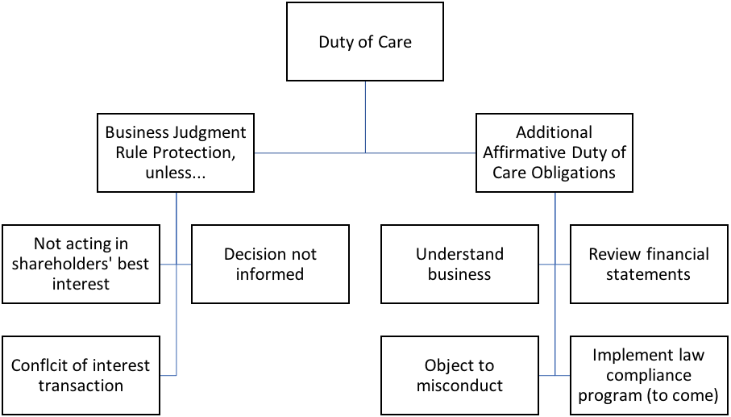

Duty of Care v. Duty of Loyalty
Duty of Care  - Regulates diligence in performing tasks  - Limited by the Business Judgment Rule (“BJR”) | Duty of Loyalty  - Regulates self-dealing transactions  - No BJR shield

    - Duty of Loyalty [No Stealing]
      - Regulates self-dealing transactions
      - No Business Judgment Rule shield
      - Conflict of interest = duty of loyalty question
      - Description of Duty of Loyalty:
        - “Essentially, the duty of loyalty mandates that the best interests of the corporation and its stockholders takes precedence over any interest possessed by a director … and not shared by the stockholders generally.”
      - Implement the Corporate Fiduciary Duty of Loyalty:
        - What’s the “right” rule?
          - No related party transactions allowed (most restrictive rule)
          - Disinterested directors approve; independent shareholders ratify; transaction is judged fair (moderate solutions)
          - Business judgment rule review (just like any other business decision) (most lenient rule)
        - Two steps in the duty of loyalty analysis
          - Step One: Does the transaction involve a conflict of interest?
            - Is a director or shareholder receiving a benefit from the firm not received by all?
            - Question of whether this counts as a conflict of interest
          - Step Two: Has the transaction been properly “Cleansed”? (MBCA § 8.61; DGCL § 144)
            - Approval by disinterested directors or disinterested shareholders or the transaction adjudged fair
            - If we’ve crossed over into a duty of loyalty issue, have any of these three procedures been carried out adequately for transaction to proceed [transaction been cleansed]
        - Various Examples in Case Law
          - Corporate Opportunity Doctrine: when does the opportunity belong to a corporation (similar question addressed in Meinhard v. Salmon and Singer v. General Automotive)
            - Broz v. CIS
          - Controlling Shareholder Transactions: what happens if you are controlling shareholder and want to do a conflict of interest transaction
            - Sinclair Oil v. Levien
          - Cleansing Transactions
            - In re Wheelabrator

Duty of Loyalty Analysis as a Two-Step Analysis
Step One: Does the transaction involve a conflict of interest?
- Deconstructing step one into three questions: [need all three to be true]
- Is the firm on one side of the transaction? (Corporate opportunity doctrine)
- Is a director or controlling shareholder on the other side of the transaction? (MBCA § 8.60)
  - Director is a party to the transaction
  - Director had knowledge and a material financial interest in the transaction or
  - A transaction which the director knew a related party had an interest in
    - Individual’s spouse, child, step-child, grandchild, sibling, half-sibling, nephew, niece, or person living in the same house (but not cousin)
  - Plaintiff has burden of proof to show there is a conflict of interest
- Is the transaction providing a benefit from the firm not received by all?

- Is there a conflict of interest? Burden on the plaintiff
  - MBCA § 860 – Conflicting interest if:
    - (i) Director is a party to the transaction;
    - (ii) Director had knowledge and a material financial interest in the transaction; or
    - (iii) A transaction which the Director knew a related person had an interest in

Step Two: Has the transaction been properly “cleansed”? (MBCA § 8.61; DGCL § 144)
- Approval by disinterested directors or disinterested shareholders or the transaction adjudged fair
- If can show that, then burden shifts to defendant to prove it was cleansed

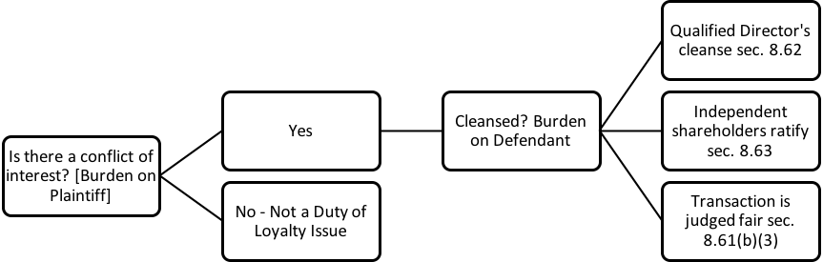

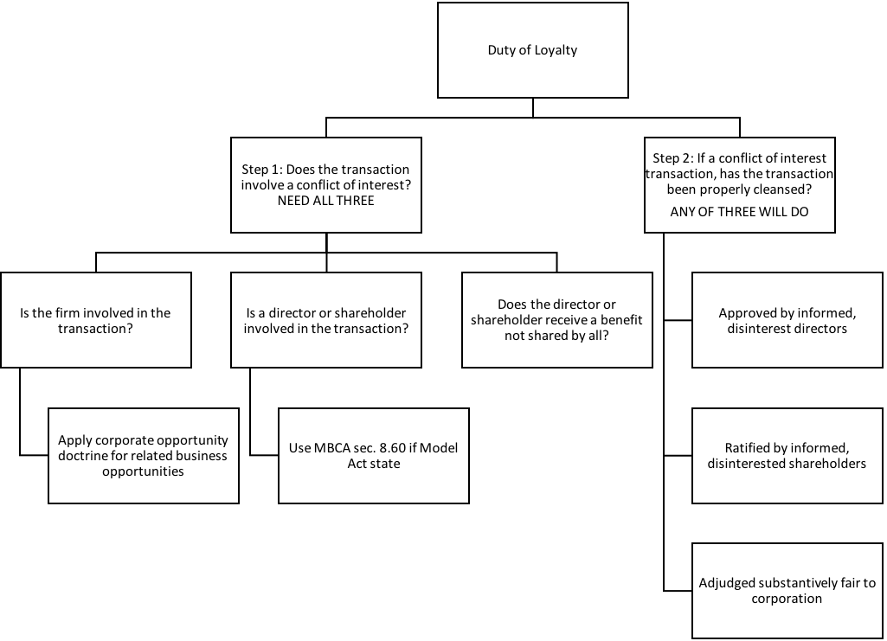
Corporate Opportunity Doctrine
- When is it a corporate opportunity?
  - Guth factors: Court weighs all 4 (don’t need all 4)
    - 1. Corporation is financially able to take the opportunity
      - Relevance of capacity?
        - Not dispositive
        - Lessens defendant’s burden
    - 2. Opportunity is in the corporation’s line of business
      - “Activity as to which it has fundamental knowledge, practical experience and ability to pursue”
      - “Consonant with its reasonable needs and aspirations for expansion”
        - This prong covers more opportunities than prong #3 [interest/expectancy]
        - Like GA v. Singer because manufacturing side job very similar to General Automotive’s business
    - 3. Corporation has an interest or expectancy in the opportunity
      - Interest: something to which the firm has a right
      - Expectancy: something which, in the ordinary course of things, would come to the corporation
        - If officer bought land to which the corporation had a contractual right, the officer took an “interest”
        - If the officer took the renewal rights to a lease the corporation had, the officer took an “expectancy”
    - 4. Embracing the opportunity would create a conflict between director’s self-interest and that of the corporation
      - Seizing the opportunity creates the conflict
      - E.g., if an officer buys a supplier to his company
- Which covers more opportunities: the line of business test, or the interest/expectancy test?
  - Line of business test

Broz v. Cellular: Robert F. Broz was the sole shareholder and President of RFB Cellular Inc. (RFBC) and was also a member of the board of Cellular Information Systems, Inc. (CIS). CIS was in financial difficulty but was in the process of being acquired, and ultimately was acquired, by PriCellular, Inc. (PriCellular). April 1994 – Mackinac Cellular decides to divest Michigan-2 license. May 1994 – Rhodes approaches Broz in Broz’s RFBC capacity. June 28, 1994 – six CIS directors agree to sell shares to PriCellular, contingent on successful tender offer. September 1994 – PriCellular negotiates option to buy Michigan-2 for $6.7 million unless there is another offer that exceeds it by $500,000 ($7.2 million). November 9, 1994 – closing date of tender offer for CIS by PriCellular. November 14, 1994 – Broz “agreed to pay” $7.2 million for Michigan-2. November 23, 1994 – PriCellular “completes financing and closes” tender offer for CIS.
- Holding: Broz was under no duty to consider the “contingent and uncertain plans of PriCellular.” Broz did not usurp a corporate opportunity
- What is the basis for the court’s determination that Michigan-2 is not a corporate opportunity of CIS?
  - Broz did not usurp a corporate opportunity
    - CIS not financially able to take the opportunity
    - Opportunity is in the line of business of CIS
    - No interest or expectancy in CIS; Rhodes didn’t even talk to them (didn’t get asked to bid)
    - If Broz buys it would that create a conflict of interest? → No because already has a conflict of interest by owning Michigan-4, so doesn’t create a new conflict
- Suppose PriCellular had no financial problems (and no delay in tender offer) and could easily have invested enough money in CIS to buy Michigan-2. What result?
  - CIS would be financial able to take the opportunity
  - Opportunity is in the line of business of CIS
  - Has an interest or expectancy because Rhodes approached PriCellular
  - No conflict of interest because already has a conflict of interest (can’t create a new one)
    - Now it looks like Broz is taking a corporate opportunity
  - Assume that once no longer a director can do whatever he wants
- Why did PriCellular not simply outbid Broz and buy Michigan-2 for itself?
  - Didn’t want to spend that much and preferred a lawsuit
- Was the court fair in treating CIS’s interest in Michigan-2 as separate from that of PriCellular?
  - Guttentag thinks the reason for siding with Broz is because he asked the directors for approval over and over again whether they were interested – wasn’t sneaking around
- What advice to you give Broz?
  - Resign from the Board of CIS – in a conflict from day one
  - Do the cleansing step – go to Board of Directors formally (formal meeting)
    - Gives him formal statement of corporation
    - Not just “chatting” individually with directors
  - Make bid before Nov. 9 (before conflict of interest)
- Relevance of board approval or lack thereof on corporate opportunity?
  - Not required
    - But run risk of court later on saying that was a conflict of interest transaction
  - Board approval creates a safe harbor
  - Meeting individually with Board members does not count → not a substitute for a formal process of presenting an opportunity to a board of directors
Is the firm involved in the transaction?
- Michigan-2 license before CIS acquisition by PriCellular per Guth: NO
- Michgan-2 license after CIS acquisition by PriCellular per Guth: YES

Requirements for Formal Board of Directors Action
Action of the Board only occurs when:
- MBCA § 8.20 – Board meeting are either regular or special.
- MBCA § 8.21 – Action without meeting requires unanimous written consent.
- MBCA § 8.22 – No notice necessary for regular meeting; two day notice required for special meeting.
- MBCA § 8.23 (a) – A director may waive notice. Except as provided by subsection (b), waiver must be in writing.
- MBCA § 8.23 (b) – A director’s attendance at a meeting waives any required notice unless the director objects. (waived two day notice requirement)
- MBCA § 8.24 – Quorum – default rule – majority; minimum quorum requirement acceptable – 1/3. Vote decided by majority present.
Keys:
- Two types of meetings: regularly scheduled and special
- Can act without a meeting (but need unanimous written consent)
- All directors have to waive notice – meeting with less than 2 days notice
  - But if one objects then can’t go forward with the meeting
- Quorum need at least half – but can change rule (can’t go below 1/3)

Controlling Shareholder Duties
- Shareholders acting as shareholders owe one another no fiduciary duties
- Controlling shareholders owe fiduciary duties to the minority
 | Duties | Liability | Roles
Board of Directors | Fiduciary Duties (case law and MBCA § 8.30-31) | Breach of fiduciary duty | Manage business (DGCL § 141(a), MBCA § 8.01(b))
Shareholders | None, unless controlling | Only if pierce corporate veil | Vote, Sue, Sell

- As long as not a controlling shareholder or director, can enter a conflict of interest transaction (regular/ordinary shareholder)

Sinclair Oil v. Levien: Sinclair Oil was a holding company with multiple subsidiaries. Each operating subsidiary functioned in one country. Sinclair Oil owned 97% of Sinven (Sinclair Venezuela) and 3% publicly owned. Minority shareholders able to bring lawsuit against Sinclair Oil because it was the controlling shareholder
Minority shareholders objected to three aspects of Sinclair-Sinven relationship:
- Sinven’s large dividends
  - Sinclair Oil owed fiduciary duties to minority shareholders because controlling shareholder
  - Sinven paid $108 million in dividends
    - Sinclair Oil needed cash; get money out of Venezuela because communist state
  - Step 1: Conflict of interest fails at “Does the director or shareholder receive a benefit not shared by all?” → every shareholder got the dividend, all shareholders were treated equally
  - Therefore, not a conflict of interest transaction
- Sinven prevented from expanding
  - Court: “no business opportunities which came to Sinven independently” → not the right test because it is not about where the opportunity comes from
  - The court should have applied the Guth factors (applying corporate opportunity doctrine):
    - 1. Financially able – MAYBE; definitely not after the dividends
    - 2. In same line of business – NO
      - on one hand oil drilling is line of business, but on the other hand not in Venezuela
    - 3. Interest/expectancy – NO
    - 4. Create a conflict – NO
      - Not a conflict of interest transaction → Sinven did not lose a corporate opportunity
- Contract between Sinven and International breached
  - “Sinclair got the oil without having to comply with contract duties”
  - Parent had obligation to fully protect rights of Sinven shareholders (breached duty of loyalty)
    - Guttentag thinks it was minor – not paying immediately is the allegation
    - Step 1:
      - Is the firm involved in the transaction? → YES
      - Is a director or controlling shareholder involved in the transaction? → YES
      - Does the director or controlling shareholder receive a benefit not shared by all? → YES; Sinclair able to buy oil from Sinven; didn’t offer deal to remaining 3% shareholders
    - Step 2:
      - Approved by informed, disinterested directors? → NO – all the directors worked for Sinclair Oil
      - Ratified by informed, disinterested shareholders? → NO – Sinven did not solicit a vote
      - Court needs to judge if fair → Breach of contract is not fair
    - This transaction was not properly cleansed
    - Court holds this is a conflict of interest transaction, not adjudged fair

How might a corporation that owns a large percentage of the stock of a corporation deal with a minority shareholder that may file fiduciary duty law suits?
- Put disinterested directors on the Board (independent directors)
- Buyout 3% shareholders
- Avoid conflicts – be aware of 3% and don’t write this contract (avoid self-inflicted wounds because breached contract that you wrote)
- Get shareholders to vote (cleanse transaction) → vote on waiver or what constitutes a conflict of interest

Note: 102(b)(7) does not allow waiving breach of duty of loyalty; only duty of care

Cleansing Transactions
In re Wheelabrator: Waste Management owns 22% of stock in WTI. Waste wants to buy another 33%, which would give them 55%. 11 directors on the board of WTI, 4 of which are Waste employees. Shareholders (disinterested, informed) voted on this merger transaction and voted in favor. Also, approval of transaction by WTI’s board by the 7 non-Waste directors. Then all 11 directors (including the 4 Waste employees) approved it. Proxy statement (ballot) sent and majority of WTI shareholders (not including Waste) approved the merger.
- Duty of care/disclosure claim = dismissed
  - Court held that directors provided fair and adequate information to shareholders; shareholders were fully informed by directors
  - Shareholder ratification of a transaction extinguishes any duty of care claim
    - Minority shareholder has no claim once a majority ratifies the decision
- Step 1: Is there a conflict of interest?
  - Is the firm involved in the transaction? Yes
  - Is a director of controlling shareholder involved in the transaction? Yes
  - Not every shareholder got benefit
    - This is a conflict of interest transaction
- Effect of Approval by Shareholders in Delaware
  - Duty of care claims
    - Extinguished
  - Duty of loyalty claims against directors (transaction between firm and director)
    - Court will defer to the business judgment of the board
    - Treat as duty of care issue
    - If corporation engages in complete waste, the court won’t defer to business judgment (i.e., bonfire with corporation cash)
    - Shifts burden of proof to plaintiff to show waste
  - Duty of loyalty claims against controlling shareholder (transaction between firm and controlling shareholder) → not as powerful as a cleanse
    - If didn’t ratify and plaintiff brings complaint, then burden on Board
    - If did ratify and plaintiff brings complaint, then plaintiff has the burden
    - Shifts burden of proof to plaintiff to show unfairness
- Analogy:
  - Controlling shareholder → spilled milk
  - Duty of care → sawdust
- Why should the effect of a fully informed shareholder vote be different for a duty of care case than for a duty of loyalty case not involving de facto control?
  - More suspicious of controlling shareholder situation (more powerful
- What must the plaintiff in Wheelbrator be prepared to prove?
  - Court treats duty of loyalty claims against directors
  - Thus, plaintiff(s) would need to prove waste (didn’t use reasonable business judgment)
- In Smith v. Van Gorkom why was the shareholder approval not a complete defense?
  - Duty of care issue → not ratified because disclosure issue; didn’t receive all the relevant information; shareholder ratification did not count because not fully informed decision

    - Duty to Act in Good Faith
        - Allowing employees in corporation to break the law
- Stone v. Ritter: In 2004, AmSouth paid $50 million in fines and penalties to settle charges that the bank had failed to file Suspicious Activity Reports. Supposed to report when customers making deposits over $10K. When does director have liability for crimes committed within the firm?
  - “A classic Caremark” complaint against directors of AmSouth, a Delaware corporation that owns commercial banks.
    - Caremark complaint - Directors did not put in place systems within the corporation to make sure employees were not breaching the law
  - Elements of a law compliance program – what would an adequate law compliance program include?
    - Policy manual
    - Training of employees
    - Compliance audits
    - Sanctions for violation
    - Provisions for self-reporting of violations to regulators
  - Old Rule: “one free bite” rule
    - Graham v. Allis-Chalmers: Directors are entitled to rely on the honesty of their subordinates until something occurs to put them on notice. If they are put on notice and then fail to act, liability may follow.
  - New Rule
    - In re Caremark: “Director’s obligation includes a duty .... to assure that a corporate information and reporting systems ... exists, and that failure to do so ... may, in theory at least, render a director liable for losses caused by non-compliance with legal standards.”
      - Legal conclusion from In re Caremark:
        - “Director’s obligation includes a duty to attempt in good faith to assure that a corporate information and reporting system … exists, and that failure to do so …may, in theory at least, render a director liable for losses caused by non-compliance with legal standards.”
  - Evolution of the Duty of Good Faith Doctrine in Delaware
    - In Cede & Co. v. Technicolor, Inc., (Del. 1993), the Delaware supreme court stated:
      - “To rebut the rule, a shareholder plaintiff assumes the burden of providing evidence that directors, in reaching their challenged decision, breached any one of the triads of their fiduciary duty – good faith, loyalty or due care.”
Two fiduciary duties (and perhaps more)?
Duty of Care  - Diligence in carrying out actions not subject to substantive review  - Failure to act and carry out basic supervision can violate duty of care | Duty of Loyalty  Conflict of interest transaction  Burden and/or standard will shift if approved by:  - Disinterested directors  - Disinterested shareholders  - Or determined to be fair
Duty of Good faith
- Failure to gather information to avoid violations of law (In re Caremark)

    - No: Stone v. Ritter “although good faith may be described colloquially as part of a ‘triad’ of fiduciary duties that includes the duties of care and loyalty, the obligation to act in good faith does not establish an independent fiduciary duty that stands on the same footing as the duties of care and loyalty.”
  - Put duty of good faith under duty of loyalty. Why?
    - DGCL § 102(b)(7): may eliminate personal liability of a director for monetary damages [wouldn’t be enforced]
Two primary fiduciary duties:
- Duty of Care – “don’t shirk”
- Duty of Loyalty – “don’t steal”
  - Must act in good faith (Stone v. Ritter)

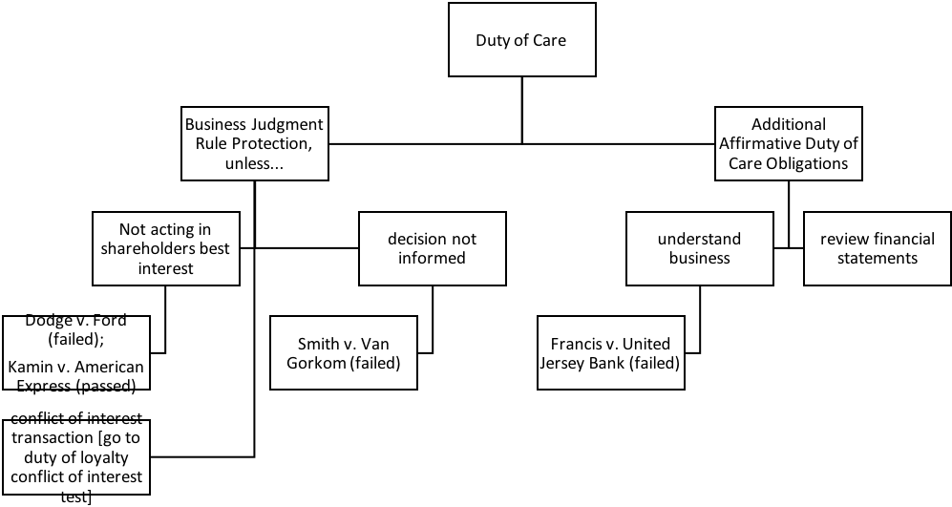

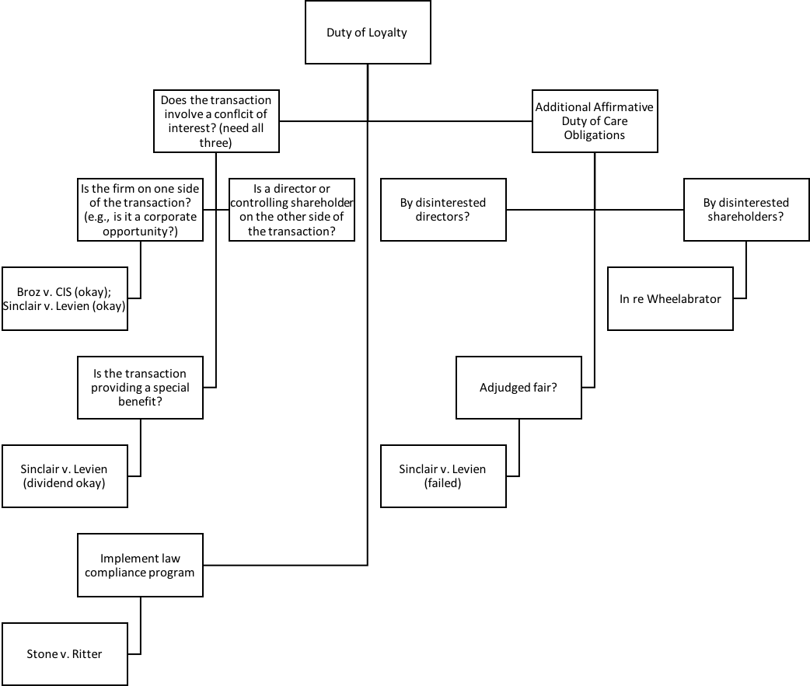

Shareholder Duties and Roles:

 | Duties | Liability | Roles
Board of Directors | Fiduciary Duties (case law and MBCA § 8.30-31) | Breach of fiduciary duty | Manage business (DGCL § 141(a), MBCA § 8.01(b))
Shareholders | None, unless controlling | Only if pierce corporate veil | Vote, Sue, Sell

- Shareholder duties:
  - None, unless controlling shareholder
- Shareholder roles:
  - Sue
  - Vote
  - Sell

Sue
- 1. Direct Suits
  - A suit alleging a direct loss to the shareholder
  - When you buy a share of stock = a contract; claims a violation of the contractually enunciated rights you got when you purchased the stock
    - Shareholders have a contractual relationship with the corporation through their stocks, so they are alleging a breach of that contract
  - Bases for direct claims:
    - Force payment of promised dividend;
    - Enjoin activities that are ultra vires;
      - Beyond their powers (something purely and obviously wasteful) (illegal use of corporation’s assets)
    - Claims of securities fraud;
    - Protect participatory rights for shareholders
      - Entitled to vote for the board of directors
- 2. Derivative Suits
  - 2 suits in one: compel corporation to sue another; and the suit against that other party
    - 1. A suit by the corporation against the directors for their failure to carry out fiduciary obligations, and
    - 2. A suit by the plaintiff arguing that he or she should substitute for the directors in managing this particular aspect of the corporation’s business
  - A suit alleging a loss to the shareholder caused by a loss to the corporation
    - The harm is being inflicted on the corporation
    - Need someone else to represent the corporation when the directors harmed the corporation – a shareholder will work on the behalf of the corporation (directors supposed to manage the affairs)
    - Needs to argue to represent corporation in bringing suit against director for breaching fiduciary duties:
      - 1. Director harmed corporation
      - 2. Shareholder needs to bring lawsuit on corporation’s behalf (directors cannot manage this business of prosecuting directors)
  - Bases for derivative suits:
    - Breach of duty of care
    - Breach of duty of loyalty
  - Financial effect of bringing a derivative action → get attorney’s fees; main beneficiary of system is lawyers (corporation will pay attorney’s fees)
  - What are remedies in a derivative law suit?
    - The shareholder is suing “in right” of the corporation, so...
      - Remedy from principal suit goes to corporation;
      - Corporation is required to pay shareholder attorney’s fees if suit is successful or settles
  - Who can bring a derivative suit under MBCA:
    - MBCA § 7.41(1): Must be a shareholder at the time of the alleged wrongdoing
    - MBCA § 7.41(2): Named plaintiff must be a fair and adequate representative of the corporation’s interests
      - e.g., no conflicted interests, such as suit for unrelated strategic purposes
    - In many states, must continue to be a shareholder
  - Three “procedural” hurdles to the derivative action
    - Bonding Requirement
      - In some states (though not Delaware), a derivative claimant with “low stakes” must post security for corporation’s legal expenses
        - In Delaware, can argue demand would have been a waste of time because so conflicted → plead demand futility
      - Why this requirement?
        - Deter frivolous law suits
    - Demand Requirement (Grimes v. Donald) [BIGGEST HURDLE]
      - Most states require shareholders in derivative suits to approach Board of Directors and demand that they pursue legal action...unless the shareholder can claim a valid excuse
      - Policy concerns supporting demand requirement:
        - The demand requirement is a recognition of the fundamental precept that directors manage the business and affairs of the corporation – Aronson v. Lewis
      - What is the demand?
        - Typically a letter from shareholder to the board of directors
          - Must request that the board bring suit on the alleged cause of action
          - Must be sufficiently specific as to apprise the board of the nature of the alleged cause of action and to evaluate its merits
        - Shareholders must make demand before filing suit...unless it’s futile
          - Court of Chancery Rule 23.1: The complaint shall allege “the efforts, if any, made by the plaintiff to obtain the action the plaintiff desires from the directors … and the reasons for the plaintiff's failure to obtain the action or for not making the effort”
      - Issues concerning the demand requirement:
        - When is demand requirement excused?
          - Demand is deemed futile if plaintiff creates a reasonable doubt that:
            - (a) Directors are disinterested and independent, or that
            - (b) Challenged transaction was product of valid exercise of business judgment
          - Discovery limited to “tools at hand”
            - Need whistleblowers
            - Government does legwork for you (SEC) → derivative lawsuits usually piggyback government lawsuits
    - Special Litigation Committees (Zapata Corp. v. Maldonado)
      - Find new independent directors – they don’t have conflict of interest and can take over the litigation
May still face Special Litigation Committee (SLC) → Zapata two-step

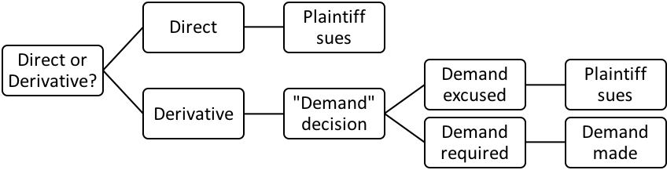

Making pre-suit demand puts plaintiff on this track
Only demand refusal decision reviewed; lose right to plead lack of independence

Grimes v. Donald: CEO Donald had a very favorable employment agreement with DSC (e.g., board not able to unduly interfere; income continuation plan where after employment ends, still gets paid; health insurance for life). Grimes, a shareholder, alleges (1) abdication of board powers to managers and (2) excessive compensation. The abdication claim is a direct claim because it’s a violation of the contract (circumvents his right to vote). The excessive compensation is a derivative claim because Grimes is claiming the board made a bad business decision and hurt the company. Grimes made a demand and then went to court to plead demand excuse/futility.
- What standard of review is applied to compensation issues and why?
  - Business Judgment; like any other expenditure Board of Directors makes decision on
- What are the claims that Grimes alleges and what is decided?
  - Abdication of board powers to managers
    - Direct claim
      - Right to directly vote on who manages the firm
      - If Directors hand off power to manage, then violates contractual right
      - Grimes loses on merits: court held that Board did not abdicate authority – they delegated their authority [contract states that Donald can say termination with cause if Board interferes]
  - Excessive compensation
    - Derivative claim → Board made bad business management decision (harm to corporation)
      - Grimes loses on procedure: can’t both make demand and plead excuse/futility
        - Once you make demand you have lost right to go to court and plead demand futility
- What is the effect of making a demand before filing a derivative suit?
  - Can still go to court after making demand
  - Business Judgment Rule applies → conflict of interest?
    - Delaware presumes you trust Directors and think they are independent
    - Only handling of demand request can be challenged
    - Thus, in Delaware, no one makes demand → plead demand futility
      - Board will refuse and can only argue one thing: that Board was wrong in refusing demand
- What recourse does shareholder have if Board decides not to pursue?
  - Director refusal of demand request subject to business judgment review, but...
  - Does making the demand affect one’s subsequent rights?
    - Yes
      - Once demand is made (in Delaware) can no longer challenge Board’s independence (citing Spiegel)
      - Only Board’s handling of the demand request can be challenged
- What does a rational plaintiff do in Delaware?
  - A rational plaintiff will file derivative suit before making demand
    - Consequences of not making demand trivial – if required, slight delay while you make demand
    - Preserves right to litigate
- What do you need to show demand futility?
  - Demand excused if show demand futile, by showing reasonable doubt (using tools at hand) that:
    - (a) majority of directors are disinterested & independent, or
    - (b) that challenged transaction was product of valid exercise of business judgment
When the directors read the demand letter, they will then take it to their lawyers and do an "investigation." Once they decide no wrong was done or that the wrong is now fixed, it becomes a business judgement decision, so the court will defer to the board. Thus, you could only go to the court to claim the board did not read the letter carefully or that they wrongfully ignored the demand.
Demand Requirement under MBCA
- MBCA § 7.42: “No shareholder may commence a derivative proceeding until … a written demand has been made … and 90 days have expired from the date the demand was made … unless irreparable injury to the corporation would result by waiting for the expiration of the 90-day period”
  - Need to wait 90 days after written demand made
- MBCA § 7.44:
  - 7.44 (a) Court will dismiss if independent directors or panel find in good faith proceeding with suit not in best interest of corporation.
  - 7.44 (b) Evaluation by (1) a majority of independent directors, or (2) a majority of committee of independent directors.
  - 7.44 (c) Can proceed after demand rejection if majority of board not independent or review not in good faith or reasonable.
    - Similar to Delaware after demand denial → Board not independent or review not in good faith or reasonable
  - 7.44 (d) Burden of proving in good faith and reasonable shifts to Board if majority of directors not independent.

Third Hurdle: Special Litigation Committees
- Zapata v. Maldonado: Demand not made, demand excused as futile, and board appoints a special litigation committee. New board members recommend dismissal. Maldonado, a shareholder, brought a derivate suit on behalf of Zapata against its board of directors, alleging breach of fiduciary duty. Maldonado had not made a prior demand on the board and instead argued that demand was futile, because all of the board members took part in the challenged transactions. Zapata then formed an SLC with new board members, who ultimately dropped the lawsuit. The court reviews the decision of the SLC under the business judgment rule.
  - Zapata Two-Step:
    - Step 1:
      - Inquiry into the independence and good faith of the committee
      - Inquire into the bases supporting the committee’s recommendations
    - Step 2:
      - Court applies its own business judgment as to whether the case should be dismissed
- Issues:
  - 1. Can the Board committee “seize” the derivative litigation?
    - Maybe – need to do Zapata two-part test
  - 2. Can the tainted Board members appoint a non-tainted committee?
    - Yes
  - 3. How should a court review the decisions of the special litigation committee?
    - Court’s business judgment
- Zapata far more intrusive judicial review than usual. Why?
  - Context: demand was excused because board disabled from acting due to conflicted interests
  - Committee appointed by the disabled board

Zapata two-step evaluation of SLC decision:
- Step 1: evaluate board’s independence, good faith, and decision process (like BJR review);
- Step 2: apply court’s business judgment, including public policy considerations

Vote
- Who votes
  - Shareholder of record
    - Holder on the record date votes (MBCA § 7.07)
      - No more than 70 days before vote
    - Default rule is one share – one vote (MBCA § 7.21)
      - Unless Articles of Incorporation provide otherwise
- When vote
  - Shareholder meetings
    - Annual meetings (MBCA § 7.01)
      - Time set in bylaws
    - Special meetings (MBCA § 7.02)
      - By request of Board of Directors, or
      - At written request of at least 10% of shares
  - Unanimous written consent (MBCA § 7.04)
- How vote
  - Most matters require a majority of shares present at a meeting at which there is a quorum (MBCA § 7.25(c))
  - Shareholders vote either in person or by proxy (MBCA § 7.22)
    - Proxy voting
      - Shareholder appoints a proxy (aka proxy agent) to vote his/her shares at the meeting
      - Appointment effected by means of a proxy (aka proxy card)
        - Can specify how shares to be voted or give agent discretion
        - Revocable
- What vote on
  - Shareholders entitled to vote on:
    - Election of directors (MBCA §§ 8.03-.8)
      - Which directors can you vote for:
        - Incumbent board nominates a slate of directors
          - The company sends out the official proxy solicitation materials
        - A competing slate currently needs to be offered in separate proxy materials
          - Insurgents pay the costs (including mailing)
        - Dodd-Frank/SEC allows director nomination (of one or more, up to 25% of Board) if > 3% shareholders for three years
          - Hard to replace directors because directors choose who goes on the ballot
          - Run a competing campaign of directors = Expensive
            - If successful and approve money spent then can be reimbursed by the company

Rosenfeld v. Fairchild Engine & Airplane Corp.: Insurgents sought to get their own directors on the board so they could fire the over-paid CEO. The insurgents convinced enough shareholders to vote for their proposed slate of directors. The company paid for the old directors’ expenses to defend their positions, and then reimbursed the new directors’ expenses after they won, even though they were not part of the company when they incurred the expenses. The reimbursement was ratified by a majority vote of the stockholders.
- What was the issue at the heart of the proxy fight to take control of the Fairchild Board?
  - Fire Carlton Ward
- What would happen to the costs incurred by the insurgents if they were unsuccessful under the “Froessel” rule?
  - [Corporation ended up paying costs from both sides of the proxy battle]
  - Froessel rule: incumbent board proxy costs paid regardless of outcome; insurgent costs may be reimbursed if insurgents win
    - Exception to incumbent Board getting costs reimbursed: needs to be bona fide policy contest/dispute → not hard to prove – reality is it is easy to claim there is a policy difference (incumbent board will almost always get costs reimbursed)
 | Win | Lose
Incumbent Board | Costs Reimbursed | Costs Reimbursed
Insurgent Board | Costs Reimbursed | Costs NOT Reimbursed
  - Alternatives to this:
    - Incumbent board doesn’t get reimbursed if lose but makes being a director hard
    - Reimburse insurgents if lose but then maybe too many proxy battles
- What happened to the costs incurred by the management when they were unsuccessful?
  - Got costs reimbursed
- What kind of incentives does this provide for proxy contests?
  - Hard game to justify playing if an insurgent
  - Dissent: Board does not have legal power to reimburse costs of winning insurgents → waste/ultra vires (beyond power of the Board)
    - Just because majority of shareholders want you to do something beyond power of Board is not enough (gets ratified by shareholders)

    - Amendments to the articles of incorporation and by- laws (MBCA §§ 10.03, 10.20)
      - Modifying Articles of Incorporation
        - Under MBCA:
          - MBCA § 10.03 An amendment to the articles of incorporation:
            - (a) must be adopted by the board of directors, and
            - (e) approved by a majority of the votes of the shareholders present (as long as a quorum (half the total))
          - Example: 100 shareholders, 60 present at the meeting then only need 31
        - Under DGCL:
          - DGCL § 242(b)(1) The directors shall adopt a resolution and holders of a majority of the outstanding stock must vote in favor of the amendment
          - Example: 100 shareholders, 60 present at the meeting, need 51 to pass → majority of total stock outstanding [higher standard under Delaware]
      - Modifying By-laws (easier to change by-laws than articles of incorporation) → can do so without director approval/involvement
        - Under MBCA:
          - MBCA § 10.20: (a) shareholders may amend or repeal, and (b) directors may amend or repeal, unless pertaining to director election or bylaws prohibit
            - Directors need to be written out
        - Under DGCL:
          - DGCL § 109(a) the power to adopt, amend, or repeal bylaws shall be in the stockholders entitled to vote (plus, directors may also have this power if so provided in the articles of incorporation)
            - Directors need to be written in

    - Fundamental transactions (e.g., mergers MBCA § 11.04)

    - Odds and ends such as “precatory” measures
      - “Precatory” measures: shareholder wishes; matters shareholders can bring to other shareholders for vote – non-binding
      - Rule 14a-8: Shareholder Proposals
        - Allows qualifying shareholders to put a proposal before their fellow shareholders
          - And have proxies solicited in favor of them in the company’s proxy statement
          - Expense thus borne by the company
      - 14a-8(b)(1): must have owned at least 1% or $2,000 (which is less) of the issuer’s securities for at least one year prior to the date the proposal is submitted
        - Multiply the number of securities the shareholder held for the one-year period by the highest selling price during the 60 calendar days before the shareholder submitted the proposal
        - Must be submitted at least 120 days (4 months) before the date on which proxy materials were mailed for the previous year’s annual shareholder’s meeting
        - 14a-8(d): proposal plus supporting statement cannot exceed 500 words
      - What company can do to reject proposal anyways:
        - 14a-8(i)(1): “If the proposal is not a proper subject of action for shareholders under the laws of the jurisdiction of the company’s organization.”
        - 14a-8(i)(2): Implementing would violate law
        - 14a-8(i)(3): Implementing would violate proxy rules
        - 14a-8(i)(4): Proposal involves personal grievance or special interest
Issues that touch on the company but not central to the operations/ordinary business matter
        - 14a-8(i)(5): Proposal is not relevant to firm’s operations
          - Something is relevant to the firms operations if it relates to operations that account for more than 5% of the company’s total assets or net earnings of the most recent year
          - Something can also be relevant if it is “otherwise significantly related to the company’s business”
        - 14a-8(i)(6): Company lacks power to implement
        - 14a-8(i)(7): Proposal deals with company’s ordinary business operations
          - Note: tension between (5) and (7)
            - Have to propose something relevant to the firm, but that does not have to do with the firm’s business operations
            - Been used for social and political issues that the firm’s business touches on
        - 14a-8(i)(8): Relates to electing directors
      - Two options:
        - Company can put proposal in proxy materials; OR
        - Company can reject it and write letter to SEC
          - Staff level action:
            - If staff determines proposal can be excluded: issue a no-action letter
            - If staff determines should be included: notify the issuer of possible enforcement action if the proposal is excluded
          - SEC role: “The SEC reluctantly referees the shareholder proposal process”
      - Process for proxy contests:
        - Proxy process regulated by federal Securities and Exchange Comm. (SEC) rules
        - Insurgents must send out “unofficial” proxy solicitation before they solicit proxies
        - The company sends out the official proxy solicitation materials
          - May include shareholder proposals – Rule 14a-8

Lovenheim v. Iroquois Brands: Company argues 14a-8(i)(5) that proposal is not relevant to the firm’s operations – pate foie gras less than .05% of business. Can be relevant if: (a) more than 5 percent or (b) ethical/moral considerations (morally or ethically significant) even if doesn’t make up big part of company’s business.
Shareholder Lovenheim wants to propose a resolution for the corporation to form a committee to research the methods their foie gras supplier uses to force feed geese to see if its humane. The foie gras operations were not economically significant to the corporation ($79,000 in revenues out of firm‐wide revenues of $141 million).
14a-8(i)(5): if the proposal relates to operations which account for less than 5 percent of the issuer’s total assets at the end of its most recent fiscal year, and for less than 5 percent of its net earnings and gross sales for its most recent fiscal year, and is not otherwise significantly related to the issuer’s business
Holding: Lovenheim’s concern about the inhumane treatment of the geese falls under the “otherwise significantly related” provision which includes matters of ethical or social significance. It does not matter that foie gras is not economically significant to the company. Therefore, the resolution should be included in the proxy.
- Pate operations economically “significant”?
  - $79,000 in revenues out of firm-wide revenues of $141 million
- Why included?
  - “Otherwise significantly related” includes ethical and/or social significance
- Why didn’t Lovenheim offer a proposal prohibiting the company from selling pate?
  - Shareholders don’t have the power → needs to be phrased as a recommendation (like to do a study)
  - 14a-8(i)(1) & (7) deal with company’s ordinary business operations → don’t get to decide how firm is managed
- Why did Lovenheim offer this proposal?
  - Own ethical desire to bring attention to this issue – make corporation more ethical
- How do you feel about that motivation as a shareholder of Iroquois Brands?
  - Terrible – costing company money to battle this
- How do you feel about the SEC spending resources to monitor shareholder proposals?
  - Controversial
    - Critics: giving shareholders voice that costs a lot of company money and SEC resources
- What can you say about the price of a share of Iroquois Brands, Ltd. stock in the period when Lovenheim submitted his proposal?
  - Owns 200 shares – in 60 days prior share price had to be at least $10 or else would not have been able to qualify to submit a proposal (needs to be $2,000)

    - Non-binding “say on pay” vote at least every three years (per Dodd-Frank Act (2010)/SEC)
      - For all public companies, shareholders get to vote on whether the people at the company are earning too much

What shareholders vote on: getting stuff on the ballot
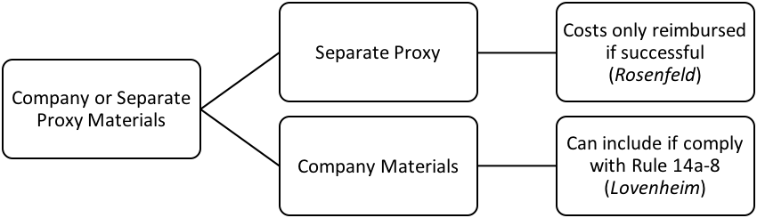

Sell
- Insider Trading
  - Law comes from Securities and Exchange Acts (1933, 1934)
Securities Act of 1933  - Regulates the public offering of new securities  - Disclosure at the time of the public offering  - Key section:  - § 5 regulates offering procedure | Securities Exchange Act of 1934  - Regulates trading activity  - Ongoing disclosure required  - Key sections:  - § 10(b) No fraud  - § 14(a) Proxy contests  - § 14(e) Tender offers  - § 16 Insider Trading

  - Is the transaction illegal insider trading? Yes, if...
    - Section 16 of ’34 Act applies (statutory insider trading; Reliance Electric Co. v. Emerson Electric Co.), or
      - Bright line prohibition: all gains within six months by statutory insiders forfeited to firm
    - Classical insider trading: a fiduciary trades in shares of his or her own firm, based on information gained as a fiduciary (SEC v. TGS) (Rule 10b-5), or
      - Firm “insider’s” use of material non-public information to trade in their firm’s shares violates Rule 10b-5
    - Tipper and tippee liability (Dirks v. SEC) (Rule 10b-5), or
    - A fiduciary trades using information that was misappropriated (US v. O’Hagan) (Rule 10b-5)

Statutory restriction on insider trading: Section 16
- Section 16(a):
  - If own over 10% or are a director or senior officer (“Statutory Insiders”), then must report ownership stake and changes to SEC
- Section 16(b):
  - “Statutory Insider” profits from a purchase and sale or sale and purchase within six months are recoverable by the firm
- Klein, Ramseyer & Bainbridge: “both over- and under-inclusive
  - Over-inclusive: knowledge doesn’t matter in this rule
  - Under-inclusive: just need to wait 6 months and one day to trade – can use inside knowledge
- Sale and purchase
  - The sale and purchase must occur within six months of each other
  - Only covers transactions where such beneficial owner at both the time of the purchase and sale
- Recovery
  - Any recovery goes to the company
  - Courts interpret the statute to maximize the gains the company recovers

Reliance Elec. v. Emerson Elec.: On 6/16, Emerson purchased 13.2% of Dodge Manufacturing. Then Dodge merged with Reliance, so Emerson wanted to dump its stock, but didn’t want all the profits to go to Reliance. So on 8/28, Emerson sold some of the stocks so it only owned 9.96% of Dodge and would no longer be a statutory insider. Then on 9/11, Emerson sold the rest of its Dodge stock. Reliance sued to recover the profits from the 9/11 sale.
- June 16: Emerson buys 13.2% of Dodge
- Aug. 28: Emerson sells some shares; reducing holdings to 9.96%
- Sep. 11: Emerson sells remainder
      - Was the June 16 purchase a “matchable” purchase?
- “matchable”: is it a transaction where section 16 applies?
  - On June 16, ownership was above 10% so yes include transaction
2. Assuming the June 16 purchase is matchable, can it be matched with the Sept. 11 sale?
- No, because only owned 9.96% - Emerson was not a 10% owner on 9/11
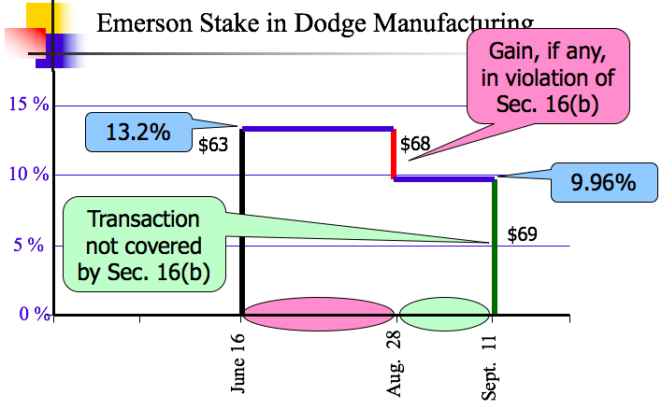
Examples of Matching:
- Assume there are 100 shares of Dunder Mifflin, Inc. (DMI) outstanding. On May 1, Michael Scott (not a director or officer of DMI) buys 5 shares of DMI for $3 per share. On June 1, Michael Scott buys 10 more shares of DMI for $13 per share. On June 30, Michael Scott sells 3 shares for $10. What is the amount, if any, of Michael Scott’s statutory insider trading liability?
  - May 1: transaction does not count for matching because does not own 10% of shares yet
  - June 1: 10 x $13 = $130 → not at 10% (own 15 shares)
  - June 30: 3 x $10 = $30 loss
    - Therefore, no insider trading liability because there was no gain
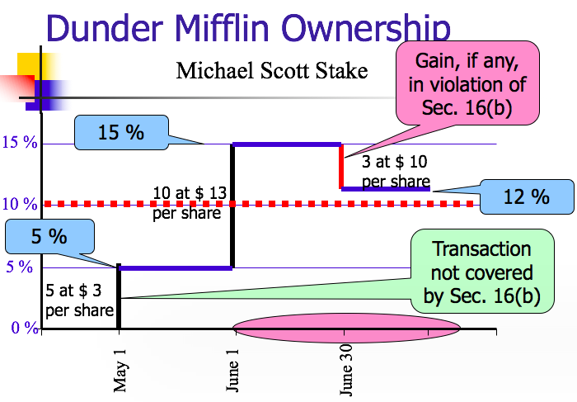
- Assume Michael Scott is a director of Dunder Mifflin, Inc. (DMI). On May 1, Michael Scott buys 10 share of DMI for $3 per share. On June 1, Michael Scott buys 20 shares of DMI for $12 per share. On June 10, Michael Scott buys 15 shares of DMI for $5 per share. On June 30, Michael Scott sells 3 shares for $10. What is the amount, if any, of Michael Scott’s statutory insider trading liability?
  - Court will maximize profits so go to lowest price.
    - 10 shares at $3 per share
    - Sells 3 shares at $10 per share – $7 gain on each = $21
  - Therefore, gain of $21 which is his statutory insider trading liability
- Assume Michael Scott is a director of Dunder Mifflin, Inc. (DMI). On May 1, Michael Scott buys 10 shares of DMI for $3 per share. On June 1, Michael Scott buys 20 shares of DMI for $12 per share. On June 10, Michael Scott buys 15 shares of DMI for $5 per share. What if he sells 12 shares for $10 on June 30th?
  - First 10 shares have a profit of $7 → $70
  - Next 2 shares have a profit of $5 → $10
  - Total: $80
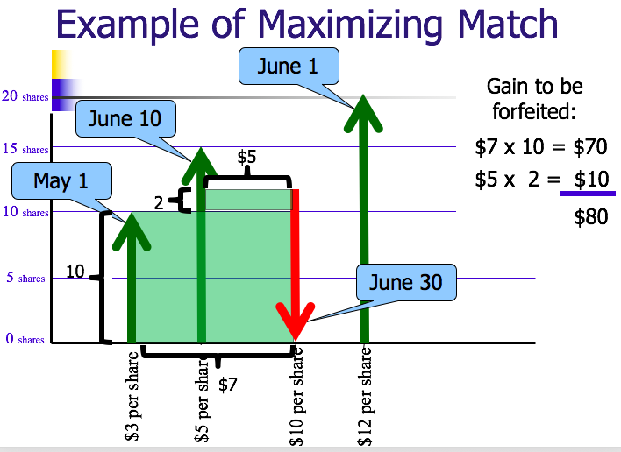
How do you avoid statutory insider trading liability?
- Wait 6 months and a day
- Stay under 10% ownership

Classical Insider Trading
- Rule 10b-5 applies, whether or not a public offering
  - It shall be unlawful for any person, directly or indirectly, by the use of any means or instrumentality of interstate commerce, or of the mails or of any facility of any national securities exchange,
    - (a) To employ any device, scheme, or artifice to defraud,
    - (b) To make any untrue statement of a material fact or to omit to state a material fact necessary in order to make the statements made, in the light of the circumstances under which they were made, not misleading, or
    - (c) To engage in any act, practice, or course of business which operates or would operate as a fraud or deceit upon any person,
  - in connection with the purchase or sale of any security.
- Defraud investors then broken the securities laws
- Avoid 10b-5 liability by being silent

SEC v. TGS: TGS started drilling for oil in Eastern Canada, but found gold instead. TGS starts buying up as much land as possible in the area. Some of the directors also started buying TGS stock. By March, the land acquisition was complete. In April, an unauthorized news article was published about TGS finding gold. TGS denied the story and said it was way overblown. Four days later, TGS issued an official statement about its gold discovery. From the time the gold was initially discovered, the stock price grew because executives at TGS and their friends were buying stock. The SEC started an investigation and eventually brought suit.
- Late 1950s: TGS begins exploring eastern Canada
- Oct. 29th – 30th 1963: Exploratory hole K-55-1 drilled
  - Visual assay promising
- Nov. 12, 1963: Based on core sample results, TGS begins land acquisition
  - President commands secrecy
  - TGS insiders and “tippees” begin acquiring shares and call options
- March 27, 1964: land acquisition complete
- April 11, 1964: unauthorized press reports
- April 12, 1964: “misleading” press release issued
- April 16, 1964: official statement made at 10 am and news appeared on Dow Jones ticker tape at 10:54 am
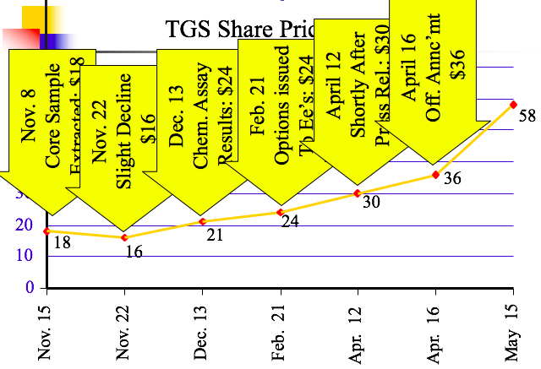
- Is there evidence the K-55-1 find was “material”?
  - General standard of materiality: “whether there is a substantial likelihood that a reasonable shareholder would consider the fact important” TSC Indus. v. Northway Inc. (1976)
- Is there evidence the press release was misleading?
  - The court gives them a pass – press release wasn’t a flat out lie and stock price continued to increase
  - Effect “of this release on the investing public was equivocal and less than abundant”
- Did TGS have a duty to disclose the K-55-1 discovery?
  - No
    - “...the timing of disclosure is a matter for the business judgment of the corporate officers, within the affirmative disclosure requirements promulgated by the exchanges and the SEC.”
  - Every quarter public companies are required to disclose profits and annually describe material facts (information) going on in company [Annual Report/10K]
- What choice did the managers at TGS have with respect to stock purchases?
  - SEC: an insider in possession of material nonpublic information must disclose such information before trading or if disclosure is impossible or improper, abstain from trading
    - If you are an insider and company disclosed information, then allowed to trade
    - If they haven’t disclosed, then cannot trade – need to abstain.
  - Thus, folks at TSG violated the rule → unfair informational advantage
- Problems with deciding TGS based on establishing a level playing field?
  - Some information advantages are created in a legitimate manner
  - Doctrinal problem – statute does not say this – says you can’t defraud investors (doesn’t protect against informational advantage)
  - Employees = agents of company – therefore, have a fiduciary obligation of some kind to shareholders
    - Should not be allowed to remain silent
    - Breach of fiduciary duty
    - Unfaithful agents = violating securities laws
- Problems with deciding TGS based on a violation of a fiduciary duty?
  - May not capture all situations where use of inside information is “unfair”
Chiarella v. U.S.: limits of “traditional” insider trading liability
- Printer (“mark-up” man) Case
- Majority:
  - Throws out the “level playing field” theory for prohibiting insider trading
  - Violation of 10b-5 occurs only if informed trader owed a duty to the corporation or shareholders of the firm whose stock he traded in. Did he?
    - No
- Violation of 10b-5 occurs only if informed trader owed a duty to the corporation or shareholders of the firm whose stock he traded in
- Facts: Chiarella worked at a printing company that handled documents concerning corporate takeovers. He figured out that one of the documents he was printing was a tender offer from the firm he was printing the material for to take over another company. He took that info and bought a bunch of the other company’s stock.
- Holding: Chiarella is not liable for insider trading because he didn’t owe a fiduciary duty to the company who’s stock he bought. Thus, he had no duty to disclose the information he uncovered. He was not trading in the shares of the firm for whom he got the information.
- NO LONGER GOOD LAW

C. Tipper and Tippee liability (Dirks v. SEC and Salman v. US) (Rule 10b-5)
Insider trading prohibition extends to those who use non-public material information they know was provided by tipper for personal benefit
- Tipper: person working at company
- Tippee: person receiving the inside information
Tipper only has liability when tippee has liability

Dirks v. SEC: A disgruntled employee of Equity Funding of America knew that the company was a fraud, so after he left, he called Dirks, a stock picker. Dirks flew to LA and visited Equity Funding of America, and it was obvious to him that it was a fraud, so he told his client. The clients traded on that info and made a bunch of money. As a result of the stock sales, Equity Funding’s stock fell abruptly and the SEC opened an investigation. The SEC found that Dirks aided and abetted insider trading in violation of SEC Rule 10b-5.
Holding: The court had to decide whether Dirks inherited an obligation to not trade for a profit based on the info be received from the Equity Funding employee. SCOTUS said only in certain circumstances. When you get a tip, sometimes you can trade on that tip. In order to inherit the liability (1) the person who provided the tip has to personally benefit from giving you the information, and (2) you have to know that what they were doing was a breach. Here, the court said the employee’s motivation in telling Dirks about the fraud within Equity Funding was for the purpose of exposing the fraud, not to benefit personally. Accordingly, Dirks did not inherit the obligation to not trade on the nonpublic information.
- Guttentag: the Equity Funding employee was a disgruntled employee and might not have really been acting for public good so much as personal benefit
- Does Dirks inherit Secrist’s “disclose or abstain” duty by being a tippee?
  - No; For tippee to inherit:
    - Tipper must flunk “Personal Benefit” test and
    - Tippee must know or have reason to know of breach
  - What constitutes a “personal benefit”
    - Monetary gain
    - Reputational gain
    - Gift to a family member
    - Quid pro quo
  - But not:
    - Desire to provide a public good
- Does equality of access survive Chiarella and Dirks?
  - No – “a duty to disclose...does not arise from the mere possession of nonpublic market information”
- Dirks also established a category of “constructive insiders” who can violate insider trading prohibitions
  - When does someone become a constructive insider?
    - Where they
      - Obtain material nonpublic information from the issuer with
      - An expectation on the part of the corporation that the outsider will keep the disclosed information confidential and
      - The relationship at least implies such a duty
        - i.e. law firm, accountants
    - If a constructive insider trades, then it is classical insider trading

Salman v. United States: Maher Kara (tipper) was tipping his brother, Michael Kara (tippee) with information about mergers and acquisitions. Michael then shared the insider information with Maher’s brother-in-law, Bassam Salman. Maher was married to Salman’s sister.
- Double-tip situation
- Court looks at initial tip: Was there a personal benefit?
  - Yes – brothers (always a personal benefit when gift to family)
- Did the ultimate tippee know initial tip was made for a personal benefit?
  - Yes – knows they are brothers; knows the source of the information; knows this so knows original tip was for a personal benefit
- Don’t need personal benefit at each tip – only at original tip
- Way to get away with it: don’t ask where information came from so don’t know if there was a personal benefit

D. A fiduciary trades using information that was misappropriated (Rule 10b-5)
- A fiduciary who trades using non-public material information that was misappropriated violates insider trading prohibitions
  - Trading stock of a company you don’t work for based on information you gained from a company you do have a fiduciary duty to
  - Before O’Hagan there would be no breach of fiduciary duty to a company if you were not an employee
    - The court pointed to 10b-5 to justify the decision → can’t have act of deception

U.S. v. O’Hagan: Defendant was working for a law firm that represented a potential buyer (Grand Met) for a tender offer for Pillsbury. Defendant took that information and bought a bunch of Pillsbury stock. When the tender offer was announced, Pillsbury stock went up $60 per share and defendant made $4.3 million.
Holding: Defendant was a constructive insider and breached his fiduciary duty to the buyer he represented. If you misappropriate information, you commit fraud. Then if you use that information to trade securities, you’ve committed securities fraud and violate Rule 10b-5. The failure to disclose was the “deception” by a trader in connection with the “purchase/sale of securities,” as explained in Rule 10b-5.
- If D was counsel to Pillsbury instead of the buyer, he would be liable under classical insider trading → this ruling adds consistency and symmetry to Rule 10b-5.
- “Misappropriation” theory consistent with §10(b) and Rule 10b-5
  - Statute/Rule proscribe “deception” by trader “in connection with purchase/sale” of securities
  - In this case, deception works through non-disclosure; and purchase/sale requirement clearly met
- Suppose O’Hagan informed both Dorsey & Whitney and Grand Met of his intention to buy Pillsbury stock, and they had approved. What result?
  - There would be no deception so no liability under a doctrinal reading of Rule 10b-5 (no deception)
  - The brazen fiduciary – courts have found that there is still liability

Rule 14e-3: can’t use information about a tender offer even if overheard it
- Prohibits insider trading during a tender offer and thus supplements Rule 10b-5
  - Once substantial steps towards a tender offer taken, Rule 14e-3(a) prohibits anyone, except the bidder, who possesses material, nonpublic information about the offer from trading in the target’s securities
  - Rule 14e-3(d) prohibits anyone connected with the tender offer from tipping material, nonpublic information about it
- Rule 14e-3 is not premised on breach of a fiduciary duty
  - O’Hagan upholds it anyway

Termination
- Voluntary dissolution:
  - Board submits and shareholders vote on proposal to dissolve: MBCA § 14.02(b)
  - Submit Articles of Dissolution to state
  - Can only carry on to wind up
- Involuntary dissolution:
  - If there is a deadlock: MBCA § 14.30

