Guttentag – Fall 2018
Business Association Outline

- Principal/Agent
    - Intro
      - Formation =
        - RST 1 test
        - Substance of relationship determinative
        - Various carve outs
        - Fact specific
  - Formation
    - Definition = Agency indicated the relationships that exists where one person acts for another
      - Legal Def.: RST 2nd of Agency Law § 1
        - An Agency (fiduciary) relationship exists where:
          - One person (the principal) consents that another (the agent) shall act on the principal’s behalf
          - Subject to the principal’s control, and
            - Doesn’t matter if the agent actually ends up following the instructions or not
            - All that matters is that the principal says what the agent will do and the agent agrees…after that the reality of what actually happens doesn’t matter
          - The agent consent to so act
            - Skipper and Gilligan Ex: prong 1 = Skipper: “Gilligan I want you to be my first made,” Prong 2 = Skipper: Gillgian do it this way,” Prong 3 = Gilligan: “I will be your first mate.”
    - Contract is NOT required to create PAR
      - The relationship is formed by manifestation of consent
      - Therefore, consideration isn’t required and OR intent to form PAR isn’t required
        - IE could literally say “this does NOT form a PAR b/w me and you” and it could still create a PAR if test is met above
        - Gorton v. Doty: Pl is a student at Soda Springs HS on the football team, the football team is playing a game in the town of Paris a few miles away, the team is in need of one more car to get the team there, Df Teacher Doty volunteers her car to the team, but only if Coach Garst drives it, the team gets in a crash on the way back, and Pl is badly injured, Pl sues Df Doty on the grounds that Garst was her agent when he drove the car so she is the principal and responsible for his actions
          - What test is used to determine if there is a PA relationship b/w Gorton and Doty?
            - RST test:
              - One person (the principal) consents that another (the agent) shall act on the principal’s behalf – Doty consented that Garth would act on her behalf by driving her car – “Garth I want you to be my driver”
              - Subject to the principal’s control, and
                - Doty made precondition and controlled situation by saying that only Garth could drive her car – “Only Garth can drive”
              - The agent consent to so act
                - Garth agrees and does drive her car “I will be your driver”
            - All elements were met under test so court finds PA relationship
          - Which element of this test provides the strongest support for the existence of a PA relationship? The least?
            - Strongest = control, she controlled the manner in which Garth would act because she said only he could drive (counter = she didn’t contorl the manner in which he would drive, when he would, how he would, etc.)
            - Weakest = first element, acting on the principal’s behalf, Garth wasn’t doing a favor for Doty, he was doing a favor for the school, he was acting on the schools behalf in the school interest to get
          - What advice would you give to Ms. Doty next time she wants to lend her car to the team?
            - Enter into an agreement describing the car as a loan
              - A loan is a market transaction, not an agency relationship so could create PAR
            - Exert less control over Coach Garth, so second prong (control) isn’t met
            - Don’t lend the car
            - Exert MORE control over Garth (IE drive the car yourself)
          - Lessons from Gorton:
            - Contract/consideration not req to create a PAR
            - Intent to form a PAR is not req. to form such a relationship
            - Anti-altruism – presumption that if someone is doing something at your instruction it is automatically for your benefit
            - Potential to create PAR in many circumstances
              - Ease of creating PAR:
                - A principal need not exercise physicaly control over the actions of its agent, so long as the principal may direct the result or ultimate objectives of the agent relationship
                - When on asks a friend to do even a slight favor for him, such as to return for credit goods recently purchased from a store, an agency relationship exists even though no compensation or other consideration was contemplated
              - Why does the ease of creating a PAR matter?
                - Bc the agent can create liability for the principal and the agent owes a fiduciary duty to the principal
      - Lender/Supplier vs. PAR
        - Agency test for a lender:
          - RST 14O: When does a creditor become a principal? At that point at which is assumes de facto control over the conduct of the debtor
        - Agency Test for Supplier
          - RST 14K: one who contracts to acquire property from a third person and convey it to another is the agent of the other ONLY IF it is agreed that he is to act primarily for the benefit of the other and not for himself
            - Factor indicating that one is a supplier rather than an agent are: (1) that he is to received a fixed price (vs. a price based on the actual cost) for the property irrespective of the price paid by him
                - This is so bc if the price varies and your profit depends on your own business sense than court thinks your in business for yourself, but if you are just getting paid a fat fee to do something then you are doing it as an agent for the other person (like post mates, they are paid the same either way)
              - Hypo: Guttentag sells books to BA students, he buys the books from Foundation Press: are Guttentag and Foundaiton Press in a lender/supplier relationship or a PAR?
                - Students pay a fixed price of $15 for the book, regardless of the wholesale price Guttentag gets the book from Foundation press (IE if Foundation Press charges Guttentag $14 for the book, Guttentag makes a $1 profit on $15 sale to students, if Foundation Press charges Guttentag $6 for the book, Guttentag makes a $9 profit on $15 sale to students), so profit is controlled dependent on what Foundation charges him → evidence in favor of Guttentag being a SUPPLIER (not an agent) bc the supplier takes the hit regardless of what the seller charges
                - Students pay price for book that is plus $3 o whatever Guttentag pays wholesale from Foundation Press ((IE if Foundation Press charges Guttentag $14 for the book, Guttentag charges $17 for the book and makes a $3 profit on sale to students, if Foundation Press charges Guttentag $9 for the book, Guttentag charges $9 makes a $3 profit on sale to students – profit is always the same) → evidence in favor of guttentag being in a PAR with Foundaiton press bc more like you are working on the principal’s behalf, you take the hit depending on what the seller gets
              - Hypo: If you have a Mastercard, do you and Mastercard have a PAR? No, creditor example not enough control over you have to have literal physical control (in Cargill in final days when they had a Cargill person some and take control of Warren’s business was at that point where it crossed from creditor to agent)
        - Jensen v. Cargil: Df has a K w/ Warren (who owns a grain elevator) that they will finance Warren to buy grain from Pl’s in an open account originally up to 175k, Warren defaults on a ton of grain elevator contracts he made with the farmers and end up being 4 mil in debt, farmers who Warren owes $ to (Pl) sue Cargill Df bc they say he is the principal and Warren was his agent therefore he is liable for the debt to the farmers, ct. says that there was a PAR b/w Cargil and Warren
          - What was the holding?
            - W is an agent and C is the principal, therefor C is liable for the contacts entered into by W, this is evidenced by C’s control over W and the fact that they continued to lend money to W well over what they initially had set
              - Prong 1: Cargill - Warren I want you to buy grain from the farmers for me, Prong 2: Cargill – I’ll tell you how to run your business (IE “requires close paternal monitoring”), Prong 3: Warren – I will be your agent
            - What is the nature of Warren/Cargills relationship?
              - Cargill loans money for working capital to Warren
              - Cargill is Warren’s grain agent at the Commodity Credit Corp
              - Cargill has the right of first refusal to purchase grain sold by Warren at terminal market
            - When did Cargill’s behavior constitute de facto control?
              - Cargill’s recommendations to Warren by phone
              - Cargill’s right of refusal on grain
              - Warren’s inability to enter into mortgages, to purchase stock or to pay dividends w/o Cargill’s approval
              - Cargill’s right to entry onto Warren’s premises to carry on periodic checks and audits
              - Cargill’s correspondence and criticism regarding Warren’s finances, officer’s salaries and inventory
              - Cargill’s determination that Warren “needed “strong paternal guidance”
              - Provision of drafts and forms to Warren upon which Cargill’s name was imprinted
              - Financing all of Warren’s purchase of grain and operating expenses
              - Cargills power to discontinue the financing of Warren’s operations
            - What arguments would you offer that this case was wrongly decided?
              - Cargill is a lender bc it loans money for “working capital” to Warren and Warren is a supplier bc Cargill has the right of first refusal to purchase market grain sold by Warren at terminal market
                - Cannot be your agent if is your supplier
            - Do the distinctions between a creditor, a supplier, and an agent in the RST sectops in this case make sense?
            - What advice do you give Cargill next time they want to work with a grain operator?
              - Draft documents so they do not suggest de facto control
              - Never make loans to operators you are purchasing grain from
              - Take more control over the operators you lend money too
              - Take less control over the operators you lend money too
              - Pay closer attention to amounts actually being disbursed
              - Keep the status quo and recognize law suits like this are a cost of doing business
      - Air BNB vs. Uber Hypo: which is more likely to cause a PAR and why?

  - Liability to Third Parties
    - Contracts
      - Liability of principal to contracts entered into by agent
          - Tension bc Principal wants rules that only make it liable if agent does what principal wants (but at same time doesn’t want to be bothered all the time so wants principal to have some authority to act on his own), whereas third parties only want to deal with agents if they are able to hold the principal accountable for what the agents commit to
        - RST2 144: a principal is subject to liability upon contracts made by an agent acting w/I his authority if made in proper form and with the understanding that the principal is the party
        - RST3 6.01: agent w/ authority can bind principal to a K
          - Many Flavors of Agent Authority:
            - Actual Authority (ACA)
              - Focuses on Agent’s reasonable interpretation of Principal’s manifestations
              - RST2 35: unless otherwise agreed (IE expressed), authority to conduct a transaction includes
                - authority to do acts which have been expressly given to the agent
- if P literally says you can do this, make me lemonade -you have ACA ot make lemonade)
                - which are incidental to it
- P doesn’t say you can do this but it is incidental to what P did ask you to do – like if P says make me lemonade and you tak a cab to the store, the cab ride is incidental to the expressed task of making lemonade
                - usually accompany it or
- P doesn’t directly say do this but in the past when P has asked you to do something you have also done X – like if in past when P asks you to make him lemonade, you have also made ice tea, then ACA to make ice tea too if P doesn’t say otherwise
                - are reasonably necessary to accomplish it
- assessed from view of agent
- P doesn’t expressly tell you to do something, but in order to make lemonade you necessarily need to buy lemons so you have ACA to do that if P asked for lemonade
              - RST3 2.02: an agent has actual authority to
                - take action designated or implied in the principal’s manifestations to the agent and
                - acts necessary or incidental to achieving the principal’s objective
              - RST3 2.01: an agent acts w/ actual authority when the agent reasonably believes that the principal wishes the agent so to act
                - Mill St. Church: church hires Bill Hogan to paint the church, Bill does most of the painting himself but needs help painting a tricky area that he can’t do by himself, he consults one of the church elders, Wagonner, about hiring someone to help and Wagonner suggests Gary Petty (but also mentions that he is hard ot reach) and never actually requires that Petty is the one hired as a helper, instead, Bill gets his brother, Sam Hogan, to help him, Sam accepts on on the first day of the job after only half hour of work, the ladder breaks and Sam falls and breaks his arm, the church pays him for his few hours of work, he then tries to file a workmen’s comp claim for his injury but the Church denies that he was an employee bc say that Bill didn’t have the authority to hire him, ct. says he was an employee bc Bill had actual implied authority bc 1) “usually accompanies” in years past Sam hired his brother to assist (says this is the most important factor when determining if was reasonably necessary) and 2) “reasonably necessary” bc this was a very high difficult portion of the church to paint and couldn’t be done alone
                - Is Sam Hogan’s belief that his brother Bill has authority to hire Sam relevant to the issue of whether Bill had ACA?
- Not for ACA, but maybe if it was for APA
                - Did it mater that “this was a very high difficult portion of the church to paint?
- Yes, this made Bill hiring someone a transactions/task that was reasonably necessary to accomplish his task (painting the whole church) for the principal
            - Apparent Authority (APA)
              - Focuses on 3p’s reasonable interpretation of Principal’s intent traceable to principal’s manifestations
              - RST2 8: APA is the power arising from the principal’s manifestations to such third person
              - RST3 2.03: APA is the power held by an agent to affect a principal’s legal relations w/ third parties when a third party reasonably believes the actor has authority to act on behalf of the principal and that belief is traceable to the principal’s manifestations
                - Difference b/w RST2 and RST3 wording: 3rd Restatement because it requires that the third party's reasonable belief is traceable to something the principal did (MG PREFERS)
              - RST2 27: APA is created by written or spoken words or other conduct of the principal, which reasonably interpreted, causes third person to believe the principal consents to have the act done on his behalf
              - RST2 159: a disclosed or partially disclosed principal is subject to liability upon contracts made by the agent acting w/I his APA
                - 3 Types of Principals:
- Disclosed – everyone knows the about PAR
- Partially Disclosed (RST2)/Unidentified (RST 3) – know the person is an agent and has a principal, but don’t know who the principal is
- Undisclosed – no one besides agent knows principal exists
  - See IAP
                - Opthalimc Surgeons v. Paychex: OSL (Pl) was a ophthalmologist’s office, they hired office manager Carleen Connor who handled all the payroll stuff, OSL and Paychex had an oral contract for payroll processing in 1989, in 1994 OSL entered into a written contract for direct deposit services with Paychex, Connor was the designated payroll contact and handled all the payroll for the office, between 2001-06 Connor was cutting herself extra checks and in those 5 years paid herself an extra 200k, OSL filed a breach of K suit against Paychex bc they said Connor had no APA to specify the withdrawal of additional payments beyond her weekly salary, ct. disagreed and said Connor had APA
- Did Connor have ACA to pay herself the extra 200k?
  - No, there was no express authority to do so, nor was it incidental/reasonably necessary/usually accompanied so no ACA
- Was Connor “cloaked w/ APA”?
  - Yes, bc in past she was authorized to do similar things (IE take out more than one weeks worth of payroll at a time w/ no objection from OSL)
- What are the indicia of Connor’s APA?
  - OSL put Connor in a position tht made it seem like she had APA bc she was the in charge of all pay roll
  - She had called in more than one weeks worth of paychecks before
  - Paychex hadn’t spoken to OSL since the 1994 agreement was made
  - OSL failed to object
- Were these direct or indirect?
  - Mostly indirect, inferred from OSL’s silence
- What could Anderoni (the head of OSL) have done to prevent this outcome?
  - Check the payroll statements
- Can silence count as a manifestation?
  - Courts do look at silence as indicia of manifestation (even though this is misguided bc manifestation is defined as words or actions)
            - Inherent Agency Power (IAP)
              - ONLY ARISES WHEN PRINCIPAL IS UNDISCLOSED
              - RST2 8A: IAP is a term used to indicate the power of an agent which is derived NOT from authority, APA or estoppel, but solely from the agency relation and exists for the protection of persons harmed by dealing with a servant or other agent
              - RST2 195:
                - an undisclosed principal is subject to liability to third persons with whom the agent
                - enters into transactions usual in such business
              - RST3 2.06(1):
                - An undisclosed principal
                - is subject to liability to a third party who is justifiably induced to make a detrimental change
                - in position by an agent acting on principal’s behalf and w/o actual authority
                - if the principal, having notice, did not take reasonable steps to notify them of the facts
                - Difference b/w RST2 and 3: RST 3 requires NOTICE (doesn’t cover what happens in Watteau)
                - Why allow IAP?
- Bc there are situations where other theories of principal liability do ot apply but as a policy matter it is appropriate to hold the principal liable anyways
              - RST3 2.06(2):
                - An undisclosed principal may not rely on instructions given an agent that reduce agent’s authority to less than a third party reasonably relieve that agent to have under the same circumstances
                - Watteu v. Fenwick: Humble owns a pub that is eventually transferred to new owners, the Df Fenwick – who was a firm a brewers, the pub however remains exactly t same after the change and Humble continues to be the barman, he was always the face of the pub ,the license remained in his name, and his name was painted on the door, IE Fenwick was completely undisclosed, under an agreement b/w Fenwick and Humble, Humble was only allowed to purchase bottled ales and mineral water for the pub, not allowed to purchase/order any other goods himself, humble however continued to order cigars and Bovril from Pl Watteau, court holds that Df is liable for agents actions (policy = Watteau reasonably expected that he was dealing w/ an entity that owned and operated the bar, not just with a bar tender acting on his own)
- Why did Humble do this?
  - Probably bc he was making $ on the side from it
- IS there any basis to hold Dfs liable on a theory of ACA or APA?
  - No, Df explicitly said to Humble that he could only order bottle ale/mineral water so humble knew he has no ACA, also no basis to argue APA bc Watteau didn’t know Fenwick existed, so could not think that Humble was working on principal’s behalf if didn’t know principal existed
- What are the mischievous consequences in a decision in favor of the Df?
  - Principals could have a written agreement in which they say agent cant do anything, but then a secret oral K with their agent where he tells agent can do whatever he wants, then if he goes out and does those things, the principal can dodge liability
    - But doesn’t this holding ignore the real problem here which was nefarious agents not nefarious principals? RST3 answers this later on by requiring NOTICE on behalf of principal
- How do the mischievous circumstances in Watteau v. Fenwick compare to those RST3 was drafted to prevent?

- Why wouldn’t a claim of estoppel have worked for Watteau?
  - Bc
- Would there be liability for Fenwick under RST3 rule?
  - No, bc he never had notice
            - Ratification (R)
              - RST2 82: Ratification is the affirmance by a person of a prior act which didn’t bind him but which was done or professedly done on his account whereby the act is given effect as if originally authorized by him
              - RST3 4.01: Ratification is the affirmance of a prior act done y another, whereby the act is given effect as if done by an agent acting with actual authority
              - RST 3 4.03: A person may ratify an act if the actor acted or purported to act s an agent on the person’s behalf
            - Estoppel (E)
              - RST2 8B: a person who if not otherwise liable as a party to a transaction purported to be done on his account, is nevertheless subject to liability to persons who have changed their positions is
                - He intentionally or carelessly caused such belief OR
                - Knowing such a belief, didn’t take reasonable steps to notify them of the facts
              - Change in position indicates payment of $, expenditure of labor, suffering a loss, or legal liability
    - Torts
      - Must have a MASTER SERVANT relationship to have liability for agent’s torts
      - A master is subject to liability for the torts of his servants committed while acting in the scope of their employment
        - Master/Servant Relationship
          - RST2 2(2): a servant is an agent whose “physical conduct is controlled or subject to the right of control by the master”
          - RST2 2(3): an independent contractor is a person who contracts with another but is not controlled or subject to control of physical conduct. He may or may not be an agent.
            - Types of independent contractors:
              - Independent contractor (agent-type)
                - Subject to limited control by P w/ respect to the chosen result
                - A has the power to act on P’s behalf
              - Nonagent Independent contractor
                - Perhaps less control on P’s part, BUT
                - A has no power to act on P’s behalf
        - RST2 § 220: 10 Factors if to Determine if Agent is also a Servant
          - To determine if unauthorized conduct is w/I the scope of employment consider:
            - Extent of master control over details of work
            - Whether one employed is a distinct occupation
            - Whether customarily done w/ or w/o supervision in this locality
            - Skill required in the particular occupation
            - Who provides instrumentalities, tools, and where the person is doing the work
            - Length of time for which person employed
            - Whether paid for time or for the job
            - Whether part of employer’s business
            - Parties beliefs about whether or not creating master servant relationship
            - Whether the principal is or is not in business
              - Humble Oil v. Martin: Df Humble owns a filling station and leases it to Schneider, Ms. Love left her car at Pl’s filling station to get serviced and filled up, the car was left unattended and before any station employee even touched it the car rolled across the street and struck Df and his kids, Df sued the filling station for damages, Df Humble argued that he shouldn’t be liable bc the filling station was effectively run by a independent contractor, Schneider, so Humble should not be liable for the negligent acts of Schneider and his employees (employee Manis was only employee there at time of accident), to support his argument that he is an independent contractor, Humble argues that none of the employees considered Humble their employer/master (they considered Schneider to be), Humble has no authority over employees, provision in the agreement b/w Humble and Schendier specifically expressly repudiated any authority Humble has over employees, court finds that these facts are not conclusive of twhether a master servant relationship existed and that Schneider is in fact NOT an IC and says there is a master-servant relationship b/w Humble and Schneider so Humble is liable not Schneider, ct says master servant relationship exists bc 1) contract says Schneider has to make reports and perform other duties in connection with operation of the station that may be required of him time to time by company 2) Humble had to pay 75% of utility bills which were most important operational costs 3) supplied gas 4) Schneider was under strict control and said that he didn’t have any business discretion besides hiring and managing employees 5) humble owned the premises 6) leased the equipment
              - Hoover v. Sun Oil: similar facts to Humble, Pl is filling up his car w/ help of gas station employee, employee drops cigarette and customer’s car sets on fire, Df Sun Oil owns the station, but leased it to Barone, Sun argues that Barone is IC so not liable, court agrees bc although station and all equipment was owned by Sun (except a few tools) and employees wear sun logo and dealers agreement where Barone was to purchase products from Sun, big Sun logo outside station, he advertised under Sun in classifieds, attended Sun training school, weekly visits of Sun reps who could make recommendations, BUT court says no m/s relationship bc Barone independently determined his own employees, hours of op, pay and working conditions of employees, rep visits only recommended did not mandate things, court says Barone is IC
              - Comparing Humble v. Hoover:
                - Important elements of business relationships include duration, control, risk of loss, and return: How can the outcomes in the 2 cases be reconciled?
- List of factors in RST 220(2)
220 Factors | Humble | Hoover
Control | May give orders  - K b/w Humble and Schneider says Schneider has “to make reports and perform other duties in connection with the operation of said station that may be required of him from time to time by Company.”  - Court says this shows that Humble has ability to make demands and make him do things | May give “recommendation”  - K b/w Sun and Barone makes it look like Sun has no control (in reality, weekly visits meant that is Barone didn’t comply w/ “recommendations” then Sun could terminate K, but bc face of agreement doesn’t say that he MUST follow orders – only says if doesn’t follow orders then cant contract w/ Sun, court things there isn’t control, even though effectively there is)
Distinct Occupation | Schneider does repairs | Barone may sell other products
Local Custom | ? | ?
Skill Required | Moderate | Moderate
Instrumentalities | Humble Oil owns the property AND stock in gas station | Sun Oil owns the property but NO stock in gas station
Length of Employment | At will (could have suggested shorter duration, in which case would lean in favor of IC but court doesn’t interpret this way) | 30 day/annual notice
Paid per time or per job | Volume-based rent | Volume-based rent but w/ a cap
Part of Employer’s Usual Business | Core part of business | Core part of business
Belief of Parties | No belief | ?
Whether Principal is or isn’t in business | Humble in business | Sun Oil in business

- Differences in Economics of Relationship
  - Not huge – but Primarily: Humble owned stock in the station, so he shared in risk of loss and return while Sun did not – only owned the property so was more like lessor/lessee
                - Why do you suppose the oil companies chose what may be thought of as a hybrid of an employment and IS relationship?
- To get the best of both worlds (legally motivated)
- The oil companies what to protect their brand name, which also tap into the economic zeal of the individual managers an allow them a degree of autonomy so that they can adjust the service to the unique needs of each local community
- IE want to be detached to a certain degree so the stations are managed better but also keep a degree of control to protect brand name
- Balance line between maintaining quality and consistency and allowing local business insight into ocal needs
                - What is your general theory of when people who do business with one another should and shouldn’t be liable for each other’s tort, or contract, damages?
- Owner’s should be standardly liable for the torts of their agents, regardless of control. This is an economic vie win which they should just factor this in as a business cost. More clear cut and don’t have different holding based on superficial formalities like Sun and Hoover
                - How do you respond to the decisions in Humble and Hoover when advising a gas company?
- If you want to avoid tort liability, don’t include a provision like Humble’s orders provision in an agreement and don’t explicitly put in writing that you have control (do it in a slyer way like Sun) bc courts clearly look to the agreement first (they did in both cases) before looks at the actual business realities
- Reserve the right to terminate if don’t follow recommendations instead (like Sun did)
- Respect the process you’ve est. in the agreement
        - RST2 § 228: General Definition of Scope of Employment
          - Conduct w/I scope of employment is and only if:
            - Of a kind employed to perform
            - Substantially w/I authorized time and space limits
            - At least in part to serve master
            - If force used, not unexpected by master
        - RST2 § 229: 10 Factors if Unauthorized Conduct is in Scope of Employment
          - To determine if unauthorized conduct within scope of employment consider:
            - The act commonly done by servants
            - Time, place, and purpose of act
            - Previous relations b/w master and servant
            - Extent business apportioned b/w different servants
            - Outside master’s enterprise or not entrusted to servant
            - Would master expect such an act
            - Similar in quality to authorized acts
            - Instrument of harm furnished by master
            - Extent departure from normal authorized methods
            - Whether or not the act is seriously criminal
              - Arguello v. Conoco: three incidents that lead to this case: 1) African American couple go into a Conoco owned gas station, the cashier Cindy Smith refuses to take the woman’s out of state ID and when the woman protests the cashier starts screaming racial epithets at her, shoves her 6-pack off the counter, and when the woman goes outside, continues screaming epithets through the intercom, couple goes outside and uses a phone to call customer service rep who agrees the conduct is bad 2) two men go into a Conoco-branded store and the clerk keeps following them as if they’re going to steal something, eventually refuses to serve them, says racist things, police come and force clerk to serve the two men 3) Mexican couple go into a Conoco-branded station ask for toilet paper for the bathroom the clerk says no and starts screaming slurs at them, same couple in a different Conoco-branded store were asked to pay for gas before they filled up while white customers could fill up and pay after the couple calls Conoco customer service and rep Pamela Harper says there’s nothing they can do bc Conoco doesn’t own the store, sue in a class action saying that Conoco has disparate treatment towards minorities, court says that Conoco-branded stores can be liable bc there was no agency relationship, says that Conoco owned store is liable bc clerk acted w/I scope of employment
                - Which path did Conoco pick in the trade-off b/w control and liability? They picked the path that gives them less control and less liability, at least as far as the Conoco-branded stores
                - Why have Conoco-owned stores at all?
- Usually want to own stores in bigger cities/urban areas bc easier to manage and could be more profitable, whereas make sense to lease them out in more rural areas
                - Why did court say no agency relationship b/w Conoco branded stores and Conoco? Do you agree w/ the court’s conclusion that Conoco-branded stores were not agents of Conoco? Is this decision consistent w/ Humble v. Hoover?
- Ct. said no m/c bc PMA agreement said that no control over day to day activities or details of operation
  - “Marketer [Conoco branded store] is an independent business and is not, nor are its employees, employees of Conoco. Conoco and Marketer are completely separate entities. They are not partners, general part- ners TTT nor agents of each other in any sense whatsoever and neither has the power to obligate or bind the other.”
- BUT court makes 2 mistakes: 1) for an agency relationship formation you look at the CONDUCT of the parties not the agreement (K not enough usually) 2) the court uses the wrong test, they focus on agency instead of m/s (while it is true that if no agency then no m/s) but they yse the wrong test bc while an agreement is PART of the 10 factor test, it shouldn’t be dispositive
- To really determine, should look at conduct of parties instead of just agreement to determine m/s or not
- This is pretty consistent w/ Humble and Hoover though bc in Humble and Hoover the court gives the most weight to the control provision in the agreement too
- Any parallels to the transactional lawyering recommendations after Jensen?
  - Either take more or less control over the operators
                - Do you agree with the Court’s conclusion that Cindy Smith might have acted w/I the scope of her employment? Depends on WHAT you classify as the act (IE was it ringing Arguello up or shouting racial slurs and knocking out her 6 pack? )Must look at RST 229 factors, court says:
- Time/place – during work shift, at place of work (gas station),
- Purpose? To complete a transaction, ct says the harassment ensued while they were trying to complete credit transaction
  - Counter argument = To harass minorities, throwing the merchandise on floor and screaming at them, locking them out was actually the opposite of her regular duty which was to facilitate transactions
- Similar to authorized acts? Sale of gas, other store items, interacting w/ customers and using intercom all (again, if we say the act is the slurs then no)
- Acts are commonly performed by servants? If we say checking people out as cash register then yes (which is what court says), but if we say screaming racial slurs over the intercom then no
- Extent of departure from normal methods – this should lean in favor of out of scope bc even if checking out customer is w/I scope screaming at them and knocking over merchandise isn’t a normal method of doing so (but court says not dispositive)
- Reasonably expect
- Instrument of harm furnished by master – intercom was the gas station’s, the entire store was the gas station’s
                - Did Pamela Harper act appropriately by refusing to help the Ecobedo’s? Yes, bc it reaffirmed the idea that Conoco had no control over the Conoco-branded store
                - Does the statement in the PMA est. that there was no agency relationship b/w Conoco and the Conoco-branded stores? It is one factor, but shouldn’t be dispositive (see above)
        - RST2 § 219: When Liable Even Outside of Scope
          - A master is liable for servant’s torts outside of scope of employment if:
            - Master intended the conduct or consequences
            - Master was negligent or reckless
            - Conduct violated a non-delegable duty of the master
            - Servant purported to act on behalf of principal and there was reliance upon apparent authority
        - Agents Liability in Tort:
          - RST2 243: An agent who does an act otherwise a tort is NOT relieved from liability by the fact that he acted at the command of the principal or on account of the principal
          - RST2 § 7.01: An agent is subject to liability to a third party harmed by the agent’s tortious conduct
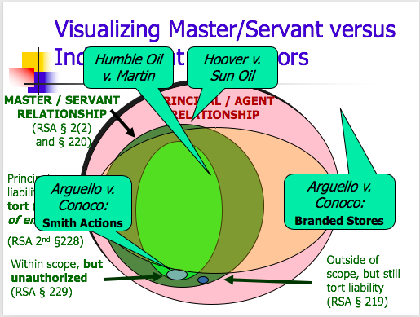
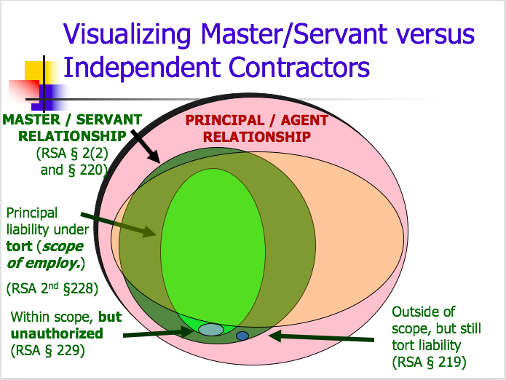
            - IE agents aren’t off the hook just bc the principal is also liable, they are liable too (it is just that usually the principal has deeper pockets so the Pl ends up going after them instead)
  - Roles and Duties
    - Roles
      - Principal → the boss, agent follows his/her directions
      - Agent → follows directions (if they don’t want to they just say no and this terminates the relationship bc based on consent)
    - Duties
      - RST2 376: General Rule [Duties of Agent to Principal]
        - The existence and extent of the duties of the agent to the principal are determined by the terms of the agreement between the parties
          - IE there are default rules, but the agreement can contract AROUND these
      - RST2 379: Duty of Care and Skill
        - Unless otherwise agreed, an agent is subject to a duty to the principal to act with standard care and with the skill which is standard
      - RST2 381: Duty to Give Info
        - Unless otherwise agreed, an agent is subject to a duty to give his principal information which is relevant to affairs entrusted to him
      - RST2 387: Duty of Loyalty
        - Unless otherwise agreed, an agent is subject to a duty to his principal to act SOLELY for the benefit of the principal. This includes:
            - Hypo: Guttentag asks you to go get him a smoothie from Sonia’s, you are also hungry and want to stay to get a burger, unless you have agreed to It prior, this is NOT ok bc you have to act for the SOLE benefit of the principal
          - Account for profits arising out of employment
            - Hypo: if while at Sonia’s you get a coupon for next time, need to tell Guttentag about coupon
          - Not act in a way that is adverse to principal w/ out disclosure
          - If adverse, be fair/disclose
          - Not to compete in subject matter of agency
          - Not to act with conflicting interests
          - Not to use/disclose confidential info
            - Gen Auto v. Singer: Pl was a manufacturer of auto parts, Df was their agent and was the manager of the auto part shop, he was an auto part guru and brought in a lot of the business for Pl, his K with Gen out said:
              - ‘‘A. To devote his entire time, skill, labor and attention to said employment, during the term of this employment, and not to engage in any other business or vocation of a permanent nature during the term of this employment, and to observe working hours for 51/2 days. B. Not to, either during the term of his employment, or at any time thereafter, disclose to any person, firm or corporation any information concerning the business or affairs of the Employer which he may have acquired in the course of or as incident to his employment hereunder, for his own benefit, or to the detriment or intended or probable detriment of the Employer.’’
A customer called Husco put in certain orders that Gen Auto couldn’t do (didn’t have right equipment and wouldn’t be a way to do it that was cost effective), so when these types of orders came in Singer decided that he would send the jobs to another company and keep the profits, didn’t tell Gen Auto he thinks this will actually help Gen Auto bc instead of having to continuously turn down orders, he fulfills the orders just not through Gen Auto, trial court finds that he breached his contract with Gen Auto (bc worked for someone else besides Gen Auto) AND breached his duty of loyalty (bc didn’t tell Gen Auto about side job)
              - What is the point of observing that Singer was supposed to tell someone higher up? That regardless of what he thought was best for the company, he had a duty to inform Gen Auto of the opportunities
              - In Section 8A in his K, what is the difference b/w “devote his entire time” and “not engage in other business of a permanent nature”? Devote his entire time makes more of a barrier to Singer doing other things (drafting pointer)
              - Would it be possible to conclude Singer breach his K but not his duty of loyalty? Vice versa?
              - Why were the damages reduced by 10k? Bc if the job had gone to Gen Auto, Singer would have gotten 3% anyways so not fair to have the damages be the ENTIRE profit
              - Why didn’t they just sue on the K theory? Bc under K you get damages for what Gen Auto would’ve made had they had THEY made the sale, versus under breach of duty of loyalty they get disgorgement, IE Singer disgorges the profit he made (minus the 3%), if had been K would’ve been lower bc Gen Auto would make less money on the deals than Singer did going to the cheaper shops (that’s the whole reason he went to those shops bc didn’t think that Gen Auto would make much profit)
              - What advice might you give to Singer? Disclose next time
  - Termination
    - Revocation and Renunciation
      - Authority terminates if the principal (by revocation) OR the agent (by renunciation) manifests to the other dissent to its continuance
        - IE just have to say you don’t want to continue
    - Effect of Termination of Authority upon APA
      - The termination of authority does not terminate APA
    - Notification Terminating APA
      - APA terminates when the third party has notice
    - Agent’s fiduciary duties to Principal after termination
      - Using confidential info after termination of agency:
        - Unless otherwise agreed, after termination, of the agency, the agent”
          - Has NO duty not to compete
          - HAS a duty to not use or disclose trade secrets. The Agent is entitled to use general info and the names of customers retained in his memory

- Partnerships
    - Intro
      - Sources of Law: UPA (1914-old law), RUPA (1997, new law)
        - Differences =
          - mandatory vs. default duties
          - financial consequences of wrongful termination
        - VOCAB
          - Revenue – (sales, gross) $ that results from selling products or services to customers
          - Profit – revenue less expenses
          - Debt – funds borrowed by the firm in exchange for claims of a fixed amount against the firm’s assets and future earnings
            - Typical terms: firm pays interest and, at “maturity” returns the principal
          - Equity – fuds invested in the firms, owners of the firm in exchange for residaul (left over) value of the firm)
            - Right to firm’s earnings and, in liquidation, firm assets AFTER all other claims are satisfied
  - Formation
    - Definition of a Partnership
      - UPA § 6(1): Entering into an association of two or more persons to carry on as co-owners of a business for profit.
    - Consider if UPA §7(3)/7(4) are relevant
      - What does it mean to carry on as co-owners? For profit?
        - UPA § 7: in determining whether a partnership exists:
          - 7(3) the sharing of gross returns (revenue) does NOT est. a partnership
          - 7(4) the receipt by a person of a share of the profits is prima facie evidence that he is a partner (IE if someone is only receiving profits and not a salary)
            - Exception: UPA § 7(4)(b):no such inference shall be made if such profits were received in payment…as wages of an employee (IE if they were receiving a salary AND profits) (see Fenwick) –
              - Also, doesn’t serve as evidence against the formation of a partnership, just doesn’t serve as prima facie evidence like it normally would if wasn’t an employee
        - Bacon & Eggs Joke: what’s what the difference between eggs and bacon? The chicken is interested, but the pig is committed
          - Analogy shows that by only sharing in profits, partners are fully committed to the success of the partnership, not just interested like an agent would be
        - Gen Auto Example
    - Common Law (Fenwick) Factors
      - Intention of the parties
      - Right to share in profits
      - Obligation to share in losses
      - Ownership and control of partnership property
      - Contribution of capital
      - Right to capital on dissolution
      - Control of management
      - Conduct towards third parties
      - Right on dissolution
        - Fenwick v. Unemployment Compensation Commission: (prof noted that was good exam q) – Fenwick owned United Beauty Shoppe, he employed Chesire as a cahier and reception clerk (received customers, take orders, collect $) for salary of $15/wk, C one day asked for more $, F said he was willing to pay her more but only if the business warranted it bc it was the depression and he didn’t want to agree to pay her more if he wouldn’t be able to afford it, C and F entered into a “partnership agreement” that basically says that F will pay C 20% of profits on top of her salary if the business warrants it, when F quits she wants to collect unemployment and the question arises of whether she was a partner or an employee (bc if she was an employee then F would be over the 8 employee mark and have to pay unemployment)
          - What were the important terms of the economic relationship (deal points) between F and C?
            - Return – C paid $15/wk + 20% of profits if business warranted, F paid $50/wk + 80% of profits
            - Risk – F bore all losses – ie if came in negatie profit, F took the hit
            - Control – F had all management control
            - Duties – both full time, F = managerial, C = clerical
            - Duration – either could sever w/ 10 days notice
          - How do you determine if C was a partner?
            - Look at all 9 factors, although C could share in profits, all ownership and control was in F so failed on the “co—ownership” aspect of partnerships, had intention w/ agreement and had potential to share in profits, but failed on all other elements – C wasn’t oligated to shar ein losses, F owned all the partnership roperty, F contributed all the capital, F was the exclusive manager, although filed partnership taxes didn’t hold themselves out as partners to anyone else (ie didn’t inform persons they bought materials from and trade name wasn’t registered as that of the partnership)
          - Does it matter in determining if C was a partner that she worked at the beauty shop?
            - NO, UPA § 7(4)(b) while receipt of profits is usually prima facie evidence that someone is a partner, this assumption does NOT exist if the profits are received as wages of an employee – IE this is an exception to normal profits are prima facie evidence rule, this means that it doesn’t show that there was a partnership but it also doesn’t cut AGAINST it, it is neutral
          - Does it matter that C and F signed a “partnership agreement”?
            - Yes, it goes to the intention of the parties element, but it is not conclusive and in this case it was not enough
  - Liability to Third Parties
    - UPA 15: all partners are liable jointly for all debts and obligations of the partnership
      - UPA 9: (contract) –
        - every partner is deemed to be an agent of the partnership and
        - the act of every partner carrying on in the usual way the business binds the partnership
        - UNLESS the partner has no authority and the other person with who he is dealing has knowledge of the fact
      - UPA 13: (tort)
        - Where wrongful act or omission of any partner acting in the ordinary course of the business of the partnership, partnership is liable
  - Roles and Duties
    - Duties
      - UPA
        - Default: (IE if the partnership agreement doesn’t say otherwise, these are the default rules the court will enforce)
          - UPA 9: every partner deemed to be agent of the partnership (RSA 376-396 apply), works exactly like principal-agent
        - Mandatory (IE these are rules that cannot be contracted around even if tried to in partnership agreement, are not the default rules, they are the minimum rules and no partnership agreement can make the standard any lower)
          - UPA 20: Obligation to render true and full info on demand
            - Lower standard than principal-agent bc only obligated to give info when prompted, not obligated to constantly keep informed even if not prompted like principal-agent
          - UPA 21: Must account for profits from any transaction connected w/ partnership
          - UPA 22: each partner has a right to a formal accounting
      - RUPA
        - RUPA 409 (a): Duty of Care & Loyalty – a partner owes other partners duties of loyalty and care stated in subsections (b) and (c) – (this section basically states the duties exist while the subsections describe the duties)
        - RUPA (c): Duty of care – Gross negligence, reckless conduct, intentional misconduct, or a knowing violation of the law is a violation of the duty of care
          - Contrast to UPA 379: Duty of Care and Skill – unless otherwise agreed, agent is subject to act w/ standard care and with the skill which is standard (IE much higher standard bc under RUPA only gross negligence is violation)
        - RUPA 409 (b): Duty of loyalty –
          - To account to the partnership and hold as trustee for it any property, profit, or benefit derived by the partner
            - (c) from the appropriation of partnership opportunity
          - Refrain from dealing as or on behalf of a party with an interest adverse to the partnership
          - Refrain from competing w/ the partnership in partnership business before dissolution
          - 409 (e) – self-interest does not mean duty violated
            - Contrast to UPA: both state that must account fo profits from any transaction connected w/ partnership but UPA states that agent is subject to duty to his principal to act solely for the benefit of the principal, RUPA says that self-interest isn’t dispositive
        - RUPA 408: Information duties –
          - maintain books and records
          - provide access to books and records
          - furnish w/o demand info required to exercise rights
          - furnish any other info on demand unless unreasonable or improper
            - Contrast to UPA: obligation to render true and full info on demand, each partner has a right to formal accounting
      - Ability to Modify
        - If not manifestly unreasonable the partnership agreement may:
          - What is manifestly unreasonable? In determining, the court will only look the period of time the challenged term became part of the parnetrship agreement and the circumstances existing at that time…then the court can invalidate that tem only if (in light of the purposes and business of the partnership) it is readily apparent that a) the objective of the term is unreasonable OR b) the term is an unreasonable means to achieve the term’s objective
        - Alter or eliminated aspects of duty of loyalty in 409(b)
        - ID specific types or categories of activities that don’t violate the duty of loyalty
        - Alter the duty of care, but may not authorize conduct involving bad faith, willful or intentional misconduct, or knowing violation of the law
          - Ex of partnership clauses: Sample partnership opportunity waiver – no person shall be obligated to present any particular investment or other opportunity to the Company or any Partner by virtue of this agreement even if such investment or other opportunity is of character that, if presented to such Person, could be taken by such Person. In addition, nothing in this Agreement shall restrict or otherwise prohibit ay person form taking, for its own account or to recommend to others any such particular investment or other opportunity.
          - Sample Related Party Waiver – Partners dealing w/ company. Upon receiving the approval of a Majority of the Partners, a Partner shall have the right to contract and otherwise del w/ the Company w/ respect to the sale or lease of real or personal property, the rendition of services, the lending of money, and for other purposes, and to receive compensation, fees, commissions, interest, and other forms of consideration in connection therewith, without being subject to claims for self-dealing or conflict of interest
      - Contrast w. UPA: under UPA RST duties can’t be changed and no provision to modify UPA 21-23, but under RUPA can only not unreasonably restrict access to books and eliminate duty of loyalty, but can remove specific categories if not manifestly unreasonable
        - Meinhard v. Salmon: M and S enter into a partnership joint venture (IE a partnership w. a fixed time limit) to rent out a commercial building (Bristol Building) for a 20 year lease and renovate it into offices and shops, M provided half the money necessary for renovations and after that M would receive 40% of profits for first 5 years and then 50% for the years after that, shared losses equally, S had the sole power to manage, lease, underlet, and operate the building. Lessor of Bristol wanted to expand Bristol into the plot he owned that was adjacent to it and renovate, it would be a whoel new project with new businesses. When lease was almost over, the lessor of the building asked S if he wanted to take over a new lease for the combined plot. S said yes, but never told M about the new opportunity. Court (Cardozo) said that S was liable bc he owed a duty of loyalty to M and this required him to tell M about the new opportunity that had evolved out of their joint venture
          - How does Cardozo justify his decision against S? Cardozo says that this was an opportunity of value that was created by what M and S created as partners IE opportunity came from partnerships you should have to tell your partner about it (good counter would’ve been that the lessor came to S not because of what S created with M, but because S was a good manager and lessor saw that, this would make it more that S created the opportunity by his actions alone vs. the opportunity came bc of his joint venture w/ M)
            - Cardozo thinks in a partnership you have to be INCREDIBLY loyal, “co-adventurers” “not honest alone, but the punctilio of an honor most sensitive is the standard of behavior,” renounce thought of self, especially as a managing partner
          - Justification of damages? Economic interests were about equal, but by giving S 51% of shares he get to still retain managerial power bc he was the managing partner
          - What could S have done to satisfy Cardozo? Warned M that the plan was submitted and that either would be free to compete for the award (what Cardozo didn’t like was that S excluded M from any chance to even compete, he was at least under the duty to inform M to give him a chance)
          - Would just disclosing the opportunity to M have allowed S to proceed under RUPA default rules? NO, under RUPA, the partners must approve – “all of the partners or a number specified in the partnership agreement may authorize or ratify, after full disclosure of all material facts, a specific act or transaction that otherwise would violate the duty of loyalty”
          - What provision would you include if you represented S? M? Which of the two above rules would be agreed upon? “such a calculus of probabilities…”
            - S: if opportunity were to arise out of this venture then either party is free to pursue without disclosure
            - M: any opportunities disclosed and ALL opportunities reasonably risen out of this venture – something like the RUPA rule
          - What was the basis if S’s defense? That the lease estension was outside of the scope of the time-limited joint venture between him and M, dissent says “the venture has in view a limited object an to end at a limited time…there was no intent to expand into a far greater undertaking lasting for many years”
          - What is M and S wanted a different rule in the partnership agreement, one that says neither partner owes fiduciary duties to the other? Partnership agreement may NOT eliminate the duty of loyalty, but if not manifestly unreasonable, partnership agreement may ID specific types or categories of activities that don’t violate the duty of loyalty
          - What should the default rule be?
          - What would Cardozo think of RUPA 409?
          - Why is Meinhard such a famous case? “Joint adventurers, like copartners, owe to one another, while the enterprise continues, the duty of finest loyalty. Many forms of conduct permissible in a workday world are forbidden to those bound by fiduciary ties. A trustee is held to something stricter than the morals of the market place.”
        - Meehan v. Shaughnessy: two lawyers, Meehan and Boyle, were partners at the law firm Parker Coulter (PC), they want to leave and start their own firm, they recruit another partner from PC (Cohen) to start MBC law firm, they also recruit three associates from PC – Schafer, Black and Fitzgerald to join them. B/w July-Dec. Meehan and Boyle planned their departure. They leased a new premises, made logistical plans, and also began to draft a list of cases they wanted to take with them to MBC and send out letters to clients asking for authorization to move their case from PC to MBC. They wanted to give notice on Dec. 1 of their intention to leave on Dec. 31, but rumors began to spread. Partners form PC began to ask Meehan about the rumors, he denied them. Finally, on Nov. 31, Shaughnessy asked Boyle and interpreted his evasive answers as a confirmation of their leaving. Court held that 1) MBC did not improperly handle the cases they took from PC, 2) that MBC was not secretly competing w/ PC, 3) that MBC did breach their duties to PC partnership bc they contacted their client in Dec. I a way that didn’t fairly giv the clients a choice to stay with PC AND that until Dec. they lied to their partners at PC about their plans to leave.
          - Why did Meehan and Boyle want to leave? Bc of a new firmwide pension plan that they unsuccessfully opposed, wanted to make more money thought they were bringing in more money than they were getting)
          - On 12/1/1984 what options were available to Parker Coulter?
          - Once Meehan and Boyle decided to leave the firm, what were they free to do? Did they need to inform their partners? Could they solicit clients? Lease a new office?
            - They could take logistical measures like secure a lease, but should have informed the partners immediately before they solicited clients
              - Summary language = prepare to compete is ok but not start competing
          - What about Schafer (the associate)? Did he have an obligation to inform the Parker Coulter Partners? He was an agent of PC, so yes – but since he told Meehan and Boyle (who were still partners that was enough)
          - Would you hire either Meehan or Boyle>
            - NOTE: Meehan is not the last word on client contact in these situations, many firms explicitly ban such behavior in partnership agreements (panership agreement in Meehan didn’t though)
    - Roles
      - UPA Default Roles:
        - UPA 9: every partner is an agent of the partnership
        - UPA 18(b): every partner can spend partnership $ if “reasonably incurred” in “ordinary and proper” conduct of the business
        - UPA 18(e): partners have “equal rights” to the management
        - UPA 18(h): difference in “ordinary matters” are decided by the “majority”
          - Nabisco v. Stroud: Stroud and Freedman are in a general partnership to sell groceries at premises named Stroud’s Food Center, several months before Feb. 1956 S told Nabisco that they would not pay for any more Nabisco sold and delivered $171 of bread at the request of F, F and S dissolved partnership on 2/25/56, the court held that F’s actions (buying bread from Nabisco) bound S
            - Explain the basis for deciding in favor of Nabisco:
              - UPA 9(1): every partner is an agent of the partnership for the purposes of its business, and the act of every partner, including the execution in the partnership name of any instrument (IE signing something on behalf of partnership), for apparently carrying on in the usual way the business of the partnership of which he is a member binds the partnership, unless the partner so acting has in fact no authority to act for the partnership in the particular matter, and the person with whom he is dealing has knowledge of the fact that he has no such authority
              - IE the court thinks that because F has the authority to enter into contracts (bc that is the default rule and the partnership rule did not restrict his authority in any way) and because buying bread was in the ordinary business of a grocery store, he effectively bound the partnership
              - “F, as a general partner w/ S, w/ no restrictions on his authority to act w/I the scope of the partnership business so far as the agreed statement of fscts shows, had under the UPA “equal rightd in the management and conduct of the business…”S, his co-partner, couldn’t restrict the power and authority of F to buy bread for the partnership as a going concern, for such a purchase was an ordinary matter connected with the partnership business”
            - Does previous business w/ Nabisco matter?
              - Not really, because F had actual authority to buy the bread so previous interactions with Nabisco didn’t matter
            - Is F personal liable to Nabisco for the cost of bread?
              - Yes bc partnership is liable to pay and that means F is jointly and severeally liable so is personally liable
            - Why wasn’t Stroud’s notification to Nabisco enough?
              - Bc having knowledge isn’t enough, there has to be knowledge on the part of Nabisco AND F didn’t have authority, but because F DID have authority, the partnership is still bound
            - What risks did Nabisco face?
              - If Freedman hadn’t had actual authority they wouldn’t have gotten paid (bc apparent authority was already out bc S had told them that they didn’t want to buy bread)
            - What could Stroud have done to protect himself from obligations incurred by F?
              - He could have restricted his ability to enter into contracts in the partnership agreement
            - Lessons from Nabisco v. Stroud:
              - Default rules regarding roles apply in a partnership unless otherwise agreed
              - Default rule provides for equal right to management (UPA 18e)
              - Default rules allow every partner to spen money in the ordinary course of partnership business (UPA 18b)
              - Default rule is that disagreements as to ordinary matters (IE if you want to change the partnership agreement to differ from the default rules) require a majority vote to be resolved (18h) – how do you do that if only two? You’re either stuck with default rules or both partners have to agree to it
          - Day v. Sidley: D is an underwriting partner and the head of the Washington office at SA, SA’s executive committee (who is in charge of the firm’s day to day decisions) wants to merge with the Liebman firm, partners are assured that “no one will be worse off” as a result of the merge the partners vote in favor of the merge, after merge happens SA’s and Liebman’s Washinton offices combine meaning the Day is no longer the sole head of the Washingotn office, D didn’t know about this and says firm didn’t disclose it before he voted, angered by this Day resigns and sues SA for fraud and breach of fiduciary duty, both dismissed
            - Fraud Claim
              - Basis = firm said no one would be worse off, D thinks he is worse off bc now he has to share his managerial position of Washinton office with someone else
              - Dismiss bc: D was not deprived of any legal right and could not have believed there would be no changes
              - Was this properly dismissed? Could argue that D had a legal right to oppose the merger had he had the full information about what would happen, although ct. says that even if he coted no it wouldn’t have made a difference (bc they already had a big enough majority), they overlook the fact that if he had the info beforehand he could’ve built an opposition that may have changed ppl’s votes- he had a legal right to make his case
            - Breach of Fiduciary Duty Claim
              - Basis = secrecy about merger consequences
              - Dismissed bc: exec board didn’t have to disclose bc there was no personal enrichment on behalf of the members of the exec board (“cts. have been primarily concerned with partners who make secret profits at the expense of the partnership”), the changes were changes to internal structure (which the partnership agreement fully gave the exec board the authority to do), bc dealing with a partnership agreement and not the default rules things are different – under default rules you would have had to disclose (agreement also says the exec board is able to carry out their dealings in secret), idea is that D willingly signed the agreement and therefore is bound by it
            - How can holding be reconciled w/ Meinhard v. Salmon? Meinhard had no partnership agreement, so default rules applied and there was a duty to disclose, also in Meinhard the secrecy was for an individual profit of Meinhard to the exclusion of the partnership and Salmon
            - What was D’s right to control before the merger? Did it change after? He was in charge of the Washington office, no not really bc he was still in charge of the Washington office he just shared that role with another person (could argue that sharing role was a decrease in managing power)
            - Is the SA control system sensible? Why? Yes, bc there are so many partners, it is necessary to have an executive board that centralizes control and takes care of day to day things bc if all partners had to agree on every detail of every day would be very inefficient (an still had good system of having partners vote on the big decisions like mergers)
            - What should D have done to protect himself when he joined SA? He could’ve demanded that the partnership agreement notify him if he had to move or share his role, IE demanded more specificity (but unlikely that this would’ve flown)
            - What could SA have done to avoid this litigation? Disclosed the changes to Day so that he could have a chance to oppose and wouldn’t have claims of breach of fiduciary duty
            - Was the SA partnership agreement well drafted? It ultimately saved SA from liability, but the language might have been confusing if partner wa sunder different expectations
              - NOTE: courts allow partnership agreements to modify statute, allow for exec committees and majority approval for matters requiring unanimity per statute
  - Termination
    - The power/right to dissolve
      - You always have the power, but not necessarily the right to dissolve a partnership
      - UPA
        - Causes of dissolution:
          - UPA 29: The dissolution of the partnership is the change in the relation of the partners caused by any partner ceasing to be associated in carrying on
          - UPA 31: Dissolution is caused -
            - (1) Without violation of the agreement b/w the partners IF → power AND right
              - (a) Termination of a definite term or particular undertaking specified in the agreement (IE if the agreement specifies that partnership will last for 5 years or until we sell 100 units)
              - (b) Express will of partner when no definite term or particular undertaking specified (IE if there’s no time limit set then all partner has to do is say they want to end it)
              - (e) expulsion of any partner in accordance with powers conferred by the agreement b/w partners (IE is the partnership agreement specifically allows for the partnership to be terminated in certain ways
            - In contravention (violation) of the agreement, where the circumstances do not permit dissolution under any other provision → power but NO right
              - UPA 38: Rights when Dissolution in Contravention of Agreement
                - Right to damages for breach
                - Other partners may continue business
                - Partner who causes dissolution gets:
                - IF business is terminated, remaining cash less damage
                - IF business continues, value of interest, less damahes, BUT VALUE OF GOOD WILL NOT CONSIDERED (good will = value oof intangible assets, such as business’ reputation, brand names and patents)
          - UPA 32: Dissolution by Decree of court (IE wouldn’t have right usually but if court says it is ok you do)
            - On application by or for a partner, the court shall decree a dissolution whenever (power AND right)
              - A partner has been declared a lunatic in any judicial proceeding or if shown to be of unsound mind
              - A partner becomes in any other way incapable of performing his part of the partnership conduct
              - A partner so conducts himself in matter relating to the partnership business that it is not reasonably practicable to carry on this business in partnership with him
              - The business of the partnership can only be carried on at a loss
      - RUPA
        - Also has dissolution
        - RUPA 601: A person is disassociated as a partner when:
          - (1) The partner’s express will
          - (2) The event is agreed upon in the partnership agreement
          - (3) The partner is expelled pursuant to the partnership agreement
        - RUPA 801:
          - A partnership is dissolved and its business must be wound up only upon occurrence of the following events
            - (1) In a partnership at will and the partner express will
            - (3) An even agreed in the partnership agreement
      - Differences UPA vs. RUPA
        - UPA = dissolution v. RUPA = disassociation and dissolution only when there is a winding up
        - Goodwill is not deducted after wrongful dissolution in RUPA
          - Goodwill = an intangible balance sheet asset, can also represent other intangibles like reputation, brand names, patents, etc. which all have real value
          - Line graphic: green line goes up bc the business ceases and reaches termination, in the other two the business continues, it never terminates
          - In UPA all three lines are a dissolution
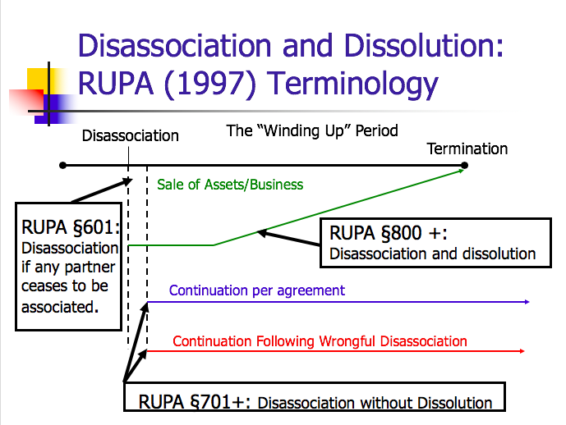
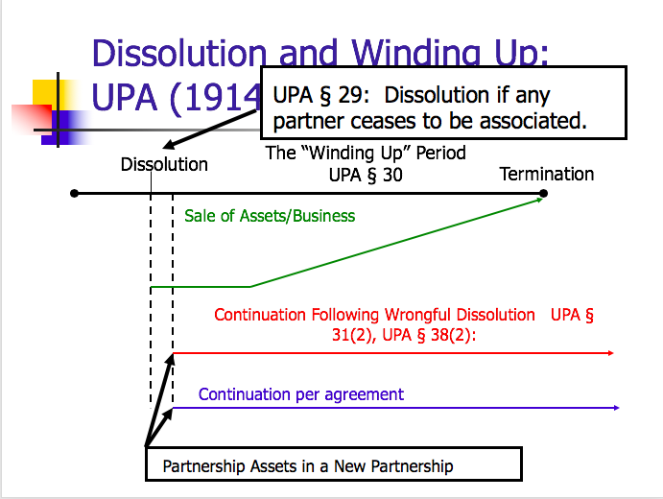
          - In RUPA only called a dissolution if the business STOPS and assets are sold (like Prentiss) IE only green line is a dissolution
        - Owen v. Cohen: O and C are partners in a bowling alley, O gives the partnership a 6.9k loan to start things up that was supposed to be paid off by prospective profits as soon as things became profitable, after 3.5 months O goes to court to get an order for a dissolution bc doesn’t want to be in partnership w/ C anymore, court find that bc C continuously humiliated O in public, said O had to do all manual labor, was taking money out of partnership w/o O consent, told a friend O wouldn’t be around long, and wanted to start a gambling room upstairs, C was conducting himself in a way that was not reasonably practicable for the partnership to carry on (C tries ot argue that these are small petty things, but court says in the aggregate theyre enough so that a partnership could not be run this way), order dissolution and for O to be repaid for loan in liquidation and then O and C split what is left (minus ssome costs)
          - Why does O file a lawsuit seeking dissolution rather than just giving notice and demand a winding up? Bc when a loan is given, it creates an implicit term in the partnership that the partnership will continue at least until that loan is repaid, so he wouldn’t have the right to terminate, wanted to go to court so he had the right to terminate
            - Implied term usually is to protect the lender but here it harmed the lender bc the lender (O) wanted out before the loan was repaid by the profits so he needs to go to court so that the court can order dissolution and liquidation of assets so he can be repaid
            - How long does that term last? Take a mental snapshot of when partnership was created and base estimate off that, need ot look at time when partnership was formed
            - “When a partner advances a sum of $ to a partnership with the understanding that the amount contributed was to be a loan to the partnership ND was to be repaid as soon as feasible from the prospective profits of the business, the partnership is for the term reasonably required to repay the loan.”
            - If O had proceeded w/o court order then C would’ve been able to continue the partnership w/o O bc O wouldn’t have had the right w/o court order
          - Was it proper to repay the loan before distributing profits?
            - Yes, under UPA 40(b) the following order is observed when distributing profits:
              - The claims of the firm’s creditors are paid (O was a creditor here bc he lent his own partnership $, so he is entitled to repayment of his loan before C gets anything)
              - Claim of a partner other than those for capital and profits
              - Those owing to partners in respect of capital
              - Those owing to partners in respect of profits
          - What is the legal effect of the order for dissolution?
            - What is the likely practical effect? Legal effect is that O now has the right and the power, practical effect is that must start liquidating partnership assets and the O will likely get the bowling alley bc can outbid C (if C were to outbid O then would effectively have pay out O anyways) and the O gets repayment of his loan before C gets anything
          - What was the statutory basis for the court dissolution?
            - UPA 32(1)(d) partner conducts himself in matters relating to the partnership that makes it not reasonably practicable to carry on
        - Collins v. Lewis: C and L want to open a cafeteria together, C is to provide the $ and L is to manage the building and development of the premises and work at the caf after, partnership agreement says that C will provide all fund to build, equip and open the caf, also says that C would be repaid of at least 30k plus interest in first year and 60 (therefore there is an implied term bc of loan IE however long it takes to repay) plus interest in years after default would cause L to surrender his interest to C, ends up costing 2x more than originally anticipated to build it, C gets mad and thinks L is incompetent in managing and that’s why it was costing so much, he eventually stops funding the cafeteria and goes to court to get a decree of dissolution, jury finds L was competently running the project, that if C had not stopped funding the project would’ve turned a profit eventually
          - Why is jury finding that the cost of opening the caf (697,603) is relevant?
            - Bc per the partnership agreement C was on the hook for funding all the costs for opening the caf so the full 697k is owed by C bc that is what the partnership agreement said
          - What did C hope to gain by obtaining a decree of dissolution?
            - The RIGHT to a dissolution
          - Where does the court’s refusal to order dissolution leave Collins? What’s likely to happen next?
            - If Collins has the power but not the right to dissolve, the remaining partner has the opportunity to carry on the business. Or Collins could try to negotiate. But here, it looks like he would rather force a sale of the business.
          - What protection should Collins have requested?
            - Maybe: to have a term in the K that he has the right to dissolution if cost to open exceeds X
        - COMPARE: Owen v. Cohen and Collins v. Lewis
          - Why did the court order dissolution in Owen but not Collins? Both involve bad blood between partners (Cohen is lazy and Collins is interfering) and in both one partner was fed up and wanted out, but in Owen there was
            - Similarities = both partnership for term (ones explicit and one implicit) both cases a partner was behaving in a way hard to carry on for a partnership for profit, but difference is that in Owen the person who was not causing the problems was asking for the dissolution but in Ollins the person who was creating the problem was asking for the dissolution, so the court didn’t want to reward the problem maker
        - Page v. Page: two brothers go into a linen supply business together, each put in 43k to the business, business is unprofitable losing 62k in 6 years, b/w 1949-57 HB’s corporation lends 47k to the firm w/ a demand note (demand note means they can demand $ back whenever, worst kind of loan), Pl brother (HB) wants out of the partnership, Df says there was no term and partnership was at will so could stop whenever he wanted, Df argues that the partnership had an implied term to go on until the business “paid itself out” IE until all the debts and obligations were paid, but ct agrees there is no implied term like there would be for a loan bc the money that was put in was equity NOT a loan, parties never discussed a term and never discussed what would happen if there was losses so it wasn’t air for Df to assume it was for a term (Df tried to argue that he made a reasonable assumption that there would be a term based on past partnerships with bro, but ct said the assumption wasn’t reasonable bc in those past partnerships the agreement in those had actually specified 5 years
          - What were the economics of the transactions?
            - In 1949 each partner contributed 43k, from 1949 to 1957 Pl’s corporation lent the partnership 47k
          - Did HB Page (Pl) have the power to dissolve the partnership?
            - Yes (trick q) you ALWAYS have the power
          - Did HB Page (Pl) have the right to dissolve the partnership?
            - Yes, bc it was an at-will partnership so could end it whenever he wanted
          - Why didn’t the brothers 86k investment in the partnership create a partnership for term?
            - Bc only a loan creates a partnership for term, equity does not and what the Page bro’s put in was equity
              - No implicit term: “viewing this evidence most favorably to the Df, I proves only that the partners expected to meet current expenses from current income and to recoup heir investment if the business were successful”… “It is true that Owen v Cohen and other cases hold that partners may impliedly agree to continue in business until aa certain sum of money is earned…or one or more partners recoup their investments or until certain debts are paid…in each of these cases, however, the implied agreement found support in the evidence”
              - Compare to Owen: implied term found in Owen bc when a partner loans $ to the firm, to be repaid form profits, the partnership may be for a term until the loan is repaid VS. in Page no plied term bc parties hope to repay start-up loan out of partnership profits not enough
                - Owen: When a partner advances a sum of $ to a partnership with the understanding tht the amount contributed was to be a loan to the partnership AND was to be repaid as soon as feasible from the prospective profits of the business, the partnership is for the term reasonably required to repay the loan
          - Why didn’t the 47k loan from HB’s corporation created an implied term?
            - Bc the loan was a demand note not a loan for a term, therefore if the loan has no term the partnership can have no term (if the loan had a term provision like to be repaid in 2 years then could’ve found implied term but bc there was a demand no there is no term)
          - Suppose HB (Pl) wishes to buy the partnership assets and continue with a new partner (who will manage and get a 25% share)?
            - Nothing wrong with this, totally allowable
          - Suppose HB (Pl) intends to liquidate the business and pick up its better accounts with a new entity?
            - These accounts are partnership property bc these customer relationships arose out of the partnership so he cannot get these relationships w/o some kind of compensation to the other partner – equity, fiduciary duty is about fairness
          - TAKEAWAY: Page allowed to terminate partnership since “for profit” does not equal a term, but still owes fiduciary duties
    - The consequences of dissolution
      - Acquisition of partnership assets by some partners
        - Prentiss v. Sheffel: Prentiss, Igel, and Sheffer are in a partnership for a shopping center, S and I each own 42.5%, P owns 15%, S and I sue for dissolution bc P is derelict in his duties and bc he failed to put up his 6k share of paying off, partnership debts, trial court decides that partnership is dissolved by freeze out, no bad faith, appoints a receiver, and orders sale of prop, S and I bid on sale and buy for 2.25 mil, P appeals the purchase of the center by S and I
          - What did the court find to be the basis for dissolution?
            - UPA 6: a partnership is an association of two or more persons to CARRY ON AS CO-OWNERS of a business
            - UPA 18: partners have equal rights to management
            - Basically court said that the freeze out wasn’t wrongful bc P was ot carrying on as a co owner, he failed ot be involved in the management (even though he was basically forced to by S and I), course of action can dissolve partnership
              - “trial court concluded that a partnership-at-will was dissolved as a result of a freeze-out or exclusion of the Df from the management and affairs of the partnership”
          - Why continue to inform a minority partner?
            - Bc they had a fiduciary duty to do so, bc if exclude them then would dissolve the partnership inadvertantly
          - Is the court correct that allowing the partners to bid benefits P?
            - Monetarily yes, but it is clear from him brining the suit that he was more interested in staying in the partnership and not letting I and S buy up the partnership so in reality not really
          - What was the paper dollar argument?
            - P argued that bc S and I already owner 85% of the corporation already to pay the difference b/w the 85% and 2.25 mil
      - Continuation following Wrongful Dissolution
        - Pav Saver v. Vasso: Pl and Df were partners in manufacturing of concrete paver machines, Pl was owner of patent, they formed a partnership, partnership agreement said 1) Pav Saver wil grant exclusive use of patent to partnership 2) partnership is permanent and will only be dissolved if all parties mutually agree, 3) upon expiration of partnership, the patent is to be returned to Pav Saver 4) if a party does dissolve the partnership, the terminating party pays to the other party 4x gross sales of 1973 fiscal year (exact wording below). Pav Saver ended the partnership in contravention of the agreement
            - PSC grants the partnership the right to use PSC's trademark
            - PSC grants the partnership the exclusive license to PSC's patent rights. "It is understood and agreed that [patents] shall remain the property of PSC and all copies shall be returned to PSC at the expiration of the partnership."
            - (11) – LIQUIDATED DAMAGES CLAUSE - "It is contemplated that this joint venture partnership shall be permanent, and same shall not be terminated or dissolved by either party except upon mutual approval of both parties. If, however, either party shall terminate or dissolve said relationship, the terminating party shall pay to the other party, as liquidated damages, a sum equal to 4 times the gross royalties received by PSC in the fiscal year ending July 31, 1973. Said liquidated damages to be paid over a ten-year period, in equal installments.
          - What is the majority decision? Vasso does NOT need to return the patents, contract tern saying that patents will be returned at expiration is unenforceable bc statutorily the innocent members of a partnership have a right to continue the partnership following a wrongful dissolution, is Pav Saver were to recoup their patents effectively Vasso could not carry on bc the entire business is based on using those patents, therefore the goodwill exclusion of UPA 38 is NOT superceded by the partnership agreements and Pav Saver can get the damages he was entitles to based on his interest in partnership and the gross sales in 1973 like the partnership agreement said
            - What is the value of the partnership EXCLUDING GOODWILL at time of dissolution? 330k so 165k owed to Dale (
            - What is the implication of the agreement as to liquidated damages? Use to determine damage payment owed to Meersman, not replace all provisions of UPA 38
          - What argument can you offer that majority is incorrect?
            - There are 2 possible interpretations of the liquidated damages clause:
              - If either party dissolves, that is wrongful, so § 38 may come into play
                - In determining the damages, under § 38, the amount is as specified under paragraph 11
              - OR – the partnership can be “terminated” (overriding § 38), subject to the damages provision
            - There are also two ways of interpreting the patent return provision:
              - They agreed that the patents would be returned UNLESS there is wrongful disassociation
              - They agreed the patents to be returned REGARDLESS of whether disassociation was wrongful
          - Would Pav-Saver be decided differently under RUPA?
            - YES, Dale would get goodwill value (of the patents) as well
          - How important is the inclusion of the language about forming a permanent partnership?
            - Suppose wasn’t referred to as a partnership?
              - Does not matter if referred to as a "partnership." Would have taken the legal form of partnership anyway. If it looks like a partnership, you don't have to call it one. (See partnership formation for review)
            - Suppose not referred to as permanent?
              - This matters bc made it so partnership was not at will or for a specified term
    - Sharing losses
      - UPA § 40(b): subject to contrary agreement, upon dissolution partnership assets should be distributed as follows:
        - Those owing to creditors other than partners,
        - Those owing to partners other than for capital and profits,
        - Those owing to partners in respect of capital, and
        - Those owing to partners in respect of profits.”
      - UPA § 40(d): "partners shall contribute, as provided by [§18(a)] the amount necessary to satisfy the liabilities [set forth in § 40(b)]."
      - UPA § 18 “The rights and duties of the partners in relation to the partnership shall be determined, subject to any agreement between them, by the following rules:
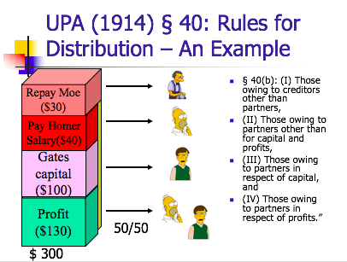
        - “(a) Each partner shall be repaid his contributions, … and share equally in the profits and surplus remaining after all liabilities, including those to partners, are satisfied; and must contribute towards the losses, whether capital or otherwise, sustained by the partnership according to his share in the profits.”
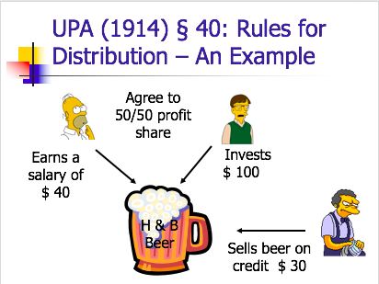
          - Kovacik v. Reed: K wants to start kitchen remodeling business, invests 10k and want R to be superintendent, share profits 50/50, didn’t discuss losses, in business less than a year, incurred 4k losses, K wants R to share the losses with him. R argues that he worked for free, court says that he doesn’t owe losses bc he contributed the labor
            - Is this holding consistent w/ the statute?
              - No, the statute says that each must contribute towards losses
              - But even though R would’ve received 50% of profits, he isn’t liable for anything
              - Statute would’ve mandated that share of losses be equal to share of profits
              - But this case mandates capital partner to pay all
            - What is the intuition behind K’s rejection of the stat scheme?
              - R is responsible as the estimator, even if R cant afford to bear the. Loss, this is how they set up the partnership
              - “Where one party contributes money and the other contributes services, in the event of a loss each would lose his own capital—the one his money and the other his labor. Another view would be that in such a situation the parties have, by their agreement to share equally in profits, agreed that the value of their contributions—the money on one hand and the labor on the other—were likewise equal; it would follow that upon the loss . . . of both money and labor, the parties have shared equally in the losses.”
            - Which provisions of the default rules leads to this problem?
              - Each partner shall be repaid his contributions? (not sure)
            - What if Reed had contributed a nominal amount of capital?
              - Then Reed would also be a capital partner and would be required to share in half the loss
            - Why didn’t Kovcik and Reed adopt a different rule?
              - Maybe Kovacik knew that Reed would be liable, set him up.
              - Probably both thought that the venture would be profitable.
              - Reed is not invested in the success of the venture. It wasn't his money, so he doesn't care.
            - What might the effect of the no loss-sharing by service partner be on behavior?
              - The service partner would be more reckless bc he is playing with other people’s money
            - What advice would you give Reed?
              - None, he made out fine. Maybe next time be more explicit so don’t have to go through litigation.
- Corporations
  - Intro
    - Sources of Corp Law
      - Individual state law (internal affairs doctrine)
        - DE state law
          - Over 850k corps ar incorporated in DE, 60% of fortune 500 companies, 50% of companies on NYSE
        - MBCA
      - Fed Law
        - Securities and Exchage Act
        - Sarbanes Oxley Act (2002)
        - Dodd Frank Act (2010)
        - JOBS Act (2012)
        - Primarily cover “public” corps
    - Basic Attributes of a Corp
      - Legal personality
        - The corp is an entity w/ separate legal existence form its owners
          - Possesses (some) constitutional rights
          - Separate taxpayer
            - Yes (free speech), No (personal privacy)
          - Requirement for formal creation
      - Limited liability
        - MBCA 6.22 → unless otherwise provided, in the articles of corp, a shareholder is NOT personally liable for the acts or debts of the corp except that he may become personally liable by reason of his own conduct or acts
      - Separation of ownership and control
        - MBCA 8.01(b) → all corporate powers shall be exercised by or under the authority of, and the business and affairs of the corporation managed by or under the direction its board of directors
        - Shareholders = owners, board of directors = the management
      - Formal capital structure
        - Capital structure: claims on the corp’s assets and future earning issued in the form of securities (the distribution of debt and equity that make up the finances of the company)
          - Vocab:
            - Securities = permanent, long-term claims on the corp’s assets and future earnings issued pursuant to formal contractual instruments
            - Capital structure = the debt securities and equity structures together constitute the firm’s capital structure
        - Significance of a Formal Capital Structure
          - Unlike in partnerships, where some people put in money, some put in labor, some put in ideas and the law says everyone is equal → corps have a formalized structures that recognize the difference in money people and idea people
            - People who put in money get SHARES OF STOCK
            - Way in which money is invested is formalized and the deal you get in a corporation is standardized
        - Debt vs. Equity
          - Shareholders = have equity
            - owners of the corp
              - in public corp, this means ppl who have shares/stocks bc they bought them
            - they elect directors and vote on major cop decisions
            - may receive firm’s earnings in form of dividends
            - in liquidation, get firm assets AFTER all other claims are satisfied (residual claimants)
          - Lenders (creditors) = have debt
            - The corp borrows funds from lenders
            - Gives them a bond (like an IOU)
            - Firm pays interest on the borrowed $
            - At “maturity” the firm returns the principal
          - The combination of debt and equity make up the firm’s assets
            - Combo of the equity shareholders have (IE how much $ they’ve paid for shares)
              - Money raised by selling shares in the company
            - And liabilities (the various debts the corp owes to lenders)
              - Money borrowed to be repaid w/ interest
      - Liquidity
        - Secondary trading markets IE NYSE and NASDAQ
        - Able to buy and sell assets/ownership of corp
        - Ownership of the corp is liquid (IE not fixed)
    - Financial Statements
      - Income statements
        - A financial statement that indicates results of operation over a specified period of time, ALA profit and loss statement
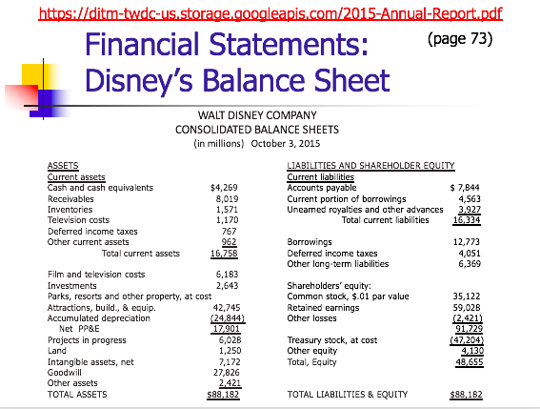
      - Balance sheets
        - Summarizes the company’s financial position at a given point in time. Usually the end of the month, year, or quarter
        - Describes the assets of the business AND the claims on those assets, either of creditor sin form of debt OR owner in form of equity
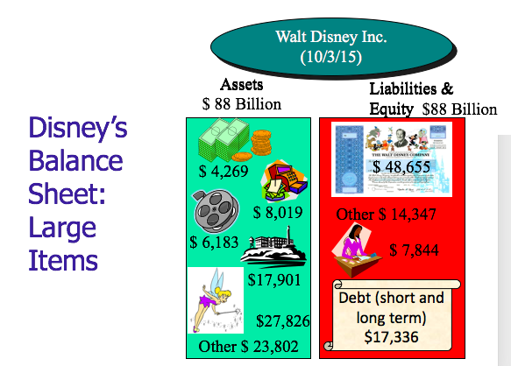
      - Both are prepped according to Generally Accepted Accounting Principals (GAAP)
    - Stock
      - Terminology
        - Authorized shares = number of shares a corp can issue
        - Outstanding shares = number of shares the corp has sold and not repurchased
          - Repurchased = firm buys back (reacquisition) the shares
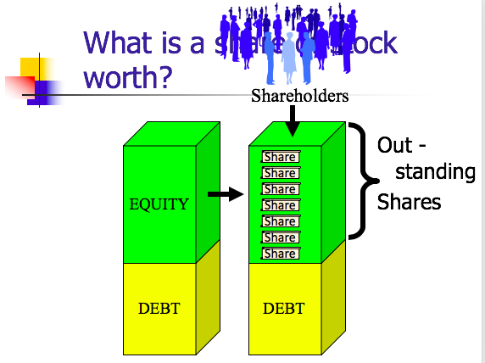
        - Authorized but unissued = shares that are authorized, but not yet sold
        - Treasury shares = shares issued and then repurchased by the firm
    - Measuring a Corp’s Value
      - Measuring Equity
        - Book value = measure of the equity value of the firm provided by the financial statement (balance sheet) – the accountant’s valuation
          - Disney: 49 bil (just look at balance sheet)
        - Market capitalization = measure of the equity value of the firm implied by the trading value of the firm’s stock (determined by multiplying the trading value of one share of stock times the total number of shares outstanding)
          - Disney: 116 (price per stock) x 1.5 bil (number of shares outstanding) = 174 bil
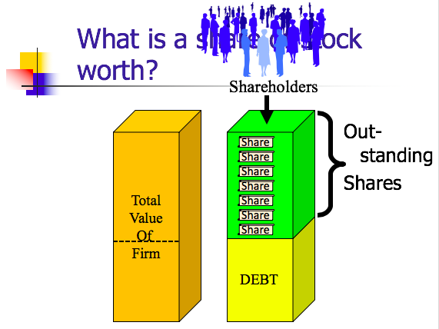
      - Enterprise value = measure of the total value of the firm’s assets (market asset value) → measured by the trading value of the firm’s stock (determined by adding the market value to the firm’s obligations)
        - IE market capitalization PLUS debt
          - Disney: 116 (price per stock) x 1.5 bil (number of shares outstanding) + 17 bil (firm’s debt) = 191 bil (enterprise value)
      - Efficient Capital Markey Hypothesis
        - The price of a stock reflects all available info
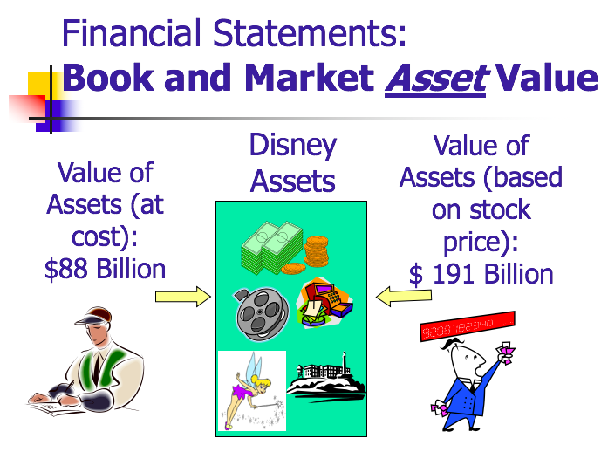
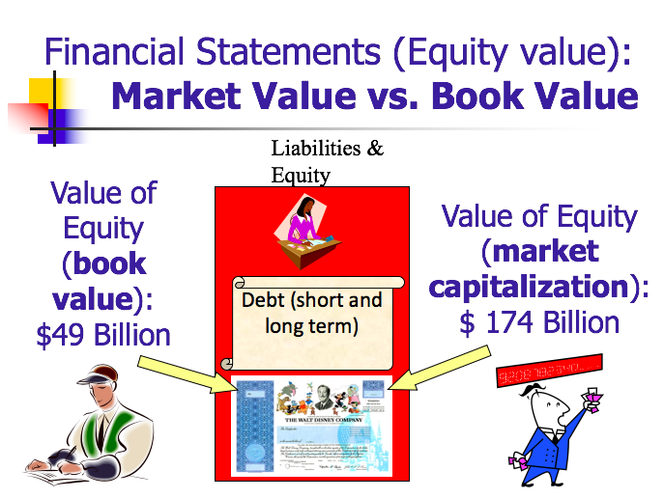
        - Market capitalization is a better measure of company’s value bc reflects things that book value cant (like how the public views the company)
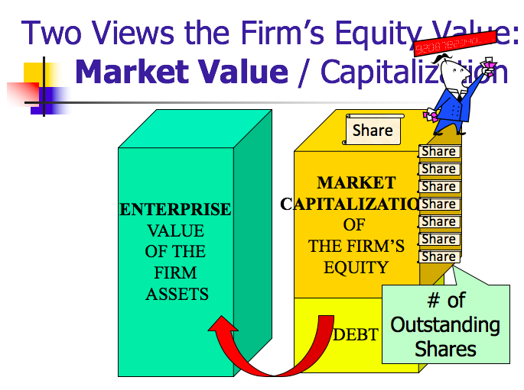
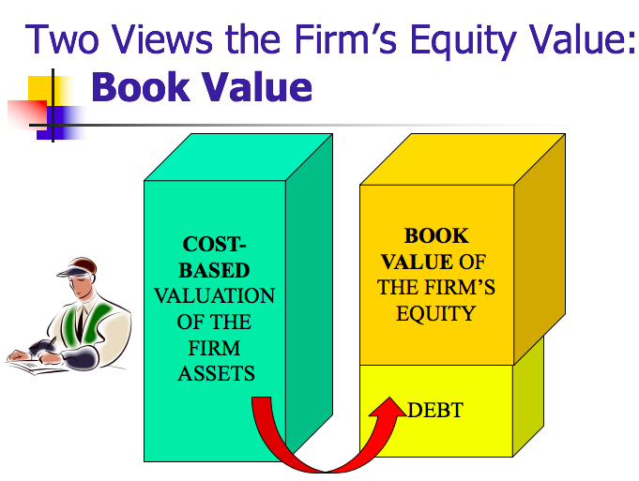
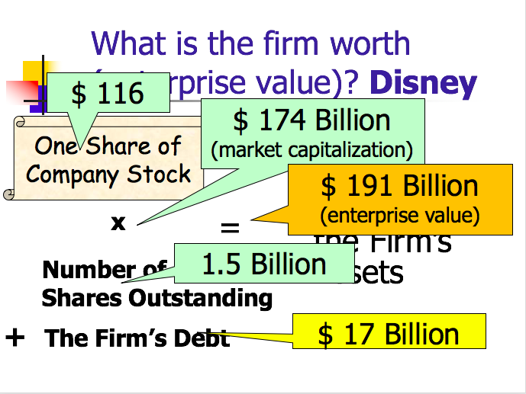
    - Unincorporated Limited Liability Entities
      - 5 unincorporated limited liability entities
        - Partnerships
          - Limited liability partnerships (LLPs)
            - General partnership w/ limited partner liability
            - Formed by filing a “statement of qualification” w/ secretary of state
            - General partnership can convert to LLP by filing
          - Limited partnerships (LPs)
            - General and limited partners
            - Formation:
              - Must life documents (usually w/ secretary of state)
            - Limited partner liability:
              - Only limited partners who participate in conctorl can be held liable
            - General partner has full personal liability
              - But, corporation can be a general partner
          - Limited liability limited partnerships (LLLPs)
            - Limited partnership in which general partners get limited liability (LLP treatment)
          - Limited liability company (LLCs)
            - Introduced in WO in 1977
            - 1988 IRS ruled LLC could qualify for partnership-like tax treatment
            - Formation
              - file w/ state
            - flexibility
              - like partnership, most aspects of management and sharing dictated by the LLC “operating agreement”
            - 2 types:
              - Member managed, all members are managers
              - Manager managed, some owners not managers and no right to vote
            - Limitations on capital structure complexity and share transferability
            - Unfavorable state franchise taxes in some states
          - S corp
            - Creation of tax code (actually a corp)
            - Advantage
              - Pass-through taxation and limited liability
            - Disadvantage
              - Constraints on # of shareholders, source of corporate income, type of shareholders (one class only), deduction on pass-through losses
      - Corps
  - Formation
    - Draft articles of incorporation & By-laws
      - Articles of incorp
        - MCBA & DGCL:
          - must include name, # of shares, address, incorporators
          - may include initial directors, management, limits on rights, liability on shareholder
      - By-laws
        - MCBA & DGCL
          - May include – provision for managing the business and regulating the affairs of the corp
    - Pick a state
    - File articles w/ Secretary of State
    - Hold Organizational meeting
    - Final Steps:
      - Finalize directors
      - Appoint officer
      - Adopt by-laws
  - Liability to Third Parties
    - Limited Liability
      - Piercing the Corporate Veil (PCV) Doctrine
        - MBCA 6.22: a shareholder of a corporation is not personal liable for the acts or debts of the corporation except that he may become personally liable by reason of his own acts or conduct
          - Walkovsky v. Carlton: Pl was hit by a cab that belonged to Seon Corporation where Df was shareholder, he owned 10 taxi corporations, practice in taxi industry in which you have a fleet of taxis and create many corporations, each that owns only one or two taxis and takes out the minimum liability insurance (10k) so that single corporation can never be liable for more than 10k, Pl argued that the 10 corps actually operated a s single entity, unit, and enterprise, ct says … “whenever anyone uses control of the corporation to further his own rather than the corporation’s business, he will be liable for the corporation’s acts ‘‘upon the principle of respondeat superior applicable even where the agent is a natural person.” Also … “it is one thing to assert that a corporation is a fragment of a larger corporate combine which actually conducts the business… It is quite another to claim that the corporation is a ‘‘dummy’’ for its individual stockholders who are in reality carrying on the business in their personal capacities for purely personal rather than corporate ends” Court says in first case, the larger corporate entity would be liable, but in the other case the individual stockholder would be liable, court says that Pl alleges that Df ran a fragmented corp entity, but no allegations that he was personally running the businesss for himself instead of the corp, court says no liability
            - Who do you feel sorry for? Walkovsky or Carlton?
              - On one hand want members of pubic to be able to recover torts, on other this is a driving force behind corp entities and their appeal
                - Dark side of limited liability: allows businesses to avoid some of cost of their activities
            - Did Carlton “attempt to defraud members of the general public?
              - Ct. says no, “not fraudulent for the owner operator of a single cab corp to take out only the minimum required liability insurance”
            - What is the difference b/w enterprise liability and PCV?
              - Enterprise → going after the sister corp, IE claiming that corp is a fragment of larger cop which actually conducts the business
              - PCV → going after shareholder, claim the corp is a dummy for its individual shareholders, who are in reality carrying on the business in their personal capacities for purely personal rather than corporate ends
            - What would Pl have to show in order to PCV?
              - That Df Carlton and his associates are actually doing business in their indiv. capacities, shuttling their own personal funds in and out of the corporations “w/o regard to formality and to suit their immediate convenience
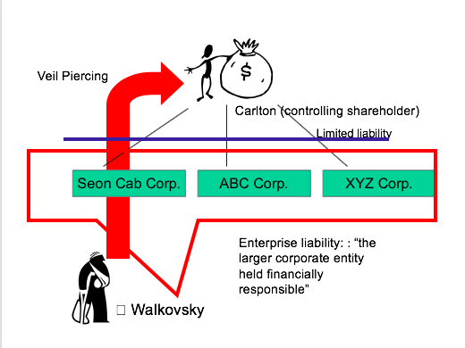
            - What would Pl have to show to recover under the enterprise theory?
              - That Carlton didn’t respect the sperate identities of the corps
                - Assignment of drivers
                - Use of bank accounts
                - Ordering of supplies, etc
            - What are the problems w/ the majority’s deference to the legislator?
              - Lobbying for these laws is often done by the corporations they will apply to (IE here the cab company would’ve lobbied for the minimum insurance) so requires a kind of divine legislator to fix problem
            - Problems w/ dissent?
              - Makes these cases too hard to adjudicate, bright line test easier to apply for courts
            - Questions after Walkovsky:
              - Can you incorporate your business for the express purpose of avoiding personal liability? Yep
              - Can you split a single business enterprise into multiple corps so as to limit liability exposure of each part of the business? Yep
          - Van Dorn PCV Test: (Need both)
            - Unity of Interest (didn’t respect the separate personhood of the corp)
              - Lack of corp formalities
              - Commingling of funds and assets
                - If write IOU is ok
              - Sever under capitalization
                - Not enough equity capital
              - Treating corporate assets as one’s own
                - Paying yourself a salary is fine, but if you continuously draw money from the corp w/ no sense of formality not ok
            - Refusing to allow PCV would:
              - Sanction fraud OR
              - Promote injustice
                - Idea is that need this element as well bc if you’re not hurting anyone ct doesn’t want to punish you just for being a bad bookkeeper
                - To promote injustice, the Pl needs to show some wrong beyond a creditor’s inability to collect would result
          - Enterprise Liability Test:
            - Failure to maintain adequate corporate records and follow corp formalities
            - Commingling of funds or assets
            - undercapitalization
            - One corp treating the assets of the other corp as its own
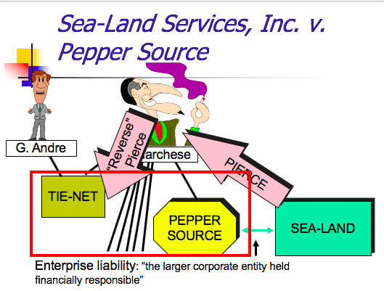
          - Sealand v. Pepper Source: SL shipped some peppers for PS, then PS didn’t pay the freight bill, PS was owned wholly by Marchese, who owned 5 other corps wholly and one corp called tie-Net with one other shareholder named G. Andre, SL won a judgment against PS, but by that time PS had been dissolved bc didn’t pay yearly fee, also even if wasn’t dissolved, PS had 0 assets so PS could’ve never paid them in the first place, court found presence of unity of interest (no formalities, never had director meetings, never made bylaws, ran all corps out of one office/phone, constantly “borrows” money for personal expenses w/o interest, corps borrow money from each other) BUT doesn’t find the necessary second element (can’t really plead fraud on MSJ and did not plead sufficient injustice other than not inability to collect on his freight bill)
            - What should Sea-Land have to show on remand to prove unjust enrichment?
              - That PS got free delivery w/o paying, he got the benefit of their contract w/o paying AND maybe that he treated his personal expenses as deductible corporate expenses, that Marchese specifically moved money around to purposely avoid creditors IE just need to show something beyond not being able to collect on the K – Here Marchese’s sneaky conduct would’ve been enough, but Sealand just didn’t plead it sufficiently on their complaint so was remanded
            - Are the unity of interest elements of the Van Dorn test conjunctive?
              - No they are just factors to consider
            - Do the two elements in the Van Dorn test make sense form a policy perspective?
              - Yes, relatively easy to avoid liability as long as you abide by some superficial formalities – but makes sense from capitalist perspective bc a main draw for corps is the lack of liability. Second element makes sense bc if the unity of interest elements are present but there was no indication of injustice, no pont in punishing people for being bad bookkeepers
            - What is reverse piercing? How does it differ from enterprise liability?
              - Reverse piercing is once you PCV you gain access to other assets that the shareholder owns (like other corps), so here you would PCV to get to Marchese and the RPCV to get access to the assets of his other 5 corps
              - Enterprise liability is when you directly gain access to the larger corp by showing same unity of interest analysis (IE don’t gain access to shareholder’s assets), RPCV is when the finances are a huge mess and you want access to both shareholders assets and other corps assets
              - First must, PCV to get to the shareholder, then can RPCV
  - Roles and Duties
    - Roles
      - Board of Directors
        - control
      - Shareholders
        - Sue
        - Vote
        - sell
      - Officers
        - manage
      - Creditors
        - Lend
    - Duties
      - Board of Directors
        - To WHOME are the fiduciary duties owed?
          - Stakeholder theory: directors are only responsible to stake holders
            - IE the community/employees/shareholders/clients
          - Shareholder Primacy Theory: directors are responsible to shareholders only
            - Dodge v. Ford: Dodge brothers are shareholder in Ford corp, they complain that ford is making a killing in profits, but instead of paying out dividends to shareholders, Henry Ford (who was head of board of directors) was reinvesting them in the business and lowering prices, Ford claimed humanitarian motives for these actions, Dodge brothers argue that the company isn’t a charity and that the main purpose for a corp is making profits not altruism
                - Dividends = a distribution of a portion of a company’s earnings, decided by the board of directors, to a class of its shareholder. Dividends may be in the form of cash, stock or prop
              - What relief were the Dodge bros seeking?
                - Dodge brothers want to enjoin Ford from expanding by building a smelting plant and to require him to pay special dividends, ct says cannot enjoin the plant construction but does require that Ford issue the dividends to shareholders
              - Why did Ford lose on the dividend issue?
                - Bc of his own testimony and articulated goals, he basically outright said that he had interests apart from maximizing profits (IE humanitarian)
- Courts may not scrutinize decisions about how to maximize profits, but they will scrutinize about WHETHER to do so
              - Did Ford really think that his company was making too much $?
                - Semi-eleemosynary – relating to charity, he was actually making decisions that benefitted shareholders and other stakeholders, but bc his testimony was so blunt that it crossed the line and court was forced to step in, if had made testimony like I am doing this bc even though the profits are high and im not issuing dividends now, this will grow the business even bigger in the future
              - Does it mater that judges are not business experts?
                - Yes, it supports the idea of deference to the board in terms of HOW to maxmizie profits
              - Does this decision support shareholder primacy?
                - YES, court basically said you can express an interest in benefitting anyone other than shareholders… “a business corp is organized and carried on primarily for the profit of the stockholders…the discretion of the director are to be employed for that end.”
                - “it is not w/I the lawful powers of a board of directors to shape and conduct the affairs of a corp for the merely incidental benefit of shareholders and for the primary purpose of benefitting others”
              - If Dodge is a correct statement of the law, why do scholars still for stakeholder theory?
                - Some scholars argue for stakeholder theory as a normative claim, rather than a descriptive claim
                - Courts give boards broad discretion to determine means and many times benefitting other stakeholders DOS benefit shareholders
                - Some statutes incorporate stakeholder theory ideas
              - Was 35 mil a fair offer to for from the Dodge bros?
                - Depends on whether you look at balance sheet (assets, liability, shareholder’s equity) or income statement (sales, revenue, gross income, net profit)
- Ford book value = 112 mil
- Dodge bros offered 35 mil and they owned 10% of the company, so they valued the company at 350 mil, 3x t hook value
- Ford income statement = (ford net income) 60 mil so offer is 6x Price earnings
- So Dodge bros were offering a very fair price and Ford turned down a god deal
        - WHO is bound by the fiduciary duties?
          - Board of directors
          - Controlling Shareholders
          - Officers
        - WHAT is the CONTENT of the duties?
          - Duty of care (no shirking)
              - Regulates diligence in performing tasks, limited by BUSINESS JUDGMENT RULE
            - MBCA – Director may be found liable IF:
              - Corporate charter indemnification or cleansing doesn’t preclude liability AND
              - Didn’t act in good faith
              - Didn’t believe she was acting in best interest of the corp (Ford/Amex)
              - Wasn’t informed (Van Gorkom)
              - Lack of objectivity due to directors’ lack of independence
              - Failed to devote ongoing attention to oversight, or devote timely attention when particular facts arise
                - IE is the inaction of a director covered by BJR? NO
            - DE Business Judgement Rule:
              - Act will defer to the Board of Directors’ business judgement UNLESS their actions:
- Focus on the fact that says ACTION so implied that inaction is not covered
                - Aren’t in the honest belief that action is in best interests of corp or
- IE DODGE V. FORD (fails BJR), absent clear expressed intent that wasn’t acting for shareholders or total waste (lets have a bonfire w/ corp money), this is really hard to overcome, all director has to say is in my judgment I thought this would be best for the corp and its ok
- Kamin v. Amex: (passes BJR) Df is board of directors for Amex, they bought stocks of DLJ corp for 30 mil, those stocks plummeted and are only worth 4 mil now, wanted to distribute the remaining income from those stocks to shareholders as dividends, two shareholders brought an action bc said if Df’s sold those stocks on the actual market they could offset their loss by 8 mil in tax capital gains, the court says that
  - What standard does the court adopt for the duty of care of directors?
    - BJR: “the question of whether or not a dividend is to be declared or a distribution of some kind should be made is exclusively a matter of business judgement for the board of directors UNLESS
      - The powers been illegally or unconscientiously executed or unless fraudulent, collusive, and destructive of the rights of stockholders
      - Fraud, dishonesty or nonfeasance
      - It appears that directors have NOT been acting in good faith
    - But none of that was found here so court says cant bring suit for a question business judgment
    - Directors are NOT held to a standard of reasonable care/average prudence
  - What were the offsetting benefits of providing the stock as a dividend?
    - Issuing a dividend to the shareholders would mean that the loss would show up on the balance sheet but not the income statement and when the loss shows up on the income statement it may reduce the price of the stock
      - What is the relevance of the ECMH to this decision? The loss would be reflected in the stock price anyways so it DEOSNT MATTER which financial statement it shows up on, regardless of how Amex would dispose of the stock
  - What other type of fiduciary claim could be made?
    - Duty of loyalty bc 4 of the directors compensation structures were dependent on this transaction and would’ve been lower compensation if sold on market
    - But ct says this is way too speculative and no indicia of bad faith
  - How should employee contracts be drafted?
    - Tie the compensation to stock market price bc stock price is best indication of firm’s value – ie echoing the ECMH
                - Are not based on an informed investigation
- Good lawyers/banks/consultants to write REPORTS
- Did they meet for a sufficiently long time? (2 hours not enough, 4 hours probably enough)
- Standard is very low, an rely on reports even if it turns out to be a bad decision
- Smith v. Van Gorkom:
  - Review the underlying transaction (management buy out - MBO) or Trans Union corp.
    - An acquisition where the management buys the purhases the shares of the corp, buys outstanding shares
    - An LBO where the purchaser is the company’s own management (can raise conflict of interest bc managemen is on both sides of transaction)
    - What is an acquisition?
    - What’s an LBO (leverage buy out)? – much like taking out a mortgage on a house, you need to borrow money to make a purchase and you use the assets of the thing you are buying to be able to borrow the $
      - An acquisition of all the firm’s outstanding shares, using BORROWED FUNDS, secured by the assets of the company to be acquired
      - Purchaser is borrowing $ based on the value of the assets the purchaser is buying – considered leveraged bc the transaction is high debt low equity
        - Why LBO? Help to finance the purchase, more risk = more return = more discipline
      - MBO is different bc the purchased is the managment
  - Review the players
    - CEO → Van Gorkom
    - CFO → Chelberg
    - Chief Operating Officer → Romans
    - Controller → Peterson
    - Trans Union Board of Directors
    - Jay Pritzker
  - Review the timeline
    - 1980
      - 8/27: internal management discussion
        - TU stock at about $38
        - Considered MBO
        - Romans runs a feasibility study (east at $50, hard at $60)
        - Van Gorkom says “I’d take $55” – 4.125 mil
      - 9/5: another internal management discussion
        - Romans mentions MBO again
        - Van Gorkom vetoes as potential conflict of interest – says we work for our shareholders we dot compete w/ them
      - Sometime before 9/13
        - Van Gorkom consults w/ Peterson
          - Asks what TU’s market capitalization is, Peterson says 490 mil and would tak5 years to pay off, need to convince a bank to lend them that much
          - Van Gorkom says to not tell ANYONE
      - 9/13-9/19
        - Van Gorkom negotiates LBO at $55/share with Pritzker
          - Prtizker wants to buy shares at market price – reduced to 1 mil shares from 1.75 mil
          - Wants market stability to ensure he can get the money even if someone else offers higher
          - So he revised the big to make it harder for people to bid against him
        - Van Gorkom is “astounded that events were mobbing with such rapidity
        - Van Gorkom, Chelberf, Prtitzker meet with TU’s bank
      - 9/20 Senior Management meeting
        - Very hostile reaction
        - TU BoD approves merger after 2 hour meeting
          - Van Gorkom signs agreement while hosting a party at Lyric opera House
      - 10/8 TU BoD approves revised deal
    - 1981:
      - 2/10 TU shareholders approve merger by 69.9% to 7.25% (22.85% abstained)
  - Review the legal issues addressed
    - Was Board’s decision informed on 8/20/1980
      - What did the board know?
        - They knew Prtizker was willing to pay 17 mil premium over the prevailing market price
        - Why wasn’t that enough? Board of Directors doesn’t know how Van Gorkom set the price
        - Board of Directors know price based on study of feasibility rather than value
    - Did the Board’s subsequent action cure?
      - No the meeting was too short, didn’t have reports, didn’t read the materials
    - Did the shareholder vote cure? NO
      - They knew Prtizker was willing to pay 17 mil premium over the prevailing market price
      - Why wasn’t that enough? Board of Directors doesn’t know how Van Gorkom set the price
      - Board of Directors know price based on study of feasibility rather than value
      - The court says that shareholders didn’t have all the info so their conclusion is invalidated, thinks that if had all info might have noted differently
    - Who has burden of proof on this issue?
      - Party attacking the boards decision
    - What must that party prove?
      - Gross negligence
    - How often do Directors lose on these grounds?
      - Very rarely
    - Why did lightning strike in Smith v. Van Gorkom?
  - What was the dissent’s argument?
    - These are sophisticated business people, they knew ehther it was a good transaction or not, the requirement of getting superfluous reports is just a formality and doesn’t od anything
  - What do you think of the dissent’s argument?
    - It is good for directors to have some degree of accountability, this I salready a low standard
  - How can director’s protect themselves from liability for being uninformed?
    - Indemnification (DGL 145)– most corps include in director agreements where if you settle a case against the directors, the corp pays for it
      - BUT statutes say that if you go to court and LOSE the directors cannot be indemnified
      - Creates inducement to settle
      - Indemnification not perfect that bc if corp goes bankrupt no one to pay – this is why get director and officer insurance too
        - Can get insurance even in situation where indemnification wouldn’t be available
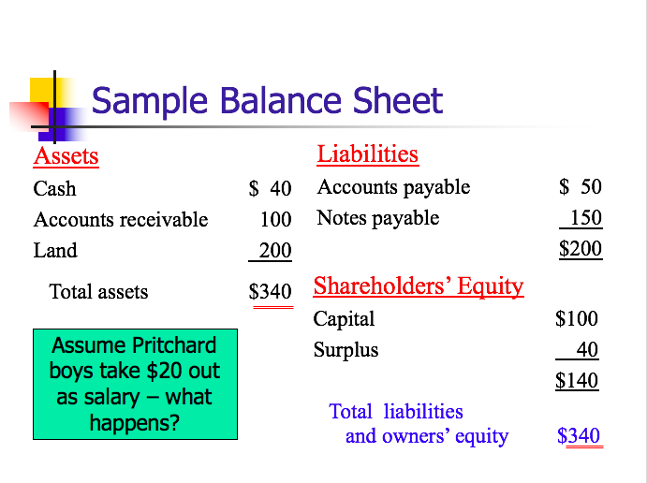
    - Get reports from lawyer/banks, meetings more than 4 hours,
  - Aftermath of Smith v. Van Gorkom
    - Individual directors paid total of 2 mil
    - Insurance paid 10 mil
    - Pritzker paid 11 mil
                - Involve a conflict of interest
                - Additional Affirmative Duty of Car Obligations
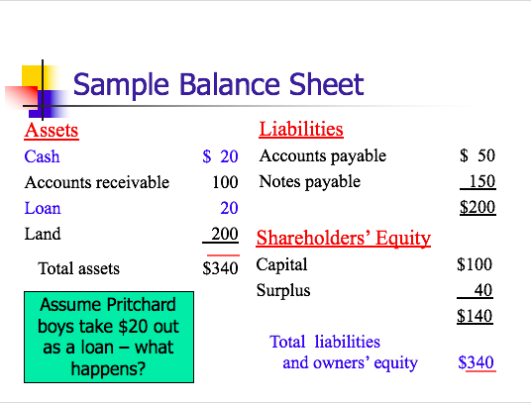
→Francis v. United Jersey Bank: Pritchard and Baird was a corp in reinsurance brokerage business, this means and insurance company basically sells some of the risk they take from policy holders and if there are claims the reinsurance company helps pay, this is done through brokers, Ms. Pritchard’s husband was director of corp and owned 48%, their sons owned the rest, husband died and left the role and stake he had in company to his wife, wife was totally MIA in corp and ignored all of her duties (she was listless, inactive, drank rather heavily, director from 1973-78), one of the sons started taking out “shareholder loans” from corp until it went bankrupt (sons of founder, active in management, dominant figures, father said Charles would take the shirt off his back, systematically embezzled large sums in form of nominal loans), Ms. Pritchard died and the corps debtors brought an action to collect, ct said that Ms. Pritchard was liable for her utter failure to carry out her duties a sa director
- Why did the sons take out loans rather than just pay themselves a bigger salary?
  - Bc if take money as a salary then it comes out of the earning (like dividends) and reduces cash (so reduces assets column on balance sheet and reduces equity column so total equity goes down
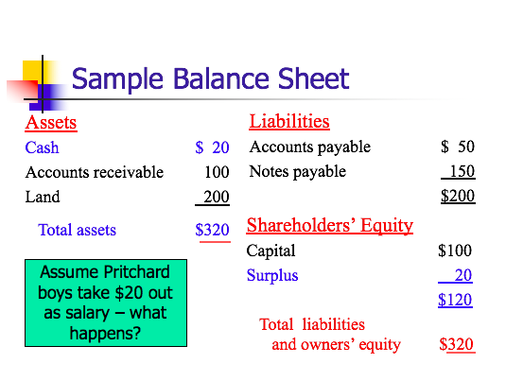
  - BUT if take out the money as a loan, still reduces cash in the assets column, but DOES NOT reduce assets, so equity stays the same (its like if you have $40 in a cash register and take $20 out but replace it with an IOU, so that ASSETS STAY THE SAME – but they are different TYPES of assets, so equity doesn’t change)
  - → court says a director should immediately be suspicious when this happens
- Why does the court use a reasonable person standard here? What happened to BJR?
  - The BJR applies to ACTIONS the director takes, not INACTION
- Did Lillian have a duty to the Pritchard and Baird clients?
  - Yes, duties owed to customers if hold funds of other in trust
  - Affirmative duties of a director:
    - Obligation of basic knowledge and supervision
    - Read and understand financial statements
    - Object to misconduct and, if necessary, resign
- Did Lillian breach her duty to those clients?
  - Yes, she did none of the above
- Was her breach a proximate cause of the clients loss?
  - Could argue yes bc if she had voiced any kind of disagreement, she could have stopped them
  - BUT the brothers were taking out the loans 3 years before the tdad even died, so cant really say that they started doing it because Lillian was neglectful if they were doing it before she was even a director
                - BUT could also counter that with her neglect didn’t cause it to start but it also allowed it to continue
            - Rationale for BJR:
                - “the directors room rather than the courtroom is the appropriate forum for thrashing out purely business questions”
              - Shareholder can elect new directors
              - Competition will lead to the failure of poorly managed firms
              - Don’t want to discourage risk taking
            - How Directors are Protected
              - BJR
              - Indemnification – protects after there is a judgment
              - Insurance
              - Legislation 102(b)(7): allows corps to add in their charter that directors to be protected from personal liability but does NOT eliminate the duty of care/loyalty (so protects before there is a judgment)
          - Duty of loyalty (no stealing)
            - Regulates self-dealing transactions. No BJR shield.
            - General:
              - Essentially the duty of loyalty mandates that the best interest of the corp and its stockholders takes precedence over any interest possessed by a director…NOT shared by the stockholders generally
            - The is the “right” rule?
              - Spectrum from No related party transactions (most restrictive) allowed to BJR (least restrictive)
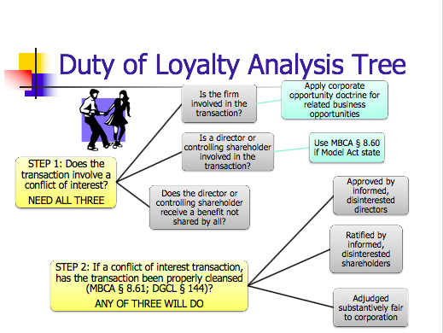
              - Moderate solution sin between: disinterested shareholder approve, independent shareholder ratify, transaction judged fair
            - 2 steps in Duty of Loyalty analysis:
              - STEP ONE: does the transaction involve a conflict of interest?
                - Is the firm on one side of the transaction?
- Either literally or corp opportunity
- Corporate opportunity doctrine (DE) → Guth test
- Guth Test: Test uses “and” but court calls them factors - is likely not all mandatory
  - Corp is financially able to take the opportunity
    - Relevance of capacity – not always dispositive bc cn argue that was gonna get financing
    - Lessen’s Df’s burden
  - Opportunity is in corp’s line of business
    - Activity as to which is had fundamental knowledge, practical experience and ability to pursue
    - Consonant with its reasonable needs and aspirations for expansion
    - Covers more than interest/expectancy test bc the language is more broad
  - Corp has an interest or expectancy in the opportunity
    - Interest = something to which the firm has a RIGHT
      - IE if officer bought land to which the corp has a contractual right, the officer took an “interest”
    - expectancy = something which, in the ordinary course of things, would come to the corp
      - IE if the officer took the renewal rights to a lease the corp had, the officer took an expectancy
  - Embracing the opportunity would create a conflict b/w director’s self-interest and that of the corp’s
    - Seizing the opportunity creates a conflict
                - Is a director or controlling shareholder involved in the transaction?
- MBCA 8.6: Conflicting Interest IF: (burden on Pl to show)
  - Director is a party to the transaction
    - IE Disney director buys a plot of land from Disney corp
  - Director has knowledge and a material financial interest in the transaction
  - OR a transaction which the director knew a related party has an interest in
    - An uncle of a Disney Direct buys a plot of land near Disney corp (apply corp opportunity there)
- Controlling Shareholders
  - Over 50%
  - Shareholders don’t have duties when acting as shareholders unless they are controlling shareholders in which case they have fiduciary duties to the minority
                - Does the director or controlling shareholder receive a benefit not shared by all?
              - STEP TWO: Has the transaction been properly “cleansed”? (MBCA 8.61; DGCL 144)
                - Approval by disinterest shareholders/directors
- These are no dispositive or absolute, doing these things might just lower your burden
                - Transaction adjudged fair (intrinsic fairness test)
- Used when no attempt made to cleanse
              - Examples From Case Law:
                - Corp Opportunity
- Broz. V. Pricellular: Pl is both on the board for CIS and is the president and sole shareholder of his own cellular co. (RFBC), CIS was being acquired by PriCellular, a new cellular zone became available for purchase, Broz bought it for RFBC, he asked CIS and they all said they weren’t interested and couldn’t afford it, but PriCellular said they would’ve been interested and since they were acquiring CIS it was a conflict of interest
  - What are the two roles of Robert F. Broz?
    - Hat 1: Broz was the sole shareholder and President of RFBC (a cellular brand)
    - Hat 2: Broz was also a member of the board of directors on CIS
      - CIS was in financial difficulty but was in the process of being acquired by Pricellular
  - What is the timeline of events?
    - April 1994 – Mackinac Cellular decides to divest Mich-2 license
    - May 1994 – Phodes approaches Broz in Broz’s RFBC capacity
    - June 1994 – six CIS directors agree to sell shares to Pricellular, contingent on successful tender offer
    - Sept 1994 – PriCellular negotiates option to buy mich-2 for 6.7 mill unless they get an offer for more than 7.2 mil
    - Nov 9, 1994 – closing date of tender offer for CIS by PriCellular
    - Nov 13, 1994 – Broz “agreed to pay” 7.2 mill for Mich-2
    - Nov 23 1994 – PriCellular completes financing and closes tender offer for CIS
    - ? 1994 – Broz completes financing and closes acquisition of Mich-2
      - Holding – Broz was under no duty to consider the “contingent and uncertain plans of PriCellular:”
  - What is the basis for the court’s determining that Mich-2 is not a corp opportunity of CIS?
    - FIRST do 3 factors:
      - Is Broz on one side? Yes bc he is buying Mich-2 and receiving a benefit only for him, no other directors get a piece
      - THEN ask is the corp on the other side? (IE would they have the opportunity to be on the other side)
    - Says formal presentation to board not necessary, informally asking them is ok
    - Goes through Guth test
      - Finance → Says that CIS was not financially able
      - Line of business → historically yes, but was trying to divest itself of cellular holdings more recently
      - Interest/expectancy → had no interest or expectancy (which Broz gleaned from talking to other directors),
      - Creates Conflict → he ct says doesn’t create a conflict bc Broz already owned Mich-4 so already ha da conflict and buying Mich-2 didn’t put him in a new line of business
    - Holding= Broz didn’t usurp a corp opportunity
  - Suppose PriCellular has no financial problems (IE no delay in tender offer) and could have easily invested enough $ in CIS to buy Mich-2. What result?
    - YES conflict, bc PriCellular has the necessary funds so financially able and it would have had a corp expectancy
    - Also if has acquired Mich-2 post the acquisition
  - Why did PriCellular not simply outbid Broz and buy Mich-2 for itself?
    - They didn’t want to they didn’t think they should have to pay the extra 600k
  - Was the court fair in treating CIS’s interest in Mch-2 as separate from that of PriCellular?
    - Calculates PRiCell’s ownership of CIS as the day financing closes,, but calculates Broz’s ownership of Mich-2 by the day he agreed to pay
  - What advice do you give Broz?
    - Resign from CIS, would sure any conflict
    - Make a formal presentation to board IE cleansed (informed , disinterested board members approve)
      - Not required here but could create a safe harbor
        - Speaking to individual boar members is snot enough, bc to be considered “board action,” whole board must meet
      - Requirements for formal board of directors action:
        - Board meeting either regular or special
        - Action w/o meeting requires unanimous written consent
        - No notice necessary for regular meeting, two day notice required for special meeting
        - A director may waive notice, except as provided by (b0< waiver must be in writing
        - A director’s attendance at a meeting waives any required notice unless the director objects
        - Qurom – default rule – majority; minimum quorum requirement acceptable – 1/3. Vote decided by majority present

                - Controlling Shareholder/Corp Opportunity/Benefit Received not Shared By All
  - Sinclair Oil v. Levien: Sinclair Oil was a holding company with multiple subsidiaries, each operating subsidiary functioned in one country, Sinven was Sinclair’s Venezuela subsidiary, Sinclair owned 93% of Sinvens stock, 3% were Venzuelen nationals, the minority stockholder objected to three aspects of the Sinclair-Sinven relationship:
    - 1) Sinven’s large dividends (Sinclair was taking out more than Sinven was earning when it needed a lot of cash) – but this was NOT a conflict of interest bc all shareholders received the benefit
      - NO CONFLICT
        - 1) Sinven was on one side
        - 2) Sinclair on the other
        - 3) BUT the benefit was received by all bc the dividends were distributed equally
          - So then just becomes a BJR about whether they should’ve taken out such big dividends and court says it doesn’t violate BJR
    - 2) Sinven was prevented from expanding (but court says none of the opportunities for expansion can to Sinven independently, so they never “lost” a corp opportunity)
      - Judged under BJR – BUT SHOULD HAVE GONE THROUGH GUTH TEST – THIS WAS WRONG
      - It was so clearly not a corporate opportunity that court didn’t even both going through Guth test but should have
        - So fails first prong of conflict test
          - 1) Was firm on one side of the transaction? NO
          - So can stop here bc need all three elements
    - 3) contract between Sinven and Sinclair International breach (Sinclair got the oil w/o having to comply w/ contract duties), broke a K on behalf of Sinven
      - Don’t have to look or do any kind of analysis of whether K was fair, just see if the provisions were breached
      - Was there a conflict?
        - 1) Is Sinven on one side? Yes
        - 2) Are the shareholders on the other? Yes, bc the K is literally between and Sinven and Sinclair Intl.
        - Did they receive a benefit that not shared by 3) all? Yes, they received the benefit of the K without the obligation and Sinven didn’t receive any of the benefit
      - They were so there IS a conflict, go to step 2
        - Step 2: was this transaction involving purchasing oil from Sinven properly cleansed?
          - Approved by disinterested shareholders? No, Sinclair was 97% of the shareholders and other 3 didn’t approve (didn’t ask bc knew they’d say no) and also likely would’ve been asking after the K was breached anyways, directors were also all Sinclair directors so none of them could be disinterested
          - Why does this case fall under the DGCL intrinsic fairness prong of the conflict of interest review provisions?
            - Bc there was no way that you could have a disinterested director vote bc all directors were Sinclair directors too and they didn’t attempt a disinterested shareholder vote w/ the minority shareholders (bc probably knew they’d say no)
            - So if NO cleansing, then court has to use intrinsic fairness
      - What does the court decide about the intrinsic fairness of this transaction between Sinven and International?
        - Sinclair got all the benefit of this transaction without adhering to any of the obligations, so not fair
  - How might a corp that owns a large percentage of the stock of a corp deal w a minority shareholder that may file fiduciary duty lawsuit?
    - Bring in some disinterested directors that you think would probably vote in your favor, and make sure the directors make decisions with fancy reports from lawyers, get rid of (buy out?) minority stockholders
                - Cleansing – Effect of Shareholder Ratification
  - In re Wheelabrator: Waste Management and Wheelabrator (WTI) were both in the waste industry, Waste bought 22% of WTI stock and elected 4 of its own directors to serve on WTI’s 11-member board, Waste and WTI negotiated a merger between the two companies in which waste would acquire another 33% (so 45 total) of WTI and WTI shareholder would get .574 of WTI shares and .469 Waste shares for each 1 WTI share, to evaluate this transaction WTI directors (not including the ones from Waste) held a meeting, WTI directors informed WTI shareholder (not counting Waste) who approved the transaction, the “effect by majority shareholders depended on the type of claim:
    - Duty of care claims
      - Extinguished
    - Duty of loyalty claims against directors
      - Shifts burden of proof to Pl to show waste (IE court will look at BJR so Pl has to show waste to overcome BJR)
    - Duty of loyalty claims against controlling shareholder
      - Shifts burden of proof to Pl to show unfairness
    - Why should the effect of a fully informed shareholder vote be different for a duty of care than for a duty of loyalty case not involving de facto control?
      - Same reason that duty of care and duty of loyalty claims are evaluated differently in first place
      - Court is more suspicious of questions of loyalty whereas as long as the directors are using some degree of care they will defer to their business judgment
    - What must the Pl in Wheelbrator be prepared to prove?

    - In Smith v. Van Gorkom why was the shareholder approval not a complete defense?
      - Bc wasn’t an informed decision so it didn’t count
          - Duty to act in good faith?
            - Failure to gather info to avoid violaitons of law
            - Stone v. Ritter: in 2004 AmSouth paid 50 mil in fines and penalties to settle charges that the bank failed to fil suspicious activity reports (SAR’s), a classic Caremark complaint against directors of AmSouth (a DE corp that owns commercial banks), caremark complaint = claiming that the directors didn’t put in systems to detect whether your employees are breaking the law or not, this est a good faith duty and how to breach it
              - Does the board have a duty to adopt a law compliance program?
                - Graham v. Allis-Chalmers: old rule – directors are entitled to rely on the honestly of their subordinates until something occurs to put them on notice, if they are put on notice and then fail t act, liability might follow (the “one free bite rule”)
                - Caremark: new rule – directors obligations include a duty to assure that a corp info and reporting systems exists and that failure to do so may in theory at least render a director liable or losses caused by non-compliance with legal standards (don’t get the free bite anymore if you didn’t have systems in place to detect it)
              - What would an adequate law compliance program include?
                - Policy manual
                - Training of employees
                - Compliance audits
                - Sanctions for violation
                - Provisions for self-reporting of violation to regulators
              - What kind of duties are Caremark duties?
                - Directors obligation includes a duty to attempt in good faith to assure that a corp information and reporting system exists and that failure to do so may in theory at least render a director liable for losses by non-compliance with legal standards
              - Evolution of the Duty of Good Faith Doctrine in DE:
                - Cede and Co. v. Technicolor: To rebut the rule, a shareholder Pl assumes the burden of providing evidence that directors in reaching their challenged decision breached any one of their TRIADS of fiduciary duty: good faith, loyalty, or due care
                - BUT ALSO
- In Stone: although good faith may be describe colloquially as part of a triad of fiduciary duties that includes the duties or care and loyalty, the obligation to act in good faith does NOT est. an independent fiduciary duty that stands on the same footing as the duties of care and loyalty
- SO conclusion is NO (although sometimes it is referred to independently it really isn’t)
              - If it is not its own independent duty, which duty does it fall under: care or loyalty?
                - Logically, it would seem to fall under care bc youre really asking the directors to exert care in the supervision of their employees BUT
                - Bc you can contract around duty of care bc of 102(b)(7) (the statute allowing the elimination of personal liability of a director for monetary damages)
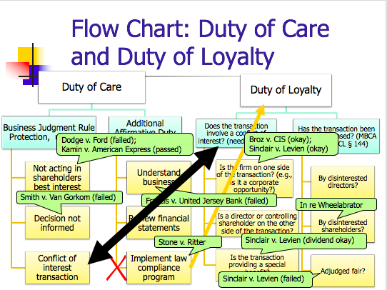
                - The courts have put it with duty of loyalty so that you cant contract around it
          - Duty to disclose?
      - Shareholder Duties/Roles
        - Role
          - Sue
            - Direct Suits - A suit alleging a direct loss to the shareholder
              - Basis:
                - Contractual rights that were granted to you when you became a shareholder
                - Force payment of a promised dividend
                - Enjoin activities that are ultra vires
                - Claims of securities fraud
                - Protect participatory rights for shareholders
            - Derivative Suits – a suit alleging a loss to the shareholder cause by a loss ot the corp
              - Basis:
                - Breach of duty of car
                - Breach of duty of loyalty
              - 2 suits within a derivative action:
                - A suit by the corp against the directors for their failure to carry out fiduciary obligations AND
                - A suit by the Pl arguing that he or she should substitute for the directors in managing this particular aspect of the corp’s business
              - Remedies:
                - The shareholder is suing “in right” of the corp so
- Remedy from principal suit goes to the corp
- Corp is required to pay shareholder attorney fees if suit is successful or settles
              - Who can bring a derivative suit under MBCA:
                - Must be shareholder at time of the alleged wrongdoing
                - Named Pl must be a fair and adequate representative of the corp’s interests
- IE no conflicted interests such as suit for unrelated strategic purpose
                - In many states, must continue to be a shareholder
              - 3 procedural hurdles in a derivative action:
                - Bonding requirements
- In some states (though not DE) a derivative claimant with low stakes must post security for corp’s legal expenses
- Why?
  - Deter frivolous law suit
                - Demand requirement
- Most states require shareholders in derivative suits to approach the Bord of Directors and demand that they pursue legal action before bringing a derivative suit
  - IN DE: Unless the shareholder can claim a valid excuse not to (IE would be futile – then can be excused)
  - Demand excused (futile) if Pl creates reasonable doubt that:
    - Directors are disinterested and independent or that
    - Challenged transaction was product of valid exercise of business judgment
  - BUT discovery limited to tools at hand
  - If file complaint must state what you did or why you didn’t do it
  - IN DE: You surrender certain rights if you file a ademan letter
- UNDER MBCA
  - Demand ALWAYS required (no futility argument) – but you don’t lose rights like you do in DE for filing demand
  - “No shareholder may commence a derivative proceeding until … a written demand has been made … and 90 days have expired from the date the demand was made … unless irreparable injury to the corporation would result by waiting for the expiration of the 90-day period”
  - Disposition of demand req:
    - 7.44 (a) Court will dismiss if independent directors or panel find in good faith proceeding with suit not in best interest of corporation.
    - 7.44 (b) Evaluation by (1) a majority of independent directors, or (2) a majority of committee of independent directors.
    - 7.44 (c) Can proceed after demand rejection if majority of board not independent or review not in good faith or reasonable.
    - 7.44 (d) Burden of proving in good faith and reasonable shifts to Board if majority of directors not independent.
- Policy concerns supporting demand req:
  - The demand requirement is a recognition of the fundamental precept that directors manage the business and affairs of the corp
- What is “the demand”
  - Typically a letter from shareholder to board of directors
    - Must request that the board bring suit on the alleged cause of action (IE basically asking them to sue themselves)
    - Must be sufficiently specific as to apprise the board of the nature of the alleged cause of action and to evaluate its merits
- Grimes v. Donald: shareholder sues bc says board has allowed Donald too much power and pay him too much, Donald has an extensive “income continuation plan” in which if he is constructively wrongfully terminated (with or without cause) he gets a lot of severance money and other benefits, also Donald is allowed to do his job without too much oversight form director, part of agreement says if they both him too much that
  - What standard of review is applied to compensation issues and why?
    - BJR bc Grimes made a demand – what would be applied I he hadn’t?
  - What are the claims that Grime alleges and what is decided?
    - Abdication of board powers to managers – direct
      - Says that the compensation system for Donald is so excessive that it creates a huge incentive for the board to not question his decision, therefore essentially abdicating their power to him
      - Direct bc as a shareholder Grimes has a right to elect firm managers and the firm has allegedly delegated too much power to Donald
      - Loses on merits, says board didn’t abdicate, they simply made a judgment and every decision limits your options to do something else
        - Also say that firm hired lawyers and banks to do reports and based their decision on those
    - Excessive Comp – derivative
      - Derivative bc challenging board management decision as a harm to corp not himself
      - Loses on procedure, cant make both a demand AND plead excuse/futility
  - What is the effect of making a demand before filing a derivative suit?
    - It limits your options, nonsensical requirement bc court says you should ask the board first but then if you ask the board clearly you trust their judgment enough to ask them to make a decision of whether they should sue themselves so you cant say you don’t trust their business judgment
  - What recourse does shareholder have if board decides not to pursue?
    - Director’s refusal of demand request subjects their decision to BJR
    - So unless the board was acting in one of 4 ways you wont be successful
      - If literally wasting money for nothing – couldn’t say that here bc money was exchanged for Donald’s work (even if was too much)
      - If affirmatively state they don’t care about shareholders (Dodge v. Ford)
      - Didn’t make an informed decision – but they did the reports here so that doesn’t work
      - Conflict? Cant even claim this bc obviously if you went to the board you trust them
    - Can only bring PROCEDURAL not substantive challenges
  - Does making the demand effect ones subsequent rights?
    - Yes! Once demand made (in DE) can no longer challenge Board’s independence (citing Spiegel), only boards handling of demand request can be challeneged
  - What doe sa rational Pl do in DE?
    - A rational Pl will file the derivative suit before making the demand
    - Consequences of not making the demand are trivial, if required slight delay while you make demand (while consequences if you make demand are big)
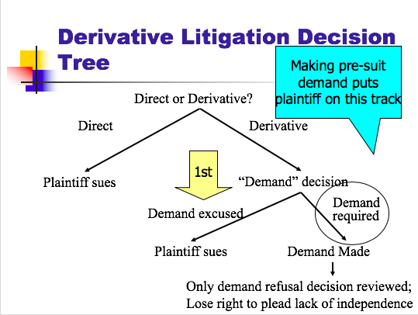
    - Preserves right to litigate on the merits
                - Special Lit Committee
- DE standard for reviewing SLC recommendations
  - Step 1:
    - Inquiry. Into the independence and good faith of the committee
    - Inquire into the bases supporting the committee’s recommendations
  - Step 2:
    - Court applies its on business judgment as to whether the case should be dismissed
- Zapata v. Maldonado: demand not made, excused as futile, board appoints SLC comprised of new board members, recommends dismissal
  - Issues:
    - Can the board seize the derivative litigation?
      - Yes
      - BUT IF THEY pass the Zapata test, but it cannot terminate it
      - Lower court says that the Board can't be trusted, so the plaintiff gets control of the case.
      - But the Appellate court says that the Board can take it back once the SLC is in place.
    - Can the tainted board members appoint a non-tainted committee?
      - Yes
      - But this situation is suspicious enough that it requires increase in judicial scrutiny and a new rule (see below), they came from a toxic fam
    - How should a court review the decisions of the special lit committee?
      - Courts business judgment
    - Why is the judicial review far more intrusive than usual?
      - Context: demand was excused bc board disabled from acting due to conflicted interests
      - Committee appointed by disabled board
    - Parallels to “cleansing” analysis? Think back to Sinclair Oil v. Levien. Sinven had no independent board members. MG suggested that Sinven could appoint independent directors to try to cleanse the transaction. Independent directors (forming SLC) may be able to preempt a derivative suit.
          - Vote
            - Who
              - Shareholder of record
                - Holder on the record date votes
- No more than 70 days before vote)
- Means they can declare a day on which whoever holds shares get to vote and then the voting day is 70 days later
  - IE if day of record is 12/1 and voting day is 12/15 and you buy a share on 12/2, you don’t vote but the person you bought the share form on 12/1 can
              - Default is 1 share – one vote (unless articles of incorp. provide otherwise)
            - When
              - Shareholder meetings
                - Annual meetings
- Time set in by laws
                - Special meetings
- By requet of Board of directors OR
- At written request of at least 10% of shares
              - Unanimous written consent
            - How
              - Most matters require majority of share at a meeting at which there is a quorum
              - Shareholders ever either I person or by proxy (like a mail in ballot)
                - Shareholder appoint a proxy (aka a proxy agent) to vote his/her shares at the meeting
                - Appointment affected by means of a proxy (aka proxy card)
- Can specify how shares to be voted or give agent discretion
- Revocable
              - Process for rpoxy contests:
                - Proxy contest regulated by SEC rules
                - Insurgents must send out unofficial proxy solicitation before they solicit proxies
                - The company sends out the official proxy materials
- May include shareholder proposals – Rule 14(a)-8
            - What
              - Election of directors
- Which directors you can vote for:
  - Incumbent board nominates a slate of directors
    - The co. sends out the official proxy solicitation materials
  - A competing slate currently needs to be offered in separate proxy materials
    - Insurgent pay the costs (including mailing) – this can be a lot when there are billion of shares in the co
  - Dodd Frank/SEC allows director nomination (of one or more, up to 25% of board) if more than 3% of shareholders for 3 years (almost never happens)
              - Amendments to article of incorp and by laws
                - Always harder to amend charter (IE articles of incorp) vs. by laws (like constitution vs. statute)
                - MBCA
- Article of incorp
  - Change must be adopted by board of directors AND approved by a majority of the votes of the shareholders present (as long as a quorum)
- By-laws
  - Shareholders may amend or repeal AND directors may amend or repeal, unless pertaining to director election or bylaws prohibit (easier to change than DE bc don’t need directors on board)
                - DGCL
- Certificate (Articles) of incorp
  - The directors shall adopt a resolution and holders of a majority of the outstanding stock must vote in favor of the amendment (more difficult to change than MBCA bc need a majority of ALL shares not just those which are present like under MBCA)
- By-laws
  - The power to adopt, amend, or repeal bylaws shall be in the stockholders entitled to vote (plus, directors may also have this power if so provided in the articles of incorp, not a given that directors can change like in MBCA)
              - Fundamental transactions
              - Odds and ends, such as “precatory” measures
                - Company materials (so don’t need to spend on a sperate proxy), can include if comply w/ Rule 14-a-8
                - Rule 14-a-8: Shareholder Proposals:
- Allows qualifying shareholders to put a proposal before their fellow shareholders
  - And have proxies solicited in favor of them in the company’s proxy statement
  - Expense thus borne by the company
- Eligibility Requirements:
  - Must have owned at least
    - 1% or $2k (whichever is less) of the issuer’s securities
      - How to calculate whether the 2k min is met? → multiply the number of securities the shareholder held for the one-yeat period by the HIGHEST SELLING price during the 60 calendar days before the shareholder submitted the proposal
    - for at least one year prior to the date the proposal is submitted
  - Must be submitted 120 days before the date on which the proxy materials were mailed for the previous year’s annual shareholder’s meeting
  - Proposal plus supporting statements cannot exceed 500 words
- Shareholder proposal can be excluded by company IF:
  - Proposal is not a proper subject of action for shareholders under the laws of the jdx of the company’s organization
  - Implementing would violate law
  - Implementing would violate proxy rules
  - Proposal involves personal grievance or special interest
  - Proposal is not relevant to firm’s operations
    - IE shareholders cannot manage the operations of the company – that is up to the directors
    - Shareholders don’t have the power to dictate what the company does and doesn’t do, that is why this is phrased as “precatory” matters
    - So when drafting, must make sure to not overstep precatory power
  - Company lacks power to implement
  - Proposal deals w/ the company’s ordinary business operations
    - Tension b/w this and the “proposal is not relevant to firm’s operations” creates a very narrow field of what can be proposed IE not something that encroaches on directors day to day operations but also not something that is outside of the scope of what the company does
    - Cant propose something that isn’t relevant but also cant propose something that is TOO releveant to day to day operations
    - Cant be too closely involved and can’t be not involved enough
  - Relating to electing directors
- SEC Response:
  - Go to SEC before go to court
  - Staff Level Action
    - If staff determines proposal can be excluded: issue a no-action letter
    - If staff determines should b eincluded: notify the issuer of possible enforcement action if proposal is excluded
  - SEC reluctantly referees the shareholder proposal process
- Lovenheim: Pl owned 200 shares of stock in Iriqouis Brand foods who produces foie gras, Pl finds the production of foie gras morally reprehensible, wants to propose a recommendation that they investigate this, Df says they don’t want it in the proxy material, Df argues there Is an exception that don’t have to include proposals that account for less than 5%, court says this meets the sweet spot of kind of proposals that must be included, why does it hit the sweet spot? Bc it says a board should look into it (BUT if has said sale of foie gras should be excluded then it might have not been a proper proposal bc then that enter territory of day to to day stuff) so him framing it in a board just looking in on the matter, but what about the relevance argument? Df argues that it is a such a small part of the economics that is not important enough, ct says when it comes to moral matters then economics don’t matter, bc there is an issue of animal rights and investors might be interested
  - Proposal said: “form a committee to study the methods by which its French supplier produces paˆt ́e de foie gras, and report to the shareholders its findings and opinions, based on expert consultation, on whether this production method causes undue distress, pain or suffering to the animals in- volved and, if so, whether further distribution of this product should be discontinued until a more humane production method is developed”
  - Are pate operations economically significant?
    - Only account for 79k of 141 mil of firm wide revenue IE not even .05% of sales
    - But bc this is an issue or morals not economics, its doesn’t matter
  - Why included?
    - “Otherwise significantly related” includes ethical and/or social significance
    - Financially insignificant but ethically significant
  - Why didn’t Lovenheim offer a proposal prohibiting the company from selling pate?
    - Bc that would’ve overstepped the precatory boundary and put him into regulating the everyday operations of the corp, the way it’s phrased now (as suggesting the formation of a committee) hits the perfect balance b/w relevance
  - Why did Lovenheim offer this proposal?
    - M he was morally opposed to it and the SEC allows shareholders to voice the opinions on things besides economics
  - How do you feel about that motivation as a shareholder of Iroqouis Brands?
    - Other shareholders might get angry that using corp money on Lovenheim’s political interests
  - How do you feel about the SEC spending resources to monitor shareholder proposals?
    - Been getting a lot of pushback recently
  - What can you say about the price of a share of Iroquois Brand stock in the period when Lovenheim submitted his proposal?
    - Must’ve costed more than $10 bc he owned 200 shares and the requirement is aboce $2k so the 200 shares must’ve exceed the 2k requirement
              - Non-binding “say on pay” vote at least every 3 years
              - Proxy fight
                - Separate proxy: costs only reimbursed is successful
- Rosenfeld v. Fairchild Engine: preparing a competitive proxy with a competitive slate
  - What was the issue at the heart of the proxy fight to take control of the Fairchild Board?
    - That the former officer and director, Card Ward, was getting paid to much
    - Who pays for campaign?
  - What would happen to the costs incurred by the insurgents if they were unsuccessful under the Froessel rule? (IE what is the holding of this case)
    - Froessel Rule: incumbent board proxy costs paid regardless of outcome (UNLESS is totally a personal dispute – but pretty much can always frame it as a policy dispute); insurgent costs may be reimbursed IF the insurgents win
    - Court also require a shareholder vote to reimburse insurgents
    - Dissent says = incumbents should only be reimbursed for expenses that are for the corp (IE policy disputes), not themselves (personal disputes) – but almost everything can be described as a policy suit
  - What happened to the costs incurred by the management when they were unsuccessful?
    - Still reimbursed
  - What kind of incentives does this provide for proxy contests?
    - Froessel rule stops proxy fights from happening too often

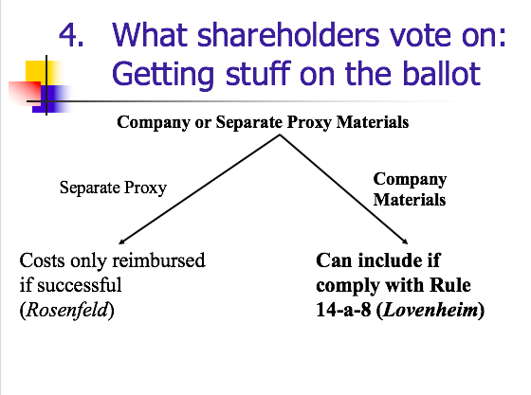
          - Sell (Insider Trading)
            - Statutory Insider Trading
                - Bright line prohibition – all gains w/I 6 months by stat insiders forfeited to firm
              - § 16(a): if owns 10% OR are a director or officer (a “Statutory Insider”), then must report ownership stake and changes to SEC
              - § 16(b) “Statutory Insider” profits from a purchase and sale OR sale and purchase within 6 months are recoverable by the firm
                - Sale and purchase:
- The sale and purchase must occur within 6 months of e/o
  - Must be a stat insider at time of sale AND purchase
- Only covers transactions where such a beneficial owner a BOTH time and purchase of sale
                - Recovery
- Any recovery goes to company
- Courts interpret the statute to maximize the gains the company recovers
  - Dunder Mifflin Hypo: assume Micheal Scott IS a director (so automatically an insider, no 10% analysis),
    - 5/1 MS buys 10 shares of SM for $3/share
    - 6/1 MS buys 20 shares of DM for $12/share
    - 6/10 MS buys 15 shares of DM for $5/share
    - 6/30 MS sells 3 shares for $10
    - Liability bc he was an insider and bought and sold w/I 6 months
    - What amount if any is his stat insider trading liability → match it to lowest price for share – here is $3/share, so take that away from what he sold (10-3) and you get $7/share, so his profit for those 3 shares was (3x7) $21
  - What if sold 12 shares for $10/share on 6/30 instead
    - You go to lowest price per share and use up all those shares (so 10 shares for $3/share) up to 10 shares = $70, for the remaining 2 shares, go to next most profitable share price (15 shares of DM for $5/share) so 2 shares at $5
              - Both over and under inclusive
                - If measured against the standard of insider trading being about someone with secret info
                - If you do it without secret info but within 6 months, it applies → over inclusive
                - If you do it with secret info but outside of 6 months (like in 7 months) it applies → under inclusive
              - How to avoid statutory Insider trading?
                - Don’t become an insider (IEdont become a director and never own more than 10%)
                - Don’t sell for profit /I 6 mo
                - Don’t have any profits
- Reliance Electric v. Emerson Electric: 6/16 - Df bought 13.2% of a Dodge’s shares; 8/28 sale disposed of 9.96%; 9/11 dispose of remainder
  - Was the 6/16 purchase “matchable” (IE was Df a stat insider on 6/16) – yes, parties didn’t even appeal that this purchase was matchable
    - In the morning before they purchased they weren’t, but in the afternoon once the purchase was made they were so treat as yes so purchase on 6/16 is subject to stat 16 liability
  - Assuming 6/16 purchase IS matchable, can it be matched to 9/11 sale?
    - NO bc Emerson wasn’t a 10% owner on 9/11
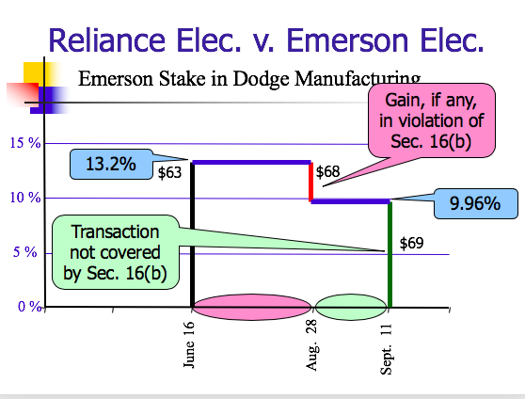
  - Assuming 1/16 purchase was matchable, 8/28 sale WAS subject to stat 16 liability and funds recoverable if any earned go to company
- Dunder Mifflin Hypo 2: assume 100 stocks outstanding, on 5/1 Michael Scott (who is NOT a director or officer of DM) buys 5 shares of DM for $3/share, on 6/1 Michael Scott buys 10 more shares of DM for $13/share, on 6/30 Michael Scott sells 3 shares for $10, what amount if any is Michael Scott’s statutory insider trading liability?
  - You ignore the 5/1 sale bc only purchases WHILE he was a stat insider count (so only 6/1 purchase counts)
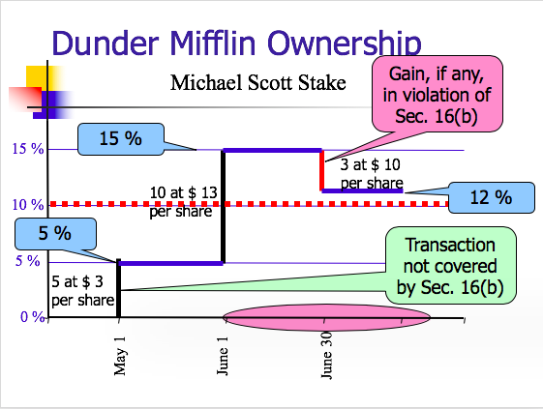
  - He incurred a loss (bc he bought the shares for $13/share and is selling at $10/share) so no recoverable profits
            - Classical Insider Trading
                - Firm insiders use of material nonpublic info to trade in their firm’s share violates 10-b-5
              - What happens when you work at a company and as a result get you get inside information others don’t know about?
              - When does your knowledge preclude you form trading?
                - When the info material nonpublic info
- Material = whether there is a substantial likelihood that a reasonable shareholder would consider the fact important
              - Rule 10 b-5: (applies whether or not a public offering)
                - It shall be unlawful for any person, directly or indirectly, by the use of any means or instrumentality of interstate commerce, or of the mails or of any facility of any national securities exchange,
- (a) To employ any device, scheme, or artifice to defraud,
- (b) To make any untrue statement of a material fact or to omit to state a material fact necessary in order to make the statements made, in the light of the circumstances under which they were made, not misleading, or
- (c) To engage in any act, practice, or course of business which operates or would operate as a fraud or deceit upon any person,
                - in connection with the purchase or sale of any security.
- Texas Gulf Sulphur: in late 1950’s TGS begins exploring eastern Canada for metal mines, in 10/29-30/63 exploratory hole k-55-1 is drilled (visually assay is VERY promising, knew they hit a gold mine), based on core smaple results, TGS begins acquiring land (presient of TGS demands secrecy), 11/12/63 – TGS insiders and “tippees” begin acquiring shares and call options, 3/37/64 land acquisition is complete, 4/11/64 unauthorized press reports, 4/12/64 TGS make press release saying that original press releases were miseleading, 4/16/64 official statement made at 10 am by TGS that they found this fruitful mine, 4/16/64 news appeared on Dow Jones ticker take at 10:54 am
  - Is there evidence that the k-55-1 find was material?
    - They bought up half of eastern Canada and their stock tripled so yes
  - Is there evidence the press release was misleading?
    - The court says that there is no evidence that the press release was misleading because the stock went up anyway after the press release. (IE nobody believes the corporation when it makes this kind of "corrective" press release anyways)
    - MG says they probably released it to get back at press bc ocrps usually have a very controlling relationship with press and get mad when they betray it
  - Did TGS have to disclose the k-55-1 discovery?
    - No, no affirmative duty to disclose everytime something good happens, they have discretion of when to disclose their discovery
  - What choice did the managers at TGS have with respect to stock purchases?
    - Disclose or if they couldn’t disclose (which they had been forbidden to by president) abstain from trading
  - Why is Rule 10b-5 helpful in addressing an insider trading claim?
    - Bc lays standard of not OMITTING MATERIAL FACT (necessary in order to make the statements made, in light of the circumstances….in connection with the purchase or sale of a security) – this is the stat basis
  - Rationales for Prohibiting Insider Trading:
    - Problems with deciding TGS based on establishing a level playing field?
      - Some information advantages are created in a legitimate manner
    - Problems with deciding TGS based on a violation of fiduciary duty?
      - May not capture all situations where use of inside info is unfair
- Chiarella: limits traditional insider trader
  - Printer mark up man case
  - Majority throws out level playing field theory for prohibiting insider trading
  - Violation of 10-b-5 occurs only if informed trader owed a duty to the corp or shareholders of the firm whose stock he traded and here he did not
  - Df worked for Pandick Press, which was going to merge with Target, Df learned this bc worked at Pandick, so bought Target stock, court said didn’t owe a duty to Target shareholders so no insider trading
            - Tipper/Tippee liability → type of classical bc still buying shares in the company the insider worked for
                - Insider trading prohibition extends to those who use non-public info they know was provided by tipper for a personal benefit
              - Middle ground between never being able to trade on a tip and always being able to (free market) → sometimes you can’t and sometimes you can
              - For a tippee to inherit a tippee’s duty to disclose or abstain, must:
                - Flunk the Personal Benefit test
- Monetary gain
- Reputational gain
  - Has to do with being a better business person so that people think you’re good at business
- Quid pro quo
- But NOT:
  - Desire to provide a public good (like Dirks did here)
                - Tippee must have reason to know of breach
              - Dirks v. SEC: Dirks was a broker at an NYC broker-dealer firm, he received material nonpublic info from an insider (Seacrist – former officer at Equity Funding America) about EFA, Secrist wanted to tell someone the info about EFA’s assets being way overstated due to fraud going on at the company, Dirks flew in and investigated at EFA and found evidence to corroborate what Secrist was saying, Dirks didn’t own and sotck in EFA but he then told his clients who did and they all sold their shares, SEC said he participated in insider trading bc he shared the allegations of fraud w/ his clients
                - Did Secrist owe a Duty to EFA and its shareholders?
- Yes, duty to disclose or abstain – he just didn’t violate it bc he disclosed it for no personal benefit and he didn’t trade
                - Did Dirst inherit Secrist’s “disclose or abstain” duty by being a tippee?
- NO, for tippee to inherit must first flunk the “personal benefit” test AND
- Tippee must know or have reason to know of breach
                - Constructive insiders → Dirks est. a category of “constructive insiders “who can violate insider trading prohibitions where they 1) obtain material nonpublic info from the issuer with (2) an expectation on the part of the corp that the outsider will keep the disclosed info confidential and (3) the relationship at least implies such a duty
- Best example = lawyers
                - Level playing field rationale is extinguished after Dirks and Chiarella → a duty to disclose does not arise from the mere possession of nonpublic market info
              - Salman: Maher gives nonpublic material info to his brother Michael, Michael who then gives it to Maher’s brother in law Bassam, Bassam used it to trade, court said eh is liable bc Salman traded w/ full knowledge that it had been imporpoerly disclosed (also a missappropriaiton case bc the info Maher actually gave was not about the company he worked for)
            - Fiduciary Trades using info that was misappropriated
                - Insider trading prohibition extends to those who use non-public material info in violation of a fiduciary obligation
              - Trading stock of a different company from the one you work at or with, with information you got from the company you work at or with
              - O’Hagan: O’Hagan worked for Grand Met as a lawyer, Grand Met was merging with Pillsbury, he bought shares in Pillsbury, ct. said that this violated a fiduciary duty (presumptive duty to not he owed to Grand Met so is liable, would have to disclose (brazen), consistent with prohibition of deception in 10-b-5
                - Disclosure might be enough, but better to not risk it courts have still put people in jail (safer to get approval)
            - Rule 14-e-3 – NO TRADING ONCE KNOW OF TENDER OFFER
              - Prohibits insider trading during a tender offer and supplement 10-b-5
                - Once substantial steps towards a tender offer taken, Rule 14e-3(a) prohibits anyone, except the bidder, who possesses material, nonpublic information about the offer from trading in the target’s securities
                - Rule 14e-3(d) prohibits anyone connected with the tender offer from tipping material, nonpublic information about it
              - Rule 14e-3 is not premised on breach of a fiduciary duty
                - O’Hagan upholds it anyway
        - Duties:
          - None unless controlling shareholder (see above)
        - Creditors Duties
          - Bottom line = governed by K law
          - Legal analysis turns on:
          - Interpretation of express terms
          - Implied duty of good faith and fair dealing
          - NO fiduciary duties to debtholders
  - Termination
    - Voluntary dissolution:
      - Board submits and shareholders vote on proposal to dissolve: MBCA § 14.02 (b)
      - Submit Articles of Dissolution to state
      - Can only carry on to wind up
    - Involuntary dissolution:
      - If there is a deadlock: MBCA § 14.30

