TORTS OUTLINE
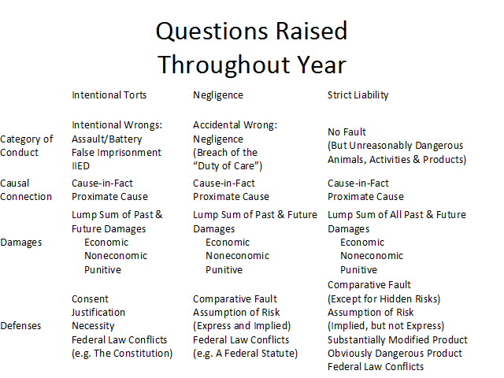

- INTENTIONAL TORTS

  - GENERAL PRINCIPLES

    - Themes of Torts
      - Compensation – putting the plaintiff in the position they were in before the injury occurred.
      - Deterrence – preventing possible tortfeasors from causing injury, and preventing defendants from reoffending.
      - Corrective Justice – when a person is wronged and severely injured, they deserve to be fully compensated by the person who wronged them.
      - Public Redress in Court – awarding noneconomic damages arguably “evens out” tort awards among the rich and poor; overall access to courts.
    - Intent requires either that one:
      - act with the particular “purpose” to produce a result forbidden by one of those causes of action; or
      - has knowledge and be “substantially certain” that those consequences will result.
    - Capacity is not a defense.
    - Whether forbidden conduct is construed as harmful or offensive is judged objectively by a “reasonable person of ordinary sensibilities” standard.

  - BATTERY/ASSAULT

    - Battery
      - Elements
        - Intentional “offensive” contact (to which person has not consented; can be poison or trap)
        - To body or object intimately connected to body
      - Doctrine of Transferred Intent – if your intentionally wrongful act incidentally hurts another, that second person also may bring an intentional tort.
      - Intent to injure is not necessary when defendant willfully sets in motion force that causes injury.
    - Assault
      - Elements
        - Intent to put individual in “reasonable apprehension” (awareness) of
        - “Imminent” bodily harm.

GARRATT v. DAILEY

Facts: Brain Dailey (5 years, 9 months) was visiting with Naomi Garratt, the sister of P. Ruth Garratt (P) went to the backyard to talk to Naomi. TC accepted D’s version: took chair and moved it a few feet then sat down, discovered P was about to sit at place where chair was, and tried to move it back in time. P sustained fracture and other injuries.
Holding: No, the court needs clarification of findings of Brain’s knowledge.
Rule: Battery would be established if knowledge of “substantial certainty” that harm would have occurred could be proven.
Rationale: Absence of intent to injury, playing a prank, embarrass, commit assault does not absolve from liability if he knew “when Brain moved chair, with substantial certainty, P would attempt to sit down.
Discussion: Intent for battery required. Need to have either (1) intent to cause harm or (2) know with substantial certainty that the harm is likely to occur.

PICARD v. BARRY PONTIAC-BUICK, INC.

Facts: Employee (D) of auto dealer (D) and Picard (P) had dispute over whether car passed inspection. Both went to a repair shop together where Picard took a photo of an employee as he was inspecting brakes. Evidence (photo) shows D pointing finger at P as D approached her.
Holdings:
(1) Yes, P established a prima facie case of assault.
(2) Yes, P proved elements of battery.
(3) Yes, damages are excessive and punitive damages are inappropriate
Rules:
(1) Assault is physical act of a threatening nature or an offer of corporal injury, which puts individual in reasonable fear of imminent bodily harm.
(2) Battery is an act that was intended to cause “an offensive contact with or unconsented touching of or trauma upon the body of another, thereby generally resulting in consummation of assault.” Intent to injure is unnecessary where D willfully sets in motion a force that in its ordinary course causes injury.
Rationale:
(1) apprehension must be type of fear normally aroused in mind of reasonable person; P’s reaction was reasonable
(2) D’s offensive contact with object attached was sufficient to constitute battery
(3) inadequate medical evidence therefore excessive and no proof of malice or bad faith, therefore inappropriate punitive damages
Discussion: Why are there no punitive damages? “No proof of malice”
- compensatory damages are enough
- act is not bad enough
- “reactive,” heat of the moment

WISHNATSKY v. HUEY

Facts: Huey (D) and Crary were in Crary’s office holding a private conversation. Wishnatsky (P) entered without knocking, but Huey pushed door closed and thereby pushed P back into the hallway.
Holding: No battery occurred.
Rule: Restatement (2d) of Torts:
18. Battery (1)(b): offensive contact with a person that directly or indirectly results.
19. What constitutes offensive contact: a bodily contact is offensive if it offends a reasonable sense of personal dignity.
Rationale: P is “unduly sensitive as to his personal dignity” and conduct must offend only the “ordinary person.”
Discussion: Contact is not “offensive” because it must be measured objectively.
Why “reasonable person”?
- not fair to have different cases based on the P
- need to draw the line for some cases
- court strikes balance between incidental conduct and offensive conduct; getting doors slammed in face considered a part of everyday life

  - FALSE IMPRISONMENT

    - Elements
      - Act intending to wrongfully confine another within boundaries fixed by actor.
      - Directly or indirectly results in confinement.
        - physical force or threats
        - duress
        - legal authority
        - not “moral” force (see Lopez)
      - Conscious of confinement or, at least, harmed by it if unconscious.
    - Notes
      - Not confined if “reasonable means of escape.”
      - Boundaries need not be physical – threats are sufficient (so long as they would threaten a person of “ordinary sensitivity”).

LOPEZ v. WINCHELL’S DONUT HOUSE

Facts: Lopez (P) was a clerk in D’s donut shop. On April 8, 1981 P was asked to come into shop where D’s employees Bell and Cesario accused P of selling donuts without registering sales. P voluntarily entered room, was never threatened, was never in fear of safety, and at no time was prevented from exiting. However, P felt “compelled” to stay and protect her reputation. P left room after she began to shake and feel ill.
Holding: No. TC properly granted D’s motion and no question of material fact exists.
Rule: Restatement of Torts: elements of false imprisonment include
- actual or apparent physical barriers
- overpowering physical force
- threats of physical force
- other duress
- asserted legal authority
Rationale: It is not enough for the P to have felt “compelled” to remain in the room. There is no evidence that P yielded to constraint of a threat, express or implied, or to physical force of any kind.
Discussion: The “moral force” that compelled P to stay in the room is not enough to constitute confinement. Why doesn’t the threat of losing a job constitute sufficient “force” of confinement? Movement in false imprisonment doctrine to strike a balance between employees’ interest in freedom of movement against employers’ need to investigate misconduct. CA: shopkeepers have immunity for “reasonable time” to investigate so long as there is “knowledge” of attempt to steal goods.

  - INTENTIONAL INFLICTION OF EMOTIONAL DISTRESS

    - Elements
      - An intentional or reckless act that, by
      - Extreme and outrageous conduct,
      - That causes
      - Severe emotional distress to another.
    - Notes
      - Must offend “generally accepted standards of decency or morality.”
      - Hallmarks of outrageous conduct include:
        - conduct continuous or repetitive
        - whether defendant is in unique position of control or authority
        - to vulnerable populations
        - by transportation company/innkeeper

WOMACK v. ELDRIDGE

Facts: Eldridge (D) was instructed by employer to obtain a photo of Womack (P) to use in a criminal court trial where employer’s client was charged with child molestation. D went to P’s house, said she was a reporter and asked to take a picture of P. At court the employer introduced the photograph as an alternate molester to his client, but the victims said it wasn’t the suspect. D was called to the stand to testify to who the man in the photo was and his address. P was an alternative because he worked at the same establishment as employer’s client. P continued to be involved in that case and was summoned to testify.
Holding: P is entitled to recovery for emotional distress even in the absence of bodily injury & a jury should determine the amount of damages.
Rule: Cause of action for emotional distress without bodily injury exists if:
- conduct was intentional or reckless
- conduct outrageous and intolerable that it offends against generally accepted standards of decency and morality
- causal connection between wrongdoer’s conduct and emotional distress
- emotional distress was severe
Rationale: Reasonable people can disagree over the issues (i.e. whether it was intentional or reckless) the court claimed to have answered. Therefore, it should have been left up to the jury.
Discussion: What did D have to know at the time of taking the picture? That it would be used in a criminal case? That he could be accused unjustly of child molestation? That is was for an attorney? Was there a causal connection between photographer’s actions and emotional distress?

HUSTLER MAGAZINE v. FALWELL

Facts: Hustler Magazine (D) published a parody ad of Jerry Falwell (P) that had a sexual double entendre of the minister’s “first time” drinking Campari Liqueur. D published an alleged “interview” with P but had a disclaimer saying “not to be taken seriously.”

Holding: A public figure, Jerry Falwell, may not recover damages for emotional harm caused by publication of “ad parody” because of the First Amendment defense.
Rules: (IIED) Cause of action for emotional distress without bodily injury exists if:
- conduct was intentional or reckless
- conduct outrageous and intolerable that it offends against generally accepted standards of decency and morality
- causal connection between wrongdoer’s conduct and emotional distress
- emotional distress was severe
(First Amendment Defense) A public figure may hold a speaker liable for damage to reputation caused by publication of a defamatory falsehood, but only if:
- the statement was made with knowledge that it was false OR
- with reckless disregard of whether it was false or not (“malice”).
Rationale: 1. The First Amendment protects public debate about public figures. 2. Caricatures are often acceptable, and the parody here is “at best a distant cousin of the political cartoons” here. 3. “Outrageousness” has an inherent subjectiveness, which would allow a jury to impose liability on the basis of the jurors’ tastes or views, or their dislike.
Discussion: First Amendment requires higher standard of maliciousness or reckless disregard.
Why do public figures have less of a right? Policy (allowing for freedom of speech and protecting political opinions) and public figures are inviting of that kind of scrutiny.
D argument could be that they are not asserting that it is a “false statement of fact”
Related to: Snyder v. Phelps (issue of public concern – gay soldier’s funeral)

SNYDER v. PHELPS involves the Westboro Baptist Church, a fundamentalist Christian church that contends that God kills soldiers in Iraq and Afghanistan as punishment for America's tolerance of homosexuality and for the presence of gays in the U.S. military. The church has rabidly anti-homosexual views, and it has gained notoriety for staging protests at the funerals of U.S. soldiers in order to draw attention to its message. Albert Snyder's son, Lance Corporal Matthew Snyder, was a U.S. Marine who was killed on March 3, 2006 during active service in Iraq. His body was returned to the United States, and his family held a funeral for him on March 10, 2006 in Westminster, Maryland. The Westboro Baptist Church pastor and founder, Fred Phelps, and members of his congregation picketed Matthew's funeral, holding signs expressing anti-gay, anti-American, and anti-Catholic slogans, including "God hates you" and "You're going to hell." On June 5, 2006, Snyder filed a lawsuit in federal court in Maryland against Westboro Baptist, Fred Phelps, and anonymous members of the church congregation. The Court dismissed all of the claims except those involving IIED (and another tort I briefly mentioned, but that you will not need to know for our class, called "invasion of privacy.") The jury found for the plaintiff on his IIED claim, and imposed a judgment of $5 million dollars in compensatory and punitive damages. The Fourth Circuit, relying on Hustler, reversed. It agreed that the statements were repugnant, and that Snyder was a private figure, but found that Westboro Baptist's statements involved issues of "public concern," and hence, were protected by the First Amendment. And in an 8-1 decision, the Supreme Court upheld the Fourth Circuit, finding that the First Amendment precluded Snyder's IIED claim.

WILLIAM v. NBC
IIED (only intentional tort where “recklessness” is enough)
P argues: intentional, outrageous, causal, and severe; not protected by First Amendment because it is malicious that NBC is manufacturing a story and going beyond their role as news reporters
D argues: First Amendment defense, this is something the public deserves to know about; separating news reporters from the actions of police/SWAT
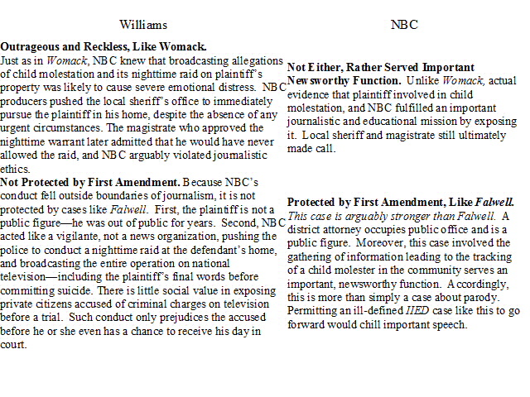
  - DEFENSES TO INTENTIONAL TORTS

    - CONSTITUTION
      - First Amendment limits tort actions involving public figures or issues of public concern to those cases that involve:
        - false statement of fact, or
        - actual malice

HUSTLER MAGAZINE v. FALWELL

Facts: Hustler Magazine (D) published a parody ad of Jerry Falwell (P) that had a sexual double entendre of the minister’s “first time” drinking Campari Liqueur. D published an alleged “interview” with P but had a disclaimer saying “not to be taken seriously.”

Holding: A public figure, Jerry Falwell, may not recover damages for emotional harm caused by publication of “ad parody” because of the First Amendment defense.
Rules: (IIED) Cause of action for emotional distress without bodily injury exists if:
- conduct was intentional or reckless
- conduct outrageous and intolerable that it offends against generally accepted standards of decency and morality
- causal connection between wrongdoer’s conduct and emotional distress
- emotional distress was severe
(First Amendment Defense) A public figure may hold a speaker liable for damage to reputation caused by publication of a defamatory falsehood, but only if:
- the statement was made with knowledge that it was false OR
- with reckless disregard of whether it was false or not (“malice”).
Rationale: 1. The First Amendment protects public debate about public figures. 2. Caricatures are often acceptable, and the parody here is “at best a distant cousin of the political cartoons” here. 3. “Outrageousness” has an inherent subjectiveness, which would allow a jury to impose liability on the basis of the jurors’ tastes or views, or their dislike.
Discussion: First Amendment requires higher standard of maliciousness or reckless disregard.
Why do public figures have less of a right? Policy (allowing for freedom of speech and protecting political opinions) and public figures are inviting of that kind of scrutiny.
D argument could be that they are not asserting that it is a “false statement of fact”
Related to: Snyder v. Phelps (issue of public concern – gay soldier’s funeral)

    - CONSENT
      - May consent to battery or other limitations on personal autonomy.
      - Limits exist when:
        - consent not informed
        - consent not voluntary
        - consent not available for malicious attacks that goes beyond scope of consent
        - consent otherwise violates public policy
      - Analogy: Assumption of Risk Doctrine in Negligence

HART v. GEYSEL

Facts: Cartwright (deceased) died as a result of a blow by Geysel (D). Decedent and D engaged in a prize fight, which was illegal according to a statute. No allegations combat resulted from anger, malice or excessive force.
Holding: P is not entitled to recover from damages sustained in a consensual and illegal prize fight.
Rule: “Minority rule.” One who engages in prize fighting, even though prohibited by law, and sustains an injury, should not have a right to recover damages that he sustains as result of combat, which he expressly consented to and engaged in.
Rationale: Adapted “minority rule” despite lack of anger or malice because:
- no man shall profit from his wrongdoings
- if he gives consent he has no right to control how the other person uses that consent
Discussion: Reasons for support for majority rule:
protecting human life and de-escalating fighting
discourages maliciousness
deter behavior to begin with and discourage fighting
can’t give consent to hurt self

BARBARA A. v. JOHN G.
Holding: (1) Impregnating P went beyond scope of her consent and (2) consent obtained through fraud is invalid.

    - JUSTIFICATION
Justification and necessity defenses reflect an underlying principle that in some cases judicial remedies won’t practically resolve dispute and self-help is needed to avoid greater injury.

      - SELF-DEFENSE

COURVOISIER v. RAYMOND

Facts: Men entered Courvoisier’s (D) building without permission. D drew gun and forced them out. They and other men gathered in the street. D fired a shot to scare them away. Men started throwing stones and objects at D. D fired second shot, which attracted attention of two officers and Raymond (P). Called out to D telling him he was an officer and to stop shooting. Street was well lit and D alleges he didn’t have his glasses. P emerged from crowd, D claims he thought he was member of crowd. D aimed and shot.
Holding: This instruction excluded from the jury a full consideration of the justification of self-defense claimed by the D.
Rule: In a civil action, D using a plea of self-defense must satisfy the jury not only that he acted honestly, but also that his fears were reasonable under the circumstances.
Rationale: The second issue of “sufficient evidence of justification” was not included in the jury instructions. If jury believed D justified in shooting a rioter (who D believed P to be), and they believe D, the jury must consider this in his defense. Verdict might have been different with these instructions.
Discussion: Self-defense. Jury needs to be instructed as to D’s justification. *Note: the doctrine of “transferred intent” carried over if indirectly shot a third person when defending self against second person.

      - DEFENSE OF PROPERTY

KATKO v. BRINEY

Facts: Katko (P) and partner broke and entered unoccupied and what they thought was an abandoned house, which belonged to Briney (D), to steal old bottles. D boarded up windows and doors, posted “no trespass” signs. There had been several intrusions over the years and loss of items. P had been there several times before. D set a “shotgun trap” which could not be seen and had no warnings. P entzaaered house, shotgun went off, hit right leg, which was permanently deformed and shortened.

Holding: An owner cannot protect personal property (unoccupied boarded-up house) against trespassers and thieves by spring gun (capable of death or serious injury).
Rule: One may use reasonable force in the protection of his property, but may not use means of force as will take human life or serious bodily injury, unless trespasser committing felony of violence or capitol punishment where human life is at risk.
Rationale: 1. Human life is valued higher than property. 2. Precedent (persuasive cases – other states).
Discussion: What if there was warning and it was less dangerous (i.e. not automatic)? If it’s not automatic then there is a decision whether or not to shoot. If it is automatic you can’t exercise judgment. People can use “reasonable force” in response to a “reasonable belief.”

    - NECESSITY

      - Public Necessity
        - for purpose of averting imminent public disaster
        - salus populi suprema lex esto (“the welfare of the people shall be the supreme law”)
      - Private Necessity
        - privilege to take steps to protect self or third parties
        - but must compensate for damages
        - privilege extends to trespass to land, but not necessarily other kinds of harm to people
      - Rationale
        - deterrence: to encourage conduct that maximizes welfare
        - corrective justice and compensation: to compensate for burden to property or personhood
      - Additional Justifications
        - placing burden on party in best position to avoid harm (boat, not dock)
        - placing burden on party best able to manage insurance costs (boat, not dock)

VINCENT v. LAKE ERIE TRANSPORTATION CO.

Facts: Steamship owned by D’s was in process of unloading at P’s dock when violent storm and winds developed and continued to increase. During that time no master would have been justified in attempting to navigate vessel. If lines holding ship to dock had been cast off she would have drifted. Lines were kept fast and continuously replaced to hold to dock. Ship constantly thrown against dock.
Holding: P entitled to compensation for injury caused by D even though use of property was necessary.
Rule: Public necessity may require taking of private property for public purposes; but jurisprudence compensation must be made.
Rationale: Those in charge deliberately held the vessel in such a position that damage resulted. D preserved ship at expense of dock therefore owners are responsible to dock owners.
Discussion: Forbidden act: trespassing on property when their time was up without permission.
Additional Rationale:
- Fairness: saved your property so you should pay (corrective justice)
- Policy: deterrence, to encourage conduct that maximizes welfare
- Place burden of damages on party in best position to avoid harm and party in best position to pay/get insurance against loss

- NEGLIGENCE

  - DUTY
An obligation to conform to a particular standard of care to another, usually that of an ordinary, prudent “reasonable person.”

    - Questions to consider:
      - What should your legal responsibility be here?
      - What is the least burdensome thing you could do?
      - What are the policy concerns?
        - risk of vigilantism
        - do not want to place burden on bystander and limit civil freedoms
        - autonomy – law shouldn’t force you to do anything to help someone else
        - ambiguity
          - factual ambiguity – whether there is a problem to begin with
          - legal ambiguity – how far does the duty extend

    - Explicit Policy Grounds for Duty (Randi W.)
      - foreseeable
      - certainty of harm to plaintiff
      - closeness of connection
      - moral blame
      - policy of preventing future harm
      - burden on defendant and community of duty
      - availability, cost and prevalence of insurance

    - Misfeasance v. Nonfeasance
      - misfeasance – when a party exposes another to an increased risk of harm (must create/cause the harm)
      - nonfeasance – when a party, passively observes harm to another, but fails to act in order to reduce that harm – even when burden of reducing harm is very, very slight
      - why is there a difference between the two?
        - lack of bright line rules
        - altruism will accomplish the same
        - multiple rescuers can be an issue and create a bigger problem
        - risky self-sacrifice
        - would limit autonomy and liberty
      - why should there be an abandonment of the distinction?
        - collective action problems/bystanders
        - welfare losses
        - moral concerns

    - Nonfeasance Exception: Special Relationship to Victim
      - Rule: generally, absent some special exception or relationship, tort law punished misfeasance, but not nonfeasance
        - Exceptions to the Rule
          - special relationship to victim (similar to Harper)
            - common carriers
            - innkeepers
            - property held open to the public
            - custody over helpless people
          - botched rescue attempts or reasonable reliance on a “voluntary undertaking” (similar to Farwell)

HARPER v. HERMAN

Facts: Jeffrey Harper (P) was one of four guests on Herman’s (D) boat on Lake Minnetonka. Herman was an experienced boat owner and considered himself to be in charge of the boat and his passengers. Harper had never been on Lake Minnetonka, but Herman was familiar with it. Harper had no formal training in diving. D was aware the water remained shallow for a good distance from land. D was lowering ladder and P asked him if he was “going in.” D said yes and P dove into 2-3 feet of water. P hit the bottom, severed his spinal cord and was rendered quadriplegic.
Holding: A boat owner who is a social host owes no duty of care to warn a guest on the boat that the water is too shallow for diving.
Rule: An affirmative duty to act only arises when a special relationship exists between parties. Restatement Second of Torts. A special relationship giving rise to a duty to warn is only found on the part of common carriers, innkeepers, possessors of and who hold it open to the public, and persons who have custody of another person under circumstances in which that other person is deprived of normal opportunities of self-protection.
Rationale: A special relationship could be found to exist if D had custody of P under circumstances in which Harper was deprived of normal opportunities to protect himself. The record does not establish that D held considerable power over P’s welfare, or that D was receiving a financial gain. Nothing suggests P expected any protection from D. Superior knowledge of a dangerous condition by itself, in the absence of a duty to provide protection, is insufficient to establish liability in negligence.
Discussion: This is a case of nonfeasance. But can an argument for misfeasance be made?
What if D knew P was a “show off”?
What if D was charging for use of boat?
What if D was asked if it was safe to dive?

FARWELL v. KEATON

Facts: Siegrist and Farwell drove to trailer lot to return an automobile. While waiting for friend to finish work they consumed beer. Followed two girls and left Farwell’s car to the drive-in restaurant down the street. Girls complained about being followed to their friends and six guys chased Siegrist and Farwell back to the lot. Farwell was severely beaten. Ice was applied to his head. Siegrist drove Farwell around for two hours, stopping at restaurants. At around midnight Farwell went to sleep in backseat of car. Siegrist drove car back to Farwell’s grandparents’ home. Tried to wake him but couldn’t, and then left him in the car in the driveway. Farwell’s grandparents discovered him the next morning and took him to the hospital. Died three days later of epidural hematoma.
Holding: There was a special relationship between the parties; therefore Siegrist owed a duty to obtain aid for Farwell.
Rule: Rule for “undertaking.” If the D does attempt to aid him, and takes charge and control of the situation, he is regarded as entering voluntarily into a relation, which is attended with responsibility.
Rule for “special relationship.” Where such a duty has been found, it has been predicated upon the existence of a special relationship between the parties; if D knew or should have known of the other person’s peril, he is required to render reasonable care under all the circumstances.
Rationale: Jury must determine if the D attempted to aid the victim. If he did, a duty arose which required D to act as a reasonable person.
Farwell and Siegrist were “companions on a social venture.” Implicit in such a common undertaking is the understanding that one will render assistance to the other when he is in peril if he can do so without endangering himself. Since they were companions, there was a special relationship between the parties.
Discussion: Reasons for court’s decision:
- voluntarily attempting to aid Farwell (voluntary undertaking)
- joint endeavor (“social companions”)
Both are sufficient bases for a duty, each are enough on its own.

KNIGHT v. CALIFORNIA
Facts: Buzzy Knight, hypoglycemic episodes. Coworkers have cared for him before. In this instance, they gave him an ensure. Knight said he was fine to drive home. Deadly crash.
Plaintiff:
                - Alleges that Defendants were negligent because they committed misfeasance, not nonfeasance, and could have taken minimal steps to prevent Buzzy’s death.
                - Even if Defendants’ actions constituted nonfeasance, they were still negligent because
- Buzzy was under their custody, care or control and
- Defendants voluntarily assumed a duty of care to sick employees, like Buzzy, in the past.
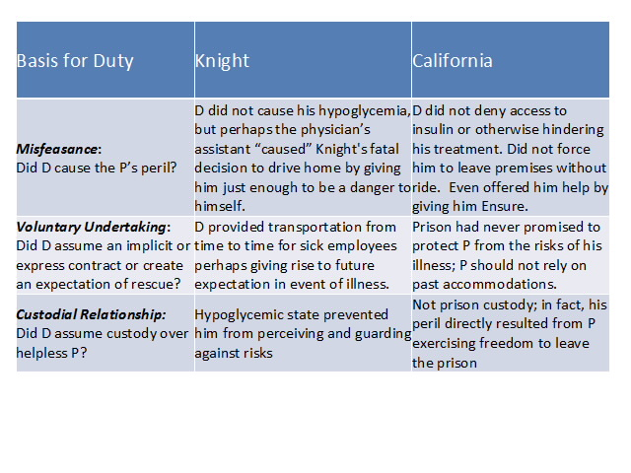
    - Nonfeasance Exception: Special Relationship to Perpetrator
      - Rule: generally, there is no duty to prevent others from causing foreseeable harm to third parties, absent a special relationship.
        - Exceptions:
          - negligent representation that impacts physical safety of others
            - R. 311 (similar to Randi W.)
              - negligently providing false information
              - that, when “reasonably relied” upon, gives rise to physical harm to third party
              - actor must reasonably expect third parties to be put in peril
              - negligence may consist of careless information gathering or communication
          - parent/child (knowing the child is likely to cause harm)
          - owner/use of property
          - one who “takes charge” of person one knows is likely to cause harm to another
            - R. 319 (similar to Tarasoff)
              - one who “takes charge” of person one knows is likely to cause physical harm to another
              - must exercise “reasonable care” to prevent harm, including warning to identifiable third parties of danger
            - Duty owed for other people’s conduct
              - residential facilities for people with mental impairment
              - homeless shelters
              - diocese

RANDI W. v. MUROC JOINT UNIFIED SCHOOL DISTRICT

Facts: Four school districts placed unreservedly affirmative references in a placement file for Gadams despite knowing that prior charges or complaints of sexual misconduct and impropriety had been leveled against Gadams in each district. Plaintiff alleges that plaintiff student’s school district relied on defendants’ letters in hiring Gadams as vice principal. Gadams sexually assaulted plaintiff. Plaintiff sues on theory of “negligent misrepresentation and fraud.”
Holdings:
      - The writer of a letter of recommendation owes to third persons a duty not to misrepresent the facts in describing the qualifications and character of a former employee, if making these misrepresentations would present a substantial, foreseeable risk of physical injury to third persons
      - These letters, recommending Gadams for any position without reservation or qualification, constituted affirmative representations that strongly implied Gadams was fit to interact appropriately and safely with female students
      - Sufficient causal connection was alleged.
Rule: Restatement Second of Torts, Section 311.
- one who negligently gives false information to another is subject to liability for physical harm caused by action taken by the other in reasonable reliance upon such information, where such harm results
  - to the other, or
  - to such third persons as the actor should reasonably expect to be put in peril by the action taken
- such negligence may consist of failure to exercise reasonable care
  - in ascertaining the accuracy of the information, or
  - in the manner in which it is communicated
Rationale:
- Duty to plaintiff. Must consider foreseeability of harm to P, degree of certainty that P suffered injury, closeness of connection between D’s conduct and injury, moral blame, policy of preventing future harm, extent of burden to D and consequences to community, and availability, cost, and prevalence of insurance.
        - assault was reasonably foreseeable, D could foresee that district would read and rely on letters; if they hadn’t given so much praise would not have hired him
        - Ds had alternative courses of conduct to avoid liability: write “full disclosure” letter, or write nothing
        - policy to encourage disclosure to protect children
      - Misleading misrepresentation or mere nondisclosure?
        - “misleading half-truths”; offered unreserved praise for character and personality; positive assertions
Discussion: Only applies to physical harm. Court does not require affirmative action to disclose, but employers can’t affirmatively make a false claim/positive assertion that it is false.
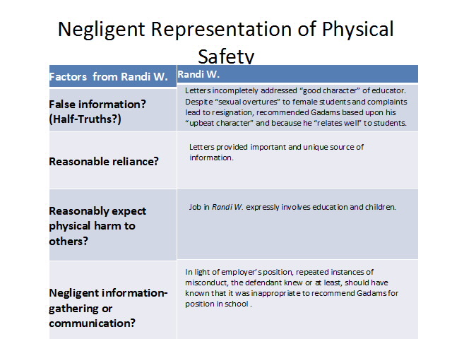

TARASOFF v. REGENTS OF THE UNIVERSITY OF CALIFORNIA

Facts: Dr. Moore was a psychologist treating Poddar. Poddar killed Tatiana Tarasoff. Plaintiffs allege that Poddar had confided his intention to kill Tarasoff to Moore. Campus police briefly detained Poddar, but released him because he appeared rational. Moore’s superior ordered that Poddar not be further detained. No one warned Tatiana or plaintiffs of peril posed by Poddar.
Holding: Once a therapist does in fact determine that a patient poses a serious danger of violence to others, he bears a duty to exercise reasonable care to protect the foreseeable victim of that danger.
Rule: Common law traditionally imposed liability only if the D bears some special relationship to the dangerous person.
Rationale: The relationship between therapist and patient satisfies special relationship requirement. Such a relationship may support affirmative duties for the benefit of third persons (ex: hospital must exercise reasonable care to control the behavior of a patient which may endanger other persons).
Professional inaccuracy in predicting violence cannot negate the therapist’s duty to protect the threatened victim. Pubic policy favoring protection of confidential character of patient-psychotherapist communications must yield to the extent to which disclosure is essential to avert danger to others.
Discussion: Tarasoff Factors:
- take charge over perpetrator of harm? therapy counts as “taking charge” because of unique position to gather info
- know or reasonably should have known about danger?
- reasonably identifiable third party? so long as you are in a position to investigate, we will leave it up to discretion of the therapist

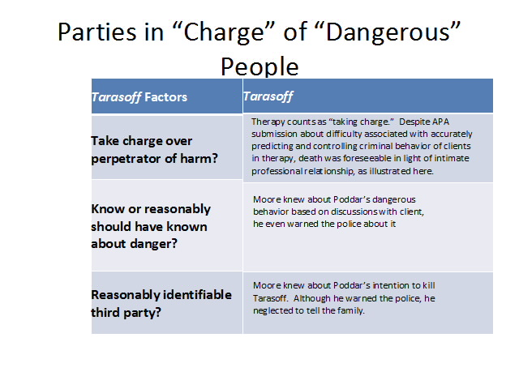
    - Special Case of Governmental Entities
      - Municipal and State Liability
        - Is the decision at issue traditionally a government function or does it arise out of private conduct – like maintenance of property or contract? (Riss)
        - Is the decision discretionary – does it reflect a balance of competing policy concerns – or is it ministerial? (Lauer)
          - discretionary decisions involve “reasoned judgment” and generally do not give rise to liability
          - ministerial acts are those that require adherence to a specific rule designed to protect the plaintiff and when ignored give rise to liability
        - Is the duty owed to the public at large, or has the government taken on specific obligation with respect to an individual? (Cuffy)
          - Assumption
          - Knowledge
          - Contact
          - Reliance

RISS v. CITY OF NEW YORK
Facts: Riss’s former boyfriend (Pugach) terrorized her for six months. He warns her, “if I can’t have you, no one can.” Riss repeatedly sought police protection. Police refused. Pugach hires “thug” to throw lye in Riss’s face, leaving her permanently disfigured and partially blind.
Holding: Plaintiff cannot sue the police as a governmental entity that holds “traditionally governmental functions.”
Rationale: This case involves government service that only the government can provide to protect the public generally. For the courts to proclaim a new and general duty could and would inevitably determine how the limited police resources of the community should be allocated.
Discussion: Plaintiffs can sue for “traditionally private conduct” (public buildings, hospitals, rapid transit, etc.) but not for things that are “traditionally a governmental function” (police protection, etc.).
Modern rationale: (1) separation of powers, (2) institutional competence of courts, (3) protects the public fisc and (4) chilling effect on public officers.

CUFFY v. NEW YORK
Facts: Cuffys sought police protection from their downstairs neightbors with whom they had a number of skirmishes. Mr. Cuffy received assurance form the police that something would be done “first thing in the morning.” Neighbor attacked him and son with baseball bat next evening. Police had done nothing.
Rule: The court recognized an exception in cases of “special relationship”
- assumption by municipality through promises or action, of an affirmative duty to act on behalf of the party who was injured;
- knowledge on the part of the municipality’s agents that inaction could lead to harm;
- some form of direct contact between municipality’s agents and injured party;
- that party’s justifiable reliance on the municipality’s undertaking.

LAUER v. CITY OF NEW YORK
Facts: After 3 year old dies, ME wrongly concluded death was homicide due to “blunt trauma.” Police investigates father for murder. Shortly after ME learns death was due to aneurism, but fails to correct report. Investigation against father continues until finding of revised autopsy.
Holding: ME’s mistake was “ministerial” but there was no duty owed to this particular plaintiff.
Rule: Ministerial acts may subject the municipal employer to liability for negligence.
Rationale: ME owed a duty to the district attorney to notify of any autopsy changes but not to the victim’s father. Violation of a statute resulting in injury gives rise to a tort action only if the intent of the statute is to protect an individual against an invasion of a property or personal interest.
Discussion: The statute must protect the specific plaintiff.

CRANICK v. OBION COUNTY FIRE DEPARTMENT
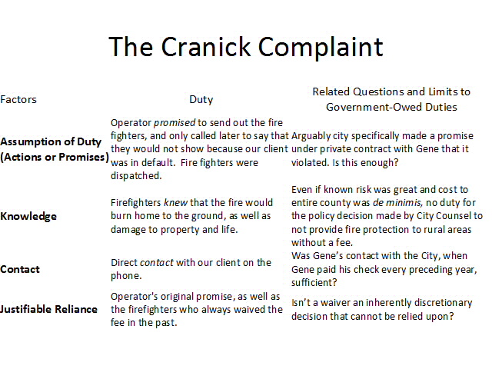
    - Limiting Duty Based On “Privity”
        - Restatement (Third) 7(b): Courts may articulate a bright line rules applicable to general classes of cases.
          - Ordinarily, privity does not define whether or not there is a duty.
          - However, courts may impose privity-based limit to account for “policy,” which includes the burden placed on D required to avoid harm and threat of unlimited liability.

STRAUSS v. BELLE REALTY CO.

Facts: D, Consolidated Edison’s power system left most of NYC in darkness. Strauss (P) is 77-year-old resident in apartment building in Queens. Con Edison provided electricity to his apartment pursuant to agreement with him, and to common areas of building under separate agreement with landlord. P fell on defective basement stairs. Alleges negligence against landlord and against utility.
Holding: A duty is not imposed on Con Edison to P, whose injuries from a fall on a darkened staircase may have conceivably been foreseeable, but with whom there was no contractual relationship for lighting in the building’s common areas.
Rationale: It is the responsibility of the courts to limit the legal consequences of wrongs to a controllable degree. Considerations of privity are not irrelevant since courts have declined to extend the duty of care to noncustomers. If liability could be found here, it must follow in many similar situations. Permitting recovery would violate the court’s responsibility to define an orbit of duty that places controllable limits.
Discussion: Limits duty based on “privity.”
Policy: would result in infinite lawsuits against Con Edison and would hurt Con Edison financially.
Misfeasance or nonfeasance? -> Misfeasance, but still limit the duty owed.
Can wife sue from injury sustained in apartment? Yes, although she is not in direct privity with Con Edison, she is close enough to person in contract.

FRANK v. OUTDOOR ADVENTURES
Non-profit selling guns at “swap-meet.” “Straw purchases” occurring, guns used on average 3.5 years after in homicide cases.

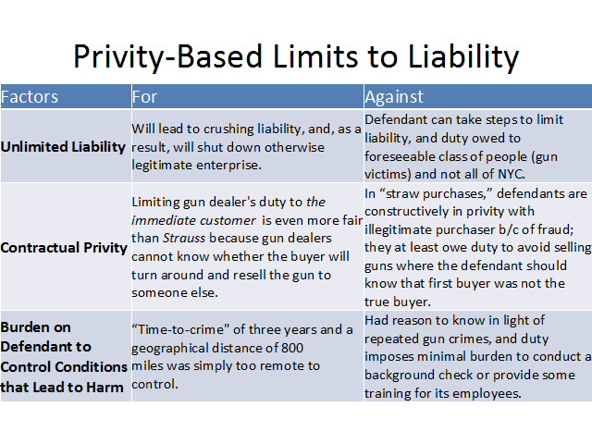
    - Limits Based On Social v. Commercial Hosts
        - Social hosts lack expertise, cohesion and money; therefore, their liability is limited in most states (majority).
        - Commercial proprietors exercise greater supervision, comprise a discrete class of people, and have more financial power.

REYNOLDS v. HICKS

Facts: Hicks were married on September 10th. Seven Hicks, under-age nephew left the reception at midnight in his sister’s car. He was involved in an automobile accident at 1 am.
Holding: Social hosts owed no duty to third persons injured by the intoxicated minor.
Rationale:
1. Social hosts are not capable of handling the responsibilities of monitoring their guests’ alcohol consumption, as are their commercial and quasi-commercial counterparts, both of which have a proprietary interest and profit motive.
2. The implications of social host liability are so much more wide sweeping and unpredictable in nature.
3. The statute of underage drinking, since parents are allowed to legally give alcohol to a minor, was not enacted to protect third persons, but rather protect minors from their own injuries.
Discussion: Distinguished social hosts from commercial. Majority rule.

FRANK v. OUTDOOR ADVENTURES
Non-profit selling guns at “swap-meet.” “Straw purchases” occurring, guns used on average 3.5 years after in homicide cases.

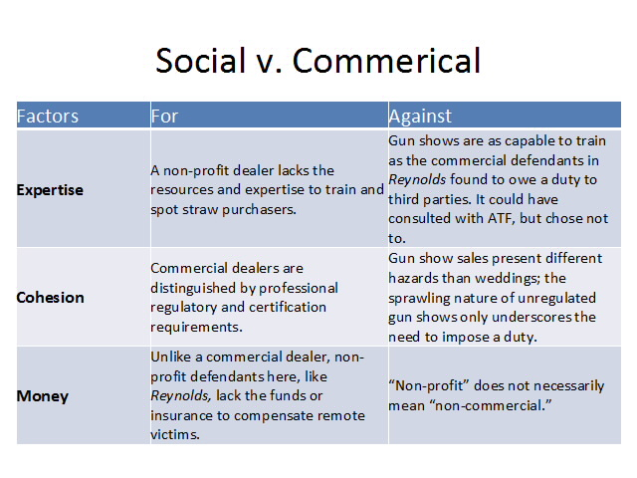
    - Negligent Entrustment Theory
        - One who knows or has reason to know property will be used in way that creates unreasonable risk of harm to another.
        - Applies to anyone who directly or indirectly supplies property for use of another.

VINCE v. WILSON

Facts: P was seriously injured in an automobile accident. Brought suit against D who had provided funding for her grandnephew, the driver of the car, in which P was a passenger, to purchase a car. Ace Auto Sales and president were added as defendants, who sold the vehicle. Driver did not have license and failed driving test several times. He was also known to abuse drugs and alcohol.
Holding: Negligent entrustment extends to a person who knowingly provides funding to an incompetent driver and to a person who knowingly sells a vehicle to an incompetent driver.
Rule: Restatement (Second) of Torts 390. “One who supplies directly or through a third person a chattel for the use of another whom the supplier knows or has reason to know to be likely because of his youth, inexperience, or otherwise, to use it in a manner involving unreasonable risk of physical harm to himself and others whom the supplier should expect to share in or be endangered by its use, is subject to liability for physical harm resulting to them.”
Rationale: Other courts have applied the rule broadly to include a dealer who sold a vehicle to an inexperienced and incompetent driver when the seller knew or should have known of the incompetency.
Rule applies to sellers, lessors, donors or lenders.
Where the D is the owner or has the right to control the instrumentality have been severely criticized.
The issue is one of negligence to be determined by the jury under proper instruction. There was evidence to suggest all defendants knew or had reason to know of driver’s incompetence.
Discussion: It doesn’t matter whether you own the thing being entrusted; it is the act of actually entrusting someone negligently.

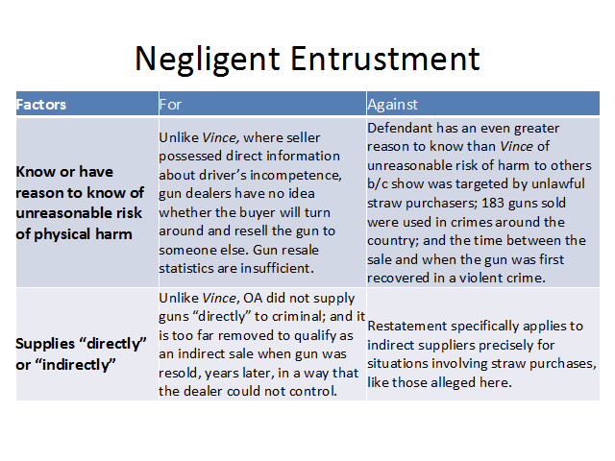
    - Duties Owed by Property Owners

      - Consider:
        - Status of Entrant
          - invitee – owe a duty to protect invitees (business guests) from known or reasonably knowable hazards on the property, even if hazard is obvious to the victim
          - licensee – owe a duty to protect licensees (social guests) from only known and non-obvious hazards on the property
            - a licensee becomes an invitee (a) if s/he confers a material benefit to the property owner or (b) if invite extended to the public
          - trespasser – owe a duty to protect trespassers from known, concealed hazards “willfully or wantonly” located on the property
        - Foreseeability of Harm to Defendant
          - actual knowledge
          - constructive knowledge
        - Severity or Obviousness of Danger to Victim
          - obvious danger
          - concealed danger

CARTER v. KINNEY (minority)

Facts: Kinney’s hosted a Bible study at their home for members of church who signed up at the church. The night before Mr. Kinney shoveled snow from driveway, but was not aware that ice had formed overnight. Mr. Carter arrived after 7 am, slipped on ice and broke his leg.
Holding: Whether D owed a duty to protect P from an unknown dangerous condition when P was a member of an exclusive group of invited people, where D received no material benefit.
Rule: Possessor owes licensee duty to make safe dangers of which possessor is aware. Possessor owes invitees duty to exercise reasonable care to protect them against both known dangers and those that would be revealed by inspection. An entrant becomes an invitee when the possessor invites with the expectation of a material benefit from the visit or extends an invitation to the public.
Rationale: Carter did not enter the land to afford Kinneys any material benefit. Therefore, he is not an invitee. Kinneys did not “throw open” their premises to the public in such a way as would imply a warranty of safety.
Discussion: Invitees can be business guests or public invitees.
Why should there be a higher duty if you hold it open to the public? Once you open property to the public you are raising the stakes; public has higher expectations.

HEINS v. WEBSTER COUNTY (majority)

Facts: After a heavy snowfall, P visited D’s hospital. Alleges he went to hospital to visit his daughter (nurse) and to inquire about the Santa Clause position. While exiting hospital he fell and injured his hip.
Holding: The invitee-licensee distinction should be abandoned and the new rule applied in this case, where a duty of reasonable care is owed to all lawful visitors.
Rule: Reasonable care for all lawful visitors. To evaluate “reasonable care,” consider: foreseeability or possibility of harm; purpose for which entrant entered premises; time, manner and circumstances under which entrant entered premises; use to which premises are put or are expected to be put; reasonableness of the inspection, repair, or warning; burden n land occupier and/or community in terms of inconvenience or cost in providing adequate protection.
Rationale: A number of jurisdictions have decided that the common-law classifications have outlived their usefulness.
Entrant’s status should not determine the duty that the landowner owes to him or her. A man’s life or limb does not become less worthy of protection because he has come upon the land without a business purpose.
Special immunity which licensee rule affords landowners cannot be justified in an urban industrial society.
Classifications have produced confusion and conflict.
Discussion: Why isn’t he a public invitee? Not there for reason that hospital is open to the public for.
Rationale: (1) corrective justice, (2) deterrence, (3) compensation
FEINBERG
Not invited, but always expected. Zim did not know about puddle of waffle batter. Wants waffles, but also wants to promote his GM fund.
            - licensee
            - Zim did not know about puddle
            - no material benefit
            - was not open to the public
            - no duty

PETHERBRIDGE
Invited, but sign posted “do not enter.” Entered where he was gassed. Room where he was not invited/allowed.
            - trespasser
            - Zim owes duty – not to willfully or wantonly hurt them by known, concealed hazards

      - Duty Owed to Child Trespassers When:
        - known or reasonably knowable child trespassers;
        - involving crippling or lethal hazards;
        - unrecognizable to children; and
        - when burden of eliminating danger is slight.

BOBBY AND BUZZY
Bobby, who is addicted to waffles, sneaks in Zim Group and bit by Buzzy.
            - Zim owes duty – to protect child trespassers

      - Property and Activities
        - owners and occupiers also owe a duty to protect known or reasonably knowable invitees and licensees from activities on the property, not simply property defects
        - must reasonably expect visitor not to discover danger
        - visitor does not know (or reasonably know of) danger

DIY WAFFLES
DIY waffles, iron catches fire, someone injured. Nothing is wrong with the property.
            - “reasonable care” duty to protect from activities

    - Duty Owed By Property Owners for Third Party Hazards

      - Modern Rule: Landlord has duty to those lawfully on property to exercise reasonable care to maintain property in safe condition, including risk of foreseeable fire hazards and crime.
        - Courts may require evidence that landlord had notice of fire hazard or prior criminal acts on property to establish that hazard was reasonably foreseeable.
        - Most courts apply a totality of the circumstances approach, taking into account the “number, nature, and location” of similar prior incidents.

POSECAI v. WAL-MART STORES, INC.

Facts: P was robbed at gunpoint in Sam’s Club’s parking lot at 7:20 pm where it was not dark. Sam’s employs a security guard who patrols the store from 5 pm to 8 pm. Only three prior offenses; only one bears any similarity.
Holding: Sam’s did not possess the requisite degree of foreseeability for the imposition of duty to provide security patrols in its parking lot.
Rule: Balancing test. Balancing the foreseeability of harm against the burden of imposing a duty to protect against the criminal acts of third persons.
Rationale: Security is a significant monetary expense for any business and further increases the cost of doing business in high crime areas. A societal problem that law enforcement cannot solve. Business owners are in best position to appreciate the crime risks that are posed on their premises and to take reasonable cautions to counteract. Very low crime risk. Foreseeability and gravity of harm remained slight.

WASHINGTON v. ALBANY HOUSING AUTHORITY
375 prior fires on property – foreseeable
location was on the property
held: some duty owed

TODOROVICH v. COLOMBIA UNIVERSITY
no prior incidents inside the building
argued D owed notice to P to notify
dangerous neighborhood, but building itself was safe
held: no duty owed

WORLD TRADE CENTER LITIGATION
Is the WTC’s actions misfeasance or nonfeasance?
“foreseeable risk of fire”
“unprecedented act of terrorism”
Does WTC owe a duty as a property owner?
Posecai, Washington, Todorovich
Other policy implications or limits to imposing a duty here?
foreseeability of harm to P
closeness of D’s connection to P and moral blame
burden of duty on D and community
availability of insurance and limitless liability

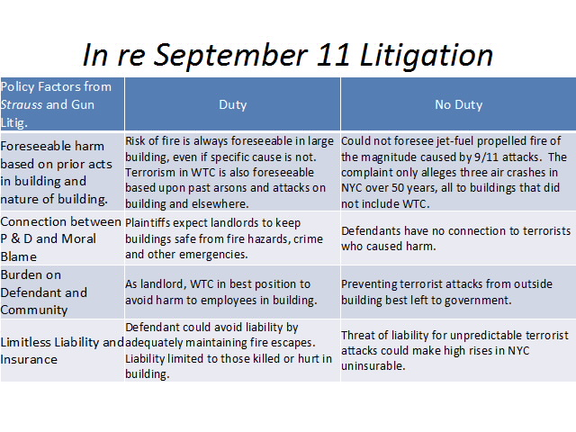

    - Non-Physical Harm

      - Three Major Concepts
        - Generally, no duty for pure emotional or economic harm (Robins Dry Dock Doctrine).
        - Does it fit within the historically recognized exceptions?
          - Pure Emotional Harm
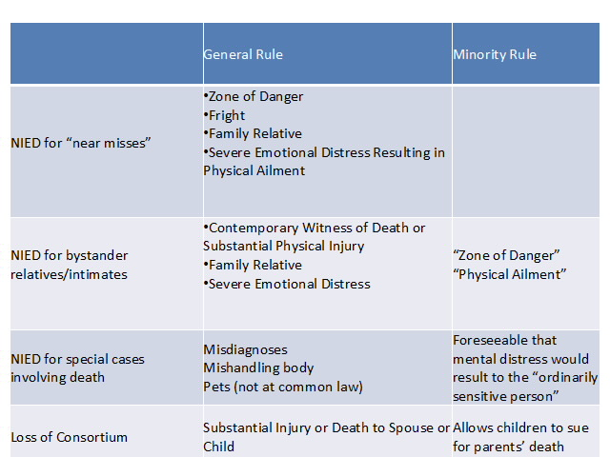
          - Pure Economic Harm
            - Restatement (Second) Section 552
        - Do competing policies support the creation of a new duty?
          - Relationships
          - Foreseeability/Best Position to Avoid Harm
          - Controllable Liability
          - Fair Compensation

      - Pure Emotional Harm
Negligent Infliction of Emotional Distress *no longer just physical contact
          - “Near Miss”/ “Zone of Danger” (Falzone)
            - negligent act
            - immediate fear of personal injury
            - causes fright
            - resulted in substantial bodily injury or sickness
          - Bystander NIED/NIED for Relatives (Portee)
            - family relative/intimate dependent
            - contemporaneous witness
            - physically close to event
            - death or substantial physical injury to relative
            - *NY law still requires P to be in “zone of danger” and suffer physical manifestation of injury
          - NIED under Gammon (minority)
            - Is it reasonably foreseeable that mental distress would result to the “ordinarily sensitive person”?
          - NIED Cases Involving Death
            - mishandling of dead bodies
            - wrongful death notice
            - loss of consortium (when spouse/child has been substantially injured or killed)
            - misdiagnosis

          - Policy for Bystander NIED (Portee)
            - relationships/fairness:
              - close relationship to victim ensures tort action serves fundamental interest in protecting “emotional tranquility”
              - “proximity” and “serious bodily harm” requirements serve similar goal
            - controllable liability:
              - contemporaneous witness requirement ensures “judicial redress within the bounds of emotional interest entitled to protection”
          - Policy Considerations in all Non-Physical Duties
            - relationships
            - foreseeability/best position to avoid harm
            - controllable liability
            - fair compensation
            - proof

FALZONE v. BUSCH
Facts: Charles standing in a field next to roadway and was hit by car. Mabel was seated in car close to where Charles was hit. Car veered “across highway” in her direction, “coming so close as to put her in fear of her safety.” She was not physically hit, but became ill and required medical attention.
Holding: Rule requiring physical contact is no longer valid and a new rule should be implemented.
Rule: Where negligence causes fright from a reasonable fear of immediate personal injury, which fright is adequately demonstrated to have resulted in substantial bodily injury or sickness, the injured person may recover if such bodily injury or sickness would be regarded as proper elements of damage had they occurred as a consequence of direct physical injury rather than fright.
Rationale: Problems with old rule requiring physical contact –
- misguided view of physical suffering, rejects belief that physical suffering is “not a natural consequence of fright”
- absence of suits in this area, rejects this argument as inconsistent with evolving development of common law
- public policy/proof, believes contemporary sophistication of medical profession and proper jury instructions can resolve problems of proof
- floodgate problem, disagrees that this is legitimate interest and no evidence suggests possibility of excessive litigation

METRO-NORTH COMMUTER RAILROAD COMPANY v. BUCKLEY (majority)
Facts: Buckley works in tunnels outside of Grand Central Station. Learns he’s been exposed to asbestos as a result of work performed in tunnel, and that as a result of exposure, 1-5% increase of cancer risk. Otherwise, no serious physical symptoms associated with exposure to asbestos.
Holding: Plaintiff has no case for NIED based on mere exposure to carcinogens.
Rule: “Zone of danger” test. The law permits recovery for emotional injury by plaintiffs who sustain a physical impact as a result of a defendant’s negligent conduct, or who are placed in immediate risk of physical harm by that conduct.
Rationale: Does the physical contact with insulation dust amount to a “physical impact”?
- “physical impact” taken from precedent does not indicate that this encompasses every form of “physical contact”; does not include a contact that amounts to no more than an exposure
- common law courts have denied recovery to those who are disease and symptom free
- policy – valid from invalid cases regarding proof, threat of unlimited and unpredictable liability, potential of flood of trivial claims
Discussion: Other circumstances where plaintiffs can recover include (a) zone of danger, as here, (b) physical contact, and (c) if disease and symptom free, in rare cases, “more likely than not” to develop disease.

MOLLEY v. UNITED STATES ARMY CORPS OF ENGINEERS
Facts: Plaintiff was exposed to toxic materials while working. Employer found out about toxicity after they began clean up operations. Symptoms include headaches and rashes. DNA mutation consistent with DNA damage from exposure to SD. 48% chance of cancer in next 10 years.
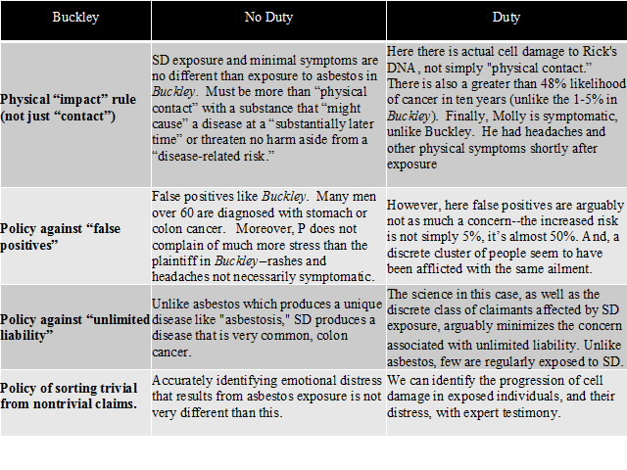
GAMMON v. OSTEOPATHIC HOSPITAL OF MAINE, INC. (minority)
Facts: Plaintiff was wrongly delivered a body part of another body from the morgue while the family mourned the loss of their father.
Holding: Plaintiff has a case that could support a jury finding of negligence.
Rule: A defendant is bound to foresee psychic harm only when such harm reasonably could be expected to befall the ordinarily sensitive person.
Rationale: A person of ordinary sensibilities is likely to experience emotional distress when they are in the vulnerable state of grieving. Abandoning the requirement of physical impact to now require foreseeability of harm to ordinarily sensitive person. The concept of foreseeability provides adequate protection against burdensome liability claims. Jurors or judges can evaluate psychic trauma with no greater difficulty than pertains to assessment of damages for any intangible injury.

PORTEE v. JAFFEE
Facts: Plaintiff watches helplessly, as her son is crushed to death by elevator. Plaintiff is never exposed to risk of physical danger. After death, plaintiff becomes severely depressed and self-destructive. She attempts to commit suicide and requires counseling.
Holding:
Rule: Negligent infliction of emotional distress requires proof of;
- death or serious physical injury of another;
- a marital or intimate familial relationship between plaintiff and injured person;
- observation of the death or injury at the scene of the accident;
- resulting in severe emotional distress.
Rationale: The existence of a marital or intimate familial relationship is an essential element of a cause of action for negligent infliction of emotional distress. That the plaintiff witness the incident is equally essential to avoid imposing liability in excess of culpability. The proximity of the plaintiff to the accident increases the likelihood that he will witness the event. The risk of emotional injury exists by virtue of the plaintiff’s perception of the accident, not his proximity to it. The observation of either death or this type of serious injury is necessary to permit recovery.

JOHNSON v. JAMAICA HOSPITAL
Facts: Hospital, maintaining sole custody over child after mother is discharged, loses baby to abduction during bomb threat. Parents sue for direct emotional distress suffered during the 4.5 months baby was missing. (Separate suit, on behalf of baby, not at issue).
Holding: Plaintiffs may not recover damages from hospital for purely emotional harm they may have suffered as a result of the direct injury inflicted upon their daughter by defendant’s breach of its care to her.
Rule: Absent certain exceptions, normally no duty to relatives/parents for pure emotional harm.
Rationale: The direct injury (abduction) was sustained by the infant. Plaintiffs’ grief and mental torment which resulted from her disappearance are not actionable. The foreseeability does not serve to establish a duty. Here, the hospital’s breach of care to patient causing direct injury to patient resulting in emotional injury to relatives of patient.
Discussion: Bovsun required either zone of danger or contemporaneous observation (bystander). Allowing parents to recover would go against policy that opposes flood of liability, especially to an indirect injury. The court distinguishes this case from Johnson and Lando where there were exceptional circumstances in which the hospital has a duty to transmit truthful info & mishandling f or failure to deliver dead body.

      - Pure Economic Harm
        - Restatement (Second) Section 552
          - Know statement will be used for a particular purpose.
          - Known parties or limited class will rely on information for that purpose.
          - Fails to exercise reasonable care in obtaining or communicated information.
        - “Near Privity” in New York
          - So confident that a particular person will use the statement for a particular purpose, it’s as though you have a contract with that person.
          - Additional causal link between the defendant and the plaintiff.

NYCAL CORPORATION v. KPMG PEAT MARWICK LLP.
Facts: KPMG prepared an audit for Gulf Resources and Chemical. Plaintiff bought a controlling interest in Gulf based off of the audit. Gulf went bankrupt in 1993. KPMG was not informed that audit report had been used for attracting investors, and had only learned of the transaction a few days before the closing.
Holding: KPMG was not liable for false statements of Gulf’s fitness.
Rule: Restatement Section 552. Limits informer’s liability to (1) a group of persons he intends to benefit or (2) a group he knows will benefit from, or be influenced by, the information. With respect to (2), it is enough that the informer intends to influence a particular person or distinct class of persons. The informer is not liable to an unlimited and undefined group of people who may rely on the information in the future.
Rationale: Section 552 limits the potential liability of an accountant to noncontractual third parties who can demonstrate actual knowledge at the moment the audit is published. Policy considerations – the auditor lacked control over the dissemination of the information and a “thoughtless blunder” could lead to liability for an indeterminate class for indeterminate time. Here, defendant did not prepare the audit report for the plaintiff’s benefit. Plaintiff was an unknown, unidentified potential future investor in Gulf.
Notes: Bily
Investors claimed reliance on financial statements defendants prepared. They misjudged a number of factors. The court found that investors “should be encouraged to rely on their own prudence, diligence, and contracting power, as well as other informational tools.”

532 MADISON AVENUE GOURMET FOODS, INC. v. FINLANDIA CENTER, INC.
Facts: South wall of building in midtown Manhattan collapses, raining bricks and mortar onto Madison Ave. Fifteen blocks of prime commercial real estate closed for 2 weeks. Businesses sue for lost business because shoppers unable to access stores. Appellate permitted claims by “businesses in such close proximity” that negligent acts could foreseeably “cause injury.”
Holding: The plaintiffs’ negligence claims based on pure economic loss fall beyond the scope of the duty owed them by defendants.
Rule: Robins Rock Dry Doctrine. Traditionally, common law rule is that no recovery for pure economic losses when the defendant creates a dangerous condition or causes physical harm to another. In exceptional cases, Congress may pass specific laws to get around that rule, particularly where risk of mass injury is grave, like the Oil Pollution Act (BP).
Rationale: Court evaluates precedent and reconciles the different cases of Dunlop Tire and Beck, both of which arose out of the same explosion. Dunlop was permitted recovery because it showed property damage (physical contact) in addition to economic loss whereas Beck only alleged economic harm. Policy-driven line-drawing is to an extent arbitrary because it will always cut off liability to persons who foreseeably might be plaintiffs. However, limiting the scope of defendants’ duty to those who have suffered personal injury or property damage – as historically courts have done – affords a principled basis for reasonably apportioning liability.

NEW YORK v. ZIMMERMAN GROUP
New York state pension fund sued Zimmerman as a result of its BP stock losses. Claims that ZG issued an opinion letter about BP’s tort liabilities, which gave BP a clean bill of health. Claims that liability would be limited to $75 million. BP informed ZG that it planned to use its opinion letters to attract large “institutional” investors.
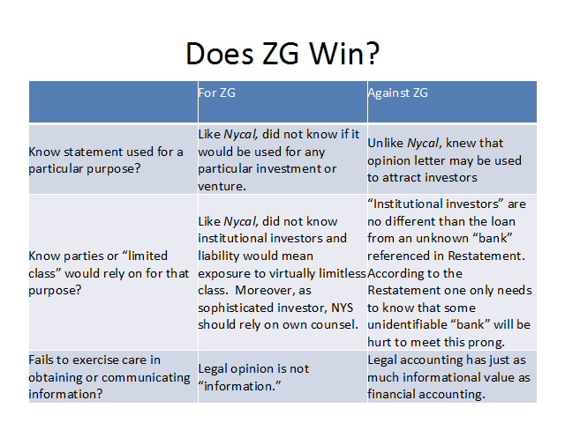

  - BREACH
A failure to satisfy that standard of care.

    - WAYS TO ESTABLISH BREACH
Factors that can establish breach:
        - is injury foreseeable?
          - was there similar danger in the past?
          - was there something about the conduct that made this gravely dangerous?
        - what was the custom?
        - was the risk needless?
        - is the injury preventable?
        - are there alternatives to this conduct?

ADAMS v. BULLOCK

Facts: Bullock (D) runs a trolley line with an overhead wire system. Trolley runs under a bridge where pedestrians often walk and children often play. Adams (P) walked across bridge while swinging a wire which touched trolley wire and shocked and burned P upon contact.
Holding: Defendant was not negligent in use of overhead wire under a bridge, despite it commonly being used by pedestrians.
Rule: Duty to adopt all reasonable precautions to minimize resulting perils.
Rationale:
(1) using overhead wire was standard; “lawful exercise of its franchise”
(2) no evidence this duty was ignored
(3) could not have possibly predicted this accident
(4) different from other cases that have claimed breach and persuasive authority supports current holding

      - REASONABLE PERSON STANDARD

        - The failure to exercise ordinary and reasonable care which persons of ordinary prudence would use in order to avoid injury.
        - Exceptions
          - Common Carriers (transportation services) and Experts
            - Must act like an “average member of profession” or exercise the “utmost duty of care.”
          - Children and Physically Disabled
            - Children, physically disabled, and, in rarer cases, mentally disabled may be subject to a more lenient standard in light of their age, wisdom, experience, or capacity.
            - i.e. “average 5 year old”
            - Adult Activities Exception
              - Exception for children exists when they engage in “adult activities.” They must act with the ordinary prudence of a reasonable person, like everyone else.
              - i.e. when driving a car

      - RISK-UTILITY ANALYSIS

        - Breach of duty exists when the burden of precautions (B) is exceeded by the probability of harm (P) and the gravity of harm (L). (B<PL).
        - Limitations
          - Information is not always perfect.
          - Transaction costs of litigation.
          - Burden, probability and loss are not easily quantified.
          - May fail to account for other externalities, customs or moral considerations and norms.

UNITED STATES v. CARROLL TOWING

Facts: Harbormaster and deckhand aboard the Carroll readjusted the lines holding fast the Anna C, a barge owned by P. Because of their negligence in securing the Anna C it broke loose and rammed against tanker whose propeller broke a hole and caused Anna C to sink with loss of cargo owned by U.S. D sought to reduce damages because P’s bargee was not present at the time and his presence would have kept the barge afloat.
Holding: P’s bargee was negligent in leaving the Anna C and it was a fair requirement that P should have a bargee aboard (unless excused) during working hours of daylight.
Rule: Hand Test. burden of precautions < (probability of risk)(gravity of injury)
Rationale: “burdens of precautions”
- bargee not required to be present at all times, especially with excuse, during the night; BUT that question is left open to custom
- BUT during working hours you need an excuse and claiming the barge was secure is not enough
  - bargee had been gone for 21 hours without an excuse
  - not beyond reasonable expectation that, with haste and bustle of many barges being “drilled,” work not done with adequate care
Discussion: The “burdens of precautions” here include: paying bargee higher wages, paying a second bargee. The “probability of risk” here is very high when there are many ships in the harbor; all that is required is to show that something can go wrong. The “gravity of the injury” was the sinking of the Anna C.

BETHEL v. NEW YORK CITY TRANSIT AUTHORITY

Facts: Bethel (P) was hurt on D’s bus when seat collapsed under him. P could not prove D knew of defect but relied on a theory of constructive notice by showing a repair record of the wheelchair lift. P alleges a proper inspection during the repairs would have revealed the defect. On the issue of constructive notice, jury instructs told jurors to consider the “duty of care that is imposed on common carriers with respect to this equipment.”
Holding: The rule of a common carrier’s duty of extraordinary care is no longer viable; therefore the jury instruction was erroneous.
Rule: Previous rule was “exercise the utmost care”; New rule is objective, reasonable person standard
Rationale: Standard of conduct must be an external and objective one. “Reasonable person” takes into account circumstances and provides sufficient flexibility. Common carrier is subject to the same duty of care as any other potential tortfeasor.

GREY v. FORD MOTOR COMPANY (PINTO)
P argues: distinguished from Carroll; loss of 3 lives because of Ford’s engineering, it was the gas cap that pushed it to death; can’t put value on human life; P had no way to foresee the injury by pulling over, BUT there is still probability of risk by stopping in middle of highway
D argues: low probability of harm (BUT how can you know how many people are in the car?); costs of burden are much higher; there is no perfectly safe vehicle; probability of this occurring is low (BUT must consider that all that is required to show is that any risk can occur, not just this type of risk)
Limitations to risk-utility analysis:
- information not always perfect (i.e. multiple people could be in car)
- not everyone sues (so cost might not be correct)
- “burden,” “probability,” and “loss” not easy to quantify
- may fail to account for other externalities, customs, norms or moral considerations (i.e. can’t put a value on life)

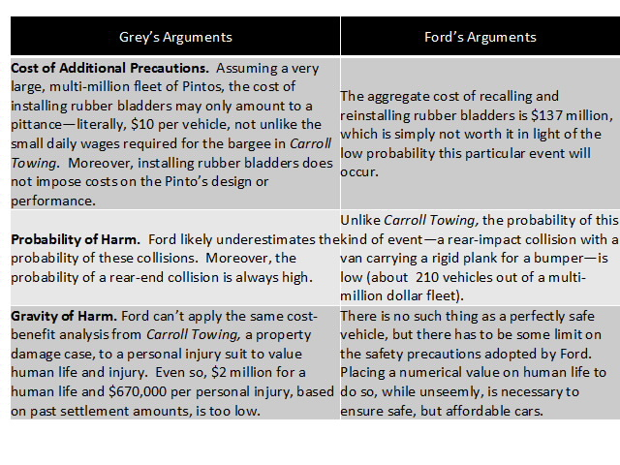
      - CUSTOM

        - Customary practices, in industry or otherwise, may provide evidence of standard of care, although not conclusive evidence.
        - Why use custom?
          - Shows feasibility of a practice
          - Shows foreseeability of an injury by others
          - Shows expertise and experience in the industry
          - Encourages internalization of safe norms
        - Objections to Using Custom
          - May not fully reflect costs of potential harm on society
          - Discourages innovation by placing limitations
          - Market failures
        - Things to Consider:
          - Is this even an applicable custom?
          - If it is a custom, was it adopted to protect against the harm alleged or for some other unrelated reason?
          - How persuasive is the custom for the jury?

TRIMARCO v. KLEIN

Facts: P tenant was badly cut when he fell through the glass door that enclosed his tub in D’s apartment building. Door turned out to be ordinary thing glass that looked the same as tempered glass. Building was built in 1953. P presented expert evidence that since 1950s using shatterproof glass had become “common use.” Jury awarded P damages.
Holding: The case that P presented was enough to send it to the jury and sustain the verdict reached.
Rule: When proof of a customary practice is coupled with a showing that it was ignored and that this departure was a proximate cause of the accident, it may serve to establish liability.
Rationale: Testimony, data, evidence were enough to establish a cause of action. It was also for the jury to determine whether the evidence does reasonably establish a general custom and whether Ds were required to uphold it, not the appellate court.
Discussion: Court held that proof of custom can be used to show a standard of care and the jury can also conclude the cost & availability of glass, combined with that custom results in sufficient evidence that D could replace the thing glass to make it reasonably safe from risk of harm.

“PUSH BUMPERS” (Harris v. Scott)
What if “push bumpers” were recommended against use in high speed chases, and other jurisdictions have adopted this recommendation?
        - support for this as custom:
          - feasible – not a burden on officers
          - foreseeable – still concerned about the life of the suspect, harm can occur
          - expertise – recommended by national organization
          - encourage internalization of norms – we want police officers to practice safety
        - opposition to this as custom:
          - only 30 states adopted it, not a clear custom
          - not established at police station in that specific jurisdiction
          - purpose of custom was to protect other people on the highway, not the suspect

      - STATUTES OR REGULATIONS

        - Unexcused violation of a statute will establish negligence when the purpose of the statute is designed to protect a particular class of people or interests, or to guard against certain harms or hazards.
          - if unexcused then conclusive evidence of negligence & jury only determines whether the statute was violated
          - if arguable excused then jury determines whether conduct, including statutory violation, was reasonable
        - Negligence Per Se – court may adopt legislation or administrative rule as the standard of reasonable care, when purpose of the law:
          - protects a particular class of people
          - protects the particular interest
          - protects against harm that results
          - protects against kind of hazard from which harm results
        - Excuses
          - childhood, physical disability or incapacity may excuse violation
          - reasonable care to comply with statute
          - lack of knowledge or notice
          - compliance entails greater risk of harm
        - Compliance with Law as Defense
          - expertise, uniformity, cost and legitimacy allows for limited defense to tort when defendant complies with statute
          - information, regulatory lapses, capture, and democratic principles of court access disfavor the defense

SUSPENDED LICENSE (Martin v. Herzog)
While Harris is driving at speed, another car crosses lane and hits him. D argues he was also negligent because he was driving without a suspended license.
Is driving with a suspended license relevant or conclusive evidence of negligence?
Questions to consider:
1. What is the purpose of having a license?
2. Did Harris not having a license influence driving of D?
3. Was license suspended for violent offense?

SPEEDING VIOLATION (Tedla v. Ellman)
Speeding because girlfriend needs emergency treatment; another car crashed after crossing the line.
Questions to consider:
1. What do speeding statutes protect against?
2. Who do speeding statutes protect?
3. Does the party have an excuse?

MARTIN v. HERZOG

Facts: P and husband were driving toward Tarrytown in a buggy and were struck by D’s automobile coming from the opposite direction. At the point of collision the highway was curving. Negligence charged against D for not keeping to right of the highway. Negligence charged against P for traveling without lights.
Holding: The charge to the jury was erroneous and misleading because evidence of violation of a statute is negligence per se, not just inconclusive evidence to be considered.
Rationale: The unexcused omission of statutory signals is negligence in itself. No license should have been conceded to the triers of the facts to find it anything else. A statute designed for the protection of human life is not to be brushed aside as a form of words.
Discussion: Statute that was violated was a very new headlight statute and was found negligence per se.

TEDLA v. ELLMAN

Facts: Two junk collectors were walking eastward along sunrise highway. There were no sidewalks and they could not use the center strip because they had baby carriages. Heavy traffic going west, and very few cars were going east. On the edge of the eastbound lane they were hit from behind by D’s car.
Holding: Pedestrians were not negligent in their noncompliance with pedestrian statute.
Rule: When the legislature has spoken, the standard of care required is no longer what the reasonably prudent man would do under the circumstances, but what the legislature has commanded.
Rationale:
(a) the statute does not prescribe additional safeguards which pedestrians must provide for “preservation of the life or limb,” nor does it impose upon pedestrians a higher standard of care
(b) cannot assume reasonably that the legislature intended a statute to require pedestrians to adhere to law when it puts them in danger
Discussion: General application: when compliance with law creates more danger and risk then that would defeat the purpose of law, therefore compliance is not required.

      - DIRECT AND CIRCUMSTANTIAL EVIDENCE

        - Testimonial, physical or documentary evidence may be used to prove, directly or indirectly, material facts, like actual or constructive knowledge.
        - Res ipsa loquitur. (when not enough evidence, such as evidence missing in McDougald, or when P unconscious in Byrne and Ybarra)
          - Injuries that would not have occurred absent negligence
          - caused by agency in exclusive control of defendant, and
          - not caused by P.

NEGRI v. STOP AND SHOP, INC.

Facts: P was shopping in D’s store, fell backwards and hit head directly on floor with “a lot of broken jars.” Evidence that D had constructive notice of a dangerous condition, which allegedly caused injuries, was presented. Testimony that baby food was ‘dirty and messy.’
Holding: The circumstantial evidence presented was sufficient to show a prima facie case of negligence.
Rationale: Slippery condition created by baby food, for a sufficient length of time prior to accident is sufficient to show constructive notice. This is a prima facie case.
Discussion: Condition of evidence matters; testimony of others matter.

GORDON v. AMERICAN MUSEUM OF NATURAL HISTORY

Facts: P injured when fell on D’s front steps because of a waxy paper that came from D’s concession stand. Claimed D was negligent because employees failed to discover and remove the paper.
Holding: There was no evidence of actual notice and lack of evidence showing constructive notice that D knew of the dangerous condition.
Rule: A defect must be visible and apparent and must exist for a sufficient length of time.
Rationale: Piece of paper could have been deposited there seconds before the accident by anyone. No evidence contradicts this. In fact, testimony shows it was a pristine piece of paper.

BYRNE v. BOADLE
Facts: Piece of paper could have been deposited there seconds before the accident by anyone. No evidence contradicts this. In fact, testimony shows it was a pristine piece of paper.
Holding: The fact that the flour fell is prima facie evidence of negligence.
Rationale: Would be wrong to lay down that in no case can presumption of negligence arise from fact of accident. P who was injured is not bound to show that it could not fall without negligence, but if there are facts inconsistent with negligence D must prove them.
Discussion: The only evidence available was 2 witnesses; P doesn’t really know anything first hand. But the court rules that this is enough. Why? Need to hold people responsible and it was clear that the flour was in the exclusive control of the D. We know that P can’t know what happened so at a minimum we can shift the burden to the D to show lack of negligence. At the very least this can get you to a jury trial. Overall, two reasons:
- shift burden to D; OR
- lets you at least get to a jury trial and can use evidence to infer

MCDOUGALD v. PERRY

Facts: P was driving behind a tractor-trailer driven by D. D drove over railroad tracks and the spare tire that was held by a chain under the tractor came out of cradle and fell to the ground. Tractor’s rear tires ran over spare, which bounded and crashed into P’s windshield.
Holding: This is the type of accident where the doctrine of res ipsa loquitur is applicable.
Rule: The injured P must establish that the instrumentality causing injury was under exclusive control of D, and that the accident is one that would not, in the ordinary course of events, have occurred without negligence on the part of the one in control.
Rationale: This would not have occurred but for the failure to exercise reasonable care by person who had control of the spare tire. P is not required to eliminate with certainty all other possible causes. Distinguished from Goodyear; insufficient evidence available to P in this case.
Discussion: Two main factors for res ipsa loquitur:
- would not ordinarily occur but for negligence?
- exclusive control of D?

YBARRA v. SPANGARD

Facts: P was under care of several Ds at several points during treatment for appendicitis. P had sharp pain in shoulder when he awakened from surgery. Later developed paralysis and atrophy of the muscles around shoulder. Prior to operation P had no pain.
Holding: The doctrine of res ipsa loquitur can apply to a suit against multiple defendants that served in a caretaking role at a hospital.
Rule: Doctrine of res ipsa loquitur (Prosser)
- accident must be kind that does not ordinarily occur in absence of negligence
- caused by agency or instrumentality within exclusive control of D
- must not have been due to voluntary action/contribution of P
Rationale: Every D was bound to exercise ordinary care to see that no unnecessary harm came to P and each would be liable for failure. Doctrine of respondent imposes liability to employers and those who are represented. Just because some may not be liable should not preclude a res ipsa loquitur case. Right of control can be constructive. If we accept Ds arguments there will rarely be compensation for patients injured while unconscious.
Discussion: The main problem here is determining if it was in the exclusive control of the D.
Policy considerations:
- ability to bring suit in hospital
- info disparity – P has no idea what happened, we have to allow him to recover, D is in best position to know what happened.
- want people to monitor each other and want them to not remain silent about responsibility

    - JUDGE v. JURY
      - Roles
        - Judges decide law.
        - Jurors decide facts.
        - Jurors decide mixed-questions of fact, except in “exceptional cases” where no reasonable juror could decide question as a matter of law.
      - Policy Factors (Restatement (Third)):
        - conflicts with social norms about responsibility
        - conflicts with another domain of law
        - institutional competence and administrative difficulties
        - deference to discretionary decisions of another branch of government
      - Benefits of Judge-Made Rules
        - need for clear lines and consistency
        - institutional competence and administrative difficulties
        - need to promote other valuable social conduct
        - deference to another branch of government
      - Benefits of Jury Decisions
        - need for discretion
        - institutional competence
        - access to courts
        - democratic principles

BALTIMORE & OHIO RAILROAD CO. v. GOODMAN

Facts: Goodman was driving a truck east and was killed by a train going southwest. Goodman “had no practical view” beyond a section house approximately 200 feet north of the crossing, until he was approximately 20 feet from the rail, and even then the engine was still obscured by the section house. Goodman slowed down to 5/6 mph and it was daylight. Goodman was familiar with the crossing.
Holding: “Nothing is suggested by the evidence to relieve Goodman from responsibility for his own death.”
Rule: When the standard of care is clear it should be laid down once and for all by the courts.
Rationale: When a man goes upon a track he knows he is going into danger if a train comes. If a driver cannot be sure he must stop and get out. If he relies on hearing and takes no further precaution he does so at his own risk.
Discussion: Court established a broad rule that when at a railroad crossing you need to “get out of car, stop, look and listen, then get back into the car.” Holmes decides the rule as an 87 year old that has never once driven a car.

POKORA v. WABASH RAILWAY CO.

Facts: Pokora (P) was driving his truck west across 4 tracks of D’s railroad. Easternmost was a switch track and one next to it was the main track. Boxcars were on a switch track north of crossing, which obscured P’s view of northern track. P heard no bell/whistle. Struck by train coming from the north on the main track. P had no view of the main track northward until train was so near that escape had been cut off.
Holding: The question was for the jury whether reasonable caution forbade his going forward in reliance on the sense of hearing.
Rule: Goodman holding. Court decided Goodman was negligent and didn’t have a cause of action.
Rationale: Goodman should not be applied in all cases to show that courts can set a standard for duty of care. That decision should be left to the jury. Also, the court in Goodman created “rules artificially developed, and imposed from without” where “extraordinary situations may not be subjected to tests fitting for common-place.”
Discussion:
Why was it for a jury to decide? There are many different facts in this case compared to Goodman.
Who is in better position to avoid accident? The train company – could have at the very least used a bell or whistle.
What has changed since Goodman? Automobile ownership has increased and now there are different interests in negligence represented, such as whether jury should decide that a change for the train company should be established.

ANDREWS v. UNITED AIRLINES, INC.

Facts: During an airplane’s arrival at a gate a briefcase fell from an overhead compartment and seriously injured P. P claim’s injury was foreseeable and D didn’t prevent it.
Holding: Summary judgment was not appropriate.
Rule: Common carrier “owes both a duty of utmost care and the vigilance of a very cautious person towards its passengers.”
Rationale:
(1) Given heightened duty, even a small risk of serious injury may form basis of liability if that risk can be eliminated; a jury could therefore find that United has failed to do “all that human care, vigilance, and foresight reasonably can do under all the circumstances.”
(2) United may not have done everything technology permits and prudence dictates to eliminate risk; modern improvements need to be considered in duty of care.
Discussion: Why leave this question for the jury? Consumers are the ones most affected by the decision, might not trust the FAA to establish new laws that don’t shave the flyer’s best interest in mind. Example of how the risk-utility Hand test might not suggest the best results.

HARRIS v. SCOTT
Rule: “unreasonable” or “excessive” when no immediate threat exists; BUT can use deadly force when officer has “probable cause to believe suspect poses threat of serious physical harm”
Should this case be dismissed (like Goodman), or should it be allowed to go to trial (like Pokora)?
D argues: leave it up to law enforcement to decide; don’t want people enriched by their crimes; police officers have specialized and important duty; P was in better position to avoid getting hurt; officers are required to make difficult decisions and the passions of the jury can unfairly punish those who were protecting the community; further implications for all car chases

  - CAUSATION
That the breach be the factual and proximate (legally recognized) cause of harm.

- Cause-In-Fact for Single Defendants (“but for” & “substantial factor”)
  - Elements of Causation
    - “But for” causation - an event was necessary to produce another event, no matter how remote
    - The “substantial factor” test – the defendant’s conduct is the “cause” if it is a “material element” and “substantial factor” in bringing about harm
  - Proving Causation: How do we show negligence was the “cause” of harm when no one witnesses the true cause and there are other plausible explanations (i.e. proving cancer from exposure)?
    - Scientific evidence that shows:
      - General causation – Is the agent capable of causing harm generally?
      - Specific causation – Did the agent cause Plaintiff’s disease? Was Plaintiff exposed to it? Was there an alternative explanation?
    - Consider (Zuchowicz & Bradford Hill Guidelines):
      - Is there a temporal relationship?
      - What is the strength of the association between exposure and disease?
      - Is there a relationship between the dose given and the response?
      - Replicated results?
      - Is the association consistent with existing knowledge?
      - Have alternative explanations been considered?
      - What is the effect of stopping exposure to product?
    - Daubert
      - Reliable testimony consistent with scientific method.
      - Relevant testimony to alleged injury.

  - Policy Considerations
    - Rejection of alternative explanations for injury in Stubbs (multiple potential causes, but found it was enough to go to trial)
    - Finding that violation of FDA regulations limiting overdoses constituted cause in Zuchowicz (was the drug what caused the harm or the negligence of giving overdoses that caused the harm?)
    - Reflects difference between legal proof of cause and scientific proof of cause (how much “science time” is sufficient for “legal time” considering statute of limitations and dormant diseases?)

STUBBS v. CITY OF ROCHESTER
Facts: Through City’s negligence, the two water systems had become intermingled and drinking water became contaminated by the sewage water. Plaintiff contracted typhoid fever, of which there are over 8 possible causes.
Holding: Plaintiff presented sufficient scientific evidence to where a jury can find defendant liable.
Rule: Multiple potential causes of injury for one or more of which a defendant is not responsible does not bar plaintiff from recovery just because all possible causes cannot be eliminated.
Rationale: The plaintiff was employed where the water was contaminated and drank the water daily. The consumption of contaminated water is a very frequent cause of typhoid fever. There were many others near the neighborhood who also contracted typhoid fever.

ZUCHOWICZ v. UNITED STATES
Facts: Complaint alleges defendant’s doctors and/or pharmacists had been negligent in directing Zuchowicz to ingest 1600 mg of Danocrine (an excessive dose) for one month. Four months later she was diagnosed with primary pulmonary hypertension and then became pregnant which made her ineligible for a heart transplant. She died one month after giving birth.
Holding: Plaintiff clearly has a case against defendants based on causation and the district court properly admitted testimony regarding plaintiff’s PPH.
Rule: Plaintiff must generally show: (a) that the defendant’s negligent act or omission was a “but for” cause of the injury, (b) that the negligence was causally linked to the harm, and (c) that the defendant’s negligent act or omission was proximate to the resulting injury.
Rationale: Plaintiff needs to show (a) that defendant’s act in giving plaintiff Danocrine was the source of her illness and death, and (b) that it was not just the Danocrine, but its negligent overdose that led to plaintiff’s demise. When a negative side effect is demonstrated to be the result of a drug, and the drug was wrongly prescribed in an unapproved and excessive dosage (i.e. a strong causal link has been shown), the plaintiff has generally shown enough o permit the finder of fact to conclude that the excessive dosage was a substantial factor. Therefore, the burden then shifts to the defendant to prove otherwise.

Dr. Egilman Direct Examination
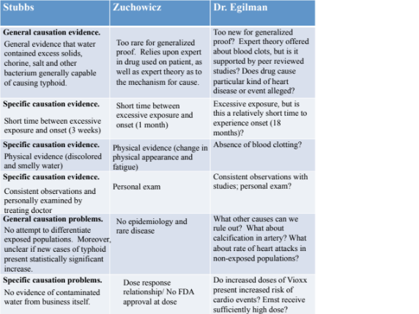

- Cause-In-Fact for Multiple Defendants
Overriding Policy Concern – injustice of barring innocent plaintiffs’ recovery solely because of defendants’ insolvency or plaintiffs’ inability to identify which of a number of wrongdoing defendants caused their injuries.

  - Joint and Several Liability

    - “When two or more actors act
(a) in concert or
(b) concurrently to
(c) produce a single injury
    - they may be held jointly and severally liable.”

    - Plaintiff might sue multiple negligent defendants, together or separately, for the full amount of damages.
    - Policy bases: difficulties in proof, insolvency of defendants, and fairness in compensation.
    - Differences in State Law – legislatures and courts have modified this rule to avoid cases where defendants bear the full cost of the injury, even when they are barely responsible for the harm.
      - 1/3 of states have abolished doctrine entirely.
      - 1/3 of states require defendant responsible by 50%.
      - California still has it, but not for non-economic damages.

  - Alternative Liability

    - Under the doctrine of alternative liability, two defendants
(a) acting negligently,
(b) who produced a single indistinguishable harm,
(c) may be held liable for the resulting injury
(d) even if only one defendant could be theoretically responsible for the harm

    - Policy – Why alternative liability (Summers)?
      - Limited number of wrongdoers
      - Proof problems
      - Unfairness of imposing burden of loss on plaintiff
      - Deterrence

SUMMERS v. TICE
Facts: Two hunters negligently shoot one man. Both use the same gauge shotgun, and the same size shot, so it is impossible to tell who shot Summers in the eye. Defendants argue they should not be held jointly and severally liable because they were not acting in concert, and that there isn’t sufficient evidence to show that either defendant actually shot Summers in the eye.
Holding: The defendants were jointly liable and that thus the negligence of both was the cause of the injury or to that legal effect.
Rule: Where a group of persons are on a hunting party, and two of them are negligent in firing in the direction of a third person who is injured, both of those so firing are liable for the injury suffered, although the negligence of only one of them could have caused the injury.
Rationale: To hold otherwise would be to exonerate both from liability, although each was negligent, and the injury resulted from such negligence. A requirement that the burden of proof on that subject be shifted to defendants becomes manifest. They brought about a situation where the negligence of one injured plaintiff, hence it should rest with them each to absolve himself if he can. Defendants are in a far better position to offer evidence.

  - Market Share Liability

    - Under a theory of market share liability, plaintiffs who consume a good may recover multiple defendants jointly or severally even when they cannot identify the defendant that caused harm when defendants
(a) participate in the same market,
(b) produce a nondescript (also known as “fungible”) product,
(c) in proportion to their share of the marketplace

    - Many other states, like California, follow a rule, like the dissent that would:
(a) permit burden shifting to allow the defendants to show they did not produce the actual drug used by plaintiff
(b) hold the defendants jointly and severally liable.

    - Policy Concerns
      - Generic or “fungible” product
      - Problems of proof
      - Defendant in superior position to reduce risk
      - Deterrence/welfare maximization – defendants’ superior ability to absorb costs and minimize costs associated with their activities
      - Compensation – unfair to bar innocent plaintiffs’ recovery

HYMOWITZ v. ELI LILLY & CO.
Facts: FDA approved use of DES for pregnant women to prevent miscarriages. Over 300 different manufacturers made it before FDA discontinued approval. Statue of limitations in New York was 6 years, so DES claims were rarely commenced until new statute allowed women to commence suits after discovery of a disorder. It was almost impossible for women to know who of the 300 manufacturers were responsible for the specific drug that was administered to them.
Holding: We choose to apportion liability so as to correspond to the overall culpability of each defendant, measured by the amount of risk of injury each defendant created to the public at large, based on a national market share. Defendants are severally (but not jointly) liable.
Rule: NY Rule. Defendants are severally liable for producing generic products in marketplace when: (1) plaintiffs mothers ingested DES during pregnancy, (2) the defendant marketed DES for pregnancy use, and (3) according to their percentage of the rational market. Even if the defendant did not produce the drug that caused plaintiff’s injury.
Rationale: We need to modify the rules of personal injury liability, in order “to achieve the needs of justice in a more modern context.” The legislature consciously created the expectations by reviving hundreds of DES cases. A market share theory, based upon a national market, provides the best solution.
Discussion: Many other states would follow a different rule, like the dissent that would (a) permit burden shifting to allow the defendants to show they did not produce the actual drug used by plaintiff and (b) hold defendants jointly and severally liable.

NATIONAL HANDGUN LITIGATION
Should gun show dealers be subject to market share liability for illegal gun sales?
Consider whether: (a) guns are fungible like drugs, (b) guns present same problems of proof as products in other cases, and (c) the rule would improve dealers incentives to reduce risk of illegal gun sales.
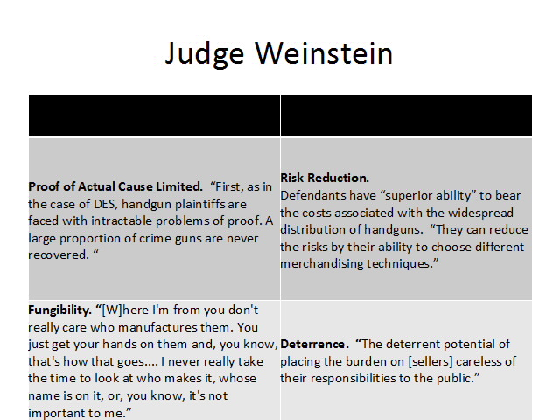
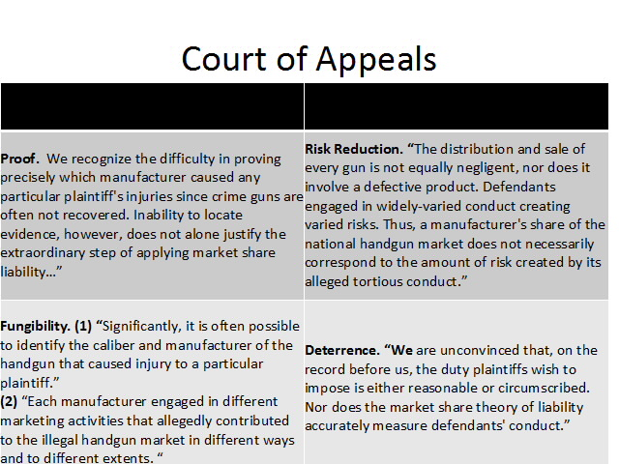

- Proximate Cause

  - The Central Question
    - Assume the defendant’s breach of a duty was, however remotely, a partial cause of the plaintiff’s injury.
    - Courts won’t hold defendants liable for every possible consequence of their negligent conduct.
    - Proximate cause means there is a sufficient connection between the defendant’s actions and the plaintiff’s harm to hold the defendant liable as a matter of policy.
    - Factors for Proximate Cause:
      - Time
      - Space
      - Directness/Indirectness
      - Foreseeability
      - Remoteness
      - Intervening Causes
    - Restatement Section 29: “An actor’s liability is limited to those physical harms that result from the risks that made the actor’s conduct tortious.”
      - Unforeseeable Harm
      - Unforeseeable (Superseding) Causes
      - Unforeseeable Plaintiffs

  - The Unforeseeable Harm

    - Is the plaintiff’s injury totally beyond the type of harm to be expected from the defendant’s conduct, or did the harm simply arise in an unusual manner or involve more serious harm than expected?
      - Unexpected Type of Harm (No proximate cause)
        - Explosion from non-flammable oil (Wagon Mound)
        - Drowning in lake of rat urine
      - Unexpected Manner of Harm (Proximate cause)
        - Hines v. Morrow – peg leg caught at railroad tracks
      - Unexpected Degree of Harm (Proximate cause)
        - The “eggshell” plaintiff
        - Suicide
        - Emotional Distress

BENN v. THOMAS (degree of harm)
Facts: Plaintiff suffers heart attack three days after auto accident. Plaintiff had a prior history of heart attack. Suffered ankle injury and bruising from the crash.
Holding: The accident was the proximate cause because although the severity of the harm was unforeseeable, the heart attack was a direct foreseeable result of the type of harm caused to the plaintiff.
Rule: “Eggshell plaintiff” rule. When as plaintiff is harmed, you take the plaintiff as you find him, even if that means you must compensate him for harm an ordinary person would not have suffered.
Rationale: The eggshell plaintiff rule rejects the limit of foreseeability that courts ordinarily require for proximate cause.
Note: Cases describe how courts recognize that when defendant’s conduct produces “serious physical injury,” the resulting suicide may also be the proximate cause.

In re an Arbitration POLEMIS (manner of harm)
Facts: Stevedores were moving benzene from one hold to another by means of a sling. Stevedores negligently knocked a wooden board into hold of the ship filled with benzene causing a spark and a subsequent explosion.
Holding: Given the breach of duty, and given the damage as a direct result of that negligence, the anticipations of the person whose negligent act has produced the damage appear to be irrelevant.
Rule: The consequences, which may reasonably be expected to result from a particular act, are material only in reference to the question whether the act is or is not a negligent act. Those consequences are the test whether the damages resulting from the act, assuming it to be negligent, are or are not too remote to be recoverable.
Rationale: It has already been found that defendant was negligent. It is immaterial that the causing of the spark by the falling of the plank could not have been reasonably anticipated. Even though the precise type of harm is not foreseeable, proximate cause still exists. The damages claimed are not too remote.

THE WAGON MOUND (type of harm)
Facts: A wharf in Sydney Harbor burns down, three days after a ship, the Wagon Mound spills “bunkering oil” at a different wharf 600 feet away.
Holding: The fire was unforeseeable, and thus, not the proximate cause.
Rule: Foreseeability of harm becomes the effective test.
Rationale: Polemis court held that if the defendant is guilty of negligence he is responsible for all the consequences whether reasonably foreseeable or not. However, to demand him to be responsible for more than the probably consequences of his act is too harsh a rule; to demand less is to ignore that civilized order requires the observance of a minimum standard of behavior. It is not the act, but the consequences on which tortious liability is founded.
Discussion: The oil itself still damaged some part of the wharf. Why aren’t the owners of the Wagon Mound liable for that under the “eggshell plaintiff” rule? Applies only to people and physical damaged caused to a person.

  - The Unforeseeable Cause
    - Did another persons’ unexpected “intervening act” cause the harm, or did that action fall within the scope of risks created by the defendant?
      - Related versus unrelated crime (failed burglar alarm, train stop, World Trade Center)
      - Related versus unrelated coincidence (tree falls on trolley)
      - Plaintiff’s own conduct

DOE v. MANHEIMER
Facts: Plaintiff, a meter reader, was raped by an unidentified assailant on property owned by defendant behinds defendant’s overgrown bushes and grass.
Holding: Defendant owed a duty, and the duty was breached, but there was no proximate cause, even though cause-in-fact existed.
Rule: Restatement Section 442. A negligent defendant is not relieved from liability…except where the harm is intentionally caused by the third person and is not within the scope of the risk created by the defendant’s conduct.
Rationale: The harm plaintiff suffered cannot reasonably be understood as within the scope of the risk created by defendant’s conduct. Section 442 contemplates reasonably foreseeable intervening misconduct, rather than all conduct that actually proceeds from a situation created by the defendant. There was no evidence that defendant had had any past experience that might reasonably have led him to perceive and act on the atypical association. The harm must be within the “scope of the risk” and the harm suffered must be of the same “general type” as that which makes the defendant’s conduct negligent in the first instance.
Discussion: The duty that exists is one to maintain the premises in a way that avoid crime. There is cause-in-fact, but no proximate cause.
Why were the bushed the cause of the harm?
They created a ‘protective zone’ that reduced or eliminated visibility and served as an inducement for crime (“catalyst” for crime).

ZIMMERMAN v. RATNER
Bruce Ratner doing construction on buildings he owns. “Broken windows” theory says that people are more likely to commit crime in areas where broken windows of cars are smashed, rusted cars, overgrown sidewalks. He also promised streetlights to prevent increased incident of crime. Last week, someone stole catalytic converter.

  - The Unforeseeable Victim

    - Was the plaintiff a foreseeable plaintiff? Was the plaintiff in some position, in time and space, to be foreseeably harmed by the defendant’s conduct?
    - Cardozo on Palsgraf:
      - “The risk to be perceived defines the duty to be obeyed and risk imports relation; it is the risk to others within the range of apprehension.”
      - Compare to: Restatement Section 29 “An actor’s liability is limited to those physical harms that result from the risks that made the actor’s conduct tortious.”

PALSGRAF v. LONG ISLAND RAILROAD CO.
Facts: Plaintiff was standing on platform of defendant’s railroad. Man carrying a package jumped aboard the train. Package contained fireworks, fell, and exploded. The shock threw penny scales at other end of platform into the plaintiff, causing injuries.
Holding: There was no tortious duty owed to plaintiff.
Rule: The defendant’s conduct must be a “wrong” in relation to a foreseeable plaintiff. The risk to be perceived defines the duty to be obeyed and risk imports relation; it is the risk to others within the range of apprehension.
Rationale: Negligence is not actionable unless it involves the invasion of a legally protected interest, the violation of a right. The plaintiff must show a “wrong” to herself, not merely a wrong to someone else, nor conduct “wrongful” because unsocial. An act is negligent because the eye of vigilance perceives the risk of damages. There was nothing in the situation to suggest to the most cautious mind that the parcel wrapped in newspaper would spread wreckage through the station. If there is no tort to be redressed, there is no occasion to consider what damage might be recovered if there were a finding of a tort.
Dissent: Discusses if it should be that where there is an act which unreasonably threatens the safety of others, is the doer liable for all its proximate consequences, even where they result in injury to one who would generally be though tot be outside the radius of danger. Everyone owes to the world at large the duty of refraining from those acts that may unreasonably threaten the safety of others. Not only is he wronged to whom harm might reasonably be expected to result, but he also who is in fact injured, even if he be outside what would generally be thought the danger zone.
Discussion: Cardozo – duty/no duty; Andrews (dissent) – proximate cause [judge v. jury]

Palsgraf Case v. Palsgraf Testimony
What facts are different?
We learn about the type of harm, no mention of children in the case, court didn’t mention her buying the ticket, work history and lost income not mentioned, that it was a crowded platform, choked in smoke and hit by a ball of fire, visit from Railroad doctor.
What was the rule adopted by Cardozo?
The defendant’s conduct must be a “wrong” in relation to a foreseeable plaintiff. “The risk to be perceived defines the duty to be obeyed and the risk imports relation; it is the risk to others within the range of apprehension.”
Was Justice Cardozo justified in ignoring all these facts?
All those facts go to damages, which are irrelevant because there was no duty, so plaintiff can’t recover for damages.
Who could Palsgraf sue?
The person carrying the fireworks, the person who set up the penny scale, maker of the penny scale, purchaser of the penny scale.

  - DAMAGES
The plaintiff is harmed.

POPPER v. DAVIDSON (Settlement Negotiation)
driving to job interview
contributory negligence: 42 mph in a 25 mph zone & fact that air bag didn’t deploy was not fault of Davidson
does defendant disclose that plaintiff can suffer from an aneurysm?
unwilling to offer for pain and suffering, which could have been prevented/were the fault of car manufacturer

ZIMMERMAN V. SPAULDING, the court held that defendant, who discovered life threatening information about the plaintiff was not ethically obligated to disclose that information in connection with a settlement negotiation. While attorneys may not affirmatively misrepresent facts in a negotiation, they may omit facts that the plaintiff relies upon, even when the plaintiff’s life is at stake.

    - COMPENSATORY DAMAGES

FEINBERG, BP COMPENSATION FUND
eligibility – those directly affect by the spill
legitimacy – documentation to prove claims
a. Should Ken require people to accept lump-sum awards and waive future claims against BP before they know the long-term effects of the spill? (Single Judgment Rule)
b. Should Ken compensate victims for their anger, frustration or mental anguish? (pain & suffering damages)
c. Should Ken deduct from his final awards the insurance payments or any other funds (“collateral sources”) that victims earned during the period for which they claim their businesses lost money as a result of the spill? (Arambula)

      - SINGLE JUDGMENT RULE
        - Purpose
- pay for the “whole crab”
- pay out for the total loss – past, present, future damages must be paid all at once
- if periodic, people might now try to recover if they are able to keep proving that they are injured; administrative burden; payments can change over time, which would be unfair to defendant

      - ECONOMIC DAMAGES
        - Past and Future Medical Expenses
        - Past and Future Lost Wages

ARAMBULA v. WELLS

Facts: Arambula (P) was injured in a rear-end collision and sued for damages. P missed work due to injuries, but was still paid weekly salary by employer (who was his brother) gratuitously. Employer wished to be reimbursed but no official agreement to do so. Wells (D) used footnote 5 from Helfend to argue no documentation of agreement meant no award and employer paid without a requirement to do so.
Holding: Helford does not sufficiently protect D from paying full damages to P when P’s employer paid wages because money comes from a “collateral source.”
Rule: Collateral Source Rule. P’s in personal injury actions can still recover full damages even though already received compensation for injuries from “collateral sources” that are “wholly independent” from D (i.e. insurance).
Rationale:
Precedent makes no special distinction between collateral sources and pure gratuitous collateral.
No other cases have used footnote in this way (most have allowed P to recover).
Majority (majority rule) of people/jurisdictions supports this.
Public policy is in favor of encouraging insurance and charity.
P may not be motivated to repay through a second act of kindness.
Discussion: Tortfeasor should not benefit from victim’s foresight and windfall of charity to plaintiff. Similarly, offsetting will punish the people with foresight of insurance and may not properly deter. Rule only applies to “wholly independent” sources of income.
Note: NY (minority rule) offsets damages if insured (except life insurance).

SEFFERT v. LA TRANSIT LINES

Facts: Seffert (P) was entering bus when doors suddenly closed on right hand and left foot. P was dragged until released on pavement. Major injuries were incurred to P’s left foot; she is crippled and will suffer pain for life (life expectancy = 34.9 years). P has since undergone 9 operations and spent 8 months in hospitals. Condition is permanent and may require future operations.

Holdings: Awards for damages are not so high that it “shocks consciousness” and

there are no grounds for claiming prejudicial error.
Rule: An appellate court can interfere on the ground that judgment is excessive if verdict is so large that it “shocks the conscience” and suggests “passion, prejudice or corruption” by the jury (Holmes).
Rationale: Each case must be decided on own facts. Items of damage are past and future pain, humiliation and constant anxiety. D did not object to math formula when P made the argument; also, D used a similar math formula during D’s arguments.
Discussion: Was future economic loss ($10,000) justified?
Was it fair to rely on her life expectancy given it is 4 years longer than a man?
Was it fair to rely on earnings (65% of a man’s income)?

      - NON ECONOMIC DAMAGES
Rationale for Non Economic Damages:
- Recognition that emotional trauma is as real as physical or economic harm
- Ways to deter wrongdoer by forcing him or her to bear the social cost of harm
- Way to assure distributional justice; if you think that non-economic damages should not be correlated to economic loss, these damages may serve as a way to level the playing field between jury awards
- Promotes court access

        - Emotional Distress

WOMACK v. ELDRIDGE

Facts: Eldridge (D) was instructed by employer to obtain a photo of Womack (P) to use in a criminal court trial where employer’s client was charged with child molestation. D went to P’s house, said she was a reporter and asked to take a picture of P. At court the employer introduced the photograph as an alternate molester to his client, but the victims said it wasn’t the suspect. D was called to the stand to testify to who the man in the photo was and his address. P was an alternative because he worked at the same establishment as employer’s client. P continued to be involved in that case and was summoned to testify.
Holding: P is entitled to recovery for emotional distress even in the absence of bodily injury & a jury should determine the amount of damages.
Rule: Cause of action for emotional distress without bodily injury exists if:
- conduct was intentional or reckless
- conduct outrageous and intolerable that it offends against generally accepted standards of decency and morality
- causal connection between wrongdoer’s conduct and emotional distress
- emotional distress was severe
Rationale: Reasonable people can disagree over the issues (i.e. whether it was intentional or reckless) the court claimed to have answered. Therefore, it should have been left up to the jury.
Discussion: What did D have to know at the time of taking the picture? That it would be used in a criminal case? That he could be accused unjustly of child molestation? That is was for an attorney?
Was there a causal connection between photographer’s actions and emotional distress?

        - Loss of Enjoyment of Life

MCDOUGALD v. GARBER

Facts: Garber’s (D) malpractice left McDougald (P) in a permanently comatose state where P provides evidence that victim can respond to certain stimuli. D asserts injuries are too severe to allow for any consciousness.

Holdings: An award for loss of enjoyment of life does not serve compensatory purpose & cognitive awareness is a prerequisite. Loss of enjoyment of life is not a separate category from pain and suffering damages.
Rule: Award of compensatory damages is to compensate victim, not punish tortfeasor; purely punitive damages are prohibited.
Consciousness only requires a “spark of awareness.”
Rationale: 1. An award of monetary damages has no “meaning or utility” to an unconscious injured person (therefore, could be considered punitive). 2.“Suffering” can easily encompass mental anguish caused by loss of enjoyment of life. 3. Approving of a separate aware would increase total award for nonpecuniary damages. 4. Estimation of nonpecuniary damages need not be so analytical because cannot be calculated with absolute precision anyway.
Discussion: Can we allow comatose patient to recover for loss of life when they can’t enjoy the money? If you need to prove “consciousness” are we creating an incentive for wrongdoers to do more damage (paradoxical situation)? Are we incentivizing maliciousness? Note: a majority of states would allow “loss of enjoyment of life” damages, like the dissent states.

    - PUNITIVE DAMAGES

      - History of Punitive Damages:
        - Not intended to compensate, but to punish.
        - Initially only for intentional misconduct, but can now span to recklessness as well.
        - As they began to punish beyond intentional misconduct, courts began to impose limits on jury awards under the Due Process Clause of the Constitution.
      - 14th Amendment Defense: Due Process Clause limits excessive punitive damage awards to those that reflect: (State Farm)
        - Reprehensibility (moral blameworthiness)
        - Proportionate relationship to actual damage (relationship between compensatory and punitive)
        - Other criminal or civil sanctions available

TAYLOR v. SUPERIOR COURT
When are you entitled to punitive damages?

Facts: Still was driving under the influence and crashed into Taylor’s (P) car causing P serious injuries. Still had previously been arrested and convicted on several drunk driving charges. He recently finished probation and was now employed and his job required him to transport alcohol. At the time of the accident Still was facing additional pending charges.
Holdings: Yes, there are sufficient allegations from which it may reasonably be concluded that D consciously disregarded the safety of others. Therefore, (1) punitive damages for D and (2) punitive damages for drunk driving.
Rule: Section 3294 of Civil Code. Authorizes recovery of punitive damages in noncontract cases “where D has been guilty of oppression, fraud, or malice, express or implied.” *Intentional, willful, or wanton misconduct.
“express” direct evidence on existence of hatred
“implied” indirect from which jury can draw inferences
“malice” act conceived in spirit of mischief or with criminal indifference to others; “deliberate and conscious disregard” for safety of others.
Rationale: Allowance of punitive damages would deter similar future behavior to the public. No valid reason for immunizing driver from punitive damages given the demonstrably and inevitable risk upon innocent people by his voluntary conduct; severe threat to public safety.
Discussion: When to impose punitive damages. Compare to texting while driving, can you
make a case for imposing punitive damages based on Taylor?

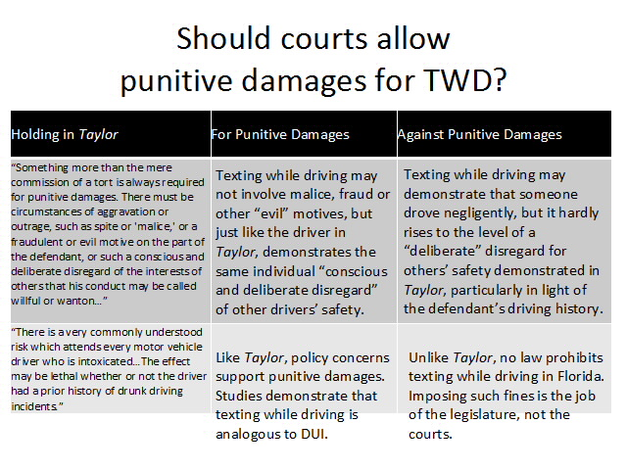

STATE FARM MUTUAL AUTOMOBILE INSURANCE CO. v. CAMPBELL
What limits does the Constitution put on punitive damages?

Facts: Curtis Campbell was driving with wife on a two-lane highway. Campbell moved into a lane with oncoming traffic to attempt to pass six vans. Ospital swerved to avoid collision and crashed into Slusher. Ospital was killed and Slusher permanently disabled. State Farm contested liability and refused to settle for $25,000 each. They went to trial, jury found Campbell was 100 percent at fault. Judgment returned for $185,849. State Farm refused to pay excess liability. Campbells then pursued a bad faith action against State Farm and was represented by Slusher and Ospital’s attorneys
Holding: Yes, the $145 million award was neither reasonable nor proportionate to the wrong committed and is in violation of the Due Process Clause.
Rule: Gore. When reviewing punitive damages, consider:
- the degree of reprehensibility of the defendant’s misconduct
- disparity between actual or potential harm suffered by plaintiff and punitive damages award
- difference between punitive damages awarded by jury and civil penalties authorized or composed in comparable cases
Rationale:
(1) State Farm is being punished for nationwide practices rather than for conduct in this specific case; State does not have interest in punishing D for conduct outside State’s jurisdiction and D can’t be punished on the basis that D is recidivist because there is little evidence provided of repeated misconduct
(2) few awards exceeding single-digit ratio will satisfy due process (looking at previous “instructive” cases) and wealth of D cannot justify an otherwise unconstitutional punitive damages award
(3) must avoid use of civil process to assess criminal penalties where higher standard of proof does not protect D; most relevant civil sanction is $10,000 fine for fraud
Discussion: Additional factors to establish reprehensibility include: (1) whether harm was physical or purely economic harm; (2) involved a reckless disregard to safety; (3) repeated misconduct; or (4) a vulnerable target.

  - DEFENSES

    - CONTRIBUTORY/COMPARATIVE NEGLIGENCE
      - Contributory Negligence – plaintiff cannot prevail
        - more lenient standard for plaintiff fault or proximate causation
        - last clear chance doctrine
        - recklessness
        - expanded jury’s role
      - Comparative Negligence – plaintiff’s fault does not present a bar to recovery; plaintiff’s recovery is only reduced by the plaintiff’s percentage of fault
        - Pure Comparative Negligence
        - Modified Comparative Negligence (requires plaintiff is no more than 50% responsible)

    - ASSUMPTION OF RISK
      - Express Assumption of Risk
        - Written or oral agreement to waive liability that is (a) broad enough and (b) clear enough to cover the harm alleged.
        - Must be consistent with public policy.
        - Public Policy
          - Public regulated business
          - Important public service
          - Available to public
          - Excessive bargaining power
          - Contract of adhesion (boilerplate)
          - Plaintiff under control or custody of defendant

HANKS v. POWDER RIDGE RESTAURANT CORP.
Facts: Parent and four kids snow tube on Powder Ridge resort in Connecticut. Parent signs an agreement barring lawsuits arising out of (a) inherent risks of sport and (b) negligence of resort. Parent injures foot on negligently maintained man-made bank on the slopes.
Holding: The contract does protect defendant’s alleged negligence but is barred as a matter of public policy.
Rationale: The Hyson court stated that the released did not specifically refer to possible negligence by the defendant, but only referred to inherent and other risks. Here, there is explicit reference to negligence. However, the law does not favor contract provisions, which relieve a person from his own negligence. The Tunkl court concluded that exculpatory agreements violate public policy if they affect the public interest adversely. They include: (1) the agreement concerns a business of a type generally suitable for public regulation; (2) the party seeking exculpation is engaged in performing a service of great importance to the public, which is often a matter of practical necessity; (3) the party holds himself out as willing to perform this service for any member of the public; (4) the party invoking exculpation possesses a decisive advantage of bargaining strength; (5) the party confronts the public with a standardized adhesion contract of exculpation and makes no provision whereby a purchaser may pay additional reasonable fees and obtain protection against negligence; (6) the person or property of the purchaser is placed under the control of the seller. There is a societal expectation that family oriented recreational activities will be reasonably safe. The plaintiff paid a fee and was under care and control of resort. Plaintiff unable to negotiate and lacked knowledge, experience and authority.

      - Implied Assumption of Risk
        - Non-written
        - Knowledge of the nature or risk of danger
        - Voluntary assumption of risk
          - Primary Assumption of Risk
  - voluntary assumption
  - known risk
  - not a true affirmative defense, but rather, determines whether defendants legal duty covers risks to which plaintiff is exposed
          - Secondary Assumption of Risk
- voluntary assumption
- known risk
- a true affirmative defense because it is asserted only after plaintiff establishes prima facie case of negligence
- Secondary Assumption of Risk v. Comparative Negligence
    - assumption of risk is a knowing and voluntary assumption of risk to oneself
    - comparative negligence is an (a) unintentional failure to take (b) reasonable care with respect to oneself

MURPHY v. STEEPLECHASE AMUSEMENT CO. (primary)
Facts: Murphy is injured on the Flopper after observing the attraction. The belt on the flopper moved about 7 mph.
Holding: Plaintiff cannot recover because he impliedly assumed the risks that were obvious in nature.
Rule: One who takes part in a sport accepts the dangers that are inherent so far as they are “obvious and necessary.”
Rationale: One who steps upon a moving belt and finds his heels above his head is in no position to discriminate with nicety between the successive stages of the shock between the jerk which is a cause and the jerk, accompanying the fall, as an instantaneous effect. Whether the movement of the belt was uniform or irregular, the risk at greatest was a fall. This was the very hazard that was invited and foreseen.

DAVENPORT v. COTTON HOPE PLANTATION (secondary)
Facts: Plaintiff rented condo from owner, where three stairways afforded access. Plaintiff informed defendant that the floodlights in the closest stairway failed, and later, fell on stairs because of poor lighting.
Holding: Plaintiff knowingly assumed risk created by defendant’s breach of a duty of care but can recover unless the degree of fault arising therefrom is greater than the negligence of the defendant. Secondary assumption is compatible with comparative negligence.
Rule: A plaintiff is not barred from recovery by the doctrine of assumption of risk unless his degree of fault arising therefrom equals or exceeds the combined fault or negligence of the other parties to the accident.
Rationale: This is not primary assumption like Murphy where defendant lacked duty of care at all because society tolerates inherently risky activity. Here, there was a duty. The defendant’s fault in causing an accident is not diminished solely because the plaintiff knowingly assumes a risk. A plaintiff would be completely barred from recovery even if his conduct is reasonable or only slightly unreasonable if assumption of risk is retained in current common law form. Co

    - PREEMPTION
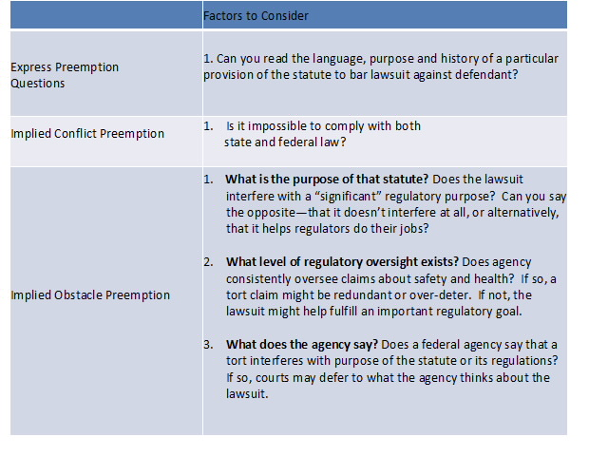
      - Express Preemption – Does federal law say that state law “requirements” in a certain area are preempted? Because statutes aren’t always clear, consider the text, purpose and legislative history of law.
        - What does the federal statute say?
        - What does the state lawsuit do?
        - Can you read the language, purpose and history of a particular provision of the statute to bar lawsuit against defendant?
      - Implied Conflict or “Impossibility” Preemption – If the federal law doesn’t say anything about state law, does federal law impose requirements that make it impossible to comply with state law?
        - Implied – the fact that the requirement exists suggests that courts can imply preemption
        - Impossible – unable to comply with both at the same time
        - Is it impossible to comply with both state and federal law?
      - Implied Obstacle Preemption – If federal law is silent and it is possible to comply with both state and federal law, does the lawsuit obstruct “purposes and objectives” of federal law?
        - What is the purpose of that statute?
        - What level of regulatory oversight exists?
        - What does the agency say?
      - Evolving Area of Law
        - Traditionally, a “presumption against preemption” of state law.
        - Preemption jurisprudence increasing view that tort law is regulatory in nature.
        - Statutory law traditionally viewed as providing only a floor for our obligations to one another.
        - Preemption reflects view that some federal statutes impose both a ceiling and a floor for the obligations and duties we owe to one another.
      - Problems with Preemption
        - Capture
        - Information lag
        - Civil recourse
        - Compensation
        - Prevents modifications of statutes
      - Policy Question
        - Who decides: Congress, agencies or juries?
        - What role does tort law continue to serve in areas increasingly regulated by federal and state agencies?

RIEGEL v. MEDTRONIC, INC. (Express Preemption)
Facts: Riegel had an angioplasty after he suffered a heart attack. The catheter burst, Riegel went on life support, and nearly died. Medtronic allegedly negligently tested, designed, labeled and marketed the catheter. Medtronic argues it complied with a federal law regulating medical devices.
Holding: Medtronic’s preemption defense prevails.
Rule: Federal Statute, The Medical Device Act, preempts state requirements “different from or in addition to” any state law requirement applicable to the device that “relates to safety and effectiveness.”
Rationale: The court evaluates whether the federal government established “specific requirements” that apply to the catheter. MDA “requirements” are that the catheter receive premarket approval, reporting requirements, cannot change product without regulatory clearance; regulator has power to withdraw approval. These are not just run-of-the-mill requirements that apply to all medical devices. State requirements are preempted only when the FDA has established specific regulations. The court then looks to whether the state tort suit imposes a different “requirement” than federal laws relating to “safety and effectiveness.” The court finds that a state tort suit imposes a different requirement because damage awards are a “potent method of governing conduct” and juries may frustrate federal scheme by failing to see the costs and benefits of a medical device.
Dissent: Notes that there’s a “presumption against preemption.” Looks at legislative history behind similar FDA regulations. They do not have preemption clauses. Observes that preemption language was likely added to preempt inconsistent statue statutes that regulate medical devices, not common law tort suits.

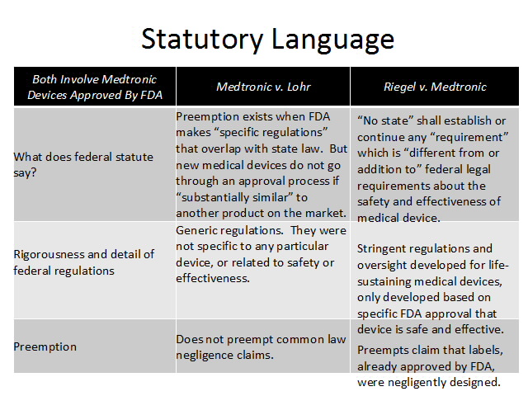

WYETH v. LEVINE (Implied Obstacle Preemption)
Facts: Wyeth was filed on behalf of a professional guitarist, Levine, who lost an arm after an injection of the nausea drug Phenergan, which is manufactured by Wyeth. The injectable form can be administered intravenously when drug injected directly into vein or through an IV drip bag. The drug is corrosive and causes gangrene if it enters an artery. Plaintiff alleges better warning would have saved her arm. Wyeth claims they could not have legally changed the drug’s label without prior approval.
Holding: Court rejected Wyeth’s federal implied preemption defense on the ground that FDA regulation sets a floor and not a ceiling for safety.
Rationale: No express preemption clause, so had to consider whether implied preemption existed based on whether lawsuit frustrated “purpose and objectives” of existing laws and FDA regulations. Court rejected arguments pointing to legislative history of the stature and lack of specific regulations designed to ensure drug safety. Wyeth could change labels without permission. Absent evidence that FDA would not have approved the new label, it could comply with both federal and state law without a conflict.

SCHWAB v. ALTRIA GROUP
Facts: Frank developed lung cancer after 25 years of smoking “light” cigarettes made by Altria. Claims negligent representations about safety specifically less tar and nicotine, despite well-documented evidence that shows Altria knew message was false.
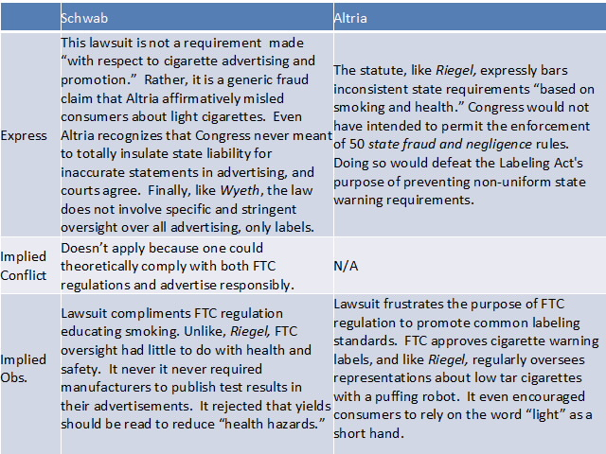

- STRICT LIABILITY

Policies
    - Corrective Justice
      - Moral blame assigned to direct cause of harm
      - Nonreciprocal risk taking
    - Deterrence
      - Loss avoidance
      - Risk spreading
      - Cost of business
    - Compensation
      - Best insurer
      - Loss not born by innocent
    - Court Access and Administration
      - Proof
      - Expense

- Abnormally Dangerous Activities
- Abnormal
- Extent to which the activity is not a common usage
- Inappropriateness of the activity
- Community value is outweighed by danger
- Dangerous
- Existence of high degree of harm to person, land or personal property
- Likelihood of great harm
- Inability to eliminate risk through reasonable care
- Examples
- Wild animals
- Blasting dynamite
- Hot air balloons in New York City

FLETCHER v. RYLANDS
Facts: Defendant builds large reservoir over coalmines in 19th century England. Defendant is faultless, but water floods through mineshafts onto neighboring property because of weakened earth and possibly engineer’s negligence.
Holding: Defendant is still liable for lawfully bringing something onto land that damaged neighboring property, despite all precautions being taken.
Rule: Defendants are strictly liable for direct and natural consequences that result from dangerous and non-natural use of land. (Rule does not apply to superior intervening causes or Acts of God.)
Rationale: Even if not liable for contractor’s faulty work, still liable for all of the natural consequences of escape. Court pointed to analogies – once a dog bites someone, owner is strictly liable for all bites that follow.

- Modern Rule for Abnormally Dangerous Activities

INDIANA HARBOR BELT R.R. v. AMERICAN CYANMID
Facts: American Cyanmid, a chemical company, ships 20,000 gallons of flammable toxic chemical called acrylonitrile on railroad tank car. Because lid on outlet was broken, spills toxic chemicals just outside of Chicago switching station causing millions of dollars in damages.
Holding:
Rule: Strict liability for unreasonably dangerous activities should be applied when a particular accident cannot be avoided by taking more care (i.e. moving to another location, or reducing the scale of the activity to reduce harm).
Rationale: Dynamite. Explosives dangerous even when handled carefully and blasting is not a commonplace activity so we want blasters to choose location carefully. Guille. Flying hot air balloon, landed in vegetable garden; even though he was not negligent, he can still be strictly liable, based on six factors. Most important factor to consider if strict liability should be used is whether you can manage harm through exercising due care (negligence). There is no reason to rely on SL when negligence is enough. We apply SL because we want to send a signal (move it somewhere else, do it a lot less, or don’t do it at all). Here, it is impossible to ship via railroad in areas that are not metropolitan areas and too many costs on the defendant. Also, negligence would be better because, here, it is not the actors (transporters) but the manufacturers who are being asked to be held strictly liable; therefore, plaintiffs could recover if it is shown that an actor’s actions caused the damage. Finally, there wasn’t anything inherently dangerous about the chemical that caused the damage it was negligently placing the lid on the container. Therefore, exercising more care would have prevented the harm.
Discussion: What can a defendant do to minimize the payout if they are going to do something that will be strictly liable? Reroute the activity away from people, do it a lot less, or don’t do it at all.
What are the Guille factors? (1) The risk of harm was great, and (2) the harm that would ensue if the risk materialized could be great. (3) Such accidents could not be prevented by due care. (4) The activity was not a matter of common usage. (5) The activity was inappropriate to the place in which it took place. (6) The value to the community of the activity did not appear to be great enough to offset its unavoidable risks.

IN RE HURRICAN KATRINA CANAL LITIGATION
Army Corps of Engineers’ maintenance dredging of Mississippi River-Gulf Outlet led to flooding from Hurricane Katrina.
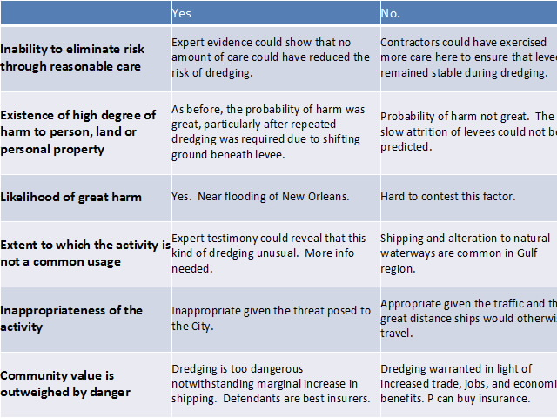

- Manufacturing Defects
- Central question in manufacturing defect cases is: Is the product different from, and more dangerous than, its intended designs?
- Restatement (Third) of Torts
- One engaged in selling or distributing products who sells or distributes a defective product is subject to strict liability for harm to “persons or property” caused by defect.
- A manufacturing defect exists when products “depart from their intended design even though all possible care was exercised.”
- Restatement (Second) of Torts
- One who sells any product in a defective condition “unreasonably dangerous” to the user or consumer is strictly liable for physical harm caused to the ultimate user, consumer, or to his or her property, if:
        - The seller is in the “business” of selling product
        - The product is expected to, and does, reach plaintiff unchanged
- Also applies when:
        - Seller exercises all possible care in making product
        - The user or consumer buys product from someone else
- Circumstantial Evidence Supporting Inference of Product Defect
- One can infer a product defect harms a plaintiff without specific proof of a defect when:
        - The incident that hurt plaintiff was of a kind that generally occurs as a result of a product defect.
        - The incident was not, in that case, solely the result of other causes.

MACPHERSON v. BUICK MOTOR CO.
Facts: Defendant is manufacturer. Sold car to retail dealer. Retail dealer resold to the plaintiff. Car collapsed and was injured. Wheel was bought from another manufacturer. There is evidence, however, that its defects could have been discovered by reasonable inspection.
Holding: Defendant was a manufacturer of automobiles and was responsible for the finished product and therefore responsibilty for a duty of inspection.
Rule: Abandons contractual privity. “Manufacturers owe a duty of care for reasonably foreseeable harm to reasonably foreseeable plaintiffs, including those persons “other than the purchaser” of the product.
Rationale: Abandon privity rule. “Precedents drawn from the days of travel by stagecoach do not fit the conditions of travel today. The principle that the danger must be imminent does not change, but the things subject to the principle do change.” Historically, limited to privity, which made sense for simple products where parties could negotiate over known problems or hazards. Exceptions existed for tainted food and poisons where harm was more difficult to know or trace.
Exceptions to rule of privity: painter purchased scaffold but servants were injured; urn exploded in restaurant and injured customers. Overall, (1) manufacturer is in best position to avoid danger and (2) mass production means contracting, by itself, insufficient to regulate dangerous new products.
Discussion: Reasons why the old rule made sense: knowledge of who you are doing business with, was possible to track down manufacturers and enter into contracts with them, smaller scale of economy, worried about crushing liability, simplicity of automobiles and ability to inspect for defects.

ESCOLA v. COCA COLA BOTTLING CO. OF FRESNO
Facts: Plaintiff was injured when a soda bottle broke in her hand. She claims she handled it carefully. Defendant bottler used pressure to bottle. Engineer testified that bottling method is “pretty near” infallible.
Holding: Escola properly benefited from res ipsa loquitur in her negligence action.
Rule: Concurring opinion - Abandons fault. A manufacturer is strictly liable when (a) places article on the market, (b) knowing that it is to be used without inspection for defects, and (c) proves to have a defect that causes injury.
Rationale: Traynor would hold Coca Cola strictly liable. Manufacturer is in the best position to avoid the harm, as opposed to the average consumer (deterrence). Manufacturer also in the best position to insure against the harm, therefore, we should place the burden on manufacturer. Customer not equipped to discover defects, whereas manufacturer is familiar with the complex practices of bottling and inspecting. (1) Information disadvantages/consumer expectations, (2) loss avoidance/insurance, (3) risk spreading/best position to avoid harm, (4) limitations of warranty and res ipsa.
Discussion: Here, the majority found that res ipsa loquitur was applied properly and found for the plaintiff. HOWEVER, the concurring opinion is where strict liability is presented and the rationale for it is discussed.
Could res ipsa loquitur apply? Res ipsa just shifts the burden to the other side to prove what happened, it doesn’t automatically allow plaintiff to prevail. Coca Cola could then argue that they did everything that they could and did not breach negligence. However, the jury in every single case held Coca Cola liable.

GREENMAN v. YUBA POWER PRODUCTS, INC.
Facts: Plaintiff’s wife bought a power tool made by defendant. Plaintiff was hurt while using tool.
Rule: Manufacturer is strictly liable in tort when an article he places on the market, knowing that it is to be used without inspection for defects, proves to have a defect that causes injury to a human being.

- Design Defects
- Ordinary Consumer Expectations
- Used in cases involving obvious defects.
- Test: A product may be found defective if the product failed to perform as safely as an ordinary consumer would expect when used in an intended or reasonably foreseeable manner.
- Rooted in implied warranty – that consumer’s expectations of a product are legally significant.
- Risk-Utility Analysis
- Used in cases involving non-obvious defects, especially where consumers have no idea how safe a product can be made.
- Test: Defendant is strictly liable if risk of danger inherent in the design outweighs the benefits.
- Considerations include:
- Probability and gravity of danger
- Feasibility and cost of safer alternative design
- Adverse consequences to product and consumer of alternative design
- Reasonable Alternative Design (RAD)
- Must prove “reasonable alternative design” would have reduced the foreseeable risk of harm.
- Must consider the advantages/disadvantages of the alternative design, including:
- Cost
- Product longevity
- Maintenance and repair
- Esthetics
- Range of consumer choice
- Other Design Defect Considerations (Camacho v. Honda Motor Co.)
  - Usefulness of product
  - Safety aspects of product
  - Availability of substitutes
  - Ability to fix without impairing usefulness or adding excessive cost
  - User’s ability to avoid danger
  - User’s knowledge of inherent dangers
  - Feasibility of manufacturer to insure
- Are there some products that are so dangerous, and so useless, that they should be considered defective even if there is no other reasonable design? (i.e. cigarettes, alcohol)
- Preemption and Strict Liability
      - Express Preemption (Riegel) – the text of federal law expressly provides that State law should not be given effect
      - Implied Preemption (Wyeth) – state and federal law impossibly conflict, presents an obstacle to “purposes and objectives” of federal law

GREG JESSEE
Facts: Jessee felt a jolt to his chest. The heart defibrillator implanted in him five years earlier was firing wildly. Second jolt made him collapse. Third knocked him unconscious. The cable connecting defibrillator to his heart had failed and the electrical wires were exposed through the coating.
Discussion:
What evidence would you want to introduce that misfiring leads were result of manufacturing defect? All other brands of pacemakers.
What evidence would you want to introduce to show design defect? Cases of other people who have the same defibrillator.
What evidence would you want to introduce to show both? All have the same design flaw with the casing but this was the one case where it actually broke through.

SOULE v. GENERAL MOTORS CORPORATION
Facts: Plaintiff’s ankles were injured when her GM car collided with another vehicle. She asserted that defects in her automobile allowed its left front wheel to break free, collapse rearward and smash the floorboard into her feet.
Holding: The ordinary consumers test cannot be applied to complex products.
Rule: Excessive Preventable Danger. Defendant is strictly liable if risk of danger inherent in the design outweighs the benefits.
Rationale: We cannot accept GM’s insinuation that ordinary consumers lack any legitimate expectations about the minimum safety of the products they use. The jury should not have been instructed on ordinary consumer expectations. A complex product may often cause injury in a way that does not engage its ordinary consumers’ reasonable minimum assumptions about safe performance. Plaintiff’s theory of design defect was one of technical and mechanical defect. Both parties assumed that quite complicated design considerations were at issues, and that expert testimony was necessary to illuminate these matters. Therefore, injection of ordinary consumer expectations into the design defect equation was improper. However, the error was harmless because it is not reasonably probably defendant would have obtained a more favorable result in its absence.
Discussion: Plaintiff alleges BOTH manufacturing defect and design defect.

GRAY v. PINTO

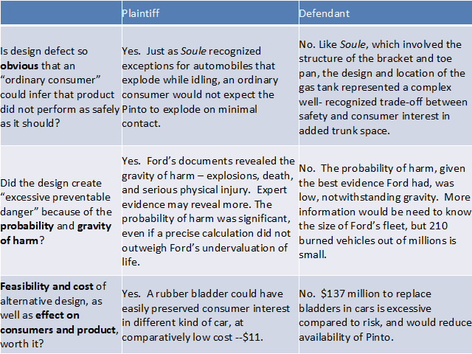

- Failure to Warn (Information Defects)
- Is a warning required at all?
      - General Rule: The seller is required to warn against (1) latent dangers resulting from (2) foreseeable uses of product (3) of which it knew or should have known.
        - This includes unintended uses of the product, so long as they are also foreseeable.
        - This also includes when even the manufacturer is unaware about the risk of danger at the time the product is made. (“knew or should have known of the danger through reasonable testing at the time of sale”).
          - Can be measured by experts in the same field, what the industry knew, or the state of the art technology at the time.
        - Many states require that the manufacturer warn consumers about newly discovered risks after the sale, if that is possible.

VASSALLO v. BAXTER HEALTHCARE CORPORATION
Facts: Plaintiff claimed silicone gel breast implants were negligently designed and she was injured. She also claimed they breached the implied warranty because of negligent product warnings.
Holding: We revise our law to state that a defendant will not be held liable under an implied warranty of merchantability for failure to warn or provide instructions about risks that were not reasonably foreseeable at the time of sale or could not have been discovered by way of reasonable testing prior to marketing.
Rule: The seller is required to give warning against a danger if he has knowledge or by the application of reasonable developed human skill and foresight should have knowledge of the danger.
Rationale: Our current law presumes that a manufacturer was fully informed of all risks associated with the product at issue at the time of the sale. This has been supported by the public policy that a defective product, “unreasonably dangerous due to lack of adequate warnings is not fit for the ordinary purposes for which it is used regardless of the absence of fault on a defendant’s part. The judge’s instructions and our law apply a hindsight analysis to the duty to warn. The majority, however, follow the Restatement comment where “if he has knowledge, or by the application of reasonable developed human skill and foresight should have knowledge, of the danger.” The goal of the law is to induce conduct that is capable of being performed. This goal is not advanced by imposing liability for failure to warn of risks that were not capable of being known. Unforeseeable risks arising from foreseeable product use by definition cannot specifically be warned against. But, the manufacturer’s duty to perform reasonable testing and to discover risks would reveal.
Discussion: The old rule was to assume the manufacturer knew. The reason was that you’re doing something that will always create risks, so you should be held liable. The reason for the new rule is that people won’t invest if they can be sued no matter what.

- Is the warning adequate?
      - General Rule: A reasonable warning not only conveys a “fair indication” of the danger, but also warns with the “degree of intensity” required by the “nature of the risk.”
      - A warning must have sufficient:
        - Reach – must reach person likely to use product (except children).
        - Scope – describes the scope of the danger for people likely to be affected by use.
        - Seriousness – describes the extent, seriousness and consequences of harm resulting from foreseeable misuse.
        - Graphic Power – physical aspects of the warning and means to convey warning must be adequate.
          - Problems with too many warnings:
            - Physical space
            - Language
            - Information economics – flooding us with information, consumers might not be able to appreciate the meaning of it

HOOD v. RYOBI AMERICA CORP.
Facts: Hood uses a miter saw, but removes the guard because he couldn’t cut a thicker piece of wood. Could not use the saw the way he needed it to work. The instructions said to “always use the blade guard” in order to avoid “serious personal injury.” There were seven clear warnings all in capital letters. The spinning blade flew off without the guard, but none of the warnings said why to keep the guard in place.
Holding: Ryobi adequately warned of the dangers and the design was not defective.
Rule: A manufacturer may be liable for placing a product on the market that bears inadequate instructions and warnings or that is defective in design.
Rationale: Maryland only requires “a warning that is reasonable under the circumstances.” A clear and specific warning will normally be sufficient and the manufacturer need not warn of every mishap or source of injury. Maryland law also asks whether the benefits of a more detailed warning outweigh the costs of requiring the change. But the price of more detailed warnings is greater than their additional printing fees. Proliferation of label detail threatens to undermine the effectiveness of warnings altogether. Also, the vast majority of consumers do not detach this critical safety feature before using this type of saw so it is clear that the warnings are not insufficient to accomplish their purpose.
Discussion: Reach? With seven warnings in the operator’s manual and on the saw itself, it properly reached operators. Scope? It didn’t state why the guard should be kept on, but did say that ‘serious injury’ could occur. Seriousness? Claimed ‘serious injury’ in capital letters seven times. Graphic power? Capital letters.

RAGANS v. MIRIAM COLLINS-PALM BEACH LABORATORIES CO.
Facts: Plaintiff hairstylist was using a permanent wave kit that she had used 30-50 times before. It contained wave lotion in a clear bottle and neutralizer in a white plastic bottle. The activator came in a tube that said “ADD TO CLEAR BOTTLE ONLY.” Instructions stated that it can cause serious injury. Plaintiff inadvertently poured a few drops into the neutralizer bottle. Resulting mixture reacted explosively and caused chemical burns.
Holding: Jury question was presented because the words failed to warn of the dangerous consequences of not following the five-word direction.
Distinguished: Saws are inherently dangerous, but you don’t expect hair products to explode.

- Is there a “learned intermediary”?
      - Majority Rule: Under the “learned intermediary doctrine,” the manufacturer owes no duty to the ultimate consumer, so long as the manufacture adequately warns the prescribing physician of the danger.
        - Exceptions have existed for: mass immunizations and when a regulatory authority requires direct warnings.
      - Minority Rule (West Virginia): State v. Karl

STATE v. KARL
Facts: Gellner was prescribed Propulsid by her primary care physician and died three days later. The manufacturer claims a defense under the learned intermediary doctrine.
Holding: The learned intermediary doctrine will not be applied, and there will be a duty to warn the ultimate consumer.
Rule: Under West Virginia products liability law, manufacturers of prescription drugs are subject to the same duty to warn consumers about the risks of their products as other manufacturers.
Rationale: Why abandon the rule? Consumers today, through advertising and the internet, are more capable of selecting their own medications, and having a better conversation with their doctors. Managed care has reduced the time allotted per patient, and physicians have less time to inform patients. Drug manufacturers now have the resources to communicate directly with patients, which is evident by the increase in advertising. There are already exceptions to the learned intermediary doctrine so requiring a duty always won’t hurt the companies that much, especially when the benefit financially to a great extent. It is not unreasonable that prescription drug manufacturers should provide appropriate warnings to the ultimate users of their products.
Discussion:
Why should warning a doctor let a manufacturer off the hook (Basis for learned intermediary doctrine)? (1) Doctor is particularly knowledgeable, as long as manufacturer provided info to the doctor, the doctor assumes responsibility through the doctor patient relationship to notify the patients. (2) Physicians are the ones who select the drugs. (3) Patients rely on doctor’s opinion and communication of prescriptions. (4) Also, manufacturers would have the burden of providing the warning to every single patient, which is not realistic. (5) Complexity of the subject and difficulty of patients to appreciate risks when talking with manufacturers.

- Warnings and Design Defects
      - Warnings are generally considered relevant to whether a design defect exits, but it is not conclusive, so long as the product with the warning remains unreasonably dangerous.
      - However, warnings about goods that are not unreasonably dangerous for particular classes of people will defeat claims of design defect.
      - Example: So long as product is not unreasonably designed for the general public and includes an adequate warning for those with allergies, the warning may bar a claim that the product was designed in an unreasonably dangerous manner.

- Defenses to Strict Liability
- Central Question: Given that strict liability does not involve fault, at all, what defenses can be raised?
      - Was the defect latent, such that the plaintiff could not discover or guard against the harm?
      - Did the plaintiff fail to take reasonable precautions regardless of known or knowable danger?
      - Or rather, did the plaintiff voluntarily and knowingly assume the risk of dangerous product?

      - Did a substantial modification of the product cause the harm?
      - Was the product “purposefully manufactured” to permit use without safety feature?
      - Absent some substantial modification, was the type of misuse foreseeable or necessary to function adequately for its purpose?
      - Did the defendant fail to warn about foreseeable hazards of alternation?
      - If so, was the danger so open and obvious that a court would take the matter away from the jury?

- Comparative Fault – When, if ever, is comparative fault even relevant?
      - Generally, comparative negligence may be used to reduce the defendant’s liability for a product defect.
      - Plaintiff may be comparatively negligent when he or she voluntarily or knowingly assumes risk of dangerous product, or for other conduct that falls below standard of care.
      - However, comparative negligence will not apply to “hidden” product defects. A plaintiff does not owe a duty to discover or guard against hidden product defects.

GENERAL MOTORS CORPORATION v. SANCHEZ
Facts: Sanchez mis-shifted into what he thought was Park, but was a “perched” position and was “hydraulic neutral.” The pickup had rolled backwards, pinned him to the gate, and he bled to death.
Holding: There was evidence to support that Sanchez breached the duty to use ordinary care and was 50% responsible for the accident.
Rule: A consumer has no duty to discover or guard against a product defect, but a consumer’s conduct other than the mere failure to discover or guard against a product defect is subject to comparative responsibility.
Rationale: There is no duty for consumers to discover product defects because they are not experts and they put their faith in the company and are not in the best position to know what is safe and what is not. But, Sanchez does not win because Sanchez failed to perform any of the safety measures described in the owner’s manual and performing any one of them would have prevented the accident. Public policy favors reasonable conduct by consumers. Regardless of any danger of a mis-shift, a driver has a duty to take reasonable precautions to secure his vehicle before getting out of it.

- Assumption of Risk – May plaintiffs expressly or impliedly assume the risk of defendant’s defective product?
      - Secondary assumption of risk may reduce, or in some states, entirely bar lawsuit.
      - Express assumption of risk (contract waivers) is not a defense.
        - Minority: Express waivers are binding on products.

- Substantial Modification of Product – Are defendants strictly liable for obvious dangers or those dangers that result from plaintiff’s “substantial” alteration of original product?
      - General Rule: A manufacturer is not liable for injuries by substantial alterations to the product by a third party that renders the product defective or unsafe.
        - Exception in most states: if substantial alteration is foreseeable.
        - Most others will not recognize defense when use is (1) foreseeable, (2) purposely designed to permit use without feature or (3) when product cannot be used for its purpose absent a modification.
      - Defendants are strictly liable for failing to warn about obvious dangers or those dangers that result from another parties’ “substantial” alteration of original product.
      - Defendants are not liable for substantial alterations to products unless:
        - It is “purposefully manufactured” to permit use without safety feature, or unless, absent some substantial change, it would not function adequately for its purpose.
        - Defendant failed to warn about foreseeable hazards of alteration.

JONES v. RYOBI, LTD.
Facts: Jones was employed at Business Cards Tomorrow and is the operator of a small printing press, which seriously injured her left hand when she caught it in the moving parts of the press. A modification was made through removing a guard, which was a common practice in the printing industry. She knew the guard was missing, knew it was dangerous, and feared she would be fired if she took the time to stop the press. Left hand got caught and was crushed.
Holding: Plaintiff’s evidence showed a third party’s modification (employer), not a defect existing when the press was sold, was the sole cause of her injury, so her claim fails as a matter of law.
Rule: Plaintiff must prove she was injured as a direct result of a defect that existed when the press was sold. Plaintiff had the burden to show the press had not been modified to create a defect that could have proximately caused her injury.
Rationale: When a third party’s modification makes a safe product unsafe, the seller is relieved of liability even if the modification is foreseeable. The distributor’s service rep testified he told BCT’s owner several times the guard should be replaced. The press was safe before the modification because the press would not run without the safety guard covering the moving parts.
Discussion:
Dissent: Manufacturer knows that 98% of people who use that printing press make that modification. The modification of the product does not cause the harm, it’s the way it was designed; there is no way to use it for its intended use without removing the guard. Also, even if you could use it with the guard, it is highly foreseeable that the guard would be removed.

LIRIANO v. HOBART CORP.
Facts: Liriano was a 17-year-old immigrant who worked in the meat department of a grocery store and lost his right hand when it got caught in a meat grinder. The safety guard had been removed and there was no warning on the grinder.
Holding: No design claim, but there is a failure to warn claim. Manufacturer liability can exist under a failure to warn theory in cases in which the substantial modification defense preclude a design defect claim.
Rule: A manufacturer is not liable for injuries caused by substantial alterations to the product by a third party that render the product defective or unsafe. Where, however, a product is purposefully manufactured to permit its use without a safety feature, a plaintiff may recover for injuries suffered as a result of removing the safety feature.
Rationale: A manufacturer is not required to insure that subsequent owners and users will not adapt the product to their own unique uses. That kind of obligation is much too broad and would effectively impose liability on manufacturers for all product-related injuries. This court is not persuaded that the existence of a substantial modification defense, however, precludes a failure to warn case. The inquiry into a duty to warn case is much more limited, focusing principally on the foreseeability of the risk and the adequacy and effectiveness of any warning. The burden of placing a warning on a product is less costly than designing a perfectly safe, tamper resistant product. A manufacturer is already liable for failing to warn against the dangers of foreseeable misuse; there is no distinction between foreseeable misuse and foreseeable alteration here. Also there may be a duty for post-sale warnings because the manufacturer is best placed to learn about post-sale defects or dangers. However, a manufacturer need not warn against open and obvious dangers, but what constitutes this is a jury question.
Discussion:
What makes a failure to warn claim different from a design defect? There is a general warning versus warnings for very specific and substantial changes to the product.

LOPEZ v. PRECISION PAPERS
Facts: Plaintiff was a forklift operator who was injured when an object fell onto his unprotected head. The overhead guard had been removed in the workplace.
Rationale: There are issues of fact whether the forklift, as marketed with an attached but removable overhead safety guard, was not reasonably safe for the uses intended or reasonably anticipated by the manufacturer. There is evidence that the forklift was purposefully manufactured to permit its use without the safety guard.

ANDERSON v. NISEI ASB
Facts: A machine for making plastic bottles came with safety doors that left a six-inch space through which hands could fit. It also came with purge doors that reduced the open space to three inches. Opening the doors shut down the machine. But drool built up and if it was not removed at least every 15 minutes it would damage the machine. Someone in the factory removed the purge guards to make it easier to get the drool out. Plaintiff reached into the 6-inch space and his arm was crushed.
Rationale: The machine was defective as marketed because of the ease of removal of the purge guards and because of the defendant’s failure to warn or address the issue of drool. The modification was essential to keep the machine running and the purge-guard removal was common in the industry, so it should have been foreseeable. The modification was not simply to increase the employer’s productivity but to make the machine function adequately.

