Agency Law
  - Agency elements:
    - mutual assent
    - agent acts on behalf of principal
      - ex. Leasor of commercial real estate NOT acting on behalf of landlord so not an agent
    - principal controls
      - when principal tells agent what to do/not do = showing og control
      - controls the ultimate objective of the relationship

friend doing friend favor suffices
  - Gorton v. Doty
    - RULES:
      - agency can be implied
      - No need for consideration in agency
  - Agent’s Fiduciary Duties to Principal (Rest. 3d §§ 8.01-8.11)
    - Duty of loyalty
    - Duty not to acquire a material benefit from a T for actions taken on behalf of P or through A’s use of position (General Automotive)
    - Duty not to act as adverse party to P
    - Duty to refrain from competing with P during agency relationship
    - Duty of confidentiality (during and after agency relationship)
    - Duty not to use P’s property for A’s own purposes
    - Duty to act in accordance with any contract with P
    - Duty of care, competence, diligence
    - Duty to act only within scope of actual authority and duty to obey
    - Duty of good conduct
    - Duty to notify P of info that A knows or has reason to know P would want to know
    - Duty to notify principal information or that Principal would want to know (General Automotive)

  - Principal’s Fiduciary Duty to Agent (Rest. 3d § 8.14)
    - duty to indemnify A for:
      - the terms of any contract between them,
      - when A makes a payment within the scope of actual authority, or that is beneficial to P unless A acts officiously in making the payment
      - when A suffers a loss that fairly should be borne by P in light of their relationship.
  - General Automotive Mfg. v. Singer
    - fiduciary duties fill contractual gaps
    - agent needs to disclose adverse behavior (breached good faith fiduciary duty) and has to get informed consent to proceed
    - why sue on fiduciary duty rather than contract?
      - could be gap in k
      - could yield better w/ different remedies
- Principal Liability in Contract
  - Actual Authority (express of implied)
    - agent’s reasonable belief from P’s express manifestations that entering into K is w/in scope of duty to carry out P’s objectives
    - Mill St. Church of Christ v. Hogan
      - hiring brother as painter implied actual authority

never told expressly he couldn’t

status quo “controlled”
    - Terminating Actual Authority
      - agreement of the parties (i.e. ending of relationship specified in K)
      - lapse of reasonable amount of time
      - after either party gives notice

EXCEPTION: when power is “given as security” (aka as consideration)
      - change of circumstances that should cause agent to realize principal would not want to terminate authority
      - fulfillment of purpose of relationship
      - by operation of law

  - Apparent Authority
    - looks to third party’s reasonable beliefs traceable to principal’s manifestations
    - 50 cent case
      - DJ attenuated to artist to have a presumption of authority to license artist’s IP
    - Terminating Apparent authority
      - when 3rd party’s expectation becomes unreasonable
  - Unidentified Principal (3rd party knows there is one)
    - agent can be liable
  - Undisclosed Principal
    - where principal is bound but doesn’t fall into other doctrine
    - Wattreau v. Fenwick
      - RULE: undisclosed principal can’t get off the hook by keeping secret limitations on agent scope

lowest cost avoider/fairness rationale
    - Acting w/out actual authority
      - principal bound when 3rd party detrimentally relies, principal has notice and doesn’t take reasonable steps to notify 3rd party of facts
  - Ratification
    - Ratification is the affirmance of a prior act done by another, whereby the act is given effect as if done by an agent acting with actual authority.
    - A person may ratify an act if the actor acted or purported to act as an agent on the person’s behalf.
    - Ratification can occur by
      - (a) manifesting assent that the act shall affect the person’s legal relations; or
      - (b) conduct that justifies a reasonable assumption that the person so consents. (Express / implied)
    - At the time of ratification, the purported P must have knowledge of all material facts (or not unaware of lack of knowledge), and T must not have already withdrawn from the transaction. Ratification is not effective if there has been a material change in circumstances that would make it inequitable to bind T, unless the T chooses to be bound.
    - Ratification creates the effects of actual authority. (Both P and T are bound by the contract and the purported A is discharged.)
    - No partial ratification.
    - Zions Gate R.V. Resort, LLC v. Oliphant
      - indicia of ratification

the prior course of dealing with Sultan in his capacity as President of the LLC

the fact that the LLC’s authorized attorney acted in a manner consistent with Sultan’s authority

the LLC’s acceptance of the plaintiffs’ deposit.
  - Estoppel
    - “1 way street” – 3rd party can bind principal, but not vice versa
    - Hodderson v. Koos Bros.
      - A person is liable to T who was justifiably induced to detrimentally rely on an actor if

(1) the alleged P intentionally or carelessly caused such belief, or

(2) alleged P was on notice and didn’t take reasonable steps to notify them of the facts.
- Tort Liability
  - overarching rule - tortfeasor
  - Direct liability
    - Actual authority
    - Negligent hire, supervision or control of agent
    - Non delegable duty
    - Activity is contracted and inherently dangerous
  - Vicarious liability/Respondant superior
    - Employee
      - definition – agent whose principal controls or has the right to control the manner and mean of the agent’s performance of work

no consideration necessary
      - Rstmt. 2d §220 a) – j) employee factors
    - Within the scope of employment? Rstmt. §7.07(2)
      - factors:

was the conduct of the same general nature as, or incidental to, the task the agent was employed to perform?

did the conduct occur substantially w/in the authorized time and space limits of employment (detour v. frolic)

was the conduct motivated at least in part by a purpose to serve the principal
      - test tip: use case law analogies heavily
    - Vicarious liability classifications: 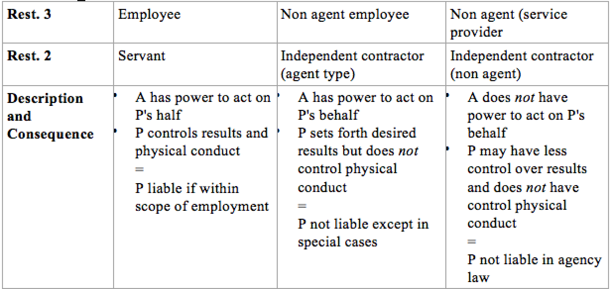
    - O’Connor v. Uber Technologies
      - CA RULES:

working for someone is prima facie showing of employee status – has to be affirmatively rebutted

principal control not measured by actual control exercised, but how much control principal retains the right to exercise

p. 59 Bortello factors a-h: indicia of employee status
    - Clover v. Ski Resort
      - personal detour case
      - jury could find still w/in scope of employment
    - Patterson v. Blair
      - son shooting out tires case
      - RULE: if tort is intentional, principal still liable is agent is trying to further principal’s goals
  - A commits tort while acting with apparent authority
    - when agent commits a tort when acting w/in apparent authority in dealing w/ a third party on or purportedly on behalf of the principal
    - Butler v. McDonald’s Corp.
      - franchisor RULE:

franchisor acted in a manner that would lead a reasonable person to conclude that the operator and/or employees of the franchise restaurant were employee agents or servants of the D

plaintiff actually believed the operator and/or employees of the franchise restaurant were agents or servants of the franchisor

plaintiff thereby relied to his detriment upon the care and skill of the allegedly negligent operator and/or employees of the franchise restaurant
- Partnerships
  - RUPE §202(a) – “An association of 2 or more ppl to carry on as co-owners of a business for profit.”
  - can be formed inadvertently
  - usually governed by K, buy some RUPA rules are not alterable
  - characteristics
    - flow-through taxation (partners, not business entity, are taxed)
    - joint/severable liability of partners
  - Formation (balancing test)
    - RUPA §202(c) partnership factors
      - sharing of gross returns NOT necessarily indicia or partnership
      - a person who receives share of profits of a business is presumed to be a partner in the business, unless the profits were received in payment of:

a debt by installments or otherwise

for services as an independent contractor or of wages or other compensation to an employee

rent

of an annuity or other retirement or health benefit to a beneficiary, representative, or designee of a deceased or retired partner

of interest or other charge on a loan, even if the amount of payment varies with the profits of the business, including a direct or indirect present or future ownership of the collateral, or rights to income, proceeds, or increase in value derived from the collateral

for the sale of the goodwill of a business or other property by installments or otherwise.

    - Fenwick v. Unemployment Compensation Commission
      - RULE: sharing of profits aloes does not create a partnership, despite parties’ intentions

partnership factors (burden on party trying to argue partnership to show):
          - parties’ intent
          - right to share profits
          - obligation to share in losses
          - conduct of parties towards third persons
          - rights of parties on dissolution

    - Martin v. Payton
      - FACTS: Hall was a friend of Respondents, and Hall’s brokerage business was suffering. Respondents discussed helping Hall and his business, but they needed to ensure that Hall’s business would discontinue their speculative, unwise investments. Respondents agreed to loan Hall $2.5 million in securities for Hall to secure $2 million in loans. In return, Respondents received Hall’s more speculative collateral and would receive a percentage of Hall’s profits. Respondents acquired the ability to review Hall’s books and veto certain investments.
      - HOLDING: The agreements did not establish a partnership. Although Respondents ensured that they had some control over the operations of Hall’s business, the controls they bargained for were to ensure that their investment was secure. Immediately prior to Respondent’s investment, Hall’s business was doing poorly due to bad decision-making and Respondents needed to prevent further bad decisions. Hall still was able to control the day-to-day affairs, and Respondents never had control to initiate their own ideas.
- 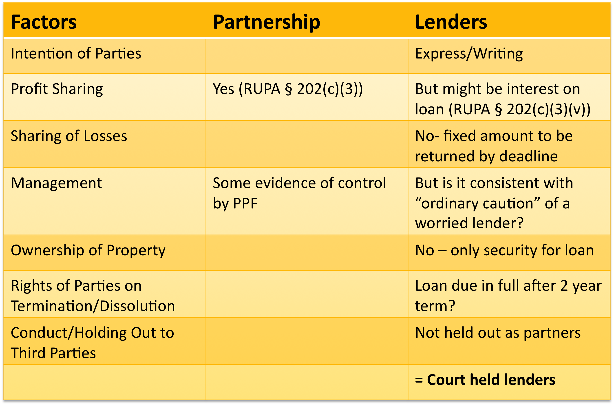

  - Partnership by Estoppel
    - 3rd party P must establish
    - elements:
      - person sought to be charged as a partner made a representation either by words or conduct purporting to be a partner, or consented to being represented by another as a partner

AND
      - the third party relied on this representation in entering into a transaction w/ the actual or purported partnership (change of position w/ consequent injury in reliance on the representation)
    - Young v. Jones
      - FACTS: Plaintiffs invested $550,000 in a South Carolina bank after they were reassured by Defendants, through an unqualified audit letter, that the investment entity was legitimate. The audit letter was based upon a falsified financial statement. Plaintiffs dealt primarily with one Defendant, PW-Bahamas, to obtain the audit letter, but they included the United States Price Waterhouse (“PW-US”�) firm as well as individual members of the PW-US firm. PW-US and its individual members did not directly handle the failed investment, but partners are jointly and severally liable for the actions of one party of a partnership. Therefore, if Plaintiffs could establish a partnership between PW-Bahamas and PW-US then PW-US could be held liable. Plaintiffs argued that a partnership by estoppel was established through pamphlets by Defendants that linked the various offices worldwide.
      - HOLDING: There was no partnership by estoppel because there was no proof that Plaintiffs relied upon any acts or statements by Defendants that a partnership existed between PW-Bahamas and PW-US. Plaintiffs never made any assertions that they extended the credit based upon a perceived partnership between Defendants and therefore can not rely upon the doctrine of partnership by estoppel.
    - Chavers v. Epsco
      - paperwork indicated partnership

a faxed list of credit references, clearly indicates that Gary was the owner and that Reggie and Mark were partners in the business.

a fax cover sheet contained the address, telephone number, and fax number of the business. Listed under this information was “Gary, Reggie, or Mark Chavers.”
          - indicates that they were holding themselves out to the public as partners of the business.

a personnel credit application - The type of business checked on the credit application is “partnership.”

checks written to Epsco showing the CWC account to be in the name of “Gary A. or Reggie J. Chavers,” indicates that Reggie was holding himself out to be a partner of CWC

business card that states “Chavers Welding, Construction & Crane Service.” Listed on the card as “owners” are Gary Chavers and Reggie Chavers

Dealership application - signed by Reggie. Reggie admits that he signed the dealership application and represented that he was an owner of “Chavers Welding,”
      - partnership by estoppel found
  - Fiduciary Duties and Obligations of Partners
    - Meinhard v. Salmon
      - RULE: when partners appropriate the benefit of the partnership without making any disclosure to the other partner, they breach the fiduciary duty of loyalty to their other partner(s)
    - RUPA rules
      - 409

409(a) “A partner owes to the partnership and the other partners the duties of loyalty and care stated in subsections (b) and (c).”

409(b) The fiduciary duty of loyalty of a partner includes the duties:
          - to account to the partnership and hold as trustee for it any property, profit, or benefit derived by the partner
          - to refrain from dealing with the partnership . . . as or on behalf of a person having an interest adverse to the partnership
          - to refrain from competing with the partnership
            - Meehan v. Shaughnessy
              - pleaving partners can prepare to compete, but cannot directly compete
              - lying to partner is clear violation of fiduciary duty
              - for universal rule for client contacts – look to state law

409(c) Duty of Care
          - “The duty of care of a partner . . . is to refrain from from engaging in grossly negligent or reckless conduct, willful or intentional misconduct, or a knowing violation of law.”

409(d) Duty of Good Faith
          - “A partner shall discharge the duties and obligations under this [act] or under the partnership agreement and exercise any rights consistently with the contractual obligation of good faith and fair dealing.”
            - partners can ratify violating conduct if unanymous

Other rules
          - (e) A partner does not violate a duty or obligation under this [act] or under the partnership agreement solely because the partner’s conduct furthers the partner’s own interest.
          - (f) All the partners may authorize or ratify, after full disclosure of all material facts, a specific act or transaction by a partner that otherwise would violate the duty of loyalty.
          - (g) It is a defense to a claim under subsection (b)(2) and any comparable claim in equity or at common law that the transaction was fair to the partnership. . .
      - 408(c) Information Disclosure

The partnership shall furnish to each partner:
          - without demand, any info. concerning the partnership’s business, financial condition, and other circumstances which the partnership knows and is material to the proper exercise of the partner’s rights and duties under the partnership agreement or this [act]…; AND
          - on demand, any other information concerning the partnership’s business, financial condition, and other circumstances, except to the extent the demand or the information demanded is unreasonable or otherwise improper under the circumstances.
      - 105 Non-waivable provisions

The partnership agreement may not:
          - Unreasonably restrict a partner’s right of access to partnership books and records
          - Alter or eliminate the duty of loyalty, although it is permissible to make specific exceptions or carveouts provided they are not manifestly unreasonable
          - Alter or eliminate the duty of care, although it is possible to make alterations provided they are not manifestly unreasonable and provided they do not authorize conduct involving bad faith, willful or intentional misconduct, or knowing violation of the law
          - Eliminate the contractual obligation of good faith and fair dealing (but the partnership agreement may prescribe standards, if not manifestly unreasonable, by which performance of the obligation is measured
          - Vary the power of a partner to dissociate
          - Restrict the right of third parties under RUPA
  - Rights of Partners in Management and Partnership Liability
    - § 401(h): “Each partner has equal rights in the management and conduct of the partnership’s business.”
    - majority rule for matters in ordinary course of business
      - has to be unanimous to make decision outside ordinary course of business
    - Partners are agents of partnership
      - UNLESS: partners act outside given authority and 3rd party knows partner is acting outside of authority
    - §305(a) – partners liable on behalf of each other when working in the ordinary course of business
    - §306(a) – partners are jointly and severally liable for partnership (b) starting when they join
    - National Biscuit Company Inc. v. Stroud
      - need a majority of partners to limit another partner’s authority (1/2 not enough)
    - Summers v. Dooley
      - ???
  - Financial Aspects of a Partnership
    - partnership property (RUPA §203, 204)
      - property acquired by partnership
      - property bought w/ partnership funds presumed to be partnership property
    - Rules
      - partners may only use property for partnership business
      - partner NOT a co-owner
      - only thing partners can transfer is their “transferable interest” (i.e. rights to receive distribution from partnership)

getting transferable interest does NOT give transferee management in partnership (though they have a right to accounting info.)

creditors can go after transegerable interest
      - partnership reimburses partners for cost of business
      - partnership indemnifies partners for ordinary course of business
      - partners can loan partnership interest-accruing loans
    - Wyatt v. Byrd
      - some of $ used to buy mobile home was from partnership = presumed to be partnership property
    - Partnership Capital Account
      - Each partner has an account that is a running balance reflecting:

their contributions (money/property)

share of profits

distributions

share of losses
  - Settlement of Accounts and Contributions in Winding Up §806
    - Capital Contributions
      - default rule – initial capital contributions not required from partners
      - service partnership (aka “K-and-L” partnerships)
      - basic default rule is the same under UPA and RUPA – each partner is credited with an amount equal to the money plus the value of any other property contributed in order to be a partner or in the person’s capacity as a partner. The contributed capital itself belongs to the partnership and can be any property (real, intangible, etc.).
    - Settlement of Accounts
      - partnership must apply its assets to discharge the obligations of creditors (including partners who are creditors).
      - If there is any surplus, that is divided among the partners in accordance with their right to distributions.
      - A partner shall contribute to the partnership an amount equal to any excess of the charges over the credits in the partner’s account
      - If a partner fails to contribute the full amount required, all of the other partners shall contribute, in the proportions in which those partners share partnership losses, the additional amount necessary to satisfy the partnership obligations for which they are personally liable.

A partner or partner's legal representative may recover from the other partners any contributions the partner makes to the extent the amount contributed exceeds that partner's share of the partnership obligations for which the partner is personally liable.
    - Kovacik v. Reed
      - minority (CA) RULE: if partner contributes all the capital and the other contributes all the services, they are not liable to each other for contribution for any losses sustained

RUPA (majority rule) does NOT like this rule
  - Dissociation
    - definition – change in relationship amongst partners caused by partnership leaving
    - §603 – Effect of Dissociation
      - 2 avenues:

if event is listed in §801, then dissolution is triggered
          - withdrawal causes dissolution of at-will partnership
          - McMormack v. Brevig
            - trial ct. ordered D could buy out P but statute required dissolution
            - §801 was triggered (judicial dissolution) only option is to dissolve and liquidate

if not in §801, buyout pursuant to §701 will happen and partnership continues
    - Consequences of Dissociation
      - right to management ceases except for matters before dissociation (same goes for liability) – remember apparent authority issue
    - Wrongful Dissociation §602
      - At-will partnership (default) allows at-will withdrawal

breach of partnership agreement = wrongful dissociation
      - term partnership (set time frame)

leaving partnership too soon = wrongful dissociation
    - 804 – Power to Bind Partnership After Dissolution
      - partners bound to acts appropriate for winding up
      - bound to acts that would have otherwise been bound to under §301
      - acts that create apparent authority
  - More on General Partnerships
    - what partnerships CAN do
      - change governance rules
      - define scope of fiduciary duties (as long as manifestly reasonable)
    - what partnerships CAN’T do
      - completely eliminate fiduciary duties
      - Alter third parties’ rights
- Other Partnerships Forms
  - LP’s (ex. VC firms)
    - partnership w/ two different types of partners
      - general partners (manage business – standard partnership liability applies)
      - limited partners (passive investors – not personally liable)

*CA rule – can become liable if they begin to act like general partners
    - Default Rules
      - profit/losses in proportion to capital contribution
      - require formal filing
  - LLP
    - limited liability form of general partnerships
    - requires formal filing w/ Sec. of State
    - shields partners from personal liability for partnership debts (but still liable for own wrongful acts)
  - LLLP
    - limited liability for of LP’s
      - general partners get limited liability
      - only a few states offer it (CA does not)
      - need to file
- Corporations
  - characteristics
    - separate entity
    - perpetual existence
    - limited liability
    - centralized management
    - divisible ownership (shares or stocks)
    - transferable shares and debt obligations
  - Corporate law
    - primarily state law (how to incorp., etc.)
  - Key documents
    - certificate/articles of incorporation
      - filed w/ state in order to incorporate
    - Bylaws
      - not filed w/ state
      - set out governing details of the corp.
  - Ultra Vires doctrine
    - corps. now have ability to incorporate for “any lawful purpose”
  - Internal Affairs Doctrine
    - law relating to incorporation is state law where incorporated
      - CA exception (Cal Corp. Code §2115)

foreign corps. (usually incorped in Delaware) with more than ½ their taxable income, property, payroll, and outstanding voting shares w/in CA subject to certain provisions of CA corp. code
- 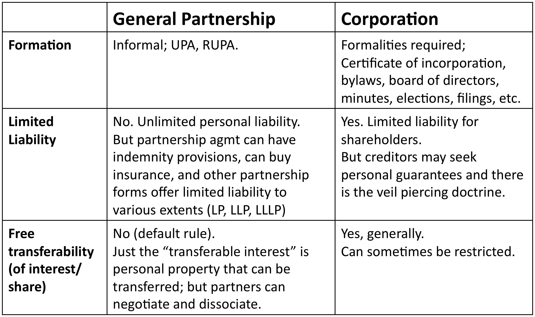
  - Board of Directors
    - individual directors have no power (only power in quorum)
    - “quorum” – minimum (at least 1/3 by statute) number of directors present to make corp. action
      - majority of quorum sets corporate action
  - Promoter liability
    - promoter = person organizing and founding corp.
    - liable for K’s entered into on bhalf of future corp. absent a contrary intent
      - post-incorporation – corp. only liable for A K the promoter entered into if adopted by corp.
    - transferring liability to corp.
      - Corp. is formed
      - corp. adopts K
      - parties agree to relieve promoter from liability

Moneywatch v. Wilbers
    - promoter fiduciary duties
      - deal in good faith
      - duty to disclose relevant info. to relevant parties
  - Defective Formation
    - De Facto Corporation
      - elements

statute for valid incorporation available

good faith attempt to incorporate

good faith use of corpprate form in transaction w/ 3rd party
    - Corporation by Estoppel (Southern Gulf)
      - when unjust to allow a party to escape liability by denying corporate existence.
- Business lingo – on separate outline
- Piercing the corporate veil
  - fact-specific (no set test) equitable doctrine
  - best 2-part test for PCV
    - unity of interest and ownership/control or domination (“alter ego)
      - generally need at least 2 of the following

failure to observe corporate formalities

comingling business and personal funds/assets

undercapitalization of the business
          - whether corp. has insurance goes to this AND
    - refusing to allows corporation piercing would sanction fraud or promote injustice
      - unsatisfied judgment alone not enough (would swallow the rule)
      - needs to be some deceipt or wrongdoing, some degree of unfairness or wrong beyond a creditor’s inability to collect

Rafaszewski v. Telecom Corp.
          - no deceipt or fraudulent behavior
    - Walkovsky v. Carlton
      - Enterprise (horizontal) liability

holds the larger corporate entity financially responsible

depends on proof that the separate identities of the corporations were not respected. If successful under this theory, the plaintiff could recover from the other corporation(s).
    - Gardemal v. Westin Hotal Co.
      - standard parent-subsidiary relationship, no grounds for PCV
    - OTR Associated v. IBC Services, Inc.
      - all subsidiary was for was to hold the lease
      - independent funds
      - P reasonably believed they were dealing with Blimpie the big corp., not a puny little subsidiary – grounds for PCV
      - Couldn’t protect themselves with knowledge and make educated decision so limited liability policy not Implicated
      - could be anywhere on the spectrum from P’s reasonable belief to D’s intent – totally factually specific

  - CA test
    - 2-part test:
      - there must be such a unity of interest and ownership between the corporation and its equitable owner that the separate personalities of the corporation and the shareholder do not in reality exist; AND
      - there must be an inequitable result if the acts in question are treated as those of the corporation alone.
- Role of Directors and Fiduciaries
  - Duty of Care
    - requires directors to use the amount of care and skill that a reasonably prudent person would reasonably be expected to exercise in a like position and under similar circumstances.
    - DOC is largely about whether the process that generated the relevant business decision was unsound (e.g., were directors grossly negligent in failing to inform themselves before making a decision?)
    - Business Judgment Rule (BJR)
      - presumes that the directors’ decisions were made “on an informed basis, in good faith and on an honest belief that the action is in the best interest of the corporation.”
      - not available in non-feasance situations (failure to perform minimal levels of oversight or making a decision at all).

Francis v. United Jersey Bank
          - nonfeasance gets regular “reasonableness” negligence standard
          - but affirmative decisions to do nothing ARE protected by BJR
      - cts. focus on whether the process that generated business decision was sound (i.e. were directors grossly negligent in failing to inform themselves before making a decision?)
      - standard of review – essentially raises the bar from negligence to gross negligence or recklessness
      - Directors are allowed to rely on expert opinions if reliance reasonable and in good faith
      - Kamin v. American Express

The decision to declare a dividend may be an unwise judgment, but it is a judgment that is outside the scrutiny of the court. The court will not overrule a business decision of the directors of a company unless there is evidence of fraud or some other dishonest dealing.
      - Schlensky v. Wrigley

old owner lights on Wrigley field case
      - Smith v. Van Gorkom

directors had a duty to “inform themselves of all material information reasonably available to them” before making a decision.
    - DGCL § 102(b)(7)
      - A provision eliminating or limiting the personal liability of a director to the corporation or its stockholders for monetary damages for breach of fiduciary duty as a director, provided that such provision shall not eliminate or limit the liability of a director: (i) For any breach of the director's duty of loyalty to the corporation or its stockholders; (ii) for acts or omissions not in good faith or which involve intentional misconduct or a knowing violation of law; … or (iv) for any transaction from which the director derived an improper personal benefit.
  - Duty of Loyalty
    - Duty of Good Faith
  - Duty of Candor/Disclosure
- Corporate Purpose, Corporate Social Responsibility, Charitable Giving, and Corporate Political Activity
  - Corporate Responsibility
    - Dodge v. Ford Motor Co.
      - ct. forced dividednd (contra usual BJR and contra Wrigley)
      - The purpose of the corporation is to make money for the shareholders, and Defendant is arbitrarily withholding money that could go to the shareholders.

maybe “arbitrarily” is the key distinction?
  - Charitable Giving
    - All 50 states have statutes providing for corporate authority to make charitable contributions.
      - DGCL § 122: “Every corporation created under this chapter shall have power to: . . .”

Make donations for the public welfare or for charitable, scientific or educational purposes, and in time of war or other national emergency in aid thereof;”
      - California Corporations Code § 207:

“Subject to any limitations contained in the articles and to compliance with other provisions of this division and any other applicable laws, a corporation shall have all of the powers of a natural person in carrying out its business activities, including, without limitation, the power to: . . .”
          - “(e) Make donations, regardless of specific corporate benefit, for the public welfare or for community fund, hospital, charitable, educational, scientific, civic, or similar purposes.”
    - Theodora Holding Corp. v. Henderson
      - RULE: ?
  - Political Contributions
    - RULE: A decision to make political contribution is analyzed using BJR under state corp. law
- MISSED CLASS

